7.1 From production to inputs
Chapter 7 · section 7.1

Fill every gap. Each word list holds one word more than there are gaps.
Chapter 7, section by section
Each stage leads to the next.
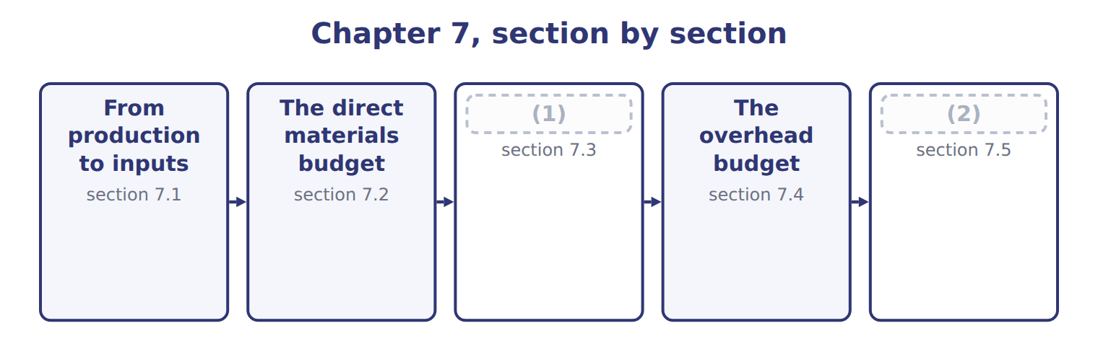
word list
The direct labor budget · Extended Example 7A: the manufacturing cost bu · The direct materials budget

Summary 1 gaps 3–10
Every input budget (3) from the production budget, not the sales budget, (4) materials and labor are used when cases are filled, not when they are sold. For each input, the budget (5) the cases to produce by the quantity per case: liters of (6) , labor hours and machine hours. Machine hours then drive the (7) overhead, while fixed overhead is (8) item by item. The link runs both ways. If an input budget shows a (9) of materials, labor or machine time, the production budget, and (10) the sales budget, must be changed.
word list
multiplies · shortage · budgeted · starts · perhaps · because · variable · concentrate · overhead

Answer key · 7.1 From production to inputs

1 The direct labor budget | 6 concentrate
2 Extended Example 7A: the manufacturing cost bu | 7 variable
3 starts | 8 budgeted
4 because | 9 shortage
5 multiplies | 10 perhaps

the summaries in full
Summary 1 Every input budget starts from the production budget, not the sales budget, because materials and labor are used when cases are filled, not when they are sold. For each input, the budget multiplies the cases to produce by the quantity per case: liters of concentrate, labor hours and machine hours. Machine hours then drive the variable overhead, while fixed overhead is budgeted item by item. The link runs both ways. If an input budget shows a shortage of materials, labor or machine time, the production budget, and perhaps the sales budget, must be changed.

7.2 The direct materials budget
Chapter 7 · section 7.2

Fill every gap. Each word list holds one word more than there are gaps.
Summary 1 gaps 1–3
The (1) materials budget has two parts: the materials to use and the materials to buy. (2) equal usage plus the desired ending stock minus the beginning stock, just like the (3) budget.
word list
Purchases · Concentrate · production · direct

Worked example: concentrate in the first quarter

Worked example: the concentrate budget for 2028
The bars are drawn to scale.
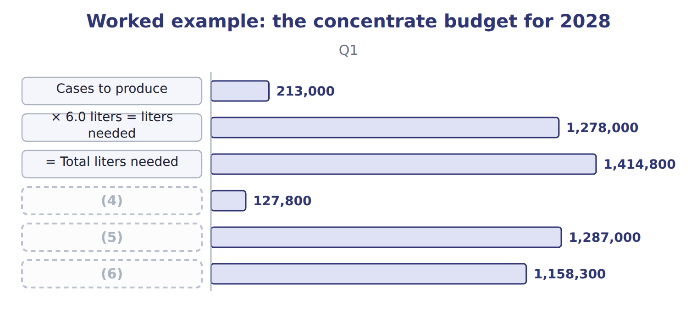
word list
direct materials budget · = Liters to buy · − Beginning stock · × $0.90 = cost of purchases

Concentrate in the third and fourth quarters

Summary 2 gaps 7–9
Complete the blank cells. The first quarter of 2029 is (7) at 218,000 cases. The (8) policy decides how much stock to hold. (9) travels further and is kept at 10% of the next quarter's needs.
word list
planned · Concentrate · procurement · quarter

Bottles, caps and cartons bought just-in-time
The bars are drawn to scale.
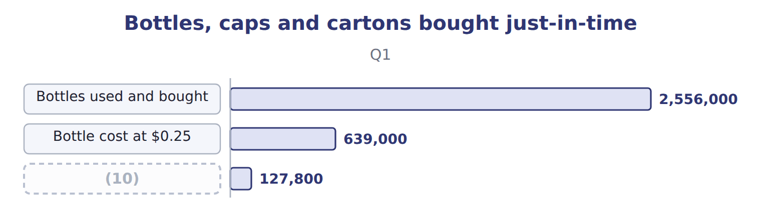
word list
Bottles used and bought · Caps and cartons at $0.60 a case

Procurement policies and their effect on the materials budget
Material | Procurement policy (B.5.h) | Effect on the materials budget
Concentrate | (11) | Purchases differ from usage by the change in stock
Bottles (Jordan Glass) | Just-in-time daily deliveries (Book 2, Chapter 17) | Purchases = usage; almost no stock
Caps and cartons | Just-in-time | Purchases = usage
Any item with a minimum order | Buy in fixed lots | (12)

word list
Keep 10% of next quarter's needs · Purchases rounded up; stock rises · × 6.0 liters = liters needed

Usage is not purchases

Summary 3 gaps 13–14
An answer that sets (13) equal to usage ignores the change in materials stock. It is right only for items bought (14) .
word list
just-in-time · further · purchases

The English this sheet uses, and its Arabic
English (exam term) | Arabic
direct materials budget | موازنة المواد المباشرة
procurement policy | سياسة الشراء
just-in-time (JIT) | التوقيت المحدد (الإنتاج في الوقت المحدد)

Answer key · 7.2 The direct materials budget

1 direct | 8 procurement
2 Purchases | 9 Concentrate
3 production | 10 Caps and cartons at $0.60 a case
4 − Beginning stock | 11 Keep 10% of next quarter's needs
5 = Liters to buy | 12 Purchases rounded up; stock rises
6 × $0.90 = cost of purchases | 13 purchases
7 planned | 14 just-in-time

the summaries in full
Summary 1 The direct materials budget has two parts: the materials to use and the materials to buy. Purchases equal usage plus the desired ending stock minus the beginning stock, just like the production budget.
Summary 2 Complete the blank cells. The first quarter of 2029 is planned at 218,000 cases. The procurement policy decides how much stock to hold. Concentrate travels further and is kept at 10% of the next quarter's needs.
Summary 3 An answer that sets purchases equal to usage ignores the change in materials stock. It is right only for items bought just-in-time.

7.3 The direct labor budget
Chapter 7 · section 7.3

Fill every gap. Each word list holds one word more than there are gaps.
Summary 1 gaps 1–2
The direct labor budget (1) the cases to produce by the (2) hours per case, then by the wage rate.
word list
working · standard · multiplies

Worked example: the direct labor budget for 2028
The bars are drawn to scale.
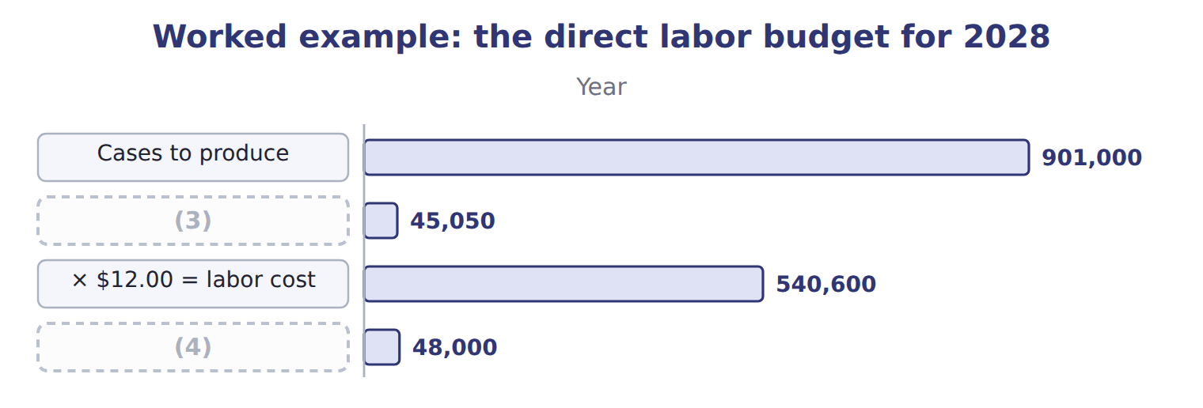
word list
Hours available · overhead budget · × 0.05 hours = hours needed

Summary 2 gaps 5–8
The budget must also be (5) . With 25 operators working 480 hours a quarter, 12,000 hours are (6) . The division (7) plans to hire two temporary operators for the summer. Checking (8) in this way is part of preparing the budget, not a separate task.
word list
available · feasibility · division · therefore · feasible

The English this sheet uses, and its Arabic
English (exam term) | Arabic
direct labor budget | موازنة العمل المباشر
feasibility | إمكانية التنفيذ

Answer key · 7.3 The direct labor budget

1 multiplies | 5 feasible
2 standard | 6 available
3 × 0.05 hours = hours needed | 7 therefore
4 Hours available | 8 feasibility

the summaries in full
Summary 1 The direct labor budget multiplies the cases to produce by the standard hours per case, then by the wage rate.
Summary 2 The budget must also be feasible. With 25 operators working 480 hours a quarter, 12,000 hours are available. The division therefore plans to hire two temporary operators for the summer. Checking feasibility in this way is part of preparing the budget, not a separate task.

7.4 The overhead budget
Chapter 7 · section 7.4

Fill every gap. Each word list holds one word more than there are gaps.
Summary 1 gaps 1–3
The overhead (1) has a variable part and a fixed part. Variable overhead moves with its driver, (2) hours, at $50.00 an hour; fixed overhead is budgeted item by item and does not change with (3) .
word list
machine · overhead · production · budget

Overhead items and rates
The bars are drawn to scale.
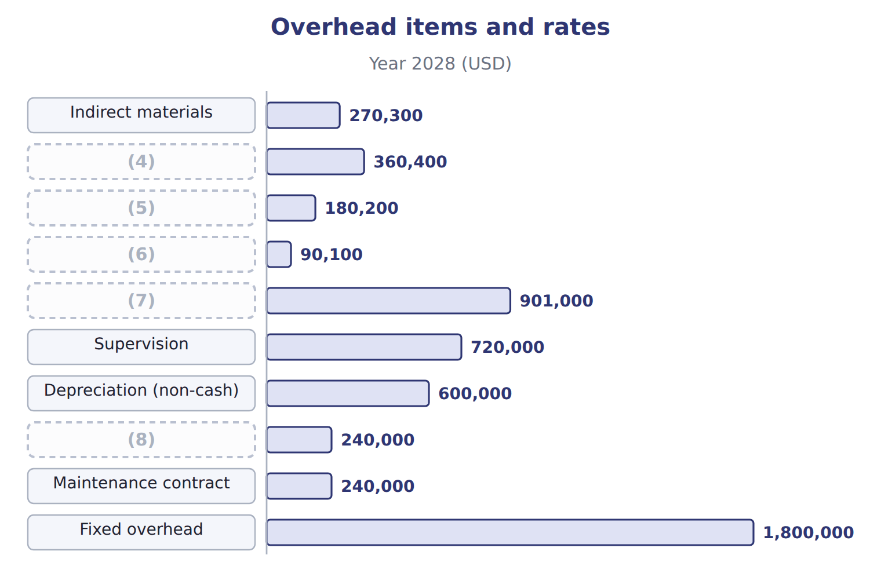
word list
Maintenance (variable part) · Power and water · direct materials budget · Variable overhead · Cleaning supplies · Insurance and property tax

Worked example: the quarterly overhead budget

Summary 2 gaps 9–10
First (9) : 213,000 cases × 0.02 = 4,260 machine hours × $50.00 = $213,000 (10) , plus $450,000 fixed = $663,000.
word list
quarter · Budgeting · variable

Worked example: the overhead budget for 2028
Overhead budget 2028 | Q1 | Q2 | Q3 | Q4 | Year
(11) | 213,000 | 228,000 | 237,000 | 223,000 | 901,000
(12) | 4,260 | 4,560 | 4,740 | 4,460 | 18,020
Variable overhead (× $50.00) | 213,000 | 228,000 | 237,000 | 223,000 | 901,000
Fixed overhead | 450,000 | 450,000 | 450,000 | 450,000 | 1,800,000
(13) | 663,000 | 678,000 | 687,000 | 673,000 | 2,701,000

word list
Overhead item · Machine hours (× 0.02) · Total overhead · Cases to produce

Fixed overhead does not follow volume

Summary 3 gaps 14–15
Budgeting fixed overhead as an amount per case makes it rise and fall with (14) . In the overhead budget, fixed overhead is the same each quarter; only (15) overhead follows the driver.
word list
quarter · variable · production

The English this sheet uses, and its Arabic
English (exam term) | Arabic
overhead budget | موازنة التكاليف الصناعية غير المباشرة

Answer key · 7.4 The overhead budget

1 budget | 9 quarter
2 machine | 10 variable
3 production | 11 Cases to produce
4 Power and water | 12 Machine hours (× 0.02)
5 Maintenance (variable part) | 13 Total overhead
6 Cleaning supplies | 14 production
7 Variable overhead | 15 variable
8 Insurance and property tax

the summaries in full
Summary 1 The overhead budget has a variable part and a fixed part. Variable overhead moves with its driver, machine hours, at $50.00 an hour; fixed overhead is budgeted item by item and does not change with production.
Summary 2 First quarter: 213,000 cases × 0.02 = 4,260 machine hours × $50.00 = $213,000 variable, plus $450,000 fixed = $663,000.
Summary 3 Budgeting fixed overhead as an amount per case makes it rise and fall with production. In the overhead budget, fixed overhead is the same each quarter; only variable overhead follows the driver.

7.5 Extended Example 7A: the manufacturing cost budget and the summer test
Chapter 7 · section 7.5

Fill every gap. Each word list holds one word more than there are gaps.
This example brings the three budgets together and tests the busiest quarter.
Extended Example: the manufacturing cost budget for 2028
The bars are drawn to scale.
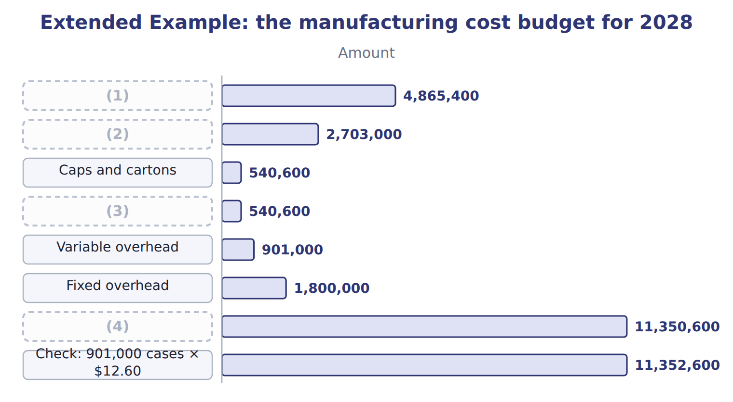
word list
Concentrate used · Bottles · just-in-time (JIT) · Budgeted manufacturing cost · Direct labor

Summary 1 gaps 5–6
At (5) , 901,000 cases × $12.60 = $11,352,600. The budget is $2,000 lower because fixed (6) is a fixed amount, while the card spreads it over a normal volume of 900,000 cases.
word list
standard · budgets · overhead

3. Can the third quarter be done?

Extended Example: can the third quarter be done?
Every item belongs to exactly one group.
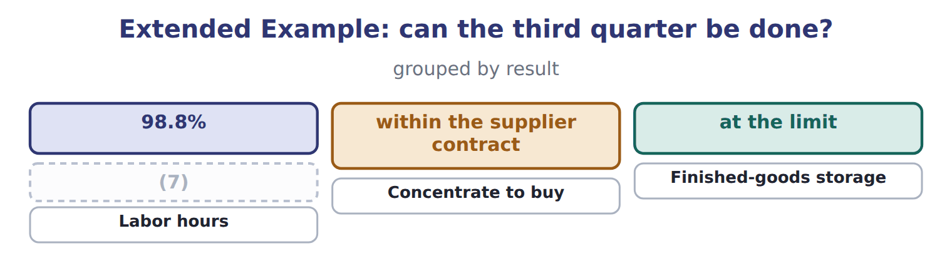
word list
Machine hours · just-in-time (JIT)

Everything ties

Concentrate purchases 5,409,000 liters = usage 5,406,000 + ending 130,800 − beginning 127,800.
Exam view

Summary 2 gaps 8–10
Expect a (8) budget and a materials policy. Compute usage, (9) in units and dollars, labor hours and cost, and overhead by variable and fixed parts. Then compare the hours or materials with what is (10) .
word list
available · purchases · overhead · production

Exam view
Tahini & Spreads, 2028 | Data
Jars to produce: second quarter | 382,000
Jars to produce: third quarter | 396,000
Sesame paste per jar | 0.50 kg
Price of sesame paste | (11)
Ending sesame stock | 20% of next quarter's needs
Labor per jar | (12)
Labor rate | (13)
Labor hours available in the second quarter | 4,500

word list
$2.50 a kg · $15.00 an hour · 0.50 kg · 0.012 hours

Item — Answer
Item | Answer
Q3 | 1,422,000 + 133,800 = 1,555,800; − 142,200 = 1,413,600 liters; × $0.90 = $1,272,240
Q4 | 1,338,000 + 130,800 (10% of 1,308,000) = 1,468,800; − 133,800 = 1,335,000 liters; × $0.90 = $1,201,500

Item — Category
Every item belongs to exactly one group.
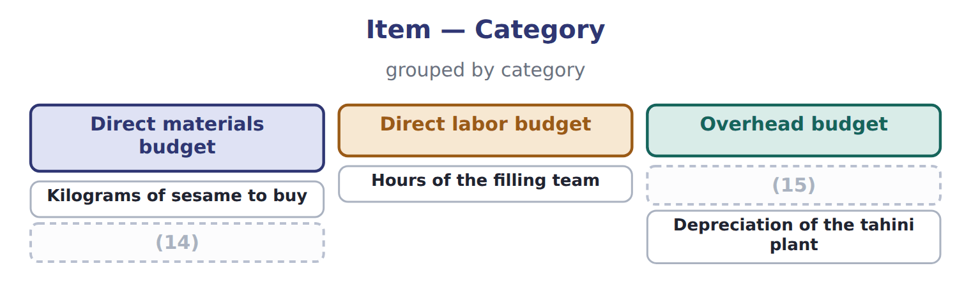
word list
Depreciation of the tahini plant · Power for the filling line · Ending stock of sesame

The English this sheet uses, and its Arabic
English (exam term) | Arabic
direct materials budget | موازنة المواد المباشرة
direct labor budget | موازنة العمل المباشر
overhead budget | موازنة التكاليف الصناعية غير المباشرة

Answer key · 7.5 Extended Example 7A: the manufacturing cost budget and the summer test

1 Concentrate used | 9 purchases
2 Bottles | 10 available
3 Direct labor | 11 $2.50 a kg
4 Budgeted manufacturing cost | 12 0.012 hours
5 standard | 13 $15.00 an hour
6 overhead | 14 Ending stock of sesame
7 Machine hours | 15 Power for the filling line
8 production

the summaries in full
Summary 1 At standard, 901,000 cases × $12.60 = $11,352,600. The budget is $2,000 lower because fixed overhead is a fixed amount, while the card spreads it over a normal volume of 900,000 cases.
Summary 2 Expect a production budget and a materials policy. Compute usage, purchases in units and dollars, labor hours and cost, and overhead by variable and fixed parts. Then compare the hours or materials with what is available.

