1.1 What strategic planning does
Chapter 1 · section 1.1

Fill every gap. Each word list holds one word more than there are gaps.
Chapter 1, section by section
Each stage leads to the next.
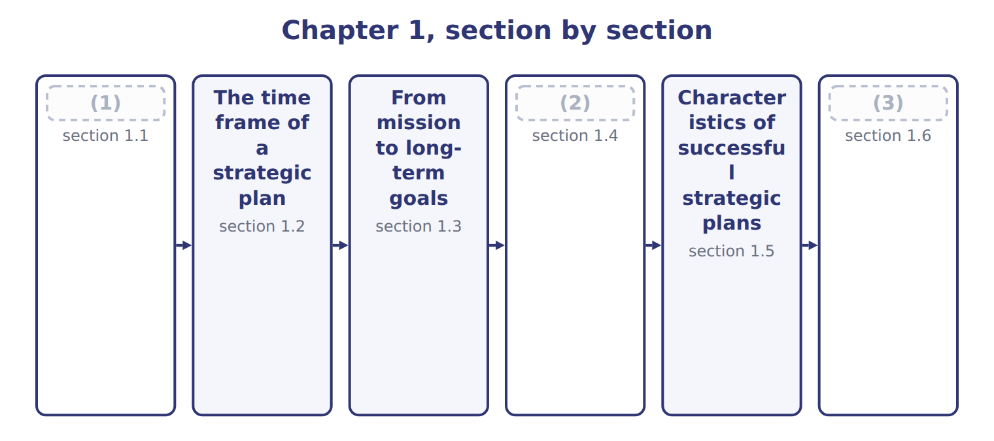
word list
What strategic planning does · Extended Example 1A: from the Orontes goals to · From mission to long-term goals · Congruence: objectives, tactics, plans and bud

Summary 1 gaps 4–10
Strategic planning decides where an (4) wants to be in the long term and how it will get there. It chooses the markets, products and ways of (5) that will lead to the (6) goals. The (7) is a strategic plan. (8) it comes first, strategic planning sets the path for (9) else. A company that plans to grow exports will budget for export staff and (10) ; a company that plans to cut costs will budget for new equipment and fewer products.
word list
competing · tactics · result · certification · long-term · Because · everything · organization

The budget is not the strategy

Summary 2 gaps 11–12
An exam (11) that says the budget sets the strategy has the order (12) . The strategy comes first; the budget puts the first year of it into money.
word list
backwards · option · tactics

The English this section uses, and its Arabic
Each term sits against what it means.
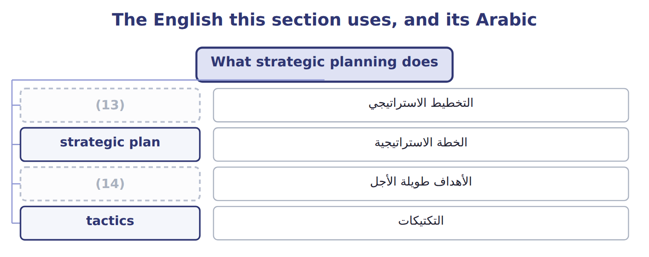
word list
long-term goals · strategic planning · vision statement

The English this sheet uses, and its Arabic
English (exam term) | Arabic
strategic planning | التخطيط الاستراتيجي
strategic plan | الخطة الاستراتيجية

Answer key · 1.1 What strategic planning does

1 What strategic planning does | 8 Because
2 Congruence: objectives, tactics, plans and bud | 9 everything
3 Extended Example 1A: from the Orontes goals to | 10 certification
4 organization | 11 option
5 competing | 12 backwards
6 long-term | 13 strategic planning
7 result | 14 long-term goals

the summaries in full
Summary 1 Strategic planning decides where an organization wants to be in the long term and how it will get there. It chooses the markets, products and ways of competing that will lead to the long-term goals. The result is a strategic plan. Because it comes first, strategic planning sets the path for everything else. A company that plans to grow exports will budget for export staff and certification; a company that plans to cut costs will budget for new equipment and fewer products.
Summary 2 An exam option that says the budget sets the strategy has the order backwards. The strategy comes first; the budget puts the first year of it into money.

1.2 The time frame of a strategic plan
Chapter 1 · section 1.2

Fill every gap. Each word list holds one word more than there are gaps.
Summary 1 gaps 1–2
A (1) plan usually looks three to five years ahead, and sometimes longer. Tactical plans cover one to three years, and (2) plans and budgets cover one year or less.
word list
strategic · operational · Orontes

Time frames of strategic, tactical and operational plans
Plan | Typical time frame | Content | Example
Strategic plan | 3–5 years or more | Mission, vision, long-term goals, main strategies | (3) : 2028–2032
Tactical plan | 1–3 years | (4) | Beverages export launch
Operational plan and budget | 1 year or less | Activities, people, resources, money | (5)
Industry pace | Shorter for fast-changing industries; longer for heavy investment |  | (6) : 5 years is common

word list
The 2028 budget · Orontes · Food production · long-term goals · How each division carries out the strategy

Summary 2 gaps 7–11
The right time frame depends on the (7) . A (8) company may plan only two or three years ahead because its market changes fast. A food (9) that builds plants and brands can plan five years or more. (10) uses a plan for 2028 to 2032. Each year the plan is (11) and rolled forward one year, so there is always a full view ahead.
word list
reviewed · budgets · industry · producer · Orontes · software

Answer key · 1.2 The time frame of a strategic plan

1 strategic | 7 industry
2 operational | 8 software
3 Orontes | 9 producer
4 How each division carries out the strategy | 10 Orontes
5 The 2028 budget | 11 reviewed
6 Food production

the summaries in full
Summary 1 A strategic plan usually looks three to five years ahead, and sometimes longer. Tactical plans cover one to three years, and operational plans and budgets cover one year or less.
Summary 2 The right time frame depends on the industry. A software company may plan only two or three years ahead because its market changes fast. A food producer that builds plants and brands can plan five years or more. Orontes uses a plan for 2028 to 2032. Each year the plan is reviewed and rolled forward one year, so there is always a full view ahead.

1.3 From mission to long-term goals
Chapter 1 · section 1.3

Fill every gap. Each word list holds one word more than there are gaps.
Summary 1 gaps 1–5
The mission statement says why the (1) exists, what it does and for whom. The (2) statement says what it wants to (3) . The mission leads to (4) goals: results the company aims to reach by the end of the plan. Good goals turn the mission into numbers and dates, so that (5) can be measured.
word list
long-term · organization · become · progress · vision · statement

Worked example: the Orontes long-term goals

Summary 2 gaps 6–7
The (6) speaks of trusted Levant foods across the region. The board turns it into five goals for 2032. For example, (7) rise from 18.0% to 30.0% of revenue.
word list
mission · businesses · exports

Worked example: the Orontes long-term goals
Long-term goal | 2027 (actual) | 2032 (goal)
Export sales as a share of revenue | 18.0% | 30.0%
Revenue from products launched in the last three years | 6.0% | 15.0%
(8) | 11.0% | 15.0%
(9) | 0.50 kWh | 0.40 kWh
(10) | 12 h | 24 h

word list
Return on investment · Training hours per employee a year · What do we want to become? · Energy per case of juice (kWh)

Mission, mission

Summary 3 gaps 11–12
In (11) , French and Arabic, 'mission' can also mean a single task or trip. In strategic planning it means the (12) lasting purpose. For this sense.
word list
organization's · purpose · English

Mission, vision and goals at Orontes Foods
 | Question it answers | Orontes Foods
Mission | (13) | To make trusted, traditional Levant foods and drinks for families and businesses across the region.
Vision | (14) | To be the first-choice Levant food brand in the Gulf and Europe by 2032.
Long-term goals | What results, by when? | (15)

word list
Why do we exist? What do we do, and for whom? · Export sales as a share of revenue · For example: exports 30.0% of revenue by 2032. · What do we want to become?

The English this section uses, and its Arabic
Each term sits against what it means.
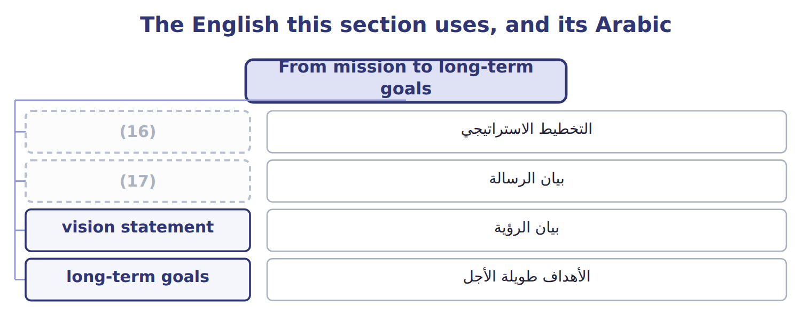
word list
mission statement · بيان الرؤية · strategic planning

The English this sheet uses, and its Arabic
English (exam term) | Arabic
mission statement | بيان الرسالة
vision statement | بيان الرؤية
long-term goals | الأهداف طويلة الأجل

Answer key · 1.3 From mission to long-term goals

1 organization | 10 Training hours per employee a year
2 vision | 11 English
3 become | 12 organization's
4 long-term | 13 Why do we exist? What do we do, and for whom?
5 progress | 14 What do we want to become?
6 mission | 15 For example: exports 30.0% of revenue by 2032.
7 exports | 16 strategic planning
8 Return on investment | 17 mission statement
9 Energy per case of juice (kWh)

the summaries in full
Summary 1 The mission statement says why the organization exists, what it does and for whom. The vision statement says what it wants to become. The mission leads to long-term goals: results the company aims to reach by the end of the plan. Good goals turn the mission into numbers and dates, so that progress can be measured.
Summary 2 The mission speaks of trusted Levant foods across the region. The board turns it into five goals for 2032. For example, exports rise from 18.0% to 30.0% of revenue.
Summary 3 In English, French and Arabic, 'mission' can also mean a single task or trip. In strategic planning it means the organization's lasting purpose. For this sense.

1.4 Congruence: objectives, tactics, plans and budgets
Chapter 1 · section 1.4

Fill every gap. Each word list holds one word more than there are gaps.
Summary 1 gaps 1–11
Short-term objectives are (1) results for the (2) year that move the company toward its goals. (3) are the specific actions used to reach them, and the (4) plan sets out the people, activities and resources. The budget puts all of this into money. Each level must fit the level above it. This fit is called (5) . If the budget cuts export (6) while the plan calls for export growth, the company will miss its goal even if every (7) meets the budget. A (8) way to set objectives is to (9) the change needed over the plan into equal yearly steps. (10) must rise by 12.0 points over 5 years, or 2.40 points a year, so the 2028 (11) is 20.4%.
word list
congruence · Tactics · divide · operational · Exports · objective · manager · results · measurable · simple · coming · marketing

The 2028 objectives

Your turn: the 2028 objectives (complete the blanks)
Goal | 2027 | Change a year | 2028 objective
Export sales as a share of revenue | 18.0% | (12) | 20.4%
Revenue from products launched in the last three years | 6.0% | (13) | 7.8%
Return on investment | 11.0% | +0.80 points | ________
Energy per case of juice (kWh) | (14) | −0.02 kWh | ________
Training hours per employee a year | 12 h | (15) | 14.4 h

word list
+2.40 points · operational plan · 0.50 kWh · +1.80 points · +2.4 h

The English this section uses, and its Arabic
Each term sits against what it means.
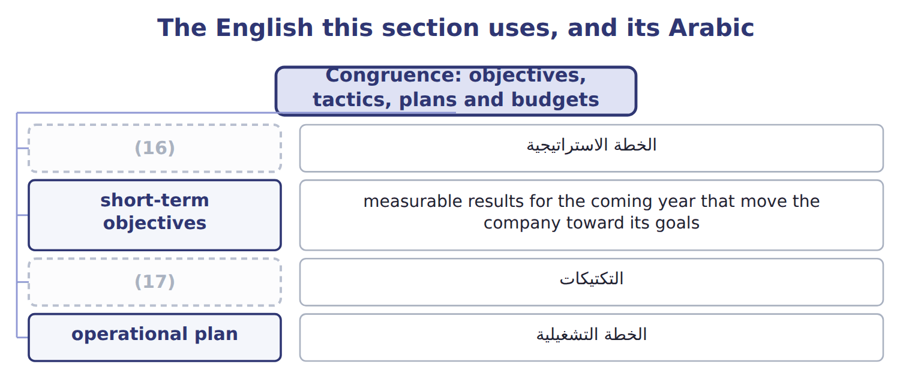
word list
mission statement · strategic plan · tactics

The English this sheet uses, and its Arabic
English (exam term) | Arabic
short-term objectives | الأهداف قصيرة الأجل
tactics | التكتيكات
operational plan | الخطة التشغيلية

Answer key · 1.4 Congruence: objectives, tactics, plans and budgets

1 measurable | 10 Exports
2 coming | 11 objective
3 Tactics | 12 +2.40 points
4 operational | 13 +1.80 points
5 congruence | 14 0.50 kWh
6 marketing | 15 +2.4 h
7 manager | 16 strategic plan
8 simple | 17 tactics
9 divide

the summaries in full
Summary 1 Short-term objectives are measurable results for the coming year that move the company toward its goals. Tactics are the specific actions used to reach them, and the operational plan sets out the people, activities and resources. The budget puts all of this into money. Each level must fit the level above it. This fit is called congruence. If the budget cuts export marketing while the plan calls for export growth, the company will miss its goal even if every manager meets the budget. A simple way to set objectives is to divide the change needed over the plan into equal yearly steps. Exports must rise by 12.0 points over 5 years, or 2.40 points a year, so the 2028 objective is 20.4%.

1.5 Characteristics of successful strategic plans
Chapter 1 · section 1.5

Fill every gap. Each word list holds one word more than there are gaps.
Summary 1 gaps 1–6
A (1) strategic plan gives a clear (2) that follows from the mission. Its goals are (3) and realistic, based on a careful study of the company and its (4) . It is also shared: managers help set their own (5) and understand how they (6) . It is linked to resources, so that people and money are available, and it is reviewed regularly, with contingency plans for the main risks.
word list
contribute · objectives · successful · direction · understand · environment · measurable

Characteristics of successful strategic plans
Characteristic | What it means
Clear direction | (7)
Measurable goals | Numbers and dates, not wishes
Realistic | Based on the analysis of internal and external factors (Chapter 2)
Shared | (8) to managers, who help set their own objectives
Resourced | (9)
Flexible | Reviewed each year; contingency plans for major risks

word list
Follows from the mission and vision · Communicated · Linked to budgets, people and investment · tactics

Measurable objectives are the most common weakness in practice.
Weak and strong objectives
Weak objective | Strong objective | Why it is better
“Grow exports.” | (10) | Measurable and dated
“Use less energy.” | (11) | A number the plant can track
“Train people more.” | “14.4 training hours per employee in 2028.” | (12)

word list
“Exports 20.4% of revenue in 2028.” · Reviewed each year; contingency plans for major risks · “0.48 kWh per case of juice in 2028.” · Owned by HR, easy to check

Answer key · 1.5 Characteristics of successful strategic plans

1 successful | 7 Follows from the mission and vision
2 direction | 8 Communicated
3 measurable | 9 Linked to budgets, people and investment
4 environment | 10 “Exports 20.4% of revenue in 2028.”
5 objectives | 11 “0.48 kWh per case of juice in 2028.”
6 contribute | 12 Owned by HR, easy to check

the summaries in full
Summary 1 A successful strategic plan gives a clear direction that follows from the mission. Its goals are measurable and realistic, based on a careful study of the company and its environment. It is also shared: managers help set their own objectives and understand how they contribute. It is linked to resources, so that people and money are available, and it is reviewed regularly, with contingency plans for the main risks.

1.6 Extended Example 1A: from the Orontes goals to the 2028 plan
Chapter 1 · section 1.6

Fill every gap. Each word list holds one word more than there are gaps.
Summary 1 gaps 1–3
This example follows all five goals from the 2032 targets to the 2028 (1) and the main tactic for each. Plan (2) : 2028 to 2032, 5 years; baseline year 2027. (3) : equal yearly steps from the baseline to each goal.
word list
objectives · targets · period · Method

Extended Example: the plan on one page
Goal | 2032 goal | 2028 objective | Main tactic
Export sales as a share of revenue | 30.0% | 20.4% | (4)
Revenue from products launched in the last three years | 15.0% | 7.8% | (5)
Return on investment | 15.0% | 11.8% | (6)
Energy per case of juice (kWh) | 0.40 kWh | (7) | New filling-line motors; kaizen on changeovers
Training hours per employee a year | 24 h | 14.4 h | (8)

word list
Supervisor and quality courses · Sell unused equipment; tighter stock control · Launch sugar-free halva and juice · Levant Distribution · Gulf retail chains; private-label tahini · 0.48 kWh

Each tactic now needs an owner, an operational plan and a budget line.
Everything ties

The first step gives the 2028 objective of 20.4%.
Exam view

Summary 2 gaps 9–11
Expect (9) to classify as mission, vision, goal, objective or tactic, and questions on time frames and on the fit between the budget and the (10) . Some questions give a goal and a period and ask for the (11) objective.
word list
first-year · strategy · statements · objective

Exam view
Levant Distribution | 2027 (actual) | 2030 (goal)
Deliveries on time | 88.0% | 97.0%
Cost per delivery stop (USD) | 42.0 | 36.0
Plan period | 2028–2030 | (12)

word list
strategic plan · 3 years

Item — Answer
Item | Answer
Return on investment, 2028 | 11.0% + (15.0% − 11.0%) ÷ 5 = 11.8%
Energy per case, 2028 | (13)

word list
To be the most reliable food distributor in the Levant · 0.50 − (0.50 − 0.40) ÷ 5 = 0.48 kWh

Statement — Category
Statement | Category
We deliver Orontes products to every shop in Jordan, fresh and on time | (14)
To be the most reliable food distributor in the Levant | Vision
97% of deliveries on time by 2030 | (15)
91% of deliveries on time in 2028 | Short-term objective
Plan delivery routes each night with new software | (16)

word list
Long-term goal · 2028 objective · Mission · Tactic

The English this section uses, and its Arabic
Each term sits against what it means.
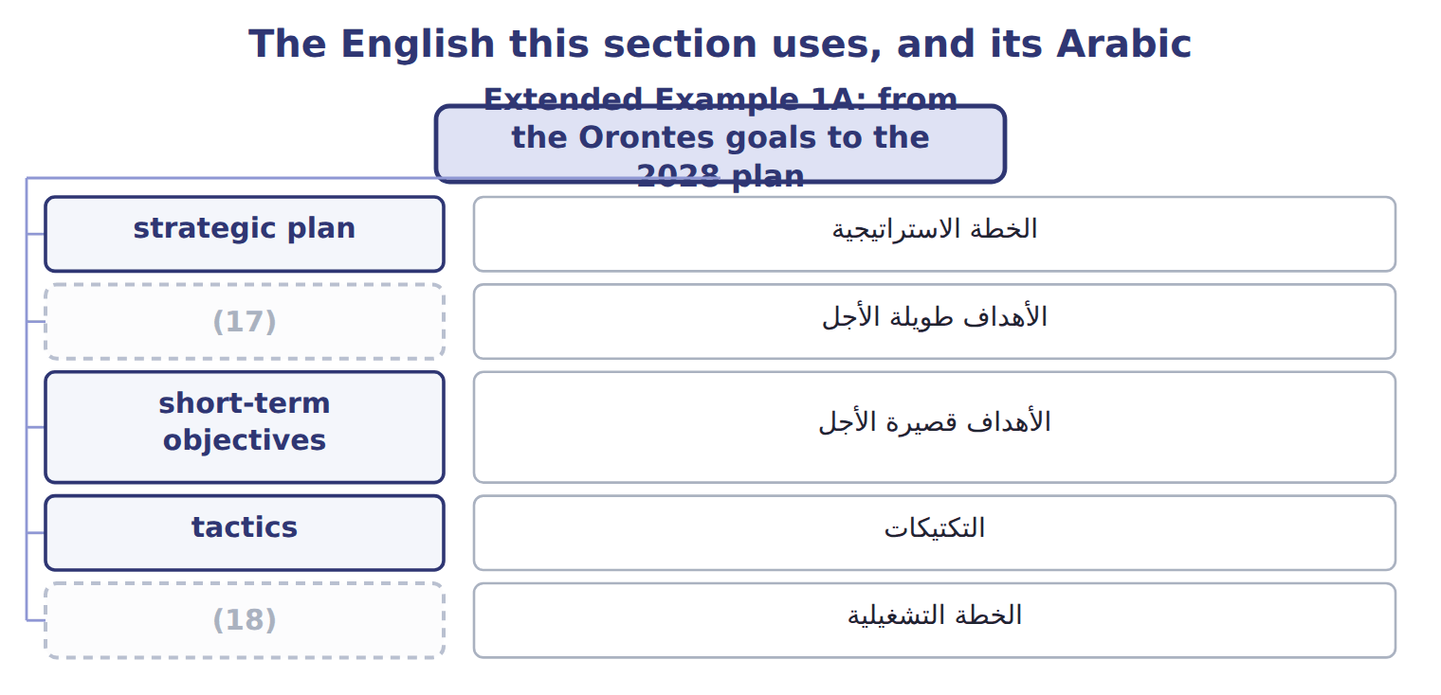
word list
strategic planning · operational plan · long-term goals

The English this sheet uses, and its Arabic
English (exam term) | Arabic
strategic plan | الخطة الاستراتيجية
long-term goals | الأهداف طويلة الأجل
short-term objectives | الأهداف قصيرة الأجل

Answer key · 1.6 Extended Example 1A: from the Orontes goals to the 2028 plan

1 objectives | 10 strategy
2 period | 11 first-year
3 Method | 12 3 years
4 Gulf retail chains; private-label tahini | 13 0.50 − (0.50 − 0.40) ÷ 5 = 0.48 kWh
5 Launch sugar-free halva and juice | 14 Mission
6 Sell unused equipment; tighter stock control | 15 Long-term goal
7 0.48 kWh | 16 Tactic
8 Supervisor and quality courses | 17 long-term goals
9 statements | 18 operational plan

the summaries in full
Summary 1 This example follows all five goals from the 2032 targets to the 2028 objectives and the main tactic for each. Plan period: 2028 to 2032, 5 years; baseline year 2027. Method: equal yearly steps from the baseline to each goal.
Summary 2 Expect statements to classify as mission, vision, goal, objective or tactic, and questions on time frames and on the fit between the budget and the strategy. Some questions give a goal and a period and ask for the first-year objective.

2.1 Analysing the external environment
Chapter 2 · section 2.1

Fill every gap. Each word list holds one word more than there are gaps.
Chapter 2, section by section
Each stage leads to the next.
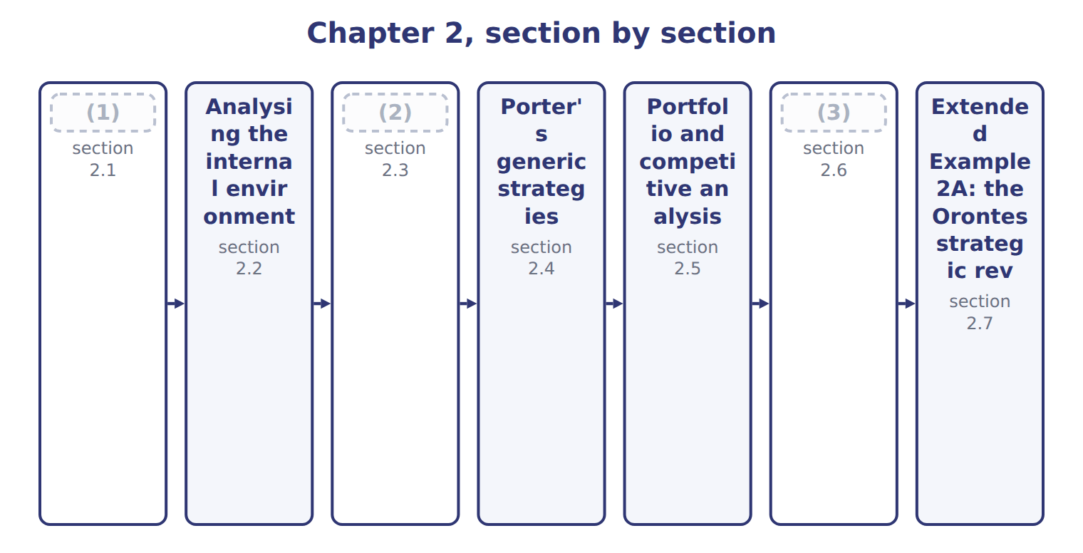
word list
Analysing the external environment · SWOT and situational analysis · Scenario planning and contingency planning · Analysing the internal environment

Summary 1 gaps 4–12
External factors are outside the (4) control. They create (5) to use and (6) to defend against. A PEST analysis reviews four groups of them: (7) , economic, social and (8) factors. (9) five forces describe the industry itself: new entrants, (10) , buyers, substitutes and rivalry. The (11) the forces, the (12) it is to earn a good profit. In the juice market, rivalry is the strongest force and supplier power the weakest, partly because Jordan Glass, which supplies the bottles, is a company Orontes partly owns. The external analysis therefore points to a threat from rivals and substitutes, and an opportunity in stable supply.
word list
threats · company's · suppliers · opportunities · harder · political · Porter's · weakest · technological · stronger

Strong forces, weak industry

Summary 2 gaps 13–14
A (13) force is bad news for profit. An answer that calls a market with powerful buyers and many (14) 'attractive' has read the forces backwards.
word list
substitutes · strong · reviews

The English this sheet uses, and its Arabic
English (exam term) | Arabic
PEST analysis | تحليل PEST (السياسي والاقتصادي والاجتماعي والتقني)
five forces | القوى الخمس

Answer key · 2.1 Analysing the external environment

1 Analysing the external environment | 8 technological
2 SWOT and situational analysis | 9 Porter's
3 Scenario planning and contingency planning | 10 suppliers
4 company's | 11 stronger
5 opportunities | 12 harder
6 threats | 13 strong
7 political | 14 substitutes

the summaries in full
Summary 1 External factors are outside the company's control. They create opportunities to use and threats to defend against. A PEST analysis reviews four groups of them: political, economic, social and technological factors. Porter's five forces describe the industry itself: new entrants, suppliers, buyers, substitutes and rivalry. The stronger the forces, the harder it is to earn a good profit. In the juice market, rivalry is the strongest force and supplier power the weakest, partly because Jordan Glass, which supplies the bottles, is a company Orontes partly owns. The external analysis therefore points to a threat from rivals and substitutes, and an opportunity in stable supply.
Summary 2 A strong force is bad news for profit. An answer that calls a market with powerful buyers and many substitutes 'attractive' has read the forces backwards.

2.2 Analysing the internal environment
Chapter 2 · section 2.2

Fill every gap. Each word list holds one word more than there are gaps.
Summary 1 gaps 1–2
Internal factors are the company's own resources and (1) : its brands, people, equipment, systems and the things it does well. They show strengths to build on and (2) to fix.
word list
capabilities · machine · weaknesses

Internal factors at Orontes
Every item belongs to exactly one group.
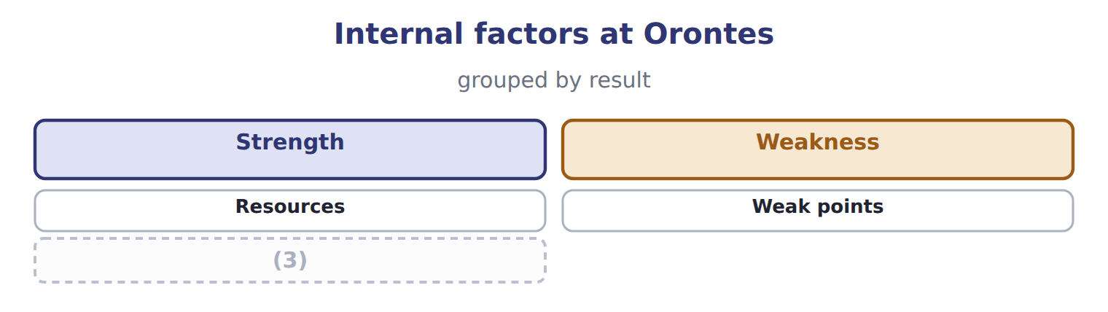
word list
Capabilities · Strength

Summary 2 gaps 4–8
A strength becomes a (4) advantage only if (5) value it, few rivals have it, and it is hard to copy. The (6) tahini recipes and brand pass this test; a new (7) machine that any rival can buy does not. The value chain of Book 2: it shows which (8) create the advantage and which only add cost.
word list
Internal · filling · activities · customers · Orontes · competitive

The English this sheet uses, and its Arabic
English (exam term) | Arabic
competitive advantage | الميزة التنافسية

Answer key · 2.2 Analysing the internal environment

1 capabilities | 5 customers
2 weaknesses | 6 Orontes
3 Capabilities | 7 filling
4 competitive | 8 activities

the summaries in full
Summary 1 Internal factors are the company's own resources and capabilities: its brands, people, equipment, systems and the things it does well. They show strengths to build on and weaknesses to fix.
Summary 2 A strength becomes a competitive advantage only if customers value it, few rivals have it, and it is hard to copy. The Orontes tahini recipes and brand pass this test; a new filling machine that any rival can buy does not. The value chain of Book 2: it shows which activities create the advantage and which only add cost.

2.3 SWOT and situational analysis
Chapter 2 · section 2.3

Fill every gap. Each word list holds one word more than there are gaps.
Summary 1 gaps 1–6
A SWOT analysis brings the two views (1) : strengths and weaknesses from inside, opportunities and threats from (2) . A (3) analysis is the wider study of the (4) current position that feeds the SWOT. The (5) step is the next one: match strengths to opportunities, for example the (6) brand to Gulf demand, and plan how to fix the weaknesses that expose the company to threats.
word list
outside · together · opportunities · situational · useful · company's · tahini

The English this sheet uses, and its Arabic
English (exam term) | Arabic
SWOT analysis | تحليل SWOT (القوة والضعف والفرص والتهديدات)
situational analysis | تحليل الموقف

Answer key · 2.3 SWOT and situational analysis

1 together | 4 company's
2 outside | 5 useful
3 situational | 6 tahini

the summaries in full
Summary 1 A SWOT analysis brings the two views together: strengths and weaknesses from inside, opportunities and threats from outside. A situational analysis is the wider study of the company's current position that feeds the SWOT. The useful step is the next one: match strengths to opportunities, for example the tahini brand to Gulf demand, and plan how to fix the weaknesses that expose the company to threats.

2.4 Porter's generic strategies
Chapter 2 · section 2.4

Fill every gap. Each word list holds one word more than there are gaps.
Summary 1 gaps 1–6
Porter (1) three ways to win. Cost (2) sells at or near the market price with the (3) costs. (4) offers something (5) value and will pay more for. A focus strategy serves a narrow segment, either at low cost or with a (6) . Beverages competes on cost in the mass juice market; Oils differentiates with traced, cold-pressed oil; Tahini & Spreads focuses on premium Gulf buyers and private label for Barada.
word list
lowest · described · customers · Beverages · Differentiation · leadership · difference

The generic strategy of each Orontes unit
Unit | Generic strategy | How it competes
Oils | (7) | premium price for traced oil
Tahini & Spreads | Focus | (8)
Beverages | Cost leadership | (9)
Pulses & Spices line | Review | (10)

word list
competitive advantage · Differentiation · niche buyers: Gulf and private label · lowest cost per case · decide to fix or leave

Summary 2 gaps 11–12
A company that tries to be (11) and most special at the same time, (12) a clear choice, risks being 'stuck in the middle' and losing to rivals that chose.
word list
cheapest · middle' · without

The English this sheet uses, and its Arabic
English (exam term) | Arabic
cost leadership | ريادة التكلفة
differentiation | التمايز
focus strategy | استراتيجية التركيز

Answer key · 2.4 Porter's generic strategies

1 described | 7 Differentiation
2 leadership | 8 niche buyers: Gulf and private label
3 lowest | 9 lowest cost per case
4 Differentiation | 10 decide to fix or leave
5 customers | 11 cheapest
6 difference | 12 without

the summaries in full
Summary 1 Porter described three ways to win. Cost leadership sells at or near the market price with the lowest costs. Differentiation offers something customers value and will pay more for. A focus strategy serves a narrow segment, either at low cost or with a difference. Beverages competes on cost in the mass juice market; Oils differentiates with traced, cold-pressed oil; Tahini & Spreads focuses on premium Gulf buyers and private label for Barada.
Summary 2 A company that tries to be cheapest and most special at the same time, without a clear choice, risks being 'stuck in the middle' and losing to rivals that chose.

2.5 Portfolio and competitive analysis
Chapter 2 · section 2.5

Fill every gap. Each word list holds one word more than there are gaps.
Summary 1 gaps 1–3
The BCG (1) matrix places each business unit by market growth and relative market share: the unit's share divided by the share of its largest (2) . Growth above 10.0% and relative share above 1.0 mark the (3) lines.
word list
competitor · dividing · rival's · growth-share

Worked example: placing Oils

Summary 2 gaps 4–6
Oils holds 22.0% of its market; the (4) rival holds 15.0%. (5) share = 22.0 ÷ 15.0 = 1.47. The market grows 3.0% a year, below the line, so Oils is in the Cash cow (6) .
word list
Relative · quadrant · business · largest

Worked example: BCG data for the Orontes portfolio
The bars are drawn to scale.
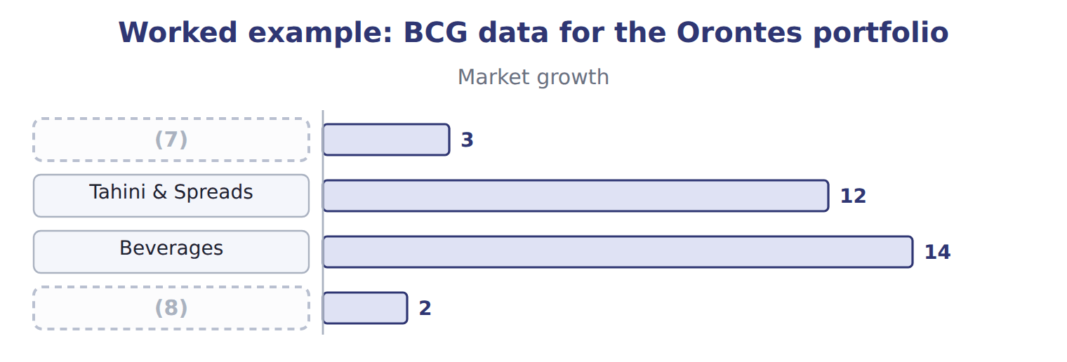
word list
Oils · situational analysis · Pulses & Spices line

Placing Beverages and Pulses & Spices

Complete the blank cells. A competitive analysis looks closely at the main rivals.
Competitive analysis: Orontes Beverages and the largest juice producer
Juice market | Orontes Beverages | Largest rival
Market share in Jordan | 8.0% | 25.0%
Strategy | Cost leadership | (9)
Strength | (10) | Advertising budget; shelf space
Weakness | Small brand; few flavours | (11)

word list
Low cost per case; Levant's distribution · Higher costs · Relative share · Brand and wide range

Relative, not own, share

Summary 3 gaps 12–13
Beverages holds 8.0% of its market, but its (12) share is 0.32, not 0.08. Always divide by the (13) rival's share.
word list
dividing · largest · relative

The English this section uses, and its Arabic
Each term sits against what it means.
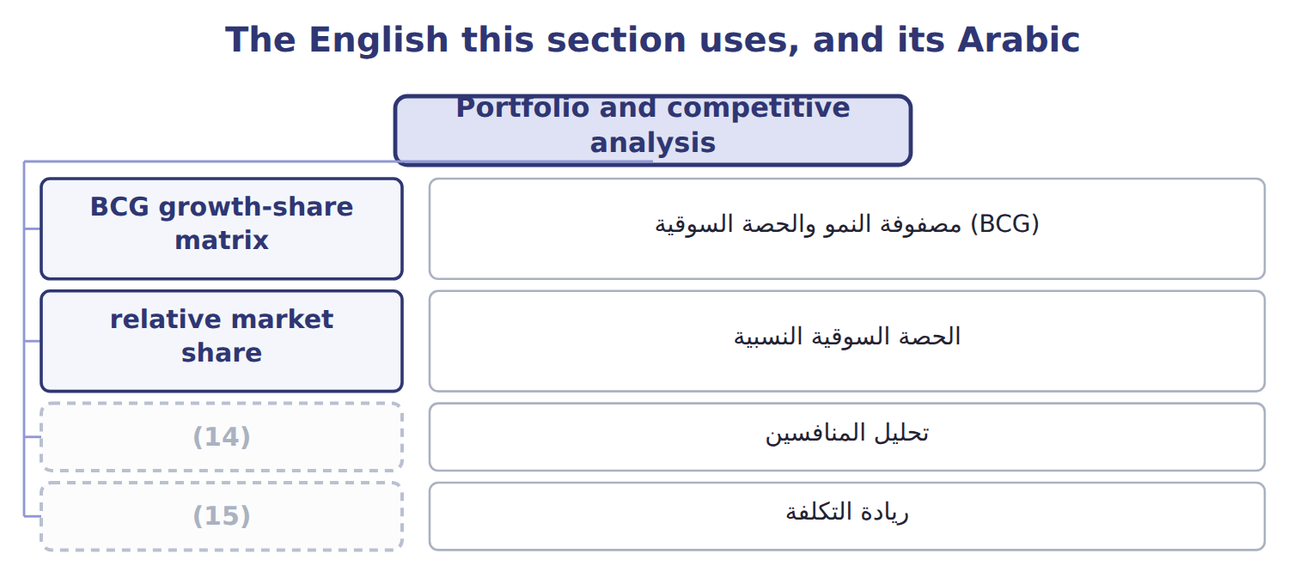
word list
competitive analysis · ريادة التكلفة · cost leadership

The English this sheet uses, and its Arabic
English (exam term) | Arabic
BCG growth-share matrix | مصفوفة النمو والحصة السوقية (BCG)
relative market share | الحصة السوقية النسبية
competitive analysis | تحليل المنافسين

Answer key · 2.5 Portfolio and competitive analysis

1 growth-share | 9 Brand and wide range
2 competitor | 10 Low cost per case; Levant's distribution
3 dividing | 11 Higher costs
4 largest | 12 relative
5 Relative | 13 largest
6 quadrant | 14 competitive analysis
7 Oils | 15 cost leadership
8 Pulses & Spices line

the summaries in full
Summary 1 The BCG growth-share matrix places each business unit by market growth and relative market share: the unit's share divided by the share of its largest competitor. Growth above 10.0% and relative share above 1.0 mark the dividing lines.
Summary 2 Oils holds 22.0% of its market; the largest rival holds 15.0%. Relative share = 22.0 ÷ 15.0 = 1.47. The market grows 3.0% a year, below the line, so Oils is in the Cash cow quadrant.
Summary 3 Beverages holds 8.0% of its market, but its relative share is 0.32, not 0.08. Always divide by the largest rival's share.

2.6 Scenario planning and contingency planning
Chapter 2 · section 2.6

Fill every gap. Each word list holds one word more than there are gaps.
Summary 1 gaps 1–3
Scenario (1) prepares for several (2) futures instead of one forecast. For tahini exports in 2032, the board (3) three scenarios, from open Gulf and EU markets to a new EU import tariff.
word list
planning · possible · considers · Contingency

Tahini export scenarios for 2030 and the contingency trigger
Scenario for tahini exports, 2030 | Operating income (USD) | Response
Open Gulf and EU markets | 2,400,000 | no action
Gulf growth as planned | 1,800,000 | (4)
New EU import tariff | 900,000 | (5)
Contingency trigger | (6) | shift export sales to Gulf buyers; delay the EU warehouse

word list
below 1,200,000 · relative market share · no action · start the contingency plan

Summary 2 gaps 7–11
Contingency (7) prepares a (8) in advance and names the trigger that starts it. If the export (9) falls below $1,200,000, as it would in the tariff scenario, Orontes will shift sales to Gulf buyers and delay its EU (10) . The two tools work together: (11) show what could happen; the contingency plan says what the company will do, and when.
word list
forecast · scenarios · response · planning · warehouse · futures

The English this section uses, and its Arabic
Each term sits against what it means.
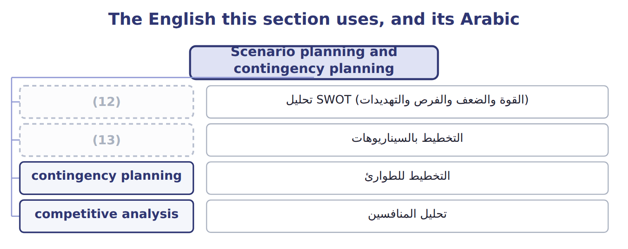
word list
SWOT analysis · competitive analysis · scenario planning

The English this sheet uses, and its Arabic
English (exam term) | Arabic
scenario planning | التخطيط بالسيناريوهات
contingency planning | التخطيط للطوارئ

Answer key · 2.6 Scenario planning and contingency planning

1 planning | 8 response
2 possible | 9 forecast
3 considers | 10 warehouse
4 no action | 11 scenarios
5 start the contingency plan | 12 SWOT analysis
6 below 1,200,000 | 13 scenario planning
7 planning

the summaries in full
Summary 1 Scenario planning prepares for several possible futures instead of one forecast. For tahini exports in 2032, the board considers three scenarios, from open Gulf and EU markets to a new EU import tariff.
Summary 2 Contingency planning prepares a response in advance and names the trigger that starts it. If the export forecast falls below $1,200,000, as it would in the tariff scenario, Orontes will shift sales to Gulf buyers and delay its EU warehouse. The two tools work together: scenarios show what could happen; the contingency plan says what the company will do, and when.

2.7 Extended Example 2A: the Orontes strategic review
Chapter 2 · section 2.7

Fill every gap. Each word list holds one word more than there are gaps.
Summary 1 gaps 1–4
This example brings the tools (1) for the board meeting that (2) the 2028 to 2032 plan. (3) : strong rivalry and (4) in juice; growing Gulf demand for tahini; a possible EU tariff. Internal: a strong tahini brand and low-cost juice filling; a small juice share and an old bottling line in Oils.
word list
approves · together · strategy · External · substitutes

Extended Example: the strategic review of each unit
The bars are drawn to scale.
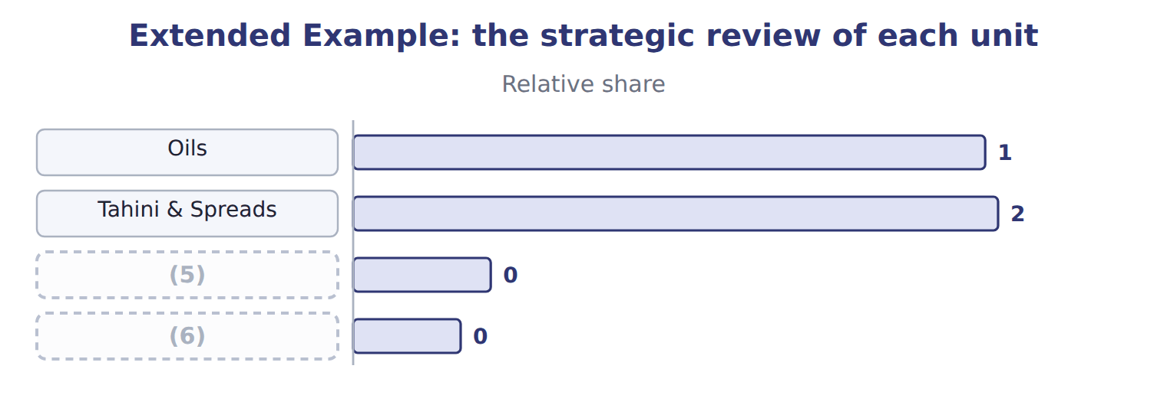
word list
Beverages · competitive advantage · Pulses & Spices line

Summary 2 gaps 7–8
The (7) range from $900,000 to $2,400,000 of export operating income, a spread of $1,500,000. The (8) plan starts if the forecast falls below $1,200,000.
word list
contingency · scenarios · strengths

Everything ties

Summary 3 gaps 9–10
Every (9) share equals the unit's share divided by the largest rival's share. (10) spread: $2,400,000 − $900,000 = $1,500,000.
word list
planning · Scenario · relative

Exam view

Summary 4 gaps 11–13
Expect to classify factors as strengths, weaknesses, (11) or threats; to compute a relative share and place a unit in the BCG matrix; to name a generic strategy from a (12) ; and to tell scenario planning from (13) planning.
word list
contingency · opportunities · growing · description

Exam view
Name each point on the scale from where it sits.
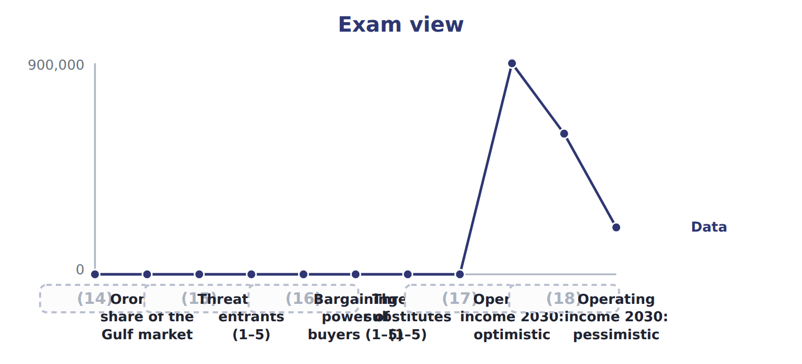
word list
Gulf tahini market growth a year · Bargaining power of suppliers (1–5) · Largest rival's share · Orontes's share of the Gulf market · Operating income 2030: base · Rivalry among competitors (1–5)

Item — Answer
Item | Answer
Beverages | (19)
Pulses & Spices | 5.0 ÷ 20.0 = 0.25; growth 2.0% → Dog

word list
An EU tariff may push more exporters to the Gulf · 8.0 ÷ 25.0 = 0.32; growth 14.0% → Question mark

Factor — Category
Factor | Category
The Orontes tahini brand is well known in Jordan | Strength
The Gulf sales team has only three people | (20)
Gulf demand for healthy traditional foods is growing | (21)
The market leader is cutting prices | (22)
An EU tariff may push more exporters to the Gulf | Threat

word list
Weakness · Threat · Opportunity · Beverages

The English this section uses, and its Arabic
Each term sits against what it means.
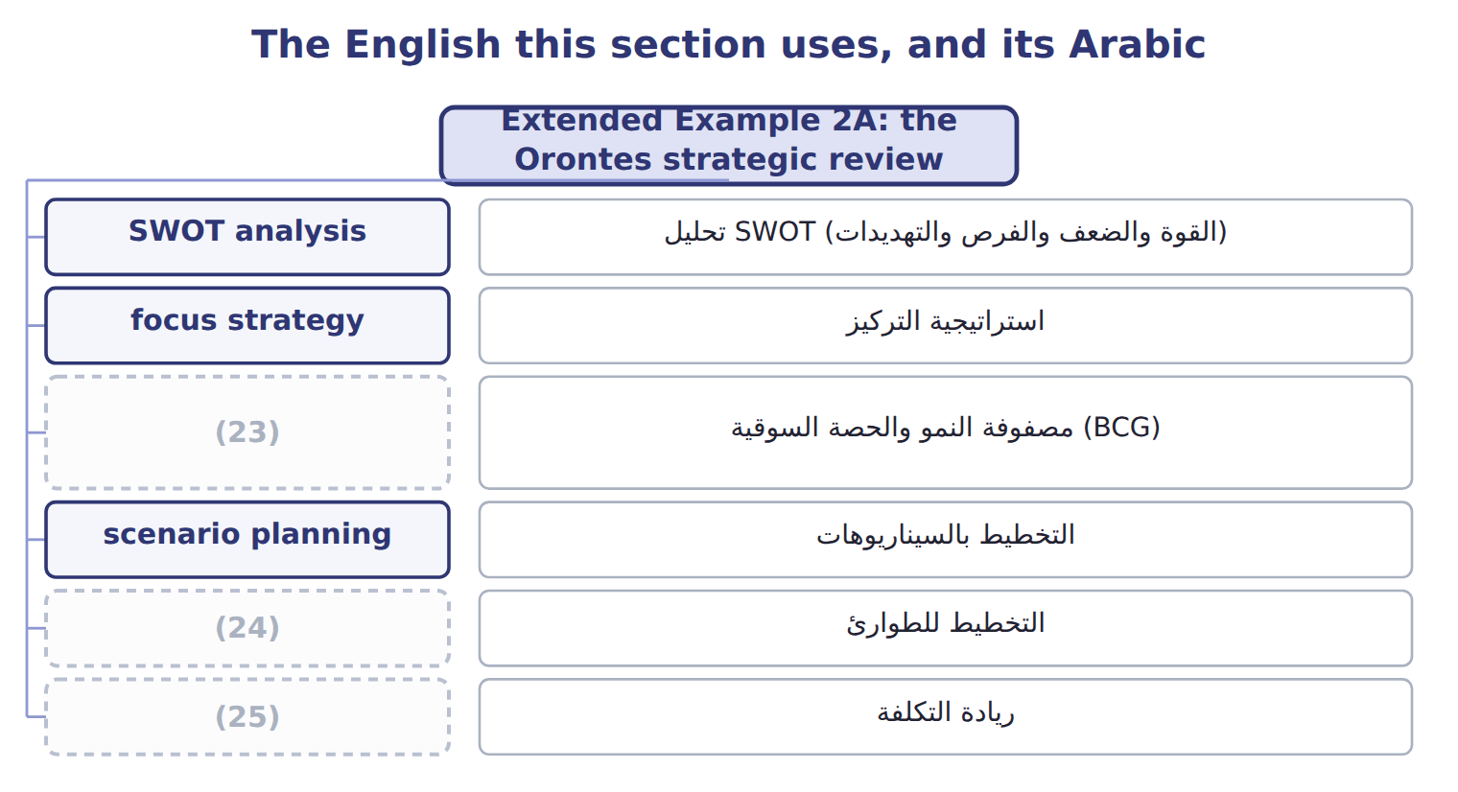
word list
contingency planning · PEST analysis · BCG growth-share matrix · cost leadership

The English this sheet uses, and its Arabic
English (exam term) | Arabic
SWOT analysis | تحليل SWOT (القوة والضعف والفرص والتهديدات)
BCG growth-share matrix | مصفوفة النمو والحصة السوقية (BCG)
contingency planning | التخطيط للطوارئ

Answer key · 2.7 Extended Example 2A: the Orontes strategic review

1 together | 14 Gulf tahini market growth a year
2 approves | 15 Largest rival's share
3 External | 16 Bargaining power of suppliers (1–5)
4 substitutes | 17 Rivalry among competitors (1–5)
5 Beverages | 18 Operating income 2030: base
6 Pulses & Spices line | 19 8.0 ÷ 25.0 = 0.32; growth 14.0% → Question mark
7 scenarios | 20 Weakness
8 contingency | 21 Opportunity
9 relative | 22 Threat
10 Scenario | 23 BCG growth-share matrix
11 opportunities | 24 contingency planning
12 description | 25 cost leadership
13 contingency

the summaries in full
Summary 1 This example brings the tools together for the board meeting that approves the 2028 to 2032 plan. External: strong rivalry and substitutes in juice; growing Gulf demand for tahini; a possible EU tariff. Internal: a strong tahini brand and low-cost juice filling; a small juice share and an old bottling line in Oils.
Summary 2 The scenarios range from $900,000 to $2,400,000 of export operating income, a spread of $1,500,000. The contingency plan starts if the forecast falls below $1,200,000.
Summary 3 Every relative share equals the unit's share divided by the largest rival's share. Scenario spread: $2,400,000 − $900,000 = $1,500,000.
Summary 4 Expect to classify factors as strengths, weaknesses, opportunities or threats; to compute a relative share and place a unit in the BCG matrix; to name a generic strategy from a description; and to tell scenario planning from contingency planning.

3.1 What budgets are for
Chapter 3 · section 3.1

Fill every gap. Each word list holds one word more than there are gaps.
Chapter 3, section by section
Each stage leads to the next.
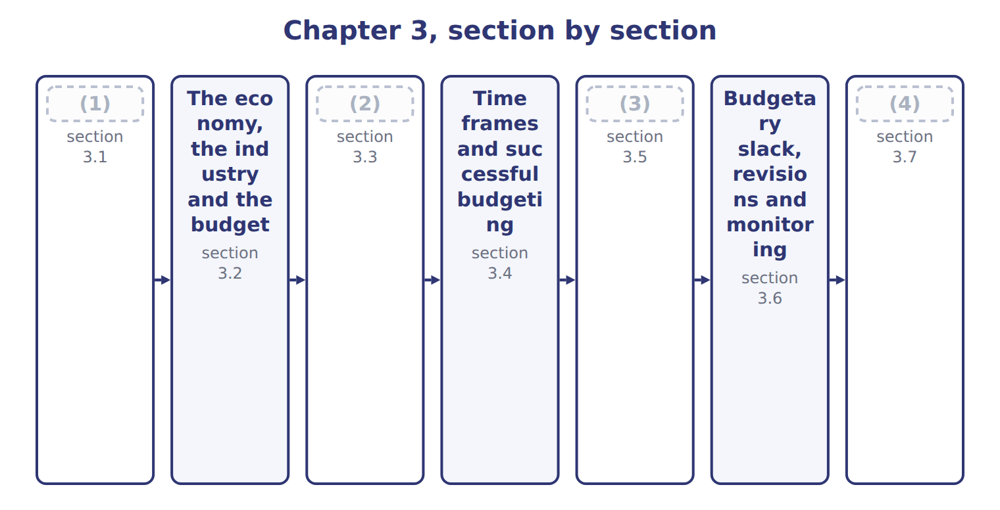
word list
Allocating resources through the budget · People: participation and controllable costs · Budgetary slack, revisions and monitoring · What budgets are for · Extended Example 3A: agreeing the Beverages sa

Summary 1 gaps 5–10
A budget is a (5) plan for a coming period, (6) in money. It turns the strategic plan into (7) objectives: how many cases to sell, what to spend and what (8) to earn. It also tells every unit what the (9) plan to do. The budget cycle runs from the strategic plan to guidelines, (10) , approval, monitoring and revision. At the end of the year, the budget becomes the yardstick for judging results.
word list
quantitative · preparation · measures · usually · profit · others · short-term

The roles of the budget at Orontes
Role of the budget | At Orontes
Planning | turns the (11) plan into next year's targets (B.2.a, B.2.c)
Coordination | (12)
Communication | (13)
Resource allocation | shares scarce funds and people (B.2.h)
Performance measurement | gives the yardstick for actual results (B.2.d)
Motivation | sets targets managers accept and work towards

word list
gives the yardstick for actual results (B.2.d) · strategic · matches sales, production and purchasing plans · tells each unit what is expected and why (B.2.f)

Summary 2 gaps 14–16
A budget measures (14) only if the targets were (15) and agreed. When a Beverages manager exceeds a budget that everyone (16) , the result means something; when the budget was imposed without discussion, it means much less.
word list
realistic · discussion · performance · understood

The English this sheet uses, and its Arabic
English (exam term) | Arabic
budget | الموازنة
budget cycle | دورة الموازنة

Answer key · 3.1 What budgets are for

1 What budgets are for | 9 others
2 Allocating resources through the budget | 10 preparation
3 People: participation and controllable costs | 11 strategic
4 Extended Example 3A: agreeing the Beverages sa | 12 matches sales, production and purchasing plans
5 quantitative | 13 tells each unit what is expected and why (B.2.f)
6 usually | 14 performance
7 short-term | 15 realistic
8 profit | 16 understood

the summaries in full
Summary 1 A budget is a quantitative plan for a coming period, usually in money. It turns the strategic plan into short-term objectives: how many cases to sell, what to spend and what profit to earn. It also tells every unit what the others plan to do. The budget cycle runs from the strategic plan to guidelines, preparation, approval, monitoring and revision. At the end of the year, the budget becomes the yardstick for judging results.
Summary 2 A budget measures performance only if the targets were realistic and agreed. When a Beverages manager exceeds a budget that everyone understood, the result means something; when the budget was imposed without discussion, it means much less.

3.2 The economy, the industry and the budget
Chapter 3 · section 3.2

Fill every gap. Each word list holds one word more than there are gaps.
Summary 1 gaps 1–5
Every budget starts from assumptions about the world outside: economic growth, (1) , exchange rates and the state of the (2) . If the assumptions are wrong, every (3) built on them is wrong too. The (4) sales budget starts from the forecast size of Jordan's juice market, 11,250,000 cases, and (5) share of 8.0%. That gives an evidence-based volume of 900,000 cases.
word list
number · inflation · Beverages · outside · Orontes's · industry

Economic and industry assumptions behind the Beverages sales budget
Assumption | Value | Source and reason
Jordan juice market 2028 | (6) | Industry forecast; market growing 14.0% a year (Chapter 2)
Orontes share | 8.0% | From the portfolio review (Chapter 2)
Evidence-based sales volume | (7) | Market × share
Selling price | (8) | No increase: the dinar is pegged to the US dollar and inflation is low
Concentrate price | $0.90 a liter | (9)

word list
900,000 cases · $20.00 a case · Supplier contract; watch world fruit prices · 11,250,000 cases · budget cycle

Summary 2 gaps 10–12
The link runs both ways. The industry sets (10) on the plan, and the plan can (11) the industry. If Orontes cuts prices to gain share, rivals may respond, and the market (12) itself must be revised.
word list
limits · evidence-based · change · forecast

Answer key · 3.2 The economy, the industry and the budget

1 inflation | 7 900,000 cases
2 industry | 8 $20.00 a case
3 number | 9 Supplier contract; watch world fruit prices
4 Beverages | 10 limits
5 Orontes's | 11 change
6 11,250,000 cases | 12 forecast

the summaries in full
Summary 1 Every budget starts from assumptions about the world outside: economic growth, inflation, exchange rates and the state of the industry. If the assumptions are wrong, every number built on them is wrong too. The Beverages sales budget starts from the forecast size of Jordan's juice market, 11,250,000 cases, and Orontes's share of 8.0%. That gives an evidence-based volume of 900,000 cases.
Summary 2 The link runs both ways. The industry sets limits on the plan, and the plan can change the industry. If Orontes cuts prices to gain share, rivals may respond, and the market forecast itself must be revised.

3.3 Allocating resources through the budget
Chapter 3 · section 3.3

Fill every gap. Each word list holds one word more than there are gaps.
Summary 1 gaps 1–2
Resources are (1) scarce. The (2) is where the company decides who gets what: money, people, machines and time. The decision should follow the strategy, not the size of each request.
word list
always · Because · budget

Worked example: the 2028 capital budget

Summary 2 gaps 3–5
The units asked for $10,000,000 of new (3) ; only $7,000,000 is available. The board uses the (4) review. It funds the star in full, gives part of its request to the question mark, cuts the cash cow's request, and funds the (5) systems.
word list
head-office · investment · machines · portfolio

Worked example: the 2028 capital budget
The bars are drawn to scale.
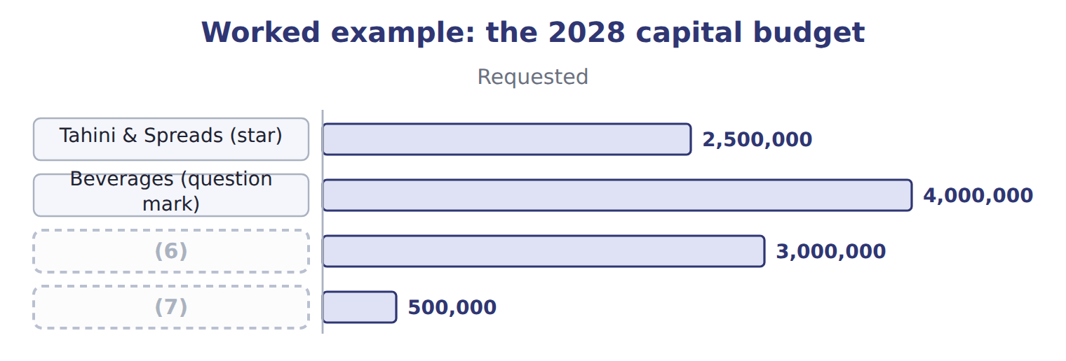
word list
Oils (cash cow) · Head office systems · Beverages (question mark)

Summary 3 gaps 8–12
Cutting every (8) by the same (9) would have been simpler, but it would have starved the star and overfed the cash cow. (10) allocation puts (11) where they support the strategy best. Because every unit sees the final allocation, the (12) also explains the strategy to the managers who did not get what they asked for.
word list
resources · systems · Efficient · percentage · budget · request

Answer key · 3.3 Allocating resources through the budget

1 always | 7 Head office systems
2 budget | 8 request
3 investment | 9 percentage
4 portfolio | 10 Efficient
5 head-office | 11 resources
6 Oils (cash cow) | 12 budget

the summaries in full
Summary 1 Resources are always scarce. The budget is where the company decides who gets what: money, people, machines and time. The decision should follow the strategy, not the size of each request.
Summary 2 The units asked for $10,000,000 of new investment; only $7,000,000 is available. The board uses the portfolio review. It funds the star in full, gives part of its request to the question mark, cuts the cash cow's request, and funds the head-office systems.
Summary 3 Cutting every request by the same percentage would have been simpler, but it would have starved the star and overfed the cash cow. Efficient allocation puts resources where they support the strategy best. Because every unit sees the final allocation, the budget also explains the strategy to the managers who did not get what they asked for.

3.4 Time frames and successful budgeting
Chapter 3 · section 3.4

Fill every gap. Each word list holds one word more than there are gaps.
Summary 1 gaps 1–3
Each budget has its own time frame. A (1) budget follows the life of the (2) ; the master budget covers one year, split into (3) or months; the cash budget may be weekly.
word list
executive · capital · quarters · project

Time frames of the main budgets
Budget | Typical time frame (B.2.i)
Strategic plan | 3–5 years (Chapter 1)
Capital budget | (4)
Master (annual) budget | (5)
Cash budget | (6)
Continuous (rolling) budget | always 12 months ahead (Chapter 5)

word list
Approves revisions under the policy · months or weeks · one year, split by quarter or month · the life of the project, often several years

Summary 2 gaps 7–10
A (7) that is too long becomes a guess; one that is too short misses the effect of (8) . The right frame (9) the decision it (10) . Successful budgeting is linked to strategy, realistic, participative, flexible within a clear policy, and followed by timely feedback.
word list
participative · supports · matches · budget · decisions

Successful budgeting and the role of top management
Successful budget process (B.2.e) | Role of top management (B.2.k)
Linked to strategy | Top management approves goals and guidelines
Realistic, evidence-based targets | (11)
Participation and communication | (12)
Flexibility with a revision policy | (13)
Timely feedback | Uses the budget in performance reviews

word list
Supports the process visibly · Approves revisions under the policy · Uses the budget in performance reviews · Sets the assumptions and resolves conflicts

Summary 3 gaps 14–17
Top (14) sets the goals and assumptions, resolves conflicts between units, approves the final budget and uses it in (15) reviews. If top (16) ignore the budget, so will (17) else. At Orontes, the chief executive opens the budget round with a letter that restates the strategic goals and the key assumptions.
word list
everyone · managers · capital · performance · management

Answer key · 3.4 Time frames and successful budgeting

1 capital | 10 supports
2 project | 11 Sets the assumptions and resolves conflicts
3 quarters | 12 Supports the process visibly
4 the life of the project, often several years | 13 Approves revisions under the policy
5 one year, split by quarter or month | 14 management
6 months or weeks | 15 performance
7 budget | 16 managers
8 decisions | 17 everyone
9 matches

the summaries in full
Summary 1 Each budget has its own time frame. A capital budget follows the life of the project; the master budget covers one year, split into quarters or months; the cash budget may be weekly.
Summary 2 A budget that is too long becomes a guess; one that is too short misses the effect of decisions. The right frame matches the decision it supports. Successful budgeting is linked to strategy, realistic, participative, flexible within a clear policy, and followed by timely feedback.
Summary 3 Top management sets the goals and assumptions, resolves conflicts between units, approves the final budget and uses it in performance reviews. If top managers ignore the budget, so will everyone else. At Orontes, the chief executive opens the budget round with a letter that restates the strategic goals and the key assumptions.

3.5 People: participation and controllable costs
Chapter 3 · section 3.5

Fill every gap. Each word list holds one word more than there are gaps.
Summary 1 gaps 1–8
In an (1) budget, top management sets every figure. In (2) budgeting, the managers who must carry out the budget help (3) it. The best (4) usually come from (5) with review. Managers who know the market and the plant (6) the figures, and top management checks them against the (7) and the strategy. A controllable cost is one a manager can (8) influence in the period. A manager should be judged on controllable costs only; other costs can be reported for information but should not affect the evaluation.
word list
participation · participative · evidence · propose · equipment · imposed · significantly · results · prepare

What can the plant manager control?

Complete the two blank rows.
Your turn: what the plant manager controls (complete the blanks)
Every item belongs to exactly one group.
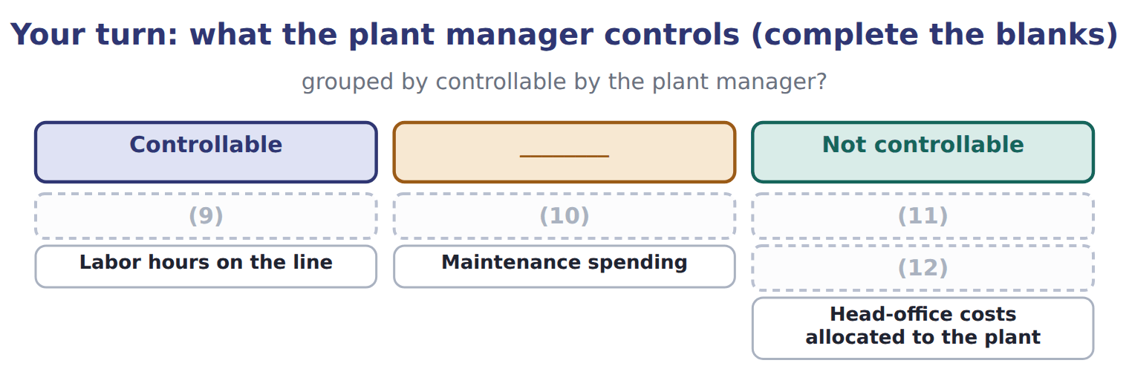
word list
Concentrate used per case · Price paid for concentrate · Wage rate set by the union contract · Depreciation of the plant · Labor hours on the line

Summary 2 gaps 13–16
Controllability also shapes (13) : the plant manager should help set targets for usage and hours, while the purchasing manager sets the price (14) . Controllability depends on the time frame: in the short run the plant manager cannot change the plant's (15) , but over several years the choice of (16) is partly his.
word list
assumptions · equipment · participation · depreciation · against

The English this section uses, and its Arabic
Each term sits against what it means.
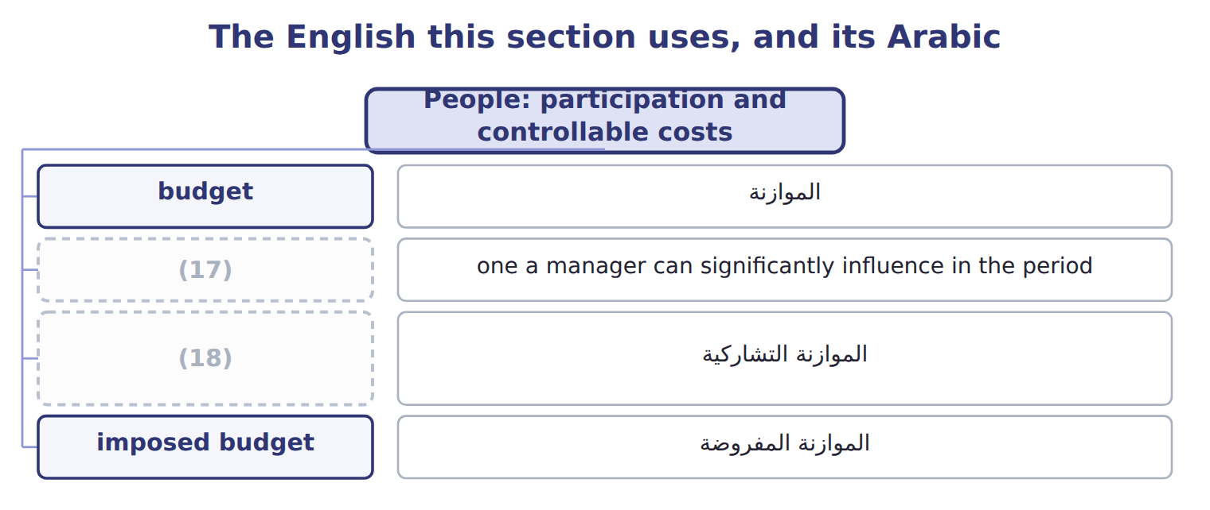
word list
controllable cost · participative budgeting · budget cycle

The English this sheet uses, and its Arabic
English (exam term) | Arabic
participative budgeting | الموازنة التشاركية
imposed budget | الموازنة المفروضة
controllable cost | التكلفة القابلة للرقابة

Answer key · 3.5 People: participation and controllable costs

1 imposed | 10 Price paid for concentrate
2 participative | 11 Wage rate set by the union contract
3 prepare | 12 Depreciation of the plant
4 results | 13 participation
5 participation | 14 assumptions
6 propose | 15 depreciation
7 evidence | 16 equipment
8 significantly | 17 controllable cost
9 Concentrate used per case | 18 participative budgeting

the summaries in full
Summary 1 In an imposed budget, top management sets every figure. In participative budgeting, the managers who must carry out the budget help prepare it. The best results usually come from participation with review. Managers who know the market and the plant propose the figures, and top management checks them against the evidence and the strategy. A controllable cost is one a manager can significantly influence in the period. A manager should be judged on controllable costs only; other costs can be reported for information but should not affect the evaluation.
Summary 2 Controllability also shapes participation: the plant manager should help set targets for usage and hours, while the purchasing manager sets the price assumptions. Controllability depends on the time frame: in the short run the plant manager cannot change the plant's depreciation, but over several years the choice of equipment is partly his.

3.6 Budgetary slack, revisions and monitoring
Chapter 3 · section 3.6

Fill every gap. Each word list holds one word more than there are gaps.
Summary 1 gaps 1–8
Budgetary slack is the gap between a (1) easy figure and the figure the (2) supports. Sales are (3) too low or costs too high, so the (4) is easy to beat. Slack damages goal (5) : the manager earns a bonus while the company plans for less than it could (6) . Budgets (7) need revising (8) the year, but only under a clear policy. A good policy revises for large changes outside managers' control, and keeps the targets for things managers can control. In July, the concentrate price rose 10%.
word list
target · sometimes · manager's · achieve · during · congruence · spending · evidence · budgeted

Within the manager's control?

Summary 2 gaps 9–10
Budgets also control (9) during the year. The comparison must use the (10) to date, not the annual total.
word list
spending · budget · overspend

Monitoring marketing spending to the end of June
Beverages marketing, 2028 (USD) | Amount
Annual marketing budget | 600,000
(11) | 300,000
(12) | 340,000
(13) | 40,000 (13.3%)
Left for the second half | 260,000

word list
Annual marketing budget · Budget to the end of June · Overspending to date · Actual to the end of June

Summary 3 gaps 14–15
Management by (14) directs attention to the largest (15) , such as the marketing overspend, so managers spend their time where it matters most.
word list
differences · budgeted · exception

Slack is measured from the evidence

Summary 4 gaps 16–17
Slack is the (16) figure minus the padded figure. (17) it against the manager's own proposal, or as a share of the proposal, gives the wrong answer.
word list
largest · Measuring · evidence-based

The English this section uses, and its Arabic
Each term sits against what it means.
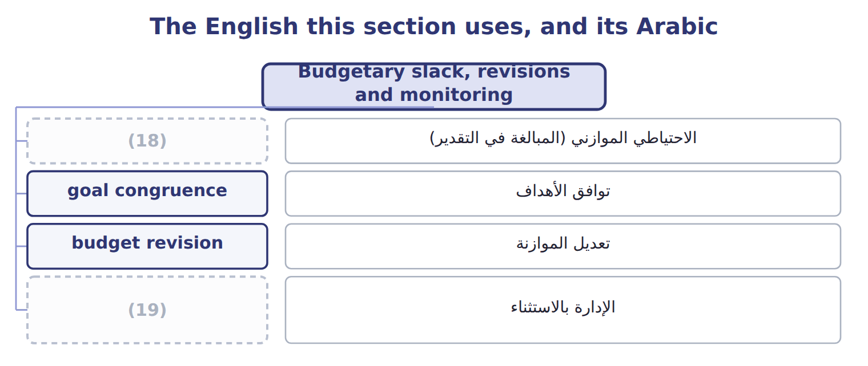
word list
budgetary slack · management by exception · budget revision

The English this sheet uses, and its Arabic
English (exam term) | Arabic
budgetary slack | الاحتياطي الموازني (المبالغة في التقدير)
goal congruence | توافق الأهداف
budget revision | تعديل الموازنة
management by exception | الإدارة بالاستثناء

Answer key · 3.6 Budgetary slack, revisions and monitoring

1 manager's | 11 Budget to the end of June
2 evidence | 12 Actual to the end of June
3 budgeted | 13 Overspending to date
4 target | 14 exception
5 congruence | 15 differences
6 achieve | 16 evidence-based
7 sometimes | 17 Measuring
8 during | 18 budgetary slack
9 spending | 19 management by exception
10 budget

the summaries in full
Summary 1 Budgetary slack is the gap between a manager's easy figure and the figure the evidence supports. Sales are budgeted too low or costs too high, so the target is easy to beat. Slack damages goal congruence: the manager earns a bonus while the company plans for less than it could achieve. Budgets sometimes need revising during the year, but only under a clear policy. A good policy revises for large changes outside managers' control, and keeps the targets for things managers can control. In July, the concentrate price rose 10%.
Summary 2 Budgets also control spending during the year. The comparison must use the budget to date, not the annual total.
Summary 3 Management by exception directs attention to the largest differences, such as the marketing overspend, so managers spend their time where it matters most.
Summary 4 Slack is the evidence-based figure minus the padded figure. Measuring it against the manager's own proposal, or as a share of the proposal, gives the wrong answer.

3.7 Extended Example 3A: agreeing the Beverages sales budget
Chapter 3 · section 3.7

Fill every gap. Each word list holds one word more than there are gaps.
Summary 1 gaps 1–2
This example follows the (1) meeting between the Beverages sales manager and the controller. (2) : 820,000 cases, from the sales manager. Evidence: market 11,250,000 cases × share 8.0% = 900,000 cases.
word list
reduces · budget · Proposal

Extended Example: slack in the Beverages sales proposal
The bars are drawn to scale.
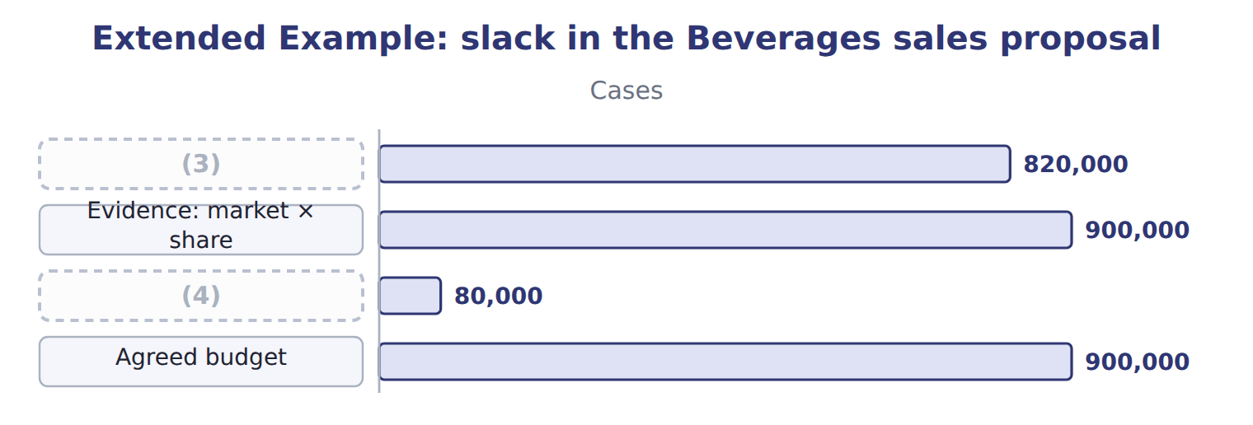
word list
budget cycle · Slack · Sales manager's proposal

Summary 2 gaps 5–8
The sales manager (5) his worry about a new rival. The (6) agrees to add a note on this risk, but the budget is set at 900,000 cases. The bonus is also (7) to both the budget and the market share, which (8) the reason to pad.
word list
reduces · controller · linked · explains · Beverages

Everything ties

Exam view

Summary 3 gaps 9–11
Expect to classify costs as (9) or not, and to (10) and measure slack. You may also have to choose the best participation approach, or judge whether a (11) should be revised under a stated policy.
word list
controllable · meeting · budget · identify

Exam view
Tahini & Spreads, 2028 budget | Data
(12) | 1,400,000
Volume supported by orders and market data (jars) | 1,500,000
(13) | $1.50

word list
Sales manager's proposal (jars) · Contribution margin per jar · Depreciation of the plant

Item — Answer
Item | Answer
Price paid for concentrate | Not (14) by the plant manager (set by purchasing and the market)
Maintenance spending | Controllable (the plant manager decides when and how much)

word list
budget · controllable

Cost on the plant manager's report — Category
Every item belongs to exactly one group.
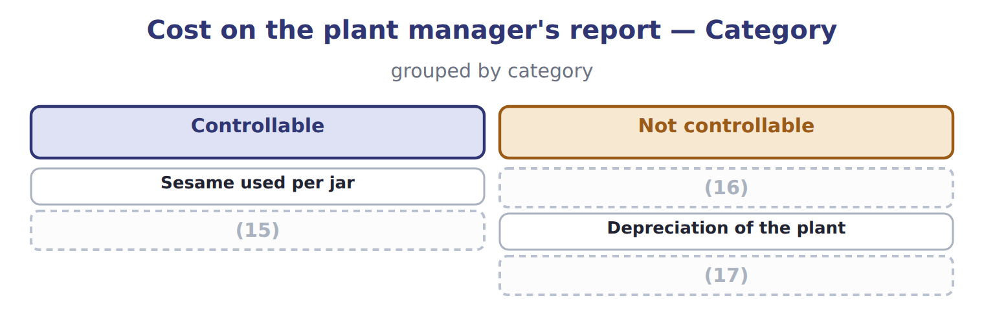
word list
Price paid for sesame · Hours worked on the filling line · Depreciation of the plant · Head-office costs allocated to the division

The English this section uses, and its Arabic
Each term sits against what it means.
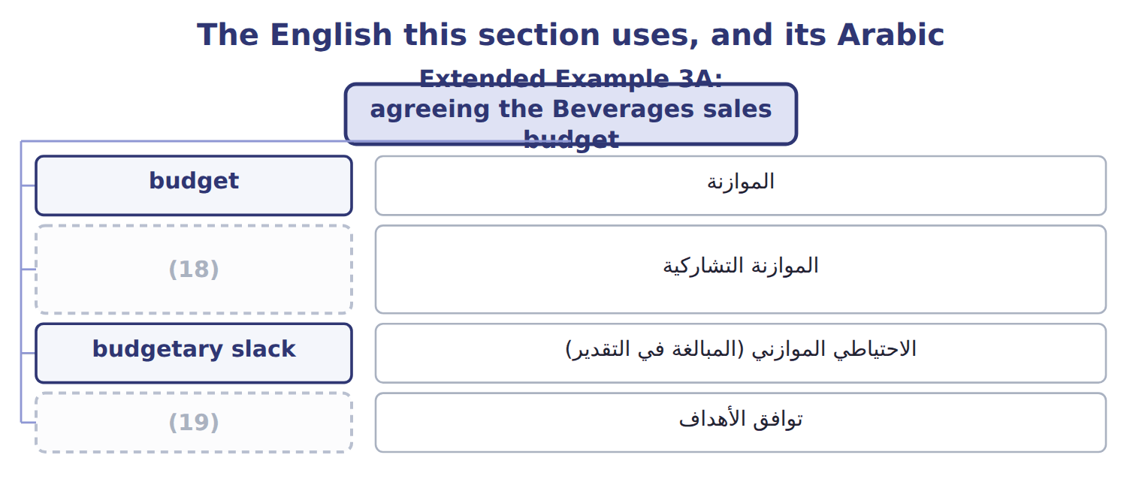
word list
توافق الأهداف · goal congruence · participative budgeting

The English this sheet uses, and its Arabic
English (exam term) | Arabic
budgetary slack | الاحتياطي الموازني (المبالغة في التقدير)
goal congruence | توافق الأهداف
participative budgeting | الموازنة التشاركية

Answer key · 3.7 Extended Example 3A: agreeing the Beverages sales budget

1 budget | 11 budget
2 Proposal | 12 Sales manager's proposal (jars)
3 Sales manager's proposal | 13 Contribution margin per jar
4 Slack | 14 controllable
5 explains | 15 Hours worked on the filling line
6 controller | 16 Price paid for sesame
7 linked | 17 Head-office costs allocated to the division
8 reduces | 18 participative budgeting
9 controllable | 19 goal congruence
10 identify

the summaries in full
Summary 1 This example follows the budget meeting between the Beverages sales manager and the controller. Proposal: 820,000 cases, from the sales manager. Evidence: market 11,250,000 cases × share 8.0% = 900,000 cases.
Summary 2 The sales manager explains his worry about a new rival. The controller agrees to add a note on this risk, but the budget is set at 900,000 cases. The bonus is also linked to both the budget and the market share, which reduces the reason to pad.
Summary 3 Expect to classify costs as controllable or not, and to identify and measure slack. You may also have to choose the best participation approach, or judge whether a budget should be revised under a stated policy.

4.1 The master budget
Chapter 4 · section 4.1

Fill every gap. Each word list holds one word more than there are gaps.
Chapter 4, section by section
Each stage leads to the next.
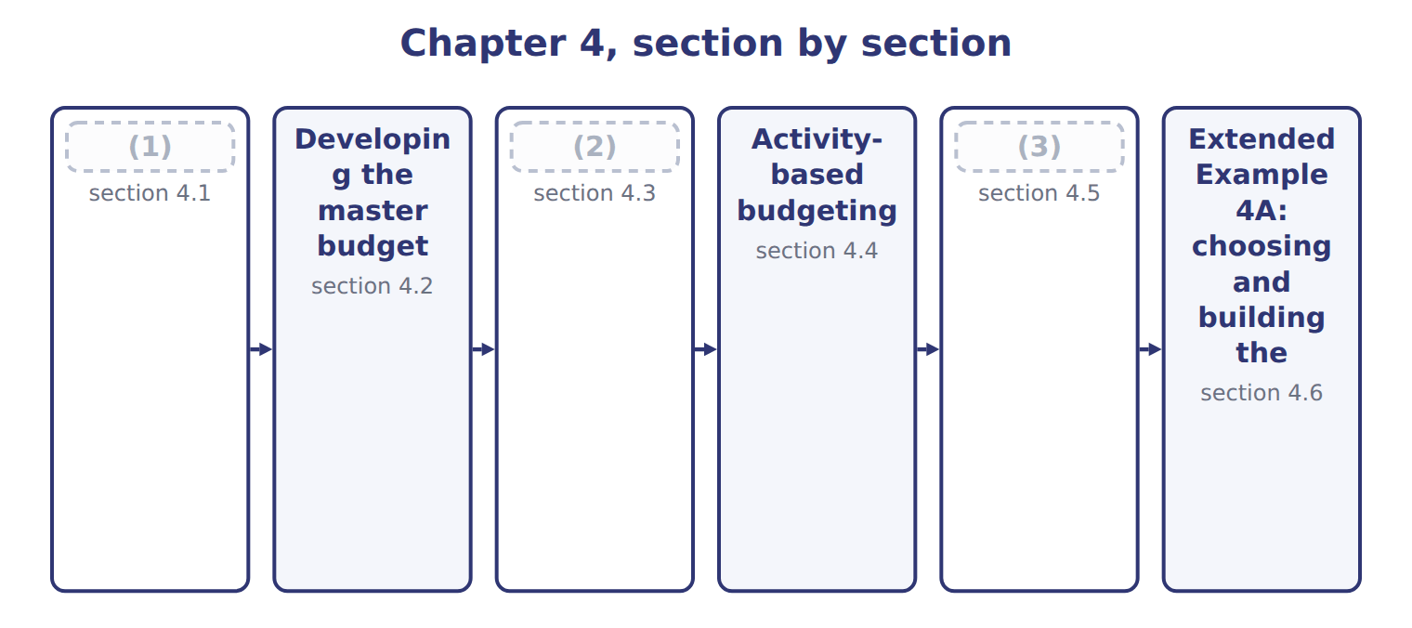
word list
section 4.2 · Project budgets · Benefits and limitations · The master budget

Summary 1 gaps 4–12
The (4) budget is the (5) annual budget of the organization. Its purpose is to plan and (6) every unit for one year, usually split into (7) and months. Every organization (8) one. It has two groups of (9) . The (10) budget plans sales, production and costs, and ends in the budgeted income (11) . The (12) budget plans capital spending and cash, and ends in the budgeted balance sheet. The sales budget sets production; production sets materials, labor and overhead; these set the cost of goods sold. Sales also drive cash collections, so an error in the sales budget spreads to every other budget.
word list
statement · coordinate · quarters · prepares · financial · master · operating · components · complete · production

Purpose, use and time frame of the three budget systems
B.4.a | Master (annual) budget | Project budget | Activity-based budget
Purpose | Plan and coordinate the whole company for a year | (13) | Plan overhead from the activities the output needs
Appropriate use | Every organization, every year | Construction, new lines, systems, launches | (14)
Time frame | (15) | The life of the project | Usually the budget year

word list
One year, by quarter or month · The life of the project · Many products using overhead differently · Plan and control one project

The English this section uses, and its Arabic
Each term sits against what it means.
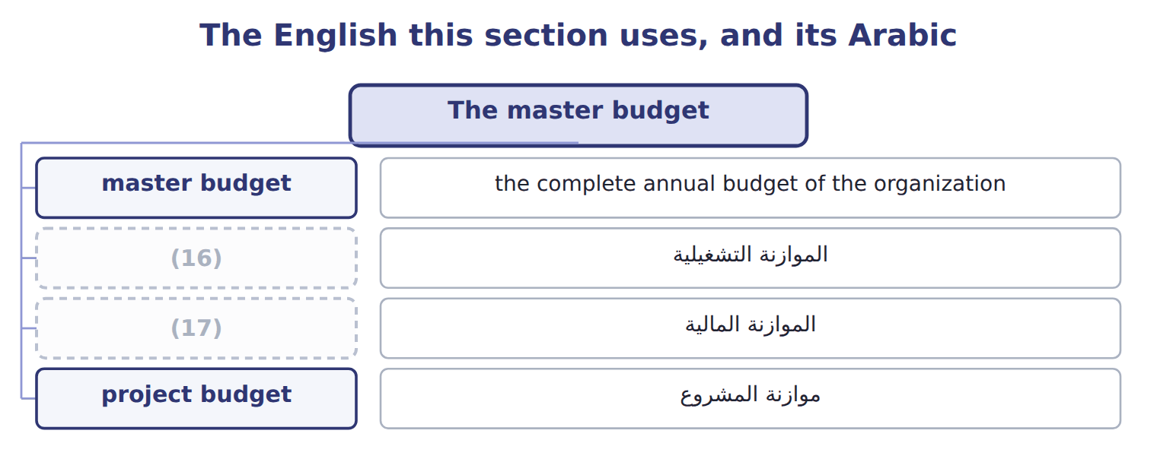
word list
operating budget · financial budget · master budget

The English this sheet uses, and its Arabic
English (exam term) | Arabic
master budget | الموازنة الشاملة
operating budget | الموازنة التشغيلية
financial budget | الموازنة المالية

Answer key · 4.1 The master budget

1 The master budget | 10 operating
2 Project budgets | 11 statement
3 Benefits and limitations | 12 financial
4 master | 13 Plan and control one project
5 complete | 14 Many products using overhead differently
6 coordinate | 15 One year, by quarter or month
7 quarters | 16 operating budget
8 prepares | 17 financial budget
9 components

the summaries in full
Summary 1 The master budget is the complete annual budget of the organization. Its purpose is to plan and coordinate every unit for one year, usually split into quarters and months. Every organization prepares one. It has two groups of components. The operating budget plans sales, production and costs, and ends in the budgeted income statement. The financial budget plans capital spending and cash, and ends in the budgeted balance sheet. The sales budget sets production; production sets materials, labor and overhead; these set the cost of goods sold. Sales also drive cash collections, so an error in the sales budget spreads to every other budget.

4.2 Developing the master budget
Chapter 4 · section 4.2

Fill every gap. Each word list holds one word more than there are gaps.
Summary 1 gaps 1–2
The master budget is (1) in a fixed order, (2) with sales, because every other figure depends on how much the company expects to sell.
word list
developed · reviewed · starting

Steps in developing the Beverages master budget
Each stage leads to the next.
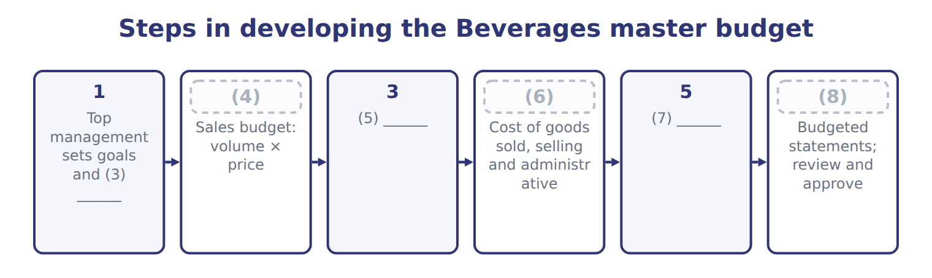
word list
4 · Production and input budgets · 6 · 2 · operating budget · assumptions · Capital and cash budgets

Summary 2 gaps 9–12
The (9) sales budget is 900,000 cases × $20.00 = $18,000,000. The process is not a (10) pass. Draft budgets are (11) , and a shortage of cash or capacity found late in the process may send the planners back to change the sales or (12) plan.
word list
depends · single · reviewed · Beverages · production

Sales first

Summary 3 gaps 13–14
An (13) that starts the master budget with (14) , purchases or cash has the order wrong. The sales budget comes first.
word list
process · answer · production

Answer key · 4.2 Developing the master budget

1 developed | 8 6
2 starting | 9 Beverages
3 assumptions | 10 single
4 2 | 11 reviewed
5 Production and input budgets | 12 production
6 4 | 13 answer
7 Capital and cash budgets | 14 production

the summaries in full
Summary 1 The master budget is developed in a fixed order, starting with sales, because every other figure depends on how much the company expects to sell.
Summary 2 The Beverages sales budget is 900,000 cases × $20.00 = $18,000,000. The process is not a single pass. Draft budgets are reviewed, and a shortage of cash or capacity found late in the process may send the planners back to change the sales or production plan.
Summary 3 An answer that starts the master budget with production, purchases or cash has the order wrong. The sales budget comes first.

4.3 Project budgets
Chapter 4 · section 4.3

Fill every gap. Each word list holds one word more than there are gaps.
Summary 1 gaps 1–3
A project (1) plans the costs of one project over its whole life, which may be (2) or longer than a year. It is used for building a plant, (3) a new line, launching a product or putting in a new system.
word list
capital · installing · shorter · budget

Worked example: the new juice filling line

Summary 2 gaps 4–5
The filling line funded: equipment, (4) , training, testing and start-up, plus a (5) for costs that cannot be predicted in detail.
word list
start-up · contingency · installation

Worked example: the filling-line project budget
The bars are drawn to scale.
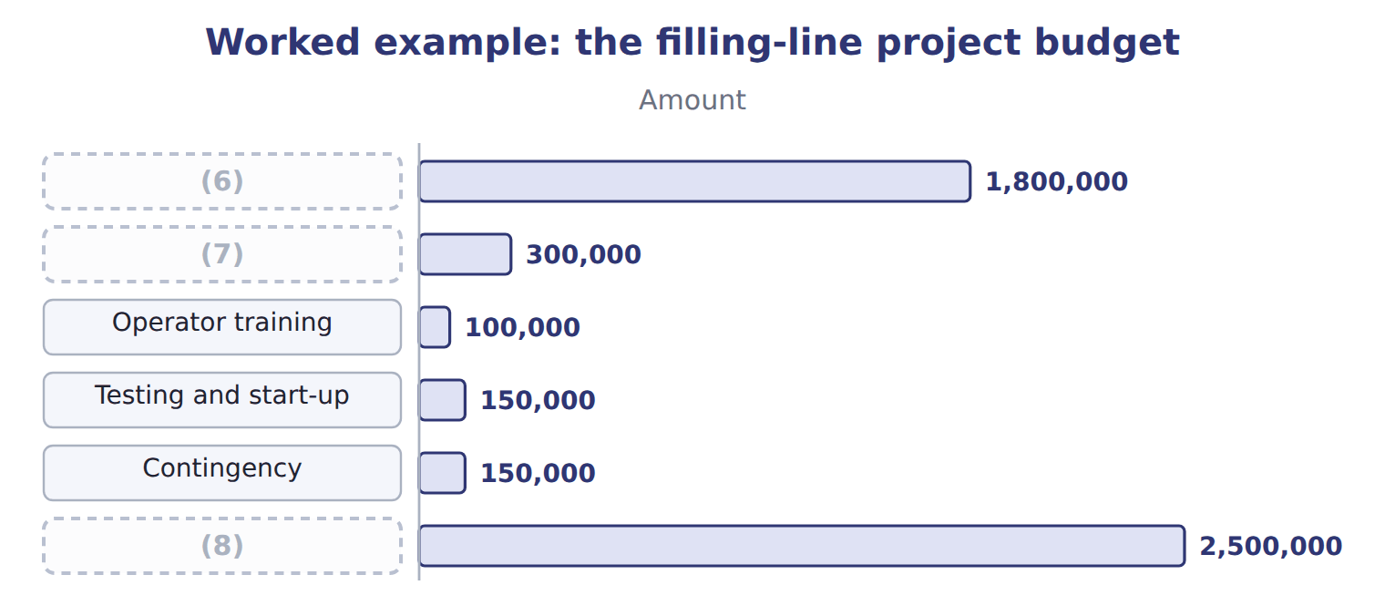
word list
Operator training · Project budget (9 months) · Installation · Filling equipment

Summary 3 gaps 9–11
A project budget also has a (9) . The project budget links to the master budget through the capital (10) budget and the cash budget. When the line starts working, its costs move into the (11) budgets.
word list
operating · expenditure · timeline · installing

The English this sheet uses, and its Arabic
English (exam term) | Arabic
project budget | موازنة المشروع
contingency | مخصص الطوارئ

Answer key · 4.3 Project budgets

1 budget | 7 Installation
2 shorter | 8 Project budget (9 months)
3 installing | 9 timeline
4 installation | 10 expenditure
5 contingency | 11 operating
6 Filling equipment

the summaries in full
Summary 1 A project budget plans the costs of one project over its whole life, which may be shorter or longer than a year. It is used for building a plant, installing a new line, launching a product or putting in a new system.
Summary 2 The filling line funded: equipment, installation, training, testing and start-up, plus a contingency for costs that cannot be predicted in detail.
Summary 3 A project budget also has a timeline. The project budget links to the master budget through the capital expenditure budget and the cash budget. When the line starts working, its costs move into the operating budgets.

4.4 Activity-based budgeting
Chapter 4 · section 4.4

Fill every gap. Each word list holds one word more than there are gaps.
Summary 1 gaps 1–3
Activity-based (1) plans overhead from the (2) that planned output will require. It is most useful when products use overhead very (3) , as lentils and za'atar do in the Pulses & Spices line.
word list
activities · budgeting · differently · contingency

Worked example: Pulses & Spices overhead for 2028

Summary 2 gaps 4–5
The 2028 plan is 220,000 packs of (4) , up from 200,000, and 40,000 packs of za'atar, down from 50,000. (5) , for example: 540 planned × $300 = $162,000.
word list
Receipts · lentils · activities

Worked example: activity-based budget for Pulses & Spices, 2028
The bars are drawn to scale.
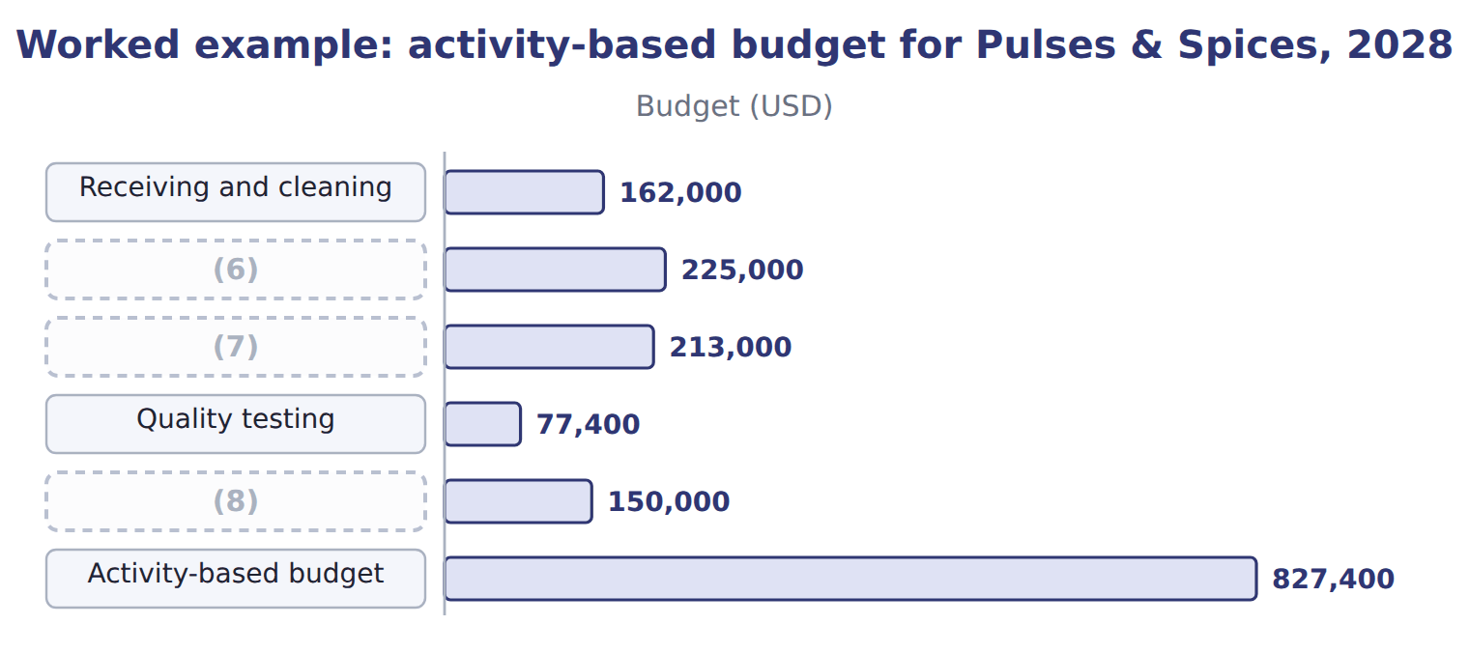
word list
Facility (capacity cost) · Packaging · master budget · Blending setups

Budgeting packaging and testing

Summary 3 gaps 9–10
Complete the blank cells. A (9) budget would take last year's (10) of $900,000 and add 3%, giving $927,000.
word list
require · traditional · overhead

The English this sheet uses, and its Arabic
English (exam term) | Arabic
activity-based budgeting | الموازنة على أساس الأنشطة

Answer key · 4.4 Activity-based budgeting

1 budgeting | 6 Blending setups
2 activities | 7 Packaging
3 differently | 8 Facility (capacity cost)
4 lentils | 9 traditional
5 Receipts | 10 overhead

the summaries in full
Summary 1 Activity-based budgeting plans overhead from the activities that planned output will require. It is most useful when products use overhead very differently, as lentils and za'atar do in the Pulses & Spices line.
Summary 2 The 2028 plan is 220,000 packs of lentils, up from 200,000, and 40,000 packs of za'atar, down from 50,000. Receipts, for example: 540 planned × $300 = $162,000.
Summary 3 Complete the blank cells. A traditional budget would take last year's overhead of $900,000 and add 3%, giving $927,000.

4.5 Benefits and limitations
Chapter 4 · section 4.5

Fill every gap. Each word list holds one word more than there are gaps.
No system suits every purpose.
Benefits and limitations of the three budget systems
System | Benefits (B.4.d) | Limitations
Master budget | Coordinates every unit; links to strategy | (1)
Project budget | Controls a project over its whole life | (2)
Activity-based budget | (3) | Needs activity data; costly to set up and maintain

word list
Hard to estimate new work; shared costs may be missed · Takes time; can become fixed and out of date · Controls a project over its whole life · Shows why overhead changes; finds waste

Summary 1 gaps 4–9
The master budget (4) everything but can (5) a fixed ritual. The project budget (6) a project well but may miss costs shared with the rest of the (7) . The activity-based budget (8) overhead but needs (9) data that many companies do not have. Companies usually combine the systems: a master budget for the whole company, project budgets for major investments, and activity-based budgets where overhead is large and varied.
word list
activity · business · controls · coordinates · become · usually · explains

Answer key · 4.5 Benefits and limitations

1 Takes time; can become fixed and out of date | 6 controls
2 Hard to estimate new work; shared costs may be missed | 7 business
3 Shows why overhead changes; finds waste | 8 explains
4 coordinates | 9 activity
5 become

the summaries in full
Summary 1 The master budget coordinates everything but can become a fixed ritual. The project budget controls a project well but may miss costs shared with the rest of the business. The activity-based budget explains overhead but needs activity data that many companies do not have. Companies usually combine the systems: a master budget for the whole company, project budgets for major investments, and activity-based budgets where overhead is large and varied.

4.6 Extended Example 4A: choosing and building the 2028 budgets
Chapter 4 · section 4.6

Fill every gap. Each word list holds one word more than there are gaps.
Summary 1 gaps 1–4
This example shows how the (1) combines the three systems for 2028. (2) as a whole: master budget, one year by month. The new (3) line: project budget, 9 months. Pulses & Spices overhead: (4) budget, because lentils and za'atar use overhead very differently.
word list
Beverages · controller · financial · activity-based · filling

Extended Example: the Beverages 2028 component map
Every item belongs to exactly one group.
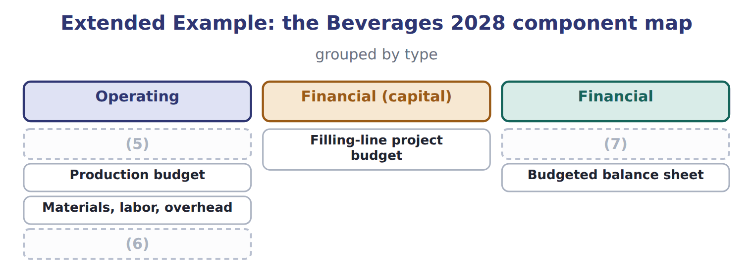
word list
Sales budget · Production budget · Budgeted income statement · Cash budget

Extended Example: activity-based and incremental budgets compared
The bars are drawn to scale.
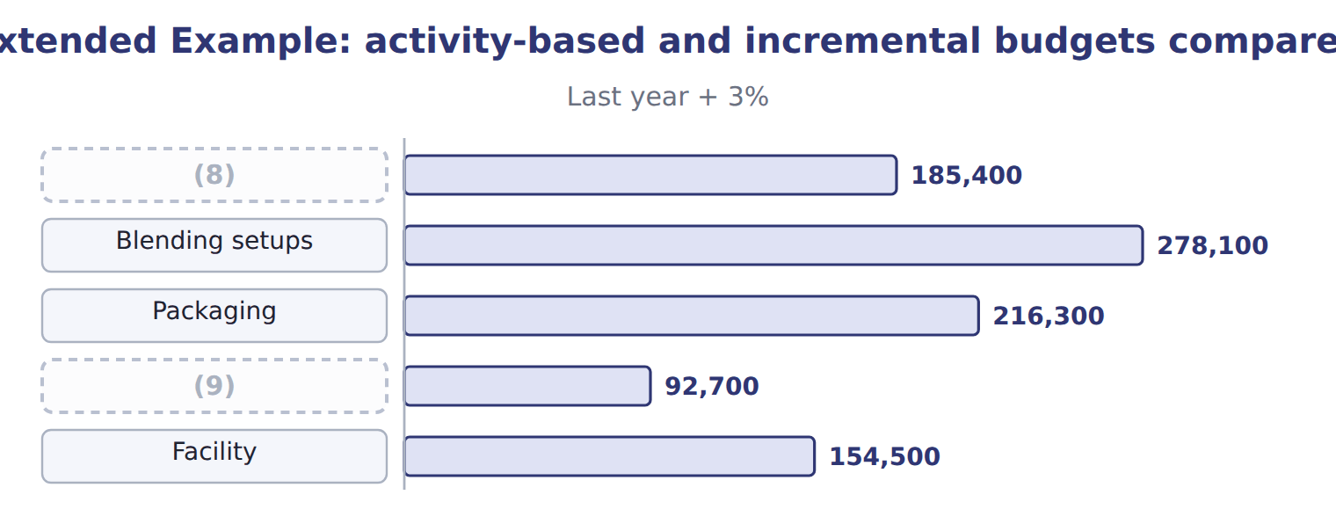
word list
activity-based budgeting · Receiving and cleaning · Quality testing

Everything ties

Project budget $2,500,000 = capital granted to Beverages.
Exam view

Summary 2 gaps 10–12
Expect to order the (10) of a master budget, to classify budgets as (11) or financial, to total a project budget, to build an (12) budget from drivers and rates, and to match each system with a situation.
word list
activity-based · operating · components · combines

Exam view
The bars are drawn to scale.
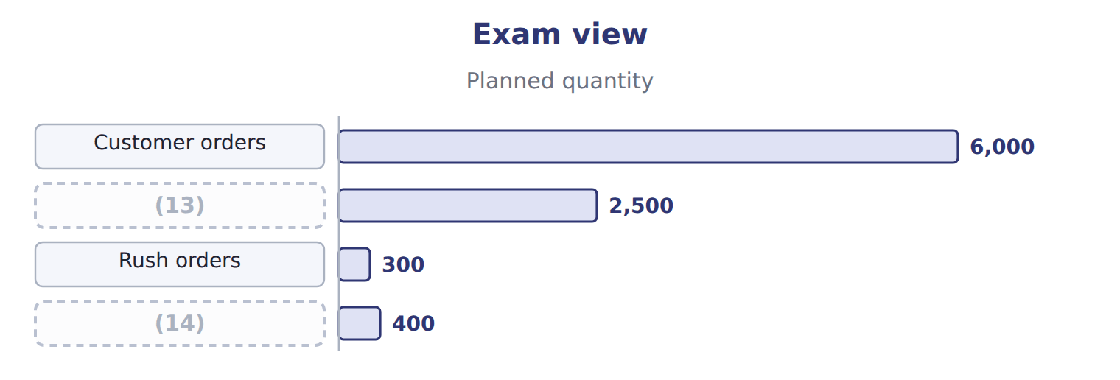
word list
Deliveries · contingency · Returns

Item — Answer
Item | Answer
Packaging | (15)
Quality testing | 1,290 tests × $60 = $77,400
Total | $827,400

word list
1,290 tests × $60 = $77,400 · 7,100 hours × $30 = $213,000

Budget — Category
Every item belongs to exactly one group.
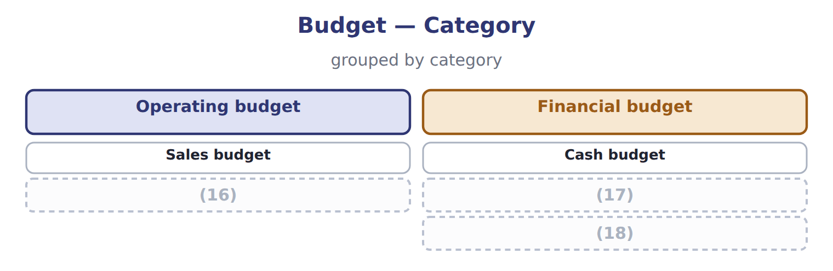
word list
activity-based budgeting · Delivery cost budget · Capital expenditure budget · Budgeted balance sheet

The English this sheet uses, and its Arabic
English (exam term) | Arabic
master budget | الموازنة الشاملة
project budget | موازنة المشروع
activity-based budgeting | الموازنة على أساس الأنشطة

Answer key · 4.6 Extended Example 4A: choosing and building the 2028 budgets

1 controller | 10 components
2 Beverages | 11 operating
3 filling | 12 activity-based
4 activity-based | 13 Deliveries
5 Sales budget | 14 Returns
6 Budgeted income statement | 15 7,100 hours × $30 = $213,000
7 Cash budget | 16 Delivery cost budget
8 Receiving and cleaning | 17 Capital expenditure budget
9 Quality testing | 18 Budgeted balance sheet

the summaries in full
Summary 1 This example shows how the controller combines the three systems for 2028. Beverages as a whole: master budget, one year by month. The new filling line: project budget, 9 months. Pulses & Spices overhead: activity-based budget, because lentils and za'atar use overhead very differently.
Summary 2 Expect to order the components of a master budget, to classify budgets as operating or financial, to total a project budget, to build an activity-based budget from drivers and rates, and to match each system with a situation.

5.1 Zero-based budgeting
Chapter 5 · section 5.1

Fill every gap. Each word list holds one word more than there are gaps.
Chapter 5, section by section
Each stage leads to the next.
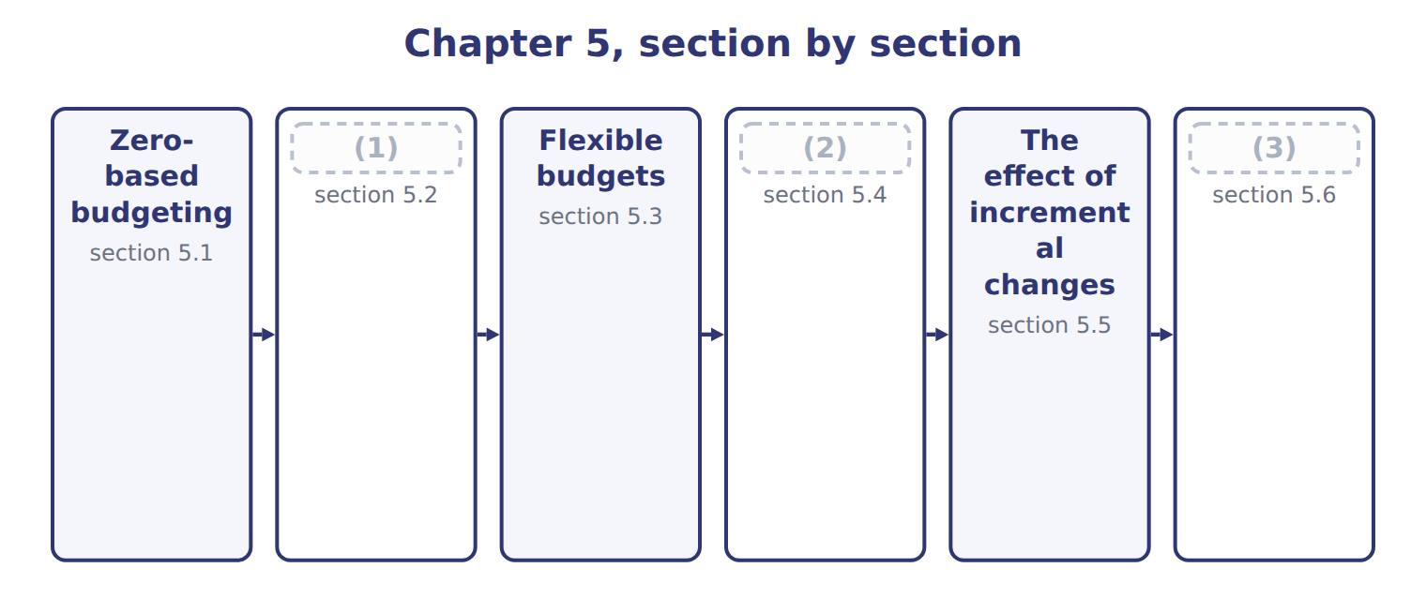
word list
Choosing a budget system · Continuous (rolling) budgets · Extended Example 5A: the 2028 budget review · The effect of incremental changes

Summary 1 gaps 4–10
Incremental budgeting starts from last year's (4) and adds or (5) a change. (6) budgeting starts from zero every year: each activity must be (7) again, as if it were new. It suits (8) costs, such as (9) services, where spending can grow without a clear reason. The budget is built from (10) packages. Each package describes an activity, its cost and its benefit; managers rank the packages, and top management funds them down the ranking until the money runs out.
word list
decision · figures · packages · subtracts · discretionary · Zero-based · head-office · justified

Worked example: the head-office budget for 2028

Summary 2 gaps 11–12
Six packages ask for $1,260,000. The board funds the (11) packages in full, reduces two and rejects the (12) .
word list
essential · sponsorships · services

Worked example: head-office decision packages for 2028
The bars are drawn to scale.
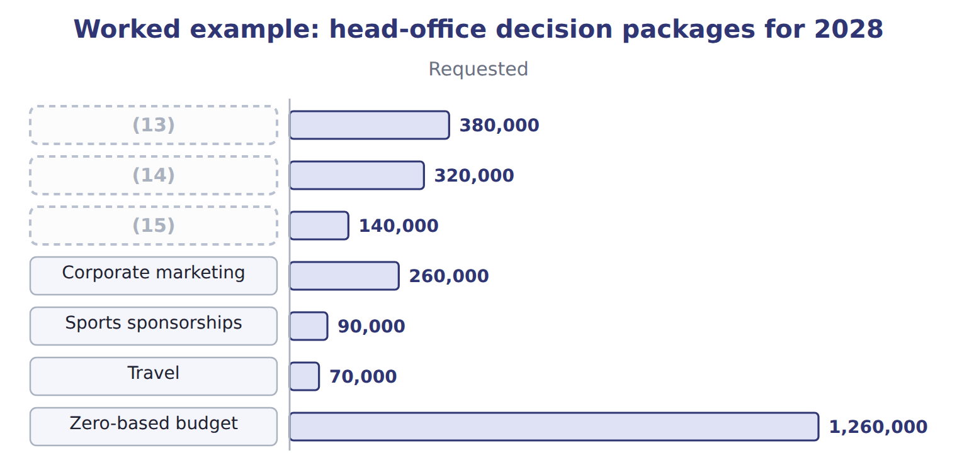
word list
IT support · Finance and reporting · decision package · Legal and compliance

Requested is not approved

Summary 3 gaps 16–17
A zero-based budget uses the (16) amount of each package. An answer that adds the (17) amounts, or starts from last year's total, has not used zero-based budgeting.
word list
Zero-based · requested · approved

The English this sheet uses, and its Arabic
English (exam term) | Arabic
zero-based budgeting | الموازنة الصفرية
incremental budgeting | الموازنة التزايدية
decision package | حزمة القرار

Answer key · 5.1 Zero-based budgeting

1 Continuous (rolling) budgets | 10 decision
2 Choosing a budget system | 11 essential
3 Extended Example 5A: the 2028 budget review | 12 sponsorships
4 figures | 13 Finance and reporting
5 subtracts | 14 IT support
6 Zero-based | 15 Legal and compliance
7 justified | 16 approved
8 discretionary | 17 requested
9 head-office

the summaries in full
Summary 1 Incremental budgeting starts from last year's figures and adds or subtracts a change. Zero-based budgeting starts from zero every year: each activity must be justified again, as if it were new. It suits discretionary costs, such as head-office services, where spending can grow without a clear reason. The budget is built from decision packages. Each package describes an activity, its cost and its benefit; managers rank the packages, and top management funds them down the ranking until the money runs out.
Summary 2 Six packages ask for $1,260,000. The board funds the essential packages in full, reduces two and rejects the sponsorships.
Summary 3 A zero-based budget uses the approved amount of each package. An answer that adds the requested amounts, or starts from last year's total, has not used zero-based budgeting.

5.2 Continuous (rolling) budgets
Chapter 5 · section 5.2

Fill every gap. Each word list holds one word more than there are gaps.
Summary 1 gaps 1–6
A (1) (rolling) budget always covers the same length of time ahead, (2) twelve months. When a month or quarter ends, it is (3) and a new one is added at the end. It suits (4) markets, like juice. The (5) budget planned 900,000 cases for 2028. In March, the first quarter is (6) ; the second quarter is raised to 230,000 cases, and the first quarter of the next year is added at 215,000.
word list
December · dropped · finished · usually · continuous · fast-changing · targets

The Beverages rolling budget before and after the March update
Beverages cases | Q1 2028 | Q2 2028 | Q3 2028 | Q4 2028 | Q1 2029 | Four quarters
Budget made in December 2027 | 210,000 | 225,000 | 240,000 | 225,000 | — | 900,000
Rolled forward in March 2028 | (7) | 230,000 | 240,000 | 225,000 | 215,000 | 910,000

word list
zero-based budgeting · (done)

Summary 2 gaps 8–10
A rolling budget keeps planning up to date, but it takes (8) work, and targets that keep moving can confuse (9) evaluation. Many companies keep the annual budget for evaluation and use a rolling (10) for planning.
word list
constant · forecast · finished · performance

The English this sheet uses, and its Arabic
English (exam term) | Arabic
continuous (rolling) budget | الموازنة المستمرة (المتحركة)

Answer key · 5.2 Continuous (rolling) budgets

1 continuous | 6 finished
2 usually | 7 (done)
3 dropped | 8 constant
4 fast-changing | 9 performance
5 December | 10 forecast

the summaries in full
Summary 1 A continuous (rolling) budget always covers the same length of time ahead, usually twelve months. When a month or quarter ends, it is dropped and a new one is added at the end. It suits fast-changing markets, like juice. The December budget planned 900,000 cases for 2028. In March, the first quarter is finished; the second quarter is raised to 230,000 cases, and the first quarter of the next year is added at 215,000.
Summary 2 A rolling budget keeps planning up to date, but it takes constant work, and targets that keep moving can confuse performance evaluation. Many companies keep the annual budget for evaluation and use a rolling forecast for planning.

5.3 Flexible budgets
Chapter 5 · section 5.3

Fill every gap. Each word list holds one word more than there are gaps.
Summary 1 gaps 1–8
A (1) budget is prepared for one planned level of (2) . A (3) budget can be prepared for any level, using the cost formula of each cost: fixed cost plus variable cost per unit. It is used mainly to (4) actual costs with what they (5) have been at the actual volume. The (6) cost formula for a month is $350,000 of fixed costs plus $11.80 of variable cost per case. The variable cost is $10.60 of (7) cost from the Book 2 card and $1.20 of (8) cost.
word list
selling · prepared · should · compare · activity · Beverages · flexible · static · manufacturing

Worked example: three levels of activity

Summary 2 gaps 9–10
At 75,000 cases, sales are $1,500,000, (9) costs $885,000 and fixed costs $350,000, so (10) income is $265,000.
word list
variable · planned · operating

Worked example: the Beverages flexible budget for one month
The bars are drawn to scale.
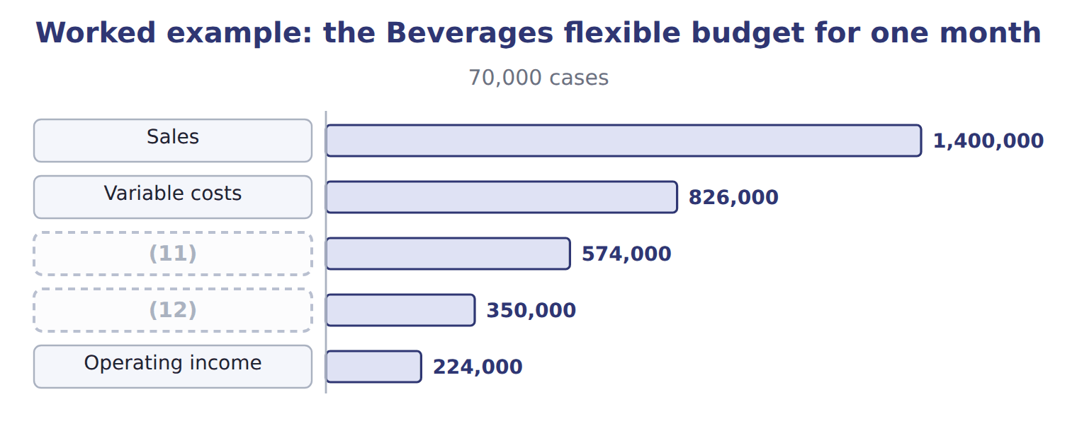
word list
Fixed costs · incremental budgeting · Contribution margin

The flexible budget at the higher volume

Summary 3 gaps 13–14
Complete the blank cells. Each extra case adds $8.20 of (13) income, because fixed costs do not change. The flexible budget (14) shows how much income should rise or fall with volume.
word list
operating · therefore · variable

The English this sheet uses, and its Arabic
English (exam term) | Arabic
flexible budget | الموازنة المرنة
static budget | الموازنة الثابتة (الساكنة)
cost formula | معادلة التكلفة

Answer key · 5.3 Flexible budgets

1 static | 8 selling
2 activity | 9 variable
3 flexible | 10 operating
4 compare | 11 Contribution margin
5 should | 12 Fixed costs
6 Beverages | 13 operating
7 manufacturing | 14 therefore

the summaries in full
Summary 1 A static budget is prepared for one planned level of activity. A flexible budget can be prepared for any level, using the cost formula of each cost: fixed cost plus variable cost per unit. It is used mainly to compare actual costs with what they should have been at the actual volume. The Beverages cost formula for a month is $350,000 of fixed costs plus $11.80 of variable cost per case. The variable cost is $10.60 of manufacturing cost from the Book 2 card and $1.20 of selling cost.
Summary 2 At 75,000 cases, sales are $1,500,000, variable costs $885,000 and fixed costs $350,000, so operating income is $265,000.
Summary 3 Complete the blank cells. Each extra case adds $8.20 of operating income, because fixed costs do not change. The flexible budget therefore shows how much income should rise or fall with volume.

5.4 Choosing a budget system
Chapter 5 · section 5.4

Fill every gap. Each word list holds one word more than there are gaps.
The right system depends on the situation and the decision.
Recommending a budget system for each situation
Business situation (B.4.e) | Recommended system | Orontes example
Costs keep rising with no clear reason; many discretionary costs | (1) | Head office
Fast-changing market; plans must look a year ahead at all times | (2) | Beverages sales
Volume varies; managers must be judged fairly on costs | (3) | Beverages plant
One large investment over more than a year | Project budget (Chapter 4) | (4)
Overhead used very differently by products | (5) | Pulses & Spices

word list
Filling line · Beverages sales · Zero-based budget · Flexible budget · Continuous (rolling) budget · Activity-based budget (Chapter 4)

Benefits and limitations of zero-based, rolling and flexible budgets
System | Benefits | Limitations
Zero-based | (6) | Takes much time; managers may resist
Continuous (rolling) | Always up to date; always a year ahead | (7)
Flexible | Fair comparison at the actual volume | (8)

word list
Removes waste; questions every cost · Needs reliable cost formulas; mixed costs must be split · Constant work; targets keep moving · One large investment over more than a year

Summary 1 gaps 9–11
Systems are often (9) . Orontes uses a master budget for the year, rolling (10) for sales and flexible budgets for plant costs. It also reviews head office on a (11) basis every few years.
word list
decision · zero-based · combined · forecasts

The English this section uses, and its Arabic
Each term sits against what it means.
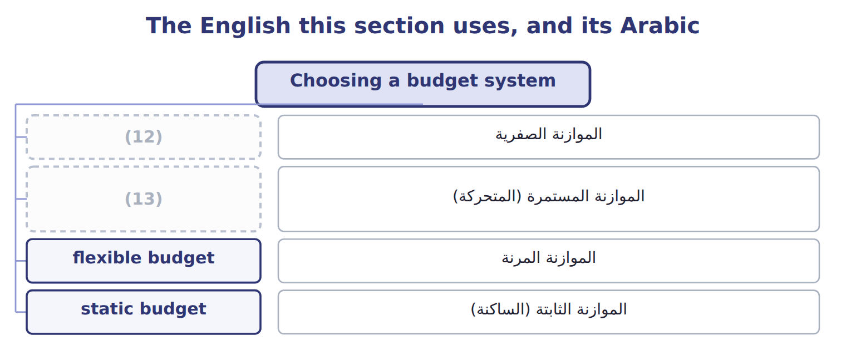
word list
static budget · zero-based budgeting · continuous (rolling) budget

Answer key · 5.4 Choosing a budget system

1 Zero-based budget | 8 Needs reliable cost formulas; mixed costs must be split
2 Continuous (rolling) budget | 9 combined
3 Flexible budget | 10 forecasts
4 Filling line | 11 zero-based
5 Activity-based budget (Chapter 4) | 12 zero-based budgeting
6 Removes waste; questions every cost | 13 continuous (rolling) budget
7 Constant work; targets keep moving

the summaries in full
Summary 1 Systems are often combined. Orontes uses a master budget for the year, rolling forecasts for sales and flexible budgets for plant costs. It also reviews head office on a zero-based basis every few years.

5.5 The effect of incremental changes
Chapter 5 · section 5.5

Fill every gap. Each word list holds one word more than there are gaps.
Summary 1 gaps 1–4
Managers often ask how a change would (1) the budget: a new price, more volume, a (2) cost. The right (3) is the change in (4) margin, and the answer must include every effect of the change, such as lost volume after a price rise.
word list
higher · affect · contribution · measure · include

Worked example: raising the juice price

Sales proposes a 5% price rise to $21.00 and expects to lose 3% of volume.
Worked example: the effect of a juice price rise
Beverages 2028 | Now | Price +5%, volume −3%
Price per case | $20.00 | $21.00
Variable cost per case | $11.80 | $11.80
Contribution margin per case | $8.20 | $9.20
(5) | 900,000 | 873,000
Contribution margin | 7,380,000 | 8,031,600
(6) |  | 651,600

word list
Cases a year · Contribution · Increase

Include the lost volume

Summary 2 gaps 7–8
Multiplying the old volume by the new margin (7) the cases lost after the price rise and (8) the gain. Use the new volume with the new margin.
word list
proposes · ignores · overstates

Answer key · 5.5 The effect of incremental changes

1 affect | 5 Cases a year
2 higher | 6 Increase
3 measure | 7 ignores
4 contribution | 8 overstates

the summaries in full
Summary 1 Managers often ask how a change would affect the budget: a new price, more volume, a higher cost. The right measure is the change in contribution margin, and the answer must include every effect of the change, such as lost volume after a price rise.
Summary 2 Multiplying the old volume by the new margin ignores the cases lost after the price rise and overstates the gain. Use the new volume with the new margin.

5.6 Extended Example 5A: the 2028 budget review
Chapter 5 · section 5.6

Fill every gap. Each word list holds one word more than there are gaps.
Summary 1 gaps 1–4
This example follows the (1) report to the board on the budget systems used for 2028. Head office: costs growing without clear reasons, mostly (2) . Beverages sales: a market that (3) every quarter. Beverages plant: volume that (4) from the plan most months. Pricing: a proposal to raise the juice price.
word list
changes · discretionary · zero-based · differs · controller's

Extended Example: systems and results of the 2028 budget review
Area | System or method | Result
Head office | Zero-based | (5) $1,100,000, saving $148,000 against last year + 4%
Beverages sales | (6) | Next four quarters 910,000 cases after the March update
Beverages costs | (7) | $350,000 a month + $11.80 a case
Pricing proposal | (8) | Price +5%: contribution margin +$651,600 a year

word list
Incremental analysis · Approved · Rolling (quarterly) · Flexible · Price +5%

Summary 2 gaps 9–10
The controller recommends adopting the zero-based (9) budget, the rolling sales forecast and the flexible plant budget. She also recommends (10) the price rise if a market test confirms the volume loss.
word list
proposal · approving · head-office

Everything ties

Summary 3 gaps 11–13
The four (11) of the December (12) total 900,000 cases, the volume agreed. Fixed (13) costs of $150,000 a month equal the Book 2 fixed overhead of $2.00 a case × 75,000 cases.
word list
budget · manufacturing · quarters · Pricing

Exam view

Summary 4 gaps 14–17
Expect to (14) a system for a (15) situation, to prepare a flexible budget at a given volume and to roll a budget forward. You may also have to (16) the effect of a price, volume or cost change on (17) margin or operating income.
word list
recommend · adopting · described · calculate · contribution

Exam view
Tahini & Spreads, 500 g jars | Data
(18) | $3.50
Variable cost per jar | $2.00
(19) | $120,000
Jars in the static budget for the month | 125,000
(20) | 110,000

word list
Jars actually sold in the month · Selling price per jar · Fixed costs per month · 80,000 × $8.20 = $656,000

Item — Answer
Item | Answer
Variable costs | (21)
Contribution margin | (22)
Operating income | $656,000 − $350,000 = $306,000

word list
80,000 × $8.20 = $656,000 · 80,000 × $11.80 = $944,000 · $656,000 − $350,000 = $306,000

Need — Category
Every item belongs to exactly one group.
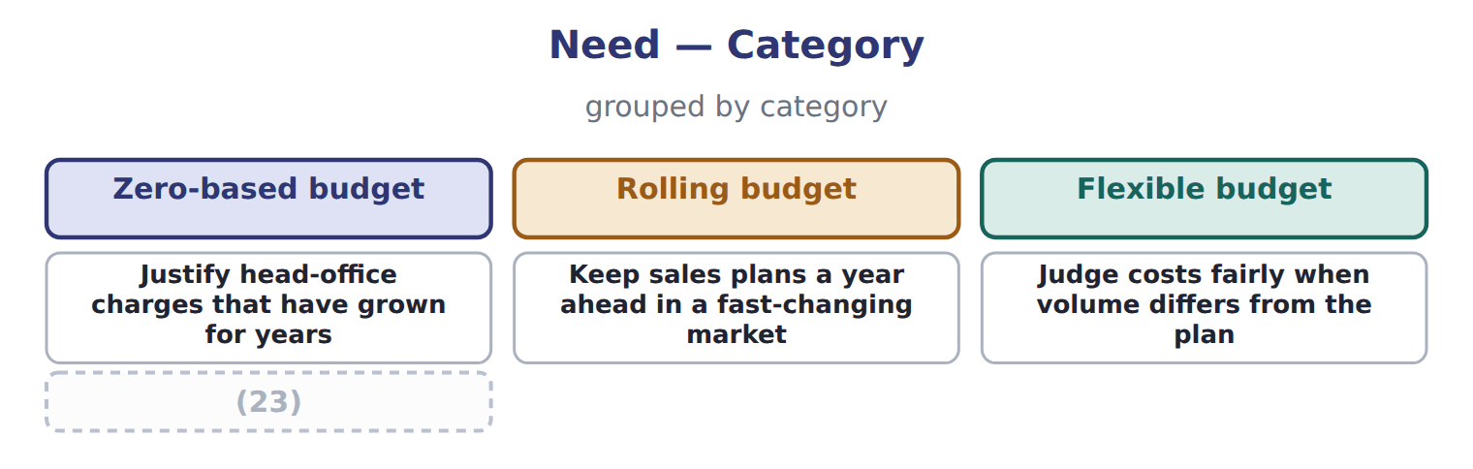
word list
Review whether each support activity is still needed · Justify head-office charges that have grown for years

The English this sheet uses, and its Arabic
English (exam term) | Arabic
zero-based budgeting | الموازنة الصفرية
continuous (rolling) budget | الموازنة المستمرة (المتحركة)
flexible budget | الموازنة المرنة

Answer key · 5.6 Extended Example 5A: the 2028 budget review

1 controller's | 13 manufacturing
2 discretionary | 14 recommend
3 changes | 15 described
4 differs | 16 calculate
5 Approved | 17 contribution
6 Rolling (quarterly) | 18 Selling price per jar
7 Flexible | 19 Fixed costs per month
8 Incremental analysis | 20 Jars actually sold in the month
9 head-office | 21 80,000 × $11.80 = $944,000
10 approving | 22 80,000 × $8.20 = $656,000
11 quarters | 23 Review whether each support activity is still needed
12 budget

the summaries in full
Summary 1 This example follows the controller's report to the board on the budget systems used for 2028. Head office: costs growing without clear reasons, mostly discretionary. Beverages sales: a market that changes every quarter. Beverages plant: volume that differs from the plan most months. Pricing: a proposal to raise the juice price.
Summary 2 The controller recommends adopting the zero-based head-office budget, the rolling sales forecast and the flexible plant budget. She also recommends approving the price rise if a market test confirms the volume loss.
Summary 3 The four quarters of the December budget total 900,000 cases, the volume agreed. Fixed manufacturing costs of $150,000 a month equal the Book 2 fixed overhead of $2.00 a case × 75,000 cases.
Summary 4 Expect to recommend a system for a described situation, to prepare a flexible budget at a given volume and to roll a budget forward. You may also have to calculate the effect of a price, volume or cost change on contribution margin or operating income.

6.1 The sales budget and the profit plan
Chapter 6 · section 6.1

Fill every gap. Each word list holds one word more than there are gaps.
Chapter 6, section by section
Each stage leads to the next.
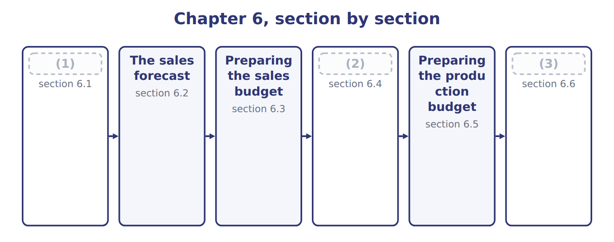
word list
Preparing the production budget · From sales to production · The sales budget and the profit plan · Extended Example 6A: a late order for the summ

Summary 1 gaps 4–9
The master budget is also called the annual profit plan, (4) it ends in (5) profit. The sales budget is its first (6) : the planned units and (7) for each period. (8) every other budget (9) on it. That is why the sales budget deserves the most care. If sales are overstated, the company buys too much material, hires too many people and plans for cash it will never collect.
word list
schedule · revenue · budgeted · depends · because · deserves · Almost

The English this sheet uses, and its Arabic
English (exam term) | Arabic
annual profit plan | خطة الربح السنوية
sales budget | موازنة المبيعات

Answer key · 6.1 The sales budget and the profit plan

1 The sales budget and the profit plan | 6 schedule
2 From sales to production | 7 revenue
3 Extended Example 6A: a late order for the summ | 8 Almost
4 because | 9 depends
5 budgeted

the summaries in full
Summary 1 The master budget is also called the annual profit plan, because it ends in budgeted profit. The sales budget is its first schedule: the planned units and revenue for each period. Almost every other budget depends on it. That is why the sales budget deserves the most care. If sales are overstated, the company buys too much material, hires too many people and plans for cash it will never collect.

6.2 The sales forecast
Chapter 6 · section 6.2

Fill every gap. Each word list holds one word more than there are gaps.
Summary 1 gaps 1–2
The sales (1) is an estimate of what the company could sell. It becomes the sales budget only after (2) decides on prices, promotions and targets.
word list
decisions · forecast · management

Factors in the Beverages sales forecast
Factor in the sales forecast (B.5.b) | Beverages 2028
The market and the industry | Juice market growing 14.0% a year (Chapter 2)
The economy | Low inflation; the dinar pegged to the US dollar (Chapter 3)
Prices and promotions | (3)
Competitors | (4)
Sales team and customers | (5)

word list
Juice market growing 14.0% a year (Chapter 2) · Orders already agreed with Levant and the supermarkets · Price held at $20.00 a case · The market leader holds a much larger share

Summary 2 gaps 6–8
Past (6) show trend and (7) . A good forecast combines several sources: the industry forecast and market share of, the sales team's knowledge of customers, and (8) methods such as the regression of Book 2.
word list
statistical · results · combines · season

Forecast is not budget

Summary 3 gaps 9–10
The (9) says what could happen; the budget says what management plans and commits to. An answer that treats them as the same thing misses (10) decisions on price and promotion.
word list
management's · forecast · industry

The English this sheet uses, and its Arabic
English (exam term) | Arabic
sales forecast | التنبؤ بالمبيعات

Answer key · 6.2 The sales forecast

1 forecast | 6 results
2 management | 7 season
3 Price held at $20.00 a case | 8 statistical
4 The market leader holds a much larger share | 9 forecast
5 Orders already agreed with Levant and the supermarkets | 10 management's

the summaries in full
Summary 1 The sales forecast is an estimate of what the company could sell. It becomes the sales budget only after management decides on prices, promotions and targets.
Summary 2 Past results show trend and season. A good forecast combines several sources: the industry forecast and market share of, the sales team's knowledge of customers, and statistical methods such as the regression of Book 2.
Summary 3 The forecast says what could happen; the budget says what management plans and commits to. An answer that treats them as the same thing misses management's decisions on price and promotion.

6.3 Preparing the sales budget
Chapter 6 · section 6.3

Fill every gap. Each word list holds one word more than there are gaps.
Summary 1 gaps 1–2
A sales budget has three (1) for each period: units, price per unit and revenue. Companies with several (2) or channels prepare a line for each and add them up.
word list
products · components · pattern

Worked example: the Beverages sales budget

First quarter: 210,000 cases × $20.00 = $4,200,000.
Worked example: the Beverages sales budget for 2028
Sales budget 2028 | Q1 | Q2 | Q3 | Q4 | Year
(3) | 210,000 | 225,000 | 240,000 | 225,000 | 900,000
(4) | $20.00 | $20.00 | $20.00 | $20.00 | $20.00
Sales revenue | 4,200,000 | 4,500,000 | 4,800,000 | 4,500,000 | 18,000,000

word list
Price per case · Cases · sales forecast

Summary 2 gaps 5–6
The (5) split matters as much as the total: (6) , purchasing and cash are all planned by quarter or month, following the pattern of sales.
word list
quarterly · revenue · production

Answer key · 6.3 Preparing the sales budget

1 components | 4 Price per case
2 products | 5 quarterly
3 Cases | 6 production

the summaries in full
Summary 1 A sales budget has three components for each period: units, price per unit and revenue. Companies with several products or channels prepare a line for each and add them up.
Summary 2 The quarterly split matters as much as the total: production, purchasing and cash are all planned by quarter or month, following the pattern of sales.

6.4 From sales to production
Chapter 6 · section 6.4

Fill every gap. Each word list holds one word more than there are gaps.
Summary 1 gaps 1–8
Production does not simply equal sales, (1) the company holds (2) goods. The production budget adds the stock (3) at the end of the period and (4) the stock already on hand at the start. The (5) stock comes from the (6) policy. (7) keeps 20% of next (8) sales in stock, so that it can meet orders while the next batch is filled. Other factors also shape the production budget: plant capacity, storage space, the shelf life of juice and the wish to keep the workforce stable.
word list
inventory · workforce · because · wanted · subtracts · quarter's · Beverages · finished · ending

Factors in the Beverages production budget
Factor in the production budget (B.5.e) | Beverages 2028
Inventory policy | (9)
Capacity | 240,000 cases a quarter (4,800 machine hours)
Storage space | Room for 50,000 cases
Shelf life | (10)
Stable workforce | (11)

word list
Juice must be sold within nine months · Ending stock = 20% of next quarter's sales · Avoid large swings in production between quarters · 240,000 cases a quarter (4,800 machine hours)

The English this sheet uses, and its Arabic
English (exam term) | Arabic
production budget | موازنة الإنتاج
inventory policy | سياسة المخزون

Answer key · 6.4 From sales to production

1 because | 7 Beverages
2 finished | 8 quarter's
3 wanted | 9 Ending stock = 20% of next quarter's sales
4 subtracts | 10 Juice must be sold within nine months
5 ending | 11 Avoid large swings in production between quarters
6 inventory

the summaries in full
Summary 1 Production does not simply equal sales, because the company holds finished goods. The production budget adds the stock wanted at the end of the period and subtracts the stock already on hand at the start. The ending stock comes from the inventory policy. Beverages keeps 20% of next quarter's sales in stock, so that it can meet orders while the next batch is filled. Other factors also shape the production budget: plant capacity, storage space, the shelf life of juice and the wish to keep the workforce stable.

6.5 Preparing the production budget
Chapter 6 · section 6.5

Fill every gap. Each word list holds one word more than there are gaps.
Worked example: the first quarter

Summary 1 gaps 1–2
Sales 210,000 + ending stock 45,000 (20% of 225,000) = 255,000 needed; − (1) stock 42,000 = 213,000 cases to (2) .
word list
produce · beginning · quarter

Worked example: the Beverages production budget for 2028
The bars are drawn to scale.
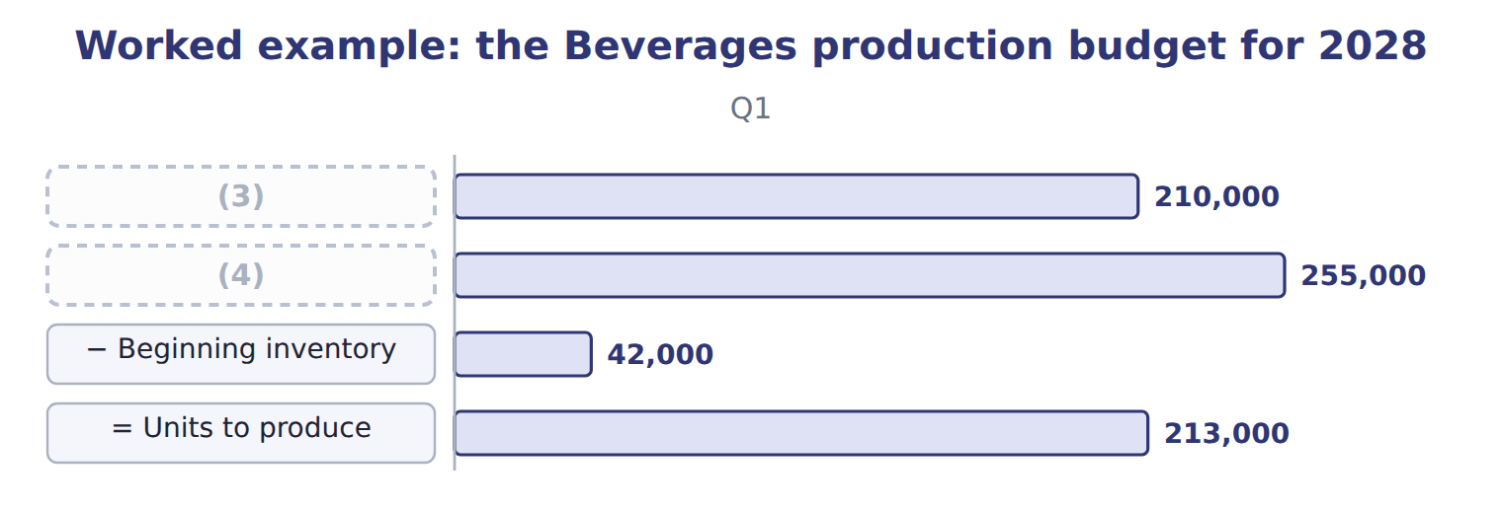
word list
= Units needed · Budgeted sales · sales forecast

The third and fourth quarters

Summary 2 gaps 5–7
Complete the blank cells. The first quarter of 2029 is (5) to sell 215,000 cases. Over the year, (6) of 901,000 cases is 900,000 cases of sales plus the rise in stock from 42,000 to 43,000. The budget must also be (7) .
word list
feasible · expected · beginning · production

Watch the signs

Summary 3 gaps 8–9
Ending inventory is added and beginning inventory is (8) . Reversing the signs, or setting ending stock from this quarter's sales instead of next quarter's, gives the wrong (9) figure.
word list
subtracted · expected · production

Answer key · 6.5 Preparing the production budget

1 beginning | 6 production
2 produce | 7 feasible
3 Budgeted sales | 8 subtracted
4 = Units needed | 9 production
5 expected

the summaries in full
Summary 1 Sales 210,000 + ending stock 45,000 (20% of 225,000) = 255,000 needed; − beginning stock 42,000 = 213,000 cases to produce.
Summary 2 Complete the blank cells. The first quarter of 2029 is expected to sell 215,000 cases. Over the year, production of 901,000 cases is 900,000 cases of sales plus the rise in stock from 42,000 to 43,000. The budget must also be feasible.
Summary 3 Ending inventory is added and beginning inventory is subtracted. Reversing the signs, or setting ending stock from this quarter's sales instead of next quarter's, gives the wrong production figure.

6.6 Extended Example 6A: a late order for the summer
Chapter 6 · section 6.6

Fill every gap. Each word list holds one word more than there are gaps.
Summary 1 gaps 1–4
In (1) , Levant asks for 10,000 extra cases in the third quarter for a hotel chain. This example tests (2) the production (3) can absorb the order. Higher third-quarter sales raise the second quarter's ending stock, and therefore (4) production, as well as third-quarter production.
word list
February · whether · already · budget · second-quarter

Extended Example: the production budget with the late order
The bars are drawn to scale.
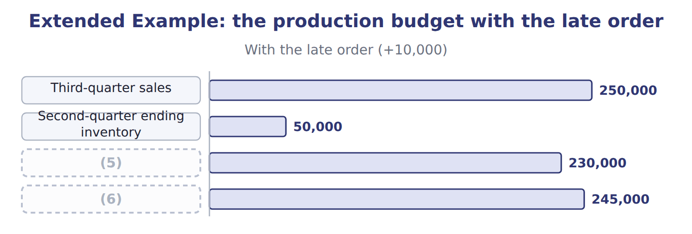
word list
sales forecast · Third-quarter production · Second-quarter production

2. Is it feasible?

Summary 2 gaps 7–8
Third-quarter (7) would be 245,000 cases, 5,000 above capacity. (8) ahead is not possible, because the store would already be full at 50,000 cases.
word list
production · Building · storage

Extended Example: options for the cases above capacity
Options for the 5,000 extra cases | Assessment
Build ahead in the second quarter | Not (9) : the store would already hold 50,000 cases, its limit
Overtime shifts in the third quarter | (10)
Outsource filling of the extra cases | Uses outside capacity (Book 2, Chapter 17); check quality
Accept only part of the order | Loses $41,000 of contribution margin

word list
Adds capacity; costs more per case · possible · Production budget

Summary 3 gaps 11–12
The (11) plans overtime shifts for the third quarter, because the extra cost per case is well below the (12) margin of $8.20 that each case earns.
word list
division · contribution · because

Everything ties

Summary 4 gaps 13–14
Budget: 900,000 cases sold + 43,000 ending − 42,000 (13) = 901,000 produced. Sales (14) $18,000,000 = the sales budget.
word list
beginning · revenue · overtime

Exam view

Summary 5 gaps 15–17
Expect a table of sales by period and an (15) policy. Compute ending and (16) stock for each period, the units to produce, and the sales revenue. Then check (17) and storage if the question gives them.
word list
beginning · capacity · division · inventory

Exam view
Tahini & Spreads, 500 g jars | Q1 2028 | Q2 2028 | Q3 2028 | Q4 2028 | Q1 2029
Jars to sell | 360,000 | 380,000 | 400,000 | 360,000 | 370,000
(18) | $3.50 | $3.50 | $3.50 | $3.50 | —

word list
Price per jar · Jars to sell

Item — Answer
Item | Answer
Q3 | (19)
Q4 | 225,000 + 43,000 (20% of 215,000) = 268,000; − 45,000 = 223,000

word list
Uses outside capacity (Book 2, Chapter 17); check quality · 240,000 + 45,000 = 285,000; − 48,000 = 237,000

Factor — Category
Every item belongs to exactly one group.
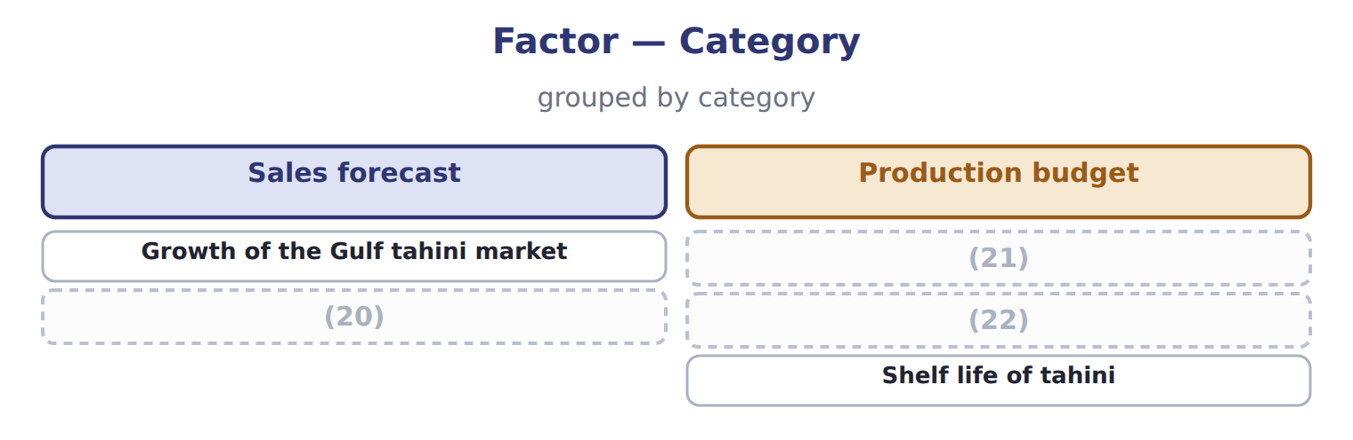
word list
Ending-stock policy of 10% · Capacity of the filling line · Planned price of the jars · Shelf life of tahini

The English this sheet uses, and its Arabic
English (exam term) | Arabic
sales budget | موازنة المبيعات
production budget | موازنة الإنتاج
inventory policy | سياسة المخزون

Answer key · 6.6 Extended Example 6A: a late order for the summer

1 February | 12 contribution
2 whether | 13 beginning
3 budget | 14 revenue
4 second-quarter | 15 inventory
5 Second-quarter production | 16 beginning
6 Third-quarter production | 17 capacity
7 production | 18 Price per jar
8 Building | 19 240,000 + 45,000 = 285,000; − 48,000 = 237,000
9 possible | 20 Planned price of the jars
10 Adds capacity; costs more per case | 21 Ending-stock policy of 10%
11 division | 22 Capacity of the filling line

the summaries in full
Summary 1 In February, Levant asks for 10,000 extra cases in the third quarter for a hotel chain. This example tests whether the production budget can absorb the order. Higher third-quarter sales raise the second quarter's ending stock, and therefore second-quarter production, as well as third-quarter production.
Summary 2 Third-quarter production would be 245,000 cases, 5,000 above capacity. Building ahead is not possible, because the store would already be full at 50,000 cases.
Summary 3 The division plans overtime shifts for the third quarter, because the extra cost per case is well below the contribution margin of $8.20 that each case earns.
Summary 4 Budget: 900,000 cases sold + 43,000 ending − 42,000 beginning = 901,000 produced. Sales revenue $18,000,000 = the sales budget.
Summary 5 Expect a table of sales by period and an inventory policy. Compute ending and beginning stock for each period, the units to produce, and the sales revenue. Then check capacity and storage if the question gives them.

7.1 From production to inputs
Chapter 7 · section 7.1

Fill every gap. Each word list holds one word more than there are gaps.
Chapter 7, section by section
Each stage leads to the next.
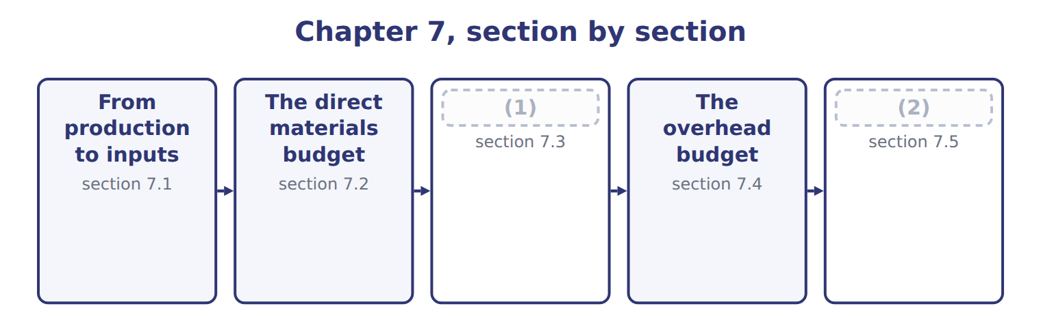
word list
The direct labor budget · Extended Example 7A: the manufacturing cost bu · The direct materials budget

Summary 1 gaps 3–10
Every input budget (3) from the production budget, not the sales budget, (4) materials and labor are used when cases are filled, not when they are sold. For each input, the budget (5) the cases to produce by the quantity per case: liters of (6) , labor hours and machine hours. Machine hours then drive the (7) overhead, while fixed overhead is (8) item by item. The link runs both ways. If an input budget shows a (9) of materials, labor or machine time, the production budget, and (10) the sales budget, must be changed.
word list
multiplies · shortage · budgeted · starts · perhaps · because · variable · concentrate · overhead

Answer key · 7.1 From production to inputs

1 The direct labor budget | 6 concentrate
2 Extended Example 7A: the manufacturing cost bu | 7 variable
3 starts | 8 budgeted
4 because | 9 shortage
5 multiplies | 10 perhaps

the summaries in full
Summary 1 Every input budget starts from the production budget, not the sales budget, because materials and labor are used when cases are filled, not when they are sold. For each input, the budget multiplies the cases to produce by the quantity per case: liters of concentrate, labor hours and machine hours. Machine hours then drive the variable overhead, while fixed overhead is budgeted item by item. The link runs both ways. If an input budget shows a shortage of materials, labor or machine time, the production budget, and perhaps the sales budget, must be changed.

7.2 The direct materials budget
Chapter 7 · section 7.2

Fill every gap. Each word list holds one word more than there are gaps.
Summary 1 gaps 1–3
The (1) materials budget has two parts: the materials to use and the materials to buy. (2) equal usage plus the desired ending stock minus the beginning stock, just like the (3) budget.
word list
Purchases · Concentrate · production · direct

Worked example: concentrate in the first quarter

Worked example: the concentrate budget for 2028
The bars are drawn to scale.
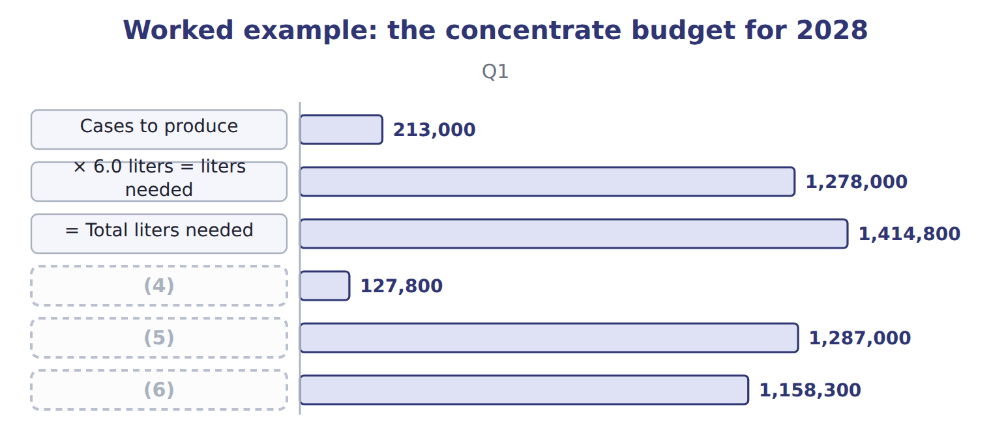
word list
direct materials budget · = Liters to buy · − Beginning stock · × $0.90 = cost of purchases

Concentrate in the third and fourth quarters

Summary 2 gaps 7–9
Complete the blank cells. The first quarter of 2029 is (7) at 218,000 cases. The (8) policy decides how much stock to hold. (9) travels further and is kept at 10% of the next quarter's needs.
word list
planned · Concentrate · procurement · quarter

Bottles, caps and cartons bought just-in-time
The bars are drawn to scale.
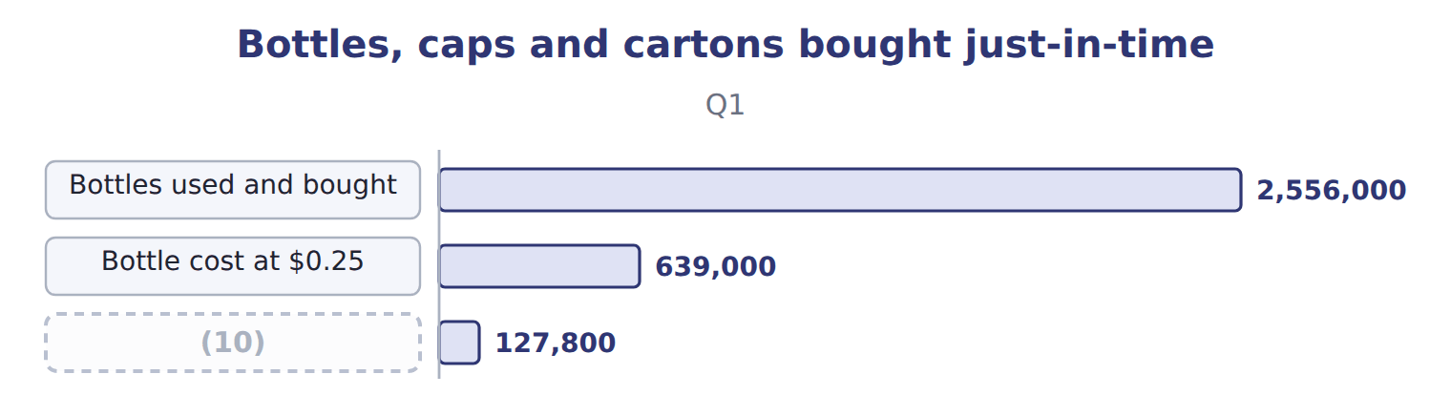
word list
Bottles used and bought · Caps and cartons at $0.60 a case

Procurement policies and their effect on the materials budget
Material | Procurement policy (B.5.h) | Effect on the materials budget
Concentrate | (11) | Purchases differ from usage by the change in stock
Bottles (Jordan Glass) | Just-in-time daily deliveries (Book 2, Chapter 17) | Purchases = usage; almost no stock
Caps and cartons | Just-in-time | Purchases = usage
Any item with a minimum order | Buy in fixed lots | (12)

word list
Keep 10% of next quarter's needs · Purchases rounded up; stock rises · × 6.0 liters = liters needed

Usage is not purchases

Summary 3 gaps 13–14
An answer that sets (13) equal to usage ignores the change in materials stock. It is right only for items bought (14) .
word list
just-in-time · further · purchases

The English this sheet uses, and its Arabic
English (exam term) | Arabic
direct materials budget | موازنة المواد المباشرة
procurement policy | سياسة الشراء
just-in-time (JIT) | التوقيت المحدد (الإنتاج في الوقت المحدد)

Answer key · 7.2 The direct materials budget

1 direct | 8 procurement
2 Purchases | 9 Concentrate
3 production | 10 Caps and cartons at $0.60 a case
4 − Beginning stock | 11 Keep 10% of next quarter's needs
5 = Liters to buy | 12 Purchases rounded up; stock rises
6 × $0.90 = cost of purchases | 13 purchases
7 planned | 14 just-in-time

the summaries in full
Summary 1 The direct materials budget has two parts: the materials to use and the materials to buy. Purchases equal usage plus the desired ending stock minus the beginning stock, just like the production budget.
Summary 2 Complete the blank cells. The first quarter of 2029 is planned at 218,000 cases. The procurement policy decides how much stock to hold. Concentrate travels further and is kept at 10% of the next quarter's needs.
Summary 3 An answer that sets purchases equal to usage ignores the change in materials stock. It is right only for items bought just-in-time.

7.3 The direct labor budget
Chapter 7 · section 7.3

Fill every gap. Each word list holds one word more than there are gaps.
Summary 1 gaps 1–2
The direct labor budget (1) the cases to produce by the (2) hours per case, then by the wage rate.
word list
working · standard · multiplies

Worked example: the direct labor budget for 2028
The bars are drawn to scale.
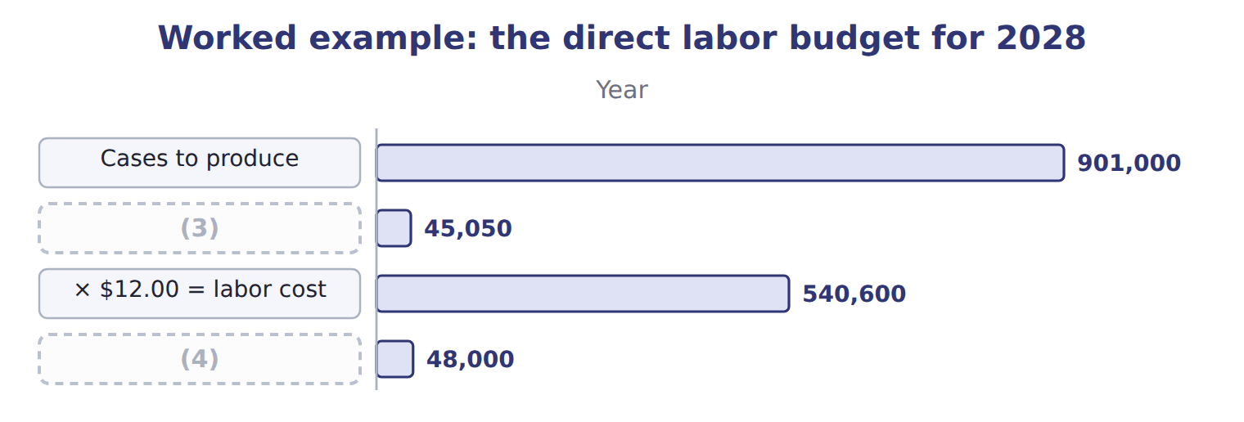
word list
Hours available · overhead budget · × 0.05 hours = hours needed

Summary 2 gaps 5–8
The budget must also be (5) . With 25 operators working 480 hours a quarter, 12,000 hours are (6) . The division (7) plans to hire two temporary operators for the summer. Checking (8) in this way is part of preparing the budget, not a separate task.
word list
available · feasibility · division · therefore · feasible

The English this sheet uses, and its Arabic
English (exam term) | Arabic
direct labor budget | موازنة العمل المباشر
feasibility | إمكانية التنفيذ

Answer key · 7.3 The direct labor budget

1 multiplies | 5 feasible
2 standard | 6 available
3 × 0.05 hours = hours needed | 7 therefore
4 Hours available | 8 feasibility

the summaries in full
Summary 1 The direct labor budget multiplies the cases to produce by the standard hours per case, then by the wage rate.
Summary 2 The budget must also be feasible. With 25 operators working 480 hours a quarter, 12,000 hours are available. The division therefore plans to hire two temporary operators for the summer. Checking feasibility in this way is part of preparing the budget, not a separate task.

7.4 The overhead budget
Chapter 7 · section 7.4

Fill every gap. Each word list holds one word more than there are gaps.
Summary 1 gaps 1–3
The overhead (1) has a variable part and a fixed part. Variable overhead moves with its driver, (2) hours, at $50.00 an hour; fixed overhead is budgeted item by item and does not change with (3) .
word list
machine · overhead · production · budget

Overhead items and rates
The bars are drawn to scale.
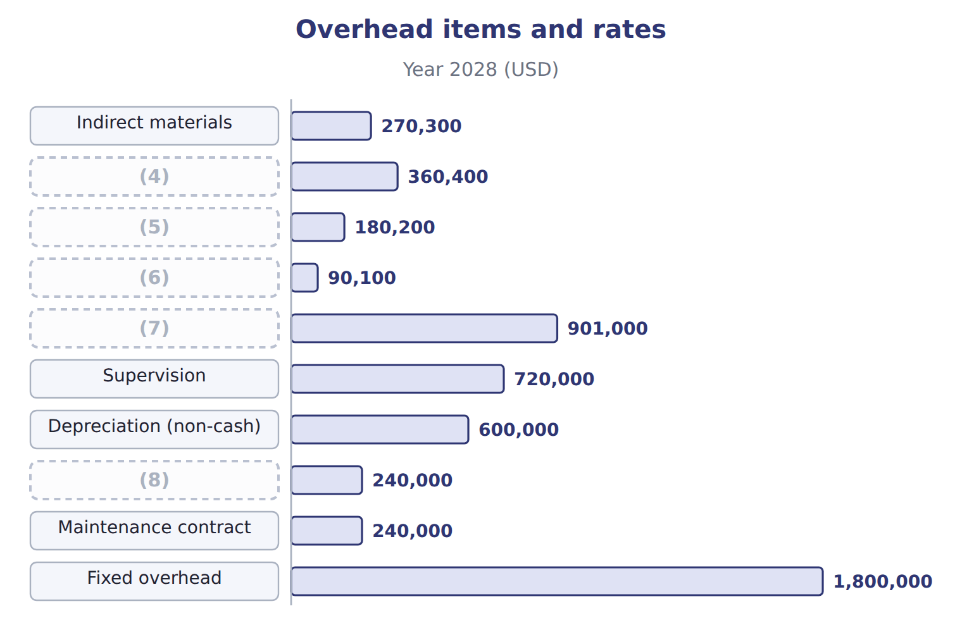
word list
Maintenance (variable part) · Power and water · direct materials budget · Variable overhead · Cleaning supplies · Insurance and property tax

Worked example: the quarterly overhead budget

Summary 2 gaps 9–10
First (9) : 213,000 cases × 0.02 = 4,260 machine hours × $50.00 = $213,000 (10) , plus $450,000 fixed = $663,000.
word list
quarter · Budgeting · variable

Worked example: the overhead budget for 2028
Overhead budget 2028 | Q1 | Q2 | Q3 | Q4 | Year
(11) | 213,000 | 228,000 | 237,000 | 223,000 | 901,000
(12) | 4,260 | 4,560 | 4,740 | 4,460 | 18,020
Variable overhead (× $50.00) | 213,000 | 228,000 | 237,000 | 223,000 | 901,000
Fixed overhead | 450,000 | 450,000 | 450,000 | 450,000 | 1,800,000
(13) | 663,000 | 678,000 | 687,000 | 673,000 | 2,701,000

word list
Overhead item · Machine hours (× 0.02) · Total overhead · Cases to produce

Fixed overhead does not follow volume

Summary 3 gaps 14–15
Budgeting fixed overhead as an amount per case makes it rise and fall with (14) . In the overhead budget, fixed overhead is the same each quarter; only (15) overhead follows the driver.
word list
quarter · variable · production

The English this sheet uses, and its Arabic
English (exam term) | Arabic
overhead budget | موازنة التكاليف الصناعية غير المباشرة

Answer key · 7.4 The overhead budget

1 budget | 9 quarter
2 machine | 10 variable
3 production | 11 Cases to produce
4 Power and water | 12 Machine hours (× 0.02)
5 Maintenance (variable part) | 13 Total overhead
6 Cleaning supplies | 14 production
7 Variable overhead | 15 variable
8 Insurance and property tax

the summaries in full
Summary 1 The overhead budget has a variable part and a fixed part. Variable overhead moves with its driver, machine hours, at $50.00 an hour; fixed overhead is budgeted item by item and does not change with production.
Summary 2 First quarter: 213,000 cases × 0.02 = 4,260 machine hours × $50.00 = $213,000 variable, plus $450,000 fixed = $663,000.
Summary 3 Budgeting fixed overhead as an amount per case makes it rise and fall with production. In the overhead budget, fixed overhead is the same each quarter; only variable overhead follows the driver.

7.5 Extended Example 7A: the manufacturing cost budget and the summer test
Chapter 7 · section 7.5

Fill every gap. Each word list holds one word more than there are gaps.
This example brings the three budgets together and tests the busiest quarter.
Extended Example: the manufacturing cost budget for 2028
The bars are drawn to scale.
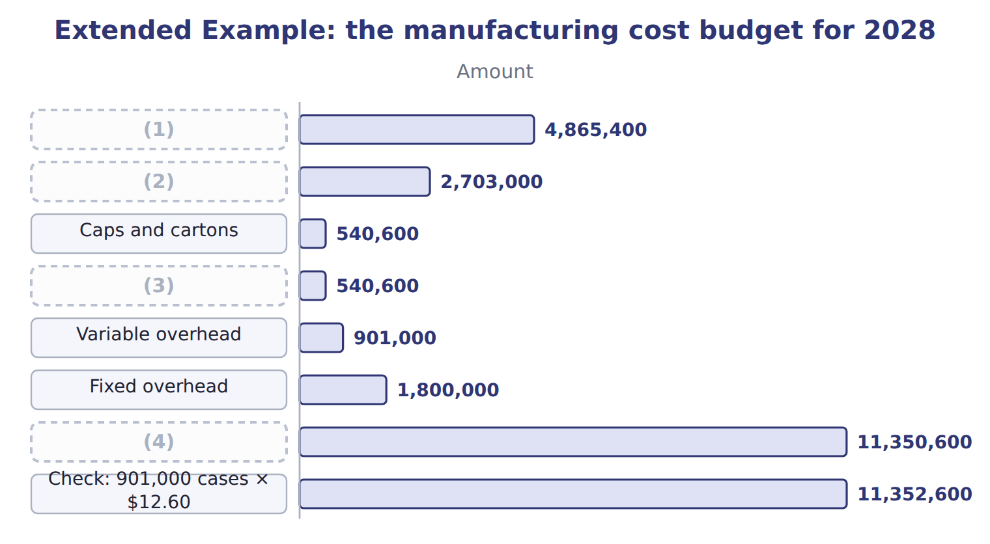
word list
Concentrate used · Bottles · just-in-time (JIT) · Budgeted manufacturing cost · Direct labor

Summary 1 gaps 5–6
At (5) , 901,000 cases × $12.60 = $11,352,600. The budget is $2,000 lower because fixed (6) is a fixed amount, while the card spreads it over a normal volume of 900,000 cases.
word list
standard · budgets · overhead

3. Can the third quarter be done?

Extended Example: can the third quarter be done?
Every item belongs to exactly one group.
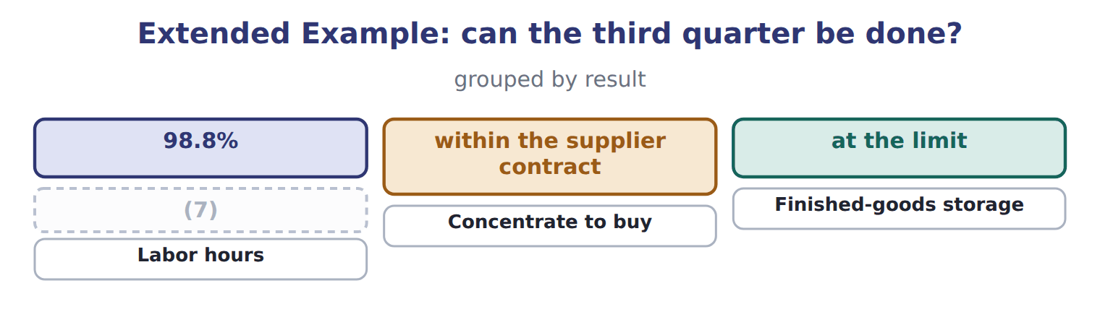
word list
Machine hours · just-in-time (JIT)

Everything ties

Concentrate purchases 5,409,000 liters = usage 5,406,000 + ending 130,800 − beginning 127,800.
Exam view

Summary 2 gaps 8–10
Expect a (8) budget and a materials policy. Compute usage, (9) in units and dollars, labor hours and cost, and overhead by variable and fixed parts. Then compare the hours or materials with what is (10) .
word list
available · purchases · overhead · production

Exam view
Tahini & Spreads, 2028 | Data
Jars to produce: second quarter | 382,000
Jars to produce: third quarter | 396,000
Sesame paste per jar | 0.50 kg
Price of sesame paste | (11)
Ending sesame stock | 20% of next quarter's needs
Labor per jar | (12)
Labor rate | (13)
Labor hours available in the second quarter | 4,500

word list
$2.50 a kg · $15.00 an hour · 0.50 kg · 0.012 hours

Item — Answer
Item | Answer
Q3 | 1,422,000 + 133,800 = 1,555,800; − 142,200 = 1,413,600 liters; × $0.90 = $1,272,240
Q4 | 1,338,000 + 130,800 (10% of 1,308,000) = 1,468,800; − 133,800 = 1,335,000 liters; × $0.90 = $1,201,500

Item — Category
Every item belongs to exactly one group.
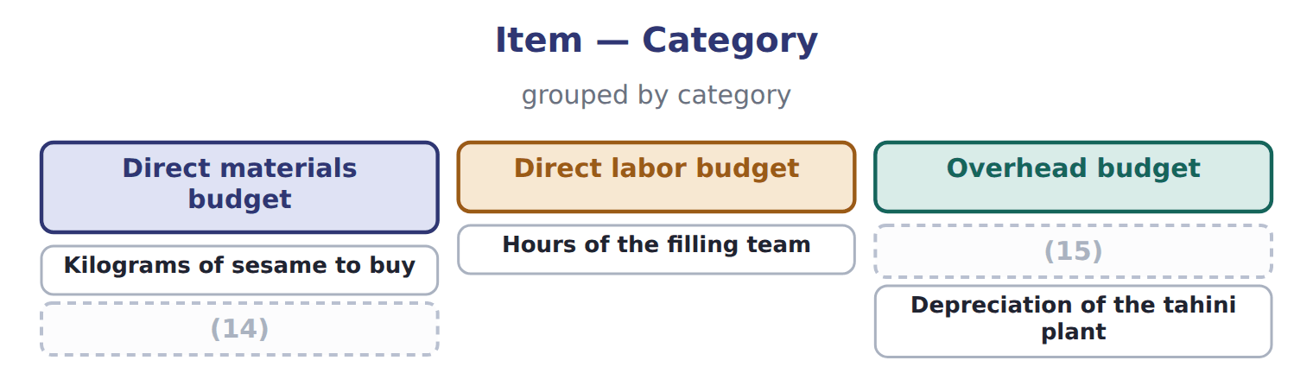
word list
Depreciation of the tahini plant · Power for the filling line · Ending stock of sesame

The English this sheet uses, and its Arabic
English (exam term) | Arabic
direct materials budget | موازنة المواد المباشرة
direct labor budget | موازنة العمل المباشر
overhead budget | موازنة التكاليف الصناعية غير المباشرة

Answer key · 7.5 Extended Example 7A: the manufacturing cost budget and the summer test

1 Concentrate used | 9 purchases
2 Bottles | 10 available
3 Direct labor | 11 $2.50 a kg
4 Budgeted manufacturing cost | 12 0.012 hours
5 standard | 13 $15.00 an hour
6 overhead | 14 Ending stock of sesame
7 Machine hours | 15 Power for the filling line
8 production

the summaries in full
Summary 1 At standard, 901,000 cases × $12.60 = $11,352,600. The budget is $2,000 lower because fixed overhead is a fixed amount, while the card spreads it over a normal volume of 900,000 cases.
Summary 2 Expect a production budget and a materials policy. Compute usage, purchases in units and dollars, labor hours and cost, and overhead by variable and fixed parts. Then compare the hours or materials with what is available.

8.1 The cost of goods sold budget
Chapter 8 · section 8.1

Fill every gap. Each word list holds one word more than there are gaps.
Chapter 8, section by section
Each stage leads to the next.
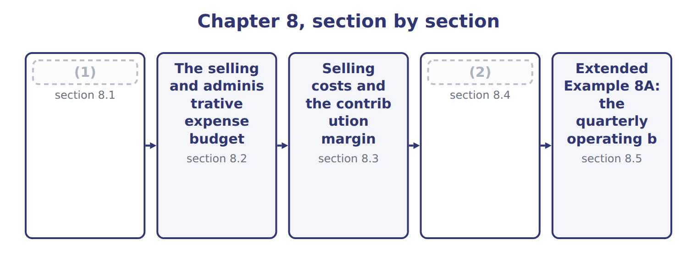
word list
The operating budget · The cost of goods sold budget · The selling and administrative expense budget

Summary 1 gaps 3–4
The cost of goods sold budget has three (3) : beginning finished goods, plus the cost of goods (4) in the period, minus ending finished goods.
word list
production · components · manufactured

Worked example: cost of goods sold for 2028

Summary 2 gaps 5–6
Beginning stock 42,000 cases × $12.60 = $529,200; plus cost of goods (5) $11,350,600; minus (6) stock 43,000 cases × $12.60 = $541,800.
word list
ending · overhead · manufactured

Worked example: the cost of goods sold budget for 2028
The bars are drawn to scale.
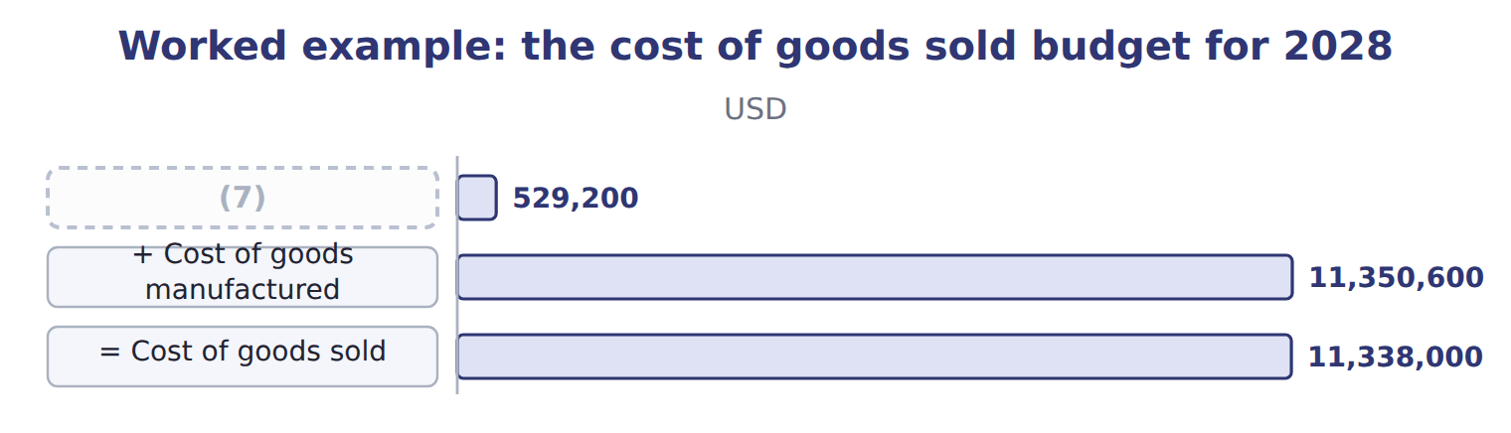
word list
cost of goods manufactured · Beginning finished goods

Summary 3 gaps 8–12
The check line (8) the result. At standard, 900,000 cases sold × $12.60 = $11,340,000; the budget is $2,000 lower because fixed overhead applied to (9) is slightly above the fixed overhead (10) . For (11) budgets, cost of goods sold is simply the cases sold at standard, and the small (12) adjustment is made at the end of the year.
word list
fixed-overhead · budgeted · production · explains · quarterly · standard

Cost of goods sold by quarter
The bars are drawn to scale.
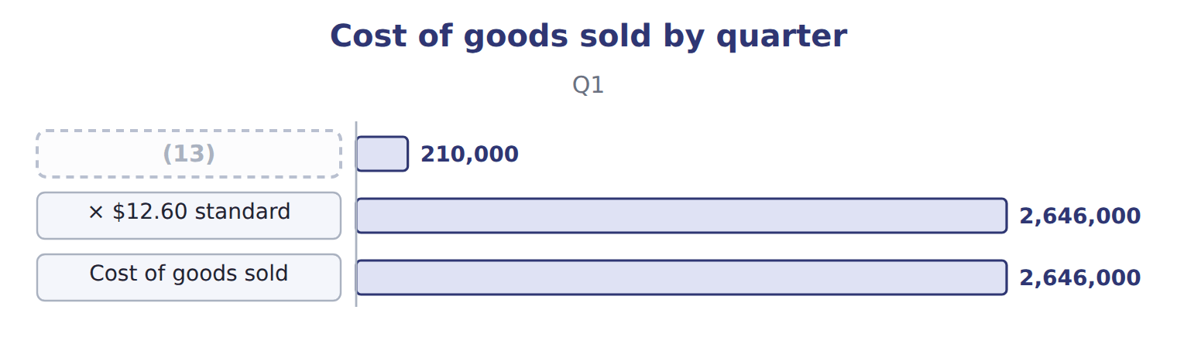
word list
Cases sold · contribution margin

Manufactured is not sold

Summary 4 gaps 14–16
Cost of goods (14) is the cost of cases finished; cost of goods sold is the cost of cases sold. An (15) that uses one for the other (16) the change in finished goods.
word list
ignores · adjustment · answer · manufactured

The English this sheet uses, and its Arabic
English (exam term) | Arabic
cost of goods sold budget | موازنة تكلفة البضاعة المباعة
cost of goods manufactured | تكلفة الإنتاج التام

Answer key · 8.1 The cost of goods sold budget

1 The cost of goods sold budget | 9 production
2 The operating budget | 10 budgeted
3 components | 11 quarterly
4 manufactured | 12 fixed-overhead
5 manufactured | 13 Cases sold
6 ending | 14 manufactured
7 Beginning finished goods | 15 answer
8 explains | 16 ignores

the summaries in full
Summary 1 The cost of goods sold budget has three components: beginning finished goods, plus the cost of goods manufactured in the period, minus ending finished goods.
Summary 2 Beginning stock 42,000 cases × $12.60 = $529,200; plus cost of goods manufactured $11,350,600; minus ending stock 43,000 cases × $12.60 = $541,800.
Summary 3 The check line explains the result. At standard, 900,000 cases sold × $12.60 = $11,340,000; the budget is $2,000 lower because fixed overhead applied to production is slightly above the fixed overhead budgeted. For quarterly budgets, cost of goods sold is simply the cases sold at standard, and the small fixed-overhead adjustment is made at the end of the year.
Summary 4 Cost of goods manufactured is the cost of cases finished; cost of goods sold is the cost of cases sold. An answer that uses one for the other ignores the change in finished goods.

8.2 The selling and administrative expense budget
Chapter 8 · section 8.2

Fill every gap. Each word list holds one word more than there are gaps.
Summary 1 gaps 1–4
The selling and (1) expense budget has two kinds of (2) . (3) selling expenses, such as freight to customers and sales (4) , change with cases sold. Fixed costs, such as marketing, salaries, administration and depreciation of offices and vehicles, are budgeted item by item.
word list
commissions · overhead · Variable · components · administrative

Components of the selling and administrative expense budget
The bars are drawn to scale.
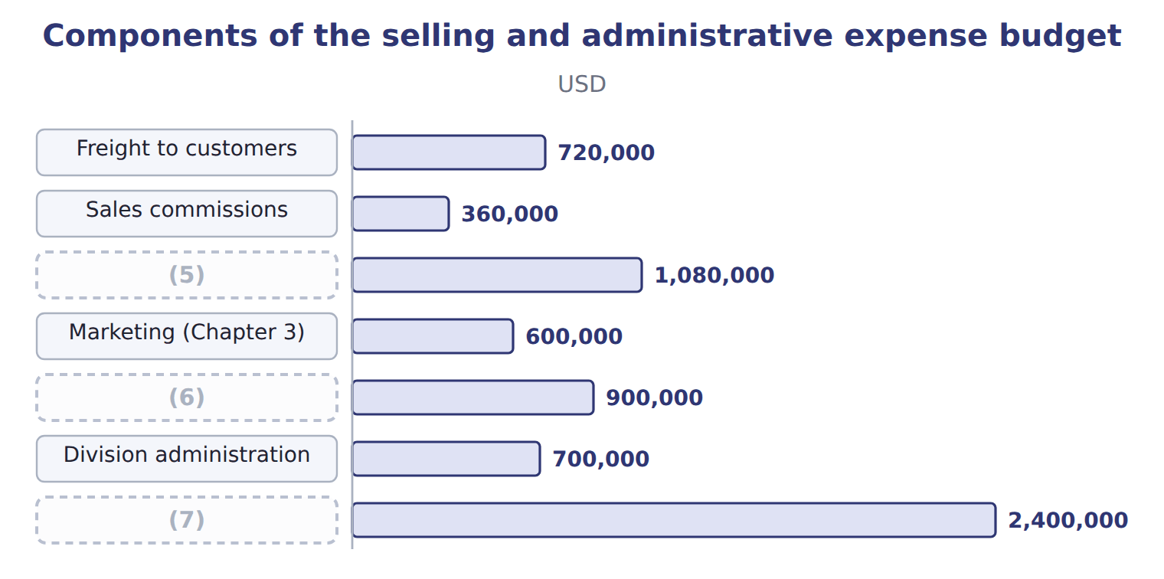
word list
Sales team salaries · Variable selling expenses · Marketing (Chapter 3) · Fixed selling and administrative

Selling and admin in the third and fourth quarters

Complete the blank cells.
Your turn: selling and admin by quarter (complete the blanks)
The bars are drawn to scale.
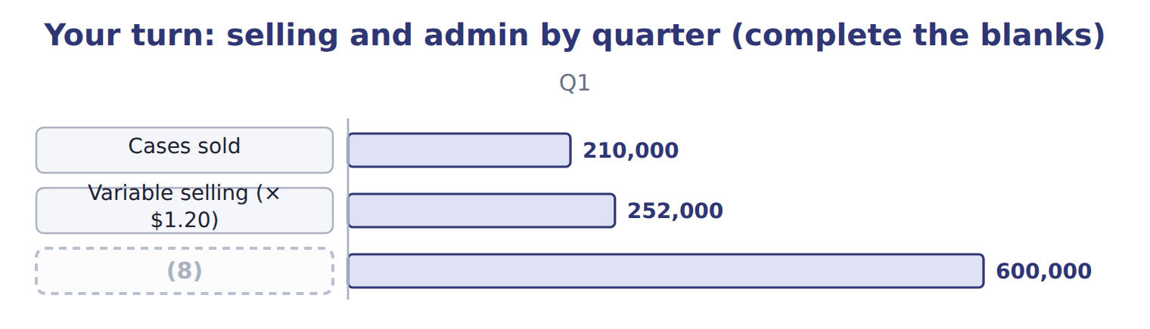
word list
cost of goods manufactured · Fixed selling and admin

Summary 2 gaps 9–10
Depreciation of offices and vehicles is shown (9) because it uses no cash, together with the depreciation in (10) overhead.
word list
commissions · manufacturing · separately

The English this sheet uses, and its Arabic
English (exam term) | Arabic
selling and administrative expense budget | موازنة المصروفات البيعية والإدارية

Answer key · 8.2 The selling and administrative expense budget

1 administrative | 6 Sales team salaries
2 components | 7 Fixed selling and administrative
3 Variable | 8 Fixed selling and admin
4 commissions | 9 separately
5 Variable selling expenses | 10 manufacturing

the summaries in full
Summary 1 The selling and administrative expense budget has two kinds of components. Variable selling expenses, such as freight to customers and sales commissions, change with cases sold. Fixed costs, such as marketing, salaries, administration and depreciation of offices and vehicles, are budgeted item by item.
Summary 2 Depreciation of offices and vehicles is shown separately because it uses no cash, together with the depreciation in manufacturing overhead.

8.3 Selling costs and the contribution margin
Chapter 8 · section 8.3

Fill every gap. Each word list holds one word more than there are gaps.
Summary 1 gaps 1–2
Selling and (1) costs affect the contribution margin only if they are variable. Freight and commissions are deducted before the contribution margin; marketing, salaries and (2) are deducted after it.
word list
administration · administrative · depends

Worked example: a commission plan

Summary 2 gaps 3–4
The sales director proposes raising (3) by $0.30 a case and cutting sales salaries by $200,000, expecting 20,000 extra cases. The (4) margin per case falls to $7.90.
word list
contribution · administrative · commissions

Worked example: the effect of a commission plan
Commission proposal | Now | Commission +$0.30 a case
Contribution margin per case | $8.20 | $7.90
Cases | 900,000 | 920,000
Contribution margin | 7,380,000 | 7,268,000
(5) |  | (112,000)
(6) |  | 200,000
Change in operating income |  | 88,000

word list
Change in contribution margin · Contribution margin per case · Saving in sales salaries

Summary 3 gaps 7–9
The (7) turns a fixed cost into a variable one. That lowers the (8) margin per case and the break-even risk, but it pays more when sales are high. The decision depends on how (9) the division is about the extra volume.
word list
confident · contribution · administration · proposal

Which costs go above the line?

Summary 4 gaps 10–11
Variable selling costs reduce the contribution margin; fixed selling and (10) costs do not. Deducting marketing or salaries before the contribution margin, or leaving out freight and (11) , gives the wrong margin.
word list
administrative · raising · commissions

Answer key · 8.3 Selling costs and the contribution margin

1 administrative | 7 proposal
2 administration | 8 contribution
3 commissions | 9 confident
4 contribution | 10 administrative
5 Change in contribution margin | 11 commissions
6 Saving in sales salaries

the summaries in full
Summary 1 Selling and administrative costs affect the contribution margin only if they are variable. Freight and commissions are deducted before the contribution margin; marketing, salaries and administration are deducted after it.
Summary 2 The sales director proposes raising commissions by $0.30 a case and cutting sales salaries by $200,000, expecting 20,000 extra cases. The contribution margin per case falls to $7.90.
Summary 3 The proposal turns a fixed cost into a variable one. That lowers the contribution margin per case and the break-even risk, but it pays more when sales are high. The decision depends on how confident the division is about the extra volume.
Summary 4 Variable selling costs reduce the contribution margin; fixed selling and administrative costs do not. Deducting marketing or salaries before the contribution margin, or leaving out freight and commissions, gives the wrong margin.

8.4 The operating budget
Chapter 8 · section 8.4

Fill every gap. Each word list holds one word more than there are gaps.
Summary 1 gaps 1–3
The operating budget, or budgeted income (1) , brings the schedules together: sales, minus cost of goods sold, minus selling and (2) expenses, gives budgeted operating income. (3) and income taxes are added later.
word list
expenses · statement · administrative · Interest

Worked example: the Beverages operating budget

Summary 2 gaps 4–5
Sales $18,000,000 − cost of goods sold $11,338,000 = gross margin $6,662,000; − selling and (4) $3,480,000 = (5) income $3,182,000.
word list
operating · together · administrative

Worked example: the Beverages operating budget for 2028
The bars are drawn to scale.
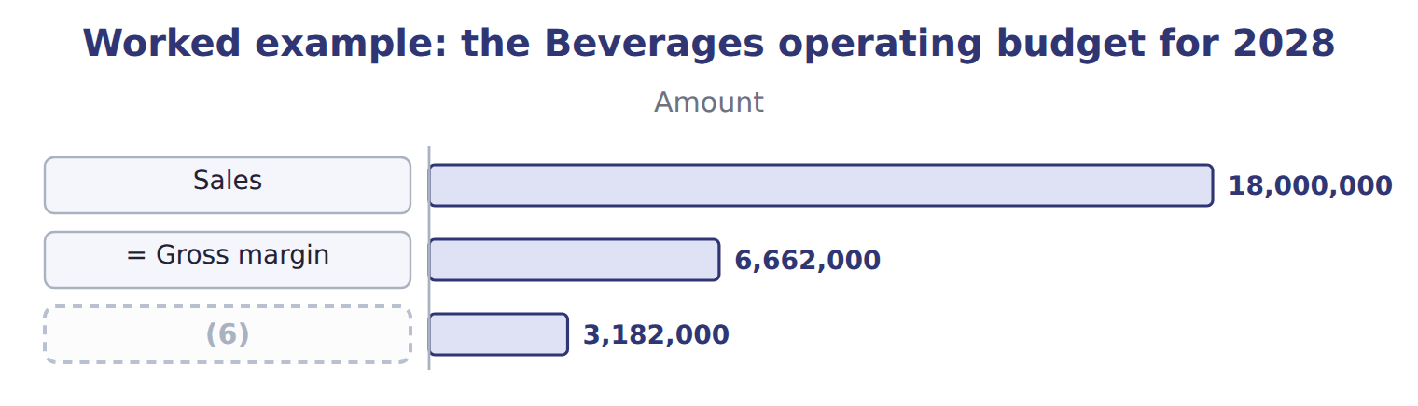
word list
= Gross margin · = Operating income

In contribution format, the same year gives $3,180,000, the flexible budget.
Reconciling the contribution and functional formats
Reconciling the two formats (USD) | Amount
(7) : 900,000 cases × $8.20 | 7,380,000
(8) | (4,200,000)
(9) | 3,180,000
+ Fixed overhead held in the rise in stock | 2,000
= Operating income, functional format | 3,182,000

word list
− Fixed costs: 12 × $350,000 · cost of goods sold budget · = Operating income, contribution format · Contribution margin

The English this sheet uses, and its Arabic
English (exam term) | Arabic
operating budget (budgeted income statement) | الموازنة التشغيلية (قائمة الدخل التقديرية)
contribution margin | هامش المساهمة

Answer key · 8.4 The operating budget

1 statement | 6 = Operating income
2 administrative | 7 Contribution margin
3 Interest | 8 − Fixed costs: 12 × $350,000
4 administrative | 9 = Operating income, contribution format
5 operating

the summaries in full
Summary 1 The operating budget, or budgeted income statement, brings the schedules together: sales, minus cost of goods sold, minus selling and administrative expenses, gives budgeted operating income. Interest and income taxes are added later.
Summary 2 Sales $18,000,000 − cost of goods sold $11,338,000 = gross margin $6,662,000; − selling and administrative $3,480,000 = operating income $3,182,000.

8.5 Extended Example 8A: the quarterly operating budget for the board
Chapter 8 · section 8.5

Fill every gap. Each word list holds one word more than there are gaps.
Summary 1 gaps 1–2
The board reviews results every quarter, so it wants the (1) budget by quarter. This example builds it from the (2) .
word list
reviews · operating · schedules

Extended Example: the quarterly operating budget
The bars are drawn to scale.
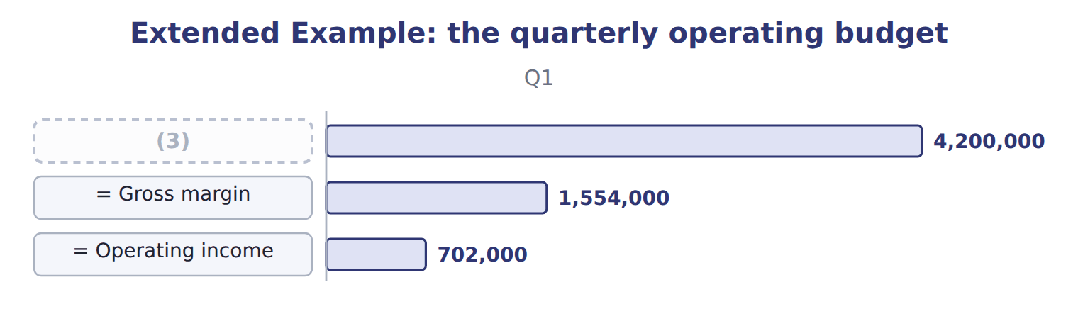
word list
Sales · contribution margin

Summary 2 gaps 4–5
Operating income (4) the season, peaking at $888,000 in the summer quarter. The board will compare each (5) actual result with this budget, using the flexible budget.
word list
follows · flexible · quarter's

Everything ties

Quarters: $702,000 + $795,000 + $888,000 + $795,000 = $3,180,000; + $2,000 at year end = $3,182,000.
Exam view

Summary 3 gaps 6–9
Expect stock and (6) figures to build cost of goods sold, a list of selling and (7) costs to classify, and the parts of an operating budget to combine. Watch which costs are (8) , and whether the question asks for gross margin, (9) margin or operating income.
word list
administrative · contribution · production · variable · schedules

Exam view
Tahini & Spreads, second quarter 2028 | Data
(10) | 380,000
Jars produced in the second quarter | 382,000
(11) | 38,000
(12) | 40,000
Selling price per jar | $3.50
Variable manufacturing cost per jar | $1.90
Fixed manufacturing overhead per jar (normal volume) | $0.64
(13) | $0.10
(14) | $40,000

word list
Finished jars at the start of the quarter · Jars sold in the second quarter · Fixed selling and admin per month · Fixed selling and administrative expense · Finished jars at the end of the quarter · Variable selling cost per jar

Item — Answer
Item | Answer
Q3 | (15) 240,000 × $1.20 = $288,000; total $288,000 + $600,000 = $888,000
Q4 | Variable 225,000 × $1.20 = $270,000; total $270,000 + $600,000 = $870,000

word list
Cost · Variable

Cost — Category
Cost | Category
Depreciation of the tahini plant | Manufacturing cost
Freight to Gulf buyers per jar | (16)
Sales team salaries | (17)
Sesame paste | (18)
Marketing in the Gulf | Fixed selling and administrative expense

word list
Manufacturing cost · Fixed selling and administrative expense · Variable selling expense · − Cost of goods sold

The English this sheet uses, and its Arabic
English (exam term) | Arabic
cost of goods sold budget | موازنة تكلفة البضاعة المباعة
selling and administrative expense budget | موازنة المصروفات البيعية والإدارية
operating budget (budgeted income statement) | الموازنة التشغيلية (قائمة الدخل التقديرية)

Answer key · 8.5 Extended Example 8A: the quarterly operating budget for the board

1 operating | 10 Jars sold in the second quarter
2 schedules | 11 Finished jars at the start of the quarter
3 Sales | 12 Finished jars at the end of the quarter
4 follows | 13 Variable selling cost per jar
5 quarter's | 14 Fixed selling and admin per month
6 production | 15 Variable
7 administrative | 16 Variable selling expense
8 variable | 17 Fixed selling and administrative expense
9 contribution | 18 Manufacturing cost

the summaries in full
Summary 1 The board reviews results every quarter, so it wants the operating budget by quarter. This example builds it from the schedules.
Summary 2 Operating income follows the season, peaking at $888,000 in the summer quarter. The board will compare each quarter's actual result with this budget, using the flexible budget.
Summary 3 Expect stock and production figures to build cost of goods sold, a list of selling and administrative costs to classify, and the parts of an operating budget to combine. Watch which costs are variable, and whether the question asks for gross margin, contribution margin or operating income.

9.1 The capital expenditure budget
Chapter 9 · section 9.1

Fill every gap. Each word list holds one word more than there are gaps.
Chapter 9, section by section
Each stage leads to the next.
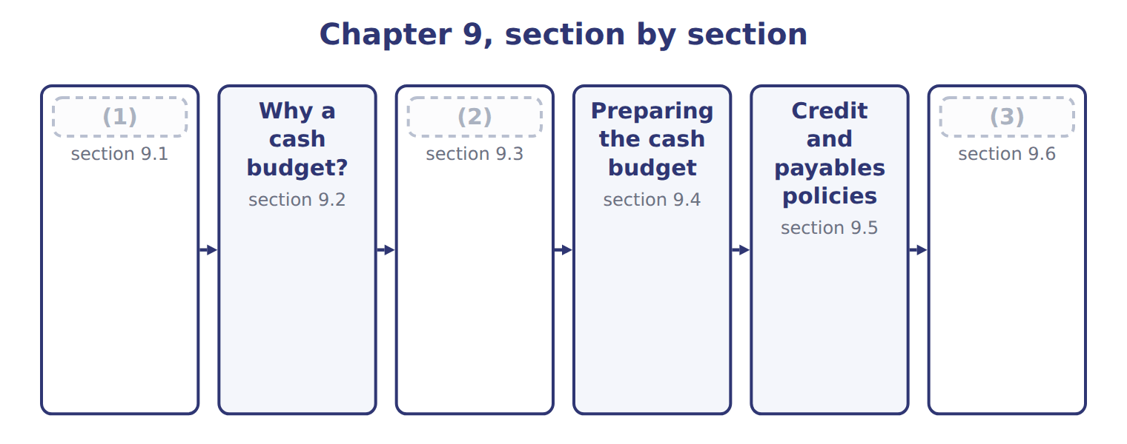
word list
Collections and payments · Extended Example 9A: financing the year and ha · Preparing the cash budget · The capital expenditure budget

Summary 1 gaps 4–7
The capital (4) budget plans spending on (5) assets, such as plant, equipment and systems, by project and by period. Each project is approved (6) , usually with capital (7) methods (a CMA Part 2 topic), and then placed in the quarter when cash will be paid.
word list
depreciation · expenditure · budgeting · separately · long-term

Worked example: the filling line by quarter

Summary 2 gaps 8–9
The project budget: (8) in the first quarter, (9) and half the training in the second, the rest in the third.
word list
installation · equipment · training

Worked example: the capital expenditure budget for 2028
The bars are drawn to scale.
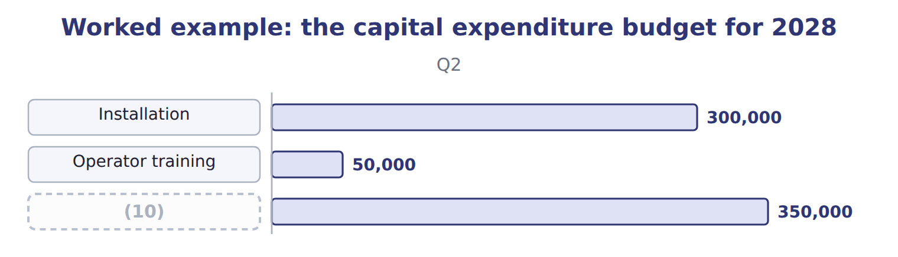
word list
Capital expenditure · credit policy

Summary 3 gaps 11–15
One (11) affects three (12) . The cash budget shows the cash paid; the budgeted income statement shows depreciation over the (13) life; the budgeted (14) sheet shows the asset at cost less depreciation. The capital budget is a (15) budget, not part of the operating budget: the purchase itself is not an expense. Only its depreciation reaches the income statement, a little at a time.
word list
balance · investment · methods · statements · asset's · financial

The English this sheet uses, and its Arabic
English (exam term) | Arabic
capital expenditure budget | موازنة النفقات الرأسمالية

Answer key · 9.1 The capital expenditure budget

1 The capital expenditure budget | 9 installation
2 Collections and payments | 10 Capital expenditure
3 Extended Example 9A: financing the year and ha | 11 investment
4 expenditure | 12 statements
5 long-term | 13 asset's
6 separately | 14 balance
7 budgeting | 15 financial
8 equipment

the summaries in full
Summary 1 The capital expenditure budget plans spending on long-term assets, such as plant, equipment and systems, by project and by period. Each project is approved separately, usually with capital budgeting methods (a CMA Part 2 topic), and then placed in the quarter when cash will be paid.
Summary 2 The project budget: equipment in the first quarter, installation and half the training in the second, the rest in the third.
Summary 3 One investment affects three statements. The cash budget shows the cash paid; the budgeted income statement shows depreciation over the asset's life; the budgeted balance sheet shows the asset at cost less depreciation. The capital budget is a financial budget, not part of the operating budget: the purchase itself is not an expense. Only its depreciation reaches the income statement, a little at a time.

9.2 Why a cash budget?
Chapter 9 · section 9.2

Fill every gap. Each word list holds one word more than there are gaps.
Summary 1 gaps 1–7
The cash budget plans the cash (1) in and going out each (2) and the cash left at the end. Its purposes are to show (3) early, so that (4) can be arranged in time, and to show surpluses that can be invested or used to repay loans. It is (5) to every other budget. Two (6) change on the way to the cash budget. Timing changes, because customers and suppliers pay later; and non-cash items, such as (7) , drop out.
word list
borrowing · linked · coming · arranged · shortages · depreciation · things · period

The English this sheet uses, and its Arabic
English (exam term) | Arabic
cash budget | الموازنة النقدية

Answer key · 9.2 Why a cash budget?

1 coming | 5 linked
2 period | 6 things
3 shortages | 7 depreciation
4 borrowing

the summaries in full
Summary 1 The cash budget plans the cash coming in and going out each period and the cash left at the end. Its purposes are to show shortages early, so that borrowing can be arranged in time, and to show surpluses that can be invested or used to repay loans. It is linked to every other budget. Two things change on the way to the cash budget. Timing changes, because customers and suppliers pay later; and non-cash items, such as depreciation, drop out.

9.3 Collections and payments
Chapter 9 · section 9.3

Fill every gap. Each word list holds one word more than there are gaps.
Summary 1 gaps 1–3
Cash (1) follow the (2) policy, not the sales budget. Beverages collects 40% of each quarter's sales in that quarter and 60% in the next, so the first quarter also collects the rest of last year's (3) sales.
word list
collections · fourth-quarter · supplier · credit

Worked example: collections in the first quarter

Summary 2 gaps 4–5
The first quarter (4) $2,460,000 still owed from last year, plus 40% of (5) sales of $4,200,000, for a total of $4,140,000.
word list
collects · supplier · first-quarter

Worked example: the collections schedule for 2028
The bars are drawn to scale.
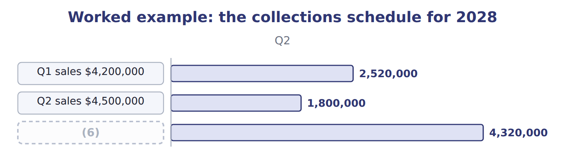
word list
Cash collections · cash disbursements

Summary 3 gaps 7–9
Cash (7) follow the (8) terms in the same way. The (9) supplier is paid 50% in the quarter of purchase and the rest in the next; bottles, wages and most expenses are paid as they occur.
word list
disbursements · straight · concentrate · payment

Concentrate payments by quarter
The bars are drawn to scale.
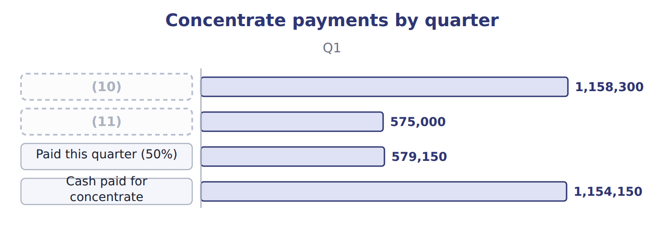
word list
Purchases (Chapter 7) · Paid from last quarter (50%) · Paid this quarter (50%)

Concentrate payments in the third and fourth quarters

Complete the blank cells.
Sales are not collections

Summary 4 gaps 12–13
An answer that puts sales or (12) straight into the cash budget ignores credit and payment terms. Build a (13) schedule and a payments schedule first.
word list
disbursements · purchases · collections

The English this section uses, and its Arabic
Each term sits against what it means.
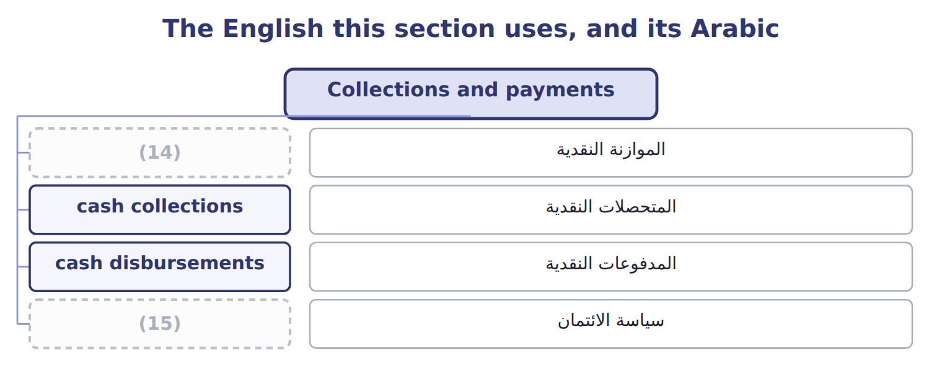
word list
cash budget · cash collections · credit policy

The English this sheet uses, and its Arabic
English (exam term) | Arabic
cash collections | المتحصلات النقدية
cash disbursements | المدفوعات النقدية
credit policy | سياسة الائتمان

Answer key · 9.3 Collections and payments

1 collections | 9 concentrate
2 credit | 10 Purchases (Chapter 7)
3 fourth-quarter | 11 Paid from last quarter (50%)
4 collects | 12 purchases
5 first-quarter | 13 collections
6 Cash collections | 14 cash budget
7 disbursements | 15 credit policy
8 payment

the summaries in full
Summary 1 Cash collections follow the credit policy, not the sales budget. Beverages collects 40% of each quarter's sales in that quarter and 60% in the next, so the first quarter also collects the rest of last year's fourth-quarter sales.
Summary 2 The first quarter collects $2,460,000 still owed from last year, plus 40% of first-quarter sales of $4,200,000, for a total of $4,140,000.
Summary 3 Cash disbursements follow the payment terms in the same way. The concentrate supplier is paid 50% in the quarter of purchase and the rest in the next; bottles, wages and most expenses are paid as they occur.
Summary 4 An answer that puts sales or purchases straight into the cash budget ignores credit and payment terms. Build a collections schedule and a payments schedule first.

9.4 Preparing the cash budget
Chapter 9 · section 9.4

Fill every gap. Each word list holds one word more than there are gaps.
Summary 1 gaps 1–5
The cash budget has four parts: beginning cash plus (1) gives cash available; minus (2) gives cash before financing; borrowing, interest and repayments give ending cash. (3) keeps a minimum cash (4) of $400,000. (5) costs are left out. Fixed overhead is paid at $300,000 a quarter, not $450,000, because $150,000 of it is depreciation; fixed selling and administrative costs are paid at $550,000.
word list
balance · repayments · Management · disbursements · collections · Non-cash

Worked example: the first quarter

Summary 2 gaps 6–7
Cash available $4,640,000 − (6) $5,163,750 = $(523,750) before financing. To stay above the minimum after interest, (7) borrows $1,000,000 in steps of $100,000; after interest of $20,000, ending cash is $456,250.
word list
quarter · Beverages · disbursements

Worked example: the Beverages cash budget for 2028
Beverages cash budget 2028 (USD) | Q1 | Q2 | Q3 | Q4
Beginning cash | 500,000 | 456,250 | 403,470 | 538,920
+ Collections | 4,140,000 | 4,320,000 | 4,620,000 | 4,680,000
(8) | 4,640,000 | 4,776,250 | 5,023,470 | 5,218,920
Concentrate | (1,154,150) | (1,197,180) | (1,254,150) | (1,236,870)
Bottles, caps and cartons | (766,800) | (820,800) | (853,200) | (802,800)
Direct labor | (127,800) | (136,800) | (142,200) | (133,800)
(9) | (213,000) | (228,000) | (237,000) | (223,000)
(10) | (300,000) | (300,000) | (300,000) | (300,000)
(11) | (252,000) | (270,000) | (288,000) | (270,000)
(12) | (550,000) | (550,000) | (550,000) | (550,000)
(13) | (1,800,000) | (350,000) | (350,000) | —
= Total disbursements | 5,163,750 | 3,852,780 | 3,974,550 | 3,516,470
(14) | (523,750) | 923,470 | 1,048,920 | 1,702,450
+ Borrowing | 1,000,000 | — | — | —
− Interest | (20,000) | (20,000) | (10,000) | —
− Repayment | — | (500,000) | (500,000) | —
(15) | 456,250 | 403,470 | 538,920 | 1,702,450

word list
Variable selling · Cash before financing · Fixed overhead (cash part) · Capital expenditure · = Cash available · Variable overhead · = Ending cash · Fixed selling and admin (cash part) · + Borrowing

The English this sheet uses, and its Arabic
English (exam term) | Arabic
minimum cash balance | الحد الأدنى للرصيد النقدي

Answer key · 9.4 Preparing the cash budget

1 collections | 9 Variable overhead
2 disbursements | 10 Fixed overhead (cash part)
3 Management | 11 Variable selling
4 balance | 12 Fixed selling and admin (cash part)
5 Non-cash | 13 Capital expenditure
6 disbursements | 14 Cash before financing
7 Beverages | 15 = Ending cash
8 = Cash available

the summaries in full
Summary 1 The cash budget has four parts: beginning cash plus collections gives cash available; minus disbursements gives cash before financing; borrowing, interest and repayments give ending cash. Management keeps a minimum cash balance of $400,000. Non-cash costs are left out. Fixed overhead is paid at $300,000 a quarter, not $450,000, because $150,000 of it is depreciation; fixed selling and administrative costs are paid at $550,000.
Summary 2 Cash available $4,640,000 − disbursements $5,163,750 = $(523,750) before financing. To stay above the minimum after interest, Beverages borrows $1,000,000 in steps of $100,000; after interest of $20,000, ending cash is $456,250.

9.5 Credit and payables policies
Chapter 9 · section 9.5

Fill every gap. Each word list holds one word more than there are gaps.
Summary 1 gaps 1–2
Credit and payables policies change the timing of cash, and (1) the borrowing. (2) faster from customers brings cash in earlier; paying suppliers faster sends it out earlier.
word list
supermarkets · therefore · Collecting

The effect of credit and payables policies on first-quarter cash
First quarter 2028 (USD) | Budget | Changed policy | Effect on cash
Collections in the first quarter | 4,140,000 | 4,560,000 | (3)
Cash before financing | (523,750) | (103,750) | +420,000
Concentrate paid in the first quarter, if paid 100% at once | 1,154,150 | 1,733,300 | −579,150

word list
+420,000 · credit policy

Summary 2 gaps 4–6
Tighter credit has a cost: customers such as Levant and the (4) may buy less or ask for discounts. Slower payment to (5) may lose discounts or goodwill. The cash budget shows the cash effect; (6) weighs it against these costs.
word list
therefore · suppliers · supermarkets · management

Policy changes move cash, not profit

Summary 3 gaps 7–9
A change in credit or (7) terms changes when cash arrives or leaves, not the sales or expenses (8) . Unless the question adds a discount or lost sales, (9) income does not change.
word list
themselves · payment · operating · supermarkets

Answer key · 9.5 Credit and payables policies

1 therefore | 6 management
2 Collecting | 7 payment
3 +420,000 | 8 themselves
4 supermarkets | 9 operating
5 suppliers

the summaries in full
Summary 1 Credit and payables policies change the timing of cash, and therefore the borrowing. Collecting faster from customers brings cash in earlier; paying suppliers faster sends it out earlier.
Summary 2 Tighter credit has a cost: customers such as Levant and the supermarkets may buy less or ask for discounts. Slower payment to suppliers may lose discounts or goodwill. The cash budget shows the cash effect; management weighs it against these costs.
Summary 3 A change in credit or payment terms changes when cash arrives or leaves, not the sales or expenses themselves. Unless the question adds a discount or lost sales, operating income does not change.

9.6 Extended Example 9A: financing the year and handing over to the pro forma statements
Chapter 9 · section 9.6

Fill every gap. Each word list holds one word more than there are gaps.
Summary 1 gaps 1–2
This example (1) the loan through the year and (2) the cash budget as a whole.
word list
follows · checks · minimum

Extended Example: the financing schedule
Every item belongs to exactly one group.
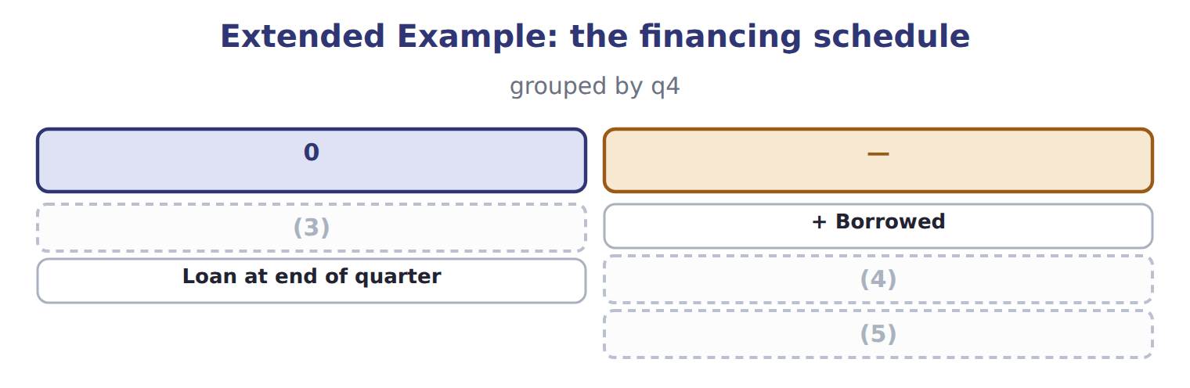
word list
capital expenditure budget · Loan at start of quarter · − Repaid · Interest paid (2% a quarter)

Extended Example: the year's cash in one reconciliation
Year 2028 (USD) | Amount
Beginning cash | 500,000
+ Collections | 17,760,000
(6) | (16,507,550)
− Interest | (50,000)
(7) | 1,000,000 − 1,000,000
(8) | 1,702,450

word list
= Ending cash · + Borrowing − repayment · Financing (USD) · − Disbursements

Extended Example: figures passed to the pro forma statements
Item passed to the pro forma statements | Amount | Where it goes
Depreciation left out of cash | $800,000 | Income statement only (Chapters 7–8)
Receivables at year end | $2,700,000 | (9)
Concentrate payable at year end | $600,750 | (10)
Filling line | $2,500,000 | (11)
Cash at year end | $1,702,450 | Balance sheet (Chapter 10)

word list
Loan at end of quarter · 60% of fourth-quarter sales · 50% of fourth-quarter purchases · New asset on the balance sheet

Everything ties

Collections $17,760,000 = sales $18,000,000 + opening receivables $2,460,000 − closing receivables $2,700,000.
Exam view

Summary 2 gaps 12–14
Expect sales and (12) with credit terms, a list of expenses including (13) , a capital purchase and a minimum cash balance. Build (14) and payments, leave out non-cash items, find cash before financing, and calculate the borrowing, interest and ending cash.
word list
collections · opening · depreciation · purchases

Exam view
Tahini & Spreads, second quarter 2028 | Data
(15) : first quarter | $1,260,000
Sales: second quarter | $1,330,000
Collected in the quarter of sale | 70%
Sesame purchases: first quarter | $457,500
Sesame purchases: second quarter | $481,000
(16) | 50%
Jars, labor and variable overhead per jar produced | $0.65
(17) | 382,000
Fixed manufacturing overhead for the quarter | $240,000, including depreciation $60,000
(18) | $38,000
(19) | $120,000
(20) | $150,000
Cash at the start of the second quarter | $300,000
(21) | $250,000

word list
New mixer, paid in the second quarter · Minimum cash balance · Fixed selling and admin for the quarter · Year 2028 (USD) · Sesame paid in the quarter of purchase · Jars produced in the second quarter · Sales · Variable selling for the quarter

Item — Answer
Item | Answer
Q3 | $1,254,150 = 50% of 1,236,060 + 50% of 1,272,240
Q4 | (22)

word list
$1,254,150 = 50% of 1,236,060 + 50% of 1,272,240 · $1,236,870 = 50% of 1,272,240 + 50% of 1,201,500

Item — Category
Every item belongs to exactly one group.
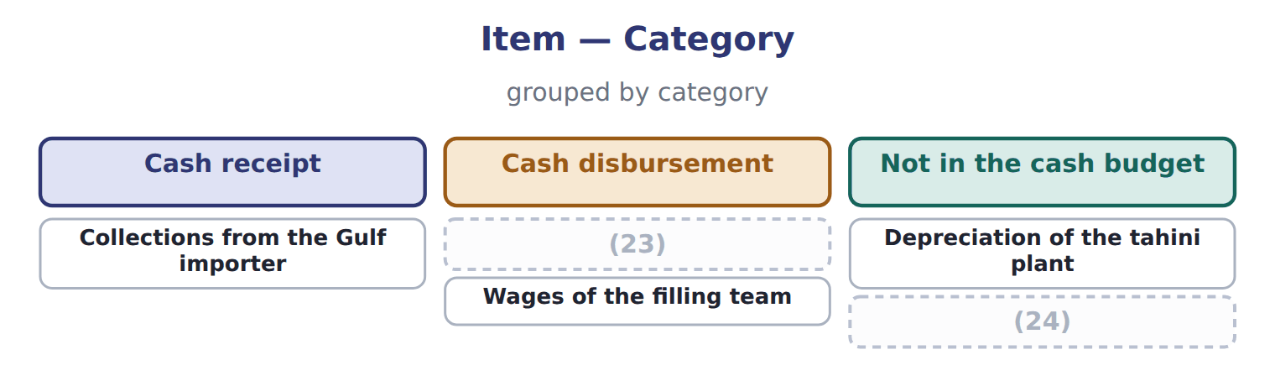
word list
Payment for the new mixer · Sales made but not yet collected · Wages of the filling team

The English this sheet uses, and its Arabic
English (exam term) | Arabic
cash budget | الموازنة النقدية
minimum cash balance | الحد الأدنى للرصيد النقدي
credit policy | سياسة الائتمان

Answer key · 9.6 Extended Example 9A: financing the year and handing over to the pro forma statements

1 follows | 13 depreciation
2 checks | 14 collections
3 Loan at start of quarter | 15 Sales
4 Interest paid (2% a quarter) | 16 Sesame paid in the quarter of purchase
5 − Repaid | 17 Jars produced in the second quarter
6 − Disbursements | 18 Variable selling for the quarter
7 + Borrowing − repayment | 19 Fixed selling and admin for the quarter
8 = Ending cash | 20 New mixer, paid in the second quarter
9 60% of fourth-quarter sales | 21 Minimum cash balance
10 50% of fourth-quarter purchases | 22 $1,236,870 = 50% of 1,272,240 + 50% of 1,201,500
11 New asset on the balance sheet | 23 Payment for the new mixer
12 purchases | 24 Sales made but not yet collected

the summaries in full
Summary 1 This example follows the loan through the year and checks the cash budget as a whole.
Summary 2 Expect sales and purchases with credit terms, a list of expenses including depreciation, a capital purchase and a minimum cash balance. Build collections and payments, leave out non-cash items, find cash before financing, and calculate the borrowing, interest and ending cash.

10.1 Purpose and relationships
Chapter 10 · section 10.1

Fill every gap. Each word list holds one word more than there are gaps.
Chapter 10, section by section
Each stage leads to the next.
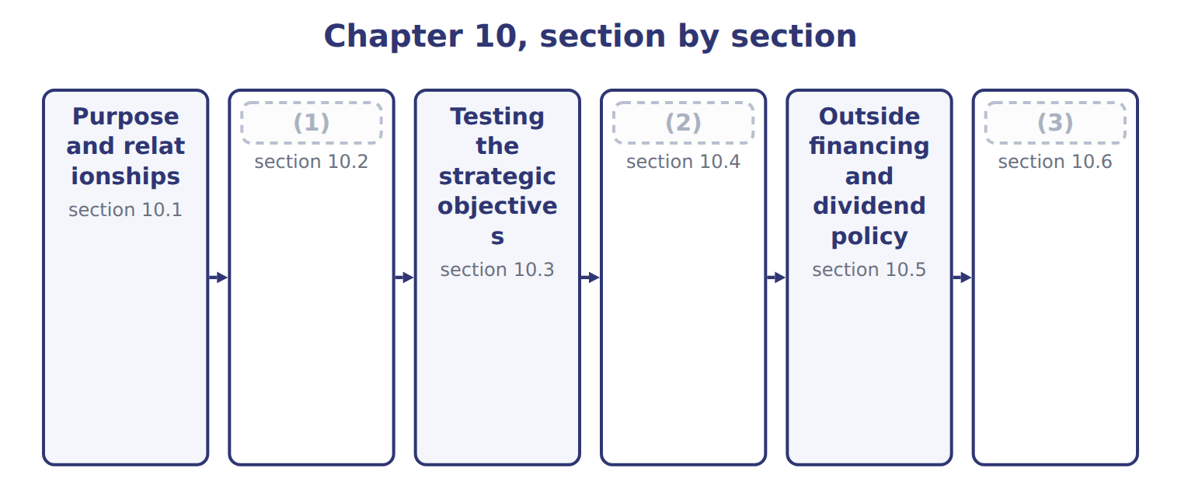
word list
The pro forma balance sheet and statement of c · pro forma statement of cash flows · Extended Example 10A: looking beyond next year · The pro forma income statement and its assumpt

Summary 1 gaps 4–11
Pro forma financial statements show what the financial statements would look like if the plan (4) . The (5) statement shows (6) profit. The pro forma balance sheet shows what the (7) will own and owe, and the pro forma statement of cash flows shows where cash will come from and go. All three come from the same budgets, so they must agree with one (8) . The (9) budgets give profit, the cash budget gives cash, and the (10) budget gives the new asset. The statements are also a last check on the plan. If the balance sheet does not balance, or the cash flow statement does not end at the cash in the cash budget, a schedule (11) is wrong.
word list
planned · capital · income · operating · budgets · somewhere · another · division · happens

The English this sheet uses, and its Arabic
English (exam term) | Arabic
pro forma financial statements | القوائم المالية التقديرية
pro forma balance sheet | الميزانية العمومية التقديرية
pro forma statement of cash flows | قائمة التدفقات النقدية التقديرية

Answer key · 10.1 Purpose and relationships

1 The pro forma income statement and its assumpt | 7 division
2 The pro forma balance sheet and statement of c | 8 another
3 Extended Example 10A: looking beyond next year | 9 operating
4 happens | 10 capital
5 income | 11 somewhere
6 planned

the summaries in full
Summary 1 Pro forma financial statements show what the financial statements would look like if the plan happens. The income statement shows planned profit. The pro forma balance sheet shows what the division will own and owe, and the pro forma statement of cash flows shows where cash will come from and go. All three come from the same budgets, so they must agree with one another. The operating budgets give profit, the cash budget gives cash, and the capital budget gives the new asset. The statements are also a last check on the plan. If the balance sheet does not balance, or the cash flow statement does not end at the cash in the cash budget, a schedule somewhere is wrong.

10.2 The pro forma income statement and its assumptions
Chapter 10 · section 10.2

Fill every gap. Each word list holds one word more than there are gaps.
The pro forma income statement extends the operating budget.
Worked example: the pro forma income statement for 2028
The bars are drawn to scale.
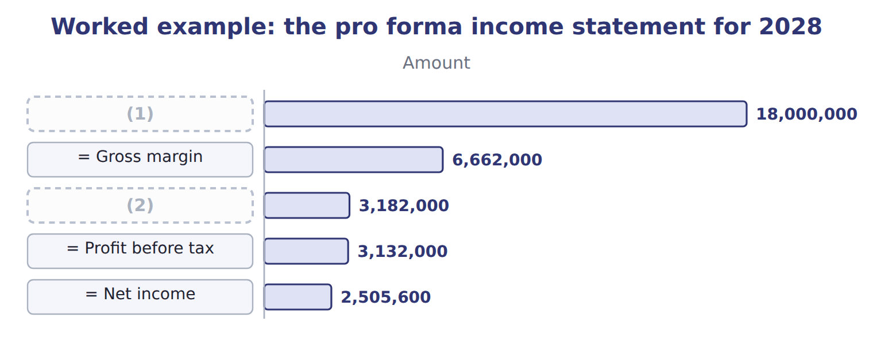
word list
= Gross margin · Sales · = Operating income

Summary 1 gaps 3–5
One plan is not (3) . (4) analysis prepares the statement under other assumptions, so that managers know which risks matter. The (5) format: fixed costs stay the same, and only volume or the margin per case changes.
word list
enough · contribution · assumptions · Sensitivity

Worked example: three more assumptions

Summary 2 gaps 6–7
If volume falls 5%, (6) income falls to $2,811,000. If (7) costs 10% more, the margin falls from $8.20 to $7.66 a case and income to $2,694,000.
word list
operating · changes · concentrate

Operating income under four sets of assumptions
Scenario (USD) | Base plan | Volume −5% | Concentrate +10% | Both
(8) | 900,000 | 855,000 | 900,000 | 855,000
(9) | $8.20 | $8.20 | $7.66 | $7.66
Total contribution margin | 7,380,000 | 7,011,000 | 6,894,000 | 6,549,300
(10) | (4,200,000) | (4,200,000) | (4,200,000) | (4,200,000)
= Operating income | 3,180,000 | 2,811,000 | 2,694,000 | 2,349,300

word list
− Fixed costs · Contribution margin a case · Cases sold · required outside financing

Both at once

Complete the last column, where volume falls and concentrate costs more.
Fixed costs stay fixed

Summary 3 gaps 11–13
In a (11) , fixed costs do not change with volume and the (12) cost per unit does not change unless the question says so. Changing both at once is the commonest error in (13) questions.
word list
statement · variable · sensitivity · scenario

The English this sheet uses, and its Arabic
English (exam term) | Arabic
sensitivity analysis | تحليل الحساسية

Answer key · 10.2 The pro forma income statement and its assumptions

1 Sales | 8 Cases sold
2 = Operating income | 9 Contribution margin a case
3 enough | 10 − Fixed costs
4 Sensitivity | 11 scenario
5 contribution | 12 variable
6 operating | 13 sensitivity
7 concentrate

the summaries in full
Summary 1 One plan is not enough. Sensitivity analysis prepares the statement under other assumptions, so that managers know which risks matter. The contribution format: fixed costs stay the same, and only volume or the margin per case changes.
Summary 2 If volume falls 5%, operating income falls to $2,811,000. If concentrate costs 10% more, the margin falls from $8.20 to $7.66 a case and income to $2,694,000.
Summary 3 In a scenario, fixed costs do not change with volume and the variable cost per unit does not change unless the question says so. Changing both at once is the commonest error in sensitivity questions.

10.3 Testing the strategic objectives
Chapter 10 · section 10.3

Fill every gap. Each word list holds one word more than there are gaps.
Summary 1 gaps 1–2
A plan is not good merely because it is (1) . It must move the company towards the (2) set in the strategic plan.
word list
profitable · measured · objectives

Testing the plan against the 2028 strategic objectives
Every item belongs to exactly one group.
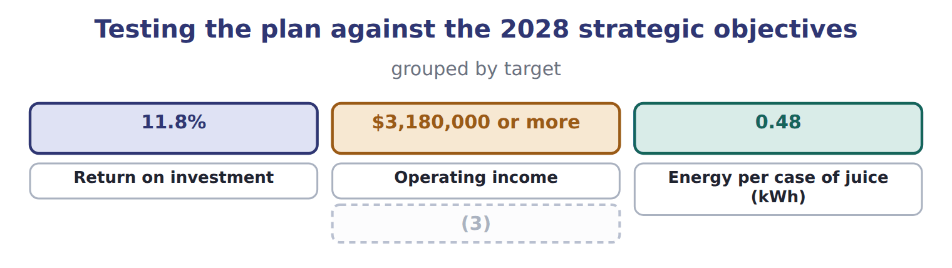
word list
Energy per case of juice (kWh) · Operating income if volume falls 5%

Summary 2 gaps 4–9
The (4) return on investment is 23.2%: net income (5) by average total assets. That is well above the group (6) of 11.8%, as a (7) division with older assets should be. The plan meets the (8) objectives, but not in the (9) where volume falls. Some objectives, such as energy per case, are not measured in money and do not appear in these statements. They are followed through the balanced scorecard.
word list
divided · measured · financial · objective · mature · division's · scenario

Answer key · 10.3 Testing the strategic objectives

1 profitable | 6 objective
2 objectives | 7 mature
3 Operating income if volume falls 5% | 8 financial
4 division's | 9 scenario
5 divided

the summaries in full
Summary 1 A plan is not good merely because it is profitable. It must move the company towards the objectives set in the strategic plan.
Summary 2 The division's return on investment is 23.2%: net income divided by average total assets. That is well above the group objective of 11.8%, as a mature division with older assets should be. The plan meets the financial objectives, but not in the scenario where volume falls. Some objectives, such as energy per case, are not measured in money and do not appear in these statements. They are followed through the balanced scorecard.

10.4 The pro forma balance sheet and statement of cash flows
Chapter 10 · section 10.4

Fill every gap. Each word list holds one word more than there are gaps.
Every line of the pro forma balance sheet comes from a schedule already prepared.
Worked example: the pro forma balance sheet
Pro forma balance sheet (USD) | 1 Jan 2028 | 31 Dec 2028 | Source
Cash | 500,000 | 1,702,450 | Cash budget
Receivables | 2,460,000 | 2,700,000 | Collections schedule
Materials | 115,020 | 117,720 | (1)
Finished goods | 529,200 | 541,800 | Production budget at standard
Property, plant and equipment | 9,000,000 | 11,500,000 | (2)
Accumulated depreciation | (3,400,000) | (4,200,000) | (3)
Total assets | 9,204,220 | 12,361,970
Payables | 575,000 | 600,750 | Payments schedule
Accrued expenses | 240,000 | 240,000 | Unchanged
Income tax payable | — | 626,400 | (4)
Dividends payable | — | 1,002,240 | Dividend policy
Bank loan | — | — | Cash budget
Share capital | 6,000,000 | 6,000,000 | (5)
Retained earnings | 2,389,220 | 3,892,580 | (6)
Total liabilities and equity | 9,204,220 | 12,361,970

word list
Materials budget · Pro forma income statement · Capital budget · Overhead and S&A budgets · Opening + net income − dividends · Unchanged · + Increase in payables

Summary 1 gaps 7–10
Two new liabilities appear: the income tax of $626,400 and the (7) of $1,002,240, both (8) for 2028 but paid early in the next year. Total (9) of $12,361,970 equal liabilities and (10) , as they must. The pro forma statement of cash flows explains the change in cash.
word list
investing · dividend · assets · equity · declared

Worked example: the pro forma statement of cash flows
Pro forma statement of cash flows 2028 (USD) | Amount
Net income | 2,505,600
+ Depreciation | 800,000
− Increase in receivables | (240,000)
− Increase in inventories | (15,300)
(11) | 25,750
(12) | 626,400
= Cash from operating activities | 3,702,450
Purchase of the filling line | (2,500,000)
(13) | (2,500,000)
(14) | 1,000,000
(15) | (1,000,000)
= Cash from financing activities | —
(16) | 1,202,450
Cash at 1 January | 500,000
(17) | 1,702,450

word list
= Cash used in investing activities · + Increase in payables · Net change in cash · Borrowing · Cash at 31 December · Repayment · + Increase in tax payable · inventories

Summary 2 gaps 18–19
It ends at $1,702,450, the (18) cash of the cash budget. If the two (19) , there would be an error in one of them.
word list
disagreed · ending · dividend

Depreciation and asset purchases

Summary 3 gaps 20–21
Depreciation is added back in the operating section (20) it reduced profit without using cash. The purchase of the filling line is an (21) outflow, not an operating one.
word list
Depreciation · because · investing

Answer key · 10.4 The pro forma balance sheet and statement of cash flows

1 Materials budget | 12 + Increase in tax payable
2 Capital budget | 13 = Cash used in investing activities
3 Overhead and S&A budgets | 14 Borrowing
4 Pro forma income statement | 15 Repayment
5 Unchanged | 16 Net change in cash
6 Opening + net income − dividends | 17 Cash at 31 December
7 dividend | 18 ending
8 declared | 19 disagreed
9 assets | 20 because
10 equity | 21 investing
11 + Increase in payables

the summaries in full
Summary 1 Two new liabilities appear: the income tax of $626,400 and the dividend of $1,002,240, both declared for 2028 but paid early in the next year. Total assets of $12,361,970 equal liabilities and equity, as they must. The pro forma statement of cash flows explains the change in cash.
Summary 2 It ends at $1,702,450, the ending cash of the cash budget. If the two disagreed, there would be an error in one of them.
Summary 3 Depreciation is added back in the operating section because it reduced profit without using cash. The purchase of the filling line is an investing outflow, not an operating one.

10.5 Outside financing and dividend policy
Chapter 10 · section 10.5

Fill every gap. Each word list holds one word more than there are gaps.
Required outside financing is what the plan cannot fund from its own cash.
The outside financing the plan requires
Financing need 2028 (USD) | Amount
(1) | 3,702,450
Cash needed for investment | (2,500,000)
Dividends to be paid (next year) | (1,002,240)
(2) | 200,210
Short-term borrowing during the year | 1,000,000
(3) | (1,000,000)
(4) | —

word list
Outside financing needed at the year end · Retained in the division · Cash generated by operations · Cash left over for the year · Repaid during the year

Summary 1 gaps 5–7
The division borrowed $1,000,000 during the year but repaid it all, so no outside (5) is needed at the year end. The seasonal (6) of, not a funding gap. (7) policy decides how much of net income leaves the business.
word list
seasonal · financing · Dividend · borrowing

The dividend and retained earnings for 2028
Dividend policy 2028 (USD) | Amount
Net income | 2,505,600
(8) | 40%
Dividend | 1,002,240
(9) | 1,503,360
(10) | 2,389,220
Retained earnings at 31 December | 3,892,580

word list
Retained in the division · Retained earnings at 1 January · sensitivity analysis · Payout rate

Summary 2 gaps 11–12
The two (11) are linked. A larger dividend would leave less cash and might force (12) ; a smaller one funds growth but gives owners less now.
word list
borrowing · decisions · Dividend

The English this sheet uses, and its Arabic
English (exam term) | Arabic
required outside financing | التمويل الخارجي المطلوب
dividend policy | سياسة توزيع الأرباح

Answer key · 10.5 Outside financing and dividend policy

1 Cash generated by operations | 7 Dividend
2 Cash left over for the year | 8 Payout rate
3 Repaid during the year | 9 Retained in the division
4 Outside financing needed at the year end | 10 Retained earnings at 1 January
5 financing | 11 decisions
6 borrowing | 12 borrowing

the summaries in full
Summary 1 The division borrowed $1,000,000 during the year but repaid it all, so no outside financing is needed at the year end. The seasonal borrowing of, not a funding gap. Dividend policy decides how much of net income leaves the business.
Summary 2 The two decisions are linked. A larger dividend would leave less cash and might force borrowing; a smaller one funds growth but gives owners less now.

10.6 Extended Example 10A: looking beyond next year
Chapter 10 · section 10.6

Fill every gap. Each word list holds one word more than there are gaps.
Summary 1 gaps 1–12
The board also asks what cash the division will need up to 2032, the end of the strategic plan. Medium- and (1) forecasts are built (2) from the quarterly cash budget. This example is (3) . A (4) cash budget works from (5) of known orders and invoices. A (6) forecast works from the strategic plan: planned growth, the (7) it needs, and the working capital that grows with sales. Growth: the juice market is (8) , so sales and working capital will keep (9) . (10) : the plant will reach its limit (11) a few years. Cash: (12) generate $3,702,450 a year at present volumes, which funds the current plan but not a second line. The division tells the board that it can fund 2028 from its own cash, but that a second filling line would need outside financing or a lower dividend. The longer the horizon, the wider the range, so the forecast is given as scenarios rather than one figure.
word list
long-term · short-term · Capacity · operations · recalculate · within · differently · schedules · exam-core · medium-term · rising · growing · investment

Everything ties

Summary 2 gaps 13–14
Balance sheet: assets $12,361,970 = (13) $2,469,390 + equity $9,892,580. Cash flows end at $1,702,450, the (14) cash of the.
word list
forecast · ending · liabilities

Exam view

Summary 3 gaps 15–17
Expect to complete a pro forma income statement with interest and tax, and to (15) it under a new (16) . You may also have to find a missing (17) figure, or work out the dividend and the outside financing a plan needs.
word list
assumption · balance-sheet · liabilities · recalculate

Extended Example: factors in a medium- or long-term cash forecast
Factor in a medium- or long-term cash forecast ( | At Orontes
Strategic plan | Export and new-product goals to 2032 (Chapter 1)
Capacity and investment | When the plant reaches its limit and what the next line would cost
Working capital | (18)
Financing and repayment | Loan repayments, interest rates and the dividend policy
Economy and market | Growth, inflation, exchange rates and (19) (Chapters 2–3)
Uncertainty | (20) rather than one forecast; the longer the horizon, the wider the range

word list
competitors · Receivables, inventory and payables grow with sales · Item · Scenarios

Tahini & Spreads, 2028 (USD) — Amount
Tahini & Spreads, 2028 (USD) | Amount
(21) | 1,250,000
(22) | 60,000
Income tax rate | 20%
(23) | 40%
Retained earnings at 1 January 2028 | 1,800,000
(24) | 7,400,000
Total assets at 31 December 2028 | 8,100,000

word list
Interest on the division loan · Total assets at 1 January 2028 · Economy and market · Budgeted operating income · Dividend payout rate

Item — Answer
Item | Answer
Cases and margin | (25)
Contribution margin | $2,349,300 + $4,200,000 fixed costs
Operating income | $2,349,300

word list
Pro forma income statement · 855,000 cases at $7.66

Item — Category
Item | Category
Income tax expense | (26)
Dividends payable | (27)
Depreciation added back | (28)
Retained earnings | Pro forma balance sheet
Purchase of the new mixer | Pro forma statement of cash flows

word list
$2,349,300 + $4,200,000 fixed costs · Pro forma income statement · Pro forma statement of cash flows · Pro forma balance sheet

The English this section uses, and its Arabic
Each term sits against what it means.
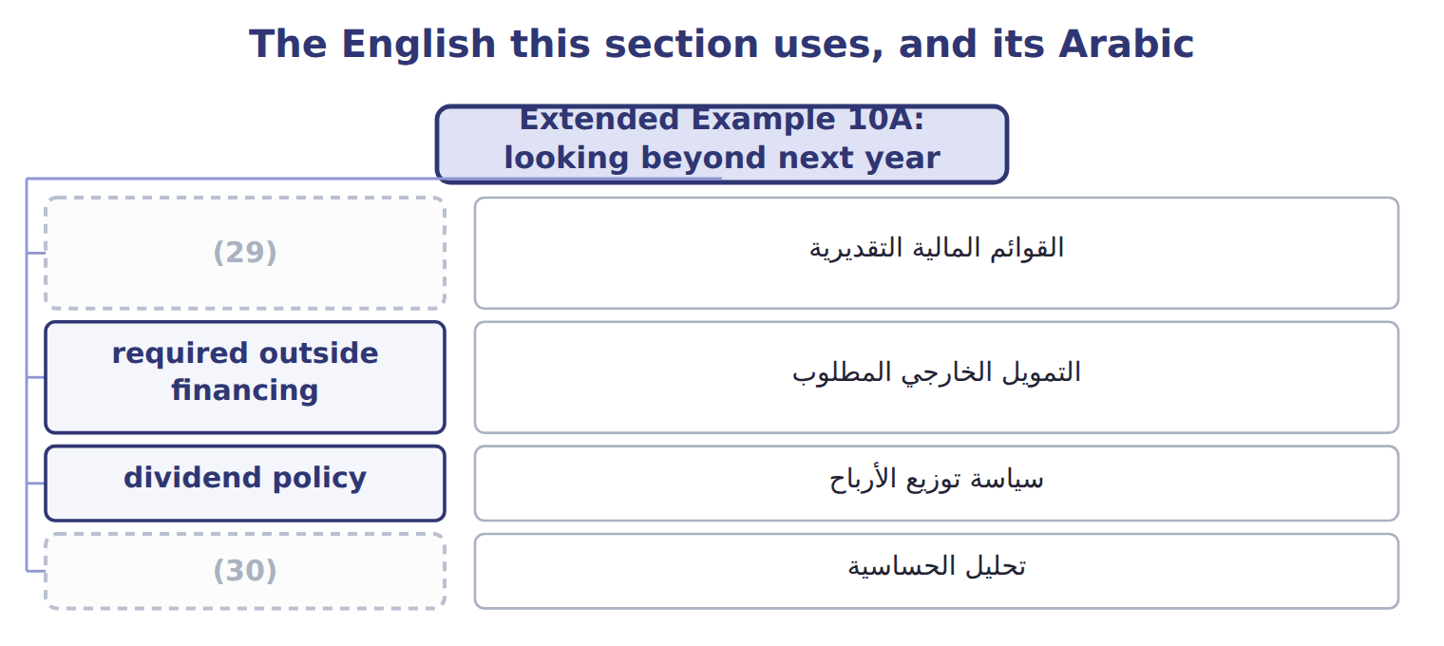
word list
سياسة توزيع الأرباح · pro forma financial statements · sensitivity analysis

The English this sheet uses, and its Arabic
English (exam term) | Arabic
pro forma financial statements | القوائم المالية التقديرية
required outside financing | التمويل الخارجي المطلوب
sensitivity analysis | تحليل الحساسية

Answer key · 10.6 Extended Example 10A: looking beyond next year

1 long-term | 16 assumption
2 differently | 17 balance-sheet
3 exam-core | 18 Receivables, inventory and payables grow with sales
4 short-term | 19 competitors
5 schedules | 20 Scenarios
6 medium-term | 21 Budgeted operating income
7 investment | 22 Interest on the division loan
8 growing | 23 Dividend payout rate
9 rising | 24 Total assets at 1 January 2028
10 Capacity | 25 855,000 cases at $7.66
11 within | 26 Pro forma income statement
12 operations | 27 Pro forma balance sheet
13 liabilities | 28 Pro forma statement of cash flows
14 ending | 29 pro forma financial statements
15 recalculate | 30 sensitivity analysis

the summaries in full
Summary 1 The board also asks what cash the division will need up to 2032, the end of the strategic plan. Medium- and long-term forecasts are built differently from the quarterly cash budget. This example is exam-core. A short-term cash budget works from schedules of known orders and invoices. A medium-term forecast works from the strategic plan: planned growth, the investment it needs, and the working capital that grows with sales. Growth: the juice market is growing, so sales and working capital will keep rising. Capacity: the plant will reach its limit within a few years. Cash: operations generate $3,702,450 a year at present volumes, which funds the current plan but not a second line. The division tells the board that it can fund 2028 from its own cash, but that a second filling line would need outside financing or a lower dividend. The longer the horizon, the wider the range, so the forecast is given as scenarios rather than one figure.
Summary 2 Balance sheet: assets $12,361,970 = liabilities $2,469,390 + equity $9,892,580. Cash flows end at $1,702,450, the ending cash of the.
Summary 3 Expect to complete a pro forma income statement with interest and tax, and to recalculate it under a new assumption. You may also have to find a missing balance-sheet figure, or work out the dividend and the outside financing a plan needs.

11.1 Measuring performance against the plan
Chapter 11 · section 11.1

Fill every gap. Each word list holds one word more than there are gaps.
Chapter 11, section by section
Each stage leads to the next.
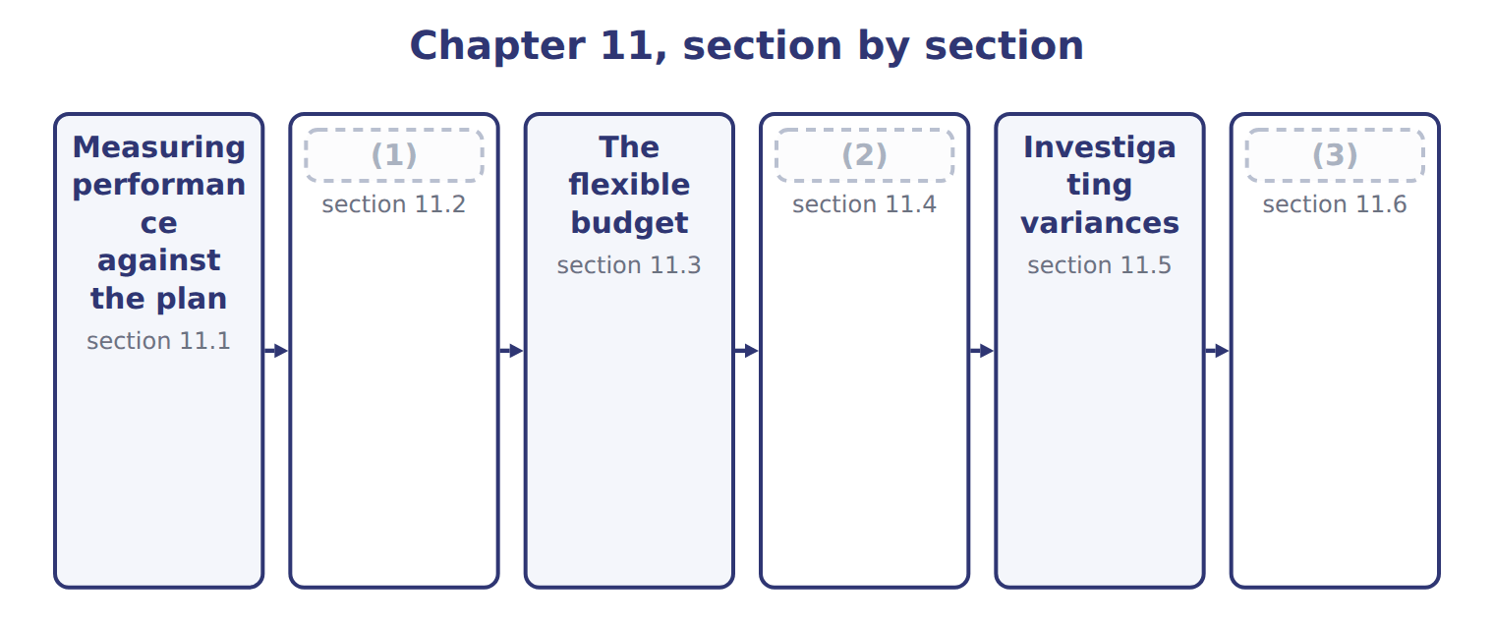
word list
The flexible budget · Sales-volume, sales-price and flexible-budget · The master-budget variance · Extended Example 11A: the June review meeting

Summary 1 gaps 4–5
Performance is measured against the (4) goals set in the budget: revenue, manufacturing costs, (5) costs and profit.
word list
describe · operational · non-manufacturing

Measures of performance against operational goals
Measure (C.1.a) | June 2028 | What it reflects
Revenue | Sales of $1,468,800 against $1,500,000 planned | (6)
Manufacturing costs | (7) | Input prices and quantities
Non-manufacturing costs | (8) | Rates and spending decisions
Profitability | Operating income of $247,632 against $265,000 planned | (9)

word list
Input prices and quantities · Variable selling, fixed selling and administrative · Volume and price · Concentrate, bottles, labor and overhead per case · All of the above together

Summary 2 gaps 10–13
A (10) between an actual result and a (11) figure is a variance. It is a favorable variance when it raises (12) income above the budget and an (13) variance when it lowers it. The words describe the effect on income, not whether the news is good.
word list
difference · Performance · operating · budgeted · unfavorable

Favorable is not always good

Summary 3 gaps 14–15
A favorable material price variance may come from buying (14) concentrate that later causes spillage. Always ask what caused the variance before judging (15) .
word list
non-manufacturing · poor-quality · performance

The English this sheet uses, and its Arabic
English (exam term) | Arabic
favorable variance | انحراف ملائم
unfavorable variance | انحراف غير ملائم

Answer key · 11.1 Measuring performance against the plan

1 The master-budget variance | 9 All of the above together
2 Sales-volume, sales-price and flexible-budget | 10 difference
3 Extended Example 11A: the June review meeting | 11 budgeted
4 operational | 12 operating
5 non-manufacturing | 13 unfavorable
6 Volume and price | 14 poor-quality
7 Concentrate, bottles, labor and overhead per case | 15 performance
8 Variable selling, fixed selling and administrative

the summaries in full
Summary 1 Performance is measured against the operational goals set in the budget: revenue, manufacturing costs, non-manufacturing costs and profit.
Summary 2 A difference between an actual result and a budgeted figure is a variance. It is a favorable variance when it raises operating income above the budget and an unfavorable variance when it lowers it. The words describe the effect on income, not whether the news is good.
Summary 3 A favorable material price variance may come from buying poor-quality concentrate that later causes spillage. Always ask what caused the variance before judging performance.

11.2 The master-budget variance
Chapter 11 · section 11.2

Fill every gap. Each word list holds one word more than there are gaps.
Summary 1 gaps 1–2
The (1) (static-budget) variance is the difference between the actual result and the master budget. For June, (2) income was $17,368 below the plan.
word list
master-budget · operating · static-budget

Worked example: June against the master budget

Sales were $1,468,800 against $1,500,000 planned, and operating income $247,632 against $265,000.
Worked example: June actual results against the master budget
The bars are drawn to scale.
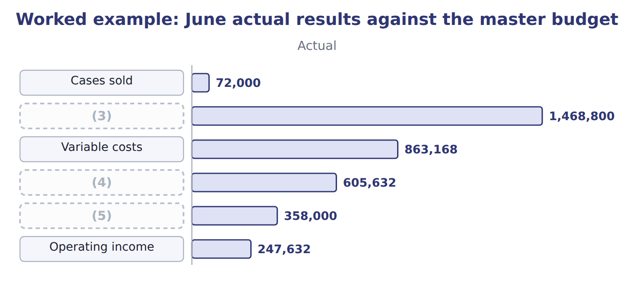
word list
Variable costs · Contribution margin · Sales · Fixed costs

Summary 2 gaps 6–11
The total is not very useful on its own, because the (6) sold 3,000 fewer cases than (7) . Lower volume reduces both revenue and (8) costs, so the comparison mixes two (9) stories. The comparison is (10) kept for the board and for the sales team, who are (11) for volume. The plant manager is judged on the flexible budget of the next section, which holds volume constant.
word list
planned · variable · therefore · different · division · comparison · responsible

Benefits and limitations of comparing with the master budget
Benefits of comparing with the master budget (C. | Limitations
Shows the total gap from the plan, including volume | (12)
Simple and well understood | Can blame a manager for a volume (13) caused by the market
Useful for the board, which approved the plan | Not a fair measure of cost control when volume differs

word list
shortfall · Variance · Mixes volume with prices and efficiency

The English this sheet uses, and its Arabic
English (exam term) | Arabic
master-budget (static-budget) variance | انحراف الموازنة الشاملة (الثابتة)

Answer key · 11.2 The master-budget variance

1 master-budget | 8 variable
2 operating | 9 different
3 Sales | 10 therefore
4 Contribution margin | 11 responsible
5 Fixed costs | 12 Mixes volume with prices and efficiency
6 division | 13 shortfall
7 planned

the summaries in full
Summary 1 The master-budget (static-budget) variance is the difference between the actual result and the master budget. For June, operating income was $17,368 below the plan.
Summary 2 The total is not very useful on its own, because the division sold 3,000 fewer cases than planned. Lower volume reduces both revenue and variable costs, so the comparison mixes two different stories. The comparison is therefore kept for the board and for the sales team, who are responsible for volume. The plant manager is judged on the flexible budget of the next section, which holds volume constant.

11.3 The flexible budget
Chapter 11 · section 11.3

Fill every gap. Each word list holds one word more than there are gaps.
Summary 1 gaps 1–3
The (1) budget answers the (2) : what should the results have been at the volume actually sold? It uses the actual volume with budgeted prices and budgeted costs. Fixed costs do not change, (3) they do not depend on volume.
word list
question · flexible · because · overspending

Worked example: the flexible budget for June

Summary 2 gaps 4–5
At 72,000 cases: sales 72,000 × $20.00 = $1,440,000; (4) costs × $11.80 = $849,600; fixed costs stay at $350,000. (5) income is $240,400.
word list
variable · Operating · results

Worked example: the three-column analysis for June
The bars are drawn to scale.
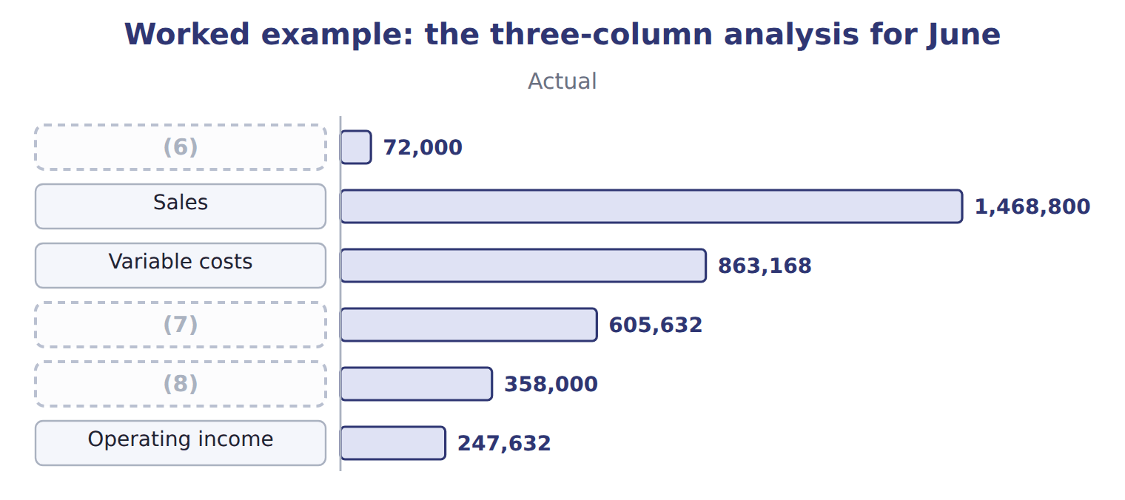
word list
favorable variance · Fixed costs · Contribution margin · Cases

The flexible-budget column

Complete the blank cells.
Fixed costs do not flex

Summary 3 gaps 9–10
The (9) budget changes only the variable items. Scaling fixed costs down to 72,000 cases would hide the real fixed-cost (10) and give the wrong flexible-budget variance.
word list
overspending · flexible · answers

The English this sheet uses, and its Arabic
English (exam term) | Arabic
flexible-budget variance | انحراف الموازنة المرنة

Answer key · 11.3 The flexible budget

1 flexible | 6 Cases
2 question | 7 Contribution margin
3 because | 8 Fixed costs
4 variable | 9 flexible
5 Operating | 10 overspending

the summaries in full
Summary 1 The flexible budget answers the question: what should the results have been at the volume actually sold? It uses the actual volume with budgeted prices and budgeted costs. Fixed costs do not change, because they do not depend on volume.
Summary 2 At 72,000 cases: sales 72,000 × $20.00 = $1,440,000; variable costs × $11.80 = $849,600; fixed costs stay at $350,000. Operating income is $240,400.
Summary 3 The flexible budget changes only the variable items. Scaling fixed costs down to 72,000 cases would hide the real fixed-cost overspending and give the wrong flexible-budget variance.

11.4 Sales-volume, sales-price and flexible-budget variances
Chapter 11 · section 11.4

Fill every gap. Each word list holds one word more than there are gaps.
Summary 1 gaps 1–8
The (1) variance is the difference between the flexible budget and the (2) budget. It equals the change in units multiplied by the budgeted (3) margin per unit: (72,000 − 75,000) × $8.20 = $24,600, (4) . The (5) variance compares the actual price with the budgeted price on the units (6) sold: ($20.40 − $20.00) × 72,000 = $28,800, favorable. Note the (7) bases: the volume variance uses the budgeted margin, the price variance uses actual units. The (8) variance is the difference between the actual result and the flexible budget: $7,232, favorable.
word list
contribution · Valuing · flexible-budget · actually · different · sales-price · master · unfavorable · sales-volume

Worked example: the June variances and how they add up
Variance | Calculation | Effect on operating income
Sales-volume variance | (9) | 24,600 U
Sales-price variance | ($20.40 − $20.00) × 72,000 | (10)
Variable cost variance | actual − flexible budget | (11)
Fixed cost variance | actual − budget | (12)
Flexible-budget variance | price + cost variances | (13)
Master-budget variance | flexible-budget + sales-volume | (14)

word list
price + cost variances · 17,368 U · 8,000 U · 28,800 F · 13,568 U · 7,232 F · (72,000 − 75,000) × $8.20

The cost side of the flexible-budget variance
The bars are drawn to scale.
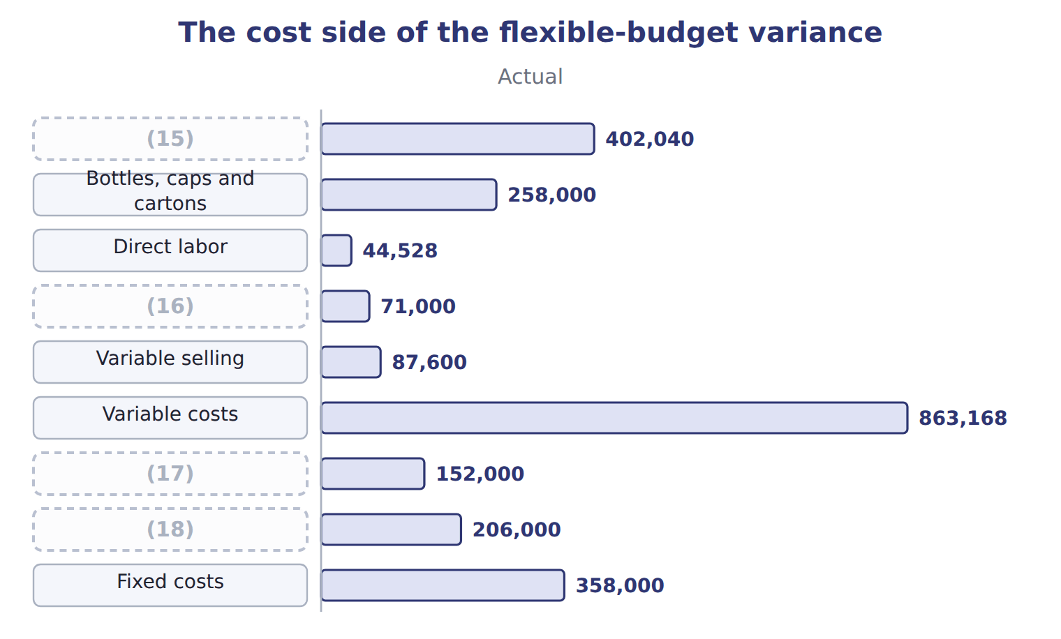
word list
Variable overhead · Fixed manufacturing · Fixed costs · Fixed selling and administrative · Concentrate

Volume at margin, price at actual units

Summary 2 gaps 19–21
Valuing the volume variance at the (19) price, or the price variance at budgeted units, are the two most (20) errors. The volume variance uses the budgeted (21) margin; the price variance uses the units actually sold.
word list
contribution · selling · sales-volume · common

The English this sheet uses, and its Arabic
English (exam term) | Arabic
sales-volume variance | انحراف حجم المبيعات
sales-price variance | انحراف سعر البيع

Answer key · 11.4 Sales-volume, sales-price and flexible-budget variances

1 sales-volume | 12 8,000 U
2 master | 13 7,232 F
3 contribution | 14 17,368 U
4 unfavorable | 15 Concentrate
5 sales-price | 16 Variable overhead
6 actually | 17 Fixed manufacturing
7 different | 18 Fixed selling and administrative
8 flexible-budget | 19 selling
9 (72,000 − 75,000) × $8.20 | 20 common
10 28,800 F | 21 contribution
11 13,568 U

the summaries in full
Summary 1 The sales-volume variance is the difference between the flexible budget and the master budget. It equals the change in units multiplied by the budgeted contribution margin per unit: (72,000 − 75,000) × $8.20 = $24,600, unfavorable. The sales-price variance compares the actual price with the budgeted price on the units actually sold: ($20.40 − $20.00) × 72,000 = $28,800, favorable. Note the different bases: the volume variance uses the budgeted margin, the price variance uses actual units. The flexible-budget variance is the difference between the actual result and the flexible budget: $7,232, favorable.
Summary 2 Valuing the volume variance at the selling price, or the price variance at budgeted units, are the two most common errors. The volume variance uses the budgeted contribution margin; the price variance uses the units actually sold.

11.5 Investigating variances
Chapter 11 · section 11.5

Fill every gap. Each word list holds one word more than there are gaps.
Summary 1 gaps 1–2
A cost (1) still mixes two causes: the price paid for an input and the (2) used.
word list
changes · variance · quantity

Investigating the concentrate and labor differences
Difference | Calculation | Amount | Likely reason
Concentrate price | ($0.92 − $0.90) × 437,000 liters | (3) | A world price rise; not controllable by the plant
Concentrate usage | (4) | 4,500 U | Spillage on the line during a changeover
Labor rate | ($12.10 − $12.00) × 3,680 hours | 368 U | (5)
Labor efficiency | (3,680 − 3,600) hours × $12.00 | (6) | The same changeover

word list
960 U · Overtime for the summer season · 8,740 U · master-budget (static-budget) variance · (437,000 − 432,000) liters × $0.90

Summary 2 gaps 7–12
The (7) price variance of $8,740 came from a world price rise, which the plant cannot control; the usage variance of $4,500 and the labor (8) variance of $960 came from one long (9) . Common reasons for (10) include changes in input prices, the quality of (11) , the skill or mix of workers, machine problems, the volume produced, and errors in the budget itself. A variance is a (12) , not an answer.
word list
quality · variances · changeover · efficiency · question · materials · concentrate

The English this sheet uses, and its Arabic
English (exam term) | Arabic
sales-volume variance | انحراف حجم المبيعات
flexible-budget variance | انحراف الموازنة المرنة
master-budget (static-budget) variance | انحراف الموازنة الشاملة (الثابتة)

Answer key · 11.5 Investigating variances

1 variance | 7 concentrate
2 quantity | 8 efficiency
3 8,740 U | 9 changeover
4 (437,000 − 432,000) liters × $0.90 | 10 variances
5 Overtime for the summer season | 11 materials
6 960 U | 12 question

the summaries in full
Summary 1 A cost variance still mixes two causes: the price paid for an input and the quantity used.
Summary 2 The concentrate price variance of $8,740 came from a world price rise, which the plant cannot control; the usage variance of $4,500 and the labor efficiency variance of $960 came from one long changeover. Common reasons for variances include changes in input prices, the quality of materials, the skill or mix of workers, machine problems, the volume produced, and errors in the budget itself. A variance is a question, not an answer.

11.6 Extended Example 11A: the June review meeting
Chapter 11 · section 11.6

Fill every gap. Each word list holds one word more than there are gaps.
Summary 1 gaps 1–3
This example follows the monthly review, where the (1) decides which variances to (2) . Orontes follows (3) by exception: a variance is investigated if it is above 5% of the budgeted figure for that item.
word list
management · whether · investigate · division

Extended Example: which variances to investigate
Item | Variance | Share of its budget | Action under the 5% rule
Sales price | (4) | 10.9% | Follow up: can the higher price be kept?
Sales volume | (5) | 9.3% | Follow up: why were cases lost?
Concentrate | 13,240 U | 5.0% | (6) : price rise and spillage
Direct labor | (7) | 3.1% | Below the 5% rule: no action
Variable overhead | (8) | 1.4% | Below the 5% rule: no action

word list
Variable costs · 28,800 F · Follow up · 1,328 U · 24,600 U · 1,000 F

Variance — Category
Every item belongs to exactly one group.
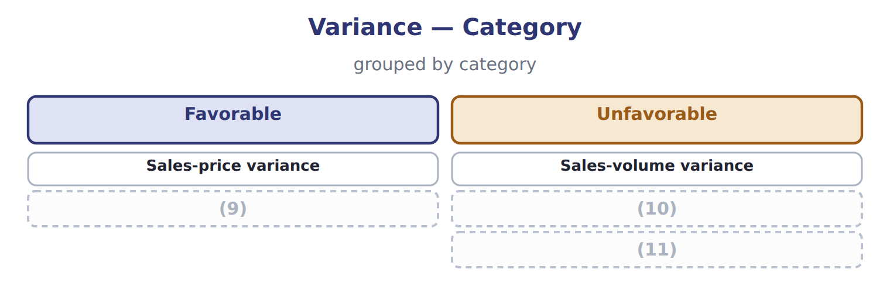
word list
sales-price variance · Flexible-budget variance · Variable cost variance · Fixed cost variance

Summary 2 gaps 12–18
Three items pass the rule. The favorable price variance is (12) as well as the (13) ones, because the division wants to know whether the higher price can be kept. Labor and (14) overhead are below the rule and are left alone. Volume was lost to a (15) promotion, not to poor (16) . The higher price held because the promotion did not reach the hotel (17) . The plant's problems came from one (18) , which the lean work of Book 2.
word list
changeover · competitor's · selling · investigated · unfavorable · customers · variable · Together

Everything ties

Together: $17,368 unfavorable, the master-budget variance.
Exam view

Summary 3 gaps 19–21
Expect a master budget, actual (19) and the actual volume. Build the flexible-budget column first, then the (20) and sales-price variances, then the flexible-budget variance. Label each as favorable or (21) by its effect on operating income.
word list
unfavorable · results · sales-volume · decides

Exam view
Tahini & Spreads, one month | Data
(22) | 125,000
Jars actually sold | 118,000
Budgeted selling price | $3.50
(23) | $3.60
Budgeted contribution margin per jar | $1.50
(24) | 240,000
(25) | 120,000
Actual fixed costs | 123,000

word list
Actual selling price · Jars in the static budget · Below the 5% rule: no action · Actual variable costs · Budgeted fixed costs for the month

Item — Answer
Item | Answer
Variable costs | (26)
Contribution margin | 72,000 × $8.20 = $590,400
Operating income | (27)

word list
72,000 × $8.20 = $590,400 · 72,000 × $11.80 = $849,600 · $590,400 − $350,000 = $240,400

The English this section uses, and its Arabic
Each term sits against what it means.
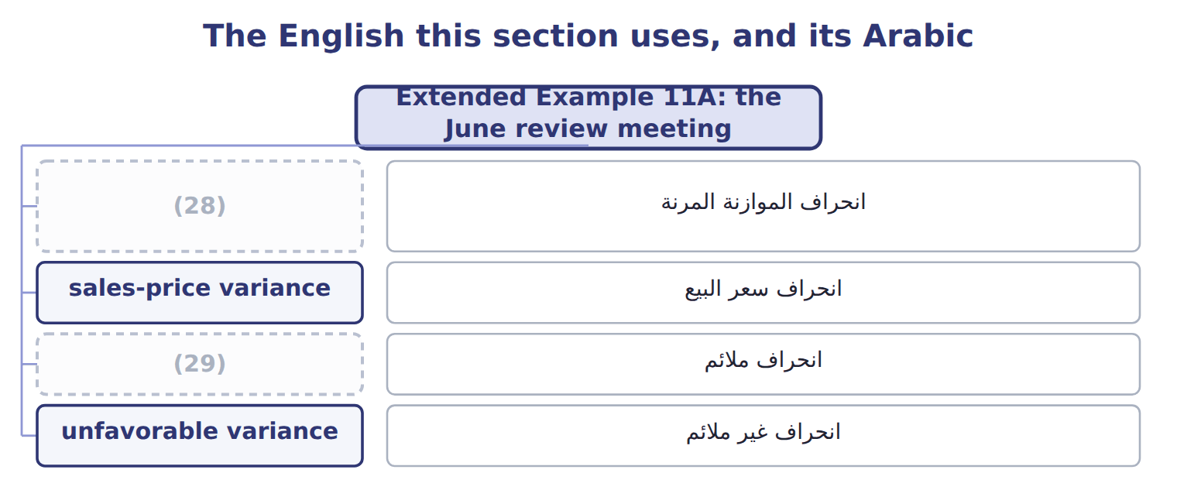
word list
favorable variance · flexible-budget variance · انحراف ملائم

The English this sheet uses, and its Arabic
English (exam term) | Arabic
sales-price variance | انحراف سعر البيع
favorable variance | انحراف ملائم
unfavorable variance | انحراف غير ملائم

Answer key · 11.6 Extended Example 11A: the June review meeting

1 division | 16 selling
2 investigate | 17 customers
3 management | 18 changeover
4 28,800 F | 19 results
5 24,600 U | 20 sales-volume
6 Follow up | 21 unfavorable
7 1,328 U | 22 Jars in the static budget
8 1,000 F | 23 Actual selling price
9 Flexible-budget variance | 24 Actual variable costs
10 Variable cost variance | 25 Budgeted fixed costs for the month
11 Fixed cost variance | 26 72,000 × $11.80 = $849,600
12 investigated | 27 $590,400 − $350,000 = $240,400
13 unfavorable | 28 flexible-budget variance
14 variable | 29 favorable variance
15 competitor's

the summaries in full
Summary 1 This example follows the monthly review, where the division decides which variances to investigate. Orontes follows management by exception: a variance is investigated if it is above 5% of the budgeted figure for that item.
Summary 2 Three items pass the rule. The favorable price variance is investigated as well as the unfavorable ones, because the division wants to know whether the higher price can be kept. Labor and variable overhead are below the rule and are left alone. Volume was lost to a competitor's promotion, not to poor selling. The higher price held because the promotion did not reach the hotel customers. The plant's problems came from one changeover, which the lean work of Book 2.
Summary 3 Expect a master budget, actual results and the actual volume. Build the flexible-budget column first, then the sales-volume and sales-price variances, then the flexible-budget variance. Label each as favorable or unfavorable by its effect on operating income.

12.1 Standard costing and why companies use it
Chapter 12 · section 12.1

Fill every gap. Each word list holds one word more than there are gaps.
Chapter 12, section by section
Each stage leads to the next.
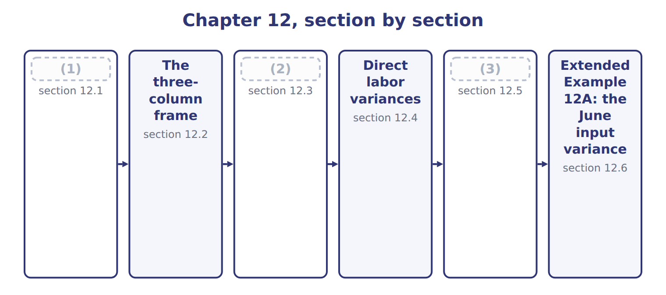
word list
Direct material variances · direct labor efficiency variance · Responsibility and linked variances · Standard costing and why companies use it

Summary 1 gaps 4–6
In a standard costing system, (4) , labor and overhead are recorded at standard cost, and the (5) between standard and actual are recorded as variances. (6) and cost of goods sold therefore carry the same cost for every unit, as.
word list
materials · Inventory · therefore · differences

Reasons for adopting a standard costing system
Reason for a standard costing system (C.1.j) | What it gives Orontes
Simpler record keeping | (7) and cost of goods sold are recorded at standard, so every unit carries the same cost
Control by exception | Variances point to what differed from the plan (Chapter 11)
Responsibility | Each variance has an owner: (8) , the plant, the sales team
Budgeting and pricing | The standard card builds the budget (Chapters 6 to 8) and supports price decisions
Motivation | Clear, (9) targets for each input (Book 2, Chapter 18)

word list
Inventory · decisions · purchasing · attainable

Summary 2 gaps 10–11
The (10) has costs of its own. (11) must be reviewed as prices and methods change, as Book 2, and a standard that is out of date produces variances that mean nothing.
word list
system · Standards · between

The English this sheet uses, and its Arabic
English (exam term) | Arabic
standard costing | نظام التكاليف المعيارية

Answer key · 12.1 Standard costing and why companies use it

1 Standard costing and why companies use it | 7 Inventory
2 Direct material variances | 8 purchasing
3 Responsibility and linked variances | 9 attainable
4 materials | 10 system
5 differences | 11 Standards
6 Inventory

the summaries in full
Summary 1 In a standard costing system, materials, labor and overhead are recorded at standard cost, and the differences between standard and actual are recorded as variances. Inventory and cost of goods sold therefore carry the same cost for every unit, as.
Summary 2 The system has costs of its own. Standards must be reviewed as prices and methods change, as Book 2, and a standard that is out of date produces variances that mean nothing.

12.2 The three-column frame
Chapter 12 · section 12.2

Fill every gap. Each word list holds one word more than there are gaps.
Summary 1 gaps 1–3
Every input variance uses the same three (1) . The left gap changes only the price, so it is the price or rate variance. The right gap changes only the (2) , so it is the (3) or usage variance.
word list
columns · standard · efficiency · quantity

Formulas for price and efficiency variances
Variance | Formula | Valued at
Material price | (4) | actual quantity bought or used
Material usage | (5) | standard price
Labor rate | (AR − SR) × AH | (6)
Labor efficiency | (AH − SH allowed) × SR | (7)
Total for an input | (8) | both parts together

word list
(AQ − SQ allowed) × SP · (AP − SP) × AQ · standard rate · actual cost − standard cost allowed · actual hours worked · (AH − SH allowed) × SR

Summary 2 gaps 9–11
The standard (9) allowed is the heart of the (10) column: it is the input the standard permits for the output (11) produced, not for the output planned. In June that is 72,000 cases, not 75,000.
word list
actually · columns · right-hand · quantity

The English this sheet uses, and its Arabic
English (exam term) | Arabic
standard quantity allowed | الكمية المعيارية المسموح بها

Answer key · 12.2 The three-column frame

1 columns | 7 standard rate
2 quantity | 8 actual cost − standard cost allowed
3 efficiency | 9 quantity
4 (AP − SP) × AQ | 10 right-hand
5 (AQ − SQ allowed) × SP | 11 actually
6 actual hours worked

the summaries in full
Summary 1 Every input variance uses the same three columns. The left gap changes only the price, so it is the price or rate variance. The right gap changes only the quantity, so it is the efficiency or usage variance.
Summary 2 The standard quantity allowed is the heart of the right-hand column: it is the input the standard permits for the output actually produced, not for the output planned. In June that is 72,000 cases, not 75,000.

12.3 Direct material variances
Chapter 12 · section 12.3

Fill every gap. Each word list holds one word more than there are gaps.
Worked example: concentrate in June

Summary 1 gaps 1–2
Price: ($0.92 − $0.90) × 437,000 (1) = $8,740 unfavorable. Usage: (437,000 − 432,000) × $0.90 = $4,500 unfavorable. (2) $13,240, the figure.
word list
purchasing · liters · Together

Worked example: the concentrate variances for June
Concentrate, June 2028 | Amount
Cases produced | 72,000
Standard liters allowed (6.0 a case) | 432,000
Actual liters used | 437,000
Standard price a liter | $0.90
Actual price a liter | $0.92
Price variance | (3)
Usage variance | (4)
Total | 13,240 U

word list
(0.92 − 0.90) × 437,000 = 8,740 U · (437,000 − 432,000) × 0.90 = 4,500 U · $260 of the variance is carried in stock

Summary 2 gaps 5–6
The price (5) can be measured when the material is bought or when it is used. Beverages bought 450,000 liters in June but used 437,000, so the two (6) differ by $260.
word list
variance · consumed · conventions

The price variance at purchase and at usage
The bars are drawn to scale.
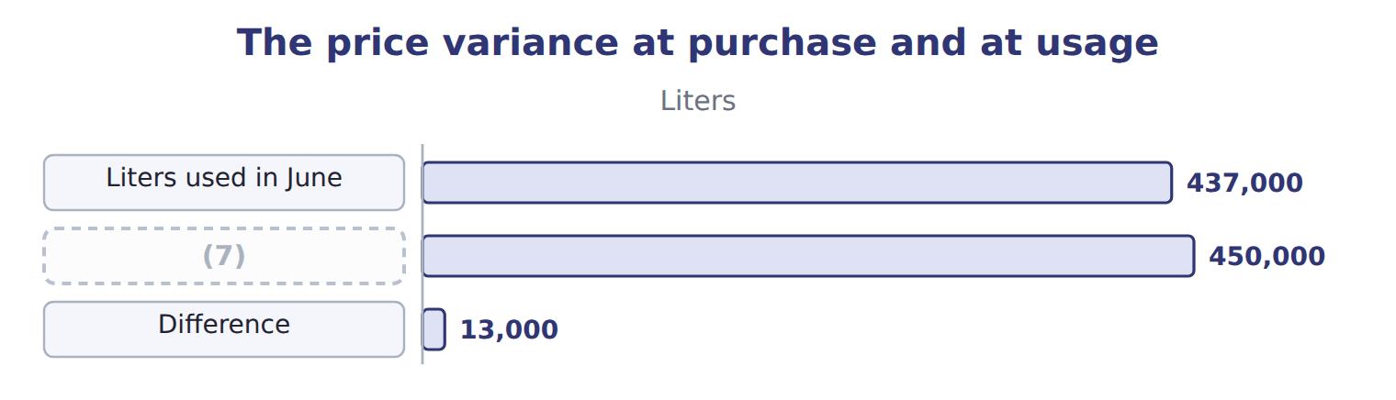
word list
Liters bought in June · direct material usage variance

Summary 3 gaps 8–11
Measuring at purchase reports the variance earlier, which helps (8) act in time, and values the stock at (9) . Measuring at usage (10) the variance to the period in which the (11) was consumed. The exam usually measures at purchase when it gives the quantity bought; otherwise use the quantity used.
word list
purchasing · Together · material · matches · standard

Which quantity?

Summary 4 gaps 12–14
The price variance always uses an actual quantity, (12) or used; the usage variance always uses the standard price. Using the standard quantity for the price variance, or the actual price for the usage variance, (13) part of the (14) .
word list
double-counts · difference · usually · bought

The English this sheet uses, and its Arabic
English (exam term) | Arabic
direct material price variance | انحراف سعر المواد المباشرة
direct material usage variance | انحراف استخدام المواد المباشرة

Answer key · 12.3 Direct material variances

1 liters | 8 purchasing
2 Together | 9 standard
3 (0.92 − 0.90) × 437,000 = 8,740 U | 10 matches
4 (437,000 − 432,000) × 0.90 = 4,500 U | 11 material
5 variance | 12 bought
6 conventions | 13 double-counts
7 Liters bought in June | 14 difference

the summaries in full
Summary 1 Price: ($0.92 − $0.90) × 437,000 liters = $8,740 unfavorable. Usage: (437,000 − 432,000) × $0.90 = $4,500 unfavorable. Together $13,240, the figure.
Summary 2 The price variance can be measured when the material is bought or when it is used. Beverages bought 450,000 liters in June but used 437,000, so the two conventions differ by $260.
Summary 3 Measuring at purchase reports the variance earlier, which helps purchasing act in time, and values the stock at standard. Measuring at usage matches the variance to the period in which the material was consumed. The exam usually measures at purchase when it gives the quantity bought; otherwise use the quantity used.
Summary 4 The price variance always uses an actual quantity, bought or used; the usage variance always uses the standard price. Using the standard quantity for the price variance, or the actual price for the usage variance, double-counts part of the difference.

12.4 Direct labor variances
Chapter 12 · section 12.4

Fill every gap. Each word list holds one word more than there are gaps.
Labor uses the same frame, with hours instead of liters and a wage rate instead of a price.
Worked example: direct labor in June

Rate: ($12.10 − $12.00) × 3,680 hours = $368 unfavorable. Efficiency: (3,680 − 3,600) × $12.00 = $960 unfavorable.
Worked example: the direct labor variances for June
Direct labor, June 2028 | Amount
Cases produced | 72,000
(1) | 3,600
Actual hours worked | 3,680
Standard rate an hour | $12.00
(2) | $12.10
(3) | (12.10 − 12.00) × 3,680 = 368 U
(4) | (3,680 − 3,600) × 12.00 = 960 U

word list
Actual rate an hour · Actual hours worked · Efficiency variance · Standard hours allowed (0.050 a case) · Rate variance

The labor variances

Complete the blank rows, then do the same for the Tahini division.
Your turn: sesame and labor in the Tahini division
Tahini & Spreads, same month | Standard | Actual
Jars produced | 110,000
Sesame: standard 0.50 kg at $2.50 | 55,000 kg allowed | (5)
Sesame price variance | ________
Sesame usage variance | ________
Labor: standard 0.012 h at $15.00 | (6) | actual 1,350 h at $15.20
Labor rate variance | ________
Labor efficiency variance | ________

word list
actual 56,200 kg at $2.45 · actual 1,350 h at $15.20 · 1,320 h allowed

Summary 1 gaps 7–8
The Tahini figures show a pattern worth noticing: the sesame price variance is favorable while the usage variance is (7) . Section 12.5 (8) why the two often move together.
word list
explains · unfavorable · pattern

The English this sheet uses, and its Arabic
English (exam term) | Arabic
direct labor rate variance | انحراف معدل أجر العمل المباشر
direct labor efficiency variance | انحراف كفاءة العمل المباشر

Answer key · 12.4 Direct labor variances

1 Standard hours allowed (0.050 a case) | 5 actual 56,200 kg at $2.45
2 Actual rate an hour | 6 1,320 h allowed
3 Rate variance | 7 unfavorable
4 Efficiency variance | 8 explains

the summaries in full
Summary 1 The Tahini figures show a pattern worth noticing: the sesame price variance is favorable while the usage variance is unfavorable. Section 12.5 explains why the two often move together.

12.5 Responsibility and linked variances
Chapter 12 · section 12.5

Fill every gap. Each word list holds one word more than there are gaps.
A variance is useful only if someone can act on it.
Who owns each variance, and why it arises
Every item belongs to exactly one group.
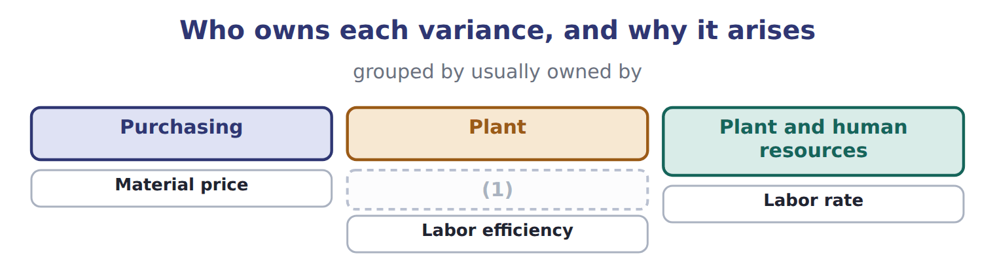
word list
Labor efficiency · Material usage

Summary 1 gaps 2–3
Ownership is a (2) point, not a rule. If purchasing buys cheaper, (3) concentrate, the price variance is favorable and the usage variance unfavorable, and the plant manager is not to blame.
word list
someone · lower-grade · starting

Decisions that move two variances at once
Decision | First effect | Likely second effect
Buying cheaper, lower-grade concentrate | (4) | Usage unfavorable: more spillage and rework
Using less-skilled operators | Rate favorable | (5) : more hours needed
Rushing a delivery by air | (6) | Usage unchanged, but the plant keeps running
Overtime to meet the summer peak | (7) | Efficiency may improve: experienced staff work the extra hours

word list
Price unfavorable · Efficiency unfavorable · Rate unfavorable · Rate favorable · Price favorable

Read the pair, not the single variance

Summary 2 gaps 8–9
A favorable price variance beside an (8) usage variance usually points to one decision, not two separate results. Judging either one alone gives the wrong (9) .
word list
Judging · conclusion · unfavorable

Answer key · 12.5 Responsibility and linked variances

1 Material usage | 6 Price unfavorable
2 starting | 7 Rate unfavorable
3 lower-grade | 8 unfavorable
4 Price favorable | 9 conclusion
5 Efficiency unfavorable

the summaries in full
Summary 1 Ownership is a starting point, not a rule. If purchasing buys cheaper, lower-grade concentrate, the price variance is favorable and the usage variance unfavorable, and the plant manager is not to blame.
Summary 2 A favorable price variance beside an unfavorable usage variance usually points to one decision, not two separate results. Judging either one alone gives the wrong conclusion.

12.6 Extended Example 12A: the June input variance report
Chapter 12 · section 12.6

Fill every gap. Each word list holds one word more than there are gaps.
This example puts the four variances into the report the division sends to head office.
Extended Example: the June input variance report
Every item belongs to exactly one group.
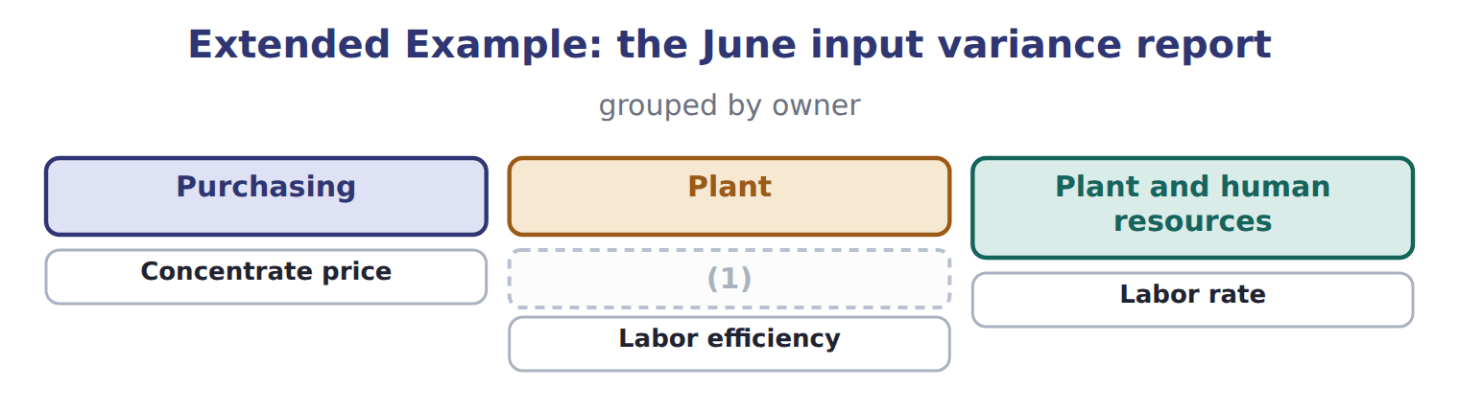
word list
Concentrate usage · Concentrate price

Variance — Category
Every item belongs to exactly one group.
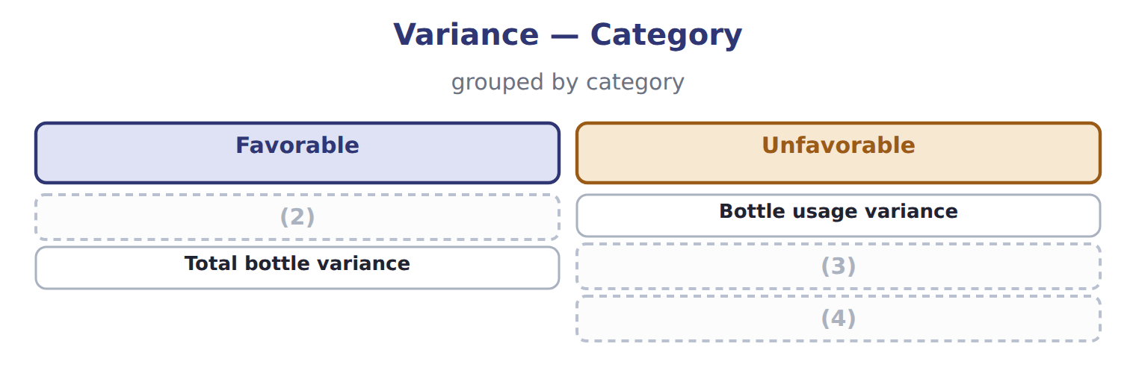
word list
Bottle price variance · Total bottle variance · Labor rate variance · Labor efficiency variance

Summary 1 gaps 5–6
Concentrate (5) the report. Its price variance is outside the (6) control, but the usage variance and the labor efficiency variance share one cause: the long changeover identified.
word list
division's · dominates · produced

Everything ties

Concentrate $8,740 + $4,500 = $13,240, the concentrate variance. Labor $368 + $960 = $1,328, the labor variance.
Exam view

Summary 2 gaps 7–9
Expect actual quantity, actual price, standard quantity per unit, standard price and the output (7) . (8) the standard quantity allowed first, then the price variance on the actual quantity and the (9) variance at the standard price.
word list
efficiency · Calculate · produced · outside

Exam view
Oils division: EVOO bottling, one month | Data
(10) | 150,000
Standard bottles a liter | 150000 per 150,000 liters
Standard price a bottle | $1.50
(11) | 152,000
Actual price a bottle | $1.47
Bottles bought in the month | 160,000
(12) | 0.075
(13) | $12.00
(14) | 11,500
Actual labor rate | $12.20

word list
direct material usage variance · Standard labor rate · Standard labor hours a liter · Actual hours worked · Liters bottled · Bottles actually used

Item — Answer
Item | Answer
Labor rate variance | ($12.10 − $12.00) × 3,680 = $368 unfavorable
Labor efficiency variance | (3,680 − 3,600) × $12.00 = $960 unfavorable
Tahini sesame price | (15)
Tahini sesame usage | (16)
Tahini labor rate | ($15.20 − $15.00) × 1,350 = $270 unfavorable
Tahini labor efficiency | (17)

word list
($2.45 − $2.50) × 56,200 = $2,810 favorable · (56,200 − 55,000) × $2.50 = $3,000 unfavorable · ($12.10 − $12.00) × 3,680 = $368 unfavorable · (1,350 − 1,320) × $15.00 = $450 unfavorable

The English this section uses, and its Arabic
Each term sits against what it means.
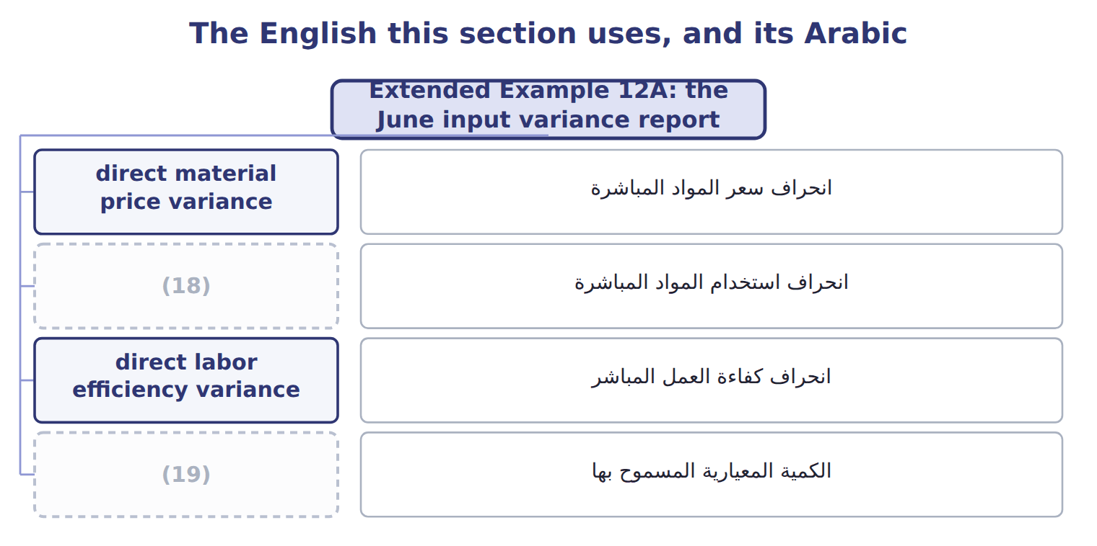
word list
direct material usage variance · انحراف سعر المواد المباشرة · standard quantity allowed

The English this sheet uses, and its Arabic
English (exam term) | Arabic
direct material price variance | انحراف سعر المواد المباشرة
direct material usage variance | انحراف استخدام المواد المباشرة
direct labor efficiency variance | انحراف كفاءة العمل المباشر

Answer key · 12.6 Extended Example 12A: the June input variance report

1 Concentrate usage | 11 Bottles actually used
2 Bottle price variance | 12 Standard labor hours a liter
3 Labor rate variance | 13 Standard labor rate
4 Labor efficiency variance | 14 Actual hours worked
5 dominates | 15 ($2.45 − $2.50) × 56,200 = $2,810 favorable
6 division's | 16 (56,200 − 55,000) × $2.50 = $3,000 unfavorable
7 produced | 17 (1,350 − 1,320) × $15.00 = $450 unfavorable
8 Calculate | 18 direct material usage variance
9 efficiency | 19 standard quantity allowed
10 Liters bottled

the summaries in full
Summary 1 Concentrate dominates the report. Its price variance is outside the division's control, but the usage variance and the labor efficiency variance share one cause: the long changeover identified.
Summary 2 Expect actual quantity, actual price, standard quantity per unit, standard price and the output produced. Calculate the standard quantity allowed first, then the price variance on the actual quantity and the efficiency variance at the standard price.

13.1 Sales-mix and sales-quantity variances
Chapter 13 · section 13.1

Fill every gap. Each word list holds one word more than there are gaps.
Chapter 13, section by section
Each stage leads to the next.
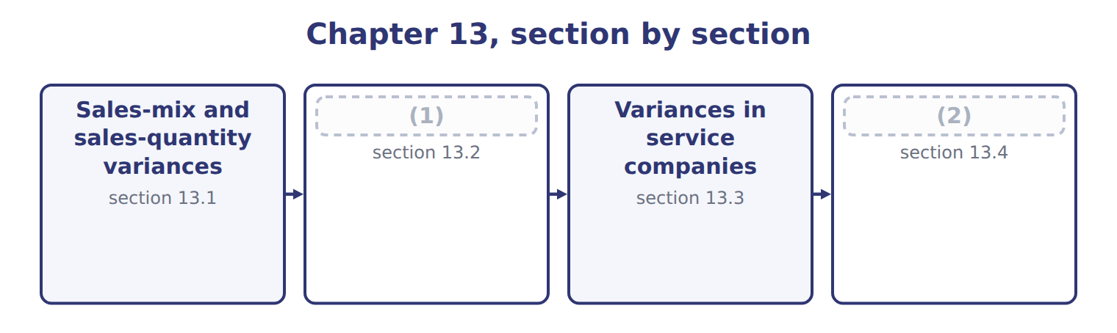
word list
Materials mix and yield variances · Variances in service companies · Extended Example 13A: the month in one report

Summary 1 gaps 3–8
When a (3) sells more than one product, the (4) variance: the total number of units, and the proportions in which they were sold. The (5) variance measures the proportions. It asks what the contribution margin would have been if the (6) total units had been sold in the budgeted mix. The (7) variance measures the total, valued at the budgeted (8) contribution margin. Tahini & Spreads sells three products.
word list
weighted-average · actual · revenue · division · sales-quantity · sales-volume · sales-mix

Budgeted and actual sales mix for the month
The bars are drawn to scale.
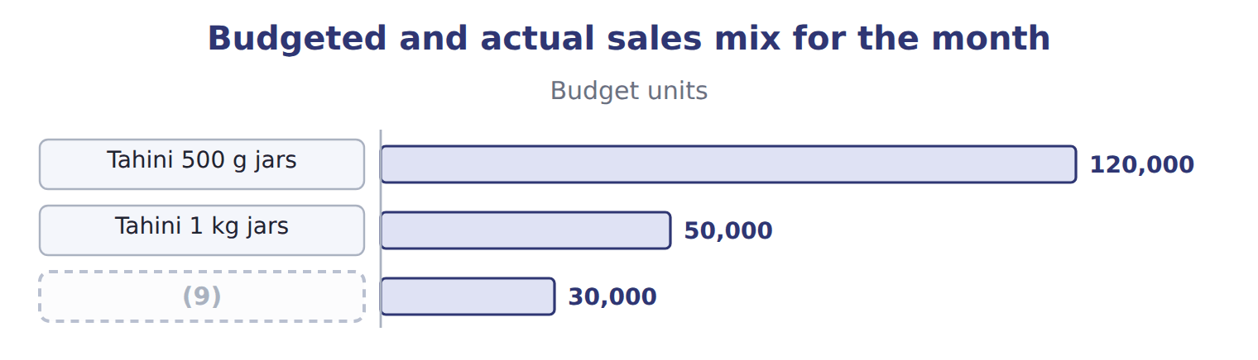
word list
Halva packs · sales-quantity variance

Worked example: the mix and quantity variances

Summary 2 gaps 10–12
In the budgeted mix, the actual 180,000 units would have (10) 108,000 of the small jars, not 117,000. Applying each (11) budgeted margin gives a mix variance of $4,500 unfavorable. The (12) variance is (180,000 − 200,000) × $1.80 = $36,000 unfavorable.
word list
cheapest · included · quantity · product's

Worked example: the sales-mix and sales-quantity variances
The bars are drawn to scale.
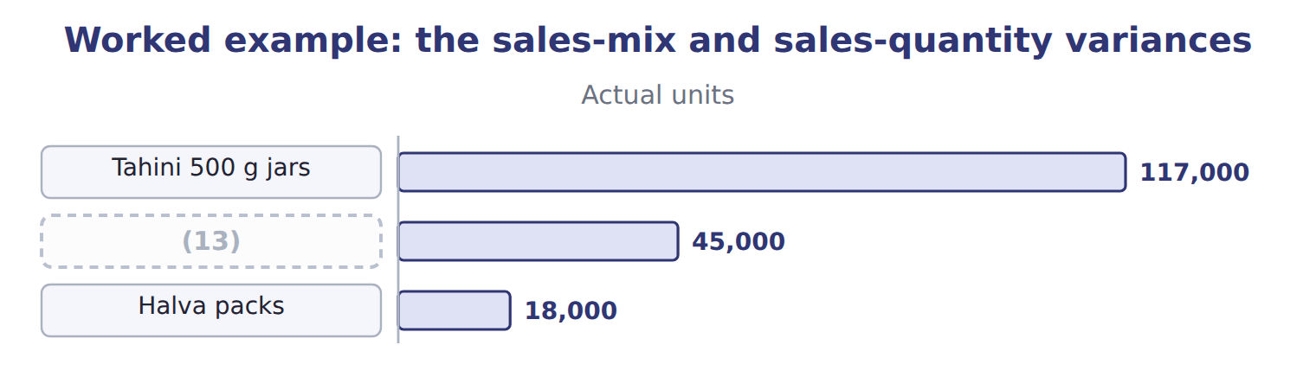
word list
Tahini 1 kg jars · Tahini 500 g jars

The two parts add to the sales-volume variance of $40,500 unfavorable.
The same volume variance, product by product
The bars are drawn to scale.
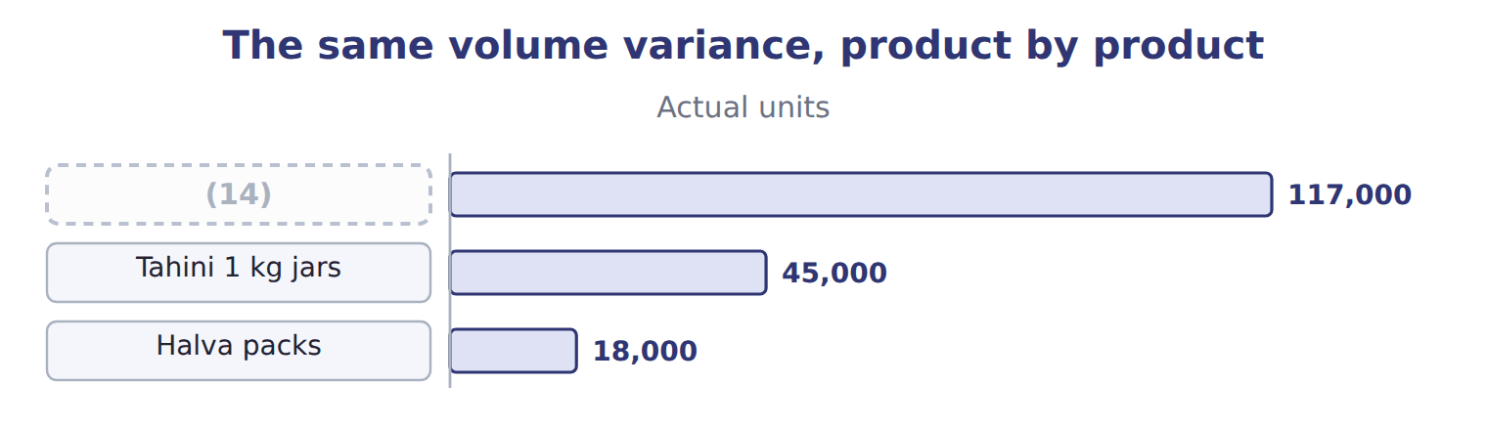
word list
Tahini 1 kg jars · Tahini 500 g jars

Summary 3 gaps 15–17
The mix matters because the products earn (15) margins. Selling a larger share of the cheapest jars costs (16) margin even when the total number of units is unchanged. The effect on (17) follows the same logic, using selling prices.
word list
different · follows · revenue · contribution

Mix uses the actual total

Summary 4 gaps 18–19
The sales-mix variance is always (18) on the actual total units. Using the budgeted total turns it into a different variance and the two parts will not add to the (19) variance.
word list
sales-volume · Applying · calculated

The English this sheet uses, and its Arabic
English (exam term) | Arabic
sales-mix variance | انحراف مزيج المبيعات
sales-quantity variance | انحراف كمية المبيعات
weighted-average contribution margin | متوسط هامش المساهمة المرجح

Answer key · 13.1 Sales-mix and sales-quantity variances

1 Materials mix and yield variances | 11 product's
2 Extended Example 13A: the month in one report | 12 quantity
3 division | 13 Tahini 1 kg jars
4 sales-volume | 14 Tahini 500 g jars
5 sales-mix | 15 different
6 actual | 16 contribution
7 sales-quantity | 17 revenue
8 weighted-average | 18 calculated
9 Halva packs | 19 sales-volume
10 included

the summaries in full
Summary 1 When a division sells more than one product, the sales-volume variance: the total number of units, and the proportions in which they were sold. The sales-mix variance measures the proportions. It asks what the contribution margin would have been if the actual total units had been sold in the budgeted mix. The sales-quantity variance measures the total, valued at the budgeted weighted-average contribution margin. Tahini & Spreads sells three products.
Summary 2 In the budgeted mix, the actual 180,000 units would have included 108,000 of the small jars, not 117,000. Applying each product's budgeted margin gives a mix variance of $4,500 unfavorable. The quantity variance is (180,000 − 200,000) × $1.80 = $36,000 unfavorable.
Summary 3 The mix matters because the products earn different margins. Selling a larger share of the cheapest jars costs contribution margin even when the total number of units is unchanged. The effect on revenue follows the same logic, using selling prices.
Summary 4 The sales-mix variance is always calculated on the actual total units. Using the budgeted total turns it into a different variance and the two parts will not add to the sales-volume variance.

13.2 Materials mix and yield variances
Chapter 13 · section 13.2

Fill every gap. Each word list holds one word more than there are gaps.
Summary 1 gaps 1–3
The same idea (1) to inputs that can be (2) for each other. Halva is made from sesame paste and sugar in a standard blend; using more paste and less sugar changes the cost even if the total input is (3) .
word list
process · unchanged · substituted · applies

Worked example: the halva blend

Worked example: the halva mix and yield variances
The bars are drawn to scale.
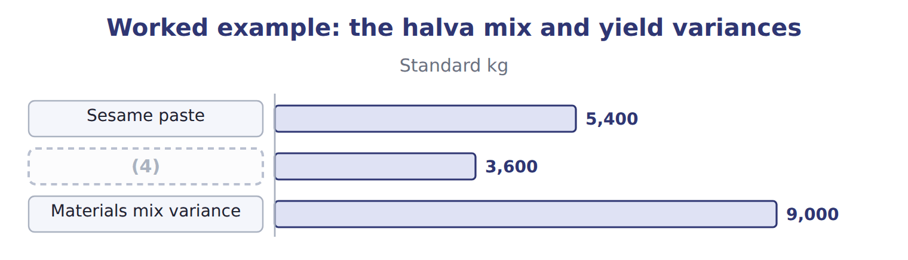
word list
Sesame paste · Sugar

The sugar line

Summary 2 gaps 5–7
Complete the blank cells. Mix and yield (5) make up the usage variance of $800 (6) , which is what. The mix variance (7) to whoever chose the blend; the yield variance to whoever ran the process.
word list
weighted-average · together · unfavorable · belongs

Yield is valued at the average

Summary 3 gaps 8–9
The yield (8) is valued at the (9) standard price of the blend, $1.90 a kilogram here, not at the price of one input.
word list
weighted-average · variance · substituted

The English this sheet uses, and its Arabic
English (exam term) | Arabic
materials mix variance | انحراف مزيج المواد
materials yield variance | انحراف مردود المواد

Answer key · 13.2 Materials mix and yield variances

1 applies | 6 unfavorable
2 substituted | 7 belongs
3 unchanged | 8 variance
4 Sugar | 9 weighted-average
5 together

the summaries in full
Summary 1 The same idea applies to inputs that can be substituted for each other. Halva is made from sesame paste and sugar in a standard blend; using more paste and less sugar changes the cost even if the total input is unchanged.
Summary 2 Complete the blank cells. Mix and yield together make up the usage variance of $800 unfavorable, which is what. The mix variance belongs to whoever chose the blend; the yield variance to whoever ran the process.
Summary 3 The yield variance is valued at the weighted-average standard price of the blend, $1.90 a kilogram here, not at the price of one input.

13.3 Variances in service companies
Chapter 13 · section 13.3

Fill every gap. Each word list holds one word more than there are gaps.
Summary 1 gaps 1–2
A service company has no finished goods, but it still has (1) : hours per delivery, hours per audit, minutes per call. Every variance in, with labor hours in place of (2) .
word list
materials · inventory · standards

Worked example: Levant Distribution

Summary 2 gaps 3–4
Levant made 2,400 (3) , allowing 1,200 hours at $10.00; it worked 1,260 hours at $10.40. The overhead (4) variance compares actual variable overhead with the standard rate applied to the hours worked.
word list
spending · deliveries · minutes

Worked example: variances at Levant Distribution
Levant: 2,400 deliveries | Calculation | Variance
Labor rate | ($10.40 − $10.00) × 1,260 hours | (5)
Labor efficiency | (6) | 600 U
Overhead spending | $7,980 − 1,260 hours × $6.00 | (7)
Overhead efficiency | (8) | 360 U

word list
504 U · Fuel, vehicle running costs, utilities · (1,260 − 1,200) hours × $6.00 · 420 U · (1,260 − 1,200) hours × $10.00

How each variance is read in a service company
Variance | In a service company | How it is calculated
Price or rate | (9) | Same formula: (AR − SR) × actual hours
Efficiency | Hours per delivery or per order | (10)
Spending | (11) | Actual overhead − standard rate × actual hours
Mix | (12) | Same formula as a materials or sales mix
No inventory | Services are consumed as produced | There is no usage variance for stock, but input (13) remain

word list
Share of senior and junior staff, or of service types · Same formula: (AH − SH allowed) × standard rate · variances · materials yield variance · Wage paid to drivers and warehouse staff · Fuel, vehicle running costs, utilities

Summary 3 gaps 14–16
The one (14) is that a service (15) be stored. There is no stock of unsold (16) , so the usage variance never carries into inventory; it affects the period in which the work was done.
word list
service · cannot · deliveries · difference

The English this sheet uses, and its Arabic
English (exam term) | Arabic
overhead spending variance | انحراف إنفاق التكاليف غير المباشرة

Answer key · 13.3 Variances in service companies

1 standards | 9 Wage paid to drivers and warehouse staff
2 materials | 10 Same formula: (AH − SH allowed) × standard rate
3 deliveries | 11 Fuel, vehicle running costs, utilities
4 spending | 12 Share of senior and junior staff, or of service types
5 504 U | 13 variances
6 (1,260 − 1,200) hours × $10.00 | 14 difference
7 420 U | 15 cannot
8 (1,260 − 1,200) hours × $6.00 | 16 deliveries

the summaries in full
Summary 1 A service company has no finished goods, but it still has standards: hours per delivery, hours per audit, minutes per call. Every variance in, with labor hours in place of materials.
Summary 2 Levant made 2,400 deliveries, allowing 1,200 hours at $10.00; it worked 1,260 hours at $10.40. The overhead spending variance compares actual variable overhead with the standard rate applied to the hours worked.
Summary 3 The one difference is that a service cannot be stored. There is no stock of unsold deliveries, so the usage variance never carries into inventory; it affects the period in which the work was done.

13.4 Extended Example 13A: the month in one report
Chapter 13 · section 13.4

Fill every gap. Each word list holds one word more than there are gaps.
This example collects the chapter's variances into the report that goes to the Orontes board.
Extended Example: the month's mix, yield and service variances
Variance | Amount | Who answers, and why
Sales mix | (1) | Sales team: the product mix moved to cheaper jars
Sales quantity | (2) | Sales team and market: fewer units in total
Materials mix (halva) | 420 U | (3) : more paste, less sugar than the recipe
Materials yield (halva) | (4) | Plant: more total input than the standard allows
Levant labor and overhead | 1,884 U | Levant: rate, efficiency and spending together

word list
Variance · 36,000 U · 380 U · Plant · 4,500 U

Summary 1 gaps 5–7
The largest number is the (5) variance: the (6) simply sold fewer units. The mix variance is smaller but more useful, because it shows that the sales team sold the cheaper jars while halva, the richest product, fell (7) .
word list
furthest · budgeted · division · quantity

Everything ties

Mix $4,500 + quantity $36,000 = sales-volume $40,500, all unfavorable. Halva mix $420 + yield $380 = usage $800, all unfavorable.
Exam view

Summary 2 gaps 8–10
Expect budgeted and actual units for several (8) with their budgeted (9) , or a standard blend with actual inputs. Work out the actual total in the budgeted or standard (10) first; that single column gives both variances.
word list
margins · proportions · products · quantity

Exam view
Each stage leads to the next.
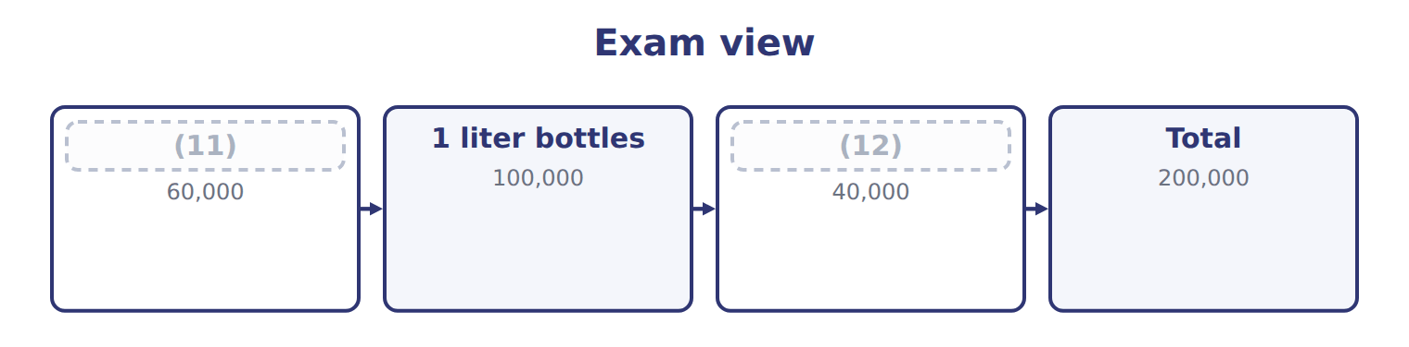
word list
5 liter cans · 500 ml bottles · overhead spending variance

Item — Answer
Item | Answer
Sugar mix variance | (3,400 − 3,680) × $1.00 = $(280) (favorable: less sugar than the blend allows)
Total mix variance | (13)

word list
$700 unfavorable − $(280) favorable = $420 unfavorable · Plant: more total input than the standard allows

Variance — Category
Each stage leads to the next.
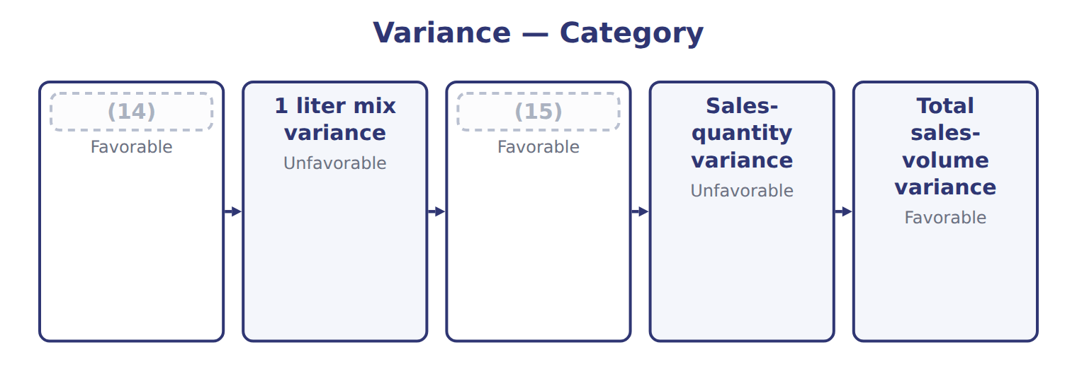
word list
5 liter mix variance · 500 ml mix variance · 1 liter mix variance

The English this section uses, and its Arabic
Each term sits against what it means.
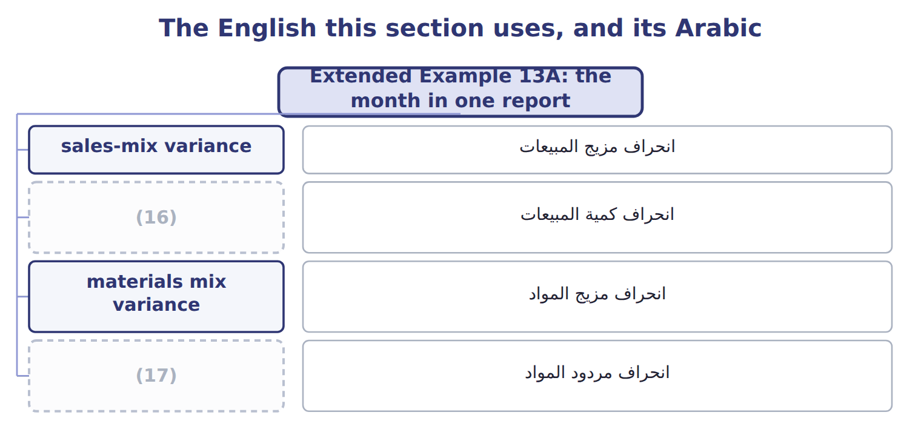
word list
انحراف مردود المواد · materials yield variance · sales-quantity variance

The English this sheet uses, and its Arabic
English (exam term) | Arabic
sales-mix variance | انحراف مزيج المبيعات
materials mix variance | انحراف مزيج المواد
materials yield variance | انحراف مردود المواد

Answer key · 13.4 Extended Example 13A: the month in one report

1 4,500 U | 10 proportions
2 36,000 U | 11 500 ml bottles
3 Plant | 12 5 liter cans
4 380 U | 13 $700 unfavorable − $(280) favorable = $420 unfavorable
5 quantity | 14 500 ml mix variance
6 division | 15 5 liter mix variance
7 furthest | 16 sales-quantity variance
8 products | 17 materials yield variance
9 margins

the summaries in full
Summary 1 The largest number is the quantity variance: the division simply sold fewer units. The mix variance is smaller but more useful, because it shows that the sales team sold the cheaper jars while halva, the richest product, fell furthest.
Summary 2 Expect budgeted and actual units for several products with their budgeted margins, or a standard blend with actual inputs. Work out the actual total in the budgeted or standard proportions first; that single column gives both variances.

14.1 Why overhead needs its own variances
Chapter 14 · section 14.1

Fill every gap. Each word list holds one word more than there are gaps.
Chapter 14, section by section
Each stage leads to the next.
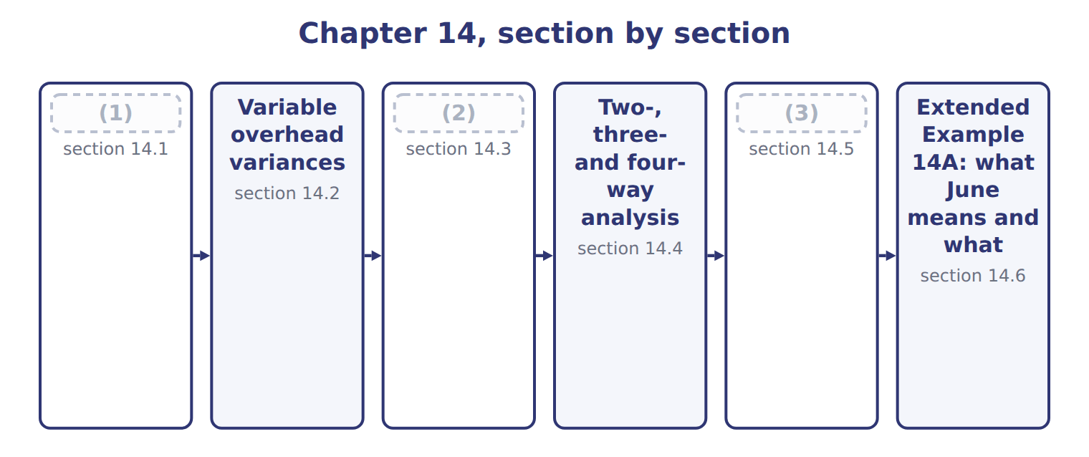
word list
Analysing variances and acting on them · Why overhead needs its own variances · Fixed overhead variances · Variable overhead variances

Summary 1 gaps 4–6
Variable overhead behaves like a (4) : it changes with a driver, here machine hours, so it has both a (5) variance and an efficiency variance. Fixed overhead does not change with (6) , so it cannot have an efficiency variance in the same sense.
word list
material · spending · activity · efficiency

How variable and fixed overhead differ
Overhead | Examples (Chapter 7) | Standard | Variances it can have
Variable overhead | Power, supplies, maintenance | (7) | Spending and efficiency
Fixed overhead | (8) | $150,000 a month | Spending, and a volume effect on absorption

word list
Power, supplies, maintenance · Supervision, depreciation, insurance · $50.00 a machine hour

Answer key · 14.1 Why overhead needs its own variances

1 Why overhead needs its own variances | 5 spending
2 Fixed overhead variances | 6 activity
3 Analysing variances and acting on them | 7 $50.00 a machine hour
4 material | 8 Supervision, depreciation, insurance

the summaries in full
Summary 1 Variable overhead behaves like a material: it changes with a driver, here machine hours, so it has both a spending variance and an efficiency variance. Fixed overhead does not change with activity, so it cannot have an efficiency variance in the same sense.

14.2 Variable overhead variances
Chapter 14 · section 14.2

Fill every gap. Each word list holds one word more than there are gaps.
The three-column frame of, with machine hours as the input.
Worked example: variable overhead in June

Summary 1 gaps 1–3
The variable overhead (1) variance compares actual overhead with the standard rate applied to the hours worked: $71,000 − 1,460 × $50.00 = $2,000 (2) . The variable overhead (3) variance values the extra hours at the standard rate: $1,000 unfavorable.
word list
spending · compares · favorable · efficiency

Worked example: the variable overhead variances for June
Variable overhead, June 2028 | Amount
Cases produced | 72,000
Standard machine hours allowed (0.02 a case) | 1,440
Actual machine hours | 1,460
Standard variable overhead rate | $50.00 an hour
Actual variable overhead | 71,000
Spending variance | (4)
Efficiency variance | (1,460 − 1,440) × 50.00 = 1,000 U
Total | (5)

word list
71,000 − 1,460 × 50.00 = 2,000 F · fixed overhead spending variance · 1,000 F

Summary 2 gaps 6–8
The two (6) make the $1,000 (7) that. Note what each (8) : spending is about the rate paid for power and supplies; efficiency is about machine hours, so it follows the same cause as the labor efficiency variance.
word list
variance · measures · favorable · together

The English this sheet uses, and its Arabic
English (exam term) | Arabic
variable overhead spending variance | انحراف إنفاق التكاليف غير المباشرة المتغيرة
variable overhead efficiency variance | انحراف كفاءة التكاليف غير المباشرة المتغيرة

Answer key · 14.2 Variable overhead variances

1 spending | 5 1,000 F
2 favorable | 6 together
3 efficiency | 7 favorable
4 71,000 − 1,460 × 50.00 = 2,000 F | 8 measures

the summaries in full
Summary 1 The variable overhead spending variance compares actual overhead with the standard rate applied to the hours worked: $71,000 − 1,460 × $50.00 = $2,000 favorable. The variable overhead efficiency variance values the extra hours at the standard rate: $1,000 unfavorable.
Summary 2 The two together make the $1,000 favorable that. Note what each measures: spending is about the rate paid for power and supplies; efficiency is about machine hours, so it follows the same cause as the labor efficiency variance.

14.3 Fixed overhead variances
Chapter 14 · section 14.3

Fill every gap. Each word list holds one word more than there are gaps.
Summary 1 gaps 1–2
Fixed overhead uses a (1) middle column: the budget, which is the same at any volume. The left gap is the fixed overhead spending variance; the right gap is the (2) variance.
word list
variance · different · production-volume

Worked example: fixed overhead in June

Summary 2 gaps 3–4
Spending: $152,000 − $150,000 = $2,000 unfavorable. (3) : $150,000 − 1,440 hours × $100.00 = $6,000 unfavorable, which is the 3,000 cases below the (4) volume × $2.00 a case.
word list
division · denominator · Production-volume

The fixed overhead variances

Complete the blank rows.
Your turn: the fixed overhead variances (complete the blanks)
Fixed overhead, June 2028 | Amount
(5) | 150,000
(6) | 1,500 machine hours
Fixed overhead rate | $100.00 an hour ($2.00 a case)
Actual fixed overhead | 152,000
(7) | 144,000
Spending variance | ________
(8) | ________

word list
Denominator volume (75,000 cases) · Applied: 1,440 hours × $100.00 · Production-volume variance · denominator level · Budgeted fixed overhead for the month

Summary 3 gaps 9–11
The (9) variance is not a (10) of cost control. Nobody spent $6,000 too much: the (11) simply produced fewer cases than the volume assumed when the rate was set, so less fixed overhead was absorbed into products.
word list
measure · overhead · division · production-volume

No fixed overhead efficiency variance

Summary 4 gaps 12–13
Fixed overhead has a spending variance and a (12) variance, and nothing else. An answer that reports a fixed overhead (13) variance has borrowed a variance that does not exist.
word list
efficiency · borrowed · production-volume

The English this sheet uses, and its Arabic
English (exam term) | Arabic
fixed overhead spending variance | انحراف إنفاق التكاليف غير المباشرة الثابتة
production-volume variance | انحراف حجم الإنتاج
denominator level | مستوى الطاقة المستخدم في المقام

Answer key · 14.3 Fixed overhead variances

1 different | 8 Production-volume variance
2 production-volume | 9 production-volume
3 Production-volume | 10 measure
4 denominator | 11 division
5 Budgeted fixed overhead for the month | 12 production-volume
6 Denominator volume (75,000 cases) | 13 efficiency
7 Applied: 1,440 hours × $100.00

the summaries in full
Summary 1 Fixed overhead uses a different middle column: the budget, which is the same at any volume. The left gap is the fixed overhead spending variance; the right gap is the production-volume variance.
Summary 2 Spending: $152,000 − $150,000 = $2,000 unfavorable. Production-volume: $150,000 − 1,440 hours × $100.00 = $6,000 unfavorable, which is the 3,000 cases below the denominator volume × $2.00 a case.
Summary 3 The production-volume variance is not a measure of cost control. Nobody spent $6,000 too much: the division simply produced fewer cases than the volume assumed when the rate was set, so less fixed overhead was absorbed into products.
Summary 4 Fixed overhead has a spending variance and a production-volume variance, and nothing else. An answer that reports a fixed overhead efficiency variance has borrowed a variance that does not exist.

14.4 Two-, three- and four-way analysis
Chapter 14 · section 14.4

Fill every gap. Each word list holds one word more than there are gaps.
The four variances can be reported in groups.
The same overhead variance in four, three and two parts
Every item belongs to exactly one group.
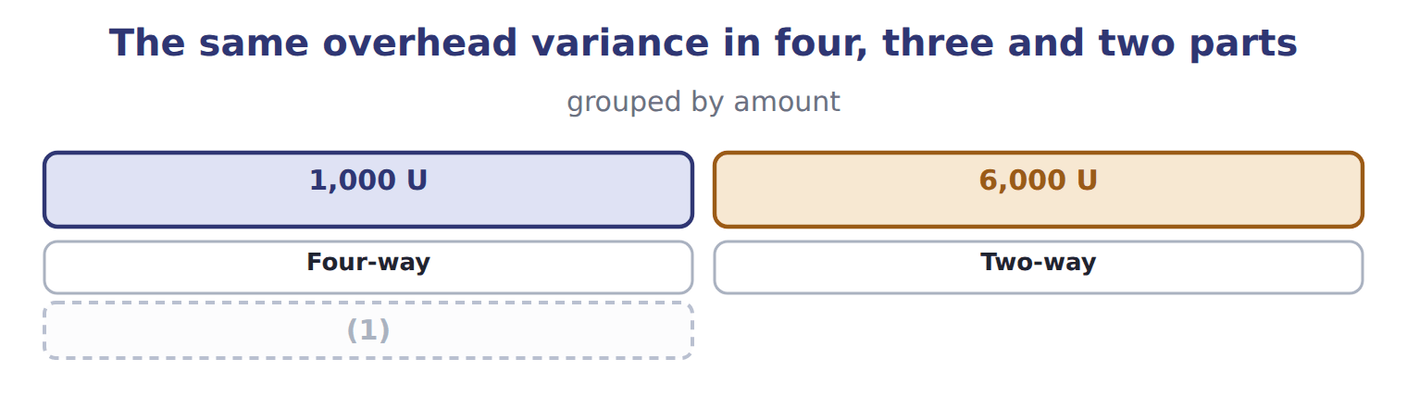
word list
Four-way · Three-way

Summary 1 gaps 2–5
In the (2) analysis the two spending (3) are combined; here they cancel, which shows why the four-way analysis is more useful. In the two-way analysis (4) except volume is called the budget or (5) variance. Whichever grouping is used, the total is the same.
word list
variances · everything · three-way · controllable · combined

Proof: actual overhead less applied overhead
Proof, June 2028 (USD) | Amount
Actual variable overhead | 71,000
(6) | 152,000
Total actual overhead | 223,000
(7) | 72,000
(8) | 144,000
(9) | 216,000
Total overhead variance (under-applied) | 7,000 U

word list
Applied fixed overhead (1,440 hours × $100.00) · Total applied overhead · Actual fixed overhead · Applied variable overhead (1,440 hours × $50.00) · Spending (variable + fixed)

Answer key · 14.4 Two-, three- and four-way analysis

1 Three-way | 6 Actual fixed overhead
2 three-way | 7 Applied variable overhead (1,440 hours × $50.00)
3 variances | 8 Applied fixed overhead (1,440 hours × $100.00)
4 everything | 9 Total applied overhead
5 controllable

the summaries in full
Summary 1 In the three-way analysis the two spending variances are combined; here they cancel, which shows why the four-way analysis is more useful. In the two-way analysis everything except volume is called the budget or controllable variance. Whichever grouping is used, the total is the same.

14.5 Analysing variances and acting on them
Chapter 14 · section 14.5

Fill every gap. Each word list holds one word more than there are gaps.
A variance report is the start of a conversation, not its conclusion.
Five questions before recommending an action
Step (C.1.s) | What to ask
1. Is it significant? | Compare with the rule of Chapter 11 (5% of the (1) figure)
2. What caused it? | Separate price from quantity, and the plan from the result
3. Who controls the cause? | A world price rise is not the plant's responsibility
4. Is it linked to another variance? | A favorable price beside an (2) usage usually has one cause
5. What action follows? | Remove the cause, change the (3) , or accept it and explain

word list
standard · Separate · budgeted · unfavorable

Summary 1 gaps 4–8
Deciding on an action before knowing the cause is the (4) fault in variance (5) , and so is acting on a variance whose cause nobody in the division controls. A favorable variance also (6) a question. A favorable (7) variance that came from skipping (8) is not good news; it has moved cost into a later month.
word list
commonest · spending · deserves · reporting · maintenance · controls

The English this sheet uses, and its Arabic
English (exam term) | Arabic
corrective action | الإجراء التصحيحي

Answer key · 14.5 Analysing variances and acting on them

1 budgeted | 5 reporting
2 unfavorable | 6 deserves
3 standard | 7 spending
4 commonest | 8 maintenance

the summaries in full
Summary 1 Deciding on an action before knowing the cause is the commonest fault in variance reporting, and so is acting on a variance whose cause nobody in the division controls. A favorable variance also deserves a question. A favorable spending variance that came from skipping maintenance is not good news; it has moved cost into a later month.

14.6 Extended Example 14A: what June means and what to do
Chapter 14 · section 14.6

Fill every gap. Each word list holds one word more than there are gaps.
Summary 1 gaps 1–2
This example takes the four overhead (1) to the review meeting and turns them into (2) .
word list
variances · Remember · decisions

Extended Example: causes and recommended actions for June
Variance | Amount | Likely cause | Recommended action
VOH spending | (3) | Cheaper power tariff agreed in May | Keep the tariff; check that quality has not suffered
VOH efficiency | 1,000 U | The long changeover ran the machines 20 hours longer than the standard | (4)
FOH spending | (5) | Unplanned repair to the filling line | Plan preventive maintenance in the quiet quarter
Production-volume | 6,000 U | 3,000 fewer cases than the normal volume, so less fixed overhead was absorbed | (6)

word list
2,000 F · 6,000 U · A sales matter, not a plant one: no plant action · Shorten changeovers (Book 2, Chapter 15) · 2,000 U

Summary 2 gaps 7–9
Only two of the four led to (7) inside the plant. The (8) spending variance is kept but watched; the volume variance is passed to the sales (9) of, because the plant cannot sell cases.
word list
favorable · action · discussion · spending

Everything ties

Summary 3 gaps 10–11
Variable overhead: $2,000 favorable + $1,000 (10) = $1,000 favorable, the figure. All four: $223,000 actual − $216,000 applied = $7,000 (11) .
word list
under-applied · unfavorable · decisions

Exam view

Summary 4 gaps 12–14
Expect actual overhead, actual hours, the standard rates, the output produced and the (12) volume. Work out the standard hours allowed first, then apply the four (13) . Remember that the (14) variance uses the standard hours allowed, never the hours worked.
word list
formulas · because · denominator · production-volume

Exam view
Tahini & Spreads overhead, one month | Data
(15) | 110,000
Standard machine hours a jar | 0.02
Standard variable overhead rate | $25.00 an hour
(16) | 80,000
Normal volume used for the fixed rate | 100,000 jars (2,000 machine hours)
(17) | 2,260
(18) | 55,000
Actual fixed overhead | 83,000

word list
Actual machine hours · Budgeted fixed overhead for the month · Jars produced · Actual variable overhead · Variable overhead efficiency variance

Item — Answer
Item | Answer
Fixed overhead spending variance | (19)
Production-volume variance | $150,000 − 1,440 × $100.00 = $6,000 unfavorable (3,000 cases × $2.00)

word list
$152,000 − $150,000 = $2,000 unfavorable · Unplanned repair to the filling line

Variance — Category
Every item belongs to exactly one group.
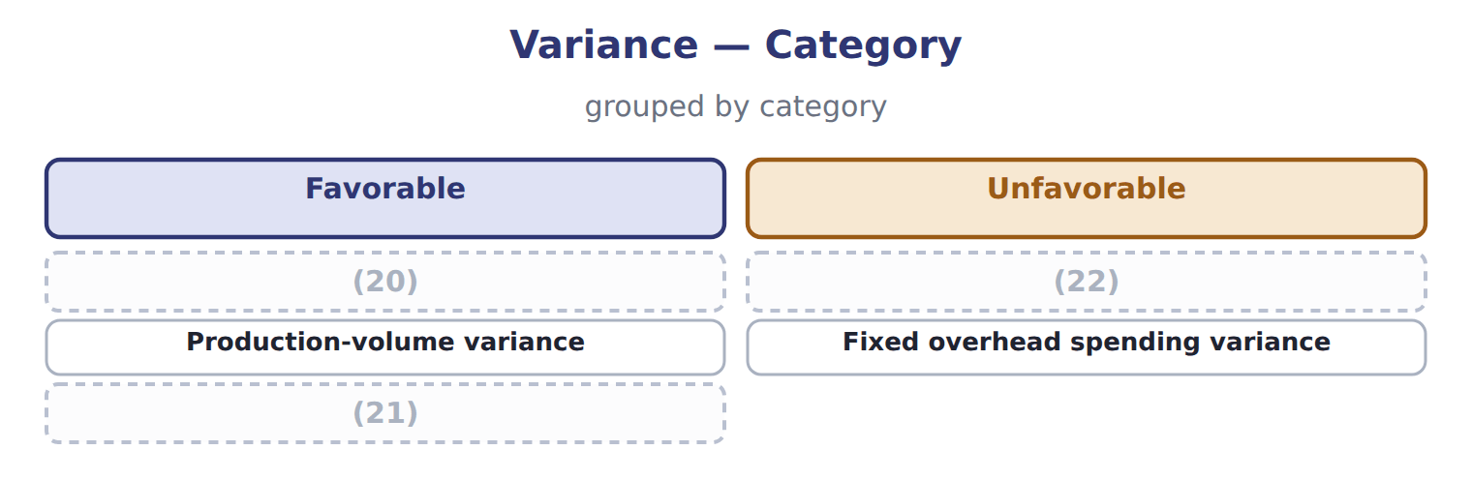
word list
fixed overhead spending variance · Variable overhead spending variance · Variable overhead efficiency variance · Total overhead variance

The English this sheet uses, and its Arabic
English (exam term) | Arabic
variable overhead spending variance | انحراف إنفاق التكاليف غير المباشرة المتغيرة
fixed overhead spending variance | انحراف إنفاق التكاليف غير المباشرة الثابتة
production-volume variance | انحراف حجم الإنتاج

Answer key · 14.6 Extended Example 14A: what June means and what to do

1 variances | 12 denominator
2 decisions | 13 formulas
3 2,000 F | 14 production-volume
4 Shorten changeovers (Book 2, Chapter 15) | 15 Jars produced
5 2,000 U | 16 Budgeted fixed overhead for the month
6 A sales matter, not a plant one: no plant action | 17 Actual machine hours
7 action | 18 Actual variable overhead
8 favorable | 19 $152,000 − $150,000 = $2,000 unfavorable
9 discussion | 20 Variable overhead spending variance
10 unfavorable | 21 Total overhead variance
11 under-applied | 22 Variable overhead efficiency variance

the summaries in full
Summary 1 This example takes the four overhead variances to the review meeting and turns them into decisions.
Summary 2 Only two of the four led to action inside the plant. The favorable spending variance is kept but watched; the volume variance is passed to the sales discussion of, because the plant cannot sell cases.
Summary 3 Variable overhead: $2,000 favorable + $1,000 unfavorable = $1,000 favorable, the figure. All four: $223,000 actual − $216,000 applied = $7,000 under-applied.
Summary 4 Expect actual overhead, actual hours, the standard rates, the output produced and the denominator volume. Work out the standard hours allowed first, then apply the four formulas. Remember that the production-volume variance uses the standard hours allowed, never the hours worked.

15.1 The four responsibility centers
Chapter 15 · section 15.1

Fill every gap. Each word list holds one word more than there are gaps.
Chapter 15, section by section
Each stage leads to the next.
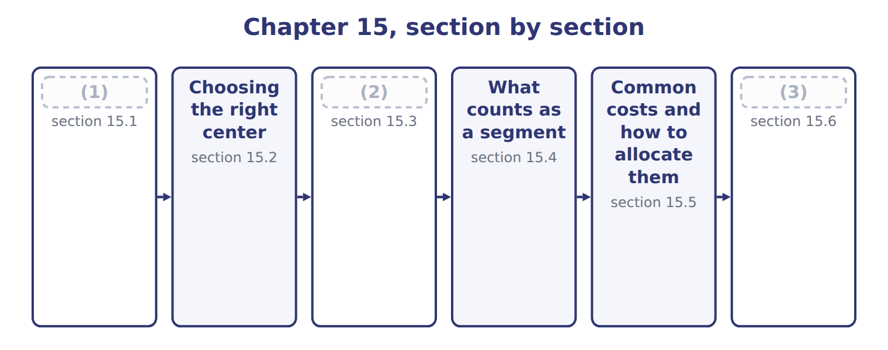
word list
The four responsibility centers · What counts as a segment · Extended Example 15A: evaluating the three div · The contribution margin report

Summary 1 gaps 4–12
A (4) center is a unit whose manager answers for a (5) set of results. There are four kinds, and they (6) only in how much the manager (7) . A cost center answers for costs, and a revenue center for revenue and the (8) costs of earning it. A profit center answers for both, and an (9) center also for the (10) used. The four form a (11) . Each center carries the (12) of the one before it and adds another, so a manager promoted from a cost center to a profit center is answering for revenue for the first time.
word list
ladder · assets · differ · investment · manager · responsibility · selling · controls · responsibilities · defined

The English this section uses, and its Arabic
Each term sits against what it means.
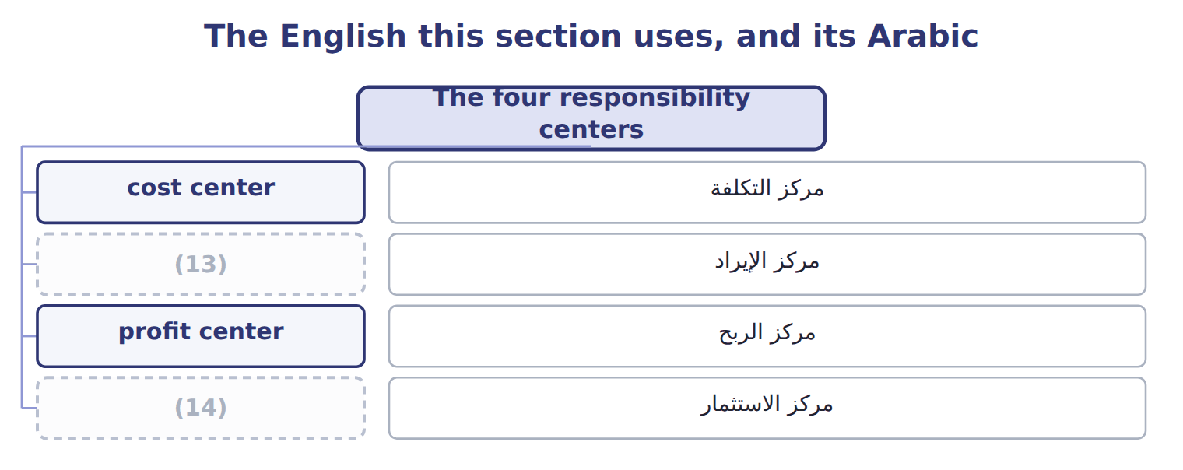
word list
investment center · revenue center · profit center

The English this sheet uses, and its Arabic
English (exam term) | Arabic
cost center | مركز التكلفة
revenue center | مركز الإيراد
profit center | مركز الربح
investment center | مركز الاستثمار

Answer key · 15.1 The four responsibility centers

1 The four responsibility centers | 8 selling
2 The contribution margin report | 9 investment
3 Extended Example 15A: evaluating the three div | 10 assets
4 responsibility | 11 ladder
5 defined | 12 responsibilities
6 differ | 13 revenue center
7 controls | 14 investment center

the summaries in full
Summary 1 A responsibility center is a unit whose manager answers for a defined set of results. There are four kinds, and they differ only in how much the manager controls. A cost center answers for costs, and a revenue center for revenue and the selling costs of earning it. A profit center answers for both, and an investment center also for the assets used. The four form a ladder. Each center carries the responsibilities of the one before it and adds another, so a manager promoted from a cost center to a profit center is answering for revenue for the first time.

15.2 Choosing the right center
Chapter 15 · section 15.2

Fill every gap. Each word list holds one word more than there are gaps.
Summary 1 gaps 1–2
The rule is simple to state and easy to break: give a manager only the (1) that matches the (2) .
word list
responsibility · revenue · authority

Choosing a responsibility center for a situation
What the manager controls (C.2.b) | Recommended center | Orontes example
The manager sets prices and controls costs, but not investment | Profit center | (3)
The manager controls costs only; another unit decides output | (4) | Tahini plant
The manager controls selling effort but not production costs | (5) | Regional sales team
The manager decides on new plant and working capital | (6) | Beverages division
The manager controls nothing but is charged a share of head office | (7) | Any division's allocated head-office cost

word list
Investment center · Levant Distribution · Any division's allocated head-office cost · Revenue center · No center: the charge is not controllable · Cost center

Summary 2 gaps 8–11
At (8) the tahini plant is a cost center, because the sales team decides what to sell and at what price. Levant (9) is a profit center, because its manager sets (10) prices and controls its costs. The Beverages division is an (11) center, because its manager decides on new equipment.
word list
authority · Distribution · delivery · investment · Orontes

Authority first, label second

Summary 3 gaps 12–17
Calling a unit a profit center does not give its (12) control over (13) . If the (14) says that another unit sets the price or the volume, the center is a cost center (15) the company labels it. The (16) also shapes (17) . A unit made a profit center will look for ways to raise revenue, which is useful when it can really influence customers, and misleading when it cannot.
word list
division · manager · however · question · behavior · choice · prices

The English this section uses, and its Arabic
Each term sits against what it means.
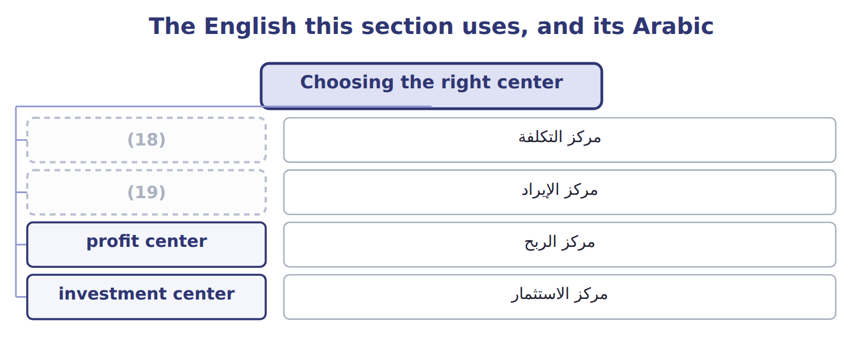
word list
revenue center · cost center · common cost

Answer key · 15.2 Choosing the right center

1 responsibility | 11 investment
2 authority | 12 manager
3 Levant Distribution | 13 prices
4 Cost center | 14 question
5 Revenue center | 15 however
6 Investment center | 16 choice
7 No center: the charge is not controllable | 17 behavior
8 Orontes | 18 cost center
9 Distribution | 19 revenue center
10 delivery

the summaries in full
Summary 1 The rule is simple to state and easy to break: give a manager only the responsibility that matches the authority.
Summary 2 At Orontes the tahini plant is a cost center, because the sales team decides what to sell and at what price. Levant Distribution is a profit center, because its manager sets delivery prices and controls its costs. The Beverages division is an investment center, because its manager decides on new equipment.
Summary 3 Calling a unit a profit center does not give its manager control over prices. If the question says that another unit sets the price or the volume, the center is a cost center however the company labels it. The choice also shapes behavior. A unit made a profit center will look for ways to raise revenue, which is useful when it can really influence customers, and misleading when it cannot.

15.3 The contribution margin report
Chapter 15 · section 15.3

Fill every gap. Each word list holds one word more than there are gaps.
Summary 1 gaps 1–8
A segment report in contribution format has three margins, each (1) a different (2) . The contribution margin is revenue less all (3) costs: $18,000,000 − $10,620,000 = $7,380,000. It shows what each extra case adds, and it is the figure used (4) . The (5) margin then deducts the fixed costs the manager can change, such as marketing and (6) . The segment margin deducts the other fixed costs (7) to the division, such as (8) of its plant. Judge the manager on the first; judge the segment on the second.
word list
traceable · depreciation · throughout · question · answering · cost-volume-profit · controllable · supervision · variable

Worked example: the Orontes segment report

Worked example: the Orontes segment report for 2028
The bars are drawn to scale.
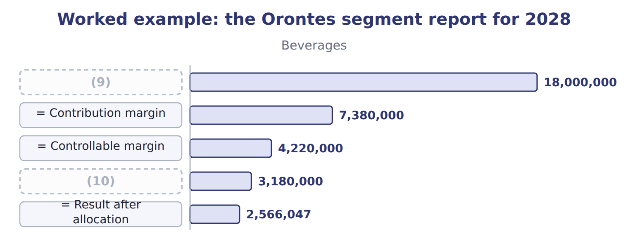
word list
stand-alone cost allocation · = Segment margin · Revenue

The Tahini & Spreads column

Complete the blank cells.
Contribution margin deducts only variable costs

Summary 2 gaps 11–12
Deducting any fixed cost before the (11) margin gives a figure that no longer measures what an extra unit adds. The (12) work of Book 2 then no longer applies to it.
word list
contribution · throughout · cost-volume-profit

The English this sheet uses, and its Arabic
English (exam term) | Arabic
controllable margin | الهامش القابل للرقابة
segment margin | هامش القطاع

Answer key · 15.3 The contribution margin report

1 answering | 7 traceable
2 question | 8 depreciation
3 variable | 9 Revenue
4 throughout | 10 = Segment margin
5 controllable | 11 contribution
6 supervision | 12 cost-volume-profit

the summaries in full
Summary 1 A segment report in contribution format has three margins, each answering a different question. The contribution margin is revenue less all variable costs: $18,000,000 − $10,620,000 = $7,380,000. It shows what each extra case adds, and it is the figure used throughout. The controllable margin then deducts the fixed costs the manager can change, such as marketing and supervision. The segment margin deducts the other fixed costs traceable to the division, such as depreciation of its plant. Judge the manager on the first; judge the segment on the second.
Summary 2 Deducting any fixed cost before the contribution margin gives a figure that no longer measures what an extra unit adds. The cost-volume-profit work of Book 2 then no longer applies to it.

15.4 What counts as a segment
Chapter 15 · section 15.4

Fill every gap. Each word list holds one word more than there are gaps.
Summary 1 gaps 1–2
A segment is any part of a (1) for which a manager is (2) and separate figures are useful.
word list
separate · business · responsible

Segments that Orontes evaluates
Segment type (C.2.e) | At Orontes | Why it is evaluated
Divisions | Beverages, Oils, Tahini & Spreads | (3)
Product lines | Juice flavours; tahini jars and halva | (4)
Geographical areas | (5) | Shows where growth and risk lie
Customers or channels | Supermarkets, hotels, Barada | (6)
Reportable segments under ASC 280 | The (7) , as reported to the chief operating decision maker | External reporting follows internal reporting

word list
divisions · Each has a manager responsible for results · Book 2, Chapter 13 measured customer profitability · cost center · Shows which products earn their keep (Chapter 13) · Jordan, the Gulf, export markets

Summary 2 gaps 8–13
Segments can overlap: the Gulf is a (8) segment that cuts across all three (9) . What (10) is that someone is (11) for the result and that the revenue and costs can be traced. External (12) follows the same logic. Under U.S. GAAP a company reports the segments its chief (13) decision maker uses, so the internal report and the published one usually share a structure.
word list
divisions · reporting · matters · accountable · operating · External · geographical

Answer key · 15.4 What counts as a segment

1 business | 8 geographical
2 responsible | 9 divisions
3 Each has a manager responsible for results | 10 matters
4 Shows which products earn their keep (Chapter 13) | 11 accountable
5 Jordan, the Gulf, export markets | 12 reporting
6 Book 2, Chapter 13 measured customer profitability | 13 operating
7 divisions

the summaries in full
Summary 1 A segment is any part of a business for which a manager is responsible and separate figures are useful.
Summary 2 Segments can overlap: the Gulf is a geographical segment that cuts across all three divisions. What matters is that someone is accountable for the result and that the revenue and costs can be traced. External reporting follows the same logic. Under U.S. GAAP a company reports the segments its chief operating decision maker uses, so the internal report and the published one usually share a structure.

15.5 Common costs and how to allocate them
Chapter 15 · section 15.5

Fill every gap. Each word list holds one word more than there are gaps.
Summary 1 gaps 1–3
A (1) cost serves more than one (2) and cannot be traced to any of them. Head office costs $1,100,000 a year, the (3) budget of, and every division is charged a share.
word list
zero-based · common · division · segment

Worked example: sharing the cold store

Summary 2 gaps 4–5
Alone, the two (4) would pay $240,000 and $120,000, a total of $360,000; (5) they pay $300,000.
word list
divisions · different · together

Worked example: three ways of sharing the cold store
Every item belongs to exactly one group.
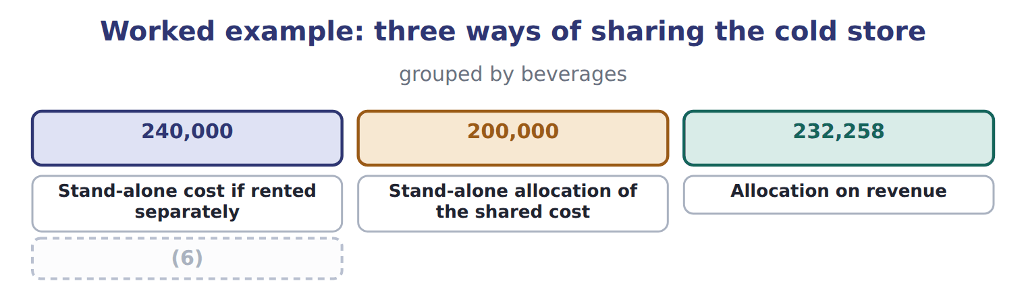
word list
incremental cost allocation · Incremental allocation (Beverages primary)

Summary 3 gaps 7–10
Each method gives a (7) answer from the same facts, and none of them is wrong. The (8) method shares the saving between the users, while the (9) method gives all of it to the second user. The choice of primary user is (10) itself a decision.
word list
different · therefore · stand-alone · incremental · division

Why allocating common costs is a problem
Issue with allocating common costs (C.2.f) | Why it matters | What to do
The charge is not controllable | A manager cannot change head-office cost by working harder | (11)
The base may be arbitrary | Revenue, floor space and (12) give different answers | Choose a base that reflects the use of the service
It can make a good segment look bad | A segment with a positive segment margin can show a loss after allocation | (13)
It can hide the cost of the service | (14) | Charge a rate per use where possible

word list
Users have no reason to economise on a free service · Report it below the segment margin · headcount · incremental cost allocation · Never close a segment on the allocated figure alone

Never close a segment on the allocated figure

Summary 4 gaps 15–16
A segment with a positive segment margin is covering its own costs and (15) to common costs. Closing it does not remove those common costs; they are simply shared among fewer (16) .
word list
contributing · segments · divisions

The English this section uses, and its Arabic
Each term sits against what it means.
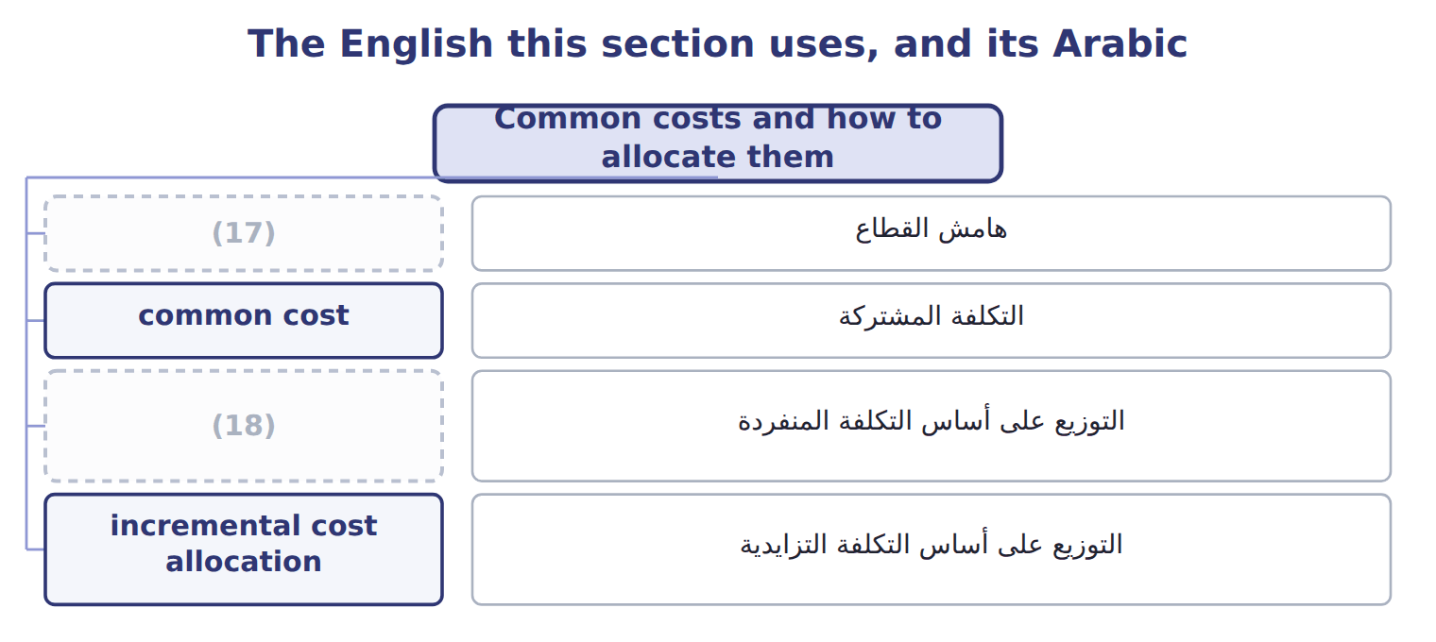
word list
investment center · stand-alone cost allocation · segment margin

The English this sheet uses, and its Arabic
English (exam term) | Arabic
common cost | التكلفة المشتركة
stand-alone cost allocation | التوزيع على أساس التكلفة المنفردة
incremental cost allocation | التوزيع على أساس التكلفة التزايدية

Answer key · 15.5 Common costs and how to allocate them

1 common | 10 therefore
2 segment | 11 Report it below the segment margin
3 zero-based | 12 headcount
4 divisions | 13 Never close a segment on the allocated figure alone
5 together | 14 Users have no reason to economise on a free service
6 Incremental allocation (Beverages primary) | 15 contributing
7 different | 16 segments
8 stand-alone | 17 segment margin
9 incremental | 18 stand-alone cost allocation

the summaries in full
Summary 1 A common cost serves more than one segment and cannot be traced to any of them. Head office costs $1,100,000 a year, the zero-based budget of, and every division is charged a share.
Summary 2 Alone, the two divisions would pay $240,000 and $120,000, a total of $360,000; together they pay $300,000.
Summary 3 Each method gives a different answer from the same facts, and none of them is wrong. The stand-alone method shares the saving between the users, while the incremental method gives all of it to the second user. The choice of primary user is therefore itself a decision.
Summary 4 A segment with a positive segment margin is covering its own costs and contributing to common costs. Closing it does not remove those common costs; they are simply shared among fewer segments.

15.6 Extended Example 15A: evaluating the three divisions
Chapter 15 · section 15.6

Fill every gap. Each word list holds one word more than there are gaps.
This example reads the segment report the way the Orontes board does.
Extended Example: the three divisions compared
The bars are drawn to scale.
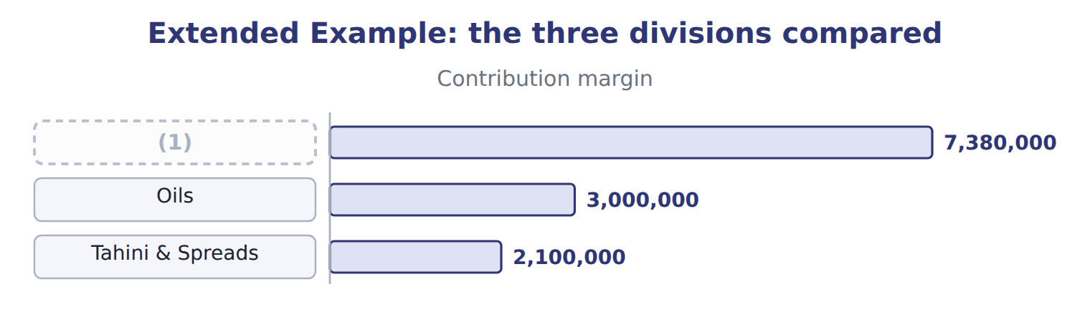
word list
segment margin · Beverages

Summary 1 gaps 2–11
Beverages earns the (2) margin in dollars and the highest (3) , which is why it (4) the capital. Tahini & Spreads earns $840,000 on a much (5) revenue, and the board has asked it to grow. Head office (6) each division a share of $1,100,000 on revenue. Tahini & Spreads is charged $179,070 and is left with $660,930. Its manager (7) that head office does no more work for his division than before, and that the charge rises whenever the other (8) grow. The board judges each manager on the (9) margin and each division on the segment margin, and treats the allocation as a (10) figure. No division is (11) on the figure after allocation.
word list
closed · smaller · charges · received · remember · memorandum · percentage · argues · controllable · divisions · largest

Everything ties

Summary 2 gaps 12–13
Beverages segment margin $3,180,000 = the (12) operating income. Segment (13) $5,020,000 − common costs $1,100,000 = company operating income $3,920,000.
word list
Spreads · contribution-format · margins

Exam view

Summary 3 gaps 14–16
Expect a list of costs to classify as variable, (14) fixed, traceable fixed or common, and then a margin to (15) . Read (16) which margin is asked for, and remember that allocated common costs come last.
word list
controllable · carefully · Spreads · calculate

Exam view
The bars are drawn to scale.
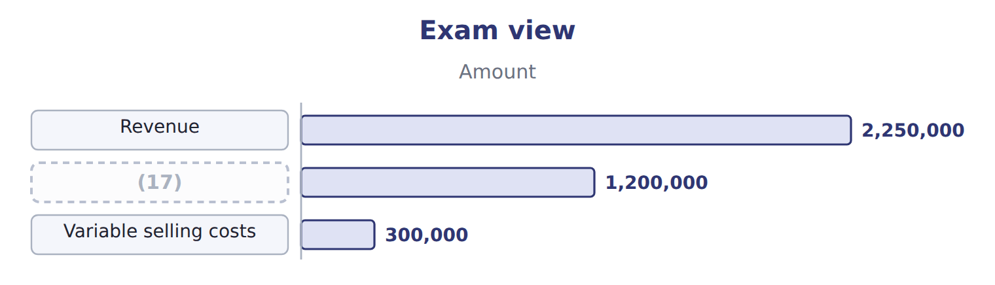
word list
stand-alone cost allocation · Variable manufacturing costs

Item — Answer
Item | Answer
Contribution margin | $5,250,000 − $3,150,000 = $2,100,000
Controllable margin | (18)
Segment margin | (19)

word list
$2,100,000 − $900,000 = $1,200,000 · $5,250,000 − $3,150,000 = $2,100,000 · $1,200,000 − $360,000 = $840,000

Cost — Category
Cost | Category
Olive oil and bottles | (20)
Marketing the manager approved | (21)
Depreciation of the bottling plant | (22)
Share of head-office costs | Common cost
Freight to customers per case | Variable cost

word list
Fixed cost the manager controls · $2,100,000 − $900,000 = $1,200,000 · Traceable fixed cost the manager does not control · Variable cost

The English this section uses, and its Arabic
Each term sits against what it means.
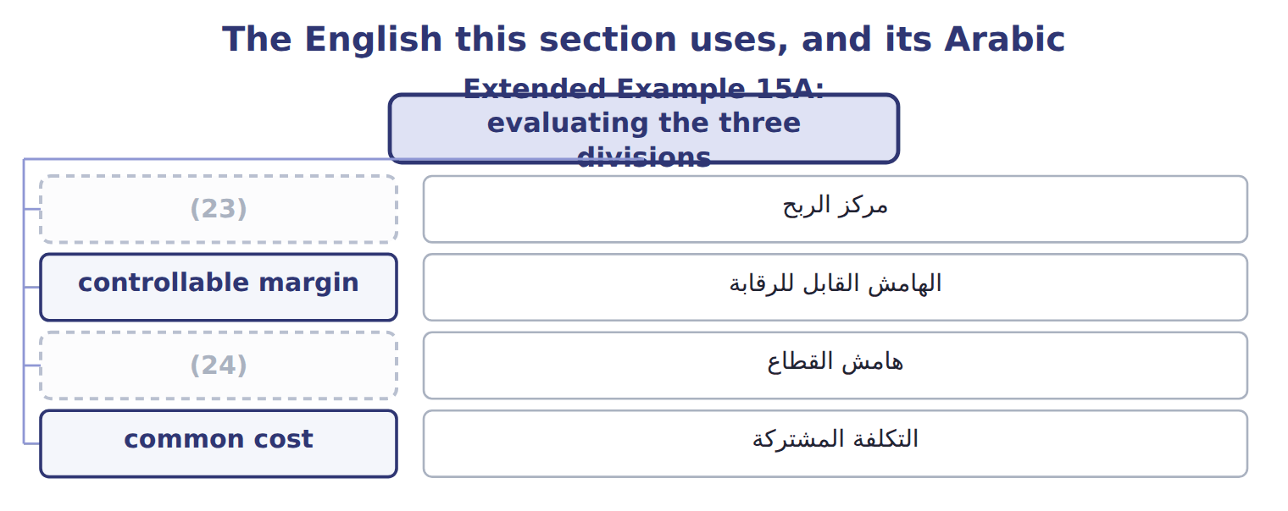
word list
profit center · investment center · segment margin

The English this sheet uses, and its Arabic
English (exam term) | Arabic
profit center | مركز الربح
segment margin | هامش القطاع
common cost | التكلفة المشتركة

Answer key · 15.6 Extended Example 15A: evaluating the three divisions

1 Beverages | 13 margins
2 largest | 14 controllable
3 percentage | 15 calculate
4 received | 16 carefully
5 smaller | 17 Variable manufacturing costs
6 charges | 18 $2,100,000 − $900,000 = $1,200,000
7 argues | 19 $1,200,000 − $360,000 = $840,000
8 divisions | 20 Variable cost
9 controllable | 21 Fixed cost the manager controls
10 memorandum | 22 Traceable fixed cost the manager does not control
11 closed | 23 profit center
12 contribution-format | 24 segment margin

the summaries in full
Summary 1 Beverages earns the largest margin in dollars and the highest percentage, which is why it received the capital. Tahini & Spreads earns $840,000 on a much smaller revenue, and the board has asked it to grow. Head office charges each division a share of $1,100,000 on revenue. Tahini & Spreads is charged $179,070 and is left with $660,930. Its manager argues that head office does no more work for his division than before, and that the charge rises whenever the other divisions grow. The board judges each manager on the controllable margin and each division on the segment margin, and treats the allocation as a memorandum figure. No division is closed on the figure after allocation.
Summary 2 Beverages segment margin $3,180,000 = the contribution-format operating income. Segment margins $5,020,000 − common costs $1,100,000 = company operating income $3,920,000.
Summary 3 Expect a list of costs to classify as variable, controllable fixed, traceable fixed or common, and then a margin to calculate. Read carefully which margin is asked for, and remember that allocated common costs come last.

16.1 What a transfer price is for
Chapter 16 · section 16.1

Fill every gap. Each word list holds one word more than there are gaps.
Chapter 16, section by section
Each stage leads to the next.
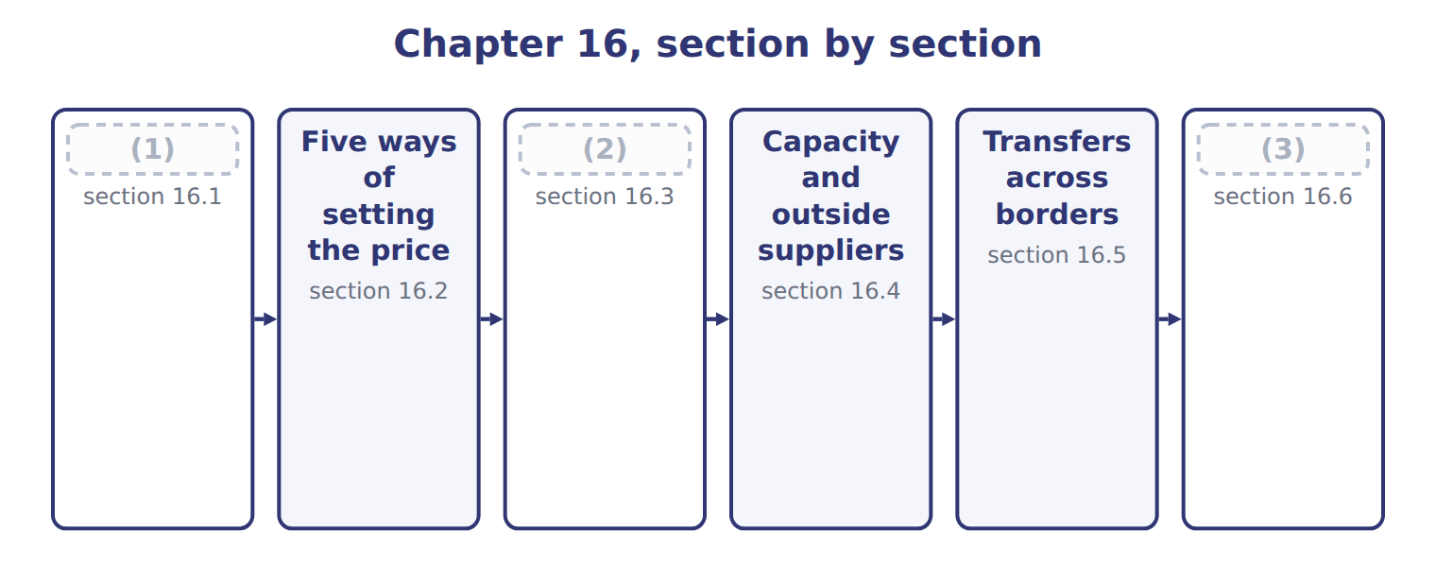
word list
The range: minimum and maximum · Extended Example 16A: raising the Gulf transfe · What a transfer price is for · Five ways of setting the price

Summary 1 gaps 4–8
A transfer price is the price one part of a company (4) another for goods or services supplied (5) . It is revenue to the (6) unit and cost to the buying unit, so the two cancel in the company (7) . (8) it cancels, the transfer price has no direct effect on company profit. Its purpose is to influence decisions and to measure performance fairly.
word list
internally · supplying · Beverages · charges · accounts · Because

The four objectives of a transfer price
Objective (C.2.h) | What it means | At Orontes
Goal congruence | (9) | A floor of variable cost keeps internal supply attractive
Fair performance evaluation | Each division's profit reflects its own work | (10)
Divisional autonomy | (11) | A negotiated price respects both managers
Company profit after tax | (12) | Set within the rules, not to shift profit

word list
A price below cost makes the supplier look bad · A floor of variable cost keeps internal supply attractive · Cross-border prices affect tariffs and tax · Managers keep the right to decide · Each manager's best choice is also best for the company

Summary 2 gaps 13–15
The (13) can conflict. A price that gives Levant a fair margin may be high enough to push (14) towards an outside carrier. The rest of the chapter works out where the price (15) sit.
word list
accounts · objectives · should · Beverages

The English this sheet uses, and its Arabic
English (exam term) | Arabic
transfer price | سعر التحويل

Answer key · 16.1 What a transfer price is for

1 What a transfer price is for | 9 Each manager's best choice is also best for the company
2 The range: minimum and maximum | 10 A price below cost makes the supplier look bad
3 Extended Example 16A: raising the Gulf transfe | 11 Managers keep the right to decide
4 charges | 12 Cross-border prices affect tariffs and tax
5 internally | 13 objectives
6 supplying | 14 Beverages
7 accounts | 15 should
8 Because

the summaries in full
Summary 1 A transfer price is the price one part of a company charges another for goods or services supplied internally. It is revenue to the supplying unit and cost to the buying unit, so the two cancel in the company accounts. Because it cancels, the transfer price has no direct effect on company profit. Its purpose is to influence decisions and to measure performance fairly.
Summary 2 The objectives can conflict. A price that gives Levant a fair margin may be high enough to push Beverages towards an outside carrier. The rest of the chapter works out where the price should sit.

16.2 Five ways of setting the price
Chapter 16 · section 16.2

Fill every gap. Each word list holds one word more than there are gaps.
Summary 1 gaps 1–3
Companies set transfer prices in five ways: at the (1) variable cost, at its full cost, at the market price, at a price the two managers (2) , or at two (3) rates for the two sides.
word list
different · Dual-rate · negotiate · supplier's

Five methods of setting a transfer price
Method (C.2.i) | Price a case | Advantages | Disadvantages
Variable cost | $0.50 | (4) | Supplier earns nothing; looks like a poor performer
Full cost | $0.80 | (5) | Fixed cost looks variable to the buyer, so it can refuse good internal business
Market price | $1.10 | (6) | No market price for many internal services; ignores savings on internal trade
Negotiated | $0.90 | (7) | Takes time; the better negotiator wins
Dual rate | $1.10 / $0.50 | Both divisions see the price that leads to the right decision | The two sides do not add up; the difference must be removed on (8)

word list
Fair to both; good when a competitive market exists · Dual rate · Simple; covers the supplier's costs · Leads to the right decision for the company · Respects autonomy; managers know their own costs · consolidation

Worked example: the same year at five prices

Summary 2 gaps 9–10
Beverages needs 900,000 cases (9) . At (10) cost Levant earns nothing on the work and Beverages keeps $6,930,000; at market price Levant earns $540,000.
word list
variable · something · delivered

Worked example: the same year at five transfer prices
The bars are drawn to scale.
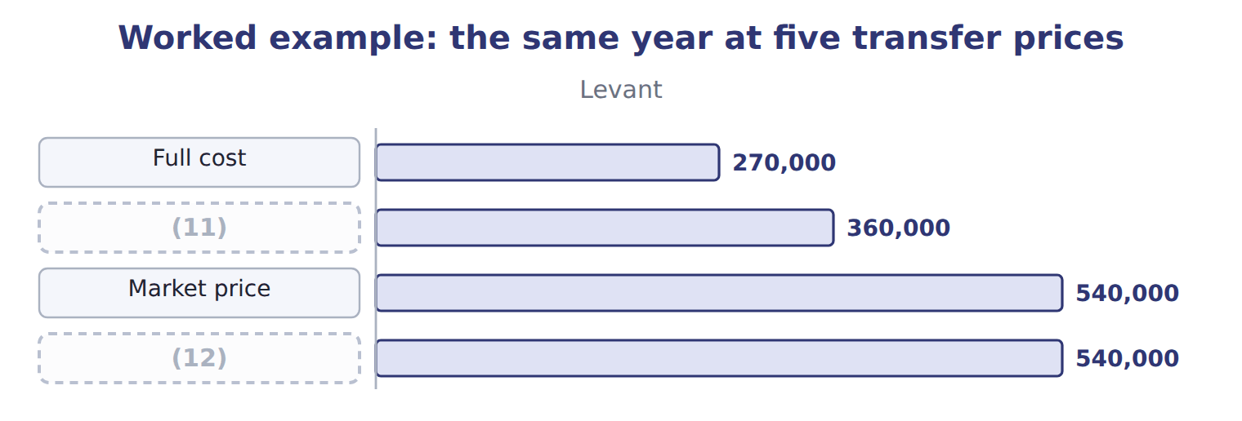
word list
Dual rate · Negotiated · transfer price

The negotiated and market prices

Summary 3 gaps 13–15
Complete the blank cells. (13) transfer pricing credits Levant with the market price and charges (14) only the variable cost, so each manager faces the figure that leads to the right decision. The $540,000 (15) is removed when the divisions are added together.
word list
difference · Dual-rate · Beverages · variable

The company column never moves

Summary 4 gaps 16–20
Changing a (16) price moves profit between (17) . If an answer shows the company better or worse off (18) of the price alone, something has been (19) . No method is right (20) . A market price suits a product with an outside market, a negotiated price suits one without, and dual rates suit a case where the right decision and fair reporting pull apart.
word list
because · negotiated · transfer · double-counted · divisions · everywhere

The English this section uses, and its Arabic
Each term sits against what it means.
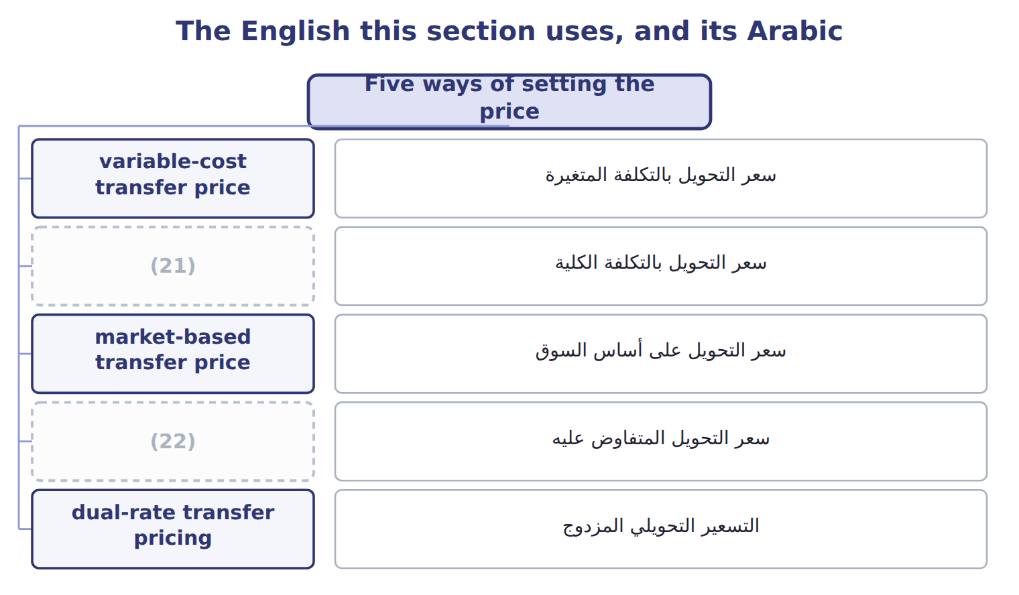
word list
التسعير التحويلي المزدوج · full-cost transfer price · negotiated transfer price

The English this sheet uses, and its Arabic
English (exam term) | Arabic
variable-cost transfer price | سعر التحويل بالتكلفة المتغيرة
full-cost transfer price | سعر التحويل بالتكلفة الكلية
market-based transfer price | سعر التحويل على أساس السوق
negotiated transfer price | سعر التحويل المتفاوض عليه
dual-rate transfer pricing | التسعير التحويلي المزدوج

Answer key · 16.2 Five ways of setting the price

1 supplier's | 12 Dual rate
2 negotiate | 13 Dual-rate
3 different | 14 Beverages
4 Leads to the right decision for the company | 15 difference
5 Simple; covers the supplier's costs | 16 transfer
6 Fair to both; good when a competitive market exists | 17 divisions
7 Respects autonomy; managers know their own costs | 18 because
8 consolidation | 19 double-counted
9 delivered | 20 everywhere
10 variable | 21 full-cost transfer price
11 Negotiated | 22 negotiated transfer price

the summaries in full
Summary 1 Companies set transfer prices in five ways: at the supplier's variable cost, at its full cost, at the market price, at a price the two managers negotiate, or at two different rates for the two sides.
Summary 2 Beverages needs 900,000 cases delivered. At variable cost Levant earns nothing on the work and Beverages keeps $6,930,000; at market price Levant earns $540,000.
Summary 3 Complete the blank cells. Dual-rate transfer pricing credits Levant with the market price and charges Beverages only the variable cost, so each manager faces the figure that leads to the right decision. The $540,000 difference is removed when the divisions are added together.
Summary 4 Changing a transfer price moves profit between divisions. If an answer shows the company better or worse off because of the price alone, something has been double-counted. No method is right everywhere. A market price suits a product with an outside market, a negotiated price suits one without, and dual rates suit a case where the right decision and fair reporting pull apart.

16.3 The range: minimum and maximum
Chapter 16 · section 16.3

Fill every gap. Each word list holds one word more than there are gaps.
Summary 1 gaps 1–3
The minimum (1) price is what the supplier must receive to be no worse off: variable cost plus the (2) cost of anything it gives up. The (3) is what the buyer could pay outside.
word list
maximum · outside · transfer · opportunity

The minimum and maximum transfer price
Rule (C.2.j) | Formula | Levant and Beverages
Minimum (the supplier will not go below) | (4) | $0.50 with spare capacity; $1.10 at full capacity
Maximum (the buyer will not go above) | (5) | $1.00 from the outside carrier
If minimum is below maximum | (6) | $0.50 to $1.00 with spare capacity
If minimum is above maximum | no internal transfer should happen | (7)

word list
the price of buying outside · variable cost + opportunity cost · no internal transfer should happen · a range exists; any price inside it suits both · At full capacity, because $1.10 is above $1.00

The English this sheet uses, and its Arabic
English (exam term) | Arabic
minimum transfer price | الحد الأدنى لسعر التحويل

Answer key · 16.3 The range: minimum and maximum

1 transfer | 5 the price of buying outside
2 opportunity | 6 a range exists; any price inside it suits both
3 maximum | 7 At full capacity, because $1.10 is above $1.00
4 variable cost + opportunity cost

the summaries in full
Summary 1 The minimum transfer price is what the supplier must receive to be no worse off: variable cost plus the opportunity cost of anything it gives up. The maximum is what the buyer could pay outside.

16.4 Capacity and outside suppliers
Chapter 16 · section 16.4

Fill every gap. Each word list holds one word more than there are gaps.
Everything turns on the opportunity cost, and that depends on capacity.
Worked example: the outside carrier's offer

Summary 1 gaps 1–3
An outside carrier offers (1) $1.00 a case. With spare capacity, the (2) real cost of (3) inside is only $0.50, so going outside would cost $450,000 a year. At full capacity the real cost is $1.10, so going outside would save $90,000.
word list
delivering · transfer · Beverages · company's

Worked example: should Beverages use the outside carrier?
Situation | Company's cost of supplying inside | Outside offer | Effect of buying outside
Levant has spare capacity | $0.50 | $1.00 | (4) : supply inside
Levant is at full capacity | $1.10 | $1.00 | Company gains $90,000: buy outside

word list
Company loses $450,000 · negotiated transfer price

Summary 2 gaps 5–7
This is why a (5) transfer price can (6) . At $0.80 a case, (7) sees a cost above the outside offer and refuses internal supply, even though the company is better off supplying inside whenever Levant has spare capacity.
word list
mislead · Beverages · delivering · full-cost

Ask about capacity first

Summary 3 gaps 8–10
The minimum (8) price cannot be found without knowing whether the (9) has spare capacity. With spare capacity there is no opportunity cost; at capacity the opportunity cost is the lost (10) margin.
word list
transfer · contribution · Everything · supplier

Answer key · 16.4 Capacity and outside suppliers

1 Beverages | 6 mislead
2 company's | 7 Beverages
3 delivering | 8 transfer
4 Company loses $450,000 | 9 supplier
5 full-cost | 10 contribution

the summaries in full
Summary 1 An outside carrier offers Beverages $1.00 a case. With spare capacity, the company's real cost of delivering inside is only $0.50, so going outside would cost $450,000 a year. At full capacity the real cost is $1.10, so going outside would save $90,000.
Summary 2 This is why a full-cost transfer price can mislead. At $0.80 a case, Beverages sees a cost above the outside offer and refuses internal supply, even though the company is better off supplying inside whenever Levant has spare capacity.
Summary 3 The minimum transfer price cannot be found without knowing whether the supplier has spare capacity. With spare capacity there is no opportunity cost; at capacity the opportunity cost is the lost contribution margin.

16.5 Transfers across borders
Chapter 16 · section 16.5

Fill every gap. Each word list holds one word more than there are gaps.
Summary 1 gaps 1–2
Orontes sells to the Gulf through a (1) it part-owns, so some (2) cross a border.
word list
distributor · transfers · part-owns

Issues in a cross-border transfer
Issue (C.2.l) | Effect on the transfer price | At Orontes
Tariffs | A higher transfer price raises the duty paid at the border | (3)
Income taxes | Profit is taxed where it is reported | Jordan 20%, the Gulf buyer 10%
Exchange rates | A price fixed in one (4) moves the profit when rates change | The dinar is pegged to the dollar; Gulf currencies are not
Currency restrictions | Cash may not be (5) , so a high price traps profit abroad | Watch controls on moving funds out
Expropriation risk | Assets or balances in a country may be seized | (6)
Availability of materials and skills | A division may have to buy inside because nothing else is available | (7)

word list
remittable · currency · Keep balances low where the risk is high · 5% on the Gulf shipment · Profit is taxed where it is reported · Specialist bottling in Jordan

Summary 2 gaps 8–14
Tax and (8) pull in opposite (9) . A (10) transfer price moves profit to the buying (11) and cuts tax if the rate there is lower. It also raises the duty paid at the border, (12) duty is charged on the (13) value. Tax (14) also set rules. A transfer price must be defensible as one that unrelated parties would have agreed, and documentation is usually required. A price chosen only to move profit invites adjustment and penalties.
word list
higher · directions · authorities · adjustment · tariffs · because · invoice · country

The English this sheet uses, and its Arabic
English (exam term) | Arabic
expropriation risk | مخاطر المصادرة

Answer key · 16.5 Transfers across borders

1 distributor | 8 tariffs
2 transfers | 9 directions
3 5% on the Gulf shipment | 10 higher
4 currency | 11 country
5 remittable | 12 because
6 Keep balances low where the risk is high | 13 invoice
7 Specialist bottling in Jordan | 14 authorities

the summaries in full
Summary 1 Orontes sells to the Gulf through a distributor it part-owns, so some transfers cross a border.
Summary 2 Tax and tariffs pull in opposite directions. A higher transfer price moves profit to the buying country and cuts tax if the rate there is lower. It also raises the duty paid at the border, because duty is charged on the invoice value. Tax authorities also set rules. A transfer price must be defensible as one that unrelated parties would have agreed, and documentation is usually required. A price chosen only to move profit invites adjustment and penalties.

16.6 Extended Example 16A: raising the Gulf transfer price
Chapter 16 · section 16.6

Fill every gap. Each word list holds one word more than there are gaps.
Summary 1 gaps 1–3
This example works out whether a (1) price rise is worth (2) . The (3) team proposes raising the price on 100,000 units by $0.20, moving $20,000 of profit from Jordan, taxed at 20%, to the Gulf buyer, taxed at 10%.
word list
finance · delivery · proposed · making

Extended Example: the tax and tariff effect of a higher Gulf price
Raising the Gulf transfer price (USD) | Amount
Profit (4) by raising the price $0.20 on 100,000 units | 20,000
Tax saved: 20% − 10% | 2,000
(5) | (1,000)
Net effect | 1,000

word list
Tax saved · shifted · Extra tariff at 5%

Summary 2 gaps 6–8
The (6) advises against (7) the price for tax reasons alone. The net gain is $1,000 against the risk of an (8) , and the Gulf currency and remittance rules could trap the extra profit abroad.
word list
changing · against · controller · adjustment

Everything ties

Summary 3 gaps 9–10
Company (9) on internal (10) is $6,930,000 at every transfer price. Tax saved $2,000 − duty $1,000 = $1,000.
word list
finance · delivery · contribution

Exam view

Summary 4 gaps 11–13
Expect a supplying (11) variable and full cost, an outside market price, an outside offer to the buyer, and a (12) about capacity. Find the (13) and the maximum, say whether a range exists, and state what the company should do.
word list
division's · statement · minimum · adjustment

Exam view
Oils and Tahini & Spreads, one year | Data
(14) | 200,000
(15) | $1.80
(16) | $0.70
Price Oils charges outside customers | $3.00
Price an outside supplier offers Tahini & Spreads | $2.70
Liters Oils can supply without giving up outside sales | 120,000

word list
Liters of pressed oil needed by Tahini & Spreads · Oils fixed cost a liter at normal volume · Oils variable cost a liter · Price Oils charges outside customers

Item — Answer
Item | Answer
Negotiated price | Levant $360,000; (17) $6,570,000; company $6,930,000
Market price | Levant $540,000; Beverages $6,390,000; company $6,930,000

word list
Beverages · Data

Statement — Category
Statement | Category
The transfer price changes which division reports the profit | (18)
Supplying from idle capacity costs the company only the variable cost | True for the company
A higher transfer price raises the supplying division's profit | (19)
Buying outside at a price above the company's incremental cost wastes cash | True for the company
A higher transfer price lowers the buying division's profit | True only for one division

word list
True for the company · True only for one division · Extra tariff at 5%

The English this sheet uses, and its Arabic
English (exam term) | Arabic
transfer price | سعر التحويل
market-based transfer price | سعر التحويل على أساس السوق
minimum transfer price | الحد الأدنى لسعر التحويل

Answer key · 16.6 Extended Example 16A: raising the Gulf transfer price

1 proposed | 11 division's
2 making | 12 statement
3 finance | 13 minimum
4 shifted | 14 Liters of pressed oil needed by Tahini & Spreads
5 Extra tariff at 5% | 15 Oils variable cost a liter
6 controller | 16 Oils fixed cost a liter at normal volume
7 changing | 17 Beverages
8 adjustment | 18 True for the company
9 contribution | 19 True only for one division
10 delivery

the summaries in full
Summary 1 This example works out whether a proposed price rise is worth making. The finance team proposes raising the price on 100,000 units by $0.20, moving $20,000 of profit from Jordan, taxed at 20%, to the Gulf buyer, taxed at 10%.
Summary 2 The controller advises against changing the price for tax reasons alone. The net gain is $1,000 against the risk of an adjustment, and the Gulf currency and remittance rules could trap the extra profit abroad.
Summary 3 Company contribution on internal delivery is $6,930,000 at every transfer price. Tax saved $2,000 − duty $1,000 = $1,000.
Summary 4 Expect a supplying division's variable and full cost, an outside market price, an outside offer to the buyer, and a statement about capacity. Find the minimum and the maximum, say whether a range exists, and state what the company should do.

17.1 Measures, goals and feedback
Chapter 17 · section 17.1

Fill every gap. Each word list holds one word more than there are gaps.
Chapter 17, section by section
Each stage leads to the next.
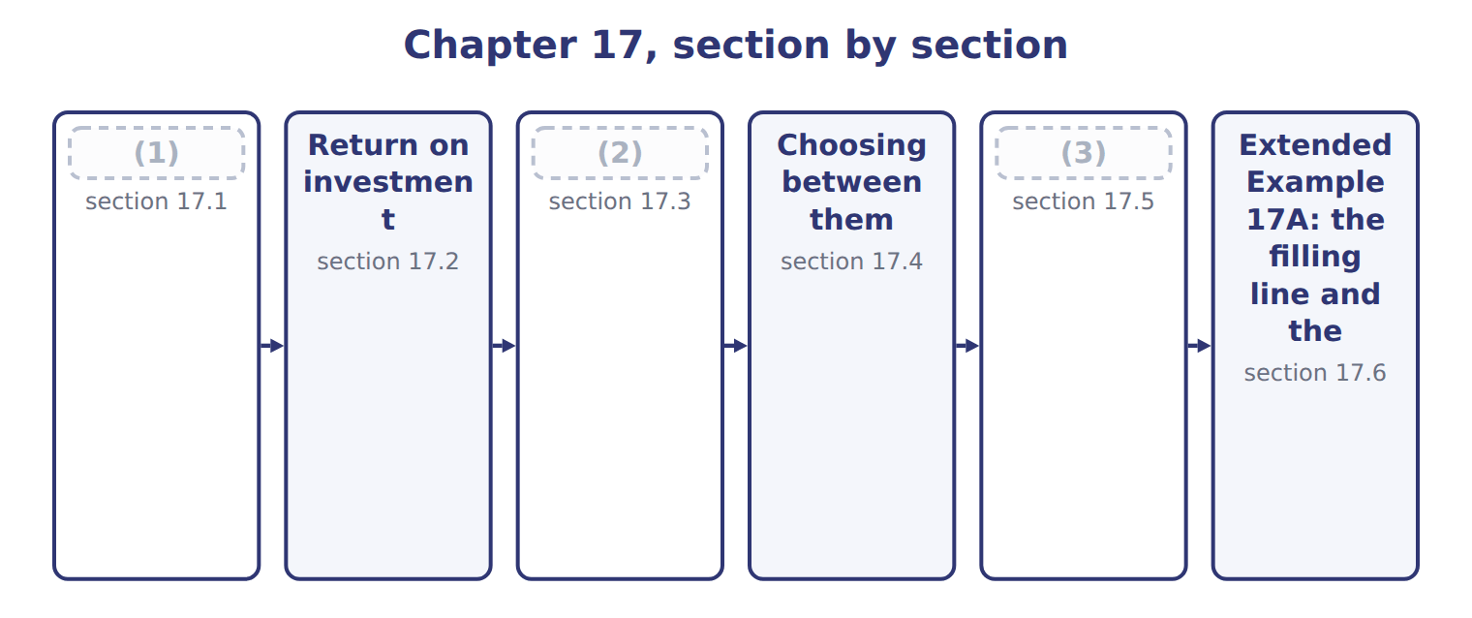
word list
Residual income · Measures, goals and feedback · required rate of return · What goes into the figures

Summary 1 gaps 4–8
A (4) measure changes (5) , so it must point at what the strategy asks for. A (6) told to grow in the Gulf and (7) only on cost will not grow in the Gulf. (8) must also arrive in time to act on. A variance report that reaches the plant six weeks after the month it describes cannot change the decision that caused it.
word list
behavior · performance · variance · Feedback · division · judged

What a good performance measure needs
What a good measure needs (C.3.a) | Why | At Orontes
Related to strategy | (9) | Chapter 1 set a return objective; ROI measures it
Timely feedback | (10) | Monthly variance reports (Chapter 11), quarterly ROI
Within the manager's control | Judge on what the manager decides | (11)
Few and clear | (12) | Chapter 18 builds a balanced set

word list
A result that arrives too late cannot change a decision · The measure should reward what the plan asks for · Too many measures divide attention · Controllable margin (Chapter 15), not allocated costs · return on sales (operating margin)

Answer key · 17.1 Measures, goals and feedback

1 Measures, goals and feedback | 7 judged
2 Residual income | 8 Feedback
3 What goes into the figures | 9 The measure should reward what the plan asks for
4 performance | 10 A result that arrives too late cannot change a decision
5 behavior | 11 Controllable margin (Chapter 15), not allocated costs
6 division | 12 Too many measures divide attention

the summaries in full
Summary 1 A performance measure changes behavior, so it must point at what the strategy asks for. A division told to grow in the Gulf and judged only on cost will not grow in the Gulf. Feedback must also arrive in time to act on. A variance report that reaches the plant six weeks after the month it describes cannot change the decision that caused it.

17.2 Return on investment
Chapter 17 · section 17.2

Fill every gap. Each word list holds one word more than there are gaps.
Summary 1 gaps 1–3
Return on (1) (ROI) is operating income divided by the operating assets used to earn it. For (2) : $3,180,000 ÷ $12,000,000 = 26.5%. ROI splits into two parts that managers can act on (3) .
word list
Reading · separately · Beverages · investment

Worked example: the three divisions

Worked example: ROI for the three divisions
The bars are drawn to scale.
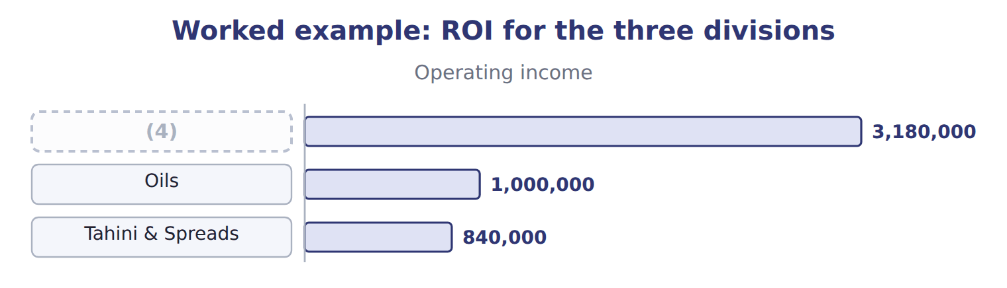
word list
suboptimization · Beverages

The Tahini & Spreads ROI

Summary 2 gaps 5–8
Complete the blank cell. (5) ROI means asking which part moved. A (6) can raise ROI by earning more on each sale or by using fewer assets, and the second route is open to abuse: selling a (7) raises ROI (8) earning a cent more.
word list
Reading · Complete · manager · warehouse · without

The English this sheet uses, and its Arabic
English (exam term) | Arabic
return on investment (ROI) | العائد على الاستثمار
return on sales (operating margin) | العائد على المبيعات (هامش التشغيل)
asset turnover | معدل دوران الأصول

Answer key · 17.2 Return on investment

1 investment | 5 Reading
2 Beverages | 6 manager
3 separately | 7 warehouse
4 Beverages | 8 without

the summaries in full
Summary 1 Return on investment (ROI) is operating income divided by the operating assets used to earn it. For Beverages: $3,180,000 ÷ $12,000,000 = 26.5%. ROI splits into two parts that managers can act on separately.
Summary 2 Complete the blank cell. Reading ROI means asking which part moved. A manager can raise ROI by earning more on each sale or by using fewer assets, and the second route is open to abuse: selling a warehouse raises ROI without earning a cent more.

17.3 Residual income
Chapter 17 · section 17.3

Fill every gap. Each word list holds one word more than there are gaps.
Worked example: residual income for the three divisions

Beverages: $3,180,000 − 12% × $12,000,000 = $1,740,000.
Worked example: residual income for the three divisions
The bars are drawn to scale.
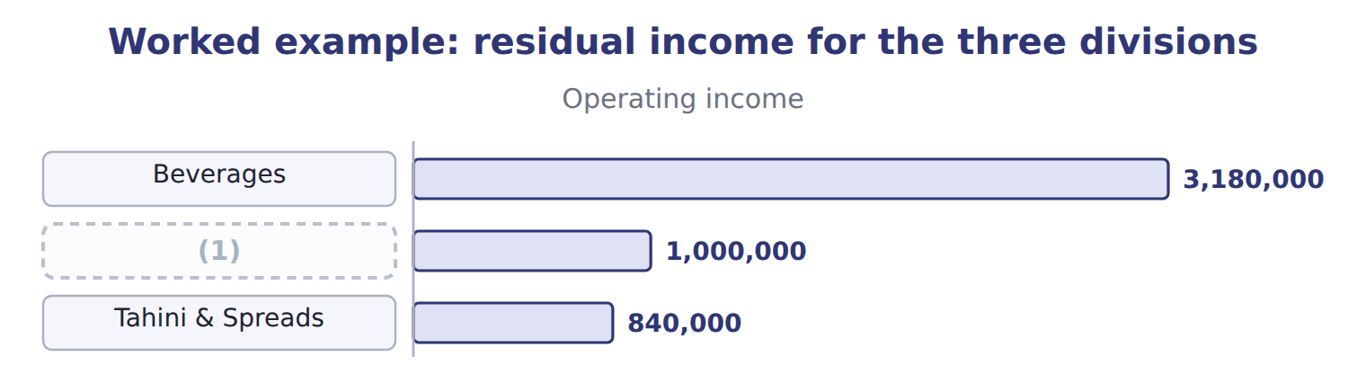
word list
Oils · suboptimization

The Tahini & Spreads residual income

Summary 1 gaps 2–5
Complete the blank cell. (2) income is an amount, not a (3) , so a large division will usually show more of it than a small one. Beverages earns $1,740,000 against $120,000 for Tahini & Spreads, but that (4) says more about size than about (5) .
word list
comparison · percentage · performance · usually · Residual

The English this sheet uses, and its Arabic
English (exam term) | Arabic
residual income (RI) | الدخل المتبقي
required rate of return | معدل العائد المطلوب
capital charge | عبء رأس المال

Answer key · 17.3 Residual income

1 Oils | 4 comparison
2 Residual | 5 performance
3 percentage

the summaries in full
Summary 1 Complete the blank cell. Residual income is an amount, not a percentage, so a large division will usually show more of it than a small one. Beverages earns $1,740,000 against $120,000 for Tahini & Spreads, but that comparison says more about size than about performance.

17.4 Choosing between them
Chapter 17 · section 17.4

Fill every gap. Each word list holds one word more than there are gaps.
Summary 1 gaps 1–2
The two measures can disagree, and the (1) is the reason both exist. Beverages is offered the (2) project: $2,500,000 of assets earning $450,000 a year, a return of 18.0%.
word list
disagreement · filling-line · residual

Worked example: the project under both measures

Worked example: the filling line under ROI and residual income
Beverages and the filling line | Division now | The project | Division after
(3) | 3,180,000 | 450,000 | 3,630,000
Operating assets | 12,000,000 | 2,500,000 | 14,500,000
ROI | 26.5% | 18.0% | 25.0%
(4) | 1,440,000 | 300,000 | 1,740,000
Residual income | 1,740,000 | 150,000 | 1,890,000

word list
return on investment (ROI) · Capital charge at 12% · Operating income

This is suboptimization: a decision that improves one measure while harming the company.
Benefits and limitations of ROI and residual income
Measure (C.3.i) | Benefits | Limitations
ROI | A percentage, so divisions of different size can be compared | Can lead a manager to reject a project that earns more than the (5) return
Residual income | Accepts every project above the required return, so no (6) | An amount, so a large division will always show more than a small one
Both | Need an agreed investment base and income measure | Both can be (7) by cutting assets rather than by earning more

word list
required · division · suboptimization · improved

Compare the project with the required return

Summary 2 gaps 8–9
A project should be judged against the required rate of return, not against the (8) current ROI. Any project above the required return raises (9) income and makes the company better off.
word list
offered · division's · residual

The English this section uses, and its Arabic
Each term sits against what it means.
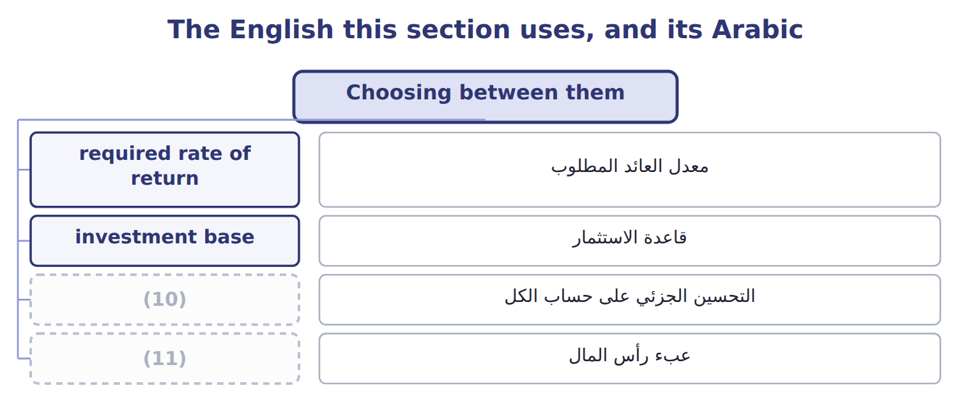
word list
capital charge · suboptimization · قاعدة الاستثمار

The English this sheet uses, and its Arabic
English (exam term) | Arabic
suboptimization | التحسين الجزئي على حساب الكل
investment base | قاعدة الاستثمار

Answer key · 17.4 Choosing between them

1 disagreement | 7 improved
2 filling-line | 8 division's
3 Operating income | 9 residual
4 Capital charge at 12% | 10 suboptimization
5 required | 11 capital charge
6 suboptimization

the summaries in full
Summary 1 The two measures can disagree, and the disagreement is the reason both exist. Beverages is offered the filling-line project: $2,500,000 of assets earning $450,000 a year, a return of 18.0%.
Summary 2 A project should be judged against the required rate of return, not against the division's current ROI. Any project above the required return raises residual income and makes the company better off.

17.5 What goes into the figures
Chapter 17 · section 17.5

Fill every gap. Each word list holds one word more than there are gaps.
Both measures depend on two numbers that accounting policy can move.
Income policies that reduce comparability
Policy (C.3.j) | Effect on measured income | What to do
Revenue recognition | A division (1) revenue earlier reports more income now | Compare only divisions using the same policy
Development spending | One division capitalises it, another expenses it | (2)
Depreciation method | Straight line against an accelerated method changes income and assets | (3)
Allocated common costs | The allocation changes reported income but not performance | (4)

word list
Use one group policy for internal reporting · recognising · Adjust before comparing, or agree one policy · accelerated · Measure on the segment margin (Chapter 15)

Summary 1 gaps 5–10
A division that recognises revenue earlier, or expenses (5) that another (6) , will report different income for identical work. (7) then measures the policy, not the (8) . The group (9) fixes one set of policies for internal reporting, even where local (10) differ. Levant reports under IFRS in Jordan, but its figures are restated to group policy before any division is compared. The investment base is just as open to question.
word list
therefore · expenses · statements · capitalises · performance · Comparison · development

Policies that change the investment base
Policy (C.3.k) | Effect on the investment base | What to do
Inventory method | FIFO and weighted average give different inventory and cost of sales | (11)
Joint asset sharing | The shared cold store of Chapter 15 serves two divisions | (12) the asset on the same basis as its cost, or exclude it from both
Gross or net book value | (13) | Net book value flatters divisions with old assets
Leased assets | (14) | Follow one rule across all divisions
Idle or non-operating assets | (15) | Exclude it from the investment base

word list
A leased plant may or may not appear in the base · Land held for sale is not used to earn operating income · FIFO and weighted average give different inventory and cost of sales · Beverages: 26.5% on net book value, 15.9% on gross · Allocate · Agree one method for internal measurement

Summary 2 gaps 16–22
The last one matters most. (16) shows 26.5% on net book value but only 15.9% on the gross cost of $20,000,000, because its plant is partly (17) . A division with old assets looks better than one that has just invested, which (18) exactly the (19) the company wants. Each of these choices can be (20) , and none of them is about (21) . What matters is that every division uses the same one, and that the basis is stated with the (22) .
word list
discourages · inventory · investment · depreciated · figures · defended · Beverages · performance

Ask what the base contains

Summary 3 gaps 23–25
Before (23) two divisions, ask whether both use the same (24) method, the same treatment of shared assets, and the same basis for property. A difference in any of them makes the comparison (25) .
word list
investment · inventory · comparing · meaningless

Answer key · 17.5 What goes into the figures

1 recognising | 14 A leased plant may or may not appear in the base
2 Adjust before comparing, or agree one policy | 15 Land held for sale is not used to earn operating income
3 Use one group policy for internal reporting | 16 Beverages
4 Measure on the segment margin (Chapter 15) | 17 depreciated
5 development | 18 discourages
6 capitalises | 19 investment
7 Comparison | 20 defended
8 performance | 21 performance
9 therefore | 22 figures
10 statements | 23 comparing
11 Agree one method for internal measurement | 24 inventory
12 Allocate | 25 meaningless
13 Beverages: 26.5% on net book value, 15.9% on gross

the summaries in full
Summary 1 A division that recognises revenue earlier, or expenses development that another capitalises, will report different income for identical work. Comparison then measures the policy, not the performance. The group therefore fixes one set of policies for internal reporting, even where local statements differ. Levant reports under IFRS in Jordan, but its figures are restated to group policy before any division is compared. The investment base is just as open to question.
Summary 2 The last one matters most. Beverages shows 26.5% on net book value but only 15.9% on the gross cost of $20,000,000, because its plant is partly depreciated. A division with old assets looks better than one that has just invested, which discourages exactly the investment the company wants. Each of these choices can be defended, and none of them is about performance. What matters is that every division uses the same one, and that the basis is stated with the figures.
Summary 3 Before comparing two divisions, ask whether both use the same inventory method, the same treatment of shared assets, and the same basis for property. A difference in any of them makes the comparison meaningless.

17.6 Extended Example 17A: the filling line and the two measures
Chapter 17 · section 17.6

Fill every gap. Each word list holds one word more than there are gaps.
This example takes the project decision to the board.
Extended Example: what each measure tells the manager
Measure | Before | After | What the manager does
ROI | 26.5% | 25.0% | (1) : the manager rejects the project
Residual income | 1,740,000 | 1,890,000 | Rises by 150,000: the manager accepts the project
The company's view | (2) | 18.0% | The project earns more than the required return: it should go ahead

word list
Falls by 1.5 points · required return 12% · Tahini & Spreads ROI

Summary 1 gaps 3–4
The board approved the line, and changed how the Beverages manager is judged: residual income for (3) decisions, ROI for comparing divisions. Both are (4) each quarter.
word list
changed · investment · reported

Everything ties

Summary 2 gaps 5–6
Beverages ROI 17.7% × 1.50 = 26.5%; the (5) margin comes. Project: $450,000 − $300,000 = $150,000 added to (6) income.
word list
residual · suboptimization · segment

Exam view

Summary 3 gaps 7–9
Expect (7) income, an investment base and a (8) return, then a project with its own income and investment. (9) ROI and residual income before and after, and say which measure leads to the decision the company wants.
word list
required · Calculate · operating · project

Exam view
Tahini & Spreads: a proposed investment | Amount
Division operating income for the year | 840,000
(10) | 6,000,000
Required rate of return | 12%
(11) | 1,000,000
(12) | 130,000

word list
Extra operating income it would earn each year · Division operating assets · $840,000 ÷ $6,000,000 = 14.0% · Investment in the new line

Item — Answer
Item | Answer
Tahini & Spreads ROI | $840,000 ÷ $6,000,000 = 14.0%
Tahini & Spreads residual income | (13)

word list
The project raises the division's residual income · $840,000 − 12% × $6,000,000 = $120,000

Statement — Category
Statement | Category
The project returns more than the required rate of return | Supports accepting
The project would lower the division's return on investment | Supports rejecting
The project raises the division's residual income | Supports accepting
The company earns more than its cost of capital on the new assets | (14)
The manager's bonus is based on return on investment | (15)

word list
Supports accepting · Residual income · Supports rejecting

The English this sheet uses, and its Arabic
English (exam term) | Arabic
return on investment (ROI) | العائد على الاستثمار
residual income (RI) | الدخل المتبقي
suboptimization | التحسين الجزئي على حساب الكل

Answer key · 17.6 Extended Example 17A: the filling line and the two measures

1 Falls by 1.5 points | 9 Calculate
2 required return 12% | 10 Division operating assets
3 investment | 11 Investment in the new line
4 reported | 12 Extra operating income it would earn each year
5 segment | 13 $840,000 − 12% × $6,000,000 = $120,000
6 residual | 14 Supports accepting
7 operating | 15 Supports rejecting
8 required

the summaries in full
Summary 1 The board approved the line, and changed how the Beverages manager is judged: residual income for investment decisions, ROI for comparing divisions. Both are reported each quarter.
Summary 2 Beverages ROI 17.7% × 1.50 = 26.5%; the segment margin comes. Project: $450,000 − $300,000 = $150,000 added to residual income.
Summary 3 Expect operating income, an investment base and a required return, then a project with its own income and investment. Calculate ROI and residual income before and after, and say which measure leads to the decision the company wants.

18.1 Critical success factors and KPIs
Chapter 18 · section 18.1

Fill every gap. Each word list holds one word more than there are gaps.
Chapter 18, section by section
Each stage leads to the next.
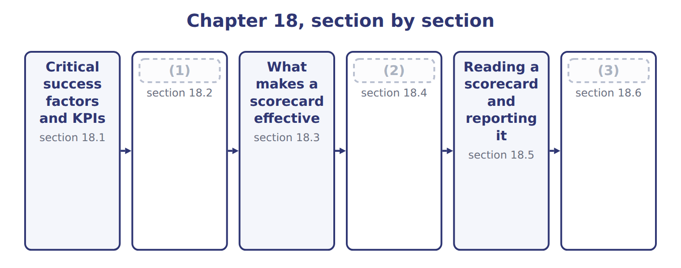
word list
Extended Example 18A: recommending measures fo · Reading a scorecard and reporting it · The strategy map · The balanced scorecard and its four perspectiv

Summary 1 gaps 4–7
A (4) success factor (CSF) is something an (5) must do well if its strategy is to succeed. A key (6) indicator (KPI) is the (7) that shows how well it is being done. The CSF is the thing; the KPI is the number.
word list
performance · matters · measure · organization · critical

Critical success factors and the KPI for each
Critical success factor | KPI that measures it | 2028
Win export customers in the Gulf | Export share of revenue | (8)
Deliver reliably | (9) | target 97%, actual 94%
Run the plant without long stoppages | (10) | target 30 minutes, actual 42
Keep skilled operators | (11) | turnover target 8%, actual 7%
Earn the return the group requires | Return on investment | (12)

word list
Training hours and staff turnover · target 20.4%, actual 19.6% · Changeover time · balanced scorecard · On-time delivery · target 11.8%, actual 12.6%

Summary 2 gaps 13–15
The pair (13) because a measure without a factor (14) it is noise, and a factor without a measure is a wish. Together they tell a manager what to work on and show whether the work is (15) .
word list
without · behind · matters · succeeding

The English this sheet uses, and its Arabic
English (exam term) | Arabic
critical success factor (CSF) | عامل النجاح الحاسم
key performance indicator (KPI) | مؤشر الأداء الرئيسي

Answer key · 18.1 Critical success factors and KPIs

1 The balanced scorecard and its four perspectiv | 9 On-time delivery
2 The strategy map | 10 Changeover time
3 Extended Example 18A: recommending measures fo | 11 Training hours and staff turnover
4 critical | 12 target 11.8%, actual 12.6%
5 organization | 13 matters
6 performance | 14 behind
7 measure | 15 succeeding
8 target 20.4%, actual 19.6%

the summaries in full
Summary 1 A critical success factor (CSF) is something an organization must do well if its strategy is to succeed. A key performance indicator (KPI) is the measure that shows how well it is being done. The CSF is the thing; the KPI is the number.
Summary 2 The pair matters because a measure without a factor behind it is noise, and a factor without a measure is a wish. Together they tell a manager what to work on and show whether the work is succeeding.

18.2 The balanced scorecard and its four perspectives
Chapter 18 · section 18.2

Fill every gap. Each word list holds one word more than there are gaps.
Summary 1 gaps 1–6
A balanced scorecard is a set of measures drawn from four (1) , each with its (2) , measures, targets and the actions planned to reach them. It is balanced because (3) results alone (4) only what has already happened. Each perspective (5) the same four (6) : what the company wants to achieve, the measure that tracks it, the target for the period and the action planned to reach it.
word list
describe · perspectives · objectives · carries · information · financial · components

Worked example: the Orontes scorecard for 2028

Worked example: the Orontes balanced scorecard for 2028
The bars are drawn to scale.
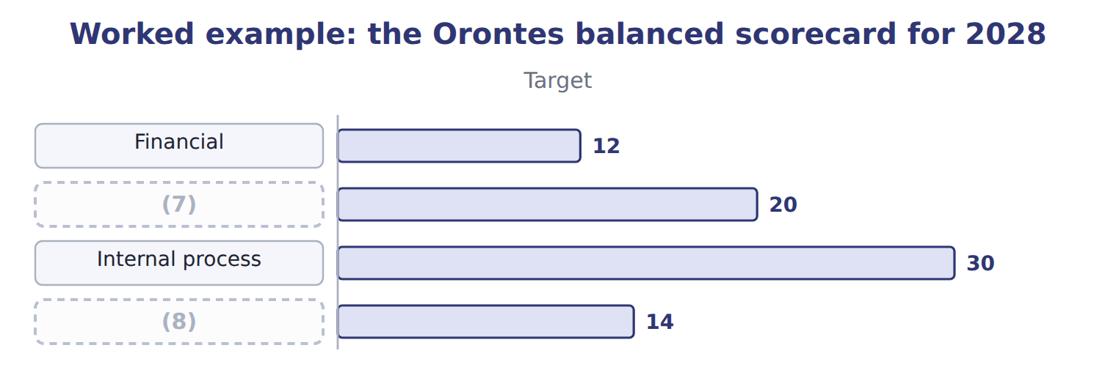
word list
Internal process · Learning and growth · Customer

The last two perspectives

Complete the blank cells.
Balanced means four perspectives, not four financial ratios

Summary 2 gaps 9–13
A scorecard with (9) , margin, return and growth on it is not (10) ; it measures the same thing four ways. Each (11) must bring (12) the others do not. The scorecard is not a report (13) after the year. It is agreed with the plan, reviewed during the year, and used to decide what to do next, which is why.
word list
profit · perspective · actions · produced · balanced · information

The English this section uses, and its Arabic
Each term sits against what it means.
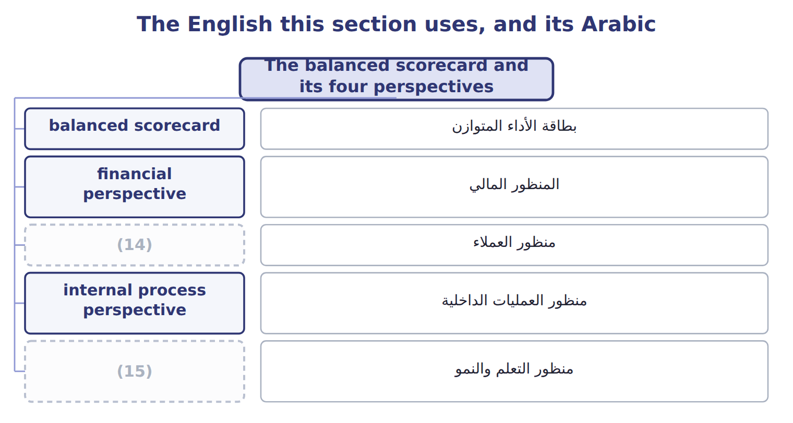
word list
learning and growth perspective · customer perspective · key performance indicator (KPI)

The English this sheet uses, and its Arabic
English (exam term) | Arabic
balanced scorecard | بطاقة الأداء المتوازن
financial perspective | المنظور المالي
customer perspective | منظور العملاء
internal process perspective | منظور العمليات الداخلية
learning and growth perspective | منظور التعلم والنمو

Answer key · 18.2 The balanced scorecard and its four perspectives

1 perspectives | 9 profit
2 objectives | 10 balanced
3 financial | 11 perspective
4 describe | 12 information
5 carries | 13 produced
6 components | 14 customer perspective
7 Customer | 15 learning and growth perspective
8 Learning and growth

the summaries in full
Summary 1 A balanced scorecard is a set of measures drawn from four perspectives, each with its objectives, measures, targets and the actions planned to reach them. It is balanced because financial results alone describe only what has already happened. Each perspective carries the same four components: what the company wants to achieve, the measure that tracks it, the target for the period and the action planned to reach it.
Summary 2 A scorecard with profit, margin, return and growth on it is not balanced; it measures the same thing four ways. Each perspective must bring information the others do not. The scorecard is not a report produced after the year. It is agreed with the plan, reviewed during the year, and used to decide what to do next, which is why.

18.3 What makes a scorecard effective
Chapter 18 · section 18.3

Fill every gap. Each word list holds one word more than there are gaps.
A scorecard fails more often from its design than from its arithmetic.
Characteristics of an effective balanced scorecard
Characteristic (C.3.o) | What it means | At Orontes
Few measures | (1) | Orontes uses 12 in total
Linked to strategy | (2) | Chapter 1 set the objectives
Balanced | Leading as well as lagging indicators | (3)
Owned | Each measure has a manager who can influence it | (4)
Measurable and timely | (5) | Delivery weekly, return quarterly
Reviewed | Measures change as the strategy changes | (6)

word list
Four to six a perspective, not forty · Training and changeover time, not only return · Every measure traces to a critical success factor · Reviewed with the plan each year · Data available often enough to act on · Changeover time belongs to the plant · Leading as well as lagging indicators

Summary 1 gaps 7–11
The commonest fault is too many (7) . A board that reviews forty numbers reviews none of them, and (8) whose bonus depends on a long list will work on (9) is easiest to move. The (10) commonest is a measure (11) owns. Every measure on the Orontes scorecard has a manager who can influence it, which is the controllability principle.
word list
reviews · measures · managers · second · whichever · nobody

Answer key · 18.3 What makes a scorecard effective

1 Four to six a perspective, not forty | 7 measures
2 Every measure traces to a critical success factor | 8 managers
3 Training and changeover time, not only return | 9 whichever
4 Changeover time belongs to the plant | 10 second
5 Data available often enough to act on | 11 nobody
6 Reviewed with the plan each year

the summaries in full
Summary 1 The commonest fault is too many measures. A board that reviews forty numbers reviews none of them, and managers whose bonus depends on a long list will work on whichever is easiest to move. The second commonest is a measure nobody owns. Every measure on the Orontes scorecard has a manager who can influence it, which is the controllability principle.

18.4 The strategy map
Chapter 18 · section 18.4

Fill every gap. Each word list holds one word more than there are gaps.
Summary 1 gaps 1–7
A strategy map draws the (1) links between the objectives in the four (2) . It is read upward: investment in people (3) processes, better processes satisfy customers, and (4) customers produce the financial result. The map (5) why leading (6) matter. Training hours and (7) time move before the financial result does, so they give warning while there is still time to act. A lagging indicator such as return on investment reports a year that is already over.
word list
satisfied · improves · changeover · indicators · perspectives · cause-and-effect · explains · objectives

The English this sheet uses, and its Arabic
English (exam term) | Arabic
strategy map | خريطة الاستراتيجية
leading indicator | مؤشر استباقي
lagging indicator | مؤشر لاحق

Answer key · 18.4 The strategy map

1 cause-and-effect | 5 explains
2 perspectives | 6 indicators
3 improves | 7 changeover
4 satisfied

the summaries in full
Summary 1 A strategy map draws the cause-and-effect links between the objectives in the four perspectives. It is read upward: investment in people improves processes, better processes satisfy customers, and satisfied customers produce the financial result. The map explains why leading indicators matter. Training hours and changeover time move before the financial result does, so they give warning while there is still time to act. A lagging indicator such as return on investment reports a year that is already over.

18.5 Reading a scorecard and reporting it
Chapter 18 · section 18.5

Fill every gap. Each word list holds one word more than there are gaps.
Worked example: what the 2028 scorecard says

Every financial measure was met, and only two of the six customer and internal-process measures.
Worked example: reading the 2028 scorecard
Perspective | Result | What it says
The financial perspective | (1) | The year was good. These are lagging indicators
The customer perspective | 1 of 3 met | Export share and (2) both missed: the strategy of Chapter 1 is behind
Internal process | (3) | Changeover time explains the variances of Chapters 12 and 14
Learning and growth | (4) | Training is on track, but new products are not
Overall | 7 of 12 met | (5)

word list
1 of 3 met · Good results now, weak drivers for next year · delivery · 3 of 3 met · learning and growth perspective · 2 of 3 met

Summary 1 gaps 6–9
The (6) reading is that 2028 was a good year that is not (7) a good 2029. Export share and (8) both missed, and those are the drivers of the (9) set. How often each measure is reported matters as much as the measure itself.
word list
strategy · delivery · building · board's · measure

How often each measure is reported
Every item belongs to exactly one group.
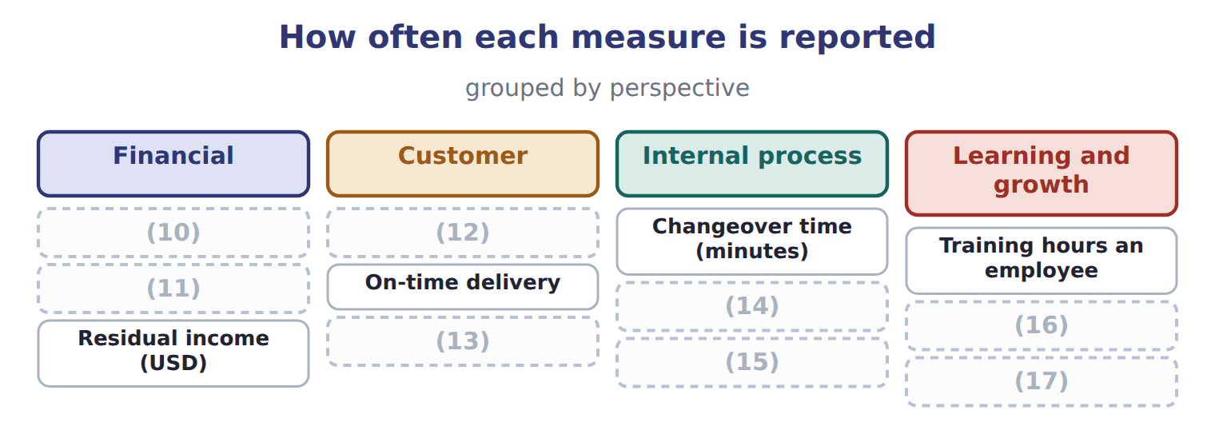
word list
Return on investment · Scrap rate · Residual income (USD) · Revenue growth · Complaints per 1,000 cases · New products share of revenue · Export share of revenue · Staff turnover · Energy a case (kWh)

Match the interval to the decision

Summary 2 gaps 18–19
A measure should be (18) as often as it can change and be acted on. Monthly reporting of a daily problem wastes a month; daily reporting of an annual measure wastes (19) .
word list
financial · attention · reported

Answer key · 18.5 Reading a scorecard and reporting it

1 3 of 3 met | 11 Revenue growth
2 delivery | 12 Export share of revenue
3 1 of 3 met | 13 Complaints per 1,000 cases
4 2 of 3 met | 14 Energy a case (kWh)
5 Good results now, weak drivers for next year | 15 Scrap rate
6 board's | 16 New products share of revenue
7 building | 17 Staff turnover
8 delivery | 18 reported
9 strategy | 19 attention
10 Return on investment

the summaries in full
Summary 1 The board's reading is that 2028 was a good year that is not building a good 2029. Export share and delivery both missed, and those are the drivers of the strategy set. How often each measure is reported matters as much as the measure itself.
Summary 2 A measure should be reported as often as it can change and be acted on. Monthly reporting of a daily problem wastes a month; daily reporting of an annual measure wastes attention.

18.6 Extended Example 18A: recommending measures for next year
Chapter 18 · section 18.6

Fill every gap. Each word list holds one word more than there are gaps.
Summary 1 gaps 1–2
The board asks for a short list of (1) to put right what 2028 missed, for use in 2029. This example (2) it.
word list
builds · targets · measures

Extended Example: recommended measures for next year
Operational goal (C.3.r) | Recommended measure | Reported | Owner
Shorten changeovers | Changeover time in minutes | (3) | Plant manager
Improve delivery | On-time delivery to Levant and the Gulf | Weekly | (4)
Grow exports | Export share of revenue | (5) | Sales director
Launch new products | Share of revenue from products under three years old | Quarterly | (6)

word list
Division managers · Daily · Levant manager · Monthly · strategy map

Summary 2 gaps 7–8
Each follows directly from a measure that was missed, each has an owner who can (7) it, and together they form one chain of the strategy map rather than four (8) targets.
word list
influence · directly · unrelated

Everything ties

Summary 3 gaps 9–10
Residual income on the (9) , $2,260,000, is the sum of the three divisions. Company return on (10) 12.6% beats the 11.8% objective set.
word list
scorecard · results · investment

Exam view

Summary 4 gaps 11–13
Expect a list of measures to sort into (11) , a scorecard to read, or a goal for which you must (12) a measure, an interval and an owner. Say what the (13) of results means, not just how many were met.
word list
investment · pattern · recommend · perspectives

Exam view
Tahini & Spreads, one quarter | Target | Actual
(14) | 840,000 | 812,000
(15) | 95% | 97%
Sesame yield (kg of paste a kg of seed) | 0.62 | 0.59
(16) | 12 | 12
Complaints from supermarkets | 5 | 9

word list
Operators trained on the new line · Gulf chain orders delivered in full · Segment margin · Recommended measure

Item — Answer
Item | Answer
Internal process | (17) : missed; energy 0.47 against 0.48: met; scrap 1.8% against 1.5%: missed
Learning and growth | Training 15.2 against 14.4: met; new products 5.1% against 7.8%: missed; turnover 7% against 8%: met

word list
Changeover time 42 against 30 · Tahini & Spreads, one quarter

Measure — Category
Measure | Category
Segment margin | (18)
Gulf chain orders delivered in full | (19)
Sesame yield a kilogram of seed | Internal process
Operators trained on the new line | (20)
Complaints from supermarkets | Customer

word list
Customer · Financial · Learning and growth · Recommended measure

The English this sheet uses, and its Arabic
English (exam term) | Arabic
critical success factor (CSF) | عامل النجاح الحاسم
balanced scorecard | بطاقة الأداء المتوازن
strategy map | خريطة الاستراتيجية

Answer key · 18.6 Extended Example 18A: recommending measures for next year

1 measures | 11 perspectives
2 builds | 12 recommend
3 Daily | 13 pattern
4 Levant manager | 14 Segment margin
5 Monthly | 15 Gulf chain orders delivered in full
6 Division managers | 16 Operators trained on the new line
7 influence | 17 Changeover time 42 against 30
8 unrelated | 18 Financial
9 scorecard | 19 Customer
10 investment | 20 Learning and growth

the summaries in full
Summary 1 The board asks for a short list of measures to put right what 2028 missed, for use in 2029. This example builds it.
Summary 2 Each follows directly from a measure that was missed, each has an owner who can influence it, and together they form one chain of the strategy map rather than four unrelated targets.
Summary 3 Residual income on the scorecard, $2,260,000, is the sum of the three divisions. Company return on investment 12.6% beats the 11.8% objective set.
Summary 4 Expect a list of measures to sort into perspectives, a scorecard to read, or a goal for which you must recommend a measure, an interval and an owner. Say what the pattern of results means, not just how many were met.

