Table of Contents

A2.2 · Unit 7 · This Time Next Year
English Animated · Telling the Story · Ballinmore, west coast of Ireland Student's Book pages 138–159 · 22 pp · ~10 hours

Part 0 · The Big Picture ◆ A · THE WORLD
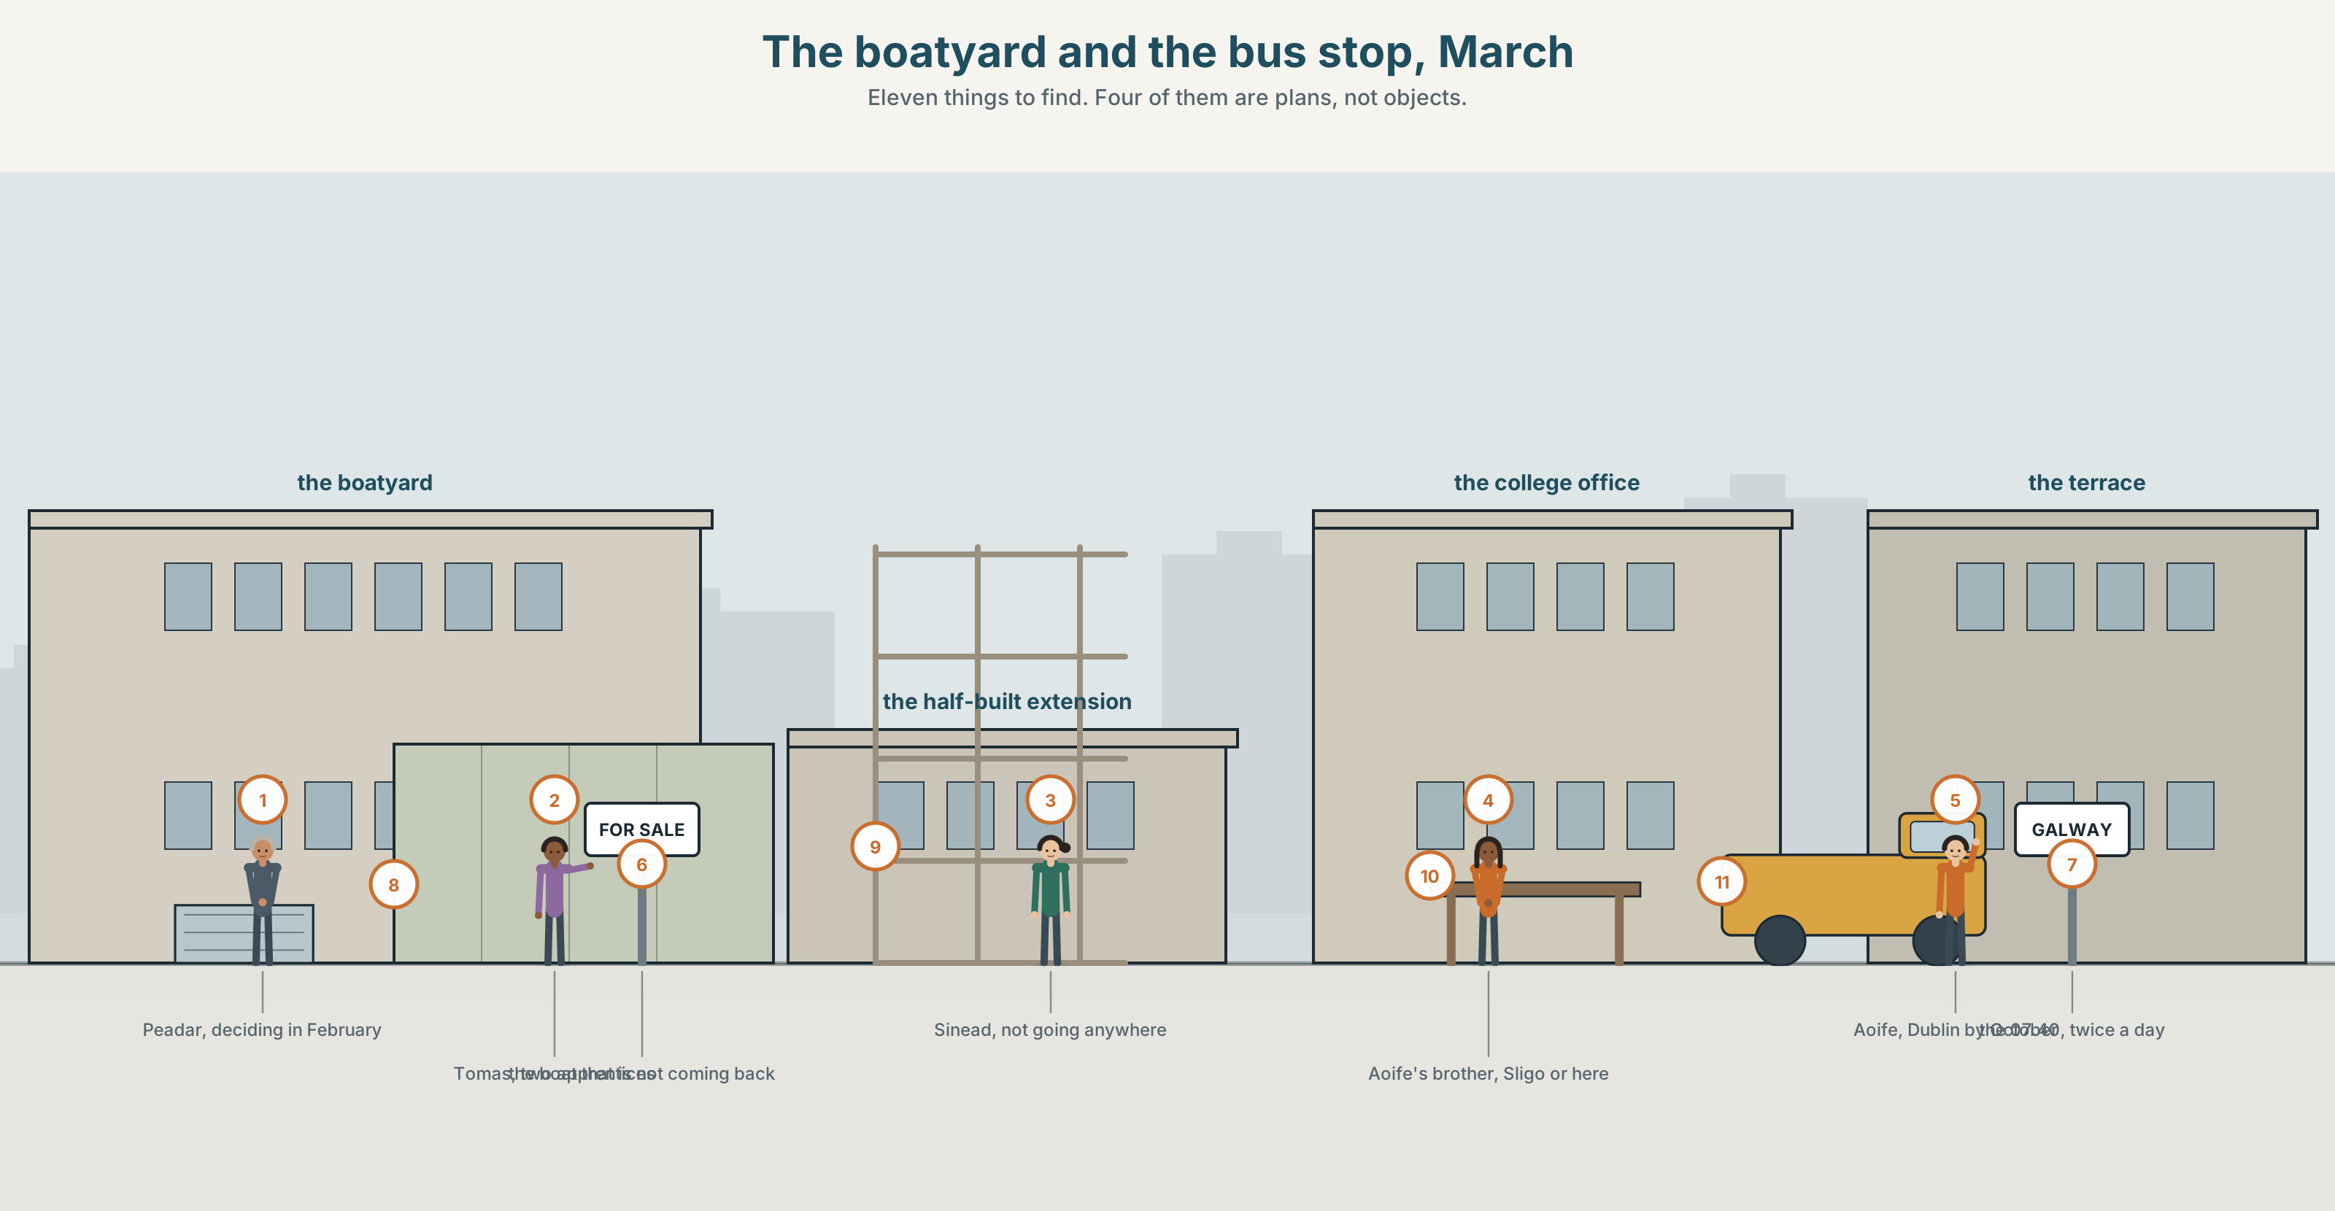{width=6.6in}
The boatyard and the bus stop, March — Eleven things to find. Four of them are plans, not objects.

What will you be doing in a year?
By the end of this unit you can describe what you will be doing in a year, with real timings. One hundred words.
◆ A · THE WORLD | A town where everybody's plan depends on somebody else's
◆ B · THE SYSTEM | the future continuous · future time expressions · 23 words for work and ambition · 17 words for placing things in the future · 'll be as one sound
◆ C · THE PERFORMANCE | A year ahead, with dates in it

0A · Find it
Find eleven things in this picture. Four of them are plans, not objects.
a job advert · a training notice · a timetable on a wall · a boat for sale · a half-built extension · a calendar · a contract on a table · a bus to Galway · a college prospectus · a key on a hook · a van with a new name on it

0B · Guess it
Three of the people in this picture will not be here in a year. Which three, and what is the evidence?

0C · Say it ⏺
Record thirty seconds. This time next year, what will you be doing on a Tuesday morning? Be specific about the Tuesday. You will record it again at the end of this unit.

Part 1 · Vocabulary Lab 1 ◆ B · THE SYSTEM
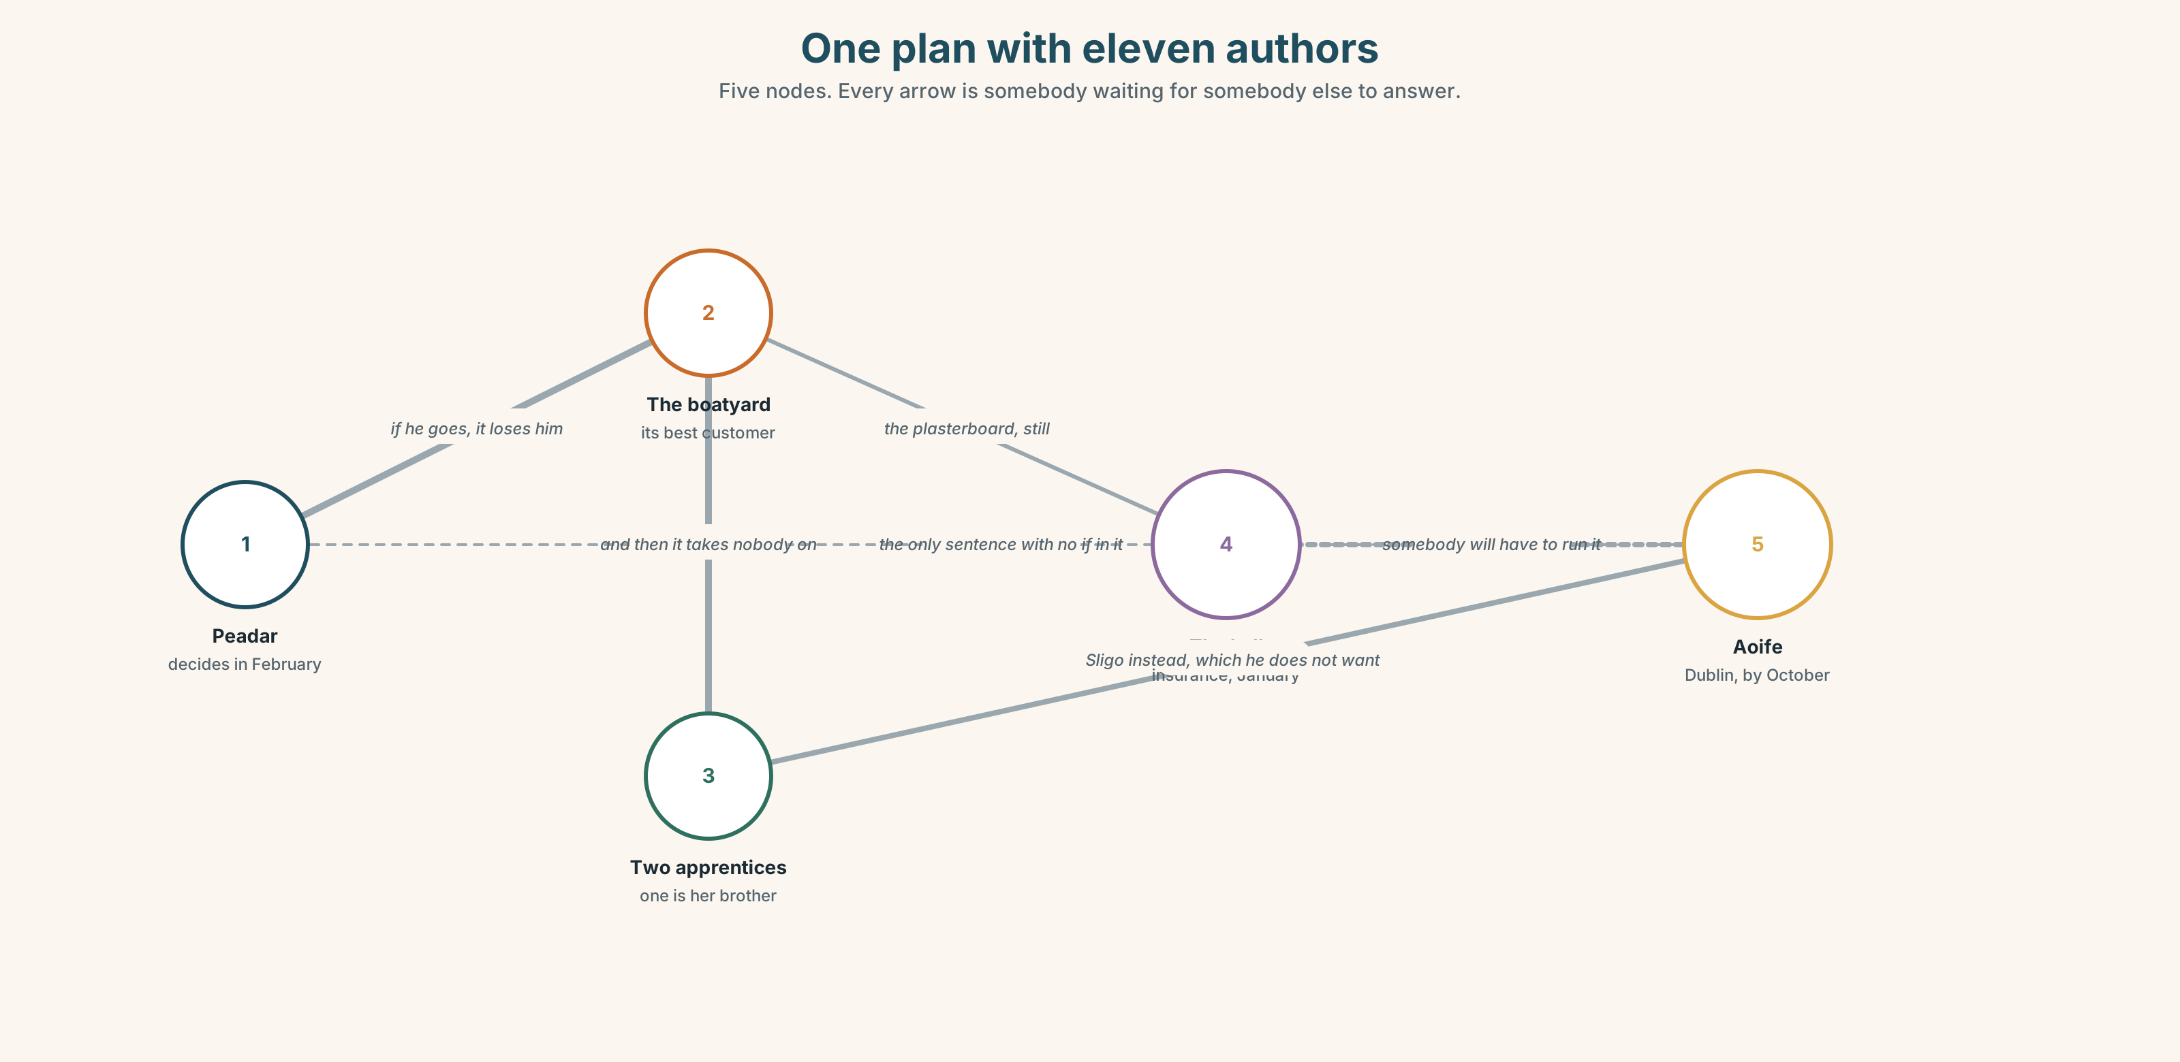{width=6.6in}
One plan with eleven authors — Five nodes. Every arrow is somebody waiting for somebody else to answer.

1A · Meet — the words of a working year
Match each word to one place on the map.
career · ambition · plan · apply · qualify · training · course · promotion · contract · season

1B · Sort — a thing you get, or a thing you do?
Two columns.
apply · promotion · qualify · contract · training · plan · course · chance
One of them is both, and that is why people confuse them. Which?

1C · Meet — the words for going and staying
leave · return · settle
Leaving is an event. Settling is a judgement, usually made by other people. After how long does somebody stop being new where you live?
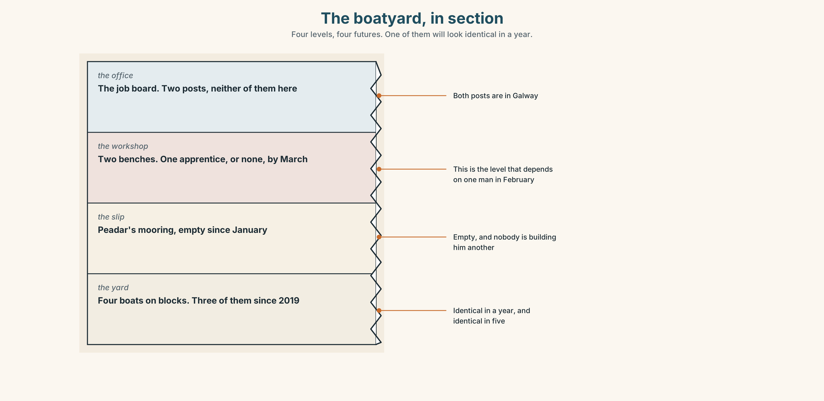{width=6.6in}
The boatyard, in section — Four levels, four futures. One of them will look identical in a year.
Look at the boatyard, in section. Four levels, four futures. Which level will have changed most in a year, and which will look identical?

1D · Stretch — the phrases
Complete each one with one word.
- This time next ______ she will be halfway through the course.
- By ______ , the extension will be finished or it will be abandoned.
- He is looking ______ work on the bigger boats.
- For some people it is a fresh ______ . For others it is leaving.
- The yard has taken ______ two apprentices for the season.

1E · The saying
f We'll see where we are.
Five words that postpone a decision without refusing it.
Write what each of these people means by it: somebody who intends to go, somebody who intends to stay, and somebody who has not decided.

1F · Own it
Think about this time next year. Tell a partner three sentences: where you will be living, what you will be doing on a weekday morning, and one thing that will decide it.

Part 2 · Listening ◆ A · THE WORLD
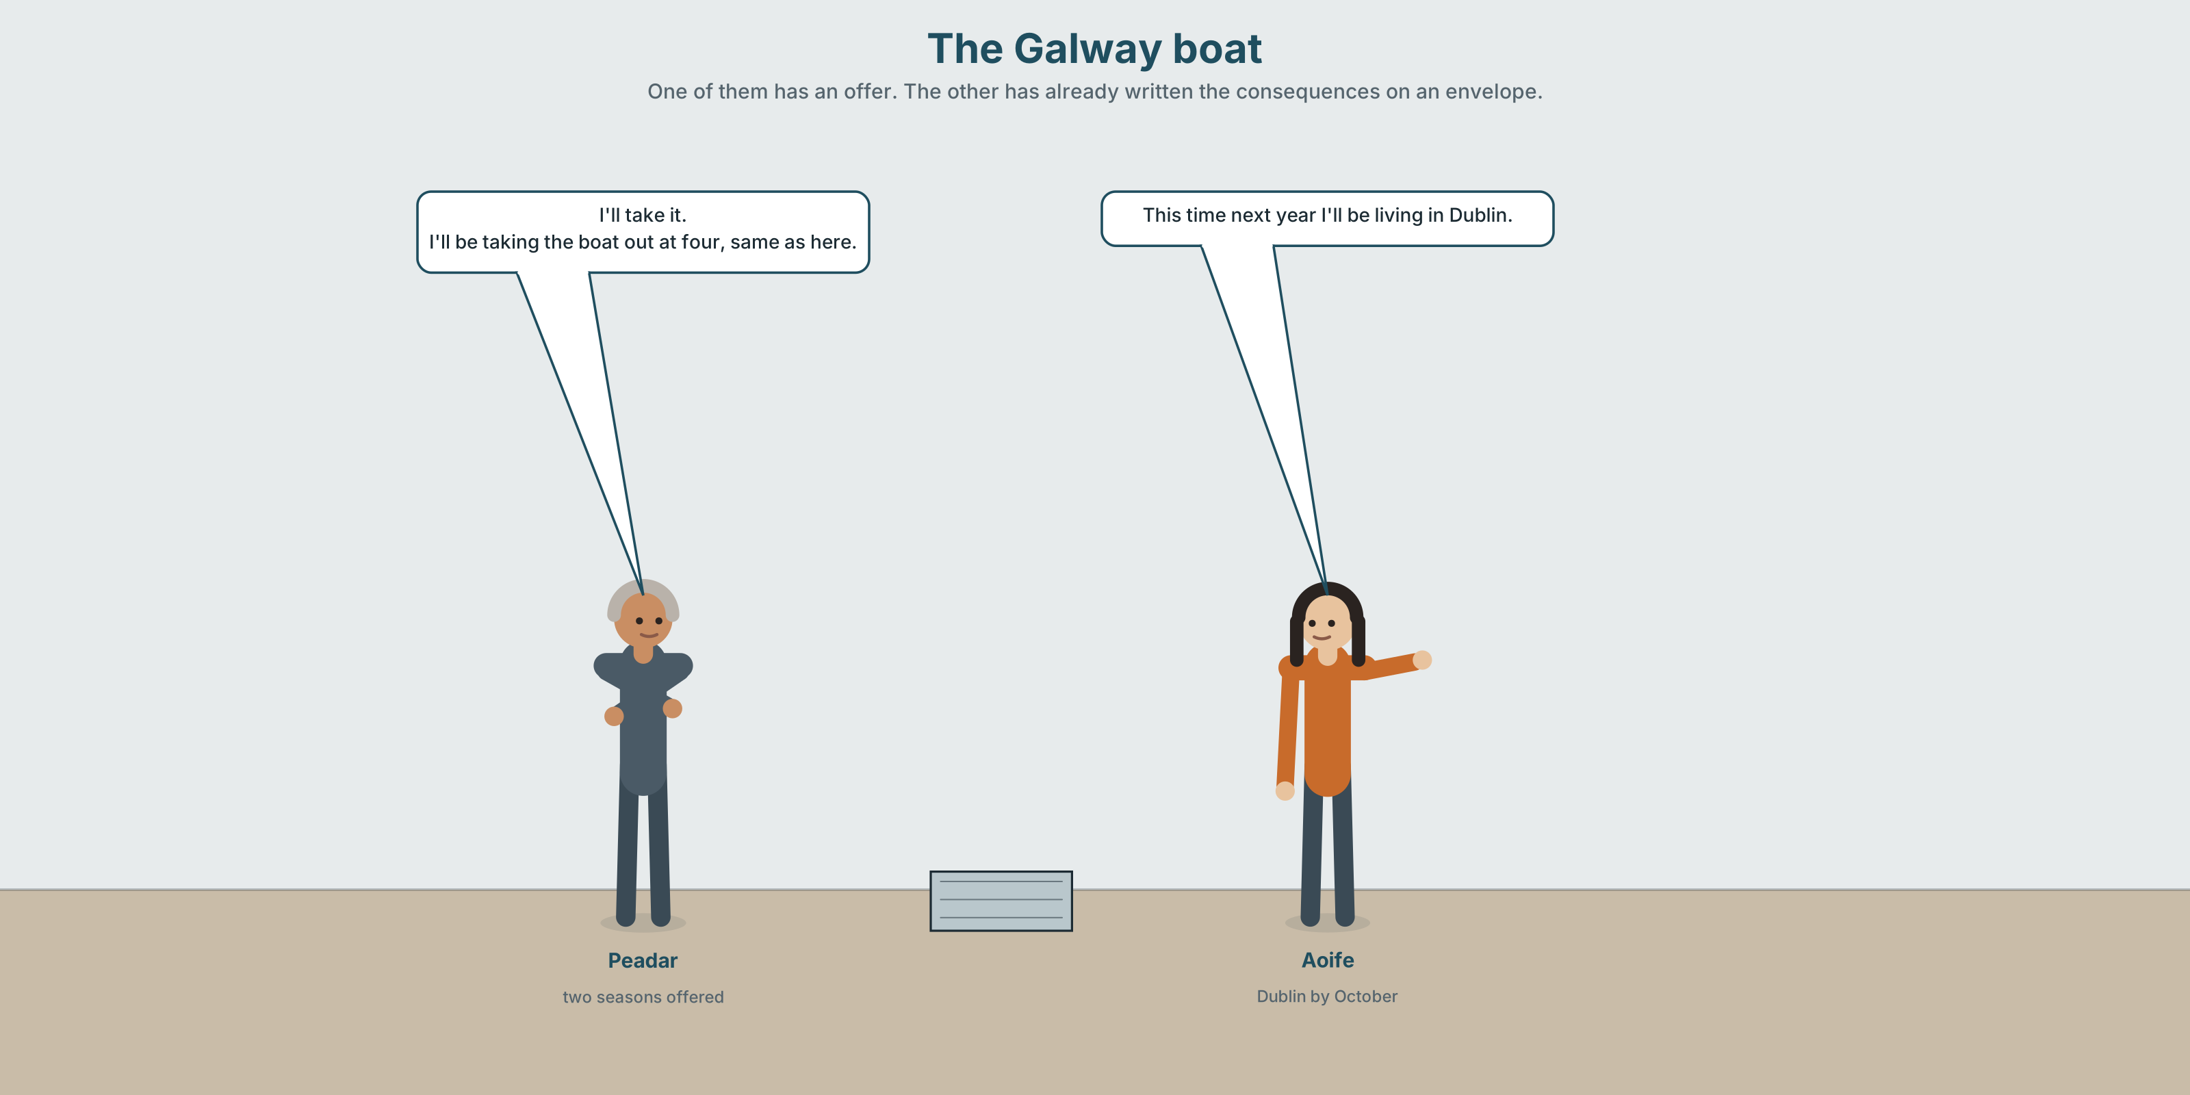{width=6.6in}
The Galway boat — One of them has an offer. The other has already written the consequences on an envelope.

2A · The Galway boat 🔊 Track 7.1
Before you listen. Peadar has been offered work on a bigger boat out of Galway. Guess: is the money the main question?
Listen once. One question. When does the contract start?
Listen again. Complete the table.
 | This time next year | What has to happen first | What they are not saying
Peadar
Aoife
Sinéad
Listen again. Choose.
- The contract is for one season / two seasons / three years.
- Peadar will be away four nights a week / three weeks at a time / permanently.
- Aoife will be at college / working here / not sure.
- The hall will be finished / still waiting / sold.
Noticing. Four sentences from the recording.
- I'll take it.
- I'll be taking the boat out at four, same as here.
- This time next year I'll be living in Galway.
- By then the hall will be finished.
One of these is a decision. Three describe a future that is simply going on. Which is the decision?

2B · Decoding clinic 🔊 Track 7.2
Twenty-five seconds of Peadar. Four jobs.
- How many times does he say I'll be?
- In I'll be taking, how many syllables can you hear in the first two words?
- Catch the date and the length of the contract.
- He says one thing about a Tuesday. What?
Transcripts, page 156.

Part 3 · Grammar Lab 1 ◆ B · THE SYSTEM

A future that is already running

3A · Notice
Look at the four sentences in Part 2.
- Sentence 1 and sentence 2 both use will. What is different about what they do?
- Sentence 3 names a time. Does it name a moment or a period?
- Which of the four would you use to answer "Have you decided?"
- I'll phone you and I'll be phoning you. Which one sounds like a promise and which like a routine?
- Try "This time next year I'll live in Galway." It is not wrong. What does it lose?

3B · See
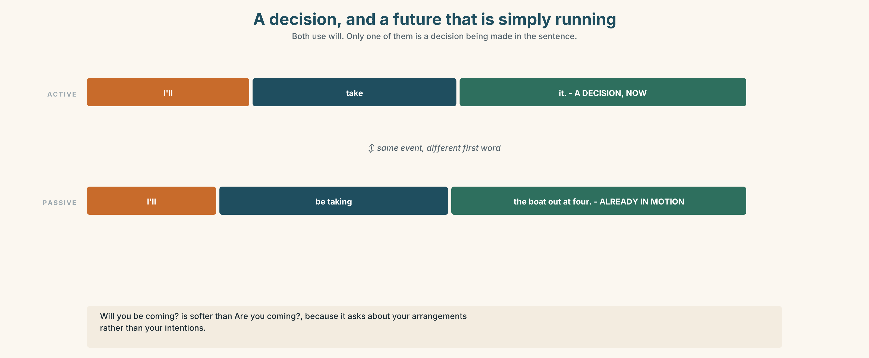{width=6.6in}
A decision, and a future that is simply running — Both use will. Only one of them is a decision being made in the sentence.
Now look at the second picture. It runs from a decision made now to a year that is simply running. Where does going to sit?
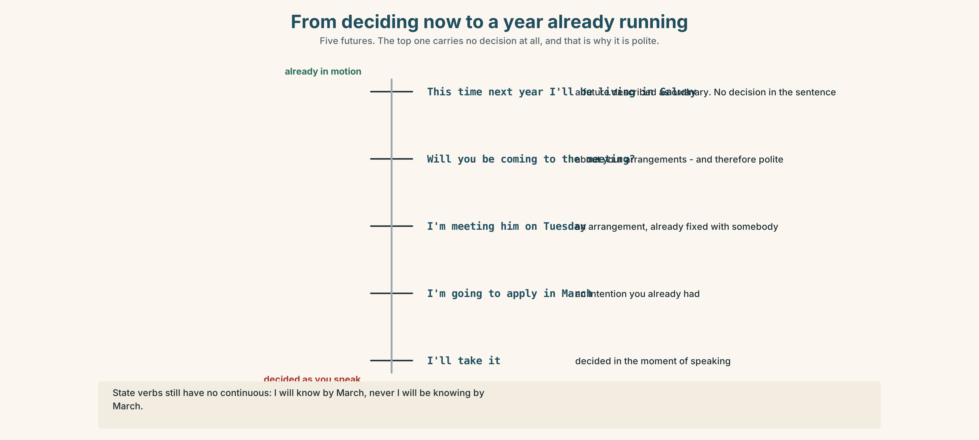{width=6.6in}
From deciding now to a year already running — Five futures. The top one carries no decision at all, and that is why it is polite.

3C · Know
 | Shape | Use it for
will | will + verb | a decision made as you speak · I'll take it.
going to | am going to + verb | an intention you already had · I'm going to apply.
future continuous | will be + -ing | a future that will simply be running · I'll be taking the boat out at four.
The future continuous is the least dramatic of the three, and that is its point. It describes a future as ordinary, as something already in motion, with no decision being made in the sentence.
It is also the polite one. Will you be coming? is softer than Are you coming?, because it asks about your arrangements rather than your intentions.
The time expressions it likes: this time next year · by then · by the end of · in a year's time · eventually · meanwhile
Watch out. State verbs still have no continuous. ✗ I'll be knowing by March. ✓ I'll know by March.

3D · Use — controlled
This time next year Peadar (1) __________ (live) in Galway and (2) __________ (take) a bigger boat out at four. The contract (3) __________ (start) in March. By then Aoife (4) __________ (study) in Dublin, and the hall (5) __________ (be) finished, or it (6) __________ (still / wait) for plasterboard. Sinéad says she (7) __________ (not go) anywhere, and that she (8) __________ (do) exactly this on the same Tuesday in five years.

3E · Use — guided
Put each one into the future continuous.
- I start the course in September. (and in October?)
- He takes the boat out at four every day. (next year, in Galway?)
- We are rebuilding the hall. (this time next year?)
- She works in Dublin. (by then?)
- They wait for the plasterboard. (by Christmas?)

3F · Use — open
Ask three people: What will you be doing at nine o'clock on a Tuesday this time next year? Push for a detail. Then report the most specific answer to the class.

3G · Check — six items
- This time next year I ______ (live) in Galway.
- By then the hall ______ (be) finished.
- ______ you ______ (come) to the meeting? (polite)
- I ______ (take) it. (deciding now)
- I ______ (apply) in March. (I decided last week)
- I ______ (know) by March. (not continuous)
0–3 → Workbook pp. 40–42. 4–5 → Part 6. 6 → page 151.

Part 4 · Speaking ◆ C · THE PERFORMANCE

4A · Fluency starter — the Tuesday
Your teacher names a time: nine o'clock, Tuesday, next March. Each learner says one sentence beginning "I'll be…" Nobody may say I don't know.
Four rounds. Four Tuesdays, further and further away.

4B · The functional core — describing a year ahead
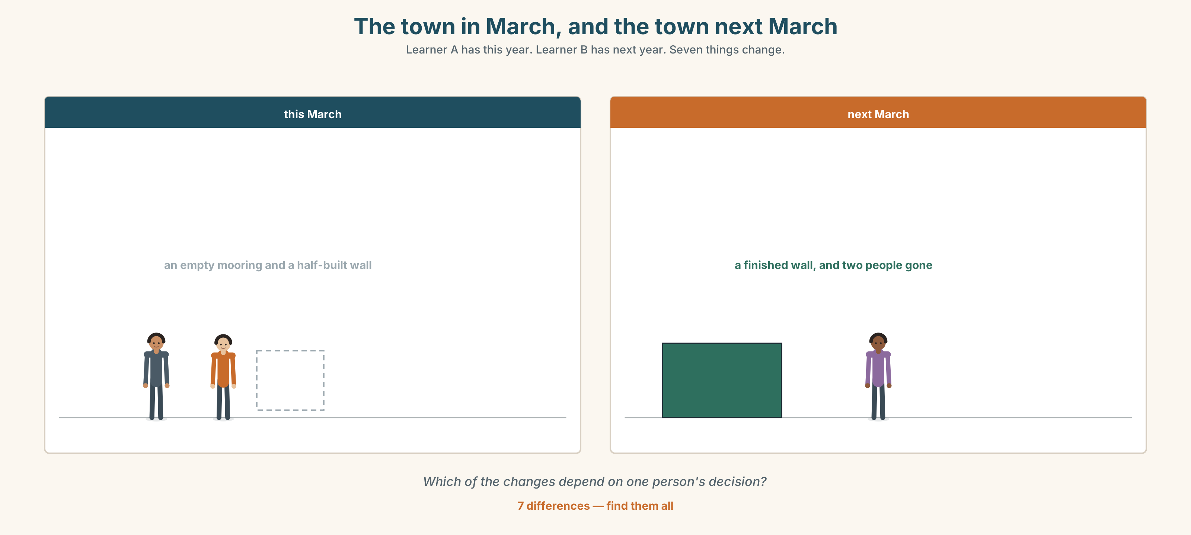{width=6.6in}
The town in March, and the town next March — Learner A has this year. Learner B has next year. Seven things change.
Language Bank
the running future | I'll be… · By then I'll be… · This time next year…
the decision | I'm going to… · I've decided to… · I'll take it.
the condition | If it comes off, I'll be… · That depends on…
the honest hedge | Hopefully. · We'll see where we are. · Ask me in March.
Role play. Learner A has been offered something far away. Learner B wants them to stay. Six minutes. Neither may use the word should.

4C · The performance — one hundred seconds ⏺
Describe your year ahead. One hundred seconds. You must give:
what you will be doing on an ordinary morning · one date · one thing that has to happen first · one thing you will not be doing
Record it.

4D · Observer
One person listens for one thing: was there a real date, or only soon?

4E · Two criteria
☐ Did I use the future continuous at least three times? ☐ Is there a specific date or month in it?

Part 5 · Reading ◆ A · THE WORLD

5A · Predict
A personal essay. The title is "Everybody here is waiting for somebody else's answer." What do you expect it to describe? One sentence.

5B · Read — one hundred and ten seconds

Everybody here is waiting for somebody else's answer
I counted it out on the back of an envelope in March and it frightened me.
Peadar will decide about Galway in February. If he goes, the boatyard loses its best customer and Tomás's cousin does not take on the two apprentices, and one of those apprentices is my brother, who will then be applying to the college in Sligo instead, which he does not want and which he will probably get.
Sinéad will not leave. She has said so for eight months and I believe her. But the hall will not reopen until the plasterboard arrives, and if it is still shut in January the committee will have to decide whether to keep paying the insurance on a building nobody can use, and if they stop paying it then Sinéad will be running a community with nowhere to put it.
I will be at college in Dublin by October. That is the only sentence in this piece with no if in it, and I notice that I have put it last, and that it is also the only one that is entirely about me.
A small town is not a set of individual plans. It is one plan with eleven authors, and nobody has the whole document.

5C · Answer
- When will Peadar decide, and what are the three consequences the writer traces?
- Where will the writer's brother apply instead, and how does she describe his chances?
- What is the chain of events around the hall?
- What is the only sentence with no if in it?
- Why does the writer notice that she put it last?
- What does the last sentence claim about small towns?

5D · Vocabulary in context
Guess from the text. Then check.
counted it out · take on · comes down to · which he will probably get · eleven authors

5E · The counter-text
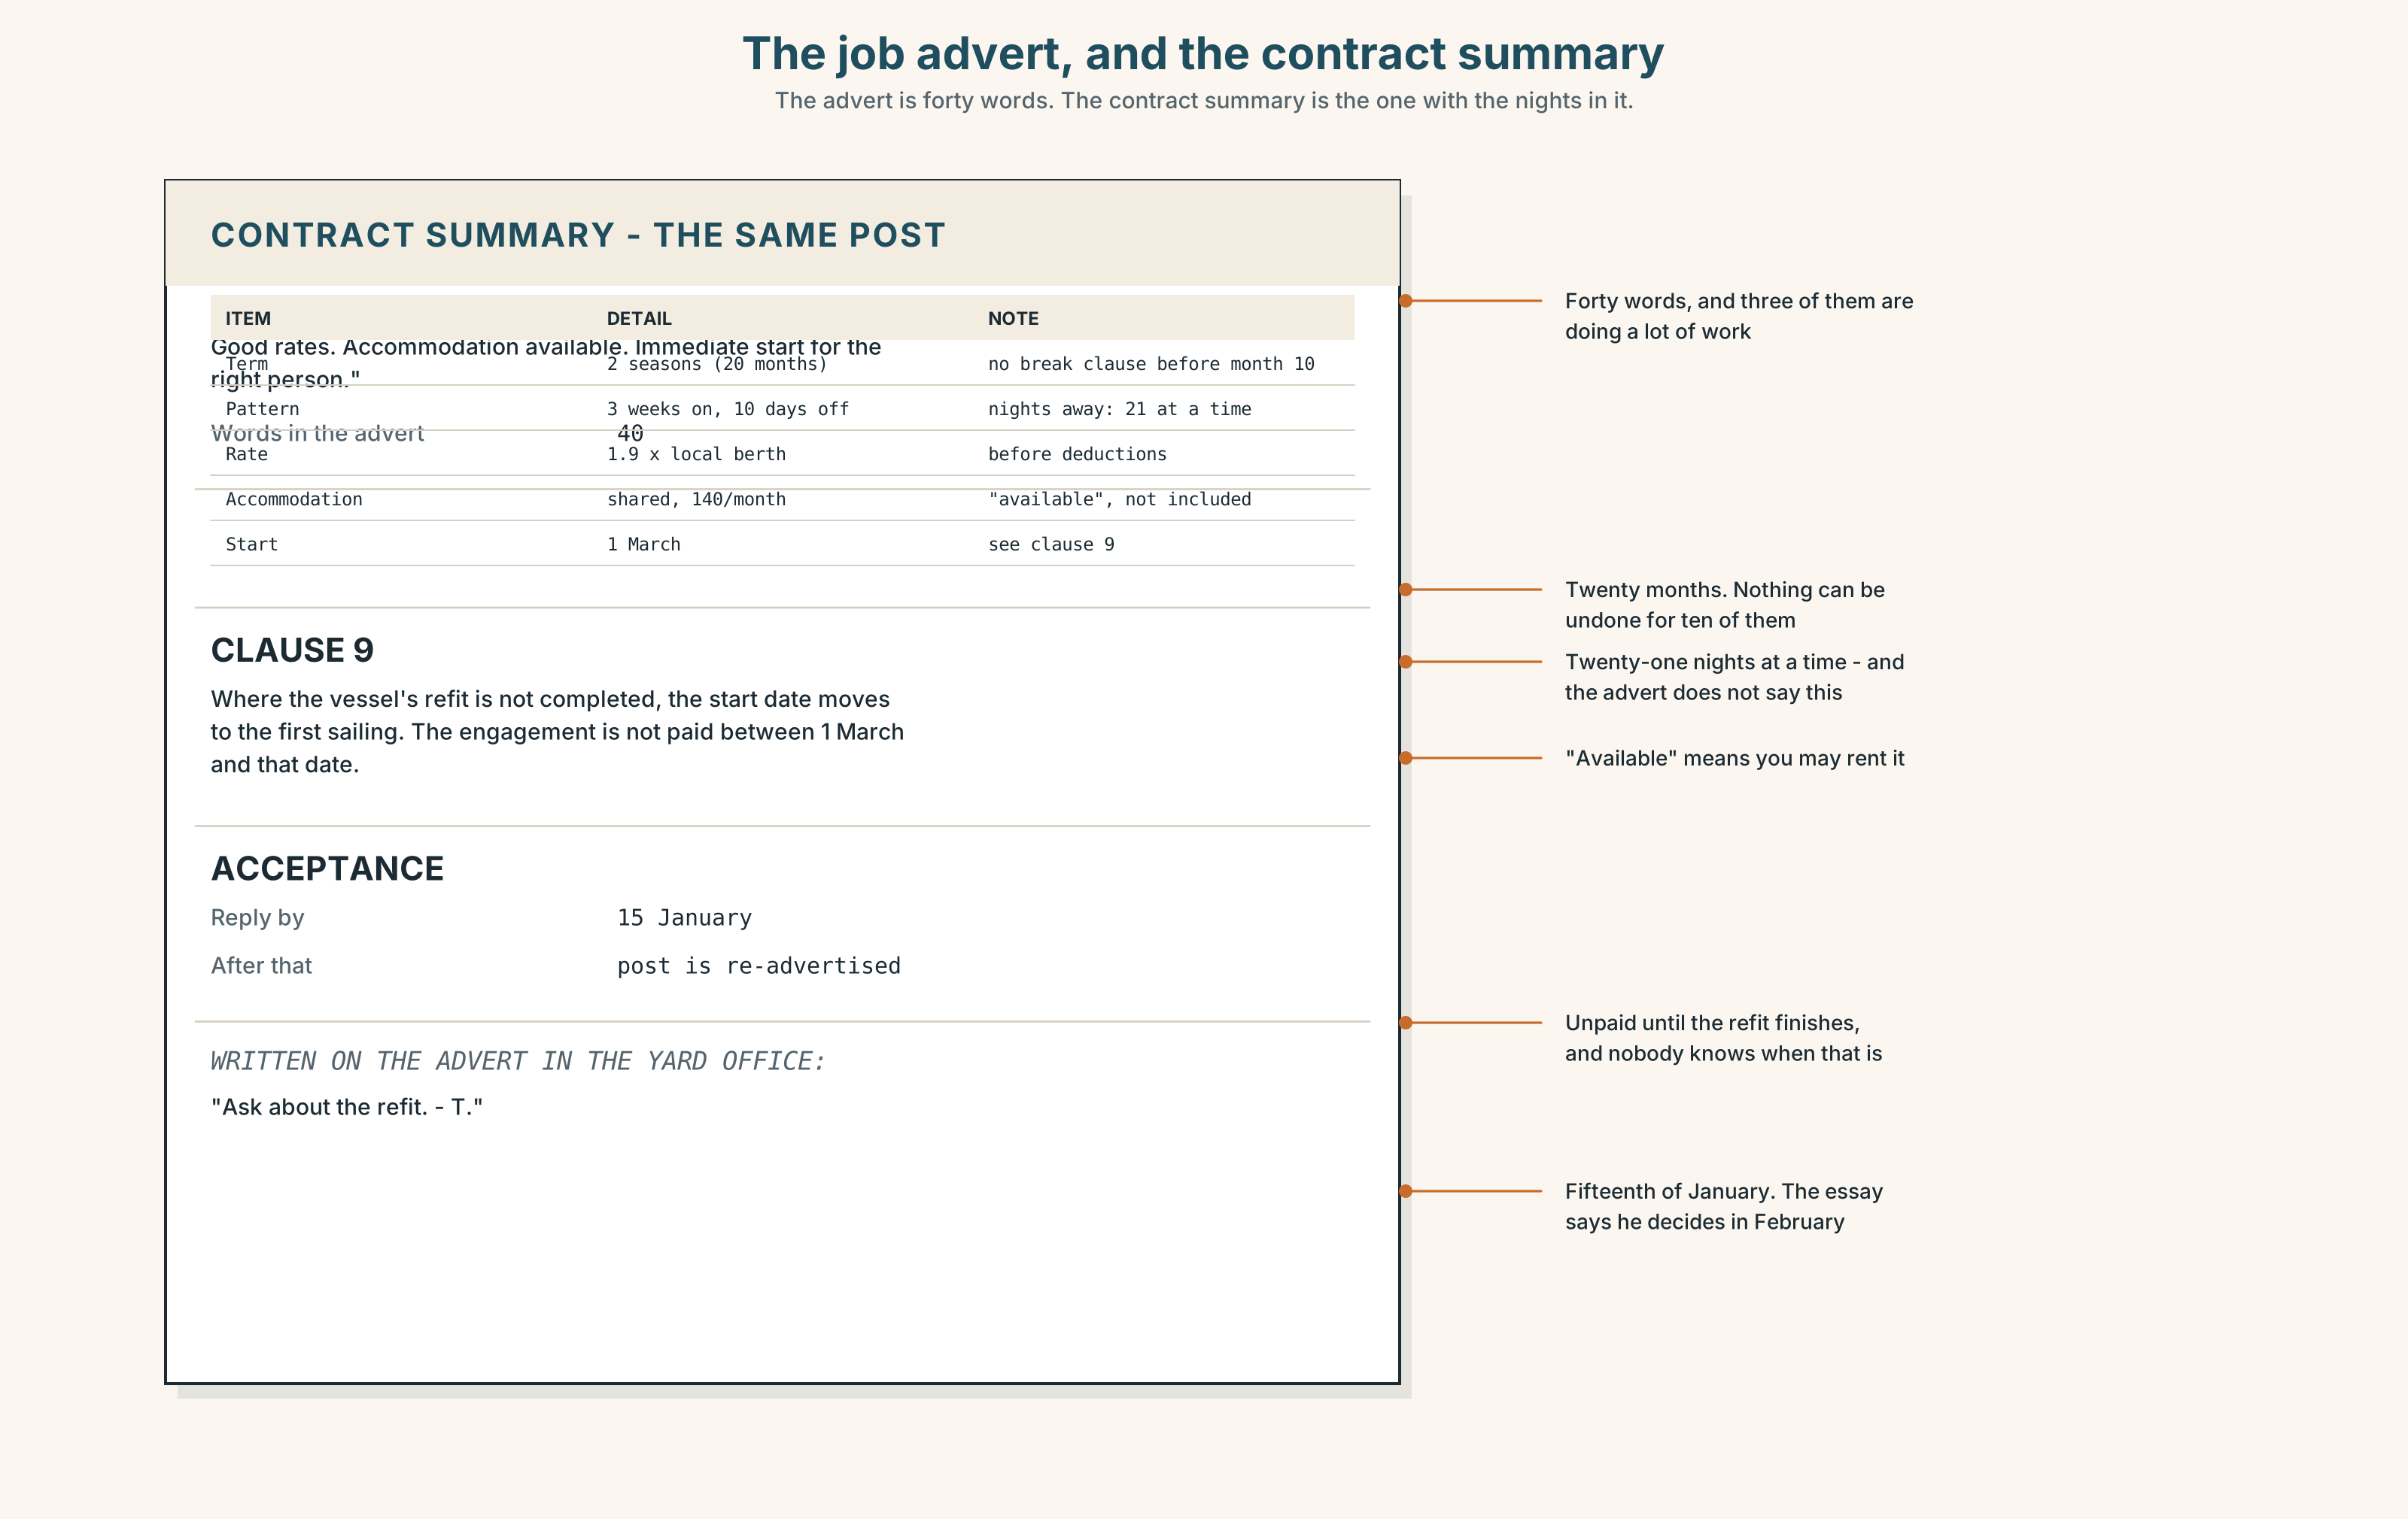{width=6.6in}
The job advert, and the contract summary — The advert is forty words. The contract summary is the one with the nights in it.
Read the job advert and the contract summary, and answer.
- What is the post, and how long is the contract?
- How many nights a week is the successful applicant away, and where is that stated?
- What does the advert say about accommodation, and what does the contract say?
- One clause changes the start date if something happens. Which, and what?

5F · Two texts
The essay says Peadar will decide in February. The contract requires acceptance by 15 January.
Put those two facts together. What has the writer got wrong, and does it matter? Two sentences.

Part 6 · Vocabulary Lab 2 ◆ B · THE SYSTEM

Putting things in the future
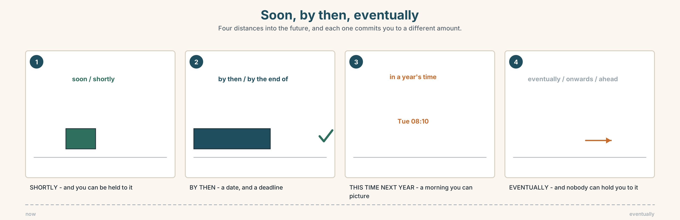{width=6.6in}
Soon, by then, eventually — Four distances into the future, and each one commits you to a different amount.

6A · Sort — soon, far off, or in between?
Three columns.
soon · shortly · eventually · by then · this time next · in a year's time · later · onwards · meanwhile · ahead

6B · Chunk completion
- This time ______ year she will be qualified.
- By the ______ of March we will know.
- In a year's ______ nobody will remember this.
- He is looking for ______ on the bigger boats.
- For her it is a fresh ______ .
- They always end ______ coming back.

6C · Three that are not as sure as they sound
hopefully · likely · eventually
Each of these looks like a prediction and is actually a hedge.
Rewrite each sentence so the hedge is honest and visible.
- Hopefully I'll be finished by March.
- He's likely to take it.
- Eventually the hall will reopen.
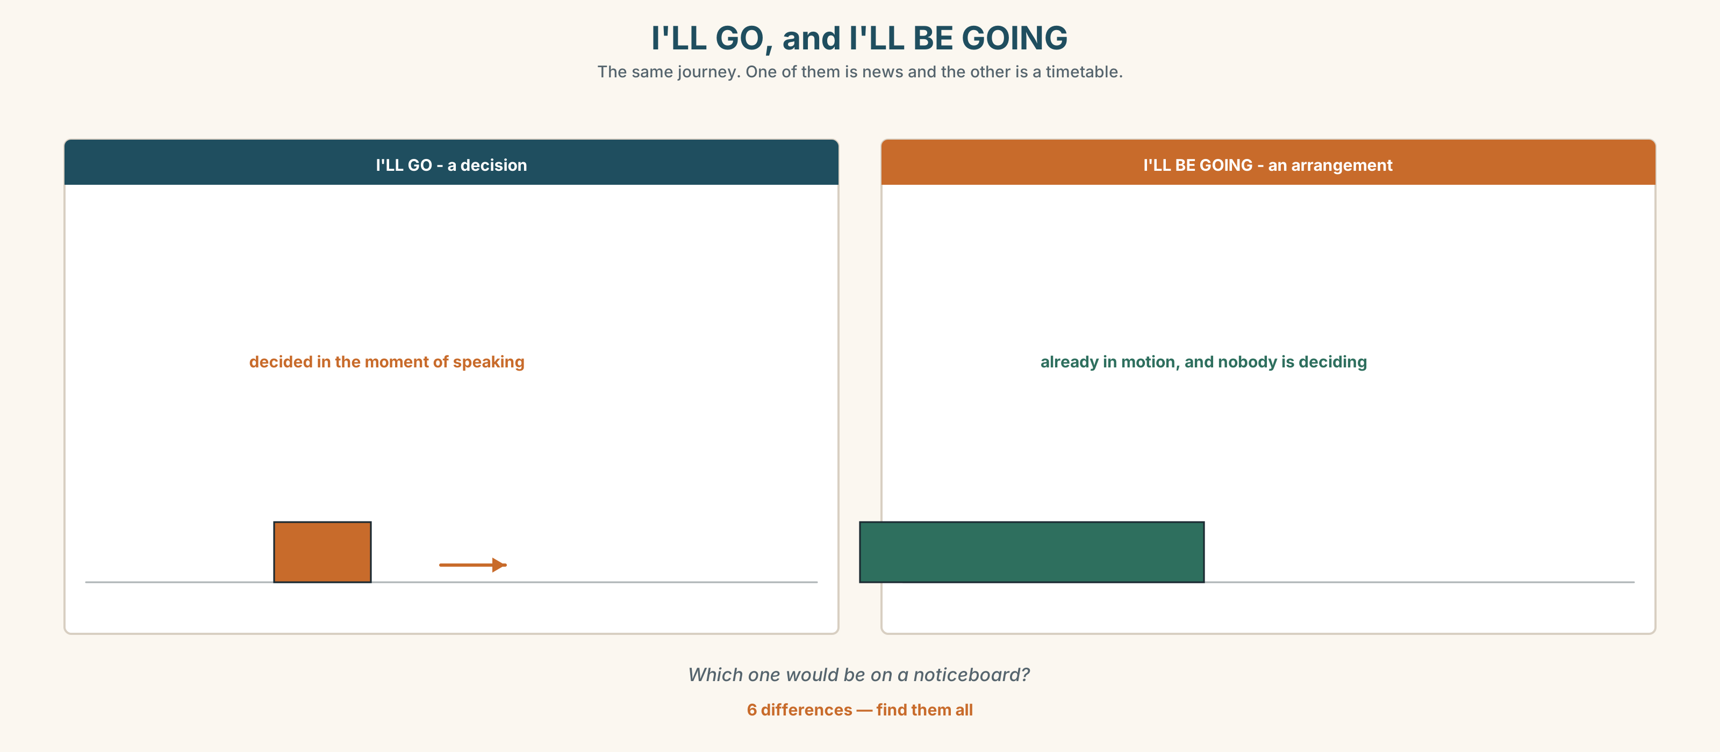{width=6.6in}
I'LL GO, and I'LL BE GOING — The same journey. One of them is news and the other is a timetable.
Six differences. Find them, then answer the question under the picture.

6D · Contrast Clinic — will, going to, or will be -ing
Six items.
- (the phone rings) I ______ get it.
- I ______ apply in March. (decided last week)
- This time next year I ______ live in Galway.
- ______ you ______ come to the meeting? (polite enquiry)
- By then we ______ wait eleven months for that plasterboard.
- I ______ know by March. (a state)

Part 7 · Pronunciation & Fluency Lab ◆ B · THE SYSTEM

Three words that become one and a half
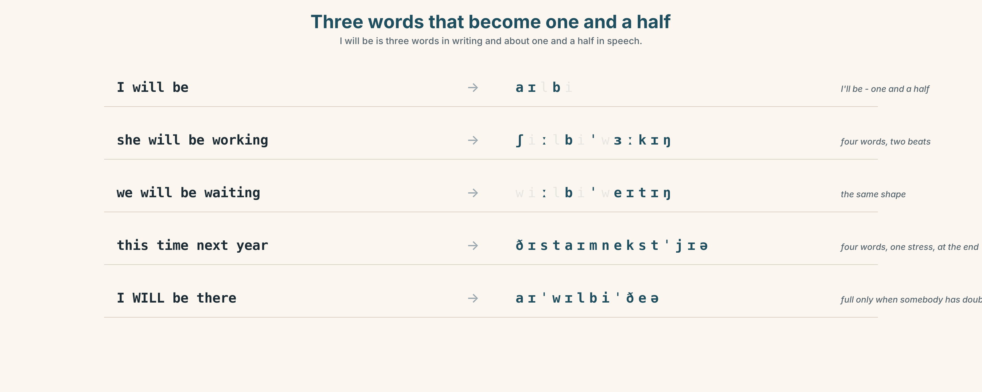{width=6.6in}
Three words that become one and a half — I will be is three words in writing and about one and a half in speech.

7A · Hear 🔊 Track 7.3
I will be → I'll be → /aɪlbi/ she will be working → /ʃiːlbiˈwɜːkɪŋ/ we will be waiting → /wiːlbiˈweɪtɪŋ/ this time next year → /ðɪstaɪmnekstˈjɪə/

7B · Say
Say each one. Then say the sentence three times, faster:
This time next year I'll be taking the boat out at four.

7C · Make it mean something
Say these two:
I WILL be there. (somebody has doubted it) I'll be there. (it is simply an arrangement)
Which of the two is a promise, and which is a timetable?

7D · Fluency 20 ⏺
Twenty seconds: three things you will be doing this time next year. Three times, faster, with 'll be every time.

Part 8 · Writing ◆ C · THE PERFORMANCE

A year ahead · 100 words
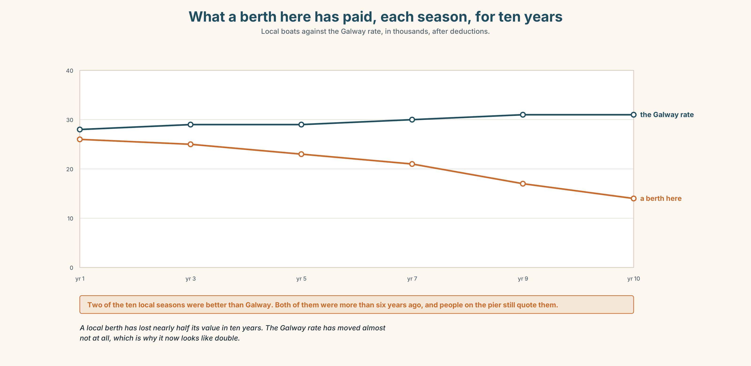{width=6.6in}
What a berth here has paid, each season, for ten years — Local boats against the Galway rate, in thousands, after deductions.

8A · Read the model
By October I'll be in Dublin, and on a Tuesday morning I'll be on the 8.10 from Drumcondra with a bag that is too heavy, because I have seen the timetable and I know what the walk is like. [a date, a specific morning, and a detail that proves the writer has actually looked]
I'll still be coming back one weekend in three. That is not sentiment; it is the cheapest train and my mother's birthday is in November. [what continues, and the reason is practical rather than emotional]
I will not be running the hall. Somebody in this town is going to have to, and it is not going to be me, and I would rather say that now than in March. [what the writer will not be doing, said plainly, which is the hardest sentence here]
Questions about the writer's choices:
- The first paragraph names a train. What does that do that "I'll be studying" does not?
- The last paragraph is a refusal. Why put it in a piece about your own year?

8B · The anti-model
Next year I hope to be doing something interesting. I would like to study or maybe work, and I am keeping my options open. Hopefully things will work out and I will be happy with whatever I decide to do.
Correct English, and a year of nothing. Name three things it does not contain.

8C · Plan
a date → an ordinary morning, with a detail → what continues, and why → one thing you will not be doing

8D · Write — 100 words

8E · Peer review — two criteria
☐ Is there a real date and a real morning? ☐ Is there one thing the writer rules out?

8F · Write it again · 8G · Publish
On the wall, with the job advert from Part 5E beside it.

Part 9 · The File ◆ A · THE WORLD + C · THE PERFORMANCE

WORK FILE · The Interview
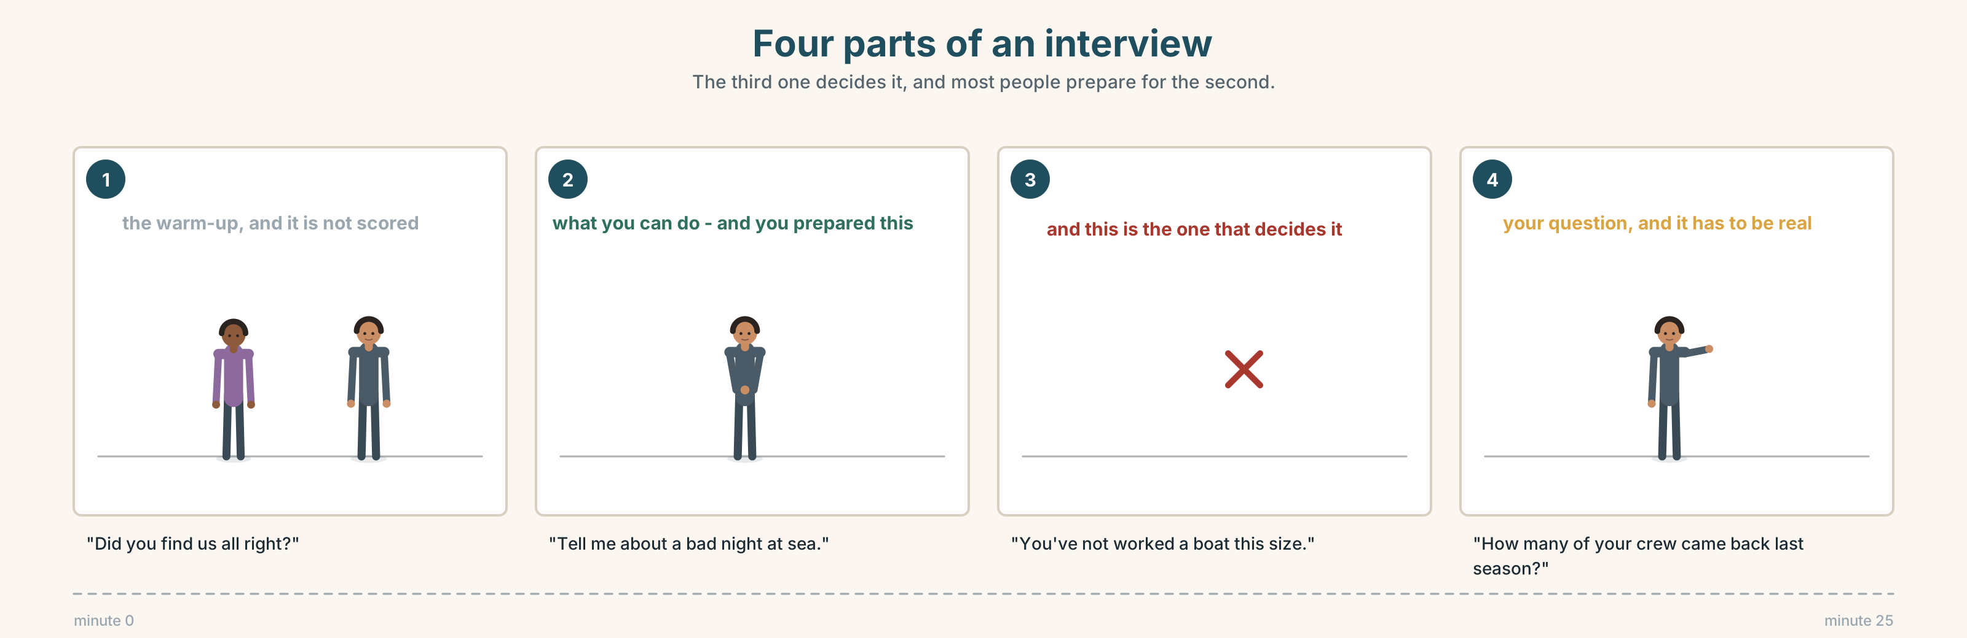{width=6.6in}
Four parts of an interview — The third one decides it, and most people prepare for the second.

9A · Twenty-five minutes 🔊 Track 7.4
Peadar is interviewed for the Galway post. Listen.
- What is the first real question, and how long does it take to arrive?
- Which answer does he give too quickly, and what does it cost him?
- What does he ask them, and when?

9B · The four parts of an interview
the warm-up · the thing you can do · the thing you have not done · the questions you ask them
Match each to one phrase.
"Did you find us all right?" · "Tell me about a bad night at sea." · "You've not worked a boat this size." · "How many of your crew came back last season?"

9C · The answer to the question about what you cannot do
The worst answer is a denial. The second worst is an apology.
Which of these four is best, and why?
- "I'd pick it up quickly."
- "No, I haven't. The handling's different and I'd want a fortnight alongside somebody."
- "Size isn't really the issue."
- "I'm sorry, I know that's a problem."

9D · Your turn
In pairs. Ten minutes. One interviews, one is interviewed, for anything at all. The interviewer must ask about something the candidate has not done. The candidate must ask one real question back.

9E · Transfer
Write down the question you would ask at the end of an interview this year. Not a polite one. A real one. Bring it.

Part 10 · Mediation & Interaction ◆ C · THE PERFORMANCE
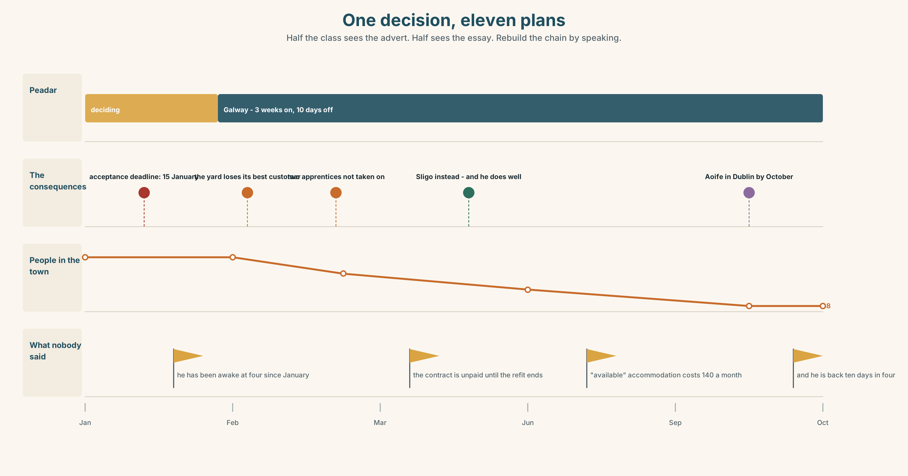{width=6.6in}
One decision, eleven plans — Half the class sees the advert. Half sees the essay. Rebuild the chain by speaking.

10A · Relay
Half the class sees the job advert. Half sees the essay. Rebuild the chain of decisions by speaking. Ten minutes.

10B · Simplify
Explain the contract summary from Part 5E to somebody who has never signed one. Four sentences only.
Plan: how long → what the hours actually are → what is not included → the one date that matters

10C · Compress
The essay in Part 5 into thirty-five words, keeping the last sentence's idea.

10D · Online
Write one message to the Galway skipper: you are interested, you have one question about the start date, and you will answer by a date you name.

10E · Your language
How does your language talk about a future that is simply running? Is there something like will be doing, or do you use a present tense? Say this time next year I'll be living in Galway in both.

Part 11 · The Decision ◆ C · THE PERFORMANCE

Galway, or the season after
Peadar is offered a berth on a bigger boat out of Galway. Two seasons, better money, three weeks at a time away.
- Take it. The money is nearly double. The boat he had is not coming back and nobody is building him another.
- Stay. Wait a season. The yard thinks there will be a berth here by next spring, and the yard has thought that before.
- Take it for one season. The contract is for two. Ask for one, and risk being turned down for something he has already decided he wants.

11A · The evidence
- The job advert and the contract from Part 5E — and the clause about the start date.
- The chart — what a berth here has paid, each season, for ten years.
- The voice. Aoife, twenty seconds: "Everyone keeps telling him what it would do to the town. Nobody has asked him what he will be doing at four o'clock in the morning if he stays, because the answer is nothing, and he has been doing nothing at four o'clock in the morning since January."

11B · Talk about it
In threes. Everybody says one. Use the frame.
This time next year Peadar will be ______ , because ______ .
Words you can use: career · chance · contract · season · leave · return · settle · future

11C · Decide
Write two sentences. Choose, and say why.
I think Peadar should ______________________ , because ______________________ .

11D · Model decision
He should take it for the two seasons and say so before January, not in February. Asking for one season is asking a skipper to carry the cost of his uncertainty, and skippers remember that. Two seasons is twenty months, and a man who has been awake at four every morning since January with nothing to go out in does not need a smaller version of the thing he wants.

11E · The Reveal
What happened. He took the two seasons and started in March.
He is away three weeks at a time and says the work is easier than here and the boat is better than anything he will ever own. He has not sold the house. He is back for ten days in four, and on those ten days he is on the pier at four in the morning doing nothing, which his sister says is the only part of this that has not changed.
The yard did not take on the two apprentices. Aoife's brother went to Sligo and is, by every account including his own, doing well.
He went. The chain in the essay happened almost exactly as she wrote it. And the one person it was supposed to be worst for is doing fine.
Was it the right decision? Say why — and say what you make of the ten days in four.

Part 12 · Landing ◆ all three lines

12A · Recycle — ten items
- This time next year I ______ (live) in Galway.
- By then the hall ______ (be) finished.
- ______ you ______ (come) to the meeting? (polite)
- He is looking ______ work on the bigger boats.
- They always end ______ coming back.
- (Unit 6) The rope ______ (must / break) in the night.
- (Unit 5) "Measure it." → He told me ______ it.
- (Unit 4) She ______ me that she had checked it. (said / told)
- (Unit 2) We ______ (wait) since June.
- (A2.1 U5) If it ______ (rain), we'll stay.

12B · Consolidate
One hundred words. Your year ahead. Three future continuous forms, one real date, and one thing you will not be doing.

12C · Can-do, with evidence
I can… | My evidence | Sure?
describe a future that is simply running | Part 3G score | ◯ ◑ ●
describe a year ahead in a hundred seconds | Part 4C recording | ◯ ◑ ●
write a hundred words with a real date in them | Part 8 draft 2 | ◯ ◑ ●
answer a question about what I have not done | Part 9D role play | ◯ ◑ ●

12D · Replay ⏺
Find your thirty seconds from Part 0C. Listen. Record it again. One sentence: what is different?

12E · Glossary — forty items, as a map
THE WORK · career · ambition · plan · contract · season · crew · boatyard · promotion GETTING IN · apply · qualify · training · course · chance · look for work · take on GOING AND STAYING · leave · return · settle · a fresh start · end up · future THE RUNNING FUTURE · will · going · be doing · this time next · by then · by the end of · in a year's time SOON, AND LATER · soon · shortly · later · eventually · onwards · meanwhile · ahead THE HEDGE · hopefully · likely · we'll see where we are · I'll still be here

12F · Next
Unit 8 · What do you know about this place?

