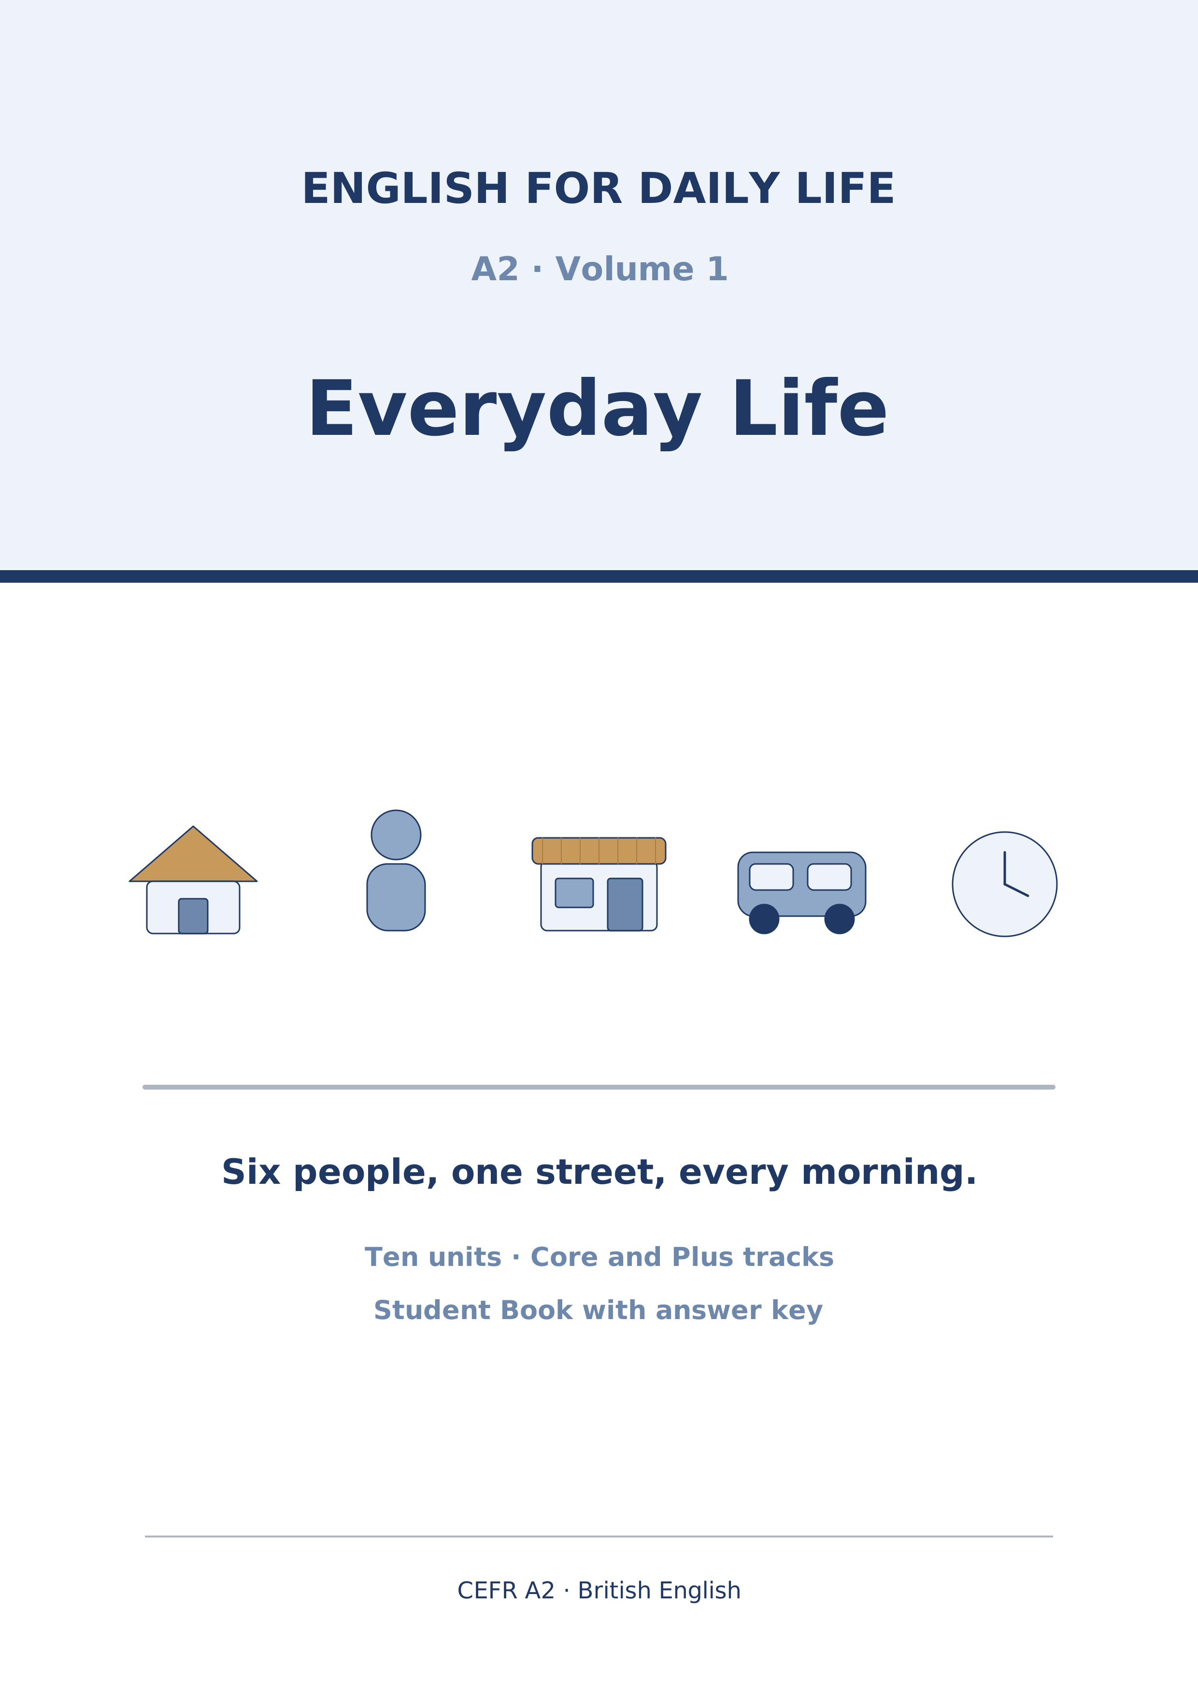
English for Daily Life
A2 · Volume 1 · Everyday Life
How to use this book
Every unit has the same ten parts in the same order, so after Unit 1 you always know where you are.
[CORE] is the Warm Up and Parts 1–6. Everybody does these.
[PLUS] is Parts 7–9. They are there when you are ready for them, and optional when you are not. Part 10 is for everybody.
Almost every exercise opens with item 0, already answered. It is the worked example: read it before you start.
Symbols
🔊 | an audio track; the script is printed on the page
☐ | something to tick when you have checked it
✗ → ✓ | a common mistake, then the correction
Stretch | a harder version of the task, for the Plus track
→ Harvest | the grammar you will meet again later in the unit
Map of the Book
Unit | Topic | Grammar | Glossary
1 | People and Routines | present simple | routine, shift, flatmate, neighbour…
2 | Home and Neighbourhood | there is/are | balcony, cupboard, rent, entrance…
3 | A Day in the City | present continuous vs present simple | market, bridge, crossing, bench…
4 | Food and Shopping | countable/uncountable | basket, aisle, receipt, fridge…
5 | Last Weekend | past simple - was/were and regular verbs | museum, picnic, concert, guest…
6 | Journeys and Mishaps | past simple - irregular verbs | suitcase, coach, gate, wallet…
7 | Choosing and Comparing | comparatives and superlatives | quality, value, brand, battery…
8 | Help and Ability | can/can't | favour, lend, borrow, advice…
9 | Finding Your Way | prepositions of place | junction, roundabout, lane, square…
10 | Doing and Making | imperatives | step, mix, pour, press…
Audio tracks
Track | Where | What
1.1 | Unit 1 · Part 1 Pronunciation | People and Routines
1.2 | Unit 1 · Part 3 (1) | People and Routines
1.3 | Unit 1 · Part 3 (2) | People and Routines
1.4 | Unit 1 · Part 3 (3) | People and Routines
1.5 | Unit 1 · Part 7B | People and Routines
2.1 | Unit 2 · Part 1 Pronunciation | Home and Neighbourhood
2.2 | Unit 2 · Part 3 (1) | Home and Neighbourhood
2.3 | Unit 2 · Part 3 (2) | Home and Neighbourhood
2.4 | Unit 2 · Part 3 (3) | Home and Neighbourhood
2.5 | Unit 2 · Part 7B | Home and Neighbourhood
3.1 | Unit 3 · Part 1 Pronunciation | A Day in the City
3.2 | Unit 3 · Part 3 (1) | A Day in the City
3.3 | Unit 3 · Part 3 (2) | A Day in the City
3.4 | Unit 3 · Part 3 (3) | A Day in the City
3.5 | Unit 3 · Part 7B | A Day in the City
4.1 | Unit 4 · Part 1 Pronunciation | Food and Shopping
4.2 | Unit 4 · Part 3 (1) | Food and Shopping
4.3 | Unit 4 · Part 3 (2) | Food and Shopping
4.4 | Unit 4 · Part 3 (3) | Food and Shopping
4.5 | Unit 4 · Part 7B | Food and Shopping
5.1 | Unit 5 · Part 1 Pronunciation | Last Weekend
5.2 | Unit 5 · Part 3 (1) | Last Weekend
5.3 | Unit 5 · Part 3 (2) | Last Weekend
5.4 | Unit 5 · Part 3 (3) | Last Weekend
5.5 | Unit 5 · Part 7B | Last Weekend
6.1 | Unit 6 · Part 1 Pronunciation | Journeys and Mishaps
6.2 | Unit 6 · Part 3 (1) | Journeys and Mishaps
6.3 | Unit 6 · Part 3 (2) | Journeys and Mishaps
6.4 | Unit 6 · Part 3 (3) | Journeys and Mishaps
6.5 | Unit 6 · Part 7B | Journeys and Mishaps
7.1 | Unit 7 · Part 1 Pronunciation | Choosing and Comparing
7.2 | Unit 7 · Part 3 (1) | Choosing and Comparing
7.3 | Unit 7 · Part 3 (2) | Choosing and Comparing
7.4 | Unit 7 · Part 3 (3) | Choosing and Comparing
7.5 | Unit 7 · Part 7B | Choosing and Comparing
8.1 | Unit 8 · Part 1 Pronunciation | Help and Ability
8.2 | Unit 8 · Part 3 (1) | Help and Ability
8.3 | Unit 8 · Part 3 (2) | Help and Ability
8.4 | Unit 8 · Part 3 (3) | Help and Ability
8.5 | Unit 8 · Part 7B | Help and Ability
9.1 | Unit 9 · Part 1 Pronunciation | Finding Your Way
9.2 | Unit 9 · Part 3 (1) | Finding Your Way
9.3 | Unit 9 · Part 3 (2) | Finding Your Way
9.4 | Unit 9 · Part 3 (3) | Finding Your Way
9.5 | Unit 9 · Part 7B | Finding Your Way
10.1 | Unit 10 · Part 1 Pronunciation | Doing and Making
10.2 | Unit 10 · Part 3 (1) | Doing and Making
10.3 | Unit 10 · Part 3 (2) | Doing and Making
10.4 | Unit 10 · Part 3 (3) | Doing and Making
10.5 | Unit 10 · Part 7B | Doing and Making
Unit 1: People and Routines
English for Daily Life · Level: A2 · Tracks: [CORE] Warm-Up + Parts 1–6 · [PLUS] Parts 7–10
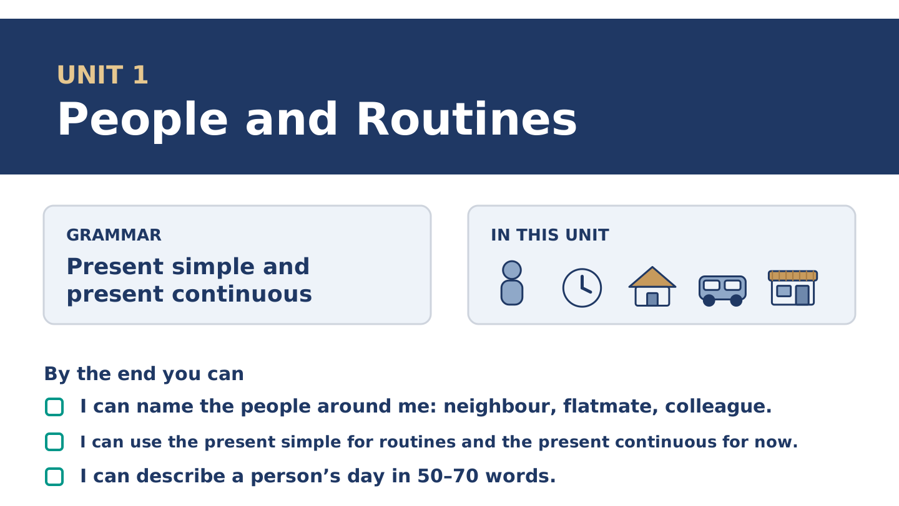
Figure 1.1 · Unit 1 at a glance: the grammar, the topic and what you will be able to do.
Warm Up
[CORE] Core track · in-class starter
Warm-up: People Words and Meanings
Match the words with their meanings. One meaning is not needed. Write the letter.
Column A
1. | Neighbour | ____
2. | Flatmate | ____
3. | Colleague | ____
4. | Routine | ____
5. | Shift | ____
Column B
a) | a person you work with
b) | the hours you work, for example eight at night to eight in the morning
c) | a person who lives near you
d) | a person who pays you every month
e) | the same things you do every day or every week
f) | a person who shares your home
Warm-up: Talking About People
Complete the sentences using the words in the word bank.
Word bank: busy | neighbour | routine | works
- Tomas ______________________ at the hospital, often at night.
- Maya has a simple morning ______________________ : coffee, radio, bus.
- Amina is our ______________________ ; her shop is downstairs.
- On Tuesdays Maya is very ______________________ , because she has a class.
Warm-up: A Street of Neighbours
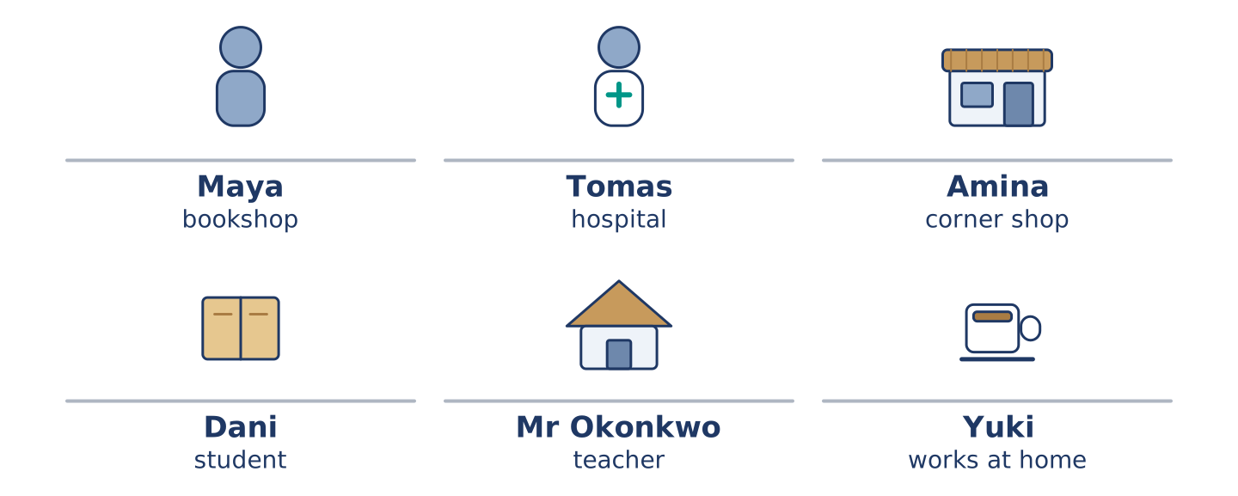
Figure 1.2 · 14 Alder Street at eight in the morning.
Read the text and choose the correct answer.
Six people live at 14 Alder Street. Maya works in a bookshop. Tomas is a nurse, and he often works at night. Amina has the corner shop downstairs. Dani is a student, and he lives on the second floor. Mr Okonkwo is seventy, and he is a retired teacher. Yuki is new here, and she works at home. Every morning the street is busy. Right now, Maya is waiting for the bus, Amina is opening her shop, and Dani is looking for his keys. Mr Okonkwo is at his window, as he is every morning. He knows the street better than anybody.
1. Where do these people live?
○ A) In a hospital
○ B) At 14 Alder Street
○ C) In a bookshop
○ D) In six different cities
2. What is Amina doing right now?
○ A) Opening her shop
○ B) Working at the hospital
○ C) Waiting for the bus
○ D) Sleeping
Part 1 · Vocabulary and Terminology
[CORE] Core track · pre-class input
Part 1: People and Routine Terms
Match the words with their meanings. One meaning is not needed. (0. is done for you.)
- Routine → the same things you do every day or every week.
Column A
1. | Shift | ____
2. | Commute | ____
3. | Appointment | ____
4. | Colleague | ____
5. | Flatmate | ____
6. | Break | ____
7. | Weekday | ____
Column B
a) | a short rest in the middle of work or study
b) | the journey between your home and your work or school
c) | a time you have arranged to see somebody, for example a doctor
d) | a person you work with
e) | Monday, Tuesday, Wednesday, Thursday or Friday
f) | a person who shares your home
g) | the hours you work, for example two in the afternoon to ten at night
h) | a day when nobody works
Gloss: commute = the journey between home and work · shift = the block of hours you work · appointment = an arranged time to see somebody
Part 1: Pronunciation
🔊 Audio Track 1.1
Listen and practise these words. Say each word aloud and stress the loud syllable (CAPITALS).
routine — rou-TINE
commute — com-MUTE
appointment — ap-POINT-ment
colleague — COL-league
usually — U-su-al-ly
neighbour — NEIGH-bour
Then listen again to the -s ending on he, she and it verbs. It has three sounds.
/s/ — he works · he starts · he gets up
/z/ — she lives · he opens · she reads
/ɪz/ — she finishes · he watches · she closes
Say each line twice. The sound depends on the letter before the -s, not on the spelling.
Part 1: Jobs, Places and Hours
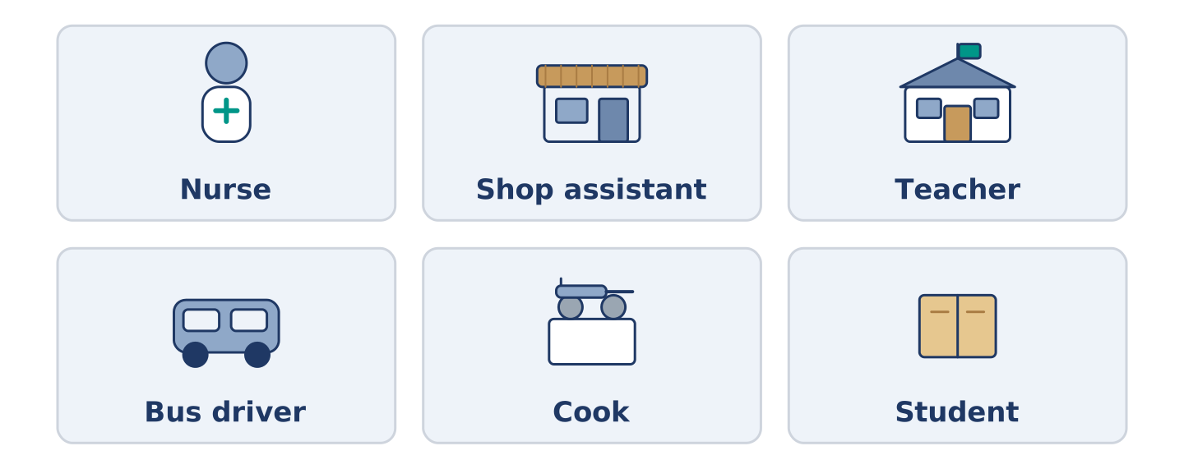
Figure 1.3 · Six jobs and the places people do them.
Complete the table. Write the place where each person works and when they usually work. (0. is done.)
Job | Place | Usual hours
Nurse | a hospital | (example)
Shop assistant
Teacher
Bus driver
- Nurse — a hospital — days, and sometimes nights.
Tomas is the nurse, so row 0 is his. For the other three, think about somebody you know. A bus driver often starts before the city is awake; a teacher works when the children are in school. There is more than one right answer, and you should be ready to say why you chose yours.
Part 1: Parts of a Day
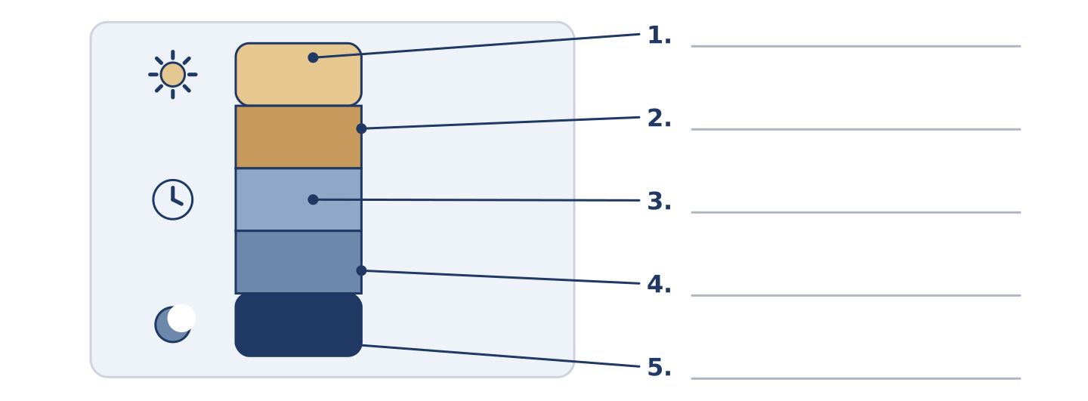
Figure 1.4 · Parts of a day — write the correct word on each line.
Match the parts of a day with their descriptions. One description is not needed. Write the letter.
Column A
1. | Dawn | ____
2. | Midday | ____
3. | Afternoon | ____
4. | Evening | ____
5. | Midnight | ____
Column B
a) | twelve o’clock in the middle of the day
b) | the hours between midday and about six
c) | the first day of the working week
d) | the early time when the sun comes up
e) | twelve o’clock at night
f) | the end of the day, when people come home
Part 1: Daily Life — Multiple Choice
Read and choose the correct answer.
1. A person who lives near you is a…
○ A) colleague
○ B) neighbour
○ C) customer
○ D) flatmate
2. The journey from your home to your work is your…
○ A) break
○ B) shift
○ C) commute
○ D) routine
3. A time you have arranged to see the doctor is an…
○ A) appointment
○ B) weekday
○ C) colleague
○ D) routine
Part 1: Vocabulary Fill-in
Complete the sentences with the correct word.
Word bank: shift | commute | appointment | break
- Tomas works a night ______________ twice a week.
- Her ______________ takes twenty minutes by bus.
- At eleven o’clock they have a short ______________ .
- Mr Okonkwo has an ______________ at the health centre on Thursday.
Part 1: Write About Your Day (short)
Write two or three sentences about your own day. Use three words from this unit.
Model — read this first:
My commute takes half an hour on two buses. I usually have a break at eleven, and I eat with a colleague from my floor. At the moment I am starting work early, because the mornings are quiet.
Part 2 · Grammar — Present Simple vs Present Continuous
[CORE] Core track · pre-class input
Part 2: Notice
Read these lines from Alder Street. Underline the verbs. Which are routines, and which are happening now?
Maya works in a bookshop. She usually starts at nine. Right now, she is waiting for the bus. Tomas works at the hospital every week. This week, he is working nights. Dani studies at the college. He usually cooks on Tuesdays, but today he is eating at his mother’s. Mr Okonkwo reads every afternoon. At the moment he is reading about birds.
Five of these sentences are about a routine, and three are about now. The time words tell you which is which. Usually, every week and every afternoon point one way. Right now, this week, today and at the moment point the other.
Part 2: Grammar Focus Box
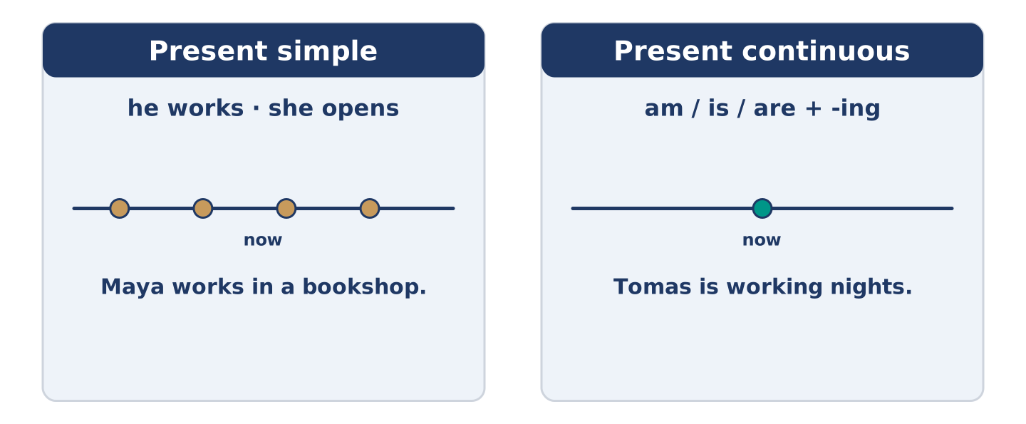
Figure 1.5 · Present simple and present continuous: again and again, or now.
 | Form | Use | Example
Present simple | I/you work; he works | routines, facts | Maya works in a bookshop.
Present continuous | am/is/are + -ing | now, this week | Tomas is working nights.
Remember: every day, usually, often → present simple. now, right now, at the moment, this week → present continuous.
Watch out! ✗ She work in a shop. → ✓ She works in a shop. (add -s for he/she/it). ✗ I waiting now. → ✓ I am waiting now. (don’t drop am/is/are).
Part 2: Controlled Practice
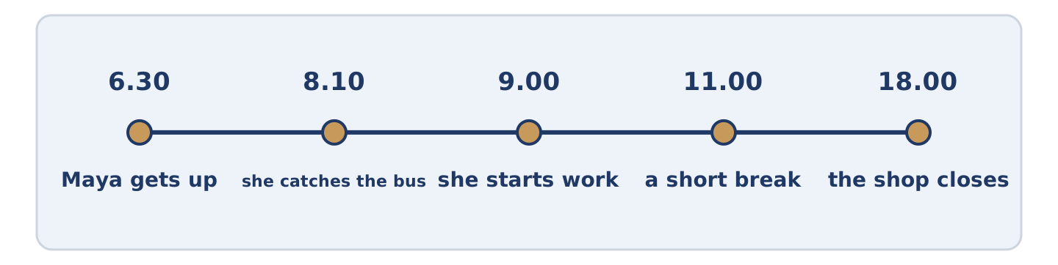
Figure 1.6 · One weekday on a line: the times this unit keeps coming back to.
Complete with the present simple or present continuous. (0. is done.)
- Maya usually starts work at nine. (start)
- Tomas ______________________ (work) at the hospital.
- Listen! Dani ______________________ (cook) in the kitchen.
- Amina ______________________ (open) the shop every morning at seven.
- This week, Yuki ______________________ (paint) her new flat.
Part 2: Simple or Continuous?
Choose the correct form. (0. is done.)
- Every morning, the bus leaves at ten past eight. (leaves / is leaving)
- Right now, Maya ______________________ (waits / is waiting) at the bus stop.
- Mr Okonkwo usually ______________________ (reads / is reading) in the afternoon.
- Look! Dani ______________________ (burns / is burning) the rice.
- Tomas ______________________ (works / is working) three nights every week.
Part 2: Correct the Sentence
Each sentence has one grammar mistake. Write the correct sentence.
- Amina open the shop at seven.
- Look! Maya wait for the bus.
- He work at the hospital every night.
- We are study English this week.
Part 2: Freer Practice
Write two sentences about yourself: one routine (present simple) and one about now (present continuous).
Part 2: Grammar Review
Choose the correct sentence.
1. Which sentence is correct (now)?
○ A) Dani cook the rice.
○ B) Dani is cooking the rice.
○ C) Dani cooking the rice.
○ D) Dani are cooking the rice.
2. Which sentence is correct (routine)?
○ A) Maya working in a bookshop.
○ B) Maya work in a bookshop.
○ C) Maya works in a bookshop.
○ D) Maya to work in a bookshop.
→ Harvest: you will see the present simple and present continuous again in the Part 5 reading. Watch for them.
Part 3 · Listening
[CORE] Core track · pre-class input · scripts printed inline
Part 3: A Nurse Talks About His Week
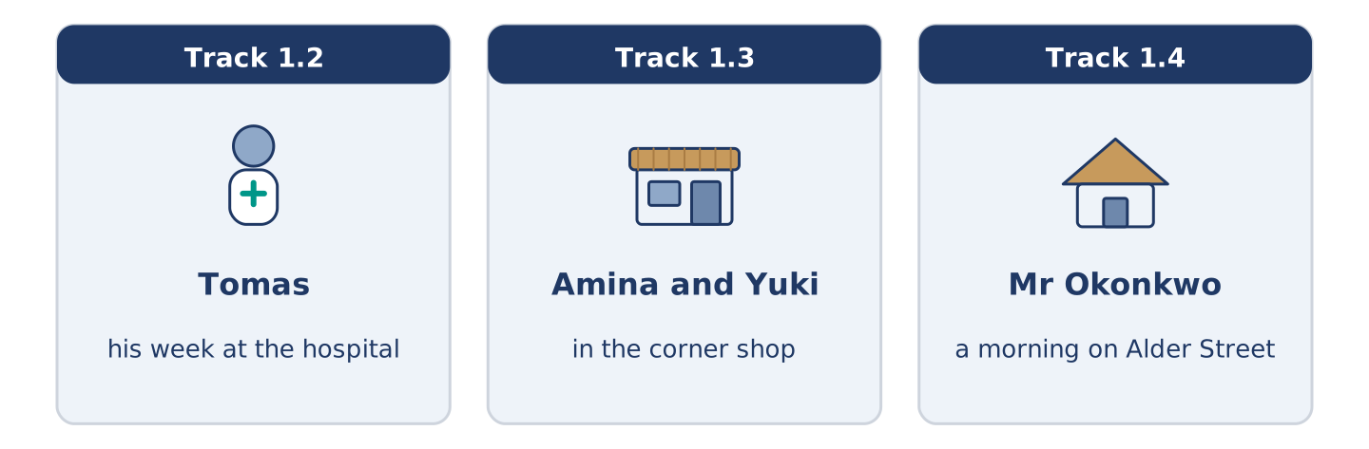
Figure 1.7 · The three listenings: who is speaking, and what about.
🔊 Audio Track 1.2
Before you listen: how many nights a week do you think a nurse works?
Tomas: Hello, I’m Tomas. I’m a nurse, and I live at 14 Alder Street with Maya. I work at the city hospital. Usually I work three days, but some weeks I work nights. This week I’m working nights, so I sleep in the morning and get up at four in the afternoon. It’s strange, but I like the quiet. Right now I’m drinking coffee and waiting for the bus.
While you listen: write True, False, or Not Given. (0. is done.)
- Tomas is a nurse. — True
- Tomas lives alone. ____
- This week Tomas is working nights. ____
- Tomas has worked at the hospital for ten years. ____
Useful phrases: I work… · Usually I… · This week I’m…
Part 3: In the Corner Shop
🔊 Audio Track 1.3
Before you listen: what do people buy in a small shop near their home?
Amina: Good morning, Yuki. You’re new here, aren’t you? Yuki: Yes, this is my first week. Amina: Welcome to Alder Street. What can I get you? Yuki: Some bread and milk, please. Do you open on Sundays? Amina: I open every day except Sunday. On Saturday I close at two. Yuki: Thank you. I’m working from home, so I’m here a lot. Amina: Then I’ll see you often.
While you listen: answer the questions. (0. is done.)
- Where is Yuki? — In the corner shop.
- Why is Yuki in the shop a lot?
- What does Yuki want to buy?
- Which day does Amina close?
Useful phrases: What can I get you? · Do you open on…? · I close at…
Part 3: A Morning on Alder Street
🔊 Audio Track 1.4
Before you listen: at eight in the morning, what are the people in your street doing?
Mr Okonkwo: It’s eight o’clock, and Alder Street is awake. Amina is opening her shop — she does that every morning at seven, but today she is late. Maya is running for the bus again. Tomas is coming home; he is finishing a night shift. Dani is carrying a very large bag of rice, and I am watching all of it from my window, as usual.
While you listen: match each person with what they are doing now. One action is not needed. (0. is done.)
- Mr Okonkwo → watching from his window.
Column A
1. | Amina | ____
2. | Maya | ____
3. | Tomas | ____
4. | Dani | ____
Column B
a) | running for the bus
b) | coming home from a night shift
c) | sleeping in the afternoon
d) | opening her shop
e) | carrying a bag of rice
Part 4 · Speaking
[CORE] Core track · in-class output
Part 4: Discussing Routines
Work with a partner. Ask and answer these questions.
- What time do you usually get up? Is it the same every day?
- What are you doing this week that is not normal for you?
- Who do you see every day — at home, at work, or in your street?
Useful language: I usually… · Every day I… · At the moment I’m… · This week I’m…
Part 4: Find the Difference (pairwork)
Student A and Student B each have a daily routine. Ask questions and find three differences.
Useful questions: What time do you get up? · Where do you work? · How do you travel? · What are you doing this week?
Student A — your routine: get up 6.30 · work in a bookshop · travel by bus · this week: evening class.
Student B — your routine: get up 6.30 · work in a hospital · travel by bike · this week: working nights.
Part 4: New Neighbour Role Play
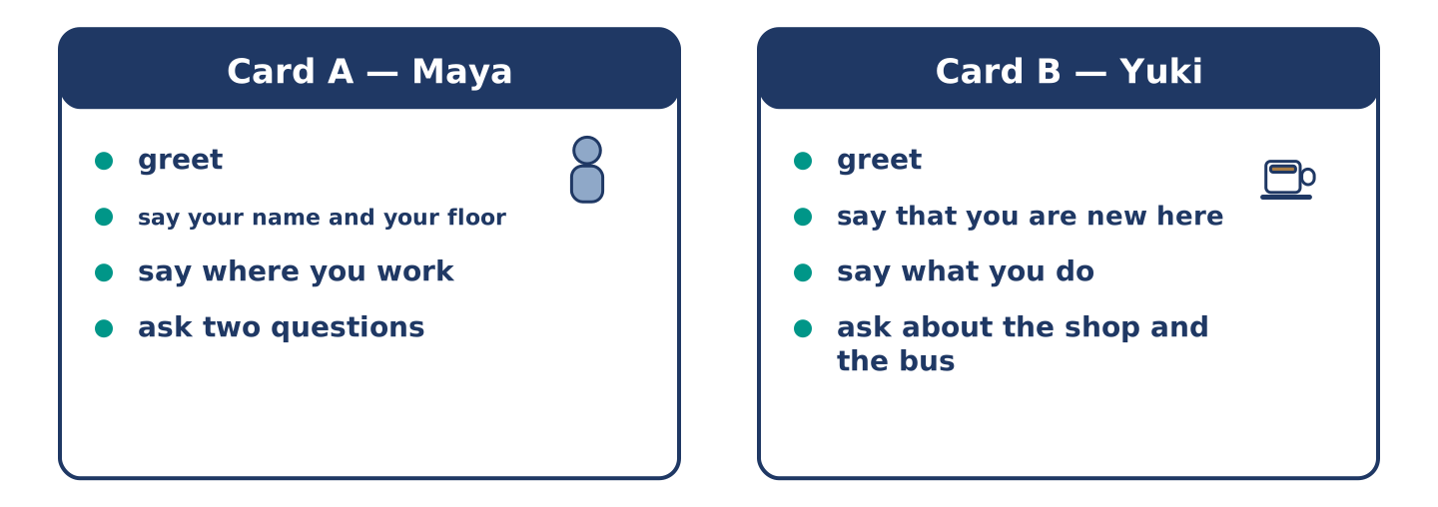
Figure 1.8 · Card A and Card B: what each of you has to say.
Work in pairs. Read the model, then use the cards.
Model exchange:
A: Hello — you’re new here, aren’t you? — B: Yes, this is my first week. — A: Welcome. I’m Maya, from the second floor. — B: I’m Yuki. Nice to meet you. — A: Do you work near here? — B: I work from home, actually. And you? — A: I work in the bookshop on the corner.
Useful language: You’re new here, aren’t you? · This is my first week · I’m… from… · Do you work near here? · Nice to meet you.
Card A — Neighbour (Maya): greet · say your name and your floor · say where you work · ask two questions about their routine.
Card B — New arrival (Yuki): greet · say that you are new here · say what you do · ask about the shop and the bus.
Your turn: run the dialogue, then swap roles.
Stretch [PLUS]: the new neighbour asks a question you cannot answer — say so politely and offer to find out.
Part 4: Mini-Presentation
Prepare a short talk (about one minute). Describe one person you see every day: who they are, what they usually do, and what they are doing at the moment.
Part 5 · Reading
[CORE] Core track · pre-class input
Part 5: What Is a Routine?
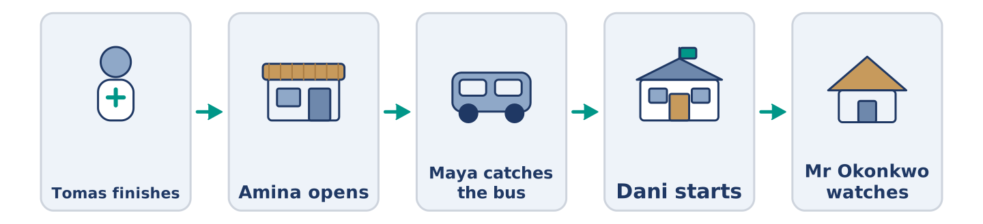
Figure 1.9 · One morning, six people, in order.
Before you read: what three things do you do every single morning?
Gloss: routine = the same things you do every day · commute = the journey between home and work · flexible = easy to change · habit = something you do without thinking
A routine is the set of things a person does again and again. Most people have a morning routine, a work routine, and a weekend routine. Maya gets up at half past six, makes coffee, and listens to the radio. Then she catches the bus. Her commute takes twenty minutes. At the bookshop she opens the till, checks the new books, and makes a list. This is the same almost every weekday. Right now, however, Maya is doing something different: she is studying for an exam, so on Tuesdays she is leaving work early. Routines are useful because they save thinking. A good routine is also flexible. When Tomas works nights, his whole routine changes, and he sleeps while the street is busy. Some people love a fixed routine; others find it boring. Most of us need a little of both: the same breakfast, and a different evening.
Answer the multiple-choice questions. (0. is done.)
- What is a routine? — the set of things a person does again and again.
1. What does Maya do after she makes coffee?
○ A) She catches the bus
○ B) She listens to the radio
○ C) She opens the till
○ D) She studies for an exam
2. Why is Maya leaving work early on Tuesdays?
○ A) Because the shop closes early
○ B) Because she is ill
○ C) Because she works nights
○ D) Because she is studying for an exam
3. Why are routines useful, according to the text?
○ A) They are always the same
○ B) They make people boring
○ C) They save thinking
○ D) They take twenty minutes
Part 5: Vocabulary in Context
Match each word from the text with its meaning. One meaning is not needed. Write the letter.
Column A
1. | commute | ____
2. | flexible | ____
3. | habit | ____
4. | weekday | ____
Column B
a) | easy to change
b) | Monday to Friday
c) | the journey between home and work
d) | something you do without thinking
e) | a short rest in the middle of the day
Part 5: Routines Around the World
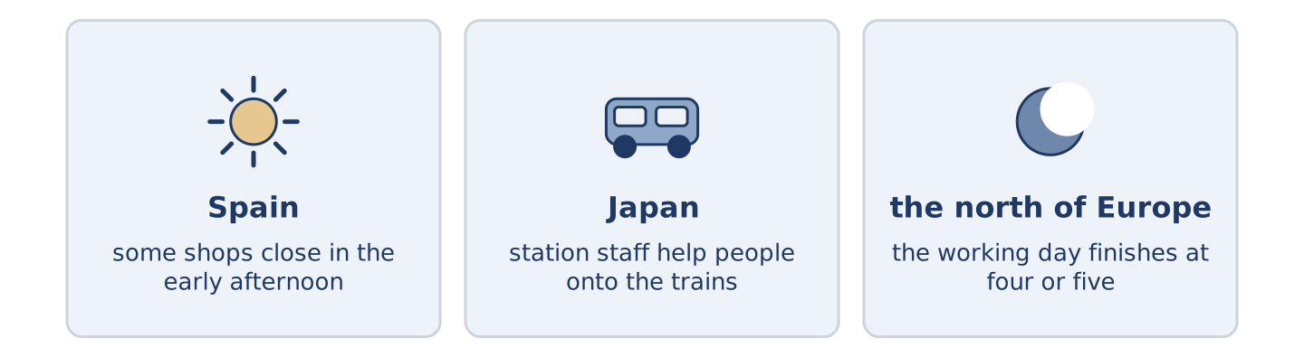
Figure 1.10 · The same day in three places.
Before you read: in your country, what time do people usually eat the evening meal?
Gloss: siesta = a short sleep in the early afternoon · rush hour = the time when many people travel to or from work
Routines are not the same everywhere. In some countries people eat the main meal at midday and rest after it; in others, nobody stops until the evening. In parts of Spain and Latin America, some shops still close for a siesta. In Japan, the morning rush hour is so busy that station staff help people onto the trains. In much of the north of Europe, the working day finishes at four or five, and the evening is long. The clock is the same everywhere. What people do with it is not.
Answer the questions. (0. is done.)
- Are routines the same everywhere? — No, they are not.
- What happens in some shops in Spain and Latin America?
- What do station staff do in Japan?
- In the text, what is the same everywhere?
Part 6 · Writing
[CORE] Core track · in-class / homework
Part 6: Describe a Person’s Day (50–70 words)
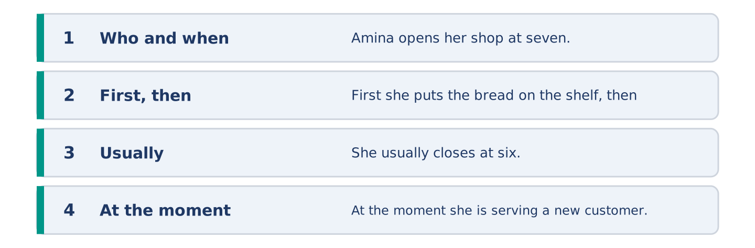
Figure 1.11 · The shape of the paragraph you are about to write.
Write about one person’s normal day. Use the present simple. Add one sentence about what they are doing at the moment.
Model — read this first:
Amina opens her shop at seven o’clock every morning. First she puts the bread on the shelf, then she makes tea. She knows almost everybody in the street, so she talks a lot. She closes at six, but on Saturday she closes at two. At the moment she is serving a new customer, because a woman called Yuki is moving in upstairs. (62 words)
Plan (fill in, then write): ___ gets up at ___. First ___, then ___. ___ usually ___. At the moment, ___ is ___.
Word bank: gets up | first | then | usually | every day | at the moment
Check before you finish: ☐ one present-simple and one present-continuous sentence? ☐ two time words? ☐ 50–70 words? ☐ capitals & full stops?
Part 6: Why Routines Matter (50–70 words)
Do you think a fixed routine is a good thing? Give your opinion and two or three reasons.
Model — read this first:
I think a routine is a good thing, but not a very strict one. A routine saves time, because you do not decide the same things every morning. It also helps you sleep well. However, a routine that never changes is boring, and you stop noticing things. In my opinion the best routine is the same before nine o’clock and free after six. (63 words)
Word bank: I think… because… | it saves time | it helps me… | however | boring | in my opinion
Check before you finish: ☐ a clear opinion? ☐ two or three reasons? ☐ 50–70 words?
Part 6: A Message to a New Neighbour (50–70 words)
Yuki has just moved into your building. Write her a short message: welcome her, tell her two useful things about the street, and offer help.
Model — read this first:
Dear Yuki, Welcome to 14 Alder Street. I live on the second floor with Tomas. Two useful things: Amina’s shop downstairs opens every day except Sunday, and the number 7 bus goes to the centre every ten minutes. The post comes before nine. If you need anything, knock on our door. See you soon. Maya (55 words)
Plan (fill in, then write): Dear ___, Welcome to ___. I live ___. Two useful things: ___ and ___. If you need ___, ___. ___
Check before you finish: ☐ greeting and close? ☐ two useful facts? ☐ an offer of help? ☐ 50–70 words?
Part 6: Reflection — My Perfect Weekday (40–60 words)
Describe your perfect weekday. What would you do, and at what times?
Model — read this first:
My perfect weekday starts late. I get up at eight, not at six, and I walk to work instead of taking the bus. I work until two, and then I stop. In the afternoon I read, and I cook something slowly. In the evening I see one friend — not three. (51 words)
Check before you finish: ☐ three or four times of day? ☐ what you do at each? ☐ 40–60 words?
Part 7 · Real-World File — Meeting Someone New
[PLUS] Plus track (optional) · stronger learners
7A: Phrase Bank
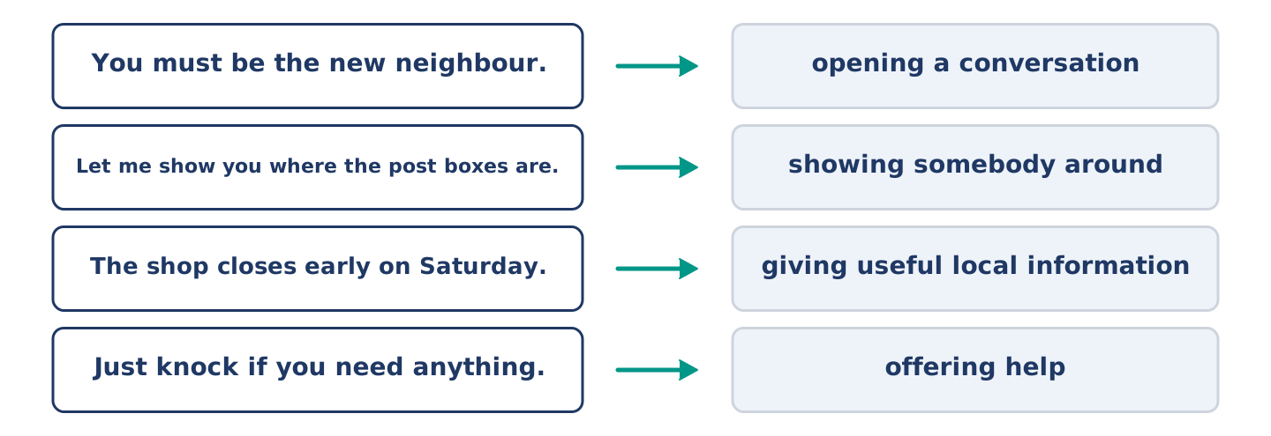
Figure 1.12 · What a neighbour says, and what each thing does.
Match what a person says with its purpose. One purpose is not needed. Write the letter.
Column A
1. | “You must be the new neighbour.” | ____
2. | “Let me show you where the post boxes are.” | ____
3. | “The shop closes early on Saturday.” | ____
4. | “Just knock if you need anything.” | ____
Column B
a) | giving useful local information
b) | offering help
c) | opening a conversation with somebody you have not met
d) | asking for money
e) | showing somebody around
7B: Neighbour Dialogue
🔊 Audio Track 1.5
Before you read: what is the first thing you say to somebody who has just moved in?
Maya: Hello — you must be the new neighbour. Yuki: Yes, I’m Yuki. I moved in on Saturday. Maya: I’m Maya, second floor. This is Tomas. Tomas: Hi. Sorry, I’m half asleep — I’m working nights this week. Yuki: Oh, don’t worry. Maya: Two things you need to know. The post comes before nine, and Amina’s shop is closed on Sundays. Yuki: That’s useful, thank you. Maya: And just knock if you need anything. We’re usually in after seven.
Answer the questions. (0. is done.)
- When did Yuki move in? — On Saturday.
- Why is Tomas tired?
- What two things does Maya tell Yuki?
- When are Maya and Tomas usually at home?
7C: Controlled Practice — Meeting Someone New
Put the steps in order. Number them 1–5. (0. is done.)
- Say hello and open the conversation. — 1
____ Give one or two useful local facts.
____ Say your name and where you live.
____ Offer help and say when you are usually in.
____ Ask one question about them.
7D: Role-Play — Welcoming a New Arrival
In pairs. One is the neighbour; one is the new arrival. Use the model and cards.
Model exchange: Maya: Hello — you must be the new neighbour. — Yuki: Yes, I moved in on Saturday. — Maya: I’m Maya, second floor. Do you know the area at all? — Yuki: Not really. Where do people shop? — Maya: Amina’s, downstairs — every day except Sunday. Just knock if you need anything.
Card A — Neighbour: open the conversation · say your name and floor · give two useful facts · offer help.
Card B — New arrival: say when you moved in · say what you do · ask two questions about the area · thank them.
Stretch [PLUS]: the new arrival asks about something noisy or awkward in the building — answer honestly but kindly.
7E: Writing — A Welcome Note (50–80 words)
You are Maya. Write a short welcome note to Yuki with three things she needs to know in her first week.
Model — read this first:
Dear Yuki, Welcome to number 14. Three things for your first week. The post comes before nine, and the box for recycling is the blue one by the door. Amina’s shop downstairs is open every day except Sunday, and she knows everything about this street. The hot water is slow in the morning — give it five minutes. We’re on the second floor if you need anything. Maya
Check before you finish: ☐ a warm welcome? ☐ three clear facts? ☐ an offer of help? ☐ 50–80 words?
Part 8 · Global Story — The Man Who Changed His Mornings
[PLUS] Plus track · pre-read / discuss
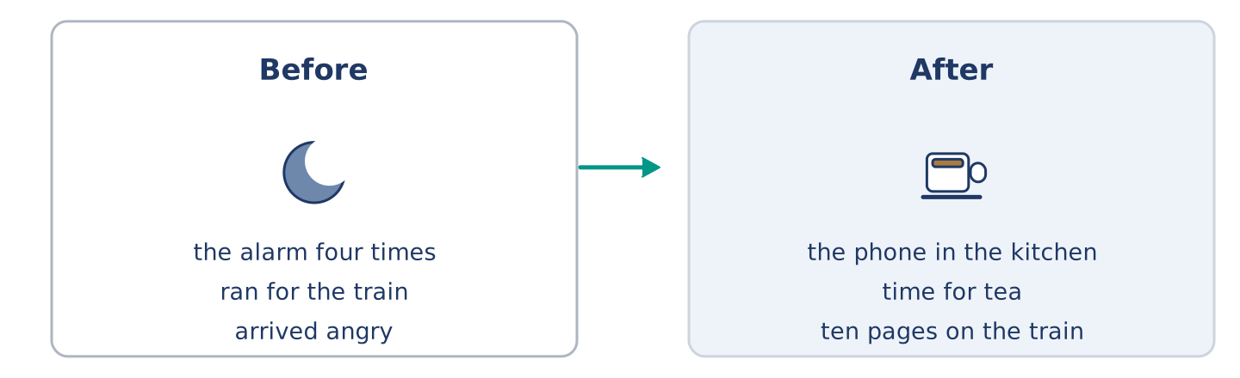
Figure 1.13 · Jun’s mornings before and after one small change.
Before you read: can a small change in the morning change a whole day?
Gloss: alarm = the clock sound that wakes you · swap = to change one thing for another · habit = something you do without thinking about it
In Seoul, a man called Jun worked in an office and hated his mornings. Every day he stopped the alarm four times, then ran for the train, and arrived angry. One winter he made one small change: he put his phone in the kitchen instead of beside his bed. Now, to stop the alarm, he had to stand up and walk. It was a very small thing, and it changed everything. He was awake five minutes earlier, so he had time for tea. With tea, he sat down. Sitting down, he read ten pages. After a year, he had thirty books behind him and he was not angry on the train. Now people ask him: “What is your secret?” He tells them: “I swapped one habit, not twenty.” His brother tried the same thing and hated it. Jun says that is also part of the answer: a routine has to be yours.
Answer the questions. (0. is done.)
- Where does Jun live? — In Seoul.
- What did Jun do every morning before the change?
- What was the one small change?
- What does Jun say about his brother?
Part 8: Vocabulary in Context
Match each word with its meaning. One meaning is not needed. Write the letter.
Column A
1. | alarm | ____
2. | swap | ____
3. | habit | ____
4. | secret | ____
Column B
a) | something you do without thinking about it
b) | the clock sound that wakes you
c) | something you do not tell other people
d) | to change one thing for another
e) | a short journey by train
Part 8: Discussion
Talk with a partner. Use the frames.
Discussion frames: “This is similar to where I live because…” · “This is different from where I live because…” · “I think the most important thing is… because…”
Part 9 · Close to Home — A New Arrival on Your Street
[PLUS] Plus track · pre-read / decide
Before you read: when somebody new moves into your building, who speaks to them first?
Yuki moved into the top flat at 14 Alder Street on a Saturday in March. She did not know anybody in the city. For the first four days she spoke to nobody except Amina in the shop, and only about bread. She worked from home, so she did not meet people at an office. In the evening she heard the building: doors, a television, somebody laughing on the stairs. She did not know any of the voices. After four days, Maya knocked on her door with a short note about the post and the bus. It took two minutes. Yuki says now that those two minutes were the difference between living in a building and living in a street. Three weeks later she knew four of the six people at number 14, and she had started leaving her door open when she cooked.
Answer the questions. (0. is done.)
- Which flat did Yuki move into? — The top flat at 14 Alder Street.
- Why did Yuki not meet people easily?
- What did Maya do after four days?
- What had changed three weeks later?
Part 9: Decision Task
A new person moves into your building next week. Should you (a) knock on the door with a note, (b) wait until you meet them on the stairs, or (c) put a message in the building’s group chat? Decide and explain. Use the frame.
Answer frame: “I think I should ___ because ___. Also, ___. This is better than ___ because ___.”
Model — read this first:
I think I should knock on the door with a short note, because a note is easy for a shy person to read later. Also, it takes two minutes and it does not ask them to talk straight away. This is better than waiting on the stairs, because you can wait for weeks and never meet somebody who works from home. (61 words)
Phrase bank: I think I should… · because… · Also,… · This is better than… · In my opinion…
Part 10 · Review and Can-Do
[CORE + PLUS] · homework / self-study
Part 10: Spiral Review
Complete the review. (0. is done.)
- The journey between your home and your work is your commute.
Word bank: routine | shift | flatmate | appointment | present continuous | present simple | neighbour | usually
- A person who shares your home is your ______________________ .
- A person who lives near you is your ______________________ .
- The same things you do every day are your ______________________ .
- Tomas works a night ______________________ twice a week.
- Maya has an ______________________ at the health centre on Thursday.
- “Maya works in a bookshop” uses the ______________________ tense.
- “Dani is cooking right now” uses the ______________________ tense.
- “She ______________________ gets up at half past six” — the word for a routine.
Part 10: Can-Do
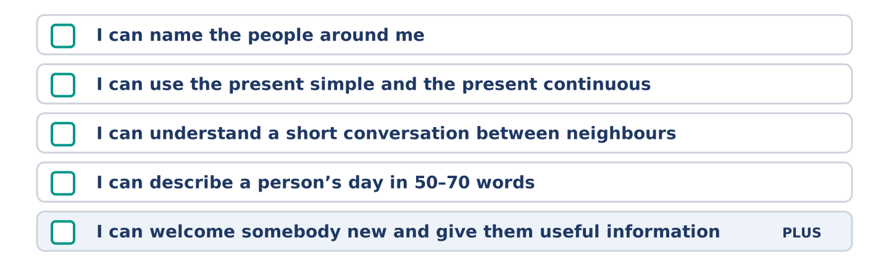
Figure 1.14 · What you can do at the end of this unit.
Can-Do checklist
☐ I can name the people around me: neighbour, flatmate, colleague.
☐ I can use the present simple for routines and the present continuous for now.
☐ I can understand a short conversation between neighbours.
☐ I can describe a person’s day in 50–70 words.
☐ I can welcome somebody new and give them useful information (Plus).
Part 10: Glossary
Unit 1 glossary (10 words)
routine · shift · flatmate · neighbour · colleague · commute · appointment · busy · usually · at the moment
Unit 2: Home and Neighbourhood
English for Daily Life · Level: A2 · Tracks: [CORE] Warm-Up + Parts 1–6 · [PLUS] Parts 7–10
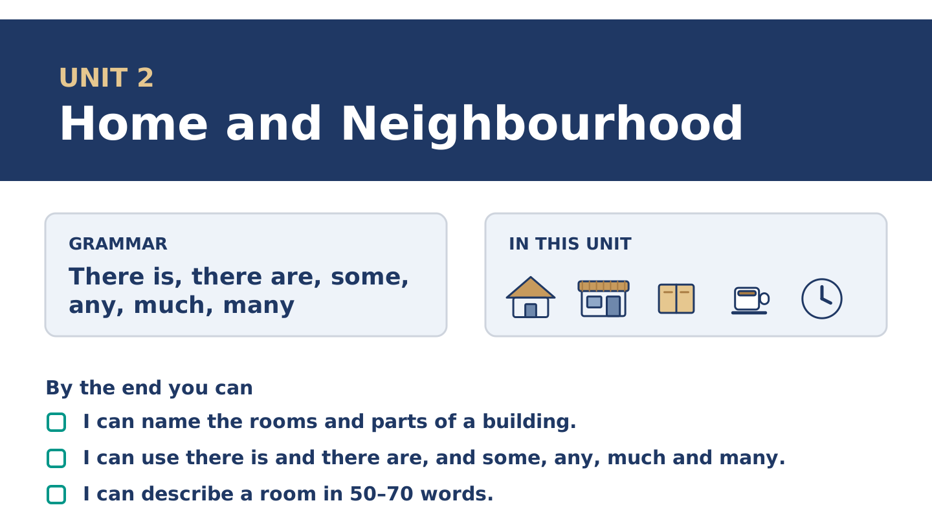
Figure 2.1 · Unit 2 at a glance: the grammar, the topic and what you will be able to do.
Warm Up
[CORE] Core track · in-class starter
Warm-up: Home Words and Meanings
Match the words with their meanings. One meaning is not needed. Write the letter.
Column A
1. | Balcony | ____
2. | Cupboard | ____
3. | Shelf | ____
4. | Stairs | ____
5. | Rent | ____
Column B
a) | the money you pay every month to live somewhere
b) | a small outside floor with a wall, outside a window
c) | a long flat board on a wall, for books or cups
d) | the steps between one floor and the next
e) | a room where people sleep
f) | a tall box with doors, for plates, cups and food
Warm-up: Talking About Homes
Complete the sentences using the words in the word bank.
Word bank: quiet | kitchen | upstairs | garden
- Mr Okonkwo lives ______________________ , on the fourth floor.
- There is a small ______________________ behind the building, with two trees and an old wall.
- Amina cooks in a very small ______________________ at the back of the shop.
- Alder Street is ______________________ after nine o’clock at night.
Warm-up: Inside Number 14
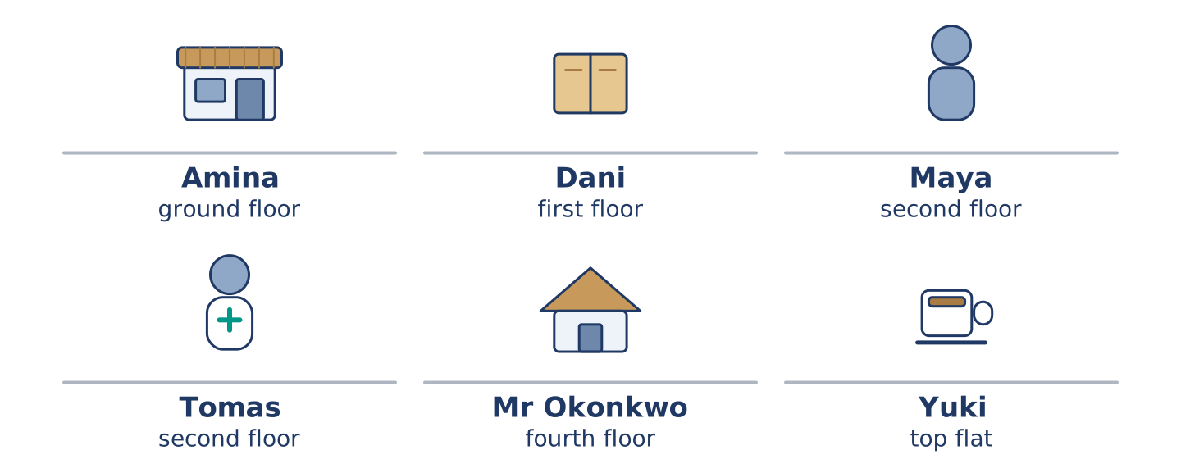
Figure 2.2 · Inside 14 Alder Street: who lives on which floor.
Read the text and choose the correct answer.
Number 14 is an old building with four floors. There is a shop on the ground floor, and there are five flats above it. There is no lift, so everybody uses the stairs. Maya and Tomas live on the second floor. Dani lives on the first floor, next to the empty flat. There is no lift, and the landing outside his door is small. Mr Okonkwo is on the fourth floor, and he has the best view in the street. He knows which stair makes a noise. Yuki has the top flat, with a small balcony and two plants on it.
1. How many floors does the building have?
○ A) Two
○ B) Six
○ C) Four
○ D) Ten
2. What is on the ground floor?
○ A) A garden
○ B) A shop
○ C) Mr Okonkwo’s flat
○ D) A lift
Part 1 · Vocabulary and Terminology
[CORE] Core track · pre-class input
Part 1: Home and Building Terms
Match the words with their meanings. One meaning is not needed. (0. is done for you.)
- Landing → the small flat space at the top of the stairs on each floor.
Column A
1. | Block | ____
2. | Entrance | ____
3. | Lift | ____
4. | Rent | ____
5. | Recycling | ____
6. | View | ____
7. | Roof | ____
Column B
a) | the money you pay every month to live somewhere
b) | a big building with many flats in it
c) | glass, paper and plastic that are used again
d) | the door you come in through, at the front
e) | what you can see from a window
f) | a small machine that carries people up and down
g) | the top of a building, over the highest floor
h) | a room with a bath in it
Gloss: block = a big building with many flats · landing = the flat space at the top of the stairs · view = what you can see from a window
Part 1: Pronunciation
🔊 Audio Track 2.1
Listen and practise these words. Say each word aloud and stress the loud syllable (CAPITALS).
balcony — BAL-co-ny
cupboard — CUP-board
upstairs — up-STAIRS
downstairs — down-STAIRS
recycling — re-CY-cling
entrance — EN-trance
Then listen again to the words that hide a letter. We write cup-board but we say CUB-berd. We write up-stairs but the two words join into one. English spelling is older than English speech.
Part 1: Rooms, Things and Places
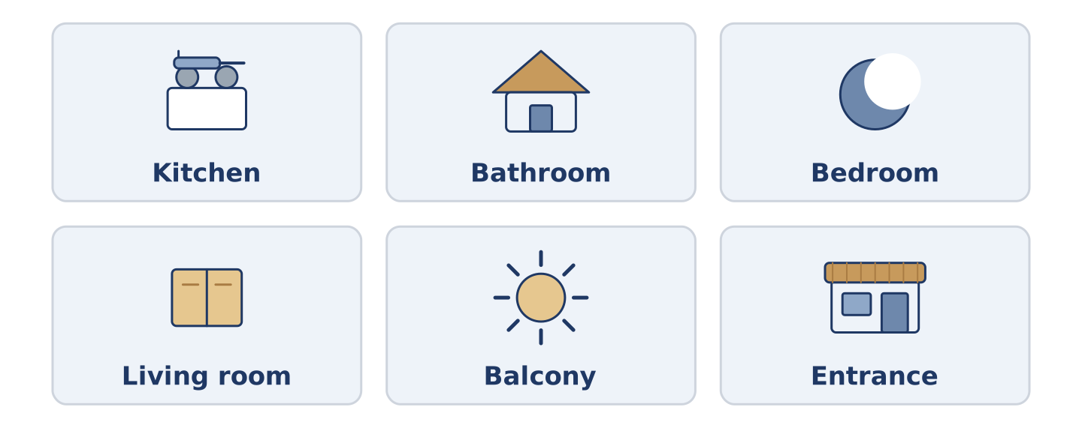
Figure 2.3 · Six rooms and one thing you find in each.
Complete the table. Write one thing you find in each room and say who uses it most. (0. is done.)
Room | One thing in it | Who uses it most
Kitchen | a cupboard | (example)
Bathroom
Bedroom
Living room
- Kitchen — a cupboard — Amina, because she cooks at the back of the shop.
Think about the home you know best. There is more than one right answer, and you should be ready to say why you chose yours.
Part 1: Parts of a Building
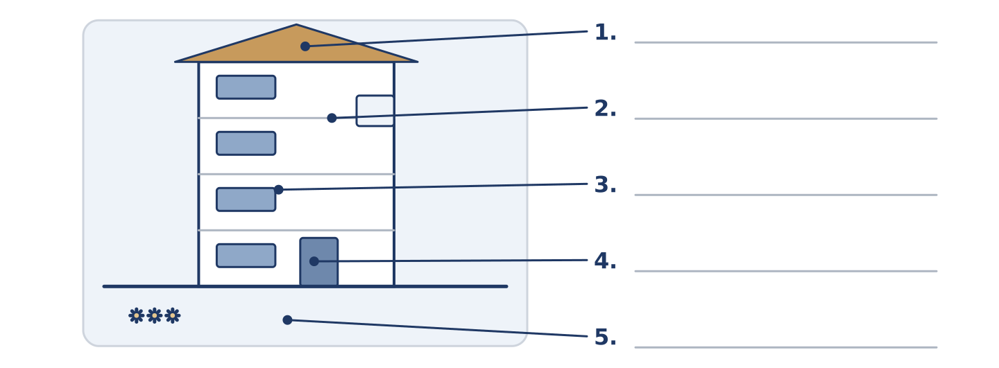
Figure 2.4 · Parts of a building — write the correct word on each line.
Match the parts of a building with their descriptions. One description is not needed. Write the letter.
Column A
1. | Roof | ____
2. | Balcony | ____
3. | Entrance | ____
4. | Stairs | ____
5. | Garden | ____
Column B
a) | the steps between one floor and the next
b) | the top of the building, over the highest floor
c) | a shelf for books and cups
d) | green ground outside, often behind the building
e) | a small outside floor with a wall, outside a window
f) | the door you come in through, at the front
Part 1: Around the Home — Multiple Choice
Read and choose the correct answer.
1. A tall box with doors, for plates and cups, is a…
○ A) shelf
○ B) balcony
○ C) cupboard
○ D) landing
2. The money you pay every month to live somewhere is the…
○ A) rent
○ B) view
○ C) entrance
○ D) roof
3. A building with many flats in it is a…
○ A) garden
○ B) block
○ C) stairs
○ D) cupboard
Part 1: Vocabulary Fill-in
Complete the sentences with the correct word.
Word bank: noisy | shelf | balcony | downstairs
- Yuki keeps two plants on her small ______________________ .
- Amina’s shop is ______________________ , on the ground floor.
- The top ______________________ in the kitchen is too high for Dani.
- Friday night is ______________________ , because the flat above has friends.
Part 1: Write About Your Home (short)
Write two or three sentences about where you live. Use three words from this unit.
Model — read this first:
There are four rooms in my flat, and the kitchen is the smallest. There is a balcony, but it is not very big. There are two shelves in the living room, and there is not much space for books.
Part 2 · Grammar — There Is, There Are, Some, Any, Much, Many
[CORE] Core track · pre-class input
Part 2: Notice
Read these lines about number 14. Underline there is and there are. Which things can you count?
There is a shop on the ground floor. There are five flats above it. There is no lift. There are some plants on Yuki’s balcony. There is not much space in Amina’s kitchen. There are not many quiet nights in the flat above Dani.
You can count flats, plants and nights: they take are, some and many. You cannot count space: it takes is and much.
Part 2: Grammar Focus Box
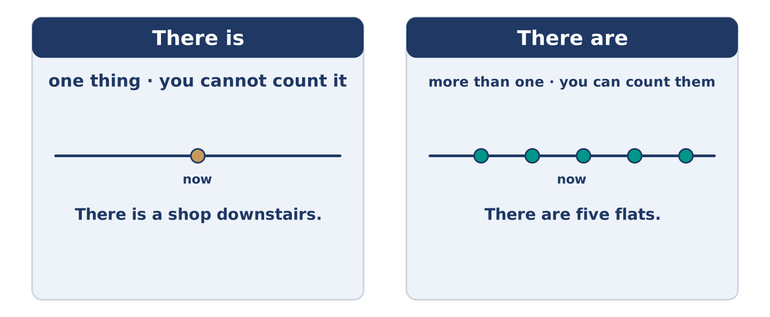
Figure 2.5 · Countable and uncountable: what changes, and what does not.
 | Form | Use | Example
There is | there is + one thing | one thing, or a thing you cannot count | There is a shop downstairs.
There are | there are + things | more than one thing you can count | There are five flats.
some / any | some in +, any in − and ? | things you do not count exactly | There are some plants. Are there any lifts?
much / many | much + uncountable, many + countable | asking or saying how many | not much space · not many nights
Remember: some when you say yes; any when you say no or ask.
Watch out! ✗ There are a shop downstairs. → ✓ There is a shop downstairs. (one thing takes is). ✗ There are not much flats. → ✓ There are not many flats. (you can count flats).
Part 2: Controlled Practice
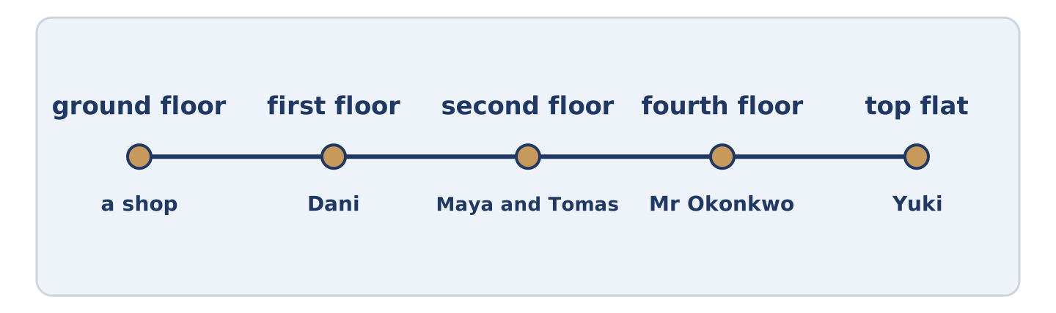
Figure 2.6 · One building, floor by floor: what there is on each.
Complete with there is or there are. (0. is done.)
- There is a shop on the ground floor.
- ______________________ five flats above the shop.
- ______________________ no lift in the building.
- ______________________ two trees in the garden.
- ______________________ a small balcony at the top.
Part 2: Some, Any, Much or Many?
Choose the correct word. (0. is done.)
- There are some plants on the balcony. (some / any)
- There are not ______________________ (much / many) quiet nights here.
- Is there ______________________ (some / any) hot water in the morning?
- There is not ______________________ (much / many) space in the kitchen.
- Amina has ______________________ (some / any) bread left on Saturday.
Part 2: Correct the Sentence
Each sentence has one grammar mistake. Write the correct sentence.
- There are a garden behind the building.
- There is not many flats on this floor.
- Are there some lifts in the block?
- There are not much light in the corridor.
Part 2: Freer Practice
Write two sentences about your own building: one with there is and one with there are.
Part 2: Grammar Review
Choose the correct sentence.
1. Which sentence is correct?
○ A) There are a shop downstairs.
○ B) There is some shop downstairs.
○ C) There is a shop downstairs.
○ D) There are shop downstairs.
2. Which sentence is correct?
○ A) There are not much flats here.
○ B) There is not many flats here.
○ C) There are not many flat here.
○ D) There are not many flats here.
→ Harvest: you will see there is, there are, some and any again in the Part 5 reading. Watch for them.
Part 3 · Listening
[CORE] Core track · pre-class input · scripts printed inline
Part 3: Yuki Looks at the Flat
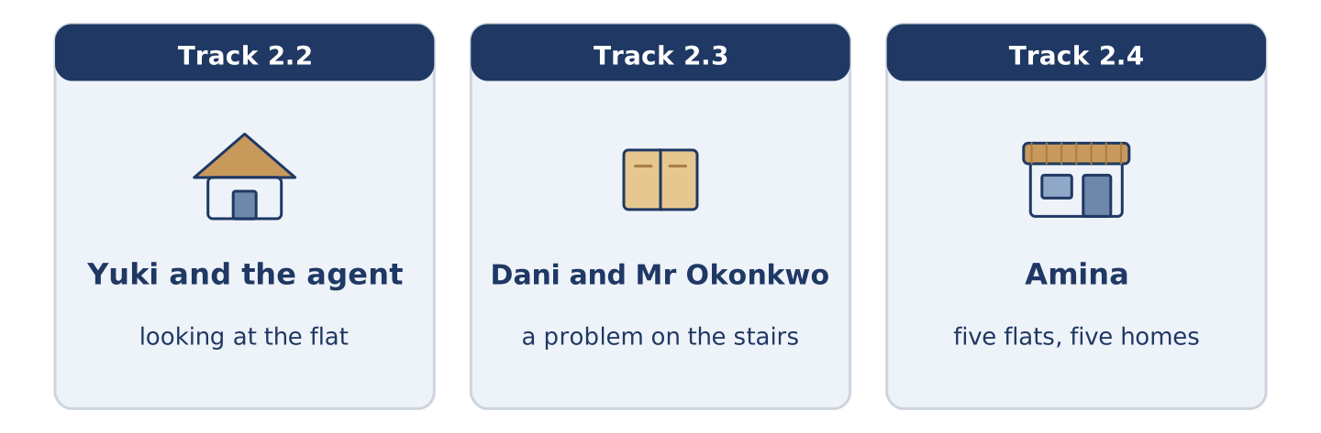
Figure 2.7 · The three listenings: who is speaking, and what about.
🔊 Audio Track 2.2
Before you listen: what do you ask before you take a flat?
Yuki: It is small, but I like it. Is there a lift? Agent: No, there is no lift. It is four floors, I am afraid. Yuki: That is fine. Is there any storage? Agent: There is a cupboard on the landing, and there is a shelf in the hall. Yuki: And the rent? Agent: Six hundred a month, and that includes the water. There are not many flats at that price near here. Yuki: No, there are not. I want it.
While you listen: write True, False, or Not Given. (0. is done.)
- Yuki is looking at a flat. — True
- There is a lift in the building. ____
- The rent includes the water. ____
- Yuki lived in this city before. ____
Useful phrases: Is there…? · There is no… · That includes…
Part 3: A Problem on the Stairs
🔊 Audio Track 2.3
Before you listen: what do neighbours argue about?
Dani: Morning. Sorry — is that your box on the landing? Mr Okonkwo: It is. There is not much space in my flat, you see. Dani: I understand, but there is not much space on the landing either. I carry my bike down every day. Mr Okonkwo: Ah. Yes. There is a cupboard downstairs, I think. Dani: There is, and it is empty. Shall I help you? Mr Okonkwo: That is kind. Thank you, Dani.
While you listen: answer the questions. (0. is done.)
- Where is the box? — On the landing.
- Why is the box on the landing?
- What does Dani carry down every day?
- What does Dani offer to do?
Part 3: Five Flats, Five Homes
🔊 Audio Track 2.4
Before you listen: what is the first thing you notice in somebody else’s home?
Amina: Five flats, five homes. In Maya and Tomas’s flat there are books on every shelf, and there is never any milk. In Dani’s flat there is one chair and a very large bag of rice. In Mr Okonkwo’s there are forty years of newspapers and a window with the best view in the street. In Yuki’s there is almost nothing yet, and a balcony with two plants. And in mine, downstairs, there is bread.
While you listen: match each home with what is in it. One thing is not needed. (0. is done.)
- Amina → bread.
Useful phrases: In ___ there is… · there are… · there is never any…
Column A
1. | Maya and Tomas | ____
2. | Dani | ____
3. | Mr Okonkwo | ____
4. | Yuki | ____
Column B
a) | one chair and a large bag of rice
b) | a balcony with two plants
c) | books on every shelf
d) | a new kitchen and a garden
e) | forty years of newspapers
Part 4 · Speaking
[CORE] Core track · in-class output
Part 4: Describing Where You Live
Work with a partner. Ask and answer these questions.
- How many rooms are there in your home? Which is the biggest?
- Is there a garden, a balcony or neither? What do you keep there?
- What is there in your street that you use every week?
Useful language: There is… · There are… · There is not much… · There are not many… · Is there any…?
Part 4: Find the Difference (pairwork)
Student A and Student B each have a flat. Ask questions and find three differences.
Useful questions: How many rooms are there? · Is there a balcony? · How much is the rent? · Is it quiet?
Student A — your flat: three rooms · a small balcony · rent six hundred · quiet at night.
Student B — your flat: three rooms · no balcony · rent six hundred · noisy on Fridays.
Part 4: Showing Somebody the Flat
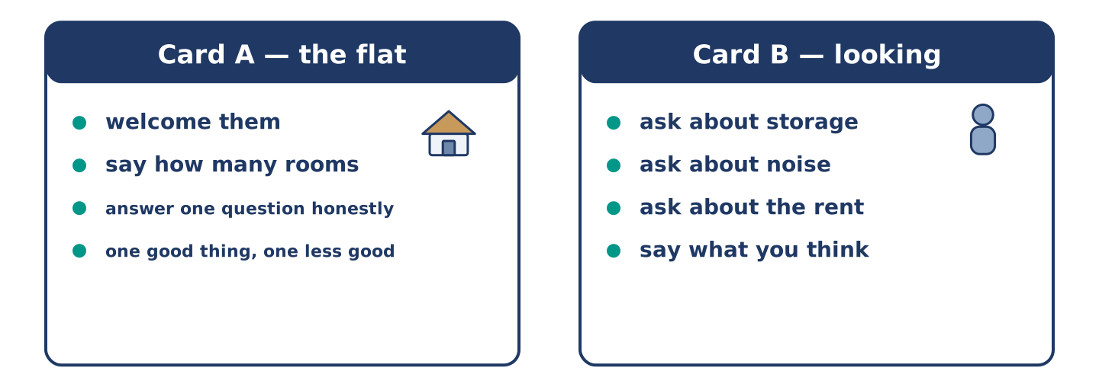
Figure 2.8 · Card A and Card B: what each of you has to say.
Work in pairs. Read the model, then use the cards.
Model exchange:
A: Come in. There are three rooms, and this is the biggest. — B: It is bigger than I thought. Is there any storage? — A: There is a cupboard on the landing. There is not much space, but it is enough for a bike. — B: And is it quiet? — A: Most nights. Not Friday.
Useful language: Come in · There are three… · Is there any…? · There is not much… · Most nights.
Card A — the person showing the flat: welcome them · say how many rooms · answer one question honestly · say one good thing and one less good thing.
Card B — the person looking: ask about storage · ask about noise · ask about the rent · say what you think.
Your turn: run the dialogue, then swap roles.
Stretch [PLUS]: Student B asks about something you would rather not talk about — answer honestly but kindly.
Part 4: Mini-Presentation
Prepare a short talk (about one minute). Describe one room you know well: what there is in it, what there is not much of, and why you like it or do not.
Part 5 · Reading
[CORE] Core track · pre-class input
Part 5: What Makes a Home?
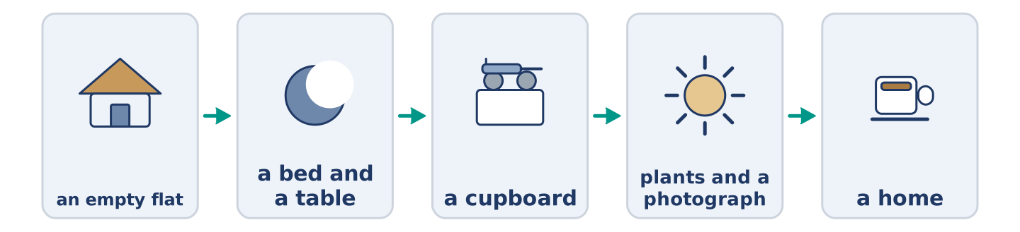
Figure 2.9 · From empty flat to home, step by step.
Before you read: what is the first thing you put in a new home?
Gloss: storage = space to keep things · furniture = tables, chairs, beds and cupboards · settle in = to start to feel at home
An empty flat is not a home. There are walls, there is a floor, and there is nothing else. There is no furniture at all. The view from the window is the only thing in the room. Most people start with the things they need: a bed, a table, two chairs. Dani bought his table first, and he still eats at it. Then they add the things they use: a cupboard, some shelves, a lamp by the chair where they read. Mr Okonkwo says his lamp is the oldest thing he owns, and he would not change it. Furniture is expensive, and the rent takes most of the money anyway. Many people live for months with a kitchen that has almost nothing in it. After the things come the small signs that somebody lives here. There are plants on the balcony. There is a photograph on the shelf and a coat by the entrance. There is bread in the cupboard and somebody’s coat by the door. A home is not the rooms; it is what people put in them and what they do there. Yuki says she knew she had settled in on the day she stopped noticing the stairs.
Answer the multiple-choice questions. (0. is done.)
- What is in an empty flat? — Walls, a floor, and nothing else.
1. What do most people buy first?
○ A) Plants and photographs
○ B) A bed, a table and chairs
○ C) A lamp and some shelves
○ D) Bread and milk
2. Why does it take time to fill a home?
○ A) Because the rooms are small
○ B) Because there is no lift
○ C) Because furniture is expensive
○ D) Because the kitchen is empty
3. When did Yuki know she had settled in?
○ A) When she bought a bed
○ B) When she met the neighbours
○ C) When the balcony had plants
○ D) When she stopped noticing the stairs
Part 5: Vocabulary in Context
Match each word from the text with its meaning. One meaning is not needed. Write the letter.
Column A
1. | storage | ____
2. | furniture | ____
3. | settle in | ____
4. | lamp | ____
Column B
a) | tables, chairs, beds and cupboards
b) | a thing that gives light in a room
c) | space to keep things
d) | the money you pay every month
e) | to start to feel at home
Part 5: Homes Around the World
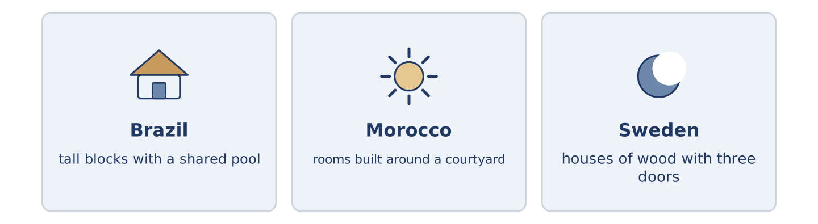
Figure 2.10 · Three homes, three answers to the same question.
Before you read: in your country, do most people live in houses or in flats?
Gloss: courtyard = an open space with walls or rooms around it · shared = used by more than one person or family
A home is not the same shape everywhere. In many cities in Brazil there are tall blocks with a shared pool and a man at the entrance who knows everybody. In parts of Morocco a house stands round a courtyard, so the rooms look inwards and the street sees almost nothing. In the north of Sweden there are houses of wood with three doors, because snow closes one of them for part of the year. There is no best shape. There is only the weather, the street and what a family needs.
Answer the questions. (0. is done.)
- Are homes the same shape everywhere? — No, they are not.
- What is at the entrance of many blocks in Brazil?
- Why do the rooms of a Moroccan house look inwards?
- Why do some Swedish houses have three doors?
Part 6 · Writing
[CORE] Core track · in-class / homework
Part 6: Describe a Room (50–70 words)
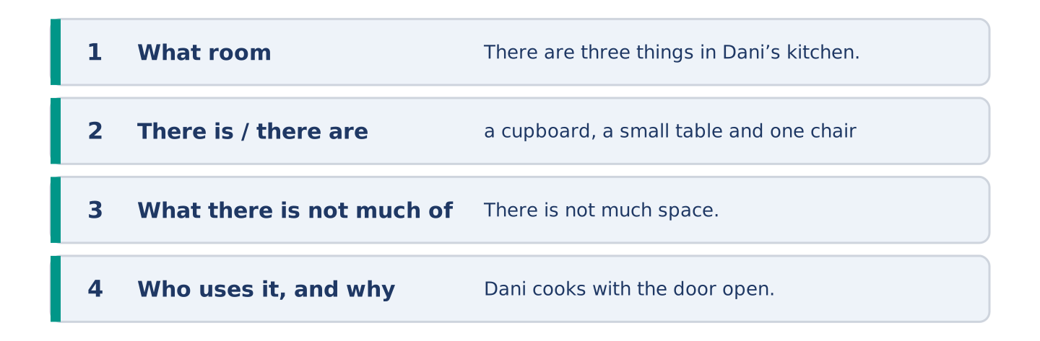
Figure 2.11 · The shape of the paragraph you are about to write.
Describe one room. Say what there is in it, what there is not much of, and who uses it.
Model — read this first:
There are three things in Dani’s kitchen: a cupboard, a small table and one chair. There is not much space, so the bag of rice lives under the table. There are no plants and there is no lamp. Dani says he does not need one, because he cooks with the door open and the light from the landing. (58 words)
Plan (fill in, then write): In ___ there is ___ and there are ___. There is not much ___. ___ uses it most, because ___.
Word bank: there is | there are | there is not much | there are not many | some | any
Check before you finish: ☐ one there is and one there are? ☐ one much or many? ☐ 50–70 words? ☐ capitals & full stops?
Part 6: A Good Place to Live (50–70 words)
What makes a street a good place to live? Give your opinion and two or three reasons.
Model — read this first:
I think a good street is a quiet one with a shop at the end of it. There are not many places where you can buy bread at seven in the morning, and that one shop changes the whole day. A good street also has somebody who notices when you are away. That is worth more than a balcony. (59 words)
Word bank: I think… because… | there is / there are | not much | not many | in my opinion
Check before you finish: ☐ a clear opinion? ☐ two or three reasons? ☐ 50–70 words?
Part 6: A Message About a Problem (50–70 words)
Something in your building is broken or in the way. Write a short, polite message to your neighbours about it.
Model — read this first:
Hello everybody. There is a large box on the second-floor landing, and there is not much room to get past it with a bike or a buggy. I think it belongs to one of us. There is an empty cupboard downstairs, and I am happy to help carry it down this evening. Just knock. Dani, flat 3 (57 words)
Plan (fill in, then write): Hello ___. There is ___ on ___. There is not much ___. I am happy to ___. ___
Check before you finish: ☐ polite, not angry? ☐ the problem said once, clearly? ☐ an offer? ☐ 50–70 words?
Part 6: Reflection — My Ideal Home (40–60 words)
Describe your ideal home. What is there, and what is there not?
Model — read this first:
In my ideal home there is one very large window and a table under it. There are shelves on two walls and there is a garden with a tree. There is not much furniture, because I do not want to clean it. There are no stairs at all. (48 words)
Check before you finish: ☐ three or four things named? ☐ one there is not? ☐ 40–60 words?
Part 7 · Real-World File — Renting and Repairs
[PLUS] Plus track (optional) · stronger learners
7A: Phrase Bank
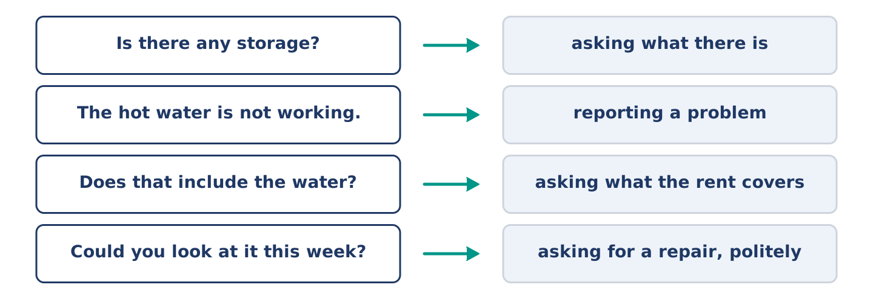
Figure 2.12 · What you say about a home, and what each thing does.
Match what a person says with its purpose. One purpose is not needed. Write the letter.
Column A
1. | “Is there any storage?” | ____
2. | “The hot water is not working.” | ____
3. | “Does that include the water?” | ____
4. | “Could you look at it this week?” | ____
Column B
a) | asking what the rent covers
b) | asking for a repair, politely
c) | asking what there is
d) | offering to pay more
e) | reporting a problem
7B: Reporting a Problem
🔊 Audio Track 2.5
Before you read: what do you say first when you telephone about a repair?
Yuki: Good morning. I am calling about flat 5 at number 14. There is no hot water in the morning. Office: Since when? Yuki: Since Monday. There is hot water in the evening, but there is not much before eight. Office: I see. Is there a problem with the heating too? Yuki: No, the heating is fine. Office: Right. There are two jobs in that street this week. Could somebody come on Thursday? Yuki: Thursday is good. Thank you.
Answer the questions. (0. is done.)
- Which flat is Yuki calling about? — Flat 5 at number 14.
- What is the problem?
- When is there hot water?
- When does somebody come?
7C: Controlled Practice — Reporting a Problem
Put the steps in order. Number them 1–5. (0. is done.)
- Say who you are and where you live. — 1
____ Say when it started.
____ Say what the problem is.
____ Agree a day.
____ Answer their questions.
7D: Role-Play — Asking for a Repair
In pairs. One lives in the flat; one works in the office. Use the model and cards.
Model exchange: A: Good morning. I am calling about flat 3. There is no light on the stairs. — B: Since when? — A: Since Saturday. — B: Is there a problem inside the flat? — A: No, only the stairs. — B: Could somebody come on Wednesday? — A: Wednesday is fine, thank you.
Card A — the person in the flat: say who you are · say the problem · say when it started · agree a day.
Card B — the office: ask since when · ask one more question · offer a day · say who comes.
Stretch [PLUS]: the office offers a day you cannot do — say so and ask for another, without getting angry.
7E: Writing — A Repair Request (50–80 words)
Write a short message to the office about something that is broken in your building.
Model — read this first:
Good morning. I am writing about flat 3 at 14 Alder Street. There is no light on the stairs between the first and second floors, and there is none since Saturday. There is not much daylight there even at midday, so it is dark for everybody in the building. Could somebody look at it this week? I am at home on Wednesday. Thank you. Dani Rossi (66 words)
Check before you finish: ☐ where you live? ☐ the problem and when it started? ☐ a day you are free? ☐ 50–80 words?
Part 8 · Global Story — The Street That Built Its Own Square
[PLUS] Plus track · pre-read / discuss
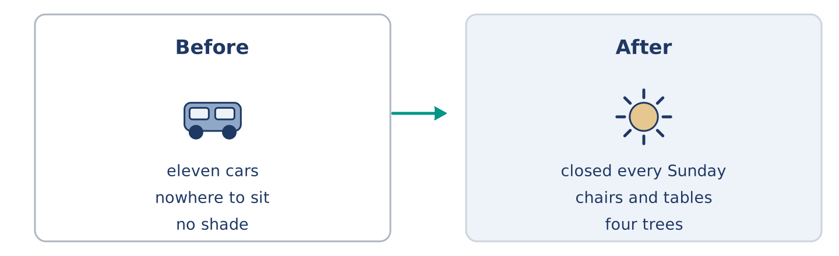
Figure 2.13 · One street in Brazil, before and after.
Before you read: can the people of one street change the street itself?
Gloss: square = an open space in a town with buildings around it · council = the people who run a town · permission = when somebody says you may do something
In a small city in Brazil there was a street with no shade and nowhere to sit. There were cars on both sides and there was not much room for anybody else. One woman, Clara, counted the cars one Sunday: eleven cars and forty-one people. She wrote the two numbers on a piece of paper and put it in every letter box. People started to talk. They asked the council for permission to close one end of the street for one Sunday a month. The council said yes, for three months. On the first Sunday there were chairs, two tables and somebody’s radio. On the third there were ninety people. The street is now closed every Sunday, and there are four trees in it. Clara says the hardest part was not the council. It was the first Sunday, when she carried out two chairs and sat down alone for twenty minutes.
Answer the questions. (0. is done.)
- Where is the street? — In a small city in Brazil.
- What did Clara count, and what were the numbers?
- What did the council agree to?
- What does Clara say was the hardest part?
Part 8: Vocabulary in Context
Match each word with its meaning. One meaning is not needed. Write the letter.
Column A
1. | shade | ____
2. | council | ____
3. | permission | ____
4. | square | ____
Column B
a) | when somebody says you may do something
b) | an open space in a town with buildings around it
c) | the people who run a town
d) | a place out of the sun
e) | the money you pay to live somewhere
Part 8: Discussion
Talk with a partner. Use the frames.
Discussion frames: “This is similar to where I live because…” · “This is different from where I live because…” · “I think the most important thing is… because…”
Part 9 · Close to Home — The Empty Flat
[PLUS] Plus track · pre-read / decide
Before you read: what happens to a building when one flat stays empty?
There is an empty flat on the first floor of number 14, next to Dani. It was empty in the spring, and it is empty now. There is no furniture in it and there is not much light, because the shutters are closed. For a while nobody thought about it. Then the post began to arrive for somebody who was not there. It sat on the landing in a pile, and the pile grew bigger every week. Mr Okonkwo put a box under the letter boxes so the post had somewhere to go. Dani started to clean that part of the landing. Amina asked twice at the shop whether anybody knew the name. Nobody did. There are five flats at number 14, and one of them is a question. Each of the five homes answers it in its own small way. Nobody ever agreed to.
Answer the questions. (0. is done.)
- Where is the empty flat? — On the first floor, next to Dani.
- Why is there not much light in the flat?
- What did Mr Okonkwo do about the post?
- What does the text say the neighbours never did?
Part 9: Decision Task
A flat in your building stood empty all year and the post is piling up. Should you (a) leave it alone, (b) ask the other neighbours what they know, or (c) write to the owner or the council? Decide and explain. Use the frame.
Answer frame: “I think I should ___ because ___. Also, ___. This is better than ___ because ___.”
Model — read this first:
I think I should ask the other neighbours first, because somebody in the building usually knows more than you do. Also, it costs nothing and it does not make a small thing into an official one. This is better than writing to the council, because the council asks questions I cannot answer yet. (53 words)
Phrase bank: I think I should… · because… · Also,… · This is better than… · In my opinion…
Part 10 · Review and Can-Do
[CORE + PLUS] · homework / self-study
Part 10: Spiral Review
Complete the review. (0. is done.)
- The money you pay every month to live somewhere is the rent.
Word bank: balcony | cupboard | neighbour | there is | there are | much | many | commute
- A tall box with doors, for plates and cups, is a ______________________ .
- A small outside floor with a wall is a ______________________ .
- A person who lives near you is your ______________________ .
- “______________________ a shop on the ground floor” — one thing.
- “______________________ five flats above it” — more than one.
- There is not ______________________ space in Amina’s kitchen.
- There are not ______________________ quiet nights above Dani.
- (from Unit 1) The journey between your home and your work is your ______________________ .
Part 10: Can-Do
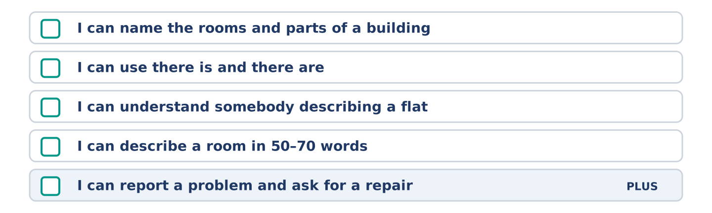
Figure 2.14 · What you can do at the end of this unit.
Can-Do checklist
☐ I can name the rooms and parts of a building.
☐ I can use there is and there are, and some, any, much and many.
☐ I can understand somebody describing a flat.
☐ I can describe a room in 50–70 words.
☐ I can report a problem and ask for a repair (Plus).
Part 10: Glossary
Unit 2 glossary (10 words)
balcony · cupboard · rent · entrance · landing · view · roof · garden · furniture · lift
Unit 3: A Day in the City
English for Daily Life · Level: A2 · Tracks: [CORE] Warm-Up + Parts 1–6 · [PLUS] Parts 7–10
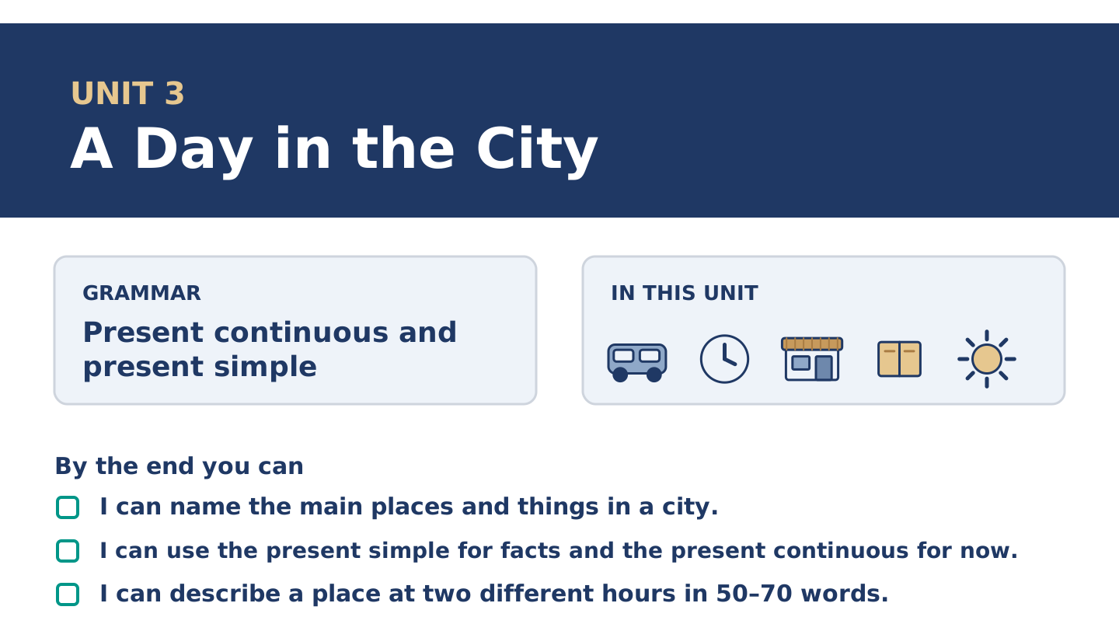
Figure 3.1 · Unit 3 at a glance: the grammar, the topic and what you will be able to do.
Warm Up
[CORE] Core track · in-class starter
Warm-up: City Words and Meanings
Match the words with their meanings. One meaning is not needed. Write the letter.
Column A
1. | Market | ____
2. | Bridge | ____
3. | Crossing | ____
4. | Bench | ____
5. | Library | ____
Column B
a) | a long seat in a park or a street
b) | a place where you borrow books
c) | a place where people sell food and other things from tables
d) | a shop that sells only bread
e) | a place to walk over a road or a river
f) | the place where you walk across a road
Warm-up: Talking About the City
Complete the sentences using the words in the word bank.
Word bank: traffic | crowd | ticket | park
- At eight o’clock the ______________________ is slow and nobody moves.
- Dani buys a ______________________ for the bus every Monday.
- There is always a ______________________ outside the station at six.
- Mr Okonkwo sits in the ______________________ when the weather is good.
Warm-up: The Same Street, Two Hours
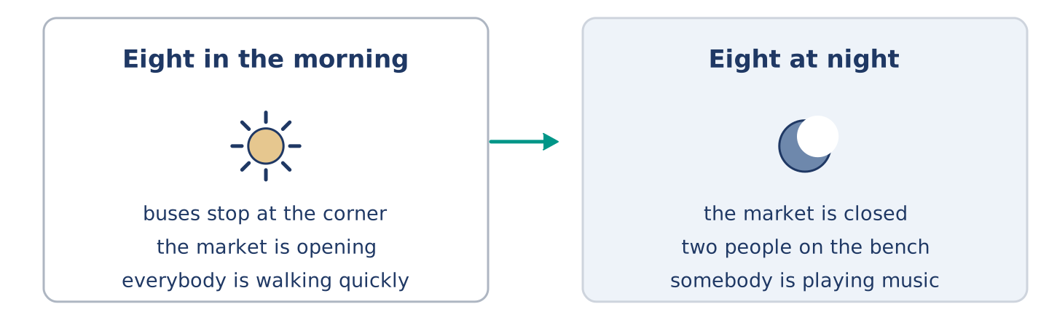
Figure 3.2 · Alder Street at eight in the morning and at eight at night.
Read the text and choose the correct answer.
At eight in the morning Alder Street is loud. Buses stop at the corner, the market is opening, and everybody is walking quickly. At eight at night the same street is almost quiet. The market is closed, two people are sitting on the bench, and somebody is playing music by the crossing. The street does not change. The city changes around it, twice a day, every day.
1. What is happening at eight in the morning?
○ A) The market is closing
○ B) Everybody is walking quickly
○ C) Two people are sitting on the bench
○ D) The street is quiet
2. What does the text say about the street?
○ A) It changes twice a day
○ B) It is always loud
○ C) It does not change
○ D) It is never quiet
Part 1 · Vocabulary and Terminology
[CORE] Core track · pre-class input
Part 1: City and Journey Terms
Match the words with their meanings. One meaning is not needed. (0. is done for you.)
- Fare → the money you pay for one journey on a bus or a train.
Column A
1. | Timetable | ____
2. | Crossing | ____
3. | Escalator | ____
4. | Traffic | ____
5. | Crowd | ____
6. | Market | ____
7. | Bench | ____
Column B
a) | all the cars and buses on a road
b) | a lot of people in one place
c) | a list of the times buses or trains come
d) | moving stairs that carry you up or down
e) | the place where you walk across a road
f) | a place where people sell things from tables
g) | a long seat in a park or a street
h) | the money you pay to live somewhere
Gloss: fare = the money for one journey · timetable = a list of times · escalator = moving stairs · platform = the place beside the train where you stand
Part 1: Pronunciation
🔊 Audio Track 3.1
Listen and practise these words. Say each word aloud and stress the loud syllable (CAPITALS).
traffic — TRA-ffic
market — MAR-ket
library — LI-bra-ry
escalator — ES-ca-la-tor
timetable — TIME-ta-ble
crossing — CRO-ssing
Then listen again to the long words. Escalator is four beats and library is three, but English speakers often say LI-bry. Say the slow form first, then the fast one, and notice which sound disappears.
Part 1: Six Places in the City
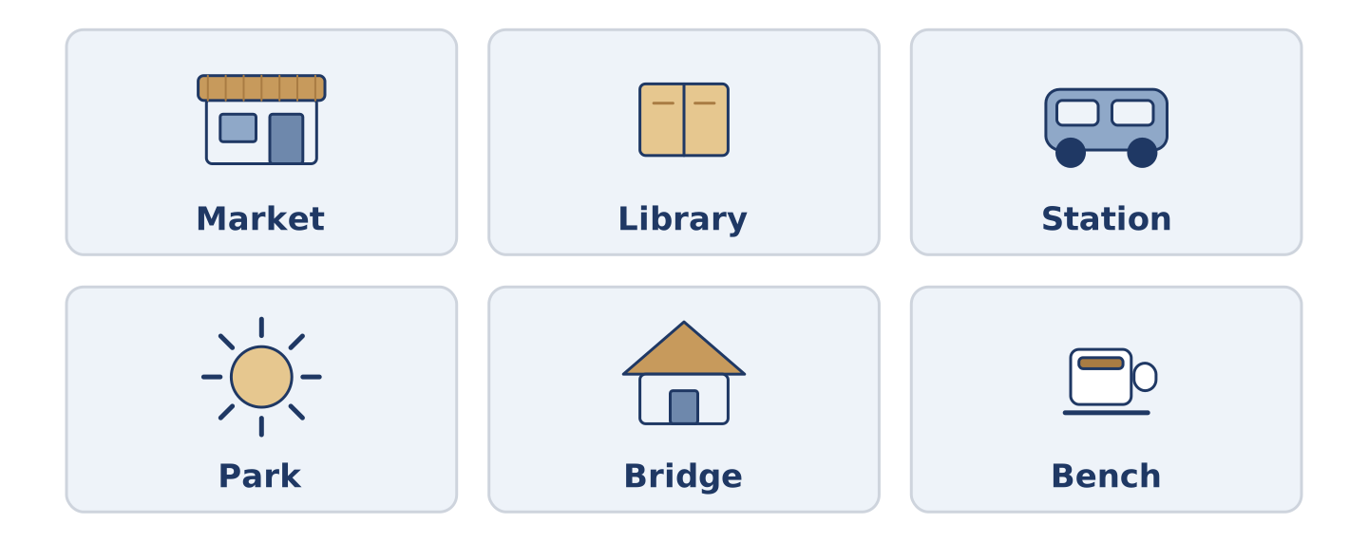
Figure 3.3 · Six places in a city and what you do at each.
Complete the table. Write what you do there and when it is busiest. (0. is done.)
Place | What you do there | Busiest at
Market | buy food | (example)
Library
Station
Park
- Market — buy food — early morning, when it opens.
Think about a city you know. There is more than one right answer, and you should be ready to say why you chose yours.
Part 1: On the Street
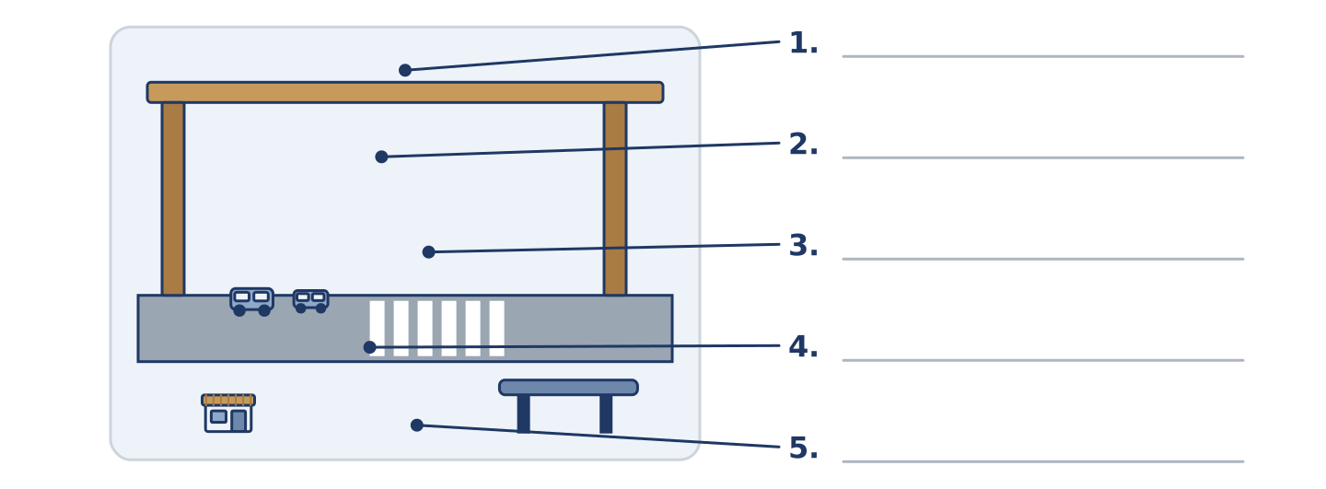
Figure 3.4 · On the street — write the correct word on each line.
Match the things on a street with their descriptions. One description is not needed. Write the letter.
Column A
1. | Crossing | ____
2. | Bench | ____
3. | Traffic | ____
4. | Bridge | ____
5. | Market | ____
Column B
a) | a place to walk over a road or a river
b) | tables in the street where people sell things
c) | the money you pay for one journey
d) | the black and white lines you walk across
e) | a long seat where you can wait or rest
f) | all the cars and buses on a road
Part 1: City Life — Multiple Choice
Read and choose the correct answer.
1. Moving stairs that carry you up or down are an…
○ A) escalator
○ B) entrance
○ C) crossing
○ D) timetable
2. A list of the times buses come is a…
○ A) fare
○ B) crowd
○ C) timetable
○ D) bench
3. The money you pay for one journey is the…
○ A) traffic
○ B) ticket
○ C) market
○ D) fare
Part 1: Vocabulary Fill-in
Complete the sentences with the correct word.
Word bank: crowd | traffic | ticket | library
- Yuki is reading in the ______________________ , because her flat is cold.
- The ______________________ stops moving at half past five every day.
- There is a ______________________ at the bus stop, so Maya is waiting.
- Dani cannot find his ______________________ , and the bus is coming.
Part 1: Write About Your City (short)
Write two or three sentences about the place where you live. Use three words from this unit.
Model — read this first:
My city is quiet in the morning and loud at six. The traffic stops near the bridge every evening, so I walk that part. There is a small market on Saturday, and I always buy two things I do not need.
Part 2 · Grammar — Present Continuous and Present Simple
[CORE] Core track · pre-class input
Part 2: Notice
Read these lines about the city. Underline the verbs. Which are always true, and which are happening now?
The market opens at six every morning. Right now it is opening, and the first van is arriving. Buses stop at this corner. At the moment three buses are standing in a line. Mr Okonkwo reads on that bench every afternoon. Today he is reading there in the rain.
Three sentences are facts; three are about this minute. The time words tell you which.
Part 2: Grammar Focus Box
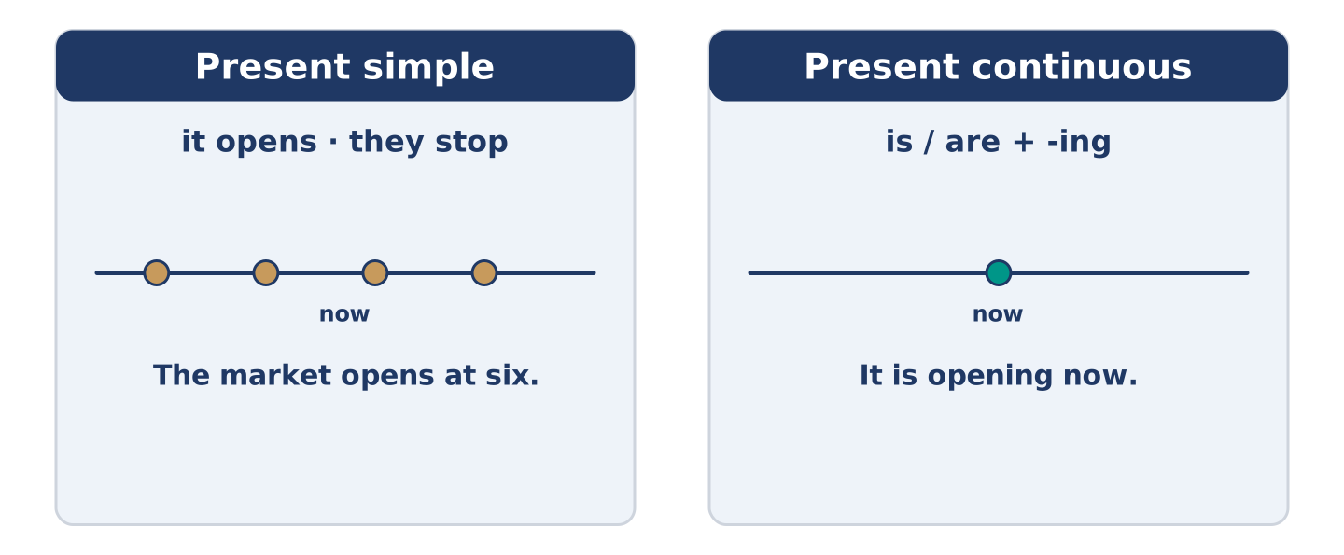
Figure 3.5 · Always true, or happening now: the same verb, two jobs.
 | Form | Use | Example
Present simple | it opens · they stop | a fact, a timetable, every day | The market opens at six.
Present continuous | is / are + -ing | this minute, in front of you | It is opening now.
Time words | every day · at the moment | they decide the tense | Today he is reading in the rain.
Stative verbs | know, want, like | no -ing form | I want a ticket.
Remember: a timetable takes the present simple: the bus leaves at six.
Watch out! ✗ The market is opening at six every day. → ✓ The market opens at six. (a fact). ✗ I am wanting a ticket. → ✓ I want a ticket. (no -ing).
Part 2: Controlled Practice
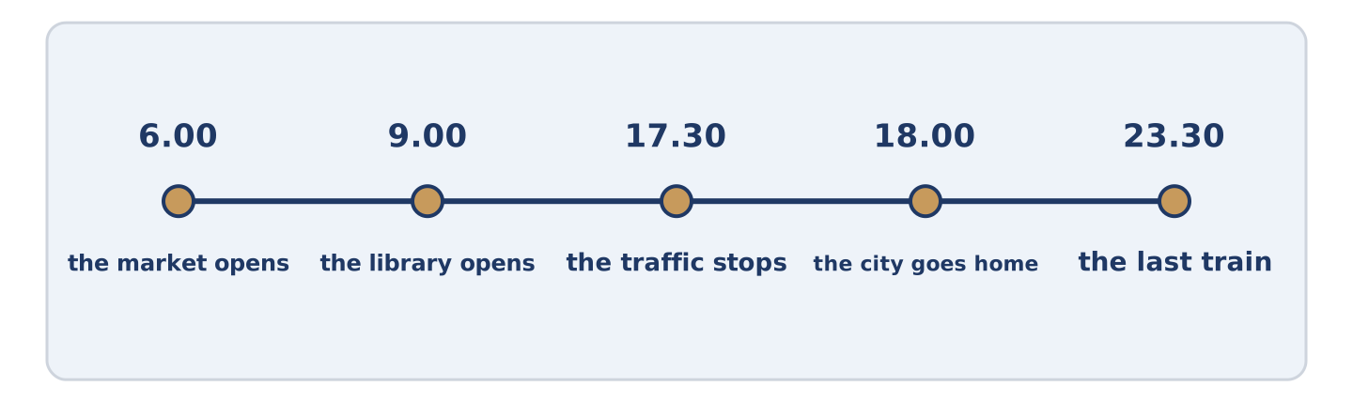
Figure 3.6 · One street, hour by hour: what happens, and what is happening.
Present simple or present continuous? (0. is done.)
- The market opens at six every morning. (open)
- Look — the first van ______________________ (arrive) now.
- Buses ______________________ (stop) at this corner every ten minutes.
- At the moment three buses ______________________ (stand) in a line.
- Mr Okonkwo ______________________ (read) on that bench every afternoon.
Part 2: Which Tense?
Choose the correct form. (0. is done.)
- Every Saturday Amina opens at seven. (opens / is opening)
- Listen! Somebody ______________________ (plays / is playing) music by the crossing.
- The number 7 bus ______________________ (leaves / is leaving) at ten past eight.
- Today Yuki ______________________ (works / is working) in the library.
- Dani ______________________ (wants / is wanting) a cheaper fare.
Part 2: Correct the Sentence
Each sentence has one grammar mistake. Write the correct sentence.
- The library is opening at nine every day.
- Look! The traffic stop at the bridge.
- I am wanting a ticket for the six o’clock bus.
- At the moment Maya wait at the crossing.
Part 2: Freer Practice
Write two sentences about your own city: one fact, and one about now.
Part 2: Grammar Review
Choose the correct sentence.
1. Which sentence is correct (a timetable)?
○ A) The bus is leaving at ten past eight every day.
○ B) The bus leaves at ten past eight every day.
○ C) The bus leave at ten past eight every day.
○ D) The bus leaving at ten past eight every day.
2. Which sentence is correct (now)?
○ A) Listen — somebody plays music.
○ B) Listen — somebody playing music.
○ C) Listen — somebody is play music.
○ D) Listen — somebody is playing music.
→ Harvest: you will see both tenses again in the Part 5 reading. Watch for the time words.
Part 3 · Listening
[CORE] Core track · pre-class input · scripts printed inline
Part 3: At the Bus Stop
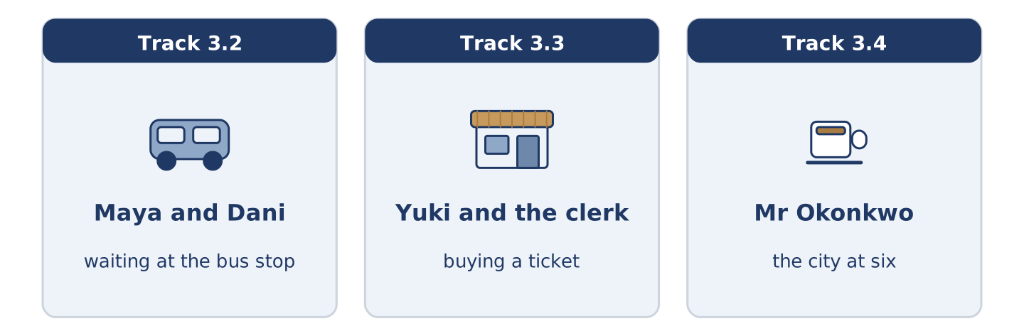
Figure 3.7 · The three listenings: who is speaking, and what about.
🔊 Audio Track 3.2
Before you listen: what do people say to each other at a bus stop?
Maya: Is the 7 coming? Dani: I think so. It says four minutes, but it’s said four minutes for a long time. Maya: It always does that. Dani: You’re off to work? Maya: Yes, but I’m starting late today, so I’m not running for once. Dani: I’m off to the library. My flat’s too cold to think in. My sister says hers is worse. Maya: Here it is. And it’s full, of course.
While you listen: write True, False, or Not Given. (0. is done.)
- Maya and Dani are at a bus stop. — True
- Maya is starting work late today. ____
- Dani is going to the market. ____
- Dani goes to the library every day. ____
Useful phrases: Is the 7 coming? · It always does that · I am going to…
Part 3: Buying a Ticket
🔊 Audio Track 3.3
Before you listen: what do you need to know before you buy a ticket?
Yuki: One ticket to the centre, please. Clerk: Single or return? Yuki: Return. How much is the fare? Clerk: Four forty. The next train leaves at ten past. Yuki: Which platform? Clerk: Platform two. The escalator is not working today, so use the stairs on the left. Yuki: Thank you. Is it usually this busy? Clerk: Every morning. You’ll get used to it.
While you listen: answer the questions. (0. is done.)
- What does Yuki want to buy? — A ticket to the centre.
- How much is the fare?
- Why does the clerk say to use the stairs?
- What does the clerk say about the crowd?
Part 3: The City at Six
🔊 Audio Track 3.4
Before you listen: what is your city doing at six in the evening?
Mr Okonkwo: Six o’clock, and the city is going home. Maya is somewhere in it, and so is Amina. The traffic is not moving on the bridge, so people are walking across it instead. Outside the station a woman is selling flowers and almost nobody is buying them. A runner is going for a train, and he is not fast enough. On my bench two students are eating and arguing about a film. Every evening is the same evening, and no evening is.
While you listen: match each person with what they are doing. One action is not needed. (0. is done.)
- Mr Okonkwo → watching from his bench.
Useful phrases: A man is… · A woman is… · Two students are…
Column A
1. | A woman | ____
2. | A runner | ____
3. | Two students | ____
4. | People on the bridge | ____
Column B
a) | running for a train
b) | selling flowers
c) | walking across
d) | buying a timetable
e) | eating and arguing about a film
Part 4 · Speaking
[CORE] Core track · in-class output
Part 4: Talking About Your City
Work with a partner. Ask and answer these questions.
- What is the busiest place in your city, and when is it busiest?
- How do you travel across the city? Is it the fastest way?
- What is happening in your street right now, do you think?
Useful language: It opens at… · Every morning… · Right now… · At the moment… · The busiest place is…
Part 4: Find the Difference (pairwork)
Student A and Student B each have a picture of the same street. Ask questions and find three differences.
Useful questions: What is happening at the crossing? · Is the market open? · How many people are waiting? · What is the man doing?
Student A — your picture: the market is open · four people are waiting · a man is selling flowers · it is raining.
Student B — your picture: the market is open · two people are waiting · a man is reading a newspaper · it is raining.
Part 4: Asking the Way
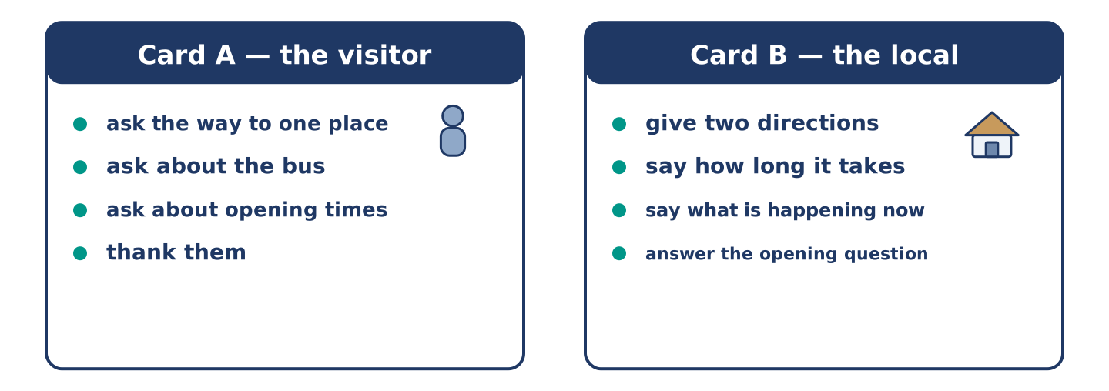
Figure 3.8 · Card A and Card B: what each of you has to say.
Work in pairs. Read the model, then use the cards.
Model exchange:
A: Excuse me, how do I get to the library? — B: Go over the bridge and turn left at the crossing. It is about ten minutes. — A: Is there a bus? — B: There is, but the traffic is terrible now. Walking is faster. — A: Thank you. Is it open on Sunday? — B: It opens at twelve on Sunday.
Useful language: Excuse me, how do I get to…? · Go over… · Turn left at… · It is about ten minutes · Walking is faster.
Card A — the visitor: ask the way to one place · ask about the bus · ask one question about opening times · thank them.
Card B — the local: give two directions · say how long it takes · say what is happening now that changes the answer · answer the opening question.
Your turn: run the dialogue, then swap roles.
Stretch [PLUS]: the visitor asks for a place you do not know — say so and offer a way to find out.
Part 4: Mini-Presentation
Prepare a short talk (about one minute). Describe one place in your city: what happens there every day, and what is happening there at the moment.
Part 5 · Reading
[CORE] Core track · pre-class input
Part 5: The City Has Two Clocks
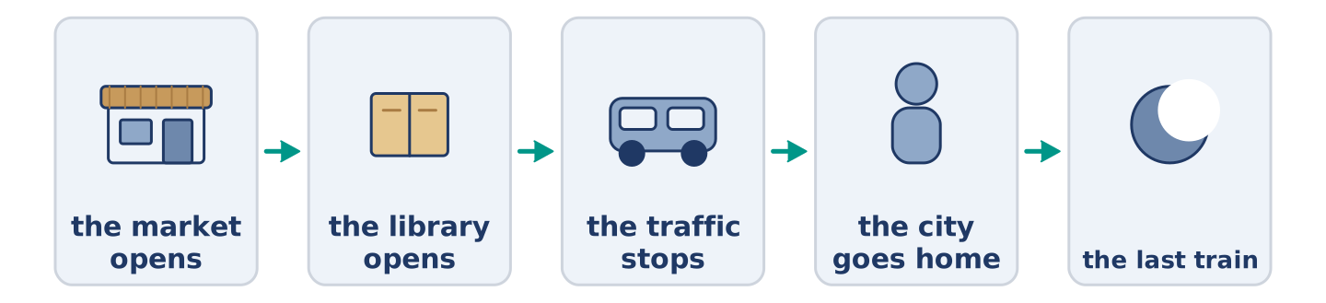
Figure 3.9 · One day in the city, hour by hour.
Before you read: is your city a different place at different hours?
Gloss: rush hour = the time when many people travel to or from work · queue = a line of people waiting · deliver = to bring things to a place
A city runs on two clocks at once. The first is the timetable: the market opens at six, the library at nine, the last train leaves at half past eleven. Somebody writes that clock down, and it almost never changes. The second clock is what people are actually doing, and it is different every day. At six the market opens, but today one van is late and half the tables are empty. At nine the library opens. This morning there is already a line of people outside, because it is cold. The woman at the door says it is never empty at that hour. Most of us live by the first clock and complain about the second. Night workers see a third city. The rest of us never meet it. A cleaner is washing the floor of an empty station. Somebody is delivering bread to a shop. It opens in four hours.
Answer the multiple-choice questions. (0. is done.)
- How many clocks does the text say a city runs on? — Two.
1. What is the first clock?
○ A) What people are doing now
○ B) The timetable
○ C) The weather
○ D) The night shift
2. Why is there a queue outside the library this morning?
○ A) Because a van is late
○ B) Because the market is closed
○ C) Because it is cold
○ D) Because the train is early
3. What do people who work nights see?
○ A) The same city as everybody else
○ B) A third city the rest of us never meet
○ C) A market that never opens
○ D) A library with no queue
Part 5: Vocabulary in Context
Match each word from the text with its meaning. One meaning is not needed. Write the letter.
Column A
1. | rush hour | ____
2. | queue | ____
3. | deliver | ____
4. | timetable | ____
Column B
a) | a line of people waiting
b) | a list of the times buses or trains come
c) | the time when many people travel to or from work
d) | to bring things to a place
e) | a long seat in a park
Part 5: Cities That Never Sleep
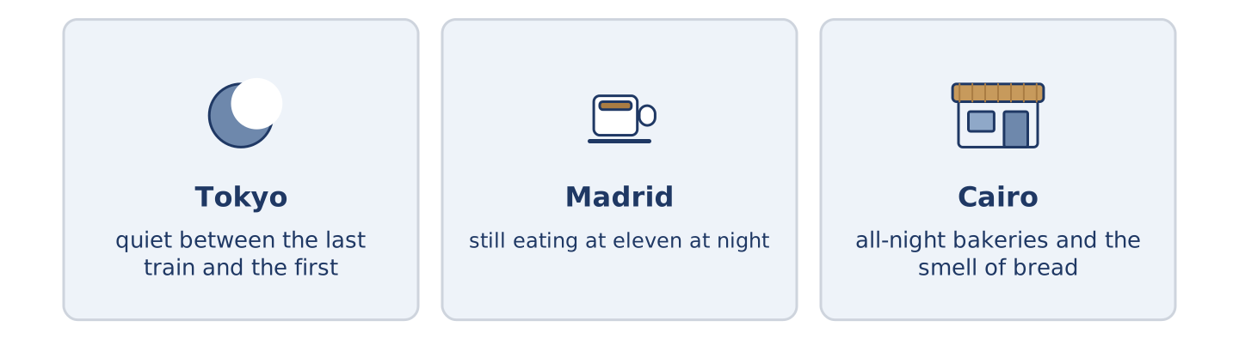
Figure 3.10 · The same hour in three cities.
Before you read: at midnight, what is still open where you live?
Gloss: all-night = open through the whole night · bakery = a shop that makes and sells bread
Some cities keep going after midnight and some do not. In Tokyo the last train is late and the first is early, and between them the city is quiet in a way that surprises visitors. In Madrid people are still eating at eleven. A grandmother orders coffee, and her street is busier then than at six. In Cairo there are all-night bakeries, and the smell of bread crosses an almost empty street. The hours are the same everywhere. What a city does with the dark is not.
Answer the questions. (0. is done.)
- Do all cities keep going after midnight? — No, they do not.
- What surprises visitors to Tokyo?
- When are the streets of Madrid busier?
- What crosses an almost empty street in Cairo?
Part 6 · Writing
[CORE] Core track · in-class / homework
Part 6: Describe a Place at Two Hours (50–70 words)
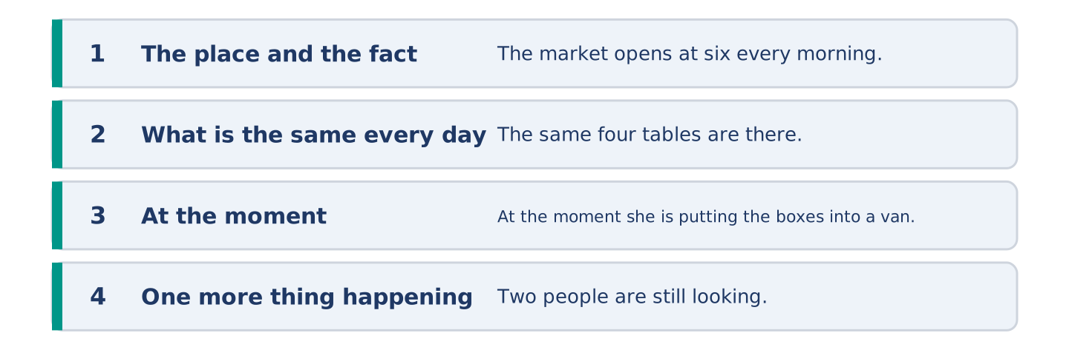
Figure 3.11 · The shape of the paragraph you are about to write.
Choose one place. Say what happens there every day, and what is happening there at the moment.
Model — read this first:
The market on Alder Street opens at six every morning and closes at two. The same four tables are there every day, and the woman on the corner sells only tomatoes. At the moment it is half past one, and she is putting the last boxes into a van. Two women are still looking, and she is pretending not to see them. (62 words)
Plan (fill in, then write): ___ opens at ___ every ___. The same ___ are there every day. At the moment ___ is ___. ___ is also ___.
Word bank: every morning | every day | at the moment | right now | opens | is opening
Check before you finish: ☐ one present-simple fact? ☐ one present-continuous sentence? ☐ two time words? ☐ 50–70 words?
Part 6: The Best Way to Cross a City (50–70 words)
What is the best way to travel across a city? Give your opinion and two or three reasons.
Model — read this first:
I think walking is the best way to cross a city, if you have the time. You see the shops that you pass every day on the bus and never notice. It is also the only way that is never late, because the traffic does not stop you. The problem is rain, and in my city it rains a lot. (60 words)
Word bank: I think… because… | it is faster | it is never late | however | in my opinion
Check before you finish: ☐ a clear opinion? ☐ two or three reasons? ☐ 50–70 words?
Part 6: A Message About Meeting (50–70 words)
You are meeting a friend in the city. Write a short message: where, when, and how they get there.
Model — read this first:
Hi Yuki. Let’s meet at the café by the library on Saturday at eleven. The 7 bus stops at the crossing outside, and it comes every ten minutes. If you walk, go over the bridge and turn left — it is about fifteen minutes from your flat. I am working until half past ten, so do not worry if I am five minutes late. Maya (65 words)
Plan (fill in, then write): Let’s meet at ___ on ___ at ___. The ___ stops ___. If you walk, ___. ___
Check before you finish: ☐ a place and a time? ☐ how to get there? ☐ one sentence about you? ☐ 50–70 words?
Part 6: Reflection — My Favourite Hour (40–60 words)
Which hour of the day do you like best in your city, and why?
Model — read this first:
My favourite hour is seven in the morning, before the traffic starts. The shops are opening and nobody is in a hurry yet. One man is always washing the front of the café, and he always says good morning. By nine the whole street is somebody else’s. (47 words)
Check before you finish: ☐ an hour named? ☐ what is happening then? ☐ a reason? ☐ 40–60 words?
Part 7 · Real-World File — Getting Around
[PLUS] Plus track (optional) · stronger learners
7A: Phrase Bank
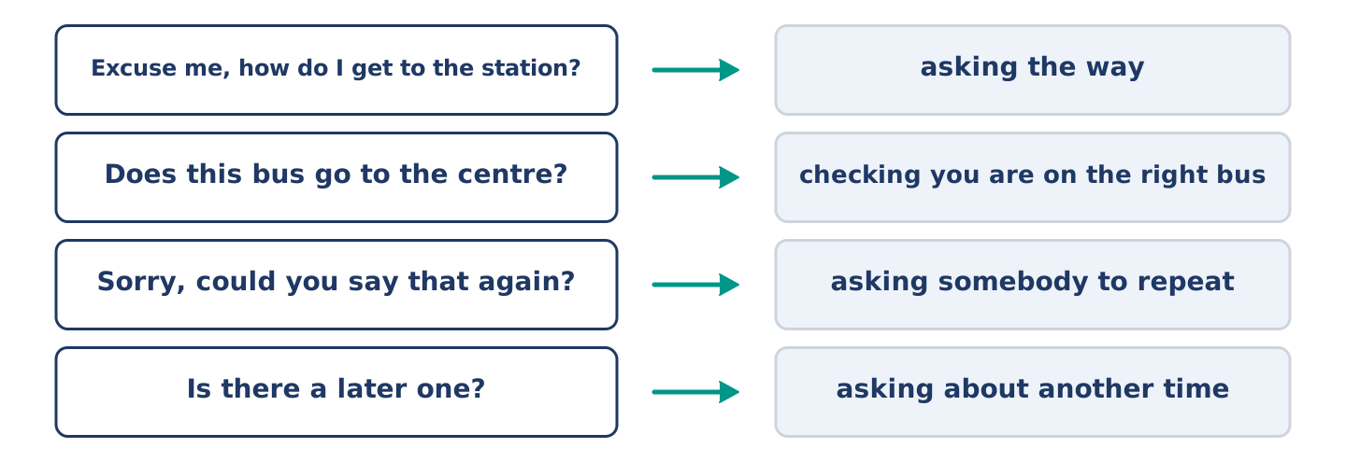
Figure 3.12 · What you say when you are lost, and what each thing does.
Match what a person says with its purpose. One purpose is not needed. Write the letter.
Column A
1. | “Excuse me, how do I get to the station?” | ____
2. | “Does this bus go to the centre?” | ____
3. | “Sorry, could you say that again?” | ____
4. | “Is there a later one?” | ____
Column B
a) | checking you are on the right bus
b) | asking the way
c) | asking somebody to repeat
d) | asking about another time
e) | complaining about the fare
7B: A Problem on the Way
🔊 Audio Track 3.5
Before you read: what do you do when the train you need is not running?
Yuki: Excuse me — the board says there is no ten past. Staff: It is. There is a problem on the line at the bridge. Yuki: Is there a later one? Staff: Half past, from platform four, but it is going the long way. It takes forty minutes, not twenty. Yuki: And the buses? Staff: The 7 and the 12 both go to the centre. The 12 is leaving in two minutes from outside. Yuki: Thank you — I am running, then.
Answer the questions. (0. is done.)
- Which train is not running? — The ten past.
- Why is that train not running?
- How long does the half past take?
- Which bus is leaving in two minutes?
7C: Controlled Practice — When a Journey Goes Wrong
Put the steps in order. Number them 1–5. (0. is done.)
- Read the board and see the problem. — 1
____ Decide and go.
____ Ask somebody who works there.
____ Ask what the other ways are.
____ Ask how long the other way takes.
7D: Role-Play — Asking About a Journey
In pairs. One is the traveller; one works at the station. Use the model and cards.
Model exchange: A: Excuse me — is the ten past running? — B: No. There is a problem at the bridge. — A: Is there a later one? — B: Half past, platform four, but it takes forty minutes. — A: Is there a bus? — B: The 12, outside, leaving now. — A: Thank you.
Card A — the traveller: say what you wanted · ask for another way · ask how long it takes · decide out loud.
Card B — the staff: say what is wrong · offer two ways · say how long each takes · say which one is leaving now.
Stretch [PLUS]: both ways are bad, and the traveller is late for something — stay calm and help them choose.
7E: Writing — A Message About a Delay (50–80 words)
You are late because of a problem on the way. Write a short message to the person who is waiting.
Model — read this first:
Hi Maya, I am sorry — I am late. There is no ten past, because of a problem on the line at the bridge, and the next train goes the long way. I am on the 12 bus instead and it is moving, slowly. I think I am twenty minutes behind. Please order something and keep a seat for me. Yuki (61 words)
Check before you finish: ☐ an apology? ☐ what happened? ☐ how late you are? ☐ what they should do? ☐ 50–80 words?
Part 8 · Global Story — The Map That Was Wrong on Purpose
[PLUS] Plus track · pre-read / discuss
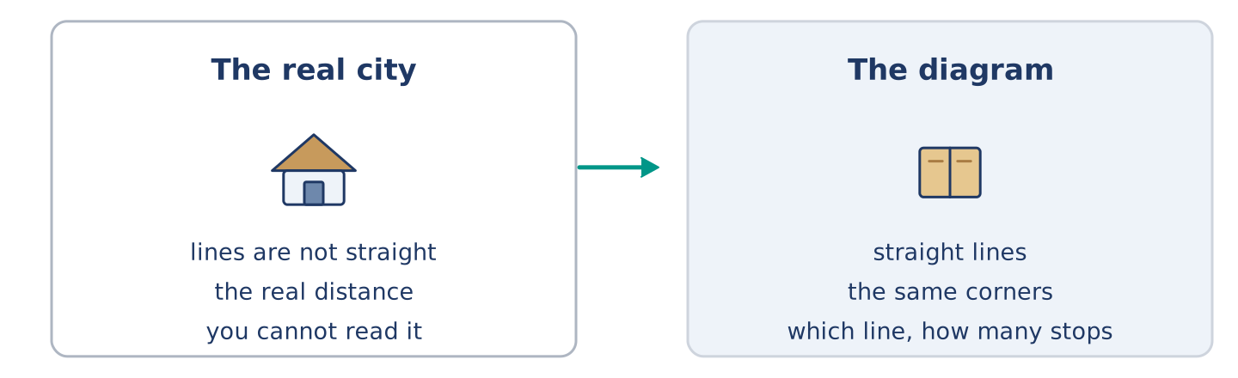
Figure 3.13 · The old map and the new one.
Before you read: can a map of a city be wrong and useful at the same time?
Gloss: underground = the train system under a city · diagram = a simple drawing that shows how things connect · scale = how a map’s size compares to the real size · cancelled = not running today
In Tokyo, like every big city, the underground map is not a picture of the city. It is a diagram. The lines are straight and the corners are all the same shape. The distance between two stations on paper has little to do with the real distance. The first map of this kind came from London, a long time ago. Its maker had an unusual job. He drew electric lines for a living. He drew the city the same way. People complained that it was wrong. It was. It was also the first map anybody could read on a moving train. Today almost every big city uses the same idea. The map is wrong about scale and right about the only three things a passenger needs: which line, which direction, how many stops.
Answer the questions. (0. is done.)
- Is an underground map a picture of the city? — No, it is a diagram.
- What was the job of the first person to draw a map of this kind?
- What did people complain about?
- What three things does the text say a passenger needs?
Part 8: Vocabulary in Context
Match each word with its meaning. One meaning is not needed. Write the letter.
Column A
1. | diagram | ____
2. | scale | ____
3. | underground | ____
4. | passenger | ____
Column B
a) | the train system under a city
b) | a person travelling on a bus or a train
c) | how a map’s size compares to the real size
d) | a simple drawing that shows how things connect
e) | a line of people waiting
Part 8: Discussion
Talk with a partner. Use the frames.
Discussion frames: “This is similar to where I live because…” · “This is different from where I live because…” · “I think the most important thing is… because…”
Part 9 · Close to Home — The Bus That Changed Its Route
[PLUS] Plus track · pre-read / decide
Before you read: what happens to a street when its bus stop moves?
For eleven years the 7 stopped at the corner of Alder Street, outside Amina’s shop. In March the bus company moved the stop two hundred metres, to the main road. The reason was the traffic: the corner is too small and the bus was blocking it twice an hour. Nobody argued with the reason. But two hundred metres is a long way with shopping, and Mr Okonkwo stopped going into town on Tuesdays. Amina noticed first. People waiting for the bus used to buy bread. Now they do not. She counted: eleven fewer customers a day, all of them between half past eight and nine. The bus is faster. The corner is clearer. And a shop with a bus stop outside it is now only a shop.
Answer the questions. (0. is done.)
- Where did the 7 stop for eleven years? — At the corner of Alder Street, outside Amina’s shop.
- Why did the bus company move the stop?
- What did Mr Okonkwo stop doing?
- How many fewer customers does Amina count, and when?
Part 9: Decision Task
A bus stop near you is moving. Should you (a) accept it, because the reason is good, (b) ask the bus company to think again, or (c) ask the people in your street what it costs them first? Decide and explain. Use the frame.
Answer frame: “I think I should ___ because ___. Also, ___. This is better than ___ because ___.”
Model — read this first:
I think I should ask the people in my street first, because at the moment I only know what it costs me. Also, a bus company listens to eleven people and not to one. This is better than accepting it straight away. Their reason is about buses, and nobody asked what the stop did for the street. (57 words)
Phrase bank: I think I should… · because… · Also,… · This is better than… · In my opinion…
Part 10 · Review and Can-Do
[CORE + PLUS] · homework / self-study
Part 10: Spiral Review
Complete the review. (0. is done.)
- The money you pay for one journey is the fare.
Word bank: timetable | crossing | traffic | crowd | opens | is opening | balcony | commute
- A list of the times buses come is a ______________________ .
- The black and white lines you walk across are a ______________________ .
- All the cars and buses on a road are the ______________________ .
- A lot of people in one place is a ______________________ .
- “The market ______________________ at six every morning” — a fact.
- “Look, it ______________________ now” — this minute.
- (from Unit 2) A small outside floor with a wall is a ______________________ .
- (from Unit 1) The journey between your home and your work is your ______________________ .
Part 10: Can-Do
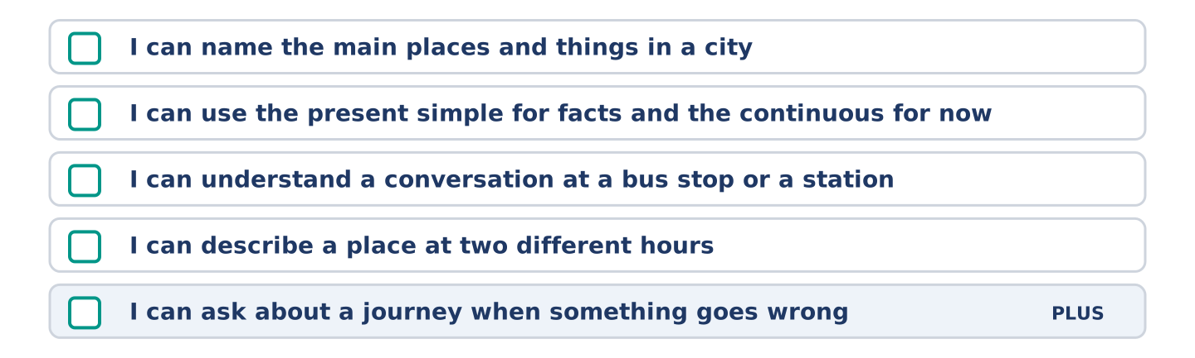
Figure 3.14 · What you can do at the end of this unit.
Can-Do checklist
☐ I can name the main places and things in a city.
☐ I can use the present simple for facts and the present continuous for now.
☐ I can understand a short conversation at a bus stop or a station.
☐ I can describe a place at two different hours in 50–70 words.
☐ I can ask about a journey when something goes wrong (Plus).
Part 10: Glossary
Unit 3 glossary (10 words)
market · bridge · crossing · bench · library · traffic · crowd · ticket · timetable · fare
Unit 4: Food and Shopping
English for Daily Life · Level: A2 · Tracks: [CORE] Warm-Up + Parts 1–6 · [PLUS] Parts 7–10
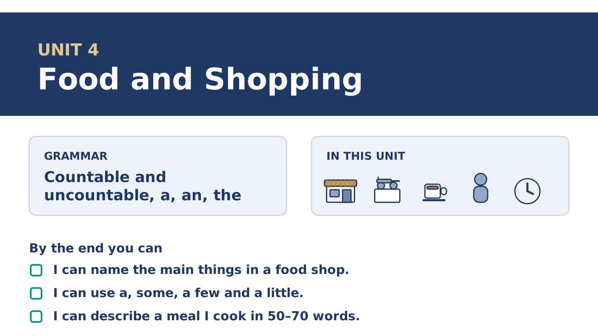
Figure 4.1 · Unit 4 at a glance: the grammar, the topic and what you will be able to do.
Warm Up
[CORE] Core track · in-class starter
Warm-up: Food Words and Meanings
Match the words with their meanings. One meaning is not needed. Write the letter.
Column A
1. | Bottle | ____
2. | Slice | ____
3. | Basket | ____
4. | Receipt | ____
5. | Flour | ____
Column B
a) | a thin flat piece cut from bread or cheese
b) | the piece of paper that shows what you paid
c) | a tall glass or plastic container for milk or water
d) | a soft white powder you use to make bread
e) | a long seat in a park
f) | a light open bag you carry shopping in
Warm-up: Talking About Food
Complete the sentences using the words in the word bank.
Word bank: fresh | sugar | vegetables | dish
- Amina puts the ______________________ bread on the shelf at seven.
- Tomas does not take ______________________ in his tea any more.
- Dani buys ______________________ on Saturday and cooks them on Sunday.
- Yuki is making a ______________________ from her grandmother’s recipe.
Warm-up: Amina’s Shop
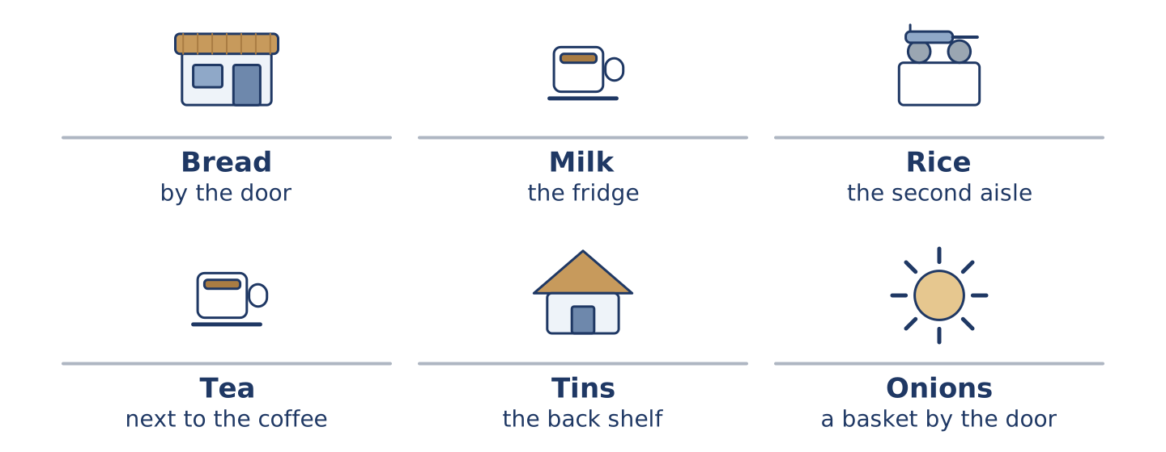
Figure 4.2 · Inside Amina’s shop: what she sells, and how much of it.
Read the text and choose the correct answer.
Amina’s shop is small, so she sells a little of everything and a lot of nothing. There is bread, milk, rice and tea. There are a few tins of beans and some fruit, and there is always a basket of onions by the door. She does not sell much meat, because there is no room for a fridge. The one small fridge holds the milk. People come in for one thing and leave with three.
1. What does Amina sell a lot of?
○ A) Meat
○ B) A little of everything
○ C) Only bread
○ D) Nothing at all
2. Why does she not sell much meat?
○ A) Nobody buys it
○ B) It is too expensive
○ C) There is not room for a fridge
○ D) She does not like it
Part 1 · Vocabulary and Terminology
[CORE] Core track · pre-class input
Part 1: Food and Shopping Terms
Match the words with their meanings. One meaning is not needed. (0. is done for you.)
- Till → the machine where you pay, and the place in the shop where it stands.
Column A
1. | Receipt | ____
2. | Basket | ____
3. | Aisle | ____
4. | Change | ____
5. | Weigh | ____
6. | Fresh | ____
7. | Slice | ____
Column B
a) | a light open bag you carry shopping in
b) | made or picked today, not yesterday
c) | to find out how heavy something is
d) | the long space between two lines of shelves
e) | the money you get back when you pay too much
f) | the piece of paper that shows what you paid
g) | a thin flat piece cut from bread or cheese
h) | a list of the times buses come
Gloss: aisle = the space between two lines of shelves · weigh = to find out how heavy something is · receipt = the paper that shows what you paid · tin = a metal container for food · packet = a paper or plastic bag a shop sells things in
Part 1: Pronunciation
🔊 Audio Track 4.1
Listen and practise these words. Say each word aloud and stress the loud syllable (CAPITALS).
receipt — re-CEIPT
vegetable — VEG-ta-ble
basket — BAS-ket
expensive — ex-PEN-sive
sugar — SU-gar
aisle — AISLE
Then listen again to the letters nobody says. Receipt has a p nobody says. Aisle has an s nobody says. Vegetable is written with four beats and said with three. English keeps letters long after it stops saying them.
Part 1: Six Things and How We Count Them
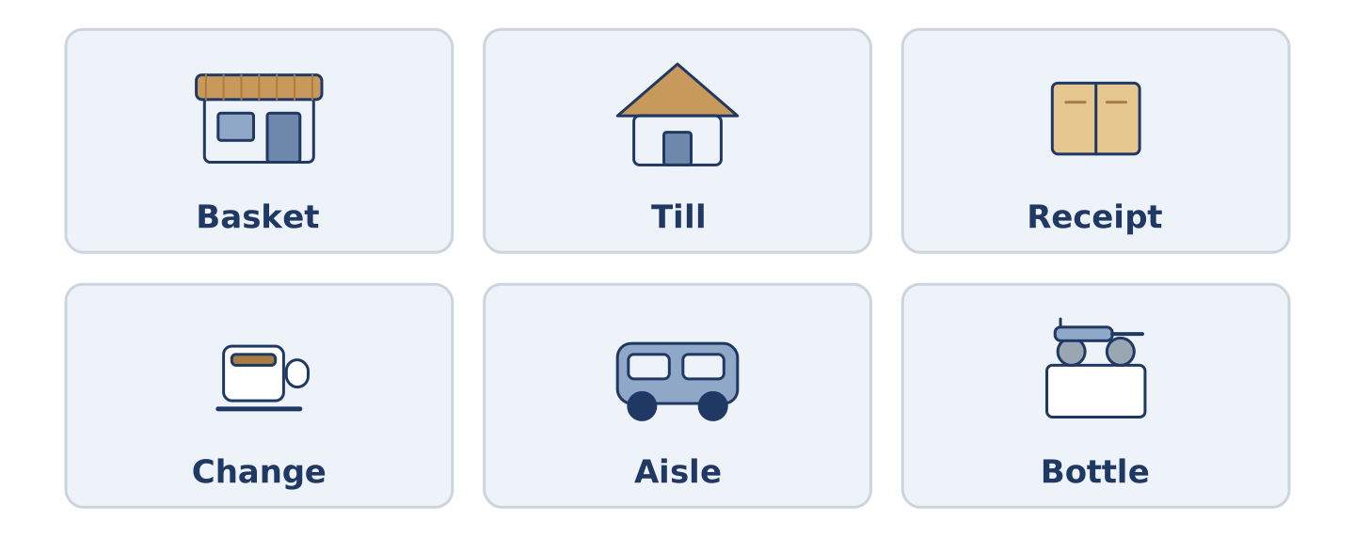
Figure 4.3 · Six things you buy, and the word you count them with.
Complete the table. Write the word you count it with and where you find it. (0. is done.)
Thing | We say | Where in the shop
Milk | a bottle of milk | (example)
Bread
Rice
Tea
- Milk — a bottle of milk — the fridge at the back. (We say a packet of tea and a kilo of rice.)
Some things we count and some we measure. There is more than one right answer, and you should be ready to say why you chose yours.
Part 1: At the Till
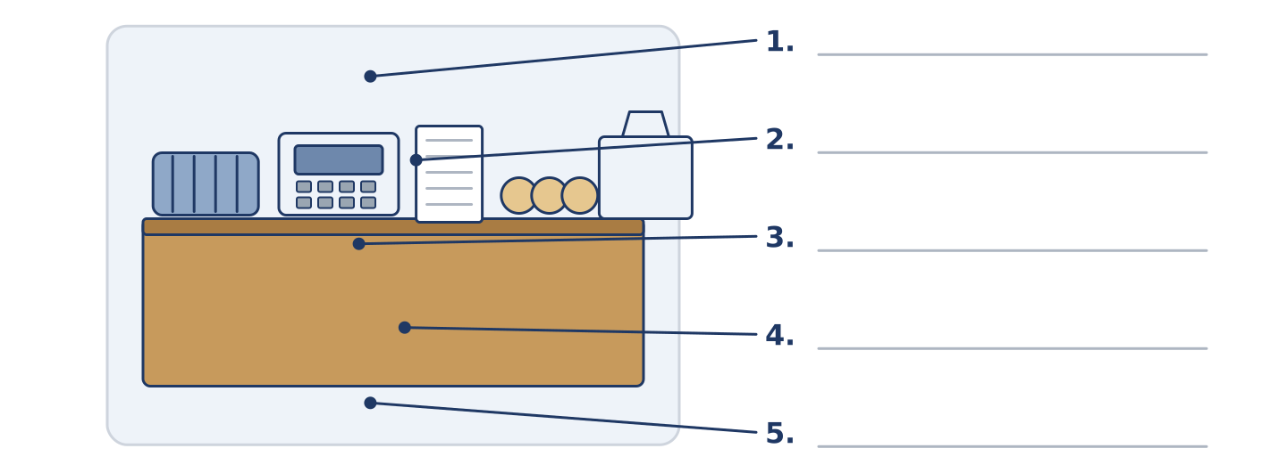
Figure 4.4 · At the till — write the correct word on each line.
Match the things at a till with their descriptions. One description is not needed. Write the letter.
Column A
1. | Basket | ____
2. | Till | ____
3. | Receipt | ____
4. | Change | ____
5. | Bag | ____
Column B
a) | the money you get back
b) | the machine where you pay
c) | what you carry the shopping home in
d) | the long space between two lines of shelves
e) | a light open bag you fill while you walk round
f) | the paper that shows what you paid
Part 1: Shopping — Multiple Choice
Read and choose the correct answer.
1. The money you get back when you pay too much is your…
○ A) receipt
○ B) change
○ C) basket
○ D) aisle
2. Bread from this morning is…
○ A) cheap
○ B) frozen
○ C) fresh
○ D) heavy
3. The long space between two lines of shelves is an…
○ A) aisle
○ B) entrance
○ C) till
○ D) basket
Part 1: Vocabulary Fill-in
Complete the sentences with the correct word.
Word bank: receipt | basket | weigh | aisle
- Keep the ______________________ , in case the milk is bad.
- Dani takes a ______________________ , because he only wants three things.
- They ______________________ the fruit at the till and the price comes up.
- The tea is in the second ______________________ , next to the coffee.
Part 1: Write About Your Shopping (short)
Write two or three sentences about where you buy food. Use three words from this unit.
Model — read this first:
I buy most things in a small shop at the end of my street. I take a basket, because a big one makes me buy too much. The bread there is always fresh, and I never keep the receipt.
Part 2 · Grammar — Countable and Uncountable, A, An, The
[CORE] Core track · pre-class input
Part 2: Notice
Read these lines about the shop. Underline the food words. Which ones can you count?
There is a basket of onions by the door. There are three tins on the shelf. There is bread, and there is milk, and there is not much meat. Amina sells a few eggs and a little cheese. She buys the bread from a shop two streets away.
You can count onions, tins and eggs. You cannot count bread, milk, meat or cheese: count the container or the piece.
Part 2: Grammar Focus Box
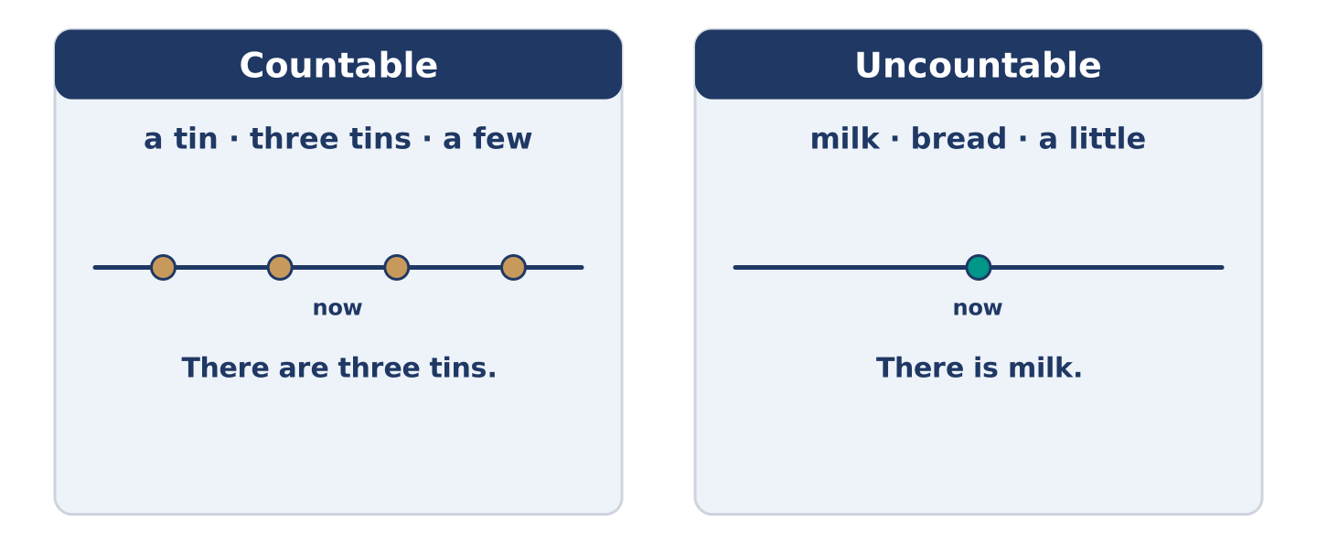
Figure 4.5 · Countable or uncountable: which words go with which.
 | Form | Use | Example
Countable | a tin · three tins | things you can count one by one | There are three tins.
Uncountable | milk · bread · rice | things you measure, never a | There is milk.
a few / a little | a few + countable, a little + uncountable | a small amount | a few eggs · a little cheese
a / an / the | a first time, the after that | which one we mean | a bakery → the bakery
Remember: say a bottle of milk, not a milk. The container is countable.
Watch out! ✗ I want a bread. → ✓ I want some bread. (bread is uncountable). ✗ There are a little tins. → ✓ There are a few tins. (tins are countable).
Part 2: Controlled Practice
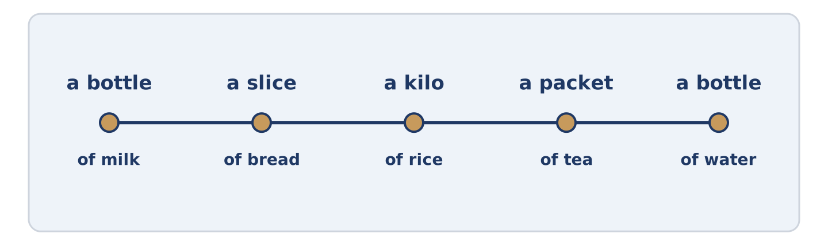
Figure 4.6 · One basket: what you count, and what you measure.
Write a, an, some or the. (0. is done.)
- Amina sells some cheese, but not much.
- Dani wants ______________________ onion for the rice.
- There is ______________________ milk in the fridge at the back.
- Yuki buys ______________________ bottle of water every morning.
- She keeps ______________________ receipt in her pocket.
Part 2: A Few or A Little?
Choose the correct words. (0. is done.)
- There are a few tins on the shelf. (a few / a little)
- Amina sells ______________________ (a few / a little) eggs every day.
- Put ______________________ (a few / a little) sugar in the tea.
- Dani has ______________________ (a few / a little) money until Friday.
- There are ______________________ (a few / a little) slices of bread left.
Part 2: Correct the Sentence
Each sentence has one grammar mistake. Write the correct sentence.
- I would like a bread, please.
- There are a little onions in the basket.
- Amina sells a few cheese and a lot of bread.
- Yuki buys a water every morning.
Part 2: Freer Practice
Write two sentences about your kitchen: one countable food, one uncountable.
Part 2: Grammar Review
Choose the correct sentence.
1. Which sentence is correct in a shop?
○ A) I want a bread, please.
○ B) I want some bread, please.
○ C) I want a few bread, please.
○ D) I want breads, please.
2. Which sentence counts correctly?
○ A) There are a little tins on the shelf.
○ B) There is a few tins on the shelf.
○ C) There are a few tin on the shelf.
○ D) There are a few tins on the shelf.
→ Harvest: you will see a few, a little and the articles again in the Part 5 reading. Watch for them.
Part 3 · Listening
[CORE] Core track · pre-class input · scripts printed inline
Part 3: In the Corner Shop Again
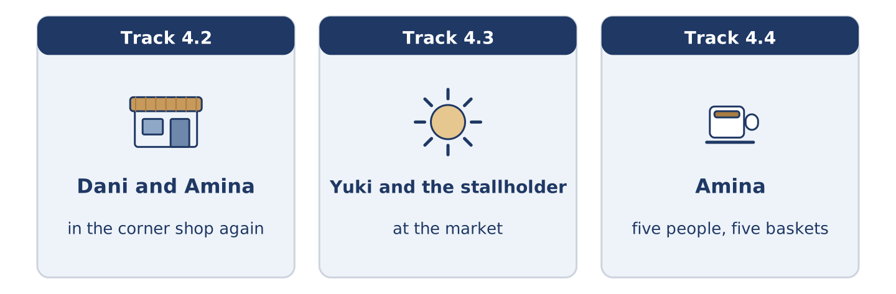
Figure 4.7 · The three listenings: who is speaking, and what about.
🔊 Audio Track 4.2
Before you listen: what do you say when a shop does not have what you want?
Dani: Have you got any rice? Amina: A little. It’s at the back, behind the tins. Dani: And eggs? Amina: A few. Six, I think. Dani: I’ll take four. Amina: Take six. You always come back on Wednesday for the other two. Dani: That’s true. Amina: And there’s fresh bread. It’s still warm. Dani: Then I’ll take that as well, and I came in for rice.
While you listen: write True, False, or Not Given. (0. is done.)
- Dani wants rice. — True
- There are a lot of eggs. ____
- The bread is fresh. ____
- Dani comes in every Wednesday. ____
Useful phrases: Have you got any…? · A little · A few · I’ll take…
Part 3: At the Market
🔊 Audio Track 4.3
Before you listen: how do you ask for an amount at a market?
Yuki: How much are the tomatoes? Stallholder: Two a kilo. How many do you want? Yuki: Half a kilo, please. And a little parsley. Stallholder: Parsley’s free with the tomatoes. Anything else? Yuki: Some lemons. Three. Stallholder: That’s three fifty. Yuki: Here’s five. Stallholder: And there’s your change and your receipt. Mind the bag — the lemons are at the bottom.
While you listen: answer the questions. (0. is done.)
- What does Yuki ask about first? — The tomatoes.
- How much are the tomatoes a kilo?
- What is free with the tomatoes?
- How much change does Yuki get?
Part 3: Five People, Five Baskets
🔊 Audio Track 4.4
Before you listen: what does somebody’s shopping tell you about them?
Amina: You learn a lot from a basket. Maya buys fruit and coffee and nothing that needs cooking. Tomas buys a lot of rice and a lot of tins, because he eats at four in the morning. Dani buys for one meal and comes back tomorrow; he has no fridge worth the name. Mr Okonkwo buys the same seven things every Friday, and the year before that as well. Yuki buys things I do not sell, asks me where to find them, and then brings me some to taste.
While you listen: match each person with their basket. One basket is not needed. (0. is done.)
- Amina → she watches the baskets.
Useful phrases: ___ buys… · a lot of… · nothing that…
Column A
1. | Maya | ____
2. | Tomas | ____
3. | Mr Okonkwo | ____
4. | Yuki | ____
Column B
a) | a lot of rice and a lot of tins
b) | the same seven things every Friday
c) | fruit and coffee, nothing to cook
d) | one meal, and back tomorrow
e) | things the shop does not sell
Part 4 · Speaking
[CORE] Core track · in-class output
Part 4: Talking About Food
Work with a partner. Ask and answer these questions.
- How often do you shop for food, and where?
- What is always in your kitchen, and what do you never buy?
- Is there a food from your country that is hard to find here?
Useful language: I buy… every… · There is always… · There is not much… · a few… · a little…
Part 4: Find the Difference (pairwork)
Student A and Student B each have a shopping basket. Ask questions and find three differences.
Useful questions: How many eggs are there? · Is there any bread? · How much milk have you got? · What is at the bottom?
Student A — your basket: six eggs · fresh bread · a little milk · three lemons.
Student B — your basket: six eggs · no bread · a lot of milk · one lemon.
Part 4: At the Market
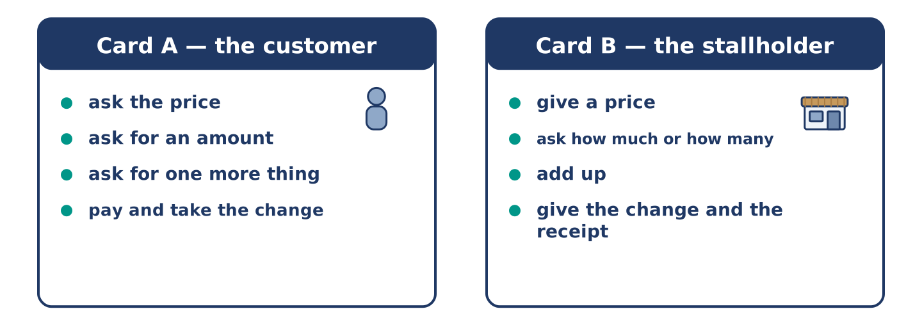
Figure 4.8 · Card A and Card B: what each of you has to say.
Work in pairs. Read the model, then use the cards.
Model exchange:
A: How much is the cheese? — B: Four a kilo. How much do you want? — A: A little. A quarter of a kilo. — B: Anything else? — A: A few tomatoes. Six. — B: That’s five twenty. — A: Here’s six. — B: And your change. Keep the receipt.
Useful language: How much is…? · How many do you want? · A little · A few · Anything else? · Here’s…
Card A — the customer: ask the price · ask for an amount · ask for one more thing · pay and take the change.
Card B — the stallholder: give a price · ask how much or how many · add up · give the change and the receipt.
Your turn: run the dialogue, then swap roles.
Stretch [PLUS]: the customer has not got enough money — take something out of the basket, politely.
Part 4: Mini-Presentation
Prepare a short talk (about one minute). Describe one meal you cook: what you need a lot of, what you need a little of, and who you cook it for.
Part 5 · Reading
[CORE] Core track · pre-class input
Part 5: What a Small Shop Is For
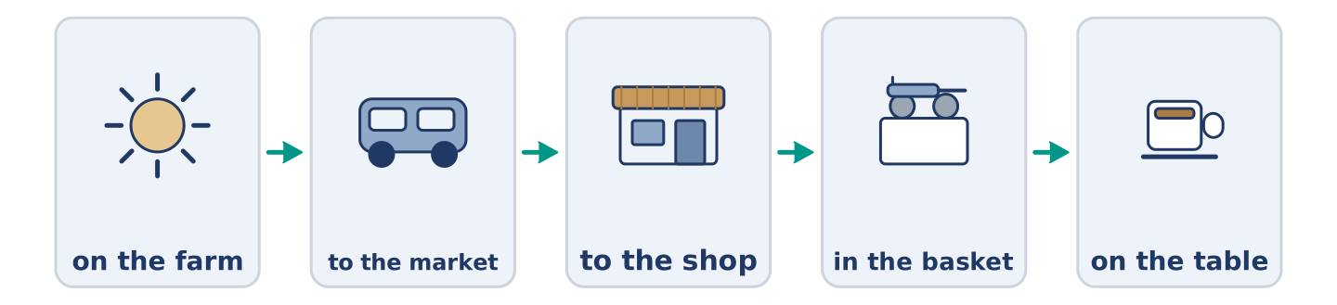
Figure 4.9 · From the farm to the basket, step by step.
Before you read: why do small shops stay open when big ones are cheaper?
Gloss: supermarket = a very big food shop · stock = the things a shop has to sell · credit = buying now and paying later
A small shop cannot win on price. A supermarket buys ten thousand bottles of milk and a corner shop buys thirty. So the corner shop pays more for each one. It cannot win on choice either: there is one kind of rice, not eleven. What a small shop has is everything else. It is open when you need one thing at seven in the morning. It knows your name, and sometimes it knows you are good for it until Friday. That is a kind of credit no supermarket offers. It carries the stock the street actually eats. The street says what that is, slowly, by buying and not buying. Amina says the shop is not really a shop. It is a list of what four hundred people want, written down in boxes.
Answer the multiple-choice questions. (0. is done.)
- Can a small shop win on price? — No, it cannot.
1. Why does a corner shop pay more for each bottle of milk?
○ A) Because the milk is fresher
○ B) Because it buys only thirty
○ C) Because the shop is small
○ D) Because it opens early
2. What kind of credit does a small shop offer?
○ A) A card you pay with
○ B) Cheaper prices on Friday
○ C) Knowing that you will pay later
○ D) Free bread for neighbours
3. What does Amina say the shop really is?
○ A) A list of what four hundred people want
○ B) A small supermarket
○ C) A place to meet people
○ D) A business that cannot win
Part 5: Vocabulary in Context
Match each word from the text with its meaning. One meaning is not needed. Write the letter.
Column A
1. | supermarket | ____
2. | stock | ____
3. | credit | ____
4. | choice | ____
Column B
a) | the things a shop has to sell
b) | buying now and paying later
c) | a very big food shop
d) | how many different things you can pick from
e) | the paper that shows what you paid
Part 5: Breakfast Around the World
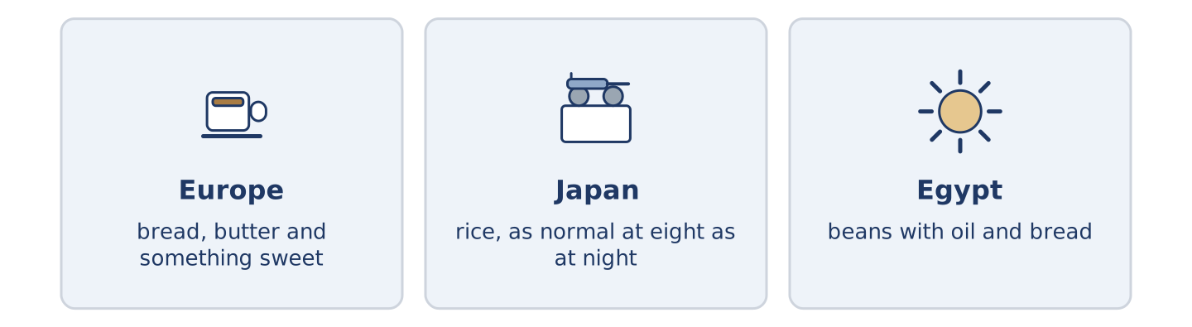
Figure 4.10 · The first meal of the day in three places.
Before you read: what do you eat in the first hour of the day?
Gloss: savoury = salty, not sweet · staple = the food people eat most days
Breakfast is the meal that travels worst. In much of Europe it is sweet: bread, butter, something with sugar in it, and coffee. In Japan it is often savoury, and rice is as normal at eight in the morning as at eight at night. In Egypt a common breakfast is beans with oil and bread. It is a staple, it costs very little, and it keeps you going until the afternoon. Visitors find other people’s breakfasts stranger than other people’s dinners. The first meal is the one we learn first, and we never quite stop expecting it.
Answer the questions. (0. is done.)
- Which meal does the text say travels worst? — Breakfast.
- What is a common breakfast in much of Europe?
- What is as normal at eight in the morning as at night in Japan?
- What does the Egyptian breakfast do until the afternoon?
Part 6 · Writing
[CORE] Core track · in-class / homework
Part 6: Describe a Meal You Cook (50–70 words)
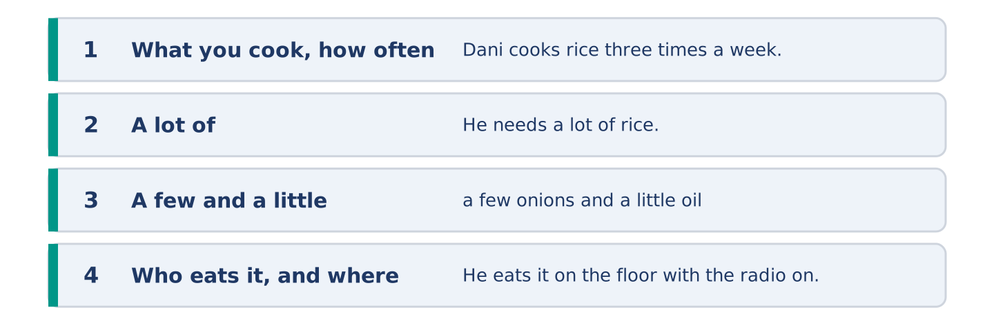
Figure 4.11 · The shape of the paragraph you are about to write.
Describe one meal. Say what you need a lot of, what you need a little of, and who eats it.
Model — read this first:
Dani cooks rice with onions about three times a week. He needs half a kilo of rice, a few onions and a little oil, and that is almost everything. He adds some tomatoes if Amina has them. It takes half an hour, and he eats it on the floor with the radio on, because there is only one chair in the flat. (62 words)
Plan (fill in, then write): I cook ___ about ___ a week. I need a lot of ___, a few ___ and a little ___. It takes ___. I eat it ___.
Word bank: a lot of | a few | a little | some | there is | there are
Check before you finish: ☐ one countable food with a few? ☐ one uncountable food with a little? ☐ who eats it? ☐ 50–70 words?
Part 6: Small Shop or Big Shop? (50–70 words)
Where is it better to buy food — a small shop or a big one? Give your opinion and two or three reasons.
Model — read this first:
I buy most things in the big shop, because it is cheaper and there is more choice. But I buy bread and milk at the corner, because they are fresh and because the big shop is twenty minutes away. In my opinion the answer is both, and the corner shop is the one I would miss. (56 words)
Word bank: I think… because… | cheaper | more choice | however | in my opinion
Check before you finish: ☐ a clear opinion? ☐ two or three reasons? ☐ 50–70 words?
Part 6: A Shopping Message (50–70 words)
Somebody is going to the shop for you. Write them a short message: what to buy, how much, and what to do if there is none.
Model — read this first:
Hi Tomas, if you are passing Amina’s, could you get a few things? A kilo of rice, half a litre of milk and a little cheese — any kind. There are usually eggs; six if there are six. If there is no cheese, do not worry. Keep the receipt. I can pay you tonight. Maya (55 words)
Plan (fill in, then write): If you are passing ___, could you get ___? A ___ of ___, and a little ___. If there is no ___, ___. ___
Check before you finish: ☐ three things with amounts? ☐ what to do if there is none? ☐ polite? ☐ 50–70 words?
Part 6: Reflection — A Food I Miss (40–60 words)
Write about a food you cannot easily buy where you are now.
Model — read this first:
I cannot buy good tomatoes here between November and May. There are tomatoes in every shop, but they taste of water. At home we ate them with salt and bread and nothing else, and that is not a dish you can make with a bad tomato. (46 words)
Check before you finish: ☐ the food named? ☐ why it is hard to find? ☐ what you did with it? ☐ 40–60 words?
Part 7 · Real-World File — Shopping and Money
[PLUS] Plus track (optional) · stronger learners
7A: Phrase Bank
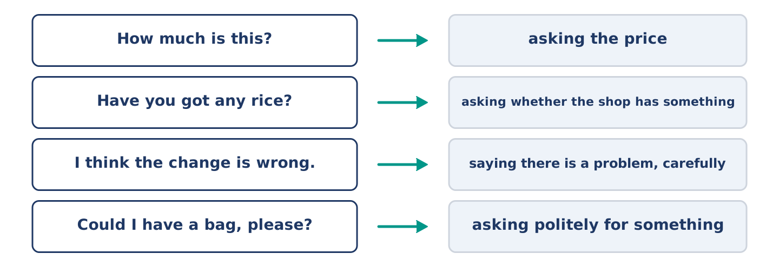
Figure 4.12 · What you say in a shop, and what each thing does.
Match what a person says with its purpose. One purpose is not needed. Write the letter.
Column A
1. | “How much is this?” | ____
2. | “Have you got any rice?” | ____
3. | “I think the change is wrong.” | ____
4. | “Could I have a bag, please?” | ____
Column B
a) | asking whether the shop has something
b) | asking politely for something
c) | asking the price
d) | saying there is a problem, carefully
e) | asking where the aisle is
7B: A Problem at the Till
🔊 Audio Track 4.5
Before you read: what do you do when a price is wrong?
Yuki: Sorry — I think the change is wrong. Assistant: Let me look. What did you give me? Yuki: A twenty. And it was eleven forty. Assistant: And I gave you… ah. I gave you change from a ten. I am sorry. Yuki: It is easy to do. Assistant: Here is the rest. Ten. Do check the receipt as well — the tomatoes went through twice. Yuki: So they did. Thank you for looking.
Answer the questions. (0. is done.)
- What does Yuki think is wrong? — The change.
- How much did Yuki give?
- What mistake did the assistant make?
- What else was wrong on the receipt?
7C: Controlled Practice — When Something Is Wrong
Put the steps in order. Number them 1–5. (0. is done.)
- Say politely that you think there is a problem. — 1
____ Thank them.
____ Say what you gave and what it cost.
____ Wait while they check.
____ Take the right change.
7D: Role-Play — Sorting It Out
In pairs. One is the customer; one works at the till. Use the model and cards.
Model exchange: A: Sorry — I think the change is wrong. — B: Let me look. What did you give me? — A: A twenty, and it was eleven forty. — B: Ah. I gave you change from a ten. I am sorry. — A: It is easy to do. — B: Here is the rest.
Card A — the customer: say there is a problem, politely · say what you gave · wait · thank them.
Card B — the assistant: ask what they gave · check · say sorry · put it right.
Stretch [PLUS]: the assistant is sure there is no mistake — stay polite and ask them to check once more.
7E: Writing — A Message About a Receipt (50–80 words)
You got home and found a mistake on your receipt. Write a short message to the shop.
Model — read this first:
Good afternoon. I shopped at your till at about half past five today and then I looked at my receipt. The tomatoes went through twice, so I paid two forty too much. I am not worried about it, but I am in most mornings and I can come by. Could you put it right when I do? Thank you. Yuki Tanaka, flat 5 (63 words)
Check before you finish: ☐ when you shopped? ☐ what the mistake is? ☐ how much? ☐ a calm tone? ☐ 50–80 words?
Part 8 · Global Story — The Shop With No Prices
[PLUS] Plus track · pre-read / discuss
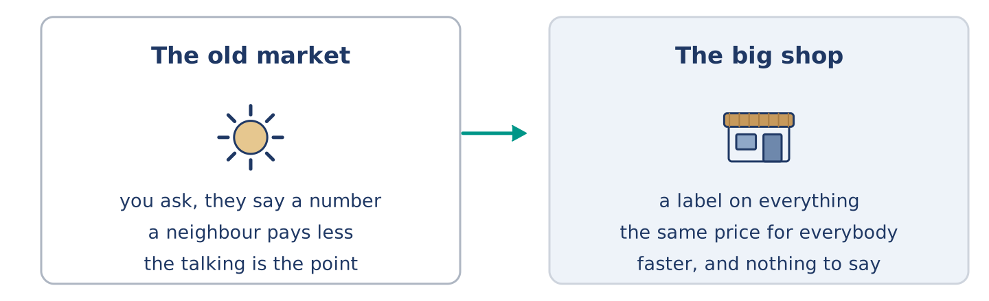
Figure 4.13 · The old market and the new one.
Before you read: can a shop work without a price on anything?
Gloss: haggle = to argue about a price until both people agree · fixed price = a price that does not change · label = a small paper with the price on it
In an old market in Fez, in Morocco, almost nothing has a price on it. You ask, the seller says a number, you say another number, and somewhere between the two you both stop. Visitors hate this. They want a label. But the system is older than labels and it does something a label cannot: it sets a different price for a different buyer. A neighbour pays less than a stranger. A family buying for a wedding pays less for more. The fixed price arrived with big shops, because a shop with four hundred products and six assistants cannot haggle four hundred times a day. It was faster. It was fairer in one way and less fair in another, and almost nobody noticed what we gave up. In Fez, they say the number is not the point. The talking is.
Answer the questions. (0. is done.)
- Where is the market? — In Fez, in Morocco.
- What do visitors want that the market does not have?
- Who pays less in that market?
- Why did big shops need a fixed price?
Part 8: Vocabulary in Context
Match each word with its meaning. One meaning is not needed. Write the letter.
Column A
1. | haggle | ____
2. | fixed price | ____
3. | label | ____
4. | stranger | ____
Column B
a) | a small paper with the price on it
b) | a price that does not change
c) | somebody you do not know
d) | to argue about a price until both people agree
e) | the things a shop has to sell
Part 8: Discussion
Talk with a partner. Use the frames.
Discussion frames: “This is similar to where I live because…” · “This is different from where I live because…” · “I think the most important thing is… because…”
Part 9 · Close to Home — The Book Under the Till
[PLUS] Plus track · pre-read / decide
Before you read: should a shop let people pay later?
There is a notebook under Amina’s till, and it is older than the till. In it there are names and small numbers. Nobody calls it credit. A man with no money until Friday takes bread and milk. Amina writes two eighty next to his name, and on Friday she crosses the line out. It works because the street is small and because almost everybody comes back. Almost. Twice in eleven years somebody moved away without paying. Both times Amina closed the page and said nothing to anybody. Her son thinks the book is a bad idea and wants her to stop. He is probably right about the money. He is wrong about what the book is for, and she cannot find the words to tell him.
Answer the questions. (0. is done.)
- Where is the notebook? — Under Amina’s till.
- What does Amina write in the notebook?
- What happened twice in eleven years?
- What does Amina’s son want?
Part 9: Decision Task
You run a small shop. Should you (a) keep a book like Amina’s, (b) stop it and take only money, or (c) keep it but only for people you have known a long time? Decide and explain. Use the frame.
Answer frame: “I think I should ___ because ___. Also, ___. This is better than ___ because ___.”
Model — read this first:
I think I should keep the book, because it costs very little. It is why people come to me and not to the big shop. Also, two bad weeks in eleven years is not very many. This is better than stopping it. The day I stop, the shop is the same as every other shop, only smaller. (57 words)
Phrase bank: I think I should… · because… · Also,… · This is better than… · In my opinion…
Part 10 · Review and Can-Do
[CORE + PLUS] · homework / self-study
Part 10: Spiral Review
Complete the review. (0. is done.)
- The paper that shows what you paid is the receipt.
Word bank: basket | aisle | fresh | change | a few | a little | timetable | balcony
- A light open bag you fill while you walk round is a ______________________ .
- The long space between two lines of shelves is an ______________________ .
- Bread made this morning is ______________________ .
- The money you get back when you pay too much is your ______________________ .
- There are ______________________ eggs left — four or five.
- Put ______________________ sugar in the tea, not much.
- (from Unit 3) A list of the times buses come is a ______________________ .
- (from Unit 2) A small outside floor with a wall is a ______________________ .
Part 10: Can-Do
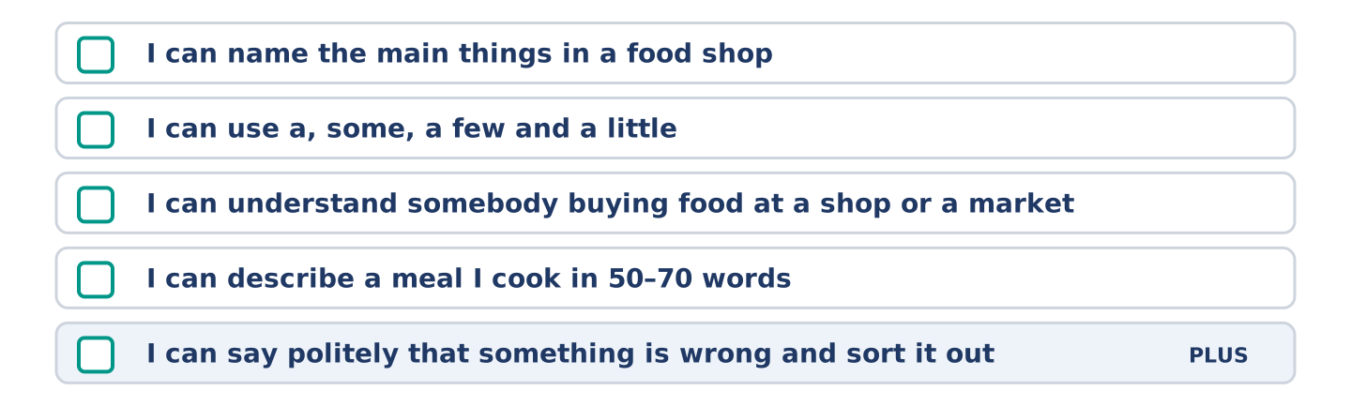
Figure 4.14 · What you can do at the end of this unit.
Can-Do checklist
☐ I can name the main things in a food shop.
☐ I can use countable and uncountable nouns with a, some, a few and a little.
☐ I can understand somebody buying food at a shop or a market.
☐ I can describe a meal I cook in 50–70 words.
☐ I can say politely that something is wrong and sort it out (Plus).
Part 10: Glossary
Unit 4 glossary (10 words)
basket · aisle · receipt · fridge · weigh · fresh · slice · bottle · kilo · sugar
Unit 5: Last Weekend
English for Daily Life · Level: A2 · Tracks: [CORE] Warm-Up + Parts 1–6 · [PLUS] Parts 7–10
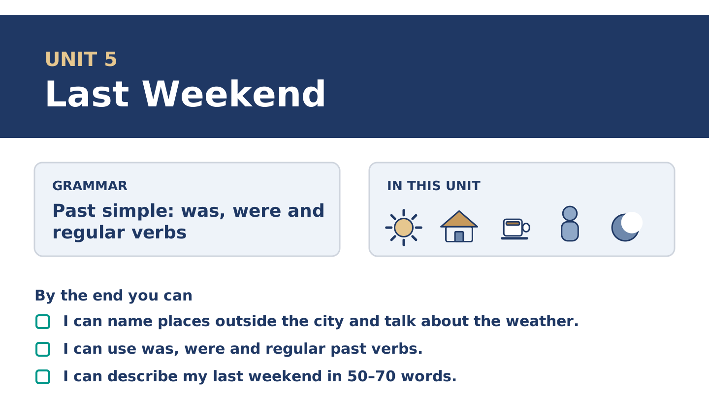
Figure 5.1 · Unit 5 at a glance: the grammar, the topic and what you will be able to do.
Warm Up
[CORE] Core track · in-class starter
Warm-up: Weekend Words and Meanings
Match the words with their meanings. One meaning is not needed. Write the letter.
Column A
1. | Museum | ____
2. | Picnic | ____
3. | Concert | ____
4. | Guest | ____
5. | Trip | ____
Column B
a) | a short journey to a place and back
b) | a meal you eat outside, sitting on the ground
c) | a building where you look at old or beautiful things
d) | a visitor to your home, for a short time
e) | an evening where people play music for other people
f) | the paper that shows what you paid
Warm-up: Talking About the Weekend
Complete the sentences using the words in the word bank.
Word bank: cinema | lake | sunny | rested
- On Saturday it was ______________________ , so everybody was outside.
- Dani went to the ______________________ and fell asleep in the film. On Friday he wanted a concert and the tickets were gone.
- Maya walked round the ______________________ in the park with Yuki.
- Tomas ______________________ all day, because he worked four nights.
Warm-up: Alder Street on Sunday
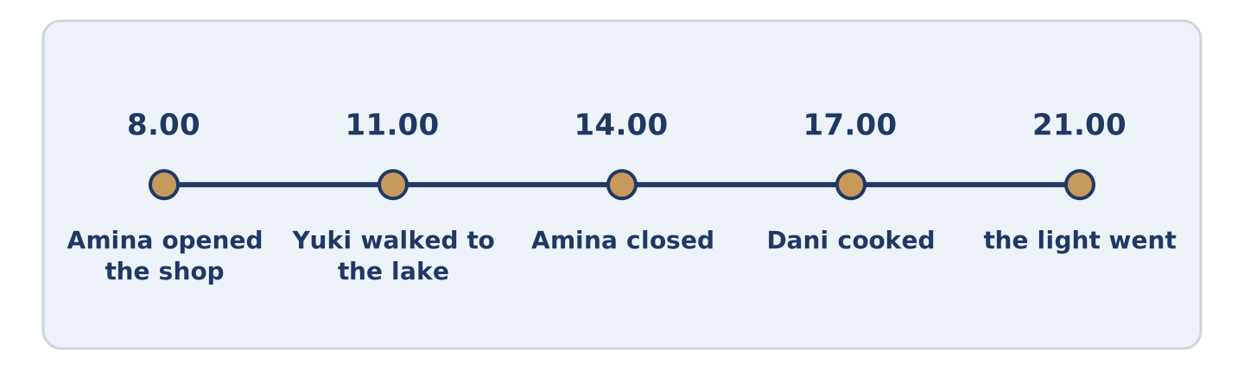
Figure 5.2 · Alder Street last Sunday, hour by hour.
Read the text and choose the correct answer.
Last Sunday was warm. Amina opened the shop at eight and closed it at two, which she only does in summer. Mr Okonkwo carried a chair outside and stayed there until the light went. Amina watched him from her door and said she envied him. Dani cooked for four people and three of them came. The fourth sent a message at nine. Yuki walked to the lake and photographed a bird. She could not name it. It was a quiet Sunday, and nobody remembers it now. That is most of what a Sunday is for.
1. What time did Amina close the shop?
○ A) At two
○ B) At four
○ C) At eight
○ D) She did not close
2. How many people came to Dani’s?
○ A) Four
○ B) Nobody
○ C) Two
○ D) Three
Part 1 · Vocabulary and Terminology
[CORE] Core track · pre-class input
Part 1: Weekend and Weather Terms
Match the words with their meanings. One meaning is not needed. (0. is done for you.)
- Countryside → the land outside towns, with fields, trees and few buildings.
Column A
1. | Beach | ____
2. | Forest | ____
3. | Village | ____
4. | Path | ____
5. | Windy | ____
6. | Cloudy | ____
7. | Guest | ____
Column B
a) | a narrow way you walk along, not a road
b) | the sand or stones beside the sea
c) | a very small town
d) | with a lot of trees close together
e) | with a strong moving air
f) | with grey sky and no sun
g) | a visitor to your home, for a short time
h) | a meal you eat outside
Gloss: path = a narrow way you walk along · countryside = the land outside towns · village = a very small town
Part 1: Pronunciation
🔊 Audio Track 5.1
Listen and practise the -ed ending. Say each pair aloud.
walked — /t/
cooked — /t/
stayed — /d/
opened — /d/
rested — /ɪd/
waited — /ɪd/
Then listen again. The -ed ending has three sounds and only one spelling. After /t/ or /d/ it becomes a whole new beat: rested is two beats, waited is two. Everywhere else it is a single sound stuck on the end, and walked is still one beat.
Part 1: Six Places People Went
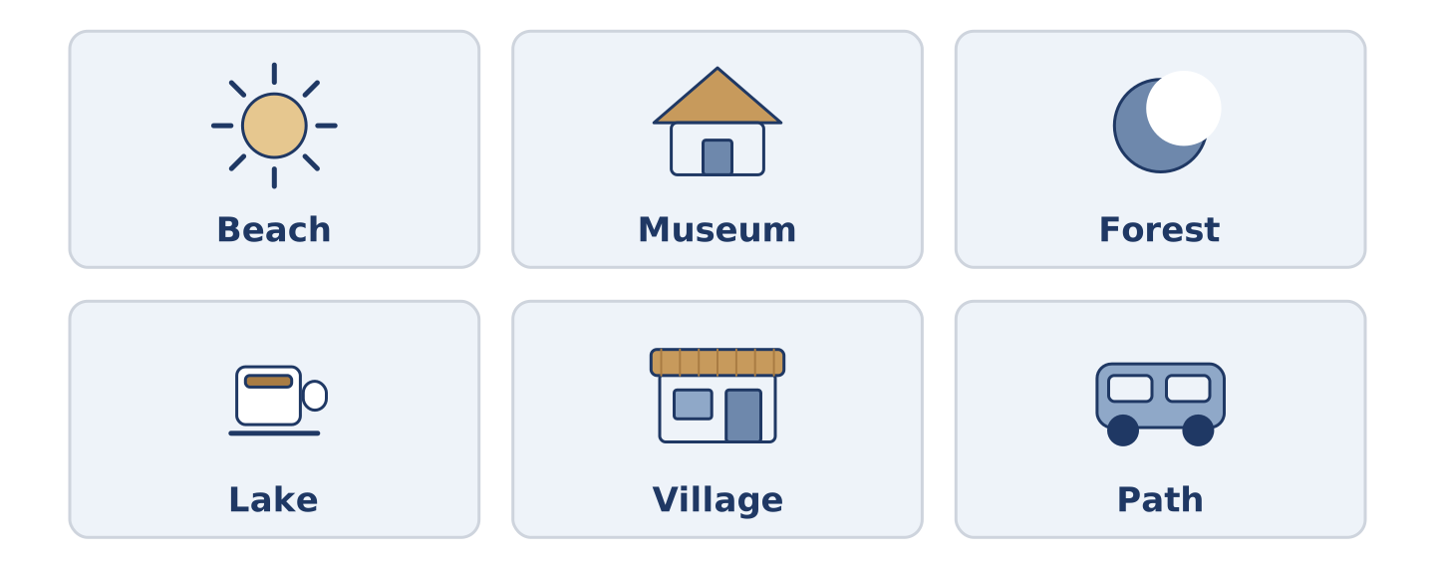
Figure 5.3 · Six places and what people did there.
Complete the table. Write what you do there and the weather you want for it. (0. is done.)
Place | What you do there | Weather you want
Beach | swim, sit, eat | (example)
Museum
Forest
Lake
- Beach — swim, sit, eat — sunny and not windy.
Think about a weekend you remember. Some places need weather and some do not. There is more than one right answer, and you should be ready to say why you chose yours.
Part 1: Out of the City
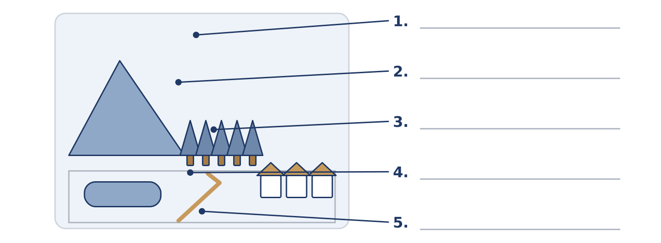
Figure 5.4 · Out of the city — write the correct word on each line.
Match the things outside a city with their descriptions. One description is not needed. Write the letter.
Column A
1. | Hill | ____
2. | Lake | ____
3. | Forest | ____
4. | Path | ____
5. | Village | ____
Column B
a) | a narrow way you walk along
b) | high ground, lower than a mountain
c) | a very small town
d) | water with land all round it
e) | the sand beside the sea
f) | a lot of trees close together
Part 1: The Weekend — Multiple Choice
Read and choose the correct answer.
1. A meal you eat outside, sitting on the ground, is a…
○ A) picnic
○ B) concert
○ C) trip
○ D) museum
2. Water with land all round it is a…
○ A) beach
○ B) path
○ C) lake
○ D) forest
3. Somebody who comes to your home for a short time is a…
○ A) village
○ B) hill
○ C) picnic
○ D) guest
Part 1: Vocabulary Fill-in
Complete the sentences with the correct word.
Word bank: museum | picnic | windy | path
- It was too ______________________ for the beach, so they went to the forest.
- The ______________________ was free on Sunday, so it was full of families. Last month there was a concert there.
- They carried the ______________________ up the hill and ate it at the top.
- The ______________________ was wet, and Dani walked into the lake.
Part 1: Write About Last Weekend (short)
Write two or three sentences about last weekend. Use three words from this unit.
Model — read this first:
On Saturday it was cloudy, so I stayed at home and cooked. Cloudy days suit me. On Sunday the sun arrived and I walked to the lake with two friends. We carried a picnic and ate it on the grass, and nobody wanted to go home. (46 words)
Part 2 · Grammar — Past Simple: Was, Were and Regular Verbs
[CORE] Core track · pre-class input
Part 2: Notice
Read these lines about last Sunday. Underline the past verbs. Which are was or were?
Last Sunday was warm. Amina opened the shop at eight. Mr Okonkwo carried a chair outside and stayed there all afternoon. The children were noisy by the lake. Dani cooked for four and three people arrived. It was a quiet day.
Was and were say what something was like. The other verbs say what somebody did, and they all end in -ed.
Part 2: Grammar Focus Box
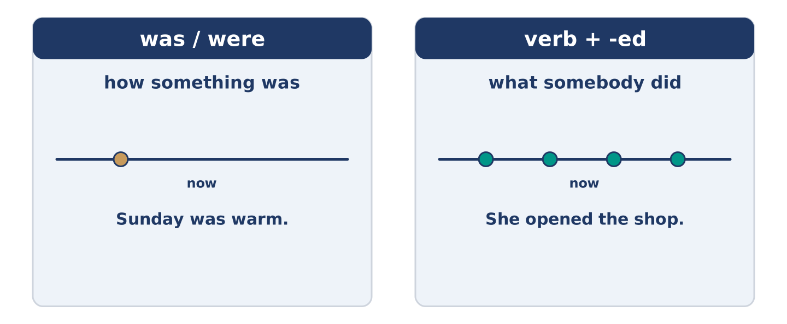
Figure 5.5 · Then and now: the same verbs, one step back.
 | Form | Use | Example
was / were | I/he/she/it was · you/we/they were | how something was | Sunday was warm.
Regular past | verb + -ed, every person | what somebody did | She opened the shop.
Negative | did not + the plain verb | what did not happen | She did not open.
Question | did + person + plain verb | asking about then | Did she open?
Remember: after did and did not, the verb loses its -ed: did you walk?, not did you walked?
Watch out! ✗ I was walk to the lake. → ✓ I walked to the lake. (one past, not two). ✗ Did you walked? → ✓ Did you walk? (did has the past already).
Part 2: Controlled Practice
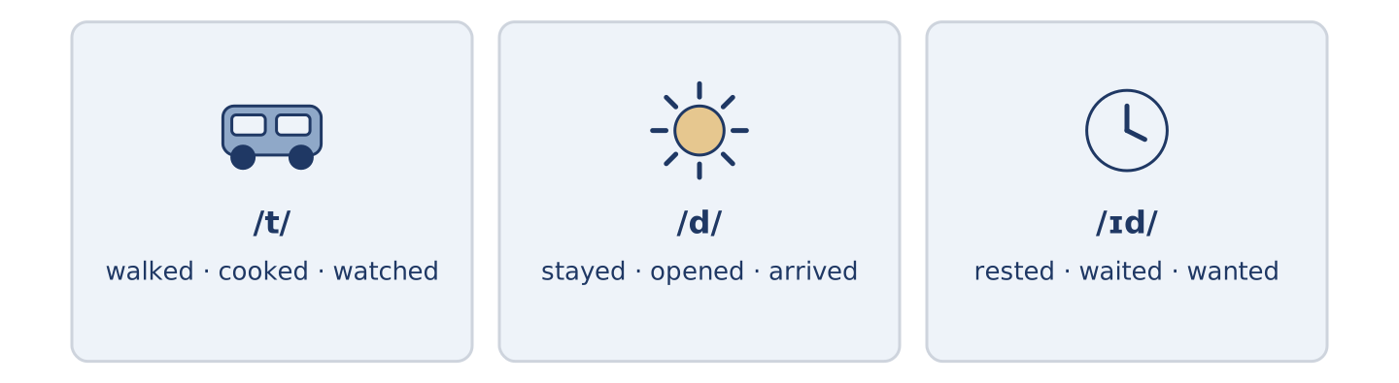
Figure 5.6 · Last Sunday on a line: what happened, and when.
Write the past simple. (0. is done.)
- Amina opened the shop at eight. (open)
- Mr Okonkwo ______________________ (carry) a chair outside.
- The children ______________________ (be) noisy by the lake.
- Dani ______________________ (cook) for four people.
- It ______________________ (be) a quiet Sunday.
Part 2: Was, Were or -ed?
Choose the correct form. (0. is done.)
- Last Sunday was warm. (was / were)
- The children ______________________ (was / were) by the lake all afternoon.
- Yuki ______________________ (walked / was walk) to the lake and back.
- The path ______________________ (was / were) wet after the rain.
- Three people ______________________ (arrived / was arrive) at Dani’s.
Part 2: Correct the Sentence
Each sentence has one grammar mistake. Write the correct sentence.
- I was walk to the beach on Saturday.
- Did you walked to the lake?
- The children was noisy all afternoon.
- Dani not cooked on Sunday.
Part 2: Freer Practice
Write two sentences about your own last weekend: one with was or were, one with an -ed verb.
Part 2: Grammar Review
Choose the correct past-simple sentence.
1. Which sentence is a correct question?
○ A) Did you walked to the lake?
○ B) Did you walk to the lake?
○ C) You did walk to the lake?
○ D) Did you walking to the lake?
2. Which sentence is correct about the weather?
○ A) Sunday was warm.
○ B) Sunday was warmed.
○ C) Sunday warmed.
○ D) Sunday were warm.
→ Harvest: you will see the past simple again in the Part 5 reading. Watch for the -ed endings.
Part 3 · Listening
[CORE] Core track · pre-class input · scripts printed inline
Part 3: What Did You Do?
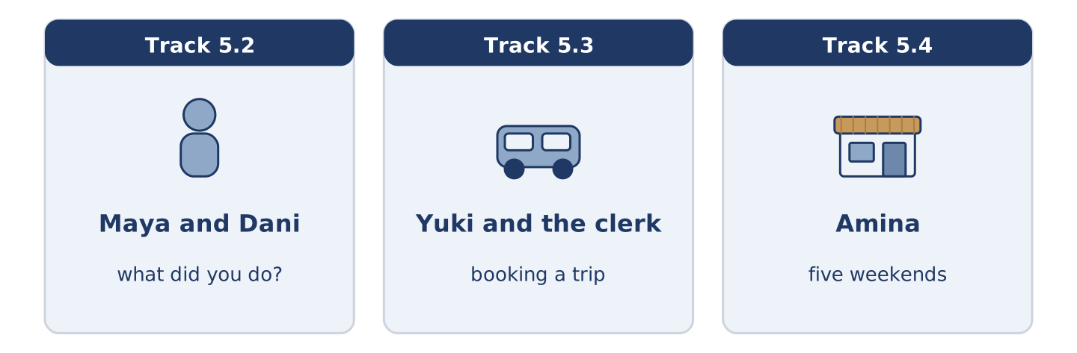
Figure 5.7 · The three listenings: who is speaking, and what about.
🔊 Audio Track 5.2
Before you listen: what is the first question people ask on a Monday?
Maya: So what did you do? Dani: Nothing. I cooked for four people and three of them turned up. Maya: That’s not nothing. Dani: It was a lot of rice. What about you? Maya: I walked to the lake with Yuki. It was windy, but it was warm. Dani: Did you swim? Maya: In November? No. One man did swim. We watched, and we decided he was braver than us.
While you listen: write True, False, or Not Given. (0. is done.)
- Dani cooked for four people. — True
- Three people came to Dani’s. ____
- Maya and Yuki swam in the lake. ____
- Maya goes to the lake every weekend. ____
Useful phrases: What did you do? · It was… · Did you…? · That’s not nothing.
Part 3: Booking a Trip
🔊 Audio Track 5.3
Before you listen: what do you ask before you book a day trip?
Yuki: I wanted to ask about the Saturday trip. Did it run last week? Clerk: No, it did not. The weather was terrible. Yuki: And this Saturday? Clerk: It looks fine. We start at eight and we are back at six. Yuki: Is lunch included? Clerk: No. Most people carry a picnic. There is a village halfway with a shop, but it closed in the spring. Yuki: Then I carry one. Two places, please.
While you listen: answer the questions. (0. is done.)
- Which trip is Yuki asking about? — The Saturday trip.
- Why did last week’s trip not run?
- What time does the trip come back?
- What happened to the shop in the village?
Part 3: Five Weekends
🔊 Audio Track 5.4
Before you listen: how different are five people’s weekends in one building?
Amina: Five flats, five weekends. Maya walked to the lake and came back cold and pleased. She says she wants to go again, and that her sister wants to come too. Tomas worked Friday, Saturday and Sunday nights, and slept through all the daylight there was. Maya said she heard him come in at six. Dani cooked too much and invited too few. Amina says she knew it before he started. Mr Okonkwo sat outside with a chair and a newspaper and talked to everybody. Yuki photographed a bird and then spent an hour looking it up.
While you listen: match each person with their weekend. One weekend is not needed. (0. is done.)
- Amina → she watched all of it from the shop.
Useful phrases: ___ walked… · ___ worked… · ___ sat outside and…
Column A
1. | Maya | ____
2. | Tomas | ____
3. | Mr Okonkwo | ____
4. | Yuki | ____
Column B
a) | worked three nights and slept through the day
b) | sat outside and talked to everybody
c) | walked to the lake and came back cold
d) | travelled to another city by train
e) | photographed a bird and looked it up
Part 4 · Speaking
[CORE] Core track · in-class output
Part 4: Talking About Last Weekend
Work with a partner. Ask and answer these questions.
- What did you do last weekend? Was it a normal one?
- What was the weather like? Did it change your plans?
- What did you want to do and not do?
Useful language: I walked… · It was… · We decided to… · I wanted to… but… · Did you…?
Part 4: Find the Difference (pairwork)
Student A and Student B each had a different Saturday. Ask questions and find three differences.
Useful questions: Where did you go? · What was the weather like? · Who did you go with? · What time did you come back?
Student A — your Saturday: the lake · windy but warm · with a friend · back at six.
Student B — your Saturday: the lake · windy and cold · alone · back at six.
Part 4: Telling the Story
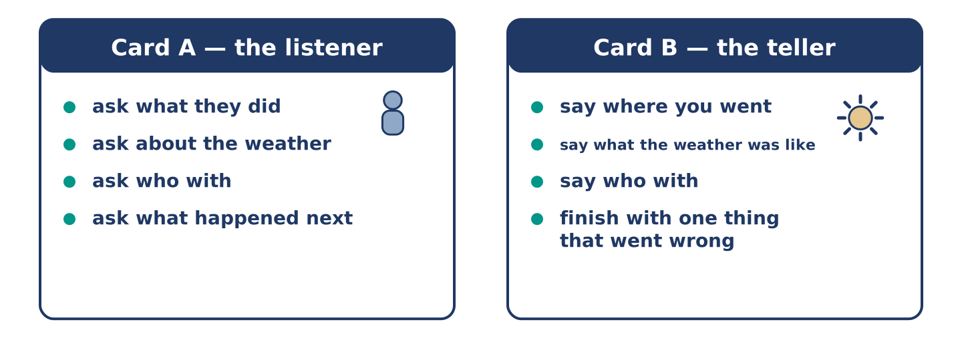
Figure 5.8 · Card A and Card B: what each of you has to say.
Work in pairs. Read the model, then use the cards.
Model exchange:
A: So what did you do at the weekend? — B: I walked to the lake. It was windy, but it was warm. — A: Did you go alone? — B: No, with Yuki. We carried a picnic and ate it on a bench. — A: And then? — B: Then it rained, and we walked home fast.
Useful language: What did you do…? · I walked… · It was… · Did you…? · And then?
Card A — the listener: ask what they did · ask about the weather · ask who with · ask what happened next.
Card B — the teller: say where you went · say what the weather was like · say who with · finish the story with one thing that went wrong.
Your turn: run the dialogue, then swap roles.
Stretch [PLUS]: the weekend was dull and there is nothing to tell — make two minutes out of it anyway.
Part 4: Mini-Presentation
Prepare a short talk (about one minute). Describe a day out you remember: where you went, what the weather was like, and one thing that did not go to plan.
Part 5 · Reading
[CORE] Core track · pre-class input
Part 5: Who Invented the Weekend
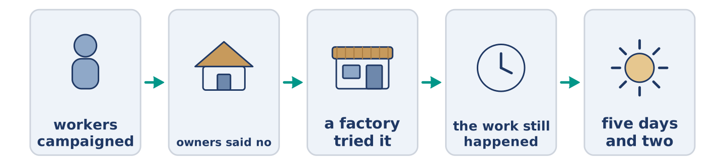
Figure 5.9 · One Saturday, from morning to night.
Before you read: has there always been a weekend?
Gloss: factory = a big building where people make things · campaign = a long effort to change something · agreement = when people decide something together · refuse = to say no
The weekend is not very old. For most of history people rested on one day, and in many places they worked on the other six. The two-day weekend arrived with factories, and it arrived slowly. Workers campaigned for it and owners said no. Then one or two factories tried it. They found something surprising: two rested days produced as much work in five as tired days produced in six. After that the argument changed. In time most of Europe and North America settled on five days and two. Almost nobody now remembers that it was ever a fight. Tomas works nights and sleeps through Saturday. He is a reminder: the weekend was always an agreement, never a fact about the world.
Answer the multiple-choice questions. (0. is done.)
- Is the weekend very old? — No, it is not.
1. How many days did people usually rest for in the past?
○ A) Two
○ B) None
○ C) One
○ D) Three
2. What did one or two factories discover?
○ A) That workers wanted more money
○ B) That six days were better
○ C) That nobody noticed
○ D) That rested workers produced as much in five days
3. What does Tomas remind us of?
○ A) That the weekend was an agreement
○ B) That nights are hard
○ C) That factories were noisy
○ D) That Saturday is the best day
Part 5: Vocabulary in Context
Match each word from the text with its meaning. One meaning is not needed. Write the letter.
Column A
1. | factory | ____
2. | campaign | ____
3. | owner | ____
4. | agreement | ____
Column B
a) | a long effort to change something
b) | the person something belongs to
c) | a big building where things are made
d) | when people decide something together
e) | a narrow way you walk along
Part 5: Days Off Around the World
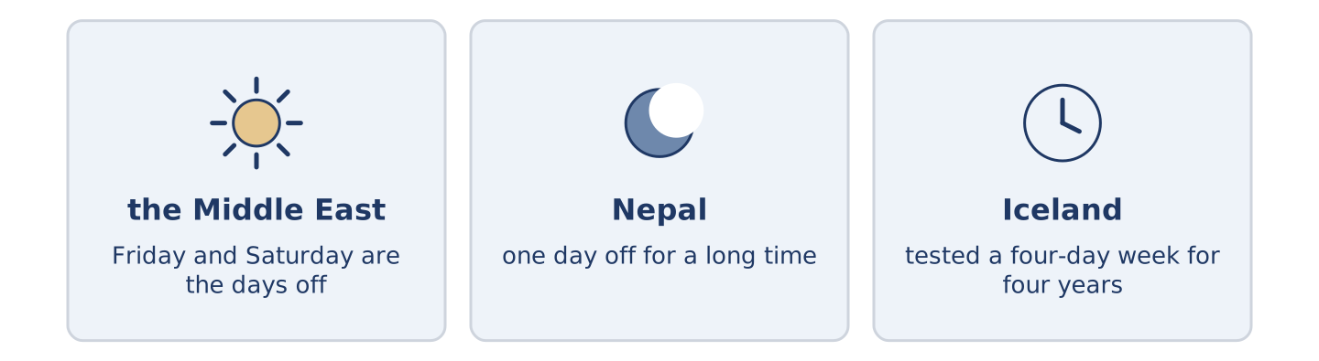
Figure 5.10 · The days off in three places.
Before you read: is the weekend Saturday and Sunday everywhere?
Gloss: day off = a day when you do not work · public holiday = a day when almost everybody is free
The weekend is not Saturday and Sunday everywhere. In much of the Middle East the days off are Friday and Saturday, because Friday is the day of prayer. In Nepal there was one day off for a long time, on Saturday, and the country only added a second recently. Iceland tested a four-day week for four years. The people in the trial did not want to go back. Each country drew its own line between work and the rest of life. Nobody drew the same one.
Answer the questions. (0. is done.)
- Is the weekend Saturday and Sunday everywhere? — No, it is not.
- Which days are off in much of the Middle East?
- How many days off did Nepal have for a long time?
- What did Iceland test, and for how long?
Part 6 · Writing
[CORE] Core track · in-class / homework
Part 6: Describe Last Weekend (50–70 words)
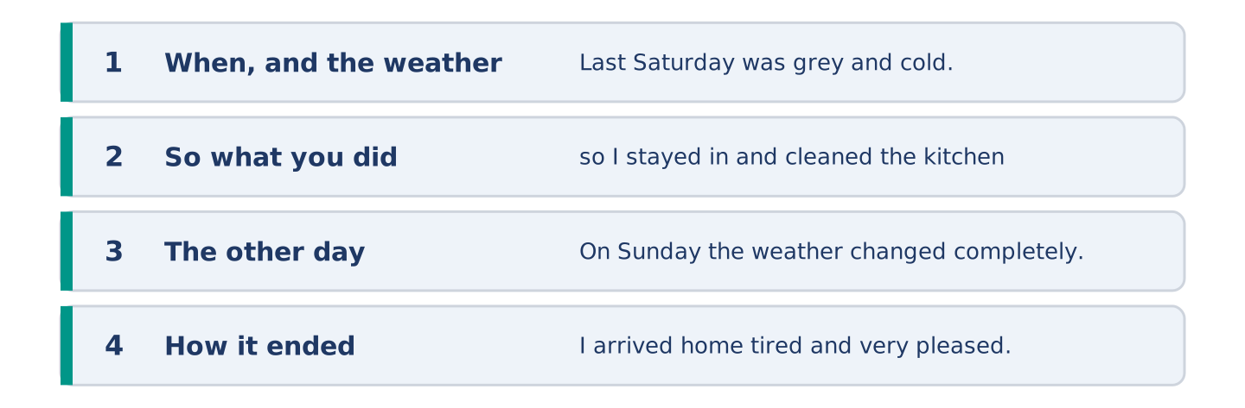
Figure 5.11 · The shape of the paragraph you are about to write.
Describe your last weekend. Say what the weather was like and what you did.
Model — read this first:
Last Saturday was grey and cold, so I stayed in and cleaned the kitchen, which needed it. On Sunday the weather changed completely. I walked to the lake with a friend and we carried a picnic. It was windy on the water and warm out of it, and we stayed until the light went. I arrived home tired and very pleased. (61 words)
Plan (fill in, then write): Last ___ was ___, so I ___. On ___ I ___. It was ___. We ___ until ___. I arrived home ___.
Word bank: was | were | walked | cooked | stayed | arrived
Check before you finish: ☐ one was or were? ☐ three -ed verbs? ☐ the weather? ☐ 50–70 words?
Part 6: The Best Kind of Weekend (50–70 words)
What makes a good weekend? Give your opinion and two or three reasons.
Model — read this first:
A good weekend has one plan in it and nothing else. With two plans in it, I spend Sunday evening tired and cross. One walk, one meal with somebody, and a lot of hours with nothing in them at all. People say they want an exciting weekend. I think they want a calm Monday. (54 words)
Word bank: I think… because… | one plan | too much | however | in my opinion
Check before you finish: ☐ a clear opinion? ☐ two or three reasons? ☐ 50–70 words?
Part 6: A Message After a Visit (50–70 words)
Somebody was your guest last weekend. Write them a short message afterwards.
Model — read this first:
Yuki, thank you for Saturday. The walk was the best part, even though the path was wet and we both nearly went into the lake. I am sorry the picnic was so heavy; next time I carry less bread and more of everything else. The photograph of the bird arrived this morning and it is on my wall. (58 words)
Plan (fill in, then write): ___, thank you for ___. The ___ was the best part, even though ___. I am sorry ___. ___
Check before you finish: ☐ a thank you? ☐ one detail only you two would know? ☐ one apology or joke? ☐ 50–70 words?
Part 6: Reflection — A Weekend I Remember (40–60 words)
Write about one weekend you still remember, and why.
Model — read this first:
I remember a weekend by the sea, long ago. It rained for two days and we played cards in a cold room and laughed until we could not speak. Nothing happened. I had better weekends that year and I cannot remember one of them. (44 words)
Check before you finish: ☐ when it was? ☐ what happened? ☐ why you remember it? ☐ 40–60 words?
Part 7 · Real-World File — Plans That Change
[PLUS] Plus track (optional) · stronger learners
7A: Phrase Bank
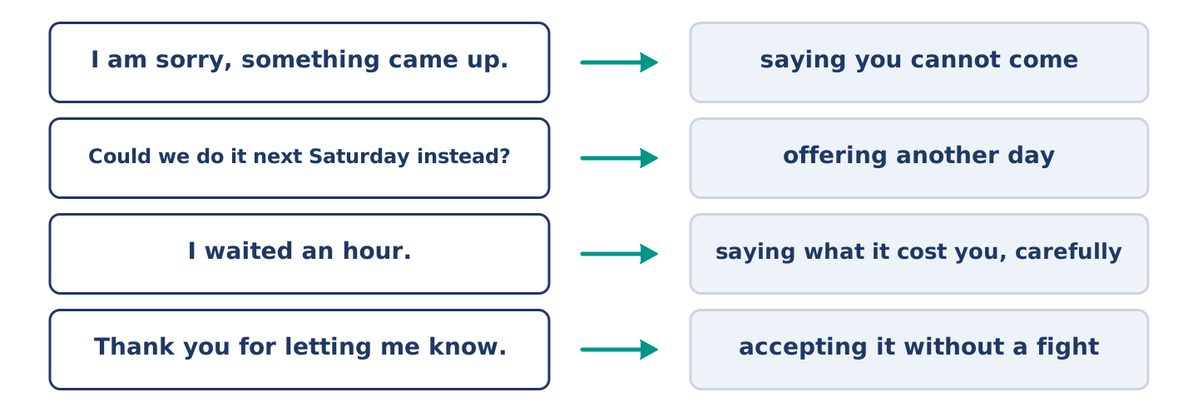
Figure 5.12 · What you say when a plan changes, and what each thing does.
Match what a person says with its purpose. One purpose is not needed. Write the letter.
Column A
1. | “I am sorry, something came up.” | ____
2. | “Could we do it next Saturday instead?” | ____
3. | “I waited an hour.” | ____
4. | “Thank you for letting me know.” | ____
Column B
a) | offering another day
b) | accepting it without a fight
c) | saying you cannot come
d) | asking for a refund
e) | saying what it cost you, carefully
7B: The Trip That Did Not Happen
🔊 Audio Track 5.5
Before you read: what do you say when somebody has wasted your morning?
Yuki: I waited at the stop for an hour. Nobody came. Clerk: I am very sorry. We stopped it at seven. The driver was ill. Yuki: Nobody telephoned me. Clerk: No. We only had your email, and I think it went to the wrong place. That was our mistake. Yuki: It was a cold hour. Clerk: I know. Shall I move you to next Saturday and take off the cost of this one? Yuki: Yes. Thank you for being straight about it.
Answer the questions. (0. is done.)
- How long did Yuki wait? — An hour.
- Why did the trip not run?
- Why did nobody telephone Yuki?
- What does the clerk offer?
7C: Controlled Practice — When a Plan Falls Through
Put the steps in order. Number them 1–5. (0. is done.)
- Say what happened to you. — 1
____ Accept it and move on.
____ Listen to the reason.
____ Say calmly what it cost you.
____ Agree the new arrangement.
7D: Role-Play — Sorting Out a Lost Morning
In pairs. One waited; one works in the office. Use the model and cards.
Model exchange: A: I waited an hour and nobody came. — B: I am very sorry. We stopped it at seven. — A: Nobody told me. — B: That was our mistake. — A: It was a cold hour. — B: I know. Shall I move you to next Saturday and take off the cost? — A: Yes, thank you.
Card A — the person who waited: say what happened · say nobody told you · say what it cost you · accept the offer.
Card B — the office: apologise · give the reason · admit the mistake · offer something real.
Stretch [PLUS]: the office offers nothing at all — ask for something, once, and then decide what to do.
7E: Writing — A Message About a Lost Morning (50–80 words)
A plan did not happen and nobody told you. Write a short, calm message about it.
Model — read this first:
Good afternoon. I booked the Saturday trip and I waited at the stop from eight until nine. Nobody came and nobody telephoned. I understand that the driver was ill and that these things happen, but I gave you a number as well as an email. Could you move me to next Saturday? And please use the number next time. Thank you. Yuki Tanaka (63 words)
Check before you finish: ☐ what you booked? ☐ what happened? ☐ what you want? ☐ a calm tone? ☐ 50–80 words?
Part 8 · Global Story — The Country That Tried a Shorter Week
[PLUS] Plus track · pre-read / discuss
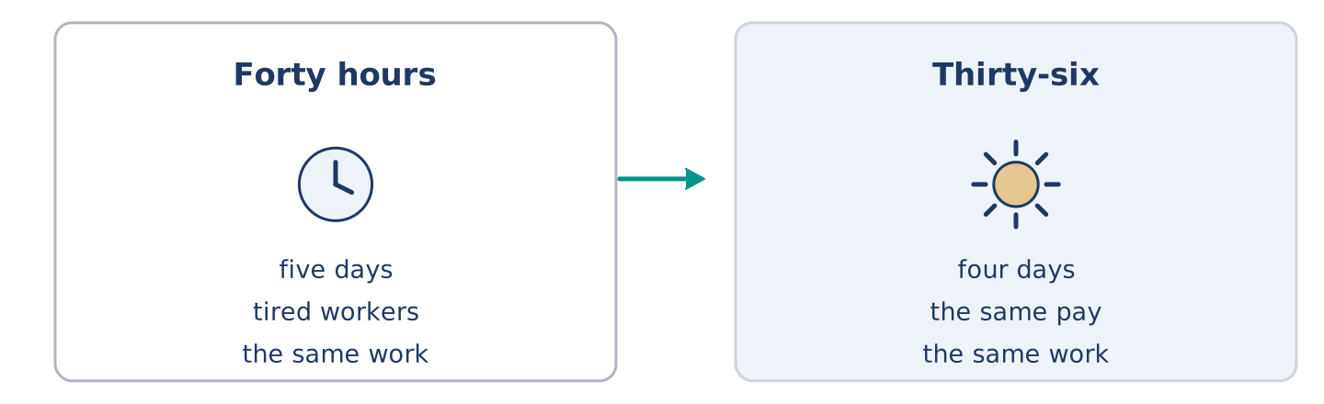
Figure 5.13 · Five days, and then four.
Before you read: would you work four days for the same money?
Gloss: trial = a test over a period of time · productivity = how much work gets done in an hour · burnout = being so tired from work that you cannot work well · union = a group that speaks for workers
Over four years Iceland ran one of the largest trials of a shorter working week. About one worker in every one hundred took part: nurses, office staff, people in schools and in city offices. They moved from forty hours to thirty-five or thirty-six, and they kept the same pay. One nurse said she got her Thursdays back. The question everybody asked was obvious. Would the work still get done? It did. Productivity stayed the same or improved in almost every place of work, and the reports showed a large drop in worry and burnout. The trial ended, and then something more interesting happened. The unions used the results, and in a few years most workers in the country won shorter hours. Iceland did not prove that four days suits everybody. It proved that the five-day week was a choice, and that a country can change its mind.
Answer the questions. (0. is done.)
- Which country ran the trial? — Iceland.
- How many hours did the workers move to?
- What happened to productivity?
- What did the unions do with the results?
Part 8: Vocabulary in Context
Match each word with its meaning. One meaning is not needed. Write the letter.
Column A
1. | trial | ____
2. | productivity | ____
3. | burnout | ____
4. | union | ____
Column B
a) | how much work gets done in an hour
b) | a group that speaks for workers
c) | a test over a period of time
d) | being so tired from work that you cannot work well
e) | a day when almost everybody is free
Part 8: Discussion
Talk with a partner. Use the frames.
Discussion frames: “This is similar to where I live because…” · “This is different from where I live because…” · “I think the most important thing is… because…”
Part 9 · Close to Home — Tomas and the Saturday He Missed
[PLUS] Plus track · pre-read / decide
Before you read: what does a person lose when they work while everybody rests?
Tomas worked eleven of the last twelve Saturday nights. He does not complain about it, because he chose the hours and because the pay is better. But last Saturday was Maya’s birthday, and the dinner was at eight, and he was at the hospital by seven. He sent a message and a photograph of the cake. Everybody understood, and he went to work anyway. On Sunday he slept until four. Maya left him a plate of the dinner and did not wake him, and she says she would do it again. Mr Okonkwo was outside in his chair. In forty years of teaching, he said, he never once worked a Saturday. He does not know how anybody manages it. Tomas said he manages it by not counting. Then he asked what time the shop closed and went to buy milk. That was his weekend.
Answer the questions. (0. is done.)
- How many of the last twelve Saturday nights did Tomas work? — Eleven.
- Why does Tomas not complain about the hours?
- What did Tomas send instead of coming to the dinner?
- What did Mr Okonkwo say about his own forty years?
Part 9: Decision Task
Your job needs you at the weekend, and your friends are free then. Should you (a) take the hours and the better pay, (b) ask to change to weekdays, or (c) keep the hours but protect one weekend a month? Decide and explain. Use the frame.
Answer frame: “I think I should ___ because ___. Also, ___. This is better than ___ because ___.”
Model — read this first:
I think I should keep the hours but protect one weekend a month, because the money matters and so do the people. Also, one weekend is easy to ask for and hard to refuse. This is better than changing to weekdays, because I would lose the extra pay and I would miss the quiet of a night shift. (58 words)
Phrase bank: I think I should… · because… · Also,… · This is better than… · In my opinion…
Part 10 · Review and Can-Do
[CORE + PLUS] · homework / self-study
Part 10: Spiral Review
Complete the review. (0. is done.)
- A narrow way you walk along is a path.
Word bank: museum | picnic | village | windy | was | were | aisle | timetable
- A building where you look at old or beautiful things is a ______________________ .
- A meal you eat outside, on the ground, is a ______________________ .
- A very small town is a ______________________ .
- With a strong moving air, the weather is ______________________ .
- Last Sunday ______________________ warm. (one day)
- The children ______________________ noisy by the lake. (more than one)
- (from Unit 4) The long space between two lines of shelves is an ______________________ .
- (from Unit 3) A list of the times buses come is a ______________________ .
Part 10: Can-Do
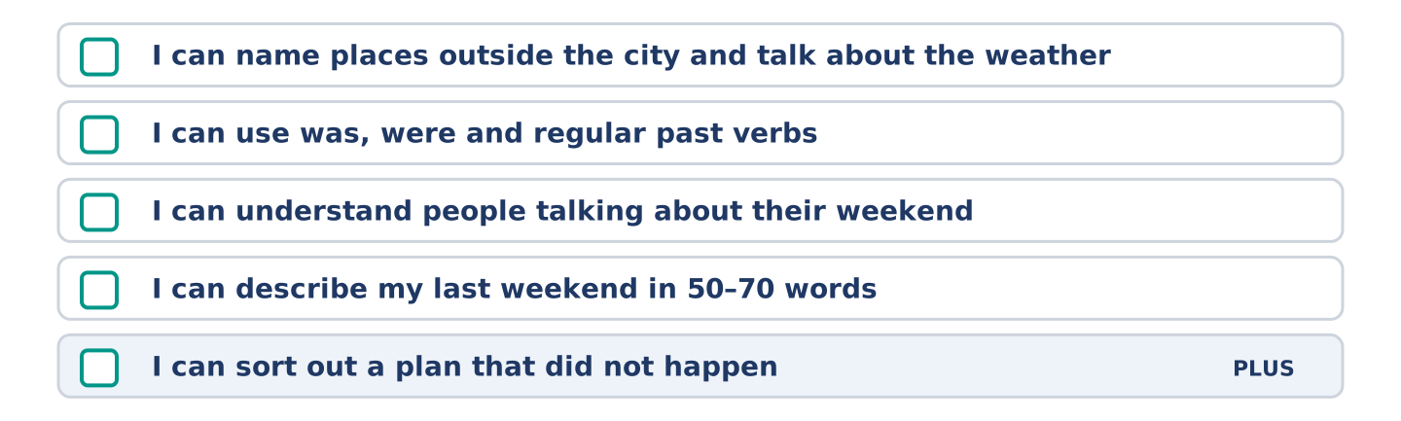
Figure 5.14 · What you can do at the end of this unit.
Can-Do checklist
☐ I can name places outside the city and talk about the weather.
☐ I can use was, were and regular past verbs.
☐ I can understand people talking about their weekend.
☐ I can describe my last weekend in 50–70 words.
☐ I can sort out a plan that did not happen (Plus).
Part 10: Glossary
Unit 5 glossary (10 words)
museum · picnic · concert · guest · beach · forest · village · path · windy · cloudy
Unit 6: Journeys and Mishaps
English for Daily Life · Level: A2 · Tracks: [CORE] Warm-Up + Parts 1–6 · [PLUS] Parts 7–10
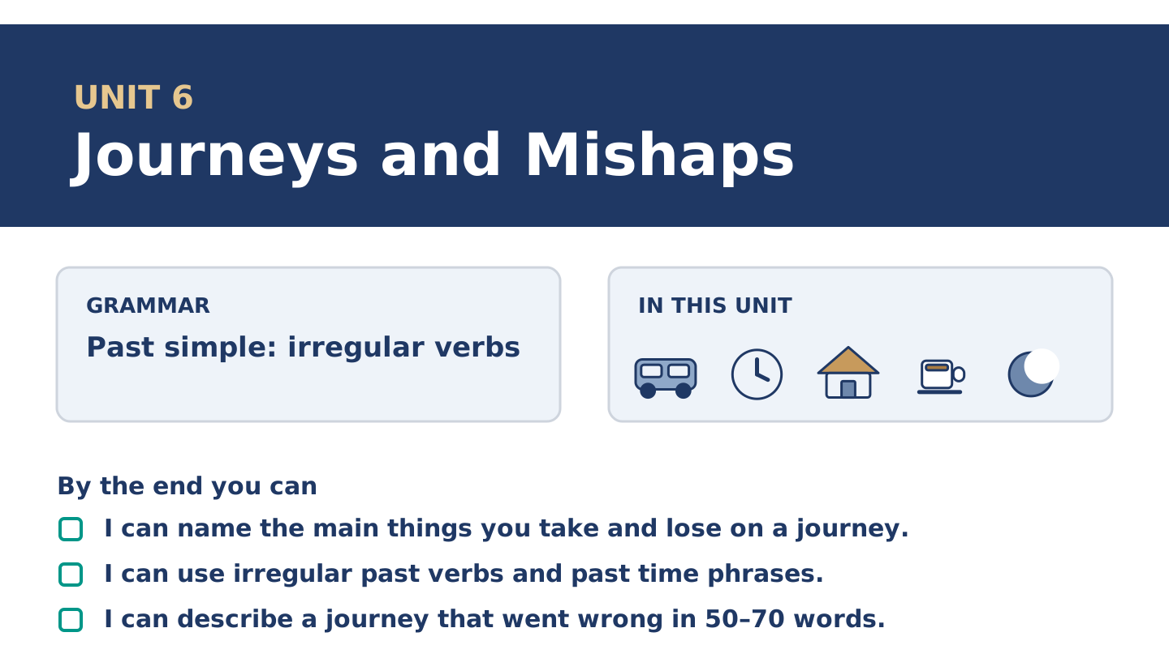
Figure 6.1 · Unit 6 at a glance: the grammar, the topic and what you will be able to do.
Warm Up
[CORE] Core track · in-class starter
Warm-up: Journey Words and Meanings
Match the words with their meanings. One meaning is not needed. Write the letter.
Column A
1. | Suitcase | ____
2. | Coach | ____
3. | Gate | ____
4. | Wallet | ____
5. | Airport | ____
Column B
a) | a long bus that takes people between cities
b) | the place where planes land and leave from
c) | a small flat case you keep money and cards in
d) | the door you go through to reach your plane
e) | a big case with a handle, for your clothes
f) | a narrow way you walk along
Warm-up: Talking About a Journey
Complete the sentences using the words in the word bank.
Word bank: taxi | umbrella | spare | missed
- Dani ______________________ the last coach and walked home in the dark.
- Yuki left her ______________________ on the train and it rained all week.
- Maya keeps a ______________________ key with Amina, for exactly this reason. She is glad she did.
- There was no bus at midnight, so Mr Okonkwo took a ______________________ .
Warm-up: The Journey That Went Wrong
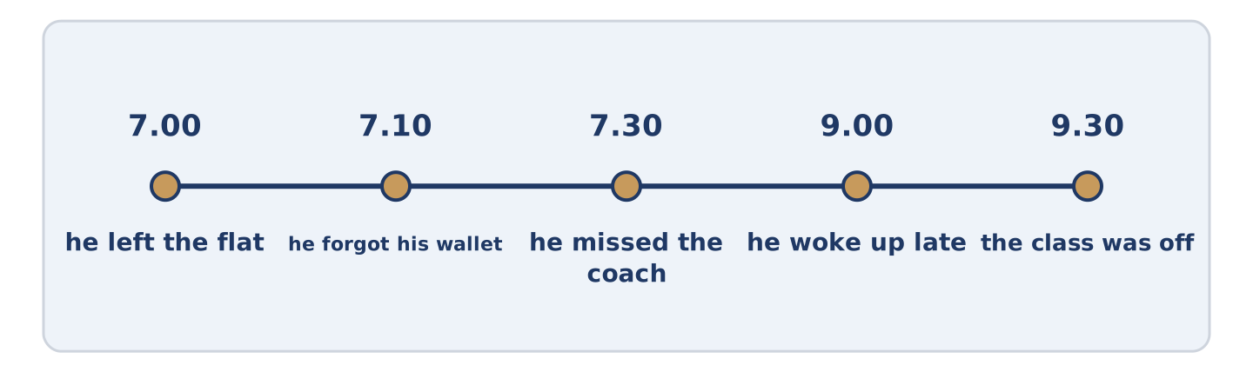
Figure 6.2 · Dani’s Tuesday, from the first mistake to the last.
Read the text and choose the correct answer.
Dani left the flat at seven and forgot his wallet. He went back for it and missed the coach. He caught the next one, fell asleep, and woke up two stops late. Then it rained, and his umbrella was at home with his wallet. He arrived an hour and a half late and found that the class was off. He says it was the best day of his week, because he met somebody at the wrong bus stop and they are now friends.
1. Why did Dani miss the coach?
○ A) He went back for his wallet
○ B) He fell asleep
○ C) It rained
○ D) The class was cancelled
2. What does Dani say about the day?
○ A) It was the worst day
○ B) He will not do it again
○ C) It was the best day of his week
○ D) He lost his umbrella
Part 1 · Vocabulary and Terminology
[CORE] Core track · pre-class input
Part 1: Journey and Mishap Terms
Match the words with their meanings. One meaning is not needed. (0. is done for you.)
- Mishap → a small thing that goes wrong, and is annoying rather than serious.
Column A
1. | Luggage | ____
2. | Delay | ____
3. | Gate | ____
4. | Charger | ____
5. | Spare | ____
6. | Coach | ____
7. | Wallet | ____
Column B
a) | kept for when the first one is lost or broken
b) | all the bags a person travels with
c) | when something comes later than it should
d) | the door you go through to reach your plane
e) | the wire that puts power back in a telephone
f) | a long bus that takes people between cities
g) | a small flat case you keep money and cards in
h) | a narrow way you walk along
Gloss: luggage = all the bags you travel with · delay = when something comes later than it should · mishap = a small thing that goes wrong · platform = the place beside the train where you stand
Part 1: Pronunciation
🔊 Audio Track 6.1
Listen and practise these irregular past forms. Say each pair aloud.
go — went
catch — caught
leave — left
forget — forgot
take — took
find — found
Then listen again. None of these adds -ed; the sound in the middle changes instead. Caught sounds like thought, and the gh says nothing at all. Learn them as pairs, out loud, not as a list on a page.
Part 1: Six Things People Lose
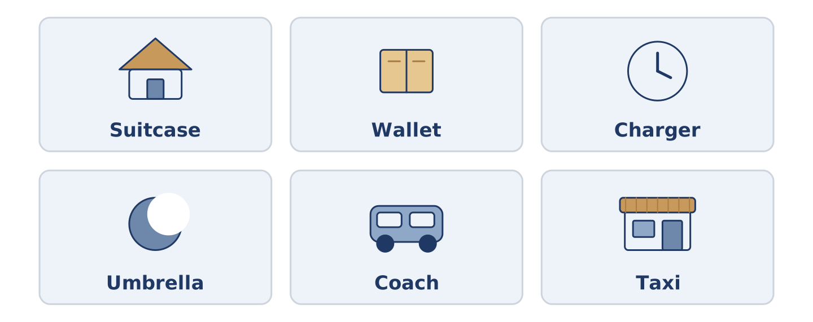
Figure 6.3 · Six things people lose, and where they lose them.
Complete the table. Write where people usually lose it and what you do then. (0. is done.)
Thing | Where people lose it | What you do
Umbrella | on the train | (example)
Wallet
Key
Charger
- Umbrella — on the train — nothing, usually, and you buy another.
Think about the last thing you lost. There is more than one right answer; be ready to say why you chose yours.
Part 1: At the Station
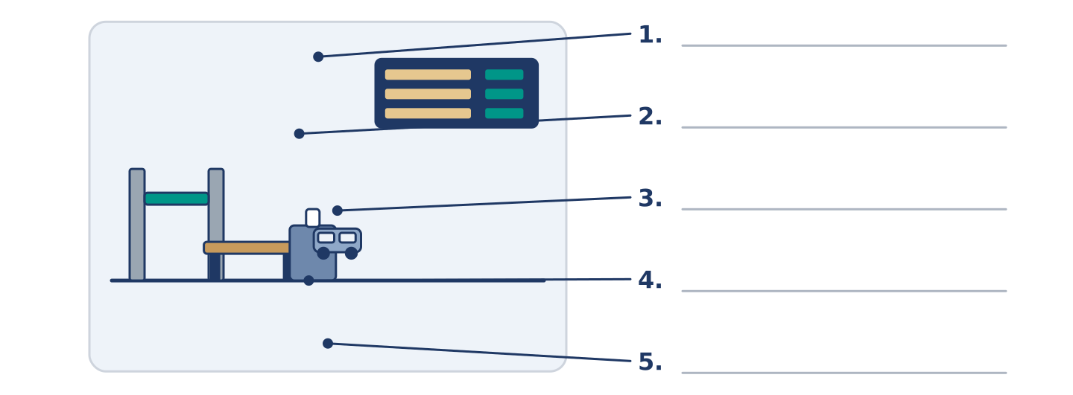
Figure 6.4 · At the station — write the correct word on each line.
Match the things at a station with their descriptions. One description is not needed. Write the letter.
Column A
1. | Gate | ____
2. | Luggage | ____
3. | Seat | ____
4. | Delay | ____
5. | Coach | ____
Column B
a) | all the bags a person travels with
b) | the place you sit for the journey
c) | the door you go through to reach your plane
d) | a long bus between cities
e) | when something comes later than it should
f) | the money you pay for one journey
Part 1: Journeys — Multiple Choice
Read and choose the correct answer.
1. A big case with a handle, for your clothes, is a…
○ A) wallet
○ B) charger
○ C) suitcase
○ D) gate
2. When something comes later than it should, there is a…
○ A) mishap
○ B) delay
○ C) coach
○ D) seat
3. A key you keep in case you lose the first one is a…
○ A) spare key
○ B) gate key
○ C) lost key
○ D) wallet key
Part 1: Vocabulary Fill-in
Complete the sentences with the correct word.
Word bank: luggage | delay | charger | coach
- There was a two-hour ______________________ , and nobody told the passengers why.
- Yuki carried her ______________________ up four floors, because there is no lift. A suitcase is heavier at the top.
- The ______________________ to the coast leaves from the back of the station, not from the airport.
- Dani forgot his ______________________ and his telephone died at eleven.
Part 1: Write About a Journey (short)
Write two or three sentences about a journey you took. Use three words from this unit.
Model — read this first:
I took the coach to the coast last summer and it was four hours late. I left my charger at home, so my telephone died somewhere in the middle. I read the back of somebody else’s newspaper for two hours and I still do not know how the story ended. (50 words)
Part 2 · Grammar — Past Simple: Irregular Verbs
[CORE] Core track · pre-class input
Part 2: Notice
Read these lines about Maya’s Thursday. Underline the past verbs. Which ones do not end in -ed?
Maya left the flat at seven and forgot her bag. She went back for it and missed the bus. She caught the next one and fell asleep. She woke up two stops late and found that it was raining.
Missed ends in -ed. The others do not: they change in the middle instead, and there is no rule for which way. English has about two hundred of these, and a learner meets the same forty again and again.
Part 2: Grammar Focus Box
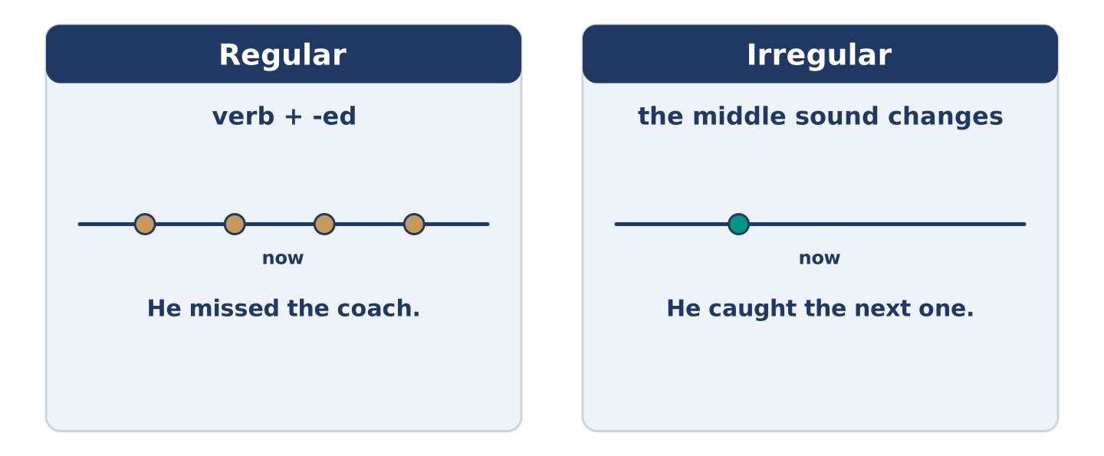
Figure 6.5 · Regular and irregular: two ways back into the past.
 | Form | Use | Example
Regular | verb + -ed | the ordinary way | He missed the coach.
Irregular | the middle sound changes | about forty common verbs | He caught the next one.
Negative | did not + plain verb | the same for both kinds | He did not catch it.
Time phrases | last week · two days ago · in the spring | say when, once, near the start | Last summer I took the coach.
Remember: after did and did not, every verb goes back to its plain form: did he go?, not did he went?
Watch out! ✗ He goed back for it. → ✓ He went back for it. (go is irregular). ✗ Did he went? → ✓ Did he go? (did carries the past).
Part 2: Controlled Practice
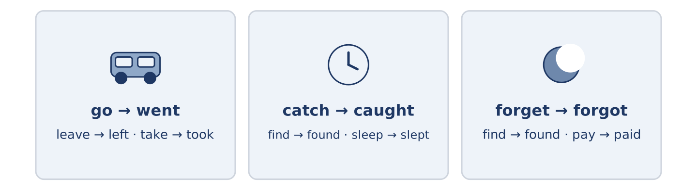
Figure 6.6 · Forty verbs you meet again and again.
Write the past simple. (0. is done.)
- Maya left the flat at seven. (leave)
- She ______________________ (forget) her bag.
- She ______________________ (go) back for it.
- She ______________________ (catch) the next bus.
- She ______________________ (find) that it was raining.
Part 2: Regular or Irregular?
Choose the correct past form. (0. is done.)
- Yuki took the train to the coast. (took / taked)
- Maya ______________________ (walked / walkt) to the station.
- Dani ______________________ (sleeped / slept) through two stops.
- The coach ______________________ (arrived / arrove) an hour late.
- Mr Okonkwo ______________________ (payed / paid) for the taxi.
Part 2: Correct the Sentence
Each sentence has one grammar mistake. Write the correct sentence.
- She goed back for her bag.
- Did she caught the next bus?
- Yuki taked the train to the coast.
- They not found the gate in time.
Part 2: Freer Practice
Write two sentences about a journey you took: one with a regular past verb and one with an irregular one.
Part 2: Grammar Review
Choose the correct past-simple sentence.
1. Which sentence uses the irregular past correctly?
○ A) She goed back for her bag.
○ B) She went back for her bag.
○ C) She did went back for her bag.
○ D) She gone back for her bag.
2. Which question is correct?
○ A) Did she caught the bus?
○ B) Did she catched the bus?
○ C) She did catch the bus?
○ D) Did she catch the bus?
→ Harvest: you will see the irregular past again in the Part 5 reading. Watch for the verbs that do not end in -ed.
Part 3 · Listening
[CORE] Core track · pre-class input · scripts printed inline
Part 3: What Happened to You?
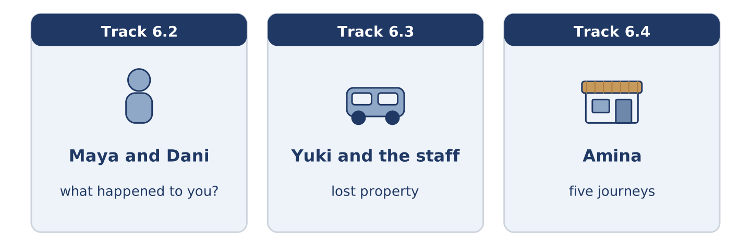
Figure 6.7 · The three listenings: who is speaking, and what about.
🔊 Audio Track 6.2
Before you listen: what is the worst journey you remember?
Maya: You look terrible. What’s happened? Dani: I left at seven and I’d forgotten my wallet. Maya: Oh no. Dani: I went back, missed the coach, caught the next one and slept through two stops. Maya: And then? Dani: Then it rained. My umbrella was at home with my wallet. Maya said hers was free all day. Maya: And the class? Dani: Off. Maya: Dani. Dani: I know, I know. But I met somebody at the wrong stop, so I am calling it a good day.
While you listen: write True, False, or Not Given. (0. is done.)
- Dani forgot his wallet. — True
- Dani caught the first coach. ____
- Dani met somebody at the wrong stop. ____
- Dani is late every week. ____
Useful phrases: What happened? · I left… and forgot… · And then? · I am calling it…
Part 3: Lost Property
🔊 Audio Track 6.3
Before you listen: what do you say when you leave something on a train?
Yuki: I left an umbrella on the ten past four yesterday. Staff: Which coach were you in? Yuki: The last one, I think. It is black with a wooden handle. Staff: We took three umbrellas off that train. One’s black. Yuki: Was there a wooden handle? Staff: There was. Give me a name and I keep it until Friday. Yuki: Yuki Tanaka. Thank you — my grandmother gave me that umbrella.
Answer the questions. (0. is done.)
- What did Yuki leave on the train? — An umbrella.
- Which coach was she in?
- How many umbrellas did the staff take off the train?
- Until when do they keep it?
Part 3: Five Journeys
🔊 Audio Track 6.4
Before you listen: how many ways can one short journey go wrong?
Amina: Everybody came in with a story this week. Maya walked to the station and the train left early, which it never does. She says she stood there and laughed, then walked back for a coffee. Tomas slept through his stop and woke at the end of the line at six. His sister telephoned him there, and she still mentions it. She mentions it every year. Dani forgot his wallet, which surprised nobody. Amina keeps bread for him on Tuesdays now. Mr Okonkwo took a taxi for the first time in nine years and the driver got lost. She was from his old school and would not take his money. Yuki lost an umbrella and found a friend. She says her week improved from there.
While you listen: match each person with what happened. One thing is not needed. (0. is done.)
- Amina → she heard all five stories.
Useful phrases: ___ walked and… · ___ slept through… · ___ took a taxi and…
Column A
1. | Maya | ____
2. | Tomas | ____
3. | Mr Okonkwo | ____
4. | Yuki | ____
Column B
a) | woke up at the end of the line
b) | the taxi driver got lost
c) | the train left early
d) | missed a plane by four minutes
e) | lost an umbrella and found a friend
Part 4 · Speaking
[CORE] Core track · in-class output
Part 4: Talking About Journeys
Work with a partner. Ask and answer these questions.
- What is the longest journey you took last year? How did you travel?
- Did anything go wrong? What did you do?
- What do you always carry, and what do you always forget?
Useful language: I took… · I left… · Then I… · I forgot… · Did you…?
Part 4: Find the Difference (pairwork)
Student A and Student B each had a bad journey. Ask questions and find three differences.
Useful questions: What time did you leave? · What did you forget? · Did you catch it? · How late were you?
Student A — your journey: left at seven · forgot your wallet · missed the coach · an hour late.
Student B — your journey: left at seven · forgot your charger · caught the coach · an hour late.
Part 4: Telling a Travel Story
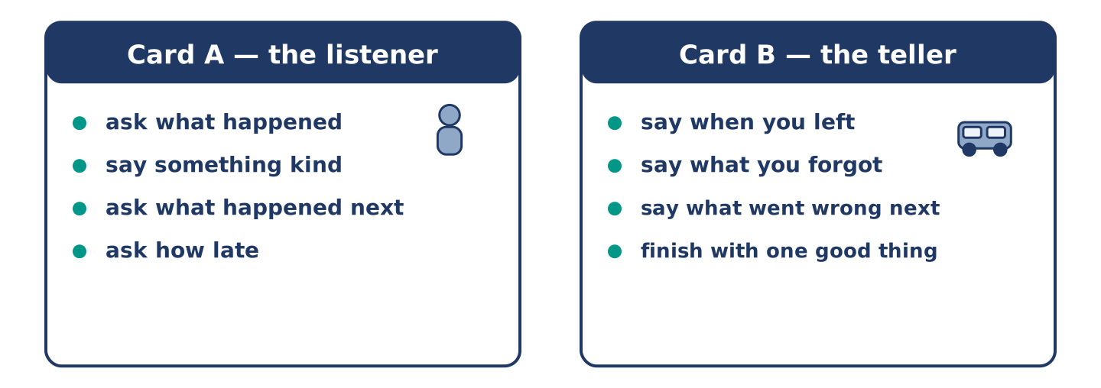
Figure 6.8 · Card A and Card B: what each of you has to say.
Work in pairs. Read the model, then use the cards.
Model exchange:
A: You look terrible. What happened? — B: I left at seven and forgot my wallet. — A: Oh no. And then? — B: I went back, missed the coach and caught the next one. — A: Were you very late? — B: An hour and a half. But I met somebody at the wrong stop.
Useful language: What happened? · I left… · And then? · Were you very late? · But…
Card A — the listener: ask what happened · say something kind · ask what happened next · ask how late.
Card B — the teller: say when you left · say what you forgot · say what went wrong next · finish with one good thing.
Your turn: run the dialogue, then swap roles.
Stretch [PLUS]: nothing at all went wrong on your journey — make the story interesting anyway.
Part 4: Mini-Presentation
Prepare a short talk (about one minute). Describe a journey that went wrong: where you went, what happened, and what you do differently now.
Part 5 · Reading
[CORE] Core track · pre-class input
Part 5: Why Journeys Go Wrong
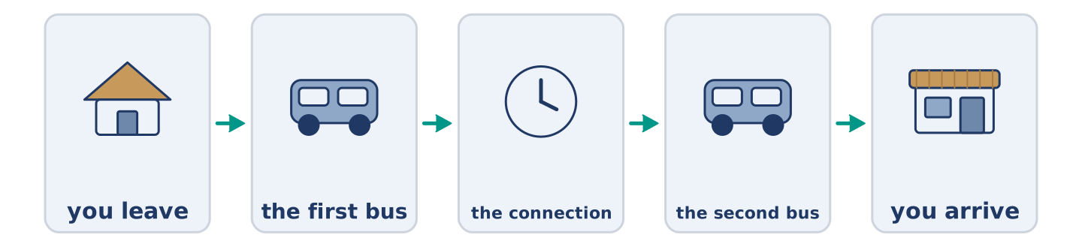
Figure 6.9 · One journey, five places it can break.
Before you read: is a long journey more likely to go wrong than a short one?
Gloss: connection = a second train or bus you need to catch · margin = the spare time between two things · chain = a line of things, each one holding the next · link = one piece of a chain
A journey is a chain, and a chain breaks at its weakest link. The flight is not often the problem. The problem is the forty minutes between the flight and the last train. Or the ten minutes between two buses in a town where the buses do not wait. Travellers usually go wrong at a connection. The reason is almost always the same: there was no margin. Somebody planned the journey as if nothing could be late. Then one thing was. Experienced travellers do the opposite. They build in the boring hour, carry the charger, and leave a spare key with a neighbour. It looks like pessimism. It is really a kind of respect for how much has to go right.
Answer the multiple-choice questions. (0. is done.)
- What does the text compare a journey to? — A chain.
1. Where do travellers usually go wrong?
○ A) On the flight
○ B) At a connection
○ C) At the gate
○ D) At home
2. What is almost always the reason?
○ A) Bad weather
○ B) The wrong ticket
○ C) There was no margin
○ D) The luggage was heavy
3. What do experienced travellers do?
○ A) Travel less
○ B) Carry nothing
○ C) Take taxis
○ D) Build in a boring hour
Part 5: Vocabulary in Context
Match each word from the text with its meaning. One meaning is not needed. Write the letter.
Column A
1. | connection | ____
2. | margin | ____
3. | chain | ____
4. | link | ____
Column B
a) | the spare time between two things
b) | one piece of a chain
c) | a second train or bus you need to catch
d) | a line of things, each one holding the next
e) | all the bags you travel with
Part 5: Journeys Around the World
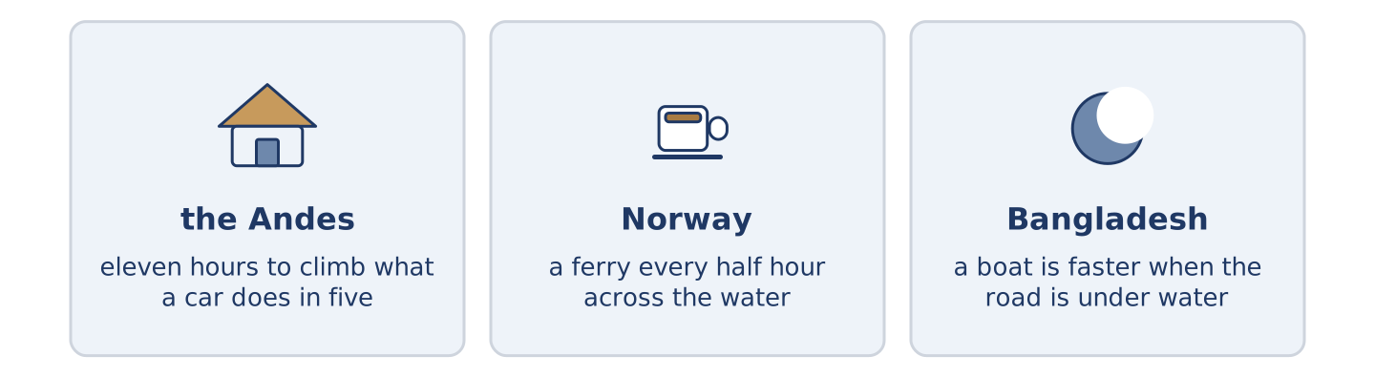
Figure 6.10 · Three journeys that take longer than they look.
Before you read: what is the slowest way to travel that people still choose?
Gloss: ferry = a boat that carries people and cars across water · oxygen = the part of the air we need to breathe
Some journeys take longer than the map says. The train from Lima up into the Andes climbs very high. It covers in eleven hours a distance a car does in five. In the west of Norway a ferry crosses the water every half hour. People argued about a road to replace it for forty years. In Bangladesh in the wet season a boat is sometimes the fastest way between two towns, because the road is under water. The shortest line on a map is not always a line you can travel.
Answer the questions. (0. is done.)
- What does the text say about some journeys? — They take longer than the map says.
- What do staff carry through the carriages in the Andes?
- How often does the ferry cross the fjord in Norway?
- Why is a boat sometimes faster in Bangladesh?
Part 6 · Writing
[CORE] Core track · in-class / homework
Part 6: A Journey That Went Wrong (50–70 words)
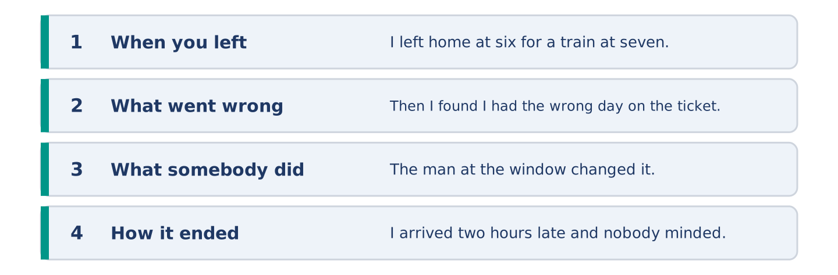
Figure 6.11 · The shape of the paragraph you are about to write.
Describe a journey that went wrong. Say when you left, what happened, and how it ended.
Model — read this first:
I left home at six for a train at seven and I was at the station by twenty past. Then I found that I had the wrong day on the ticket. The woman at the window changed it and charged me nothing, which I did not expect. I caught the nine o’clock and arrived two hours late, and nobody minded at all. (62 words)
Plan (fill in, then write): I left ___ at ___. Then I ___. ___ and I ___. I arrived ___ and ___.
Word bank: left | went | caught | forgot | found | took
Check before you finish: ☐ three irregular past verbs? ☐ one time phrase near the start? ☐ how it ended? ☐ 50–70 words?
Part 6: The Best Way to Travel (50–70 words)
What is the best way to make a long journey? Give your opinion and two or three reasons.
Model — read this first:
I would take the slow train every time. It costs less, nobody weighs your luggage, and you can see the country changing out of the window instead of a cloud. It takes six hours instead of two, but two of those hours were always an airport anyway. The sums are better than people think. (54 words)
Word bank: I think… because… | it costs less | however | in my opinion | instead of
Check before you finish: ☐ a clear opinion? ☐ two or three reasons? ☐ 50–70 words?
Part 6: A Message About Being Late (50–70 words)
You are arriving late. Write a short message to the person who is waiting.
Model — read this first:
Maya, I am so sorry. I left on time and then I forgot my wallet and went back for it, and that cost me the coach. I am on the next one and I think I am ninety minutes behind. Please do not wait at the station in the rain. I know where the café is and I can find you there. Dani (63 words)
Plan (fill in, then write): ___, I am so sorry. I ___ and then I ___. I am ___ and I think I am ___ behind. Please ___. ___
Check before you finish: ☐ an apology? ☐ what happened, briefly? ☐ how late? ☐ what they should do? ☐ 50–70 words?
Part 6: Reflection — Something I Lost (40–60 words)
Write about something you lost on a journey.
Model — read this first:
I left a book on a bus in another country and I think about it more than I think about the country. It was not a good book. Somebody had written a name and a date inside the front cover, and I meant to find out whose it was. (49 words)
Check before you finish: ☐ what you lost? ☐ where? ☐ why it stayed with you? ☐ 40–60 words?
Part 7 · Real-World File — When Things Go Wrong Away From Home
[PLUS] Plus track (optional) · stronger learners
7A: Phrase Bank
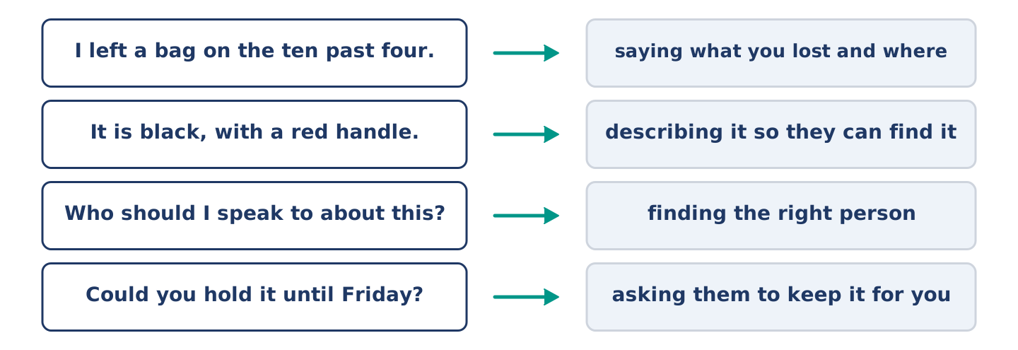
Figure 6.12 · What you say when something is lost, and what each thing does.
Match what a person says with its purpose. One purpose is not needed. Write the letter.
Column A
1. | “I left a bag on the ten past four.” | ____
2. | “It is black, with a red handle.” | ____
3. | “Who do I speak to about this?” | ____
4. | “Could you hold it until Friday?” | ____
Column B
a) | describing it so they can find it
b) | asking them to keep it for you
c) | saying what you lost and where
d) | asking for money back
e) | finding the right person
7B: Reporting a Loss
🔊 Audio Track 6.5
Before you read: what does somebody need to know before they can help you find something?
Yuki: I left a bag on the ten past four from the coast yesterday. Staff: Where were you sitting? Yuki: The last coach, by the window. Staff: And what does it look like? Yuki: Dark green, and open at one corner, with a library card inside with my name. Staff: That’s helpful. Most people just say “a bag”. Who do I speak to if it comes in tomorrow? Yuki: Me, please. Here is my number, and my sister’s. Staff: We hold things for a month. After that they go to a shop for good causes.
Answer the questions. (0. is done.)
- When did Yuki leave the bag? — Yesterday, on the ten past four.
- Where was she sitting?
- What is inside the bag with her name on it?
- How long does the station hold things?
7C: Controlled Practice — Reporting Something Lost
Put the steps in order. Number them 1–5. (0. is done.)
- Say what you lost and when. — 1
____ Leave a way to reach you.
____ Say where you were sitting.
____ Ask what happens next.
____ Describe it well enough to find.
7D: Role-Play — At the Lost Property Desk
In pairs. One lost something; one works at the desk. Use the model and cards.
Model exchange: A: I left a bag on the ten past four. — B: Where were you sitting? — A: The last coach, by the window. — B: What does it look like? — A: Dark green, and open at one corner. — B: Leave me a number. We hold things for a month.
Card A — the traveller: say what and when · say where you sat · describe it in detail · leave a number.
Card B — the desk: ask where they sat · ask for a description · say what happens next · say how long you keep things.
Stretch [PLUS]: the bag has something in it that cannot be replaced — say so without making a scene.
7E: Writing — A Lost Property Message (50–80 words)
Write a short message to a station about something you left on a train.
Model — read this first:
Good morning. I travelled on the ten past four from the coast yesterday and I left a dark green bag in the last coach, by the window. It is open at one corner, and there is a library card inside with my name on it. There is nothing expensive in it, but the notebook matters to me. Could you let me know if it comes in? Thank you. Yuki Tanaka (70 words)
Check before you finish: ☐ the train and the day? ☐ where you sat? ☐ a description somebody could use? ☐ how to reach you? ☐ 50–80 words?
Part 8 · Global Story — The Train That Climbs
[PLUS] Plus track · pre-read / discuss
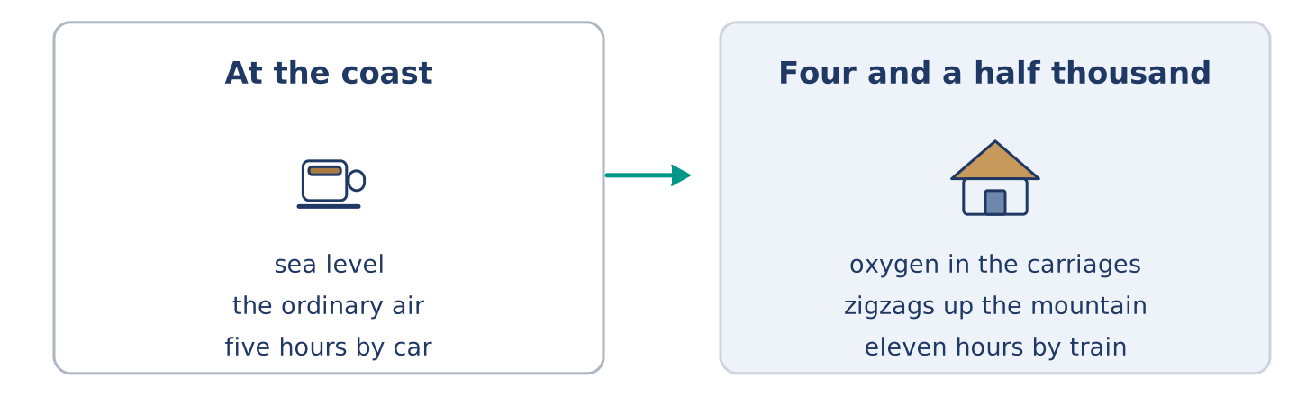
Figure 6.13 · Sea level, and four and a half thousand metres up.
Before you read: what happens to a train when the air gets thin?
Gloss: zigzag = a line that turns sharply left and right to climb · switchback = a place where a train goes forward, stops, and goes back up · carriage = one part of a train, with seats in it
The train line from Lima into the Andes is very old, and it is still one of the highest in the world. It leaves the coast at sea level and reaches four and a half thousand metres. The air up there is thin, and the staff carry a little oxygen for anybody who needs it. The line could not climb that fast straight, so the engineers cut zigzags into the mountain. The train runs forward into a dead end, stops, and goes back up the next section. There are many of these switchbacks. Passengers who do not know about them think something is wrong the first time the train starts to go back. It takes eleven hours to cover a distance a car does in five. Almost everybody who travels it says the eleven hours were the point.
Answer the questions. (0. is done.)
- Where does the railway start? — At the coast, at sea level.
- How high does the line reach?
- Why did the engineers cut zigzags into the mountain?
- What do passengers think the first time the train reverses?
Part 8: Vocabulary in Context
Match each word with its meaning. One meaning is not needed. Write the letter.
Column A
1. | zigzag | ____
2. | switchback | ____
3. | summit | ____
4. | carriage | ____
Column B
a) | a place where a train reverses to climb
b) | one part of a train, with seats in it
c) | the highest point
d) | a line that turns sharply left and right
e) | the spare time between two things
Part 8: Discussion
Talk with a partner. Use the frames.
Discussion frames: “This is similar to where I live because…” · “This is different from where I live because…” · “I think the most important thing is… because…”
Part 9 · Close to Home — The Spare Key
[PLUS] Plus track · pre-read / decide
Before you read: who has a key to your home, apart from you?
Amina has four spare keys in a box under the till, and each one has a small paper with a flat number on it. Maya left hers there three years ago after she spent a night on the stairs. She says it was the coldest night of her life. Dani left his after he locked himself out twice in one month. Amina says she was not surprised either time, and that she expects a third. Mr Okonkwo left his before anybody asked, and said only that somebody needs one. Yuki left no key. Amina never suggested it, because there is a right moment to ask and it is not the first month. The box is not a security system. Twice a year somebody comes in at eight with the face of a person locked out. Amina reaches under the till and says nothing.
Answer the questions. (0. is done.)
- Where does Amina keep the spare keys? — In a box under the till.
- Why did Maya leave a key?
- What did Mr Okonkwo say when he left his?
- Why did Amina not suggest it to Yuki?
Part 9: Decision Task
A neighbour wants to keep a spare key to your home. Should you (a) say yes, (b) say no and keep a key somewhere outside, or (c) say no and change nothing? Decide and explain. Use the frame.
Answer frame: “I think I should ___ because ___. Also, ___. This is better than ___ because ___.”
Model — read this first:
I think I should say yes, because a locked door at midnight is a worse problem than a neighbour with a key. Also, the question means something, and saying no says something back. This is better than hiding a key outside. A key outside is a key anybody can find, and I would never quite stop thinking about it. (59 words)
Phrase bank: I think I should… · because… · Also,… · This is better than… · In my opinion…
Part 10 · Review and Can-Do
[CORE + PLUS] · homework / self-study
Part 10: Spiral Review
Complete the review. (0. is done.)
- All the bags a person travels with are their luggage.
Word bank: suitcase | delay | gate | spare | went | caught | museum | basket
- A big case with a handle, for your clothes, is a ______________________ .
- When something comes later than it should, there is a ______________________ .
- The door you go through to reach your plane is the ______________________ .
- A key you keep in case you lose the first one is a ______________________ key.
- He forgot his wallet, so he ______________________ back for it. (go)
- He ______________________ the next coach. (catch)
- (from Unit 5) A building where you look at old or beautiful things is a ______________________ .
- (from Unit 4) A light open bag you fill while you walk round is a ______________________ .
Part 10: Can-Do
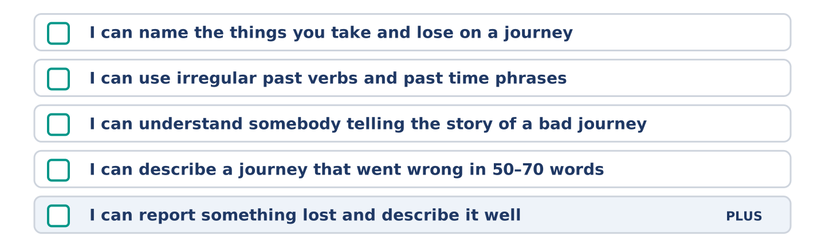
Figure 6.14 · What you can do at the end of this unit.
Can-Do checklist
☐ I can name the main things you take and lose on a journey.
☐ I can use irregular past verbs and past time phrases.
☐ I can understand somebody telling the story of a bad journey.
☐ I can describe a journey that went wrong in 50–70 words.
☐ I can report something lost and describe it well (Plus).
Part 10: Glossary
Unit 6 glossary (10 words)
suitcase · coach · gate · wallet · airport · luggage · delay · charger · spare · taxi
Unit 7: Choosing and Comparing
English for Daily Life · Level: A2 · Tracks: [CORE] Warm-Up + Parts 1–6 · [PLUS] Parts 7–10
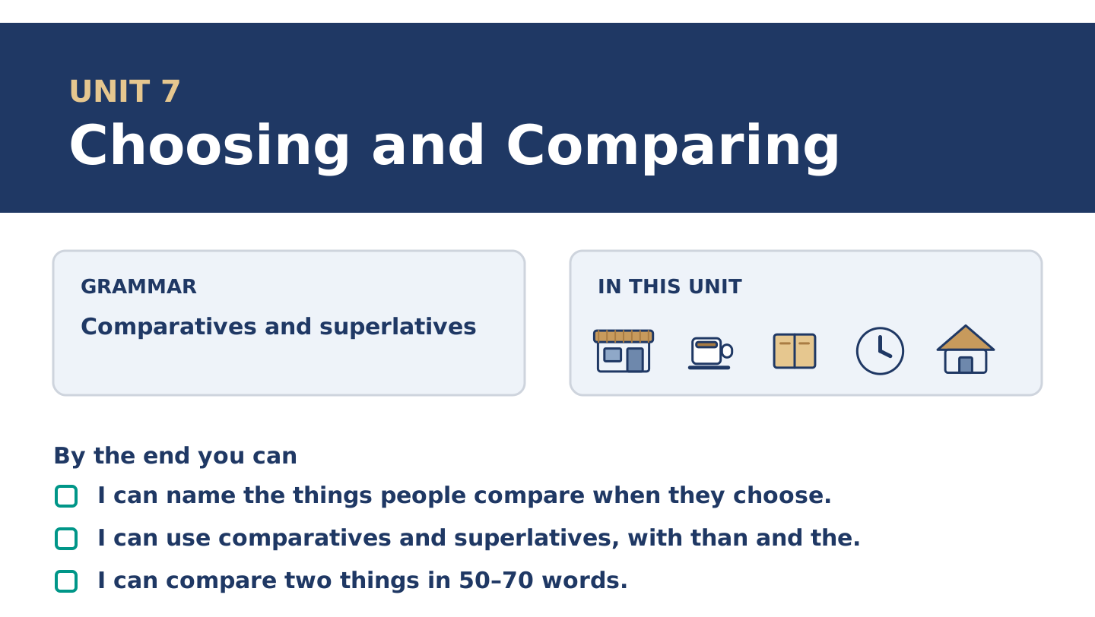
Figure 7.1 · Unit 7 at a glance: the grammar, the topic and what you will be able to do.
Warm Up
[CORE] Core track · in-class starter
Warm-up: Choosing Words and Meanings
Match the words with their meanings. One meaning is not needed. Write the letter.
Column A
1. | Quality | ____
2. | Value | ____
3. | Brand | ____
4. | Battery | ____
5. | Deal | ____
Column B
a) | the name a company puts on the things it makes
b) | how good something is, and how long it lasts
c) | the part that holds the power in a telephone
d) | a price that is better than the usual one
e) | what you get for the money you pay
f) | the paper that shows what you paid
Warm-up: Talking About Things
Complete the sentences using the words in the word bank.
Word bank: heavier | cheaper | screen | colour
- The small coat is ______________________ than the big one, but it is warmer.
- Dani dropped his telephone and the ______________________ broke.
- Yuki likes the blue one, but the ______________________ is the last thing she decides.
- A full suitcase is ______________________ than you think when there is no lift.
Warm-up: Two Coats
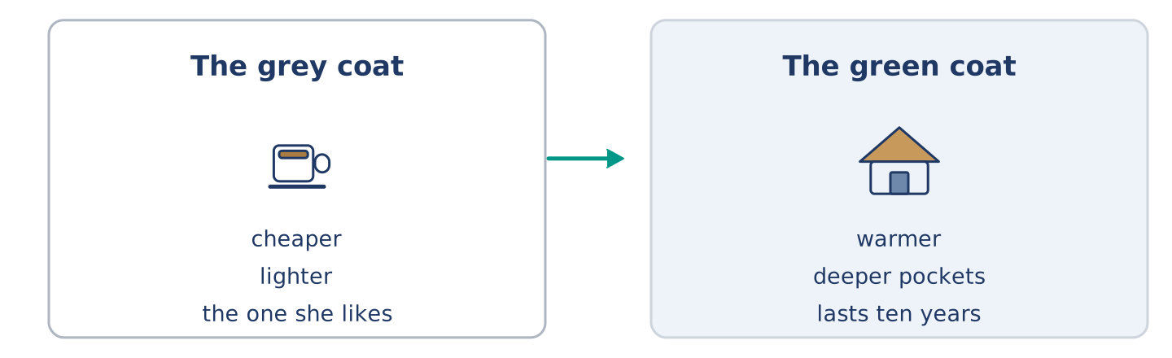
Figure 7.2 · Two coats, side by side.
Read the text and choose the correct answer.
Maya is looking at two coats. The grey one is cheaper and lighter, and it is the one she likes. The green one costs almost twice as much, but it is warmer, the pockets are deeper, and the shop says it lasts ten years. Yuki says the green one is better value. Maya says the grey one is better value today, because today she has no money. They are both right, and the coat is still in the shop.
1. Which coat is cheaper?
○ A) The green one
○ B) The grey one
○ C) They cost the same
○ D) Neither is for sale
2. Why does Maya say the grey one is better value?
○ A) It is warmer
○ B) The pockets are deeper
○ C) It lasts ten years
○ D) She has no money today
Part 1 · Vocabulary and Terminology
[CORE] Core track · pre-class input
Part 1: Comparing and Choosing Terms
Match the words with their meanings. One meaning is not needed. (0. is done for you.)
- Second-hand → owned by somebody else before you, and usually cheaper.
Column A
1. | Quality | ____
2. | Model | ____
3. | Screen | ____
4. | Repair | ____
5. | Offer | ____
6. | Width | ____
7. | Deal | ____
Column B
a) | to mend something that is broken
b) | how good something is, and how long it lasts
c) | one particular version of a thing a company makes
d) | the flat glass part of a telephone that lights up
e) | a lower price, for a short time
f) | how wide something is, from side to side
g) | a price that is better than the usual one
h) | a small flat case you keep money in
Gloss: second-hand = owned by somebody before you · model = one version of a thing a company makes · mend = to repair something that is broken
Part 1: Pronunciation
🔊 Audio Track 7.1
Listen and practise these comparatives. Say each pair aloud.
cheap — cheaper
warm — warmer
heavy — heavier
good — better
bad — worse
expensive — more expensive
Then listen again to the end of each word. The -er ending is weak and short; it is never the loud part. Heavier keeps three beats and more expensive keeps four. Say the pairs. Listen for what does not change: the loud part stays where it was.
Part 1: Six Things and Six Qualities
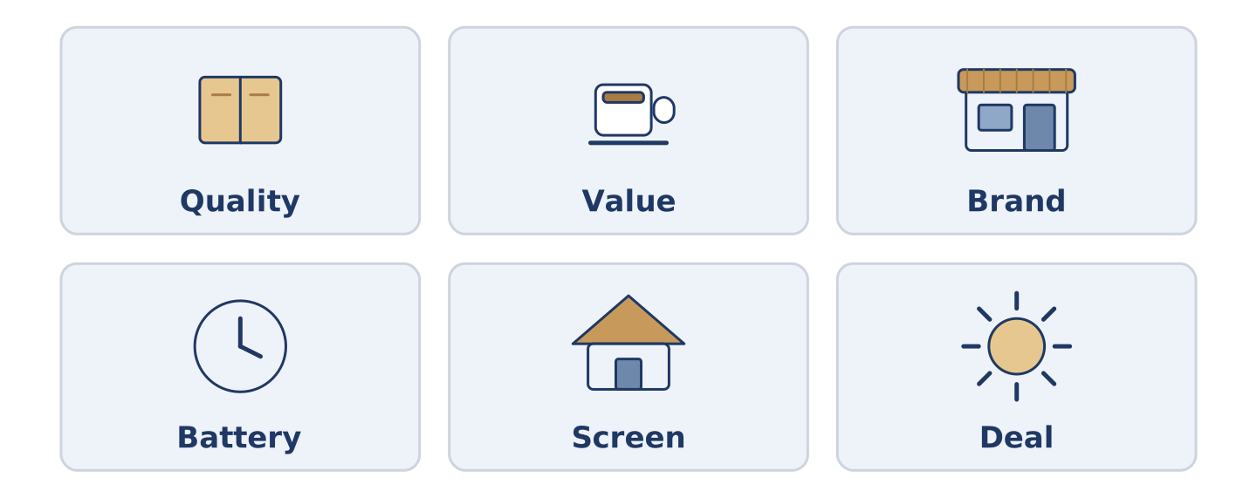
Figure 7.3 · Six things people compare, and what they compare them for.
Complete the table. Write what people compare it for and which matters most. (0. is done.)
Thing | What people compare | What matters most
Coat | warmth, price, pockets | (example)
Telephone
Flat
Bicycle
- Coat — warmth, price, pockets — warmth, because a cold coat is no coat.
Think about the last thing you chose between. There is more than one right answer; be ready to say why you chose yours.
Part 1: Comparing Two Things
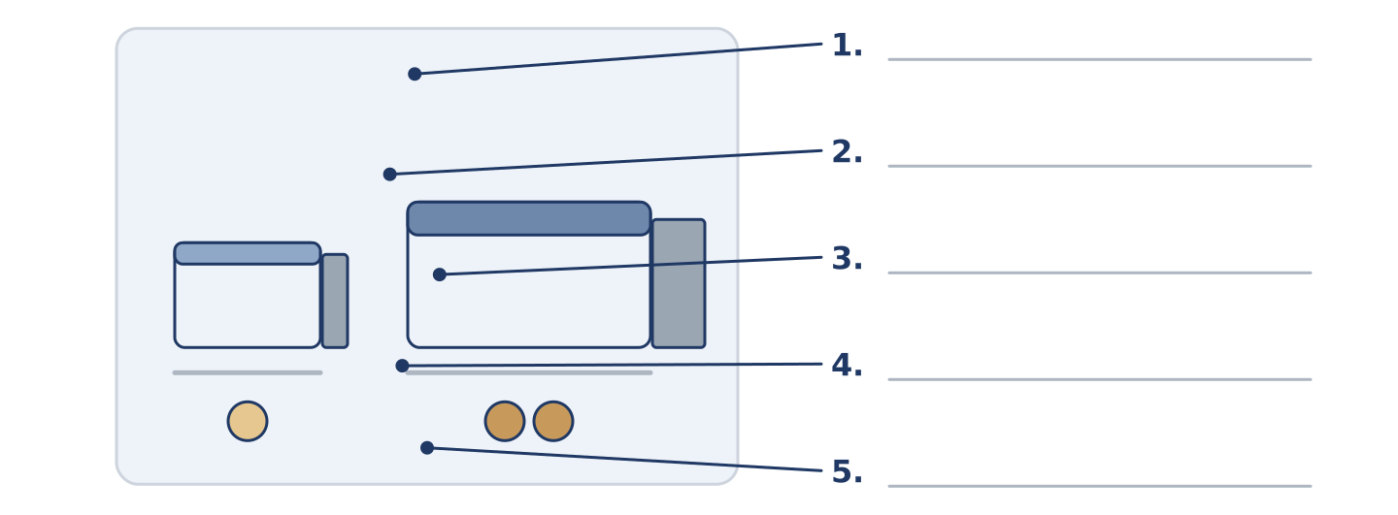
Figure 7.4 · Comparing two things — write the correct word on each line.
Match the words with their descriptions. One description is not needed. Write the letter.
Column A
1. | Wider | ____
2. | Deeper | ____
3. | Thicker | ____
4. | Lighter | ____
5. | Stronger | ____
Column B
a) | going further down than the other one
b) | weighing less than the other one
c) | harder to break than the other one
d) | measuring more from side to side
e) | costing less than the other one
f) | measuring more from front to back
Part 1: Choosing — Multiple Choice
Read and choose the correct answer.
1. A thing owned by somebody before you is…
○ A) second-hand
○ B) better value
○ C) a model
○ D) a deal
2. How good something is, and how long it lasts, is its…
○ A) width
○ B) offer
○ C) quality
○ D) screen
3. A lower price for a short time is an…
○ A) order
○ B) offer
○ C) model
○ D) brand
Part 1: Vocabulary Fill-in
Complete the sentences with the correct word.
Word bank: quality | battery | repair | brand
- The ______________________ in her old telephone lasts four hours.
- The shop can ______________________ it for thirty, or sell her a new one for two hundred.
- Nobody in the street can name the ______________________ of Mr Okonkwo’s coat.
- The ______________________ of the cheap shoes was worse than she expected.
Part 1: Write About a Choice (short)
Write two or three sentences about something you chose between. Use three words from this unit.
Model — read this first:
Last month I looked at two bicycles. The second-hand one was cheaper and heavier; the new one was lighter and cost three times as much. I chose the old one, because the quality of the frame was better than anything new at that price. (44 words)
Part 2 · Grammar — Comparatives and Superlatives
[CORE] Core track · pre-class input
Part 2: Notice
Underline the comparing words. Which compare two things, and which more?
The grey coat is cheaper. The green one is warmer and the pockets are deeper. The green one is the most expensive coat in the shop, and the grey one is the lightest. Of the three shops in the street, this one is the best.
Cheaper, warmer and deeper compare two. The most expensive, the lightest and the best pick one out of a group.
Part 2: Grammar Focus Box
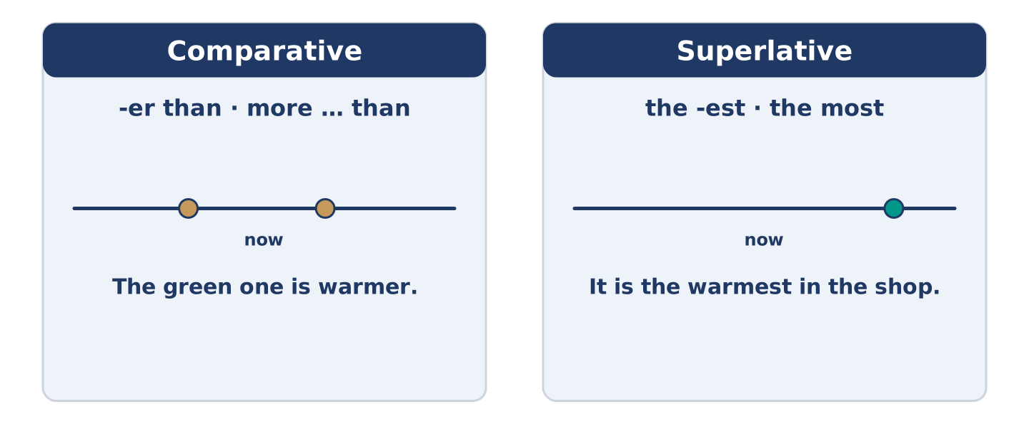
Figure 7.5 · Two things, or one out of many.
 | Form | Use | Example
Short word | + -er · + -est | one or two beats | cheap → cheaper → the cheapest
Long word | more · the most | three beats or more | expensive → more expensive
Irregular | good → better → the best | a short list | bad → worse → the worst
than / in | -er than · the -est in | which goes where | warmer than · the best in the street
Remember: than after a comparative; the before a superlative.
Watch out! ✗ It is more cheaper. → ✓ It is cheaper. (one is enough). ✗ It is the most cheap shop. → ✓ It is the cheapest shop. (cheap is short).
Part 2: Controlled Practice
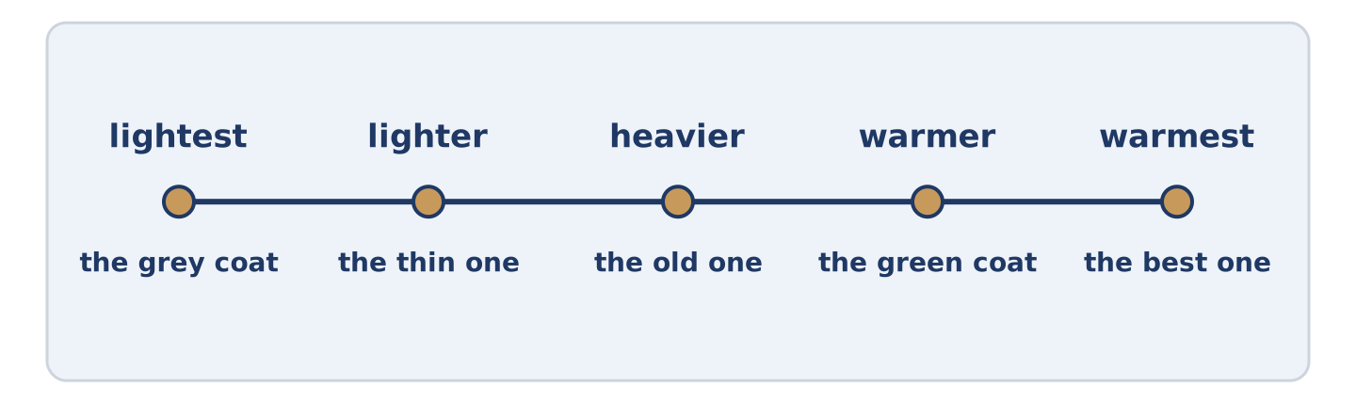
Figure 7.6 · Three coats on one line, from lightest to warmest.
Write the comparative. (0. is done.)
- The grey coat is cheaper than the green one. (cheap)
- The green coat is ______________________ than the grey one. (warm)
- A full suitcase is ______________________ than you think. (heavy)
- This telephone is ______________________ than that one. (expensive)
- The second-hand bicycle was ______________________ than the new one. (good)
Part 2: Comparative or Superlative?
Choose the correct form. (0. is done.)
- The green coat is the most expensive in the shop. (more expensive / the most expensive)
- This shop is ______________________ (cheaper / the cheapest) in the street.
- Her telephone is ______________________ (older / the oldest) than mine.
- Of all the coats, the grey one is ______________________ (lighter / the lightest).
- The quality is ______________________ (worse / the worst) than she expected.
Part 2: Correct the Sentence
Each sentence has one grammar mistake. Write the correct sentence.
- The green coat is more warmer than the grey one.
- This is the most cheap shop in the street.
- Her telephone is older that mine.
- Of all the coats, the grey one is lighter.
Part 2: Freer Practice
Compare two things you own: one comparative, one superlative.
Part 2: Grammar Review
Choose the correct sentence.
1. Which sentence compares two things correctly?
○ A) The green coat is more warmer.
○ B) The green coat is warmer that the grey one.
○ C) The green coat is warmer than the grey one.
○ D) The green coat is the warmer than the grey one.
2. Which superlative is correct?
○ A) It is the most cheap shop in the street.
○ B) It is the cheapest shop in the street.
○ C) It is cheapest shop in the street.
○ D) It is the more cheap shop in the street.
→ Harvest: you will see comparatives and superlatives again in the Part 5 reading. Watch for than and the.
Part 3 · Listening
[CORE] Core track · pre-class input · scripts printed inline
Part 3: Which One?
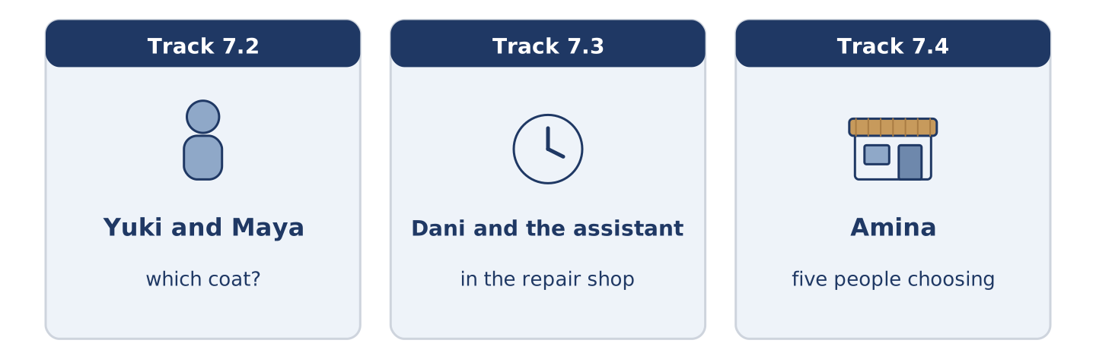
Figure 7.7 · The three listenings: who is speaking, and what about.
🔊 Audio Track 7.2
Before you listen: how long do you take to choose between two things?
Yuki: The green one’s warmer. Maya: It’s also twice the price. Yuki: Yes, but it lasts ten years. Maya: So they say. Yuki: The pockets are deeper too. Maya: I know. I know everything you’re saying and I still want the grey one. Yuki: Then buy the grey one. Maya: But you’re right. Yuki: I’m often right and it never helps.
While you listen: write True, False, or Not Given. (0. is done.)
- The green coat is warmer. — True
- The green coat costs twice as much. ____
- Maya buys the green coat. ____
- Yuki agrees that the grey one is better. ____
Useful phrases: It’s warmer · It’s twice the price · Yes, but… · I still want…
Part 3: In the Repair Shop
🔊 Audio Track 7.3
Before you listen: is it better to mend a thing or replace it?
Dani: The screen’s broken. Can you repair it? Assistant: I can. Thirty, and it takes two days. Dani: And a new one? Assistant: The same model is two hundred. A newer model is three. Dani: So repairing is much cheaper. Assistant: Much. It’s also a better telephone than the cheap new ones, if you don’t mind the marks. Dani: I don’t mind anything that costs thirty.
Answer the questions. (0. is done.)
- What is broken? — The screen.
- How much is the repair, and how long does it take?
- How much is the same model new?
- What does the assistant say about the cheap new ones?
Part 3: Five Choices
🔊 Audio Track 7.4
Before you listen: what do people in one building disagree about?
Amina: Everybody chooses differently. Maya buys the cheapest thing and replaces it twice. Tomas buys the best one and keeps it for fifteen years. Dani buys whatever is nearest, which is usually mine. Mr Okonkwo buys nothing at all and repairs what he has, and his coat is older than Dani. Yuki reads about it for a week, asks four people, and then buys the first one she saw.
While you listen: match each person with how they choose. One way is not needed. (0. is done.)
- Amina → she sells to all of them.
Useful phrases: ___ buys the cheapest · ___ buys the best · ___ repairs what he has
Column A
1. | Maya | ____
2. | Tomas | ____
3. | Mr Okonkwo | ____
4. | Yuki | ____
Column B
a) | buys the best one and keeps it fifteen years
b) | reads for a week and buys the first one she saw
c) | buys the cheapest and replaces it twice
d) | borrows instead of buying
e) | repairs what he has and buys nothing
Part 4 · Speaking
[CORE] Core track · in-class output
Part 4: Comparing Things
Work with a partner. Ask and answer these questions.
- What is the best thing you ever bought? What made it better than the others?
- Do you buy the cheapest or the best? Has that changed?
- What is the oldest thing you own that still works?
Useful language: It is cheaper than… · It is the best… in… · better value · worse than I expected
Part 4: Find the Difference (pairwork)
Student A and Student B each have a telephone. Ask questions and find three differences.
Useful questions: How old is it? · Is the battery good? · How much was it? · Is the screen bigger than mine?
Student A — your telephone: two years old · the battery lasts a day · two hundred · a small screen.
Student B — your telephone: two years old · the battery lasts four hours · three hundred · a bigger screen.
Part 4: Helping Somebody Choose
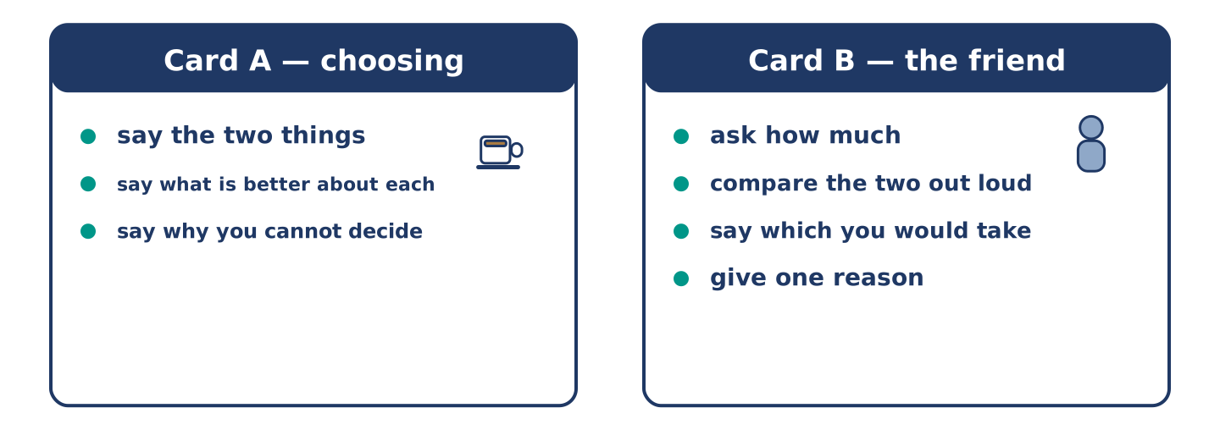
Figure 7.8 · Card A and Card B: what each of you has to say.
Work in pairs. Read the model, then use the cards.
Model exchange:
A: I cannot decide. The grey one is cheaper. — B: How much cheaper? — A: Almost half. — B: And the green one? — A: Warmer, deeper pockets, lasts longer. — B: Then the green one is better value, but the grey one is better today. Which problem is bigger?
Useful language: How much cheaper? · It is warmer than… · better value · Which is bigger…? · I cannot decide.
Card A — the person choosing: say the two things · say what is better about each · say why you cannot decide.
Card B — the friend: ask how much · compare the two out loud · say which you would take · give one reason.
Your turn: run the dialogue, then swap roles.
Stretch [PLUS]: your friend chooses the one you would not — agree with them anyway, and mean it.
Part 4: Mini-Presentation
Prepare a short talk (about one minute). Compare two things you use every day: which is older, which is better, and which you would replace first.
Part 5 · Reading
[CORE] Core track · pre-class input
Part 5: The Cheapest Is Not the Cheapest
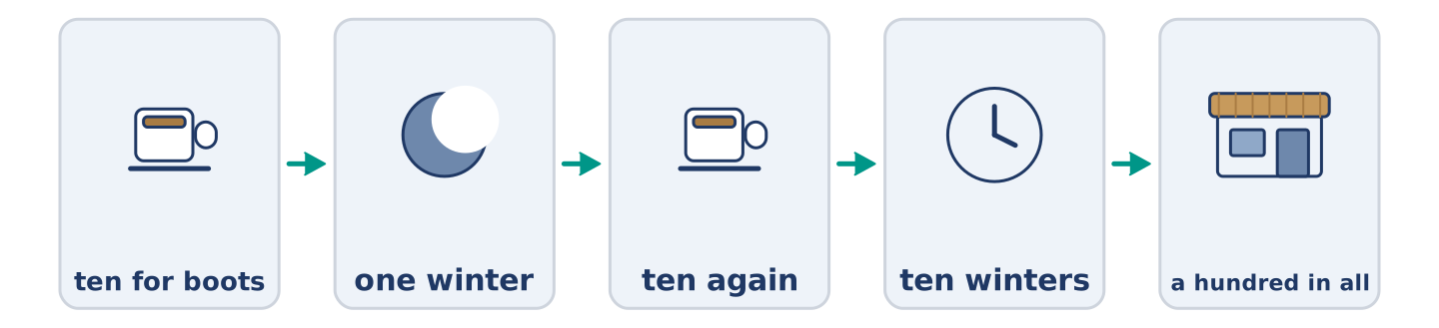
Figure 7.9 · One pair of boots, over ten years.
Before you read: can a cheap thing cost more than an expensive one?
Gloss: boots = strong shoes that cover the ankle · afford = to have enough money for something · sole = the flat bottom of a shoe
There is an old idea about boots. A poor man buys cheap boots for ten and they last one winter. A rich man buys good boots for fifty and they last ten years. After ten years the poor man paid a hundred and his feet are still wet. The rich man paid fifty and his feet are dry. The cheap boots are more expensive than the good ones. The only reason anybody buys them is that ten is what they can afford today. The idea is not really about boots. It is about the difference between a price and a cost, and about how much more expensive it is to be poor.
Answer the multiple-choice questions. (0. is done.)
- How long do the cheap boots last? — One winter.
1. How much does the poor man pay over ten years?
○ A) Fifty
○ B) Ten
○ C) A hundred
○ D) Nothing
2. Why does anybody buy the cheap boots?
○ A) Because they are warmer
○ B) Because ten is what they can afford today
○ C) Because the shop is nearer
○ D) Because they last longer
3. What is the idea really about?
○ A) The difference between a price and a cost
○ B) How to mend boots
○ C) Which shop is best
○ D) Why winters are cold
Part 5: Vocabulary in Context
Match each word from the text with its meaning. One meaning is not needed. Write the letter.
Column A
1. | afford | ____
2. | sole | ____
3. | cost | ____
4. | boots | ____
Column B
a) | strong shoes that cover the ankle
b) | everything you pay in the end, not only today
c) | to have enough money for something
d) | the flat bottom of a shoe
e) | how good something is
Part 5: Repairing Instead of Buying
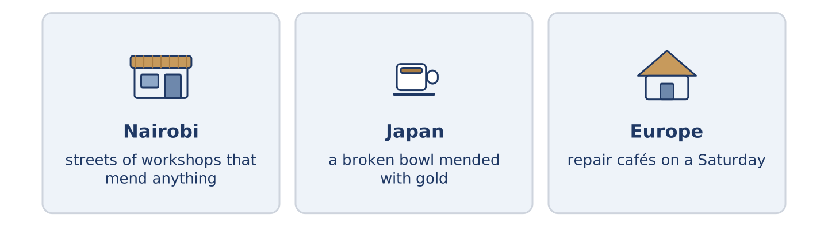
Figure 7.10 · Three places where things get mended.
Before you read: in your town, where do you take a broken thing?
Gloss: workshop = a small place where people make or repair things · gold = the yellow metal rings are made of
In some places people never stopped repairing things. In Nairobi there are whole streets of small workshops. A man repairs a radio, a shoe or a fridge for a tenth of the price of a new one. In Japan there is an old idea called kintsugi. Somebody repairs a broken bowl with gold, so the line of the break is the best part of it. In parts of Europe people now meet in repair cafés on a Saturday to repair each other’s things for nothing. The cheapest thing you can buy is often the thing you already own.
Answer the questions. (0. is done.)
- What does the text say about some places? — People there never stopped repairing things.
- What can a man in Nairobi repair?
- What does a person use to repair a bowl in kintsugi?
- Where do people in parts of Europe meet to mend things?
Part 6 · Writing
[CORE] Core track · in-class / homework
Part 6: Compare Two Things (50–70 words)
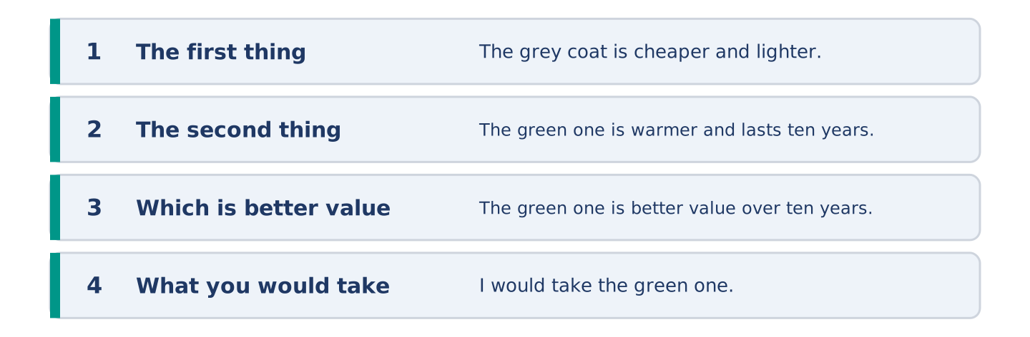
Figure 7.11 · The shape of the paragraph you are about to write.
Compare two things you could buy. Say what is better about each, and which you would take.
Model — read this first:
The grey coat is cheaper and lighter, and I like it more. The green one is warmer, the pockets are deeper, and it lasts ten years instead of two. The green one is better value over ten years and the grey one is better value this month. I would take the green one, if somebody else were paying. (58 words)
Plan (fill in, then write): The ___ is ___ and ___. The ___ is ___ and ___. ___ is better value because ___. I would take ___.
Word bank: cheaper | warmer | better | the best | than | better value
Check before you finish: ☐ two comparatives? ☐ one superlative? ☐ than used correctly? ☐ 50–70 words?
Part 6: Cheap or Good? (50–70 words)
Is it better to buy cheap things often or good things rarely? Give your opinion and two or three reasons.
Model — read this first:
I buy the good one when I can. I buy the cheap one when I cannot, which is most of the time. That is not a plan, it is a bank account. The one thing I never buy cheap is shoes. Bad shoes cost you a day, then a week, then your back. (53 words)
Word bank: I think… because… | better value | however | in my opinion | it depends on
Check before you finish: ☐ a clear opinion? ☐ two or three reasons? ☐ 50–70 words?
Part 6: A Message Recommending Something (50–70 words)
A friend is choosing between two things. Write them a short message with your advice.
Model — read this first:
Yuki, take the green one. I know it is twice the price and I know the grey one is nicer. But you walk everywhere and you were cold all last winter, and the grey one does not fix that. If the money is the problem, wait three weeks. The coat is not going anywhere. (54 words)
Plan (fill in, then write): ___, take the ___. I know ___ and I know ___. But ___. If ___, ___.
Check before you finish: ☐ a clear recommendation? ☐ one point for the other side? ☐ a reason from their life? ☐ 50–70 words?
Part 6: Reflection — The Best Thing I Own (40–60 words)
Write about the best thing you own, and why it is the best.
Model — read this first:
The best thing I own is a knife my grandmother used for forty years. It is not the best knife or the most beautiful. It is the only thing in my kitchen that is older than I am, and it goes to somebody else’s kitchen after me. (47 words)
Check before you finish: ☐ the thing named? ☐ one superlative? ☐ why it is the best? ☐ 40–60 words?
Part 7 · Real-World File — Mending, Returning, Complaining
[PLUS] Plus track (optional) · stronger learners
7A: Phrase Bank
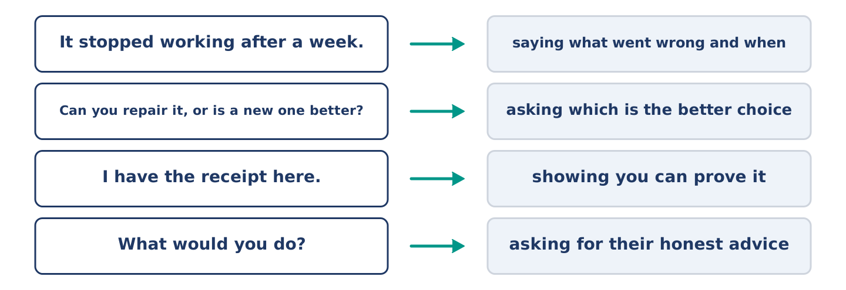
Figure 7.12 · What you say when something is wrong with a thing, and what each does.
Match what a person says with its purpose. One purpose is not needed. Write the letter.
Column A
1. | “It stopped working after a week.” | ____
2. | “Can it be mended, or is it better to replace it?” | ____
3. | “I have the receipt here.” | ____
4. | “What would you do?” | ____
Column B
a) | asking for their honest advice
b) | showing you can prove it
c) | saying what went wrong and when
d) | asking which is the better choice
e) | asking for a cheaper model
7B: Taking Something Back
🔊 Audio Track 7.5
Before you read: what do you need before you take something back to a shop?
Yuki: I bought these boots three weeks ago and the sole came off one of them. Assistant: Three weeks? That shouldn’t happen. Have you got the receipt? Yuki: Here. Assistant: Then you can have your money back, or a new pair. Yuki: Which would you do? Assistant: Honestly? A different pair. These are our cheapest and we see a lot of them back. The pair behind you costs ten more and is much better made. Yuki: Then I pay the ten.
Answer the questions. (0. is done.)
- What is wrong with the boots? — The sole came off one of them.
- How long ago did Yuki buy them?
- What two things does the assistant offer?
- What does the assistant honestly advise?
7C: Controlled Practice — Taking Something Back
Put the steps in order. Number them 1–5. (0. is done.)
- Say what you bought and when. — 1
____ Decide what you want.
____ Say what went wrong.
____ Ask what they can do.
____ Show the receipt.
7D: Role-Play — At the Counter
In pairs. One is the customer; one works in the shop. Use the model and cards.
Model exchange: A: I bought these three weeks ago and the sole came off. — B: That shouldn’t happen. Have you got the receipt? — A: Here. — B: Money back, or a new pair? — A: Which would you do? — B: A different pair. These are our cheapest.
Card A — the customer: say what and when · say what went wrong · show the receipt · ask for advice.
Card B — the shop: ask for the receipt · offer two things · give honest advice · say why.
Stretch [PLUS]: the shop says the fault is yours — disagree without raising your voice.
7E: Writing — A Message About a Fault (50–80 words)
Something you bought stopped working. Write a short message to the shop.
Model — read this first:
Good morning. I bought a pair of boots from you three weeks ago and the sole came away from one of them. I have the receipt and I can bring them in any afternoon. I am not asking for very much — a repair would be fine, or a different pair if that is easier for you. Could you let me know which you would prefer? Thank you. Yuki Tanaka (70 words)
Check before you finish: ☐ what and when? ☐ what went wrong? ☐ what you want? ☐ a reasonable tone? ☐ 50–80 words?
Part 8 · Global Story — The Street That Repairs Everything
[PLUS] Plus track · pre-read / discuss
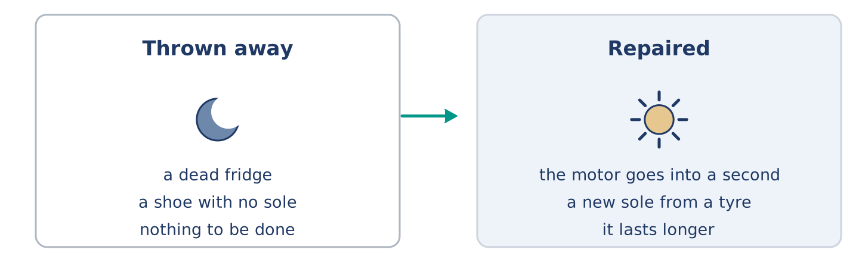
Figure 7.13 · A broken thing, and the two roads out of it.
Before you read: what happens to a broken thing in your town?
Gloss: jua kali = an open-air workshop in Kenya, from the words for hot sun · informal = outside the official system · skill = something you can do well because you learned it · motor = the part that makes a machine go
In Nairobi there is a part of the city where almost nothing is thrown away. People call it jua kali, which means hot sun, because the workshops are in the open air. A man takes the motor out of a dead fridge and puts it into a working one. A woman cuts a new sole for a shoe out of an old tyre. That shoe then lasts longer than the one it came from. There are thousands of these workshops and almost none of them has an office or a sign. Visitors from richer countries often call it poor, and part of it is. But the skill in those streets is real and hard to find. Most of Europe lost it in two generations. The cheapest thing is still the thing you already own; what Nairobi kept is the knowledge of how to keep it.
Answer the questions. (0. is done.)
- What does jua kali mean? — Hot sun.
- Why are the workshops called that?
- What does a woman cut a new sole out of?
- What did most of Europe lose?
Part 8: Vocabulary in Context
Match each word with its meaning. One meaning is not needed. Write the letter.
Column A
1. | skill | ____
2. | informal | ____
3. | tyre | ____
4. | generation | ____
Column B
a) | outside the official system
b) | something you can do well because you learned it
c) | all the people born at about the same time
d) | the round rubber part of a wheel
e) | the flat bottom of a shoe
Part 8: Discussion
Talk with a partner. Use the frames.
Discussion frames: “This is similar to where I live because…” · “This is different from where I live because…” · “I think the most important thing is… because…”
Part 9 · Close to Home — Mr Okonkwo’s Coat
[PLUS] Plus track · pre-read / decide
Before you read: how old is the oldest thing you wear?
Mr Okonkwo’s coat is older than Dani. It was expensive when he bought it, and he says that was the point. A woman two streets away relined it twice, and she no longer takes new work. The buttons are not the ones it came with. It is not the warmest coat on Alder Street and it is certainly not the lightest. It is the only one anybody ever repaired. Dani asked him once why he did not simply buy a new one. Mr Okonkwo said he could, easily, and that the coat was not really the point either. He did not explain what was. Amina thinks she knows. She never says, because some things get smaller when you say them out loud. She also knew him long before I did.
Answer the questions. (0. is done.)
- How old is Mr Okonkwo’s coat? — Older than Dani.
- What did a woman two streets away do twice?
- What did Dani ask him?
- Why has Amina not said what she thinks?
Part 9: Decision Task
Something you own is broken. Should you (a) mend it, (b) buy the cheapest new one, or (c) save up and buy the best one? Decide and explain. Use the frame.
Answer frame: “I think I should ___ because ___. Also, ___. This is better than ___ because ___.”
Model — read this first:
I think I should mend it, because a mend costs a tenth of a new one and this one still works otherwise. Also, I know this one, and a new one would be a month of small surprises. This is better than buying the cheapest, because the cheapest would be broken again by the spring. (55 words)
Phrase bank: I think I should… · because… · Also,… · This is better than… · In my opinion…
Part 10 · Review and Can-Do
[CORE + PLUS] · homework / self-study
Part 10: Spiral Review
Complete the review. (0. is done.)
- How good something is, and how long it lasts, is its quality.
Word bank: brand | battery | screen | deal | cheaper | the cheapest | suitcase | basket
- The name a company puts on the things it makes is the ______________________ .
- The part that holds the power in a telephone is the ______________________ .
- The flat glass part that lights up is the ______________________ .
- A price better than the usual one is a ______________________ .
- The grey coat is ______________________ than the green one. (two things)
- This shop is ______________________ in the street. (more than two)
- (from Unit 6) A big case with a handle, for your clothes, is a ______________________ .
- (from Unit 4) A light open bag you fill while you walk round is a ______________________ .
Part 10: Can-Do
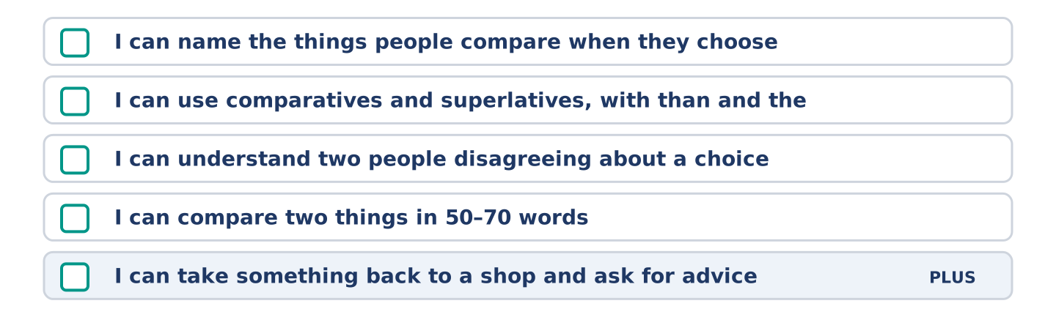
Figure 7.14 · What you can do at the end of this unit.
Can-Do checklist
☐ I can name the things people compare when they choose.
☐ I can use comparatives and superlatives, with than and the.
☐ I can understand two people disagreeing about a choice.
☐ I can compare two things in 50–70 words.
☐ I can take something back to a shop and ask for advice (Plus).
Part 10: Glossary
Unit 7 glossary (10 words)
quality · value · brand · battery · screen · deal · repair · model · second-hand · offer
Unit 8: Help and Ability
English for Daily Life · Level: A2 · Tracks: [CORE] Warm-Up + Parts 1–6 · [PLUS] Parts 7–10
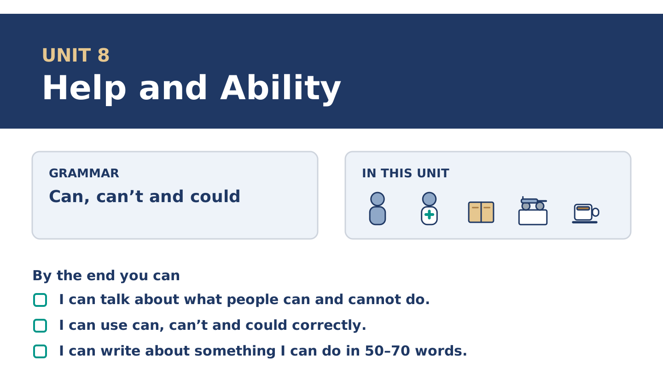
Figure 8.1 · Unit 8 at a glance: the grammar, the topic and what you will be able to do.
Warm Up
[CORE] Core track · in-class starter
Warm-up: Helping Words and Meanings
Match the words with their meanings. One meaning is not needed. Write the letter.
Column A
1. | Lend | ____
2. | Borrow | ____
3. | Favour | ____
4. | Lesson | ____
5. | Beginner | ____
Column B
a) | somebody who is starting to learn something
b) | to give something to somebody for a short time
c) | a kind thing you do for somebody because they asked
d) | one hour in which somebody teaches you
e) | to take something from somebody for a short time
f) | a price that is better than the usual one
Warm-up: Talking About What You Can Do
Complete the sentences using the words in the word bank.
Word bank: lend | instrument | patient | beginner
- Tomas is very ______________________ when somebody is frightened.
- Mr Okonkwo can play one ______________________ , and he plays it badly.
- Can you ______________________ me a pen? I need one for ten minutes.
- Yuki is a complete ______________________ , and she says so before anybody else can.
Warm-up: Six People, Six Skills
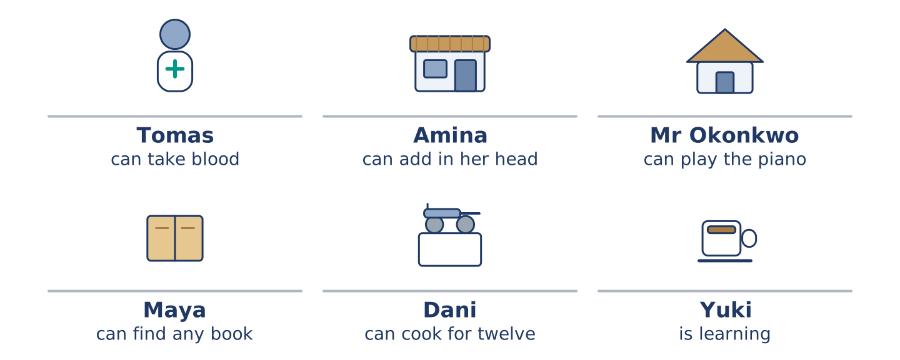
Figure 8.2 · What each of them can do, and what they cannot.
Read the text and choose the correct answer.
Everybody at number 14 can do something the others cannot. Tomas can take blood from an arm without anybody noticing. Amina can add four prices in her head faster than the till. Mr Okonkwo can play the piano, badly, and he says badly is enough. Maya can find any book in under a minute. Dani can cook rice for twelve people with no warning. Yuki cannot do any of these things yet, and she is the only one still learning something new.
1. What can Amina do?
○ A) Play the piano
○ B) Add four prices in her head
○ C) Find any book
○ D) Cook for twelve
2. What is true about Yuki?
○ A) She can play an instrument
○ B) She cooks for twelve
○ C) She is learning something new
○ D) She works at the hospital
Part 1 · Vocabulary and Terminology
[CORE] Core track · pre-class input
Part 1: Ability and Helping Terms
Match the words with their meanings. One meaning is not needed. (0. is done for you.)
- Able → having the strength, the time or the skill to do something.
Column A
1. | Favour | ____
2. | Lend | ____
3. | Advice | ____
4. | Course | ____
5. | Patient | ____
6. | Instrument | ____
7. | Beginner | ____
Column B
a) | a set of lessons on one subject
b) | a kind thing you do because somebody asked
c) | calm with somebody who is slow or frightened
d) | to give something for a short time
e) | a thing you play music on
f) | what you say to somebody who does not know what to do
g) | somebody who is starting to learn
h) | one version of a thing a company makes
Gloss: favour = a kind thing you do because somebody asked · instrument = a thing you play music on · patient = calm with somebody who is slow
Part 1: Pronunciation
🔊 Audio Track 8.1
Listen to can and can’t. Say each pair aloud.
I can swim — can is short and weak: /kən/
I can’t swim — can’t is long and clear: /kɑːnt/
Can you help? — can is weak again: /kən/
Yes, I can. — at the end it is strong: /kæn/
This is the hardest sound in the unit, and it matters. In the middle of a sentence can almost disappears, and can’t is the one you hear. If a learner says can loudly, an English ear hears can’t, and the answer comes out wrong.
Part 1: Six Skills and Where You Learn Them
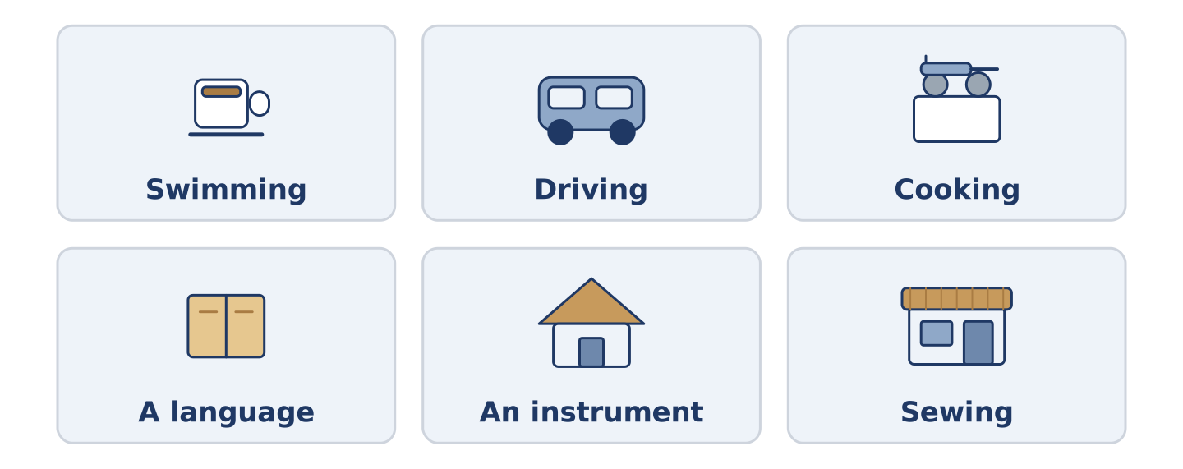
Figure 8.3 · Six things people learn, and where they learn them.
Complete the table. Write where you learn it and how long it takes. (0. is done.)
Skill | Where you learn it | How long it takes
Swimming | a pool, with a teacher | (example)
Driving
Cooking
A language
- Swimming — a pool, with a teacher — a few weeks to float, years to be good.
Think about something you learned as an adult. There is more than one right answer; be ready to say why you chose yours.
Part 1: Asking for Help
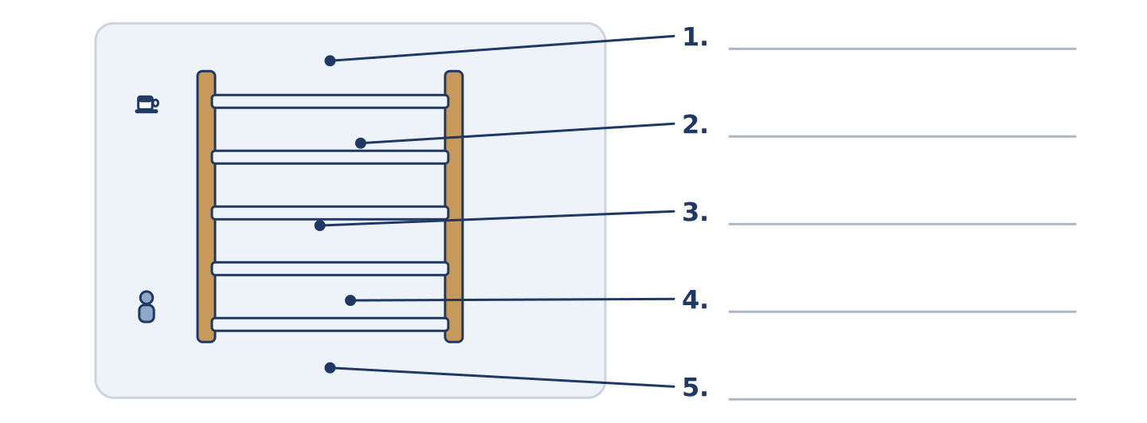
Figure 8.4 · Asking for help — write the correct word on each line.
Match the ways of asking with their descriptions. One description is not needed. Write the letter.
Column A
1. | Can you…? | ____
2. | Could you…? | ____
3. | Would you mind…? | ____
4. | I was wondering… | ____
5. | Give me… | ____
Column B
a) | the politest of all, and the longest
b) | the plainest way, between friends
c) | not a question at all, and rarely polite
d) | a little more polite than can
e) | very polite, and it needs a no to mean yes
f) | asking what somebody is able to do
Part 1: Helping — Multiple Choice
Read and choose the correct answer.
1. Somebody who is starting to learn is a…
○ A) beginner
○ B) course
○ C) favour
○ D) lesson
2. To give something to somebody for a short time is to…
○ A) borrow
○ B) lend
○ C) lift
○ D) learn
3. Calm with somebody who is slow or frightened means…
○ A) patient
○ B) able
○ C) kind
○ D) quiet
Part 1: Vocabulary Fill-in
Complete the sentences with the correct word.
Word bank: favour | advice | course | borrow
- Can I ______________________ your bicycle for an hour?
- Yuki is doing a ten-week ______________________ on Thursday evenings.
- Dani asked Amina for ______________________ and then did the opposite.
- Could you do me a ______________________ and watch the shop for ten minutes?
Part 1: Write About What You Can Do (short)
Write two or three sentences about something you can do well. Use three words from this unit.
Model — read this first:
I can cook about six things and I can cook them very well. I cannot follow the steps in a book; I lose my place and I start to make it up. My father was patient with me for two years and then he gave me a pan and left the kitchen. (52 words)
Part 2 · Grammar — Can, Can’t and Could
[CORE] Core track · pre-class input
Part 2: Notice
Read these lines. Underline can, can’t and could. Which ask, and which tell you about ability?
Amina can add four prices in her head. Mr Okonkwo can play the piano, badly. Yuki can’t swim, but she could float when she was eight. Can you lend me a pen? Could you watch the shop for ten minutes? I could carry one box, but I can’t carry four.
Three of these are about ability. Two are requests. One is about the past.
Part 2: Grammar Focus Box
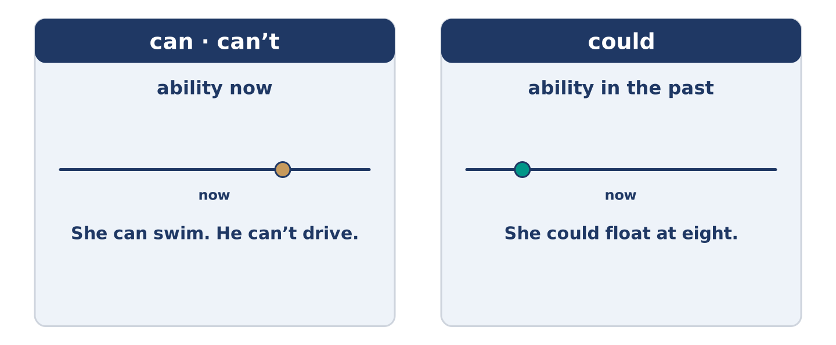
Figure 8.5 · Can and could: what they do, and how polite they are.
 | Form | Use | Example
can / can’t | can + plain verb, every person | ability now | She can swim. He can’t drive.
could | could + plain verb | ability in the past | He could float at eight.
Can you…? | a question, plain | asking a friend | Can you lend me a pen?
Could you…? | a question, softer | asking anybody | Could you watch the shop?
Remember: can and could never take to: I can swim, not I can to swim.
Watch out! ✗ He cans swim. → ✓ He can swim. (can never takes -s). ✗ Can you to help me? → ✓ Can you help me? (no to after can).
Part 2: Controlled Practice
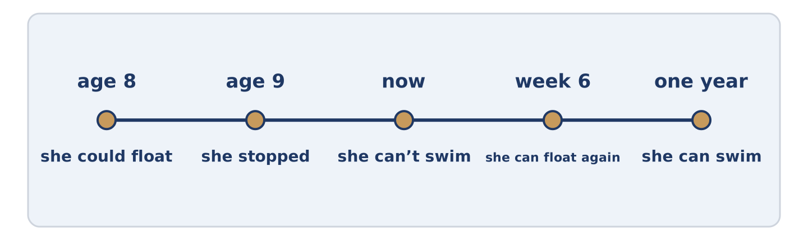
Figure 8.6 · Six people, and what each of them can do.
Complete with can, can’t or could. (0. is done.)
- Amina can add four prices in her head.
- Yuki ______________________ swim, but she wants to learn.
- Mr Okonkwo ______________________ play the piano, badly.
- When she was eight, Yuki ______________________ float.
- ______________________ you watch the shop for ten minutes?
Part 2: Ability or Request?
Write ability or request. (0. is done.)
- Tomas can take blood from an arm. — ability
- Could you lend me a pen? ____________
- Dani can cook rice for twelve people. ____________
- Can you carry this box? ____________
- Mr Okonkwo could run, when he was younger. ____________
Part 2: Correct the Sentence
Each sentence has one grammar mistake. Write the correct sentence.
- He cans play the piano.
- Can you to help me with this box?
- Yuki can’t to swim yet.
- When he was young, he can run very fast.
Part 2: Freer Practice
Write two sentences about yourself: one thing you can do, and one thing you could do when you were a child.
Part 2: Grammar Review
Choose the correct sentence.
1. Which sentence about ability is correct?
○ A) He cans swim very well.
○ B) He can to swim very well.
○ C) He can swim very well.
○ D) He can swims very well.
2. Which is the more polite request?
○ A) Give me a pen.
○ B) You lend me a pen.
○ C) Can you lend me a pen, yes?
○ D) Could you lend me a pen?
→ Harvest: you will see can, can’t and could again in the Part 5 reading. Watch for the requests.
Part 3 · Listening
[CORE] Core track · pre-class input · scripts printed inline
Part 3: Asking a Favour
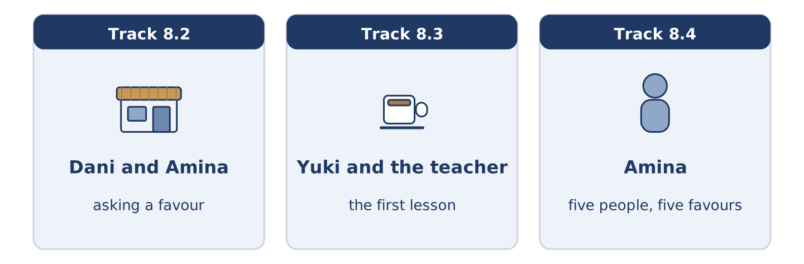
Figure 8.7 · The three listenings: who is speaking, and what about.
🔊 Audio Track 8.2
Before you listen: how do you ask for something you think is too much to ask?
Dani: Amina, could you do me a favour? Amina: That depends entirely on the favour. Dani: Could you watch my bike for an hour? Amina: I can watch it, but I can’t carry it anywhere, so don’t be long. Dani: One hour. Amina: You said one hour last time and I shut at six with a bicycle in front of the door. Dani: I know. I’m sorry. Amina: Go on. One hour.
While you listen: write True, False, or Not Given. (0. is done.)
- Dani asks Amina for a favour. — True
- Amina says she can carry the bike. ____
- Dani was late once before. ____
- Amina charges Dani for watching the bike. ____
Useful phrases: Could you do me a favour? · That depends… · I can… but I can’t… · Go on.
Part 3: The First Lesson
🔊 Audio Track 8.3
Before you listen: what do you say to a teacher on the first day?
Teacher: Can you swim at all? Yuki: No. I could float when I was eight and then I stopped. Teacher: That’s more than most people start with. Can you put your face in the water? Yuki: I can, but I don’t like it. Teacher: Good, that’s the honest answer. We can work with that. You can’t learn this in a month, but you can learn it. Yuki: How long? Teacher: It depends how often you come, and whether you tell me the truth.
Answer the questions. (0. is done.)
- What is Yuki learning? — To swim.
- What could Yuki do when she was eight?
- What can she do, even though she does not like it?
- What two things does the time depend on?
Part 3: Five People, Five Favours
🔊 Audio Track 8.4
Before you listen: who do people in your street ask for help?
Amina: They all ask me and they all ask different things. Maya can’t reach the top shelf in her own kitchen, so she asks Tomas. Tomas can’t cook, so he asks Dani, who can. Dani can’t keep money, so he asks nobody and comes to me. Mr Okonkwo can do almost everything and asks for nothing, which is its own kind of problem. Yuki asks very politely for very small things, and I tell her every week that she can ask for more.
While you listen: match each person with their favour. One is not needed. (0. is done.)
- Amina → everybody asks her.
Useful phrases: ___ asks Tomas · ___ asks Dani · ___ asks for very little
Column A
1. | Maya | ____
2. | Tomas | ____
3. | Mr Okonkwo | ____
4. | Yuki | ____
Column B
a) | asks Dani, because he cannot cook
b) | asks nothing of anybody
c) | asks Tomas, because he can reach the top shelf
d) | asks for a lift to the station
e) | asks politely for very small things
Part 4 · Speaking
[CORE] Core track · in-class output
Part 4: Talking About What You Can Do
Work with a partner. Ask and answer these questions.
- What can you do that most people cannot?
- What could you do as a child that you cannot do now?
- What do you want to learn, and what stops you?
Useful language: I can… · I can’t… yet · I could… when I was… · I want to learn…
Part 4: Find the Difference (pairwork)
Student A and Student B each have a list of skills. Ask questions and find three differences.
Useful questions: Can you swim? · Can you drive? · Could you do it as a child? · How well can you cook?
Student A — you can: swim, cook well, play an instrument. You cannot drive.
Student B — you can: swim, drive, cook a little. You cannot play an instrument.
Part 4: Asking for a Favour
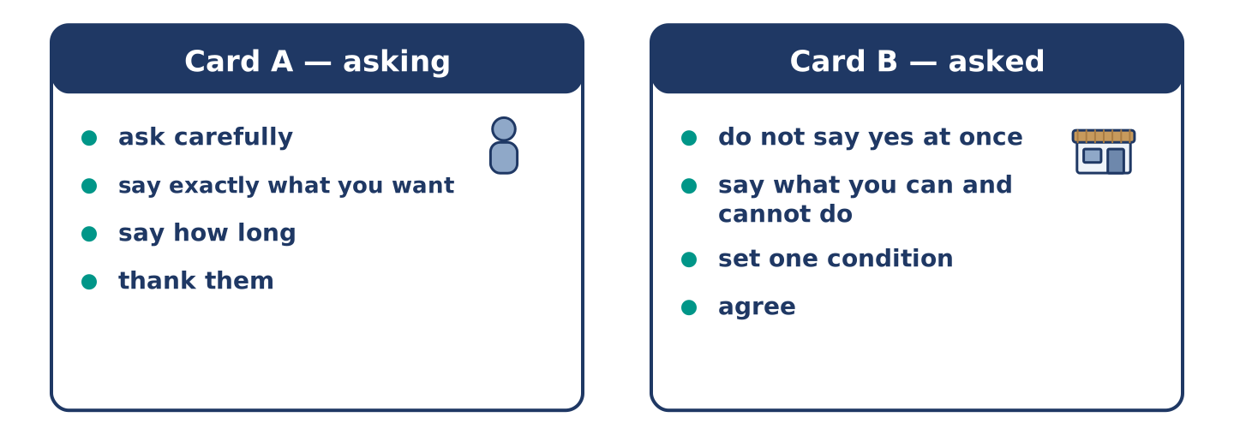
Figure 8.8 · Card A and Card B: what each of you has to say.
Work in pairs. Read the model, then use the cards.
Model exchange:
A: Could you do me a favour? — B: That depends on the favour. — A: Could you watch my bike for an hour? — B: I can watch it, but I can’t move it. — A: That’s fine. — B: And one hour means one hour. — A: One hour. Thank you.
Useful language: Could you do me a favour? · That depends… · I can… but I can’t… · That’s fine.
Card A — asking: ask carefully · say exactly what you want · say how long · thank them.
Card B — asked: do not say yes immediately · say what you can and cannot do · set one condition · agree.
Your turn: run the dialogue, then swap roles.
Stretch [PLUS]: you have to say no — do it in a way that leaves the friendship where it was.
Part 4: Mini-Presentation
Prepare a short talk (about one minute). Describe something you learned as an adult: what you could not do at first, and what you can do now.
Part 5 · Reading
[CORE] Core track · pre-class input
Part 5: Why Adults Think They Cannot Learn
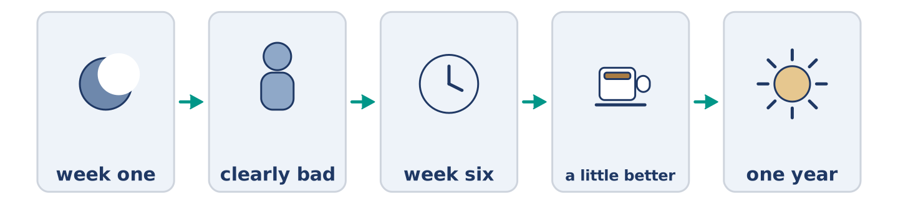
Figure 8.9 · One skill, from the first week to the first year.
Before you read: is it harder to learn something new at forty than at four?
Gloss: adult = a grown-up person · beginner = somebody starting to learn · progress = getting better over time
Adults often say they cannot learn a new skill, and they are almost always wrong. What they mean is that they cannot be a beginner in front of other people. A child of four falls over in a swimming pool and nobody thinks anything of it. An adult of forty falls over and feels it in the back of the neck for an hour. So adults avoid the first six weeks. Those six weeks are the only really unpleasant part. Then they decide they were too old. The research says something different. Adults learn some things faster than children, because they can understand an explanation and a child cannot. What adults cannot do is practise badly in public for long enough. The skill is not the problem. The audience is.
Answer the multiple-choice questions. (0. is done.)
- What do adults often say? — That they cannot learn a new skill.
1. What does the text say adults really mean?
○ A) They have no time
○ B) They cannot be a beginner in front of people
○ C) They are too old
○ D) The lessons cost too much
2. Why do adults sometimes learn faster than children?
○ A) They practise more
○ B) They are stronger
○ C) They can understand an explanation
○ D) They have better teachers
3. What does the text say the real problem is?
○ A) The skill
○ B) The teacher
○ C) The price
○ D) The audience
Part 5: Vocabulary in Context
Match each word from the text with its meaning. One meaning is not needed. Write the letter.
Column A
1. | progress | ____
2. | avoid | ____
3. | audience | ____
4. | explanation | ____
Column B
a) | the others in the room
b) | getting better over time
c) | words that make something clear
d) | to stay away from something on purpose
e) | somebody who is starting to learn
Part 5: Learning Together
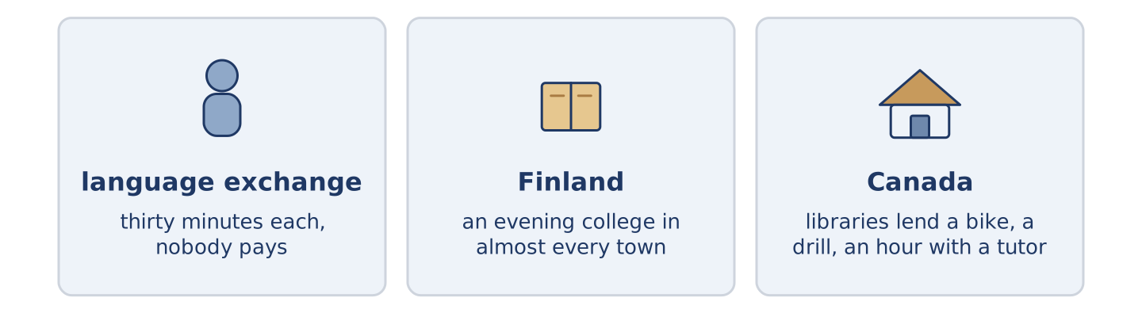
Figure 8.10 · Three places where people teach each other.
Before you read: who taught you the most useful thing you know?
Gloss: exchange = when two people each give something · tutor = somebody who teaches one person at a time
Not all teaching happens in a school. In many cities there are language exchanges. Two people meet for an hour, and each one speaks the other’s language for thirty minutes. Neither of them pays. In Finland almost every town has an evening college. A cook, a driver and an old judge can sit in the same guitar class for beginners, and nobody finds it strange. In Canada libraries have a long tradition of lending more than books. In some cities you can borrow a bike, a drill, or an hour with a tutor. It is the same in every country. If a town makes room for it, people can usually find a teacher they can afford.
Answer the questions. (0. is done.)
- Does all teaching happen in a school? — No, it does not.
- How long does each person speak in a language exchange?
- Who can sit in the same beginners’ class in Finland?
- What can you borrow from some libraries in Canada?
Part 6 · Writing
[CORE] Core track · in-class / homework
Part 6: Something I Can Do (50–70 words)
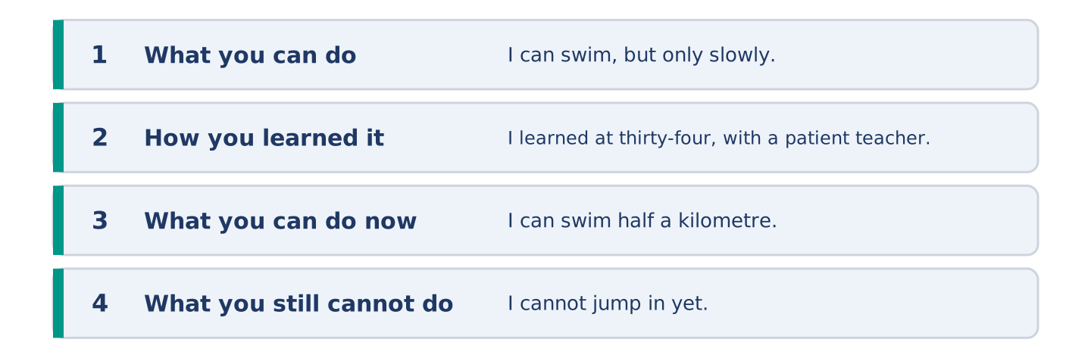
Figure 8.11 · The shape of the paragraph you are about to write.
Write about something you can do. Say how well, how you learned it, and what you still cannot do.
Model — read this first:
I can swim, but only in a straight line and only slowly. I learned at thirty-four, in a pool with six other adults and a very patient teacher. The best advice I got was to come twice a week and stop counting the weeks. I can swim half a kilometre now. I still cannot jump in from the side, and I cannot swim in the sea without thinking about what is under me. (73 words)
Plan (fill in, then write): I can ___, but only ___. I learned ___. I can ___ now. I still cannot ___.
Word bank: I can | I can’t | I could | when I was | still | yet
Check before you finish: ☐ two can sentences? ☐ one cannot? ☐ one could about the past? ☐ 50–70 words?
Part 6: Is It Harder to Learn Later? (50–70 words)
Is it harder to learn something new as an adult? Give your opinion and two or three reasons.
Model — read this first:
It is not harder, it is more embarrassing, and people confuse the two. A child can be bad at something in front of thirty other children and forget it by lunch. An adult remembers it for a week. If you can get past six weeks of being clearly bad, you can learn almost anything. Most people stop in week three. (60 words)
Word bank: I think… because… | harder | however | in my opinion | it depends on
Check before you finish: ☐ a clear opinion? ☐ two or three reasons? ☐ 50–70 words?
Part 6: Asking for Help in Writing (50–70 words)
You need a favour from a neighbour. Write them a short message asking for it.
Model — read this first:
Tomas, could you do me a favour on Thursday? I have a box coming between nine and one and I cannot be at home. Could you take it in if you are back from your shift? It is one box and it is not heavy. If you are asleep, do not worry at all — I can ask Amina instead. Maya (61 words)
Plan (fill in, then write): ___, could you do me a favour on ___? I ___ and I cannot ___. Could you ___? If ___, ___.
Check before you finish: ☐ the favour said plainly? ☐ when? ☐ a way out for them? ☐ 50–70 words?
Part 6: Reflection — Something I Want to Learn (40–60 words)
Write about something you cannot do and want to learn.
Model — read this first:
I cannot read music. I can play three songs on a guitar by copying somebody’s fingers, which is not the same thing. I would like to open a page and hear it. I thought this every year for eleven years and I never found a Tuesday evening for it. (49 words)
Check before you finish: ☐ what you cannot do? ☐ why you want it? ☐ what stops you? ☐ 40–60 words?
Part 7 · Real-World File — Asking, Offering, Refusing
[PLUS] Plus track (optional) · stronger learners
7A: Phrase Bank
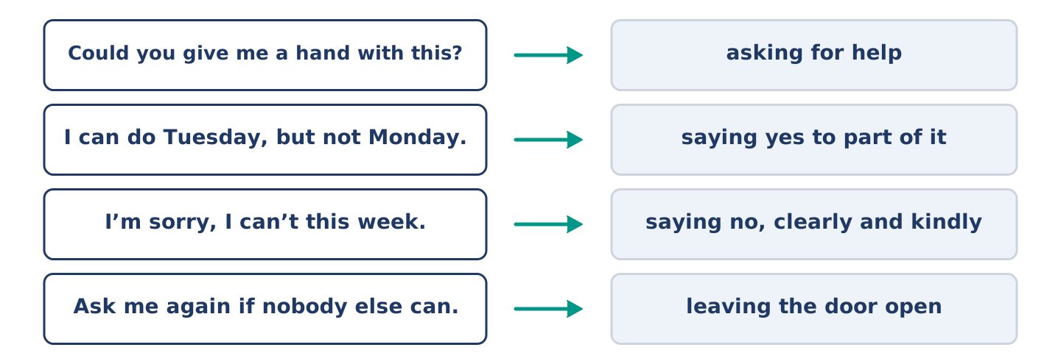
Figure 8.12 · What you say when you ask or refuse, and what each does.
Match what a person says with its purpose. One purpose is not needed. Write the letter.
Column A
1. | “Could you give me a hand with this?” | ____
2. | “I can do Tuesday, but not Monday.” | ____
3. | “I’m sorry, I can’t this week.” | ____
4. | “Ask me again if nobody else can.” | ____
Column B
a) | leaving the door open
b) | saying no, clearly and kindly
c) | asking for help
d) | asking for money
e) | saying yes to part of it
7B: Asking and Being Refused
🔊 Audio Track 8.5
Before you read: how do you say no to somebody you like?
Maya: Tomas, could you take a box on Thursday? Tomas: What time? Maya: Between nine and one. Tomas: I’m sorry, I can’t. I finish at eight and I’d be asleep through all of it. Maya: Of course. I didn’t think. Tomas: Ask Amina — she’s open and she’s thirty seconds away. Maya: I didn’t want to ask her again. Tomas: Maya, she keeps four keys in a box for exactly this. Ask her.
Answer the questions. (0. is done.)
- What does Maya ask Tomas to do? — Take a box on Thursday.
- Why can Tomas not do it?
- Who does Tomas suggest instead?
- Why did Maya not want to ask Amina again?
7C: Controlled Practice — Asking Well
Put the steps in order. Number them 1–5. (0. is done.)
- Ask whether it is possible at all. — 1
____ Thank them, whatever they say.
____ Say exactly what you need and when.
____ Say what happens if they cannot.
____ Wait for an honest answer.
7D: Role-Play — Asking and Refusing
In pairs. One asks for a favour; one has to say no. Use the model and cards.
Model exchange: A: Could you take a box on Thursday? — B: What time? — A: Between nine and one. — B: I’m sorry, I can’t. I’d be asleep. — A: Of course. — B: Ask Amina. She’s thirty seconds away.
Card A — asking: ask carefully · give the detail · accept the no · ask the next question.
Card B — refusing: ask one question first · say no clearly · give the real reason · offer somebody else.
Stretch [PLUS]: the person asking is in real trouble and you still cannot help — say so without pretending.
7E: Writing — Asking Somebody You Do Not Know Well (50–80 words)
Write a short message asking a favour of a neighbour you have only met twice.
Model — read this first:
Hello — this is Yuki from the top flat. I am sorry to ask when we only met twice. I have a box coming on Friday afternoon and I cannot be here. Could you possibly take it in? It is small. If you are out or busy, please do not worry about it at all; we can find another day. Thank you either way. Yuki, flat 5 (67 words)
Check before you finish: ☐ who you are? ☐ the favour, in one sentence? ☐ a clear way out for them? ☐ 50–80 words?
Part 8 · Global Story — The Library That Lends Everything
[PLUS] Plus track · pre-read / discuss
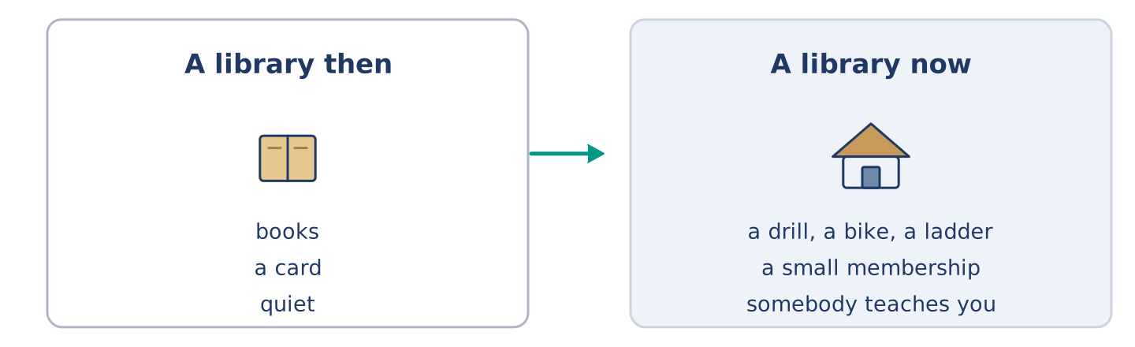
Figure 8.13 · What a library used to lend, and what it lends now.
Before you read: should a library lend you a drill?
Gloss: drill = a tool that makes holes · tool = a thing you use to make or mend something · membership = the right to use something, usually for a year · ladder = steps you carry, for reaching high things · storage = space where things sit and wait
There is a number that people in libraries like to repeat. The average drill in a house does thirteen minutes of work in its whole life. Everything else is storage. Some years ago a library in Toronto took that seriously and started lending tools as well as books. There are now hundreds of these libraries across Canada and beyond. You pay a small membership, or in many cities nothing at all, and you borrow a drill, a bike, a sewing machine, a ladder. The arguments against it were obvious and mostly wrong: people would break things, nobody would bring them back, it would cost a fortune. In practice tools come back, because the next job usually needs the same tool. The libraries say the surprising part is not the lending. It is how many people arrive to borrow a drill and leave knowing how to use one.
Answer the questions. (0. is done.)
- How much work does the average drill do in its whole life? — Thirteen minutes.
- What did a library in Toronto start doing?
- What were the arguments against it?
- What do the libraries say is the surprising part?
Part 8: Vocabulary in Context
Match each word with its meaning. One meaning is not needed. Write the letter.
Column A
1. | tool | ____
2. | membership | ____
3. | ladder | ____
4. | storage | ____
Column B
a) | the right to use something, usually for a year
b) | space where things sit and wait
c) | a thing you use to make or mend something
d) | steps you carry, for reaching high things
e) | the others in the room
Part 8: Discussion
Talk with a partner. Use the frames.
Discussion frames: “This is similar to where I live because…” · “This is different from where I live because…” · “I think the most important thing is… because…”
Part 9 · Close to Home — What Mr Okonkwo Cannot Do
[PLUS] Plus track · pre-read / decide
Before you read: is it harder to ask for help or to give it?
Mr Okonkwo can mend a chair, reline a coat and teach a child to read in a few months. He cannot, since February, carry a full shopping bag up four floors without stopping twice on the way. Nobody at number 14 mentioned this, and neither did he. Amina started putting his Friday shopping into two light bags instead of one heavy one, and said nothing. Dani began to appear on the stairs at about the right time on Fridays, with a reason. Maya asked him to teach her something, which was true and was also not the point. Mr Okonkwo noticed all three and said nothing either, which is a kind of thank you, and everybody at number 14 understood it perfectly.
Answer the questions. (0. is done.)
- What can Mr Okonkwo do? — Mend a chair, reline a coat and teach a child to read.
- What has he not been able to do since February?
- What did Amina start doing?
- What did Mr Okonkwo do about all three?
Part 9: Decision Task
Somebody near you needs help and does not ask. Should you (a) offer directly, (b) help without saying anything, or (c) wait until they ask? Decide and explain. Use the frame.
Answer frame: “I think I should ___ because ___. Also, ___. This is better than ___ because ___.”
Model — read this first:
I think I should help without saying anything, because an offer makes somebody say out loud that they need help. Saying it out loud is the hard part. Also, a small change nobody mentions costs them nothing. This is better than waiting until they ask, because the ones in most need of help ask last of all. (57 words)
Phrase bank: I think I should… · because… · Also,… · This is better than… · In my opinion…
Part 10 · Review and Can-Do
[CORE + PLUS] · homework / self-study
Part 10: Spiral Review
Complete the review. (0. is done.)
- A kind thing you do because somebody asked is a favour.
Word bank: lend | borrow | beginner | patient | can | could | quality | suitcase
- To give something to somebody for a short time is to ______________________ .
- To take something from somebody for a short time is to ______________________ .
- Somebody who is starting to learn is a ______________________ .
- Calm with somebody who is slow or frightened is ______________________ .
- Amina ______________________ add four prices in her head. (now)
- Yuki ______________________ float when she was eight. (then)
- (from Unit 7) How good something is, and how long it lasts, is its ______________________ .
- (from Unit 6) A big case with a handle, for your clothes, is a ______________________ .
Part 10: Can-Do
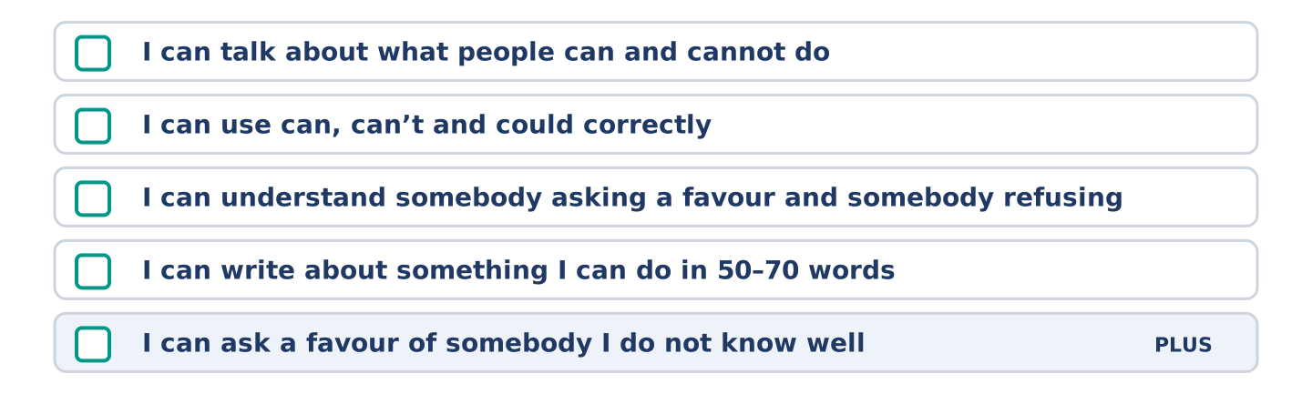
Figure 8.14 · What you can do at the end of this unit.
Can-Do checklist
☐ I can talk about what people can and cannot do.
☐ I can use can, can’t and could correctly.
☐ I can understand somebody asking for a favour and somebody refusing.
☐ I can write about something I can do in 50–70 words.
☐ I can ask a favour of somebody I do not know well (Plus).
Part 10: Glossary
Unit 8 glossary (10 words)
favour · lend · borrow · advice · course · lesson · beginner · patient · instrument · able
Unit 9: Finding Your Way
English for Daily Life · Level: A2 · Tracks: [CORE] Warm-Up + Parts 1–6 · [PLUS] Parts 7–10
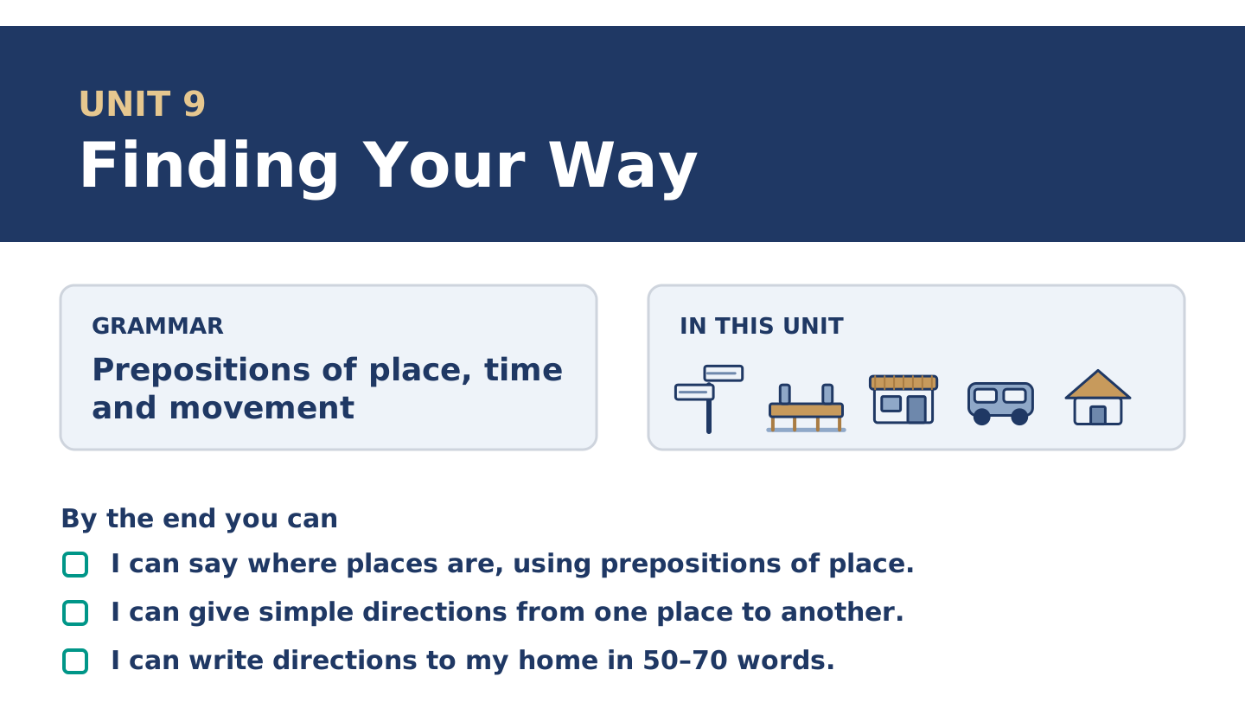
Figure 9.1 · Unit 9 at a glance: the grammar, the topic and what you will be able to do.
Warm Up
[CORE] Core track · in-class starter
Warm-up: Words for Places and Roads
Match the words with their meanings. One meaning is not needed. Write the letter.
Column A
1. | Junction | ____
2. | Roundabout | ____
3. | Lane | ____
4. | Square | ____
5. | Address | ____
Column B
a) | the number and the street where somebody lives
b) | a circle of road where cars go round one way
c) | a narrow road between fields or houses
d) | where two or more roads meet
e) | an open space in a town with buildings round it
f) | a wide road that goes round a whole city
Warm-up: Saying Where Things Are
Complete the sentences using the words in the word bank.
Word bank: address | far | towards | lane
- Yuki wrote her new ______________________ on a card for Amina.
- The health centre is not ______________________ — about eight minutes on foot.
- Walk ______________________ the bridge and turn left at the bench.
- The shop takes its boxes in from a narrow ______________________ behind the building.
Warm-up: Alder Street from End to End
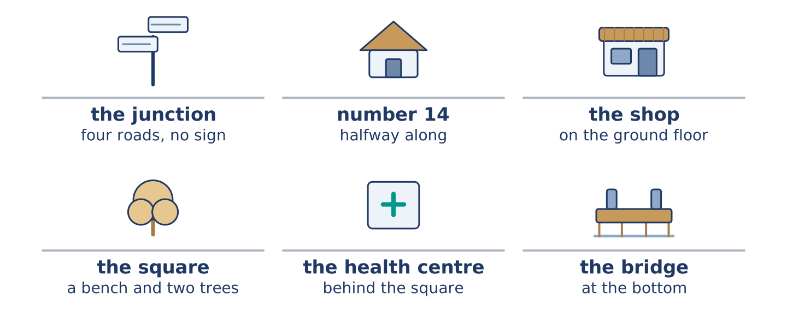
Figure 9.2 · Alder Street from the junction at the top to the square at the bottom.
Read the text and choose the correct answer.
Alder Street runs downhill between the market and the bridge. Number 14 is the tall house halfway along, with the shop on the ground floor. At the top there is a junction with four roads and no sign. At the bottom there is a small square with a bench and two trees. The health centre is behind the square. A first-time visitor usually stops at the junction and rings from there.
1. Where is number 14?
○ A) At the top of the street
○ B) Behind the square
○ C) Next to the bridge
○ D) Halfway along the street
2. What is at the bottom of the street?
○ A) A small square
○ B) A junction with four roads
○ C) The market
○ D) The health centre
Part 1 · Vocabulary and Terminology
[CORE] Core track · pre-class input
Part 1: Words for Finding Your Way
Match the words with their meanings. One meaning is not needed. (0. is done for you.)
- Block → a group of buildings with streets on all four sides.
Column A
1. | Junction | ____
2. | Roundabout | ____
3. | Lane | ____
4. | Square | ____
5. | Address | ____
6. | Towards | ____
7. | Ahead | ____
Column B
a) | in the direction of something
b) | where two or more roads meet
c) | a circle of road where cars go round one way
d) | in front of you, further along
e) | the number and the street where somebody lives
f) | an open space in a town with buildings round it
g) | a narrow road between fields or houses
h) | the paper that tells you when the bus leaves
Gloss: junction = where two or more roads meet · roundabout = a circle of road where cars go round one way · lane = a narrow road
Part 1: Pronunciation
🔊 Audio Track 9.1
Listen to these directions. Say each one aloud, then say it to a partner.
Turn left at the junction — at the is weak and quick: /ətðə/
Go straight ahead — a in ahead almost disappears: /əˈhed/
It is opposite the square — the is weak again: /ðə/
Down to the bridge, then left — to the is one soft sound: /təðə/
Directions carry the sense in the big words: left, junction, ahead, bridge. The small words between are weak and fast. Give them all the same weight and your listener cannot hear which ones matter.
Part 1: Four Kinds of Place
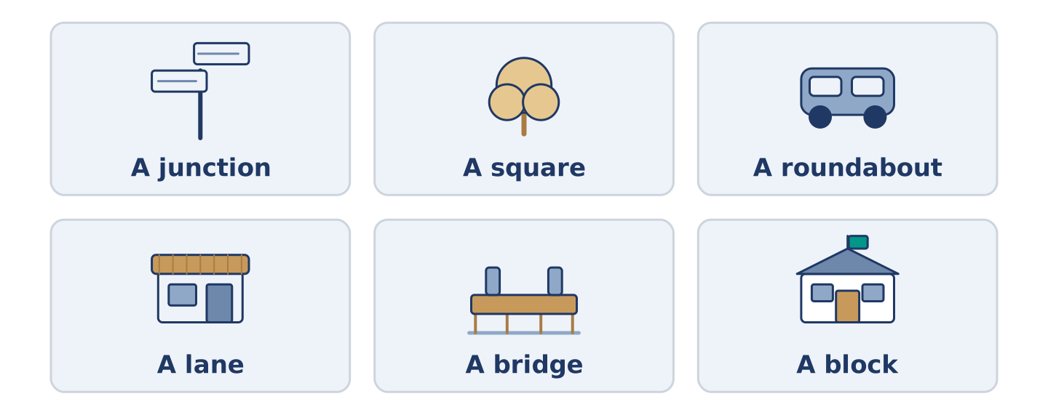
Figure 9.3 · Four kinds of place, and what you see at each one.
Complete the table. Write what you see there and how you say where it is. (0. is done.)
Place | What you see there | How you say where it is
A junction | four roads and no sign | (example)
A square
A roundabout
A lane
- A junction — four roads and no sign — at the junction.
Think about the street you know best. There is more than one right answer; be ready to say why.
Part 1: Where Exactly?
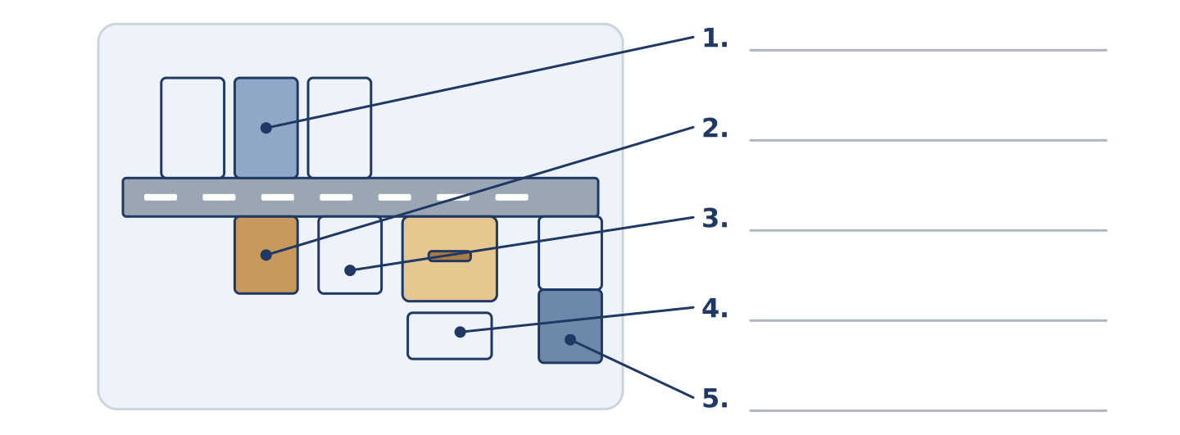
Figure 9.4 · Where exactly — write the correct word on each line.
Match the words with their meanings. One meaning is not needed. Write the letter.
Column A
1. | Opposite | ____
2. | Between | ____
3. | Behind | ____
4. | Below | ____
5. | Next to | ____
Column B
a) | with one thing on each side
b) | under it, on a lower floor
c) | at its side, touching or almost
d) | on the other side of the road from it
e) | further along the same road
f) | on the far side of it, out of sight
Part 1: Finding Your Way — Multiple Choice
Read and choose the correct answer.
1. Where two or more roads meet is a…
○ A) square
○ B) lane
○ C) junction
○ D) block
2. The number and the street where you live is your…
○ A) sign
○ B) map
○ C) direction
○ D) address
3. In front of you, further along, is…
○ A) below
○ B) ahead
○ C) towards
○ D) opposite
Part 1: Vocabulary Fill-in
Complete the sentences with the correct word.
Word bank: ahead | square | junction | block
- Walk straight ______________________ for two minutes and you reach the bridge.
- There is a bench and two trees in the ______________________ at the bottom.
- Turn right at the ______________________ and the health centre is on your left.
- The hospital takes up a whole ______________________ near the river.
Part 1: Write Where You Live (short)
Write two or three sentences saying where you live. Use three words from this unit.
Model — read this first:
I live in a lane behind a square, and the lane has no sign at either end. The nearest junction is two minutes away, and I tell people to wait there. My own address is easy to write and almost impossible to find. (43 words)
Part 2 · Grammar — Prepositions of Place, Time and Movement
[CORE] Core track · pre-class input
Part 2: Notice
Read these lines. Underline the prepositions. Which say where, which say when, and which say how?
The shop is on the corner. The health centre is behind the square. Amina opens at seven. The bus goes along Alder Street and over the bridge. Yuki walked towards the junction and stopped. On Saturday the market is in the square. The 7 goes round the roundabout twice.
Three say where. Two say when. Two say how somebody moves.
Part 2: Grammar Focus Box
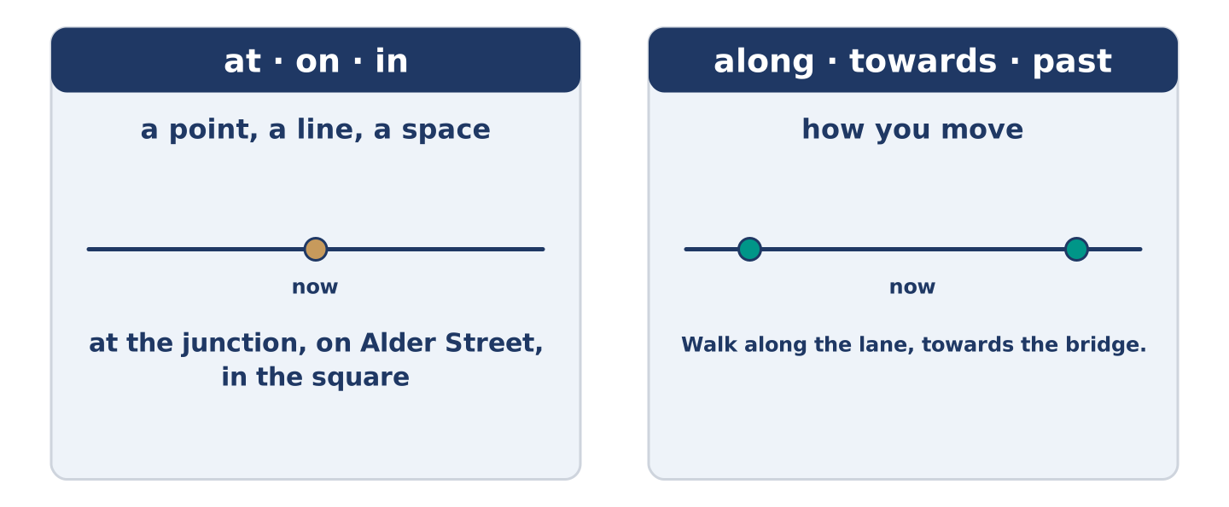
Figure 9.5 · At, on and in: a point, a line and a space.
 | Form | Use | Example
at | + a point | a spot | Wait at the junction.
on | + a line | a street | He lives on Alder Street.
in | + a space | a town | The market is in the square.
along / towards | + a path | movement | Walk along the lane.
above / below | + a thing | position | His flat is above the shop.
Remember: at is for a point, on for a line, in for a space: at the junction, on Alder Street, in the square.
Watch out! ✗ The health centre is behind of the square. → ✓ The health centre is behind the square. (no of after behind). ✗ Walk at the bridge. → ✓ Walk to the bridge. (to for where you end up).
Part 2: Controlled Practice
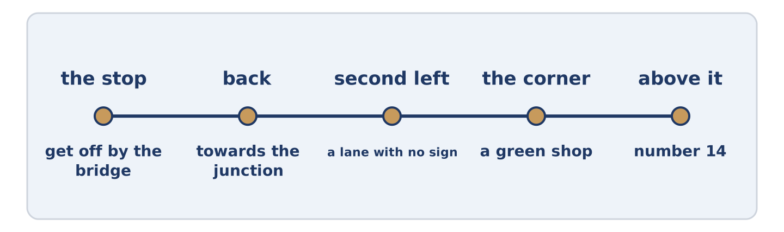
Figure 9.6 · One walk, from the junction to the health centre, step by step.
Complete with at, on, in, along or towards. (0. is done.)
- Amina opens the shop at seven.
- Number 14 is ______________________ Alder Street.
- Walk ______________________ the lane and you come out by the bridge.
- The market is ______________________ the square on Saturday.
- Yuki walked ______________________ the junction and stopped.
Part 2: Where, When or How?
Write where, when or how. (0. is done.)
- The health centre is behind the square. — where
- The bus leaves at twenty past eight. ____________
- Walk across the square. ____________
- His flat is above the shop. ____________
- On Saturday the market opens early. ____________
Part 2: Correct the Sentence
Each sentence has one grammar mistake. Write the correct sentence.
- The health centre is behind of the square.
- Walk at the bridge and then turn left.
- Amina opens the shop in seven.
- Yuki lives at the top flat of number 14.
Part 2: Freer Practice
Write two sentences: one saying where you live, and one saying how a visitor walks to you from the bus stop.
Part 2: Grammar Review
Choose the correct sentence.
1. Which sentence about place is correct?
○ A) The health centre is behind the square.
○ B) The health centre is behind of the square.
○ C) The health centre is behind to the square.
○ D) The health centre is behind at it.
2. Which sentence about movement is right?
○ A) Walk at the bridge, then left.
○ B) Walk in the bridge, then left.
○ C) Walk to the bridge, then left.
○ D) Walk the bridge way, then left.
→ Harvest: you will see these prepositions again in the Part 5 reading. Watch for the words that say where.
Part 3 · Listening
[CORE] Core track · pre-class input · scripts printed inline
Part 3: Asking the Way Next Door
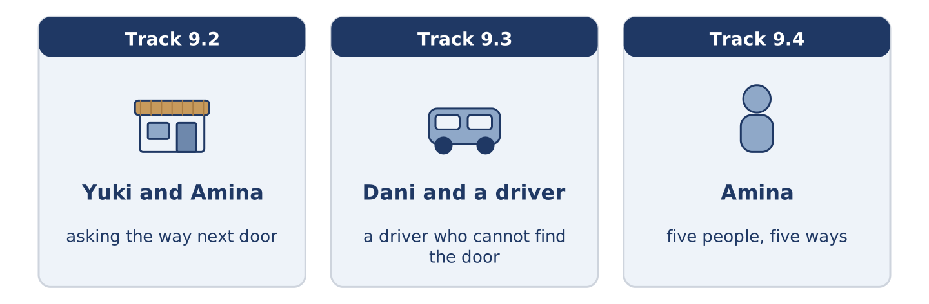
Figure 9.7 · The three listenings: who is speaking, and what about.
🔊 Audio Track 9.2
Before you listen: how do you ask the way in a place you do not know?
Yuki: Amina, how do I get to the health centre? Amina: Out of the door, left, down to the square. Yuki: And then? Amina: You cross the square, you pass the bench, and it’s the low building behind. Yuki: Is it far? Amina: Eight minutes for you. Ten if you stop to read the signs, and I tell you now, they’re no help. Yuki: Why not? Amina: They point at the old one, and the old one closed in the spring.
While you listen: write True, False, or Not Given. (0. is done.)
- Yuki asks the way to the health centre. — True
- Amina says the health centre is behind the square. ____
- The walk takes twenty minutes. ____
- Amina went to the health centre last week. ____
Useful phrases: How do I get to…? · And then? · Is it far? · past the…
Part 3: A Driver Who Cannot Find the Door
🔊 Audio Track 9.3
Before you listen: what do you say on the phone to somebody who cannot find you?
Driver: I’m at a junction with four roads and no sign. Dani: That’s the top of our street. Driver: Which way do I go? Dani: You come down the hill, towards the bridge. Driver: I can see a shop. Dani: Stop there — we’re on the ground floor behind it. Driver: I can’t see a number. Dani: You never do, in this street. Look for the green one. Driver: Got it.
Answer the questions. (0. is done.)
- Where is the driver? — At a junction with four roads.
- Which way does Dani tell him to come?
- Where in the building does Dani live?
- What does Dani tell him to look for?
Part 3: Five People, Five Ways
🔊 Audio Track 9.4
Before you listen: do you follow a map, a sign or a person?
Amina: I watch them all go past, and every one of them does it differently. Maya walks with her map open and still turns the wrong way. Tomas knows every back lane between us and the hospital. Dani goes by the shops, and he gets there. Mr Okonkwo gives you directions by what used to be on the corner, and those shops closed years ago. Yuki writes it down, and I see her read it again at every junction.
While you listen: match each person with their way of finding it. One is not needed. (0. is done.)
- Amina → she watches them all go past.
Useful phrases: ___ walks with the map · ___ knows the back lanes · ___ writes it down
Column A
1. | Maya | ____
2. | Tomas | ____
3. | Mr Okonkwo | ____
4. | Yuki | ____
Column B
a) | knows every back lane in the area
b) | gives directions by what is no longer there
c) | walks with the map open and still turns the wrong way
d) | writes it down and reads it at every junction
e) | asks the driver to wait at the corner
Part 4 · Speaking
[CORE] Core track · in-class output
Part 4: How You Find Your Way
Work with a partner. Ask and answer these questions.
- How do you find your way in a city you do not know?
- Do you use a map, a sign, or a person?
- What is the hardest place you ever tried to find?
Useful language: I go by… · I look for… · straight ahead · towards the…
Part 4: Find the Difference (pairwork)
Student A and Student B each have a map of the same street. Ask questions and find three differences.
Useful questions: Where is the shop? · Is it opposite the square? · What is next to the junction? · How far is the bridge?
Student A — on your map: the shop is on the corner, the bench is in the square, the health centre is behind the square.
Student B — on your map: the shop is opposite the square, the bench is by the junction, the health centre is next to the bridge.
Part 4: Asking the Way
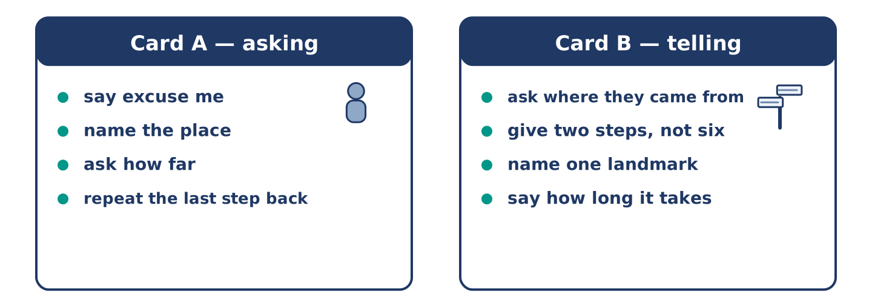
Figure 9.8 · Card A and Card B: what each of you has to say.
Work in pairs. Read the model, then use the cards.
Model exchange:
A: Excuse me, how do I get to the square? — B: Straight ahead, then left at the junction. — A: Is it far? — B: Four minutes. — A: And the health centre? — B: Behind the square, the low building. — A: Thank you.
Useful language: Excuse me… · How do I get to…? · Is it far? · Straight ahead.
Card A — asking: say excuse me · name the place · ask how far · repeat the last step back.
Card B — telling: ask where they came from · give two steps, not six · name one landmark · say how long it takes.
Your turn: run the dialogue, then swap roles.
Stretch [PLUS]: you do not know the way either — say so, and still be useful.
Part 4: Mini-Presentation
Prepare a short talk (about one minute). Describe the way from your home to the nearest shop, in four steps.
Part 5 · Reading
[CORE] Core track · pre-class input
Part 5: Why Some People Cannot Read a Map
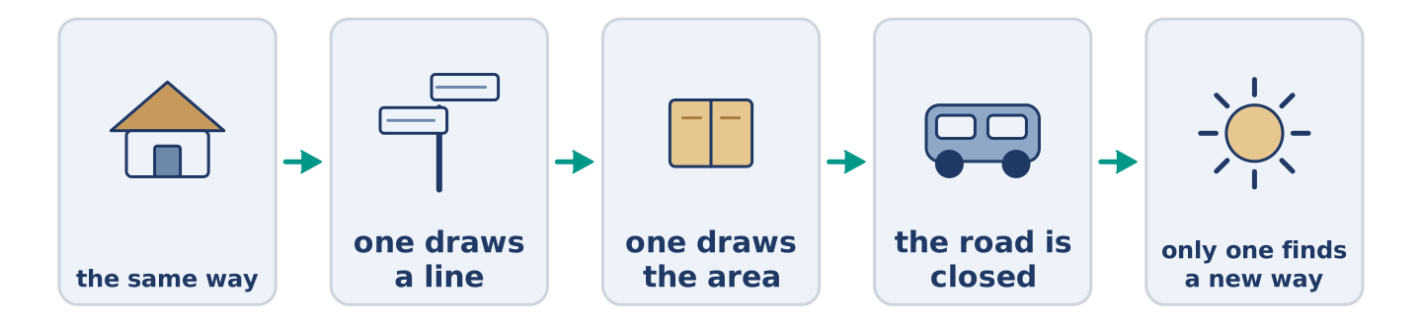
Figure 9.9 · One walk, two ways of knowing it.
Before you read: do you find your way by map or by landmark?
Gloss: landmark = a thing you can see and remember · route = the line you walk from one place to another · survey = a picture of the whole place · facing = looking in that direction
Two people walk the same way home every day for a year. Ask them to draw it. One draws a line with four turns, in the right order. The other draws the whole area, river included. Both of them get home. Only the second one finds a new way when the road is closed. The first kind of knowing is the route: the line you walk. The second is the survey: the picture of the whole place. Most of us stay with the first, because it works. A map helps only when the reader already knows which way they face. That is why a traveller can hold a map, turn it round twice, and walk the wrong way out of a station. The map is not the problem. The direction is.
Answer the multiple-choice questions. (0. is done.)
- What do the two people do every day? — They walk the same way home.
1. What does the first person draw?
○ A) The whole area
○ B) A line with four turns
○ C) The river
○ D) The station
2. Who finds a new way when the road is closed?
○ A) Both of them
○ B) Neither of them
○ C) The first person
○ D) The second person
3. According to the text, what is the thing that really goes wrong?
○ A) The direction you are facing
○ B) The map
○ C) The river
○ D) The road
Part 5: Vocabulary in Context
Match each word from the text with its meaning. One meaning is not needed. Write the letter.
Column A
1. | route | ____
2. | survey | ____
3. | landmark | ____
4. | facing | ____
Column B
a) | a thing you can see and remember
b) | the line you walk from one place to another
c) | looking in that direction
d) | a picture of the whole place
e) | a wide road that goes round a city
Part 5: How Three Cities Tell You Where You Are
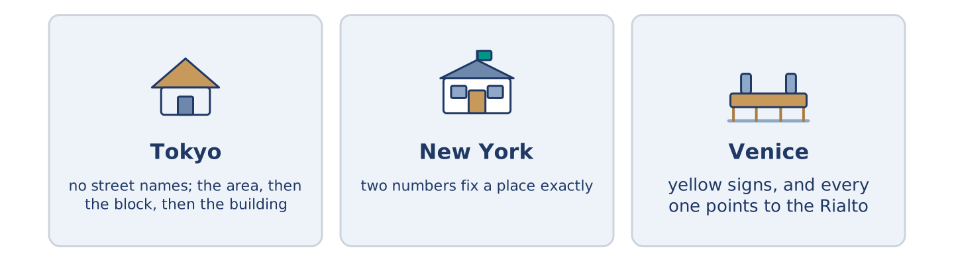
Figure 9.10 · Three cities, three ways of saying where you are.
Before you read: how does your own city tell you where you are?
Gloss: grid = streets that cross each other in straight lines · avenue = a wide street with trees · police box = a very small police station on a corner
Cities answer that very differently. In Tokyo most streets have no name. An address names the area, then the block, then the building, and the buildings run by age, not by position. So people find their way by landmarks, and there is a police box on many corners. In New York the streets run one way in numbers and the avenues run the other way. Two numbers fix a place exactly, and nobody there offers a landmark. In Venice almost nothing carries a useful number. Instead small yellow signs sit high on the walls, and every one points to the Rialto or to San Marco. They never find a stranger’s own street, but nobody stays lost for long.
Answer the questions. (0. is done.)
- Do most streets in Tokyo have names? — No, most of them do not.
- What three things does a Tokyo address give you?
- What do you need to know in New York to know where you stand?
- What do the yellow signs in Venice point to?
Part 6 · Writing
[CORE] Core track · in-class / homework
Part 6: Directions to Your Door (50–70 words)
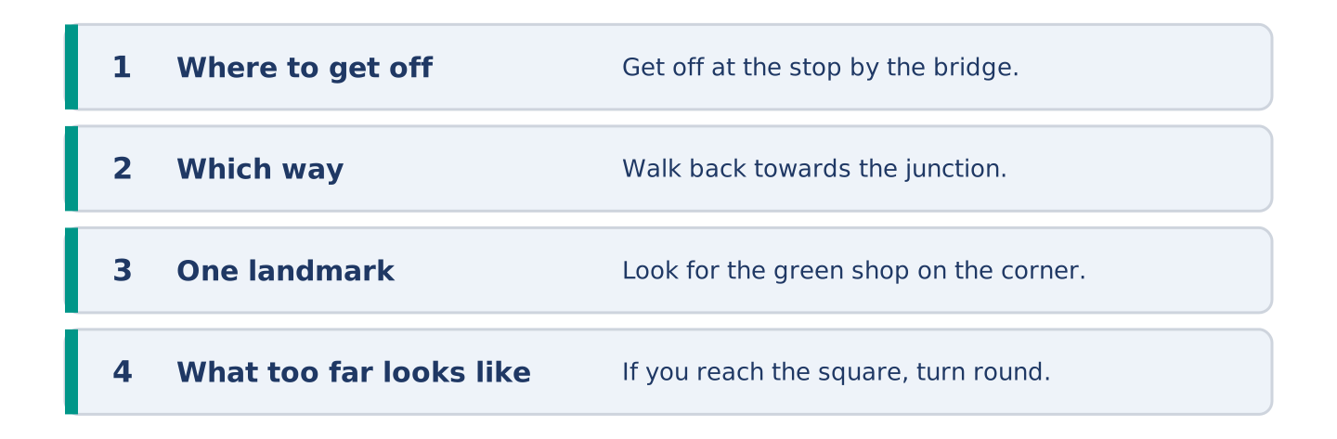
Figure 9.11 · The shape of the directions you are about to write.
A friend is coming to your home for the first time. Write the directions from the nearest bus stop.
Model — read this first:
Get off at the stop by the bridge and walk back towards the junction. Take the second road on your left; it is a narrow lane with no sign. Keep going until you see a green shop on the corner. We are above the shop, at number 14. If you reach the square, turn round — that is too far. (60 words)
Plan (fill in, then write): Get off at ___. Walk towards ___. Take the ___ road on your ___. Look for ___. We are ___.
Word bank: get off | towards | straight ahead | on your left | opposite | until
Check before you finish: ☐ where to get off? ☐ two or three steps only? ☐ one landmark? ☐ 50–70 words?
Part 6: A Map or a Person? (50–70 words)
Is it better to ask a person or to look at a map? Give your opinion and two or three reasons.
Model — read this first:
A person is better, and not because people are kinder than maps. A map gives everything at once, and almost none of it is the part you need. A person gives three steps and one landmark, and then stops. The only trouble is that somebody who does not know the way often does not say so. (56 words)
Word bank: I think… because… | better | however | in my opinion | it depends on
Check before you finish: ☐ a clear opinion? ☐ two or three reasons? ☐ 50–70 words?
Part 6: A Place That Is Hard to Find (50–70 words)
Write about a place that is hard to find. Say where it is and why people walk past it.
Model — read this first:
The bookshop where I work is hard to find, and we rather like it that way. It sits in a lane behind the square, below the level of the street. The door is under a baker’s sign that is not ours. People walk past it twice. Then they ask in the baker’s, and the baker sends them back three doors. (60 words)
Plan (fill in, then write): ___ is hard to find. It is ___. The trouble is ___. People usually ___.
Check before you finish: ☐ where it is? ☐ why people walk past? ☐ one preposition of place in each sentence? ☐ 50–70 words?
Part 6: Reflection — The Time I Got Lost (40–60 words)
Write about a time you got lost. Say where you were and what you did.
Model — read this first:
I got lost in the town I grew up in, which is the worst kind. I was walking to the station and I turned one junction early. Everything looked almost right for ten minutes, and that is what kept me walking. In the end I asked a child. (48 words)
Check before you finish: ☐ where you were? ☐ what went wrong? ☐ what you did? ☐ 40–60 words?
Part 7 · Real-World File — Asking the Way and Giving It
[PLUS] Plus track (optional) · stronger learners
7A: Phrase Bank
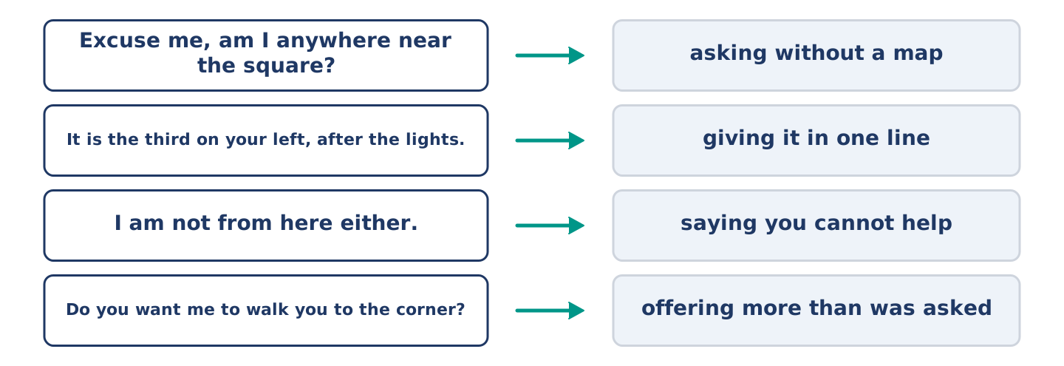
Figure 9.12 · What you say when you ask the way, and what each line does.
Match what a person says with its purpose. One purpose is not needed. Write the letter.
Column A
1. | “Excuse me, am I anywhere near the square?” | ____
2. | “It is the third on your left, after the lights.” | ____
3. | “I am not from here either.” | ____
4. | “Do you want me to walk you to the corner?” | ____
Column B
a) | giving it in one line
b) | offering more than was asked
c) | asking without a map
d) | asking how much the bus costs
e) | saying you cannot help
7B: Asking and Being Sent the Wrong Way
🔊 Audio Track 9.5
Before you read: did anybody ever send you the wrong way?
Yuki: Excuse me, is this the way to the health centre? Man: Yes, straight ahead, past the post office, then left. Yuki: Thank you. (four minutes later) Yuki: Excuse me — the health centre? Woman: You walked away from it. Yuki: A man sent me straight ahead. Woman: He sent you to the old one. Everybody does. It shut in the spring. Yuki: Why doesn’t anybody move the sign? Woman: Somebody asks me that every week.
Answer the questions. (0. is done.)
- What does Yuki ask the man? — Whether she is on the way to the health centre.
- What did the man tell her to do?
- Why was his answer wrong?
- What does the woman say about the sign?
7C: Controlled Practice — Giving Directions Well
Put the steps in order. Number them 1–5. (0. is done.)
- Ask where the person is standing now. — 1
____ Say how long it takes on foot.
____ Give two steps, and no more.
____ Tell them what to do if they go too far.
____ Name one thing they cannot miss.
7D: Role-Play — Asking the Way
In pairs. One asks the way; one gives it. Use the model and cards.
Model exchange: A: Excuse me, am I near the square? — B: Which way did you come? — A: From the bridge. — B: Then you are two minutes away. Straight ahead, past the shop. — A: And the health centre? — B: Behind the square, the low building.
Card A — asking: say where you came from · name the place · ask how far · repeat the last step back.
Card B — telling: ask where they are first · two steps only · one landmark · say what too far looks like.
Stretch [PLUS]: the place they are looking for closed last year — tell them, and send them somewhere better.
7E: Writing — Directions for a Driver (50–80 words)
A driver cannot find your building. Write the message you send.
Model — read this first:
You are at the top junction — four roads and no sign on any of them. Come down the hill towards the bridge, slowly. The first building with a shop in it is ours. The shop is green; the door beside it is blue. There is no number on it, and no number on any door in this street. Park in the lane behind if the front is full. (69 words)
Check before you finish: ☐ where they are now? ☐ which way to come? ☐ one landmark? ☐ 50–80 words?
Part 8 · Global Story — The Numbers on the Dutch Signs
[PLUS] Plus track · pre-read / discuss
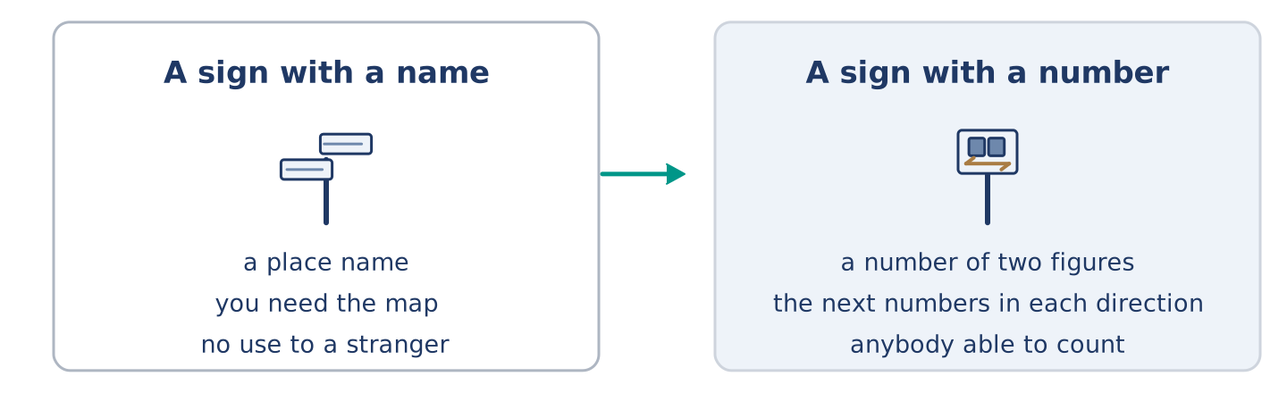
Figure 9.13 · A sign with a place name, and a sign with a number.
Before you read: can a sign tell you the way without naming a single place?
Gloss: network = many paths joined together · pole = a tall thin post · stranger = somebody who does not know the place
In the Netherlands the bike paths do not name where you are going. They give a number. At every junction of the network there is a small green and white sign on a pole. It carries a number of two figures, and the next numbers in each direction. A rider plans the day as a string of numbers: sixty-one, fifty-eight, forty-four, twelve. Then the ride goes from one to the next, and no place name comes into it at all. The idea came from old working paths in Belgium and moved north. The clever part is what it does to a stranger. A place name only helps a rider who already knows the map. A number helps anybody able to count. Children use it. Visitors use it. So do the local families, every week of the year.
Answer the questions. (0. is done.)
- What do the Dutch cycle signs tell you? — A number.
- What else is on the sign besides the number?
- How do you plan a ride?
- Why does a number help a stranger more than a place name?
Part 8: Vocabulary in Context
Match each word with its meaning. One meaning is not needed. Write the letter.
Column A
1. | network | ____
2. | pole | ____
3. | junction | ____
4. | stranger | ____
Column B
a) | a tall thin post
b) | somebody who does not know the place
c) | many paths joined together
d) | where two or more paths meet
e) | a wide street with trees
Part 8: Discussion
Talk with a partner. Use the frames.
Discussion frames: “This is similar to where I live because…” · “This is different from where I live because…” · “I think the most important thing is… because…”
Part 9 · Close to Home — The House With No Number
[PLUS] Plus track · pre-read / decide
Before you read: whose job is it to put a number on a door?
Alder Street has no useful numbers. The old houses at the top came down years ago, and nobody gave the rest new numbers. So number 14 sits between number 8 and number 20. Three doors carry no number at all. Amina gave up and painted GREEN SHOP across her window, which works better than any number. Boxes go to the wrong half of the street twice a week. A car from the health centre once stood at the top junction for eleven minutes. Yuki wrote her address on a card for five drivers in her first month, and three of them still drove past. Maya wants the city to number the street again. Amina points out that the city took eight years to repair one street lamp. Dani painted a 14 on a piece of wood and tied it to the gate. It is still there, upside down.
Answer the questions. (0. is done.)
- Does Alder Street have useful numbers? — No, it does not.
- Why does number 14 sit between 8 and 20?
- What did Amina paint across her window?
- What did Dani tie to the gate?
Part 9: Decision Task
Your street has no useful numbers. Should you (a) ask the city to number it again, (b) put up your own sign at the junction, or (c) tell everybody the landmark instead? Decide and explain. Use the frame.
Answer frame: “I think I should ___ because ___. Also, ___. This is better than ___ because ___.”
Model — read this first:
I think I should put up my own sign at the junction, because that is where every stranger stops. A number on a door only helps somebody already standing outside it. Also, a sign at the junction costs one afternoon. This is better than waiting for the city, because the city repaired one street lamp in eight years. (58 words)
Phrase bank: I think I should… · because… · Also,… · This is better than… · In my opinion…
Part 10 · Review and Can-Do
[CORE + PLUS] · homework / self-study
Part 10: Spiral Review
Complete the review. (0. is done.)
- Where two or more roads meet is a junction.
Word bank: roundabout | lane | square | address | towards | at | borrow | timetable
- A circle of road where cars go round one way is a ______________________ .
- A narrow road between fields or houses is a ______________________ .
- An open space in a town with buildings round it is a ______________________ .
- The number and the street where you live is your ______________________ .
- Walk ______________________ the bridge and turn left at the bench.
- Amina opens the shop ______________________ seven.
- (from Unit 8) To take something from somebody for a short time is to ______________________ .
- (from Unit 3) The paper that tells you when the bus leaves is a ______________________ .
Part 10: Can-Do
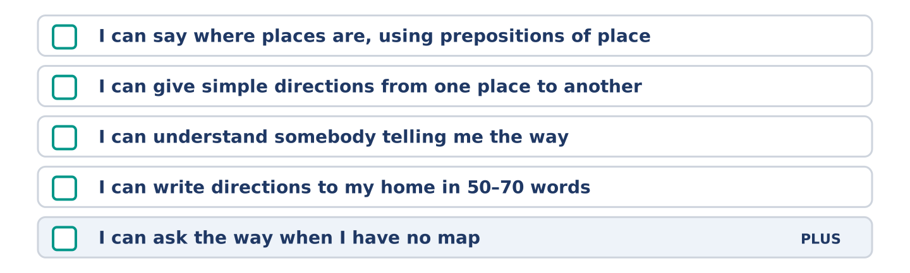
Figure 9.14 · What you can do at the end of this unit.
Can-Do checklist
☐ I can say where places are, using prepositions of place.
☐ I can give simple directions from one place to another.
☐ I can understand somebody telling me the way.
☐ I can write directions to my home in 50–70 words.
☐ I can ask the way when I have no map (Plus).
Part 10: Glossary
Unit 9 glossary (10 words)
junction · roundabout · lane · square · address · block · towards · ahead · below · far
Unit 10: Doing and Making
English for Daily Life · Level: A2 · Tracks: [CORE] Warm-Up + Parts 1–6 · [PLUS] Parts 7–10
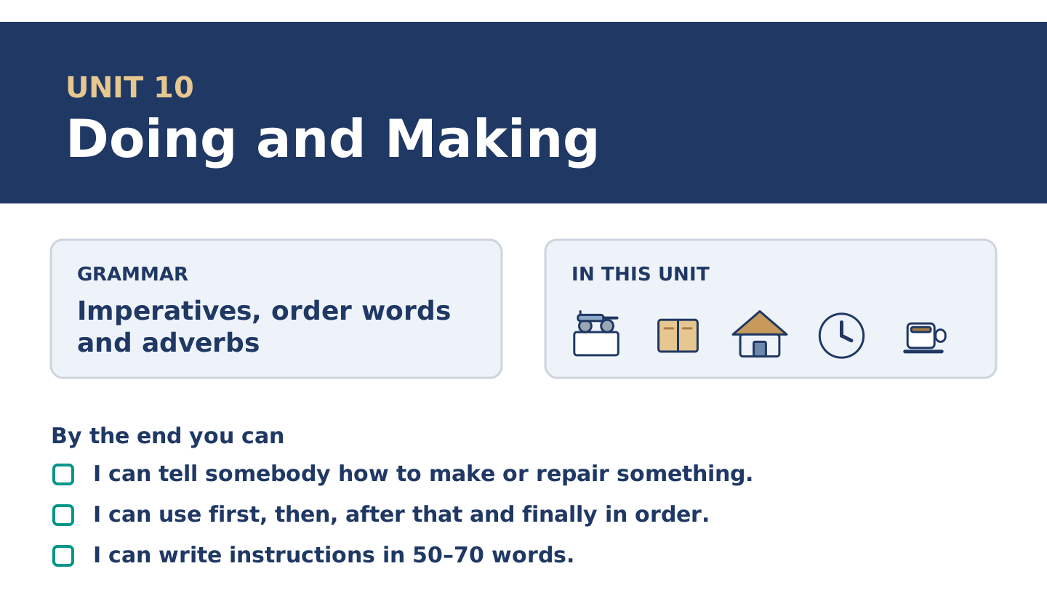
Figure 10.1 · Unit 10 at a glance: the grammar, the topic and what you will be able to do.
Warm Up
[CORE] Core track · in-class starter
Warm-up: Words for Doing and Making
Match the words with their meanings. One meaning is not needed. Write the letter.
Column A
1. | Mix | ____
2. | Pour | ____
3. | Press | ____
4. | Glue | ____
5. | Step | ____
Column B
a) | to push down on something with your hand
b) | one of the things you do, in order
c) | to put two or more things together and turn them
d) | to stick two things so that they hold
e) | to tip a liquid out of one thing into another
f) | to cut something into two equal halves
Warm-up: Saying How Somebody Does It
Complete the sentences using the words in the word bank.
Word bank: carefully | finally | tidy | layer
- Mr Okonkwo works slowly and very ______________________ , and he never has to start again.
- Dani cooks well and leaves a kitchen nobody could call ______________________ .
- Put one ______________________ of paper down, then the glue, then the next.
- Wait for it to dry, and ______________________ turn the whole thing over.
Warm-up: Six People, Six Things They Make
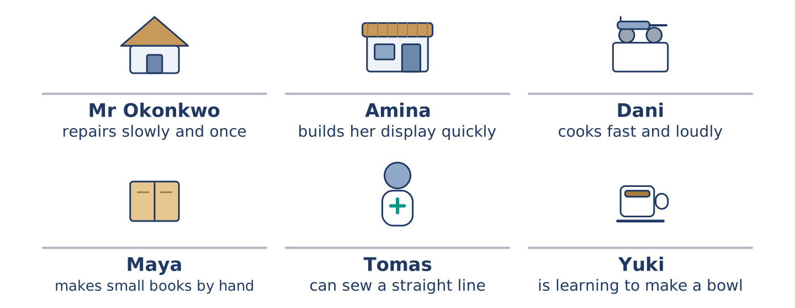
Figure 10.2 · What each of them makes or repairs, and how.
Read the text and choose the correct answer.
Everybody at number 14 makes something, and they all do it differently. Mr Okonkwo works slowly and carefully, and what he repairs outlasts everybody who stood and watched. Amina builds her window display quickly, because the shop is open while she works. Dani cooks fast and loudly and cleans up badly. Maya makes small books by hand, one at a time. Tomas can sew a straight line because his work taught him. Yuki is learning to make a bowl, and she threw the first four away.
1. Who repairs slowly and carefully?
○ A) Amina
○ B) Dani
○ C) Mr Okonkwo
○ D) Tomas
2. Why does Amina build her display quickly?
○ A) She does not like the work
○ B) She is not very good at it
○ C) Somebody is waiting for it
○ D) The shop is open while she works
Part 1 · Vocabulary and Terminology
[CORE] Core track · pre-class input
Part 1: Words for Making and Repairing
Match the words with their meanings. One meaning is not needed. (0. is done for you.)
- Tidy → to put things back where they belong, so the place is clear.
Column A
1. | Mix | ____
2. | Pour | ____
3. | Press | ____
4. | Glue | ____
5. | Brush | ____
6. | Layer | ____
7. | Step | ____
Column B
a) | to put two or more things together and turn them
b) | one of the things you do, in order
c) | a thin flat covering, with another one over it
d) | to stick two things so that they hold
e) | to tip a liquid out of one thing into another
f) | to move a brush across something
g) | to push down on something with your hand
h) | to weigh something before you buy it
Gloss: layer = a thin flat covering, with another one over it · glue = something that sticks two things together · step = one of the things you do, in order · instruction = a sentence telling you what to do · edge = the line where something stops
Part 1: Pronunciation
🔊 Audio Track 10.1
Listen to these instructions. Say each one aloud, then say it to a partner.
Mix it well — the verb comes first and takes the beat
Don’t press too hard — the beat moves onto the verb again
Now pour it slowly — now is small, pour is big
Finally, brush the edges — two beats, one for each
An instruction in English starts with its verb, and the verb takes the beat. That is how a listener knows it is an instruction and not a statement. Say the verb clearly and the small words around it quickly, and your partner can follow you with their hands while you talk.
Part 1: Four Things People Make
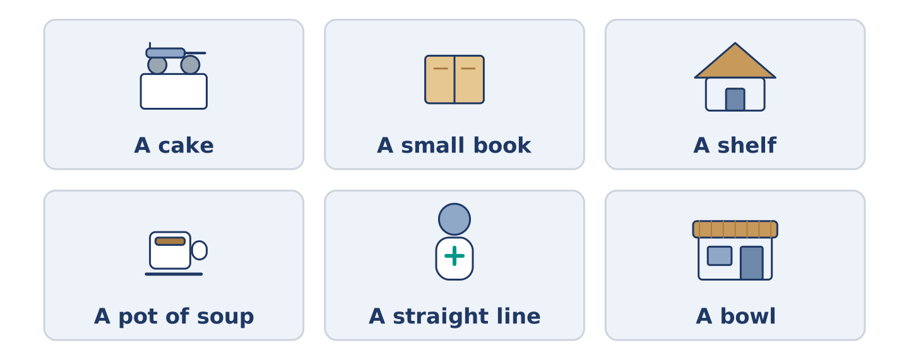
Figure 10.3 · Four things people make, and what each one needs.
Complete the table. Write what you need and the first step. (0. is done.)
What you make | What you need | The first step
A cake | a bowl, a spoon, an oven | (example)
A small book
A shelf
A teapot of soup
- A cake — a bowl, a spoon, an oven — mix the dry things first.
Think about something you have made. There is more than one right answer; be ready to say why.
Part 1: Order the Steps
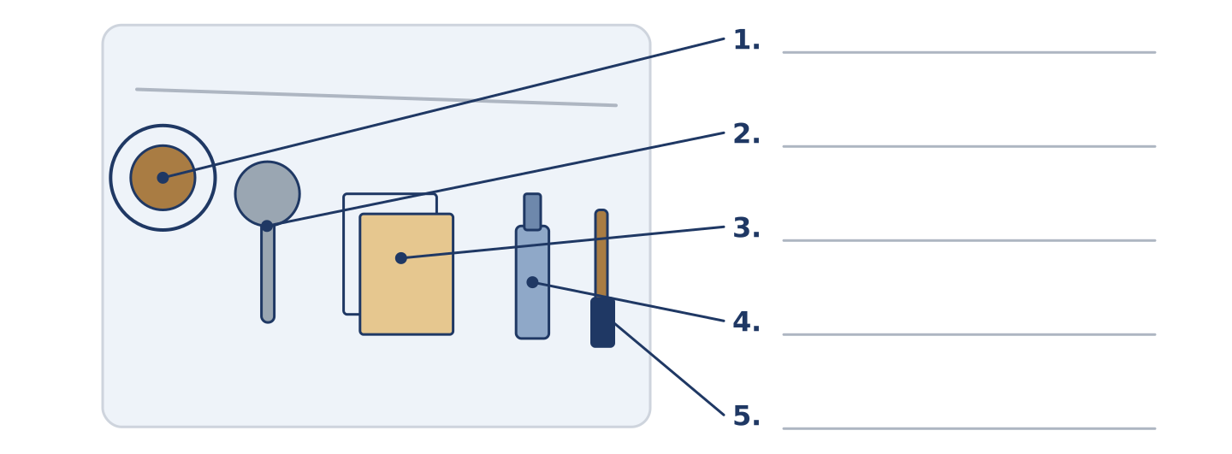
Figure 10.4 · The order of work — write the correct word on each line.
Match the order words with what they do. One meaning is not needed. Write the letter.
Column A
1. | First | ____
2. | Then | ____
3. | After that | ____
4. | Finally | ____
5. | While | ____
Column B
a) | the step that comes straight after the one before
b) | at the same time as something else
c) | the step before everything else
d) | one more step, later in the order
e) | the step that comes before the one before
f) | the last step of all
Part 1: Making — Multiple Choice
Read and choose the correct answer.
1. To put two or more things together and turn them is to…
○ A) mix
○ B) press
○ C) pour
○ D) brush
2. A thin flat covering, with another one over it, is a…
○ A) step
○ B) brush
○ C) layer
○ D) glue
3. The word for the last step of all is…
○ A) first
○ B) finally
○ C) while
○ D) then
Part 1: Vocabulary Fill-in
Complete the sentences with the correct word.
Word bank: press | pour | brush | glue
- ______________________ the water slowly, or it goes everywhere.
- ______________________ the two edges together and count to twenty.
- Use a little ______________________ , not a lot; a lot takes a day to dry.
- ______________________ the dust off before you start.
Part 1: Write Instructions (short)
Write two or three sentences telling somebody how to make something simple. Use three words from this unit.
Model — read this first:
First, warm the teapot and pour the water away. Put in one spoon of tea for each person and pour the water on. Wait four minutes, and do not press the leaves, because pressing them makes it bitter. (38 words)
Part 2 · Grammar — Imperatives, Sequencers and Adverbs
[CORE] Core track · pre-class input
Part 2: Notice
Read these lines. Underline the verbs that give an order. Which words give the order, which say when, and which say how?
Mix it well. Do not press too hard. First, warm the teapot. Then pour the water on. After that, wait four minutes. Finally, brush the edges carefully. Work slowly and you only do it once.
Three of these say when. Two say how. The rest give the order itself.
Part 2: Grammar Focus Box
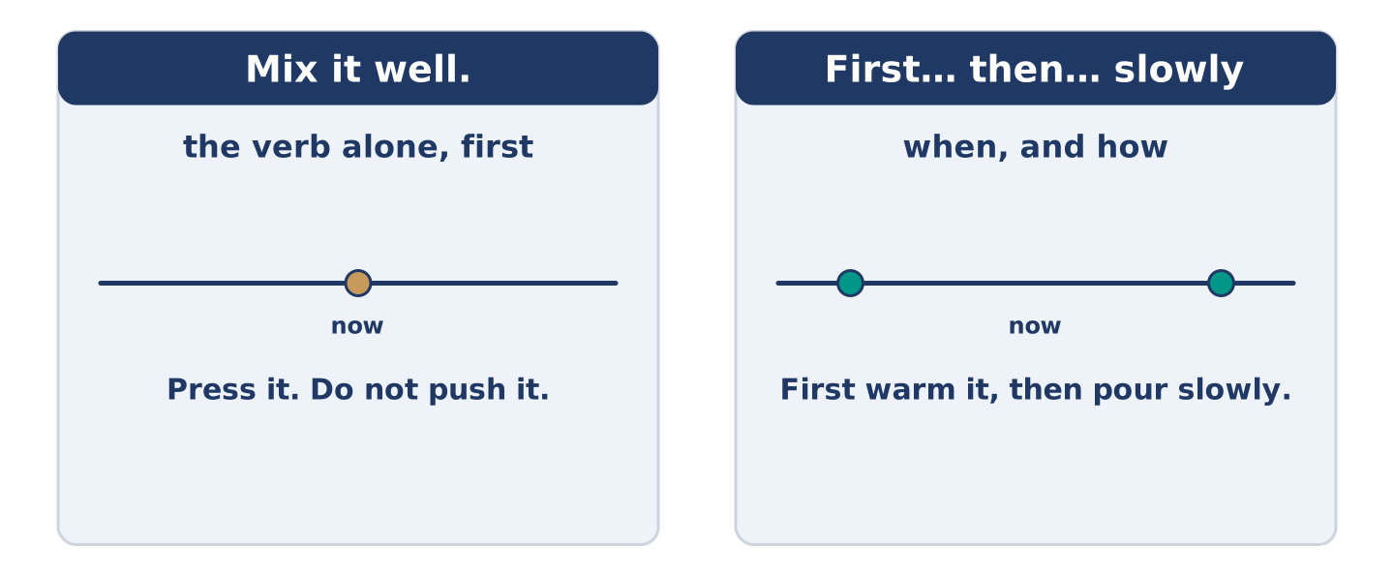
Figure 10.5 · An order, a sequence and a manner: three jobs, three places in the sentence.
 | Form | Use | Example
imperative | the verb alone, no subject | telling somebody to do it | Mix it well.
negative | do not + the verb alone | telling them not to | Do not press too hard.
order words | first, then, after that, finally | the order of the steps | First, warm the teapot.
adverbs | adjective + -ly | how to do it | Pour it slowly.
Remember: an instruction has no you: Mix it well, not You mix it well.
Watch out! ✗ Don’t to press it. → ✓ Do not press it. (no to after do not). ✗ Pour it careful. → ✓ Pour it carefully. (an adverb, not an adjective, after the verb).
Part 2: Controlled Practice
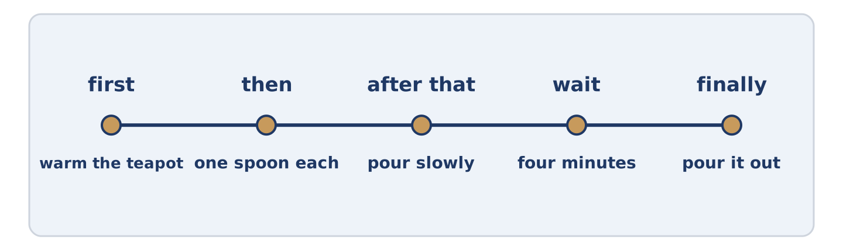
Figure 10.6 · One job, from the first step to the last.
Complete with first, then, after that, finally or do not. (0. is done.)
- First, warm the teapot.
- ______________________ pour the water on.
- ______________________ , wait four minutes.
- ______________________ press the leaves.
- ______________________ , pour it out.
Part 2: Order, When or How?
Write order, when or how. (0. is done.)
- Mix it well. — order
- Finally, brush the edges. ____________
- Work slowly. ____________
- Do not press too hard. ____________
- After that, wait four minutes. ____________
Part 2: Correct the Sentence
Each sentence has one grammar mistake. Write the correct sentence.
- You mix it well before you start.
- Don’t to press the leaves.
- Pour the water careful.
- After that you leave it dry.
Part 2: Freer Practice
Write two instructions for somebody in your kitchen: one telling them to do something, one telling them not to.
Part 2: Grammar Review
Choose the correct sentence.
1. Which instruction is correct?
○ A) You press the two edges together.
○ B) To press the two edges together.
○ C) Pressing the two edges together.
○ D) Press the two edges together.
2. Which sentence says how to do it?
○ A) Pour the water first.
○ B) Pour the water after that.
○ C) Pour the water carefully.
○ D) Pour the water finally.
→ Harvest: you will see imperatives and order words again in the Part 5 reading. Watch for them.
Part 3 · Listening
[CORE] Core track · pre-class input · scripts printed inline
Part 3: A First Lesson in Making Something
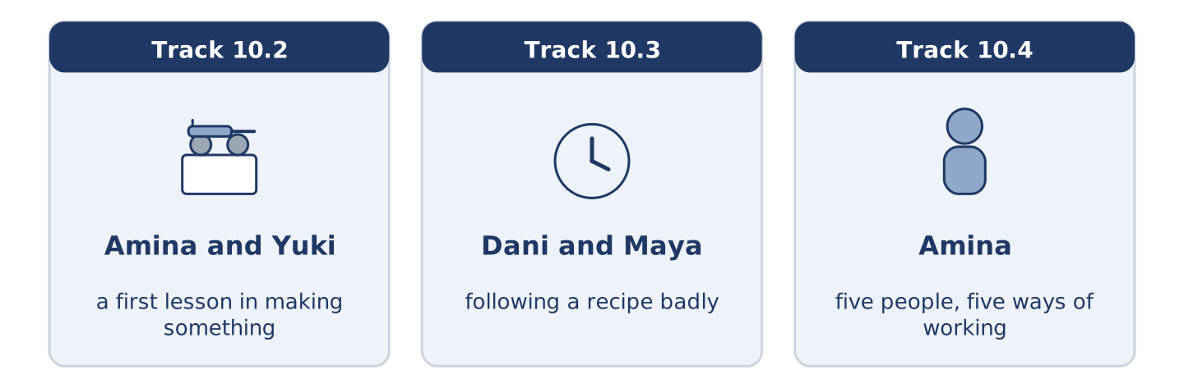
Figure 10.7 · The three listenings: who is speaking, and what about.
🔊 Audio Track 10.2
Before you listen: who taught you to make the first thing you ever made?
Amina: Right. Wash your hands, then dry them properly. Yuki: They are dry. Amina: They aren’t. Flour sticks to wet hands and then nothing works. Now, mix the dry things first. Yuki: All of them? Amina: All of them, and mix them well. Then pour in the water, slowly, with the other hand turning. Yuki: It’s too wet. Amina: It’s meant to be. Don’t add flour, whatever you do. Everybody adds flour and everybody is wrong.
While you listen: write True, False, or Not Given. (0. is done.)
- Amina tells Yuki to wash her hands. — True
- Amina says to mix the wet things first. ____
- Amina tells her not to add flour. ____
- Yuki made this with her mother. ____
Useful phrases: Wash your hands · mix the dry things first · pour it slowly · Don’t add…
Part 3: Following a Recipe Badly
🔊 Audio Track 10.3
Before you listen: do you read all of a recipe before you start?
Dani: It says warm the oven. Maya: Did you warm the oven? Dani: I am warming it now. Maya: Dani, it is step one. Dani: It is step one of thirteen and I am on step four. Maya: What is step four? Dani: Pour it into the dish. Maya: Which dish? Dani: There is a dish in step two. Maya: So read step two. Dani: I read all of them at the start. Maya: You looked at all of them.
Answer the questions. (0. is done.)
- What does step one say? — Warm the oven.
- Which step is Dani on?
- What does step four tell him to do?
- What does Maya say he did at the start?
Part 3: Five People, Five Ways of Working
🔊 Audio Track 10.4
Before you listen: do you work quickly and repair it later, or slowly and once?
Amina: I watch them all come through the shop, and every one of them works differently. Mr Okonkwo does it slowly and does it once. Dani does it fast and does it again on Sunday. Maya reads the whole thing twice before she touches anything. Tomas works in the same order every time, because that is how they taught him. Yuki asks me first, and I never mind, because asking first is cheaper than starting again.
While you listen: match each person with the way they work. One is not needed. (0. is done.)
- Amina → she watches them all come through.
Useful phrases: ___ does it once · ___ reads it twice · ___ asks first
Column A
1. | Mr Okonkwo | ____
2. | Dani | ____
3. | Maya | ____
4. | Tomas | ____
Column B
a) | reads the whole thing twice before starting
b) | works in the same order every time
c) | does it slowly and does it once
d) | does it fast and does it again later
e) | stops halfway and leaves it
Part 4 · Speaking
[CORE] Core track · in-class output
Part 4: How You Make Things
Work with a partner. Ask and answer these questions.
- What is the last thing you made or repaired?
- Do you work quickly or slowly, and does it show?
- What is the one step people always leave out?
Useful language: First I… · Then I… · carefully · Don’t…
Part 4: Find the Difference (pairwork)
Student A and Student B each have the steps for the same job, in a different order. Ask questions and find three differences.
Useful questions: What is step one? · What comes after that? · Do you press it or glue it? · Is that the last step?
Student A — your steps: measure, cut, glue, press, leave it to dry.
Student B — your steps: measure, cut, press, glue, brush the edges.
Part 4: Teaching Somebody a Job
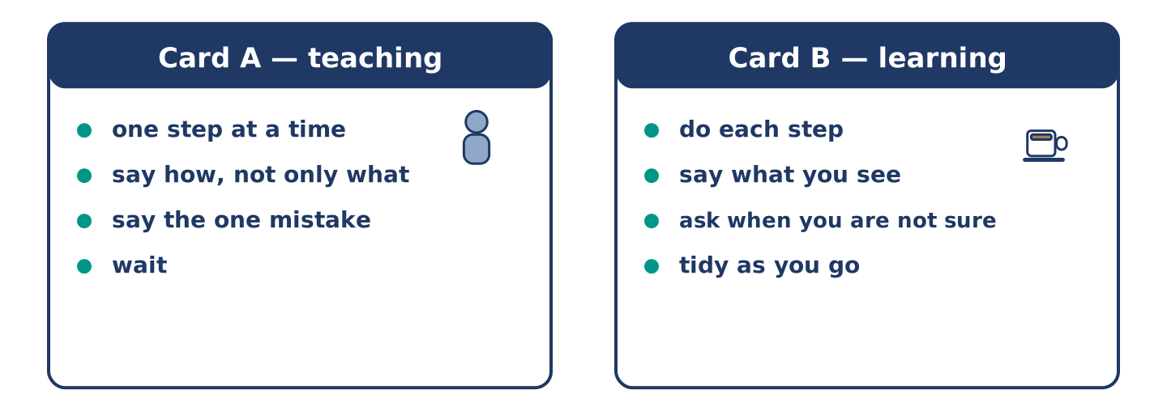
Figure 10.8 · Card A and Card B: what each of you has to say.
Work in pairs. Read the model, then use the cards.
Model exchange:
A: Right — wash your hands and dry them properly. — B: They are dry. — A: They are not. Now mix the dry things first. — B: All of them? — A: All of them. Then pour the water in slowly. — B: It is too wet. — A: It is meant to be. Don’t add flour.
Useful language: Right… · First… · Then… · Don’t…
Card A — teaching: one step at a time · say how, not only what · say the one mistake everybody makes · wait.
Card B — learning: do each step · say what you see · ask when you are not sure · do not run ahead.
Your turn: run the dialogue, then swap roles.
Stretch [PLUS]: your partner did the step wrong — say so without taking it off them.
Part 4: Mini-Presentation
Prepare a short talk (about one minute). Teach the class to make or repair something, in four steps.
Part 5 · Reading
[CORE] Core track · pre-class input
Part 5: Why Instructions Are So Hard to Write
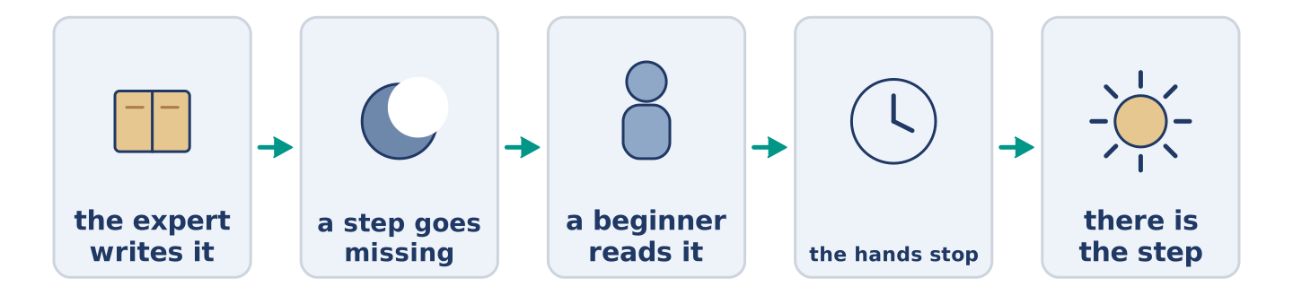
Figure 10.9 · One job, written badly and written well.
Before you read: have you ever followed instructions that left a step out?
Gloss: expert = somebody with years of practice · obvious = so clear that nobody says it · assume = to think something is true without checking · draft = an early try, before the last one
Ask an expert to write down how they do a thing, and watch them leave steps out. They are not being lazy. The missing steps are the ones they stopped seeing years ago, because the hand does them without asking. A baker writes knead the dough and assumes everybody knows how hard. A carpenter writes fix the shelf to the wall and never says which goes in first. The step that is obvious to the writer is the one the reader needs most. The best instructions in the world are usually written by somebody who learned the job last year and still remembers not knowing. Give the first draft to a beginner and watch their hands, not their face. The place where the hands stop is the missing step.
Answer the multiple-choice questions. (0. is done.)
- What do experts do when they write instructions? — They leave steps out.
1. Why do experts leave steps out?
○ A) They stopped seeing those steps years ago
○ B) They are lazy
○ C) They want to keep the skill
○ D) They write too fast
2. Who writes the best instructions?
○ A) The fastest worker
○ B) The oldest expert
○ C) A teacher
○ D) Somebody who learned the job last year
3. What does the text say to watch?
○ A) Their face
○ B) Their hands
○ C) The clock
○ D) The first step
Part 5: Vocabulary in Context
Match each word from the text with its meaning. One meaning is not needed. Write the letter.
Column A
1. | expert | ____
2. | obvious | ____
3. | assume | ____
4. | draft | ____
Column B
a) | so clear that nobody says it
b) | somebody with years of practice
c) | an early try at something, before the last one
d) | to think something is true without checking
e) | the last step of all
Part 5: Three Ways of Writing an Instruction
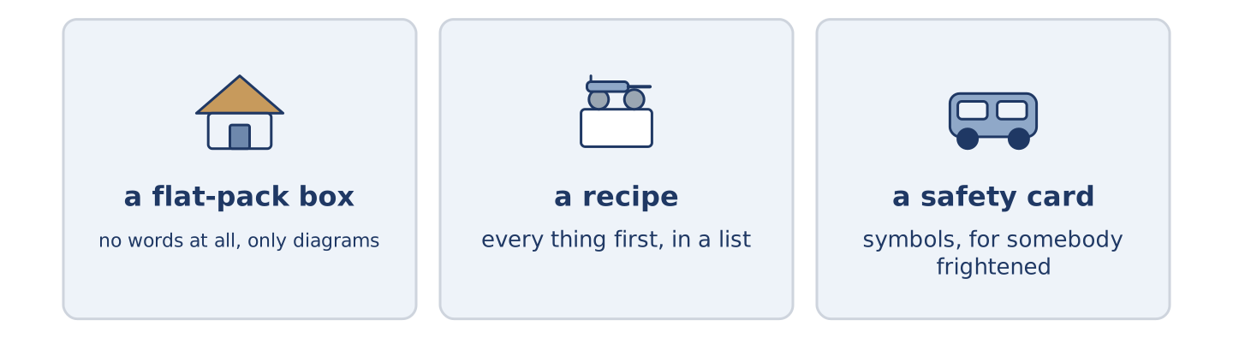
Figure 10.10 · Three kinds of instruction, and who each one is for.
Before you read: can an instruction work with no words at all?
Gloss: diagram = a drawing that explains · translate = to put into another language · symbol = a small picture that stands for a word · recipe = written steps for cooking one thing
People build an instruction in very different ways. A flat-pack company in Sweden decided years ago to use no words at all, only diagrams. The same box goes to fifty countries, and nobody wants to translate it fifty times. A recipe does the opposite. It names every thing first, in a list, and only then tells you what to do. Nothing is missing by the time your hands are too dirty to turn a page. The safety card in the seat in front of you uses symbols and almost no reading. It has to work for a frightened person in a hurry. Each one chose its form from its reader. That is the whole art of it.
Answer the questions. (0. is done.)
- Do all instructions use words? — No, they do not.
- Why does the flat-pack company use only diagrams?
- What does a recipe name first?
- Why does the safety card use symbols?
Part 6 · Writing
[CORE] Core track · in-class / homework
Part 6: How to Make Something (50–70 words)
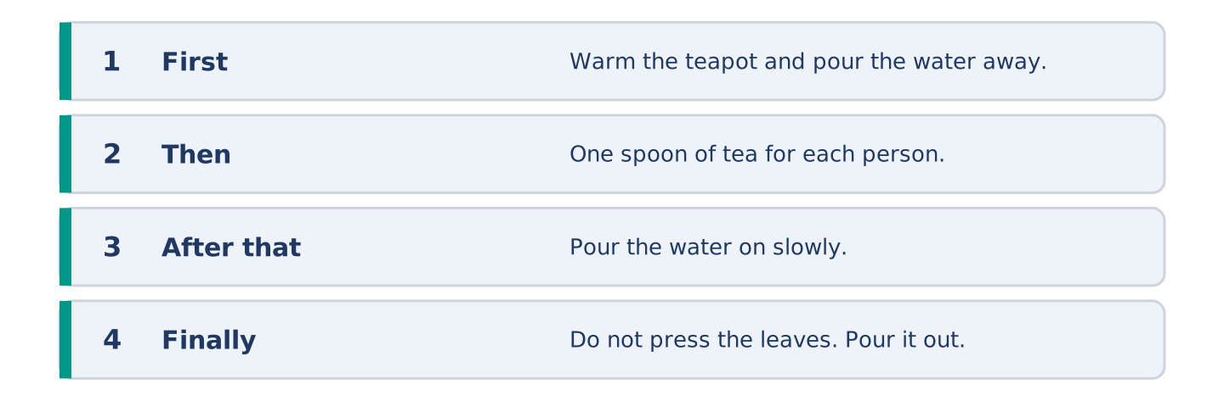
Figure 10.11 · The shape of the instructions you are about to write.
Write instructions for something simple you can make. Use order words and at least two -ly words.
Model — read this first:
First, warm the teapot with hot water and pour the water away. Put in one spoon of tea for each person, then pour the boiling water on slowly. Leave it for four minutes. Do not press the leaves, however late you are, because pressing them makes the whole teapot bitter. Finally, pour it out and drink it while it is hot. (61 words)
Plan (fill in, then write): First, ___. Then ___. After that, ___. Do not ___. Finally, ___.
Word bank: first | then | after that | finally | carefully | do not
Check before you finish: ☐ four steps in order? ☐ two adverbs? ☐ one do not? ☐ 50–70 words?
Part 6: Quickly or Slowly? (50–70 words)
Is it better to work quickly and repair it later, or slowly and once? Give your opinion and two or three reasons.
Model — read this first:
Slowly, and I say that as somebody who works quickly. Every fast job I have is a job I did twice. The second time is never quicker than doing it properly was, and it is always at a worse moment. The only real argument for speed is that a slow job is sometimes never finished at all. (57 words)
Word bank: I think… because… | quickly | however | in my opinion | it depends on
Check before you finish: ☐ a clear opinion? ☐ two or three reasons? ☐ 50–70 words?
Part 6: Instructions That Went Wrong (50–70 words)
Write about a time you followed instructions and it went wrong. Say what the instructions said and what happened.
Model — read this first:
The shelf came with a page of pictures and no words. Picture four showed two screws going in. It did not show which one goes in first, and I chose wrongly. The shelf held for a week and then came off the wall at four in the morning, carefully taking the paint with it. (54 words)
Plan (fill in, then write): The instructions said ___. I ___. Then ___. In the end ___.
Check before you finish: ☐ what the instructions said? ☐ what you did? ☐ what happened? ☐ 50–70 words?
Part 6: Reflection — Something I Can Make (40–60 words)
Write about one thing you can make or repair. Say who taught you and how you work.
Model — read this first:
I can repair a bicycle wheel, badly but well enough to get home. My uncle taught me in an afternoon and said nothing the whole time except again. I work slowly and I still get it wrong twice. The wheel always turns in the end. (45 words)
Check before you finish: ☐ what you can make? ☐ who taught you? ☐ how you work? ☐ 40–60 words?
Part 7 · Real-World File — Following and Giving Instructions
[PLUS] Plus track (optional) · stronger learners
7A: Phrase Bank
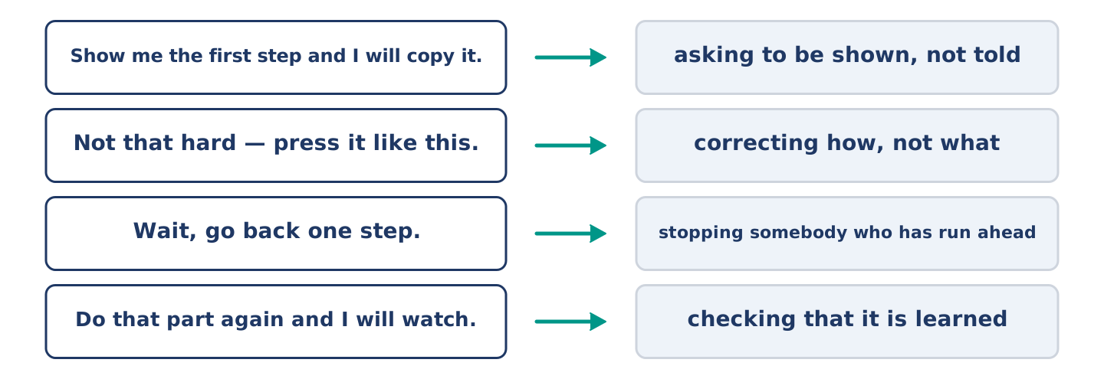
Figure 10.12 · What you say while you teach or learn a job, and what each line does.
Match what a person says with its purpose. One purpose is not needed. Write the letter.
Column A
1. | “Show me the first step and I will copy it.” | ____
2. | “Not that hard — press it like this.” | ____
3. | “Wait, go back one step.” | ____
4. | “Do that part again while I watch.” | ____
Column B
a) | correcting how, not what
b) | asking to be shown, not told
c) | asking how much it costs
d) | stopping somebody who has run ahead
e) | checking that it is learned
7B: Teaching and Being Taught
🔊 Audio Track 10.5
Before you read: is it harder to teach a job or to be taught one?
Mr Okonkwo: Hold it there. No — there. Yuki: Like this? Mr Okonkwo: Press it, but not hard. You are pushing. Yuki: What is the difference? Mr Okonkwo: Press is your hand. Push is your arm. Yuki: Oh. Mr Okonkwo: Now you have it. Do that part again while I watch. Yuki: Why can’t you just tell me? Mr Okonkwo: I did tell you. It took four minutes. Your hands took eleven seconds.
Answer the questions. (0. is done.)
- What does Mr Okonkwo tell Yuki to do first? — Hold it in the right place.
- What is Yuki doing wrong?
- How does he explain the difference?
- Why does he ask her to do it again?
7C: Controlled Practice — Teaching a Job Well
Put the steps in order. Number them 1–5. (0. is done.)
- Show the whole job once, quickly. — 1
____ Watch their hands, not their face.
____ Let them do the first step alone.
____ Break it into steps and name each one.
____ Ask them to do the hard step again.
7D: Role-Play — Teaching a Job
In pairs. One teaches a simple job; one learns it. Use the model and cards.
Model exchange: A: Hold it there. — B: Like this? — A: Press it, but not hard. You are pushing. — B: What is the difference? — A: Press is your hand. Push is your arm. — B: Oh. — A: Now do that part again and I will watch.
Card A — teaching: show it once · one step at a time · correct the how, not the person · ask for it again.
Card B — learning: copy, do not guess · say what you feel · ask the difference · tidy as you go.
Stretch [PLUS]: your learner does it a different way and it works — decide whether to correct them.
7E: Writing — Instructions for a Complete Beginner (50–80 words)
Write instructions for a job you know, for somebody doing it the first time.
Model — read this first:
Lay the two pieces flat with the good side down. Brush a thin layer of glue on one of them only, right to the edges, and count slowly to sixty while it stops shining. Then press them together and put a heavy book on top. Leave it until the morning. Do not move it to look at it, because that is how everybody loses a first attempt. (67 words)
Check before you finish: ☐ the steps in order? ☐ one thing said about how, not what? ☐ one warning? ☐ 50–80 words?
Part 8 · Global Story — The Street Laid by Hand
[PLUS] Plus track · pre-read / discuss
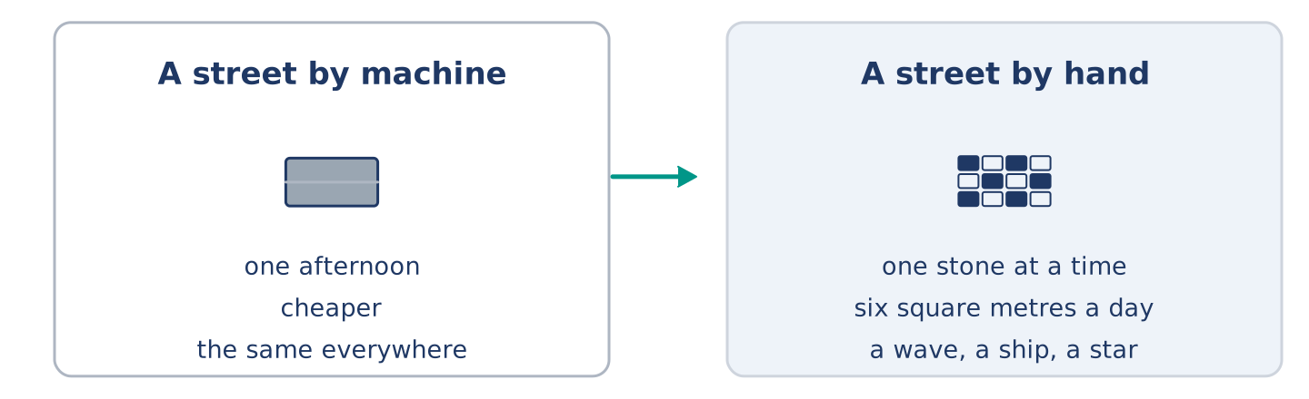
Figure 10.13 · A street laid by machine, and a street laid by hand.
Before you read: is anything near you still made by hand?
Gloss: craft = a skill of making things with your hands · trade = a job you learn by doing it beside somebody · design = the shape or pattern somebody planned
Most of a city goes down by machine in an afternoon. In Portugal the famous black and white streets go down one small stone at a time, by hand, on somebody’s knees. The worker cuts each stone to shape with a hammer, sets it into the bed, taps it level, and moves on. A good one lays perhaps six square metres in a day. The design is a wave, or a ship, or a star, and the worker reads it from a drawing the way a player reads music. It is slower than a machine and it costs more, and the cities keep doing it, because a machine street is the same street everywhere. They teach the trade the old way. A learner works on their knees beside somebody who laid stone for thirty years, and copies the hands rather than the words.
Answer the questions. (0. is done.)
- How does most of a city go down? — By machine, in an afternoon.
- What are the four things the worker does to each stone?
- Why do the cities keep doing it, when a machine is cheaper?
- How is the trade taught?
Part 8: Vocabulary in Context
Match each word with its meaning. One meaning is not needed. Write the letter.
Column A
1. | craft | ____
2. | design | ____
3. | trade | ____
4. | level | ____
Column B
a) | the shape or pattern somebody planned
b) | flat, with no part higher than another
c) | a skill of making things with your hands
d) | a job you learn by doing it beside somebody
e) | a small picture that stands for a word
Part 8: Discussion
Talk with a partner. Use the frames.
Discussion frames: “This is similar to where I live because…” · “This is different from where I live because…” · “I think the most important thing is… because…”
Part 9 · Close to Home — The Sign That Is Still Upside Down
[PLUS] Plus track · pre-read / decide
Before you read: whose job is it to put right something nobody else has noticed?
The 14 Dani painted and tied to the gate is still upside down. Everybody at number 14 saw it weeks ago. Nobody said anything, and the reasons are all different. Maya thinks it is Dani’s and therefore Dani’s to turn. Tomas noticed it on a Tuesday and meant to do it on the Wednesday. By the Thursday it was a thing he walked past. Mr Okonkwo nearly turned it the first evening, but he was not sure Dani had finished. Amina knows exactly whose it is and says nothing, because Dani made it at all, which is more than the rest of them did. Yuki is sure it is on purpose, and says so. Dani painted it, tied it on in the dark, and never once looked at it again.
Answer the questions. (0. is done.)
- What is still upside down? — The 14 Dani tied to the gate.
- Why did Tomas not turn it?
- Why did Mr Okonkwo leave it?
- What does Yuki think?
Part 9: Decision Task
Somebody near you did a job badly, and it is still wrong. Should you (a) do it yourself, (b) tell the person who did it, or (c) leave it? Decide and explain. Use the frame.
Answer frame: “I think I should ___ because ___. Also, ___. This is better than ___ because ___.”
Model — read this first:
I think I should do it myself, because it takes two minutes and the conversation takes a week. Also, nobody who made something badly enjoys hearing about it. This is better than telling Dani, because Dani made the sign at all, and the rest of us only walked past it. (50 words)
Phrase bank: I think I should… · because… · Also,… · This is better than… · In my opinion…
Part 10 · Review and Can-Do
[CORE + PLUS] · homework / self-study
Part 10: Spiral Review
Complete the review. (0. is done.)
- To put two or more things together and turn them is to mix.
Word bank: pour | press | glue | layer | carefully | do not | junction | borrow
- To tip a liquid out of one thing into another is to ______________________ .
- To push down on something with your hand is to ______________________ .
- Something that sticks two things together is ______________________ .
- A thin flat covering, with another one over it, is a ______________________ .
- Work slowly and ______________________ , and you only do it once.
- ______________________ press the leaves, however late you are.
- (from Unit 9) Where two or more roads meet is a ______________________ .
- (from Unit 8) To take something from somebody for a short time is to ______________________ .
Part 10: Can-Do
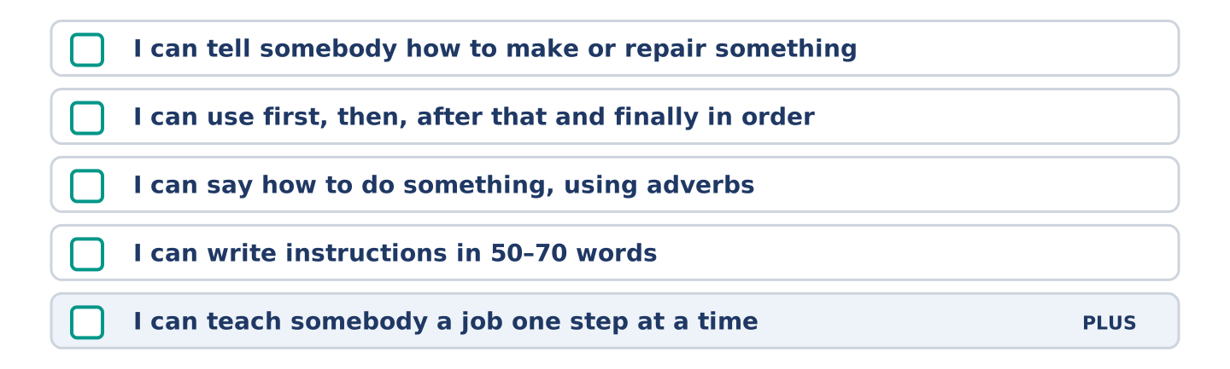
Figure 10.14 · What you can do at the end of this unit.
Can-Do checklist
☐ I can tell somebody how to make or repair something.
☐ I can use first, then, after that and finally in order.
☐ I can say how to do something, using adverbs.
☐ I can write instructions in 50–70 words.
☐ I can teach somebody a job one step at a time (Plus).
Part 10: Glossary
Unit 10 glossary (10 words)
step · mix · pour · press · glue · layer · brush · carefully · finally · tidy
Answer Key
The source this course is modelled on has no answer key at all. This one covers every closed item, and gives marking points and a sample answer for every open task.
Unit 1: People and Routines — Answer Key
English for Daily Life · Teacher’s section. The source book has no answer key; this is an addition. Open tasks carry a sample answer, not the only correct one.

Warm Up
Warm-up: People Words and Meanings
- c · 2. f · 3. a · 4. e · 5. b Not needed: d) a person who pays you every month
Warm-up: Talking About People
- works · 2. routine · 3. neighbour · 4. busy
Warm-up: A Street of Neighbours
- B) At 14 Alder Street · 2. A) Opening her shop

Part 1 · Vocabulary and Terminology
Part 1: People and Routine Terms
- g · 2. b · 3. c · 4. d · 5. f · 6. a · 7. e Not needed: h) a day when nobody works
Item 0 (Routine) is a standalone worked example, exactly as in the source: the word is not in Column A and its meaning is not in Column B, so it uses up no letter. Seven items, eight letters, one spare.
Part 1: Pronunciation (Track 1.1)
Stress as printed: rou-TINE · com-MUTE · ap-POINT-ment · COL-league · U-su-al-ly · NEIGH-bour
Note that routine and commute take the stress on the second syllable, while colleague, usually and neighbour take it on the first. Learners who stress ROU-tine are following their first language, not English.
The -s ending, three sounds: /s/ after /p t k f θ/ — works, starts, gets, waits, stops /z/ after a vowel or a voiced sound — lives, opens, reads, knows, goes /ɪz/ after /s z ʃ tʃ dʒ/ — finishes, closes, watches, washes, changes
Part 1: Jobs, Places and Hours
- Nurse — a hospital — days, and sometimes nights (given)
Accept any sensible pair. The expected answers:
Job | Place | Usual hours
Shop assistant | a shop | shop hours, often including Saturday
Teacher | a school | weekday mornings and afternoons
Bus driver | a bus (on the road) | early starts, in shifts
Part 1: Parts of a Day
- d · 2. a · 3. b · 4. f · 5. e Not needed: c) the first day of the working week
Part 1: Daily Life — Multiple Choice
- B) neighbour · 2. C) commute · 3. A) appointment
Part 1: Vocabulary Fill-in
- shift · 2. commute · 3. break · 4. appointment
Part 1: Write About Your Day (short)
Open. Two or three sentences, using three words from the unit. The unit prints a model; this is a second one.
Sample: I usually get up at seven, and my commute takes forty minutes. My flatmate works a late shift, so the flat is quiet in the morning. At the moment I am finishing a course, so I study on the bus.

Part 2 · Grammar — Present Simple vs Present Continuous
Part 2: Notice
Verbs, and which is which: works (routine) · starts (routine) · is waiting (now) · works (routine) · is working (now — this week) · studies (routine) · cooks (routine) · is eating (now) · reads (routine) · is reading (now)
Five routines, three sentences about now. The time words are the evidence; make learners point at them.
Part 2: Controlled Practice
- starts (given) · 1. works · 2. is cooking · 3. opens · 4. is painting
Part 2: Simple or Continuous?
- leaves (given) · 1. is waiting · 2. reads · 3. is burning · 4. works
Part 2: Correct the Sentence
- Amina opens the shop at seven. (third person -s)
- Look! Maya is waiting for the bus. (happening now)
- He works at the hospital every night. (third person -s)
- We are studying English this week. (-ing after are)
Part 2: Freer Practice
Open. One present simple and one present continuous, correctly formed.
Sample: I finish work at five every day. This week I am working from home.
Part 2: Grammar Review
- B) Dani is cooking the rice. · 2. C) Maya works in a bookshop.

Part 3 · Listening
Part 3: A Nurse Talks About His Week (Track 1.2)
- True (given)
- False — he lives with Maya at 14 Alder Street.
- True — “This week I’m working nights.”
- Not Given — he says where he works, never for how long.
Part 3: In the Corner Shop (Track 1.3)
- In the corner shop. (given)
- Because she works from home.
- Some bread and milk.
- Sunday. (She also closes early, at two, on Saturday.)
Part 3: A Morning on Alder Street (Track 1.4)
- Mr Okonkwo → watching from his window (given)
- d · 2. a · 3. b · 4. e Not needed: c) sleeping in the afternoon

Part 4 · Speaking
All four tasks are productive. Accept any answer that meets the brief; correct form, not content.
Part 4: Discussing Routines
Listen for present simple with usually / every day and present continuous with this week / at the moment. The second question is the one that forces the continuous.
Sample: I usually get up at half past six, but not at the weekend. This week I am travelling to another city for work, so I am getting up at five. I see my flatmate every day and the woman in the bakery every morning.
Part 4: Find the Difference (pairwork)
Marking points: ☐ questions in the present simple ☐ one question in the present continuous for this week ☐ exactly three differences reported.
Three differences: workplace (bookshop / hospital) · transport (bus / bike) · this week (evening class / working nights). The get-up time (6.30) is the same in both — learners who report four differences have guessed.
Sample exchange: A: What time do you get up? — B: At half past six. — A: Me too. Where do you work? — B: I work in a hospital. — A: I work in a bookshop. How do you travel? — B: By bike. — A: I take the bus. And what are you doing this week? — B: I’m working nights.
Part 4: New Neighbour Role Play
Marking points: ☐ both partners speak ☐ present simple for work and home ☐ at least one present continuous ☐ the exchange closes politely.
Card A must produce: a greeting, a name and floor, a workplace, two questions. Card B must produce: a greeting, a statement that they are new, a job, two questions.
Sample: A: Hello — you’re new here, aren’t you? — B: Yes, this is my first week. I’m Yuki. — A: I’m Maya, flat 2. I work in the bookshop on the corner. Do you work near here? — B: I work from home, actually. Is the shop downstairs open on Sundays? — A: No, that’s the one day Amina closes.
Stretch: accept I’m not sure, actually — I’ll ask Amina and let you know or similar. The marker is a polite admission plus an offer, not an invented answer.
Part 4: Mini-Presentation
Marking points: ☐ about one minute ☐ at least one present-simple routine sentence ☐ at least one present-continuous at the moment sentence ☐ the person is identified before anything is said about them.
Sample (51 words): I want to talk about Mr Okonkwo, my neighbour on the fourth floor. He is a retired teacher, and he is seventy. He reads his newspaper every afternoon by the window, and he watches the whole street. At the moment he is waiting for an appointment at the clinic on Thursday.

Part 5 · Reading
Part 5: What Is a Routine?
- the set of things a person does again and again (given)
- B) She listens to the radio
- D) Because she is studying for an exam
- C) They save thinking
Part 5: Vocabulary in Context
- c · 2. a · 3. d · 4. b Not needed: e) a short rest in the middle of the day
Part 5: Routines Around the World
- No, they are not. (given)
- They close for a siesta — a short sleep in the early afternoon.
- They help people onto the trains in the morning rush hour.
- The clock. What people do with it is not the same.

Part 6 · Writing
Each task already prints a model. These are the marking points and a second sample, so that the printed model is not the only answer a learner has seen.
Part 6: Describe a Person’s Day (50–70 words)
Marking points: ☐ at least one present simple routine sentence ☐ at least one present continuous at the moment sentence ☐ two time expressions ☐ 50–70 words ☐ capitals and full stops.
Sample (53 words): My brother gets up at five, because he drives a bus. First he makes tea, then he walks to the depot. He usually starts at six and finishes at two, so he is at home in the afternoon. At the moment he is doing a training course, so on Thursdays he finishes late.
Part 6: Why Routines Matter (50–70 words)
Marking points: ☐ a clear opinion in the first sentence ☐ two or three reasons, each with because or a linker ☐ 50–70 words.
Sample (56 words): I do not think a fixed routine is always good. It helps in the morning, because nobody wants to think before coffee. But a routine can make a week disappear, and you remember nothing. I prefer a routine for small things and no routine for the evening. That way the days are not all the same.
Part 6: A Message to a New Neighbour (50–70 words)
Marking points: ☐ greeting and close ☐ two useful facts about the place ☐ an offer of help ☐ 50–70 words.
Sample (53 words): Hi Yuki, Welcome to the building. I’m Dani, flat 3. Two things that help: the hot water is slow before eight, so wait a few minutes, and the number 7 bus stops right outside. Amina downstairs will change a note for you if you need coins for the machine. Knock any time. Dani
Part 6: Reflection — My Perfect Weekday (40–60 words)
Marking points: ☐ three or four times of day named ☐ an activity at each ☐ 40–60 words.
Sample (48 words): My perfect weekday is quiet. At seven I drink coffee and nobody talks to me. At nine I start work, and I finish at three. In the afternoon I swim. In the evening I cook something that takes an hour, and I do not look at my phone.

Part 7 · Real-World File — Meeting Someone New
7A: Phrase Bank
- c · 2. e · 3. a · 4. b Not needed: d) asking for money
7B: Neighbour Dialogue (Track 1.5)
- On Saturday. (given)
- Because he is working nights this week.
- The post comes before nine, and Amina’s shop is closed on Sundays.
- After seven.
7C: Controlled Practice — Meeting Someone New
- Say hello and open the conversation — 1 (given) Give one or two useful local facts — 4 Say your name and where you live — 2 Offer help and say when you are usually in — 5 Ask one question about them — 3
7D: Role-Play — Welcoming a New Arrival
Marking points: ☐ an opener that does not assume ☐ two facts a newcomer could not know ☐ an offer with a time attached ☐ the new arrival asks, not only answers.
Card A must produce: an opener, a name and floor, two local facts, an offer of help. Card B must produce: a move-in date, a job, two questions about the area, thanks.
Sample: A: You must be the new neighbour. — B: Yes, I moved in on Saturday. I’m Yuki. — A: I’m Maya, second floor. Two things: the post comes before nine, and Amina’s shop is closed on Sundays. — B: That’s useful. Is the hot water always slow? — A: In the morning, yes. Give it five minutes. Knock any time after seven.
Stretch: the honest-but-kind answer. Accept The flat above is noisy on Fridays, but they stop by eleven and they’re fine if you ask — a real fact plus something that makes it liveable. Do not accept Everything is perfect.
7E: Writing — A Welcome Note (50–80 words)
Marking points: ☐ a warm opening ☐ exactly three facts, clearly separated ☐ an offer of help ☐ 50–80 words.
Sample (59 words): Dear Yuki, Welcome to Alder Street. Three things for this week. First, the post: it comes before nine, so listen for the door. Second, the front door sticks — lift it a little and it opens. Third, Amina’s shop downstairs is closed on Sundays, so buy bread on Saturday. I’m on the second floor if you need anything. Maya

Part 8 · Global Story — The Woman Who Changed Her Mornings
- In Seoul. (given)
- He stopped the alarm four times, then ran for the train, and arrived angry.
- He put his phone in the kitchen instead of beside his bed, so he had to stand up to stop the alarm.
- His brother tried the same change and hated it. Jun says that is part of the answer: a routine has to be yours.
Part 8: Vocabulary in Context
- b · 2. d · 3. a · 4. c Not needed: e) a short journey by train
Part 8: Discussion
Marking points: ☐ at least one similar frame ☐ at least one different frame ☐ a reason after each ☐ the frames are used, not paraphrased.
Sample: This is similar to where I live because most people here also travel to work by train, and the mornings are very fast. This is different from where I live because nobody drinks tea before work — we all drink coffee standing up. I think the most important thing is the five minutes, because five minutes is small enough to keep.

Part 9 · Close to Home — A New Arrival on Your Street
- The top flat at 14 Alder Street. (given)
- She worked from home, so she did not meet people at an office, and she knew nobody in the city.
- She knocked on Yuki’s door with a short note about the post and the bus.
- She knew four of the six people at number 14, and she had started leaving her door open when she cooked.
Part 9: Decision Task
No option is wrong. The task is the reasoning, and the frame must be used.
Marking points: ☐ a choice stated in the first sentence ☐ a because reason ☐ a second point after Also ☐ a comparison with one rejected option ☐ 50–70 words.
Sample (59 words): I think I should put a message in the group chat, because then everybody knows at the same time and nobody is the one person who did nothing. Also, a message is easy to answer later. This is better than knocking on the door, because some people do not want a stranger at the door in their first week.
The three options, and the strongest case for each:
- (a) a note through the door — works for a shy person or somebody who works from home; it asks nothing of them immediately.
- (b) wait for the stairs — no pressure, nothing forced; but it can take weeks, and may never happen at all.
- (c) the group chat — reaches everybody at once and is easy; but a new person may not be in the chat yet, and a message to a group is not a welcome to a person.

Part 10 · Review and Can-Do
Part 10: Spiral Review
- commute (given)
- flatmate · 2. neighbour · 3. routine · 4. shift · 5. appointment
- present simple · 7. present continuous · 8. usually
Part 10: Can-Do
Self-assessment. No key. If a learner cannot tick line 2, send them back to Part 2; line 4, back to Part 6.
Part 10: Glossary
routine · shift · flatmate · neighbour · colleague · commute · appointment · busy · usually · at the moment

Counts for this unit, against the source’s own.
 | Source U1 | This unit
Words | 4,636 | 5,216
Sub-sections | 42 | 42
Figures | 4 | 4
Audio tracks | 5 | 5
Seeded 0. worked examples | 14 | 14
one meaning / purpose is not needed | 7 | 7
Model — read this first | 7 | 7 (all filled; the source’s are empty)
Before you read | 5 | 5
Check before you finish | 5 | 5
Word bank | 4 | 5
Gloss | 4 | 4
Before you listen | 3 | 3
Useful language / phrases / questions | 5 | 5
Model exchange | 2 | 2
Stretch | 2 | 2
Remember · Watch out! · Harvest · Answer frame · Phrase bank · Discussion frames | 1 each | 1 each
Glossary words | 10 | 10
Can-Do lines | 5 | 5
Writing tasks | 5 (50–70 ×3, 40–60 ×1, 50–80 ×1) | 5 (same)
Closed items: 61 — matching 29 · MCQ 10 · gap-fill 13 · True/False/Not Given 3 · short answer 10 — plus 4 ordering steps and 3 table cells. The 580-word excess over the source is the filled Models and this unit’s longer Part 1 table; it is inside the source’s own unit range once the Models are discounted.
Unit 2: Home and Neighbourhood — Answer Key
English for Daily Life · Teacher’s section. The source book has no answer key; this is an addition. Open tasks carry a sample answer, not the only correct one.

Warm Up
Warm-up: Home Words and Meanings
- b · 2. f · 3. c · 4. d · 5. a Not needed: e) a room where people sleep
Warm-up: Talking About Homes
- upstairs · 2. garden · 3. kitchen · 4. quiet
Warm-up: Inside Number 14
- C) Four · 2. B) A shop

Part 1 · Vocabulary and Terminology
Part 1: Home and Building Terms
- b · 2. d · 3. f · 4. a · 5. c · 6. e · 7. g Not needed: h) a room with a bath in it
Item 0 (Landing) is a standalone worked example, as in the source: the word is not in Column A and its meaning is not in Column B, so it uses up no letter. Seven items, eight letters, one spare.
Part 1: Pronunciation (Track 2.1)
Stress as printed: BAL-co-ny · CUP-board · up-STAIRS · down-STAIRS · re-CY-cling · EN-trance
Upstairs and downstairs take the stress on the second part, because the first part is the one that does not change. Learners who stress UP-stairs are hearing two words where English hears one.
The hidden letters: cupboard is said /ˈkʌbəd/ — the p is gone and the oa is one short sound. Balcony has three syllables, not two.
Part 1: Rooms, Things and Places
- Kitchen — a cupboard — Amina, because she cooks at the back of the shop (given)
Accept any sensible pair. The expected answers:
Room | One thing in it | Who uses it most
Bathroom | a shelf, a mirror | everybody, one at a time
Bedroom | a bed, a cupboard | the person who sleeps there
Living room | a chair, a lamp, shelves | whoever is at home
Part 1: Parts of a Building
- b · 2. e · 3. f · 4. a · 5. d Not needed: c) a shelf for books and cups
Part 1: Around the Home — Multiple Choice
- C) cupboard · 2. A) rent · 3. B) block
Part 1: Vocabulary Fill-in
- balcony · 2. downstairs · 3. shelf · 4. noisy
Part 1: Write About Your Home (short)
Open. Two or three sentences, using three words from the unit. The unit prints a model; this is a second one.
Sample: There are two rooms in my flat and the kitchen is part of the living room. There is a cupboard by the door, but there is not much space in it. There is no balcony, and I miss that most.

Part 2 · Grammar — There Is, There Are, Some, Any, Much, Many
Part 2: Notice
there is — a shop · no lift · not much space there are — five flats · some plants · not many quiet nights
Countable: flats, plants, nights → are, some, many. Uncountable: space → is, much.
Part 2: Controlled Practice
- There is (given) · 1. There are · 2. There is · 3. There are · 4. There is
Part 2: Some, Any, Much or Many?
- some (given) · 1. many · 2. any · 3. much · 4. some
Part 2: Correct the Sentence
- There is a garden behind the building. (one thing)
- There are not many flats on this floor. (you can count flats)
- Are there any lifts in the block? (a question takes any)
- There is not much light in the corridor. (light is uncountable, so there is not there are*)*
Part 2: Freer Practice
Open. One there is and one there are, both correctly formed.
Sample: There is a lift in my building, and it is always slow. There are twelve flats on my floor.
Part 2: Grammar Review
- C) There is a shop downstairs. · 2. D) There are not many flats here.

Part 3 · Listening
Part 3: Yuki Looks at the Flat (Track 2.2)
- True (given)
- False — the agent says there is no lift.
- True — “six hundred a month, and that includes the water”.
- Not Given — she says nothing about living here before.
Part 3: A Problem on the Stairs (Track 2.3)
- On the landing. (given)
- Because there is not much space in Mr Okonkwo’s flat.
- His bike.
- He offers to help carry the box down to the cupboard.
Part 3: Five Flats, Five Homes (Track 2.4)
- Amina → bread (given)
- c · 2. a · 3. e · 4. b Not needed: d) a new kitchen and a garden

Part 4 · Speaking
All four tasks are productive. Accept any answer that meets the brief; correct form, not content.
Part 4: Describing Where You Live
Marking points: ☐ there is and there are both used ☐ at least one much or many ☐ a question asked as well as answered.
Sample: There are four rooms in my flat and the living room is the biggest. There is no garden, but there is a balcony where I keep two plants. In my street there is a bakery that I use every week.
Part 4: Find the Difference (pairwork)
Marking points: ☐ questions with Is there and How many ☐ exactly three differences reported.
Three differences: balcony (small one / none) · noise (quiet at night / noisy on Fridays) · and the third is a trap — the rent is the same and so is the number of rooms. Pairs who report four differences have guessed.
Sample exchange: A: How many rooms are there? — B: Three. — A: Me too. Is there a balcony? — B: No, there isn’t. — A: There is a small one in mine. How much is the rent? — B: Six hundred. — A: The same. Is it quiet? — B: Not on Fridays.
Part 4: Showing Somebody the Flat
Marking points: ☐ both partners speak ☐ there is / there are in the description ☐ one honest answer that is not all good ☐ a closing opinion from B.
Card A must produce: a welcome, the number of rooms, an honest answer, one good and one less good thing. Card B must produce: questions about storage, noise and rent, and a verdict.
Stretch: accept The flat above is noisy on Fridays, but they stop by eleven — a real fact plus something that makes it liveable. Do not accept Everything is perfect.
Part 4: Mini-Presentation
Marking points: ☐ about one minute ☐ what there is ☐ what there is not much of ☐ a reason for liking it or not.
Sample (51 words): I want to talk about my kitchen. There is a window over the sink and there are two shelves, and that is almost everything. There is not much space, so two people cannot cook there. I like it anyway, because the window looks at the garden and the light is good.

Part 5 · Reading
Part 5: What Makes a Home?
- Walls, a floor, and nothing else. (given)
- B) A bed, a table and chairs
- C) Because furniture is expensive
- D) When she stopped noticing the stairs
Part 5: Vocabulary in Context
- c · 2. a · 3. e · 4. b Not needed: d) the money you pay every month
Part 5: Homes Around the World
- No, they are not. (given)
- A man who knows everybody.
- So that the street sees almost nothing of the house.
- Because snow closes one of the doors for part of the year.

Part 6 · Writing
Each task already prints a model. These are the marking points and a second sample, so that the printed model is not the only answer a learner has seen.
Part 6: Describe a Room (50–70 words)
Marking points: ☐ at least one there is and one there are ☐ at least one much or many ☐ who uses it ☐ 50–70 words.
Sample (56 words): There are two chairs and a very low table in Mr Okonkwo’s living room. There are newspapers on every shelf, and there are more under the window. There is not much room to walk. He uses it every afternoon, and from his chair he can see the whole street, which is the point of the room.
Part 6: A Good Place to Live (50–70 words)
Marking points: ☐ a clear opinion in the first sentence ☐ two or three reasons, each with because or a linker ☐ 50–70 words.
Sample (53 words): A good place to live is not the quietest one. There are streets near me where nothing happens and nobody knows anybody. I would rather have a little noise and a shop that is open late. In my opinion the test is simple: can you borrow something from a neighbour without feeling strange?
Part 6: A Message About a Problem (50–70 words)
Marking points: ☐ polite, not accusing ☐ the problem stated once and clearly ☐ an offer of help ☐ 50–70 words.
Sample (56 words): Hello everybody. There are three bags by the front door and they have been there since Monday. There is not much room to get a buggy past them. I do not know whose they are, and I am not complaining — I am happy to move them to the cupboard if nobody minds. Maya, flat 2
Part 6: Reflection — My Ideal Home (40–60 words)
Marking points: ☐ three or four things named ☐ at least one there is not ☐ 40–60 words.
Sample (45 words): In my ideal home there is one room that is only for quiet. There are no screens in it and there is not much furniture: a chair, a lamp, a shelf. Everything else can be noisy. There is a door, and the door closes properly.

Part 7 · Real-World File — Renting and Repairs
7A: Phrase Bank
- c · 2. e · 3. a · 4. b Not needed: d) offering to pay more
7B: Reporting a Problem (Track 2.5)
- Flat 5 at number 14. (given)
- There is no hot water in the morning.
- In the evening — there is not much before eight.
- On Thursday.
7C: Controlled Practice — Reporting a Problem
- Say who you are and where you live — 1 (given) Say when it started — 3 Say what the problem is — 2 Agree a day — 5 Answer their questions — 4
7D: Role-Play — Asking for a Repair
Marking points: ☐ the flat identified first ☐ the problem in one sentence ☐ when it started ☐ a day agreed ☐ nobody loses their temper.
Sample: A: Good morning, this is flat 5 at number 14. There is no hot water before eight. — B: Since when? — A: Since Monday. — B: Is the heating working? — A: Yes, only the water. — B: Could somebody come on Thursday? — A: Thursday is fine, thank you.
Stretch: accept I am sorry, I am not at home on Thursday. Would Friday be possible? The marker is a refusal plus an alternative, not a complaint.
7E: Writing — A Repair Request (50–80 words)
Marking points: ☐ the address and flat ☐ the problem and when it started ☐ why it matters, briefly ☐ a day you are free ☐ 50–80 words.
Sample (61 words): Good morning. I am writing from flat 5 at 14 Alder Street. There is no hot water before about eight in the morning, and it has been like this since Monday. The heating is fine, so I think it is only the water. Could somebody come and look this week? I am at home all day Thursday. Thank you. Yuki Tanaka

Part 8 · Global Story — The Street That Built Its Own Square
- In a small city in Brazil. (given)
- The cars and the people on one Sunday: eleven cars and forty-one people.
- To close one end of the street for one Sunday a month, for three months.
- The first Sunday, when she carried out two chairs and sat down alone for twenty minutes.
Part 8: Vocabulary in Context
- d · 2. c · 3. a · 4. b Not needed: e) the money you pay to live somewhere
Part 8: Discussion
Open. Each learner should produce at least one similar frame and one different frame, with a reason.
Sample: This is similar to where I live because our street is also full of cars and there is nowhere to sit. This is different from where I live because nobody here would ask the council — we would just complain. I think the most important thing is that one person started, because everybody else was waiting.

Part 9 · Close to Home — The Empty Flat
- On the first floor, next to Dani. (given)
- Because the shutters are closed.
- He put a box under the letter boxes so the post had somewhere to go.
- They never agreed to do any of it — each home answers the question in its own small way.
Part 9: Decision Task
No option is wrong. The task is the reasoning, and the frame must be used.
Marking points: ☐ a choice stated in the first sentence ☐ a because reason ☐ a second point after Also ☐ a comparison with one rejected option ☐ 50–70 words.
The three options, and the strongest case for each:
- (a) leave it alone — it is not your flat and not your post; doing nothing is sometimes the respectful answer, and the pile hurts nobody.
- (b) ask the neighbours — cheap, friendly, and usually enough; somebody in a building of five normally knows something.
- (c) write to the owner or the council — the only option that can actually resolve it, but it makes a small thing official and you may not have the facts yet.
Sample (49 words): I think I should write to the council, because the post is not safe on an open landing and nobody else can stop it arriving. Also, it has gone on for months. This is better than asking the neighbours, because we asked each other already and nobody knows anything.

Part 10 · Review and Can-Do
Part 10: Spiral Review
- rent (given)
- cupboard · 2. balcony · 3. neighbour · 4. There is · 5. There are
- much · 7. many · 8. commute
Part 10: Can-Do
Self-assessment. No key. If a learner cannot tick line 2, send them back to Part 2; line 4, back to Part 6.
Part 10: Glossary
balcony · cupboard · rent · entrance · landing · view · roof · garden · furniture · lift

Counts for this unit.
Closed items 59 — matching 29 · MCQ 10 · gap-fill 13 · True/False/Not Given 3 · short answer 11 — plus 4 ordering steps and 6 table cells. Open tasks 11. Seeded 0. worked examples 14. Figures 14.
Unit 3: A Day in the City — Answer Key
English for Daily Life · Teacher’s section. The source book has no answer key; this is an addition. Open tasks carry a sample answer, not the only correct one.

Warm Up
Warm-up: City Words and Meanings
- c · 2. e · 3. f · 4. a · 5. b Not needed: d) a shop that sells only bread
Warm-up: Talking About the City
- traffic · 2. ticket · 3. crowd · 4. park
Warm-up: The Same Street, Two Hours
- B) Everybody is walking quickly · 2. C) It does not change

Part 1 · Vocabulary and Terminology
Part 1: City and Journey Terms
- c · 2. e · 3. d · 4. a · 5. b · 6. f · 7. g Not needed: h) the money you pay to live somewhere
Item 0 (Fare) is a standalone worked example, as in the source: the word is not in Column A and its meaning is not in Column B, so it uses up no letter. Seven items, eight letters, one spare.
Part 1: Pronunciation (Track 3.1)
Stress as printed: TRA-ffic · MAR-ket · LI-bra-ry · ES-ca-la-tor · TIME-ta-ble · CRO-ssing
Every one of these takes the stress on the first syllable. That is the common pattern for English nouns of two or three syllables, and it is worth saying out loud as a pattern rather than six separate facts.
The fast forms: library becomes /ˈlaɪbri/ and escalator keeps all four syllables but the last two go very light. Teach the slow form first; learners who only hear the fast one cannot spell it.
Part 1: Six Places in the City
- Market — buy food — early morning, when the stalls open (given)
Accept any sensible pair. The expected answers:
Place | What you do there | Busiest at
Library | read, borrow books, work | after school, and cold mornings
Station | catch a train, buy a ticket | rush hour, morning and evening
Park | walk, sit, meet people | weekends and warm evenings
Part 1: On the Street
- d · 2. e · 3. f · 4. a · 5. b Not needed: c) the money you pay for one journey
Part 1: City Life — Multiple Choice
- A) escalator · 2. C) timetable · 3. D) fare
Part 1: Vocabulary Fill-in
- library · 2. traffic · 3. crowd · 4. ticket
Part 1: Write About Your City (short)
Open. Two or three sentences, using three words from the unit. The unit prints a model; this is a second one.
Sample: There is a market near my flat on Thursdays and the crowd fills the whole street. The traffic stops completely, and people walk in the road. I usually buy a ticket for the bus home, because I cannot carry everything.

Part 2 · Grammar — Present Continuous and Present Simple
Part 2: Notice
Always true: opens · stop · reads Happening now: is opening · is arriving · are standing · is reading
The time words are the evidence: every morning, every afternoon and a plain verb one way; right now, at the moment, today the other. Make learners point at them.
Part 2: Controlled Practice
- opens (given) · 1. is arriving · 2. stop · 3. are standing · 4. reads
Part 2: Which Tense?
- opens (given) · 1. is playing · 2. leaves · 3. is working · 4. wants
Item 2 is the one to stop on: a timetable takes the present simple even though it is about the future. Item 4 is the stative verb — want has no -ing form.
Part 2: Correct the Sentence
- The library opens at nine every day. (every day is a fact)
- Look! The traffic is stopping at the bridge. (happening now)
- I want a ticket for the six o’clock bus. (want has no -ing)
- At the moment Maya is waiting at the crossing. (at the moment)
Part 2: Freer Practice
Open. One present simple fact and one present continuous sentence, both correctly formed.
Sample: The shops here close at six every day. At the moment the whole street is closing, and it is only half past five.
Part 2: Grammar Review
- B) The bus leaves at ten past eight every day. · 2. D) Listen — somebody is playing music.

Part 3 · Listening
Part 3: At the Bus Stop (Track 3.2)
- True (given)
- True — “I am starting late today”.
- False — he is going to the library.
- Not Given — he says why he is going today, not how often.
Part 3: Buying a Ticket (Track 3.3)
- A ticket to the centre. (given)
- Four forty.
- Because the escalator is not working today.
- That it is busy every morning, and you get used to it.
Part 3: The City at Six (Track 3.4)
- Mr Okonkwo → watching from his bench (given)
- b · 2. a · 3. e · 4. c Not needed: d) buying a timetable

Part 4 · Speaking
All four tasks are productive. Accept any answer that meets the brief; correct form, not content.
Part 4: Talking About Your City
Marking points: ☐ one present-simple fact ☐ one present-continuous right now sentence ☐ a superlative used correctly in the first answer.
Sample: The busiest place is the station, and it is busiest at about half past eight. I cross the city by bus, which is not the fastest way, but I can read. Right now I think my street is almost empty, because everybody is at work.
Part 4: Find the Difference (pairwork)
Marking points: ☐ questions in the present continuous ☐ exactly three differences reported.
Three differences: people waiting (four / two) · the man (selling flowers / reading a newspaper) · and the third is the trap — the market is open in both and it is raining in both. Pairs who report four have guessed.
Sample exchange: A: What is happening at the crossing? — B: Nothing much. Is the market open? — A: Yes. — B: Mine too. How many people are waiting? — A: Four. — B: Only two here. What is the man doing? — A: Selling flowers. — B: Mine is reading a newspaper.
Part 4: Asking the Way
Marking points: ☐ two directions given ☐ a time said ☐ one present-continuous sentence that changes the advice ☐ the opening question answered.
Card A must produce: a request for directions, a question about the bus, a question about opening times, thanks. Card B must produce: two directions, a duration, something happening now, an opening time.
Stretch: accept I am sorry, I do not know that one — but the woman in the café will. Shall I ask her? The marker is an admission plus a route to the answer.
Part 4: Mini-Presentation
Marking points: ☐ about one minute ☐ what happens there every day ☐ what is happening there at the moment ☐ the place named first.
Sample (49 words): I want to talk about the bridge in my city. Every day it is full of traffic from four until seven, and people walk across instead of waiting. At the moment, I think, nothing is happening there at all, because it is Sunday morning and the city is asleep.

Part 5 · Reading
Part 5: The City Has Two Clocks
- Two. (given)
- B) The timetable
- C) Because it is cold
- B) A third city the rest of us never meet
Part 5: Vocabulary in Context
- c · 2. a · 3. d · 4. b Not needed: e) a long seat in a park
Part 5: Cities That Never Sleep
- No, they do not. (given)
- How quiet the city is between the last train and the first.
- At eleven at night — busier then than at six.
- The smell of bread from the all-night bakeries.

Part 6 · Writing
Each task already prints a model. These are the marking points and a second sample, so that the printed model is not the only answer a learner has seen.
Part 6: Describe a Place at Two Hours (50–70 words)
Marking points: ☐ one present-simple fact about every day ☐ one present-continuous sentence about now ☐ two time expressions ☐ 50–70 words.
Sample (54 words): The library opens at nine and closes at seven every day except Sunday. The same three people are always waiting outside before it opens. At the moment it is almost four, and the room upstairs is filling with students. A man by the window is asleep over a newspaper, and nobody is waking him.
Part 6: The Best Way to Cross a City (50–70 words)
Marking points: ☐ a clear opinion ☐ two or three reasons ☐ one concession or problem named ☐ 50–70 words.
Sample (56 words): For me the bus is the best way, because I can read and because it costs less than everything else. It is slow at six, but at six everything is slow. People say cycling is faster and they are right, but I do not want to arrive at work wet. The bus is the comfortable answer.
Part 6: A Message About Meeting (50–70 words)
Marking points: ☐ a place and a time ☐ how to get there, with one detail ☐ one sentence about yourself ☐ 50–70 words.
Sample (62 words): Hi Dani. Shall we meet at the bench by the park entrance at two on Sunday? The 12 bus stops right there and it runs every twenty minutes on Sundays. If you walk from your side it is about half an hour, and the bridge is the quick way. I am at the market first, so message me if you are early.
Part 6: Reflection — My Favourite Hour (40–60 words)
Marking points: ☐ an hour named ☐ what is happening at that hour ☐ a reason ☐ 40–60 words.
Sample (47 words): I like ten at night best. The traffic is gone and the shops are shut, and the only people out are walking dogs or coming off a late shift. The city is doing nothing, and it is the one hour when it belongs to whoever is awake.

Part 7 · Real-World File — Getting Around
7A: Phrase Bank
- b · 2. a · 3. c · 4. d Not needed: e) complaining about the fare
7B: A Problem on the Way (Track 3.5)
- The ten past. (given)
- Because there is a problem on the line at the bridge.
- Forty minutes, not twenty, because it goes the long way.
- The 12.
7C: Controlled Practice — When a Journey Goes Wrong
- Read the board and see the problem — 1 (given) Decide and go — 5 Ask somebody who works there — 2 Ask what the other ways are — 3 Ask how long the other way takes — 4
7D: Role-Play — Asking About a Journey
Marking points: ☐ the original plan stated ☐ an alternative asked for ☐ a duration asked about ☐ a decision said out loud ☐ nobody loses their temper.
Sample: A: Excuse me, is the ten past running? — B: No, there is a problem at the bridge. — A: Is there a later train? — B: Half past, platform four, but it takes forty minutes. — A: And a bus? — B: The 12, outside, now. — A: Then I am running. Thank you.
Stretch: both options are bad. Accept a staff member who says plainly which is less bad and why — the bus is slower but it is certainly going; the train may be cancelled too — rather than one who pretends there is a good answer.
7E: Writing — A Message About a Delay (50–80 words)
Marking points: ☐ an apology in the first line ☐ what happened ☐ how late ☐ what the other person should do ☐ 50–80 words.
Sample (63 words): Dani, I am sorry, I am going to be late. There is a problem on the line and my train is cancelled, so I am waiting for the 12 bus instead. It is here but the traffic is not moving. I think I am half an hour behind. Do not wait outside in the cold — go in and get a table. Maya

Part 8 · Global Story — The Map That Was Wrong on Purpose
- No, it is a diagram. (given)
- He drew electric lines for a living.
- That the map was wrong — the distances and corners do not match the real city.
- Which line, which direction, and how many stops.
Part 8: Vocabulary in Context
- d · 2. c · 3. a · 4. b Not needed: e) a line of people waiting
Part 8: Discussion
Open. Each learner should produce at least one similar frame and one different frame, with a reason.
Sample: This is similar to where I live because our bus map is also a diagram and the distances are nonsense. This is different from where I live because we have no underground at all, so the map is only buses. I think the most important thing is that a map should answer one question well, because a map that answers five answers none.

Part 9 · Close to Home — The Bus That Changed Its Route
- At the corner of Alder Street, outside Amina’s shop. (given)
- Because the corner is too small and the bus was blocking it twice an hour.
- He stopped going into town on Tuesdays.
- Eleven fewer a day, all between half past eight and nine.
Part 9: Decision Task
No option is wrong. The task is the reasoning, and the frame must be used.
Marking points: ☐ a choice stated in the first sentence ☐ a because reason ☐ a second point after Also ☐ a comparison with one rejected option ☐ 50–70 words.
The three options, and the strongest case for each:
- (a) accept it — the reason given is real and about safety; a narrow corner blocked twice an hour is a problem for everybody, not only the bus company.
- (b) ask the bus company to think again — fastest route to a change if one is possible, but an argument of one person against a stated safety reason rarely wins.
- (c) ask the street first — you learn what it actually costs before you argue, and eleven voices count where one does not. The cost is time, and the stop moves while you are asking.
Sample (56 words): I think I should accept it, because the reason is about safety and I cannot argue with a corner that is too small. Also, the bus is faster for everybody now, including me. This is better than asking the street, because we would spend a month on it and the answer would still be the same.

Part 10 · Review and Can-Do
Part 10: Spiral Review
- fare (given)
- timetable · 2. crossing · 3. traffic · 4. crowd
- opens · 6. is opening · 7. balcony · 8. commute
Part 10: Can-Do
Self-assessment. No key. If a learner cannot tick line 2, send them back to Part 2; line 4, back to Part 6.
Part 10: Glossary
market · bridge · crossing · bench · library · traffic · crowd · ticket · timetable · fare

Counts for this unit.
Closed items 60 — matching 29 · MCQ 10 · gap-fill 13 · True/False/Not Given 3 · short answer 11 — plus 4 ordering steps and 6 table cells. Open tasks 11. Seeded 0. worked examples 14. Figures 14.
Unit 4: Food and Shopping — Answer Key
English for Daily Life · Teacher’s section. The source book has no answer key; this is an addition. Open tasks carry a sample answer, not the only correct one.

Warm Up
Warm-up: Food Words and Meanings
- c · 2. a · 3. f · 4. b · 5. d Not needed: e) a long seat in a park
Warm-up: Talking About Food
- fresh · 2. sugar · 3. vegetables · 4. dish
Warm-up: Amina’s Shop
- B) A little of everything · 2. C) There is not room for a fridge

Part 1 · Vocabulary and Terminology
Part 1: Food and Shopping Terms
- f · 2. a · 3. d · 4. e · 5. c · 6. b · 7. g Not needed: h) a list of the times buses come
Item 0 (Till) is a standalone worked example, as in the source: the word is not in Column A and its meaning is not in Column B, so it uses up no letter. Seven items, eight letters, one spare.
Part 1: Pronunciation (Track 4.1)
Stress as printed: re-CEIPT · VEG-ta-ble · BAS-ket · ex-PEN-sive · SU-gar · AISLE
Receipt and expensive take the stress on the second syllable; the other four take it on the first. Group them that way rather than teaching six separate facts.
The silent letters are the point of this drill: the p in receipt, the s in aisle, and the middle e in vegetable that four syllables on paper become three in the mouth. Learners who spell by sound will drop the letters; learners who speak by spelling will add syllables. Say both forms.
Part 1: Six Things and How We Count Them
- Milk — a bottle of milk — the fridge at the back (given)
Accept any sensible pair. The expected answers:
Thing | We say | Where in the shop
Bread | a loaf of bread, a slice of bread | by the door, where it is fresh
Rice | a bag of rice, a kilo of rice | the dry aisle, with the pasta
Tea | a packet of tea, a cup of tea | next to the coffee
The teaching point: none of these four is countable on its own. We count the container, the piece or the weight.
Part 1: At the Till
- e · 2. b · 3. f · 4. a · 5. c Not needed: d) the long space between two lines of shelves
Part 1: Shopping — Multiple Choice
- B) change · 2. C) fresh · 3. A) aisle
Part 1: Vocabulary Fill-in
- receipt · 2. basket · 3. weigh · 4. aisle
Part 1: Write About Your Shopping (short)
Open. Two or three sentences, using three words from the unit. The unit prints a model; this is a second one.
Sample: I do most of my shopping on Saturday in a big shop twenty minutes away. I always take a list, because otherwise I come home with a few things I wanted and nothing I needed. The fresh bread is the one thing I buy at the corner.

Part 2 · Grammar — Countable and Uncountable, A, An, The
Part 2: Notice
Countable: onions · tins · eggs Uncountable: bread · milk · meat · cheese
With the uncountable ones we count the container or the piece instead: a basket of onions, a slice of bread, a bottle of milk.
Part 2: Controlled Practice
- some (given) · 1. an · 2. some · 3. a · 4. the
Item 1 takes an because onion starts with a vowel sound. Item 4 takes the because it is the receipt we already know about.
Part 2: A Few or A Little?
- a few (given) · 1. a few · 2. a little · 3. a little · 4. a few
Item 3 is the one to stop on: money is uncountable in English even though you can count coins.
Part 2: Correct the Sentence
- I would like some bread, please. (bread is uncountable)
- There are a few onions in the basket. (onions are countable)
- Amina sells a little cheese and a lot of bread. (cheese is uncountable)
- Yuki buys a bottle of water every morning. (water is uncountable; the bottle is not)
Part 2: Freer Practice
Open. One countable food and one uncountable one, each with the right quantifier.
Sample: There are always a few eggs in my fridge, and usually not many. There is never much milk, because I drink it too fast.
Part 2: Grammar Review
- B) I want some bread, please. · 2. D) There are a few tins on the shelf.

Part 3 · Listening
Part 3: In the Corner Shop Again (Track 4.2)
- True (given)
- False — there are a few; six, Amina thinks.
- True — “there’s fresh bread. It’s still warm.”
- Not Given — Amina says he comes back on Wednesday for the other two, which is about this week, not every week.
Part 3: At the Market (Track 4.3)
- The tomatoes. (given)
- Two a kilo.
- The parsley.
- One fifty — she gives five and it comes to three fifty.
Part 3: Five People, Five Baskets (Track 4.4)
- Amina → she watches the baskets (given)
- c · 2. a · 3. b · 4. e Not needed: d) one meal, and back tomorrow

Part 4 · Speaking
All four tasks are productive. Accept any answer that meets the brief; correct form, not content.
Part 4: Talking About Food
Marking points: ☐ a frequency expression in the first answer ☐ one a few or a little ☐ one negative — something they never buy.
Sample: I shop twice a week, usually at the big shop and sometimes at the market. There is always rice and there are always eggs, and I never buy biscuits, because I eat the whole packet. The one thing I cannot find here is the cheese we have at home.
Part 4: Find the Difference (pairwork)
Marking points: ☐ How many with countable, How much with uncountable ☐ exactly three differences.
Three differences: bread (fresh / none) · milk (a little / a lot) · lemons (three / one). The eggs are the same in both, six and six. Pairs who report four have guessed.
Sample exchange: A: How many eggs are there? — B: Six. — A: Me too. Is there any bread? — B: No, none. — A: I have fresh bread. How much milk have you got? — B: A lot. — A: Only a little here. And lemons? — B: One. — A: Three.
Part 4: At the Market
Marking points: ☐ a price asked and given ☐ How much or How many used correctly ☐ an amount, not just a name ☐ the money and the change both handled.
Card A must produce: a price question, an amount, one more item, payment. Card B must produce: a price, a how much/how many question, a total, change and receipt.
Stretch: accept I am sorry, I have not got enough — could you take the lemons off? The marker is a clean, unembarrassed withdrawal, not an apology that goes on.
Part 4: Mini-Presentation
Marking points: ☐ about one minute ☐ one a lot of ☐ one a little or a few ☐ who eats it.
Sample (48 words): I cook a soup with lentils about once a week. I need a lot of lentils, a few carrots and a little oil, and the rest is water and time. It is cheap and it makes enough for three days, which is good, because I cook for one.

Part 5 · Reading
Part 5: What a Small Shop Is For
- No, it cannot. (given)
- B) Because it buys only thirty
- C) Knowing that you will pay later
- A) A list of what four hundred people want
Part 5: Vocabulary in Context
- c · 2. a · 3. b · 4. d Not needed: e) the paper that shows what you paid
Part 5: Breakfast Around the World
- Breakfast. (given)
- Something sweet — bread, butter, something with sugar in it, and coffee.
- Rice.
- It keeps you going until the afternoon.

Part 6 · Writing
Each task already prints a model. These are the marking points and a second sample, so that the printed model is not the only answer a learner has seen.
Part 6: Describe a Meal You Cook (50–70 words)
Marking points: ☐ one countable food with a few ☐ one uncountable food with a little or a lot of ☐ who eats it ☐ 50–70 words.
Sample (56 words): Maya makes the same pasta every Sunday. She needs a lot of tomatoes, a little salt and three or four cloves of garlic, and nothing else at all. It takes twenty minutes and it is better the next day. She cooks enough for two, because Tomas comes home at some point and he is always hungry.
Part 6: Small Shop or Big Shop? (50–70 words)
Marking points: ☐ a clear opinion ☐ two or three reasons ☐ one point for the other side ☐ 50–70 words.
Sample (52 words): The small shop is better, even though it costs more. You can go at seven in the morning, you can go in slippers, and somebody notices if you have not been in for a week. The big shop has everything and knows nobody. I pay a little extra for the second thing.
Part 6: A Shopping Message (50–70 words)
Marking points: ☐ three things with amounts ☐ one instruction for if something is missing ☐ polite ☐ 50–70 words.
Sample (55 words): Dani, are you going past the shop? Could you get a kilo of rice, a little butter and some cheese — the big bag if there is one. If there is no butter do not go anywhere else, we can manage. I think there is money in the jar by the door. Thank you. Yuki
Part 6: Reflection — A Food I Miss (40–60 words)
Marking points: ☐ the food named ☐ why it is hard to find ☐ what you did with it ☐ 40–60 words.
Sample (44 words): I miss the small sour plums we ate in summer. There are plums here, but they are big and sweet and they are not the same thing. We used to eat them with salt, standing by the tree, and nobody ever brought a bowl.

Part 7 · Real-World File — Shopping and Money
7A: Phrase Bank
- c · 2. a · 3. d · 4. b Not needed: e) asking where the aisle is
7B: A Problem at the Till (Track 4.5)
- The change. (given)
- A twenty.
- He gave change from a ten instead of from a twenty.
- The tomatoes went through twice.
7C: Controlled Practice — When Something Is Wrong
- Say politely that you think there is a problem — 1 (given) Thank them — 5 Say what you gave and what it cost — 2 Wait while they check — 3 Take the right change — 4
7D: Role-Play — Sorting It Out
Marking points: ☐ the problem raised without blame ☐ the facts given plainly ☐ the apology accepted lightly ☐ thanks at the end.
Sample: A: Sorry, I think the change is wrong. — B: Let me look. What did you give me? — A: A twenty. It was eleven forty. — B: Ah, I gave you change from a ten. Sorry about that. — A: It is easy to do. — B: Here is the rest. — A: Thank you.
Stretch: the assistant is sure there is no mistake. Accept Would you mind checking the receipt with me? I may have it wrong. The marker is a second ask that gives the other person a way out.
7E: Writing — A Message About a Receipt (50–80 words)
Marking points: ☐ when you shopped ☐ the mistake, specifically ☐ the amount ☐ a tone that is not angry ☐ 50–80 words.
Sample (63 words): Good morning. I was at your shop yesterday at about four. Looking at the receipt at home, I see the milk is on it twice. It is only one pound ten and I am not worried, but I thought you would want to know, in case the till is doing it to everybody. I am usually in on Saturdays. Thank you. Maya Oduya

Part 8 · Global Story — The Shop With No Prices
- In Fez, in Morocco. (given)
- A label — a price written on the thing.
- A neighbour pays less than a stranger, and a family buying a lot for a wedding pays less for more.
- Because a shop with four hundred products and six assistants cannot haggle four hundred times a day.
Part 8: Vocabulary in Context
- d · 2. b · 3. a · 4. c Not needed: e) the things a shop has to sell
Part 8: Discussion
Open. Each learner should produce at least one similar frame and one different frame, with a reason.
Sample: This is similar to where I live because at our market you still ask the price and nobody writes it down. This is different from where I live because in the shops everything has a label and nobody would dream of arguing. I think the most important thing is that the talking is part of it, because once there is a label there is nothing to say.

Part 9 · Close to Home — The Book Under the Till
- Under Amina’s till. (given)
- Names and small numbers — what people owe.
- Somebody moved away without paying, and Amina closed the page and said nothing.
- He wants her to stop; he thinks the book is a bad idea.
Part 9: Decision Task
No option is wrong. The task is the reasoning, and the frame must be used.
Marking points: ☐ a choice stated in the first sentence ☐ a because reason ☐ a second point after Also ☐ a comparison with one rejected option ☐ 50–70 words.
The three options, and the strongest case for each:
- (a) keep the book — it is cheap, it is why the street uses the shop at all, and two bad debts in eleven years is a very small cost.
- (b) stop it — a small shop has almost no margin; the son is right that it is money the business cannot really spare, and it is simpler for whoever runs the shop next.
Sample (53 words): I think I should keep it only for people I have known a long time, because that is where the risk is smallest. Also, I can still say yes to almost everybody. This is better than keeping it for anybody, because one bad month would cost me more than the goodwill is worth.
- (c) keep it for people you have known a long time — most of the benefit with most of the risk removed, but it creates two kinds of customer in a street of four hundred people, and everybody will know which kind they are.

Part 10 · Review and Can-Do
Part 10: Spiral Review
- receipt (given)
- basket · 2. aisle · 3. fresh · 4. change
- a few · 6. a little · 7. timetable · 8. balcony
Part 10: Can-Do
Self-assessment. No key. If a learner cannot tick line 2, send them back to Part 2; line 4, back to Part 6.
Part 10: Glossary
basket · aisle · receipt · fridge · weigh · fresh · slice · bottle · kilo · sugar

Counts for this unit.
Closed items 60 — matching 29 · MCQ 10 · gap-fill 13 · True/False/Not Given 3 · short answer 11 — plus 4 ordering steps and 6 table cells. Open tasks 11. Seeded 0. worked examples 14. Figures 14.
Unit 5: Last Weekend — Answer Key
English for Daily Life · Teacher’s section. The source book has no answer key; this is an addition. Open tasks carry a sample answer, not the only correct one.

Warm Up
Warm-up: Weekend Words and Meanings
- c · 2. b · 3. e · 4. d · 5. a Not needed: f) the paper that shows what you paid
Warm-up: Talking About the Weekend
- sunny · 2. cinema · 3. lake · 4. rested
Warm-up: Alder Street on Sunday
- A) At two · 2. D) Three

Part 1 · Vocabulary and Terminology
Part 1: Weekend and Weather Terms
- b · 2. d · 3. c · 4. a · 5. e · 6. f · 7. g Not needed: h) a meal you eat outside
Item 0 (Countryside) is a standalone worked example, as in the source: the word is not in Column A and its meaning is not in Column B, so it uses up no letter. Seven items, eight letters, one spare.
Part 1: Pronunciation (Track 5.1)
This drill is the one that decides whether a learner sounds fluent in the past simple, so give it real time.
/t/ after a voiceless sound — walked · cooked · washed · stopped · watched /d/ after a voiced sound or a vowel — stayed · opened · called · played · arrived /ɪd/ after /t/ or /d/ only — rested · waited · wanted · decided · started
Only the third group adds a beat. Walked is one beat and rested is two. Learners who say walk-ed are reading the spelling; learners who say rest-d have over-corrected. Drill the pairs, not the rule.
Part 1: Six Places People Went
- Beach — swim, sit, eat — sunny and not windy (given)
Accept any sensible pair. The expected answers:
Place | What you do there | Weather you want
Museum | look, read, keep dry | rain — that is the point of a museum
Forest | walk, look for things, be quiet | cool and dry
Lake | walk round, swim if you are brave | warm and still
Part 1: Out of the City
- b · 2. d · 3. f · 4. a · 5. c Not needed: e) the sand beside the sea
Part 1: The Weekend — Multiple Choice
- A) picnic · 2. C) lake · 3. D) guest
Part 1: Vocabulary Fill-in
- windy · 2. museum · 3. picnic · 4. path
Part 1: Write About Last Weekend (short)
Open. Two or three sentences, using three words from the unit. The unit prints a model; this is a second one.
Sample: Last weekend was cloudy and I did not go far. On Saturday I walked to the museum, because it was free and it was dry. On Sunday I cooked and watched the rain and that was the whole weekend.

Part 2 · Grammar — Past Simple: Was, Were and Regular Verbs
Part 2: Notice
was / were — was warm · were noisy · was an ordinary day -ed verbs — opened · carried · stayed · cooked · arrived
Was and were describe. The -ed verbs tell you what somebody did. Make learners sort the list into two columns before they do anything else.
Part 2: Controlled Practice
- opened (given) · 1. carried · 2. were · 3. cooked · 4. was
Item 1 is the spelling point: carry ends in a consonant plus y, so it becomes carried, not carryed.
Part 2: Was, Were or -ed?
- was (given) · 1. were · 2. walked · 3. was · 4. arrived
Items 2 and 4 are the trap: was walk and was arrive put the past in twice. One past per verb.
Part 2: Correct the Sentence
- I walked to the beach on Saturday. (one past, not two)
- Did you walk to the lake? (did already carries the past)
- The children were noisy all afternoon. (children is plural)
- Dani did not cook on Sunday. (the negative needs did not)
Part 2: Freer Practice
Open. One was or were sentence and one -ed verb, both correctly formed.
Sample: Last Saturday was long and quiet. I cleaned the whole flat and then I watched three films.
Part 2: Grammar Review
- B) Did you walk to the lake? · 2. A) Sunday was warm.

Part 3 · Listening
Part 3: What Did You Do? (Track 5.2)
- True (given)
- True — three of the four turned up.
- False — they watched a man who swam; they did not.
- Not Given — she says she went, not how often.
Part 3: Booking a Trip (Track 5.3)
- The Saturday trip. (given)
- Because the weather was terrible.
- At six.
- It closed in the spring.
Part 3: Five Weekends (Track 5.4)
- Amina → she watched all of it from the shop (given)
- c · 2. a · 3. b · 4. e Not needed: d) travelled to another city by train

Part 4 · Speaking
All four tasks are productive. Accept any answer that meets the brief; correct form, not content.
Part 4: Talking About Last Weekend
Marking points: ☐ at least three past verbs ☐ one was or were ☐ a did you question asked, not only answered.
Sample: Last weekend was not normal, because my sister arrived on Friday. We walked round the city on Saturday and it rained the whole time. I wanted to show her the park and we never got there.
Part 4: Find the Difference (pairwork)
Marking points: ☐ questions with did and the plain verb ☐ exactly three differences.
Three differences: the weather (warm / cold) · who with (a friend / alone) · and the third is the trap — the place is the same and so is the time they came back. Pairs who report four have guessed. Only two of the four facts differ, so the honest answer is two, and the pair who says so has listened properly.
Sample exchange: A: Where did you go? — B: The lake. — A: Me too. What was the weather like? — B: Windy and cold. — A: Windy but warm here. Who did you go with? — B: Nobody. — A: I was with a friend. What time did you come back? — B: Six. — A: The same.
Part 4: Telling the Story
Marking points: ☐ four past verbs at least ☐ the weather named ☐ a did you question from A ☐ one thing that went wrong.
Card A must produce: four questions, in order. Card B must produce: a place, the weather, a companion, and a problem.
Stretch: the weekend was dull. Accept a learner who makes two minutes out of nothing — the queue, the rain, what they almost did — rather than one who invents a holiday.
Part 4: Mini-Presentation
Marking points: ☐ about one minute ☐ where ☐ the weather ☐ one thing that did not go to plan.
Sample (50 words): Two summers ago we went to a beach three hours away. The weather was perfect and the water was warm. Then we walked back to the car and it was not there, because we parked on the wrong road, and we spent an hour looking for it in the dark.

Part 5 · Reading
Part 5: Who Invented the Weekend
- No, it is not. (given)
- C) One
- D) That rested workers produced as much in five days
- A) That the weekend was an agreement
Part 5: Vocabulary in Context
- c · 2. a · 3. b · 4. d Not needed: e) a narrow way you walk along
Part 5: Days Off Around the World
- No, it is not. (given)
- Friday and Saturday.
- One, on Saturday.
- A four-day week, for four years.

Part 6 · Writing
Each task already prints a model. These are the marking points and a second sample, so that the printed model is not the only answer a learner has seen.
Part 6: Describe Last Weekend (50–70 words)
Marking points: ☐ one was or were ☐ at least three -ed verbs ☐ the weather ☐ 50–70 words.
Sample (55 words): Last Saturday was the first warm day of the year. I opened every window in the flat and then I decided not to clean anything at all. I walked to the market and carried home more than I needed. On Sunday it rained all day and I was quite pleased, because I wanted an excuse.
Part 6: The Best Kind of Weekend (50–70 words)
Marking points: ☐ a clear opinion ☐ two or three reasons ☐ 50–70 words.
Sample (54 words): The best weekend has other people in it on Saturday and nobody in it on Sunday. I like company, but I need one day where nothing is arranged and nobody is waiting. A weekend that is full of plans is a short week. I would rather be a little bored than a little late.
Part 6: A Message After a Visit (50–70 words)
Marking points: ☐ a thank you ☐ one specific detail ☐ one apology or joke ☐ 50–70 words.
Sample (56 words): Dani, thank you for Saturday. There was far too much rice and you knew it, and it was still the best meal I have eaten this month. I am sorry I arrived so late — the bus simply did not come. Next time I will bring something, and I will not promise to be on time.
Part 6: Reflection — A Weekend I Remember (40–60 words)
Marking points: ☐ when ☐ what happened ☐ why it stayed with you ☐ 40–60 words.
Sample (43 words): I remember the weekend we moved house, which sounds like a strange thing to remember well. It rained, nothing fitted through the door, and we ate on the floor at midnight. We were exhausted and we laughed more than we had all year.

Part 7 · Real-World File — Plans That Change
7A: Phrase Bank
- c · 2. a · 3. e · 4. b Not needed: d) asking for a refund
7B: The Trip That Did Not Happen (Track 5.5)
- An hour. (given)
- Because the driver was ill.
- Because they only had her email, and it went to the wrong place.
- To move her to next Saturday and take off the cost of this one.
7C: Controlled Practice — When a Plan Falls Through
- Say what happened to you — 1 (given) Accept it and move on — 5 Listen to the reason — 2 Say calmly what it cost you — 3 Agree the new arrangement — 4
7D: Role-Play — Sorting Out a Lost Morning
Marking points: ☐ the facts stated without shouting ☐ the cost named once ☐ a real offer from B ☐ the offer accepted or refused clearly.
Sample: A: I waited an hour and nobody came. — B: I am very sorry, we cancelled it at seven. — A: Nobody told me. — B: That was our mistake. — A: It was a cold hour. — B: I know. Shall I move you to Saturday and take off the cost? — A: Yes. Thank you.
Stretch: the company offers nothing. Accept a learner who asks once, plainly — Is there anything you can do? — and then states a decision rather than arguing. Do not accept a monologue.
7E: Writing — A Message About a Lost Morning (50–80 words)
Marking points: ☐ what was booked ☐ what happened, with times ☐ what you want ☐ a calm tone ☐ 50–80 words.
Sample (59 words): Good morning. I booked two places on Saturday’s trip. We were at the stop from a quarter to eight until nine, and nothing came. I have since read that it did not run. I understand that the weather was bad; I would like to have been told. Could you move the booking to next Saturday? Thank you. Maya Oduya

Part 8 · Global Story — The Country That Tried a Shorter Week
- Iceland. (given)
- From forty hours to thirty-five or thirty-six, on the same pay.
- It stayed the same or improved in almost every place of work.
- They used the results to win shorter hours for most workers in the country.
Part 8: Vocabulary in Context
- c · 2. a · 3. d · 4. b Not needed: e) a day when almost everybody is free
Part 8: Discussion
Open. Each learner should produce at least one similar frame and one different frame, with a reason.
Sample: This is similar to where I live because people here also talk about a four-day week and nobody does anything. This is different from where I live because our unions are much weaker, so a trial would end and stop there. I think the most important thing is that it was a choice all along, because once you see that, you can argue about it.

Part 9 · Close to Home — Tomas and the Saturday He Missed
- Eleven. (given)
- Because he chose the hours and the pay is better.
- A message and a photograph of the cake he had left in the kitchen.
- That in forty years of teaching he never once worked a Saturday, and he does not know how anybody manages it.
Part 9: Decision Task
No option is wrong. The task is the reasoning, and the frame must be used.
Marking points: ☐ a choice stated in the first sentence ☐ a because reason ☐ a second point after Also ☐ a comparison with one rejected option ☐ 50–70 words.
The three options, and the strongest case for each:
- (a) take the hours and the pay — the money is real and so is the quiet; people who work nights often prefer them, and Tomas is one of them.
- (b) move to weekdays — the only option that actually solves the problem rather than managing it, at the cost of pay and of work the person may like better.
- (c) protect one weekend a month — cheap to ask for, hard to refuse, and it keeps both things. It does not fix anything, which is sometimes the right answer and sometimes a way of not deciding.
Sample (55 words): I think I should ask to change to weekdays, because eleven Saturdays out of twelve is not a job, it is a wall. Also, the extra pay never quite covers what you miss. This is better than protecting one weekend a month, because one weekend a month is still eleven you are not there for.

Part 10 · Review and Can-Do
Part 10: Spiral Review
- path (given)
- museum · 2. picnic · 3. village · 4. windy
- was · 6. were · 7. aisle · 8. timetable
Part 10: Can-Do
Self-assessment. No key. If a learner cannot tick line 2, send them back to Part 2; line 4, back to Part 6.
Part 10: Glossary
museum · picnic · concert · guest · beach · forest · village · path · windy · cloudy

Counts for this unit.
Closed items 60 — matching 29 · MCQ 10 · gap-fill 13 · True/False/Not Given 3 · short answer 11 — plus 4 ordering steps and 6 table cells. Open tasks 11. Seeded 0. worked examples 14. Figures 14.
Unit 6: Journeys and Mishaps — Answer Key
English for Daily Life · Teacher’s section. The source book has no answer key; this is an addition. Open tasks carry a sample answer, not the only correct one.

Warm Up
Warm-up: Journey Words and Meanings
- e · 2. a · 3. d · 4. c · 5. b Not needed: f) a narrow way you walk along
Warm-up: Talking About a Journey
- missed · 2. umbrella · 3. spare · 4. taxi
Warm-up: The Journey That Went Wrong
- A) He went back for his wallet · 2. C) It was the best day of his week

Part 1 · Vocabulary and Terminology
Part 1: Journey and Mishap Terms
- b · 2. c · 3. d · 4. e · 5. a · 6. f · 7. g Not needed: h) a narrow way you walk along
Item 0 (Mishap) is a standalone worked example, as in the source: the word is not in Column A and its meaning is not in Column B, so it uses up no letter. Seven items, eight letters, one spare.
Part 1: Pronunciation (Track 6.1)
go → went · catch → caught · leave → left · forget → forgot · take → took · find → found
None of these takes -ed. The vowel in the middle changes, and there is no rule that predicts which way, so they are learned as pairs and out loud.
Two sound traps worth the time: caught rhymes with thought and the gh is silent, and left and found keep their final consonant clearly — learners who swallow it produce lef and foun, which an English ear hears as a different word.
Part 1: Six Things People Lose
- Umbrella — on the train — nothing, usually, and you buy another (given)
Accept any sensible pair. The expected answers:
Thing | Where people lose it | What you do
Wallet | at a till, in a pocket, on a seat | telephone the bank first, then look
Key | in a coat, in a bag, in the door | go to whoever keeps your spare
Charger | in a hotel, behind a bed, at a friend’s | buy another, and lose that one too
Part 1: At the Station
- c · 2. a · 3. b · 4. e · 5. d Not needed: f) the money you pay for one journey
Part 1: Journeys — Multiple Choice
- A) suitcase · 2. B) delay · 3. A) spare key
Part 1: Vocabulary Fill-in
- delay · 2. luggage · 3. coach · 4. charger
Part 1: Write About a Journey (short)
Open. Two or three sentences, using three words from the unit. The unit prints a model; this is a second one.
Sample: I took a coach across the country last year and it was the longest day of my life. I forgot to charge my telephone and I had no book. I counted the delays: four, and none of them was explained.

Part 2 · Grammar — Past Simple: Irregular Verbs
Part 2: Notice
Regular: missed Irregular: left · forgot · went · caught · fell · woke · found
Seven irregular to one regular, in five short sentences. That ratio is why these forty verbs are worth drilling: they are the commonest verbs in the language, and the common ones are the irregular ones.
Part 2: Controlled Practice
- left (given) · 1. forgot · 2. went · 3. caught · 4. found
Part 2: Regular or Irregular?
- took (given) · 1. walked · 2. slept · 3. arrived · 4. paid
Items 1 and 3 are regular and look it. Items 2 and 4 are the trap: sleeped and payed are both wrong, and both are the mistake a learner makes when the rule is winning over the ear.
Part 2: Correct the Sentence
- She went back for her bag. (go is irregular)
- Did she catch the next bus? (did carries the past)
- Yuki took the train to the coast. (take is irregular)
- They did not find the gate in time. (the negative needs did not)
Part 2: Freer Practice
Open. One regular past verb and one irregular, both correctly formed.
Sample: I walked to the station in the rain and then I found that the train was cancelled.
Part 2: Grammar Review
- B) She went back for her bag. · 2. D) Did she catch the bus?

Part 3 · Listening
Part 3: What Happened to You? (Track 6.2)
- True (given)
- False — he missed it and caught the next one.
- True — “I met somebody at the wrong stop”.
- Not Given — he describes this day, not his usual week.
Part 3: Lost Property (Track 6.3)
- An umbrella. (given)
- The last coach.
- Three.
- Until Friday.
Part 3: Five Journeys (Track 6.4)
- Amina → she heard all five stories (given)
- c · 2. a · 3. b · 4. e Not needed: d) missed a plane by four minutes

Part 4 · Speaking
All four tasks are productive. Accept any answer that meets the brief; correct form, not content.
Part 4: Talking About Journeys
Marking points: ☐ at least three past verbs, two of them irregular ☐ one time phrase ☐ a did you question asked as well as answered.
Sample: The longest journey I took last year was eleven hours by coach. Nothing went wrong exactly, but the air conditioning broke and nobody opened a window for five hours. I always carry water now. I always forget a book.
Part 4: Find the Difference (pairwork)
Marking points: ☐ questions with did and the plain verb ☐ exactly two differences reported.
The differences: what they forgot (wallet / charger) · whether they caught it (missed / caught). The departure time is the same and so is how late they were — which is the interesting part, because the same delay arrived by two different routes.
Sample exchange: A: What time did you leave? — B: Seven. — A: Me too. What did you forget? — B: My charger. — A: My wallet. Did you catch it? — B: Yes. — A: I missed it. How late were you? — B: An hour. — A: The same.
Part 4: Telling a Travel Story
Marking points: ☐ four past verbs at least, two irregular ☐ a departure time ☐ a sympathetic noise from A ☐ one good thing at the end.
Card A must produce: four questions, in order, and one kind remark. Card B must produce: a time, a thing forgotten, a second problem, a good ending.
Stretch: nothing went wrong. Accept a learner who finds the interest somewhere else — the person opposite, the view, the silence — rather than one who invents a disaster.
Part 4: Mini-Presentation
Marking points: ☐ about one minute ☐ where ☐ what happened, in order ☐ what they do differently now.
Sample (54 words): Two years ago I went to visit my brother and I took the wrong train. I did not notice for forty minutes, because I was asleep. I arrived at a town I had never heard of at eleven at night. Now I take a photograph of the departure board before I get on anything.

Part 5 · Reading
Part 5: Why Journeys Go Wrong
- A chain. (given)
- B) At a connection
- C) There was no margin
- D) Build in a boring hour
Part 5: Vocabulary in Context
- c · 2. a · 3. d · 4. b Not needed: e) all the bags you travel with
Part 5: Journeys Around the World
- They take longer than the map says. (given)
- Oxygen.
- Every half hour.
- Because in the wet season the road is under water.

Part 6 · Writing
Each task already prints a model. These are the marking points and a second sample, so that the printed model is not the only answer a learner has seen.
Part 6: A Journey That Went Wrong (50–70 words)
Marking points: ☐ at least three irregular past verbs ☐ a time phrase near the start ☐ how it ended ☐ 50–70 words.
Sample (59 words): Last March I took a coach to see my sister and I left my bag on it. I did not notice until the coach had gone. I went to the desk and a man telephoned the driver, who found it under a seat and brought it back on the evening run. I waited six hours and I was lucky.
Part 6: The Best Way to Travel (50–70 words)
Marking points: ☐ a clear opinion ☐ two or three reasons ☐ one point for the other side ☐ 50–70 words.
Sample (52 words): I would fly, and I know what people say about trains. A train is pleasant for four hours and a punishment for twelve. I would rather spend two hours being bored in an airport than a whole day being bored at a window. The view stops being a view after a while.
Part 6: A Message About Being Late (50–70 words)
Marking points: ☐ an apology ☐ what happened, briefly ☐ how late ☐ an instruction for the other person ☐ 50–70 words.
Sample (53 words): Yuki, I am so sorry. The train stopped outside the station and has not moved for twenty minutes, and nobody has said why. I think I am at least half an hour behind. Please order and start without me — I would rather you ate than waited. I will come straight there. Maya
Part 6: Reflection — Something I Lost (40–60 words)
Marking points: ☐ what you lost ☐ where ☐ why it stayed with you ☐ 40–60 words.
Sample (43 words): I lost a scarf on a night bus when I was twenty. It was not expensive and it was not even mine. I had borrowed it from a friend who never once mentioned it afterwards, which is why I still think about it.

Part 7 · Real-World File — When Things Go Wrong Away From Home
7A: Phrase Bank
- c · 2. a · 3. e · 4. b Not needed: d) asking for money back
7B: Reporting a Loss (Track 6.5)
- Yesterday, on the ten past four. (given)
- In the last coach, by the window.
- A library card.
- For a month, and after that things go to a charity.
7C: Controlled Practice — Reporting Something Lost
- Say what you lost and when — 1 (given) Leave a way to reach you — 5 Say where you were sitting — 2 Ask what happens next — 4 Describe it well enough to find — 3
7D: Role-Play — At the Lost Property Desk
Marking points: ☐ what and when, in the first sentence ☐ where they sat ☐ a description with at least two specific details ☐ a contact ☐ a question about what happens next.
Sample: A: I left a bag on the ten past four yesterday. — B: Where were you sitting? — A: Last coach, by the window. — B: What does it look like? — A: Dark green, broken zip, a library card inside. — B: Leave a number. We keep things a month.
Stretch: something in the bag cannot be replaced. Accept There is a notebook in it that I cannot replace — would you mind putting a note on it? The marker is a specific, small request, not an appeal.
7E: Writing — A Lost Property Message (50–80 words)
Marking points: ☐ the train and the day ☐ where you sat ☐ a description somebody could act on ☐ how to reach you ☐ 50–80 words.
Sample (67 words): Good afternoon. I travelled on the seven forty from the city on Monday and I think I left a grey coat on the luggage rack in the third coach. There is a bus ticket in the left pocket and a small hole in the right one. My number is below. If it has come in, I can collect it any afternoon this week. Thank you. Dani Rossi

Part 8 · Global Story — The Train That Climbs
- At the coast, at sea level. (given)
- Four and a half thousand metres.
- Because the line could not climb that fast in a straight line.
- That something is wrong.
Part 8: Vocabulary in Context
- d · 2. a · 3. c · 4. b Not needed: e) the spare time between two things
Part 8: Discussion
Open. Each learner should produce at least one similar frame and one different frame, with a reason.
Sample: This is similar to where I live because our mountain road also zigzags and the bus takes three hours to go thirty kilometres. This is different from where I live because nobody here thinks of the journey as the point — we complain the whole way. I think the most important thing is that the slow way shows you the country, because at speed it is only weather.

Part 9 · Close to Home — The Spare Key
- In a tin under the till. (given)
- Because she spent a night on the stairs.
- Only that somebody needs one.
- Because there is a right moment for that offer, and it is not the first month.
Part 9: Decision Task
No option is wrong. The task is the reasoning, and the frame must be used.
Marking points: ☐ a choice stated in the first sentence ☐ a because reason ☐ a second point after Also ☐ a comparison with one rejected option ☐ 50–70 words.
The three options, and the strongest case for each:
- (a) say yes — the cost is almost nothing and the benefit arrives on the one night you need it; the offer is also a relationship, and accepting it is part of living somewhere.
- (b) a key hidden outside — no trust required and no awkwardness, but a key under a stone is a key anybody can find, and you will think about it.
- (c) change nothing — the only option with no new risk at all, and the one that leaves you on the stairs at midnight.
Sample (55 words): I think I should say no and change nothing, because I do not know my neighbours well and a key is a large thing to give. Also, I have never locked myself out. This is better than hiding a key outside, because a hidden key is the worst of both: a risk and no relationship.

Part 10 · Review and Can-Do
Part 10: Spiral Review
- luggage (given)
- suitcase · 2. delay · 3. gate · 4. spare
- went · 6. caught · 7. museum · 8. basket
Part 10: Can-Do
Self-assessment. No key. If a learner cannot tick line 2, send them back to Part 2; line 4, back to Part 6.
Part 10: Glossary
suitcase · coach · gate · wallet · airport · luggage · delay · charger · spare · taxi

Counts for this unit.
Closed items 60 — matching 29 · MCQ 10 · gap-fill 13 · True/False/Not Given 3 · short answer 11 — plus 4 ordering steps and 6 table cells. Open tasks 11. Seeded 0. worked examples 14. Figures 14.
Unit 7: Choosing and Comparing — Answer Key
English for Daily Life · Teacher’s section. The source book has no answer key; this is an addition. Open tasks carry a sample answer, not the only correct one.

Warm Up
Warm-up: Choosing Words and Meanings
- b · 2. e · 3. a · 4. c · 5. d Not needed: f) the paper that shows what you paid
Warm-up: Talking About Things
- cheaper · 2. screen · 3. colour · 4. heavier
Warm-up: Two Coats
- B) The grey one · 2. D) She has no money today

Part 1 · Vocabulary and Terminology
Part 1: Comparing and Choosing Terms
- b · 2. c · 3. d · 4. a · 5. e · 6. f · 7. g Not needed: h) a small flat case you keep money in
Item 0 (Second-hand) is a standalone worked example, as in the source: the word is not in Column A and its meaning is not in Column B, so it uses up no letter. Seven items, eight letters, one spare.
Part 1: Pronunciation (Track 7.1)
cheap → cheaper · warm → warmer · heavy → heavier · good → better · bad → worse · expensive → more expensive
The teaching point is the one that is easy to miss: the comparative never moves the loud part. CHEAP becomes CHEAP-er, not cheap-ER. The -er is weak and short, and learners who give it weight sound like they are counting rather than speaking.
Heavier has three beats and more expensive has four. Drill them against each other so the learner hears that a long word does not take -er at all.
Part 1: Six Things and Six Qualities
- Coat — warmth, price, pockets — warmth, because a cold coat is no coat (given)
Accept any sensible pair. The expected answers:
Thing | What people compare | What matters most
Telephone | price, battery, screen, age | the battery, because everything else survives
Flat | rent, size, floor, light | rent, until you have lived somewhere dark
Bicycle | weight, price, how it was looked after | how it was looked after
Part 1: Comparing Two Things
- d · 2. a · 3. f · 4. b · 5. c Not needed: e) costing less than the other one
Part 1: Choosing — Multiple Choice
- A) second-hand · 2. C) quality · 3. B) offer
Part 1: Vocabulary Fill-in
- battery · 2. repair · 3. brand · 4. quality
Part 1: Write About a Choice (short)
Open. Two or three sentences, using three words from the unit. The unit prints a model; this is a second one.
Sample: I chose between two second-hand telephones last year. One had a bigger screen and a worse battery; the other was older and had been looked after. I took the older one and I have not regretted it once.

Part 2 · Grammar — Comparatives and Superlatives
Part 2: Notice
Comparing two: cheaper · warmer · deeper Picking one out of a group: the most expensive · the lightest · the best
The signal words are the evidence. Than follows a comparative; the comes before a superlative, and in or of usually follows it.
Part 2: Controlled Practice
- cheaper (given) · 1. warmer · 2. heavier · 3. more expensive · 4. better
Item 2 is the spelling point: heavy ends in a consonant plus y, so it becomes heavier. Item 3 is the length point: expensive has three beats, so it takes more, never -er. Item 4 is irregular and simply has to be known.
Part 2: Comparative or Superlative?
- the most expensive (given) · 1. the cheapest · 2. older · 3. the lightest · 4. worse
Item 1 takes the superlative because in the street names a group; item 2 takes the comparative because than follows.
Part 2: Correct the Sentence
- The green coat is warmer than the grey one. (one comparative is enough)
- This is the cheapest shop in the street. (cheap is short, so -est)
- Her telephone is older than mine. (than, not that)
- Of all the coats, the grey one is the lightest. (of all names a group)
Part 2: Freer Practice
Open. One comparative and one superlative, both correctly formed.
Sample: My bicycle is heavier than my brother’s, and it is the oldest one in the building.
Part 2: Grammar Review
- C) The green coat is warmer than the grey one. · 2. B) It is the cheapest shop in the street.

Part 3 · Listening
Part 3: Which One? (Track 7.2)
- True (given)
- True — “It’s also twice the price.”
- Not Given — she says she wants the grey one; she does not say what she buys.
- False — Yuki tells her to buy the grey one, but does not agree that it is better.
Part 3: In the Repair Shop (Track 7.3)
- The screen. (given)
- Thirty pounds, and two days.
- Two hundred.
- That the old telephone, repaired, is better than the cheap new ones.
Part 3: Five Choices (Track 7.4)
- Amina → she sells to all of them (given)
- c · 2. a · 3. e · 4. b Not needed: d) borrows instead of buying

Part 4 · Speaking
All four tasks are productive. Accept any answer that meets the brief; correct form, not content.
Part 4: Comparing Things
Marking points: ☐ one superlative in the first answer ☐ one comparative with than ☐ a change over time described in the second.
Sample: The best thing I ever bought was a second-hand sewing machine. It is heavier and uglier than the new ones and it has not broken in nine years. I used to buy the cheapest of everything. Now I buy the cheapest of most things and the best of two.
Part 4: Find the Difference (pairwork)
Marking points: ☐ comparative questions, not only yes/no ones ☐ exactly three differences.
Three differences: the battery (a day / four hours) · the price (two hundred / three hundred) · the screen (small / bigger). The age is the same — two years each. Pairs who report four have guessed.
Sample exchange: A: How old is it? — B: Two years. — A: Mine too. Is the battery good? — B: Four hours. — A: Mine lasts a day. How much was it? — B: Three hundred. — A: Two. Is the screen bigger than mine? — B: I think so.
Part 4: Helping Somebody Choose
Marking points: ☐ two things named and compared ☐ at least three comparatives ☐ a recommendation with one reason ☐ B asks at least one question before advising.
Card A must produce: two options, what is better about each, the reason for the deadlock. Card B must produce: a question, a comparison out loud, a choice, a reason.
Stretch: your friend chooses the other one. Accept You are right, actually — you will wear it more and nothing further. A learner who keeps arguing has failed the task.
Part 4: Mini-Presentation
Marking points: ☐ about one minute ☐ two things compared ☐ one superlative ☐ which they would replace first, with a reason.
Sample (57 words): I use two bags every day. The old one is uglier and much stronger, and it has been with me for six years. The new one is lighter and the zip is already going. The new one is the worse bag, which is annoying, because it cost more, and it is the one I will replace first.

Part 5 · Reading
Part 5: The Cheapest Is Not the Cheapest
- One winter. (given)
- C) A hundred pounds
- B) Because ten pounds is what they can afford today
- A) The difference between a price and a cost
Part 5: Vocabulary in Context
- c · 2. d · 3. b · 4. a Not needed: e) how good something is
Part 5: Repairing Instead of Buying
- People there never stopped repairing things. (given)
- A radio, a shoe or a fridge.
- Gold.
- In repair cafés, on a Saturday.

Part 6 · Writing
Each task already prints a model. These are the marking points and a second sample, so that the printed model is not the only answer a learner has seen.
Part 6: Compare Two Things (50–70 words)
Marking points: ☐ at least two comparatives ☐ one superlative ☐ than used correctly ☐ a decision at the end ☐ 50–70 words.
Sample (65 words): The second-hand bicycle is heavier and much cheaper, and somebody has clearly looked after it. The new one is lighter, faster and three times the price. For the way I ride, which is slowly and in the rain, the old one is the better bicycle and almost certainly the best value in the shop. I would take it and spend the difference on a lock.
Part 6: Cheap or Good? (50–70 words)
Marking points: ☐ a clear position ☐ two or three reasons ☐ one exception named ☐ 50–70 words.
Sample (56 words): Good things, when the thing is used every day. A chair, a bed, shoes, a knife: these are worth the money because you touch them a thousand times. Everything else can be cheap, because you will lose it or stop wanting it. The mistake is buying a good version of something you do not really use.
Part 6: A Message Recommending Something (50–70 words)
Marking points: ☐ a clear recommendation in the first line ☐ one point for the other side ☐ a reason drawn from the friend’s life ☐ 50–70 words.
Sample (57 words): Dani, get the repair. I know a new one is tempting and I know the old one is scratched. But you drop everything, and in a month the new one would look exactly like the old one and you would be two hundred pounds poorer. Thirty pounds and two days. Then take yourself out with the rest.
Part 6: Reflection — The Best Thing I Own (40–60 words)
Marking points: ☐ the thing named ☐ at least one superlative ☐ why it is the best, not simply that it is ☐ 40–60 words.
Sample (43 words): The best thing I own is a radio that only gets two stations. It is the oldest thing in my flat and the ugliest. It was in the kitchen of every home I have had, and it is the first thing I unpack.

Part 7 · Real-World File — Mending, Returning, Complaining
7A: Phrase Bank
- c · 2. d · 3. b · 4. a Not needed: e) asking for a cheaper model
7B: Taking Something Back (Track 7.5)
- The sole came off one of them. (given)
- Three weeks ago.
- Her money back, or a new pair.
- A different pair — the ones ten pounds more, which are much better made.
7C: Controlled Practice — Taking Something Back
- Say what you bought and when — 1 (given) Decide what you want — 5 Say what went wrong — 2 Ask what they can do — 4 Show the receipt — 3
7D: Role-Play — At the Counter
Marking points: ☐ what and when, in the first sentence ☐ the fault stated once ☐ the receipt produced without being asked twice ☐ a question that invites honest advice ☐ a decision.
Sample: A: I bought these three weeks ago and the sole came off. — B: That shouldn’t happen. Have you got the receipt? — A: Here. — B: Money back, or a new pair? — A: Which would you do? — B: A different pair. These are our cheapest. — A: Then I will pay the difference.
Stretch: the shop says the fault is yours. Accept I understand, but three weeks is not long for a sole. Could somebody else look at them? The marker is a disagreement with a next step in it.
7E: Writing — A Message About a Fault (50–80 words)
Marking points: ☐ what and when ☐ the fault ☐ what you are asking for ☐ a tone that leaves them room ☐ 50–80 words.
Sample (61 words): Good afternoon. I bought a kettle from you a month ago and it has started to switch itself off before it boils. I still have the receipt and the box. I would rather have it repaired than replaced if that is possible, but I am happy either way. Could you tell me what you need from me? Thank you. Maya Oduya

Part 8 · Global Story — The Street That Repairs Everything
- Hot sun. (given)
- Because the workshops are in the open air.
- An old tyre.
- The skill of repairing things.
Part 8: Vocabulary in Context
- b · 2. a · 3. d · 4. c Not needed: e) the flat bottom of a shoe
Part 8: Discussion
Open. Each learner should produce at least one similar frame and one different frame, with a reason.
Sample: This is similar to where I live because my grandfather mended everything and had the tools for it. This is different from where I live because now there is nowhere to take a broken thing, and the shops will not even look at it. I think the most important thing is the skill, because you can buy a new fridge but you cannot buy somebody who knows how the old one worked.

Part 9 · Close to Home — Mr Okonkwo’s Coat
- Older than Dani. (given)
- She relined the coat.
- Why he did not simply buy a new one.
- Because some things get smaller when you say them out loud.
Part 9: Decision Task
No option is wrong. The task is the reasoning, and the frame must be used.
Marking points: ☐ a choice stated in the first sentence ☐ a because reason ☐ a second point after Also ☐ a comparison with one rejected option ☐ 50–70 words.
The three options, and the strongest case for each:
- (a) mend it — cheapest now, keeps a thing you already understand, and the repair usually outlasts the price difference. It fails when the thing was poor to begin with.
- (b) buy the cheapest new one — the only option available when there is no money this month, and sometimes that is the whole argument. It is also how the boots story starts.
- (c) save up for the best — the right answer over ten years and the wrong one over ten days. It assumes you can wait, which is exactly what the Part 5 reading says not everybody can.
Sample (56 words): I think I should save up and buy the best one, because this is the third cheap one I have bought and the first two are in a drawer. Also, I use it every day, which is the test. This is better than mending it, because the part that broke is the part that always breaks.

Part 10 · Review and Can-Do
Part 10: Spiral Review
- quality (given)
- brand · 2. battery · 3. screen · 4. deal
- cheaper · 6. the cheapest · 7. suitcase · 8. basket
Part 10: Can-Do
Self-assessment. No key. If a learner cannot tick line 2, send them back to Part 2; line 4, back to Part 6.
Part 10: Glossary
quality · value · brand · battery · screen · deal · repair · model · second-hand · offer

Counts for this unit.
Closed items 60 — matching 29 · MCQ 10 · gap-fill 13 · True/False/Not Given 3 · short answer 11 — plus 4 ordering steps and 6 table cells. Open tasks 11. Seeded 0. worked examples 14. Figures 14.
Unit 8: Help and Ability — Answer Key
English for Daily Life · Teacher’s section. The source book has no answer key; this is an addition. Open tasks carry a sample answer, not the only correct one.

Warm Up
Warm-up: Helping Words and Meanings
- b · 2. e · 3. c · 4. d · 5. a Not needed: f) a price that is better than the usual one
Warm-up: Talking About What You Can Do
- patient · 2. instrument · 3. lend · 4. beginner
Warm-up: Six People, Six Skills
- B) Add four prices in her head · 2. C) She is learning something new

Part 1 · Vocabulary and Terminology
Part 1: Ability and Helping Terms
- b · 2. d · 3. f · 4. a · 5. c · 6. e · 7. g Not needed: h) one version of a thing a company makes
Item 0 (Able) is a standalone worked example, as in the source: the word is not in Column A and its meaning is not in Column B, so it uses up no letter. Seven items, eight letters, one spare.
Part 1: Pronunciation (Track 8.1)
This is the hardest drill in the book so far, and it is worth ten minutes.
In the middle of a sentence, can is weak: /kən/, almost swallowed. I can swim sounds like I kn swim. Can’t is long and clear: /kɑːnt/. The vowel is the signal, not the t, which often disappears before a consonant. At the end of a sentence, can goes strong: Yes, I can. /kæn/
The failure to listen for: a learner who says can loudly in the middle of a sentence is heard as saying can’t, and the conversation goes backwards from there. Drill the minimal pair until the class can tell them apart with their eyes shut.
Part 1: Six Skills and Where You Learn Them
- Swimming — a pool, with a teacher — a few weeks to float, years to be good (given)
Accept any sensible pair. The expected answers:
Skill | Where you learn it | How long it takes
Driving | on a road, with a teacher beside you | months of lessons, years to be calm
Cooking | a kitchen, usually somebody else’s | one evening for one dish, a life for the rest
A language | a class, a flat, a shop, a telephone | the first year is the slowest
Part 1: Asking for Help
- b · 2. d · 3. e · 4. a · 5. c Not needed: f) asking what somebody is able to do
Item 3 is the one to talk about: Would you mind…? is answered with No when the answer is yes, which surprises learners and is worth saying out loud.
Part 1: Helping — Multiple Choice
- A) beginner · 2. B) lend · 3. A) patient
Part 1: Vocabulary Fill-in
- borrow · 2. course · 3. advice · 4. favour
Part 1: Write About What You Can Do (short)
Open. Two or three sentences, using three words from the unit. The unit prints a model; this is a second one.
Sample: I can drive, but I passed the test late and I am still not a confident driver. I had thirty lessons and a very patient teacher. I still cannot park in a space I would call tight.

Part 2 · Grammar — Can, Can’t and Could
Part 2: Notice
Ability: can add · can play · can’t swim · can’t carry Request: Can you lend…? · Could you watch…? Past: could float · could carry
The teaching point: the same word does three jobs, and only the sentence tells you which.
Part 2: Controlled Practice
- can (given) · 1. can’t · 2. can · 3. could · 4. Could (or Can*)*
Part 2: Ability or Request?
- ability (given) · 1. request · 2. ability · 3. request · 4. ability (in the past)
Part 2: Correct the Sentence
- She can play the piano. (can never takes -s)
- Can you help me with this box? (no to after can)
- Yuki can’t swim yet. (no to after can’t)
- When he was young, he could run very fast. (the past of can)
Part 2: Freer Practice
Open. One can about now, one could about childhood.
Sample: I can read three languages and speak one of them badly. I could do a handstand when I was ten and I would not try it now.
Part 2: Grammar Review
- C) She can swim very well. · 2. D) Could you lend me a pen?

Part 3 · Listening
Part 3: Asking a Favour (Track 8.2)
- True (given)
- False — she says she can watch it but cannot carry it.
- True — “You said one hour last time and I shut at six with a bicycle in the doorway.”
- Not Given — nothing is said about money.
Part 3: The First Lesson (Track 8.3)
- To swim. (given)
- She could float.
- Put her face in the water.
- How often she comes, and whether she tells the teacher the truth.
Part 3: Five People, Five Favours (Track 8.4)
- Amina → everybody asks her (given)
- c · 2. a · 3. b · 4. e Not needed: d) asks for a lift to the station

Part 4 · Speaking
All four tasks are productive. Accept any answer that meets the brief; correct form, not content.
Part 4: Talking About What You Can Do
Marking points: ☐ can and can’t both used ☐ one could about childhood ☐ a reason in the third answer.
Sample: I can read a map, which seems to be unusual now. I could stand on my hands when I was twelve and I certainly cannot now. I want to learn to swim properly, and what stops me is that the pool is full of eight-year-olds who are better than me.
Part 4: Find the Difference (pairwork)
Marking points: ☐ Can you…? questions ☐ exactly three differences.
Three differences: driving (cannot / can) · the instrument (can / cannot) · cooking (well / a little). Swimming is the same — both can. Pairs who report four have guessed.
Sample exchange: A: Can you swim? — B: Yes. — A: Me too. Can you drive? — B: Yes. — A: I can’t. How well can you cook? — B: A little. — A: I cook well. Can you play an instrument? — B: No. — A: I can.
Part 4: Asking for a Favour
Marking points: ☐ A asks before explaining ☐ the request is specific, with a time ☐ B does not say yes immediately ☐ B names one thing they cannot do ☐ thanks.
Card A must produce: a careful opening, the detail, the duration, thanks. Card B must produce: a question first, a limit, a condition, agreement.
Stretch: you have to say no. Accept I am sorry, I really can’t this week — ask me again next week and I mean that. The marker is a refusal with a door left open, not an excuse.
Part 4: Mini-Presentation
Marking points: ☐ about one minute ☐ what they could not do at first ☐ what they can do now ☐ one honest limit.
Sample (56 words): I started learning to swim at thirty-four. In the first lesson I could not put my face in the water, and I was the only adult in a pool full of children. Now I can swim half a kilometre without stopping. I still cannot jump in from the side and I do not intend to learn.

Part 5 · Reading
Part 5: Why Adults Think They Cannot Learn
- That they cannot learn a new skill. (given)
- B) They cannot be a beginner in front of people
- C) They can understand an explanation
- D) The audience
Part 5: Vocabulary in Context
- b · 2. d · 3. a · 4. c Not needed: e) somebody who is starting to learn
Part 5: Learning Together
- No, it does not. (given)
- Thirty minutes each.
- A cook, a driver and an old judge.
- A bike, a drill, or an hour with a tutor.

Part 6 · Writing
Each task already prints a model. These are the marking points and a second sample, so that the printed model is not the only answer a learner has seen.
Part 6: Something I Can Do (50–70 words)
Marking points: ☐ two can sentences ☐ one cannot ☐ one could about the past ☐ 50–70 words.
Sample (58 words): I can sew well enough to mend anything I own. My grandmother could make a coat from nothing, and I cannot do that, but she sat with me for a winter when I was nine. I can take up a hem on a bus. I cannot cut a pattern, and I have stopped pretending that I will learn.
Part 6: Is It Harder to Learn Later? (50–70 words)
Marking points: ☐ a clear opinion ☐ two or three reasons ☐ 50–70 words.
Sample (53 words): It is harder, but not for the reason people give. A child has nothing else to do and no dignity to protect. An adult has a job, a tired evening and a strong memory of being bad at things. The brain is fine. It is the hour and the pride that are missing.
Part 6: Asking for Help in Writing (50–70 words)
Marking points: ☐ the favour in one sentence ☐ the time ☐ an easy way out for the other person ☐ 50–70 words.
Sample (56 words): Amina, could you do me a favour on Saturday morning? I have to be at the hospital at seven and the box is coming at nine. It is one small box. If the shop is busy, please just say so — I can ask them to leave it with somebody else. Thank you either way. Tomas
Part 6: Reflection — Something I Want to Learn (40–60 words)
Marking points: ☐ what you cannot do ☐ why you want it ☐ what stops you ☐ 40–60 words.
Sample (47 words): I cannot swim, and I am forty-one. I grew up two hours from any water and nobody thought about it. I want to be able to go into the sea without calculating. What stops me is the idea of a lesson with my own students in it.

Part 7 · Real-World File — Asking, Offering, Refusing
7A: Phrase Bank
- c · 2. e · 3. b · 4. a Not needed: d) asking for money
7B: Asking and Being Refused (Track 8.5)
- Take a box on Thursday. (given)
- Because he finishes at eight in the morning and would be asleep through all of it.
- Amina.
- Because she did not want to ask her again.
7C: Controlled Practice — Asking Well
- Ask whether it is possible at all — 1 (given) Thank them, whatever they say — 5 Say exactly what you need and when — 2 Say what happens if they cannot — 4 Wait for an honest answer — 3
7D: Role-Play — Asking and Refusing
Marking points: ☐ B asks a question before answering ☐ the no is clear, not buried ☐ a real reason given ☐ an alternative offered ☐ A accepts without pressing.
Sample: A: Could you take a box on Thursday? — B: What time? — A: Between nine and one. — B: I’m sorry, I can’t, I’d be asleep. — A: Of course, I didn’t think. — B: Ask Amina, she’s open. — A: I will. Thank you.
Stretch: the person is in real trouble and you still cannot help. Accept I can’t do this, and I’m not going to pretend I might. What I can do is telephone Amina for you now. The marker is a plain no plus one concrete thing.
7E: Writing — Asking Somebody You Do Not Know Well (50–80 words)
Marking points: ☐ who you are ☐ the favour in one sentence ☐ an explicit way out ☐ a tone that does not over-apologise ☐ 50–80 words.
Sample (68 words): Hello, this is Dani from flat 3 — we met on the stairs last week. I am sorry to ask so soon. My bicycle lock has broken and I am waiting for a new one. Would it be possible to leave the bike inside the entrance for two nights? If that is awkward for any reason, please say so and I will find another answer. Thank you. Dani

Part 8 · Global Story — The Library That Lends Everything
- Thirteen minutes of work. (given)
- It started lending tools as well as books.
- That people would break things, that nobody would bring them back, and that it would cost a fortune.
- How many people arrive to borrow a drill and leave knowing how to use one.
Part 8: Vocabulary in Context
- c · 2. a · 3. d · 4. b Not needed: e) the others in the room
Part 8: Discussion
Open. Each learner should produce at least one similar frame and one different frame, with a reason.
Sample: This is similar to where I live because our library lends films and board games, which nobody expected either. This is different from where I live because there is no tool library anywhere near me and I own three drills between four flats. I think the most important thing is the teaching, because a drill you cannot use is still a drill in a cupboard.

Part 9 · Close to Home — What Mr Okonkwo Cannot Do
- Mend a chair, reline a coat and teach a child to read. (given)
- Carry a full shopping bag up four floors without stopping twice.
- She started putting his Friday shopping into two light bags instead of one heavy one.
- He noticed all three and said nothing, which is a kind of thank you.
Part 9: Decision Task
No option is wrong. The task is the reasoning, and the frame must be used.
Marking points: ☐ a choice stated in the first sentence ☐ a because reason ☐ a second point after Also ☐ a comparison with one rejected option ☐ 50–70 words.
The three options, and the strongest case for each:
- (a) offer directly — the only honest option, and the only one that treats the person as an adult who can say no. It also forces them to admit something out loud, which is the hard part.
- (b) help without saying anything — costs them nothing and preserves the thing they are protecting. It can also be a way of deciding for somebody what they need.
- (c) wait until they ask — respects them completely, and is the right answer with people who do ask. The people who most need help are often the ones who never will.
Sample (53 words): I think I should offer directly, because helping in secret decides for somebody what they can manage. Also, an offer can be refused, and a refusal is information. This is better than waiting until they ask, because somebody who has not asked in four months is not about to start on the fifth.

Part 10 · Review and Can-Do
Part 10: Spiral Review
- favour (given)
- lend · 2. borrow · 3. beginner · 4. patient
- can · 6. could · 7. quality · 8. suitcase
Part 10: Can-Do
Self-assessment. No key. If a learner cannot tick line 2, send them back to Part 2; line 4, back to Part 6.
Part 10: Glossary
favour · lend · borrow · advice · course · lesson · beginner · patient · instrument · able

Counts for this unit.
Closed items 60 — matching 29 · MCQ 10 · gap-fill 13 · True/False/Not Given 3 · short answer 11 — plus 4 ordering steps and 6 table cells. Open tasks 11. Seeded 0. worked examples 14. Figures 14.
Unit 9: Finding Your Way — Answer Key
English for Daily Life · Teacher’s section. The source book has no answer key; this is an addition. Open tasks carry a sample answer, not the only correct one.

Warm Up
Warm-up: Words for Places and Roads
- d · 2. b · 3. c · 4. e · 5. a Not needed: f) a wide road that goes round a whole city
Warm-up: Saying Where Things Are
- address · 2. far · 3. towards · 4. lane
Warm-up: Alder Street from End to End
- D) Halfway along the street · 2. A) A small square

Part 1 · Vocabulary and Terminology
Part 1: Words for Finding Your Way
- b · 2. c · 3. g · 4. f · 5. e · 6. a · 7. d Not needed: h) the paper that tells you when the bus leaves
Item 0 (Block) is a standalone worked example, as in the source: the word is not in Column A and its meaning is not in Column B, so it uses up no letter. Seven items, eight letters, one spare.
Part 1: Pronunciation (Track 9.1)
Directions are the clearest place in the course to hear English rhythm, because the content words and the function words sit next to each other in a fixed pattern.
The big words carry the sense and take the beat: left, junction, ahead, bridge, square. at the collapses to one quick sound: /ətðə/. to the does the same: /təðə/. The a of ahead is a schwa, not a full vowel: /əˈhed/, never /eɪˈhed/.
The failure to listen for: a learner who gives every word the same weight. It sounds polite and careful, and it is very hard to follow, because the listener has no way of hearing which words are the instruction. Drill it as rhythm first, with the class tapping the beats, and only then as words.
Part 1: Four Kinds of Place
- A junction — four roads and no sign — at the junction (given)
Accept any sensible pair. The expected answers:
Place | What you see there | How you say where it is
A square | an open space, benches, buildings round the edge | in the square
A roundabout | a circle of road, cars going one way | at the roundabout
A lane | a narrow road, no markings, often no sign | in or down the lane
The preposition is the point of the exercise, not the description. At a junction and at a roundabout because each is one point you arrive at; in a square because a square has sides and you stand inside it.
Part 1: Where Exactly?
- d · 2. a · 3. f · 4. b · 5. c Not needed: e) further along the same road
Item 1 is the one to talk about: opposite in English means across a road or a space from something, not merely near it. Learners whose first language uses one word for opposite and in front of will need this said twice.
Part 1: Finding Your Way — Multiple Choice
- C) junction · 2. D) address · 3. B) ahead
Part 1: Vocabulary Fill-in
- ahead · 2. square · 3. junction · 4. block
Part 1: Write Where You Live (short)
Open. Two or three sentences, using three words from the unit. The unit prints a model; this is a second one.
Sample: I live on the fourth floor of a block opposite a roundabout, which is loud and very easy to describe. The junction below us has a postbox on it. Nobody who comes once ever needs the address twice.

Part 2 · Grammar — Prepositions of Place, Time and Movement
Part 2: Notice
Where: on the corner · behind the square · in the square When: at seven · On Saturday How somebody moves: along Alder Street and over the bridge · towards the junction · round the roundabout
The teaching point: at, on and in all do both jobs. The same three words tell you where something is and when something happens, and only what follows them decides which.
Part 2: Controlled Practice
- at (given) · 1. on · 2. along · 3. in · 4. towards
Part 2: Where, When or How?
- where (given) · 1. when · 2. how · 3. where · 4. when
Part 2: Correct the Sentence
- The health centre is behind the square. (no of after behind*)*
- Walk to the bridge and then turn left. (to for where you end up; at is where you already are)
- Amina opens the shop at seven. (at for a clock time)
- Yuki lives in the top flat at number 14. (in a flat, at a number)
Part 2: Freer Practice
Open. One sentence of place, one of movement.
Sample: I live on the second floor of a house between a baker and a launderette. From the bus stop you walk towards the church, past the postbox, and we are the blue door on the left.
Part 2: Grammar Review
- A) The health centre is behind the square. · 2. C) Walk to the bridge, then left.

Part 3 · Listening
Part 3: Asking the Way Next Door (Track 9.2)
- True (given)
- True — “it’s the low building behind”.
- False — she says eight minutes, ten if you stop at the signs.
- Not Given — nothing is said about Amina going there.
Part 3: A Driver Who Cannot Find the Door (Track 9.3)
- At a junction with four roads. (given)
- Down the hill, towards the bridge.
- On the ground floor, behind the shop.
- The green shop.
Part 3: Five People, Five Ways (Track 9.4)
- Amina → she watches them all go past (given)
- c · 2. a · 3. b · 4. d Not needed: e) asks the driver to wait at the corner

Part 4 · Speaking
All four tasks are productive. Accept any answer that meets the brief; correct form, not content.
Part 4: How You Find Your Way
Marking points: ☐ at least two prepositions of place ☐ one preposition of movement ☐ a reason in the third answer.
Sample: I go by the shops, always. I cannot hold a map in my head at all, but I remember a red door and a bridge. The hardest place I ever tried to find was a flat above a shop with no number, in a lane behind a square, and I walked past it four times.
Part 4: Find the Difference (pairwork)
Marking points: ☐ Where is…? and Is it…? questions ☐ exactly three differences.
Three differences: the shop (on the corner / opposite the square) · the bench (in the square / by the junction) · the health centre (behind the square / next to the bridge). Pairs who report four have guessed.
Sample exchange: A: Where is the shop? — B: Opposite the square. — A: Mine is on the corner. Is the bench in the square? — B: No, by the junction. — A: Different. And the health centre? — B: Next to the bridge. — A: Behind the square on mine. Three.
Part 4: Asking the Way
Marking points: ☐ A opens with excuse me ☐ A asks how far ☐ A repeats the last step back ☐ B asks where they came from ☐ B gives no more than two steps ☐ B names one landmark.
Card A must produce: an opening, the place, the distance, a check. Card B must produce: a question first, two steps, a landmark, a time.
The commonest fault is B giving six steps. Stop the pair and make them do it in two, then let them carry on. Real directions are short because the listener cannot hold more.
Stretch: you do not know the way either. Accept I’m sorry, I don’t know this street at all — but the post office at the junction is open and they do know. The marker is an honest no plus one useful fact, not a guess.
Part 4: Mini-Presentation
Marking points: ☐ about one minute ☐ four steps, in order ☐ at least one landmark ☐ one preposition of movement in each step.
Sample (51 words): Out of my door and left, along the lane to the end. Across the main road at the lights, not before them, because the traffic comes round the bend fast. Then right, towards the river, and the shop is the second door after the postbox. Four minutes if nobody stops me.

Part 5 · Reading
Part 5: Why Some People Cannot Read a Map
- They walk the same way home. (given)
- B) A line with four turns
- D) The second person
- A) The direction you are facing
Part 5: Vocabulary in Context
- b · 2. d · 3. a · 4. c Not needed: e) a wide road that goes round a city
Part 5: How Three Cities Tell You Where You Are
- No, most of them do not. (given)
- The area, then the block, then the building.
- Two numbers — the street number and the avenue.
- The Rialto or San Marco.

Part 6 · Writing
Each task already prints a model. These are the marking points and a second sample, so that the printed model is not the only answer a learner has seen.
Part 6: Directions to Your Door (50–70 words)
Marking points: ☐ where to get off ☐ no more than three steps ☐ one landmark ☐ what too far looks like ☐ 50–70 words.
Sample (58 words): Get off at the second stop after the bridge, by the postbox. Cross the road and walk towards the church, about two minutes. We are in the lane that runs behind it, third gate along, and the gate is green. If you come out at the roundabout you have gone past us. Ring twice; the bell is quiet.
Part 6: A Map or a Person? (50–70 words)
Marking points: ☐ a clear opinion ☐ two or three reasons ☐ 50–70 words.
Sample (52 words): A map is better, because a map does not round the numbers or forget a turn. People are kind and people are wrong. The best answer I ever had was from a man who walked me two streets and left me facing the right way, and no map can do that part.
Part 6: A Place That Is Hard to Find (50–70 words)
Marking points: ☐ where it is, in prepositions ☐ why people walk past ☐ one preposition of place in each sentence ☐ 50–70 words.
Sample (57 words): The office I work in sits above a shop and behind a car park, and the door is between two other doors that look exactly the same. There is no sign at street level. Visitors ring the wrong bell, then the other wrong bell, then ours. We put a note on the gate and somebody took it.
Part 6: Reflection — The Time I Got Lost (40–60 words)
Marking points: ☐ where you were ☐ what went wrong ☐ what you did ☐ 40–60 words.
Sample (46 words): I got lost between two platforms in a station I use every week. I came up the wrong stairs and the whole place was the wrong way round. I stood still for a minute, which felt stupid, and then everything turned itself the right way again.

Part 7 · Real-World File — Asking the Way and Giving It
7A: Phrase Bank
- c · 2. a · 3. e · 4. b Not needed: d) asking how much the bus costs
7B: Asking and Being Sent the Wrong Way (Track 9.5)
- Whether she is on the way to the health centre. (given)
- Go straight ahead, past the post office, then left.
- Because he sent her to the old health centre, and it closed in the spring.
- That somebody asks her about it every week.
7C: Controlled Practice — Giving Directions Well
- Ask where the person is standing now — 1 (given) Say how long it takes on foot — 4 Give two steps, and no more — 2 Tell them what to do if they go too far — 5 Name one thing they cannot miss — 3
7D: Role-Play — Asking the Way
Marking points: ☐ B asks where they came from before answering ☐ two steps only ☐ one landmark named ☐ a time given ☐ A repeats the last step back.
Sample: A: Excuse me, am I near the square? — B: Which way did you come? — A: Up from the bridge. — B: Then you are two minutes off. Straight ahead, past the green shop. — A: Past the green shop, and then the square? — B: Yes. — A: Thank you.
Stretch: the place closed last year. Accept That closed last spring, I’m afraid. The new one is on the far side of the square, behind the library. The marker is the bad news first and the alternative second, in that order.
7E: Writing — Directions for a Driver (50–80 words)
Marking points: ☐ where the driver is now ☐ which way to come ☐ one landmark ☐ something about parking or the door ☐ 50–80 words.
Sample (67 words): You are at the lights by the market, I think. Turn away from the market and come along the lane for about two hundred metres. Ours is the only building with a yard in front of it, and there is a green van in the yard most days. Park behind the van. The door is below the level of the road, so go down the three steps.

Part 8 · Global Story — The Numbers on the Dutch Signs
- A number. (given)
- The next numbers in each direction.
- As a string of numbers, one junction after another.
- Because a place name only helps somebody who already knows the map, and a number helps anybody able to count.
Part 8: Vocabulary in Context
- c · 2. a · 3. d · 4. b Not needed: e) a wide street with trees
Part 8: Discussion
Open. Each learner should produce at least one similar frame and one different frame, with a reason.
Sample: This is similar to where I live because our bus stops have letters, and everybody says meet me at stop C. This is different from where I live because our paths have no names and no numbers at all, so you cannot tell anybody where you are. I think the most important thing is that a number needs no local knowledge, because that is the part a visitor never has.

Part 9 · Close to Home — The House With No Number
- No, it does not. (given)
- Because the old houses at the top came down and nobody numbered what was left.
- GREEN SHOP.
- A piece of wood with a 14 painted on it.
Part 9: Decision Task
No option is wrong. The task is the reasoning, and the frame must be used.
Marking points: ☐ a choice stated in the first sentence ☐ a because reason ☐ a second point after Also ☐ a comparison with one rejected option ☐ 50–70 words.
The three options, and the strongest case for each:
- (a) ask the city to number it again — the only one that fixes it for everybody, for ever, including the people who move in next year. It is also the one nobody alive on that street expects to see finished.
- (b) put up your own sign at the junction — cheap, quick, and placed exactly where every stranger already stops. It has no standing, so anybody can take it down, and somebody usually does.
- (c) tell everybody the landmark instead — what the street already does, and it works. It only works for people who were told, which leaves out every driver, every visitor and every emergency.
Sample (57 words): I think I should ask the city to number it again, because a landmark is no use to an ambulance at two in the morning. Also, our own sign lasts until the first windy week. This is better than telling everybody the green shop, because the people who most need the number are the ones nobody told.

Part 10 · Review and Can-Do
Part 10: Spiral Review
- junction (given)
- roundabout · 2. lane · 3. square · 4. address
- towards · 6. at · 7. borrow · 8. timetable
Part 10: Can-Do
Self-assessment. No key. If a learner cannot tick line 1, send them back to Part 2; line 4, back to Part 6.
Part 10: Glossary
junction · roundabout · lane · square · address · block · towards · ahead · below · far

Counts for this unit.
Closed items 60 — matching 29 · MCQ 10 · gap-fill 13 · True/False/Not Given 3 · short answer 11 — plus 4 ordering steps and 6 table cells. Open tasks 11. Seeded 0. worked examples 14. Figures 14.
Unit 10: Doing and Making — Answer Key
English for Daily Life · Teacher’s section. The source book has no answer key; this is an addition. Open tasks carry a sample answer, not the only correct one.

Warm Up
Warm-up: Words for Doing and Making
- c · 2. e · 3. a · 4. d · 5. b Not needed: f) to cut something into two equal halves
Warm-up: Saying How Somebody Does It
- carefully · 2. tidy · 3. layer · 4. finally
Warm-up: Six People, Six Things They Make
- C) Mr Okonkwo · 2. D) The shop is open while she works

Part 1 · Vocabulary and Terminology
Part 1: Words for Making and Repairing
- a · 2. e · 3. g · 4. d · 5. f · 6. c · 7. b Not needed: h) to weigh something before you buy it
Item 0 (Tidy) is a standalone worked example, as in the source: the word is not in Column A and its meaning is not in Column B, so it uses up no letter. Seven items, eight letters, one spare.
Part 1: Pronunciation (Track 10.1)
This is the easiest drill of the ten and the one learners most often get wrong in real use, because the rule is so simple that nobody teaches it.
An English instruction puts its verb first and gives the verb the beat: MIX it well. POUR it slowly. The words around the verb go small and fast: it, the, too, now. A negative keeps the beat on the verb, not on the not: Do not PRESS too hard.
The failure to listen for: a learner who stresses every word equally. The sentence stops sounding like an instruction and starts sounding like a list, and a partner trying to follow with their hands has nothing to follow. Drill it with the class doing the action as they say it; the beat and the hand land together or the rhythm is wrong.
Part 1: Four Things People Make
- A cake — a bowl, a spoon, an oven — mix the dry things first (given)
Accept any sensible set. The expected answers:
What you make | What you need | The first step
A small book | paper, thread, a needle, glue | cut the paper to one size
A shelf | wood, screws, a drill, a level | measure the wall, not the wood
A pot of soup | a pan, water, whatever is left | cut everything the same size
The shelf row is the one to talk about: measuring the wall before the wood is exactly the step an expert leaves out, which is the Part 5 reading in one line.
Part 1: Order the Steps
- c · 2. a · 3. d · 4. f · 5. b Not needed: e) the step that comes before the one before
Part 1: Making — Multiple Choice
- A) mix · 2. C) layer · 3. B) finally
Part 1: Vocabulary Fill-in
- Pour · 2. Press · 3. glue · 4. Brush
Part 1: Write Instructions (short)
Open. Two or three sentences, using three words from the unit. The unit prints a model; this is a second one.
Sample: First, lay the paper flat and press it with your hand. Brush a thin layer of glue along one edge only. Finally, put the next sheet on top and leave it under a book.

Part 2 · Grammar — Imperatives, Sequencers and Adverbs
Part 2: Notice
Order: Mix it well · Do not press too hard · warm the teapot · pour the water on · wait · brush the edges · Work slowly When: First · Then · After that · Finally How: carefully · slowly
The teaching point: the three jobs sit in three different places. The order word comes first, the verb comes next with the beat on it, and the -ly word comes last. Learners who put the -ly word in the middle are understood, but they sound translated.
Part 2: Controlled Practice
- First (given) · 1. Then · 2. After that · 3. Do not · 4. Finally
Part 2: Order, When or How?
- order (given) · 1. when · 2. how · 3. order · 4. when
Part 2: Correct the Sentence
- Mix it well before you start. (an instruction has no you*)*
- Do not press the leaves. (no to after do not*)*
- Pour the water carefully. (an adverb after the verb, not an adjective)
- After that, leave it to dry. (leave it to dry, not leave it dry*)*
Part 2: Freer Practice
Open. One positive instruction, one negative.
Sample: Put the pan on the small ring and turn it down as soon as it starts. Do not lift the lid for the first ten minutes, however much you want to.
Part 2: Grammar Review
- D) Press the two edges together. · 2. C) Pour the water carefully.

Part 3 · Listening
Part 3: A First Lesson in Making Something (Track 10.2)
- True (given)
- False — she says mix the dry things first.
- True — “Don’t add flour, whatever you do.”
- Not Given — nothing is said about Yuki’s mother.
Part 3: Following a Recipe Badly (Track 10.3)
- Warm the oven. (given)
- Step four.
- Pour it into the dish.
- He looked at all of them, which is not the same as reading them.
Part 3: Five People, Five Ways of Working (Track 10.4)
- Amina → she watches them all come through (given)
- c · 2. d · 3. a · 4. b Not needed: e) stops halfway and leaves it

Part 4 · Speaking
All four tasks are productive. Accept any answer that meets the brief; correct form, not content.
Part 4: How You Make Things
Marking points: ☐ at least two order words ☐ one -ly word ☐ a real answer to the third question.
Sample: The last thing I mended was a chair leg, and it took me a weekend because I did the glue twice. I work slowly, and it shows in the sense that the chair is still standing. The step people always leave out is waiting. Everybody moves it too early.
Part 4: Find the Difference (pairwork)
Marking points: ☐ What is step one? and What comes after that? questions ☐ exactly three differences.
Three differences: step three (glue / press) · step four (press / glue) · the last step (leave it to dry / brush the edges). Measure and cut are the same on both. Pairs who report four have guessed.
Sample exchange: A: What is step one? — B: Measure. — A: Same. Then? — B: Cut. — A: Same. After that? — B: Press. — A: Mine says glue. One. — B: Then glue. — A: Mine says press. Two. — B: Finally brush the edges. — A: Mine says leave it to dry. Three.
Part 4: Teaching Somebody a Job
Marking points: ☐ A gives one step at a time ☐ A says how, not only what ☐ A names the common mistake ☐ B says what they see or feel ☐ B does not run ahead.
Card A must produce: one step, a manner, a warning, a pause. Card B must produce: an action, an observation, a question, patience.
The commonest fault is A giving the whole job in one breath. Stop the pair and make A say one step and then stop talking. The silence is the teaching.
Stretch: your partner has done the step wrong. Accept Leave it there — look, you are pushing with your arm. Try it again with just your hand. The marker is a correction that keeps the work in the learner’s hands.
Part 4: Mini-Presentation
Marking points: ☐ about one minute ☐ four steps in order ☐ at least two -ly words ☐ one do not.
Sample (52 words): First, warm the teapot and pour the water away; cold china kills the tea. Then put in one spoon for each person. Pour the boiling water on slowly, right onto the leaves. Wait four minutes and do not press them, however late you are. Finally, pour it out and drink it hot.

Part 5 · Reading
Part 5: Why Instructions Are So Hard to Write
- They leave steps out. (given)
- A) They stopped seeing those steps years ago
- D) Somebody who learned the job last year
- B) Their hands
Part 5: Vocabulary in Context
- b · 2. a · 3. d · 4. c Not needed: e) the last step of all
Part 5: Three Ways of Writing an Instruction
- No, they do not. (given)
- Because the same box goes to fifty countries, and nobody wants to translate it fifty times.
- Every thing you need, in a list.
- Because it has to work for a frightened person in a hurry.

Part 6 · Writing
Each task already prints a model. These are the marking points and a second sample, so that the printed model is not the only answer a learner has seen.
Part 6: How to Make Something (50–70 words)
Marking points: ☐ four steps in order ☐ two -ly words ☐ one do not ☐ 50–70 words.
Sample (61 words): First, cut the bread thickly, because thin bread falls apart under the butter. Then butter it right to the edges, not just the middle. After that, lay the cheese on evenly and close it carefully. Do not press it flat, whatever you have seen in a shop. Finally, cut it corner to corner, which tastes better and I cannot explain why.
Part 6: Quickly or Slowly? (50–70 words)
Marking points: ☐ a clear opinion ☐ two or three reasons ☐ 50–70 words.
Sample (53 words): Quickly, and I know how that sounds. A slow job waits for a good afternoon, and the good afternoon does not come. A fast job is finished and wrong, and a wrong finished thing can be mended on a Sunday. The only jobs worth doing slowly are the ones you cannot do twice.
Part 6: Instructions That Went Wrong (50–70 words)
Marking points: ☐ what the instructions said ☐ what you did ☐ what happened ☐ 50–70 words.
Sample (51 words): The box said soak the beans overnight, so I soaked them for two hours and told myself it was nearly the same. Then I cooked them for the time it gave. We ate at ten, out of a pan of small stones in water, and nobody said anything, which was worse.
Part 6: Reflection — Something I Can Make (40–60 words)
Marking points: ☐ what you can make ☐ who taught you ☐ how you work ☐ 40–60 words.
Sample (49 words): I can make bread, and it is the only thing I make the same way every time. My neighbour taught me across a kitchen table in one afternoon and wrote nothing down. I work slowly and I weigh everything, because the one time I guessed, it came out flat.

Part 7 · Real-World File — Following and Giving Instructions
7A: Phrase Bank
- b · 2. a · 3. d · 4. e Not needed: c) asking how much it costs
7B: Teaching and Being Taught (Track 10.5)
- Hold it in the right place. (given)
- She is pushing instead of pressing.
- Press is your hand; push is your arm.
- To see whether her hands have it, not whether she understood it.
7C: Controlled Practice — Teaching a Job Well
- Show the whole job once, quickly — 1 (given) Watch their hands, not their face — 4 Let them do the first step alone — 3 Break it into steps and name each one — 2 Ask them to do the hard step again — 5
7D: Role-Play — Teaching a Job
Marking points: ☐ A shows before telling ☐ A corrects the how, not the person ☐ A asks for it again ☐ B copies rather than guesses ☐ B says what they feel.
Sample: A: Hold it there. — B: Like this? — A: Nearly. Lower. — B: Now? — A: Yes. Press it, but not hard. — B: It feels like nothing. — A: That is what it should feel like. Do it again while I watch.
Stretch: the learner does it a different way and it works. Accept That is not how I was taught, and it works, so keep it — but do it my way once so you know both. The marker is a teacher who can be wrong without losing the room.
7E: Writing — Instructions for a Complete Beginner (50–80 words)
Marking points: ☐ the steps in order ☐ at least one -ly word about how ☐ one warning ☐ 50–80 words.
Sample (64 words): Lay the cloth flat and smooth it with your hand until there is no fold left anywhere. Thread the needle and tie one knot, no more; two knots pull through. Sew slowly from right to left, and keep the stitches the same size rather than small. Do not pull the thread tight after each stitch. Finally, tie off on the back where nobody looks.

Part 8 · Global Story — The Street Laid by Hand
- By machine, in an afternoon. (given)
- He cuts it to shape, sets it into the bed, taps it level, and moves on.
- Because a machine street is the same street everywhere.
- The old way: a learner works beside somebody who laid stone for thirty years and copies the hands, not the words.
Part 8: Vocabulary in Context
- c · 2. a · 3. d · 4. b Not needed: e) a small picture that stands for a word
Part 8: Discussion
Open. Each learner should produce at least one similar frame and one different frame, with a reason.
Sample: This is similar to where I live because the old part of my town has stone steps that somebody cut by hand, and you can see where. This is different from where I live because everything new goes down in one afternoon and looks the same as the next street. I think the most important thing is that somebody still knows how, because once nobody knows, the choice is gone.

Part 9 · Close to Home — The Sign That Is Still Upside Down
- The 14 Dani tied to the gate. (given)
- He meant to do it on the Wednesday, and by the Thursday it was a thing he walked past.
- He was not sure Dani had finished.
- That it is on purpose.
Part 9: Decision Task
No option is wrong. The task is the reasoning, and the frame must be used.
Marking points: ☐ a choice stated in the first sentence ☐ a because reason ☐ a second point after Also ☐ a comparison with one rejected option ☐ 50–70 words.
The three options, and the strongest case for each:
- (a) do it yourself — two minutes, no conversation, and nobody has to be told they did something badly. It also quietly takes the job off the person whose job it was.
- (b) tell the person who did it — treats them as somebody who can fix their own work, which is what they are. It costs them a small embarrassment they did not ask for.
- (c) leave it — the sign works upside down, everybody can read a 14 either way up, and the street has survived worse. Leaving things is also how a street ends up with nothing working.
Sample (55 words): I think I should tell Dani, because it is his sign and he is the only one who can turn it without it becoming a comment. Also, he tied it on in the dark and has no idea. This is better than doing it myself, because then nobody ever learns the gate needs looking at.

Part 10 · Review and Can-Do
Part 10: Spiral Review
- mix (given)
- pour · 2. press · 3. glue · 4. layer
- carefully · 6. Do not · 7. junction · 8. borrow
Part 10: Can-Do
Self-assessment. No key. If a learner cannot tick line 2, send them back to Part 2; line 4, back to Part 6.
Part 10: Glossary
step · mix · pour · press · glue · layer · brush · carefully · finally · tidy

Counts for this unit.
Closed items 60 — matching 29 · MCQ 10 · gap-fill 13 · True/False/Not Given 3 · short answer 11 — plus 4 ordering steps and 6 table cells. Open tasks 11. Seeded 0. worked examples 14. Figures 14.
