Handout 3.1
Purpose and structure of the income statement
section 3.1 of the book
Before you start
Three summaries of this handout, in the book’s own words. Read all three first: together they are the whole session. Then fill the gaps, guessing where you have to.

What this handout settles, cycle by cycle
In this handout | What you will read | How you check it
Purpose and structure of the income statement | a figure to read · Orontes Foods Inc., year ended December 31, 2025 | An investor wants to predict a company's future earnings. Which statement is MOST useful for this?
The words this section uses precisely | Item · The English the exam uses, and what it translates | What is the safest way to settle a disagreement about an answer on this sheet?

Words this handout uses precisely
Words this handout uses precisely | tick it if you could already use it in a sentence
income statement
unusual or infrequent item
other income and expense
other comprehensive income (OCI)

1. Where the section starts — Fill every gap. The list holds more words than there are gaps, so one or two of them are not used.
choose from: single-step income statement · operating income · strategic shift · component of an entity · multi-step income statement
A shows subtotals: gross profit, and income before income taxes. A adds all revenues and gains, deducts all expenses and losses, and reaches net income in one step.
2. What it settles in the middle — Fill every gap. The list holds more words than there are gaps, so one or two of them are not used.
choose from: component of an entity · single-step income statement · operating income · multi-step income statement · strategic shift
Managers use it to compare results with budgets and with competitors. A shows subtotals: gross profit, and income before income taxes. A adds all revenues and gains, deducts all expenses and losses, and reaches net income in one step.
3. Where it ends — Fill every gap. The list holds more words than there are gaps, so one or two of them are not used.
choose from: strategic shift · operating income · single-step income statement · multi-step income statement · component of an entity
A shows subtotals: gross profit, and income before income taxes. A adds all revenues and gains, deducts all expenses and losses, and reaches net income in one step. SEC registrants such as Orontes follow the SEC's list of captions, which gives a multi-step layout.

CYCLE A | Purpose and structure of the income statement

ORIENT One claim. Decide now; you will check it in a moment.

4. Every number in a financial statement belongs to an element the framework defines. TRUE / FALSE
MODEL Read it before you answer anything below it.

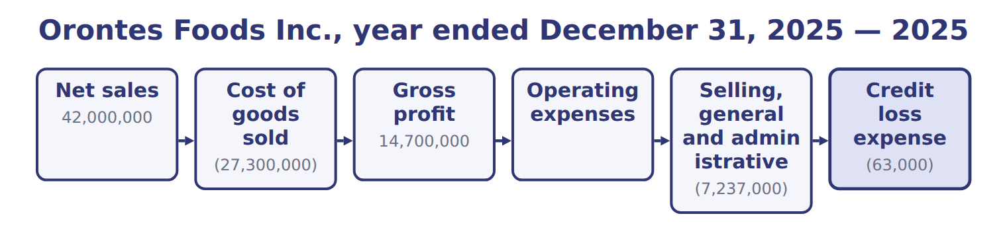
Orontes Foods Inc., year ended December 31, 2025 — the book’s own table
Orontes Foods Inc., year ended December 31, 2025 | 2025
Net sales | 42,000,000
Cost of goods sold | (27,300,000)
Gross profit | 14,700,000
Operating expenses
Selling, general and administrative | (7,237,000)
Credit loss expense | (63,000)
Research and development | (500,000)
Impairment losses | (2,724,000)
Total operating expenses | (10,524,000)
Operating income | 4,176,000

Orontes Foods Inc., year ended December 31, 2025 — the book’s own table (continued)
Orontes Foods Inc., year ended December 31, 2025 | 2025
Other income and (expense)
Interest expense | (390,000)
Interest and dividend income | 3,800
Unrealized gains on securities | 4,000
Equity-method income | 177,000
Gain on sale of equipment | 3,000
Loss on sale of receivables | (15,000)
Total other income and (expense) | (217,200)
Income before income taxes | 3,958,800
Income tax expense | (989,700)

Orontes Foods Inc., year ended December 31, 2025 — the book’s own table (continued)
Orontes Foods Inc., year ended December 31, 2025 | 2025
Net income | 2,969,100
Earnings per share, basic and diluted | $0.37
Weighted-average shares outstanding | 8,099,726
Other comprehensive income
Unrealized loss on available-for-sale debt securities, net of tax of 375 | (1,125)
Comprehensive income | 2,967,975

READ THE MODEL Every answer is printed above. Find it, do not recall it.

5. Which part of this chapter is section 3.1?
A. Purpose and structure of the income statement
B. Building the multi-step income statement
C. Comprehensive income
D. Unusual items and discontinued operations
6. Which part of this chapter is section 3.2?
A. Comprehensive income
B. Purpose and structure of the income statement
C. Building the multi-step income statement
D. Unusual items and discontinued operations
7. Which part of this chapter is section 3.3?
A. Purpose and structure of the income statement
B. Comprehensive income
C. Unusual items and discontinued operations
D. Building the multi-step income statement
8. Which part of this chapter is section 3.4?
A. Building the multi-step income statement
B. Comprehensive income
C. Purpose and structure of the income statement
D. Unusual items and discontinued operations
APPLY No help on this move.

9. An investor wants to predict a company's future earnings. Which statement is MOST useful for this?
A. The balance sheet
B. The statement of changes in equity
C. The auditor's report
D. The income statement
10. A lender wants to know if a borrower's main business earns enough to cover its interest. Which subtotal is MOST useful?
A. Net income | C. Comprehensive income
B. Operating income | D. Gross profit
11. The heading of an income statement should read:
A. As of December 31, 2025
B. At December 31, 2025
C. For the year ended December 31, 2025
D. On December 31, 2025
12. Why do most U.S. public companies use a multi-step rather than a single-step income statement?
A. It gives a higher net income
B. U.S. GAAP requires the multi-step form for all companies
C. It shows cash flows from operations
D. The subtotals help users see how much comes from main operations

WORK IN PAIRS | Compare every answer on this page with your partner before you read any key.
If you disagree: go back to the model and find the row that settles it. The row decides, not the louder voice.
CHECKPOINT 13. An investor wants to predict a company's future earnings. Which statement is MOST useful for this?
A. The balance sheet
B. The statement of changes in equity
C. The auditor's report
D. The income statement
If you got it wrong: redo the READ THE MODEL questions of cycle A with the model in front of you.

CYCLE B | The words this section uses precisely

ORIENT

14. A term in the exam means exactly what the book defines it to mean, whatever it means in ordinary English. TRUE / FALSE
MODEL

Item — the book’s own table
Item | Category
Fire loss | Operating expenses
Lawsuit settlement | Operating expenses
Interest expense | Other income and expense
Gain on sale of equipment | Other income and expense
Loss on sale of the division | Discontinued operations

The English the exam uses, and what it translates
English (exam term) | the Arabic it translates
income statement | قائمة الدخل
unusual or infrequent item | بند غير عادي أو غير متكرر
other income and expense | الإيرادات والمصروفات الأخرى
other comprehensive income (OCI) | الدخل الشامل الآخر

READ THE MODEL

Write the letter of the Arabic term beside each English term. Every term is used once.
A قائمة الدخل | C بند غير عادي أو غير متكرر
B الدخل الشامل الآخر | D الإيرادات والمصروفات الأخرى

15. income statement
16. unusual or infrequent item
17. other comprehensive income (OCI)
18. other income and expense

19. Which category does the book give for Fire loss?
A. Other income and expense | C. Operating expenses
B. Discontinued operations
20. Which category does the book give for Lawsuit settlement?
A. Discontinued operations | C. Operating expenses
B. Other income and expense
21. Which category does the book give for Interest expense?
A. Discontinued operations | C. Operating expenses
B. Other income and expense
APPLY

22. Which item is an operating expense on a U.S. multi-step income statement?
A. Research and development
B. Interest expense
C. Income tax expense
D. Loss from discontinued operations
23. A company has net sales of $900,000, cost of goods sold of $540,000, selling expenses of $120,000, administrative expenses of $90,000 and interest expense of $30,000. What is its operating income?
A. $120,000 | C. $240,000
B. $150,000 | D. $360,000
CHECKPOINT 24. What is the safest way to settle a disagreement about an answer on this sheet?
A. find the row of the model that decides it
B. take the answer of whoever is more confident
C. leave it until the lecturer says
D. choose the longer option
If you got it wrong: redo the READ THE MODEL questions of cycle B.

FROM MEMORY | Close the earlier pages first.
25. Rebuild the figure from this handout. Label every part and fill in every box.
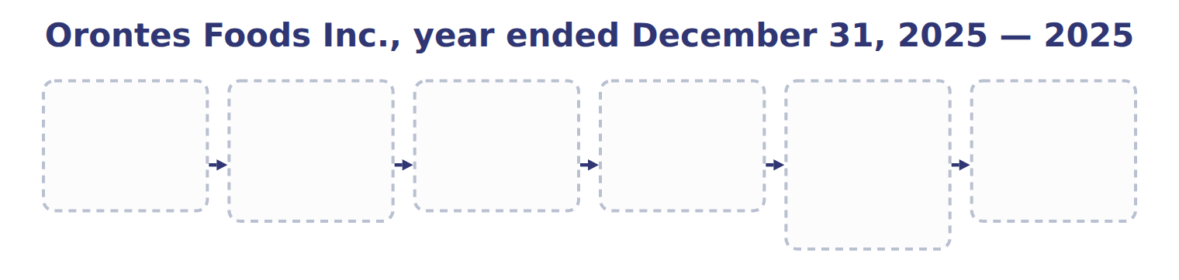
TEACH IT BACK | Write it for a classmate who missed this session — not for the marker.
26. In three or four sentences, write what this section settles and the one rule a reader has to take away.
every one of these words must appear: income statement · unusual or infrequent item · other income and expense · other comprehensive income (OCI)

Handout 3.2
Building the multi-step income statement
section 3.2 of the book
Before you start
Three summaries of this handout, in the book’s own words. Read all three first: together they are the whole session. Then fill the gaps, guessing where you have to.

What this handout settles, cycle by cycle
In this handout | What you will read | How you check it
Building the multi-step income statement | a figure to read · Barada Wholesale, year ended December 31, 2025 ( | Under U.S. GAAP, which presentation of operating expenses is required?
The words this section uses precisely | Item · The English the exam uses, and what it translates · Suppose: Orontes, 2026 (whole USD) | What is the safest way to settle a disagreement about an answer on this sheet?

Words this handout uses precisely
Words this handout uses precisely | tick it if you could already use it in a sentence
multi-step income statement
comprehensive income
function of expense
reclassification adjustment

1. Where the section starts — Fill every gap. The list holds more words than there are gaps, so one or two of them are not used.
choose from: Operating income · Other income and expense · comprehensive income · discontinued operation
is gross profit minus operating expenses: selling, general and administrative expenses, research and development, credit losses and impairments. Interest and income tax are never operating expenses. follows operating income.
2. What it settles in the middle — Fill every gap. The list holds more words than there are gaps, so one or two of them are not used.
choose from: operating income · comprehensive income · discontinued operation · Other income and expense
Interest and income tax are never operating expenses. follows . It contains interest, investment income and gains and losses. A gain or loss comes from a peripheral or incidental transaction, and it is shown net.
3. Where it ends — Fill every gap. The list holds more words than there are gaps, so one or two of them are not used.
choose from: comprehensive income · Other income and expense · operating income · discontinued operation
follows . It contains interest, investment income and gains and losses. A gain or loss comes from a peripheral or incidental transaction, and it is shown net. Income tax expense is then deducted from income before income taxes.

CYCLE A | Building the multi-step income statement

ORIENT One claim. Decide now; you will check it in a moment.

4. Every number in a financial statement belongs to an element the framework defines. TRUE / FALSE
MODEL Read it before you answer anything below it.

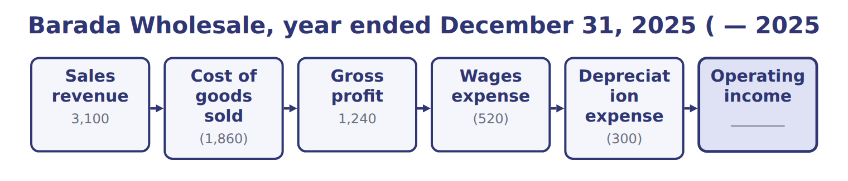
Barada Wholesale, year ended December 31, 2025 ( — the book’s own table
Barada Wholesale, year ended December 31, 2025 ( | 2025
Sales revenue | 3,100
Cost of goods sold | (1,860)
Gross profit | 1,240
Wages expense | (520)
Depreciation expense | (300)
Operating income | ________
Interest expense | (90)
Net income | ________
Gross profit as a percentage of sales | ________

READ THE MODEL Every answer is printed above. Find it, do not recall it.

5. Which part of this chapter is section 3.1?
A. Purpose and structure of the income statement
B. Building the multi-step income statement
C. Comprehensive income
D. Unusual items and discontinued operations
6. Which part of this chapter is section 3.2?
A. Comprehensive income
B. Purpose and structure of the income statement
C. Building the multi-step income statement
D. Unusual items and discontinued operations
7. Which part of this chapter is section 3.3?
A. Purpose and structure of the income statement
B. Comprehensive income
C. Unusual items and discontinued operations
D. Building the multi-step income statement
8. Which part of this chapter is section 3.4?
A. Building the multi-step income statement
B. Comprehensive income
C. Purpose and structure of the income statement
D. Unusual items and discontinued operations

APPLY No help on this move.

9. Under U.S. GAAP, which presentation of operating expenses is required?
A. No specific presentation is required; SEC captions lead to a functional presentation
B. By nature, such as materials and staff costs
C. By function, with a note by nature for all companies today
D. Operating profit as a required subtotal
10. For which amounts must a U.S. public company with a simple capital structure show EPS on the face of the income statement?
A. Gross profit and operating income
B. Comprehensive income only
C. Income from continuing operations and net income
D. Unusual or infrequent items
11. A company reports a large loss from a flood, which is unusual for it. How is the loss presented?
A. Net of tax, below income from continuing operations
B. As an extraordinary item with its own EPS
C. Only in the notes
D. As a separate line in income from continuing operations, before tax
12. Orontes sells an oven with a cost of $60,000 and accumulated depreciation of $42,000 for $21,000. How is the sale shown on the income statement?
A. Revenue of $21,000
B. A gain of $3,000 in other income and expense
C. A gain of $21,000
D. A loss of $39,000
WORK IN PAIRS | Compare every answer on this page with your partner before you read any key.
If you disagree: go back to the model and find the row that settles it. The row decides, not the louder voice.
CHECKPOINT 13. Under U.S. GAAP, which presentation of operating expenses is required?
A. No specific presentation is required; SEC captions lead to a functional presentation
B. By nature, such as materials and staff costs
C. By function, with a note by nature for all companies today
D. Operating profit as a required subtotal
If you got it wrong: redo the READ THE MODEL questions of cycle A with the model in front of you.

CYCLE B | The words this section uses precisely

ORIENT

14. A term in the exam means exactly what the book defines it to mean, whatever it means in ordinary English. TRUE / FALSE
MODEL

Item — the book’s own table
Item | Answer
Operating income | 1,240 − 520 − 300 = 420
Net income | 420 − 90 = 330, the same as in Chapter 1
Gross profit percentage | 1,240 ÷ 3,100 = 40%

The English the exam uses, and what it translates
English (exam term) | the Arabic it translates
multi-step income statement | قائمة الدخل متعددة المراحل
comprehensive income | الدخل الشامل
function of expense | عرض المصروفات حسب الوظيفة
reclassification adjustment | تعديل إعادة التصنيف

READ THE MODEL

Write the letter of the Arabic term beside each English term. Every term is used once.
A تعديل إعادة التصنيف | C عرض المصروفات حسب الوظيفة
B الدخل الشامل | D قائمة الدخل متعددة المراحل

15. comprehensive income
16. multi-step income statement
17. function of expense
18. reclassification adjustment

19. Which answer does the book give for Operating income?
A. 1,240 − 520 − 300 = 420
B. 1,240 ÷ 3,100 = 40%
C. 420 − 90 = 330, the same as in Chapter 1
20. Which answer does the book give for Net income?
A. 1,240 − 520 − 300 = 420
B. 420 − 90 = 330, the same as in Chapter 1
C. 1,240 ÷ 3,100 = 40%
21. Which answer does the book give for Gross profit percentage?
A. 1,240 ÷ 3,100 = 40%
B. 420 − 90 = 330, the same as in Chapter 1
C. 1,240 − 520 − 300 = 420
APPLY

22. Which condition is NOT needed for a disposal to be reported as a discontinued operation?
A. The component must be sold, held for sale or disposed of
B. The disposal must be a strategic shift
C. The shift must have a major effect on operations and results
D. The component must have been profitable
Suppose: Orontes, 2026 (whole USD) — the extract for the question that follows
Suppose: Orontes, 2026 (whole USD) | Before tax | Tax benefit | Net of tax
Loss from operations of the frozen-foods business | (420,000) | 105,000 | (315,000)
Loss on disposal of the business | (180,000) | 45,000 | (135,000)
Loss from discontinued operations | (600,000) | 150,000 | (450,000)

23. The extract for this question is printed with it. What loss from discontinued operations does Orontes report (whole USD)?
A. 315,000 | C. 600,000
B. 450,000 | D. 750,000

CHECKPOINT 24. What is the safest way to settle a disagreement about an answer on this sheet?
A. find the row of the model that decides it
B. take the answer of whoever is more confident
C. leave it until the lecturer says
D. choose the longer option
If you got it wrong: redo the READ THE MODEL questions of cycle B.

FROM MEMORY | Close the earlier pages first.
25. Rebuild the figure from this handout. Label every part and fill in every box.
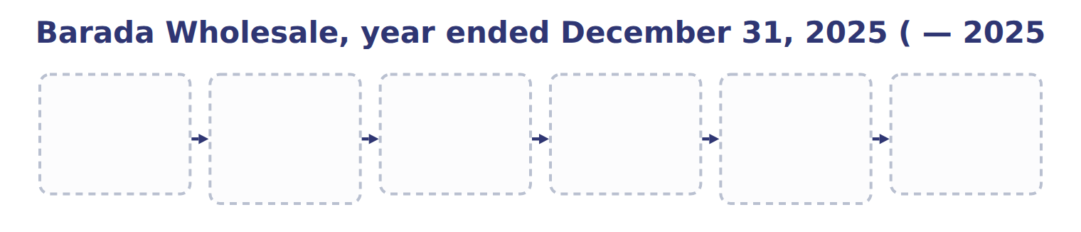
TEACH IT BACK | Write it for a classmate who missed this session — not for the marker.
26. In three or four sentences, write what this section settles and the one rule a reader has to take away.
every one of these words must appear: multi-step income statement · comprehensive income · function of expense · reclassification adjustment

Handout 3.3
Unusual items and discontinued operations
section 3.3 of the book
Before you start
Three summaries of this handout, in the book’s own words. Read all three first: together they are the whole session. Then fill the gaps, guessing where you have to.

What this handout settles, cycle by cycle
In this handout | What you will read | How you check it
Unusual items and discontinued operations | a figure to read · Suppose: Orontes, 2026 (whole USD) · the book’s own rule, gapped | Which statement reports a company's performance over a period of time?
The words this section uses precisely | The English the exam uses, and what it translates | What is the safest way to settle a disagreement about an answer on this sheet?

Words this handout uses precisely
Words this handout uses precisely | tick it if you could already use it in a sentence
operating income
accumulated other comprehensive income (AOCI)
component of an entity

1. Where the section starts — Fill every gap. The list holds more words than there are gaps, so one or two of them are not used.
choose from: strategic shift · function of expense · component of an entity · discontinued operation · other income and expense · unusual or infrequent item
An , such as a large fire loss, is shown as a separate line within continuing operations, before tax. A is a that the company has sold, has classified as held for sale, or has abandoned. The disposal must also be a with a major effect on the company.
2. What it settles in the middle — Fill every gap. The list holds more words than there are gaps, so one or two of them are not used.
choose from: income from continuing operations · other income and expense · discontinued operation · intraperiod tax allocation · income statement · strategic shift · component of an entity
The results of a , including any gain or loss on disposal, appear below , net of their own tax. This is called . Ask the questions in order: OCI first, then discontinued operations, then unusual items, and finally main activities or . Decision chart: where does an item go in the ?.
3. Where it ends — Fill every gap. The list holds more words than there are gaps, so one or two of them are not used.
choose from: component of an entity · other income and expense · income from continuing operations · discontinued operation · intraperiod tax allocation · strategic shift
The results of a , including any gain or loss on disposal, appear below , net of their own tax. This is called . Ask the questions in order: OCI first, then discontinued operations, then unusual items, and finally main activities or .

CYCLE A | Unusual items and discontinued operations

ORIENT One claim. Decide now; you will check it in a moment.

4. Every number in a financial statement belongs to an element the framework defines. TRUE / FALSE
MODEL Read it before you answer anything below it.

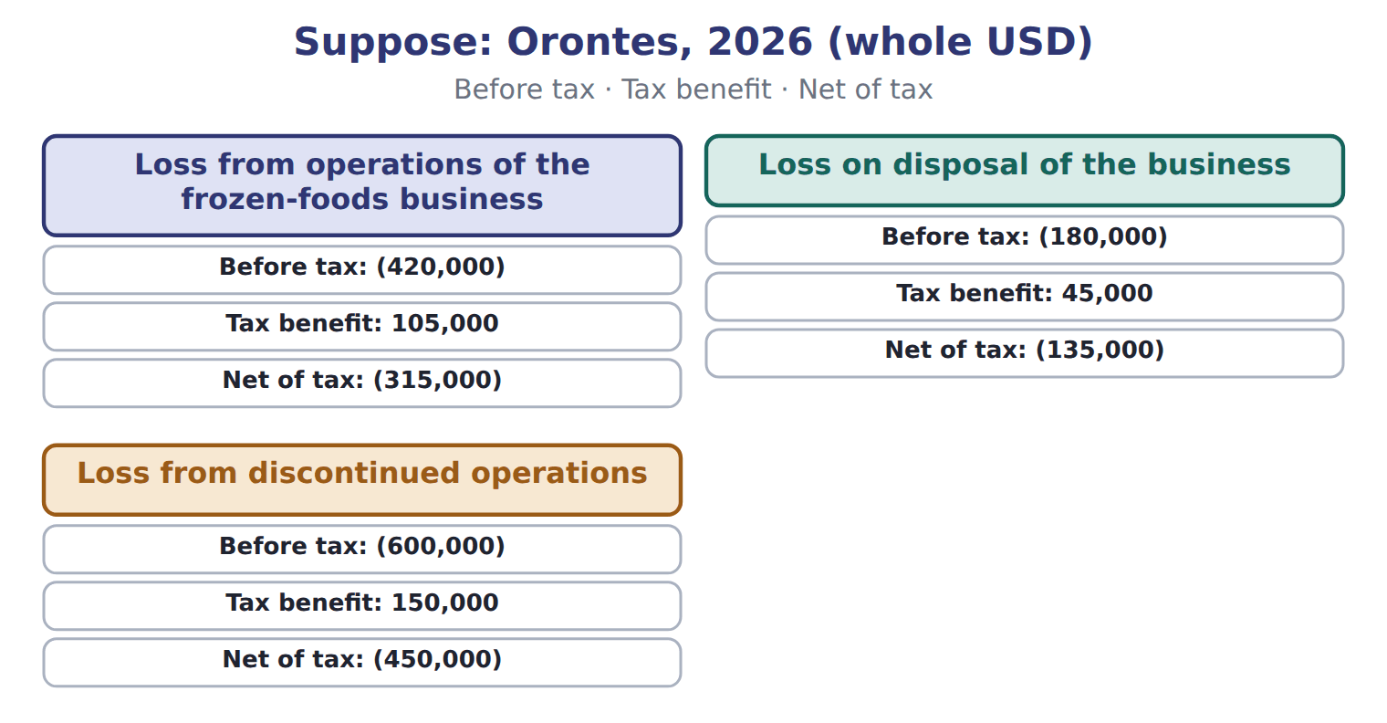
Suppose: Orontes, 2026 (whole USD) — the book’s own table
Suppose: Orontes, 2026 (whole USD) | Before tax | Tax benefit | Net of tax
Loss from operations of the frozen-foods business | (420,000) | 105,000 | (315,000)
Loss on disposal of the business | (180,000) | 45,000 | (135,000)
Loss from discontinued operations | (600,000) | 150,000 | (450,000)

READ THE MODEL Every answer is printed above. Find it, do not recall it.

5. Which before tax does the book give for Loss from operations of the frozen-foods business?
A. (600,000) | C. (180,000)
B. (420,000)
6. Which before tax does the book give for Loss on disposal of the business?
A. (600,000) | C. (180,000)
B. (420,000)
7. Which before tax does the book give for Loss from discontinued operations?
A. (420,000) | C. (600,000)
B. (180,000)

INVENT THE RULE

8. Complete the book’s own sentence. The list holds more words than there are gaps.
use every one of these words: other income and expense · component of an entity · strategic shift · discontinued operation
A is a that the company has sold, has classified as held for sale, or has abandoned.

Two of the book’s own cases, side by side
Loss from operations of the frozen-foods business | Loss on disposal of the business
Before tax: (420,000) | Before tax: (180,000)
Tax benefit: 105,000 | Tax benefit: 45,000
Only the facts above differ. What is the net of tax of Loss from operations of the frozen-foods business?
9. Choose one:
A. (315,000) | C. (450,000)
B. (135,000)
APPLY No help on this move.

10. Orontes sells an old delivery van for more than its carrying amount. The difference is:
A. revenue, because cash was received
B. a reduction of cost of goods sold
C. a gain, shown net in other income and expense
D. a direct increase in retained earnings
11. A company reports net income of $500,000. Its OCI for the year is a gain of $40,000 after tax. AOCI was $100,000 at the start of the year. What is comprehensive income?
A. $500,000 | C. $600,000
B. $540,000 | D. $640,000
12. Where may a U.S. company report OCI?
A. Only in the statement of changes in equity
B. In one continuous statement of comprehensive income, or in a separate statement right after the income statement
C. Only in the notes
D. Inside operating income
13. A company sells an AFS debt security and realizes a gain that had been in AOCI. What is the purpose of the reclassification adjustment?
A. To move the gain from net income to OCI
B. To defer the gain to next year
C. To remove the gain from retained earnings
D. To avoid counting the same gain twice in comprehensive income
14. Orontes's land has risen in value by $1 million this year. How does this affect the 2025 income statement?
A. It is a gain in other income
B. It is OCI
C. It has no effect, because the gain is not realized or recognized
D. It increases revenue

Orontes Foods Inc., year ended December 31, 2025 — the extract for the question that follows
Orontes Foods Inc., year ended December 31, 2025 | 2025
Net sales | 42,000,000
Cost of goods sold | (27,300,000)
Gross profit | 14,700,000
Operating expenses
Selling, general and administrative | (7,237,000)
Credit loss expense | (63,000)
Research and development | (500,000)
Impairment losses | (2,724,000)
Total operating expenses | (10,524,000)
Operating income | 4,176,000

Orontes Foods Inc., year ended December 31, 2025 — the extract for the question that follows (continued)
Orontes Foods Inc., year ended December 31, 2025 | 2025
Other income and (expense)
Interest expense | (390,000)
Interest and dividend income | 3,800
Unrealized gains on securities | 4,000
Equity-method income | 177,000
Gain on sale of equipment | 3,000
Loss on sale of receivables | (15,000)
Total other income and (expense) | (217,200)
Income before income taxes | 3,958,800
Income tax expense | (989,700)

Orontes Foods Inc., year ended December 31, 2025 — the extract for the question that follows (continued)
Orontes Foods Inc., year ended December 31, 2025 | 2025
Net income | 2,969,100
Earnings per share, basic and diluted | $0.37
Weighted-average shares outstanding | 8,099,726
Other comprehensive income
Unrealized loss on available-for-sale debt securities, net of tax of 375 | (1,125)
Comprehensive income | 2,967,975

15. The extract for this question is printed with it. What is Orontes's operating income for 2025 (whole USD)?
A. 3,786,000 | C. 6,900,000
B. 4,176,000 | D. 14,700,000
WORK IN PAIRS | Compare every answer on this page with your partner before you read any key.
If you disagree: go back to the model and find the row that settles it. The row decides, not the louder voice.

CHECKPOINT 16. Which statement reports a company's performance over a period of time?
A. The balance sheet
B. The income statement
C. The notes on accounting policies
D. The statement of financial position
If you got it wrong: redo the READ THE MODEL questions of cycle A with the model in front of you.

CYCLE B | The words this section uses precisely

ORIENT

17. A term in the exam means exactly what the book defines it to mean, whatever it means in ordinary English. TRUE / FALSE
MODEL

The English the exam uses, and what it translates
English (exam term) | the Arabic it translates
operating income | الدخل التشغيلي
accumulated other comprehensive income (AOCI) | الدخل الشامل الآخر المتراكم
component of an entity | مكوِّن من مكونات المنشأة

READ THE MODEL

18. A glossary term and its translation are a pair the book itself gives. TRUE / FALSE
APPLY

19. A company changes from a multi-step to a single-step income statement. What happens to net income?
A. It does not change
B. It increases, because gains are added to revenues
C. It decreases, because tax is deducted twice
D. It cannot be determined without the balance sheet
20. Near the year-end, a manager delays advertising until January to meet a profit target. This illustrates which limitation?
A. Net income can be influenced by the timing of discretionary costs
B. The income statement omits unrealized value changes
C. Net income is measured at fair value
D. The income statement shows cash flows
21. Which amount starts the operating section of a U.S. statement of cash flows under the indirect method?
A. Operating income | C. Gross profit
B. Comprehensive income | D. Net income
CHECKPOINT 22. What is the safest way to settle a disagreement about an answer on this sheet?
A. find the row of the model that decides it
B. take the answer of whoever is more confident
C. leave it until the lecturer says
D. choose the longer option
If you got it wrong: redo the READ THE MODEL questions of cycle B.

FROM MEMORY | Close the earlier pages first.
23. Rebuild the figure from this handout. Label every part and fill in every box.
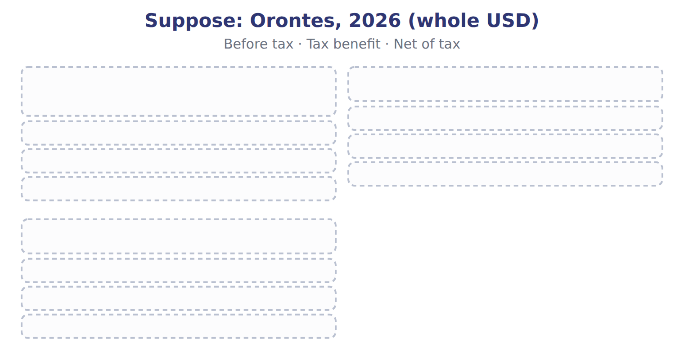
TEACH IT BACK | Write it for a classmate who missed this session — not for the marker.
24. In three or four sentences, write what this section settles and the one rule a reader has to take away.
every one of these words must appear: operating income · accumulated other comprehensive income (AOCI) · component of an entity

Handout 3.4
Comprehensive income
section 3.4 of the book
Before you start
Three summaries of this handout, in the book’s own words. Read all three first: together they are the whole session. Then fill the gaps, guessing where you have to.

What this handout settles, cycle by cycle
In this handout | What you will read | How you check it
Comprehensive income | a figure to read · Item · Orontes Foods Inc., year ended December 31, 2025 | An IFRS company revalues its land upward. How is the increase reported?
The words this section uses precisely | The English the exam uses, and what it translates | What is the safest way to settle a disagreement about an answer on this sheet?

Words this handout uses precisely
Words this handout uses precisely | tick it if you could already use it in a sentence
income from continuing operations
earnings per share (EPS)
strategic shift

1. Where the section starts — Fill every gap. The list holds more words than there are gaps, so one or two of them are not used.
choose from: reclassification adjustment · comprehensive income · component of an entity · other income and expense
OCI builds a balance in equity called accumulated other (AOCI). When an item is realized, for example when Orontes sells an AFS security, the gain or loss moves from AOCI into net income. This stops the same gain being counted twice.
2. What it settles in the middle — Fill every gap. The list holds more words than there are gaps, so one or two of them are not used.
choose from: other income and expense · component of an entity · reclassification adjustment · comprehensive income
Showing OCI only in the statement of changes in equity is not allowed. OCI builds a balance in equity called accumulated other (AOCI). When an item is realized, for example when Orontes sells an AFS security, the gain or loss moves from AOCI into net income. This stops the same gain being counted twice.
3. Where it ends — Fill every gap. The list holds more words than there are gaps, so one or two of them are not used.
choose from: reclassification adjustment · Comprehensive income · component of an entity · other income and expense
This stops the same gain being counted twice. Under IFRS, a revaluation surplus on PP&E, fair value changes on equity investments elected to OCI, and pension remeasurements stay in OCI forever. GAAP does not allow PP&E revaluation, and it reclassifies its OCI items to net income later. adds this year's OCI, not the AOCI balance.

CYCLE A | Comprehensive income

ORIENT One claim. Decide now; you will check it in a moment.

4. The book gives the U.S. GAAP of Unrealized gains and losses on debt securities (AFS / FVOCI) as “OCI; reclassified to net income on sale”. TRUE / FALSE
MODEL Read it before you answer anything below it.

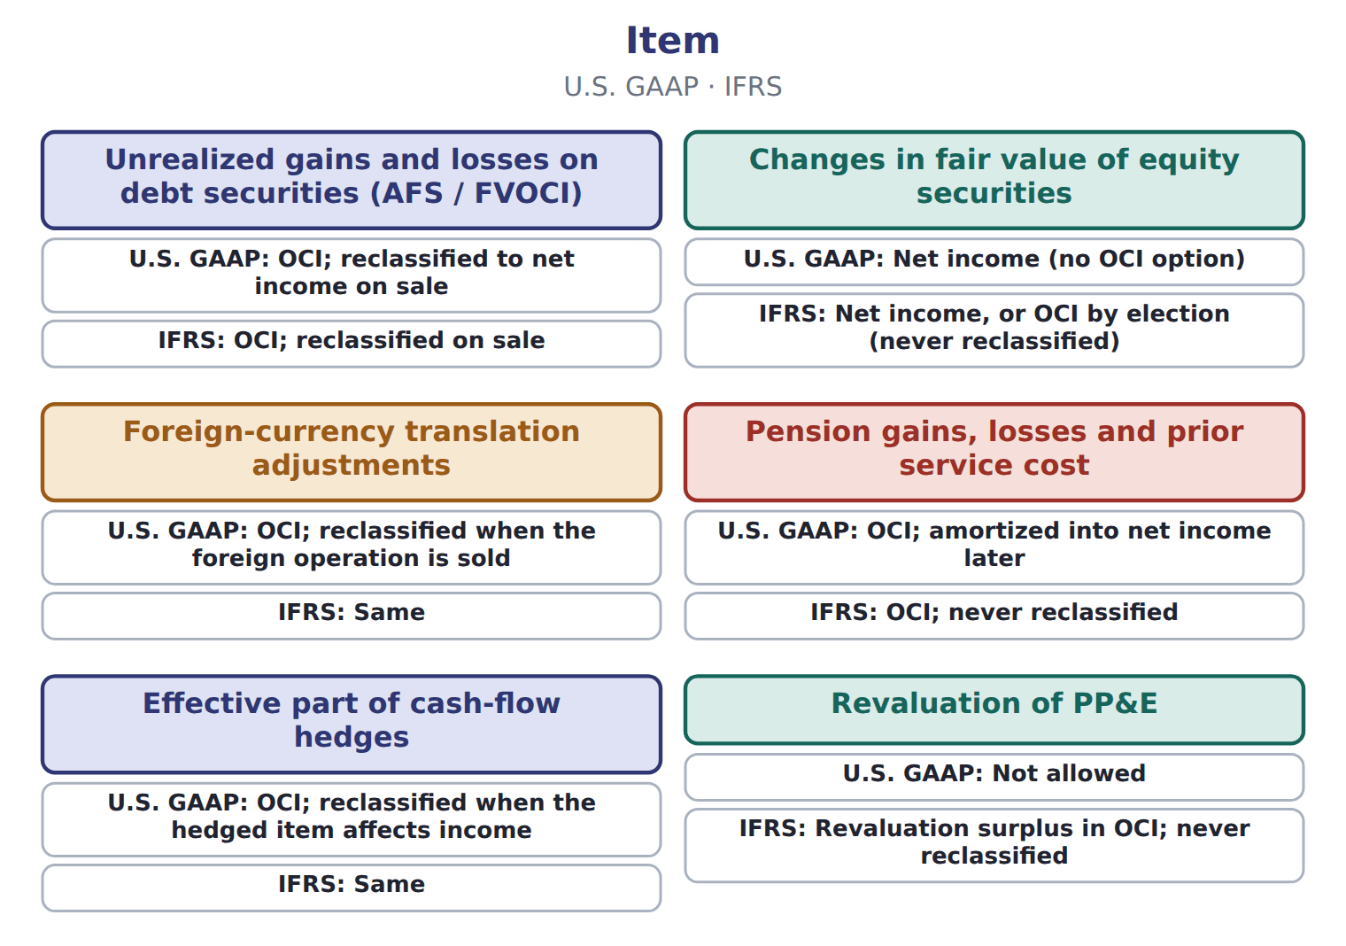

Item — the book’s own table
Item | U.S. GAAP | IFRS
Unrealized gains and losses on debt securities (AFS / FVOCI) | OCI; reclassified to net income on sale | OCI; reclassified on sale
Changes in fair value of equity securities | Net income (no OCI option) | Net income, or OCI by election (never reclassified)
Foreign-currency translation adjustments | OCI; reclassified when the foreign operation is sold | Same
Pension gains, losses and prior service cost | OCI; amortized into net income later | OCI; never reclassified
Effective part of cash-flow hedges | OCI; reclassified when the hedged item affects income | Same
Revaluation of PP&E | Not allowed | Revaluation surplus in OCI; never reclassified

READ THE MODEL Every answer is printed above. Find it, do not recall it.

5. Which item does the book pair with “OCI; reclassified to net income on sale”?
A. Effective part of cash-flow hedges
B. Pension gains, losses and prior service cost
C. Changes in fair value of equity securities
D. Unrealized gains and losses on debt securities (AFS / FVOCI)
6. Which item does the book pair with “Net income (no OCI option)”?
A. Revaluation of PP&E
B. Foreign-currency translation adjustments
C. Pension gains, losses and prior service cost
D. Changes in fair value of equity securities
7. Which item does the book pair with “OCI; reclassified when the foreign operation is sold”?
A. Effective part of cash-flow hedges
B. Pension gains, losses and prior service cost
C. Changes in fair value of equity securities
D. Foreign-currency translation adjustments
8. Which item does the book pair with “OCI; amortized into net income later”?
A. Revaluation of PP&E
B. Effective part of cash-flow hedges
C. Changes in fair value of equity securities
D. Pension gains, losses and prior service cost
9. The book gives the IFRS of Unrealized gains and losses on debt securities (AFS / FVOCI) as “OCI; reclassified on sale”. TRUE / FALSE
10. The book gives the IFRS of Changes in fair value of equity securities as “Revaluation surplus in OCI; never reclassified”. TRUE / FALSE
APPLY No help on this move.

11. An IFRS company revalues its land upward. How is the increase reported?
A. As a gain in profit or loss
B. In OCI, reclassified to profit when the land is sold
C. In OCI as a revaluation surplus, never reclassified to profit
D. It is not recognized under IFRS

Orontes Foods Inc., year ended December 31, 2025 — the extract for the question that follows
Orontes Foods Inc., year ended December 31, 2025 | 2025
Net sales | 42,000,000
Cost of goods sold | (27,300,000)
Gross profit | 14,700,000
Operating expenses
Selling, general and administrative | (7,237,000)
Credit loss expense | (63,000)
Research and development | (500,000)
Impairment losses | (2,724,000)
Total operating expenses | (10,524,000)
Operating income | 4,176,000

Orontes Foods Inc., year ended December 31, 2025 — the extract for the question that follows (continued)
Orontes Foods Inc., year ended December 31, 2025 | 2025
Other income and (expense)
Interest expense | (390,000)
Interest and dividend income | 3,800
Unrealized gains on securities | 4,000
Equity-method income | 177,000
Gain on sale of equipment | 3,000
Loss on sale of receivables | (15,000)
Total other income and (expense) | (217,200)
Income before income taxes | 3,958,800
Income tax expense | (989,700)

Orontes Foods Inc., year ended December 31, 2025 — the extract for the question that follows (continued)
Orontes Foods Inc., year ended December 31, 2025 | 2025
Net income | 2,969,100
Earnings per share, basic and diluted | $0.37
Weighted-average shares outstanding | 8,099,726
Other comprehensive income
Unrealized loss on available-for-sale debt securities, net of tax of 375 | (1,125)
Comprehensive income | 2,967,975

12. The extract for this question is printed with it. Which amount is Orontes's income before income taxes for 2025 (whole USD)?
A. 2,969,100 | C. 3,958,800
B. 3,781,800 | D. 4,176,000
WORK IN PAIRS | Compare every answer on this page with your partner before you read any key.
If you disagree: go back to the model and find the row that settles it. The row decides, not the louder voice.

CHECKPOINT 13. An IFRS company revalues its land upward. How is the increase reported?
A. As a gain in profit or loss
B. In OCI, reclassified to profit when the land is sold
C. In OCI as a revaluation surplus, never reclassified to profit
D. It is not recognized under IFRS
If you got it wrong: redo the READ THE MODEL questions of cycle A with the model in front of you.

CYCLE B | The words this section uses precisely

ORIENT

14. A term in the exam means exactly what the book defines it to mean, whatever it means in ordinary English. TRUE / FALSE
MODEL

The English the exam uses, and what it translates
English (exam term) | the Arabic it translates
income from continuing operations | الدخل من العمليات المستمرة
earnings per share (EPS) | ربحية السهم
strategic shift | تحول استراتيجي

READ THE MODEL

15. A glossary term and its translation are a pair the book itself gives. TRUE / FALSE
APPLY

16. Writing a term in English is part of answering the question, not an extra. TRUE / FALSE
CHECKPOINT 17. What is the safest way to settle a disagreement about an answer on this sheet?
A. find the row of the model that decides it
B. take the answer of whoever is more confident
C. leave it until the lecturer says
D. choose the longer option
If you got it wrong: redo the READ THE MODEL questions of cycle B.

FROM MEMORY | Close the earlier pages first.
18. Rebuild the figure from this handout. Label every part and fill in every box.
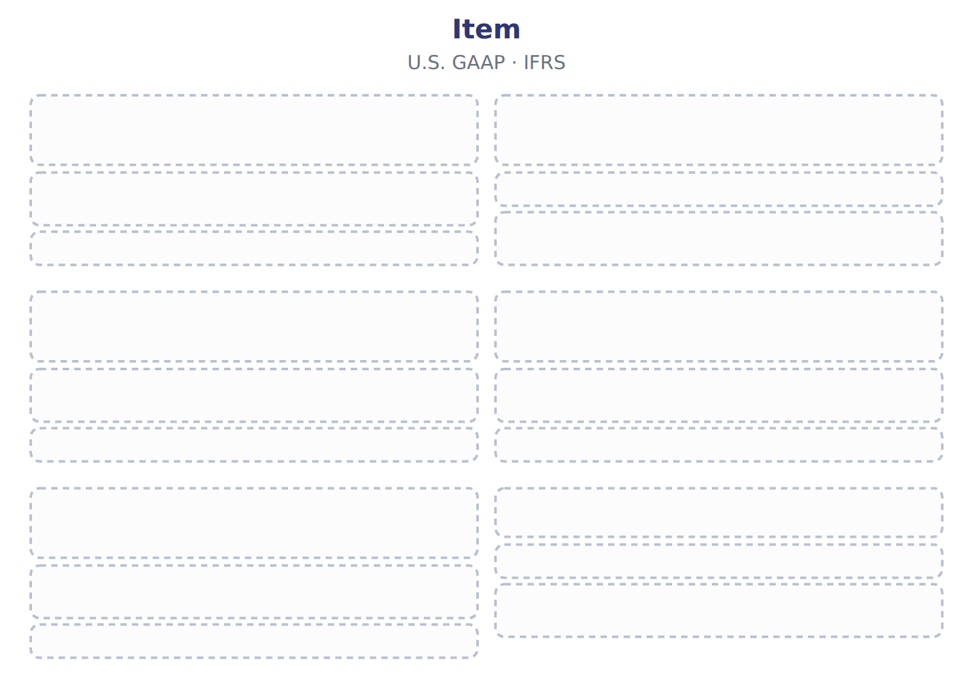
TEACH IT BACK | Write it for a classmate who missed this session — not for the marker.
19. In three or four sentences, write what this section settles and the one rule a reader has to take away.
every one of these words must appear: income from continuing operations · earnings per share (EPS) · strategic shift

Handout 3.5
Limitations and links to the other statements
section 3.5 of the book
Before you start
Three summaries of this handout, in the book’s own words. Read all three first: together they are the whole session. Then fill the gaps, guessing where you have to.

What this handout settles, cycle by cycle
In this handout | What you will read | How you check it
Limitations and links to the other statements | a figure to read · Item / memo (USD 000) | Which of these did this cycle settle?
The words this section uses precisely | Item · The English the exam uses, and what it translates | What is the safest way to settle a disagreement about an answer on this sheet?

Words this handout uses precisely
Words this handout uses precisely | tick it if you could already use it in a sentence
discontinued operation
single-step income statement
intraperiod tax allocation

1. Where the section starts — Fill every gap. The list holds more words than there are gaps, so one or two of them are not used.
choose from: impairment · income statement · estimates · Different · other income and expense
Net income depends on many : useful lives, credit losses, tests and warranty costs. companies also choose different methods, such as FIFO or LIFO for inventory. Two similar companies can therefore report different profits from the same activity.
2. What it settles in the middle — Fill every gap. The list holds more words than there are gaps, so one or two of them are not used.
choose from: other income and expense · discretionary · advertising · income statement · importantly
Managers can influence results by timing sales or costs, such as research or , near the year-end. Most , net income is not cash. Accrual accounting records revenue when it is earned and expenses when they are incurred.
3. Where it ends — Fill every gap. The list holds more words than there are gaps, so one or two of them are not used.
choose from: other income and expense · subtotals · exceptionnel · income statement · statement
The face of the does not change. IFRS 18 replaces IAS 1 and adds required , including operating profit. French résultat means profit, not result in general, and résultat is not a U.S.
How every cycle on this sheet works
How a cycle works | what you do
MODEL | read the figure or the table before you answer anything
READ THE MODEL | every answer is printed on the same page
INVENT THE RULE | write the rule yourself, then compare with the book
APPLY | no help on this move
CHECKPOINT | mark it yourself; if you miss it, the sheet says what to redo

CYCLE A | Limitations and links to the other statements

ORIENT One claim. Decide now; you will check it in a moment.

4. Every number in a financial statement belongs to an element the framework defines. TRUE / FALSE
MODEL Read it before you answer anything below it.

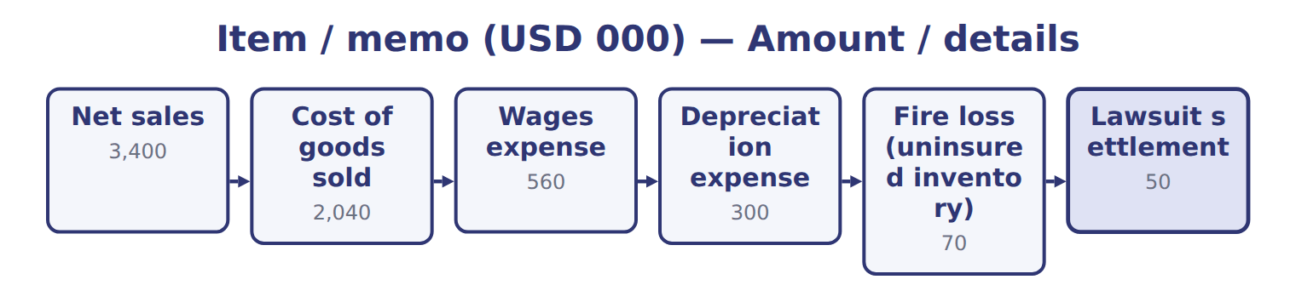
Item / memo (USD 000) — the book’s own table
Item / memo (USD 000) | Amount / details
Net sales | 3,400
Cost of goods sold | 2,040
Wages expense | 560
Depreciation expense | 300
Fire loss (uninsured inventory) | 70
Lawsuit settlement | 50
Interest expense | 80
Gain on sale of equipment | 20
M1 | In August 2026 Barada sold its catering-supply division to focus only on wholesale food. The division was one of Barada's two lines of busin
M2 | In 2026 the division had an operating loss of 60 before tax. Barada lost 40 before tax on the sale.

Item / memo (USD 000) — the book’s own table (continued)
Item / memo (USD 000) | Amount / details
M3 | The fire loss is the uninsured inventory destroyed on February 10, 2026. Fires are unusual for Barada.
M4 | The income tax rate is 25% on all items. Barada has no other comprehensive income.

READ THE MODEL Every answer is printed above. Find it, do not recall it.

5. Which part of this chapter is section 3.1?
A. Purpose and structure of the income statement
B. Building the multi-step income statement
C. Comprehensive income
D. Unusual items and discontinued operations
6. Which part of this chapter is section 3.2?
A. Comprehensive income
B. Purpose and structure of the income statement
C. Building the multi-step income statement
D. Unusual items and discontinued operations
7. Which part of this chapter is section 3.3?
A. Purpose and structure of the income statement
B. Comprehensive income
C. Unusual items and discontinued operations
D. Building the multi-step income statement
8. Which part of this chapter is section 3.4?
A. Building the multi-step income statement
B. Comprehensive income
C. Purpose and structure of the income statement
D. Unusual items and discontinued operations
APPLY No help on this move.

9. The rule you have just written is the book’s own rule. TRUE / FALSE
WORK IN PAIRS | Compare every answer on this page with your partner before you read any key.
If you disagree: go back to the model and find the row that settles it. The row decides, not the louder voice.
CHECKPOINT 10. Which of these did this cycle settle?
A. the rule and where it comes from
B. nothing in particular
C. only the vocabulary
D. only the arithmetic
If you got it wrong: redo the READ THE MODEL questions of cycle A.

CYCLE B | The words this section uses precisely

ORIENT

11. A term in the exam means exactly what the book defines it to mean, whatever it means in ordinary English. TRUE / FALSE

MODEL

Item — the book’s own table
Item | Category
Fire loss
Lawsuit settlement
Interest expense
Gain on sale of equipment
Loss on sale of the division

The English the exam uses, and what it translates
English (exam term) | the Arabic it translates
discontinued operation | العمليات غير المستمرة (المتوقفة)
single-step income statement | قائمة الدخل ذات المرحلة الواحدة
intraperiod tax allocation | توزيع الضريبة داخل الفترة

READ THE MODEL

12. A glossary term and its translation are a pair the book itself gives. TRUE / FALSE
APPLY

13. Writing a term in English is part of answering the question, not an extra. TRUE / FALSE
CHECKPOINT 14. What is the safest way to settle a disagreement about an answer on this sheet?
A. find the row of the model that decides it
B. take the answer of whoever is more confident
C. leave it until the lecturer says
D. choose the longer option
If you got it wrong: redo the READ THE MODEL questions of cycle B.

FROM MEMORY | Close the earlier pages first.
15. Rebuild the figure from this handout. Label every part and fill in every box.
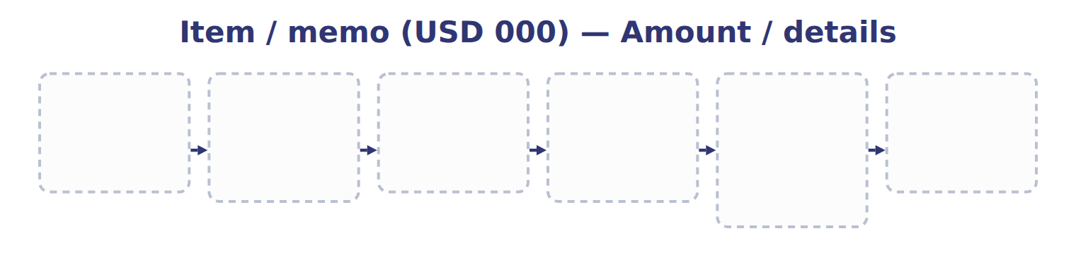
TEACH IT BACK | Write it for a classmate who missed this session — not for the marker.
16. In three or four sentences, write what this section settles and the one rule a reader has to take away.
every one of these words must appear: discontinued operation · single-step income statement · intraperiod tax allocation

Handout 3.6
The whole chapter
every section, shuffled, and the chapter’s own case set
Before you start
Three summaries of this chapter, in the book’s own words, with words taken out. Read all three first: together they are the whole chapter. Then fill the gaps.

What this handout settles, cycle by cycle
In this handout | What you will read | How you check it
The whole chapter, in order | a figure to read | A company's warehouse is destroyed by an earthquake, which is rare in its area. Under current U.S. GAAP the loss is shown:
The chapter’s case set | The chapter’s case set, item by item | What has to be settled before any figure in a case set is worked out?
The words it uses precisely | income statement · multi-step income statement · operating income · income from continuing operations · discontinued operation · unusual or infrequent item | matching, at the end of cycle B

1. Where the chapter starts — Fill every gap. The list holds more words than there are gaps, so one or two of them are not used.
choose from: operating income · comprehensive income · multi-step income statement · single-step income statement · strategic shift
A shows subtotals: gross profit, and income before income taxes. A adds all revenues and gains, deducts all expenses and losses, and reaches net income in one step.
2. What it settles in the middle — Fill every gap. The list holds more words than there are gaps, so one or two of them are not used.
choose from: discontinued operation · other income and expense · income from continuing operations · comprehensive income · operating income · income statement · intraperiod tax allocation
The results of a , including any gain or loss on disposal, appear below , net of their own tax. This is called . Ask the questions in order: OCI first, then discontinued operations, then unusual items, and finally main activities or . Decision chart: where does an item go in the ?.
3. Where it ends — Fill every gap. The list holds more words than there are gaps, so one or two of them are not used.
choose from: reclassification adjustment · strategic shift · operating income · comprehensive income
OCI builds a balance in equity called accumulated other (AOCI). When an item is realized, for example when Orontes sells an AFS security, the gain or loss moves from AOCI into net income. This stops the same gain being counted twice.

CYCLE A | The whole chapter, in order

ORIENT

4. The sections of a chapter have to be taken in order, because each one uses what the one before it settled. TRUE / FALSE
MODEL

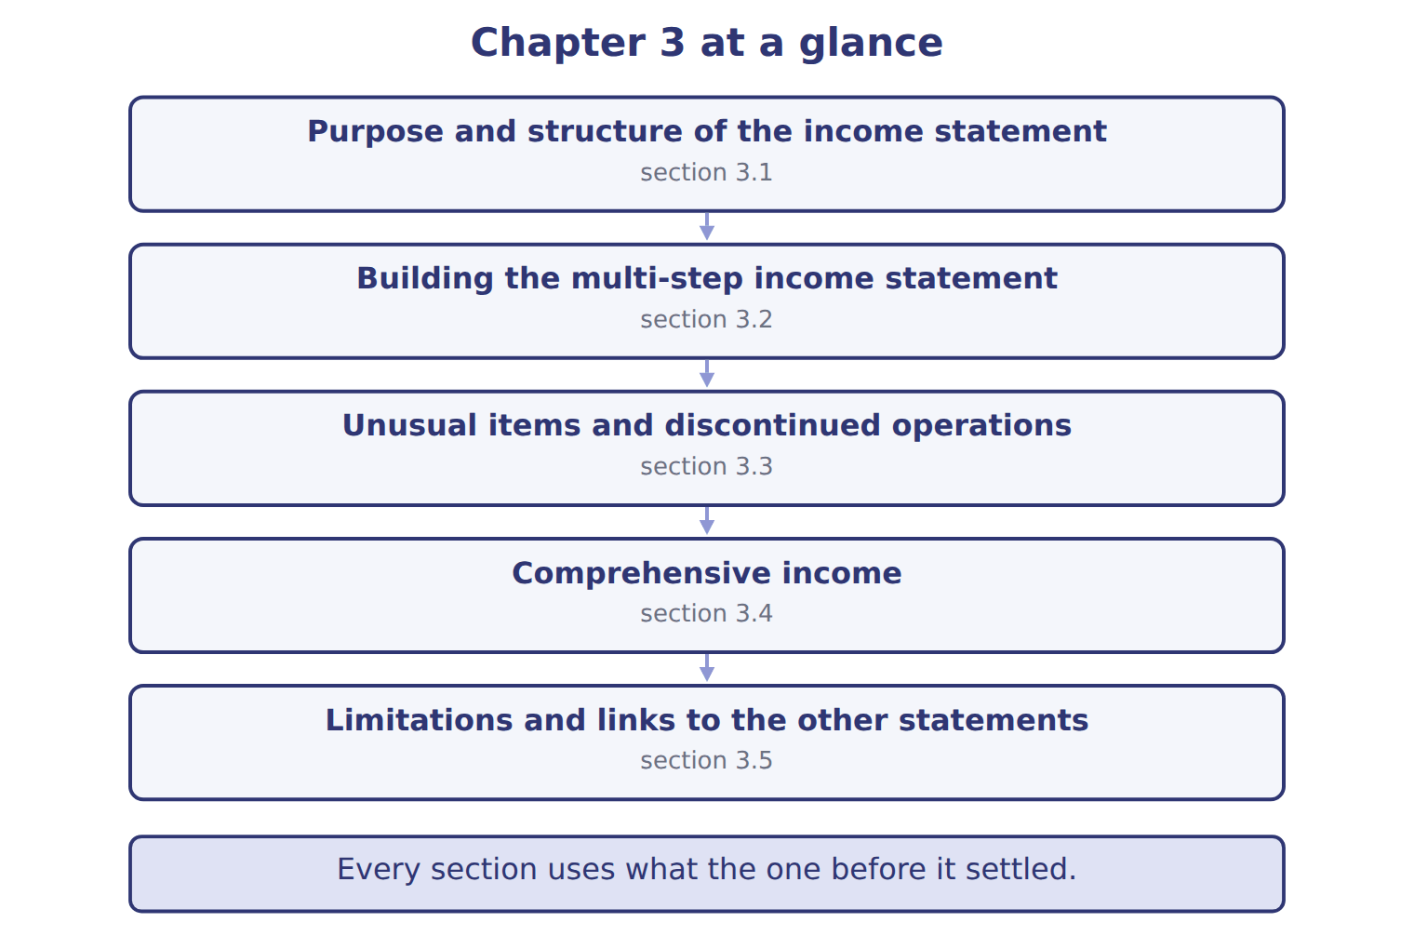
READ THE MODEL

5. “section 3.1” — which part of the chapter is this?
A. Comprehensive income
B. Unusual items and discontinued operations
C. Building the multi-step income statement
D. Purpose and structure of the income statement
6. “section 3.2” — which part of the chapter is this?
A. Unusual items and discontinued operations
B. Building the multi-step income statement
C. Purpose and structure of the income statement
D. Comprehensive income
7. “section 3.3” — which part of the chapter is this?
A. Building the multi-step income statement
B. Purpose and structure of the income statement
C. Unusual items and discontinued operations
D. Comprehensive income
Write the letter of the section number beside each section title. Every number is used once.
A 3.1 | D 3.4
B 3.2 | E 3.5
C 3.3

8. Purpose and structure of the income statement
9. Building the multi-step income statement
10. Unusual items and discontinued operations
11. Comprehensive income
12. Limitations and links to the other statements

APPLY

13. Why can two similar companies report different net income for the same activity?
A. The income statement uses current market values
B. Net income equals cash received
C. They may use different estimates and accounting methods
D. U.S. GAAP requires one layout
WORK IN PAIRS | Compare every answer with your partner first.
If you disagree: name the section each question belongs to. Most disagreements turn out to be about the section, not the answer.
CHECKPOINT 14. A company's warehouse is destroyed by an earthquake, which is rare in its area. Under current U.S. GAAP the loss is shown:
A. as a separate line in continuing operations, before tax
B. as an extraordinary item, net of tax
C. in discontinued operations
D. in OCI
If you got it wrong: go back to the MODEL move of cycle A and find the section this question belongs to.

CYCLE B | The chapter’s case set

ORIENT

15. In a case question, the exhibit has to be read and adjusted before any figure is worked out. TRUE / FALSE

MODEL

The chapter’s case set, item by item
Item | What it asks
C3-1 | Place each item in the section of the multi-step income statement where it belongs. (On the exam screen you would drag e
C3-2 | Enter Barada's operating income for 2026.
C3-3 | Enter Barada's income from continuing operations.
C3-4 | Enter the loss from discontinued operations, net of tax (as a positive number).
C3-5 | Enter Barada's net income for 2026.
C3-6 | How does Barada present the fire loss? [select]

READ THE MODEL

16. Which of these does item C3-1 ask for?
A. Enter the loss from discontinued operations, net of tax (as a positive
B. Place each item in the section of the multi-step income statement wher
C. Enter Barada's income from continuing operations.
D. Enter Barada's operating income for 2026.
17. Which of these does item C3-2 ask for?
A. Place each item in the section of the multi-step income statement wher
B. Enter Barada's operating income for 2026.
C. Enter the loss from discontinued operations, net of tax (as a positive
D. Enter Barada's income from continuing operations.
18. Which of these does item C3-3 ask for?
A. Enter the loss from discontinued operations, net of tax (as a positive
B. Enter Barada's operating income for 2026.
C. Enter Barada's income from continuing operations.
D. Place each item in the section of the multi-step income statement wher
19. Which of these does item C3-4 ask for?
A. Enter Barada's operating income for 2026.
B. Enter the loss from discontinued operations, net of tax (as a positive
C. Place each item in the section of the multi-step income statement wher
D. Enter Barada's income from continuing operations.
20. Which of these does item C3-5 ask for?
A. Enter Barada's income from continuing operations.
B. Enter Barada's net income for 2026.
C. Enter Barada's operating income for 2026.
D. Place each item in the section of the multi-step income statement wher
21. Which of these does item C3-6 ask for?
A. How does Barada present the fire loss? [select]
B. Enter Barada's operating income for 2026.
C. Place each item in the section of the multi-step income statement wher
D. Enter Barada's income from continuing operations.
APPLY

22. A company's warehouse is destroyed by an earthquake, which is rare in its area. Under current U.S. GAAP the loss is shown:
A. as a separate line in continuing operations, before tax
B. as an extraordinary item, net of tax
C. in discontinued operations
D. in OCI

23. Which disposal is MOST likely to be a discontinued operation?
A. A retailer closes one of its 200 stores
B. A food company sells its whole beverages division, one of its three main lines of business
C. A factory sells an old production machine
D. A company stops selling one small product in a large range
CHECKPOINT 24. What has to be settled before any figure in a case set is worked out?
A. the exhibit, adjusted for every note that goes with it
B. the method the company uses
C. the tax rate
D. the order of the items
If you got it wrong: reread the case panel in the MODEL move of cycle B.

FROM MEMORY | Close the earlier pages first.
25. Rebuild the chapter map. Write every section in order and what each one settles.
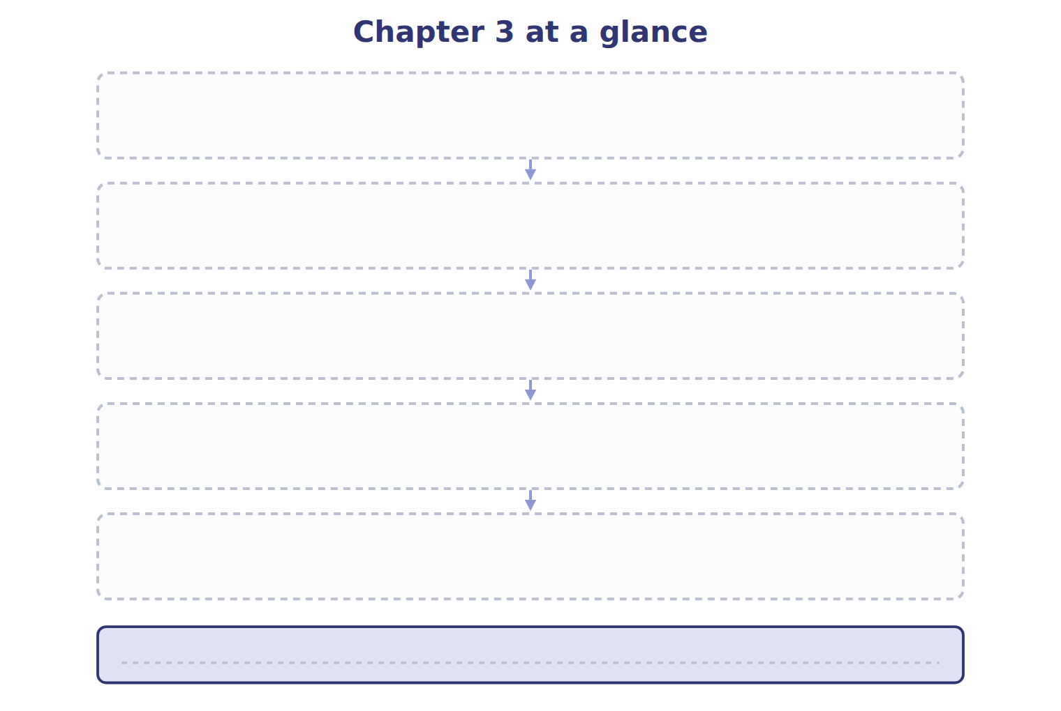
TEACH IT BACK | Write it for a student starting this chapter tomorrow — not for the marker.
26. In four or five sentences, write what the whole chapter settles, section by section.
every one of these words must appear: income statement · multi-step income statement · operating income · income from continuing operations

