Handout 6.1
Recognizing and measuring receivables
section 6.1 of the book
Before you start
Three summaries of this handout, in the book’s own words. Read all three first: together they are the whole session. Then fill the gaps, guessing where you have to.

What this handout settles, cycle by cycle
In this handout | What you will read | How you check it
Recognizing and measuring receivables | a figure to read · Transfer · Age of receivable | Under CECL, when does a company first recognize expected credit losses on a trade receivable?
The words this section uses precisely | Item · The English the exam uses, and what it translates | What is the safest way to settle a disagreement about an answer on this sheet?

Words this handout uses precisely
Words this handout uses precisely | tick it if you could already use it in a sentence
accounts receivable
aging schedule
factoring
contract asset
amortized cost
factor
pledging

1. Where the section starts — Fill every gap. The list holds more words than there are gaps, so one or two of them are not used.
choose from: secured borrowing · transfers · unconditional · notes receivable · receivable
A company records an account when its right to be paid is : only the passage of time is needed before payment is due. This usually happens when it delivers the goods or services and control (Chapter 11). If the company still has to do something else before it can bill, for example finish a second delivery, it has a contract asset, not a receivable.
2. What it settles in the middle — Fill every gap. The list holds more words than there are gaps, so one or two of them are not used.
choose from: discounts · secured borrowing · notes receivable · questions · forfeited
Some older still use the gross and net methods. Under the gross method, the company records the full invoice and records a sales discount only when a customer pays early. Under the net method, it records the sale net of the discount, and records sales when a customer pays late.
3. Where it ends — Fill every gap. The list holds more words than there are gaps, so one or two of them are not used.
choose from: secured borrowing · notes receivable · amortized · discount · Receivable
The is then to interest revenue over the life of the note. : only time must pass before payment. Contract asset: the company must still perform.

CYCLE A | Recognizing and measuring receivables

ORIENT One claim. Decide now; you will check it in a moment.

4. The book gives the category of T1 as “Sale”. TRUE / FALSE
MODEL Read it before you answer anything below it.

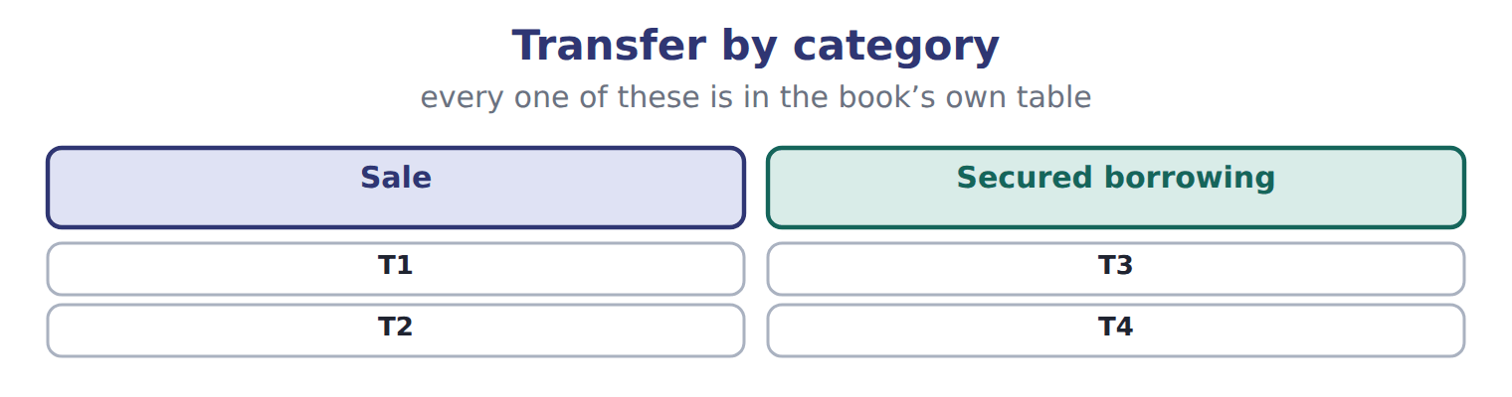

Transfer — the book’s own table
Transfer | Category
T1 | Sale
T2 | Sale
T3 | Secured borrowing
T4 | Secured borrowing

READ THE MODEL Every answer is printed above. Find it, do not recall it.

5. Which transfer does the book pair with “Sale”?
A. T4 | C. T3
B. T1
6. Which transfer does the book pair with “Sale”?
A. T2 | C. T3
B. T4
7. Which transfer does the book pair with “Secured borrowing”?
A. T1 | C. T3
B. T2
8. Which transfer does the book pair with “Secured borrowing”?
A. T4 | C. T1
B. T2
9. The book gives the category of T1 as “Sale”. TRUE / FALSE
10. The book gives the category of T2 as “Secured borrowing”. TRUE / FALSE
SORT THEM | Write each one under its category. Every item belongs to exactly one group.
the items: T1 · T2 · T3 · T4
Sale | Secured borrowing

APPLY No help on this move.

13. Under CECL, when does a company first recognize expected credit losses on a trade receivable?
A. When a loss becomes probable
B. When the customer misses a payment
C. When the receivable is first recognized
D. When the receivable is written off
14. A customer pays 1,500 that Orontes had written off last year. Under the allowance method, what is the first entry?
A. Debit Accounts receivable, credit Allowance for credit losses
B. Debit Cash, credit Revenue
C. Debit Cash, credit Credit loss expense
D. Debit Allowance for credit losses, credit Accounts receivable
15. Why is the direct write-off method not acceptable under U.S. GAAP when bad debts are material?
A. It is not allowed for U.S. tax returns.
B. It records losses too early.
C. It records losses late and shows receivables at more than the amount expected to be collected.
D. It reduces cash flow from operations.
Age of receivable — the extract for the question that follows
Age of receivable | Amount | Expected loss rate | Required allowance
Current | 400,000 | 1% | 4,000
1–30 days past due | 150,000 | 3% | 4,500
31–60 days past due | 60,000 | 10% | 6,000
61–90 days past due | 30,000 | 25% | 7,500
Over 90 days past due | 20,000 | 60% | 12,000
Total | 660,000 |  | 34,000

16. The extract for this question is printed with it. What is the required allowance for credit losses at December 31, 2025 (whole USD)?
A. 6,000 | C. 34,000
B. 28,000 | D. 626,000
WORK IN PAIRS | Compare every answer on this page with your partner before you read any key.
If you disagree: go back to the model and find the row that settles it. The row decides, not the louder voice.
CHECKPOINT 17. Under CECL, when does a company first recognize expected credit losses on a trade receivable?
A. When a loss becomes probable
B. When the customer misses a payment
C. When the receivable is first recognized
D. When the receivable is written off
If you got it wrong: redo the READ THE MODEL questions of cycle A with the model in front of you.

CYCLE B | The words this section uses precisely

ORIENT

18. A term in the exam means exactly what the book defines it to mean, whatever it means in ordinary English. TRUE / FALSE

MODEL

Item — the book’s own table
Item | Answer
1–60 days past due | 80,000 × 8% = 6,400
Over 60 days past due | 40,000 × 25% = 10,000
Required allowance | 3,600 + 6,400 + 10,000 = 20,000

The English the exam uses, and what it translates
English (exam term) | the Arabic it translates
accounts receivable | الذمم المدينة (المدينون)
aging schedule | جدول أعمار الذمم المدينة
factoring | تخصيم الذمم المدينة (بيع الديون)
contract asset | أصل العقد
amortized cost | التكلفة المستنفدة (التكلفة المطفأة)
factor | شركة التخصيم
pledging | رهن الذمم المدينة

READ THE MODEL

Write the letter of the Arabic term beside each English term. Every term is used once.
A التكلفة المستنفدة (التكلفة المطفأة)
B الذمم المدينة (المدينون)
C رهن الذمم المدينة
D شركة التخصيم
E تخصيم الذمم المدينة (بيع الديون)
F أصل العقد

19. contract asset
20. factor
21. pledging
22. amortized cost
23. factoring
24. accounts receivable

25. Which answer does the book give for 1–60 days past due?
A. 40,000 × 25% = 10,000 | C. 3,600 + 6,400 + 10,000 = 20,000
B. 80,000 × 8% = 6,400
26. Which answer does the book give for Over 60 days past due?
A. 3,600 + 6,400 + 10,000 = 20,000 | C. 40,000 × 25% = 10,000
B. 80,000 × 8% = 6,400
27. Which answer does the book give for Required allowance?
A. 40,000 × 25% = 10,000 | C. 80,000 × 8% = 6,400
B. 3,600 + 6,400 + 10,000 = 20,000

APPLY

28. Which statement about the percentage-of-sales approach is correct under CECL?
A. It is the method CECL requires.
B. It gives the required ending balance of the allowance.
C. It is the same as the direct write-off method.
D. It estimates the expense directly but does not measure expected losses on the ending receivables.
29. Orontes accepts a two-year note from a customer with no stated interest. How is the note recorded?
A. At its present value, with the discount amortized to interest revenue
B. At its face amount, with no interest
C. At its face amount plus interest at the market rate
D. At the customer's cost of the goods
CHECKPOINT 30. What is the safest way to settle a disagreement about an answer on this sheet?
A. find the row of the model that decides it
B. take the answer of whoever is more confident
C. leave it until the lecturer says
D. choose the longer option
If you got it wrong: redo the READ THE MODEL questions of cycle B.

FROM MEMORY | Close the earlier pages first.
31. Rebuild the figure from this handout. Label every part and fill in every box.
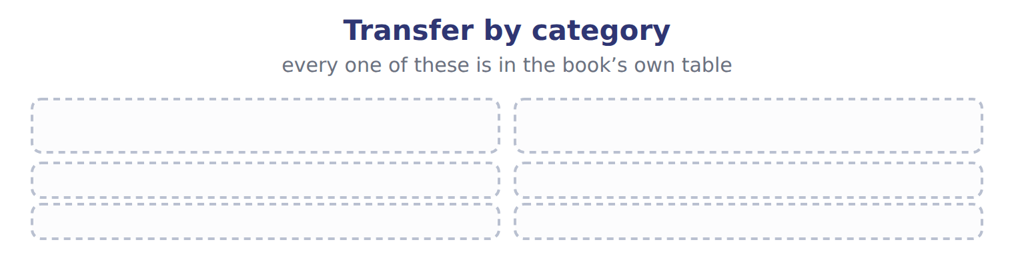
TEACH IT BACK | Write it for a classmate who missed this session — not for the marker.
32. In three or four sentences, write what this section settles and the one rule a reader has to take away.
every one of these words must appear: accounts receivable · aging schedule · factoring · contract asset

Handout 6.2
The allowance for credit losses
section 6.2 of the book
Before you start
Three summaries of this handout, in the book’s own words. Read all three first: together they are the whole session. Then fill the gaps, guessing where you have to.

What this handout settles, cycle by cycle
In this handout | What you will read | How you check it
The allowance for credit losses | a figure to read · Age of receivable · the book’s own rule, gapped | Under ASU 2025-05, a practical expedient lets companies assume current conditions will not change when they forecast losses on current receivables. How should a CMA candidate treat it in 2026?
The words this section uses precisely | Age of receivable · The English the exam uses, and what it translates | What is the safest way to settle a disagreement about an answer on this sheet?

Words this handout uses precisely
Words this handout uses precisely | tick it if you could already use it in a sentence
allowance for credit losses
credit loss expense
recourse
cash discount
recovery
recourse liability
effective control

1. Where the section starts — Fill every gap. The list holds more words than there are gaps, so one or two of them are not used.
choose from: notes receivable · accounts receivable · Allowance for credit losses · amortized cost · write-off
T-account: the expense is the plug that reaches the required balance. When a customer's balance is clearly uncollectible, the company records a : debit the allowance and credit .
2. What it settles in the middle — Fill every gap. The list holds more words than there are gaps, so one or two of them are not used.
choose from: recovery · write-off · notes receivable · amortized cost · accounts receivable
The changes neither net income nor net receivables, because the expense was already recorded when the allowance was built. If the customer later pays, the company records a : it first reinstates the receivable (debit , credit allowance) and then records the cash collection.
3. Where it ends — Fill every gap. The list holds more words than there are gaps, so one or two of them are not used.
choose from: amortized cost · write-off · notes receivable · allowance for credit losses
GAAP answer, always write , never provision for doubtful debts or reserve for bad debts. The aging gives the required ENDING allowance, not the expense. Expense = required balance − unadjusted credit balance, or required balance + unadjusted debit balance. A does not change net income or net receivables.

CYCLE A | The allowance for credit losses

ORIENT One claim. Decide now; you will check it in a moment.

4. The book gives the amount of Current as “400,000”. TRUE / FALSE
MODEL Read it before you answer anything below it.

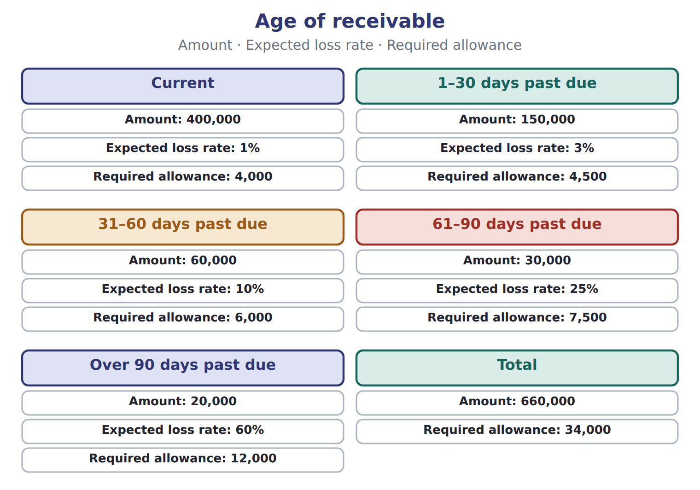

Age of receivable — the book’s own table
Age of receivable | Amount | Expected loss rate | Required allowance
Current | 400,000 | 1% | 4,000
1–30 days past due | 150,000 | 3% | 4,500
31–60 days past due | 60,000 | 10% | 6,000
61–90 days past due | 30,000 | 25% | 7,500
Over 90 days past due | 20,000 | 60% | 12,000
Total | 660,000 |  | 34,000

READ THE MODEL Every answer is printed above. Find it, do not recall it.

5. Which amount does the book give for Current?
A. 60,000 | C. 660,000
B. 400,000 | D. 30,000
6. Which amount does the book give for 1–30 days past due?
A. 150,000 | C. 400,000
B. 20,000 | D. 60,000
7. Which amount does the book give for 31–60 days past due?
A. 60,000 | C. 400,000
B. 30,000 | D. 20,000
8. Which amount does the book give for 61–90 days past due?
A. 20,000 | C. 400,000
B. 30,000 | D. 150,000
9. The book gives the required allowance of Current as “4,000”. TRUE / FALSE
10. The book gives the required allowance of 1–30 days past due as “4,000”. TRUE / FALSE
Complete every empty cell. The first full row shows the pattern.
Age of receivable | Amount | Expected loss rate | Required allowance
Current | 400,000 | 1% | 4,000
1–30 days past due
31–60 days past due
61–90 days past due
Over 90 days past due
Total

INVENT THE RULE

16. Complete the book’s own sentence. The list holds more words than there are gaps.
use every one of these words: write-off · credit loss expense · aging schedule · accounts receivable
When a customer's balance is clearly uncollectible, the company records a : debit the allowance and credit .

Two of the book’s own cases, side by side
Current | 1–30 days past due
Amount: 400,000 | Amount: 150,000
Expected loss rate: 1% | Expected loss rate: 3%
Only the facts above differ. What is the required allowance of Current?
17. Choose one:
A. 6,000 | C. 7,500
B. 4,000 | D. 4,500
APPLY No help on this move.

18. Under ASU 2025-05, a practical expedient lets companies assume current conditions will not change when they forecast losses on current receivables. How should a CMA candidate treat it in 2026?
A. As the main CECL rule
B. As a rule that applies only to IFRS companies
C. As a replacement for the aging method
D. As a watch item that is not yet tested
19. Receivables are transferred with recourse. They are legally isolated, the factor may pledge them, and the seller has no repurchase right or duty. How is the transfer recorded?
A. As a secured borrowing, because there is recourse
B. As a sale, with no liability
C. As a sale, with a recourse liability at fair value
D. As a pledge of receivables
20. Use the Orontes factoring example. If the transfer with recourse qualifies as a sale, what is the loss (whole USD)?
A. 6,000 | C. 21,000
B. 15,000 | D. 40,000
21. Compared with a sale of receivables, a secured borrowing:
A. removes the receivables and adds no liability.
B. removes the receivables and adds a recourse liability.
C. keeps the receivables on the balance sheet and adds a liability.
D. has no effect on the balance sheet.
WORK IN PAIRS | Compare every answer on this page with your partner before you read any key.
If you disagree: go back to the model and find the row that settles it. The row decides, not the louder voice.
CHECKPOINT 22. Under ASU 2025-05, a practical expedient lets companies assume current conditions will not change when they forecast losses on current receivables. How should a CMA candidate treat it in 2026?
A. As the main CECL rule
B. As a rule that applies only to IFRS companies
C. As a replacement for the aging method
D. As a watch item that is not yet tested
If you got it wrong: redo the READ THE MODEL questions of cycle A with the model in front of you.

CYCLE B | The words this section uses precisely

ORIENT

23. A term in the exam means exactly what the book defines it to mean, whatever it means in ordinary English. TRUE / FALSE

MODEL

Age of receivable — the book’s own table
Age of receivable | Amount | Expected loss rate | Required allowance
Current | 180,000 | 2% | 3,600
1–60 days past due | 80,000 | 8% | ______
Over 60 days past due | 40,000 | 25% | ______
Total | 300,000 |  | ______

The English the exam uses, and what it translates
English (exam term) | the Arabic it translates
allowance for credit losses | مخصص الخسائر الائتمانية
credit loss expense | مصروف الخسائر الائتمانية
recourse | حق الرجوع
cash discount | خصم تعجيل الدفع (خصم نقدي)
recovery | استرداد دين مشطوب
recourse liability | التزام حق الرجوع
effective control | السيطرة الفعلية

READ THE MODEL

Write the letter of the Arabic term beside each English term. Every term is used once.
A مخصص الخسائر الائتمانية | D خصم تعجيل الدفع (خصم نقدي)
B مصروف الخسائر الائتمانية | E حق الرجوع
C التزام حق الرجوع | F السيطرة الفعلية

24. effective control
25. recourse liability
26. credit loss expense
27. cash discount
28. recourse
29. allowance for credit losses

30. Which amount does the book give for Current?
A. 180,000 | C. 300,000
B. 80,000 | D. 40,000
31. Which amount does the book give for 1–60 days past due?
A. 300,000 | C. 80,000
B. 180,000 | D. 40,000
32. Which amount does the book give for Over 60 days past due?
A. 40,000 | C. 80,000
B. 300,000 | D. 180,000

APPLY

33. Orontes pledges its receivables as collateral for a bank loan. How are the receivables reported?
A. They stay on the balance sheet, with disclosure of the pledge.
B. They are removed from the balance sheet.
C. They are reclassified as a liability.
D. They are written down to fair value.
34. Under IFRS 9, how are expected credit losses measured on trade receivables without a significant financing component?
A. At 12-month expected losses
B. Only when a loss is probable
C. Only when the receivable is written off
D. Always at lifetime expected losses
CHECKPOINT 35. What is the safest way to settle a disagreement about an answer on this sheet?
A. find the row of the model that decides it
B. take the answer of whoever is more confident
C. leave it until the lecturer says
D. choose the longer option
If you got it wrong: redo the READ THE MODEL questions of cycle B.

FROM MEMORY | Close the earlier pages first.
36. Rebuild the figure from this handout. Label every part and fill in every box.
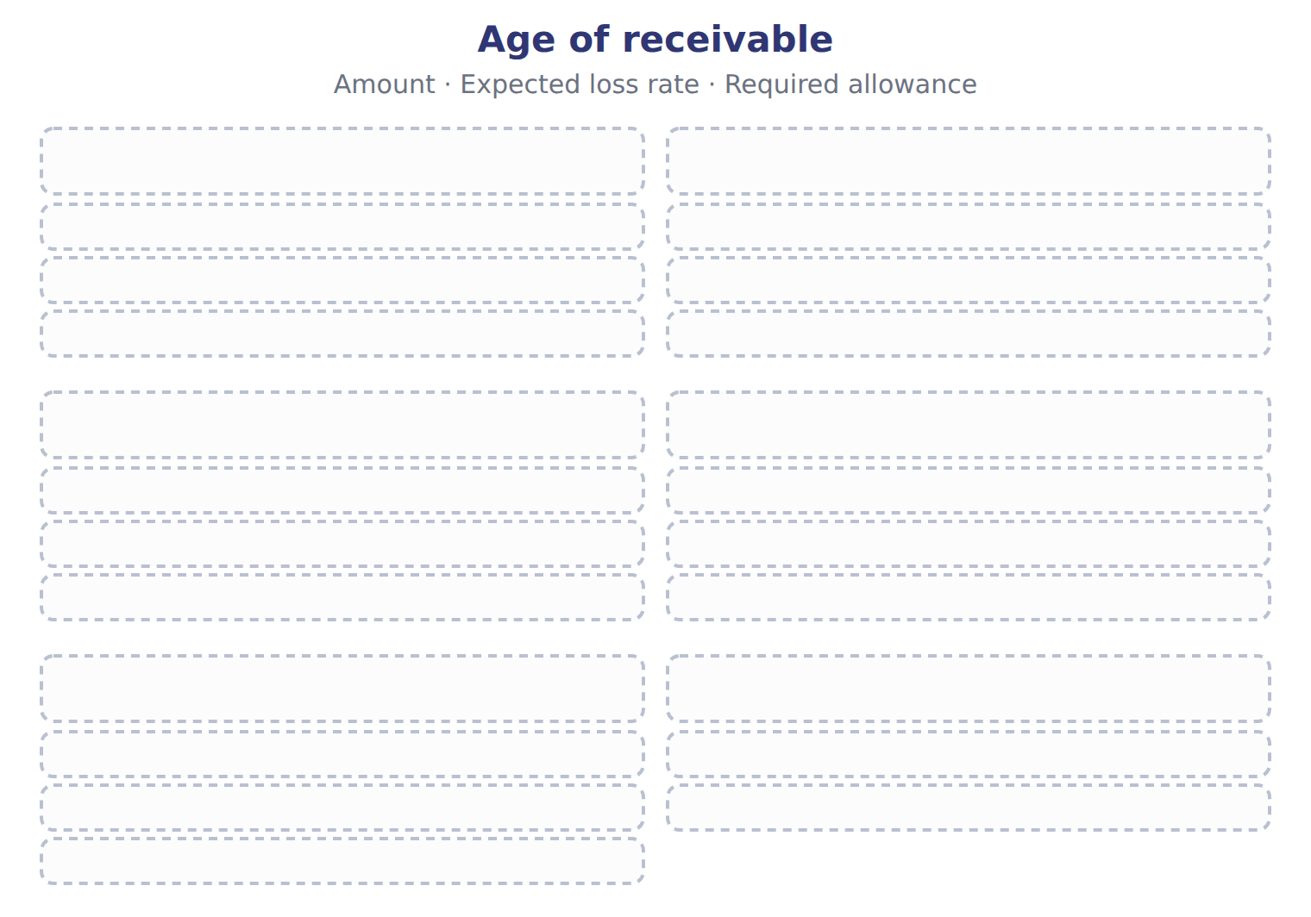
TEACH IT BACK | Write it for a classmate who missed this session — not for the marker.
37. In three or four sentences, write what this section settles and the one rule a reader has to take away.
every one of these words must appear: allowance for credit losses · credit loss expense · recourse · cash discount

Handout 6.3
Transferring receivables: sale or secured borrowing?
section 6.3 of the book
Before you start
Three summaries of this handout, in the book’s own words. Read all three first: together they are the whole session. Then fill the gaps, guessing where you have to.

What this handout settles, cycle by cycle
In this handout | What you will read | How you check it
Transferring receivables: sale or secured borrowing? | a figure to read · Item | Receivables are factored with substantial recourse. The transfer meets the three ASC 860 conditions. Which statement is MOST likely correct?
The words this section uses precisely | Transfer · The English the exam uses, and what it translates | What is the safest way to settle a disagreement about an answer on this sheet?

Words this handout uses precisely
Words this handout uses precisely | tick it if you could already use it in a sentence
current expected credit losses (CECL)
write-off
secured borrowing
notes receivable
direct write-off method
holdback (due from factor)
legal isolation

1. Where the section starts — Fill every gap. The list holds more words than there are gaps, so one or two of them are not used.
choose from: effective control · factor · factoring · write-off · secured borrowing
Second, the can pledge or exchange the receivables. Third, the seller does not keep , for example through an agreement to buy the receivables back before they mature. If any condition fails, the transfer is a .
2. What it settles in the middle — Fill every gap. The list holds more words than there are gaps, so one or two of them are not used.
choose from: secured borrowing · factor · write-off · effective control · recourse liability
The receivables stay on the balance sheet, marked as pledged. Loss on a sale = carrying amount − (cash + due from − ). Effects of one transfer as a sale without recourse, a sale with recourse, or a .
3. Where it ends — Fill every gap. The list holds more words than there are gaps, so one or two of them are not used.
choose from: write-off · Factoring · effective control · recourse
with substantial usually keeps most of the risk with the seller, so under IFRS it often fails derecognition and is treated as borrowing. Do not assume that every transfer with recourse is a borrowing. The holdback is an asset (due from factor), not part of the loss.

CYCLE A | Transferring receivables: sale or secured borrowing?

ORIENT One claim. Decide now; you will check it in a moment.

4. The book gives the Details (whole USD) of Aging as “Current: 250,000 at an expected loss rate of 2%”. TRUE / FALSE
MODEL Read it before you answer anything below it.

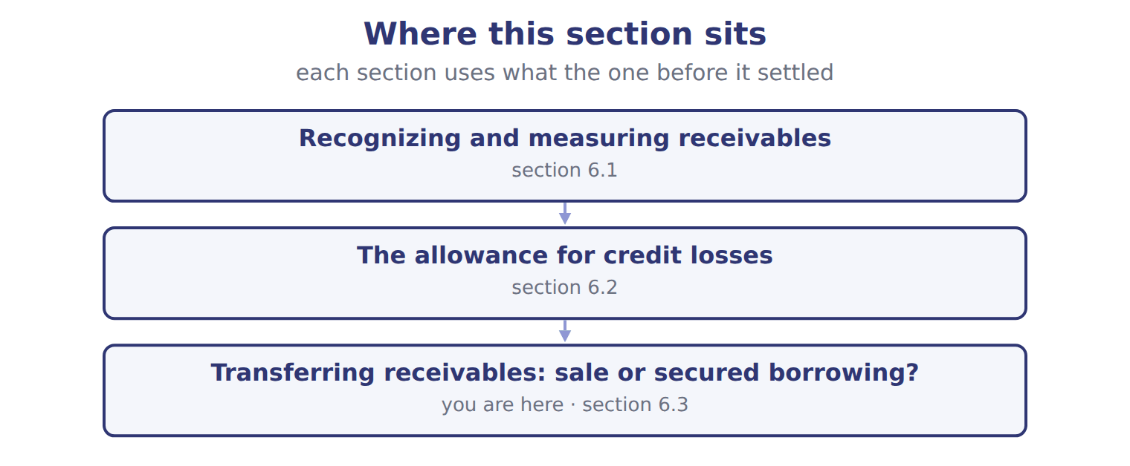

Item — the book’s own table
Item | Details (whole USD)
Aging | Current: 250,000 at an expected loss rate of 2%
Aging | 1–60 days past due: 90,000 at an expected loss rate of 10%
Aging | Over 60 days past due: 40,000 at an expected loss rate of 40%
Allowance account | Beginning balance 18,000 (credit). Write-offs during 2025: 24,000. Recoveries: 1,000.
Transfer T1 | Receivables sold to a factor without recourse. The factor may resell them. Orontes has no right or duty to buy them back.
Transfer T2 | Receivables transferred with recourse. They are legally isolated from Orontes, the factor may pledge them, and Orontes cannot buy them back.
Transfer T3 | Receivables transferred to a bank, but Orontes must repurchase them before they mature.
Transfer T4 | Receivables pledged as collateral for a bank loan; Orontes still collects them.
Transfer T2 details | Carrying amount 200,000; factor's fee 2%; holdback 4%; fair value of the recourse obligation 3,000.

READ THE MODEL Every answer is printed above. Find it, do not recall it.

5. Which item does the book pair with “Current: 250,000 at an expected loss rate of 2%”?
A. Transfer T2 | C. Aging
B. Allowance account | D. Transfer T3
6. Which item does the book pair with “1–60 days past due: 90,000 at an expected loss rate of 10%”?
A. Transfer T2 | C. Aging
B. Transfer T2 details | D. Transfer T4
7. Which item does the book pair with “Over 60 days past due: 40,000 at an expected loss rate of 40%”?
A. Transfer T4 | C. Transfer T3
B. Transfer T2 details | D. Aging
8. Which item does the book pair with “Beginning balance 18,000 (credit). Write-offs during 2025: 24,000. Recoveries: 1,000.”?
A. Transfer T2 | C. Transfer T1
B. Allowance account | D. Transfer T3
9. The book gives the Details (whole USD) of Aging as “Current: 250,000 at an expected loss rate of 2%”. TRUE / FALSE
10. The book gives the Details (whole USD) of Aging as “Beginning balance 18,000 (credit). Write-offs during 2025: 24,000. Recoveries: 1,000.”. TRUE / FALSE

APPLY No help on this move.

11. Receivables are factored with substantial recourse. The transfer meets the three ASC 860 conditions. Which statement is MOST likely correct?
A. Both frameworks treat it as a borrowing.
B. U.S. GAAP treats it as a sale; IFRS 9 may treat it as a borrowing.
C. Both frameworks treat it as a sale with no liability.
D. IFRS treats it as a sale; U.S. GAAP treats it as a borrowing.
12. Spiral review (Chapter 1). Where is the allowance for credit losses reported?
A. As a liability
B. As an expense
C. As a contra-asset, deducted from accounts receivable
D. As a reduction of equity
13. Spiral review (Chapter 1). Recording credit loss expense in the period of the sale, before any customer defaults, is an example of:
A. the cash basis | C. immediate recognition
B. the direct write-off method | D. the matching principle
WORK IN PAIRS | Compare every answer on this page with your partner before you read any key.
If you disagree: go back to the model and find the row that settles it. The row decides, not the louder voice.
CHECKPOINT 14. Receivables are factored with substantial recourse. The transfer meets the three ASC 860 conditions. Which statement is MOST likely correct?
A. Both frameworks treat it as a borrowing.
B. U.S. GAAP treats it as a sale; IFRS 9 may treat it as a borrowing.
C. Both frameworks treat it as a sale with no liability.
D. IFRS treats it as a sale; U.S. GAAP treats it as a borrowing.
If you got it wrong: redo the READ THE MODEL questions of cycle A with the model in front of you.

CYCLE B | The words this section uses precisely

ORIENT

15. A term in the exam means exactly what the book defines it to mean, whatever it means in ordinary English. TRUE / FALSE
MODEL

Transfer — the book’s own table
Transfer | Category
T1
T2
T3
T4

The English the exam uses, and what it translates
English (exam term) | the Arabic it translates
current expected credit losses (CECL) | الخسائر الائتمانية المتوقعة الحالية
write-off | شطب (إعدام) الدين
secured borrowing | اقتراض مضمون
notes receivable | أوراق القبض
direct write-off method | طريقة الشطب المباشر
holdback (due from factor) | المبلغ المحتجز (مستحق من شركة التخصيم)
legal isolation | العزل القانوني

READ THE MODEL

Write the letter of the Arabic term beside each English term. Every term is used once.
A المبلغ المحتجز (مستحق من شركة التخصيم)
B طريقة الشطب المباشر
C شطب (إعدام) الدين
D أوراق القبض
E العزل القانوني
F اقتراض مضمون

16. secured borrowing
17. holdback (due from factor)
18. direct write-off method
19. notes receivable
20. legal isolation
21. write-off

APPLY

22. Writing a term in English is part of answering the question, not an extra. TRUE / FALSE
CHECKPOINT 23. What is the safest way to settle a disagreement about an answer on this sheet?
A. find the row of the model that decides it
B. take the answer of whoever is more confident
C. leave it until the lecturer says
D. choose the longer option
If you got it wrong: redo the READ THE MODEL questions of cycle B.

FROM MEMORY | Close the earlier pages first.
24. Rebuild the figure from this handout. Label every part and fill in every box.
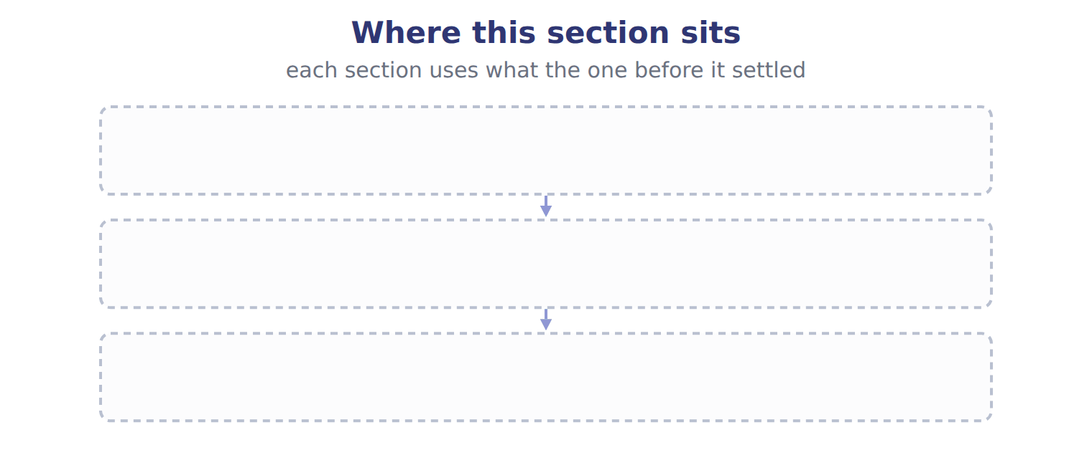
TEACH IT BACK | Write it for a classmate who missed this session — not for the marker.
25. In three or four sentences, write what this section settles and the one rule a reader has to take away.
every one of these words must appear: current expected credit losses (CECL) · write-off · secured borrowing · notes receivable

Handout 6.4
The whole chapter
every section, shuffled, and the chapter’s own case set
Before you start
Three summaries of this chapter, in the book’s own words, with words taken out. Read all three first: together they are the whole chapter. Then fill the gaps.

What this handout settles, cycle by cycle
In this handout | What you will read | How you check it
The whole chapter, in order | a figure to read | Orontes has delivered the first of two shipments under one contract. It can bill the customer only after the second shipment. What should Orontes record for the first shipment?
The chapter’s case set | The chapter’s case set, item by item | What has to be settled before any figure in a case set is worked out?
The words it uses precisely | accounts receivable · allowance for credit losses · current expected credit losses (CECL) · aging schedule · credit loss expense · write-off | matching, at the end of cycle B

1. Where the chapter starts — Fill every gap. The list holds more words than there are gaps, so one or two of them are not used.
choose from: factor · recourse liability · secured borrowing · write-off · factoring
The receivables stay on the balance sheet, marked as pledged. Loss on a sale = carrying amount − (cash + due from − ). Effects of one transfer as a sale without recourse, a sale with recourse, or a .
2. What it settles in the middle — Fill every gap. The list holds more words than there are gaps, so one or two of them are not used.
choose from: factoring · accounts receivable · Allowance for credit losses · pledging · write-off
T-account: the expense is the plug that reaches the required balance. When a customer's balance is clearly uncollectible, the company records a : debit the allowance and credit .
3. Where it ends — Fill every gap. The list holds more words than there are gaps, so one or two of them are not used.
choose from: recourse liability · factor · factoring · write-off · secured borrowing
Loss on a sale = carrying amount − (cash + due from − ). Effects of one transfer as a sale without recourse, a sale with recourse, or a . The balance sheet effect is the main reason companies care.

CYCLE A | The whole chapter, in order

ORIENT

4. The sections of a chapter have to be taken in order, because each one uses what the one before it settled. TRUE / FALSE
MODEL

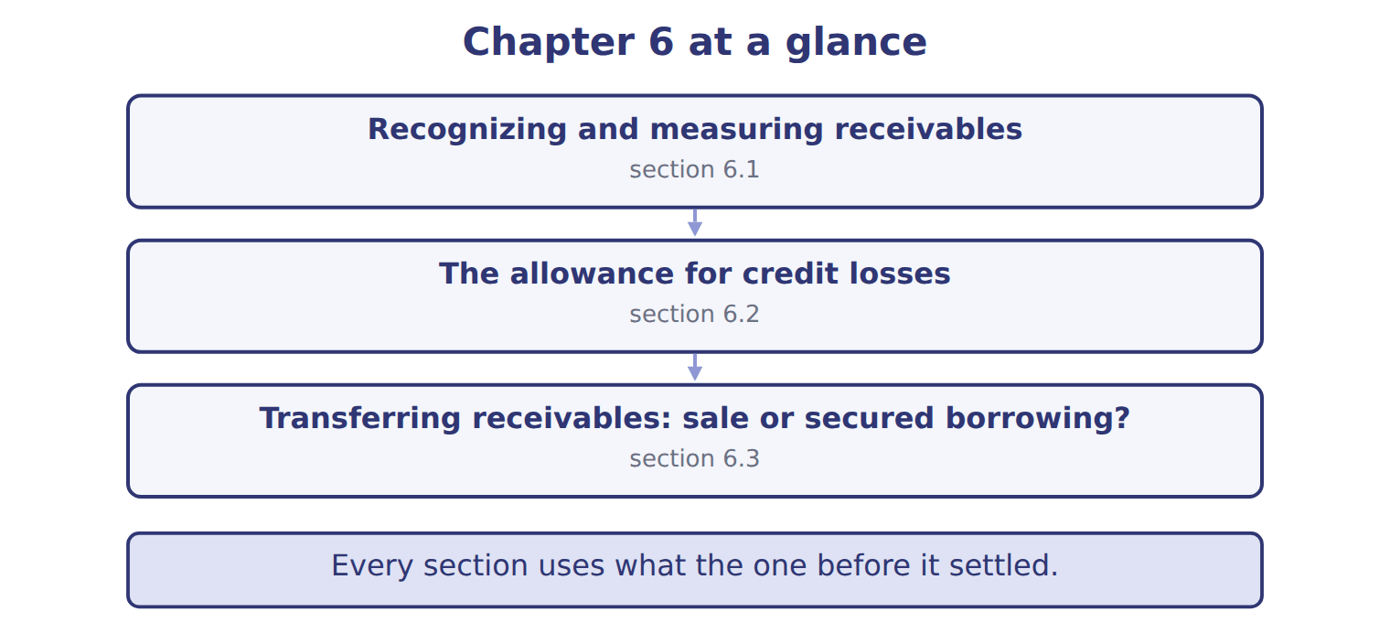
READ THE MODEL

5. “section 6.1” — which part of the chapter is this?
A. Transferring receivables: sale or secured borrowing?
B. The allowance for credit losses
C. Recognizing and measuring receivables
6. “section 6.2” — which part of the chapter is this?
A. Recognizing and measuring receivables
B. The allowance for credit losses
C. Transferring receivables: sale or secured borrowing?
7. “section 6.3” — which part of the chapter is this?
A. Recognizing and measuring receivables
B. Transferring receivables: sale or secured borrowing?
C. The allowance for credit losses
Write the letter of the section number beside each section title. Every number is used once.
A 6.1 | C 6.3
B 6.2

8. Recognizing and measuring receivables
9. The allowance for credit losses
10. Transferring receivables: sale or secured borrowing?

APPLY

11. Orontes transfers receivables to a bank but must buy them back before they mature. How should Orontes account for the transfer?
A. As a sale with recourse | C. As a contract asset
B. As a sale without recourse | D. As a secured borrowing

WORK IN PAIRS | Compare every answer with your partner first.
If you disagree: name the section each question belongs to. Most disagreements turn out to be about the section, not the answer.
CHECKPOINT 12. Orontes has delivered the first of two shipments under one contract. It can bill the customer only after the second shipment. What should Orontes record for the first shipment?
A. A contract asset
B. An account receivable
C. Nothing until it can bill
D. Unearned revenue
If you got it wrong: go back to the MODEL move of cycle A and find the section this question belongs to.

CYCLE B | The chapter’s case set

ORIENT

13. In a case question, the exhibit has to be read and adjusted before any figure is worked out. TRUE / FALSE

MODEL

The chapter’s case set, item by item
Item | What it asks
C6-1 | Enter the required allowance for credit losses at December 31, 2025.
C6-2 | Enter the credit loss expense for 2025.
C6-3 | Enter net accounts receivable at December 31, 2025.
C6-4 | Classify each transfer. (On the exam screen you would drag each transfer into a box.)
C6-5 | Enter the loss on transfer T2.
C6-6 | In January 2026 Orontes writes off a customer balance of $4,500. The effect on net accounts receivable is: [select]

READ THE MODEL

14. Which of these does item C6-1 ask for?
A. Enter the credit loss expense for 2025.
B. Enter net accounts receivable at December 31, 2025.
C. Classify each transfer. (On the exam screen you would drag each transf
D. Enter the required allowance for credit losses at December 31, 2025.
15. Which of these does item C6-2 ask for?
A. Enter net accounts receivable at December 31, 2025.
B. Enter the credit loss expense for 2025.
C. Classify each transfer. (On the exam screen you would drag each transf
D. Enter the required allowance for credit losses at December 31, 2025.
16. Which of these does item C6-3 ask for?
A. Classify each transfer. (On the exam screen you would drag each transf
B. Enter the required allowance for credit losses at December 31, 2025.
C. Enter net accounts receivable at December 31, 2025.
D. Enter the credit loss expense for 2025.
17. Which of these does item C6-4 ask for?
A. Enter the credit loss expense for 2025.
B. Enter the required allowance for credit losses at December 31, 2025.
C. Enter net accounts receivable at December 31, 2025.
D. Classify each transfer. (On the exam screen you would drag each transf
18. Which of these does item C6-5 ask for?
A. Enter net accounts receivable at December 31, 2025.
B. Enter the required allowance for credit losses at December 31, 2025.
C. Enter the loss on transfer T2.
D. Enter the credit loss expense for 2025.
19. Which of these does item C6-6 ask for?
A. In January 2026 Orontes writes off a customer balance of $4,500. The e
B. Enter net accounts receivable at December 31, 2025.
C. Enter the required allowance for credit losses at December 31, 2025.
D. Enter the credit loss expense for 2025.
APPLY

20. Orontes has delivered the first of two shipments under one contract. It can bill the customer only after the second shipment. What should Orontes record for the first shipment?
A. A contract asset | C. Nothing until it can bill
B. An account receivable | D. Unearned revenue

21. A trade receivable is due in 60 days. At what amount is it recorded?
A. Its present value using a market interest rate
B. The invoice amount, with discounts recorded only when taken
C. The transaction price, reduced for expected discounts and returns
D. The invoice amount less expected credit losses, recorded as one net number
CHECKPOINT 22. What has to be settled before any figure in a case set is worked out?
A. the exhibit, adjusted for every note that goes with it
B. the method the company uses
C. the tax rate
D. the order of the items
If you got it wrong: reread the case panel in the MODEL move of cycle B.

FROM MEMORY | Close the earlier pages first.
23. Rebuild the chapter map. Write every section in order and what each one settles.
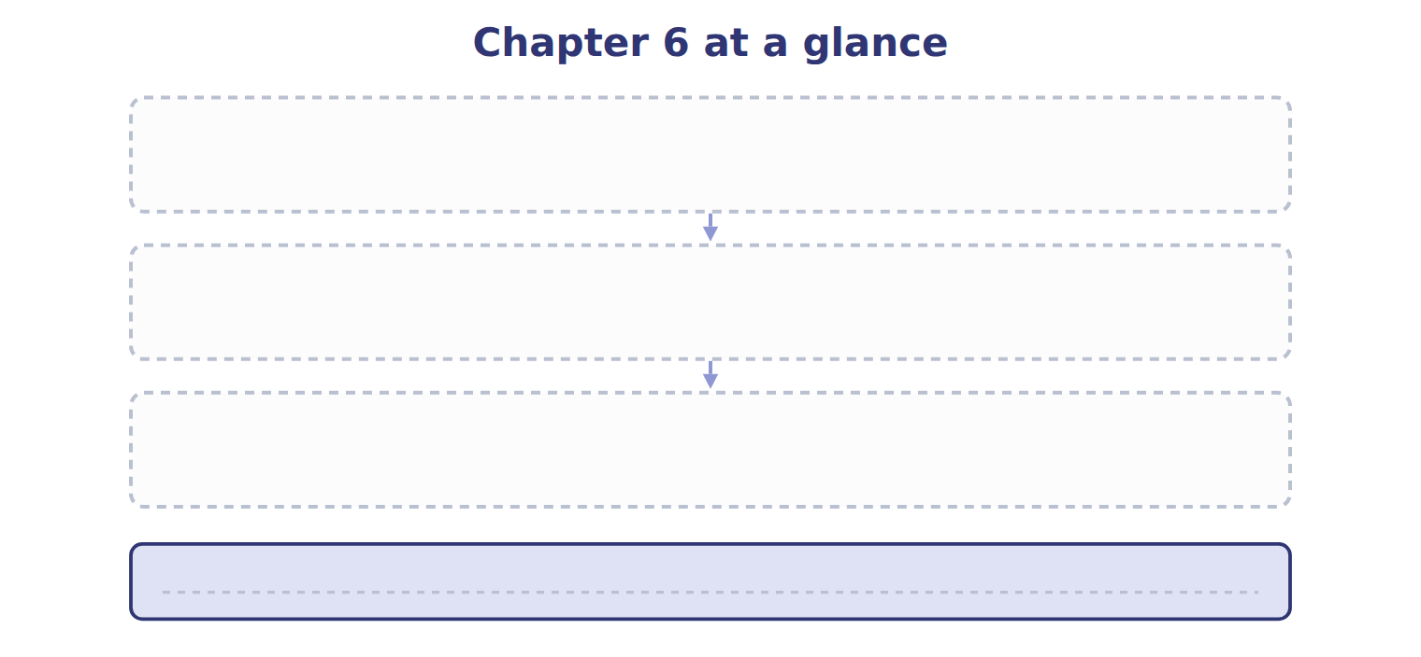
TEACH IT BACK | Write it for a student starting this chapter tomorrow — not for the marker.
24. In four or five sentences, write what the whole chapter settles, section by section.
every one of these words must appear: accounts receivable · allowance for credit losses · current expected credit losses (CECL) · aging schedule

