Handout 1.1
Who uses financial statements, and why?
section 1.1 of the book
Before you start
Three summaries of this handout, in the book’s own words. Read all three first: together they are the whole session. Then fill the gaps, guessing where you have to.

What this handout settles, cycle by cycle
In this handout | What you will read | How you check it
Who uses financial statements, and why? | a figure to read · User · the book’s own rule, gapped | Which group is a primary user of general-purpose financial statements?
The words this section uses precisely | Verb · The English the exam uses, and what it translates | What is the safest way to settle a disagreement about an answer on this sheet?

Words this handout uses precisely
Words this handout uses precisely | tick it if you could already use it in a sentence
financial statements
expense
accrual basis
faithful representation
net income
journal entry
accounts receivable

1. Where the section starts — Fill every gap. The list holds more words than there are gaps, so one or two of them are not used.
choose from: matching principle · income statement · Financial statements · cost of goods sold · statement of cash flows · statement of changes in equity · balance sheet
summarize these facts in a standard form for people outside the company. The four main statements are the , the , the and the .
2. What it settles in the middle — Fill every gap. The list holds more words than there are gaps, so one or two of them are not used.
choose from: conceptual framework · cost of goods sold · statement of cash flows · Relevance · income statement · matching principle
How did the company perform in the period? The answers this. Where did cash come from, and where did it go? The answers this. The lists the qualities of useful information. means the information can make a difference to a decision.
3. Where it ends — Fill every gap. The list holds more words than there are gaps, so one or two of them are not used.
choose from: matching principle · faithful representation · relevance · primary users · cost of goods sold
Managers are users, but not of general-purpose statements. Also remember: and are the two fundamental qualities. Comparability, verifiability, timeliness and understandability are only enhancing qualities.

CYCLE A | Who uses financial statements, and why?

ORIENT One claim. Decide now; you will check it in a moment.

4. The book gives the decision of Investors (shareholders) — PRIMARY as “Buy, hold or sell shares”. TRUE / FALSE
MODEL Read it before you answer anything below it.

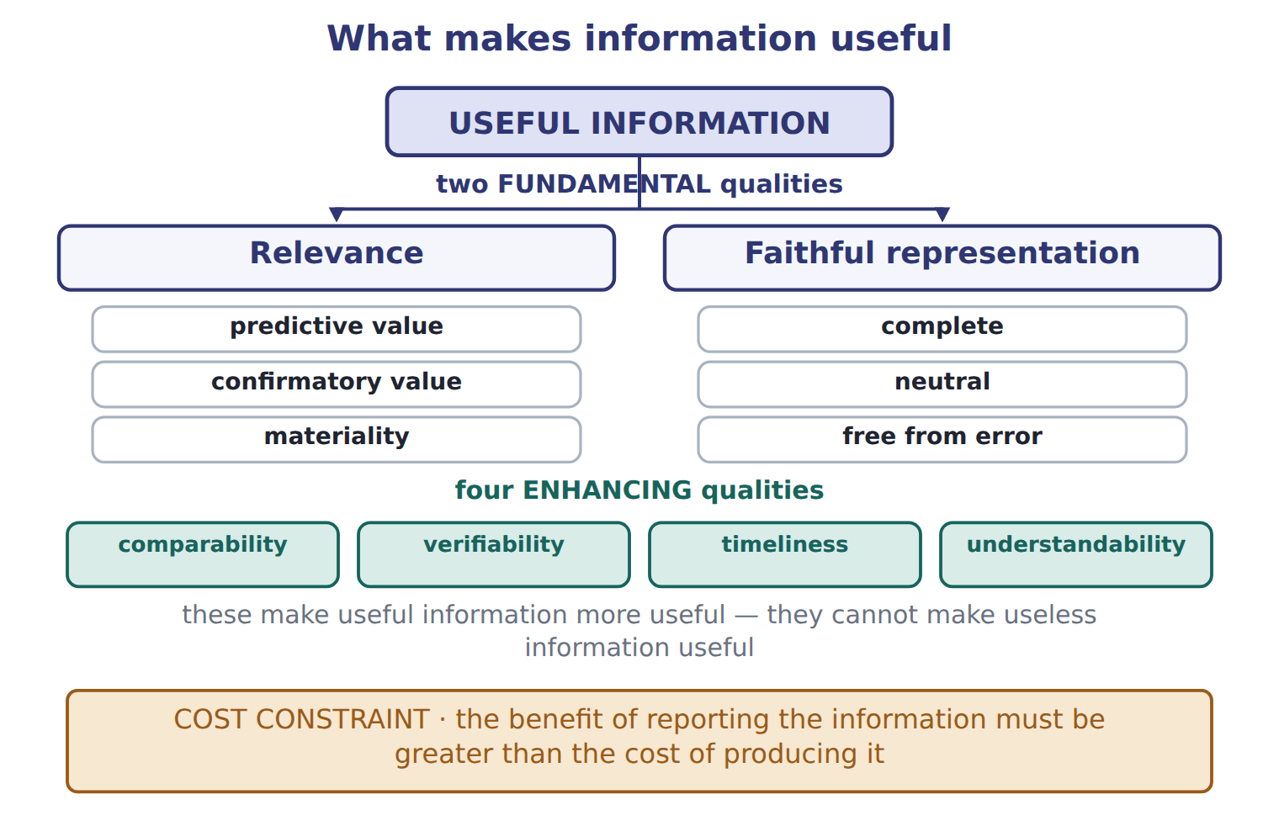

User — the book’s own table
User | Decision | Key question | Statements used most
Investors (shareholders) — PRIMARY | Buy, hold or sell shares | Will the company create future cash flows and returns? | Income statement, cash flows, balance sheet
Lenders (banks, bondholders) — PRIMARY | Lend, renew or stop a loan | Can the company pay interest and repay the principal on time? | Cash flows, balance sheet
Other creditors (suppliers) — PRIMARY | Sell on credit, set credit terms | Will the company pay its bills when due? | Balance sheet (short-term items), cash flows
Employees and unions | Stay, negotiate pay | Is the company stable and profitable? | Income statement
Customers | Sign long-term contracts | Will the company continue to supply us? | Balance sheet, income statement
Governments and regulators | Tax, oversight, statistics | Does the company follow the rules and pay its taxes? | All statements and notes
Managers (internal) | Plan and control operations | Not a primary user: can use internal reports | Internal management reports

READ THE MODEL Every answer is printed above. Find it, do not recall it.

5. Which decision does the book give for Investors (shareholders) — PRIMARY?
A. Plan and control operations | C. Buy, hold or sell shares
B. Stay, negotiate pay | D. Tax, oversight, statistics
6. Which decision does the book give for Lenders (banks, bondholders) — PRIMARY?
A. Lend, renew or stop a loan | C. Sign long-term contracts
B. Tax, oversight, statistics | D. Plan and control operations
7. Which decision does the book give for Other creditors (suppliers) — PRIMARY?
A. Stay, negotiate pay | C. Lend, renew or stop a loan
B. Tax, oversight, statistics | D. Sell on credit, set credit terms
8. Which decision does the book give for Employees and unions?
A. Stay, negotiate pay | C. Lend, renew or stop a loan
B. Tax, oversight, statistics | D. Sign long-term contracts
9. The book gives the statements used most of Investors (shareholders) — PRIMARY as “Income statement, cash flows, balance sheet”. TRUE / FALSE
10. The book gives the statements used most of Lenders (banks, bondholders) — PRIMARY as “Income statement, cash flows, balance sheet”. TRUE / FALSE
INVENT THE RULE

11. Complete the book’s own sentence. The list holds more words than there are gaps.
use every one of these words: journal entry · statement of changes in equity · statement of cash flows · income statement · cost of goods sold
The four main statements are the balance sheet, the , the and the .

Two of the book’s own cases, side by side
Lenders (banks, bondholders) — PRIMARY | Employees and unions
Decision: Lend, renew or stop a loan | Decision: Stay, negotiate pay
Key question: Can the company pay interest and repay the principal on time? | Key question: Is the company stable and profitable?
Only the facts above differ. What is the statements used most of Lenders (banks, bondholders) — PRIMARY?
12. Choose one:
A. Balance sheet, income statement | C. All statements and notes
B. Cash flows, balance sheet | D. Income statement
APPLY No help on this move.

13. Under the U.S. conceptual framework, the objective of general-purpose financial reporting is to provide useful information mainly to:
A. the board of directors and senior management.
B. government statisticians and tax authorities.
C. existing and potential investors, lenders and other creditors.
D. the company's employees and trade unions.
14. A bank is deciding whether to renew a five-year loan to Orontes. Which information will the bank find MOST useful?
A. The highest and lowest share price during the year
B. The company's ability to generate cash to pay interest and repay principal
C. The number of products the company sells
D. The names of the company's major shareholders
15. Two companies use the same accounting methods, so an analyst can compare their results. This quality is called:
A. relevance | C. faithful representation
B. verifiability | D. comparability
16. A company issues common stock for cash. What is the effect on the accounting equation?
A. Assets increase and equity increases.
B. Assets increase and revenue increases.
C. Assets increase and liabilities increase.
D. There is no effect on the equation.
WORK IN PAIRS | Compare every answer on this page with your partner before you read any key.
If you disagree: go back to the model and find the row that settles it. The row decides, not the louder voice.
CHECKPOINT 17. Which group is a primary user of general-purpose financial statements?
A. The company's managers
B. The company's internal auditors
C. The company's board of directors
D. Existing and potential lenders
If you got it wrong: redo the READ THE MODEL questions of cycle A with the model in front of you.

CYCLE B | The words this section uses precisely

ORIENT

18. A term in the exam means exactly what the book defines it to mean, whatever it means in ordinary English. TRUE / FALSE

MODEL

Verb — the book’s own table
Verb | Meaning in financial reporting
recognize | include an item in the statements, with a name and an amount
measure | decide the amount of the item
record | enter the item in the accounts (journal and ledger)
present | show the item on the face of a statement
disclose | explain the item in the notes to the statements

The English the exam uses, and what it translates
English (exam term) | the Arabic it translates
financial statements | القوائم المالية
expense | مصروف (مصروفات)
accrual basis | أساس الاستحقاق
faithful representation | التمثيل الصادق
net income | صافي الدخل
journal entry | قيد اليومية
accounts receivable | الذمم المدينة (المدينون)
prepaid expense | مصروف مدفوع مقدماً
conceptual framework | الإطار المفاهيمي

READ THE MODEL

Write the letter of the Arabic term beside each English term. Every term is used once.
A مصروف مدفوع مقدماً | D القوائم المالية
B أساس الاستحقاق | E الإطار المفاهيمي
C صافي الدخل | F مصروف (مصروفات)

19. prepaid expense
20. expense
21. conceptual framework
22. net income
23. accrual basis
24. financial statements

25. Which verb does the book pair with “include an item in the statements, with a name and an amount”?
A. measure | C. disclose
B. present | D. recognize
26. Which verb does the book pair with “decide the amount of the item”?
A. measure | C. disclose
B. record | D. present
27. Which verb does the book pair with “enter the item in the accounts (journal and ledger)”?
A. record | C. recognize
B. present | D. measure

APPLY

28. Information helps an investor forecast next year's cash flows. This information has:
A. predictive value | C. comparability
B. verifiability | D. timeliness
29. The board declares a cash dividend that will be paid next month. What is the effect immediately after the declaration?
A. Expenses increase and net income decreases.
B. Liabilities increase and equity decreases.
C. Assets decrease and equity decreases.
D. There is no effect until the dividend is paid.
30. Which transaction changes total assets but does NOT change total equity?
A. Borrowing cash from a bank
B. Paying wages in cash
C. Selling goods on credit at a profit
D. Buying equipment for cash
CHECKPOINT 31. What is the safest way to settle a disagreement about an answer on this sheet?
A. find the row of the model that decides it
B. take the answer of whoever is more confident
C. leave it until the lecturer says
D. choose the longer option
If you got it wrong: redo the READ THE MODEL questions of cycle B.

FROM MEMORY | Close the earlier pages first.
32. Rebuild the figure from this handout. Label every part and fill in every box.
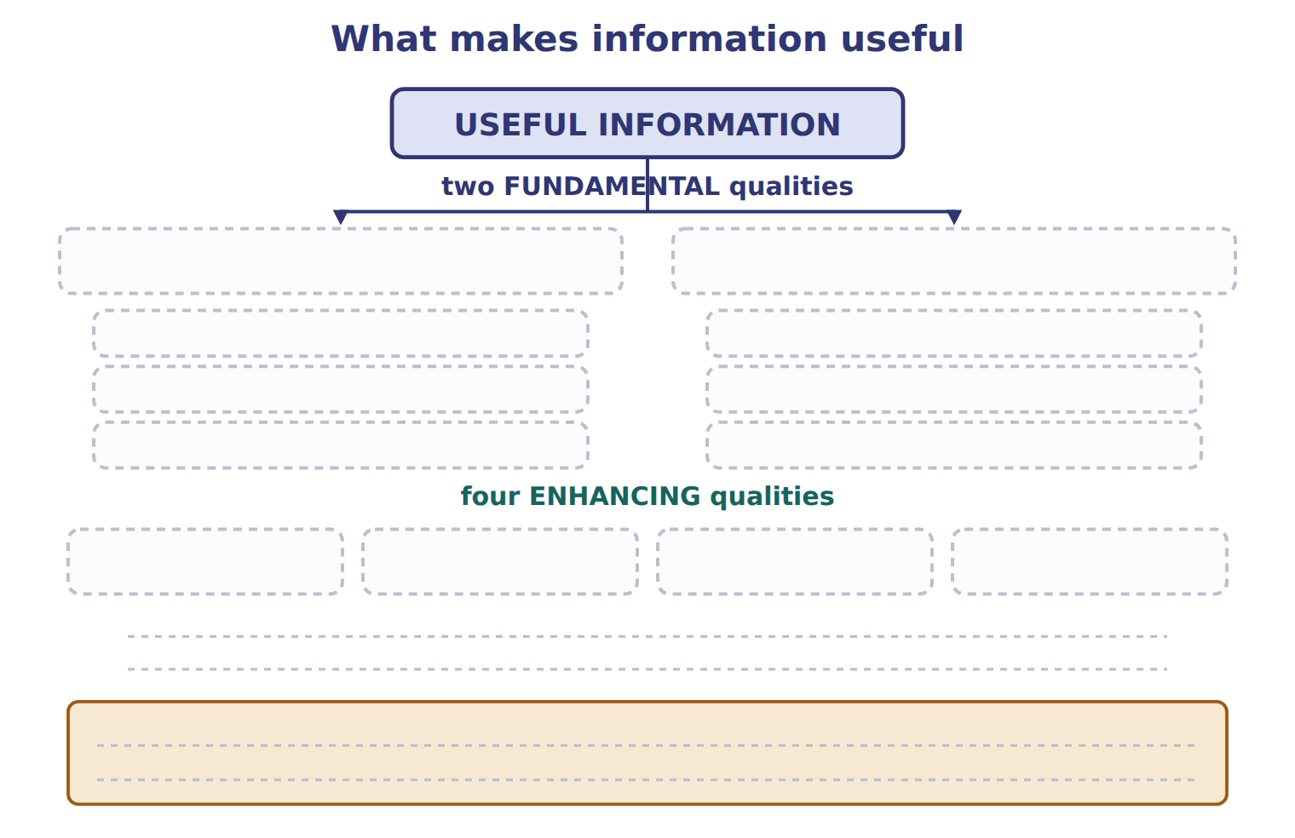
TEACH IT BACK | Write it for a classmate who missed this session — not for the marker.
33. In three or four sentences, write what this section settles and the one rule a reader has to take away.
every one of these words must appear: financial statements · expense · accrual basis · faithful representation

Answer key · Handout 1.1 · Who uses financial statements, and why?

1 Financial statements · balance sheet · income statement · statement of changes in equity · statement of cash flows | 12 B | 23 B
2 income statement · statement of cash flows · conceptual framework · Relevance | 13 C | 24 D
3 primary users · relevance · faithful representation | 14 B | 25 D
4 T | 15 D | 26 A
5 C | 16 A | 27 A
6 A | 17 D | 28 A
7 D | 18 T | 29 B
8 A | 19 A | 30 A
9 T | 20 F | 31 A
10 F | 21 E | 32 Compare with the model earlier in this handout.
11 income statement · statement of changes in equity · statement of cash flows | 22 C | 33 A company collects thousands of facts every day: sales, purchases, salaries and loans. Financial statements summarize these facts in a standard form for people outside the company. The four main statements are the balance sheet, the income statement, the statement of changes in equity and the statement of cash flows.

11 what the book says
The four main statements are the balance sheet, the income statement, the statement of changes in equity and the statement of cash flows.

why
1 The book writes: “Financial statements summarize these facts in a standard form for people outside the company. The four main statements are the balance sheet, the income statement, the statement of changes in equity and the statement of cash flows.”
2 The book writes: “How did the company perform in the period? The income statement answers this. Where did cash come from, and where did it go? The statement of cash flows answers this. The conceptual framework lists the qualities of useful information. Relevance means the information can make a difference to a decision.”
3 The book writes: “Managers are users, but not primary users of general-purpose statements. Also remember: relevance and faithful representation are the two fundamental qualities. Comparability, verifiability, timeliness and understandability are only enhancing qualities.”
4 The book pairs Investors (shareholders) — PRIMARY with “Buy, hold or sell shares”.
5 The book’s own table gives Buy, hold or sell shares as the decision of Investors (shareholders) — PRIMARY.
6 The book’s own table gives Lend, renew or stop a loan as the decision of Lenders (banks, bondholders) — PRIMARY.
7 The book’s own table gives Sell on credit, set credit terms as the decision of Other creditors (suppliers) — PRIMARY.
8 The book’s own table gives Stay, negotiate pay as the decision of Employees and unions.
9 The book pairs Investors (shareholders) — PRIMARY with “Income statement, cash flows, balance sheet”.
10 The book pairs Lenders (banks, bondholders) — PRIMARY with “Cash flows, balance sheet”, not with “Income statement, cash flows, balance sheet”.
12 The book gives Cash flows, balance sheet as the statements used most of Lenders (banks, bondholders) — PRIMARY.
13 These are the primary users. They provide resources and cannot demand special reports. A is wrong: Management can obtain internal information, so it is not a primary user. B is wrong: Governments use the statements, but they are not the primary users named by the framework.
14 A lender's main question is repayment: can the borrower pay interest and principal on time? A is wrong: Share prices interest investors more than lenders and do not show repayment ability. C is wrong: The product count does not show whether the company can repay the loan.
15 Comparability lets users identify similarities and differences between companies or periods. A is wrong: Relevance means the information can make a difference to a decision. B is wrong: Verifiability means independent observers could reach the same result.
16 Cash (an asset) increases, and contributed capital (equity) increases by the same amount. B is wrong: Selling shares is financing from owners, not revenue. C is wrong: Shares are equity, not debt. A liability arises only when the company borrows.
17 The primary users are existing and potential investors, lenders and other creditors. A is wrong: Managers can get internal information, so they are not primary users. B is wrong: Internal auditors work inside the company and use internal records.
18 CMA questions use exact terms, and one word can change the answer.
25 The book’s own table pairs recognize with “include an item in the statements, with a name and an amount”.
26 The book’s own table pairs measure with “decide the amount of the item”.
27 The book’s own table pairs record with “enter the item in the accounts (journal and ledger)”.

Handout 1.2
The building blocks: elements and the accounting equation
section 1.2 of the book
Before you start
Three summaries of this handout, in the book’s own words. Read all three first: together they are the whole session. Then fill the gaps, guessing where you have to.

What this handout settles, cycle by cycle
In this handout | What you will read | How you check it
The building blocks: elements and the accounting equation | a figure to read · Account | Which item is an expense?
The words this section uses precisely | Row · The English the exam uses, and what it translates | What is the safest way to settle a disagreement about an answer on this sheet?

Words this handout uses precisely
Words this handout uses precisely | tick it if you could already use it in a sentence
primary users
retained earnings
matching principle
materiality
common stock
T-account
accounts payable

1. Where the section starts — Fill every gap. The list holds more words than there are gaps, so one or two of them are not used.
choose from: balance sheet · inventory · revenue · asset · dividend · accounts receivable · liability
Three of them describe the at one date. An is a present right of an entity to an economic benefit. Examples: cash, , and equipment. A is a present obligation of an entity to transfer an economic benefit.
2. What it settles in the middle — Fill every gap. The list holds more words than there are gaps, so one or two of them are not used.
choose from: revenue · dividend · additional paid-in capital · par value · net income · Retained earnings · common stock
Contributed capital is what owners paid in: at its , plus (APIC). (RE) are the past that the company kept instead of paying it out as dividends.
3. Where it ends — Fill every gap. The list holds more words than there are gaps, so one or two of them are not used.
choose from: Dividend · retained earnings · expense · Revenue · accounts receivable · income statement · cost of goods sold
s and gains increase . s also decrease it, but a dividend is not an . It is a distribution to owners, so it never appears in the . IFRS also uses the word income for both revenue and gains, while U.S.

CYCLE A | The building blocks: elements and the accounting equation

ORIENT One claim. Decide now; you will check it in a moment.

4. The book gives the category of Prepaid rent as “Asset”. TRUE / FALSE
MODEL Read it before you answer anything below it.

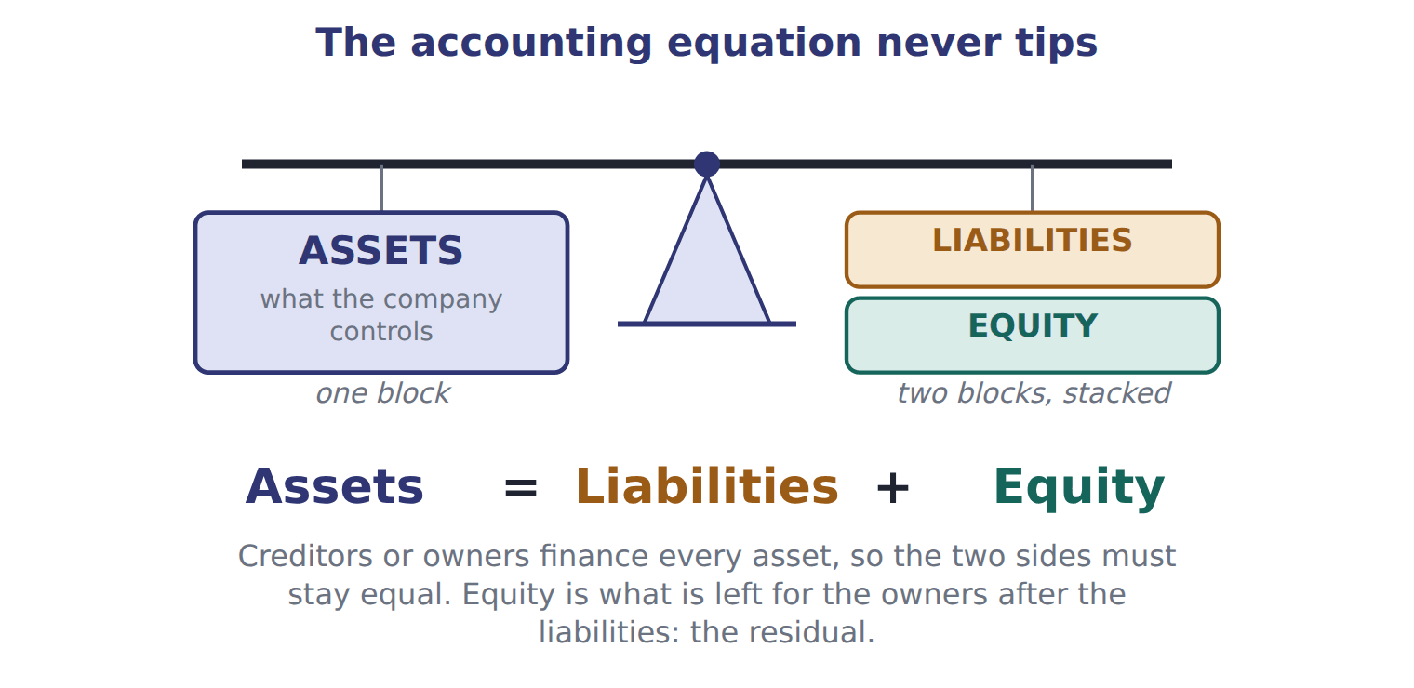

Account — the book’s own table
Account | Category
Prepaid rent | Asset
Land | Asset
Dividends payable | Liability
Additional paid-in capital | Equity
Sales revenue | Revenue
Interest expense | Expense
Allowance for credit losses | Contra-asset
Accumulated depreciation | Contra-asset

READ THE MODEL Every answer is printed above. Find it, do not recall it.

5. Which category does the book give for Prepaid rent?
A. Revenue | C. Asset
B. Contra-asset | D. Equity
6. Which category does the book give for Land?
A. Contra-asset | C. Revenue
B. Expense | D. Asset
7. Which category does the book give for Dividends payable?
A. Revenue | C. Asset
B. Contra-asset | D. Liability
8. Which category does the book give for Additional paid-in capital?
A. Expense | C. Revenue
B. Equity | D. Liability
9. The book gives the category of Prepaid rent as “Asset”. TRUE / FALSE
10. The book gives the category of Land as “Contra-asset”. TRUE / FALSE
APPLY No help on this move.

11. A company has assets of 900 and liabilities of 350. It then borrows 100 in cash and declares and pays a cash dividend of 40. What is total equity after these transactions?
A. 450 | C. 550
B. 510 | D. 610
12. Which account normally has a debit balance?
A. Accounts payable | C. Prepaid rent
B. Sales revenue | D. Additional paid-in capital
13. Accumulated depreciation is BEST described as:
A. a liability for future asset replacement.
B. a contra-asset account with a credit balance.
C. an expense of the current period.
D. a reduction of retained earnings.
14. Orontes ships goods on December 20, 2025 and invoices 90. The goods cost 54. The customer pays on January 15, 2026. The fiscal year ends on December 31. How much revenue does Orontes report for fiscal 2025?
A. 0 | C. 54
B. 36 | D. 90

WORK IN PAIRS | Compare every answer on this page with your partner before you read any key.
If you disagree: go back to the model and find the row that settles it. The row decides, not the louder voice.
CHECKPOINT 15. Which item is an expense?
A. A cash dividend paid to shareholders
B. Wages paid to plant workers
C. Repayment of a bank loan
D. Purchase of a new bottling line
If you got it wrong: redo the READ THE MODEL questions of cycle A with the model in front of you.

CYCLE B | The words this section uses precisely

ORIENT

16. A term in the exam means exactly what the book defines it to mean, whatever it means in ordinary English. TRUE / FALSE
MODEL

Row — the book’s own table
Row | Transaction | Journal entry | Effects
4 | A Dubai hotel group paid cash in advance for pastries that Orontes will deliver in March. | Dr Cash 60; Cr Contract liability (unearned revenue) 60 | Assets +60, liabilities +60, equity 0, net income 0; cash flow: operating +60.
5 | Paid the dividend declared on January 31. | Dr Dividends payable 50; Cr Cash 50 | Assets (50), liabilities (50), equity 0, net income 0; cash flow: financing (50).
6 | Recorded one month of interest on the bank note. Orontes has not paid it yet. | Dr Interest expense 4; Cr Interest payable 4 | Assets 0, liabilities +4, equity (4), net income (4); cash flow: none.

The English the exam uses, and what it translates
English (exam term) | the Arabic it translates
primary users | المستخدمون الرئيسيون
retained earnings | الأرباح المحتجزة
matching principle | مبدأ مقابلة الإيرادات بالمصروفات
materiality | الأهمية النسبية
common stock | الأسهم العادية
T-account | حساب على شكل حرف T
accounts payable | الذمم الدائنة (الدائنون)
contract liability (unearned revenue) | التزام العقد (إيراد مقبوض مقدماً)
balance sheet | الميزانية العمومية

READ THE MODEL

Write the letter of the Arabic term beside each English term. Every term is used once.
A الأرباح المحتجزة | D المستخدمون الرئيسيون
B الذمم الدائنة (الدائنون) | E مبدأ مقابلة الإيرادات بالمصروفات
C حساب على شكل حرف T | F الأسهم العادية

17. common stock
18. T-account
19. primary users
20. matching principle
21. accounts payable
22. retained earnings

23. Which row does the book pair with “A Dubai hotel group paid cash in advance for pastries that Orontes will deliver in March.”?
A. 4 | C. 5
B. 6
24. Which row does the book pair with “Paid the dividend declared on January 31.”?
A. 6 | C. 5
B. 4
25. Which row does the book pair with “Recorded one month of interest on the bank note. Orontes has not paid it yet.”?
A. 4 | C. 6
B. 5

APPLY

26. A company has total assets of 500 and total liabilities of 320. What is its equity?
A. 180 | C. 500
B. 320 | D. 820
27. Which statement about the matching principle is correct?
A. Expenses are recognized in the period in which they are paid.
B. Revenues are recognized in the period in which cash is received.
C. All costs are capitalized as assets until related revenue is earned.
D. Expenses are recognized in the same period as the revenues they help to produce.
28. On February 10, Orontes pays 24 for 12 months of warehouse rent in advance. How does the payment appear immediately after it is made?
A. As an asset of 24
B. As an expense of 24
C. As a liability of 24
D. It is not recorded until the end of the month.
CHECKPOINT 29. What is the safest way to settle a disagreement about an answer on this sheet?
A. find the row of the model that decides it
B. take the answer of whoever is more confident
C. leave it until the lecturer says
D. choose the longer option
If you got it wrong: redo the READ THE MODEL questions of cycle B.

FROM MEMORY | Close the earlier pages first.
30. Rebuild the figure from this handout. Label every part and fill in every box.
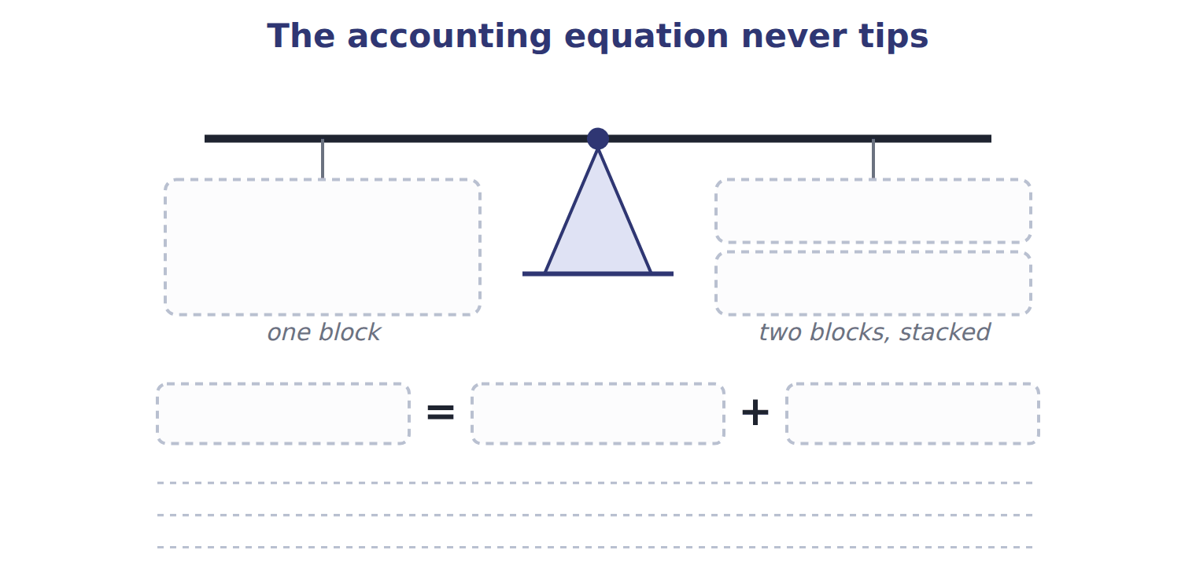
TEACH IT BACK | Write it for a classmate who missed this session — not for the marker.
31. In three or four sentences, write what this section settles and the one rule a reader has to take away.
every one of these words must appear: primary users · retained earnings · matching principle · materiality

Answer key · Handout 1.2 · The building blocks: elements and the accounting equation

1 balance sheet · asset · accounts receivable · inventory · liability | 12 C | 23 A
2 common stock · par value · additional paid-in capital · Retained earnings · net income | 13 B | 24 C
3 Revenue · retained earnings · Dividend · expense · income statement | 14 D | 25 C
4 T | 15 B | 26 A
5 C | 16 T | 27 D
6 D | 17 F | 28 A
7 D | 18 C | 29 A
8 B | 19 D | 30 Compare with the model earlier in this handout.
9 T | 20 E | 31 Every amount in the financial statements belongs to an element. The FASB conceptual framework defines ten elements. Three of them describe the balance sheet at one date.
10 F | 21 B
11 B | 22 A

why
1 The book writes: “Three of them describe the balance sheet at one date. An asset is a present right of an entity to an economic benefit. Examples: cash, accounts receivable, inventory and equipment. A liability is a present obligation of an entity to transfer an economic benefit.”
2 The book writes: “Contributed capital is what owners paid in: common stock at its par value, plus additional paid-in capital (APIC). Retained earnings (RE) are the past net income that the company kept instead of paying it out as dividends.”
3 The book writes: “Revenues and gains increase retained earnings. Dividends also decrease it, but a dividend is not an expense. It is a distribution to owners, so it never appears in the income statement. IFRS also uses the word income for both revenue and gains, while U.S.”
4 The book pairs Prepaid rent with “Asset”.
5 The book’s own table gives Asset as the category of Prepaid rent.
6 The book’s own table gives Asset as the category of Land.
7 The book’s own table gives Liability as the category of Dividends payable.
8 The book’s own table gives Equity as the category of Additional paid-in capital.
9 The book pairs Prepaid rent with “Asset”.
10 The book pairs Land with “Asset”, not with “Contra-asset”.
11 Equity starts at 550 (900 − 350). Borrowing does not change equity. The dividend reduces it by 40, so equity is 510. A is wrong: This is total liabilities after the loan (350 + 100), not equity. C is wrong: This ignores the dividend, which reduces retained earnings.
12 Prepaid rent is an asset, and assets have debit balances. A is wrong: Accounts payable is a liability, with a credit balance. B is wrong: Revenue increases equity, so it has a credit balance.
13 It reduces the cost of equipment on the balance sheet and has a credit balance. A is wrong: The company owes nobody anything, so it is not a liability. C is wrong: Depreciation expense is the period's charge; accumulated depreciation is the running total on the balance sheet.
14 Under the accrual basis, revenue is recorded when the goods are delivered, in 2025. A is wrong: This is cash-basis thinking. The cash timing does not decide the period. B is wrong: This is the gross profit (revenue minus cost), not the revenue.
15 Wages are a cost of the company's central operations, so they are an expense. A is wrong: A dividend is a distribution to owners. It reduces retained earnings but is not an expense. C is wrong: Repaying principal reduces a liability and an asset. No expense arises.
16 CMA questions use exact terms, and one word can change the answer.
23 The book’s own table pairs 4 with “A Dubai hotel group paid cash in advance for pastries that Orontes will deliver in March.”.
24 The book’s own table pairs 5 with “Paid the dividend declared on January 31.”.
25 The book’s own table pairs 6 with “Recorded one month of interest on the bank note. Orontes has not paid it yet.”.
26 Equity = assets − liabilities = 500 − 320 = 180. B is wrong: This is the liabilities figure, not equity. C is wrong: This is total assets, not equity.

Handout 1.3
Double entry: debits and credits
section 1.3 of the book
Before you start
Three summaries of this handout, in the book’s own words. Read all three first: together they are the whole session. Then fill the gaps, guessing where you have to.

What this handout settles, cycle by cycle
In this handout | What you will read | How you check it
Double entry: debits and credits | a figure to read · Statement · the book’s own rule, gapped | Which account normally has a credit balance?
The words this section uses precisely | The English the exam uses, and what it translates | What is the safest way to settle a disagreement about an answer on this sheet?

Words this handout uses precisely
Words this handout uses precisely | tick it if you could already use it in a sentence
asset
dividend
U.S. GAAP
recognize
additional paid-in capital
trial balance
inventory

1. Where the section starts — Fill every gap. The list holds more words than there are gaps, so one or two of them are not used.
choose from: balance sheet · contra account · credit · normal balance · debit · income statement · equity
Accounts on the left side of the equation (assets, expenses and dividends) increase with a . Accounts on the right side (liabilities, and revenues) increase with a . A reduces a related account, so it has the opposite .
2. What it settles in the middle — Fill every gap. The list holds more words than there are gaps, so one or two of them are not used.
choose from: net income · retained earnings · revenue · balance sheet · liability · debit
Orontes records when it delivers the goods, not when the customer pays. Row 6 reduces by 50 and creates a . No cash moves until February, and does not change. It reduces retained earnings, not net income.
3. Where it ends — Fill every gap. The list holds more words than there are gaps, so one or two of them are not used.
choose from: credit · balance sheet · debit · expense · asset
One (cash) becomes another asset (equipment). The cost becomes an later, through depreciation. Feb 3: Paid a supplier for olives bought on in January. Feb 8: Collected part of the January receivable from GreenBasket Supermarkets.

CYCLE A | Double entry: debits and credits

ORIENT One claim. Decide now; you will check it in a moment.

4. The book gives the question it answers of Balance sheet as “What does the company have and owe, and what is the owners' claim?”. TRUE / FALSE
MODEL Read it before you answer anything below it.

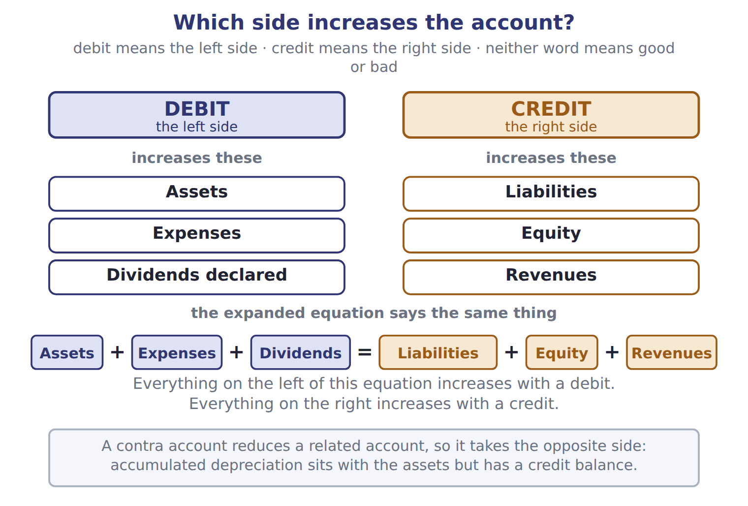

Statement — the book’s own table
Statement | Question it answers | Time | Chapter
Balance sheet | What does the company have and owe, and what is the owners' claim? | at a date | 2
Income statement | How did the company perform? | for a period | 3
Statement of changes in equity | Why did each equity account change? | for a period | 4
Statement of cash flows | Where did cash come from, and where did it go? | for a period | 5

READ THE MODEL Every answer is printed above. Find it, do not recall it.

5. Which question it answers does the book give for Balance sheet?
A. Where did cash come from, and where did it go?
B. How did the company perform?
C. What does the company have and owe, and what is the owners' claim?
D. Why did each equity account change?
6. Which question it answers does the book give for Income statement?
A. What does the company have and owe, and what is the owners' claim?
B. How did the company perform?
C. Where did cash come from, and where did it go?
D. Why did each equity account change?
7. Which question it answers does the book give for Statement of changes in equity?
A. Why did each equity account change?
B. What does the company have and owe, and what is the owners' claim?
C. How did the company perform?
D. Where did cash come from, and where did it go?
8. Which question it answers does the book give for Statement of cash flows?
A. How did the company perform?
B. Why did each equity account change?
C. What does the company have and owe, and what is the owners' claim?
D. Where did cash come from, and where did it go?
SORT THEM | Write each one under its time. Every item belongs to exactly one group.
the items: Balance sheet · Income statement · Statement of changes in equity · Statement of cash flows
at a date | for a period

INVENT THE RULE

11. Complete the book’s own sentence. The list holds more words than there are gaps.
use every one of these words: revenue · allowance for credit losses · U.S. GAAP · accounts receivable
The reduces in the same way (Chapter 6).

Two of the book’s own cases, side by side
Balance sheet | Income statement
Question it answers: What does the company have and owe, and what is the owners' claim? | Question it answers: How did the company perform?
Time: at a date | Time: for a period
Only the facts above differ. What is the chapter of Balance sheet?
12. Choose one:
A. 2 | C. 3
B. 5 | D. 4
APPLY No help on this move.

13. Which statement explains why retained earnings changed during the year?
A. The statement of changes in equity
B. The balance sheet
C. The statement of cash flows
D. The income statement
14. Net income for the period flows directly into:
A. the cash balance on the balance sheet.
B. retained earnings in the statement of changes in equity.
C. total liabilities.
D. common stock.
15. Which statement is TRUE?
A. The PCAOB writes U.S. GAAP for public companies.
B. The IASB writes U.S. GAAP for companies that also report under IFRS.
C. The ASC contains IFRS for U.S. companies.
D. The SEC has legal authority over public company reporting and recognizes the FASB as the standard setter.
16. A Jordanian company's IFRS statements show share premium of 400. Under U.S. GAAP, the same item is called:
A. retained earnings. | C. additional paid-in capital.
B. common stock. | D. treasury stock.
WORK IN PAIRS | Compare every answer on this page with your partner before you read any key.
If you disagree: go back to the model and find the row that settles it. The row decides, not the louder voice.
CHECKPOINT 17. Which account normally has a credit balance?
A. Prepaid rent
B. Accumulated depreciation
C. Cost of goods sold
D. Dividends declared
If you got it wrong: redo the READ THE MODEL questions of cycle A with the model in front of you.

CYCLE B | The words this section uses precisely

ORIENT

18. A term in the exam means exactly what the book defines it to mean, whatever it means in ordinary English. TRUE / FALSE

MODEL

The English the exam uses, and what it translates
English (exam term) | the Arabic it translates
asset | أصل (أصول)
dividend | توزيعات الأرباح
U.S. GAAP | المبادئ المحاسبية المقبولة عموماً في الولايات المتحدة
recognize | يعترف (الاعتراف)
additional paid-in capital | علاوة إصدار الأسهم (رأس المال الإضافي المدفوع)
trial balance | ميزان المراجعة
inventory | المخزون
FASB | مجلس معايير المحاسبة المالية
statement of financial position | قائمة المركز المالي

READ THE MODEL

Write the letter of the Arabic term beside each English term. Every term is used once.
A المبادئ المحاسبية المقبولة عموماً في الولايات المتحدة
B مجلس معايير المحاسبة المالية
C قائمة المركز المالي
D يعترف (الاعتراف)
E علاوة إصدار الأسهم (رأس المال الإضافي المدفوع)
F ميزان المراجعة

19. U.S. GAAP
20. recognize
21. FASB
22. statement of financial position
23. trial balance
24. additional paid-in capital

APPLY

25. Orontes buys a bottling line for 1,200 in cash. Which journal entry is correct?
A. Debit Cash 1,200; credit Equipment 1,200
B. Debit Equipment expense 1,200; credit Cash 1,200
C. Debit Equipment 1,200; credit Notes payable 1,200
D. Debit Equipment 1,200; credit Cash 1,200
CHECKPOINT 26. What is the safest way to settle a disagreement about an answer on this sheet?
A. find the row of the model that decides it
B. take the answer of whoever is more confident
C. leave it until the lecturer says
D. choose the longer option
If you got it wrong: redo the READ THE MODEL questions of cycle B.

FROM MEMORY | Close the earlier pages first.
27. Rebuild the figure from this handout. Label every part and fill in every box.
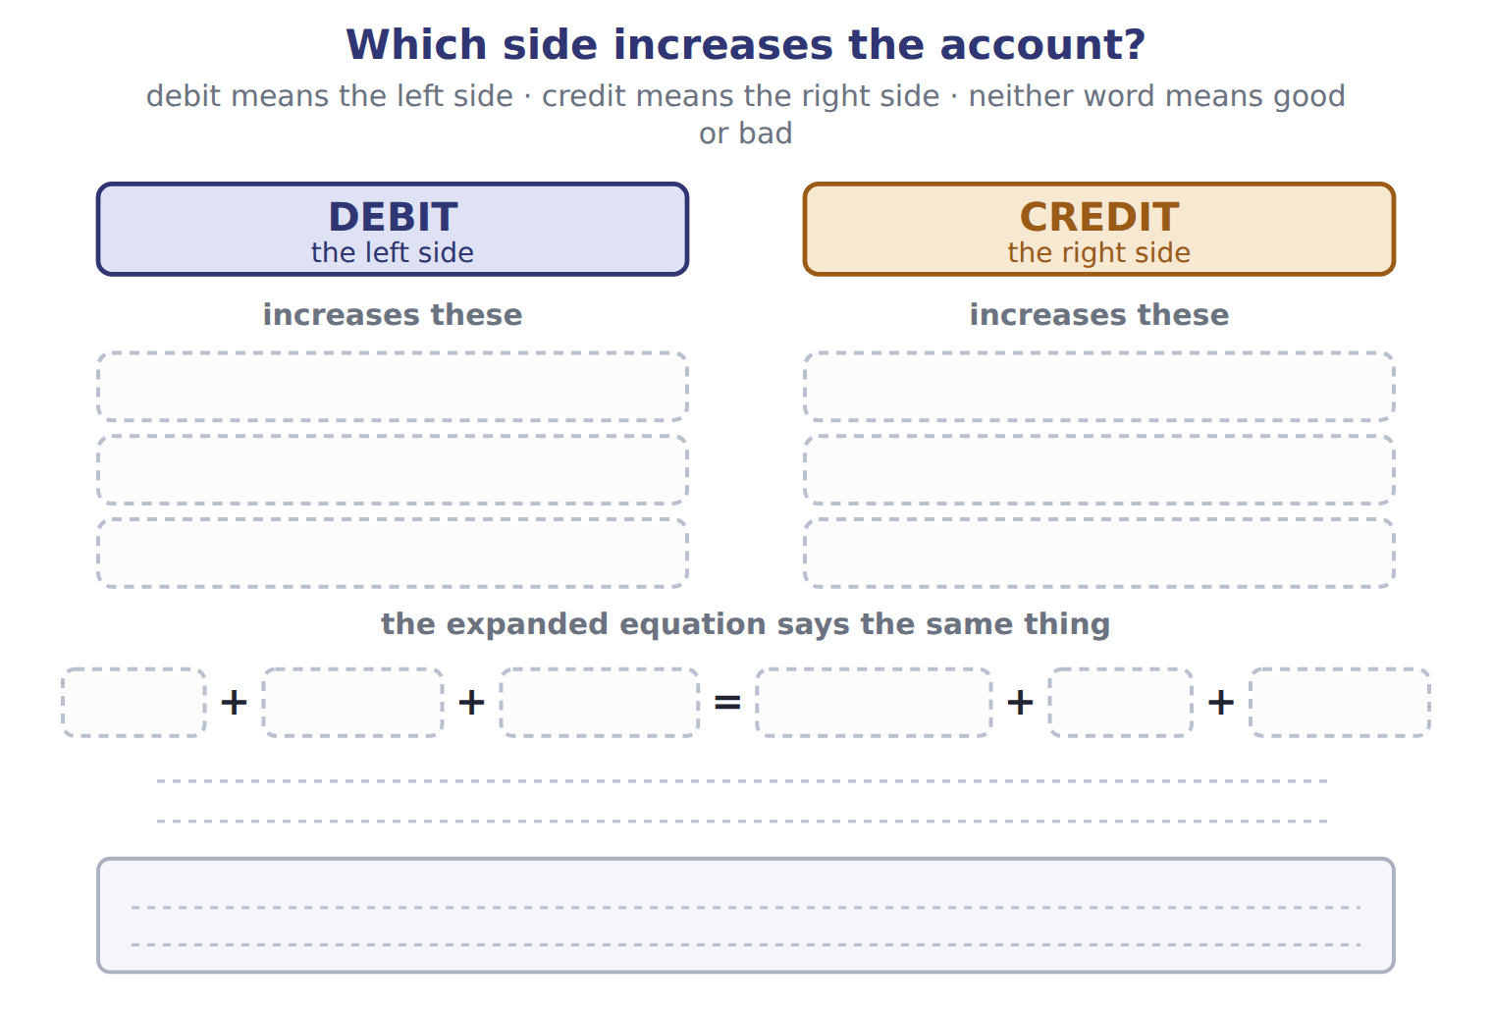
TEACH IT BACK | Write it for a classmate who missed this session — not for the marker.
28. In three or four sentences, write what this section settles and the one rule a reader has to take away.
every one of these words must appear: asset · dividend · U.S. GAAP · recognize

Answer key · Handout 1.3 · Double entry: debits and credits

1 debit · equity · credit · contra account · normal balance | 11 allowance for credit losses · accounts receivable | 21 B
2 revenue · retained earnings · liability · net income | 12 A | 22 C
3 asset · expense · credit | 13 A | 23 F
4 T | 14 B | 24 E
5 C | 15 D | 25 D
6 B | 16 C | 26 A
7 A | 17 B | 27 Compare with the model earlier in this handout.
8 D | 18 T | 28 Accountants record every transaction with the double-entry system. Each transaction affects at least two accounts, and total debits always equal total credits. This is why the accounting equation always balances.
9 at a date: Balance sheet | 19 A
10 for a period: Income statement, Statement of changes in equity, Statement of cash flows | 20 D

11 what the book says
The allowance for credit losses reduces accounts receivable in the same way (Chapter 6).

why
1 The book writes: “Accounts on the left side of the equation (assets, expenses and dividends) increase with a debit. Accounts on the right side (liabilities, equity and revenues) increase with a credit. A contra account reduces a related account, so it has the opposite normal balance.”
2 The book writes: “Orontes records revenue when it delivers the goods, not when the customer pays. Row 6 reduces retained earnings by 50 and creates a liability. No cash moves until February, and net income does not change. It reduces retained earnings, not net income.”
3 The book writes: “One asset (cash) becomes another asset (equipment). The cost becomes an expense later, through depreciation. Feb 3: Paid a supplier for olives bought on credit in January. Feb 8: Collected part of the January receivable from GreenBasket Supermarkets.”
4 The book pairs Balance sheet with “What does the company have and owe, and what is the owners' claim?”.
5 The book’s own table gives What does the company have and owe, and what is the owners' claim? as the question it answers of Balance sheet.
6 The book’s own table gives How did the company perform? as the question it answers of Income statement.
7 The book’s own table gives Why did each equity account change? as the question it answers of Statement of changes in equity.
8 The book’s own table gives Where did cash come from, and where did it go? as the question it answers of Statement of cash flows.
12 The book gives 2 as the chapter of Balance sheet.
13 The statement of changes in equity shows beginning retained earnings, net income, dividends and ending retained earnings. B is wrong: The balance sheet shows only the ending balance at one date. C is wrong: The statement of cash flows explains cash, not equity.
14 Net income is closed into retained earnings. A is wrong: Net income is not cash. The statement of cash flows explains the cash balance. C is wrong: Net income belongs to the owners, so it goes to equity, not liabilities.
15 The SEC has the legal authority; the FASB sets the standards; the ASC holds U.S. GAAP. A is wrong: The PCAOB sets auditing standards. B is wrong: The IASB writes IFRS only.
16 Share premium and additional paid-in capital both mean the amount received above par value. A is wrong: Retained earnings come from profits, not from issuing shares. B is wrong: Common stock holds only the par value.
17 Accumulated depreciation is a contra-asset account, so it has the opposite (credit) balance to assets. A is wrong: Prepaid rent is an asset, so its normal balance is a debit. C is wrong: Cost of goods sold is an expense, so its normal balance is a debit.
18 CMA questions use exact terms, and one word can change the answer.
25 One asset increases (debit Equipment) and another asset decreases (credit Cash). A is wrong: The sides are reversed: this entry would increase cash and decrease equipment. B is wrong: The bottling line is an asset, not an expense of this period.
26 Every item on a Workshop sheet is settled by something printed on the same sheet.

Handout 1.4
The accrual basis and the matching principle
section 1.4 of the book
Before you start
Three summaries of this handout, in the book’s own words. Read all three first: together they are the whole session. Then fill the gaps, guessing where you have to.

What this handout settles, cycle by cycle
In this handout | What you will read | How you check it
The accrual basis and the matching principle | a figure to read · Type · the book’s own rule, gapped | On December 28, a customer pays Orontes 60 for goods that Orontes will deliver in January. What does Orontes report at December 31?
The words this section uses precisely | The English the exam uses, and what it translates | What is the safest way to settle a disagreement about an answer on this sheet?

Words this handout uses precisely
Words this handout uses precisely | tick it if you could already use it in a sentence
liability
accounting equation
IFRS
disclose
par value
contra account
cost of goods sold

1. Where the section starts — Fill every gap. The list holds more words than there are gaps, so one or two of them are not used.
choose from: U.S. GAAP · faithful representation · accrual basis · contra account · revenue · financial statements
When should a company record s and expenses? use the . Under the accrual basis, a company records revenue when it earns it, that is, when it delivers the goods or services. It records expenses when it incurs them.
2. What it settles in the middle — Fill every gap. The list holds more words than there are gaps, so one or two of them are not used.
choose from: Cost of goods sold · matching principle · revenue · faithful representation · contra account
The says: record expenses in the same period as the s they help to produce. is the classic example: Orontes records it at the same time as the sales revenue. Some costs help many periods, such as a bottling line.
3. Where it ends — Fill every gap. The list holds more words than there are gaps, so one or two of them are not used.
choose from: prepaid expense · asset · contra account · revenue · faithful representation · liability
A is an : the company has paid for a future benefit. A contract (unearned ) is a liability: the company must still deliver the goods or services. Cash received in advance is a liability, not revenue.

CYCLE A | The accrual basis and the matching principle

ORIENT One claim. Decide now; you will check it in a moment.

4. The book gives the what happens of Prepaid expense (deferral) as “Cash is paid before the expense is incurred.”. TRUE / FALSE
MODEL Read it before you answer anything below it.

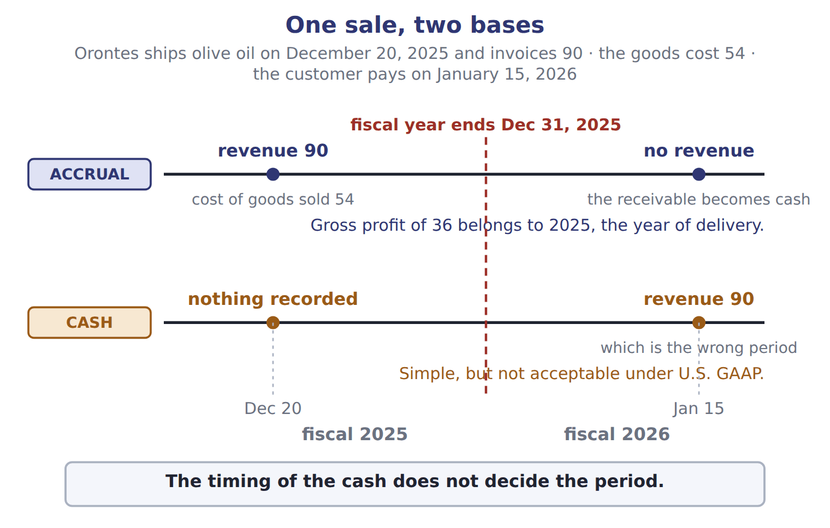

Type — the book’s own table
Type | What happens | Orontes example | Creates
Prepaid expense (deferral) | Cash is paid before the expense is incurred. | Rent paid in advance (February, row 3) | an asset
Contract liability, or unearned revenue (deferral) | Cash is received before the revenue is earned. | Hotel pays in advance (February, row 4) | a liability
Accrued expense | The expense is incurred before cash is paid. | Interest owed on the bank note (February, row 6) | a liability
Accrued revenue | Revenue is earned before cash is received or billed. | Studied in Chapter 11 | an asset

READ THE MODEL Every answer is printed above. Find it, do not recall it.

5. Which what happens does the book give for Prepaid expense (deferral)?
A. Cash is paid before the expense is incurred.
B. Cash is received before the revenue is earned.
C. The expense is incurred before cash is paid.
D. Revenue is earned before cash is received or billed.
6. Which what happens does the book give for Contract liability, or unearned revenue (deferral)?
A. The expense is incurred before cash is paid.
B. Cash is paid before the expense is incurred.
C. Cash is received before the revenue is earned.
D. Revenue is earned before cash is received or billed.
7. Which what happens does the book give for Accrued expense?
A. Cash is paid before the expense is incurred.
B. The expense is incurred before cash is paid.
C. Cash is received before the revenue is earned.
D. Revenue is earned before cash is received or billed.
8. Which what happens does the book give for Accrued revenue?
A. Cash is paid before the expense is incurred.
B. Cash is received before the revenue is earned.
C. The expense is incurred before cash is paid.
D. Revenue is earned before cash is received or billed.
9. The book gives the creates of Prepaid expense (deferral) as “an asset”. TRUE / FALSE
10. The book gives the creates of Contract liability, or unearned revenue (deferral) as “an asset”. TRUE / FALSE
SORT THEM | Write each one under its creates. Every item belongs to exactly one group.
the items: Prepaid expense (deferral) · Contract liability, or unearned revenue (deferral) · Accrued expense · Accrued revenue
a liability | an asset

INVENT THE RULE

13. Complete the book’s own sentence. The list holds more words than there are gaps.
use every one of these words: prepaid expense · cost of goods sold · gain · asset
A is an : the company has paid for a future benefit.

Two of the book’s own cases, side by side
Prepaid expense (deferral) | Contract liability, or unearned revenue (deferral)
What happens: Cash is paid before the expense is incurred. | What happens: Cash is received before the revenue is earned.
Orontes example: Rent paid in advance (February, row 3) | Orontes example: Hotel pays in advance (February, row 4)
Only the facts above differ. What is the creates of Prepaid expense (deferral)?
14. Choose one:
A. an asset | C. both of them
B. a liability | D. neither of them
APPLY No help on this move.

15. On December 28, a customer pays Orontes 60 for goods that Orontes will deliver in January. What does Orontes report at December 31?
A. A liability of 60
B. Revenue of 60
C. An asset of 60 and revenue of 60
D. Nothing until the goods are delivered
WORK IN PAIRS | Compare every answer on this page with your partner before you read any key.
If you disagree: go back to the model and find the row that settles it. The row decides, not the louder voice.
CHECKPOINT 16. On December 28, a customer pays Orontes 60 for goods that Orontes will deliver in January. What does Orontes report at December 31?
A. A liability of 60
B. Revenue of 60
C. An asset of 60 and revenue of 60
D. Nothing until the goods are delivered
If you got it wrong: redo the READ THE MODEL questions of cycle A with the model in front of you.

CYCLE B | The words this section uses precisely

ORIENT

17. A term in the exam means exactly what the book defines it to mean, whatever it means in ordinary English. TRUE / FALSE

MODEL

The English the exam uses, and what it translates
English (exam term) | the Arabic it translates
liability | التزام (التزامات)
accounting equation | المعادلة المحاسبية
IFRS | المعايير الدولية لإعداد التقارير المالية
disclose | يُفصح (الإفصاح)
par value | القيمة الاسمية
contra account | حساب مقابل (حساب عكسي)
cost of goods sold | تكلفة البضاعة المباعة
Accounting Standards Codification (ASC) | تقنين معايير المحاسبة
income statement | قائمة الدخل

READ THE MODEL

Write the letter of the Arabic term beside each English term. Every term is used once.
A المعادلة المحاسبية
B تكلفة البضاعة المباعة
C يُفصح (الإفصاح)
D المعايير الدولية لإعداد التقارير المالية
E التزام (التزامات)
F حساب مقابل (حساب عكسي)

18. accounting equation
19. disclose
20. cost of goods sold
21. IFRS
22. contra account
23. liability

APPLY

24. Which cost is matched to revenue by cause and effect?
A. Depreciation of the Amman bottling line
B. Advertising for a new product
C. Cost of goods sold
D. Rent for the head office
CHECKPOINT 25. What is the safest way to settle a disagreement about an answer on this sheet?
A. find the row of the model that decides it
B. take the answer of whoever is more confident
C. leave it until the lecturer says
D. choose the longer option
If you got it wrong: redo the READ THE MODEL questions of cycle B.

FROM MEMORY | Close the earlier pages first.
26. Rebuild the figure from this handout. Label every part and fill in every box.
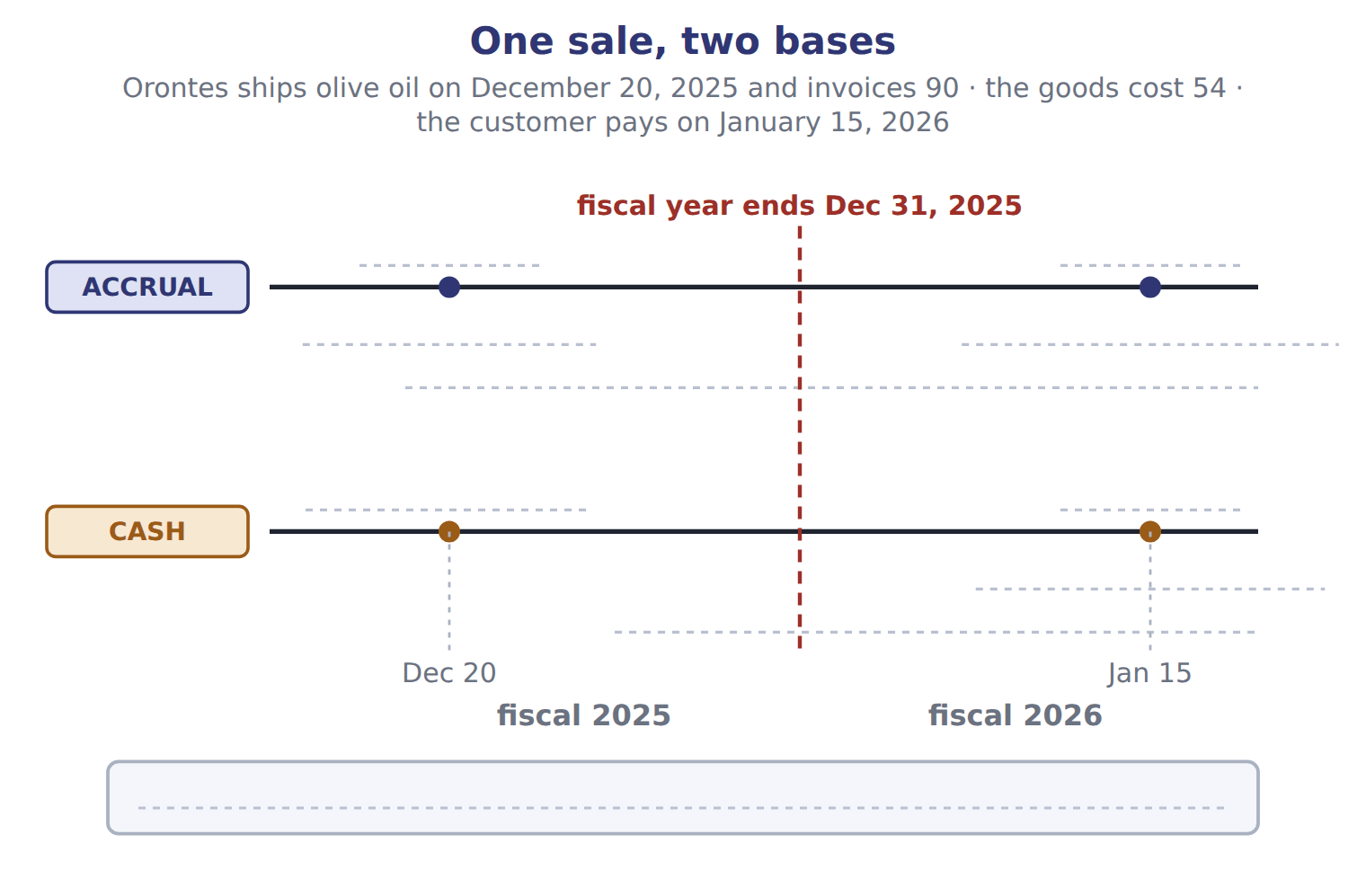
TEACH IT BACK | Write it for a classmate who missed this session — not for the marker.
27. In three or four sentences, write what this section settles and the one rule a reader has to take away.
every one of these words must appear: liability · accounting equation · IFRS · disclose

Answer key · Handout 1.4 · The accrual basis and the matching principle

1 revenue · U.S. GAAP · financial statements · accrual basis | 10 F | 19 C
2 matching principle · revenue · Cost of goods sold | 11 a liability: Contract liability, or unearned revenue (deferral), Accrued expense | 20 B
3 prepaid expense · asset · liability · revenue | 12 an asset: Prepaid expense (deferral), Accrued revenue | 21 D
4 T | 13 prepaid expense · asset | 22 F
5 A | 14 A | 23 E
6 C | 15 A | 24 C
7 B | 16 A | 25 A
8 D | 17 T | 26 Compare with the model earlier in this handout.
9 T | 18 A | 27 When should a company record revenues and expenses? U.S. GAAP financial statements use the accrual basis. Under the accrual basis, a company records revenue when it earns it, that is, when it delivers the goods or services. It records expenses when it incurs them. The timing of the cash does not decide the period. The cash basis records items only when cash

13 what the book says
A prepaid expense is an asset: the company has paid for a future benefit.

why
1 The book writes: “When should a company record revenues and expenses? U.S. GAAP financial statements use the accrual basis. Under the accrual basis, a company records revenue when it earns it, that is, when it delivers the goods or services. It records expenses when it incurs them.”
2 The book writes: “The matching principle says: record expenses in the same period as the revenues they help to produce. Cost of goods sold is the classic example: Orontes records it at the same time as the sales revenue. Some costs help many periods, such as a bottling line.”
3 The book writes: “A prepaid expense is an asset: the company has paid for a future benefit. A contract liability (unearned revenue) is a liability: the company must still deliver the goods or services. Cash received in advance is a liability, not revenue.”
4 The book pairs Prepaid expense (deferral) with “Cash is paid before the expense is incurred.”.
5 The book’s own table gives Cash is paid before the expense is incurred. as the what happens of Prepaid expense (deferral).
6 The book’s own table gives Cash is received before the revenue is earned. as the what happens of Contract liability, or unearned revenue (deferral).
7 The book’s own table gives The expense is incurred before cash is paid. as the what happens of Accrued expense.
8 The book’s own table gives Revenue is earned before cash is received or billed. as the what happens of Accrued revenue.
9 The book pairs Prepaid expense (deferral) with “an asset”.
10 The book pairs Contract liability, or unearned revenue (deferral) with “a liability”, not with “an asset”.
14 The book gives an asset as the creates of Prepaid expense (deferral).
15 Cash increases, and Orontes owes the customer the goods. This is a contract liability (unearned revenue). B is wrong: Revenue is not earned until the goods are delivered in January. C is wrong: The cash asset is correct, but the credit is a liability, not revenue.
16 Cash increases, and Orontes owes the customer the goods. This is a contract liability (unearned revenue). B is wrong: Revenue is not earned until the goods are delivered in January. C is wrong: The cash asset is correct, but the credit is a liability, not revenue.
17 CMA questions use exact terms, and one word can change the answer.
24 Cost of goods sold links directly to each sale, so it is recorded with the sales revenue. A is wrong: Depreciation uses systematic and rational allocation over the years of use. B is wrong: Advertising has no clear link to specific revenue, so it is recognized immediately.
25 Every item on a Workshop sheet is settled by something printed on the same sheet.

Handout 1.5
Who writes the rules? U.S. GAAP and IFRS
section 1.5 of the book
Before you start
Three summaries of this handout, in the book’s own words. Read all three first: together they are the whole session. Then fill the gaps, guessing where you have to.

What this handout settles, cycle by cycle
In this handout | What you will read | How you check it
Who writes the rules? U.S. GAAP and IFRS | a figure to read · ■ U.S. GAAP (used on the exam) | Which organization writes U.S. GAAP?
The words this section uses precisely | The English the exam uses, and what it translates | What is the safest way to settle a disagreement about an answer on this sheet?

Words this handout uses precisely
Words this handout uses precisely | tick it if you could already use it in a sentence
equity
debit
general-purpose financial statements
gain
double-entry system
accumulated depreciation
notes payable

1. Where the section starts — Fill every gap. The list holds more words than there are gaps, so one or two of them are not used.
choose from: FASB · U.S. GAAP · relevance · accumulated depreciation
In the United States, the accounting rules are called (generally accepted accounting principles). The (Financial Accounting Standards Board) writes them. The FASB is a private, independent organization.
2. What it settles in the middle — Fill every gap. The list holds more words than there are gaps, so one or two of them are not used.
choose from: accumulated depreciation · IFRS · IASB · relevance
The PCAOB sets auditing standards, not accounting standards. Outside the United States, many countries use (International Financial Reporting Standards). The (International Accounting Standards Board) issues them, under the IFRS Foundation.
3. Where it ends — Fill every gap. The list holds more words than there are gaps, so one or two of them are not used.
choose from: U.S. GAAP · relevance · accumulated depreciation · IASB · IFRS · FASB
Who writes the rules: SEC, and the ASC for ; Foundation and for IFRS. However, Section A also asks about the main differences between U.S. If you learned accounting under IFRS, this is good news: most concepts are the same.

CYCLE A | Who writes the rules? U.S. GAAP and IFRS

ORIENT One claim. Decide now; you will check it in a moment.

4. Every number in a financial statement belongs to an element the framework defines. TRUE / FALSE
MODEL Read it before you answer anything below it.

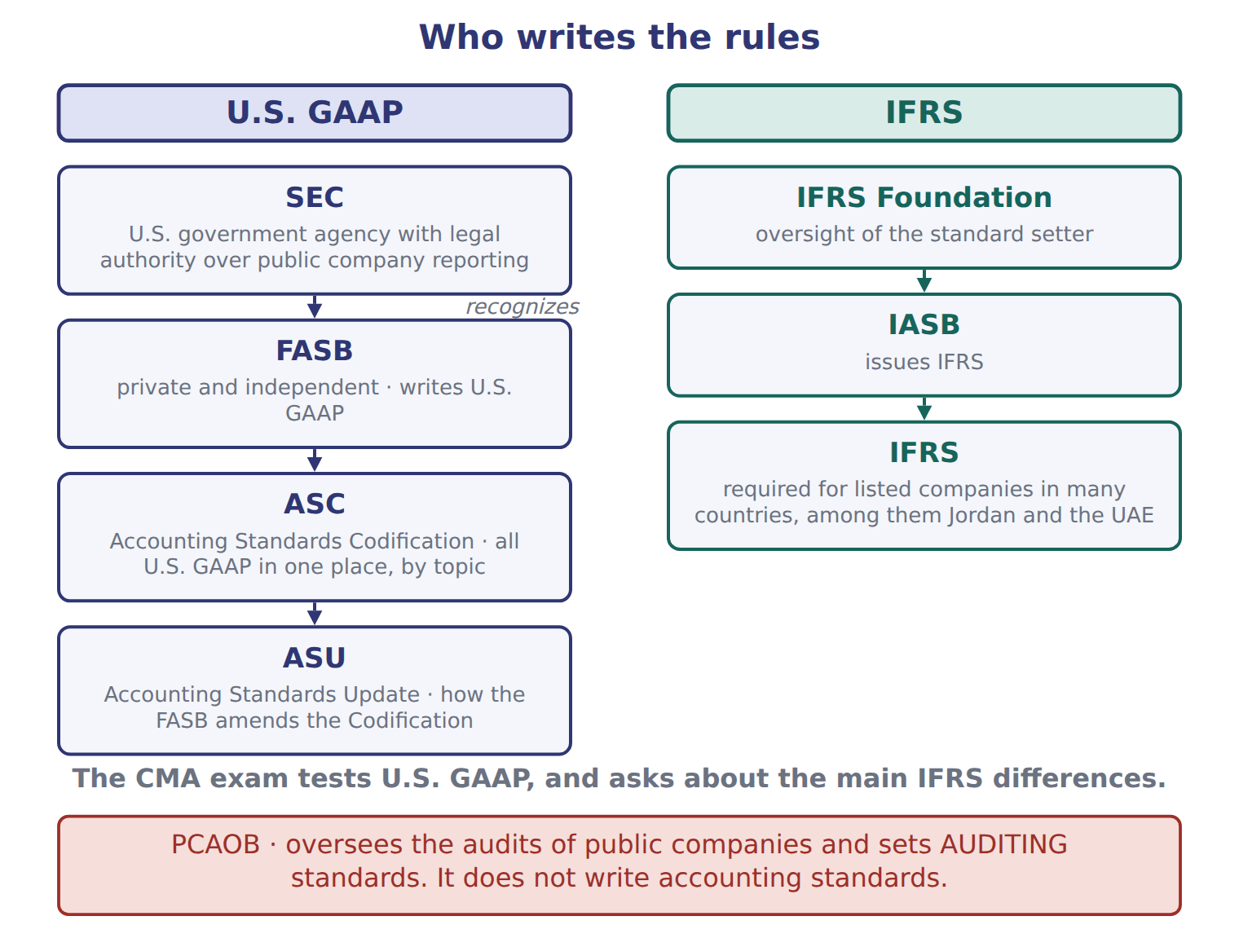

■ U.S. GAAP (used on the exam) — the book’s own table
■ U.S. GAAP (used on the exam) | ● IFRS
balance sheet | statement of financial position
income statement | statement of profit or loss
common stock | share capital (ordinary shares)
additional paid-in capital | share premium
accounts receivable | trade receivables
net income | profit

READ THE MODEL Every answer is printed above. Find it, do not recall it.

5. Which ● IFRS does the book give for balance sheet?
A. statement of profit or loss | C. share capital (ordinary shares)
B. statement of financial position | D. profit
6. Which ● IFRS does the book give for income statement?
A. statement of profit or loss | C. statement of financial position
B. share capital (ordinary shares) | D. profit
7. Which ● IFRS does the book give for common stock?
A. statement of financial position | C. trade receivables
B. statement of profit or loss | D. share capital (ordinary shares)
8. Which ● IFRS does the book give for additional paid-in capital?
A. statement of financial position | C. share premium
B. profit | D. share capital (ordinary shares)
APPLY No help on this move.

9. Which organization writes U.S. GAAP?
A. The FASB | C. The PCAOB
B. The SEC | D. The IASB
WORK IN PAIRS | Compare every answer on this page with your partner before you read any key.
If you disagree: go back to the model and find the row that settles it. The row decides, not the louder voice.
CHECKPOINT 10. Which organization writes U.S. GAAP?
A. The FASB
B. The SEC
C. The PCAOB
D. The IASB
If you got it wrong: redo the READ THE MODEL questions of cycle A with the model in front of you.

CYCLE B | The words this section uses precisely

ORIENT

11. A term in the exam means exactly what the book defines it to mean, whatever it means in ordinary English. TRUE / FALSE

MODEL

The English the exam uses, and what it translates
English (exam term) | the Arabic it translates
equity | حقوق الملكية
debit | مدين
general-purpose financial statements | القوائم المالية ذات الغرض العام
gain | مكسب (مكاسب)
double-entry system | نظام القيد المزدوج
accumulated depreciation | مجمع الإهلاك (مجمع الاستهلاك / الاهتلاك)
notes payable | أوراق الدفع
IASB | مجلس معايير المحاسبة الدولية
statement of changes in equity | قائمة التغيرات في حقوق الملكية

READ THE MODEL

Write the letter of the Arabic term beside each English term. Every term is used once.
A مكسب (مكاسب) | D مجلس معايير المحاسبة الدولية
B قائمة التغيرات في حقوق الملكية | E حقوق الملكية
C القوائم المالية ذات الغرض العام | F مدين

12. debit
13. general-purpose financial statements
14. gain
15. statement of changes in equity
16. equity
17. IASB

APPLY

18. The IFRS term share premium has the same meaning as the U.S. GAAP term:
A. retained earnings | C. net income
B. common stock | D. additional paid-in capital
CHECKPOINT 19. What is the safest way to settle a disagreement about an answer on this sheet?
A. find the row of the model that decides it
B. take the answer of whoever is more confident
C. leave it until the lecturer says
D. choose the longer option
If you got it wrong: redo the READ THE MODEL questions of cycle B.

FROM MEMORY | Close the earlier pages first.
20. Rebuild the figure from this handout. Label every part and fill in every box.
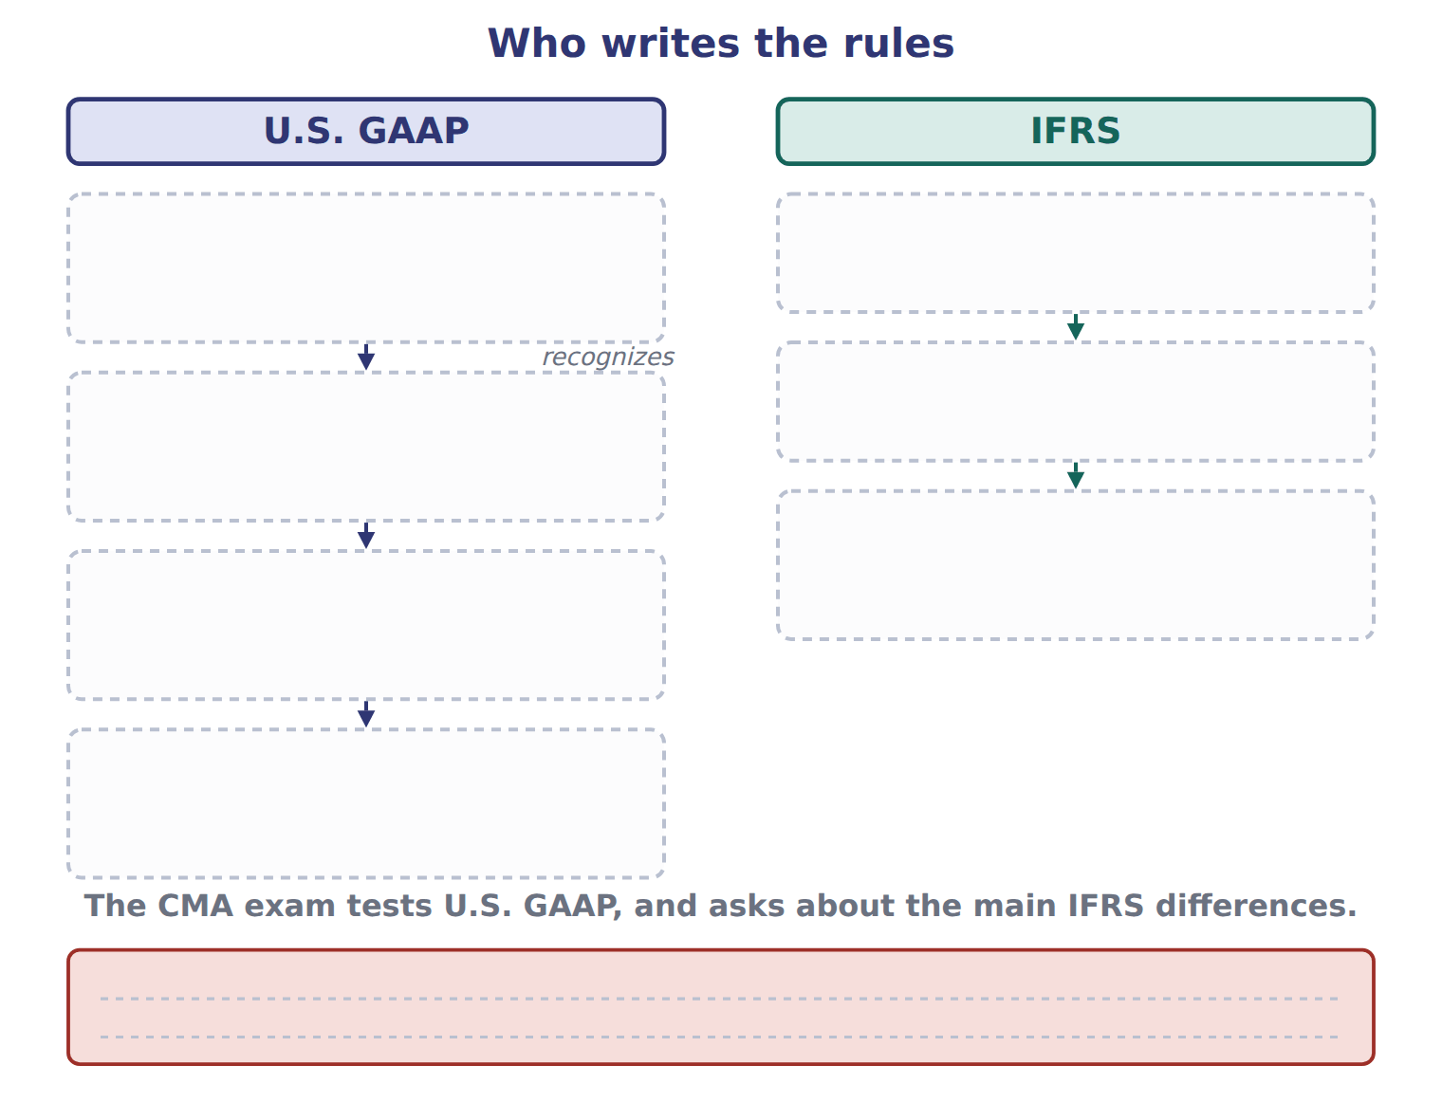
TEACH IT BACK | Write it for a classmate who missed this session — not for the marker.
21. In three or four sentences, write what this section settles and the one rule a reader has to take away.
every one of these words must appear: equity · debit · general-purpose financial statements · gain

Answer key · Handout 1.5 · Who writes the rules? U.S. GAAP and IFRS

1 U.S. GAAP · FASB | 8 C | 15 B
2 IFRS · IASB | 9 A | 16 E
3 FASB · U.S. GAAP · IFRS · IASB | 10 A | 17 D
4 T | 11 T | 18 D
5 B | 12 F | 19 A
6 A | 13 C | 20 Compare with the model earlier in this handout.
7 D | 14 A | 21 In the United States, the accounting rules are called U.S. GAAP (generally accepted accounting principles). The FASB (Financial Accounting Standards Board) writes them. The FASB is a private, independent organization. It keeps all U.S. GAAP in one place: the Accounting Standards Codification (ASC). The ASC is the single source of authoritative nongovernmenta

why
1 The book writes: “In the United States, the accounting rules are called U.S. GAAP (generally accepted accounting principles). The FASB (Financial Accounting Standards Board) writes them. The FASB is a private, independent organization.”
2 The book writes: “The PCAOB sets auditing standards, not accounting standards. Outside the United States, many countries use IFRS (International Financial Reporting Standards). The IASB (International Accounting Standards Board) issues them, under the IFRS Foundation.”
3 The book writes: “Who writes the rules: SEC, FASB and the ASC for U.S. GAAP; IFRS Foundation and IASB for IFRS. However, Section A also asks about the main differences between U.S. If you learned accounting under IFRS, this is good news: most concepts are the same.”
4 The framework defines the elements, and every amount belongs to one of them.
5 The book’s own table gives statement of financial position as the ● IFRS of balance sheet.
6 The book’s own table gives statement of profit or loss as the ● IFRS of income statement.
7 The book’s own table gives share capital (ordinary shares) as the ● IFRS of common stock.
8 The book’s own table gives share premium as the ● IFRS of additional paid-in capital.
9 The FASB writes U.S. GAAP and keeps it in the Accounting Standards Codification. B is wrong: The SEC has legal authority, but it recognizes the FASB as the standard setter. C is wrong: The PCAOB sets auditing standards, not accounting standards.
10 The FASB writes U.S. GAAP and keeps it in the Accounting Standards Codification. B is wrong: The SEC has legal authority, but it recognizes the FASB as the standard setter. C is wrong: The PCAOB sets auditing standards, not accounting standards.
11 CMA questions use exact terms, and one word can change the answer.
18 Share premium is the amount received for shares above their par value: additional paid-in capital. A is wrong: Retained earnings come from past profits, not from selling shares. B is wrong: Common stock holds only the par value of the shares.
19 Every item on a Workshop sheet is settled by something printed on the same sheet.

Handout 1.6
A first look at the four statements
section 1.6 of the book
Before you start
Three summaries of this handout, in the book’s own words. Read all three first: together they are the whole session. Then fill the gaps, guessing where you have to.

What this handout settles, cycle by cycle
In this handout | What you will read | How you check it
A first look at the four statements | a figure to read · Account | Which statement reports amounts at a single date?
The words this section uses precisely | Account · The English the exam uses, and what it translates | What is the safest way to settle a disagreement about an answer on this sheet?

Words this handout uses precisely
Words this handout uses precisely | tick it if you could already use it in a sentence
revenue
credit
relevance
loss
normal balance
allowance for credit losses
cash basis

1. Where the section starts — Fill every gap. The list holds more words than there are gaps, so one or two of them are not used.
choose from: trial balance · retained earnings · balance sheet · cost of goods sold · Net income
Each statement answers a different question for users. Chapters 2 to 5 study each statement in detail. flows into , and the net change in cash explains the cash balance on the .
2. What it settles in the middle — Fill every gap. The list holds more words than there are gaps, so one or two of them are not used.
choose from: dividend · retained earnings · cost of goods sold · net income · trial balance
How the four statements connect through , and cash. You can see both links in the January transactions of Orontes. The declared was 50, so retained earnings rose by 30.
3. Where it ends — Fill every gap. The list holds more words than there are gaps, so one or two of them are not used.
choose from: net income · relevance · cost of goods sold · trial balance
Notice that and the change in cash are very different numbers. Before you leave this chapter, practise reading a . A trial balance lists every account balance and checks that total debits equal total credits.

CYCLE A | A first look at the four statements

ORIENT One claim. Decide now; you will check it in a moment.

4. The book gives the debit of Cash as “1,050”. TRUE / FALSE
MODEL Read it before you answer anything below it.

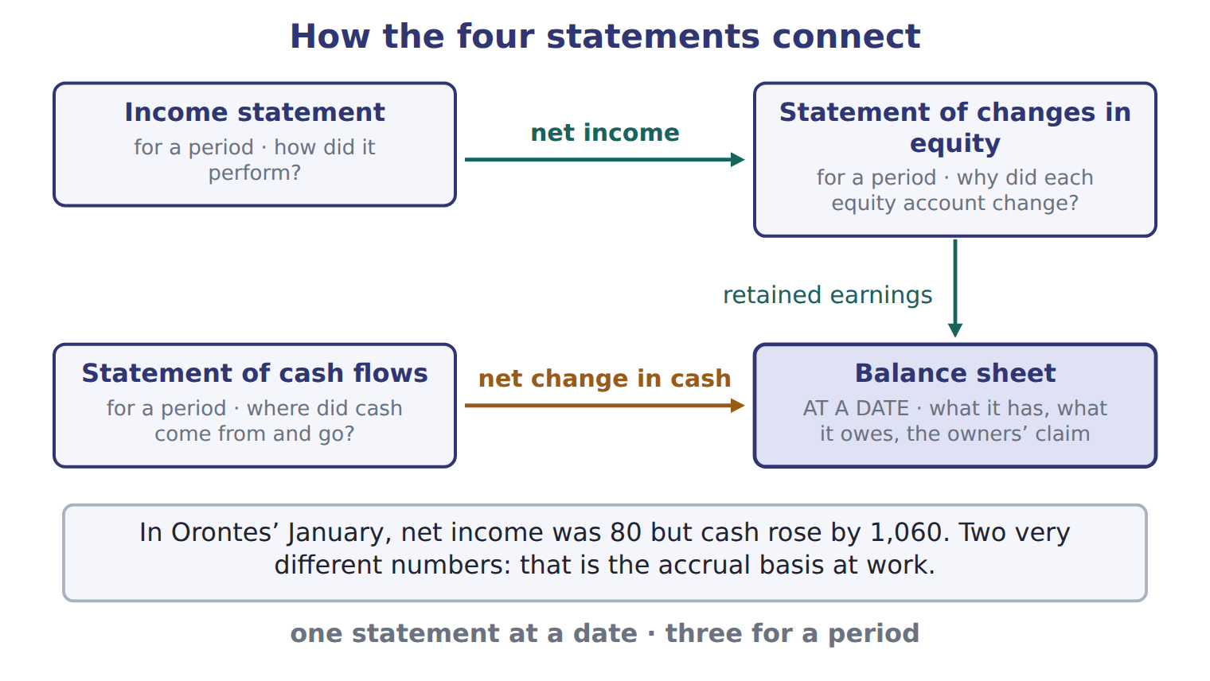
Account — the book’s own table
Account | Debit | Credit
Cash | 1,050
Accounts receivable | 300
Allowance for credit losses |  | 20
Inventory | 420
Prepaid rent | 24
Land | 936
Equipment | 4,200
Accumulated depreciation |  | 900
Accounts payable |  | 380
Dividends payable |  | 50

Account — the book’s own table (continued)
Account | Debit | Credit
Notes payable (long-term) |  | 1,800
Common stock |  | 600
Additional paid-in capital |  | 1,900
Retained earnings, January 1 |  | 1,000
Dividends declared | 50
Sales revenue |  | 3,100
Cost of goods sold | 1,860
Wages expense | 520
Depreciation expense | 300
Interest expense | 90

Account — the book’s own table (continued)
Account | Debit | Credit
Totals | 9,750 | 9,750

READ THE MODEL Every answer is printed above. Find it, do not recall it.

5. Which debit does the book give for Cash?
A. 936 | C. 1,050
B. 1,860 | D. 520
6. Which debit does the book give for Accounts receivable?
A. 24 | C. 4,200
B. 300 | D. 9,750
7. Which debit does the book give for Inventory?
A. 4,200 | C. 9,750
B. 90 | D. 420
APPLY No help on this move.

8. Which statement reports amounts at a single date?
A. The income statement
B. The balance sheet
C. The statement of changes in equity
D. The statement of cash flows
WORK IN PAIRS | Compare every answer on this page with your partner before you read any key.
If you disagree: go back to the model and find the row that settles it. The row decides, not the louder voice.
CHECKPOINT 9. Which statement reports amounts at a single date?
A. The income statement
B. The balance sheet
C. The statement of changes in equity
D. The statement of cash flows
If you got it wrong: redo the READ THE MODEL questions of cycle A with the model in front of you.

CYCLE B | The words this section uses precisely

ORIENT

10. A term in the exam means exactly what the book defines it to mean, whatever it means in ordinary English. TRUE / FALSE
MODEL

Account — the book’s own table
Account | Category
Prepaid rent
Land
Dividends payable
Additional paid-in capital
Sales revenue
Interest expense
Allowance for credit losses
Accumulated depreciation

The English the exam uses, and what it translates
English (exam term) | the Arabic it translates
revenue | إيراد (إيرادات)
credit | دائن
relevance | الملاءمة
loss | خسارة
normal balance | الرصيد الطبيعي
allowance for credit losses | مخصص الخسائر الائتمانية
cash basis | الأساس النقدي
SEC | هيئة الأوراق المالية والبورصات الأمريكية
statement of cash flows | قائمة التدفقات النقدية

READ THE MODEL

Write the letter of the Arabic term beside each English term. Every term is used once.
A قائمة التدفقات النقدية | D دائن
B إيراد (إيرادات) | E مخصص الخسائر الائتمانية
C الرصيد الطبيعي | F خسارة

11. credit
12. loss
13. revenue
14. allowance for credit losses
15. normal balance
16. statement of cash flows

APPLY

17. Writing a term in English is part of answering the question, not an extra. TRUE / FALSE
CHECKPOINT 18. What is the safest way to settle a disagreement about an answer on this sheet?
A. find the row of the model that decides it
B. take the answer of whoever is more confident
C. leave it until the lecturer says
D. choose the longer option
If you got it wrong: redo the READ THE MODEL questions of cycle B.

FROM MEMORY | Close the earlier pages first.
19. Rebuild the figure from this handout. Label every part and fill in every box.
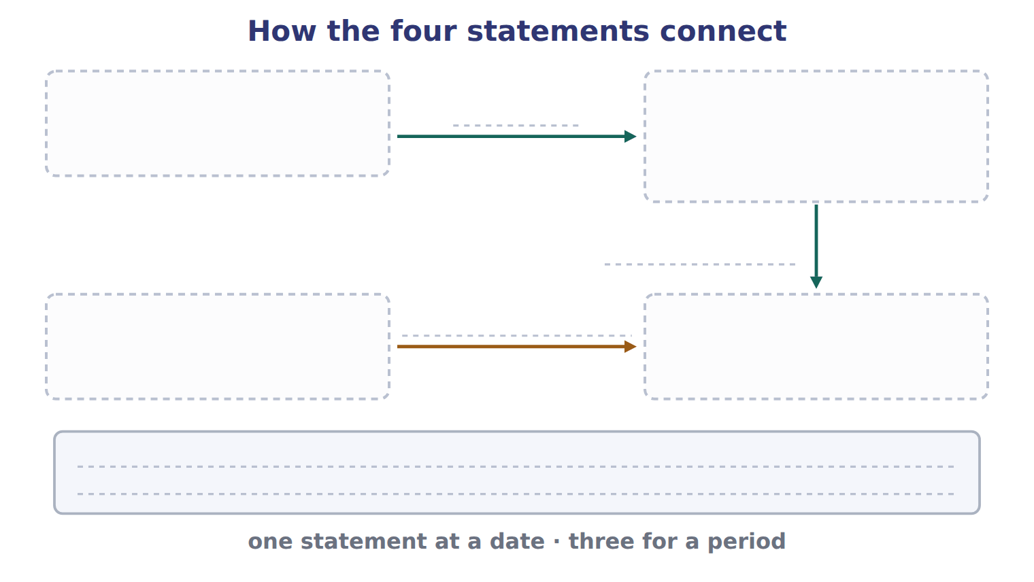
TEACH IT BACK | Write it for a classmate who missed this session — not for the marker.
20. In three or four sentences, write what this section settles and the one rule a reader has to take away.
every one of these words must appear: revenue · credit · relevance · loss

Answer key · Handout 1.6 · A first look at the four statements

1 Net income · retained earnings · balance sheet | 8 B | 15 C
2 net income · retained earnings · dividend | 9 B | 16 A
3 net income · trial balance | 10 T | 17 T
4 T | 11 D | 18 A
5 C | 12 F | 19 Compare with the model earlier in this handout.
6 B | 13 B | 20 Each statement answers a different question for users. Chapters 2 to 5 study each statement in detail. Here is the overview.
7 D | 14 E

why
1 The book writes: “Each statement answers a different question for users. Chapters 2 to 5 study each statement in detail. Net income flows into retained earnings, and the net change in cash explains the cash balance on the balance sheet.”
2 The book writes: “How the four statements connect through net income, retained earnings and cash. You can see both links in the January transactions of Orontes. The dividend declared was 50, so retained earnings rose by 30.”
3 The book writes: “Notice that net income and the change in cash are very different numbers. Before you leave this chapter, practise reading a trial balance. A trial balance lists every account balance and checks that total debits equal total credits.”
4 The book pairs Cash with “1,050”.
5 The book’s own table gives 1,050 as the debit of Cash.
6 The book’s own table gives 300 as the debit of Accounts receivable.
7 The book’s own table gives 420 as the debit of Inventory.
8 The balance sheet shows position at one date. The other statements cover a period. A is wrong: The income statement covers a period. C is wrong: The statement of changes in equity covers a period.
9 The balance sheet shows position at one date. The other statements cover a period. A is wrong: The income statement covers a period. C is wrong: The statement of changes in equity covers a period.
10 CMA questions use exact terms, and one word can change the answer.
17 The exam marks the term, so the English word is the answer.
18 Every item on a Workshop sheet is settled by something printed on the same sheet.

Handout 1.7
The whole chapter
every section, shuffled, and the chapter’s own case set
Before you start
Three summaries of this chapter, in the book’s own words, with words taken out. Read all three first: together they are the whole chapter. Then fill the gaps.

What this handout settles, cycle by cycle
In this handout | What you will read | How you check it
The whole chapter, in order | a figure to read | Which part of the chapter does a question about definitions belong to?
The chapter’s case set | The chapter’s case set, item by item | What has to be settled before any figure in a case set is worked out?
The words it uses precisely | financial statements · primary users · asset · liability · equity · revenue | matching, at the end of cycle B

1. Where the chapter starts — Fill every gap. The list holds more words than there are gaps, so one or two of them are not used.
choose from: recognize · retained earnings · Revenue · Dividend · liability · income statement · expense
s and gains increase . s also decrease it, but a dividend is not an . It is a distribution to owners, so it never appears in the . IFRS also uses the word income for both revenue and gains, while U.S.
2. What it settles in the middle — Fill every gap. The list holds more words than there are gaps, so one or two of them are not used.
choose from: debit · contra account · recognize · equity · liability · credit · normal balance
Accounts on the left side of the equation (assets, expenses and dividends) increase with a . Accounts on the right side (liabilities, and revenues) increase with a . A reduces a related account, so it has the opposite .
3. Where it ends — Fill every gap. The list holds more words than there are gaps, so one or two of them are not used.
choose from: recognize · balance sheet · liability · asset · revenue · prepaid expense
A is an : the company has paid for a future benefit. A contract (unearned ) is a liability: the company must still deliver the goods or services. Cash received in advance is a liability, not revenue.

CYCLE A | The whole chapter, in order

ORIENT

4. The sections of a chapter have to be taken in order, because each one uses what the one before it settled. TRUE / FALSE
MODEL

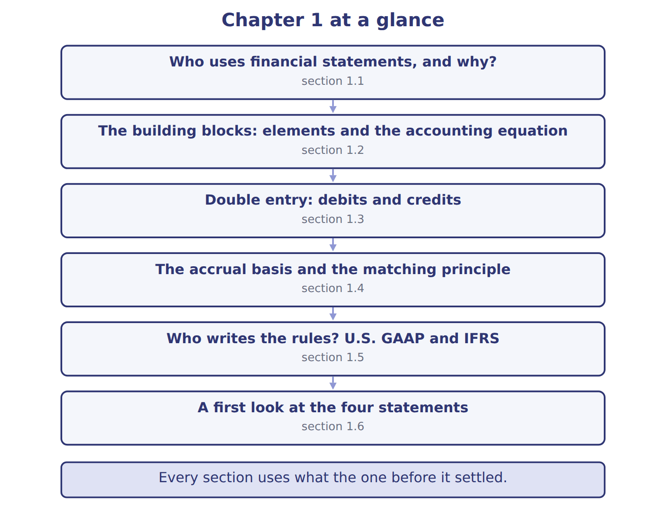
READ THE MODEL

5. “section 1.1” — which part of the chapter is this?
A. Double entry: debits and credits
B. The accrual basis and the matching principle
C. The building blocks: elements and the accounting equation
D. Who uses financial statements, and why?
6. “section 1.2” — which part of the chapter is this?
A. The accrual basis and the matching principle
B. Who uses financial statements, and why?
C. The building blocks: elements and the accounting equation
D. Double entry: debits and credits
7. “section 1.3” — which part of the chapter is this?
A. The building blocks: elements and the accounting equation
B. Who uses financial statements, and why?
C. The accrual basis and the matching principle
D. Double entry: debits and credits
Write the letter of the section number beside each section title. Every number is used once.
A 1.1 | D 1.4
B 1.2 | E 1.5
C 1.3 | F 1.6

8. Who uses financial statements, and why?
9. The building blocks: elements and the accounting equation
10. Double entry: debits and credits
11. The accrual basis and the matching principle
12. Who writes the rules? U.S. GAAP and IFRS
13. A first look at the four statements

APPLY

WORK IN PAIRS | Compare every answer with your partner first.
If you disagree: name the section each question belongs to. Most disagreements turn out to be about the section, not the answer.
CHECKPOINT 14. Which part of the chapter does a question about definitions belong to?
A. Who uses financial statements, and why?
B. A first look at the four statements
C. none of them
D. all of them
If you got it wrong: go back to the MODEL move of cycle A.

CYCLE B | The chapter’s case set

ORIENT

15. In a case question, the exhibit has to be read and adjusted before any figure is worked out. TRUE / FALSE

MODEL

The chapter’s case set, item by item
Item | What it asks
C1-1 | Match each account to its category. (On the exam screen you would drag each account into a box.)
C1-2 | Enter Barada's net income for 2025 (USD 000).
C1-3 | Enter Barada's total assets at December 31, 2025 (USD 000).
C1-4 | After closing, Barada's retained earnings at December 31, 2025 are: [select]
C1-5 | Enter Barada's total liabilities at December 31, 2025 (USD 000).

READ THE MODEL

16. Which of these does item C1-1 ask for?
A. Match each account to its category. (On the exam screen you would drag
B. After closing, Barada's retained earnings at December 31, 2025 are: [s
C. Enter Barada's total assets at December 31, 2025 (USD 000).
D. Enter Barada's net income for 2025 (USD 000).
17. Which of these does item C1-2 ask for?
A. Match each account to its category. (On the exam screen you would drag
B. Enter Barada's net income for 2025 (USD 000).
C. After closing, Barada's retained earnings at December 31, 2025 are: [s
D. Enter Barada's total assets at December 31, 2025 (USD 000).
18. Which of these does item C1-3 ask for?
A. Enter Barada's total assets at December 31, 2025 (USD 000).
B. Match each account to its category. (On the exam screen you would drag
C. Enter Barada's net income for 2025 (USD 000).
D. After closing, Barada's retained earnings at December 31, 2025 are: [s
19. Which of these does item C1-4 ask for?
A. After closing, Barada's retained earnings at December 31, 2025 are: [s
B. Enter Barada's total assets at December 31, 2025 (USD 000).
C. Enter Barada's net income for 2025 (USD 000).
D. Match each account to its category. (On the exam screen you would drag
20. Which of these does item C1-5 ask for?
A. Match each account to its category. (On the exam screen you would drag
B. Enter Barada's total liabilities at December 31, 2025 (USD 000).
C. Enter Barada's total assets at December 31, 2025 (USD 000).
D. Enter Barada's net income for 2025 (USD 000).
APPLY

CHECKPOINT 21. What has to be settled before any figure in a case set is worked out?
A. the exhibit, adjusted for every note that goes with it
B. the method the company uses
C. the tax rate
D. the order of the items
If you got it wrong: reread the case panel in the MODEL move of cycle B.

FROM MEMORY | Close the earlier pages first.
22. Rebuild the chapter map. Write every section in order and what each one settles.
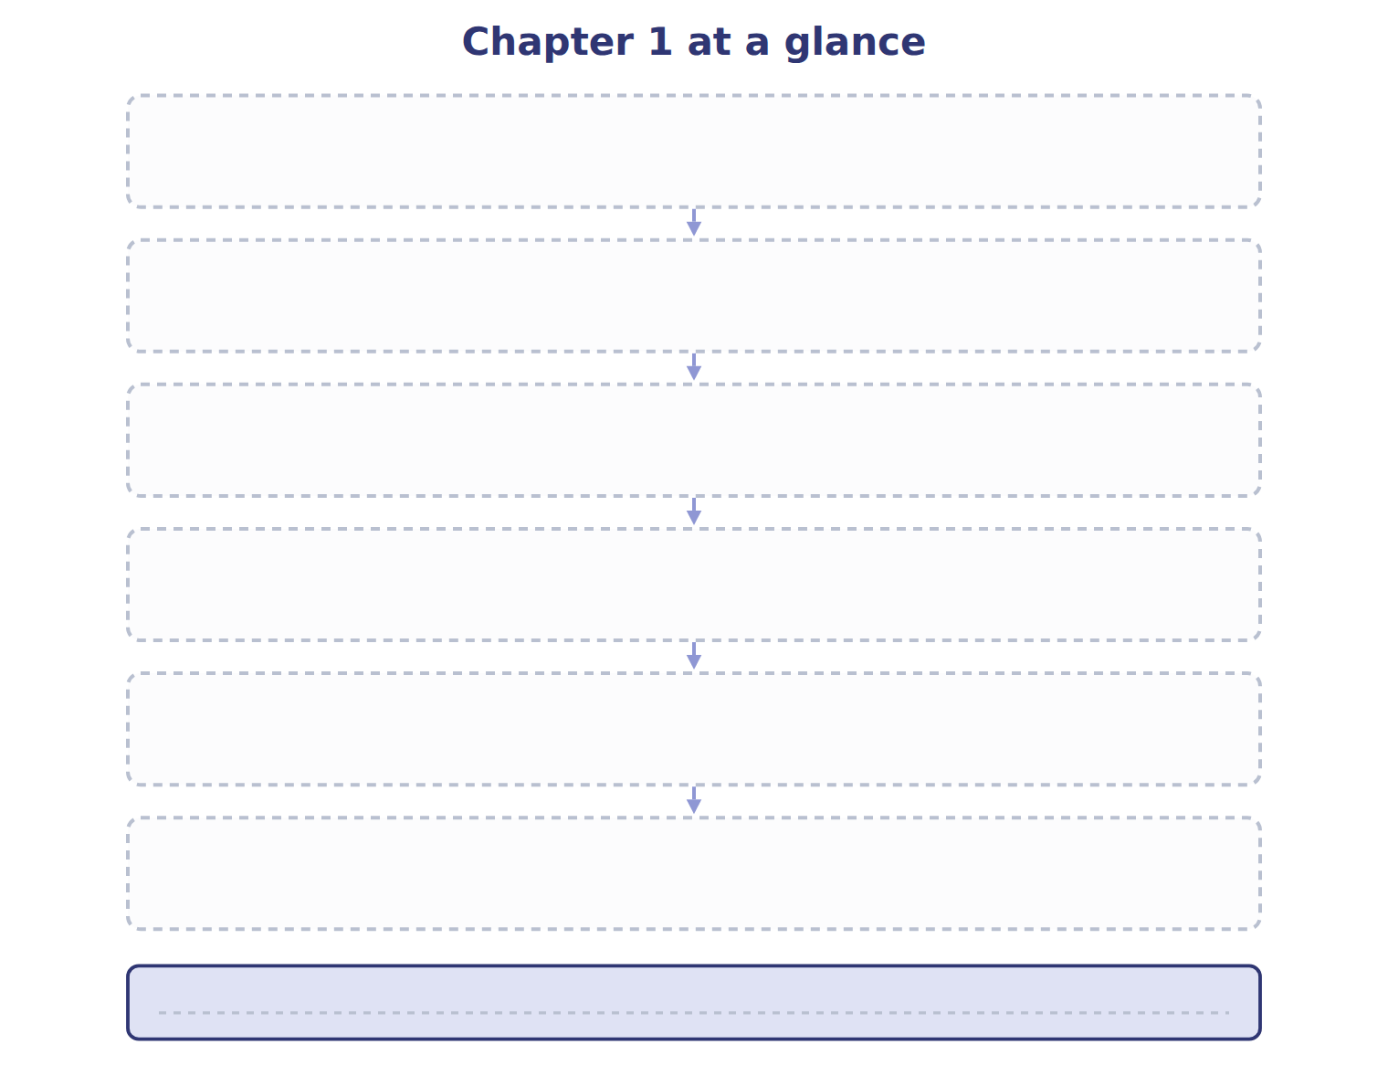
TEACH IT BACK | Write it for a student starting this chapter tomorrow — not for the marker.
23. In four or five sentences, write what the whole chapter settles, section by section.
every one of these words must appear: financial statements · primary users · asset · liability

Answer key · Handout 1.7 · The whole chapter

1 Revenue · retained earnings · Dividend · expense · income statement | 9 B | 17 B
2 debit · equity · credit · contra account · normal balance | 10 C | 18 A
3 prepaid expense · asset · liability · revenue | 11 D | 19 A
4 T | 12 E | 20 B
5 D | 13 F | 21 A
6 C | 14 A | 22 Compare with the model earlier in this handout.
7 D | 15 T | 23 1.1: Who uses financial statements, and why?. 1.2: The building blocks: elements and the accounting equation. 1.3: Double entry: debits and credits. 1.4: The accrual basis and the matching principle. 1.5: Who writes the rules? U.S. GAAP and IFRS. 1.6: A first look at the four statements.
8 A | 16 A

why
1 The book writes: “Revenues and gains increase retained earnings. Dividends also decrease it, but a dividend is not an expense. It is a distribution to owners, so it never appears in the income statement. IFRS also uses the word income for both revenue and gains, while U.S.”
2 The book writes: “Accounts on the left side of the equation (assets, expenses and dividends) increase with a debit. Accounts on the right side (liabilities, equity and revenues) increase with a credit. A contra account reduces a related account, so it has the opposite normal balance.”
3 The book writes: “A prepaid expense is an asset: the company has paid for a future benefit. A contract liability (unearned revenue) is a liability: the company must still deliver the goods or services. Cash received in advance is a liability, not revenue.”
4 The map shows the order the decisions have to be taken in.
5 The book numbers it 1.1.
6 The book numbers it 1.2.
7 The book numbers it 1.3.
14 The first section settles the vocabulary.
15 Every later answer depends on the adjusted exhibit.
16 The book states item C1-1 in those words.
17 The book states item C1-2 in those words.
18 The book states item C1-3 in those words.
19 The book states item C1-4 in those words.
20 The book states item C1-5 in those words.
21 Every later answer depends on the adjusted exhibit.

Handout 2.1
Purpose and structure of the balance sheet
section 2.1 of the book
Before you start
Three summaries of this handout, in the book’s own words. Read all three first: together they are the whole session. Then fill the gaps, guessing where you have to.

What this handout settles, cycle by cycle
In this handout | What you will read | How you check it
Purpose and structure of the balance sheet | a figure to read · Orontes Foods Inc. (whole USD) | Which question does the balance sheet help users answer MOST directly?
The words this section uses precisely | Account · The English the exam uses, and what it translates · Orontes Foods Inc. (whole USD) | What is the safest way to settle a disagreement about an answer on this sheet?

Words this handout uses precisely
Words this handout uses precisely | tick it if you could already use it in a sentence
balance sheet
working capital
liquidity
covenant
right of setoff

1. Where the section starts — Fill every gap. The list holds more words than there are gaps, so one or two of them are not used.
choose from: solvency · working capital · current assets · balance sheet · liquidity
The reports a company's assets, liabilities and equity at one point in time. It answers three questions for investors and lenders. Can the company pay its bills in the coming months? This is . Can it pay all its debts over time? This is .
2. What it settles in the middle — Fill every gap. The list holds more words than there are gaps, so one or two of them are not used.
choose from: Current assets · working capital · solvency · liquidity
Some companies, such as banks, list items in order of instead, without a current subtotal. All the amounts come from the same records as the earlier chapters on receivables, inventory, investments and long-lived assets. For example, the equity-method investments include Jordan Glass Co. come first, from cash down to assets held for sale.
3. Where it ends — Fill every gap. The list holds more words than there are gaps, so one or two of them are not used.
choose from: liquidity · current assets · financial flexibility · solvency · working capital
Can the company pay its bills in the coming months? This is . Can it pay all its debts over time? This is . Can it raise cash or change its plans if something unexpected happens? This is .

CYCLE A | Purpose and structure of the balance sheet

ORIENT One claim. Decide now; you will check it in a moment.

4. Every number in a financial statement belongs to an element the framework defines. TRUE / FALSE
MODEL Read it before you answer anything below it.

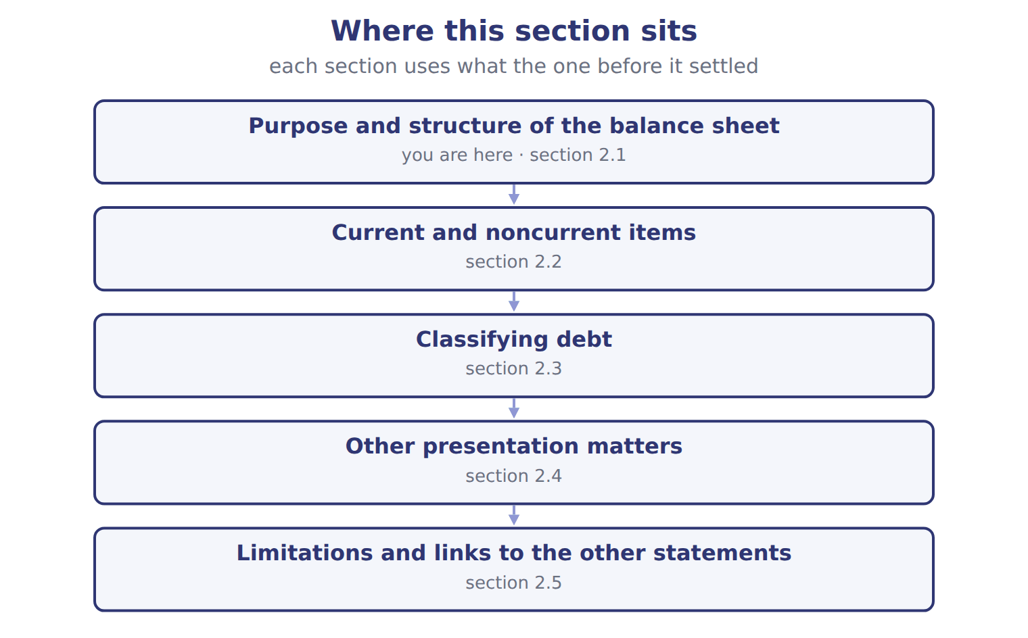
Orontes Foods Inc. (whole USD) — the book’s own table
Orontes Foods Inc. (whole USD) | Dec 31, 2025 | Dec 31, 2024
ASSETS
Current assets
Cash | 7,302,100 | 2,100,000
Trading securities | 42,000 | 40,000
Accounts receivable, net of allowance (2025: 156,000; 2024: 140,000) | 4,144,000 | 3,760,000
Inventory | 2,450,000 | 2,300,000
Prepaid expenses | 204,000 | 180,000
Assets held for sale | 46,000 | —
Total current assets | 14,188,100 | 8,380,000
Noncurrent assets

Orontes Foods Inc. (whole USD) — the book’s own table (continued)
Orontes Foods Inc. (whole USD) | Dec 31, 2025 | Dec 31, 2024
Debt securities (held-to-maturity and available-for-sale) | 88,500 | 90,000
Equity securities | 27,000 | 25,000
Equity-method investments | 1,807,000 | 500,000
Property, plant and equipment, net of accumulated depreciation (2025: 11,988,000; 2024: 8,000,000) | 14,802,000 | 16,000,000
Brand (indefinite-lived) | 260,000 | 300,000
Goodwill | 300,000 | 950,000
Other noncurrent assets | 200,000 | 200,000
TOTAL ASSETS | 31,672,600 | 26,445,000
LIABILITIES AND STOCKHOLDERS' EQUITY
Current liabilities

Orontes Foods Inc. (whole USD) — the book’s own table (continued)
Orontes Foods Inc. (whole USD) | Dec 31, 2025 | Dec 31, 2024
Accounts payable | 2,050,000 | 1,900,000
Accrued liabilities | 900,000 | 850,000
Income taxes payable | 350,000 | 300,000
Contract liabilities | 180,000 | 120,000
Dividends payable | 400,000 | —
Current portion of long-term debt | 400,000 | 400,000
Total current liabilities | 4,280,000 | 3,570,000
Long-term debt, less current portion | 6,000,000 | 5,600,000
Deferred tax liability | 999,625 | 900,000
Total liabilities | 11,279,625 | 10,070,000

Orontes Foods Inc. (whole USD) — the book’s own table (continued)
Orontes Foods Inc. (whole USD) | Dec 31, 2025 | Dec 31, 2024
Commitments and contingencies (Note 12)
Stockholders' equity
Common stock, $1 par; shares issued and outstanding: 2025 8,100,000, 2024 8,000,000 | 8,100,000 | 8,000,000
Additional paid-in capital | 5,400,000 | 4,000,000
Retained earnings | 6,894,100 | 4,375,000
Accumulated other comprehensive income (loss) | (1,125) | —
Total stockholders' equity | 20,392,975 | 16,375,000
TOTAL LIABILITIES AND STOCKHOLDERS' EQUITY | 31,672,600 | 26,445,000

READ THE MODEL Every answer is printed above. Find it, do not recall it.

5. Which part of this chapter is section 2.1?
A. Purpose and structure of the balance sheet
B. Classifying debt
C. Current and noncurrent items
D. Other presentation matters
6. Which part of this chapter is section 2.2?
A. Classifying debt
B. Other presentation matters
C. Current and noncurrent items
D. Purpose and structure of the balance sheet
7. Which part of this chapter is section 2.3?
A. Purpose and structure of the balance sheet
B. Classifying debt
C. Other presentation matters
D. Current and noncurrent items
8. Which part of this chapter is section 2.4?
A. Current and noncurrent items
B. Purpose and structure of the balance sheet
C. Other presentation matters
D. Classifying debt

APPLY No help on this move.

9. Which question does the balance sheet help users answer MOST directly?
A. How profitable was the company this year?
B. How much cash did operations produce this year?
C. What is the market value of the company?
D. Can the company pay its debts as they fall due?
10. The ability of a company to take effective action to change the amounts and timing of cash flows is called:
A. liquidity. | C. solvency.
B. financial flexibility. | D. working capital.
11. Why do U.S. SEC registrants present a classified balance sheet?
A. So users can separate short-term resources and obligations from long-term ones
B. So assets are shown at fair value
C. So equity equals the market value of the shares
D. So the balance sheet can be prepared without notes
12. Which item is a noncurrent asset?
A. Prepaid rent for the next six months
B. Trading securities
C. Inventory
D. Cash surrender value of a life insurance policy
WORK IN PAIRS | Compare every answer on this page with your partner before you read any key.
If you disagree: go back to the model and find the row that settles it. The row decides, not the louder voice.
CHECKPOINT 13. Which question does the balance sheet help users answer MOST directly?
A. How profitable was the company this year?
B. How much cash did operations produce this year?
C. What is the market value of the company?
D. Can the company pay its debts as they fall due?
If you got it wrong: redo the READ THE MODEL questions of cycle A with the model in front of you.

CYCLE B | The words this section uses precisely

ORIENT

14. A term in the exam means exactly what the book defines it to mean, whatever it means in ordinary English. TRUE / FALSE
MODEL

Account — the book’s own table
Account | Category
Prepaid rent | Current asset
Land | Noncurrent asset
Allowance for credit losses | Current asset
Dividends payable | Current liability
Additional paid-in capital | Equity

The English the exam uses, and what it translates
English (exam term) | the Arabic it translates
balance sheet | الميزانية العمومية
working capital | رأس المال العامل
liquidity | السيولة
covenant | تعهد (شرط) في اتفاقية القرض
right of setoff | حق المقاصة

READ THE MODEL

Write the letter of the Arabic term beside each English term. Every term is used once.
A تعهد (شرط) في اتفاقية القرض | D الميزانية العمومية
B حق المقاصة | E السيولة
C رأس المال العامل

15. right of setoff
16. liquidity
17. balance sheet
18. working capital
19. covenant

20. Which category does the book give for Prepaid rent?
A. Equity | C. Noncurrent asset
B. Current liability | D. Current asset
21. Which category does the book give for Land?
A. Equity | C. Current asset
B. Current liability | D. Noncurrent asset
22. Which category does the book give for Allowance for credit losses?
A. Equity | C. Noncurrent asset
B. Current liability | D. Current asset

APPLY

Orontes Foods Inc. (whole USD) — the extract for the question that follows
Orontes Foods Inc. (whole USD) | Dec 31, 2025 | Dec 31, 2024
ASSETS
Current assets
Cash | 7,302,100 | 2,100,000
Trading securities | 42,000 | 40,000
Accounts receivable, net of allowance (2025: 156,000; 2024: 140,000) | 4,144,000 | 3,760,000
Inventory | 2,450,000 | 2,300,000
Prepaid expenses | 204,000 | 180,000
Assets held for sale | 46,000 | —
Total current assets | 14,188,100 | 8,380,000
Noncurrent assets

Orontes Foods Inc. (whole USD) — the extract for the question that follows (continued)
Orontes Foods Inc. (whole USD) | Dec 31, 2025 | Dec 31, 2024
Debt securities (held-to-maturity and available-for-sale) | 88,500 | 90,000
Equity securities | 27,000 | 25,000
Equity-method investments | 1,807,000 | 500,000
Property, plant and equipment, net of accumulated depreciation (2025: 11,988,000; 2024: 8,000,000) | 14,802,000 | 16,000,000
Brand (indefinite-lived) | 260,000 | 300,000
Goodwill | 300,000 | 950,000
Other noncurrent assets | 200,000 | 200,000
TOTAL ASSETS | 31,672,600 | 26,445,000
LIABILITIES AND STOCKHOLDERS' EQUITY
Current liabilities

Orontes Foods Inc. (whole USD) — the extract for the question that follows (continued)
Orontes Foods Inc. (whole USD) | Dec 31, 2025 | Dec 31, 2024
Accounts payable | 2,050,000 | 1,900,000
Accrued liabilities | 900,000 | 850,000
Income taxes payable | 350,000 | 300,000
Contract liabilities | 180,000 | 120,000
Dividends payable | 400,000 | —
Current portion of long-term debt | 400,000 | 400,000
Total current liabilities | 4,280,000 | 3,570,000
Long-term debt, less current portion | 6,000,000 | 5,600,000
Deferred tax liability | 999,625 | 900,000
Total liabilities | 11,279,625 | 10,070,000

Orontes Foods Inc. (whole USD) — the extract for the question that follows (continued)
Orontes Foods Inc. (whole USD) | Dec 31, 2025 | Dec 31, 2024
Commitments and contingencies (Note 12)
Stockholders' equity
Common stock, $1 par; shares issued and outstanding: 2025 8,100,000, 2024 8,000,000 | 8,100,000 | 8,000,000
Additional paid-in capital | 5,400,000 | 4,000,000
Retained earnings | 6,894,100 | 4,375,000
Accumulated other comprehensive income (loss) | (1,125) | —
Total stockholders' equity | 20,392,975 | 16,375,000
TOTAL LIABILITIES AND STOCKHOLDERS' EQUITY | 31,672,600 | 26,445,000

23. The extract for this question is printed with it. What is Orontes's working capital at December 31, 2025 (whole USD)?
A. 2,908,475 | C. 10,064,100
B. 9,908,100 | D. 10,308,100
24. The extract for this question is printed with it. What is Orontes's current ratio at December 31, 2025?
A. 0.30 | C. 3.31
B. 2.35 | D. 3.62
CHECKPOINT 25. What is the safest way to settle a disagreement about an answer on this sheet?
A. find the row of the model that decides it
B. take the answer of whoever is more confident
C. leave it until the lecturer says
D. choose the longer option
If you got it wrong: redo the READ THE MODEL questions of cycle B.

FROM MEMORY | Close the earlier pages first.
26. Rebuild the figure from this handout. Label every part and fill in every box.
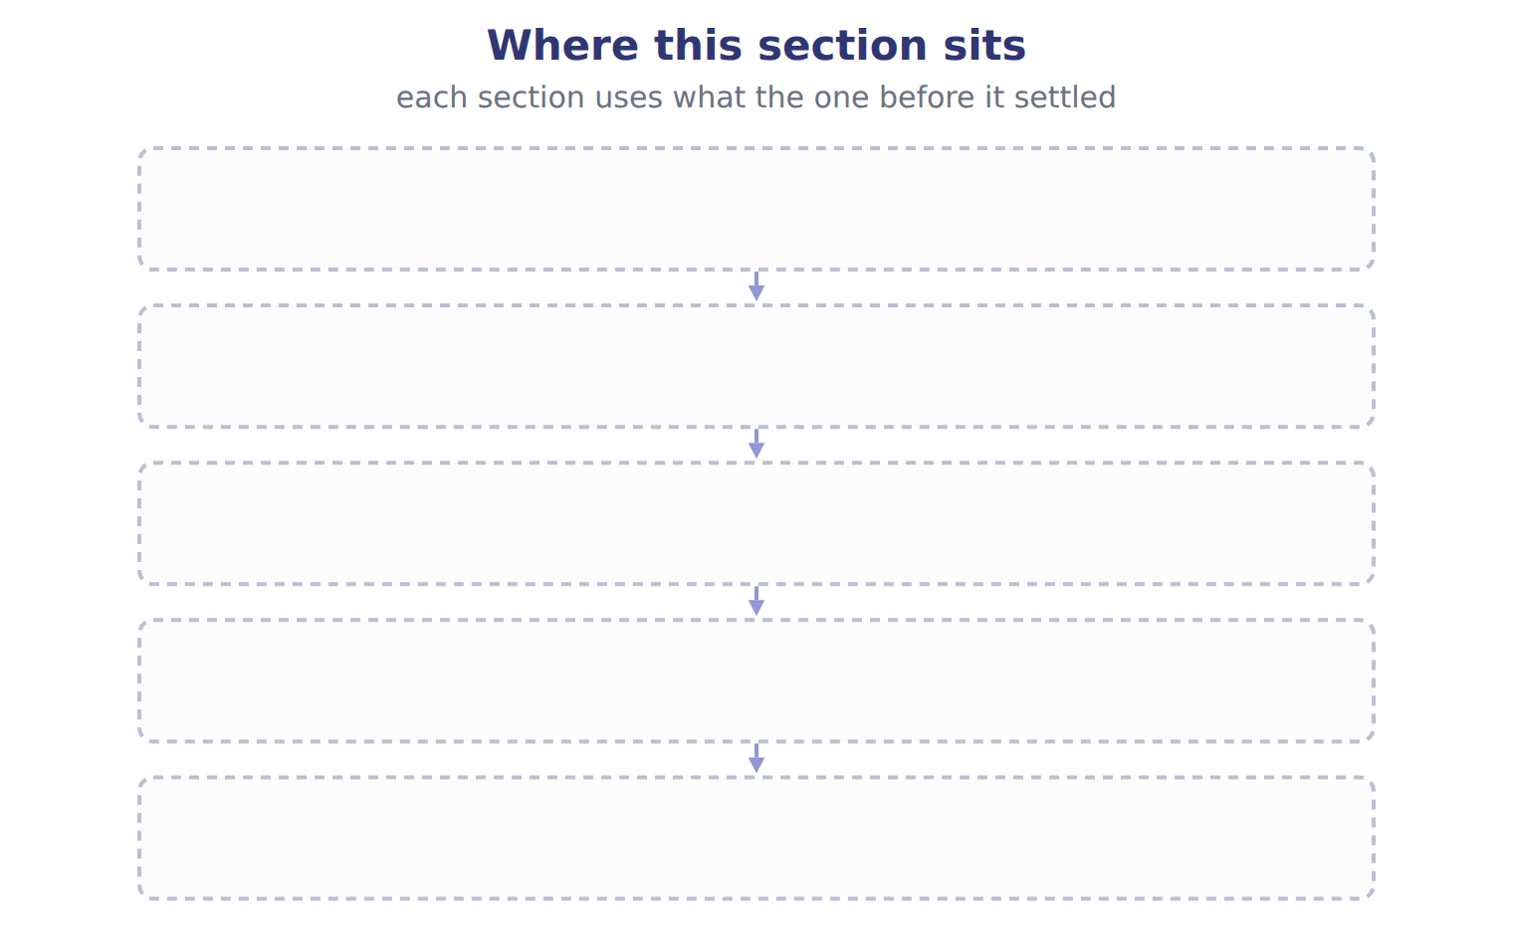
TEACH IT BACK | Write it for a classmate who missed this session — not for the marker.
27. In three or four sentences, write what this section settles and the one rule a reader has to take away.
every one of these words must appear: balance sheet · working capital · liquidity · covenant

Answer key · Handout 2.1 · Purpose and structure of the balance sheet

1 balance sheet · liquidity · solvency | 10 B | 19 A
2 liquidity · Current assets | 11 A | 20 D
3 liquidity · solvency · financial flexibility | 12 D | 21 D
4 T | 13 D | 22 D
5 A | 14 T | 23 B
6 C | 15 B | 24 C
7 B | 16 E | 25 A
8 C | 17 D | 26 Compare with the model earlier in this handout.
9 D | 18 C | 27 The balance sheet reports a company's assets, liabilities and equity at one point in time. It answers three questions for investors and lenders. Can the company pay its bills in the coming months? This is liquidity. Can it pay all its debts over time? This is solvency. Can it raise cash or change its plans if something unexpected happens? This is financial f

why
1 The book writes: “The balance sheet reports a company's assets, liabilities and equity at one point in time. It answers three questions for investors and lenders. Can the company pay its bills in the coming months? This is liquidity. Can it pay all its debts over time? This is solvency.”
2 The book writes: “Some companies, such as banks, list items in order of liquidity instead, without a current subtotal. All the amounts come from the same records as the earlier chapters on receivables, inventory, investments and long-lived assets. For example, the equity-method investments include Jordan Glass Co. Current assets come first, from cash down to assets held for sale.”
3 The book writes: “Can the company pay its bills in the coming months? This is liquidity. Can it pay all its debts over time? This is solvency. Can it raise cash or change its plans if something unexpected happens? This is financial flexibility.”
4 The framework defines the elements, and every amount belongs to one of them.
5 The book numbers “Purpose and structure of the balance sheet” as section 2.1.
6 The book numbers “Current and noncurrent items” as section 2.2.
7 The book numbers “Classifying debt” as section 2.3.
8 The book numbers “Other presentation matters” as section 2.4.
9 The balance sheet shows resources and obligations for judging liquidity and solvency. A is wrong: Profitability is shown on the income statement. B is wrong: Operating cash flow is on the statement of cash flows.
10 Financial flexibility is the ability to respond to unexpected needs and opportunities. A is wrong: Liquidity is about meeting short-term obligations. C is wrong: Solvency is about meeting all obligations over time.
11 Classification shows the short-term position clearly. B is wrong: Classification does not change measurement. C is wrong: Equity is a book amount.
12 Cash surrender value is excluded from current assets. A is wrong: Prepaid rent for six months will be used up within a year. B is wrong: Trading securities are held for sale soon.
13 The balance sheet shows resources and obligations for judging liquidity and solvency. A is wrong: Profitability is shown on the income statement. B is wrong: Operating cash flow is on the statement of cash flows.
14 CMA questions use exact terms, and one word can change the answer.
20 The book’s own table gives Current asset as the category of Prepaid rent.
21 The book’s own table gives Noncurrent asset as the category of Land.
22 The book’s own table gives Current asset as the category of Allowance for credit losses.
23 $14,188,100 − $4,280,000 = $9,908,100. A is wrong: This subtracts total liabilities. C is wrong: This adds back the allowance; receivables are included net.
24 $14,188,100 ÷ $4,280,000. A is wrong: This divides current liabilities by current assets. B is wrong: This is the 2024 ratio.
25 Every item on a Workshop sheet is settled by something printed on the same sheet.

Handout 2.2
Current and noncurrent items
section 2.2 of the book
Before you start
Three summaries of this handout, in the book’s own words. Read all three first: together they are the whole session. Then fill the gaps, guessing where you have to.

What this handout settles, cycle by cycle
In this handout | What you will read | How you check it
Current and noncurrent items | a figure to read · Item · the book’s own rule, gapped | A lender wants to know if Orontes can pay the bills that fall due in the next few months. Which quality is the lender assessing?
The words this section uses precisely | Item · The English the exam uses, and what it translates | What is the safest way to settle a disagreement about an answer on this sheet?

Words this handout uses precisely
Words this handout uses precisely | tick it if you could already use it in a sentence
classified balance sheet
current portion of long-term debt
solvency
waiver

1. Where the section starts — Fill every gap. The list holds more words than there are gaps, so one or two of them are not used.
choose from: Current liabilities · current assets · operating cycle · grace period · solvency
The is the average time from buying materials to collecting cash from customers. are obligations the company expects to settle by using or by creating other current liabilities.
2. What it settles in the middle — Fill every gap. The list holds more words than there are gaps, so one or two of them are not used.
choose from: current ratio · solvency · current assets · current liabilities · current portion of long-term debt · grace period · Working capital
On the liability side, is current, because that part of the principal is due within a year. Two measures come directly from these totals. is minus . The is current assets divided by current liabilities.
3. Where it ends — Fill every gap. The list holds more words than there are gaps, so one or two of them are not used.
choose from: solvency · working capital · current assets · current ratio · grace period · current liabilities
Paying a supplier in cash reduces and by the same amount: does not change, but the changes. Reclassifying debt from current to noncurrent increases working capital and the current ratio.

CYCLE A | Current and noncurrent items

ORIENT One claim. Decide now; you will check it in a moment.

4. The book gives the classification of Cash set aside in a sinking fund to repay bonds in 2029 as “Noncurrent asset”. TRUE / FALSE
MODEL Read it before you answer anything below it.

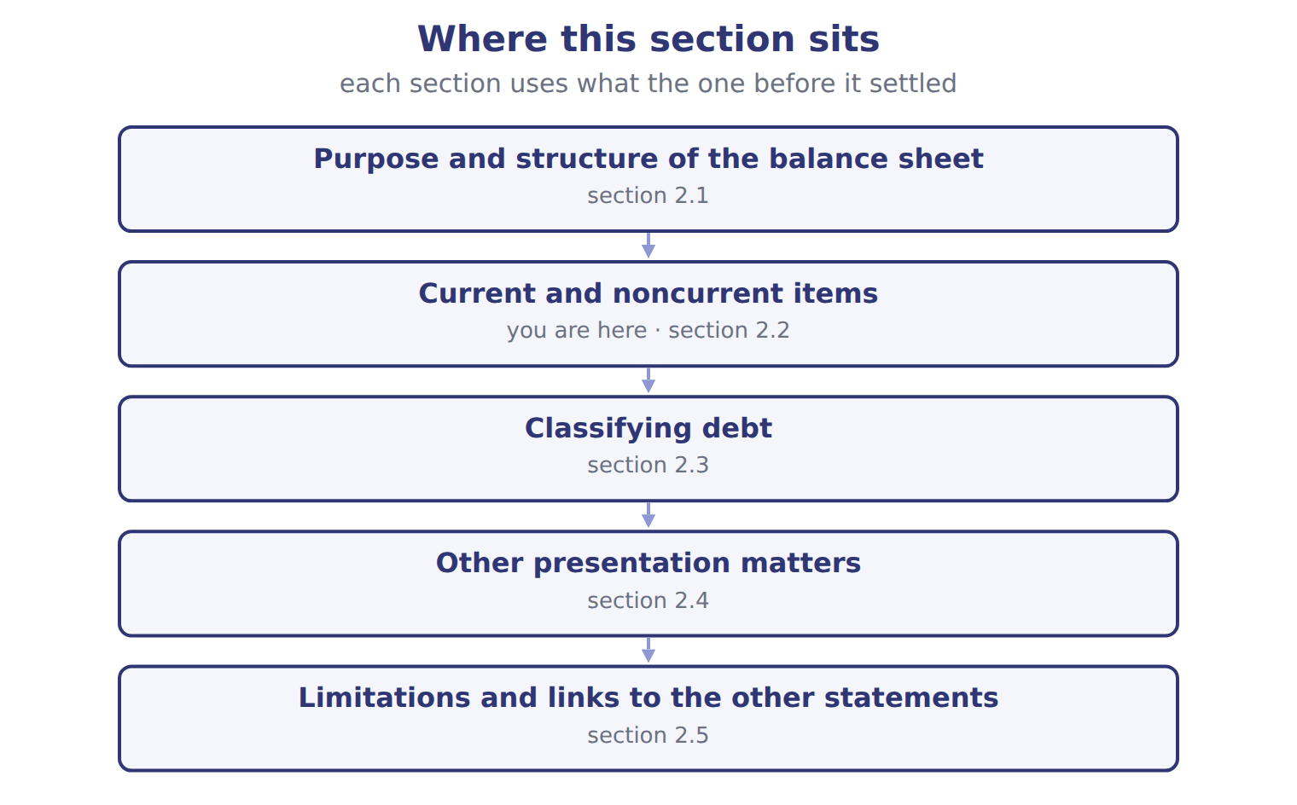

Item — the book’s own table
Item | Classification | Reason
Cash set aside in a sinking fund to repay bonds in 2029 | Noncurrent asset | Restricted for a noncurrent purpose
Date vinegar that Orontes ages for 18 months before sale | Current asset | The operating cycle is longer than one year, so the cycle applies
Cash surrender value of an executive life insurance policy | ________ | ________
Bank loan due on demand; the bank has never asked for repayment | ________ | ________
Deferred tax asset from warranty costs expected to reverse next year | ________ | ________
Customer deposits for orders to be delivered next month | ________ | ________

READ THE MODEL Every answer is printed above. Find it, do not recall it.

5. Which classification does the book give for Cash set aside in a sinking fund to repay bonds in 2029?
A. Current asset | C. Noncurrent asset
B. ________
6. Which classification does the book give for Date vinegar that Orontes ages for 18 months before sale?
A. Noncurrent asset | C. Current asset
B. ________
7. Which classification does the book give for Cash surrender value of an executive life insurance policy?
A. Noncurrent asset | C. ________
B. Current asset
8. Which classification does the book give for Bank loan due on demand; the bank has never asked for repayment?
A. Current asset | C. ________
B. Noncurrent asset
9. The book gives the reason of Cash set aside in a sinking fund to repay bonds in 2029 as “Restricted for a noncurrent purpose”. TRUE / FALSE
10. The book gives the reason of Date vinegar that Orontes ages for 18 months before sale as “________”. TRUE / FALSE
INVENT THE RULE

11. Complete the book’s own sentence. The list holds more words than there are gaps.
use every one of these words: working capital · grace period · current assets · current liabilities · classified balance sheet
Paying a supplier in cash reduces and by the same amount: does not change, but the current ratio changes.

Two of the book’s own cases, side by side
Cash set aside in a sinking fund to repay bonds in 2029 | Cash surrender value of an executive life insurance policy
Classification: Noncurrent asset | Classification: ________
Only the facts above differ. What is the reason of Cash set aside in a sinking fund to repay bonds in 2029?
12. Choose one:
A. Restricted for a noncurrent purpose
B. ________
C. both of them
D. neither of them
APPLY No help on this move.

13. A cheese maker ages its cheese for two years before sale. How does it classify its cheese inventory?
A. Noncurrent, because it will not be sold within one year
B. Current, because its operating cycle is longer than one year
C. Half current, half noncurrent
D. Noncurrent until the last year of aging
14. Early in 2026, Orontes pays $500,000 of accounts payable in cash. What happens to its working capital and its current ratio of 3.31?
A. Both fall
B. Working capital falls; the current ratio does not change
C. Working capital does not change; the current ratio rises to 3.62
D. Neither changes
15. A company with a current ratio of 0.8 borrows cash on a 90-day note. What is the effect on the current ratio?
A. It increases | C. It does not change
B. It decreases | D. It cannot be determined
16. At December 31, 2025, a company violates a covenant and its long-term loan becomes callable. On February 10, 2026, before the statements are issued, the lender waives its rights until June 2027. Under U.S. GAAP the loan is:
A. current, because the waiver came after year-end.
B. current, because the violation happened.
C. split: half current, half noncurrent.
D. noncurrent.
17. A bank loan is due on demand. The bank has never asked for repayment and the company does not expect it to. The loan is classified as:
A. noncurrent.
B. current.
C. noncurrent unless the bank demands payment.
D. equity.

Orontes Foods Inc. (whole USD) — the extract for the question that follows
Orontes Foods Inc. (whole USD) | Dec 31, 2025 | Dec 31, 2024
ASSETS
Current assets
Cash | 7,302,100 | 2,100,000
Trading securities | 42,000 | 40,000
Accounts receivable, net of allowance (2025: 156,000; 2024: 140,000) | 4,144,000 | 3,760,000
Inventory | 2,450,000 | 2,300,000
Prepaid expenses | 204,000 | 180,000
Assets held for sale | 46,000 | —
Total current assets | 14,188,100 | 8,380,000
Noncurrent assets

Orontes Foods Inc. (whole USD) — the extract for the question that follows (continued)
Orontes Foods Inc. (whole USD) | Dec 31, 2025 | Dec 31, 2024
Debt securities (held-to-maturity and available-for-sale) | 88,500 | 90,000
Equity securities | 27,000 | 25,000
Equity-method investments | 1,807,000 | 500,000
Property, plant and equipment, net of accumulated depreciation (2025: 11,988,000; 2024: 8,000,000) | 14,802,000 | 16,000,000
Brand (indefinite-lived) | 260,000 | 300,000
Goodwill | 300,000 | 950,000
Other noncurrent assets | 200,000 | 200,000
TOTAL ASSETS | 31,672,600 | 26,445,000
LIABILITIES AND STOCKHOLDERS' EQUITY
Current liabilities

Orontes Foods Inc. (whole USD) — the extract for the question that follows (continued)
Orontes Foods Inc. (whole USD) | Dec 31, 2025 | Dec 31, 2024
Accounts payable | 2,050,000 | 1,900,000
Accrued liabilities | 900,000 | 850,000
Income taxes payable | 350,000 | 300,000
Contract liabilities | 180,000 | 120,000
Dividends payable | 400,000 | —
Current portion of long-term debt | 400,000 | 400,000
Total current liabilities | 4,280,000 | 3,570,000
Long-term debt, less current portion | 6,000,000 | 5,600,000
Deferred tax liability | 999,625 | 900,000
Total liabilities | 11,279,625 | 10,070,000

Orontes Foods Inc. (whole USD) — the extract for the question that follows (continued)
Orontes Foods Inc. (whole USD) | Dec 31, 2025 | Dec 31, 2024
Commitments and contingencies (Note 12)
Stockholders' equity
Common stock, $1 par; shares issued and outstanding: 2025 8,100,000, 2024 8,000,000 | 8,100,000 | 8,000,000
Additional paid-in capital | 5,400,000 | 4,000,000
Retained earnings | 6,894,100 | 4,375,000
Accumulated other comprehensive income (loss) | (1,125) | —
Total stockholders' equity | 20,392,975 | 16,375,000
TOTAL LIABILITIES AND STOCKHOLDERS' EQUITY | 31,672,600 | 26,445,000

18. The extract for this question is printed with it. What was Orontes's working capital at December 31, 2024 (whole USD)?
A. (1,690,000) | C. 8,380,000
B. 4,810,000 | D. 9,908,100
WORK IN PAIRS | Compare every answer on this page with your partner before you read any key.
If you disagree: go back to the model and find the row that settles it. The row decides, not the louder voice.
CHECKPOINT 19. A lender wants to know if Orontes can pay the bills that fall due in the next few months. Which quality is the lender assessing?
A. Liquidity
B. Solvency
C. Profitability
D. Financial flexibility
If you got it wrong: redo the READ THE MODEL questions of cycle A with the model in front of you.

CYCLE B | The words this section uses precisely

ORIENT

20. A term in the exam means exactly what the book defines it to mean, whatever it means in ordinary English. TRUE / FALSE
MODEL

Item — the book’s own table
Item | Answer
Cash surrender value | Noncurrent asset: it is not expected to be turned into cash in the operating cycle.
Loan due on demand | Current liability: debt due on demand is current, whatever the bank's expected behaviour.
Deferred tax asset | Noncurrent asset: all deferred taxes are noncurrent.
Customer deposits | Current liability (contract liability): it will be settled by delivering goods within a year.

The English the exam uses, and what it translates
English (exam term) | the Arabic it translates
classified balance sheet | قائمة المركز المالي المبوبة
current portion of long-term debt | الجزء المتداول من الديون طويلة الأجل
solvency | الملاءة المالية
waiver | تنازل (إعفاء) من الدائن

READ THE MODEL

Write the letter of the Arabic term beside each English term. Every term is used once.
A الجزء المتداول من الديون طويلة الأجل
B تنازل (إعفاء) من الدائن
C قائمة المركز المالي المبوبة
D الملاءة المالية

21. solvency
22. current portion of long-term debt
23. classified balance sheet
24. waiver

25. Which item does the book pair with “Noncurrent asset: it is not expected to be turned into cash in the operating cycle.”?
A. Deferred tax asset | C. Cash surrender value
B. Loan due on demand | D. Customer deposits
26. Which item does the book pair with “Current liability: debt due on demand is current, whatever the bank's expected behaviour.”?
A. Cash surrender value | C. Loan due on demand
B. Deferred tax asset | D. Customer deposits
27. Which item does the book pair with “Noncurrent asset: all deferred taxes are noncurrent.”?
A. Loan due on demand | C. Deferred tax asset
B. Customer deposits | D. Cash surrender value
APPLY

28. Which heading is correct for Orontes's balance sheet?
A. Balance sheet for the year ended December 31, 2025
B. Balance sheet for the period January 1 to December 31, 2025
C. Balance sheet as of December 31, 2025
D. Balance sheet for 2025
29. At December 31, 2025, a company has a $5 million note due in April 2026. On February 1, 2026, before the statements are issued, it issues 10-year bonds and uses the cash to repay the note. Under U.S. GAAP the note is:
A. current, because the bonds were issued after year-end
B. noncurrent, because it was refinanced before issuance
C. current, because refinancing is never allowed
D. shown in equity
30. A loan agreement lets the lender demand repayment if there is a 'material adverse change'. The company is healthy and acceleration is remote. The long-term loan is:
A. noncurrent. | C. current, with a note.
B. current. | D. noncurrent only under IFRS.

CHECKPOINT 31. What is the safest way to settle a disagreement about an answer on this sheet?
A. find the row of the model that decides it
B. take the answer of whoever is more confident
C. leave it until the lecturer says
D. choose the longer option
If you got it wrong: redo the READ THE MODEL questions of cycle B.

FROM MEMORY | Close the earlier pages first.
32. Rebuild the figure from this handout. Label every part and fill in every box.
TEACH IT BACK | Write it for a classmate who missed this session — not for the marker.
33. In three or four sentences, write what this section settles and the one rule a reader has to take away.
every one of these words must appear: classified balance sheet · current portion of long-term debt · solvency · waiver

Answer key · Handout 2.2 · Current and noncurrent items

1 operating cycle · Current liabilities · current assets | 12 A | 23 C
2 current portion of long-term debt · Working capital · current assets · current liabilities · current ratio | 13 B | 24 B
3 current assets · current liabilities · working capital · current ratio | 14 C | 25 C
4 T | 15 A | 26 C
5 C | 16 D | 27 C
6 C | 17 B | 28 C
7 C | 18 B | 29 B
8 C | 19 A | 30 A
9 T | 20 T | 31 A
10 F | 21 D | 32 Compare with the model earlier in this handout.
11 current assets · current liabilities · working capital | 22 A | 33 Current assets are cash and other assets that the company expects to turn into cash, sell or use up within one year or within its operating cycle, whichever is longer. The operating cycle is the average time from buying materials to collecting cash from customers. Current liabilities are obligations the company expects to settle by using current assets or by

11 what the book says
Paying a supplier in cash reduces current assets and current liabilities by the same amount: working capital does not change, but the current ratio changes.

why
1 The book writes: “The operating cycle is the average time from buying materials to collecting cash from customers. Current liabilities are obligations the company expects to settle by using current assets or by creating other current liabilities.”
2 The book writes: “On the liability side, current portion of long-term debt is current, because that part of the principal is due within a year. Two measures come directly from these totals. Working capital is current assets minus current liabilities. The current ratio is current assets divided by current liabilities.”
3 The book writes: “Paying a supplier in cash reduces current assets and current liabilities by the same amount: working capital does not change, but the current ratio changes. Reclassifying debt from current to noncurrent increases working capital and the current ratio.”
4 The book pairs Cash set aside in a sinking fund to repay bonds in 2029 with “Noncurrent asset”.
5 The book’s own table gives Noncurrent asset as the classification of Cash set aside in a sinking fund to repay bonds in 2029.
6 The book’s own table gives Current asset as the classification of Date vinegar that Orontes ages for 18 months before sale.
7 The book’s own table gives ________ as the classification of Cash surrender value of an executive life insurance policy.
8 The book’s own table gives ________ as the classification of Bank loan due on demand; the bank has never asked for repayment.
9 The book pairs Cash set aside in a sinking fund to repay bonds in 2029 with “Restricted for a noncurrent purpose”.
10 The book pairs Date vinegar that Orontes ages for 18 months before sale with “The operating cycle is longer than one year, so the cycle applies”, not with “________”.
12 The book gives Restricted for a noncurrent purpose as the reason of Cash set aside in a sinking fund to repay bonds in 2029.
13 Current means one year or the operating cycle, whichever is longer. A is wrong: The one-year test applies only when the operating cycle is shorter. C is wrong: Inventory in the normal cycle is not split.
14 Current assets and current liabilities fall by the same amount; with a ratio above 1, the ratio rises. A is wrong: Working capital is unchanged because both sides fall equally. B is wrong: Working capital is the difference, which does not change; the ratio does.
15 Adding the same amount to both terms moves a ratio below 1 toward 1. B is wrong: A ratio falls only if it starts above 1. C is wrong: Equal changes leave working capital, not the ratio, unchanged.
16 A waiver for more than one year obtained before issuance keeps the debt noncurrent. A is wrong: This is the IFRS answer. B is wrong: The waiver removes the lender's right to demand payment.
17 Debt due on demand is current regardless of expectations. A is wrong: The lender's legal right, not expected behaviour, decides. C is wrong: The right to demand payment makes it current now.
18 Current assets of $8,380,000 minus current liabilities of $3,570,000. A is wrong: This subtracts total liabilities, not current liabilities. C is wrong: These are current assets only; current liabilities are not deducted.
19 Liquidity is the ability to pay short-term obligations as they fall due. B is wrong: Solvency is about paying all debts over the long term. C is wrong: Profitability is measured on the income statement, not by short-term payment ability.
20 CMA questions use exact terms, and one word can change the answer.
25 The book’s own table pairs Cash surrender value with “Noncurrent asset: it is not expected to be turned into cash in the operating cycle.”.

Handout 2.3
Classifying debt
section 2.3 of the book
Before you start
Three summaries of this handout, in the book’s own words. Read all three first: together they are the whole session. Then fill the gaps, guessing where you have to.

What this handout settles, cycle by cycle
In this handout | What you will read | How you check it
Classifying debt | a figure to read · Situation at the reporting date | A loss from a lawsuit is probable. Lawyers estimate it at between $40,000 and $100,000, with no amount more likely than another. Under U.S. GAAP the company accrues:
The words this section uses precisely | The English the exam uses, and what it translates | What is the safest way to settle a disagreement about an answer on this sheet?

Words this handout uses precisely
Words this handout uses precisely | tick it if you could already use it in a sentence
current assets
callable debt
financial flexibility
grace period

1. Where the section starts — Fill every gap. The list holds more words than there are gaps, so one or two of them are not used.
choose from: grace period · subsequent events · callable debt · covenant · solvency · waiver
If a company breaks a , the lender may be able to demand repayment at once. Such is current, even if the company does not expect the lender to act. It stays noncurrent only if, before the statements are issued, the lender gives a for more than one year, or a exists and the company will probably cure the violation within it.
2. What it settles in the middle — Fill every gap. The list holds more words than there are gaps, so one or two of them are not used.
choose from: solvency · subsequent events · refinancing · waiver
Decision tree for classifying debt as current or noncurrent under U.S. IAS 1 asks one question: at the reporting date, does the company have a right to defer settlement for at least twelve months? A or obtained after the reporting date does not count.
3. Where it ends — Fill every gap. The list holds more words than there are gaps, so one or two of them are not used.
choose from: waiver · covenant · solvency · subsequent events
SC2-5 A five-year loan is repaid in equal annual installments. SC2-6 At December 31 a company breaks a loan , so the loan is payable on demand. On January 15, before the statements are issued, the bank gives an 18-month .

CYCLE A | Classifying debt

ORIENT One claim. Decide now; you will check it in a moment.

4. Every number in a financial statement belongs to an element the framework defines. TRUE / FALSE
MODEL Read it before you answer anything below it.

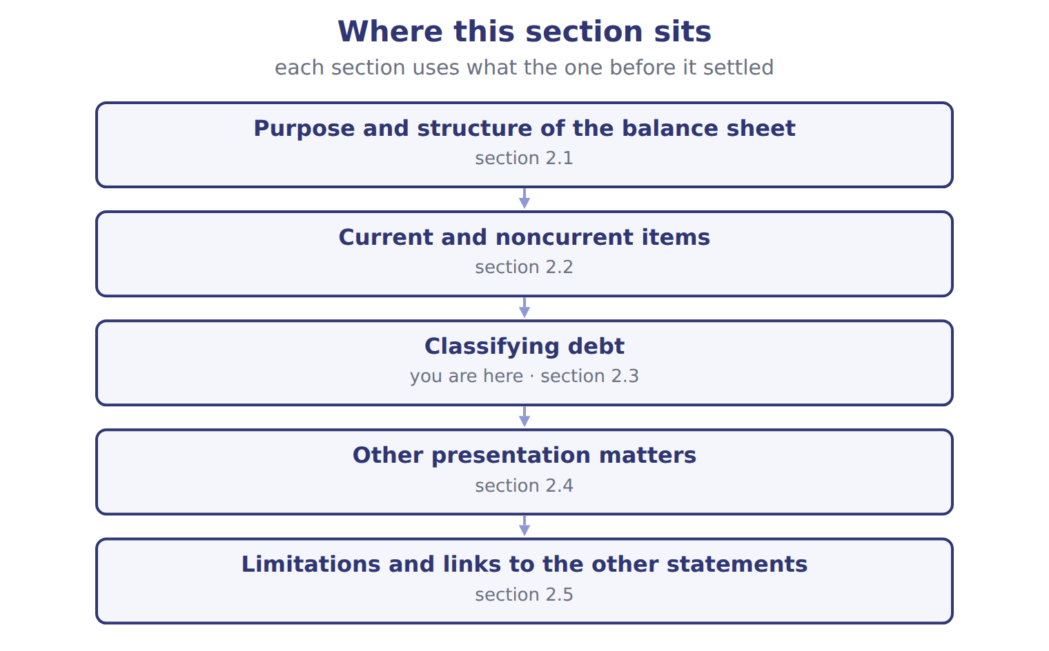

Situation at the reporting date — the book’s own table
Situation at the reporting date | U.S. GAAP (ASC 470-10) | IFRS (IAS 1)
Short-term debt refinanced long-term after year-end, before issuance | Noncurrent (intent and demonstrated ability) | Current (no right to defer at the reporting date)
Covenant broken at year-end; waiver for more than 12 months obtained after year-end | Noncurrent | Current
Covenant broken at year-end; waiver obtained on or before year-end | Noncurrent | Noncurrent
Covenant tested only after year-end (future compliance doubtful) | Noncurrent; disclose | Noncurrent; disclose the risk
Subjective acceleration clause | Current only if acceleration is probable | Ignored unless it removes the right to defer
Deferred tax assets and liabilities | All noncurrent | All non-current

READ THE MODEL Every answer is printed above. Find it, do not recall it.

5. Which part of this chapter is section 2.1?
A. Purpose and structure of the balance sheet
B. Classifying debt
C. Current and noncurrent items
D. Other presentation matters
6. Which part of this chapter is section 2.2?
A. Classifying debt
B. Other presentation matters
C. Current and noncurrent items
D. Purpose and structure of the balance sheet
7. Which part of this chapter is section 2.3?
A. Purpose and structure of the balance sheet
B. Classifying debt
C. Other presentation matters
D. Current and noncurrent items
8. Which part of this chapter is section 2.4?
A. Current and noncurrent items
B. Purpose and structure of the balance sheet
C. Other presentation matters
D. Classifying debt

APPLY No help on this move.

9. A loss from a lawsuit is probable. Lawyers estimate it at between $40,000 and $100,000, with no amount more likely than another. Under U.S. GAAP the company accrues:
A. $70,000
B. $100,000
C. nothing, and discloses the range
D. $40,000 and discloses the possible additional loss
10. On January 20, before the statements are issued, a customer that owed $80,000 at December 31 goes bankrupt. Its finances had been getting worse for months. What does the company do?
A. Adjusts the year-end allowance for credit losses
B. Discloses the event only
C. Records the loss next year
D. Does nothing
11. A company has a deferred tax asset that will reverse next year. On a U.S. GAAP balance sheet it is shown as:
A. a current asset.
B. a noncurrent asset.
C. a reduction of income taxes payable.
D. split between current and noncurrent.
12. Which item is NOT usually recorded on the balance sheet?
A. A brand the company bought
B. Goodwill from an acquisition
C. A brand the company developed itself
D. Equipment under a finance lease
WORK IN PAIRS | Compare every answer on this page with your partner before you read any key.
If you disagree: go back to the model and find the row that settles it. The row decides, not the louder voice.
CHECKPOINT 13. A loss from a lawsuit is probable. Lawyers estimate it at between $40,000 and $100,000, with no amount more likely than another. Under U.S. GAAP the company accrues:
A. $70,000
B. $100,000
C. nothing, and discloses the range
D. $40,000 and discloses the possible additional loss
If you got it wrong: redo the READ THE MODEL questions of cycle A with the model in front of you.

CYCLE B | The words this section uses precisely

ORIENT

14. A term in the exam means exactly what the book defines it to mean, whatever it means in ordinary English. TRUE / FALSE

MODEL

The English the exam uses, and what it translates
English (exam term) | the Arabic it translates
current assets | الأصول المتداولة
callable debt | دين قابل للاستدعاء (مستحق عند الطلب)
financial flexibility | المرونة المالية
grace period | فترة سماح

READ THE MODEL

Write the letter of the Arabic term beside each English term. Every term is used once.
A دين قابل للاستدعاء (مستحق عند الطلب)
B فترة سماح
C المرونة المالية
D الأصول المتداولة

15. current assets
16. financial flexibility
17. grace period
18. callable debt

APPLY

19. A company delays paying its suppliers until January so that its December 31 balance sheet shows more cash. This illustrates which limitation?
A. The balance sheet uses historical cost
B. The balance sheet omits internally developed intangibles
C. The balance sheet relies on estimates
D. The balance sheet shows only one date
20. Orontes's total stockholders' equity at December 31, 2025 is $20,392,975. This amount is:
A. the market value of Orontes's shares
B. the cash the owners could take out today
C. the price a buyer would pay for Orontes
D. a book amount based mostly on historical cost
CHECKPOINT 21. What is the safest way to settle a disagreement about an answer on this sheet?
A. find the row of the model that decides it
B. take the answer of whoever is more confident
C. leave it until the lecturer says
D. choose the longer option
If you got it wrong: redo the READ THE MODEL questions of cycle B.

FROM MEMORY | Close the earlier pages first.
22. Rebuild the figure from this handout. Label every part and fill in every box.
TEACH IT BACK | Write it for a classmate who missed this session — not for the marker.
23. In three or four sentences, write what this section settles and the one rule a reader has to take away.
every one of these words must appear: current assets · callable debt · financial flexibility · grace period

Answer key · Handout 2.3 · Classifying debt

1 covenant · callable debt · waiver · grace period | 9 D | 17 B
2 waiver · refinancing | 10 A | 18 A
3 covenant · waiver | 11 B | 19 D
4 T | 12 C | 20 D
5 A | 13 D | 21 A
6 C | 14 T | 22 Compare with the model earlier in this handout.
7 B | 15 D | 23 Debt is where classification gets difficult, and where the exam likes to test. Long-term debt that is due in installments is split: the current portion of long-term debt is current and the rest is noncurrent. Orontes shows $400,000 as current and $6,000,000 as long-term.
8 C | 16 C

why
1 The book writes: “If a company breaks a covenant, the lender may be able to demand repayment at once. Such callable debt is current, even if the company does not expect the lender to act. It stays noncurrent only if, before the statements are issued, the lender gives a waiver for more than one year, or a grace period exists and the company will probably cure the violation within it.”
2 The book writes: “Decision tree for classifying debt as current or noncurrent under U.S. IAS 1 asks one question: at the reporting date, does the company have a right to defer settlement for at least twelve months? A waiver or refinancing obtained after the reporting date does not count.”
3 The book writes: “SC2-5 A five-year loan is repaid in equal annual installments. SC2-6 At December 31 a company breaks a loan covenant, so the loan is payable on demand. On January 15, before the statements are issued, the bank gives an 18-month waiver.”
4 The framework defines the elements, and every amount belongs to one of them.
5 The book numbers “Purpose and structure of the balance sheet” as section 2.1.
6 The book numbers “Current and noncurrent items” as section 2.2.
7 The book numbers “Classifying debt” as section 2.3.
8 The book numbers “Other presentation matters” as section 2.4.
9 With no best estimate in the range, U.S. GAAP accrues the minimum. A is wrong: The midpoint is the IFRS approach. B is wrong: The maximum is not required.
10 The condition, the customer's weak finances, existed at year-end, so it is a recognized event. B is wrong: Disclosure only is for conditions that arose after year-end. C is wrong: The loss belongs to the year in which the condition existed.
11 All deferred tax assets and liabilities are noncurrent. A is wrong: The old current/noncurrent split was removed. C is wrong: It cannot be offset against taxes payable without a right of setoff.
12 Internally developed intangibles are not recognized as assets. A is wrong: A purchased brand is recorded at its cost. B is wrong: Acquired goodwill is recorded.
13 With no best estimate in the range, U.S. GAAP accrues the minimum. A is wrong: The midpoint is the IFRS approach. B is wrong: The maximum is not required.
14 CMA questions use exact terms, and one word can change the answer.
19 Year-end amounts can be managed because the statement shows a single day. A is wrong: Cash and payables are not measured at historical cost in this sense. B is wrong: No intangible is involved.
20 Equity is assets minus liabilities as recorded. A is wrong: Market value depends on share prices, not on book amounts. B is wrong: Equity is not a cash amount.
21 Every item on a Workshop sheet is settled by something printed on the same sheet.

Handout 2.4
Other presentation matters
section 2.4 of the book
Before you start
Three summaries of this handout, in the book’s own words. Read all three first: together they are the whole session. Then fill the gaps, guessing where you have to.

What this handout settles, cycle by cycle
In this handout | What you will read | How you check it
Other presentation matters | a figure to read · Likelihood of the loss · the book’s own rule, gapped | Orontes's retained earnings were $4,375,000 on January 1, 2025. Net income was $2,969,100, OCI was $(1,125), and dividends declared were $450,000. What are retained earnings at December 31, 2025 (whole USD)?
The words this section uses precisely | The English the exam uses, and what it translates | What is the safest way to settle a disagreement about an answer on this sheet?

Words this handout uses precisely
Words this handout uses precisely | tick it if you could already use it in a sentence
current liabilities
loss contingency
current ratio
subjective acceleration clause

1. Where the section starts — Fill every gap. The list holds more words than there are gaps, so one or two of them are not used.
choose from: subsequent events · solvency · loss contingency · balance sheet
A few more rules decide what appears on the and how. All deferred tax assets and liabilities are noncurrent. A is an existing situation that may cause a loss, such as a lawsuit.
2. What it settles in the middle — Fill every gap. The list holds more words than there are gaps, so one or two of them are not used.
choose from: Subsequent events · balance sheet · liquidity · solvency
Gain contingencies are never recorded before they are realized. happen after the date but before the statements are issued. If an event gives more information about a condition that already existed at year-end, the company adjusts the statements.
3. Where it ends — Fill every gap. The list holds more words than there are gaps, so one or two of them are not used.
choose from: balance sheet · solvency · Subsequent events · liquidity
If it is only reasonably possible, the company discloses it in a note. If it is remote, the company does nothing. Gain contingencies are never recorded before they are realized. happen after the date but before the statements are issued.

CYCLE A | Other presentation matters

ORIENT One claim. Decide now; you will check it in a moment.

4. Every number in a financial statement belongs to an element the framework defines. TRUE / FALSE
MODEL Read it before you answer anything below it.

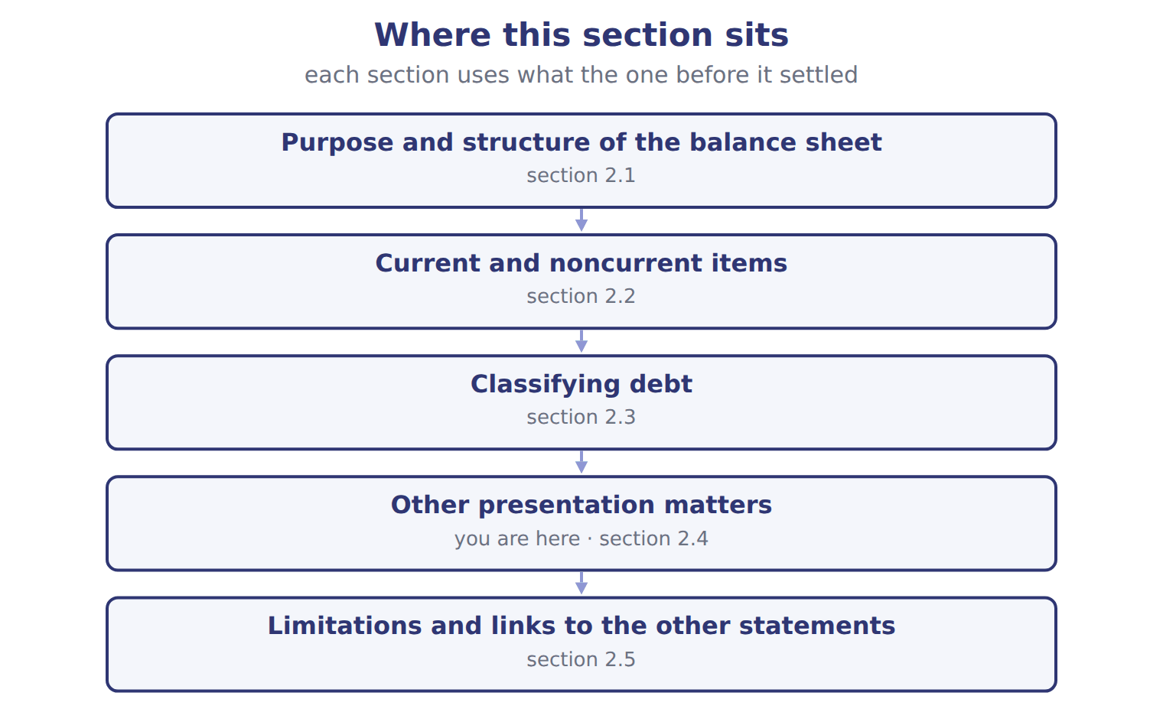

Likelihood of the loss — the book’s own table
Likelihood of the loss | Recognition (if reasonably estimable) | Disclosure
Probable | Accrue a liability and a loss (best estimate; if no best estimate, the minimum of the range) | Accrue and disclose
Reasonably possible | No accrual | Disclose the nature and an estimate (or say it cannot be estimated)
Remote | No accrual | No disclosure (except guarantees)
Gain contingency | Never recognized before it is realized | Disclose carefully, without misleading

READ THE MODEL Every answer is printed above. Find it, do not recall it.

5. Which likelihood of the loss does the book pair with “Accrue a liability and a loss (best estimate; if no best estimate, the minimum of the range)”?
A. Gain contingency | C. Remote
B. Probable | D. Reasonably possible
6. Which likelihood of the loss does the book pair with “No accrual”?
A. Probable | C. Gain contingency
B. Reasonably possible
7. Which likelihood of the loss does the book pair with “No accrual”?
A. Remote | C. Gain contingency
B. Probable
8. Which likelihood of the loss does the book pair with “Never recognized before it is realized”?
A. Reasonably possible | C. Probable
B. Gain contingency | D. Remote
9. The book gives the disclosure of Probable as “Accrue and disclose”. TRUE / FALSE
10. The book gives the disclosure of Reasonably possible as “Disclose carefully, without misleading”. TRUE / FALSE
INVENT THE RULE

11. Complete the book’s own sentence. The list holds more words than there are gaps.
use every one of these words: liquidity · Subsequent events · balance sheet · loss contingency
happen after the date but before the statements are issued.

Two of the book’s own cases, side by side
Probable | Remote
Recognition (if reasonably estimable): Accrue a liability and a loss (best estimate; if no best estimate, the minimum of the range) | Recognition (if reasonably estimable): No accrual
Only the facts above differ. What is the disclosure of Probable?
12. Choose one:
A. Accrue and disclose
B. Disclose carefully, without misleading
C. No disclosure (except guarantees)

APPLY No help on this move.

13. Orontes's retained earnings were $4,375,000 on January 1, 2025. Net income was $2,969,100, OCI was $(1,125), and dividends declared were $450,000. What are retained earnings at December 31, 2025 (whole USD)?
A. 6,892,975 | C. 7,294,100
B. 6,894,100 | D. 7,344,100
14. Company X owes Company Y $50,000, and Company Y owes Company X $30,000 on a separate contract. There is no legal right of setoff. How does Company X present these amounts?
A. A net payable of $20,000
B. A net receivable of $20,000
C. A receivable of $30,000 and a payable of $50,000
D. Only a note disclosure
WORK IN PAIRS | Compare every answer on this page with your partner before you read any key.
If you disagree: go back to the model and find the row that settles it. The row decides, not the louder voice.
CHECKPOINT 15. Orontes's retained earnings were $4,375,000 on January 1, 2025. Net income was $2,969,100, OCI was $(1,125), and dividends declared were $450,000. What are retained earnings at December 31, 2025 (whole USD)?
A. 6,892,975
B. 6,894,100
C. 7,294,100
D. 7,344,100
If you got it wrong: redo the READ THE MODEL questions of cycle A with the model in front of you.

CYCLE B | The words this section uses precisely

ORIENT

16. A term in the exam means exactly what the book defines it to mean, whatever it means in ordinary English. TRUE / FALSE
MODEL

The English the exam uses, and what it translates
English (exam term) | the Arabic it translates
current liabilities | الالتزامات المتداولة
loss contingency | خسارة محتملة (التزام محتمل)
current ratio | نسبة التداول
subjective acceleration clause | شرط التعجيل التقديري

READ THE MODEL

Write the letter of the Arabic term beside each English term. Every term is used once.
A خسارة محتملة (التزام محتمل) | C الالتزامات المتداولة
B نسبة التداول | D شرط التعجيل التقديري

17. current liabilities
18. loss contingency
19. subjective acceleration clause
20. current ratio

APPLY

21. Writing a term in English is part of answering the question, not an extra. TRUE / FALSE
CHECKPOINT 22. What is the safest way to settle a disagreement about an answer on this sheet?
A. find the row of the model that decides it
B. take the answer of whoever is more confident
C. leave it until the lecturer says
D. choose the longer option
If you got it wrong: redo the READ THE MODEL questions of cycle B.

FROM MEMORY | Close the earlier pages first.
23. Rebuild the figure from this handout. Label every part and fill in every box.
TEACH IT BACK | Write it for a classmate who missed this session — not for the marker.
24. In three or four sentences, write what this section settles and the one rule a reader has to take away.
every one of these words must appear: current liabilities · loss contingency · current ratio · subjective acceleration clause

Answer key · Handout 2.4 · Other presentation matters

1 balance sheet · loss contingency | 9 T | 17 C
2 Subsequent events · balance sheet | 10 F | 18 A
3 Subsequent events · balance sheet | 11 Subsequent events · balance sheet | 19 D
4 T | 12 A | 20 B
5 B | 13 B | 21 T
6 B | 14 C | 22 A
7 A | 15 B | 23 Compare with the model earlier in this handout.
8 B | 16 T | 24 A few more rules decide what appears on the balance sheet and how. All deferred tax assets and liabilities are noncurrent. Orontes shows its deferred tax liability of $999,625 below long-term debt. Assets and liabilities may be offset only when a right of setoff exists: the two parties owe each other determinable amounts, the company has the legal right and

11 what the book says
Subsequent events happen after the balance sheet date but before the statements are issued.

why
1 The book writes: “A few more rules decide what appears on the balance sheet and how. All deferred tax assets and liabilities are noncurrent. A loss contingency is an existing situation that may cause a loss, such as a lawsuit.”
2 The book writes: “Gain contingencies are never recorded before they are realized. Subsequent events happen after the balance sheet date but before the statements are issued. If an event gives more information about a condition that already existed at year-end, the company adjusts the statements.”
3 The book writes: “If it is only reasonably possible, the company discloses it in a note. If it is remote, the company does nothing. Gain contingencies are never recorded before they are realized. Subsequent events happen after the balance sheet date but before the statements are issued.”
4 The framework defines the elements, and every amount belongs to one of them.
5 The book’s own table pairs Probable with “Accrue a liability and a loss (best estimate; if no best estimate, the minimum of the range)”.
6 The book’s own table pairs Reasonably possible with “No accrual”.
7 The book’s own table pairs Remote with “No accrual”.
8 The book’s own table pairs Gain contingency with “Never recognized before it is realized”.
9 The book pairs Probable with “Accrue and disclose”.
10 The book pairs Reasonably possible with “Disclose the nature and an estimate (or say it cannot be estimated)”, not with “Disclose carefully, without misleading”.
12 The book gives Accrue and disclose as the disclosure of Probable.
13 Opening + net income − dividends declared. OCI goes to AOCI, not retained earnings. A is wrong: This puts OCI into retained earnings. C is wrong: This deducts only the dividends paid, not those declared.
14 Without a right of setoff, assets and liabilities are shown gross. A is wrong: Netting needs a legal right of setoff. B is wrong: Netting needs a right of setoff, and the sign is also wrong.
15 Opening + net income − dividends declared. OCI goes to AOCI, not retained earnings. A is wrong: This puts OCI into retained earnings. C is wrong: This deducts only the dividends paid, not those declared.
16 CMA questions use exact terms, and one word can change the answer.
21 The exam marks the term, so the English word is the answer.
22 Every item on a Workshop sheet is settled by something printed on the same sheet.

Handout 2.5
Limitations and links to the other statements
section 2.5 of the book
Before you start
Three summaries of this handout, in the book’s own words. Read all three first: together they are the whole session. Then fill the gaps, guessing where you have to.

What this handout settles, cycle by cycle
In this handout | What you will read | How you check it
Limitations and links to the other statements | a figure to read · Account / memo (USD 000) | Which of these did this cycle settle?
The words this section uses precisely | Account · The English the exam uses, and what it translates | What is the safest way to settle a disagreement about an answer on this sheet?

Words this handout uses precisely
Words this handout uses precisely | tick it if you could already use it in a sentence
operating cycle
subsequent events
restricted cash
refinancing

1. Where the section starts — Fill every gap. The list holds more words than there are gaps, so one or two of them are not used.
choose from: valuation · Orontes's · callable debt · historical · operating cycle
The balance sheet is useful, but it is not a of the company. Most assets are at cost, not current value: land and buildings are shown at what they cost years ago. Many amounts depend on estimates, such as the allowance for credit losses and useful lives.
2. What it settles in the middle — Fill every gap. The list holds more words than there are gaps, so one or two of them are not used.
choose from: callable debt · therefore · suppliers · operating cycle · statements
Finally, the balance sheet shows one day. A company can improve its year-end picture, for example by delaying payments to for a few days. Readers compare several dates and read the other too.
3. Where it ends — Fill every gap. The list holds more words than there are gaps, so one or two of them are not used.
choose from: callable debt · operating cycle · balance-sheet · comprehensive · stockholders'
The net change in cash in the statement of cash flows explains the change in the cash. Other income works the same way. Total equity is a book amount.
How every cycle on this sheet works
How a cycle works | what you do
MODEL | read the figure or the table before you answer anything
READ THE MODEL | every answer is printed on the same page
INVENT THE RULE | write the rule yourself, then compare with the book
APPLY | no help on this move
CHECKPOINT | mark it yourself; if you miss it, the sheet says what to redo

CYCLE A | Limitations and links to the other statements

ORIENT One claim. Decide now; you will check it in a moment.

4. Every number in a financial statement belongs to an element the framework defines. TRUE / FALSE
MODEL Read it before you answer anything below it.

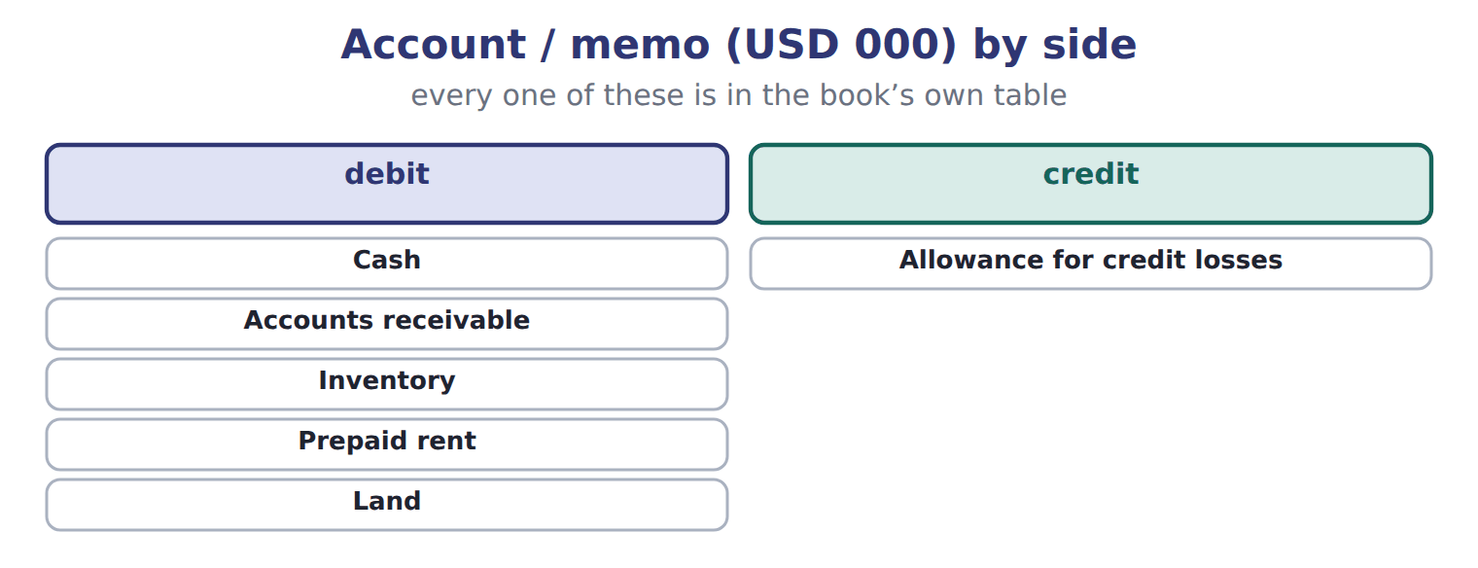
Account / memo (USD 000) — the book’s own table
Account / memo (USD 000) | Balance / details | Side
Cash | 1,050 | debit
Accounts receivable | 300 | debit
Allowance for credit losses | 20 | credit
Inventory | 420 | debit
Prepaid rent | 24 | debit
Land | 936 | debit
Equipment | 4,200 | debit
Accumulated depreciation | 900 | credit
Accounts payable | 380 | credit
Dividends payable | 50 | credit

Account / memo (USD 000) — the book’s own table (continued)
Account / memo (USD 000) | Balance / details | Side
Notes payable (long-term) | 1,800 | credit
Common stock | 600 | credit
Additional paid-in capital | 1,900 | credit
Retained earnings, December 31 (after closing) | 1,280 | credit
M1 | Of the notes payable, 300 is an installment due on June 30, 2026. The rest is due in 2029.
M2 | At December 31, Barada broke a debt-to-equity covenant on the note. On January 20, 2026, before the statements were issued, the bank waived
M3 | A former employee has sued Barada. Its lawyers think a loss of about 60 is reasonably possible, but not probable.
M4 | On February 10, 2026, before the statements were issued, a fire destroyed inventory that cost 70.

READ THE MODEL Every answer is printed above. Find it, do not recall it.

5. Which part of this chapter is section 2.1?
A. Purpose and structure of the balance sheet
B. Classifying debt
C. Current and noncurrent items
D. Other presentation matters
6. Which part of this chapter is section 2.2?
A. Classifying debt
B. Other presentation matters
C. Current and noncurrent items
D. Purpose and structure of the balance sheet
7. Which part of this chapter is section 2.3?
A. Purpose and structure of the balance sheet
B. Classifying debt
C. Other presentation matters
D. Current and noncurrent items
8. Which part of this chapter is section 2.4?
A. Current and noncurrent items
B. Purpose and structure of the balance sheet
C. Other presentation matters
D. Classifying debt
APPLY No help on this move.

9. The rule you have just written is the book’s own rule. TRUE / FALSE
WORK IN PAIRS | Compare every answer on this page with your partner before you read any key.
If you disagree: go back to the model and find the row that settles it. The row decides, not the louder voice.

CHECKPOINT 10. Which of these did this cycle settle?
A. the rule and where it comes from
B. nothing in particular
C. only the vocabulary
D. only the arithmetic
If you got it wrong: redo the READ THE MODEL questions of cycle A.

CYCLE B | The words this section uses precisely

ORIENT

11. A term in the exam means exactly what the book defines it to mean, whatever it means in ordinary English. TRUE / FALSE
MODEL

Account — the book’s own table
Account | Category
Prepaid rent
Land
Allowance for credit losses
Dividends payable
Additional paid-in capital

The English the exam uses, and what it translates
English (exam term) | the Arabic it translates
operating cycle | دورة التشغيل
subsequent events | الأحداث اللاحقة لتاريخ الميزانية
restricted cash | النقد المقيد
refinancing | إعادة التمويل

READ THE MODEL

Write the letter of the Arabic term beside each English term. Every term is used once.
A النقد المقيد | C إعادة التمويل
B الأحداث اللاحقة لتاريخ الميزانية | D دورة التشغيل

12. operating cycle
13. subsequent events
14. restricted cash
15. refinancing

APPLY

16. Writing a term in English is part of answering the question, not an extra. TRUE / FALSE

CHECKPOINT 17. What is the safest way to settle a disagreement about an answer on this sheet?
A. find the row of the model that decides it
B. take the answer of whoever is more confident
C. leave it until the lecturer says
D. choose the longer option
If you got it wrong: redo the READ THE MODEL questions of cycle B.

FROM MEMORY | Close the earlier pages first.
18. Rebuild the figure from this handout. Label every part and fill in every box.
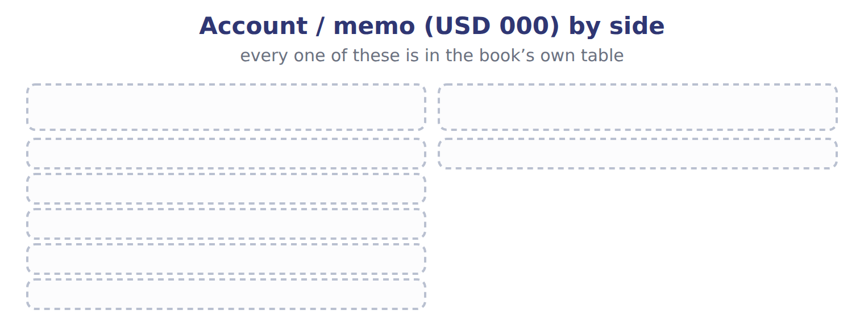
TEACH IT BACK | Write it for a classmate who missed this session — not for the marker.
19. In three or four sentences, write what this section settles and the one rule a reader has to take away.
every one of these words must appear: operating cycle · subsequent events · restricted cash · refinancing

Answer key · Handout 2.5 · Limitations and links to the other statements

1 valuation · historical · Orontes's | 8 C | 15 C
2 suppliers · therefore · statements | 9 T | 16 T
3 balance-sheet · comprehensive · stockholders' | 10 A | 17 A
4 T | 11 T | 18 Compare with the model earlier in this handout.
5 A | 12 D | 19 The balance sheet is useful, but it is not a valuation of the company. Most assets are at historical cost, not current value: Orontes's land and buildings are shown at what they cost years ago. Many amounts depend on estimates, such as the allowance for credit losses and useful lives.
6 C | 13 B
7 B | 14 A

why
1 The book writes: “The balance sheet is useful, but it is not a valuation of the company. Most assets are at historical cost, not current value: Orontes's land and buildings are shown at what they cost years ago. Many amounts depend on estimates, such as the allowance for credit losses and useful lives.”
2 The book writes: “Finally, the balance sheet shows one day. A company can improve its year-end picture, for example by delaying payments to suppliers for a few days. Readers therefore compare several dates and read the other statements too.”
3 The book writes: “The net change in cash in the statement of cash flows explains the change in the balance-sheet cash. Other comprehensive income works the same way. Total stockholders' equity is a book amount.”
4 The framework defines the elements, and every amount belongs to one of them.
5 The book numbers “Purpose and structure of the balance sheet” as section 2.1.
6 The book numbers “Current and noncurrent items” as section 2.2.
7 The book numbers “Classifying debt” as section 2.3.
8 The book numbers “Other presentation matters” as section 2.4.
9 Compare your sentence with the book’s wording in the key.
10 Every cycle settles one rule and shows where it comes from.
11 CMA questions use exact terms, and one word can change the answer.
16 The exam marks the term, so the English word is the answer.
17 Every item on a Workshop sheet is settled by something printed on the same sheet.

Handout 2.6
The whole chapter
every section, shuffled, and the chapter’s own case set
Before you start
Three summaries of this chapter, in the book’s own words, with words taken out. Read all three first: together they are the whole chapter. Then fill the gaps.

What this handout settles, cycle by cycle
In this handout | What you will read | How you check it
The whole chapter, in order | a figure to read | A five-year loan is repaid in equal annual installments. At year-end, how is the next installment classified?
The chapter’s case set | The chapter’s case set, item by item | What has to be settled before any figure in a case set is worked out?
The words it uses precisely | balance sheet · classified balance sheet · current assets · current liabilities · operating cycle · working capital | matching, at the end of cycle B

1. Where the chapter starts — Fill every gap. The list holds more words than there are gaps, so one or two of them are not used.
choose from: current assets · Working capital · current ratio · balance sheet · callable debt · current portion of long-term debt · current liabilities
On the liability side, is current, because that part of the principal is due within a year. Two measures come directly from these totals. is minus . The is current assets divided by current liabilities.
2. What it settles in the middle — Fill every gap. The list holds more words than there are gaps, so one or two of them are not used.
choose from: current liabilities · balance sheet · working capital · current assets · current ratio · callable debt
Paying a supplier in cash reduces and by the same amount: does not change, but the changes. Reclassifying debt from current to noncurrent increases working capital and the current ratio.
3. Where it ends — Fill every gap. The list holds more words than there are gaps, so one or two of them are not used.
choose from: classified balance sheet · Subsequent events · callable debt · balance sheet
If it is only reasonably possible, the company discloses it in a note. If it is remote, the company does nothing. Gain contingencies are never recorded before they are realized. happen after the date but before the statements are issued.

CYCLE A | The whole chapter, in order

ORIENT

4. The sections of a chapter have to be taken in order, because each one uses what the one before it settled. TRUE / FALSE
MODEL

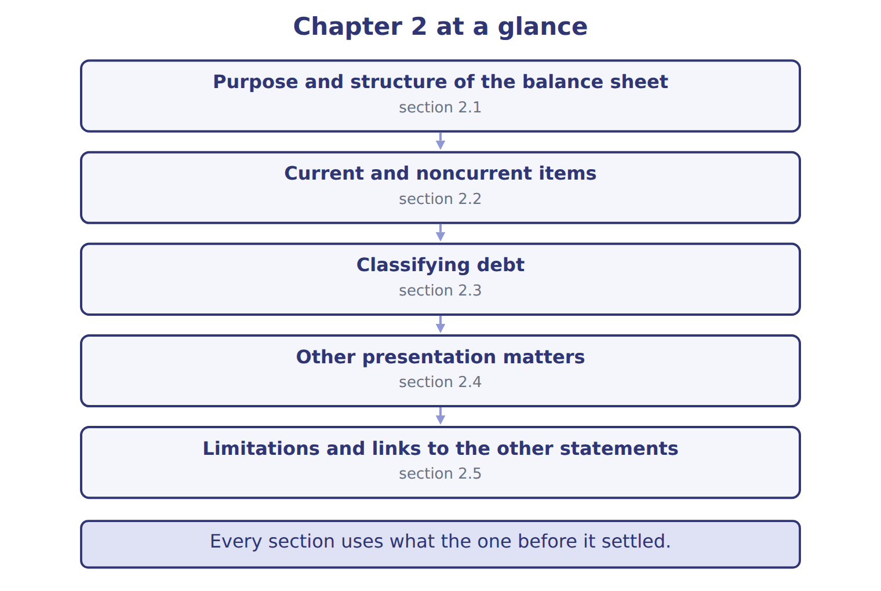
READ THE MODEL

5. “section 2.1” — which part of the chapter is this?
A. Classifying debt
B. Current and noncurrent items
C. Other presentation matters
D. Purpose and structure of the balance sheet
6. “section 2.2” — which part of the chapter is this?
A. Classifying debt
B. Other presentation matters
C. Current and noncurrent items
D. Purpose and structure of the balance sheet
7. “section 2.3” — which part of the chapter is this?
A. Current and noncurrent items
B. Classifying debt
C. Other presentation matters
D. Purpose and structure of the balance sheet
Write the letter of the section number beside each section title. Every number is used once.
A 2.1 | D 2.4
B 2.2 | E 2.5
C 2.3

8. Purpose and structure of the balance sheet
9. Current and noncurrent items
10. Classifying debt
11. Other presentation matters
12. Limitations and links to the other statements

APPLY

13. Orontes bought land in 2005 for $400,000. It is worth about $2 million today. What does the balance sheet show for the land?
A. $400,000, because land is at historical cost
B. $2,000,000, because the balance sheet shows current values
C. $1,200,000, the average
D. $400,000 plus depreciation
WORK IN PAIRS | Compare every answer with your partner first.
If you disagree: name the section each question belongs to. Most disagreements turn out to be about the section, not the answer.
CHECKPOINT 14. A five-year loan is repaid in equal annual installments. At year-end, how is the next installment classified?
A. As a noncurrent liability
B. As a current liability
C. As a reduction of cash
D. Only in a note
If you got it wrong: go back to the MODEL move of cycle A and find the section this question belongs to.

CYCLE B | The chapter’s case set

ORIENT

15. In a case question, the exhibit has to be read and adjusted before any figure is worked out. TRUE / FALSE

MODEL

The chapter’s case set, item by item
Item | What it asks
C2-1 | Classify each account. (On the exam screen you would drag each account into a box.)
C2-2 | Enter Barada's total current assets.
C2-3 | Enter Barada's total current liabilities.
C2-4 | Enter Barada's working capital.
C2-5 | How does Barada report the February fire (M4)? [select]
C2-6 | How does Barada report the lawsuit (M3)? [select]

READ THE MODEL

16. Which of these does item C2-1 ask for?
A. Enter Barada's total current liabilities.
B. Enter Barada's working capital.
C. Enter Barada's total current assets.
D. Classify each account. (On the exam screen you would drag each account
17. Which of these does item C2-2 ask for?
A. Enter Barada's total current liabilities.
B. Enter Barada's working capital.
C. Enter Barada's total current assets.
D. Classify each account. (On the exam screen you would drag each account
18. Which of these does item C2-3 ask for?
A. Enter Barada's total current assets.
B. Enter Barada's working capital.
C. Classify each account. (On the exam screen you would drag each account
D. Enter Barada's total current liabilities.
19. Which of these does item C2-4 ask for?
A. Enter Barada's working capital.
B. Classify each account. (On the exam screen you would drag each account
C. Enter Barada's total current assets.
D. Enter Barada's total current liabilities.
20. Which of these does item C2-5 ask for?
A. Classify each account. (On the exam screen you would drag each account
B. Enter Barada's total current assets.
C. How does Barada report the February fire (M4)? [select]
D. Enter Barada's total current liabilities.
21. Which of these does item C2-6 ask for?
A. How does Barada report the lawsuit (M3)? [select]
B. Enter Barada's total current liabilities.
C. Classify each account. (On the exam screen you would drag each account
D. Enter Barada's total current assets.
APPLY

22. A five-year loan is repaid in equal annual installments. At year-end, how is the next installment classified?
A. As a noncurrent liability | C. As a reduction of cash
B. As a current liability | D. Only in a note

23. At December 31 a company breaks a loan covenant, so the loan is payable on demand. On January 15, before the statements are issued, the bank gives an 18-month waiver. How is the loan classified under IFRS?
A. Noncurrent
B. Current under IFRS only if the bank is expected to demand payment
C. Split between current and noncurrent
D. Current
CHECKPOINT 24. What has to be settled before any figure in a case set is worked out?
A. the exhibit, adjusted for every note that goes with it
B. the method the company uses
C. the tax rate
D. the order of the items
If you got it wrong: reread the case panel in the MODEL move of cycle B.

FROM MEMORY | Close the earlier pages first.
25. Rebuild the chapter map. Write every section in order and what each one settles.
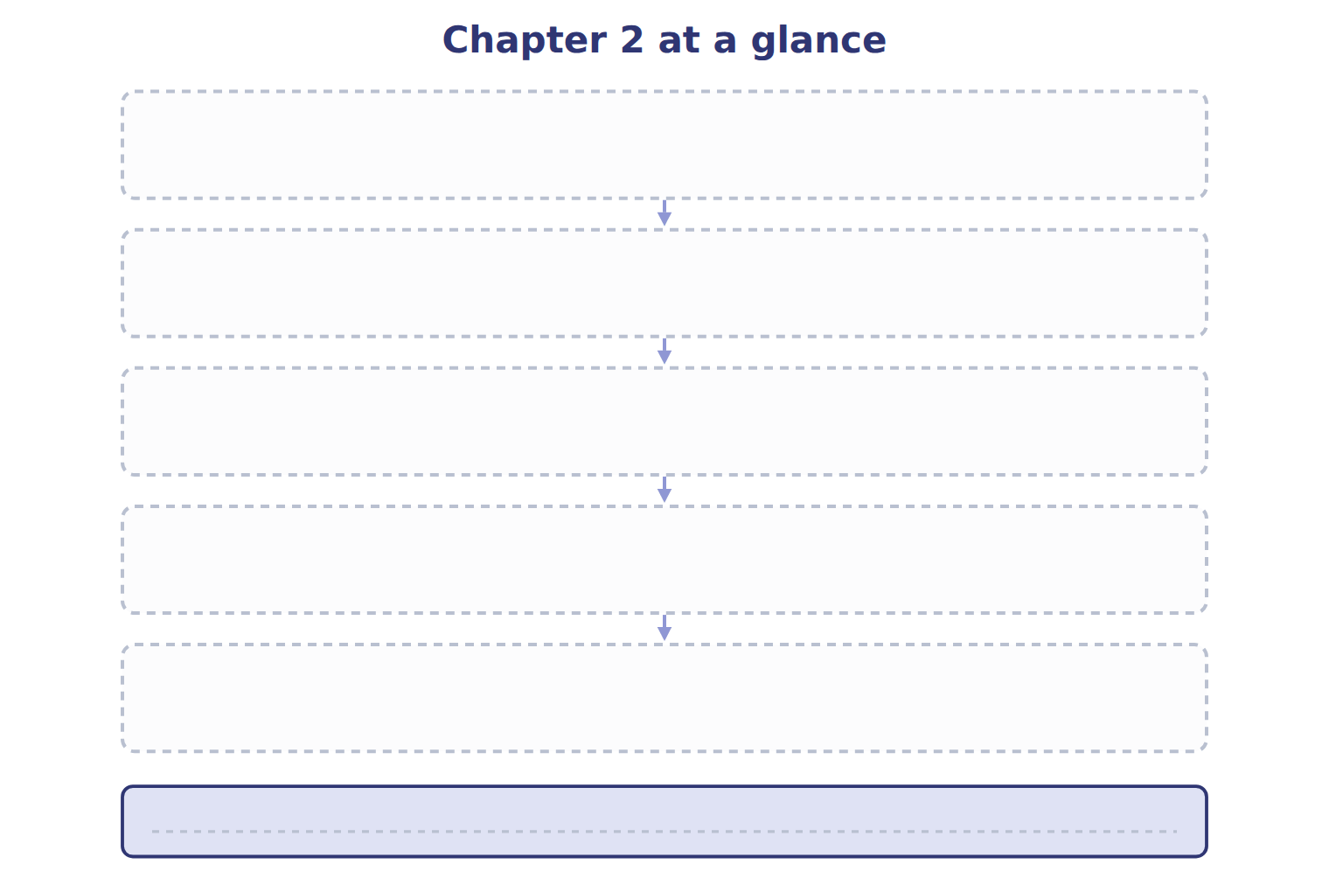
TEACH IT BACK | Write it for a student starting this chapter tomorrow — not for the marker.
26. In four or five sentences, write what the whole chapter settles, section by section.
every one of these words must appear: balance sheet · classified balance sheet · current assets · current liabilities

Answer key · Handout 2.6 · The whole chapter

1 current portion of long-term debt · Working capital · current assets · current liabilities · current ratio | 10 C | 19 A
2 current assets · current liabilities · working capital · current ratio | 11 D | 20 C
3 Subsequent events · balance sheet | 12 E | 21 A
4 T | 13 A | 22 B
5 D | 14 B | 23 D
6 C | 15 T | 24 A
7 B | 16 D | 25 Compare with the model earlier in this handout.
8 A | 17 C | 26 2.1: Purpose and structure of the balance sheet. 2.2: Current and noncurrent items. 2.3: Classifying debt. 2.4: Other presentation matters. 2.5: Limitations and links to the other statements.
9 B | 18 D

why
1 The book writes: “On the liability side, current portion of long-term debt is current, because that part of the principal is due within a year. Two measures come directly from these totals. Working capital is current assets minus current liabilities. The current ratio is current assets divided by current liabilities.”
2 The book writes: “Paying a supplier in cash reduces current assets and current liabilities by the same amount: working capital does not change, but the current ratio changes. Reclassifying debt from current to noncurrent increases working capital and the current ratio.”
3 The book writes: “If it is only reasonably possible, the company discloses it in a note. If it is remote, the company does nothing. Gain contingencies are never recorded before they are realized. Subsequent events happen after the balance sheet date but before the statements are issued.”
4 The map shows the order the decisions have to be taken in.
5 The book numbers it 2.1.
6 The book numbers it 2.2.
7 The book numbers it 2.3.
13 Most assets, including land, are at historical cost. B is wrong: The balance sheet is not a valuation; land stays at cost. C is wrong: There is no averaging of cost and value.
14 Principal due within one year is the current portion of long-term debt. A is wrong: The part due within a year must be moved to current liabilities. C is wrong: Cash is paid only when the installment is paid.
15 Every later answer depends on the adjusted exhibit.
16 The book states item C2-1 in those words.
17 The book states item C2-2 in those words.
18 The book states item C2-3 in those words.
19 The book states item C2-4 in those words.
20 The book states item C2-5 in those words.
21 The book states item C2-6 in those words.
22 Principal due within one year is the current portion of long-term debt. A is wrong: The part due within a year must be moved to current liabilities. C is wrong: Cash is paid only when the installment is paid.
23 IFRS looks only at the right to defer that existed at the reporting date. A is wrong: This is the U.S. GAAP answer; under IFRS a waiver after the reporting date does not count. B is wrong: Expectations do not matter; the right at the reporting date does.
24 Every later answer depends on the adjusted exhibit.

Handout 3.1
Purpose and structure of the income statement
section 3.1 of the book
Before you start
Three summaries of this handout, in the book’s own words. Read all three first: together they are the whole session. Then fill the gaps, guessing where you have to.

What this handout settles, cycle by cycle
In this handout | What you will read | How you check it
Purpose and structure of the income statement | a figure to read · Orontes Foods Inc., year ended December 31, 2025 | An investor wants to predict a company's future earnings. Which statement is MOST useful for this?
The words this section uses precisely | Item · The English the exam uses, and what it translates | What is the safest way to settle a disagreement about an answer on this sheet?

Words this handout uses precisely
Words this handout uses precisely | tick it if you could already use it in a sentence
income statement
unusual or infrequent item
other income and expense
other comprehensive income (OCI)

1. Where the section starts — Fill every gap. The list holds more words than there are gaps, so one or two of them are not used.
choose from: single-step income statement · operating income · strategic shift · component of an entity · multi-step income statement
A shows subtotals: gross profit, and income before income taxes. A adds all revenues and gains, deducts all expenses and losses, and reaches net income in one step.
2. What it settles in the middle — Fill every gap. The list holds more words than there are gaps, so one or two of them are not used.
choose from: component of an entity · single-step income statement · operating income · multi-step income statement · strategic shift
Managers use it to compare results with budgets and with competitors. A shows subtotals: gross profit, and income before income taxes. A adds all revenues and gains, deducts all expenses and losses, and reaches net income in one step.
3. Where it ends — Fill every gap. The list holds more words than there are gaps, so one or two of them are not used.
choose from: strategic shift · operating income · single-step income statement · multi-step income statement · component of an entity
A shows subtotals: gross profit, and income before income taxes. A adds all revenues and gains, deducts all expenses and losses, and reaches net income in one step. SEC registrants such as Orontes follow the SEC's list of captions, which gives a multi-step layout.

CYCLE A | Purpose and structure of the income statement

ORIENT One claim. Decide now; you will check it in a moment.

4. Every number in a financial statement belongs to an element the framework defines. TRUE / FALSE
MODEL Read it before you answer anything below it.

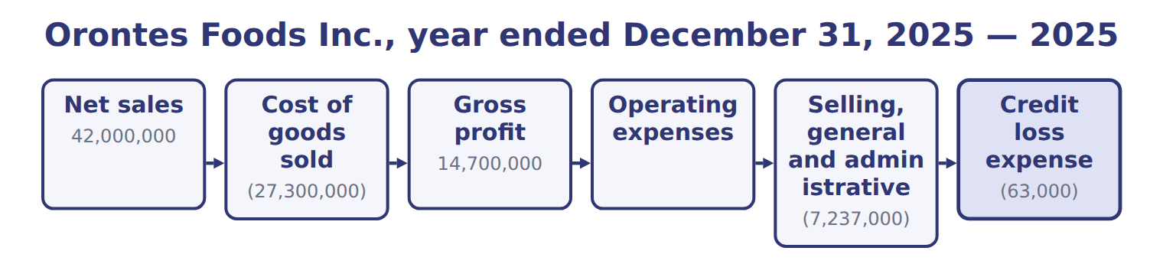
Orontes Foods Inc., year ended December 31, 2025 — the book’s own table
Orontes Foods Inc., year ended December 31, 2025 | 2025
Net sales | 42,000,000
Cost of goods sold | (27,300,000)
Gross profit | 14,700,000
Operating expenses
Selling, general and administrative | (7,237,000)
Credit loss expense | (63,000)
Research and development | (500,000)
Impairment losses | (2,724,000)
Total operating expenses | (10,524,000)
Operating income | 4,176,000

Orontes Foods Inc., year ended December 31, 2025 — the book’s own table (continued)
Orontes Foods Inc., year ended December 31, 2025 | 2025
Other income and (expense)
Interest expense | (390,000)
Interest and dividend income | 3,800
Unrealized gains on securities | 4,000
Equity-method income | 177,000
Gain on sale of equipment | 3,000
Loss on sale of receivables | (15,000)
Total other income and (expense) | (217,200)
Income before income taxes | 3,958,800
Income tax expense | (989,700)

Orontes Foods Inc., year ended December 31, 2025 — the book’s own table (continued)
Orontes Foods Inc., year ended December 31, 2025 | 2025
Net income | 2,969,100
Earnings per share, basic and diluted | $0.37
Weighted-average shares outstanding | 8,099,726
Other comprehensive income
Unrealized loss on available-for-sale debt securities, net of tax of 375 | (1,125)
Comprehensive income | 2,967,975

READ THE MODEL Every answer is printed above. Find it, do not recall it.

5. Which part of this chapter is section 3.1?
A. Purpose and structure of the income statement
B. Building the multi-step income statement
C. Comprehensive income
D. Unusual items and discontinued operations
6. Which part of this chapter is section 3.2?
A. Comprehensive income
B. Purpose and structure of the income statement
C. Building the multi-step income statement
D. Unusual items and discontinued operations
7. Which part of this chapter is section 3.3?
A. Purpose and structure of the income statement
B. Comprehensive income
C. Unusual items and discontinued operations
D. Building the multi-step income statement
8. Which part of this chapter is section 3.4?
A. Building the multi-step income statement
B. Comprehensive income
C. Purpose and structure of the income statement
D. Unusual items and discontinued operations
APPLY No help on this move.

9. An investor wants to predict a company's future earnings. Which statement is MOST useful for this?
A. The balance sheet
B. The statement of changes in equity
C. The auditor's report
D. The income statement
10. A lender wants to know if a borrower's main business earns enough to cover its interest. Which subtotal is MOST useful?
A. Net income | C. Comprehensive income
B. Operating income | D. Gross profit
11. The heading of an income statement should read:
A. As of December 31, 2025
B. At December 31, 2025
C. For the year ended December 31, 2025
D. On December 31, 2025
12. Why do most U.S. public companies use a multi-step rather than a single-step income statement?
A. It gives a higher net income
B. U.S. GAAP requires the multi-step form for all companies
C. It shows cash flows from operations
D. The subtotals help users see how much comes from main operations

WORK IN PAIRS | Compare every answer on this page with your partner before you read any key.
If you disagree: go back to the model and find the row that settles it. The row decides, not the louder voice.
CHECKPOINT 13. An investor wants to predict a company's future earnings. Which statement is MOST useful for this?
A. The balance sheet
B. The statement of changes in equity
C. The auditor's report
D. The income statement
If you got it wrong: redo the READ THE MODEL questions of cycle A with the model in front of you.

CYCLE B | The words this section uses precisely

ORIENT

14. A term in the exam means exactly what the book defines it to mean, whatever it means in ordinary English. TRUE / FALSE
MODEL

Item — the book’s own table
Item | Category
Fire loss | Operating expenses
Lawsuit settlement | Operating expenses
Interest expense | Other income and expense
Gain on sale of equipment | Other income and expense
Loss on sale of the division | Discontinued operations

The English the exam uses, and what it translates
English (exam term) | the Arabic it translates
income statement | قائمة الدخل
unusual or infrequent item | بند غير عادي أو غير متكرر
other income and expense | الإيرادات والمصروفات الأخرى
other comprehensive income (OCI) | الدخل الشامل الآخر

READ THE MODEL

Write the letter of the Arabic term beside each English term. Every term is used once.
A قائمة الدخل | C بند غير عادي أو غير متكرر
B الدخل الشامل الآخر | D الإيرادات والمصروفات الأخرى

15. income statement
16. unusual or infrequent item
17. other comprehensive income (OCI)
18. other income and expense

19. Which category does the book give for Fire loss?
A. Other income and expense | C. Operating expenses
B. Discontinued operations
20. Which category does the book give for Lawsuit settlement?
A. Discontinued operations | C. Operating expenses
B. Other income and expense
21. Which category does the book give for Interest expense?
A. Discontinued operations | C. Operating expenses
B. Other income and expense
APPLY

22. Which item is an operating expense on a U.S. multi-step income statement?
A. Research and development
B. Interest expense
C. Income tax expense
D. Loss from discontinued operations
23. A company has net sales of $900,000, cost of goods sold of $540,000, selling expenses of $120,000, administrative expenses of $90,000 and interest expense of $30,000. What is its operating income?
A. $120,000 | C. $240,000
B. $150,000 | D. $360,000
CHECKPOINT 24. What is the safest way to settle a disagreement about an answer on this sheet?
A. find the row of the model that decides it
B. take the answer of whoever is more confident
C. leave it until the lecturer says
D. choose the longer option
If you got it wrong: redo the READ THE MODEL questions of cycle B.

FROM MEMORY | Close the earlier pages first.
25. Rebuild the figure from this handout. Label every part and fill in every box.
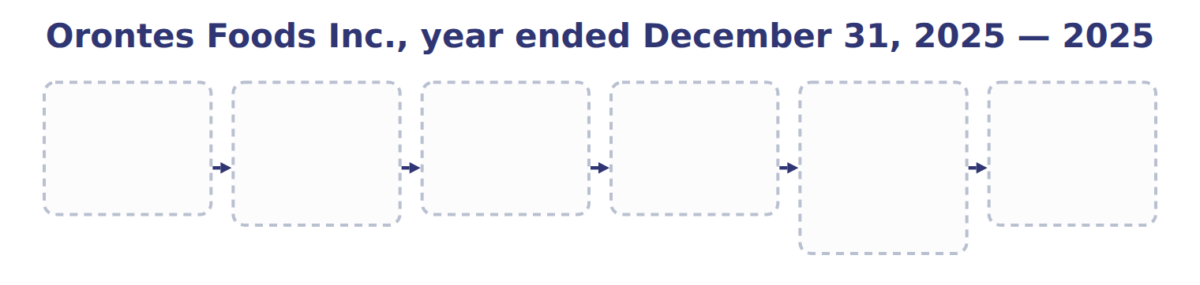
TEACH IT BACK | Write it for a classmate who missed this session — not for the marker.
26. In three or four sentences, write what this section settles and the one rule a reader has to take away.
every one of these words must appear: income statement · unusual or infrequent item · other income and expense · other comprehensive income (OCI)

Answer key · Handout 3.1 · Purpose and structure of the income statement

1 multi-step income statement · operating income · single-step income statement | 10 B | 19 C
2 multi-step income statement · operating income · single-step income statement | 11 C | 20 C
3 multi-step income statement · operating income · single-step income statement | 12 D | 21 B
4 T | 13 D | 22 A
5 A | 14 T | 23 B
6 C | 15 A | 24 A
7 C | 16 C | 25 Compare with the model earlier in this handout.
8 B | 17 B | 26 The income statement reports a company's revenues, expenses, gains and losses for a period, usually a year. The result is net income, which increases retained earnings. Where the balance sheet is a photograph, the income statement is a film of the whole year.
9 D | 18 D

why
1 The book writes: “A multi-step income statement shows subtotals: gross profit, operating income and income before income taxes. A single-step income statement adds all revenues and gains, deducts all expenses and losses, and reaches net income in one step.”
2 The book writes: “Managers use it to compare results with budgets and with competitors. A multi-step income statement shows subtotals: gross profit, operating income and income before income taxes. A single-step income statement adds all revenues and gains, deducts all expenses and losses, and reaches net income in one step.”
3 The book writes: “A multi-step income statement shows subtotals: gross profit, operating income and income before income taxes. A single-step income statement adds all revenues and gains, deducts all expenses and losses, and reaches net income in one step. SEC registrants such as Orontes follow the SEC's list of captions, which gives a multi-step layout.”
4 The framework defines the elements, and every amount belongs to one of them.
5 The book numbers “Purpose and structure of the income statement” as section 3.1.
6 The book numbers “Building the multi-step income statement” as section 3.2.
7 The book numbers “Unusual items and discontinued operations” as section 3.3.
8 The book numbers “Comprehensive income” as section 3.4.
9 Past performance on the income statement is the starting point for predicting future earnings. A is wrong: The balance sheet shows position at one date, not performance. B is wrong: It shows changes in equity, using net income from the income statement.
10 Operating income is earned before interest, so it can be compared with interest expense. A is wrong: Net income is after interest has already been deducted. C is wrong: Comprehensive income includes OCI, which is not from main operations.
11 The income statement covers a period. A is wrong: 'As of' is used for the balance sheet. B is wrong: 'At' a date is a balance sheet heading.
12 Subtotals separate operating results from other items. A is wrong: Both layouts give the same net income. B is wrong: U.S. GAAP does not require one layout; SEC captions lead to multi-step.
13 Past performance on the income statement is the starting point for predicting future earnings. A is wrong: The balance sheet shows position at one date, not performance. B is wrong: It shows changes in equity, using net income from the income statement.
14 CMA questions use exact terms, and one word can change the answer.
19 The book’s own table gives Operating expenses as the category of Fire loss.
20 The book’s own table gives Operating expenses as the category of Lawsuit settlement.
21 The book’s own table gives Other income and expense as the category of Interest expense.
22 R&D is part of the costs of running the main business. B is wrong: Interest is in other income and expense. C is wrong: Tax is deducted after income before income taxes.
23 Gross profit of $360,000 minus operating expenses of $210,000. A is wrong: This also deducts interest. C is wrong: This deducts only selling expenses.
24 Every item on a Workshop sheet is settled by something printed on the same sheet.

Handout 3.2
Building the multi-step income statement
section 3.2 of the book
Before you start
Three summaries of this handout, in the book’s own words. Read all three first: together they are the whole session. Then fill the gaps, guessing where you have to.

What this handout settles, cycle by cycle
In this handout | What you will read | How you check it
Building the multi-step income statement | a figure to read · Barada Wholesale, year ended December 31, 2025 ( | Under U.S. GAAP, which presentation of operating expenses is required?
The words this section uses precisely | Item · The English the exam uses, and what it translates · Suppose: Orontes, 2026 (whole USD) | What is the safest way to settle a disagreement about an answer on this sheet?

Words this handout uses precisely
Words this handout uses precisely | tick it if you could already use it in a sentence
multi-step income statement
comprehensive income
function of expense
reclassification adjustment

1. Where the section starts — Fill every gap. The list holds more words than there are gaps, so one or two of them are not used.
choose from: Operating income · Other income and expense · comprehensive income · discontinued operation
is gross profit minus operating expenses: selling, general and administrative expenses, research and development, credit losses and impairments. Interest and income tax are never operating expenses. follows operating income.
2. What it settles in the middle — Fill every gap. The list holds more words than there are gaps, so one or two of them are not used.
choose from: operating income · comprehensive income · discontinued operation · Other income and expense
Interest and income tax are never operating expenses. follows . It contains interest, investment income and gains and losses. A gain or loss comes from a peripheral or incidental transaction, and it is shown net.
3. Where it ends — Fill every gap. The list holds more words than there are gaps, so one or two of them are not used.
choose from: comprehensive income · Other income and expense · operating income · discontinued operation
follows . It contains interest, investment income and gains and losses. A gain or loss comes from a peripheral or incidental transaction, and it is shown net. Income tax expense is then deducted from income before income taxes.

CYCLE A | Building the multi-step income statement

ORIENT One claim. Decide now; you will check it in a moment.

4. Every number in a financial statement belongs to an element the framework defines. TRUE / FALSE
MODEL Read it before you answer anything below it.

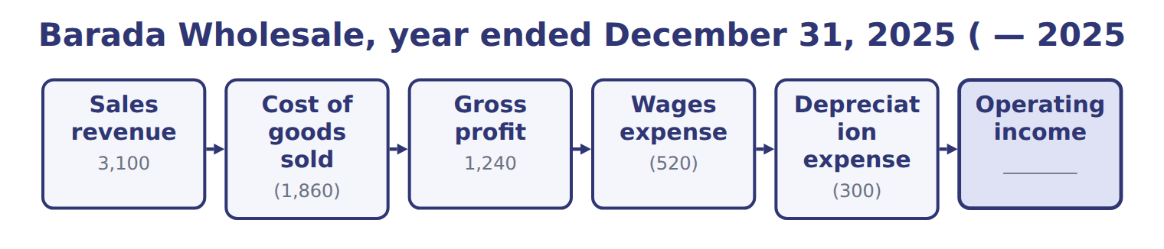
Barada Wholesale, year ended December 31, 2025 ( — the book’s own table
Barada Wholesale, year ended December 31, 2025 ( | 2025
Sales revenue | 3,100
Cost of goods sold | (1,860)
Gross profit | 1,240
Wages expense | (520)
Depreciation expense | (300)
Operating income | ________
Interest expense | (90)
Net income | ________
Gross profit as a percentage of sales | ________

READ THE MODEL Every answer is printed above. Find it, do not recall it.

5. Which part of this chapter is section 3.1?
A. Purpose and structure of the income statement
B. Building the multi-step income statement
C. Comprehensive income
D. Unusual items and discontinued operations
6. Which part of this chapter is section 3.2?
A. Comprehensive income
B. Purpose and structure of the income statement
C. Building the multi-step income statement
D. Unusual items and discontinued operations
7. Which part of this chapter is section 3.3?
A. Purpose and structure of the income statement
B. Comprehensive income
C. Unusual items and discontinued operations
D. Building the multi-step income statement
8. Which part of this chapter is section 3.4?
A. Building the multi-step income statement
B. Comprehensive income
C. Purpose and structure of the income statement
D. Unusual items and discontinued operations

APPLY No help on this move.

9. Under U.S. GAAP, which presentation of operating expenses is required?
A. No specific presentation is required; SEC captions lead to a functional presentation
B. By nature, such as materials and staff costs
C. By function, with a note by nature for all companies today
D. Operating profit as a required subtotal
10. For which amounts must a U.S. public company with a simple capital structure show EPS on the face of the income statement?
A. Gross profit and operating income
B. Comprehensive income only
C. Income from continuing operations and net income
D. Unusual or infrequent items
11. A company reports a large loss from a flood, which is unusual for it. How is the loss presented?
A. Net of tax, below income from continuing operations
B. As an extraordinary item with its own EPS
C. Only in the notes
D. As a separate line in income from continuing operations, before tax
12. Orontes sells an oven with a cost of $60,000 and accumulated depreciation of $42,000 for $21,000. How is the sale shown on the income statement?
A. Revenue of $21,000
B. A gain of $3,000 in other income and expense
C. A gain of $21,000
D. A loss of $39,000
WORK IN PAIRS | Compare every answer on this page with your partner before you read any key.
If you disagree: go back to the model and find the row that settles it. The row decides, not the louder voice.
CHECKPOINT 13. Under U.S. GAAP, which presentation of operating expenses is required?
A. No specific presentation is required; SEC captions lead to a functional presentation
B. By nature, such as materials and staff costs
C. By function, with a note by nature for all companies today
D. Operating profit as a required subtotal
If you got it wrong: redo the READ THE MODEL questions of cycle A with the model in front of you.

CYCLE B | The words this section uses precisely

ORIENT

14. A term in the exam means exactly what the book defines it to mean, whatever it means in ordinary English. TRUE / FALSE
MODEL

Item — the book’s own table
Item | Answer
Operating income | 1,240 − 520 − 300 = 420
Net income | 420 − 90 = 330, the same as in Chapter 1
Gross profit percentage | 1,240 ÷ 3,100 = 40%

The English the exam uses, and what it translates
English (exam term) | the Arabic it translates
multi-step income statement | قائمة الدخل متعددة المراحل
comprehensive income | الدخل الشامل
function of expense | عرض المصروفات حسب الوظيفة
reclassification adjustment | تعديل إعادة التصنيف

READ THE MODEL

Write the letter of the Arabic term beside each English term. Every term is used once.
A تعديل إعادة التصنيف | C عرض المصروفات حسب الوظيفة
B الدخل الشامل | D قائمة الدخل متعددة المراحل

15. comprehensive income
16. multi-step income statement
17. function of expense
18. reclassification adjustment

19. Which answer does the book give for Operating income?
A. 1,240 − 520 − 300 = 420
B. 1,240 ÷ 3,100 = 40%
C. 420 − 90 = 330, the same as in Chapter 1
20. Which answer does the book give for Net income?
A. 1,240 − 520 − 300 = 420
B. 420 − 90 = 330, the same as in Chapter 1
C. 1,240 ÷ 3,100 = 40%
21. Which answer does the book give for Gross profit percentage?
A. 1,240 ÷ 3,100 = 40%
B. 420 − 90 = 330, the same as in Chapter 1
C. 1,240 − 520 − 300 = 420
APPLY

22. Which condition is NOT needed for a disposal to be reported as a discontinued operation?
A. The component must be sold, held for sale or disposed of
B. The disposal must be a strategic shift
C. The shift must have a major effect on operations and results
D. The component must have been profitable
Suppose: Orontes, 2026 (whole USD) — the extract for the question that follows
Suppose: Orontes, 2026 (whole USD) | Before tax | Tax benefit | Net of tax
Loss from operations of the frozen-foods business | (420,000) | 105,000 | (315,000)
Loss on disposal of the business | (180,000) | 45,000 | (135,000)
Loss from discontinued operations | (600,000) | 150,000 | (450,000)

23. The extract for this question is printed with it. What loss from discontinued operations does Orontes report (whole USD)?
A. 315,000 | C. 600,000
B. 450,000 | D. 750,000

CHECKPOINT 24. What is the safest way to settle a disagreement about an answer on this sheet?
A. find the row of the model that decides it
B. take the answer of whoever is more confident
C. leave it until the lecturer says
D. choose the longer option
If you got it wrong: redo the READ THE MODEL questions of cycle B.

FROM MEMORY | Close the earlier pages first.
25. Rebuild the figure from this handout. Label every part and fill in every box.
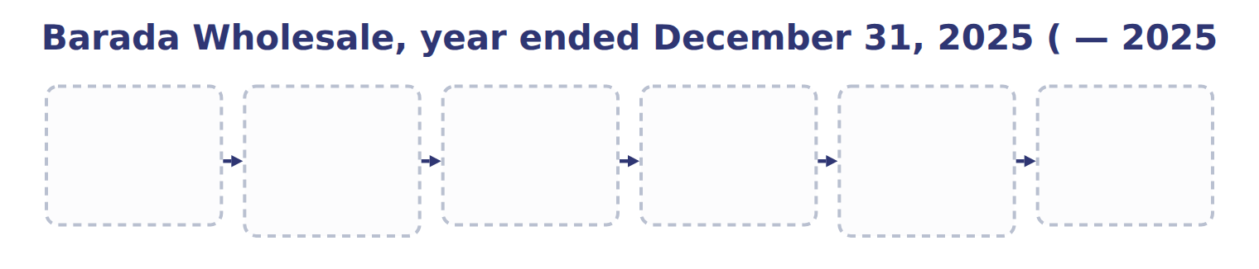
TEACH IT BACK | Write it for a classmate who missed this session — not for the marker.
26. In three or four sentences, write what this section settles and the one rule a reader has to take away.
every one of these words must appear: multi-step income statement · comprehensive income · function of expense · reclassification adjustment

Answer key · Handout 3.2 · Building the multi-step income statement

1 Operating income · Other income and expense | 10 C | 19 A
2 Other income and expense · operating income | 11 D | 20 B
3 Other income and expense · operating income | 12 B | 21 A
4 T | 13 A | 22 D
5 A | 14 T | 23 B
6 C | 15 B | 24 A
7 C | 16 D | 25 Compare with the model earlier in this handout.
8 B | 17 C | 26 Gross profit is net sales minus cost of goods sold. It shows how much the company earns on what it sells before its other costs. Orontes's gross profit is $14,700,000, which is 35% of net sales.
9 A | 18 A

why
1 The book writes: “Operating income is gross profit minus operating expenses: selling, general and administrative expenses, research and development, credit losses and impairments. Interest and income tax are never operating expenses. Other income and expense follows operating income.”
2 The book writes: “Interest and income tax are never operating expenses. Other income and expense follows operating income. It contains interest, investment income and gains and losses. A gain or loss comes from a peripheral or incidental transaction, and it is shown net.”
3 The book writes: “Other income and expense follows operating income. It contains interest, investment income and gains and losses. A gain or loss comes from a peripheral or incidental transaction, and it is shown net. Income tax expense is then deducted from income before income taxes.”
4 The framework defines the elements, and every amount belongs to one of them.
5 The book numbers “Purpose and structure of the income statement” as section 3.1.
6 The book numbers “Building the multi-step income statement” as section 3.2.
7 The book numbers “Unusual items and discontinued operations” as section 3.3.
8 The book numbers “Comprehensive income” as section 3.4.
9 U.S. GAAP does not mandate function or nature. B is wrong: Nature is common under IFRS, not required in the U.S. C is wrong: DISE note disclosures start only in 2027 and are not yet testable.
10 EPS is required for income from continuing operations and net income. A is wrong: EPS is not shown for these subtotals. B is wrong: EPS is not required for comprehensive income.
11 Unusual or infrequent items stay in continuing operations, before tax. A is wrong: Only discontinued operations are shown net of tax there. B is wrong: Extraordinary items were removed.
12 Proceeds of $21,000 minus the carrying amount of $18,000; gains are shown net. A is wrong: Selling equipment is not revenue. C is wrong: Gains are shown net, not as the full proceeds.
13 U.S. GAAP does not mandate function or nature. B is wrong: Nature is common under IFRS, not required in the U.S. C is wrong: DISE note disclosures start only in 2027 and are not yet testable.
14 CMA questions use exact terms, and one word can change the answer.
19 The book’s own table gives 1,240 − 520 − 300 = 420 as the answer of Operating income.
20 The book’s own table gives 420 − 90 = 330, the same as in Chapter 1 as the answer of Net income.
21 The book’s own table gives 1,240 ÷ 3,100 = 40% as the answer of Gross profit percentage.
22 Profitable and loss-making components can both be discontinued operations. A is wrong: This is one of the conditions. B is wrong: This is one of the conditions.
23 Both losses, each net of its tax benefit: $315,000 + $135,000. A is wrong: This leaves out the loss on disposal. C is wrong: This is before tax.
24 Every item on a Workshop sheet is settled by something printed on the same sheet.

Handout 3.3
Unusual items and discontinued operations
section 3.3 of the book
Before you start
Three summaries of this handout, in the book’s own words. Read all three first: together they are the whole session. Then fill the gaps, guessing where you have to.

What this handout settles, cycle by cycle
In this handout | What you will read | How you check it
Unusual items and discontinued operations | a figure to read · Suppose: Orontes, 2026 (whole USD) · the book’s own rule, gapped | Which statement reports a company's performance over a period of time?
The words this section uses precisely | The English the exam uses, and what it translates | What is the safest way to settle a disagreement about an answer on this sheet?

Words this handout uses precisely
Words this handout uses precisely | tick it if you could already use it in a sentence
operating income
accumulated other comprehensive income (AOCI)
component of an entity

1. Where the section starts — Fill every gap. The list holds more words than there are gaps, so one or two of them are not used.
choose from: strategic shift · function of expense · component of an entity · discontinued operation · other income and expense · unusual or infrequent item
An , such as a large fire loss, is shown as a separate line within continuing operations, before tax. A is a that the company has sold, has classified as held for sale, or has abandoned. The disposal must also be a with a major effect on the company.
2. What it settles in the middle — Fill every gap. The list holds more words than there are gaps, so one or two of them are not used.
choose from: income from continuing operations · other income and expense · discontinued operation · intraperiod tax allocation · income statement · strategic shift · component of an entity
The results of a , including any gain or loss on disposal, appear below , net of their own tax. This is called . Ask the questions in order: OCI first, then discontinued operations, then unusual items, and finally main activities or . Decision chart: where does an item go in the ?.
3. Where it ends — Fill every gap. The list holds more words than there are gaps, so one or two of them are not used.
choose from: component of an entity · other income and expense · income from continuing operations · discontinued operation · intraperiod tax allocation · strategic shift
The results of a , including any gain or loss on disposal, appear below , net of their own tax. This is called . Ask the questions in order: OCI first, then discontinued operations, then unusual items, and finally main activities or .

CYCLE A | Unusual items and discontinued operations

ORIENT One claim. Decide now; you will check it in a moment.

4. Every number in a financial statement belongs to an element the framework defines. TRUE / FALSE
MODEL Read it before you answer anything below it.

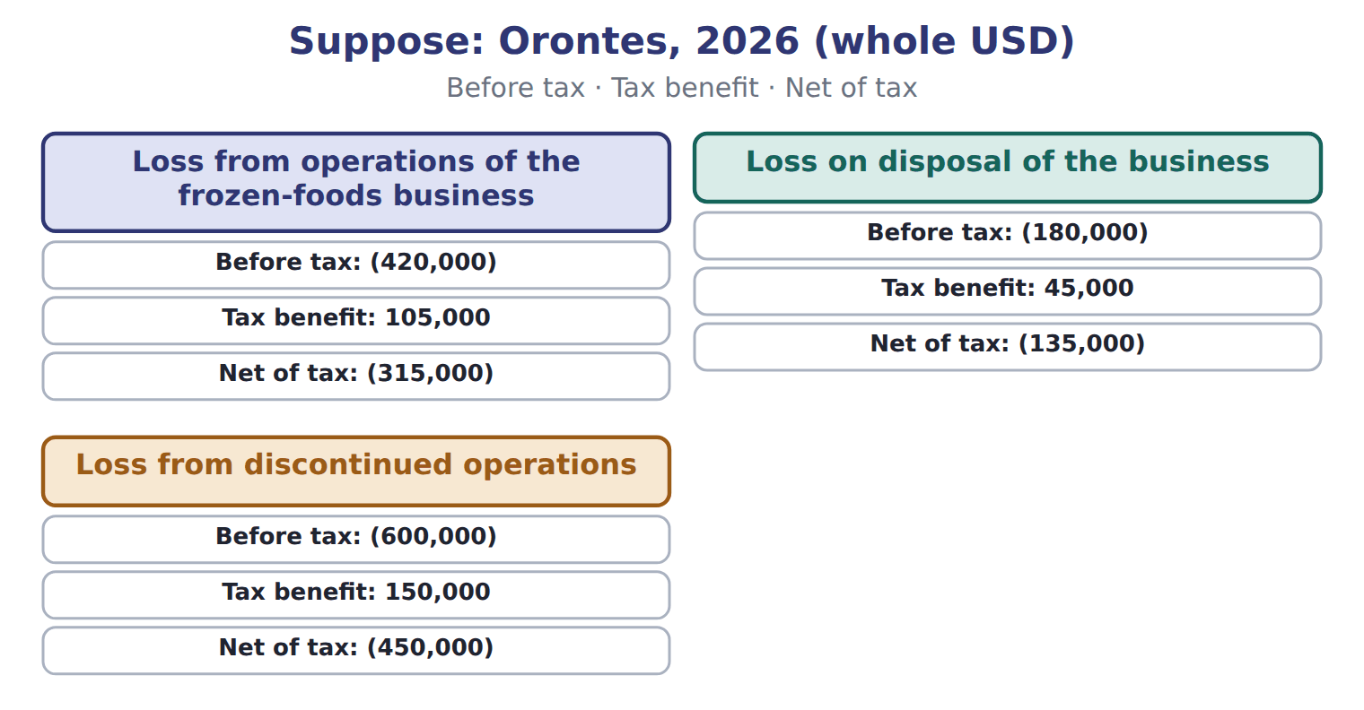
Suppose: Orontes, 2026 (whole USD) — the book’s own table
Suppose: Orontes, 2026 (whole USD) | Before tax | Tax benefit | Net of tax
Loss from operations of the frozen-foods business | (420,000) | 105,000 | (315,000)
Loss on disposal of the business | (180,000) | 45,000 | (135,000)
Loss from discontinued operations | (600,000) | 150,000 | (450,000)

READ THE MODEL Every answer is printed above. Find it, do not recall it.

5. Which before tax does the book give for Loss from operations of the frozen-foods business?
A. (600,000) | C. (180,000)
B. (420,000)
6. Which before tax does the book give for Loss on disposal of the business?
A. (600,000) | C. (180,000)
B. (420,000)
7. Which before tax does the book give for Loss from discontinued operations?
A. (420,000) | C. (600,000)
B. (180,000)

INVENT THE RULE

8. Complete the book’s own sentence. The list holds more words than there are gaps.
use every one of these words: other income and expense · component of an entity · strategic shift · discontinued operation
A is a that the company has sold, has classified as held for sale, or has abandoned.

Two of the book’s own cases, side by side
Loss from operations of the frozen-foods business | Loss on disposal of the business
Before tax: (420,000) | Before tax: (180,000)
Tax benefit: 105,000 | Tax benefit: 45,000
Only the facts above differ. What is the net of tax of Loss from operations of the frozen-foods business?
9. Choose one:
A. (315,000) | C. (450,000)
B. (135,000)
APPLY No help on this move.

10. Orontes sells an old delivery van for more than its carrying amount. The difference is:
A. revenue, because cash was received
B. a reduction of cost of goods sold
C. a gain, shown net in other income and expense
D. a direct increase in retained earnings
11. A company reports net income of $500,000. Its OCI for the year is a gain of $40,000 after tax. AOCI was $100,000 at the start of the year. What is comprehensive income?
A. $500,000 | C. $600,000
B. $540,000 | D. $640,000
12. Where may a U.S. company report OCI?
A. Only in the statement of changes in equity
B. In one continuous statement of comprehensive income, or in a separate statement right after the income statement
C. Only in the notes
D. Inside operating income
13. A company sells an AFS debt security and realizes a gain that had been in AOCI. What is the purpose of the reclassification adjustment?
A. To move the gain from net income to OCI
B. To defer the gain to next year
C. To remove the gain from retained earnings
D. To avoid counting the same gain twice in comprehensive income
14. Orontes's land has risen in value by $1 million this year. How does this affect the 2025 income statement?
A. It is a gain in other income
B. It is OCI
C. It has no effect, because the gain is not realized or recognized
D. It increases revenue

Orontes Foods Inc., year ended December 31, 2025 — the extract for the question that follows
Orontes Foods Inc., year ended December 31, 2025 | 2025
Net sales | 42,000,000
Cost of goods sold | (27,300,000)
Gross profit | 14,700,000
Operating expenses
Selling, general and administrative | (7,237,000)
Credit loss expense | (63,000)
Research and development | (500,000)
Impairment losses | (2,724,000)
Total operating expenses | (10,524,000)
Operating income | 4,176,000

Orontes Foods Inc., year ended December 31, 2025 — the extract for the question that follows (continued)
Orontes Foods Inc., year ended December 31, 2025 | 2025
Other income and (expense)
Interest expense | (390,000)
Interest and dividend income | 3,800
Unrealized gains on securities | 4,000
Equity-method income | 177,000
Gain on sale of equipment | 3,000
Loss on sale of receivables | (15,000)
Total other income and (expense) | (217,200)
Income before income taxes | 3,958,800
Income tax expense | (989,700)

Orontes Foods Inc., year ended December 31, 2025 — the extract for the question that follows (continued)
Orontes Foods Inc., year ended December 31, 2025 | 2025
Net income | 2,969,100
Earnings per share, basic and diluted | $0.37
Weighted-average shares outstanding | 8,099,726
Other comprehensive income
Unrealized loss on available-for-sale debt securities, net of tax of 375 | (1,125)
Comprehensive income | 2,967,975

15. The extract for this question is printed with it. What is Orontes's operating income for 2025 (whole USD)?
A. 3,786,000 | C. 6,900,000
B. 4,176,000 | D. 14,700,000
WORK IN PAIRS | Compare every answer on this page with your partner before you read any key.
If you disagree: go back to the model and find the row that settles it. The row decides, not the louder voice.

CHECKPOINT 16. Which statement reports a company's performance over a period of time?
A. The balance sheet
B. The income statement
C. The notes on accounting policies
D. The statement of financial position
If you got it wrong: redo the READ THE MODEL questions of cycle A with the model in front of you.

CYCLE B | The words this section uses precisely

ORIENT

17. A term in the exam means exactly what the book defines it to mean, whatever it means in ordinary English. TRUE / FALSE
MODEL

The English the exam uses, and what it translates
English (exam term) | the Arabic it translates
operating income | الدخل التشغيلي
accumulated other comprehensive income (AOCI) | الدخل الشامل الآخر المتراكم
component of an entity | مكوِّن من مكونات المنشأة

READ THE MODEL

18. A glossary term and its translation are a pair the book itself gives. TRUE / FALSE
APPLY

19. A company changes from a multi-step to a single-step income statement. What happens to net income?
A. It does not change
B. It increases, because gains are added to revenues
C. It decreases, because tax is deducted twice
D. It cannot be determined without the balance sheet
20. Near the year-end, a manager delays advertising until January to meet a profit target. This illustrates which limitation?
A. Net income can be influenced by the timing of discretionary costs
B. The income statement omits unrealized value changes
C. Net income is measured at fair value
D. The income statement shows cash flows
21. Which amount starts the operating section of a U.S. statement of cash flows under the indirect method?
A. Operating income | C. Gross profit
B. Comprehensive income | D. Net income
CHECKPOINT 22. What is the safest way to settle a disagreement about an answer on this sheet?
A. find the row of the model that decides it
B. take the answer of whoever is more confident
C. leave it until the lecturer says
D. choose the longer option
If you got it wrong: redo the READ THE MODEL questions of cycle B.

FROM MEMORY | Close the earlier pages first.
23. Rebuild the figure from this handout. Label every part and fill in every box.
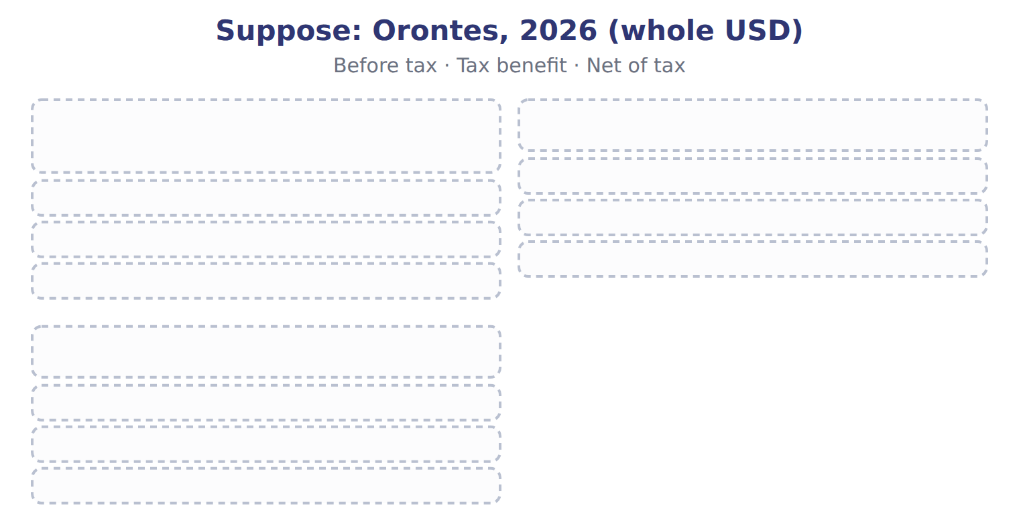
TEACH IT BACK | Write it for a classmate who missed this session — not for the marker.
24. In three or four sentences, write what this section settles and the one rule a reader has to take away.
every one of these words must appear: operating income · accumulated other comprehensive income (AOCI) · component of an entity

Answer key · Handout 3.3 · Unusual items and discontinued operations

1 unusual or infrequent item · discontinued operation · component of an entity · strategic shift | 9 A | 17 T
2 discontinued operation · income from continuing operations · intraperiod tax allocation · other income and expense · income statement | 10 C | 18 T
3 discontinued operation · income from continuing operations · intraperiod tax allocation · other income and expense | 11 B | 19 A
4 T | 12 B | 20 A
5 B | 13 D | 21 D
6 C | 14 C | 22 A
7 C | 15 B | 23 Compare with the model earlier in this handout.
8 discontinued operation · component of an entity | 16 B | 24 Some items need special attention because they may not happen again. U.S. GAAP no longer has extraordinary items; the FASB removed them in 2015. An unusual or infrequent item, such as a large fire loss, is shown as a separate line within continuing operations, before tax. It is never shown net of tax.

8 what the book says
A discontinued operation is a component of an entity that the company has sold, has classified as held for sale, or has abandoned.

why
1 The book writes: “An unusual or infrequent item, such as a large fire loss, is shown as a separate line within continuing operations, before tax. A discontinued operation is a component of an entity that the company has sold, has classified as held for sale, or has abandoned. The disposal must also be a strategic shift with a major effect on the company.”
2 The book writes: “The results of a discontinued operation, including any gain or loss on disposal, appear below income from continuing operations, net of their own tax. This is called intraperiod tax allocation. Ask the questions in order: OCI first, then discontinued operations, then unusual items, and finally main activities or other income and expense. Decision chart: where does an item go in the income statement?.”
3 The book writes: “The results of a discontinued operation, including any gain or loss on disposal, appear below income from continuing operations, net of their own tax. This is called intraperiod tax allocation. Ask the questions in order: OCI first, then discontinued operations, then unusual items, and finally main activities or other income and expense.”
4 The framework defines the elements, and every amount belongs to one of them.
5 The book’s own table gives (420,000) as the before tax of Loss from operations of the frozen-foods business.
6 The book’s own table gives (180,000) as the before tax of Loss on disposal of the business.
7 The book’s own table gives (600,000) as the before tax of Loss from discontinued operations.
9 The book gives (315,000) as the net of tax of Loss from operations of the frozen-foods business.
10 Selling equipment is peripheral, so the net difference is a gain. A is wrong: Revenue comes from the main activities, not from selling equipment. B is wrong: The van is not inventory.
11 Net income plus this year's OCI. A is wrong: This leaves out OCI. C is wrong: This adds the opening AOCI instead of this year's OCI.
12 ASU 2011-05 requires one or two statements. A is wrong: Showing OCI only in equity is no longer allowed. C is wrong: OCI must be on the face of a statement.
13 The gain moves from AOCI into net income; without the adjustment, comprehensive income would include it twice. A is wrong: The gain moves the other way: from OCI to net income. B is wrong: A realized gain is not deferred.
14 Unrecognized increases in value are one limitation of the income statement. A is wrong: U.S. GAAP does not recognize this increase. B is wrong: Revaluation surplus in OCI is an IFRS option only.
15 Gross profit of $14,700,000 minus operating expenses of $10,524,000. A is wrong: This also deducts interest expense, which is below operating income. C is wrong: This leaves out the impairment losses, which are operating expenses.
16 The income statement covers a period; the balance sheet is at one date. A is wrong: The balance sheet shows one date, not a period. C is wrong: The notes explain the statements; they do not report performance.
17 CMA questions use exact terms, and one word can change the answer.
18 The term tables in each section are the book’s own.
19 Only the grouping changes; the same items are included. B is wrong: Gains are included in both layouts. C is wrong: Tax is deducted once in both layouts.
20 Earnings management through timing is a known limitation. B is wrong: No unrealized value change is involved. C is wrong: Net income is not a fair value measure.
21 The indirect method reconciles net income to operating cash flow. A is wrong: Starting from operating profit is the IFRS 18 approach, not yet testable. B is wrong: OCI is not part of the reconciliation.

Handout 3.4
Comprehensive income
section 3.4 of the book
Before you start
Three summaries of this handout, in the book’s own words. Read all three first: together they are the whole session. Then fill the gaps, guessing where you have to.

What this handout settles, cycle by cycle
In this handout | What you will read | How you check it
Comprehensive income | a figure to read · Item · Orontes Foods Inc., year ended December 31, 2025 | An IFRS company revalues its land upward. How is the increase reported?
The words this section uses precisely | The English the exam uses, and what it translates | What is the safest way to settle a disagreement about an answer on this sheet?

Words this handout uses precisely
Words this handout uses precisely | tick it if you could already use it in a sentence
income from continuing operations
earnings per share (EPS)
strategic shift

1. Where the section starts — Fill every gap. The list holds more words than there are gaps, so one or two of them are not used.
choose from: reclassification adjustment · comprehensive income · component of an entity · other income and expense
OCI builds a balance in equity called accumulated other (AOCI). When an item is realized, for example when Orontes sells an AFS security, the gain or loss moves from AOCI into net income. This stops the same gain being counted twice.
2. What it settles in the middle — Fill every gap. The list holds more words than there are gaps, so one or two of them are not used.
choose from: other income and expense · component of an entity · reclassification adjustment · comprehensive income
Showing OCI only in the statement of changes in equity is not allowed. OCI builds a balance in equity called accumulated other (AOCI). When an item is realized, for example when Orontes sells an AFS security, the gain or loss moves from AOCI into net income. This stops the same gain being counted twice.
3. Where it ends — Fill every gap. The list holds more words than there are gaps, so one or two of them are not used.
choose from: reclassification adjustment · Comprehensive income · component of an entity · other income and expense
This stops the same gain being counted twice. Under IFRS, a revaluation surplus on PP&E, fair value changes on equity investments elected to OCI, and pension remeasurements stay in OCI forever. GAAP does not allow PP&E revaluation, and it reclassifies its OCI items to net income later. adds this year's OCI, not the AOCI balance.

CYCLE A | Comprehensive income

ORIENT One claim. Decide now; you will check it in a moment.

4. The book gives the U.S. GAAP of Unrealized gains and losses on debt securities (AFS / FVOCI) as “OCI; reclassified to net income on sale”. TRUE / FALSE
MODEL Read it before you answer anything below it.

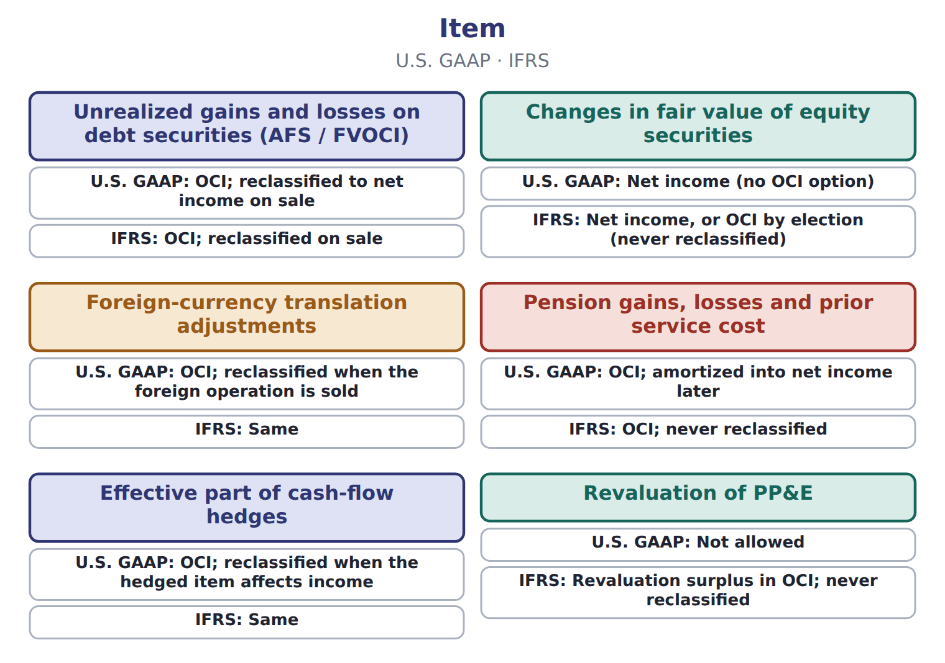

Item — the book’s own table
Item | U.S. GAAP | IFRS
Unrealized gains and losses on debt securities (AFS / FVOCI) | OCI; reclassified to net income on sale | OCI; reclassified on sale
Changes in fair value of equity securities | Net income (no OCI option) | Net income, or OCI by election (never reclassified)
Foreign-currency translation adjustments | OCI; reclassified when the foreign operation is sold | Same
Pension gains, losses and prior service cost | OCI; amortized into net income later | OCI; never reclassified
Effective part of cash-flow hedges | OCI; reclassified when the hedged item affects income | Same
Revaluation of PP&E | Not allowed | Revaluation surplus in OCI; never reclassified

READ THE MODEL Every answer is printed above. Find it, do not recall it.

5. Which item does the book pair with “OCI; reclassified to net income on sale”?
A. Effective part of cash-flow hedges
B. Pension gains, losses and prior service cost
C. Changes in fair value of equity securities
D. Unrealized gains and losses on debt securities (AFS / FVOCI)
6. Which item does the book pair with “Net income (no OCI option)”?
A. Revaluation of PP&E
B. Foreign-currency translation adjustments
C. Pension gains, losses and prior service cost
D. Changes in fair value of equity securities
7. Which item does the book pair with “OCI; reclassified when the foreign operation is sold”?
A. Effective part of cash-flow hedges
B. Pension gains, losses and prior service cost
C. Changes in fair value of equity securities
D. Foreign-currency translation adjustments
8. Which item does the book pair with “OCI; amortized into net income later”?
A. Revaluation of PP&E
B. Effective part of cash-flow hedges
C. Changes in fair value of equity securities
D. Pension gains, losses and prior service cost
9. The book gives the IFRS of Unrealized gains and losses on debt securities (AFS / FVOCI) as “OCI; reclassified on sale”. TRUE / FALSE
10. The book gives the IFRS of Changes in fair value of equity securities as “Revaluation surplus in OCI; never reclassified”. TRUE / FALSE
APPLY No help on this move.

11. An IFRS company revalues its land upward. How is the increase reported?
A. As a gain in profit or loss
B. In OCI, reclassified to profit when the land is sold
C. In OCI as a revaluation surplus, never reclassified to profit
D. It is not recognized under IFRS

Orontes Foods Inc., year ended December 31, 2025 — the extract for the question that follows
Orontes Foods Inc., year ended December 31, 2025 | 2025
Net sales | 42,000,000
Cost of goods sold | (27,300,000)
Gross profit | 14,700,000
Operating expenses
Selling, general and administrative | (7,237,000)
Credit loss expense | (63,000)
Research and development | (500,000)
Impairment losses | (2,724,000)
Total operating expenses | (10,524,000)
Operating income | 4,176,000

Orontes Foods Inc., year ended December 31, 2025 — the extract for the question that follows (continued)
Orontes Foods Inc., year ended December 31, 2025 | 2025
Other income and (expense)
Interest expense | (390,000)
Interest and dividend income | 3,800
Unrealized gains on securities | 4,000
Equity-method income | 177,000
Gain on sale of equipment | 3,000
Loss on sale of receivables | (15,000)
Total other income and (expense) | (217,200)
Income before income taxes | 3,958,800
Income tax expense | (989,700)

Orontes Foods Inc., year ended December 31, 2025 — the extract for the question that follows (continued)
Orontes Foods Inc., year ended December 31, 2025 | 2025
Net income | 2,969,100
Earnings per share, basic and diluted | $0.37
Weighted-average shares outstanding | 8,099,726
Other comprehensive income
Unrealized loss on available-for-sale debt securities, net of tax of 375 | (1,125)
Comprehensive income | 2,967,975

12. The extract for this question is printed with it. Which amount is Orontes's income before income taxes for 2025 (whole USD)?
A. 2,969,100 | C. 3,958,800
B. 3,781,800 | D. 4,176,000
WORK IN PAIRS | Compare every answer on this page with your partner before you read any key.
If you disagree: go back to the model and find the row that settles it. The row decides, not the louder voice.

CHECKPOINT 13. An IFRS company revalues its land upward. How is the increase reported?
A. As a gain in profit or loss
B. In OCI, reclassified to profit when the land is sold
C. In OCI as a revaluation surplus, never reclassified to profit
D. It is not recognized under IFRS
If you got it wrong: redo the READ THE MODEL questions of cycle A with the model in front of you.

CYCLE B | The words this section uses precisely

ORIENT

14. A term in the exam means exactly what the book defines it to mean, whatever it means in ordinary English. TRUE / FALSE
MODEL

The English the exam uses, and what it translates
English (exam term) | the Arabic it translates
income from continuing operations | الدخل من العمليات المستمرة
earnings per share (EPS) | ربحية السهم
strategic shift | تحول استراتيجي

READ THE MODEL

15. A glossary term and its translation are a pair the book itself gives. TRUE / FALSE
APPLY

16. Writing a term in English is part of answering the question, not an extra. TRUE / FALSE
CHECKPOINT 17. What is the safest way to settle a disagreement about an answer on this sheet?
A. find the row of the model that decides it
B. take the answer of whoever is more confident
C. leave it until the lecturer says
D. choose the longer option
If you got it wrong: redo the READ THE MODEL questions of cycle B.

FROM MEMORY | Close the earlier pages first.
18. Rebuild the figure from this handout. Label every part and fill in every box.
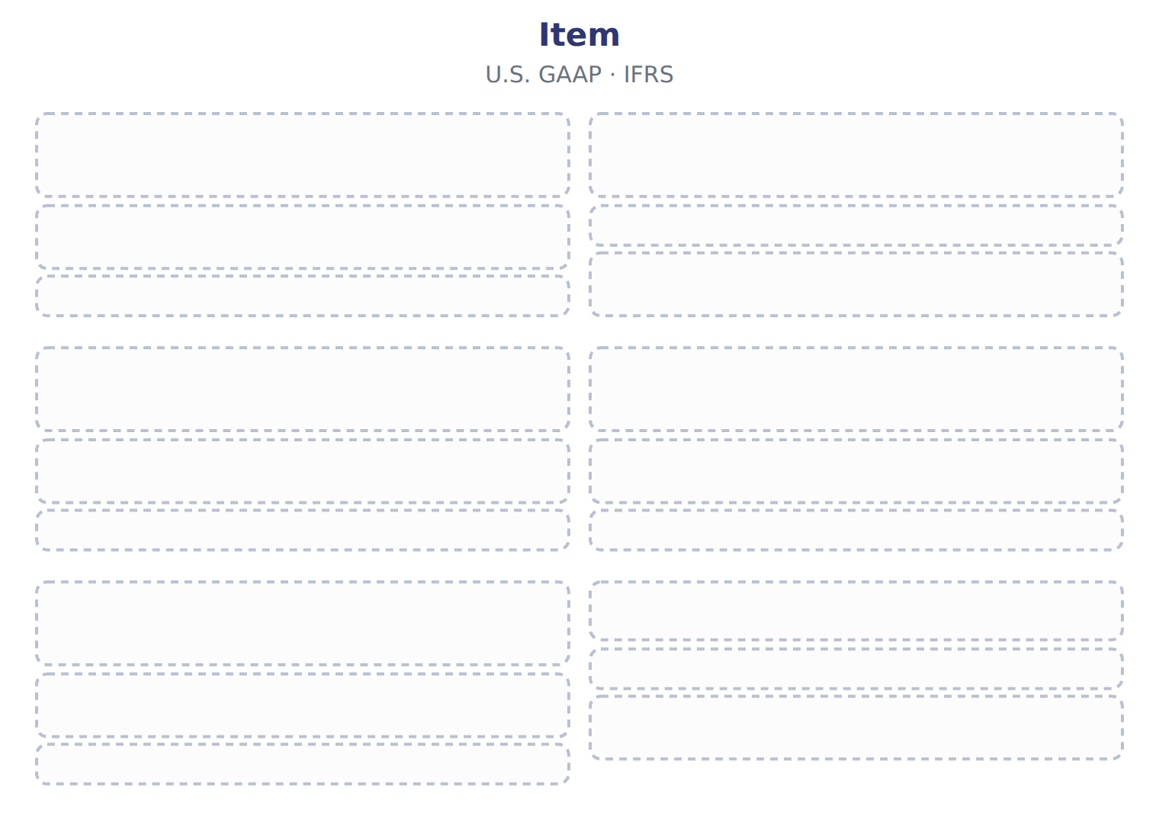
TEACH IT BACK | Write it for a classmate who missed this session — not for the marker.
19. In three or four sentences, write what this section settles and the one rule a reader has to take away.
every one of these words must appear: income from continuing operations · earnings per share (EPS) · strategic shift

Answer key · Handout 3.4 · Comprehensive income

1 comprehensive income · reclassification adjustment | 8 D | 15 T
2 comprehensive income · reclassification adjustment | 9 T | 16 T
3 reclassification adjustment · Comprehensive income | 10 F | 17 A
4 T | 11 C | 18 Compare with the model earlier in this handout.
5 D | 12 C | 19 Some changes in value do not go through net income. U.S. GAAP sends them to other comprehensive income (OCI) until they are realized. Comprehensive income is net income plus OCI for the period.
6 D | 13 C
7 D | 14 T

why
1 The book writes: “OCI builds a balance in equity called accumulated other comprehensive income (AOCI). When an item is realized, for example when Orontes sells an AFS security, the gain or loss moves from AOCI into net income. This reclassification adjustment stops the same gain being counted twice.”
2 The book writes: “Showing OCI only in the statement of changes in equity is not allowed. OCI builds a balance in equity called accumulated other comprehensive income (AOCI). When an item is realized, for example when Orontes sells an AFS security, the gain or loss moves from AOCI into net income. This reclassification adjustment stops the same gain being counted twice.”
3 The book writes: “This reclassification adjustment stops the same gain being counted twice. Under IFRS, a revaluation surplus on PP&E, fair value changes on equity investments elected to OCI, and pension remeasurements stay in OCI forever. GAAP does not allow PP&E revaluation, and it reclassifies its OCI items to net income later. Comprehensive income adds this year's OCI, not the AOCI balance.”
4 The book pairs Unrealized gains and losses on debt securities (AFS / FVOCI) with “OCI; reclassified to net income on sale”.
5 The book’s own table pairs Unrealized gains and losses on debt securities (AFS / FVOCI) with “OCI; reclassified to net income on sale”.
6 The book’s own table pairs Changes in fair value of equity securities with “Net income (no OCI option)”.
7 The book’s own table pairs Foreign-currency translation adjustments with “OCI; reclassified when the foreign operation is sold”.
8 The book’s own table pairs Pension gains, losses and prior service cost with “OCI; amortized into net income later”.
9 The book pairs Unrealized gains and losses on debt securities (AFS / FVOCI) with “OCI; reclassified on sale”.
10 The book pairs Changes in fair value of equity securities with “Net income, or OCI by election (never reclassified)”, not with “Revaluation surplus in OCI; never reclassified”.
11 IAS 16 revaluation increases go to OCI and are not recycled. A is wrong: Revaluation increases go to OCI, unless they reverse an earlier loss. B is wrong: Revaluation surplus is never recycled under IFRS.
12 Operating income plus other income and expense. A is wrong: This is after tax. B is wrong: This leaves out equity-method income.
13 IAS 16 revaluation increases go to OCI and are not recycled. A is wrong: Revaluation increases go to OCI, unless they reverse an earlier loss. B is wrong: Revaluation surplus is never recycled under IFRS.
14 CMA questions use exact terms, and one word can change the answer.
15 The term tables in each section are the book’s own.
16 The exam marks the term, so the English word is the answer.
17 Every item on a Workshop sheet is settled by something printed on the same sheet.

Handout 3.5
Limitations and links to the other statements
section 3.5 of the book
Before you start
Three summaries of this handout, in the book’s own words. Read all three first: together they are the whole session. Then fill the gaps, guessing where you have to.

What this handout settles, cycle by cycle
In this handout | What you will read | How you check it
Limitations and links to the other statements | a figure to read · Item / memo (USD 000) | Which of these did this cycle settle?
The words this section uses precisely | Item · The English the exam uses, and what it translates | What is the safest way to settle a disagreement about an answer on this sheet?

Words this handout uses precisely
Words this handout uses precisely | tick it if you could already use it in a sentence
discontinued operation
single-step income statement
intraperiod tax allocation

1. Where the section starts — Fill every gap. The list holds more words than there are gaps, so one or two of them are not used.
choose from: impairment · income statement · estimates · Different · other income and expense
Net income depends on many : useful lives, credit losses, tests and warranty costs. companies also choose different methods, such as FIFO or LIFO for inventory. Two similar companies can therefore report different profits from the same activity.
2. What it settles in the middle — Fill every gap. The list holds more words than there are gaps, so one or two of them are not used.
choose from: other income and expense · discretionary · advertising · income statement · importantly
Managers can influence results by timing sales or costs, such as research or , near the year-end. Most , net income is not cash. Accrual accounting records revenue when it is earned and expenses when they are incurred.
3. Where it ends — Fill every gap. The list holds more words than there are gaps, so one or two of them are not used.
choose from: other income and expense · subtotals · exceptionnel · income statement · statement
The face of the does not change. IFRS 18 replaces IAS 1 and adds required , including operating profit. French résultat means profit, not result in general, and résultat is not a U.S.
How every cycle on this sheet works
How a cycle works | what you do
MODEL | read the figure or the table before you answer anything
READ THE MODEL | every answer is printed on the same page
INVENT THE RULE | write the rule yourself, then compare with the book
APPLY | no help on this move
CHECKPOINT | mark it yourself; if you miss it, the sheet says what to redo

CYCLE A | Limitations and links to the other statements

ORIENT One claim. Decide now; you will check it in a moment.

4. Every number in a financial statement belongs to an element the framework defines. TRUE / FALSE
MODEL Read it before you answer anything below it.

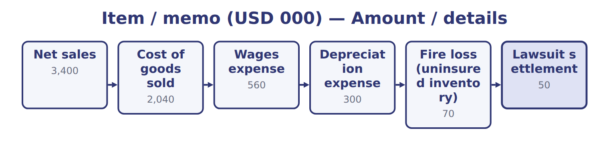
Item / memo (USD 000) — the book’s own table
Item / memo (USD 000) | Amount / details
Net sales | 3,400
Cost of goods sold | 2,040
Wages expense | 560
Depreciation expense | 300
Fire loss (uninsured inventory) | 70
Lawsuit settlement | 50
Interest expense | 80
Gain on sale of equipment | 20
M1 | In August 2026 Barada sold its catering-supply division to focus only on wholesale food. The division was one of Barada's two lines of busin
M2 | In 2026 the division had an operating loss of 60 before tax. Barada lost 40 before tax on the sale.

Item / memo (USD 000) — the book’s own table (continued)
Item / memo (USD 000) | Amount / details
M3 | The fire loss is the uninsured inventory destroyed on February 10, 2026. Fires are unusual for Barada.
M4 | The income tax rate is 25% on all items. Barada has no other comprehensive income.

READ THE MODEL Every answer is printed above. Find it, do not recall it.

5. Which part of this chapter is section 3.1?
A. Purpose and structure of the income statement
B. Building the multi-step income statement
C. Comprehensive income
D. Unusual items and discontinued operations
6. Which part of this chapter is section 3.2?
A. Comprehensive income
B. Purpose and structure of the income statement
C. Building the multi-step income statement
D. Unusual items and discontinued operations
7. Which part of this chapter is section 3.3?
A. Purpose and structure of the income statement
B. Comprehensive income
C. Unusual items and discontinued operations
D. Building the multi-step income statement
8. Which part of this chapter is section 3.4?
A. Building the multi-step income statement
B. Comprehensive income
C. Purpose and structure of the income statement
D. Unusual items and discontinued operations
APPLY No help on this move.

9. The rule you have just written is the book’s own rule. TRUE / FALSE
WORK IN PAIRS | Compare every answer on this page with your partner before you read any key.
If you disagree: go back to the model and find the row that settles it. The row decides, not the louder voice.
CHECKPOINT 10. Which of these did this cycle settle?
A. the rule and where it comes from
B. nothing in particular
C. only the vocabulary
D. only the arithmetic
If you got it wrong: redo the READ THE MODEL questions of cycle A.

CYCLE B | The words this section uses precisely

ORIENT

11. A term in the exam means exactly what the book defines it to mean, whatever it means in ordinary English. TRUE / FALSE

MODEL

Item — the book’s own table
Item | Category
Fire loss
Lawsuit settlement
Interest expense
Gain on sale of equipment
Loss on sale of the division

The English the exam uses, and what it translates
English (exam term) | the Arabic it translates
discontinued operation | العمليات غير المستمرة (المتوقفة)
single-step income statement | قائمة الدخل ذات المرحلة الواحدة
intraperiod tax allocation | توزيع الضريبة داخل الفترة

READ THE MODEL

12. A glossary term and its translation are a pair the book itself gives. TRUE / FALSE
APPLY

13. Writing a term in English is part of answering the question, not an extra. TRUE / FALSE
CHECKPOINT 14. What is the safest way to settle a disagreement about an answer on this sheet?
A. find the row of the model that decides it
B. take the answer of whoever is more confident
C. leave it until the lecturer says
D. choose the longer option
If you got it wrong: redo the READ THE MODEL questions of cycle B.

FROM MEMORY | Close the earlier pages first.
15. Rebuild the figure from this handout. Label every part and fill in every box.
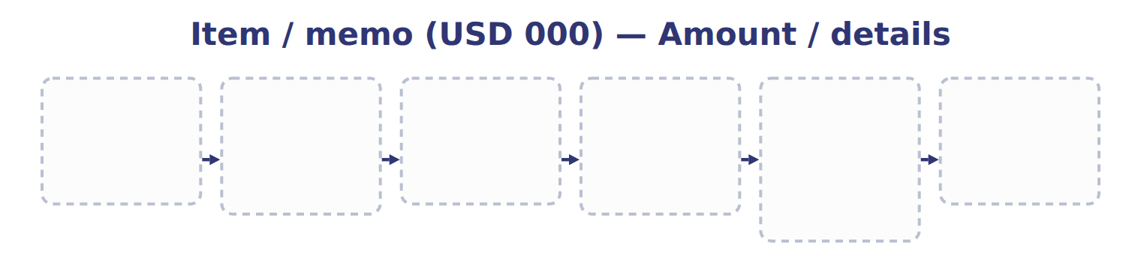
TEACH IT BACK | Write it for a classmate who missed this session — not for the marker.
16. In three or four sentences, write what this section settles and the one rule a reader has to take away.
every one of these words must appear: discontinued operation · single-step income statement · intraperiod tax allocation

Answer key · Handout 3.5 · Limitations and links to the other statements

1 estimates · impairment · Different | 7 C | 13 T
2 discretionary · advertising · importantly | 8 B | 14 A
3 statement · subtotals · exceptionnel | 9 T | 15 Compare with the model earlier in this handout.
4 T | 10 A | 16 Net income depends on many estimates: useful lives, credit losses, impairment tests and warranty costs. Different companies also choose different methods, such as FIFO or LIFO for inventory. Two similar companies can therefore report different profits from the same activity.
5 A | 11 T
6 C | 12 T

why
1 The book writes: “Net income depends on many estimates: useful lives, credit losses, impairment tests and warranty costs. Different companies also choose different methods, such as FIFO or LIFO for inventory. Two similar companies can therefore report different profits from the same activity.”
2 The book writes: “Managers can influence results by timing sales or discretionary costs, such as research or advertising, near the year-end. Most importantly, net income is not cash. Accrual accounting records revenue when it is earned and expenses when they are incurred.”
3 The book writes: “The face of the statement does not change. IFRS 18 replaces IAS 1 and adds required subtotals, including operating profit. French résultat means profit, not result in general, and résultat exceptionnel is not a U.S.”
4 The framework defines the elements, and every amount belongs to one of them.
5 The book numbers “Purpose and structure of the income statement” as section 3.1.
6 The book numbers “Building the multi-step income statement” as section 3.2.
7 The book numbers “Unusual items and discontinued operations” as section 3.3.
8 The book numbers “Comprehensive income” as section 3.4.
9 Compare your sentence with the book’s wording in the key.
10 Every cycle settles one rule and shows where it comes from.
11 CMA questions use exact terms, and one word can change the answer.
12 The term tables in each section are the book’s own.
13 The exam marks the term, so the English word is the answer.
14 Every item on a Workshop sheet is settled by something printed on the same sheet.

Handout 3.6
The whole chapter
every section, shuffled, and the chapter’s own case set
Before you start
Three summaries of this chapter, in the book’s own words, with words taken out. Read all three first: together they are the whole chapter. Then fill the gaps.

What this handout settles, cycle by cycle
In this handout | What you will read | How you check it
The whole chapter, in order | a figure to read | A company's warehouse is destroyed by an earthquake, which is rare in its area. Under current U.S. GAAP the loss is shown:
The chapter’s case set | The chapter’s case set, item by item | What has to be settled before any figure in a case set is worked out?
The words it uses precisely | income statement · multi-step income statement · operating income · income from continuing operations · discontinued operation · unusual or infrequent item | matching, at the end of cycle B

1. Where the chapter starts — Fill every gap. The list holds more words than there are gaps, so one or two of them are not used.
choose from: operating income · comprehensive income · multi-step income statement · single-step income statement · strategic shift
A shows subtotals: gross profit, and income before income taxes. A adds all revenues and gains, deducts all expenses and losses, and reaches net income in one step.
2. What it settles in the middle — Fill every gap. The list holds more words than there are gaps, so one or two of them are not used.
choose from: discontinued operation · other income and expense · income from continuing operations · comprehensive income · operating income · income statement · intraperiod tax allocation
The results of a , including any gain or loss on disposal, appear below , net of their own tax. This is called . Ask the questions in order: OCI first, then discontinued operations, then unusual items, and finally main activities or . Decision chart: where does an item go in the ?.
3. Where it ends — Fill every gap. The list holds more words than there are gaps, so one or two of them are not used.
choose from: reclassification adjustment · strategic shift · operating income · comprehensive income
OCI builds a balance in equity called accumulated other (AOCI). When an item is realized, for example when Orontes sells an AFS security, the gain or loss moves from AOCI into net income. This stops the same gain being counted twice.

CYCLE A | The whole chapter, in order

ORIENT

4. The sections of a chapter have to be taken in order, because each one uses what the one before it settled. TRUE / FALSE
MODEL

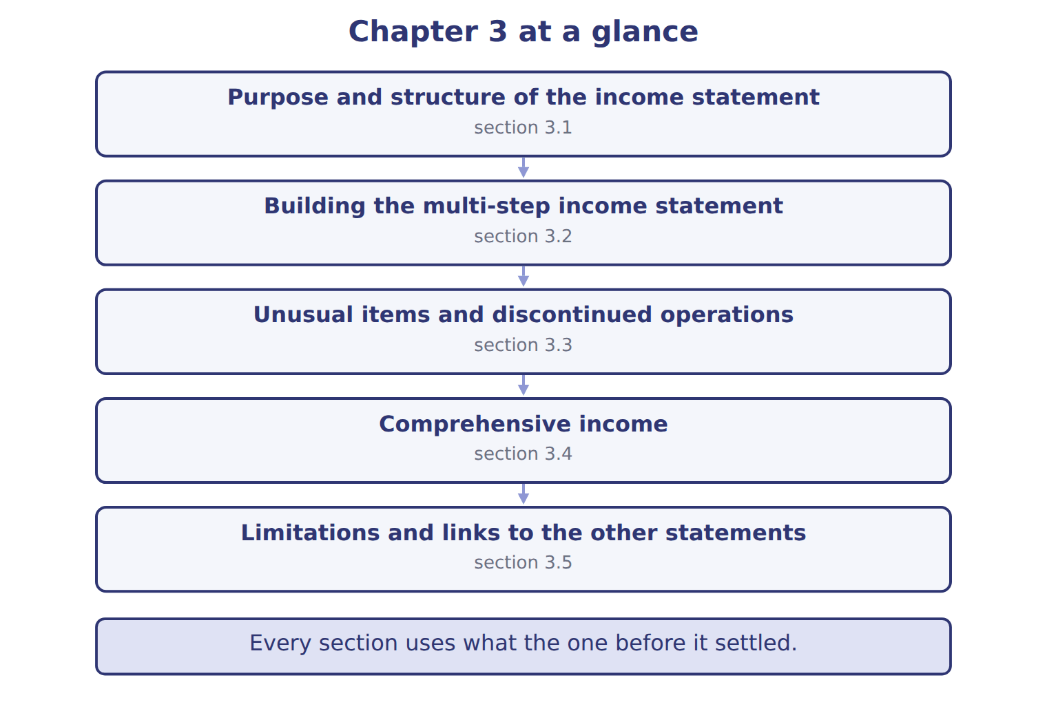
READ THE MODEL

5. “section 3.1” — which part of the chapter is this?
A. Comprehensive income
B. Unusual items and discontinued operations
C. Building the multi-step income statement
D. Purpose and structure of the income statement
6. “section 3.2” — which part of the chapter is this?
A. Unusual items and discontinued operations
B. Building the multi-step income statement
C. Purpose and structure of the income statement
D. Comprehensive income
7. “section 3.3” — which part of the chapter is this?
A. Building the multi-step income statement
B. Purpose and structure of the income statement
C. Unusual items and discontinued operations
D. Comprehensive income
Write the letter of the section number beside each section title. Every number is used once.
A 3.1 | D 3.4
B 3.2 | E 3.5
C 3.3

8. Purpose and structure of the income statement
9. Building the multi-step income statement
10. Unusual items and discontinued operations
11. Comprehensive income
12. Limitations and links to the other statements

APPLY

13. Why can two similar companies report different net income for the same activity?
A. The income statement uses current market values
B. Net income equals cash received
C. They may use different estimates and accounting methods
D. U.S. GAAP requires one layout
WORK IN PAIRS | Compare every answer with your partner first.
If you disagree: name the section each question belongs to. Most disagreements turn out to be about the section, not the answer.
CHECKPOINT 14. A company's warehouse is destroyed by an earthquake, which is rare in its area. Under current U.S. GAAP the loss is shown:
A. as a separate line in continuing operations, before tax
B. as an extraordinary item, net of tax
C. in discontinued operations
D. in OCI
If you got it wrong: go back to the MODEL move of cycle A and find the section this question belongs to.

CYCLE B | The chapter’s case set

ORIENT

15. In a case question, the exhibit has to be read and adjusted before any figure is worked out. TRUE / FALSE

MODEL

The chapter’s case set, item by item
Item | What it asks
C3-1 | Place each item in the section of the multi-step income statement where it belongs. (On the exam screen you would drag e
C3-2 | Enter Barada's operating income for 2026.
C3-3 | Enter Barada's income from continuing operations.
C3-4 | Enter the loss from discontinued operations, net of tax (as a positive number).
C3-5 | Enter Barada's net income for 2026.
C3-6 | How does Barada present the fire loss? [select]

READ THE MODEL

16. Which of these does item C3-1 ask for?
A. Enter the loss from discontinued operations, net of tax (as a positive
B. Place each item in the section of the multi-step income statement wher
C. Enter Barada's income from continuing operations.
D. Enter Barada's operating income for 2026.
17. Which of these does item C3-2 ask for?
A. Place each item in the section of the multi-step income statement wher
B. Enter Barada's operating income for 2026.
C. Enter the loss from discontinued operations, net of tax (as a positive
D. Enter Barada's income from continuing operations.
18. Which of these does item C3-3 ask for?
A. Enter the loss from discontinued operations, net of tax (as a positive
B. Enter Barada's operating income for 2026.
C. Enter Barada's income from continuing operations.
D. Place each item in the section of the multi-step income statement wher
19. Which of these does item C3-4 ask for?
A. Enter Barada's operating income for 2026.
B. Enter the loss from discontinued operations, net of tax (as a positive
C. Place each item in the section of the multi-step income statement wher
D. Enter Barada's income from continuing operations.
20. Which of these does item C3-5 ask for?
A. Enter Barada's income from continuing operations.
B. Enter Barada's net income for 2026.
C. Enter Barada's operating income for 2026.
D. Place each item in the section of the multi-step income statement wher
21. Which of these does item C3-6 ask for?
A. How does Barada present the fire loss? [select]
B. Enter Barada's operating income for 2026.
C. Place each item in the section of the multi-step income statement wher
D. Enter Barada's income from continuing operations.
APPLY

22. A company's warehouse is destroyed by an earthquake, which is rare in its area. Under current U.S. GAAP the loss is shown:
A. as a separate line in continuing operations, before tax
B. as an extraordinary item, net of tax
C. in discontinued operations
D. in OCI

23. Which disposal is MOST likely to be a discontinued operation?
A. A retailer closes one of its 200 stores
B. A food company sells its whole beverages division, one of its three main lines of business
C. A factory sells an old production machine
D. A company stops selling one small product in a large range
CHECKPOINT 24. What has to be settled before any figure in a case set is worked out?
A. the exhibit, adjusted for every note that goes with it
B. the method the company uses
C. the tax rate
D. the order of the items
If you got it wrong: reread the case panel in the MODEL move of cycle B.

FROM MEMORY | Close the earlier pages first.
25. Rebuild the chapter map. Write every section in order and what each one settles.
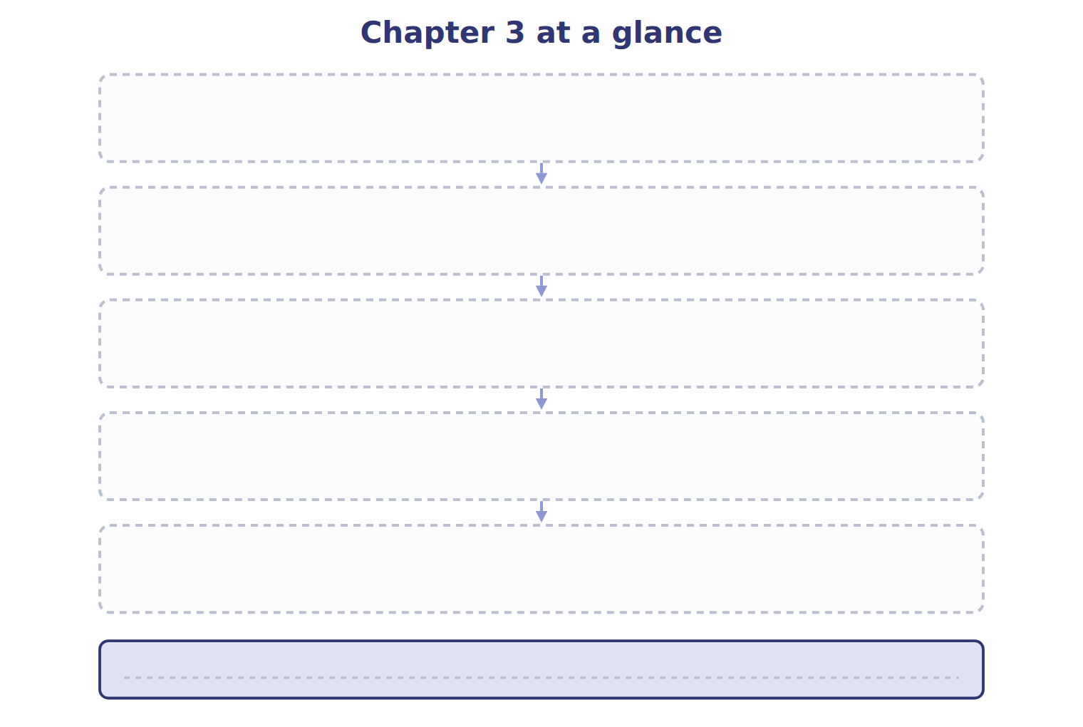
TEACH IT BACK | Write it for a student starting this chapter tomorrow — not for the marker.
26. In four or five sentences, write what the whole chapter settles, section by section.
every one of these words must appear: income statement · multi-step income statement · operating income · income from continuing operations

Answer key · Handout 3.6 · The whole chapter

1 multi-step income statement · operating income · single-step income statement | 10 C | 19 B
2 discontinued operation · income from continuing operations · intraperiod tax allocation · other income and expense · income statement | 11 D | 20 B
3 comprehensive income · reclassification adjustment | 12 E | 21 A
4 T | 13 C | 22 A
5 D | 14 A | 23 B
6 B | 15 T | 24 A
7 C | 16 B | 25 Compare with the model earlier in this handout.
8 A | 17 B | 26 3.1: Purpose and structure of the income statement. 3.2: Building the multi-step income statement. 3.3: Unusual items and discontinued operations. 3.4: Comprehensive income. 3.5: Limitations and links to the other statements.
9 B | 18 C

why
1 The book writes: “A multi-step income statement shows subtotals: gross profit, operating income and income before income taxes. A single-step income statement adds all revenues and gains, deducts all expenses and losses, and reaches net income in one step.”
2 The book writes: “The results of a discontinued operation, including any gain or loss on disposal, appear below income from continuing operations, net of their own tax. This is called intraperiod tax allocation. Ask the questions in order: OCI first, then discontinued operations, then unusual items, and finally main activities or other income and expense. Decision chart: where does an item go in the income statement?.”
3 The book writes: “OCI builds a balance in equity called accumulated other comprehensive income (AOCI). When an item is realized, for example when Orontes sells an AFS security, the gain or loss moves from AOCI into net income. This reclassification adjustment stops the same gain being counted twice.”
4 The map shows the order the decisions have to be taken in.
5 The book numbers it 3.1.
6 The book numbers it 3.2.
7 The book numbers it 3.3.
13 Estimates (useful lives) and methods (FIFO or LIFO) reduce comparability. A is wrong: Most amounts are based on historical cost. B is wrong: Net income is an accrual measure, not cash.
14 Extraordinary items were removed in 2015; unusual or infrequent items stay in continuing operations. B is wrong: Extraordinary items no longer exist. C is wrong: No component was sold or abandoned.
15 Every later answer depends on the adjusted exhibit.
16 The book states item C3-1 in those words.
17 The book states item C3-2 in those words.
18 The book states item C3-3 in those words.
19 The book states item C3-4 in those words.
20 The book states item C3-5 in those words.
21 The book states item C3-6 in those words.
22 Extraordinary items were removed in 2015; unusual or infrequent items stay in continuing operations. B is wrong: Extraordinary items no longer exist. C is wrong: No component was sold or abandoned.
23 Leaving a major line of business is a strategic shift with a major effect. A is wrong: One store out of many is not a strategic shift. C is wrong: Selling one asset gives a gain or loss, not a discontinued operation.
24 Every later answer depends on the adjusted exhibit.

Handout 4.1
Components of equity and the statement of changes in equity
section 4.1 of the book
Before you start
Three summaries of this handout, in the book’s own words. Read all three first: together they are the whole session. Then fill the gaps, guessing where you have to.

What this handout settles, cycle by cycle
In this handout | What you will read | How you check it
Components of equity and the statement of changes in equity | a figure to read · Transaction · the book’s own rule, gapped | Which change in equity is a transaction with owners?
The words this section uses precisely | The English the exam uses, and what it translates | What is the safest way to settle a disagreement about an answer on this sheet?

Words this handout uses precisely
Words this handout uses precisely | tick it if you could already use it in a sentence
statement of changes in equity
stock split
cost method

1. Where the section starts — Fill every gap. The list holds more words than there are gaps, so one or two of them are not used.
choose from: date of record · Contributed capital · preferred stock · Treasury stock · issued shares
is what owners have paid in: common stock and at par or stated value, plus additional paid-in capital. Earned capital is retained earnings and AOCI. is deducted from the total.
2. What it settles in the middle — Fill every gap. The list holds more words than there are gaps, so one or two of them are not used.
choose from: issued shares · preferred stock · date of record · Contributed capital
is what owners have paid in: common stock and at par or stated value, plus additional paid-in capital. Earned capital is retained earnings and AOCI.
3. Where it ends — Fill every gap. The list holds more words than there are gaps, so one or two of them are not used.
choose from: issued shares · date of record · Treasury stock · preferred stock · Contributed capital
Comprehensive income, which the company earns, is the other. is what owners have paid in: common stock and at par or stated value, plus additional paid-in capital. Earned capital is retained earnings and AOCI. is deducted from the total.
How every cycle on this sheet works
How a cycle works | what you do
MODEL | read the figure or the table before you answer anything
READ THE MODEL | every answer is printed on the same page
INVENT THE RULE | write the rule yourself, then compare with the book
APPLY | no help on this move
CHECKPOINT | mark it yourself; if you miss it, the sheet says what to redo

CYCLE A | Components of equity and the statement of changes in equity

ORIENT One claim. Decide now; you will check it in a moment.

4. The book gives the retained earnings of Declare a cash dividend as “Decreases”. TRUE / FALSE
MODEL Read it before you answer anything below it.

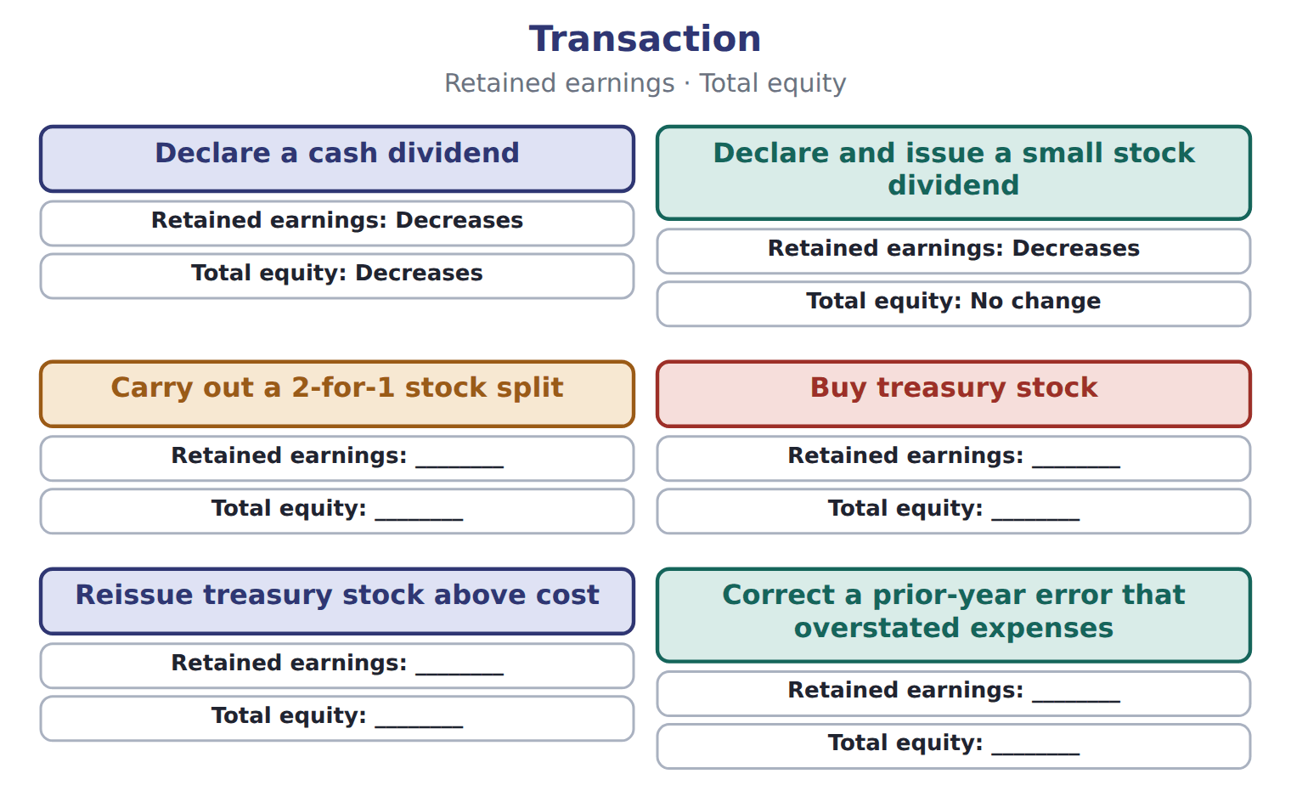

Transaction — the book’s own table
Transaction | Retained earnings | Total equity
Declare a cash dividend | Decreases | Decreases
Declare and issue a small stock dividend | Decreases | No change
Carry out a 2-for-1 stock split | ________ | ________
Buy treasury stock | ________ | ________
Reissue treasury stock above cost | ________ | ________
Correct a prior-year error that overstated expenses | ________ | ________

READ THE MODEL Every answer is printed above. Find it, do not recall it.

5. Which transaction does the book pair with “Decreases”?
A. Correct a prior-year error that overstated expenses
B. Buy treasury stock
C. Declare a cash dividend
D. Reissue treasury stock above cost
6. Which transaction does the book pair with “Decreases”?
A. Declare and issue a small stock dividend
B. Reissue treasury stock above cost
C. Carry out a 2-for-1 stock split
D. Buy treasury stock
7. Which transaction does the book pair with “________”?
A. Declare a cash dividend
B. Declare and issue a small stock dividend
C. Carry out a 2-for-1 stock split
8. Which transaction does the book pair with “________”?
A. Declare a cash dividend
B. Declare and issue a small stock dividend
C. Buy treasury stock
9. The book gives the total equity of Declare a cash dividend as “Decreases”. TRUE / FALSE
10. The book gives the total equity of Declare and issue a small stock dividend as “________”. TRUE / FALSE
SORT THEM | Write each one under its retained earnings. Every item belongs to exactly one group.
the items: Declare a cash dividend · Declare and issue a small stock dividend · Carry out a 2-for-1 stock split · Buy treasury stock · Reissue treasury stock above cost · Correct a prior-year error that overstated expenses
Decreases | ________

INVENT THE RULE

13. Complete the book’s own sentence. The list holds more words than there are gaps.
use every one of these words: preferred stock · declaration date · date of record · Contributed capital
is what owners have paid in: common stock and at par or stated value, plus additional paid-in capital.

Two of the book’s own cases, side by side
Declare a cash dividend | Declare and issue a small stock dividend
Retained earnings: Decreases | Retained earnings: Decreases
Only the facts above differ. What is the total equity of Declare a cash dividend?
14. Choose one:
A. ________ | C. Decreases
B. No change
APPLY No help on this move.

15. Which change in equity is a transaction with owners?
A. Earning net income
B. Recording an OCI loss on AFS debt securities
C. Declaring a cash dividend
D. Recording depreciation
16. An investor wants to know whether a company paid out more in dividends than it earned this year. Which statement shows both amounts together?
A. The balance sheet
B. The statement of changes in equity
C. The income statement
D. The notes on accounting policies
17. For which periods must an SEC registrant reconcile each equity caption?
A. Only for the latest year
B. For every period for which it presents an income statement
C. Only when equity changes by more than 10%
D. Only in interim reports
18. Which heading is correct for a statement of changes in equity?
A. As of December 31, 2025
B. At December 31, 2025
C. On December 31, 2025
D. For the year ended December 31, 2025
WORK IN PAIRS | Compare every answer on this page with your partner before you read any key.
If you disagree: go back to the model and find the row that settles it. The row decides, not the louder voice.
CHECKPOINT 19. Which change in equity is a transaction with owners?
A. Earning net income
B. Recording an OCI loss on AFS debt securities
C. Declaring a cash dividend
D. Recording depreciation
If you got it wrong: redo the READ THE MODEL questions of cycle A with the model in front of you.

CYCLE B | The words this section uses precisely

ORIENT

20. A term in the exam means exactly what the book defines it to mean, whatever it means in ordinary English. TRUE / FALSE

MODEL

The English the exam uses, and what it translates
English (exam term) | the Arabic it translates
statement of changes in equity | قائمة التغيرات في حقوق الملكية
stock split | تجزئة الأسهم
cost method | طريقة التكلفة

READ THE MODEL

21. A glossary term and its translation are a pair the book itself gives. TRUE / FALSE
APPLY

22. Where does treasury stock appear on a U.S. balance sheet?
A. As a current asset
B. As a long-term investment
C. As a deduction within stockholders' equity
D. As a liability
23. A company has issued 1,000,000 shares and holds 50,000 of them as treasury stock. How many shares are outstanding?
A. 50,000 | C. 1,000,000
B. 950,000 | D. 1,050,000
CHECKPOINT 24. What is the safest way to settle a disagreement about an answer on this sheet?
A. find the row of the model that decides it
B. take the answer of whoever is more confident
C. leave it until the lecturer says
D. choose the longer option
If you got it wrong: redo the READ THE MODEL questions of cycle B.

FROM MEMORY | Close the earlier pages first.
25. Rebuild the figure from this handout. Label every part and fill in every box.
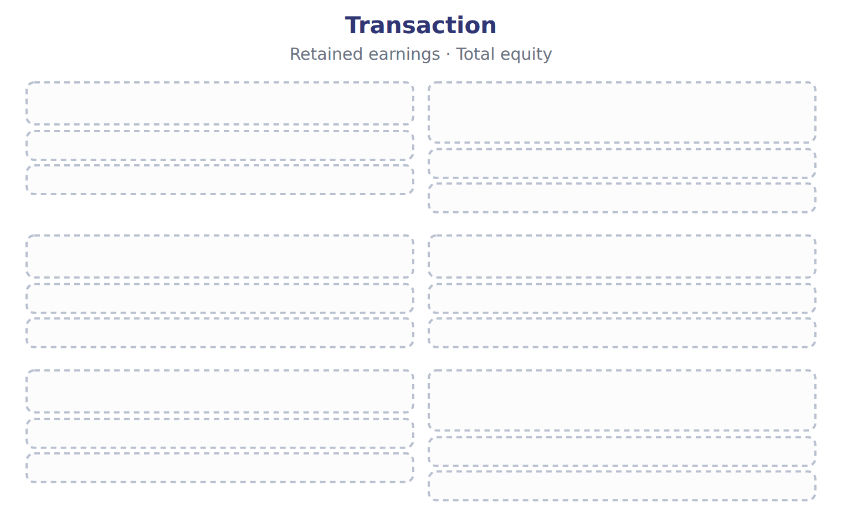
TEACH IT BACK | Write it for a classmate who missed this session — not for the marker.
26. In three or four sentences, write what this section settles and the one rule a reader has to take away.
every one of these words must appear: statement of changes in equity · stock split · cost method

Answer key · Handout 4.1 · Components of equity and the statement of changes in equity

1 Contributed capital · preferred stock · Treasury stock | 10 F | 19 C
2 Contributed capital · preferred stock | 11 Decreases: Declare a cash dividend, Declare and issue a small stock dividend | 20 T
3 Contributed capital · preferred stock · Treasury stock | 12 ________: Carry out a 2-for-1 stock split, Buy treasury stock, Reissue treasury stock above cost, Correct a prior-year error that overstated expenses | 21 T
4 T | 13 Contributed capital · preferred stock | 22 C
5 C | 14 C | 23 B
6 A | 15 C | 24 A
7 C | 16 B | 25 Compare with the model earlier in this handout.
8 C | 17 B | 26 The statement of changes in equity explains why each part of equity changed during the period. It separates two kinds of change. Transactions with owners, such as issuing shares and paying dividends, are one kind. Comprehensive income, which the company earns, is the other.
9 T | 18 D

13 what the book says
Contributed capital is what owners have paid in: common stock and preferred stock at par or stated value, plus additional paid-in capital.

why
1 The book writes: “Contributed capital is what owners have paid in: common stock and preferred stock at par or stated value, plus additional paid-in capital. Earned capital is retained earnings and AOCI. Treasury stock is deducted from the total.”
2 The book writes: “Contributed capital is what owners have paid in: common stock and preferred stock at par or stated value, plus additional paid-in capital. Earned capital is retained earnings and AOCI.”
3 The book writes: “Comprehensive income, which the company earns, is the other. Contributed capital is what owners have paid in: common stock and preferred stock at par or stated value, plus additional paid-in capital. Earned capital is retained earnings and AOCI. Treasury stock is deducted from the total.”
4 The book pairs Declare a cash dividend with “Decreases”.
5 The book’s own table pairs Declare a cash dividend with “Decreases”.
6 The book’s own table pairs Declare and issue a small stock dividend with “Decreases”.
7 The book’s own table pairs Carry out a 2-for-1 stock split with “________”.
8 The book’s own table pairs Buy treasury stock with “________”.
9 The book pairs Declare a cash dividend with “Decreases”.
10 The book pairs Declare and issue a small stock dividend with “No change”, not with “________”.
14 The book gives Decreases as the total equity of Declare a cash dividend.
15 Dividends are distributions to owners. A is wrong: Net income is earned, not a transaction with owners. B is wrong: OCI is part of comprehensive income.
16 The retained earnings column shows net income and dividends side by side. A is wrong: The balance sheet shows only the closing balance. C is wrong: Dividends are not on the income statement.
17 S-X 3-04 requires a reconciliation for each period with an income statement. A is wrong: Comparative periods are also reconciled. C is wrong: There is no size threshold.
18 It explains changes over a period. A is wrong: 'As of' is used for the balance sheet. B is wrong: A single date describes a balance sheet.
19 Dividends are distributions to owners. A is wrong: Net income is earned, not a transaction with owners. B is wrong: OCI is part of comprehensive income.
20 CMA questions use exact terms, and one word can change the answer.
21 The term tables in each section are the book’s own.
22 Treasury stock is contra-equity. A is wrong: A company cannot own itself as an asset. B is wrong: Treasury stock is not an investment.
23 Outstanding shares = issued shares − treasury shares. A is wrong: This is the number of treasury shares. C is wrong: This includes treasury shares.

Handout 4.2
Issuing and buying back shares
section 4.2 of the book
Before you start
Three summaries of this handout, in the book’s own words. Read all three first: together they are the whole session. Then fill the gaps, guessing where you have to.

What this handout settles, cycle by cycle
In this handout | What you will read | How you check it
Issuing and buying back shares | a figure to read · Account | A company declares a stock dividend on December 20 and distributes the shares on January 10. How does it present the stock dividend distributable at December 31?
The words this section uses precisely | The English the exam uses, and what it translates | What is the safest way to settle a disagreement about an answer on this sheet?

Words this handout uses precisely
Words this handout uses precisely | tick it if you could already use it in a sentence
contributed capital
appropriated retained earnings
declaration date

1. Where the section starts — Fill every gap. The list holds more words than there are gaps, so one or two of them are not used.
choose from: treasury stock · stock split · issued shares · declaration date · outstanding shares · Preferred stock · cost method
is recorded in the same way, in its own account. A company may buy back its own shares and hold them as . Under the , treasury stock is recorded at the price paid and deducted from equity. Shares held as treasury stock are but not : they receive no dividends and have no votes.
2. What it settles in the middle — Fill every gap. The list holds more words than there are gaps, so one or two of them are not used.
choose from: declaration date · treasury stock · cost method · issued shares · preferred stock · outstanding shares
Shares held as are but not : they receive no dividends and have no votes. A company never records a gain or loss on its own shares in net income. Treasury stock under the : buy back, reissue or retire.
3. Where it ends — Fill every gap. The list holds more words than there are gaps, so one or two of them are not used.
choose from: declaration date · preferred stock · treasury stock · issued shares · outstanding shares · cost method
A company may buy back its own shares and hold them as . Under the , treasury stock is recorded at the price paid and deducted from equity. Shares held as treasury stock are but not : they receive no dividends and have no votes.

CYCLE A | Issuing and buying back shares

ORIENT One claim. Decide now; you will check it in a moment.

4. The book gives the category of APIC–treasury stock as “Contributed capital”. TRUE / FALSE
MODEL Read it before you answer anything below it.

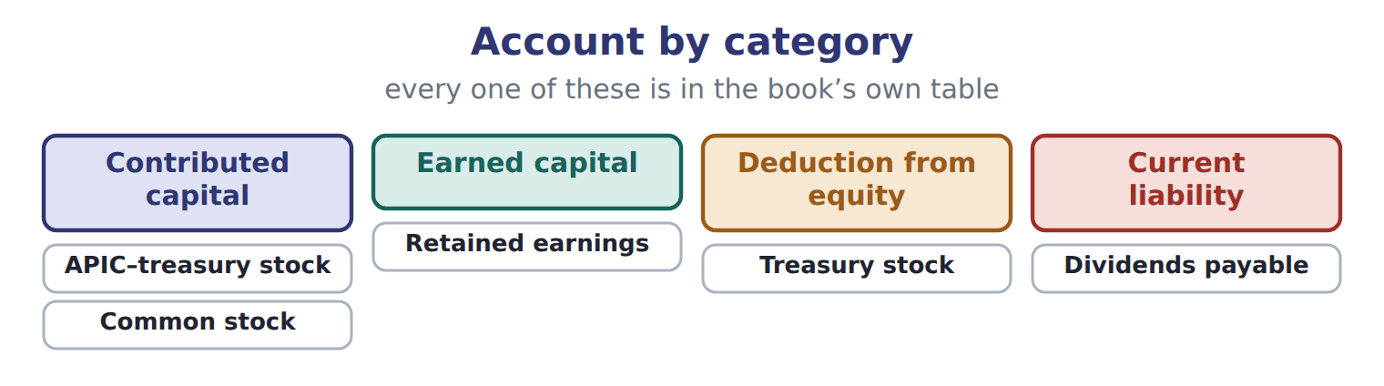

Account — the book’s own table
Account | Category
APIC–treasury stock | Contributed capital
Retained earnings | Earned capital
Treasury stock | Deduction from equity
Dividends payable | Current liability
Common stock | Contributed capital

READ THE MODEL Every answer is printed above. Find it, do not recall it.

5. Which category does the book give for APIC–treasury stock?
A. Earned capital | C. Contributed capital
B. Current liability | D. Deduction from equity
6. Which category does the book give for Retained earnings?
A. Earned capital | C. Contributed capital
B. Deduction from equity | D. Current liability
7. Which category does the book give for Treasury stock?
A. Contributed capital | C. Current liability
B. Earned capital | D. Deduction from equity
8. Which category does the book give for Dividends payable?
A. Current liability | C. Contributed capital
B. Deduction from equity | D. Earned capital
9. The book gives the category of APIC–treasury stock as “Contributed capital”. TRUE / FALSE
10. The book gives the category of Retained earnings as “Contributed capital”. TRUE / FALSE
SORT THEM | Write each one under its category. Every item belongs to exactly one group.
the items: APIC–treasury stock · Retained earnings · Treasury stock · Dividends payable · Common stock
Contributed capital | Current liability | Deduction from equity | Earned capital

APPLY No help on this move.

15. A company declares a stock dividend on December 20 and distributes the shares on January 10. How does it present the stock dividend distributable at December 31?
A. As a current liability | C. As a long-term liability
B. In stockholders' equity | D. In the notes only
16. Which item is part of contributed capital?
A. Retained earnings
B. Accumulated other comprehensive income
C. Appropriated retained earnings
D. Additional paid-in capital
17. In a statement of changes in equity, in which column does an OCI loss on AFS debt securities appear?
A. Retained earnings
B. Additional paid-in capital
C. Accumulated other comprehensive income
D. Treasury stock
18. A company's retained earnings were $800,000 on January 1. Net income was $250,000, cash dividends declared were $60,000, and a 5% stock dividend was measured at $90,000. What are retained earnings at December 31?
A. $900,000 | C. $990,000
B. $960,000 | D. $1,050,000
WORK IN PAIRS | Compare every answer on this page with your partner before you read any key.
If you disagree: go back to the model and find the row that settles it. The row decides, not the louder voice.
CHECKPOINT 19. A company declares a stock dividend on December 20 and distributes the shares on January 10. How does it present the stock dividend distributable at December 31?
A. As a current liability
B. In stockholders' equity
C. As a long-term liability
D. In the notes only
If you got it wrong: redo the READ THE MODEL questions of cycle A with the model in front of you.

CYCLE B | The words this section uses precisely

ORIENT

20. A term in the exam means exactly what the book defines it to mean, whatever it means in ordinary English. TRUE / FALSE
MODEL

The English the exam uses, and what it translates
English (exam term) | the Arabic it translates
contributed capital | رأس المال المساهم به (المدفوع)
appropriated retained earnings | أرباح مبقاة مخصصة
declaration date | تاريخ الإعلان

READ THE MODEL

21. A glossary term and its translation are a pair the book itself gives. TRUE / FALSE

APPLY

22. A company pays $50,000 of legal and underwriting costs to issue new common shares. How does it record the costs?
A. As an expense
B. As a reduction of additional paid-in capital
C. As an intangible asset
D. As a reduction of retained earnings
23. A company issues common shares in exchange for land. The shares are actively traded. The land is recorded at:
A. the par value of the shares
B. the seller's carrying amount of the land
C. the fair value of the shares
D. zero, because no cash was paid
CHECKPOINT 24. What is the safest way to settle a disagreement about an answer on this sheet?
A. find the row of the model that decides it
B. take the answer of whoever is more confident
C. leave it until the lecturer says
D. choose the longer option
If you got it wrong: redo the READ THE MODEL questions of cycle B.

FROM MEMORY | Close the earlier pages first.
25. Rebuild the figure from this handout. Label every part and fill in every box.
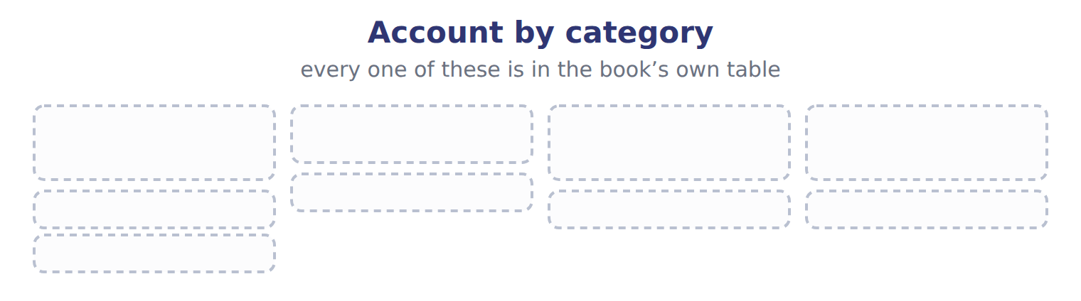
TEACH IT BACK | Write it for a classmate who missed this session — not for the marker.
26. In three or four sentences, write what this section settles and the one rule a reader has to take away.
every one of these words must appear: contributed capital · appropriated retained earnings · declaration date

Answer key · Handout 4.2 · Issuing and buying back shares

1 Preferred stock · treasury stock · cost method · issued shares · outstanding shares | 10 F | 19 B
2 treasury stock · issued shares · outstanding shares · cost method | 11 Contributed capital: APIC–treasury stock, Common stock | 20 T
3 treasury stock · cost method · issued shares · outstanding shares | 12 Current liability: Dividends payable | 21 T
4 T | 13 Deduction from equity: Treasury stock | 22 B
5 C | 14 Earned capital: Retained earnings | 23 C
6 A | 15 B | 24 A
7 D | 16 D | 25 Compare with the model earlier in this handout.
8 A | 17 C | 26 When a company issues shares for cash, it credits common stock with the par value and APIC with the rest. If the shares have no par and no stated value, the whole amount goes to common stock. Direct costs of issuing shares, such as underwriting fees, reduce APIC; they are not expenses.
9 T | 18 A

why
1 The book writes: “Preferred stock is recorded in the same way, in its own account. A company may buy back its own shares and hold them as treasury stock. Under the cost method, treasury stock is recorded at the price paid and deducted from equity. Shares held as treasury stock are issued shares but not outstanding shares: they receive no dividends and have no votes.”
2 The book writes: “Shares held as treasury stock are issued shares but not outstanding shares: they receive no dividends and have no votes. A company never records a gain or loss on its own shares in net income. Treasury stock under the cost method: buy back, reissue or retire.”
3 The book writes: “A company may buy back its own shares and hold them as treasury stock. Under the cost method, treasury stock is recorded at the price paid and deducted from equity. Shares held as treasury stock are issued shares but not outstanding shares: they receive no dividends and have no votes.”
4 The book pairs APIC–treasury stock with “Contributed capital”.
5 The book’s own table gives Contributed capital as the category of APIC–treasury stock.
6 The book’s own table gives Earned capital as the category of Retained earnings.
7 The book’s own table gives Deduction from equity as the category of Treasury stock.
8 The book’s own table gives Current liability as the category of Dividends payable.
9 The book pairs APIC–treasury stock with “Contributed capital”.
10 The book pairs Retained earnings with “Earned capital”, not with “Contributed capital”.
15 No assets will be paid, so it is equity. A is wrong: Only a cash dividend creates a liability. C is wrong: Nothing is owed to anyone.
16 APIC comes from owners' payments. A is wrong: Retained earnings are earned capital. B is wrong: AOCI is earned capital.
17 OCI goes to AOCI, not retained earnings. A is wrong: Only net income goes to retained earnings. B is wrong: APIC is for owner contributions.
18 Opening + net income − cash dividends − stock dividend. B is wrong: This leaves out the cash dividend. C is wrong: This leaves out the stock dividend.
19 No assets will be paid, so it is equity. A is wrong: Only a cash dividend creates a liability. C is wrong: Nothing is owed to anyone.
20 CMA questions use exact terms, and one word can change the answer.
21 The term tables in each section are the book’s own.
22 Direct equity issuance costs reduce the proceeds, so they reduce APIC. A is wrong: Equity issuance costs are not expensed. C is wrong: They are not an asset.
23 Use the more reliable fair value; a traded share price is reliable. A is wrong: Par value is only a legal amount. B is wrong: The seller's book value is not the exchange value.
24 Every item on a Workshop sheet is settled by something printed on the same sheet.

Handout 4.3
Dividends, stock dividends and stock splits
section 4.3 of the book
Before you start
Three summaries of this handout, in the book’s own words. Read all three first: together they are the whole session. Then fill the gaps, guessing where you have to.

What this handout settles, cycle by cycle
In this handout | What you will read | How you check it
Dividends, stock dividends and stock splits | a figure to read · Type · the book’s own rule, gapped | A company reissues treasury shares for more than their cost. The excess is:
The words this section uses precisely | Suppose: Orontes, 8,100,000 shares · The English the exam uses, and what it translates | What is the safest way to settle a disagreement about an answer on this sheet?

Words this handout uses precisely
Words this handout uses precisely | tick it if you could already use it in a sentence
outstanding shares
prior-period adjustment
date of record

1. Where the section starts — Fill every gap. The list holds more words than there are gaps, so one or two of them are not used.
choose from: prior-period adjustment · date of record · property dividend · declaration date · outstanding shares
On the the company debits retained earnings and credits dividends payable, a current liability. On the no entry is made; it only decides who is paid. On the payment date the liability is paid. A is paid with a noncash asset.
2. What it settles in the middle — Fill every gap. The list holds more words than there are gaps, so one or two of them are not used.
choose from: stock dividend · outstanding shares · cost method · prior-period adjustment · liquidating dividend · contributed capital
A returns , so it reduces APIC rather than retained earnings. A gives shareholders more shares instead of cash. For a small stock dividend, below about 20% to 25% of the , the company moves the fair value of the new shares from retained earnings to common stock and APIC.
3. Where it ends — Fill every gap. The list holds more words than there are gaps, so one or two of them are not used.
choose from: stock dividend · prior-period adjustment · outstanding shares · stock split
A increases the number of shares and reduces the par value per share in proportion. Total equity never changes: only the labels inside equity move. Small at fair value; large stock dividend at par.

CYCLE A | Dividends, stock dividends and stock splits

ORIENT One claim. Decide now; you will check it in a moment.

4. The book gives the measured at of Cash dividend as “Amount declared”. TRUE / FALSE
MODEL Read it before you answer anything below it.

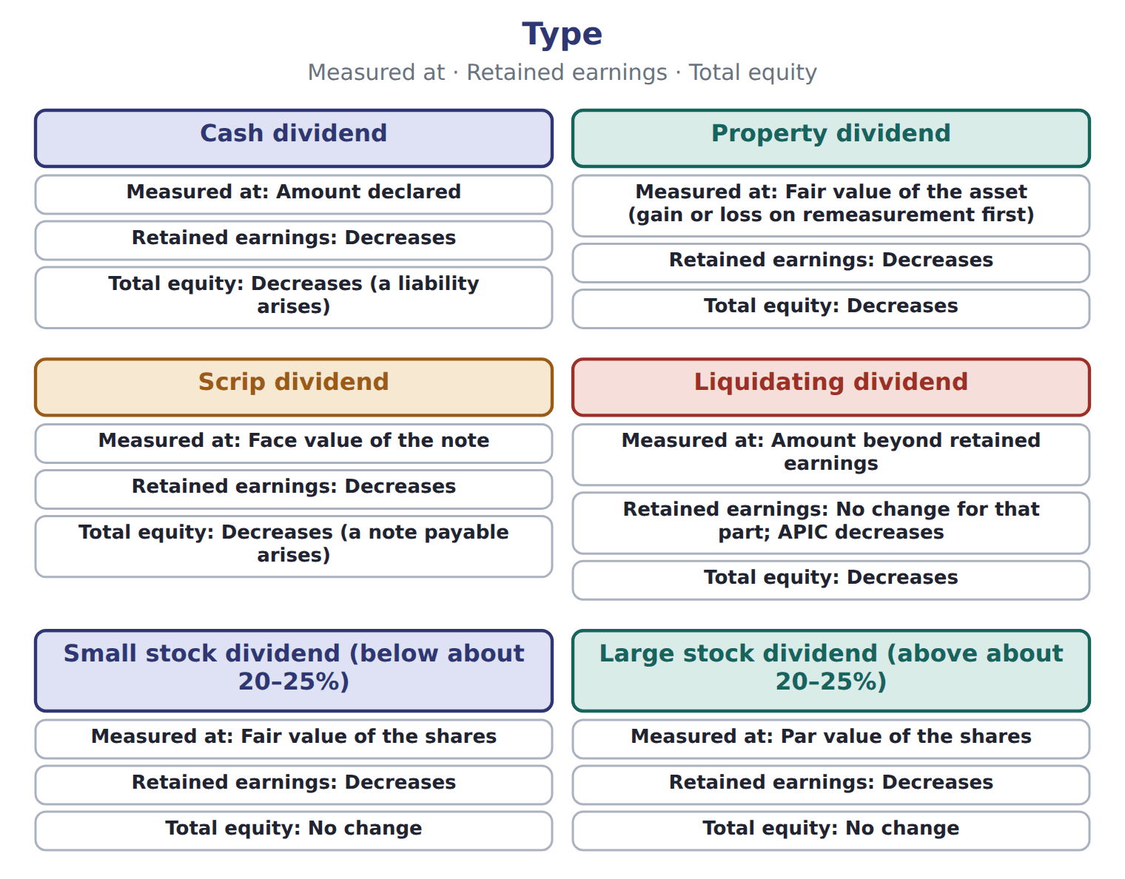

Type — the book’s own table
Type | Measured at | Retained earnings | Total equity
Cash dividend | Amount declared | Decreases | Decreases (a liability arises)
Property dividend | Fair value of the asset (gain or loss on remeasurement first) | Decreases | Decreases
Scrip dividend | Face value of the note | Decreases | Decreases (a note payable arises)
Liquidating dividend | Amount beyond retained earnings | No change for that part; APIC decreases | Decreases
Small stock dividend (below about 20–25%) | Fair value of the shares | Decreases | No change
Large stock dividend (above about 20–25%) | Par value of the shares | Decreases | No change
Stock split | No entry; par per share falls | No change | No change

READ THE MODEL Every answer is printed above. Find it, do not recall it.

5. Which type does the book pair with “Amount declared”?
A. Liquidating dividend | C. Stock split
B. Scrip dividend | D. Cash dividend
6. Which type does the book pair with “Fair value of the asset (gain or loss on remeasurement first)”?
A. Large stock dividend (above about 20–25%)
B. Property dividend
C. Small stock dividend (below about 20–25%)
D. Liquidating dividend
7. Which type does the book pair with “Face value of the note”?
A. Scrip dividend
B. Large stock dividend (above about 20–25%)
C. Liquidating dividend
D. Cash dividend
8. Which type does the book pair with “Amount beyond retained earnings”?
A. Cash dividend | C. Property dividend
B. Stock split | D. Liquidating dividend
9. The book gives the total equity of Cash dividend as “Decreases (a liability arises)”. TRUE / FALSE
10. The book gives the total equity of Property dividend as “No change”. TRUE / FALSE
INVENT THE RULE

11. Complete the book’s own sentence. The list holds more words than there are gaps.
use every one of these words: prior-period adjustment · issued shares · liquidating dividend · contributed capital
A returns , so it reduces APIC rather than retained earnings.

Two of the book’s own cases, side by side
Cash dividend | Property dividend
Measured at: Amount declared | Measured at: Fair value of the asset (gain or loss on remeasurement first)
Retained earnings: Decreases | Retained earnings: Decreases
Only the facts above differ. What is the total equity of Cash dividend?
12. Choose one:
A. Decreases (a note payable arises)
B. No change
C. Decreases (a liability arises)
D. Decreases
APPLY No help on this move.

13. A company reissues treasury shares for more than their cost. The excess is:
A. credited to APIC–treasury stock | C. credited to retained earnings
B. reported as a gain in net income | D. reported in OCI
14. What is the effect of buying treasury stock for cash?
A. Total equity does not change
B. Retained earnings decrease
C. Total assets increase
D. Total equity decreases; retained earnings do not change
15. A company declares a property dividend of land with a carrying amount of $60,000 and a fair value of $90,000. What is recorded?
A. Retained earnings are reduced by $60,000; no gain
B. A gain of $30,000, and retained earnings are reduced by $90,000
C. A gain of $90,000
D. Retained earnings are reduced by $30,000
16. What entry is made on the date of record for a cash dividend?
A. No entry
B. Debit retained earnings; credit dividends payable
C. Debit dividends payable; credit cash
D. Debit retained earnings; credit cash
WORK IN PAIRS | Compare every answer on this page with your partner before you read any key.
If you disagree: go back to the model and find the row that settles it. The row decides, not the louder voice.
CHECKPOINT 17. A company reissues treasury shares for more than their cost. The excess is:
A. credited to APIC–treasury stock
B. reported as a gain in net income
C. credited to retained earnings
D. reported in OCI
If you got it wrong: redo the READ THE MODEL questions of cycle A with the model in front of you.

CYCLE B | The words this section uses precisely

ORIENT

18. A term in the exam means exactly what the book defines it to mean, whatever it means in ordinary English. TRUE / FALSE

MODEL

Suppose: Orontes, 8,100,000 shares — the book’s own table
Suppose: Orontes, 8,100,000 shares | 4% stock dividend | 50% stock dividend | 2-for-1 split
New shares issued | 324,000 | 4,050,000 | 8,100,000
Measured at | fair value $15 | par $1 | no entry
Retained earnings | (4,860,000) | (4,050,000) | no change
Common stock | 324,000 | 4,050,000 | no change
Additional paid-in capital | 4,536,000 | no change | no change
Total stockholders' equity | no change | no change | no change
Par value per share afterward | $1 | $1 | $0.50

The English the exam uses, and what it translates
English (exam term) | the Arabic it translates
outstanding shares | الأسهم القائمة (المتداولة)
prior-period adjustment | تسوية سنوات سابقة
date of record | تاريخ التسجيل (الاستحقاق)

READ THE MODEL

19. A glossary term and its translation are a pair the book itself gives. TRUE / FALSE
APPLY

20. A company with 500,000 shares of $2 par stock declares a 2-for-1 stock split. What happens?
A. Retained earnings decrease by $1,000,000
B. Common stock increases by $1,000,000
C. Total equity doubles
D. 1,000,000 shares of $1 par; no entry and no change in any equity account
Suppose: Orontes, 8,100,000 shares — the extract for the question that follows
Suppose: Orontes, 8,100,000 shares | 4% stock dividend | 50% stock dividend | 2-for-1 split
New shares issued | 324,000 | 4,050,000 | 8,100,000
Measured at | fair value $15 | par $1 | no entry
Retained earnings | (4,860,000) | (4,050,000) | no change
Common stock | 324,000 | 4,050,000 | no change
Additional paid-in capital | 4,536,000 | no change | no change
Total stockholders' equity | no change | no change | no change
Par value per share afterward | $1 | $1 | $0.50

21. The extract for this question is printed with it. By how much does the 50% stock dividend reduce Orontes's retained earnings (whole USD)?
A. 0 | C. 4,860,000
B. 4,050,000 | D. 60,750,000

CHECKPOINT 22. What is the safest way to settle a disagreement about an answer on this sheet?
A. find the row of the model that decides it
B. take the answer of whoever is more confident
C. leave it until the lecturer says
D. choose the longer option
If you got it wrong: redo the READ THE MODEL questions of cycle B.

FROM MEMORY | Close the earlier pages first.
23. Rebuild the figure from this handout. Label every part and fill in every box.
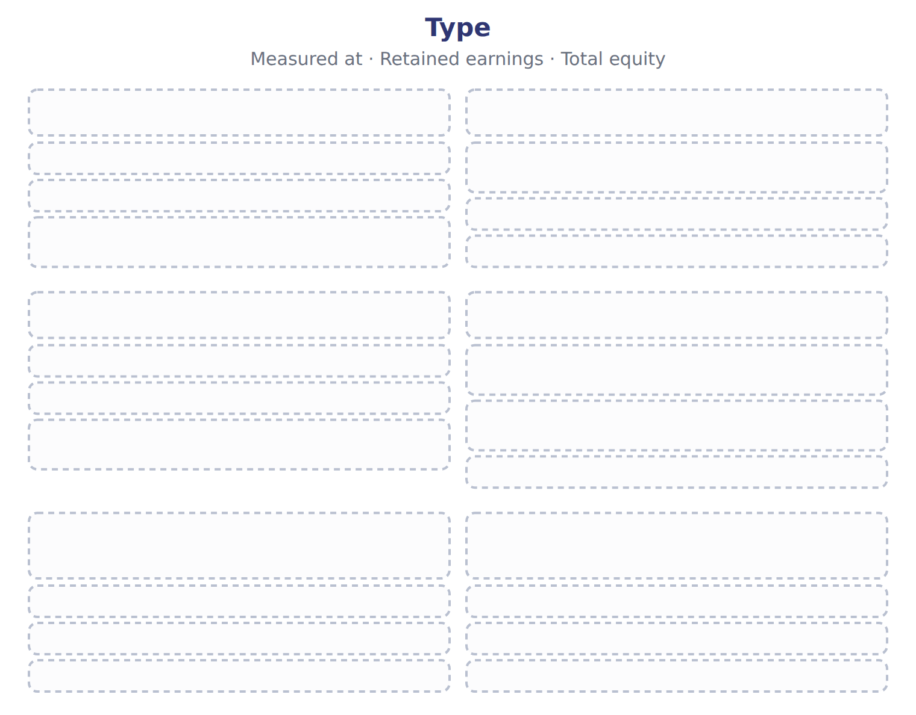
TEACH IT BACK | Write it for a classmate who missed this session — not for the marker.
24. In three or four sentences, write what this section settles and the one rule a reader has to take away.
every one of these words must appear: outstanding shares · prior-period adjustment · date of record

Answer key · Handout 4.3 · Dividends, stock dividends and stock splits

1 declaration date · date of record · property dividend | 9 T | 17 A
2 liquidating dividend · contributed capital · stock dividend · outstanding shares | 10 F | 18 T
3 stock split · stock dividend | 11 liquidating dividend · contributed capital | 19 T
4 T | 12 C | 20 D
5 D | 13 A | 21 B
6 B | 14 D | 22 A
7 A | 15 B | 23 Compare with the model earlier in this handout.
8 D | 16 A | 24 A cash dividend has three dates. On the declaration date the company debits retained earnings and credits dividends payable, a current liability. On the date of record no entry is made; it only decides who is paid. On the payment date the liability is paid. Orontes declared $400,000 in December 2025, so that amount is still payable at year-end.

11 what the book says
A liquidating dividend returns contributed capital, so it reduces APIC rather than retained earnings.

why
1 The book writes: “On the declaration date the company debits retained earnings and credits dividends payable, a current liability. On the date of record no entry is made; it only decides who is paid. On the payment date the liability is paid. A property dividend is paid with a noncash asset.”
2 The book writes: “A liquidating dividend returns contributed capital, so it reduces APIC rather than retained earnings. A stock dividend gives shareholders more shares instead of cash. For a small stock dividend, below about 20% to 25% of the outstanding shares, the company moves the fair value of the new shares from retained earnings to common stock and APIC.”
3 The book writes: “A stock split increases the number of shares and reduces the par value per share in proportion. Total equity never changes: only the labels inside equity move. Small stock dividend at fair value; large stock dividend at par.”
4 The book pairs Cash dividend with “Amount declared”.
5 The book’s own table pairs Cash dividend with “Amount declared”.
6 The book’s own table pairs Property dividend with “Fair value of the asset (gain or loss on remeasurement first)”.
7 The book’s own table pairs Scrip dividend with “Face value of the note”.
8 The book’s own table pairs Liquidating dividend with “Amount beyond retained earnings”.
9 The book pairs Cash dividend with “Decreases (a liability arises)”.
10 The book pairs Property dividend with “Decreases”, not with “No change”.
12 The book gives Decreases (a liability arises) as the total equity of Cash dividend.
13 Transactions in a company's own shares never create income. B is wrong: No gains are recorded on a company's own shares. C is wrong: Retained earnings are not credited for treasury transactions.
14 Cash falls and equity falls by the same amount through treasury stock. A is wrong: Treasury stock reduces equity. B is wrong: The purchase is recorded in treasury stock, not retained earnings.
15 Remeasure the land to fair value first, then distribute it at fair value. A is wrong: The asset must be remeasured to fair value. C is wrong: The gain is only the increase over carrying amount.
16 The date of record only decides who will be paid. B is wrong: This is the declaration-date entry. C is wrong: This is the payment-date entry.
17 Transactions in a company's own shares never create income. B is wrong: No gains are recorded on a company's own shares. C is wrong: Retained earnings are not credited for treasury transactions.
18 CMA questions use exact terms, and one word can change the answer.
19 The term tables in each section are the book’s own.
20 A split changes the number of shares and the par per share only. A is wrong: A split does not move retained earnings. B is wrong: Common stock stays the same in total.
21 A large stock dividend moves only par: 4,050,000 shares × $1. A is wrong: A large stock dividend is still recorded; only a split has no entry. C is wrong: This is the small stock dividend.

Handout 4.4
Retained earnings
section 4.4 of the book
Before you start
Three summaries of this handout, in the book’s own words. Read all three first: together they are the whole session. Then fill the gaps, guessing where you have to.

What this handout settles, cycle by cycle
In this handout | What you will read | How you check it
Retained earnings | a figure to read · Item | What is the main purpose of the statement of changes in equity?
The words this section uses precisely | The English the exam uses, and what it translates | What is the safest way to settle a disagreement about an answer on this sheet?

Words this handout uses precisely
Words this handout uses precisely | tick it if you could already use it in a sentence
treasury stock
preferred stock
property dividend

1. Where the section starts — Fill every gap. The list holds more words than there are gaps, so one or two of them are not used.
choose from: treasury stock · prior-period adjustment · appropriated retained earnings · date of record
These stay within equity; no costs are ever charged to them. If a company finds an error in earlier financial statements, it does not correct it through this year's net income. It makes a : it restates the earlier years and adjusts the opening balance of retained earnings, net of tax.
2. What it settles in the middle — Fill every gap. The list holds more words than there are gaps, so one or two of them are not used.
choose from: date of record · appropriated retained earnings · prior-period adjustment · treasury stock
These stay within equity; no costs are ever charged to them. If a company finds an error in earlier financial statements, it does not correct it through this year's net income. It makes a : it restates the earlier years and adjusts the opening balance of retained earnings, net of tax. Retained earnings may also be restricted by law or by loan covenants.
3. Where it ends — Fill every gap. The list holds more words than there are gaps, so one or two of them are not used.
choose from: prior-period adjustment · appropriated retained earnings · treasury stock · date of record
A board may set part of retained earnings aside, for example for a new plant. These stay within equity; no costs are ever charged to them. If a company finds an error in earlier financial statements, it does not correct it through this year's net income. It makes a : it restates the earlier years and adjusts the opening balance of retained earnings, net of tax.

CYCLE A | Retained earnings

ORIENT One claim. Decide now; you will check it in a moment.

4. The book gives the answer of 2-for-1 stock split as “Retained earnings: no change. Total equity: no change (no entry is made).”. TRUE / FALSE
MODEL Read it before you answer anything below it.

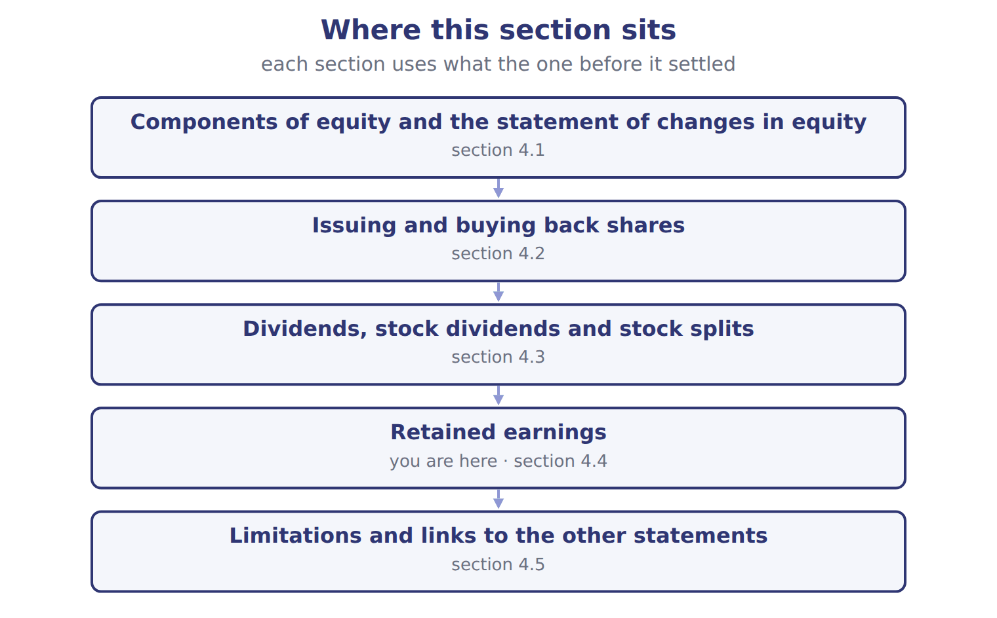

Item — the book’s own table
Item | Answer
2-for-1 stock split | Retained earnings: no change. Total equity: no change (no entry is made).
Buy treasury stock | Retained earnings: no change. Total equity: decreases by the cost.
Reissue treasury stock above cost | Retained earnings: no change (the excess goes to APIC–treasury stock). Total equity: increases by the cash received.
Correct an error that overstated expenses | Retained earnings: opening balance increases, net of tax. Total equity: increases.

READ THE MODEL Every answer is printed above. Find it, do not recall it.

5. Which answer does the book give for 2-for-1 stock split?
A. Retained earnings: no change. Total equity: decreases by the cost.
B. Retained earnings: no change. Total equity: no change (no entry is made).
C. Retained earnings: opening balance increases, net of tax. Total equity: increases.
6. Which answer does the book give for Buy treasury stock?
A. Retained earnings: no change. Total equity: decreases by the cost.
B. Retained earnings: no change. Total equity: no change (no entry is made).
C. Retained earnings: opening balance increases, net of tax. Total equity: increases.
7. Which answer does the book give for Correct an error that overstated expenses?
A. Retained earnings: no change. Total equity: no change (no entry is made).
B. Retained earnings: opening balance increases, net of tax. Total equity: increases.
C. Retained earnings: no change. Total equity: decreases by the cost.
8. The book gives the answer of 2-for-1 stock split as “Retained earnings: no change. Total equity: no change (no entry is made).”. TRUE / FALSE
9. The book gives the answer of Buy treasury stock as “Retained earnings: opening balance increases, net of tax. Total equity: increases.”. TRUE / FALSE

APPLY No help on this move.

10. Use the treasury stock example in Section 4.2. By how much does the second reissue reduce retained earnings (whole USD)?
A. 0 | C. 40,000
B. 20,000 | D. 60,000
11. A company declares a 5% stock dividend. It is measured at:
A. the par value of the new shares
B. zero, because no assets leave the company
C. the fair value of the new shares
D. the book value per share
12. A company has issued 1,000,000 shares, of which 100,000 are held in treasury. It declares a 10% stock dividend. How many new shares does it issue?
A. 10,000 | C. 100,000
B. 90,000 | D. 110,000
13. Which transaction reduces total stockholders' equity?
A. Declaring and issuing a small stock dividend
B. Declaring a cash dividend
C. Carrying out a 3-for-1 stock split
D. Appropriating retained earnings for a new plant
14. Which is a limitation of the equity section of the balance sheet?
A. It includes all internally built intangibles
B. It shows the market value of the company
C. It is prepared on a cash basis
D. Treasury stock is shown at its cost, not at the current share price
15. Why may a company's retained earnings not show how much it can legally pay as dividends?
A. Legal capital rules and loan covenants can restrict distributions
B. Retained earnings include share premium
C. Retained earnings are measured at fair value
D. Dividends are paid from AOCI
WORK IN PAIRS | Compare every answer on this page with your partner before you read any key.
If you disagree: go back to the model and find the row that settles it. The row decides, not the louder voice.
CHECKPOINT 16. What is the main purpose of the statement of changes in equity?
A. To show the market value of the company's shares
B. To show cash received from owners only
C. To explain why each part of equity changed during the period
D. To report revenues and expenses
If you got it wrong: redo the READ THE MODEL questions of cycle A with the model in front of you.

CYCLE B | The words this section uses precisely

ORIENT

17. A term in the exam means exactly what the book defines it to mean, whatever it means in ordinary English. TRUE / FALSE

MODEL

The English the exam uses, and what it translates
English (exam term) | the Arabic it translates
treasury stock | أسهم الخزينة
preferred stock | الأسهم الممتازة
property dividend | توزيعات عينية

READ THE MODEL

18. A glossary term and its translation are a pair the book itself gives. TRUE / FALSE
APPLY

19. Orontes issues 100,000 shares of $1 par common stock for $1,500,000 in cash. What is credited to additional paid-in capital (whole USD)?
A. 0 | C. 1,400,000
B. 100,000 | D. 1,500,000
20. A company pays a dividend of $300,000, but its retained earnings are only $200,000. The extra $100,000 is:
A. an expense
B. a liquidating dividend that reduces APIC
C. a reduction of treasury stock
D. shown as negative OCI
21. A company retires treasury shares that cost more than their par value and original APIC. For the exam today, the excess is charged to:
A. retained earnings, or split between APIC and retained earnings
B. APIC only, as ASU 2025-12 requires
C. net income as a loss
D. OCI
CHECKPOINT 22. What is the safest way to settle a disagreement about an answer on this sheet?
A. find the row of the model that decides it
B. take the answer of whoever is more confident
C. leave it until the lecturer says
D. choose the longer option
If you got it wrong: redo the READ THE MODEL questions of cycle B.

FROM MEMORY | Close the earlier pages first.
23. Rebuild the figure from this handout. Label every part and fill in every box.
TEACH IT BACK | Write it for a classmate who missed this session — not for the marker.
24. In three or four sentences, write what this section settles and the one rule a reader has to take away.
every one of these words must appear: treasury stock · preferred stock · property dividend

Answer key · Handout 4.4 · Retained earnings

1 appropriated retained earnings · prior-period adjustment | 9 F | 17 T
2 appropriated retained earnings · prior-period adjustment | 10 B | 18 T
3 appropriated retained earnings · prior-period adjustment | 11 C | 19 C
4 T | 12 B | 20 B
5 B | 13 B | 21 A
6 A | 14 D | 22 A
7 B | 15 A | 23 Compare with the model earlier in this handout.
8 T | 16 C | 24 Retained earnings are the profits a company has kept since it began, less the dividends it has declared. A board may set part of retained earnings aside, for example for a new plant. These appropriated retained earnings stay within equity; no costs are ever charged to them.

why
1 The book writes: “These appropriated retained earnings stay within equity; no costs are ever charged to them. If a company finds an error in earlier financial statements, it does not correct it through this year's net income. It makes a prior-period adjustment: it restates the earlier years and adjusts the opening balance of retained earnings, net of tax.”
2 The book writes: “These appropriated retained earnings stay within equity; no costs are ever charged to them. If a company finds an error in earlier financial statements, it does not correct it through this year's net income. It makes a prior-period adjustment: it restates the earlier years and adjusts the opening balance of retained earnings, net of tax. Retained earnings may also be restricted by law or by loan covenants.”
3 The book writes: “A board may set part of retained earnings aside, for example for a new plant. These appropriated retained earnings stay within equity; no costs are ever charged to them. If a company finds an error in earlier financial statements, it does not correct it through this year's net income. It makes a prior-period adjustment: it restates the earlier years and adjusts the opening balance of retained earnings, net of tax.”
4 The book pairs 2-for-1 stock split with “Retained earnings: no change. Total equity: no change (no entry is made).”.
5 The book’s own table gives Retained earnings: no change. Total equity: no change (no entry is made). as the answer of 2-for-1 stock split.
6 The book’s own table gives Retained earnings: no change. Total equity: decreases by the cost. as the answer of Buy treasury stock.
7 The book’s own table gives Retained earnings: opening balance increases, net of tax. Total equity: increases. as the answer of Correct an error that overstated expenses.
8 The book pairs 2-for-1 stock split with “Retained earnings: no change. Total equity: no change (no entry is made).”.
9 The book pairs Buy treasury stock with “Retained earnings: no change. Total equity: decreases by the cost.”, not with “Retained earnings: opening balance increases, net of tax. Total equity: increases.”.
10 The shortfall of $60,000 first uses APIC–treasury stock of $40,000. A is wrong: APIC–treasury stock is not large enough to absorb the whole shortfall. C is wrong: This is the APIC–treasury stock balance used, not the charge to retained earnings.
11 A small stock dividend is measured at fair value. A is wrong: Par value is used for large stock dividends. B is wrong: No entry is made only for a stock split.
12 Stock dividends are based on outstanding shares. A is wrong: This applies the rate to the treasury shares only. C is wrong: This includes the treasury shares.
13 A cash dividend creates a liability, so equity falls. A is wrong: A stock dividend moves amounts within equity. C is wrong: A split changes only the number of shares.
14 Historical cost measures limit what equity tells users. A is wrong: Internally built intangibles are not recorded. B is wrong: Equity is a book amount.
15 Restrictions are disclosed, not deducted from the balance. B is wrong: Share premium is APIC, not retained earnings. C is wrong: Retained earnings are not a fair value.
16 It reconciles the opening and closing balance of each equity account. A is wrong: Equity is a book amount, not a market value. B is wrong: It includes noncash changes such as net income and stock dividends.
17 CMA questions use exact terms, and one word can change the answer.
18 The term tables in each section are the book’s own.
19 Cash minus par value: $1,500,000 − $100,000. A is wrong: Shares sold above par create APIC. B is wrong: This is the par value, which goes to common stock.
20 Amounts beyond retained earnings return contributed capital. A is wrong: Dividends are never expenses. C is wrong: Treasury stock is not involved.

Handout 4.5
Limitations and links to the other statements
section 4.5 of the book
Before you start
Three summaries of this handout, in the book’s own words. Read all three first: together they are the whole session. Then fill the gaps, guessing where you have to.

What this handout settles, cycle by cycle
In this handout | What you will read | How you check it
Limitations and links to the other statements | a figure to read · Balance / event (USD 000 unless stated) | Under IFRS, how is a stock dividend (bonus issue) of 10% measured?
The words this section uses precisely | Account · The English the exam uses, and what it translates | What is the safest way to settle a disagreement about an answer on this sheet?

Words this handout uses precisely
Words this handout uses precisely | tick it if you could already use it in a sentence
stock dividend
issued shares
liquidating dividend

1. Where the section starts — Fill every gap. The list holds more words than there are gaps, so one or two of them are not used.
choose from: contributed capital · liquidating dividend · statement of changes in equity · Treasury stock
is shown at the price paid, not at today's share price. Legal capital rules also differ from state to state, so equity does not show exactly how much a company may legally distribute. The takes net income and OCI from the statement of comprehensive income, and dividends and share issues from the company's owner transactions.
2. What it settles in the middle — Fill every gap. The list holds more words than there are gaps, so one or two of them are not used.
choose from: contributed capital · distribute · liquidating dividend · today's · Treasury
stock is shown at the price paid, not at share price. Legal capital rules also differ from state to state, so equity does not show exactly how much a company may legally .
3. Where it ends — Fill every gap. The list holds more words than there are gaps, so one or two of them are not used.
choose from: comprehensive · contributed capital · transactions · liquidating dividend · statement
The of changes in equity takes net income and OCI from the statement of income, and dividends and share issues from the company's owner . Its closing balances are the equity section of the balance sheet. Chapter 5 shows how the cash parts of these transactions appear in the financing section.

CYCLE A | Limitations and links to the other statements

ORIENT One claim. Decide now; you will check it in a moment.

4. Every number in a financial statement belongs to an element the framework defines. TRUE / FALSE
MODEL Read it before you answer anything below it.

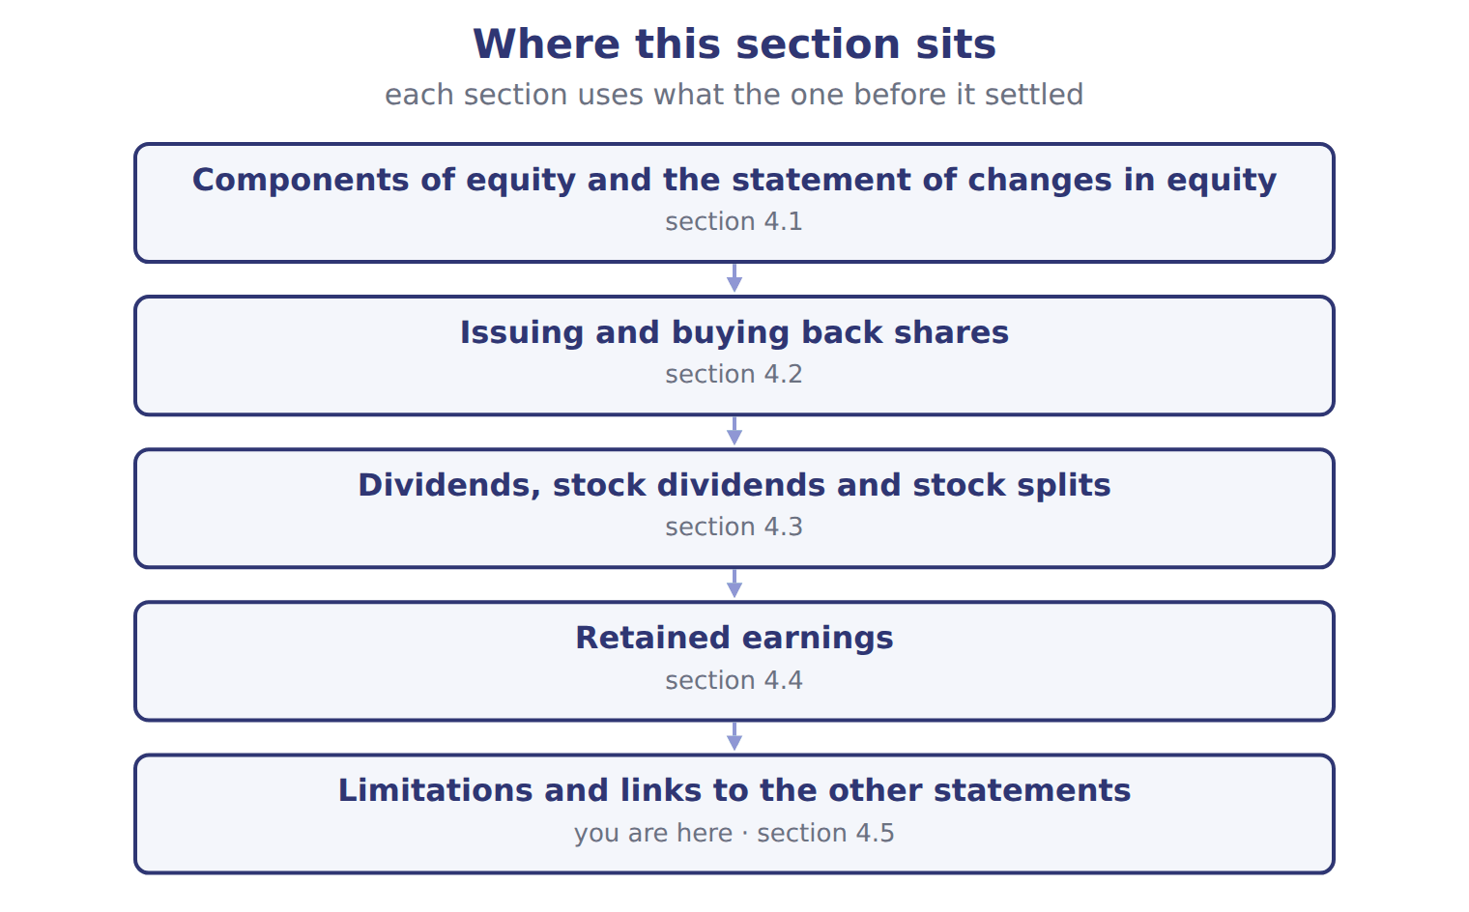

Balance / event (USD 000 unless stated) — the book’s own table
Balance / event (USD 000 unless stated) | Amount / details
Common stock, $1 par (600,000 shares issued and outstanding) | 600
Additional paid-in capital | 1,900
Retained earnings | 1,280
Total stockholders' equity, January 1, 2026 | 3,780
E1 | March 5: Barada bought 80,000 of its own shares at $6 per share (cost method).
E2 | June 10: Barada reissued 20,000 treasury shares at $8 per share.
E3 | August 20: Barada reissued 10,000 treasury shares at $4 per share.
E4 | October 1: Barada declared and issued a 10% stock dividend. The market price was $7 per share.
E5 | December 15: Barada declared a cash dividend of $0.20 per outstanding share, payable in January 2027.
E6 | Net income for 2026 was 165 (the Chapter 3 case).

READ THE MODEL Every answer is printed above. Find it, do not recall it.

5. Which part of this chapter is section 4.1?
A. Dividends, stock dividends and stock splits
B. Retained earnings
C. Issuing and buying back shares
D. Components of equity and the statement of changes in equity
6. Which part of this chapter is section 4.2?
A. Components of equity and the statement of changes in equity
B. Retained earnings
C. Dividends, stock dividends and stock splits
D. Issuing and buying back shares
7. Which part of this chapter is section 4.3?
A. Retained earnings
B. Issuing and buying back shares
C. Components of equity and the statement of changes in equity
D. Dividends, stock dividends and stock splits
8. Which part of this chapter is section 4.4?
A. Retained earnings
B. Dividends, stock dividends and stock splits
C. Issuing and buying back shares
D. Components of equity and the statement of changes in equity
APPLY No help on this move.

9. Under IFRS, how is a stock dividend (bonus issue) of 10% measured?
A. Always at fair value
B. Always at par, like a U.S. large stock dividend
C. IFRS has no small/large rule; practice varies by local law
D. It is recorded as an expense
WORK IN PAIRS | Compare every answer on this page with your partner before you read any key.
If you disagree: go back to the model and find the row that settles it. The row decides, not the louder voice.

CHECKPOINT 10. Under IFRS, how is a stock dividend (bonus issue) of 10% measured?
A. Always at fair value
B. Always at par, like a U.S. large stock dividend
C. IFRS has no small/large rule; practice varies by local law
D. It is recorded as an expense
If you got it wrong: redo the READ THE MODEL questions of cycle A with the model in front of you.

CYCLE B | The words this section uses precisely

ORIENT

11. A term in the exam means exactly what the book defines it to mean, whatever it means in ordinary English. TRUE / FALSE
MODEL

Account — the book’s own table
Account | Category
APIC–treasury stock
Retained earnings
Treasury stock
Dividends payable
Common stock

The English the exam uses, and what it translates
English (exam term) | the Arabic it translates
stock dividend | توزيعات أسهم (أسهم منحة)
issued shares | الأسهم المصدرة
liquidating dividend | توزيعات تصفية (إرجاع رأس مال)

READ THE MODEL

12. A glossary term and its translation are a pair the book itself gives. TRUE / FALSE
APPLY

13. Writing a term in English is part of answering the question, not an extra. TRUE / FALSE
CHECKPOINT 14. What is the safest way to settle a disagreement about an answer on this sheet?
A. find the row of the model that decides it
B. take the answer of whoever is more confident
C. leave it until the lecturer says
D. choose the longer option
If you got it wrong: redo the READ THE MODEL questions of cycle B.

FROM MEMORY | Close the earlier pages first.
15. Rebuild the figure from this handout. Label every part and fill in every box.
TEACH IT BACK | Write it for a classmate who missed this session — not for the marker.
16. In three or four sentences, write what this section settles and the one rule a reader has to take away.
every one of these words must appear: stock dividend · issued shares · liquidating dividend

Answer key · Handout 4.5 · Limitations and links to the other statements

1 Treasury stock · statement of changes in equity | 7 D | 13 T
2 Treasury · today's · distribute | 8 A | 14 A
3 statement · comprehensive · transactions | 9 C | 15 Compare with the model earlier in this handout.
4 T | 10 C | 16 Total equity is a book value: assets minus liabilities, as measured by the accounting rules. It is not what the company is worth. Most assets are at historical cost, and internally built brands and know-how are not recorded.
5 D | 11 T
6 D | 12 T

why
1 The book writes: “Treasury stock is shown at the price paid, not at today's share price. Legal capital rules also differ from state to state, so equity does not show exactly how much a company may legally distribute. The statement of changes in equity takes net income and OCI from the statement of comprehensive income, and dividends and share issues from the company's owner transactions.”
2 The book writes: “Treasury stock is shown at the price paid, not at today's share price. Legal capital rules also differ from state to state, so equity does not show exactly how much a company may legally distribute.”
3 The book writes: “The statement of changes in equity takes net income and OCI from the statement of comprehensive income, and dividends and share issues from the company's owner transactions. Its closing balances are the equity section of the balance sheet. Chapter 5 shows how the cash parts of these transactions appear in the financing section.”
4 The framework defines the elements, and every amount belongs to one of them.
5 The book numbers “Components of equity and the statement of changes in equity” as section 4.1.
6 The book numbers “Issuing and buying back shares” as section 4.2.
7 The book numbers “Dividends, stock dividends and stock splits” as section 4.3.
8 The book numbers “Retained earnings” as section 4.4.
9 The small/large distinction is U.S. GAAP only. A is wrong: IFRS does not require fair value for bonus issues. B is wrong: IFRS has no rule that fixes par.
10 The small/large distinction is U.S. GAAP only. A is wrong: IFRS does not require fair value for bonus issues. B is wrong: IFRS has no rule that fixes par.
11 CMA questions use exact terms, and one word can change the answer.
12 The term tables in each section are the book’s own.
13 The exam marks the term, so the English word is the answer.
14 Every item on a Workshop sheet is settled by something printed on the same sheet.

Handout 4.6
The whole chapter
every section, shuffled, and the chapter’s own case set
Before you start
Three summaries of this chapter, in the book’s own words, with words taken out. Read all three first: together they are the whole chapter. Then fill the gaps.

What this handout settles, cycle by cycle
In this handout | What you will read | How you check it
The whole chapter, in order | a figure to read | A company declares a 5% stock dividend. It is measured at:
The chapter’s case set | The chapter’s case set, item by item · Suppose: Orontes, 8,100,000 shares | What has to be settled before any figure in a case set is worked out?
The words it uses precisely | statement of changes in equity · contributed capital · outstanding shares · treasury stock · stock dividend · stock split | matching, at the end of cycle B

1. Where the chapter starts — Fill every gap. The list holds more words than there are gaps, so one or two of them are not used.
choose from: issued shares · Preferred stock · declaration date · outstanding shares · cost method · treasury stock · property dividend
is recorded in the same way, in its own account. A company may buy back its own shares and hold them as . Under the , treasury stock is recorded at the price paid and deducted from equity. Shares held as treasury stock are but not : they receive no dividends and have no votes.
2. What it settles in the middle — Fill every gap. The list holds more words than there are gaps, so one or two of them are not used.
choose from: contributed capital · cost method · outstanding shares · issued shares · liquidating dividend · stock dividend
A returns , so it reduces APIC rather than retained earnings. A gives shareholders more shares instead of cash. For a small stock dividend, below about 20% to 25% of the , the company moves the fair value of the new shares from retained earnings to common stock and APIC.
3. Where it ends — Fill every gap. The list holds more words than there are gaps, so one or two of them are not used.
choose from: cost method · stock dividend · appropriated retained earnings · issued shares
SC4-5 A company declares a 5% . Retained earnings are the profits a company has kept since it began, less the dividends it has declared. A board may set part of retained earnings aside, for example for a new plant. These stay within equity; no costs are ever charged to them.

CYCLE A | The whole chapter, in order

ORIENT

4. The sections of a chapter have to be taken in order, because each one uses what the one before it settled. TRUE / FALSE
MODEL

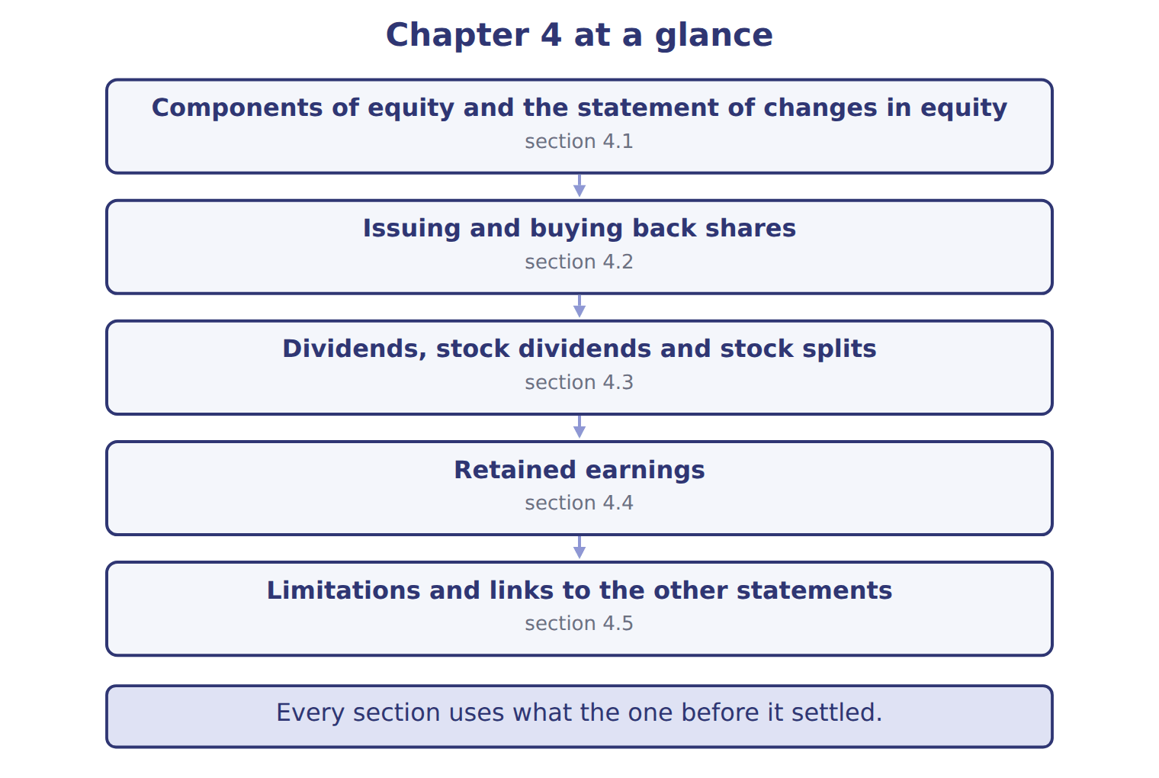
READ THE MODEL

5. “section 4.1” — which part of the chapter is this?
A. Issuing and buying back shares
B. Components of equity and the statement of changes in equity
C. Retained earnings
D. Dividends, stock dividends and stock splits
6. “section 4.2” — which part of the chapter is this?
A. Issuing and buying back shares
B. Dividends, stock dividends and stock splits
C. Retained earnings
D. Components of equity and the statement of changes in equity
7. “section 4.3” — which part of the chapter is this?
A. Components of equity and the statement of changes in equity
B. Dividends, stock dividends and stock splits
C. Issuing and buying back shares
D. Retained earnings
Write the letter of the section number beside each section title. Every number is used once.
A 4.1 | D 4.4
B 4.2 | E 4.5
C 4.3

8. Components of equity and the statement of changes in equity
9. Issuing and buying back shares
10. Dividends, stock dividends and stock splits
11. Retained earnings
12. Limitations and links to the other statements

APPLY

13. Why is Orontes's total equity much lower than the market value of its shares?
A. Equity is measured at fair value each year
B. Treasury stock is shown at market value
C. Equity includes only contributed capital
D. Most assets are at historical cost and internally built intangibles are not recorded
WORK IN PAIRS | Compare every answer with your partner first.
If you disagree: name the section each question belongs to. Most disagreements turn out to be about the section, not the answer.
CHECKPOINT 14. A company declares a 5% stock dividend. It is measured at:
A. the par value of the new shares
B. zero, because no assets leave the company
C. the fair value of the new shares
D. the book value per share
If you got it wrong: go back to the MODEL move of cycle A and find the section this question belongs to.

CYCLE B | The chapter’s case set

ORIENT

15. In a case question, the exhibit has to be read and adjusted before any figure is worked out. TRUE / FALSE

MODEL

The chapter’s case set, item by item
Item | What it asks
C4-1 | Classify each account at the end of 2026. (On the exam screen you would drag each account into a box.)
C4-2 | Enter the balance of APIC–treasury stock at December 31, 2026.
C4-3 | Enter the amount transferred out of retained earnings for the stock dividend (E4).
C4-4 | Enter the cash dividend declared on December 15 (E5).
C4-5 | Enter retained earnings at December 31, 2026.
C4-6 | Enter total stockholders' equity at December 31, 2026.

READ THE MODEL

16. Which of these does item C4-1 ask for?
A. Enter the balance of APIC–treasury stock at December 31, 2026.
B. Classify each account at the end of 2026. (On the exam screen you woul
C. Enter the amount transferred out of retained earnings for the stock di
D. Enter the cash dividend declared on December 15 (E5).
17. Which of these does item C4-2 ask for?
A. Enter the amount transferred out of retained earnings for the stock di
B. Classify each account at the end of 2026. (On the exam screen you woul
C. Enter the balance of APIC–treasury stock at December 31, 2026.
D. Enter the cash dividend declared on December 15 (E5).
18. Which of these does item C4-3 ask for?
A. Enter the cash dividend declared on December 15 (E5).
B. Enter the amount transferred out of retained earnings for the stock di
C. Enter the balance of APIC–treasury stock at December 31, 2026.
D. Classify each account at the end of 2026. (On the exam screen you woul
19. Which of these does item C4-4 ask for?
A. Enter the amount transferred out of retained earnings for the stock di
B. Classify each account at the end of 2026. (On the exam screen you woul
C. Enter the balance of APIC–treasury stock at December 31, 2026.
D. Enter the cash dividend declared on December 15 (E5).
20. Which of these does item C4-5 ask for?
A. Enter retained earnings at December 31, 2026.
B. Classify each account at the end of 2026. (On the exam screen you woul
C. Enter the amount transferred out of retained earnings for the stock di
D. Enter the balance of APIC–treasury stock at December 31, 2026.
21. Which of these does item C4-6 ask for?
A. Enter the amount transferred out of retained earnings for the stock di
B. Enter total stockholders' equity at December 31, 2026.
C. Classify each account at the end of 2026. (On the exam screen you woul
D. Enter the balance of APIC–treasury stock at December 31, 2026.
APPLY

22. A company declares a 5% stock dividend. It is measured at:
A. the par value of the new shares
B. zero, because no assets leave the company
C. the fair value of the new shares
D. the book value per share

Suppose: Orontes, 8,100,000 shares — the extract for the question that follows
Suppose: Orontes, 8,100,000 shares | 4% stock dividend | 50% stock dividend | 2-for-1 split
New shares issued | 324,000 | 4,050,000 | 8,100,000
Measured at | fair value $15 | par $1 | no entry
Retained earnings | (4,860,000) | (4,050,000) | no change
Common stock | 324,000 | 4,050,000 | no change
Additional paid-in capital | 4,536,000 | no change | no change
Total stockholders' equity | no change | no change | no change
Par value per share afterward | $1 | $1 | $0.50

23. The extract for this question is printed with it. By how much does the 4% stock dividend reduce Orontes's retained earnings (whole USD)?
A. 0 | C. 4,536,000
B. 324,000 | D. 4,860,000
CHECKPOINT 24. What has to be settled before any figure in a case set is worked out?
A. the exhibit, adjusted for every note that goes with it
B. the method the company uses
C. the tax rate
D. the order of the items
If you got it wrong: reread the case panel in the MODEL move of cycle B.

FROM MEMORY | Close the earlier pages first.
25. Rebuild the chapter map. Write every section in order and what each one settles.
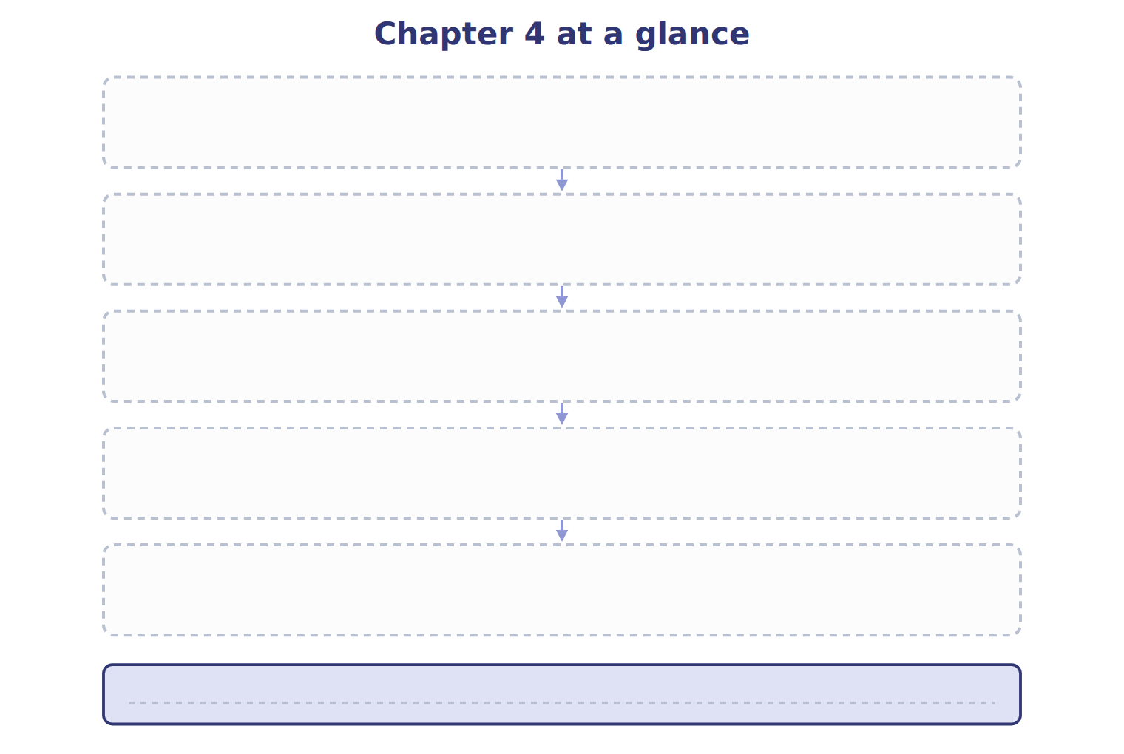
TEACH IT BACK | Write it for a student starting this chapter tomorrow — not for the marker.
26. In four or five sentences, write what the whole chapter settles, section by section.
every one of these words must appear: statement of changes in equity · contributed capital · outstanding shares · treasury stock

Answer key · Handout 4.6 · The whole chapter

1 Preferred stock · treasury stock · cost method · issued shares · outstanding shares | 10 C | 19 D
2 liquidating dividend · contributed capital · stock dividend · outstanding shares | 11 D | 20 A
3 stock dividend · appropriated retained earnings | 12 E | 21 B
4 T | 13 D | 22 C
5 B | 14 C | 23 D
6 A | 15 T | 24 A
7 B | 16 B | 25 Compare with the model earlier in this handout.
8 A | 17 C | 26 4.1: Components of equity and the statement of changes in equity. 4.2: Issuing and buying back shares. 4.3: Dividends, stock dividends and stock splits. 4.4: Retained earnings. 4.5: Limitations and links to the other statements.
9 B | 18 B

why
1 The book writes: “Preferred stock is recorded in the same way, in its own account. A company may buy back its own shares and hold them as treasury stock. Under the cost method, treasury stock is recorded at the price paid and deducted from equity. Shares held as treasury stock are issued shares but not outstanding shares: they receive no dividends and have no votes.”
2 The book writes: “A liquidating dividend returns contributed capital, so it reduces APIC rather than retained earnings. A stock dividend gives shareholders more shares instead of cash. For a small stock dividend, below about 20% to 25% of the outstanding shares, the company moves the fair value of the new shares from retained earnings to common stock and APIC.”
3 The book writes: “SC4-5 A company declares a 5% stock dividend. Retained earnings are the profits a company has kept since it began, less the dividends it has declared. A board may set part of retained earnings aside, for example for a new plant. These appropriated retained earnings stay within equity; no costs are ever charged to them.”
4 The map shows the order the decisions have to be taken in.
5 The book numbers it 4.1.
6 The book numbers it 4.2.
7 The book numbers it 4.3.
13 Book value is not a valuation. A is wrong: Equity is not remeasured to fair value. B is wrong: Treasury stock is shown at cost.
14 A small stock dividend is measured at fair value. A is wrong: Par value is used for large stock dividends. B is wrong: No entry is made only for a stock split.
15 Every later answer depends on the adjusted exhibit.
16 The book states item C4-1 in those words.
17 The book states item C4-2 in those words.
18 The book states item C4-3 in those words.
19 The book states item C4-4 in those words.
20 The book states item C4-5 in those words.
21 The book states item C4-6 in those words.
22 A small stock dividend is measured at fair value. A is wrong: Par value is used for large stock dividends. B is wrong: No entry is made only for a stock split.
23 324,000 new shares × fair value of $15. A is wrong: A stock dividend is recorded; only a split needs no entry. B is wrong: This uses par, the rule for large stock dividends.
24 Every later answer depends on the adjusted exhibit.

Handout 5.1
Purpose and structure of the statement of cash flows
section 5.1 of the book
Before you start
Three summaries of this handout, in the book’s own words. Read all three first: together they are the whole session. Then fill the gaps, guessing where you have to.

What this handout settles, cycle by cycle
In this handout | What you will read | How you check it
Purpose and structure of the statement of cash flows | a figure to read · Orontes Foods Inc., year ended December 31, 2025 | A lender wants to know whether a company's operations produce enough cash to repay a loan. Which section is MOST useful?
The words this section uses precisely | Item · The English the exam uses, and what it translates | What is the safest way to settle a disagreement about an answer on this sheet?

Words this handout uses precisely
Words this handout uses precisely | tick it if you could already use it in a sentence
statement of cash flows
indirect method

1. Where the section starts — Fill every gap. The list holds more words than there are gaps, so one or two of them are not used.
choose from: indirect method · statement of cash flows · operating activities · cash equivalents
The reports a company's cash receipts and cash payments for a period. It helps them judge whether the company can produce cash, pay its debts and dividends, and fund its growth without new financing. The statement explains the change in cash, and restricted cash together.
2. What it settles in the middle — Fill every gap. The list holds more words than there are gaps, so one or two of them are not used.
choose from: operating activities · statement of cash flows · financing activities · investing activities · Cash equivalents · indirect method
are short-term, highly liquid investments with an original maturity to the holder of three months or less. Moving money between these categories is not a cash flow. Cash flows are grouped into , and .
3. Where it ends — Fill every gap. The list holds more words than there are gaps, so one or two of them are not used.
choose from: statement of cash flows · financing activities · cash equivalents · operating activities · investing activities
Moving money between these categories is not a cash flow. Cash flows are grouped into , and . Strong operating cash is a good sign, but a reader should also ask where the cash went.

CYCLE A | Purpose and structure of the statement of cash flows

ORIENT One claim. Decide now; you will check it in a moment.

4. Every number in a financial statement belongs to an element the framework defines. TRUE / FALSE
MODEL Read it before you answer anything below it.

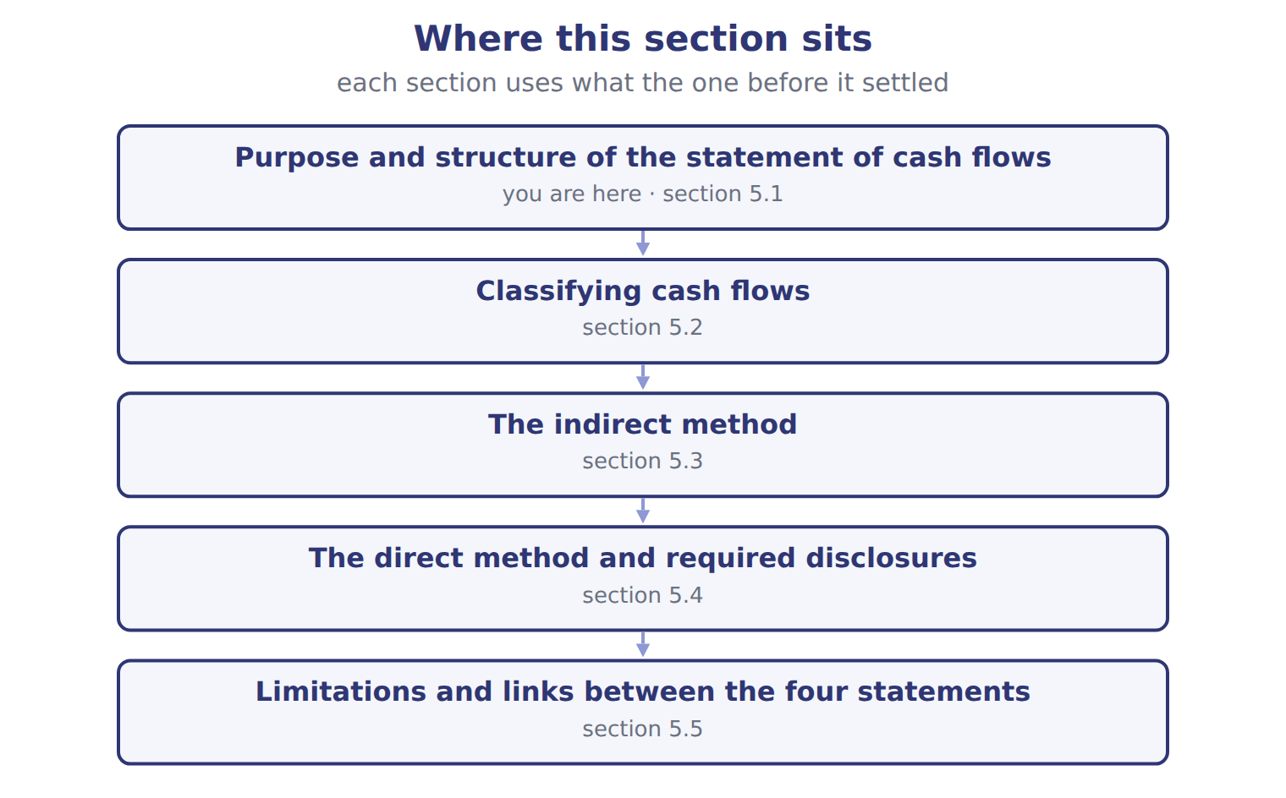
Orontes Foods Inc., year ended December 31, 2025 — the book’s own table
Orontes Foods Inc., year ended December 31, 2025 | 2025
Cash flows from operating activities
Net income | 2,969,100
Adjustments to reconcile net income to net cash from operating activities:
Depreciation | 2,100,000
Impairment losses | 2,724,000
Equity-method income | (177,000)
Dividends from equity-method investees | 70,000
Gain on sale of equipment | (3,000)
Unrealized gains on securities | (4,000)
Deferred income taxes | 100,000

Orontes Foods Inc., year ended December 31, 2025 — the book’s own table (continued)
Orontes Foods Inc., year ended December 31, 2025 | 2025
Increase in accounts receivable, net | (384,000)
Increase in inventory | (150,000)
Increase in prepaid expenses | (24,000)
Increase in accounts payable | 150,000
Increase in accrued liabilities | 50,000
Increase in income taxes payable | 50,000
Increase in contract liabilities | 60,000
Net cash provided by operating activities | 7,531,100
Cash flows from investing activities
Purchases of property, plant and equipment | (3,000,000)

Orontes Foods Inc., year ended December 31, 2025 — the book’s own table (continued)
Orontes Foods Inc., year ended December 31, 2025 | 2025
Proceeds from sale of equipment | 21,000
Investment in Jordan Glass Co. | (1,200,000)
Net cash used in investing activities | (4,179,000)
Cash flows from financing activities
Issuance of common stock | 1,500,000
Proceeds from bank note | 800,000
Repayment of long-term debt | (400,000)
Dividends paid | (50,000)
Net cash provided by financing activities | 1,850,000
Net increase in cash | 5,202,100

Orontes Foods Inc., year ended December 31, 2025 — the book’s own table (continued)
Orontes Foods Inc., year ended December 31, 2025 | 2025
Cash, January 1, 2025 | 2,100,000
Cash, December 31, 2025 | 7,302,100
Supplemental disclosures
Interest paid | 390,000
Income taxes paid | 839,700
Noncash investing and financing activities | none

READ THE MODEL Every answer is printed above. Find it, do not recall it.

5. Which part of this chapter is section 5.1?
A. Purpose and structure of the statement of cash flows
B. The direct method and required disclosures
C. The indirect method
D. Classifying cash flows
6. Which part of this chapter is section 5.2?
A. Classifying cash flows
B. The direct method and required disclosures
C. Purpose and structure of the statement of cash flows
D. The indirect method
7. Which part of this chapter is section 5.3?
A. Classifying cash flows
B. The indirect method
C. Purpose and structure of the statement of cash flows
D. The direct method and required disclosures
8. Which part of this chapter is section 5.4?
A. The indirect method
B. The direct method and required disclosures
C. Purpose and structure of the statement of cash flows
D. Classifying cash flows

APPLY No help on this move.

9. A lender wants to know whether a company's operations produce enough cash to repay a loan. Which section is MOST useful?
A. Investing activities | C. Operating activities
B. Financing activities | D. Noncash disclosures
10. Use Figures F05-02 and F05-03. What is the MAIN reason Orontes's operating cash flow is higher than its net income?
A. Orontes collected more than it sold
B. Depreciation and impairments reduced net income but used no cash
C. The bank note increased operating cash
D. Dividends paid were added back
11. A growing company shows positive operating cash flow, negative investing cash flow and positive financing cash flow. The MOST likely explanation is that it:
A. is selling its assets to repay debt
B. earns cash from operations and is also borrowing or issuing shares to invest in new assets
C. is in financial trouble and cannot pay its suppliers
D. is paying large dividends from asset sales
12. Which question can the statement of cash flows answer that the balance sheet alone cannot?
A. What were total assets at year-end?
B. What is the par value of the shares?
C. How did the company pay for its new equipment this year?
D. What is the allowance for credit losses?
WORK IN PAIRS | Compare every answer on this page with your partner before you read any key.
If you disagree: go back to the model and find the row that settles it. The row decides, not the louder voice.
CHECKPOINT 13. A lender wants to know whether a company's operations produce enough cash to repay a loan. Which section is MOST useful?
A. Investing activities
B. Financing activities
C. Operating activities
D. Noncash disclosures
If you got it wrong: redo the READ THE MODEL questions of cycle A with the model in front of you.

CYCLE B | The words this section uses precisely

ORIENT

14. A term in the exam means exactly what the book defines it to mean, whatever it means in ordinary English. TRUE / FALSE
MODEL

Item — the book’s own table
Item | Answer
Interest paid on a bank loan | Operating (U.S. GAAP gives no choice).
Selling Jordan Glass shares | Investing: another company's securities.
Land for a long-term note | Noncash investing and financing activity: disclosed, not in the body.
Buying back own shares | Financing: a transaction with owners.

The English the exam uses, and what it translates
English (exam term) | the Arabic it translates
statement of cash flows | قائمة التدفقات النقدية
indirect method | الطريقة غير المباشرة

READ THE MODEL

15. Which answer does the book give for Interest paid on a bank loan?
A. Investing: another company's securities.
B. Operating (U.S. GAAP gives no choice).
C. Noncash investing and financing activity: disclosed, not in the body.
D. Financing: a transaction with owners.
16. Which answer does the book give for Selling Jordan Glass shares?
A. Noncash investing and financing activity: disclosed, not in the body.
B. Financing: a transaction with owners.
C. Operating (U.S. GAAP gives no choice).
D. Investing: another company's securities.
17. Which answer does the book give for Land for a long-term note?
A. Investing: another company's securities.
B. Financing: a transaction with owners.
C. Noncash investing and financing activity: disclosed, not in the body.
D. Operating (U.S. GAAP gives no choice).
APPLY

18. Under U.S. GAAP, cash dividends paid to shareholders are:
A. an operating activity | C. a noncash activity
B. an investing activity | D. a financing activity
19. Orontes received dividends of $70,000 from its equity-method investees. Under U.S. GAAP, using the cumulative-earnings approach, they are:
A. operating inflows | C. financing inflows
B. investing inflows | D. not cash flows
CHECKPOINT 20. What is the safest way to settle a disagreement about an answer on this sheet?
A. find the row of the model that decides it
B. take the answer of whoever is more confident
C. leave it until the lecturer says
D. choose the longer option
If you got it wrong: redo the READ THE MODEL questions of cycle B.

FROM MEMORY | Close the earlier pages first.
21. Rebuild the figure from this handout. Label every part and fill in every box.
TEACH IT BACK | Write it for a classmate who missed this session — not for the marker.
22. In three or four sentences, write what this section settles and the one rule a reader has to take away.
every one of these words must appear: statement of cash flows · indirect method

Answer key · Handout 5.1 · Purpose and structure of the statement of cash flows

1 statement of cash flows · cash equivalents | 9 C | 17 C
2 Cash equivalents · operating activities · investing activities · financing activities | 10 B | 18 D
3 operating activities · investing activities · financing activities | 11 B | 19 A
4 T | 12 C | 20 A
5 A | 13 C | 21 Compare with the model earlier in this handout.
6 A | 14 T | 22 The statement of cash flows reports a company's cash receipts and cash payments for a period. Users need it because profit is not cash. It helps them judge whether the company can produce cash, pay its debts and dividends, and fund its growth without new financing.
7 B | 15 B
8 B | 16 D

why
1 The book writes: “The statement of cash flows reports a company's cash receipts and cash payments for a period. It helps them judge whether the company can produce cash, pay its debts and dividends, and fund its growth without new financing. The statement explains the change in cash, cash equivalents and restricted cash together.”
2 The book writes: “Cash equivalents are short-term, highly liquid investments with an original maturity to the holder of three months or less. Moving money between these categories is not a cash flow. Cash flows are grouped into operating activities, investing activities and financing activities.”
3 The book writes: “Moving money between these categories is not a cash flow. Cash flows are grouped into operating activities, investing activities and financing activities. Strong operating cash is a good sign, but a reader should also ask where the cash went.”
4 The framework defines the elements, and every amount belongs to one of them.
5 The book numbers “Purpose and structure of the statement of cash flows” as section 5.1.
6 The book numbers “Classifying cash flows” as section 5.2.
7 The book numbers “The indirect method” as section 5.3.
8 The book numbers “The direct method and required disclosures” as section 5.4.
9 Operating cash flow is the ongoing source of repayment. A is wrong: Investing flows come from buying and selling long-term assets. B is wrong: Financing shows the loans themselves, not the ability to repay.
10 Noncash expenses of $4,924,000 explain most of the difference. A is wrong: Receivables rose, which reduced operating cash. C is wrong: Borrowing is a financing inflow.
11 Investment outflows are funded by operations and new financing. A is wrong: Selling assets would give positive investing cash flow. C is wrong: Positive operating cash flow does not suggest this.
12 The cash flow statement shows the sources and uses of cash during the year. A is wrong: The balance sheet shows total assets. B is wrong: Par value is shown in equity.
13 Operating cash flow is the ongoing source of repayment. A is wrong: Investing flows come from buying and selling long-term assets. B is wrong: Financing shows the loans themselves, not the ability to repay.
14 CMA questions use exact terms, and one word can change the answer.
15 The book’s own table gives Operating (U.S. GAAP gives no choice). as the answer of Interest paid on a bank loan.
16 The book’s own table gives Investing: another company's securities. as the answer of Selling Jordan Glass shares.
17 The book’s own table gives Noncash investing and financing activity: disclosed, not in the body. as the answer of Land for a long-term note.
18 Distributions to owners are financing. A is wrong: This is an IAS 7 option, not U.S. GAAP. B is wrong: Dividends paid are not investing.
19 Dividends received up to cumulative equity earnings are operating. B is wrong: This is an IAS 7 option; U.S. GAAP puts them in operating. C is wrong: Dividends received are never financing.
20 Every item on a Workshop sheet is settled by something printed on the same sheet.

Handout 5.2
Classifying cash flows
section 5.2 of the book
Before you start
Three summaries of this handout, in the book’s own words. Read all three first: together they are the whole session. Then fill the gaps, guessing where you have to.

What this handout settles, cycle by cycle
In this handout | What you will read | How you check it
Classifying cash flows | a figure to read · Cash flow · Orontes Foods Inc., year ended December 31, 2025 | A company moves $500,000 from its operating bank account into a restricted account set aside to repay a bond. How is this shown in the statement of cash flows?
The words this section uses precisely | Transaction (U.S. GAAP) · The English the exam uses, and what it translates | What is the safest way to settle a disagreement about an answer on this sheet?

Words this handout uses precisely
Words this handout uses precisely | tick it if you could already use it in a sentence
cash equivalents
direct method

1. Where the section starts — Fill every gap. The list holds more words than there are gaps, so one or two of them are not used.
choose from: statement of cash flows · direct method · Financing activities · Operating activities
are the main revenue activities: cash from customers and cash paid to suppliers and employees. Anything that is not investing or financing is also operating. are with owners and lenders.
2. What it settles in the middle — Fill every gap. The list holds more words than there are gaps, so one or two of them are not used.
choose from: dividends · statement of cash flows · direct method · operating · Classifying
GAAP fixes four items that students often get wrong. Interest paid, interest received, received and income taxes are all . interest, dividends and taxes: U.S.
3. Where it ends — Fill every gap. The list holds more words than there are gaps, so one or two of them are not used.
choose from: statement of cash flows · financing · activities · direct method · investing
These noncash and are not shown in the body of the statement. Under IAS 7 today, interest paid can be operating or financing, and interest and dividends received can be operating or investing. Interest paid is operating, not financing, under U.S.
How every cycle on this sheet works
How a cycle works | what you do
MODEL | read the figure or the table before you answer anything
READ THE MODEL | every answer is printed on the same page
INVENT THE RULE | write the rule yourself, then compare with the book
APPLY | no help on this move
CHECKPOINT | mark it yourself; if you miss it, the sheet says what to redo

CYCLE A | Classifying cash flows

ORIENT One claim. Decide now; you will check it in a moment.

4. The book gives the U.S. GAAP (fixed) of Interest paid as “Operating”. TRUE / FALSE
MODEL Read it before you answer anything below it.

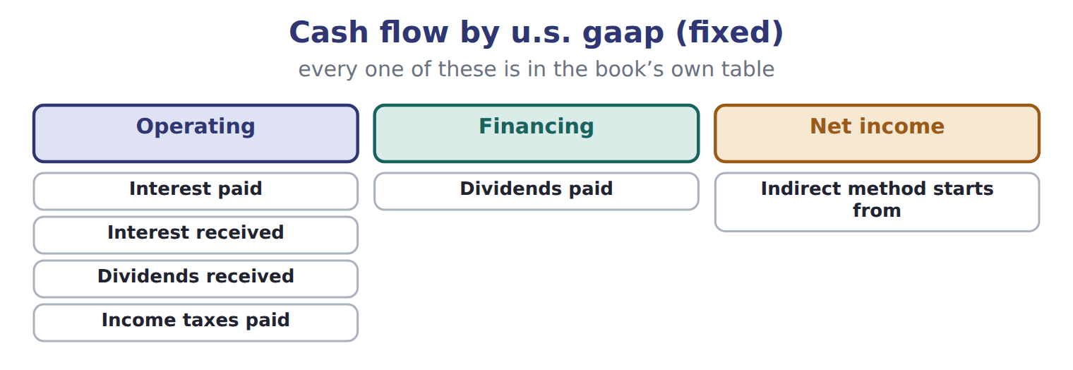

Cash flow — the book’s own table
Cash flow | U.S. GAAP (fixed) | IAS 7 today (choice) | IAS 7 with IFRS 18 (from 2027)
Interest paid | Operating | Operating or financing | Follows the category of the expense; often financing
Interest received | Operating | Operating or investing | Often investing
Dividends received | Operating | Operating or investing | Often investing
Dividends paid | Financing | Operating or financing | Financing
Income taxes paid | Operating | Operating, unless tied to investing or financing | Operating, unless tied to investing or financing
Indirect method starts from | Net income | Profit or loss | Operating profit or loss

READ THE MODEL Every answer is printed above. Find it, do not recall it.

5. Which cash flow does the book pair with “Operating”?
A. Interest paid | C. Dividends paid
B. Indirect method starts from
6. Which cash flow does the book pair with “Operating”?
A. Dividends paid | C. Interest received
B. Indirect method starts from
7. Which cash flow does the book pair with “Operating”?
A. Indirect method starts from | C. Dividends received
B. Dividends paid
8. Which cash flow does the book pair with “Financing”?
A. Dividends paid | C. Dividends received
B. Income taxes paid | D. Indirect method starts from
9. The book gives the IAS 7 with IFRS 18 (from 2027) of Interest paid as “Follows the category of the expense; often financing”. TRUE / FALSE
10. The book gives the IAS 7 with IFRS 18 (from 2027) of Interest received as “Follows the category of the expense; often financing”. TRUE / FALSE
SORT THEM | Write each one under its u.s. gaap (fixed). Every item belongs to exactly one group.
the items: Interest paid · Interest received · Dividends received · Dividends paid · Income taxes paid · Indirect method starts from
Financing | Net income | Operating

APPLY No help on this move.

14. A company moves $500,000 from its operating bank account into a restricted account set aside to repay a bond. How is this shown in the statement of cash flows?
A. As an investing outflow
B. It is not a cash flow, because restricted cash is included in the total
C. As a financing outflow
D. As an operating outflow
15. An IFRS company reports interest paid in financing activities. How would the same payment be classified under U.S. GAAP?
A. Operating | C. Investing
B. Financing | D. Either operating or financing
16. Which item appears in the investing section of a U.S. statement of cash flows?
A. Cash paid to buy back the company's own shares
B. Interest received on a loan to a customer
C. Cash received from issuing bonds
D. Cash paid to buy shares of another company, held as an available-for-sale investment
Orontes Foods Inc., year ended December 31, 2025 — the extract for the question that follows
Orontes Foods Inc., year ended December 31, 2025 | 2025
Cash flows from operating activities
Net income | 2,969,100
Adjustments to reconcile net income to net cash from operating activities:
Depreciation | 2,100,000
Impairment losses | 2,724,000
Equity-method income | (177,000)
Dividends from equity-method investees | 70,000
Gain on sale of equipment | (3,000)
Unrealized gains on securities | (4,000)
Deferred income taxes | 100,000

Orontes Foods Inc., year ended December 31, 2025 — the extract for the question that follows (continued)
Orontes Foods Inc., year ended December 31, 2025 | 2025
Increase in accounts receivable, net | (384,000)
Increase in inventory | (150,000)
Increase in prepaid expenses | (24,000)
Increase in accounts payable | 150,000
Increase in accrued liabilities | 50,000
Increase in income taxes payable | 50,000
Increase in contract liabilities | 60,000
Net cash provided by operating activities | 7,531,100
Cash flows from investing activities
Purchases of property, plant and equipment | (3,000,000)

Orontes Foods Inc., year ended December 31, 2025 — the extract for the question that follows (continued)
Orontes Foods Inc., year ended December 31, 2025 | 2025
Proceeds from sale of equipment | 21,000
Investment in Jordan Glass Co. | (1,200,000)
Net cash used in investing activities | (4,179,000)
Cash flows from financing activities
Issuance of common stock | 1,500,000
Proceeds from bank note | 800,000
Repayment of long-term debt | (400,000)
Dividends paid | (50,000)
Net cash provided by financing activities | 1,850,000
Net increase in cash | 5,202,100

Orontes Foods Inc., year ended December 31, 2025 — the extract for the question that follows (continued)
Orontes Foods Inc., year ended December 31, 2025 | 2025
Cash, January 1, 2025 | 2,100,000
Cash, December 31, 2025 | 7,302,100
Supplemental disclosures
Interest paid | 390,000
Income taxes paid | 839,700
Noncash investing and financing activities | none

17. The extract for this question is printed with it. What is Orontes's net cash provided by operating activities for 2025 (whole USD)?
A. 4,807,100 | C. 7,708,100
B. 7,531,100 | D. 8,299,100
WORK IN PAIRS | Compare every answer on this page with your partner before you read any key.
If you disagree: go back to the model and find the row that settles it. The row decides, not the louder voice.
CHECKPOINT 18. A company moves $500,000 from its operating bank account into a restricted account set aside to repay a bond. How is this shown in the statement of cash flows?
A. As an investing outflow
B. It is not a cash flow, because restricted cash is included in the total
C. As a financing outflow
D. As an operating outflow
If you got it wrong: redo the READ THE MODEL questions of cycle A with the model in front of you.

CYCLE B | The words this section uses precisely

ORIENT

19. A term in the exam means exactly what the book defines it to mean, whatever it means in ordinary English. TRUE / FALSE

MODEL

Transaction (U.S. GAAP) — the book’s own table
Transaction (U.S. GAAP) | Activity
Cash paid to buy a delivery truck | Investing
Cash dividends paid to shareholders | Financing
Interest paid on a bank loan | ________
Cash received from selling Jordan Glass shares | ________
Land acquired by issuing a long-term note (no cash) | ________
Cash paid to buy back the company's own shares | ________

The English the exam uses, and what it translates
English (exam term) | the Arabic it translates
cash equivalents | معادلات النقد (ما في حكم النقد)
direct method | الطريقة المباشرة

READ THE MODEL

20. Which activity does the book give for Cash paid to buy a delivery truck?
A. Investing | C. ________
B. Financing
21. Which activity does the book give for Cash dividends paid to shareholders?
A. ________ | C. Investing
B. Financing
22. Which activity does the book give for Interest paid on a bank loan?
A. ________ | C. Investing
B. Financing
APPLY

23. A company reports net income of $200,000, depreciation of $50,000 and a gain on sale of equipment of $10,000. Accounts receivable rose by $30,000 and accounts payable fell by $5,000. What is net cash from operating activities?
A. $205,000 | C. $225,000
B. $215,000 | D. $265,000
24. How is an increase in a deferred tax liability treated under the indirect method?
A. It is added to net income | C. It is a financing inflow
B. It is subtracted from net income | D. It is ignored
CHECKPOINT 25. What is the safest way to settle a disagreement about an answer on this sheet?
A. find the row of the model that decides it
B. take the answer of whoever is more confident
C. leave it until the lecturer says
D. choose the longer option
If you got it wrong: redo the READ THE MODEL questions of cycle B.

FROM MEMORY | Close the earlier pages first.
26. Rebuild the figure from this handout. Label every part and fill in every box.
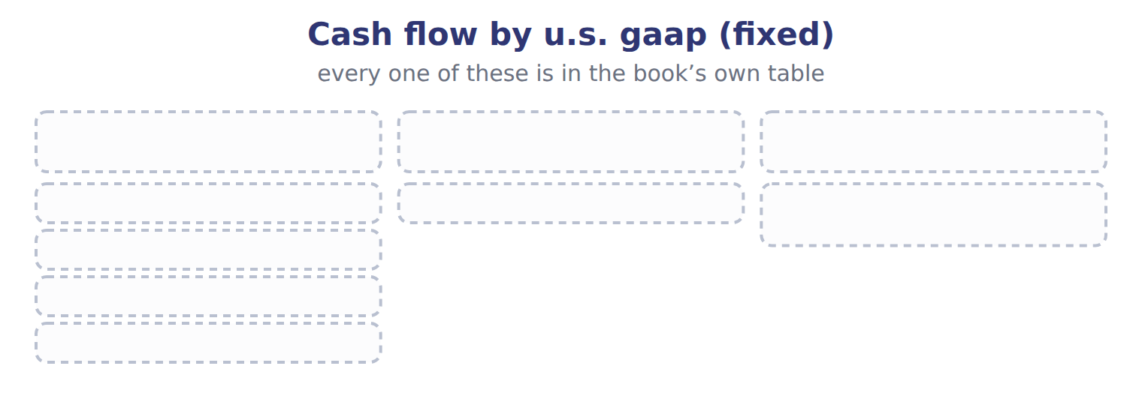
TEACH IT BACK | Write it for a classmate who missed this session — not for the marker.
27. In three or four sentences, write what this section settles and the one rule a reader has to take away.
every one of these words must appear: cash equivalents · direct method

Answer key · Handout 5.2 · Classifying cash flows

1 Operating activities · Financing activities | 10 F | 19 T
2 dividends · operating · Classifying | 11 Financing: Dividends paid | 20 A
3 investing · financing · activities | 12 Net income: Indirect method starts from | 21 B
4 T | 13 Operating: Interest paid, Interest received, Dividends received, Income taxes paid | 22 A
5 A | 14 B | 23 A
6 C | 15 A | 24 A
7 C | 16 D | 25 A
8 A | 17 B | 26 Compare with the model earlier in this handout.
9 T | 18 B | 27 Operating activities are the main revenue activities: cash from customers and cash paid to suppliers and employees. Anything that is not investing or financing is also operating. Investing activities involve long-term assets and other companies' securities: Orontes paid $3,000,000 for equipment and $1,200,000 for its Jordan Glass shares.

why
1 The book writes: “Operating activities are the main revenue activities: cash from customers and cash paid to suppliers and employees. Anything that is not investing or financing is also operating. Financing activities are with owners and lenders.”
2 The book writes: “GAAP fixes four items that students often get wrong. Interest paid, interest received, dividends received and income taxes are all operating. Classifying interest, dividends and taxes: U.S.”
3 The book writes: “These noncash investing and financing activities are not shown in the body of the statement. Under IAS 7 today, interest paid can be operating or financing, and interest and dividends received can be operating or investing. Interest paid is operating, not financing, under U.S.”
4 The book pairs Interest paid with “Operating”.
5 The book’s own table pairs Interest paid with “Operating”.
6 The book’s own table pairs Interest received with “Operating”.
7 The book’s own table pairs Dividends received with “Operating”.
8 The book’s own table pairs Dividends paid with “Financing”.
9 The book pairs Interest paid with “Follows the category of the expense; often financing”.
10 The book pairs Interest received with “Often investing”, not with “Follows the category of the expense; often financing”.
14 Transfers between cash and restricted cash are not cash flows. A is wrong: The statement explains cash and restricted cash together. C is wrong: No bond has been repaid yet.
15 U.S. GAAP fixes interest paid in operating. B is wrong: Financing is an IAS 7 option only. C is wrong: Interest paid is never investing.
16 Buying other companies' securities (not trading) is investing. A is wrong: Buying back own shares is financing. B is wrong: Interest received is operating.
17 Net income adjusted for noncash items, gains, equity-method items and working capital. A is wrong: This forgets to add back the impairment losses. C is wrong: This leaves equity-method income in operating cash flow.
18 Transfers between cash and restricted cash are not cash flows. A is wrong: The statement explains cash and restricted cash together. C is wrong: No bond has been repaid yet.
19 CMA questions use exact terms, and one word can change the answer.
20 The book’s own table gives Investing as the activity of Cash paid to buy a delivery truck.
21 The book’s own table gives Financing as the activity of Cash dividends paid to shareholders.
22 The book’s own table gives ________ as the activity of Interest paid on a bank loan.
23 200,000 + 50,000 − 10,000 − 30,000 − 5,000. B is wrong: This adds the decrease in payables. C is wrong: This adds the gain instead of subtracting it.

Handout 5.3
The indirect method
section 5.3 of the book
Before you start
Three summaries of this handout, in the book’s own words. Read all three first: together they are the whole session. Then fill the gaps, guessing where you have to.

What this handout settles, cycle by cycle
In this handout | What you will read | How you check it
The indirect method | a figure to read · Cash flow | Orontes's dividends payable rose by $400,000 in 2025. How does this affect net cash from operating activities?
The words this section uses precisely | The English the exam uses, and what it translates | What is the safest way to settle a disagreement about an answer on this sheet?

Words this handout uses precisely
Words this handout uses precisely | tick it if you could already use it in a sentence
operating activities
noncash investing and financing activities

1. Where the section starts — Fill every gap. The list holds more words than there are gaps, so one or two of them are not used.
choose from: liabilities · impairments · depreciation · cash equivalents · operating activities
It starts with net income and removes everything that is not an operating cash flow. First, add back noncash expenses and losses, such as , and an increase in deferred tax . Second, remove gains and losses on investing and financing items; the cash from those sales belongs in investing.
2. What it settles in the middle — Fill every gap. The list holds more words than there are gaps, so one or two of them are not used.
choose from: receivables · equity-method · cash equivalents · liabilities · operating activities
Also subtract income, which is not cash, and add the dividends received from the investee. Third, adjust for changes in current operating assets and from the balance sheet. When rise, the company has recorded revenue it has not yet collected, so the increase is subtracted.
3. Where it ends — Fill every gap. The list holds more words than there are gaps, so one or two of them are not used.
choose from: cash equivalents · operating · operating activities · Dividends · financing
Sign rules for the indirect method, with Orontes examples. Start from net income, never from income. payable and notes payable are items.
How every cycle on this sheet works
How a cycle works | what you do
MODEL | read the figure or the table before you answer anything
READ THE MODEL | every answer is printed on the same page
INVENT THE RULE | write the rule yourself, then compare with the book
APPLY | no help on this move
CHECKPOINT | mark it yourself; if you miss it, the sheet says what to redo

CYCLE A | The indirect method

ORIENT One claim. Decide now; you will check it in a moment.

4. The book gives the category of Lawsuit settlement paid as “Operating”. TRUE / FALSE
MODEL Read it before you answer anything below it.

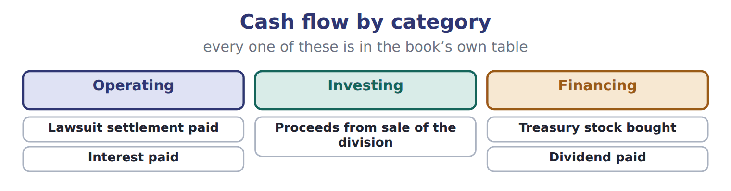

Cash flow — the book’s own table
Cash flow | Category
Lawsuit settlement paid | Operating
Proceeds from sale of the division | Investing
Treasury stock bought | Financing
Interest paid | Operating
Dividend paid | Financing

READ THE MODEL Every answer is printed above. Find it, do not recall it.

5. Which category does the book give for Lawsuit settlement paid?
A. Financing | C. Operating
B. Investing
6. Which category does the book give for Proceeds from sale of the division?
A. Investing | C. Financing
B. Operating
7. Which category does the book give for Treasury stock bought?
A. Investing | C. Operating
B. Financing
8. Which category does the book give for Interest paid?
A. Operating | C. Financing
B. Investing
9. The book gives the category of Lawsuit settlement paid as “Operating”. TRUE / FALSE
10. The book gives the category of Proceeds from sale of the division as “Operating”. TRUE / FALSE
SORT THEM | Write each one under its category. Every item belongs to exactly one group.
the items: Lawsuit settlement paid · Proceeds from sale of the division · Treasury stock bought · Interest paid · Dividend paid
Financing | Investing | Operating

APPLY No help on this move.

14. Orontes's dividends payable rose by $400,000 in 2025. How does this affect net cash from operating activities?
A. It is added as an increase in a liability
B. It has no effect, because dividends are a financing item
C. It is subtracted
D. It is added to investing
15. Under U.S. GAAP, the indirect method begins with:
A. operating income | C. net income
B. income before income taxes | D. comprehensive income
16. Orontes's current income tax expense was $889,700, and income taxes payable rose by $50,000. How much income tax did Orontes pay in 2025 (whole USD)?
A. 839,700 | C. 939,700
B. 889,700 | D. 989,700
17. A company reports a loss of $12,000 on the sale of a delivery van, for which it received $30,000. How is this shown?
A. Add $12,000 in operating; show $30,000 in investing
B. Subtract $12,000 in operating; show $30,000 in investing
C. Show $42,000 in investing
D. Show $18,000 in investing
WORK IN PAIRS | Compare every answer on this page with your partner before you read any key.
If you disagree: go back to the model and find the row that settles it. The row decides, not the louder voice.
CHECKPOINT 18. Orontes's dividends payable rose by $400,000 in 2025. How does this affect net cash from operating activities?
A. It is added as an increase in a liability
B. It has no effect, because dividends are a financing item
C. It is subtracted
D. It is added to investing
If you got it wrong: redo the READ THE MODEL questions of cycle A with the model in front of you.

CYCLE B | The words this section uses precisely

ORIENT

19. A term in the exam means exactly what the book defines it to mean, whatever it means in ordinary English. TRUE / FALSE
MODEL

The English the exam uses, and what it translates
English (exam term) | the Arabic it translates
operating activities | الأنشطة التشغيلية
noncash investing and financing activities | الأنشطة الاستثمارية والتمويلية غير النقدية

READ THE MODEL

20. A glossary term and its translation are a pair the book itself gives. TRUE / FALSE

APPLY

21. Which is a limitation of the statement of cash flows?
A. It is prepared on the accrual basis
B. Important noncash investing and financing deals appear only in the notes
C. It ignores cash paid for interest
D. It shows only noncash items
22. Why is operating cash flow not a good measure of profitability?
A. It includes too many estimates
B. It is measured at fair value
C. It excludes cash from customers
D. It ignores accruals, so it can be high in a year with poor profits, or low in a good year
CHECKPOINT 23. What is the safest way to settle a disagreement about an answer on this sheet?
A. find the row of the model that decides it
B. take the answer of whoever is more confident
C. leave it until the lecturer says
D. choose the longer option
If you got it wrong: redo the READ THE MODEL questions of cycle B.

FROM MEMORY | Close the earlier pages first.
24. Rebuild the figure from this handout. Label every part and fill in every box.

TEACH IT BACK | Write it for a classmate who missed this session — not for the marker.
25. In three or four sentences, write what this section settles and the one rule a reader has to take away.
every one of these words must appear: operating activities · noncash investing and financing activities

Answer key · Handout 5.3 · The indirect method

1 depreciation · impairments · liabilities | 10 F | 19 T
2 equity-method · liabilities · receivables | 11 Financing: Treasury stock bought, Dividend paid | 20 T
3 operating · Dividends · financing | 12 Investing: Proceeds from sale of the division | 21 B
4 T | 13 Operating: Lawsuit settlement paid, Interest paid | 22 D
5 C | 14 B | 23 A
6 A | 15 C | 24 Compare with the model earlier in this handout.
7 B | 16 A | 25 Most U.S. companies use the indirect method for operating activities. It starts with net income and removes everything that is not an operating cash flow. First, add back noncash expenses and losses, such as depreciation, impairments and an increase in deferred tax liabilities.
8 A | 17 A
9 T | 18 B

why
1 The book writes: “It starts with net income and removes everything that is not an operating cash flow. First, add back noncash expenses and losses, such as depreciation, impairments and an increase in deferred tax liabilities. Second, remove gains and losses on investing and financing items; the cash from those sales belongs in investing.”
2 The book writes: “Also subtract equity-method income, which is not cash, and add the dividends received from the investee. Third, adjust for changes in current operating assets and liabilities from the balance sheet. When receivables rise, the company has recorded revenue it has not yet collected, so the increase is subtracted.”
3 The book writes: “Sign rules for the indirect method, with Orontes examples. Start from net income, never from operating income. Dividends payable and notes payable are financing items.”
4 The book pairs Lawsuit settlement paid with “Operating”.
5 The book’s own table gives Operating as the category of Lawsuit settlement paid.
6 The book’s own table gives Investing as the category of Proceeds from sale of the division.
7 The book’s own table gives Financing as the category of Treasury stock bought.
8 The book’s own table gives Operating as the category of Interest paid.
9 The book pairs Lawsuit settlement paid with “Operating”.
10 The book pairs Proceeds from sale of the division with “Investing”, not with “Operating”.
14 Only operating working capital is adjusted in operating activities. A is wrong: Dividends payable is not an operating liability. C is wrong: It does not belong in operating at all.
15 The reconciliation starts from net income. A is wrong: Starting from operating profit is the amended IAS 7 approach. B is wrong: Taxes must be included, so start after tax.
16 Part of the current tax was still unpaid at year-end. B is wrong: This ignores the unpaid amount. C is wrong: An increase in taxes payable means less was paid.
17 Add back the noncash loss; show the actual proceeds in investing. B is wrong: A loss is added back, not subtracted. C is wrong: Investing shows the cash received.
18 Only operating working capital is adjusted in operating activities. A is wrong: Dividends payable is not an operating liability. C is wrong: It does not belong in operating at all.
19 CMA questions use exact terms, and one word can change the answer.
20 The term tables in each section are the book’s own.
21 A building bought with a mortgage never appears in the body. A is wrong: It is a cash-basis statement. C is wrong: Interest paid is included in operating.
22 Profitability is measured on the accrual basis. A is wrong: Cash flows involve few estimates. B is wrong: Cash flows are not fair values.
23 Every item on a Workshop sheet is settled by something printed on the same sheet.

Handout 5.4
The direct method and required disclosures
section 5.4 of the book
Before you start
Three summaries of this handout, in the book’s own words. Read all three first: together they are the whole session. Then fill the gaps, guessing where you have to.

What this handout settles, cycle by cycle
In this handout | What you will read | How you check it
The direct method and required disclosures | a figure to read · Orontes, 2025, direct method (whole USD) | Two companies make the same interest payments. One reports under U.S. GAAP, the other under IFRS and classifies interest as financing. Which limitation does this show?
The words this section uses precisely | The English the exam uses, and what it translates | What is the safest way to settle a disagreement about an answer on this sheet?

Words this handout uses precisely
Words this handout uses precisely | tick it if you could already use it in a sentence
investing activities

1. Where the section starts — Fill every gap. The list holds more words than there are gaps, so one or two of them are not used.
choose from: investing activities · encourages · operating · customers · direct method
The direct method shows the main classes of receipts and payments, such as cash from and cash paid to suppliers. The FASB it, but few companies use it.
2. What it settles in the middle — Fill every gap. The list holds more words than there are gaps, so one or two of them are not used.
choose from: reconciliation · investing activities · direct method · receivables · operating
A company that uses it must still show the of net income to cash flow. Cash from customers is sales adjusted for the change in and customer deposits.
3. Where it ends — Fill every gap. The list holds more words than there are gaps, so one or two of them are not used.
choose from: indirect · disclose · investing activities · interest · direct method
A company using the method must paid and income taxes paid. SC5-8 A company uses the indirect method.
How every cycle on this sheet works
How a cycle works | what you do
MODEL | read the figure or the table before you answer anything
READ THE MODEL | every answer is printed on the same page
INVENT THE RULE | write the rule yourself, then compare with the book
APPLY | no help on this move
CHECKPOINT | mark it yourself; if you miss it, the sheet says what to redo

CYCLE A | The direct method and required disclosures

ORIENT One claim. Decide now; you will check it in a moment.

4. Every number in a financial statement belongs to an element the framework defines. TRUE / FALSE
MODEL Read it before you answer anything below it.

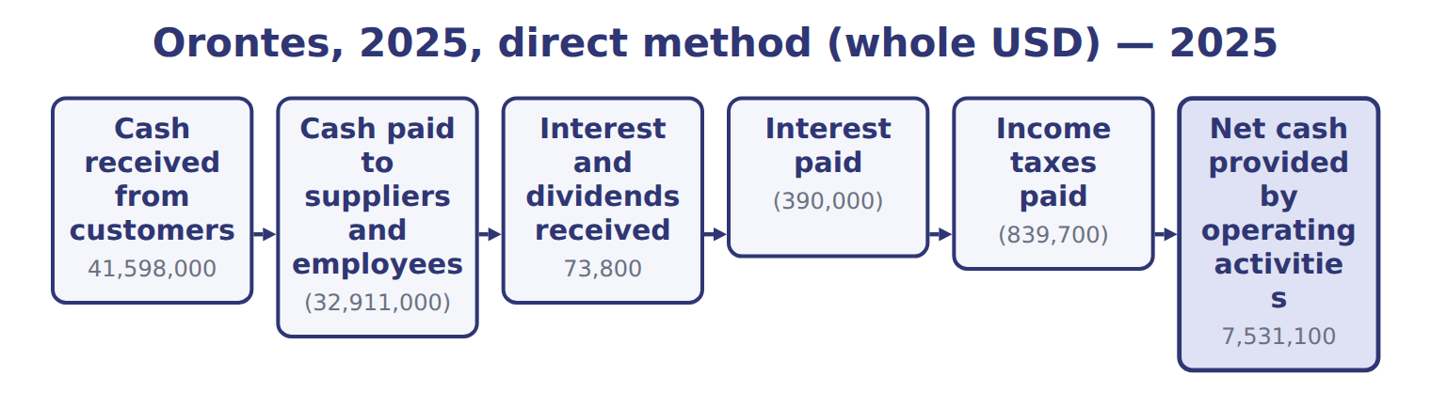
Orontes, 2025, direct method (whole USD) — the book’s own table
Orontes, 2025, direct method (whole USD) | 2025
Cash received from customers | 41,598,000
Cash paid to suppliers and employees | (32,911,000)
Interest and dividends received | 73,800
Interest paid | (390,000)
Income taxes paid | (839,700)
Net cash provided by operating activities | 7,531,100

READ THE MODEL Every answer is printed above. Find it, do not recall it.

5. Which part of this chapter is section 5.1?
A. Purpose and structure of the statement of cash flows
B. The direct method and required disclosures
C. The indirect method
D. Classifying cash flows
6. Which part of this chapter is section 5.2?
A. Classifying cash flows
B. The direct method and required disclosures
C. Purpose and structure of the statement of cash flows
D. The indirect method
7. Which part of this chapter is section 5.3?
A. Classifying cash flows
B. The indirect method
C. Purpose and structure of the statement of cash flows
D. The direct method and required disclosures
8. Which part of this chapter is section 5.4?
A. The indirect method
B. The direct method and required disclosures
C. Purpose and structure of the statement of cash flows
D. Classifying cash flows

APPLY No help on this move.

9. Two companies make the same interest payments. One reports under U.S. GAAP, the other under IFRS and classifies interest as financing. Which limitation does this show?
A. Classification differences reduce comparability
B. Cash flows depend on estimates
C. Noncash items are omitted
D. The statement uses historical cost
10. A company stops replacing its old machines. What is the likely short-term effect on its statement of cash flows?
A. Operating cash flow falls immediately
B. Financing inflows rise
C. Investing outflows fall, so total cash looks strong even though the future may be weaker
D. Nothing changes
11. Orontes declared dividends of $450,000 in 2025, and dividends payable rose by $400,000. What are dividends paid in the financing section (whole USD)?
A. 50,000 | C. 450,000
B. 400,000 | D. 850,000
12. Orontes's net accounts receivable rose by $384,000 on its balance sheet. Where does this change appear?
A. As an investing outflow
B. In the statement of changes in equity
C. Nowhere; balance sheet changes are not used
D. As a deduction in operating activities (indirect method)
WORK IN PAIRS | Compare every answer on this page with your partner before you read any key.
If you disagree: go back to the model and find the row that settles it. The row decides, not the louder voice.
CHECKPOINT 13. Two companies make the same interest payments. One reports under U.S. GAAP, the other under IFRS and classifies interest as financing. Which limitation does this show?
A. Classification differences reduce comparability
B. Cash flows depend on estimates
C. Noncash items are omitted
D. The statement uses historical cost
If you got it wrong: redo the READ THE MODEL questions of cycle A with the model in front of you.

CYCLE B | The words this section uses precisely

ORIENT

14. A term in the exam means exactly what the book defines it to mean, whatever it means in ordinary English. TRUE / FALSE
MODEL

The English the exam uses, and what it translates
English (exam term) | the Arabic it translates
investing activities | الأنشطة الاستثمارية

READ THE MODEL

15. A glossary term and its translation are a pair the book itself gives. TRUE / FALSE

APPLY

16. A company using the direct method must also:
A. present a reconciliation of net income to operating cash flow
B. stop disclosing noncash activities
C. classify interest paid as financing
D. present an income statement by nature
CHECKPOINT 17. What is the safest way to settle a disagreement about an answer on this sheet?
A. find the row of the model that decides it
B. take the answer of whoever is more confident
C. leave it until the lecturer says
D. choose the longer option
If you got it wrong: redo the READ THE MODEL questions of cycle B.

FROM MEMORY | Close the earlier pages first.
18. Rebuild the figure from this handout. Label every part and fill in every box.
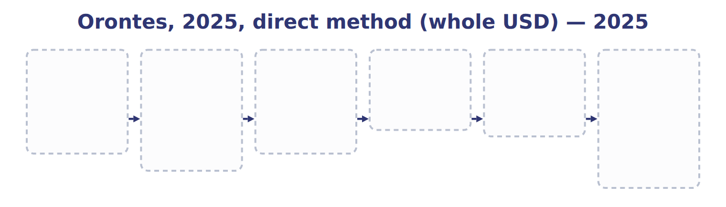
TEACH IT BACK | Write it for a classmate who missed this session — not for the marker.
19. In three or four sentences, write what this section settles and the one rule a reader has to take away.
every one of these words must appear: investing activities

Answer key · Handout 5.4 · The direct method and required disclosures

1 operating · customers · encourages | 8 B | 15 T
2 reconciliation · operating · receivables | 9 A | 16 A
3 indirect · disclose · interest | 10 C | 17 A
4 T | 11 A | 18 Compare with the model earlier in this handout.
5 A | 12 D | 19 The direct method shows the main classes of operating receipts and payments, such as cash from customers and cash paid to suppliers. The FASB encourages it, but few companies use it. A company that uses it must still show the reconciliation of net income to operating cash flow.
6 A | 13 A
7 B | 14 T

why
1 The book writes: “The direct method shows the main classes of operating receipts and payments, such as cash from customers and cash paid to suppliers. The FASB encourages it, but few companies use it.”
2 The book writes: “A company that uses it must still show the reconciliation of net income to operating cash flow. Cash from customers is sales adjusted for the change in receivables and customer deposits.”
3 The book writes: “A company using the indirect method must disclose interest paid and income taxes paid. SC5-8 A company uses the indirect method.”
4 The framework defines the elements, and every amount belongs to one of them.
5 The book numbers “Purpose and structure of the statement of cash flows” as section 5.1.
6 The book numbers “Classifying cash flows” as section 5.2.
7 The book numbers “The indirect method” as section 5.3.
8 The book numbers “The direct method and required disclosures” as section 5.4.
9 The same payment can land in different sections. B is wrong: No estimate is involved. C is wrong: Interest paid is a cash flow.
10 One year of cash flows can hide underinvestment. A is wrong: Operations are not directly affected at first. B is wrong: No financing is involved.
11 Declared minus the increase in the unpaid amount. B is wrong: This is only the unpaid part. C is wrong: This uses dividends declared, not paid.
12 Balance sheet changes in operating items drive the indirect method. A is wrong: Trade receivables are operating. B is wrong: Receivables are not an equity account.
13 The same payment can land in different sections. B is wrong: No estimate is involved. C is wrong: Interest paid is a cash flow.
14 CMA questions use exact terms, and one word can change the answer.
15 The term tables in each section are the book’s own.
16 The reconciliation is still required. B is wrong: Noncash disclosures are always required. C is wrong: Interest paid stays operating.
17 Every item on a Workshop sheet is settled by something printed on the same sheet.

Handout 5.5
Limitations and links between the four statements
section 5.5 of the book
Before you start
Three summaries of this handout, in the book’s own words. Read all three first: together they are the whole session. Then fill the gaps, guessing where you have to.

What this handout settles, cycle by cycle
In this handout | What you will read | How you check it
Limitations and links between the four statements | a figure to read · Barada Wholesale (USD 000) | Why do users need a statement of cash flows when they already have an income statement?
The words this section uses precisely | Cash flow · The English the exam uses, and what it translates | What is the safest way to settle a disagreement about an answer on this sheet?

Words this handout uses precisely
Words this handout uses precisely | tick it if you could already use it in a sentence
financing activities

1. Where the section starts — Fill every gap. The list holds more words than there are gaps, so one or two of them are not used.
choose from: statement of cash flows · cash equivalents · indirect method · financing activities
It is only a proposal; the definition of does not change. French tableau de financement is an older funds statement based on working capital, not a . The IFRS term is tableau des flux de trésorerie.
2. What it settles in the middle — Fill every gap. The list holds more words than there are gaps, so one or two of them are not used.
choose from: financing activities · statement of cash flows · cash equivalents · indirect method
That is the amount in the financing section. It is only a proposal; the definition of does not change. French tableau de financement is an older funds statement based on working capital, not a .
3. Where it ends — Fill every gap. The list holds more words than there are gaps, so one or two of them are not used.
choose from: cash equivalents · financing activities · indirect method · statement of cash flows
That is the amount in the financing section. It is only a proposal; the definition of does not change. French tableau de financement is an older funds statement based on working capital, not a . The IFRS term is tableau des flux de trésorerie.
How every cycle on this sheet works
How a cycle works | what you do
MODEL | read the figure or the table before you answer anything
READ THE MODEL | every answer is printed on the same page
INVENT THE RULE | write the rule yourself, then compare with the book
APPLY | no help on this move
CHECKPOINT | mark it yourself; if you miss it, the sheet says what to redo

CYCLE A | Limitations and links between the four statements

ORIENT One claim. Decide now; you will check it in a moment.

4. Every number in a financial statement belongs to an element the framework defines. TRUE / FALSE
MODEL Read it before you answer anything below it.

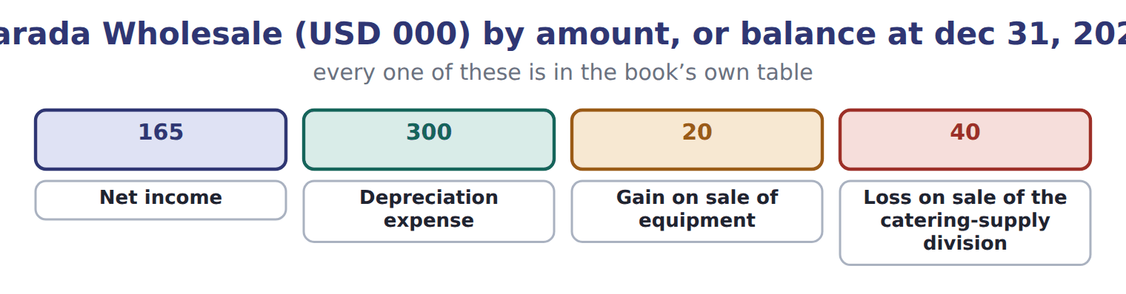
Barada Wholesale (USD 000) — the book’s own table
Barada Wholesale (USD 000) | Amount, or balance at Dec 31, 2025 | Balance at Dec 31, 2026
Income statement items, 2026
Net income | 165
Depreciation expense | 300
Gain on sale of equipment | 20
Loss on sale of the catering-supply division | 40
Balances
Accounts receivable, net | 280 | 310
Inventory | 420 | 390
Prepaid rent | 24 | 26
Accounts payable | 380 | 410

Barada Wholesale (USD 000) — the book’s own table (continued)
Barada Wholesale (USD 000) | Amount, or balance at Dec 31, 2025 | Balance at Dec 31, 2026
Income taxes payable | 0 | 30
Cash | 1,050 | ?
Other 2026 cash information
Proceeds from sale of equipment | 70
Proceeds from sale of the division | 150
Purchases of equipment | 200
Note installment repaid (Chapter 2, M1) | 300
Dividend paid (declared in 2025) | 50
Treasury stock bought (Chapter 4, E1) | 480
Treasury stock reissued (E2 and E3) | 200

Barada Wholesale (USD 000) — the book’s own table (continued)
Barada Wholesale (USD 000) | Amount, or balance at Dec 31, 2025 | Balance at Dec 31, 2026
Cash dividend declared December 15, 2026, payable January 2027 | 121

READ THE MODEL Every answer is printed above. Find it, do not recall it.

5. Which part of this chapter is section 5.1?
A. Purpose and structure of the statement of cash flows
B. The direct method and required disclosures
C. The indirect method
D. Classifying cash flows
6. Which part of this chapter is section 5.2?
A. Classifying cash flows
B. The direct method and required disclosures
C. Purpose and structure of the statement of cash flows
D. The indirect method
7. Which part of this chapter is section 5.3?
A. Classifying cash flows
B. The indirect method
C. Purpose and structure of the statement of cash flows
D. The direct method and required disclosures
8. Which part of this chapter is section 5.4?
A. The indirect method
B. The direct method and required disclosures
C. Purpose and structure of the statement of cash flows
D. Classifying cash flows
APPLY No help on this move.

9. Under U.S. GAAP, interest paid on a bank loan is classified as:
A. a financing activity
B. an operating activity
C. an investing activity
D. operating or financing, as the company chooses
10. A company acquires a building by signing a $2 million mortgage note with the seller. No cash changes hands. How is this reported?
A. As a noncash investing and financing activity, disclosed separately
B. As an investing outflow and a financing inflow of $2 million
C. As an operating outflow
D. It is not reported anywhere
WORK IN PAIRS | Compare every answer on this page with your partner before you read any key.
If you disagree: go back to the model and find the row that settles it. The row decides, not the louder voice.
CHECKPOINT 11. Why do users need a statement of cash flows when they already have an income statement?
A. Because the income statement ignores revenue
B. Because the statement of cash flows shows the market value of assets
C. Because net income is not the same as cash generated
D. Because cash flows are measured at fair value
If you got it wrong: redo the READ THE MODEL questions of cycle A with the model in front of you.

CYCLE B | The words this section uses precisely

ORIENT

12. A term in the exam means exactly what the book defines it to mean, whatever it means in ordinary English. TRUE / FALSE
MODEL

Cash flow — the book’s own table
Cash flow | Category
Lawsuit settlement paid
Proceeds from sale of the division
Treasury stock bought
Interest paid
Dividend paid

The English the exam uses, and what it translates
English (exam term) | the Arabic it translates
financing activities | الأنشطة التمويلية

READ THE MODEL

13. A glossary term and its translation are a pair the book itself gives. TRUE / FALSE
APPLY

14. On December 1 a company buys a Treasury bill that matures in five months, on April 30. At December 31 it has two months left to maturity. Is it a cash equivalent?
A. Yes, because it matures within three months of the year-end
B. Yes, because all Treasury bills are cash equivalents
C. No, because only bank deposits are cash equivalents
D. No, because its original maturity to the company was more than three months
CHECKPOINT 15. What is the safest way to settle a disagreement about an answer on this sheet?
A. find the row of the model that decides it
B. take the answer of whoever is more confident
C. leave it until the lecturer says
D. choose the longer option
If you got it wrong: redo the READ THE MODEL questions of cycle B.

FROM MEMORY | Close the earlier pages first.
16. Rebuild the figure from this handout. Label every part and fill in every box.
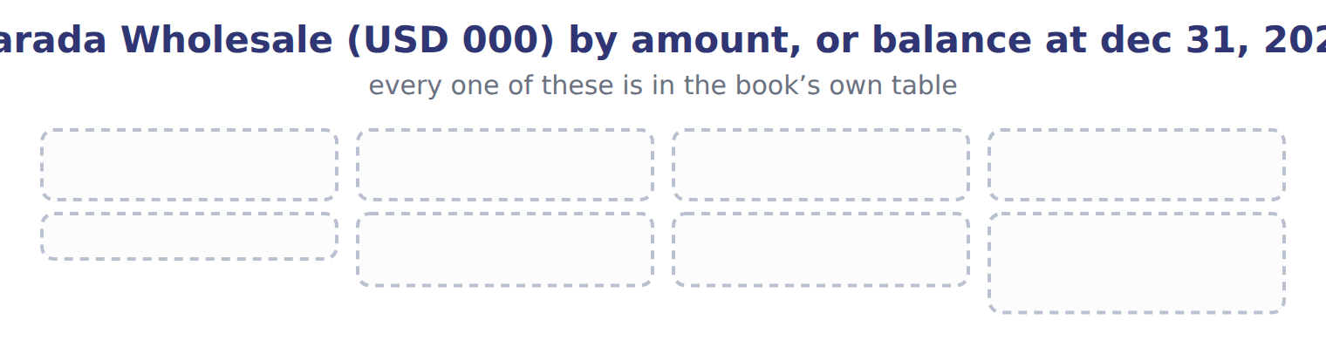
TEACH IT BACK | Write it for a classmate who missed this session — not for the marker.
17. In three or four sentences, write what this section settles and the one rule a reader has to take away.
every one of these words must appear: financing activities

Answer key · Handout 5.5 · Limitations and links between the four statements

1 cash equivalents · statement of cash flows | 7 B | 13 T
2 cash equivalents · statement of cash flows | 8 B | 14 D
3 cash equivalents · statement of cash flows | 9 B | 15 A
4 T | 10 A | 16 Compare with the model earlier in this handout.
5 A | 11 C | 17 Cash flows are harder to manage than profits, but not impossible. A company can raise operating cash near year-end by delaying payments to suppliers or by selling receivables. The statement also shows only one year, and it is not a measure of profit.
6 A | 12 T

why
1 The book writes: “It is only a proposal; the definition of cash equivalents does not change. French tableau de financement is an older funds statement based on working capital, not a statement of cash flows. The IFRS term is tableau des flux de trésorerie.”
2 The book writes: “That is the amount in the financing section. It is only a proposal; the definition of cash equivalents does not change. French tableau de financement is an older funds statement based on working capital, not a statement of cash flows.”
3 The book writes: “That is the amount in the financing section. It is only a proposal; the definition of cash equivalents does not change. French tableau de financement is an older funds statement based on working capital, not a statement of cash flows. The IFRS term is tableau des flux de trésorerie.”
4 The framework defines the elements, and every amount belongs to one of them.
5 The book numbers “Purpose and structure of the statement of cash flows” as section 5.1.
6 The book numbers “Classifying cash flows” as section 5.2.
7 The book numbers “The indirect method” as section 5.3.
8 The book numbers “The direct method and required disclosures” as section 5.4.
9 U.S. GAAP fixes interest paid in operating activities. A is wrong: This is an IAS 7 option, not U.S. GAAP. C is wrong: Interest paid is never investing.
10 Noncash investing and financing deals are disclosed, not shown in the body. B is wrong: No cash moved, so no cash flows are shown. C is wrong: Buying a building is not operating.
11 Accrual profit and cash can differ greatly. A is wrong: The income statement reports revenue. B is wrong: No statement shows the market value of the company.
12 CMA questions use exact terms, and one word can change the answer.
13 The term tables in each section are the book’s own.
14 The test uses original maturity to the holder, not remaining maturity. A is wrong: Remaining maturity at year-end is not the test. B is wrong: Maturity decides, not the type of security.
15 Every item on a Workshop sheet is settled by something printed on the same sheet.

Handout 5.6
The whole chapter
every section, shuffled, and the chapter’s own case set
Before you start
Three summaries of this chapter, in the book’s own words, with words taken out. Read all three first: together they are the whole chapter. Then fill the gaps.

What this handout settles, cycle by cycle
In this handout | What you will read | How you check it
The whole chapter, in order | a figure to read | Under the indirect method, how does Orontes treat the 384,000 increase in net accounts receivable?
The chapter’s case set | The chapter’s case set, item by item | What has to be settled before any figure in a case set is worked out?
The words it uses precisely | statement of cash flows · cash equivalents · operating activities · investing activities · financing activities · indirect method | matching, at the end of cycle B

1. Where the chapter starts — Fill every gap. The list holds more words than there are gaps, so one or two of them are not used.
choose from: direct method · operating activities · Cash equivalents · investing activities · indirect method · financing activities
are short-term, highly liquid investments with an original maturity to the holder of three months or less. Moving money between these categories is not a cash flow. Cash flows are grouped into , and .
2. What it settles in the middle — Fill every gap. The list holds more words than there are gaps, so one or two of them are not used.
choose from: direct method · investing activities · cash equivalents · financing activities · operating activities
Moving money between these categories is not a cash flow. Cash flows are grouped into , and . Strong operating cash is a good sign, but a reader should also ask where the cash went.
3. Where it ends — Fill every gap. The list holds more words than there are gaps, so one or two of them are not used.
choose from: operating activities · statement of cash flows · cash equivalents · financing activities
It is only a proposal; the definition of does not change. French tableau de financement is an older funds statement based on working capital, not a . The IFRS term is tableau des flux de trésorerie.

CYCLE A | The whole chapter, in order

ORIENT

4. The sections of a chapter have to be taken in order, because each one uses what the one before it settled. TRUE / FALSE
MODEL

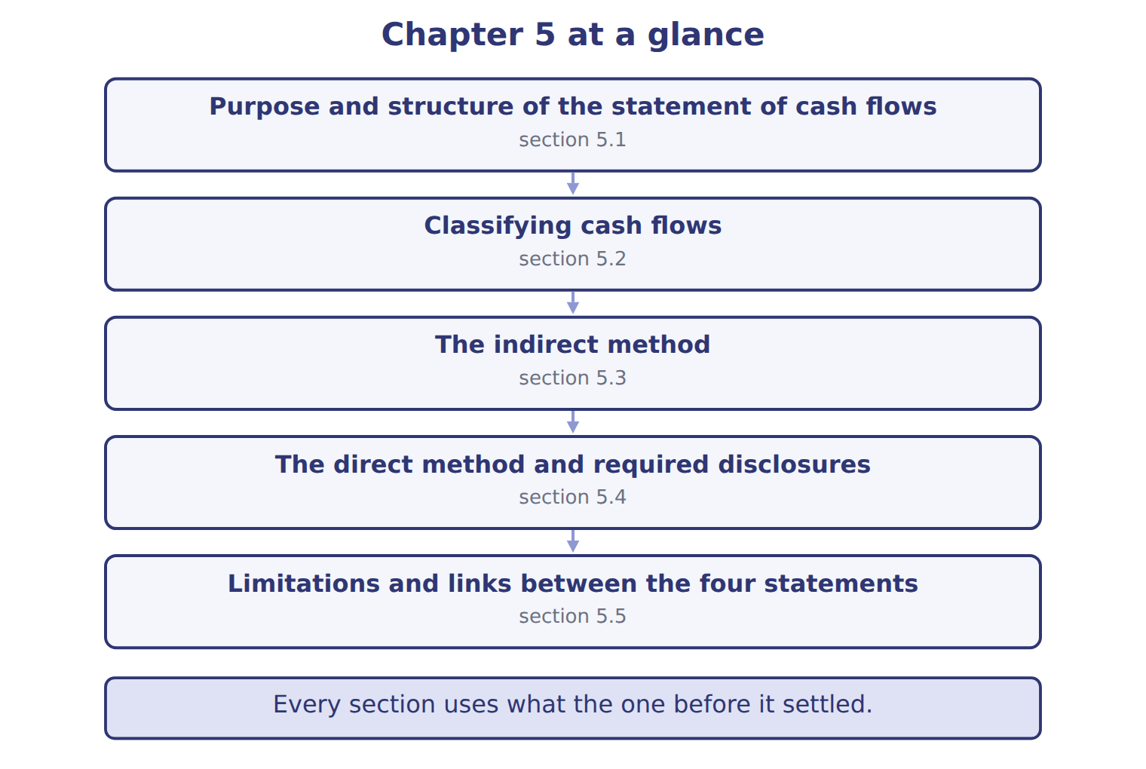
READ THE MODEL

5. “section 5.1” — which part of the chapter is this?
A. The direct method and required disclosures
B. Classifying cash flows
C. Purpose and structure of the statement of cash flows
D. The indirect method
6. “section 5.2” — which part of the chapter is this?
A. The direct method and required disclosures
B. Classifying cash flows
C. The indirect method
D. Purpose and structure of the statement of cash flows
7. “section 5.3” — which part of the chapter is this?
A. The direct method and required disclosures
B. The indirect method
C. Classifying cash flows
D. Purpose and structure of the statement of cash flows
Write the letter of the section number beside each section title. Every number is used once.
A 5.1 | D 5.4
B 5.2 | E 5.5
C 5.3

8. Purpose and structure of the statement of cash flows
9. Classifying cash flows
10. The indirect method
11. The direct method and required disclosures
12. Limitations and links between the four statements

APPLY

13. How can a company increase its operating cash flow at year-end without improving its business?
A. By recording more depreciation
B. By issuing new shares
C. By revaluing its land
D. By delaying payments to suppliers until January
WORK IN PAIRS | Compare every answer with your partner first.
If you disagree: name the section each question belongs to. Most disagreements turn out to be about the section, not the answer.
CHECKPOINT 14. Under the indirect method, how does Orontes treat the 384,000 increase in net accounts receivable?
A. Adds it to net income
B. Shows it in investing activities
C. Subtracts it from net income
D. Ignores it
If you got it wrong: go back to the MODEL move of cycle A and find the section this question belongs to.

CYCLE B | The chapter’s case set

ORIENT

15. In a case question, the exhibit has to be read and adjusted before any figure is worked out. TRUE / FALSE

MODEL

The chapter’s case set, item by item
Item | What it asks
C5-1 | Classify each 2026 cash flow. (On the exam screen you would drag each item into a box.)
C5-2 | Enter Barada's net cash provided by operating activities for 2026 (indirect method).
C5-3 | Enter Barada's net cash from investing activities for 2026.
C5-4 | Enter Barada's net cash used in financing activities for 2026 (as a positive number).
C5-5 | Enter Barada's cash at December 31, 2026.
C5-6 | Where does Barada show the 2026 dividend declared on December 15 and payable in January 2027? [select]

READ THE MODEL

16. Which of these does item C5-1 ask for?
A. Enter Barada's net cash from investing activities for 2026.
B. Classify each 2026 cash flow. (On the exam screen you would drag each
C. Enter Barada's net cash used in financing activities for 2026 (as a po
D. Enter Barada's net cash provided by operating activities for 2026 (ind
17. Which of these does item C5-2 ask for?
A. Classify each 2026 cash flow. (On the exam screen you would drag each
B. Enter Barada's net cash used in financing activities for 2026 (as a po
C. Enter Barada's net cash provided by operating activities for 2026 (ind
D. Enter Barada's net cash from investing activities for 2026.
18. Which of these does item C5-3 ask for?
A. Enter Barada's net cash used in financing activities for 2026 (as a po
B. Enter Barada's net cash from investing activities for 2026.
C. Enter Barada's net cash provided by operating activities for 2026 (ind
D. Classify each 2026 cash flow. (On the exam screen you would drag each
19. Which of these does item C5-4 ask for?
A. Classify each 2026 cash flow. (On the exam screen you would drag each
B. Enter Barada's net cash provided by operating activities for 2026 (ind
C. Enter Barada's net cash from investing activities for 2026.
D. Enter Barada's net cash used in financing activities for 2026 (as a po
20. Which of these does item C5-5 ask for?
A. Classify each 2026 cash flow. (On the exam screen you would drag each
B. Enter Barada's net cash provided by operating activities for 2026 (ind
C. Enter Barada's cash at December 31, 2026.
D. Enter Barada's net cash from investing activities for 2026.
21. Which of these does item C5-6 ask for?
A. Where does Barada show the 2026 dividend declared on December 15 and p
B. Classify each 2026 cash flow. (On the exam screen you would drag each
C. Enter Barada's net cash from investing activities for 2026.
D. Enter Barada's net cash provided by operating activities for 2026 (ind
APPLY

22. Under the indirect method, how does Orontes treat the 384,000 increase in net accounts receivable?
A. Adds it to net income | C. Subtracts it from net income
B. Shows it in investing activities | D. Ignores it

23. A company sells equipment with a carrying amount of $40,000 for $55,000. How is the sale shown under the indirect method?
A. Add $15,000 in operating; show $55,000 in investing
B. Subtract the $15,000 gain in operating; show $55,000 in investing
C. Show $15,000 in investing only
D. Show $55,000 in operating
CHECKPOINT 24. What has to be settled before any figure in a case set is worked out?
A. the exhibit, adjusted for every note that goes with it
B. the method the company uses
C. the tax rate
D. the order of the items
If you got it wrong: reread the case panel in the MODEL move of cycle B.

FROM MEMORY | Close the earlier pages first.
25. Rebuild the chapter map. Write every section in order and what each one settles.
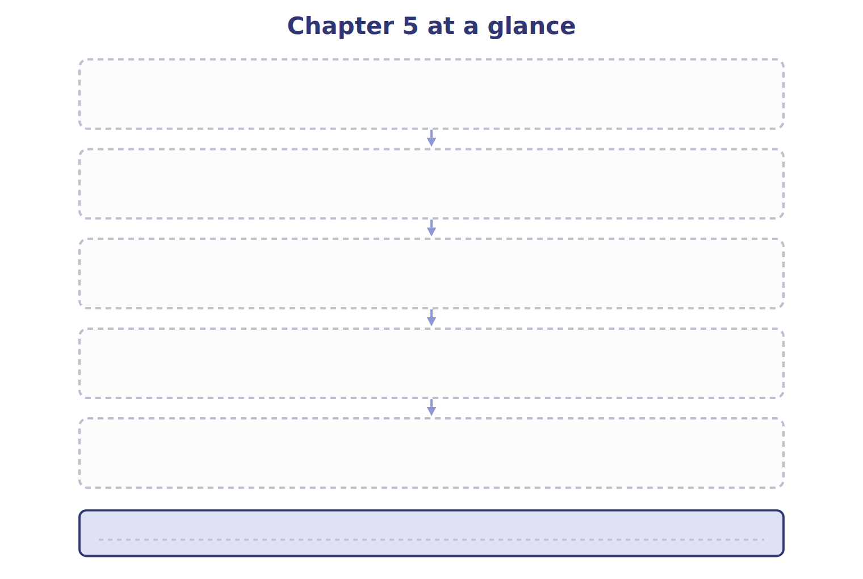
TEACH IT BACK | Write it for a student starting this chapter tomorrow — not for the marker.
26. In four or five sentences, write what the whole chapter settles, section by section.
every one of these words must appear: statement of cash flows · cash equivalents · operating activities · investing activities

Answer key · Handout 5.6 · The whole chapter

1 Cash equivalents · operating activities · investing activities · financing activities | 10 C | 19 D
2 operating activities · investing activities · financing activities | 11 D | 20 C
3 cash equivalents · statement of cash flows | 12 E | 21 A
4 T | 13 D | 22 C
5 C | 14 C | 23 B
6 B | 15 T | 24 A
7 B | 16 B | 25 Compare with the model earlier in this handout.
8 A | 17 C | 26 5.1: Purpose and structure of the statement of cash flows. 5.2: Classifying cash flows. 5.3: The indirect method. 5.4: The direct method and required disclosures. 5.5: Limitations and links between the four statements.
9 B | 18 B

why
1 The book writes: “Cash equivalents are short-term, highly liquid investments with an original maturity to the holder of three months or less. Moving money between these categories is not a cash flow. Cash flows are grouped into operating activities, investing activities and financing activities.”
2 The book writes: “Moving money between these categories is not a cash flow. Cash flows are grouped into operating activities, investing activities and financing activities. Strong operating cash is a good sign, but a reader should also ask where the cash went.”
3 The book writes: “It is only a proposal; the definition of cash equivalents does not change. French tableau de financement is an older funds statement based on working capital, not a statement of cash flows. The IFRS term is tableau des flux de trésorerie.”
4 The map shows the order the decisions have to be taken in.
5 The book numbers it 5.1.
6 The book numbers it 5.2.
7 The book numbers it 5.3.
13 Timing of payments shifts operating cash between years. A is wrong: Depreciation is noncash; it does not change cash flow. B is wrong: Share issues are financing inflows.
14 Revenue was recorded but not yet collected. A is wrong: An increase in an operating asset is subtracted. B is wrong: Trade receivables are operating.
15 Every later answer depends on the adjusted exhibit.
16 The book states item C5-1 in those words.
17 The book states item C5-2 in those words.
18 The book states item C5-3 in those words.
19 The book states item C5-4 in those words.
20 The book states item C5-5 in those words.
21 The book states item C5-6 in those words.
22 Revenue was recorded but not yet collected. A is wrong: An increase in an operating asset is subtracted. B is wrong: Trade receivables are operating.
23 The gain is removed from operating; the full proceeds are investing. A is wrong: A gain is subtracted, not added. C is wrong: Investing shows the full proceeds, not the gain.
24 Every later answer depends on the adjusted exhibit.

Handout 6.1
Recognizing and measuring receivables
section 6.1 of the book
Before you start
Three summaries of this handout, in the book’s own words. Read all three first: together they are the whole session. Then fill the gaps, guessing where you have to.

What this handout settles, cycle by cycle
In this handout | What you will read | How you check it
Recognizing and measuring receivables | a figure to read · Transfer · Age of receivable | Under CECL, when does a company first recognize expected credit losses on a trade receivable?
The words this section uses precisely | Item · The English the exam uses, and what it translates | What is the safest way to settle a disagreement about an answer on this sheet?

Words this handout uses precisely
Words this handout uses precisely | tick it if you could already use it in a sentence
accounts receivable
aging schedule
factoring
contract asset
amortized cost
factor
pledging

1. Where the section starts — Fill every gap. The list holds more words than there are gaps, so one or two of them are not used.
choose from: secured borrowing · transfers · unconditional · notes receivable · receivable
A company records an account when its right to be paid is : only the passage of time is needed before payment is due. This usually happens when it delivers the goods or services and control (Chapter 11). If the company still has to do something else before it can bill, for example finish a second delivery, it has a contract asset, not a receivable.
2. What it settles in the middle — Fill every gap. The list holds more words than there are gaps, so one or two of them are not used.
choose from: discounts · secured borrowing · notes receivable · questions · forfeited
Some older still use the gross and net methods. Under the gross method, the company records the full invoice and records a sales discount only when a customer pays early. Under the net method, it records the sale net of the discount, and records sales when a customer pays late.
3. Where it ends — Fill every gap. The list holds more words than there are gaps, so one or two of them are not used.
choose from: secured borrowing · notes receivable · amortized · discount · Receivable
The is then to interest revenue over the life of the note. : only time must pass before payment. Contract asset: the company must still perform.

CYCLE A | Recognizing and measuring receivables

ORIENT One claim. Decide now; you will check it in a moment.

4. The book gives the category of T1 as “Sale”. TRUE / FALSE
MODEL Read it before you answer anything below it.

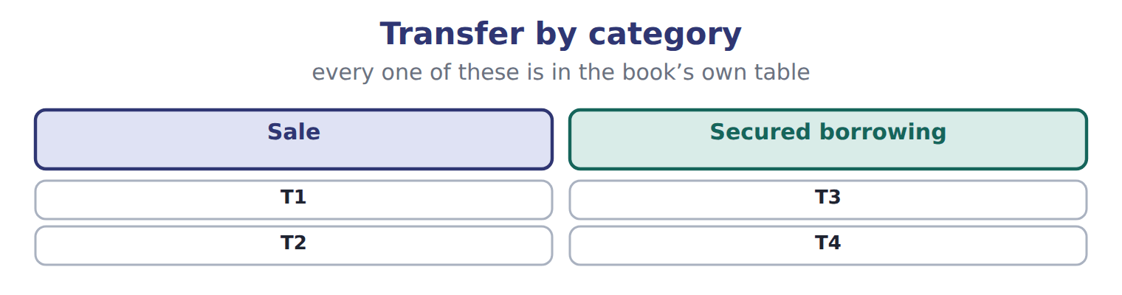

Transfer — the book’s own table
Transfer | Category
T1 | Sale
T2 | Sale
T3 | Secured borrowing
T4 | Secured borrowing

READ THE MODEL Every answer is printed above. Find it, do not recall it.

5. Which transfer does the book pair with “Sale”?
A. T4 | C. T3
B. T1
6. Which transfer does the book pair with “Sale”?
A. T2 | C. T3
B. T4
7. Which transfer does the book pair with “Secured borrowing”?
A. T1 | C. T3
B. T2
8. Which transfer does the book pair with “Secured borrowing”?
A. T4 | C. T1
B. T2
9. The book gives the category of T1 as “Sale”. TRUE / FALSE
10. The book gives the category of T2 as “Secured borrowing”. TRUE / FALSE
SORT THEM | Write each one under its category. Every item belongs to exactly one group.
the items: T1 · T2 · T3 · T4
Sale | Secured borrowing

APPLY No help on this move.

13. Under CECL, when does a company first recognize expected credit losses on a trade receivable?
A. When a loss becomes probable
B. When the customer misses a payment
C. When the receivable is first recognized
D. When the receivable is written off
14. A customer pays 1,500 that Orontes had written off last year. Under the allowance method, what is the first entry?
A. Debit Accounts receivable, credit Allowance for credit losses
B. Debit Cash, credit Revenue
C. Debit Cash, credit Credit loss expense
D. Debit Allowance for credit losses, credit Accounts receivable
15. Why is the direct write-off method not acceptable under U.S. GAAP when bad debts are material?
A. It is not allowed for U.S. tax returns.
B. It records losses too early.
C. It records losses late and shows receivables at more than the amount expected to be collected.
D. It reduces cash flow from operations.
Age of receivable — the extract for the question that follows
Age of receivable | Amount | Expected loss rate | Required allowance
Current | 400,000 | 1% | 4,000
1–30 days past due | 150,000 | 3% | 4,500
31–60 days past due | 60,000 | 10% | 6,000
61–90 days past due | 30,000 | 25% | 7,500
Over 90 days past due | 20,000 | 60% | 12,000
Total | 660,000 |  | 34,000

16. The extract for this question is printed with it. What is the required allowance for credit losses at December 31, 2025 (whole USD)?
A. 6,000 | C. 34,000
B. 28,000 | D. 626,000
WORK IN PAIRS | Compare every answer on this page with your partner before you read any key.
If you disagree: go back to the model and find the row that settles it. The row decides, not the louder voice.
CHECKPOINT 17. Under CECL, when does a company first recognize expected credit losses on a trade receivable?
A. When a loss becomes probable
B. When the customer misses a payment
C. When the receivable is first recognized
D. When the receivable is written off
If you got it wrong: redo the READ THE MODEL questions of cycle A with the model in front of you.

CYCLE B | The words this section uses precisely

ORIENT

18. A term in the exam means exactly what the book defines it to mean, whatever it means in ordinary English. TRUE / FALSE

MODEL

Item — the book’s own table
Item | Answer
1–60 days past due | 80,000 × 8% = 6,400
Over 60 days past due | 40,000 × 25% = 10,000
Required allowance | 3,600 + 6,400 + 10,000 = 20,000

The English the exam uses, and what it translates
English (exam term) | the Arabic it translates
accounts receivable | الذمم المدينة (المدينون)
aging schedule | جدول أعمار الذمم المدينة
factoring | تخصيم الذمم المدينة (بيع الديون)
contract asset | أصل العقد
amortized cost | التكلفة المستنفدة (التكلفة المطفأة)
factor | شركة التخصيم
pledging | رهن الذمم المدينة

READ THE MODEL

Write the letter of the Arabic term beside each English term. Every term is used once.
A التكلفة المستنفدة (التكلفة المطفأة)
B الذمم المدينة (المدينون)
C رهن الذمم المدينة
D شركة التخصيم
E تخصيم الذمم المدينة (بيع الديون)
F أصل العقد

19. contract asset
20. factor
21. pledging
22. amortized cost
23. factoring
24. accounts receivable

25. Which answer does the book give for 1–60 days past due?
A. 40,000 × 25% = 10,000 | C. 3,600 + 6,400 + 10,000 = 20,000
B. 80,000 × 8% = 6,400
26. Which answer does the book give for Over 60 days past due?
A. 3,600 + 6,400 + 10,000 = 20,000 | C. 40,000 × 25% = 10,000
B. 80,000 × 8% = 6,400
27. Which answer does the book give for Required allowance?
A. 40,000 × 25% = 10,000 | C. 80,000 × 8% = 6,400
B. 3,600 + 6,400 + 10,000 = 20,000

APPLY

28. Which statement about the percentage-of-sales approach is correct under CECL?
A. It is the method CECL requires.
B. It gives the required ending balance of the allowance.
C. It is the same as the direct write-off method.
D. It estimates the expense directly but does not measure expected losses on the ending receivables.
29. Orontes accepts a two-year note from a customer with no stated interest. How is the note recorded?
A. At its present value, with the discount amortized to interest revenue
B. At its face amount, with no interest
C. At its face amount plus interest at the market rate
D. At the customer's cost of the goods
CHECKPOINT 30. What is the safest way to settle a disagreement about an answer on this sheet?
A. find the row of the model that decides it
B. take the answer of whoever is more confident
C. leave it until the lecturer says
D. choose the longer option
If you got it wrong: redo the READ THE MODEL questions of cycle B.

FROM MEMORY | Close the earlier pages first.
31. Rebuild the figure from this handout. Label every part and fill in every box.
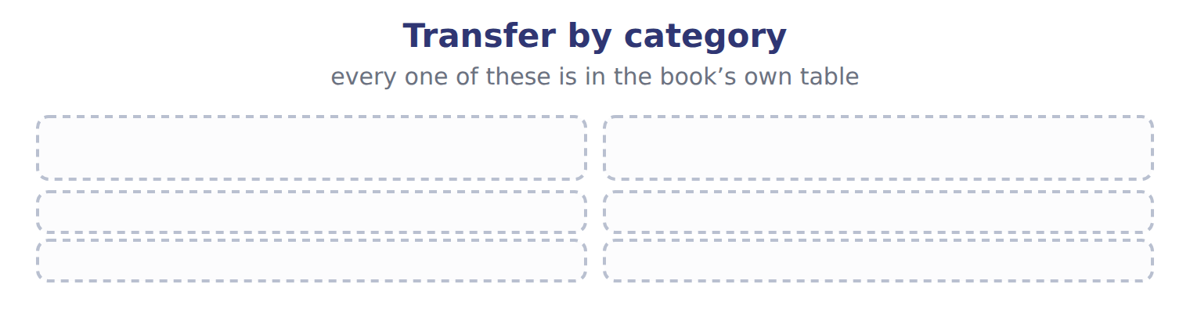
TEACH IT BACK | Write it for a classmate who missed this session — not for the marker.
32. In three or four sentences, write what this section settles and the one rule a reader has to take away.
every one of these words must appear: accounts receivable · aging schedule · factoring · contract asset

Answer key · Handout 6.1 · Recognizing and measuring receivables

1 receivable · unconditional · transfers | 12 Secured borrowing: T3, T4 | 23 E
2 questions · discounts · forfeited | 13 C | 24 B
3 discount · amortized · Receivable | 14 A | 25 B
4 T | 15 C | 26 C
5 B | 16 C | 27 B
6 A | 17 C | 28 D
7 C | 18 T | 29 A
8 A | 19 F | 30 A
9 T | 20 D | 31 Compare with the model earlier in this handout.
10 F | 21 C | 32 A company records an account receivable when its right to be paid is unconditional: only the passage of time is needed before payment is due. This usually happens when it delivers the goods or services and transfers control (Chapter 11). If the company still has to do something else before it can bill, for example finish a second delivery, it has a contract
11 Sale: T1, T2 | 22 A

why
1 The book writes: “A company records an account receivable when its right to be paid is unconditional: only the passage of time is needed before payment is due. This usually happens when it delivers the goods or services and transfers control (Chapter 11). If the company still has to do something else before it can bill, for example finish a second delivery, it has a contract asset, not a receivable.”
2 The book writes: “Some older questions still use the gross and net methods. Under the gross method, the company records the full invoice and records a sales discount only when a customer pays early. Under the net method, it records the sale net of the discount, and records sales discounts forfeited when a customer pays late.”
3 The book writes: “The discount is then amortized to interest revenue over the life of the note. Receivable: only time must pass before payment. Contract asset: the company must still perform.”
4 The book pairs T1 with “Sale”.
5 The book’s own table pairs T1 with “Sale”.
6 The book’s own table pairs T2 with “Sale”.
7 The book’s own table pairs T3 with “Secured borrowing”.
8 The book’s own table pairs T4 with “Secured borrowing”.
9 The book pairs T1 with “Sale”.
10 The book pairs T2 with “Sale”, not with “Secured borrowing”.
13 CECL records lifetime expected losses from day one. A is wrong: The probable threshold belonged to the old incurred-loss model. B is wrong: CECL does not wait for evidence of a loss.
14 The company first reinstates the receivable; the second entry records the cash collection. B is wrong: A recovery is not revenue. C is wrong: The recovery goes back to the allowance, not the expense account.
15 Losses are recorded only when balances are written off, so receivables are overstated and matching fails. A is wrong: The direct method is the method used for U.S. tax. B is wrong: It records losses late, not early.
16 The sum of each group's amount × its expected loss rate. A is wrong: This is the unadjusted balance before the year-end entry. B is wrong: This is the credit loss expense, not the required balance.
17 CECL records lifetime expected losses from day one. A is wrong: The probable threshold belonged to the old incurred-loss model. B is wrong: CECL does not wait for evidence of a loss.
18 CMA questions use exact terms, and one word can change the answer.
25 The book’s own table gives 80,000 × 8% = 6,400 as the answer of 1–60 days past due.
26 The book’s own table gives 40,000 × 25% = 10,000 as the answer of Over 60 days past due.
27 The book’s own table gives 3,600 + 6,400 + 10,000 = 20,000 as the answer of Required allowance.
28 It is an income-statement approach; CECL focuses on the expected losses on the receivables at the balance sheet date. A is wrong: CECL does not require any single method; aging and loss-rate methods fit it better. B is wrong: The aging method gives the required ending balance.

Handout 6.2
The allowance for credit losses
section 6.2 of the book
Before you start
Three summaries of this handout, in the book’s own words. Read all three first: together they are the whole session. Then fill the gaps, guessing where you have to.

What this handout settles, cycle by cycle
In this handout | What you will read | How you check it
The allowance for credit losses | a figure to read · Age of receivable · the book’s own rule, gapped | Under ASU 2025-05, a practical expedient lets companies assume current conditions will not change when they forecast losses on current receivables. How should a CMA candidate treat it in 2026?
The words this section uses precisely | Age of receivable · The English the exam uses, and what it translates | What is the safest way to settle a disagreement about an answer on this sheet?

Words this handout uses precisely
Words this handout uses precisely | tick it if you could already use it in a sentence
allowance for credit losses
credit loss expense
recourse
cash discount
recovery
recourse liability
effective control

1. Where the section starts — Fill every gap. The list holds more words than there are gaps, so one or two of them are not used.
choose from: notes receivable · accounts receivable · Allowance for credit losses · amortized cost · write-off
T-account: the expense is the plug that reaches the required balance. When a customer's balance is clearly uncollectible, the company records a : debit the allowance and credit .
2. What it settles in the middle — Fill every gap. The list holds more words than there are gaps, so one or two of them are not used.
choose from: recovery · write-off · notes receivable · amortized cost · accounts receivable
The changes neither net income nor net receivables, because the expense was already recorded when the allowance was built. If the customer later pays, the company records a : it first reinstates the receivable (debit , credit allowance) and then records the cash collection.
3. Where it ends — Fill every gap. The list holds more words than there are gaps, so one or two of them are not used.
choose from: amortized cost · write-off · notes receivable · allowance for credit losses
GAAP answer, always write , never provision for doubtful debts or reserve for bad debts. The aging gives the required ENDING allowance, not the expense. Expense = required balance − unadjusted credit balance, or required balance + unadjusted debit balance. A does not change net income or net receivables.

CYCLE A | The allowance for credit losses

ORIENT One claim. Decide now; you will check it in a moment.

4. The book gives the amount of Current as “400,000”. TRUE / FALSE
MODEL Read it before you answer anything below it.

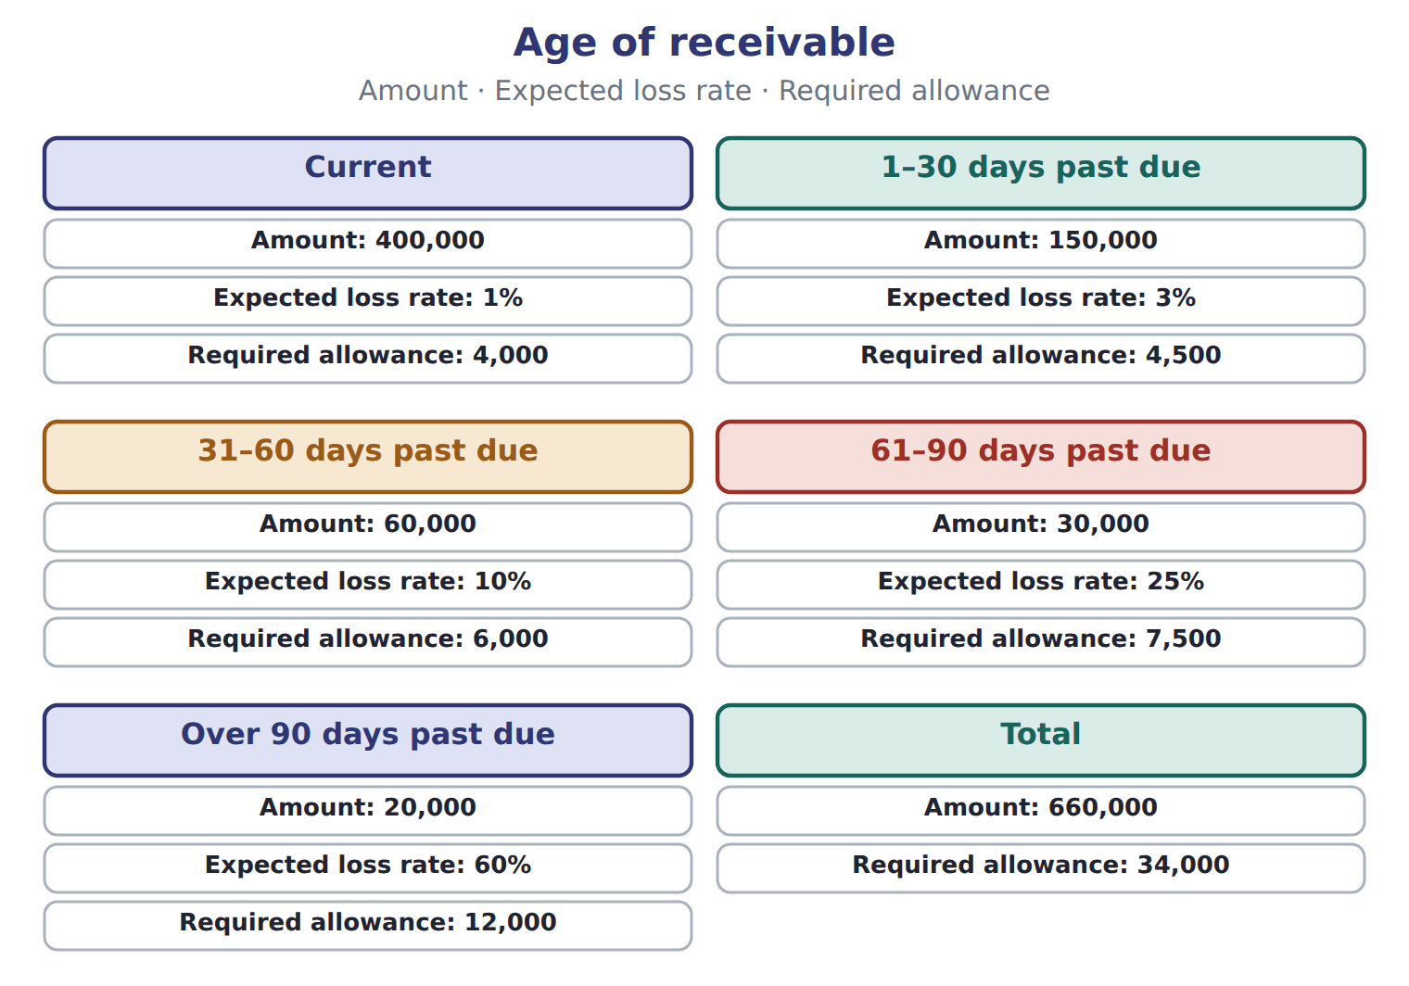

Age of receivable — the book’s own table
Age of receivable | Amount | Expected loss rate | Required allowance
Current | 400,000 | 1% | 4,000
1–30 days past due | 150,000 | 3% | 4,500
31–60 days past due | 60,000 | 10% | 6,000
61–90 days past due | 30,000 | 25% | 7,500
Over 90 days past due | 20,000 | 60% | 12,000
Total | 660,000 |  | 34,000

READ THE MODEL Every answer is printed above. Find it, do not recall it.

5. Which amount does the book give for Current?
A. 60,000 | C. 660,000
B. 400,000 | D. 30,000
6. Which amount does the book give for 1–30 days past due?
A. 150,000 | C. 400,000
B. 20,000 | D. 60,000
7. Which amount does the book give for 31–60 days past due?
A. 60,000 | C. 400,000
B. 30,000 | D. 20,000
8. Which amount does the book give for 61–90 days past due?
A. 20,000 | C. 400,000
B. 30,000 | D. 150,000
9. The book gives the required allowance of Current as “4,000”. TRUE / FALSE
10. The book gives the required allowance of 1–30 days past due as “4,000”. TRUE / FALSE
Complete every empty cell. The first full row shows the pattern.
Age of receivable | Amount | Expected loss rate | Required allowance
Current | 400,000 | 1% | 4,000
1–30 days past due
31–60 days past due
61–90 days past due
Over 90 days past due
Total

INVENT THE RULE

16. Complete the book’s own sentence. The list holds more words than there are gaps.
use every one of these words: write-off · credit loss expense · aging schedule · accounts receivable
When a customer's balance is clearly uncollectible, the company records a : debit the allowance and credit .

Two of the book’s own cases, side by side
Current | 1–30 days past due
Amount: 400,000 | Amount: 150,000
Expected loss rate: 1% | Expected loss rate: 3%
Only the facts above differ. What is the required allowance of Current?
17. Choose one:
A. 6,000 | C. 7,500
B. 4,000 | D. 4,500
APPLY No help on this move.

18. Under ASU 2025-05, a practical expedient lets companies assume current conditions will not change when they forecast losses on current receivables. How should a CMA candidate treat it in 2026?
A. As the main CECL rule
B. As a rule that applies only to IFRS companies
C. As a replacement for the aging method
D. As a watch item that is not yet tested
19. Receivables are transferred with recourse. They are legally isolated, the factor may pledge them, and the seller has no repurchase right or duty. How is the transfer recorded?
A. As a secured borrowing, because there is recourse
B. As a sale, with no liability
C. As a sale, with a recourse liability at fair value
D. As a pledge of receivables
20. Use the Orontes factoring example. If the transfer with recourse qualifies as a sale, what is the loss (whole USD)?
A. 6,000 | C. 21,000
B. 15,000 | D. 40,000
21. Compared with a sale of receivables, a secured borrowing:
A. removes the receivables and adds no liability.
B. removes the receivables and adds a recourse liability.
C. keeps the receivables on the balance sheet and adds a liability.
D. has no effect on the balance sheet.
WORK IN PAIRS | Compare every answer on this page with your partner before you read any key.
If you disagree: go back to the model and find the row that settles it. The row decides, not the louder voice.
CHECKPOINT 22. Under ASU 2025-05, a practical expedient lets companies assume current conditions will not change when they forecast losses on current receivables. How should a CMA candidate treat it in 2026?
A. As the main CECL rule
B. As a rule that applies only to IFRS companies
C. As a replacement for the aging method
D. As a watch item that is not yet tested
If you got it wrong: redo the READ THE MODEL questions of cycle A with the model in front of you.

CYCLE B | The words this section uses precisely

ORIENT

23. A term in the exam means exactly what the book defines it to mean, whatever it means in ordinary English. TRUE / FALSE

MODEL

Age of receivable — the book’s own table
Age of receivable | Amount | Expected loss rate | Required allowance
Current | 180,000 | 2% | 3,600
1–60 days past due | 80,000 | 8% | ______
Over 60 days past due | 40,000 | 25% | ______
Total | 300,000 |  | ______

The English the exam uses, and what it translates
English (exam term) | the Arabic it translates
allowance for credit losses | مخصص الخسائر الائتمانية
credit loss expense | مصروف الخسائر الائتمانية
recourse | حق الرجوع
cash discount | خصم تعجيل الدفع (خصم نقدي)
recovery | استرداد دين مشطوب
recourse liability | التزام حق الرجوع
effective control | السيطرة الفعلية

READ THE MODEL

Write the letter of the Arabic term beside each English term. Every term is used once.
A مخصص الخسائر الائتمانية | D خصم تعجيل الدفع (خصم نقدي)
B مصروف الخسائر الائتمانية | E حق الرجوع
C التزام حق الرجوع | F السيطرة الفعلية

24. effective control
25. recourse liability
26. credit loss expense
27. cash discount
28. recourse
29. allowance for credit losses

30. Which amount does the book give for Current?
A. 180,000 | C. 300,000
B. 80,000 | D. 40,000
31. Which amount does the book give for 1–60 days past due?
A. 300,000 | C. 80,000
B. 180,000 | D. 40,000
32. Which amount does the book give for Over 60 days past due?
A. 40,000 | C. 80,000
B. 300,000 | D. 180,000

APPLY

33. Orontes pledges its receivables as collateral for a bank loan. How are the receivables reported?
A. They stay on the balance sheet, with disclosure of the pledge.
B. They are removed from the balance sheet.
C. They are reclassified as a liability.
D. They are written down to fair value.
34. Under IFRS 9, how are expected credit losses measured on trade receivables without a significant financing component?
A. At 12-month expected losses
B. Only when a loss is probable
C. Only when the receivable is written off
D. Always at lifetime expected losses
CHECKPOINT 35. What is the safest way to settle a disagreement about an answer on this sheet?
A. find the row of the model that decides it
B. take the answer of whoever is more confident
C. leave it until the lecturer says
D. choose the longer option
If you got it wrong: redo the READ THE MODEL questions of cycle B.

FROM MEMORY | Close the earlier pages first.
36. Rebuild the figure from this handout. Label every part and fill in every box.
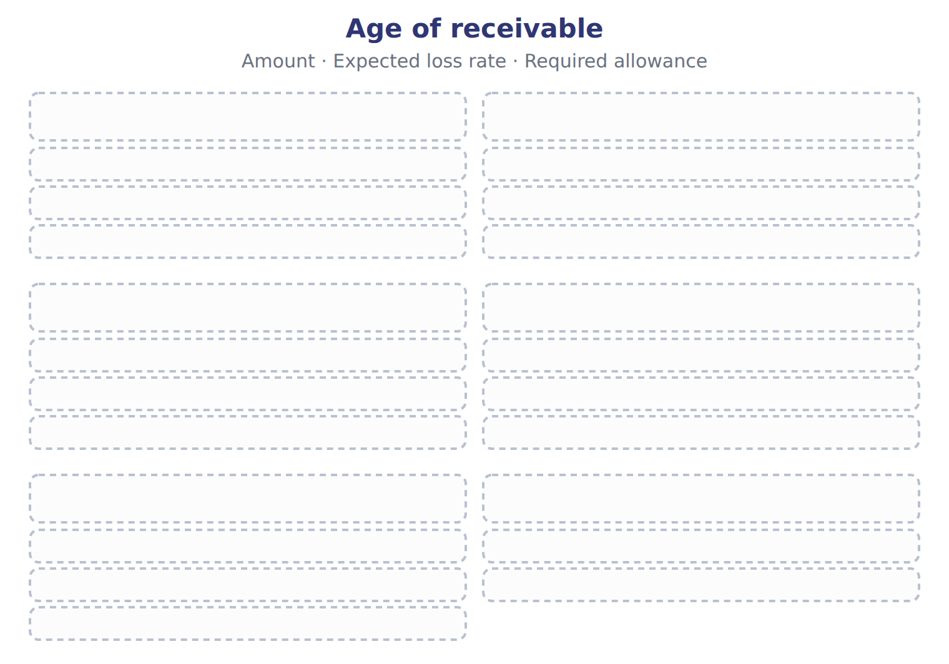
TEACH IT BACK | Write it for a classmate who missed this session — not for the marker.
37. In three or four sentences, write what this section settles and the one rule a reader has to take away.
every one of these words must appear: allowance for credit losses · credit loss expense · recourse · cash discount

Answer key · Handout 6.2 · The allowance for credit losses

1 Allowance for credit losses · write-off · accounts receivable | 14 Over 90 days past due: 20,000 · 60% · 12,000 | 27 D
2 write-off · recovery · accounts receivable | 15 Total: 660,000 · · 34,000 | 28 E
3 allowance for credit losses · write-off | 16 write-off · accounts receivable | 29 A
4 T | 17 B | 30 A
5 B | 18 D | 31 C
6 A | 19 C | 32 A
7 A | 20 C | 33 A
8 B | 21 C | 34 D
9 T | 22 D | 35 A
10 F | 23 T | 36 Compare with the model earlier in this handout.
11 1–30 days past due: 150,000 · 3% · 4,500 | 24 F | 37 Under current expected credit losses (CECL), a company presents its receivables net of an allowance that covers all the credit losses it expects over their life. It records these expected losses from the first day. It does not wait until a loss becomes probable. The estimate uses past experience, current conditions and reasonable and supportable forecasts.
12 31–60 days past due: 60,000 · 10% · 6,000 | 25 C
13 61–90 days past due: 30,000 · 25% · 7,500 | 26 B

16 what the book says
When a customer's balance is clearly uncollectible, the company records a write-off: debit the allowance and credit accounts receivable.

why
1 The book writes: “Allowance for credit losses T-account: the expense is the plug that reaches the required balance. When a customer's balance is clearly uncollectible, the company records a write-off: debit the allowance and credit accounts receivable.”
2 The book writes: “The write-off changes neither net income nor net receivables, because the expense was already recorded when the allowance was built. If the customer later pays, the company records a recovery: it first reinstates the receivable (debit accounts receivable, credit allowance) and then records the cash collection.”
3 The book writes: “GAAP answer, always write allowance for credit losses, never provision for doubtful debts or reserve for bad debts. The aging gives the required ENDING allowance, not the expense. Expense = required balance − unadjusted credit balance, or required balance + unadjusted debit balance. A write-off does not change net income or net receivables.”
4 The book pairs Current with “400,000”.
5 The book’s own table gives 400,000 as the amount of Current.
6 The book’s own table gives 150,000 as the amount of 1–30 days past due.
7 The book’s own table gives 60,000 as the amount of 31–60 days past due.
8 The book’s own table gives 30,000 as the amount of 61–90 days past due.
9 The book pairs Current with “4,000”.
10 The book pairs 1–30 days past due with “4,500”, not with “4,000”.
17 The book gives 4,000 as the required allowance of Current.
18 It is effective for annual periods beginning after December 15, 2025; under the one-year rule it is not yet tested. A is wrong: It is an optional simplification and is not yet testable. B is wrong: It is a U.S. GAAP update.
19 All three sale conditions are met; recourse adds a liability to the sale. A is wrong: Recourse alone does not make the transfer a borrowing. B is wrong: The recourse obligation must be recorded.
20 Carrying amount − (cash + due from factor − recourse liability). A is wrong: This is only the recourse liability. B is wrong: This leaves out the recourse liability.
21 In a borrowing, the receivables stay (pledged) and the cash received is a liability. A is wrong: That describes a sale without recourse. B is wrong: That describes a sale with recourse.
22 It is effective for annual periods beginning after December 15, 2025; under the one-year rule it is not yet tested. A is wrong: It is an optional simplification and is not yet testable. B is wrong: It is a U.S. GAAP update.
23 CMA questions use exact terms, and one word can change the answer.
30 The book’s own table gives 180,000 as the amount of Current.
31 The book’s own table gives 80,000 as the amount of 1–60 days past due.
32 The book’s own table gives 40,000 as the amount of Over 60 days past due.

Handout 6.3
Transferring receivables: sale or secured borrowing?
section 6.3 of the book
Before you start
Three summaries of this handout, in the book’s own words. Read all three first: together they are the whole session. Then fill the gaps, guessing where you have to.

What this handout settles, cycle by cycle
In this handout | What you will read | How you check it
Transferring receivables: sale or secured borrowing? | a figure to read · Item | Receivables are factored with substantial recourse. The transfer meets the three ASC 860 conditions. Which statement is MOST likely correct?
The words this section uses precisely | Transfer · The English the exam uses, and what it translates | What is the safest way to settle a disagreement about an answer on this sheet?

Words this handout uses precisely
Words this handout uses precisely | tick it if you could already use it in a sentence
current expected credit losses (CECL)
write-off
secured borrowing
notes receivable
direct write-off method
holdback (due from factor)
legal isolation

1. Where the section starts — Fill every gap. The list holds more words than there are gaps, so one or two of them are not used.
choose from: effective control · factor · factoring · write-off · secured borrowing
Second, the can pledge or exchange the receivables. Third, the seller does not keep , for example through an agreement to buy the receivables back before they mature. If any condition fails, the transfer is a .
2. What it settles in the middle — Fill every gap. The list holds more words than there are gaps, so one or two of them are not used.
choose from: secured borrowing · factor · write-off · effective control · recourse liability
The receivables stay on the balance sheet, marked as pledged. Loss on a sale = carrying amount − (cash + due from − ). Effects of one transfer as a sale without recourse, a sale with recourse, or a .
3. Where it ends — Fill every gap. The list holds more words than there are gaps, so one or two of them are not used.
choose from: write-off · Factoring · effective control · recourse
with substantial usually keeps most of the risk with the seller, so under IFRS it often fails derecognition and is treated as borrowing. Do not assume that every transfer with recourse is a borrowing. The holdback is an asset (due from factor), not part of the loss.

CYCLE A | Transferring receivables: sale or secured borrowing?

ORIENT One claim. Decide now; you will check it in a moment.

4. The book gives the Details (whole USD) of Aging as “Current: 250,000 at an expected loss rate of 2%”. TRUE / FALSE
MODEL Read it before you answer anything below it.

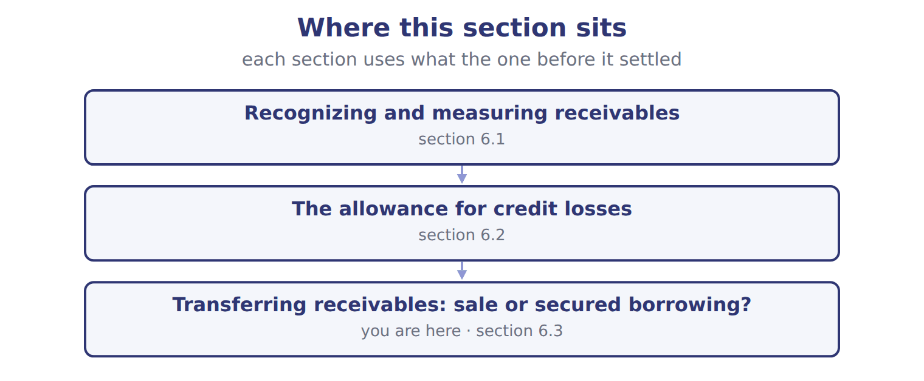

Item — the book’s own table
Item | Details (whole USD)
Aging | Current: 250,000 at an expected loss rate of 2%
Aging | 1–60 days past due: 90,000 at an expected loss rate of 10%
Aging | Over 60 days past due: 40,000 at an expected loss rate of 40%
Allowance account | Beginning balance 18,000 (credit). Write-offs during 2025: 24,000. Recoveries: 1,000.
Transfer T1 | Receivables sold to a factor without recourse. The factor may resell them. Orontes has no right or duty to buy them back.
Transfer T2 | Receivables transferred with recourse. They are legally isolated from Orontes, the factor may pledge them, and Orontes cannot buy them back.
Transfer T3 | Receivables transferred to a bank, but Orontes must repurchase them before they mature.
Transfer T4 | Receivables pledged as collateral for a bank loan; Orontes still collects them.
Transfer T2 details | Carrying amount 200,000; factor's fee 2%; holdback 4%; fair value of the recourse obligation 3,000.

READ THE MODEL Every answer is printed above. Find it, do not recall it.

5. Which item does the book pair with “Current: 250,000 at an expected loss rate of 2%”?
A. Transfer T2 | C. Aging
B. Allowance account | D. Transfer T3
6. Which item does the book pair with “1–60 days past due: 90,000 at an expected loss rate of 10%”?
A. Transfer T2 | C. Aging
B. Transfer T2 details | D. Transfer T4
7. Which item does the book pair with “Over 60 days past due: 40,000 at an expected loss rate of 40%”?
A. Transfer T4 | C. Transfer T3
B. Transfer T2 details | D. Aging
8. Which item does the book pair with “Beginning balance 18,000 (credit). Write-offs during 2025: 24,000. Recoveries: 1,000.”?
A. Transfer T2 | C. Transfer T1
B. Allowance account | D. Transfer T3
9. The book gives the Details (whole USD) of Aging as “Current: 250,000 at an expected loss rate of 2%”. TRUE / FALSE
10. The book gives the Details (whole USD) of Aging as “Beginning balance 18,000 (credit). Write-offs during 2025: 24,000. Recoveries: 1,000.”. TRUE / FALSE

APPLY No help on this move.

11. Receivables are factored with substantial recourse. The transfer meets the three ASC 860 conditions. Which statement is MOST likely correct?
A. Both frameworks treat it as a borrowing.
B. U.S. GAAP treats it as a sale; IFRS 9 may treat it as a borrowing.
C. Both frameworks treat it as a sale with no liability.
D. IFRS treats it as a sale; U.S. GAAP treats it as a borrowing.
12. Spiral review (Chapter 1). Where is the allowance for credit losses reported?
A. As a liability
B. As an expense
C. As a contra-asset, deducted from accounts receivable
D. As a reduction of equity
13. Spiral review (Chapter 1). Recording credit loss expense in the period of the sale, before any customer defaults, is an example of:
A. the cash basis | C. immediate recognition
B. the direct write-off method | D. the matching principle
WORK IN PAIRS | Compare every answer on this page with your partner before you read any key.
If you disagree: go back to the model and find the row that settles it. The row decides, not the louder voice.
CHECKPOINT 14. Receivables are factored with substantial recourse. The transfer meets the three ASC 860 conditions. Which statement is MOST likely correct?
A. Both frameworks treat it as a borrowing.
B. U.S. GAAP treats it as a sale; IFRS 9 may treat it as a borrowing.
C. Both frameworks treat it as a sale with no liability.
D. IFRS treats it as a sale; U.S. GAAP treats it as a borrowing.
If you got it wrong: redo the READ THE MODEL questions of cycle A with the model in front of you.

CYCLE B | The words this section uses precisely

ORIENT

15. A term in the exam means exactly what the book defines it to mean, whatever it means in ordinary English. TRUE / FALSE
MODEL

Transfer — the book’s own table
Transfer | Category
T1
T2
T3
T4

The English the exam uses, and what it translates
English (exam term) | the Arabic it translates
current expected credit losses (CECL) | الخسائر الائتمانية المتوقعة الحالية
write-off | شطب (إعدام) الدين
secured borrowing | اقتراض مضمون
notes receivable | أوراق القبض
direct write-off method | طريقة الشطب المباشر
holdback (due from factor) | المبلغ المحتجز (مستحق من شركة التخصيم)
legal isolation | العزل القانوني

READ THE MODEL

Write the letter of the Arabic term beside each English term. Every term is used once.
A المبلغ المحتجز (مستحق من شركة التخصيم)
B طريقة الشطب المباشر
C شطب (إعدام) الدين
D أوراق القبض
E العزل القانوني
F اقتراض مضمون

16. secured borrowing
17. holdback (due from factor)
18. direct write-off method
19. notes receivable
20. legal isolation
21. write-off

APPLY

22. Writing a term in English is part of answering the question, not an extra. TRUE / FALSE
CHECKPOINT 23. What is the safest way to settle a disagreement about an answer on this sheet?
A. find the row of the model that decides it
B. take the answer of whoever is more confident
C. leave it until the lecturer says
D. choose the longer option
If you got it wrong: redo the READ THE MODEL questions of cycle B.

FROM MEMORY | Close the earlier pages first.
24. Rebuild the figure from this handout. Label every part and fill in every box.
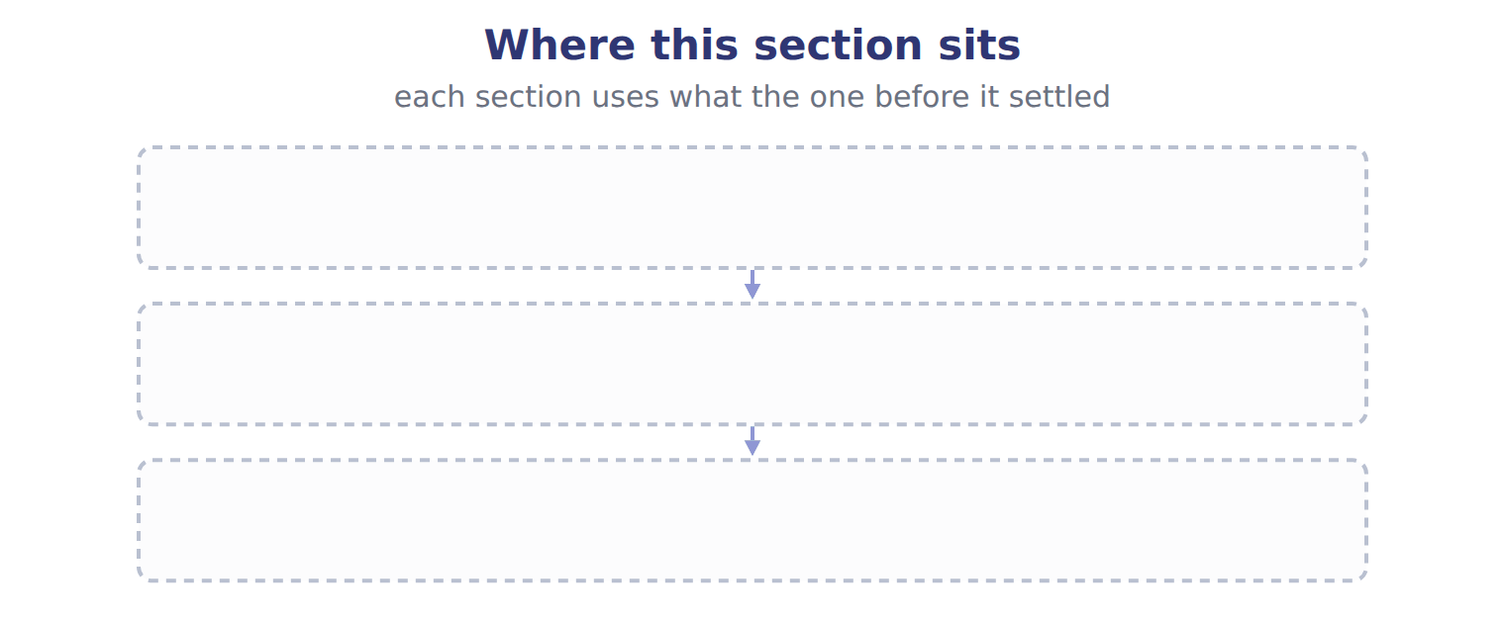
TEACH IT BACK | Write it for a classmate who missed this session — not for the marker.
25. In three or four sentences, write what this section settles and the one rule a reader has to take away.
every one of these words must appear: current expected credit losses (CECL) · write-off · secured borrowing · notes receivable

Answer key · Handout 6.3 · Transferring receivables: sale or secured borrowing?

1 factor · effective control · secured borrowing | 10 F | 19 D
2 factor · recourse liability · secured borrowing | 11 B | 20 E
3 Factoring · recourse | 12 C | 21 C
4 T | 13 D | 22 T
5 C | 14 B | 23 A
6 C | 15 T | 24 Compare with the model earlier in this handout.
7 D | 16 F | 25 A company that needs cash before its customers pay can use its receivables in two ways. It can use them as collateral for a loan (pledging), or it can transfer them to a finance company called a factor. This is factoring. The accounting question is simple: is the transfer a sale, or is it really a loan?
8 B | 17 A
9 T | 18 B

why
1 The book writes: “Second, the factor can pledge or exchange the receivables. Third, the seller does not keep effective control, for example through an agreement to buy the receivables back before they mature. If any condition fails, the transfer is a secured borrowing.”
2 The book writes: “The receivables stay on the balance sheet, marked as pledged. Loss on a sale = carrying amount − (cash + due from factor − recourse liability). Effects of one transfer as a sale without recourse, a sale with recourse, or a secured borrowing.”
3 The book writes: “Factoring with substantial recourse usually keeps most of the risk with the seller, so under IFRS it often fails derecognition and is treated as borrowing. Do not assume that every transfer with recourse is a borrowing. The holdback is an asset (due from factor), not part of the loss.”
4 The book pairs Aging with “Current: 250,000 at an expected loss rate of 2%”.
5 The book’s own table pairs Aging with “Current: 250,000 at an expected loss rate of 2%”.
6 The book’s own table pairs Aging with “1–60 days past due: 90,000 at an expected loss rate of 10%”.
7 The book’s own table pairs Aging with “Over 60 days past due: 40,000 at an expected loss rate of 40%”.
8 The book’s own table pairs Allowance account with “Beginning balance 18,000 (credit). Write-offs during 2025: 24,000. Recoveries: 1,000.”.
9 The book pairs Aging with “Current: 250,000 at an expected loss rate of 2%”.
10 The book pairs Aging with “1–60 days past due: 90,000 at an expected loss rate of 10%”, not with “Beginning balance 18,000 (credit). Write-offs during 2025: 24,000. Recoveries: 1,000.”.
11 IFRS 9 focuses on risks and rewards; substantial recourse often keeps the risk with the seller. A is wrong: Under U.S. GAAP the ASC 860 conditions decide, and they are met. C is wrong: A U.S. GAAP sale with recourse records a recourse liability.
12 It reduces receivables to the amount expected to be collected. A is wrong: It is a contra-asset, not a liability. B is wrong: The expense is a separate account; the allowance is the balance sheet total.
13 The expected loss is matched with the revenue of the same period. A is wrong: No cash moves when the expense is recorded. B is wrong: The direct method waits until a balance is written off.
14 IFRS 9 focuses on risks and rewards; substantial recourse often keeps the risk with the seller. A is wrong: Under U.S. GAAP the ASC 860 conditions decide, and they are met. C is wrong: A U.S. GAAP sale with recourse records a recourse liability.
15 CMA questions use exact terms, and one word can change the answer.
22 The exam marks the term, so the English word is the answer.
23 Every item on a Workshop sheet is settled by something printed on the same sheet.

Handout 6.4
The whole chapter
every section, shuffled, and the chapter’s own case set
Before you start
Three summaries of this chapter, in the book’s own words, with words taken out. Read all three first: together they are the whole chapter. Then fill the gaps.

What this handout settles, cycle by cycle
In this handout | What you will read | How you check it
The whole chapter, in order | a figure to read | Orontes has delivered the first of two shipments under one contract. It can bill the customer only after the second shipment. What should Orontes record for the first shipment?
The chapter’s case set | The chapter’s case set, item by item | What has to be settled before any figure in a case set is worked out?
The words it uses precisely | accounts receivable · allowance for credit losses · current expected credit losses (CECL) · aging schedule · credit loss expense · write-off | matching, at the end of cycle B

1. Where the chapter starts — Fill every gap. The list holds more words than there are gaps, so one or two of them are not used.
choose from: factor · recourse liability · secured borrowing · write-off · factoring
The receivables stay on the balance sheet, marked as pledged. Loss on a sale = carrying amount − (cash + due from − ). Effects of one transfer as a sale without recourse, a sale with recourse, or a .
2. What it settles in the middle — Fill every gap. The list holds more words than there are gaps, so one or two of them are not used.
choose from: factoring · accounts receivable · Allowance for credit losses · pledging · write-off
T-account: the expense is the plug that reaches the required balance. When a customer's balance is clearly uncollectible, the company records a : debit the allowance and credit .
3. Where it ends — Fill every gap. The list holds more words than there are gaps, so one or two of them are not used.
choose from: recourse liability · factor · factoring · write-off · secured borrowing
Loss on a sale = carrying amount − (cash + due from − ). Effects of one transfer as a sale without recourse, a sale with recourse, or a . The balance sheet effect is the main reason companies care.

CYCLE A | The whole chapter, in order

ORIENT

4. The sections of a chapter have to be taken in order, because each one uses what the one before it settled. TRUE / FALSE
MODEL

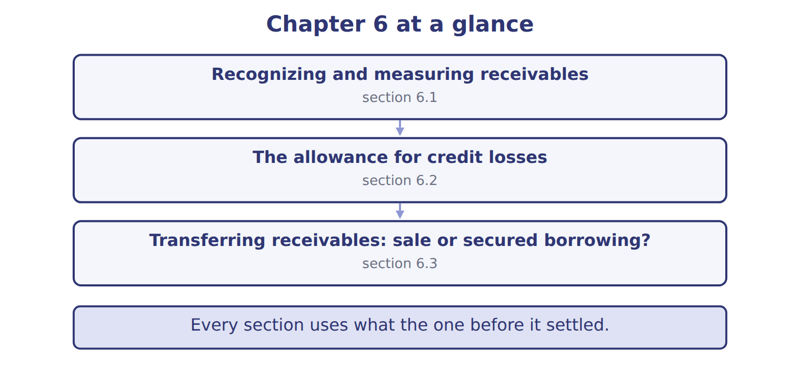
READ THE MODEL

5. “section 6.1” — which part of the chapter is this?
A. Transferring receivables: sale or secured borrowing?
B. The allowance for credit losses
C. Recognizing and measuring receivables
6. “section 6.2” — which part of the chapter is this?
A. Recognizing and measuring receivables
B. The allowance for credit losses
C. Transferring receivables: sale or secured borrowing?
7. “section 6.3” — which part of the chapter is this?
A. Recognizing and measuring receivables
B. Transferring receivables: sale or secured borrowing?
C. The allowance for credit losses
Write the letter of the section number beside each section title. Every number is used once.
A 6.1 | C 6.3
B 6.2

8. Recognizing and measuring receivables
9. The allowance for credit losses
10. Transferring receivables: sale or secured borrowing?

APPLY

11. Orontes transfers receivables to a bank but must buy them back before they mature. How should Orontes account for the transfer?
A. As a sale with recourse | C. As a contract asset
B. As a sale without recourse | D. As a secured borrowing

WORK IN PAIRS | Compare every answer with your partner first.
If you disagree: name the section each question belongs to. Most disagreements turn out to be about the section, not the answer.
CHECKPOINT 12. Orontes has delivered the first of two shipments under one contract. It can bill the customer only after the second shipment. What should Orontes record for the first shipment?
A. A contract asset
B. An account receivable
C. Nothing until it can bill
D. Unearned revenue
If you got it wrong: go back to the MODEL move of cycle A and find the section this question belongs to.

CYCLE B | The chapter’s case set

ORIENT

13. In a case question, the exhibit has to be read and adjusted before any figure is worked out. TRUE / FALSE

MODEL

The chapter’s case set, item by item
Item | What it asks
C6-1 | Enter the required allowance for credit losses at December 31, 2025.
C6-2 | Enter the credit loss expense for 2025.
C6-3 | Enter net accounts receivable at December 31, 2025.
C6-4 | Classify each transfer. (On the exam screen you would drag each transfer into a box.)
C6-5 | Enter the loss on transfer T2.
C6-6 | In January 2026 Orontes writes off a customer balance of $4,500. The effect on net accounts receivable is: [select]

READ THE MODEL

14. Which of these does item C6-1 ask for?
A. Enter the credit loss expense for 2025.
B. Enter net accounts receivable at December 31, 2025.
C. Classify each transfer. (On the exam screen you would drag each transf
D. Enter the required allowance for credit losses at December 31, 2025.
15. Which of these does item C6-2 ask for?
A. Enter net accounts receivable at December 31, 2025.
B. Enter the credit loss expense for 2025.
C. Classify each transfer. (On the exam screen you would drag each transf
D. Enter the required allowance for credit losses at December 31, 2025.
16. Which of these does item C6-3 ask for?
A. Classify each transfer. (On the exam screen you would drag each transf
B. Enter the required allowance for credit losses at December 31, 2025.
C. Enter net accounts receivable at December 31, 2025.
D. Enter the credit loss expense for 2025.
17. Which of these does item C6-4 ask for?
A. Enter the credit loss expense for 2025.
B. Enter the required allowance for credit losses at December 31, 2025.
C. Enter net accounts receivable at December 31, 2025.
D. Classify each transfer. (On the exam screen you would drag each transf
18. Which of these does item C6-5 ask for?
A. Enter net accounts receivable at December 31, 2025.
B. Enter the required allowance for credit losses at December 31, 2025.
C. Enter the loss on transfer T2.
D. Enter the credit loss expense for 2025.
19. Which of these does item C6-6 ask for?
A. In January 2026 Orontes writes off a customer balance of $4,500. The e
B. Enter net accounts receivable at December 31, 2025.
C. Enter the required allowance for credit losses at December 31, 2025.
D. Enter the credit loss expense for 2025.
APPLY

20. Orontes has delivered the first of two shipments under one contract. It can bill the customer only after the second shipment. What should Orontes record for the first shipment?
A. A contract asset | C. Nothing until it can bill
B. An account receivable | D. Unearned revenue

21. A trade receivable is due in 60 days. At what amount is it recorded?
A. Its present value using a market interest rate
B. The invoice amount, with discounts recorded only when taken
C. The transaction price, reduced for expected discounts and returns
D. The invoice amount less expected credit losses, recorded as one net number
CHECKPOINT 22. What has to be settled before any figure in a case set is worked out?
A. the exhibit, adjusted for every note that goes with it
B. the method the company uses
C. the tax rate
D. the order of the items
If you got it wrong: reread the case panel in the MODEL move of cycle B.

FROM MEMORY | Close the earlier pages first.
23. Rebuild the chapter map. Write every section in order and what each one settles.
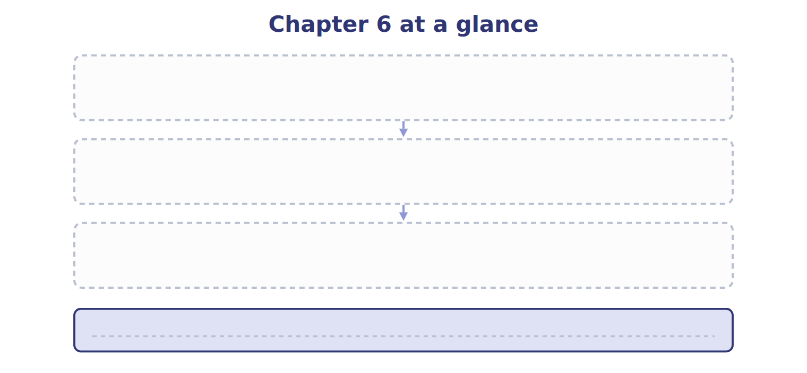
TEACH IT BACK | Write it for a student starting this chapter tomorrow — not for the marker.
24. In four or five sentences, write what the whole chapter settles, section by section.
every one of these words must appear: accounts receivable · allowance for credit losses · current expected credit losses (CECL) · aging schedule

Answer key · Handout 6.4 · The whole chapter

1 factor · recourse liability · secured borrowing | 9 B | 17 D
2 Allowance for credit losses · write-off · accounts receivable | 10 C | 18 C
3 factor · recourse liability · secured borrowing | 11 D | 19 A
4 T | 12 A | 20 A
5 C | 13 T | 21 C
6 B | 14 D | 22 A
7 B | 15 B | 23 Compare with the model earlier in this handout.
8 A | 16 C | 24 6.1: Recognizing and measuring receivables. 6.2: The allowance for credit losses. 6.3: Transferring receivables: sale or secured borrowing?.

why
1 The book writes: “The receivables stay on the balance sheet, marked as pledged. Loss on a sale = carrying amount − (cash + due from factor − recourse liability). Effects of one transfer as a sale without recourse, a sale with recourse, or a secured borrowing.”
2 The book writes: “Allowance for credit losses T-account: the expense is the plug that reaches the required balance. When a customer's balance is clearly uncollectible, the company records a write-off: debit the allowance and credit accounts receivable.”
3 The book writes: “Loss on a sale = carrying amount − (cash + due from factor − recourse liability). Effects of one transfer as a sale without recourse, a sale with recourse, or a secured borrowing. The balance sheet effect is the main reason companies care.”
4 The map shows the order the decisions have to be taken in.
5 The book numbers it 6.1.
6 The book numbers it 6.2.
7 The book numbers it 6.3.
11 The repurchase duty means Orontes keeps effective control, so the sale conditions fail. A is wrong: Effective control prevents sale accounting whatever the recourse terms. B is wrong: The transfer fails the effective-control condition.
12 Orontes has performed, but its right to payment still depends on the second shipment, not only on time. B is wrong: A receivable needs an unconditional right to payment. C is wrong: Orontes has transferred control of the first shipment, so it records something now.
13 Every later answer depends on the adjusted exhibit.
14 The book states item C6-1 in those words.
15 The book states item C6-2 in those words.
16 The book states item C6-3 in those words.
17 The book states item C6-4 in those words.
18 The book states item C6-5 in those words.
19 The book states item C6-6 in those words.
20 Orontes has performed, but its right to payment still depends on the second shipment, not only on time. B is wrong: A receivable needs an unconditional right to payment. C is wrong: Orontes has transferred control of the first shipment, so it records something now.
21 Receivables are recorded at the transaction price; expected discounts and returns are variable consideration. Short-term receivables are not discounted. A is wrong: Receivables due within one year are not discounted. B is wrong: That is the older gross method; expected discounts are variable consideration today.
22 Every later answer depends on the adjusted exhibit.

Handout 7.1
Which goods belong in inventory?
section 7.1 of the book
Before you start
Three summaries of this handout, in the book’s own words. Read all three first: together they are the whole session. Then fill the gaps, guessing where you have to.

What this handout settles, cycle by cycle
In this handout | What you will read | How you check it
Which goods belong in inventory? | a figure to read · Memo item | A seller ships goods on December 30, FOB destination. The goods arrive on January 2. At December 31, the goods should be:
The words this section uses precisely | The English the exam uses, and what it translates | What is the safest way to settle a disagreement about an answer on this sheet?

Words this handout uses precisely
Words this handout uses precisely | tick it if you could already use it in a sentence
inventory
weighted-average cost
goods in transit
consignee
normal capacity
specific identification

1. Where the section starts — Fill every gap. The list holds more words than there are gaps, so one or two of them are not used.
choose from: consignee · inventory · periodic inventory system · consignment · weighted-average cost · consignor · FOB destination
Under , the seller keeps control until the goods arrive, so the seller includes them. In a , the (the owner) gives goods to a , who sells them for a commission. The goods stay in the consignor's .
2. What it settles in the middle — Fill every gap. The list holds more words than there are gaps, so one or two of them are not used.
choose from: weighted-average cost · inventory · periodic inventory system · FOB shipping point · FOB destination · goods in transit
In a bill-and-hold sale, the seller keeps the goods in its unless strict conditions show that the buyer already controls them. : the BUYER includes . : the SELLER includes them.
3. Where it ends — Fill every gap. The list holds more words than there are gaps, so one or two of them are not used.
choose from: consignee · periodic inventory system · FOB shipping point · consignor · consignment · weighted-average cost
Arabic: البضاعة بالأمانة is ; the owner is the (المُرسِل) and the seller in the shop is the (المُرسَل إليه). SC7-1 On December 28, a supplier in Türkiye ships glass bottles to Orontes, .

CYCLE A | Which goods belong in inventory?

ORIENT One claim. Decide now; you will check it in a moment.

4. The book gives the category of M1 (FOB shipping point, bought) as “Add to the count”. TRUE / FALSE
MODEL Read it before you answer anything below it.

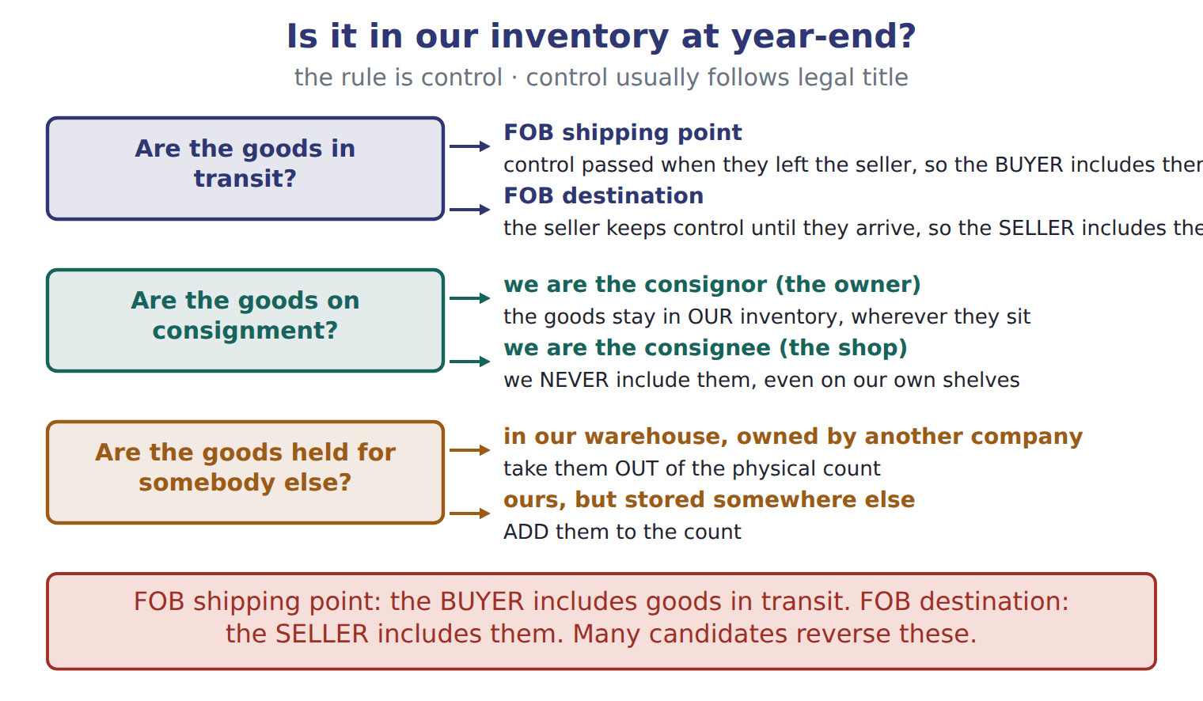

Memo item — the book’s own table
Memo item | Category
M1 (FOB shipping point, bought) | Add to the count
M2 (FOB destination, sold) | Add to the count
M3 (held for a Beirut producer) | Subtract from the count
M4 (at a Doha consignee) | Add to the count

READ THE MODEL Every answer is printed above. Find it, do not recall it.

5. Which memo item does the book pair with “Subtract from the count”?
A. M4 (at a Doha consignee) | C. M2 (FOB destination, sold)
B. M1 (FOB shipping point, bought) | D. M3 (held for a Beirut producer)
6. The book gives the category of M1 (FOB shipping point, bought) as “Add to the count”. TRUE / FALSE
7. The book gives the category of M2 (FOB destination, sold) as “Subtract from the count”. TRUE / FALSE
SORT THEM | Write each one under its category. Every item belongs to exactly one group.
the items: M1 (FOB shipping point, bought) · M2 (FOB destination, sold) · M3 (held for a Beirut producer) · M4 (at a Doha consignee)
Add to the count | Subtract from the count

APPLY No help on this move.

10. A seller ships goods on December 30, FOB destination. The goods arrive on January 2. At December 31, the goods should be:
A. included in the buyer's inventory.
B. included in the seller's inventory, with no sale recorded yet.
C. removed from the seller's inventory, with a sale recorded.
D. excluded from both companies' inventories.
11. A strike cut production far below normal capacity. How should the fixed production overhead that was not allocated to units be treated?
A. As an expense of the period
B. Added to the cost of the units produced
C. Deferred as an asset to next year
D. Charged directly to retained earnings
12. Which item is a period cost for Orontes?
A. Import duties on sesame seeds
B. Freight-in on glass bottles
C. Wages of bottling-line workers
D. Advertising for a new tahini brand
13. Which statement about periodic and perpetual systems is TRUE?
A. LIFO gives the same cost of goods sold under both systems.
B. The moving average always equals the periodic weighted average.
C. FIFO gives the same cost of goods sold under both systems.
D. A perpetual system requires specific identification.

WORK IN PAIRS | Compare every answer on this page with your partner before you read any key.
If you disagree: go back to the model and find the row that settles it. The row decides, not the louder voice.
CHECKPOINT 14. A seller ships goods on December 30, FOB destination. The goods arrive on January 2. At December 31, the goods should be:
A. included in the buyer's inventory.
B. included in the seller's inventory, with no sale recorded yet.
C. removed from the seller's inventory, with a sale recorded.
D. excluded from both companies' inventories.
If you got it wrong: redo the READ THE MODEL questions of cycle A with the model in front of you.

CYCLE B | The words this section uses precisely

ORIENT

15. A term in the exam means exactly what the book defines it to mean, whatever it means in ordinary English. TRUE / FALSE
MODEL

The English the exam uses, and what it translates
English (exam term) | the Arabic it translates
inventory | المخزون
weighted-average cost | المتوسط المرجح للتكلفة
goods in transit | بضاعة في الطريق
consignee | المُرسَل إليه (الوكيل بالعمولة)
normal capacity | الطاقة العادية
specific identification | التحديد العيني (التمييز المحدد)

READ THE MODEL

Write the letter of the Arabic term beside each English term. Every term is used once.
A المتوسط المرجح للتكلفة | D بضاعة في الطريق
B المُرسَل إليه (الوكيل بالعمولة) | E المخزون
C الطاقة العادية | F التحديد العيني (التمييز المحدد)

16. specific identification
17. goods in transit
18. inventory
19. weighted-average cost
20. normal capacity
21. consignee

APPLY

22. In the Orontes olive-oil example, what is FIFO cost of goods sold (whole USD)?
A. 100,000 | C. 279,000
B. 272,000 | D. 288,000
23. Beginning inventory was 100 units at $10. The company bought 200 units at $12 and then 100 units at $15. It sold 250 units. Using periodic LIFO, what is ending inventory?
A. 1,600 | C. 2,100
B. 1,838 | D. 3,300
CHECKPOINT 24. What is the safest way to settle a disagreement about an answer on this sheet?
A. find the row of the model that decides it
B. take the answer of whoever is more confident
C. leave it until the lecturer says
D. choose the longer option
If you got it wrong: redo the READ THE MODEL questions of cycle B.

FROM MEMORY | Close the earlier pages first.
25. Rebuild the figure from this handout. Label every part and fill in every box.
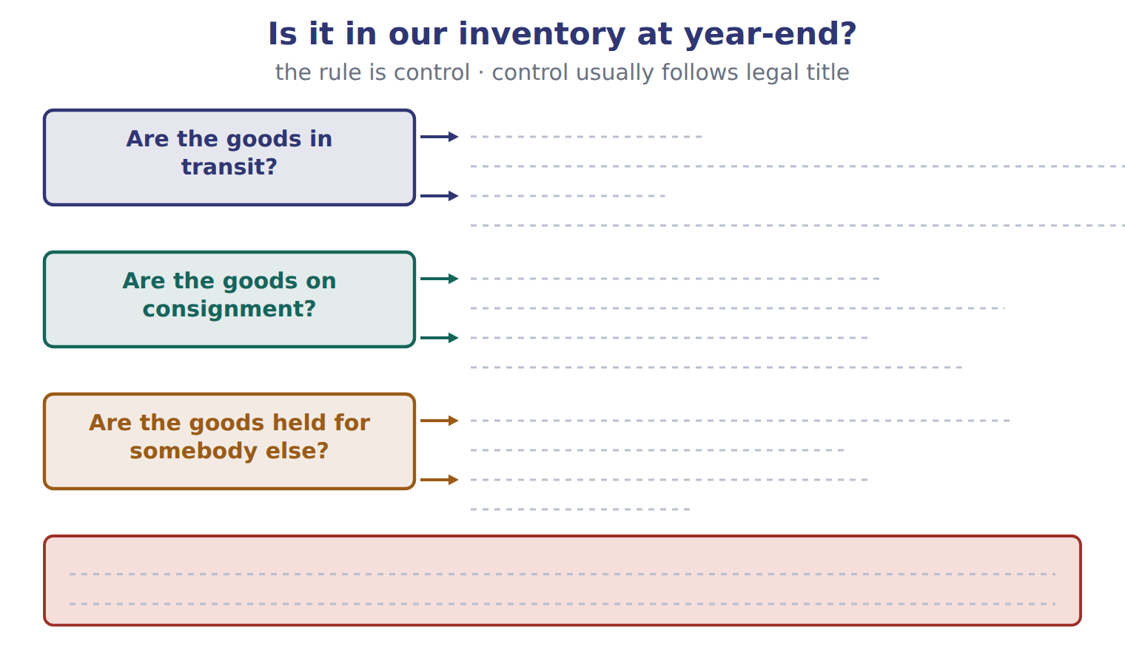
TEACH IT BACK | Write it for a classmate who missed this session — not for the marker.
26. In three or four sentences, write what this section settles and the one rule a reader has to take away.
every one of these words must appear: inventory · weighted-average cost · goods in transit · consignee

Answer key · Handout 7.1 · Which goods belong in inventory?

1 FOB destination · consignment · consignor · consignee · inventory | 10 B | 19 A
2 inventory · FOB shipping point · goods in transit · FOB destination | 11 A | 20 C
3 consignment · consignor · consignee · FOB shipping point | 12 D | 21 B
4 T | 13 C | 22 B
5 D | 14 B | 23 A
6 T | 15 T | 24 A
7 F | 16 F | 25 Compare with the model earlier in this handout.
8 Add to the count: M1 (FOB shipping point, bought), M2 (FOB destination, sold), M4 (at a Doha consignee) | 17 D | 26 Inventory means goods held for sale in the ordinary course of business, goods in production, and materials that will be used in production. A retailer such as Barada Wholesale, Inc. has one inventory account. A manufacturer such as Orontes has three: raw materials, work in process and finished goods.
9 Subtract from the count: M3 (held for a Beirut producer) | 18 E

why
1 The book writes: “Under FOB destination, the seller keeps control until the goods arrive, so the seller includes them. In a consignment, the consignor (the owner) gives goods to a consignee, who sells them for a commission. The goods stay in the consignor's inventory.”
2 The book writes: “In a bill-and-hold sale, the seller keeps the goods in its inventory unless strict conditions show that the buyer already controls them. FOB shipping point: the BUYER includes goods in transit. FOB destination: the SELLER includes them.”
3 The book writes: “Arabic: البضاعة بالأمانة is consignment; the owner is the consignor (المُرسِل) and the seller in the shop is the consignee (المُرسَل إليه). SC7-1 On December 28, a supplier in Türkiye ships glass bottles to Orontes, FOB shipping point.”
4 The book pairs M1 (FOB shipping point, bought) with “Add to the count”.
5 The book’s own table pairs M3 (held for a Beirut producer) with “Subtract from the count”.
6 The book pairs M1 (FOB shipping point, bought) with “Add to the count”.
7 The book pairs M2 (FOB destination, sold) with “Add to the count”, not with “Subtract from the count”.
10 Under FOB destination, the seller keeps control until delivery. A is wrong: The buyer includes goods in transit only under FOB shipping point. C is wrong: Control has not passed, so no sale is recorded yet.
11 Fixed overhead is allocated on normal capacity; the unallocated part is a period expense. B is wrong: This would give each unit an abnormally high cost. C is wrong: No future benefit exists, so it is not an asset.
12 Advertising is a selling cost, expensed when incurred. A is wrong: Duties bring materials to their location, so they are inventory cost. B is wrong: Freight-in is inventory cost.
13 FIFO always sells the oldest units first, whatever the timing of sales. A is wrong: Perpetual LIFO can only use costs that exist on each sale date. B is wrong: The moving average changes after each purchase, so results usually differ.
14 Under FOB destination, the seller keeps control until delivery. A is wrong: The buyer includes goods in transit only under FOB shipping point. C is wrong: Control has not passed, so no sale is recorded yet.
15 CMA questions use exact terms, and one word can change the answer.
22 Goods available minus FIFO ending inventory (the newest costs). A is wrong: This is FIFO ending inventory, not cost of goods sold. C is wrong: This is the weighted-average result.
23 150 units remain at the oldest costs: 100 × $10 + 50 × $12 = 1,600. B is wrong: This uses the weighted average ($12.25 × 150, rounded). C is wrong: This uses the newest costs (FIFO).
24 Every item on a Workshop sheet is settled by something printed on the same sheet.

Handout 7.2
Which costs belong in inventory?
section 7.2 of the book
Before you start
Three summaries of this handout, in the book’s own words. Read all three first: together they are the whole session. Then fill the gaps, guessing where you have to.

What this handout settles, cycle by cycle
In this handout | What you will read | How you check it
Which costs belong in inventory? | a figure to read · Item · the book’s own rule, gapped | Specific identification is MOST appropriate for:
The words this section uses precisely | The English the exam uses, and what it translates | What is the safest way to settle a disagreement about an answer on this sheet?

Words this handout uses precisely
Words this handout uses precisely | tick it if you could already use it in a sentence
cost of goods sold
periodic inventory system
FOB shipping point
physical count
abnormal waste
moving average

1. Where the section starts — Fill every gap. The list holds more words than there are gaps, so one or two of them are not used.
choose from: cost of goods sold · purchase discount · abnormal waste · FOB shipping point · freight-in · inventory
These are inventoriable costs: they stay in as an asset, and they become when the goods are sold. Other costs are period costs: they are expenses in the period in which they occur. For goods that are bought, cost includes the purchase price, , import duties, non-refundable taxes and handling, less trade discounts and any taken for early payment.
2. What it settles in the middle — Fill every gap. The list holds more words than there are gaps, so one or two of them are not used.
choose from: FOB shipping point · Period cost · inventory · freight-out · normal capacity · abnormal waste
In the same way, (unusual spoilage, idle time or extra freight) is an expense, not cost. s include to customers, sales commissions, advertising, general and administrative costs, and the storage of finished goods. Interest on inventory that is produced routinely is also a period cost.
3. Where it ends — Fill every gap. The list holds more words than there are gaps, so one or two of them are not used.
choose from: FOB shipping point · abnormal waste · freight-out · Period cost · inventory
s include to customers, sales commissions, advertising, general and administrative costs, and the storage of finished goods. Interest on that is produced routinely is also a period cost. Inventoriable costs versus period costs.

CYCLE A | Which costs belong in inventory?

ORIENT One claim. Decide now; you will check it in a moment.

4. The book gives the amount of Invoice price as “20,000”. TRUE / FALSE
MODEL Read it before you answer anything below it.

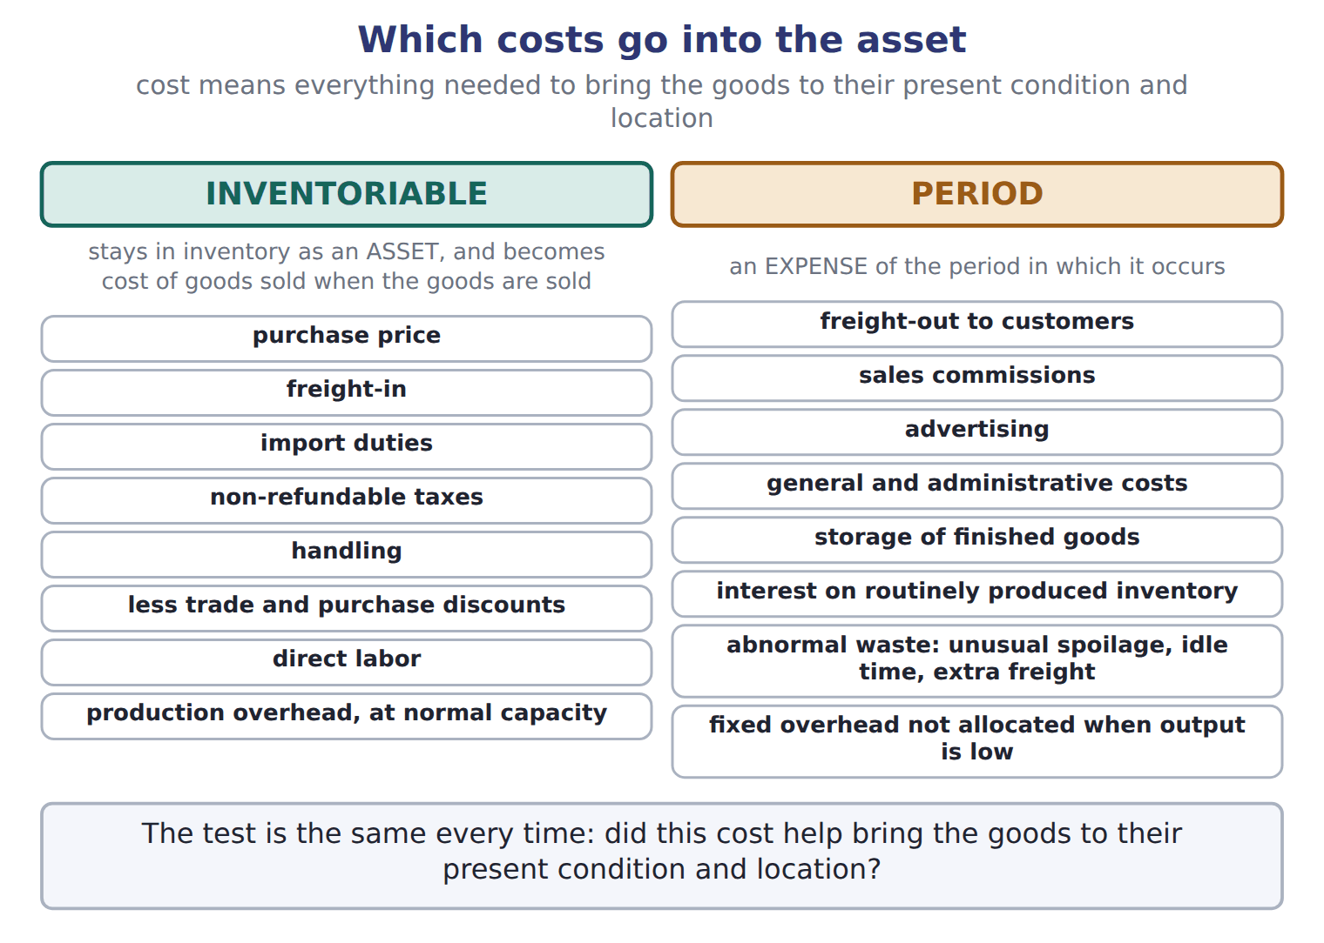

Item — the book’s own table
Item | Amount | Inventory cost?
Invoice price | 20,000 | Yes
Purchase discount taken | (400) | Yes (reduces cost)
Freight-in from the port to Amman | 1,200 | Yes
Import duty (not refundable) | 900 | Yes
Insurance while the bottles are in transit | 300 | Yes
Freight-out when filled bottles go to customers | 700 | No: selling expense
Storage of finished olive oil | 250 | No: period cost
Cost of the bottles in inventory | 22,000

READ THE MODEL Every answer is printed above. Find it, do not recall it.

5. Which amount does the book give for Invoice price?
A. 22,000 | C. 20,000
B. (400) | D. 250
6. Which amount does the book give for Purchase discount taken?
A. 700 | C. 900
B. 250 | D. (400)
7. Which amount does the book give for Freight-in from the port to Amman?
A. 900 | C. 22,000
B. (400) | D. 1,200
8. Which amount does the book give for Import duty (not refundable)?
A. 700 | C. 900
B. (400) | D. 1,200
9. The book gives the inventory cost? of Invoice price as “Yes”. TRUE / FALSE
10. The book gives the inventory cost? of Purchase discount taken as “Yes”. TRUE / FALSE
INVENT THE RULE

11. Complete the book’s own sentence. The list holds more words than there are gaps.
use every one of these words: inventory · inventoriable cost · cost of goods sold · LIFO reserve
These are inventoriable costs: they stay in as an asset, and they become when the goods are sold.

Two of the book’s own cases, side by side
Invoice price | Purchase discount taken
Amount: 20,000 | Amount: (400)
Only the facts above differ. What is the inventory cost? of Invoice price?
12. Choose one:
A. Yes | C. Yes (reduces cost)
B. No: selling expense | D. No: period cost

APPLY No help on this move.

13. Specific identification is MOST appropriate for:
A. unique, high-value items such as cars.
B. large volumes of identical glass bottles.
C. any items when prices are rising.
D. perishable food products.
14. Prices are falling. Which method gives the highest gross profit?
A. FIFO
B. Weighted average
C. LIFO
D. All methods give the same gross profit.
15. What is the Orontes LIFO reserve for olive oil at the end of 2025 (whole USD)?
A. 4,000 | C. 9,000
B. 7,000 | D. 16,000
16. Prices are rising, and a LIFO company sells more units than it buys, so old layers are liquidated. What is the effect in that year?
A. Gross profit decreases.
B. Gross profit increases.
C. There is no effect, because costs are historical.
D. A loss arises that must be deferred.
WORK IN PAIRS | Compare every answer on this page with your partner before you read any key.
If you disagree: go back to the model and find the row that settles it. The row decides, not the louder voice.
CHECKPOINT 17. Specific identification is MOST appropriate for:
A. unique, high-value items such as cars.
B. large volumes of identical glass bottles.
C. any items when prices are rising.
D. perishable food products.
If you got it wrong: redo the READ THE MODEL questions of cycle A with the model in front of you.

CYCLE B | The words this section uses precisely

ORIENT

18. A term in the exam means exactly what the book defines it to mean, whatever it means in ordinary English. TRUE / FALSE

MODEL

The English the exam uses, and what it translates
English (exam term) | the Arabic it translates
cost of goods sold | تكلفة البضاعة المباعة
periodic inventory system | نظام الجرد الدوري
FOB shipping point | التسليم عند نقطة الشحن
physical count | الجرد الفعلي
abnormal waste | التلف غير العادي
moving average | المتوسط المتحرك

READ THE MODEL

Write the letter of the Arabic term beside each English term. Every term is used once.
A نظام الجرد الدوري | D التلف غير العادي
B التسليم عند نقطة الشحن | E المتوسط المتحرك
C تكلفة البضاعة المباعة | F الجرد الفعلي

19. cost of goods sold
20. abnormal waste
21. moving average
22. physical count
23. FOB shipping point
24. periodic inventory system

APPLY

25. The LIFO conformity rule requires that:
A. a company using LIFO for its U.S. tax return also uses LIFO in its financial statements.
B. companies reporting under IFRS use LIFO.
C. a company using LIFO applies it to every inventory in every country.
D. a company using LIFO for its financial statements uses FIFO for tax.
26. Orontes overstated its 2025 ending inventory by 40 (USD 000). Ignoring taxes, what is the effect on retained earnings at the end of 2026?
A. Overstated by 40 | C. Understated by 40
B. No effect | D. Overstated by 80
CHECKPOINT 27. What is the safest way to settle a disagreement about an answer on this sheet?
A. find the row of the model that decides it
B. take the answer of whoever is more confident
C. leave it until the lecturer says
D. choose the longer option
If you got it wrong: redo the READ THE MODEL questions of cycle B.

FROM MEMORY | Close the earlier pages first.
28. Rebuild the figure from this handout. Label every part and fill in every box.
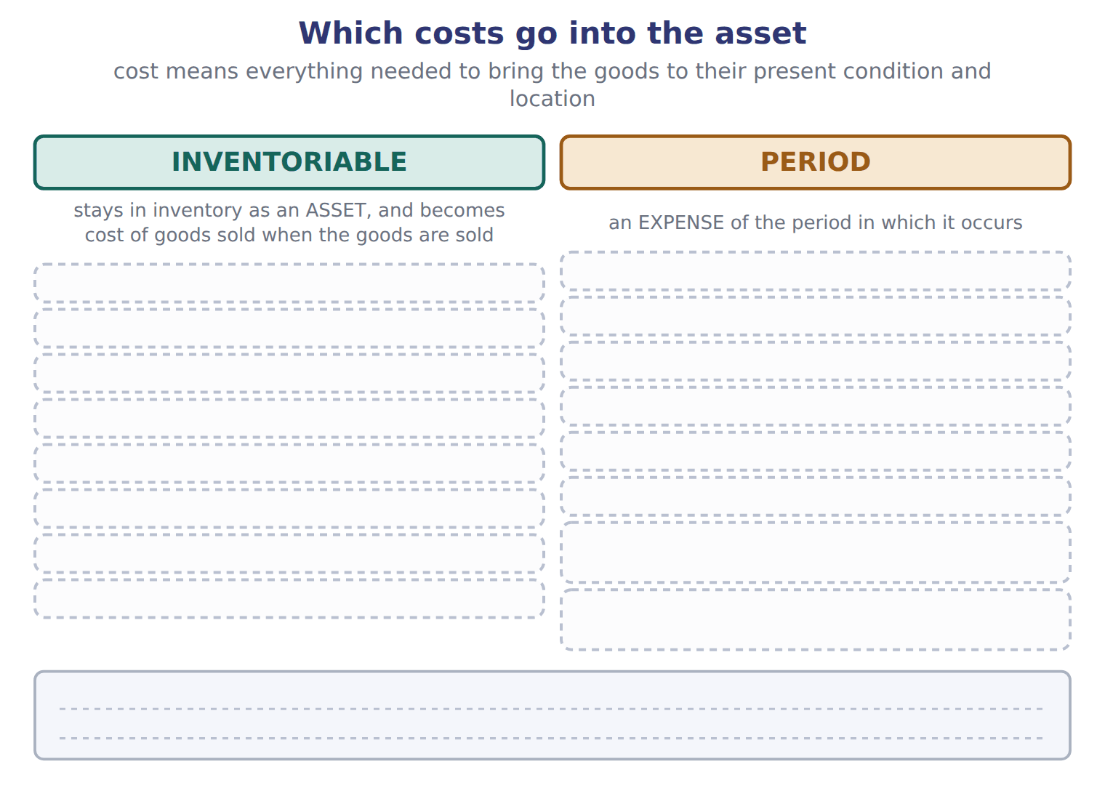
TEACH IT BACK | Write it for a classmate who missed this session — not for the marker.
29. In three or four sentences, write what this section settles and the one rule a reader has to take away.
every one of these words must appear: cost of goods sold · periodic inventory system · FOB shipping point · physical count

Answer key · Handout 7.2 · Which costs belong in inventory?

1 inventory · cost of goods sold · freight-in · purchase discount | 11 inventory · cost of goods sold | 21 E
2 abnormal waste · inventory · Period cost · freight-out | 12 A | 22 F
3 Period cost · freight-out · inventory | 13 A | 23 B
4 T | 14 C | 24 A
5 C | 15 D | 25 A
6 D | 16 B | 26 B
7 D | 17 A | 27 A
8 C | 18 T | 28 Compare with the model earlier in this handout.
9 T | 19 C | 29 Inventory is recorded at cost. Cost means all the costs needed to bring the goods to their present condition and location. These are inventoriable costs: they stay in inventory as an asset, and they become cost of goods sold when the goods are sold. Other costs are period costs: they are expenses in the period in which they occur.
10 F | 20 D

11 what the book says
These are inventoriable costs: they stay in inventory as an asset, and they become cost of goods sold when the goods are sold.

why
1 The book writes: “These are inventoriable costs: they stay in inventory as an asset, and they become cost of goods sold when the goods are sold. Other costs are period costs: they are expenses in the period in which they occur. For goods that are bought, cost includes the purchase price, freight-in, import duties, non-refundable taxes and handling, less trade discounts and any purchase discount taken for early payment.”
2 The book writes: “In the same way, abnormal waste (unusual spoilage, idle time or extra freight) is an expense, not inventory cost. Period costs include freight-out to customers, sales commissions, advertising, general and administrative costs, and the storage of finished goods. Interest on inventory that is produced routinely is also a period cost.”
3 The book writes: “Period costs include freight-out to customers, sales commissions, advertising, general and administrative costs, and the storage of finished goods. Interest on inventory that is produced routinely is also a period cost. Inventoriable costs versus period costs.”
4 The book pairs Invoice price with “20,000”.
5 The book’s own table gives 20,000 as the amount of Invoice price.
6 The book’s own table gives (400) as the amount of Purchase discount taken.
7 The book’s own table gives 1,200 as the amount of Freight-in from the port to Amman.
8 The book’s own table gives 900 as the amount of Import duty (not refundable).
9 The book pairs Invoice price with “Yes”.
10 The book pairs Purchase discount taken with “Yes (reduces cost)”, not with “Yes”.
12 The book gives Yes as the inventory cost? of Invoice price.
13 It tracks the cost of each individual item, which is practical only for distinct items. B is wrong: Identical items are interchangeable; tracking each one is costly and allows manipulation. C is wrong: Price trends do not decide when specific identification fits.
14 With falling prices, LIFO puts the newest, lowest costs into cost of goods sold. A is wrong: FIFO gives the highest profit only when prices rise. B is wrong: The average is always between FIFO and LIFO.
15 FIFO inventory minus LIFO inventory. A is wrong: This is the tax saving, not the reserve. B is wrong: This compares FIFO with the weighted average, not with LIFO.
16 Old, low costs flow into cost of goods sold, so gross profit rises for that year. A is wrong: Low old costs reduce cost of goods sold. C is wrong: The old costs are much lower than current costs, so income changes.
17 It tracks the cost of each individual item, which is practical only for distinct items. B is wrong: Identical items are interchangeable; tracking each one is costly and allows manipulation. C is wrong: Price trends do not decide when specific identification fits.
18 CMA questions use exact terms, and one word can change the answer.
25 It is a U.S. tax rule that links the tax method to the financial statements. B is wrong: IFRS prohibits LIFO. C is wrong: The rule links tax and book methods; it does not force one method everywhere.
26 The error overstates 2025 income and understates 2026 income by the same amount, so it counterbalances. A is wrong: This is the effect at the end of 2025, not 2026. C is wrong: Only 2026 income is understated; the cumulative effect is zero.
27 Every item on a Workshop sheet is settled by something printed on the same sheet.

Handout 7.3
Cost flow assumptions
section 7.3 of the book
Before you start
Three summaries of this handout, in the book’s own words. Read all three first: together they are the whole session. Then fill the gaps, guessing where you have to.

What this handout settles, cycle by cycle
In this handout | What you will read | How you check it
Cost flow assumptions | a figure to read · Method · the book’s own rule, gapped | The tax rate is 25%. Ending inventory was overstated by 40. By how much is net income overstated in that year?
The words this section uses precisely | Method · The English the exam uses, and what it translates | What is the safest way to settle a disagreement about an answer on this sheet?

Words this handout uses precisely
Words this handout uses precisely | tick it if you could already use it in a sentence
goods available for sale
perpetual inventory system
FOB destination
freight-in
inventoriable cost
LIFO liquidation

1. Where the section starts — Fill every gap. The list holds more words than there are gaps, so one or two of them are not used.
choose from: cost of goods sold · moving average · Specific identification · cost flow assumption · consignee · inventory
When a company sells some units and keeps others, it must decide which costs go to and which stay in ending . This decision is a . It does not need to match the physical flow of the goods. tracks the actual cost of each item.
2. What it settles in the middle — Fill every gap. The list holds more words than there are gaps, so one or two of them are not used.
choose from: cost of goods sold · consignee · periodic inventory system · perpetual inventory system · moving average
In a , the company counts the goods at year-end and calculates for the whole period. In a , it updates inventory and cost of goods sold after every purchase and every sale.
3. Where it ends — Fill every gap. The list holds more words than there are gaps, so one or two of them are not used.
choose from: moving average · inventory · cost of goods sold · consignee · specific identification
Then check that plus ending equals the cost of goods available. Faded example: periodic LIFO for Dubai pastry trays; the learner completes the dashed boxes. IAS 2 allows FIFO and the weighted average, and it requires for items that are not interchangeable.

CYCLE A | Cost flow assumptions

ORIENT One claim. Decide now; you will check it in a moment.

4. The book gives the periodic: ending inventory of FIFO as “100,000”. TRUE / FALSE
MODEL Read it before you answer anything below it.

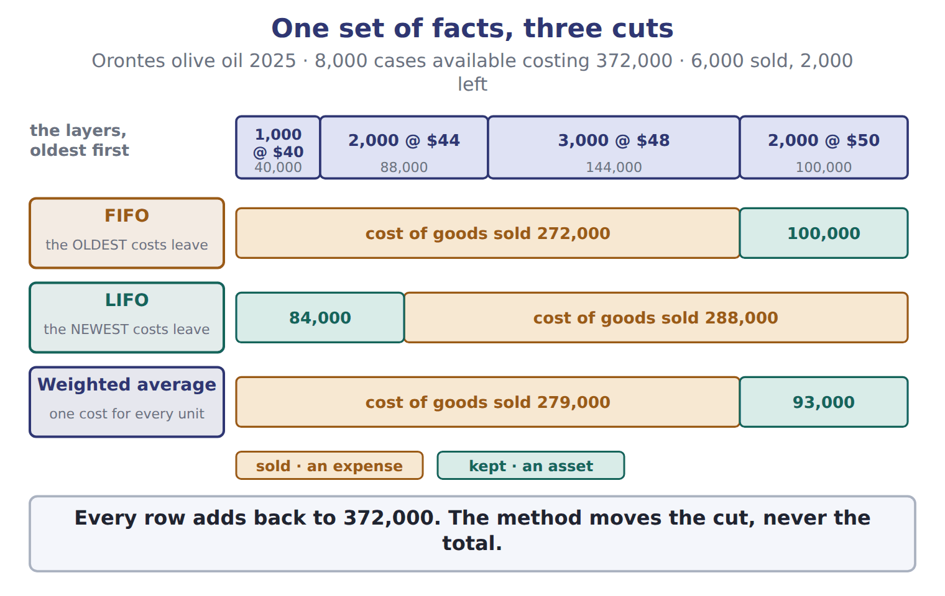

Method — the book’s own table
Method | Periodic: ending inventory | Periodic: COGS | Perpetual: ending inventory | Perpetual: COGS
FIFO | 100,000 | 272,000 | 100,000 | 272,000
LIFO | 84,000 | 288,000 | 93,000 | 279,000
Average (weighted / moving) | 93,000 | 279,000 | 97,633 | 274,367

READ THE MODEL Every answer is printed above. Find it, do not recall it.

5. Which method does the book pair with “100,000”?
A. Average (weighted / moving) | C. LIFO
B. FIFO
6. Which method does the book pair with “84,000”?
A. Average (weighted / moving) | C. FIFO
B. LIFO
7. Which method does the book pair with “93,000”?
A. LIFO | C. Average (weighted / moving)
B. FIFO
8. The book gives the Perpetual: COGS of FIFO as “272,000”. TRUE / FALSE
9. The book gives the Perpetual: COGS of LIFO as “274,367”. TRUE / FALSE
Complete every empty cell. The first full row shows the pattern.
Method | Periodic: ending inventory | Periodic: COGS | Perpetual: ending inventory | Perpetual: COGS
FIFO | 100,000 | 272,000 | 100,000 | 272,000
LIFO
Average (weighted / moving)

INVENT THE RULE

12. Complete the book’s own sentence. The list holds more words than there are gaps.
use every one of these words: consignee · periodic inventory system · cost of goods sold · freight-in
In a , the company counts the goods at year-end and calculates for the whole period.

Two of the book’s own cases, side by side
FIFO | LIFO
Periodic: ending inventory: 100,000 | Periodic: ending inventory: 84,000
Periodic: COGS: 272,000 | Periodic: COGS: 288,000
Perpetual: ending inventory: 100,000 | Perpetual: ending inventory: 93,000
Only the facts above differ. What is the perpetual: cogs of FIFO?
13. Choose one:
A. 274,367 | C. 272,000
B. 279,000

APPLY No help on this move.

14. The tax rate is 25%. Ending inventory was overstated by 40. By how much is net income overstated in that year?
A. 10 | C. 40
B. 30 | D. 50
15. Ending inventory for 2026 is understated by 15. Inventory for 2025 was correct. What is the effect on 2026 cost of goods sold?
A. Understated by 15 | C. Overstated by 15
B. No effect | D. Overstated by 30
16. Spiral review (Chapter 1). Orontes buys olives on account. What is the effect immediately after the purchase?
A. Assets increase and liabilities increase.
B. Expenses increase and net income decreases.
C. Assets increase and equity increases.
D. There is no effect until Orontes pays.
17. Spiral review (Chapter 1). Orontes records cost of goods sold at the same time as the related sales revenue. Which approach does this follow?
A. Systematic and rational allocation
B. Matching by cause and effect
C. Immediate recognition
D. The cash basis
WORK IN PAIRS | Compare every answer on this page with your partner before you read any key.
If you disagree: go back to the model and find the row that settles it. The row decides, not the louder voice.
CHECKPOINT 18. The tax rate is 25%. Ending inventory was overstated by 40. By how much is net income overstated in that year?
A. 10
B. 30
C. 40
D. 50
If you got it wrong: redo the READ THE MODEL questions of cycle A with the model in front of you.

CYCLE B | The words this section uses precisely

ORIENT

19. A term in the exam means exactly what the book defines it to mean, whatever it means in ordinary English. TRUE / FALSE
MODEL

Method — the book’s own table
Method | Ending inventory (cases left) | Ending inventory | Cost of goods sold
FIFO | the newest costs: 2,000 × $50 | 100,000 | 272,000
LIFO | the oldest costs: 1,000 × $40 + 1,000 × $44 | 84,000 | 288,000
Weighted average | 2,000 × $46.50 (= 372,000 ÷ 8,000) | 93,000 | 279,000

The English the exam uses, and what it translates
English (exam term) | the Arabic it translates
goods available for sale | البضاعة المتاحة للبيع
perpetual inventory system | نظام الجرد المستمر
FOB destination | التسليم عند نقطة الوصول
freight-in | مصاريف نقل المشتريات
inventoriable cost | تكلفة قابلة للتحميل على المخزون
LIFO liquidation | تصفية طبقات LIFO

READ THE MODEL

Write the letter of the Arabic term beside each English term. Every term is used once.
A مصاريف نقل المشتريات | D نظام الجرد المستمر
B التسليم عند نقطة الوصول | E البضاعة المتاحة للبيع
C تكلفة قابلة للتحميل على المخزون | F تصفية طبقات LIFO

20. perpetual inventory system
21. goods available for sale
22. FOB destination
23. inventoriable cost
24. LIFO liquidation
25. freight-in

26. Which method does the book pair with “the newest costs: 2,000 × $50”?
A. Weighted average | C. FIFO
B. LIFO
27. Which method does the book pair with “the oldest costs: 1,000 × $40 + 1,000 × $44”?
A. Weighted average | C. LIFO
B. FIFO
28. Which method does the book pair with “2,000 × $46.50 (= 372,000 ÷ 8,000)”?
A. LIFO | C. FIFO
B. Weighted average
APPLY

29. Cedar Retail S.A.L. reports under IFRS. Which method may it NOT use?
A. FIFO
B. Weighted average
C. LIFO
D. Specific identification for unique items
CHECKPOINT 30. What is the safest way to settle a disagreement about an answer on this sheet?
A. find the row of the model that decides it
B. take the answer of whoever is more confident
C. leave it until the lecturer says
D. choose the longer option
If you got it wrong: redo the READ THE MODEL questions of cycle B.

FROM MEMORY | Close the earlier pages first.
31. Rebuild the figure from this handout. Label every part and fill in every box.
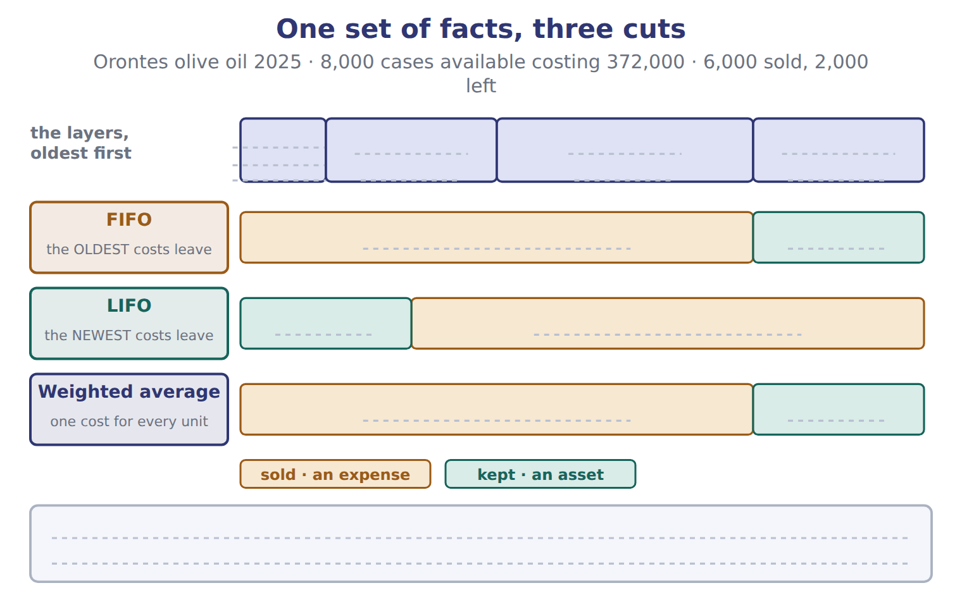
TEACH IT BACK | Write it for a classmate who missed this session — not for the marker.
32. In three or four sentences, write what this section settles and the one rule a reader has to take away.
every one of these words must appear: goods available for sale · perpetual inventory system · FOB destination · freight-in

Answer key · Handout 7.3 · Cost flow assumptions

1 cost of goods sold · inventory · cost flow assumption · Specific identification | 12 periodic inventory system · cost of goods sold | 23 C
2 periodic inventory system · cost of goods sold · perpetual inventory system | 13 C | 24 F
3 cost of goods sold · inventory · specific identification | 14 B | 25 A
4 T | 15 C | 26 C
5 B | 16 A | 27 C
6 B | 17 B | 28 B
7 C | 18 B | 29 C
8 T | 19 T | 30 A
9 F | 20 D | 31 Compare with the model earlier in this handout.
10 LIFO: 84,000 · 288,000 · 93,000 · 279,000 | 21 E | 32 Unit costs change during the year. When a company sells some units and keeps others, it must decide which costs go to cost of goods sold and which stay in ending inventory. This decision is a cost flow assumption. It does not need to match the physical flow of the goods.
11 Average (weighted / moving): 93,000 · 279,000 · 97,633 · 274,367 | 22 B

12 what the book says
In a periodic inventory system, the company counts the goods at year-end and calculates cost of goods sold for the whole period.

why
1 The book writes: “When a company sells some units and keeps others, it must decide which costs go to cost of goods sold and which stay in ending inventory. This decision is a cost flow assumption. It does not need to match the physical flow of the goods. Specific identification tracks the actual cost of each item.”
2 The book writes: “In a periodic inventory system, the company counts the goods at year-end and calculates cost of goods sold for the whole period. In a perpetual inventory system, it updates inventory and cost of goods sold after every purchase and every sale.”
3 The book writes: “Then check that cost of goods sold plus ending inventory equals the cost of goods available. Faded example: periodic LIFO for Dubai pastry trays; the learner completes the dashed boxes. IAS 2 allows FIFO and the weighted average, and it requires specific identification for items that are not interchangeable.”
4 The book pairs FIFO with “100,000”.
5 The book’s own table pairs FIFO with “100,000”.
6 The book’s own table pairs LIFO with “84,000”.
7 The book’s own table pairs Average (weighted / moving) with “93,000”.
8 The book pairs FIFO with “272,000”.
9 The book pairs LIFO with “279,000”, not with “274,367”.
13 The book gives 272,000 as the perpetual: cogs of FIFO.
14 After-tax effect = pretax error × (1 − tax rate). A is wrong: This is the tax effect only. C is wrong: This is the pretax effect.
15 COGS = beginning inventory + purchases − ending inventory, so low ending inventory raises COGS. A is wrong: This reverses the direction. B is wrong: Ending inventory directly changes COGS.
16 Inventory (an asset) and accounts payable (a liability) both increase. B is wrong: The olives become an expense only when the products are sold. C is wrong: Buying on credit creates a liability, not equity.
17 Cost of goods sold links directly to each sale. A is wrong: Allocation is used for costs such as depreciation. C is wrong: Immediate recognition is for costs with no clear link to revenue.
18 After-tax effect = pretax error × (1 − tax rate). A is wrong: This is the tax effect only. C is wrong: This is the pretax effect.
19 CMA questions use exact terms, and one word can change the answer.
26 The book’s own table pairs FIFO with “the newest costs: 2,000 × $50”.
27 The book’s own table pairs LIFO with “the oldest costs: 1,000 × $40 + 1,000 × $44”.
28 The book’s own table pairs Weighted average with “2,000 × $46.50 (= 372,000 ÷ 8,000)”.
29 IAS 2 prohibits LIFO. A is wrong: FIFO is allowed under IAS 2. B is wrong: The weighted average is allowed under IAS 2.

Handout 7.4
Effects on income, taxes and assets
section 7.4 of the book
Before you start
Three summaries of this handout, in the book’s own words. Read all three first: together they are the whole session. Then fill the gaps, guessing where you have to.

What this handout settles, cycle by cycle
In this handout | What you will read | How you check it
Effects on income, taxes and assets | a figure to read | Which of these did this cycle settle?
The words this section uses precisely | The English the exam uses, and what it translates | What is the safest way to settle a disagreement about an answer on this sheet?

Words this handout uses precisely
Words this handout uses precisely | tick it if you could already use it in a sentence
FIFO (first-in, first-out)
LIFO reserve
consignment
freight-out
period cost
LIFO conformity rule

1. Where the section starts — Fill every gap. The list holds more words than there are gaps, so one or two of them are not used.
choose from: freight-in · cost of goods sold · physical count · gross profit · inventory
When prices are rising, the methods give very different results. FIFO puts the old, cheaper costs into . So FIFO gives the lowest cost of goods sold, the highest , the highest income tax and the highest ending .
2. What it settles in the middle — Fill every gap. The list holds more words than there are gaps, so one or two of them are not used.
choose from: physical count · cost of goods sold · LIFO reserve · freight-in · inventory
An analyst can convert LIFO results to FIFO with two relationships. FIFO equals LIFO inventory plus the . FIFO equals LIFO cost of goods sold minus the increase in the LIFO reserve during the year.
3. Where it ends — Fill every gap. The list holds more words than there are gaps, so one or two of them are not used.
choose from: freight-in · physical count · cost of goods sold · LIFO reserve
A company that uses LIFO for its tax return must also use LIFO in its financial statements. To get FIFO , SUBTRACT the increase in the from LIFO cost of goods sold. In rising prices, LIFO gives LOWER income and LOWER taxes, not higher.

CYCLE A | Effects on income, taxes and assets

ORIENT One claim. Decide now; you will check it in a moment.

4. Every number in a financial statement belongs to an element the framework defines. TRUE / FALSE
MODEL Read it before you answer anything below it.

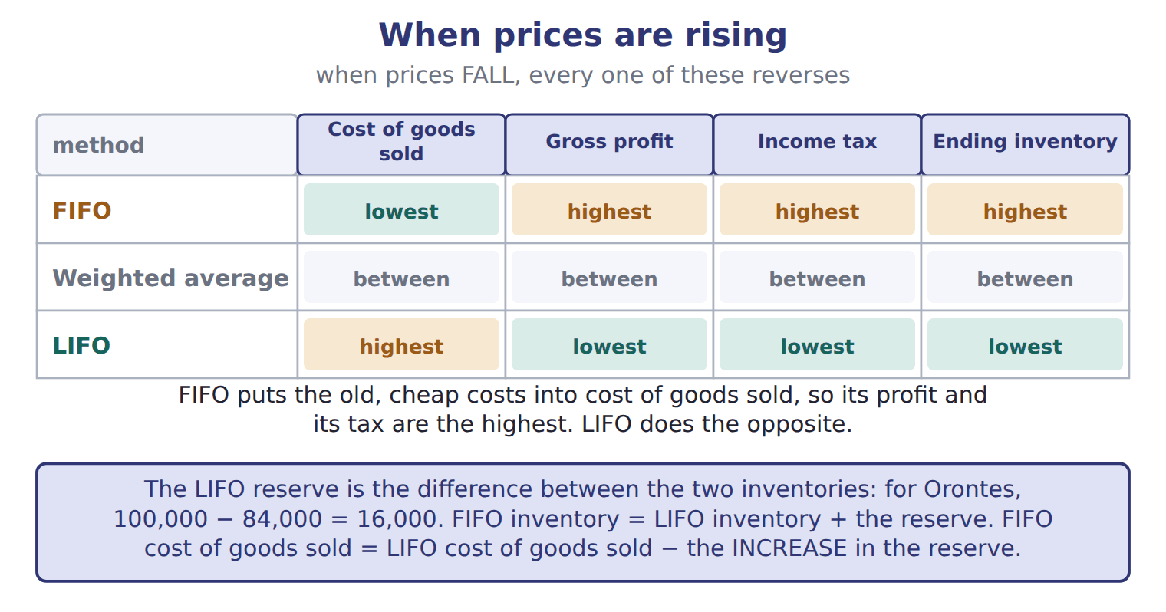
READ THE MODEL Every answer is printed above. Find it, do not recall it.

5. Which part of this chapter is section 7.1?
A. Effects on income, taxes and assets
B. Which goods belong in inventory?
C. Cost flow assumptions
D. Which costs belong in inventory?
6. Which part of this chapter is section 7.2?
A. Cost flow assumptions
B. Which goods belong in inventory?
C. Which costs belong in inventory?
D. Effects on income, taxes and assets
7. Which part of this chapter is section 7.3?
A. Effects on income, taxes and assets
B. Cost flow assumptions
C. Which costs belong in inventory?
D. Which goods belong in inventory?
8. Which part of this chapter is section 7.4?
A. Cost flow assumptions
B. Which goods belong in inventory?
C. Which costs belong in inventory?
D. Effects on income, taxes and assets
APPLY No help on this move.

9. The rule you have just written is the book’s own rule. TRUE / FALSE
WORK IN PAIRS | Compare every answer on this page with your partner before you read any key.
If you disagree: go back to the model and find the row that settles it. The row decides, not the louder voice.

CHECKPOINT 10. Which of these did this cycle settle?
A. the rule and where it comes from
B. nothing in particular
C. only the vocabulary
D. only the arithmetic
If you got it wrong: redo the READ THE MODEL questions of cycle A.

CYCLE B | The words this section uses precisely

ORIENT

11. A term in the exam means exactly what the book defines it to mean, whatever it means in ordinary English. TRUE / FALSE
MODEL

The English the exam uses, and what it translates
English (exam term) | the Arabic it translates
FIFO (first-in, first-out) | الوارد أولاً يُصرف أولاً
LIFO reserve | احتياطي LIFO (فرق تقويم LIFO)
consignment | البضاعة بالأمانة
freight-out | مصاريف نقل المبيعات
period cost | تكلفة الفترة
LIFO conformity rule | قاعدة التوافق الضريبي لطريقة LIFO

READ THE MODEL

Write the letter of the Arabic term beside each English term. Every term is used once.
A احتياطي LIFO (فرق تقويم LIFO) | D قاعدة التوافق الضريبي لطريقة LIFO
B الوارد أولاً يُصرف أولاً | E تكلفة الفترة
C البضاعة بالأمانة | F مصاريف نقل المبيعات

12. FIFO (first-in, first-out)
13. freight-out
14. LIFO reserve
15. period cost
16. LIFO conformity rule
17. consignment

APPLY

18. Writing a term in English is part of answering the question, not an extra. TRUE / FALSE
CHECKPOINT 19. What is the safest way to settle a disagreement about an answer on this sheet?
A. find the row of the model that decides it
B. take the answer of whoever is more confident
C. leave it until the lecturer says
D. choose the longer option
If you got it wrong: redo the READ THE MODEL questions of cycle B.

FROM MEMORY | Close the earlier pages first.
20. Rebuild the figure from this handout. Label every part and fill in every box.
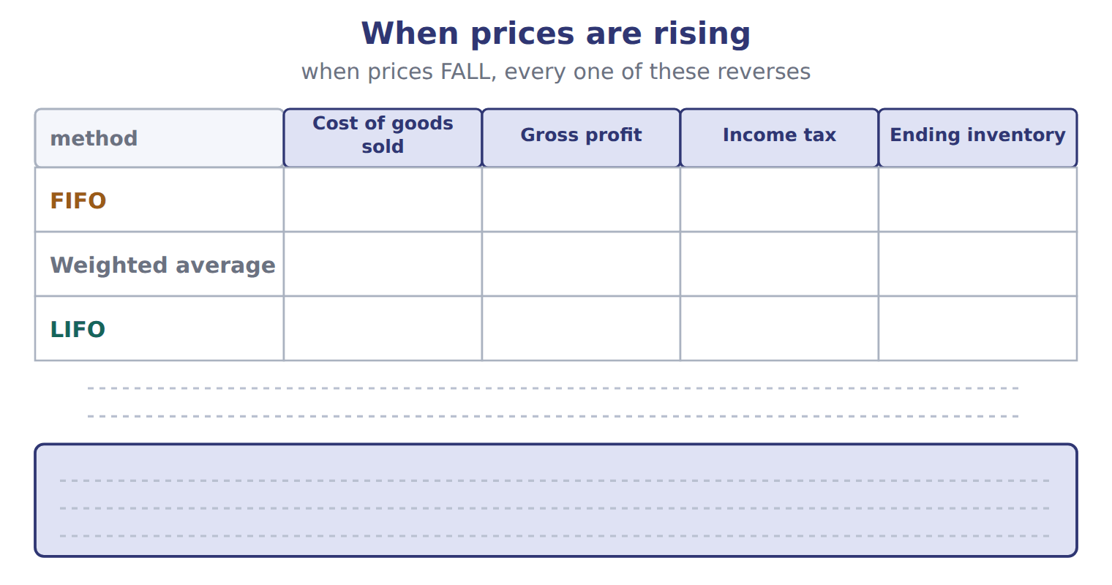
TEACH IT BACK | Write it for a classmate who missed this session — not for the marker.
21. In three or four sentences, write what this section settles and the one rule a reader has to take away.
every one of these words must appear: FIFO (first-in, first-out) · LIFO reserve · consignment · freight-out

Answer key · Handout 7.4 · Effects on income, taxes and assets

1 cost of goods sold · gross profit · inventory | 8 D | 15 E
2 inventory · LIFO reserve · cost of goods sold | 9 T | 16 D
3 cost of goods sold · LIFO reserve | 10 A | 17 C
4 T | 11 T | 18 T
5 B | 12 B | 19 A
6 C | 13 F | 20 Compare with the model earlier in this handout.
7 B | 14 A | 21 When prices are rising, the methods give very different results. FIFO puts the old, cheaper costs into cost of goods sold. So FIFO gives the lowest cost of goods sold, the highest gross profit, the highest income tax and the highest ending inventory. LIFO gives the opposite. The weighted average falls in between. When prices are falling, all these relationsh

why
1 The book writes: “When prices are rising, the methods give very different results. FIFO puts the old, cheaper costs into cost of goods sold. So FIFO gives the lowest cost of goods sold, the highest gross profit, the highest income tax and the highest ending inventory.”
2 The book writes: “An analyst can convert LIFO results to FIFO with two relationships. FIFO inventory equals LIFO inventory plus the LIFO reserve. FIFO cost of goods sold equals LIFO cost of goods sold minus the increase in the LIFO reserve during the year.”
3 The book writes: “A company that uses LIFO for its tax return must also use LIFO in its financial statements. To get FIFO cost of goods sold, SUBTRACT the increase in the LIFO reserve from LIFO cost of goods sold. In rising prices, LIFO gives LOWER income and LOWER taxes, not higher.”
4 The framework defines the elements, and every amount belongs to one of them.
5 The book numbers “Which goods belong in inventory?” as section 7.1.
6 The book numbers “Which costs belong in inventory?” as section 7.2.
7 The book numbers “Cost flow assumptions” as section 7.3.
8 The book numbers “Effects on income, taxes and assets” as section 7.4.
9 Compare your sentence with the book’s wording in the key.
10 Every cycle settles one rule and shows where it comes from.
11 CMA questions use exact terms, and one word can change the answer.
18 The exam marks the term, so the English word is the answer.
19 Every item on a Workshop sheet is settled by something printed on the same sheet.

Handout 7.5
Inventory errors
section 7.5 of the book
Before you start
Three summaries of this handout, in the book’s own words. Read all three first: together they are the whole session. Then fill the gaps, guessing where you have to.

What this handout settles, cycle by cycle
In this handout | What you will read | How you check it
Inventory errors | a figure to read · Item | Which of these did this cycle settle?
The words this section uses precisely | Memo item · The English the exam uses, and what it translates | What is the safest way to settle a disagreement about an answer on this sheet?

Words this handout uses precisely
Words this handout uses precisely | tick it if you could already use it in a sentence
LIFO (last-in, first-out)
counterbalancing error
consignor
purchase discount
cost flow assumption
gross profit

1. Where the section starts — Fill every gap. The list holds more words than there are gaps, so one or two of them are not used.
choose from: cost of goods sold · purchase discount · inventory · gross profit
If ending is wrong, is wrong in the same year. And because this year's ending inventory is next year's beginning inventory, the error moves into the next year too. Cost of goods sold was understated by 40, so pretax income was overstated by 40.
2. What it settles in the middle — Fill every gap. The list holds more words than there are gaps, so one or two of them are not used.
choose from: purchase discount · inventory · gross profit · cost of goods sold
Errors in purchases work in a similar way. Row 3 is a classic exam item: when a purchase is left out of both purchases and the count, and income are still correct, but and accounts payable are both understated.
3. Where it ends — Fill every gap. The list holds more words than there are gaps, so one or two of them are not used.
choose from: inventory · gross profit · purchase discount · physical count
In a question, find the direction for the first year, then reverse it for the second year. SC7-10 A purchase on account at year-end was not recorded, and the goods were not included in the . Net income is overstated; is correct.

CYCLE A | Inventory errors

ORIENT One claim. Decide now; you will check it in a moment.

4. The book gives the answer of COGS, line 2: 1,200 × $22 as “$26,400”. TRUE / FALSE
MODEL Read it before you answer anything below it.

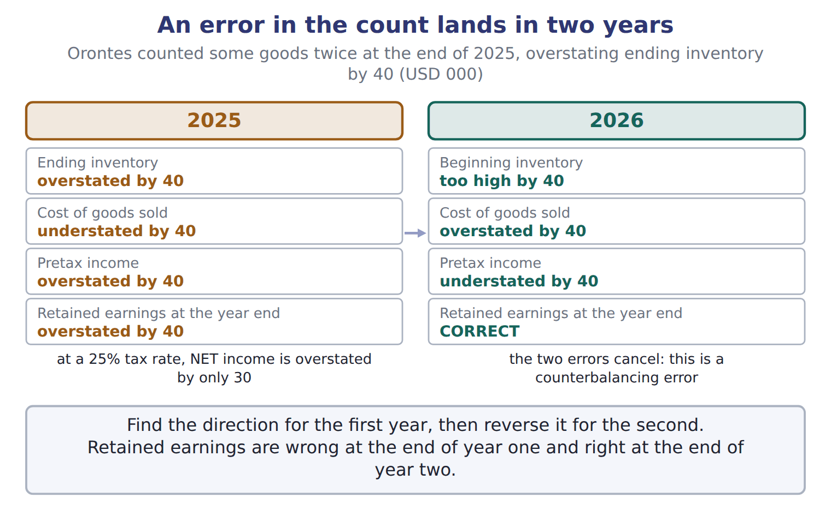

Item — the book’s own table
Item | Answer
COGS, line 2: 1,200 × $22 | $26,400
Ending inventory, line 1: 300 × $22 | $6,600
Ending inventory, line 2: 500 × $20 | $10,000
Total COGS | $25,000 + $26,400 = $51,400
Total ending inventory | $6,600 + $10,000 = $16,600
Check | $51,400 + $16,600 = $68,000, the cost of goods available.

READ THE MODEL Every answer is printed above. Find it, do not recall it.

5. Which answer does the book give for COGS, line 2: 1,200 × $22?
A. $26,400
B. $25,000 + $26,400 = $51,400
C. $10,000
D. $51,400 + $16,600 = $68,000, the cost of goods available.
6. Which answer does the book give for Ending inventory, line 1: 300 × $22?
A. $26,400
B. $6,600 + $10,000 = $16,600
C. $6,600
D. $51,400 + $16,600 = $68,000, the cost of goods available.
7. Which answer does the book give for Ending inventory, line 2: 500 × $20?
A. $10,000 | C. $25,000 + $26,400 = $51,400
B. $6,600 + $10,000 = $16,600 | D. $26,400
8. Which answer does the book give for Total COGS?
A. $6,600
B. $10,000
C. $25,000 + $26,400 = $51,400
D. $51,400 + $16,600 = $68,000, the cost of goods available.
9. The book gives the answer of COGS, line 2: 1,200 × $22 as “$26,400”. TRUE / FALSE
10. The book gives the answer of Ending inventory, line 1: 300 × $22 as “$51,400 + $16,600 = $68,000, the cost of goods available.”. TRUE / FALSE
APPLY No help on this move.

11. The rule you have just written is the book’s own rule. TRUE / FALSE
WORK IN PAIRS | Compare every answer on this page with your partner before you read any key.
If you disagree: go back to the model and find the row that settles it. The row decides, not the louder voice.
CHECKPOINT 12. Which of these did this cycle settle?
A. the rule and where it comes from
B. nothing in particular
C. only the vocabulary
D. only the arithmetic
If you got it wrong: redo the READ THE MODEL questions of cycle A.

CYCLE B | The words this section uses precisely

ORIENT

13. A term in the exam means exactly what the book defines it to mean, whatever it means in ordinary English. TRUE / FALSE

MODEL

Memo item — the book’s own table
Memo item | Category
M1 (FOB shipping point, bought)
M2 (FOB destination, sold)
M3 (held for a Beirut producer)
M4 (at a Doha consignee)

The English the exam uses, and what it translates
English (exam term) | the Arabic it translates
LIFO (last-in, first-out) | الوارد أخيراً يُصرف أولاً
counterbalancing error | خطأ ذاتي التصحيح (خطأ معاكس)
consignor | المُرسِل (مالك البضاعة بالأمانة)
purchase discount | خصم المشتريات (خصم نقدي)
cost flow assumption | افتراض تدفق التكلفة
gross profit | مجمل الربح

READ THE MODEL

Write the letter of the Arabic term beside each English term. Every term is used once.
A خصم المشتريات (خصم نقدي) | D خطأ ذاتي التصحيح (خطأ معاكس)
B مجمل الربح | E الوارد أخيراً يُصرف أولاً
C افتراض تدفق التكلفة | F المُرسِل (مالك البضاعة بالأمانة)

14. consignor
15. cost flow assumption
16. LIFO (last-in, first-out)
17. purchase discount
18. gross profit
19. counterbalancing error

APPLY

20. Writing a term in English is part of answering the question, not an extra. TRUE / FALSE
CHECKPOINT 21. What is the safest way to settle a disagreement about an answer on this sheet?
A. find the row of the model that decides it
B. take the answer of whoever is more confident
C. leave it until the lecturer says
D. choose the longer option
If you got it wrong: redo the READ THE MODEL questions of cycle B.

FROM MEMORY | Close the earlier pages first.
22. Rebuild the figure from this handout. Label every part and fill in every box.
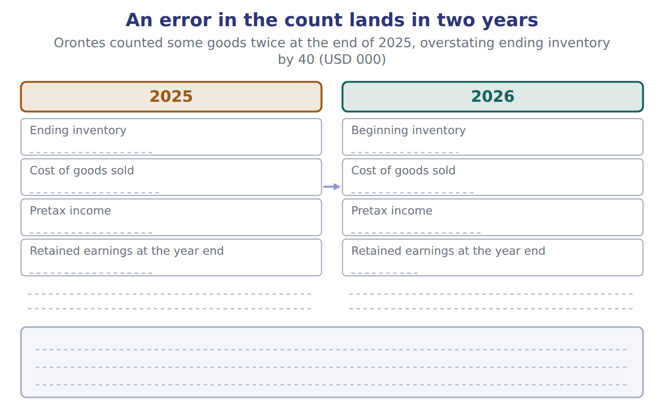
TEACH IT BACK | Write it for a classmate who missed this session — not for the marker.
23. In three or four sentences, write what this section settles and the one rule a reader has to take away.
every one of these words must appear: LIFO (last-in, first-out) · counterbalancing error · consignor · purchase discount

Answer key · Handout 7.5 · Inventory errors

1 inventory · cost of goods sold | 9 T | 17 A
2 cost of goods sold · inventory | 10 F | 18 B
3 physical count · inventory | 11 T | 19 D
4 T | 12 A | 20 T
5 A | 13 T | 21 A
6 C | 14 F | 22 Compare with the model earlier in this handout.
7 A | 15 C | 23 Cost of goods sold depends on the count: beginning inventory plus purchases minus ending inventory. If ending inventory is wrong, cost of goods sold is wrong in the same year. And because this year's ending inventory is next year's beginning inventory, the error moves into the next year too.
8 C | 16 E

why
1 The book writes: “If ending inventory is wrong, cost of goods sold is wrong in the same year. And because this year's ending inventory is next year's beginning inventory, the error moves into the next year too. Cost of goods sold was understated by 40, so pretax income was overstated by 40.”
2 The book writes: “Errors in purchases work in a similar way. Row 3 is a classic exam item: when a purchase is left out of both purchases and the count, cost of goods sold and income are still correct, but inventory and accounts payable are both understated.”
3 The book writes: “In a question, find the direction for the first year, then reverse it for the second year. SC7-10 A purchase on account at year-end was not recorded, and the goods were not included in the physical count. Net income is overstated; inventory is correct.”
4 The book pairs COGS, line 2: 1,200 × $22 with “$26,400”.
5 The book’s own table gives $26,400 as the answer of COGS, line 2: 1,200 × $22.
6 The book’s own table gives $6,600 as the answer of Ending inventory, line 1: 300 × $22.
7 The book’s own table gives $10,000 as the answer of Ending inventory, line 2: 500 × $20.
8 The book’s own table gives $25,000 + $26,400 = $51,400 as the answer of Total COGS.
9 The book pairs COGS, line 2: 1,200 × $22 with “$26,400”.
10 The book pairs Ending inventory, line 1: 300 × $22 with “$6,600”, not with “$51,400 + $16,600 = $68,000, the cost of goods available.”.
11 Compare your sentence with the book’s wording in the key.
12 Every cycle settles one rule and shows where it comes from.
13 CMA questions use exact terms, and one word can change the answer.
20 The exam marks the term, so the English word is the answer.
21 Every item on a Workshop sheet is settled by something printed on the same sheet.

Handout 7.6
The whole chapter
every section, shuffled, and the chapter’s own case set
Before you start
Three summaries of this chapter, in the book’s own words, with words taken out. Read all three first: together they are the whole chapter. Then fill the gaps.

What this handout settles, cycle by cycle
In this handout | What you will read | How you check it
The whole chapter, in order | a figure to read | On December 28, a supplier in Türkiye ships glass bottles to Orontes, FOB shipping point. They arrive on January 4. Who includes the bottles in inventory at December 31?
The chapter’s case set | The chapter’s case set, item by item | What has to be settled before any figure in a case set is worked out?
The words it uses precisely | inventory · cost of goods sold · goods available for sale · FIFO (first-in, first-out) · LIFO (last-in, first-out) · weighted-average cost | matching, at the end of cycle B

1. Where the chapter starts — Fill every gap. The list holds more words than there are gaps, so one or two of them are not used.
choose from: FOB destination · inventory · consignee · consignment · inventoriable cost · consignor · goods available for sale
Under , the seller keeps control until the goods arrive, so the seller includes them. In a , the (the owner) gives goods to a , who sells them for a commission. The goods stay in the consignor's .
2. What it settles in the middle — Fill every gap. The list holds more words than there are gaps, so one or two of them are not used.
choose from: inventoriable cost · cost of goods sold · goods available for sale · perpetual inventory system · periodic inventory system
In a , the company counts the goods at year-end and calculates for the whole period. In a , it updates inventory and cost of goods sold after every purchase and every sale.
3. Where it ends — Fill every gap. The list holds more words than there are gaps, so one or two of them are not used.
choose from: goods available for sale · inventory · gross profit · inventoriable cost · cost of goods sold
So FIFO gives the lowest , the highest , the highest income tax and the highest ending . When prices are falling, all these relationships reverse. Effects of FIFO, weighted average and LIFO when prices are rising.

CYCLE A | The whole chapter, in order

ORIENT

4. The sections of a chapter have to be taken in order, because each one uses what the one before it settled. TRUE / FALSE
MODEL

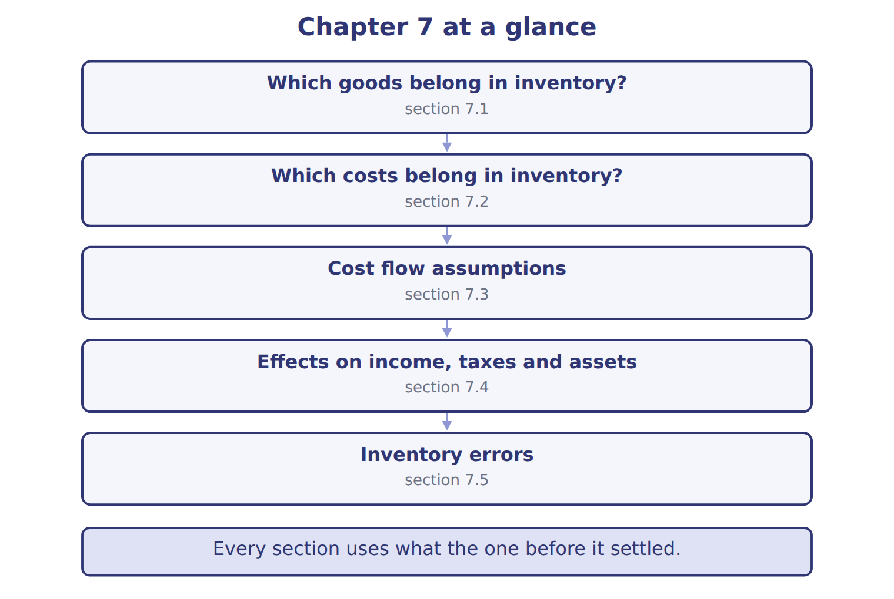
READ THE MODEL

5. “section 7.1” — which part of the chapter is this?
A. Cost flow assumptions
B. Which costs belong in inventory?
C. Effects on income, taxes and assets
D. Which goods belong in inventory?
6. “section 7.2” — which part of the chapter is this?
A. Effects on income, taxes and assets
B. Which goods belong in inventory?
C. Which costs belong in inventory?
D. Cost flow assumptions
7. “section 7.3” — which part of the chapter is this?
A. Effects on income, taxes and assets
B. Which goods belong in inventory?
C. Which costs belong in inventory?
D. Cost flow assumptions
Write the letter of the section number beside each section title. Every number is used once.
A 7.1 | D 7.4
B 7.2 | E 7.5
C 7.3

8. Which goods belong in inventory?
9. Which costs belong in inventory?
10. Cost flow assumptions
11. Effects on income, taxes and assets
12. Inventory errors

APPLY

13. Under LIFO, ending inventory consists of:
A. the newest costs.
B. an average of all costs.
C. the actual cost of each unit still on hand.
D. the oldest costs.
14. What is the weighted-average cost per case of olive oil in the Orontes example?
A. $40.00 | C. $46.50
B. $45.50 | D. $50.00
15. Prices are rising. Which method gives the highest net income?
A. FIFO
B. LIFO
C. Weighted average
D. All methods give the same net income.
16. A company reports LIFO cost of goods sold of 500,000. Its LIFO reserve increased from 30,000 to 45,000 during the year. What would cost of goods sold be under FIFO?
A. 455,000 | C. 515,000
B. 485,000 | D. 545,000
17. Ending inventory for 2025 was understated. What are the effects on net income?
A. 2025 overstated; 2026 understated
B. 2025 understated; 2026 no effect
C. No effect in either year
D. 2025 understated; 2026 overstated
WORK IN PAIRS | Compare every answer with your partner first.
If you disagree: name the section each question belongs to. Most disagreements turn out to be about the section, not the answer.

CHECKPOINT 18. On December 28, a supplier in Türkiye ships glass bottles to Orontes, FOB shipping point. They arrive on January 4. Who includes the bottles in inventory at December 31?
A. The supplier, the seller
B. Neither company until the bottles arrive
C. Both companies, half each
D. Orontes, the buyer
If you got it wrong: go back to the MODEL move of cycle A and find the section this question belongs to.

CYCLE B | The chapter’s case set

ORIENT

19. In a case question, the exhibit has to be read and adjusted before any figure is worked out. TRUE / FALSE

MODEL

The chapter’s case set, item by item
Item | What it asks
C7-1 | For each memo item, decide how Orontes should adjust the physical count. (On the exam screen you would drag each item in
C7-2 | Enter the correct number of cartons in ending inventory.
C7-3 | Enter FIFO ending inventory in USD.
C7-4 | Enter weighted-average cost of goods sold in USD.
C7-5 | If Orontes had used the unadjusted count, its FIFO cost of goods sold would have been: [select]
C7-6 | If Orontes used periodic LIFO for tahini, what would the LIFO reserve be at December 31 (USD)? The beginning layer is th

READ THE MODEL

20. Which of these does item C7-1 ask for?
A. For each memo item, decide how Orontes should adjust the physical coun
B. Enter the correct number of cartons in ending inventory.
C. Enter weighted-average cost of goods sold in USD.
D. Enter FIFO ending inventory in USD.
21. Which of these does item C7-2 ask for?
A. Enter the correct number of cartons in ending inventory.
B. Enter weighted-average cost of goods sold in USD.
C. For each memo item, decide how Orontes should adjust the physical coun
D. Enter FIFO ending inventory in USD.
22. Which of these does item C7-3 ask for?
A. For each memo item, decide how Orontes should adjust the physical coun
B. Enter weighted-average cost of goods sold in USD.
C. Enter the correct number of cartons in ending inventory.
D. Enter FIFO ending inventory in USD.
23. Which of these does item C7-4 ask for?
A. Enter the correct number of cartons in ending inventory.
B. Enter FIFO ending inventory in USD.
C. Enter weighted-average cost of goods sold in USD.
D. For each memo item, decide how Orontes should adjust the physical coun
24. Which of these does item C7-5 ask for?
A. Enter FIFO ending inventory in USD.
B. If Orontes had used the unadjusted count, its FIFO cost of goods sold
C. For each memo item, decide how Orontes should adjust the physical coun
D. Enter the correct number of cartons in ending inventory.
25. Which of these does item C7-6 ask for?
A. If Orontes used periodic LIFO for tahini, what would the LIFO reserve
B. Enter FIFO ending inventory in USD.
C. For each memo item, decide how Orontes should adjust the physical coun
D. Enter the correct number of cartons in ending inventory.
APPLY

26. On December 28, a supplier in Türkiye ships glass bottles to Orontes, FOB shipping point. They arrive on January 4. Who includes the bottles in inventory at December 31?
A. The supplier, the seller
B. Neither company until the bottles arrive
C. Both companies, half each
D. Orontes, the buyer

27. Barada Wholesale holds cartons of Orontes tahini on consignment and sells them for a commission. Which statement is correct at year-end?
A. Orontes includes the cartons in inventory; Barada does not.
B. Barada includes the cartons because they are in its warehouse.
C. Both companies include the cartons.
D. Neither company includes the cartons until they are sold.
CHECKPOINT 28. What has to be settled before any figure in a case set is worked out?
A. the exhibit, adjusted for every note that goes with it
B. the method the company uses
C. the tax rate
D. the order of the items
If you got it wrong: reread the case panel in the MODEL move of cycle B.

FROM MEMORY | Close the earlier pages first.
29. Rebuild the chapter map. Write every section in order and what each one settles.
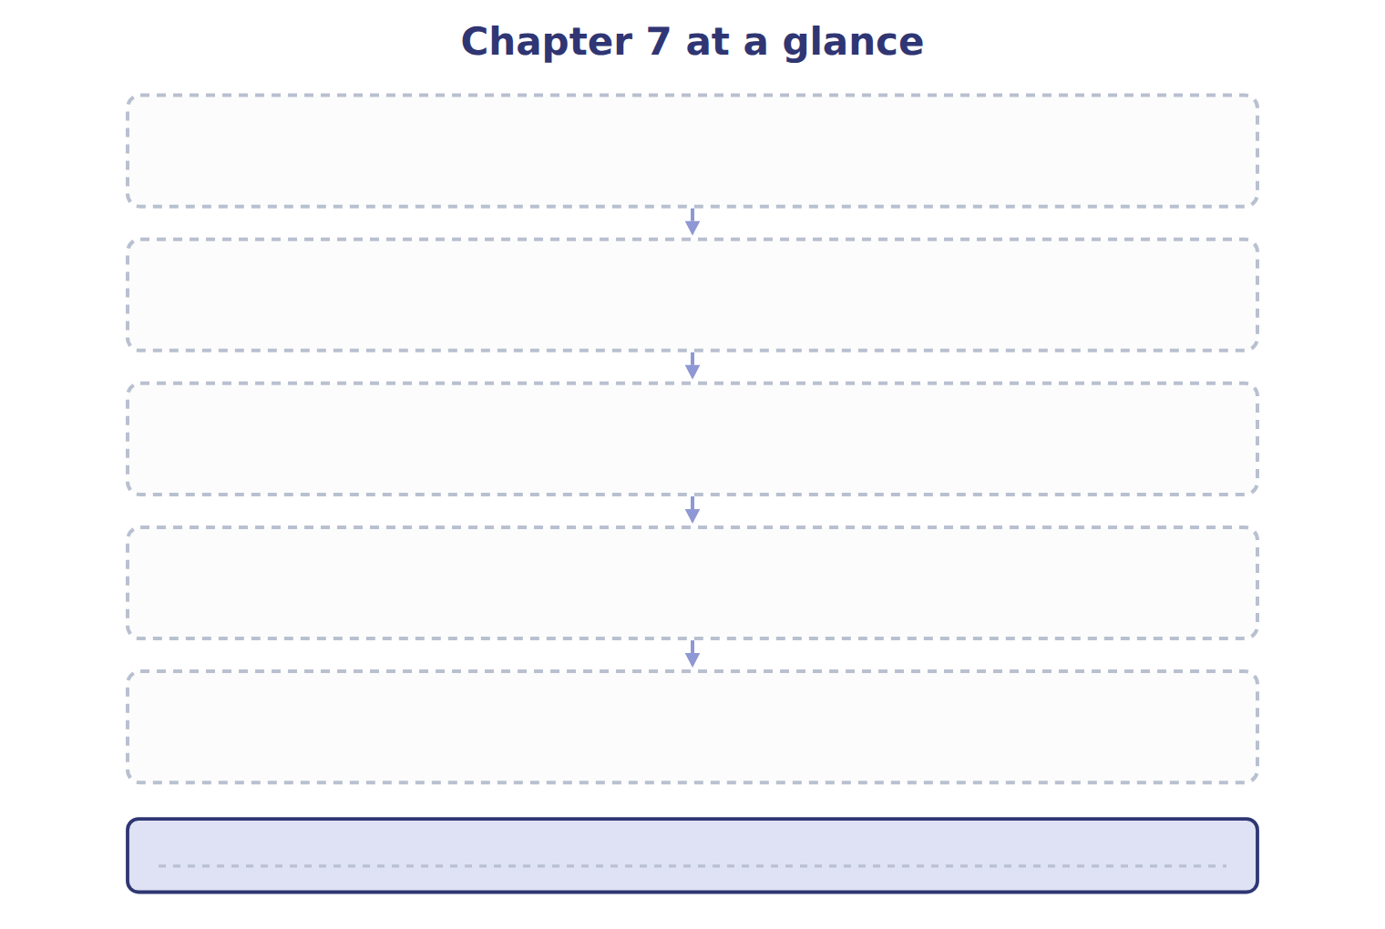
TEACH IT BACK | Write it for a student starting this chapter tomorrow — not for the marker.
30. In four or five sentences, write what the whole chapter settles, section by section.
every one of these words must appear: inventory · cost of goods sold · goods available for sale · FIFO (first-in, first-out)

Answer key · Handout 7.6 · The whole chapter

1 FOB destination · consignment · consignor · consignee · inventory | 11 D | 21 A
2 periodic inventory system · cost of goods sold · perpetual inventory system | 12 E | 22 D
3 cost of goods sold · gross profit · inventory | 13 D | 23 C
4 T | 14 C | 24 B
5 D | 15 A | 25 A
6 C | 16 B | 26 D
7 D | 17 D | 27 A
8 A | 18 D | 28 A
9 B | 19 T | 29 Compare with the model earlier in this handout.
10 C | 20 A | 30 7.1: Which goods belong in inventory?. 7.2: Which costs belong in inventory?. 7.3: Cost flow assumptions. 7.4: Effects on income, taxes and assets. 7.5: Inventory errors.

why
1 The book writes: “Under FOB destination, the seller keeps control until the goods arrive, so the seller includes them. In a consignment, the consignor (the owner) gives goods to a consignee, who sells them for a commission. The goods stay in the consignor's inventory.”
2 The book writes: “In a periodic inventory system, the company counts the goods at year-end and calculates cost of goods sold for the whole period. In a perpetual inventory system, it updates inventory and cost of goods sold after every purchase and every sale.”
3 The book writes: “So FIFO gives the lowest cost of goods sold, the highest gross profit, the highest income tax and the highest ending inventory. When prices are falling, all these relationships reverse. Effects of FIFO, weighted average and LIFO when prices are rising.”
4 The map shows the order the decisions have to be taken in.
5 The book numbers it 7.1.
6 The book numbers it 7.2.
7 The book numbers it 7.3.
13 LIFO sends the newest costs to cost of goods sold, so the oldest costs stay in inventory. A is wrong: The newest costs stay in inventory under FIFO. B is wrong: That is the average method.
14 Cost of goods available divided by units available. A is wrong: This is the oldest unit cost. B is wrong: This is a simple average of the four unit prices. It ignores the number of units in each layer.
15 FIFO puts the oldest, cheapest costs into cost of goods sold, so income is highest. B is wrong: LIFO gives the lowest income when prices rise. C is wrong: The average falls between FIFO and LIFO.
16 FIFO COGS = LIFO COGS − increase in the LIFO reserve = 500,000 − 15,000. A is wrong: This subtracts the ending reserve instead of the change in the reserve. C is wrong: This adds the increase instead of subtracting it.
17 Low ending inventory makes 2025 COGS too high. It also makes 2026 beginning inventory too low, so 2026 COGS is too low. A is wrong: These are the effects of an overstated ending inventory. B is wrong: The error carries into next year through beginning inventory.
18 Under FOB shipping point, control passes to the buyer when the goods leave the seller. A is wrong: The seller keeps goods in transit only under FOB destination. B is wrong: Someone always controls the goods; in transit they belong to the buyer here.
19 Every later answer depends on the adjusted exhibit.
20 The book states item C7-1 in those words.
21 The book states item C7-2 in those words.
22 The book states item C7-3 in those words.
23 The book states item C7-4 in those words.
24 The book states item C7-5 in those words.
25 The book states item C7-6 in those words.

