English for Daily Life

A1 — Student Book
15 units · 570 exercises · 330 figures
A beginner’s course. Everything happens on one street, Hill Road, and the same eight people live there, so the only new thing on any page is the language.
Unit | Title | Grammar
1 | Hello | am, is, are · my, your, his, her
2 | In the Class | questions and short answers · isn’t, aren’t · a/an · this, that
3 | Who’s This? | possessive ’s · plural nouns · our, their
4 | Where I Live | there is, there are · how many · in, on, under
5 | Every Day | present simple I, you, we, they · time · days
6 | She Works Here | present simple he, she, it · does
7 | Food and Drink | some, any · countable and uncountable · like
8 | In the Town | prepositions of place · imperatives
9 | I Can Do That | can, can’t
10 | Last Weekend | was, were · past time words
11 | A Day Out | past simple, regular verbs
12 | Last Year | past simple, irregular verbs · questions with did
13 | Right Now | present continuous · beside the present simple
14 | Next Week | going to
15 | Bigger and Better | comparatives · adjectives
The people of Hill Road
Nadia cooks at the cafe. Sam drives bus 12. Lili is a student. Marek looks after the flats. Fatima is a nurse at the clinic and teaches the evening class. Ben works in the shop. Rosa is Marek’s mother. Omar is his son.

Unit 1: Hello
In this unit you say hello. You say your name. You count to ten.
Warm Up
W1 Look at Figure 1.1. Tick the words you know.
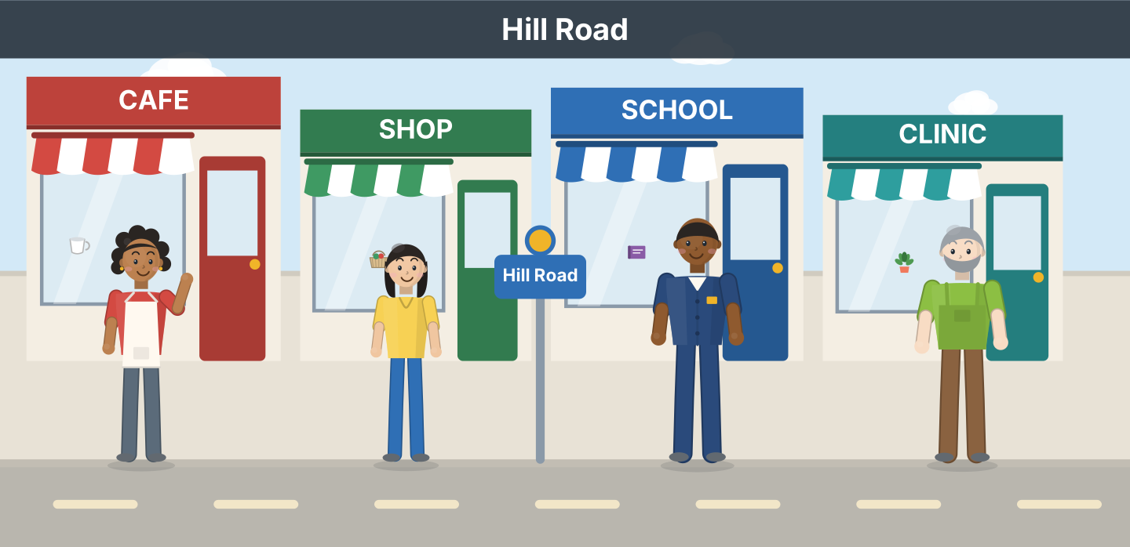
Figure 1.1 · Hill Road.
- a cafe — ✓ (example)
- a shop — ______
- a school — ______
- a clinic — ______
- a bus — ______
W2 Look at Figure 1.2. Write the number: 1, 2 or 3.
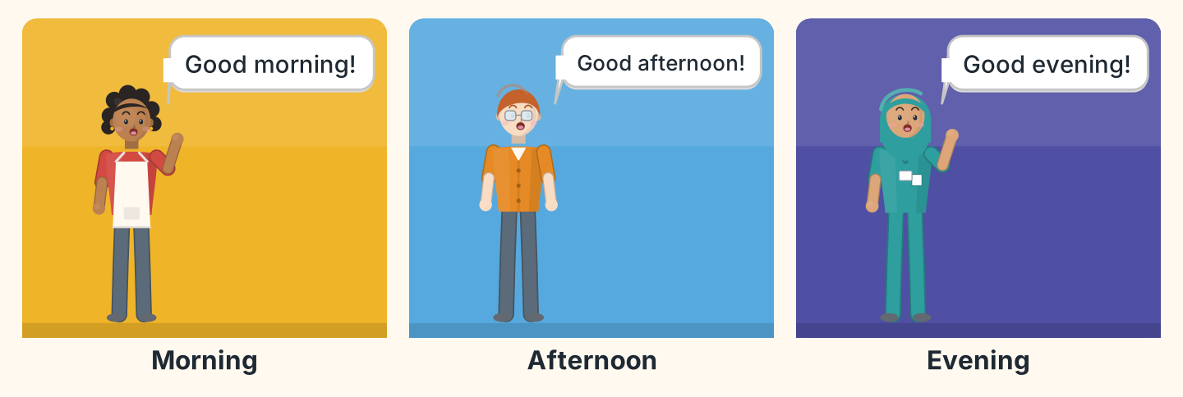
Figure 1.2 · Three times of day.
- Good evening. — 3 (example)
- Good morning. — ______
- Good afternoon. — ______
- Good morning. — ______
W3 Say hello to three people in your class.
- Hello. I’m Lili. (example)
- Say hello.
- Say your name.
- Say goodbye.
Part 1 · Words & Sounds
1A Look at Figure 1.3. Match the person and the job.
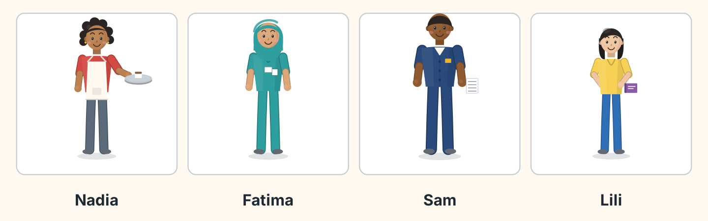
Figure 1.3 · Four people on Hill Road.
Person | Job
1 Nadia | a a student
2 Fatima | b a cook
3 Sam | c a nurse
4 Lili | d a driver
 | e a teacher
One option is not needed.
- 1 — b (example)
- 2 — ______
- 3 — ______
- 4 — ______
1B Look at Figure 1.4. Write the letters in the box.
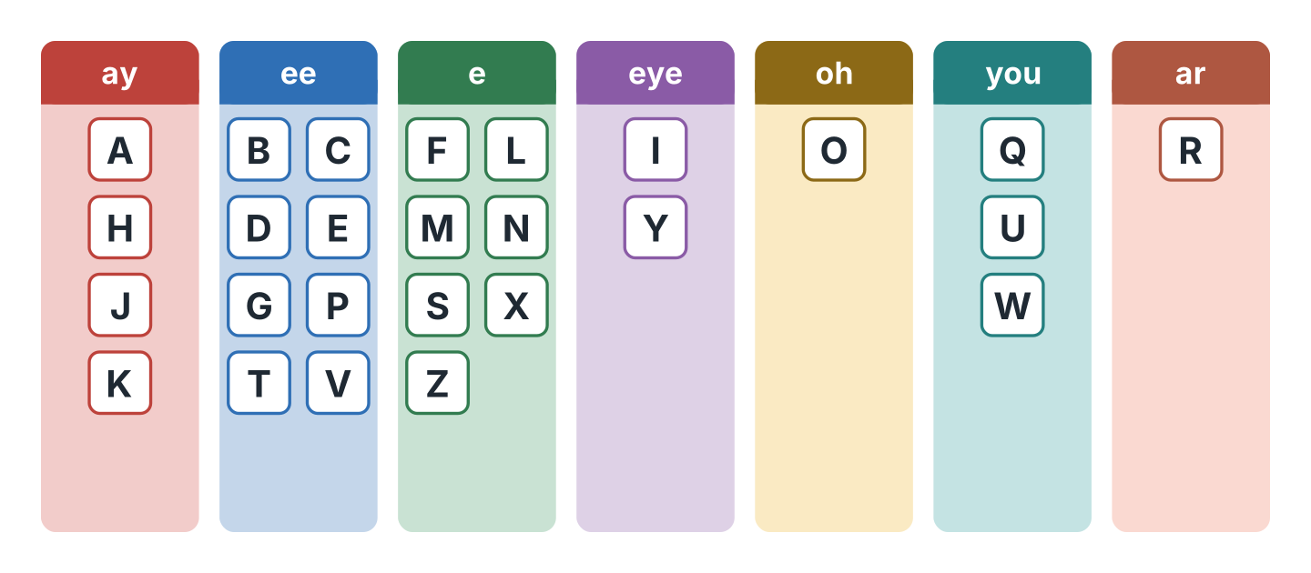
Figure 1.4 · The alphabet in seven sounds.
Words: A · E · I · O · U
- ay — A (example)
- ee — ______
- eye — ______
- oh — ______
- you — ______
1C Listen. Write the letters you hear.
- S-A-M — Sam (example)
- ______________
- ______________
- ______________
- ______________
1D Look at Figure 1.5. Write the word.
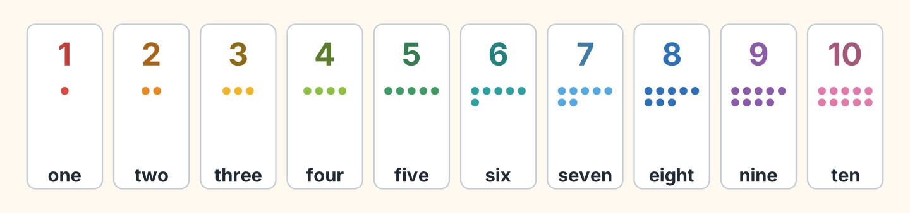
Figure 1.5 · One to ten.
- 2 — two (example)
- 5 — ______________
- 7 — ______________
- 9 — ______________
- 10 — ______________
1E Write the number.
- six — 6 (example)
- three — ______
- eight — ______
- one — ______
- four — ______
1F Say it. Look at Figure 1.6. Say the words.
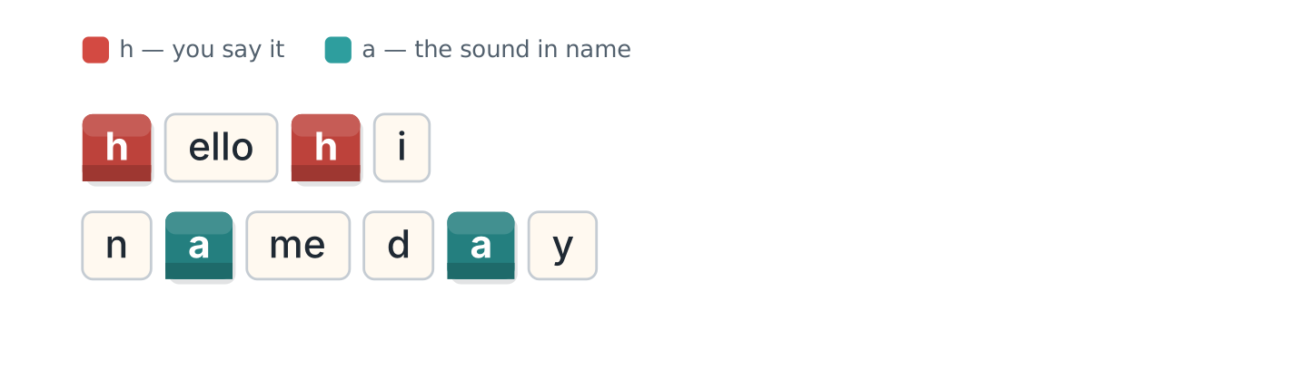
Figure 1.6 · Two sounds in hello and name.
- hello (example)
- hi
- name
- day
- Hello, Hannah.
Part 2 · Grammar
2A Look at Figure 1.7. Complete with am, is or are.
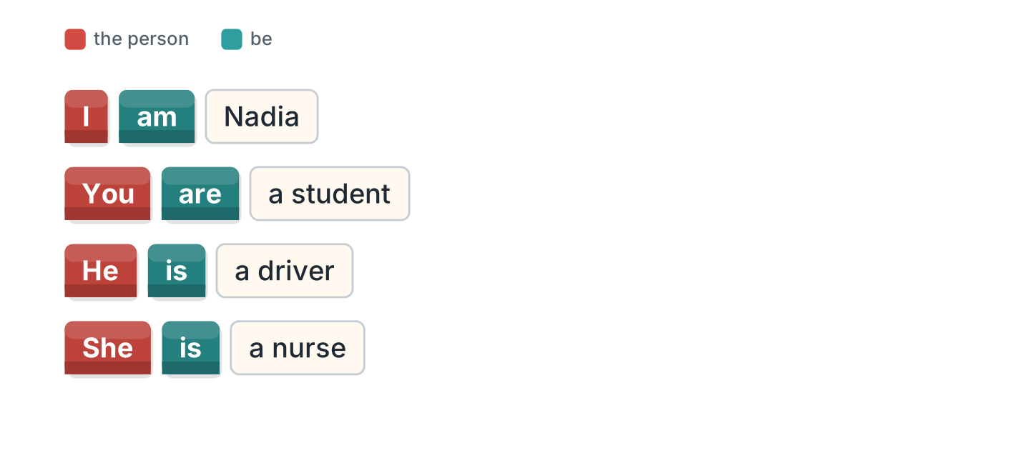
Figure 1.7 · am, is and are.
- I am Nadia. (am) (example)
- She ______ a nurse.
- You ______ a student.
- He ______ a driver.
- I ______ from Egypt.
2B Choose the correct word.
- I (am / is) Lili. — am (example)
- He (am / is) Sam.
- You (is / are) a teacher.
- She (are / is) from Brazil.
- I (am / are) a cook.
2C Look at Figure 1.8. Write the short form.
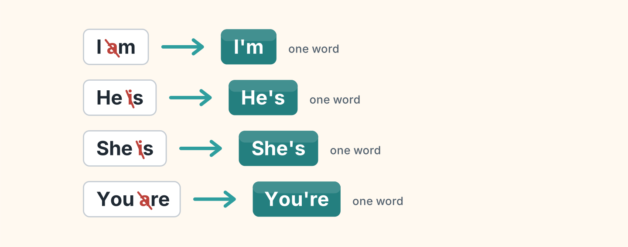
Figure 1.8 · Two words become one.
- I am — I’m (example)
- He is — ______________
- She is — ______________
- You are — ______________
2D Write the long form.
- I’m — I am (example)
- She’s — ______________
- He’s — ______________
- You’re — ______________
2E Look at Figure 1.9. Complete with my, your, his or her.

Figure 1.9 · my, your, his and her.
- I’m Lili. My name is Lili. (My) (example)
- He’s Ben. ______ name is Ben.
- She’s Nadia. ______ name is Nadia.
- Hello. What’s ______ name?
- I’m Omar. ______ name is Omar.
2F Find the mistake. Write the correct word.
- I is Sam. — am (example)
- She are a nurse. — ______________
- He am from Poland. — ______________
- You is a student. — ______________
Part 3 · Listening
3A Listen. Look at Figure 1.10. Write the number.
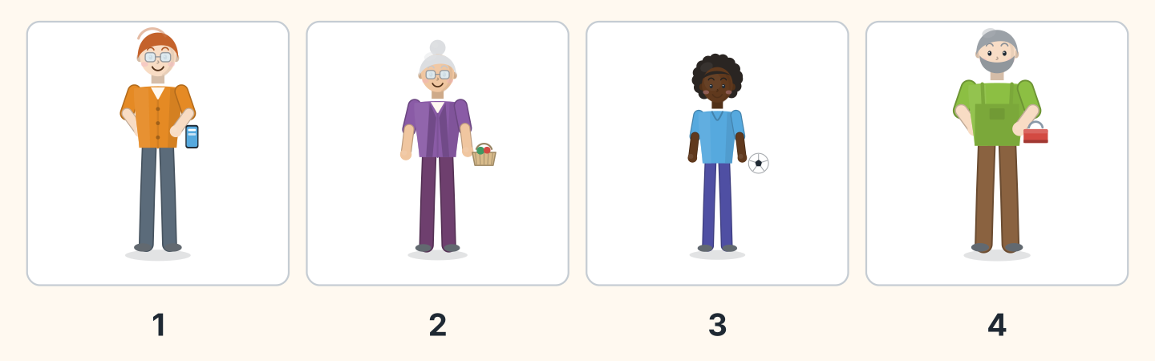
Figure 1.10 · Four voices.
- Ben — 1 (example)
- Rosa — ______
- Omar — ______
- Marek — ______
3B Listen. Look at Figure 1.11. Complete the class list.
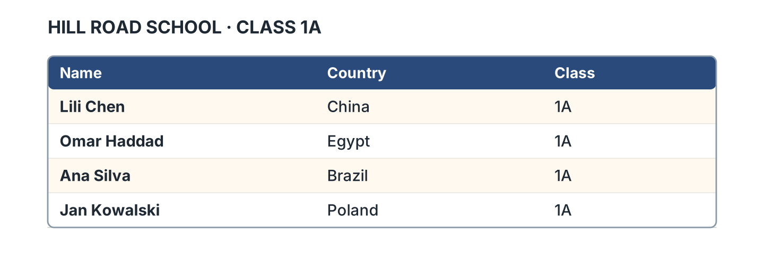
Figure 1.11 · The class list.
- Lili Chen is from China. (China) (example)
- Omar Haddad is from ______________.
- Ana Silva is from ______________.
- Jan Kowalski is from ______________.
3C Listen. Look at Figure 1.12. Tick the country.
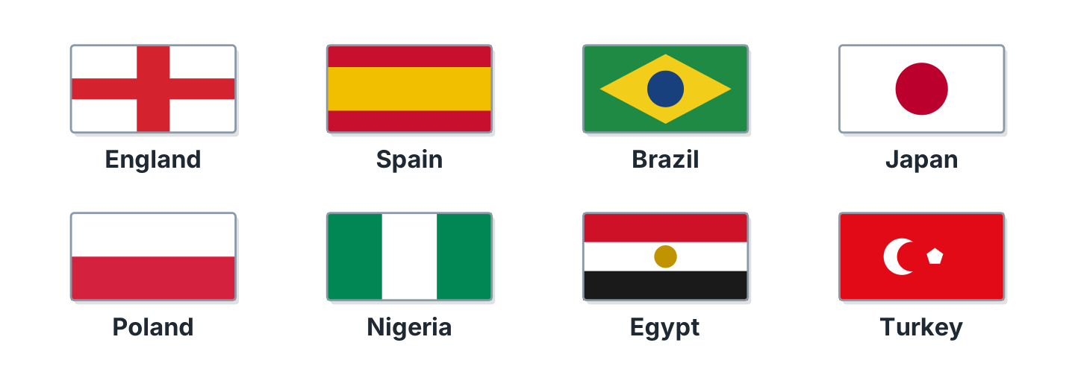
Figure 1.12 · Eight countries.
- Japan ✓ (example)
- Spain — ______
- Turkey — ______
- Nigeria — ______
- England — ______
3D Listen. Write the name.
- B-E-N — Ben (example)
- ______________
- ______________
- ______________
Part 4 · Speaking
4A Look at Figure 1.13. Ask and answer with a friend.

Figure 1.13 · A question and an answer.
- A: What’s your name? B: I’m Lili. (example)
- A: What’s your name? B: ______________
- A: Where are you from? B: ______________
- A: Are you a student? B: ______________
4B Spell your name. Then spell your friend’s name.
- L-I-L-I (example)
- Spell your first name.
- Spell your surname.
- Spell your friend’s first name.
4C Look at Figure 1.14. Introduce a friend.
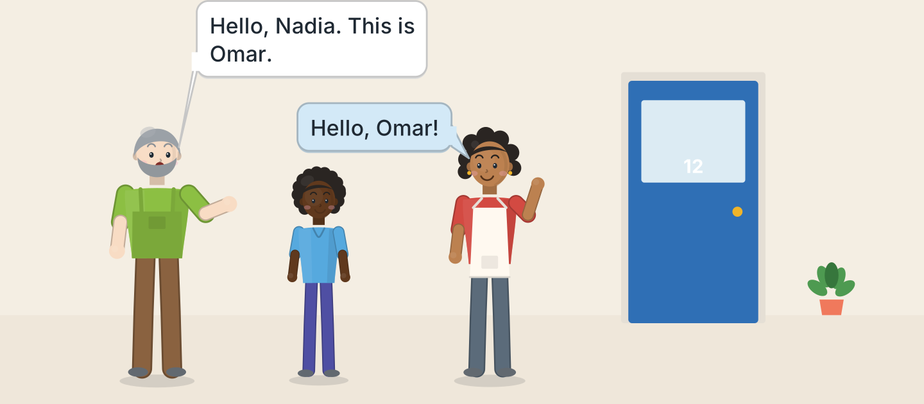
Figure 1.14 · Marek introduces Omar.
- Hello, Nadia. This is Omar. (example)
- Say hello.
- Say your friend’s name.
- Your friend says hello.
4D Say goodbye to three people.
- Goodbye, Sam. (example)
- Goodbye, ______________.
- Bye, ______________.
- Goodbye, ______________.
Part 5 · Reading
5A Look at Figure 1.15. Answer yes or no.
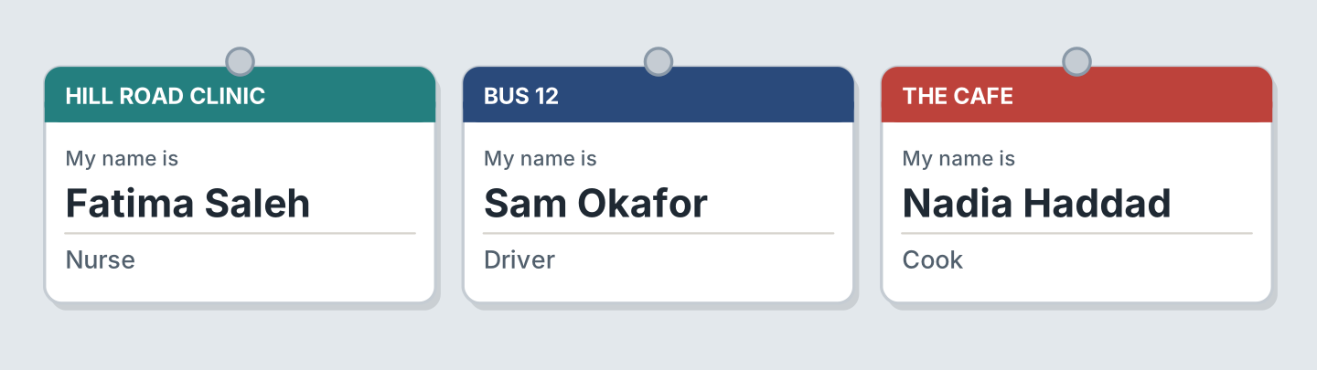
Figure 1.15 · Three name badges.
- Fatima is a nurse. — yes (example)
- Sam is a cook. — ______
- Nadia is at the cafe. — ______
- Fatima is at the clinic. — ______
- Sam is a driver. — ______
5B Look at Figure 1.15. Complete the sentences.
Words: cook · driver · nurse · clinic
- Fatima is a nurse. (nurse) (example)
- Sam is a ______________.
- Nadia is a ______________.
- Fatima is at the ______________.
5C Look at Figure 1.16. Choose the correct answer.
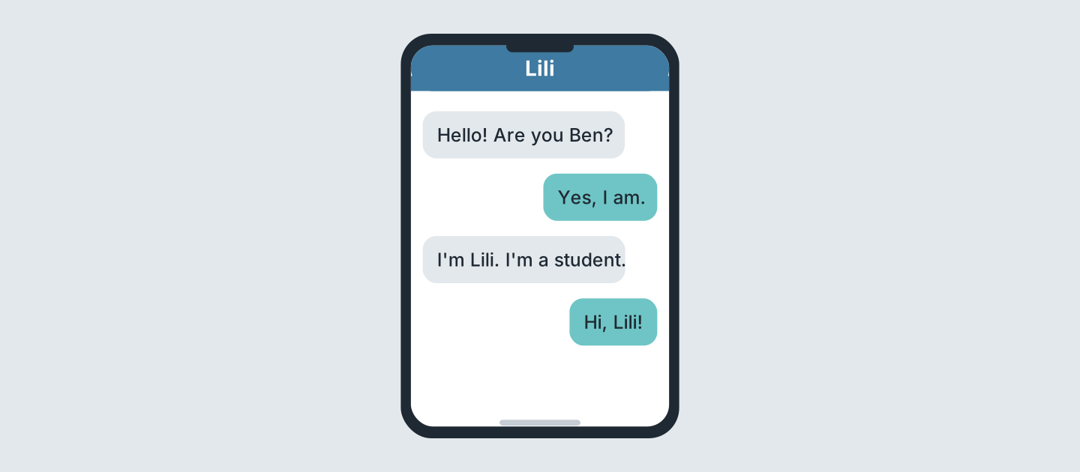
Figure 1.16 · Two messages.
- Who is the student? (a) Ben (b) Lili (c) Sam — b (example)
- Who writes first? (a) Lili (b) Ben (c) Nadia
- Is Ben there? (a) yes (b) no (c) we do not know
- What is Lili? (a) a cook (b) a driver (c) a student
5D Read and correct. Write the correct word.
- Lili is a nurse. — student (example)
- Ben is a student. — ______________
- Fatima is a cook. — ______________
- Sam is a teacher. — ______________
Part 6 · Writing
6A Look at Figure 1.17. Complete the form for you.
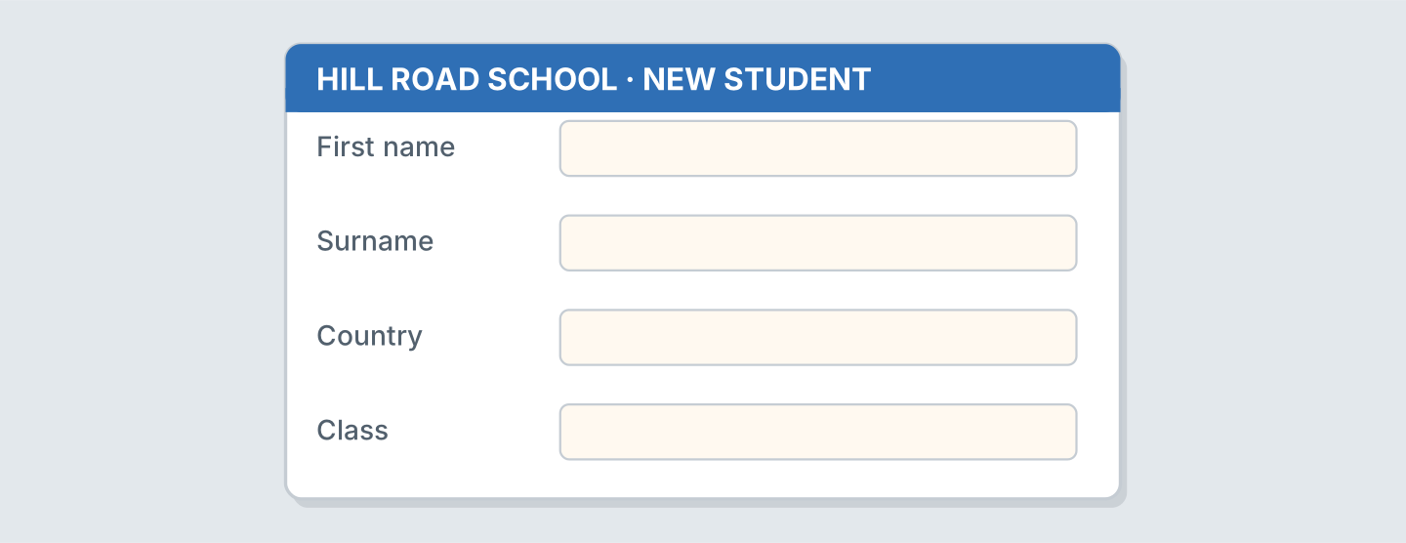
Figure 1.17 · A form for a new student.
- First name: Lili (example)
- First name: ______________
- Surname: ______________
- Country: ______________
6B Look at Figure 1.18. Write three sentences about you.
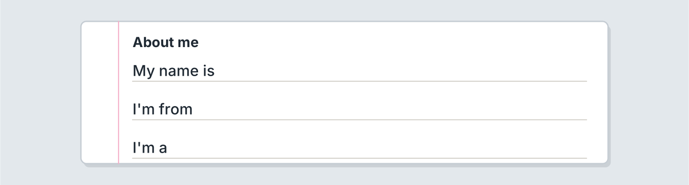
Figure 1.18 · Three lines about you.
- My name is Lili. (example)
- My name is ______________.
- I’m from ______________.
- I’m a ______________.
6C Write a message to a new friend. Write three lines.
- Hello! I’m Lili. (example)
- Say hello.
- Say your name.
- Say your country.
Part 7 · Real-World File
7A Look at Figure 1.19. Answer the questions.
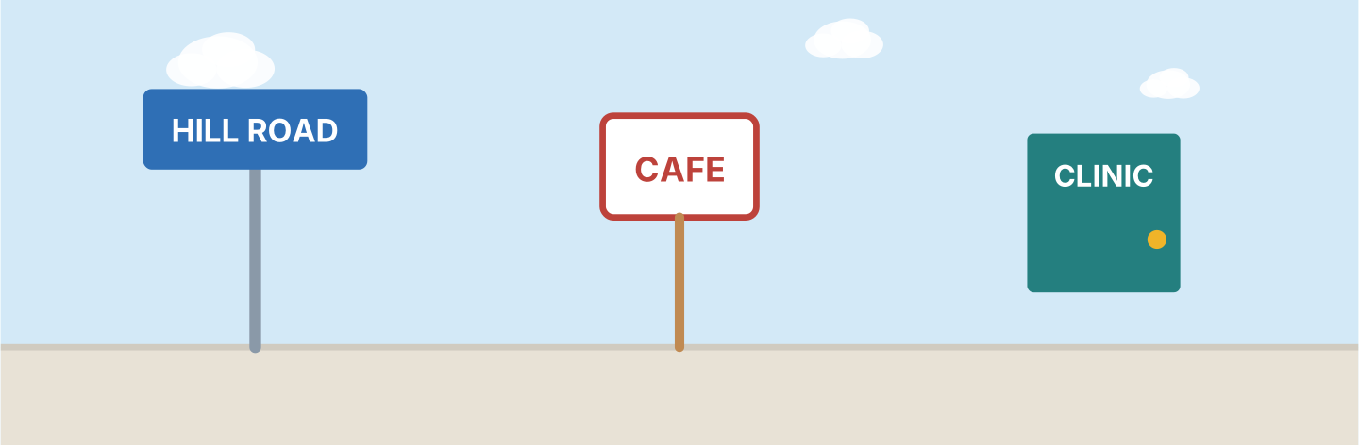
Figure 1.19 · Signs on Hill Road.
- What is the street? — Hill Road (example)
- Where is the cafe? — ______________
- Where is the nurse? — ______________
- What is the number of the bus? — ______________
7B Look at Figure 1.20. Write your name on the badge.

Figure 1.20 · A badge with no name.
- My name is Lili. (example)
- Write your first name.
- Write your surname.
- Write your school.
7C Look at Figure 1.11 again. Complete line 5 for you.
- Name: Lili Chen (example)
- Name: ______________
- Country: ______________
- Class: ______________
Part 8 · Review & Can-Do
8A Look at Figure 1.21. Write the job.
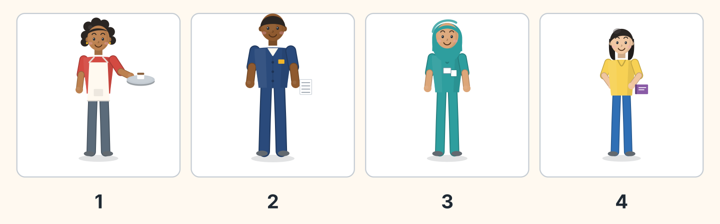
Figure 1.21 · Four people to name.
Words: cook · driver · nurse · student · teacher
- 1 — cook (example)
- 2 — ______________
- 3 — ______________
- 4 — ______________
8B Complete the conversation.
Words: am · Hello · name · you
- A: Hello. I’m Sam. (Hello) (example)
- B: Hi, Sam. My ______ is Lili.
- A: Are ______ a student?
- B: Yes, I ______.
8C Write the numbers.
- 3 — three (example)
- 6 — ______________
- 8 — ______________
- 10 — ______________
8D Match the person and the country.
Person | Country
1 Lili | a Egypt
2 Omar | b Poland
3 Ana | c China
4 Jan | d Brazil
 | e Japan
One option is not needed.
- 1 — c (example)
- 2 — ______
- 3 — ______
- 4 — ______
8E Look at Figure 1.22. Tick what you can do.
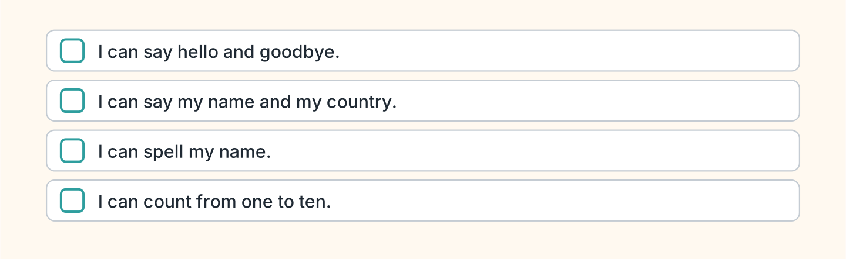
Figure 1.22 · What I can do.
- I can say hello and goodbye. — ✓ (example)
- I can say my name and my country. — ______
- I can spell my name. — ______
- I can count from one to ten. — ______

Unit 2: In the Class
In this unit you name things in the class. You ask questions. You say no.
Warm Up
W1 Look at Figure 2.1. Tick the things you can see.
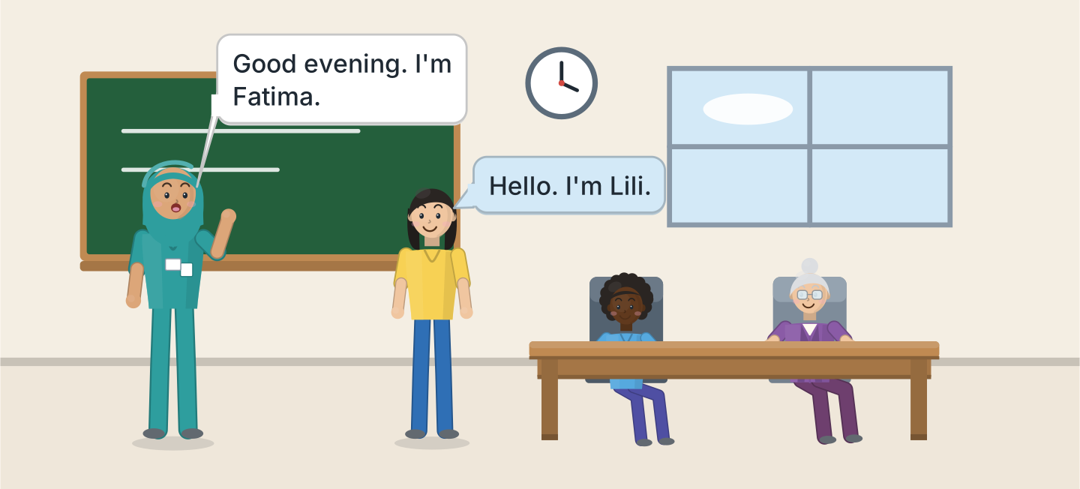
Figure 2.1 · The evening class.
- a board — ✓ (example)
- a window — ______
- a clock — ______
- a desk — ______
- a chair — ______
W2 Look at Figure 2.2. Write the word.
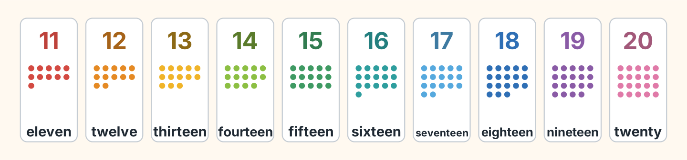
Figure 2.2 · Eleven to twenty.
- 11 — eleven (example)
- 13 — ______________
- 15 — ______________
- 18 — ______________
- 20 — ______________
W3 Count from eleven to twenty with a friend.
- eleven, twelve, thirteen (example)
- Count from 11 to 15.
- Count from 16 to 20.
- Count from 11 to 20.
Part 1 · Words & Sounds
1A Look at Figure 2.3. Write the word.
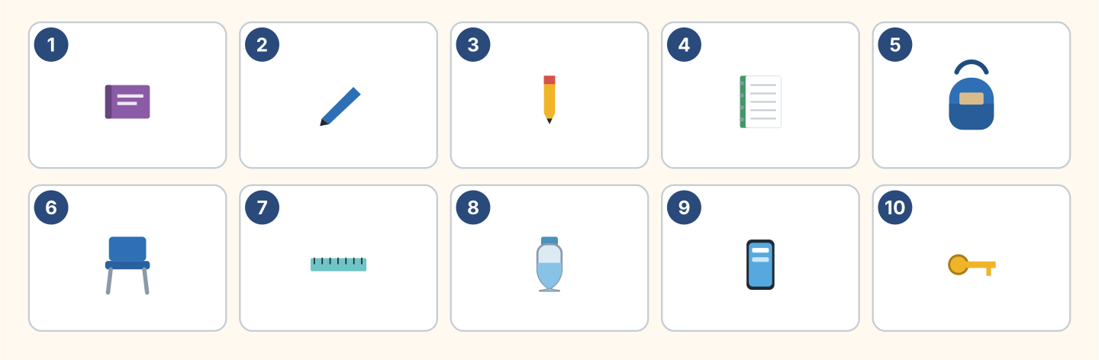
Figure 2.3 · Ten things in the class.
Words: bag · book · bottle · chair · key · notebook · pen · pencil · phone · ruler
- 1 — book (example)
- 2 — ______________
- 3 — ______________
- 6 — ______________
- 10 — ______________
1B Look at Figure 2.4. Write a or an.
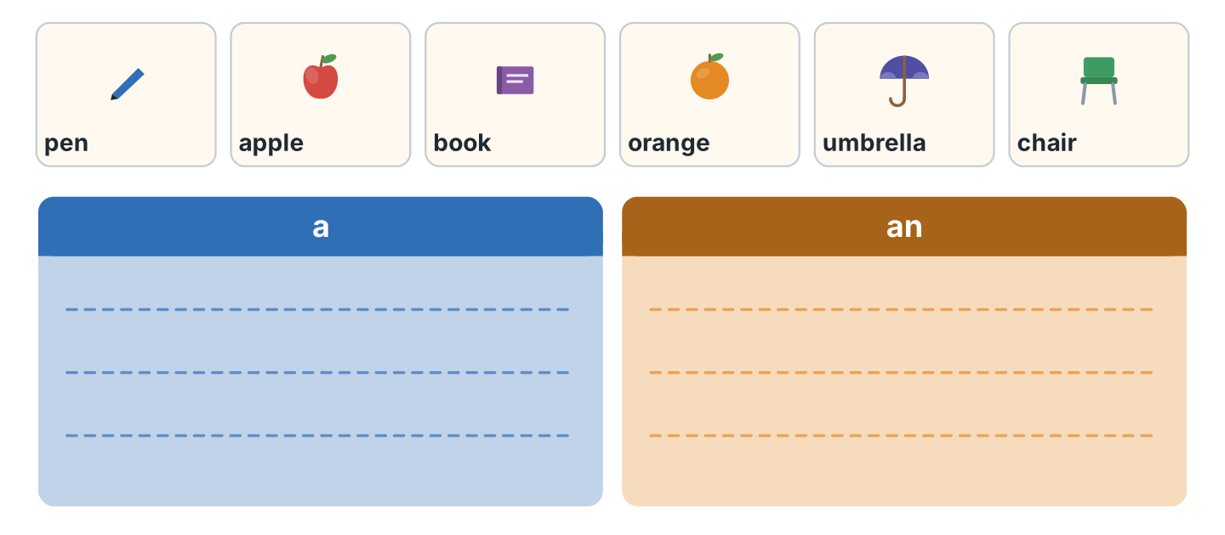
Figure 2.4 · a or an.
- a pen (example)
- ______ apple
- ______ book
- ______ orange
- ______ umbrella
1C Say it. Listen to the first sound. Then say a or an.
- a pen (example)
- an apple
- a chair
- an orange
- an umbrella
1D Look at Figure 2.5. Write this or that.
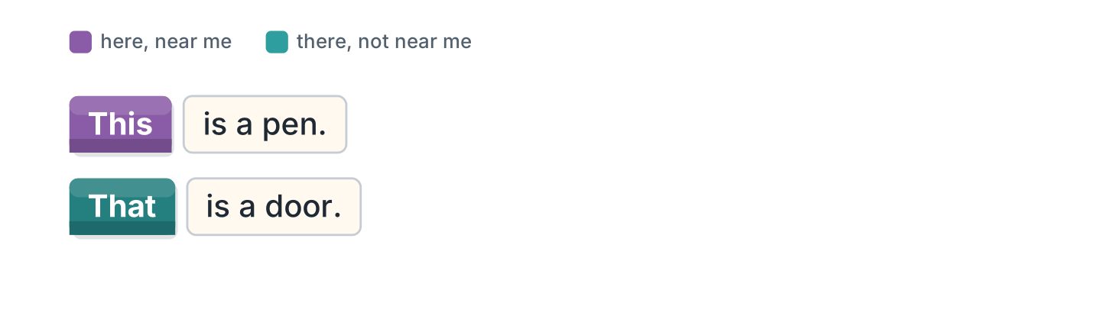
Figure 2.5 · this and that.
- This is a pen. (This) (example)
- ______ is a door.
- ______ is my bag. It is here.
- ______ is the board. It is there.
1E Look at Figure 2.6. Match the job and the place.
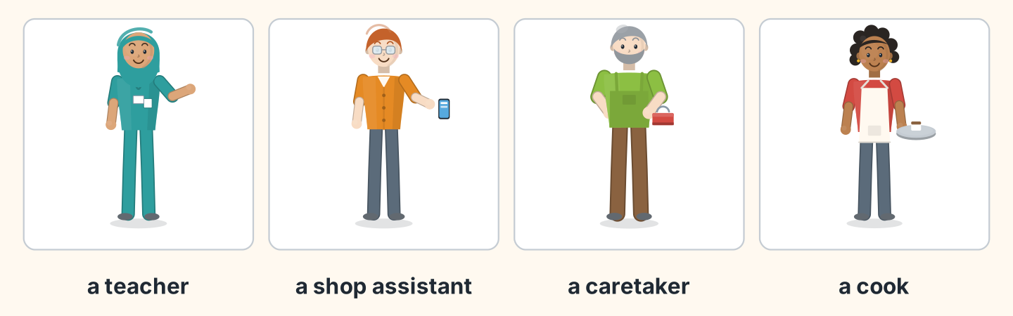
Figure 2.6 · Four jobs.
Job | Place
1 a teacher | a the cafe
2 a shop assistant | b the school
3 a caretaker | c the shop
4 a cook | d the flats
 | e the clinic
One option is not needed.
- 1 — b (example)
- 2 — ______
- 3 — ______
- 4 — ______
1F Write the number.
- fourteen — 14 (example)
- twelve — ______
- seventeen — ______
- nineteen — ______
- twenty — ______
Part 2 · Grammar
2A Look at Figure 2.7. Write the question.
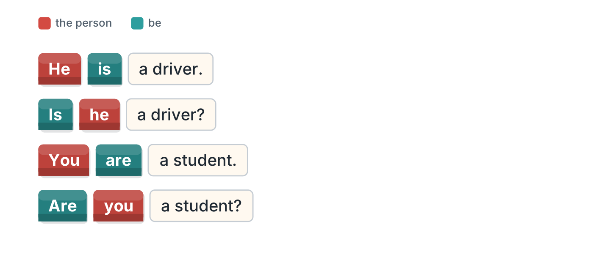
Figure 2.7 · A sentence and a question.
- He is a driver. — Is he a driver? (example)
- She is a nurse. — ______________
- You are a student. — ______________
- It is a pen. — ______________
2B Complete the question with Is or Are.
- Is he a teacher? (Is) (example)
- ______ you from Poland?
- ______ she in Room 11?
- ______ it your bag?
- ______ they students?
2C Look at Figure 2.8. Write the short form.
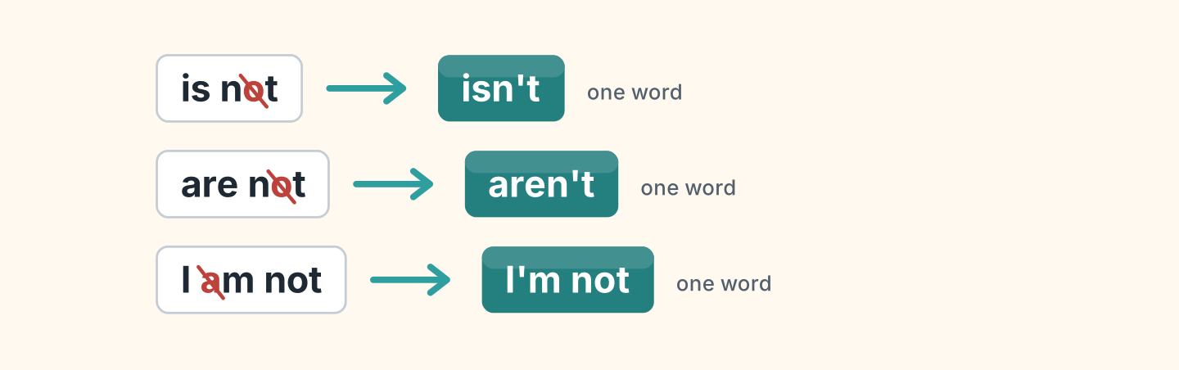
Figure 2.8 · The short negative.
- is not — isn’t (example)
- are not — ______________
- I am not — ______________
2D Complete with isn’t or aren’t.
- He isn’t a cook. (isn’t) (example)
- She ______________ a doctor.
- They ______________ in Room 12.
- It ______________ my pen.
- You ______________ in my class.
2E Look at Figure 2.9. Write the answer.
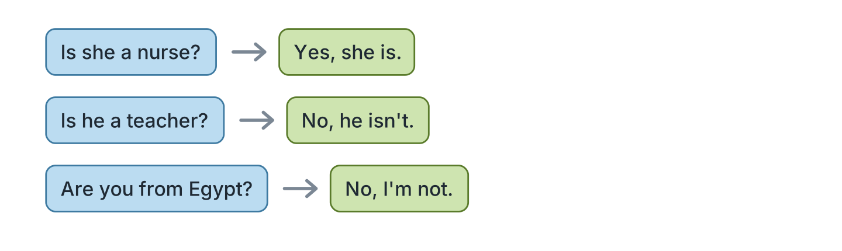
Figure 2.9 · Yes and no answers.
- Is she a nurse? — Yes, she is. (example)
- Is he a teacher? ✗ — ______________
- Are you from Egypt? ✗ — ______________
- Is it your book? ✓ — ______________
2F Find the mistake. Write the correct word.
- Is you a student? — Are (example)
- She not is a teacher. — ______________
- Are he in Room 11? — ______________
- It aren’t my bag. — ______________
Part 3 · Listening
3A Listen. Look at Figure 2.10. Write the number.
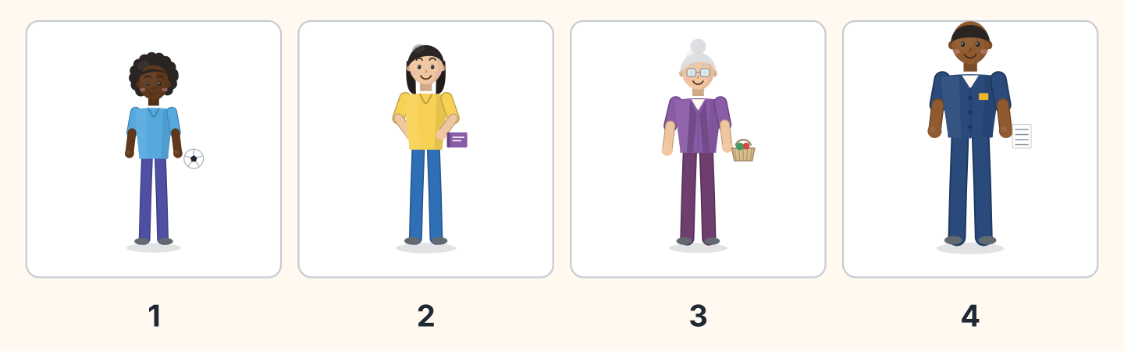
Figure 2.10 · Four people in the class.
- Omar — 1 (example)
- Lili — ______
- Rosa — ______
- Sam — ______
3B Listen. Look at Figure 2.11. Complete the timetable.
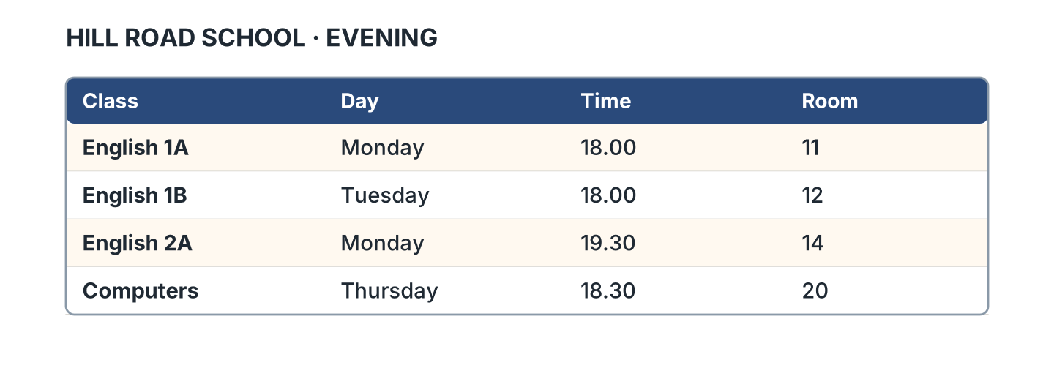
Figure 2.11 · The evening timetable.
- English 1A is on Monday. (Monday) (example)
- English 1B is in Room ______.
- English 2A is at ______________.
- Computers is on ______________.
3C Listen. Look at Figure 2.12. Write the number you hear.
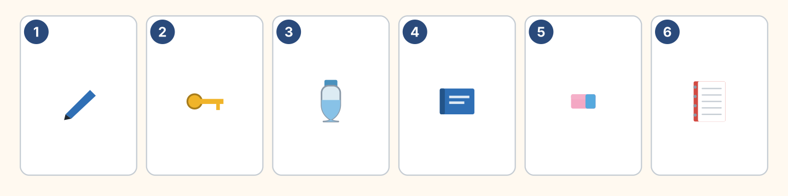
Figure 2.12 · Six things on a desk.
- a pen — 1 (example)
- a bottle — ______
- a book — ______
- a notebook — ______
3D Listen. Write the room number.
- Fatima — Room 11 (example)
- Lili — Room ______
- Omar — Room ______
- Rosa — Room ______
Part 4 · Speaking
4A Look at Figure 2.13. Ask and answer about five things.
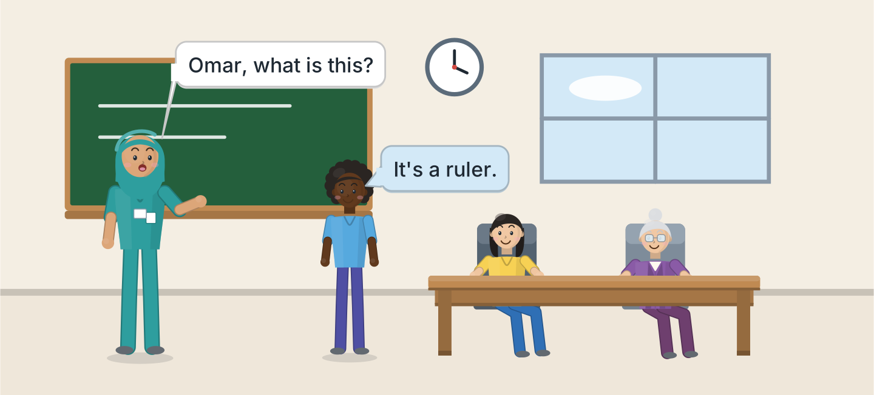
Figure 2.13 · Asking in the class.
- A: What is this? B: It’s a ruler. (example)
- Ask about a pen.
- Ask about a book.
- Ask about a chair.
- Ask about a window.
4B Look at Figure 2.14. Ask and answer with a friend.
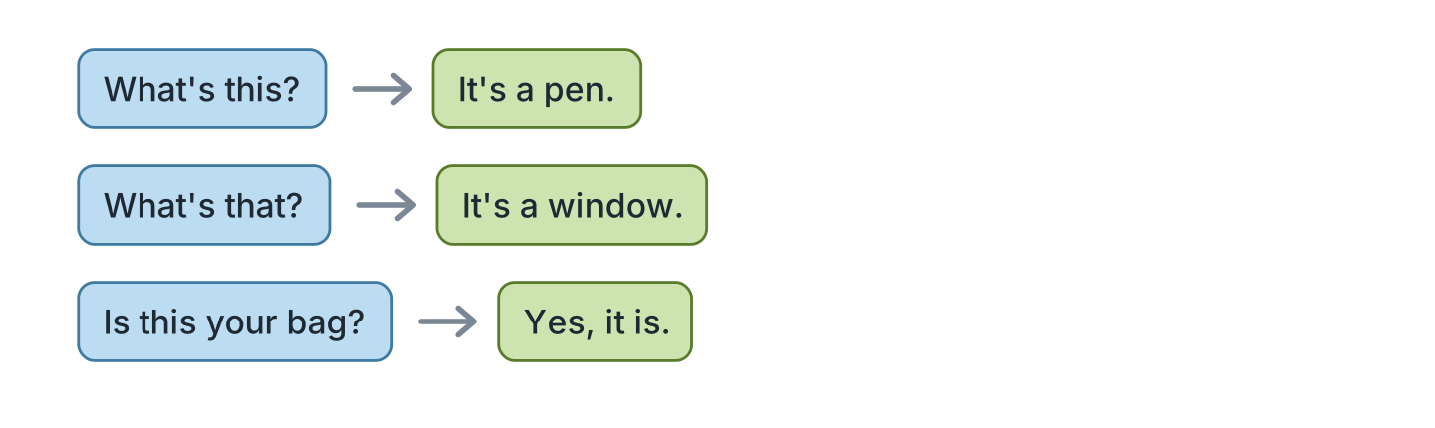
Figure 2.14 · Ask and answer.
- A: What’s this? B: It’s a pen. (example)
- A: What’s that? B: ______________
- A: Is this your bag? B: ______________
- A: Is that your pencil? B: ______________
4C Ask three friends about their class.
- A: Are you in Class 1A? B: Yes, I am. (example)
- Ask about the class.
- Ask about the room.
- Ask about the teacher.
4D Say these things to your teacher.
- Sorry. Again, please. (example)
- Open your book, please.
- What is this in English?
- Thank you.
Part 5 · Reading
5A Look at Figure 2.15. Answer the questions.
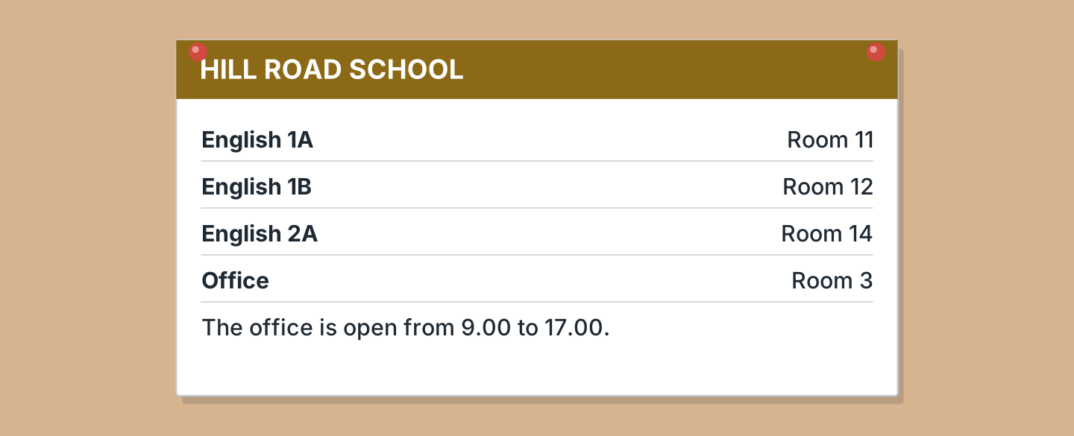
Figure 2.15 · A notice at the school.
- Where is English 1A? — Room 11 (example)
- Where is English 1B? — ______________
- Where is the office? — ______________
- Where is English 2A? — ______________
5B Look at Figure 2.15. Answer yes or no.
- English 1A is in Room 11. — yes (example)
- The office is in Room 14. — ______
- The office is open at 10.00. — ______
- English 2A is in Room 12. — ______
5C Look at Figure 2.16. Choose the correct answer.
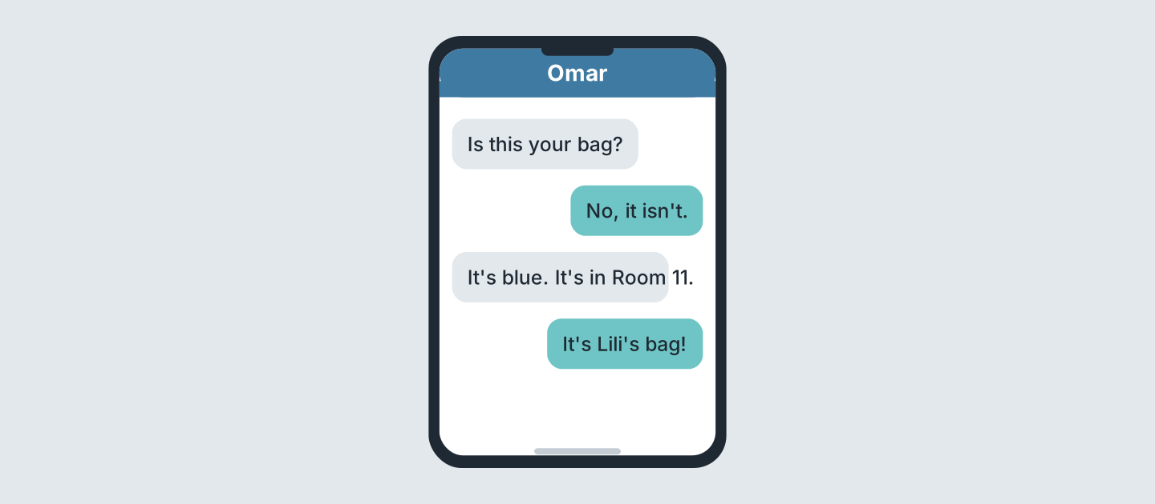
Figure 2.16 · Messages about a bag.
- Who writes first? (a) Omar (b) Lili (c) Rosa — a (example)
- What colour is the bag? (a) red (b) blue (c) black
- Where is the bag? (a) Room 11 (b) Room 12 (c) Room 14
- Whose bag is it? (a) Omar’s (b) Lili’s (c) Rosa’s
5D Read and correct. Write the correct word.
- The bag is red. — blue (example)
- The bag is in Room 14. — ______________
- The office is in Room 11. — ______________
- English 1B is on Monday. — ______________
Part 6 · Writing
6A Look at Figure 2.17. Complete the card for you.
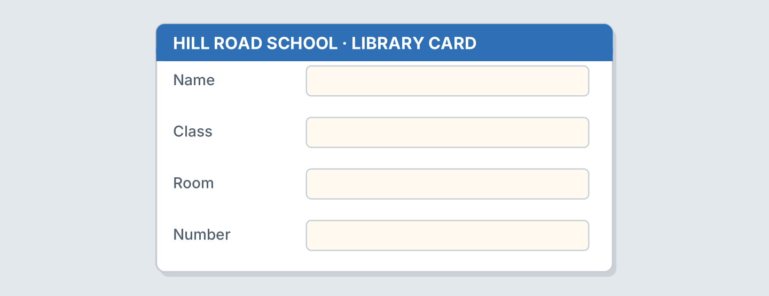
Figure 2.17 · A card for the library.
- Name: Omar Haddad (example)
- Name: ______________
- Class: ______________
- Room: ______________
6B Look at Figure 2.18. Write four lines about your class.
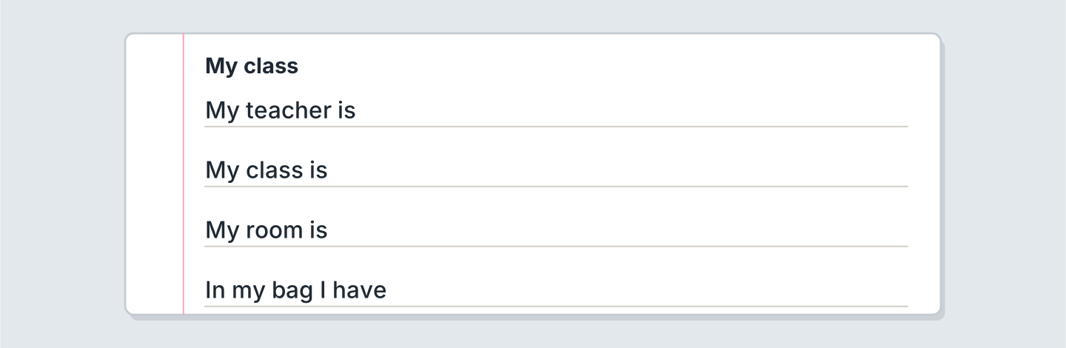
Figure 2.18 · Four lines about your class.
- My teacher is Fatima. (example)
- My teacher is ______________.
- My class is ______________.
- My room is ______________.
6C Write a message about a lost bag. Write three lines.
- Is this your bag? (example)
- Ask about the bag.
- Say the colour.
- Say the room.
Part 7 · Real-World File
7A Look at Figure 2.19. Answer the questions.
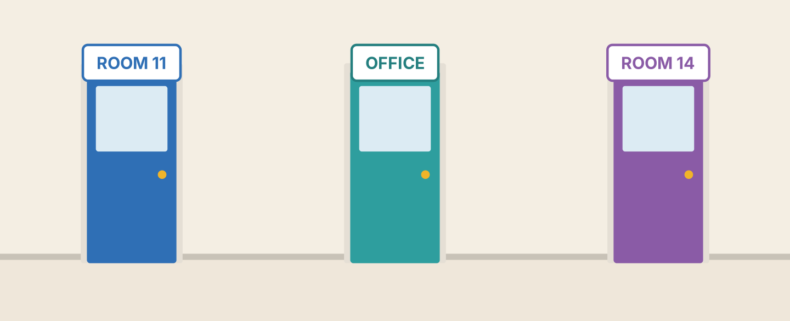
Figure 2.19 · Three doors at the school.
- What is the first room? — Room 11 (example)
- What is the second door? — ______________
- What is the third room? — ______________
- Is Room 12 here? — ______
7B Look at Figure 2.20. Complete the sentences.
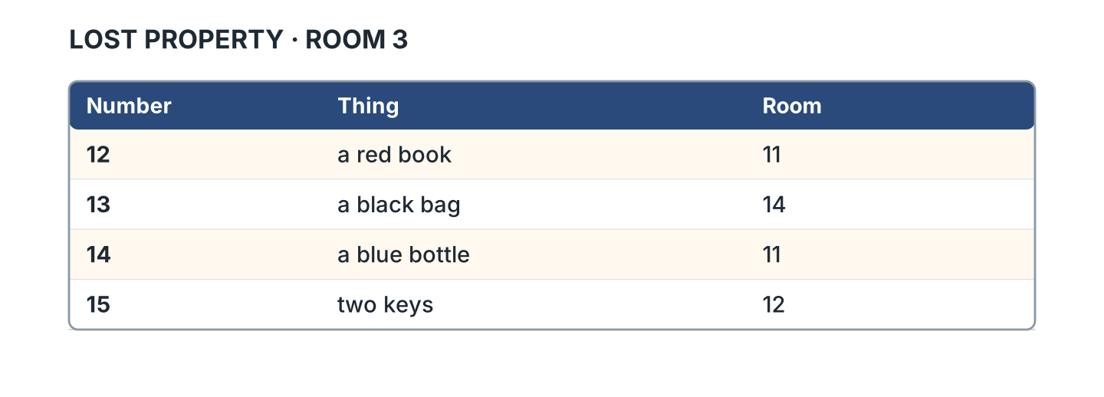
Figure 2.20 · The lost property list.
- Number 12 is a red book. (book) (example)
- Number 13 is a black ______________.
- Number 14 is a blue ______________.
- Number 15 is two ______________.
7C Look at Figure 2.20. Write line 16 for your thing.
- 16 · a green pen · Room 11 (example)
- Number: ______________
- Thing: ______________
- Room: ______________
Part 8 · Review & Can-Do
8A Look at Figure 2.21. Write the word.
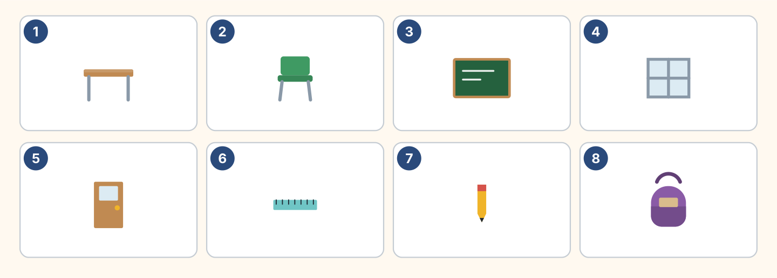
Figure 2.21 · Eight things from this unit.
Words: bag · board · chair · desk · door · pencil · ruler · window
- 1 — desk (example)
- 3 — ______________
- 4 — ______________
- 5 — ______________
- 8 — ______________
8B Complete the conversation.
Words: isn’t · It’s · this · What
- A: What is this? (What) (example)
- B: ______ a ruler.
- A: Is ______ your ruler?
- B: No, it ______. It’s Lili’s.
8C Write the numbers.
- 16 — sixteen (example)
- 11 — ______________
- 14 — ______________
- 19 — ______________
8D Write a or an.
- a desk (example)
- ______ orange
- ______ window
- ______ umbrella
- ______ ruler
8E Look at Figure 2.22. Tick what you can do.
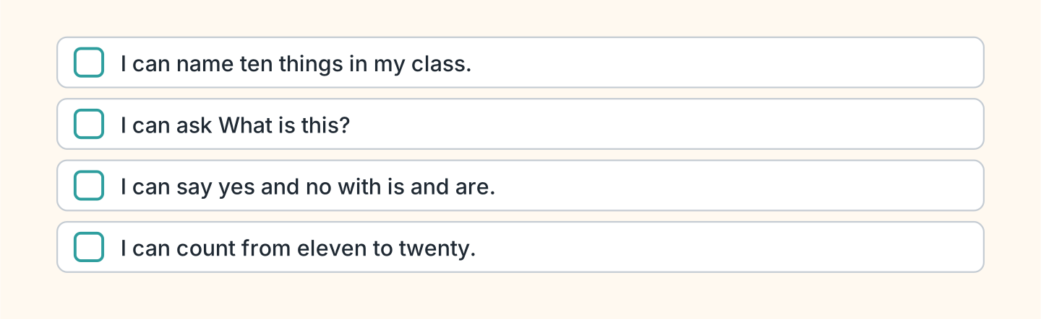
Figure 2.22 · What I can do.
- I can name ten things in my class. — ✓ (example)
- I can ask What is this? — ______
- I can say yes and no with is and are. — ______
- I can count from eleven to twenty. — ______

Unit 3: Who’s This?
In this unit you talk about your family. You count to a hundred.
Warm Up
W1 Look at Figure 3.1. Write the name.
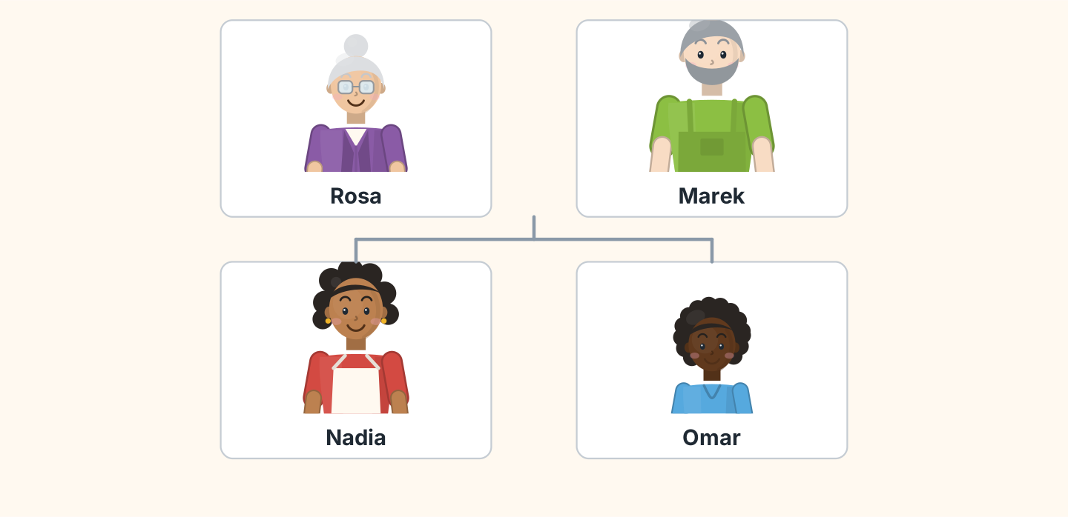
Figure 3.1 · Marek’s family.
- the grandmother — Rosa (example)
- the father — ______________
- the mother — ______________
- the son — ______________
W2 Look at Figure 3.2. Write the word.
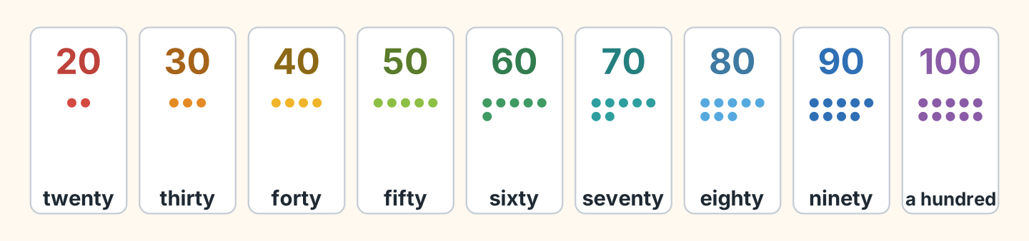
Figure 3.2 · Twenty to a hundred.
- 20 — twenty (example)
- 40 — ______________
- 60 — ______________
- 90 — ______________
- 100 — ______________
W3 Say the numbers to a friend.
- twenty, thirty, forty (example)
- Count 20, 30, 40, 50.
- Count 60, 70, 80.
- Say your age.
Part 1 · Words & Sounds
1A Look at Figure 3.3. Match the person and the word.
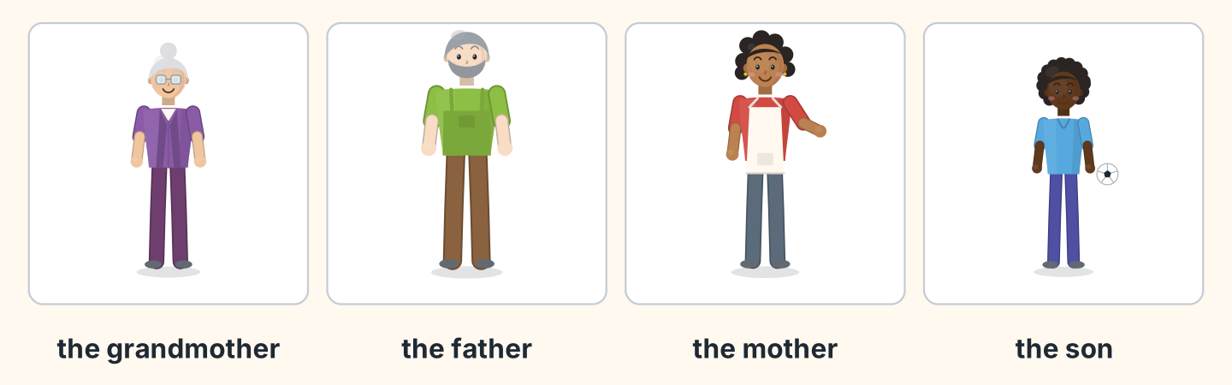
Figure 3.3 · Four people in a family.
Person | Word
1 Rosa | a the son
2 Marek | b the grandmother
3 Nadia | c the daughter
4 Omar | d the father
 | e the mother
One option is not needed.
- 1 — b (example)
- 2 — ______
- 3 — ______
- 4 — ______
1B Look at Figure 3.4. Write one or two.
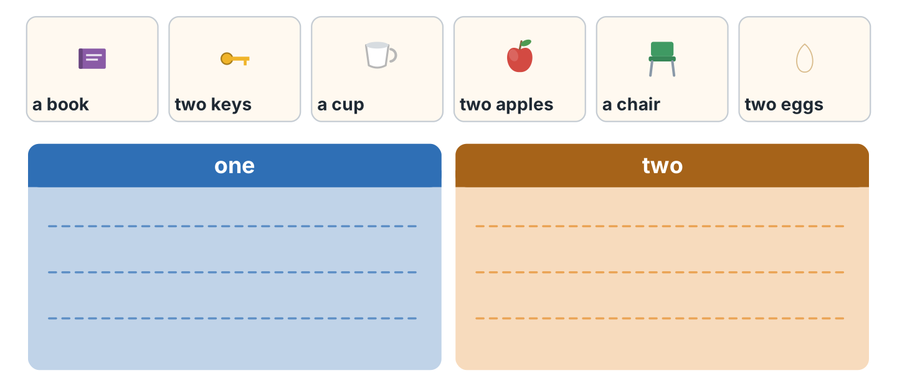
Figure 3.4 · One and two.
- a book — one (example)
- two keys — ______________
- a cup — ______________
- two apples — ______________
- two eggs — ______________
1C Look at Figure 3.5. Write the plural.
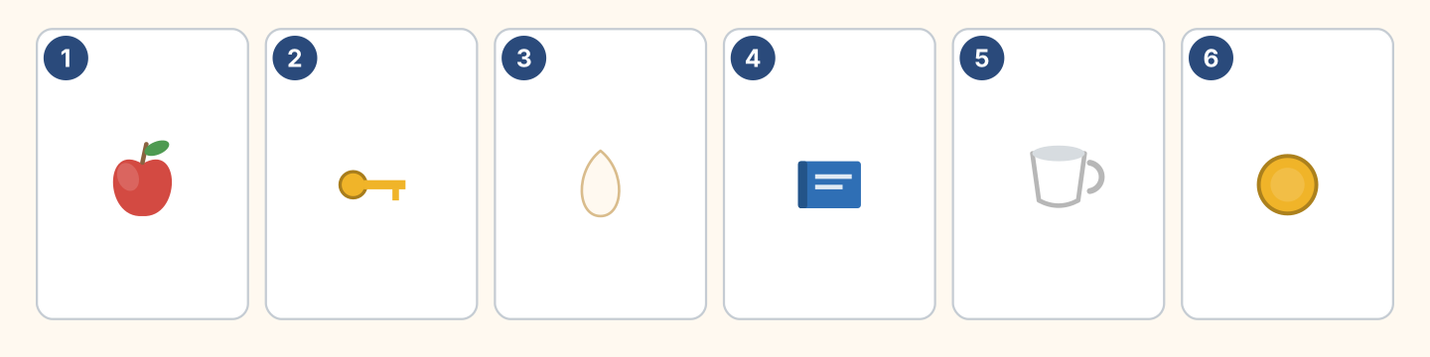
Figure 3.5 · Six things to count.
- one apple — two apples (example)
- one key — two ______________
- one egg — two ______________
- one cup — two ______________
1D Say it. Say the plural of these words.
- book — books (example)
- key
- sister
- watch
- family
1E Look at Figure 3.6. Write the sentence.
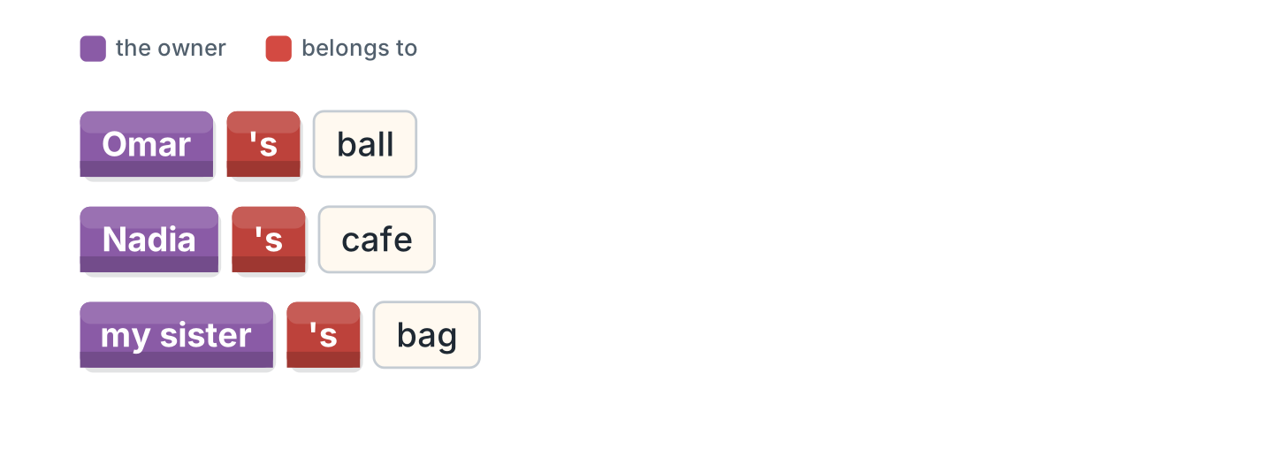
Figure 3.6 · The ’s of the owner.
- the ball of Omar — Omar’s ball (example)
- the cafe of Nadia — ______________
- the bag of my sister — ______________
- the son of Marek — ______________
1F Write the number.
- seventy — 70 (example)
- thirty — ______
- fifty — ______
- eighty — ______
- a hundred — ______
Part 2 · Grammar
2A Look at Figure 3.7. Complete with our or their.
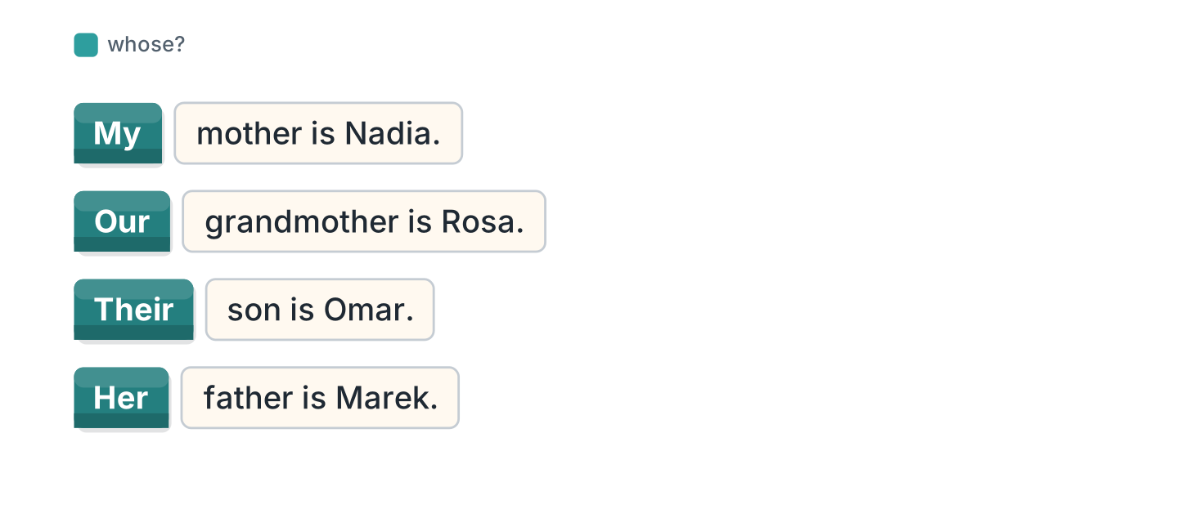
Figure 3.7 · our and their.
- My mother is Nadia. (My) (example)
- ______ grandmother is Rosa.
- ______ son is Omar.
- ______ father is a driver.
2B Choose the correct word.
- This is (my / me) sister. — my (example)
- Rosa is (her / she) grandmother.
- (Our / We) father is Marek.
- (They / Their) son is nine.
- (He / His) name is Omar.
2C Look at Figure 3.8. Write the plural.
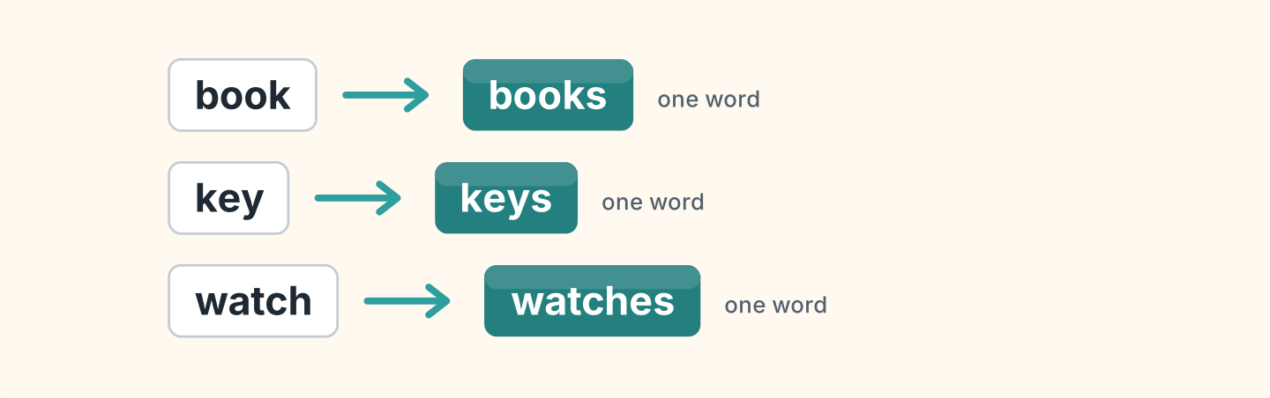
Figure 3.8 · One book, two books.
- one book — two books (example)
- one key — ______________
- one watch — ______________
- one family — ______________
2D Write the answer with ’s.
- Whose bag is it? (Lili) — It’s Lili’s bag. (example)
- Whose ball is it? (Omar) — ______________
- Whose cafe is it? (Nadia) — ______________
- Whose keys are they? (Marek) — ______________
2E Look at Figure 3.9. Write the question.
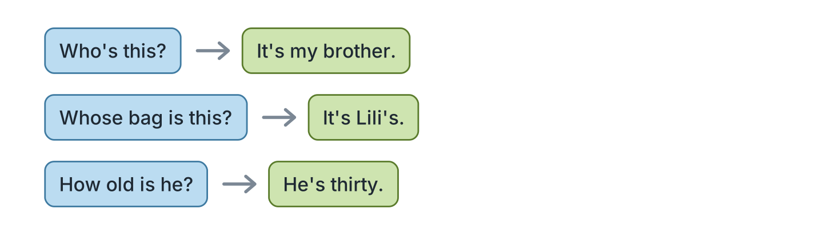
Figure 3.9 · Who and whose.
- It’s my brother. — Who’s this? (example)
- It’s Lili’s. — ______________
- He’s thirty. — ______________
- She’s my mother. — ______________
2F Find the mistake. Write the correct word.
- Whose this? — Who’s (example)
- He have two sister. — ______________
- This is the bag of Omar. — ______________
- Their is my mother. — ______________
Part 3 · Listening
3A Listen. Look at Figure 3.10. Write the number.
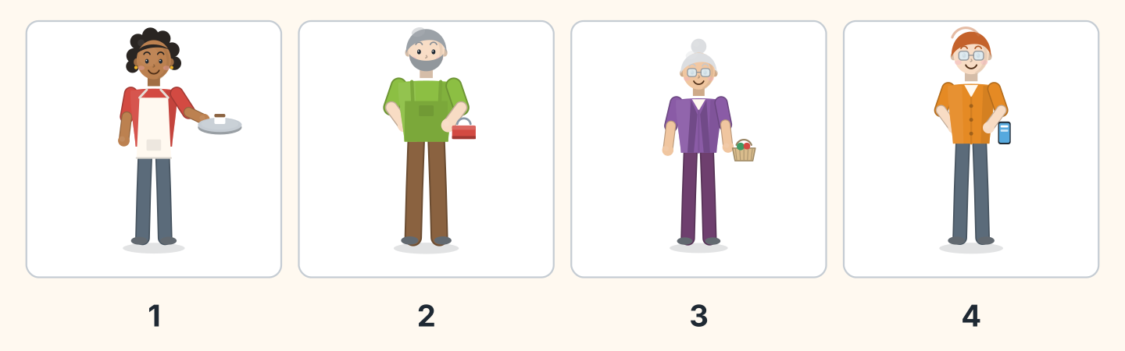
Figure 3.10 · Four people talking.
- Nadia — 1 (example)
- Marek — ______
- Rosa — ______
- Ben — ______
3B Listen. Look at Figure 3.11. Write the age.
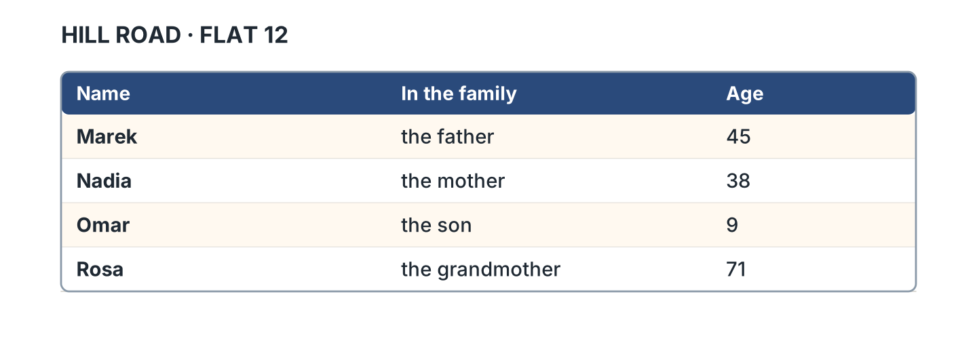
Figure 3.11 · A family list.
- Marek — 45 (example)
- Nadia — ______
- Omar — ______
- Rosa — ______
3C Listen. Look at Figure 3.12. Write yes or no.
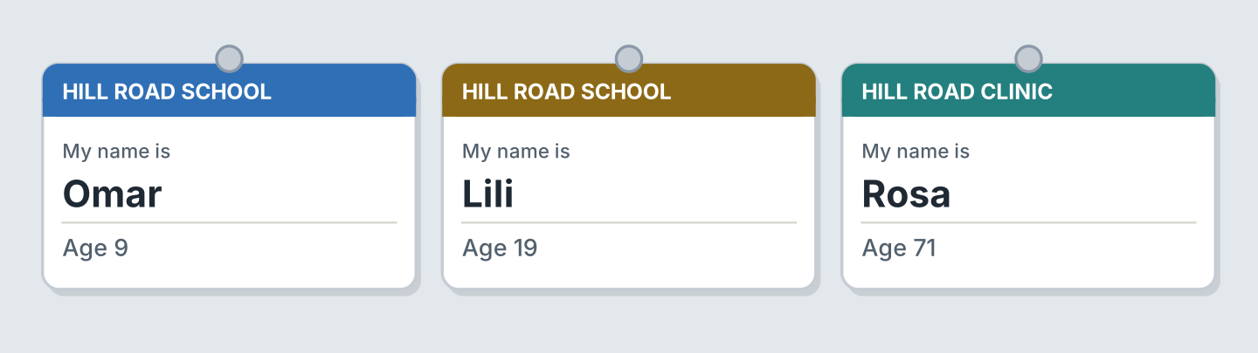
Figure 3.12 · Ages on three cards.
- Omar is nine. — yes (example)
- Lili is twenty. — ______
- Rosa is seventy-one. — ______
- Omar is at the clinic. — ______
3D Listen. Write the number you hear.
- thirty-five — 35 (example)
- ______
- ______
- ______
Part 4 · Speaking
4A Look at Figure 3.13. Introduce a person.
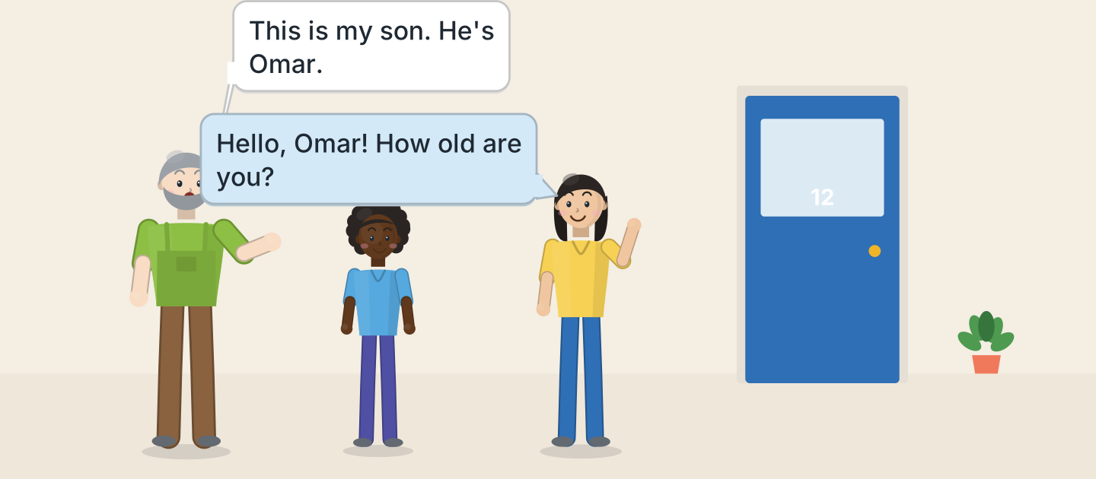
Figure 3.13 · Omar meets Lili.
- This is my son. He’s Omar. (example)
- Introduce a person in your family.
- Say the name.
- Say the age.
4B Look at Figure 3.14. Ask and answer.
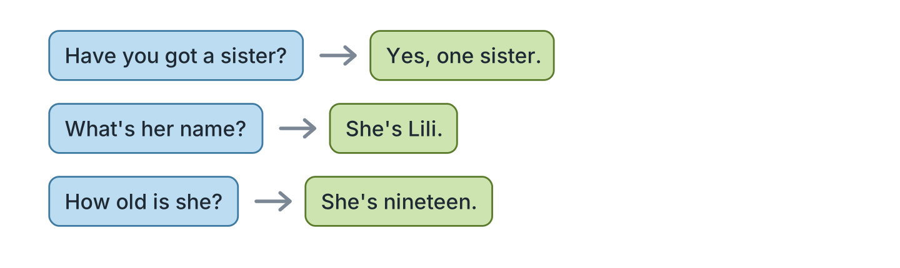
Figure 3.14 · Ask about a family.
- A: Have you got a sister? B: Yes, one sister. (example)
- A: What’s her name? B: ______________
- A: How old is she? B: ______________
- A: Where does she live? B: ______________
4C Ask three friends about a brother or a sister.
- A: Who’s this? B: This is my brother. (example)
- Ask about a brother.
- Ask about a sister.
- Ask the age.
4D Say the ages of four people you know.
- My mother is forty-two. (example)
- ______________
- ______________
- ______________
Part 5 · Reading
5A Look at Figure 3.15. Answer the questions.
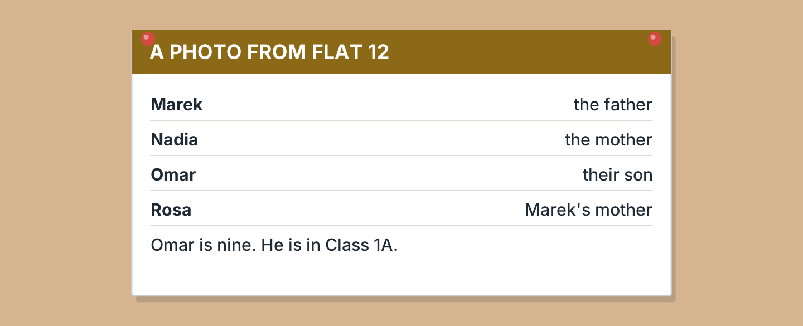
Figure 3.15 · A note about a photo.
- Who is the father? — Marek (example)
- Who is the mother? — ______________
- Who is their son? — ______________
- Whose mother is Rosa? — ______________
5B Look at Figure 3.15. Write yes or no.
- Omar is nine. — yes (example)
- Omar is in Class 1B. — ______
- Rosa is Nadia’s mother. — ______
- Marek is the father. — ______
5C Look at Figure 3.16. Choose the correct answer.
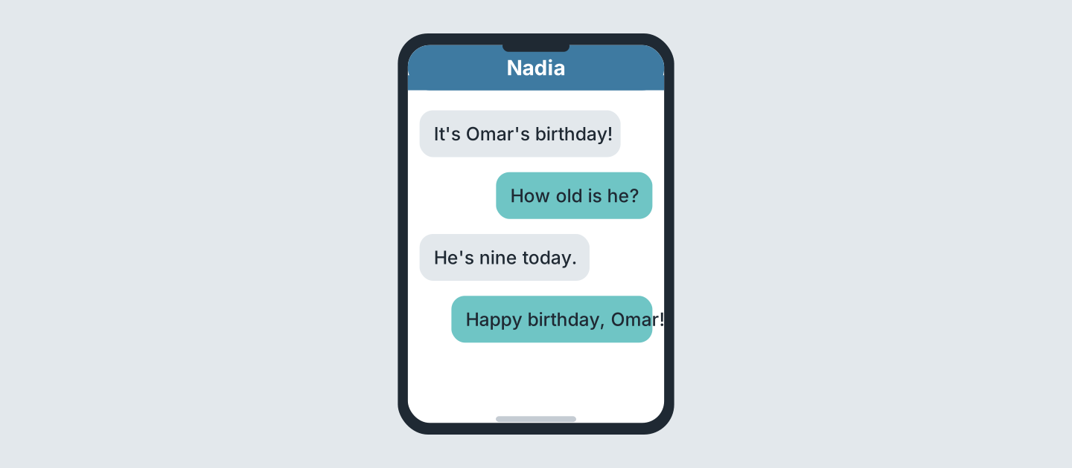
Figure 3.16 · Messages about a birthday.
- Whose birthday is it? (a) Nadia’s (b) Omar’s (c) Rosa’s — b (example)
- How old is he? (a) eight (b) nine (c) ten
- When is the birthday? (a) today (b) Monday (c) Sunday
- Who writes first? (a) Nadia (b) Omar (c) Rosa
5D Read and correct. Write the correct word.
- Omar is ten. — nine (example)
- Rosa is the mother. — ______________
- Nadia is forty-five. — ______________
- Omar is in Class 2A. — ______________
Part 6 · Writing
6A Look at Figure 3.17. Complete the card for you.
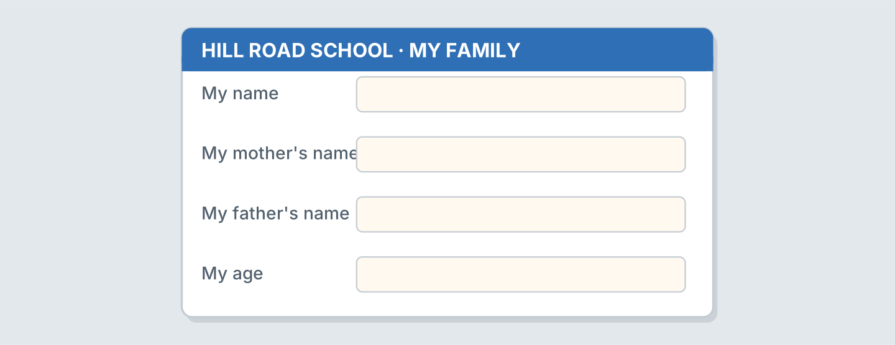
Figure 3.17 · A card for a family.
- My name: Omar Haddad (example)
- My name: ______________
- My mother’s name: ______________
- My age: ______________
6B Look at Figure 3.18. Write four lines.
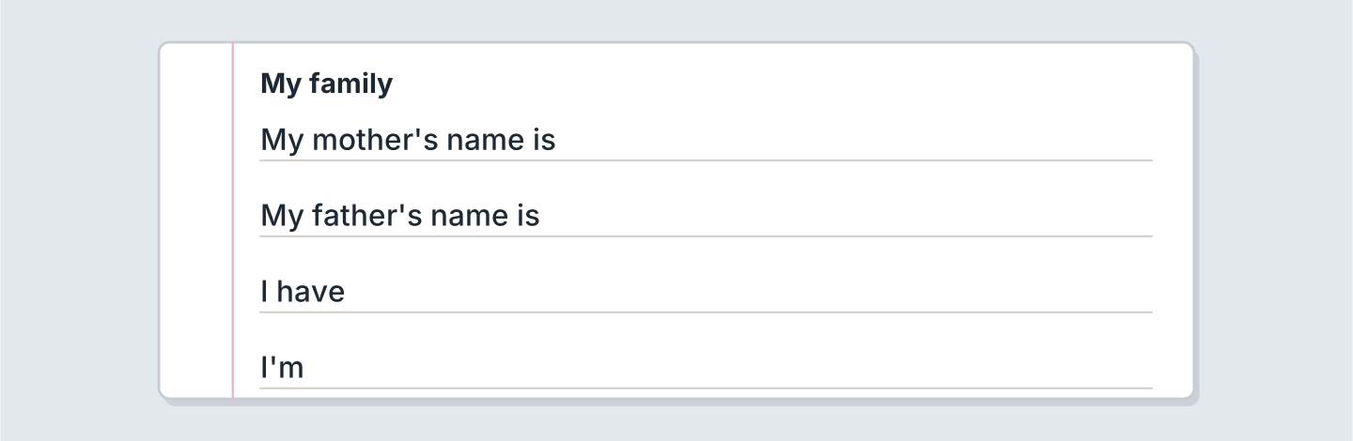
Figure 3.18 · Four lines about your family.
- My mother’s name is Nadia. (example)
- My mother’s name is ______________.
- My father’s name is ______________.
- I have ______________.
6C Write about a person in your family. Write three lines.
- This is my grandmother. (example)
- Say who the person is.
- Say the name.
- Say the age.
Part 7 · Real-World File
7A Look at Figure 3.19. Answer the questions.
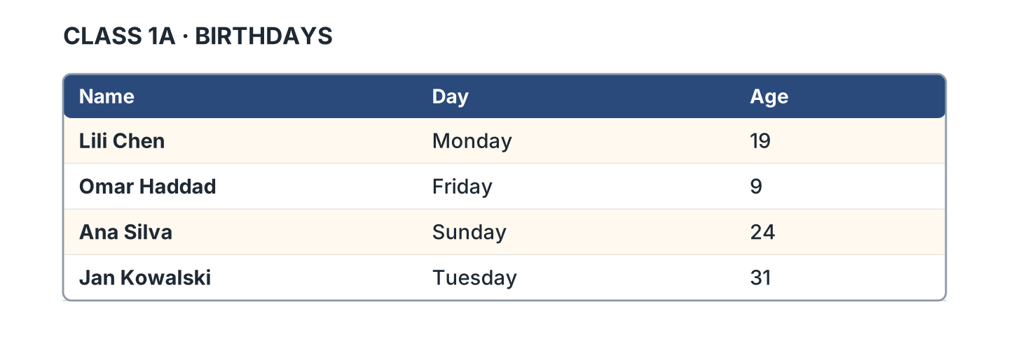
Figure 3.19 · A list of birthdays.
- Whose birthday is on Friday? — Omar’s (example)
- Whose birthday is on Monday? — ______________
- How old is Ana? — ______________
- Whose birthday is on Sunday? — ______________
7B Look at Figure 3.20. Write the age.
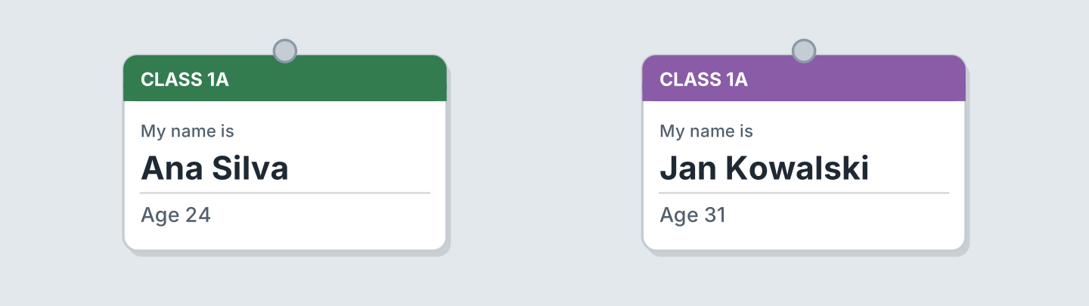
Figure 3.20 · Two cards with ages.
- Ana Silva — 24 (example)
- Jan Kowalski — ______
- Who is older? — ______________
- Who is in Class 1A? — ______________
7C Write your own card. Use Figure 3.20.
- Name: Ana Silva · Age 24 (example)
- Name: ______________
- Age: ______________
- Class: ______________
Part 8 · Review & Can-Do
8A Look at Figure 3.21. Write the word.
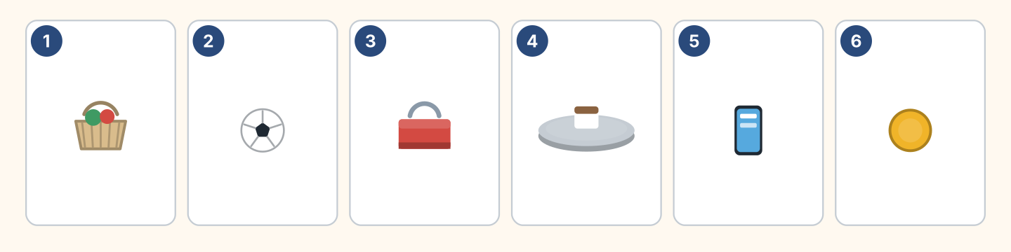
Figure 3.21 · Six people and things.
Words: ball · basket · coin · phone · toolbox · tray
- 1 — basket (example)
- 2 — ______________
- 3 — ______________
- 4 — ______________
- 6 — ______________
8B Complete the conversation.
Words: How · my · old · Who’s
- A: Who’s this? (Who’s) (example)
- B: This is ______ brother.
- A: ______ old is he?
- B: He’s twelve years ______.
8C Write the numbers.
- 45 — forty-five (example)
- 30 — ______________
- 70 — ______________
- 100 — ______________
8D Match the question and the answer.
Question | Answer
1 Who’s this? | a It’s Lili’s.
2 Whose bag is it? | b She’s thirty.
3 How old is she? | c It’s my sister.
4 Where is she from? | d She’s from Spain.
 | e Yes, she is.
One option is not needed.
- 1 — c (example)
- 2 — ______
- 3 — ______
- 4 — ______
8E Look at Figure 3.22. Tick what you can do.
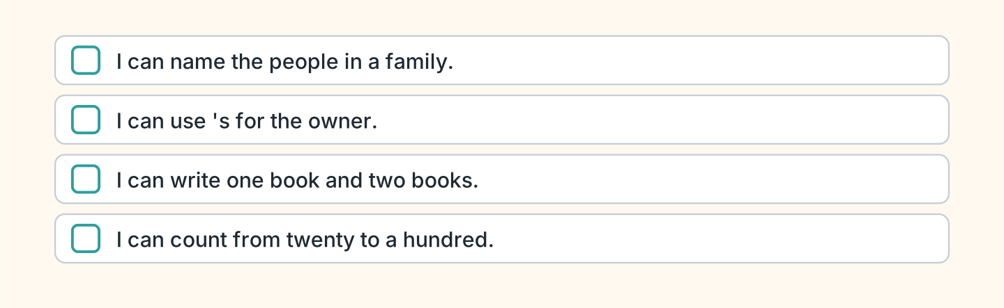
Figure 3.22 · What I can do.
- I can name the people in a family. — ✓ (example)
- I can use ’s for the owner. — ______
- I can write one book and two books. — ______
- I can count from twenty to a hundred. — ______

Unit 4: Where I Live
In this unit you say what is in your home. You ask how many.
Warm Up
W1 Look at Figure 4.1. Tick the rooms you can see.
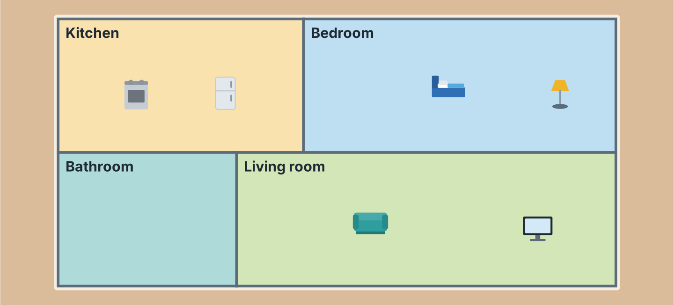
Figure 4.1 · A flat on Hill Road.
- a kitchen — ✓ (example)
- a bedroom — ______
- a bathroom — ______
- a living room — ______
- a garden — ______
W2 Look at Figure 4.2. Write the word.
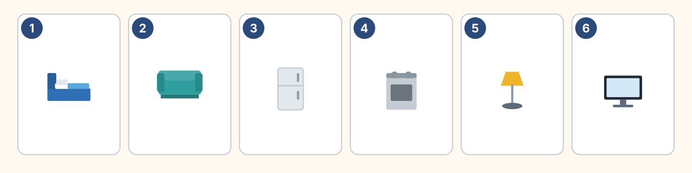
Figure 4.2 · Six things in a home.
Words: bed · cooker · fridge · lamp · sofa · tv
- 1 — bed (example)
- 2 — ______________
- 3 — ______________
- 5 — ______________
- 6 — ______________
W3 Say the rooms in your home.
- In my home there is a kitchen. (example)
- Say two rooms.
- Say your mother’s room.
- Say your brother or sister’s room.
Part 1 · Words & Sounds
1A Look at Figure 4.3. Write the room.
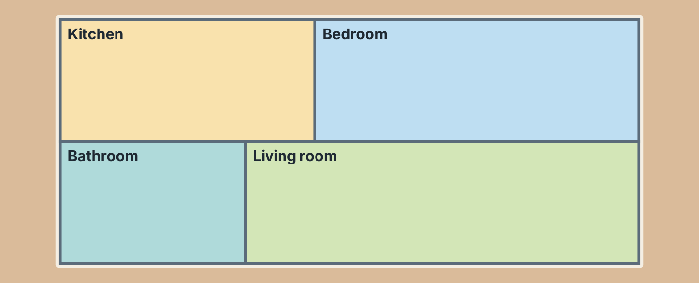
Figure 4.3 · Four rooms.
- You cook here. — the kitchen (example)
- You sleep here. — ______________
- You wash here. — ______________
- You watch TV here. — ______________
1B Look at Figure 4.4. Write the word.
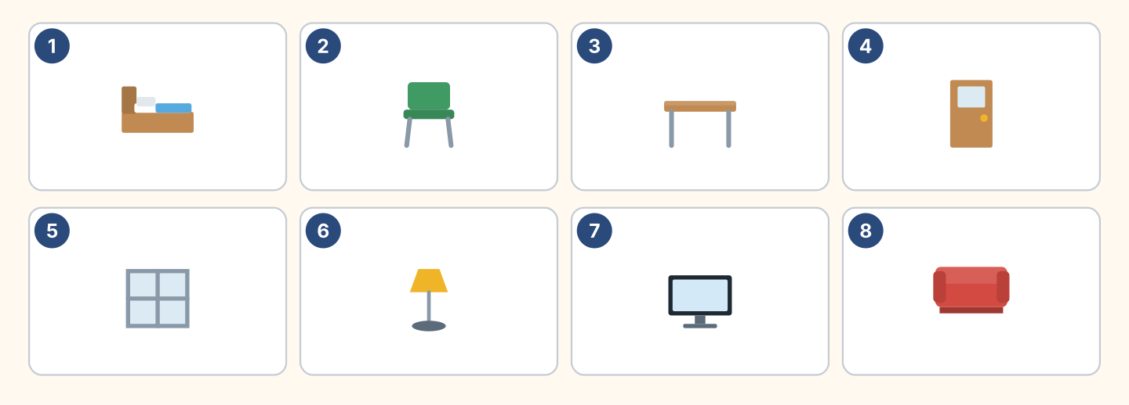
Figure 4.4 · Eight things to name.
Words: bed · chair · desk · door · lamp · sofa · tv · window
- 1 — bed (example)
- 3 — ______________
- 4 — ______________
- 6 — ______________
- 8 — ______________
1C Look at Figure 4.5. Write in, on or under.
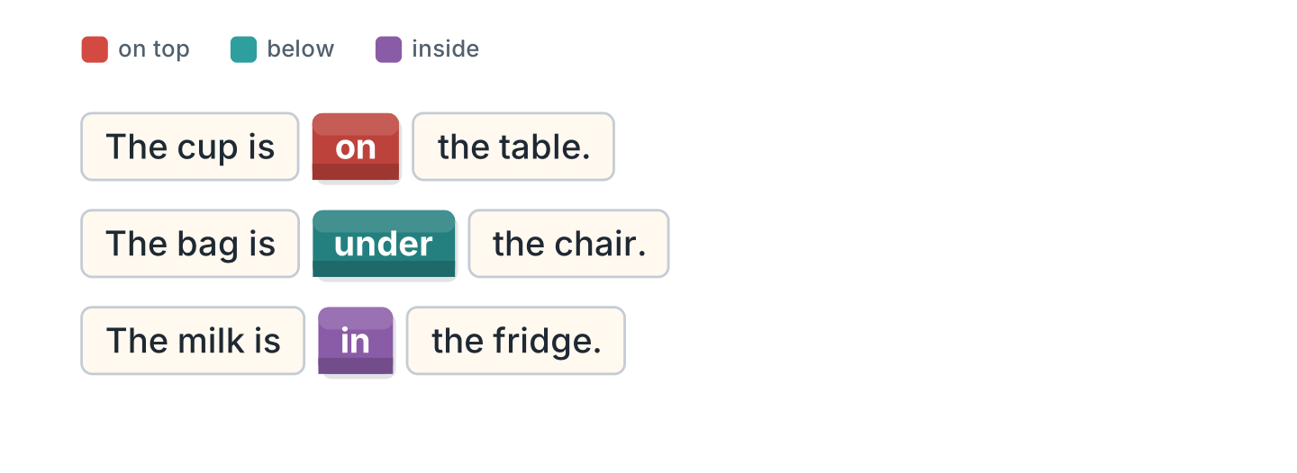
Figure 4.5 · in, on and under.
- The cup is on the table. (on) (example)
- The bag is ______ the chair.
- The milk is ______ the fridge.
- The lamp is ______ the desk.
1D Say it. Say where the things are.
- The book is on the bed. (example)
- Say where your bag is.
- Say where your pen is.
- Say where your phone is.
1E Look at Figure 4.6. Write kitchen or bedroom.
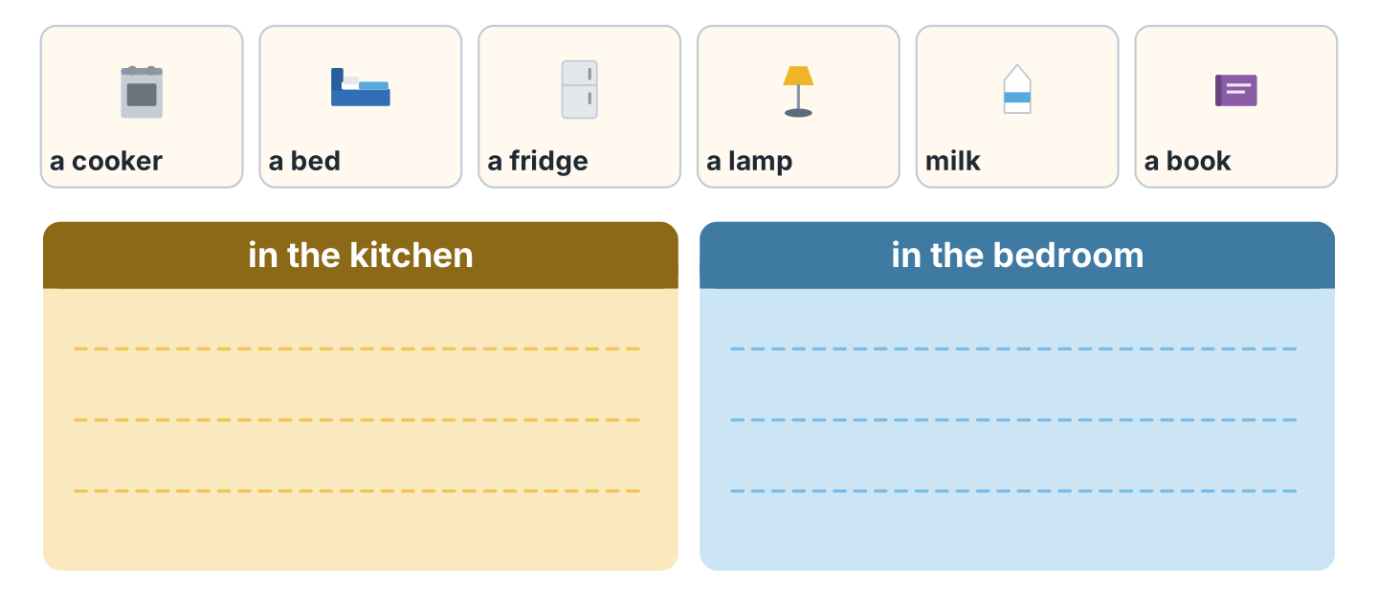
Figure 4.6 · Kitchen or bedroom.
- a cooker — kitchen (example)
- a bed — ______________
- a fridge — ______________
- a lamp — ______________
1F Write the opposite word.
- big — small (example)
- old — ______________
- young — ______________
- up — ______________
Part 2 · Grammar
2A Look at Figure 4.7. Write There is or There are.
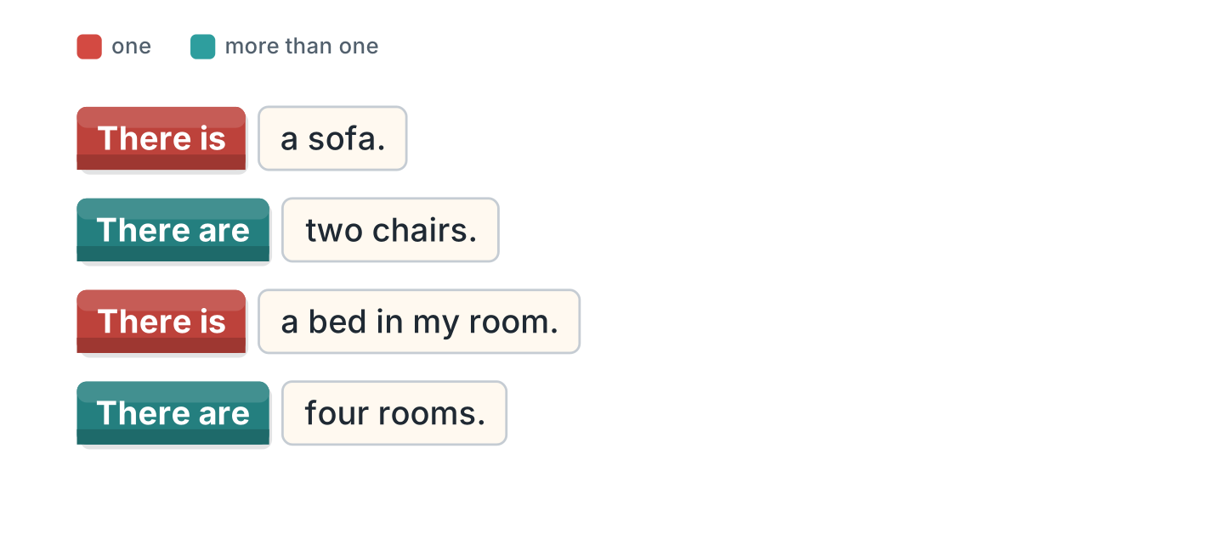
Figure 4.7 · There is and there are.
- There is a sofa. (There is) (example)
- ______________ two chairs.
- ______________ a bed in my room.
- ______________ four rooms.
2B Choose the correct word.
- There (is / are) a lamp. — is (example)
- There (is / are) three windows.
- There (is / are) a big kitchen.
- There (is / are) two beds.
- There (is / are) a garden.
2C Look at Figure 4.8. Write the short form.
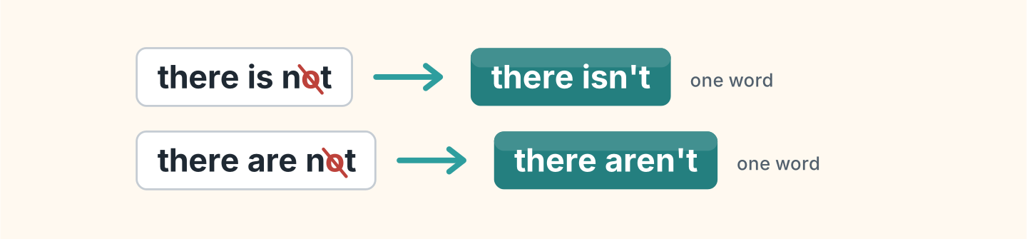
Figure 4.8 · The short negative.
- there is not — there isn’t (example)
- there are not — ______________
- There is not a garden. — ______________
2D Complete with isn’t or aren’t.
- There isn’t a balcony. (isn’t) (example)
- There ______________ any chairs.
- There ______________ a shower.
- There ______________ two bathrooms.
2E Look at Figure 4.9. Write the answer.
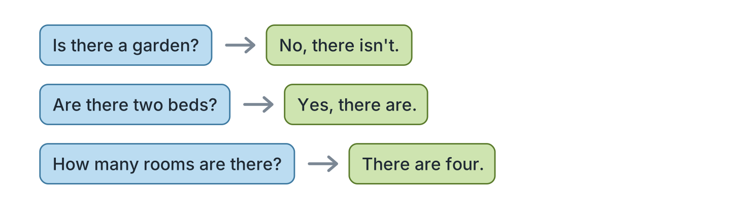
Figure 4.9 · Asking how many.
- Is there a garden? ✗ — No, there isn’t. (example)
- Are there two beds? ✓ — ______________
- Is there a kitchen? ✓ — ______________
- How many rooms are there? (4) — ______________
2F Find the mistake. Write the correct words.
- There are a bed. — There is (example)
- There is two chairs. — ______________
- How many room are there? — ______________
- There aren’t a garden. — ______________
Part 3 · Listening
3A Listen. Look at Figure 4.10. Write the number.
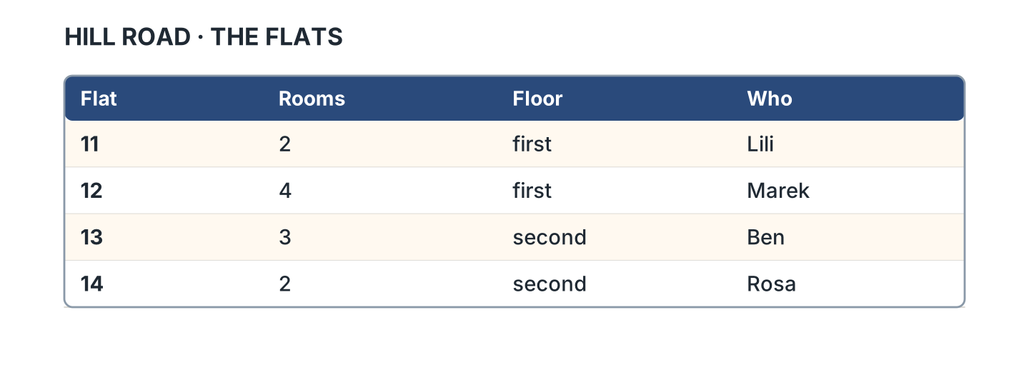
Figure 4.10 · Four flats.
- Lili — 11 (example)
- Marek — ______
- Ben — ______
- Rosa — ______
3B Listen. Look at Figure 4.11. Write the room.
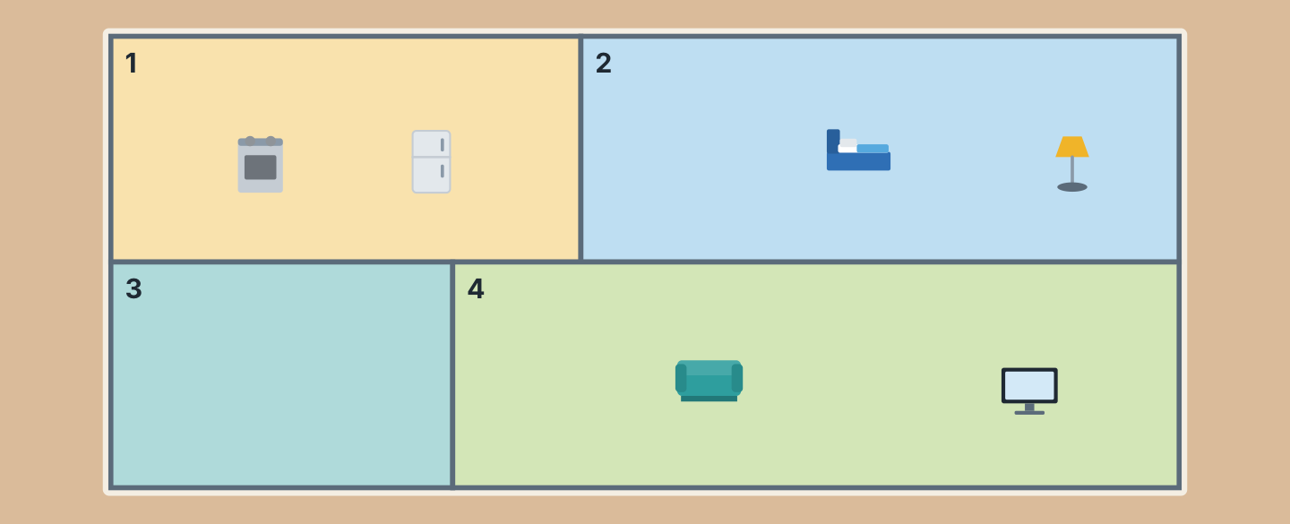
Figure 4.11 · A plan with no words.
- Room 1 — the kitchen (example)
- Room 2 — ______________
- Room 3 — ______________
- Room 4 — ______________
3C Listen. Look at Figure 4.12. Write the number.
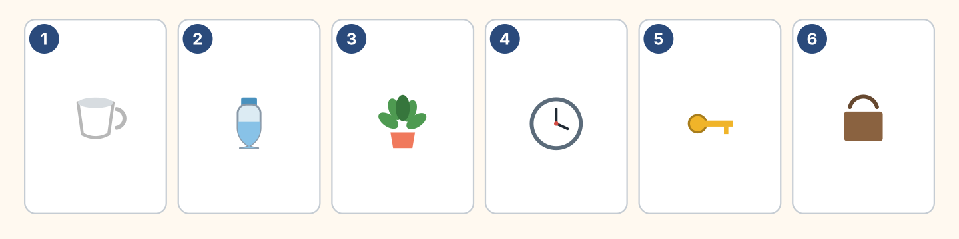
Figure 4.12 · Six more things.
- a cup — 1 (example)
- a clock — ______
- a plant — ______
- a bag — ______
3D Listen. Write how many.
- chairs — 4 (example)
- windows — ______
- beds — ______
- rooms — ______
Part 4 · Speaking
4A Look at Figure 4.13. Talk about your home.
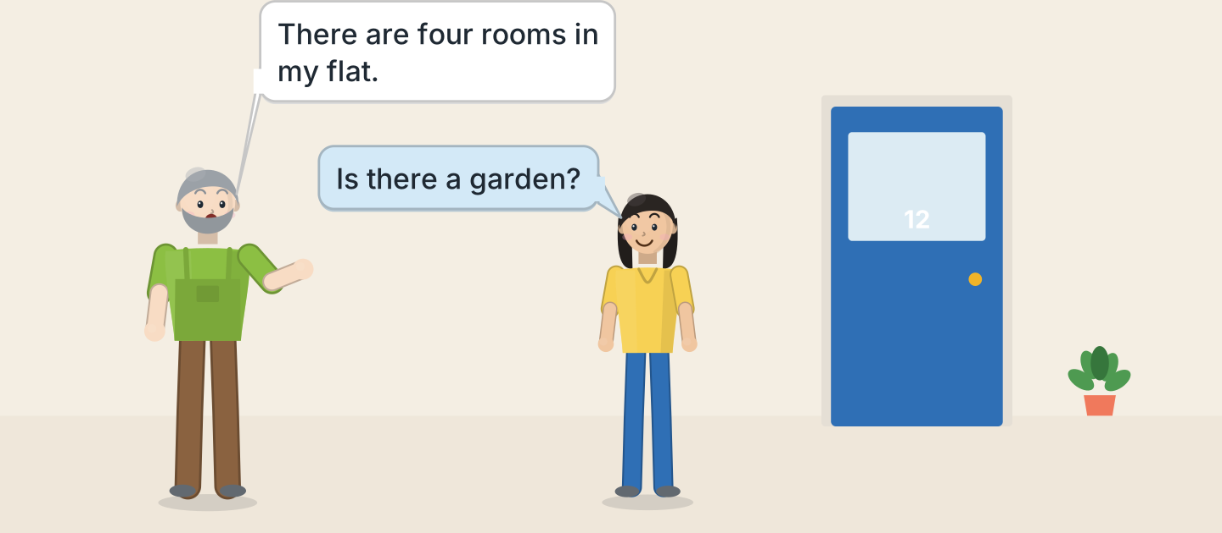
Figure 4.13 · Marek shows the flat.
- There are four rooms in my flat. (example)
- Say how many rooms.
- Say one room.
- Say one thing in it.
4B Look at Figure 4.14. Ask and answer.
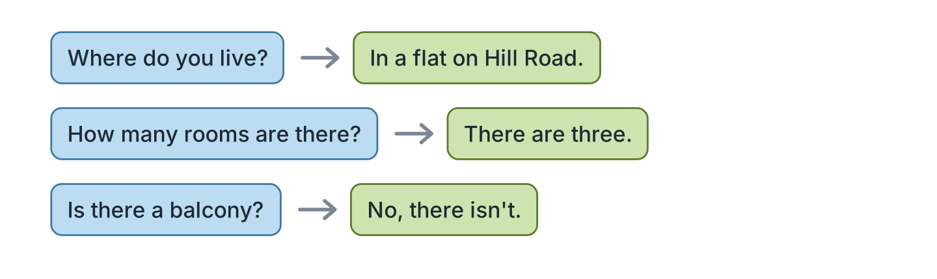
Figure 4.14 · Ask about a home.
- A: Where do you live? B: In a flat on Hill Road. (example)
- A: How many rooms are there? B: ______________
- A: Is there a garden? B: ______________
- A: Is there a balcony? B: ______________
4C Ask a friend about their home.
- A: Is there a kitchen? B: Yes, there is. (example)
- Ask about the kitchen.
- Ask about his sister’s room.
- Ask about her parents.
4D Say where three things are in your bag.
- My pen is in my bag. (example)
- ______________
- ______________
- ______________
Part 5 · Reading
5A Look at Figure 4.15. Answer the questions.
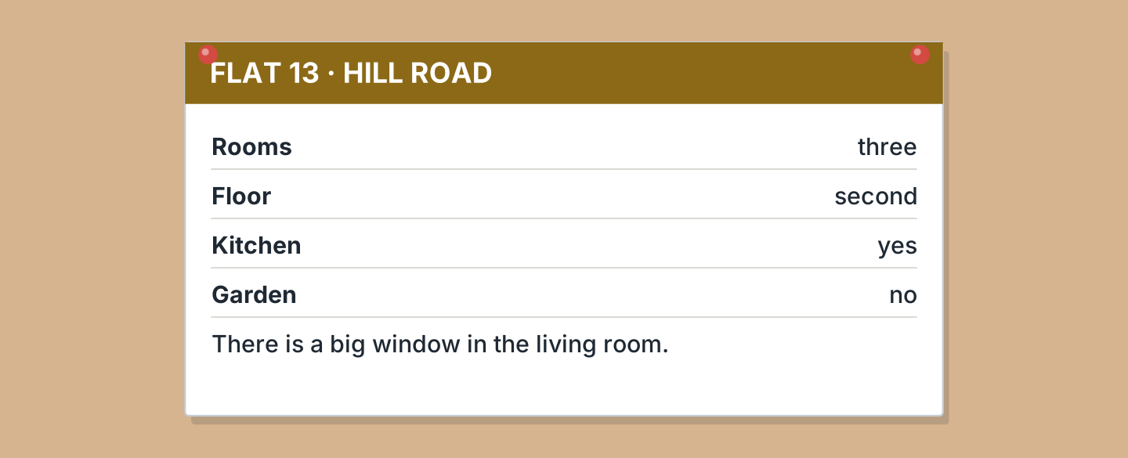
Figure 4.15 · A flat for rent.
- How many rooms are there? — three (example)
- Which floor is it? — ______________
- Is there a garden? — ______________
- Where is the big window? — ______________
5B Look at Figure 4.15. Write yes or no.
- There is a kitchen. — yes (example)
- There are four rooms. — ______
- There is a garden. — ______
- It is on the first floor. — ______
5C Look at Figure 4.16. Choose the correct answer.
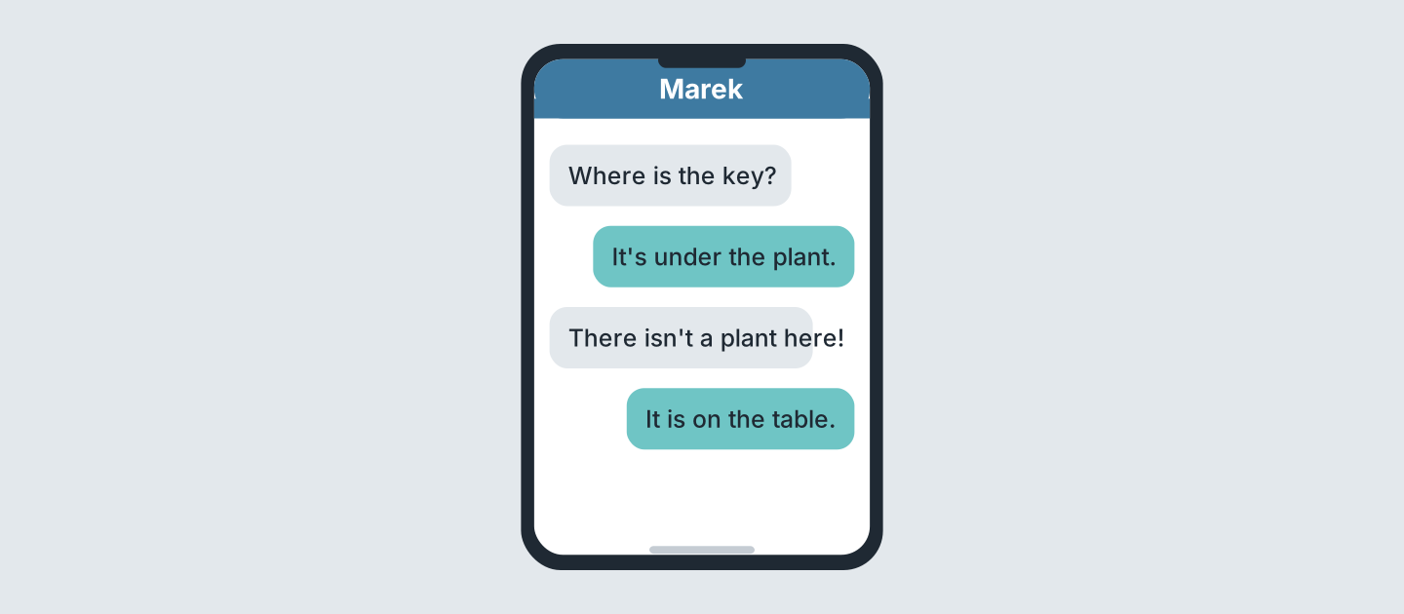
Figure 4.16 · Messages about a key.
- What is lost? (a) bag (b) key (c) phone — b (example)
- Where is it first? (a) table (b) plant (c) bag
- Is there a plant? (a) yes (b) no (c) maybe
- Where is the key? (a) fridge (b) table (c) bed
5D Read and correct. Write the correct word.
- The key is in the fridge. — table (example)
- Flat 13 is on the first floor. — ______________
- There are four rooms in Flat 13. — ______________
- There is a garden. — ______________
Part 6 · Writing
6A Look at Figure 4.17. Complete the form for you.
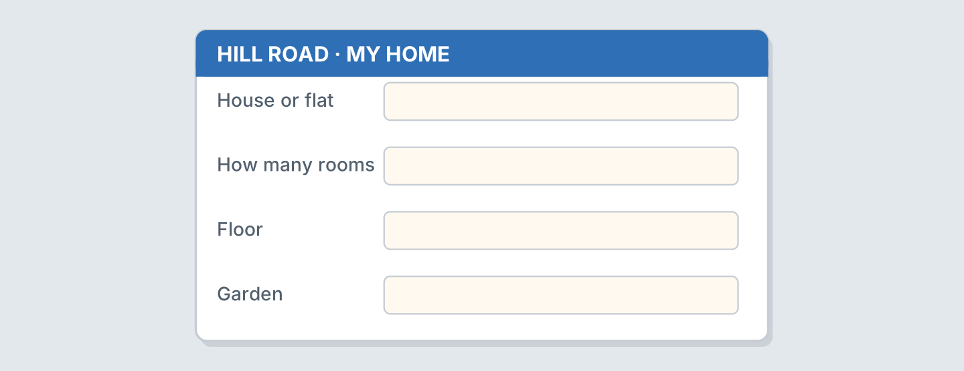
Figure 4.17 · A form about your home.
- House or flat: a flat (example)
- House or flat: ______________
- How many rooms: ______________
- Garden: ______________
6B Look at Figure 4.18. Write four lines.
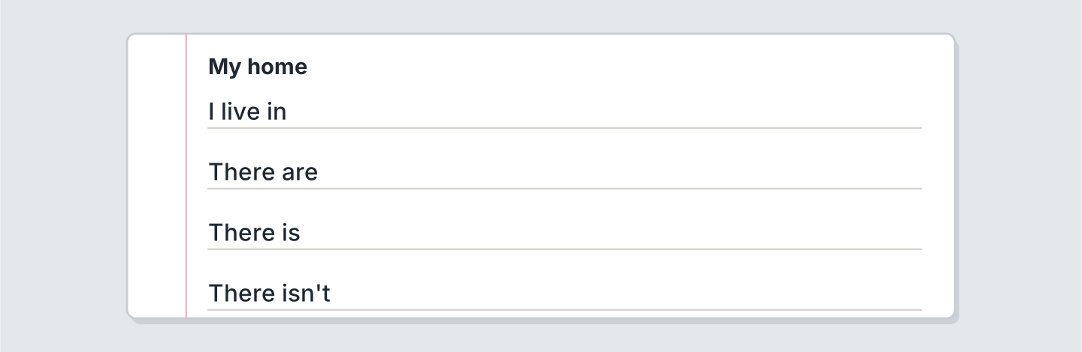
Figure 4.18 · Four lines about your home.
- I live in a flat with my parents. (example)
- I live in ______________.
- There are ______________.
- My sister’s room is ______________.
6C Write about your bedroom. Write three lines.
- There is a bed in my room. (example)
- Say one thing in the room.
- Say whose room it is.
- Say one thing that is not there.
Part 7 · Real-World File
7A Look at Figure 4.19. Answer the questions.
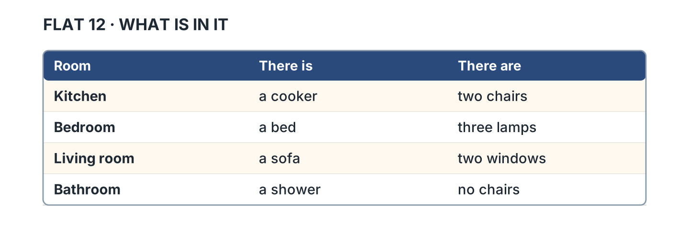
Figure 4.19 · What is in the rooms.
- What is in the kitchen? — a cooker (example)
- How many lamps are in the bedroom? — ______________
- What is in the living room? — ______________
- How many chairs are in the kitchen? — ______________
7B Look at Figure 4.20. Write the number.
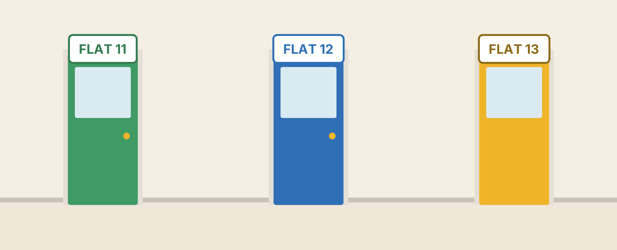
Figure 4.20 · Doors in the flats.
- the green door — Flat 11 (example)
- the blue door — ______________
- the yellow door — ______________
- Is Flat 14 here? — ______
7C Write a note about a flat. Use Figure 4.15.
- Rooms: three (example)
- Rooms: ______________
- Floor: ______________
- Garden: ______________
Part 8 · Review & Can-Do
8A Look at Figure 4.21. Write the word.
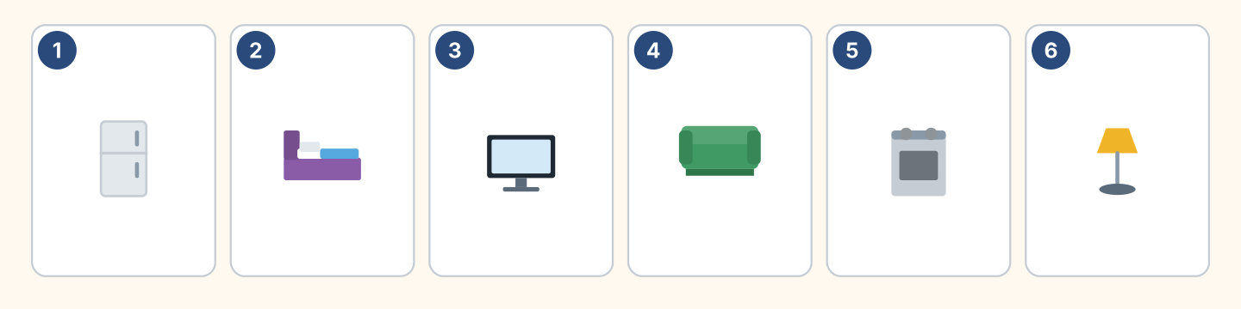
Figure 4.21 · Six things from this unit.
Words: bed · cooker · fridge · lamp · sofa · tv
- 1 — fridge (example)
- 2 — ______________
- 3 — ______________
- 5 — ______________
- 6 — ______________
8B Complete the conversation.
Words: are · How · isn’t · there
- A: How many rooms are there? (How) (example)
- B: There ______ three.
- A: Is ______ a garden?
- B: No, there ______.
8C Write in, on or under.
- The cat is under the bed. (under) (example)
- My father’s keys are ______ the fridge.
- The photo of my children is ______ the desk.
- My grandmother’s bag is ______ the chair.
8D Match the question and the answer.
Question | Answer
1 How many rooms are there? | a On the second floor.
2 Is there a garden? | b There are three.
3 Which floor is it? | c No, there isn’t.
4 Where is the key? | d Under the plant.
 | e Yes, I am.
One option is not needed.
- 1 — b (example)
- 2 — ______
- 3 — ______
- 4 — ______
8E Look at Figure 4.22. Tick what you can do.
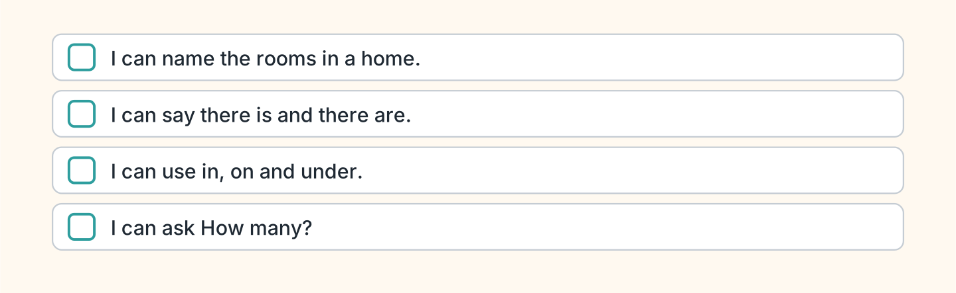
Figure 4.22 · What I can do.
- I can name the rooms in a home. — ✓ (example)
- I can say there is and there are. — ______
- I can use in, on and under. — ______
- I can ask How many? — ______

Unit 5: Every Day
In this unit you say what you do every day. You tell the time.
Warm Up
W1 Look at Figure 5.1. Write the time.
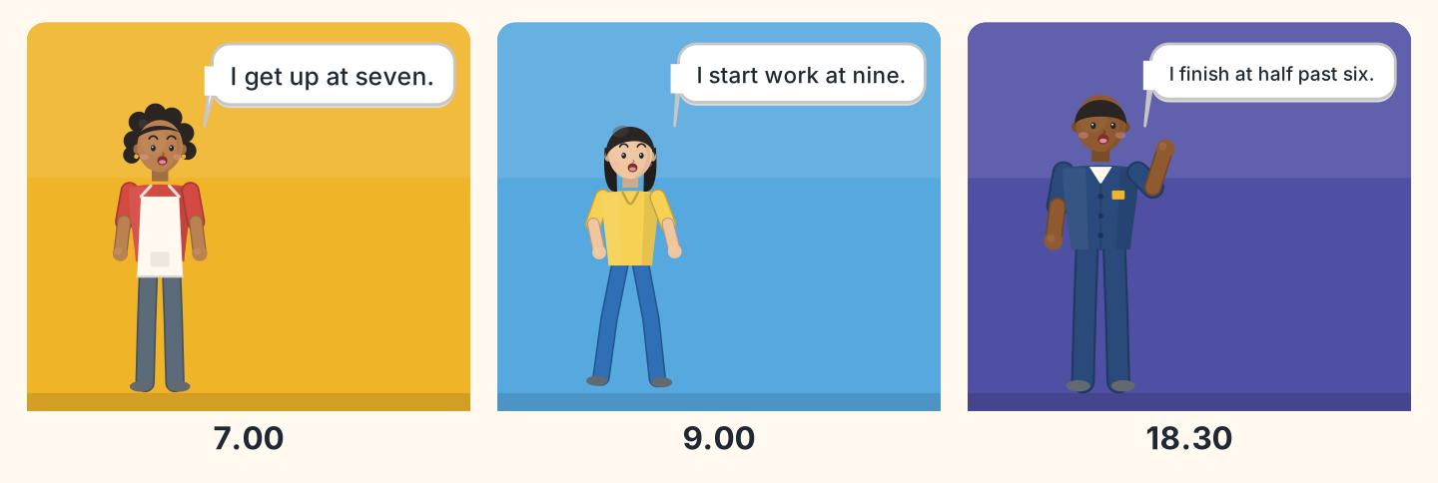
Figure 5.1 · A day on Hill Road.
- Nadia gets up at — seven (example)
- Lili starts work at — ______________
- Sam finishes at — ______________
- Who gets up first? — ______________
W2 Look at Figure 5.2. Write the time.
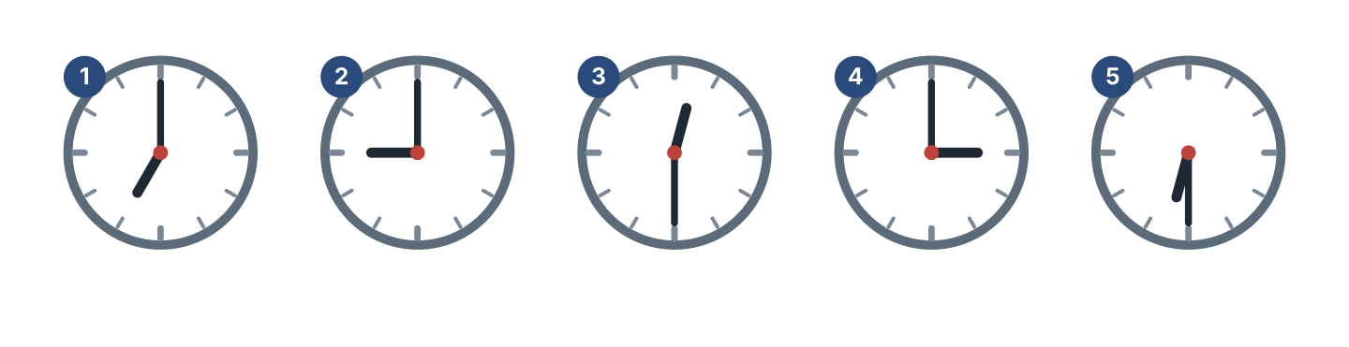
Figure 5.2 · Five times.
- clock 1 — seven o’clock (example)
- clock 2 — ______________
- clock 3 — ______________
- clock 5 — ______________
W3 Say the days of the week.
- Monday, Tuesday, Wednesday (example)
- Say the seven days.
- Say your free day.
- Say today.
Part 1 · Words & Sounds
1A Look at Figure 5.3. Write the word.
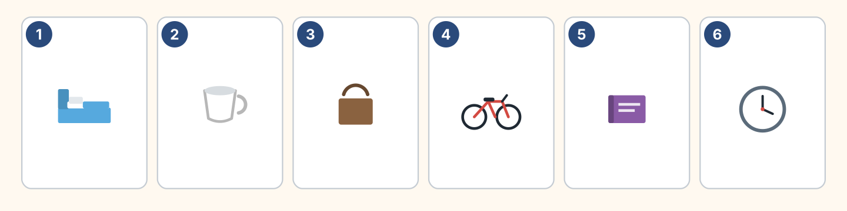
Figure 5.3 · A day in six pictures.
Words: bag · bed · bike · book · clock · cup
- 1 — bed (example)
- 2 — ______________
- 3 — ______________
- 4 — ______________
- 6 — ______________
1B Look at Figure 5.4. Write the time.
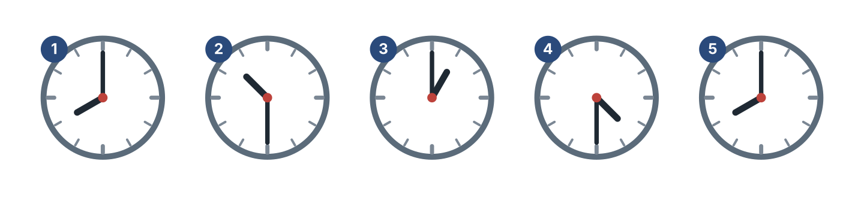
Figure 5.4 · Five more times.
- clock 1 — eight o’clock (example)
- clock 2 — ______________
- clock 3 — ______________
- clock 4 — ______________
1C Look at Figure 5.5. Write at or on.
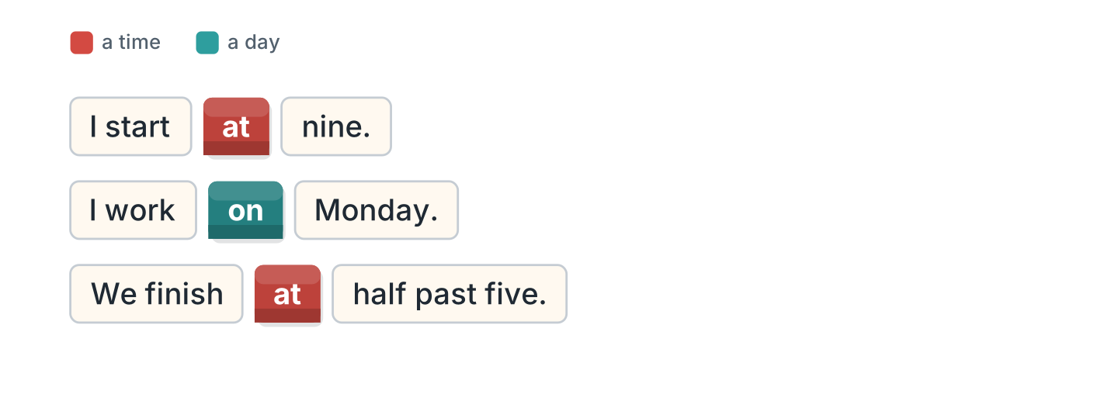
Figure 5.5 · at and on.
- I start at nine. (at) (example)
- My father works ______ Monday.
- We finish ______ half past five.
- My sister studies ______ Saturday.
1D Say it. Say these times.
- 7.00 — seven o’clock (example)
- 9.30
- 12.00
- 4.30
- 6.15
1E Look at Figure 5.6. Answer the questions.
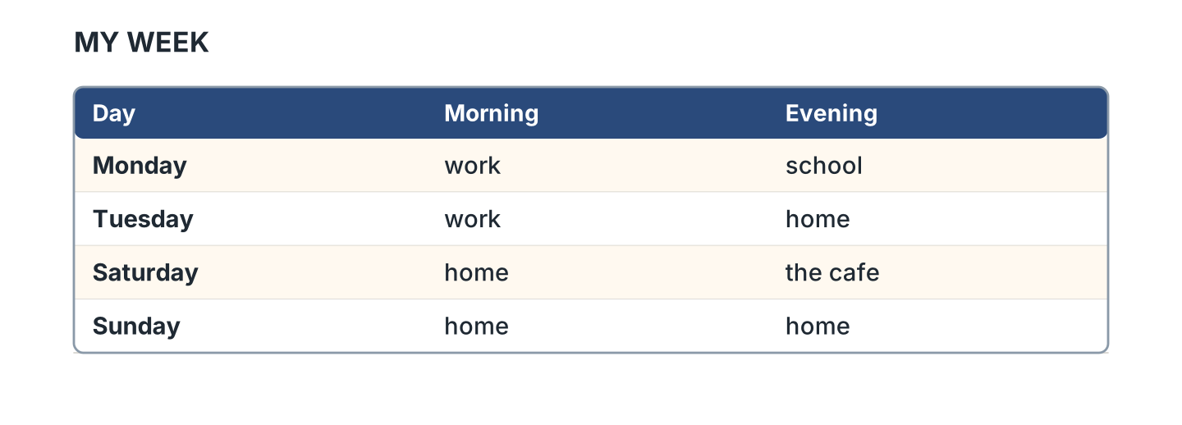
Figure 5.6 · The days of the week.
- What do I do on Monday morning? — work (example)
- What do I do on Monday evening? — ______________
- Where am I on Saturday evening? — ______________
- What do I do on Sunday? — ______________
1F Write the day after.
- Monday — Tuesday (example)
- Friday — ______________
- Saturday — ______________
- Wednesday — ______________
Part 2 · Grammar
2A Look at Figure 5.7. Complete the sentence.
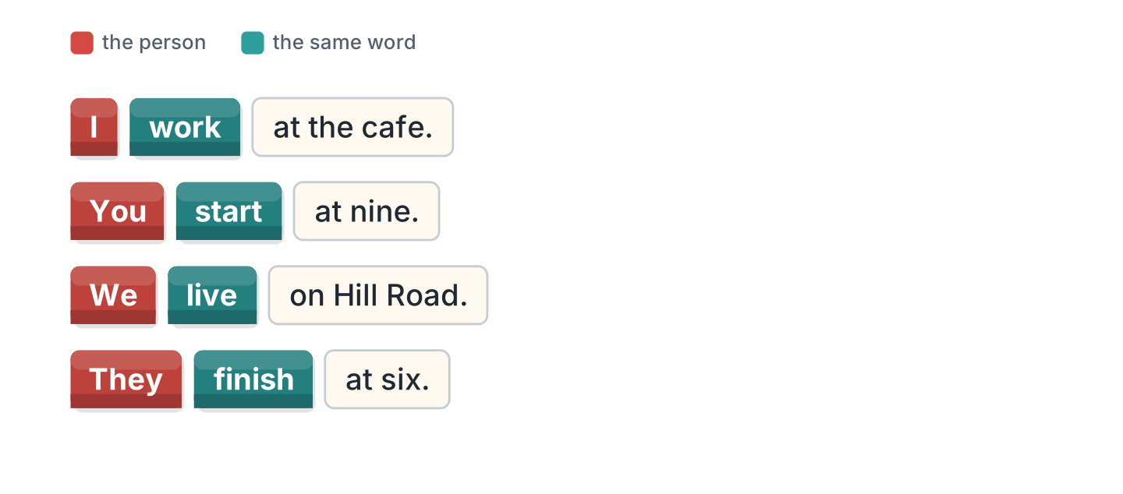
Figure 5.7 · I, you, we and they.
- I work at the cafe. (work) (example)
- We ______________ on Hill Road.
- You ______________ at nine.
- They ______________ at six.
2B Choose the correct word.
- I (work / works) here. — work (example)
- They (live / lives) in a flat.
- We (start / starts) at eight.
- You (study / studies) English.
- I (get / gets) up early.
2C Look at Figure 5.8. Write the short form.

Figure 5.8 · The negative.
- do not — don’t (example)
- I do not work here. — ______________
- We do not study on Sunday. — ______________
2D Write the negative.
- I work on Monday. — I don’t work on Monday. (example)
- We live here. — ______________
- They start at eight. — ______________
- You study English. — ______________
2E Look at Figure 5.9. Write the answer.
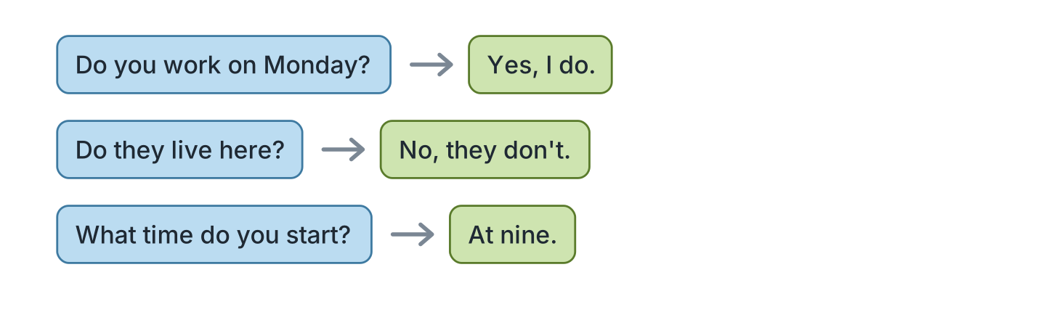
Figure 5.9 · Questions with do.
- Do you work on Monday? ✓ — Yes, I do. (example)
- Do they live here? ✗ — ______________
- Do you study English? ✓ — ______________
- What time do you start? (9.00) — ______________
2F Find the mistake. Write the correct words.
- I no work here. — don’t work (example)
- We starts at nine. — ______________
- Do you lives here? — ______________
- They don’t lives here. — ______________
Part 3 · Listening
3A Listen. Look at Figure 5.10. Write the number.
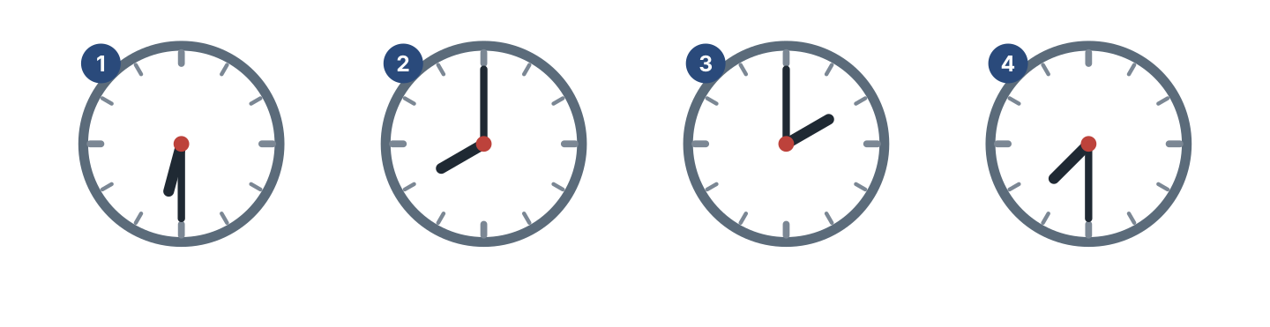
Figure 5.10 · Four people, four times.
- half past six — 1 (example)
- eight o’clock — ______
- two o’clock — ______
- half past seven — ______
3B Listen. Look at Figure 5.11. Complete the week.
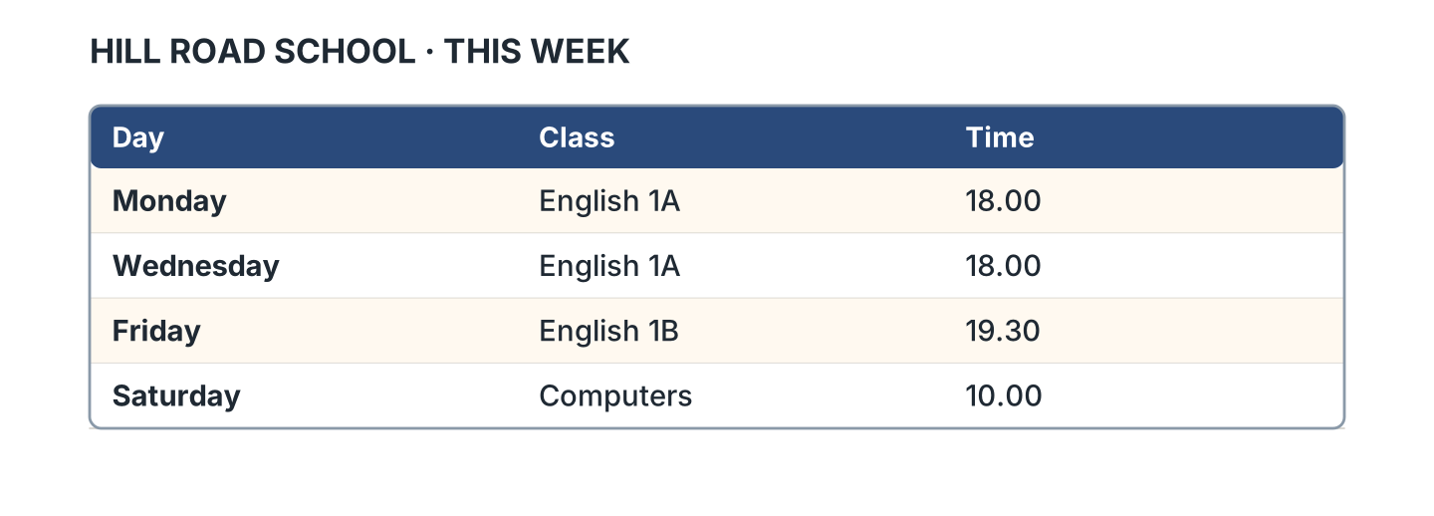
Figure 5.11 · A week at the school.
- English 1A starts at six. (six) (example)
- English 1B is on ______________.
- English 1B starts at ______________.
- Computers is in room ______________.
3C Listen. Look at Figure 5.12. Write the number.
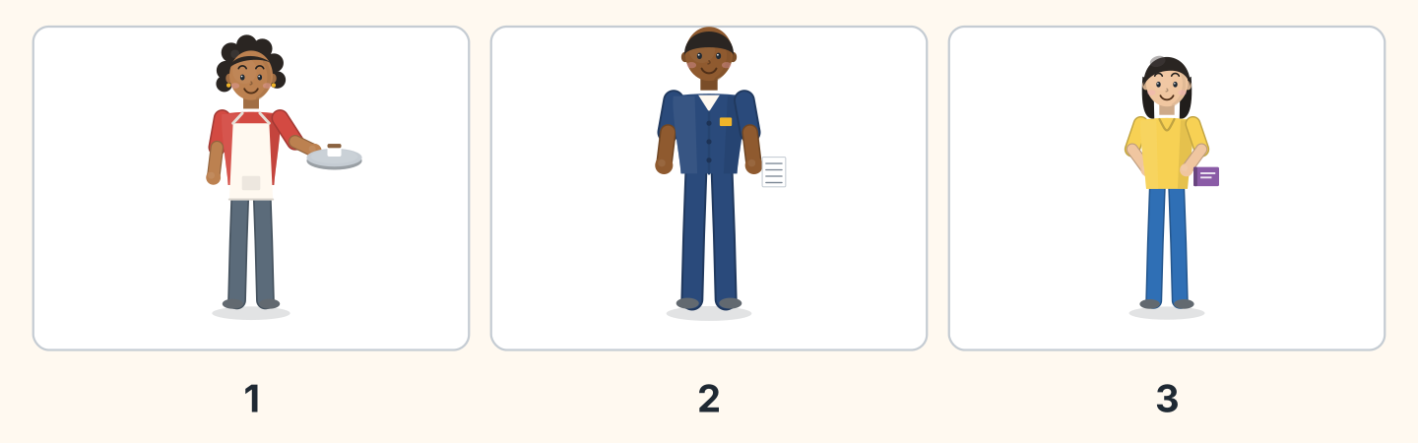
Figure 5.12 · Three people in a day.
- Nadia — 1 (example)
- Sam — ______
- Lili — ______
- Who starts first? — ______________
3D Listen. Write the time you hear.
- half past eight — 8.30 (example)
- ______________
- ______________
- ______________
Part 4 · Speaking
4A Look at Figure 5.13. Ask about times.
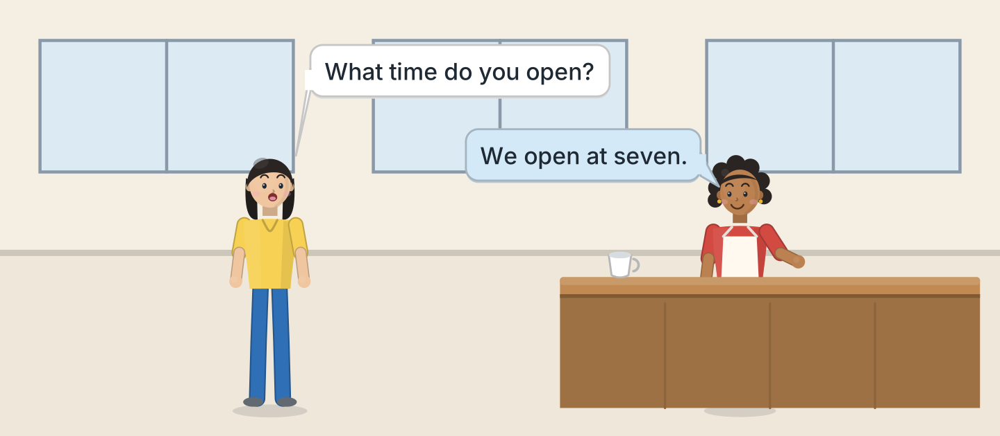
Figure 5.13 · Lili asks about the day.
- A: What time do you open? B: We open at seven. (example)
- Ask when the cafe opens.
- Ask when it closes.
- Ask about Sunday.
4B Look at Figure 5.14. Ask and answer.

Figure 5.14 · Ask about a day.
- A: What time do you get up? B: At half past six. (example)
- A: Do you work on Sunday? B: ______________
- A: When do you study? B: ______________
- A: What time do you finish? B: ______________
4C Ask three friends about their day.
- A: What time do you start? B: At nine. (example)
- Ask about their brother.
- Ask about their kitchen and their garden.
- Ask about the weekend.
4D Say four things you do every day.
- I get up at seven. I have breakfast in the big kitchen. (example)
- ______________
- ______________
- ______________
Part 5 · Reading
5A Look at Figure 5.15. Answer the questions.
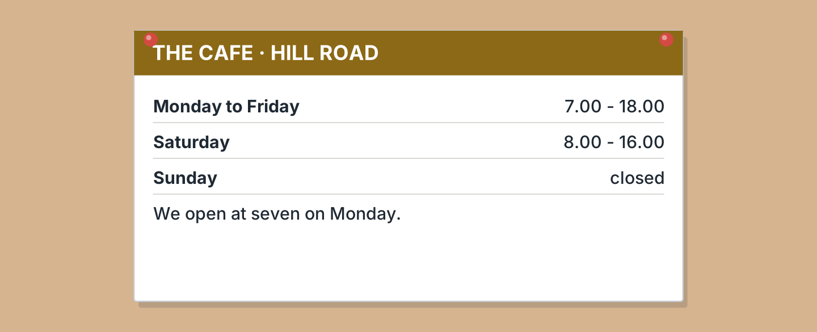
Figure 5.15 · The cafe times.
- What time does it open on Monday? — seven (example)
- What time does it close on Friday? — ______________
- When does it open on Saturday? — ______________
- Is it open on Sunday? — ______________
5B Look at Figure 5.15. Write yes or no.
- It opens at seven on Monday. — yes (example)
- It is open on Sunday. — ______
- It closes at four on Saturday. — ______
- It opens at eight on Tuesday. — ______
5C Look at Figure 5.16. Choose the correct answer.
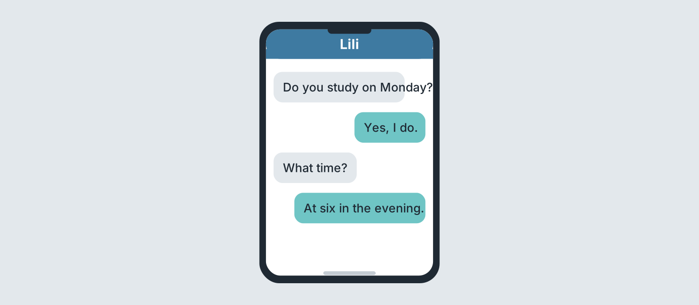
Figure 5.16 · Messages about a class.
- Who studies on Monday? (a) Lili (b) Ben (c) Sam — a (example)
- What time is the class? (a) four (b) six (c) eight
- When is it? (a) morning (b) afternoon (c) evening
- Who writes first? (a) Lili (b) a friend (c) Nadia
5D Read and correct. Write the correct word.
- The cafe opens at eight. — seven (example)
- The cafe is open on Sunday. — ______________
- The class is at four. — ______________
- The cafe closes at nine. — ______________
Part 6 · Writing
6A Look at Figure 5.17. Complete the form for you.
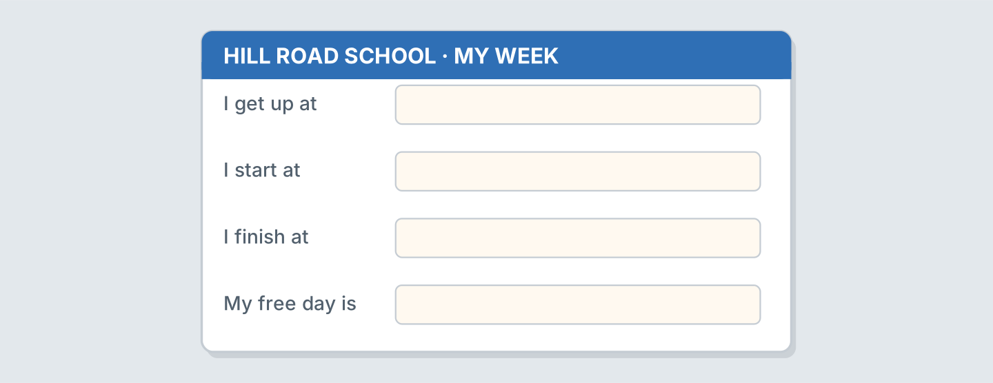
Figure 5.17 · A form about your week.
- I get up at: half past six (example)
- I get up at: ______________
- I start at: ______________
- My free day is: ______________
6B Look at Figure 5.18. Write four lines.
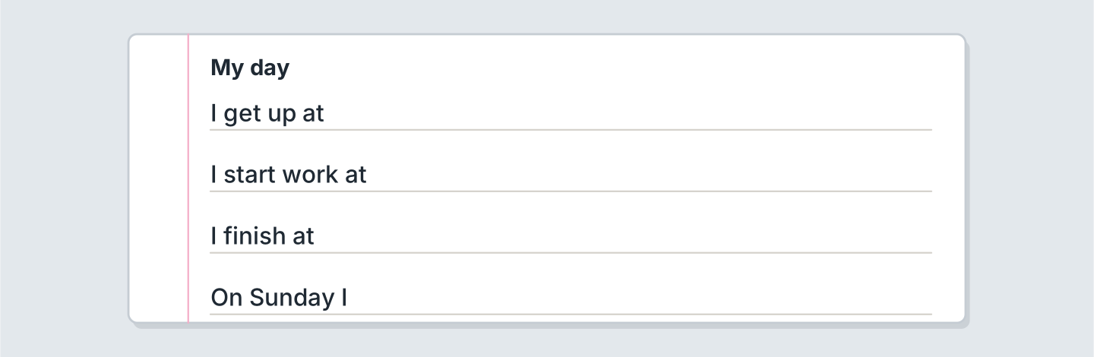
Figure 5.18 · Four lines about your day.
- My mother gets up at seven. (example)
- I get up in my bedroom at ______________.
- I start work at ______________.
- On Sunday my family ______________.
6C Write about your weekend. Write three lines.
- On Saturday I study with my sister. (example)
- Say one thing you do.
- Say who is with you.
- Say one thing you do not do.
Part 7 · Real-World File
7A Look at Figure 5.19. Answer the questions.
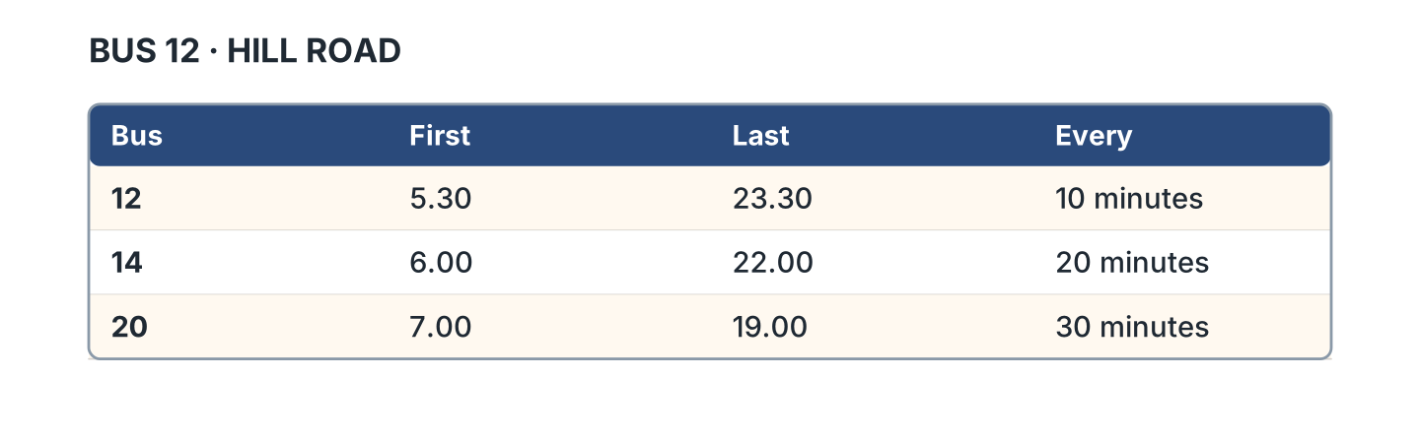
Figure 5.19 · The bus times.
- When is the first bus 12? — 5.30 (example)
- When is the last bus 12? — ______________
- When is the last bus 14? — ______________
- When is the first bus 20? — ______________
7B Look at Figure 5.20. Write the time.
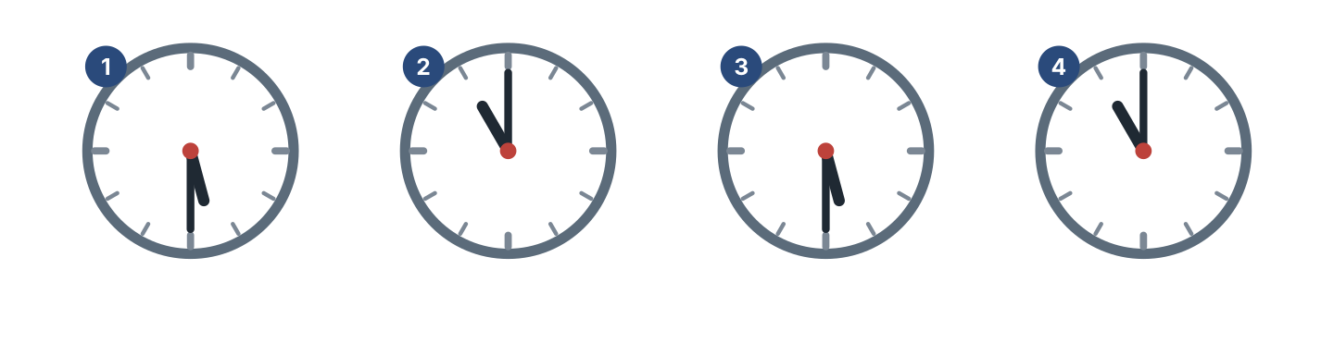
Figure 5.20 · Four clocks to read.
- clock 1 — half past five (example)
- clock 2 — ______________
- clock 3 — ______________
- clock 4 — ______________
7C Write your own times. Use Figure 5.19.
- First bus: 5.30 (example)
- I leave home at: ______________
- My bus is: ______________
- I arrive at: ______________
Part 8 · Review & Can-Do
8A Look at Figure 5.21. Write the word.
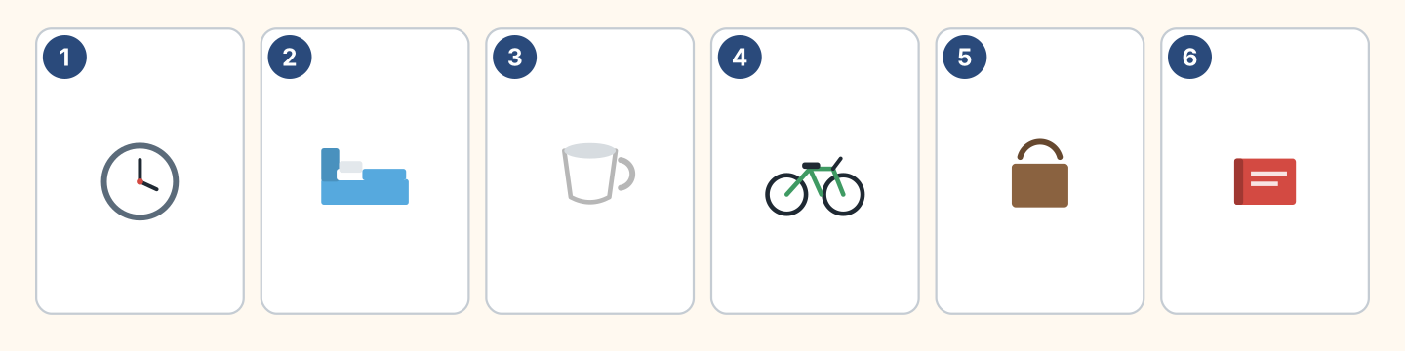
Figure 5.21 · Six things from this unit.
Words: bag · bed · bike · book · clock · cup
- 1 — clock (example)
- 2 — ______________
- 3 — ______________
- 4 — ______________
- 6 — ______________
8B Complete the conversation.
Words: at · do · don’t · What
- A: What time do you start? (What) (example)
- B: I start ______ eight.
- A: ______ you work on Sunday?
- B: No, I ______.
8C Write the time in words.
- 9.30 — half past nine (example)
- 7.00 — ______________
- 11.30 — ______________
- 2.00 — ______________
8D Match the question and the answer.
Question | Answer
1 What time do you get up? | a On Monday.
2 When do you study? | b At seven.
3 Do you work on Sunday? | c No, I don’t.
4 Where do you work? | d At the cafe.
 | e Yes, there is.
One option is not needed.
- 1 — b (example)
- 2 — ______
- 3 — ______
- 4 — ______
8E Look at Figure 5.22. Tick what you can do.
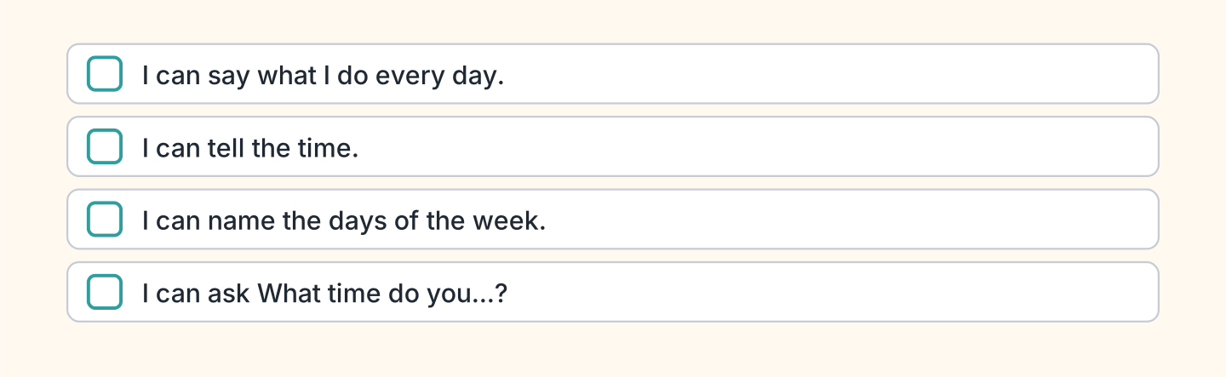
Figure 5.22 · What I can do.
- I can say what I do every day. — ✓ (example)
- I can tell the time. — ______
- I can name the days of the week. — ______
- I can ask What time do you start? — ______

Unit 6: She Works Here
In this unit you say what another person does. You ask about them.
Warm Up
W1 Look at Figure 6.1. Write the job.
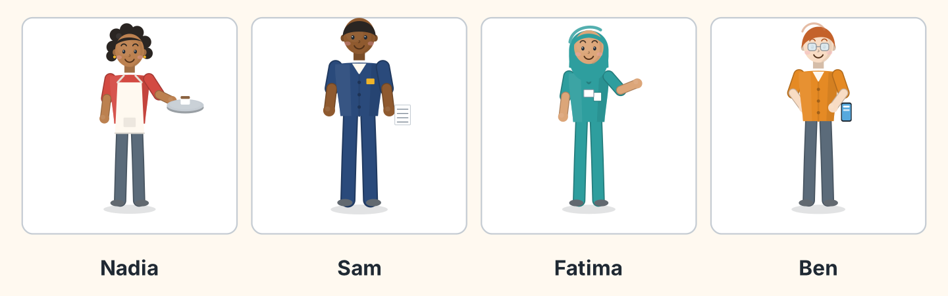
Figure 6.1 · Four people at work.
Words: cook · driver · nurse · shop assistant
- Nadia — a cook (example)
- Sam — ______________
- Fatima — ______________
- Ben — ______________
W2 Look at Figure 6.2. Write the place.
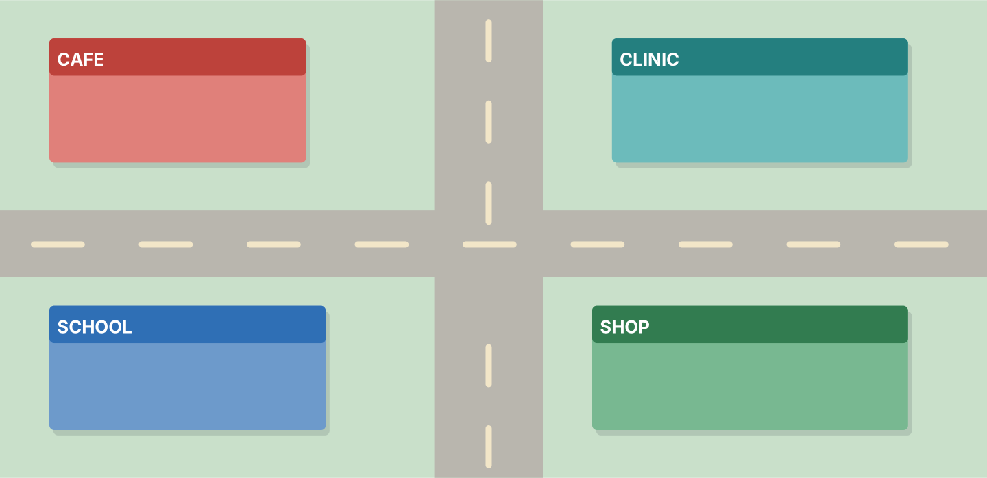
Figure 6.2 · Four places of work.
- Nadia works at — the cafe (example)
- Fatima works at — ______________
- Lili studies at — ______________
- Ben works at — ______________
W3 Say what three people in your family do.
- My mother is a teacher. (example)
- Say a job.
- Say the place.
- Say the time they start.
Part 1 · Words & Sounds
1A Look at Figure 6.3. Match the person and the job.
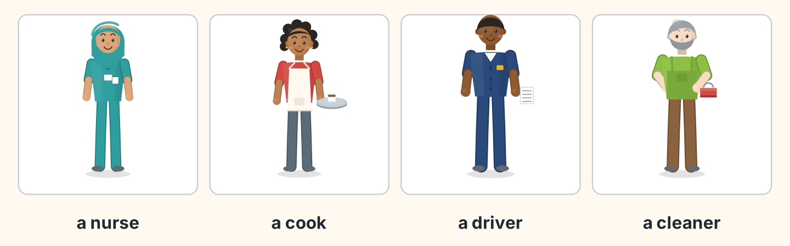
Figure 6.3 · Six jobs.
Person | Job
1 Fatima | a a cleaner
2 Nadia | b a nurse
3 Sam | c a cook
4 Marek | d a driver
 | e a doctor
One option is not needed.
- 1 — b (example)
- 2 — ______
- 3 — ______
- 4 — ______
1B Look at Figure 6.4. Answer the questions.
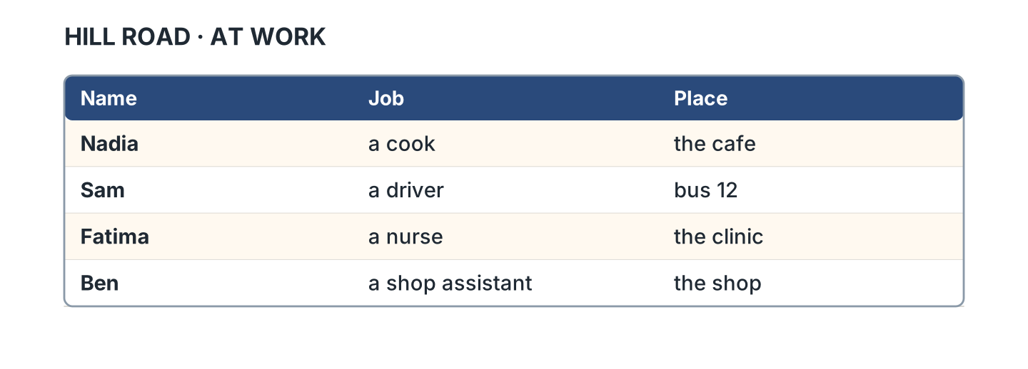
Figure 6.4 · Who works where.
- Where does Nadia work? — the cafe (example)
- Where does Sam work? — ______________
- What does Fatima do? — ______________
- What does Ben do? — ______________
1C Look at Figure 6.5. Write the word in the correct box.
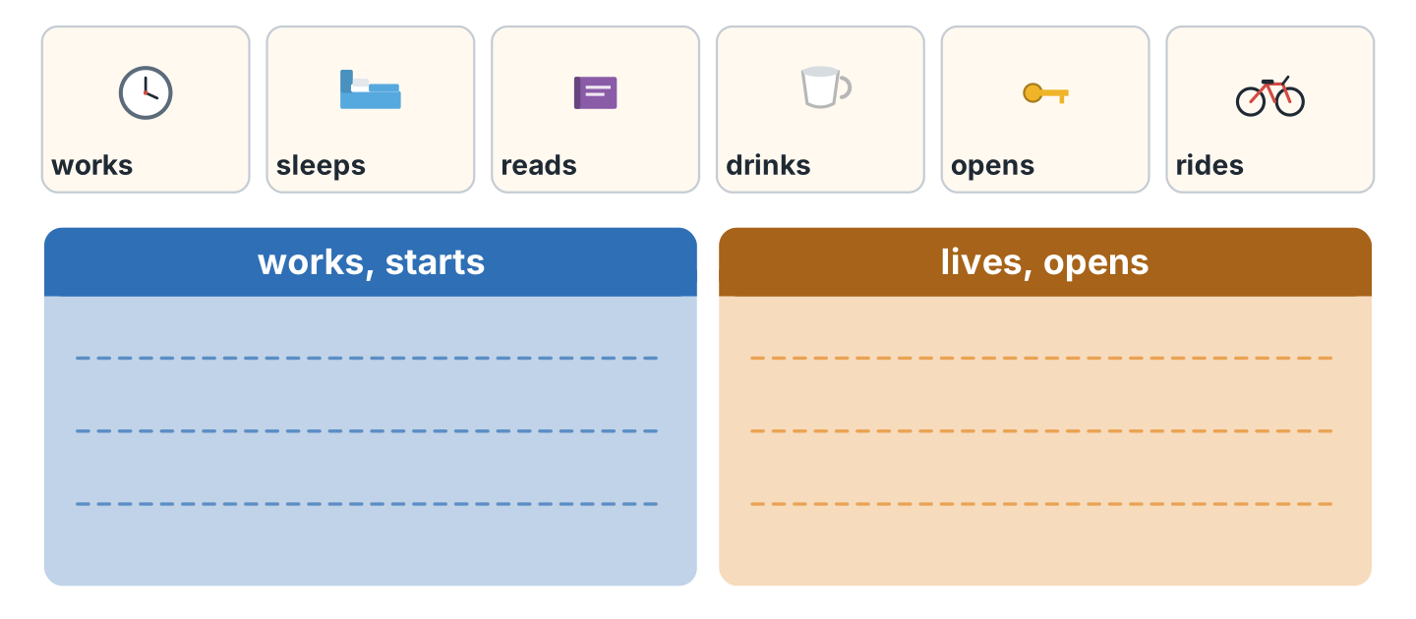
Figure 6.5 · The sound of the s.
- works — the first box (example)
- lives — ______________
- reads — ______________
- opens — ______________
1D Say it. Say these words.
- works (example)
- starts
- lives
- opens
- finishes
1E Look at Figure 6.6. Write the word.
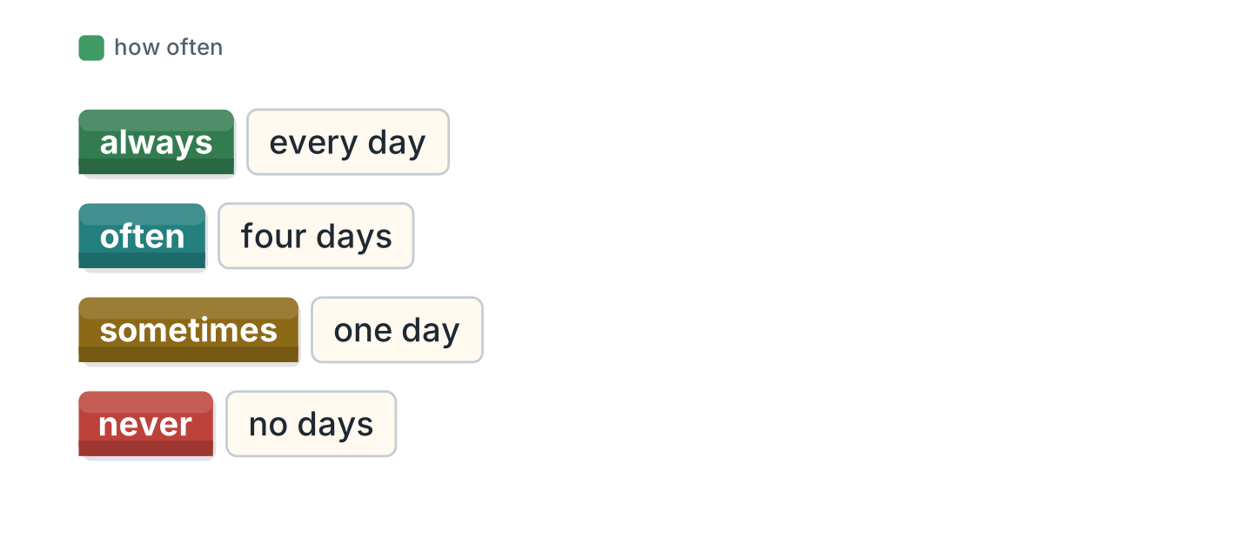
Figure 6.6 · How often it happens.
Words: always · never · often · sometimes
- every day — always (example)
- four days — ______________
- one day — ______________
- no days — ______________
1F Write the place for the job.
- a nurse — a clinic (example)
- a cook — ______________
- a driver — ______________
- a teacher — ______________
Part 2 · Grammar
2A Look at Figure 6.7. Complete with works or work.
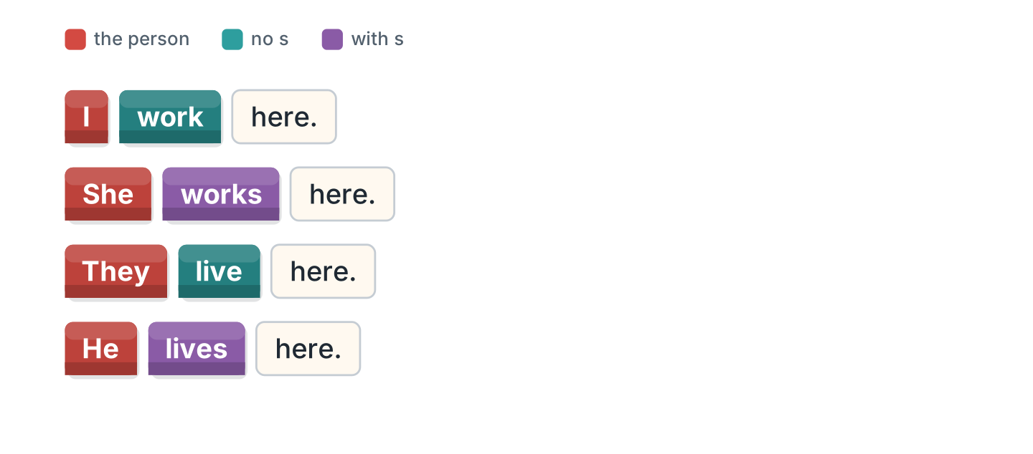
Figure 6.7 · He, she and it.
- She works here. (works) (example)
- They ______________ here.
- He ______________ on Hill Road.
- I ______________ at the school.
2B Write the he form.
- I work — he works (example)
- I live — he ______________
- I start — she ______________
- I finish — she ______________
- I study — he ______________
2C Look at Figure 6.8. Write the short form.

Figure 6.8 · The negative with does.
- does not — doesn’t (example)
- She does not work here. — ______________
- He does not live here. — ______________
2D Complete with don’t or doesn’t.
- She doesn’t work on Friday. (doesn’t) (example)
- They ______________ live here.
- He ______________ start at eight.
- I ______________ work on Sunday.
2E Look at Figure 6.9. Write the answer.
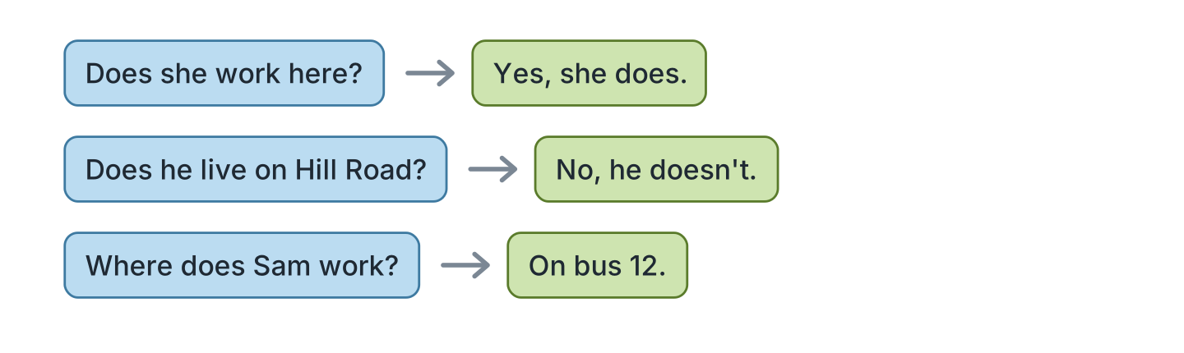
Figure 6.9 · Questions with does.
- Does she work here? ✓ — Yes, she does. (example)
- Does he live on Hill Road? ✗ — ______________
- Does Nadia cook? ✓ — ______________
- Where does Sam work? (bus 12) — ______________
2F Find the mistake. Write the correct words.
- She work here. — works (example)
- Does she works here? — ______________
- He don’t live here. — ______________
- Sam drive a bus. — ______________
Part 3 · Listening
3A Listen. Look at Figure 6.10. Write the number.
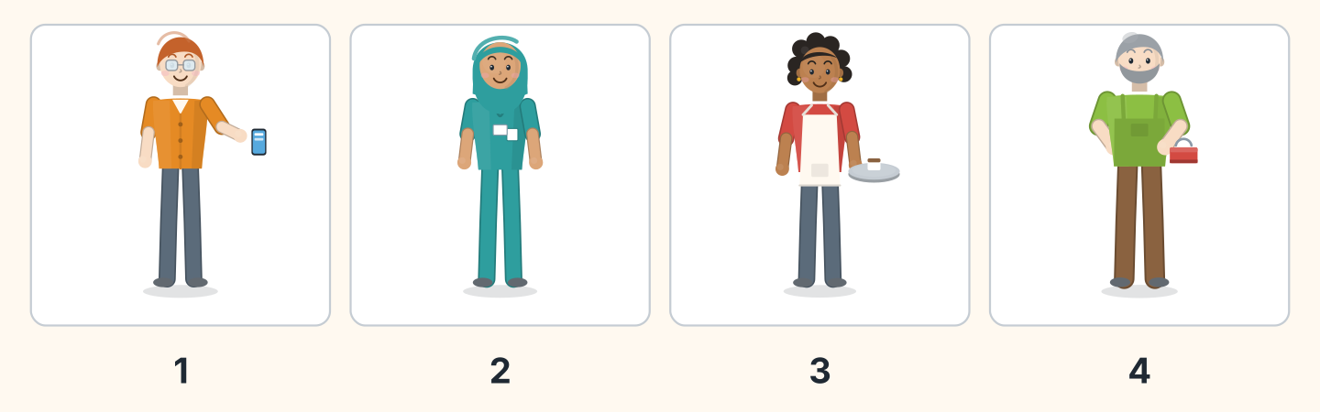
Figure 6.10 · Four workers.
- Ben — 1 (example)
- Fatima — ______
- Nadia — ______
- Marek — ______
3B Listen. Look at Figure 6.11. Complete the week.
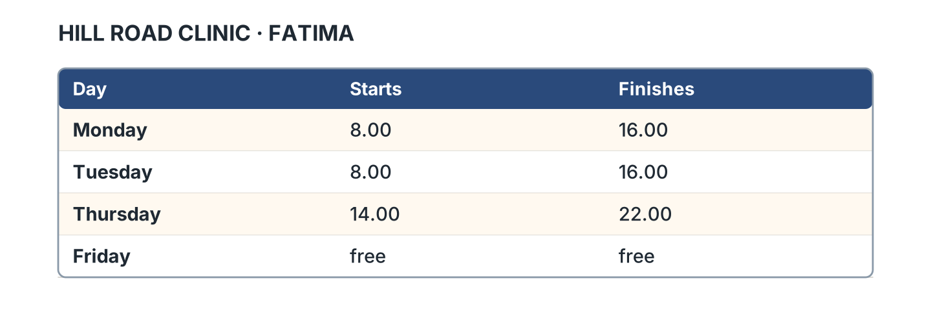
Figure 6.11 · A week at the clinic.
- On Monday she starts at eight. (eight) (example)
- On Tuesday she finishes at ______________.
- On Thursday she starts at ______________.
- On Friday she is ______________.
3C Listen. Look at Figure 6.12. Tick the box.
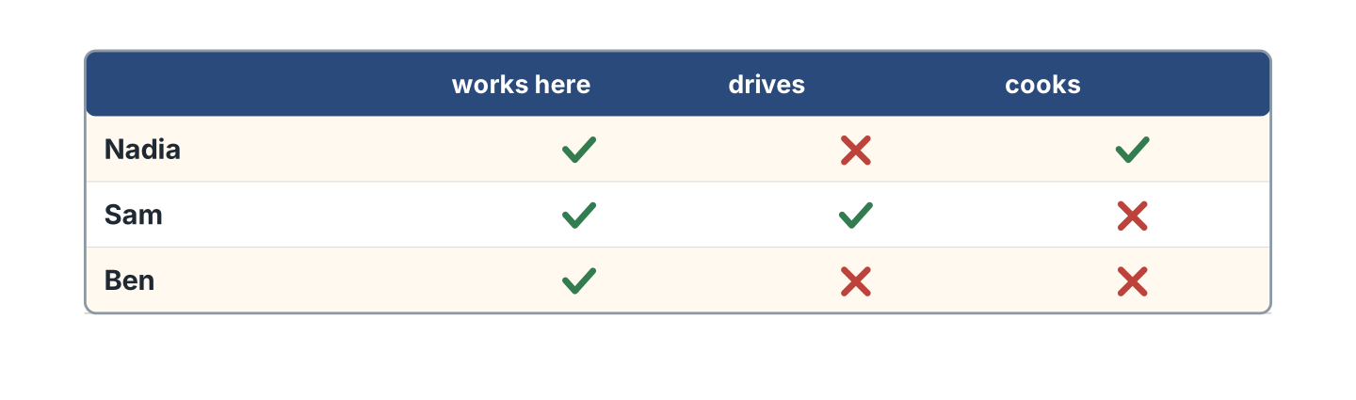
Figure 6.12 · Who does what.
- Nadia cooks. — ✓ (example)
- Sam drives. — ______
- Ben cooks. — ______
- Nadia drives. — ______
3D Listen. Write the job you hear.
- a nurse (example)
- ______________
- ______________
- ______________
Part 4 · Speaking
4A Look at Figure 6.13. Ask about Fatima.
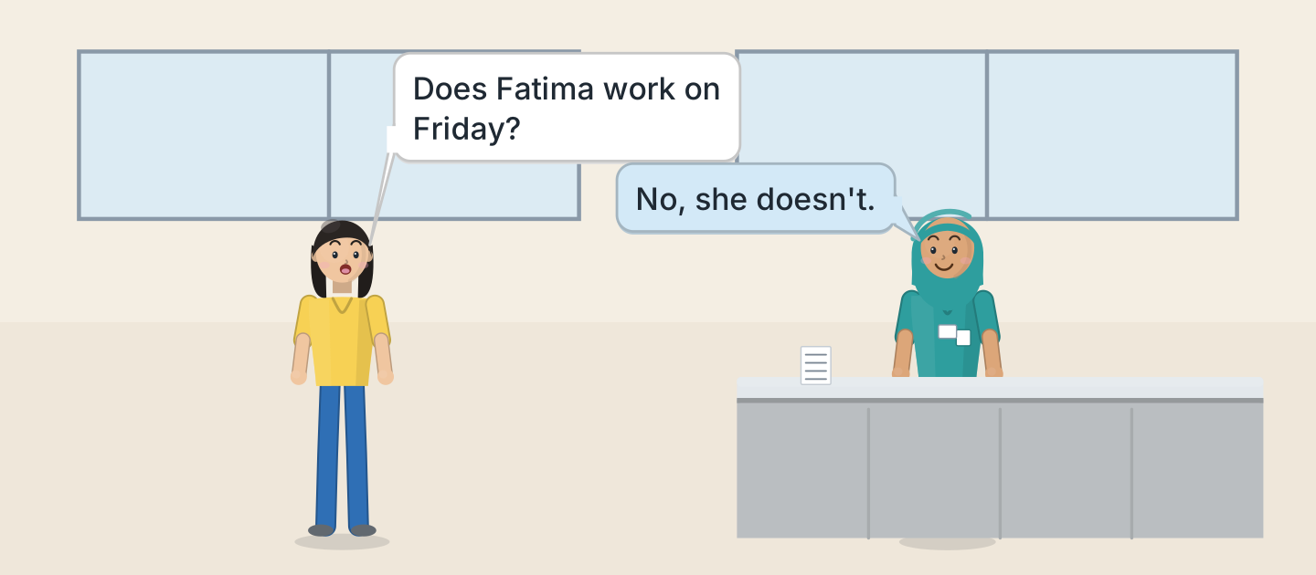
Figure 6.13 · Lili asks about Fatima.
- A: Does Fatima work on Friday? B: No, she doesn’t. (example)
- Ask where she works.
- Ask when she starts.
- Ask about Saturday.
4B Look at Figure 6.14. Ask and answer.
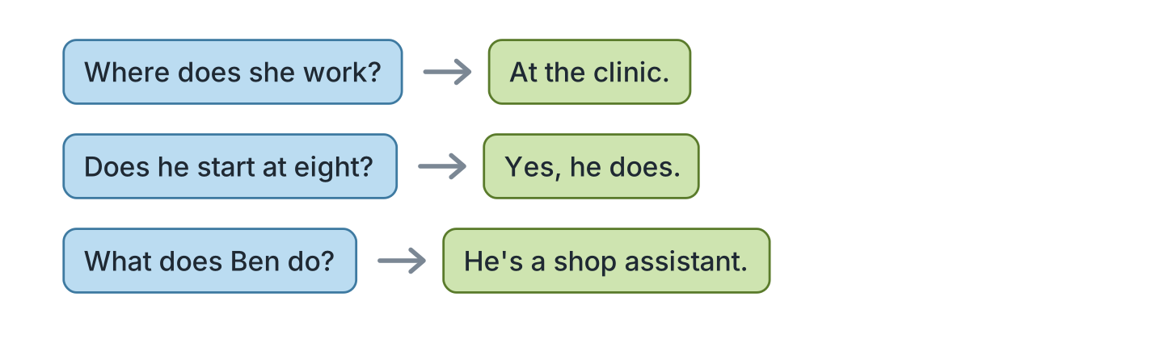
Figure 6.14 · Ask about a person.
- A: Where does she work? B: At the clinic. (example)
- A: Does he start at eight? B: ______________
- A: What does Ben do? B: ______________
- A: Does she work on Sunday? B: ______________
4C Tell a friend about a person you know.
- My brother works in a shop. (example)
- Say the job.
- Say the room or the flat.
- Say when they start.
4D Ask a friend about their family.
- A: What does your father do? B: He’s a driver. (example)
- Ask about a mother or a father.
- Ask about the place.
- Ask about the time.
Part 5 · Reading
5A Look at Figure 6.15. Answer the questions.
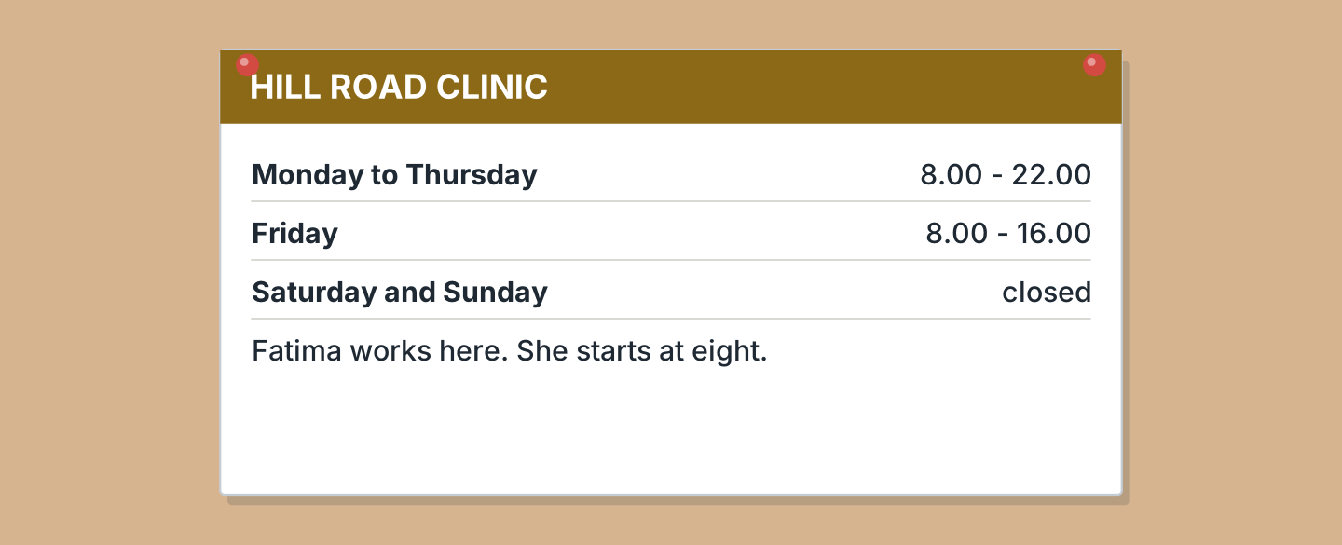
Figure 6.15 · A notice about the clinic.
- When does it open on Monday? — eight (example)
- When does it close on Thursday? — ______________
- Is the clinic shut at the weekend? — ______________
- Who works there? — ______________
5B Look at Figure 6.15. Write yes or no.
- The clinic opens at eight. — yes (example)
- It is open all day Saturday. — ______
- It closes at ten on Monday. — ______
- Fatima works on Friday evening. — ______
5C Look at Figure 6.16. Choose the correct answer.
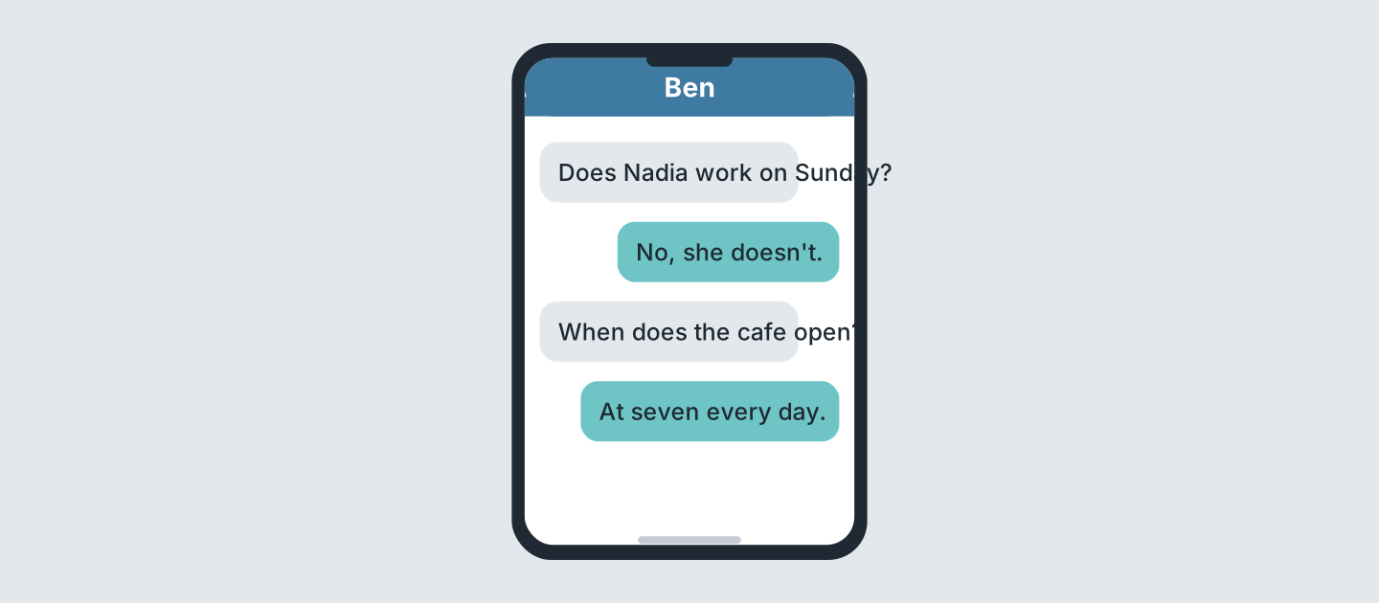
Figure 6.16 · Messages about a job.
- Who asks first? (a) Ben (b) Nadia (c) Sam — a (example)
- Does Nadia work on Sunday? (a) yes (b) no (c) maybe
- When does the cafe open? (a) six (b) seven (c) eight
- How often does it open? (a) every day (b) Monday (c) never
5D Read and correct. Write the correct word.
- Fatima is a cook. — nurse (example)
- Fatima works on Friday evening. — ______________
- The clinic opens at nine. — ______________
- Ben works at the clinic. — ______________
Part 6 · Writing
6A Look at Figure 6.17. Complete the form.
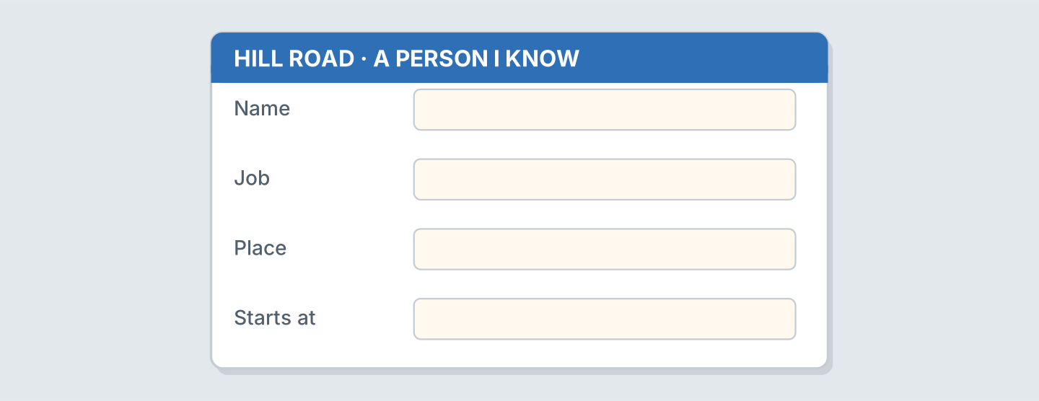
Figure 6.17 · A form about a person.
- Name: Fatima Saleh (example)
- Name: ______________
- Job: ______________
- Place: ______________
6B Look at Figure 6.18. Write four lines.
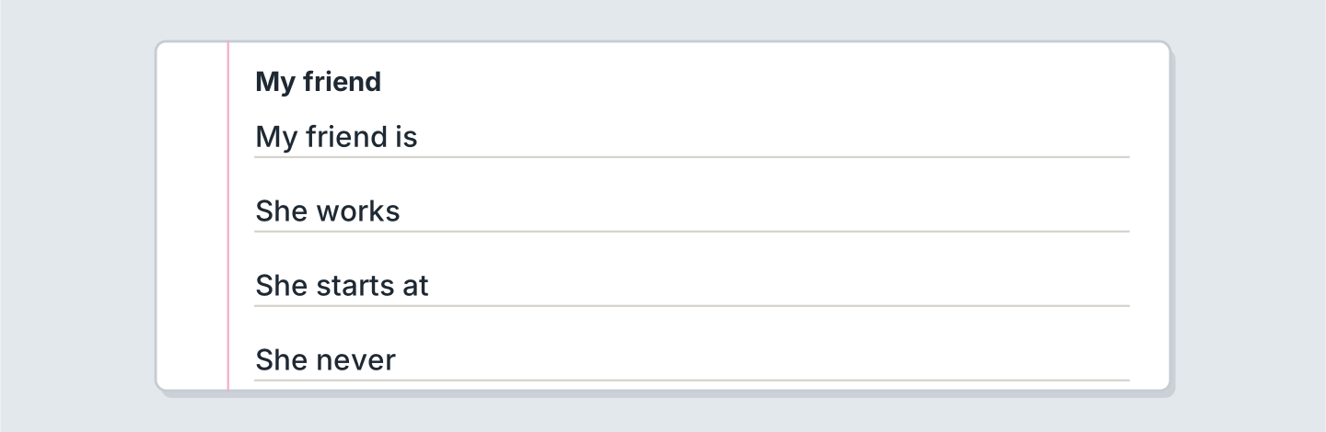
Figure 6.18 · Four lines about a friend.
- My friend is a nurse. She lives in a small house. (example)
- My friend is ______________.
- She works ______________.
- There is a big ______________ in her kitchen.
6C Write about a person at your work or school. Write three lines.
- Marek is a cleaner. He washes the flats. (example)
- Say the name and the job.
- Say the floor or the room.
- Say one thing they do.
Part 7 · Real-World File
7A Look at Figure 6.19. Answer the questions.
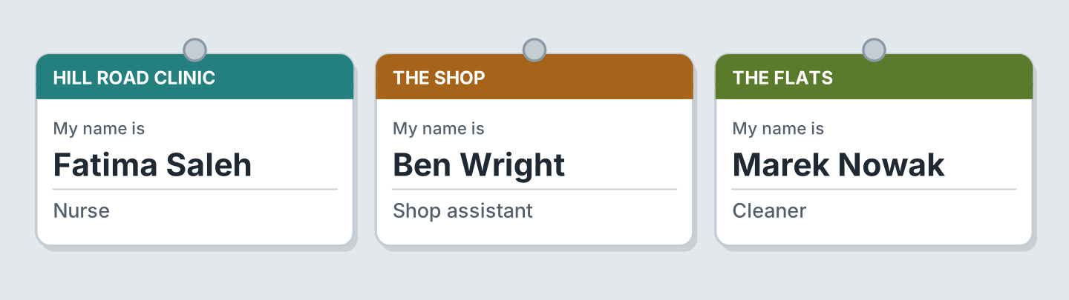
Figure 6.19 · Three places of work.
- Who is a nurse? — Fatima (example)
- Who works at the shop? — ______________
- What does Marek do? — ______________
- Where does Fatima work? — ______________
7B Look at Figure 6.20. Answer the questions.
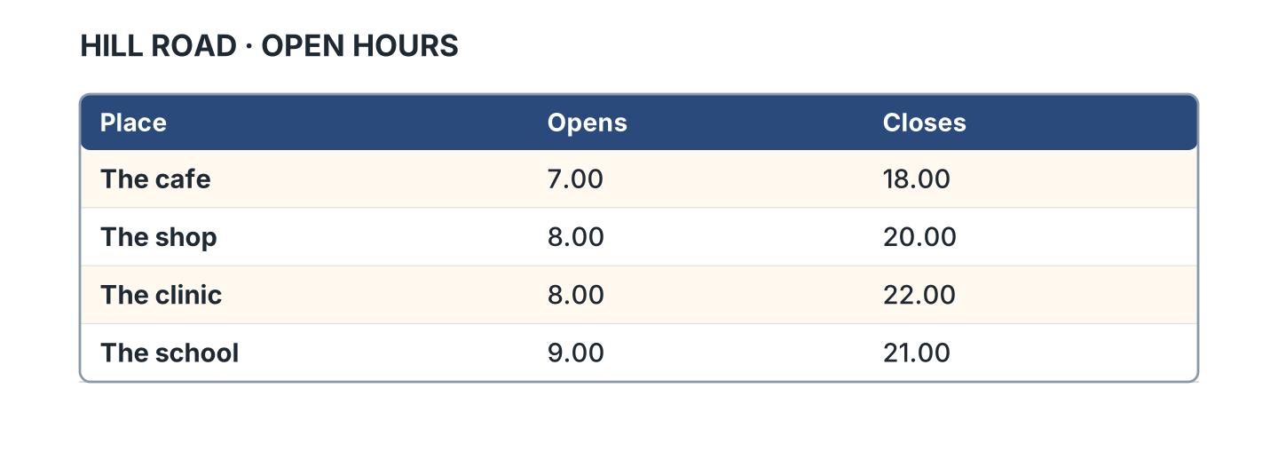
Figure 6.20 · Hours at four places.
- When does the cafe open? — 7.00 (example)
- When does the shop close? — ______________
- Which place closes last? — ______________
- Which place opens last? — ______________
7C Write the hours of a place you know.
- The shop opens at eight. (example)
- Name of the place: ______________
- It opens at: ______________
- It closes at: ______________
Part 8 · Review & Can-Do
8A Look at Figure 6.21. Write the word.
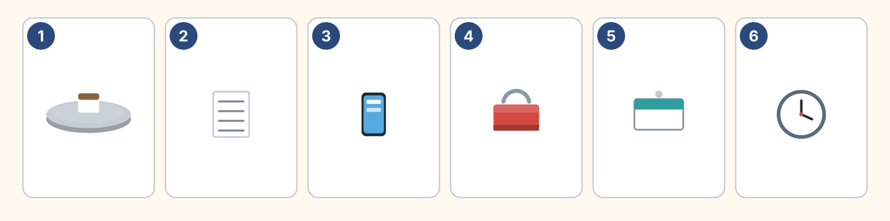
Figure 6.21 · Six things from this unit.
Words: badge · clock · phone · timetable · toolbox · tray
- 1 — tray (example)
- 2 — ______________
- 3 — ______________
- 4 — ______________
- 6 — ______________
8B Complete the conversation.
Words: does · doesn’t · What · works
- A: What does your sister do? (What) (example)
- B: She ______ at the clinic.
- A: ______ she work on Friday?
- B: No, she ______.
8C Write the he or she form.
- I live — she lives (example)
- I start — he ______________
- I watch — she ______________
- I study — he ______________
8D Match the question and the answer.
Question | Answer
1 What does she do? | a At the clinic.
2 Where does he work? | b She’s a nurse.
3 Does he work on Sunday? | c No, he doesn’t.
4 When does she start? | d At eight.
 | e Yes, there are.
One option is not needed.
- 1 — b (example)
- 2 — ______
- 3 — ______
- 4 — ______
8E Look at Figure 6.22. Tick what you can do.
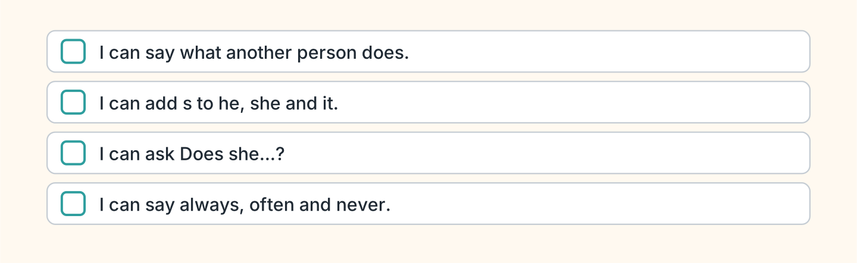
Figure 6.22 · What I can do.
- I can say what another person does. — ✓ (example)
- I can add s to he, she and it. — ______
- I can ask Does she work here? — ______
- I can say always, often and never. — ______

Unit 7: Food and Drink
In this unit you order food. You say what you like.
Warm Up
W1 Look at Figure 7.1. Answer the questions.
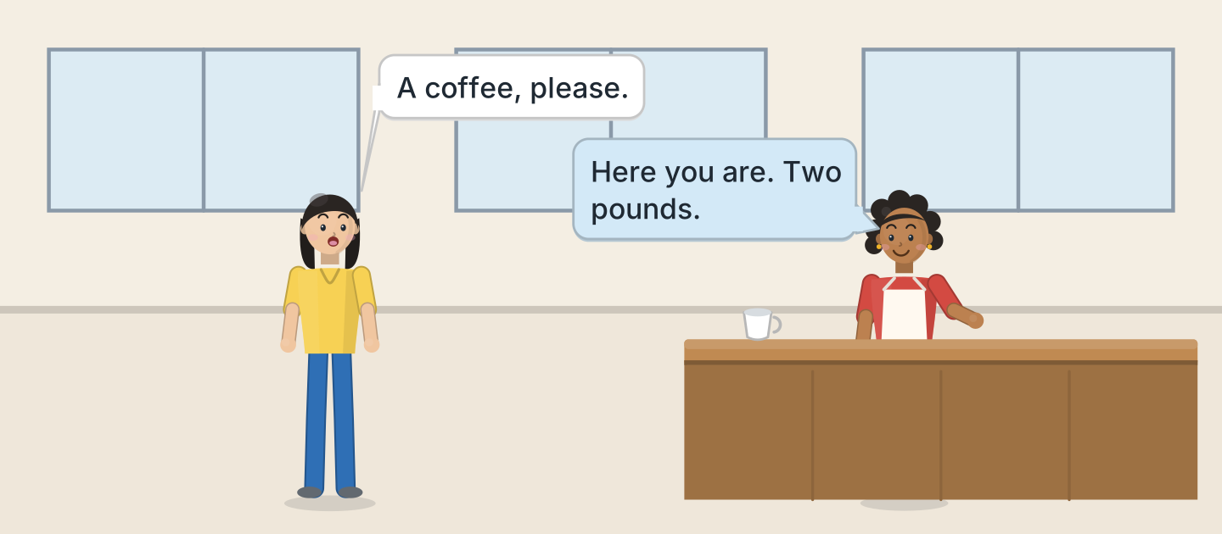
Figure 7.1 · A morning at the cafe.
- What does Lili want? — a coffee (example)
- How much is it? — ______________
- Who works at the cafe? — ______________
- Is Lili at the shop? — ______
W2 Look at Figure 7.2. Write the word.
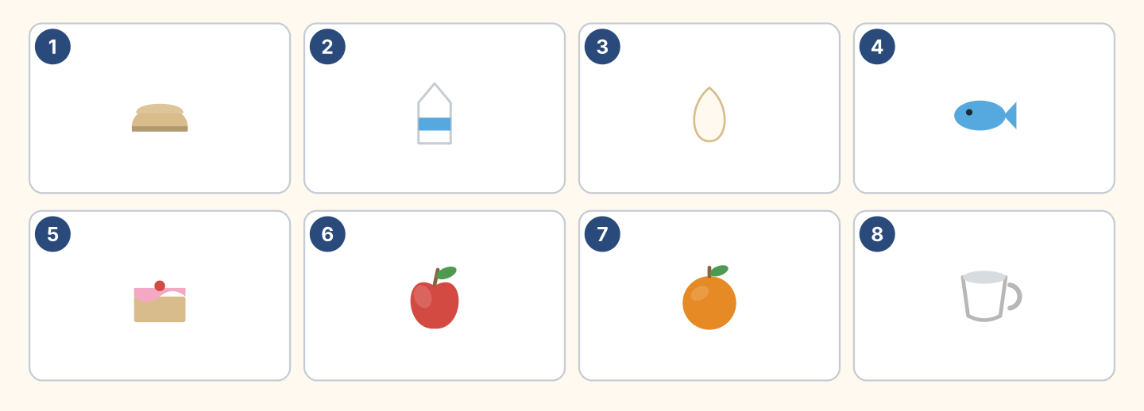
Figure 7.2 · Eight things to eat and drink.
Words: apple · bread · cake · cup · egg · fish · milk · orange
- 1 — bread (example)
- 2 — ______________
- 3 — ______________
- 5 — ______________
- 7 — ______________
W3 Say three things you eat every day.
- I eat bread and cheese every morning. (example)
- Say one food you have for lunch.
- Say what your mother cooks.
- Say one thing you never eat.
Part 1 · Words & Sounds
1A Look at Figure 7.3. Answer the questions.
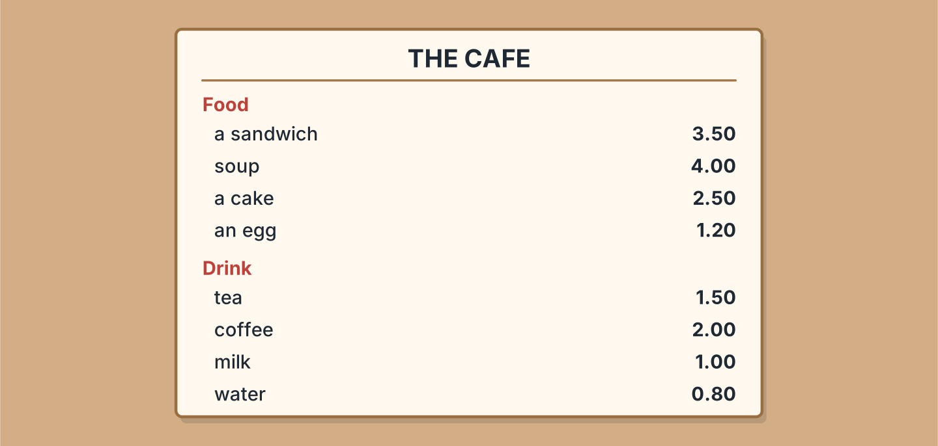
Figure 7.3 · The cafe menu.
- How much is a cake? — 2.50 (example)
- How much is soup? — ______________
- How much is tea? — ______________
- What is the cheapest drink? — ______________
1B Look at Figure 7.4. Write a, an or nothing.
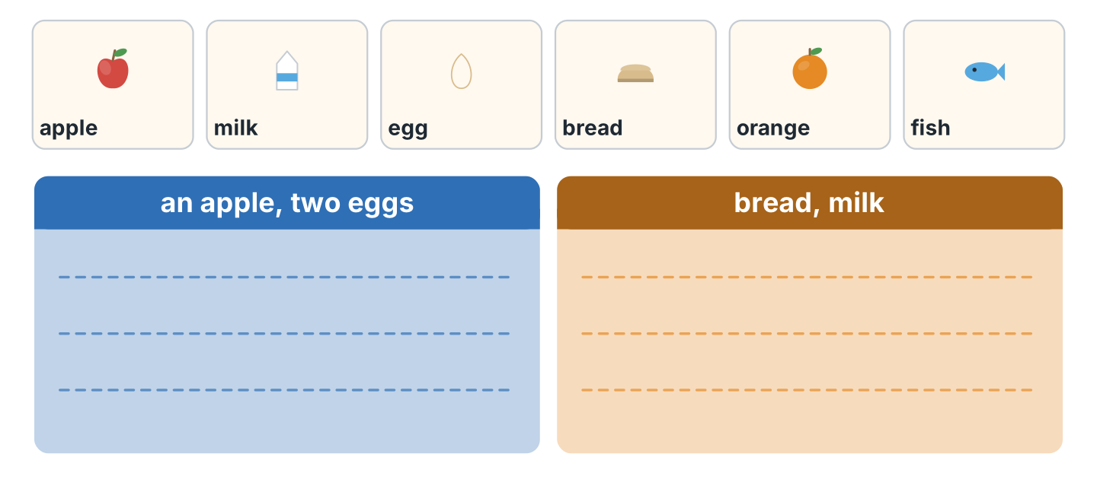
Figure 7.4 · One or not one.
- an apple (example)
- ______ milk
- ______ egg
- ______ bread
- ______ orange
1C Look at Figure 7.5. Write some or any.
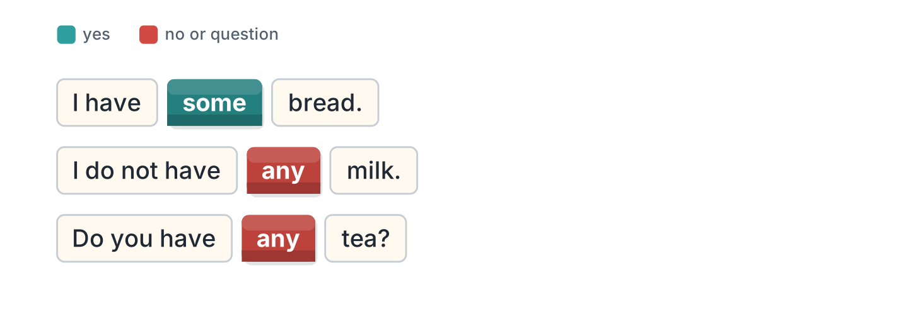
Figure 7.5 · some and any.
- I have some bread. (some) (example)
- I do not have ______ milk.
- Do you have ______ tea?
- We have ______ cake.
1D Say it. Say the prices.
- 2.50 — two pounds fifty (example)
- 1.50
- 4.00
- 0.80
- 3.50
1E Look at Figure 7.6. Write the word.
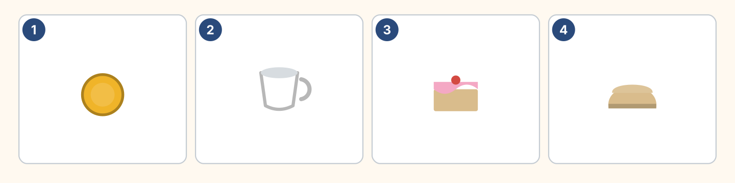
Figure 7.6 · Four prices.
Words: bread · cake · coin · cup
- 1 — coin (example)
- 2 — ______________
- 3 — ______________
- 4 — ______________
1F Write the food or the drink.
- tea — a drink (example)
- bread — ______________
- coffee — ______________
- a busy restaurant sells — ______________
Part 2 · Grammar
2A Look at Figure 7.7. Complete the sentence.
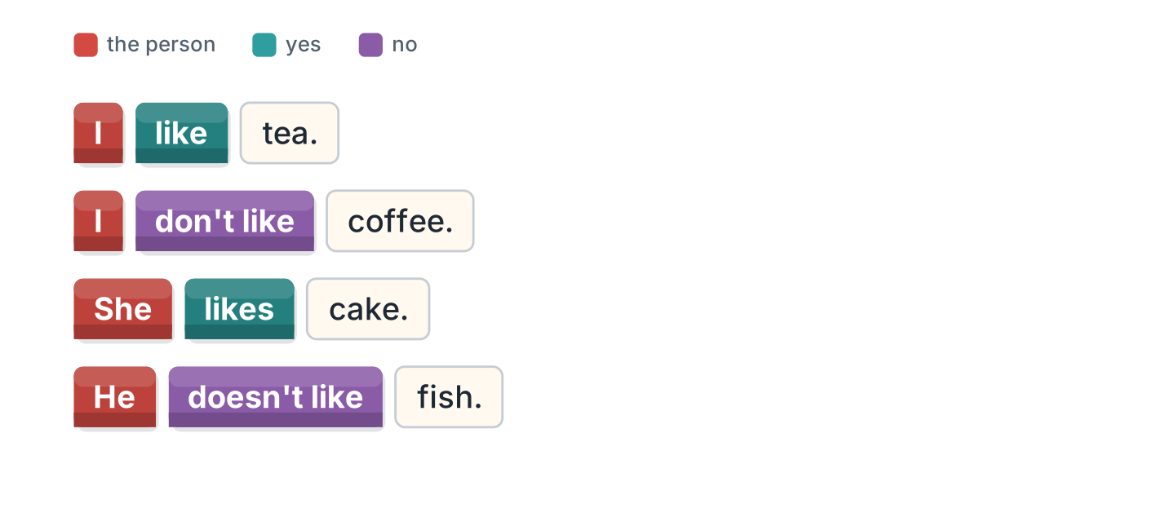
Figure 7.7 · like and do not like.
- I like tea. (like) (example)
- She ______________ cake.
- He ______________ fish.
- I ______________ coffee.
2B Choose the correct word.
- She (like / likes) cake. — likes (example)
- I (like / likes) fish.
- He (don’t / doesn’t) like milk.
- They (like / likes) soup.
- We (don’t / doesn’t) like coffee.
2C Look at Figure 7.8. Write the answer.
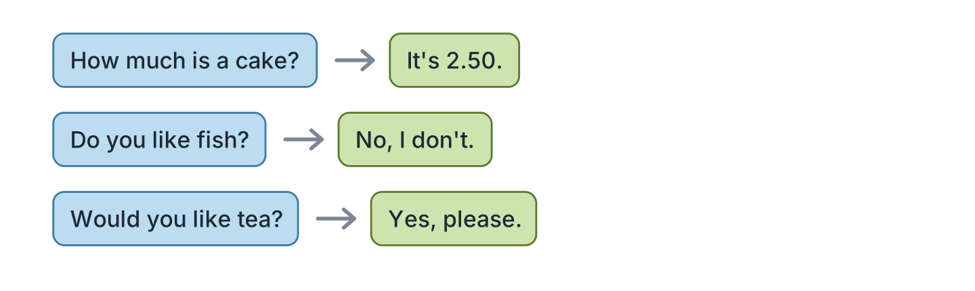
Figure 7.8 · Asking the price.
- How much is a cake? — It’s 2.50. (example)
- Do you like fish? ✗ — ______________
- Would you like tea? ✓ — ______________
- How much is soup? — ______________
2D Write some or any.
- We have some bread. (some) (example)
- There isn’t ______ milk.
- Is there ______ cake?
- I have ______ water.
2E Look at Figure 7.9. Answer the questions.
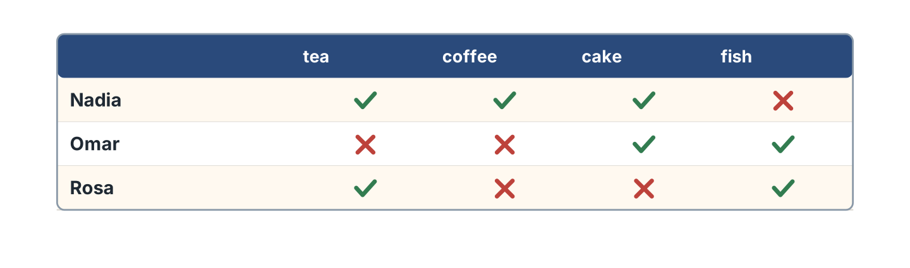
Figure 7.9 · Who likes what.
- Does Nadia like tea? — Yes, she does. (example)
- Does Omar like coffee? — ______________
- Does Rosa like fish? — ______________
- Who likes cake? — ______________
2F Find the mistake. Write the correct words.
- I likes tea. — like (example)
- She don’t like fish. — ______________
- Do you have some milk? — ______________
- He like cake. — ______________
Part 3 · Listening
3A Listen. Look at Figure 7.10. Write the number.
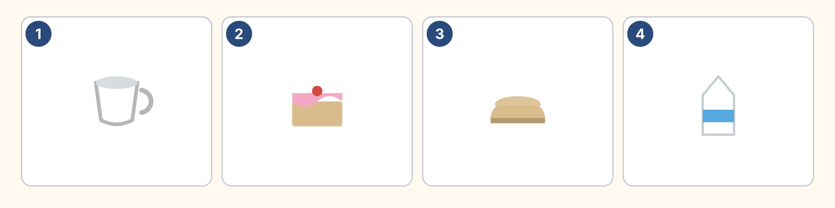
Figure 7.10 · Four orders.
- a cup of tea — 1 (example)
- a cake — ______
- bread — ______
- milk — ______
3B Listen. Look at Figure 7.11. Write the price.
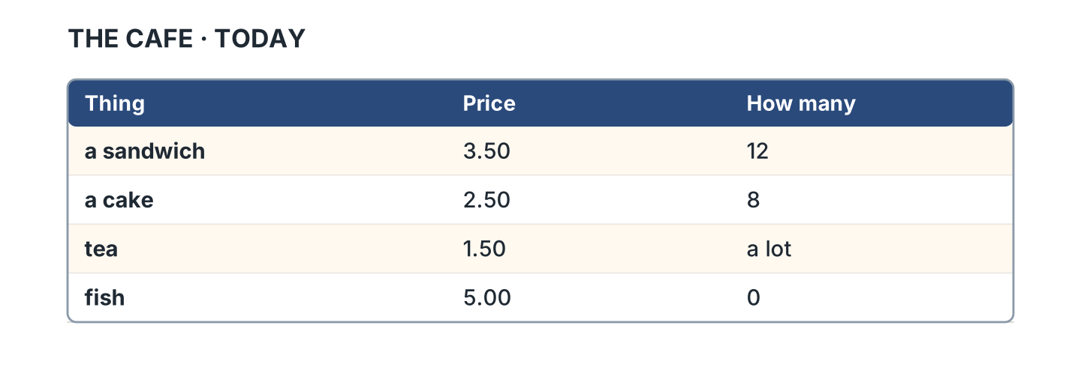
Figure 7.11 · What the cafe sells.
- a sandwich — 3.50 (example)
- a cake — ______________
- tea — ______________
- fish — ______________
3C Listen. Look at Figure 7.12. Write how many.
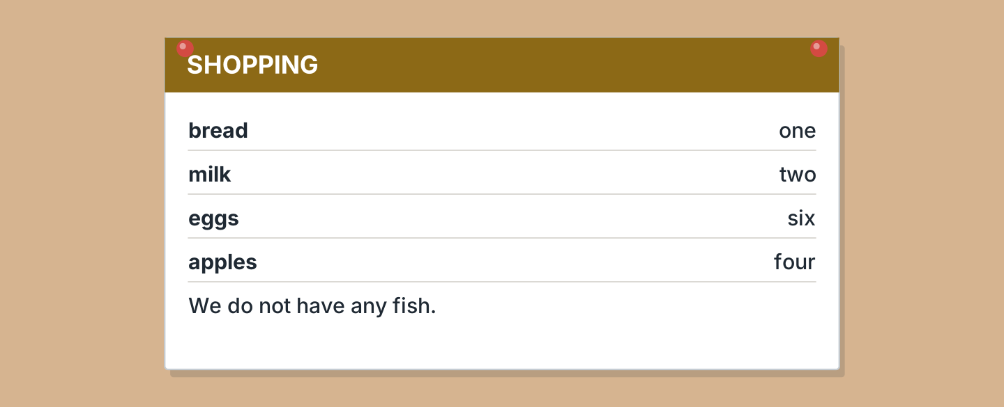
Figure 7.12 · A shopping list.
- bread — one (example)
- milk — ______________
- eggs — ______________
- apples — ______________
3D Listen. Write the price you hear.
- two pounds — 2.00 (example)
- ______________
- ______________
- ______________
Part 4 · Speaking
4A Look at Figure 7.13. Order something.
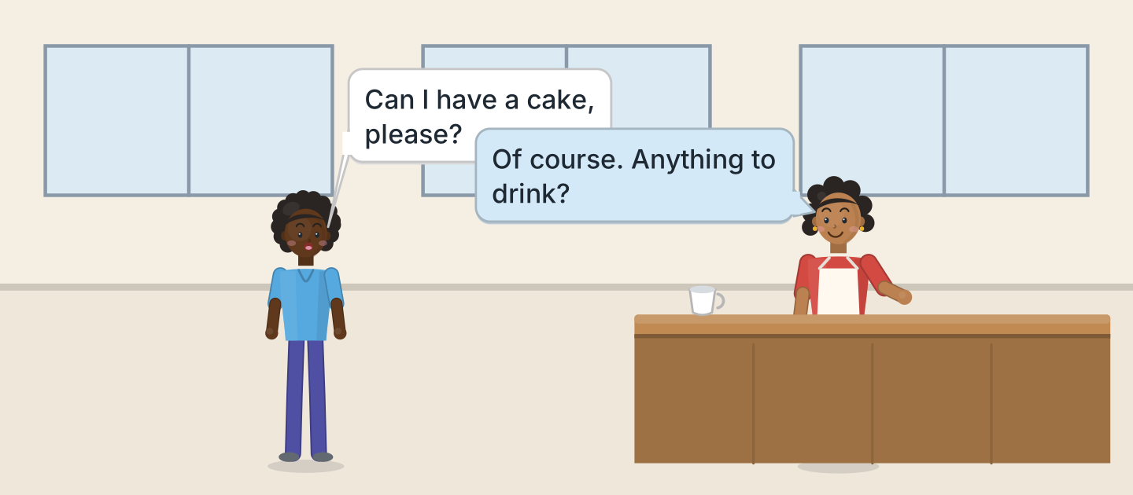
Figure 7.13 · Omar orders.
- A: Can I have a cake, please? B: Of course. (example)
- Order a drink.
- Order some food.
- Ask the price.
4B Look at Figure 7.14. Ask and answer.
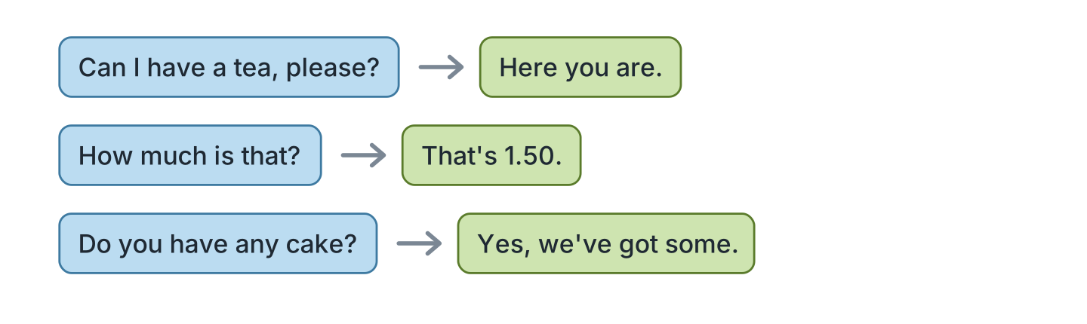
Figure 7.14 · At the counter.
- A: Can I have a tea, please? B: Here you are. (example)
- A: How much is that? B: ______________
- A: Do you have any cake? B: ______________
- A: Would you like milk? B: ______________
4C Ask three friends what they like.
- A: Do you like coffee? B: Yes, I do. (example)
- Ask about a drink.
- Ask what the waiter sells.
- Ask about breakfast.
4D Say four things you like and do not like.
- I like soup. I don’t like fish. (example)
- ______________
- ______________
- ______________
Part 5 · Reading
5A Look at Figure 7.15. Answer the questions.
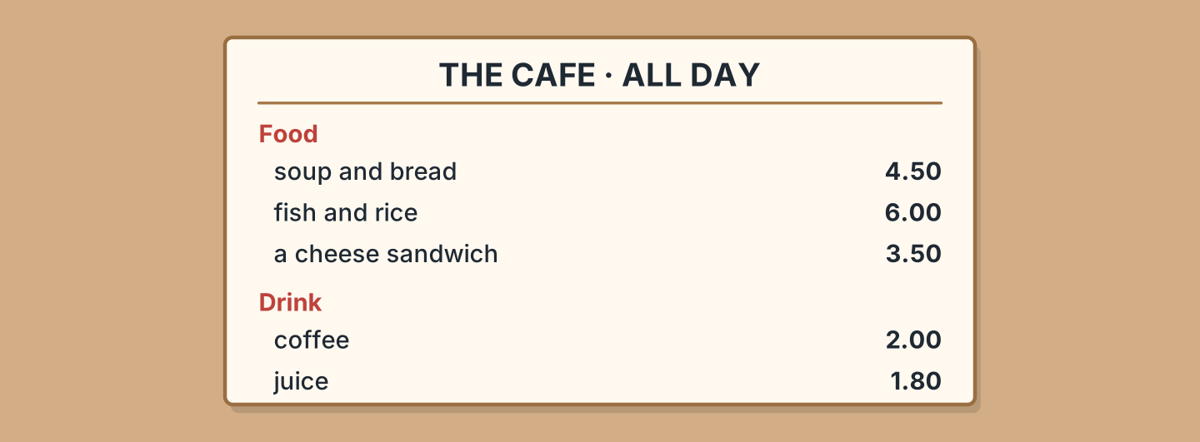
Figure 7.15 · A longer menu.
- How much is the soup? — 4.50 (example)
- How much is the juice? — ______________
- What comes with the fish? — ______________
- Which food is cheapest? — ______________
5B Look at Figure 7.15. Write yes or no.
- There is soup on the menu. — yes (example)
- The coffee is two pounds. — ______
- There is a fish sandwich. — ______
- The juice is one pound eighty. — ______
5C Look at Figure 7.16. Choose the correct answer.
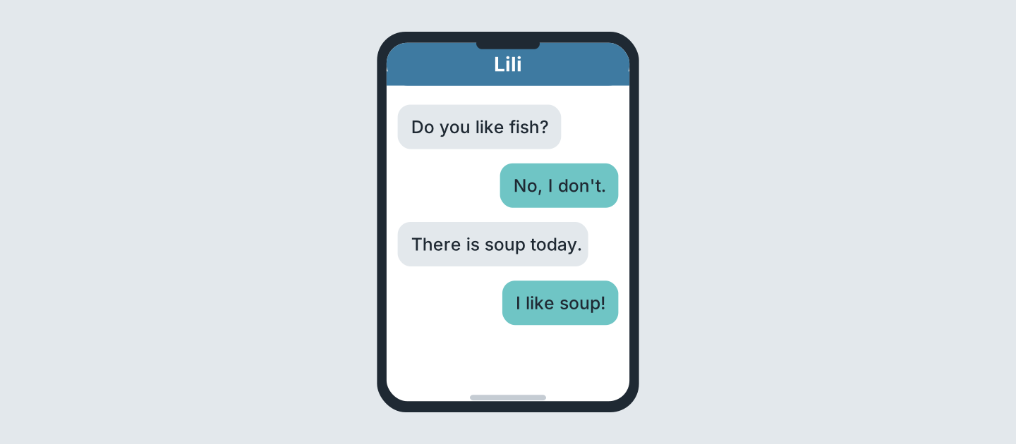
Figure 7.16 · Messages about lunch.
- Who writes first? (a) a friend (b) Lili (c) Nadia — a (example)
- Does Lili like fish? (a) yes (b) no (c) maybe
- What is there today? (a) soup (b) fish (c) cake
- Does Lili like soup? (a) yes (b) no (c) maybe
5D Read and correct. Write the correct word.
- Lili likes fish. — soup (example)
- The coffee is one pound. — ______________
- There is cake today. — ______________
- The juice is three pounds. — ______________
Part 6 · Writing
6A Look at Figure 7.17. Complete the form.
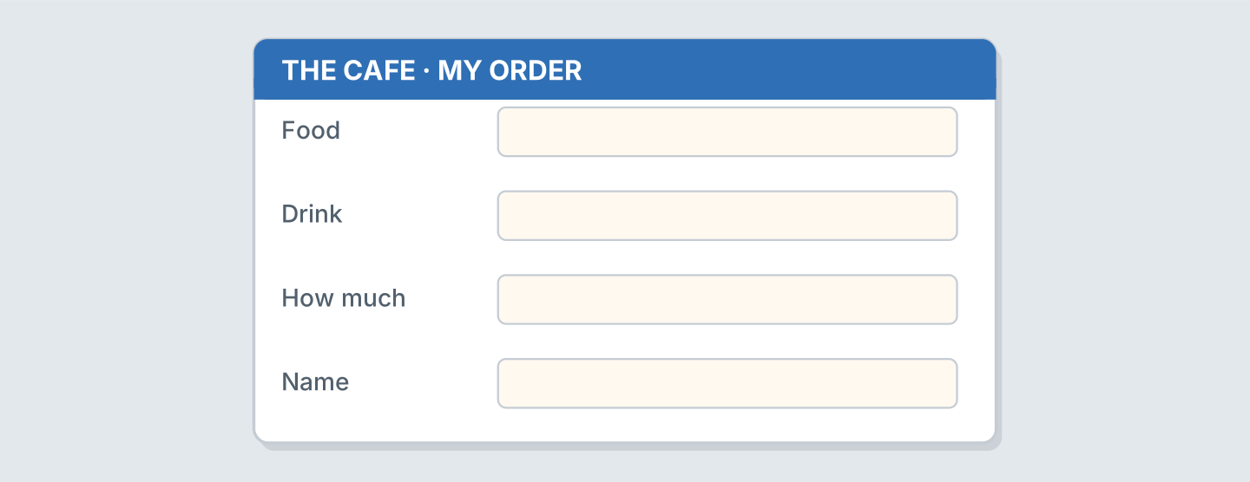
Figure 7.17 · A form for your order.
- Food: a sandwich (example)
- Food: ______________
- Drink: ______________
- How much: ______________
6B Look at Figure 7.18. Write four lines.
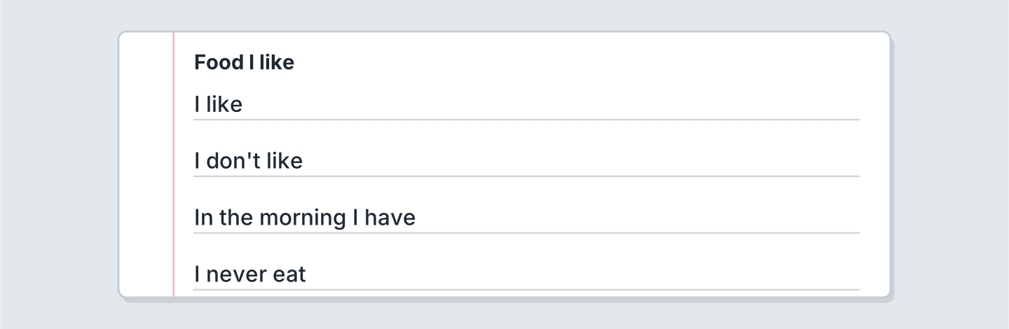
Figure 7.18 · Four lines about food.
- I like bread and cheese in the kitchen at home. (example)
- I like ______________.
- My father often cooks ______________.
- I never eat ______________.
6C Write a shopping list. Write four things.
- bread, milk, eggs, apples for the fridge (example)
- ______________
- ______________
- ______________
Part 7 · Real-World File
7A Look at Figure 7.19. Answer the questions.
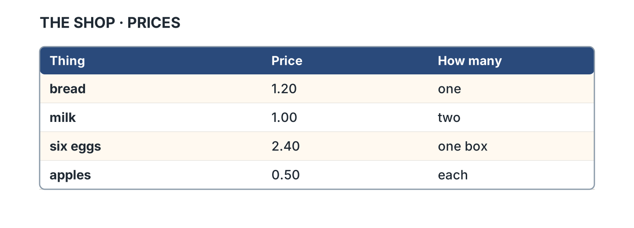
Figure 7.19 · Prices in the shop.
- How much is bread? — 1.20 (example)
- How much is milk? — ______________
- How much are six eggs? — ______________
- How much is one apple? — ______________
7B Look at Figure 7.20. Write the word.
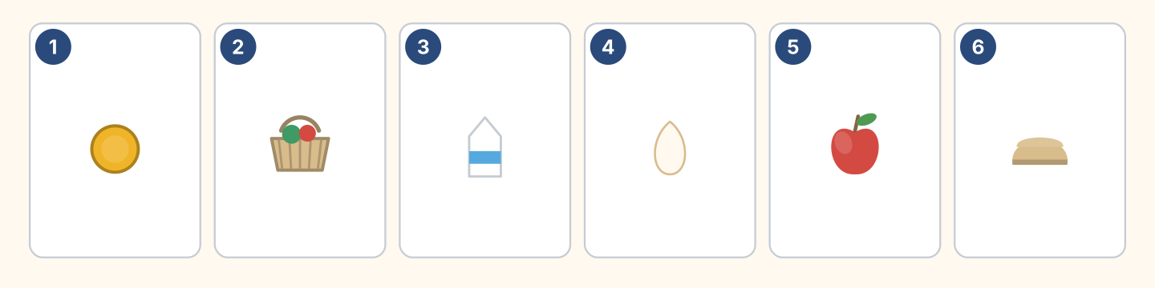
Figure 7.20 · Money and food.
Words: apple · basket · bread · coin · egg · milk
- 1 — coin (example)
- 2 — ______________
- 3 — ______________
- 5 — ______________
7C Write what you buy. Use Figure 7.19.
- I buy bread at the market in the morning. It’s 1.20. (example)
- ______________
- ______________
- ______________
Part 8 · Review & Can-Do
8A Look at Figure 7.21. Write the word.
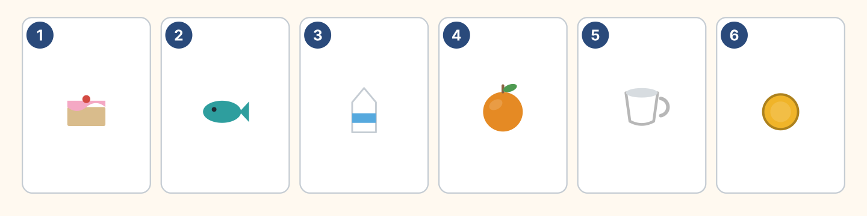
Figure 7.21 · Six things from this unit.
Words: cake · coin · cup · fish · milk · orange
- 1 — cake (example)
- 2 — ______________
- 3 — ______________
- 4 — ______________
- 6 — ______________
8B Complete the conversation.
Words: any · Can · how · like
- A: Can I have a tea, please? (Can) (example)
- B: Of course. Would you ______ milk?
- A: No, thank you. Do you have ______ cake?
- B: Yes. And ______ much is that?
8C Write some or any.
- I have some bread. (some) (example)
- There isn’t ______ fish.
- Do you have ______ milk?
- We have ______ eggs.
8D Match the question and the answer.
Question | Answer
1 How much is a cake? | a Yes, please.
2 Do you like fish? | b It’s 2.50.
3 Would you like tea? | c No, I don’t.
4 Can I have bread? | d Here you are.
 | e She’s a cook.
One option is not needed.
- 1 — b (example)
- 2 — ______
- 3 — ______
- 4 — ______
8E Look at Figure 7.22. Tick what you can do.
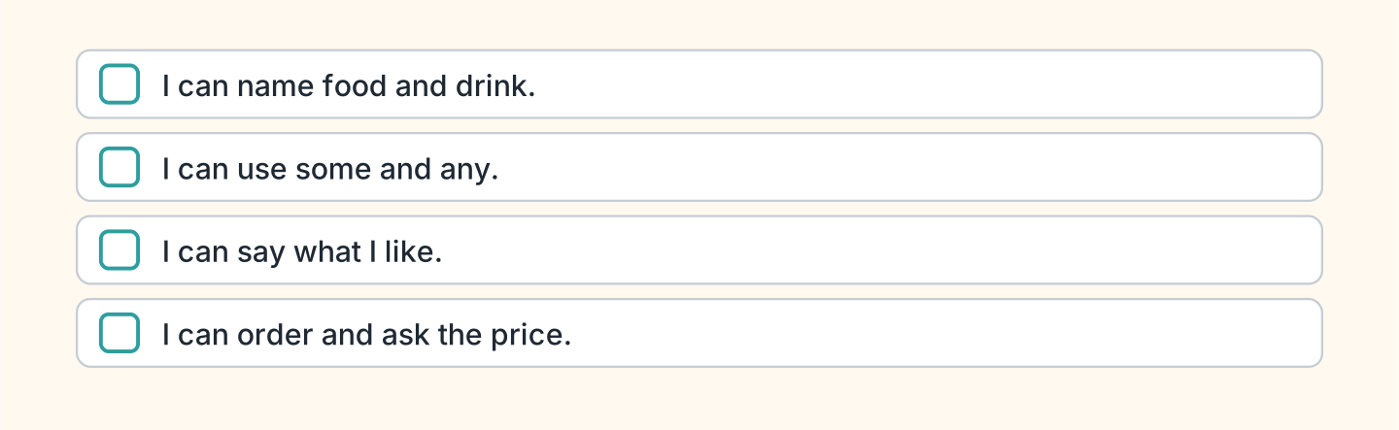
Figure 7.22 · What I can do.
- I can name food and drink. — ✓ (example)
- I can use some and any. — ______
- I can say what I like. — ______
- I can order and ask the price. — ______

Unit 8: In the Town
In this unit you find places in a town. You ask the way.
Warm Up
W1 Look at Figure 8.1. Write the place.
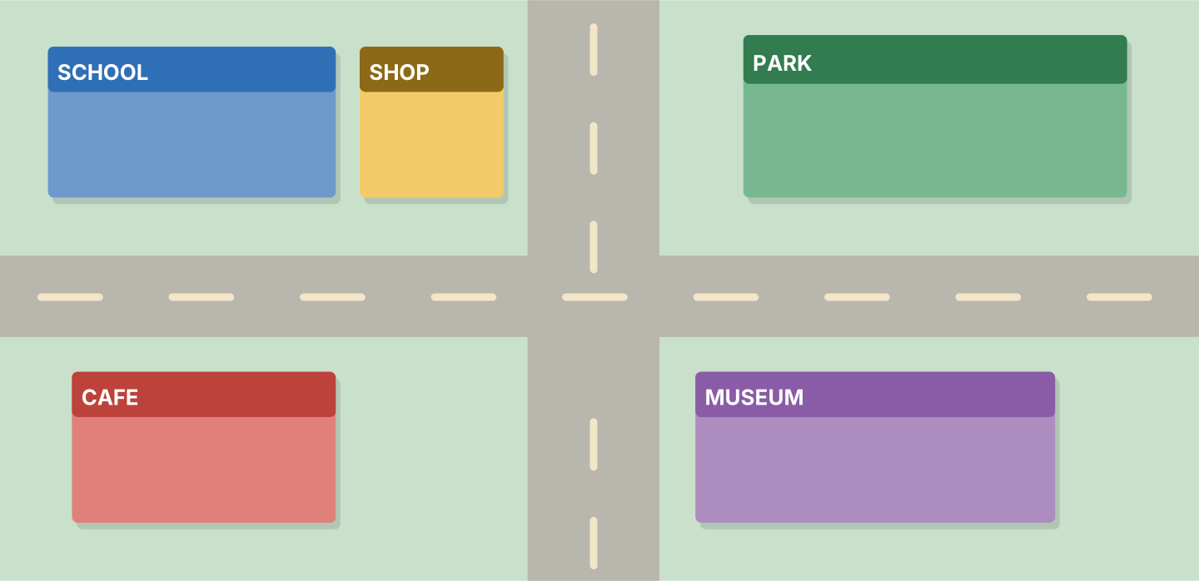
Figure 8.1 · The map of the town.
- You learn here, often in the evening. — the school (example)
- You see old things here. — ______________
- You buy a cheese sandwich here. — ______________
- Children play here. — ______________
W2 Look at Figure 8.2. Write the word.
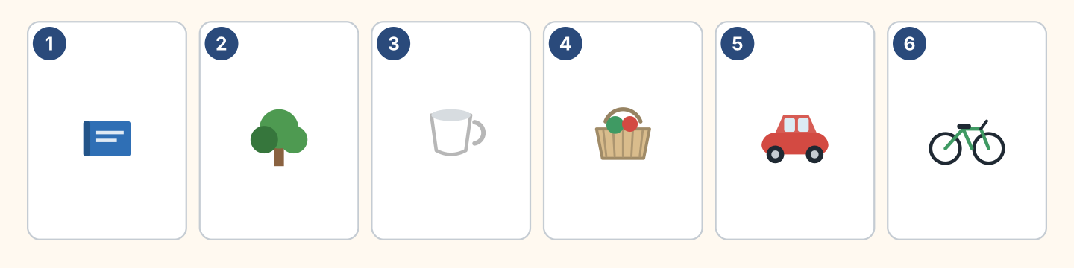
Figure 8.2 · Six places.
Words: basket · bike · book · car · cup · tree
- 1 — book (example)
- 2 — ______________
- 4 — ______________
- 5 — ______________
- 6 — ______________
W3 Say four places in your town.
- There is a market here. I buy fruit for lunch. (example)
- Say one place near the busy station.
- Say where you buy fruit and juice.
- Say one place that is not there.
Part 1 · Words & Sounds
1A Look at Figure 8.3. Write the place.
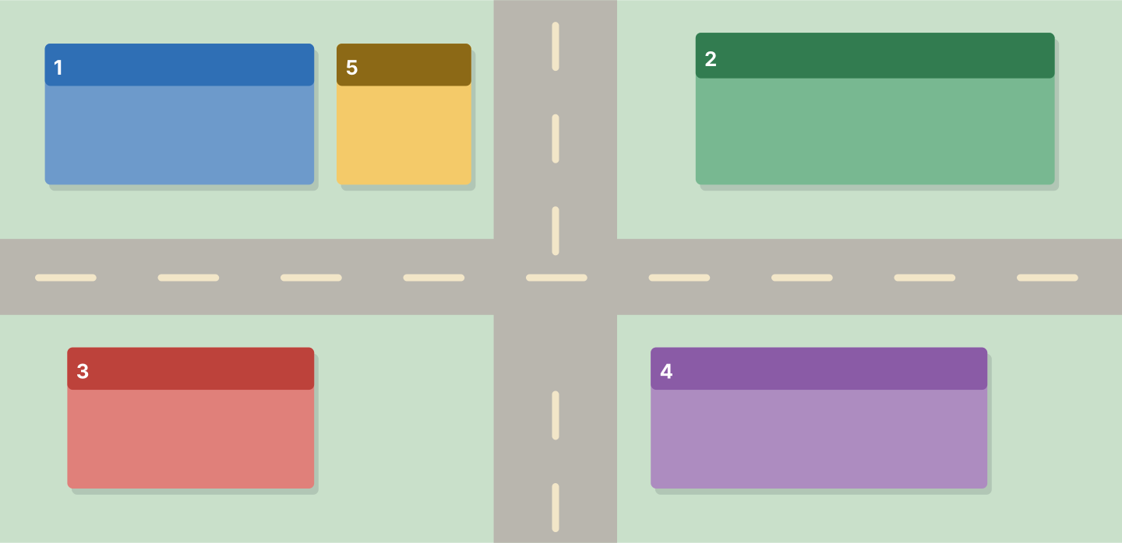
Figure 8.3 · A map with numbers.
Words: cafe · museum · park · school · shop
- 1 — school (example)
- 2 — ______________
- 3 — ______________
- 4 — ______________
- 5 — ______________
1B Look at Figure 8.4. Write the word.
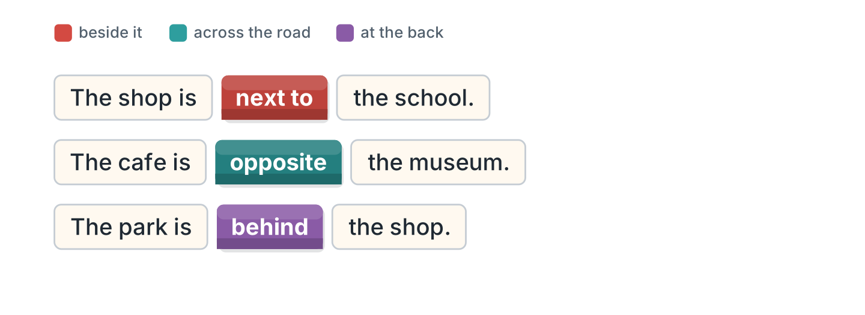
Figure 8.4 · next to and opposite.
- The shop is next to the school. (next to) (example)
- The cafe is ______________ the museum.
- The park is ______________ the shop.
- The bus stop is ______________ the cafe.
1C Look at Figure 8.5. Write the word.
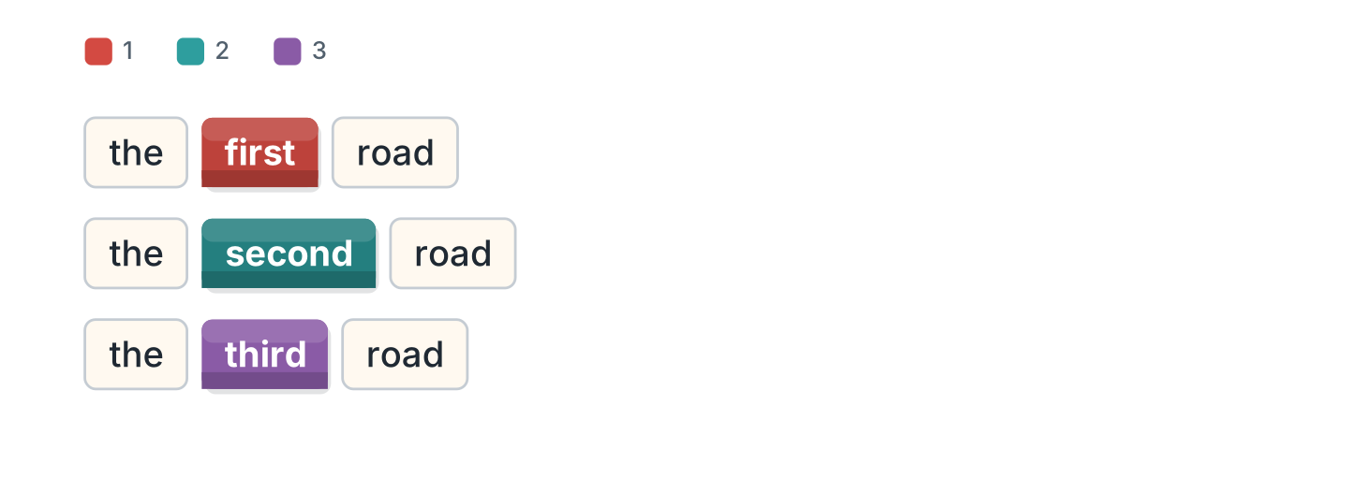
Figure 8.5 · First, second, third.
- road 1 — the first road (example)
- road 2 — ______________
- road 3 — ______________
- Which road is the museum on? — ______________
1D Say it. Say these words.
- first (example)
- second
- third
- straight
- opposite
1E Look at Figure 8.6. Answer the questions.
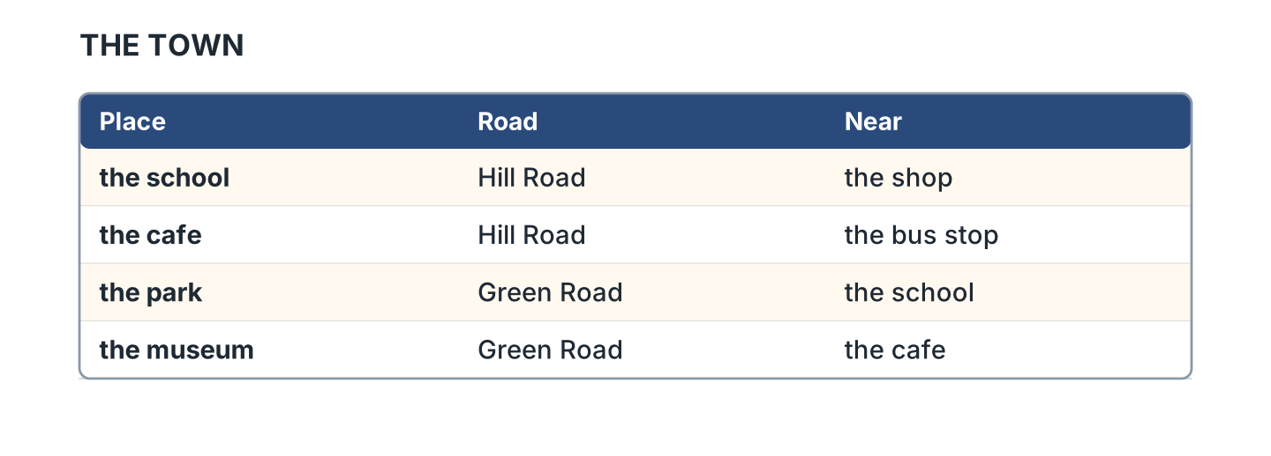
Figure 8.6 · Where the places are.
- Which road is the school on? — Hill Road (example)
- Which road is the park on? — ______________
- What is near the cafe? — ______________
- What is near the school? — ______________
1F Write the opposite word.
- left — right (example)
- near — ______________
- first — ______________
- here — ______________
Part 2 · Grammar
2A Look at Figure 8.7. Complete the sentence.
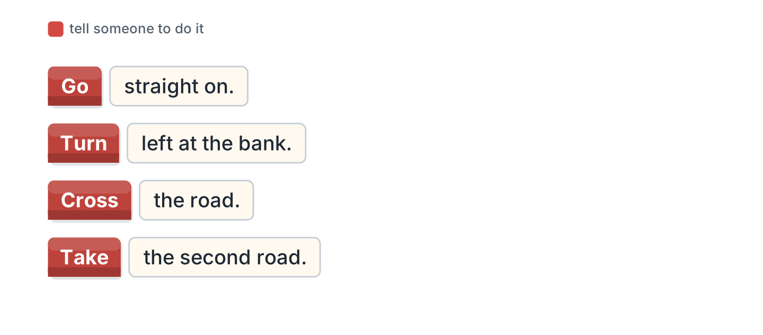
Figure 8.7 · Telling someone the way.
Words: Cross · Go · Take · Turn
- Go straight on. (Go) (example)
- ______ left at the bank.
- ______ the road.
- ______ the second road.
2B Choose the correct word.
- Turn (left / leave) at the shop. — left (example)
- Go (straight / street) on.
- Take the (two / second) road.
- The cafe is (opposite / open) the park.
- Cross the (road / ride).
2C Look at Figure 8.8. Write the answer.
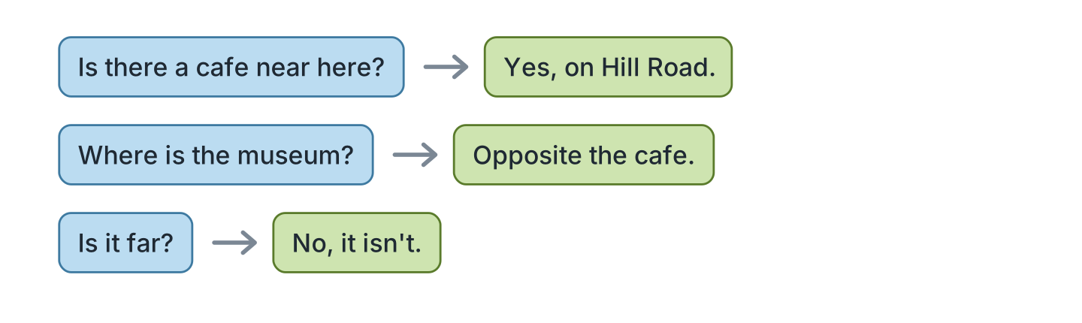
Figure 8.8 · Asking if there is one.
- Is there a cafe near here? ✓ — Yes, on Hill Road. (example)
- Where is the museum? — ______________
- Is it far? ✗ — ______________
- Is there a bank here? ✓ — ______________
2D Write the instruction.
- (go / straight) — Go straight on. (example)
- (turn / left) — ______________
- (cross / road) — ______________
- (take / first road) — ______________
2E Look at Figure 8.9. Answer the questions.
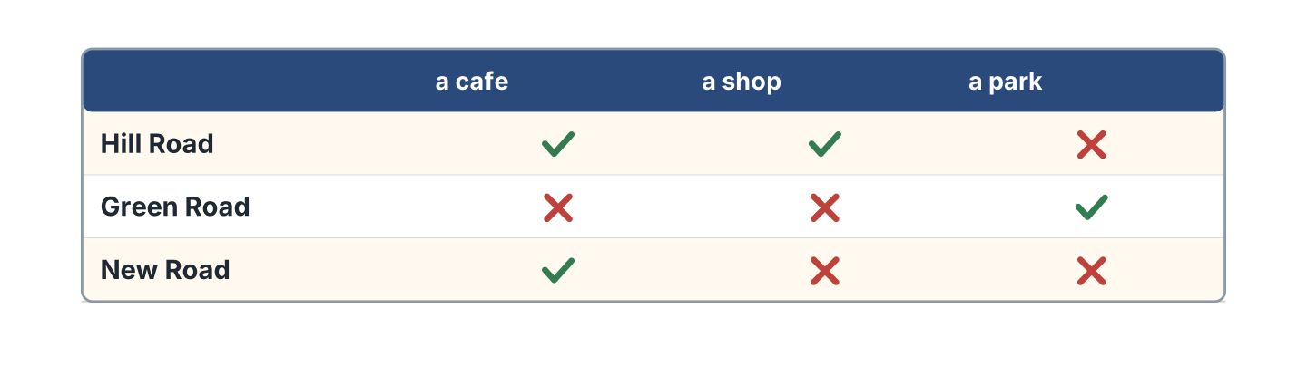
Figure 8.9 · What is on each road.
- Is there a cafe on Hill Road? — Yes, there is. (example)
- Is there a park on Hill Road? — ______________
- Is there a shop on New Road? — ______________
- Which road has a park? — ______________
2F Find the mistake. Write the correct words.
- Go straight at. — on (example)
- Turn to left at the bank. — ______________
- Take the two road. — ______________
- The cafe is next the school. — ______________
Part 3 · Listening
3A Listen. Look at Figure 8.10. Write the place.
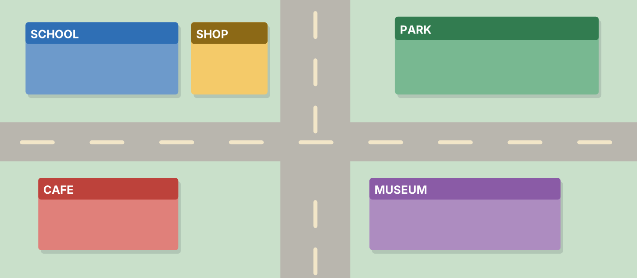
Figure 8.10 · A map to listen to.
- Go straight on. — the park (example)
- ______________
- ______________
- ______________
3B Listen. Look at Figure 8.11. Write the time.
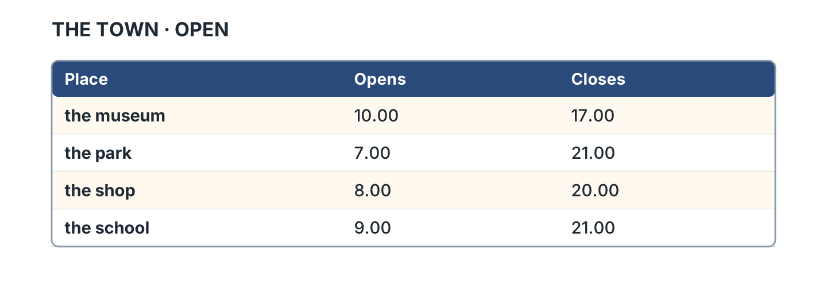
Figure 8.11 · Four places and their times.
- The museum opens at ten. (ten) (example)
- The park closes at ______________.
- The shop opens at ______________.
- The school closes at ______________.
3C Listen. Look at Figure 8.12. Write the number.
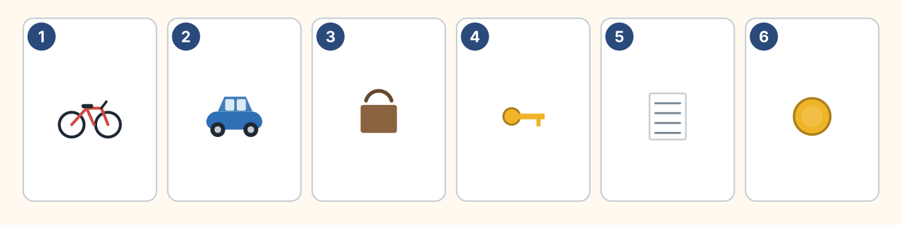
Figure 8.12 · Six ways to travel.
- a bike — 1 (example)
- a car — ______
- a bag — ______
- a coin — ______
3D Listen. Write left or right.
- left (example)
- ______________
- ______________
- ______________
Part 4 · Speaking
4A Look at Figure 8.13. Ask the way.
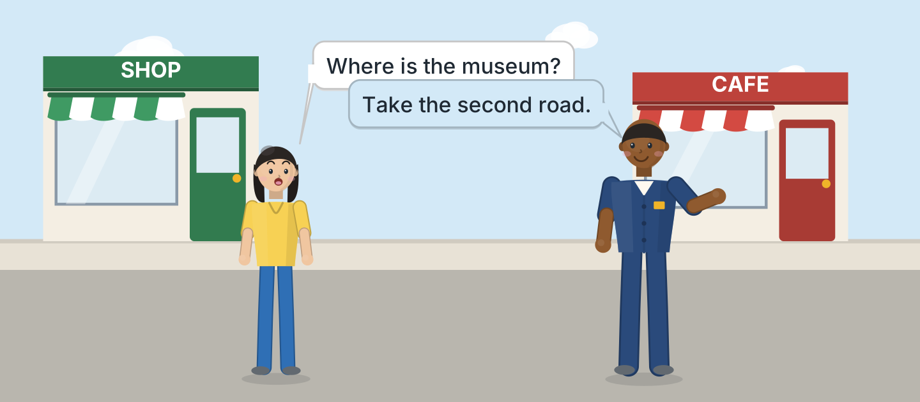
Figure 8.13 · Sam tells Lili the way.
- A: Where is the museum? B: Take the second road. (example)
- Ask about the park.
- Ask about the cafe.
- Ask if it is far.
4B Look at Figure 8.14. Ask and answer.
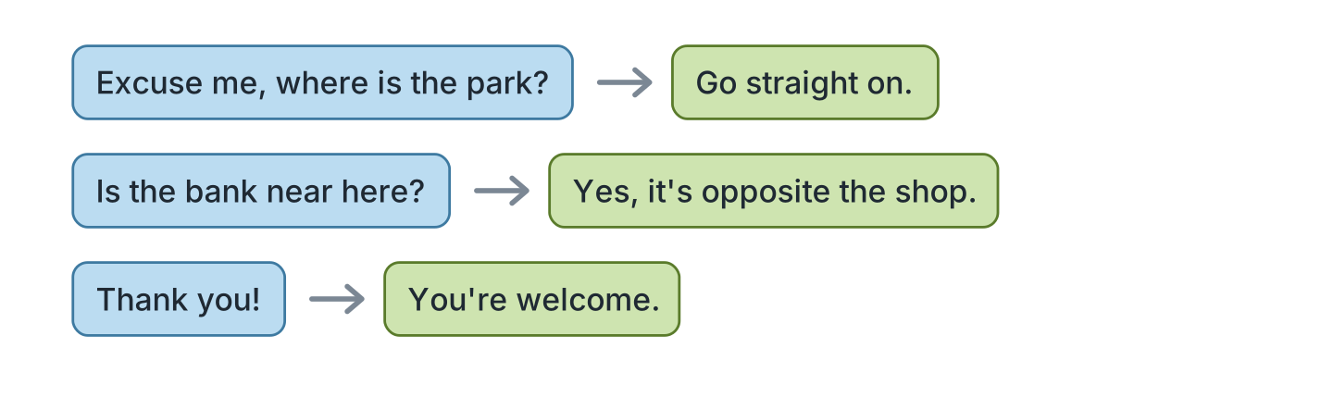
Figure 8.14 · Ask the way.
- A: Excuse me, where is the park? B: Go straight on. (example)
- A: Is the bank near here? B: ______________
- A: Is it far? B: ______________
- A: Thank you! B: ______________
4C Tell a friend the way to your home.
- Take the first road. Turn left. (example)
- Say the first road.
- Say left or right.
- Say what is near.
4D Ask three friends about their town.
- A: Is there a museum in your town? B: Yes, there is. (example)
- Ask about a hotel with cheap food.
- Ask where the market sells fish.
- Ask about a cheap restaurant.
Part 5 · Reading
5A Look at Figure 8.15. Answer the questions.
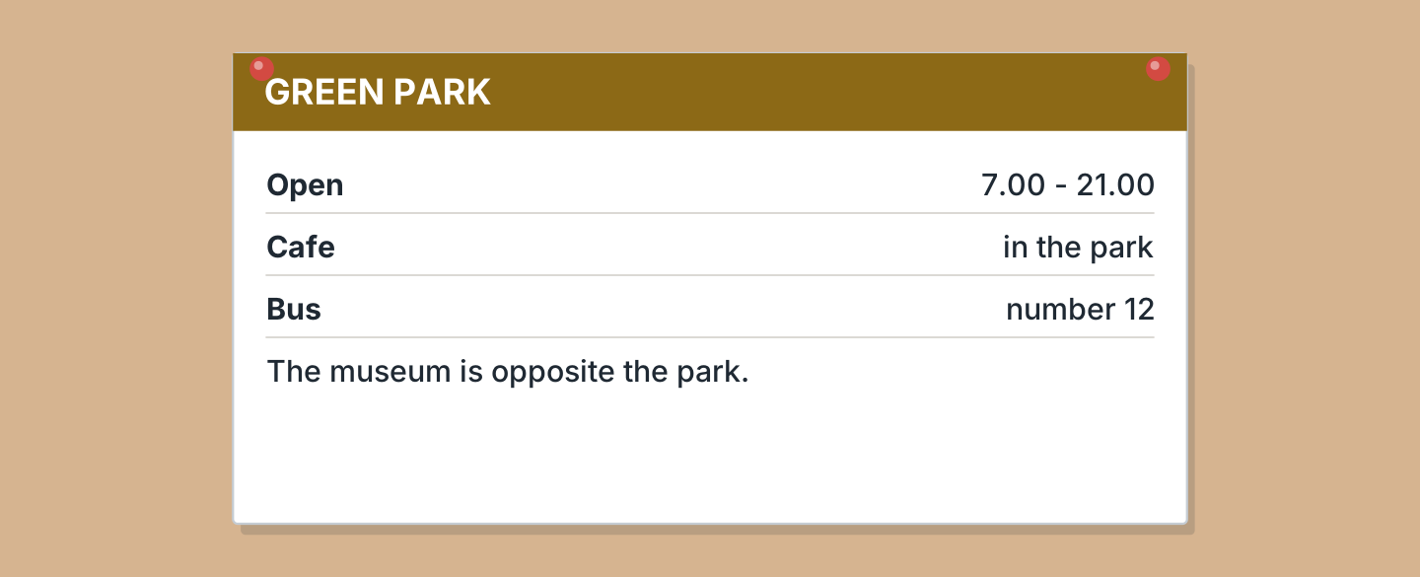
Figure 8.15 · A notice in the park.
- When does the park open? — 7.00 (example)
- When does it close? — ______________
- Which bus goes there? — ______________
- What is opposite the park? — ______________
5B Look at Figure 8.15. Write yes or no.
- There is a cafe in the park. — yes (example)
- The park closes at nine. — ______
- Bus 14 goes there. — ______
- The museum is opposite the park. — ______
5C Look at Figure 8.16. Choose the correct answer.
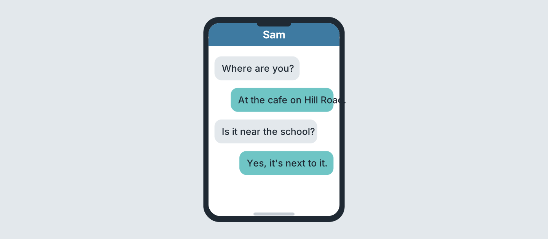
Figure 8.16 · Messages about a place.
- Who asks first? (a) Sam (b) Lili (c) Ben — a (example)
- Where is the writer? (a) park (b) cafe (c) school
- Which road is it on? (a) Hill (b) Green (c) New
- Is it near the school? (a) yes (b) no (c) maybe
5D Read and correct. Write the correct word.
- The park closes at nine. — twenty-one (example)
- Bus 14 goes to the park. — ______________
- The cafe is on Green Road. — ______________
- The park opens at eight. — ______________
Part 6 · Writing
6A Look at Figure 8.17. Complete the form.
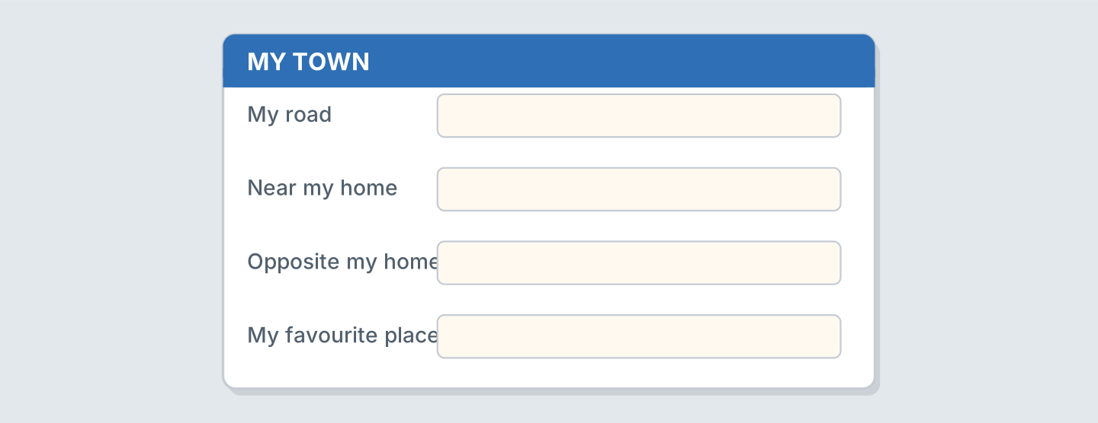
Figure 8.17 · A form about your town.
- My road: Hill Road (example)
- My road: ______________
- Near my home: ______________
- My favourite place: ______________
6B Look at Figure 8.18. Write four lines.
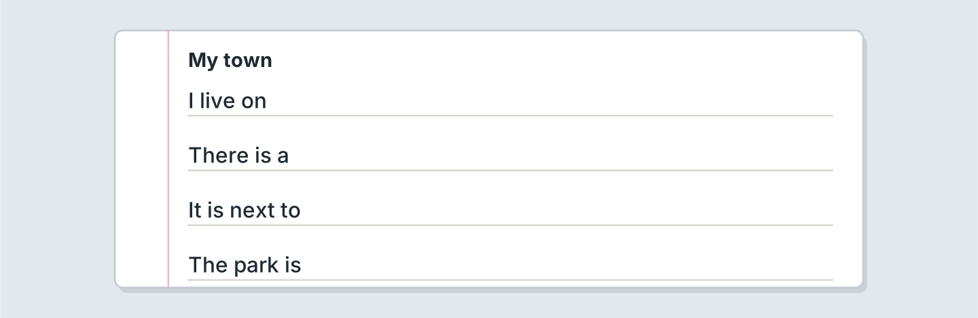
Figure 8.18 · Four lines about your town.
- I live near a cheap market. (example)
- I live on ______________.
- There is a ______________.
- I buy milk at ______________.
6C Write the way from your home to a shop.
- Turn right. Go straight on. (example)
- Say the first thing to do.
- Say left or right.
- Say where the supermarket and the bank are.
Part 7 · Real-World File
7A Look at Figure 8.19. Answer the questions.
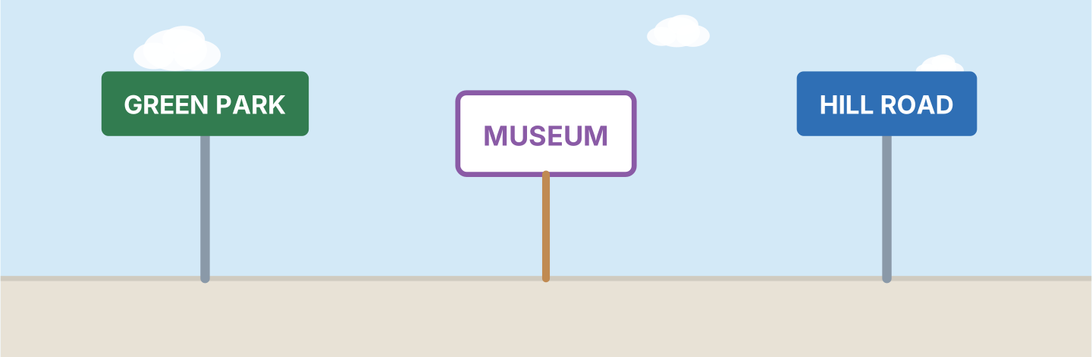
Figure 8.19 · Signs in the town.
- What is the green sign? — Green Park (example)
- What is the purple sign? — ______________
- What is the blue sign? — ______________
- Which sign is a road? — ______________
7B Look at Figure 8.20. Answer the questions.
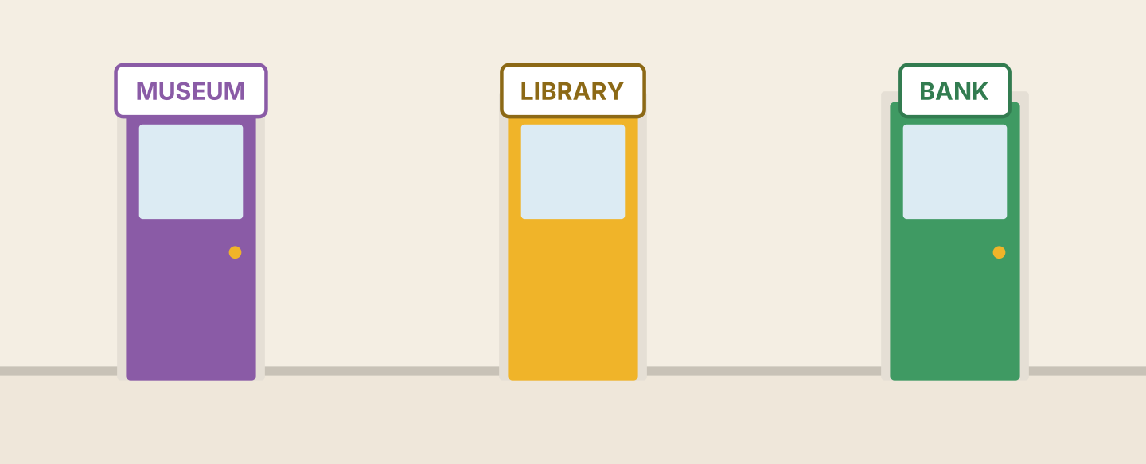
Figure 8.20 · Three doors in the town.
- What is the purple door? — the museum (example)
- What is the yellow door? — ______________
- What is the green door? — ______________
- Is there a bank? — ______
7C Write three signs for your town.
- HILL ROAD · THE BAKERY · THE MARKET (example)
- ______________
- ______________
- ______________
Part 8 · Review & Can-Do
8A Look at Figure 8.21. Write the word.
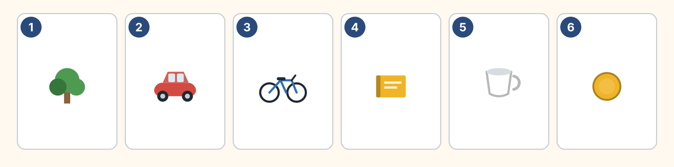
Figure 8.21 · Six things from this unit.
Words: bike · book · car · coin · cup · tree
- 1 — tree (example)
- 2 — ______________
- 3 — ______________
- 4 — ______________
- 6 — ______________
8B Complete the conversation.
Words: far · left · straight · Where
- A: Where is the bank? (Where) (example)
- B: Go ______ on, then turn ______.
- A: Is it ______?
- B: No, it is near.
8C Write next to, opposite or behind.
- The shop is next to the school. (next to) (example)
- The cafe is ______________ the museum.
- The park is ______________ the shop.
- The bank is ______________ the cafe.
8D Match the question and the answer.
Question | Answer
1 Where is the park? | a No, it’s near.
2 Is it far? | b Go straight on.
3 Is there a cafe here? | c Yes, on Hill Road.
4 Which road is it? | d The second one.
 | e She’s a nurse.
One option is not needed.
- 1 — b (example)
- 2 — ______
- 3 — ______
- 4 — ______
8E Look at Figure 8.22. Tick what you can do.
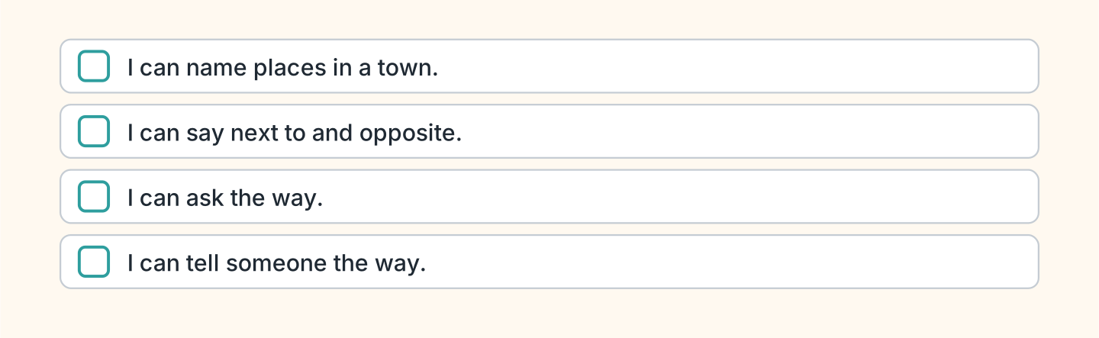
Figure 8.22 · What I can do.
- I can name places in a town. — ✓ (example)
- I can say next to and opposite. — ______
- I can ask the way. — ______
- I can tell someone the way. — ______

Unit 9: I Can Do That
In this unit you say what you can do. You ask a friend.
Warm Up
W1 Look at Figure 9.1. Write yes or no.
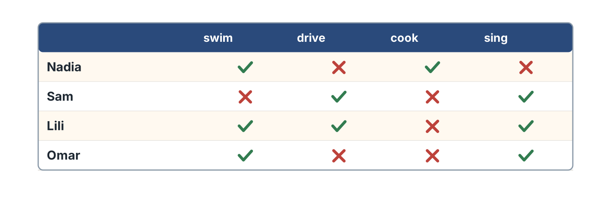
Figure 9.1 · Four people and four things.
- Nadia can swim. — yes (example)
- Sam can cook. — ______
- Lili can drive. — ______
- Omar can sing. — ______
W2 Look at Figure 9.2. Write the word.
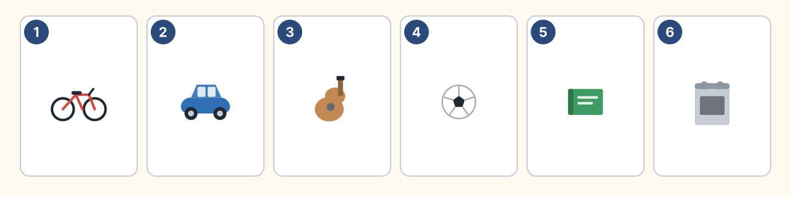
Figure 9.2 · Six things people do.
Words: ball · bike · book · car · cooker · guitar
- 1 — bike (example)
- 2 — ______________
- 3 — ______________
- 5 — ______________
- 6 — ______________
W3 Say three things you can do.
- I can swim at the pool near the square. (example)
- Say one thing you can do.
- Say if it is near the station or the market.
- Ask a friend.
Part 1 · Words & Sounds
1A Look at Figure 9.3. Match the person and the word.
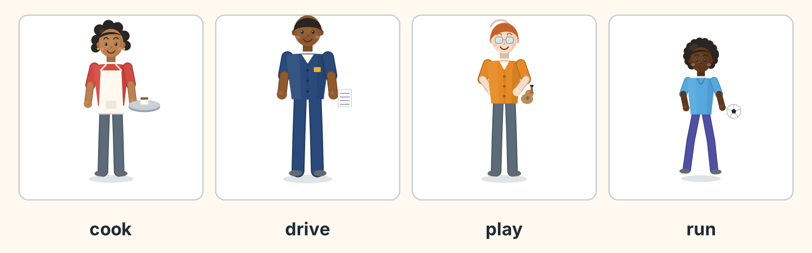
Figure 9.3 · Four people doing things.
Person | Word
1 Nadia | a play
2 Sam | b cook
3 Ben | c drive
4 Omar | d run
 | e swim
One option is not needed.
- 1 — b (example)
- 2 — ______
- 3 — ______
- 4 — ______
1B Look at Figure 9.4. Write the word.
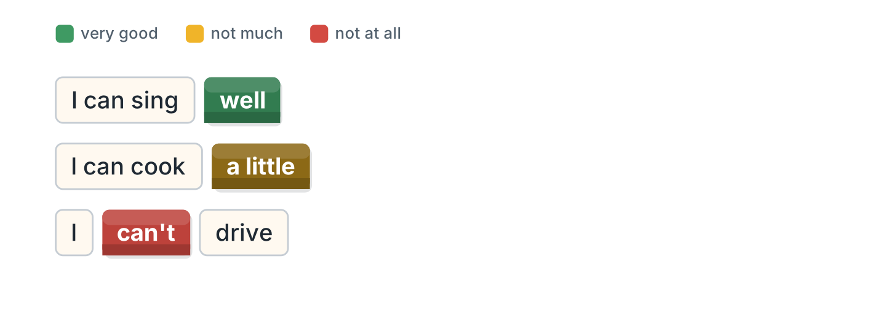
Figure 9.4 · Well or a little.
Words: a little · can’t · well
- I can sing well. (well) (example)
- I can cook ______________.
- I ______________ drive.
- She can swim ______________.
1C Look at Figure 9.5. Write the word.
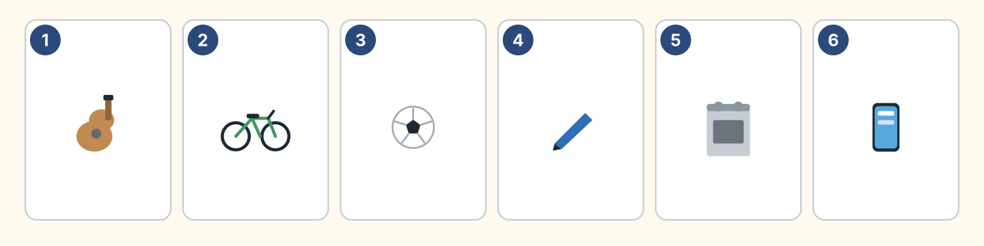
Figure 9.5 · Six things to try.
Words: ball · bike · cooker · guitar · pen · phone
- 1 — guitar (example)
- 2 — ______________
- 3 — ______________
- 5 — ______________
1D Say it. Say these words.
- can (example)
- can’t
- swim
- drive
- guitar
1E Look at Figure 9.6. Answer the questions.
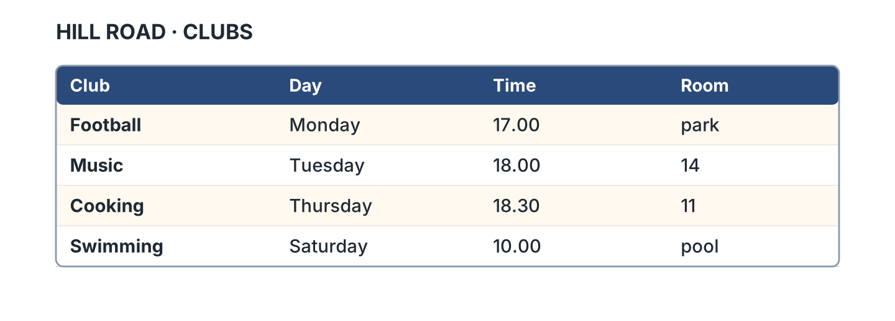
Figure 9.6 · A club list.
- When is the football club? — Monday (example)
- When is the music club? — ______________
- Where is the cooking club? — ______________
- What time is swimming? — ______________
1F Write the thing you need.
- to play music — a guitar (example)
- to ride to the hotel — ______________
- to cook some rice — ______________
- to play football — ______________
Part 2 · Grammar
2A Look at Figure 9.7. Complete with can or can’t.
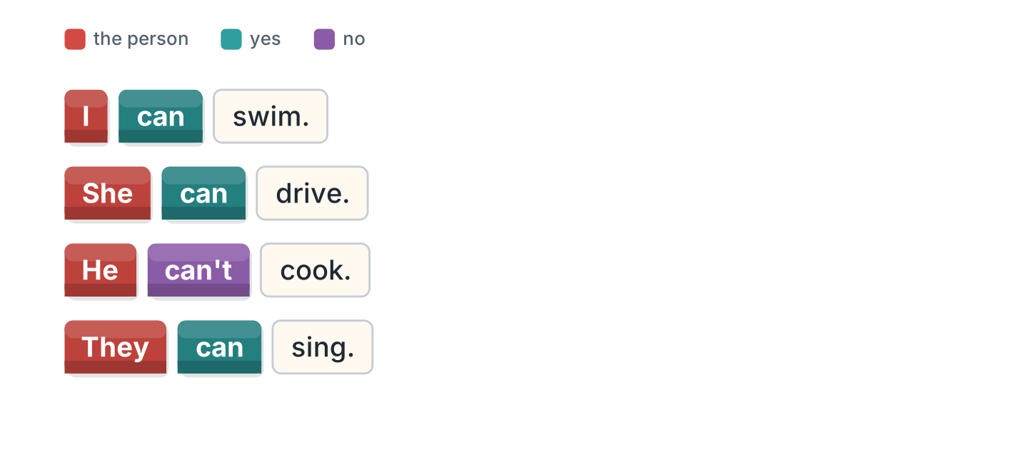
Figure 9.7 · can and cannot.
- I can swim. (can) (example)
- She ______________ drive.
- He ______________ cook.
- They ______________ sing.
2B Choose the correct word.
- She (can / cans) drive. — can (example)
- I can (swim / swims).
- He (can’t / doesn’t can) cook.
- They can (play / plays) football.
- We (can / cans) help.
2C Look at Figure 9.8. Write the short form.

Figure 9.8 · The short form.
- cannot — can’t (example)
- I cannot drive. — ______________
- She cannot come. — ______________
2D Write the negative.
- I can swim. — I can’t swim. (example)
- He can cook. — ______________
- They can sing. — ______________
- She can drive. — ______________
2E Look at Figure 9.9. Write the answer.
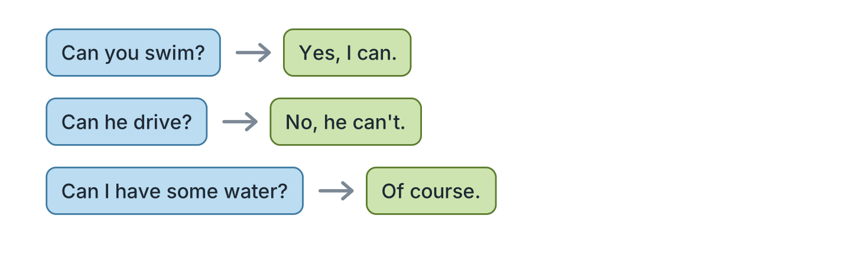
Figure 9.9 · Questions with can.
- Can you swim? ✓ — Yes, I can. (example)
- Can he drive? ✗ — ______________
- Can they sing? ✓ — ______________
- Can I have some water? ✓ — ______________
2F Find the mistake. Write the correct words.
- She cans drive. — can (example)
- I can to swim. — ______________
- He don’t can cook. — ______________
- Can you to help me? — ______________
Part 3 · Listening
3A Listen. Look at Figure 9.10. Write the number.
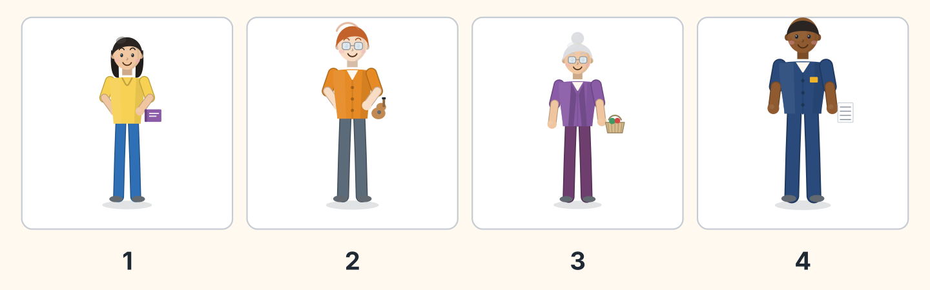
Figure 9.10 · Four voices to match.
- Lili — 1 (example)
- Ben — ______
- Rosa — ______
- Sam — ______
3B Listen. Look at Figure 9.11. Write yes or no.
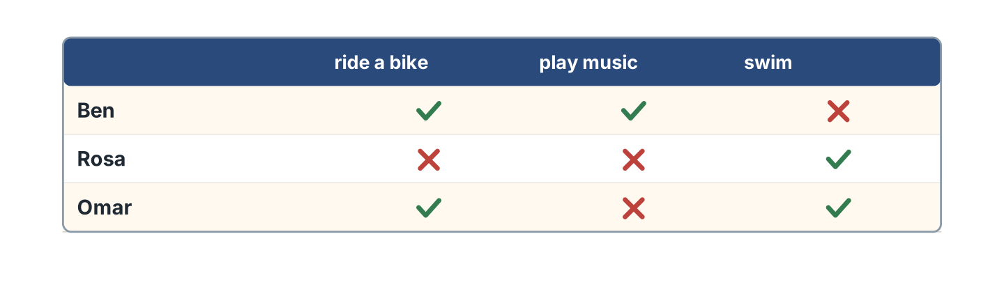
Figure 9.11 · A grid to complete.
- Ben can ride a bike. — yes (example)
- Rosa can swim. — ______
- Omar can play music. — ______
- Ben can swim. — ______
3C Listen. Look at Figure 9.12. Write the club.
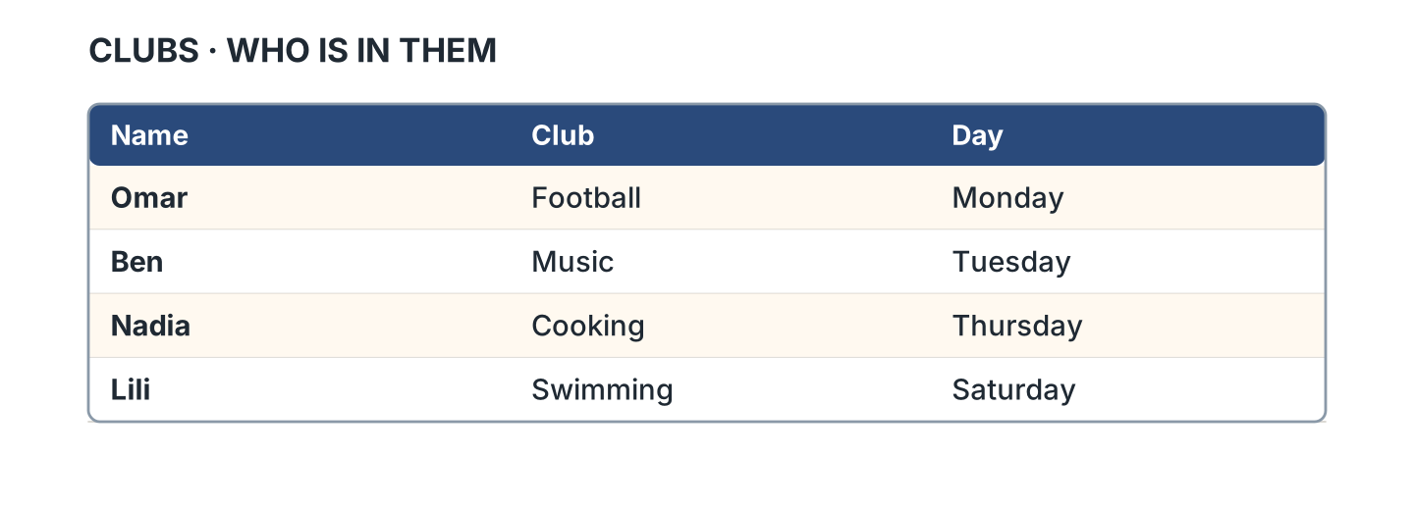
Figure 9.12 · Who is in which club.
- Omar — Football (example)
- Ben — ______________
- Nadia — ______________
- Lili — ______________
3D Listen. Write can or can’t.
- can (example)
- ______________
- ______________
- ______________
Part 4 · Speaking
4A Look at Figure 9.13. Ask a friend.
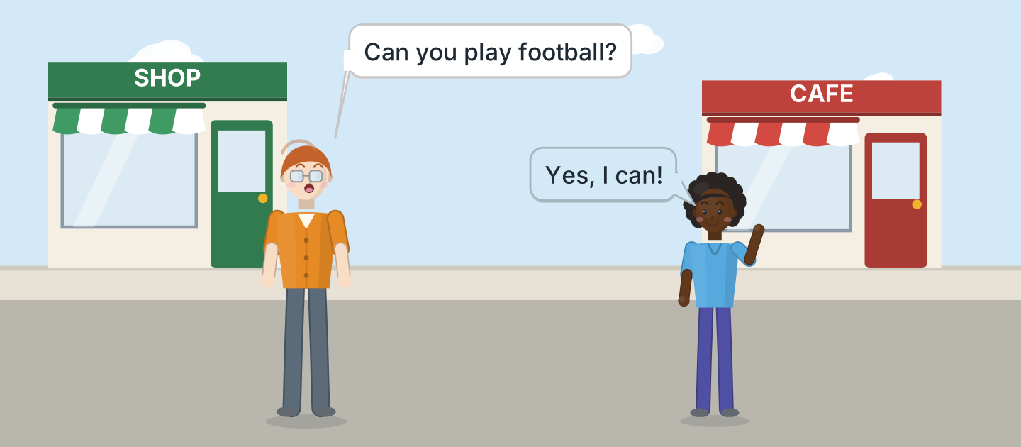
Figure 9.13 · Ben asks Omar.
- A: Can you play football? B: Yes, I can! (example)
- Ask about swimming at the hotel pool.
- Ask about cooking rice and fish.
- Ask about music.
4B Look at Figure 9.14. Ask and answer.
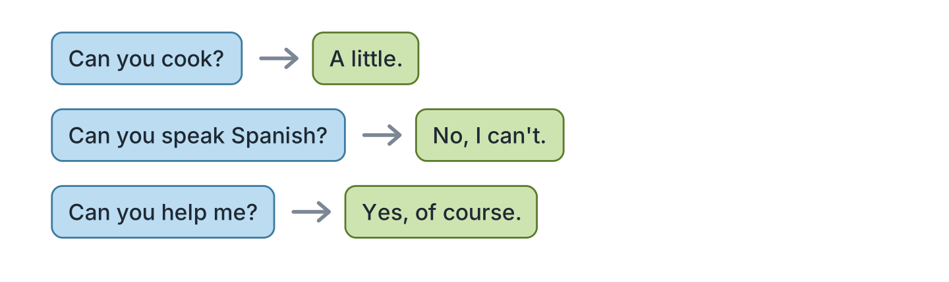
Figure 9.14 · Ask a friend.
- A: Can you cook? B: A little. (example)
- A: Can you speak Spanish? B: ______________
- A: Can you help me? B: ______________
- A: Can you drive? B: ______________
4C Tell a friend about your family.
- My father can drive to the market. (example)
- Say one thing a person can do.
- Say if they often help at the hospital.
- Say how well.
4D Choose a club and tell a friend.
- I want the music club. I can play guitar. (example)
- Say the club and the road.
- Say if it is far or near the park.
- Say what you can do.
Part 5 · Reading
5A Look at Figure 9.15. Answer the questions.
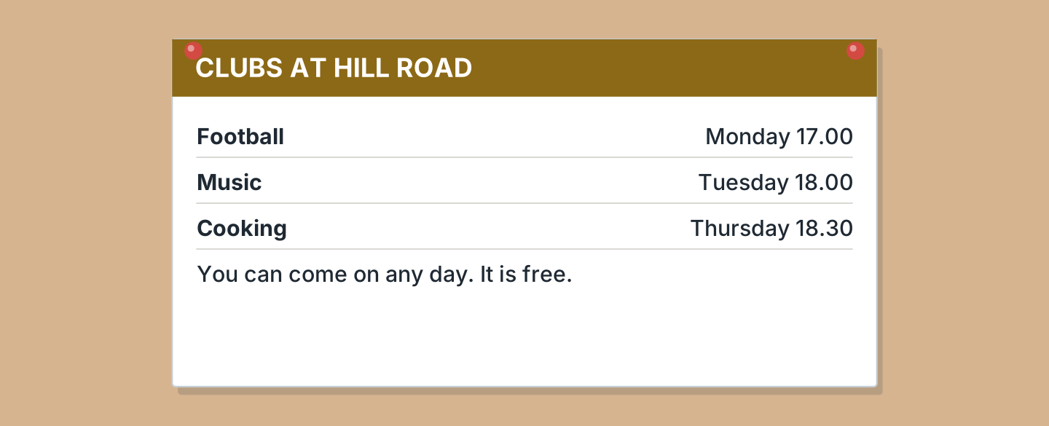
Figure 9.15 · A notice about the clubs.
- When is the football club? — Monday (example)
- What time is the music club? — ______________
- When is the cooking club? — ______________
- What does it cost? — ______________
5B Look at Figure 9.15. Write yes or no.
- The clubs are free. — yes (example)
- The music club is on Monday. — ______
- You can come on any day. — ______
- The cooking club is at six. — ______
5C Look at Figure 9.16. Choose the correct answer.
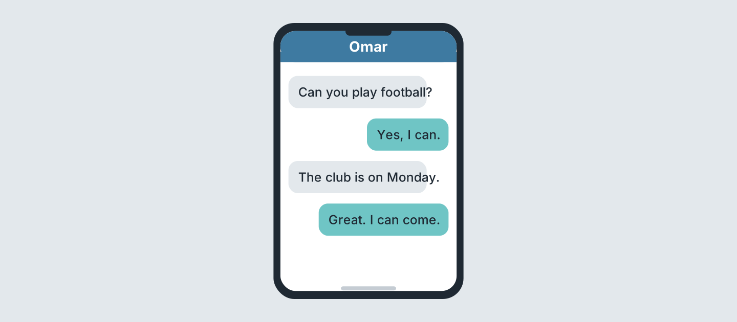
Figure 9.16 · Messages about a club.
- Who texts first? (a) a friend (b) Omar (c) Ben — a (example)
- Can Omar play football? (a) yes (b) no (c) perhaps
- Which day is the club? (a) Monday (b) Tuesday (c) Sunday
- Is Omar coming? (a) yes (b) no (c) perhaps
5D Read and correct. Write the correct word.
- The football club is on Tuesday. — Monday (example)
- The music club is at five. — ______________
- The clubs cost five pounds. — ______________
- The cooking club is on Friday. — ______________
Part 6 · Writing
6A Look at Figure 9.17. Complete the form.
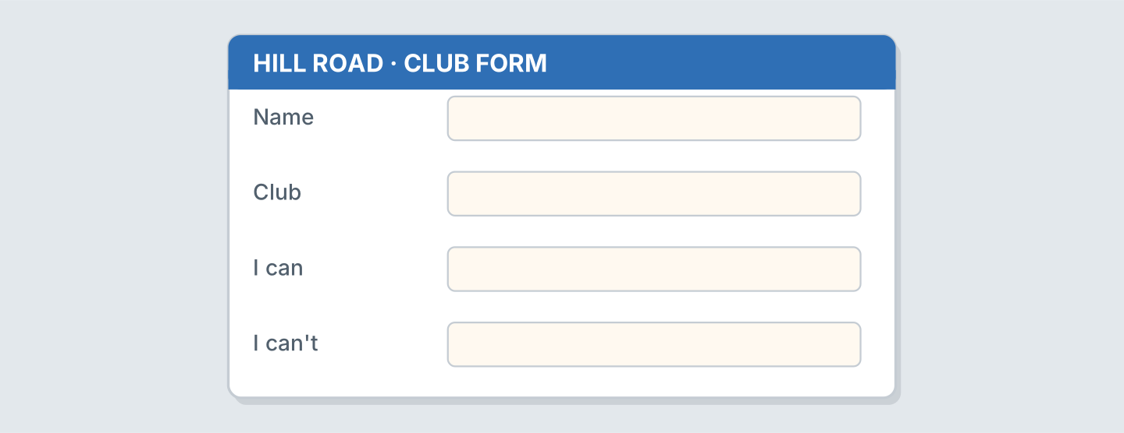
Figure 9.17 · A form for a club.
- Club: Music (example)
- Name: ______________
- Club: ______________
- I can: ______________
6B Look at Figure 9.18. Write four lines.
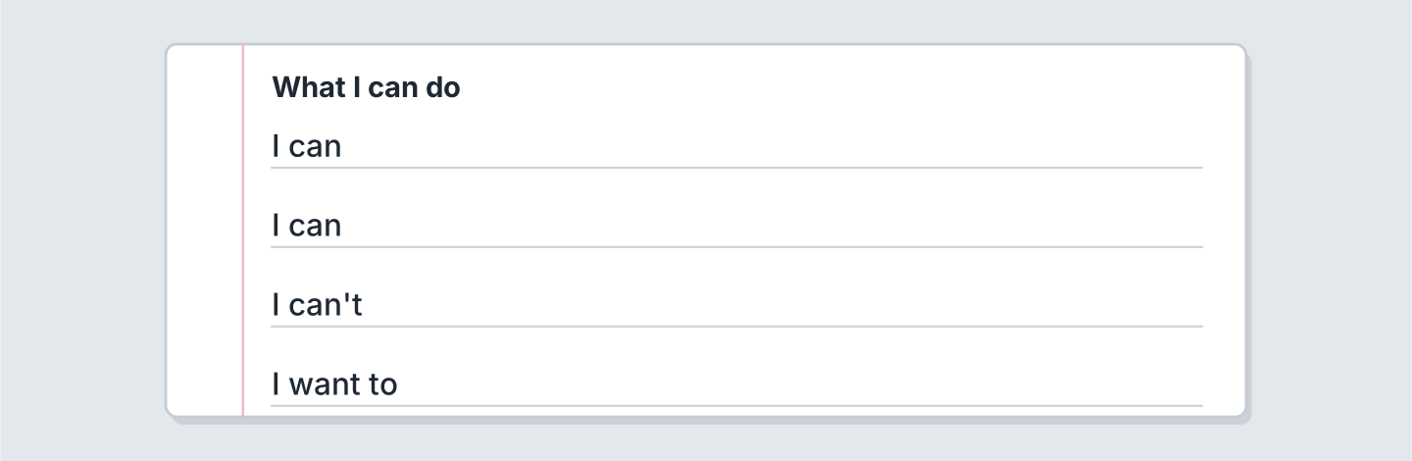
Figure 9.18 · Four lines about you.
- I can swim well. (example)
- I can ______________.
- I can’t ______________.
- I want to ______________.
6C Write about a friend. Write three lines.
- My friend can play the guitar in the park. (example)
- Say one thing they can do.
- Say if they walk to the square or take a ticket.
- Say which club is good for them.
Part 7 · Real-World File
7A Look at Figure 9.19. Answer the questions.
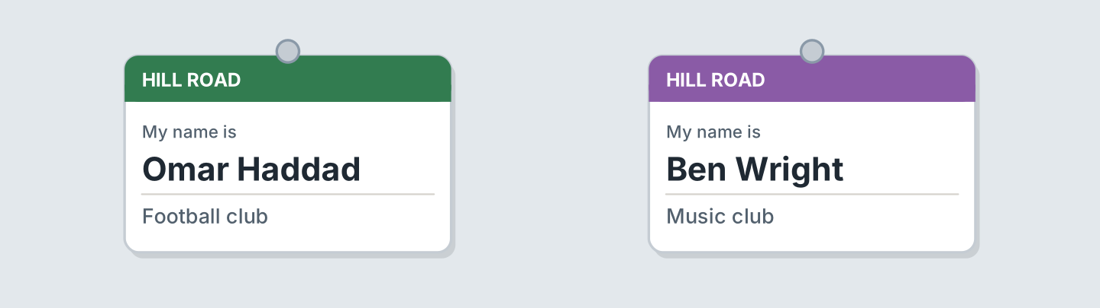
Figure 9.19 · A club card.
- Which club is Omar in? — Football (example)
- Which club is Ben in? — ______________
- Where are the clubs? — ______________
- Who is in the music club? — ______________
7B Look at Figure 9.20. Answer the questions.
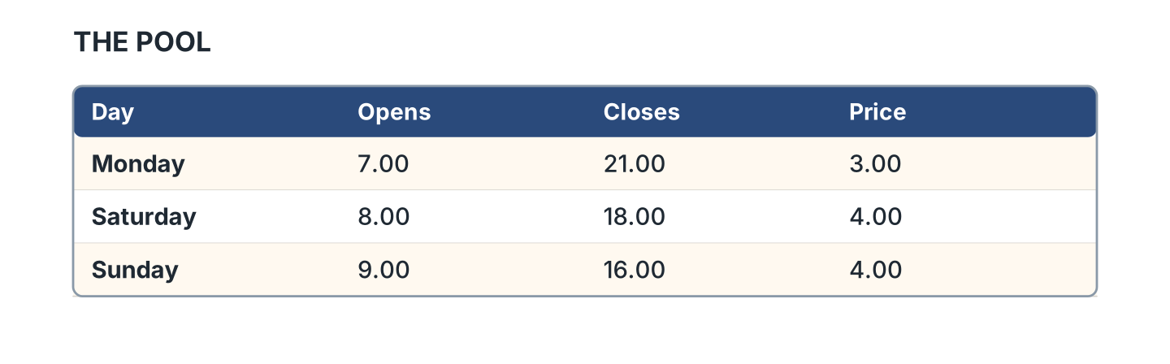
Figure 9.20 · The pool times.
- When does the pool open on Monday? — 7.00 (example)
- When does it close on Sunday? — ______________
- How much is it on Saturday? — ______________
- Which day is cheapest? — ______________
7C Write a club card for you.
- Name: Omar · Club: Football (example)
- Name: ______________
- Club: ______________
- Day: ______________
Part 8 · Review & Can-Do
8A Look at Figure 9.21. Write the word.
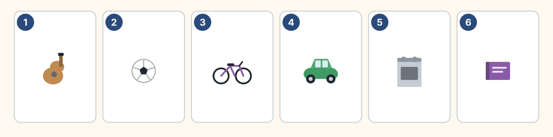
Figure 9.21 · Six things from this unit.
Words: ball · bike · book · car · cooker · guitar
- 1 — guitar (example)
- 2 — ______________
- 3 — ______________
- 4 — ______________
- 6 — ______________
8B Complete the conversation.
Words: can · can’t · little · you
- A: Can you cook? (Can) (example)
- B: Yes, a ______.
- A: ______ you drive?
- B: No, I ______.
8C Write can or can’t.
- She can swim well. (can) (example)
- He ______ drive. He has no car.
- They ______ sing. They are in a band.
- I ______ cook. I eat at the cafe.
8D Match the question and the answer.
Question | Answer
1 Can you swim? | a A little.
2 Can you cook? | b Yes, of course.
3 Can you help me? | c No, I can’t.
4 Can I have water? | d Here you are.
 | e At the clinic.
One option is not needed.
- 1 — c (example)
- 2 — ______
- 3 — ______
- 4 — ______
8E Look at Figure 9.22. Tick what you can do.
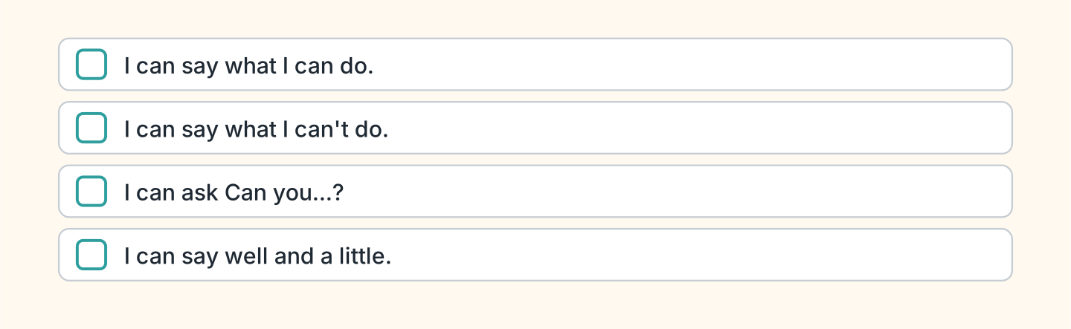
Figure 9.22 · What I can do.
- I can say what I can do. — ✓ (example)
- I can say what I can’t do. — ______
- I can ask Can you swim? — ______
- I can say well and a little. — ______

Unit 10: Last Weekend
In this unit you say where you were. You talk about the weekend.
Warm Up
W1 Look at Figure 10.1. Write the word.
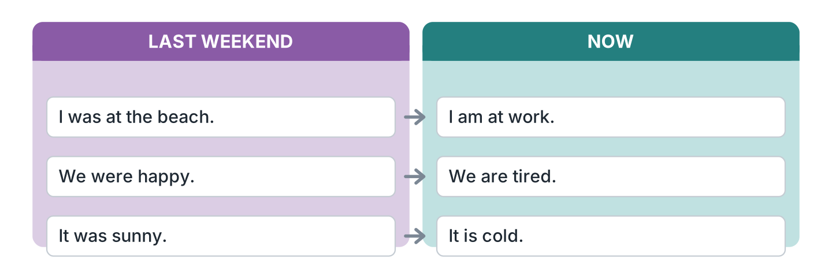
Figure 10.1 · Last weekend and now.
- I was at the beach. (was) (example)
- We ______ happy.
- It ______ sunny.
- We ______ tired now.
W2 Look at Figure 10.2. Write the word.
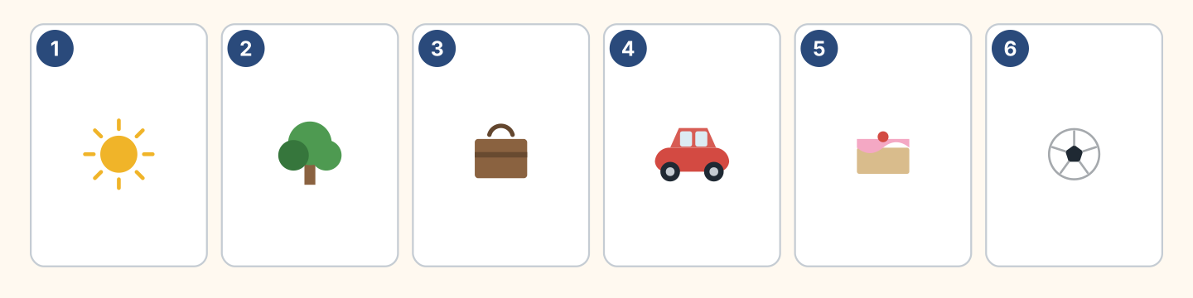
Figure 10.2 · Six places and things.
Words: ball · cake · car · suitcase · sun · tree
- 1 — sun (example)
- 2 — ______________
- 3 — ______________
- 5 — ______________
- 6 — ______________
W3 Say where you were last weekend.
- I was at home on Saturday. (example)
- Say where you were.
- Say if the market and the park were open.
- Say how it was.
Part 1 · Words & Sounds
1A Look at Figure 10.3. Match the person and the word.
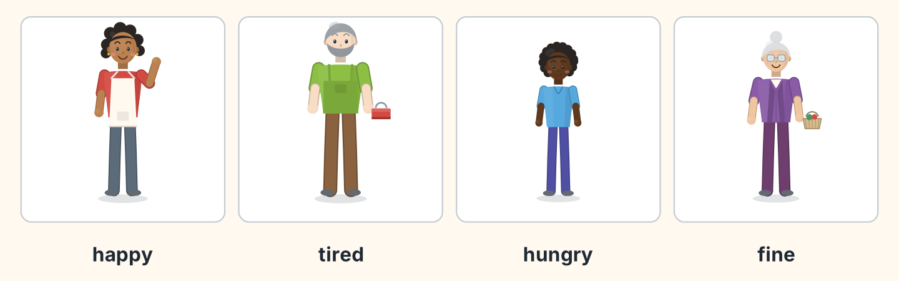
Figure 10.3 · Four feelings.
Person | Word
1 Nadia | a tired
2 Marek | b happy
3 Omar | c fine
4 Rosa | d hungry
 | e angry
One option is not needed.
- 1 — b (example)
- 2 — ______
- 3 — ______
- 4 — ______
1B Look at Figure 10.4. Write the place.
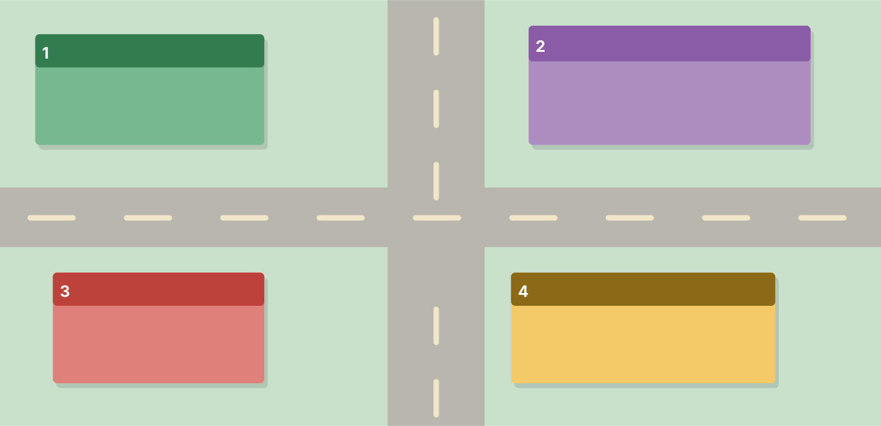
Figure 10.4 · Four places by number.
Words: cafe · home · museum · park
- 1 — park (example)
- 2 — ______________
- 3 — ______________
- 4 — ______________
1C Look at Figure 10.5. Write the time word.
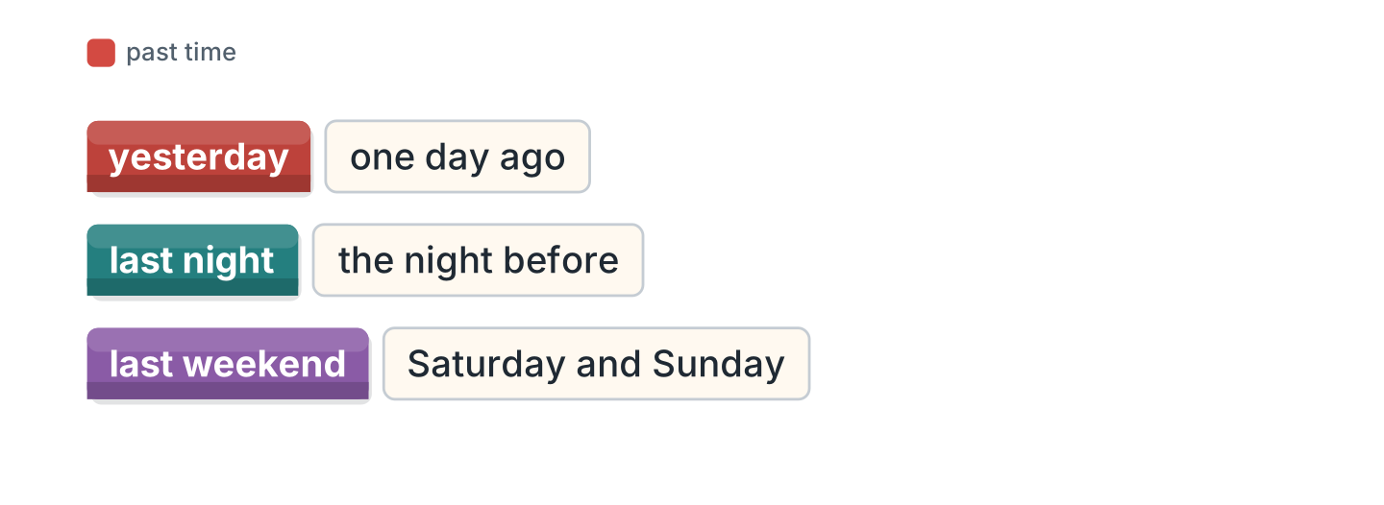
Figure 10.5 · Yesterday and last week.
- one day ago — yesterday (example)
- the night before — ______________
- Saturday and Sunday — ______________
- seven days ago — ______________
1D Say it. Say these words.
- yesterday (example)
- was
- were
- weekend
- holiday
1E Look at Figure 10.6. Answer the questions.
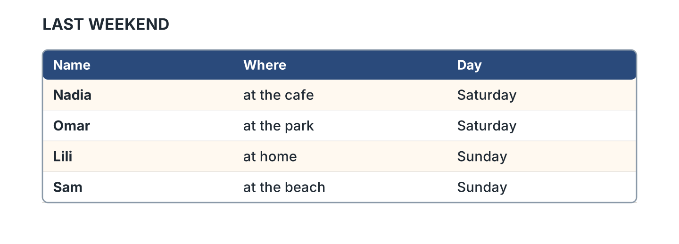
Figure 10.6 · A weekend list.
- Where was Nadia? — at the cafe (example)
- Where was Omar? — ______________
- Who was at home? — ______________
- Who was at the beach? — ______________
1F Write the opposite word.
- happy — sad (example)
- tired — ______________
- hungry — ______________
- great — ______________
Part 2 · Grammar
2A Look at Figure 10.7. Complete with was or were.
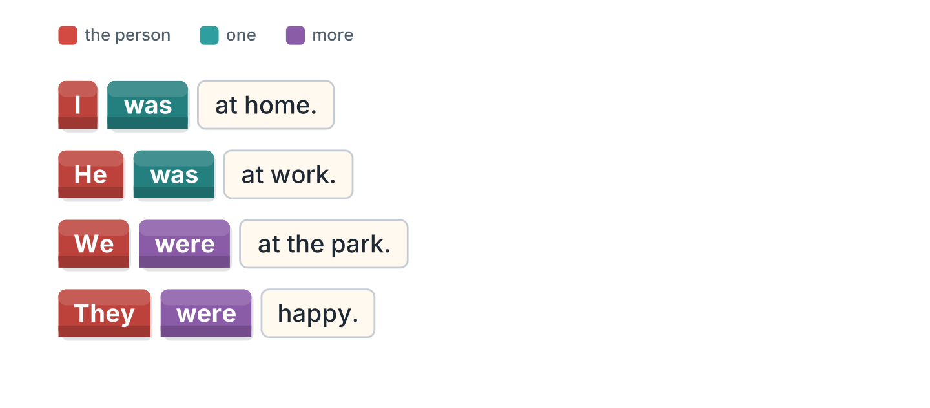
Figure 10.7 · was and were.
- I was at home. (was) (example)
- He ______ at work.
- We ______ at the park.
- They ______ happy.
2B Choose the correct word.
- I (was / were) tired. — was (example)
- They (was / were) at school.
- She (was / were) at the cafe.
- We (was / were) at the beach.
- It (was / were) sunny.
2C Look at Figure 10.8. Write the short form.

Figure 10.8 · The short negative.
- was not — wasn’t (example)
- were not — ______________
- I was not at home. — ______________
2D Write the negative.
- I was at work. — I wasn’t at work. (example)
- She was tired. — ______________
- They were at the park. — ______________
- It was cold. — ______________
2E Look at Figure 10.9. Write the answer.
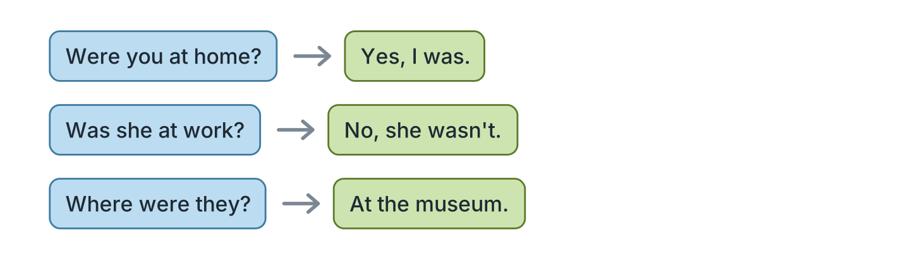
Figure 10.9 · Questions about the past.
- Were you at home? ✓ — Yes, I was. (example)
- Was she at work? ✗ — ______________
- Were they at the park? ✓ — ______________
- Where were they? (museum) — ______________
2F Find the mistake. Write the correct word.
- I were at home. — was (example)
- They was at school. — ______________
- Was you at the beach? — ______________
- She weren’t tired. — ______________
Part 3 · Listening
3A Listen. Look at Figure 10.10. Write the number.
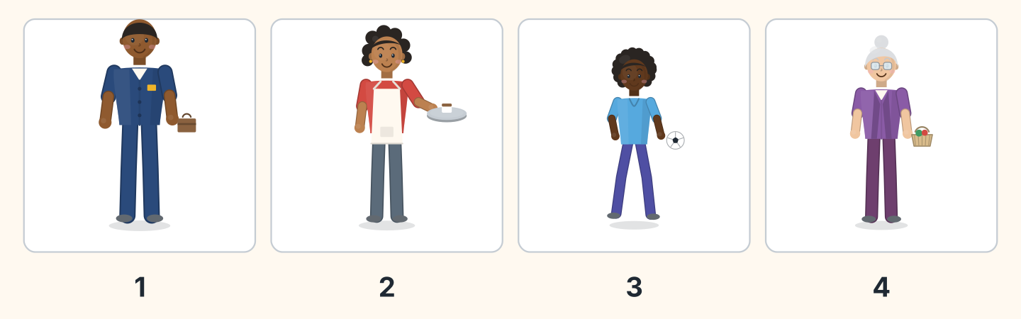
Figure 10.10 · Four people last weekend.
- Sam — 1 (example)
- Nadia — ______
- Omar — ______
- Rosa — ______
3B Listen. Look at Figure 10.11. Write yes or no.
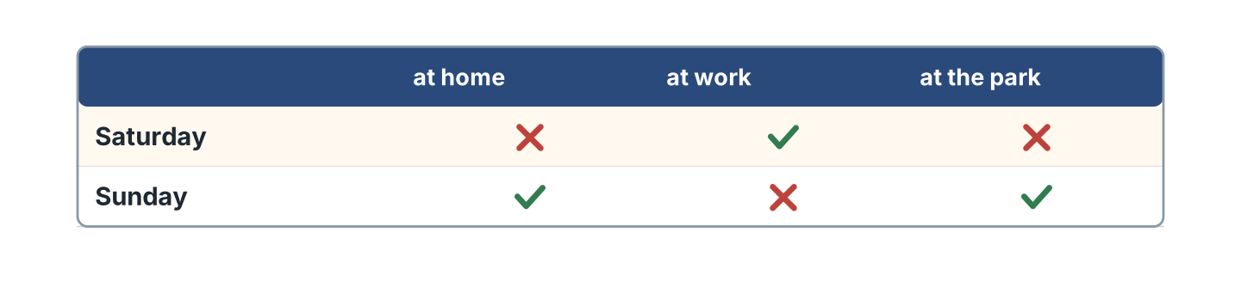
Figure 10.11 · Where everyone was.
- On Saturday they were at work. — yes (example)
- On Saturday they were at home. — ______
- On Sunday they were at the park. — ______
- On Sunday they were at work. — ______
3C Listen. Look at Figure 10.12. Complete the week.
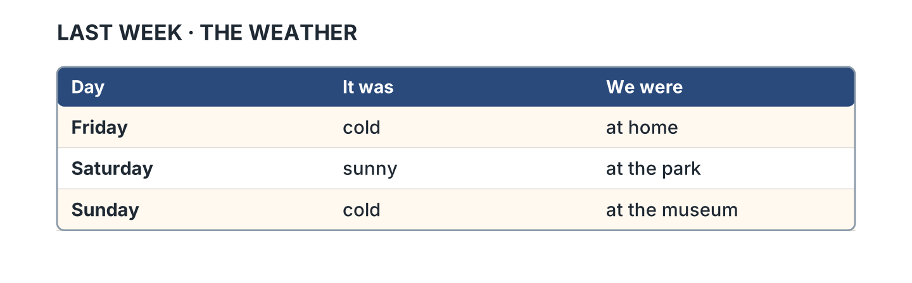
Figure 10.12 · The weather last week.
- On Friday it was cold. (cold) (example)
- On Saturday it was ______________.
- On Saturday they were at ______________.
- On Sunday they were at ______________.
3D Listen. Write was or were.
- was (example)
- ______________
- ______________
- ______________
Part 4 · Speaking
4A Look at Figure 10.13. Ask about the weekend.
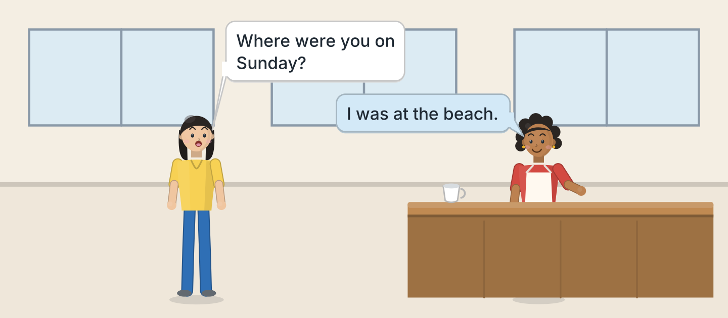
Figure 10.13 · Nadia asks about the weekend.
- A: Where were you on Sunday? B: I was at the beach. (example)
- Ask if the hotel and the cinema were open.
- Ask who they were with.
- Ask how it was.
4B Look at Figure 10.14. Ask and answer.
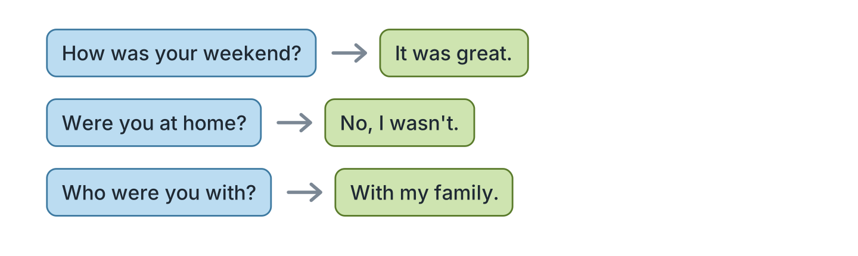
Figure 10.14 · Ask about the weekend.
- A: How was your weekend? B: It was great. (example)
- A: Were you at home? B: ______________
- A: Who were you with? B: ______________
- A: Where were you? B: ______________
4C Tell a friend about last Saturday.
- I was at the park with my family. (example)
- Say where you were.
- Say if you walked or bought a ticket.
- Say how it was.
4D Ask three friends about yesterday.
- A: Where were you yesterday? B: At work. (example)
- Ask if they could swim at the pool.
- Ask if their club was open.
- Ask how it was.
Part 5 · Reading
5A Look at Figure 10.15. Answer the questions.
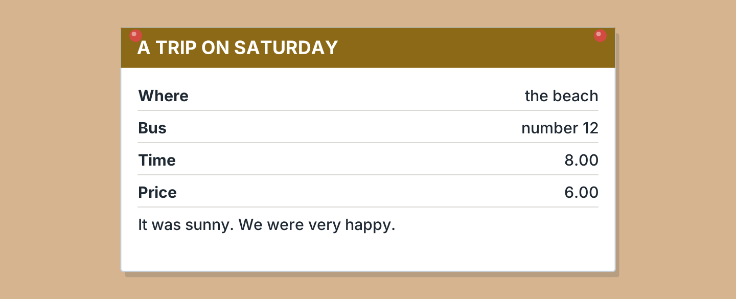
Figure 10.15 · A note about a trip.
- Where was the trip? — the beach (example)
- Which bus was it? — ______________
- What time was it? — ______________
- How much was it? — ______________
5B Look at Figure 10.15. Write yes or no.
- The trip was on Saturday. — yes (example)
- It was cold. — ______
- The bus was number 14. — ______
- They were happy. — ______
5C Look at Figure 10.16. Choose the correct answer.
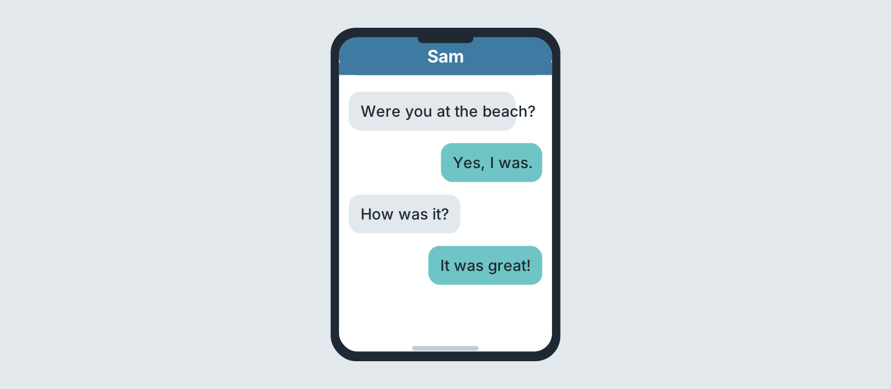
Figure 10.16 · Messages after the weekend.
- Who starts? (a) a friend (b) Sam (c) Lili — a (example)
- Where was Sam? (a) home (b) beach (c) park
- How was it? (a) great (b) cold (c) bad
- Was Sam at the beach? (a) yes (b) no (c) maybe
5D Read and correct. Write the correct word.
- The trip was on Sunday. — Saturday (example)
- The bus was at nine. — ______________
- The trip was ten pounds. — ______________
- It was cold at the beach. — ______________
Part 6 · Writing
6A Look at Figure 10.17. Complete the form.
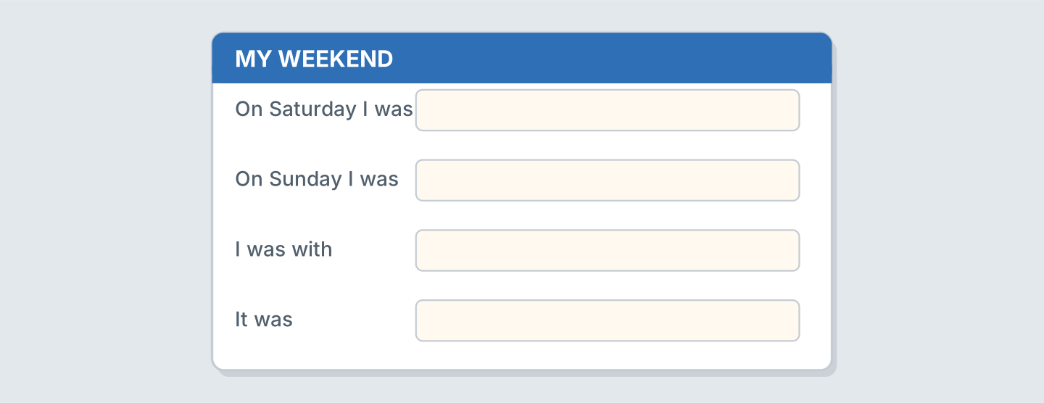
Figure 10.17 · A form about your weekend.
- On Saturday I was: at the park (example)
- On Saturday I was: ______________
- On Sunday I was: ______________
- I was with: ______________
6B Look at Figure 10.18. Write four lines.
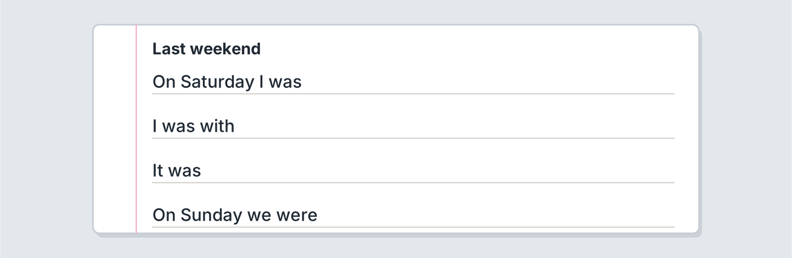
Figure 10.18 · Four lines about last weekend.
- On Saturday I was at the market. (example)
- On Saturday I was ______________.
- I was with ______________.
- The shop was ______________.
6C Write a message about your weekend. Write three lines.
- I was at the beach. It was sunny. (example)
- Say where you were.
- Say if the cafe was open.
- Say how you felt.
Part 7 · Real-World File
7A Look at Figure 10.19. Answer the questions.
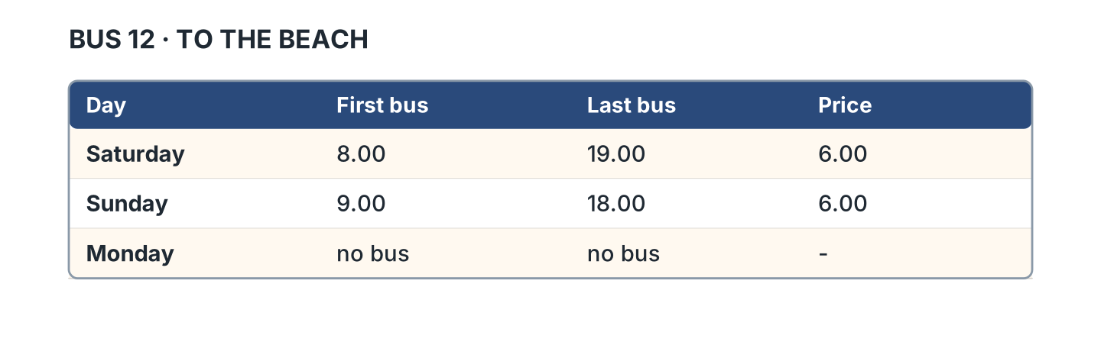
Figure 10.19 · The bus to the beach.
- When is the first bus on Saturday? — 8.00 (example)
- When is the last bus on Sunday? — ______________
- How much is the bus? — ______________
- Is there a bus on Monday? — ______
7B Look at Figure 10.20. Write the sentence.
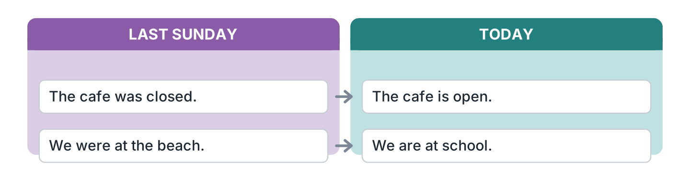
Figure 10.20 · Then and now.
- Last Sunday the cafe was closed. (closed) (example)
- Today the cafe is ______________.
- Last Sunday we were at ______________.
- Today we are at ______________.
7C Write about a trip you made.
- I was at the museum on Sunday. It was cheap. (example)
- Where: ______________
- When: ______________
- How it was: ______________
Part 8 · Review & Can-Do
8A Look at Figure 10.21. Write the word.
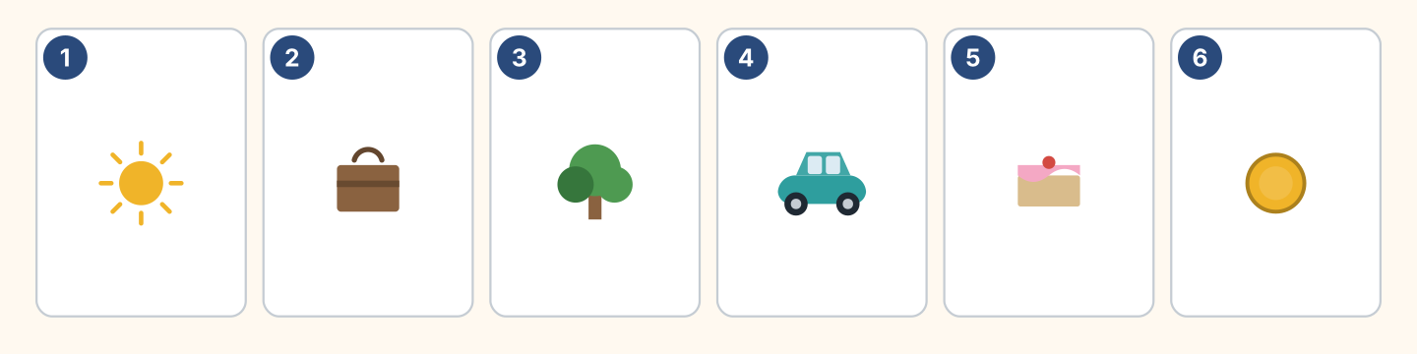
Figure 10.21 · Six things from this unit.
Words: cake · car · coin · suitcase · sun · tree
- 1 — sun (example)
- 2 — ______________
- 3 — ______________
- 4 — ______________
- 6 — ______________
8B Complete the conversation.
Words: was · Were · were · Where
- A: Where were you on Sunday? (Where) (example)
- B: I ______ at the beach.
- A: ______ you with your family?
- B: Yes, we ______ all there.
8C Write was or were.
- I was at home. (was) (example)
- They ______ at the park.
- She ______ tired.
- We ______ very happy.
8D Match the question and the answer.
Question | Answer
1 Where were you? | a It was great.
2 How was it? | b At the beach.
3 Were you alone? | c No, with my family.
4 When was the trip? | d On Saturday.
 | e Yes, I can.
One option is not needed.
- 1 — b (example)
- 2 — ______
- 3 — ______
- 4 — ______
8E Look at Figure 10.22. Tick what you can do.
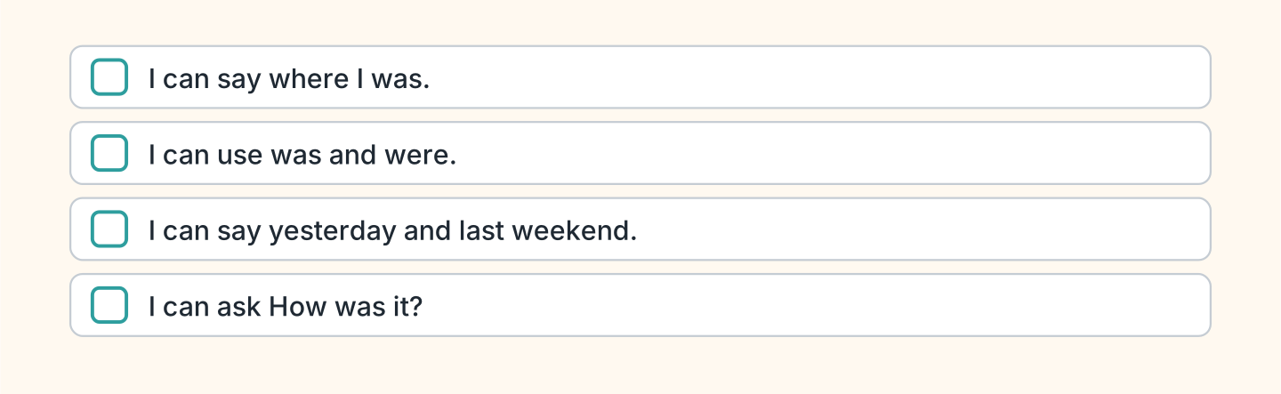
Figure 10.22 · What I can do.
- I can say where I was. — ✓ (example)
- I can use was and were. — ______
- I can say yesterday and last weekend. — ______
- I can ask How was it? — ______

Unit 11: A Day Out
In this unit you say what you did yesterday. You add ed to a verb.
Warm Up
W1 Look at Figure 11.1. Write the word.
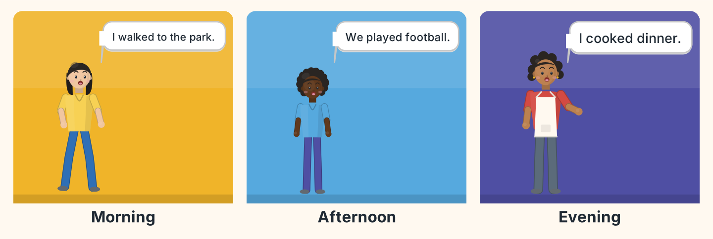
Figure 11.1 · A day out.
- Lili walked to the park. (walked) (example)
- Omar and his friends ______________ football.
- Nadia ______________ dinner.
- Who walked? — ______________
W2 Look at Figure 11.2. Write the word.
Words: ball · bike · cake · cup · sun · tree
- 1 — ball (example)
- 2 — ______________
- 4 — ______________
- 5 — ______________
- 6 — ______________
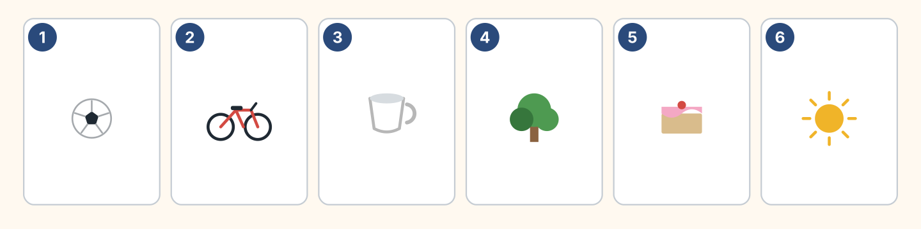
Figure 11.2 · Six things from the day.
W3 Say three things you did yesterday.
- Yesterday I walked to work. (example)
- Say one thing in the morning.
- Say one thing in the evening.
- Say if you were tired.
Part 1 · Words & Sounds
1A Look at Figure 11.3. Write the past form.
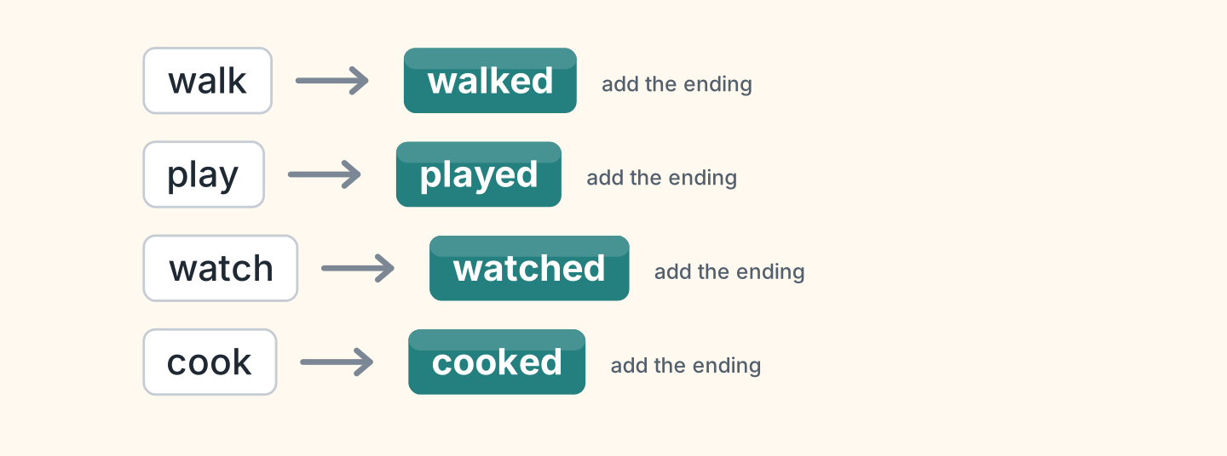
Figure 11.3 · Add the ending.
- walk — walked (example)
- play — ______________
- watch — ______________
- cook — ______________
- open — ______________
1B Look at Figure 11.4. Write the word in the correct box.
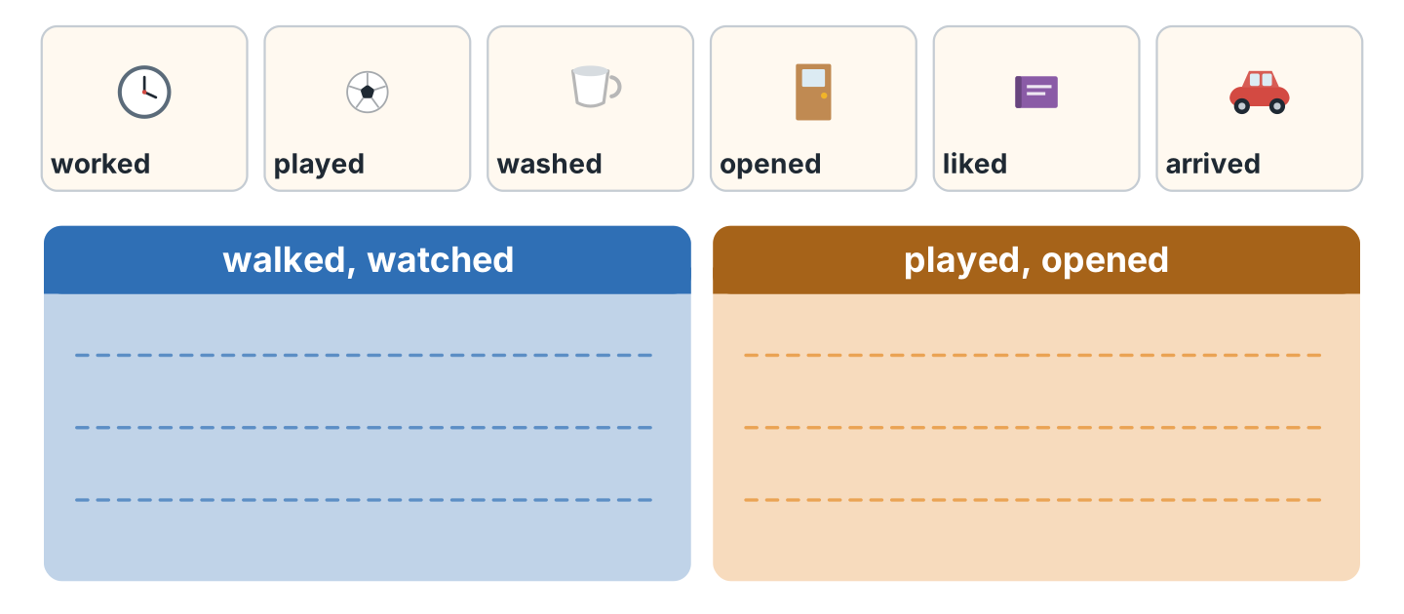
Figure 11.4 · Two endings to hear.
- worked — the first box (example)
- played — ______________
- washed — ______________
- arrived — ______________
1C Say it. Say these past forms.
- walked (example)
- played
- watched
- opened
- visited
1D Look at Figure 11.5. Write the name.
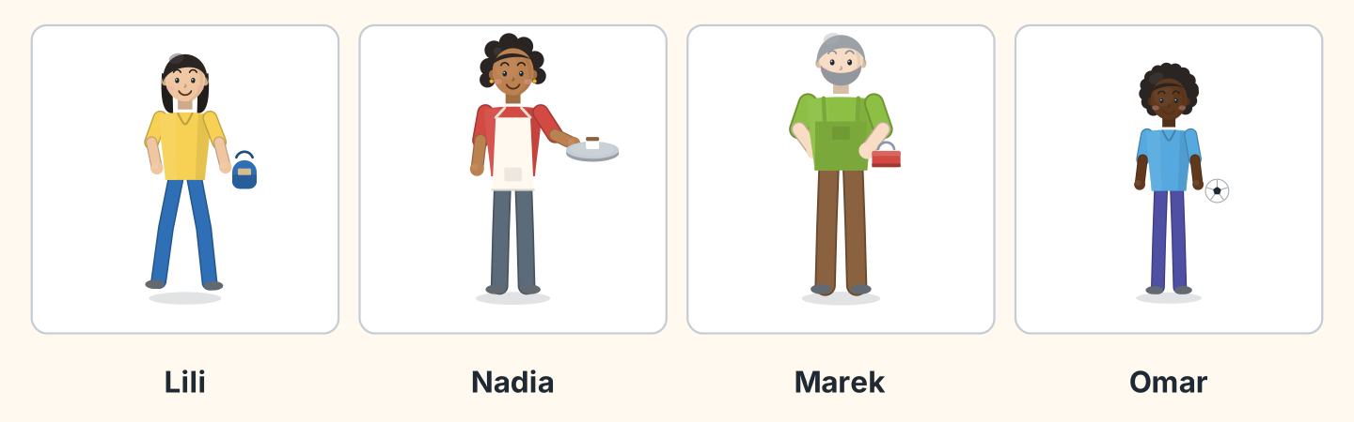
Figure 11.5 · Four people yesterday.
- She walked to the park. — Lili (example)
- She cooked dinner. — ______________
- He played football. — ______________
- He carried a toolbox. — ______________
1E Look at Figure 11.6. Answer the questions.
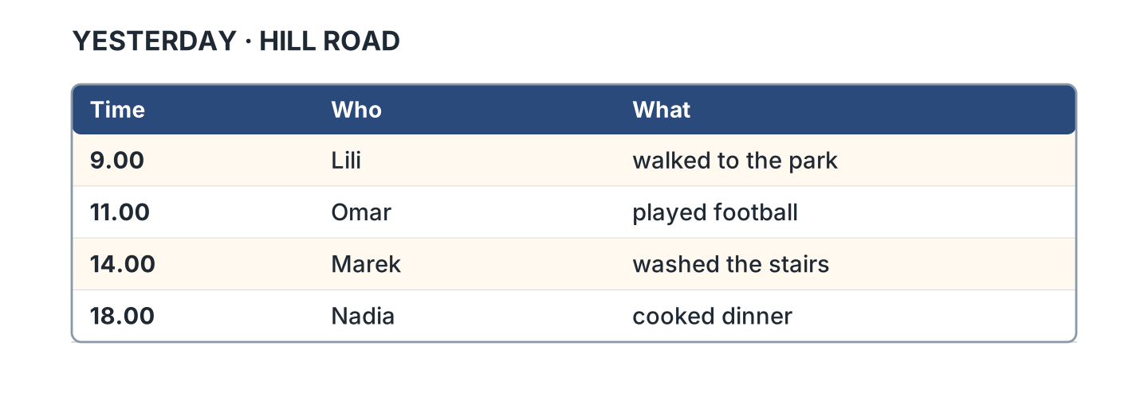
Figure 11.6 · What happened and when.
- What did Lili do? — she walked to the park (example)
- What did Omar do? — ______________
- When did Marek work? — ______________
- Who cooked dinner? — ______________
1F Write the past form.
- help — helped (example)
- ask — ______________
- listen — ______________
- wait — ______________
Part 2 · Grammar
2A Look at Figure 11.7. Complete the sentence.
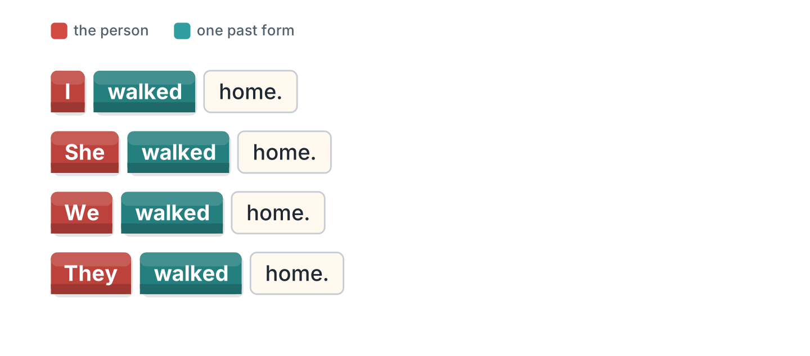
Figure 11.7 · The form does not change.
- I walked home. (walked) (example)
- She ______________ home.
- We ______________ home.
- They ______________ home.
2B Choose the correct word.
- I (walk / walked) home yesterday. — walked (example)
- She (play / played) football last week.
- We (cook / cooked) dinner yesterday.
- They (watch / watched) a film last night.
- He (open / opened) the shop at eight.
2C Look at Figure 11.8. Write the short form.

Figure 11.8 · The short negative.
- did not — didn’t (example)
- I did not walk. — ______________
- She did not play. — ______________
2D Write the negative.
- I walked home. — I didn’t walk home. (example)
- She played football. — ______________
- We watched a film. — ______________
- They cooked dinner. — ______________
2E Look at Figure 11.9. Write the answer.
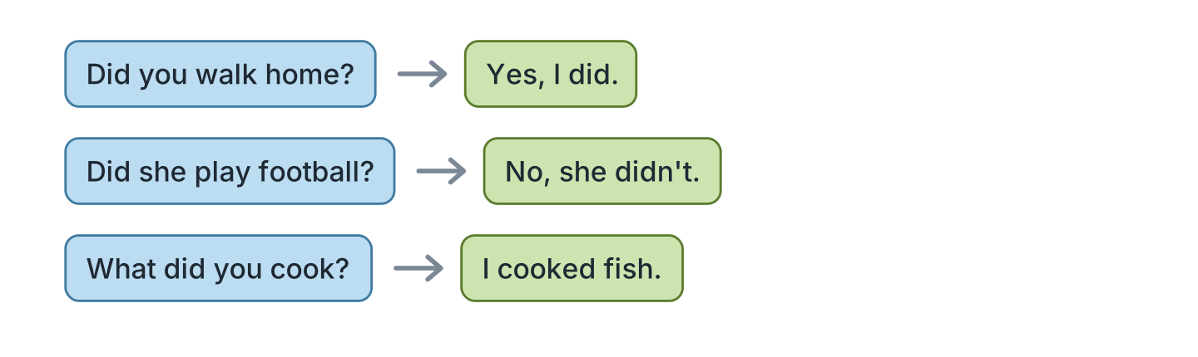
Figure 11.9 · Questions about yesterday.
- Did you walk home? ✓ — Yes, I did. (example)
- Did she play football? ✗ — ______________
- Did they cook dinner? ✓ — ______________
- What did you cook? (fish) — ______________
2F Find the mistake. Write the correct words.
- I walk home yesterday. — walked (example)
- She didn’t walked home. — ______________
- Did you played football? — ______________
- We no watched a film. — ______________
Part 3 · Listening
3A Listen. Look at Figure 11.10. Write the number.
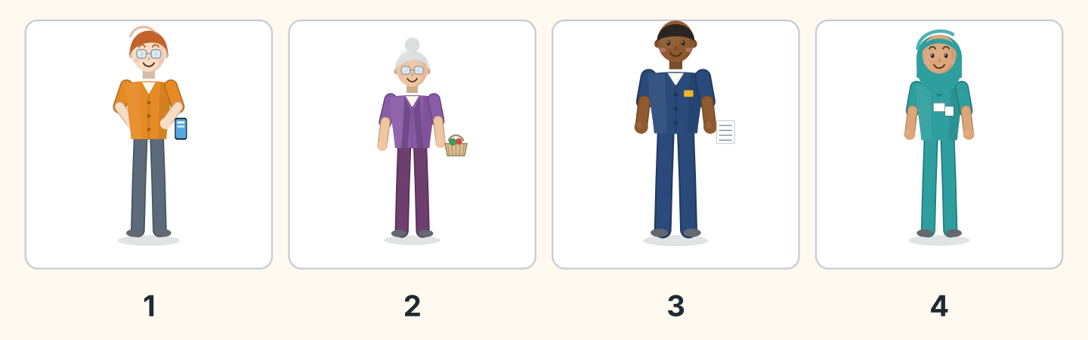
Figure 11.10 · Four voices.
- Ben — 1 (example)
- Rosa — ______
- Sam — ______
- Fatima — ______
3B Listen. Look at Figure 11.11. Complete the day.
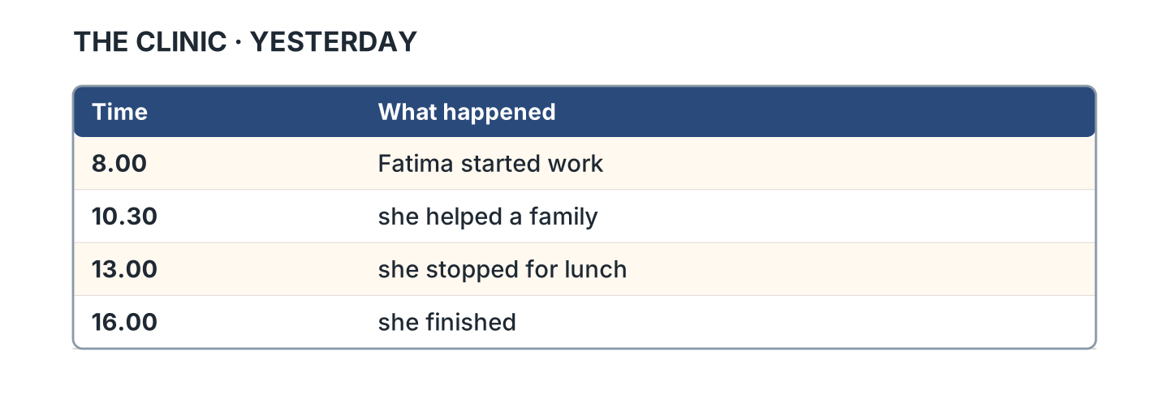
Figure 11.11 · The day at the clinic.
- Fatima started work at eight. (eight) (example)
- She helped a family at ______________.
- She stopped for ______________.
- She finished at ______________.
3C Listen. Look at Figure 11.12. Write the number.
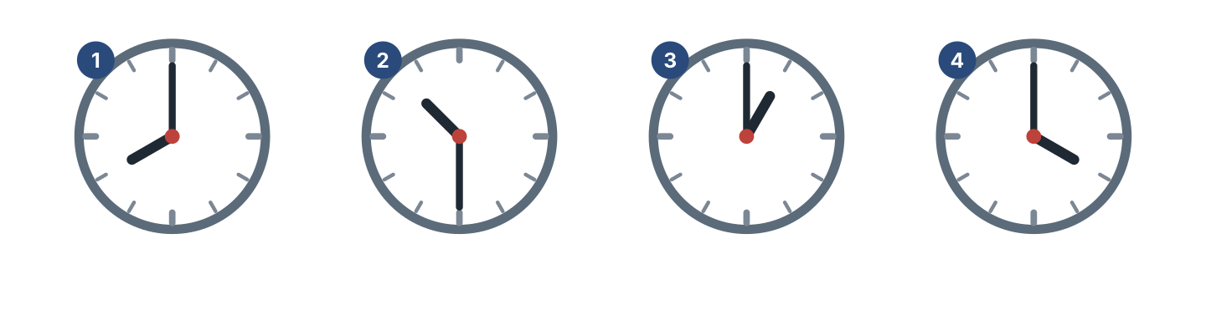
Figure 11.12 · Four times to hear.
- eight o’clock — 1 (example)
- half past ten — ______
- one o’clock — ______
- four o’clock — ______
3D Listen. Write the past form you hear.
- walked (example)
- ______________
- ______________
- ______________
Part 4 · Speaking
4A Look at Figure 11.13. Talk about yesterday.
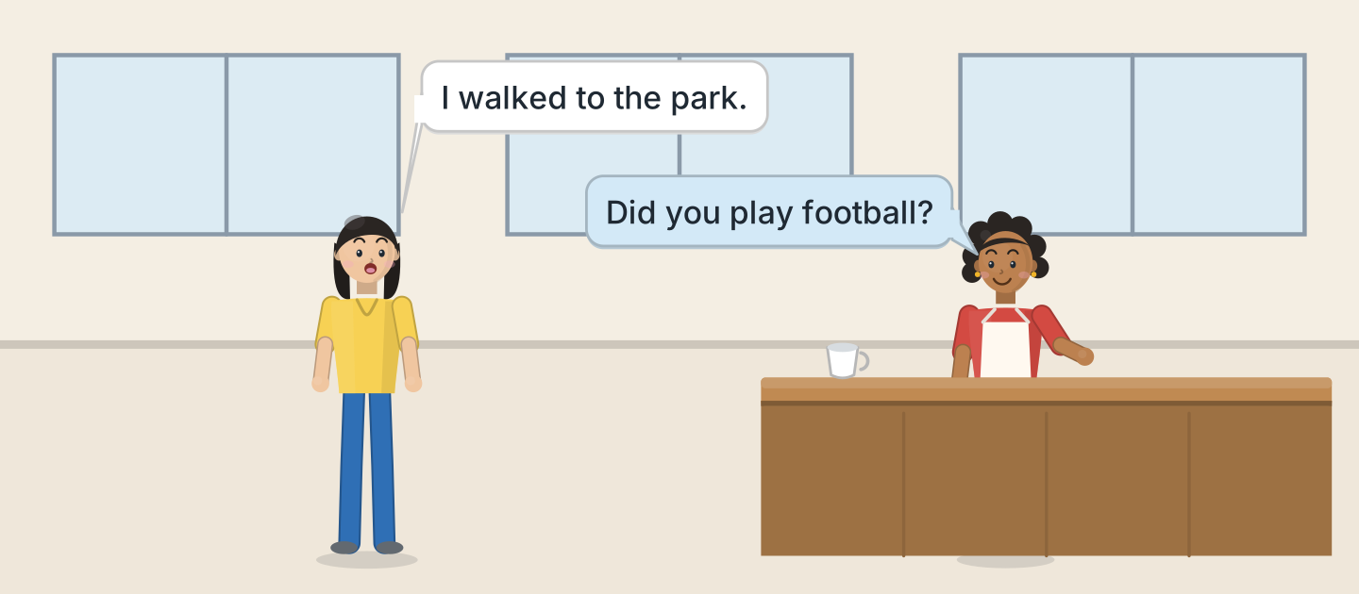
Figure 11.13 · Lili talks about the day.
- A: I walked to the park. B: Did you play football? (example)
- Say which road you walked to.
- Ask your friend about the museum.
- Say what you cooked for dinner.
4B Look at Figure 11.14. Ask and answer.
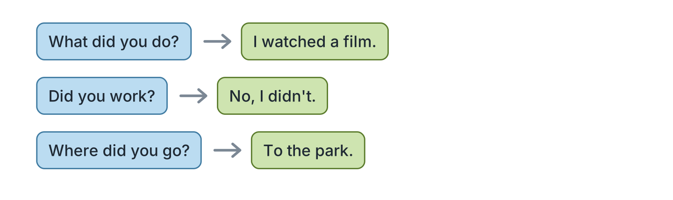
Figure 11.14 · Ask about yesterday.
- A: What did you do? B: I watched a film. (example)
- A: Did you work? B: ______________
- A: Where did you go? B: ______________
- A: Who did you see? B: ______________
4C Ask three friends about the weekend.
- A: Did you stay at home? B: Yes, I did. (example)
- Ask about the shop on Saturday.
- Ask about the market.
- Ask if the market was open.
4D Say four things your family did last week.
- My sister visited our grandmother and cooked rice. (example)
- ______________
- ______________
- ______________
Part 5 · Reading
5A Look at Figure 11.15. Answer the questions.
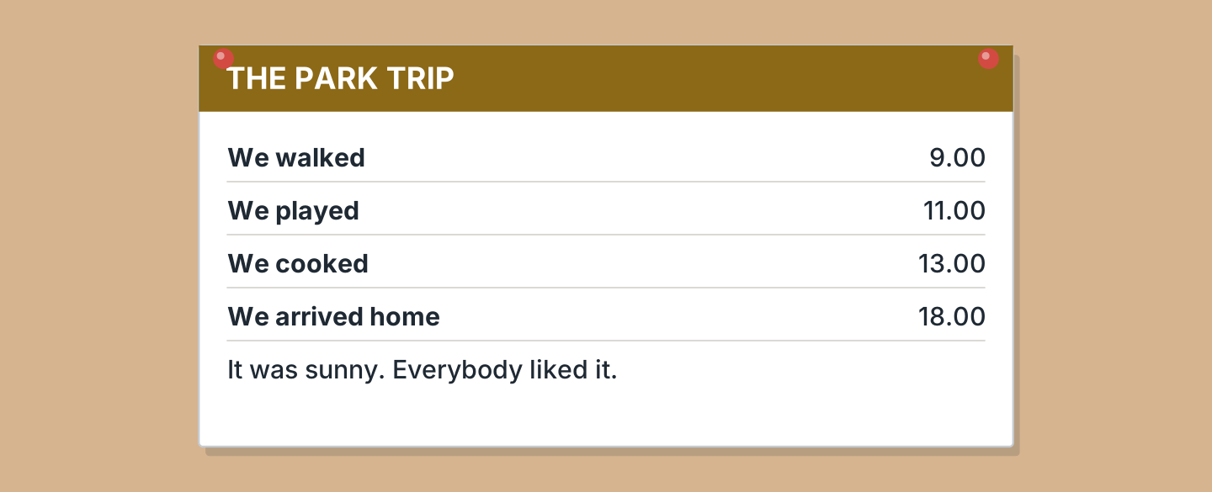
Figure 11.15 · A note about the trip.
- When did they walk? — at nine (example)
- When did they play? — ______________
- When did they arrive home? — ______________
- How was the weather? — ______________
5B Look at Figure 11.15. Write yes or no.
- They walked at nine. — yes (example)
- They cooked at eleven. — ______
- The weather was cold. — ______
- Everybody liked it. — ______
5C Look at Figure 11.16. Choose the correct answer.
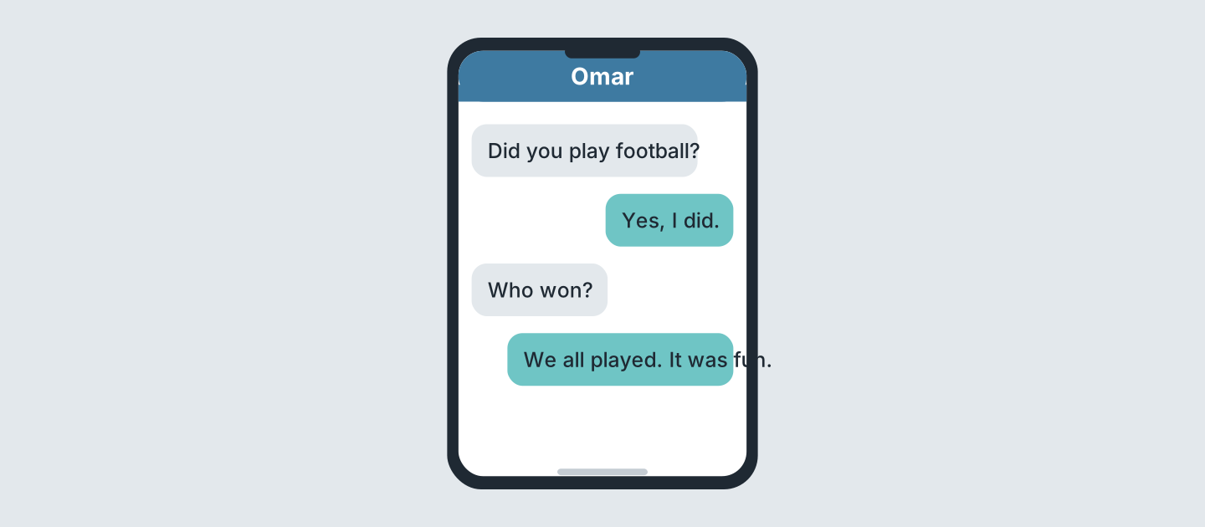
Figure 11.16 · Messages after the day.
- Who begins? (a) a friend (b) Omar (c) Lili — a (example)
- Did Omar play? (a) yes (b) no (c) perhaps
- Who won? (a) Omar (b) nobody (c) everybody
- How was it? (a) fun (b) cold (c) long
5D Read and correct. Write the correct word.
- They walked at ten. — nine (example)
- They arrived home at six in the morning. — ______________
- It was cold at the park. — ______________
- They played at one. — ______________
Part 6 · Writing
6A Look at Figure 11.17. Complete the form.
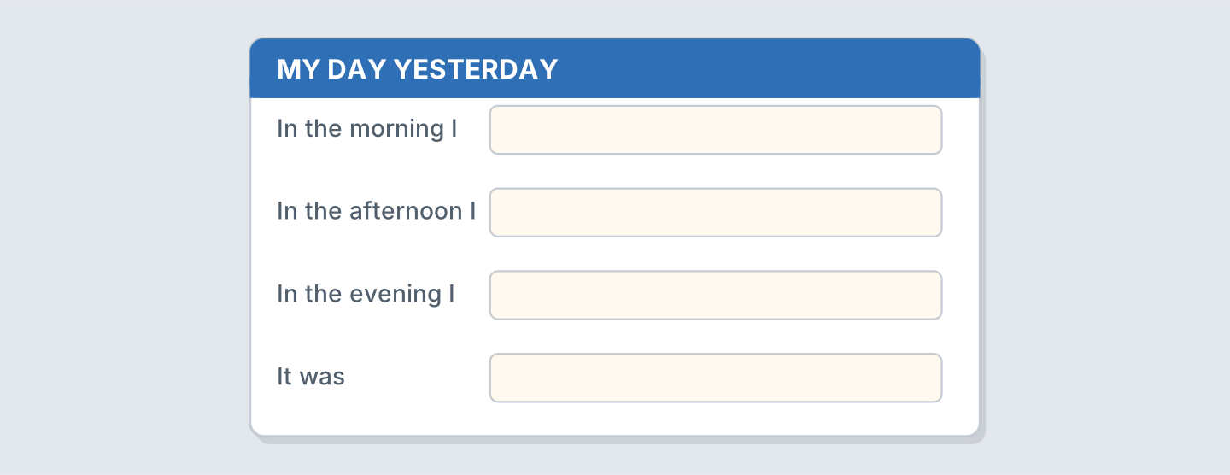
Figure 11.17 · A form about yesterday.
- In the morning I: walked to work (example)
- In the morning I: ______________
- In the evening I: ______________
- It was: ______________
6B Look at Figure 11.18. Write four lines.
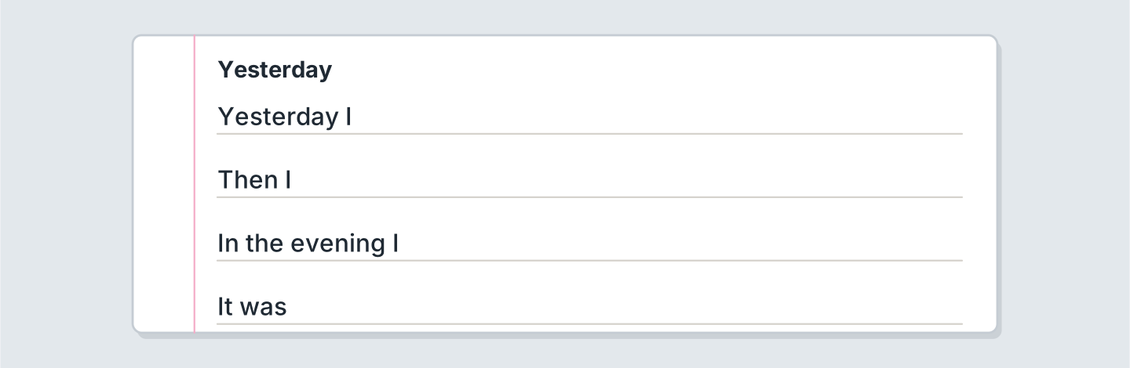
Figure 11.18 · Four lines about yesterday.
- Yesterday I walked to the shop. (example)
- Yesterday I ______________.
- Then I ______________.
- The weather was ______________.
6C Write about a day out. Write three lines.
- We walked to the park near the library. (example)
- Say where you walked.
- Say what you did.
- Say if the shop was busy.
Part 7 · Real-World File
7A Look at Figure 11.19. Answer the questions.
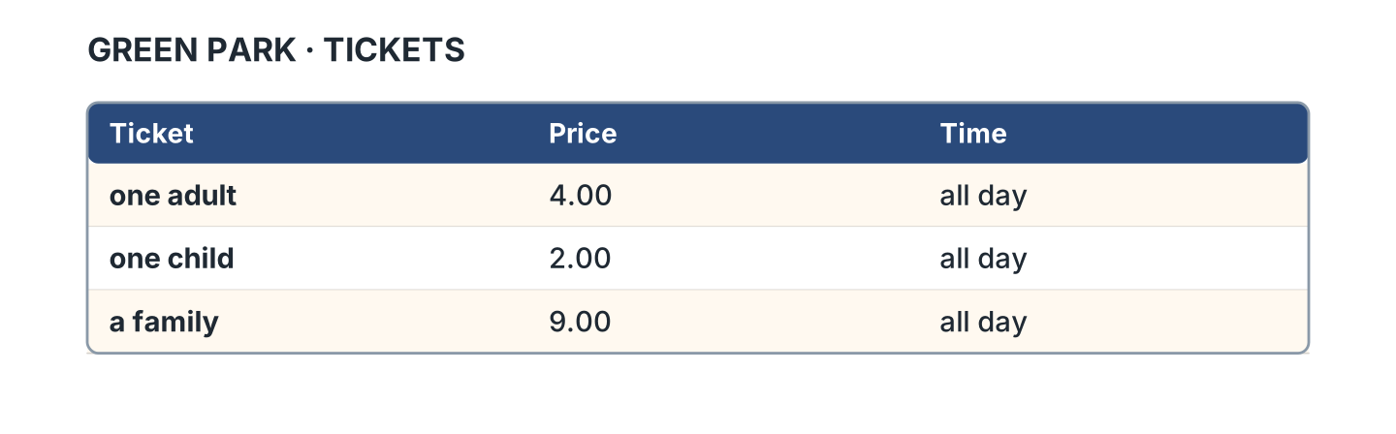
Figure 11.19 · The ticket for the park.
- How much is one adult? — 4.00 (example)
- How much is one child? — ______________
- How much is a family? — ______________
- How long is a ticket for? — ______________
7B Look at Figure 11.20. Write the sentence.
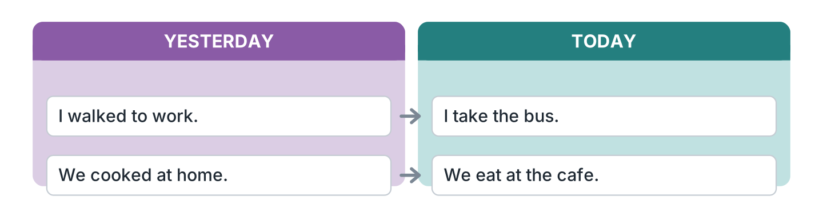
Figure 11.20 · Yesterday and today.
- Yesterday I walked to work. (walked) (example)
- Today I ______________ the bus.
- Yesterday we ______________ at home.
- Today we ______________ at the cafe.
7C Write a ticket for a place you know.
- One adult · 4.00 · all day (example)
- Place: ______________
- Price: ______________
- Time: ______________
Part 8 · Review & Can-Do
8A Look at Figure 11.21. Write the word.
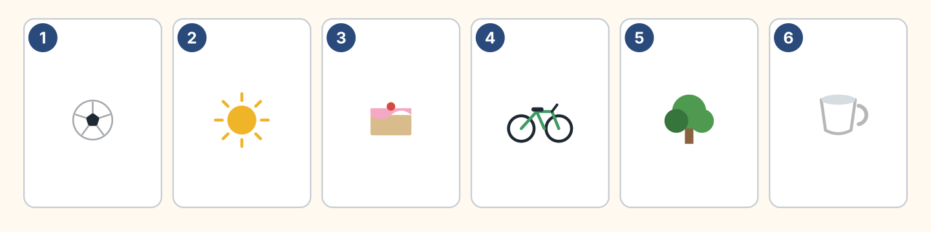
Figure 11.21 · Six things from this unit.
Words: ball · bike · cake · cup · sun · tree
- 1 — ball (example)
- 2 — ______________
- 3 — ______________
- 4 — ______________
- 5 — ______________
8B Complete the conversation.
Words: did · didn’t · Did · walked
- A: Did you go out yesterday? (Did) (example)
- B: Yes, I ______. I ______ to the park.
- A: ______ you play football?
- B: No, I ______.
8C Write the past form.
- visit — visited (example)
- wash — ______________
- close — ______________
- carry — ______________
8D Match the question and the answer.
Question | Answer
1 What did you do? | a Yes, I did.
2 Did you walk? | b I watched a film.
3 Where did you go? | c To the park.
4 How was it? | d It was fun.
 | e She’s a nurse.
One option is not needed.
- 1 — b (example)
- 2 — ______
- 3 — ______
- 4 — ______
8E Look at Figure 11.22. Tick what you can do.
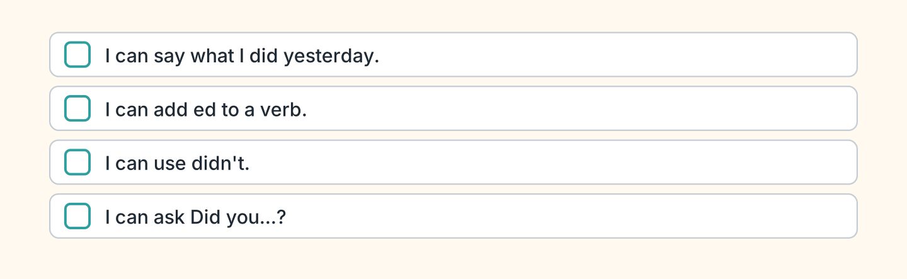
Figure 11.22 · What I can do.
- I can say what I did yesterday. — ✓ (example)
- I can add ed to a verb. — ______
- I can use didn’t. — ______
- I can ask Did you…? — ______

Unit 12: Last Year
In this unit you use went, saw and had. You ask about the past.
Warm Up
W1 Look at Figure 12.1. Write the past form.
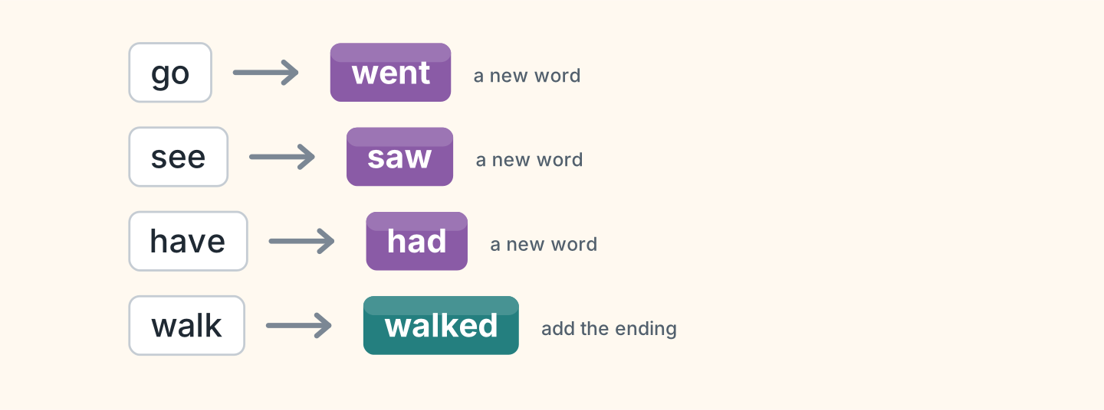
Figure 12.1 · Some verbs change.
- go — went (example)
- see — ______________
- have — ______________
- walk — ______________
W2 Look at Figure 12.2. Write the word.
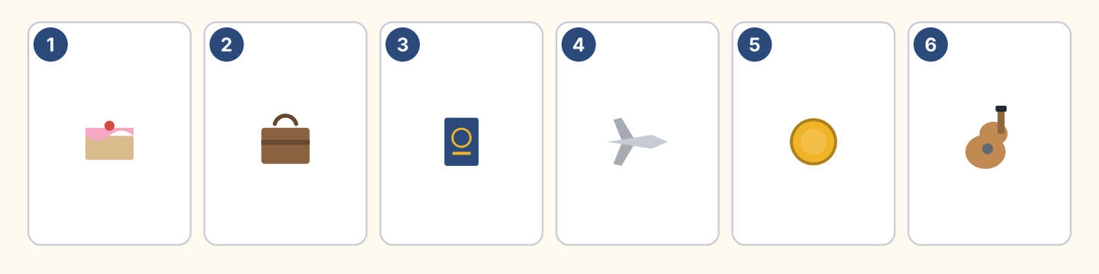
Figure 12.2 · Six things from last year.
Words: cake · coin · guitar · passport · plane · suitcase
- 1 — cake (example)
- 2 — ______________
- 3 — ______________
- 4 — ______________
- 6 — ______________
W3 Say three things you did last year.
- Last year I went to Spain. (example)
- Say where you went.
- Say who you saw.
- Say if the trip was long or short.
Part 1 · Words & Sounds
1A Look at Figure 12.3. Write the past form.
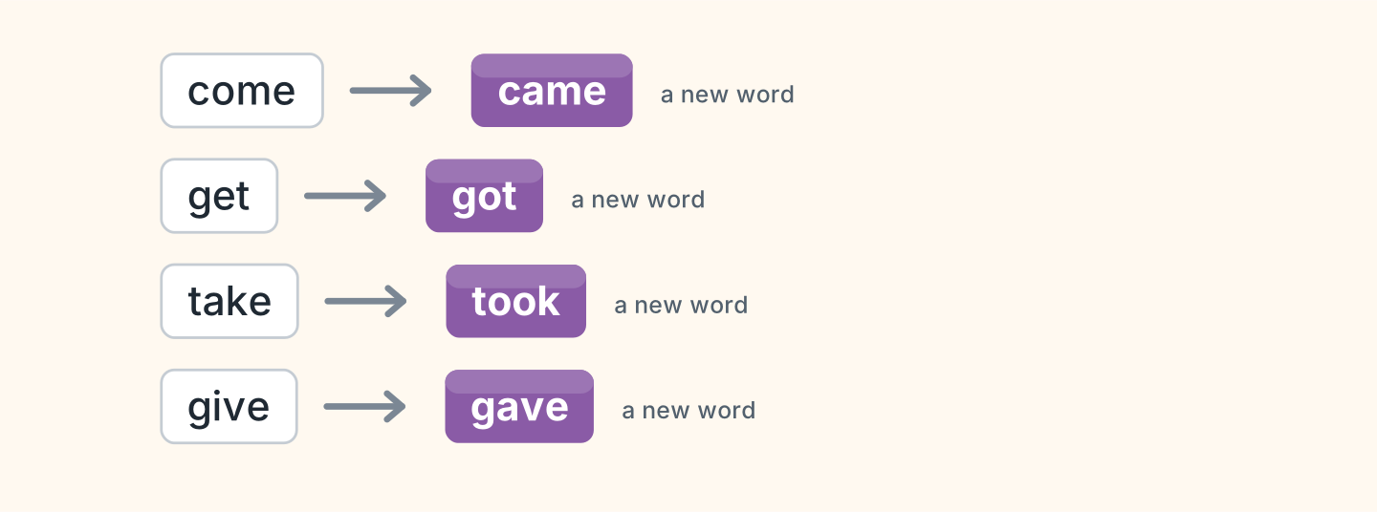
Figure 12.3 · Eight new past forms.
- come — came (example)
- get — ______________
- take — ______________
- give — ______________
1B Look at Figure 12.4. Write the word in the correct box.
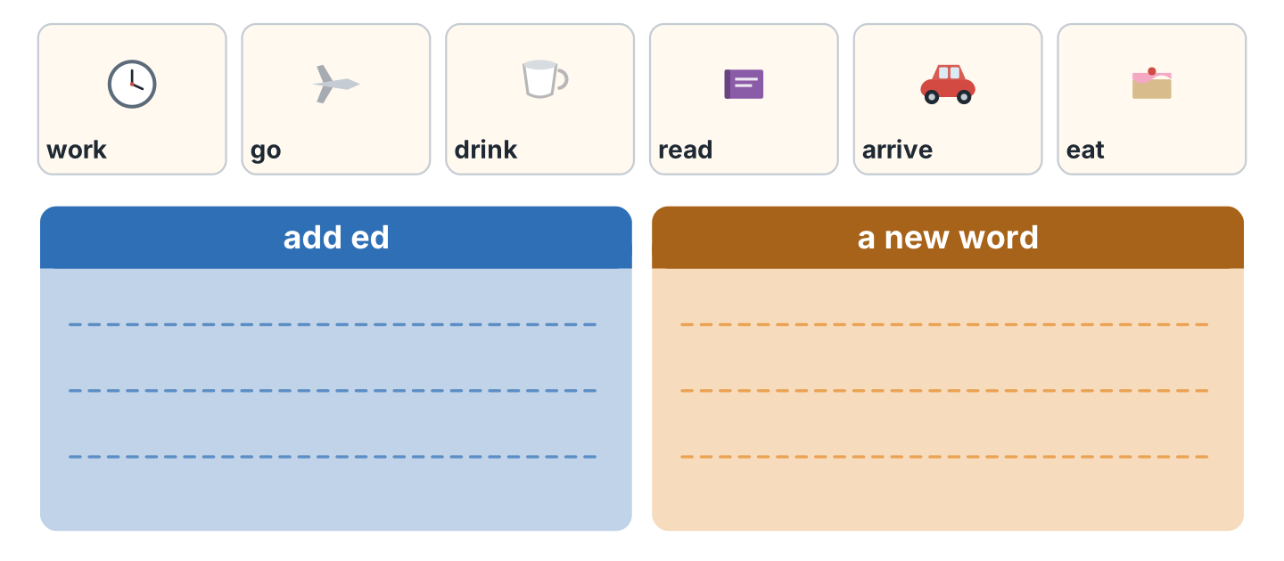
Figure 12.4 · Add it or change it.
- work — add ed (example)
- go — ______________
- drink — ______________
- arrive — ______________
1C Say it. Say these new past words.
- went (example)
- saw
- had
- took
- gave
1D Look at Figure 12.5. Write the name.
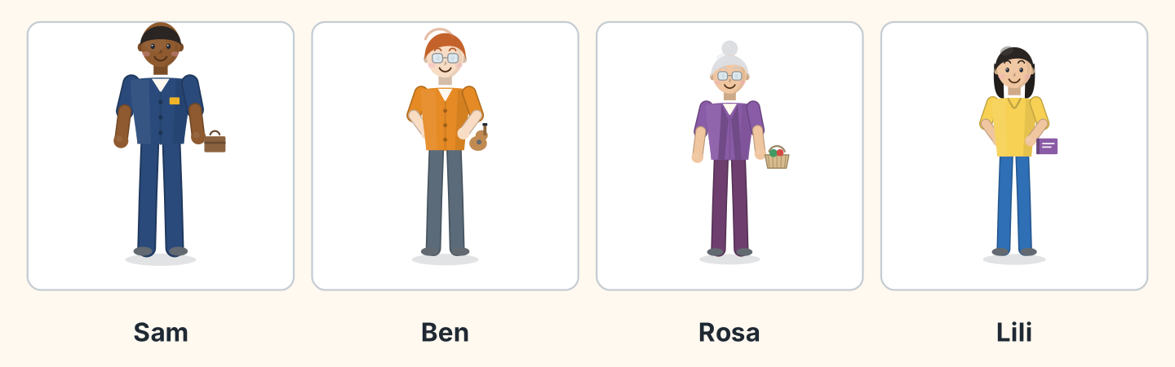
Figure 12.5 · Four people last year.
- He carried a suitcase. — Sam (example)
- He held a guitar. — ______________
- She carried a basket. — ______________
- She held a book. — ______________
1E Look at Figure 12.6. Answer the questions.
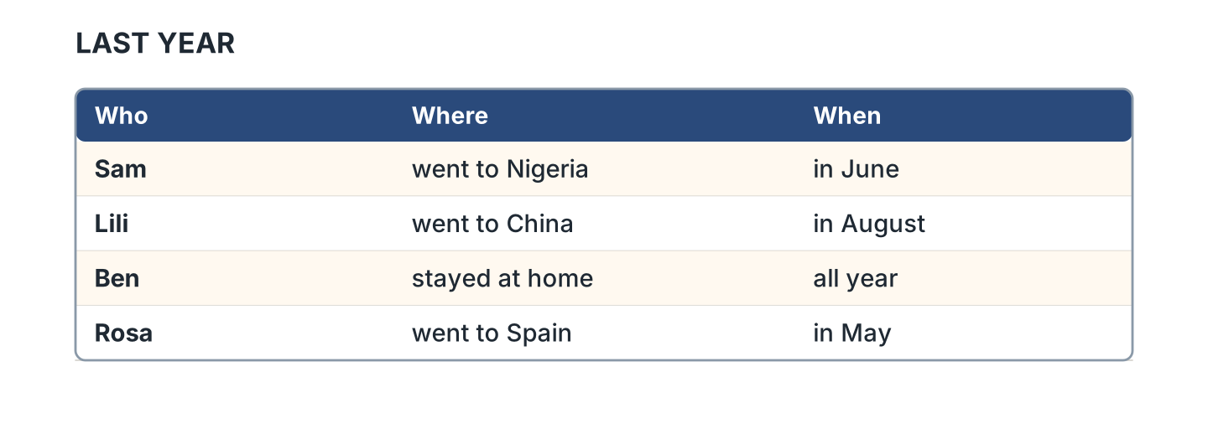
Figure 12.6 · Where people went.
- Where did Sam go? — to Nigeria (example)
- Where did Lili go? — ______________
- When did Rosa go? — ______________
- Who stayed at home? — ______________
1F Write the new past word.
- eat — ate (example)
- say — ______________
- meet — ______________
- find — ______________
Part 2 · Grammar
2A Look at Figure 12.7. Write the question.
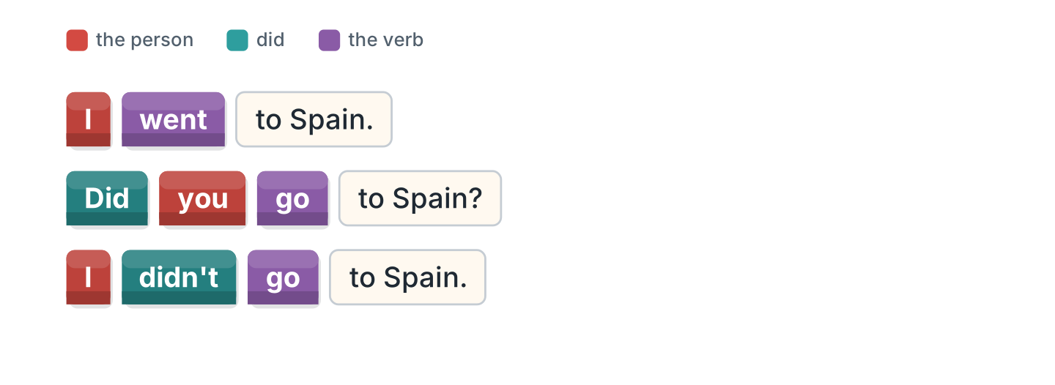
Figure 12.7 · Did and the plain verb.
- I went to Spain. — Did you go to Spain? (example)
- She saw the sea. — ______________
- They took a plane. — ______________
- He had a party. — ______________
2B Choose the correct verb.
- Did you (go / went) to Spain? — go (example)
- I (see / saw) my family.
- She didn’t (take / took) a plane.
- We (have / had) a good time.
- Did they (come / came) home?
2C Look at Figure 12.8. Write the answer.
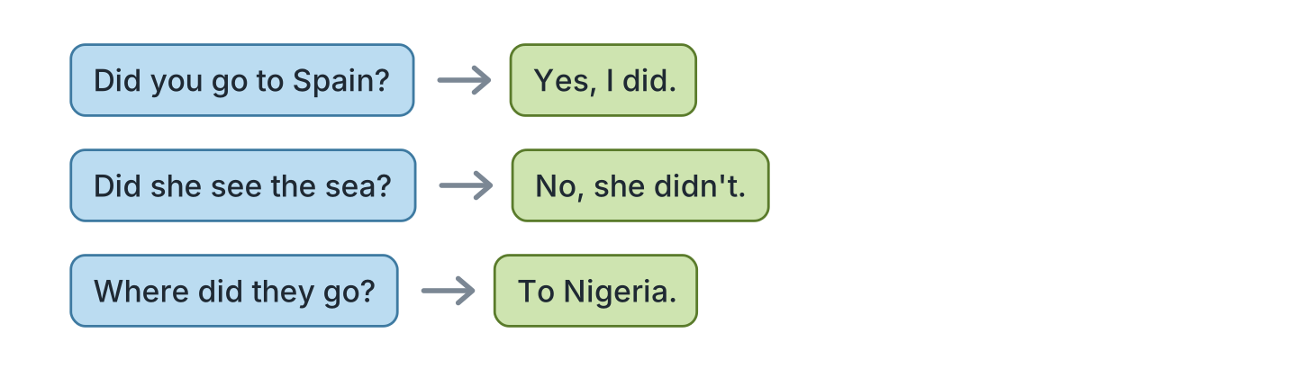
Figure 12.8 · Questions and answers.
- Did you go to Spain? ✓ — Yes, I did. (example)
- Did she see the sea? ✗ — ______________
- Did they take a plane? ✓ — ______________
- Where did they go? (Nigeria) — ______________
2D Write the sentence with didn’t.
- I went to Spain. — I didn’t go to Spain. (example)
- She saw the sea. — ______________
- We had a party. — ______________
- They took a plane. — ______________
2E Look at Figure 12.9. Write yes or no.
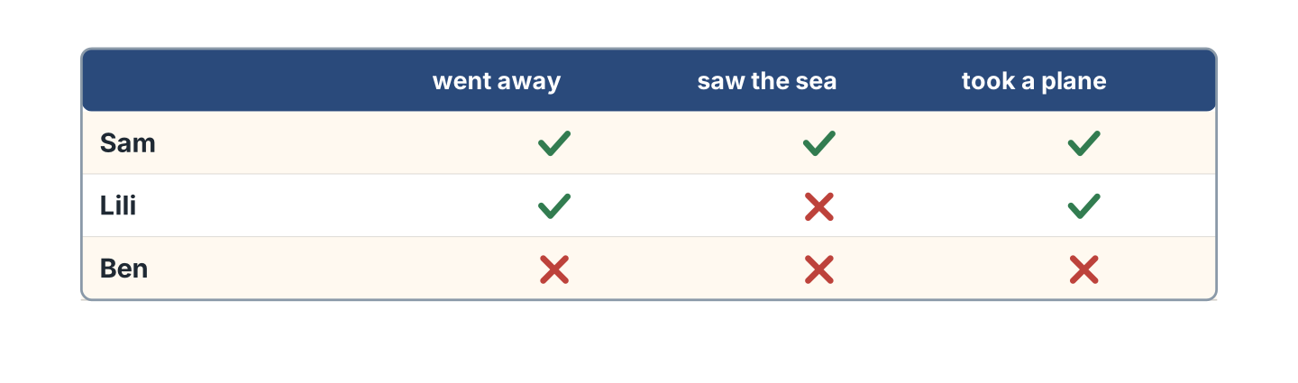
Figure 12.9 · Who did what.
- Sam went away. — yes (example)
- Lili saw the sea. — ______
- Ben took a plane. — ______
- Sam took a plane. — ______
2F Find the wrong verb. Write the correct one.
- Did you went to Spain? — go (example)
- I didn’t saw my family. — ______________
- She go to the beach. — ______________
- We taked a plane. — ______________
Part 3 · Listening
3A Listen. Look at Figure 12.10. Write the number.
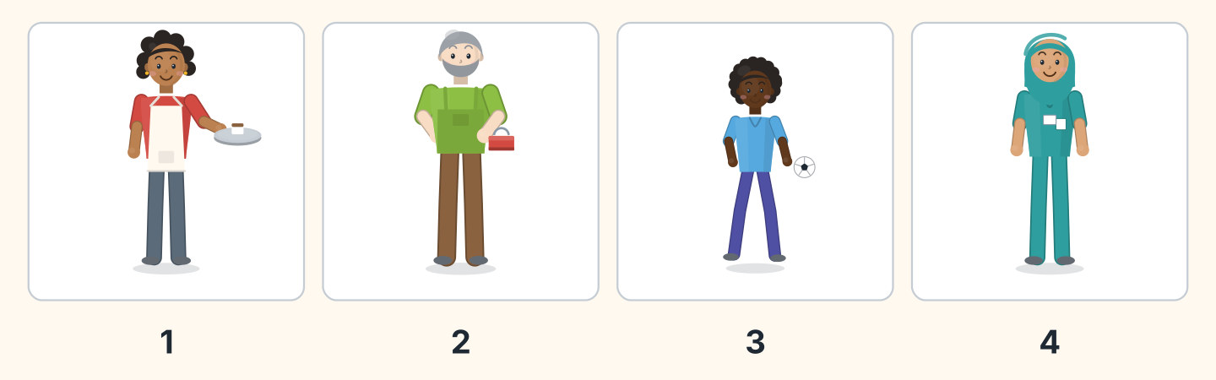
Figure 12.10 · Four voices about last year.
- Nadia — 1 (example)
- Marek — ______
- Omar — ______
- Fatima — ______
3B Listen. Look at Figure 12.11. Complete the lines.
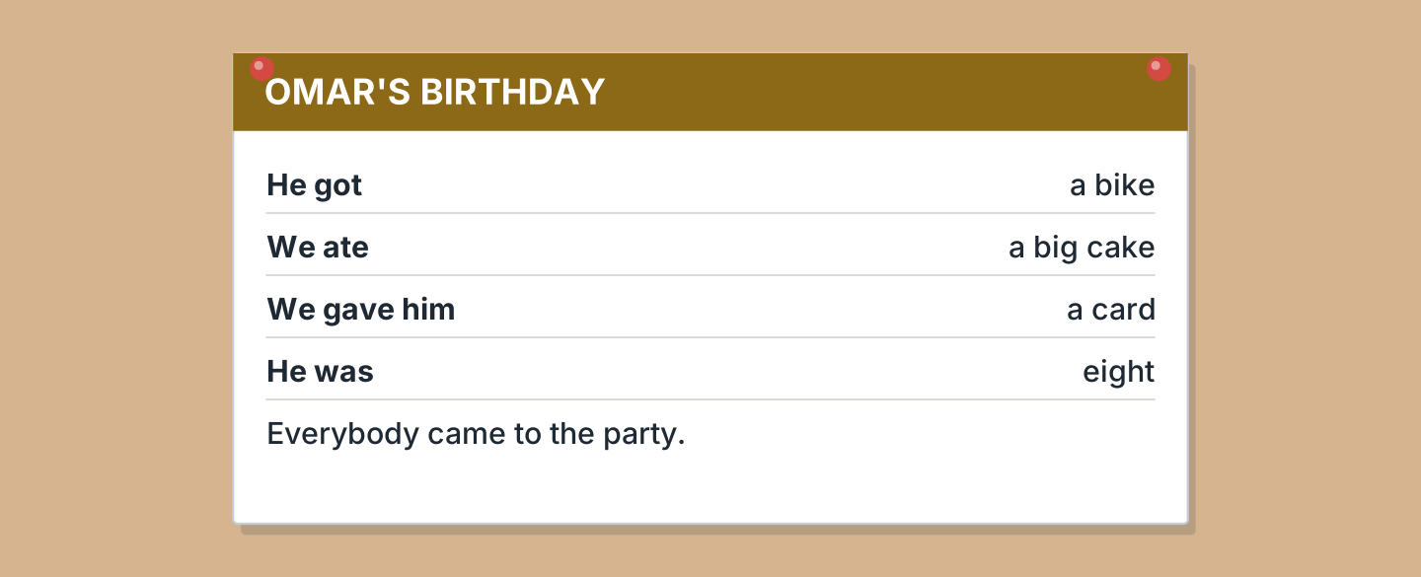
Figure 12.11 · A birthday last year.
- Omar got a bike. (a bike) (example)
- They ate ______________.
- They gave him ______________.
- He was ______________.
3C Listen. Look at Figure 12.12. Write the number.
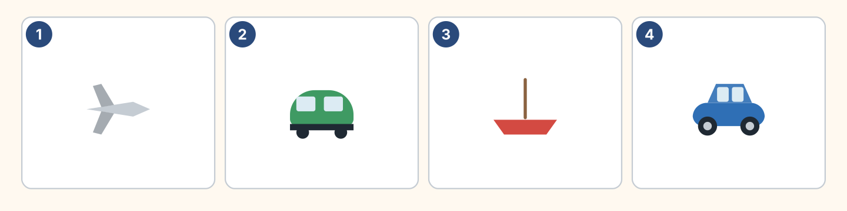
Figure 12.12 · Four ways to travel.
- a plane — 1 (example)
- a train — ______
- a boat — ______
- a car — ______
3D Listen. Write the new past word you hear.
- went (example)
- ______________
- ______________
- ______________
Part 4 · Speaking
4A Look at Figure 12.13. Ask about last year.
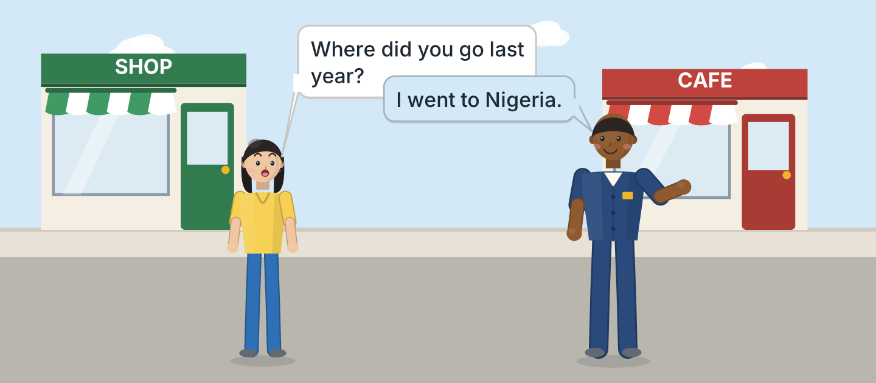
Figure 12.13 · Sam talks about last year.
- A: Where did you go last year? B: I went to Nigeria. (example)
- Ask which country your friend visited.
- Ask what they saw there.
- Ask if the food was good.
4B Look at Figure 12.14. Ask and answer.
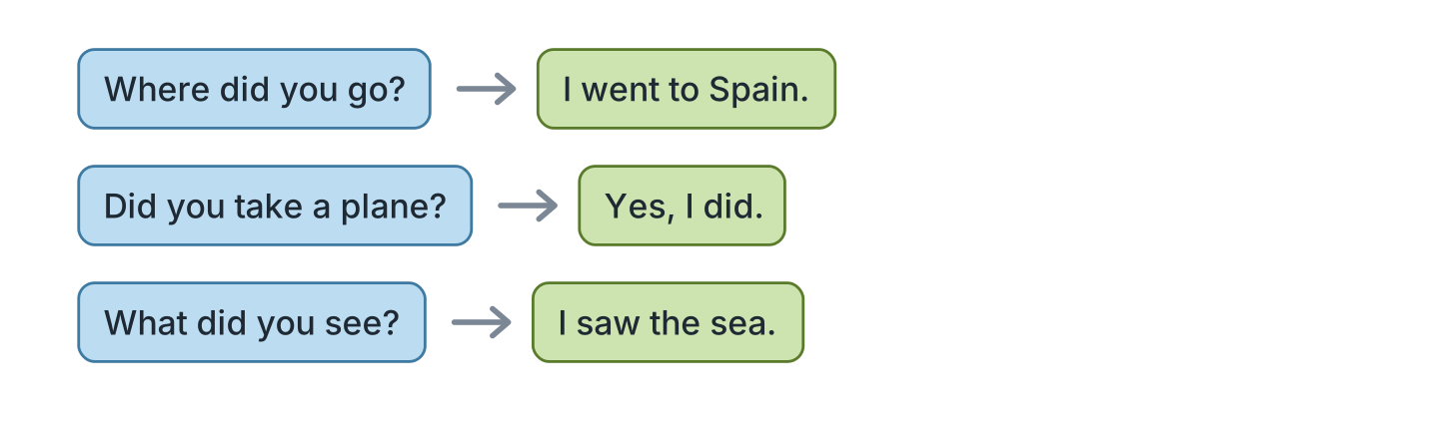
Figure 12.14 · Ask about last year.
- A: Where did you go? B: I went to Spain. (example)
- A: Did you take a plane? B: ______________
- A: What did you see? B: ______________
- A: Who did you go with? B: ______________
4C Tell a friend about a birthday.
- I had a party at the restaurant. We ate a cake. (example)
- Say what you had for the party.
- Say what you ate and drank.
- Say who came and helped.
4D Ask three friends about a trip.
- A: Did you go away last year? B: Yes, I did. (example)
- Ask where.
- Ask how they went.
- Ask when they came home.
Part 5 · Reading
5A Look at Figure 12.15. Answer the questions.
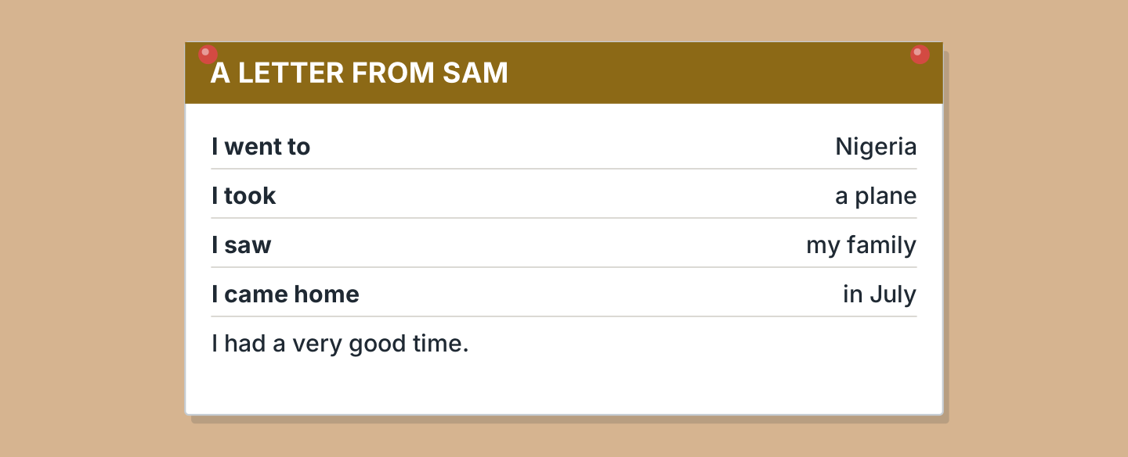
Figure 12.15 · A letter about a trip.
- Where did Sam go? — to Nigeria (example)
- How did he go? — ______________
- Who did he see? — ______________
- When did he come home? — ______________
5B Look at Figure 12.15. Write yes or no.
- Sam went to Nigeria. — yes (example)
- He took a train. — ______
- He saw his family. — ______
- He came home in June. — ______
5C Look at Figure 12.16. Choose the correct answer.
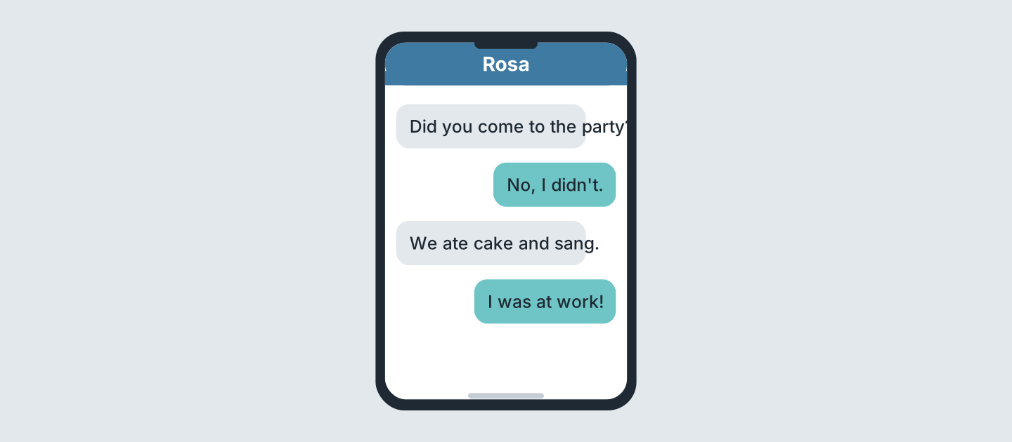
Figure 12.16 · Messages about a party.
- What did they eat? (a) cake (b) fish (c) soup — a (example)
- Did Rosa go to it? (a) yes (b) no (c) maybe
- Who asks her? (a) a friend (b) Ben (c) Omar
- Where was Rosa? (a) home (b) work (c) the park
5D Read and correct. Write the correct word.
- Sam took a train. — plane (example)
- Sam came home in June. — ______________
- Sam went to Spain. — ______________
- Rosa came to the party. — ______________
Part 6 · Writing
6A Look at Figure 12.17. Complete the form.
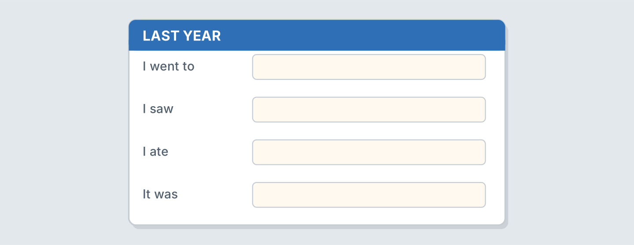
Figure 12.17 · A form about last year.
- I went to: Spain (example)
- I went to: ______________
- I saw: ______________
- It was: ______________
6B Look at Figure 12.18. Write four lines.
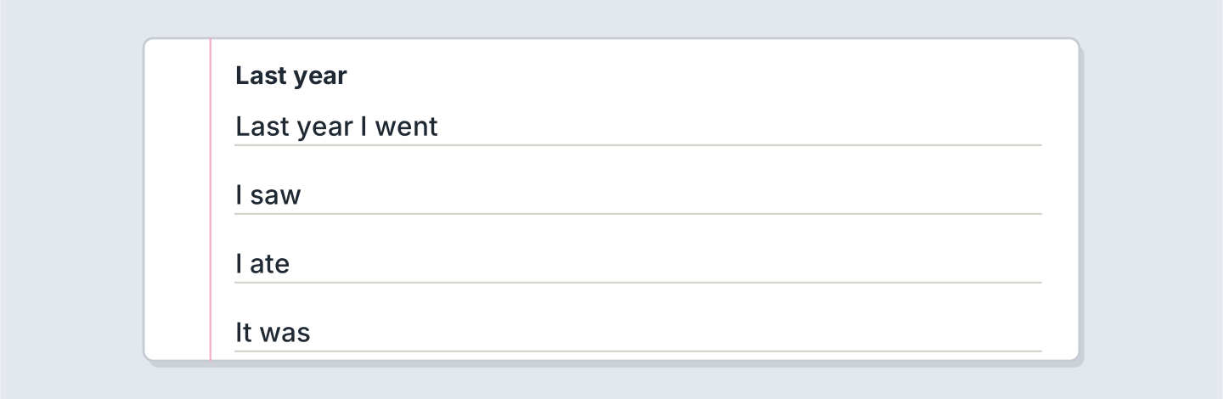
Figure 12.18 · Four lines about last year.
- Last year I went to the sea and stayed a week. (example)
- Last year I went ______________.
- I saw ______________.
- The food was ______________.
6C Write a short letter about a trip. Write three lines.
- I went to the mountains and walked all day. (example)
- Say which country you visited.
- Say what you watched or played.
- Say when you arrived home.
Part 7 · Real-World File
7A Look at Figure 12.19. Answer the questions.
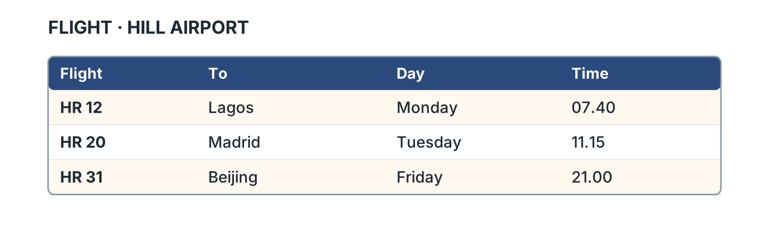
Figure 12.19 · A plane ticket.
- Where does HR 12 go? — Lagos (example)
- Where does HR 20 go? — ______________
- What time is HR 31? — ______________
- Which day is HR 12? — ______________
7B Look at Figure 12.20. Write the sentence.
Figure 12.20 · Then and now.
- Last year I went by plane. (went) (example)
- This year I ______________ by bus.
- Last year we ______________ at home.
- This year we ______________ at the cafe.
7C Write a ticket for a trip you want.
- HR 12 · Lagos · Monday · 07.40 (example)
- To: ______________
- Day: ______________
- Time: ______________
Part 8 · Review & Can-Do
8A Look at Figure 12.21. Write the word.
Figure 12.21 · Six things from this unit.
Words: boat · cake · passport · plane · suitcase · train
- 1 — passport (example)
- 2 — ______________
- 3 — ______________
- 4 — ______________
- 5 — ______________
8B Complete the conversation.
Words: did · Did · saw · went
- A: Did you go away last year? (Did) (example)
- B: Yes, I ______. I ______ to Spain.
- A: What ______ you see?
- B: I ______ the sea.
8C Write the past form.
- drink — drank (example)
- write — ______________
- know — ______________
- sleep — ______________
8D Match the question and the answer.
Question | Answer
1 Where did you go? | a Yes, I did.
2 Did you take a plane? | b To Nigeria.
3 What did you see? | c My family.
4 When did you come home? | d In July.
 | e It’s a bike.
One option is not needed.
- 1 — b (example)
- 2 — ______
- 3 — ______
- 4 — ______
8E Look at Figure 12.22. Tick what you can do.
Figure 12.22 · What I can do.
- I can use went, saw, had and got. — ✓ (example)
- I can ask about a country. — ______
- I can say what I did last year. — ______
- I can tell a friend about a trip. — ______

Unit 13: Right Now
In this unit you say what is happening now. You add ing to a verb.
Warm Up
W1 Look at Figure 13.1. Answer the questions.
Figure 13.1 · The class right now.
- What is Lili doing? — she is writing (example)
- Who is asking the question? — ______________
- Where are they? — ______________
- How many people are sitting? — ______________
W2 Look at Figure 13.2. Write the word.
Figure 13.2 · Six things people wear.
Words: coat · dress · hat · shirt · shoes · trousers
- 1 — shirt (example)
- 2 — ______________
- 3 — ______________
- 5 — ______________
- 6 — ______________
W3 Say what three people near you are doing.
- My friend is reading. She watched a film and waited. (example)
- Say what one person near you is doing.
- Say what you are wearing and where you bought it.
- Say if the market and the restaurant are open.
Part 1 · Words & Sounds
1A Look at Figure 13.3. Write the ing form.
Figure 13.3 · Adding ing.
- work — working (example)
- read — ______________
- wait — ______________
- sit — ______________
1B Look at Figure 13.4. Write the name.
Figure 13.4 · Four people doing things.
- She is carrying a tray. — Nadia (example)
- He is holding a phone. — ______________
- She is carrying a basket. — ______________
- He is holding a toolbox. — ______________
1C Look at Figure 13.5. Write the word.
Figure 13.5 · What they are wearing.
Words: coat · dress · hat · shirt
- 1 — hat (example)
- 2 — ______________
- 3 — ______________
- 4 — ______________
1D Say it. Say these ing forms.
- working (example)
- reading
- sitting
- running
- waiting
1E Look at Figure 13.6. Answer the questions.
Figure 13.6 · Who is doing what.
- What is Nadia doing? — she is cooking (example)
- What is Sam doing? — ______________
- Where is Lili? — ______________
- Who is running? — ______________
1F Write the ing form.
- cook — cooking (example)
- eat — ______________
- drink — ______________
- sleep — ______________
Part 2 · Grammar
2A Look at Figure 13.7. Complete with am, is or are.
Figure 13.7 · be plus ing.
- I am reading. (am) (example)
- She ______ reading.
- They ______ reading.
- We ______ waiting.
2B Choose the correct word.
- I (am / is) working. — am (example)
- She (is / are) cooking.
- They (is / are) waiting.
- He (am / is) reading.
- We (is / are) sitting.
2C Look at Figure 13.8. Write the sentence for now.
Figure 13.8 · Every day and right now.
- I work at the cafe. — I’m working now. (example)
- She reads every day. — ______________
- They play on Monday. — ______________
- We cook every evening. — ______________
2D Write the negative.
- I am working. — I’m not working. (example)
- She is cooking. — ______________
- They are waiting. — ______________
- He is reading. — ______________
2E Look at Figure 13.9. Write the answer.
Figure 13.9 · Questions about now.
- What are you doing? (wait) — I’m waiting. (example)
- Is she working? ✓ — ______________
- Are they eating? ✗ — ______________
- What are you reading? (a book) — ______________
2F Find the mistake. Write the correct words.
- I working now. — am working (example)
- She is cook dinner. — ______________
- They is waiting. — ______________
- He no is reading. — ______________
Part 3 · Listening
3A Listen. Look at Figure 13.10. Write the number.
Figure 13.10 · Four people to find.
- Lili — 1 (example)
- Sam — ______
- Omar — ______
- Nadia — ______
3B Listen. Look at Figure 13.11. Write yes or no.
Figure 13.11 · A moment in the class.
- Omar is listening. — yes (example)
- Fatima is sitting. — ______
- Two people are sitting. — ______
- Omar is writing. — ______
3C Listen. Look at Figure 13.12. Write the place.
Figure 13.12 · Where everyone is.
- Ben — in the shop (example)
- Fatima — ______________
- Marek — ______________
- Rosa — ______________
3D Listen. Write the ing form you hear.
- waiting (example)
- ______________
- ______________
- ______________
Part 4 · Speaking
4A Look at Figure 13.13. Ask what is happening.
Figure 13.13 · Ben on the phone.
- A: What are you doing? B: I’m waiting for the bus. (example)
- Ask what your friend is cooking, soup or fish.
- Say what you are doing at this moment.
- Say who visited and helped you yesterday.
4B Look at Figure 13.14. Ask and answer.
Figure 13.14 · Ask what is happening.
- A: What are you doing? B: I’m cooking. (example)
- A: Where is he walking? B: ______________
- A: Are you working today? B: ______________
- A: What are you wearing? B: ______________
4C Say what four people in your class are doing.
- Lili is reading a book. Yesterday she walked here. (example)
- ______________
- ______________
- ______________
4D Describe what a friend is wearing.
- She is wearing a red coat. She took it to the party. (example)
- Say one thing they are wearing.
- Say the colour of it.
- Ask if they are cold.
Part 5 · Reading
5A Look at Figure 13.15. Answer the questions.
Figure 13.15 · A notice on the door.
- What is Nadia doing? — she is cooking (example)
- What is Ben doing? — ______________
- Is the cafe open? — ______________
- Who are they waiting for? — ______________
5B Look at Figure 13.15. Write yes or no.
- Nadia is cooking. — yes (example)
- The cafe is closed. — ______
- Ben is helping. — ______
- They are waiting for you. — ______
5C Look at Figure 13.16. Choose the correct answer.
Figure 13.16 · Messages right now.
- Where is Lili? (a) home (b) school (c) shop — a (example)
- What is Lili doing? (a) reading (b) cooking (c) waiting
- Where is the friend? (a) home (b) the bus stop (c) school
- Is Lili going out? (a) yes (b) no (c) perhaps
5D Read and correct. Write the correct word.
- Lili is cooking at home. — reading (example)
- The friend is waiting at the shop. — ______________
- Nadia is washing in the cafe. — ______________
- The cafe is closed. — ______________
Part 6 · Writing
6A Look at Figure 13.17. Complete the form.
Figure 13.17 · A form about right now.
- I am: sitting in the class (example)
- I am: ______________
- I am wearing: ______________
- Outside it is: ______________
6B Look at Figure 13.18. Write four lines.
Figure 13.18 · Four lines about now.
- I’m sitting in the kitchen. I came home and gave it back. (example)
- I’m sitting in ______________.
- I’m wearing ______________.
- Outside it is ______________.
6C Write a message about this moment. Write three lines.
- I’m waiting. I walked here and found my ticket. (example)
- Say where you are and how you came here.
- Say what you are doing.
- Ask if your friend got a ticket.
Part 7 · Real-World File
7A Look at Figure 13.19. Answer the questions.
Figure 13.19 · The board at the station.
- What is train A12 doing? — waiting (example)
- What is train B40 doing? — ______________
- Which train is late? — ______________
- What time is train B40? — ______________
7B Look at Figure 13.20. Write the word.
Figure 13.20 · Three ways to travel now.
Words: bike · car · train
- 1 — train (example)
- 2 — ______________
- 3 — ______________
- Which one has two wheels? — ______________
7C Write three lines for a station board.
- A12 · the city · 14.05 · waiting (example)
- ______________
- ______________
- ______________
Part 8 · Review & Can-Do
8A Look at Figure 13.21. Write the word.
Figure 13.21 · Six things from this unit.
Words: coat · dress · hat · shirt · shoes · trousers
- 1 — shirt (example)
- 2 — ______________
- 4 — ______________
- 5 — ______________
- 6 — ______________
8B Complete the conversation.
Words: am · are · doing · waiting
- A: What are you doing? (doing) (example)
- B: I ______ ______ for the bus.
- A: ______ you going to work?
- B: Yes, I am.
8C Write the ing form.
- sit — sitting (example)
- run — ______________
- write — ______________
- carry — ______________
8D Match the question and the answer.
Question | Answer
1 What are you doing? | a Yes, I am.
2 Are you working? | b I’m reading.
3 Where are you going? | c To the shop.
4 What is she wearing? | d A red coat.
 | e I went to Spain.
One option is not needed.
- 1 — b (example)
- 2 — ______
- 3 — ______
- 4 — ______
8E Look at Figure 13.22. Tick what you can do.
Figure 13.22 · What I can do.
- I can say what is happening now. — ✓ (example)
- I can add ing to a verb. — ______
- I can ask What are you doing? — ______
- I can name six things people wear. — ______

Unit 14: Next Week
In this unit you say what you are going to do. You talk about next week.
Warm Up
W1 Look at Figure 14.1. Answer the questions.
Figure 14.1 · Lili’s week.
- What is she going to do on Monday? — see Nadia (example)
- What is on Tuesday? — ______________
- Which day has two things? — ______________
- Where is she going on Friday? — ______________
W2 Look at Figure 14.2. Write the word.
Figure 14.2 · Six things for a trip.
Words: bag · coin · passport · plane · suitcase · timetable
- 1 — suitcase (example)
- 2 — ______________
- 3 — ______________
- 5 — ______________
- 6 — ______________
W3 Say three things you are going to do next week.
- I’m going to visit my sister. Last year I stayed a week. (example)
- Say one thing you will visit.
- Say the day and the time.
- Say who is going with you.
Part 1 · Words & Sounds
1A Look at Figure 14.3. Complete the sentence.
Figure 14.3 · going to and a verb.
- I am going to visit Spain. (going to) (example)
- She is ______________ fly on Monday.
- We are ______________ stay a week.
- They are ______________ meet us.
1B Look at Figure 14.4. Write the word.
Figure 14.4 · Four ways to travel.
Words: boat · car · plane · train
- 1 — plane (example)
- 2 — ______________
- 3 — ______________
- 4 — ______________
1C Say it. Say these words.
- going to (example)
- tomorrow
- tonight
- soon
- later
1D Look at Figure 14.5. Write the name.
Figure 14.5 · Four people with plans.
- He is carrying a suitcase. — Sam (example)
- She is holding a book. — ______________
- She is carrying a tray. — ______________
- He is packing a bag. — ______________
1E Look at Figure 14.6. Answer the questions.
Figure 14.6 · When people are going.
- Where is Sam going? — Nigeria (example)
- When is Lili going? — ______________
- How is Rosa going? — ______________
- Who is going by car? — ______________
1F Write the time word.
- the day after today — tomorrow (example)
- this evening — ______________
- in a short time — ______________
- after this — ______________
Part 2 · Grammar
2A Look at Figure 14.7. Write the short form.
Figure 14.7 · The short forms.
- I am going — I’m going (example)
- She is going — ______________
- We are going — ______________
- They are going — ______________
2B Choose the correct form of be.
- I (am / is) going to fly. — am (example)
- She (is / are) going to stay.
- They (is / are) going to meet us.
- We (am / are) going to pack.
- He (is / are) going to book a ticket.
2C Look at Figure 14.8. Write the answer.
Figure 14.8 · Questions about plans.
- Are you going to fly? ✓ — Yes, I am. (example)
- Is she going to stay? ✗ — ______________
- Are they going to meet us? ✓ — ______________
- When are you going? (Monday) — ______________
2D Write the sentence with not.
- I’m going to fly. — I’m not going to fly. (example)
- She’s going to stay. — ______________
- They’re going to meet us. — ______________
- We’re going to pack. — ______________
2E Look at Figure 14.9. Write yes or no.
Figure 14.9 · Who is going where.
- Sam is going by plane. — yes (example)
- Lili is going by plane. — ______
- Rosa is going next week. — ______
- Lili is going next week. — ______
2F Find the missing word. Write it.
- I going to fly. — am going (example)
- She is going fly. — ______________
- They going to stay. — ______________
- Are you going to flying? — ______________
Part 3 · Listening
3A Listen. Look at Figure 14.10. Complete the week.
Figure 14.10 · A week to complete.
- On Monday I am going to work. (work) (example)
- On Wednesday I am going to ______________.
- On Friday I am going to ______________.
- Which day is free? — ______________
3B Listen. Look at Figure 14.11. Write the number.
Figure 14.11 · Four voices with plans.
- Rosa — 1 (example)
- Marek — ______
- Omar — ______
- Fatima — ______
3C Listen. Look at Figure 14.12. Write the time.
Figure 14.12 · The airport board.
- HR 12 — 07.40 (example)
- HR 20 — ______________
- HR 31 — ______________
- Which flight is first? — ______________
3D Listen. Write the day you hear.
- Monday (example)
- ______________
- ______________
- ______________
Part 4 · Speaking
4A Look at Figure 14.13. Talk about a plan.
Figure 14.13 · Sam packs a suitcase.
- A: I’m going to fly. B: Are you going to Lagos? (example)
- Say which country you will visit.
- Say the day you walked there before.
- Ask if your friend watched the film.
4B Look at Figure 14.14. Ask and answer.
Figure 14.14 · Ask about a plan.
- A: What is the plan? B: I’m going to Spain. (example)
- A: When are you going? B: ______________
- A: Are you going to fly? B: ______________
- A: Who are you going with? B: ______________
4C Ask three friends about the weekend.
- A: What are you going to do? B: I’m going to rest. (example)
- Ask about the first day.
- Ask about the last day.
- Ask who with.
4D Make a plan with a friend.
- We’re going to meet at the station and buy some food. (example)
- Say the place and what you will eat.
- Say the time you are waiting.
- Say how you are going.
Part 5 · Reading
5A Look at Figure 14.15. Answer the questions.
Figure 14.15 · A plan on the board.
- Where is the trip? — the beach (example)
- When is it? — ______________
- What does a ticket cost? — ______________
- Where are they going to meet? — ______________
5B Look at Figure 14.15. Write yes or no.
- The trip is to the beach. — yes (example)
- The trip is on Sunday. — ______
- They are going by train. — ______
- The trip is free. — ______
5C Look at Figure 14.16. Choose the correct answer.
Figure 14.16 · Messages about a plan.
- Where is Sam going? (a) beach (b) city (c) park — a (example)
- When is Sam going? (a) Friday (b) Saturday (c) Sunday
- How is he going? (a) bus (b) car (c) train
- What will he book? (a) room (b) ticket (c) car
5D Read and correct. Write the correct word.
- The trip is on Sunday. — Saturday (example)
- The trip is nine pounds. — ______________
- They are going by bus. — ______________
- They are going to meet at the school. — ______________
Part 6 · Writing
6A Look at Figure 14.17. Complete the form.
Figure 14.17 · A form about next week.
- I am going to: visit my family (example)
- I am going to: ______________
- When: ______________
- How: ______________
6B Look at Figure 14.18. Write four lines.
Figure 14.18 · Four lines about your plan.
- Next week I’m going to visit Spain. (example)
- Next week I’m going to ______________.
- I’m going on ______________.
- I’m going with ______________.
6C Write a message about a plan. Write three lines.
- I’m going to the beach on Saturday. (example)
- Say where you are going.
- Say when.
- Ask your friend to come.
Part 7 · Real-World File
7A Look at Figure 14.19. Answer the questions.
Figure 14.19 · The train to the beach.
- When does the Saturday train leave? — 08.10 (example)
- When does it arrive? — ______________
- How much is the ticket? — ______________
- Is there a train on Monday? — ______
7B Look at Figure 14.20. Write your own week.
Figure 14.20 · A week to fill in.
- Monday: I’m going to work. (example)
- Monday: ______________
- Wednesday: ______________
- Friday: ______________
7C Write a plan for a trip.
- The beach · Saturday · by train · 6.00 (example)
- Where: ______________
- When: ______________
- How: ______________
Part 8 · Review & Can-Do
8A Look at Figure 14.21. Write the word.
Figure 14.21 · Six things from this unit.
Words: boat · passport · plane · suitcase · timetable · train
- 1 — plane (example)
- 2 — ______________
- 3 — ______________
- 4 — ______________
- 6 — ______________
8B Complete the conversation.
Words: going · to · What · when
- A: What are you going to do? (What) (example)
- B: I’m ______ to visit my family.
- A: And ______ are you going?
- B: I’m going ______ fly on Monday.
8C Write the short form.
- I am going — I’m going (example)
- He is going — ______________
- They are going — ______________
- We are going — ______________
8D Match the question and the answer.
Question | Answer
1 What are you going to do? | a On Monday.
2 When are you going? | b I’m going to rest.
3 Are you going to fly? | c Yes, I am.
4 Who are you going with? | d With my family.
 | e I went to Spain.
One option is not needed.
- 1 — b (example)
- 2 — ______
- 3 — ______
- 4 — ______
8E Look at Figure 14.22. Tick what you can do.
Figure 14.22 · What I can do.
- I can say what I am going to do. — ✓ (example)
- I can talk about next week. — ______
- I can ask When are you going? — ______
- I can name four ways to travel. — ______

Unit 15: Bigger and Better
In this unit you compare two things. You say which one you want.
Warm Up
W1 Look at Figure 15.1. Answer the questions.
Figure 15.1 · Two bikes to choose.
- Which bike is cheaper? — the green bike (example)
- Which bike is bigger? — ______________
- Which bike is newer? — ______________
- How much is the red bike? — ______________
W2 Look at Figure 15.2. Write the word.
Figure 15.2 · Add er to the word.
- big — bigger (example)
- old — ______________
- cheap — ______________
- good — ______________
W3 Compare two things in your bag.
- My pen is longer than my key. I will pack it tonight. (example)
- Say two things you will pack tomorrow.
- Say which is bigger.
- Say which you need for the flight.
Part 1 · Words & Sounds
1A Look at Figure 15.3. Write the opposite.
Figure 15.3 · Opposites.
- big — small (example)
- old — ______________
- cheap — ______________
- fast — ______________
1B Look at Figure 15.4. Answer the questions.
Figure 15.4 · Two cars to compare.
- Which car is cheaper? — the blue car (example)
- Which car is newer? — ______________
- Which car is bigger? — ______________
- How much is the red car? — ______________
1C Look at Figure 15.5. Write the comparing word.
Figure 15.5 · Long words take more.
- cheap — cheaper (example)
- expensive — ______________
- easy — ______________
- difficult — ______________
1D Say it. Say these words.
- bigger (example)
- cheaper
- easier
- busier
- more expensive
1E Look at Figure 15.6. Answer the questions.
Figure 15.6 · Four things and their prices.
- How much is the bike? — 85 (example)
- How much is the coat? — ______________
- Which thing is cheapest? — ______________
- Which things are small? — ______________
1F Write the comparing word.
- long — longer (example)
- short — ______________
- quiet — ______________
- busy — ______________
Part 2 · Grammar
2A Look at Figure 15.7. Complete the sentence.
Figure 15.7 · than between the two.
- The red bike is bigger than the green one. (than) (example)
- Spain is warmer ______ England.
- The train is faster ______ the bus.
- This coat is cheaper ______ that one.
2B Choose the correct word.
- The red bike is (big / bigger) than the green one. — bigger (example)
- This coat is (cheap / cheaper) than that one.
- Green Town is (busy / busier) than Hill Road.
- The train is (more fast / faster) than the bus.
- This book is (more difficult / difficulter).
2C Look at Figure 15.8. Write the answer.
Figure 15.8 · Questions about two things.
- Which bike is cheaper? — The green one. (example)
- Is Spain warmer than England? ✓ — ______________
- Which is better? (the red one) — ______________
- Which car is bigger? (the red one) — ______________
2D Write the sentence with than.
- (the train / fast / the bus) — The train is faster than the bus. (example)
- (the coat / cheap / the bike) — ______________
- (Rosa / old / Omar) — ______________
- (this book / easy / that book) — ______________
2E Look at Figure 15.9. Write yes or no.
Figure 15.9 · Which one is which.
- The red bike is bigger. — yes (example)
- The red bike is cheaper. — ______
- The green bike is newer. — ______
- The green bike is cheaper. — ______
2F Find the mistake. Write the correct words.
- This bike is more big. — bigger (example)
- Spain is warm than England. — ______________
- This coat is cheaper that one. — ______________
- This book is difficulter. — ______________
Part 3 · Listening
3A Listen. Look at Figure 15.10. Answer the questions.
Figure 15.10 · Two coats.
- Which coat is cheaper? — the brown coat (example)
- Which coat is bigger? — ______________
- How much is the navy coat? — ______________
- Which coat does she want? — ______________
3B Listen. Look at Figure 15.11. Write the number.
Figure 15.11 · Two towns.
- People in Hill Road — 4000 (example)
- Shops in Green Town — ______________
- Schools in Green Town — ______________
- Parks in Hill Road — ______________
3C Listen. Look at Figure 15.12. Write the number.
Figure 15.12 · Four things to compare.
- a bike — 1 (example)
- a car — ______
- a hat — ______
- a coat — ______
3D Listen. Write the comparing word you hear.
- cheaper (example)
- ______________
- ______________
- ______________
Part 4 · Speaking
4A Look at Figure 15.13. Choose in the shop.
Figure 15.13 · Choosing in the shop.
- A: Which bike is cheaper? B: The green one is cheaper. (example)
- Ask what the price was last year.
- Ask which one to take to the airport.
- Say which you plan to book soon.
4B Look at Figure 15.14. Ask and answer.
Figure 15.14 · Ask and choose.
- A: Which one is bigger? B: The red one. (example)
- A: Is this one cheaper? B: ______________
- A: Which do you like? B: ______________
- A: Which is better? B: ______________
4C Compare two towns you know.
- My town is busier than Hill Road. (example)
- Say the two towns you went to.
- Say which is busier and which you saw first.
- Say which one you are going to visit again.
4D Compare two people in your family.
- My brother is younger than me. He went to the party. (example)
- Say who is older.
- Say who is younger.
- Say one more thing.
Part 5 · Reading
5A Look at Figure 15.15. Answer the questions.
Figure 15.15 · A notice in the shop.
- How much is the green bike? — 85 (example)
- How much is the red bike? — ______________
- Which bike is cheaper? — ______________
- How much is a hat? — ______________
5B Look at Figure 15.15. Write yes or no.
- The green bike is cheaper. — yes (example)
- The coat is forty pounds. — ______
- The red bike is cheaper. — ______
- A hat is nine pounds. — ______
5C Look at Figure 15.16. Choose the correct answer.
Figure 15.16 · Messages about a bike.
- Who speaks first? (a) a friend (b) Ben (c) Lili — a (example)
- Which bike is newer? (a) red (b) green (c) both
- Which is more expensive? (a) red (b) green (c) both
- Which is cheaper? (a) red (b) green (c) both
5D Read and correct. Write the correct word.
- The red bike is cheaper. — green (example)
- The green bike is newer. — ______________
- The green bike is more expensive. — ______________
- A hat is forty pounds. — ______________
Part 6 · Writing
6A Look at Figure 15.17. Complete the form.
Figure 15.17 · A form to compare two things.
- Thing one: the red bike (example)
- Thing one: ______________
- Thing two: ______________
- Which is cheaper: ______________
6B Look at Figure 15.18. Write four lines.
Figure 15.18 · Four lines comparing.
- One is a red bike. (example)
- One is ______________.
- The other is ______________.
- I want the ______________.
6C Write about two things in a shop. Write three lines.
- The red coat is more expensive. I plan to buy it later. (example)
- Say the two things you had.
- Compare them.
- Say which one you are going to take.
Part 7 · Real-World File
7A Look at Figure 15.19. Answer the questions.
Figure 15.19 · Two buses to the beach.
- Which is cheaper? — bus 12 (example)
- Which is faster? — ______________
- How much is the train? — ______________
- How often is bus 12? — ______________
7B Look at Figure 15.20. Answer the questions.
Figure 15.20 · Two hats in the window.
- Which hat is cheaper? — the red hat (example)
- Which hat is bigger? — ______________
- How much is the green hat? — ______________
- Which one do you want? — ______________
7C Compare two prices you know.
- The bus is cheaper than the plane. I will fly tomorrow. (example)
- The thing I am going to buy: ______________
- The thing I saw last week: ______________
- Which is cheaper: ______________
Part 8 · Review & Can-Do
8A Look at Figure 15.21. Write the word.
Figure 15.21 · Six things from this unit.
Words: bag · bike · car · coat · coin · hat
- 1 — bike (example)
- 2 — ______________
- 3 — ______________
- 4 — ______________
- 5 — ______________
8B Complete the conversation.
Words: cheaper · one · than · Which
- A: Which bike is cheaper? (Which) (example)
- B: The green ______ is ______.
- A: Is it smaller ______ the red one?
- B: Yes, it is.
8C Write the comparing word.
- small — smaller (example)
- young — ______________
- nice — ______________
- expensive — ______________
8D Match the question and the answer.
Question | Answer
1 Which is cheaper? | a The green one.
2 Is it bigger? | b Yes, it is.
3 Which do you want? | c The red one.
4 How much is it? | d It’s 85.
 | e I’m going to fly.
One option is not needed.
- 1 — a (example)
- 2 — ______
- 3 — ______
- 4 — ______
8E Look at Figure 15.22. Tick what you can do.
Figure 15.22 · What I can do.
- I can compare two things. — ✓ (example)
- I can add er to a short word. — ______
- I can use more with a long word. — ______
- I can say which one I want. — ______

