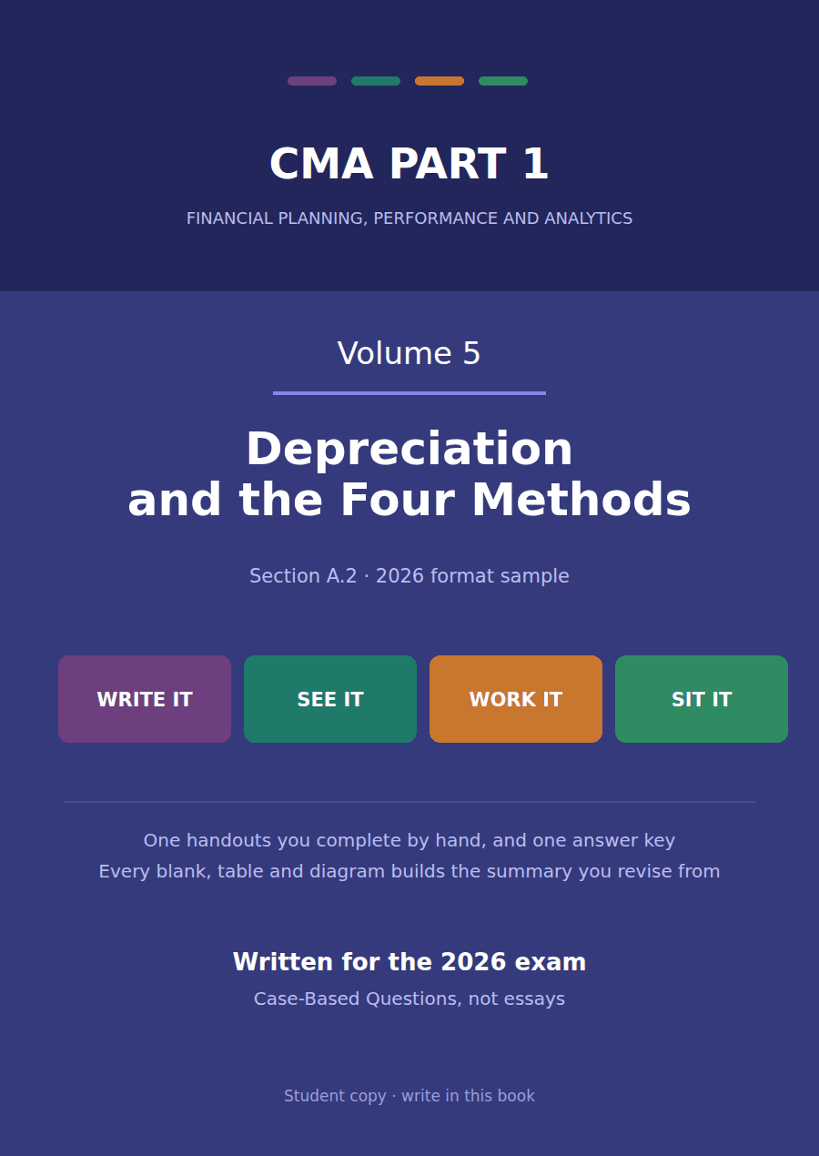

CMA Part 1 · Volume 5
Long-Lived Assets
One handout, rebuilt. Five schedules, sixty cells to complete, and not one figure printed in the prose that a table then asks for. The case gives three estimates; everything else is derived.
These handouts are not notes to read. You write them. The words you supply are the summary, so a finished handout is a page you can revise from, in your own handwriting.
Work in pen. Do not look at the key until the whole handout is done — the key is written to explain the mistake, and you only get that benefit if you have made it first.
The one handouts
# | Handout | What it gives you
1 | The Depreciation Methods, Side by Side | One machine, one life, one amount to write off. Four patterns for writing it off, and you compute every one of them.

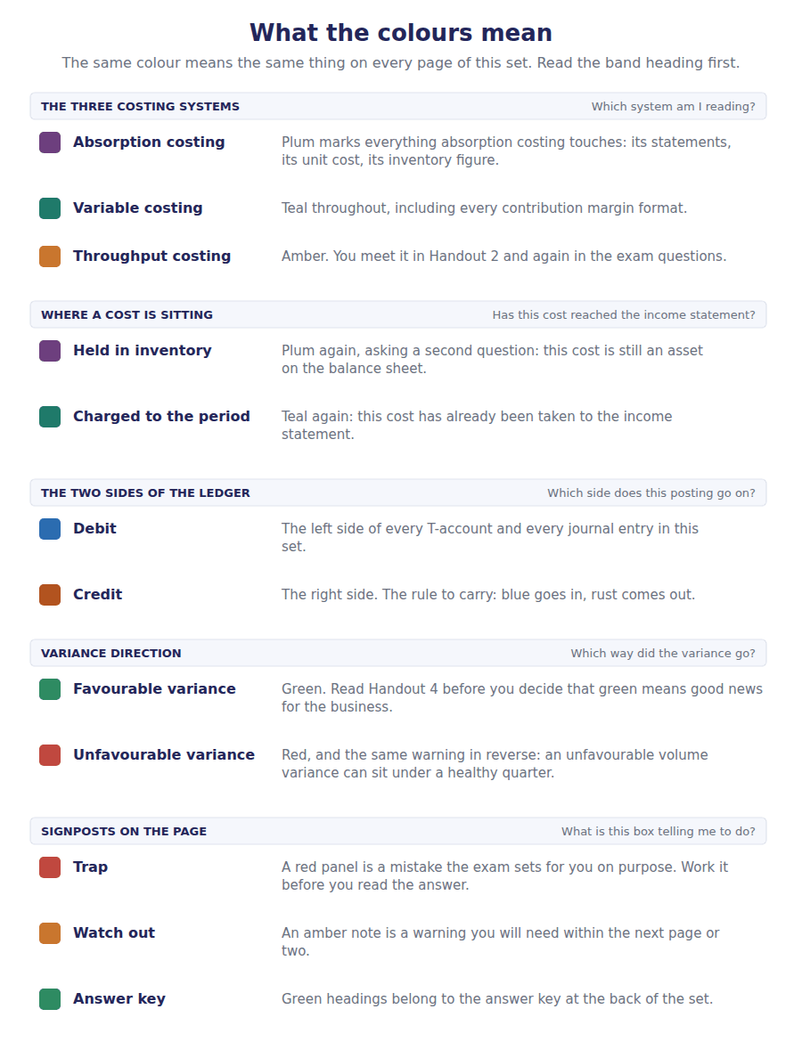
How to read the markers
Marker | Meaning
R1 | Teaching English. Short sentences. This is where a new idea arrives.
R2 | Textbook English. Longer sentences and passive verbs, as a textbook writes them.
R3 | Exam English. Exactly how the CMA exam phrases it, traps included.
Numbered rule | A space you fill in. The number matches the answer key.
Red table | A trap. Read it twice.

Handout 1 · The Depreciation Methods, Side by Side
One machine, one life, one amount to write off. Four patterns for writing it off, and you compute every one of them.
Volume 5 · Long-Lived Assets · R1 moving to R2
LANGUAGE FOCUS
Register you are working in | R1 while the three estimates are named, R2 once the schedules are being built.
Say it exactly like this | estimate a useful life · write off the depreciable amount · apply a rate to a falling carrying amount · accelerate a charge into the early years · cap a charge at the residual value · depreciate on the basis of output
Words that are not the same | cost / carrying amount · useful life / residual value · straight line / accelerated · time-based / activity-based
Remember | An accelerated method is not a larger total. It is the same total, taken sooner. Residual value is not what the asset will be worth. It is what this company expects to get for it at the end of its own use of it.

One machine, four schedules
In January 20X4 Northwind bought a packing machine for $500,000. It expects to use the machine for 5 years, and then to sell it for about $50,000.
Those three numbers are everything a depreciation method is given: what the machine cost, how long the company expects to use it, and what it expects to get back at the end. The first is a fact; the other two are estimates made by management.
The machine is expected to produce 900,000 units over its life, and the production plan for each of the five years is in the table in Part 5.
In this handout you build four schedules from those figures. Nothing in the pages that follow tells you an answer before the table asks for it.
الحالة بالعربية
في يناير من عام 20X4 اشترت شركة نورثويند آلة تعبئة بمبلغ $500,000. وتتوقع أن تستخدم الآلة لمدة 5 سنوات، ثم تبيعها بنحو $50,000.
هذه الأرقام الثلاثة هي كل ما تُعطاه أي طريقة إهلاك: كم كلّفت الآلة، وكم سنة تتوقع الشركة أن تستخدمها، وكم تتوقع أن تسترد في النهاية. الأول حقيقة، والاثنان الآخران تقديران تضعهما الإدارة.
ويُتوقع أن تنتج الآلة 900,000 وحدة خلال عمرها، وخطة الإنتاج لكل سنة من السنوات الخمس موجودة في الجدول في الجزء الخامس.
في هذه الورقة ستبني أربعة جداول إهلاك من هذه الأرقام. ولن تجد في الصفحات التالية أي إجابة قبل أن يطلبها الجدول منك.

Part 1 · The three estimates and the one figure they fix
Exercise 1A Read and complete. Write one word in each space.
WORD BANK
accumulated · cost · depreciable · life · period · residual · value
Not every word is used.

R1 Every method needs the same three inputs. The first is what the machine ¹ , and it is the only one of the three that is a fact rather than a judgement.
The second is how long the company expects to use it, which is its useful ² . It is an estimate about this company’s own use, not a statement about how long such a machine could last.
The third is what the company expects to receive for the machine when it has finished with it, which is its ³ value.
Subtract the third from the first and you have the total every method must write off. That total is called the ⁴ amount, and it is fixed before any method is chosen.
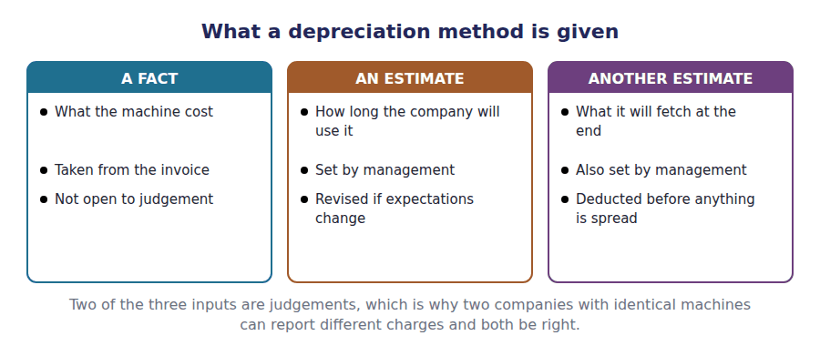
Part 2 · Straight line the same charge every year
Exercise 1B Build the straight-line schedule. Year 1 is worked; complete years 2 to 5.
First move: The worked cell shows the division. Every later year repeats it.
Year | Charge for the year | Accumulated depreciation | Carrying amount at the year end
1 | $90,000 = $450,000 ÷ 5 | $90,000 | $410,000
2
3
4
5
Twelve cells. The charge column never changes; the other two move every year.

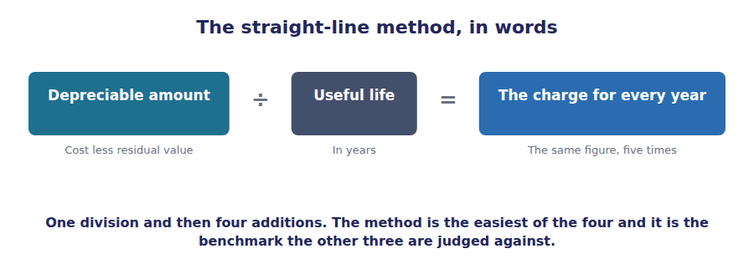
Part 3 · Double declining balance a fixed rate on a falling amount
R2 This method takes twice the straight-line rate and applies it to the carrying amount rather than to the depreciable amount. Because the carrying amount falls every year, the charge falls with it. Residual value is not in the formula at all.
Exercise 1C Build the double declining balance schedule. Year 1 is worked; complete years 2 to 5.
First move: Each year’s opening figure is the previous year’s closing figure.
Year | Carrying amount at the start | Charge for the year | Carrying amount at the year end
1 | $500,000 | $200,000 = 40% × $500,000 | $300,000
2
3
4
5
One of the five years cannot use the formula. Work down the column and you will find which, and Exercise 1D asks you why.

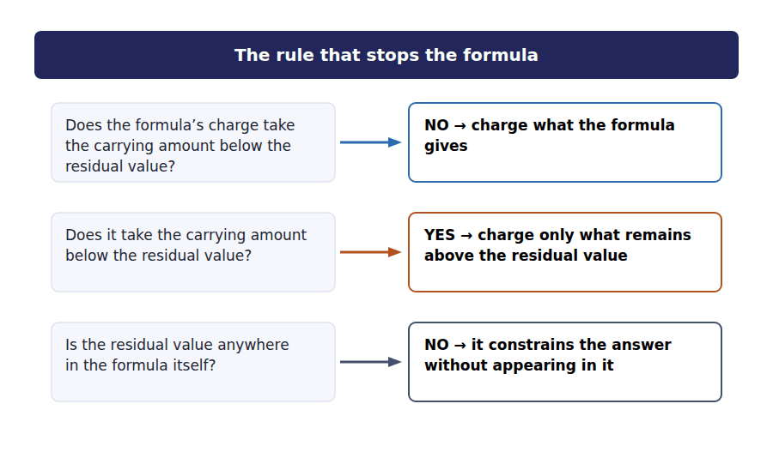
Exercise 1D Read and complete. Write one word in each space.
WORD BANK
accelerated · amount · capped · depreciable · end · even · ignored
Not every word is used.

R2 Double declining balance is called an ⁵ method, because it puts more of the charge into the early years and less into the late ones.
It does that by applying a fixed rate to the carrying ⁶ , which falls every year, rather than to the depreciable amount, which does not.
The formula never mentions the residual value. Every other method deducts it before anything is spread; this one leaves it out and deals with it only at the ⁷ .
That is why one year in your schedule is different. No method may take an asset below its residual value, so in that year the charge is ⁸ at whatever remains above it.
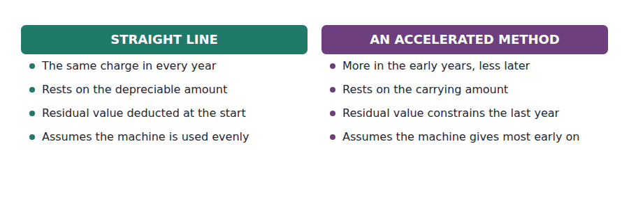
Part 4 · Sum of the years’ digits the other accelerated method
Exercise 1E Build the sum of the years’ digits schedule. Year 1 is worked; complete years 2 to 5.
First move: The denominator is the digits of the life added together. The numerator counts down.
Year | Fraction | Charge for the year | Carrying amount at the year end
1 | 5 / 15 | $150,000 = 5/15 × $450,000 | $350,000
2
3
4
5
Unlike the previous method, this one applies its fraction to the depreciable amount, so the residual value is handled at the start and never constrains the last year.

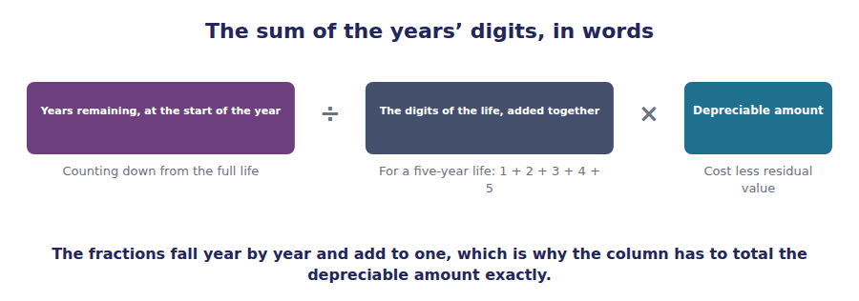
Part 5 · Units of production when time is not what wears it out
Exercise 1F Build the units of production schedule. Year 1 is worked; complete years 2 to 5.
First move: Find the rate per unit first: the depreciable amount over the total units expected.
Year | Units produced | Charge for the year | Carrying amount at the year end
1 | 240,000 | $120,000 = 240,000 × $0.50 | $380,000
2 | 210,000
3 | 180,000
4 | 150,000
5 | 120,000
The units column is given. The rate per unit is not, and the worked row shows it in use.

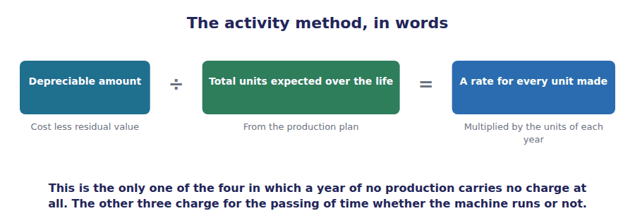
Part 6 · The four, side by side and what each one assumes
Exercise 1G Read your four schedules back and complete the comparison. The straight-line row is worked.
First move: Every figure in this table is already somewhere in your own work.
Method | Year 1 charge | Year 5 charge | Total over 5 years | What it assumes about the machine
Straight line | $90,000 | $90,000 | $450,000 | That it is used evenly, year after year
Double declining balance
Sum of the years’ digits
Units of production
Add your four totals when you have finished. If any two of them differ, one of your schedules has an arithmetic error in it.

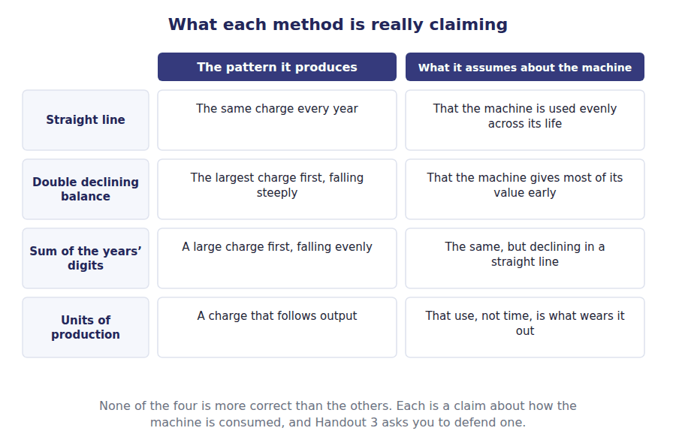
Watch out! Add the charge column of each of your four schedules. All four totals must be the same figure, because the method chooses the pattern and the depreciable amount was fixed before any method was chosen. If two of your columns disagree, the error is arithmetic and not a difference between the methods.
Part 7 · Exam pitch the questions as the CMA sets them
1. [Level A] An asset costs $500,000, has a residual value of $50,000 and a 5-year life. The depreciable amount is:
(A) $500,000
(B) $450,000
(C) $50,000
(D) $550,000
2. [Level A] Under double declining balance, the rate is applied to:
(A) The depreciable amount
(B) The carrying amount
(C) The residual value
(D) The original cost, every year
3. [Level B] Under double declining balance, the residual value:
(A) Is deducted before the rate is applied
(B) Does not enter the formula, but the asset may not be taken below it
(C) Is ignored entirely
(D) Is added to the final year’s charge
4. [Level B] An asset with a 5-year life is depreciated by the sum of the years’ digits. The denominator of the fraction is:
(A) 5
(B) 15
(C) 10
(D) 25
5. [Level B] A machine depreciated by the units of production method stands idle for a whole year. The charge for that year is:
(A) The same as the previous year
(B) Nil
(C) The straight-line charge
(D) Half the previous year
6. [Level C] Which of the following is TRUE of all four methods?
(A) They charge the same amount in year 1
(B) They write off the same total over the asset’s life
(C) They produce the same carrying amount at the end of year 2
(D) They all ignore residual value
7. [Level C] A company replaces its delivery vans every four years although they could run for eight. The useful life used for depreciation should be:
(A) Eight years, the physical life
(B) Four years, because that is this company’s expected use
(C) Whichever gives the lower charge
(D) The average of the two
ADAPTIVE TIP Write the three estimates at the top of the page before computing anything: cost, life, residual. Then write the depreciable amount underneath them. Every one of the four methods is built from those four numbers, and a question that withholds one of them is withholding the only thing you needed.

Answer Key
Volume 5 · Handouts 1 to 1
Every answer carries the reason for it and the mistake it defeats.

Handout 1 · The Depreciation Methods, Side by Side answers
Completed text and exercises
# | Answer | Why | The trap it defeats
1 | cost | The one input that is not an estimate.
2 | life | How long this company expects to use it.
3 | residual | What is expected back at the end.
4 | depreciable | The total every method must reach. | Students expect the method to change the total. It changes only which years carry it.
5 | accelerated | Sooner, not more.
6 | amount | The figure that falls each year.
7 | end | Out of the formula, but not out of the method.
8 | capped | Only what is left above the floor. | Students apply the formula to the last year and take the asset below its residual value. No method may do that.

Exam-pitch questions
# | Answer | Why | The trap it defeats
1 | (B) $450,000 | Cost less residual value. (A) is the error that would write the asset down to nothing and ignore the $50,000 the company expects to get back. | Level A
2 | (B) The carrying amount | A fixed rate on a falling balance, which is what makes the charge decline. (D) would give the same charge every year and so would not be an accelerated method at all. | Level A
3 | (B) Does not enter the formula, but the asset may not be taken below it | Out of the formula and still binding, which is why one year of the schedule you built behaves differently from the rest. (C) is the error that takes an asset below what it will fetch. | Level B
4 | (B) 15 | The digits of the life added together: 1 + 2 + 3 + 4 + 5. (A) is the life itself, which is the straight-line denominator. | Level B
5 | (B) Nil | No output, no charge. It is the one behaviour no time-based method can produce, and it is why the method suits an asset worn out by use rather than by age. | Level B
6 | (B) They write off the same total over the asset’s life | The depreciable amount is fixed before a method is chosen, so the total cannot differ. Your four columns are the proof, and if they are not equal one of them is wrong. | Level C
7 | (B) Four years, because that is this company’s expected use | Useful life is the period of the company’s own expected use, not how long the asset could last for somebody. (A) is the single most common error on this definition. | Level C

Exercise 1B · straight line
Exercise 1C · double declining balance
Exercise 1E · sum of the years’ digits
Exercise 1F · units of production
Exercise 1G · the four compared
R2 The fourth column is the same figure four times, and that is the whole point of the handout. The year 1 column ranges from $90,000 to $200,000, which is the same machine reported four ways in its first year. Handout 2 works out what that does to the statements.

Glossary
Every term in Volume 5, with the Arabic equivalent and the places it misleads
The third column is for recognition only. In the exam room you work in English.

Term | What it means in CMA English | بالعربية | Careful
accelerated method | A method that charges more in the early years and less in the late ones. | طريقة الإهلاك المعجل | Sooner, not more. Over the whole life an accelerated method writes off exactly what straight line writes off.
activity method | A method that charges on the basis of output rather than the passing of time. | طريقة وحدات الإنتاج | An idle machine takes no charge at all, which is the one behaviour no time-based method can produce.
carrying amount | Cost less the depreciation charged to date. | المبلغ المدرج | Falls every year and must never go below the residual value, whatever a formula produces.
depreciable amount | Cost less residual value: the total every method must write off. | المبلغ القابل للإهلاك | Fixed before any method is chosen. The method decides only the pattern, never the total.
residual value | What the company expects to receive for the asset when it has finished with it. | القيمة المتبقية | Deducted before anything is spread. One method leaves it out of the formula and still may not go below it.
useful life | The number of years, or the output, over which this company expects to use the asset. | العمر الإنتاجي | The company’s own expected use, not how long the asset could last for somebody else.

