Handout 10.1
The cost of property, plant and equipment
section 10.1 of the book
Before you start
Three summaries of this handout, in the book’s own words. Read all three first: together they are the whole session. Then fill the gaps, guessing where you have to.

What this handout settles, cycle by cycle
In this handout | What you will read | How you check it
The cost of property, plant and equipment | a figure to read · Asset | Which cost is added to the cost of a new machine?
The words this section uses precisely | The English the exam uses, and what it translates | What is the safest way to settle a disagreement about an answer on this sheet?

Words this handout uses precisely
Words this handout uses precisely | tick it if you could already use it in a sentence
property, plant and equipment (PP&E)
impairment
revenue expenditure
units-of-production method
asset group

1. Where the section starts — Fill every gap. The list holds more words than there are gaps, so one or two of them are not used.
choose from: goodwill · revenue expenditure · amortization · capital expenditure
After purchase, a that extends the asset's life or increases its capacity is added to its cost. A , such as ordinary repairs and maintenance, is an expense of the period.
2. What it settles in the middle — Fill every gap. The list holds more words than there are gaps, so one or two of them are not used.
choose from: amortization · revenue expenditure · goodwill · capital expenditure
After purchase, a that extends the asset's life or increases its capacity is added to its cost. A , such as ordinary repairs and maintenance, is an expense of the period. When a company builds an asset for its own use, it capitalizes interest during construction.
3. Where it ends — Fill every gap. The list holds more words than there are gaps, so one or two of them are not used.
choose from: revenue expenditure · amortization · capital expenditure · goodwill
When it buys several assets for one price, it divides the price by their relative fair values. After purchase, a that extends the asset's life or increases its capacity is added to its cost. A , such as ordinary repairs and maintenance, is an expense of the period.

CYCLE A | The cost of property, plant and equipment

ORIENT One claim. Decide now; you will check it in a moment.

4. The book gives the category of P as “Two steps: recoverability, then fair value”. TRUE / FALSE
MODEL Read it before you answer anything below it.

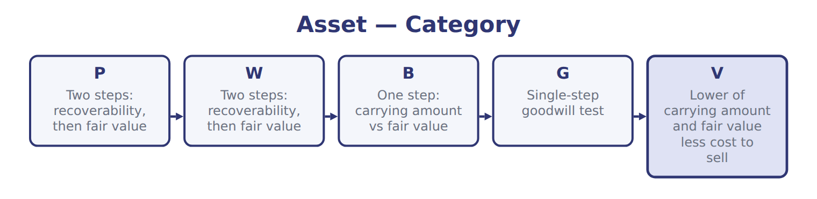
Asset — the book’s own table
Asset | Category
P | Two steps: recoverability, then fair value
W | Two steps: recoverability, then fair value
B | One step: carrying amount vs fair value
G | Single-step goodwill test
V | Lower of carrying amount and fair value less cost to sell

READ THE MODEL Every answer is printed above. Find it, do not recall it.

5. Which category does the book give for P?
A. Single-step goodwill test
B. Lower of carrying amount and fair value less cost to sell
C. Two steps: recoverability, then fair value
D. One step: carrying amount vs fair value
6. Which category does the book give for W?
A. One step: carrying amount vs fair value
B. Single-step goodwill test
C. Lower of carrying amount and fair value less cost to sell
D. Two steps: recoverability, then fair value
7. Which category does the book give for B?
A. One step: carrying amount vs fair value
B. Two steps: recoverability, then fair value
C. Single-step goodwill test
D. Lower of carrying amount and fair value less cost to sell
8. Which category does the book give for G?
A. Single-step goodwill test
B. Lower of carrying amount and fair value less cost to sell
C. One step: carrying amount vs fair value
D. Two steps: recoverability, then fair value
9. The book gives the category of P as “Two steps: recoverability, then fair value”. TRUE / FALSE
10. The book gives the category of W as “Single-step goodwill test”. TRUE / FALSE

APPLY No help on this move.

11. Use the bottling line. What is double-declining depreciation in year 2 (whole USD)?
A. 210,000 | C. 288,000
B. 280,000 | D. 480,000
12. After two years, Orontes revises the useful life and salvage value of an asset. How does it account for the change?
A. By restating the prior two years
B. Prospectively, over the remaining life
C. By a cumulative adjustment in the current year
D. By an adjustment to opening retained earnings
13. Orontes buys land with an old building, which it knocks down to build a warehouse. The demolition cost is:
A. added to the cost of the new warehouse.
B. expensed immediately.
C. added to the cost of the land.
D. added to the cost of the old building.
14. Use the bottling line. What is sum-of-the-years'-digits depreciation in year 1 (whole USD)?
A. 70,000 | C. 400,000
B. 350,000 | D. 480,000
15. Use the bottling line. What is double-declining depreciation in year 1 (whole USD)?
A. 210,000 | C. 420,000
B. 350,000 | D. 480,000
16. Compared with straight-line, an accelerated method in the FIRST year of an asset's life gives:
A. lower net income and a lower carrying amount.
B. higher net income and a higher carrying amount.
C. higher cash flow from operations before taxes.
D. higher total depreciation over the asset's life.
WORK IN PAIRS | Compare every answer on this page with your partner before you read any key.
If you disagree: go back to the model and find the row that settles it. The row decides, not the louder voice.
CHECKPOINT 17. Which cost is added to the cost of a new machine?
A. Repairs after the first year of use
B. Training staff to use the machine
C. Insurance during normal operations
D. Installation and testing before use
If you got it wrong: redo the READ THE MODEL questions of cycle A with the model in front of you.

CYCLE B | The words this section uses precisely

ORIENT

18. A term in the exam means exactly what the book defines it to mean, whatever it means in ordinary English. TRUE / FALSE

MODEL

The English the exam uses, and what it translates
English (exam term) | the Arabic it translates
property, plant and equipment (PP&E) | العقارات والآلات والمعدات
impairment | الهبوط في القيمة (انخفاض القيمة)
revenue expenditure | نفقة إيرادية
units-of-production method | طريقة وحدات الإنتاج
asset group | مجموعة أصول

READ THE MODEL

Write the letter of the Arabic term beside each English term. Every term is used once.
A العقارات والآلات والمعدات | D مجموعة أصول
B نفقة إيرادية | E الهبوط في القيمة (انخفاض القيمة)
C طريقة وحدات الإنتاج

19. asset group
20. property, plant and equipment (PP&E)
21. units-of-production method
22. impairment
23. revenue expenditure

APPLY

24. Use the capitalized interest example in Section 10.1. How much interest does Orontes capitalize (USD 000)?
A. 0 | C. 150
B. 120 | D. 2,000
25. Use the change-in-estimate example. What is the new annual straight-line depreciation (whole USD)?
A. 172,500 | C. 210,000
B. 185,000 | D. 780,000
26. Under group depreciation, what happens when one asset in the group is retired?
A. A gain or loss is recognized on that asset.
B. The group is re-depreciated.
C. No gain or loss is recognized.
D. The group rate is restated for prior years.
CHECKPOINT 27. What is the safest way to settle a disagreement about an answer on this sheet?
A. find the row of the model that decides it
B. take the answer of whoever is more confident
C. leave it until the lecturer says
D. choose the longer option
If you got it wrong: redo the READ THE MODEL questions of cycle B.

FROM MEMORY | Close the earlier pages first.
28. Rebuild the figure from this handout. Label every part and fill in every box.
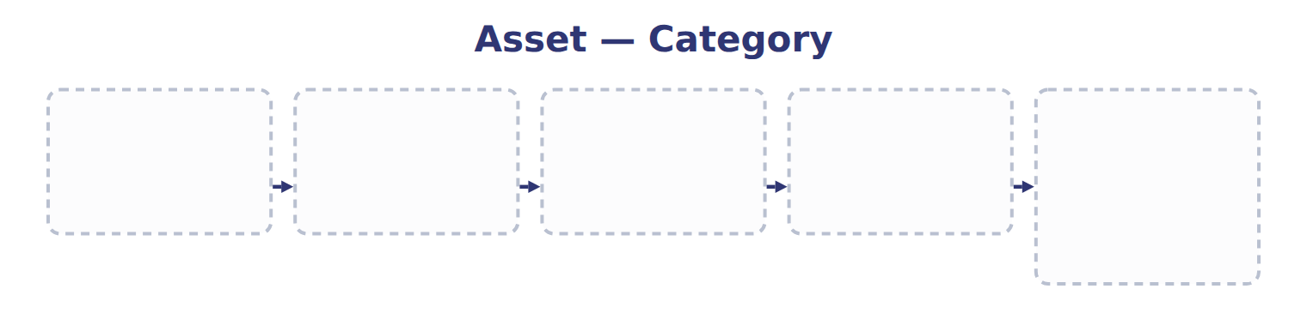
TEACH IT BACK | Write it for a classmate who missed this session — not for the marker.
29. In three or four sentences, write what this section settles and the one rule a reader has to take away.
every one of these words must appear: property, plant and equipment (PP&E) · impairment · revenue expenditure · units-of-production method

Handout 10.2
Depreciation methods and their effects
section 10.2 of the book
Before you start
Three summaries of this handout, in the book’s own words. Read all three first: together they are the whole session. Then fill the gaps, guessing where you have to.

What this handout settles, cycle by cycle
In this handout | What you will read | How you check it
Depreciation methods and their effects | a figure to read · Effect · the book’s own rule, gapped | The bottling line's wear depends on machine hours, and its hours fall each year. Which method gives the BEST matching of expense with use?
The words this section uses precisely | The English the exam uses, and what it translates | What is the safest way to settle a disagreement about an answer on this sheet?

Words this handout uses precisely
Words this handout uses precisely | tick it if you could already use it in a sentence
depreciable base
recoverability test
capitalized interest
change in accounting estimate
reporting unit

1. Where the section starts — Fill every gap. The list holds more words than there are gaps, so one or two of them are not used.
choose from: salvage value · Straight-line method · depreciable base · reporting unit · capitalized interest · Double-declining-balance method · useful life
Depreciation spreads the , cost minus , over the in a systematic and rational way. : the same amount each year, depreciable base ÷ useful life. : twice the straight-line rate, applied to the beginning book value.
2. What it settles in the middle — Fill every gap. The list holds more words than there are gaps, so one or two of them are not used.
choose from: useful life · change in accounting estimate · reporting unit · depreciable base · salvage value
Depreciation expense each year for the bottling line under four methods. Depreciation is not a cash flow, so the method changes cash only through income taxes, and U.S. A new or is a .
3. Where it ends — Fill every gap. The list holds more words than there are gaps, so one or two of them are not used.
choose from: reporting unit · depreciable base · useful life · salvage value
GAAP allows this but does not require it. IAS 16 also allows the revaluation model, with increases going to a revaluation surplus in OCI. SC10-4 After two years, Orontes revises the and of an asset.

CYCLE A | Depreciation methods and their effects

ORIENT One claim. Decide now; you will check it in a moment.

4. The book gives the straight-line of Expense in early years as “Lowest (even)”. TRUE / FALSE
MODEL Read it before you answer anything below it.

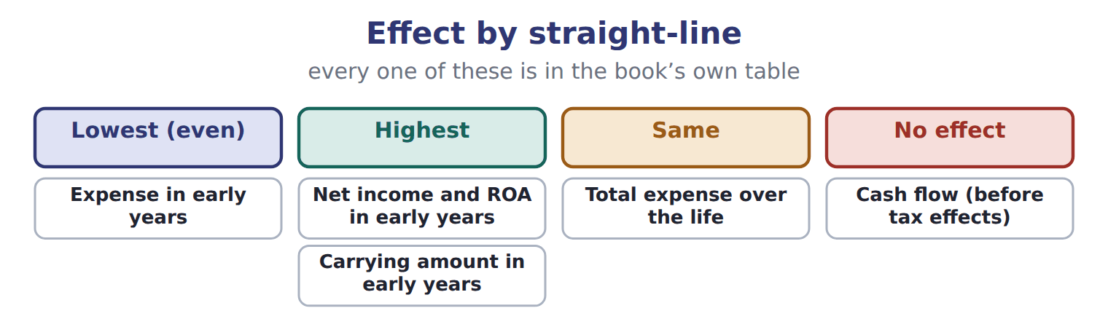
Effect — the book’s own table
Effect | Straight-line | Double-declining | SYD | Units of production
Expense in early years | Lowest (even) | Highest | High | Follows use
Net income and ROA in early years | Highest | Lowest | Low | Follows use
Carrying amount in early years | Highest | Lowest | Low | Follows use
Total expense over the life | Same | Same | Same | Same
Cash flow (before tax effects) | No effect | No effect | No effect | No effect

READ THE MODEL Every answer is printed above. Find it, do not recall it.

5. Which straight-line does the book give for Expense in early years?
A. Highest | C. Lowest (even)
B. Same | D. No effect
6. Which straight-line does the book give for Net income and ROA in early years?
A. No effect | C. Highest
B. Lowest (even) | D. Same
7. Which straight-line does the book give for Carrying amount in early years?
A. Highest | C. Same
B. Lowest (even) | D. No effect
8. Which straight-line does the book give for Total expense over the life?
A. Highest | C. Lowest (even)
B. No effect | D. Same
9. The book gives the units of production of Expense in early years as “Follows use”. TRUE / FALSE
10. The book gives the units of production of Net income and ROA in early years as “Same”. TRUE / FALSE
SORT THEM | Write each one under its straight-line. Every item belongs to exactly one group.
the items: Expense in early years · Net income and ROA in early years · Carrying amount in early years · Total expense over the life · Cash flow (before tax effects)
Highest | Lowest (even) | No effect | Same

Complete every empty cell. The first full row shows the pattern.
Effect | Straight-line | Double-declining | SYD | Units of production
Expense in early years | Lowest (even) | Highest | High | Follows use
Net income and ROA in early years
Carrying amount in early years
Total expense over the life
Cash flow (before tax effects)

INVENT THE RULE

19. Complete the book’s own sentence. The list holds more words than there are gaps.
use every one of these words: recoverability test · depreciable base · reporting unit · useful life · salvage value
Depreciation spreads the , cost minus , over the in a systematic and rational way.

Two of the book’s own cases, side by side
Expense in early years | Total expense over the life
Straight-line: Lowest (even) | Straight-line: Same
Double-declining: Highest | Double-declining: Same
SYD: High | SYD: Same
Only the facts above differ. What is the units of production of Expense in early years?
20. Choose one:
A. Same | C. No effect
B. Follows use
APPLY No help on this move.

21. The bottling line's wear depends on machine hours, and its hours fall each year. Which method gives the BEST matching of expense with use?
A. Straight-line | C. Units of production
B. Sum-of-the-years'-digits | D. Double-declining balance
22. A machine cost 50,000. At January 1, accumulated depreciation was 30,000, and straight-line depreciation is 4,000 a year. It is sold on July 1 for 17,000. What is the gain or loss?
A. Loss of 3,000 | C. Loss of 33,000
B. Gain of 1,000 | D. Loss of 1,000
23. A fire destroys a warehouse with a carrying amount of 400. Insurance pays 520, and the company uses the money to build a new warehouse. What does the company record for the fire?
A. A gain of 120
B. No gain, because the money is reinvested
C. A loss of 400
D. A gain of 520
24. An asset group has a carrying amount of 900, undiscounted future cash flows of 950 and a fair value of 800. What impairment loss is recorded?
A. 0 | C. 100
B. 50 | D. 150
WORK IN PAIRS | Compare every answer on this page with your partner before you read any key.
If you disagree: go back to the model and find the row that settles it. The row decides, not the louder voice.
CHECKPOINT 25. The bottling line's wear depends on machine hours, and its hours fall each year. Which method gives the BEST matching of expense with use?
A. Straight-line
B. Sum-of-the-years'-digits
C. Units of production
D. Double-declining balance
If you got it wrong: redo the READ THE MODEL questions of cycle A with the model in front of you.

CYCLE B | The words this section uses precisely

ORIENT

26. A term in the exam means exactly what the book defines it to mean, whatever it means in ordinary English. TRUE / FALSE

MODEL

The English the exam uses, and what it translates
English (exam term) | the Arabic it translates
depreciable base | المبلغ القابل للاستهلاك
recoverability test | اختبار قابلية الاسترداد
capitalized interest | الفائدة المرسملة
change in accounting estimate | التغير في التقدير المحاسبي
reporting unit | وحدة إعداد التقارير

READ THE MODEL

Write the letter of the Arabic term beside each English term. Every term is used once.
A التغير في التقدير المحاسبي | D اختبار قابلية الاسترداد
B المبلغ القابل للاستهلاك | E وحدة إعداد التقارير
C الفائدة المرسملة

27. reporting unit
28. recoverability test
29. capitalized interest
30. depreciable base
31. change in accounting estimate

APPLY

32. Which statement about assets held for sale is correct?
A. They are measured at the lower of carrying amount and fair value less cost to sell, and are not depreciated.
B. They are depreciated faster because they will be sold soon.
C. They are measured at fair value, with gains above the carrying amount recognized.
D. They are tested with the two-step recoverability test.
33. An indefinite-lived brand has a carrying amount of 300 and a fair value of 260. How is it tested and what is the loss?
A. Two-step test; no loss if undiscounted cash flows exceed 300
B. Amortize it instead of testing
C. One-step test; no loss because brands cannot be impaired
D. One-step fair value test; loss of 40
CHECKPOINT 34. What is the safest way to settle a disagreement about an answer on this sheet?
A. find the row of the model that decides it
B. take the answer of whoever is more confident
C. leave it until the lecturer says
D. choose the longer option
If you got it wrong: redo the READ THE MODEL questions of cycle B.

FROM MEMORY | Close the earlier pages first.
35. Rebuild the figure from this handout. Label every part and fill in every box.
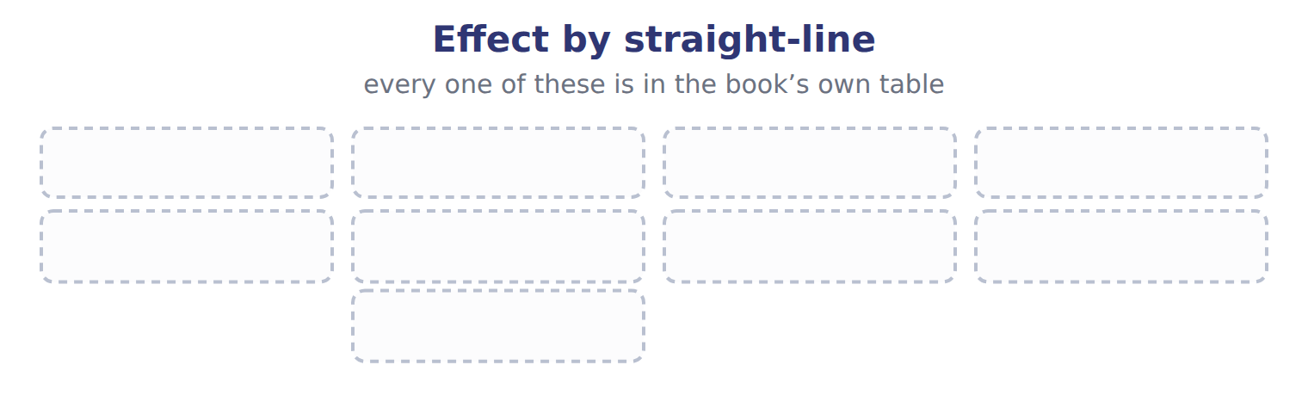
TEACH IT BACK | Write it for a classmate who missed this session — not for the marker.
36. In three or four sentences, write what this section settles and the one rule a reader has to take away.
every one of these words must appear: depreciable base · recoverability test · capitalized interest · change in accounting estimate

Handout 10.3
Recommending a depreciation method
section 10.3 of the book
Before you start
Three summaries of this handout, in the book’s own words. Read all three first: together they are the whole session. Then fill the gaps, guessing where you have to.

What this handout settles, cycle by cycle
In this handout | What you will read | How you check it
Recommending a depreciation method | a figure to read · Item | Under U.S. GAAP, a public company tests goodwill. Which statement is correct?
The words this section uses precisely | The English the exam uses, and what it translates | What is the safest way to settle a disagreement about an answer on this sheet?

Words this handout uses precisely
Words this handout uses precisely | tick it if you could already use it in a sentence
salvage value
goodwill
straight-line method
involuntary conversion
indefinite-lived intangible asset

1. Where the section starts — Fill every gap. The list holds more words than there are gaps, so one or two of them are not used.
choose from: recommending · kilometres · amortization · capital expenditure · depreciation
The best method matches the pattern in which the company uses up the asset's benefits. Decision path for a method. A delivery truck wears out with driven, so units of production fits.
2. What it settles in the middle — Fill every gap. The list holds more words than there are gaps, so one or two of them are not used.
choose from: comparability · amortization · capital expenditure · management's · straight-line
An office building gives similar service each year, so fits. For the bottling line, machine hours drive the wear, so units of production gives the best matching; straight-line is simpler and is acceptable if use is fairly even. Other factors can support the choice: with other companies in the industry, the cost of tracking usage, and view of income smoothing.
3. Where it ends — Fill every gap. The list holds more words than there are gaps, so one or two of them are not used.
choose from: capital expenditure · usefulness · recommendation · kilometres · amortization
In a Level C question, a earns credit only with a reason from the facts: how the asset is used and when its benefits arrive. SC10-5 A delivery truck wears out mainly with driven, and the number of kilometres changes a lot from year to year. It loses quickly as technology changes.

CYCLE A | Recommending a depreciation method

ORIENT One claim. Decide now; you will check it in a moment.

4. The book gives the answer of Year 2 as “50% × 45,000 = 22,500; ending book value 22,500”. TRUE / FALSE
MODEL Read it before you answer anything below it.

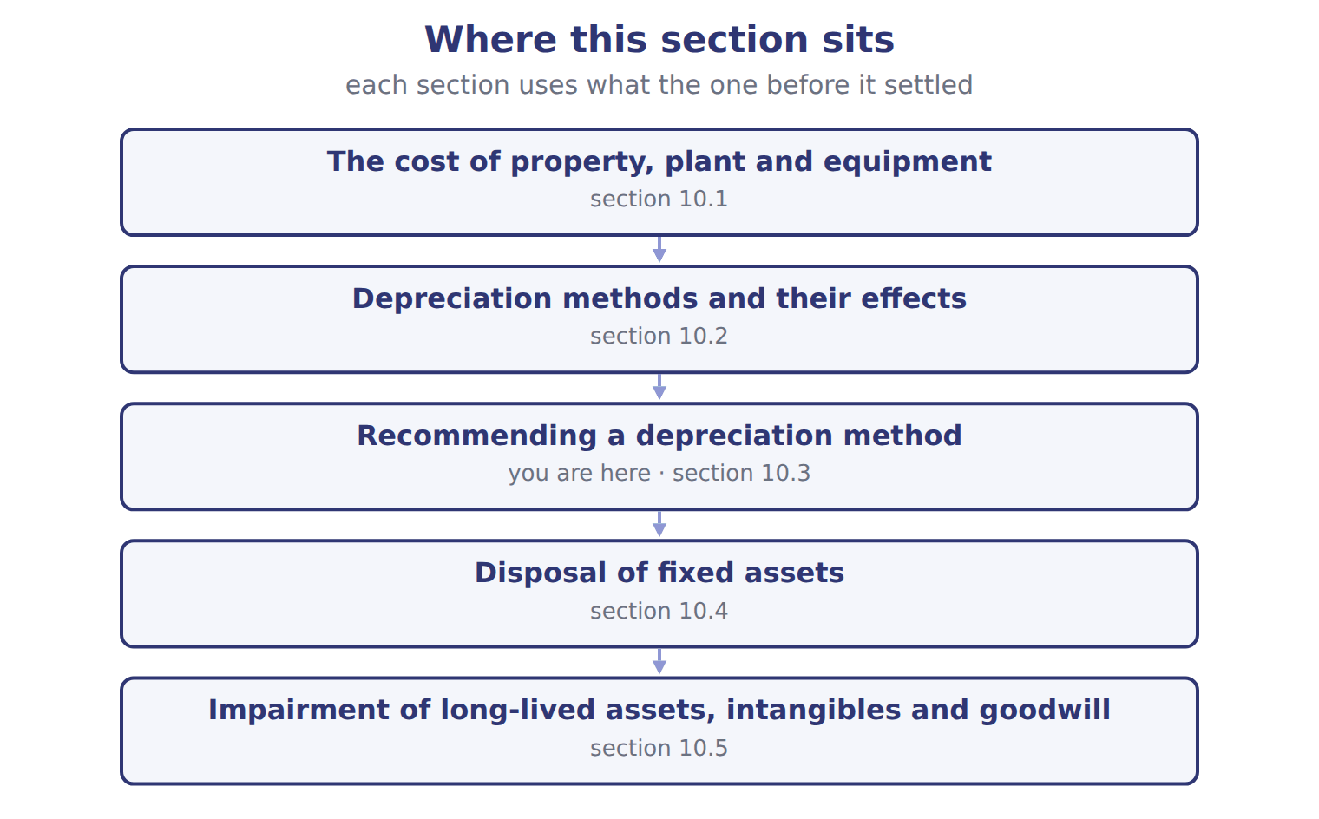
Item — the book’s own table
Item | Answer
Year 2 | 50% × 45,000 = 22,500; ending book value 22,500
Year 3 | 50% × 22,500 = 11,250; ending book value 11,250
Year 4 | The rate would give more than is left above salvage, so depreciation is 11,250 − 10,000 = 1,250; ending book value 10,000

READ THE MODEL Every answer is printed above. Find it, do not recall it.

5. Which item does the book pair with “50% × 45,000 = 22,500; ending book value 22,500”?
A. Year 2 | C. Year 3
B. Year 4
6. Which item does the book pair with “50% × 22,500 = 11,250; ending book value 11,250”?
A. Year 4 | C. Year 2
B. Year 3
7. The book gives the answer of Year 2 as “50% × 45,000 = 22,500; ending book value 22,500”. TRUE / FALSE
8. The book gives the answer of Year 3 as “50% × 45,000 = 22,500; ending book value 22,500”. TRUE / FALSE

APPLY No help on this move.

9. Under U.S. GAAP, a public company tests goodwill. Which statement is correct?
A. The loss is measured against the implied fair value of goodwill.
B. The loss is the reporting unit's carrying amount minus its fair value, capped at goodwill.
C. Goodwill is amortized over ten years and tested only when indicators exist.
D. Goodwill impairment is reversed if the unit's fair value recovers.
10. Orontes spends 500 on developing a new frozen dessert. The project meets all six IAS 38 criteria. How does Orontes report the 500 under U.S. GAAP?
A. As an intangible asset
B. As inventory
C. As an expense
D. Half as an asset and half as an expense
11. Which statement about impairment under IAS 36 is TRUE?
A. The first step uses undiscounted cash flows.
B. Goodwill impairment can be reversed.
C. Impairment losses on assets other than goodwill can be reversed.
D. Recoverable amount is the lower of fair value less costs of disposal and value in use.
12. Spiral review (Chapter 1). Recording depreciation expense has what effect on the accounting equation?
A. Assets decrease and equity decreases.
B. Assets decrease and liabilities increase.
C. Liabilities increase and equity decreases.
D. No effect, because no cash moves.
WORK IN PAIRS | Compare every answer on this page with your partner before you read any key.
If you disagree: go back to the model and find the row that settles it. The row decides, not the louder voice.
CHECKPOINT 13. Under U.S. GAAP, a public company tests goodwill. Which statement is correct?
A. The loss is measured against the implied fair value of goodwill.
B. The loss is the reporting unit's carrying amount minus its fair value, capped at goodwill.
C. Goodwill is amortized over ten years and tested only when indicators exist.
D. Goodwill impairment is reversed if the unit's fair value recovers.
If you got it wrong: redo the READ THE MODEL questions of cycle A with the model in front of you.

CYCLE B | The words this section uses precisely

ORIENT

14. A term in the exam means exactly what the book defines it to mean, whatever it means in ordinary English. TRUE / FALSE

MODEL

The English the exam uses, and what it translates
English (exam term) | the Arabic it translates
salvage value | القيمة المتبقية (قيمة الخردة)
goodwill | الشهرة
straight-line method | طريقة القسط الثابت
involuntary conversion | التحويل غير الإرادي
indefinite-lived intangible asset | أصل غير ملموس غير محدد العمر

READ THE MODEL

Write the letter of the Arabic term beside each English term. Every term is used once.
A الشهرة | D أصل غير ملموس غير محدد العمر
B التحويل غير الإرادي | E طريقة القسط الثابت
C القيمة المتبقية (قيمة الخردة)

15. salvage value
16. involuntary conversion
17. indefinite-lived intangible asset
18. straight-line method
19. goodwill

APPLY

20. Writing a term in English is part of answering the question, not an extra. TRUE / FALSE
CHECKPOINT 21. What is the safest way to settle a disagreement about an answer on this sheet?
A. find the row of the model that decides it
B. take the answer of whoever is more confident
C. leave it until the lecturer says
D. choose the longer option
If you got it wrong: redo the READ THE MODEL questions of cycle B.

FROM MEMORY | Close the earlier pages first.
22. Rebuild the figure from this handout. Label every part and fill in every box.
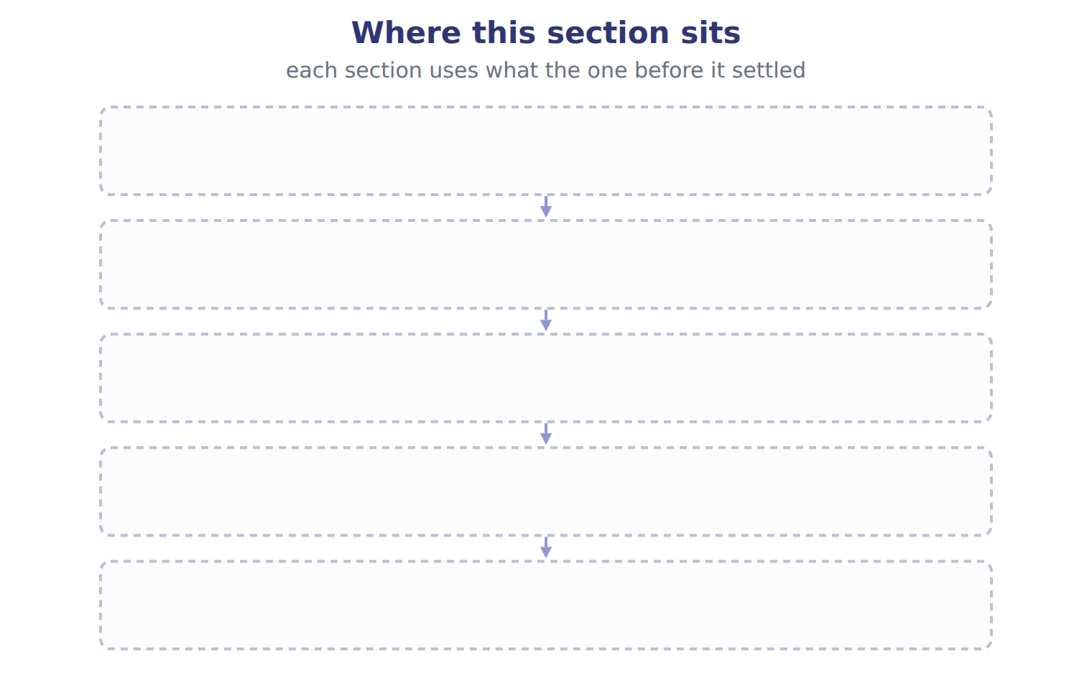
TEACH IT BACK | Write it for a classmate who missed this session — not for the marker.
23. In three or four sentences, write what this section settles and the one rule a reader has to take away.
every one of these words must appear: salvage value · goodwill · straight-line method · involuntary conversion

Handout 10.4
Disposal of fixed assets
section 10.4 of the book
Before you start
Three summaries of this handout, in the book’s own words. Read all three first: together they are the whole session. Then fill the gaps, guessing where you have to.

What this handout settles, cycle by cycle
In this handout | What you will read | How you check it
Disposal of fixed assets | a figure to read | Which of these did this cycle settle?
The words this section uses precisely | The English the exam uses, and what it translates | What is the safest way to settle a disagreement about an answer on this sheet?

Words this handout uses precisely
Words this handout uses precisely | tick it if you could already use it in a sentence
useful life
amortization
double-declining-balance method
commercial substance
research and development (R&D)

1. Where the section starts — Fill every gap. The list holds more words than there are gaps, so one or two of them are not used.
choose from: useful life · involuntary conversion · carrying amount · revenue expenditure
Disposal of the Dubai oven: update depreciation, find the , then the gain. In an , such as a fire or a government expropriation, the company records a gain or loss even if it reinvests the insurance money.
2. What it settles in the middle — Fill every gap. The list holds more words than there are gaps, so one or two of them are not used.
choose from: carrying amount · involuntary conversion · revenue expenditure · useful life
The gain or loss is part of income from continuing operations. Disposal of the Dubai oven: update depreciation, find the , then the gain. In an , such as a fire or a government expropriation, the company records a gain or loss even if it reinvests the insurance money.
3. Where it ends — Fill every gap. The list holds more words than there are gaps, so one or two of them are not used.
choose from: commercial substance · useful life · carrying amount · revenue expenditure
In an exchange of assets with , the new asset is recorded at fair value and the gain or loss is recognized; without commercial substance, the exchange is recorded at book value. Record depreciation up to the sale date before you compute the gain or loss. Compare proceeds with the , not with the original cost.

CYCLE A | Disposal of fixed assets

ORIENT One claim. Decide now; you will check it in a moment.

4. Every number in a financial statement belongs to an element the framework defines. TRUE / FALSE
MODEL Read it before you answer anything below it.

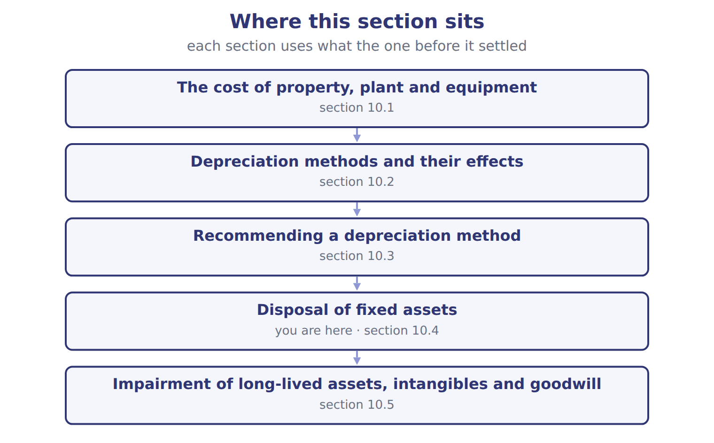
READ THE MODEL Every answer is printed above. Find it, do not recall it.

5. Which part of this chapter is section 10.1?
A. Recommending a depreciation method
B. Depreciation methods and their effects
C. Impairment of long-lived assets, intangibles and goodwill
D. The cost of property, plant and equipment
6. Which part of this chapter is section 10.2?
A. Depreciation methods and their effects
B. Disposal of fixed assets
C. Recommending a depreciation method
D. The cost of property, plant and equipment
7. Which part of this chapter is section 10.3?
A. The cost of property, plant and equipment
B. Recommending a depreciation method
C. Depreciation methods and their effects
D. Disposal of fixed assets
8. Which part of this chapter is section 10.4?
A. Recommending a depreciation method
B. Disposal of fixed assets
C. Depreciation methods and their effects
D. The cost of property, plant and equipment

APPLY No help on this move.

9. The rule you have just written is the book’s own rule. TRUE / FALSE
WORK IN PAIRS | Compare every answer on this page with your partner before you read any key.
If you disagree: go back to the model and find the row that settles it. The row decides, not the louder voice.
CHECKPOINT 10. Which of these did this cycle settle?
A. the rule and where it comes from
B. nothing in particular
C. only the vocabulary
D. only the arithmetic
If you got it wrong: redo the READ THE MODEL questions of cycle A.

CYCLE B | The words this section uses precisely

ORIENT

11. A term in the exam means exactly what the book defines it to mean, whatever it means in ordinary English. TRUE / FALSE
MODEL

The English the exam uses, and what it translates
English (exam term) | the Arabic it translates
useful life | العمر الإنتاجي
amortization | الإطفاء
double-declining-balance method | طريقة القسط المتناقص المضاعف
commercial substance | الجوهر التجاري
research and development (R&D) | البحث والتطوير

READ THE MODEL

Write the letter of the Arabic term beside each English term. Every term is used once.
A الجوهر التجاري | D الإطفاء
B البحث والتطوير | E طريقة القسط المتناقص المضاعف
C العمر الإنتاجي

12. double-declining-balance method
13. research and development (R&D)
14. useful life
15. commercial substance
16. amortization

APPLY

17. Writing a term in English is part of answering the question, not an extra. TRUE / FALSE

CHECKPOINT 18. What is the safest way to settle a disagreement about an answer on this sheet?
A. find the row of the model that decides it
B. take the answer of whoever is more confident
C. leave it until the lecturer says
D. choose the longer option
If you got it wrong: redo the READ THE MODEL questions of cycle B.

FROM MEMORY | Close the earlier pages first.
19. Rebuild the figure from this handout. Label every part and fill in every box.
TEACH IT BACK | Write it for a classmate who missed this session — not for the marker.
20. In three or four sentences, write what this section settles and the one rule a reader has to take away.
every one of these words must appear: useful life · amortization · double-declining-balance method · commercial substance

Handout 10.5
Impairment of long-lived assets, intangibles and goodwill
section 10.5 of the book
Before you start
Three summaries of this handout, in the book’s own words. Read all three first: together they are the whole session. Then fill the gaps, guessing where you have to.

What this handout settles, cycle by cycle
In this handout | What you will read | How you check it
Impairment of long-lived assets, intangibles and goodwill | a figure to read · Item | Which of these did this cycle settle?
The words this section uses precisely | Asset · The English the exam uses, and what it translates | What is the safest way to settle a disagreement about an answer on this sheet?

Words this handout uses precisely
Words this handout uses precisely | tick it if you could already use it in a sentence
carrying amount
capital expenditure
sum-of-the-years'-digits method
held for sale

1. Where the section starts — Fill every gap. The list holds more words than there are gaps, so one or two of them are not used.
choose from: carrying amount · recoverability test · capital expenditure · impairment · commercial substance
In the , the company compares the with the sum of the undiscounted future cash flows. If the carrying amount is not higher, there is no , even if fair value is lower.
2. What it settles in the middle — Fill every gap. The list holds more words than there are gaps, so one or two of them are not used.
choose from: reporting unit · capital expenditure · indefinite-lived intangible asset · Goodwill · carrying amount · commercial substance
An , such as a brand with no expected end, is not amortized. It is tested at least every year in one step: against fair value. is not amortized by public companies. It is tested at least every year at the level of the .
3. Where it ends — Fill every gap. The list holds more words than there are gaps, so one or two of them are not used.
choose from: commercial substance · capital expenditure · goodwill · carrying amount · impairment
IAS 36 uses one step: compare the with the recoverable amount, which is the higher of fair value less costs of disposal and value in use (a discounted amount). IFRS allows the reversal of losses on assets other than .

CYCLE A | Impairment of long-lived assets, intangibles and goodwill

ORIENT One claim. Decide now; you will check it in a moment.

4. The book gives the asset of P as “Pastry line, Dubai”. TRUE / FALSE
MODEL Read it before you answer anything below it.

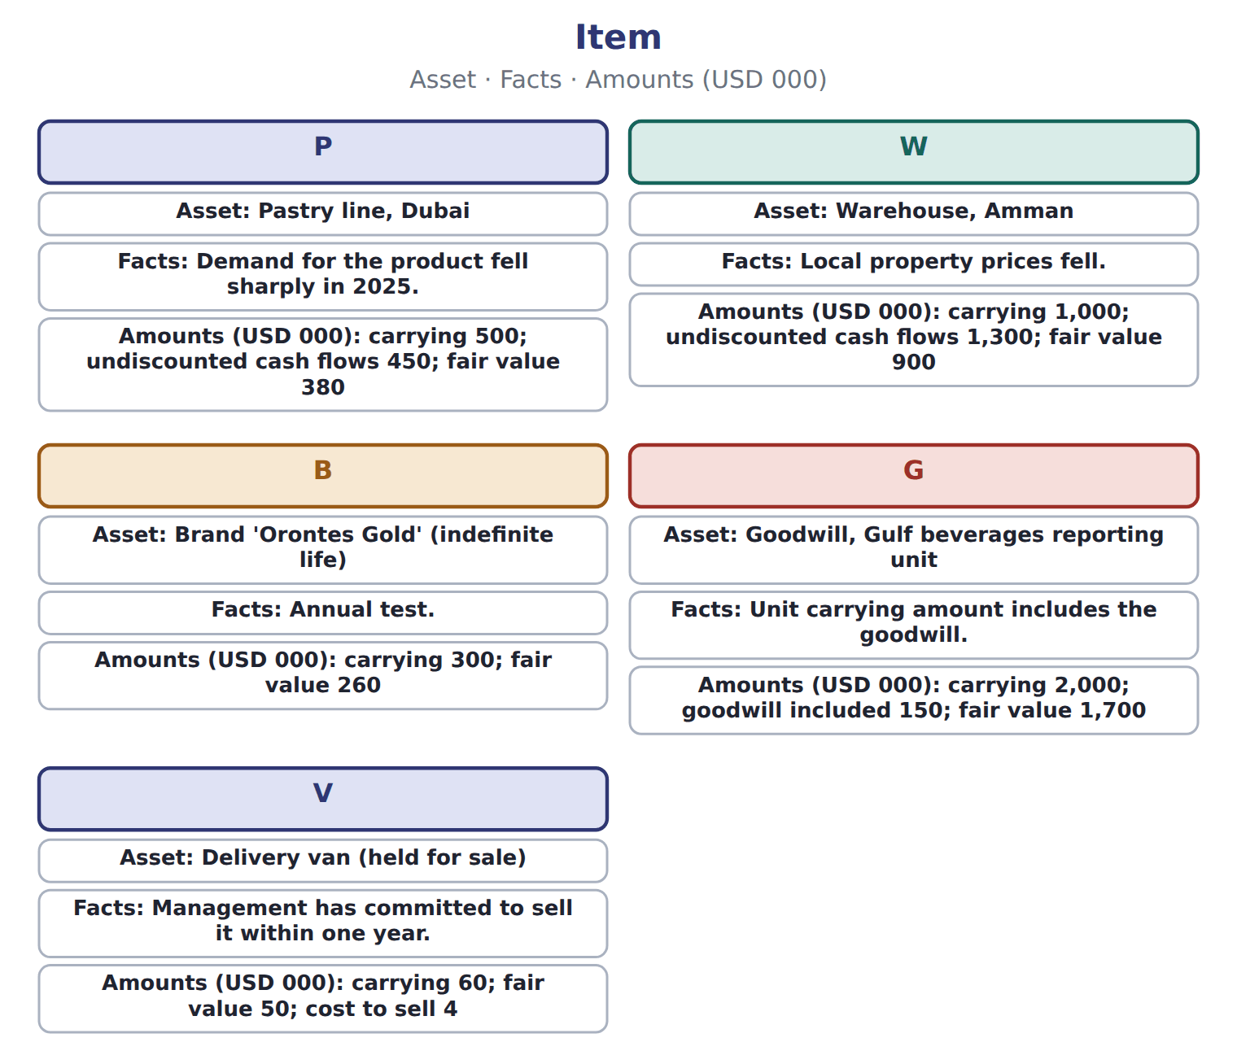

Item — the book’s own table
Item | Asset | Facts | Amounts (USD 000)
P | Pastry line, Dubai | Demand for the product fell sharply in 2025. | carrying 500; undiscounted cash flows 450; fair value 380
W | Warehouse, Amman | Local property prices fell. | carrying 1,000; undiscounted cash flows 1,300; fair value 900
B | Brand 'Orontes Gold' (indefinite life) | Annual test. | carrying 300; fair value 260
G | Goodwill, Gulf beverages reporting unit | Unit carrying amount includes the goodwill. | carrying 2,000; goodwill included 150; fair value 1,700
V | Delivery van (held for sale) | Management has committed to sell it within one year. | carrying 60; fair value 50; cost to sell 4

READ THE MODEL Every answer is printed above. Find it, do not recall it.

5. Which asset does the book give for P?
A. Warehouse, Amman
B. Brand 'Orontes Gold' (indefinite life)
C. Pastry line, Dubai
D. Delivery van (held for sale)
6. Which asset does the book give for W?
A. Delivery van (held for sale)
B. Pastry line, Dubai
C. Warehouse, Amman
D. Brand 'Orontes Gold' (indefinite life)
7. Which asset does the book give for B?
A. Delivery van (held for sale)
B. Goodwill, Gulf beverages reporting unit
C. Brand 'Orontes Gold' (indefinite life)
D. Pastry line, Dubai
8. Which asset does the book give for G?
A. Goodwill, Gulf beverages reporting unit
B. Pastry line, Dubai
C. Delivery van (held for sale)
D. Brand 'Orontes Gold' (indefinite life)
9. The book gives the Amounts (USD 000) of P as “carrying 500; undiscounted cash flows 450; fair value 380”. TRUE / FALSE
10. The book gives the Amounts (USD 000) of W as “carrying 60; fair value 50; cost to sell 4”. TRUE / FALSE
APPLY No help on this move.

11. The rule you have just written is the book’s own rule. TRUE / FALSE
WORK IN PAIRS | Compare every answer on this page with your partner before you read any key.
If you disagree: go back to the model and find the row that settles it. The row decides, not the louder voice.
CHECKPOINT 12. Which of these did this cycle settle?
A. the rule and where it comes from
B. nothing in particular
C. only the vocabulary
D. only the arithmetic
If you got it wrong: redo the READ THE MODEL questions of cycle A.

CYCLE B | The words this section uses precisely

ORIENT

13. A term in the exam means exactly what the book defines it to mean, whatever it means in ordinary English. TRUE / FALSE
MODEL

Asset — the book’s own table
Asset | Category
P
W
B
G
V

The English the exam uses, and what it translates
English (exam term) | the Arabic it translates
carrying amount | القيمة الدفترية
capital expenditure | نفقة رأسمالية
sum-of-the-years'-digits method | طريقة مجموع أرقام السنوات
held for sale | محتفظ بها للبيع

READ THE MODEL

Write the letter of the Arabic term beside each English term. Every term is used once.
A طريقة مجموع أرقام السنوات | C نفقة رأسمالية
B القيمة الدفترية | D محتفظ بها للبيع

14. capital expenditure
15. sum-of-the-years'-digits method
16. held for sale
17. carrying amount

APPLY

18. Writing a term in English is part of answering the question, not an extra. TRUE / FALSE
CHECKPOINT 19. What is the safest way to settle a disagreement about an answer on this sheet?
A. find the row of the model that decides it
B. take the answer of whoever is more confident
C. leave it until the lecturer says
D. choose the longer option
If you got it wrong: redo the READ THE MODEL questions of cycle B.

FROM MEMORY | Close the earlier pages first.
20. Rebuild the figure from this handout. Label every part and fill in every box.
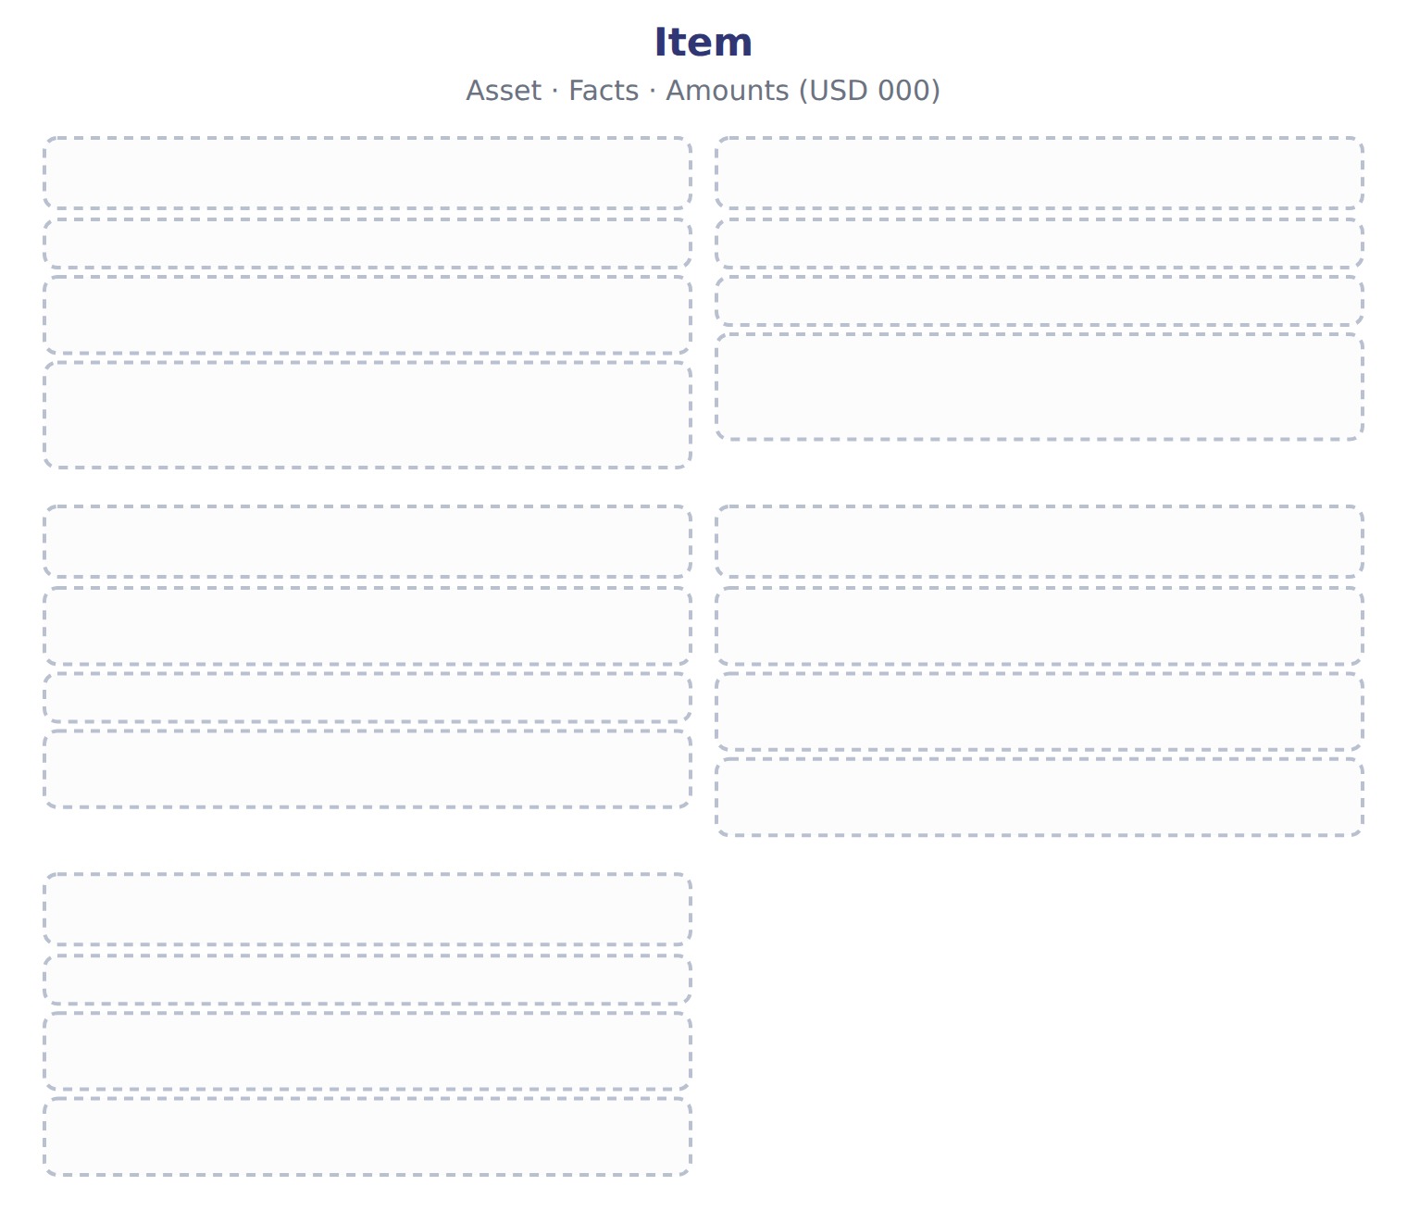
TEACH IT BACK | Write it for a classmate who missed this session — not for the marker.
21. In three or four sentences, write what this section settles and the one rule a reader has to take away.
every one of these words must appear: carrying amount · capital expenditure · sum-of-the-years'-digits method · held for sale

Handout 10.6
The whole chapter
every section, shuffled, and the chapter’s own case set
Before you start
Three summaries of this chapter, in the book’s own words, with words taken out. Read all three first: together they are the whole chapter. Then fill the gaps.

What this handout settles, cycle by cycle
In this handout | What you will read | How you check it
The whole chapter, in order | a figure to read | A delivery truck wears out mainly with kilometres driven, and the number of kilometres changes a lot from year to year. Which method BEST matches its use?
The chapter’s case set | The chapter’s case set, item by item | What has to be settled before any figure in a case set is worked out?
The words it uses precisely | property, plant and equipment (PP&E) · depreciable base · salvage value · useful life · carrying amount · impairment | matching, at the end of cycle B

1. Where the chapter starts — Fill every gap. The list holds more words than there are gaps, so one or two of them are not used.
choose from: useful life · amortization · Straight-line method · depreciable base · capitalized interest · salvage value · impairment
SC10-2 Use the example in Section 10.1. Depreciation spreads the , cost minus , over the in a systematic and rational way. : the same amount each year, depreciable base ÷ useful life.
2. What it settles in the middle — Fill every gap. The list holds more words than there are gaps, so one or two of them are not used.
choose from: amortization · impairment · carrying amount · useful life · asset group
An occurs when a company cannot recover an asset's . GAAP uses different tests for different assets. The company tests an (the lowest level with its own cash flows) only when indicators suggest a problem, such as a sharp fall in market price, physical damage or continuing losses.
3. Where it ends — Fill every gap. The list holds more words than there are gaps, so one or two of them are not used.
choose from: indefinite-lived intangible asset · Goodwill · reporting unit · amortization · carrying amount · useful life
An , such as a brand with no expected end, is not amortized. It is tested at least every year in one step: against fair value. is not amortized by public companies. It is tested at least every year at the level of the .

CYCLE A | The whole chapter, in order

ORIENT

4. The sections of a chapter have to be taken in order, because each one uses what the one before it settled. TRUE / FALSE
MODEL

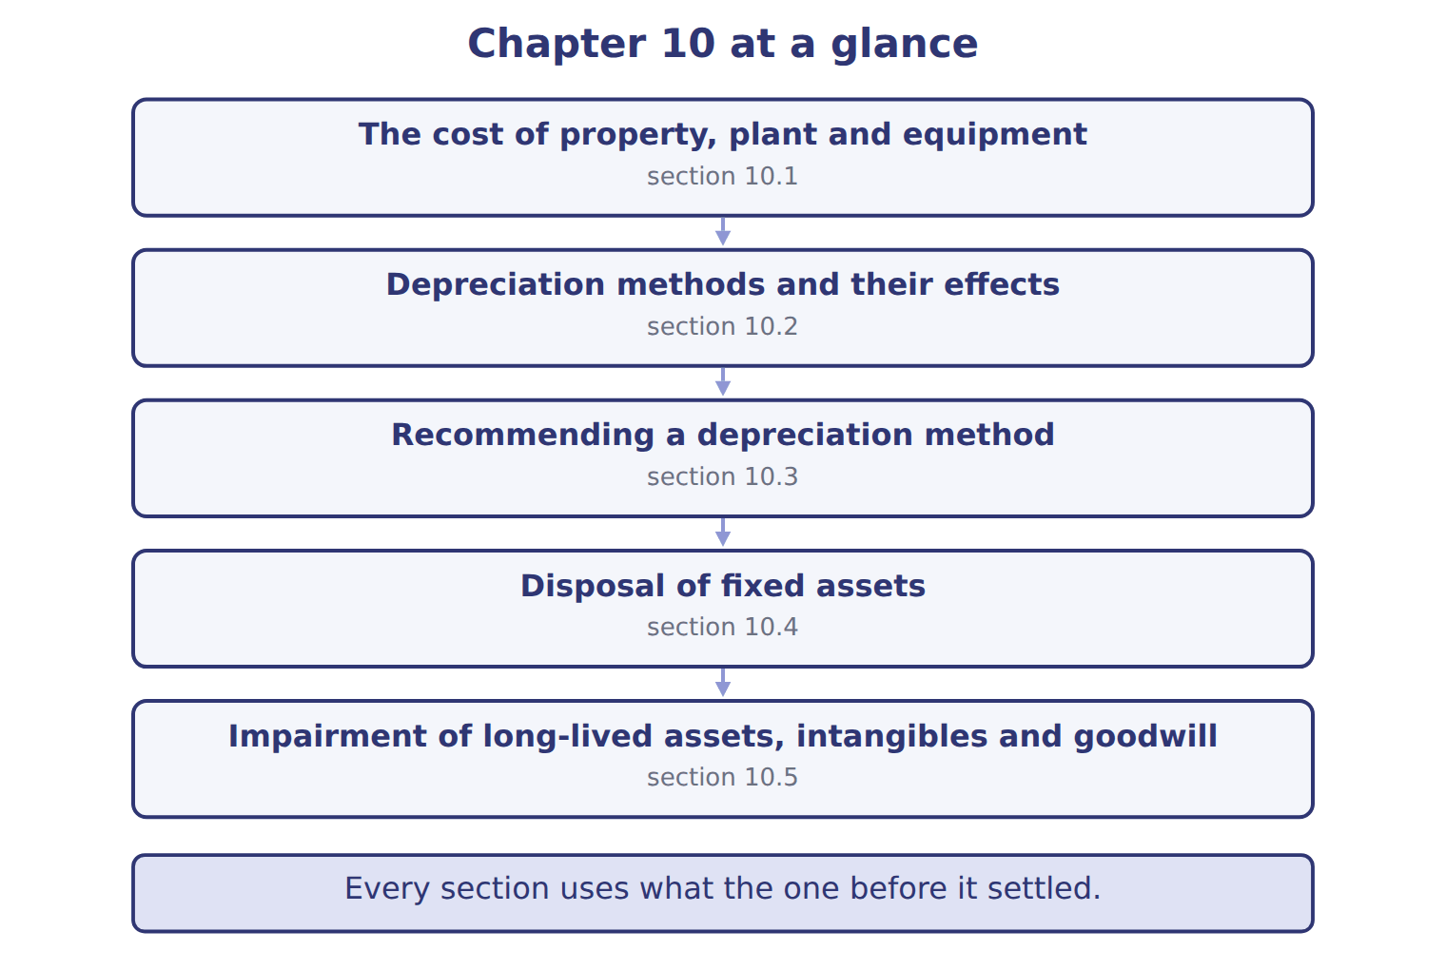
READ THE MODEL

5. Which part of this chapter is section 10.1?
A. The cost of property, plant and equipment
B. Recommending a depreciation method
C. Depreciation methods and their effects
D. Impairment of long-lived assets, intangibles and goodwill
6. Which part of this chapter is section 10.2?
A. Depreciation methods and their effects
B. Disposal of fixed assets
C. The cost of property, plant and equipment
D. Recommending a depreciation method
7. Which part of this chapter is section 10.3?
A. Depreciation methods and their effects
B. The cost of property, plant and equipment
C. Recommending a depreciation method
D. Disposal of fixed assets
Write the letter of the section number beside each section title. Every number is used once.
A 10.1 | D 10.4
B 10.2 | E 10.5
C 10.3

8. The cost of property, plant and equipment
9. Depreciation methods and their effects
10. Recommending a depreciation method
11. Disposal of fixed assets
12. Impairment of long-lived assets, intangibles and goodwill

APPLY

13. Use the Jordan plant example. What impairment loss does Orontes record (USD 000)?
A. 0 | C. 1,900
B. 800 | D. 7,100
WORK IN PAIRS | Compare every answer with your partner first.
If you disagree: name the section each question belongs to. Most disagreements turn out to be about the section, not the answer.
CHECKPOINT 14. A delivery truck wears out mainly with kilometres driven, and the number of kilometres changes a lot from year to year. Which method BEST matches its use?
A. Straight-line
B. Double-declining balance
C. Units of production
D. Sum-of-the-years'-digits
If you got it wrong: go back to the MODEL move of cycle A and find the section this question belongs to.

CYCLE B | The chapter’s case set

ORIENT

15. In a case question, the exhibit has to be read and adjusted before any figure is worked out. TRUE / FALSE

MODEL

The chapter’s case set, item by item
Item | What it asks
C10-1 | Match each asset to the test that applies. (On the exam screen you would drag each asset into a box.)
C10-2 | Enter the impairment loss for the pastry line (P).
C10-3 | Enter the impairment loss for the warehouse (W).
C10-4 | Enter the goodwill impairment loss (G).
C10-5 | Enter the total impairment and held-for-sale losses for all five assets.
C10-6 | In 2026 the fair value of the pastry line recovers to its old carrying amount. Under U.S. GAAP, the 2025 loss: [select]

READ THE MODEL

16. Which of these does item C10-1 ask for?
A. In 2026 the fair value of the pastry line recovers to its old carrying
B. Enter the impairment loss for the pastry line (P).
C. Match each asset to the test that applies. (On the exam screen you wou
D. Enter the total impairment and held-for-sale losses for all five asset
17. Which of these does item C10-2 ask for?
A. Enter the impairment loss for the pastry line (P).
B. Match each asset to the test that applies. (On the exam screen you wou
C. Enter the goodwill impairment loss (G).
D. Enter the impairment loss for the warehouse (W).
18. Which of these does item C10-3 ask for?
A. Match each asset to the test that applies. (On the exam screen you wou
B. Enter the impairment loss for the pastry line (P).
C. Enter the goodwill impairment loss (G).
D. Enter the impairment loss for the warehouse (W).
19. Which of these does item C10-4 ask for?
A. Enter the impairment loss for the warehouse (W).
B. Enter the goodwill impairment loss (G).
C. Match each asset to the test that applies. (On the exam screen you wou
D. Enter the impairment loss for the pastry line (P).
20. Which of these does item C10-5 ask for?
A. Match each asset to the test that applies. (On the exam screen you wou
B. In 2026 the fair value of the pastry line recovers to its old carrying
C. Enter the impairment loss for the pastry line (P).
D. Enter the total impairment and held-for-sale losses for all five asset
21. Which of these does item C10-6 ask for?
A. Enter the total impairment and held-for-sale losses for all five asset
B. Match each asset to the test that applies. (On the exam screen you wou
C. Enter the impairment loss for the pastry line (P).
D. In 2026 the fair value of the pastry line recovers to its old carrying
APPLY

22. A delivery truck wears out mainly with kilometres driven, and the number of kilometres changes a lot from year to year. Which method BEST matches its use?
A. Straight-line | C. Units of production
B. Double-declining balance | D. Sum-of-the-years'-digits

23. Which reason BEST supports an accelerated method for a computer server?
A. It gives equal service each year.
B. It loses usefulness quickly as technology changes.
C. It must use the same method as the tax return.
D. Accelerated methods raise early income.
CHECKPOINT 24. What has to be settled before any figure in a case set is worked out?
A. the exhibit, adjusted for every note that goes with it
B. the method the company uses
C. the tax rate
D. the order of the items
If you got it wrong: reread the case panel in the MODEL move of cycle B.

FROM MEMORY | Close the earlier pages first.
25. Rebuild the chapter map. Write every section in order and what each one settles.
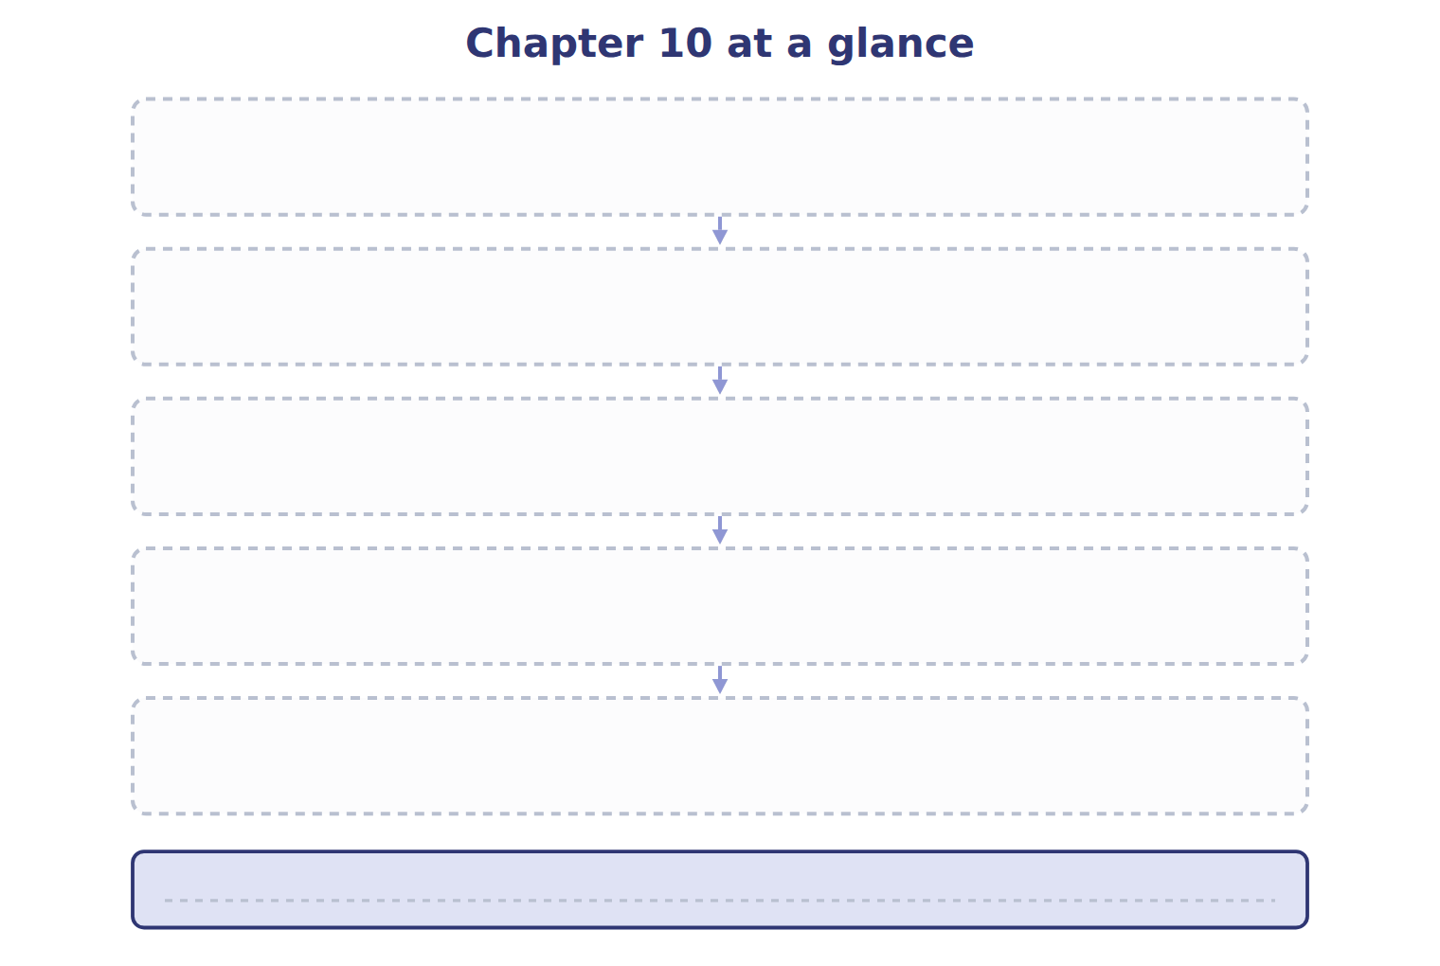
TEACH IT BACK | Write it for a student starting this chapter tomorrow — not for the marker.
26. In four or five sentences, write what the whole chapter settles, section by section.
every one of these words must appear: property, plant and equipment (PP&E) · depreciable base · salvage value · useful life

