Handout 11.1
Revenue and the core principle
section 11.1 of the book
Before you start
Three summaries of this handout, in the book’s own words. Read all three first: together they are the whole session. Then fill the gaps, guessing where you have to.

What this handout settles, cycle by cycle
In this handout | What you will read | How you check it
Revenue and the core principle | a figure to read · Item · Step | Under ASC 606, when does a company recognize revenue?
The words this section uses precisely | Item · The English the exam uses, and what it translates | What is the safest way to settle a disagreement about an answer on this sheet?

Words this handout uses precisely
Words this handout uses precisely | tick it if you could already use it in a sentence
revenue
point in time
consideration payable to a customer
breakage

1. Where the section starts — Fill every gap. The list holds more words than there are gaps, so one or two of them are not used.
choose from: standalone selling price · activities · providing · company's · matching principle
Revenue is the inflow from a main , such as selling goods or services. It measures revenue at the amount it expects to be entitled to in exchange.
2. What it settles in the middle — Fill every gap. The list holds more words than there are gaps, so one or two of them are not used.
choose from: standalone selling price · therefore · matching principle · customer · benefits
Control means the can direct the use of the asset and obtain almost all of its . The key question is not when the company is paid, but when the customer gains control.
3. Where it ends — Fill every gap. The list holds more words than there are gaps, so one or two of them are not used.
choose from: matching principle · answers · arrive · standalone selling price · question
Cash can before, at or after that moment. Each step one , and each uses the answer to the step before.
How every cycle on this sheet works
How a cycle works | what you do
MODEL | read the figure or the table before you answer anything
READ THE MODEL | every answer is printed on the same page
INVENT THE RULE | write the rule yourself, then compare with the book
APPLY | no help on this move
CHECKPOINT | mark it yourself; if you miss it, the sheet says what to redo

CYCLE A | Revenue and the core principle

ORIENT One claim. Decide now; you will check it in a moment.

4. Every number in a financial statement belongs to an element the framework defines. TRUE / FALSE
MODEL Read it before you answer anything below it.

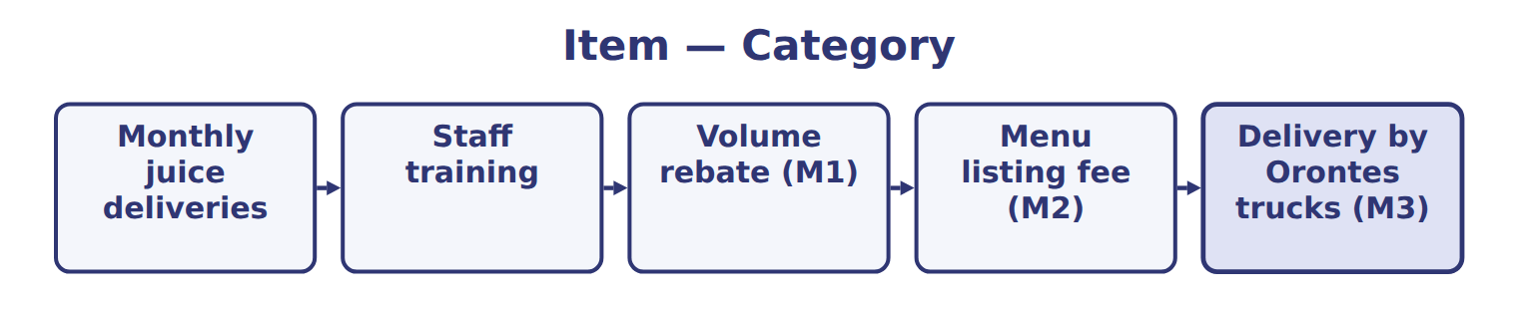
Item — the book’s own table
Item | Category
Monthly juice deliveries
Staff training
Volume rebate (M1)
Menu listing fee (M2)
Delivery by Orontes trucks (M3)

READ THE MODEL Every answer is printed above. Find it, do not recall it.

5. Which part of this chapter is section 11.1?
A. Matching, contract costs and IFRS differences
B. Special situations
C. Revenue and the core principle
D. Steps 3 and 4: the transaction price and its allocation
6. Which part of this chapter is section 11.2?
A. Steps 3 and 4: the transaction price and its allocation
B. Step 5: recognizing revenue over time or at a point in time
C. Matching, contract costs and IFRS differences
D. Steps 1 and 2: the contract and its performance obligations
7. Which part of this chapter is section 11.3?
A. Step 5: recognizing revenue over time or at a point in time
B. Steps 1 and 2: the contract and its performance obligations
C. Matching, contract costs and IFRS differences
D. Steps 3 and 4: the transaction price and its allocation
8. Which part of this chapter is section 11.4?
A. Steps 3 and 4: the transaction price and its allocation
B. Steps 1 and 2: the contract and its performance obligations
C. Matching, contract costs and IFRS differences
D. Step 5: recognizing revenue over time or at a point in time

APPLY No help on this move.

9. A U.S. company believes it is 55% likely to collect the consideration in a new contract. Under ASC 606, the contract:
A. meets the criteria, because collection is more likely than not
B. meets the criteria, because the price is fixed
C. is recognized as revenue when signed
D. does not yet meet the criteria, so cash received is a liability
10. Which transaction produces revenue for Orontes?
A. Receiving a bank loan
B. Selling an old delivery van
C. Delivering olive oil to a supermarket that has ordered it
D. Issuing new shares
11. A customer pays Orontes in December for goods that Orontes will deliver in January. In which year is revenue recognized?
A. In December, when cash is received
B. Half in each year
C. When the customer pays the invoice
D. In January, when control of the goods passes
12. Which indicator suggests that a company is a principal rather than an agent?
A. It receives a fixed commission per sale
B. It bears the inventory risk before the goods are transferred
C. The supplier sets the selling price
D. The supplier is responsible for fulfilling the order
Step — the extract for the question that follows
Step | Orontes's analysis | Result (whole USD)
1. Identify the contract | A signed agreement for olive oil, a dispenser and maintenance; payment terms clear; collection probable. | Contract exists
2. Identify the performance obligations | Olive oil, the dispenser and maintenance can each be bought separately and are not highly interdependent. | Three obligations
3. Determine the transaction price | Fixed price; no variable amounts, no financing component, no payments to GreenBasket. | 1,080,000
4. Allocate the price | Relative standalone selling prices totalling 1,200,000; each obligation gets 90%. | 810,000 / 180,000 / 90,000
5. Recognize revenue | Oil and dispenser: at delivery (point in time). Maintenance: over 24 months (over time). | 2026: 515,250

13. The extract for this question is printed with it. Why does the GreenBasket contract contain three performance obligations?
A. The contract has three payment dates
B. Orontes sends three invoices
C. Each promise is distinct: GreenBasket can benefit from each on its own, and they are separately identifiable
D. Every contract has one obligation for each department involved

Suppose: Barada sells 1,000 units at $20 (cost $ — the extract for the question that follows
Suppose: Barada sells 1,000 units at $20 (cost $ | Whole USD
Sales price of all units | 20,000
Units expected to be returned | 50
Revenue recognized | ________
Refund liability | ________
Asset: right to recover returned products | ________
Cost of goods sold | ________

14. The extract for this question is printed with it. How much revenue does Barada recognize on the sale (whole USD)?
A. 1,000 | C. 19,000
B. 7,600 | D. 20,000
WORK IN PAIRS | Compare every answer on this page with your partner before you read any key.
If you disagree: go back to the model and find the row that settles it. The row decides, not the louder voice.
CHECKPOINT 15. Under ASC 606, when does a company recognize revenue?
A. When it transfers control of promised goods or services to the customer
B. When it receives cash from the customer
C. When the contract is signed
D. When it sends an invoice
If you got it wrong: redo the READ THE MODEL questions of cycle A with the model in front of you.

CYCLE B | The words this section uses precisely

ORIENT

16. A term in the exam means exactly what the book defines it to mean, whatever it means in ordinary English. TRUE / FALSE
MODEL

Item — the book’s own table
Item | Category
Monthly juice deliveries | Performance obligation
Staff training | Performance obligation
Volume rebate (M1) | Reduces the transaction price
Menu listing fee (M2) | Reduces the transaction price
Delivery by Orontes trucks (M3) | Fulfillment cost

The English the exam uses, and what it translates
English (exam term) | the Arabic it translates
revenue | إيراد (إيرادات)
point in time | عند نقطة من الزمن
consideration payable to a customer | العوض المستحق الدفع للعميل
breakage | الحقوق غير المستخدمة (الكسر)

READ THE MODEL

Write the letter of the Arabic term beside each English term. Every term is used once.
A العوض المستحق الدفع للعميل | C الحقوق غير المستخدمة (الكسر)
B إيراد (إيرادات) | D عند نقطة من الزمن

17. breakage
18. consideration payable to a customer
19. point in time
20. revenue

21. Which category does the book give for Monthly juice deliveries?
A. Reduces the transaction price | C. Fulfillment cost
B. Performance obligation
22. Which category does the book give for Staff training?
A. Performance obligation | C. Fulfillment cost
B. Reduces the transaction price
23. Which category does the book give for Volume rebate (M1)?
A. Performance obligation | C. Reduces the transaction price
B. Fulfillment cost
APPLY

24. What is the correct order of the five steps?
A. Transaction price, contract, allocation, obligations, recognition
B. Contract, performance obligations, transaction price, allocation, recognition
C. Contract, transaction price, recognition, obligations, allocation
D. Obligations, contract, allocation, transaction price, recognition
25. In a bill-and-hold arrangement, which condition is NOT required before the seller recognizes revenue?
A. The goods are identified separately as the customer's
B. The goods are ready for physical transfer
C. The seller cannot use the goods or direct them to another customer
D. The customer has paid in full
26. Orontes sells a dispenser and agrees to buy it back in one year at a higher price. The arrangement is accounted for as:
A. a sale with revenue now
B. a financing arrangement, not a sale
C. a sale with a right of return
D. a consignment

CHECKPOINT 27. What is the safest way to settle a disagreement about an answer on this sheet?
A. find the row of the model that decides it
B. take the answer of whoever is more confident
C. leave it until the lecturer says
D. choose the longer option
If you got it wrong: redo the READ THE MODEL questions of cycle B.

FROM MEMORY | Close the earlier pages first.
28. Rebuild the figure from this handout. Label every part and fill in every box.
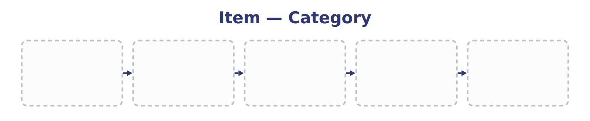
TEACH IT BACK | Write it for a classmate who missed this session — not for the marker.
29. In three or four sentences, write what this section settles and the one rule a reader has to take away.
every one of these words must appear: revenue · point in time · consideration payable to a customer · breakage

Handout 11.2
Steps 1 and 2: the contract and its performance obligations
section 11.2 of the book
Before you start
Three summaries of this handout, in the book’s own words. Read all three first: together they are the whole session. Then fill the gaps, guessing where you have to.

What this handout settles, cycle by cycle
In this handout | What you will read | How you check it
Steps 1 and 2: the contract and its performance obligations | a figure to read · Step · Suppose: sales of 2,400,000 with a 3% volume reb | Customers earn loyalty points worth a discount on future purchases that they would not otherwise get. The points are:
The words this section uses precisely | Item · The English the exam uses, and what it translates | What is the safest way to settle a disagreement about an answer on this sheet?

Words this handout uses precisely
Words this handout uses precisely | tick it if you could already use it in a sentence
performance obligation
principal
output method
incremental costs of obtaining a contract

1. Where the section starts — Fill every gap. The list holds more words than there are gaps, so one or two of them are not used.
choose from: output method · over time · breakage · point in time
Fixed price; no variable amounts, no financing component, no payments to GreenBasket. Oil and dispenser: at delivery ( ). Maintenance: over 24 months ( ). GAAP, probable means likely to occur: in practice, about 75% or more.
2. What it settles in the middle — Fill every gap. The list holds more words than there are gaps, so one or two of them are not used.
choose from: over time · breakage · point in time · output method
Olive oil, the dispenser and maintenance can each be bought separately and are not highly interdependent. Fixed price; no variable amounts, no financing component, no payments to GreenBasket. Oil and dispenser: at delivery ( ). Maintenance: over 24 months ( ).
3. Where it ends — Fill every gap. The list holds more words than there are gaps, so one or two of them are not used.
choose from: over time · output method · breakage · point in time
Oil and dispenser: at delivery ( ). Maintenance: over 24 months ( ). GAAP, probable means likely to occur: in practice, about 75% or more. IFRS 15 uses probable to mean more likely than not.

CYCLE A | Steps 1 and 2: the contract and its performance obligations

ORIENT One claim. Decide now; you will check it in a moment.

4. Every number in a financial statement belongs to an element the framework defines. TRUE / FALSE
MODEL Read it before you answer anything below it.

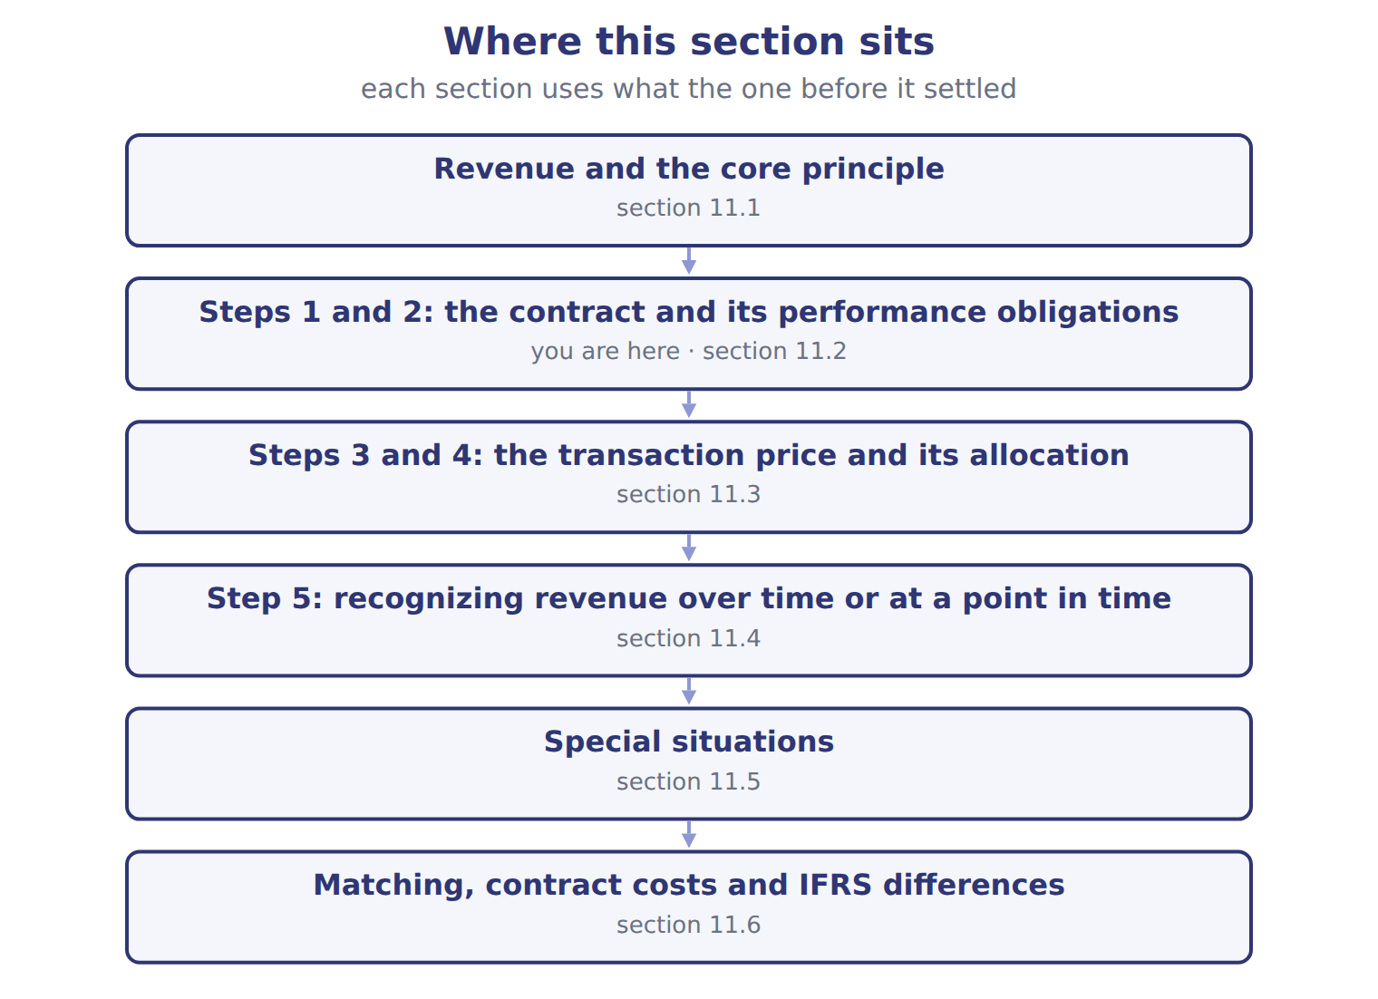

Step — the book’s own table
Step | Orontes's analysis | Result (whole USD)
1. Identify the contract | A signed agreement for olive oil, a dispenser and maintenance; payment terms clear; collection probable. | Contract exists
2. Identify the performance obligations | Olive oil, the dispenser and maintenance can each be bought separately and are not highly interdependent. | Three obligations
3. Determine the transaction price | Fixed price; no variable amounts, no financing component, no payments to GreenBasket. | 1,080,000
4. Allocate the price | Relative standalone selling prices totalling 1,200,000; each obligation gets 90%. | 810,000 / 180,000 / 90,000
5. Recognize revenue | Oil and dispenser: at delivery (point in time). Maintenance: over 24 months (over time). | 2026: 515,250

READ THE MODEL Every answer is printed above. Find it, do not recall it.

5. Which step does the book pair with “A signed agreement for olive oil, a dispenser and maintenance; payment terms clear; collection probable.”?
A. 4. Allocate the price
B. 2. Identify the performance obligations
C. 1. Identify the contract
D. 3. Determine the transaction price
6. Which step does the book pair with “Olive oil, the dispenser and maintenance can each be bought separately and are not highly interdependent.”?
A. 1. Identify the contract
B. 5. Recognize revenue
C. 2. Identify the performance obligations
D. 3. Determine the transaction price
7. Which step does the book pair with “Fixed price; no variable amounts, no financing component, no payments to GreenBasket.”?
A. 1. Identify the contract
B. 5. Recognize revenue
C. 3. Determine the transaction price
D. 2. Identify the performance obligations
8. Which step does the book pair with “Relative standalone selling prices totalling 1,200,000; each obligation gets 90%.”?
A. 1. Identify the contract
B. 5. Recognize revenue
C. 4. Allocate the price
D. 2. Identify the performance obligations
9. The book gives the Result (whole USD) of 1. Identify the contract as “Contract exists”. TRUE / FALSE
10. The book gives the Result (whole USD) of 2. Identify the performance obligations as “810,000 / 180,000 / 90,000”. TRUE / FALSE

APPLY No help on this move.

11. Customers earn loyalty points worth a discount on future purchases that they would not otherwise get. The points are:
A. a separate performance obligation (a material right)
B. a marketing expense
C. ignored until redeemed
D. a reduction of cost of goods sold
12. A gym charges a nonrefundable joining fee when a customer signs a one-year membership. The fee is:
A. revenue at once, because it is nonrefundable
B. a liability until the customer leaves
C. deferred and recognized over the membership period
D. deducted from expenses
13. A customer will pay for goods two years after delivery, and the price includes a large interest element. The company should:
A. recognize the full price as revenue at delivery
B. recognize revenue when cash is received
C. adjust the transaction price for the significant financing component
D. ignore the interest because payment is certain
Suppose: sales of 2,400,000 with a 3% volume reb — the extract for the question that follows
Suppose: sales of 2,400,000 with a 3% volume reb | How it works | Revenue (whole USD)
Most likely amount | The rebate is all or nothing, so use the single most likely outcome: the rebate is earned (70% likely). | 2,328,000
Expected value | Probability-weighted: 70% × 72,000 = 50,400 rebate. Best when there are many possible outcomes. | 2,349,600
Constraint | Include variable amounts only if a significant reversal of revenue is not probable later. | Applies to both

14. The extract for this question is printed with it. Orontes's rebate is all or nothing. What revenue does Orontes recognize on the sales (whole USD)?
A. 72,000 | C. 2,349,600
B. 2,328,000 | D. 2,400,000
WORK IN PAIRS | Compare every answer on this page with your partner before you read any key.
If you disagree: go back to the model and find the row that settles it. The row decides, not the louder voice.
CHECKPOINT 15. Customers earn loyalty points worth a discount on future purchases that they would not otherwise get. The points are:
A. a separate performance obligation (a material right)
B. a marketing expense
C. ignored until redeemed
D. a reduction of cost of goods sold
If you got it wrong: redo the READ THE MODEL questions of cycle A with the model in front of you.

CYCLE B | The words this section uses precisely

ORIENT

16. A term in the exam means exactly what the book defines it to mean, whatever it means in ordinary English. TRUE / FALSE

MODEL

Item — the book’s own table
Item | Answer
Revenue recognized | (1,000 − 50) × $20 = 19,000
Refund liability | 50 × $20 = 1,000
Asset: right to recover products | 50 × $12 = 600, shown separately from the refund liability
Cost of goods sold | (1,000 − 50) × $12 = 11,400

The English the exam uses, and what it translates
English (exam term) | the Arabic it translates
performance obligation | التزام الأداء
principal | الأصيل
output method | طريقة المخرجات
incremental costs of obtaining a contract | التكاليف الإضافية للحصول على العقد

READ THE MODEL

Write the letter of the Arabic term beside each English term. Every term is used once.
A التزام الأداء | C الأصيل
B طريقة المخرجات | D التكاليف الإضافية للحصول على العقد

17. output method
18. incremental costs of obtaining a contract
19. performance obligation
20. principal

21. Which answer does the book give for Revenue recognized?
A. (1,000 − 50) × $12 = 11,400
B. (1,000 − 50) × $20 = 19,000
C. 50 × $12 = 600, shown separately from the refund liability
D. 50 × $20 = 1,000
22. Which answer does the book give for Refund liability?
A. 50 × $20 = 1,000
B. (1,000 − 50) × $20 = 19,000
C. 50 × $12 = 600, shown separately from the refund liability
D. (1,000 − 50) × $12 = 11,400
23. Which item does the book pair with “50 × $12 = 600, shown separately from the refund liability”?
A. Asset: right to recover products | C. Refund liability
B. Revenue recognized | D. Cost of goods sold

APPLY

24. A U.S. retailer collects 5% sales tax from customers for the state. Under its policy election, the tax is:
A. included in revenue
B. excluded from revenue and recorded as a liability
C. recorded as an expense when paid
D. recorded in OCI
25. When may a company use the residual approach to estimate a standalone selling price?
A. Only when the price is highly variable or uncertain
B. Always, because it is the simplest
C. Whenever the contract includes a discount
D. Never under U.S. GAAP
CHECKPOINT 26. What is the safest way to settle a disagreement about an answer on this sheet?
A. find the row of the model that decides it
B. take the answer of whoever is more confident
C. leave it until the lecturer says
D. choose the longer option
If you got it wrong: redo the READ THE MODEL questions of cycle B.

FROM MEMORY | Close the earlier pages first.
27. Rebuild the figure from this handout. Label every part and fill in every box.
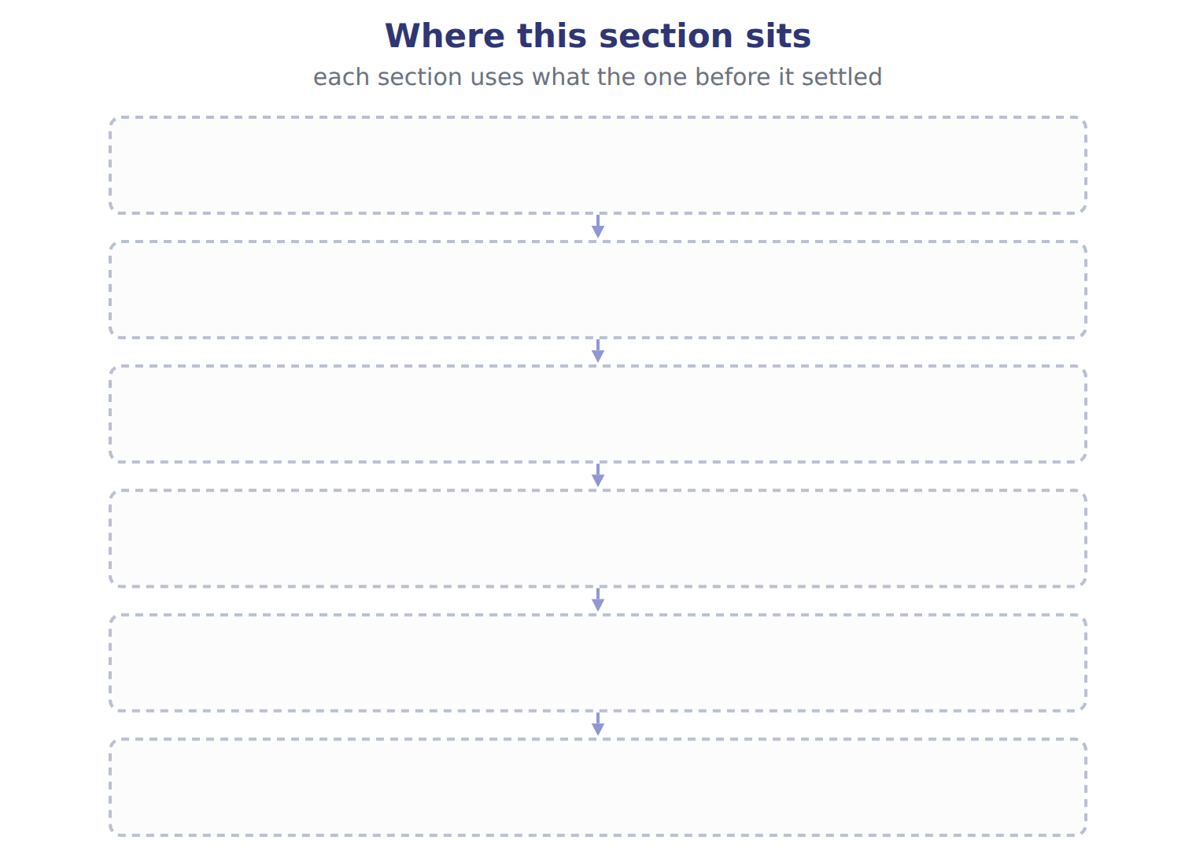
TEACH IT BACK | Write it for a classmate who missed this session — not for the marker.
28. In three or four sentences, write what this section settles and the one rule a reader has to take away.
every one of these words must appear: performance obligation · principal · output method · incremental costs of obtaining a contract

Handout 11.3
Steps 3 and 4: the transaction price and its allocation
section 11.3 of the book
Before you start
Three summaries of this handout, in the book’s own words. Read all three first: together they are the whole session. Then fill the gaps, guessing where you have to.

What this handout settles, cycle by cycle
In this handout | What you will read | How you check it
Steps 3 and 4: the transaction price and its allocation | a figure to read · Suppose: sales of 2,400,000 with a 3% volume reb · the book’s own rule, gapped | Orontes provides cleaning services every week to a hotel. How is revenue recognized?
The words this section uses precisely | The English the exam uses, and what it translates | What is the safest way to settle a disagreement about an answer on this sheet?

Words this handout uses precisely
Words this handout uses precisely | tick it if you could already use it in a sentence
transaction price
agent
input method
matching principle

1. Where the section starts — Fill every gap. The list holds more words than there are gaps, so one or two of them are not used.
choose from: bill-and-hold arrangement · constraint on variable consideration · principal · revenue
Variable amounts are included only to the extent that a significant reversal of is not probable later. This is the . The rebate is all or nothing, so use the single most likely outcome: the rebate is earned (70% likely).
2. What it settles in the middle — Fill every gap. The list holds more words than there are gaps, so one or two of them are not used.
choose from: transaction price · revenue · bill-and-hold arrangement · principal · significant financing component · Consideration payable to a customer
Three other items change the . A is removed when payment and delivery are far apart; if they are within one year, the company may ignore it. , such as a slotting fee paid to a supermarket for shelf space, reduces .
3. Where it ends — Fill every gap. The list holds more words than there are gaps, so one or two of them are not used.
choose from: bill-and-hold arrangement · principal · standalone selling price · Revenue
A discount is normally shared by all obligations. Each obligation therefore receives 90% of its standalone price. Allocating the GreenBasket discount by relative . for each obligation is its allocated price, not its standalone selling price.

CYCLE A | Steps 3 and 4: the transaction price and its allocation

ORIENT One claim. Decide now; you will check it in a moment.

4. Every number in a financial statement belongs to an element the framework defines. TRUE / FALSE
MODEL Read it before you answer anything below it.

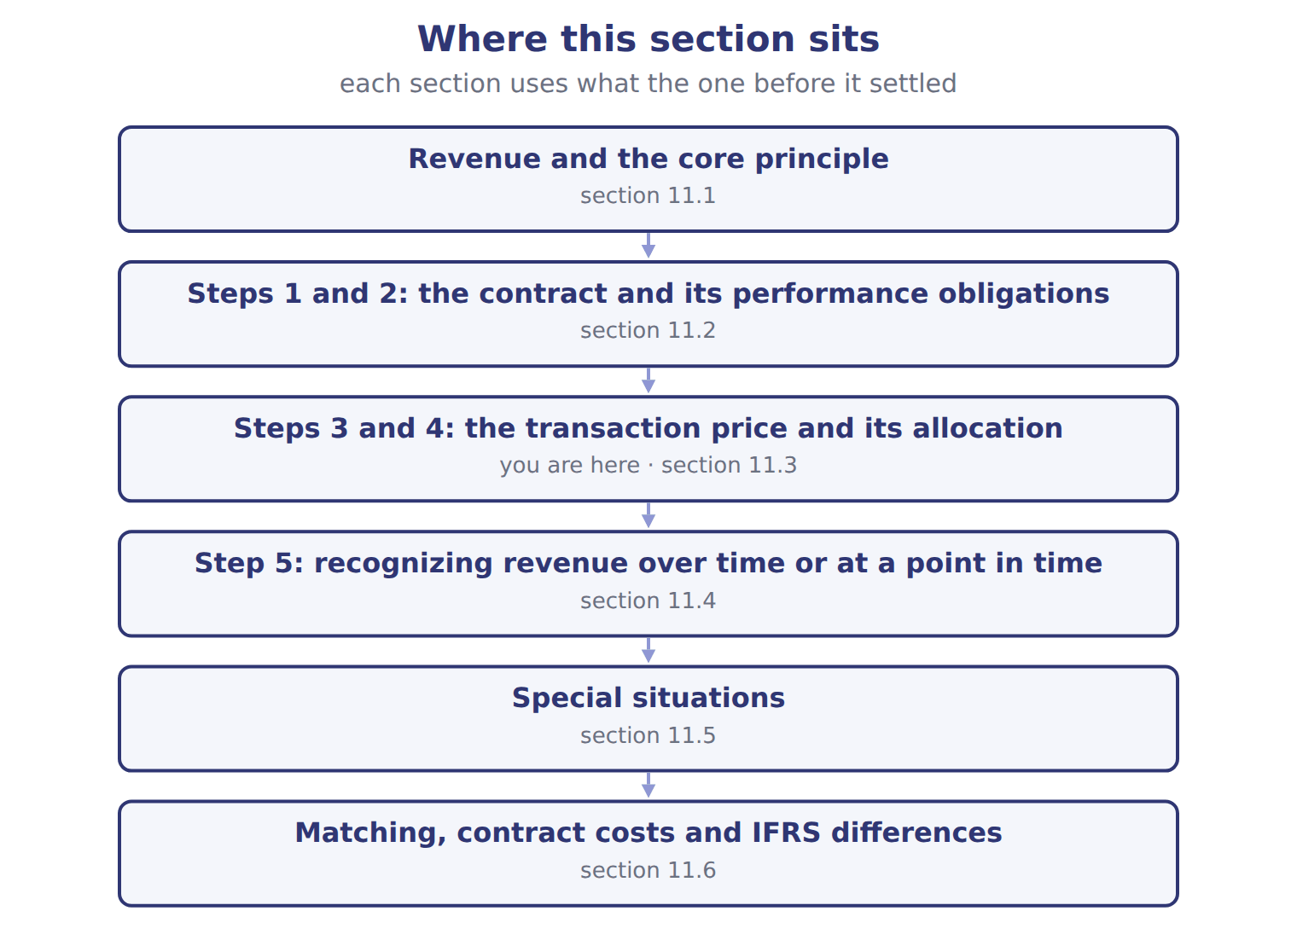

Suppose: sales of 2,400,000 with a 3% volume reb — the book’s own table
Suppose: sales of 2,400,000 with a 3% volume reb | How it works | Revenue (whole USD)
Most likely amount | The rebate is all or nothing, so use the single most likely outcome: the rebate is earned (70% likely). | 2,328,000
Expected value | Probability-weighted: 70% × 72,000 = 50,400 rebate. Best when there are many possible outcomes. | 2,349,600
Constraint | Include variable amounts only if a significant reversal of revenue is not probable later. | Applies to both

READ THE MODEL Every answer is printed above. Find it, do not recall it.

5. Which part of this chapter is section 11.1?
A. Matching, contract costs and IFRS differences
B. Special situations
C. Revenue and the core principle
D. Steps 3 and 4: the transaction price and its allocation
6. Which part of this chapter is section 11.2?
A. Steps 3 and 4: the transaction price and its allocation
B. Step 5: recognizing revenue over time or at a point in time
C. Matching, contract costs and IFRS differences
D. Steps 1 and 2: the contract and its performance obligations
7. Which part of this chapter is section 11.3?
A. Step 5: recognizing revenue over time or at a point in time
B. Steps 1 and 2: the contract and its performance obligations
C. Matching, contract costs and IFRS differences
D. Steps 3 and 4: the transaction price and its allocation
8. Which part of this chapter is section 11.4?
A. Steps 3 and 4: the transaction price and its allocation
B. Steps 1 and 2: the contract and its performance obligations
C. Matching, contract costs and IFRS differences
D. Step 5: recognizing revenue over time or at a point in time
INVENT THE RULE

9. Complete the book’s own sentence. The list holds more words than there are gaps.
use every one of these words: Consideration payable to a customer · contract asset · point in time · revenue
, such as a slotting fee paid to a supermarket for shelf space, reduces .

Two of the book’s own cases, side by side
Most likely amount | Expected value
How it works: The rebate is all or nothing, so use the single most likely outcome: the rebate is earned (70% likely). | How it works: Probability-weighted: 70% × 72,000 = 50,400 rebate. Best when there are many possible outcomes.
Only the facts above differ. What is the revenue (whole usd) of Most likely amount?
10. Choose one:
A. Applies to both | C. 2,349,600
B. 2,328,000

APPLY No help on this move.

11. Orontes provides cleaning services every week to a hotel. How is revenue recognized?
A. At the end of the contract
B. Over time, because the hotel receives and uses the benefit as Orontes performs
C. When the hotel pays
D. At the start, when the contract is signed
12. A builder constructs a factory on land owned by the customer. The customer controls the work in progress. Revenue is recognized:
A. over time, using a measure of progress
B. at completion
C. when the final payment is received
D. only if the customer pays in advance
13. Which is an input method for measuring progress on a contract?
A. Units delivered
B. Milestones reached
C. Costs incurred to date compared with total expected costs
D. Surveys of work performed
14. A company has delivered goods, but it cannot bill the customer until it also delivers a second product next month. At year-end it reports:
A. a receivable | C. a contract asset
B. a contract liability | D. no balance
WORK IN PAIRS | Compare every answer on this page with your partner before you read any key.
If you disagree: go back to the model and find the row that settles it. The row decides, not the louder voice.
CHECKPOINT 15. Orontes provides cleaning services every week to a hotel. How is revenue recognized?
A. At the end of the contract
B. Over time, because the hotel receives and uses the benefit as Orontes performs
C. When the hotel pays
D. At the start, when the contract is signed
If you got it wrong: redo the READ THE MODEL questions of cycle A with the model in front of you.

CYCLE B | The words this section uses precisely

ORIENT

16. A term in the exam means exactly what the book defines it to mean, whatever it means in ordinary English. TRUE / FALSE

MODEL

The English the exam uses, and what it translates
English (exam term) | the Arabic it translates
transaction price | سعر المعاملة
agent | الوكيل
input method | طريقة المدخلات
matching principle | مبدأ مقابلة الإيرادات بالمصروفات

READ THE MODEL

Write the letter of the Arabic term beside each English term. Every term is used once.
A سعر المعاملة | C طريقة المدخلات
B الوكيل | D مبدأ مقابلة الإيرادات بالمصروفات

17. input method
18. transaction price
19. agent
20. matching principle

APPLY

21. A company may estimate variable consideration and include it in the transaction price only to the extent that:
A. a significant reversal of revenue is not probable later
B. the amount is certain
C. the customer has already paid
D. the amount is less than 10% of the price
22. Which practice follows the matching principle?
A. Expensing inventory when it is purchased
B. Recognizing cost of goods sold in the period the related sale is recognized
C. Recognizing revenue when cash is received
D. Capitalizing all advertising costs
CHECKPOINT 23. What is the safest way to settle a disagreement about an answer on this sheet?
A. find the row of the model that decides it
B. take the answer of whoever is more confident
C. leave it until the lecturer says
D. choose the longer option
If you got it wrong: redo the READ THE MODEL questions of cycle B.

FROM MEMORY | Close the earlier pages first.
24. Rebuild the figure from this handout. Label every part and fill in every box.
TEACH IT BACK | Write it for a classmate who missed this session — not for the marker.
25. In three or four sentences, write what this section settles and the one rule a reader has to take away.
every one of these words must appear: transaction price · agent · input method · matching principle

Handout 11.4
Step 5: recognizing revenue over time or at a point in time
section 11.4 of the book
Before you start
Three summaries of this handout, in the book’s own words. Read all three first: together they are the whole session. Then fill the gaps, guessing where you have to.

What this handout settles, cycle by cycle
In this handout | What you will read | How you check it
Step 5: recognizing revenue over time or at a point in time | a figure to read · Obligation · the book’s own rule, gapped | A company pays a $2,000 commission to win a six-month service contract. It may:
The words this section uses precisely | The English the exam uses, and what it translates | What is the safest way to settle a disagreement about an answer on this sheet?

Words this handout uses precisely
Words this handout uses precisely | tick it if you could already use it in a sentence
standalone selling price
contract asset
refund liability

1. Where the section starts — Fill every gap. The list holds more words than there are gaps, so one or two of them are not used.
choose from: revenue · contract asset · over time · input method · output method · matching principle · point in time
Progress is measured by an , such as units delivered, or an , such as costs incurred. If no over-time criterion is met, is recognized at a : when control passes.
2. What it settles in the middle — Fill every gap. The list holds more words than there are gaps, so one or two of them are not used.
choose from: variable consideration · point in time · revenue · contract asset · over time · matching principle
Decision chart: is recognized or at a ?. Olive oil is recognized at each delivery. A arises when the company has performed but its right to payment still depends on something other than time.
3. Where it ends — Fill every gap. The list holds more words than there are gaps, so one or two of them are not used.
choose from: output method · point in time · over time · contract asset · revenue · input method · matching principle
Step 5: recognize when, or as, each obligation is satisfied. Progress is measured by an , such as units delivered, or an , such as costs incurred. If no over-time criterion is met, revenue is recognized at a : when control passes.

CYCLE A | Step 5: recognizing revenue over time or at a point in time

ORIENT One claim. Decide now; you will check it in a moment.

4. The book gives the allocated of Olive oil as “810,000”. TRUE / FALSE
MODEL Read it before you answer anything below it.

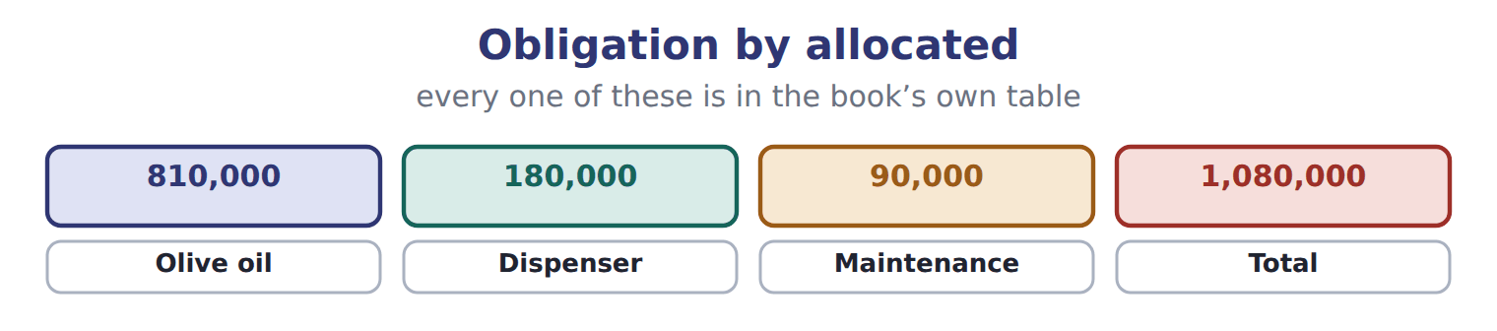

Obligation — the book’s own table
Obligation | Allocated | Timing | Progress in 2026 | 2026 revenue
Olive oil | 810,000 | Point in time (each delivery) | 8,000 of 20,000 cases × 40 | 324,000
Dispenser | 180,000 | Point in time (installed October 1) | installed | 180,000
Maintenance | 90,000 | Over time (24 months) | 3 months × 3,750 | 11,250
Total | 1,080,000 |  |  | 515,250

READ THE MODEL Every answer is printed above. Find it, do not recall it.

5. Which allocated does the book give for Olive oil?
A. 1,080,000 | C. 810,000
B. 180,000 | D. 90,000
6. Which allocated does the book give for Dispenser?
A. 90,000 | C. 180,000
B. 1,080,000 | D. 810,000
7. Which allocated does the book give for Maintenance?
A. 810,000 | C. 1,080,000
B. 90,000 | D. 180,000
8. Which allocated does the book give for Total?
A. 180,000 | C. 90,000
B. 810,000 | D. 1,080,000
9. The book gives the 2026 revenue of Olive oil as “324,000”. TRUE / FALSE
10. The book gives the 2026 revenue of Dispenser as “324,000”. TRUE / FALSE
SORT THEM | Write each one under its allocated. Every item belongs to exactly one group.
the items: Olive oil · Dispenser · Maintenance · Total
1,080,000 | 180,000 | 810,000 | 90,000

Complete every empty cell. The first full row shows the pattern.
Obligation | Allocated | Timing | Progress in 2026 | 2026 revenue
Olive oil | 810,000 | Point in time (each delivery) | 8,000 of 20,000 cases × 40 | 324,000
Dispenser
Maintenance
Total

INVENT THE RULE

18. Complete the book’s own sentence. The list holds more words than there are gaps.
use every one of these words: output method · input method · over time · point in time · principal
Progress is measured by an , such as units delivered, or an , such as costs incurred.

Two of the book’s own cases, side by side
Olive oil | Dispenser
Allocated: 810,000 | Allocated: 180,000
Timing: Point in time (each delivery) | Timing: Point in time (installed October 1)
Progress in 2026: 8,000 of 20,000 cases × 40 | Progress in 2026: installed
Only the facts above differ. What is the 2026 revenue of Olive oil?
19. Choose one:
A. 180,000 | C. 11,250
B. 324,000 | D. 515,250
APPLY No help on this move.

20. A company pays a $2,000 commission to win a six-month service contract. It may:
A. never expense it
B. deduct it from revenue
C. capitalize it as equipment
D. expense the commission immediately, using the practical expedient
21. Which cost to fulfill a contract may be capitalized?
A. General administrative costs
B. Costs of wasted materials
C. Set-up costs that relate directly to the contract and create a resource used later in it
D. Costs of work already performed
22. Which statement about ASC 606 and IFRS 15 is correct?
A. IFRS 15 has a different number of steps
B. U.S. GAAP reverses impairment of contract costs
C. IFRS 15 does not allow over-time recognition
D. U.S. companies may elect to treat shipping after control passes as a fulfillment cost; IFRS 15 has no such election
WORK IN PAIRS | Compare every answer on this page with your partner before you read any key.
If you disagree: go back to the model and find the row that settles it. The row decides, not the louder voice.
CHECKPOINT 23. A company pays a $2,000 commission to win a six-month service contract. It may:
A. never expense it
B. deduct it from revenue
C. capitalize it as equipment
D. expense the commission immediately, using the practical expedient
If you got it wrong: redo the READ THE MODEL questions of cycle A with the model in front of you.

CYCLE B | The words this section uses precisely

ORIENT

24. A term in the exam means exactly what the book defines it to mean, whatever it means in ordinary English. TRUE / FALSE

MODEL

The English the exam uses, and what it translates
English (exam term) | the Arabic it translates
standalone selling price | سعر البيع المستقل
contract asset | أصل العقد
refund liability | التزام الاسترداد

READ THE MODEL

25. A glossary term and its translation are a pair the book itself gives. TRUE / FALSE
APPLY

26. Writing a term in English is part of answering the question, not an extra. TRUE / FALSE
CHECKPOINT 27. What is the safest way to settle a disagreement about an answer on this sheet?
A. find the row of the model that decides it
B. take the answer of whoever is more confident
C. leave it until the lecturer says
D. choose the longer option
If you got it wrong: redo the READ THE MODEL questions of cycle B.

FROM MEMORY | Close the earlier pages first.
28. Rebuild the figure from this handout. Label every part and fill in every box.
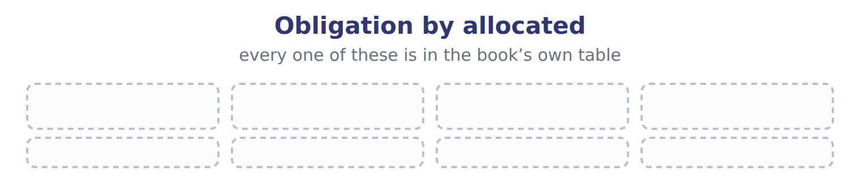
TEACH IT BACK | Write it for a classmate who missed this session — not for the marker.
29. In three or four sentences, write what this section settles and the one rule a reader has to take away.
every one of these words must appear: standalone selling price · contract asset · refund liability

Handout 11.5
Special situations
section 11.5 of the book
Before you start
Three summaries of this handout, in the book’s own words. Read all three first: together they are the whole session. Then fill the gaps, guessing where you have to.

What this handout settles, cycle by cycle
In this handout | What you will read | How you check it
Special situations | a figure to read · Suppose: Barada sells 1,000 units at $20 (cost $ | Which of these did this cycle settle?
The words this section uses precisely | The English the exam uses, and what it translates | What is the safest way to settle a disagreement about an answer on this sheet?

Words this handout uses precisely
Words this handout uses precisely | tick it if you could already use it in a sentence
variable consideration
constraint on variable consideration
bill-and-hold arrangement

1. Where the section starts — Fill every gap. The list holds more words than there are gaps, so one or two of them are not used.
choose from: Principal · agent · revenue · refund liability · output method · point in time
or : gross or net on a drop shipment. When customers may return goods, the company recognizes revenue only for goods it does not expect to be returned. It records a for expected refunds and a separate asset for its right to recover the returned goods.
2. What it settles in the middle — Fill every gap. The list holds more words than there are gaps, so one or two of them are not used.
choose from: bill-and-hold arrangement · point in time · revenue · output method · material right
In a , is recognized only if the goods are identified, ready and cannot be used for other customers, and the customer asked for the arrangement. A promise to buy the goods back usually means no sale has taken place. Customer options can create a , such as loyalty points, which is a separate obligation.
3. Where it ends — Fill every gap. The list holds more words than there are gaps, so one or two of them are not used.
choose from: output method · refund liability · agent · breakage · revenue · point in time
For gift cards, the company recognizes , the part customers are not expected to use, in proportion to the cards that are used. Nonrefundable upfront fees are usually deferred. An 's is its commission, not the full price the customer pays. Present the and the return asset separately.

CYCLE A | Special situations

ORIENT One claim. Decide now; you will check it in a moment.

4. Every number in a financial statement belongs to an element the framework defines. TRUE / FALSE
MODEL Read it before you answer anything below it.

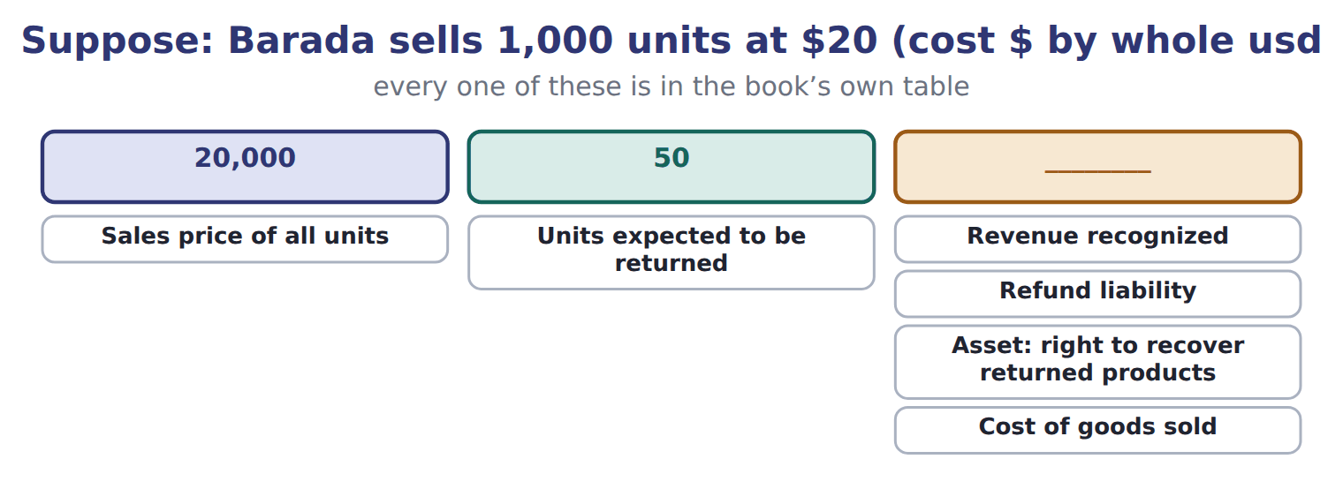
Suppose: Barada sells 1,000 units at $20 (cost $ — the book’s own table
Suppose: Barada sells 1,000 units at $20 (cost $ | Whole USD
Sales price of all units | 20,000
Units expected to be returned | 50
Revenue recognized | ________
Refund liability | ________
Asset: right to recover returned products | ________
Cost of goods sold | ________

READ THE MODEL Every answer is printed above. Find it, do not recall it.

SORT THEM | Write each one under its whole usd. Every item belongs to exactly one group.
the items: Sales price of all units · Units expected to be returned · Revenue recognized · Refund liability · Asset: right to recover returned products · Cost of goods sold
20,000 | 50 | ________

APPLY No help on this move.

8. The rule you have just written is the book’s own rule. TRUE / FALSE
WORK IN PAIRS | Compare every answer on this page with your partner before you read any key.
If you disagree: go back to the model and find the row that settles it. The row decides, not the louder voice.

CHECKPOINT 9. Which of these did this cycle settle?
A. the rule and where it comes from
B. nothing in particular
C. only the vocabulary
D. only the arithmetic
If you got it wrong: redo the READ THE MODEL questions of cycle A.

CYCLE B | The words this section uses precisely

ORIENT

10. A term in the exam means exactly what the book defines it to mean, whatever it means in ordinary English. TRUE / FALSE
MODEL

The English the exam uses, and what it translates
English (exam term) | the Arabic it translates
variable consideration | العوض المتغير
constraint on variable consideration | قيد العوض المتغير
bill-and-hold arrangement | ترتيب الفوترة والاحتفاظ

READ THE MODEL

11. A glossary term and its translation are a pair the book itself gives. TRUE / FALSE
APPLY

12. Writing a term in English is part of answering the question, not an extra. TRUE / FALSE
CHECKPOINT 13. What is the safest way to settle a disagreement about an answer on this sheet?
A. find the row of the model that decides it
B. take the answer of whoever is more confident
C. leave it until the lecturer says
D. choose the longer option
If you got it wrong: redo the READ THE MODEL questions of cycle B.

FROM MEMORY | Close the earlier pages first.
14. Rebuild the figure from this handout. Label every part and fill in every box.
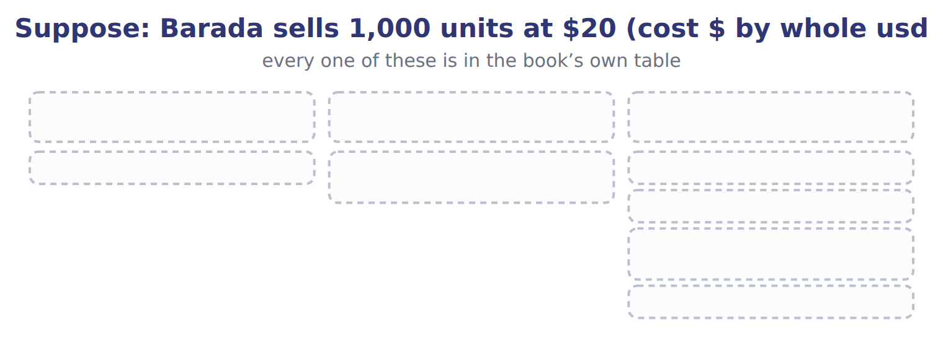
TEACH IT BACK | Write it for a classmate who missed this session — not for the marker.
15. In three or four sentences, write what this section settles and the one rule a reader has to take away.
every one of these words must appear: variable consideration · constraint on variable consideration · bill-and-hold arrangement

Handout 11.6
Matching, contract costs and IFRS differences
section 11.6 of the book
Before you start
Three summaries of this handout, in the book’s own words. Read all three first: together they are the whole session. Then fill the gaps, guessing where you have to.

What this handout settles, cycle by cycle
In this handout | What you will read | How you check it
Matching, contract costs and IFRS differences | a figure to read · Item (USD 000) | Which of these did this cycle settle?
The words this section uses precisely | Topic · The English the exam uses, and what it translates | What is the safest way to settle a disagreement about an answer on this sheet?

Words this handout uses precisely
Words this handout uses precisely | tick it if you could already use it in a sentence
over time
significant financing component
material right

1. Where the section starts — Fill every gap. The list holds more words than there are gaps, so one or two of them are not used.
choose from: advertising · recognized · bill-and-hold arrangement · depreciated · point in time
The matching principle says that expenses are in the same period as the revenues they help to earn. Cost of goods sold is recognized when the related sale is recognized. Costs with no future benefit, such as most , are expensed at once, and long-lived assets are over the periods they serve.
2. What it settles in the middle — Fill every gap. The list holds more words than there are gaps, so one or two of them are not used.
choose from: capitalizes · immediately · point in time · amortization · bill-and-hold arrangement
It this amount and expenses it as it transfers the goods and services. If the period is one year or less, the company may expense such costs . Costs to fulfill a contract are capitalized only if they relate directly to it and create a resource that will be used.
3. Where it ends — Fill every gap. The list holds more words than there are gaps, so one or two of them are not used.
choose from: point in time · capitalized · comparisons · produits · bill-and-hold arrangement
They matter for , but the five steps are the same. Arabic إيرادات مؤجلة and French constatés d'avance describe cash received before revenue is earned. SC11-12 A company impaired a contract cost last year.

CYCLE A | Matching, contract costs and IFRS differences

ORIENT One claim. Decide now; you will check it in a moment.

4. Every number in a financial statement belongs to an element the framework defines. TRUE / FALSE
MODEL Read it before you answer anything below it.

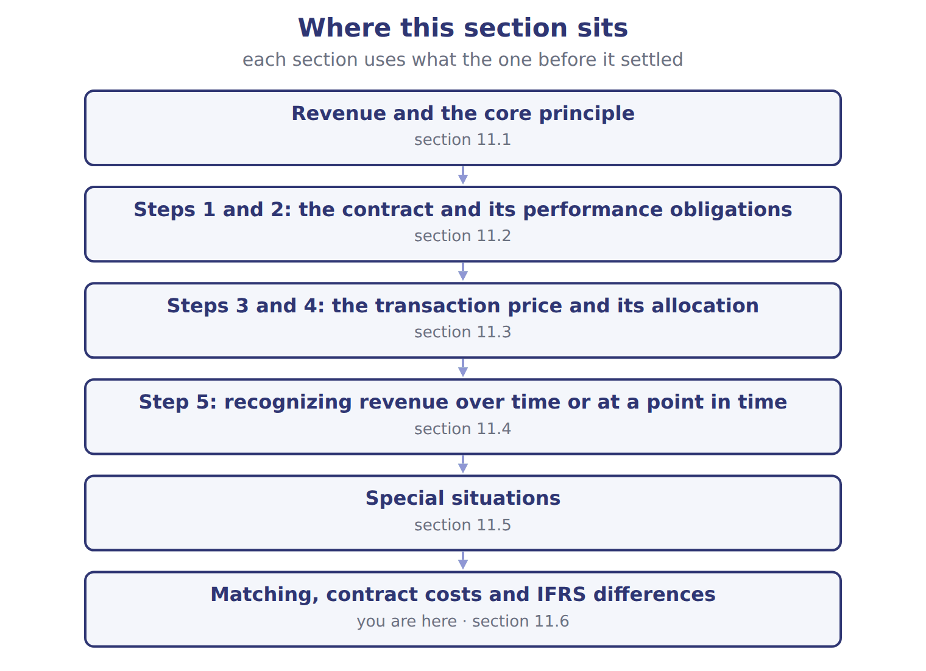

Item (USD 000) — the book’s own table
Item (USD 000) | Amount / details
Contract date | September 1, 2026
Customer | Qasr Hotels, a hotel chain in Amman
Fixed contract price | 600
Fruit juices: 12 equal monthly deliveries from September 2026 (standalone selling price) | 540
Staff training on storing and serving juices, completed in September 2026 (standalone selling price) | 60
M1 | If Qasr's orders pass a volume target, Qasr pays 30 less. Orontes expects the target to be met, and a reversal is not probable.
M2 | Orontes pays Qasr 10 to list Orontes juices on hotel menus. Orontes receives no distinct service.
M3 | Orontes delivers by its own trucks; control passes when the juices arrive. Orontes treats shipping as a fulfillment cost.
M4 | By December 31, 2026, Qasr has paid 250. Four monthly deliveries have been made.

READ THE MODEL Every answer is printed above. Find it, do not recall it.

5. Which part of this chapter is section 11.1?
A. Matching, contract costs and IFRS differences
B. Special situations
C. Revenue and the core principle
D. Steps 3 and 4: the transaction price and its allocation
6. Which part of this chapter is section 11.2?
A. Steps 3 and 4: the transaction price and its allocation
B. Step 5: recognizing revenue over time or at a point in time
C. Matching, contract costs and IFRS differences
D. Steps 1 and 2: the contract and its performance obligations
7. Which part of this chapter is section 11.3?
A. Step 5: recognizing revenue over time or at a point in time
B. Steps 1 and 2: the contract and its performance obligations
C. Matching, contract costs and IFRS differences
D. Steps 3 and 4: the transaction price and its allocation
8. Which part of this chapter is section 11.4?
A. Steps 3 and 4: the transaction price and its allocation
B. Steps 1 and 2: the contract and its performance obligations
C. Matching, contract costs and IFRS differences
D. Step 5: recognizing revenue over time or at a point in time
APPLY No help on this move.

9. The rule you have just written is the book’s own rule. TRUE / FALSE
WORK IN PAIRS | Compare every answer on this page with your partner before you read any key.
If you disagree: go back to the model and find the row that settles it. The row decides, not the louder voice.

CHECKPOINT 10. Which of these did this cycle settle?
A. the rule and where it comes from
B. nothing in particular
C. only the vocabulary
D. only the arithmetic
If you got it wrong: redo the READ THE MODEL questions of cycle A.

CYCLE B | The words this section uses precisely

ORIENT

11. A term in the exam means exactly what the book defines it to mean, whatever it means in ordinary English. TRUE / FALSE
MODEL

Topic — the book’s own table
Topic | U.S. GAAP (ASC 606) | IFRS 15
Collectibility threshold ('probable') | Likely (a high threshold) | More likely than not
Shipping after control passes | May elect to treat as a fulfillment cost | No election; may be an obligation
Sales taxes collected | May elect to exclude all | Judge each tax: principal or agent
Impairment of capitalized contract costs | Never reversed | Reversed (limited)
License renewals | Revenue when the renewal period begins | Policy choice
Onerous contracts | No general rule | IAS 37 provision

The English the exam uses, and what it translates
English (exam term) | the Arabic it translates
over time | على مدى زمني
significant financing component | مكوِّن تمويلي جوهري
material right | حق جوهري

READ THE MODEL

12. Which topic does the book pair with “Likely (a high threshold)”?
A. Shipping after control passes
B. Onerous contracts
C. Sales taxes collected
D. Collectibility threshold ('probable')
13. Which topic does the book pair with “May elect to treat as a fulfillment cost”?
A. Impairment of capitalized contract costs
B. Onerous contracts
C. License renewals
D. Shipping after control passes
14. Which topic does the book pair with “May elect to exclude all”?
A. Shipping after control passes
B. Impairment of capitalized contract costs
C. Sales taxes collected
D. Onerous contracts
APPLY

15. Writing a term in English is part of answering the question, not an extra. TRUE / FALSE

CHECKPOINT 16. What is the safest way to settle a disagreement about an answer on this sheet?
A. find the row of the model that decides it
B. take the answer of whoever is more confident
C. leave it until the lecturer says
D. choose the longer option
If you got it wrong: redo the READ THE MODEL questions of cycle B.

FROM MEMORY | Close the earlier pages first.
17. Rebuild the figure from this handout. Label every part and fill in every box.
TEACH IT BACK | Write it for a classmate who missed this session — not for the marker.
18. In three or four sentences, write what this section settles and the one rule a reader has to take away.
every one of these words must appear: over time · significant financing component · material right

Handout 11.7
The whole chapter
every section, shuffled, and the chapter’s own case set
Before you start
Three summaries of this chapter, in the book’s own words, with words taken out. Read all three first: together they are the whole chapter. Then fill the gaps.

What this handout settles, cycle by cycle
In this handout | What you will read | How you check it
The whole chapter, in order | a figure to read | Orontes pays a supermarket $30,000 for shelf space and receives no distinct service. How is the payment treated?
The chapter’s case set | The chapter’s case set, item by item · Obligation | What has to be settled before any figure in a case set is worked out?
The words it uses precisely | revenue · performance obligation · transaction price · standalone selling price · variable consideration · over time | matching, at the end of cycle B

1. Where the chapter starts — Fill every gap. The list holds more words than there are gaps, so one or two of them are not used.
choose from: material right · input method · variable consideration · transaction price · revenue
Step 3: determine the , the amount the company expects to receive. It includes , such as rebates and bonuses. The company estimates it using the expected value, for many possible outcomes, or the most likely amount, for an all-or-nothing outcome. Variable amounts are included only to the extent that a significant reversal of is not probable later.
2. What it settles in the middle — Fill every gap. The list holds more words than there are gaps, so one or two of them are not used.
choose from: output method · input method · point in time · revenue · over time · performance obligation · material right
Progress is measured by an , such as units delivered, or an , such as costs incurred. If no over-time criterion is met, is recognized at a : when control passes.
3. Where it ends — Fill every gap. The list holds more words than there are gaps, so one or two of them are not used.
choose from: revenue · material right · input method · Principal · agent · refund liability
or : gross or net on a drop shipment. When customers may return goods, the company recognizes revenue only for goods it does not expect to be returned. It records a for expected refunds and a separate asset for its right to recover the returned goods.

CYCLE A | The whole chapter, in order

ORIENT

4. The sections of a chapter have to be taken in order, because each one uses what the one before it settled. TRUE / FALSE
MODEL

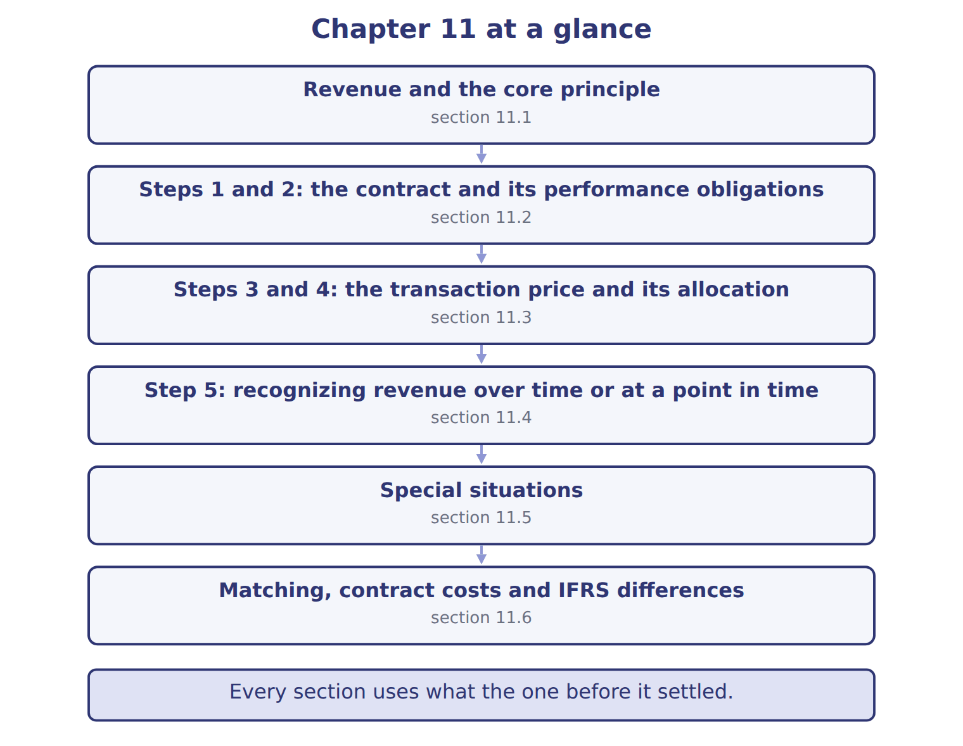
READ THE MODEL

5. Which part of this chapter is section 11.1?
A. Matching, contract costs and IFRS differences
B. Special situations
C. Steps 3 and 4: the transaction price and its allocation
D. Revenue and the core principle
6. Which part of this chapter is section 11.2?
A. Steps 3 and 4: the transaction price and its allocation
B. Step 5: recognizing revenue over time or at a point in time
C. Steps 1 and 2: the contract and its performance obligations
D. Matching, contract costs and IFRS differences
7. Which part of this chapter is section 11.3?
A. Step 5: recognizing revenue over time or at a point in time
B. Steps 3 and 4: the transaction price and its allocation
C. Steps 1 and 2: the contract and its performance obligations
D. Matching, contract costs and IFRS differences
Write the letter of the section number beside each section title. Every number is used once.
A 11.1 | D 11.4
B 11.2 | E 11.5
C 11.3 | F 11.6

8. Revenue and the core principle
9. Steps 1 and 2: the contract and its performance obligations
10. Steps 3 and 4: the transaction price and its allocation
11. Step 5: recognizing revenue over time or at a point in time
12. Special situations
13. Matching, contract costs and IFRS differences

APPLY

14. Orontes pays a sales commission of $32,400 to win the two-year GreenBasket contract. How is it treated?
A. Expensed immediately
B. Capitalized and expensed as the goods and services are transferred
C. Deducted from revenue
D. Added to the cost of the dispenser
WORK IN PAIRS | Compare every answer with your partner first.
If you disagree: name the section each question belongs to. Most disagreements turn out to be about the section, not the answer.
CHECKPOINT 15. Orontes pays a supermarket $30,000 for shelf space and receives no distinct service. How is the payment treated?
A. As a marketing expense
B. As a reduction of the transaction price (revenue)
C. As a prepaid asset amortized over five years
D. As cost of goods sold
If you got it wrong: go back to the MODEL move of cycle A and find the section this question belongs to.

CYCLE B | The chapter’s case set

ORIENT

16. In a case question, the exhibit has to be read and adjusted before any figure is worked out. TRUE / FALSE

MODEL

The chapter’s case set, item by item
Item | What it asks
C11-1 | Classify each item in the Qasr contract. (On the exam screen you would drag each item into a box.)
C11-2 | Enter the transaction price.
C11-3 | Enter the transaction price allocated to the staff training.
C11-4 | Enter Orontes's 2026 revenue from the Qasr contract.
C11-5 | Enter the contract liability at December 31, 2026.
C11-6 | How does Orontes treat the menu listing fee (M2)? [select]

READ THE MODEL

17. Which of these does item C11-1 ask for?
A. How does Orontes treat the menu listing fee (M2)? [select]
B. Enter the transaction price allocated to the staff training.
C. Classify each item in the Qasr contract. (On the exam screen you would
D. Enter Orontes's 2026 revenue from the Qasr contract.
18. Which of these does item C11-2 ask for?
A. Enter the contract liability at December 31, 2026.
B. Enter Orontes's 2026 revenue from the Qasr contract.
C. Enter the transaction price.
D. How does Orontes treat the menu listing fee (M2)? [select]
19. Which of these does item C11-3 ask for?
A. Enter Orontes's 2026 revenue from the Qasr contract.
B. How does Orontes treat the menu listing fee (M2)? [select]
C. Classify each item in the Qasr contract. (On the exam screen you would
D. Enter the transaction price allocated to the staff training.
20. Which of these does item C11-4 ask for?
A. Enter Orontes's 2026 revenue from the Qasr contract.
B. Enter the contract liability at December 31, 2026.
C. Enter the transaction price allocated to the staff training.
D. How does Orontes treat the menu listing fee (M2)? [select]
21. Which of these does item C11-5 ask for?
A. How does Orontes treat the menu listing fee (M2)? [select]
B. Enter the contract liability at December 31, 2026.
C. Enter the transaction price allocated to the staff training.
D. Enter Orontes's 2026 revenue from the Qasr contract.
22. Which of these does item C11-6 ask for?
A. Enter the transaction price allocated to the staff training.
B. Enter Orontes's 2026 revenue from the Qasr contract.
C. Enter the contract liability at December 31, 2026.
D. How does Orontes treat the menu listing fee (M2)? [select]
APPLY

23. Orontes pays a supermarket $30,000 for shelf space and receives no distinct service. How is the payment treated?
A. As a marketing expense
B. As a reduction of the transaction price (revenue)
C. As a prepaid asset amortized over five years
D. As cost of goods sold

Obligation — the extract for the question that follows
Obligation | Allocated | Timing | Progress in 2026 | 2026 revenue
Olive oil | 810,000 | Point in time (each delivery) | 8,000 of 20,000 cases × 40 | 324,000
Dispenser | 180,000 | Point in time (installed October 1) | installed | 180,000
Maintenance | 90,000 | Over time (24 months) | 3 months × 3,750 | 11,250
Total | 1,080,000 |  |  | 515,250

24. The extract for this question is printed with it. What is Orontes's 2026 revenue on the GreenBasket contract (whole USD)?
A. 515,250 | C. 594,000
B. 572,500 | D. 1,080,000
CHECKPOINT 25. What has to be settled before any figure in a case set is worked out?
A. the exhibit, adjusted for every note that goes with it
B. the method the company uses
C. the tax rate
D. the order of the items
If you got it wrong: reread the case panel in the MODEL move of cycle B.

FROM MEMORY | Close the earlier pages first.
26. Rebuild the chapter map. Write every section in order and what each one settles.
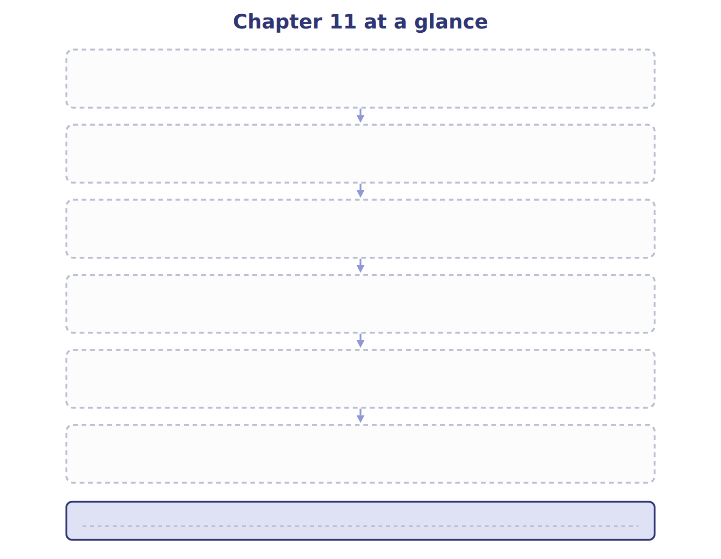
TEACH IT BACK | Write it for a student starting this chapter tomorrow — not for the marker.
27. In four or five sentences, write what the whole chapter settles, section by section.
every one of these words must appear: revenue · performance obligation · transaction price · standalone selling price

