Handout 13.1
Why book income and taxable income differ
section 13.1 of the book
Before you start
Three summaries of this handout, in the book’s own words. Read all three first: together they are the whole session. Then fill the gaps, guessing where you have to.

What this handout settles, cycle by cycle
In this handout | What you will read | How you check it
Why book income and taxable income differ | a figure to read · Orontes Foods Inc., 2025 (whole USD) | Income tax expense on the income statement equals:
The words this section uses precisely | Item · The English the exam uses, and what it translates | What is the safest way to settle a disagreement about an answer on this sheet?

Words this handout uses precisely
Words this handout uses precisely | tick it if you could already use it in a sentence
taxable income
valuation allowance
taxable temporary difference
uncertain tax position

1. Where the section starts — Fill every gap. The list holds more words than there are gaps, so one or two of them are not used.
choose from: different · government · uncertain tax position · differently · current tax expense
Tax returns follow tax law and are prepared for the . The two sets of rules have goals, so taxable income is usually not the same as income before income taxes. If a company simply reported the tax it paid, its tax expense would jump around when the rules timed items .
2. What it settles in the middle — Fill every gap. The list holds more words than there are gaps, so one or two of them are not used.
choose from: taxable · current tax expense · different · usually · uncertain tax position
The two sets of rules have goals, so income is not the same as income before income taxes.
3. Where it ends — Fill every gap. The list holds more words than there are gaps, so one or two of them are not used.
choose from: uncertain tax position · current tax expense · transactions · recognizes · differently
If a company simply reported the tax it paid, its tax expense would jump around when the rules timed items . The company the tax effects of in the same periods as the transactions themselves, using deferred taxes.
How every cycle on this sheet works
How a cycle works | what you do
MODEL | read the figure or the table before you answer anything
READ THE MODEL | every answer is printed on the same page
INVENT THE RULE | write the rule yourself, then compare with the book
APPLY | no help on this move
CHECKPOINT | mark it yourself; if you miss it, the sheet says what to redo

CYCLE A | Why book income and taxable income differ

ORIENT One claim. Decide now; you will check it in a moment.

4. Every number in a financial statement belongs to an element the framework defines. TRUE / FALSE
MODEL Read it before you answer anything below it.

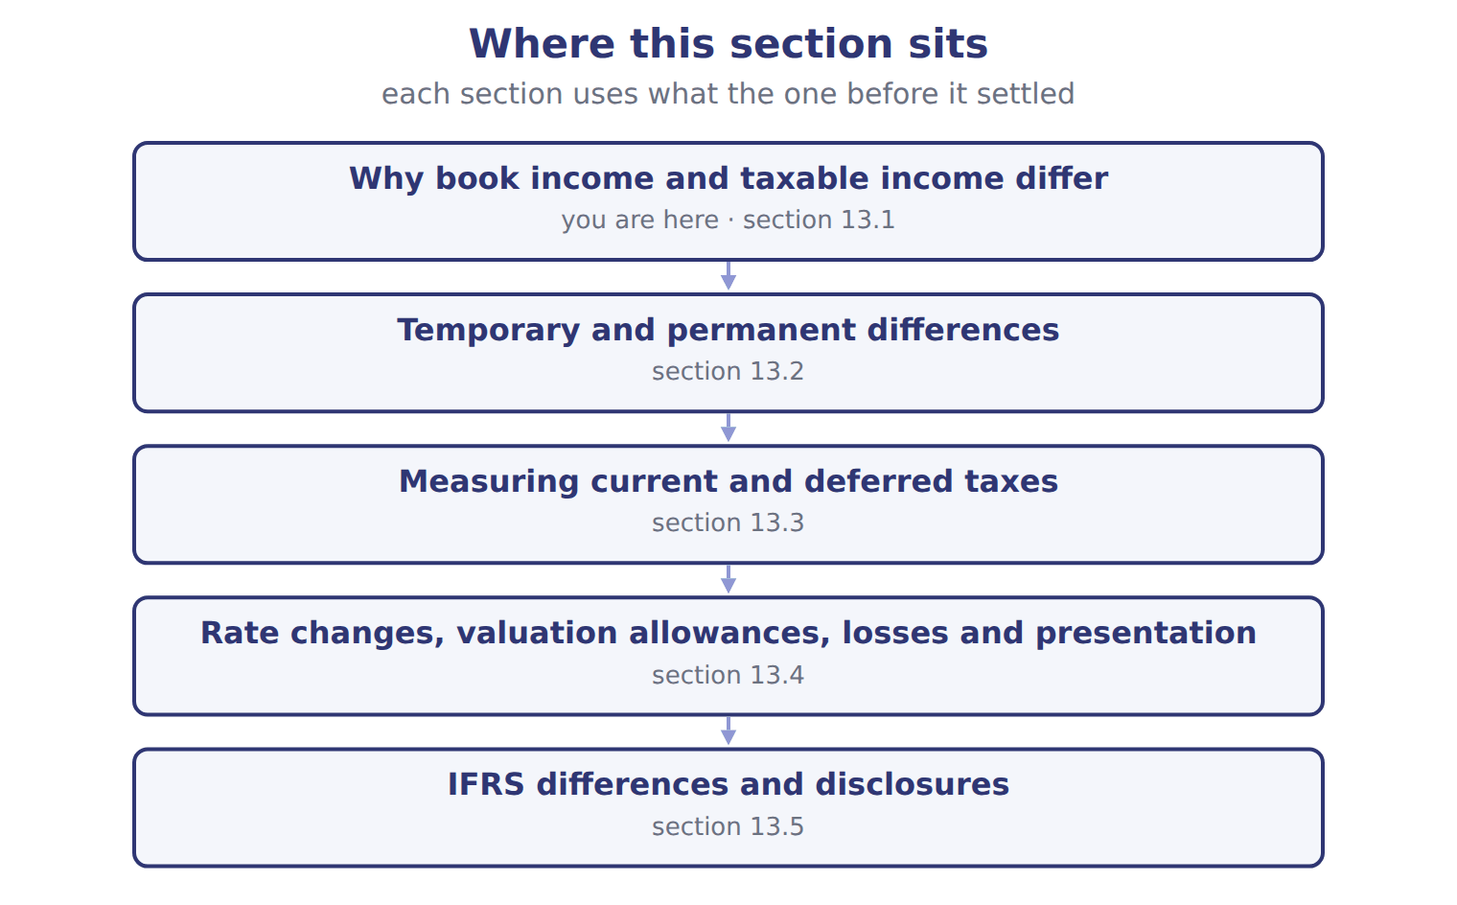

Orontes Foods Inc., 2025 (whole USD) — the book’s own table
Orontes Foods Inc., 2025 (whole USD) | Amount
Income before income taxes | 3,958,800
Income tax expense (25% combined federal and state rate) | 989,700
Current tax expense (taxes on 2025 taxable income) | 889,700
Deferred tax expense (25% of the 400,000 increase in net taxable temporary differences) | 100,000
Income taxes paid in cash (Chapter 5) | 839,700
Deferred tax liability, January 1, 2025 | 900,000
Deferred tax liability, December 31, 2025 (after the 375 tax effect of the OCI loss) | 999,625

READ THE MODEL Every answer is printed above. Find it, do not recall it.

5. Which amount does the book give for Income before income taxes?
A. 889,700 | C. 3,958,800
B. 989,700 | D. 100,000
6. Which amount does the book give for Income tax expense (25% combined federal and state rate)?
A. 989,700 | C. 839,700
B. 100,000 | D. 889,700
7. Which amount does the book give for Current tax expense (taxes on 2025 taxable income)?
A. 889,700 | C. 100,000
B. 989,700 | D. 839,700
APPLY No help on this move.

8. Income tax expense on the income statement equals:
A. current tax expense plus deferred tax expense
B. income taxes paid in cash
C. taxable income times the tax rate
D. pretax income times the tax rate in all cases
9. A company's deferred tax liability rose from $300,000 to $380,000, and its deferred tax asset rose from $50,000 to $70,000. What is deferred tax expense?
A. $60,000 | C. $100,000
B. $80,000 | D. $310,000
10. A law signed on July 4 cuts the tax rate from next year. When does the company record the effect on its deferred tax balances?
A. Next year, when the new rate applies
B. In the period that includes July 4
C. Over the years the differences reverse
D. Never; only current tax changes

Orontes Foods Inc., 2025 (whole USD) — the extract for the question that follows
Orontes Foods Inc., 2025 (whole USD) | Amount
Income before income taxes | 3,958,800
Income tax expense (25% combined federal and state rate) | 989,700
Current tax expense (taxes on 2025 taxable income) | 889,700
Deferred tax expense (25% of the 400,000 increase in net taxable temporary differences) | 100,000
Income taxes paid in cash (Chapter 5) | 839,700
Deferred tax liability, January 1, 2025 | 900,000
Deferred tax liability, December 31, 2025 (after the 375 tax effect of the OCI loss) | 999,625

11. The extract for this question is printed with it. Why did Orontes pay less tax in 2025 than its current tax expense?
A. Deferred tax is paid in cash
B. Income taxes payable rose, so part of the current tax was still unpaid
C. The OCI loss reduced taxes paid
D. Orontes had a tax refund from 2024
WORK IN PAIRS | Compare every answer on this page with your partner before you read any key.
If you disagree: go back to the model and find the row that settles it. The row decides, not the louder voice.
CHECKPOINT 12. Income tax expense on the income statement equals:
A. current tax expense plus deferred tax expense
B. income taxes paid in cash
C. taxable income times the tax rate
D. pretax income times the tax rate in all cases
If you got it wrong: redo the READ THE MODEL questions of cycle A with the model in front of you.

CYCLE B | The words this section uses precisely

ORIENT

13. A term in the exam means exactly what the book defines it to mean, whatever it means in ordinary English. TRUE / FALSE
MODEL

Item — the book’s own table
Item | Category
Municipal bond interest
Late-filing fine
Tax depreciation above book
Warranty liability
Rent received in advance

The English the exam uses, and what it translates
English (exam term) | the Arabic it translates
taxable income | الدخل الخاضع للضريبة
valuation allowance | مخصص التقييم
taxable temporary difference | فرق مؤقت خاضع للضريبة
uncertain tax position | مركز ضريبي غير مؤكد

READ THE MODEL

Write the letter of the Arabic term beside each English term. Every term is used once.
A فرق مؤقت خاضع للضريبة | C الدخل الخاضع للضريبة
B مخصص التقييم | D مركز ضريبي غير مؤكد

14. valuation allowance
15. uncertain tax position
16. taxable temporary difference
17. taxable income

APPLY

18. A company has an unrealized loss on AFS debt securities in OCI. Its tax effect is:
A. shown with the OCI item, not in income tax expense on continuing operations
B. ignored
C. added to current tax expense
D. recorded in retained earnings
19. Pretax income is $500,000, and there are no temporary differences. It includes $20,000 of tax-exempt interest and a $10,000 nondeductible fine. At a 25% rate, what is income tax expense?
A. $122,500 | C. $127,500
B. $125,000 | D. $132,500
CHECKPOINT 20. What is the safest way to settle a disagreement about an answer on this sheet?
A. find the row of the model that decides it
B. take the answer of whoever is more confident
C. leave it until the lecturer says
D. choose the longer option
If you got it wrong: redo the READ THE MODEL questions of cycle B.

FROM MEMORY | Close the earlier pages first.
21. Rebuild the figure from this handout. Label every part and fill in every box.
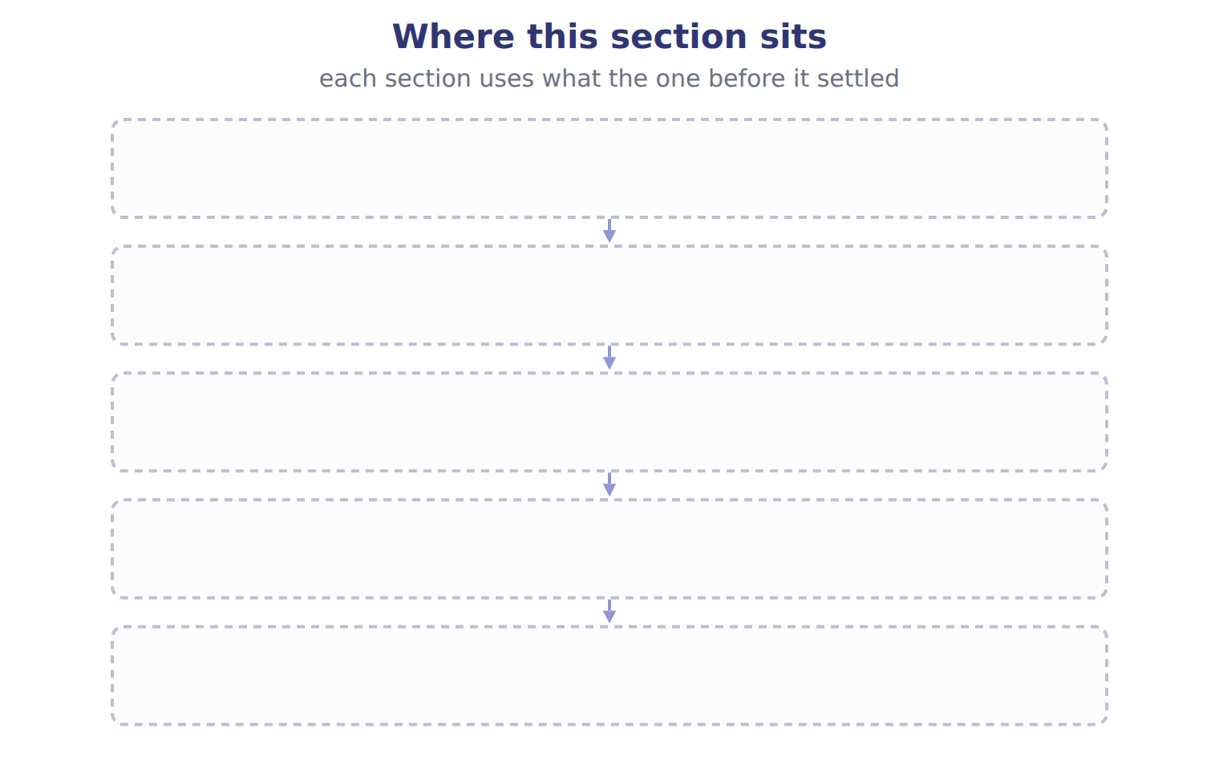
TEACH IT BACK | Write it for a classmate who missed this session — not for the marker.
22. In three or four sentences, write what this section settles and the one rule a reader has to take away.
every one of these words must appear: taxable income · valuation allowance · taxable temporary difference · uncertain tax position

Handout 13.2
Temporary and permanent differences
section 13.2 of the book
Before you start
Three summaries of this handout, in the book’s own words. Read all three first: together they are the whole session. Then fill the gaps, guessing where you have to.

What this handout settles, cycle by cycle
In this handout | What you will read | How you check it
Temporary and permanent differences | a figure to read · Item · the book’s own rule, gapped | Under U.S. GAAP, a tax position is recognized in the financial statements if it is:
The words this section uses precisely | Item · The English the exam uses, and what it translates · Suppose: Orontes, 2026 (whole USD) | What is the safest way to settle a disagreement about an answer on this sheet?

Words this handout uses precisely
Words this handout uses precisely | tick it if you could already use it in a sentence
temporary difference
enacted tax rate
deductible temporary difference
intraperiod tax allocation

1. Where the section starts — Fill every gap. The list holds more words than there are gaps, so one or two of them are not used.
choose from: taxable income · taxable temporary difference · deductible temporary difference · tax basis · current tax expense · temporary difference · deferred tax asset
A arises when the of an asset or liability differs from its carrying amount on the balance sheet. A will increase future ; a will reduce it.
2. What it settles in the middle — Fill every gap. The list holds more words than there are gaps, so one or two of them are not used.
choose from: permanent difference · deductible temporary difference · deferred tax asset · taxable temporary difference · deferred tax liability · temporary difference
A creates a : tax that will be paid later. A creates a deferred tax asset: tax that will be saved later. Decision chart: , deferred tax liability or deferred tax asset?.
3. Where it ends — Fill every gap. The list holds more words than there are gaps, so one or two of them are not used.
choose from: deferred tax asset · current tax expense · temporary difference · deferred tax liability
Tax depreciation faster than book: less tax now, more later: . Warranty accrued now, deductible when paid: more tax now, less later: . Fines and municipal interest: permanent, no deferred tax.

CYCLE A | Temporary and permanent differences

ORIENT One claim. Decide now; you will check it in a moment.

4. The book gives the type of difference of Tax depreciation faster than book (bonus, MACRS) as “Temporary, taxable”. TRUE / FALSE
MODEL Read it before you answer anything below it.

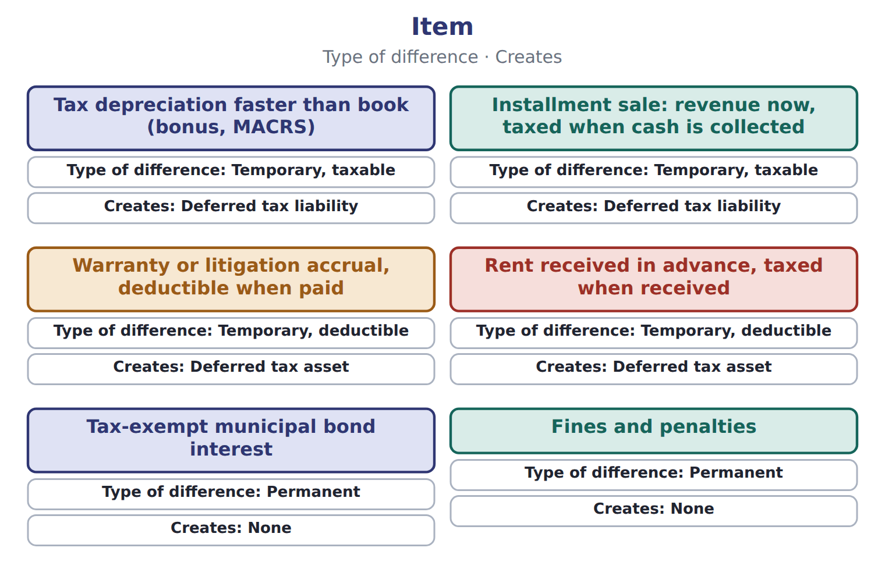

Item — the book’s own table
Item | Type of difference | Creates
Tax depreciation faster than book (bonus, MACRS) | Temporary, taxable | Deferred tax liability
Installment sale: revenue now, taxed when cash is collected | Temporary, taxable | Deferred tax liability
Warranty or litigation accrual, deductible when paid | Temporary, deductible | Deferred tax asset
Rent received in advance, taxed when received | Temporary, deductible | Deferred tax asset
Tax-exempt municipal bond interest | Permanent | None
Fines and penalties | Permanent | None
Life insurance premiums when the company is the beneficiary | Permanent | None

READ THE MODEL Every answer is printed above. Find it, do not recall it.

5. Which type of difference does the book give for Tax depreciation faster than book (bonus, MACRS)?
A. Temporary, deductible | C. Permanent
B. Temporary, taxable
6. Which type of difference does the book give for Installment sale: revenue now, taxed when cash is collected?
A. Permanent | C. Temporary, taxable
B. Temporary, deductible
7. Which type of difference does the book give for Warranty or litigation accrual, deductible when paid?
A. Temporary, deductible | C. Permanent
B. Temporary, taxable
8. Which type of difference does the book give for Rent received in advance, taxed when received?
A. Temporary, deductible | C. Permanent
B. Temporary, taxable
9. The book gives the creates of Tax depreciation faster than book (bonus, MACRS) as “Deferred tax liability”. TRUE / FALSE
10. The book gives the creates of Installment sale: revenue now, taxed when cash is collected as “None”. TRUE / FALSE
INVENT THE RULE

11. Complete the book’s own sentence. The list holds more words than there are gaps.
use every one of these words: taxable temporary difference · deductible temporary difference · permanent difference · current tax expense
A will increase future taxable income; a will reduce it.

Two of the book’s own cases, side by side
Tax depreciation faster than book (bonus, MACRS) | Warranty or litigation accrual, deductible when paid
Type of difference: Temporary, taxable | Type of difference: Temporary, deductible
Only the facts above differ. What is the creates of Tax depreciation faster than book (bonus, MACRS)?
12. Choose one:
A. Deferred tax liability | C. None
B. Deferred tax asset
APPLY No help on this move.

13. Under U.S. GAAP, a tax position is recognized in the financial statements if it is:
A. more likely than not to be sustained on its technical merits
B. certain to be accepted
C. probable in the IFRS sense
D. not yet examined by the tax authority
14. Which item creates a temporary difference?
A. A fine for breaking the law
B. Tax-exempt municipal interest
C. An accrued warranty expense deductible for tax when paid
D. Life insurance premiums on an officer, where the company is the beneficiary
15. A company receives rent for next year in advance. Tax law taxes it now; GAAP recognizes it next year. This creates:
A. a taxable temporary difference and a deferred tax liability
B. a permanent difference
C. no difference
D. a deductible temporary difference and a deferred tax asset
16. A company uses the installment method for tax, but recognizes the full sale for books. The difference is:
A. a deductible temporary difference
B. a taxable temporary difference
C. a permanent difference
D. a valuation allowance
WORK IN PAIRS | Compare every answer on this page with your partner before you read any key.
If you disagree: go back to the model and find the row that settles it. The row decides, not the louder voice.
CHECKPOINT 17. Under U.S. GAAP, a tax position is recognized in the financial statements if it is:
A. more likely than not to be sustained on its technical merits
B. certain to be accepted
C. probable in the IFRS sense
D. not yet examined by the tax authority
If you got it wrong: redo the READ THE MODEL questions of cycle A with the model in front of you.

CYCLE B | The words this section uses precisely

ORIENT

18. A term in the exam means exactly what the book defines it to mean, whatever it means in ordinary English. TRUE / FALSE

MODEL

Item — the book’s own table
Item | Category
Municipal bond interest | Permanent difference
Late-filing fine | Permanent difference
Tax depreciation above book | Taxable temporary difference (DTL)
Warranty liability | Deductible temporary difference (DTA)
Rent received in advance | Deductible temporary difference (DTA)

The English the exam uses, and what it translates
English (exam term) | the Arabic it translates
temporary difference | فرق مؤقت
enacted tax rate | معدل الضريبة المُقر (المسنون)
deductible temporary difference | فرق مؤقت قابل للخصم
intraperiod tax allocation | توزيع الضريبة داخل الفترة

READ THE MODEL

Write the letter of the Arabic term beside each English term. Every term is used once.
A فرق مؤقت | C فرق مؤقت قابل للخصم
B معدل الضريبة المُقر (المسنون) | D توزيع الضريبة داخل الفترة

19. enacted tax rate
20. intraperiod tax allocation
21. deductible temporary difference
22. temporary difference

23. Which category does the book give for Municipal bond interest?
A. Permanent difference
B. Taxable temporary difference (DTL)
C. Deductible temporary difference (DTA)
24. Which category does the book give for Late-filing fine?
A. Deductible temporary difference (DTA)
B. Permanent difference
C. Taxable temporary difference (DTL)
25. Which item does the book pair with “Taxable temporary difference (DTL)”?
A. Warranty liability | C. Tax depreciation above book
B. Municipal bond interest | D. Late-filing fine
APPLY

26. How do permanent differences affect the financial statements?
A. They create deferred tax assets
B. They create deferred tax liabilities
C. They have no effect at all
D. They change the effective tax rate but create no deferred taxes

Suppose: Orontes, 2026 (whole USD) — the extract for the question that follows
Suppose: Orontes, 2026 (whole USD) | Amount | % of pretax income
Current tax expense | 357,000
Deferred tax liability created: 25% × 600,000 | 150,000
Deferred tax asset created: 25% × 38,000 | (9,500)
Deferred tax expense | 140,500
Total income tax expense | 497,500 | 24.875%
Rate reconciliation (ASU 2023-09 style)
Tax at the statutory rate: 25% × 2,000,000 | 500,000 | 25.000%
Nontaxable or nondeductible items: municipal interest | (5,000) | -0.250%
Nontaxable or nondeductible items: fine | 2,500 | 0.125%
Income tax expense and effective tax rate | 497,500 | 24.875%

27. The extract for this question is printed with it. Which balances does Orontes carry at the end of 2026 for the equipment and the warranty (whole USD)?
A. A DTA of 150,000 and a DTL of 9,500
B. A current DTL of 140,500
C. A DTL of 150,000 and a DTA of 9,500, shown as one net noncurrent DTL
D. No deferred taxes
CHECKPOINT 28. What is the safest way to settle a disagreement about an answer on this sheet?
A. find the row of the model that decides it
B. take the answer of whoever is more confident
C. leave it until the lecturer says
D. choose the longer option
If you got it wrong: redo the READ THE MODEL questions of cycle B.

FROM MEMORY | Close the earlier pages first.
29. Rebuild the figure from this handout. Label every part and fill in every box.
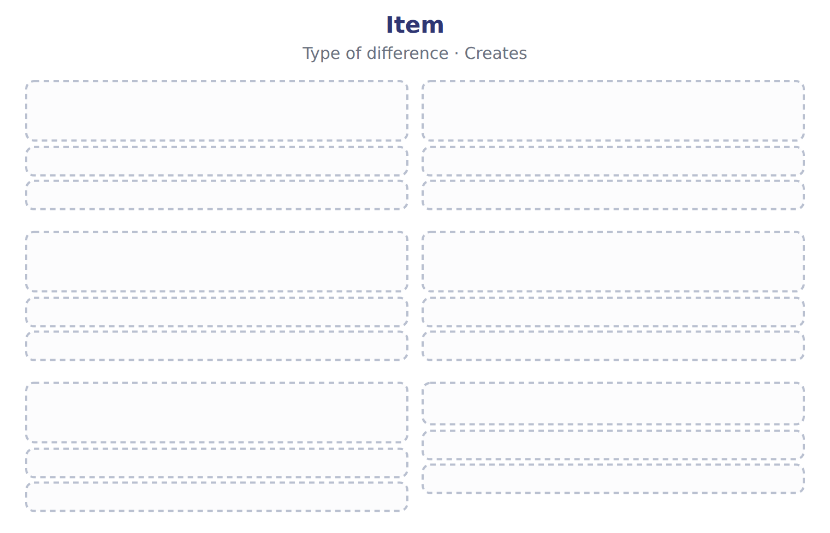
TEACH IT BACK | Write it for a classmate who missed this session — not for the marker.
30. In three or four sentences, write what this section settles and the one rule a reader has to take away.
every one of these words must appear: temporary difference · enacted tax rate · deductible temporary difference · intraperiod tax allocation

Handout 13.3
Measuring current and deferred taxes
section 13.3 of the book
Before you start
Three summaries of this handout, in the book’s own words. Read all three first: together they are the whole session. Then fill the gaps, guessing where you have to.

What this handout settles, cycle by cycle
In this handout | What you will read | How you check it
Measuring current and deferred taxes | a figure to read · Suppose: Orontes, 2026 (whole USD) · the book’s own rule, gapped | What is the purpose of interperiod tax allocation?
The words this section uses precisely | Suppose: Orontes, 2026 (whole USD) · The English the exam uses, and what it translates · Orontes Foods Inc., 2025 (whole USD) | What is the safest way to settle a disagreement about an answer on this sheet?

Words this handout uses precisely
Words this handout uses precisely | tick it if you could already use it in a sentence
permanent difference
interperiod tax allocation
tax basis

1. Where the section starts — Fill every gap. The list holds more words than there are gaps, so one or two of them are not used.
choose from: enacted tax rate · tax basis · valuation allowance · taxable income
Current tax is times the tax rate. Deferred tax liabilities and assets are the temporary differences times the that will apply when they reverse.
2. What it settles in the middle — Fill every gap. The list holds more words than there are gaps, so one or two of them are not used.
choose from: Deferred tax expense · tax basis · valuation allowance · deferred tax liability
is the change in the net during the year. Deferred taxes follow from the same differences.
3. Where it ends — Fill every gap. The list holds more words than there are gaps, so one or two of them are not used.
choose from: enacted tax rate · tax basis · valuation allowance · taxable income · Deferred tax expense · deferred tax liability
Current tax is times the tax rate. Deferred tax liabilities and assets are the temporary differences times the that will apply when they reverse. is the change in the net during the year.

CYCLE A | Measuring current and deferred taxes

ORIENT One claim. Decide now; you will check it in a moment.

4. Every number in a financial statement belongs to an element the framework defines. TRUE / FALSE
MODEL Read it before you answer anything below it.

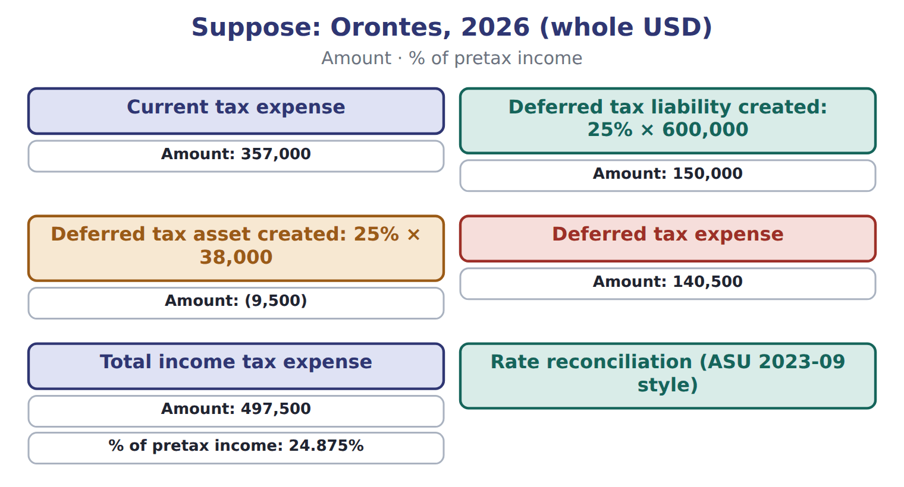

Suppose: Orontes, 2026 (whole USD) — the book’s own table
Suppose: Orontes, 2026 (whole USD) | Amount | % of pretax income
Current tax expense | 357,000
Deferred tax liability created: 25% × 600,000 | 150,000
Deferred tax asset created: 25% × 38,000 | (9,500)
Deferred tax expense | 140,500
Total income tax expense | 497,500 | 24.875%
Rate reconciliation (ASU 2023-09 style)
Tax at the statutory rate: 25% × 2,000,000 | 500,000 | 25.000%
Nontaxable or nondeductible items: municipal interest | (5,000) | -0.250%
Nontaxable or nondeductible items: fine | 2,500 | 0.125%
Income tax expense and effective tax rate | 497,500 | 24.875%

READ THE MODEL Every answer is printed above. Find it, do not recall it.

5. Which amount does the book give for Current tax expense?
A. 357,000 | C. 140,500
B. (9,500) | D. 150,000
6. Which amount does the book give for Deferred tax liability created: 25% × 600,000?
A. 150,000 | C. (9,500)
B. 357,000 | D. 140,500
7. Which amount does the book give for Deferred tax asset created: 25% × 38,000?
A. 150,000 | C. 357,000
B. (9,500) | D. 140,500
8. Which amount does the book give for Deferred tax expense?
A. 150,000 | C. (9,500)
B. 357,000 | D. 140,500
INVENT THE RULE

9. Complete the book’s own sentence. The list holds more words than there are gaps.
use every one of these words: Deferred tax expense · deferred tax liability · tax basis · permanent difference
is the change in the net during the year.

Two of the book’s own cases, side by side
Total income tax expense | Tax at the statutory rate: 25% × 2,000,000
Amount: 497,500 | Amount: 500,000
Only the facts above differ. What is the % of pretax income of Total income tax expense?
10. Choose one:
A. 0.125% | C. -0.250%
B. 25.000% | D. 24.875%

APPLY No help on this move.

11. Which item is a permanent difference?
A. Accelerated tax depreciation
B. Interest on tax-exempt municipal bonds
C. An accrued warranty expense
D. Rent received in advance
12. A company deducts depreciation faster for tax than for books. This creates:
A. a deferred tax asset | C. a deferred tax liability
B. a permanent difference | D. a valuation allowance
13. Which evidence MOST suggests that a valuation allowance is needed?
A. Cumulative losses in recent years
B. A long record of profits
C. Large deferred tax liabilities reversing in the same years
D. A signed contract that will produce taxable profits
14. A U.S. company has a federal tax loss in 2026. Under current law it can:
A. carry it back two years for a refund
B. carry the loss forward without a time limit, using it against up to 80% of future taxable income each year
C. carry it forward for 20 years only
D. deduct it only in 2027
15. A company has a deferred tax liability in the United States and a deferred tax asset in France. How are they presented?
A. As one net amount
B. As current items
C. Only in the notes
D. Separately: they are in different tax jurisdictions
16. A company's DTL of $200,000 (at 25%) relates to differences that reverse after a new enacted rate of 21% takes effect. What is the DTL?
A. $42,000 | C. $200,000
B. $168,000 | D. $232,000
WORK IN PAIRS | Compare every answer on this page with your partner before you read any key.
If you disagree: go back to the model and find the row that settles it. The row decides, not the louder voice.
CHECKPOINT 17. What is the purpose of interperiod tax allocation?
A. To report only the tax paid in cash
B. To make taxable income equal book income
C. To spread tax expense evenly over five years
D. To recognize the tax effects of transactions in the same periods as the transactions
If you got it wrong: redo the READ THE MODEL questions of cycle A with the model in front of you.

CYCLE B | The words this section uses precisely

ORIENT

18. A term in the exam means exactly what the book defines it to mean, whatever it means in ordinary English. TRUE / FALSE

MODEL

Suppose: Orontes, 2026 (whole USD) — the book’s own table
Suppose: Orontes, 2026 (whole USD) | Amount
Income before income taxes (book) | 2,000,000
Less: tax-exempt municipal interest (permanent) | (20,000)
Add: fine, not deductible (permanent) | 10,000
Less: tax depreciation 900,000 above book depreciation 300,000 (temporary) | (600,000)
Add: warranty expense 60,000 not yet deductible; repairs paid 22,000 (temporary) | 38,000
Taxable income | 1,428,000
Current tax expense at 25% | 357,000

The English the exam uses, and what it translates
English (exam term) | the Arabic it translates
permanent difference | فرق دائم
interperiod tax allocation | توزيع الضريبة بين الفترات
tax basis | الأساس الضريبي

READ THE MODEL

19. Which amount does the book give for Income before income taxes (book)?
A. 2,000,000 | C. (600,000)
B. 1,428,000 | D. (20,000)
20. Which amount does the book give for Less: tax-exempt municipal interest (permanent)?
A. 2,000,000 | C. (600,000)
B. (20,000) | D. 1,428,000
21. Which amount does the book give for Add: fine, not deductible (permanent)?
A. 38,000 | C. 10,000
B. (20,000) | D. 357,000
APPLY

22. An IFRS company expects to use only $60,000 of a potential $100,000 deferred tax asset. Under IAS 12 it reports:
A. a $100,000 asset and a $40,000 allowance
B. no deferred tax asset
C. a deferred tax asset of $60,000
D. a $100,000 asset
23. How does a U.S. company account for the Pillar Two global minimum top-up tax?
A. By recording a deferred tax liability
B. As a current cost in the period, with no deferred taxes
C. By remeasuring all deferred taxes at 15%
D. As OCI

Orontes Foods Inc., 2025 (whole USD) — the extract for the question that follows
Orontes Foods Inc., 2025 (whole USD) | Amount
Income before income taxes | 3,958,800
Income tax expense (25% combined federal and state rate) | 989,700
Current tax expense (taxes on 2025 taxable income) | 889,700
Deferred tax expense (25% of the 400,000 increase in net taxable temporary differences) | 100,000
Income taxes paid in cash (Chapter 5) | 839,700
Deferred tax liability, January 1, 2025 | 900,000
Deferred tax liability, December 31, 2025 (after the 375 tax effect of the OCI loss) | 999,625

24. The extract for this question is printed with it. What is Orontes's deferred tax expense for 2025 (whole USD)?
A. 100,000 | C. 989,700
B. 400,000 | D. 999,625
CHECKPOINT 25. What is the safest way to settle a disagreement about an answer on this sheet?
A. find the row of the model that decides it
B. take the answer of whoever is more confident
C. leave it until the lecturer says
D. choose the longer option
If you got it wrong: redo the READ THE MODEL questions of cycle B.

FROM MEMORY | Close the earlier pages first.
26. Rebuild the figure from this handout. Label every part and fill in every box.
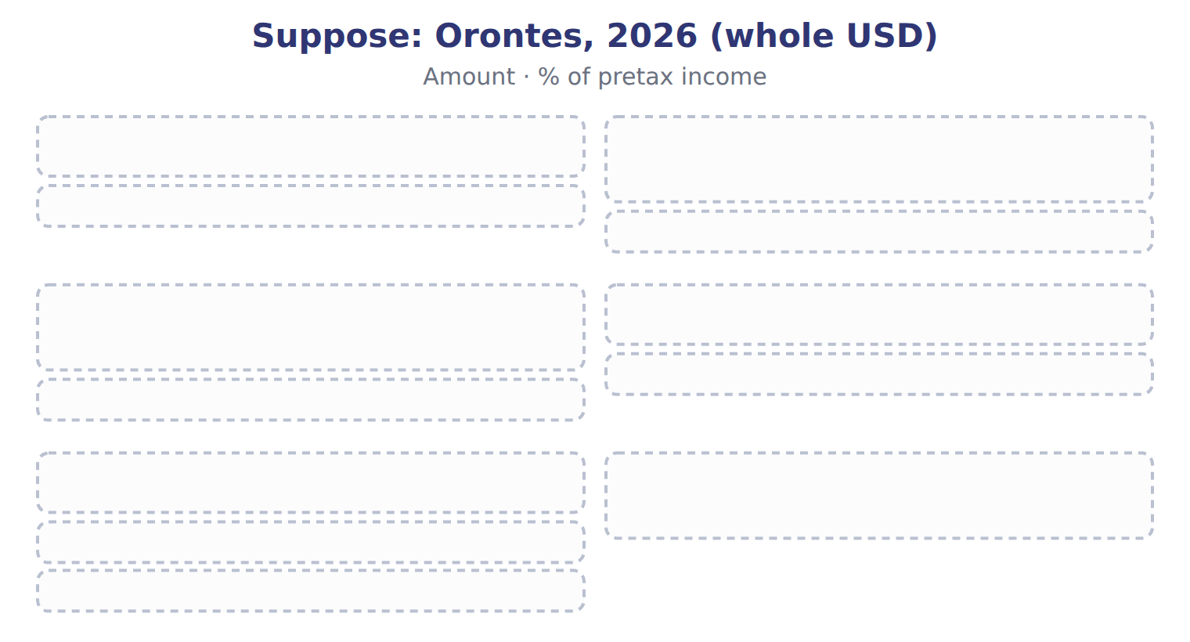
TEACH IT BACK | Write it for a classmate who missed this session — not for the marker.
27. In three or four sentences, write what this section settles and the one rule a reader has to take away.
every one of these words must appear: permanent difference · interperiod tax allocation · tax basis

Handout 13.4
Rate changes, valuation allowances, losses and presentation
section 13.4 of the book
Before you start
Three summaries of this handout, in the book’s own words. Read all three first: together they are the whole session. Then fill the gaps, guessing where you have to.

What this handout settles, cycle by cycle
In this handout | What you will read | How you check it
Rate changes, valuation allowances, losses and presentation | a figure to read · Item · the book’s own rule, gapped | Under ASU 2023-09, a public company with a 21% statutory rate must separately show a reconciling item when it is at least:
The words this section uses precisely | Item · The English the exam uses, and what it translates | What is the safest way to settle a disagreement about an answer on this sheet?

Words this handout uses precisely
Words this handout uses precisely | tick it if you could already use it in a sentence
deferred tax liability
current tax expense
effective tax rate

1. Where the section starts — Fill every gap. The list holds more words than there are gaps, so one or two of them are not used.
choose from: permanent difference · deferred tax asset · valuation allowance · taxable income · deferred tax liability
A is useful only if the company will have enough to use it. If it is more likely than not that some of the asset will not be realized, the company records a .
2. What it settles in the middle — Fill every gap. The list holds more words than there are gaps, so one or two of them are not used.
choose from: taxable income · deferred tax liability · deferred tax asset · net operating loss carryforward · valuation allowance · permanent difference
Decision chart: does a need a ?. A tax loss creates a , which is a deferred tax asset. They can be carried forward without a time limit, but they can reduce only 80% of in any year.
3. Where it ends — Fill every gap. The list holds more words than there are gaps, so one or two of them are not used.
choose from: valuation allowance · deferred tax liability · uncertain tax position · permanent difference
Record the full effect of a rate change in continuing operations when the law is enacted. Record the full DTA, then a : do not record only the probable part. An is recognized only if it is more likely than not to be accepted by the tax authority.

CYCLE A | Rate changes, valuation allowances, losses and presentation

ORIENT One claim. Decide now; you will check it in a moment.

4. The book gives the type of Tax-exempt municipal bond interest as “Permanent”. TRUE / FALSE
MODEL Read it before you answer anything below it.

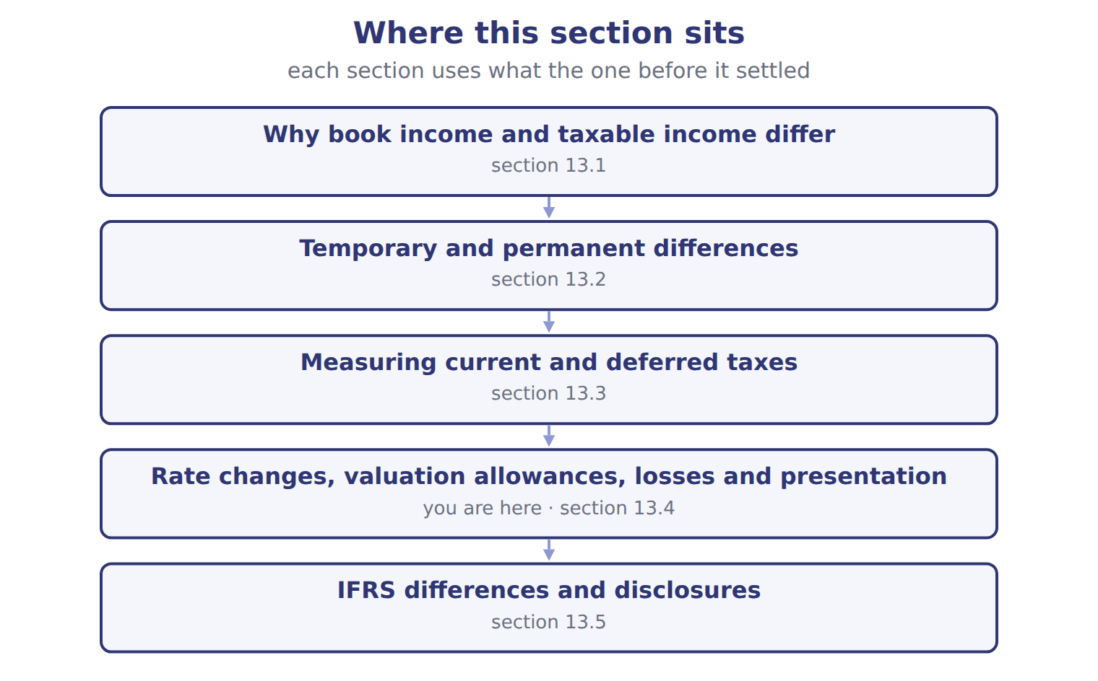

Item — the book’s own table
Item | Type | Creates
Tax-exempt municipal bond interest | Permanent | None
Tax depreciation faster than book depreciation | Temporary, taxable | DTL
Warranty expense accrued now, deducted for tax when repairs are paid | ________ | ________
Fine for breaking an environmental law | ________ | ________
Rent received in advance, taxed when received | ________ | ________
Equity-method income, taxed only when dividends are received | ________ | ________

READ THE MODEL Every answer is printed above. Find it, do not recall it.

5. Which type does the book give for Tax-exempt municipal bond interest?
A. Permanent | C. ________
B. Temporary, taxable
6. Which type does the book give for Tax depreciation faster than book depreciation?
A. ________ | C. Permanent
B. Temporary, taxable
7. Which type does the book give for Warranty expense accrued now, deducted for tax when repairs are paid?
A. ________ | C. Permanent
B. Temporary, taxable
8. Which type does the book give for Fine for breaking an environmental law?
A. Permanent | C. ________
B. Temporary, taxable
9. The book gives the creates of Tax-exempt municipal bond interest as “None”. TRUE / FALSE
10. The book gives the creates of Tax depreciation faster than book depreciation as “________”. TRUE / FALSE
INVENT THE RULE

11. Complete the book’s own sentence. The list holds more words than there are gaps.
use every one of these words: deferred tax asset · taxable income · uncertain tax position · current tax expense
A is useful only if the company will have enough to use it.

Two of the book’s own cases, side by side
Tax-exempt municipal bond interest | Tax depreciation faster than book depreciation
Type: Permanent | Type: Temporary, taxable
Only the facts above differ. What is the creates of Tax-exempt municipal bond interest?
12. Choose one:
A. ________ | C. None
B. DTL

APPLY No help on this move.

13. Under ASU 2023-09, a public company with a 21% statutory rate must separately show a reconciling item when it is at least:
A. 1% of revenue
B. 5% of pretax income multiplied by the statutory rate
C. 10% of tax expense
D. any amount, however small
14. Which pair lists one taxable and one deductible temporary difference?
A. Accelerated tax depreciation; accrued litigation loss
B. Municipal interest; fines
C. Accrued warranty; allowance for credit losses
D. Installment sale; accelerated tax depreciation
WORK IN PAIRS | Compare every answer on this page with your partner before you read any key.
If you disagree: go back to the model and find the row that settles it. The row decides, not the louder voice.
CHECKPOINT 15. Under ASU 2023-09, a public company with a 21% statutory rate must separately show a reconciling item when it is at least:
A. 1% of revenue
B. 5% of pretax income multiplied by the statutory rate
C. 10% of tax expense
D. any amount, however small
If you got it wrong: redo the READ THE MODEL questions of cycle A with the model in front of you.

CYCLE B | The words this section uses precisely

ORIENT

16. A term in the exam means exactly what the book defines it to mean, whatever it means in ordinary English. TRUE / FALSE
MODEL

Item — the book’s own table
Item | Answer
Warranty expense accrued now | Temporary, deductible: DTA
Fine for breaking the law | Permanent: no deferred tax
Rent received in advance | Temporary, deductible (taxed now, earned later): DTA
Equity-method income | Temporary, taxable (taxed later): DTL

The English the exam uses, and what it translates
English (exam term) | the Arabic it translates
deferred tax liability | التزام ضريبي مؤجل
current tax expense | مصروف الضريبة الجارية
effective tax rate | معدل الضريبة الفعلي

READ THE MODEL

17. Which answer does the book give for Warranty expense accrued now?
A. Temporary, deductible: DTA
B. Temporary, deductible (taxed now, earned later): DTA
C. Permanent: no deferred tax
D. Temporary, taxable (taxed later): DTL
18. Which answer does the book give for Fine for breaking the law?
A. Temporary, deductible: DTA
B. Permanent: no deferred tax
C. Temporary, taxable (taxed later): DTL
D. Temporary, deductible (taxed now, earned later): DTA
19. Which answer does the book give for Rent received in advance?
A. Temporary, deductible: DTA
B. Temporary, taxable (taxed later): DTL
C. Temporary, deductible (taxed now, earned later): DTA
D. Permanent: no deferred tax
APPLY

20. Writing a term in English is part of answering the question, not an extra. TRUE / FALSE
CHECKPOINT 21. What is the safest way to settle a disagreement about an answer on this sheet?
A. find the row of the model that decides it
B. take the answer of whoever is more confident
C. leave it until the lecturer says
D. choose the longer option
If you got it wrong: redo the READ THE MODEL questions of cycle B.

FROM MEMORY | Close the earlier pages first.
22. Rebuild the figure from this handout. Label every part and fill in every box.
TEACH IT BACK | Write it for a classmate who missed this session — not for the marker.
23. In three or four sentences, write what this section settles and the one rule a reader has to take away.
every one of these words must appear: deferred tax liability · current tax expense · effective tax rate

Handout 13.5
IFRS differences and disclosures
section 13.5 of the book
Before you start
Three summaries of this handout, in the book’s own words. Read all three first: together they are the whole session. Then fill the gaps, guessing where you have to.

What this handout settles, cycle by cycle
In this handout | What you will read | How you check it
IFRS differences and disclosures | a figure to read · Barada Wholesale, 2027 (whole USD) | Which of these did this cycle settle?
The words this section uses precisely | Topic · The English the exam uses, and what it translates | What is the safest way to settle a disagreement about an answer on this sheet?

Words this handout uses precisely
Words this handout uses precisely | tick it if you could already use it in a sentence
deferred tax asset
deferred tax expense
net operating loss carryforward

1. Where the section starts — Fill every gap. The list holds more words than there are gaps, so one or two of them are not used.
choose from: deferred tax expense · enacted tax rate · valuation allowance · deferred tax asset
The biggest one for the exam is the : IFRS recognizes only the amount it is probable to use, while U.S. GAAP records the full asset and a separate .
2. What it settles in the middle — Fill every gap. The list holds more words than there are gaps, so one or two of them are not used.
choose from: enacted tax rate · deferred tax asset · valuation allowance · deferred tax expense
The biggest one for the exam is the : IFRS recognizes only the amount it is probable to use, while U.S. GAAP records the full asset and a separate . They show a rate reconciliation in dollars and percentages with eight standard categories, and they list separately any item of at least 5% of pretax income times the statutory rate.
3. Where it ends — Fill every gap. The list holds more words than there are gaps, so one or two of them are not used.
choose from: government · enacted tax rate · deferred tax expense · provision · contra-asset
It is an expense, not an IAS 37 (مخصص) and not a reserve. Arabic مخصص التقييم, the valuation allowance, is a , not a liability. SC13-9 A tax rate cut has been announced by the but not yet signed into law.
How every cycle on this sheet works
How a cycle works | what you do
MODEL | read the figure or the table before you answer anything
READ THE MODEL | every answer is printed on the same page
INVENT THE RULE | write the rule yourself, then compare with the book
APPLY | no help on this move
CHECKPOINT | mark it yourself; if you miss it, the sheet says what to redo

CYCLE A | IFRS differences and disclosures

ORIENT One claim. Decide now; you will check it in a moment.

4. Every number in a financial statement belongs to an element the framework defines. TRUE / FALSE
MODEL Read it before you answer anything below it.

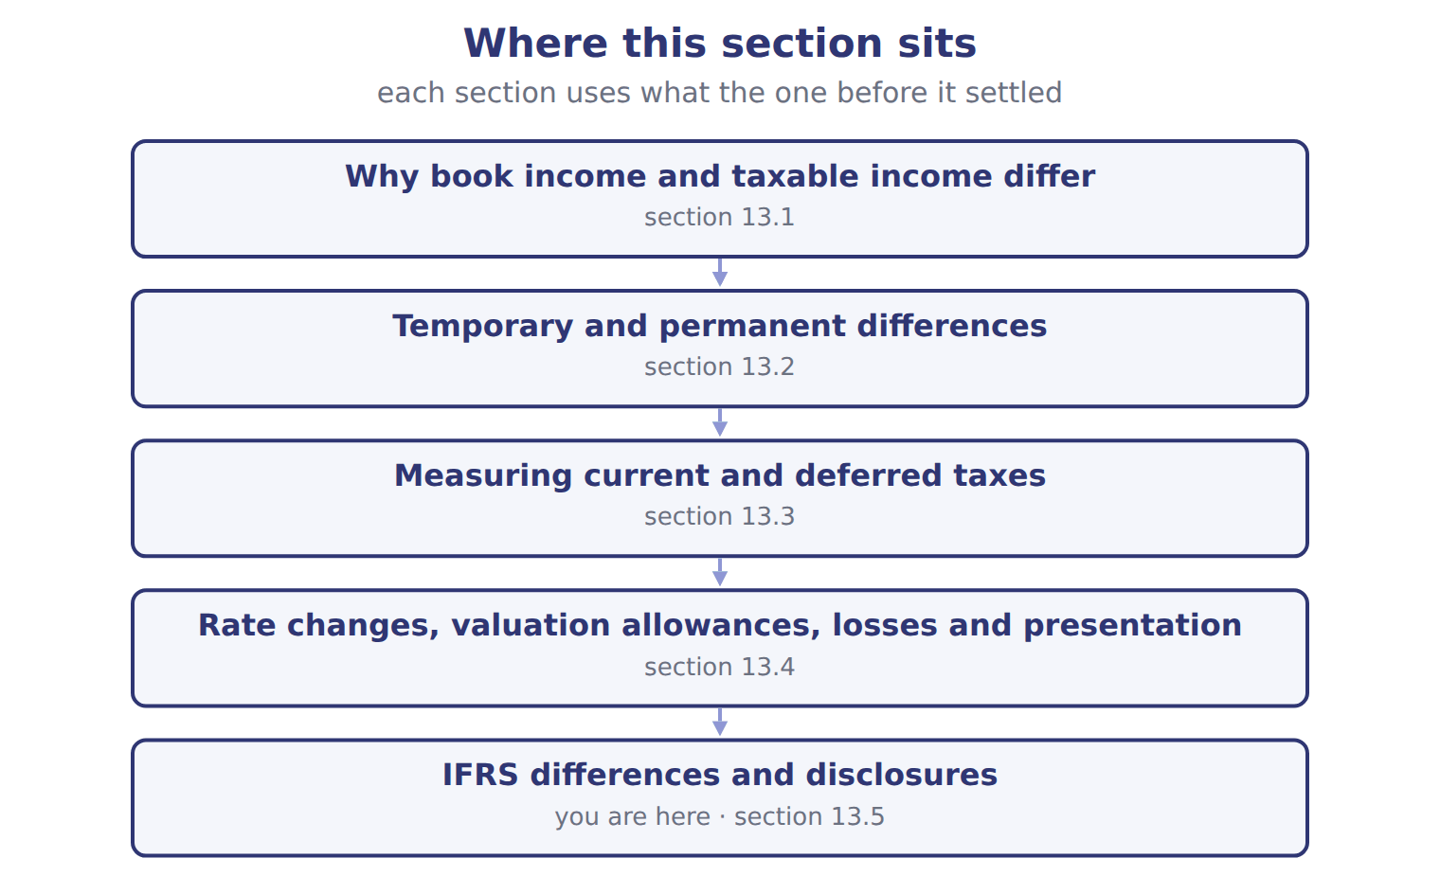

Barada Wholesale, 2027 (whole USD) — the book’s own table
Barada Wholesale, 2027 (whole USD) | Amount / details
Income before income taxes, 2027 | 400,000
Tax-exempt municipal bond interest included in income | 12,000
Fine for a late customs filing (not deductible) | 6,000
Tax depreciation above book depreciation in 2027 | 60,000
Warranty liability at December 31, 2027 (Chapter 12 case); repairs are deductible when paid | 18,000
M1 | The enacted combined tax rate is 25% for 2027 and all later years.
M2 | Barada had no temporary differences at January 1, 2027. All deferred taxes are in one tax jurisdiction.
M3 | Barada has been profitable for many years and expects to stay profitable.

READ THE MODEL Every answer is printed above. Find it, do not recall it.

5. Which part of this chapter is section 13.1?
A. Measuring current and deferred taxes
B. IFRS differences and disclosures
C. Why book income and taxable income differ
D. Temporary and permanent differences
6. Which part of this chapter is section 13.2?
A. Why book income and taxable income differ
B. IFRS differences and disclosures
C. Temporary and permanent differences
D. Measuring current and deferred taxes
7. Which part of this chapter is section 13.3?
A. IFRS differences and disclosures
B. Temporary and permanent differences
C. Why book income and taxable income differ
D. Measuring current and deferred taxes
8. Which part of this chapter is section 13.4?
A. Why book income and taxable income differ
B. Measuring current and deferred taxes
C. Rate changes, valuation allowances, losses and presentation
D. Temporary and permanent differences
APPLY No help on this move.

9. The rule you have just written is the book’s own rule. TRUE / FALSE
WORK IN PAIRS | Compare every answer on this page with your partner before you read any key.
If you disagree: go back to the model and find the row that settles it. The row decides, not the louder voice.
CHECKPOINT 10. Which of these did this cycle settle?
A. the rule and where it comes from
B. nothing in particular
C. only the vocabulary
D. only the arithmetic
If you got it wrong: redo the READ THE MODEL questions of cycle A.

CYCLE B | The words this section uses precisely

ORIENT

11. A term in the exam means exactly what the book defines it to mean, whatever it means in ordinary English. TRUE / FALSE
MODEL

Topic — the book’s own table
Topic | U.S. GAAP (ASC 740) | IFRS (IAS 12)
Recognizing deferred tax assets | Record the full DTA, then a valuation allowance if realization is not more likely than not | Recognize only the amount for which taxable profit is probable
Tax rate | Enacted rates only | Enacted or substantively enacted rates
Initial recognition exemption | None in general | Yes, outside business combinations (narrowed in 2021)
Uncertain tax positions | Two steps: more likely than not, then largest amount over 50% likely | IFRIC 23: most likely amount or expected value
Balance sheet classification | Noncurrent | Non-current
Pillar Two top-up tax | Period cost; no deferred tax | Mandatory exception; no deferred tax

The English the exam uses, and what it translates
English (exam term) | the Arabic it translates
deferred tax asset | أصل ضريبي مؤجل
deferred tax expense | مصروف الضريبة المؤجلة
net operating loss carryforward | ترحيل صافي الخسارة التشغيلية

READ THE MODEL

12. Which topic does the book pair with “Record the full DTA, then a valuation allowance if realization is not more likely than not”?
A. Pillar Two top-up tax | C. Recognizing deferred tax assets
B. Initial recognition exemption | D. Tax rate
13. Which topic does the book pair with “Enacted rates only”?
A. Balance sheet classification | C. Tax rate
B. Recognizing deferred tax assets | D. Pillar Two top-up tax
14. Which topic does the book pair with “None in general”?
A. Uncertain tax positions | C. Initial recognition exemption
B. Recognizing deferred tax assets | D. Balance sheet classification
APPLY

15. Writing a term in English is part of answering the question, not an extra. TRUE / FALSE
CHECKPOINT 16. What is the safest way to settle a disagreement about an answer on this sheet?
A. find the row of the model that decides it
B. take the answer of whoever is more confident
C. leave it until the lecturer says
D. choose the longer option
If you got it wrong: redo the READ THE MODEL questions of cycle B.

FROM MEMORY | Close the earlier pages first.
17. Rebuild the figure from this handout. Label every part and fill in every box.
TEACH IT BACK | Write it for a classmate who missed this session — not for the marker.
18. In three or four sentences, write what this section settles and the one rule a reader has to take away.
every one of these words must appear: deferred tax asset · deferred tax expense · net operating loss carryforward

Handout 13.6
The whole chapter
every section, shuffled, and the chapter’s own case set
Before you start
Three summaries of this chapter, in the book’s own words, with words taken out. Read all three first: together they are the whole chapter. Then fill the gaps.

What this handout settles, cycle by cycle
In this handout | What you will read | How you check it
The whole chapter, in order | a figure to read · Suppose: Orontes, 2026 (whole USD) | The extract for this question is printed with it. What is Orontes's 2026 taxable income (whole USD)?
The chapter’s case set | The chapter’s case set, item by item · Suppose: Orontes, 2026 (whole USD) | What has to be settled before any figure in a case set is worked out?
The words it uses precisely | taxable income · temporary difference · permanent difference · deferred tax liability · deferred tax asset · valuation allowance | matching, at the end of cycle B

1. Where the chapter starts — Fill every gap. The list holds more words than there are gaps, so one or two of them are not used.
choose from: taxable income · tax basis · temporary difference · current tax expense · deferred tax liability · deductible temporary difference · taxable temporary difference
A arises when the of an asset or liability differs from its carrying amount on the balance sheet. A will increase future ; a will reduce it.
2. What it settles in the middle — Fill every gap. The list holds more words than there are gaps, so one or two of them are not used.
choose from: enacted tax rate · Deferred tax expense · deferred tax liability · current tax expense · taxable income · valuation allowance
Current tax is times the tax rate. Deferred tax liabilities and assets are the temporary differences times the that will apply when they reverse. is the change in the net during the year.
3. Where it ends — Fill every gap. The list holds more words than there are gaps, so one or two of them are not used.
choose from: current tax expense · uncertain tax position · valuation allowance · deferred tax asset · deferred tax liability
An is recognized only if it is more likely than not to be accepted by the tax authority. The global minimum tax (Pillar Two) is treated as a current cost in the year it arises, with no deferred taxes. The biggest one for the exam is the : IFRS recognizes only the amount it is probable to use, while U.S. GAAP records the full asset and a separate .

CYCLE A | The whole chapter, in order

ORIENT

4. The sections of a chapter have to be taken in order, because each one uses what the one before it settled. TRUE / FALSE
MODEL

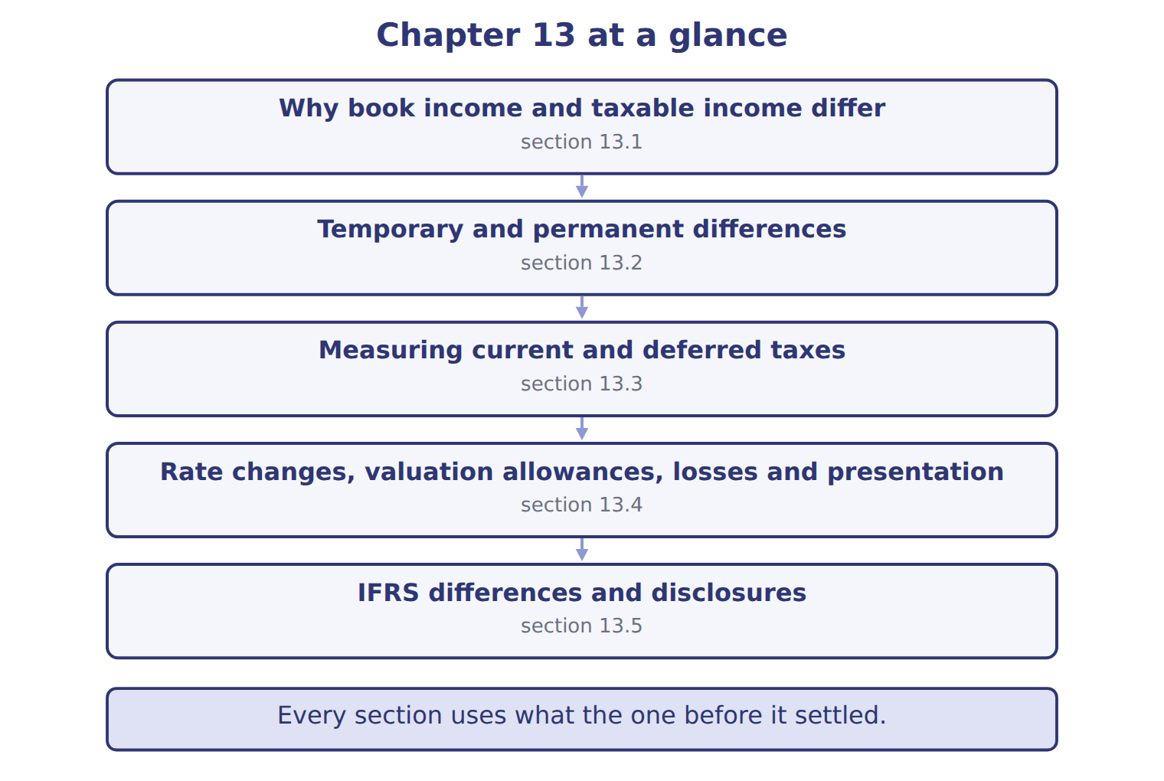
READ THE MODEL

5. Which part of this chapter is section 13.1?
A. Temporary and permanent differences
B. Why book income and taxable income differ
C. Measuring current and deferred taxes
D. IFRS differences and disclosures
6. Which part of this chapter is section 13.2?
A. Temporary and permanent differences
B. Measuring current and deferred taxes
C. IFRS differences and disclosures
D. Why book income and taxable income differ
7. Which part of this chapter is section 13.3?
A. Measuring current and deferred taxes
B. Temporary and permanent differences
C. IFRS differences and disclosures
D. Why book income and taxable income differ
Write the letter of the section number beside each section title. Every number is used once.
A 13.1 | D 13.4
B 13.2 | E 13.5
C 13.3

8. Why book income and taxable income differ
9. Temporary and permanent differences
10. Measuring current and deferred taxes
11. Rate changes, valuation allowances, losses and presentation
12. IFRS differences and disclosures

APPLY

Suppose: Orontes, 2026 (whole USD) — the extract for the question that follows
Suppose: Orontes, 2026 (whole USD) | Amount
Income before income taxes (book) | 2,000,000
Less: tax-exempt municipal interest (permanent) | (20,000)
Add: fine, not deductible (permanent) | 10,000
Less: tax depreciation 900,000 above book depreciation 300,000 (temporary) | (600,000)
Add: warranty expense 60,000 not yet deductible; repairs paid 22,000 (temporary) | 38,000
Taxable income | 1,428,000
Current tax expense at 25% | 357,000

13. The extract for this question is printed with it. What is Orontes's 2026 taxable income (whole USD)?
A. 357,000 | C. 1,990,000
B. 1,428,000 | D. 2,000,000

Suppose: Orontes, 2026 (whole USD) — the extract for the question that follows
Suppose: Orontes, 2026 (whole USD) | Amount | % of pretax income
Current tax expense | 357,000
Deferred tax liability created: 25% × 600,000 | 150,000
Deferred tax asset created: 25% × 38,000 | (9,500)
Deferred tax expense | 140,500
Total income tax expense | 497,500 | 24.875%
Rate reconciliation (ASU 2023-09 style)
Tax at the statutory rate: 25% × 2,000,000 | 500,000 | 25.000%
Nontaxable or nondeductible items: municipal interest | (5,000) | -0.250%
Nontaxable or nondeductible items: fine | 2,500 | 0.125%
Income tax expense and effective tax rate | 497,500 | 24.875%

14. The extract for this question is printed with it. What is Orontes's total income tax expense for 2026 (whole USD)?
A. 159,500 | C. 497,500
B. 357,000 | D. 500,000
15. A company has a deferred tax asset of $100,000. It is more likely than not that only $60,000 will be realized. It reports:
A. a $60,000 asset with no allowance account
B. a $100,000 asset with no allowance
C. a $40,000 liability
D. the $100,000 asset and a $40,000 valuation allowance
16. A tax rate cut has been announced by the government but not yet signed into law. Under IFRS it is substantively enacted. Which rate does a U.S. GAAP company use?
A. The announced rate | C. The rate the company expects
B. An average of the two | D. The current enacted rate
WORK IN PAIRS | Compare every answer with your partner first.
If you disagree: name the section each question belongs to. Most disagreements turn out to be about the section, not the answer.
Suppose: Orontes, 2026 (whole USD) — the extract for the question that follows
Suppose: Orontes, 2026 (whole USD) | Amount
Income before income taxes (book) | 2,000,000
Less: tax-exempt municipal interest (permanent) | (20,000)
Add: fine, not deductible (permanent) | 10,000
Less: tax depreciation 900,000 above book depreciation 300,000 (temporary) | (600,000)
Add: warranty expense 60,000 not yet deductible; repairs paid 22,000 (temporary) | 38,000
Taxable income | 1,428,000
Current tax expense at 25% | 357,000

CHECKPOINT 17. The extract for this question is printed with it. What is Orontes's 2026 taxable income (whole USD)?
A. 357,000
B. 1,428,000
C. 1,990,000
D. 2,000,000
If you got it wrong: go back to the MODEL move of cycle A and find the section this question belongs to.

CYCLE B | The chapter’s case set

ORIENT

18. In a case question, the exhibit has to be read and adjusted before any figure is worked out. TRUE / FALSE

MODEL

The chapter’s case set, item by item
Item | What it asks
C13-1 | Classify each item. (On the exam screen you would drag each item into a box.)
C13-2 | Enter Barada's 2027 taxable income.
C13-3 | Enter Barada's 2027 current tax expense.
C13-4 | Enter Barada's 2027 deferred tax expense.
C13-5 | Enter Barada's 2027 total income tax expense.
C13-6 | How does Barada present its deferred taxes at December 31, 2027? [select]

READ THE MODEL

19. Which of these does item C13-1 ask for?
A. Enter Barada's 2027 deferred tax expense.
B. Enter Barada's 2027 total income tax expense.
C. Classify each item. (On the exam screen you would drag each item into
D. How does Barada present its deferred taxes at December 31, 2027? [sele
20. Which of these does item C13-2 ask for?
A. Enter Barada's 2027 current tax expense.
B. Enter Barada's 2027 deferred tax expense.
C. Enter Barada's 2027 total income tax expense.
D. Enter Barada's 2027 taxable income.
21. Which of these does item C13-3 ask for?
A. Enter Barada's 2027 current tax expense.
B. Enter Barada's 2027 taxable income.
C. Enter Barada's 2027 total income tax expense.
D. Enter Barada's 2027 deferred tax expense.
22. Which of these does item C13-4 ask for?
A. Enter Barada's 2027 current tax expense.
B. Enter Barada's 2027 total income tax expense.
C. Enter Barada's 2027 deferred tax expense.
D. Enter Barada's 2027 taxable income.
23. Which of these does item C13-5 ask for?
A. Enter Barada's 2027 current tax expense.
B. Enter Barada's 2027 taxable income.
C. Enter Barada's 2027 total income tax expense.
D. Enter Barada's 2027 deferred tax expense.
24. Which of these does item C13-6 ask for?
A. Enter Barada's 2027 total income tax expense.
B. How does Barada present its deferred taxes at December 31, 2027? [sele
C. Enter Barada's 2027 deferred tax expense.
D. Classify each item. (On the exam screen you would drag each item into

APPLY

Suppose: Orontes, 2026 (whole USD) — the extract for the question that follows
Suppose: Orontes, 2026 (whole USD) | Amount
Income before income taxes (book) | 2,000,000
Less: tax-exempt municipal interest (permanent) | (20,000)
Add: fine, not deductible (permanent) | 10,000
Less: tax depreciation 900,000 above book depreciation 300,000 (temporary) | (600,000)
Add: warranty expense 60,000 not yet deductible; repairs paid 22,000 (temporary) | 38,000
Taxable income | 1,428,000
Current tax expense at 25% | 357,000

25. The extract for this question is printed with it. What is Orontes's 2026 taxable income (whole USD)?
A. 357,000 | C. 1,990,000
B. 1,428,000 | D. 2,000,000
Suppose: Orontes, 2026 (whole USD) — the extract for the question that follows
Suppose: Orontes, 2026 (whole USD) | Amount | % of pretax income
Current tax expense | 357,000
Deferred tax liability created: 25% × 600,000 | 150,000
Deferred tax asset created: 25% × 38,000 | (9,500)
Deferred tax expense | 140,500
Total income tax expense | 497,500 | 24.875%
Rate reconciliation (ASU 2023-09 style)
Tax at the statutory rate: 25% × 2,000,000 | 500,000 | 25.000%
Nontaxable or nondeductible items: municipal interest | (5,000) | -0.250%
Nontaxable or nondeductible items: fine | 2,500 | 0.125%
Income tax expense and effective tax rate | 497,500 | 24.875%

26. The extract for this question is printed with it. What is Orontes's total income tax expense for 2026 (whole USD)?
A. 159,500 | C. 497,500
B. 357,000 | D. 500,000
CHECKPOINT 27. What has to be settled before any figure in a case set is worked out?
A. the exhibit, adjusted for every note that goes with it
B. the method the company uses
C. the tax rate
D. the order of the items
If you got it wrong: reread the case panel in the MODEL move of cycle B.

FROM MEMORY | Close the earlier pages first.
28. Rebuild the chapter map. Write every section in order and what each one settles.
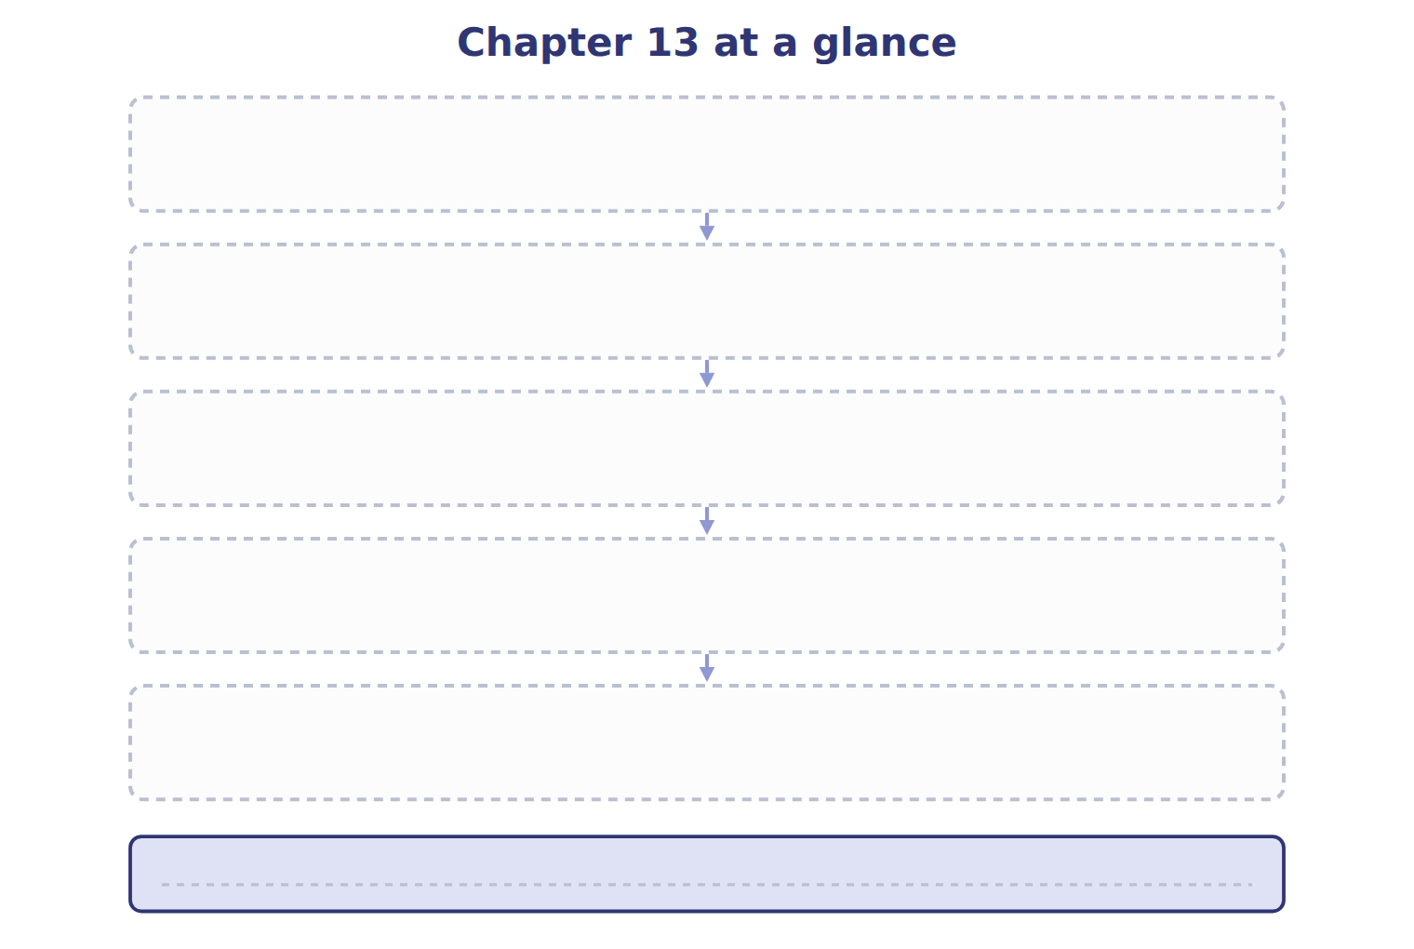
TEACH IT BACK | Write it for a student starting this chapter tomorrow — not for the marker.
29. In four or five sentences, write what the whole chapter settles, section by section.
every one of these words must appear: taxable income · temporary difference · permanent difference · deferred tax liability

