Handout 15.1
Gains and losses
section 15.1 of the book
Before you start
Three summaries of this handout, in the book’s own words. Read all three first: together they are the whole session. Then fill the gaps, guessing where you have to.

What this handout settles, cycle by cycle
In this handout | What you will read | How you check it
Gains and losses | a figure to read · Orontes, 2025 (whole USD) · the book’s own rule, gapped | A company sells land with a carrying amount of $300,000 for $360,000. On the income statement it reports:
The words this section uses precisely | Item · The English the exam uses, and what it translates | What is the safest way to settle a disagreement about an answer on this sheet?

Words this handout uses precisely
Words this handout uses precisely | tick it if you could already use it in a sentence
gain
disposal group
strategic shift

1. Where the section starts — Fill every gap. The list holds more words than there are gaps, so one or two of them are not used.
choose from: gain · disposal group · comprehensive income · loss
A or is an increase or decrease in equity from a peripheral or incidental transaction: something other than the company's main activities and other than a transaction with owners. Selling an old machine, settling a lawsuit and a change in the value of an investment are examples.
2. What it settles in the middle — Fill every gap. The list holds more words than there are gaps, so one or two of them are not used.
choose from: gain · disposal group · comprehensive income · loss
A or is an increase or decrease in equity from a peripheral or incidental transaction: something other than the company's main activities and other than a transaction with owners. Selling an old machine, settling a lawsuit and a change in the value of an investment are examples. In a multi-step statement, most gains and losses appear in other income and expense, below operating income.
3. Where it ends — Fill every gap. The list holds more words than there are gaps, so one or two of them are not used.
choose from: comprehensive income · impairments · infrequent · multi-step · gain
In a statement, most gains and losses appear in other income and expense, below operating income. Losses that arise from operating assets, such as , are usually shown within operating expenses. Items that are unusual or get a separate line within continuing operations, before tax.

CYCLE A | Gains and losses

ORIENT One claim. Decide now; you will check it in a moment.

4. Every number in a financial statement belongs to an element the framework defines. TRUE / FALSE
MODEL Read it before you answer anything below it.

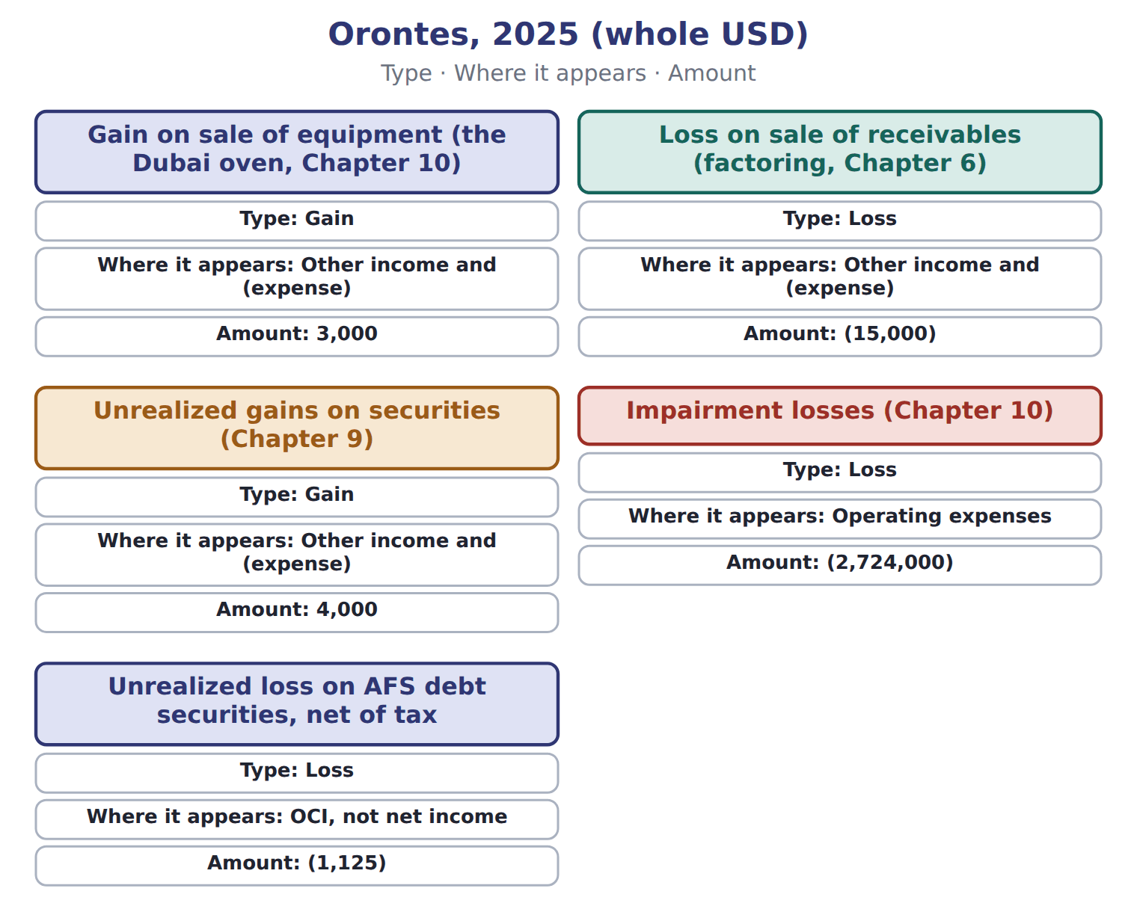

Orontes, 2025 (whole USD) — the book’s own table
Orontes, 2025 (whole USD) | Type | Where it appears | Amount
Gain on sale of equipment (the Dubai oven, Chapter 10) | Gain | Other income and (expense) | 3,000
Loss on sale of receivables (factoring, Chapter 6) | Loss | Other income and (expense) | (15,000)
Unrealized gains on securities (Chapter 9) | Gain | Other income and (expense) | 4,000
Impairment losses (Chapter 10) | Loss | Operating expenses | (2,724,000)
Unrealized loss on AFS debt securities, net of tax | Loss | OCI, not net income | (1,125)

READ THE MODEL Every answer is printed above. Find it, do not recall it.

5. Which where it appears does the book give for Gain on sale of equipment (the Dubai oven, Chapter 10)?
A. Other income and (expense) | C. OCI, not net income
B. Operating expenses
6. Which where it appears does the book give for Loss on sale of receivables (factoring, Chapter 6)?
A. Operating expenses | C. OCI, not net income
B. Other income and (expense)
7. Which where it appears does the book give for Unrealized gains on securities (Chapter 9)?
A. Operating expenses | C. Other income and (expense)
B. OCI, not net income
8. Which where it appears does the book give for Impairment losses (Chapter 10)?
A. Operating expenses | C. OCI, not net income
B. Other income and (expense)
SORT THEM | Write each one under its type. Every item belongs to exactly one group.
the items: Gain on sale of equipment (the Dubai oven, Chapter 10) · Loss on sale of receivables (factoring, Chapter 6) · Unrealized gains on securities (Chapter 9) · Impairment losses (Chapter 10) · Unrealized loss on AFS debt securities, net of tax
Gain | Loss

INVENT THE RULE

11. Complete the book’s own sentence. The list holds more words than there are gaps.
use every one of these words: comprehensive income · gain · loss · strategic shift
A or is an increase or decrease in equity from a peripheral or incidental transaction: something other than the company's main activities and other than a transaction with owners.

Two of the book’s own cases, side by side
Gain on sale of equipment (the Dubai oven, Chapter 10) | Loss on sale of receivables (factoring, Chapter 6)
Type: Gain | Type: Loss
Where it appears: Other income and (expense) | Where it appears: Other income and (expense)
Only the facts above differ. What is the amount of Gain on sale of equipment (the Dubai oven, Chapter 10)?
12. Choose one:
A. (15,000) | C. 3,000
B. 4,000 | D. (2,724,000)
APPLY No help on this move.

13. A company sells land with a carrying amount of $300,000 for $360,000. On the income statement it reports:
A. revenue of $360,000
B. a gain of $60,000 in other income
C. revenue of $360,000 and cost of sales of $300,000
D. a gain of $360,000
14. A company settles a large lawsuit, which is unusual for it, for a loss of $500,000. The loss is presented:
A. as a separate line in continuing operations, before tax
B. as an extraordinary item, net of tax
C. in OCI
D. in discontinued operations
15. Which statement about gains and losses is correct?
A. They are always shown in OCI
B. They are always shown gross
C. They arise from peripheral or incidental transactions and are usually shown net
D. They include dividends paid to owners
16. Which cost is recognized by cause and effect?
A. Depreciation of the head office
B. Research costs
C. The CEO's salary
D. Sales commissions on goods sold this year
WORK IN PAIRS | Compare every answer on this page with your partner before you read any key.
If you disagree: go back to the model and find the row that settles it. The row decides, not the louder voice.
CHECKPOINT 17. A company sells land with a carrying amount of $300,000 for $360,000. On the income statement it reports:
A. revenue of $360,000
B. a gain of $60,000 in other income
C. revenue of $360,000 and cost of sales of $300,000
D. a gain of $360,000
If you got it wrong: redo the READ THE MODEL questions of cycle A with the model in front of you.

CYCLE B | The words this section uses precisely

ORIENT

18. A term in the exam means exactly what the book defines it to mean, whatever it means in ordinary English. TRUE / FALSE

MODEL

Item — the book’s own table
Item | Category
Gain on sale of a warehouse
Lawsuit settlement loss
Dry-foods operating loss
Dry-foods gain on sale
AFS holding gain

The English the exam uses, and what it translates
English (exam term) | the Arabic it translates
gain | مكسب (مكاسب)
disposal group | مجموعة الاستبعاد
strategic shift | تحول استراتيجي

READ THE MODEL

19. A glossary term and its translation are a pair the book itself gives. TRUE / FALSE
APPLY

20. Under U.S. GAAP, costs of researching a new juice recipe are:
A. capitalized as an intangible asset
B. capitalized once the recipe is technically feasible
C. added to inventory
D. expensed when incurred
21. Orontes pays 12 months of rent in advance on July 1. At December 31, the expense recognized is:
A. twelve months of rent
B. nothing until the lease ends
C. six months of rent; the rest is a prepaid asset
D. the whole payment as a period cost
CHECKPOINT 22. What is the safest way to settle a disagreement about an answer on this sheet?
A. find the row of the model that decides it
B. take the answer of whoever is more confident
C. leave it until the lecturer says
D. choose the longer option
If you got it wrong: redo the READ THE MODEL questions of cycle B.

FROM MEMORY | Close the earlier pages first.
23. Rebuild the figure from this handout. Label every part and fill in every box.
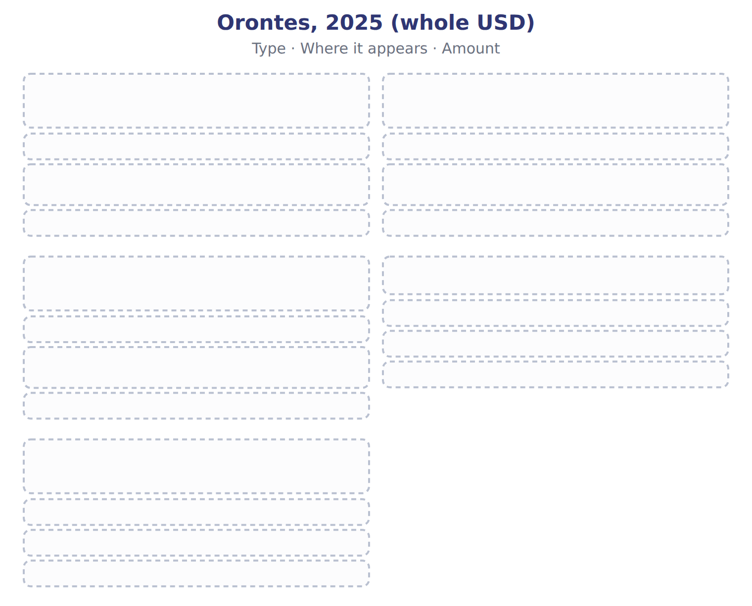
TEACH IT BACK | Write it for a classmate who missed this session — not for the marker.
24. In three or four sentences, write what this section settles and the one rule a reader has to take away.
every one of these words must appear: gain · disposal group · strategic shift

Handout 15.2
Expense recognition
section 15.2 of the book
Before you start
Three summaries of this handout, in the book’s own words. Read all three first: together they are the whole session. Then fill the gaps, guessing where you have to.

What this handout settles, cycle by cycle
In this handout | What you will read | How you check it
Expense recognition | a figure to read · Approach | Which item is part of U.S. OCI?
The words this section uses precisely | Item · The English the exam uses, and what it translates | What is the safest way to settle a disagreement about an answer on this sheet?

Words this handout uses precisely
Words this handout uses precisely | tick it if you could already use it in a sentence
loss
fair value less cost to sell

1. Where the section starts — Fill every gap. The list holds more words than there are gaps, so one or two of them are not used.
choose from: systematic and rational allocation · loss · comprehensive income · period cost
When a cost benefits several periods but cannot be linked to specific revenue, it is spread by . Depreciation of the bottling line and the expiry of prepaid rent are examples. When a cost has no clear link to future revenue, it is a and is expensed at once.
2. What it settles in the middle — Fill every gap. The list holds more words than there are gaps, so one or two of them are not used.
choose from: period cost · comprehensive income · systematic and rational allocation · loss
This is the matching principle from Chapter 11. When a cost benefits several periods but cannot be linked to specific revenue, it is spread by . Depreciation of the bottling line and the expiry of prepaid rent are examples. When a cost has no clear link to future revenue, it is a and is expensed at once.
3. Where it ends — Fill every gap. The list holds more words than there are gaps, so one or two of them are not used.
choose from: systematic and rational allocation · comprehensive income · loss · period cost
When a cost benefits several periods but cannot be linked to specific revenue, it is spread by . Depreciation of the bottling line and the expiry of prepaid rent are examples. When a cost has no clear link to future revenue, it is a and is expensed at once. Advertising and research and development are expensed when incurred, even if they may bring future sales.
How every cycle on this sheet works
How a cycle works | what you do
MODEL | read the figure or the table before you answer anything
READ THE MODEL | every answer is printed on the same page
INVENT THE RULE | write the rule yourself, then compare with the book
APPLY | no help on this move
CHECKPOINT | mark it yourself; if you miss it, the sheet says what to redo

CYCLE A | Expense recognition

ORIENT One claim. Decide now; you will check it in a moment.

4. The book gives the idea of Cause and effect (matching) as “Expense follows the related revenue”. TRUE / FALSE
MODEL Read it before you answer anything below it.

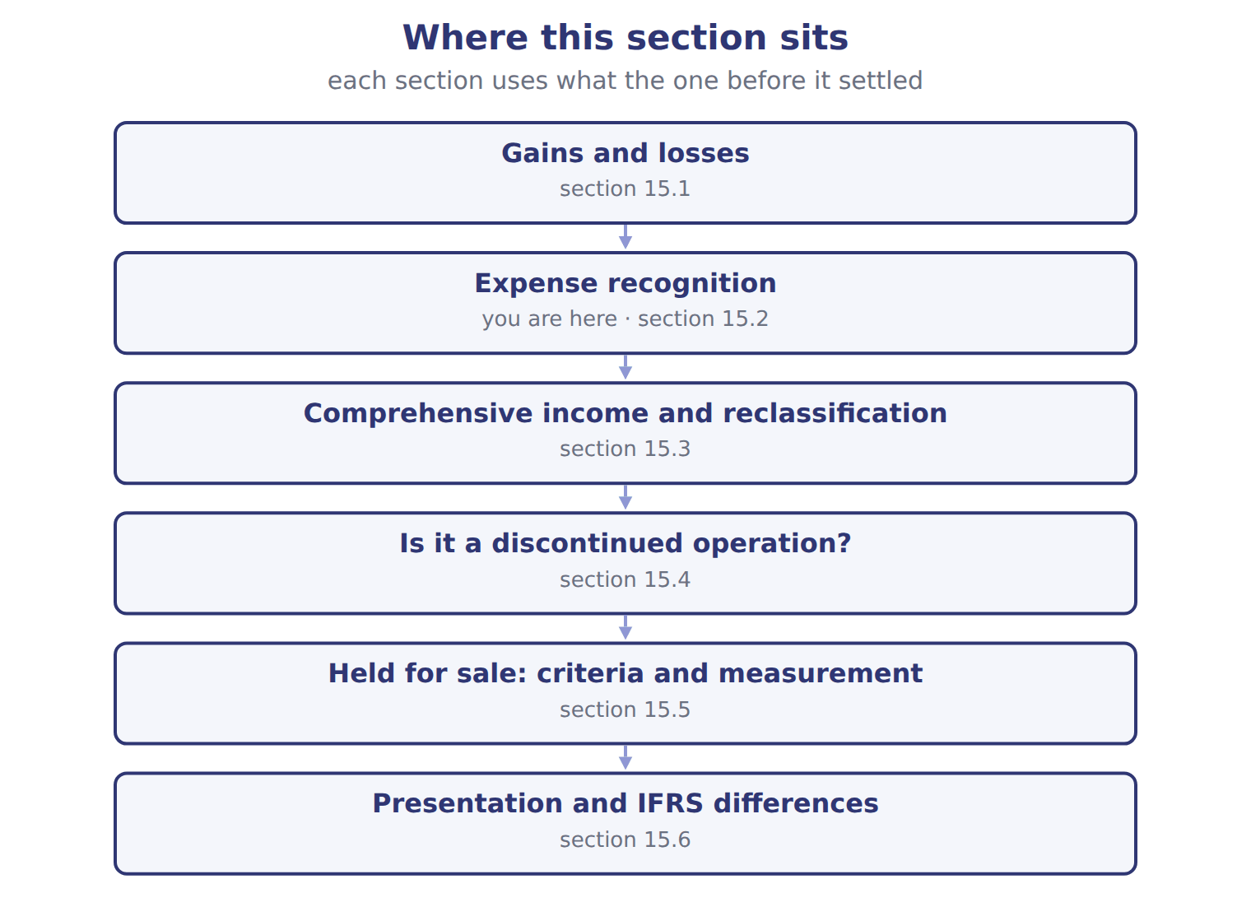

Approach — the book’s own table
Approach | Idea | Orontes examples
Cause and effect (matching) | Expense follows the related revenue | Cost of goods sold; sales commissions (capitalized, Chapter 11)
Systematic and rational allocation | Cost spread over the periods that benefit | Depreciation of the bottling line; prepaid rent
Immediate recognition | No clear link to future revenue: a period cost | Advertising; research and development; most general administration

READ THE MODEL Every answer is printed above. Find it, do not recall it.

5. Which idea does the book give for Cause and effect (matching)?
A. No clear link to future revenue: a period cost
B. Cost spread over the periods that benefit
C. Expense follows the related revenue
6. Which idea does the book give for Systematic and rational allocation?
A. Expense follows the related revenue
B. No clear link to future revenue: a period cost
C. Cost spread over the periods that benefit
7. Which idea does the book give for Immediate recognition?
A. Cost spread over the periods that benefit
B. Expense follows the related revenue
C. No clear link to future revenue: a period cost
8. The book gives the orontes examples of Cause and effect (matching) as “Cost of goods sold; sales commissions (capitalized, Chapter 11)”. TRUE / FALSE
9. The book gives the orontes examples of Systematic and rational allocation as “Advertising; research and development; most general administration”. TRUE / FALSE
APPLY No help on this move.

10. Which item is part of U.S. OCI?
A. A foreign currency translation adjustment
B. An unrealized gain on equity securities
C. A gain on sale of equipment
D. An impairment loss
11. A company sells an AFS bond at a gain of $30,000 that was already in AOCI. What reclassification adjustment appears in OCI in the year of sale?
A. +$30,000 | C. $0
B. −$30,000 | D. −$60,000
12. Net income is $900,000. OCI includes a $50,000 holding gain on AFS bonds and a $20,000 reclassification of gains realized this year. Ignoring tax, what is comprehensive income?
A. $900,000 | C. $950,000
B. $930,000 | D. $970,000
13. Over the whole life of an AFS bond, from purchase to sale, total comprehensive income from the bond equals:
A. the total gain or loss, counted once
B. twice the total gain
C. zero
D. the OCI of the final year
WORK IN PAIRS | Compare every answer on this page with your partner before you read any key.
If you disagree: go back to the model and find the row that settles it. The row decides, not the louder voice.

CHECKPOINT 14. Which item is part of U.S. OCI?
A. A foreign currency translation adjustment
B. An unrealized gain on equity securities
C. A gain on sale of equipment
D. An impairment loss
If you got it wrong: redo the READ THE MODEL questions of cycle A with the model in front of you.

CYCLE B | The words this section uses precisely

ORIENT

15. A term in the exam means exactly what the book defines it to mean, whatever it means in ordinary English. TRUE / FALSE
MODEL

Item — the book’s own table
Item | Category
Gain on sale of a warehouse | Continuing operations
Lawsuit settlement loss | Continuing operations
Dry-foods operating loss | Discontinued operations
Dry-foods gain on sale | Discontinued operations
AFS holding gain | Other comprehensive income

The English the exam uses, and what it translates
English (exam term) | the Arabic it translates
loss | خسارة
fair value less cost to sell | القيمة العادلة ناقصاً تكاليف البيع

READ THE MODEL

16. Which category does the book give for Gain on sale of a warehouse?
A. Other comprehensive income | C. Discontinued operations
B. Continuing operations
17. Which category does the book give for Lawsuit settlement loss?
A. Other comprehensive income | C. Continuing operations
B. Discontinued operations
18. Which category does the book give for Dry-foods operating loss?
A. Other comprehensive income | C. Continuing operations
B. Discontinued operations

APPLY

19. On March 15 a board approves a plan to sell a division, but the division is not yet available for immediate sale. When can it be classified as held for sale?
A. On March 15 | C. At the next year-end
B. When the sale is completed | D. When all six criteria are met
20. A held-for-sale group was written down by $100,000. Its fair value less cost to sell then rises by $150,000 before the sale. What gain may the company recognize?
A. $0 | C. $100,000
B. $50,000 | D. $150,000
CHECKPOINT 21. What is the safest way to settle a disagreement about an answer on this sheet?
A. find the row of the model that decides it
B. take the answer of whoever is more confident
C. leave it until the lecturer says
D. choose the longer option
If you got it wrong: redo the READ THE MODEL questions of cycle B.

FROM MEMORY | Close the earlier pages first.
22. Rebuild the figure from this handout. Label every part and fill in every box.
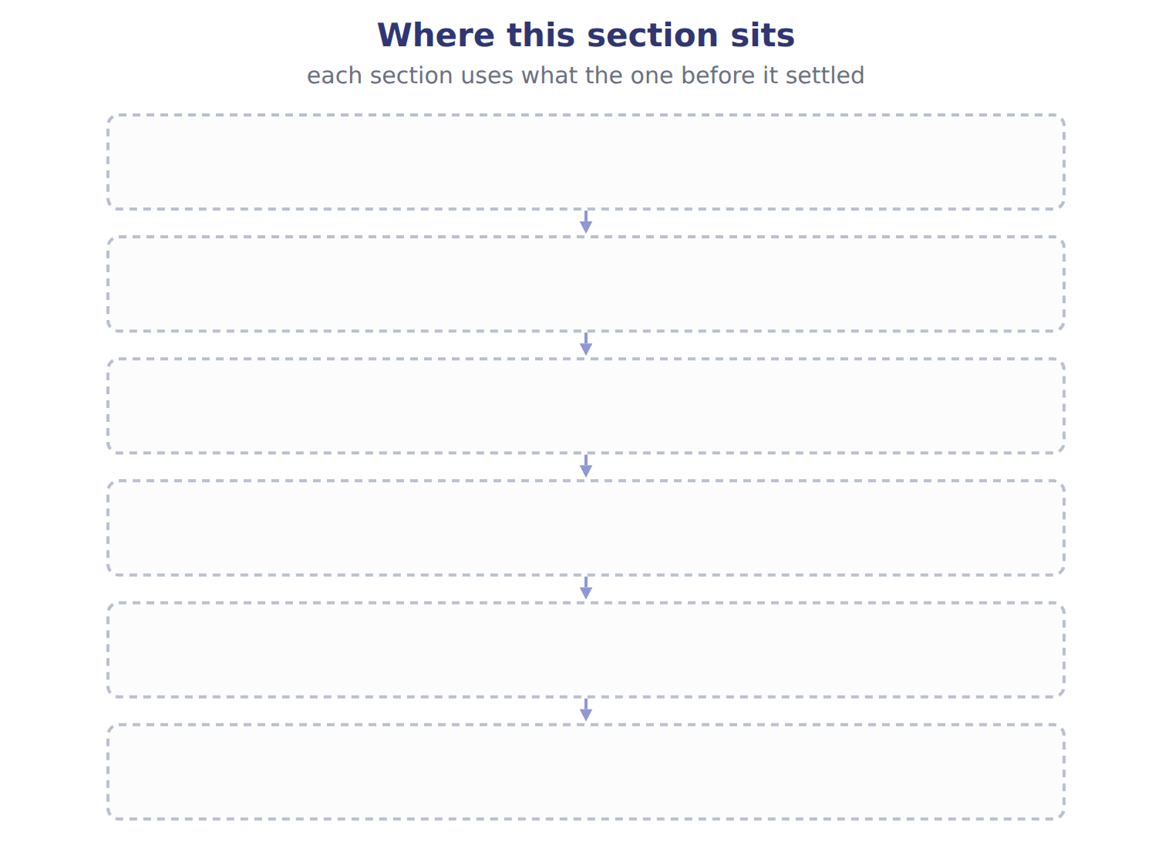
TEACH IT BACK | Write it for a classmate who missed this session — not for the marker.
23. In three or four sentences, write what this section settles and the one rule a reader has to take away.
every one of these words must appear: loss · fair value less cost to sell

Handout 15.3
Comprehensive income and reclassification
section 15.3 of the book
Before you start
Three summaries of this handout, in the book’s own words. Read all three first: together they are the whole session. Then fill the gaps, guessing where you have to.

What this handout settles, cycle by cycle
In this handout | What you will read | How you check it
Comprehensive income and reclassification | a figure to read · Suppose: AFS bond bought for 100,000 · the book’s own rule, gapped | A company sells a major line of business, with an operating loss of $80,000 and a gain on sale of $280,000, both before tax. At a 25% tax rate, what does it report in discontinued operations?
The words this section uses precisely | Item · The English the exam uses, and what it translates | What is the safest way to settle a disagreement about an answer on this sheet?

Words this handout uses precisely
Words this handout uses precisely | tick it if you could already use it in a sentence
comprehensive income
holding gain or loss

1. Where the section starts — Fill every gap. The list holds more words than there are gaps, so one or two of them are not used.
choose from: reclassification adjustment · Comprehensive income · gain · component of an entity · holding gain or loss
OCI and the for an AFS bond over two years. Forgetting the reclassification counts a realized twice. adds this year's OCI, not the AOCI balance. Report OCI net of tax, or before tax with one tax line: do not mix them.
2. What it settles in the middle — Fill every gap. The list holds more words than there are gaps, so one or two of them are not used.
choose from: comprehensive income · gain · holding gain or loss · component of an entity · reclassification adjustment
At the same time a removes it from OCI. Without this adjustment, the same would be counted twice in : once in OCI when it arose, and again in net income on the sale.
3. Where it ends — Fill every gap. The list holds more words than there are gaps, so one or two of them are not used.
choose from: gain · component of an entity · Comprehensive income · reclassification adjustment · holding gain or loss
OCI and the for an AFS bond over two years. Forgetting the reclassification counts a realized twice. adds this year's OCI, not the AOCI balance.

CYCLE A | Comprehensive income and reclassification

ORIENT One claim. Decide now; you will check it in a moment.

4. Every number in a financial statement belongs to an element the framework defines. TRUE / FALSE
MODEL Read it before you answer anything below it.

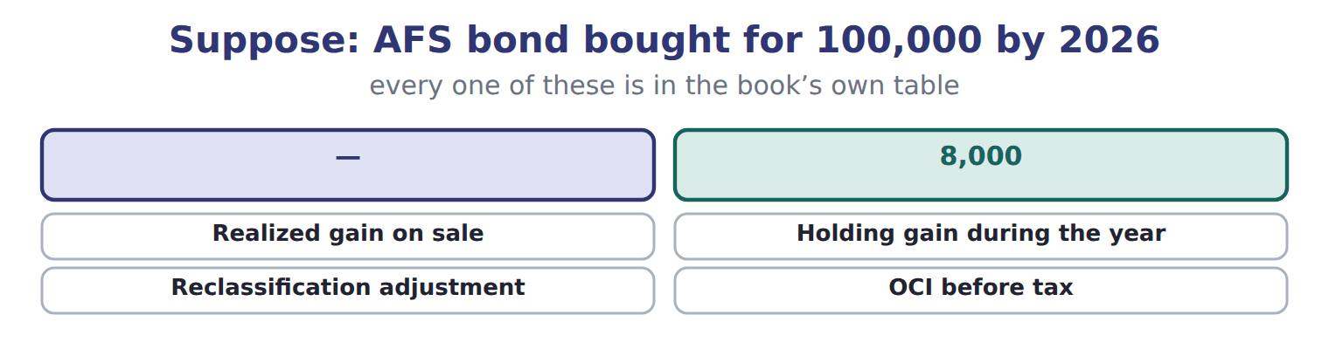

Suppose: AFS bond bought for 100,000 — the book’s own table
Suppose: AFS bond bought for 100,000 | 2026 | 2027
Net income
Realized gain on sale | — | 10,000
Other comprehensive income
Holding gain during the year | 8,000 | 2,000
Reclassification adjustment | — | (10,000)
OCI before tax | 8,000 | (8,000)
Tax at 25% | (2,000) | 2,000
OCI, net of tax | 6,000 | (6,000)
AOCI at year-end (for this bond) | 6,000 | 0

READ THE MODEL Every answer is printed above. Find it, do not recall it.

5. Which part of this chapter is section 15.1?
A. Expense recognition
B. Presentation and IFRS differences
C. Is it a discontinued operation?
D. Gains and losses
6. Which part of this chapter is section 15.2?
A. Expense recognition
B. Gains and losses
C. Presentation and IFRS differences
D. Is it a discontinued operation?
7. Which part of this chapter is section 15.3?
A. Held for sale: criteria and measurement
B. Presentation and IFRS differences
C. Is it a discontinued operation?
D. Comprehensive income and reclassification
8. Which part of this chapter is section 15.4?
A. Comprehensive income and reclassification
B. Presentation and IFRS differences
C. Held for sale: criteria and measurement
D. Is it a discontinued operation?
INVENT THE RULE

9. Complete the book’s own sentence. The list holds more words than there are gaps.
use every one of these words: gain · component of an entity · holding gain or loss · comprehensive income
Without this adjustment, the same would be counted twice in : once in OCI when it arose, and again in net income on the sale.

Two of the book’s own cases, side by side
Realized gain on sale | Holding gain during the year
2026: — | 2026: 8,000
Only the facts above differ. What is the 2027 of Realized gain on sale?
10. Choose one:
A. (8,000) | C. 2,000
B. (10,000) | D. 10,000

APPLY No help on this move.

11. A company sells a major line of business, with an operating loss of $80,000 and a gain on sale of $280,000, both before tax. At a 25% tax rate, what does it report in discontinued operations?
A. A gain of $200,000 | C. A gain of $280,000
B. A gain of $150,000, net of tax | D. A loss of $60,000
12. A company decides to sell a warehouse, which meets the held-for-sale criteria but is not a component. How is it reported?
A. As a discontinued operation
B. In OCI
C. Not at all until sold
D. Separately on the balance sheet as held for sale; its results stay in continuing operations
13. Which item is included in a disposal group held for sale?
A. Goodwill allocated to the component
B. Only the component's PP&E
C. The company's head-office building
D. Retained earnings
14. Under IFRS, what happens to a revaluation surplus on land when the land is sold?
A. It is reclassified to profit or loss
B. It becomes a discontinued operation
C. It is never reclassified to profit; it may be transferred to retained earnings
D. It is reversed through OCI and profit
WORK IN PAIRS | Compare every answer on this page with your partner before you read any key.
If you disagree: go back to the model and find the row that settles it. The row decides, not the louder voice.
CHECKPOINT 15. A company sells a major line of business, with an operating loss of $80,000 and a gain on sale of $280,000, both before tax. At a 25% tax rate, what does it report in discontinued operations?
A. A gain of $200,000
B. A gain of $150,000, net of tax
C. A gain of $280,000
D. A loss of $60,000
If you got it wrong: redo the READ THE MODEL questions of cycle A with the model in front of you.

CYCLE B | The words this section uses precisely

ORIENT

16. A term in the exam means exactly what the book defines it to mean, whatever it means in ordinary English. TRUE / FALSE
MODEL

Item — the book’s own table
Item | Answer
All operations in Jordan | Yes: a major geographic area.
An old bottling machine | No: a single asset; the gain or loss stays in continuing operations.
The stake in Jordan Glass | Yes: a major equity-method investment.
One juice flavour | No: not a strategic shift.

The English the exam uses, and what it translates
English (exam term) | the Arabic it translates
comprehensive income | الدخل الشامل
holding gain or loss | مكسب أو خسارة الاحتفاظ

READ THE MODEL

17. Which answer does the book give for All operations in Jordan?
A. Yes: a major equity-method investment.
B. No: not a strategic shift.
C. Yes: a major geographic area.
D. No: a single asset; the gain or loss stays in continuing operations.
18. Which answer does the book give for An old bottling machine?
A. No: not a strategic shift.
B. Yes: a major geographic area.
C. Yes: a major equity-method investment.
D. No: a single asset; the gain or loss stays in continuing operations.
19. Which answer does the book give for The stake in Jordan Glass?
A. Yes: a major equity-method investment.
B. No: not a strategic shift.
C. No: a single asset; the gain or loss stays in continuing operations.
D. Yes: a major geographic area.
APPLY

20. Writing a term in English is part of answering the question, not an extra. TRUE / FALSE
CHECKPOINT 21. What is the safest way to settle a disagreement about an answer on this sheet?
A. find the row of the model that decides it
B. take the answer of whoever is more confident
C. leave it until the lecturer says
D. choose the longer option
If you got it wrong: redo the READ THE MODEL questions of cycle B.

FROM MEMORY | Close the earlier pages first.
22. Rebuild the figure from this handout. Label every part and fill in every box.
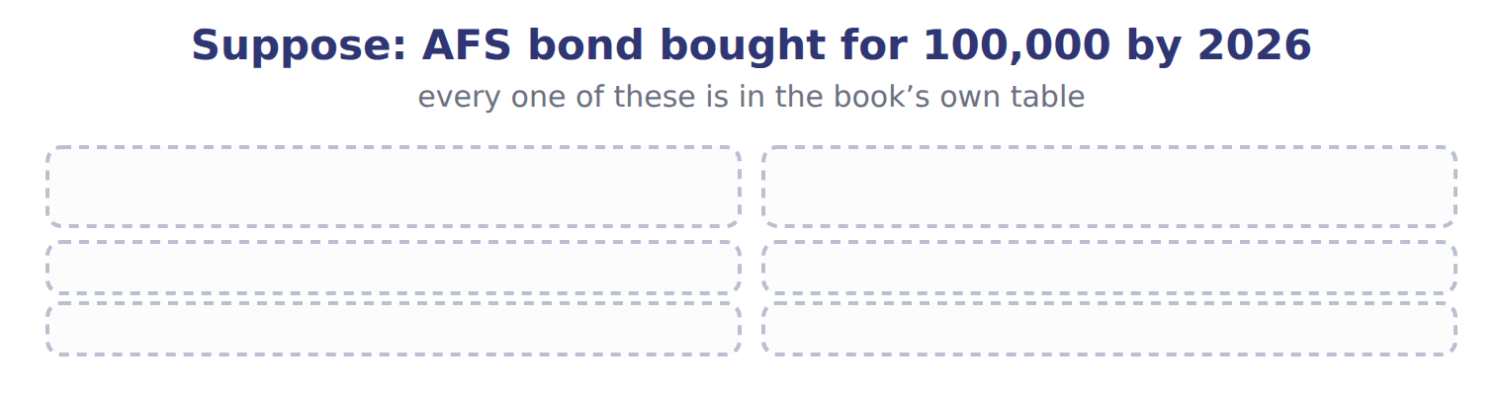
TEACH IT BACK | Write it for a classmate who missed this session — not for the marker.
23. In three or four sentences, write what this section settles and the one rule a reader has to take away.
every one of these words must appear: comprehensive income · holding gain or loss

Handout 15.4
Is it a discontinued operation?
section 15.4 of the book
Before you start
Three summaries of this handout, in the book’s own words. Read all three first: together they are the whole session. Then fill the gaps, guessing where you have to.

What this handout settles, cycle by cycle
In this handout | What you will read | How you check it
Is it a discontinued operation? | a figure to read · Suppose these disposals happen | Which of these did this cycle settle?
The words this section uses precisely | The English the exam uses, and what it translates | What is the safest way to settle a disagreement about an answer on this sheet?

Words this handout uses precisely
Words this handout uses precisely | tick it if you could already use it in a sentence
reclassification adjustment
period cost

1. Where the section starts — Fill every gap. The list holds more words than there are gaps, so one or two of them are not used.
choose from: period cost · component of an entity · discontinued operation · strategic shift · gain
A disposal is reported as a only if three things are true. First, it is a : its operations and cash flows can be clearly separated from the rest of the company. Second, the disposal is a that has, or will have, a major effect on operations and results.
2. What it settles in the middle — Fill every gap. The list holds more words than there are gaps, so one or two of them are not used.
choose from: held for sale · strategic shift · gain · discontinued operation
Third, the component has been sold, abandoned or spun off, or it is . Examples of a are leaving a major line of business, a major geographic area or a major equity-method investment. There is no official percentage for 'major'; it is a judgment.
3. Where it ends — Fill every gap. The list holds more words than there are gaps, so one or two of them are not used.
choose from: gain · loss · strategic shift · period cost · component of an entity · discontinued operation
Selling one machine, one store or one small product is not a . The or stays in continuing operations, as for the Dubai oven. A business that meets the held-for-sale criteria when it is acquired is also a .
How every cycle on this sheet works
How a cycle works | what you do
MODEL | read the figure or the table before you answer anything
READ THE MODEL | every answer is printed on the same page
INVENT THE RULE | write the rule yourself, then compare with the book
APPLY | no help on this move
CHECKPOINT | mark it yourself; if you miss it, the sheet says what to redo

CYCLE A | Is it a discontinued operation?

ORIENT One claim. Decide now; you will check it in a moment.

4. Every number in a financial statement belongs to an element the framework defines. TRUE / FALSE
MODEL Read it before you answer anything below it.

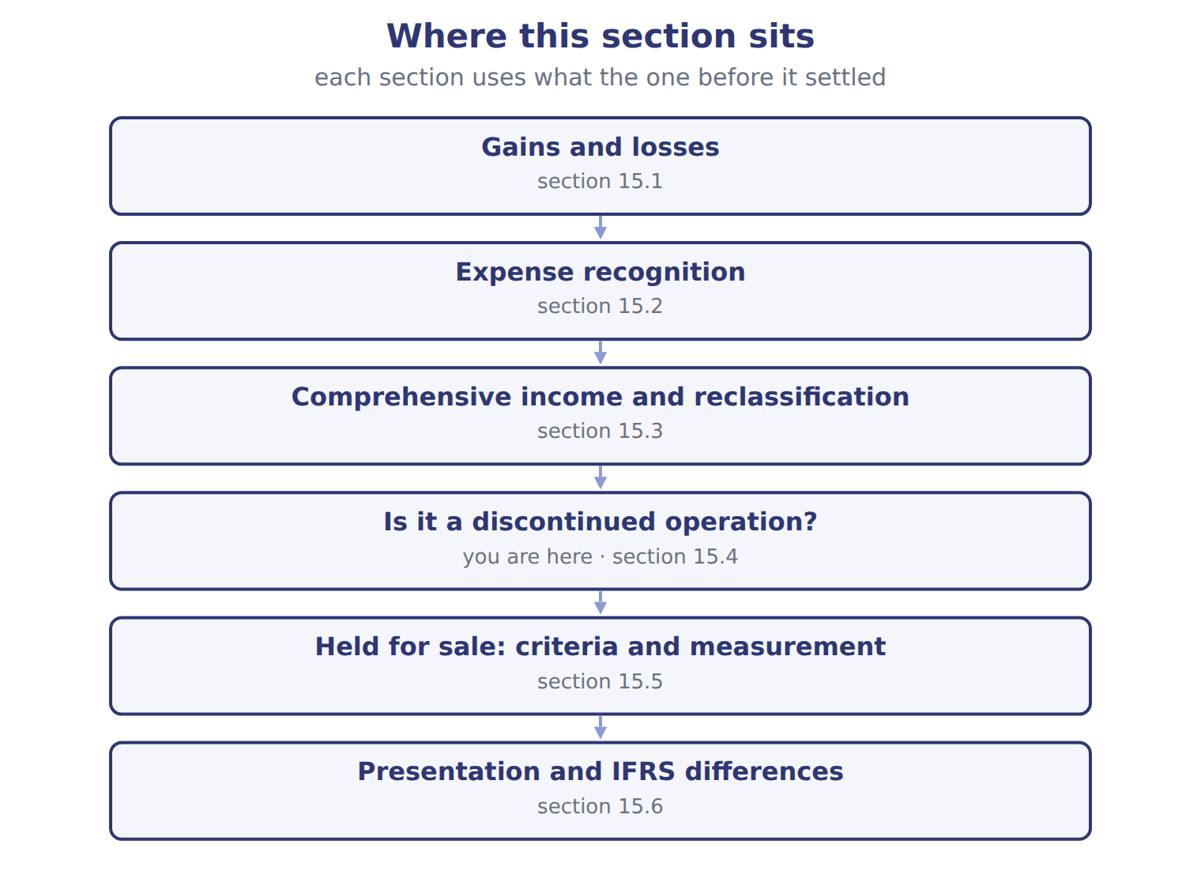

Suppose these disposals happen — the book’s own table
Suppose these disposals happen | Discontinued operation?
Orontes sells its whole frozen-foods business, one of its four product lines | Yes: a major line of business
Orontes closes one of its twelve olive-oil shops | No: not a strategic shift
Orontes sells all its operations in Jordan, its only foreign market | ________
Orontes sells an old bottling machine | ________
Orontes sells its 30% stake in Jordan Glass, a major equity-method investment | ________
Orontes stops selling one flavour of juice | ________

READ THE MODEL Every answer is printed above. Find it, do not recall it.

5. Which discontinued operation? does the book give for Orontes closes one of its twelve olive-oil shops?
A. No: not a strategic shift | C. ________
B. Yes: a major line of business
6. Which discontinued operation? does the book give for Orontes sells all its operations in Jordan, its only foreign market?
A. No: not a strategic shift | C. Yes: a major line of business
B. ________
7. Which discontinued operation? does the book give for Orontes sells an old bottling machine?
A. ________ | C. No: not a strategic shift
B. Yes: a major line of business
APPLY No help on this move.

8. The rule you have just written is the book’s own rule. TRUE / FALSE
WORK IN PAIRS | Compare every answer on this page with your partner before you read any key.
If you disagree: go back to the model and find the row that settles it. The row decides, not the louder voice.
CHECKPOINT 9. Which of these did this cycle settle?
A. the rule and where it comes from
B. nothing in particular
C. only the vocabulary
D. only the arithmetic
If you got it wrong: redo the READ THE MODEL questions of cycle A.

CYCLE B | The words this section uses precisely

ORIENT

10. A term in the exam means exactly what the book defines it to mean, whatever it means in ordinary English. TRUE / FALSE

MODEL

The English the exam uses, and what it translates
English (exam term) | the Arabic it translates
reclassification adjustment | تعديل إعادة التصنيف
period cost | تكلفة الفترة

READ THE MODEL

11. A glossary term and its translation are a pair the book itself gives. TRUE / FALSE
APPLY

12. Writing a term in English is part of answering the question, not an extra. TRUE / FALSE
CHECKPOINT 13. What is the safest way to settle a disagreement about an answer on this sheet?
A. find the row of the model that decides it
B. take the answer of whoever is more confident
C. leave it until the lecturer says
D. choose the longer option
If you got it wrong: redo the READ THE MODEL questions of cycle B.

FROM MEMORY | Close the earlier pages first.
14. Rebuild the figure from this handout. Label every part and fill in every box.
TEACH IT BACK | Write it for a classmate who missed this session — not for the marker.
15. In three or four sentences, write what this section settles and the one rule a reader has to take away.
every one of these words must appear: reclassification adjustment · period cost

Handout 15.5
Held for sale: criteria and measurement
section 15.5 of the book
Before you start
Three summaries of this handout, in the book’s own words. Read all three first: together they are the whole session. Then fill the gaps, guessing where you have to.

What this handout settles, cycle by cycle
In this handout | What you will read | How you check it
Held for sale: criteria and measurement | a figure to read · Suppose: frozen-foods disposal group, June 30, 2 | Which item is a gain rather than revenue for Orontes?
The words this section uses precisely | The English the exam uses, and what it translates · Orontes, 2025 (whole USD) | What is the safest way to settle a disagreement about an answer on this sheet?

Words this handout uses precisely
Words this handout uses precisely | tick it if you could already use it in a sentence
discontinued operation
systematic and rational allocation

1. Where the section starts — Fill every gap. The list holds more words than there are gaps, so one or two of them are not used.
choose from: held for sale · discontinued operation · disposal group · fair value less cost to sell · strategic shift
A component can be reported as discontinued before it is sold, once it is . A held-for-sale is measured at the lower of its carrying amount and its .
2. What it settles in the middle — Fill every gap. The list holds more words than there are gaps, so one or two of them are not used.
choose from: discontinued operation · strategic shift · held for sale · loss
The board approved the plan in March, but the business became only on June 30, when all six criteria were met. Timeline of the frozen-foods business: plan, held for sale, sale. This is the disposal that Chapter 3 reported.
3. Where it ends — Fill every gap. The list holds more words than there are gaps, so one or two of them are not used.
choose from: discontinued operation · held for sale · disposal group · fair value less cost to sell · strategic shift
A component can be reported as discontinued before it is sold, once it is . A held-for-sale is measured at the lower of its carrying amount and its . Depreciation stops, and later increases in value are recognized only up to the losses already recorded.

CYCLE A | Held for sale: criteria and measurement

ORIENT One claim. Decide now; you will check it in a moment.

4. Every number in a financial statement belongs to an element the framework defines. TRUE / FALSE
MODEL Read it before you answer anything below it.

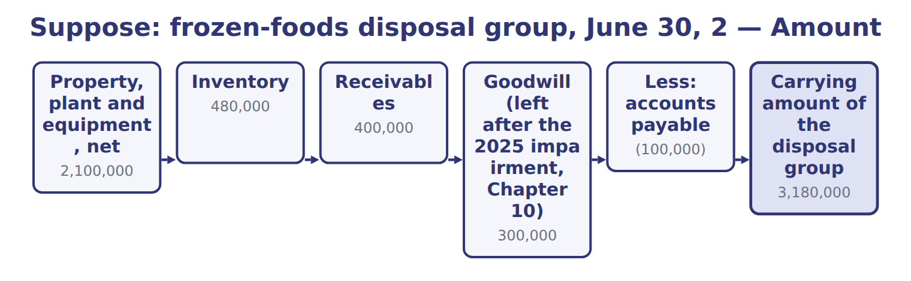
Suppose: frozen-foods disposal group, June 30, 2 — the book’s own table
Suppose: frozen-foods disposal group, June 30, 2 | Amount
Property, plant and equipment, net | 2,100,000
Inventory | 480,000
Receivables | 400,000
Goodwill (left after the 2025 impairment, Chapter 10) | 300,000
Less: accounts payable | (100,000)
Carrying amount of the disposal group | 3,180,000
Fair value less cost to sell | 3,000,000
Remeasurement loss (in discontinued operations) | 180,000
Held-for-sale group at June 30, 2026 | 3,000,000

READ THE MODEL Every answer is printed above. Find it, do not recall it.

5. Which amount does the book give for Property, plant and equipment, net?
A. 3,180,000 | C. 2,100,000
B. (100,000) | D. 3,000,000
6. Which amount does the book give for Inventory?
A. 400,000 | C. 180,000
B. 300,000 | D. 480,000
7. Which amount does the book give for Receivables?
A. 300,000 | C. 180,000
B. 480,000 | D. 400,000
8. Which amount does the book give for Goodwill (left after the 2025 impairment, Chapter 10)?
A. 400,000 | C. 180,000
B. 480,000 | D. 300,000

APPLY No help on this move.

9. Depreciation of the bottling line is an example of which expense recognition approach?
A. Cause and effect
B. Systematic and rational allocation
C. Immediate recognition
D. Cash basis
10. Orontes spends $200,000 on a TV advertising campaign that it expects to raise sales next year. The cost is:
A. capitalized and amortized over next year
B. added to inventory
C. expensed when incurred
D. deferred until the sales occur
WORK IN PAIRS | Compare every answer on this page with your partner before you read any key.
If you disagree: go back to the model and find the row that settles it. The row decides, not the louder voice.
CHECKPOINT 11. Which item is a gain rather than revenue for Orontes?
A. The excess of proceeds over carrying amount when it sells an old oven
B. Sales of olive oil to supermarkets
C. Fees for maintaining dispensers
D. Sales of fruit juices
If you got it wrong: redo the READ THE MODEL questions of cycle A with the model in front of you.

CYCLE B | The words this section uses precisely

ORIENT

12. A term in the exam means exactly what the book defines it to mean, whatever it means in ordinary English. TRUE / FALSE
MODEL

The English the exam uses, and what it translates
English (exam term) | the Arabic it translates
discontinued operation | العمليات غير المستمرة (المتوقفة)
systematic and rational allocation | التوزيع المنتظم والمنطقي

READ THE MODEL

13. A glossary term and its translation are a pair the book itself gives. TRUE / FALSE
APPLY

Orontes, 2025 (whole USD) — the extract for the question that follows
Orontes, 2025 (whole USD) | Type | Where it appears | Amount
Gain on sale of equipment (the Dubai oven, Chapter 10) | Gain | Other income and (expense) | 3,000
Loss on sale of receivables (factoring, Chapter 6) | Loss | Other income and (expense) | (15,000)
Unrealized gains on securities (Chapter 9) | Gain | Other income and (expense) | 4,000
Impairment losses (Chapter 10) | Loss | Operating expenses | (2,724,000)
Unrealized loss on AFS debt securities, net of tax | Loss | OCI, not net income | (1,125)

14. The extract for this question is printed with it. Where does Orontes report its 2025 impairment losses?
A. In other income and expense
B. In OCI
C. Net of tax below continuing operations
D. Within operating expenses
CHECKPOINT 15. What is the safest way to settle a disagreement about an answer on this sheet?
A. find the row of the model that decides it
B. take the answer of whoever is more confident
C. leave it until the lecturer says
D. choose the longer option
If you got it wrong: redo the READ THE MODEL questions of cycle B.

FROM MEMORY | Close the earlier pages first.
16. Rebuild the figure from this handout. Label every part and fill in every box.
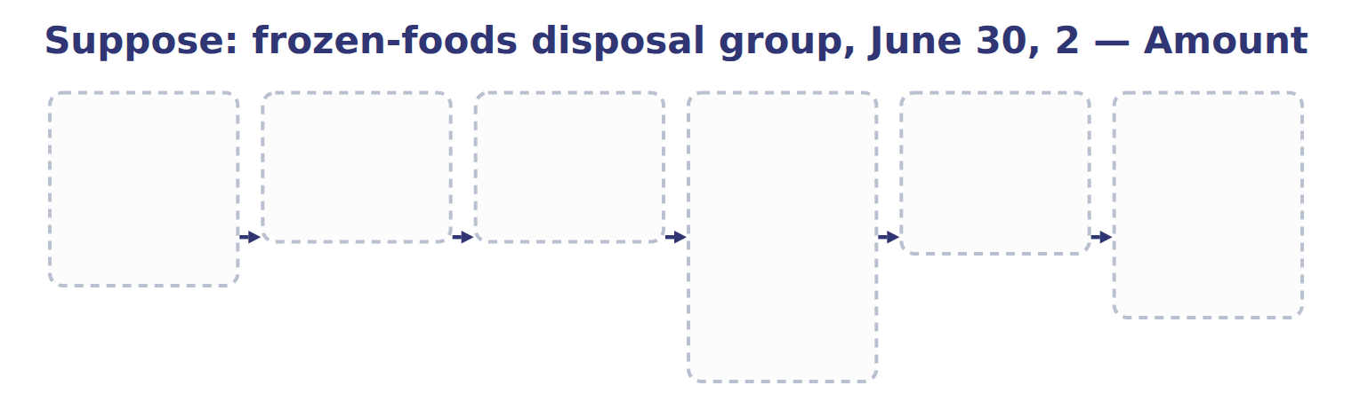
TEACH IT BACK | Write it for a classmate who missed this session — not for the marker.
17. In three or four sentences, write what this section settles and the one rule a reader has to take away.
every one of these words must appear: discontinued operation · systematic and rational allocation

Handout 15.6
Presentation and IFRS differences
section 15.6 of the book
Before you start
Three summaries of this handout, in the book’s own words. Read all three first: together they are the whole session. Then fill the gaps, guessing where you have to.

What this handout settles, cycle by cycle
In this handout | What you will read | How you check it
Presentation and IFRS differences | a figure to read · Suppose: Orontes, 2027 (USD 000) | Which of these did this cycle settle?
The words this section uses precisely | Topic · The English the exam uses, and what it translates | What is the safest way to settle a disagreement about an answer on this sheet?

Words this handout uses precisely
Words this handout uses precisely | tick it if you could already use it in a sentence
held for sale
component of an entity

1. Where the section starts — Fill every gap. The list holds more words than there are gaps, so one or two of them are not used.
choose from: held for sale · discontinued operation · loss · gain · strategic shift
The results of a , including its operating results and any remeasurement or disposal or , are shown net of their own tax below income from continuing operations. Public companies also show per-share amounts for discontinued operations.
2. What it settles in the middle — Fill every gap. The list holds more words than there are gaps, so one or two of them are not used.
choose from: loss · strategic shift · gain · held for sale · discontinued operation
The results of a , including its operating results and any remeasurement or disposal or , are shown net of their own tax below income from continuing operations. Public companies also show per-share amounts for discontinued operations. The comparative years are reclassified so that all periods are shown on the same basis.
3. Where it ends — Fill every gap. The list holds more words than there are gaps, so one or two of them are not used.
choose from: held for sale · strategic shift · loss · discontinued operation
Under IFRS 5, a must be a separate major line of business or geographical area, and earlier balance sheets are not re-presented. Some IFRS OCI items, such as a revaluation surplus, never return to profit or .
How every cycle on this sheet works
How a cycle works | what you do
MODEL | read the figure or the table before you answer anything
READ THE MODEL | every answer is printed on the same page
INVENT THE RULE | write the rule yourself, then compare with the book
APPLY | no help on this move
CHECKPOINT | mark it yourself; if you miss it, the sheet says what to redo

CYCLE A | Presentation and IFRS differences

ORIENT One claim. Decide now; you will check it in a moment.

4. Every number in a financial statement belongs to an element the framework defines. TRUE / FALSE
MODEL Read it before you answer anything below it.

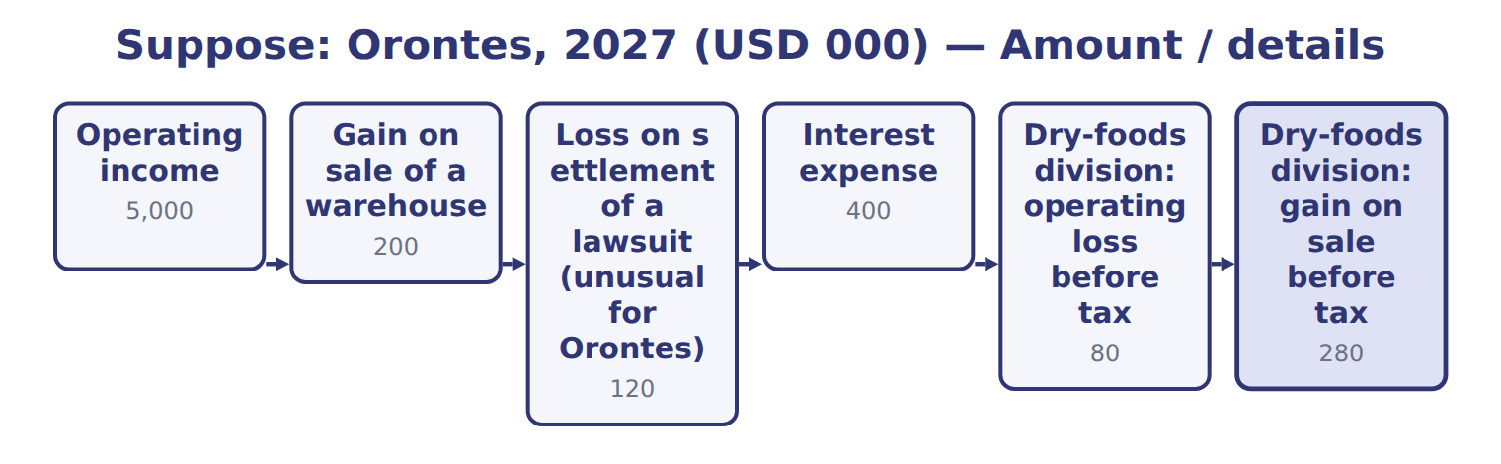
Suppose: Orontes, 2027 (USD 000) — the book’s own table
Suppose: Orontes, 2027 (USD 000) | Amount / details
Operating income | 5,000
Gain on sale of a warehouse | 200
Loss on settlement of a lawsuit (unusual for Orontes) | 120
Interest expense | 400
Dry-foods division: operating loss before tax | 80
Dry-foods division: gain on sale before tax | 280
Unrealized holding gain on AFS debt securities during 2027 | 40
Realized gain on AFS securities sold in 2027 (included in AOCI before) | 24
M1 | In 2027 Orontes sold its dry-foods division, one of its main product lines. The sale is a strategic shift with a major effect.
M2 | The tax rate is 25% on all items. The realized AFS gain is already in the other income figures.

Suppose: Orontes, 2027 (USD 000) — the book’s own table (continued)
Suppose: Orontes, 2027 (USD 000) | Amount / details
M3 | Orontes presents one continuous statement of comprehensive income.

READ THE MODEL Every answer is printed above. Find it, do not recall it.

5. Which part of this chapter is section 15.1?
A. Expense recognition
B. Presentation and IFRS differences
C. Is it a discontinued operation?
D. Gains and losses
6. Which part of this chapter is section 15.2?
A. Expense recognition
B. Gains and losses
C. Presentation and IFRS differences
D. Is it a discontinued operation?
7. Which part of this chapter is section 15.3?
A. Held for sale: criteria and measurement
B. Presentation and IFRS differences
C. Is it a discontinued operation?
D. Comprehensive income and reclassification
8. Which part of this chapter is section 15.4?
A. Comprehensive income and reclassification
B. Presentation and IFRS differences
C. Held for sale: criteria and measurement
D. Is it a discontinued operation?
APPLY No help on this move.

9. The rule you have just written is the book’s own rule. TRUE / FALSE
WORK IN PAIRS | Compare every answer on this page with your partner before you read any key.
If you disagree: go back to the model and find the row that settles it. The row decides, not the louder voice.
CHECKPOINT 10. Which of these did this cycle settle?
A. the rule and where it comes from
B. nothing in particular
C. only the vocabulary
D. only the arithmetic
If you got it wrong: redo the READ THE MODEL questions of cycle A.

CYCLE B | The words this section uses precisely

ORIENT

11. A term in the exam means exactly what the book defines it to mean, whatever it means in ordinary English. TRUE / FALSE

MODEL

Topic — the book’s own table
Topic | U.S. GAAP | IFRS (IFRS 5, IAS 1, IFRS 18)
Definition of discontinued operation | Component + strategic shift with a major effect | Separate major line of business or geographical area
Sale expected within a year | Probable | Highly probable
Balance sheet of earlier years | Re-presented: assets and liabilities shown separately | Not re-presented
OCI later reclassified to profit | All OCI items | Some items never (e.g., revaluation surplus)
Extraordinary items | Not allowed | Not allowed
Presentation from 2027 | Unchanged | IFRS 18 categories (not testable before about 2028)

The English the exam uses, and what it translates
English (exam term) | the Arabic it translates
held for sale | محتفظ به للبيع
component of an entity | مكوِّن من مكونات المنشأة

READ THE MODEL

12. Which topic does the book pair with “Component + strategic shift with a major effect”?
A. OCI later reclassified to profit
B. Presentation from 2027
C. Balance sheet of earlier years
D. Definition of discontinued operation
13. Which topic does the book pair with “Probable”?
A. Presentation from 2027 | C. Sale expected within a year
B. Extraordinary items | D. Balance sheet of earlier years
14. Which topic does the book pair with “Re-presented: assets and liabilities shown separately”?
A. Extraordinary items | C. Sale expected within a year
B. Presentation from 2027 | D. Balance sheet of earlier years
APPLY

15. Writing a term in English is part of answering the question, not an extra. TRUE / FALSE
CHECKPOINT 16. What is the safest way to settle a disagreement about an answer on this sheet?
A. find the row of the model that decides it
B. take the answer of whoever is more confident
C. leave it until the lecturer says
D. choose the longer option
If you got it wrong: redo the READ THE MODEL questions of cycle B.

FROM MEMORY | Close the earlier pages first.
17. Rebuild the figure from this handout. Label every part and fill in every box.
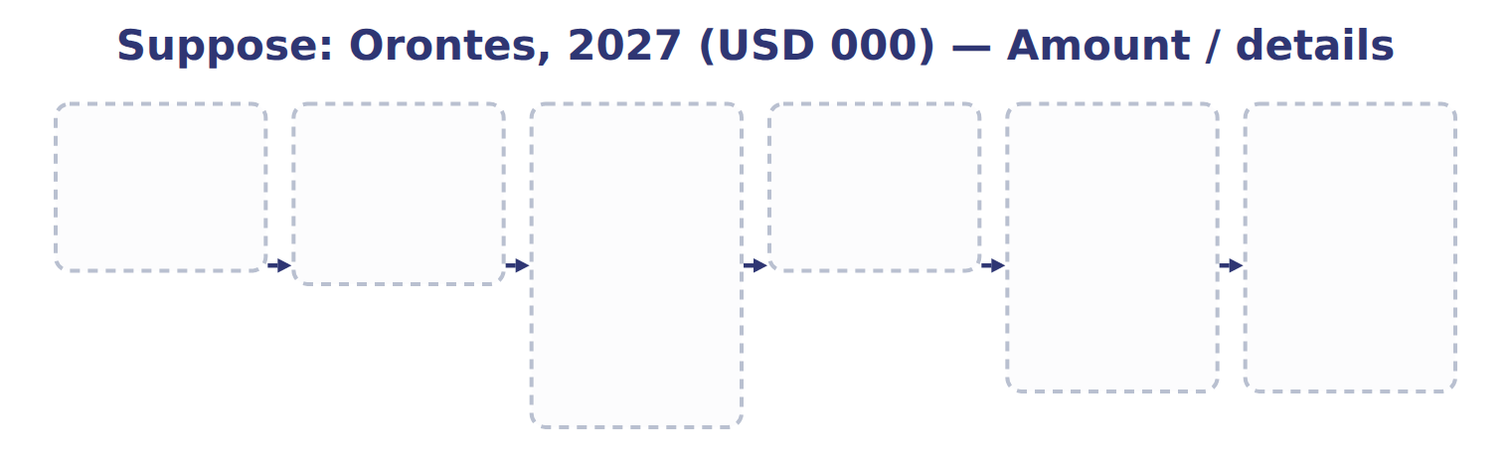
TEACH IT BACK | Write it for a classmate who missed this session — not for the marker.
18. In three or four sentences, write what this section settles and the one rule a reader has to take away.
every one of these words must appear: held for sale · component of an entity

Handout 15.7
The whole chapter
every section, shuffled, and the chapter’s own case set
Before you start
Three summaries of this chapter, in the book’s own words, with words taken out. Read all three first: together they are the whole chapter. Then fill the gaps.

What this handout settles, cycle by cycle
In this handout | What you will read | How you check it
The whole chapter, in order | a figure to read · Suppose: AFS bond bought for 100,000 | The extract for this question is printed with it. What is Orontes's OCI for 2027 before tax (whole USD)?
The chapter’s case set | The chapter’s case set, item by item · Suppose: AFS bond bought for 100,000 | What has to be settled before any figure in a case set is worked out?
The words it uses precisely | gain · loss · comprehensive income · reclassification adjustment · discontinued operation · held for sale | matching, at the end of cycle B

1. Where the chapter starts — Fill every gap. The list holds more words than there are gaps, so one or two of them are not used.
choose from: strategic shift · reclassification adjustment · disposal group · gain
Unrealized s on equity securities are not OCI; they go to net income. When an OCI item is realized, for example when an AFS bond is sold, the gain moves into net income. At the same time a removes it from OCI.
2. What it settles in the middle — Fill every gap. The list holds more words than there are gaps, so one or two of them are not used.
choose from: held for sale · strategic shift · discontinued operation · loss · disposal group · gain
Selling one machine, one store or one small product is not a . The or stays in continuing operations, as for the Dubai oven. A business that meets the held-for-sale criteria when it is acquired is also a .
3. Where it ends — Fill every gap. The list holds more words than there are gaps, so one or two of them are not used.
choose from: discontinued operation · gain · held for sale · loss · strategic shift · disposal group
Stop depreciation once the group is . The results of a , including its operating results and any remeasurement or disposal or , are shown net of their own tax below income from continuing operations.

CYCLE A | The whole chapter, in order

ORIENT

4. The sections of a chapter have to be taken in order, because each one uses what the one before it settled. TRUE / FALSE
MODEL

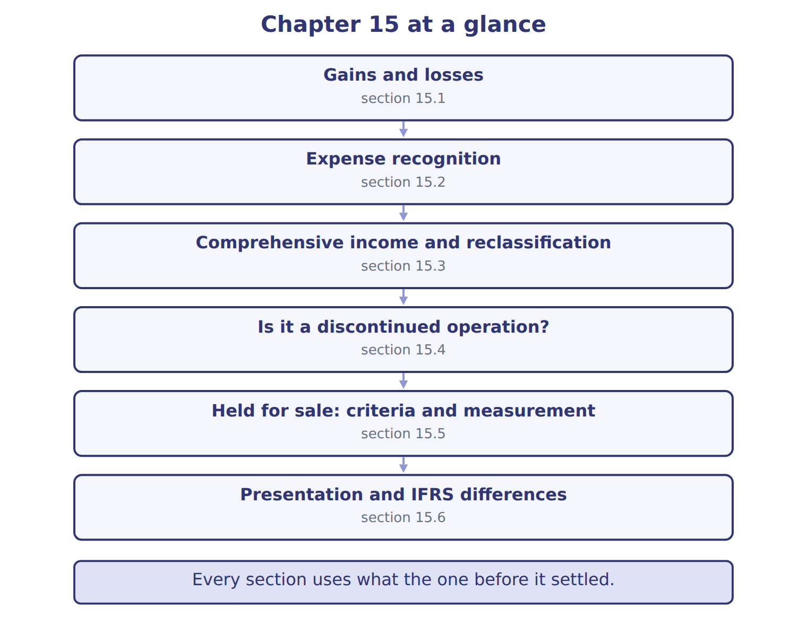
READ THE MODEL

5. Which part of this chapter is section 15.1?
A. Is it a discontinued operation?
B. Presentation and IFRS differences
C. Gains and losses
D. Expense recognition
6. Which part of this chapter is section 15.2?
A. Presentation and IFRS differences
B. Is it a discontinued operation?
C. Expense recognition
D. Gains and losses
7. Which part of this chapter is section 15.3?
A. Comprehensive income and reclassification
B. Is it a discontinued operation?
C. Held for sale: criteria and measurement
D. Presentation and IFRS differences
Write the letter of the section number beside each section title. Every number is used once.
A 15.1 | D 15.4
B 15.2 | E 15.5
C 15.3 | F 15.6

8. Gains and losses
9. Expense recognition
10. Comprehensive income and reclassification
11. Is it a discontinued operation?
12. Held for sale: criteria and measurement
13. Presentation and IFRS differences

APPLY

14. A company reports a discontinued operation in 2027. How does it present the 2026 comparative income statement?
A. It leaves 2026 unchanged
B. It reclassifies the component's 2026 results into discontinued operations
C. It removes 2026 from the statements
D. It restates 2026 retained earnings
WORK IN PAIRS | Compare every answer with your partner first.
If you disagree: name the section each question belongs to. Most disagreements turn out to be about the section, not the answer.
Suppose: AFS bond bought for 100,000 — the extract for the question that follows
Suppose: AFS bond bought for 100,000 | 2026 | 2027
Net income
Realized gain on sale | — | 10,000
Other comprehensive income
Holding gain during the year | 8,000 | 2,000
Reclassification adjustment | — | (10,000)
OCI before tax | 8,000 | (8,000)
Tax at 25% | (2,000) | 2,000
OCI, net of tax | 6,000 | (6,000)
AOCI at year-end (for this bond) | 6,000 | 0

CHECKPOINT 15. The extract for this question is printed with it. What is Orontes's OCI for 2027 before tax (whole USD)?
A. (8,000)
B. 0
C. 2,000
D. 10,000
If you got it wrong: go back to the MODEL move of cycle A and find the section this question belongs to.

CYCLE B | The chapter’s case set

ORIENT

16. In a case question, the exhibit has to be read and adjusted before any figure is worked out. TRUE / FALSE

MODEL

The chapter’s case set, item by item
Item | What it asks
C15-1 | Place each item in the statement of comprehensive income. (On the exam screen you would drag each item into a box.)
C15-2 | Enter income from continuing operations, net of tax.
C15-3 | Enter income from discontinued operations, net of tax.
C15-4 | Enter net income.
C15-5 | Enter OCI, net of tax.
C15-6 | Enter comprehensive income.

READ THE MODEL

17. Which of these does item C15-1 ask for?
A. Enter comprehensive income.
B. Place each item in the statement of comprehensive income. (On the exam
C. Enter income from discontinued operations, net of tax.
D. Enter income from continuing operations, net of tax.
18. Which of these does item C15-2 ask for?
A. Enter income from continuing operations, net of tax.
B. Enter income from discontinued operations, net of tax.
C. Enter comprehensive income.
D. Place each item in the statement of comprehensive income. (On the exam
19. Which of these does item C15-3 ask for?
A. Enter income from discontinued operations, net of tax.
B. Enter income from continuing operations, net of tax.
C. Enter comprehensive income.
D. Place each item in the statement of comprehensive income. (On the exam
20. Which of these does item C15-4 ask for?
A. Enter comprehensive income.
B. Enter income from continuing operations, net of tax.
C. Enter net income.
D. Enter OCI, net of tax.
21. Which of these does item C15-5 ask for?
A. Enter OCI, net of tax.
B. Enter net income.
C. Enter income from continuing operations, net of tax.
D. Enter comprehensive income.
22. Which of these does item C15-6 ask for?
A. Enter income from continuing operations, net of tax.
B. Enter comprehensive income.
C. Enter net income.
D. Enter OCI, net of tax.

APPLY

Suppose: AFS bond bought for 100,000 — the extract for the question that follows
Suppose: AFS bond bought for 100,000 | 2026 | 2027
Net income
Realized gain on sale | — | 10,000
Other comprehensive income
Holding gain during the year | 8,000 | 2,000
Reclassification adjustment | — | (10,000)
OCI before tax | 8,000 | (8,000)
Tax at 25% | (2,000) | 2,000
OCI, net of tax | 6,000 | (6,000)
AOCI at year-end (for this bond) | 6,000 | 0

23. The extract for this question is printed with it. What is Orontes's OCI for 2027 before tax (whole USD)?
A. (8,000) | C. 2,000
B. 0 | D. 10,000
24. Which disposal is a discontinued operation?
A. Selling all operations in the company's only foreign country
B. Closing one of twelve shops
C. Selling an old delivery van
D. Stopping one small product
CHECKPOINT 25. What has to be settled before any figure in a case set is worked out?
A. the exhibit, adjusted for every note that goes with it
B. the method the company uses
C. the tax rate
D. the order of the items
If you got it wrong: reread the case panel in the MODEL move of cycle B.

FROM MEMORY | Close the earlier pages first.
26. Rebuild the chapter map. Write every section in order and what each one settles.
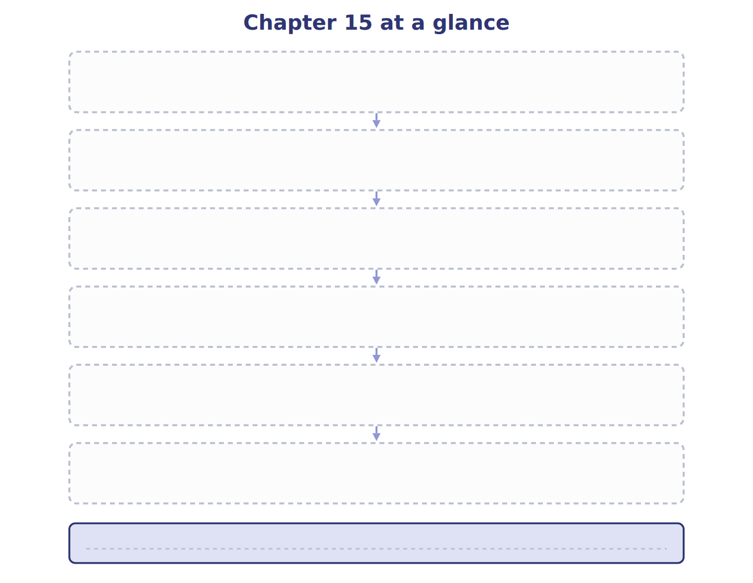
TEACH IT BACK | Write it for a student starting this chapter tomorrow — not for the marker.
27. In four or five sentences, write what the whole chapter settles, section by section.
every one of these words must appear: gain · loss · comprehensive income · reclassification adjustment

