Handout 16.1
What consolidated statements are
section 16.1 of the book
Before you start
Three summaries of this handout, in the book’s own words. Read all three first: together they are the whole session. Then fill the gaps, guessing where you have to.

What this handout settles, cycle by cycle
In this handout | What you will read | How you check it
What consolidated statements are | a figure to read · Item | A parent owns 80% of a subsidiary. What part of the subsidiary's revenue appears in the consolidated income statement?
The words this section uses precisely | Investment · The English the exam uses, and what it translates | What is the safest way to settle a disagreement about an answer on this sheet?

Words this handout uses precisely
Words this handout uses precisely | tick it if you could already use it in a sentence
consolidated financial statements
intercompany transaction
acquisition method

1. Where the section starts — Fill every gap. The list holds more words than there are gaps, so one or two of them are not used.
choose from: controlling financial interest · Consolidated financial statements · downstream sale · parent · joint venture
present a and its subsidiaries as a single economic entity. They are prepared mainly for the parent's shareholders and creditors, who need to see all the resources the group controls and all its obligations. A company consolidates another entity when it has a in it.
2. What it settles in the middle — Fill every gap. The list holds more words than there are gaps, so one or two of them are not used.
choose from: noncontrolling interest · parent · subsidiary · downstream sale · joint venture
Consolidation adds all of the 's assets, liabilities, revenues and expenses to the 's, line by line, even when the parent owns less than all of its shares. The part of a subsidiary's equity that the parent does not own is the (NCI).
3. Where it ends — Fill every gap. The list holds more words than there are gaps, so one or two of them are not used.
choose from: downstream sale · joint venture · parent · noncontrolling interest
Net income and comprehensive income are split between the and NCI on the face of the statements. These older terms still appear in many MENA and French texts. The exam uses (الحصص غير المسيطرة, participations ne donnant pas le contrôle).

CYCLE A | What consolidated statements are

ORIENT One claim. Decide now; you will check it in a moment.

4. The book gives the answer of Less: upstream unrealized profit as “(25,000)”. TRUE / FALSE
MODEL Read it before you answer anything below it.

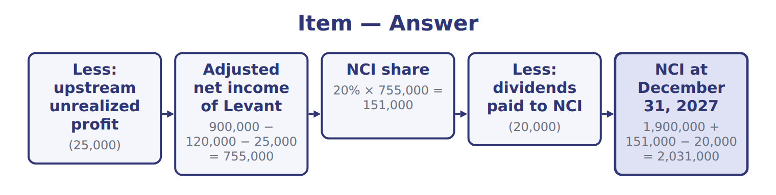
Item — the book’s own table
Item | Answer
Less: upstream unrealized profit | (25,000)
Adjusted net income of Levant | 900,000 − 120,000 − 25,000 = 755,000
NCI share | 20% × 755,000 = 151,000
Less: dividends paid to NCI | (20,000)
NCI at December 31, 2027 | 1,900,000 + 151,000 − 20,000 = 2,031,000

READ THE MODEL Every answer is printed above. Find it, do not recall it.

5. Which answer does the book give for Less: upstream unrealized profit?
A. 20% × 755,000 = 151,000
B. 900,000 − 120,000 − 25,000 = 755,000
C. (25,000)
D. (20,000)
6. Which answer does the book give for Adjusted net income of Levant?
A. (25,000)
B. 1,900,000 + 151,000 − 20,000 = 2,031,000
C. 900,000 − 120,000 − 25,000 = 755,000
D. 20% × 755,000 = 151,000
7. Which answer does the book give for NCI share?
A. (20,000)
B. 900,000 − 120,000 − 25,000 = 755,000
C. (25,000)
D. 20% × 755,000 = 151,000
8. Which answer does the book give for Less: dividends paid to NCI?
A. (20,000)
B. (25,000)
C. 20% × 755,000 = 151,000
D. 900,000 − 120,000 − 25,000 = 755,000
9. The book gives the answer of Less: upstream unrealized profit as “(25,000)”. TRUE / FALSE
10. The book gives the answer of Adjusted net income of Levant as “20% × 755,000 = 151,000”. TRUE / FALSE

APPLY No help on this move.

11. A parent owns 80% of a subsidiary. What part of the subsidiary's revenue appears in the consolidated income statement?
A. 80%
B. 20%
C. None; only the parent's share of net income
D. 100%
12. How is consolidated net income presented under U.S. GAAP?
A. Only the parent's share is shown
B. NCI's share is shown as an expense
C. In total, then split between the parent and NCI on the face
D. NCI's share is shown only in the notes
13. A parent pays $5,000,000 for 70% of a company. NCI is worth $2,000,000, and net assets at fair value are $6,500,000. What is goodwill under U.S. GAAP?
A. $0 | C. $500,000
B. $450,000 | D. $1,500,000
14. After an acquisition, the subsidiary has losses and NCI would become negative. Under U.S. GAAP:
A. losses are still attributed to NCI, even if NCI becomes negative
B. all losses go to the parent once NCI reaches zero
C. NCI is reclassified as a liability
D. the parent stops consolidating
WORK IN PAIRS | Compare every answer on this page with your partner before you read any key.
If you disagree: go back to the model and find the row that settles it. The row decides, not the louder voice.
CHECKPOINT 15. A parent owns 80% of a subsidiary. What part of the subsidiary's revenue appears in the consolidated income statement?
A. 80%
B. 20%
C. None; only the parent's share of net income
D. 100%
If you got it wrong: redo the READ THE MODEL questions of cycle A with the model in front of you.

CYCLE B | The words this section uses precisely

ORIENT

16. A term in the exam means exactly what the book defines it to mean, whatever it means in ordinary English. TRUE / FALSE
MODEL

Investment — the book’s own table
Investment | Category
Tadmor Retail (75%)
Supplier (30%, significant influence)
Listed food company (8%)
Cold-storage SPV that Barada directs and guarantees (VIE)

The English the exam uses, and what it translates
English (exam term) | the Arabic it translates
consolidated financial statements | القوائم المالية الموحدة
intercompany transaction | المعاملة داخل المجموعة
acquisition method | طريقة الاستحواذ

READ THE MODEL

17. A glossary term and its translation are a pair the book itself gives. TRUE / FALSE
APPLY

18. Which feature suggests that an entity is a VIE?
A. It has many shareholders
B. Its equity at risk is too small to finance its activities without extra support
C. It pays dividends
D. Its shares are listed
19. A bank lends to a VIE and bears large losses if it fails, but has no power over its activities. The bank:
A. is the primary beneficiary because it bears the losses
B. must use the equity method
C. is not the primary beneficiary
D. must use proportionate consolidation
CHECKPOINT 20. What is the safest way to settle a disagreement about an answer on this sheet?
A. find the row of the model that decides it
B. take the answer of whoever is more confident
C. leave it until the lecturer says
D. choose the longer option
If you got it wrong: redo the READ THE MODEL questions of cycle B.

FROM MEMORY | Close the earlier pages first.
21. Rebuild the figure from this handout. Label every part and fill in every box.
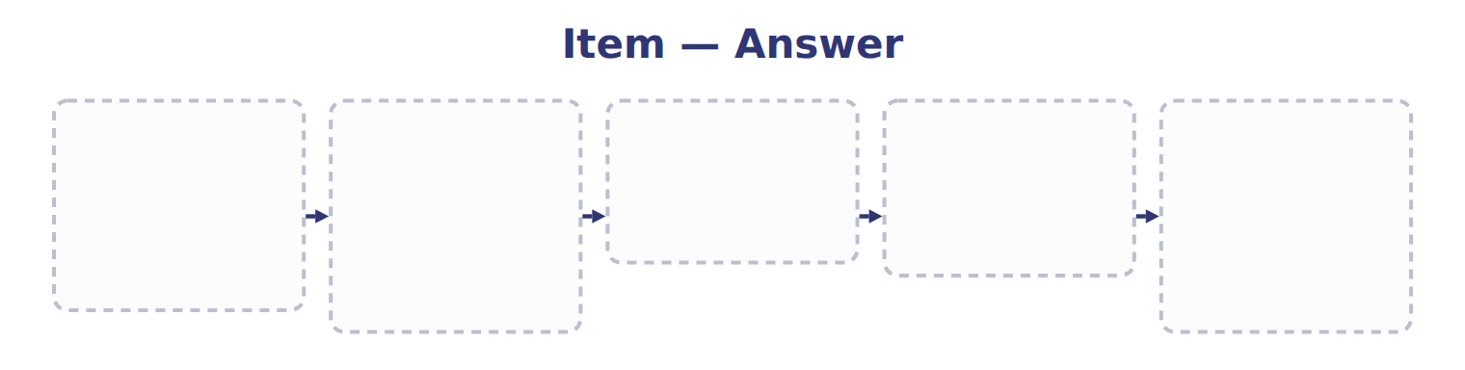
TEACH IT BACK | Write it for a classmate who missed this session — not for the marker.
22. In three or four sentences, write what this section settles and the one rule a reader has to take away.
every one of these words must appear: consolidated financial statements · intercompany transaction · acquisition method

Handout 16.2
Two control models: VIE first, then votes
section 16.2 of the book
Before you start
Three summaries of this handout, in the book’s own words. Read all three first: together they are the whole session. Then fill the gaps, guessing where you have to.

What this handout settles, cycle by cycle
In this handout | What you will read | How you check it
Two control models: VIE first, then votes | a figure to read · Suppose: Orontes Cold-Chain Logistics SPV, 2027 | A company holds 60% of the votes, but a 40% owner must approve the annual budget and key hires. Under the voting model:
The words this section uses precisely | Investment · The English the exam uses, and what it translates · Suppose: Levant items, 2027 (whole USD) | What is the safest way to settle a disagreement about an answer on this sheet?

Words this handout uses precisely
Words this handout uses precisely | tick it if you could already use it in a sentence
parent
unrealized profit
goodwill

1. Where the section starts — Fill every gap. The list holds more words than there are gaps, so one or two of them are not used.
choose from: subsidiary · variable · activities · joint venture · identify
GAAP has two ways to control, and they are applied in order. First, the company asks whether the other entity is a interest entity (VIE). An entity is a VIE if its equity at risk is too small to finance its , or if its equity holders do not have the power to direct it or do not bear its losses and returns.
2. What it settles in the middle — Fill every gap. The list holds more words than there are gaps, so one or two of them are not used.
choose from: substantive · participating · joint venture · subsidiary · entrepreneur
A company that holds more than 50% of the votes generally controls the entity, unless other owners have rights, such as the right to approve budgets. Decision chart: test the VIE model first, then the voting interest model. Suppose a logistics owns all the shares of Orontes Cold-Chain Logistics SPV.
3. Where it ends — Fill every gap. The list holds more words than there are gaps, so one or two of them are not used.
choose from: subsidiary · beneficiary · guarantee · consolidates · joint venture
Orontes has the power and bears the losses through its , so it is the primary . Orontes the SPV although it owns no shares. Test the VIE model before counting votes.

CYCLE A | Two control models: VIE first, then votes

ORIENT One claim. Decide now; you will check it in a moment.

4. Every number in a financial statement belongs to an element the framework defines. TRUE / FALSE
MODEL Read it before you answer anything below it.

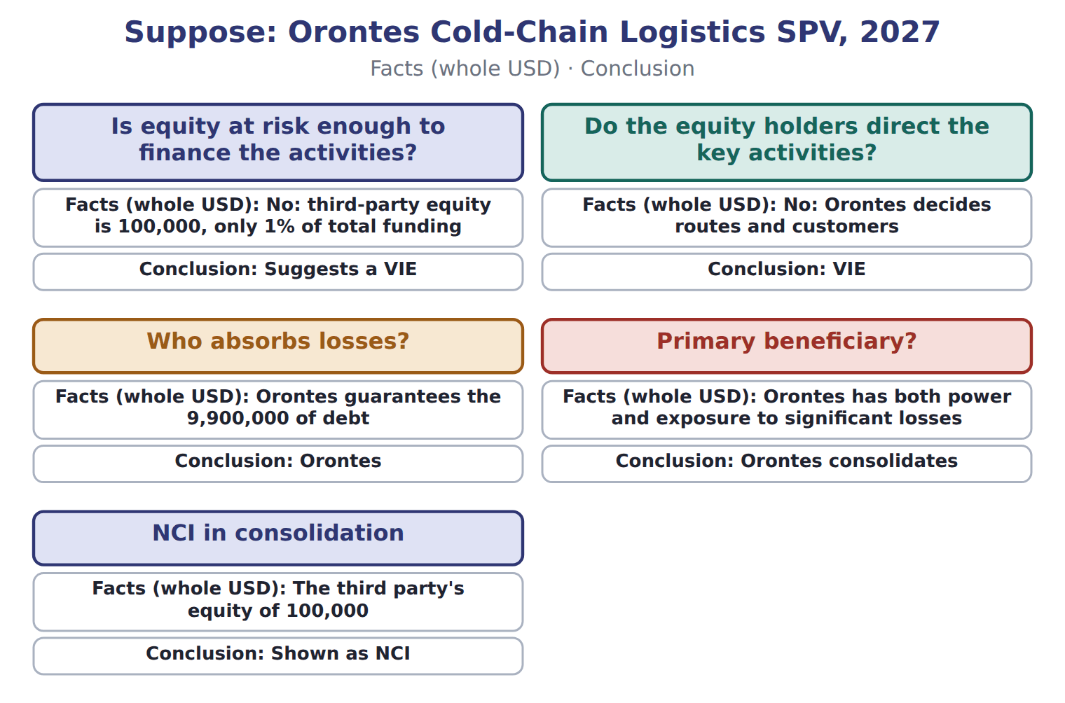

Suppose: Orontes Cold-Chain Logistics SPV, 2027 — the book’s own table
Suppose: Orontes Cold-Chain Logistics SPV, 2027 | Facts (whole USD) | Conclusion
Is equity at risk enough to finance the activities? | No: third-party equity is 100,000, only 1% of total funding | Suggests a VIE
Do the equity holders direct the key activities? | No: Orontes decides routes and customers | VIE
Who absorbs losses? | Orontes guarantees the 9,900,000 of debt | Orontes
Primary beneficiary? | Orontes has both power and exposure to significant losses | Orontes consolidates
NCI in consolidation | The third party's equity of 100,000 | Shown as NCI

READ THE MODEL Every answer is printed above. Find it, do not recall it.

5. Which conclusion does the book give for Is equity at risk enough to finance the activities??
A. Orontes consolidates | C. Suggests a VIE
B. Shown as NCI | D. Orontes
6. Which conclusion does the book give for Do the equity holders direct the key activities??
A. Shown as NCI | C. Orontes
B. VIE | D. Suggests a VIE
7. Which conclusion does the book give for Who absorbs losses??
A. Shown as NCI | C. Suggests a VIE
B. Orontes | D. VIE
8. Which conclusion does the book give for Primary beneficiary??
A. Orontes consolidates | C. Shown as NCI
B. Suggests a VIE | D. Orontes
APPLY No help on this move.

9. A company holds 60% of the votes, but a 40% owner must approve the annual budget and key hires. Under the voting model:
A. the 60% holder controls
B. the 40% owner controls
C. both consolidate
D. the 60% holder does not have control, because the other owner has substantive participating rights
10. Two companies each hold 50% of a joint venture and share control. Under U.S. GAAP, each uses:
A. the equity method | C. full consolidation
B. proportionate consolidation | D. fair value
11. In which case does U.S. GAAP allow proportionate consolidation?
A. A 50% joint venture in food distribution
B. A 30% associate
C. An undivided interest in an oil and gas property
D. An 80% subsidiary
12. Under the equity method, the investor's investment account increases by:
A. all of the investee's net income
B. dividends received
C. the investee's revenue
D. its share of the investee's net income
WORK IN PAIRS | Compare every answer on this page with your partner before you read any key.
If you disagree: go back to the model and find the row that settles it. The row decides, not the louder voice.

CHECKPOINT 13. A company holds 60% of the votes, but a 40% owner must approve the annual budget and key hires. Under the voting model:
A. the 60% holder controls
B. the 40% owner controls
C. both consolidate
D. the 60% holder does not have control, because the other owner has substantive participating rights
If you got it wrong: redo the READ THE MODEL questions of cycle A with the model in front of you.

CYCLE B | The words this section uses precisely

ORIENT

14. A term in the exam means exactly what the book defines it to mean, whatever it means in ordinary English. TRUE / FALSE
MODEL

Investment — the book’s own table
Investment | Category
Tadmor Retail (75%) | Full consolidation
Supplier (30%, significant influence) | Equity method
Listed food company (8%) | Fair value through net income
Cold-storage SPV that Barada directs and guarantees (VIE) | Full consolidation

The English the exam uses, and what it translates
English (exam term) | the Arabic it translates
parent | المنشأة الأم
unrealized profit | الربح غير المحقق
goodwill | الشهرة

READ THE MODEL

15. Which category does the book give for Tadmor Retail (75%)?
A. Full consolidation | C. Fair value through net income
B. Equity method
16. Which category does the book give for Supplier (30%, significant influence)?
A. Full consolidation | C. Fair value through net income
B. Equity method
17. Which category does the book give for Listed food company (8%)?
A. Equity method | C. Full consolidation
B. Fair value through net income

APPLY

Suppose: Levant items, 2027 (whole USD) — the extract for the question that follows
Suppose: Levant items, 2027 (whole USD) | Eliminate | Result | Who bears it
Intercompany sales and cost of sales | Remove 750,000 of sales and cost of sales | Revenue and expenses fall; no profit effect | —
Downstream unrealized profit (30% unsold) | 60,000 from inventory and profit | Inventory at the group's cost | Orontes
Upstream unrealized profit (40% unsold) | 25,000 from inventory and profit | Inventory at the group's cost | Orontes 20,000, NCI 5,000
Intercompany receivable and payable | 120,000 from both | The group cannot owe itself | —
Truck sold for 90,000 (carrying 60,000) | Gain 30,000; extra depreciation 6,000 a year | Truck back to its original cost basis | Orontes
Loan of 1,000,000 at 6% | Loan and interest of 60,000 | No debt or interest inside the group | —
Dividend of 100,000 | Orontes's dividend income 80,000 | NCI falls by 20,000 | NCI

18. The extract for this question is printed with it. How much intercompany sales revenue is removed in consolidation (whole USD)?
A. 0 | C. 500,000
B. 85,000 | D. 750,000
19. The extract for this question is printed with it. What happens to the truck gain in the 2027 consolidated statements?
A. The gain stays because it was a real sale
B. The 30,000 gain is removed, and 6,000 of extra depreciation is reversed
C. Only 80% of the gain is removed
D. The gain moves to OCI
CHECKPOINT 20. What is the safest way to settle a disagreement about an answer on this sheet?
A. find the row of the model that decides it
B. take the answer of whoever is more confident
C. leave it until the lecturer says
D. choose the longer option
If you got it wrong: redo the READ THE MODEL questions of cycle B.

FROM MEMORY | Close the earlier pages first.
21. Rebuild the figure from this handout. Label every part and fill in every box.
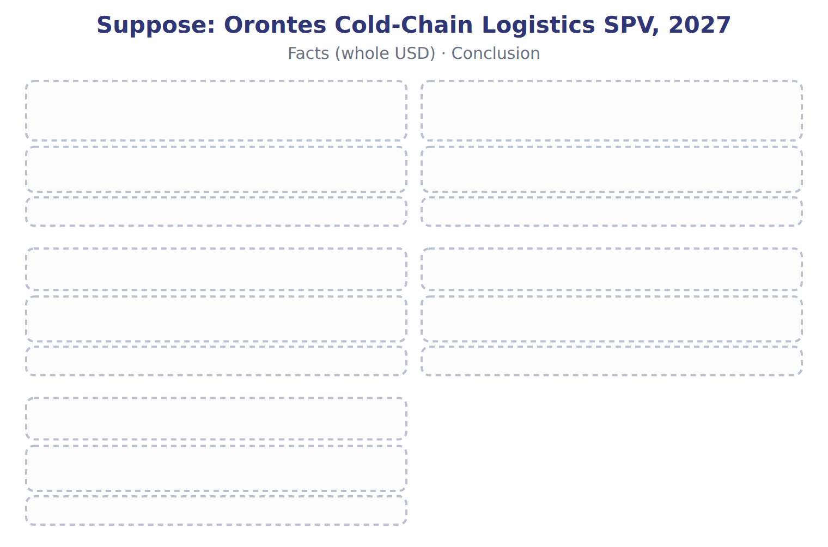
TEACH IT BACK | Write it for a classmate who missed this session — not for the marker.
22. In three or four sentences, write what this section settles and the one rule a reader has to take away.
every one of these words must appear: parent · unrealized profit · goodwill

Handout 16.3
Full consolidation, proportionate consolidation and the equity method
section 16.3 of the book
Before you start
Three summaries of this handout, in the book’s own words. Read all three first: together they are the whole session. Then fill the gaps, guessing where you have to.

What this handout settles, cycle by cycle
In this handout | What you will read | How you check it
Full consolidation, proportionate consolidation and the equity method | a figure to read · Method · the book’s own rule, gapped | Which item is NOT eliminated in consolidation?
The words this section uses precisely | The English the exam uses, and what it translates | What is the safest way to settle a disagreement about an answer on this sheet?

Words this handout uses precisely
Words this handout uses precisely | tick it if you could already use it in a sentence
subsidiary
controlling financial interest
downstream sale

1. Where the section starts — Fill every gap. The list holds more words than there are gaps, so one or two of them are not used.
choose from: subsidiary · equity method · upstream sale · goodwill · parent
The 's items are added in full, and NCI shows the part the does not own. The , which the LOS call 'equity consolidation', is used when the investor has significant influence, usually 20% to 50% of the votes, and for most joint ventures.
2. What it settles in the middle — Fill every gap. The list holds more words than there are gaps, so one or two of them are not used.
choose from: subsidiary · upstream sale · equity method · goodwill · proportionate consolidation
A controlled 's intercompany profit is removed in full. The LOS phrase 'equity consolidation' means the : one line, no NCI. Also, joint ventures use the equity method, not .
3. Where it ends — Fill every gap. The list holds more words than there are gaps, so one or two of them are not used.
choose from: upstream sale · goodwill · equity method · proportionate consolidation · subsidiary
The methods also remove intercompany profit differently. A controlled 's intercompany profit is removed in full. The LOS phrase 'equity consolidation' means the : one line, no NCI. Also, joint ventures use the equity method, not .
How every cycle on this sheet works
How a cycle works | what you do
MODEL | read the figure or the table before you answer anything
READ THE MODEL | every answer is printed on the same page
INVENT THE RULE | write the rule yourself, then compare with the book
APPLY | no help on this move
CHECKPOINT | mark it yourself; if you miss it, the sheet says what to redo

CYCLE A | Full consolidation, proportionate consolidation and the equity method

ORIENT One claim. Decide now; you will check it in a moment.

4. The book gives the When used (U.S. GAAP) of Full consolidation as “Control (subsidiary or VIE)”. TRUE / FALSE
MODEL Read it before you answer anything below it.

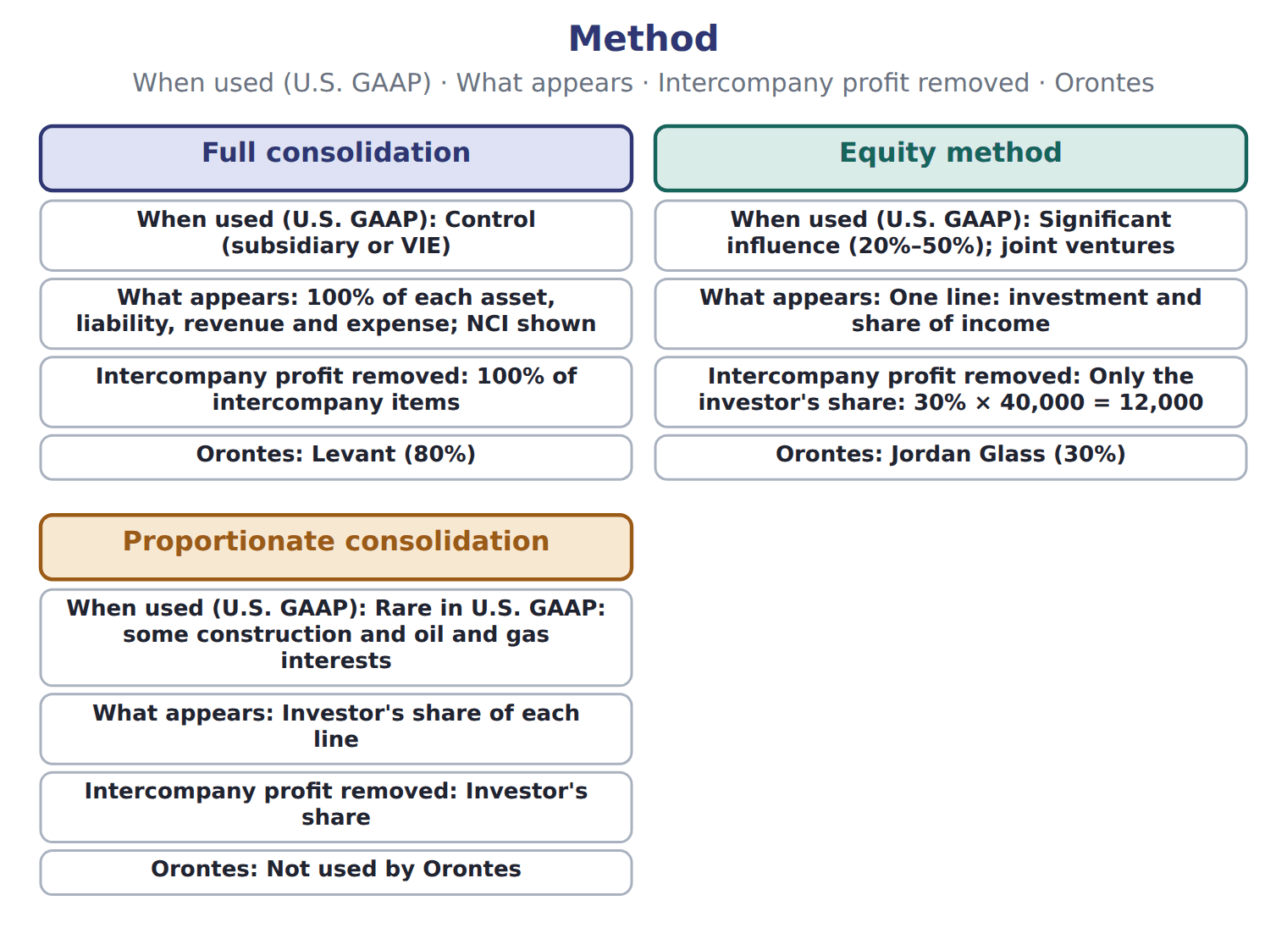

Method — the book’s own table
Method | When used (U.S. GAAP) | What appears | Intercompany profit removed | Orontes
Full consolidation | Control (subsidiary or VIE) | 100% of each asset, liability, revenue and expense; NCI shown | 100% of intercompany items | Levant (80%)
Equity method | Significant influence (20%–50%); joint ventures | One line: investment and share of income | Only the investor's share: 30% × 40,000 = 12,000 | Jordan Glass (30%)
Proportionate consolidation | Rare in U.S. GAAP: some construction and oil and gas interests | Investor's share of each line | Investor's share | Not used by Orontes

READ THE MODEL Every answer is printed above. Find it, do not recall it.

5. Which method does the book pair with “Control (subsidiary or VIE)”?
A. Equity method | C. Proportionate consolidation
B. Full consolidation
6. Which method does the book pair with “Significant influence (20%–50%); joint ventures”?
A. Proportionate consolidation | C. Full consolidation
B. Equity method
7. Which method does the book pair with “Rare in U.S. GAAP: some construction and oil and gas interests”?
A. Proportionate consolidation | C. Equity method
B. Full consolidation
8. The book gives the orontes of Full consolidation as “Levant (80%)”. TRUE / FALSE
9. The book gives the orontes of Equity method as “Levant (80%)”. TRUE / FALSE
INVENT THE RULE

10. Complete the book’s own sentence. The list holds more words than there are gaps.
use every one of these words: subsidiary · goodwill · downstream sale · parent
The 's items are added in full, and NCI shows the part the does not own.

Two of the book’s own cases, side by side
Full consolidation | Equity method
When used (U.S. GAAP): Control (subsidiary or VIE) | When used (U.S. GAAP): Significant influence (20%–50%); joint ventures
What appears: 100% of each asset, liability, revenue and expense; NCI shown | What appears: One line: investment and share of income
Intercompany profit removed: 100% of intercompany items | Intercompany profit removed: Only the investor's share: 30% × 40,000 = 12,000
Only the facts above differ. What is the orontes of Full consolidation?
11. Choose one:
A. Levant (80%) | C. Jordan Glass (30%)
B. Not used by Orontes

APPLY No help on this move.

12. Which item is NOT eliminated in consolidation?
A. Levant's payable to Orontes
B. Interest on Orontes's loan to Levant
C. Dividends Levant pays to Orontes
D. Sales from Levant to a supermarket outside the group
13. A parent sells inventory to its 60%-owned subsidiary at a profit of $10,000; all of it is still unsold. How much of the elimination reduces NCI?
A. $0 | C. $6,000
B. $4,000 | D. $10,000
14. Under IFRS 11, how does a party account for a joint operation?
A. It uses the equity method
B. It recognizes its own share of the assets, liabilities, revenues and expenses
C. It fully consolidates
D. It measures the interest at fair value
Suppose: NCI in Levant, 2027 (whole USD) — the extract for the question that follows
Suppose: NCI in Levant, 2027 (whole USD) | Amount
NCI at January 1, 2027 (fair value) | 1,900,000
Levant's 2027 net income | 900,000
Less: depreciation on the PP&E step-up (1,200,000 ÷ 10 years) | (120,000)
Less: upstream unrealized profit | ________
Adjusted net income of Levant | ________
NCI share (20%) | ________
Less: dividends paid to NCI | ________
NCI at December 31, 2027 | ________

15. The extract for this question is printed with it. What is Levant's net income attributable to NCI for 2027 (whole USD)?
A. 20,000 | C. 180,000
B. 151,000 | D. 755,000
WORK IN PAIRS | Compare every answer on this page with your partner before you read any key.
If you disagree: go back to the model and find the row that settles it. The row decides, not the louder voice.
CHECKPOINT 16. Which item is NOT eliminated in consolidation?
A. Levant's payable to Orontes
B. Interest on Orontes's loan to Levant
C. Dividends Levant pays to Orontes
D. Sales from Levant to a supermarket outside the group
If you got it wrong: redo the READ THE MODEL questions of cycle A with the model in front of you.

CYCLE B | The words this section uses precisely

ORIENT

17. A term in the exam means exactly what the book defines it to mean, whatever it means in ordinary English. TRUE / FALSE

MODEL

The English the exam uses, and what it translates
English (exam term) | the Arabic it translates
subsidiary | المنشأة التابعة
controlling financial interest | الحصة المالية المسيطرة
downstream sale | البيع من الأم إلى التابعة

READ THE MODEL

18. A glossary term and its translation are a pair the book itself gives. TRUE / FALSE
APPLY

19. Orontes sells half of its Levant shares and loses control, keeping a 40% stake. It:
A. records an equity transaction with no gain or loss
B. keeps consolidating Levant
C. measures the 40% at its old carrying amount with no gain or loss
D. deconsolidates Levant and measures the 40% at fair value, with a gain or loss in net income
20. Under U.S. GAAP, which party must reassess whether it is a VIE's primary beneficiary every reporting period?
A. Every party with a variable interest
B. Only the largest lender
C. Only the equity holders
D. No one; it is decided once
CHECKPOINT 21. What is the safest way to settle a disagreement about an answer on this sheet?
A. find the row of the model that decides it
B. take the answer of whoever is more confident
C. leave it until the lecturer says
D. choose the longer option
If you got it wrong: redo the READ THE MODEL questions of cycle B.

FROM MEMORY | Close the earlier pages first.
22. Rebuild the figure from this handout. Label every part and fill in every box.
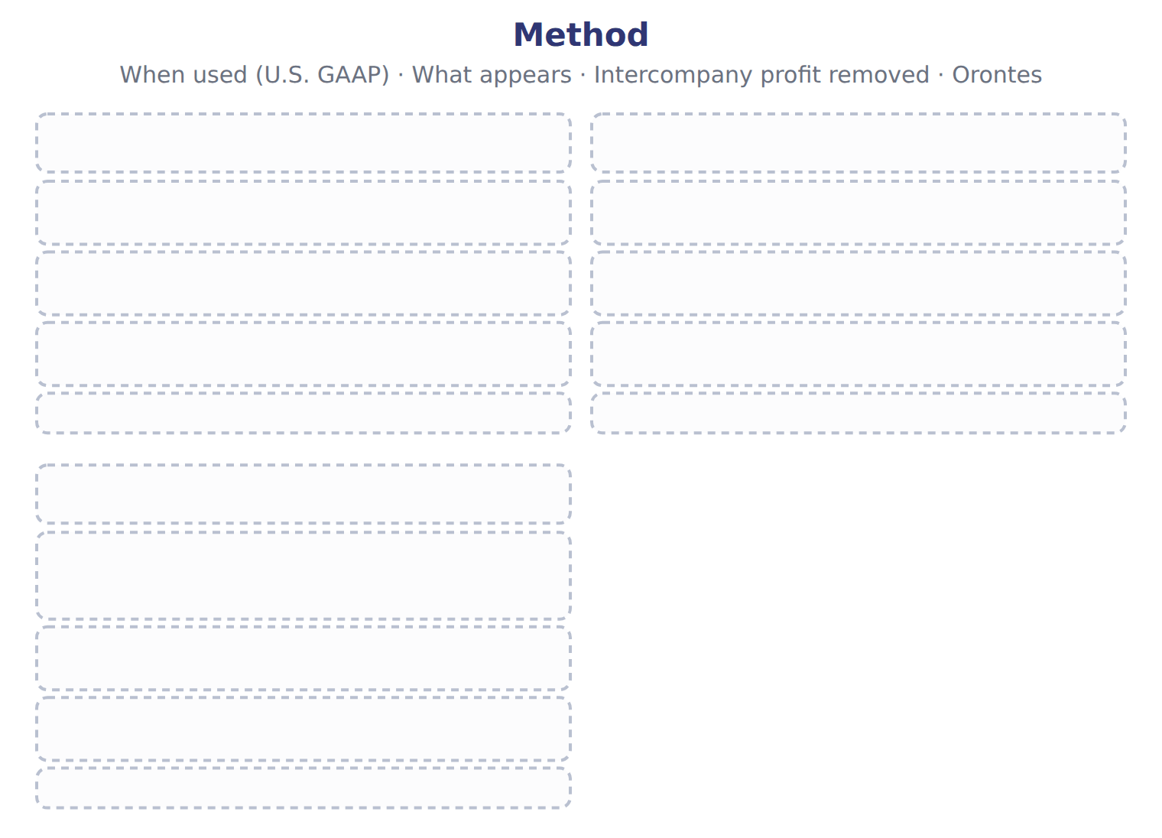
TEACH IT BACK | Write it for a classmate who missed this session — not for the marker.
23. In three or four sentences, write what this section settles and the one rule a reader has to take away.
every one of these words must appear: subsidiary · controlling financial interest · downstream sale

Handout 16.4
The acquisition: goodwill and noncontrolling interest
section 16.4 of the book
Before you start
Three summaries of this handout, in the book’s own words. Read all three first: together they are the whole session. Then fill the gaps, guessing where you have to.

What this handout settles, cycle by cycle
In this handout | What you will read | How you check it
The acquisition: goodwill and noncontrolling interest | a figure to read · Consolidation worksheet, January 1, 2027 (whole | Which of these did this cycle settle?
The words this section uses precisely | The English the exam uses, and what it translates | What is the safest way to settle a disagreement about an answer on this sheet?

Words this handout uses precisely
Words this handout uses precisely | tick it if you could already use it in a sentence
variable interest entity
proportionate consolidation
upstream sale

1. Where the section starts — Fill every gap. The list holds more words than there are gaps, so one or two of them are not used.
choose from: subsidiary · upstream sale · intercompany transaction · acquisition method
When a company gains control of a business, it uses the . It measures the 's identifiable assets and liabilities at fair value, and it measures NCI at fair value too.
2. What it settles in the middle — Fill every gap. The list holds more words than there are gaps, so one or two of them are not used.
choose from: Goodwill · intercompany transaction · subsidiary · upstream sale · acquisition method
When a company gains control of a business, it uses the . It measures the 's identifiable assets and liabilities at fair value, and it measures NCI at fair value too. is the price paid plus the fair value of NCI, minus the fair value of the net assets.
3. Where it ends — Fill every gap. The list holds more words than there are gaps, so one or two of them are not used.
choose from: subsidiary · upstream sale · Goodwill · intercompany transaction · acquisition method
When a company gains control of a business, it uses the . It measures the 's identifiable assets and liabilities at fair value, and it measures NCI at fair value too. is the price paid plus the fair value of NCI, minus the fair value of the net assets. Goodwill at acquisition: price plus NCI fair value minus net assets at fair value.
How every cycle on this sheet works
How a cycle works | what you do
MODEL | read the figure or the table before you answer anything
READ THE MODEL | every answer is printed on the same page
INVENT THE RULE | write the rule yourself, then compare with the book
APPLY | no help on this move
CHECKPOINT | mark it yourself; if you miss it, the sheet says what to redo

CYCLE A | The acquisition: goodwill and noncontrolling interest

ORIENT One claim. Decide now; you will check it in a moment.

4. Every number in a financial statement belongs to an element the framework defines. TRUE / FALSE
MODEL Read it before you answer anything below it.

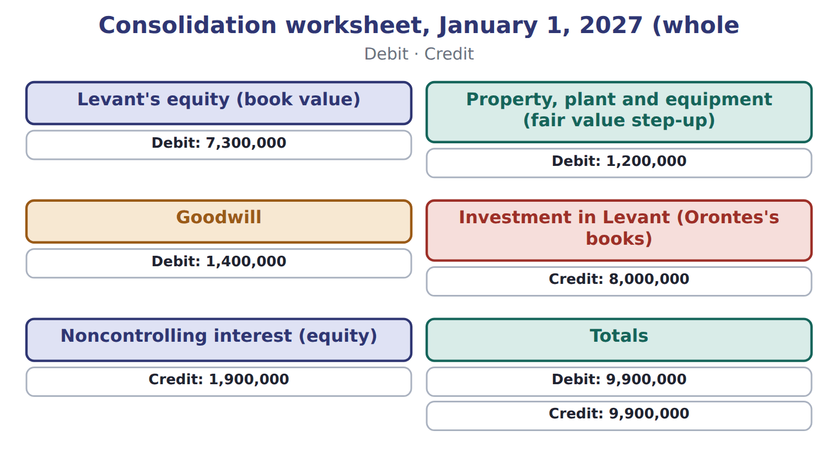

Consolidation worksheet, January 1, 2027 (whole — the book’s own table
Consolidation worksheet, January 1, 2027 (whole | Debit | Credit
Levant's equity (book value) | 7,300,000
Property, plant and equipment (fair value step-up) | 1,200,000
Goodwill | 1,400,000
Investment in Levant (Orontes's books) |  | 8,000,000
Noncontrolling interest (equity) |  | 1,900,000
Totals | 9,900,000 | 9,900,000

READ THE MODEL Every answer is printed above. Find it, do not recall it.

5. Which debit does the book give for Levant's equity (book value)?
A. 7,300,000 | C. 1,200,000
B. 1,400,000 | D. 9,900,000
6. Which debit does the book give for Property, plant and equipment (fair value step-up)?
A. 1,400,000 | C. 9,900,000
B. 7,300,000 | D. 1,200,000
7. Which debit does the book give for Goodwill?
A. 1,400,000 | C. 9,900,000
B. 1,200,000 | D. 7,300,000
8. Which credit does the book give for Investment in Levant (Orontes's books)?
A. 8,000,000 | C. 9,900,000
B. 1,900,000
APPLY No help on this move.

9. The rule you have just written is the book’s own rule. TRUE / FALSE
WORK IN PAIRS | Compare every answer on this page with your partner before you read any key.
If you disagree: go back to the model and find the row that settles it. The row decides, not the louder voice.
CHECKPOINT 10. Which of these did this cycle settle?
A. the rule and where it comes from
B. nothing in particular
C. only the vocabulary
D. only the arithmetic
If you got it wrong: redo the READ THE MODEL questions of cycle A.

CYCLE B | The words this section uses precisely

ORIENT

11. A term in the exam means exactly what the book defines it to mean, whatever it means in ordinary English. TRUE / FALSE

MODEL

The English the exam uses, and what it translates
English (exam term) | the Arabic it translates
variable interest entity | منشأة ذات حصص متغيرة
proportionate consolidation | التوحيد التناسبي
upstream sale | البيع من التابعة إلى الأم

READ THE MODEL

12. A glossary term and its translation are a pair the book itself gives. TRUE / FALSE
APPLY

13. Writing a term in English is part of answering the question, not an extra. TRUE / FALSE
CHECKPOINT 14. What is the safest way to settle a disagreement about an answer on this sheet?
A. find the row of the model that decides it
B. take the answer of whoever is more confident
C. leave it until the lecturer says
D. choose the longer option
If you got it wrong: redo the READ THE MODEL questions of cycle B.

FROM MEMORY | Close the earlier pages first.
15. Rebuild the figure from this handout. Label every part and fill in every box.
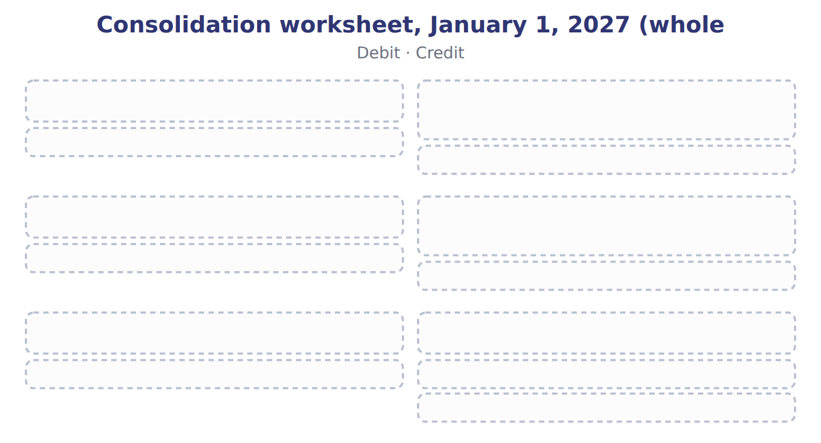
TEACH IT BACK | Write it for a classmate who missed this session — not for the marker.
16. In three or four sentences, write what this section settles and the one rule a reader has to take away.
every one of these words must appear: variable interest entity · proportionate consolidation · upstream sale

Handout 16.5
Eliminating intercompany balances and transactions
section 16.5 of the book
Before you start
Three summaries of this handout, in the book’s own words. Read all three first: together they are the whole session. Then fill the gaps, guessing where you have to.

What this handout settles, cycle by cycle
In this handout | What you will read | How you check it
Eliminating intercompany balances and transactions | a figure to read · Suppose: NCI in Levant, 2027 (whole USD) | Which of these did this cycle settle?
The words this section uses precisely | Suppose: Levant items, 2027 (whole USD) · The English the exam uses, and what it translates | What is the safest way to settle a disagreement about an answer on this sheet?

Words this handout uses precisely
Words this handout uses precisely | tick it if you could already use it in a sentence
primary beneficiary
joint venture

1. Where the section starts — Fill every gap. The list holds more words than there are gaps, so one or two of them are not used.
choose from: primary beneficiary · Unrealized profit · equity method · intercompany transaction
Every is therefore eliminated in full, whatever the percentage owned: sales and cost of sales, receivables and payables, loans and interest, and dividends. on goods still held inside the group is also removed from inventory and income until the goods are sold to outsiders.
2. What it settles in the middle — Fill every gap. The list holds more words than there are gaps, so one or two of them are not used.
choose from: unrealized profit · upstream sale · subsidiary · equity method · downstream sale · parent
In a the earned the profit, so the whole elimination reduces the parent's share. In an the earned it, so NCI bears its share. Downstream and upstream sales between Orontes and Levant.
3. Where it ends — Fill every gap. The list holds more words than there are gaps, so one or two of them are not used.
choose from: primary beneficiary · Unrealized profit · upstream sale · subsidiary · equity method · downstream sale · parent
on goods still held inside the group is also removed from inventory and income until the goods are sold to outsiders. In a the earned the profit, so the whole elimination reduces the parent's share. In an the earned it, so NCI bears its share.

CYCLE A | Eliminating intercompany balances and transactions

ORIENT One claim. Decide now; you will check it in a moment.

4. Every number in a financial statement belongs to an element the framework defines. TRUE / FALSE
MODEL Read it before you answer anything below it.

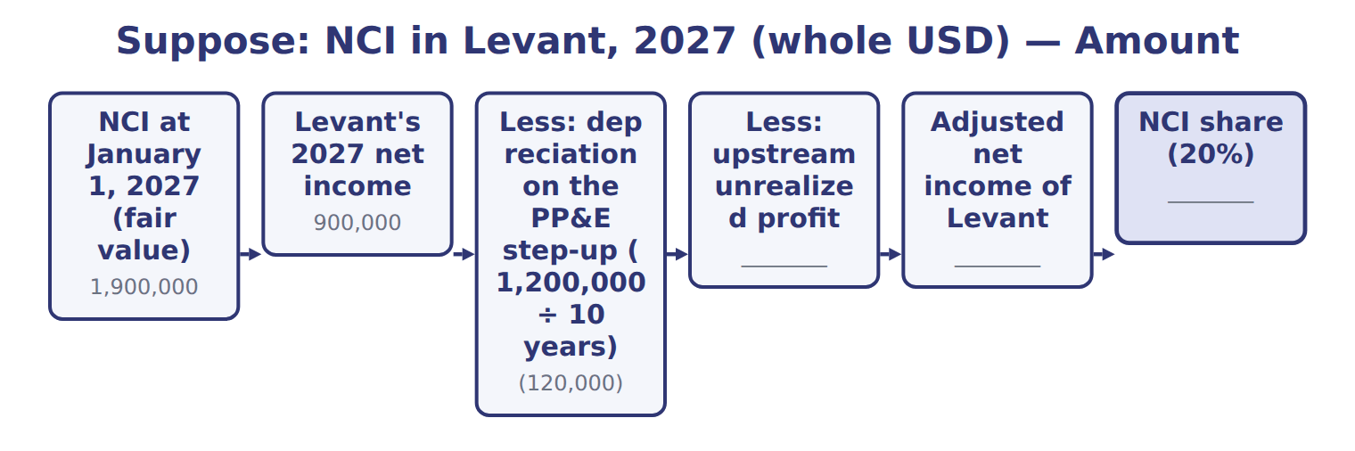
Suppose: NCI in Levant, 2027 (whole USD) — the book’s own table
Suppose: NCI in Levant, 2027 (whole USD) | Amount
NCI at January 1, 2027 (fair value) | 1,900,000
Levant's 2027 net income | 900,000
Less: depreciation on the PP&E step-up (1,200,000 ÷ 10 years) | (120,000)
Less: upstream unrealized profit | ________
Adjusted net income of Levant | ________
NCI share (20%) | ________
Less: dividends paid to NCI | ________
NCI at December 31, 2027 | ________

READ THE MODEL Every answer is printed above. Find it, do not recall it.

5. Which amount does the book give for NCI at January 1, 2027 (fair value)?
A. 1,900,000 | C. (120,000)
B. ________ | D. 900,000
6. Which amount does the book give for Levant's 2027 net income?
A. ________ | C. 900,000
B. 1,900,000 | D. (120,000)
7. Which amount does the book give for Less: depreciation on the PP&E step-up (1,200,000 ÷ 10 years)?
A. ________ | C. 900,000
B. 1,900,000 | D. (120,000)
8. Which amount does the book give for Less: upstream unrealized profit?
A. 1,900,000 | C. ________
B. 900,000 | D. (120,000)

APPLY No help on this move.

9. The rule you have just written is the book’s own rule. TRUE / FALSE
WORK IN PAIRS | Compare every answer on this page with your partner before you read any key.
If you disagree: go back to the model and find the row that settles it. The row decides, not the louder voice.
CHECKPOINT 10. Which of these did this cycle settle?
A. the rule and where it comes from
B. nothing in particular
C. only the vocabulary
D. only the arithmetic
If you got it wrong: redo the READ THE MODEL questions of cycle A.

CYCLE B | The words this section uses precisely

ORIENT

11. A term in the exam means exactly what the book defines it to mean, whatever it means in ordinary English. TRUE / FALSE
MODEL

Suppose: Levant items, 2027 (whole USD) — the book’s own table
Suppose: Levant items, 2027 (whole USD) | Eliminate | Result | Who bears it
Intercompany sales and cost of sales | Remove 750,000 of sales and cost of sales | Revenue and expenses fall; no profit effect | —
Downstream unrealized profit (30% unsold) | 60,000 from inventory and profit | Inventory at the group's cost | Orontes
Upstream unrealized profit (40% unsold) | 25,000 from inventory and profit | Inventory at the group's cost | Orontes 20,000, NCI 5,000
Intercompany receivable and payable | 120,000 from both | The group cannot owe itself | —
Truck sold for 90,000 (carrying 60,000) | Gain 30,000; extra depreciation 6,000 a year | Truck back to its original cost basis | Orontes
Loan of 1,000,000 at 6% | Loan and interest of 60,000 | No debt or interest inside the group | —
Dividend of 100,000 | Orontes's dividend income 80,000 | NCI falls by 20,000 | NCI

The English the exam uses, and what it translates
English (exam term) | the Arabic it translates
primary beneficiary | المستفيد الرئيسي
joint venture | المشروع المشترك

READ THE MODEL

12. Which eliminate does the book give for Intercompany sales and cost of sales?
A. 60,000 from inventory and profit
B. 25,000 from inventory and profit
C. Remove 750,000 of sales and cost of sales
D. Gain 30,000; extra depreciation 6,000 a year
13. Which eliminate does the book give for Downstream unrealized profit (30% unsold)?
A. Orontes's dividend income 80,000 | C. 60,000 from inventory and profit
B. Loan and interest of 60,000 | D. 25,000 from inventory and profit
14. Which eliminate does the book give for Upstream unrealized profit (40% unsold)?
A. Orontes's dividend income 80,000 | C. Loan and interest of 60,000
B. 25,000 from inventory and profit | D. 60,000 from inventory and profit
APPLY

15. Writing a term in English is part of answering the question, not an extra. TRUE / FALSE
CHECKPOINT 16. What is the safest way to settle a disagreement about an answer on this sheet?
A. find the row of the model that decides it
B. take the answer of whoever is more confident
C. leave it until the lecturer says
D. choose the longer option
If you got it wrong: redo the READ THE MODEL questions of cycle B.

FROM MEMORY | Close the earlier pages first.
17. Rebuild the figure from this handout. Label every part and fill in every box.
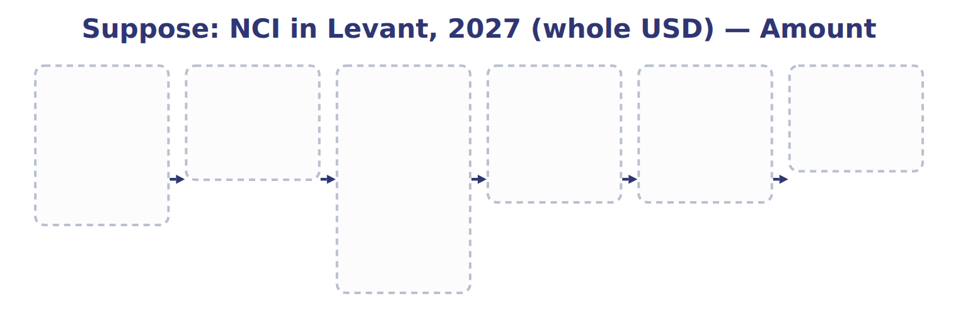
TEACH IT BACK | Write it for a classmate who missed this session — not for the marker.
18. In three or four sentences, write what this section settles and the one rule a reader has to take away.
every one of these words must appear: primary beneficiary · joint venture

Handout 16.6
IFRS differences and what is changing
section 16.6 of the book
Before you start
Three summaries of this handout, in the book’s own words. Read all three first: together they are the whole session. Then fill the gaps, guessing where you have to.

What this handout settles, cycle by cycle
In this handout | What you will read | How you check it
IFRS differences and what is changing | a figure to read · Suppose: Barada Wholesale and Tadmor Retail, 202 · Suppose: Orontes Cold-Chain Logistics SPV, 2027 | What do consolidated financial statements present?
The words this section uses precisely | Topic · The English the exam uses, and what it translates | What is the safest way to settle a disagreement about an answer on this sheet?

Words this handout uses precisely
Words this handout uses precisely | tick it if you could already use it in a sentence
noncontrolling interest
equity method

1. Where the section starts — Fill every gap. The list holds more words than there are gaps, so one or two of them are not used.
choose from: unrealized profit · equity method · variable interest entity · subsidiary
Under IFRS 11, joint ventures use the and joint operations recognize their own share of assets and liabilities. SC16-11 An IFRS company measures NCI at its share of the 's net assets.
2. What it settles in the middle — Fill every gap. The list holds more words than there are gaps, so one or two of them are not used.
choose from: subsidiary · variable interest entity · unrealized profit · equity method
There is no separate VIE model, and an investor can have de facto control with less than half of the votes. Under IFRS 11, joint ventures use the and joint operations recognize their own share of assets and liabilities. SC16-11 An IFRS company measures NCI at its share of the 's net assets.
3. Where it ends — Fill every gap. The list holds more words than there are gaps, so one or two of them are not used.
choose from: variable interest entity · unrealized profit · subsidiary · equity method
Under IFRS 11, joint ventures use the and joint operations recognize their own share of assets and liabilities. SC16-11 An IFRS company measures NCI at its share of the 's net assets. SC16-12 An investor holds 45% of the votes; the other 55% are spread among thousands of small shareholders.

CYCLE A | IFRS differences and what is changing

ORIENT One claim. Decide now; you will check it in a moment.

4. Every number in a financial statement belongs to an element the framework defines. TRUE / FALSE
MODEL Read it before you answer anything below it.

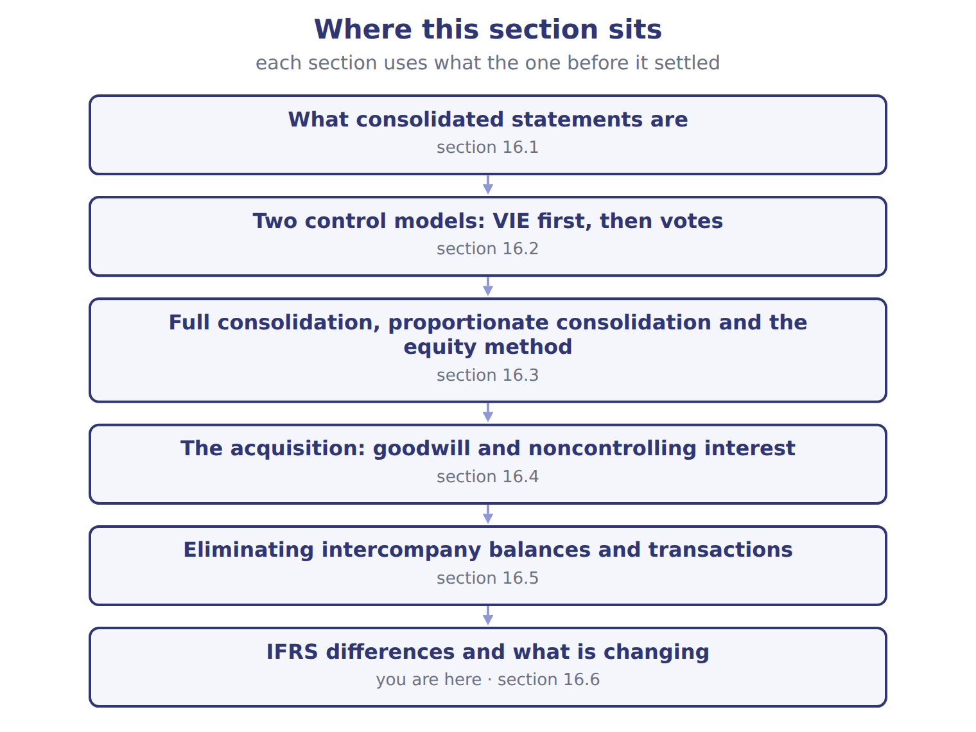

Suppose: Barada Wholesale and Tadmor Retail, 202 — the book’s own table
Suppose: Barada Wholesale and Tadmor Retail, 202 | Amount
Price paid for 75% of Tadmor Retail LLC, January 1, 2028 | 600
Fair value of the 25% noncontrolling interest | 190
Fair value of Tadmor's identifiable net assets | 700
Barada sold goods to Tadmor: sales 200, margin 30%, 25% still held by Tadmor
Tadmor sold goods to Barada: sales 160, margin 25%, 50% still held by Barada
Tadmor owes Barada at December 31, 2028 | 40
Tadmor's 2028 net income (before any consolidation adjustment) | 120
Dividends paid by Tadmor in 2028 | 40
M1 | Tadmor's assets are at fair value on its books, so there is no step-up to depreciate.
M2 | Barada also holds 30% of a supplier (significant influence) and 8% of a listed food company.

READ THE MODEL Every answer is printed above. Find it, do not recall it.

5. Which amount does the book give for Price paid for 75% of Tadmor Retail LLC, January 1, 2028?
A. 700 | C. 190
B. 600 | D. 120
6. Which amount does the book give for Fair value of the 25% noncontrolling interest?
A. 190 | C. 600
B. 120 | D. 700
7. Which amount does the book give for Fair value of Tadmor's identifiable net assets?
A. 700 | C. 120
B. 190 | D. 600
APPLY No help on this move.

8. Under U.S. GAAP, which test does a company apply first to decide whether to consolidate an entity?
A. Whether the entity is a variable interest entity
B. Whether it holds more than 50% of the votes
C. Whether it has significant influence
D. Whether the entity is profitable
Suppose: Orontes Cold-Chain Logistics SPV, 2027 — the extract for the question that follows
Suppose: Orontes Cold-Chain Logistics SPV, 2027 | Facts (whole USD) | Conclusion
Is equity at risk enough to finance the activities? | No: third-party equity is 100,000, only 1% of total funding | Suggests a VIE
Do the equity holders direct the key activities? | No: Orontes decides routes and customers | VIE
Who absorbs losses? | Orontes guarantees the 9,900,000 of debt | Orontes
Primary beneficiary? | Orontes has both power and exposure to significant losses | Orontes consolidates
NCI in consolidation | The third party's equity of 100,000 | Shown as NCI

9. The extract for this question is printed with it. Why does Orontes consolidate the cold-chain SPV?
A. It owns more than 50% of the shares
B. It has both the power to direct the SPV and exposure to its losses through the guarantee
C. It lends money to the SPV
D. The SPV is profitable
WORK IN PAIRS | Compare every answer on this page with your partner before you read any key.
If you disagree: go back to the model and find the row that settles it. The row decides, not the louder voice.
CHECKPOINT 10. What do consolidated financial statements present?
A. Only the parent's own assets and liabilities
B. The parent's share of each subsidiary's assets
C. A parent and its subsidiaries as a single economic entity
D. All companies in which the parent holds any shares
If you got it wrong: redo the READ THE MODEL questions of cycle A with the model in front of you.

CYCLE B | The words this section uses precisely

ORIENT

11. A term in the exam means exactly what the book defines it to mean, whatever it means in ordinary English. TRUE / FALSE
MODEL

Topic — the book’s own table
Topic | U.S. GAAP (ASC 810, 805) | IFRS (IFRS 10, 3, 11)
Control model | Two: VIE model first, then voting interest | One: power, variable returns and the link between them
Control below 50% of votes | Not through voting alone (unless a VIE) | Possible: de facto control
Measuring NCI | Fair value (full goodwill) | Fair value or share of net assets (partial goodwill), deal by deal
Joint arrangements | Joint ventures: equity method | Joint ventures: equity method; joint operations: own share of assets and liabilities
Group accounting policies | No general uniformity rule | Uniform policies required
Investment-entity subsidiaries in a parent's statements | Parent keeps their fair value accounting | A non-investment-entity parent consolidates them

The English the exam uses, and what it translates
English (exam term) | the Arabic it translates
noncontrolling interest | الحصص غير المسيطرة
equity method | طريقة حقوق الملكية

READ THE MODEL

12. Which topic does the book pair with “Two: VIE model first, then voting interest”?
A. Control model
B. Investment-entity subsidiaries in a parent's statements
C. Group accounting policies
D. Joint arrangements
13. Which topic does the book pair with “Not through voting alone (unless a VIE)”?
A. Control model
B. Group accounting policies
C. Control below 50% of votes
D. Investment-entity subsidiaries in a parent's statements
14. Which topic does the book pair with “Fair value (full goodwill)”?
A. Measuring NCI
B. Investment-entity subsidiaries in a parent's statements
C. Group accounting policies
D. Joint arrangements
APPLY

15. Where does Orontes present the noncontrolling interest in Levant?
A. As a noncurrent liability
B. Between liabilities and equity, as 'minority interest'
C. Only in the notes
D. In consolidated equity, separately from the parent's equity
CHECKPOINT 16. What is the safest way to settle a disagreement about an answer on this sheet?
A. find the row of the model that decides it
B. take the answer of whoever is more confident
C. leave it until the lecturer says
D. choose the longer option
If you got it wrong: redo the READ THE MODEL questions of cycle B.

FROM MEMORY | Close the earlier pages first.
17. Rebuild the figure from this handout. Label every part and fill in every box.
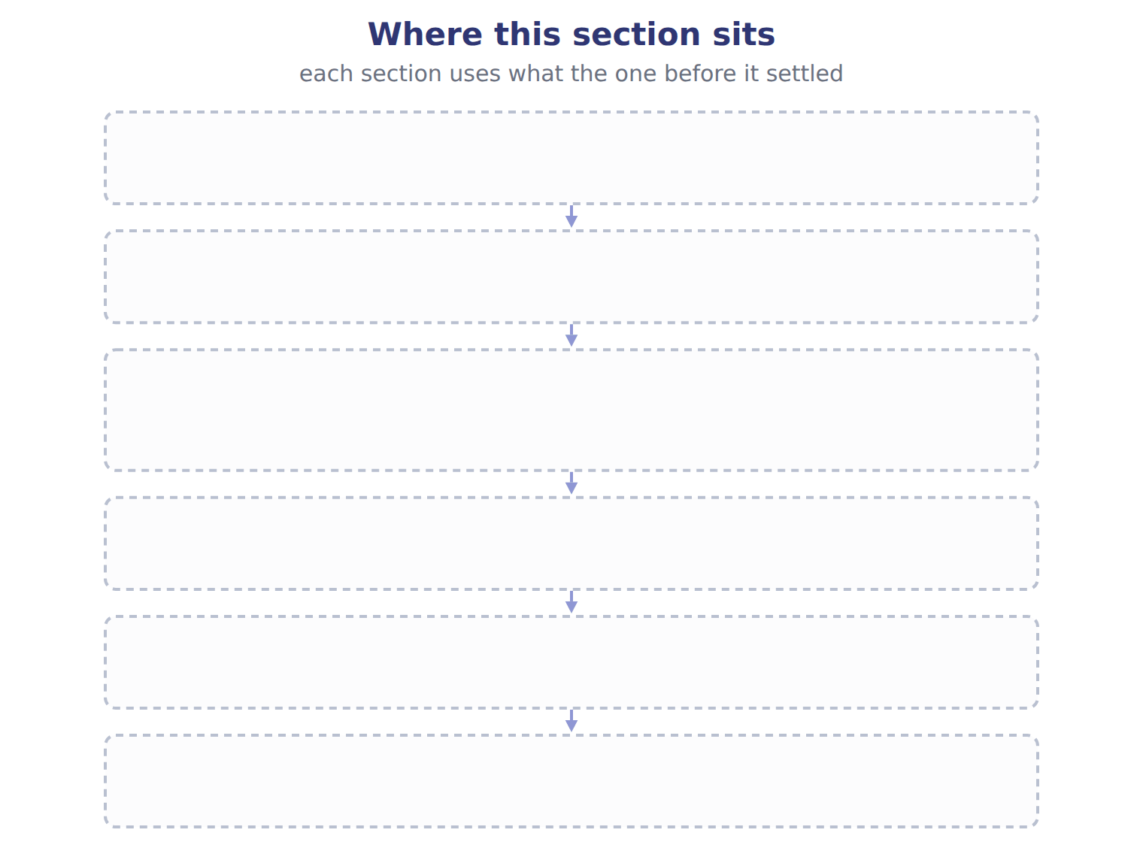
TEACH IT BACK | Write it for a classmate who missed this session — not for the marker.
18. In three or four sentences, write what this section settles and the one rule a reader has to take away.
every one of these words must appear: noncontrolling interest · equity method

Handout 16.7
The whole chapter
every section, shuffled, and the chapter’s own case set
Before you start
Three summaries of this chapter, in the book’s own words, with words taken out. Read all three first: together they are the whole chapter. Then fill the gaps.

What this handout settles, cycle by cycle
In this handout | What you will read | How you check it
The whole chapter, in order | a figure to read | Orontes holds 30% of Jordan Glass and has significant influence. Which method does it use?
The chapter’s case set | The chapter’s case set, item by item · Method | What has to be settled before any figure in a case set is worked out?
The words it uses precisely | consolidated financial statements · parent · subsidiary · variable interest entity · primary beneficiary · noncontrolling interest | matching, at the end of cycle B

1. Where the chapter starts — Fill every gap. The list holds more words than there are gaps, so one or two of them are not used.
choose from: controlling financial interest · upstream sale · variable interest entity · subsidiary · parent
A company consolidates another entity when it has a in it. Consolidation adds all of the 's assets, liabilities, revenues and expenses to the 's, line by line, even when the parent owns less than all of its shares.
2. What it settles in the middle — Fill every gap. The list holds more words than there are gaps, so one or two of them are not used.
choose from: variable interest entity · proportionate consolidation · acquisition method · subsidiary · upstream sale · equity method
Also, joint ventures use the , not . SC16-5 Orontes holds 30% of Jordan Glass and has significant influence. When a company gains control of a business, it uses the . It measures the 's identifiable assets and liabilities at fair value, and it measures NCI at fair value too.
3. Where it ends — Fill every gap. The list holds more words than there are gaps, so one or two of them are not used.
choose from: downstream sale · Unrealized profit · upstream sale · subsidiary · primary beneficiary · parent · variable interest entity
on goods still held inside the group is also removed from inventory and income until the goods are sold to outsiders. In a the earned the profit, so the whole elimination reduces the parent's share. In an the earned it, so NCI bears its share.

CYCLE A | The whole chapter, in order

ORIENT

4. The sections of a chapter have to be taken in order, because each one uses what the one before it settled. TRUE / FALSE
MODEL

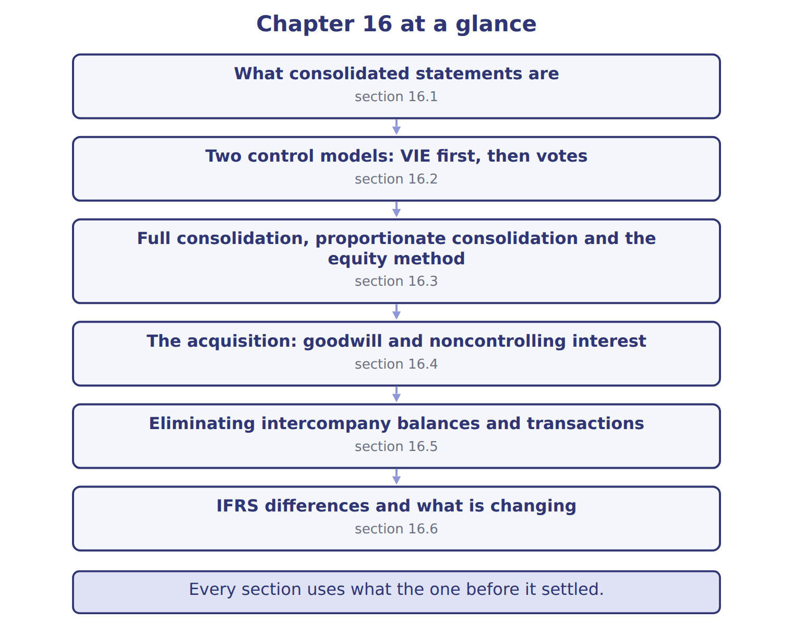
READ THE MODEL

5. Which part of this chapter is section 16.1?
A. IFRS differences and what is changing
B. Eliminating intercompany balances and transactions
C. What consolidated statements are
D. Two control models: VIE first, then votes
6. Which part of this chapter is section 16.2?
A. Eliminating intercompany balances and transactions
B. What consolidated statements are
C. IFRS differences and what is changing
D. Two control models: VIE first, then votes
7. Which part of this chapter is section 16.3?
A. Eliminating intercompany balances and transactions
B. Two control models: VIE first, then votes
C. Full consolidation, proportionate consolidation and the equity method
D. The acquisition: goodwill and noncontrolling interest
Write the letter of the section number beside each section title. Every number is used once.
A 16.1 | D 16.4
B 16.2 | E 16.5
C 16.3 | F 16.6

8. What consolidated statements are
9. Two control models: VIE first, then votes
10. Full consolidation, proportionate consolidation and the equity method
11. The acquisition: goodwill and noncontrolling interest
12. Eliminating intercompany balances and transactions
13. IFRS differences and what is changing

APPLY

14. An IFRS company measures NCI at its share of the subsidiary's net assets. For Levant, goodwill would be (whole USD):
A. 0 | C. 1,400,000
B. 1,200,000 | D. 1,700,000
WORK IN PAIRS | Compare every answer with your partner first.
If you disagree: name the section each question belongs to. Most disagreements turn out to be about the section, not the answer.
CHECKPOINT 15. Orontes holds 30% of Jordan Glass and has significant influence. Which method does it use?
A. Full consolidation
B. Proportionate consolidation
C. Fair value through net income
D. The equity method
If you got it wrong: go back to the MODEL move of cycle A and find the section this question belongs to.

CYCLE B | The chapter’s case set

ORIENT

16. In a case question, the exhibit has to be read and adjusted before any figure is worked out. TRUE / FALSE

MODEL

The chapter’s case set, item by item
Item | What it asks
C16-1 | Choose the method for each investment. (On the exam screen you would drag each item into a box.)
C16-2 | Enter the goodwill Barada recognizes on January 1, 2028.
C16-3 | Enter the total unrealized profit eliminated from inventory at December 31, 2028.
C16-4 | Enter the 2028 net income attributable to NCI.
C16-5 | Enter NCI at December 31, 2028.
C16-6 | How is the amount Tadmor owes Barada treated in consolidation? [select]

READ THE MODEL

17. Which of these does item C16-1 ask for?
A. Choose the method for each investment. (On the exam screen you would d
B. Enter the goodwill Barada recognizes on January 1, 2028.
C. How is the amount Tadmor owes Barada treated in consolidation? [select
D. Enter the total unrealized profit eliminated from inventory at Decembe
18. Which of these does item C16-2 ask for?
A. Enter the goodwill Barada recognizes on January 1, 2028.
B. Enter the 2028 net income attributable to NCI.
C. Enter the total unrealized profit eliminated from inventory at Decembe
D. Choose the method for each investment. (On the exam screen you would d
19. Which of these does item C16-3 ask for?
A. Enter the goodwill Barada recognizes on January 1, 2028.
B. Choose the method for each investment. (On the exam screen you would d
C. How is the amount Tadmor owes Barada treated in consolidation? [select
D. Enter the total unrealized profit eliminated from inventory at Decembe
20. Which of these does item C16-4 ask for?
A. Choose the method for each investment. (On the exam screen you would d
B. Enter NCI at December 31, 2028.
C. Enter the goodwill Barada recognizes on January 1, 2028.
D. Enter the 2028 net income attributable to NCI.
21. Which of these does item C16-5 ask for?
A. Enter the 2028 net income attributable to NCI.
B. Enter NCI at December 31, 2028.
C. Choose the method for each investment. (On the exam screen you would d
D. Enter the goodwill Barada recognizes on January 1, 2028.
22. Which of these does item C16-6 ask for?
A. Enter the total unrealized profit eliminated from inventory at Decembe
B. Choose the method for each investment. (On the exam screen you would d
C. Enter the goodwill Barada recognizes on January 1, 2028.
D. How is the amount Tadmor owes Barada treated in consolidation? [select
APPLY

23. Orontes holds 30% of Jordan Glass and has significant influence. Which method does it use?
A. Full consolidation | C. Fair value through net income
B. Proportionate consolidation | D. The equity method

Method — the extract for the question that follows
Method | When used (U.S. GAAP) | What appears | Intercompany profit removed | Orontes
Full consolidation | Control (subsidiary or VIE) | 100% of each asset, liability, revenue and expense; NCI shown | 100% of intercompany items | Levant (80%)
Equity method | Significant influence (20%–50%); joint ventures | One line: investment and share of income | Only the investor's share: 30% × 40,000 = 12,000 | Jordan Glass (30%)
Proportionate consolidation | Rare in U.S. GAAP: some construction and oil and gas interests | Investor's share of each line | Investor's share | Not used by Orontes

24. The extract for this question is printed with it. How much unrealized profit on bottles bought from Jordan Glass does Orontes remove (whole USD)?
A. 0 | C. 40,000
B. 12,000 | D. 80,000
CHECKPOINT 25. What has to be settled before any figure in a case set is worked out?
A. the exhibit, adjusted for every note that goes with it
B. the method the company uses
C. the tax rate
D. the order of the items
If you got it wrong: reread the case panel in the MODEL move of cycle B.

FROM MEMORY | Close the earlier pages first.
26. Rebuild the chapter map. Write every section in order and what each one settles.
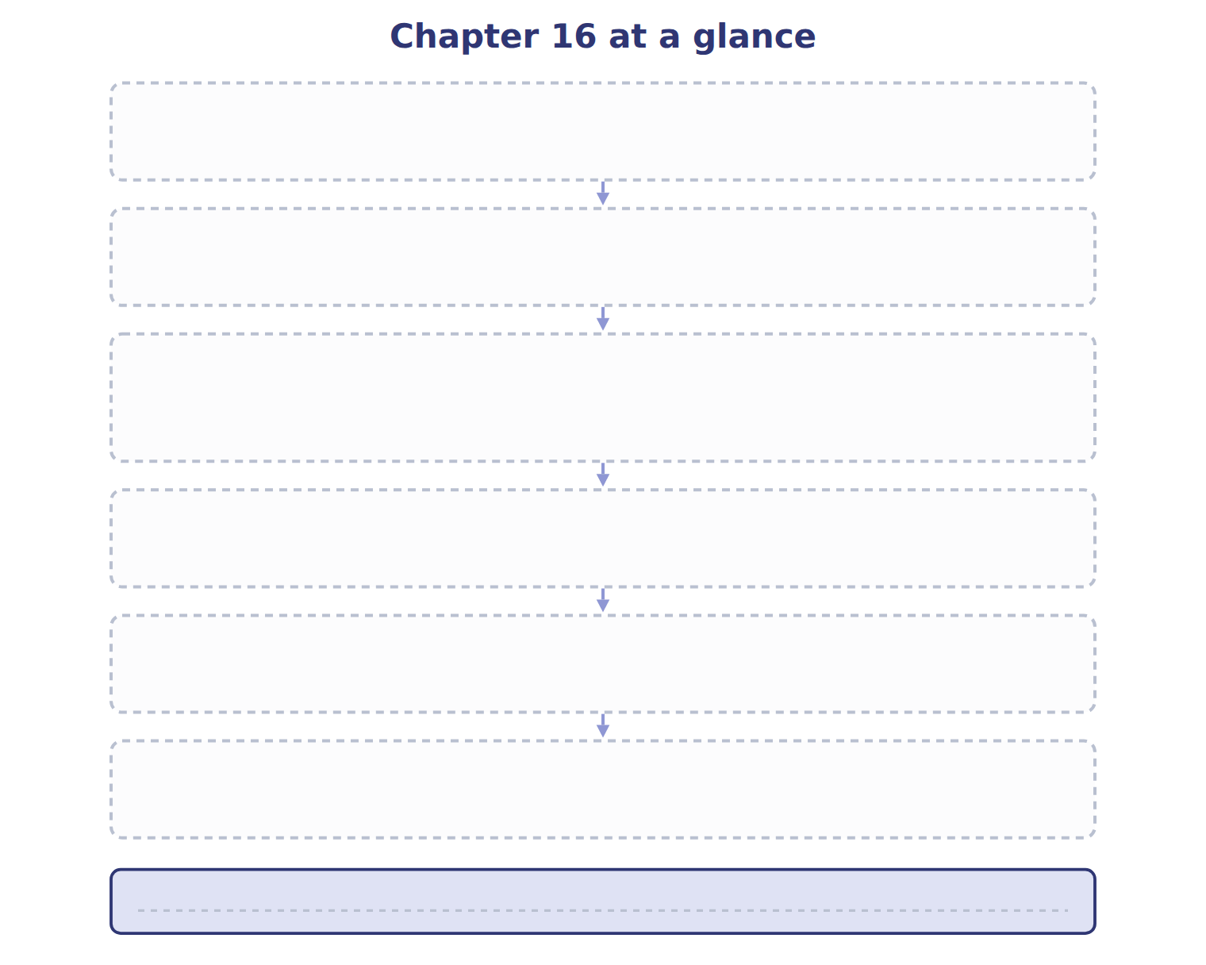
TEACH IT BACK | Write it for a student starting this chapter tomorrow — not for the marker.
27. In four or five sentences, write what the whole chapter settles, section by section.
every one of these words must appear: consolidated financial statements · parent · subsidiary · variable interest entity

