Handout 18.1
Integrated thinking, integrated reporting and the integrated report
section 18.1 of the book
Before you start
Three summaries of this handout, in the book’s own words. Read all three first: together they are the whole session. Then fill the gaps, guessing where you have to.

What this handout settles, cycle by cycle
In this handout | What you will read | How you check it
Integrated thinking, integrated reporting and the integrated report | a figure to read · Disclosure | Integrated thinking means:
The words this section uses precisely | The English the exam uses, and what it translates · Capital | What is the safest way to settle a disagreement about an answer on this sheet?

Words this handout uses precisely
Words this handout uses precisely | tick it if you could already use it in a sentence
integrated reporting
outcomes
social and relationship capital

1. Where the section starts — Fill every gap. The list holds more words than there are gaps, so one or two of them are not used.
choose from: human capital · Integrated thinking · guiding principles · capitals
is the way management considers the relationships between the company's units and the resources, or , that it uses and affects. It leads to decisions that consider value creation over the short, medium and long term.
2. What it settles in the middle — Fill every gap. The list holds more words than there are gaps, so one or two of them are not used.
choose from: Integrated reporting · integrated thinking · human capital · guiding principles
is the process, founded on , that results in a periodic integrated report. The integrated report is the product: a concise communication about how the company's strategy, governance, performance and prospects lead to the creation, preservation or erosion of value over time.
3. Where it ends — Fill every gap. The list holds more words than there are gaps, so one or two of them are not used.
choose from: capitals · human capital · Integrated thinking · guiding principles · Integrated reporting
is the way management considers the relationships between the company's units and the resources, or , that it uses and affects. It leads to decisions that consider value creation over the short, medium and long term. is the process, founded on integrated thinking, that results in a periodic integrated report.

CYCLE A | Integrated thinking, integrated reporting and the integrated report

ORIENT One claim. Decide now; you will check it in a moment.

4. The book gives the category of D1 Driver training as “Human capital”. TRUE / FALSE
MODEL Read it before you answer anything below it.

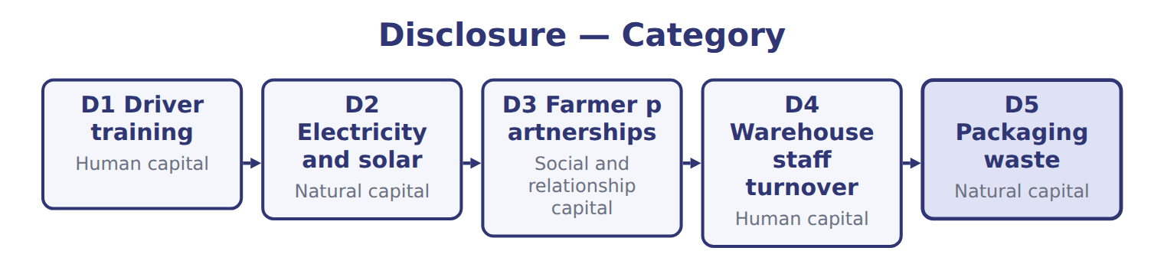
Disclosure — the book’s own table
Disclosure | Category
D1 Driver training | Human capital
D2 Electricity and solar | Natural capital
D3 Farmer partnerships | Social and relationship capital
D4 Warehouse staff turnover | Human capital
D5 Packaging waste | Natural capital

READ THE MODEL Every answer is printed above. Find it, do not recall it.

5. Which category does the book give for D1 Driver training?
A. Social and relationship capital | C. Natural capital
B. Human capital
6. Which category does the book give for D2 Electricity and solar?
A. Natural capital | C. Social and relationship capital
B. Human capital
7. Which category does the book give for D3 Farmer partnerships?
A. Human capital | C. Social and relationship capital
B. Natural capital
8. Which category does the book give for D4 Warehouse staff turnover?
A. Social and relationship capital | C. Human capital
B. Natural capital
9. The book gives the category of D1 Driver training as “Human capital”. TRUE / FALSE
10. The book gives the category of D2 Electricity and solar as “Human capital”. TRUE / FALSE

APPLY No help on this move.

11. Integrated thinking means:
A. combining the financial statements of a parent and its subsidiaries
B. preparing one report for all regulators
C. integrating IFRS and U.S. GAAP
D. management considering the relationships between the company's units and the capitals it uses and affects
12. Which guiding principle is Orontes applying when it links its irrigation spending to water use and to grower yields?
A. Conciseness | C. Consistency and comparability
B. Connectivity of information | D. Reliability and completeness
13. Orontes includes both a successful product launch and a failed one in its integrated report. Which principle does this reflect?
A. Reliability and completeness | C. Strategic focus
B. Materiality | D. Stakeholder relationships
14. Under the Framework, a matter is material if it:
A. exceeds 5% of net income
B. is required by the SEC
C. could substantively affect the company's ability to create value over the short, medium or long term
D. has already caused a loss
WORK IN PAIRS | Compare every answer on this page with your partner before you read any key.
If you disagree: go back to the model and find the row that settles it. The row decides, not the louder voice.
CHECKPOINT 15. Integrated thinking means:
A. combining the financial statements of a parent and its subsidiaries
B. preparing one report for all regulators
C. integrating IFRS and U.S. GAAP
D. management considering the relationships between the company's units and the capitals it uses and affects
If you got it wrong: redo the READ THE MODEL questions of cycle A with the model in front of you.

CYCLE B | The words this section uses precisely

ORIENT

16. A term in the exam means exactly what the book defines it to mean, whatever it means in ordinary English. TRUE / FALSE
MODEL

The English the exam uses, and what it translates
English (exam term) | the Arabic it translates
integrated reporting | إعداد التقارير المتكاملة
outcomes | النتائج (الآثار)
social and relationship capital | رأس المال الاجتماعي والعلاقات

READ THE MODEL

17. A glossary term and its translation are a pair the book itself gives. TRUE / FALSE

APPLY

18. Which group is NOT the primary audience of an integrated report, although it benefits from it?
A. Shareholders
B. Lenders
C. Local communities
D. Other providers of financial capital
Capital — the extract for the question that follows
Capital | Orontes examples (2027) | Possible measure
Financial | Equity and bank loans (Part I) | Cash flow from operations
Manufactured | Presses, bottling lines, cold stores | Plant capacity
Intellectual | Recipes, brand, new sparkling-juice line | Share of sales from new products
Human | 1,850 employees | 20 training hours per employee
Social and relationship | 2,400 farmers in grower cooperatives; supermarket customers | Farmer contracts renewed
Natural | Olive groves, water, energy | Water 900,000 m3; renewable electricity 30%

19. The extract for this question is printed with it. Orontes's 2,400 cooperative farmers are an example of which capital?
A. Human capital | C. Natural capital
B. Social and relationship capital | D. Financial capital
CHECKPOINT 20. What is the safest way to settle a disagreement about an answer on this sheet?
A. find the row of the model that decides it
B. take the answer of whoever is more confident
C. leave it until the lecturer says
D. choose the longer option
If you got it wrong: redo the READ THE MODEL questions of cycle B.

FROM MEMORY | Close the earlier pages first.
21. Rebuild the figure from this handout. Label every part and fill in every box.
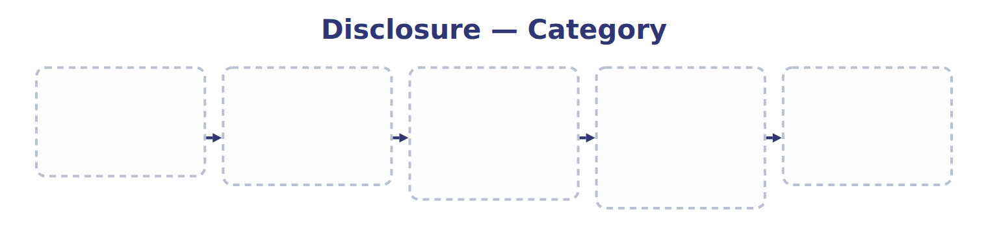
TEACH IT BACK | Write it for a classmate who missed this session — not for the marker.
22. In three or four sentences, write what this section settles and the one rule a reader has to take away.
every one of these words must appear: integrated reporting · outcomes · social and relationship capital

Handout 18.2
The primary purpose
section 18.2 of the book
Before you start
Three summaries of this handout, in the book’s own words. Read all three first: together they are the whole session. Then fill the gaps, guessing where you have to.

What this handout settles, cycle by cycle
In this handout | What you will read | How you check it
The primary purpose | a figure to read · Report · the book’s own rule, gapped | Orontes's secret recipe for flavoured olive oil is an example of:
The words this section uses precisely | The English the exam uses, and what it translates | What is the safest way to settle a disagreement about an answer on this sheet?

Words this handout uses precisely
Words this handout uses precisely | tick it if you could already use it in a sentence
integrated report
content elements
natural capital

1. Where the section starts — Fill every gap. The list holds more words than there are gaps, so one or two of them are not used.
choose from: financial capital · human capital · integrated report · natural capital
The primary purpose of an is to explain to providers of , such as shareholders and lenders, how the company creates, preserves or erodes value over time. This is the exam answer to 'Who is the main audience?'.
2. What it settles in the middle — Fill every gap. The list holds more words than there are gaps, so one or two of them are not used.
choose from: financial capital · natural capital · human capital · integrated reporting
In the United States, is voluntary; U.S. The primary audience is providers of , not 'all stakeholders'. All stakeholders benefit, but the Framework names investors and lenders first. SC18-4 Orontes's draft integrated report says it is written 'mainly for our employees'.
3. Where it ends — Fill every gap. The list holds more words than there are gaps, so one or two of them are not used.
choose from: financial capital · human capital · integrated report · natural capital
The primary audience is providers of , not 'all stakeholders'. All stakeholders benefit, but the Framework names investors and lenders first. SC18-4 Orontes's draft says it is written 'mainly for our employees'.
How every cycle on this sheet works
How a cycle works | what you do
MODEL | read the figure or the table before you answer anything
READ THE MODEL | every answer is printed on the same page
INVENT THE RULE | write the rule yourself, then compare with the book
APPLY | no help on this move
CHECKPOINT | mark it yourself; if you miss it, the sheet says what to redo

CYCLE A | The primary purpose

ORIENT One claim. Decide now; you will check it in a moment.

4. The book gives the primary audience of Financial statements (U.S. GAAP) as “Investors and creditors”. TRUE / FALSE
MODEL Read it before you answer anything below it.

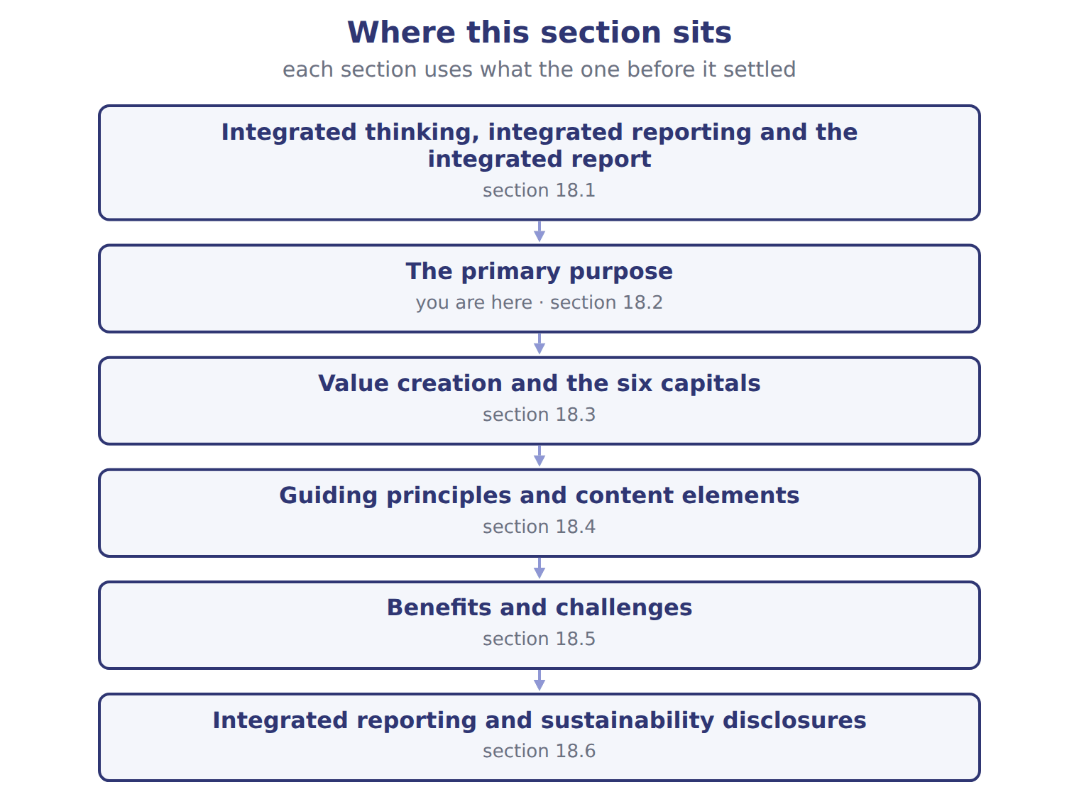

Report — the book’s own table
Report | Primary audience | Focus | Required for Orontes?
Financial statements (U.S. GAAP) | Investors and creditors | Financial position and performance | Yes: required for an SEC registrant
Management's discussion and analysis (MD&A) | Investors | Explains results, liquidity and risks | Yes: SEC requirement
Integrated report (<IR> Framework) | Providers of financial capital, then other stakeholders | How value is created, preserved or eroded, using all six capitals | No: voluntary
Sustainability disclosures (IFRS S1 and S2) | Investors | Sustainability and climate risks that affect prospects | Only where a jurisdiction adopts them

READ THE MODEL Every answer is printed above. Find it, do not recall it.

5. Which primary audience does the book give for Financial statements (U.S. GAAP)?
A. Investors and creditors
B. Investors
C. Providers of financial capital, then other stakeholders
6. Which primary audience does the book give for Management's discussion and analysis (MD&A)?
A. Investors
B. Investors and creditors
C. Providers of financial capital, then other stakeholders
7. Which report does the book pair with “Providers of financial capital, then other stakeholders”?
A. Management's discussion and analysis (MD&A)
B. Sustainability disclosures (IFRS S1 and S2)
C. Financial statements (U.S. GAAP)
D. Integrated report (<IR> Framework)
8. Which primary audience does the book give for Sustainability disclosures (IFRS S1 and S2)?
A. Investors and creditors
B. Providers of financial capital, then other stakeholders
C. Investors
9. The book gives the Required for Orontes? of Financial statements (U.S. GAAP) as “Yes: required for an SEC registrant”. TRUE / FALSE
10. The book gives the Required for Orontes? of Management's discussion and analysis (MD&A) as “Yes: required for an SEC registrant”. TRUE / FALSE
INVENT THE RULE

11. Complete the book’s own sentence. The list holds more words than there are gaps.
use every one of these words: integrated report · integrated thinking · financial capital · outputs
The primary purpose of an is to explain to providers of , such as shareholders and lenders, how the company creates, preserves or erodes value over time.

Two of the book’s own cases, side by side
Financial statements (U.S. GAAP) | Management's discussion and analysis (MD&A)
Primary audience: Investors and creditors | Primary audience: Investors
Focus: Financial position and performance | Focus: Explains results, liquidity and risks
Only the facts above differ. What is the required for orontes? of Financial statements (U.S. GAAP)?
12. Choose one:
A. No: voluntary
B. Yes: SEC requirement
C. Only where a jurisdiction adopts them
D. Yes: required for an SEC registrant

APPLY No help on this move.

13. Orontes's secret recipe for flavoured olive oil is an example of:
A. Intellectual capital | C. Human capital
B. Manufactured capital | D. Financial capital
14. In the worked example, which capital falls when Orontes pays for the irrigation system?
A. Natural capital | C. Intellectual capital
B. Human capital | D. Financial capital
15. Must a company use exactly the six capital categories in its integrated report?
A. Yes; all six headings are mandatory
B. Yes, but only for listed companies
C. No; capitals are not part of the Framework
D. No; the categories are a checklist, but it should consider all the capitals it uses or affects
Capital — the extract for the question that follows
Capital | Orontes examples (2027) | Possible measure
Financial | Equity and bank loans (Part I) | Cash flow from operations
Manufactured | Presses, bottling lines, cold stores | Plant capacity
Intellectual | Recipes, brand, new sparkling-juice line | Share of sales from new products
Human | 1,850 employees | 20 training hours per employee
Social and relationship | 2,400 farmers in grower cooperatives; supermarket customers | Farmer contracts renewed
Natural | Olive groves, water, energy | Water 900,000 m3; renewable electricity 30%

16. The extract for this question is printed with it. What is Orontes's training per employee in 2027?
A. 37,000 hours | C. 20 hours
B. 1,850 hours | D. 2 hours
WORK IN PAIRS | Compare every answer on this page with your partner before you read any key.
If you disagree: go back to the model and find the row that settles it. The row decides, not the louder voice.
CHECKPOINT 17. Orontes's secret recipe for flavoured olive oil is an example of:
A. Intellectual capital
B. Manufactured capital
C. Human capital
D. Financial capital
If you got it wrong: redo the READ THE MODEL questions of cycle A with the model in front of you.

CYCLE B | The words this section uses precisely

ORIENT

18. A term in the exam means exactly what the book defines it to mean, whatever it means in ordinary English. TRUE / FALSE

MODEL

The English the exam uses, and what it translates
English (exam term) | the Arabic it translates
integrated report | التقرير المتكامل
content elements | عناصر المحتوى
natural capital | رأس المال الطبيعي

READ THE MODEL

19. A glossary term and its translation are a pair the book itself gives. TRUE / FALSE
APPLY

20. 'How does the board oversee water risk?' is answered by which content element?
A. Performance | C. Business model
B. Governance | D. Outlook
21. Which content element explains how the company decided what to include and how it measured it?
A. Basis of preparation and presentation
B. Strategy and resource allocation
C. Risks and opportunities
D. Organizational overview and external environment
CHECKPOINT 22. What is the safest way to settle a disagreement about an answer on this sheet?
A. find the row of the model that decides it
B. take the answer of whoever is more confident
C. leave it until the lecturer says
D. choose the longer option
If you got it wrong: redo the READ THE MODEL questions of cycle B.

FROM MEMORY | Close the earlier pages first.
23. Rebuild the figure from this handout. Label every part and fill in every box.
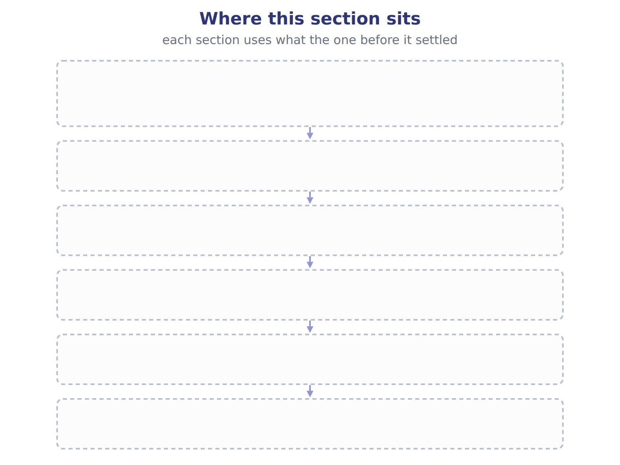
TEACH IT BACK | Write it for a classmate who missed this session — not for the marker.
24. In three or four sentences, write what this section settles and the one rule a reader has to take away.
every one of these words must appear: integrated report · content elements · natural capital

Handout 18.3
Value creation and the six capitals
section 18.3 of the book
Before you start
Three summaries of this handout, in the book’s own words. Read all three first: together they are the whole session. Then fill the gaps, guessing where you have to.

What this handout settles, cycle by cycle
In this handout | What you will read | How you check it
Value creation and the six capitals | a figure to read · Capital · the book’s own rule, gapped | How many content elements and guiding principles does the Framework set out?
The words this section uses precisely | Orontes disclosure · The English the exam uses, and what it translates | What is the safest way to settle a disagreement about an answer on this sheet?

Words this handout uses precisely
Words this handout uses precisely | tick it if you could already use it in a sentence
integrated thinking
financial capital
guiding principles

1. Where the section starts — Fill every gap. The list holds more words than there are gaps, so one or two of them are not used.
choose from: social and relationship capital · manufactured capital · guiding principles · financial capital · intellectual capital · natural capital · integrated reporting
The Framework describes value in terms of six capitals: stocks of value that increase, decrease or change as the company works. They are , , , human capital, and .
2. What it settles in the middle — Fill every gap. The list holds more words than there are gaps, so one or two of them are not used.
choose from: natural capital · capitals · value creation process · guiding principles · integrated report · outcomes · outputs
The : , business model, and . Capitals are connected, so decisions involve trade-offs. The six categories are not mandatory; a company may group them differently, but it should consider all the capitals it uses or affects. An explains the whole trade-off, not only the cost.
3. Where it ends — Fill every gap. The list holds more words than there are gaps, so one or two of them are not used.
choose from: capitals · integrated reporting · natural capital · guiding principles
In , are resources and relationships, not share capital. French capital social means share capital, but capital social et relationnel is one of the six capitals. SC18-6 Orontes produces bottled olive oil and olive-pit waste.

CYCLE A | Value creation and the six capitals

ORIENT One claim. Decide now; you will check it in a moment.

4. The book gives the orontes examples (2027) of Financial as “Equity and bank loans (Part I)”. TRUE / FALSE
MODEL Read it before you answer anything below it.

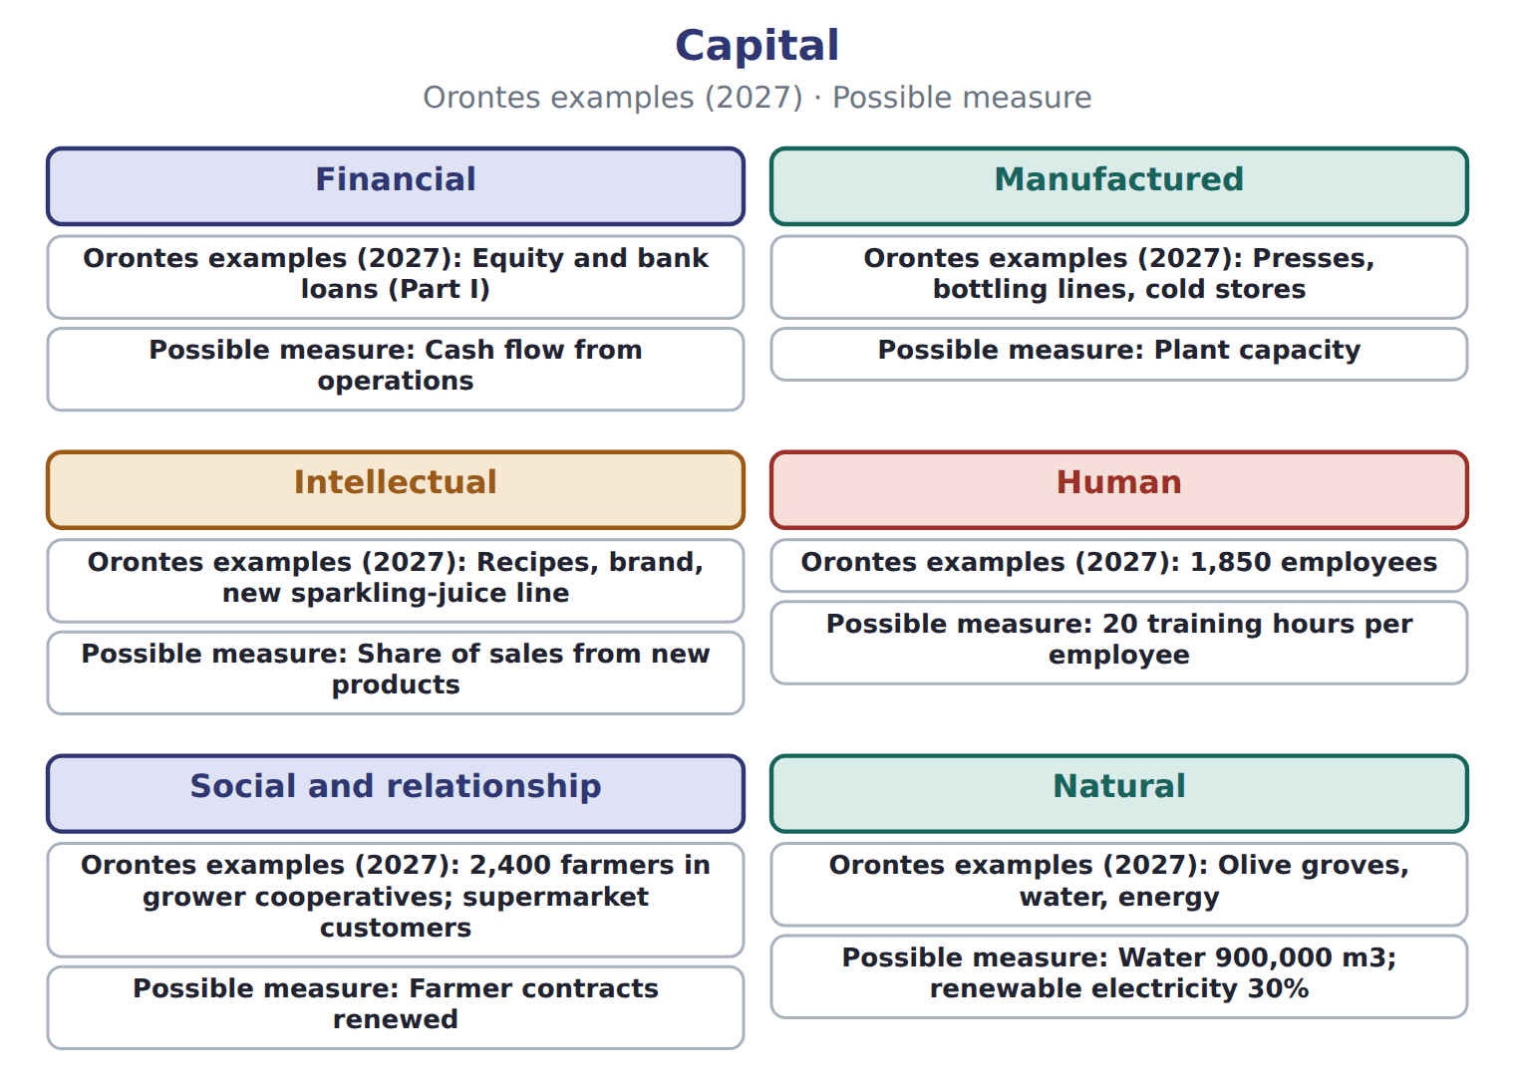

Capital — the book’s own table
Capital | Orontes examples (2027) | Possible measure
Financial | Equity and bank loans (Part I) | Cash flow from operations
Manufactured | Presses, bottling lines, cold stores | Plant capacity
Intellectual | Recipes, brand, new sparkling-juice line | Share of sales from new products
Human | 1,850 employees | 20 training hours per employee
Social and relationship | 2,400 farmers in grower cooperatives; supermarket customers | Farmer contracts renewed
Natural | Olive groves, water, energy | Water 900,000 m3; renewable electricity 30%

READ THE MODEL Every answer is printed above. Find it, do not recall it.

5. Which capital does the book pair with “Equity and bank loans (Part I)”?
A. Manufactured | C. Human
B. Natural | D. Financial
6. Which capital does the book pair with “Presses, bottling lines, cold stores”?
A. Manufactured | C. Natural
B. Human | D. Social and relationship
7. Which capital does the book pair with “Recipes, brand, new sparkling-juice line”?
A. Intellectual | C. Natural
B. Financial | D. Manufactured
8. Which capital does the book pair with “1,850 employees”?
A. Financial | C. Intellectual
B. Human | D. Manufactured
9. The book gives the possible measure of Financial as “Cash flow from operations”. TRUE / FALSE
10. The book gives the possible measure of Manufactured as “Share of sales from new products”. TRUE / FALSE
INVENT THE RULE

11. Complete the book’s own sentence. The list holds more words than there are gaps.
use every one of these words: intellectual capital · value creation process · manufactured capital · social and relationship capital · guiding principles
They are financial capital, , , human capital, and natural capital.

Two of the book’s own cases, side by side
Financial | Manufactured
Orontes examples (2027): Equity and bank loans (Part I) | Orontes examples (2027): Presses, bottling lines, cold stores
Only the facts above differ. What is the possible measure of Financial?
12. Choose one:
A. Cash flow from operations | C. Plant capacity
B. 20 training hours per employee | D. Share of sales from new products

APPLY No help on this move.

13. How many content elements and guiding principles does the Framework set out?
A. Seven content elements and eight guiding principles
B. Six of each
C. Eight content elements and seven guiding principles
D. Eight of each
14. Why do integrated reports from different companies often differ in their measures?
A. The SEC requires different KPIs for each industry
B. The Framework is principles-based and does not prescribe KPIs
C. Integrated reports are audited under different standards
D. Each company must use the six capitals in a different order
15. A company fears that disclosing its product plans will help competitors. This concern is:
A. a guiding principle
B. a content element
C. a benefit of integrated reporting
D. a challenge of integrated reporting
16. Which statement about the International <IR> Framework is correct?
A. It was last revised in January 2021 and is maintained by the IFRS Foundation
B. It was replaced by IFRS S1 in 2024
C. It is part of U.S. GAAP
D. It was withdrawn when the IIRC closed
WORK IN PAIRS | Compare every answer on this page with your partner before you read any key.
If you disagree: go back to the model and find the row that settles it. The row decides, not the louder voice.
CHECKPOINT 17. How many content elements and guiding principles does the Framework set out?
A. Seven content elements and eight guiding principles
B. Six of each
C. Eight content elements and seven guiding principles
D. Eight of each
If you got it wrong: redo the READ THE MODEL questions of cycle A with the model in front of you.

CYCLE B | The words this section uses precisely

ORIENT

18. A term in the exam means exactly what the book defines it to mean, whatever it means in ordinary English. TRUE / FALSE
MODEL

Orontes disclosure — the book’s own table
Orontes disclosure | Capital
Headroom under bank loan covenants | Financial
A new bottling line | Manufactured
Safety training for factory staff | ________
The trademark for Orontes Gold olive oil | ________
Water drawn from local wells | ________
Long-term contracts with grower cooperatives | ________

The English the exam uses, and what it translates
English (exam term) | the Arabic it translates
integrated thinking | التفكير المتكامل
financial capital | رأس المال المالي
guiding principles | المبادئ التوجيهية

READ THE MODEL

19. Which capital does the book give for Headroom under bank loan covenants?
A. Manufactured | C. Financial
B. ________
20. Which capital does the book give for A new bottling line?
A. Manufactured | C. Financial
B. ________
21. Which capital does the book give for Safety training for factory staff?
A. Financial | C. Manufactured
B. ________
APPLY

22. Writing a term in English is part of answering the question, not an extra. TRUE / FALSE
CHECKPOINT 23. What is the safest way to settle a disagreement about an answer on this sheet?
A. find the row of the model that decides it
B. take the answer of whoever is more confident
C. leave it until the lecturer says
D. choose the longer option
If you got it wrong: redo the READ THE MODEL questions of cycle B.

FROM MEMORY | Close the earlier pages first.
24. Rebuild the figure from this handout. Label every part and fill in every box.
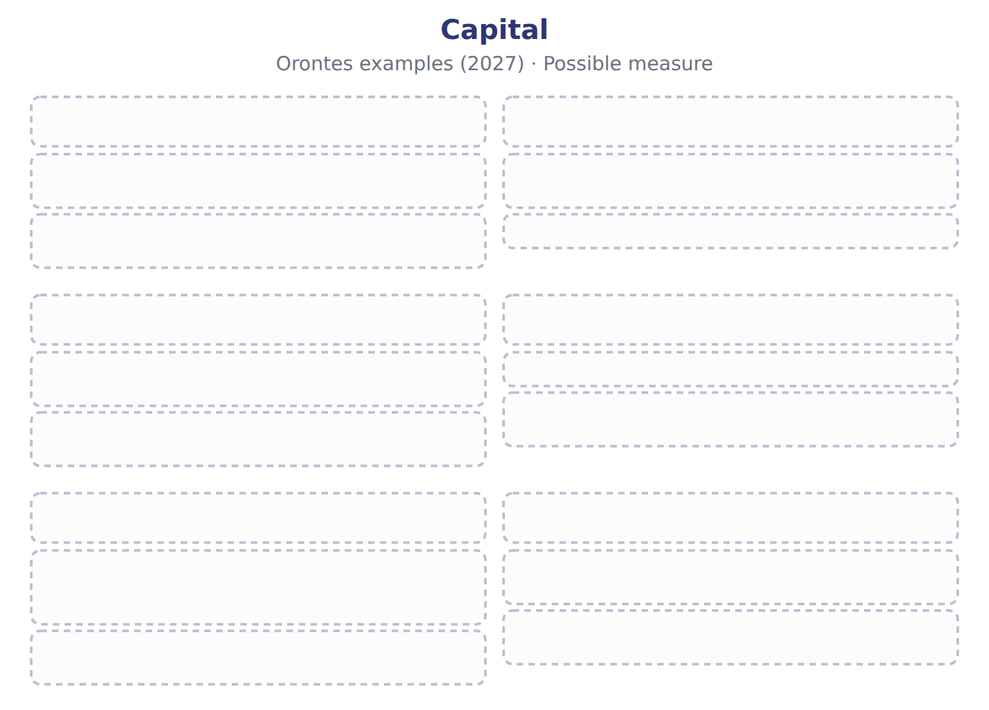
TEACH IT BACK | Write it for a classmate who missed this session — not for the marker.
25. In three or four sentences, write what this section settles and the one rule a reader has to take away.
every one of these words must appear: integrated thinking · financial capital · guiding principles

Handout 18.4
Guiding principles and content elements
section 18.4 of the book
Before you start
Three summaries of this handout, in the book’s own words. Read all three first: together they are the whole session. Then fill the gaps, guessing where you have to.

What this handout settles, cycle by cycle
In this handout | What you will read | How you check it
Guiding principles and content elements | a figure to read · Content element (8) · the book’s own rule, gapped | Which of these did this cycle settle?
The words this section uses precisely | Guiding principle (7) · The English the exam uses, and what it translates | What is the safest way to settle a disagreement about an answer on this sheet?

Words this handout uses precisely
Words this handout uses precisely | tick it if you could already use it in a sentence
capitals
manufactured capital

1. Where the section starts — Fill every gap. The list holds more words than there are gaps, so one or two of them are not used.
choose from: guiding principles · manufactured capital · natural capital · content elements
The Framework is principles-based: it does not prescribe KPIs or measurement methods. Seven shape how the report is prepared, such as connectivity of information, materiality and conciseness. Eight set what the report covers.
2. What it settles in the middle — Fill every gap. The list holds more words than there are gaps, so one or two of them are not used.
choose from: natural capital · content elements · integrated report · manufactured capital · guiding principles
Those charged with governance, such as the board, should include a statement that they are responsible for the . The report can stand alone or be a distinguishable part of another report, such as the annual report. There are seven (how to report) and eight (what to report).
3. Where it ends — Fill every gap. The list holds more words than there are gaps, so one or two of them are not used.
choose from: guiding principles · content elements · manufactured capital · natural capital
There are seven (how to report) and eight (what to report). Materiality and connectivity are principles; governance, business model and outlook are content elements.
How every cycle on this sheet works
How a cycle works | what you do
MODEL | read the figure or the table before you answer anything
READ THE MODEL | every answer is printed on the same page
INVENT THE RULE | write the rule yourself, then compare with the book
APPLY | no help on this move
CHECKPOINT | mark it yourself; if you miss it, the sheet says what to redo

CYCLE A | Guiding principles and content elements

ORIENT One claim. Decide now; you will check it in a moment.

4. Every number in a financial statement belongs to an element the framework defines. TRUE / FALSE
MODEL Read it before you answer anything below it.

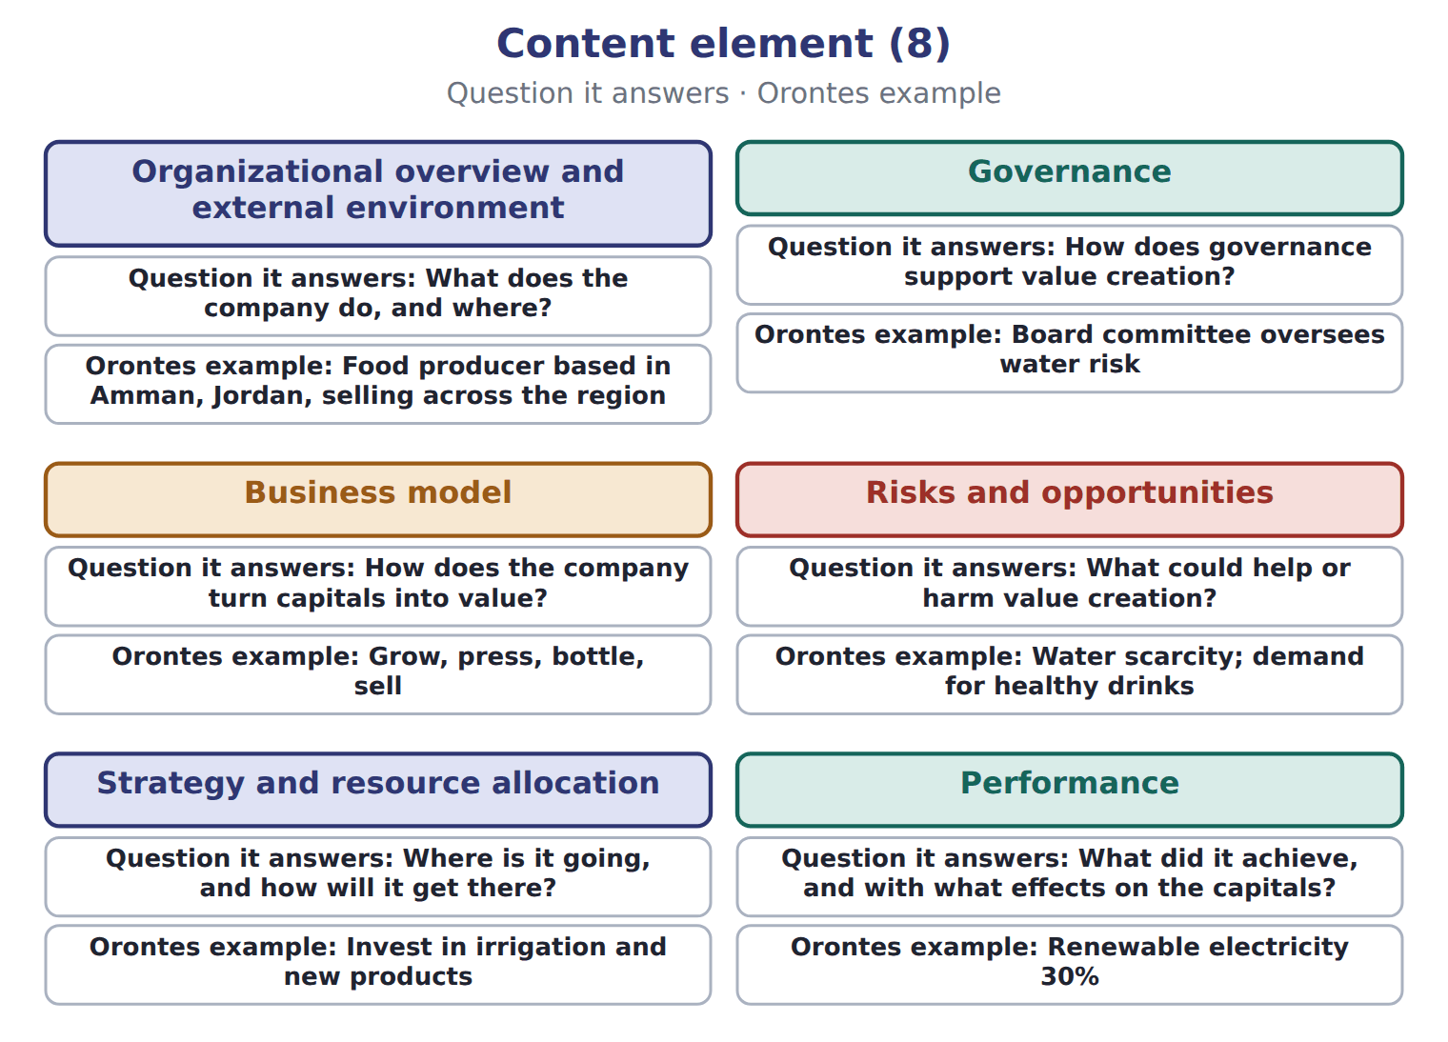

Content element (8) — the book’s own table
Content element (8) | Question it answers | Orontes example
Organizational overview and external environment | What does the company do, and where? | Food producer based in Amman, Jordan, selling across the region
Governance | How does governance support value creation? | Board committee oversees water risk
Business model | How does the company turn capitals into value? | Grow, press, bottle, sell
Risks and opportunities | What could help or harm value creation? | Water scarcity; demand for healthy drinks
Strategy and resource allocation | Where is it going, and how will it get there? | Invest in irrigation and new products
Performance | What did it achieve, and with what effects on the capitals? | Renewable electricity 30%
Outlook | What challenges and uncertainties lie ahead? | Olive yields and prices to 2030
Basis of preparation and presentation | How were matters chosen and measured? | Materiality process; measurement methods

READ THE MODEL Every answer is printed above. Find it, do not recall it.

5. Which question it answers does the book give for Organizational overview and external environment?
A. What does the company do, and where?
B. What could help or harm value creation?
C. How does governance support value creation?
D. How were matters chosen and measured?
6. Which question it answers does the book give for Governance?
A. How does the company turn capitals into value?
B. What challenges and uncertainties lie ahead?
C. How does governance support value creation?
D. Where is it going, and how will it get there?
7. Which question it answers does the book give for Business model?
A. What challenges and uncertainties lie ahead?
B. Where is it going, and how will it get there?
C. How does the company turn capitals into value?
D. How does governance support value creation?
8. Which question it answers does the book give for Risks and opportunities?
A. What does the company do, and where?
B. How does governance support value creation?
C. What could help or harm value creation?
D. How were matters chosen and measured?
INVENT THE RULE

9. Complete the book’s own sentence. The list holds more words than there are gaps.
use every one of these words: outputs · manufactured capital · content elements · guiding principles
There are seven (how to report) and eight (what to report).

Two of the book’s own cases, side by side
Governance | Business model
Question it answers: How does governance support value creation? | Question it answers: How does the company turn capitals into value?
Only the facts above differ. What is the orontes example of Governance?
10. Choose one:
A. Board committee oversees water risk
B. Invest in irrigation and new products
C. Renewable electricity 30%
D. Grow, press, bottle, sell
APPLY No help on this move.

11. The rule you have just written is the book’s own rule. TRUE / FALSE
WORK IN PAIRS | Compare every answer on this page with your partner before you read any key.
If you disagree: go back to the model and find the row that settles it. The row decides, not the louder voice.
CHECKPOINT 12. Which of these did this cycle settle?
A. the rule and where it comes from
B. nothing in particular
C. only the vocabulary
D. only the arithmetic
If you got it wrong: redo the READ THE MODEL questions of cycle A.

CYCLE B | The words this section uses precisely

ORIENT

13. A term in the exam means exactly what the book defines it to mean, whatever it means in ordinary English. TRUE / FALSE
MODEL

Guiding principle (7) — the book’s own table
Guiding principle (7) | What it means | Orontes example
Strategic focus and future orientation | Explain strategy and how it creates value over time | Plans for the sparkling-juice line to 2030
Connectivity of information | Show how capitals, strategy and performance link | Irrigation spending linked to water use and grower yields
Stakeholder relationships | Explain key relationships and how the company responds | Work with grower cooperatives
Materiality | Include matters that substantively affect value creation | Water scarcity; olive prices
Conciseness | Be short and clear | Refer to the financial statements rather than repeat them
Reliability and completeness | Include positive and negative matters, without material error | Report a failed product launch too
Consistency and comparability | Use the same basis over time and allow comparison | Same water measure every year

The English the exam uses, and what it translates
English (exam term) | the Arabic it translates
capitals | رؤوس الأموال
manufactured capital | رأس المال المصنَّع

READ THE MODEL

14. Which what it means does the book give for Strategic focus and future orientation?
A. Explain strategy and how it creates value over time
B. Show how capitals, strategy and performance link
C. Use the same basis over time and allow comparison
D. Explain key relationships and how the company responds
15. Which what it means does the book give for Connectivity of information?
A. Use the same basis over time and allow comparison
B. Show how capitals, strategy and performance link
C. Explain strategy and how it creates value over time
D. Explain key relationships and how the company responds
16. Which what it means does the book give for Stakeholder relationships?
A. Explain key relationships and how the company responds
B. Use the same basis over time and allow comparison
C. Include matters that substantively affect value creation
D. Explain strategy and how it creates value over time
APPLY

17. Writing a term in English is part of answering the question, not an extra. TRUE / FALSE
CHECKPOINT 18. What is the safest way to settle a disagreement about an answer on this sheet?
A. find the row of the model that decides it
B. take the answer of whoever is more confident
C. leave it until the lecturer says
D. choose the longer option
If you got it wrong: redo the READ THE MODEL questions of cycle B.

FROM MEMORY | Close the earlier pages first.
19. Rebuild the figure from this handout. Label every part and fill in every box.
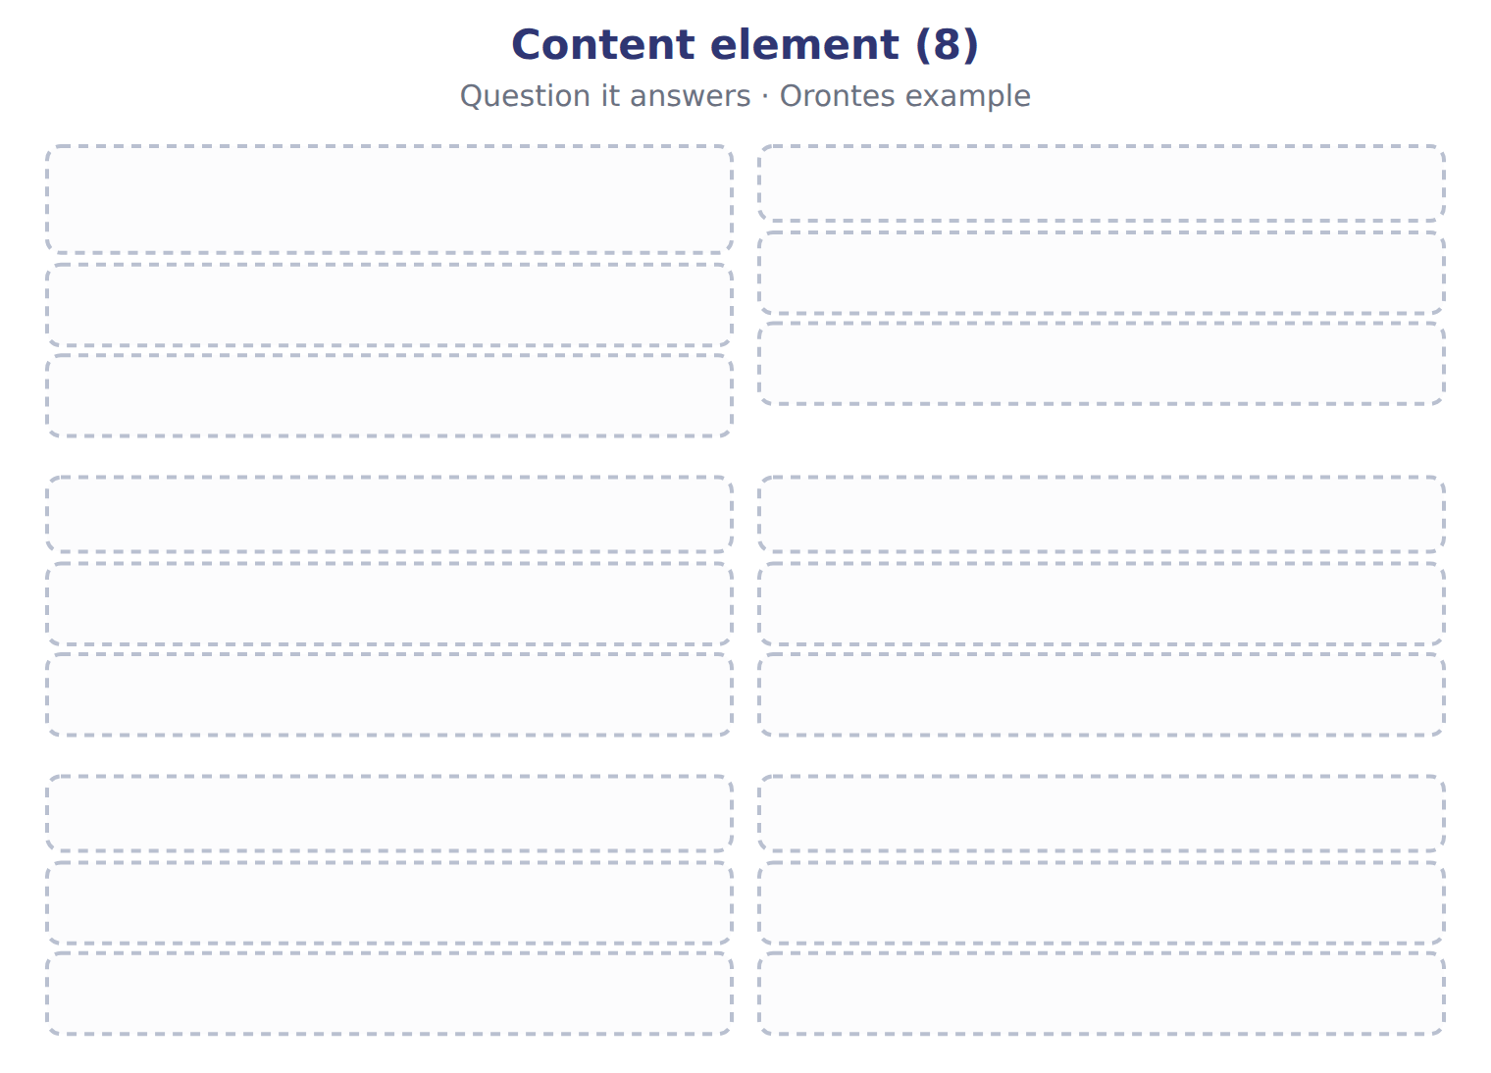
TEACH IT BACK | Write it for a classmate who missed this session — not for the marker.
20. In three or four sentences, write what this section settles and the one rule a reader has to take away.
every one of these words must appear: capitals · manufactured capital

Handout 18.5
Benefits and challenges
section 18.5 of the book
Before you start
Three summaries of this handout, in the book’s own words. Read all three first: together they are the whole session. Then fill the gaps, guessing where you have to.

What this handout settles, cycle by cycle
In this handout | What you will read | How you check it
Benefits and challenges | a figure to read · Item | Which of these did this cycle settle?
The words this section uses precisely | The English the exam uses, and what it translates | What is the safest way to settle a disagreement about an answer on this sheet?

Words this handout uses precisely
Words this handout uses precisely | tick it if you could already use it in a sentence
value creation process
intellectual capital

1. Where the section starts — Fill every gap. The list holds more words than there are gaps, so one or two of them are not used.
choose from: guiding principles · content elements · integrated reporting · capitals
Supporters say improves management itself: to report on all the , managers must think about how they connect. It can improve the allocation of capital, give investors a clearer and more concise picture, and encourage a long-term view.
2. What it settles in the middle — Fill every gap. The list holds more words than there are gaps, so one or two of them are not used.
choose from: guiding principles · content elements · capitals · integrated reporting
Supporters say improves management itself: to report on all the , managers must think about how they connect. It can improve the allocation of capital, give investors a clearer and more concise picture, and encourage a long-term view. Preparing the report takes time and money, and non-financial capitals such as relationships and skills are hard to measure.
3. Where it ends — Fill every gap. The list holds more words than there are gaps, so one or two of them are not used.
choose from: integrated · comparability · challenges · content elements · guiding principles
Because the Framework is voluntary and does not prescribe measures, reports differ between companies, which limits . Benefits and of reporting.
How every cycle on this sheet works
How a cycle works | what you do
MODEL | read the figure or the table before you answer anything
READ THE MODEL | every answer is printed on the same page
INVENT THE RULE | write the rule yourself, then compare with the book
APPLY | no help on this move
CHECKPOINT | mark it yourself; if you miss it, the sheet says what to redo

CYCLE A | Benefits and challenges

ORIENT One claim. Decide now; you will check it in a moment.

4. The book gives the answer of Safety training for factory staff as “Human capital”. TRUE / FALSE
MODEL Read it before you answer anything below it.

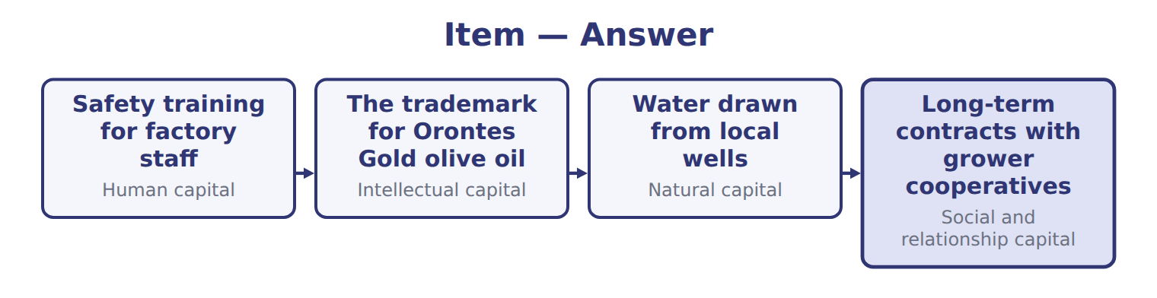
Item — the book’s own table
Item | Answer
Safety training for factory staff | Human capital
The trademark for Orontes Gold olive oil | Intellectual capital
Water drawn from local wells | Natural capital
Long-term contracts with grower cooperatives | Social and relationship capital

READ THE MODEL Every answer is printed above. Find it, do not recall it.

5. Which answer does the book give for Safety training for factory staff?
A. Human capital | C. Social and relationship capital
B. Intellectual capital | D. Natural capital
6. Which answer does the book give for The trademark for Orontes Gold olive oil?
A. Intellectual capital | C. Human capital
B. Natural capital | D. Social and relationship capital
7. Which answer does the book give for Water drawn from local wells?
A. Intellectual capital | C. Natural capital
B. Human capital | D. Social and relationship capital
8. Which answer does the book give for Long-term contracts with grower cooperatives?
A. Social and relationship capital | C. Human capital
B. Intellectual capital | D. Natural capital
9. The book gives the answer of Safety training for factory staff as “Human capital”. TRUE / FALSE
10. The book gives the answer of The trademark for Orontes Gold olive oil as “Human capital”. TRUE / FALSE
APPLY No help on this move.

11. The rule you have just written is the book’s own rule. TRUE / FALSE
WORK IN PAIRS | Compare every answer on this page with your partner before you read any key.
If you disagree: go back to the model and find the row that settles it. The row decides, not the louder voice.

CHECKPOINT 12. Which of these did this cycle settle?
A. the rule and where it comes from
B. nothing in particular
C. only the vocabulary
D. only the arithmetic
If you got it wrong: redo the READ THE MODEL questions of cycle A.

CYCLE B | The words this section uses precisely

ORIENT

13. A term in the exam means exactly what the book defines it to mean, whatever it means in ordinary English. TRUE / FALSE
MODEL

The English the exam uses, and what it translates
English (exam term) | the Arabic it translates
value creation process | عملية خلق القيمة
intellectual capital | رأس المال الفكري

READ THE MODEL

14. A glossary term and its translation are a pair the book itself gives. TRUE / FALSE
APPLY

15. Writing a term in English is part of answering the question, not an extra. TRUE / FALSE
CHECKPOINT 16. What is the safest way to settle a disagreement about an answer on this sheet?
A. find the row of the model that decides it
B. take the answer of whoever is more confident
C. leave it until the lecturer says
D. choose the longer option
If you got it wrong: redo the READ THE MODEL questions of cycle B.

FROM MEMORY | Close the earlier pages first.
17. Rebuild the figure from this handout. Label every part and fill in every box.

TEACH IT BACK | Write it for a classmate who missed this session — not for the marker.
18. In three or four sentences, write what this section settles and the one rule a reader has to take away.
every one of these words must appear: value creation process · intellectual capital

Handout 18.6
Integrated reporting and sustainability disclosures
section 18.6 of the book
Before you start
Three summaries of this handout, in the book’s own words. Read all three first: together they are the whole session. Then fill the gaps, guessing where you have to.

What this handout settles, cycle by cycle
In this handout | What you will read | How you check it
Integrated reporting and sustainability disclosures | a figure to read · Item | Which of these did this cycle settle?
The words this section uses precisely | Disclosure · The English the exam uses, and what it translates | What is the safest way to settle a disagreement about an answer on this sheet?

Words this handout uses precisely
Words this handout uses precisely | tick it if you could already use it in a sentence
outputs
human capital

1. Where the section starts — Fill every gap. The list holds more words than there are gaps, so one or two of them are not used.
choose from: jurisdiction · sustainability · disclosure · financial capital · integrated reporting
IFRS S1 and IFRS S2, issued by the ISSB, require of and climate risks that affect a company's prospects. They apply only where a adopts them.
2. What it settles in the middle — Fill every gap. The list holds more words than there are gaps, so one or two of them are not used.
choose from: integrated reporting · disclosures · integrated · financial capital · information
S1 asks for connected , an idea taken from reporting, but S1 and S2 are not an integrated report. It is voluntary, and it is not in the LOS.
3. Where it ends — Fill every gap. The list holds more words than there are gaps, so one or two of them are not used.
choose from: integrated reporting · publishes · background · financial capital · disclosures
These are facts, not exam content. SC18-11 A company IFRS S2 climate .
How every cycle on this sheet works
How a cycle works | what you do
MODEL | read the figure or the table before you answer anything
READ THE MODEL | every answer is printed on the same page
INVENT THE RULE | write the rule yourself, then compare with the book
APPLY | no help on this move
CHECKPOINT | mark it yourself; if you miss it, the sheet says what to redo

CYCLE A | Integrated reporting and sustainability disclosures

ORIENT One claim. Decide now; you will check it in a moment.

4. The book gives the Barada Wholesale: draft first integrated report, of D1 as “Barada trained all delivery drivers in safe driving.”. TRUE / FALSE
MODEL Read it before you answer anything below it.

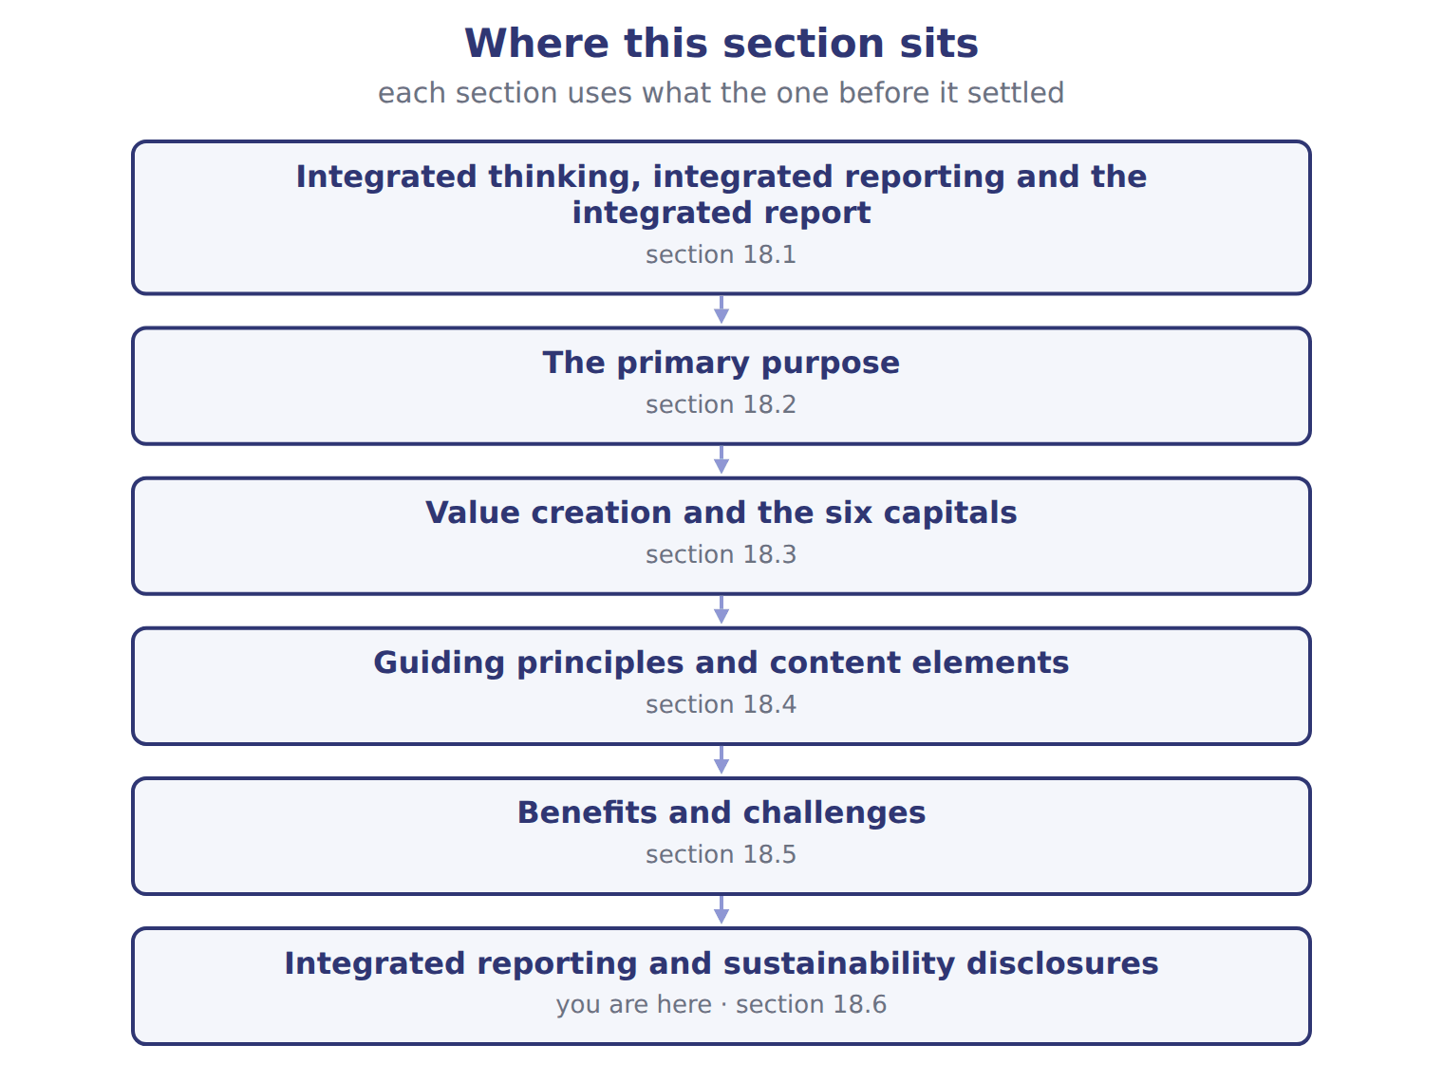

Item — the book’s own table
Item | Barada Wholesale: draft first integrated report,
D1 | Barada trained all delivery drivers in safe driving.
D2 | Barada used 600 MWh of electricity in 2028; 150 MWh came from its own solar panels.
D3 | Barada signed five-year partnerships with 60 small farmers.
D4 | Staff turnover in the warehouse fell from 25% to 15%.
D5 | Packaging waste sent to landfill fell by one third.
D6 | Rising fuel prices could cut Barada's delivery margins in 2029 and 2030.
M1 | The draft says: 'This report is written mainly for our employees and the local community.'
M2 | The draft links each strategic goal to the KPI and the capital it affects.

READ THE MODEL Every answer is printed above. Find it, do not recall it.

5. Which item does the book pair with “Barada trained all delivery drivers in safe driving.”?
A. D3 | C. D1
B. D6 | D. D2
6. Which item does the book pair with “Barada used 600 MWh of electricity in 2028; 150 MWh came from its own solar panels.”?
A. D1 | C. D5
B. M1 | D. D2
7. Which item does the book pair with “Barada signed five-year partnerships with 60 small farmers.”?
A. M1 | C. D5
B. D3 | D. D4
8. Which item does the book pair with “Staff turnover in the warehouse fell from 25% to 15%.”?
A. D2 | C. D1
B. D4 | D. D5
9. The book gives the Barada Wholesale: draft first integrated report, of D1 as “Barada trained all delivery drivers in safe driving.”. TRUE / FALSE
10. The book gives the Barada Wholesale: draft first integrated report, of D2 as “Packaging waste sent to landfill fell by one third.”. TRUE / FALSE
APPLY No help on this move.

11. The rule you have just written is the book’s own rule. TRUE / FALSE
WORK IN PAIRS | Compare every answer on this page with your partner before you read any key.
If you disagree: go back to the model and find the row that settles it. The row decides, not the louder voice.
CHECKPOINT 12. Which of these did this cycle settle?
A. the rule and where it comes from
B. nothing in particular
C. only the vocabulary
D. only the arithmetic
If you got it wrong: redo the READ THE MODEL questions of cycle A.

CYCLE B | The words this section uses precisely

ORIENT

13. A term in the exam means exactly what the book defines it to mean, whatever it means in ordinary English. TRUE / FALSE
MODEL

Disclosure — the book’s own table
Disclosure | Category
D1 Driver training
D2 Electricity and solar
D3 Farmer partnerships
D4 Warehouse staff turnover
D5 Packaging waste

The English the exam uses, and what it translates
English (exam term) | the Arabic it translates
outputs | المخرجات
human capital | رأس المال البشري

READ THE MODEL

14. A glossary term and its translation are a pair the book itself gives. TRUE / FALSE
APPLY

15. Writing a term in English is part of answering the question, not an extra. TRUE / FALSE
CHECKPOINT 16. What is the safest way to settle a disagreement about an answer on this sheet?
A. find the row of the model that decides it
B. take the answer of whoever is more confident
C. leave it until the lecturer says
D. choose the longer option
If you got it wrong: redo the READ THE MODEL questions of cycle B.

FROM MEMORY | Close the earlier pages first.
17. Rebuild the figure from this handout. Label every part and fill in every box.
TEACH IT BACK | Write it for a classmate who missed this session — not for the marker.
18. In three or four sentences, write what this section settles and the one rule a reader has to take away.
every one of these words must appear: outputs · human capital

Handout 18.7
The whole chapter
every section, shuffled, and the chapter’s own case set
Before you start
Three summaries of this chapter, in the book’s own words, with words taken out. Read all three first: together they are the whole chapter. Then fill the gaps.

What this handout settles, cycle by cycle
In this handout | What you will read | How you check it
The whole chapter, in order | a figure to read | Which statement correctly describes the relationship between the three ideas?
The chapter’s case set | The chapter’s case set, item by item | What has to be settled before any figure in a case set is worked out?
The words it uses precisely | integrated reporting · integrated report · integrated thinking · capitals · value creation process · outputs | matching, at the end of cycle B

1. Where the chapter starts — Fill every gap. The list holds more words than there are gaps, so one or two of them are not used.
choose from: capitals · human capital · natural capital · Integrated thinking · Integrated reporting
is the way management considers the relationships between the company's units and the resources, or , that it uses and affects. It leads to decisions that consider value creation over the short, medium and long term. is the process, founded on integrated thinking, that results in a periodic integrated report.
2. What it settles in the middle — Fill every gap. The list holds more words than there are gaps, so one or two of them are not used.
choose from: financial capital · human capital · value creation process · intellectual capital · natural capital · manufactured capital · social and relationship capital
They are , , , human capital, and natural capital. In the , the business model takes capitals as inputs and turns them, through its activities, into outputs: products, by-products and waste.
3. Where it ends — Fill every gap. The list holds more words than there are gaps, so one or two of them are not used.
choose from: human capital · integrated reporting · capitals · content elements · natural capital · guiding principles
There are seven (how to report) and eight (what to report). Materiality and connectivity are principles; governance, business model and outlook are content elements. Supporters say improves management itself: to report on all the , managers must think about how they connect.

CYCLE A | The whole chapter, in order

ORIENT

4. The sections of a chapter have to be taken in order, because each one uses what the one before it settled. TRUE / FALSE
MODEL

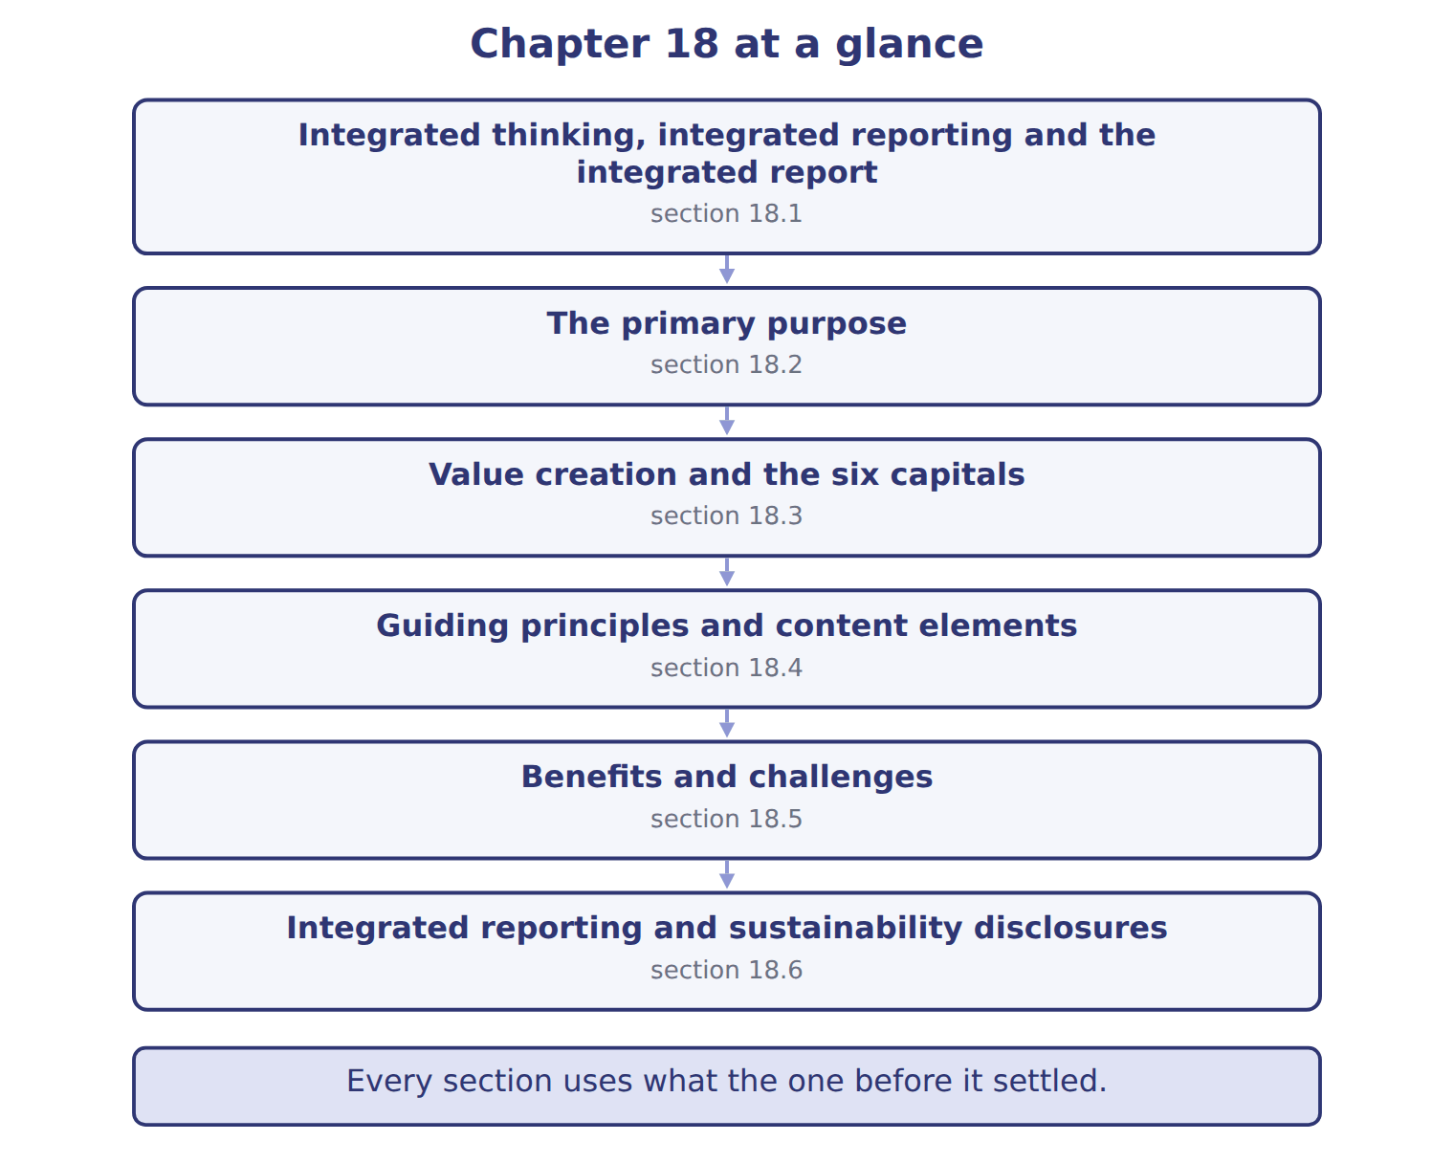
READ THE MODEL

5. Which part of this chapter is section 18.1?
A. Integrated reporting and sustainability disclosures
B. Value creation and the six capitals
C. Guiding principles and content elements
D. Integrated thinking, integrated reporting and the integrated report
6. Which part of this chapter is section 18.2?
A. Guiding principles and content elements
B. Benefits and challenges
C. The primary purpose
D. Value creation and the six capitals
7. Which part of this chapter is section 18.3?
A. Benefits and challenges
B. The primary purpose
C. Value creation and the six capitals
D. Guiding principles and content elements
Write the letter of the section number beside each section title. Every number is used once.
A 18.1 | D 18.4
B 18.2 | E 18.5
C 18.3 | F 18.6

8. Integrated thinking, integrated reporting and the integrated report
9. The primary purpose
10. Value creation and the six capitals
11. Guiding principles and content elements
12. Benefits and challenges
13. Integrated reporting and sustainability disclosures

APPLY

14. Which list gives the six capitals?
A. Share capital, APIC, retained earnings, AOCI, treasury stock, NCI
B. Cash, receivables, inventory, PP&E, intangibles, investments
C. Land, labour, capital, enterprise, technology, energy
D. Financial, manufactured, intellectual, human, social and relationship, natural
15. Orontes produces bottled olive oil and olive-pit waste. Its grove water table falls. Which statement is correct?
A. The oil is an outcome; the water table is an output
B. All three are outcomes
C. The oil and waste are outputs; the fall in the water table is an outcome
D. All three are inputs
16. Which is a content element of an integrated report?
A. Conciseness | C. Materiality
B. Business model | D. Connectivity of information
17. Orontes writes: 'Olive yields may fall by 2030 as rainfall declines.' Which content element does this belong to?
A. Outlook
B. Governance
C. Basis of preparation and presentation
D. Organizational overview
18. Which is a benefit of integrated reporting?
A. It is required by U.S. GAAP
B. It removes the need for audited financial statements
C. It prescribes standard KPIs for all companies
D. It encourages managers to think about how the capitals connect

19. Which is a challenge of integrated reporting?
A. It is too short to be useful
B. Human and relationship capital are hard to measure reliably
C. It cannot mention risks
D. It is limited to financial information
WORK IN PAIRS | Compare every answer with your partner first.
If you disagree: name the section each question belongs to. Most disagreements turn out to be about the section, not the answer.
CHECKPOINT 20. Which statement correctly describes the relationship between the three ideas?
A. The integrated report produces integrated thinking
B. Integrated thinking drives integrated reporting, the process that produces the integrated report
C. Integrated reporting is the report; integrated thinking is the process
D. They are three names for the same document
If you got it wrong: go back to the MODEL move of cycle A and find the section this question belongs to.

CYCLE B | The chapter’s case set

ORIENT

21. In a case question, the exhibit has to be read and adjusted before any figure is worked out. TRUE / FALSE

MODEL

The chapter’s case set, item by item
Item | What it asks
C18-1 | Match each disclosure to the capital it mainly affects. (On the exam screen you would drag each item into a box.)
C18-2 | Enter the percentage of Barada's 2028 electricity that came from its own solar panels (whole number).
C18-3 | Disclosure D6 on fuel prices belongs to which content element? [select]
C18-4 | How should the reviewer correct memo M1? [select]
C18-5 | Memo M2 applies which guiding principle? [select]
C18-6 | Barada is not listed and reports under U.S. GAAP. Its integrated report is: [select]

READ THE MODEL

22. Which of these does item C18-1 ask for?
A. Disclosure D6 on fuel prices belongs to which content element? [select
B. Match each disclosure to the capital it mainly affects. (On the exam s
C. Enter the percentage of Barada's 2028 electricity that came from its o
D. Barada is not listed and reports under U.S. GAAP. Its integrated repor
23. Which of these does item C18-2 ask for?
A. Disclosure D6 on fuel prices belongs to which content element? [select
B. Enter the percentage of Barada's 2028 electricity that came from its o
C. Match each disclosure to the capital it mainly affects. (On the exam s
D. Barada is not listed and reports under U.S. GAAP. Its integrated repor
24. Which of these does item C18-3 ask for?
A. Match each disclosure to the capital it mainly affects. (On the exam s
B. Enter the percentage of Barada's 2028 electricity that came from its o
C. Disclosure D6 on fuel prices belongs to which content element? [select
D. Barada is not listed and reports under U.S. GAAP. Its integrated repor
25. Which of these does item C18-4 ask for?
A. Match each disclosure to the capital it mainly affects. (On the exam s
B. Memo M2 applies which guiding principle? [select]
C. Enter the percentage of Barada's 2028 electricity that came from its o
D. How should the reviewer correct memo M1? [select]
26. Which of these does item C18-5 ask for?
A. Match each disclosure to the capital it mainly affects. (On the exam s
B. How should the reviewer correct memo M1? [select]
C. Memo M2 applies which guiding principle? [select]
D. Enter the percentage of Barada's 2028 electricity that came from its o
27. Which of these does item C18-6 ask for?
A. Barada is not listed and reports under U.S. GAAP. Its integrated repor
B. Enter the percentage of Barada's 2028 electricity that came from its o
C. Match each disclosure to the capital it mainly affects. (On the exam s
D. Disclosure D6 on fuel prices belongs to which content element? [select
APPLY

28. A company publishes IFRS S2 climate disclosures. Which statement is correct?
A. These are sustainability disclosures; they are not by themselves an integrated report
B. They are an integrated report
C. They replace the six capitals
D. They are required by U.S. GAAP

CHECKPOINT 29. What has to be settled before any figure in a case set is worked out?
A. the exhibit, adjusted for every note that goes with it
B. the method the company uses
C. the tax rate
D. the order of the items
If you got it wrong: reread the case panel in the MODEL move of cycle B.

FROM MEMORY | Close the earlier pages first.
30. Rebuild the chapter map. Write every section in order and what each one settles.
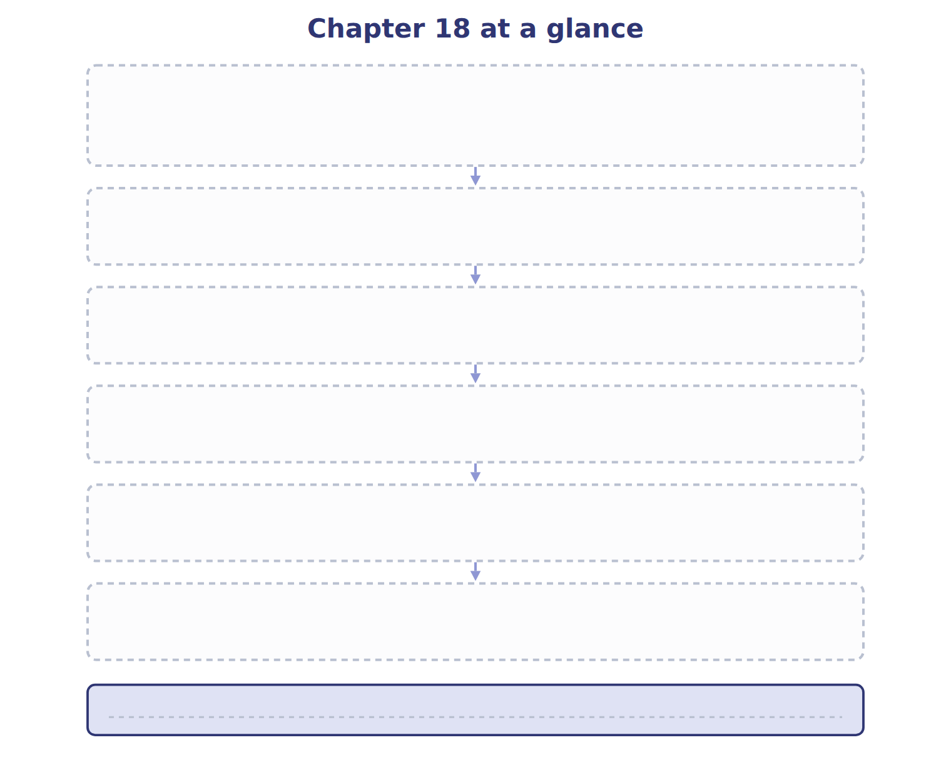
TEACH IT BACK | Write it for a student starting this chapter tomorrow — not for the marker.
31. In four or five sentences, write what the whole chapter settles, section by section.
every one of these words must appear: integrated reporting · integrated report · integrated thinking · capitals

