Handout 2.1
Purpose and structure of the balance sheet
section 2.1 of the book
Before you start
Answer every one of these now, from what you already know or by guessing. You are not expected to get them right: you are about to be shown where each answer comes from.

What this handout settles
This handout settles | where it is answered
Purpose and structure of the balance sheet | cycle A
Account and what goes with it | cycle B
and you mark your own answers | at every checkpoint

1. Early in 2026, Orontes pays $500,000 of accounts payable in cash. What happens to its working capital and its current ratio of 3.31?
A. Both fall
B. Working capital falls; the current ratio does not change
C. Working capital does not change; the current ratio rises to 3.62
D. Neither changes
2. A company with a current ratio of 0.8 borrows cash on a 90-day note. What is the effect on the current ratio?
A. It increases | C. It does not change
B. It decreases | D. It cannot be determined
3. Which category does the book give for Prepaid rent?
A. Equity | C. Current liability
B. Current asset | D. Noncurrent asset
4. Which category does the book give for Land?
A. Equity | C. Current liability
B. Current asset | D. Noncurrent asset
5. Which category does the book give for Allowance for credit losses?
A. Equity | C. Current asset
B. Noncurrent asset | D. Current liability
6. Which category does the book give for Dividends payable?
A. Noncurrent asset | C. Current liability
B. Equity | D. Current asset
7. Which category does the book give for Additional paid-in capital?
A. Noncurrent asset | C. Current asset
B. Equity | D. Current liability
8. The book gives the category of Prepaid rent as “Current asset”. TRUE / FALSE
9. The book gives the category of Land as “Current liability”. TRUE / FALSE
10. The book gives the category of Allowance for credit losses as “Current asset”. TRUE / FALSE

CYCLE A | Purpose and structure of the balance sheet

ORIENT One claim. Decide now; you will check it in a moment.

11. Every number in a financial statement belongs to an element the framework defines. TRUE / FALSE
MODEL Read it before you answer anything below it.

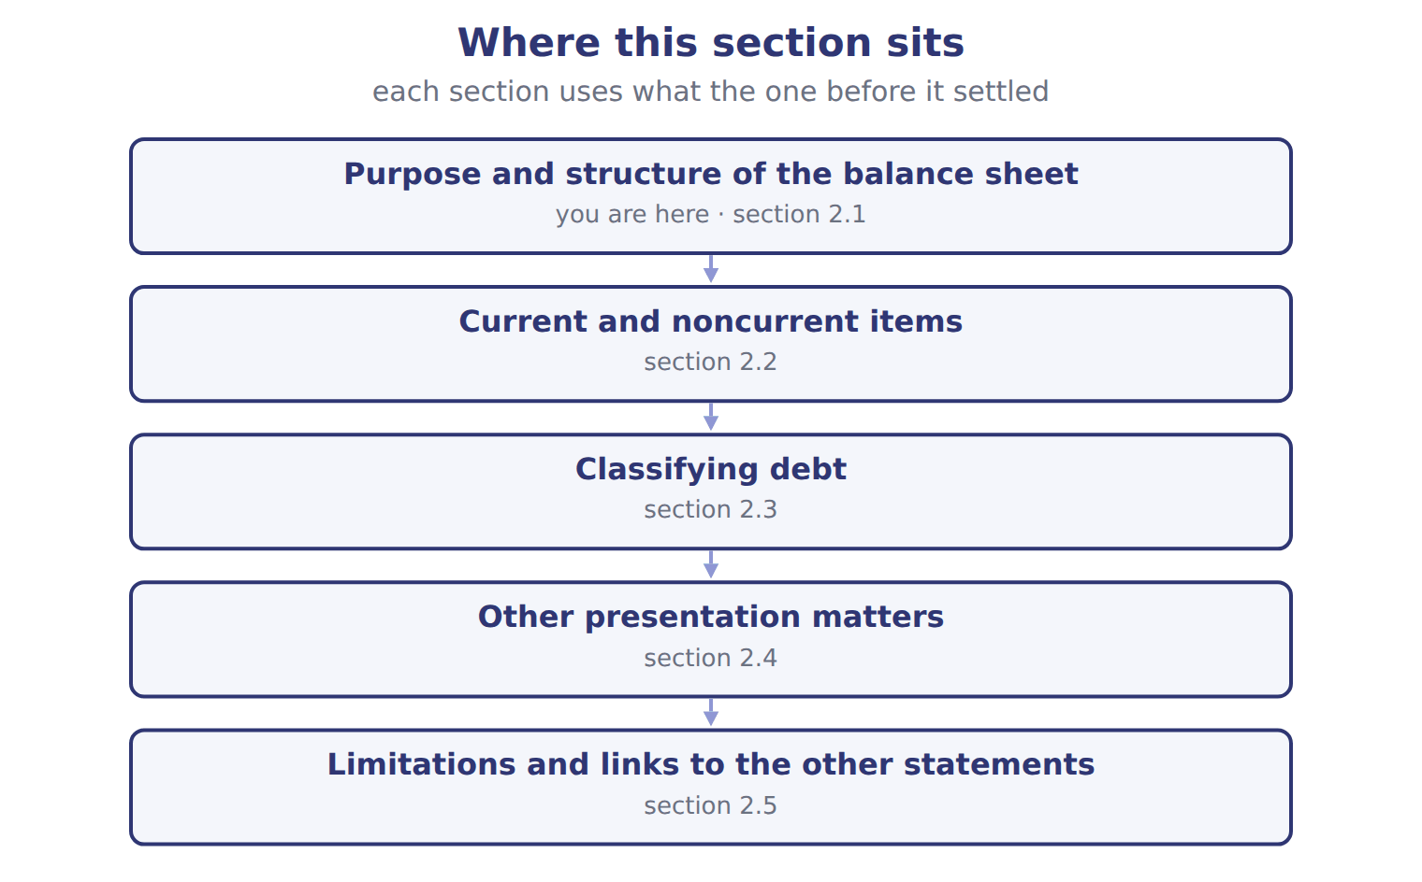
Orontes Foods Inc. (whole USD) — the book’s own table
Orontes Foods Inc. (whole USD) | Dec 31, 2025 | Dec 31, 2024
ASSETS
Current assets
Cash | 7,302,100 | 2,100,000
Trading securities | 42,000 | 40,000
Accounts receivable, net of allowance (2025: 156,000; 2024: 140,000) | 4,144,000 | 3,760,000
Inventory | 2,450,000 | 2,300,000
Prepaid expenses | 204,000 | 180,000
Assets held for sale | 46,000 | —
Total current assets | 14,188,100 | 8,380,000
Noncurrent assets

Orontes Foods Inc. (whole USD) — the book’s own table (continued)
Orontes Foods Inc. (whole USD) | Dec 31, 2025 | Dec 31, 2024
Debt securities (held-to-maturity and available-for-sale) | 88,500 | 90,000
Equity securities | 27,000 | 25,000
Equity-method investments | 1,807,000 | 500,000
Property, plant and equipment, net of accumulated depreciation (2025: 11,988,000; 2024: 8,000,000) | 14,802,000 | 16,000,000
Brand (indefinite-lived) | 260,000 | 300,000
Goodwill | 300,000 | 950,000
Other noncurrent assets | 200,000 | 200,000
TOTAL ASSETS | 31,672,600 | 26,445,000
LIABILITIES AND STOCKHOLDERS' EQUITY
Current liabilities

Orontes Foods Inc. (whole USD) — the book’s own table (continued)
Orontes Foods Inc. (whole USD) | Dec 31, 2025 | Dec 31, 2024
Accounts payable | 2,050,000 | 1,900,000
Accrued liabilities | 900,000 | 850,000
Income taxes payable | 350,000 | 300,000
Contract liabilities | 180,000 | 120,000
Dividends payable | 400,000 | —
Current portion of long-term debt | 400,000 | 400,000
Total current liabilities | 4,280,000 | 3,570,000
Long-term debt, less current portion | 6,000,000 | 5,600,000
Deferred tax liability | 999,625 | 900,000
Total liabilities | 11,279,625 | 10,070,000

Orontes Foods Inc. (whole USD) — the book’s own table (continued)
Orontes Foods Inc. (whole USD) | Dec 31, 2025 | Dec 31, 2024
Commitments and contingencies (Note 12)
Stockholders' equity
Common stock, $1 par; shares issued and outstanding: 2025 8,100,000, 2024 8,000,000 | 8,100,000 | 8,000,000
Additional paid-in capital | 5,400,000 | 4,000,000
Retained earnings | 6,894,100 | 4,375,000
Accumulated other comprehensive income (loss) | (1,125) | —
Total stockholders' equity | 20,392,975 | 16,375,000
TOTAL LIABILITIES AND STOCKHOLDERS' EQUITY | 31,672,600 | 26,445,000

READ THE MODEL Every answer is printed above. Find it, do not recall it.

12. Which part of this chapter is section 2.1?
A. Purpose and structure of the balance sheet
B. Classifying debt
C. Current and noncurrent items
D. Other presentation matters
13. Which part of this chapter is section 2.2?
A. Classifying debt
B. Other presentation matters
C. Current and noncurrent items
D. Purpose and structure of the balance sheet
14. Which part of this chapter is section 2.3?
A. Purpose and structure of the balance sheet
B. Classifying debt
C. Other presentation matters
D. Current and noncurrent items
15. Which part of this chapter is section 2.4?
A. Current and noncurrent items
B. Purpose and structure of the balance sheet
C. Other presentation matters
D. Classifying debt

APPLY No help on this move.

16. Which question does the balance sheet help users answer MOST directly?
A. How profitable was the company this year?
B. How much cash did operations produce this year?
C. What is the market value of the company?
D. Can the company pay its debts as they fall due?
17. The ability of a company to take effective action to change the amounts and timing of cash flows is called:
A. liquidity. | C. solvency.
B. financial flexibility. | D. working capital.
18. Why do U.S. SEC registrants present a classified balance sheet?
A. So users can separate short-term resources and obligations from long-term ones
B. So assets are shown at fair value
C. So equity equals the market value of the shares
D. So the balance sheet can be prepared without notes
19. Which item is a noncurrent asset?
A. Prepaid rent for the next six months
B. Trading securities
C. Inventory
D. Cash surrender value of a life insurance policy
WORK IN PAIRS | Compare every answer on this page with your partner before you read any key.
If you disagree: go back to the model and find the row that settles it. The row decides, not the louder voice.
CHECKPOINT 20. Which question does the balance sheet help users answer MOST directly?
A. How profitable was the company this year?
B. How much cash did operations produce this year?
C. What is the market value of the company?
D. Can the company pay its debts as they fall due?
If you got it wrong: redo the READ THE MODEL questions of cycle A with the model in front of you.

CYCLE B | The words this section uses precisely

ORIENT

21. A term in the exam means exactly what the book defines it to mean, whatever it means in ordinary English. TRUE / FALSE
MODEL

Account — the book’s own table
Account | Category
Prepaid rent | Current asset
Land | Noncurrent asset
Allowance for credit losses | Current asset
Dividends payable | Current liability
Additional paid-in capital | Equity

The English the exam uses, and what it translates
English (exam term) | the Arabic it translates
balance sheet | الميزانية العمومية
working capital | رأس المال العامل
liquidity | السيولة
covenant | تعهد (شرط) في اتفاقية القرض
right of setoff | حق المقاصة

READ THE MODEL

Write the letter of the Arabic term beside each English term. Every term is used once.
A تعهد (شرط) في اتفاقية القرض | D الميزانية العمومية
B حق المقاصة | E السيولة
C رأس المال العامل

22. right of setoff
23. liquidity
24. balance sheet
25. working capital
26. covenant

27. Which category does the book give for Prepaid rent?
A. Equity | C. Noncurrent asset
B. Current liability | D. Current asset
28. Which category does the book give for Land?
A. Equity | C. Current asset
B. Current liability | D. Noncurrent asset
29. Which category does the book give for Allowance for credit losses?
A. Equity | C. Noncurrent asset
B. Current liability | D. Current asset

APPLY

Orontes Foods Inc. (whole USD) — the extract for the question that follows
Orontes Foods Inc. (whole USD) | Dec 31, 2025 | Dec 31, 2024
ASSETS
Current assets
Cash | 7,302,100 | 2,100,000
Trading securities | 42,000 | 40,000
Accounts receivable, net of allowance (2025: 156,000; 2024: 140,000) | 4,144,000 | 3,760,000
Inventory | 2,450,000 | 2,300,000
Prepaid expenses | 204,000 | 180,000
Assets held for sale | 46,000 | —
Total current assets | 14,188,100 | 8,380,000
Noncurrent assets

Orontes Foods Inc. (whole USD) — the extract for the question that follows (continued)
Orontes Foods Inc. (whole USD) | Dec 31, 2025 | Dec 31, 2024
Debt securities (held-to-maturity and available-for-sale) | 88,500 | 90,000
Equity securities | 27,000 | 25,000
Equity-method investments | 1,807,000 | 500,000
Property, plant and equipment, net of accumulated depreciation (2025: 11,988,000; 2024: 8,000,000) | 14,802,000 | 16,000,000
Brand (indefinite-lived) | 260,000 | 300,000
Goodwill | 300,000 | 950,000
Other noncurrent assets | 200,000 | 200,000
TOTAL ASSETS | 31,672,600 | 26,445,000
LIABILITIES AND STOCKHOLDERS' EQUITY
Current liabilities

Orontes Foods Inc. (whole USD) — the extract for the question that follows (continued)
Orontes Foods Inc. (whole USD) | Dec 31, 2025 | Dec 31, 2024
Accounts payable | 2,050,000 | 1,900,000
Accrued liabilities | 900,000 | 850,000
Income taxes payable | 350,000 | 300,000
Contract liabilities | 180,000 | 120,000
Dividends payable | 400,000 | —
Current portion of long-term debt | 400,000 | 400,000
Total current liabilities | 4,280,000 | 3,570,000
Long-term debt, less current portion | 6,000,000 | 5,600,000
Deferred tax liability | 999,625 | 900,000
Total liabilities | 11,279,625 | 10,070,000

Orontes Foods Inc. (whole USD) — the extract for the question that follows (continued)
Orontes Foods Inc. (whole USD) | Dec 31, 2025 | Dec 31, 2024
Commitments and contingencies (Note 12)
Stockholders' equity
Common stock, $1 par; shares issued and outstanding: 2025 8,100,000, 2024 8,000,000 | 8,100,000 | 8,000,000
Additional paid-in capital | 5,400,000 | 4,000,000
Retained earnings | 6,894,100 | 4,375,000
Accumulated other comprehensive income (loss) | (1,125) | —
Total stockholders' equity | 20,392,975 | 16,375,000
TOTAL LIABILITIES AND STOCKHOLDERS' EQUITY | 31,672,600 | 26,445,000

30. The extract for this question is printed with it. What is Orontes's working capital at December 31, 2025 (whole USD)?
A. 2,908,475 | C. 10,064,100
B. 9,908,100 | D. 10,308,100
31. The extract for this question is printed with it. What is Orontes's current ratio at December 31, 2025?
A. 0.30 | C. 3.31
B. 2.35 | D. 3.62
CHECKPOINT 32. What is the safest way to settle a disagreement about an answer on this sheet?
A. find the row of the model that decides it
B. take the answer of whoever is more confident
C. leave it until the lecturer says
D. choose the longer option
If you got it wrong: redo the READ THE MODEL questions of cycle B.

FROM MEMORY | Close the earlier pages first.
33. Rebuild the figure from this handout. Label every part and fill in every box.
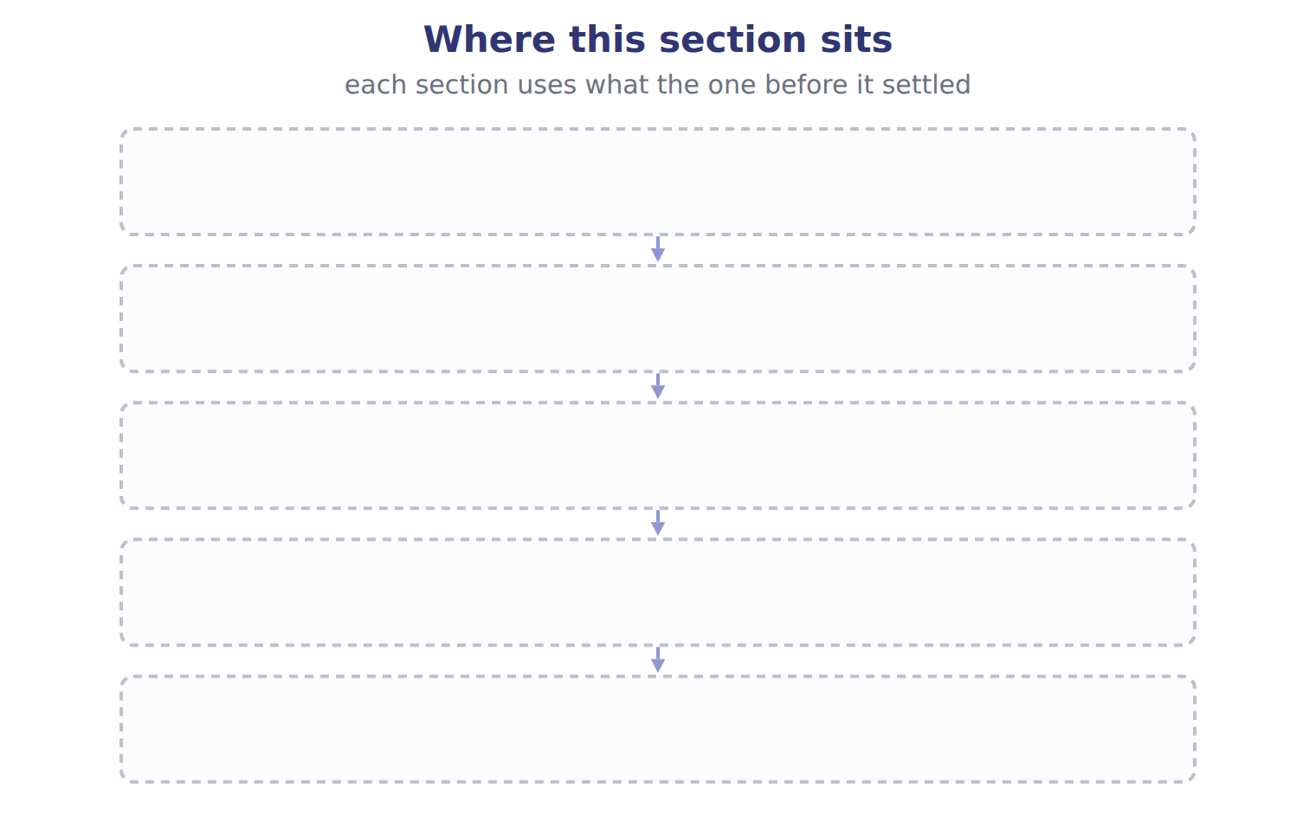
TEACH IT BACK | Write it for a classmate who missed this session — not for the marker.
34. In three or four sentences, write what this section settles and the one rule a reader has to take away.
every one of these words must appear: balance sheet · working capital · liquidity · covenant

Handout 2.2
Current and noncurrent items
section 2.2 of the book
Before you start
Answer every one of these now, from what you already know or by guessing. You are not expected to get them right: you are about to be shown where each answer comes from.

What this handout settles
This handout settles | where it is answered
Current and noncurrent items | cycle A
Item and what goes with it | cycle B
and you mark your own answers | at every checkpoint

1. A loss from a lawsuit is probable. Lawyers estimate it at between $40,000 and $100,000, with no amount more likely than another. Under U.S. GAAP the company accrues:
A. $70,000
B. $100,000
C. nothing, and discloses the range
D. $40,000 and discloses the possible additional loss
2. On January 20, before the statements are issued, a customer that owed $80,000 at December 31 goes bankrupt. Its finances had been getting worse for months. What does the company do?
A. Adjusts the year-end allowance for credit losses
B. Discloses the event only
C. Records the loss next year
D. Does nothing
3. Which classification does the book give for Cash set aside in a sinking fund to repay bonds in 2029?
A. ________ | C. Current asset
B. Noncurrent asset
4. Which classification does the book give for Date vinegar that Orontes ages for 18 months before sale?
A. Noncurrent asset | C. Current asset
B. ________
5. Which classification does the book give for Cash surrender value of an executive life insurance policy?
A. ________ | C. Noncurrent asset
B. Current asset
6. Which classification does the book give for Bank loan due on demand; the bank has never asked for repayment?
A. ________ | C. Current asset
B. Noncurrent asset
7. Which classification does the book give for Deferred tax asset from warranty costs expected to reverse next year?
A. ________ | C. Noncurrent asset
B. Current asset

CYCLE A | Current and noncurrent items

ORIENT One claim. Decide now; you will check it in a moment.

8. The book gives the classification of Cash set aside in a sinking fund to repay bonds in 2029 as “Noncurrent asset”. TRUE / FALSE
MODEL Read it before you answer anything below it.

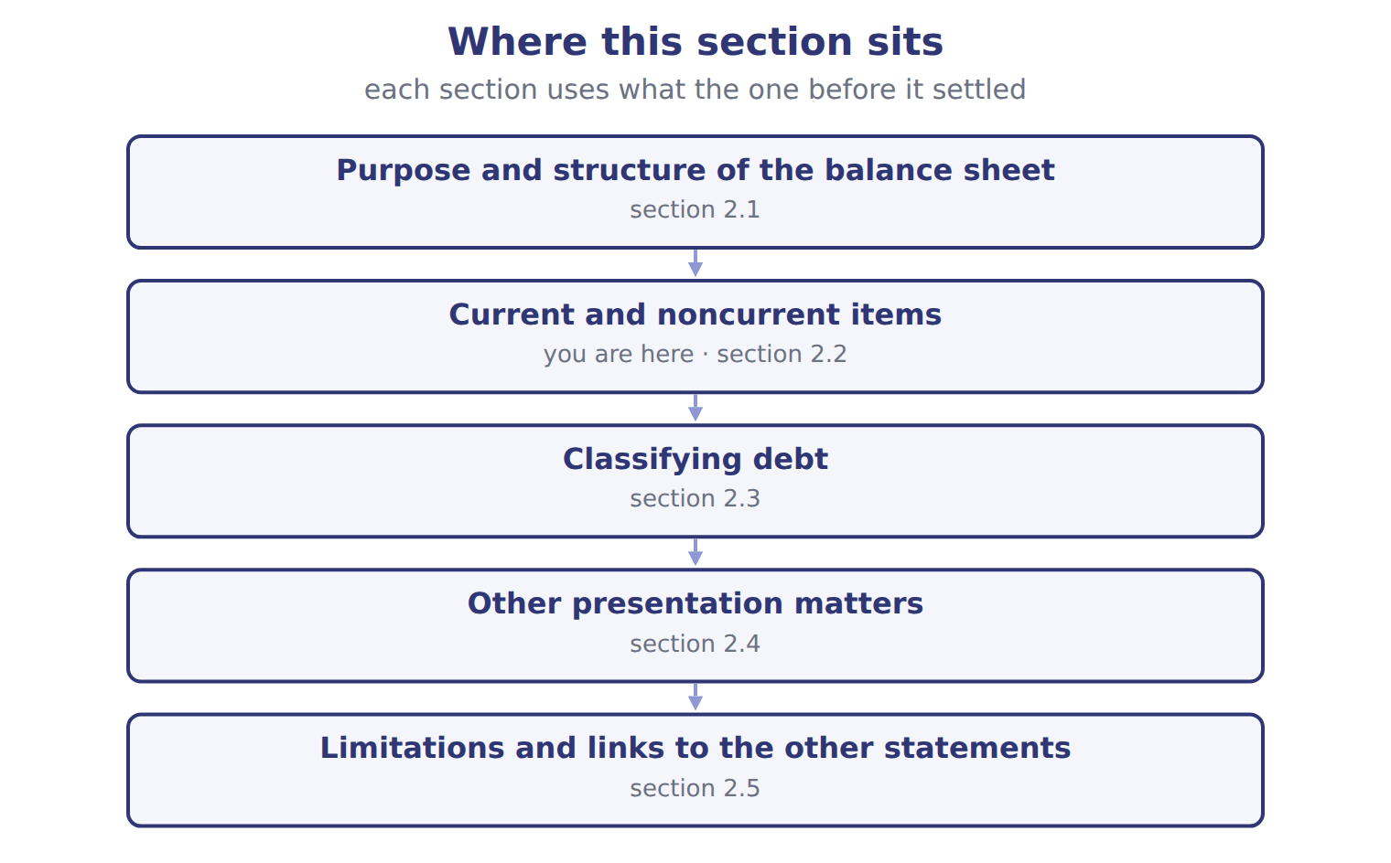

Item — the book’s own table
Item | Classification | Reason
Cash set aside in a sinking fund to repay bonds in 2029 | Noncurrent asset | Restricted for a noncurrent purpose
Date vinegar that Orontes ages for 18 months before sale | Current asset | The operating cycle is longer than one year, so the cycle applies
Cash surrender value of an executive life insurance policy | ________ | ________
Bank loan due on demand; the bank has never asked for repayment | ________ | ________
Deferred tax asset from warranty costs expected to reverse next year | ________ | ________
Customer deposits for orders to be delivered next month | ________ | ________

READ THE MODEL Every answer is printed above. Find it, do not recall it.

9. Which classification does the book give for Cash set aside in a sinking fund to repay bonds in 2029?
A. Current asset | C. Noncurrent asset
B. ________
10. Which classification does the book give for Date vinegar that Orontes ages for 18 months before sale?
A. Noncurrent asset | C. Current asset
B. ________
11. Which classification does the book give for Cash surrender value of an executive life insurance policy?
A. Noncurrent asset | C. ________
B. Current asset
12. Which classification does the book give for Bank loan due on demand; the bank has never asked for repayment?
A. Current asset | C. ________
B. Noncurrent asset
13. The book gives the reason of Cash set aside in a sinking fund to repay bonds in 2029 as “Restricted for a noncurrent purpose”. TRUE / FALSE
14. The book gives the reason of Date vinegar that Orontes ages for 18 months before sale as “________”. TRUE / FALSE

APPLY No help on this move.

15. A cheese maker ages its cheese for two years before sale. How does it classify its cheese inventory?
A. Noncurrent, because it will not be sold within one year
B. Current, because its operating cycle is longer than one year
C. Half current, half noncurrent
D. Noncurrent until the last year of aging
16. Early in 2026, Orontes pays $500,000 of accounts payable in cash. What happens to its working capital and its current ratio of 3.31?
A. Both fall
B. Working capital falls; the current ratio does not change
C. Working capital does not change; the current ratio rises to 3.62
D. Neither changes
17. A company with a current ratio of 0.8 borrows cash on a 90-day note. What is the effect on the current ratio?
A. It increases | C. It does not change
B. It decreases | D. It cannot be determined
18. At December 31, 2025, a company violates a covenant and its long-term loan becomes callable. On February 10, 2026, before the statements are issued, the lender waives its rights until June 2027. Under U.S. GAAP the loan is:
A. current, because the waiver came after year-end.
B. current, because the violation happened.
C. split: half current, half noncurrent.
D. noncurrent.
19. A bank loan is due on demand. The bank has never asked for repayment and the company does not expect it to. The loan is classified as:
A. noncurrent.
B. current.
C. noncurrent unless the bank demands payment.
D. equity.
Orontes Foods Inc. (whole USD) — the extract for the question that follows
Orontes Foods Inc. (whole USD) | Dec 31, 2025 | Dec 31, 2024
ASSETS
Current assets
Cash | 7,302,100 | 2,100,000
Trading securities | 42,000 | 40,000
Accounts receivable, net of allowance (2025: 156,000; 2024: 140,000) | 4,144,000 | 3,760,000
Inventory | 2,450,000 | 2,300,000
Prepaid expenses | 204,000 | 180,000
Assets held for sale | 46,000 | —
Total current assets | 14,188,100 | 8,380,000
Noncurrent assets

Orontes Foods Inc. (whole USD) — the extract for the question that follows (continued)
Orontes Foods Inc. (whole USD) | Dec 31, 2025 | Dec 31, 2024
Debt securities (held-to-maturity and available-for-sale) | 88,500 | 90,000
Equity securities | 27,000 | 25,000
Equity-method investments | 1,807,000 | 500,000
Property, plant and equipment, net of accumulated depreciation (2025: 11,988,000; 2024: 8,000,000) | 14,802,000 | 16,000,000
Brand (indefinite-lived) | 260,000 | 300,000
Goodwill | 300,000 | 950,000
Other noncurrent assets | 200,000 | 200,000
TOTAL ASSETS | 31,672,600 | 26,445,000
LIABILITIES AND STOCKHOLDERS' EQUITY
Current liabilities

Orontes Foods Inc. (whole USD) — the extract for the question that follows (continued)
Orontes Foods Inc. (whole USD) | Dec 31, 2025 | Dec 31, 2024
Accounts payable | 2,050,000 | 1,900,000
Accrued liabilities | 900,000 | 850,000
Income taxes payable | 350,000 | 300,000
Contract liabilities | 180,000 | 120,000
Dividends payable | 400,000 | —
Current portion of long-term debt | 400,000 | 400,000
Total current liabilities | 4,280,000 | 3,570,000
Long-term debt, less current portion | 6,000,000 | 5,600,000
Deferred tax liability | 999,625 | 900,000
Total liabilities | 11,279,625 | 10,070,000

Orontes Foods Inc. (whole USD) — the extract for the question that follows (continued)
Orontes Foods Inc. (whole USD) | Dec 31, 2025 | Dec 31, 2024
Commitments and contingencies (Note 12)
Stockholders' equity
Common stock, $1 par; shares issued and outstanding: 2025 8,100,000, 2024 8,000,000 | 8,100,000 | 8,000,000
Additional paid-in capital | 5,400,000 | 4,000,000
Retained earnings | 6,894,100 | 4,375,000
Accumulated other comprehensive income (loss) | (1,125) | —
Total stockholders' equity | 20,392,975 | 16,375,000
TOTAL LIABILITIES AND STOCKHOLDERS' EQUITY | 31,672,600 | 26,445,000

20. The extract for this question is printed with it. What was Orontes's working capital at December 31, 2024 (whole USD)?
A. (1,690,000) | C. 8,380,000
B. 4,810,000 | D. 9,908,100
WORK IN PAIRS | Compare every answer on this page with your partner before you read any key.
If you disagree: go back to the model and find the row that settles it. The row decides, not the louder voice.
CHECKPOINT 21. A lender wants to know if Orontes can pay the bills that fall due in the next few months. Which quality is the lender assessing?
A. Liquidity
B. Solvency
C. Profitability
D. Financial flexibility
If you got it wrong: redo the READ THE MODEL questions of cycle A with the model in front of you.

CYCLE B | The words this section uses precisely

ORIENT

22. A term in the exam means exactly what the book defines it to mean, whatever it means in ordinary English. TRUE / FALSE
MODEL

Item — the book’s own table
Item | Answer
Cash surrender value | Noncurrent asset: it is not expected to be turned into cash in the operating cycle.
Loan due on demand | Current liability: debt due on demand is current, whatever the bank's expected behaviour.
Deferred tax asset | Noncurrent asset: all deferred taxes are noncurrent.
Customer deposits | Current liability (contract liability): it will be settled by delivering goods within a year.

The English the exam uses, and what it translates
English (exam term) | the Arabic it translates
classified balance sheet | قائمة المركز المالي المبوبة
current portion of long-term debt | الجزء المتداول من الديون طويلة الأجل
solvency | الملاءة المالية
waiver | تنازل (إعفاء) من الدائن

READ THE MODEL

Write the letter of the Arabic term beside each English term. Every term is used once.
A الجزء المتداول من الديون طويلة الأجل
B تنازل (إعفاء) من الدائن
C قائمة المركز المالي المبوبة
D الملاءة المالية

23. solvency
24. current portion of long-term debt
25. classified balance sheet
26. waiver

27. Which item does the book pair with “Noncurrent asset: it is not expected to be turned into cash in the operating cycle.”?
A. Deferred tax asset | C. Cash surrender value
B. Loan due on demand | D. Customer deposits
28. Which item does the book pair with “Current liability: debt due on demand is current, whatever the bank's expected behaviour.”?
A. Cash surrender value | C. Loan due on demand
B. Deferred tax asset | D. Customer deposits
29. Which item does the book pair with “Noncurrent asset: all deferred taxes are noncurrent.”?
A. Loan due on demand | C. Deferred tax asset
B. Customer deposits | D. Cash surrender value
APPLY

30. Which heading is correct for Orontes's balance sheet?
A. Balance sheet for the year ended December 31, 2025
B. Balance sheet for the period January 1 to December 31, 2025
C. Balance sheet as of December 31, 2025
D. Balance sheet for 2025
31. At December 31, 2025, a company has a $5 million note due in April 2026. On February 1, 2026, before the statements are issued, it issues 10-year bonds and uses the cash to repay the note. Under U.S. GAAP the note is:
A. current, because the bonds were issued after year-end
B. noncurrent, because it was refinanced before issuance
C. current, because refinancing is never allowed
D. shown in equity
32. A loan agreement lets the lender demand repayment if there is a 'material adverse change'. The company is healthy and acceleration is remote. The long-term loan is:
A. noncurrent. | C. current, with a note.
B. current. | D. noncurrent only under IFRS.

CHECKPOINT 33. What is the safest way to settle a disagreement about an answer on this sheet?
A. find the row of the model that decides it
B. take the answer of whoever is more confident
C. leave it until the lecturer says
D. choose the longer option
If you got it wrong: redo the READ THE MODEL questions of cycle B.

FROM MEMORY | Close the earlier pages first.
34. Rebuild the figure from this handout. Label every part and fill in every box.
TEACH IT BACK | Write it for a classmate who missed this session — not for the marker.
35. In three or four sentences, write what this section settles and the one rule a reader has to take away.
every one of these words must appear: classified balance sheet · current portion of long-term debt · solvency · waiver

Handout 2.3
Classifying debt
section 2.3 of the book
Before you start
Answer every one of these now, from what you already know or by guessing. You are not expected to get them right: you are about to be shown where each answer comes from.

What this handout settles
This handout settles | where it is answered
Classifying debt | cycle A
and you mark your own answers | at every checkpoint

1. Orontes's retained earnings were $4,375,000 on January 1, 2025. Net income was $2,969,100, OCI was $(1,125), and dividends declared were $450,000. What are retained earnings at December 31, 2025 (whole USD)?
A. 6,892,975 | C. 7,294,100
B. 6,894,100 | D. 7,344,100
2. Company X owes Company Y $50,000, and Company Y owes Company X $30,000 on a separate contract. There is no legal right of setoff. How does Company X present these amounts?
A. A net payable of $20,000
B. A net receivable of $20,000
C. A receivable of $30,000 and a payable of $50,000
D. Only a note disclosure
3. Which part of this chapter is section 2.1?
A. Purpose and structure of the balance sheet
B. Classifying debt
C. Current and noncurrent items
D. Other presentation matters
4. Which part of this chapter is section 2.2?
A. Classifying debt
B. Other presentation matters
C. Current and noncurrent items
D. Purpose and structure of the balance sheet
5. Which part of this chapter is section 2.3?
A. Purpose and structure of the balance sheet
B. Classifying debt
C. Other presentation matters
D. Current and noncurrent items
6. Which part of this chapter is section 2.4?
A. Current and noncurrent items
B. Purpose and structure of the balance sheet
C. Other presentation matters
D. Classifying debt
7. Which part of this chapter is section 2.5?
A. Current and noncurrent items
B. Classifying debt
C. Limitations and links to the other statements
D. Purpose and structure of the balance sheet

CYCLE A | Classifying debt

ORIENT One claim. Decide now; you will check it in a moment.

8. Every number in a financial statement belongs to an element the framework defines. TRUE / FALSE
MODEL Read it before you answer anything below it.

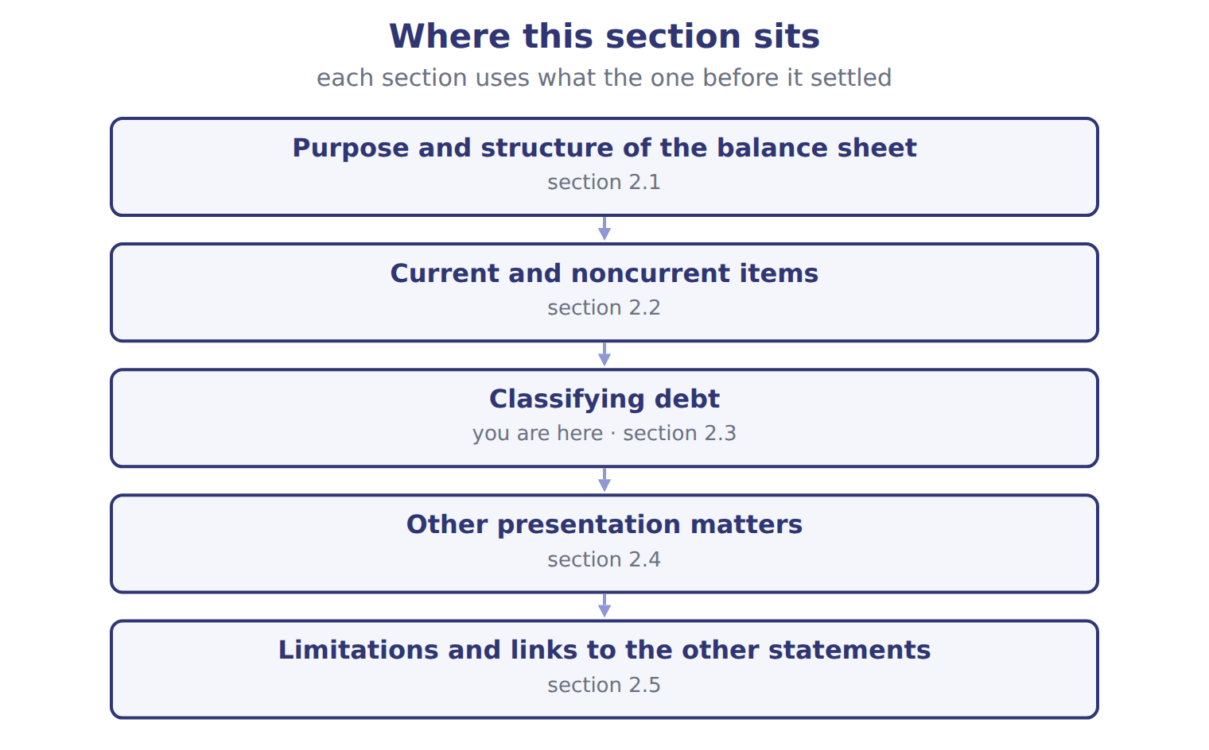

Situation at the reporting date — the book’s own table
Situation at the reporting date | U.S. GAAP (ASC 470-10) | IFRS (IAS 1)
Short-term debt refinanced long-term after year-end, before issuance | Noncurrent (intent and demonstrated ability) | Current (no right to defer at the reporting date)
Covenant broken at year-end; waiver for more than 12 months obtained after year-end | Noncurrent | Current
Covenant broken at year-end; waiver obtained on or before year-end | Noncurrent | Noncurrent
Covenant tested only after year-end (future compliance doubtful) | Noncurrent; disclose | Noncurrent; disclose the risk
Subjective acceleration clause | Current only if acceleration is probable | Ignored unless it removes the right to defer
Deferred tax assets and liabilities | All noncurrent | All non-current

READ THE MODEL Every answer is printed above. Find it, do not recall it.

9. Which part of this chapter is section 2.1?
A. Purpose and structure of the balance sheet
B. Classifying debt
C. Current and noncurrent items
D. Other presentation matters
10. Which part of this chapter is section 2.2?
A. Classifying debt
B. Other presentation matters
C. Current and noncurrent items
D. Purpose and structure of the balance sheet
11. Which part of this chapter is section 2.3?
A. Purpose and structure of the balance sheet
B. Classifying debt
C. Other presentation matters
D. Current and noncurrent items
12. Which part of this chapter is section 2.4?
A. Current and noncurrent items
B. Purpose and structure of the balance sheet
C. Other presentation matters
D. Classifying debt

APPLY No help on this move.

13. A loss from a lawsuit is probable. Lawyers estimate it at between $40,000 and $100,000, with no amount more likely than another. Under U.S. GAAP the company accrues:
A. $70,000
B. $100,000
C. nothing, and discloses the range
D. $40,000 and discloses the possible additional loss
14. On January 20, before the statements are issued, a customer that owed $80,000 at December 31 goes bankrupt. Its finances had been getting worse for months. What does the company do?
A. Adjusts the year-end allowance for credit losses
B. Discloses the event only
C. Records the loss next year
D. Does nothing
15. A company has a deferred tax asset that will reverse next year. On a U.S. GAAP balance sheet it is shown as:
A. a current asset.
B. a noncurrent asset.
C. a reduction of income taxes payable.
D. split between current and noncurrent.
16. Which item is NOT usually recorded on the balance sheet?
A. A brand the company bought
B. Goodwill from an acquisition
C. A brand the company developed itself
D. Equipment under a finance lease
WORK IN PAIRS | Compare every answer on this page with your partner before you read any key.
If you disagree: go back to the model and find the row that settles it. The row decides, not the louder voice.
CHECKPOINT 17. A loss from a lawsuit is probable. Lawyers estimate it at between $40,000 and $100,000, with no amount more likely than another. Under U.S. GAAP the company accrues:
A. $70,000
B. $100,000
C. nothing, and discloses the range
D. $40,000 and discloses the possible additional loss
If you got it wrong: redo the READ THE MODEL questions of cycle A with the model in front of you.

CYCLE B | The words this section uses precisely

ORIENT

18. A term in the exam means exactly what the book defines it to mean, whatever it means in ordinary English. TRUE / FALSE

MODEL

The English the exam uses, and what it translates
English (exam term) | the Arabic it translates
current assets | الأصول المتداولة
callable debt | دين قابل للاستدعاء (مستحق عند الطلب)
financial flexibility | المرونة المالية
grace period | فترة سماح

READ THE MODEL

Write the letter of the Arabic term beside each English term. Every term is used once.
A دين قابل للاستدعاء (مستحق عند الطلب)
B فترة سماح
C المرونة المالية
D الأصول المتداولة

19. current assets
20. financial flexibility
21. grace period
22. callable debt

APPLY

23. A company delays paying its suppliers until January so that its December 31 balance sheet shows more cash. This illustrates which limitation?
A. The balance sheet uses historical cost
B. The balance sheet omits internally developed intangibles
C. The balance sheet relies on estimates
D. The balance sheet shows only one date
24. Orontes's total stockholders' equity at December 31, 2025 is $20,392,975. This amount is:
A. the market value of Orontes's shares
B. the cash the owners could take out today
C. the price a buyer would pay for Orontes
D. a book amount based mostly on historical cost
CHECKPOINT 25. What is the safest way to settle a disagreement about an answer on this sheet?
A. find the row of the model that decides it
B. take the answer of whoever is more confident
C. leave it until the lecturer says
D. choose the longer option
If you got it wrong: redo the READ THE MODEL questions of cycle B.

FROM MEMORY | Close the earlier pages first.
26. Rebuild the figure from this handout. Label every part and fill in every box.
TEACH IT BACK | Write it for a classmate who missed this session — not for the marker.
27. In three or four sentences, write what this section settles and the one rule a reader has to take away.
every one of these words must appear: current assets · callable debt · financial flexibility · grace period

Handout 2.4
Other presentation matters
section 2.4 of the book
Before you start
Answer every one of these now, from what you already know or by guessing. You are not expected to get them right: you are about to be shown where each answer comes from.

What this handout settles
This handout settles | where it is answered
Other presentation matters | cycle A
and you mark your own answers | at every checkpoint

1. Which likelihood of the loss does the book pair with “Accrue a liability and a loss (best estimate; if no best estimate, the minimum of the range)”?
A. Probable | C. Gain contingency
B. Remote | D. Reasonably possible
2. Which likelihood of the loss does the book pair with “No accrual”?
A. Reasonably possible | C. Probable
B. Gain contingency
3. Which likelihood of the loss does the book pair with “Never recognized before it is realized”?
A. Reasonably possible | C. Remote
B. Gain contingency | D. Probable
4. Which disclosure does the book give for Probable?
A. No disclosure (except guarantees)
B. Accrue and disclose
C. Disclose carefully, without misleading
D. Disclose the nature and an estimate (or say it cannot be estimated)
5. Which disclosure does the book give for Reasonably possible?
A. Disclose carefully, without misleading
B. Disclose the nature and an estimate (or say it cannot be estimated)
C. Accrue and disclose
D. No disclosure (except guarantees)
6. Which disclosure does the book give for Remote?
A. No disclosure (except guarantees)
B. Disclose carefully, without misleading
C. Accrue and disclose
D. Disclose the nature and an estimate (or say it cannot be estimated)
7. Which disclosure does the book give for Gain contingency?
A. Disclose the nature and an estimate (or say it cannot be estimated)
B. Disclose carefully, without misleading
C. Accrue and disclose
D. No disclosure (except guarantees)
8. The book gives the disclosure of Probable as “Accrue and disclose”. TRUE / FALSE
9. The book gives the disclosure of Reasonably possible as “Accrue and disclose”. TRUE / FALSE
10. The book gives the disclosure of Remote as “No disclosure (except guarantees)”. TRUE / FALSE

CYCLE A | Other presentation matters

ORIENT One claim. Decide now; you will check it in a moment.

11. Every number in a financial statement belongs to an element the framework defines. TRUE / FALSE
MODEL Read it before you answer anything below it.

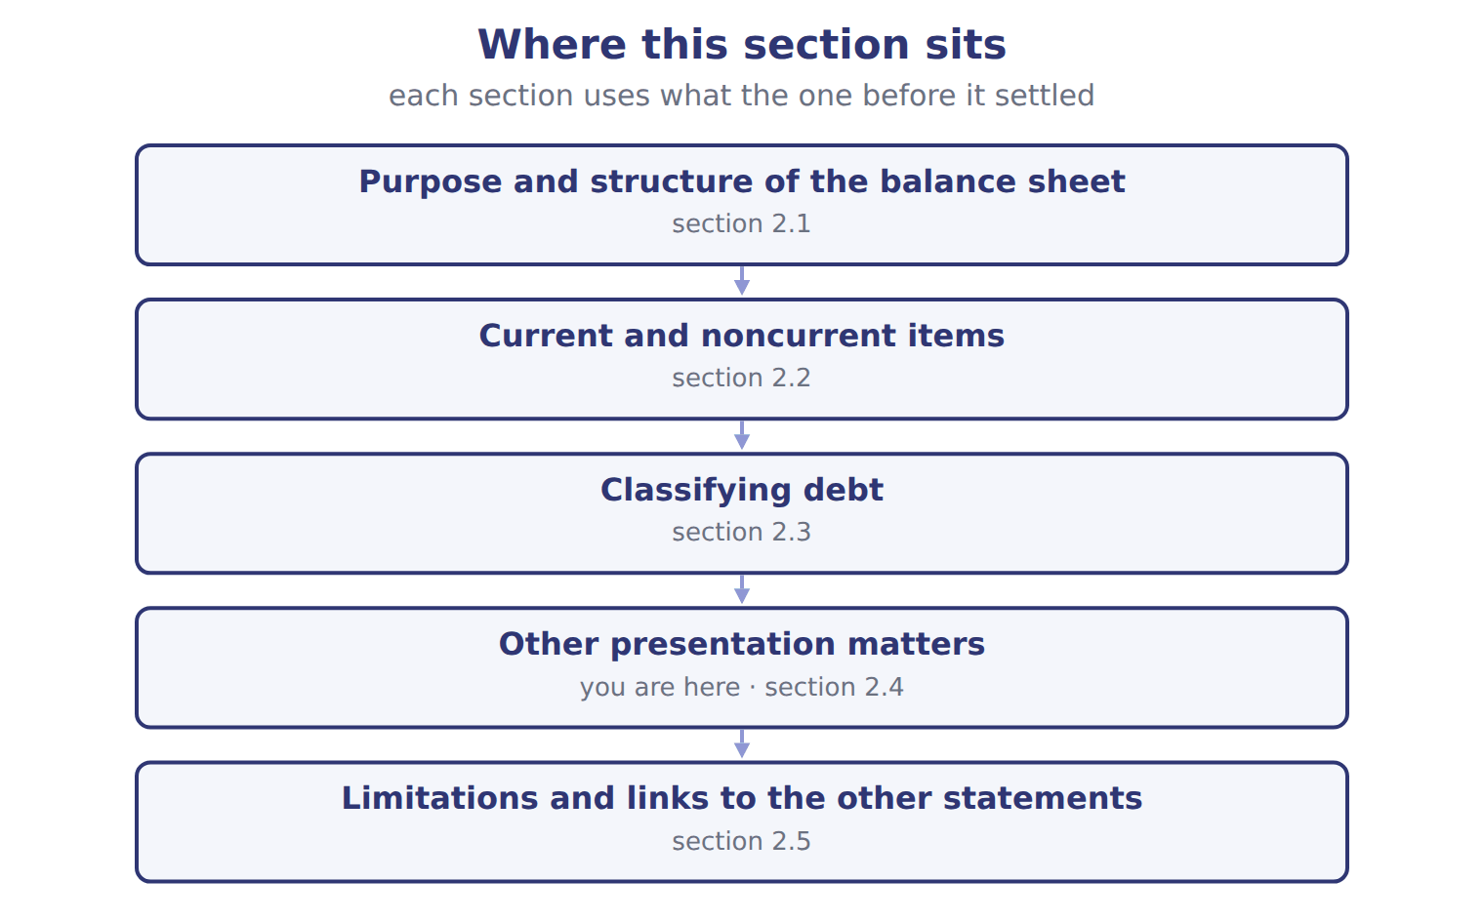

Likelihood of the loss — the book’s own table
Likelihood of the loss | Recognition (if reasonably estimable) | Disclosure
Probable | Accrue a liability and a loss (best estimate; if no best estimate, the minimum of the range) | Accrue and disclose
Reasonably possible | No accrual | Disclose the nature and an estimate (or say it cannot be estimated)
Remote | No accrual | No disclosure (except guarantees)
Gain contingency | Never recognized before it is realized | Disclose carefully, without misleading

READ THE MODEL Every answer is printed above. Find it, do not recall it.

12. Which likelihood of the loss does the book pair with “Accrue a liability and a loss (best estimate; if no best estimate, the minimum of the range)”?
A. Gain contingency | C. Remote
B. Probable | D. Reasonably possible
13. Which likelihood of the loss does the book pair with “No accrual”?
A. Probable | C. Gain contingency
B. Reasonably possible
14. Which likelihood of the loss does the book pair with “No accrual”?
A. Remote | C. Gain contingency
B. Probable
15. Which likelihood of the loss does the book pair with “Never recognized before it is realized”?
A. Reasonably possible | C. Probable
B. Gain contingency | D. Remote
16. The book gives the disclosure of Probable as “Accrue and disclose”. TRUE / FALSE
17. The book gives the disclosure of Reasonably possible as “Disclose carefully, without misleading”. TRUE / FALSE
APPLY No help on this move.

18. Orontes's retained earnings were $4,375,000 on January 1, 2025. Net income was $2,969,100, OCI was $(1,125), and dividends declared were $450,000. What are retained earnings at December 31, 2025 (whole USD)?
A. 6,892,975 | C. 7,294,100
B. 6,894,100 | D. 7,344,100
19. Company X owes Company Y $50,000, and Company Y owes Company X $30,000 on a separate contract. There is no legal right of setoff. How does Company X present these amounts?
A. A net payable of $20,000
B. A net receivable of $20,000
C. A receivable of $30,000 and a payable of $50,000
D. Only a note disclosure
WORK IN PAIRS | Compare every answer on this page with your partner before you read any key.
If you disagree: go back to the model and find the row that settles it. The row decides, not the louder voice.

CHECKPOINT 20. Orontes's retained earnings were $4,375,000 on January 1, 2025. Net income was $2,969,100, OCI was $(1,125), and dividends declared were $450,000. What are retained earnings at December 31, 2025 (whole USD)?
A. 6,892,975
B. 6,894,100
C. 7,294,100
D. 7,344,100
If you got it wrong: redo the READ THE MODEL questions of cycle A with the model in front of you.

CYCLE B | The words this section uses precisely

ORIENT

21. A term in the exam means exactly what the book defines it to mean, whatever it means in ordinary English. TRUE / FALSE
MODEL

The English the exam uses, and what it translates
English (exam term) | the Arabic it translates
current liabilities | الالتزامات المتداولة
loss contingency | خسارة محتملة (التزام محتمل)
current ratio | نسبة التداول
subjective acceleration clause | شرط التعجيل التقديري

READ THE MODEL

Write the letter of the Arabic term beside each English term. Every term is used once.
A خسارة محتملة (التزام محتمل) | C الالتزامات المتداولة
B نسبة التداول | D شرط التعجيل التقديري

22. current liabilities
23. loss contingency
24. subjective acceleration clause
25. current ratio

APPLY

26. Writing a term in English is part of answering the question, not an extra. TRUE / FALSE
CHECKPOINT 27. What is the safest way to settle a disagreement about an answer on this sheet?
A. find the row of the model that decides it
B. take the answer of whoever is more confident
C. leave it until the lecturer says
D. choose the longer option
If you got it wrong: redo the READ THE MODEL questions of cycle B.

FROM MEMORY | Close the earlier pages first.
28. Rebuild the figure from this handout. Label every part and fill in every box.
TEACH IT BACK | Write it for a classmate who missed this session — not for the marker.
29. In three or four sentences, write what this section settles and the one rule a reader has to take away.
every one of these words must appear: current liabilities · loss contingency · current ratio · subjective acceleration clause

Handout 2.5
Limitations and links to the other statements
section 2.5 of the book
Before you start
Answer every one of these now, from what you already know or by guessing. You are not expected to get them right: you are about to be shown where each answer comes from.

What this handout settles
This handout settles | where it is answered
Limitations and links to the other statements | cycle A
Account and what goes with it | cycle B
and you mark your own answers | at every checkpoint

1. Which part of this chapter is section 2.1?
A. Purpose and structure of the balance sheet
B. Classifying debt
C. Current and noncurrent items
D. Other presentation matters
2. Which part of this chapter is section 2.2?
A. Classifying debt
B. Other presentation matters
C. Current and noncurrent items
D. Purpose and structure of the balance sheet
3. Which part of this chapter is section 2.3?
A. Purpose and structure of the balance sheet
B. Classifying debt
C. Other presentation matters
D. Current and noncurrent items
4. Which part of this chapter is section 2.4?
A. Current and noncurrent items
B. Purpose and structure of the balance sheet
C. Other presentation matters
D. Classifying debt
5. Which part of this chapter is section 2.5?
A. Current and noncurrent items
B. Classifying debt
C. Limitations and links to the other statements
D. Purpose and structure of the balance sheet
6. Which category does the book give for Prepaid rent?
A. Equity | C. Current liability
B. Noncurrent asset | D. Current asset
7. Which category does the book give for Land?
A. Current liability | C. Equity
B. Current asset | D. Noncurrent asset
8. Which category does the book give for Allowance for credit losses?
A. Current asset | C. Equity
B. Current liability | D. Noncurrent asset

CYCLE A | Limitations and links to the other statements

ORIENT One claim. Decide now; you will check it in a moment.

9. Every number in a financial statement belongs to an element the framework defines. TRUE / FALSE
MODEL Read it before you answer anything below it.

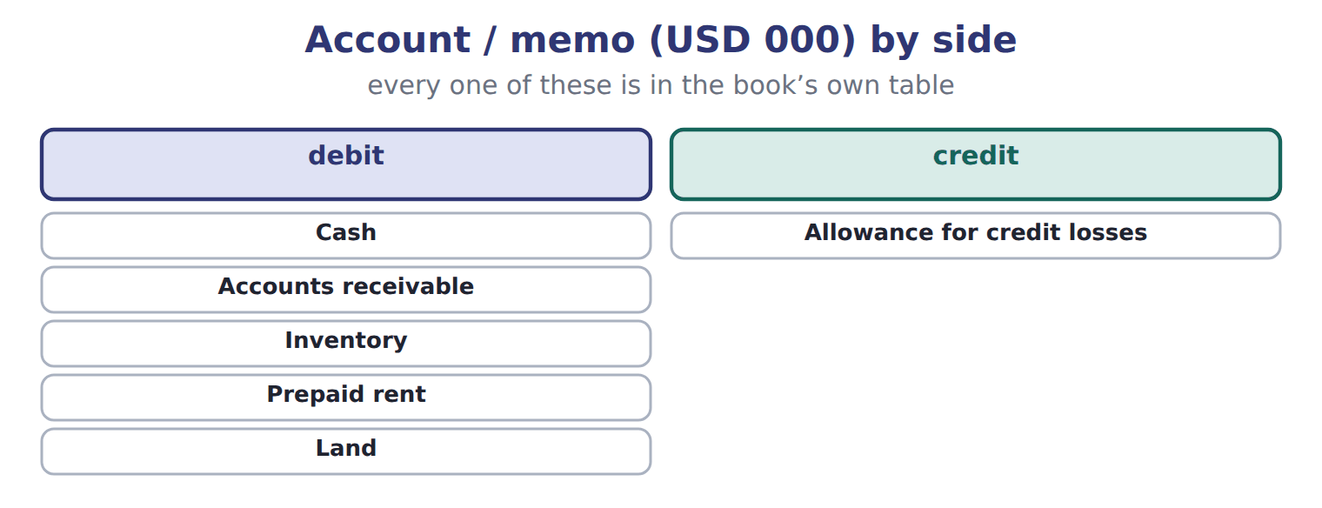
Account / memo (USD 000) — the book’s own table
Account / memo (USD 000) | Balance / details | Side
Cash | 1,050 | debit
Accounts receivable | 300 | debit
Allowance for credit losses | 20 | credit
Inventory | 420 | debit
Prepaid rent | 24 | debit
Land | 936 | debit
Equipment | 4,200 | debit
Accumulated depreciation | 900 | credit
Accounts payable | 380 | credit
Dividends payable | 50 | credit

Account / memo (USD 000) — the book’s own table (continued)
Account / memo (USD 000) | Balance / details | Side
Notes payable (long-term) | 1,800 | credit
Common stock | 600 | credit
Additional paid-in capital | 1,900 | credit
Retained earnings, December 31 (after closing) | 1,280 | credit
M1 | Of the notes payable, 300 is an installment due on June 30, 2026. The rest is due in 2029.
M2 | At December 31, Barada broke a debt-to-equity covenant on the note. On January 20, 2026, before the statements were issued, the bank waived
M3 | A former employee has sued Barada. Its lawyers think a loss of about 60 is reasonably possible, but not probable.
M4 | On February 10, 2026, before the statements were issued, a fire destroyed inventory that cost 70.

READ THE MODEL Every answer is printed above. Find it, do not recall it.

10. Which part of this chapter is section 2.1?
A. Purpose and structure of the balance sheet
B. Classifying debt
C. Current and noncurrent items
D. Other presentation matters
11. Which part of this chapter is section 2.2?
A. Classifying debt
B. Other presentation matters
C. Current and noncurrent items
D. Purpose and structure of the balance sheet
12. Which part of this chapter is section 2.3?
A. Purpose and structure of the balance sheet
B. Classifying debt
C. Other presentation matters
D. Current and noncurrent items
13. Which part of this chapter is section 2.4?
A. Current and noncurrent items
B. Purpose and structure of the balance sheet
C. Other presentation matters
D. Classifying debt
APPLY No help on this move.

14. The rule you have just written is the book’s own rule. TRUE / FALSE
WORK IN PAIRS | Compare every answer on this page with your partner before you read any key.
If you disagree: go back to the model and find the row that settles it. The row decides, not the louder voice.

CHECKPOINT 15. Which of these did this cycle settle?
A. the rule and where it comes from
B. nothing in particular
C. only the vocabulary
D. only the arithmetic
If you got it wrong: redo the READ THE MODEL questions of cycle A.

CYCLE B | The words this section uses precisely

ORIENT

16. A term in the exam means exactly what the book defines it to mean, whatever it means in ordinary English. TRUE / FALSE
MODEL

Account — the book’s own table
Account | Category
Prepaid rent
Land
Allowance for credit losses
Dividends payable
Additional paid-in capital

The English the exam uses, and what it translates
English (exam term) | the Arabic it translates
operating cycle | دورة التشغيل
subsequent events | الأحداث اللاحقة لتاريخ الميزانية
restricted cash | النقد المقيد
refinancing | إعادة التمويل

READ THE MODEL

Write the letter of the Arabic term beside each English term. Every term is used once.
A النقد المقيد | C إعادة التمويل
B الأحداث اللاحقة لتاريخ الميزانية | D دورة التشغيل

17. operating cycle
18. subsequent events
19. restricted cash
20. refinancing

APPLY

21. Writing a term in English is part of answering the question, not an extra. TRUE / FALSE

CHECKPOINT 22. What is the safest way to settle a disagreement about an answer on this sheet?
A. find the row of the model that decides it
B. take the answer of whoever is more confident
C. leave it until the lecturer says
D. choose the longer option
If you got it wrong: redo the READ THE MODEL questions of cycle B.

FROM MEMORY | Close the earlier pages first.
23. Rebuild the figure from this handout. Label every part and fill in every box.
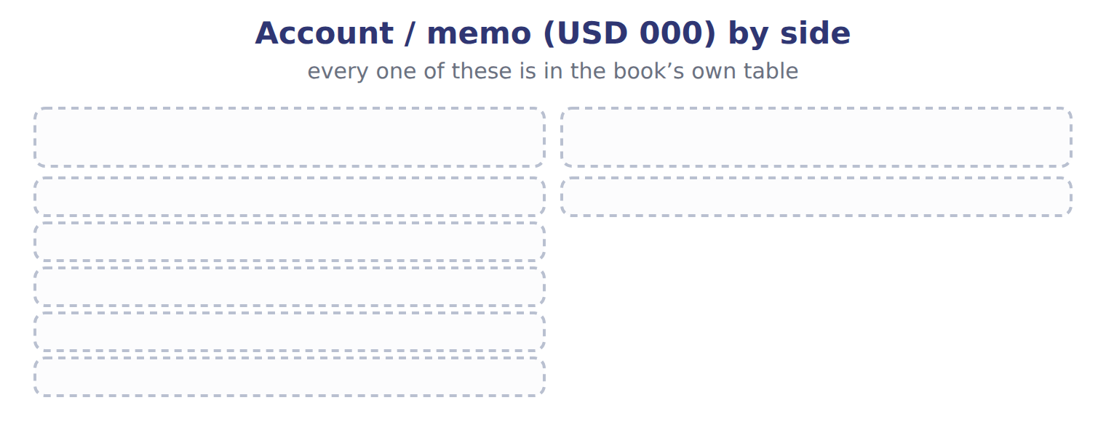
TEACH IT BACK | Write it for a classmate who missed this session — not for the marker.
24. In three or four sentences, write what this section settles and the one rule a reader has to take away.
every one of these words must appear: operating cycle · subsequent events · restricted cash · refinancing

Handout 2.6
The whole chapter
every section, shuffled, and the chapter’s own case set
Before you start
Answer every one of these now. They come from every part of the chapter, in no particular order.

What this handout settles
This handout settles | where it is answered
every section of the chapter, shuffled | cycle A
the chapter’s own case set | cycle B
and you mark your own answers | at every checkpoint

1. A five-year loan is repaid in equal annual installments. At year-end, how is the next installment classified?
A. As a noncurrent liability | C. As a reduction of cash
B. As a current liability | D. Only in a note
2. At December 31 a company breaks a loan covenant, so the loan is payable on demand. On January 15, before the statements are issued, the bank gives an 18-month waiver. How is the loan classified under IFRS?
A. Noncurrent
B. Current under IFRS only if the bank is expected to demand payment
C. Split between current and noncurrent
D. Current
3. Lawyers say a loss from a lawsuit is reasonably possible and could be about $200,000. What does the company do under U.S. GAAP?
A. Disclose it in a note, with no accrual
B. Accrue a liability of $200,000
C. Do nothing
D. Accrue half the amount
4. On February 5, before the statements are issued, a flood destroys a warehouse. The year ended on December 31. What does the company do?
A. Records the loss in the year just ended
B. Records the loss and discloses it
C. Discloses the event in a note
D. Does nothing until next year
5. Orontes bought land in 2005 for $400,000. It is worth about $2 million today. What does the balance sheet show for the land?
A. $400,000, because land is at historical cost
B. $2,000,000, because the balance sheet shows current values
C. $1,200,000, the average
D. $400,000 plus depreciation
6. Which part of this chapter is section 2.1?
A. Purpose and structure of the balance sheet
B. Classifying debt
C. Current and noncurrent items
D. Other presentation matters

CYCLE A | The whole chapter, in order

ORIENT

7. The sections of a chapter have to be taken in order, because each one uses what the one before it settled. TRUE / FALSE
MODEL

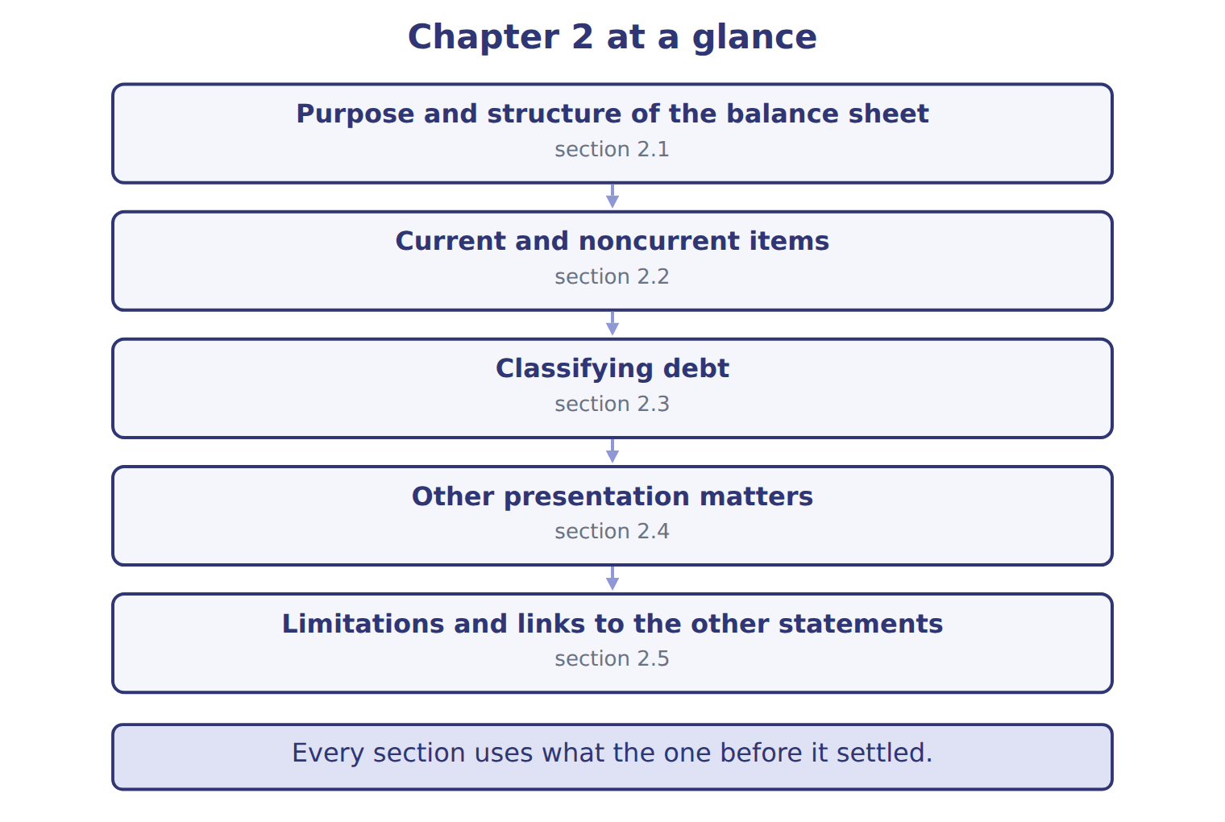
READ THE MODEL

8. “section 2.1” — which part of the chapter is this?
A. Classifying debt
B. Current and noncurrent items
C. Other presentation matters
D. Purpose and structure of the balance sheet
9. “section 2.2” — which part of the chapter is this?
A. Classifying debt
B. Other presentation matters
C. Current and noncurrent items
D. Purpose and structure of the balance sheet
10. “section 2.3” — which part of the chapter is this?
A. Current and noncurrent items
B. Classifying debt
C. Other presentation matters
D. Purpose and structure of the balance sheet
Write the letter of the section number beside each section title. Every number is used once.
A 2.1 | D 2.4
B 2.2 | E 2.5
C 2.3

11. Purpose and structure of the balance sheet
12. Current and noncurrent items
13. Classifying debt
14. Other presentation matters
15. Limitations and links to the other statements

APPLY

16. Orontes bought land in 2005 for $400,000. It is worth about $2 million today. What does the balance sheet show for the land?
A. $400,000, because land is at historical cost
B. $2,000,000, because the balance sheet shows current values
C. $1,200,000, the average
D. $400,000 plus depreciation
WORK IN PAIRS | Compare every answer with your partner first.
If you disagree: name the section each question belongs to. Most disagreements turn out to be about the section, not the answer.
CHECKPOINT 17. A five-year loan is repaid in equal annual installments. At year-end, how is the next installment classified?
A. As a noncurrent liability
B. As a current liability
C. As a reduction of cash
D. Only in a note
If you got it wrong: go back to the MODEL move of cycle A and find the section this question belongs to.

CYCLE B | The chapter’s case set

ORIENT

18. In a case question, the exhibit has to be read and adjusted before any figure is worked out. TRUE / FALSE

MODEL

The chapter’s case set, item by item
Item | What it asks
C2-1 | Classify each account. (On the exam screen you would drag each account into a box.)
C2-2 | Enter Barada's total current assets.
C2-3 | Enter Barada's total current liabilities.
C2-4 | Enter Barada's working capital.
C2-5 | How does Barada report the February fire (M4)? [select]
C2-6 | How does Barada report the lawsuit (M3)? [select]

READ THE MODEL

19. Which of these does item C2-1 ask for?
A. Enter Barada's total current liabilities.
B. Enter Barada's working capital.
C. Enter Barada's total current assets.
D. Classify each account. (On the exam screen you would drag each account
20. Which of these does item C2-2 ask for?
A. Enter Barada's total current liabilities.
B. Enter Barada's working capital.
C. Enter Barada's total current assets.
D. Classify each account. (On the exam screen you would drag each account
21. Which of these does item C2-3 ask for?
A. Enter Barada's total current assets.
B. Enter Barada's working capital.
C. Classify each account. (On the exam screen you would drag each account
D. Enter Barada's total current liabilities.
22. Which of these does item C2-4 ask for?
A. Enter Barada's working capital.
B. Classify each account. (On the exam screen you would drag each account
C. Enter Barada's total current assets.
D. Enter Barada's total current liabilities.
23. Which of these does item C2-5 ask for?
A. Classify each account. (On the exam screen you would drag each account
B. Enter Barada's total current assets.
C. How does Barada report the February fire (M4)? [select]
D. Enter Barada's total current liabilities.
24. Which of these does item C2-6 ask for?
A. How does Barada report the lawsuit (M3)? [select]
B. Enter Barada's total current liabilities.
C. Classify each account. (On the exam screen you would drag each account
D. Enter Barada's total current assets.
APPLY

25. A five-year loan is repaid in equal annual installments. At year-end, how is the next installment classified?
A. As a noncurrent liability | C. As a reduction of cash
B. As a current liability | D. Only in a note

26. At December 31 a company breaks a loan covenant, so the loan is payable on demand. On January 15, before the statements are issued, the bank gives an 18-month waiver. How is the loan classified under IFRS?
A. Noncurrent
B. Current under IFRS only if the bank is expected to demand payment
C. Split between current and noncurrent
D. Current
CHECKPOINT 27. What has to be settled before any figure in a case set is worked out?
A. the exhibit, adjusted for every note that goes with it
B. the method the company uses
C. the tax rate
D. the order of the items
If you got it wrong: reread the case panel in the MODEL move of cycle B.

FROM MEMORY | Close the earlier pages first.
28. Rebuild the chapter map. Write every section in order and what each one settles.
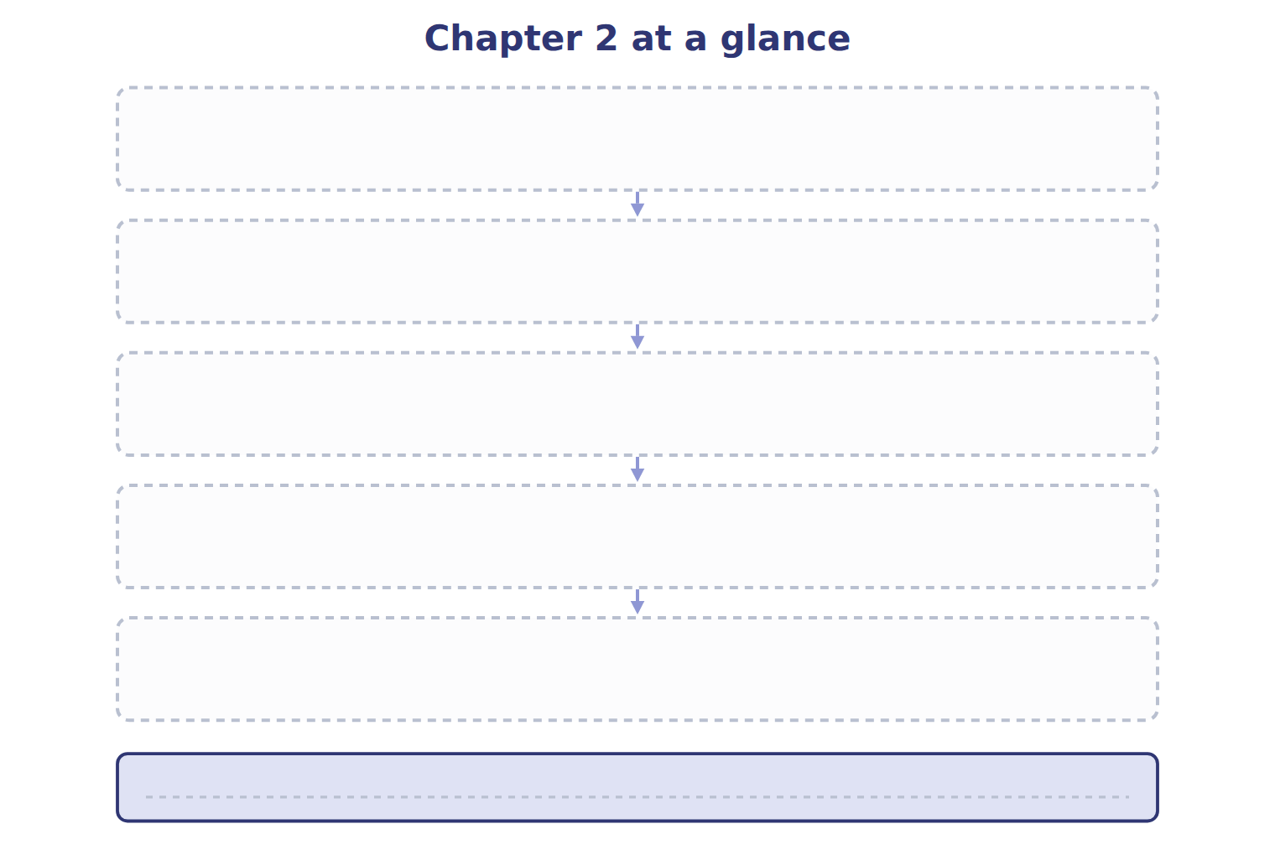
TEACH IT BACK | Write it for a student starting this chapter tomorrow — not for the marker.
29. In four or five sentences, write what the whole chapter settles, section by section.
every one of these words must appear: balance sheet · classified balance sheet · current assets · current liabilities

