Handout 4.1
Components of equity and the statement of changes in equity
section 4.1 of the book
Before you start
Answer every one of these now, from what you already know or by guessing. You are not expected to get them right: you are about to be shown where each answer comes from.

What this handout settles
This handout settles | where it is answered
Components of equity and the statement of changes in equity | cycle A
and you mark your own answers | at every checkpoint

1. A company declares a stock dividend on December 20 and distributes the shares on January 10. How does it present the stock dividend distributable at December 31?
A. As a current liability | C. As a long-term liability
B. In stockholders' equity | D. In the notes only
2. Which item is part of contributed capital?
A. Retained earnings
B. Accumulated other comprehensive income
C. Appropriated retained earnings
D. Additional paid-in capital
3. Which transaction does the book pair with “Decreases”?
A. Correct a prior-year error that overstated expenses
B. Declare a cash dividend
C. Carry out a 2-for-1 stock split
D. Reissue treasury stock above cost
4. Which transaction does the book pair with “________”?
A. Declare a cash dividend
B. Carry out a 2-for-1 stock split
C. Declare and issue a small stock dividend
5. Which total equity does the book give for Declare a cash dividend?
A. No change | C. ________
B. Decreases
6. Which total equity does the book give for Declare and issue a small stock dividend?
A. ________ | C. No change
B. Decreases
7. Which total equity does the book give for Carry out a 2-for-1 stock split?
A. Decreases | C. No change
B. ________
8. Which total equity does the book give for Buy treasury stock?
A. No change | C. Decreases
B. ________
9. Which total equity does the book give for Reissue treasury stock above cost?
A. ________ | C. No change
B. Decreases

CYCLE A | Components of equity and the statement of changes in equity

ORIENT One claim. Decide now; you will check it in a moment.

10. The book gives the retained earnings of Declare a cash dividend as “Decreases”. TRUE / FALSE
MODEL Read it before you answer anything below it.

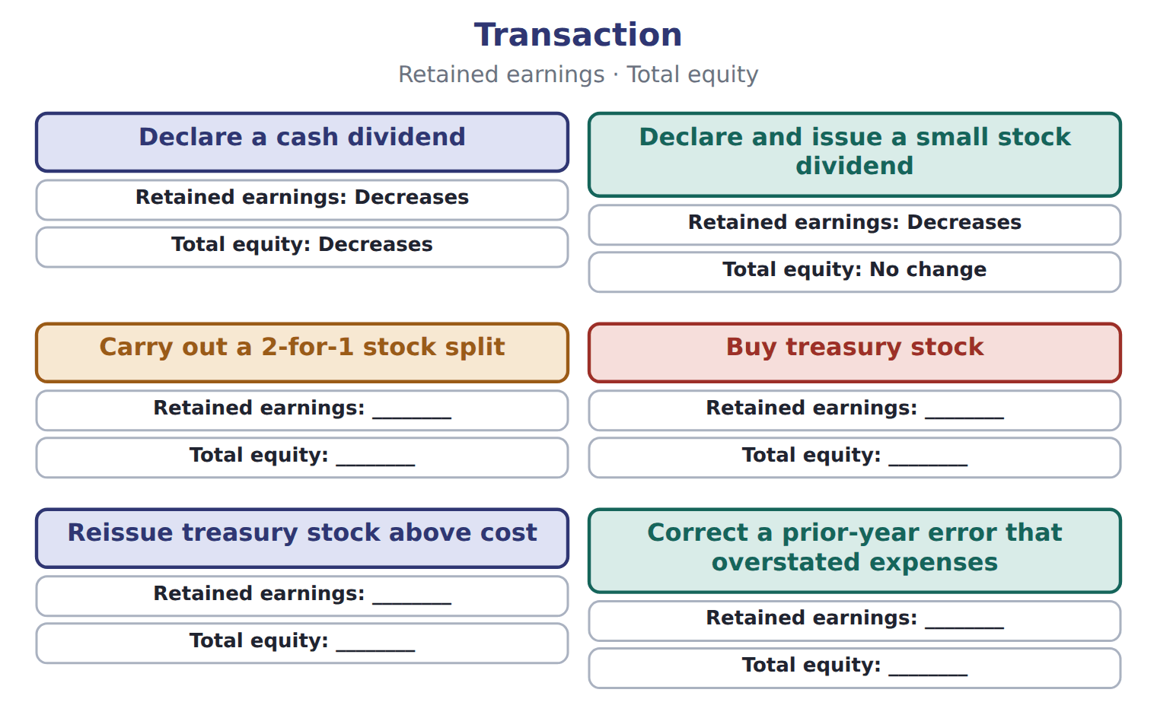

Transaction — the book’s own table
Transaction | Retained earnings | Total equity
Declare a cash dividend | Decreases | Decreases
Declare and issue a small stock dividend | Decreases | No change
Carry out a 2-for-1 stock split | ________ | ________
Buy treasury stock | ________ | ________
Reissue treasury stock above cost | ________ | ________
Correct a prior-year error that overstated expenses | ________ | ________

READ THE MODEL Every answer is printed above. Find it, do not recall it.

11. Which transaction does the book pair with “Decreases”?
A. Correct a prior-year error that overstated expenses
B. Buy treasury stock
C. Declare a cash dividend
D. Reissue treasury stock above cost
12. Which transaction does the book pair with “Decreases”?
A. Declare and issue a small stock dividend
B. Reissue treasury stock above cost
C. Carry out a 2-for-1 stock split
D. Buy treasury stock
13. Which transaction does the book pair with “________”?
A. Declare a cash dividend
B. Declare and issue a small stock dividend
C. Carry out a 2-for-1 stock split
14. Which transaction does the book pair with “________”?
A. Declare a cash dividend
B. Declare and issue a small stock dividend
C. Buy treasury stock
15. The book gives the total equity of Declare a cash dividend as “Decreases”. TRUE / FALSE
16. The book gives the total equity of Declare and issue a small stock dividend as “________”. TRUE / FALSE
SORT THEM | Write each one under its retained earnings. Every item belongs to exactly one group.
the items: Declare a cash dividend · Declare and issue a small stock dividend · Carry out a 2-for-1 stock split · Buy treasury stock · Reissue treasury stock above cost · Correct a prior-year error that overstated expenses
Decreases | ________

APPLY No help on this move.

19. Which change in equity is a transaction with owners?
A. Earning net income
B. Recording an OCI loss on AFS debt securities
C. Declaring a cash dividend
D. Recording depreciation
20. An investor wants to know whether a company paid out more in dividends than it earned this year. Which statement shows both amounts together?
A. The balance sheet
B. The statement of changes in equity
C. The income statement
D. The notes on accounting policies
21. For which periods must an SEC registrant reconcile each equity caption?
A. Only for the latest year
B. For every period for which it presents an income statement
C. Only when equity changes by more than 10%
D. Only in interim reports
22. Which heading is correct for a statement of changes in equity?
A. As of December 31, 2025
B. At December 31, 2025
C. On December 31, 2025
D. For the year ended December 31, 2025
WORK IN PAIRS | Compare every answer on this page with your partner before you read any key.
If you disagree: go back to the model and find the row that settles it. The row decides, not the louder voice.
CHECKPOINT 23. Which change in equity is a transaction with owners?
A. Earning net income
B. Recording an OCI loss on AFS debt securities
C. Declaring a cash dividend
D. Recording depreciation
If you got it wrong: redo the READ THE MODEL questions of cycle A with the model in front of you.

CYCLE B | The words this section uses precisely

ORIENT

24. A term in the exam means exactly what the book defines it to mean, whatever it means in ordinary English. TRUE / FALSE
MODEL

The English the exam uses, and what it translates
English (exam term) | the Arabic it translates
statement of changes in equity | قائمة التغيرات في حقوق الملكية
stock split | تجزئة الأسهم
cost method | طريقة التكلفة

READ THE MODEL

25. A glossary term and its translation are a pair the book itself gives. TRUE / FALSE

APPLY

26. Where does treasury stock appear on a U.S. balance sheet?
A. As a current asset
B. As a long-term investment
C. As a deduction within stockholders' equity
D. As a liability
27. A company has issued 1,000,000 shares and holds 50,000 of them as treasury stock. How many shares are outstanding?
A. 50,000 | C. 1,000,000
B. 950,000 | D. 1,050,000
CHECKPOINT 28. What is the safest way to settle a disagreement about an answer on this sheet?
A. find the row of the model that decides it
B. take the answer of whoever is more confident
C. leave it until the lecturer says
D. choose the longer option
If you got it wrong: redo the READ THE MODEL questions of cycle B.

FROM MEMORY | Close the earlier pages first.
29. Rebuild the figure from this handout. Label every part and fill in every box.
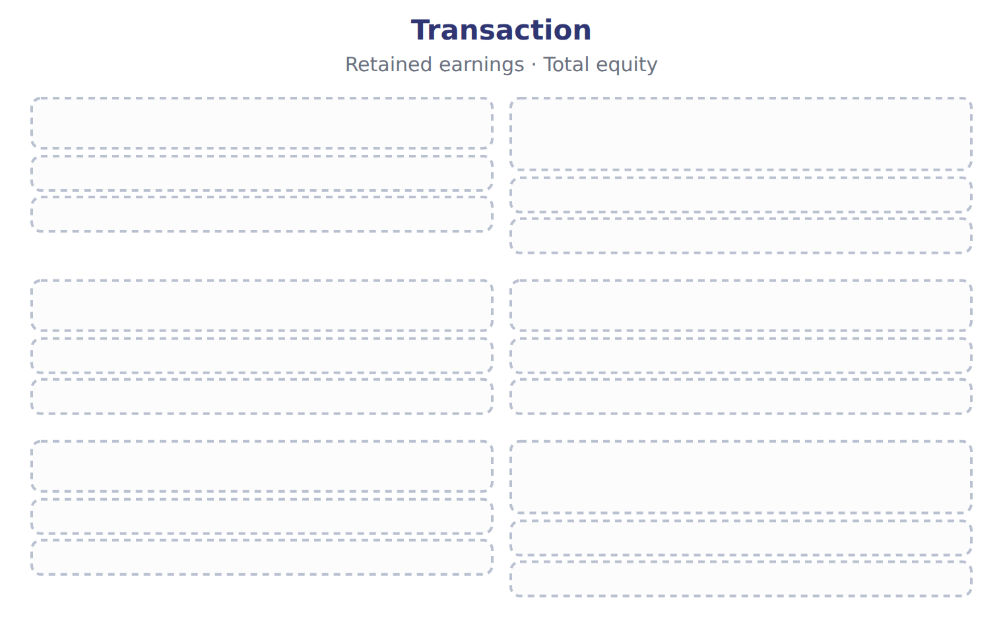
TEACH IT BACK | Write it for a classmate who missed this session — not for the marker.
30. In three or four sentences, write what this section settles and the one rule a reader has to take away.
every one of these words must appear: statement of changes in equity · stock split · cost method

Handout 4.2
Issuing and buying back shares
section 4.2 of the book
Before you start
Answer every one of these now, from what you already know or by guessing. You are not expected to get them right: you are about to be shown where each answer comes from.

What this handout settles
This handout settles | where it is answered
Issuing and buying back shares | cycle A
and you mark your own answers | at every checkpoint

1. A company reissues treasury shares for more than their cost. The excess is:
A. credited to APIC–treasury stock | C. credited to retained earnings
B. reported as a gain in net income | D. reported in OCI
2. What is the effect of buying treasury stock for cash?
A. Total equity does not change
B. Retained earnings decrease
C. Total assets increase
D. Total equity decreases; retained earnings do not change
3. Which category does the book give for APIC–treasury stock?
A. Current liability | C. Contributed capital
B. Deduction from equity | D. Earned capital
4. Which category does the book give for Retained earnings?
A. Deduction from equity | C. Current liability
B. Contributed capital | D. Earned capital
5. Which category does the book give for Treasury stock?
A. Contributed capital | C. Earned capital
B. Current liability | D. Deduction from equity
6. Which category does the book give for Dividends payable?
A. Earned capital | C. Contributed capital
B. Deduction from equity | D. Current liability
7. Which category does the book give for Common stock?
A. Current liability | C. Deduction from equity
B. Contributed capital | D. Earned capital
8. The book gives the category of APIC–treasury stock as “Contributed capital”. TRUE / FALSE
9. The book gives the category of Retained earnings as “Deduction from equity”. TRUE / FALSE
10. The book gives the category of Treasury stock as “Deduction from equity”. TRUE / FALSE

CYCLE A | Issuing and buying back shares

ORIENT One claim. Decide now; you will check it in a moment.

11. The book gives the category of APIC–treasury stock as “Contributed capital”. TRUE / FALSE
MODEL Read it before you answer anything below it.

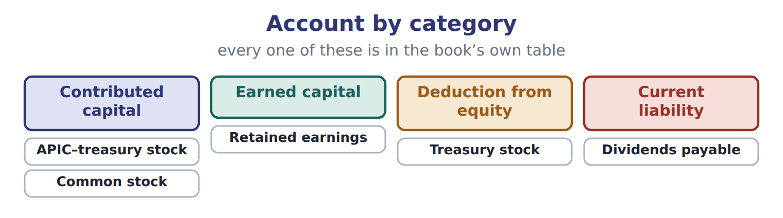

Account — the book’s own table
Account | Category
APIC–treasury stock | Contributed capital
Retained earnings | Earned capital
Treasury stock | Deduction from equity
Dividends payable | Current liability
Common stock | Contributed capital

READ THE MODEL Every answer is printed above. Find it, do not recall it.

12. Which category does the book give for APIC–treasury stock?
A. Earned capital | C. Contributed capital
B. Current liability | D. Deduction from equity
13. Which category does the book give for Retained earnings?
A. Earned capital | C. Contributed capital
B. Deduction from equity | D. Current liability
14. Which category does the book give for Treasury stock?
A. Contributed capital | C. Current liability
B. Earned capital | D. Deduction from equity
15. Which category does the book give for Dividends payable?
A. Current liability | C. Contributed capital
B. Deduction from equity | D. Earned capital
16. The book gives the category of APIC–treasury stock as “Contributed capital”. TRUE / FALSE
17. The book gives the category of Retained earnings as “Contributed capital”. TRUE / FALSE
SORT THEM | Write each one under its category. Every item belongs to exactly one group.
the items: APIC–treasury stock · Retained earnings · Treasury stock · Dividends payable · Common stock
Contributed capital | Current liability | Deduction from equity | Earned capital

APPLY No help on this move.

22. A company declares a stock dividend on December 20 and distributes the shares on January 10. How does it present the stock dividend distributable at December 31?
A. As a current liability | C. As a long-term liability
B. In stockholders' equity | D. In the notes only
23. Which item is part of contributed capital?
A. Retained earnings
B. Accumulated other comprehensive income
C. Appropriated retained earnings
D. Additional paid-in capital
24. In a statement of changes in equity, in which column does an OCI loss on AFS debt securities appear?
A. Retained earnings
B. Additional paid-in capital
C. Accumulated other comprehensive income
D. Treasury stock
25. A company's retained earnings were $800,000 on January 1. Net income was $250,000, cash dividends declared were $60,000, and a 5% stock dividend was measured at $90,000. What are retained earnings at December 31?
A. $900,000 | C. $990,000
B. $960,000 | D. $1,050,000
WORK IN PAIRS | Compare every answer on this page with your partner before you read any key.
If you disagree: go back to the model and find the row that settles it. The row decides, not the louder voice.
CHECKPOINT 26. A company declares a stock dividend on December 20 and distributes the shares on January 10. How does it present the stock dividend distributable at December 31?
A. As a current liability
B. In stockholders' equity
C. As a long-term liability
D. In the notes only
If you got it wrong: redo the READ THE MODEL questions of cycle A with the model in front of you.

CYCLE B | The words this section uses precisely

ORIENT

27. A term in the exam means exactly what the book defines it to mean, whatever it means in ordinary English. TRUE / FALSE
MODEL

The English the exam uses, and what it translates
English (exam term) | the Arabic it translates
contributed capital | رأس المال المساهم به (المدفوع)
appropriated retained earnings | أرباح مبقاة مخصصة
declaration date | تاريخ الإعلان

READ THE MODEL

28. A glossary term and its translation are a pair the book itself gives. TRUE / FALSE

APPLY

29. A company pays $50,000 of legal and underwriting costs to issue new common shares. How does it record the costs?
A. As an expense
B. As a reduction of additional paid-in capital
C. As an intangible asset
D. As a reduction of retained earnings
30. A company issues common shares in exchange for land. The shares are actively traded. The land is recorded at:
A. the par value of the shares
B. the seller's carrying amount of the land
C. the fair value of the shares
D. zero, because no cash was paid
CHECKPOINT 31. What is the safest way to settle a disagreement about an answer on this sheet?
A. find the row of the model that decides it
B. take the answer of whoever is more confident
C. leave it until the lecturer says
D. choose the longer option
If you got it wrong: redo the READ THE MODEL questions of cycle B.

FROM MEMORY | Close the earlier pages first.
32. Rebuild the figure from this handout. Label every part and fill in every box.
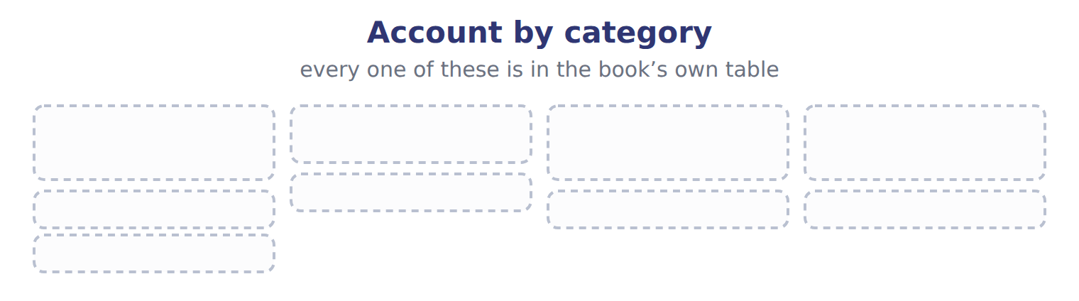
TEACH IT BACK | Write it for a classmate who missed this session — not for the marker.
33. In three or four sentences, write what this section settles and the one rule a reader has to take away.
every one of these words must appear: contributed capital · appropriated retained earnings · declaration date

Handout 4.3
Dividends, stock dividends and stock splits
section 4.3 of the book
Before you start
Answer every one of these now, from what you already know or by guessing. You are not expected to get them right: you are about to be shown where each answer comes from.

What this handout settles
This handout settles | where it is answered
Dividends, stock dividends and stock splits | cycle A
Suppose: Orontes, 8,100,000 shares and what goes with it | cycle B
and you mark your own answers | at every checkpoint

1. A company has issued 1,000,000 shares, of which 100,000 are held in treasury. It declares a 10% stock dividend. How many new shares does it issue?
A. 10,000 | C. 100,000
B. 90,000 | D. 110,000
2. Which transaction reduces total stockholders' equity?
A. Declaring and issuing a small stock dividend
B. Declaring a cash dividend
C. Carrying out a 3-for-1 stock split
D. Appropriating retained earnings for a new plant
3. Which type does the book pair with “Amount declared”?
A. Scrip dividend
B. Small stock dividend (below about 20–25%)
C. Cash dividend
D. Large stock dividend (above about 20–25%)
4. Which type does the book pair with “Fair value of the asset (gain or loss on remeasurement first)”?
A. Liquidating dividend
B. Large stock dividend (above about 20–25%)
C. Cash dividend
D. Property dividend
5. Which type does the book pair with “Face value of the note”?
A. Small stock dividend (below about 20–25%)
B. Scrip dividend
C. Property dividend
D. Stock split
6. Which type does the book pair with “Amount beyond retained earnings”?
A. Large stock dividend (above about 20–25%)
B. Liquidating dividend
C. Small stock dividend (below about 20–25%)
D. Cash dividend
7. Which type does the book pair with “Fair value of the shares”?
A. Scrip dividend
B. Large stock dividend (above about 20–25%)
C. Small stock dividend (below about 20–25%)
D. Cash dividend

CYCLE A | Dividends, stock dividends and stock splits

ORIENT One claim. Decide now; you will check it in a moment.

8. The book gives the measured at of Cash dividend as “Amount declared”. TRUE / FALSE
MODEL Read it before you answer anything below it.

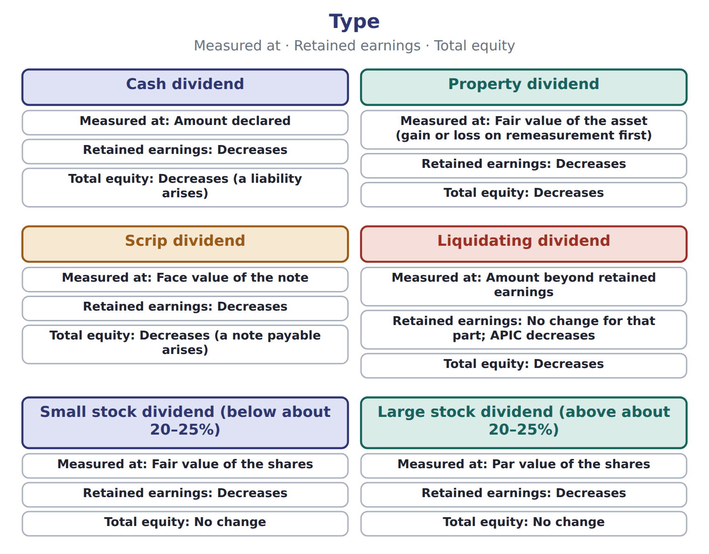

Type — the book’s own table
Type | Measured at | Retained earnings | Total equity
Cash dividend | Amount declared | Decreases | Decreases (a liability arises)
Property dividend | Fair value of the asset (gain or loss on remeasurement first) | Decreases | Decreases
Scrip dividend | Face value of the note | Decreases | Decreases (a note payable arises)
Liquidating dividend | Amount beyond retained earnings | No change for that part; APIC decreases | Decreases
Small stock dividend (below about 20–25%) | Fair value of the shares | Decreases | No change
Large stock dividend (above about 20–25%) | Par value of the shares | Decreases | No change
Stock split | No entry; par per share falls | No change | No change

READ THE MODEL Every answer is printed above. Find it, do not recall it.

9. Which type does the book pair with “Amount declared”?
A. Liquidating dividend | C. Stock split
B. Scrip dividend | D. Cash dividend
10. Which type does the book pair with “Fair value of the asset (gain or loss on remeasurement first)”?
A. Large stock dividend (above about 20–25%)
B. Property dividend
C. Small stock dividend (below about 20–25%)
D. Liquidating dividend
11. Which type does the book pair with “Face value of the note”?
A. Scrip dividend
B. Large stock dividend (above about 20–25%)
C. Liquidating dividend
D. Cash dividend
12. Which type does the book pair with “Amount beyond retained earnings”?
A. Cash dividend | C. Property dividend
B. Stock split | D. Liquidating dividend
13. The book gives the total equity of Cash dividend as “Decreases (a liability arises)”. TRUE / FALSE
14. The book gives the total equity of Property dividend as “No change”. TRUE / FALSE

APPLY No help on this move.

15. A company reissues treasury shares for more than their cost. The excess is:
A. credited to APIC–treasury stock | C. credited to retained earnings
B. reported as a gain in net income | D. reported in OCI
16. What is the effect of buying treasury stock for cash?
A. Total equity does not change
B. Retained earnings decrease
C. Total assets increase
D. Total equity decreases; retained earnings do not change
17. A company declares a property dividend of land with a carrying amount of $60,000 and a fair value of $90,000. What is recorded?
A. Retained earnings are reduced by $60,000; no gain
B. A gain of $30,000, and retained earnings are reduced by $90,000
C. A gain of $90,000
D. Retained earnings are reduced by $30,000
18. What entry is made on the date of record for a cash dividend?
A. No entry
B. Debit retained earnings; credit dividends payable
C. Debit dividends payable; credit cash
D. Debit retained earnings; credit cash
WORK IN PAIRS | Compare every answer on this page with your partner before you read any key.
If you disagree: go back to the model and find the row that settles it. The row decides, not the louder voice.
CHECKPOINT 19. A company reissues treasury shares for more than their cost. The excess is:
A. credited to APIC–treasury stock
B. reported as a gain in net income
C. credited to retained earnings
D. reported in OCI
If you got it wrong: redo the READ THE MODEL questions of cycle A with the model in front of you.

CYCLE B | The words this section uses precisely

ORIENT

20. A term in the exam means exactly what the book defines it to mean, whatever it means in ordinary English. TRUE / FALSE
MODEL

Suppose: Orontes, 8,100,000 shares — the book’s own table
Suppose: Orontes, 8,100,000 shares | 4% stock dividend | 50% stock dividend | 2-for-1 split
New shares issued | 324,000 | 4,050,000 | 8,100,000
Measured at | fair value $15 | par $1 | no entry
Retained earnings | (4,860,000) | (4,050,000) | no change
Common stock | 324,000 | 4,050,000 | no change
Additional paid-in capital | 4,536,000 | no change | no change
Total stockholders' equity | no change | no change | no change
Par value per share afterward | $1 | $1 | $0.50

The English the exam uses, and what it translates
English (exam term) | the Arabic it translates
outstanding shares | الأسهم القائمة (المتداولة)
prior-period adjustment | تسوية سنوات سابقة
date of record | تاريخ التسجيل (الاستحقاق)

READ THE MODEL

21. A glossary term and its translation are a pair the book itself gives. TRUE / FALSE
APPLY

22. A company with 500,000 shares of $2 par stock declares a 2-for-1 stock split. What happens?
A. Retained earnings decrease by $1,000,000
B. Common stock increases by $1,000,000
C. Total equity doubles
D. 1,000,000 shares of $1 par; no entry and no change in any equity account
Suppose: Orontes, 8,100,000 shares — the extract for the question that follows
Suppose: Orontes, 8,100,000 shares | 4% stock dividend | 50% stock dividend | 2-for-1 split
New shares issued | 324,000 | 4,050,000 | 8,100,000
Measured at | fair value $15 | par $1 | no entry
Retained earnings | (4,860,000) | (4,050,000) | no change
Common stock | 324,000 | 4,050,000 | no change
Additional paid-in capital | 4,536,000 | no change | no change
Total stockholders' equity | no change | no change | no change
Par value per share afterward | $1 | $1 | $0.50

23. The extract for this question is printed with it. By how much does the 50% stock dividend reduce Orontes's retained earnings (whole USD)?
A. 0 | C. 4,860,000
B. 4,050,000 | D. 60,750,000
CHECKPOINT 24. What is the safest way to settle a disagreement about an answer on this sheet?
A. find the row of the model that decides it
B. take the answer of whoever is more confident
C. leave it until the lecturer says
D. choose the longer option
If you got it wrong: redo the READ THE MODEL questions of cycle B.

FROM MEMORY | Close the earlier pages first.
25. Rebuild the figure from this handout. Label every part and fill in every box.
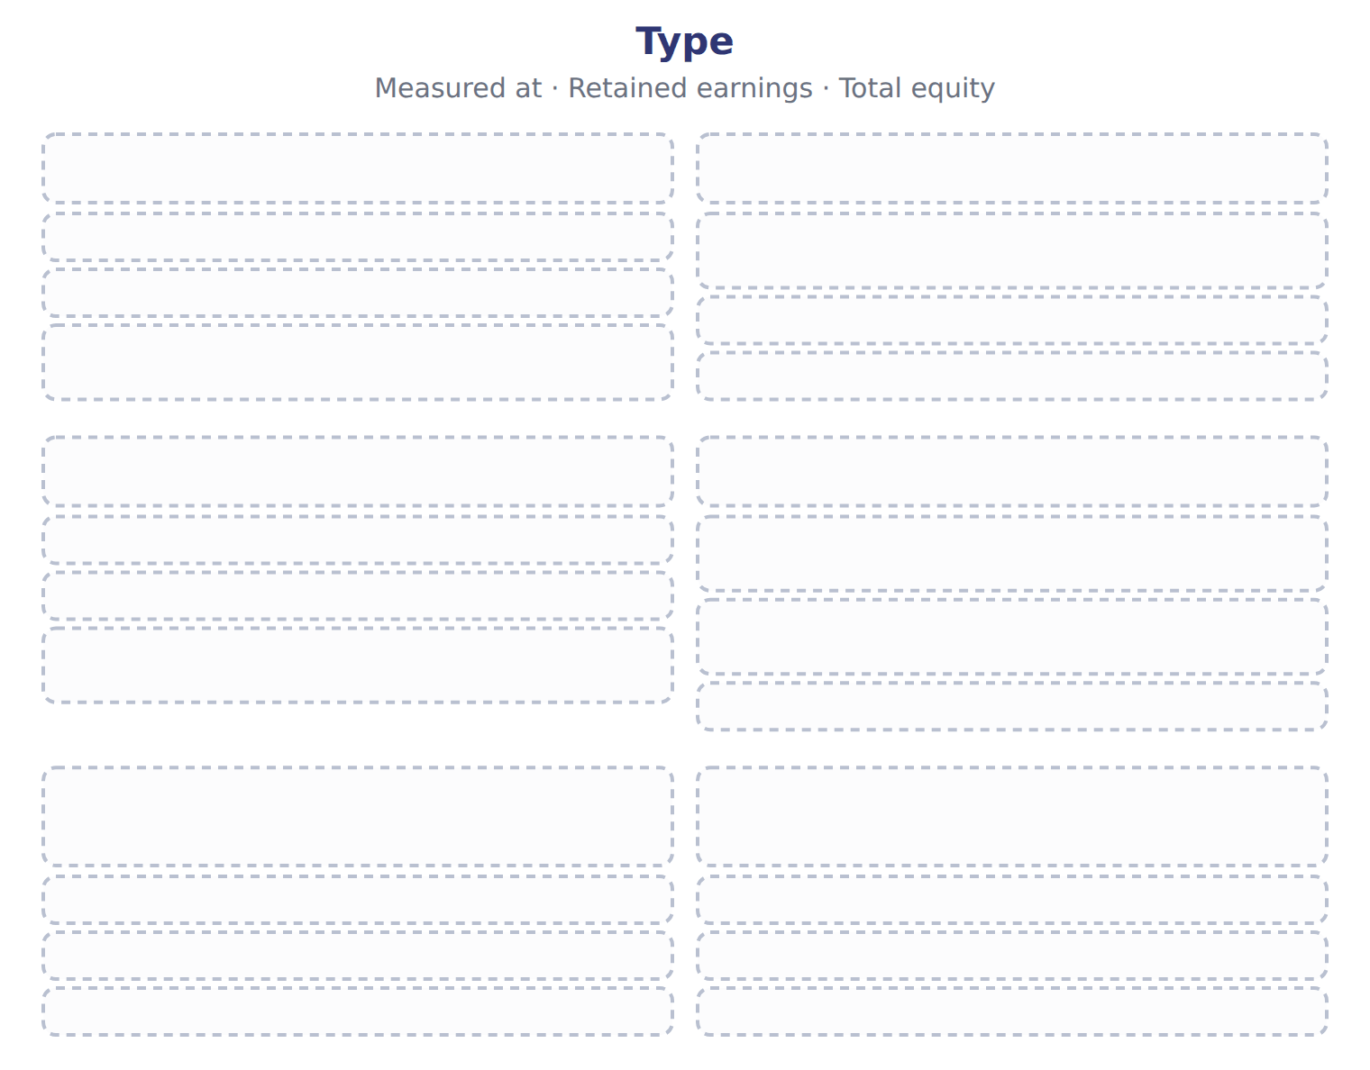
TEACH IT BACK | Write it for a classmate who missed this session — not for the marker.
26. In three or four sentences, write what this section settles and the one rule a reader has to take away.
every one of these words must appear: outstanding shares · prior-period adjustment · date of record

Handout 4.4
Retained earnings
section 4.4 of the book
Before you start
Answer every one of these now, from what you already know or by guessing. You are not expected to get them right: you are about to be shown where each answer comes from.

What this handout settles
This handout settles | where it is answered
Retained earnings | cycle A
and you mark your own answers | at every checkpoint

1. Under IFRS, how is a stock dividend (bonus issue) of 10% measured?
A. Always at fair value
B. Always at par, like a U.S. large stock dividend
C. IFRS has no small/large rule; practice varies by local law
D. It is recorded as an expense
2. Which answer does the book give for 2-for-1 stock split?
A. Retained earnings: no change. Total equity: decreases by the cost.
B. Retained earnings: no change. Total equity: no change (no entry is made).
C. Retained earnings: opening balance increases, net of tax. Total equity: increases.
3. Which answer does the book give for Buy treasury stock?
A. Retained earnings: opening balance increases, net of tax. Total equity: increases.
B. Retained earnings: no change. Total equity: decreases by the cost.
C. Retained earnings: no change. Total equity: no change (no entry is made).
4. Which answer does the book give for Correct an error that overstated expenses?
A. Retained earnings: no change. Total equity: decreases by the cost.
B. Retained earnings: opening balance increases, net of tax. Total equity: increases.
C. Retained earnings: no change. Total equity: no change (no entry is made).
5. The book gives the answer of 2-for-1 stock split as “Retained earnings: no change. Total equity: no change (no entry is made).”. TRUE / FALSE
6. The book gives the answer of Buy treasury stock as “Retained earnings: opening balance increases, net of tax. Total equity: increases.”. TRUE / FALSE
7. What is the main purpose of the statement of changes in equity?
A. To show the market value of the company's shares
B. To show cash received from owners only
C. To explain why each part of equity changed during the period
D. To report revenues and expenses
8. Orontes issues 100,000 shares of $1 par common stock for $1,500,000 in cash. What is credited to additional paid-in capital (whole USD)?
A. 0 | C. 1,400,000
B. 100,000 | D. 1,500,000

CYCLE A | Retained earnings

ORIENT One claim. Decide now; you will check it in a moment.

9. The book gives the answer of 2-for-1 stock split as “Retained earnings: no change. Total equity: no change (no entry is made).”. TRUE / FALSE
MODEL Read it before you answer anything below it.

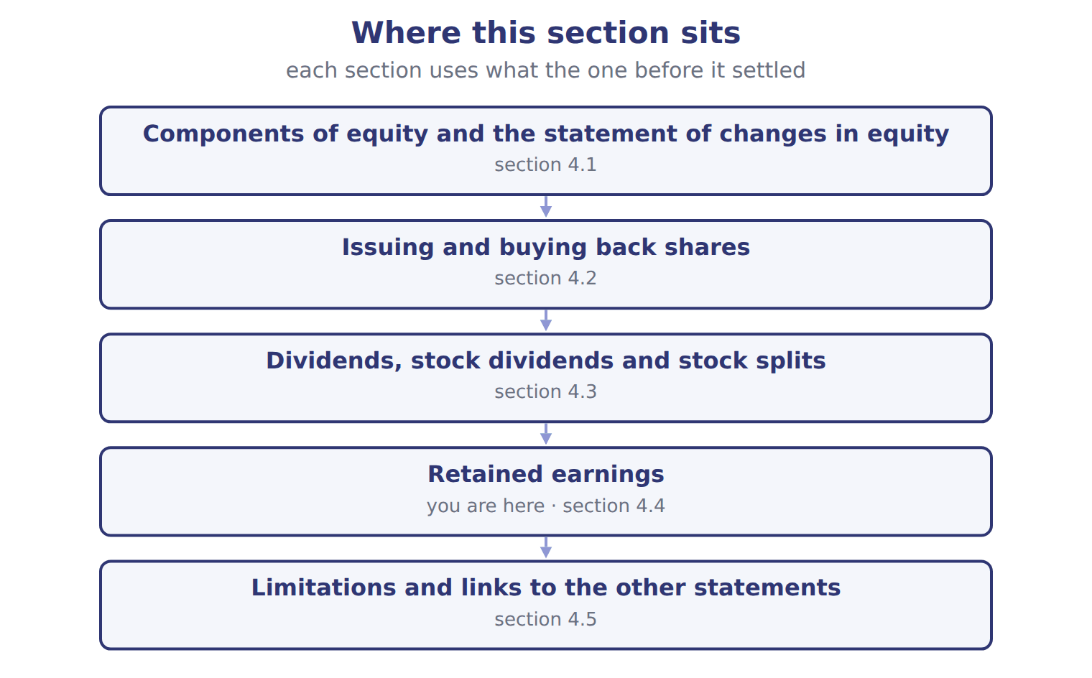

Item — the book’s own table
Item | Answer
2-for-1 stock split | Retained earnings: no change. Total equity: no change (no entry is made).
Buy treasury stock | Retained earnings: no change. Total equity: decreases by the cost.
Reissue treasury stock above cost | Retained earnings: no change (the excess goes to APIC–treasury stock). Total equity: increases by the cash received.
Correct an error that overstated expenses | Retained earnings: opening balance increases, net of tax. Total equity: increases.

READ THE MODEL Every answer is printed above. Find it, do not recall it.

10. Which answer does the book give for 2-for-1 stock split?
A. Retained earnings: no change. Total equity: decreases by the cost.
B. Retained earnings: no change. Total equity: no change (no entry is made).
C. Retained earnings: opening balance increases, net of tax. Total equity: increases.
11. Which answer does the book give for Buy treasury stock?
A. Retained earnings: no change. Total equity: decreases by the cost.
B. Retained earnings: no change. Total equity: no change (no entry is made).
C. Retained earnings: opening balance increases, net of tax. Total equity: increases.
12. Which answer does the book give for Correct an error that overstated expenses?
A. Retained earnings: no change. Total equity: no change (no entry is made).
B. Retained earnings: opening balance increases, net of tax. Total equity: increases.
C. Retained earnings: no change. Total equity: decreases by the cost.
13. The book gives the answer of 2-for-1 stock split as “Retained earnings: no change. Total equity: no change (no entry is made).”. TRUE / FALSE
14. The book gives the answer of Buy treasury stock as “Retained earnings: opening balance increases, net of tax. Total equity: increases.”. TRUE / FALSE

APPLY No help on this move.

15. Use the treasury stock example in Section 4.2. By how much does the second reissue reduce retained earnings (whole USD)?
A. 0 | C. 40,000
B. 20,000 | D. 60,000
16. A company declares a 5% stock dividend. It is measured at:
A. the par value of the new shares
B. zero, because no assets leave the company
C. the fair value of the new shares
D. the book value per share
17. A company has issued 1,000,000 shares, of which 100,000 are held in treasury. It declares a 10% stock dividend. How many new shares does it issue?
A. 10,000 | C. 100,000
B. 90,000 | D. 110,000
18. Which transaction reduces total stockholders' equity?
A. Declaring and issuing a small stock dividend
B. Declaring a cash dividend
C. Carrying out a 3-for-1 stock split
D. Appropriating retained earnings for a new plant
19. Which is a limitation of the equity section of the balance sheet?
A. It includes all internally built intangibles
B. It shows the market value of the company
C. It is prepared on a cash basis
D. Treasury stock is shown at its cost, not at the current share price
20. Why may a company's retained earnings not show how much it can legally pay as dividends?
A. Legal capital rules and loan covenants can restrict distributions
B. Retained earnings include share premium
C. Retained earnings are measured at fair value
D. Dividends are paid from AOCI
WORK IN PAIRS | Compare every answer on this page with your partner before you read any key.
If you disagree: go back to the model and find the row that settles it. The row decides, not the louder voice.
CHECKPOINT 21. What is the main purpose of the statement of changes in equity?
A. To show the market value of the company's shares
B. To show cash received from owners only
C. To explain why each part of equity changed during the period
D. To report revenues and expenses
If you got it wrong: redo the READ THE MODEL questions of cycle A with the model in front of you.

CYCLE B | The words this section uses precisely

ORIENT

22. A term in the exam means exactly what the book defines it to mean, whatever it means in ordinary English. TRUE / FALSE

MODEL

The English the exam uses, and what it translates
English (exam term) | the Arabic it translates
treasury stock | أسهم الخزينة
preferred stock | الأسهم الممتازة
property dividend | توزيعات عينية

READ THE MODEL

23. A glossary term and its translation are a pair the book itself gives. TRUE / FALSE
APPLY

24. Orontes issues 100,000 shares of $1 par common stock for $1,500,000 in cash. What is credited to additional paid-in capital (whole USD)?
A. 0 | C. 1,400,000
B. 100,000 | D. 1,500,000
25. A company pays a dividend of $300,000, but its retained earnings are only $200,000. The extra $100,000 is:
A. an expense
B. a liquidating dividend that reduces APIC
C. a reduction of treasury stock
D. shown as negative OCI
26. A company retires treasury shares that cost more than their par value and original APIC. For the exam today, the excess is charged to:
A. retained earnings, or split between APIC and retained earnings
B. APIC only, as ASU 2025-12 requires
C. net income as a loss
D. OCI
CHECKPOINT 27. What is the safest way to settle a disagreement about an answer on this sheet?
A. find the row of the model that decides it
B. take the answer of whoever is more confident
C. leave it until the lecturer says
D. choose the longer option
If you got it wrong: redo the READ THE MODEL questions of cycle B.

FROM MEMORY | Close the earlier pages first.
28. Rebuild the figure from this handout. Label every part and fill in every box.
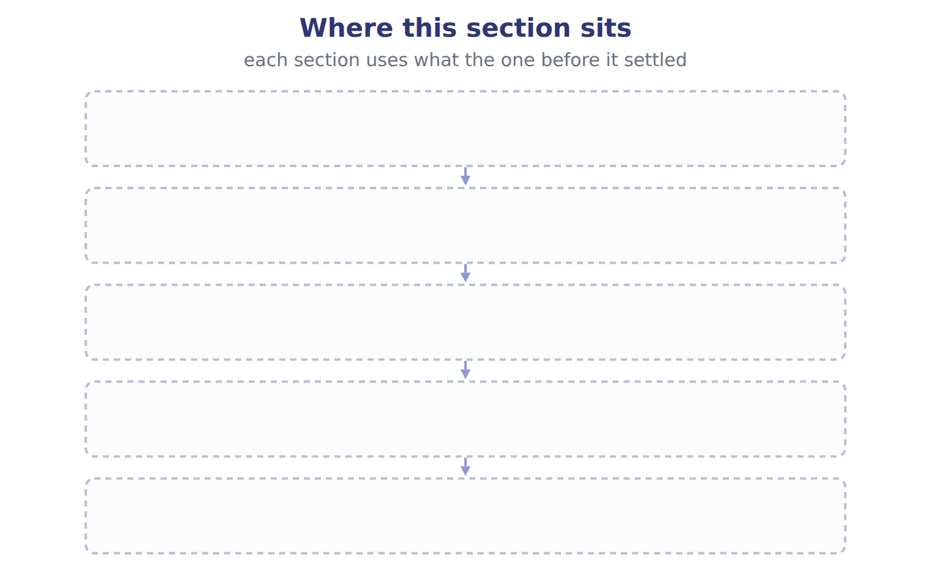
TEACH IT BACK | Write it for a classmate who missed this session — not for the marker.
29. In three or four sentences, write what this section settles and the one rule a reader has to take away.
every one of these words must appear: treasury stock · preferred stock · property dividend

Handout 4.5
Limitations and links to the other statements
section 4.5 of the book
Before you start
Answer every one of these now, from what you already know or by guessing. You are not expected to get them right: you are about to be shown where each answer comes from.

What this handout settles
This handout settles | where it is answered
Limitations and links to the other statements | cycle A
Account and what goes with it | cycle B
and you mark your own answers | at every checkpoint

1. Which part of this chapter is section 4.1?
A. Dividends, stock dividends and stock splits
B. Retained earnings
C. Issuing and buying back shares
D. Components of equity and the statement of changes in equity
2. Which part of this chapter is section 4.2?
A. Components of equity and the statement of changes in equity
B. Retained earnings
C. Dividends, stock dividends and stock splits
D. Issuing and buying back shares
3. Which part of this chapter is section 4.3?
A. Retained earnings
B. Issuing and buying back shares
C. Components of equity and the statement of changes in equity
D. Dividends, stock dividends and stock splits
4. Which part of this chapter is section 4.4?
A. Retained earnings
B. Dividends, stock dividends and stock splits
C. Issuing and buying back shares
D. Components of equity and the statement of changes in equity
5. Which part of this chapter is section 4.5?
A. Issuing and buying back shares
B. Limitations and links to the other statements
C. Components of equity and the statement of changes in equity
D. Dividends, stock dividends and stock splits
6. Which total equity does the book give for Declare a cash dividend?
A. ________ | C. Decreases
B. No change
7. Which total equity does the book give for Declare and issue a small stock dividend?
A. Decreases | C. No change
B. ________
8. Which total equity does the book give for Carry out a 2-for-1 stock split?
A. No change | C. ________
B. Decreases

CYCLE A | Limitations and links to the other statements

ORIENT One claim. Decide now; you will check it in a moment.

9. Every number in a financial statement belongs to an element the framework defines. TRUE / FALSE
MODEL Read it before you answer anything below it.

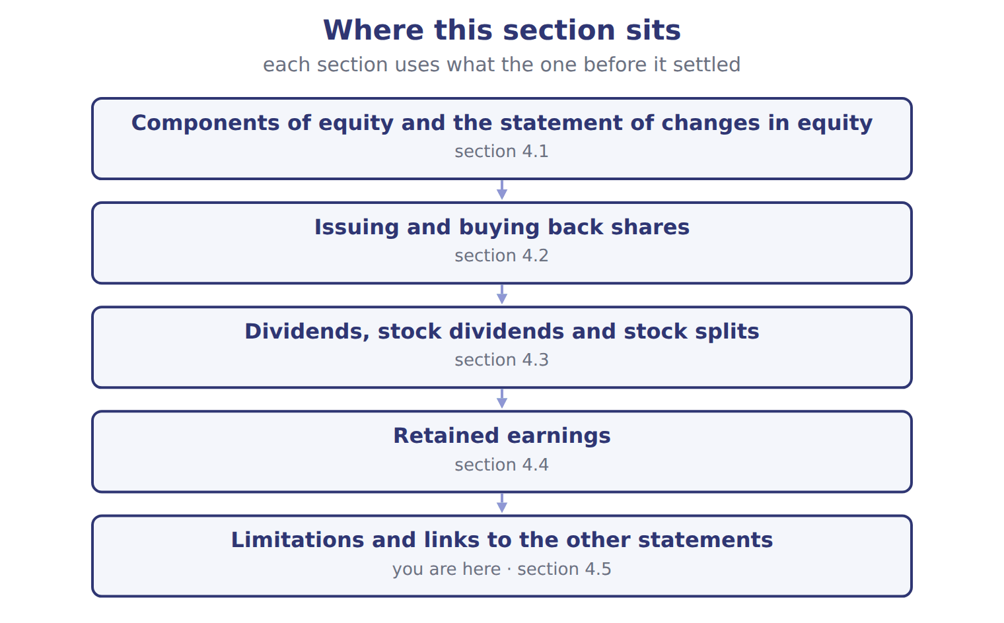

Balance / event (USD 000 unless stated) — the book’s own table
Balance / event (USD 000 unless stated) | Amount / details
Common stock, $1 par (600,000 shares issued and outstanding) | 600
Additional paid-in capital | 1,900
Retained earnings | 1,280
Total stockholders' equity, January 1, 2026 | 3,780
E1 | March 5: Barada bought 80,000 of its own shares at $6 per share (cost method).
E2 | June 10: Barada reissued 20,000 treasury shares at $8 per share.
E3 | August 20: Barada reissued 10,000 treasury shares at $4 per share.
E4 | October 1: Barada declared and issued a 10% stock dividend. The market price was $7 per share.
E5 | December 15: Barada declared a cash dividend of $0.20 per outstanding share, payable in January 2027.
E6 | Net income for 2026 was 165 (the Chapter 3 case).

READ THE MODEL Every answer is printed above. Find it, do not recall it.

10. Which part of this chapter is section 4.1?
A. Dividends, stock dividends and stock splits
B. Retained earnings
C. Issuing and buying back shares
D. Components of equity and the statement of changes in equity
11. Which part of this chapter is section 4.2?
A. Components of equity and the statement of changes in equity
B. Retained earnings
C. Dividends, stock dividends and stock splits
D. Issuing and buying back shares
12. Which part of this chapter is section 4.3?
A. Retained earnings
B. Issuing and buying back shares
C. Components of equity and the statement of changes in equity
D. Dividends, stock dividends and stock splits
13. Which part of this chapter is section 4.4?
A. Retained earnings
B. Dividends, stock dividends and stock splits
C. Issuing and buying back shares
D. Components of equity and the statement of changes in equity
APPLY No help on this move.

14. Under IFRS, how is a stock dividend (bonus issue) of 10% measured?
A. Always at fair value
B. Always at par, like a U.S. large stock dividend
C. IFRS has no small/large rule; practice varies by local law
D. It is recorded as an expense
WORK IN PAIRS | Compare every answer on this page with your partner before you read any key.
If you disagree: go back to the model and find the row that settles it. The row decides, not the louder voice.

CHECKPOINT 15. Under IFRS, how is a stock dividend (bonus issue) of 10% measured?
A. Always at fair value
B. Always at par, like a U.S. large stock dividend
C. IFRS has no small/large rule; practice varies by local law
D. It is recorded as an expense
If you got it wrong: redo the READ THE MODEL questions of cycle A with the model in front of you.

CYCLE B | The words this section uses precisely

ORIENT

16. A term in the exam means exactly what the book defines it to mean, whatever it means in ordinary English. TRUE / FALSE
MODEL

Account — the book’s own table
Account | Category
APIC–treasury stock
Retained earnings
Treasury stock
Dividends payable
Common stock

The English the exam uses, and what it translates
English (exam term) | the Arabic it translates
stock dividend | توزيعات أسهم (أسهم منحة)
issued shares | الأسهم المصدرة
liquidating dividend | توزيعات تصفية (إرجاع رأس مال)

READ THE MODEL

17. A glossary term and its translation are a pair the book itself gives. TRUE / FALSE
APPLY

18. Writing a term in English is part of answering the question, not an extra. TRUE / FALSE
CHECKPOINT 19. What is the safest way to settle a disagreement about an answer on this sheet?
A. find the row of the model that decides it
B. take the answer of whoever is more confident
C. leave it until the lecturer says
D. choose the longer option
If you got it wrong: redo the READ THE MODEL questions of cycle B.

FROM MEMORY | Close the earlier pages first.
20. Rebuild the figure from this handout. Label every part and fill in every box.
TEACH IT BACK | Write it for a classmate who missed this session — not for the marker.
21. In three or four sentences, write what this section settles and the one rule a reader has to take away.
every one of these words must appear: stock dividend · issued shares · liquidating dividend

Handout 4.6
The whole chapter
every section, shuffled, and the chapter’s own case set
Before you start
Answer every one of these now. They come from every part of the chapter, in no particular order.

What this handout settles
This handout settles | where it is answered
every section of the chapter, shuffled | cycle A
the chapter’s own case set | cycle B
and you mark your own answers | at every checkpoint

1. A company declares a 5% stock dividend. It is measured at:
A. the par value of the new shares
B. zero, because no assets leave the company
C. the fair value of the new shares
D. the book value per share
2. In 2026 a company finds that it overstated its 2024 depreciation expense. How does it correct the error?
A. It reports a gain in 2026 net income
B. It reduces 2026 depreciation expense
C. It records the correction in OCI
D. It restates prior years and increases opening retained earnings, net of tax
3. An IFRS company reports a 'translation reserve'. Where would this amount appear in U.S. GAAP equity?
A. Retained earnings
B. Accumulated other comprehensive income
C. Additional paid-in capital
D. Appropriated retained earnings
4. Why is Orontes's total equity much lower than the market value of its shares?
A. Equity is measured at fair value each year
B. Treasury stock is shown at market value
C. Equity includes only contributed capital
D. Most assets are at historical cost and internally built intangibles are not recorded
5. Which part of this chapter is section 4.1?
A. Dividends, stock dividends and stock splits
B. Retained earnings
C. Issuing and buying back shares
D. Components of equity and the statement of changes in equity
6. Which part of this chapter is section 4.2?
A. Components of equity and the statement of changes in equity
B. Retained earnings
C. Dividends, stock dividends and stock splits
D. Issuing and buying back shares
7. Which part of this chapter is section 4.3?
A. Retained earnings
B. Issuing and buying back shares
C. Components of equity and the statement of changes in equity
D. Dividends, stock dividends and stock splits

CYCLE A | The whole chapter, in order

ORIENT

8. The sections of a chapter have to be taken in order, because each one uses what the one before it settled. TRUE / FALSE
MODEL

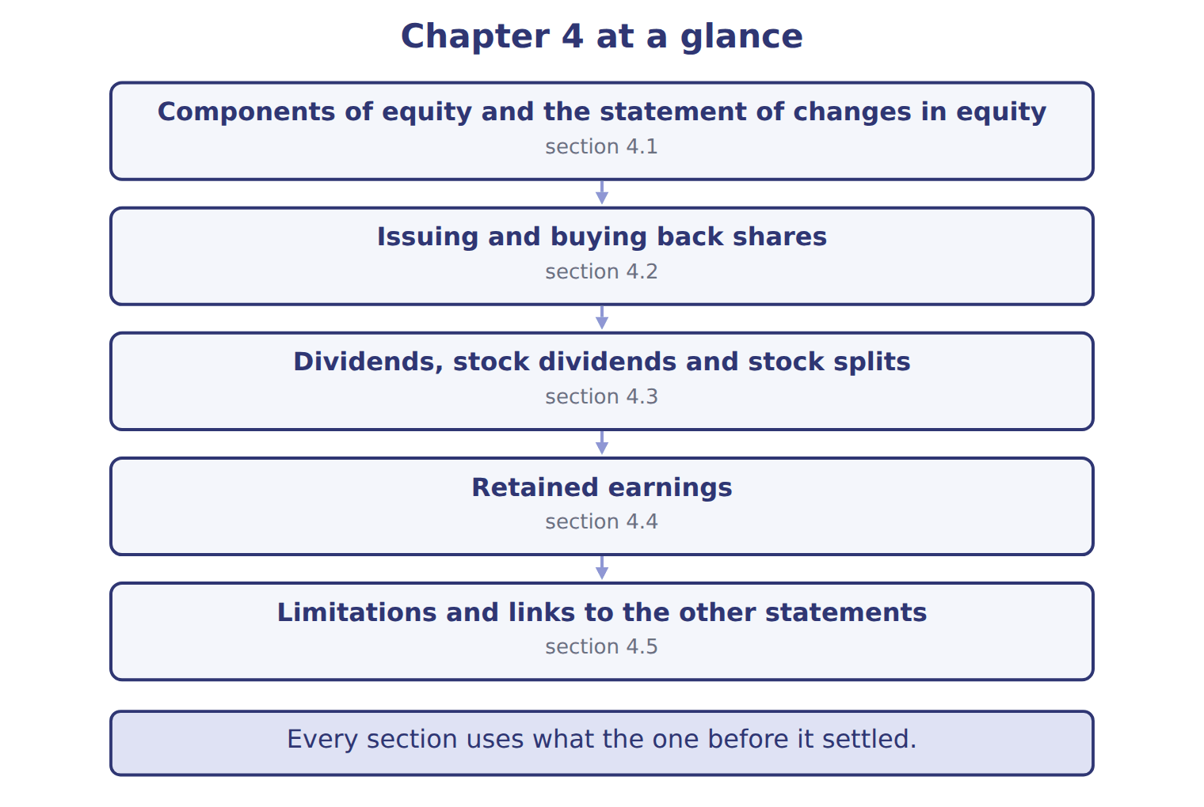
READ THE MODEL

9. “section 4.1” — which part of the chapter is this?
A. Issuing and buying back shares
B. Components of equity and the statement of changes in equity
C. Retained earnings
D. Dividends, stock dividends and stock splits
10. “section 4.2” — which part of the chapter is this?
A. Issuing and buying back shares
B. Dividends, stock dividends and stock splits
C. Retained earnings
D. Components of equity and the statement of changes in equity
11. “section 4.3” — which part of the chapter is this?
A. Components of equity and the statement of changes in equity
B. Dividends, stock dividends and stock splits
C. Issuing and buying back shares
D. Retained earnings
Write the letter of the section number beside each section title. Every number is used once.
A 4.1 | D 4.4
B 4.2 | E 4.5
C 4.3

12. Components of equity and the statement of changes in equity
13. Issuing and buying back shares
14. Dividends, stock dividends and stock splits
15. Retained earnings
16. Limitations and links to the other statements

APPLY

17. Why is Orontes's total equity much lower than the market value of its shares?
A. Equity is measured at fair value each year
B. Treasury stock is shown at market value
C. Equity includes only contributed capital
D. Most assets are at historical cost and internally built intangibles are not recorded
WORK IN PAIRS | Compare every answer with your partner first.
If you disagree: name the section each question belongs to. Most disagreements turn out to be about the section, not the answer.
CHECKPOINT 18. A company declares a 5% stock dividend. It is measured at:
A. the par value of the new shares
B. zero, because no assets leave the company
C. the fair value of the new shares
D. the book value per share
If you got it wrong: go back to the MODEL move of cycle A and find the section this question belongs to.

CYCLE B | The chapter’s case set

ORIENT

19. In a case question, the exhibit has to be read and adjusted before any figure is worked out. TRUE / FALSE

MODEL

The chapter’s case set, item by item
Item | What it asks
C4-1 | Classify each account at the end of 2026. (On the exam screen you would drag each account into a box.)
C4-2 | Enter the balance of APIC–treasury stock at December 31, 2026.
C4-3 | Enter the amount transferred out of retained earnings for the stock dividend (E4).
C4-4 | Enter the cash dividend declared on December 15 (E5).
C4-5 | Enter retained earnings at December 31, 2026.
C4-6 | Enter total stockholders' equity at December 31, 2026.

READ THE MODEL

20. Which of these does item C4-1 ask for?
A. Enter the balance of APIC–treasury stock at December 31, 2026.
B. Classify each account at the end of 2026. (On the exam screen you woul
C. Enter the amount transferred out of retained earnings for the stock di
D. Enter the cash dividend declared on December 15 (E5).
21. Which of these does item C4-2 ask for?
A. Enter the amount transferred out of retained earnings for the stock di
B. Classify each account at the end of 2026. (On the exam screen you woul
C. Enter the balance of APIC–treasury stock at December 31, 2026.
D. Enter the cash dividend declared on December 15 (E5).
22. Which of these does item C4-3 ask for?
A. Enter the cash dividend declared on December 15 (E5).
B. Enter the amount transferred out of retained earnings for the stock di
C. Enter the balance of APIC–treasury stock at December 31, 2026.
D. Classify each account at the end of 2026. (On the exam screen you woul
23. Which of these does item C4-4 ask for?
A. Enter the amount transferred out of retained earnings for the stock di
B. Classify each account at the end of 2026. (On the exam screen you woul
C. Enter the balance of APIC–treasury stock at December 31, 2026.
D. Enter the cash dividend declared on December 15 (E5).
24. Which of these does item C4-5 ask for?
A. Enter retained earnings at December 31, 2026.
B. Classify each account at the end of 2026. (On the exam screen you woul
C. Enter the amount transferred out of retained earnings for the stock di
D. Enter the balance of APIC–treasury stock at December 31, 2026.
25. Which of these does item C4-6 ask for?
A. Enter the amount transferred out of retained earnings for the stock di
B. Enter total stockholders' equity at December 31, 2026.
C. Classify each account at the end of 2026. (On the exam screen you woul
D. Enter the balance of APIC–treasury stock at December 31, 2026.
APPLY

26. A company declares a 5% stock dividend. It is measured at:
A. the par value of the new shares
B. zero, because no assets leave the company
C. the fair value of the new shares
D. the book value per share

Suppose: Orontes, 8,100,000 shares — the extract for the question that follows
Suppose: Orontes, 8,100,000 shares | 4% stock dividend | 50% stock dividend | 2-for-1 split
New shares issued | 324,000 | 4,050,000 | 8,100,000
Measured at | fair value $15 | par $1 | no entry
Retained earnings | (4,860,000) | (4,050,000) | no change
Common stock | 324,000 | 4,050,000 | no change
Additional paid-in capital | 4,536,000 | no change | no change
Total stockholders' equity | no change | no change | no change
Par value per share afterward | $1 | $1 | $0.50

27. The extract for this question is printed with it. By how much does the 4% stock dividend reduce Orontes's retained earnings (whole USD)?
A. 0 | C. 4,536,000
B. 324,000 | D. 4,860,000
CHECKPOINT 28. What has to be settled before any figure in a case set is worked out?
A. the exhibit, adjusted for every note that goes with it
B. the method the company uses
C. the tax rate
D. the order of the items
If you got it wrong: reread the case panel in the MODEL move of cycle B.

FROM MEMORY | Close the earlier pages first.
29. Rebuild the chapter map. Write every section in order and what each one settles.
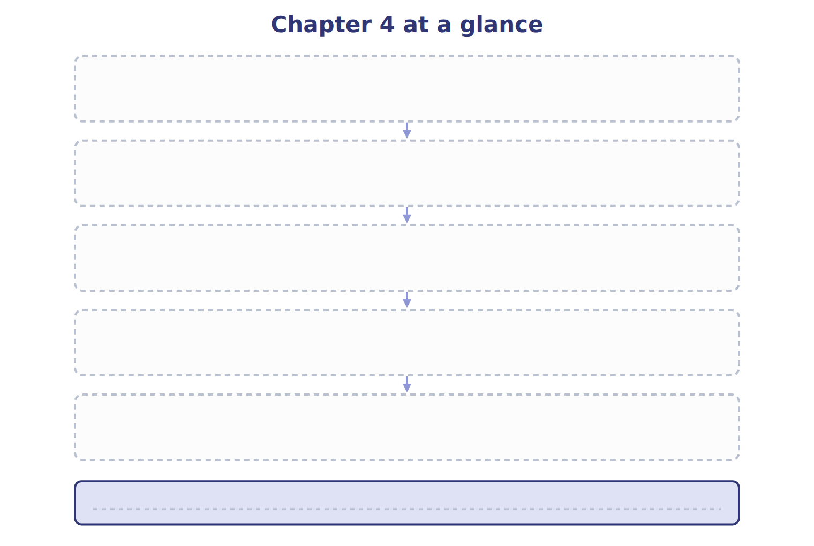
TEACH IT BACK | Write it for a student starting this chapter tomorrow — not for the marker.
30. In four or five sentences, write what the whole chapter settles, section by section.
every one of these words must appear: statement of changes in equity · contributed capital · outstanding shares · treasury stock

