Handout 5.1
Purpose and structure of the statement of cash flows
section 5.1 of the book
Before you start
Answer every one of these now, from what you already know or by guessing. You are not expected to get them right: you are about to be shown where each answer comes from.

What this handout settles
This handout settles | where it is answered
Purpose and structure of the statement of cash flows | cycle A
Item and what goes with it | cycle B
and you mark your own answers | at every checkpoint

1. A company moves $500,000 from its operating bank account into a restricted account set aside to repay a bond. How is this shown in the statement of cash flows?
A. As an investing outflow
B. It is not a cash flow, because restricted cash is included in the total
C. As a financing outflow
D. As an operating outflow
2. An IFRS company reports interest paid in financing activities. How would the same payment be classified under U.S. GAAP?
A. Operating | C. Investing
B. Financing | D. Either operating or financing
3. Which answer does the book give for Interest paid on a bank loan?
A. Financing: a transaction with owners.
B. Operating (U.S. GAAP gives no choice).
C. Investing: another company's securities.
D. Noncash investing and financing activity: disclosed, not in the body.
4. Which answer does the book give for Selling Jordan Glass shares?
A. Noncash investing and financing activity: disclosed, not in the body.
B. Operating (U.S. GAAP gives no choice).
C. Investing: another company's securities.
D. Financing: a transaction with owners.
5. Which answer does the book give for Land for a long-term note?
A. Financing: a transaction with owners.
B. Operating (U.S. GAAP gives no choice).
C. Noncash investing and financing activity: disclosed, not in the body.
D. Investing: another company's securities.
6. Which answer does the book give for Buying back own shares?
A. Operating (U.S. GAAP gives no choice).
B. Financing: a transaction with owners.
C. Investing: another company's securities.
D. Noncash investing and financing activity: disclosed, not in the body.
7. The book gives the answer of Interest paid on a bank loan as “Operating (U.S. GAAP gives no choice).”. TRUE / FALSE
8. The book gives the answer of Selling Jordan Glass shares as “Operating (U.S. GAAP gives no choice).”. TRUE / FALSE
9. The book gives the answer of Land for a long-term note as “Noncash investing and financing activity: disclosed, not in the body.”. TRUE / FALSE

CYCLE A | Purpose and structure of the statement of cash flows

ORIENT One claim. Decide now; you will check it in a moment.

10. Every number in a financial statement belongs to an element the framework defines. TRUE / FALSE
MODEL Read it before you answer anything below it.

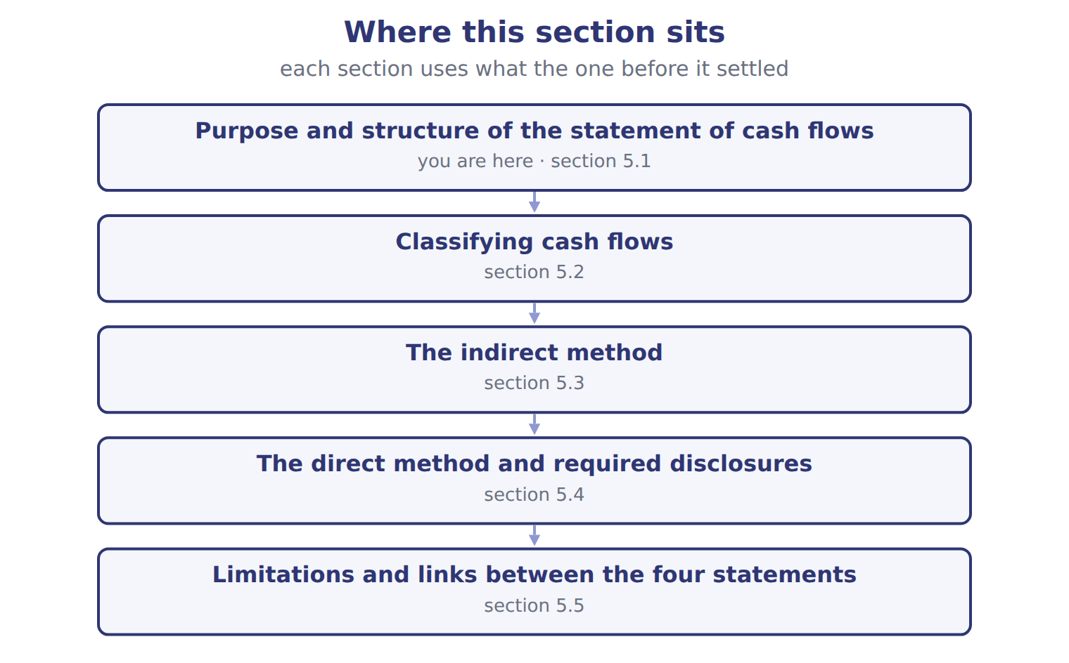
Orontes Foods Inc., year ended December 31, 2025 — the book’s own table
Orontes Foods Inc., year ended December 31, 2025 | 2025
Cash flows from operating activities
Net income | 2,969,100
Adjustments to reconcile net income to net cash from operating activities:
Depreciation | 2,100,000
Impairment losses | 2,724,000
Equity-method income | (177,000)
Dividends from equity-method investees | 70,000
Gain on sale of equipment | (3,000)
Unrealized gains on securities | (4,000)
Deferred income taxes | 100,000

Orontes Foods Inc., year ended December 31, 2025 — the book’s own table (continued)
Orontes Foods Inc., year ended December 31, 2025 | 2025
Increase in accounts receivable, net | (384,000)
Increase in inventory | (150,000)
Increase in prepaid expenses | (24,000)
Increase in accounts payable | 150,000
Increase in accrued liabilities | 50,000
Increase in income taxes payable | 50,000
Increase in contract liabilities | 60,000
Net cash provided by operating activities | 7,531,100
Cash flows from investing activities
Purchases of property, plant and equipment | (3,000,000)

Orontes Foods Inc., year ended December 31, 2025 — the book’s own table (continued)
Orontes Foods Inc., year ended December 31, 2025 | 2025
Proceeds from sale of equipment | 21,000
Investment in Jordan Glass Co. | (1,200,000)
Net cash used in investing activities | (4,179,000)
Cash flows from financing activities
Issuance of common stock | 1,500,000
Proceeds from bank note | 800,000
Repayment of long-term debt | (400,000)
Dividends paid | (50,000)
Net cash provided by financing activities | 1,850,000
Net increase in cash | 5,202,100

Orontes Foods Inc., year ended December 31, 2025 — the book’s own table (continued)
Orontes Foods Inc., year ended December 31, 2025 | 2025
Cash, January 1, 2025 | 2,100,000
Cash, December 31, 2025 | 7,302,100
Supplemental disclosures
Interest paid | 390,000
Income taxes paid | 839,700
Noncash investing and financing activities | none

READ THE MODEL Every answer is printed above. Find it, do not recall it.

11. Which part of this chapter is section 5.1?
A. Purpose and structure of the statement of cash flows
B. The direct method and required disclosures
C. The indirect method
D. Classifying cash flows
12. Which part of this chapter is section 5.2?
A. Classifying cash flows
B. The direct method and required disclosures
C. Purpose and structure of the statement of cash flows
D. The indirect method
13. Which part of this chapter is section 5.3?
A. Classifying cash flows
B. The indirect method
C. Purpose and structure of the statement of cash flows
D. The direct method and required disclosures
14. Which part of this chapter is section 5.4?
A. The indirect method
B. The direct method and required disclosures
C. Purpose and structure of the statement of cash flows
D. Classifying cash flows

APPLY No help on this move.

15. A lender wants to know whether a company's operations produce enough cash to repay a loan. Which section is MOST useful?
A. Investing activities | C. Operating activities
B. Financing activities | D. Noncash disclosures
16. Use Figures F05-02 and F05-03. What is the MAIN reason Orontes's operating cash flow is higher than its net income?
A. Orontes collected more than it sold
B. Depreciation and impairments reduced net income but used no cash
C. The bank note increased operating cash
D. Dividends paid were added back
17. A growing company shows positive operating cash flow, negative investing cash flow and positive financing cash flow. The MOST likely explanation is that it:
A. is selling its assets to repay debt
B. earns cash from operations and is also borrowing or issuing shares to invest in new assets
C. is in financial trouble and cannot pay its suppliers
D. is paying large dividends from asset sales
18. Which question can the statement of cash flows answer that the balance sheet alone cannot?
A. What were total assets at year-end?
B. What is the par value of the shares?
C. How did the company pay for its new equipment this year?
D. What is the allowance for credit losses?
WORK IN PAIRS | Compare every answer on this page with your partner before you read any key.
If you disagree: go back to the model and find the row that settles it. The row decides, not the louder voice.
CHECKPOINT 19. A lender wants to know whether a company's operations produce enough cash to repay a loan. Which section is MOST useful?
A. Investing activities
B. Financing activities
C. Operating activities
D. Noncash disclosures
If you got it wrong: redo the READ THE MODEL questions of cycle A with the model in front of you.

CYCLE B | The words this section uses precisely

ORIENT

20. A term in the exam means exactly what the book defines it to mean, whatever it means in ordinary English. TRUE / FALSE
MODEL

Item — the book’s own table
Item | Answer
Interest paid on a bank loan | Operating (U.S. GAAP gives no choice).
Selling Jordan Glass shares | Investing: another company's securities.
Land for a long-term note | Noncash investing and financing activity: disclosed, not in the body.
Buying back own shares | Financing: a transaction with owners.

The English the exam uses, and what it translates
English (exam term) | the Arabic it translates
statement of cash flows | قائمة التدفقات النقدية
indirect method | الطريقة غير المباشرة

READ THE MODEL

21. Which answer does the book give for Interest paid on a bank loan?
A. Investing: another company's securities.
B. Operating (U.S. GAAP gives no choice).
C. Noncash investing and financing activity: disclosed, not in the body.
D. Financing: a transaction with owners.
22. Which answer does the book give for Selling Jordan Glass shares?
A. Noncash investing and financing activity: disclosed, not in the body.
B. Financing: a transaction with owners.
C. Operating (U.S. GAAP gives no choice).
D. Investing: another company's securities.
23. Which answer does the book give for Land for a long-term note?
A. Investing: another company's securities.
B. Financing: a transaction with owners.
C. Noncash investing and financing activity: disclosed, not in the body.
D. Operating (U.S. GAAP gives no choice).
APPLY

24. Under U.S. GAAP, cash dividends paid to shareholders are:
A. an operating activity | C. a noncash activity
B. an investing activity | D. a financing activity
25. Orontes received dividends of $70,000 from its equity-method investees. Under U.S. GAAP, using the cumulative-earnings approach, they are:
A. operating inflows | C. financing inflows
B. investing inflows | D. not cash flows
CHECKPOINT 26. What is the safest way to settle a disagreement about an answer on this sheet?
A. find the row of the model that decides it
B. take the answer of whoever is more confident
C. leave it until the lecturer says
D. choose the longer option
If you got it wrong: redo the READ THE MODEL questions of cycle B.

FROM MEMORY | Close the earlier pages first.
27. Rebuild the figure from this handout. Label every part and fill in every box.
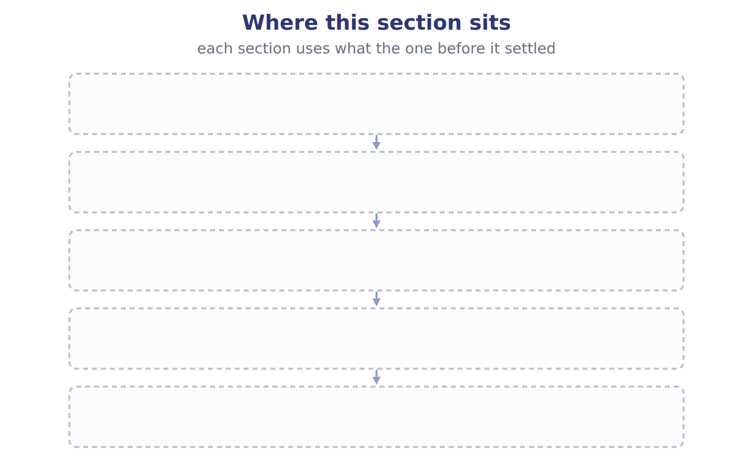
TEACH IT BACK | Write it for a classmate who missed this session — not for the marker.
28. In three or four sentences, write what this section settles and the one rule a reader has to take away.
every one of these words must appear: statement of cash flows · indirect method

Handout 5.2
Classifying cash flows
section 5.2 of the book
Before you start
Answer every one of these now, from what you already know or by guessing. You are not expected to get them right: you are about to be shown where each answer comes from.

What this handout settles
This handout settles | where it is answered
Classifying cash flows | cycle A
Transaction (U.S. GAAP) and what goes with it | cycle B
and you mark your own answers | at every checkpoint

1. Orontes's dividends payable rose by $400,000 in 2025. How does this affect net cash from operating activities?
A. It is added as an increase in a liability
B. It has no effect, because dividends are a financing item
C. It is subtracted
D. It is added to investing
2. Under U.S. GAAP, the indirect method begins with:
A. operating income | C. net income
B. income before income taxes | D. comprehensive income
3. Which cash flow does the book pair with “Operating”?
A. Dividends paid | C. Interest paid
B. Indirect method starts from
4. Which cash flow does the book pair with “Financing”?
A. Interest paid | C. Interest received
B. Dividends paid | D. Income taxes paid
5. Which cash flow does the book pair with “Net income”?
A. Dividends received | C. Income taxes paid
B. Dividends paid | D. Indirect method starts from
6. Which cash flow does the book pair with “Operating or financing”?
A. Interest received | C. Dividends received
B. Interest paid | D. Indirect method starts from
7. Which cash flow does the book pair with “Operating or investing”?
A. Indirect method starts from | C. Interest paid
B. Income taxes paid | D. Interest received
8. Which cash flow does the book pair with “Operating, unless tied to investing or financing”?
A. Interest paid | C. Interest received
B. Dividends received | D. Income taxes paid
9. Which cash flow does the book pair with “Profit or loss”?
A. Dividends received | C. Indirect method starts from
B. Interest received | D. Dividends paid

CYCLE A | Classifying cash flows

ORIENT One claim. Decide now; you will check it in a moment.

10. The book gives the U.S. GAAP (fixed) of Interest paid as “Operating”. TRUE / FALSE
MODEL Read it before you answer anything below it.

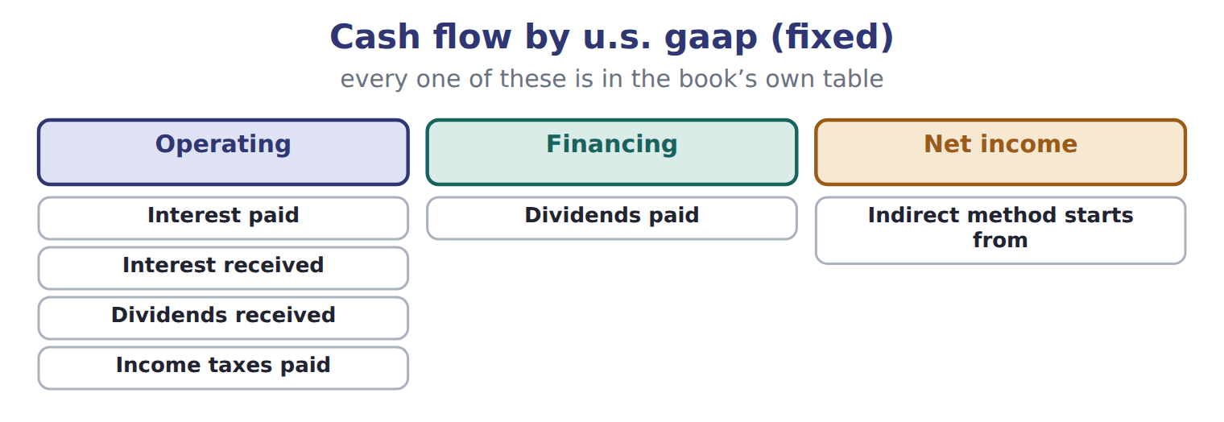

Cash flow — the book’s own table
Cash flow | U.S. GAAP (fixed) | IAS 7 today (choice) | IAS 7 with IFRS 18 (from 2027)
Interest paid | Operating | Operating or financing | Follows the category of the expense; often financing
Interest received | Operating | Operating or investing | Often investing
Dividends received | Operating | Operating or investing | Often investing
Dividends paid | Financing | Operating or financing | Financing
Income taxes paid | Operating | Operating, unless tied to investing or financing | Operating, unless tied to investing or financing
Indirect method starts from | Net income | Profit or loss | Operating profit or loss

READ THE MODEL Every answer is printed above. Find it, do not recall it.

11. Which cash flow does the book pair with “Operating”?
A. Interest paid | C. Dividends paid
B. Indirect method starts from
12. Which cash flow does the book pair with “Operating”?
A. Dividends paid | C. Interest received
B. Indirect method starts from
13. Which cash flow does the book pair with “Operating”?
A. Indirect method starts from | C. Dividends received
B. Dividends paid
14. Which cash flow does the book pair with “Financing”?
A. Dividends paid | C. Dividends received
B. Income taxes paid | D. Indirect method starts from
15. The book gives the IAS 7 with IFRS 18 (from 2027) of Interest paid as “Follows the category of the expense; often financing”. TRUE / FALSE
16. The book gives the IAS 7 with IFRS 18 (from 2027) of Interest received as “Follows the category of the expense; often financing”. TRUE / FALSE
SORT THEM | Write each one under its u.s. gaap (fixed). Every item belongs to exactly one group.
the items: Interest paid · Interest received · Dividends received · Dividends paid · Income taxes paid · Indirect method starts from
Financing | Net income | Operating

APPLY No help on this move.

20. A company moves $500,000 from its operating bank account into a restricted account set aside to repay a bond. How is this shown in the statement of cash flows?
A. As an investing outflow
B. It is not a cash flow, because restricted cash is included in the total
C. As a financing outflow
D. As an operating outflow
21. An IFRS company reports interest paid in financing activities. How would the same payment be classified under U.S. GAAP?
A. Operating | C. Investing
B. Financing | D. Either operating or financing
22. Which item appears in the investing section of a U.S. statement of cash flows?
A. Cash paid to buy back the company's own shares
B. Interest received on a loan to a customer
C. Cash received from issuing bonds
D. Cash paid to buy shares of another company, held as an available-for-sale investment
Orontes Foods Inc., year ended December 31, 2025 — the extract for the question that follows
Orontes Foods Inc., year ended December 31, 2025 | 2025
Cash flows from operating activities
Net income | 2,969,100
Adjustments to reconcile net income to net cash from operating activities:
Depreciation | 2,100,000
Impairment losses | 2,724,000
Equity-method income | (177,000)
Dividends from equity-method investees | 70,000
Gain on sale of equipment | (3,000)
Unrealized gains on securities | (4,000)
Deferred income taxes | 100,000

Orontes Foods Inc., year ended December 31, 2025 — the extract for the question that follows (continued)
Orontes Foods Inc., year ended December 31, 2025 | 2025
Increase in accounts receivable, net | (384,000)
Increase in inventory | (150,000)
Increase in prepaid expenses | (24,000)
Increase in accounts payable | 150,000
Increase in accrued liabilities | 50,000
Increase in income taxes payable | 50,000
Increase in contract liabilities | 60,000
Net cash provided by operating activities | 7,531,100
Cash flows from investing activities
Purchases of property, plant and equipment | (3,000,000)

Orontes Foods Inc., year ended December 31, 2025 — the extract for the question that follows (continued)
Orontes Foods Inc., year ended December 31, 2025 | 2025
Proceeds from sale of equipment | 21,000
Investment in Jordan Glass Co. | (1,200,000)
Net cash used in investing activities | (4,179,000)
Cash flows from financing activities
Issuance of common stock | 1,500,000
Proceeds from bank note | 800,000
Repayment of long-term debt | (400,000)
Dividends paid | (50,000)
Net cash provided by financing activities | 1,850,000
Net increase in cash | 5,202,100

Orontes Foods Inc., year ended December 31, 2025 — the extract for the question that follows (continued)
Orontes Foods Inc., year ended December 31, 2025 | 2025
Cash, January 1, 2025 | 2,100,000
Cash, December 31, 2025 | 7,302,100
Supplemental disclosures
Interest paid | 390,000
Income taxes paid | 839,700
Noncash investing and financing activities | none

23. The extract for this question is printed with it. What is Orontes's net cash provided by operating activities for 2025 (whole USD)?
A. 4,807,100 | C. 7,708,100
B. 7,531,100 | D. 8,299,100
WORK IN PAIRS | Compare every answer on this page with your partner before you read any key.
If you disagree: go back to the model and find the row that settles it. The row decides, not the louder voice.
CHECKPOINT 24. A company moves $500,000 from its operating bank account into a restricted account set aside to repay a bond. How is this shown in the statement of cash flows?
A. As an investing outflow
B. It is not a cash flow, because restricted cash is included in the total
C. As a financing outflow
D. As an operating outflow
If you got it wrong: redo the READ THE MODEL questions of cycle A with the model in front of you.

CYCLE B | The words this section uses precisely

ORIENT

25. A term in the exam means exactly what the book defines it to mean, whatever it means in ordinary English. TRUE / FALSE

MODEL

Transaction (U.S. GAAP) — the book’s own table
Transaction (U.S. GAAP) | Activity
Cash paid to buy a delivery truck | Investing
Cash dividends paid to shareholders | Financing
Interest paid on a bank loan | ________
Cash received from selling Jordan Glass shares | ________
Land acquired by issuing a long-term note (no cash) | ________
Cash paid to buy back the company's own shares | ________

The English the exam uses, and what it translates
English (exam term) | the Arabic it translates
cash equivalents | معادلات النقد (ما في حكم النقد)
direct method | الطريقة المباشرة

READ THE MODEL

26. Which activity does the book give for Cash paid to buy a delivery truck?
A. Investing | C. ________
B. Financing
27. Which activity does the book give for Cash dividends paid to shareholders?
A. ________ | C. Investing
B. Financing
28. Which activity does the book give for Interest paid on a bank loan?
A. ________ | C. Investing
B. Financing
APPLY

29. A company reports net income of $200,000, depreciation of $50,000 and a gain on sale of equipment of $10,000. Accounts receivable rose by $30,000 and accounts payable fell by $5,000. What is net cash from operating activities?
A. $205,000 | C. $225,000
B. $215,000 | D. $265,000
30. How is an increase in a deferred tax liability treated under the indirect method?
A. It is added to net income | C. It is a financing inflow
B. It is subtracted from net income | D. It is ignored
CHECKPOINT 31. What is the safest way to settle a disagreement about an answer on this sheet?
A. find the row of the model that decides it
B. take the answer of whoever is more confident
C. leave it until the lecturer says
D. choose the longer option
If you got it wrong: redo the READ THE MODEL questions of cycle B.

FROM MEMORY | Close the earlier pages first.
32. Rebuild the figure from this handout. Label every part and fill in every box.
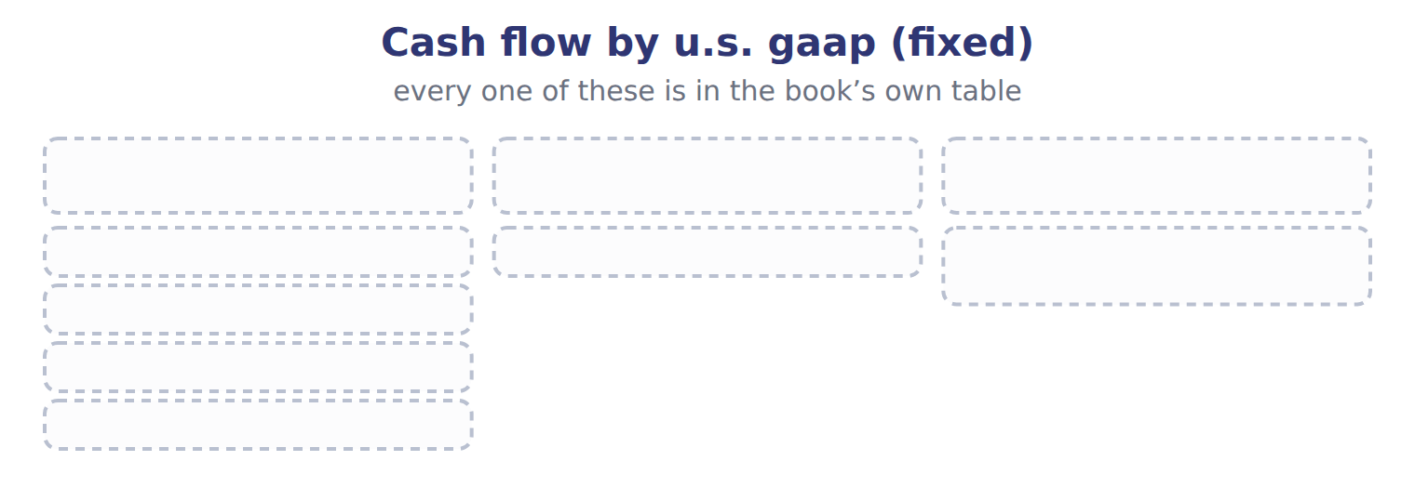
TEACH IT BACK | Write it for a classmate who missed this session — not for the marker.
33. In three or four sentences, write what this section settles and the one rule a reader has to take away.
every one of these words must appear: cash equivalents · direct method

Handout 5.3
The indirect method
section 5.3 of the book
Before you start
Answer every one of these now, from what you already know or by guessing. You are not expected to get them right: you are about to be shown where each answer comes from.

What this handout settles
This handout settles | where it is answered
The indirect method | cycle A
and you mark your own answers | at every checkpoint

1. Two companies make the same interest payments. One reports under U.S. GAAP, the other under IFRS and classifies interest as financing. Which limitation does this show?
A. Classification differences reduce comparability
B. Cash flows depend on estimates
C. Noncash items are omitted
D. The statement uses historical cost
2. A company stops replacing its old machines. What is the likely short-term effect on its statement of cash flows?
A. Operating cash flow falls immediately
B. Financing inflows rise
C. Investing outflows fall, so total cash looks strong even though the future may be weaker
D. Nothing changes
3. Which category does the book give for Lawsuit settlement paid?
A. Investing | C. Financing
B. Operating
4. Which category does the book give for Proceeds from sale of the division?
A. Financing | C. Operating
B. Investing
5. Which category does the book give for Treasury stock bought?
A. Financing | C. Operating
B. Investing
6. Which category does the book give for Interest paid?
A. Operating | C. Investing
B. Financing
7. Which category does the book give for Dividend paid?
A. Operating | C. Financing
B. Investing
8. The book gives the category of Lawsuit settlement paid as “Operating”. TRUE / FALSE
9. The book gives the category of Proceeds from sale of the division as “Financing”. TRUE / FALSE
10. The book gives the category of Treasury stock bought as “Financing”. TRUE / FALSE

CYCLE A | The indirect method

ORIENT One claim. Decide now; you will check it in a moment.

11. The book gives the category of Lawsuit settlement paid as “Operating”. TRUE / FALSE
MODEL Read it before you answer anything below it.

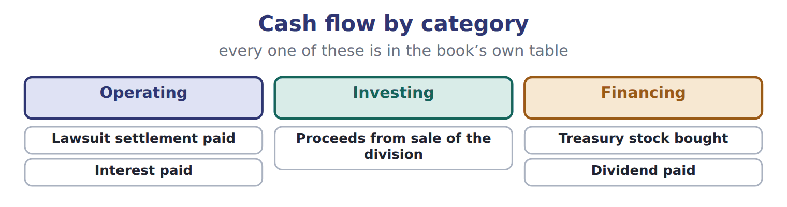

Cash flow — the book’s own table
Cash flow | Category
Lawsuit settlement paid | Operating
Proceeds from sale of the division | Investing
Treasury stock bought | Financing
Interest paid | Operating
Dividend paid | Financing

READ THE MODEL Every answer is printed above. Find it, do not recall it.

12. Which category does the book give for Lawsuit settlement paid?
A. Financing | C. Operating
B. Investing
13. Which category does the book give for Proceeds from sale of the division?
A. Investing | C. Financing
B. Operating
14. Which category does the book give for Treasury stock bought?
A. Investing | C. Operating
B. Financing
15. Which category does the book give for Interest paid?
A. Operating | C. Financing
B. Investing
16. The book gives the category of Lawsuit settlement paid as “Operating”. TRUE / FALSE
17. The book gives the category of Proceeds from sale of the division as “Operating”. TRUE / FALSE
SORT THEM | Write each one under its category. Every item belongs to exactly one group.
the items: Lawsuit settlement paid · Proceeds from sale of the division · Treasury stock bought · Interest paid · Dividend paid
Financing | Investing | Operating

APPLY No help on this move.

21. Orontes's dividends payable rose by $400,000 in 2025. How does this affect net cash from operating activities?
A. It is added as an increase in a liability
B. It has no effect, because dividends are a financing item
C. It is subtracted
D. It is added to investing
22. Under U.S. GAAP, the indirect method begins with:
A. operating income | C. net income
B. income before income taxes | D. comprehensive income
23. Orontes's current income tax expense was $889,700, and income taxes payable rose by $50,000. How much income tax did Orontes pay in 2025 (whole USD)?
A. 839,700 | C. 939,700
B. 889,700 | D. 989,700
24. A company reports a loss of $12,000 on the sale of a delivery van, for which it received $30,000. How is this shown?
A. Add $12,000 in operating; show $30,000 in investing
B. Subtract $12,000 in operating; show $30,000 in investing
C. Show $42,000 in investing
D. Show $18,000 in investing
WORK IN PAIRS | Compare every answer on this page with your partner before you read any key.
If you disagree: go back to the model and find the row that settles it. The row decides, not the louder voice.
CHECKPOINT 25. Orontes's dividends payable rose by $400,000 in 2025. How does this affect net cash from operating activities?
A. It is added as an increase in a liability
B. It has no effect, because dividends are a financing item
C. It is subtracted
D. It is added to investing
If you got it wrong: redo the READ THE MODEL questions of cycle A with the model in front of you.

CYCLE B | The words this section uses precisely

ORIENT

26. A term in the exam means exactly what the book defines it to mean, whatever it means in ordinary English. TRUE / FALSE
MODEL

The English the exam uses, and what it translates
English (exam term) | the Arabic it translates
operating activities | الأنشطة التشغيلية
noncash investing and financing activities | الأنشطة الاستثمارية والتمويلية غير النقدية

READ THE MODEL

27. A glossary term and its translation are a pair the book itself gives. TRUE / FALSE

APPLY

28. Which is a limitation of the statement of cash flows?
A. It is prepared on the accrual basis
B. Important noncash investing and financing deals appear only in the notes
C. It ignores cash paid for interest
D. It shows only noncash items
29. Why is operating cash flow not a good measure of profitability?
A. It includes too many estimates
B. It is measured at fair value
C. It excludes cash from customers
D. It ignores accruals, so it can be high in a year with poor profits, or low in a good year
CHECKPOINT 30. What is the safest way to settle a disagreement about an answer on this sheet?
A. find the row of the model that decides it
B. take the answer of whoever is more confident
C. leave it until the lecturer says
D. choose the longer option
If you got it wrong: redo the READ THE MODEL questions of cycle B.

FROM MEMORY | Close the earlier pages first.
31. Rebuild the figure from this handout. Label every part and fill in every box.
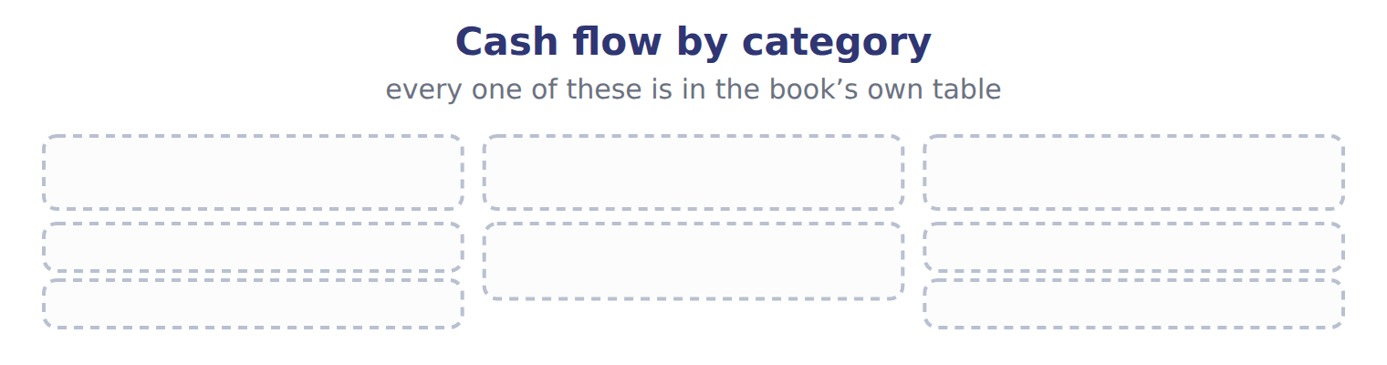
TEACH IT BACK | Write it for a classmate who missed this session — not for the marker.
32. In three or four sentences, write what this section settles and the one rule a reader has to take away.
every one of these words must appear: operating activities · noncash investing and financing activities

Handout 5.4
The direct method and required disclosures
section 5.4 of the book
Before you start
Answer every one of these now, from what you already know or by guessing. You are not expected to get them right: you are about to be shown where each answer comes from.

What this handout settles
This handout settles | where it is answered
The direct method and required disclosures | cycle A
and you mark your own answers | at every checkpoint

1. Which part of this chapter is section 5.1?
A. Purpose and structure of the statement of cash flows
B. The direct method and required disclosures
C. The indirect method
D. Classifying cash flows
2. Which part of this chapter is section 5.2?
A. Classifying cash flows
B. The direct method and required disclosures
C. Purpose and structure of the statement of cash flows
D. The indirect method
3. Which part of this chapter is section 5.3?
A. Classifying cash flows
B. The indirect method
C. Purpose and structure of the statement of cash flows
D. The direct method and required disclosures
4. Which part of this chapter is section 5.4?
A. The indirect method
B. The direct method and required disclosures
C. Purpose and structure of the statement of cash flows
D. Classifying cash flows
5. Which part of this chapter is section 5.5?
A. The indirect method
B. Classifying cash flows
C. Limitations and links between the four statements
D. Purpose and structure of the statement of cash flows
6. Which answer does the book give for Interest paid on a bank loan?
A. Noncash investing and financing activity: disclosed, not in the body.
B. Investing: another company's securities.
C. Operating (U.S. GAAP gives no choice).
D. Financing: a transaction with owners.
7. Which answer does the book give for Selling Jordan Glass shares?
A. Investing: another company's securities.
B. Financing: a transaction with owners.
C. Operating (U.S. GAAP gives no choice).
D. Noncash investing and financing activity: disclosed, not in the body.

CYCLE A | The direct method and required disclosures

ORIENT One claim. Decide now; you will check it in a moment.

8. Every number in a financial statement belongs to an element the framework defines. TRUE / FALSE
MODEL Read it before you answer anything below it.

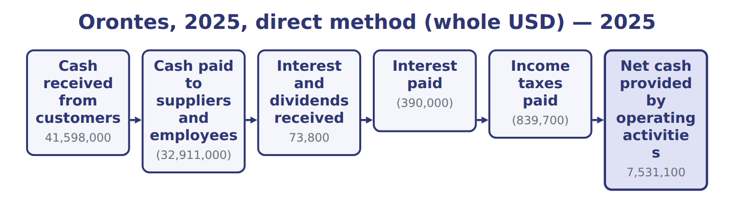
Orontes, 2025, direct method (whole USD) — the book’s own table
Orontes, 2025, direct method (whole USD) | 2025
Cash received from customers | 41,598,000
Cash paid to suppliers and employees | (32,911,000)
Interest and dividends received | 73,800
Interest paid | (390,000)
Income taxes paid | (839,700)
Net cash provided by operating activities | 7,531,100

READ THE MODEL Every answer is printed above. Find it, do not recall it.

9. Which part of this chapter is section 5.1?
A. Purpose and structure of the statement of cash flows
B. The direct method and required disclosures
C. The indirect method
D. Classifying cash flows
10. Which part of this chapter is section 5.2?
A. Classifying cash flows
B. The direct method and required disclosures
C. Purpose and structure of the statement of cash flows
D. The indirect method
11. Which part of this chapter is section 5.3?
A. Classifying cash flows
B. The indirect method
C. Purpose and structure of the statement of cash flows
D. The direct method and required disclosures
12. Which part of this chapter is section 5.4?
A. The indirect method
B. The direct method and required disclosures
C. Purpose and structure of the statement of cash flows
D. Classifying cash flows

APPLY No help on this move.

13. Two companies make the same interest payments. One reports under U.S. GAAP, the other under IFRS and classifies interest as financing. Which limitation does this show?
A. Classification differences reduce comparability
B. Cash flows depend on estimates
C. Noncash items are omitted
D. The statement uses historical cost
14. A company stops replacing its old machines. What is the likely short-term effect on its statement of cash flows?
A. Operating cash flow falls immediately
B. Financing inflows rise
C. Investing outflows fall, so total cash looks strong even though the future may be weaker
D. Nothing changes
15. Orontes declared dividends of $450,000 in 2025, and dividends payable rose by $400,000. What are dividends paid in the financing section (whole USD)?
A. 50,000 | C. 450,000
B. 400,000 | D. 850,000
16. Orontes's net accounts receivable rose by $384,000 on its balance sheet. Where does this change appear?
A. As an investing outflow
B. In the statement of changes in equity
C. Nowhere; balance sheet changes are not used
D. As a deduction in operating activities (indirect method)
WORK IN PAIRS | Compare every answer on this page with your partner before you read any key.
If you disagree: go back to the model and find the row that settles it. The row decides, not the louder voice.
CHECKPOINT 17. Two companies make the same interest payments. One reports under U.S. GAAP, the other under IFRS and classifies interest as financing. Which limitation does this show?
A. Classification differences reduce comparability
B. Cash flows depend on estimates
C. Noncash items are omitted
D. The statement uses historical cost
If you got it wrong: redo the READ THE MODEL questions of cycle A with the model in front of you.

CYCLE B | The words this section uses precisely

ORIENT

18. A term in the exam means exactly what the book defines it to mean, whatever it means in ordinary English. TRUE / FALSE
MODEL

The English the exam uses, and what it translates
English (exam term) | the Arabic it translates
investing activities | الأنشطة الاستثمارية

READ THE MODEL

19. A glossary term and its translation are a pair the book itself gives. TRUE / FALSE

APPLY

20. A company using the direct method must also:
A. present a reconciliation of net income to operating cash flow
B. stop disclosing noncash activities
C. classify interest paid as financing
D. present an income statement by nature
CHECKPOINT 21. What is the safest way to settle a disagreement about an answer on this sheet?
A. find the row of the model that decides it
B. take the answer of whoever is more confident
C. leave it until the lecturer says
D. choose the longer option
If you got it wrong: redo the READ THE MODEL questions of cycle B.

FROM MEMORY | Close the earlier pages first.
22. Rebuild the figure from this handout. Label every part and fill in every box.
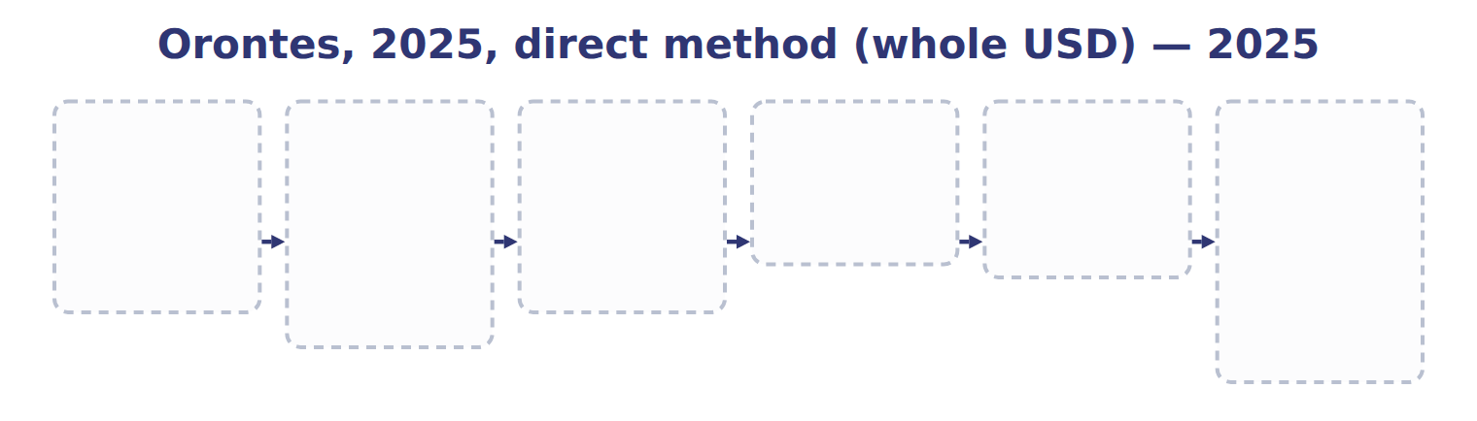
TEACH IT BACK | Write it for a classmate who missed this session — not for the marker.
23. In three or four sentences, write what this section settles and the one rule a reader has to take away.
every one of these words must appear: investing activities

Handout 5.5
Limitations and links between the four statements
section 5.5 of the book
Before you start
Answer every one of these now, from what you already know or by guessing. You are not expected to get them right: you are about to be shown where each answer comes from.

What this handout settles
This handout settles | where it is answered
Limitations and links between the four statements | cycle A
Cash flow and what goes with it | cycle B
and you mark your own answers | at every checkpoint

1. Why do users need a statement of cash flows when they already have an income statement?
A. Because the income statement ignores revenue
B. Because the statement of cash flows shows the market value of assets
C. Because net income is not the same as cash generated
D. Because cash flows are measured at fair value
2. On December 1 a company buys a Treasury bill that matures in five months, on April 30. At December 31 it has two months left to maturity. Is it a cash equivalent?
A. Yes, because it matures within three months of the year-end
B. Yes, because all Treasury bills are cash equivalents
C. No, because only bank deposits are cash equivalents
D. No, because its original maturity to the company was more than three months
3. Which part of this chapter is section 5.1?
A. Purpose and structure of the statement of cash flows
B. The direct method and required disclosures
C. The indirect method
D. Classifying cash flows
4. Which part of this chapter is section 5.2?
A. Classifying cash flows
B. The direct method and required disclosures
C. Purpose and structure of the statement of cash flows
D. The indirect method
5. Which part of this chapter is section 5.3?
A. Classifying cash flows
B. The indirect method
C. Purpose and structure of the statement of cash flows
D. The direct method and required disclosures
6. Which part of this chapter is section 5.4?
A. The indirect method
B. The direct method and required disclosures
C. Purpose and structure of the statement of cash flows
D. Classifying cash flows
7. Which part of this chapter is section 5.5?
A. The indirect method
B. Classifying cash flows
C. Limitations and links between the four statements
D. Purpose and structure of the statement of cash flows

CYCLE A | Limitations and links between the four statements

ORIENT One claim. Decide now; you will check it in a moment.

8. Every number in a financial statement belongs to an element the framework defines. TRUE / FALSE
MODEL Read it before you answer anything below it.

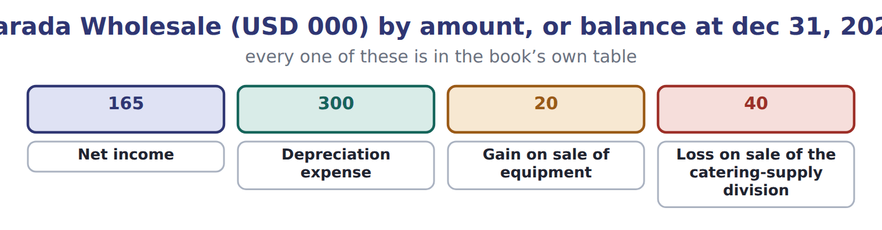
Barada Wholesale (USD 000) — the book’s own table
Barada Wholesale (USD 000) | Amount, or balance at Dec 31, 2025 | Balance at Dec 31, 2026
Income statement items, 2026
Net income | 165
Depreciation expense | 300
Gain on sale of equipment | 20
Loss on sale of the catering-supply division | 40
Balances
Accounts receivable, net | 280 | 310
Inventory | 420 | 390
Prepaid rent | 24 | 26
Accounts payable | 380 | 410

Barada Wholesale (USD 000) — the book’s own table (continued)
Barada Wholesale (USD 000) | Amount, or balance at Dec 31, 2025 | Balance at Dec 31, 2026
Income taxes payable | 0 | 30
Cash | 1,050 | ?
Other 2026 cash information
Proceeds from sale of equipment | 70
Proceeds from sale of the division | 150
Purchases of equipment | 200
Note installment repaid (Chapter 2, M1) | 300
Dividend paid (declared in 2025) | 50
Treasury stock bought (Chapter 4, E1) | 480
Treasury stock reissued (E2 and E3) | 200

Barada Wholesale (USD 000) — the book’s own table (continued)
Barada Wholesale (USD 000) | Amount, or balance at Dec 31, 2025 | Balance at Dec 31, 2026
Cash dividend declared December 15, 2026, payable January 2027 | 121

READ THE MODEL Every answer is printed above. Find it, do not recall it.

9. Which part of this chapter is section 5.1?
A. Purpose and structure of the statement of cash flows
B. The direct method and required disclosures
C. The indirect method
D. Classifying cash flows
10. Which part of this chapter is section 5.2?
A. Classifying cash flows
B. The direct method and required disclosures
C. Purpose and structure of the statement of cash flows
D. The indirect method
11. Which part of this chapter is section 5.3?
A. Classifying cash flows
B. The indirect method
C. Purpose and structure of the statement of cash flows
D. The direct method and required disclosures
12. Which part of this chapter is section 5.4?
A. The indirect method
B. The direct method and required disclosures
C. Purpose and structure of the statement of cash flows
D. Classifying cash flows
APPLY No help on this move.

13. Under U.S. GAAP, interest paid on a bank loan is classified as:
A. a financing activity
B. an operating activity
C. an investing activity
D. operating or financing, as the company chooses
14. A company acquires a building by signing a $2 million mortgage note with the seller. No cash changes hands. How is this reported?
A. As a noncash investing and financing activity, disclosed separately
B. As an investing outflow and a financing inflow of $2 million
C. As an operating outflow
D. It is not reported anywhere
WORK IN PAIRS | Compare every answer on this page with your partner before you read any key.
If you disagree: go back to the model and find the row that settles it. The row decides, not the louder voice.
CHECKPOINT 15. Why do users need a statement of cash flows when they already have an income statement?
A. Because the income statement ignores revenue
B. Because the statement of cash flows shows the market value of assets
C. Because net income is not the same as cash generated
D. Because cash flows are measured at fair value
If you got it wrong: redo the READ THE MODEL questions of cycle A with the model in front of you.

CYCLE B | The words this section uses precisely

ORIENT

16. A term in the exam means exactly what the book defines it to mean, whatever it means in ordinary English. TRUE / FALSE
MODEL

Cash flow — the book’s own table
Cash flow | Category
Lawsuit settlement paid
Proceeds from sale of the division
Treasury stock bought
Interest paid
Dividend paid

The English the exam uses, and what it translates
English (exam term) | the Arabic it translates
financing activities | الأنشطة التمويلية

READ THE MODEL

17. A glossary term and its translation are a pair the book itself gives. TRUE / FALSE
APPLY

18. On December 1 a company buys a Treasury bill that matures in five months, on April 30. At December 31 it has two months left to maturity. Is it a cash equivalent?
A. Yes, because it matures within three months of the year-end
B. Yes, because all Treasury bills are cash equivalents
C. No, because only bank deposits are cash equivalents
D. No, because its original maturity to the company was more than three months
CHECKPOINT 19. What is the safest way to settle a disagreement about an answer on this sheet?
A. find the row of the model that decides it
B. take the answer of whoever is more confident
C. leave it until the lecturer says
D. choose the longer option
If you got it wrong: redo the READ THE MODEL questions of cycle B.

FROM MEMORY | Close the earlier pages first.
20. Rebuild the figure from this handout. Label every part and fill in every box.
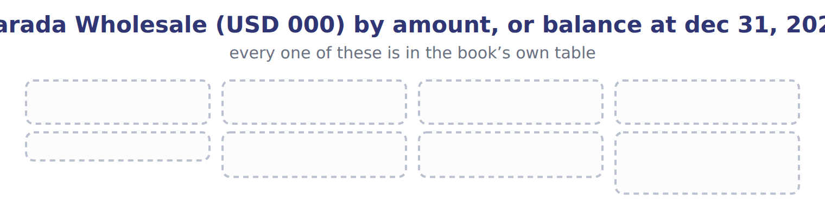
TEACH IT BACK | Write it for a classmate who missed this session — not for the marker.
21. In three or four sentences, write what this section settles and the one rule a reader has to take away.
every one of these words must appear: financing activities

Handout 5.6
The whole chapter
every section, shuffled, and the chapter’s own case set
Before you start
Answer every one of these now. They come from every part of the chapter, in no particular order.

What this handout settles
This handout settles | where it is answered
every section of the chapter, shuffled | cycle A
the chapter’s own case set | cycle B
and you mark your own answers | at every checkpoint

1. Under the indirect method, how does Orontes treat the 384,000 increase in net accounts receivable?
A. Adds it to net income | C. Subtracts it from net income
B. Shows it in investing activities | D. Ignores it
2. A company sells equipment with a carrying amount of $40,000 for $55,000. How is the sale shown under the indirect method?
A. Add $15,000 in operating; show $55,000 in investing
B. Subtract the $15,000 gain in operating; show $55,000 in investing
C. Show $15,000 in investing only
D. Show $55,000 in operating
3. A company's sales were $500,000, all on credit. Accounts receivable increased by $40,000. How much cash was received from customers?
A. $40,000 | C. $500,000
B. $460,000 | D. $540,000
4. A company uses the indirect method. Which amounts must it disclose?
A. Interest paid and income taxes paid
B. Cash received from customers
C. Cash paid to suppliers
D. Gross profit in cash terms
5. How can a company increase its operating cash flow at year-end without improving its business?
A. By recording more depreciation
B. By issuing new shares
C. By revaluing its land
D. By delaying payments to suppliers until January
6. Which part of this chapter is section 5.1?
A. Purpose and structure of the statement of cash flows
B. The direct method and required disclosures
C. The indirect method
D. Classifying cash flows
7. Which part of this chapter is section 5.2?
A. Classifying cash flows
B. The direct method and required disclosures
C. Purpose and structure of the statement of cash flows
D. The indirect method

CYCLE A | The whole chapter, in order

ORIENT

8. The sections of a chapter have to be taken in order, because each one uses what the one before it settled. TRUE / FALSE
MODEL

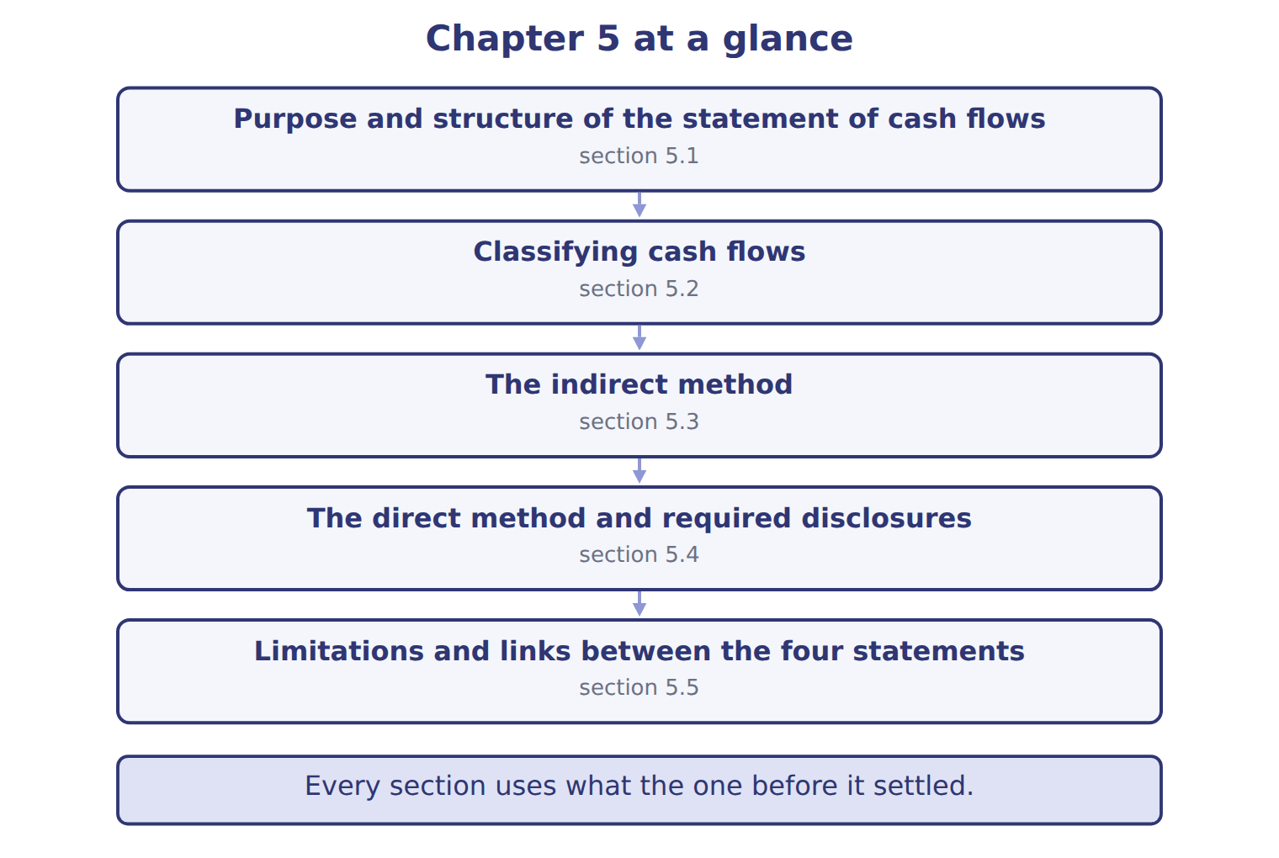
READ THE MODEL

9. “section 5.1” — which part of the chapter is this?
A. The direct method and required disclosures
B. Classifying cash flows
C. Purpose and structure of the statement of cash flows
D. The indirect method
10. “section 5.2” — which part of the chapter is this?
A. The direct method and required disclosures
B. Classifying cash flows
C. The indirect method
D. Purpose and structure of the statement of cash flows
11. “section 5.3” — which part of the chapter is this?
A. The direct method and required disclosures
B. The indirect method
C. Classifying cash flows
D. Purpose and structure of the statement of cash flows
Write the letter of the section number beside each section title. Every number is used once.
A 5.1 | D 5.4
B 5.2 | E 5.5
C 5.3

12. Purpose and structure of the statement of cash flows
13. Classifying cash flows
14. The indirect method
15. The direct method and required disclosures
16. Limitations and links between the four statements

APPLY

17. How can a company increase its operating cash flow at year-end without improving its business?
A. By recording more depreciation
B. By issuing new shares
C. By revaluing its land
D. By delaying payments to suppliers until January
WORK IN PAIRS | Compare every answer with your partner first.
If you disagree: name the section each question belongs to. Most disagreements turn out to be about the section, not the answer.
CHECKPOINT 18. Under the indirect method, how does Orontes treat the 384,000 increase in net accounts receivable?
A. Adds it to net income
B. Shows it in investing activities
C. Subtracts it from net income
D. Ignores it
If you got it wrong: go back to the MODEL move of cycle A and find the section this question belongs to.

CYCLE B | The chapter’s case set

ORIENT

19. In a case question, the exhibit has to be read and adjusted before any figure is worked out. TRUE / FALSE

MODEL

The chapter’s case set, item by item
Item | What it asks
C5-1 | Classify each 2026 cash flow. (On the exam screen you would drag each item into a box.)
C5-2 | Enter Barada's net cash provided by operating activities for 2026 (indirect method).
C5-3 | Enter Barada's net cash from investing activities for 2026.
C5-4 | Enter Barada's net cash used in financing activities for 2026 (as a positive number).
C5-5 | Enter Barada's cash at December 31, 2026.
C5-6 | Where does Barada show the 2026 dividend declared on December 15 and payable in January 2027? [select]

READ THE MODEL

20. Which of these does item C5-1 ask for?
A. Enter Barada's net cash from investing activities for 2026.
B. Classify each 2026 cash flow. (On the exam screen you would drag each
C. Enter Barada's net cash used in financing activities for 2026 (as a po
D. Enter Barada's net cash provided by operating activities for 2026 (ind
21. Which of these does item C5-2 ask for?
A. Classify each 2026 cash flow. (On the exam screen you would drag each
B. Enter Barada's net cash used in financing activities for 2026 (as a po
C. Enter Barada's net cash provided by operating activities for 2026 (ind
D. Enter Barada's net cash from investing activities for 2026.
22. Which of these does item C5-3 ask for?
A. Enter Barada's net cash used in financing activities for 2026 (as a po
B. Enter Barada's net cash from investing activities for 2026.
C. Enter Barada's net cash provided by operating activities for 2026 (ind
D. Classify each 2026 cash flow. (On the exam screen you would drag each
23. Which of these does item C5-4 ask for?
A. Classify each 2026 cash flow. (On the exam screen you would drag each
B. Enter Barada's net cash provided by operating activities for 2026 (ind
C. Enter Barada's net cash from investing activities for 2026.
D. Enter Barada's net cash used in financing activities for 2026 (as a po
24. Which of these does item C5-5 ask for?
A. Classify each 2026 cash flow. (On the exam screen you would drag each
B. Enter Barada's net cash provided by operating activities for 2026 (ind
C. Enter Barada's cash at December 31, 2026.
D. Enter Barada's net cash from investing activities for 2026.
25. Which of these does item C5-6 ask for?
A. Where does Barada show the 2026 dividend declared on December 15 and p
B. Classify each 2026 cash flow. (On the exam screen you would drag each
C. Enter Barada's net cash from investing activities for 2026.
D. Enter Barada's net cash provided by operating activities for 2026 (ind
APPLY

26. Under the indirect method, how does Orontes treat the 384,000 increase in net accounts receivable?
A. Adds it to net income | C. Subtracts it from net income
B. Shows it in investing activities | D. Ignores it

27. A company sells equipment with a carrying amount of $40,000 for $55,000. How is the sale shown under the indirect method?
A. Add $15,000 in operating; show $55,000 in investing
B. Subtract the $15,000 gain in operating; show $55,000 in investing
C. Show $15,000 in investing only
D. Show $55,000 in operating
CHECKPOINT 28. What has to be settled before any figure in a case set is worked out?
A. the exhibit, adjusted for every note that goes with it
B. the method the company uses
C. the tax rate
D. the order of the items
If you got it wrong: reread the case panel in the MODEL move of cycle B.

FROM MEMORY | Close the earlier pages first.
29. Rebuild the chapter map. Write every section in order and what each one settles.
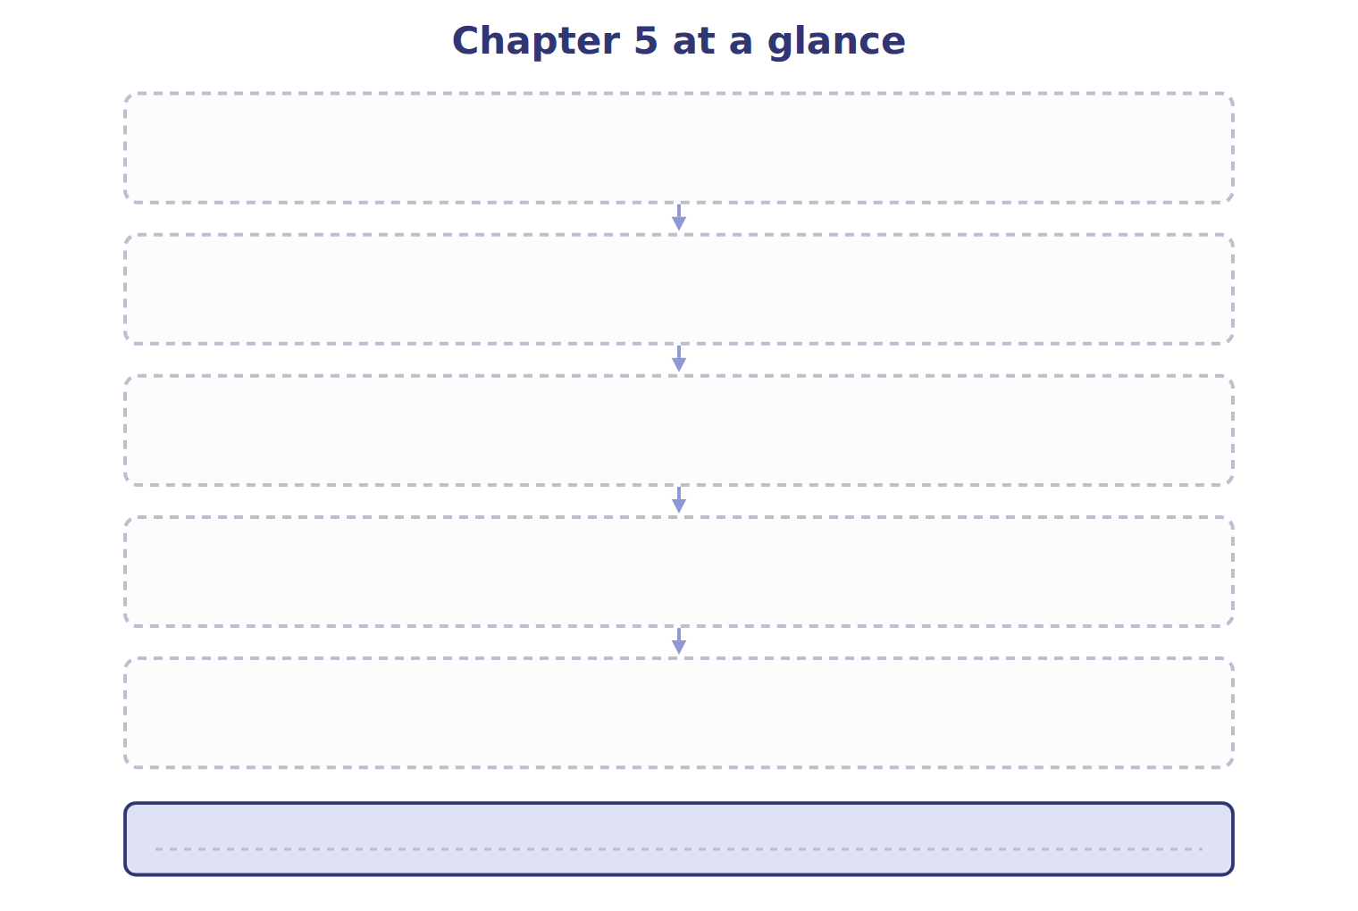
TEACH IT BACK | Write it for a student starting this chapter tomorrow — not for the marker.
30. In four or five sentences, write what the whole chapter settles, section by section.
every one of these words must appear: statement of cash flows · cash equivalents · operating activities · investing activities

