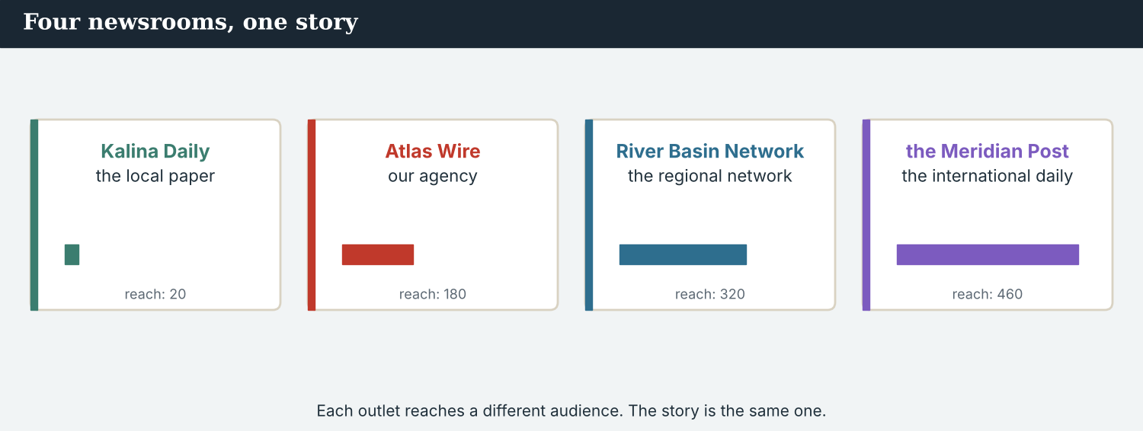
Four newsrooms, one story — the partnership this book is about.
English for Journalists
International Edition · Book 2
Across Borders
Student’s Book
A free press, without borders.
CEFR lower B1 → medium B1 · 10 units · Atlas Wire, and the newsrooms it works with
A note on real and invented content. The facts about journalism around the world in 2026 are true, dated and attributed on the page. Atlas Wire, Kalina Daily, the River Basin Network, the Meridian Post, their staff, the town of Kalina, the river Vara and the people in the stories are invented, for practice. Real people and real outlets are only ever in true, sourced facts — never in an invented quote.

WELCOME About Book 2
English for Journalists, Book 2, continues the newsroom English course. In Book 1, you learned to report a story with Atlas Wire, an invented independent news agency with a world desk in Geneva, and to carry it from the crossing at Kalina to a front page. In Book 2, that story grows: Atlas Wire begins to work with other newsrooms — Kalina Daily, the local paper in the town itself; the River Basin Network, a regional network; and the Meridian Post, a large international daily — and learns to make one story with partners who are bigger and smaller than itself, in English, without losing anybody’s truth.
The course climbs from lower B1 to medium B1 — the first half of B1. Each unit teaches one new piece of grammar and one part of cross-border journalism: recapping a running story, briefing a colleague abroad, planning across time zones, filing to a foreign desk, setting the conditions for publication, weighing a claim, writing for the wire, explaining a place to a distant reader, co-writing, and finally co-producing a package for the world.
The cross-border strand
About a fifth of the book is the Across Borders strand: in every unit, at least one part involves working with a partner in another country, and Units 4, 7 and 10 are wholly cross-border. It prepares a journalist to work inside an international partnership — with the outlets above them, who reach further, and the outlets below them, whose story it is.
How to use this book
1. Each unit has a Warm-Up and eleven parts: Words, Grammar, a Skill, Listening, Reading, Writing, Speaking, Ethics, Digital, Review, and an Assignment.
2. Every part builds up step by step: you see a model, notice how it works, practise it, and then produce your own.
3. Grammar is taught half as controlled practice and half in your own words. Every part mixes exercises you can check with open tasks to discuss and create.
4. The Ethics part in every unit builds the Code — accurate, fair, independent, and kind — now tested across borders, and in both directions.
5. The Answer Key at the end of each unit gives the answers to the closed exercises. Open tasks (discussion, role-play, and your own writing) are marked.
The newsroom, and the newsrooms it works with
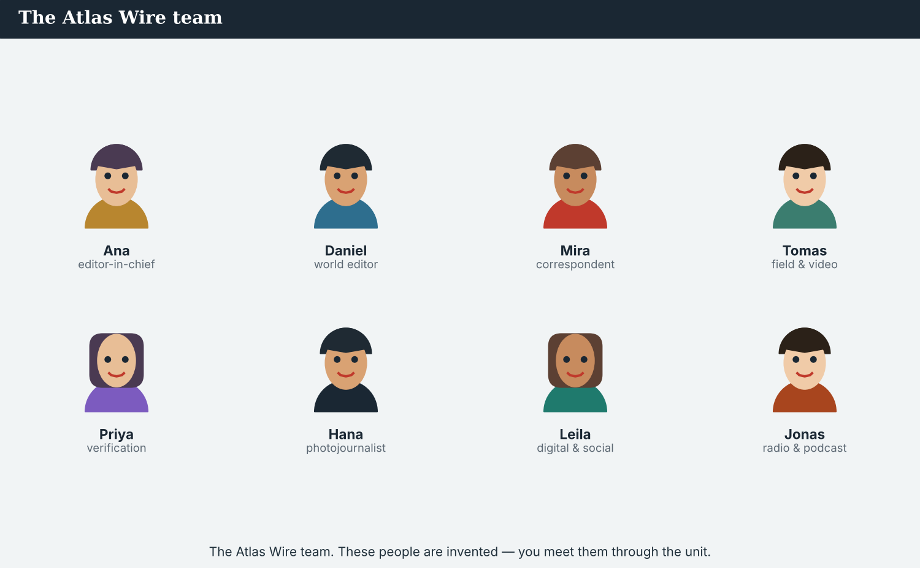
The Atlas Wire team you meet in every unit. These people, and the partners abroad, are invented, for practice.

CONTENTS The ten units
Unit 1 Back on the Story  present perfect vs past simple (+ ever/never/just/already/yet)  Unit 2 The Backstory  used to / would · past continuous  Unit 3 Planning the Coverage  future: will / going to / present continuous  Unit 4 Across the Desk  reported speech · say/tell · according to  Unit 5 If We Confirm It  zero and first conditionals · time clauses | Unit 6 How Sure Are You?  might/may/could · should/ought to  Unit 7 For the Wire  the passive across tenses  Unit 8 The Bigger Picture  comparatives and superlatives · as…as, too/enough  Unit 9 Joining It Up  quantifiers, articles and connectors  Unit 10 Across Borders: The Co-Production  gerunds and infinitives · the capstone
Every unit also has a Warm-Up, eleven parts, ~28 illustrations, and a full Answer Key. The Kalina story runs through all ten — from being noticed abroad to a full cross-border co-production.

BOOK 2 · UNIT 1 Back on the Story: Where We Are Now
Beat · Report & Across Borders CEFR lower B1 → medium B1
In this unit you learn to…
1. contrast experience and finished events (present perfect vs past simple)
2. use ever, never, just, already and yet
3. recap a running story for a colleague
4. introduce your outlet to a partner abroad
The Atlas Wire team — a year on, their work has been noticed by bigger newsrooms.
Where we are now. A year has passed since Atlas Wire published its front page, A crossing comes home. The valley has changed, the story has run all year — and now the coverage has been noticed well beyond the wire. This week, a message arrived from Omar Faris, an editor at the Meridian Post, a large international daily. Atlas Wire has never co-produced a story with another newsroom before. (The Meridian Post and Omar Faris are invented, for practice.)

WARM-UP Catching up
A short scene to start the unit. Read it, then answer.
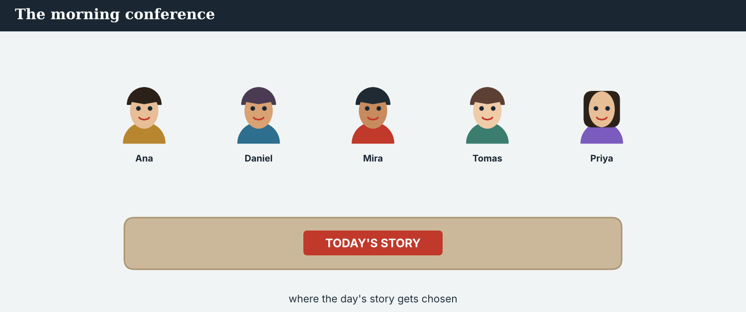
The morning conference — the team catches up on the running story.
At the conference, Ana has news. “Good morning, everyone. I have something to share,” she says. “We have covered Kalina for a year now, and people have noticed. Yesterday, an editor at the Meridian Post wrote to us. His name is Omar Faris. He said he has followed our coverage for months, and he wants to talk.”
The room is quiet. “We have never co-produced with another newsroom,” Mira says. “No,” Ana smiles, “we haven’t. But the story has grown, and it has reached further than we thought. Let’s see where it goes.”
W1 Answer the questions.
1. How long has Atlas Wire covered Kalina? ___________
2. Who wrote to the team, and from where? ___________
3. Has Atlas Wire co-produced with another newsroom before? ___________
W2 True or false? Write T or F.
1. Omar wrote to the team yesterday. ______
2. Omar has followed Atlas Wire for months. ______
3. Atlas Wire has co-produced with many newsrooms. ______
W3 Find one present-perfect verb (has/have + done) and one past-simple verb in the text. Write them.
1. ________________________
PRODUCE Talk about it
W4 Discuss with a partner.
1. What is a story that has run for a long time in your country? What has happened in it?
2. Have you ever worked or studied with people from another country? How was it?
PRODUCE One more
W5 Discuss. Would you want a story you reported to reach a much bigger audience? What is good, and what is difficult, about that?

PART 1 The words of a running story
The words for a story that grows and travels. Learn these first.
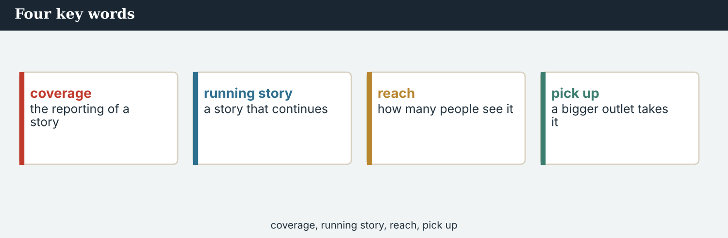
Four key words — coverage, running story, reach, pick up.
The words
Word | Meaning
coverage | the reporting of a story
running story | a story that continues over time
cover | to report on a story
follow up | to report more on a story
pick up | when another outlet takes your story
reach | how many people see your work
audience | the people who read or watch
outlet | a paper, network, agency or website
syndicate | to share or sell a story to other outlets
update | new information
so far | until now
recently | a short time ago
propose | to suggest
partner | an outlet you work with
co-production | a piece made by two or more outlets together
PRACTISE Controlled practice
1A Match the word (1–10) to the meaning (a–j).
1. coverage  2. running story  3. reach  4. outlet  5. audience  6. follow up  7. pick up  8. propose  9. partner  10. co-production | a) a story that continues over time  b) the reporting of a story  c) how many people see your work  d) the people who read or watch  e) a paper, network, agency or website  f) to report more on a story  g) when another outlet takes your story  h) an outlet you work with  i) to suggest  j) a piece made by two or more outlets together
1B Complete the sentences with a word from the box.
WORD BOX
coverage · reach · outlet · audience · picked up · partner
1. Atlas Wire’s ___________ of the valley has run for a year.
2. The story has a wide ___________ now — many people have seen it.
3. An international ___________ , the Meridian Post, has noticed the work.
4. The ___________ is far bigger than before.
5. Two other newsrooms have ___________ our story.
6. Omar wants Atlas Wire to be a ___________ .
1C Match the two halves.
1. cover  2. follow  3. pick  4. reach  5. propose | a) a story  b) up a lead  c) up a story  d) an audience  e) a plan
1D Circle the word that is different.
1. outlet · network · paper · deadline
2. cover · report · follow up · shout
3. reach · audience · readers · rumour
4. partner · colleague · associate · rival
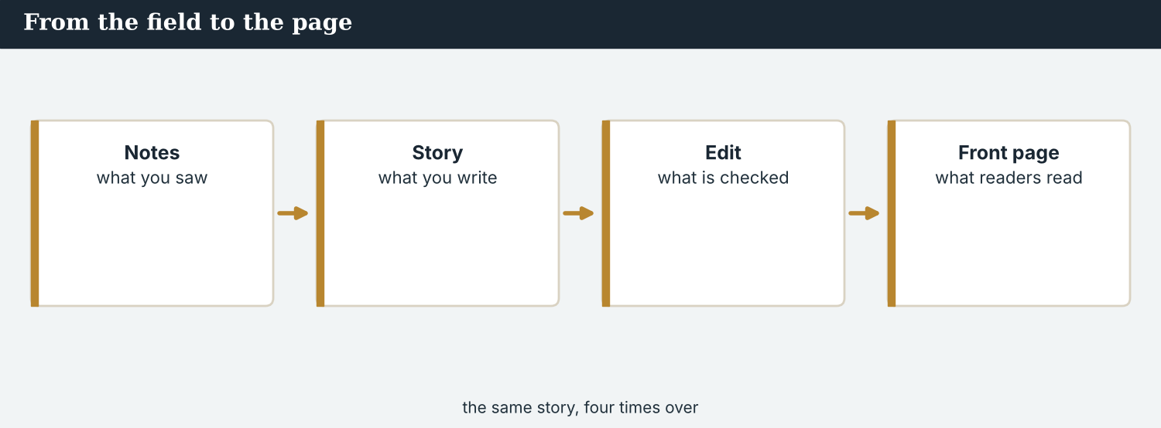
The front page that started it all — now read far beyond the wire.
1E Complete the paragraph. Use: coverage · running · reach · outlet · noticed.
Atlas Wire’s ___________ of Kalina is a ___________ story. Over a year, its ___________ has grown. Now a large international ___________ has ___________ the work, and wants to talk.
1F Read the definition. Write the word.
1. a story that continues over time → ___________
2. how many people see your work → ___________
3. a piece made by two or more outlets together → ___________
4. until now → ___________
1G Complete the collocation paragraph. Use: syndicate · update · follow up · audience · so far.
The desk will ___________ the story to other outlets. Mira will ___________ next week, and send an ___________ . ___________ , the ___________ is far wider than it was.
PRODUCE Over to you
1H Answer about you. Write full sentences.
1. What news outlet do you follow? What does it cover?
2. Has a story from your town ever reached a national or foreign outlet?
PRODUCE Talk about it
1I Discuss. Which two words in this unit are new for you? Make a sentence with one.
1J Complete the paragraph. Use: coverage · reach · partner · audience · noticed.
Atlas Wire’s ___________ of the valley has a wide ___________ now. A large daily has ___________ the work and wants to be a ___________ . The ___________ is far bigger than before.
1K Creative. Write two sentences about a story you have followed for a long time. Use has/have + done.

PART 2 Grammar: perfect and past
Present perfect for up to now; past simple for a finished time.
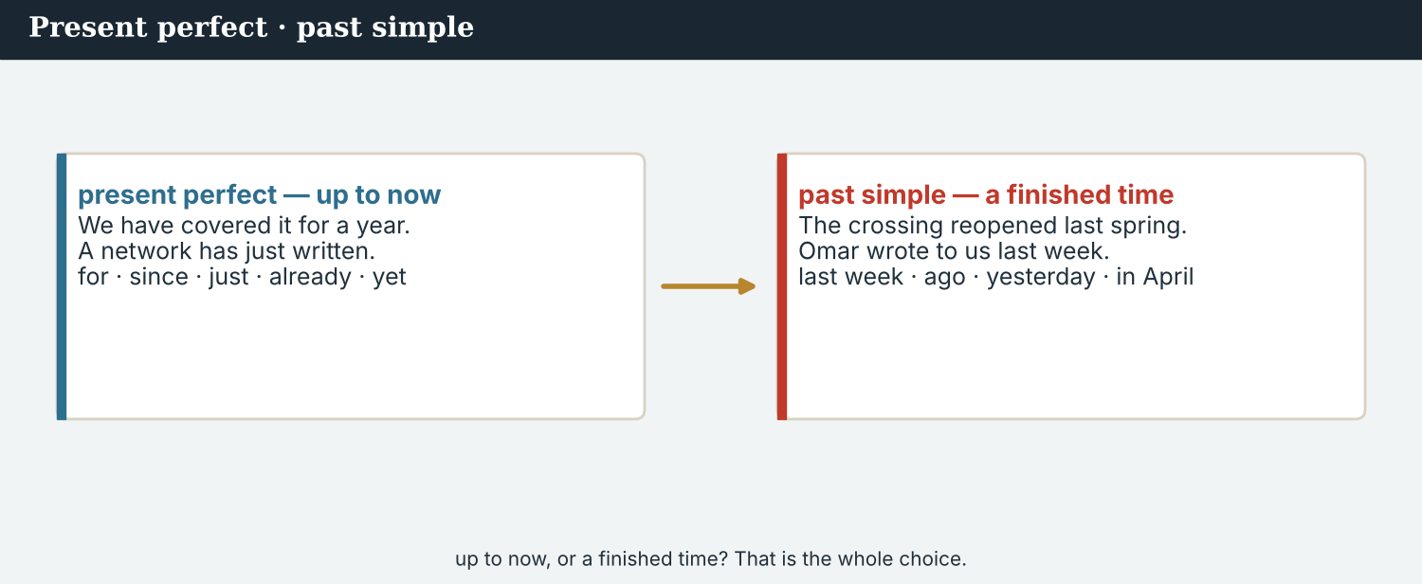
present perfect = up to now · past simple = a finished time.
1 · Present perfect — up to now
Form: has / have + past participle.
We use it for experience and unfinished time: We have covered this story for a year. The Meridian Post has just contacted us.
Signal words: for, since, just, already, yet, ever, never.
2 · Past simple — a finished time
Form: the past form of the verb (regular -ed, or irregular).
We use it for a finished time: The crossing reopened last spring. Omar wrote to us last week.
Signal words: last week, ago, yesterday, in April.
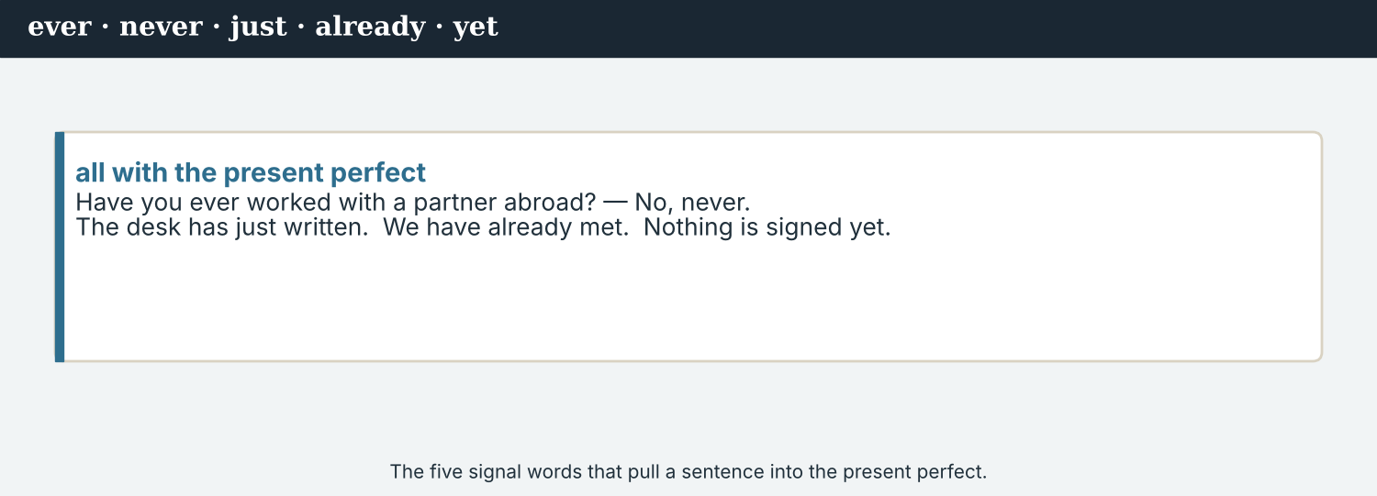
just, already, yet, ever, never — all with the present perfect.
3 · Which one?
Result now, or up to now → present perfect: “We have worked on it for a year.”
A finished time → past simple: “We started it last April.”
Ever and never ask and answer about experience: “Have you ever co-produced a story? — No, never.”
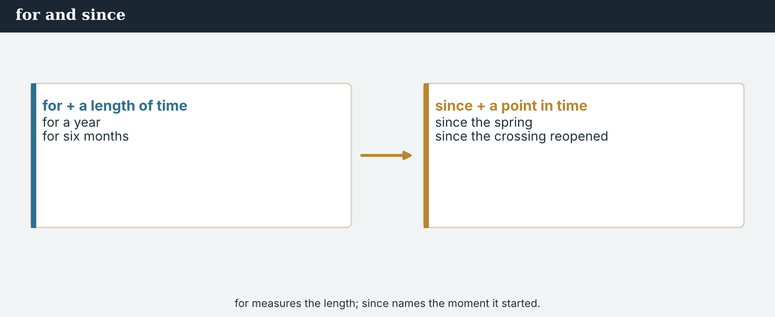
for + a length of time; since + a point in time.
PRACTISE Structured practice
2A Write the past participle and the past simple.
1. cover → have ___________ / ___________ (past)
2. write → have ___________ / ___________ (past)
3. see → have ___________ / ___________ (past)
4. do → have ___________ / ___________ (past)
2B Complete with the present perfect (has/have + done).
1. We ___________ (cover) this story for a year.
2. The Meridian Post ___________ (just / notice) our work.
3. Mira ___________ (never / co-produce) with another newsroom.
4. The story ___________ (reach) a wide audience.
2C Present perfect or past simple? Choose the correct form.
1. The crossing ___________ (reopen) last spring.
2. We ___________ (follow) the story since April.
3. Omar ___________ (write) to us last week.
4. The team ___________ (already / meet) about it.
2D Make a question with ever, and a short answer with never.
1. you / work / with another newsroom → ________________________
2. Atlas Wire / file / for a daily paper → ________________________
Your own words
2E Write two things you have done this year. Use the present perfect.
1. ________________________
2. ________________________
2F Write two things you did last week. Use the past simple.
1. ________________________
2. ________________________
2G Rewrite in the present perfect or the past simple.
1. we / cover / it / for a year (up to now) → ________________________
2. the crossing / reopen / last spring (finished) → ________________________
3. a daily / just / notice / us (up to now) → ________________________
2H Your own words. Write one thing you have done recently, and one thing you did last year.
1. ________________________
2. ________________________

PART 3 Recapping a running story
Before a partner joins, you catch them up: what has happened, and what is new.
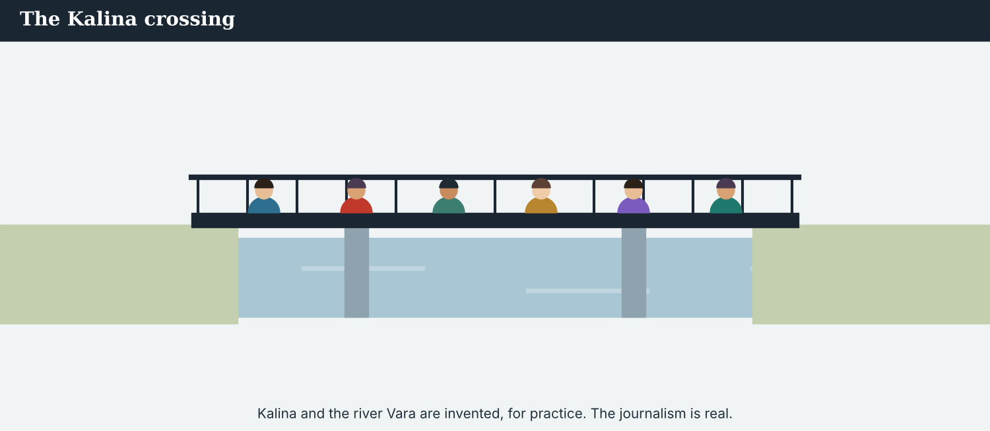
The crossing at Kalina — the story that has run all year.
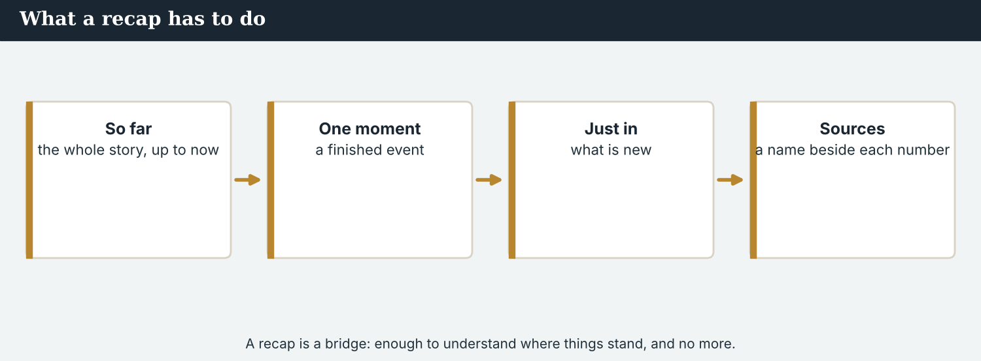
A recap: what has happened so far, and what is new.
MODEL A model recap
“Here is where we are. We have covered Kalina for a year. The crossing reopened last spring, and a hundred families have returned. Recently, the school reopened too. So far, the coverage has reached readers in a dozen countries. Just this week, a large daily noticed our work. Nothing has been agreed yet.”
NOTICE Notice the recap
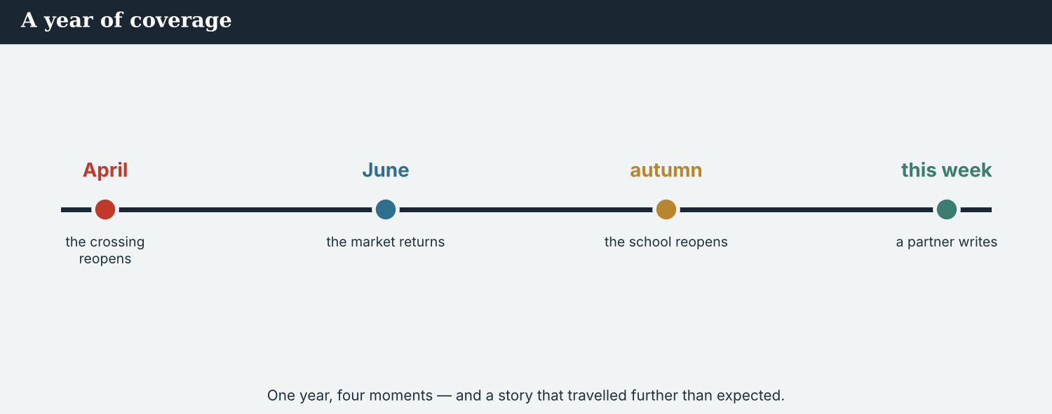
A year on: the running story, from the reopening to the day it travelled.
3A Answer about the model.
1. How long has the team covered the story? ___________
2. What happened last spring? ___________
3. What has just happened this week? ___________
3B Find one present-perfect verb and one past-simple verb in the recap. Write them.
1. ________________________
PRACTISE What has happened / what happened
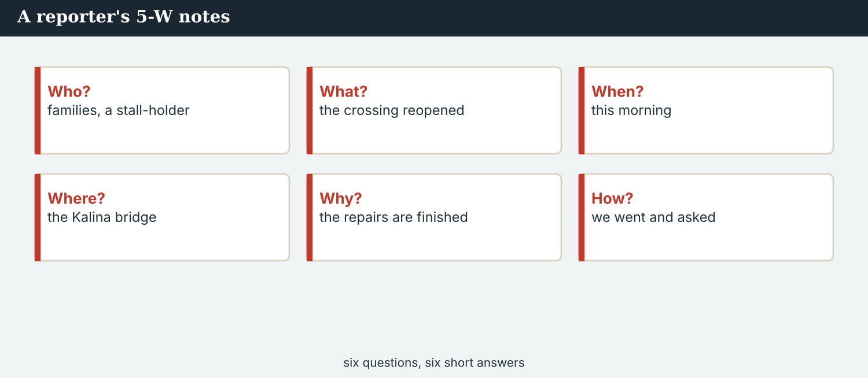
A recap answers: what has happened so far, and what is new?
3C Write the sentence in the present perfect (up to now) or past simple (a finished time).
1. the coverage / reach / a wide audience (up to now) → ________________________
2. the crossing / reopen / last spring (finished) → ________________________
3. a daily / just / notice / our work (up to now) → ________________________
3D Complete the recap. Use: have · has · reopened · yet.
We ______ covered the story for a year. The crossing ______ last spring, and families ______ returned. Nothing has been agreed ______ .
PRACTISE One more
3E Put the recap in order. Number the sentences 1–4.
1. A daily has just noticed our work. ______
2. We have covered the story for a year. ______
3. The crossing reopened last spring. ______
4. A hundred families have returned. ______
PRODUCE Your turn
3F Choose a running story (real or invented). Write a short recap (4–5 sentences): what has happened so far, what happened at one point, and what is new.
________________________
________________________
________________________
________________________
PRODUCE Discuss
3G Talk with a partner. Why is a good recap useful when someone new joins a story?
3H When you recap, why do you use the present perfect for ‘so far’ and the past simple for one moment? Give an example of each.
3I Discuss. Think of one running story you know. Recap it in three sentences: so far, one moment, and what is new.

PART 4 Listening: news from abroad
Two audios. Listen for what has happened, and for the message from abroad.
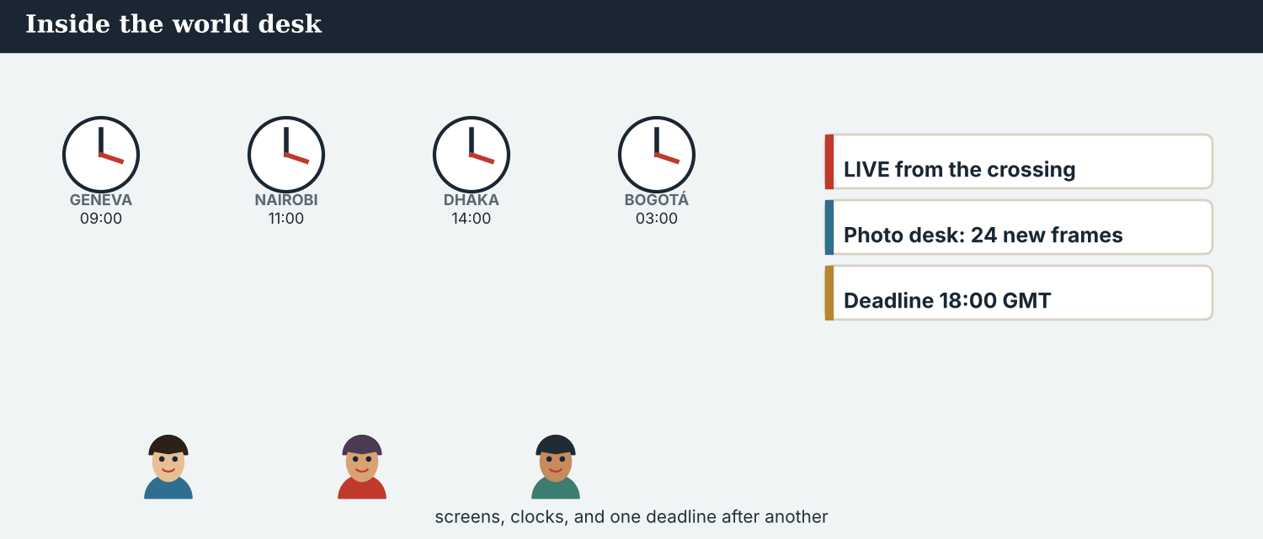
In the newsroom — the team catches up before the call.
Listening A · catching up in the newsroom
MODEL Audio 1.1 — Mira and Ana
Ana: Mira, catch me up. Where are we with the story?
Mira: We have covered it for a year now. The crossing reopened last spring.
Ana: And the families?
Mira: A hundred have returned so far. The school reopened recently, too.
Ana: Has anything new happened this week?
Mira: Yes — a large international daily has just noticed our work. Omar Faris wrote yesterday.
Ana: Good. Have we ever co-produced a story with another newsroom?
Mira: No, never. This would be the first time.
Ana: And the sources — are the numbers still solid?
Mira: Yes. The Crossing Office has confirmed the hundred families, and Priya has checked every figure.
Ana: Perfect. Then we are ready to talk to them.
PRACTISE Listen for detail
4A Before you listen: what do you think Mira will say has happened? Write one idea.
1. ______
4B Answer the questions.
1. How long has the team covered the story? ___________
2. When did the crossing reopen? ___________
3. How many families have returned so far? ___________
4. What has just happened this week? ___________
4C Present perfect or past simple? Write PP or PS for each.
1. “We have covered it for a year.” ______
2. “The crossing reopened last spring.” ______
3. “A daily has just noticed our work.” ______
4D Complete the notes.
So far (up to now): ___________
One finished event: ___________
Just this week: ___________
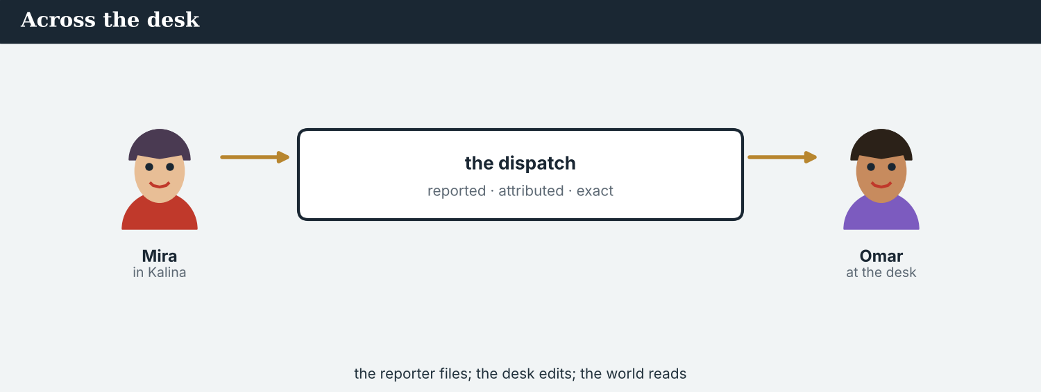
Audio 1.2 — the first message from Omar Faris at the Meridian Post.
Listening B · the message from the Meridian Post
MODEL Audio 1.2 — Omar calls
Omar: Hello, this is Omar Faris, an editor at the Meridian Post.
Mira: Hello! Thank you for calling. We have heard a great deal about the Post.
Omar: I have followed your coverage of the Kalina crossing for months. It is very careful work.
Mira: Thank you. We have covered it since the crossing reopened.
Omar: We would like to propose something. Have you ever co-produced a story with another newsroom?
Mira: No, we haven’t — this would be the first time.
Omar: Then let us talk. I will send a proposal, and we can meet next week.
Mira: Wonderful. I will introduce the whole desk.
Omar: One more thing — we would never change your reporting. It stays yours, and the local paper’s.
Mira: Thank you. That matters to us.
Omar: Of course. A careful local record is exactly why we called. I will write today.
PRACTISE Listen for detail
4E Before you listen: what do you think Omar wants? Guess.
1. ______
4F Complete the answers.
1. Omar is an editor at the ___________ .
2. He has ___________ Atlas Wire’s coverage for months.
3. He wants to ___________ something.
4. Atlas Wire has ___________ co-produced with another newsroom.
4G Which present-perfect forms do you hear? Write two (has/have + done).
1. ________________________
4H Answer. Why does Omar ask ‘Have you ever co-produced a story with another newsroom?’
1. ________________________
PRACTISE Both audios
4I Complete the summary. Use: covered · reopened · noticed · never.
Atlas Wire has ______ the story for a year; the crossing ______ last spring. A large daily has ______ the work. Atlas Wire has ______ co-produced a story before.
PRODUCE What do you think?
4J Discuss. Why might an agency want to work with a bigger daily? What might it worry about?
PRACTISE Both audios
4K Complete the summary of the two audios. Use: covered · reopened · noticed · never.
Mira told Ana the team has ______ the story for a year; the crossing ______ last spring. Then Omar called: a large daily has ______ the work. Atlas Wire has ______ co-produced a story before.
PRODUCE What do you think?
4L Discuss. Would you trust a newsroom you have never worked with? What would you check first?

PART 5 Reading: a year on
Two readings. Read for the whole year, and for how to catch up.
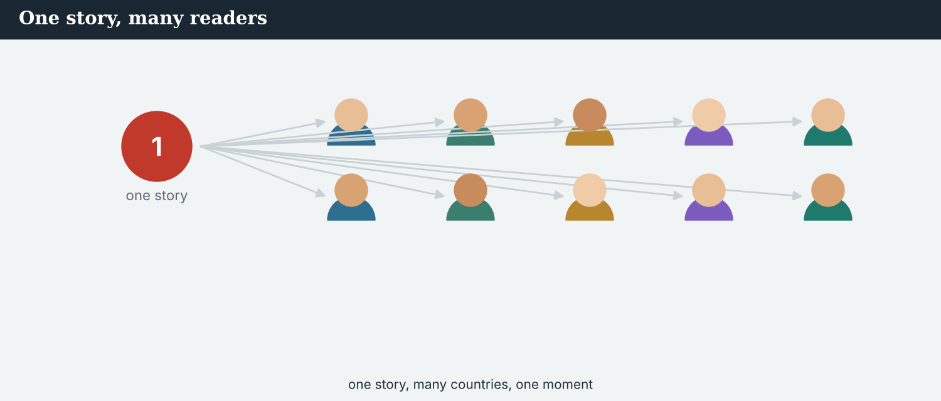
A year of coverage — and a story that has travelled.
Reading A · a year on: the story that travelled
A year on: the story that travelled
It has been a year since Atlas Wire published its front page about the crossing at Kalina, and the story has never really stopped. It has become the desk’s longest running story, and, this month, it has reached further than anyone expected.
A great deal has happened since that front page. The crossing reopened last spring, and, according to the Crossing Office, a hundred families have returned to the valley. The school reopened in the autumn, and a small café has opened at the end of the bridge. Atlas Wire has followed every step, and its correspondent, Mira Sandoval, has written most of the coverage.
“I have covered this valley for a year now,” Mira said. “When we started, the road was empty. I never thought the story would travel so far. But it has — people have read it in countries that have never heard of the river Vara.”
Last week, that reach became clear. An editor at the Meridian Post, a large international daily, wrote to the desk. He said he had followed the coverage for months, and he proposed working together. Atlas Wire has never co-produced a story with another newsroom before.
“We are an agency; we file, and others publish,” said Ana Ferreira, the editor-in-chief. “We have not agreed anything yet. But the story has grown, and it has found a much wider audience. Now we have to decide, carefully, what to do next — and how to keep it honest.”
The Post is not the only outlet that has noticed. In recent weeks, the River Basin Network has asked to run the coverage across the region, and readers have written from four continents. The audience, once a wire list, has grown far wider than before.
There is one more thing the desk has not forgotten. Kalina Daily, the small paper in the town itself, has covered the crossing every week since long before Atlas Wire arrived. “Whatever we build,” Ana said, “they are in it, and their name is on it. That part is not negotiable.”
PRACTISE Comprehension
5A Before you read: look at the title. What does ‘the story that travelled’ mean? Write one sentence.
1. ______
5B True or false? Write T or F.
1. The story is the desk’s longest running story. ______
2. A hundred families have returned. ______
3. Atlas Wire has co-produced a story before. ______
4. The team has agreed to work with the Meridian Post. ______
5C Answer the questions.
1. How long has Mira covered the valley? ___________
2. What happened last spring? ___________
3. What did the editor at the Meridian Post propose? ___________
5D Find a word in the text.
1. a story that continues over time (2 words) → ___________
2. how many people see your work → ___________
3. to suggest → ___________
A long-running story can reach far beyond the town where it began.
Reading B · catching up on a running story — four tips
Four tips for a recap
1. Say what has happened so far. Use the present perfect for the whole story up to now: ‘We have covered it for a year.’
2. Say what happened at key moments. Use the past simple for a finished time: ‘The crossing reopened last spring.’
3. Say what is new. Use just, recently and already: ‘A daily has just noticed our work.’ Keep it short.
4. Name your sources, and stay accurate. A recap is still journalism: a source for each number, no more than has really happened, and the name of the newsroom that was there before you.
5. Keep it short. A recap is a bridge, not the story. Give enough to understand where things stand, and no more.
PRACTISE Comprehension
5E Before you read: which tense tells the whole story ‘so far’? Guess.
1. ______
5F Match the tip to the example.
1. What has happened so far  2. What happened at a key moment  3. What is new  4. Stay accurate | a) ‘The crossing reopened last spring.’  b) ‘A daily has just noticed us.’  c) give a source for each number  d) ‘We have covered it for a year.’
5G Which tip uses the past simple? Write the number.
1. ______
PRACTISE Words from the readings
5H Find a word in Reading A or Reading B.
1. the reporting of a story → ___________
2. the people who read or watch → ___________
3. to suggest → ___________
PRODUCE Discuss
5I Talk about it. Ana says the team must decide ‘how to keep it honest’. What do you think she means?
5J Which of the four tips is the most important for a recap? Say why.
PRACTISE Signal words
5K Which tense does each signal word take? Write PP (present perfect) or PS (past simple).
1. for a year ______
2. last spring ______
3. just ______
4. three days ago ______
5. since April ______
6. yesterday ______
PRODUCE Discuss
5L Talk about it. Reading B says keep it short. Why is that hard when you love a story you have followed for a year?

PART 6 Writing: a catch-up note
Two short pieces: a where-we-are note, and a short introduction to a partner.
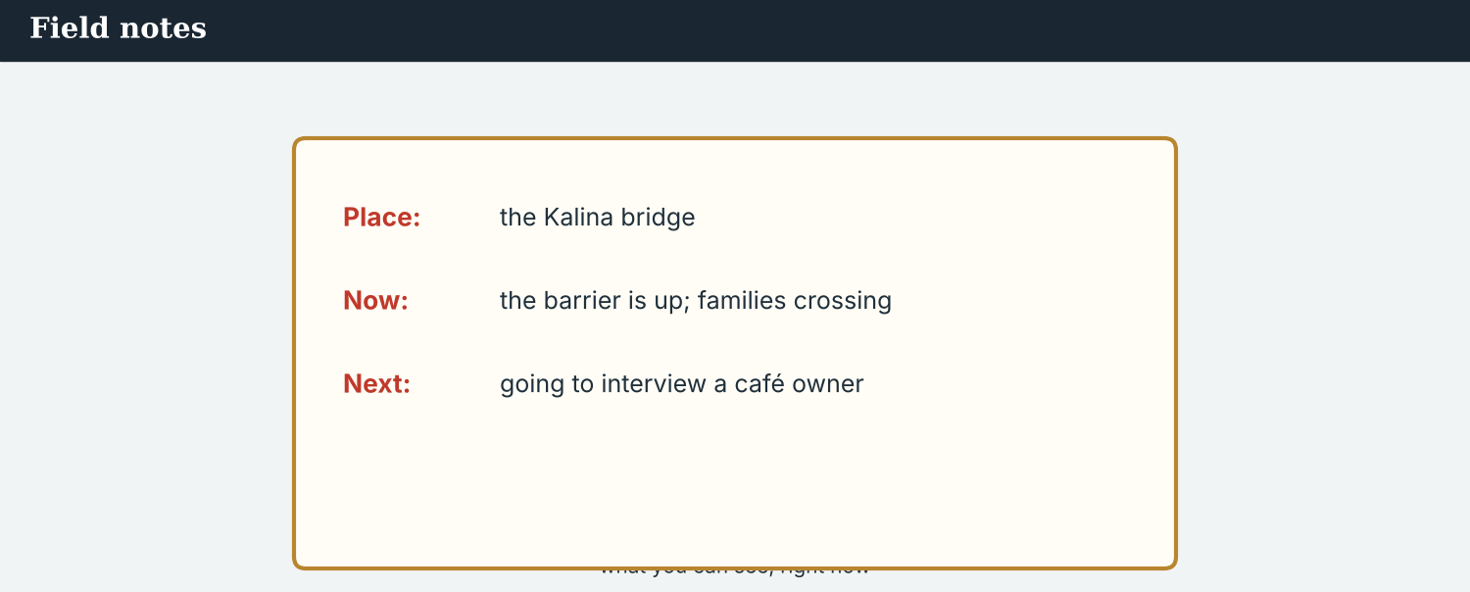
A catch-up note: so far, and just in.
Writing 1 · a where-we-are note
MODEL A model
So far: we have covered the story for a year; 100 families have returned
Key moment: the crossing reopened last spring
Just in: a large international daily has noticed our work
NOTICE Notice the model
6A Answer about the model.
1. Which line uses the present perfect? ___________
2. Which line uses the past simple? ___________
PRODUCE Write your note
6B Choose a running story. Write a where-we-are note: so far (present perfect), a key moment (past simple), and just in (present perfect).
So far: ___________
Key moment: ___________
Just in: ___________
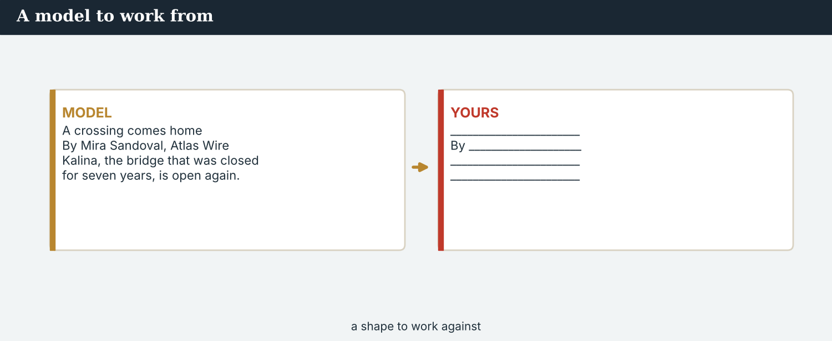
An introduction to a partner is short, warm, and clear.
Writing 2 · an introduction to a partner
MODEL A model
Dear Omar, thank you for your message. We are Atlas Wire, an independent news agency with a world desk in Geneva. We have covered the Kalina crossing for a year, with Kalina Daily reporting alongside us from the town itself. We have never co-produced a story before, but we would be glad to talk. — Ana
NOTICE Notice the model
6C Answer. Which present-perfect sentences introduce the outlet’s experience? Write one.
1. ___________
PRACTISE Complete the note
6D Complete the introduction. Use: have · has · covered.
We are Atlas Wire. We ______ ______ the Kalina crossing for a year. Our correspondent ______ written most of the coverage.
PRODUCE Write your introduction
6E Write a short introduction (3–4 sentences) of a news outlet to a new partner. Say who you are and what you have covered.
________________________
________________________
________________________
PRACTISE Fix it
6F This uses the wrong tense. Correct it (present perfect for ‘up to now’, past simple for ‘last spring’).
“We covered the story for a year. The crossing has reopened last spring.”
________________________
PRACTISE Plan it
6G Plan a longer catch-up. Write three points: what has happened so far, one key moment, and what is just in.
So far: ___________
One moment: ___________
Just in: ___________
PRACTISE Fix it
6H This introduction is long and vague. Cut it to two clear sentences: who you are, and what you have covered.
“Hello, we are an agency and we do lots of things and we have been around and we cover many stories and things happen and we write about them.”
________________________

PART 7 Speaking: introducing your outlet
Catch a partner up, and introduce your outlet. Use present perfect and past simple.
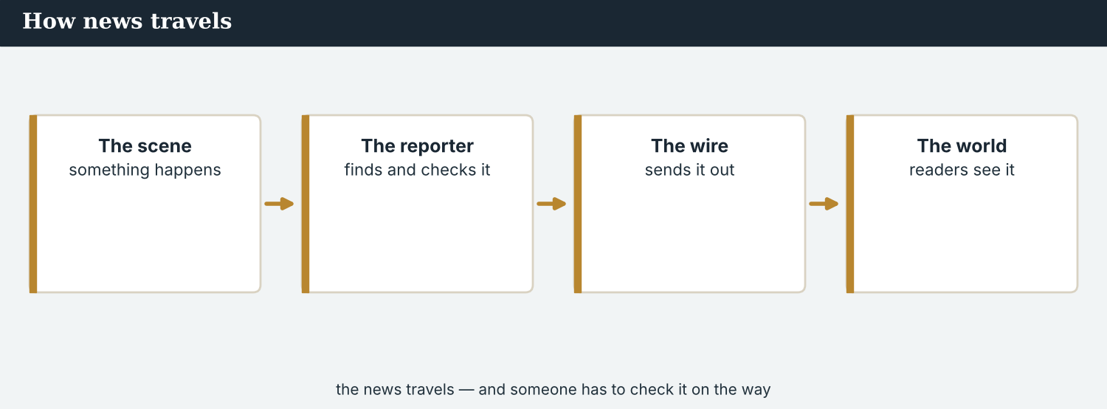
A story that has travelled: from the valley, to the wire, to the world.
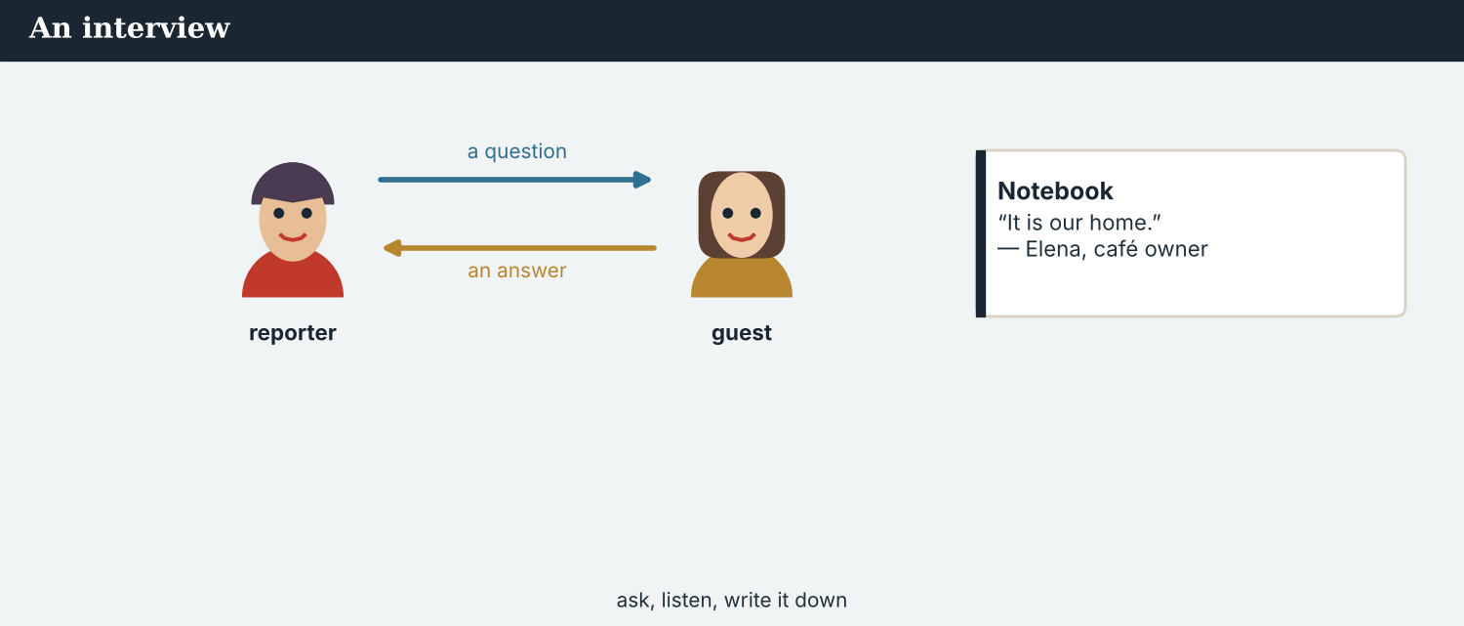
Catch a colleague up, then introduce your outlet.
A model dialogue · catching a colleague up
MODEL Listen and read
Sofia: I’m new — can you catch me up on the story?
Mira: Of course. We have covered the Kalina crossing for a year.
Sofia: What happened first?
Mira: The crossing reopened last spring. Since then, a hundred families have returned.
Sofia: Has anything happened this week?
Mira: Yes — a large daily has just noticed our work.
Sofia: That’s exciting! Have we ever co-produced a story before?
Mira: No, never. This would be the first time.
NOTICE Notice the tenses
7A Find one present-perfect sentence and one past-simple sentence. Write them.
1. ________________________
PRACTISE Controlled practice
7B Answer with the present perfect or the past simple.
1. How long / you / cover / the story? → ___________
2. When / the crossing / reopen? → ___________
3. What / just / happen? → ___________
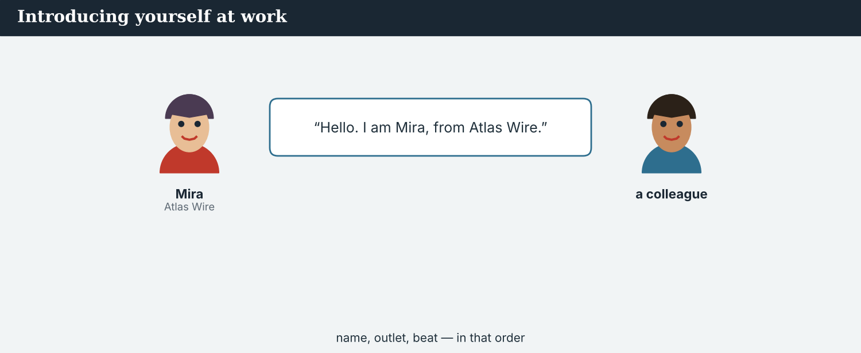
Introduce yourself and your outlet before you begin.
7C Make a question with ever, then answer.
1. you / ever / work / with a foreign outlet → ________________________
2. your outlet / ever / win / a prize → ________________________
PRODUCE Your role
Correspondent | Catch a colleague up: say what has happened so far, one key moment, and what is new.
New colleague | Ask: ‘What has happened so far?’ and ‘Have you ever…?’
Observer | Listen. Did the correspondent use the present perfect for ‘so far’ and the past simple for one moment?
7D Choose a role from the table. Catch your partner up on a story.
PRODUCE Role-play
7E Role-play a catch-up: a correspondent, a new colleague, and an observer. Then swap roles.
A second dialogue · introducing your outlet to a partner
MODEL Listen and read
Mira: Hello, Omar. I’d like to introduce our desk.
Omar: Please do. Tell me about Atlas Wire.
Mira: We are an independent news agency in Geneva. We have filed world news for eleven years.
Omar: And this story?
Mira: We have followed Kalina since the crossing reopened. It is our proudest work.
Omar: It shows. I have read every piece.
Mira: Thank you. We have never co-produced a story, but we are glad to talk — and Kalina Daily has to be part of it.
PRACTISE Controlled practice
7F Write the present-perfect sentence Mira uses about the agency’s experience.
1. ________________________
PRODUCE Self-check
Did I… | Yes | Almost | Not yet
use the present perfect for ‘so far’ / experience? | ☐ | ☐ | ☐
use the past simple for one finished moment? | ☐ | ☐ | ☐
use ever / never / just when they fit? | ☐ | ☐ | ☐
introduce my outlet clearly? | ☐ | ☐ | ☐
7G Role-play introducing your outlet to a new partner. Then swap roles.
7H Complete the mini-dialogue with the correct tense.
1. How long ___________ you covered it? — For a year.
2. When ___________ it reopen? — Last spring.
3. ___________ you ever co-produced a story? — No, never.
PRODUCE Over to you
7I Discuss. How would you introduce your own outlet (or a favourite one) to a foreign editor, in one clear sentence?

PART 8 Ethics: keeping it accurate, keeping it ours
A story that travels must stay accurate — and stay true to the place it comes from.
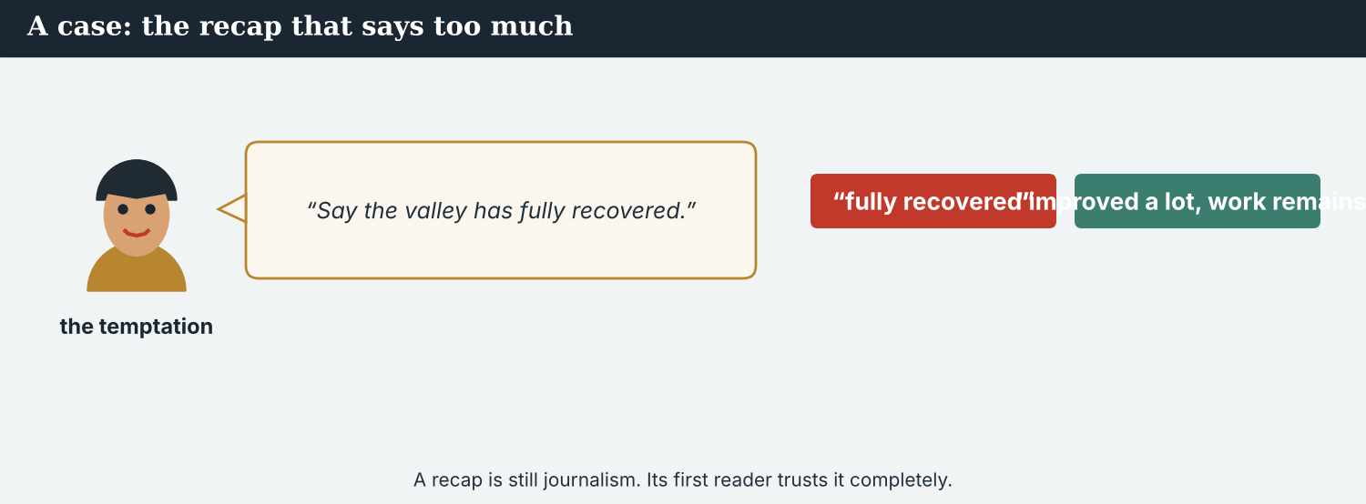
‘Fully recovered’ is a claim; ‘has improved a lot’ is what you can say.
A first case · the recap that says too much
A case. Mira writes a recap for the new partner. She wants it to sound strong, so she nearly writes: ‘The Kalina valley has fully recovered, and everything is finished.’ It would read well, and a big partner might like a simple, bright line. But that is not accurate. The crossing has reopened and many families have returned — a great deal has improved — but the clinic is still closed, the bus does not cross yet, and not everyone has come home. The partner has never been to Kalina; they will build their whole picture on Mira’s words. A recap is still journalism, and its first reader trusts it completely. Mira knows the Code: report what has really happened, not more. What does Mira write in the recap?
NOTICE What do you do?
8A Choose (a) or (b), and write one reason.
1. (a) ‘the valley has fully recovered’ (b) ‘the valley has improved a lot, but work remains’. Choice: ______ Because ________________________
2. Saying ‘fully recovered’ when it is not is (a) accurate (b) not accurate. Choice: ______
8B Can you say it has happened? Write Y (yes) or N (not yet).
1. The crossing has reopened. ______
2. Everyone has returned. ______
3. Many families have come back. ______
4. The valley has fully recovered. ______
PRACTISE Apply the Code
8C Complete the rule. Use: accurate · recap · more · check.
A ______ is still journalism. Be ______ : do not say ______ has happened than really has, and ______ every number.
PRODUCE Discuss
8D Discuss. Why is a ‘too positive’ recap a problem, especially for a partner who has never seen the valley?
A second case · keeping the local voice
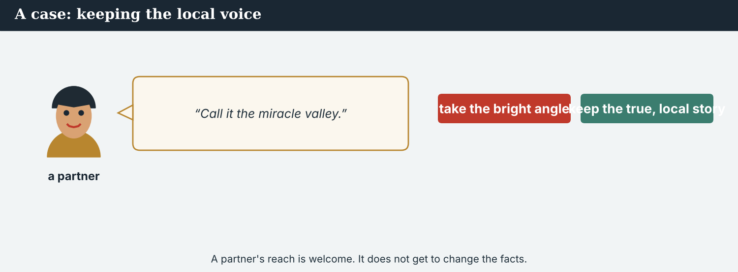
A bigger partner’s reach is welcome — but the story stays true to the place.
A case. The Meridian Post is interested — but the editor suggests a simpler, more dramatic angle: ‘the miracle valley that came back from nothing’. It would travel well and reach millions. But it is not quite true. The recovery was slow and hard, and it was done, day by day, by the people who live there. ‘Came back from nothing’ erases years of ordinary work, and it makes the valley sound helpless rather than strong. There is a second problem: the Post’s draft names only Atlas Wire, and Kalina Daily has covered this crossing every week for years. The Post’s reach is real and welcome. But the facts, and the credit, are not the Post’s to change. The Code says: independence — a partner’s reach must never change the story, however large the audience. What does Atlas Wire do?
NOTICE What do you do?
8E Choose (a) or (b), and write one reason.
1. (a) take the dramatic ‘miracle’ angle for the reach (b) keep the true story, and name Kalina Daily. Choice: ______ Because ________________________
2. Letting a partner’s reach change the facts is (a) independent (b) not independent. Choice: ______
8F Complete with: accurate · reach · local · independent.
1. A partner’s ___________ is welcome.
2. But the story must stay ___________ .
3. Keep the ___________ voice — and the name of the paper that was there first.
4. Stay ___________ : the facts do not change for a bigger audience.
PRODUCE Discuss
8G Discuss. Why is it important to keep the local voice — and the local byline — when a story goes to a wide audience?
PRODUCE Write it
8H Write two sentences that keep the story true and local, but still make it clear for a wider audience. Use the present perfect.
PRACTISE One more
8I Fact, opinion, or overclaim (says too much)? Write F, O, or X.
1. The crossing has reopened. ______
2. The valley is the best place in the region. ______
3. Everything has fully recovered. ______
4. A hundred families have returned, the office says. ______
PRODUCE Write it
8J Write one honest sentence Atlas Wire could send the Meridian Post about the recovery: true, and clear for a reader who has never been there.

PART 9 Digital: the ‘one year on’ thread
Online, an anniversary post recaps a running story — accurately.
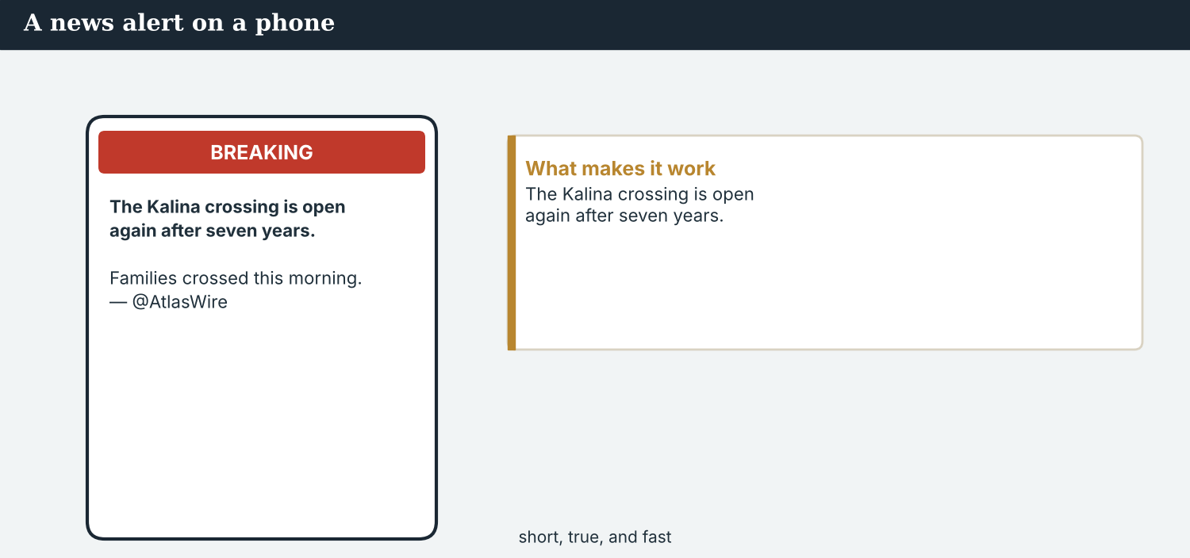
A ‘one year on’ post — what has happened, in a line.
MODEL A model post
ONE YEAR ON · We have covered the Kalina crossing for a year, with @KalinaDaily. The crossing reopened last spring, and 100 families have returned. This week, our work has reached a large international daily. — @AtlasWire
NOTICE The parts of the post
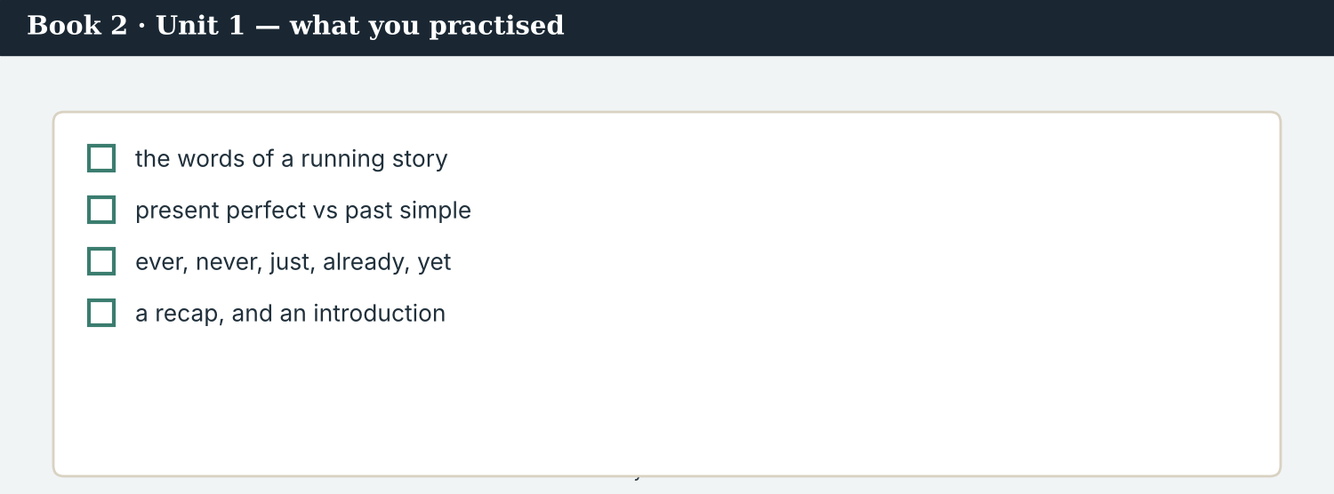
The reach has grown over the year: more people have read the coverage each season.
9A Match the part to the tense/idea.
1. We have covered it for a year  2. The crossing reopened last spring  3. 100 families have returned  4. our work has reached a large daily | a) past simple (a finished time)  b) present perfect (up to now)  c) present perfect (result now)  d) present perfect (just now)
PRACTISE Find and build
9B Find one present-perfect verb and one past-simple verb in the post. Write them.
1. ________________________
9C This post uses the wrong tense. Correct it.
“We have covered it since a year. The crossing has reopened last spring.”
________________________
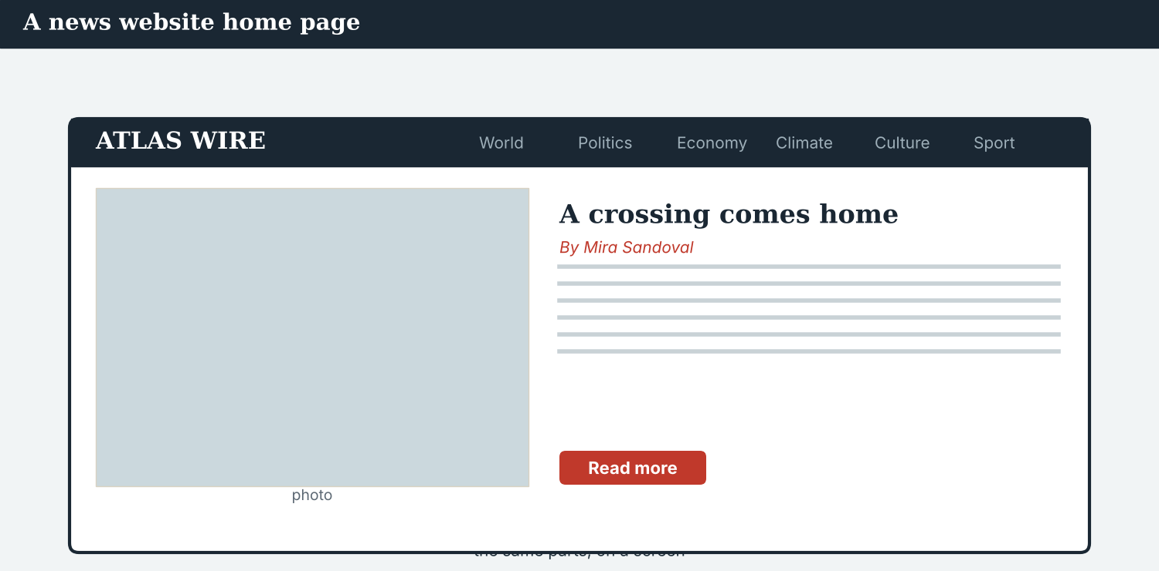
The post links to the full ‘one year on’ feature.
9D Write a ‘one year on’ post. Use one present-perfect and one past-simple sentence.
ONE YEAR ON · ___________ (up to now). ___________ (a finished moment). — @AtlasWire
PRODUCE Write your post
9E Write a one-line anniversary post about a story you know. Use the present perfect.
________________________
9F Creative. Write a short headline (4–6 words) for a ‘one year on’ story.
9G A reader abroad asks: ‘Has the valley fully recovered?’ Write a short, honest reply.
________________________
PRODUCE Discuss
9H Discuss. Online, an anniversary post can travel fast and far. Why must it still be exact?
9I Creative. Write a two-line one-year-on thread: line 1 in the present perfect, line 2 in the past simple.
________________________
________________________
PRODUCE Discuss
9J Discuss. Do one-year-on posts help readers, or do they make a long story too simple? Why?

PART 10 Review & Can-Do
Check your new English before Unit 2.
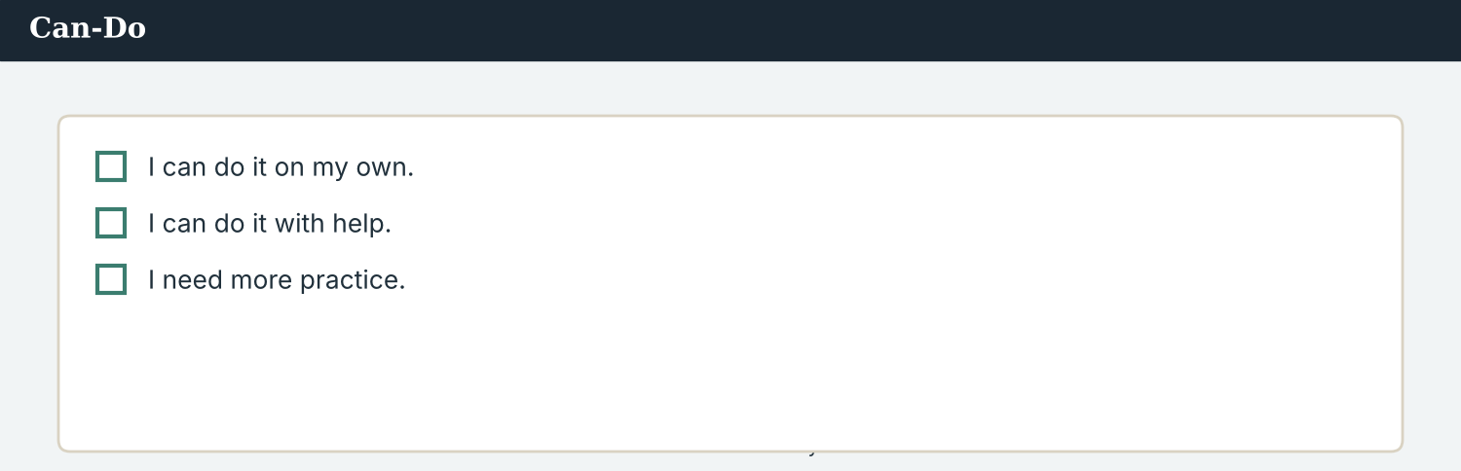
Can-Do — tick what you can do now.
10A Vocabulary. Complete with: coverage · running · reach · outlet · audience · picked up · partner · co-production.
1. Atlas Wire’s ___________ has run for a year.
2. It is a ___________ story — it continues over time.
3. Its ___________ has grown; more people see it now.
4. A large international ___________ has noticed the work.
5. The ___________ is wider than before.
6. Another newsroom has ___________ the story.
7. Omar wants Atlas Wire to be a ___________ .
8. A piece made by two outlets together is a ___________ .
10B Grammar. Present perfect or past simple? Choose the correct form.
1. We ___________ (cover) the story for a year.
2. The crossing ___________ (reopen) last spring.
3. A daily ___________ (just / notice) our work.
4. Omar ___________ (write) to us last week.
10C Grammar. Make a question with ever and a short answer with never.
1. you / co-produce / a story → ________________________
10D Signal words. Choose: for · since · ago · yet.
1. We have covered it ______ a year.
2. We have followed it ______ the crossing reopened.
3. The crossing reopened a year ______ .
4. Nothing has been agreed ______ .
10E Read and answer.
Atlas Wire has covered the Kalina crossing for a year. The crossing reopened last spring, and a hundred families have returned. This week, a large international daily has noticed the work and proposed a co-production. The team has not agreed anything yet.
1. How long has Atlas Wire covered the crossing? ___________
2. What happened last spring? ___________
3. Has the team agreed yet? ___________
Can-Do — tick what you can do now
☐ I can contrast experience and finished events (present perfect vs past simple).
☐ I can use ever, never, just, already and yet.
☐ I can recap a running story.
☐ I can introduce my outlet to a partner.
10F Reflect. Which part of Unit 1 was the most useful for you? Why?
10G Grammar review. Write the sentence correctly.
1. We have covered it since a year. → ________________________
2. The crossing has reopened last spring. → ________________________
3. Have you ever co-produced a story? — No, I have ever. → ________________________
4. A daily has noticed our work last week. → ________________________
10H Mixed review. Complete with the present perfect or the past simple.
1. We ___________ (follow) the story since April.
2. The school ___________ (reopen) in the autumn.
3. A daily ___________ (just / write) to us.
4. We ___________ (never / co-produce) a story.
10I Reflect. Write one sentence about what you have learned in this unit. Use the present perfect.

PART 11 Assignment: a catch-up for a partner
Put the unit together: recap your story and introduce your outlet.
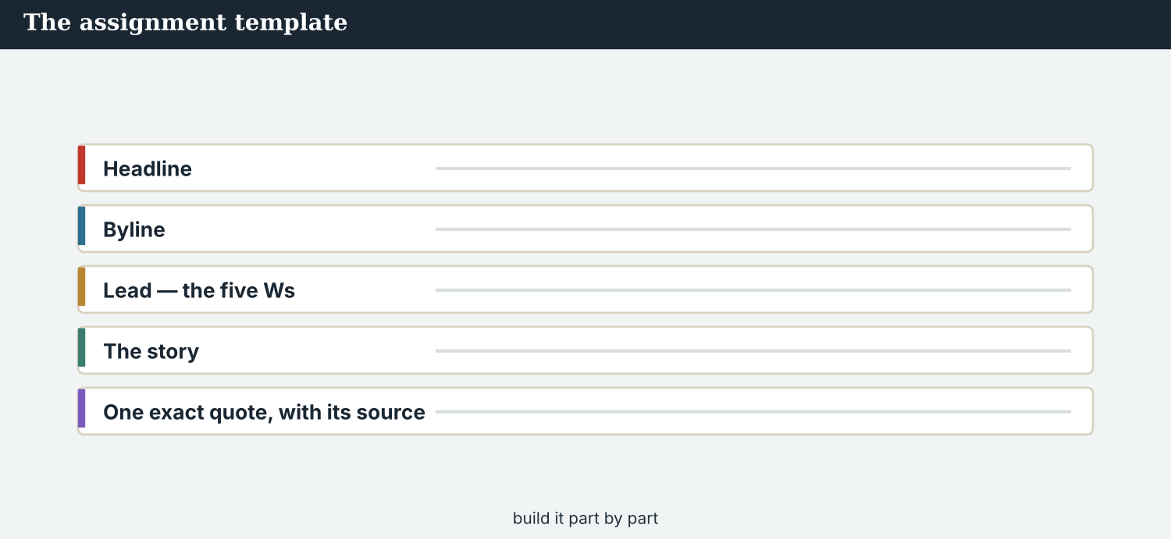
The assignment template — your catch-up note.
Your task. Imagine a new partner is joining a story you are covering (real or invented). Write a short catch-up note (5–6 sentences). Say what has happened so far (present perfect), what happened at one key moment (past simple), and what is new (just / recently). Then add one line that introduces your outlet, and one that names anyone else who has been reporting the story. Be accurate — do not say more has happened than really has.
A model — use Reading A to check the shape of your note.
Remember: present perfect for ‘so far’ and experience; past simple for one finished moment; just / recently for what is new; name a source for any number; name the newsroom that was there first; keep it true.
Success criteria | Yes | Almost | Not yet
I use the present perfect for what has happened so far. | ☐ | ☐ | ☐
I use the past simple for one key moment. | ☐ | ☐ | ☐
I say what is new (just / recently). | ☐ | ☐ | ☐
I introduce my outlet in one line. | ☐ | ☐ | ☐
It is accurate — no more than really happened. | ☐ | ☐ | ☐
Keep this. In Unit 2, you learn the past deeper — used to and would — to tell a partner how things used to be, before the story began.

ANSWER KEY Book 2 · Unit 1
Check your answers. Open tasks (discussion, role-play and your own writing) are marked at the end.
W1 1 for a year · 2 Omar Faris, from the Meridian Post · 3 no, never (not before)
W2 1 F (he wrote yesterday) · 2 T · 3 F
W3 present perfect: have covered / has noticed / have never co-produced (any) · past simple: wrote / said (any)
1A 1-b, 2-a, 3-c, 4-e, 5-d, 6-f, 7-g, 8-i, 9-h, 10-j (accept sensible matches)
1B 1 coverage · 2 reach · 3 outlet · 4 audience · 5 picked up · 6 partner
1C 1 cover a story · 2 follow up a lead · 3 pick up a story · 4 reach an audience · 5 propose a plan
1D 1 deadline · 2 shout · 3 rumour · 4 rival
1E 1 coverage · 2 running · 3 reach · 4 outlet · 5 noticed
1F 1 running story · 2 reach · 3 co-production · 4 so far
1G syndicate · follow up · update · So far · audience
1J 1 coverage · 2 reach · 3 noticed · 4 partner · 5 audience
2A 1 covered / covered · 2 written / wrote · 3 seen / saw · 4 done / did
2B 1 have covered · 2 has just noticed · 3 has never co-produced · 4 has reached
2C 1 reopened · 2 have followed · 3 wrote · 4 has already met
2D 1 Have you ever worked with another newsroom? — No, never. · 2 Has Atlas Wire ever filed for a daily paper? — No, never.
2G 1 We have covered it for a year. · 2 The crossing reopened last spring. · 3 A daily has just noticed us.
3A 1 for a year · 2 the crossing reopened · 3 a large daily noticed the work (this week)
3B present perfect: have covered / have returned / has reached (any) · past simple: reopened
3C 1 The coverage has reached a wide audience. · 2 The crossing reopened last spring. · 3 A daily has just noticed our work.
3D have · reopened · have · yet
3E 1 We have covered the story for a year. · 2 The crossing reopened last spring. · 3 A hundred families have returned. · 4 A daily has just noticed our work.
4B 1 for a year · 2 last spring · 3 a hundred · 4 a large daily has noticed the work / Omar wrote
4C 1 PP · 2 PS · 3 PP
4D So far = covered a year; 100 families returned · One event = the crossing reopened last spring · Just this week = a daily noticed the work
4F 1 Meridian Post · 2 followed · 3 propose (something) · 4 never
4G (any two) have heard · have followed · have covered · has (never) co-produced
4H to find out whether it is Atlas Wire’s first time / whether they have the experience
4I covered · reopened · noticed · never
4K covered · reopened · noticed · never
5B 1 T · 2 T · 3 F · 4 F
5C 1 for a year · 2 the crossing reopened · 3 working together (a co-production)
5D 1 running story · 2 reach · 3 propose
5F so far → ‘We have covered it for a year.’ · a key moment → ‘The crossing reopened last spring.’ · what is new → ‘A daily has just noticed us.’ · stay accurate → give a source for each number
5G Tip 2
5H 1 coverage · 2 audience · 3 propose
5K 1 PP · 2 PS · 3 PP · 4 PS · 5 PP · 6 PS
6A 1 ‘we have covered the story for a year’ (present perfect) · 2 ‘the crossing reopened last spring’ (past simple)
6C (any) ‘We have covered the Kalina crossing for a year.’ / ‘We have never co-produced a story before.’
6D have · covered · has
6F ‘We have covered the story for a year. The crossing reopened last spring.’
6H (example) We are Atlas Wire, an independent news agency in Geneva. We have covered the Kalina crossing for a year.
7A present perfect: ‘We have covered the Kalina crossing for a year.’ · past simple: ‘The crossing reopened last spring.’
7B 1 We have covered it for a year. · 2 It reopened last spring. · 3 A daily has just noticed our work.
7C 1 Have you ever worked with a foreign outlet? — (answer) · 2 Has your outlet ever won a prize? — (answer)
7F ‘We have filed world news for eleven years.’
7H 1 have · 2 did · 3 Have
8A 1 (b) ‘improved a lot, but work remains’ · 2 (b) not accurate
8B 1 Y · 2 N · 3 Y · 4 N
8C recap · accurate · more · check
8E 1 (b) keep the true story, and name Kalina Daily · 2 (b) not independent
8F 1 reach · 2 accurate · 3 local · 4 independent
8I 1 F · 2 O · 3 X (overclaim) · 4 F
9A ‘We have covered it for a year’ → present perfect (up to now) · ‘The crossing reopened last spring’ → past simple · ‘100 families have returned’ → present perfect (result now) · ‘our work has reached a large daily’ → present perfect (just now)
9B present perfect: have covered / have returned / has reached (any) · past simple: reopened
9C ‘We have covered it for a year. The crossing reopened last spring.’
10A 1 coverage · 2 running · 3 reach · 4 outlet · 5 audience · 6 picked up · 7 partner · 8 co-production
10B 1 have covered · 2 reopened · 3 has just noticed · 4 wrote
10C Have you ever co-produced a story? — No, never.
10D 1 for · 2 since · 3 ago · 4 yet
10E 1 for a year · 2 the crossing reopened · 3 no, not yet
10G 1 We have covered it for a year. · 2 The crossing reopened last spring. · 3 No, I never have. / No, never. · 4 A daily noticed our work last week.
10H 1 have followed · 2 reopened · 3 has just written · 4 have never co-produced
Open tasks W4, W5, 1H, 1I, 1K, 2E, 2F, 2H, 3F, 3G, 3H, 3I, 4A, 4E, 4H, 4J, 4L, 5A, 5E, 5I, 5J, 5L, 6B, 6E, 6G, 7D, 7E, 7G, 7I, 8D, 8G, 8H, 8J, 9D, 9E, 9F, 9G, 9H, 9I, 9J, 10F, 10I — your own answers (discussion, role-play, writing).
A note on real and invented content. The facts about journalism around the world in 2026 are true. Atlas Wire, Kalina Daily, the Meridian Post, their staff, Omar Faris, Kalina and the story are invented, for practice. Real people and outlets are only ever in true, sourced facts — never in an invented quote.
English for Journalists — International Edition · Book 2 · Unit 1 (30-page standard). CEFR lower B1 → medium B1 · Beat: Report & Across Borders · two readings · two listenings · two writing pieces · two ethics cases · two speaking dialogues · balanced sections · ~28 figures · featured cast + a partner abroad · fictional agency, factual backdrop.

BOOK 2 · UNIT 2 The Backstory: How Things Used to Be
Beat · Feature & Across Borders CEFR lower B1 → medium B1
In this unit you learn to…
1. describe how things used to be (used to)
2. talk about repeated past actions (would)
3. use the past continuous for background
4. give the backstory to a colleague abroad
The Atlas Wire team — now telling the valley’s backstory to a much wider audience.
An editor asks for the backstory. The Meridian Post was not the only outlet to notice Atlas Wire’s coverage. Omar Faris is now helping bring the story to readers on four continents. But to tell it well, he needs the backstory — how Kalina used to be, before the barrier came down and the families left. This week, Mira writes that backstory, and briefs Omar. Dren, at Kalina Daily, has the part no outsider has: he lived it. (Kalina Daily, the Meridian Post, Dren and Omar are invented, for practice.)

WARM-UP The way it was
A short scene to start the unit. Read it, then answer.
The morning conference — the team remembers how the valley used to be.
“Omar has asked for background,” Ana says. “He wants to know what the valley was like before.” Mira nods. “Dren remembers it better than any of us. The bridge used to be full every morning. Old Bekim would open his stall at dawn and sweep the boards. Then, over one hard winter, families began to leave. When the barrier came down, the road was emptying, week by week.”
She pauses. “For seven years it was quiet. But that quiet is the backstory — it is why the reopening matters so much. Omar needs to understand the before, or he cannot understand the now.”
W1 Answer the questions.
1. What did the bridge use to be like every morning? ___________
2. What would Bekim do at dawn? ___________
3. What was happening when the barrier came down? ___________
W2 True or false? Write T or F.
1. The bridge used to be empty every morning. ______
2. Bekim would open his stall at dawn. ______
3. The road was emptying when the barrier came down. ______
W3 Find one ‘used to’, one ‘would’, and one past-continuous verb (was/were + -ing) in the text.
1. ________________________
PRODUCE Talk about it
W4 Discuss with a partner.
1. What did your town or street use to be like when you were a child? What has changed?
2. What is one thing you used to do every day that you do not do now?
PRODUCE One more
W5 Discuss. Why does a reader abroad need the backstory before they can understand the news today?

PART 1 The words of the backstory
The words for background and memory. Learn these first.
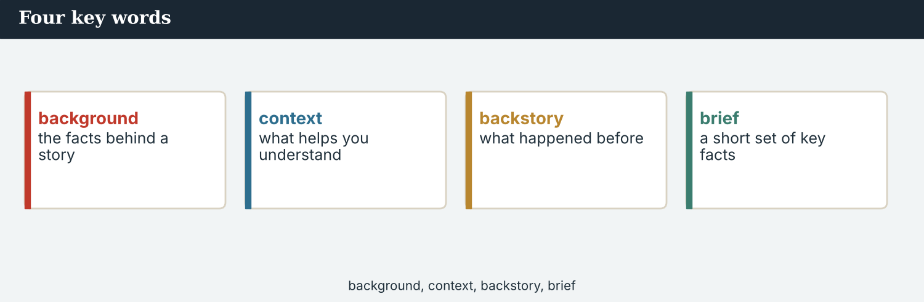
Four key words — background, context, backstory, brief.
The words
Word | Meaning
background | the facts behind a story
context | what helps you understand a story
backstory | what happened before the story began
brief (v) | to give someone the key facts
brief (n) | a short set of key facts
in those days | at that time in the past
quiet | with little noise or activity
empty | with no people
busy | full of activity
rebuild | to build again
return | to come back
memory | something you remember
recall | to remember
no longer | not any more
once | at a time in the past
back then | at that time
correspondent | a reporter who files from another place
archive | the record of what an outlet has published
PRACTISE Controlled practice
1A Match the word (1–10) to the meaning (a–j).
1. background  2. context  3. backstory  4. brief  5. in those days  6. recall  7. no longer  8. correspondent  9. archive  10. memory | a) what happened before the story  b) the facts behind a story  c) what helps you understand it  d) to give someone the key facts  e) at that time in the past  f) to remember  g) not any more  h) a reporter who files from far away  i) the record of what an outlet has published  j) something you remember
1B Complete the sentences with a word from the box.
WORD BOX
background · context · backstory · brief · correspondent · recall
1. Omar needs the ___________ before he can write the story.
2. The ___________ is what happened before the barrier came down.
3. Mira will ___________ him — give him the key facts.
4. Good ___________ helps a reader understand the news.
5. Omar is a ___________ turned editor at an international daily.
6. Older residents ___________ how the valley used to be.
1C Match the two halves.
1. give the  2. provide  3. brief a  4. recall a  5. search an | a) background  b) context  c) correspondent  d) memory  e) archive
1D Circle the word that is different.
1. quiet · empty · still · busy
2. background · context · backstory · deadline
3. recall · remember · recover · look back
4. correspondent · reporter · editor · rumour
Behind every front page there is a backstory.
1E Complete the paragraph. Use: backstory · quiet · used to · returned · context.
The valley ___________ be busy. Then it went ___________ for seven years, before the families ___________ . That ___________ is the ___________ — it helps a reader understand why the return matters.
1F Read the definition. Write the word.
1. what happened before the story began → ___________
2. a reporter who files from another place → ___________
3. not any more → ___________
4. to give someone the key facts → ___________
1G Complete the collocation paragraph. Use: brief · background · memory · archive · context.
Omar asked Mira for ___________ , so she wrote a short ___________ . She searched the ___________ for the early coverage. It gave the ___________ a reader needs, and one clear ___________ from a resident.
PRODUCE Over to you
1H Answer about you. Write full sentences.
1. What is one place that used to be very different? Describe how it used to be.
2. Who could give you the backstory of your town? Why them?
PRODUCE Talk about it
1I Discuss. Which two words in this unit are new for you? Make a sentence with one.
1J Complete with: quiet · empty · busy · rebuild · return.
The road was ___________ and ___________ for years. Now it is ___________ again. People have begun to ___________ their houses, and families ___________ every month.
1K Creative. Write two sentences about how a place you know used to be, and how it is now.

PART 2 Grammar: the way things were
used to for past states and habits; would for repeated actions; the past continuous for background.
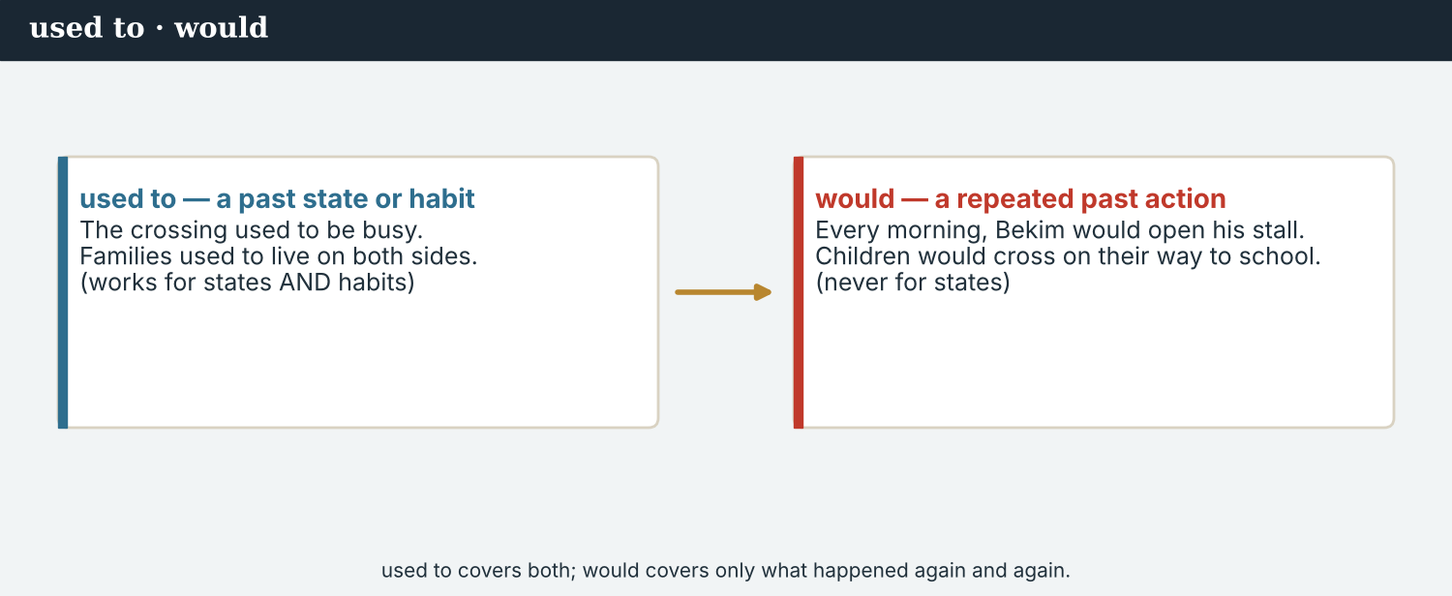
used to — a past state that is not true now; would — a repeated action.
1 · used to — how things were
Form: used to + verb. The bridge used to be closed. Families used to live on both sides.
For a past state or habit that is not true now.
Negative: It didn’t use to be busy. Question: Did it use to be quiet?
2 · would — what happened again and again
Form: would + verb. Every morning, Bekim would open his stall.
For a repeated past action — something that happened again and again.
Not for states: say it used to be closed, NOT it would be closed.
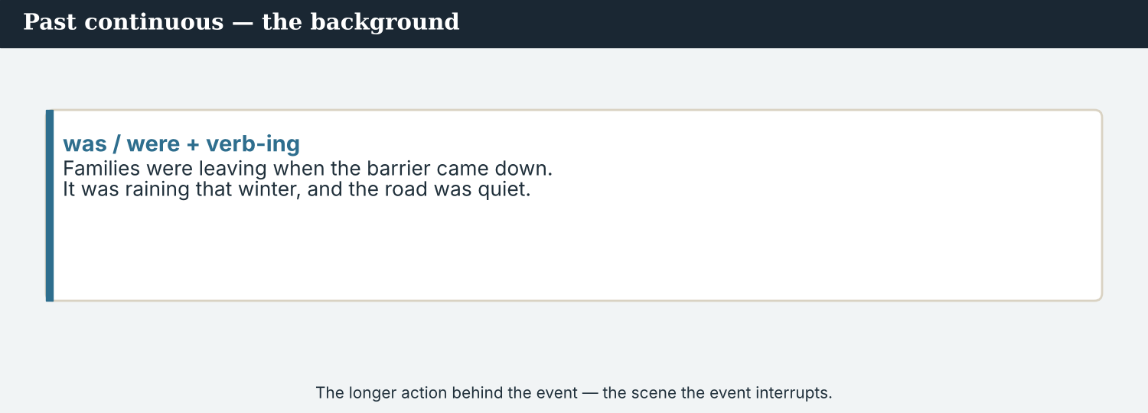
past continuous = the longer background; past simple = the event.
3 · past continuous — the background
Form: was / were + verb-ing. The families were leaving when the barrier came down.
For a longer background action, often interrupted by a past-simple event.
Set the scene: “It was raining, and the road was quiet.”
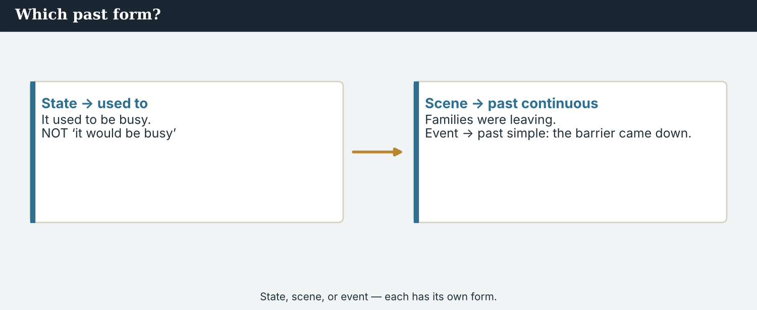
State, scene, or event — each has its own form.
PRACTISE Structured practice
2A Complete with used to (+ or –).
1. The bridge ___________ (be) full every morning.
2. The road ___________ not (be) empty.
3. Families ___________ (live) on both sides.
4. It ___________ not (be) quiet like this.
2B used to or would? (Remember: would is not for states.)
1. Bekim ___________ open his stall at dawn. (repeated action)
2. The bridge ___________ be busy. (state)
3. Children ___________ cross on their way to school. (repeated action)
4. There ___________ be a school on the far side. (state)
2C Complete with the past continuous (was/were + -ing).
1. The families ___________ (leave) when the barrier came down.
2. It ___________ (rain) that winter, and the road was quiet.
3. People ___________ (pack) their things all week.
2D Join with when. Use the past continuous and the past simple.
1. the families / leave // the barrier / come down → ________________________
2. Mira / write / the backstory // Omar / call → ________________________
Your own words
2E Write two things your town used to be like. Use used to.
1. ________________________
2. ________________________
2F Write two things you would do as a child (repeated actions). Use would.
1. ________________________
2. ________________________
2G Rewrite the sentence correctly (used to / would / past continuous).
1. The bridge would be busy every day. → ________________________
2. When the barrier came down, families left slowly for months. (use the past continuous) → ________________________
2H Your own words. Describe one memory: what was happening, and what used to be true then.
1. ________________________

PART 3 Giving good background
Before a partner can tell the story, you give them the backstory — in order, and fairly.
The crossing today. The backstory is everything this place was before the barrier came down.
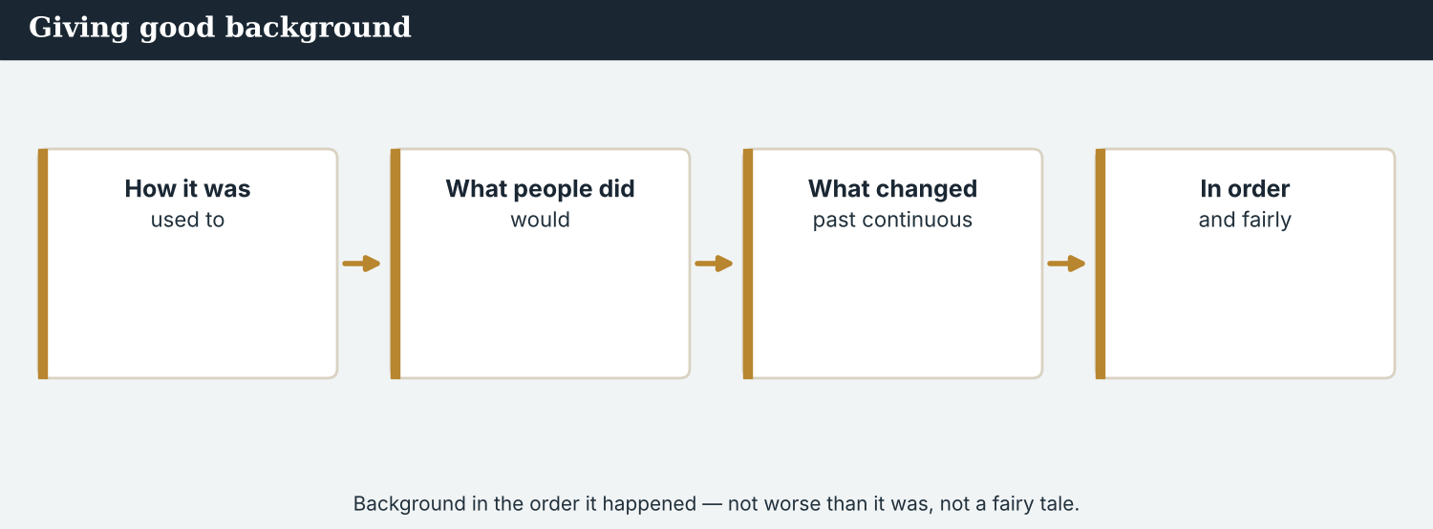
Good background gives the story in order: what came before, and when.
MODEL A model backstory
“Here is the backstory. Kalina used to be one of the busiest crossings on the river. Every morning, stall-holders would set up before dawn, and children would cross to the school on the far side. Then, over one hard winter, things changed. Families were leaving, week by week, and when the barrier finally came down, the valley went quiet. For seven years it stayed that way. That quiet is the background — without it, you cannot see how far the return has come.”
NOTICE Notice the background
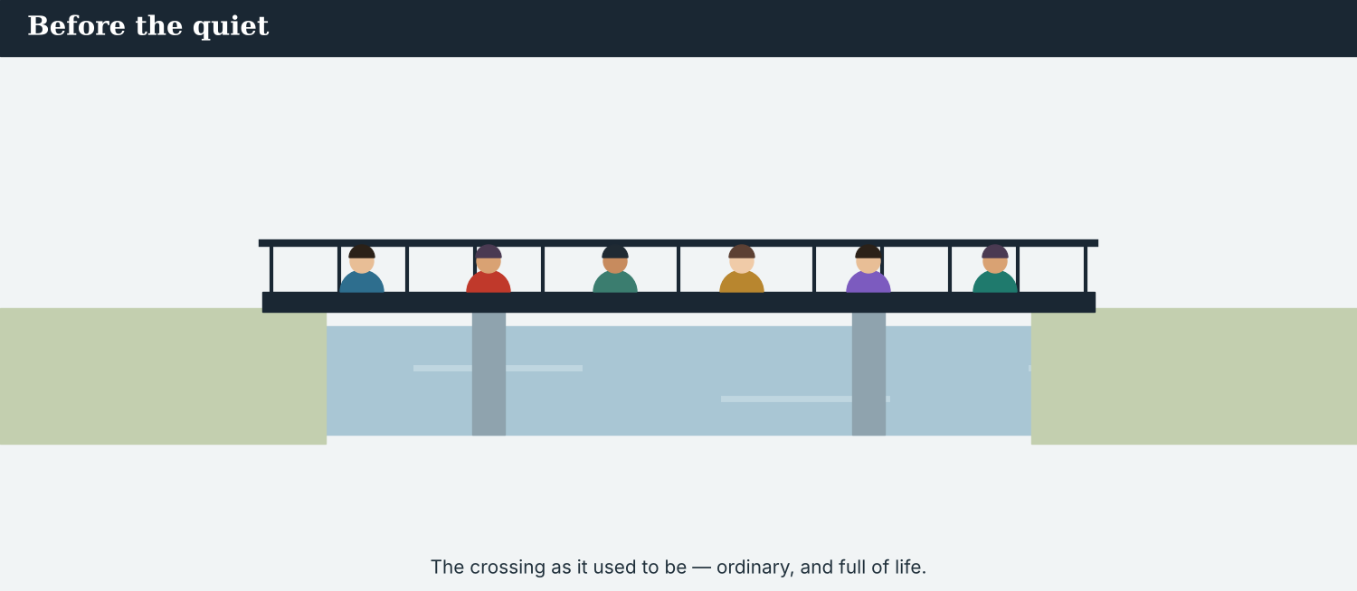
The backstory shows what a place used to be — and how far it has come.
3A Answer about the model.
1. What did Kalina use to be? ___________
2. What would the stall-holders do every morning? ___________
3. What was happening when the barrier came down? ___________
3B Find one ‘used to’, one ‘would’, and one past-continuous verb in the model. Write them.
1. ________________________
PRACTISE Build the background
Good background answers: how was it before, and when did it change?
3C Write the sentence with used to, would, or the past continuous.
1. the crossing / be / busy (past state) → ________________________
2. children / cross / to school (repeated action) → ________________________
3. the families / leave (background, when the barrier came down) → ________________________
3D Complete the backstory. Use: used to · would · were · came.
The bridge ______ be full. Stall-holders ______ set up at dawn. Then families ______ leaving, and when the barrier ______ down, the valley went quiet.
PRACTISE One more
3E Put the backstory in order. Number the sentences 1–4.
1. The valley went quiet for seven years. ______
2. The crossing used to be busy. ______
3. Families were leaving, and the barrier came down. ______
4. Last spring, the families began to return. ______
PRODUCE Your turn
3F Choose a place you know. Write a short backstory (4–5 sentences): how it used to be (used to), what people would do (would), and what was happening when it changed (past continuous).
________________________
________________________
________________________
________________________
PRODUCE Discuss
3G Talk with a partner. Why must a backstory be in order for a reader who was not there?
3H Why is ‘would’ wrong for a state (e.g. ‘the bridge would be closed’)? Give the correct sentence.
3I Discuss. Think of a place that has changed a lot. Give its backstory in three sentences.

PART 4 Listening: briefing the editor
Two audios. Listen for the backstory, and for a resident’s memory.
An editor abroad needs the backstory. Mira briefs Omar.
Listening A · Mira briefs Omar
MODEL Audio 2.1 — Mira and Omar
Omar: Mira, thank you for the brief. Before I edit, I need the backstory.
Mira: Of course. Kalina used to be one of the busiest crossings on the river.
Omar: And the people?
Mira: Families used to live on both sides. Every morning, stall-holders would set up before dawn, and children would cross to the school.
Omar: So what changed?
Mira: Over one hard winter, families were leaving, week by week. When the barrier finally came down, the valley went quiet.
Omar: For how long?
Mira: Seven years. That quiet is the background. Without it, the return does not mean much.
Omar: I understand now. One more thing — who should I ask for the human side?
Mira: Dren, at Kalina Daily. He grew up there. He remembers what I only read about.
PRACTISE Listen for detail
4A Before you listen: what backstory do you think Mira will give? Write one idea.
1. ______
4B Answer the questions.
1. What did Kalina use to be? ___________
2. What would the stall-holders do? ___________
3. What was happening over that hard winter? ___________
4. How long did the valley stay quiet? ___________
4C used to, would, or past continuous? Write U, W, or PC.
1. “Kalina used to be one of the busiest crossings.” ______
2. “Children would cross to the school.” ______
3. “Families were leaving, week by week.” ______
4D Complete the notes.
Used to be: ___________
People would: ___________
What was happening when it changed: ___________
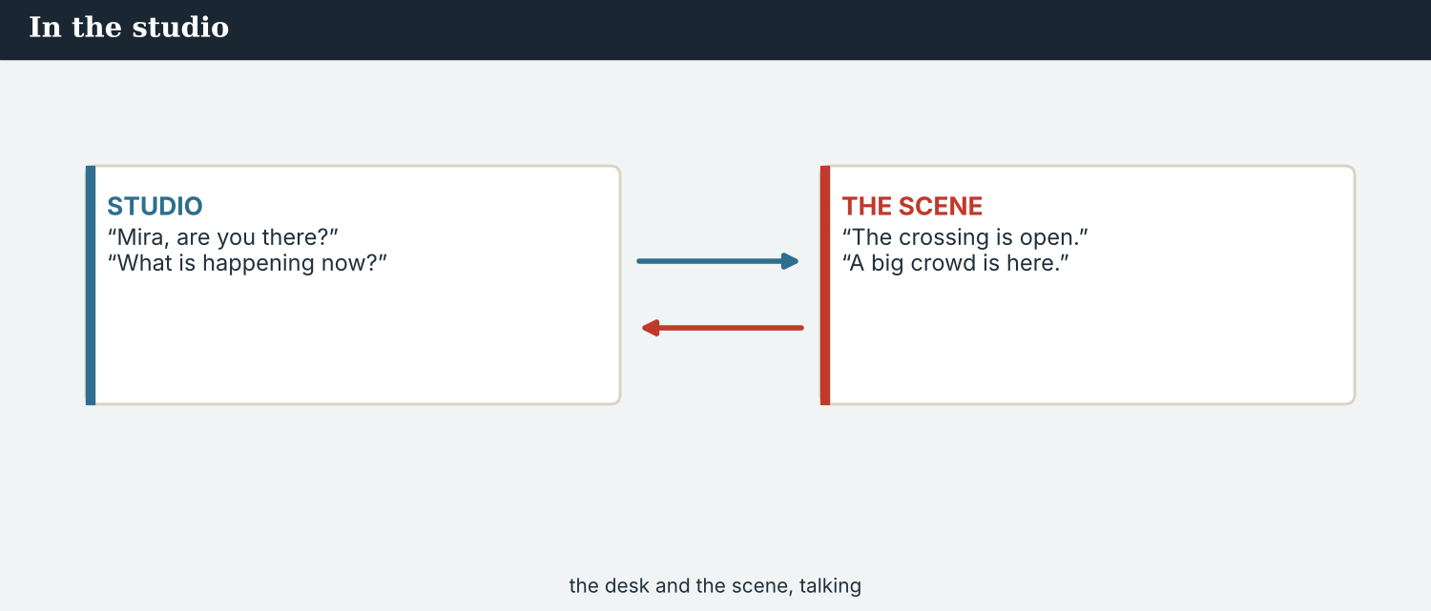
Audio 2.2 — an old stall-holder recalls how it used to be.
Listening B · a resident remembers
MODEL Audio 2.2 — Bekim
Dren: Bekim, you have worked on this bridge all your life. What was it like, back then?
Bekim: Ah, in those days the bridge never slept. I used to open my stall before the sun.
Dren: Every day?
Bekim: Every day. I would sweep the boards, and my neighbour would bring me coffee from the far side.
Dren: And when things changed?
Bekim: It was slow. People were leaving quietly. One winter, I was sweeping the boards, and I looked up — the bridge was empty.
Dren: That must have been hard.
Bekim: It was. But now the children are back. This morning, I was setting up, and I heard them again. The sound had come home.
PRACTISE Listen for detail
4E Before you listen: what do you think Bekim will remember? Guess.
1. ______
4F Complete the answers.
1. Bekim ___________ (use to) open his stall before the sun.
2. He ___________ (would) sweep the boards every day.
3. One winter he was sweeping when he saw the bridge was ___________ .
4. Now, when he sets up, he ___________ the children again.
4G Which forms do you hear? Write one ‘used to’, one ‘would’, and one past-continuous phrase.
1. ________________________
4H Answer. What does Bekim mean by ‘the sound had come home’?
1. ________________________
PRACTISE Both audios
4I Complete the summary. Use: used to · would · leaving · quiet.
The crossing ______ be busy; stall-holders ______ set up at dawn. Then families were ______ , and for seven years the valley was ______ . Now the children are back.
4J A resident’s memory is powerful background. Why is it stronger than a list of facts?
1. ________________________
PRODUCE What do you think?
4K Complete the note comparing the two audios.
Mira’s brief gives: ___________
Bekim’s memory adds: ___________
4L Discuss. If you were Omar, which would help you more — the brief or the memory? Why not both?

PART 5 Reading: the way it was
Two readings. Read for the backstory, and for how to give good background.
A backstory feature — the valley, before the story we know.
Reading A · the backstory: how the crossing used to be
Before the quiet: a short history of the Kalina crossing
To understand the reopening of the Kalina crossing, you have to know the bridge as it used to be. For years, this was one of the busiest crossings on the river. It was never rich, but it was full of life, and everyone knew everyone on both banks.
In those days, the market on the bridge opened before the sun. Stall-holders like Bekim would arrive at dawn, set out the boxes, and sweep the boards. By seven, the crossing was loud with sellers and buyers from both sides. Children would cut across on their way to the school on the far bank, and old men would sit outside the café at the end of the bridge, as they had for thirty years.
Then, over one hard winter, things began to change. Families were leaving, quietly at first, and then in greater numbers. Stalls closed one by one. “I remember it clearly,” Bekim says. “One morning I was sweeping the boards, and I looked up. The bridge was empty. I had never seen it empty before.”
When the barrier finally came down, the valley went quiet, and it stayed quiet for seven years. The café shut. Grass grew between the stones at the end of the bridge. For a long time, Kalina was a place people remembered rather than a place people crossed.
That is the backstory, and it is not decoration: it matters. The crossing that reopened last spring did not open in an empty history; it opened where a whole life used to be. When a hundred families return, the number means little on its own. It means a great deal when you know how many left, and how long the valley waited. The past is not just background. It is the reason the present is news.
PRACTISE Comprehension
5A Before you read: look at the title. Why would a reader need to know ‘how the crossing used to be’? Write one sentence.
1. ______
5B True or false? Write T or F.
1. The crossing used to be one of the busiest on the river. ______
2. The market used to open late in the day. ______
3. The families all left in a single week. ______
4. The valley stayed quiet for seven years. ______
5C Answer the questions.
1. What would stall-holders do at dawn? ___________
2. What was Bekim doing when he saw the empty bridge? ___________
3. Why does the number ‘a hundred families’ matter more with the backstory? ___________
5D Find a word or phrase in the text.
1. at that time in the past → ___________
2. with no people → ___________
3. the facts behind a story → ___________
The backstory is what lets a distant reader feel the weight of the news.
Reading B · good background: what an editor abroad needs
Four rules for good background
1. Use used to for how things were. Past states and habits that are not true now: ‘The market used to be busy.’
2. Use would for what people did again and again. Repeated actions: ‘Every morning, he would open his stall.’ (But not for states.)
3. Use the past continuous to set the scene. A longer background, often broken by an event: ‘Families were leaving when the barrier came down.’
4. Keep it fair and in order. Give the background in the order it happened, and never make the past worse or better than it was to make today bigger. Where you can, take it from someone who was there — and say who.
PRACTISE Comprehension
5E Before you read: which form is for a repeated past action — used to or would? Guess.
1. ______
5F Match the rule to the example.
1. used to  2. would  3. past continuous  4. keep it fair | a) ‘Every morning, he would open his stall.’  b) ‘Families were leaving when it closed.’  c) ‘The market used to be busy.’  d) do not make the past sound worse than it was
5G Which rule is about honesty, not grammar? Write the number.
1. ______
PRACTISE Words from the readings
5H Find a word in Reading A or Reading B.
1. with little noise or activity → ___________
2. to come back → ___________
3. a reporter who files from another place → ___________
PRACTISE Both readings
5I Complete the sentence with used to, would, or the past continuous.
1. The café ___________ (be) open all day. (state)
2. Old men ___________ (sit) outside every afternoon. (repeated action)
3. The river ___________ (run) high when the children crossed. (background)
PRODUCE Discuss
5J Talk about it. Reading A says ‘the past is the reason the present is news’. What does this mean?
5K Which of the four background rules is the hardest to follow? Say why.
5L Discuss. Bekim’s memory of the empty bridge is one image. Why is one strong image good background?

PART 6 Writing: a backstory brief
Two short pieces: a background brief, and a short backstory paragraph.
A brief gives the key background in a few clear lines.
Writing 1 · a background brief
MODEL A model
Used to be: one of the busiest crossings on the river
People would: set up stalls at dawn; children crossed to school
What changed: families were leaving; the barrier came down one winter
Then: quiet for seven years, until the reopening last spring
NOTICE Notice the model
6A Answer about the model.
1. Which line uses used to? ___________
2. Which line uses the past continuous? ___________
PRODUCE Write your brief
6B Choose a place. Write a background brief: used to be, people would, what changed (past continuous), and then.
Used to be: ___________
People would: ___________
What changed: ___________
Then: ___________
A backstory paragraph turns the brief into readable prose.
Writing 2 · a backstory paragraph
MODEL A model
Kalina used to be one of the busiest crossings on the river. Every morning, stall-holders would set up at dawn, and children would cross to the school on the far bank. Then, over one hard winter, families were leaving, and the barrier came down. For seven years, the valley was quiet — and that quiet is why the return matters so much today.
NOTICE Notice the model
6C Answer. Find one ‘used to’, one ‘would’, and one past-continuous verb in the paragraph.
1. ___________
PRACTISE Complete the paragraph
6D Complete the backstory. Use: used to · would · were · came.
The bridge ______ be full of children. Old men ______ sit by the café. Then families ______ leaving, and when the barrier ______ down, the valley went quiet.
PRODUCE Write your paragraph
6E Turn your brief into a backstory paragraph (4–5 sentences). Use used to, would, and the past continuous.
________________________
________________________
________________________
PRACTISE Fix it
6F This uses ‘would’ wrongly (for states). Correct it with used to.
“The market would be busy, and the café would be open all day.”
________________________
PRACTISE Plan it
6G Plan a longer backstory. Write three notes: a past state (used to), a repeated action (would), and a scene (past continuous).
Used to: ___________
Would: ___________
Was happening: ___________
6H Peer-check. Swap with a partner. Did they use used to for states and would only for repeated actions? Write one note.
________________________

PART 7 Speaking: giving the backstory
Brief a partner on the backstory. Use used to, would, and the past continuous.
Give the backstory: how it was, what people did, what changed.
A model dialogue · briefing a colleague
MODEL Listen and read
Sofia: I’m writing the follow-up. Can you give me the backstory?
Mira: Sure. The crossing used to be one of the busiest on the river.
Sofia: And daily life?
Mira: Every morning, stall-holders would set up early, and children would cross to school.
Sofia: What changed?
Mira: Families were leaving over one hard winter, and when the barrier came down, the valley went quiet.
Sofia: For how long?
Mira: Seven years. That is why the reopening is such big news now.
NOTICE Notice the forms
7A Find one ‘used to’, one ‘would’, and one past-continuous sentence. Write them.
1. ________________________
PRACTISE Controlled practice
7B Answer with used to, would, or the past continuous.
1. What / the crossing / use to / be? → ___________
2. What / stall-holders / would / do? → ___________
3. What / happen / when the barrier / come down? → ___________
Introduce the backstory before you tell today’s news.
7C Make a ‘used to’ question, then answer it.
1. the bridge / be / busy → ________________________
2. a school / be / on the far bank → ________________________
PRODUCE Your role
Correspondent | Give the backstory: what the place used to be, what people would do, and what was happening when it changed.
New colleague | Ask: ‘What did it use to be like?’ and ‘What changed?’
Observer | Listen. Did the correspondent use used to for states and would only for repeated actions?
7D Choose a role from the table. Brief your partner on a backstory.
PRODUCE Role-play
7E Role-play a briefing: a correspondent, a new colleague, and an observer. Then swap roles.
A second dialogue · briefing an editor abroad
MODEL Listen and read
Omar: Mira, I have your brief, but I want the human side. What was it like?
Mira: You should hear it from Dren — he grew up there. But the short version: there was an old stall-holder, Bekim. He used to open before the sun.
Omar: Every day?
Mira: Every day. He would sweep the boards while his neighbour brought coffee. Then, one winter, he was sweeping and looked up — the bridge was empty.
Omar: That is the image I needed. Thank you.
Mira: Use it well — and keep it true. It was ordinary life, not a fairy tale. And put Dren’s name on it; it is his town.
PRACTISE Controlled practice
7F Write the past-continuous sentence Mira uses about Bekim and the empty bridge.
1. ________________________
PRODUCE Self-check
Did I… | Yes | Almost | Not yet
use used to for past states? | ☐ | ☐ | ☐
use would only for repeated actions? | ☐ | ☐ | ☐
use the past continuous to set a scene? | ☐ | ☐ | ☐
give the backstory in order, and fairly? | ☐ | ☐ | ☐
7G Role-play briefing an editor abroad. Give the backstory and one human memory. Then swap roles.
PRACTISE Plan it
7H Plan your briefing. Note one used-to fact, one would action, and one past-continuous scene.
7I Discuss. How would you brief a foreign editor on the backstory of your own town, in four sentences?

PART 8 Ethics: a fair backstory
The past is powerful. A fair backstory tells it as it was — not worse, and not like a fairy tale.
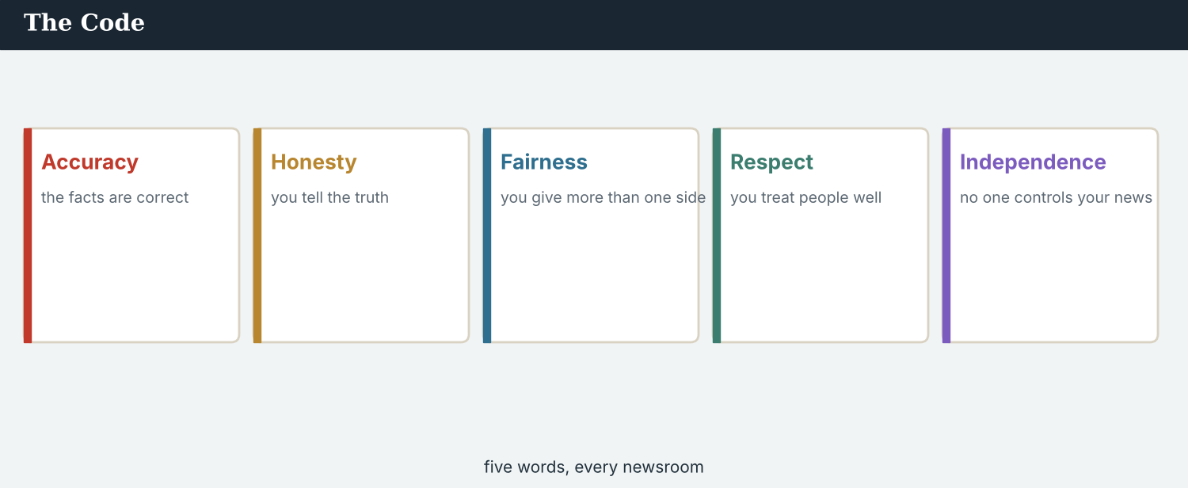
The Code applies to the past as much as to today: the backstory must be accurate, honest and fair.
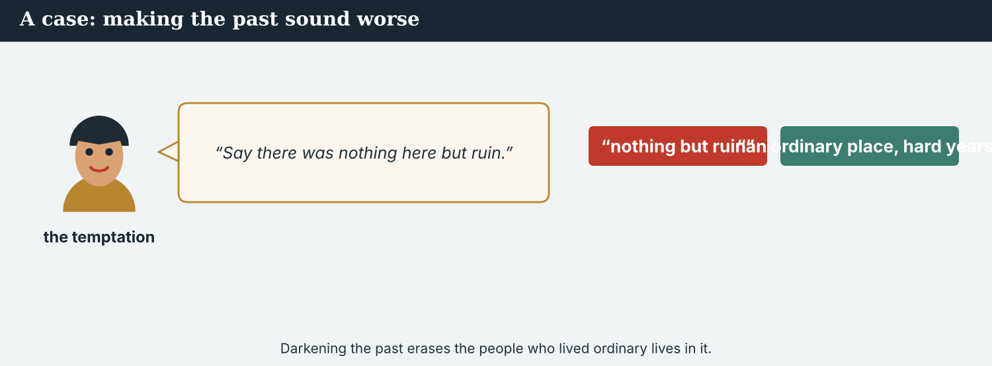
A backstory can be true, or it can be shaped to make today look bigger.
A first case · making the past sound worse
A case. Mira wants the reopening to feel like a triumph, so she is tempted to darken the backstory: to write that the valley ‘used to be a place of nothing but fear and ruin.’ It would make the recovery look bigger. But it is not true. The valley used to be poor, yes, and the quiet years were real — but before them it was an ordinary, living place, full of small joys: children crossing to school, coffee carried over the bridge at dawn, neighbours on two banks who knew each other. To paint the past as ‘nothing but ruin’ would erase those people and their ordinary lives, just to make a brighter headline today. The Code says: report the past as it was. What does Mira write?
NOTICE What do you do?
8A Choose (a) or (b), and write one reason.
1. (a) ‘a place of nothing but fear and ruin’ (b) ‘an ordinary, living crossing that went through hard years’. Choice: ______ Because ________________________
2. Darkening the past to make today look bigger is (a) fair (b) not fair. Choice: ______
8B Fair background, or shaped? Write F or S.
1. ‘The market used to be busy every morning.’ ______
2. ‘There was nothing here but fear.’ ______
3. ‘Children used to cross to the school.’ ______
4. ‘The valley was a ruin with no life at all.’ ______
PRACTISE Apply the Code
8C Complete the rule. Use: was · fair · bigger · order.
Tell the past as it ______ . Keep it ______ , and in ______ . Do not darken it to make today’s story ______ .
PRODUCE Discuss
8D Discuss. Why does erasing the ordinary good of the past also hurt the people who lived it?
A second case · the fairy-tale angle
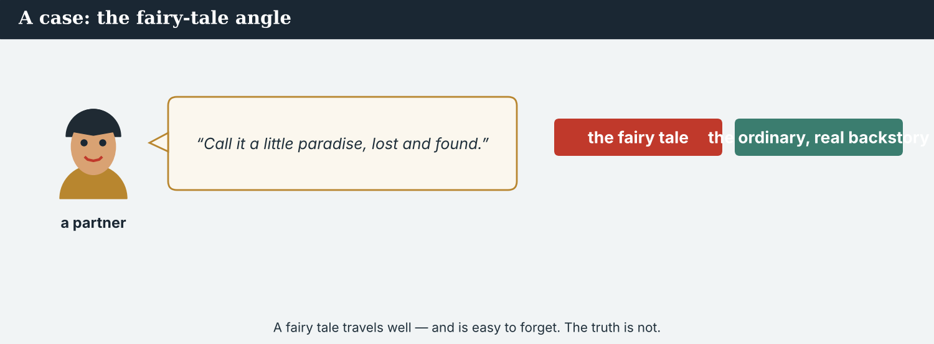
A partner abroad may want a simpler, prettier past. Keep it true.
A case. Omar’s own editor at the Meridian Post loves the backstory, but suggests a softer, prettier version for an international audience: ‘the little paradise that was lost and found again.’ It is warm and it would travel well. But it is not quite true. Kalina was never a paradise; it was an ordinary crossing, sometimes hard, made of real people. ‘Paradise lost’ turns them into a fairy tale, and a fairy tale is easy to forget. The Post’s reach is real, and Mira wants the story to travel — but the people in it deserve to be seen as they were, and Dren, who grew up there, would not recognise the place in that sentence. The Code says: keep it true, even when a prettier version would please a partner. What does Mira tell Omar?
NOTICE What do you do?
8E Choose (a) or (b), and write one reason.
1. (a) the ‘little paradise’ fairy tale (b) the ordinary, real backstory. Choice: ______ Because ________________________
2. A fairy-tale past is (a) easy to remember and true (b) easy to forget and not true. Choice: ______
8F Complete with: true · real · ordinary · fairy tale.
1. The valley was an ___________ place, not a paradise.
2. A ___________ is easy to forget.
3. Keep the backstory ___________ .
4. The people in it were ___________ .
PRODUCE Discuss
8G Discuss. Why does an honest, ordinary backstory respect people more than a beautiful, false one?
PRODUCE Write it
8H Write two sentences of true backstory for Omar — warm and human, but not a fairy tale. Use used to and would.
PRACTISE One more
8I True, shaped, or fairy tale? Write T, S, or FT.
1. ‘Neighbours used to carry coffee across the bridge.’ ______
2. ‘It was a perfect little paradise.’ ______
3. ‘There was nothing here but ruin.’ ______
4. ‘Children would cross to school each morning.’ ______
8J Discuss. A partner’s bigger audience is tempting. Why is keeping the past true worth more than a version that travels?

PART 9 Digital: a ‘then and now’ thread
Online, a ‘then and now’ post shares the backstory — in a line, and true.
A ‘then and now’ post — how it used to be, and how it is.
MODEL A model post
THEN AND NOW · Kalina used to be one of the busiest crossings on the river. Stall-holders would set up at dawn. Then families were leaving, and the barrier came down. Today, the children are back. — @AtlasWire with @KalinaDaily
NOTICE The parts of the post
9A Match the part to the form.
1. used to be one of the busiest  2. Stall-holders would set up at dawn  3. families were leaving  4. the children are back | a) past continuous (the scene)  b) used to (a past state)  c) present (today)  d) would (a repeated action)
PRACTISE Find and build
9B Find one ‘used to’, one ‘would’, and one past-continuous verb in the post. Write them.
1. ________________________
9C This post uses ‘would’ wrongly. Correct it with used to.
“The market would be busy, and there would be a school on the far bank.”
________________________
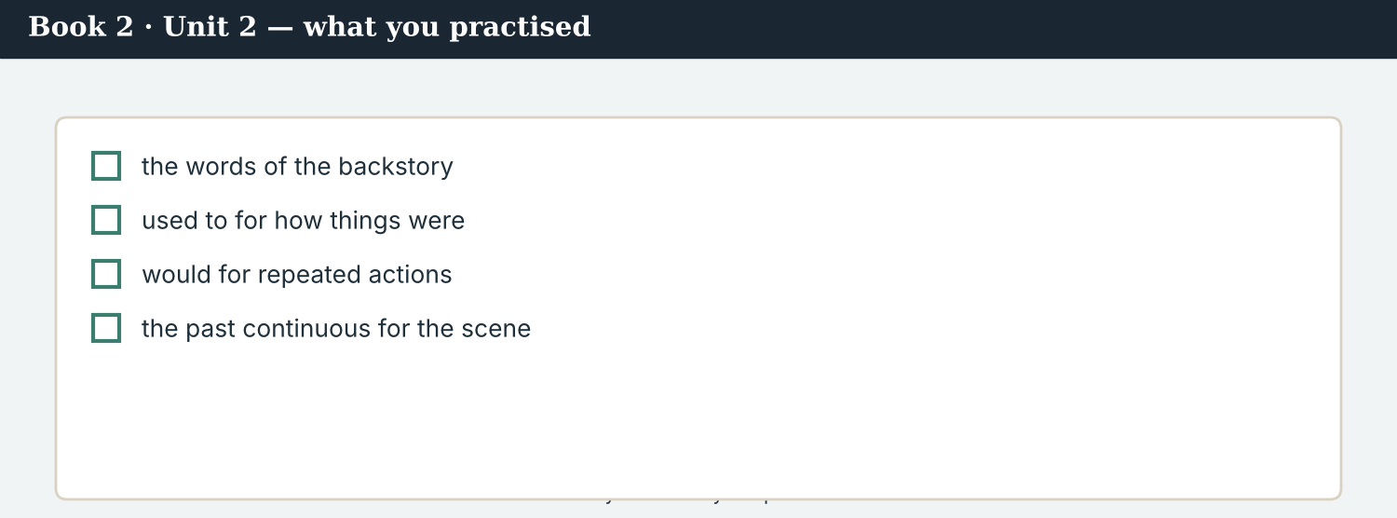
A good ‘then and now’ answers: how was it, and how is it now?
9D Write a ‘then and now’ post. Use one used to, one would, and one past-continuous verb.
THEN AND NOW · ___________ (used to). ___________ (would). ___________ (past continuous). — @AtlasWire
PRODUCE Write your post
9E Write a one-line ‘then and now’ post about a place you know. Use used to.
________________________
9F Creative. Write a short headline (4–6 words) for a ‘then and now’ backstory.
9G A reader abroad asks: ‘What was it like before?’ Write a short, true reply. Use used to and would.
________________________
9H A ‘then and now’ post can make the past look too dark or too golden. Write one line that stays fair.
________________________
PRODUCE Discuss
9I Creative. Write a two-line thread: line 1 ‘then’ (used to / would), line 2 ‘now’ (present).
________________________
________________________
9J Discuss. A short ‘then and now’ post loses a lot of the backstory. What is gained, and what is lost?

PART 10 Review & Can-Do
Check your new English before Unit 3.
Then and now — how the crossing used to be, and how it is.
10A Vocabulary. Complete with: background · context · backstory · brief · correspondent · recall · no longer · quiet.
1. Omar needs the ___________ before he edits.
2. Good ___________ helps a reader understand.
3. The ___________ is what happened before.
4. Mira wrote a short ___________ for him.
5. Omar is a ___________ turned editor.
6. Old residents ___________ how it was.
7. The road is ___________ empty.
8. For seven years, the valley was ___________ .
10B Grammar. Complete with used to (+ or –).
1. The market ___________ (be) full every morning.
2. It ___________ not (be) empty like this.
3. Families ___________ (live) on both sides.
4. There ___________ (be) a café at the end of the bridge.
10C Grammar. used to or would?
1. Bekim ___________ open his stall at dawn. (repeated action)
2. The crossing ___________ be busy. (state)
3. Children ___________ cross to the school. (repeated action)
Can-Do — tick what you can do now.
10D Grammar. Complete with the past continuous.
1. The families ___________ (leave) when the barrier came down.
2. It ___________ (rain) that winter.
3. Bekim ___________ (sweep) the boards when he saw the empty bridge.
10E Read and answer.
Kalina used to be one of the busiest crossings on the river. Stall-holders would set up at dawn, and children would cross to the school. Then families were leaving, and the barrier came down. For seven years the valley was quiet — and that is why the return is such news.
1. What did the crossing use to be? ___________
2. What would the stall-holders do? ___________
3. What was happening before the barrier came down? ___________
Can-Do — tick what you can do now
☐ I can describe how things used to be (used to).
☐ I can talk about repeated past actions (would).
☐ I can use the past continuous for background.
☐ I can give the backstory to a colleague abroad.
10F Reflect. Which part of Unit 2 was the most useful for you? Why?
10G Grammar review. Write the sentence correctly.
1. The market would be busy in those days. → ________________________
2. Children used to crossing to the school. → ________________________
3. The families leaving when the barrier came down. → ________________________
4. It use to be quiet here. → ________________________
10H Mixed review. Complete with used to, would, or the past continuous.
1. The café ___________ (be) open all day.
2. Old men ___________ (sit) by the bridge every afternoon.
3. The river ___________ (run) high when the children crossed.
10I Reflect. Write one sentence about how your own town used to be. Use used to.

PART 11 Assignment: a backstory brief
Put the unit together: write the backstory for a partner abroad.
The assignment template — your backstory brief.
Your task. An editor abroad is going to publish a story you know, and needs the backstory. Write a short backstory brief (6–7 sentences). Say how the place used to be (used to), what people would do (would), and what was happening when it changed (past continuous). Add one human memory, and name the person it came from. Keep it true and in order — not worse than it was, and not a fairy tale.
A model — use Reading A to check the shape of your brief.
Remember: used to for past states; would only for repeated actions; the past continuous for the scene; give it in order; keep it fair and human; name whoever remembers it.
Success criteria | Yes | Almost | Not yet
I use used to for how things were. | ☐ | ☐ | ☐
I use would only for repeated actions. | ☐ | ☐ | ☐
I use the past continuous to set a scene. | ☐ | ☐ | ☐
I add one true, human memory, with a name. | ☐ | ☐ | ☐
It is fair and in order — not darkened, not a fairy tale. | ☐ | ☐ | ☐
Keep this. In Unit 3, you plan the coverage ahead — the future forms (will, going to, present continuous) — to arrange a joint project across time zones.

ANSWER KEY Book 2 · Unit 2
Check your answers. Open tasks (discussion, role-play and your own writing) are marked at the end.
W1 1 full every morning · 2 open his stall at dawn and sweep the boards · 3 the road was emptying (week by week)
W2 1 F (it used to be full) · 2 T · 3 T
W3 used to: ‘used to be full’ · would: ‘would open his stall’ · past continuous: ‘was emptying’
1A 1-b, 2-c, 3-a, 4-d, 5-e, 6-f, 7-g, 8-h, 9-i, 10-j (accept sensible matches)
1B 1 background · 2 backstory · 3 brief · 4 context · 5 correspondent · 6 recall
1C 1 give the background · 2 provide context · 3 brief a correspondent · 4 recall a memory · 5 search an archive
1D 1 busy · 2 deadline · 3 recover · 4 rumour
1E 1 used to · 2 quiet · 3 returned · 4 context · 5 backstory
1F 1 backstory · 2 correspondent · 3 no longer · 4 brief
1G background · brief · archive · context · memory
1J 1 quiet · 2 empty · 3 busy · 4 rebuild · 5 return
2A 1 used to be · 2 didn’t use to be · 3 used to live · 4 didn’t use to be
2B 1 would · 2 used to · 3 would · 4 used to
2C 1 were leaving · 2 was raining · 3 were packing
2D 1 The families were leaving when the barrier came down. · 2 Mira was writing the backstory when Omar called.
2G 1 The bridge used to be busy every day. · 2 When the barrier came down, families were leaving (for months).
3A 1 one of the busiest crossings on the river · 2 set up before dawn · 3 families were leaving (the valley went quiet)
3B used to: ‘used to be one of the busiest’ · would: ‘would set up before dawn’ · past continuous: ‘families were leaving’
3C 1 The crossing used to be busy. · 2 Children would cross to school. · 3 The families were leaving when the barrier came down.
3D used to · would · were · came
3E 1 The crossing used to be busy. · 2 Families were leaving, and the barrier came down. · 3 The valley went quiet for seven years. · 4 Last spring, the families began to return.
3H ‘would’ is only for repeated actions, not states. Correct: ‘The bridge used to be closed.’
4B 1 one of the busiest crossings on the river · 2 set up before dawn (children crossed to school) · 3 families were leaving · 4 seven years
4C 1 U · 2 W · 3 PC
4D Used to be = one of the busiest crossings · People would = set up stalls / children crossed · What was happening = families were leaving
4F 1 used to · 2 would · 3 empty · 4 hears
4G used to: ‘used to open’ · would: ‘would sweep’ · past continuous: ‘was sweeping’ / ‘were leaving’
4I used to · would · leaving · quiet
4J because a memory gives a real image and feeling, which a reader far away can picture and remember
4K brief = the ordered facts (used to / would / what changed) · memory = one human image (the empty bridge)
5B 1 T · 2 F · 3 F · 4 T
5C 1 arrive at dawn, set out the boxes, sweep the boards · 2 sweeping the boards · 3 it shows how much was lost and how long the valley waited
5D 1 in those days · 2 empty · 3 background
5F used to → ‘The market used to be busy.’ · would → ‘he would open his stall.’ · past continuous → ‘Families were leaving when it closed.’ · keep it fair → do not make the past sound worse than it was
5G Rule 4
5H 1 quiet · 2 return · 3 correspondent
5I 1 used to be · 2 would sit · 3 was running
6A 1 ‘Used to be: one of the busiest crossings…’ · 2 ‘families were leaving’ (What changed)
6C used to: ‘used to be one of the busiest’ · would: ‘would set up at dawn’ · past continuous: ‘families were leaving’
6D used to · would · were · came
6F ‘The market used to be busy, and the café used to be open all day.’
7A used to: ‘used to be one of the busiest’ · would: ‘would set up early’ · past continuous: ‘families were leaving’
7B 1 It used to be one of the busiest on the river. · 2 They would set up early. · 3 Families were leaving when it came down.
7C 1 Did the bridge use to be busy? — (answer) · 2 Did a school use to be on the far bank? — (answer)
7F ‘he was sweeping (the boards) and looked up, and the bridge was empty’
8A 1 (b) ‘an ordinary, living crossing that went through hard years’ · 2 (b) not fair
8B 1 F · 2 S · 3 F · 4 S
8C was · fair · order · bigger
8E 1 (b) the ordinary, real backstory · 2 (b) easy to forget and not true
8F 1 ordinary · 2 fairy tale · 3 true · 4 real
8I 1 T · 2 FT · 3 S · 4 T
9A ‘used to be one of the busiest’ → used to · ‘Stall-holders would set up at dawn’ → would · ‘families were leaving’ → past continuous · ‘the children are back’ → present
9B used to: ‘used to be’ · would: ‘would set up’ · past continuous: ‘were leaving’
9C ‘The market used to be busy, and there used to be a school on the far bank.’
10A 1 background · 2 context · 3 backstory · 4 brief · 5 correspondent · 6 recall · 7 no longer · 8 quiet
10B 1 used to be · 2 didn’t use to be · 3 used to live · 4 used to be
10C 1 would · 2 used to · 3 would
10D 1 were leaving · 2 was raining · 3 was sweeping
10E 1 one of the busiest crossings on the river · 2 set up at dawn (and children crossed) · 3 families were leaving
10G 1 The market used to be busy in those days. · 2 Children used to cross to the school. · 3 The families were leaving when the barrier came down. · 4 It used to be quiet here.
10H 1 used to be · 2 would sit · 3 was running
Open tasks W4, W5, 1H, 1I, 1K, 2E, 2F, 2H, 3F, 3G, 3I, 4A, 4E, 4H, 4L, 5A, 5E, 5J, 5K, 5L, 6B, 6E, 6G, 6H, 7D, 7E, 7G, 7H, 7I, 8D, 8G, 8H, 8J, 9D, 9E, 9F, 9G, 9H, 9I, 9J, 10F, 10I — your own answers (discussion, role-play, writing).
A note on real and invented content. The facts about journalism around the world in 2026 are true. Atlas Wire, Kalina Daily, the Meridian Post, their staff, Omar Faris, Dren, Bekim, Kalina and the story are invented, for practice. Real people and outlets are only ever in true, sourced facts — never in an invented quote.
English for Journalists — International Edition · Book 2 · Unit 2 (30-page standard). CEFR lower B1 → medium B1 · Beat: Feature & Across Borders · two readings · two listenings · two writing pieces · two ethics cases · two speaking dialogues · balanced sections · ~28 figures · featured cast + an editor abroad · fictional agency, factual backdrop.

BOOK 2 · UNIT 3 Planning the Coverage: What Happens Next
Beat · Planning & Across Borders CEFR lower B1 → medium B1
In this unit you learn to…
1. make plans and promises with will
2. talk about plans already made with going to
3. use the present continuous for fixed arrangements
4. plan a joint project across time zones
The Atlas Wire team — planning a project that will run in four countries at once.
Three outlets, one project. The backstory did its work: readers abroad now see why one crossing matters. So the story grows. Atlas Wire, Kalina Daily, the River Basin Network and the Meridian Post are going to cover the whole Vara basin together — the other crossings, what reopened and what did not. Four newsrooms, four clocks, one plan. (Atlas Wire, Kalina Daily, the River Basin Network and the Meridian Post are invented, for practice.)

WARM-UP The plan for the month
A short scene to start the unit. Read it, then answer.
The morning conference — four newsrooms, one plan, and a calendar on the wall.
“We are going to cover the whole basin,” Ana says, “not just Kalina.” She points at the calendar. “The kick-off call is on Thursday at two. Ines is joining from the River Basin Network, Omar from the Meridian Post, and Dren from Kalina Daily.”
Mira writes it down. “Two o’clock where?”
Ana smiles. “Two o’clock here is seven in the morning for Omar. I’ll move it to four. Dren is travelling on Thursday, so he will call in from the road.”
“And the deadline?”
“We are publishing on the last Sunday of the month. All four of us, the same hour.”
W1 Answer the questions.
1. What are the four newsrooms going to cover? ___________
2. When is the kick-off call? ___________
3. Who is joining from the Meridian Post? ___________
W2 True or false? Write T or F.
1. The project is only about Kalina. ______
2. Ana is going to move the call to four o’clock. ______
3. The four newsrooms are publishing on the same day. ______
W3 Find one ‘will’, one ‘going to’, and one present-continuous future in the text.
1. ________________________
PRODUCE Talk about it
W4 Discuss with a partner.
1. What are you going to do this week? Name two things.
2. What is one thing you are doing at a fixed time tomorrow?
PRODUCE One more
W5 Discuss. Why is a shared deadline difficult when partners are in four different time zones?

PART 1 The words of planning
The words for plans, dates and deadlines. Learn these first.
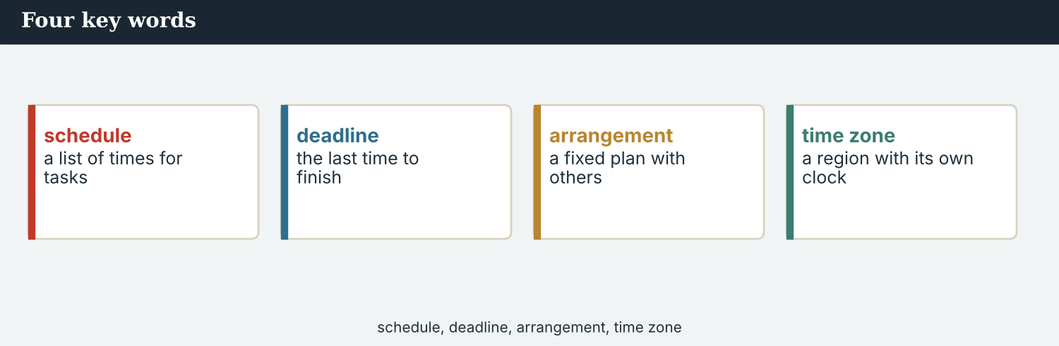
Four key words — plan, schedule, deadline, time zone.
The words
Word | Meaning
plan (n) | what you are going to do, and when
schedule | a list of times for the work
deadline | the time by which work must be finished
time zone | the local clock in one part of the world
coordinate | to make people’s work fit together
assignment | work given to a reporter
commission (v) | to ask someone to do work for you
pitch (v) | to offer an idea to an editor
draft (n) | an early version of a text
agree | to decide together
diary | the list of planned stories
slot | where and when a story will run
lead time | the time you need before publication
available | free to meet or to work
confirm | to say something is certain
kick-off | a project’s first meeting
milestone | a date when one part must be done
ahead | in front, in time or place
PRACTISE Controlled practice
1A Match the word (1–10) to the meaning (a–j).
1. plan  2. schedule  3. deadline  4. time zone  5. coordinate  6. pitch  7. draft  8. slot  9. lead time  10. milestone | a) a list of times for the work  b) what you are going to do, and when  c) the time by which work must be finished  d) the local clock in one part of the world  e) to make several people’s work fit together  f) to offer a story idea to an editor  g) an early version of a piece of writing  h) the place and time a story will run  i) the time you need before publication  j) a date when one part must be finished
1B Complete the sentences with a word from the box.
WORD BOX
plan · deadline · time zones · coordinate · kick-off · available
1. The four newsrooms have one ___________ for the basin.
2. Our ___________ is the last Sunday of the month.
3. The partners are in three different ___________ .
4. Someone has to ___________ four teams.
5. The ___________ call is on Thursday.
6. Dren is travelling, so he is not ___________ .
1C Match the two halves.
1. meet a  2. agree a  3. coordinate the  4. file a  5. book a | a) deadline  b) plan  c) coverage  d) draft  e) slot
1D Circle the word that is different.
1. plan · schedule · diary · rumour
2. deadline · milestone · slot · archive
3. agree · confirm · settle · refuse
4. commission · assign · pitch · delete
One newsroom, four clocks: the planning desk of a cross-border project.
1E Complete the paragraph. Use: plan · deadline · time zones · coordinate · milestones.
The partners agreed one ___________ , with three ___________ along the way and a single ___________ at the end. Because they work in different ___________ , one editor has to ___________ every call.
1F Read the definition. Write the word.
1. the first meeting of a project → ___________
2. free, able to meet or to work → ___________
3. an early version of a piece of writing → ___________
4. to say that something is certain → ___________
1G Complete the collocation paragraph. Use: pitch · commission · draft · slot · deadline.
Mira will ___________ the idea on Thursday. Omar is going to ___________ a photo essay. Dren is sending his first ___________ next week, the subeditors have kept a ___________ on page three, and nobody will miss the ___________ .
PRODUCE Over to you
1H Answer about you. Write full sentences.
1. What is your next deadline? What are you going to do before it?
2. Who coordinates the work in your team? How?
PRODUCE Talk about it
1I Discuss. Which two words in this unit are new for you? Make a sentence with one.
1J Complete with: agree · confirm · available · ahead · diary.
Put the call in the ___________ . Ana will ___________ the time by email, and the others will ___________ in writing. Dren is only ___________ after four. A week ___________ , and nothing is late.
1K Creative. Write two sentences about a plan for next month. Use going to and a time expression.

PART 2 Grammar: talking about the future
will for decisions and promises; going to for plans already made; the present continuous for fixed arrangements.
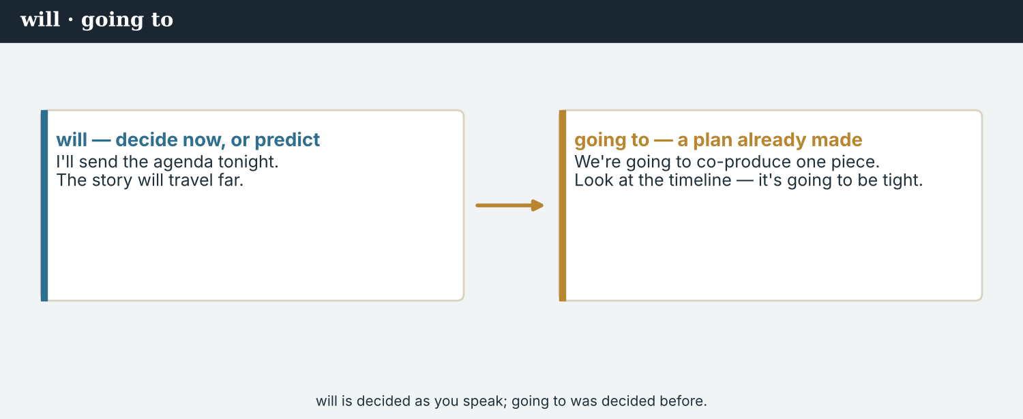
will — a decision at the moment of speaking; going to — a plan made before.
1 · will — decisions, promises, predictions
Form: will + verb. “I will move the call to four.” “It will take three weeks.”
For a decision made as you speak, a promise, an offer, or a prediction.
Negative: It won’t be ready. Question: Will you file by Friday?
2 · going to — a plan already made
Form: am / is / are going to + verb. “We are going to cover the whole basin.”
For a plan or intention decided before now — and for a prediction you can see coming.
Not a decision at the moment of speaking: for that, use will.
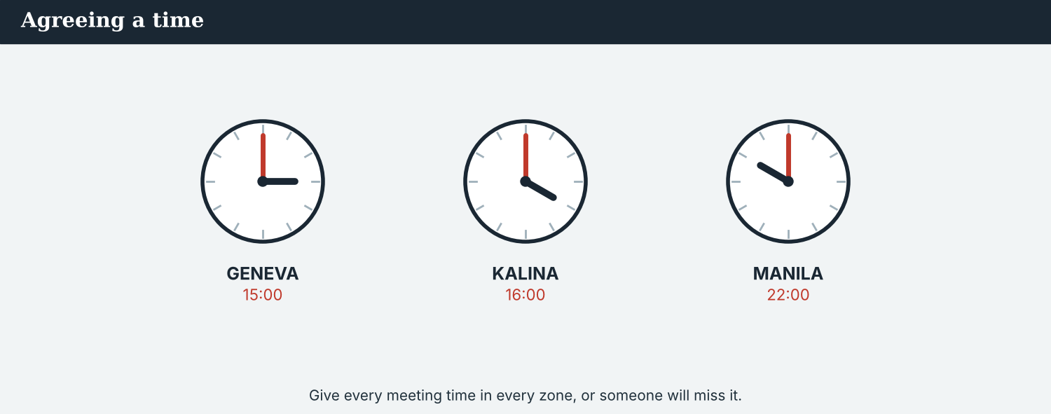
going to = the plan; present continuous = the plan with a time and a place.
3 · present continuous — a fixed arrangement
Form: am / is / are + verb-ing, with a future time. “We are publishing on Sunday.”
For an arrangement that is fixed: a time, a place, and other people who know.
“Ines is joining at four.” “Dren is travelling on Thursday.”
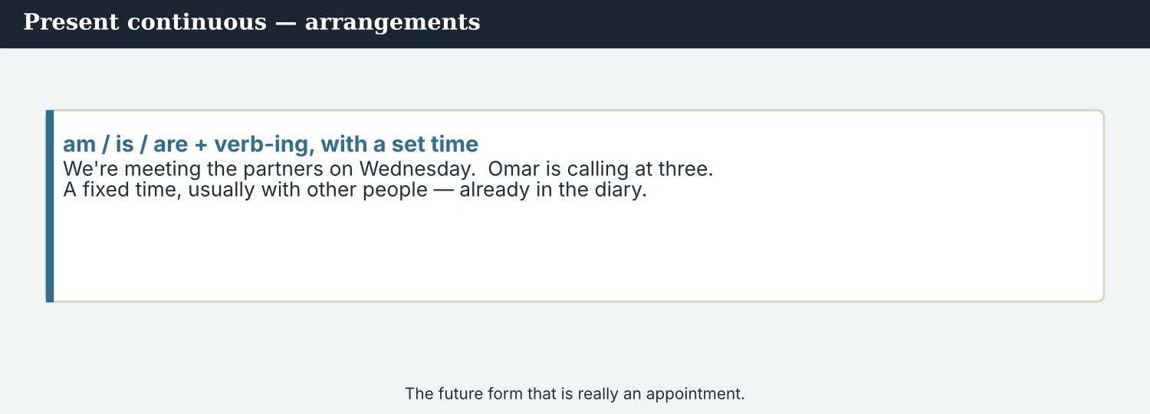
Decision now, plan already made, or fixed arrangement — each has its own form.
PRACTISE Structured practice
2A Complete with will or won’t.
1. “The time does not suit Omar. I ___________ move the call.”
2. “Don’t worry — we ___________ miss the deadline.”
3. “It ___________ take about three weeks.”
4. “___________ you confirm it by email?”
2B will or going to?
1. We ___________ cover the whole basin. (a plan agreed last week)
2. “The line is bad — I ___________ call you back.” (a decision now)
3. Omar ___________ commission a photo essay. (he has decided already)
4. “That looks heavy. I ___________ carry it.” (an offer)
2C Complete with the present continuous for a fixed arrangement.
1. We ___________ (publish) on the last Sunday of the month.
2. Ines ___________ (join) the call at four.
3. Dren ___________ (travel) on Thursday.
2D Write the sentence. Use going to or the present continuous.
1. we / cover / the whole basin (a plan) → ________________________
2. the four partners / publish / on Sunday (a fixed arrangement) → ________________________
Your own words
2E Write two plans you have for next month. Use going to.
1. ________________________
2. ________________________
2F Write two fixed arrangements in your week. Use the present continuous.
1. ________________________
2. ________________________
2G Rewrite the sentence correctly (will / going to / present continuous).
1. We will cover the whole basin — we agreed it last week. → ________________________
2. I think I am going to call you back; the line is bad. → ________________________
2H Your own words. Describe one plan and one promise about your next piece of work.
1. ________________________

PART 3 Planning across time zones
A cross-border plan needs one calendar, one deadline, and a time that works for everybody.
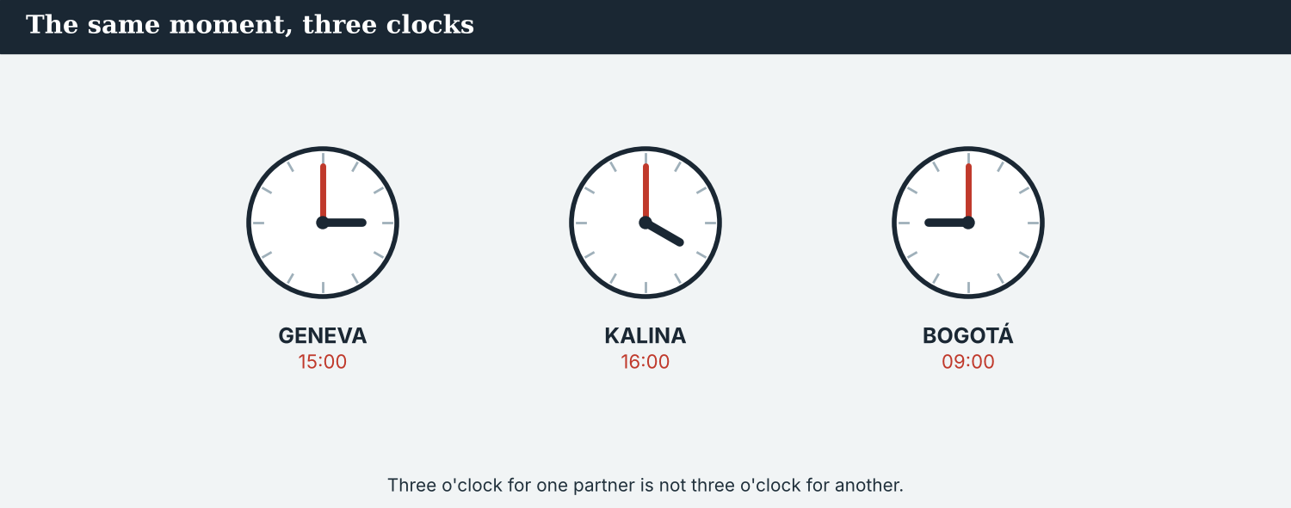
Four partners, four clocks. Somebody’s convenient hour is somebody’s dawn.
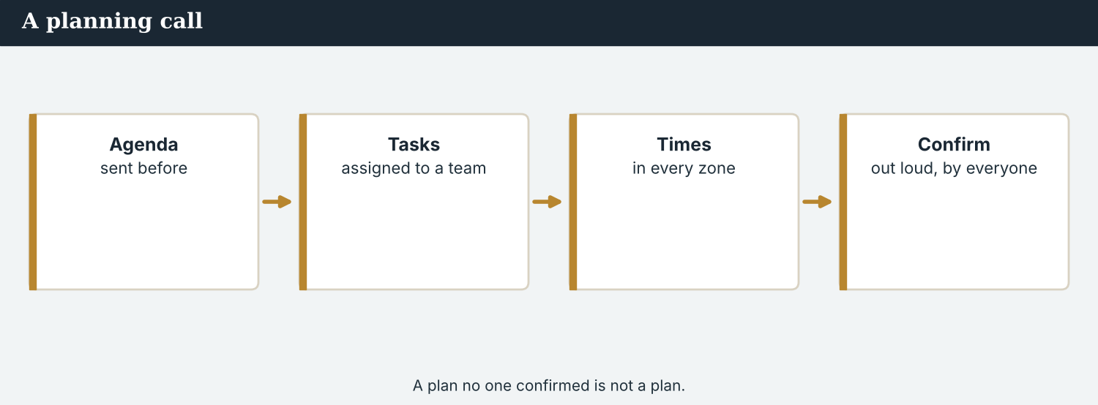
A good plan says who, what, when — and in whose time zone.
MODEL A model plan
“Here is the plan. We are going to cover the whole Vara basin — seven crossings, not one. Kalina Daily is reporting the two upstream; the River Basin Network is taking the middle three; we are taking the mouth of the river. The Meridian Post is editing the English version.
The kick-off call is on Thursday at 16:00 Geneva — 10:00 for Omar, 18:00 for Ines. First drafts are due on the 14th. We are publishing on the last Sunday, all four of us, at 07:00 GMT. I will send the calendar tonight.”
NOTICE Notice the plan
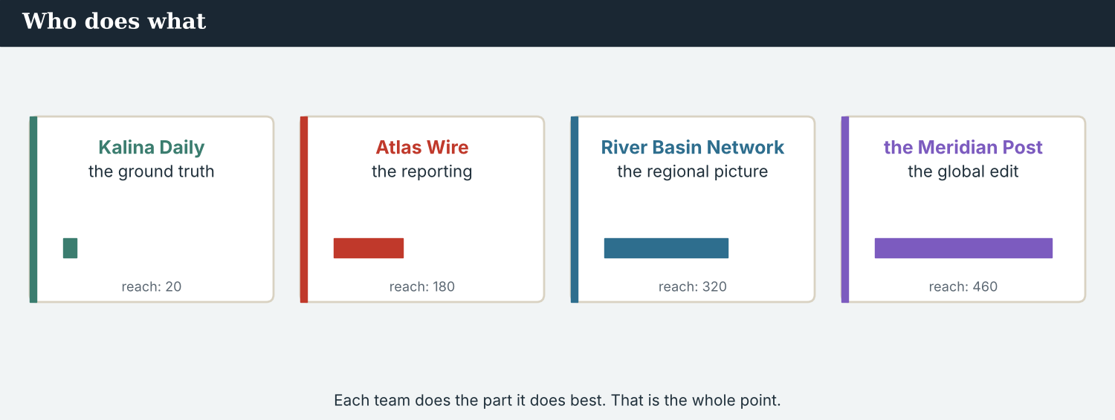
Every milestone has a date; every date has a time zone.
3A Answer about the model.
1. What are the four partners going to cover? ___________
2. Who is reporting the two upstream crossings? ___________
3. When are they publishing? ___________
3B Find one ‘going to’, one present-continuous future, and one ‘will’ in the model. Write them.
1. ________________________
PRACTISE Build the plan
A plan answers the five questions too: who, what, where, when — and in whose clock.
3C Write the sentence with going to or the present continuous.
1. we / cover / seven crossings (a plan) → ________________________
2. Kalina Daily / report / the upstream crossings (agreed, fixed) → ________________________
3. I / send / the calendar / tonight (an offer made now, use will) → ________________________
3D Complete the plan. Use: are · going · is · will.
We are ______ to cover the whole basin. Kalina Daily ______ reporting upstream, and we ______ taking the mouth of the river. I ______ send the calendar tonight.
PRACTISE One more
3E Put the plan in order. Number the steps 1–4.
1. First drafts are due. ______
2. The kick-off call takes place. ______
3. All four partners publish. ______
4. The editors agree who covers what. ______
PRODUCE Your turn
3F Choose a story. Write a short plan (4–5 sentences): what you are going to cover (going to), who is doing which part (present continuous), one date, and one promise (will).
________________________
________________________
________________________
________________________
PRODUCE Discuss
3G Talk with a partner. Why must a plan name the time zone as well as the hour?
3H Why is ‘we are publishing on Sunday’ stronger than ‘we will publish on Sunday’? Explain.
3I Discuss. Who should choose the hour of a call: the biggest partner, or the one furthest away?

PART 4 Listening: the kick-off call
Two audios. Listen for the plan, the dates, and who is doing what.
Three editors on one call, in three time zones.
Listening A · the three-way kick-off call
MODEL Audio 3.1 — Ana, Ines and Omar
Ana: Thank you both for the early hour. We are going to cover the whole basin — seven crossings.
Omar: Good. The Post will run the English version in print on the last Sunday.
Ines: The Network is taking the three middle crossings. We are sending a reporter upriver next week.
Ana: And Kalina Daily is reporting the two upstream. Dren is travelling today, so he will call in later.
Omar: When are the first drafts due?
Ana: The 14th. Then we have eight days to edit and translate.
Ines: That is tight. I will ask for a day more if the water levels change.
Ana: Agreed. One deadline we do not move: we are publishing at 07:00 GMT.
Omar: Understood. I will send the embargo note tomorrow.
PRACTISE Listen for detail
4A Before you listen: what do you think the three editors will agree first? Write one idea.
1. ______
4B Answer the questions.
1. How many crossings are the partners going to cover? ___________
2. Which crossings is the River Basin Network taking? ___________
3. When are the first drafts due? ___________
4. At what time are all four publishing? ___________
4C will, going to, or present continuous? Write W, G, or PC.
1. “We are going to cover the whole basin.” ______
2. “We are publishing at 07:00 GMT.” ______
3. “I will send the embargo note tomorrow.” ______
4D Complete the notes.
The plan: ___________
Who is doing what: ___________
The one date nobody moves: ___________
Audio 3.2 — the reporters sort out the week between them.
Listening B · two reporters fix the week
MODEL Audio 3.2 — Mira and Dren
Mira: Dren, I have the calendar. Are you still going to take the two upstream crossings?
Dren: Yes. I am driving up on Monday and staying two nights.
Mira: Then I will not duplicate you — I am taking the mouth of the river.
Dren: Good. One thing: Thursday’s call is at four your time. That is six for me, and I am at the council meeting.
Mira: I will ask Ana to move it to three.
Dren: Thank you. I will send my notes before the call, so nothing is lost.
Mira: When are you filing?
Dren: The 13th — a day early. The river is rising, and I would rather be ahead.
PRACTISE Listen for detail
4E Before you listen: what problem do you think the two reporters will have to solve? Guess.
1. ______
4F Complete the answers.
1. Dren ___________ (drive) up on Monday and staying two nights.
2. Mira ___________ (take) the mouth of the river.
3. Mira ___________ ask Ana to move the call to three.
4. Dren ___________ (file) on the 13th, a day early.
4G Which forms do you hear? Write one ‘will’, one ‘going to’, and one present-continuous phrase.
1. ________________________
4H Answer. Why does Dren want to file a day early?
1. ________________________
PRACTISE Both audios
4I Complete the summary. Use: going to · publishing · will · filing.
The four partners are ______ cover seven crossings. Dren is ______ on the 13th, and Mira ______ take the mouth of the river. All four are ______ at 07:00 GMT.
4J On the call, one editor asked for the hour to be moved. Why does that matter in a partnership?
1. ________________________
PRODUCE What do you think?
4K Complete the note comparing the two audios.
The editors’ call decides: ___________
The reporters’ call decides: ___________
4L Discuss. Which call does more real work — the one between editors, or the one between reporters?

PART 5 Reading: one basin, four newsrooms
Two readings. Read for the plan, and for how to plan across borders.
One project, four mastheads, four audiences — and a single hour of publication.
Reading A · the project plan, explained
Seven crossings, one Sunday: how the basin project will work
At the end of this month, four newsrooms are publishing one investigation at the same hour. It is called The Seven Crossings, and it asks a simple question: a year after Kalina reopened, what has happened to the rest of the river?
The work is divided by geography. Kalina Daily, the paper in the town itself, is reporting the two upstream crossings. The River Basin Network is taking the middle three. Atlas Wire is covering the two at the mouth of the river, and the Meridian Post is editing the English version.
“Nobody could do this alone, and nobody should,” says Ines Duarte, who edits for the River Basin Network. “We are going to put seven small stories beside each other, and the picture they make is the story.”
The calendar is short. First drafts are due on the 14th; the edit and translation take eight days; everything goes out at 07:00 GMT on the last Sunday. “That hour is the only thing we will not move,” says Ana Ferreira of Atlas Wire. “If one partner runs early, the others lose the day.”
Four time zones have their own rules. The kick-off call was moved twice: four o’clock in Geneva is ten in the morning for the Post’s desk and six in the evening for Dren Markaj at Kalina Daily. “We learned to write the time zone beside every hour,” Omar Faris of the Meridian Post says. “It sounds small. It saves a week.”
The hardest part, all four editors say, is not the logistics. It is holding to one standard when four newsrooms have four house styles, four lawyers and four audiences. So the partners agreed their rules before their deadlines: every figure confirmed twice, every local reporter named, and nothing published that the others have not seen.
PRACTISE Comprehension
5A Before you read: look at the title. What do you think ‘one Sunday’ refers to? Write one sentence.
1. ______
5B True or false? Write T or F.
1. The four newsrooms are publishing at different hours. ______
2. Kalina Daily is reporting the two upstream crossings. ______
3. First drafts are due on the 14th. ______
4. The partners agreed their deadlines before their rules. ______
5C Answer the questions.
1. Which crossings is Atlas Wire covering? ___________
2. What is the one thing the partners will not move? ___________
3. What do the editors call the hardest part of the project? ___________
5D Find a word or phrase in the text.
1. the local clock in one part of the world → ___________
2. a date when one part must be finished → ___________
3. to make several people’s work fit together → ___________
Four newsrooms, one standard: the rules come before the calendar.
Reading B · good planning across borders
Four rules for planning with partners
1. Name the time zone every time. Write ‘16:00 Geneva’ or ‘07:00 GMT’, never just ‘four o’clock’. A plan that does not say whose clock it means is not a plan.
2. Share the calendar, not only the deadline. Partners need the milestones between: the kick-off, the drafts, the edit, the hour.
3. Agree the standard before the schedule. How a figure is confirmed, who is named, what each partner may publish — all before anyone writes.
4. Let the smallest partner choose the hour. The newsroom closest to the story has the fewest people and the least room to move. It should not be the one getting up at dawn.
PRACTISE Comprehension
5E Before you read: which rule do you think matters most in a four-country project? Guess.
1. ______
5F Match the rule to the example.
1. name the time zone  2. share the calendar  3. agree the standard  4. the smallest partner chooses | a) ‘first drafts on the 14th, edit to the 22nd’  b) ‘every figure confirmed twice’  c) ‘07:00 GMT, not seven o’clock’  d) move the call so Dren does not lose his evening
5G Which rule is about fairness between partners, not about dates? Write the number.
1. ______
PRACTISE Words from the readings
5H Find a word in Reading A or Reading B.
1. the first meeting of a project → ___________
2. an early version of a piece of writing → ___________
3. a list of times for the work → ___________
PRACTISE Both readings
5I Complete the sentence with will, going to, or the present continuous.
1. The four partners ___________ (publish) at 07:00 GMT. (a fixed arrangement)
2. They ___________ (put) seven small stories beside each other. (a plan)
3. “That hour is the only thing we ___________ not move.” (a promise)
PRODUCE Discuss
5J Talk about it. Reading A says seven small stories make one picture. What does this mean?
5K Which of the four planning rules would your own team find hardest? Say why.
5L Discuss. ‘Agree the standard before the schedule.’ Why is it harder to agree afterwards?

PART 6 Writing: the plan on paper
Two short pieces: a project schedule, and a planning email to a partner.
A schedule on one page: who, what, when, in whose clock.
Writing 1 · a project schedule
MODEL A model
PROJECT · The Seven Crossings
Kick-off: Thursday 16:00 Geneva / 10:00 New York / 18:00 Kalina
Reporting: Kalina Daily — upstream · RBN — middle · Atlas Wire — mouth
First drafts: the 14th · Edit and translation: the 15th–22nd
Publication: last Sunday, 07:00 GMT, all four partners
NOTICE Notice the model
6A Answer about the model.
1. Which line gives three time zones for one hour? ___________
2. Which line is the one date nobody moves? ___________
PRODUCE Write your schedule
6B Choose a story and two partners. Write a schedule: kick-off (with time zones), who reports what, drafts, publication.
Kick-off: ___________
Reporting: ___________
First drafts: ___________
Publication: ___________
A planning email turns the schedule into something a partner can answer.
Writing 2 · a planning email to a partner
MODEL A model
Dear Ines,
Here is the plan as we agreed it. We are going to cover the two crossings at the mouth; you are taking the middle three. First drafts are due on the 14th, and we are publishing at 07:00 GMT on the last Sunday.
I will send the shared calendar tonight, with every hour in all three time zones. If the water levels change your plans, tell me early.
Best wishes, Mira
NOTICE Notice the model
6C Answer. Find one ‘going to’, one present-continuous future, and one ‘will’ in the email.
1. ___________
PRACTISE Complete the paragraph
6D Complete the email. Use: going · are · will · am.
We are ______ to take the mouth of the river. You ______ taking the middle crossings. I ______ send the calendar tonight, and I ______ writing to Omar as well.
PRODUCE Write your email
6E Turn your schedule into a short planning email (4–5 sentences). Use going to, the present continuous, and one will promise.
________________________
________________________
________________________
PRACTISE Fix it
6F This email promises a date that is not fixed, and gives an hour with no time zone. Correct both.
“We will definitely publish some time next week. The call is at four. I will confirm everything later, probably.”
________________________
PRACTISE Plan it
6G Plan a project note. Write three lines: the plan (going to), one arrangement (present continuous), one promise (will).
Plan: ___________
Arrangement: ___________
Promise: ___________
6H Peer-check. Swap with a partner. Is there a time zone with every hour, and a date for every milestone? Write one note.
________________________

PART 7 Speaking: agreeing the plan
Agree a joint plan on a call. Use will, going to and the present continuous.
Agreeing a plan out loud: who does what, by when, in whose clock.
A model dialogue · agreeing who does what
MODEL Listen and read
Sofia: So what are we going to do about the other six crossings?
Mira: We are taking two, at the mouth. Kalina Daily is taking the upstream pair.
Sofia: And the middle three?
Mira: The River Basin Network. Ines is sending a reporter upriver next week.
Sofia: When do we file?
Mira: First drafts on the 14th. I will put the calendar in the shared folder tonight.
Sofia: And publication?
Mira: The last Sunday, 07:00 GMT. That hour does not move.
NOTICE Notice the forms
7A Find one ‘going to’, one present-continuous future, and one ‘will’ sentence. Write them.
1. ________________________
PRACTISE Controlled practice
7B Answer with will, going to, or the present continuous.
1. What / we / going to / do / about the other crossings? → ___________
2. Who / take / the middle three? (fixed) → ___________
3. When / you / send / the calendar? (a promise) → ___________
Open a planning call by saying what is already agreed.
7C Make a question about a plan, then answer it.
1. the partners / publish / on Sunday → ________________________
2. Ines / send / a reporter / next week → ________________________
PRODUCE Your role
Coordinator | Say the plan: what you are going to cover, who is doing what, and the dates.
Partner | Ask: ‘When are you filing?’ and ‘Four o’clock in whose time zone?’
Observer | Listen. Did the coordinator give a time zone with every hour?
7D Choose a role from the table. Agree a plan with your partner.
PRODUCE Role-play
7E Role-play a kick-off call: a coordinator, a partner, and an observer. Then swap roles.
A second dialogue · moving the hour
MODEL Listen and read
Omar: Mira, about Thursday — four o’clock Geneva is ten in the morning here. I can do it.
Mira: You can; Dren cannot. Six in the evening is his council meeting, and he is the one in the town.
Omar: Then we will move it. Three o’clock?
Mira: Three works for everybody. I am sending the new invitation now.
Omar: Good. And I will write the hour in all three zones.
Mira: Thank you. It saves a week.
PRACTISE Controlled practice
7F Write the two sentences Omar uses to agree the change — one with ‘will’, one with the present continuous.
1. ________________________
PRODUCE Self-check
Did I… | Yes | Almost | Not yet
use going to for a plan already made? | ☐ | ☐ | ☐
use the present continuous for fixed arrangements? | ☐ | ☐ | ☐
use will for a decision or a promise made now? | ☐ | ☐ | ☐
give the time zone with every hour? | ☐ | ☐ | ☐
7G Role-play moving the hour of a call so that the smallest partner is not the one who loses. Then swap roles.
PRACTISE Plan it
7H Plan your call. Note one going-to plan, one fixed arrangement, and one will promise.
7I Discuss. How would you agree one deadline with three partners under different pressures?

PART 8 Ethics: a plan you can keep
A date is a promise. Promising one you cannot keep costs somebody else the work.
A plan is part of the Code: what you promise a partner, you owe them.
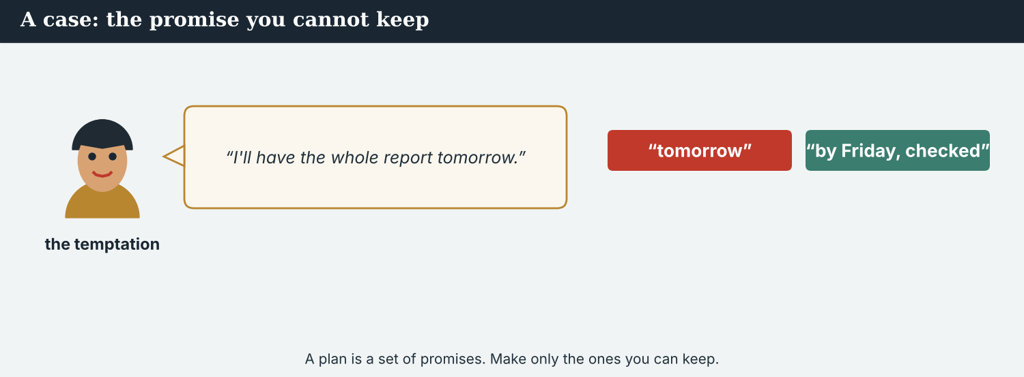
A partner’s perfect date can be another newsroom’s impossible one.
A first case · the date that suits the biggest partner
A case. The Meridian Post wants to publish a week earlier, so the project lands in its big Sunday edition. Omar asks Mira: can Atlas Wire be ready? She wants to say yes — the Post’s reach is enormous, and a partner who is pleased comes back. But a week earlier means Priya cannot confirm the water-level figures twice, and Dren cannot reach the far-bank families at all. The thin part would be the part about the people whose river it is. The Code says: do not promise a date that forces you to publish what you have not checked. What does Mira tell Omar?
NOTICE What do you do?
8A Choose (a) or (b), and write one reason.
1. (a) ‘Yes, we will be ready.’ (b) ‘No — a week earlier and the figures are unconfirmed.’ Choice: ______ Because ________________________
2. Agreeing a date you cannot meet is (a) good partnership (b) a risk you pass to others. Choice: ______
8B A promise you can keep, or one you cannot? Write K or C.
1. ‘We are publishing on the 28th; the drafts are in.’ ______
2. ‘We will be ready a week early, somehow.’ ______
3. ‘I will file on the 13th — I am ahead already.’ ______
4. ‘Yes to any date you like.’ ______
PRACTISE Apply the Code
8C Complete the rule. Use: check · keep · early · zone.
Promise only what you can ______ . Say no to a date that leaves no time to ______ . Tell a partner ______ if a plan changes, and always name the time ______ .
PRODUCE Discuss
8D Discuss. Why is ‘yes’ to a bigger partner sometimes the least honest answer?
A second case · the call nobody could attend
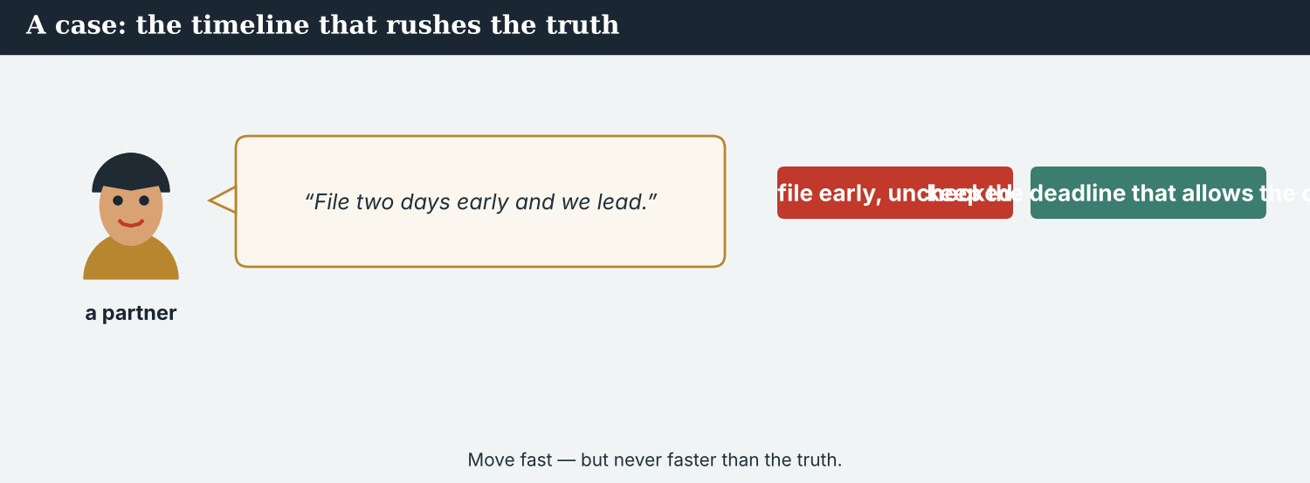
A decision taken while one partner was offline is not an agreement.
A case. The second kick-off call falls at an hour when Dren is on the road and cannot join. The three larger partners take it anyway, and agree how the upstream crossings will be framed — his crossings, in his town. Afterwards, the minutes say ‘agreed by all partners’. Nobody lied; Dren was simply not there. But Kalina Daily is the smallest partner, closest to the people in the story, and it will still be in Kalina long after the others have moved on. The Code says: a partner who could not be in the room has not agreed. What should Mira do?
NOTICE What do you do?
8E Choose (a) or (b), and write one reason.
1. (a) send the minutes as ‘agreed by all’ (b) hold the upstream decisions until Dren can speak. Choice: ______ Because ________________________
2. A decision taken without the local partner is (a) efficient and fair (b) efficient and not fair. Choice: ______
8F Complete with: agreed · smallest · minutes · present.
1. Dren was not ___________ on the call.
2. Kalina Daily is the ___________ partner.
3. The ___________ said ‘all partners’.
4. Nothing is ___________ until he has spoken.
PRODUCE Discuss
8G Discuss. Why does the newsroom that stays in the town lose most from a framing it did not choose?
PRODUCE Write it
8H Write two sentences to the partners, holding the upstream decisions until Dren can speak. Use will and going to.
PRACTISE One more
8I Fair planning, or not? Write F or N.
1. ‘We moved the call so the local reporter could join.’ ______
2. ‘He was not there, so we decided for him.’ ______
3. ‘Every hour is written in three time zones.’ ______
4. ‘We announced the date before the smallest partner agreed.’ ______
8J Discuss. A big partner’s calendar is powerful. What does a small partner have that is worth as much?

PART 9 Digital: a ‘coming soon’ post
Online, you can announce a plan — carefully. A date you post is a date you owe.
A ‘coming soon’ post promises a date to the whole internet.
MODEL A model post
COMING THIS MONTH · Four newsrooms are publishing one investigation into the seven crossings of the Vara basin. We are going to look at what reopened, and what did not. Out on the last Sunday, 07:00 GMT. — @AtlasWire with @KalinaDaily and @MeridianPost
NOTICE The parts of the post
9A Match the part to the form.
1. Four newsrooms are publishing  2. We are going to look at  3. Out on the last Sunday, 07:00 GMT  4. with @KalinaDaily | a) going to (the plan)  b) present continuous (the fixed arrangement)  c) the partners, named  d) the hour, with its time zone
PRACTISE Find and build
9B Find one ‘going to’ and one present-continuous future in the post. Write them.
1. ________________________
9C This post gives no time zone and promises a date that is not fixed. Correct both.
“Big project coming at four o’clock, probably Sunday or maybe the week after.”
________________________
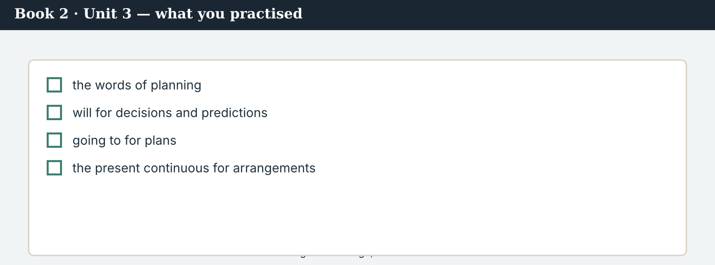
A good ‘coming soon’ answers: what, with whom, and exactly when.
9D Write a ‘coming soon’ post. Use one going to, one present continuous, and one hour with its time zone.
COMING SOON · ___________ (present continuous). ___________ (going to). Out at ___________ . — @AtlasWire
PRODUCE Write your post
9E Write a one-line ‘coming soon’ post about a piece of work you have planned. Use going to.
________________________
9F Creative. Write a short headline (4–6 words) for a project that is still to come.
9G A reader asks: ‘Why are four newsrooms doing this together?’ Write a short reply. Use going to.
________________________
9H A ‘coming soon’ post can promise more than the work delivers. Write one line that promises only what is certain.
________________________
PRODUCE Discuss
9I Creative. Write a two-line thread: line 1 the plan (going to), line 2 the fixed hour (present continuous).
________________________
________________________
9J Discuss. Announcing a date brings readers — and risk. When is it better to say nothing until you publish?

PART 10 Review & Can-Do
Check your new English before Unit 4.
The project page: what is coming, with whom, and exactly when.
10A Vocabulary. Complete with: plan · schedule · deadline · time zone · coordinate · draft · slot · milestone.
1. The partners agreed one ___________ for the basin.
2. Ana sent the ___________ with every hour in it.
3. The ___________ is the last Sunday.
4. Four o’clock in which ___________ ?
5. Somebody has to ___________ four newsrooms.
6. Dren is sending his first ___________ .
7. The subeditors kept a ___________ on page three.
8. The 14th is the first ___________ .
10B Grammar. Complete with will or won’t.
1. “The hour does not suit Dren. I ___________ move it.”
2. “Don’t worry — we ___________ miss the deadline.”
3. “It ___________ take about three weeks.”
4. “I ___________ send the calendar tonight.”
10C Grammar. will or going to?
1. We ___________ cover the whole basin. (agreed last week)
2. “The line is bad — I ___________ call you back.” (a decision now)
3. Omar ___________ commission a photo essay. (already decided)
Can-Do — tick what you can do now.
10D Grammar. Complete with the present continuous for the future.
1. We ___________ (publish) on the last Sunday.
2. Ines ___________ (join) the call at four.
3. Dren ___________ (travel) on Thursday.
10E Read and answer.
Four newsrooms are going to cover the seven crossings of the Vara basin. Kalina Daily is reporting upstream, the River Basin Network the middle, and Atlas Wire the mouth of the river. All four are publishing at 07:00 GMT on the last Sunday. “That hour is the only thing we will not move,” Ana says.
1. What are the four newsrooms going to cover? ___________
2. Who is reporting upstream? ___________
3. What is the one thing they will not move? ___________
Can-Do — tick what you can do now
☐ I can make plans and promises with will.
☐ I can talk about plans already made with going to.
☐ I can use the present continuous for fixed arrangements.
☐ I can plan a joint project across time zones.
10F Reflect. Which part of Unit 3 was the most useful for you? Why?
10G Grammar review. Write the sentence correctly.
1. We will cover the basin — we agreed it last week. → ________________________
2. I am going to call you back; the line is bad. → ________________________
3. We are going to publish at 07:00 on Sunday; it is fixed and agreed. → ________________________
4. The call is at four o’clock. → ________________________
10H Mixed review. Complete with will, going to, or the present continuous.
1. Ines ___________ (send) a reporter upriver next week. (fixed)
2. We ___________ (put) seven stories beside each other. (a plan)
3. “That hour is the only thing we ___________ (not move).” (a promise)
10I Reflect. Write one sentence about a plan you are going to make. Name a date.

PART 11 Assignment: a project plan
Put the unit together: plan a joint story with two partners.
The assignment template — your project plan.
Your task. You and two partner newsrooms abroad are going to cover one story together. Write a project plan (6–7 sentences): what you are going to cover (going to), who is doing which part (present continuous), the kick-off hour in all three time zones, two milestones, the hour of publication, and one promise you can keep (will). Let the partner closest to the story choose the hour.
A model — use Reading A and the Writing 1 model to check the shape of your plan.
Remember: going to for the plan; the present continuous for arrangements; will for a promise made now; a time zone with every hour; a date for every milestone; nothing agreed while a partner is offline.
Success criteria | Yes | Almost | Not yet
I use going to for the plan we have already made. | ☐ | ☐ | ☐
I use the present continuous for the fixed arrangements. | ☐ | ☐ | ☐
I use will for a promise I can keep. | ☐ | ☐ | ☐
I give the time zone with every hour. | ☐ | ☐ | ☐
Every partner, including the smallest, can meet the plan. | ☐ | ☐ | ☐
Keep this. In Unit 4, you file to a foreign desk — reported speech (say, tell, according to) — so that what a source said arrives abroad exactly as they said it.

ANSWER KEY Book 2 · Unit 3
Check your answers. Open tasks (discussion, role-play and your own writing) are marked at the end.
W1 1 the whole Vara basin (not just Kalina) · 2 Thursday at two, moved to four · 3 Omar (Faris)
W2 1 F (the whole basin) · 2 T · 3 T
W3 will: ‘I’ll move it to four’ · going to: ‘we are going to cover’ · present continuous: ‘Ines is joining’
1A 1-b, 2-a, 3-c, 4-d, 5-e, 6-f, 7-g, 8-h, 9-i, 10-j
1B 1 plan · 2 deadline · 3 time zones · 4 coordinate · 5 kick-off · 6 available
1C 1 meet a deadline · 2 agree a plan · 3 coordinate the coverage · 4 file a draft · 5 book a slot
1D 1 rumour · 2 archive · 3 refuse · 4 delete
1E 1 plan · 2 milestones · 3 deadline · 4 time zones · 5 coordinate
1F 1 kick-off · 2 available · 3 draft · 4 confirm
1G pitch · commission · draft · slot · deadline
1J agree/confirm · confirm · agree · available · ahead
2A 1 will · 2 won’t · 3 will · 4 Will
2B 1 are going to · 2 will · 3 is going to · 4 will
2C 1 are publishing · 2 is joining · 3 is travelling
2D 1 We are going to cover the whole basin. · 2 The four partners are publishing on Sunday.
2G 1 We are going to cover the whole basin — we agreed it last week. · 2 I will call you back; the line is bad.
3A 1 the whole Vara basin — seven crossings · 2 Kalina Daily · 3 on the last Sunday of the month, at 07:00 GMT
3B going to: ‘we are going to cover’ · present continuous: ‘Kalina Daily is reporting’ · will: ‘I will send the calendar tonight’
3C 1 We are going to cover seven crossings. · 2 Kalina Daily is reporting the upstream crossings. · 3 I will send the calendar tonight.
3D going · is · are · will
3E 1 The editors agree who covers what. · 2 The kick-off call takes place. · 3 First drafts are due. · 4 All four partners publish.
3H ‘we are publishing’ is a fixed arrangement — date, hour and partners already agreed; ‘we will publish’ sounds like an intention that could change
4B 1 seven · 2 the three in the middle of the valley · 3 the 14th · 4 07:00 GMT
4C 1 G · 2 PC · 3 W
4D The plan = the whole basin, seven crossings · Who is doing what = Kalina Daily upstream, RBN middle, Atlas Wire the mouth, the Post edits · The date nobody moves = 07:00 GMT, last Sunday
4F 1 is driving · 2 am taking · 3 will · 4 is filing
4G will: ‘I will ask Ana’ · going to: ‘are you still going to take’ · present continuous: ‘I am driving up on Monday’
4H because the river is rising and he would rather be ahead, in case his plans change
4I going to · filing · will · publishing
4J an hour that suits the biggest partner can cost the smallest one its evening; agreeing the hour together is part of being equal partners
4K Editors decide = the plan, the division of work, the publication hour · Reporters decide = who goes where, when each files, how not to duplicate
5B 1 F · 2 T · 3 T · 4 F
5C 1 the two at the mouth of the river · 2 the hour of publication (07:00 GMT) · 3 holding to one standard across four newsrooms
5D 1 time zone · 2 milestone · 3 coordinate
5F name the time zone → ‘07:00 GMT, not seven o’clock’ · share the calendar → ‘drafts on the 14th, edit to the 22nd’ · agree the standard → ‘every figure confirmed twice’ · the smallest partner chooses → move the call for Dren
5G Rule 4
5H 1 kick-off · 2 draft · 3 schedule / calendar
5I 1 are publishing · 2 are going to put · 3 will
6A 1 the kick-off line (16:00 Geneva / 10:00 New York / 18:00 Kalina) · 2 the publication line
6C going to: ‘we are going to cover’ · present continuous: ‘you are taking’ · will: ‘I will send the shared calendar’
6D going · are · will · am
6F ‘We are publishing on Sunday the 28th. The call is at 16:00 Geneva (18:00 Kalina). I will confirm tonight.’
7A going to: ‘what are we going to do’ · present continuous: ‘Ines is sending a reporter’ · will: ‘I will put the calendar in the shared folder’
7B 1 We are going to cover the two crossings at the mouth. · 2 The River Basin Network is taking the middle three. · 3 I will send it tonight.
7C 1 Are the partners publishing on Sunday? — Yes, at 07:00 GMT. · 2 Is Ines sending a reporter next week? — Yes.
7F ‘Then we will move it.’ · ‘I am sending the new invitation now.’ (accept ‘I will write the hour in all three zones’)
8A 1 (b) ‘No — a week earlier and the figures are unconfirmed.’ · 2 (b) a risk you pass to others
8B 1 K · 2 C · 3 K · 4 C
8C keep · check · early · zone
8E 1 (b) hold the upstream decisions until Dren can speak · 2 (b) efficient and not fair
8F 1 present · 2 smallest · 3 minutes · 4 agreed
8I 1 F · 2 N · 3 F · 4 N
9A ‘Four newsrooms are publishing’ → present continuous · ‘We are going to look at’ → going to · ‘07:00 GMT’ → the hour with its time zone · ‘with @KalinaDaily’ → the partners, named
9B going to: ‘we are going to look at’ · present continuous: ‘four newsrooms are publishing’
9C ‘Our joint investigation is out on Sunday the 28th at 07:00 GMT.’
10A 1 plan · 2 schedule · 3 deadline · 4 time zone · 5 coordinate · 6 draft · 7 slot · 8 milestone
10B 1 will · 2 won’t · 3 will · 4 will
10C 1 are going to · 2 will · 3 is going to
10D 1 are publishing · 2 is joining · 3 is travelling
10E 1 the seven crossings of the Vara basin · 2 Kalina Daily · 3 the publication hour (07:00 GMT)
10G 1 We are going to cover the basin — we agreed it last week. · 2 I will call you back; the line is bad. · 3 We are publishing at 07:00 GMT on Sunday. · 4 The call is at 16:00 Geneva (18:00 Kalina).
10H 1 is sending · 2 are going to put · 3 will not move
Open tasks W4, W5, 1H, 1I, 1K, 2E, 2F, 2H, 3F, 3G, 3I, 4A, 4E, 4L, 5A, 5E, 5J, 5K, 5L, 6B, 6E, 6G, 6H, 7D, 7E, 7G, 7H, 7I, 8D, 8G, 8H, 8J, 9D, 9E, 9F, 9G, 9H, 9I, 9J, 10F, 10I — your own answers (discussion, role-play, writing).
A note on real and invented content. The facts about journalism around the world in 2026 are true. Atlas Wire, Kalina Daily, the River Basin Network, the Meridian Post, their staff, the Vara basin and the story are invented, for practice. Real people and outlets are only ever in true, sourced facts — never in an invented quote.
English for Journalists — International Edition · Book 2 · Unit 3 (30-page standard). CEFR lower B1 → medium B1 · Beat: Planning & Across Borders · two readings · two listenings · two writing pieces · two ethics cases · two speaking dialogues · balanced sections · ~28 figures · featured cast + three partners · fictional agency, factual backdrop.

BOOK 2 · UNIT 4 Across the Desk: Reporting What Was Said
Beat · Across Borders (wholly) CEFR lower B1 → medium B1
In this unit you learn to…
1. report what someone said (reported speech)
2. use say and tell correctly
3. attribute a fact with according to
4. file copy to a desk in another country
The Atlas Wire team — filing to a foreign desk, where every quote is checked again.
A quote crosses four borders. This unit is wholly cross-border. A woman speaks at a stall in Kalina, in her own language. Dren writes it down. Mira reports it to Omar’s desk at the Meridian Post, in English. A subeditor in another city tidies it for print. By the time a reader on another continent sees it, the sentence has crossed four borders — and it has to arrive meaning exactly what she meant. (Atlas Wire, Kalina Daily, the Meridian Post and everyone in the stories are invented, for practice.)

WARM-UP What she actually said
A short scene to start the unit. Read it, then answer.
The morning conference — one sentence, four versions, and a desk abroad waiting.
“The desk has queries,” Ana says. “Omar’s subeditor asks whether we can shorten the long quote.”
Mira looks up. “She said, ‘The water is a little better this year.’ The desk has it as ‘residents say the river has recovered.’”
“That is not the same sentence,” says Daniel.
“No,” Mira says. “She told me it was a little better. She did not tell me it had recovered.”
Ana nods. “Then we send it back. According to the desk, it is only tidier. According to her, it is wrong.”
W1 Answer the questions.
1. What did the woman say about the water? ___________
2. What did the desk change it to? ___________
3. What is Ana going to do? ___________
W2 True or false? Write T or F.
1. The woman said the river had recovered. ______
2. Mira says the two sentences mean the same. ______
3. Ana is going to send the query back. ______
W3 Find one ‘said’, one ‘told’, and one ‘according to’ in the text.
1. ________________________
PRODUCE Talk about it
W4 Discuss with a partner.
1. Has anyone ever reported your words wrongly? What happened?
2. Why is ‘a little better’ not the same as ‘recovered’?
PRODUCE One more
W5 Discuss. A sentence passes through four people before it is printed. Where is it most likely to change?

PART 1 The words of attribution
The words for quoting, reporting and saying where a fact came from.
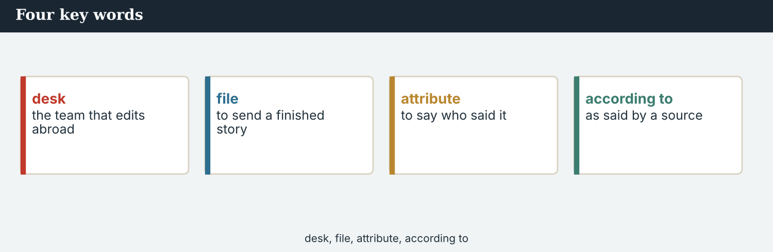
Four key words — quote, paraphrase, attribution, according to.
The words
Word | Meaning
quote (n) | a person’s exact words
paraphrase (v) | to report what was said in your own words
attribution | the name you put beside a fact
attribute (v) | to say where a fact came from
according to | as said by a person or body
on the record | said for publication, with a name
off the record | said not for publication
desk | the editors who handle one kind of story
file (v) | to send your story to the desk
copy (n) | the text a reporter files
subeditor | the editor who checks and cuts copy
translate | to put words into another language
interpreter | a person who translates speech
accurate | exactly right
claim (v) | to say something is true without proof
deny | to say something is not true
insist | to say something firmly again
add | to say something more
PRACTISE Controlled practice
1A Match the word (1–10) to the meaning (a–j).
1. quote  2. paraphrase  3. attribution  4. according to  5. off the record  6. desk  7. copy  8. subeditor  9. interpreter  10. claim | a) to report what was said in your own words  b) a person’s exact words  c) the name beside a fact  d) as said by a person or body  e) said not for publication  f) the editors who handle one kind of story  g) the text a reporter files  h) the editor who checks and cuts copy  i) a person who translates speech  j) to say something is true without proof
1B Complete the sentences with a word from the box.
WORD BOX
quote · paraphrase · attribution · desk · filed · subeditor
1. Mira ___________ the story at six.
2. The foreign ___________ had three queries.
3. A ___________ gives a person’s exact words.
4. A ___________ puts it in your own words.
5. Every fact needs an ___________ .
6. A ___________ cut two lines from the copy.
1C Match the two halves.
1. file  2. check  3. attribute  4. book an  5. deny a | a) copy  b) a quote  c) a fact  d) interpreter  e) claim
1D Circle the word that is different.
1. quote · paraphrase · attribution · deadline
2. say · tell · add · delete
3. accurate · exact · correct · rough
4. claim · insist · deny · schedule
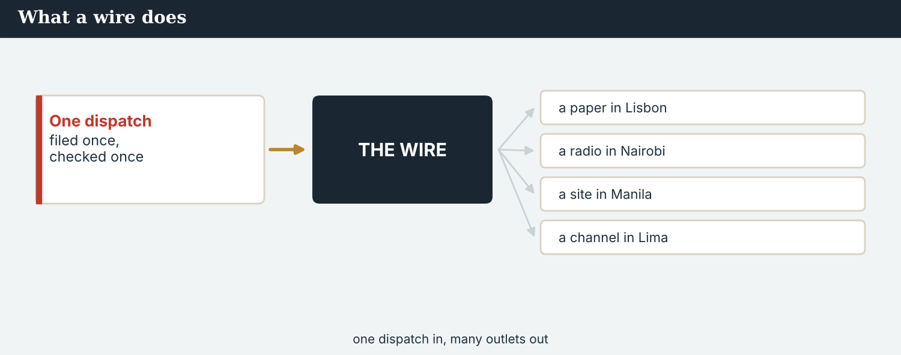
A wire report travels further than any one newsroom. So does an error in it.
1E Complete the paragraph. Use: quote · attribution · according to · paraphrase · accurate.
A ___________ gives the exact words; a ___________ gives the sense. Both need an ___________ . Write ’___________ the Crossing Office’ when the fact is theirs, and check that your version is ___________ .
1F Read the definition. Write the word.
1. said for publication, with a name → ___________
2. to send your story to the desk → ___________
3. to say something is not true → ___________
4. to say something firmly again → ___________
1G Complete the collocation paragraph. Use: filed · desk · subeditor · quote · off the record.
Mira ___________ her copy at six. The foreign ___________ read it twice. A ___________ queried one long ___________ , and asked whether a second source had spoken ___________ .
PRODUCE Over to you
1H Answer about you. Write full sentences.
1. When do you quote, and when do you paraphrase?
2. Who checks your work before it is published?
PRODUCE Talk about it
1I Discuss. Which two words in this unit are new for you? Make a sentence with one.
1J Complete with: translate · interpreter · accurate · claim · add.
Dren used an ___________ to ___________ the interview. The English had to be ___________ . One man made a ___________ about the lorries, and would not ___________ anything else.
1K Creative. Write two sentences reporting something a colleague told you. Use told and according to.

PART 2 Grammar: reporting what was said
Reported speech and the tense shift; say and tell; according to for facts.
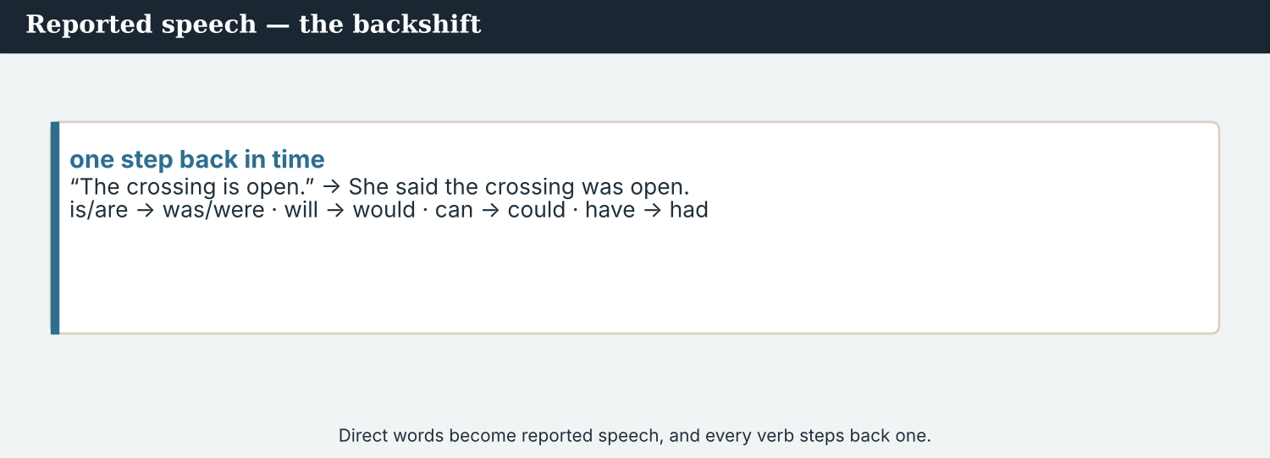
Direct speech keeps the words; reported speech shifts the tense back.
1 · reported speech — one step back
Direct: “The water is better.” → Reported: She said the water was better.
Present → past · past → past perfect · will → would · can → could
Pronouns and times move too: today → that day, tomorrow → the next day.
2 · say and tell
say + what was said: She said the water was better. (not she said me)
tell + person + what was said: She told me the water was better.
Also: add, insist, deny, claim — each carries a different weight. Choose carefully.
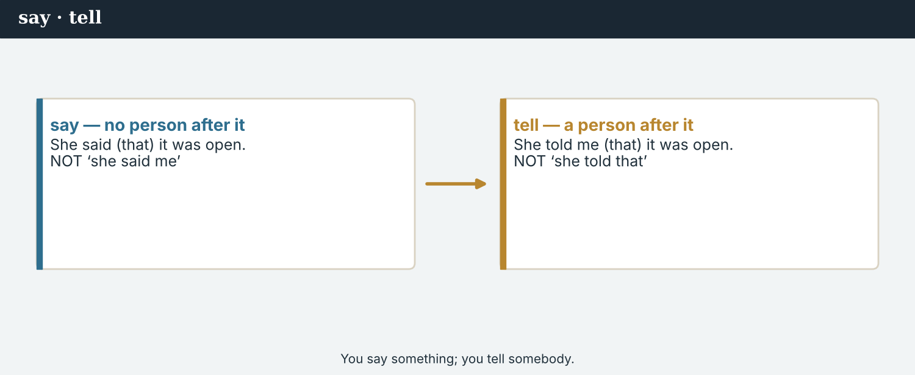
say something · tell somebody something — the difference matters in print.
3 · according to — attributing a fact
Form: According to + a person or body + a fact. “According to the Crossing Office, 112 families have returned.”
Use it for a fact you have not confirmed yourself, and for figures from an official body.
Not for your own reporting: if you counted it, say so.
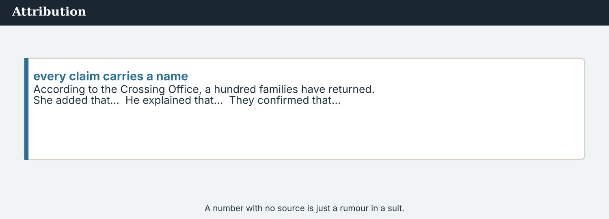
Quote, paraphrase, or according to — three ways to carry what was said.
PRACTISE Structured practice
2A Put into reported speech.
1. “The water is a little better.” → She said ___________
2. “We will reopen the second crossing.” → He said ___________
3. “I can reach the far bank.” → She said ___________
4. “The lorries came back last spring.” → He said ___________
2B say or tell?
1. She ___________ me the water was better.
2. He ___________ that the office had no figures.
3. Dren ___________ Mira what the woman had said.
4. The spokesman ___________ nothing at all.
2C Complete with according to.
1. ___________ the Crossing Office, 112 families have returned.
2. ___________ Kalina Daily, the school reopened in March.
3. ___________ Dren, the far bank is still closed.
2D Rewrite with a stronger or weaker verb: added, insisted, denied, claimed.
1. He said again that the road was safe. → He ___________
2. He said it was not true. → He ___________
Your own words
2E Write two things a colleague told you this week. Use told.
1. ________________________
2. ________________________
2F Write two facts with according to. Name the source each time.
1. ________________________
2. ________________________
2G Rewrite the sentence correctly (reported speech / say / tell).
1. She said me the water was better. → ________________________
2. He said the crossing is open. (report it) → ________________________
2H Your own words. Report one thing you heard today, twice: as a quote, and as a paraphrase.
1. ________________________

PART 3 Filing to a foreign desk
Copy for a desk abroad must say who said what, where the fact came from, and in what language it was said.
A foreign desk reads your copy without knowing the place. Every name must carry its own weight.
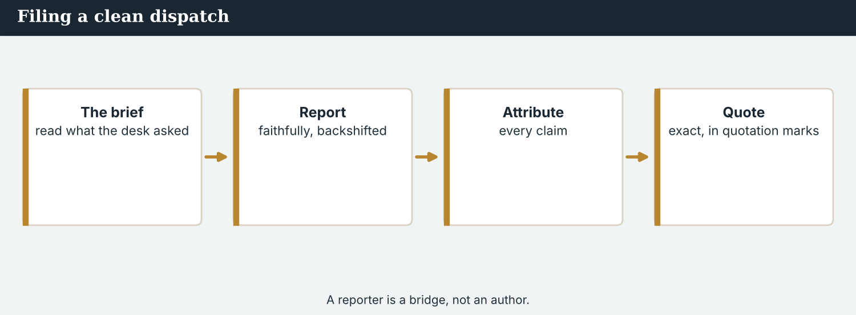
Good copy: the quote, the attribution, and the language it was spoken in.
MODEL A model filing note
“Here is the copy. The long quote is exact: ‘The water is a little better this year.’ She said it in her own language; Dren interpreted, and I read the English back to her before we left.
The figure is not ours. According to the Crossing Office, 112 families have returned. We have asked twice for the method and have not been given it.
One man told Dren the lorries were coming back. He would not go on the record, so it is not in the copy.”
NOTICE Notice the filing note
3A Answer about the model.
1. Which sentence is an exact quote? ___________
2. Where does the figure come from? ___________
3. Why is the man’s claim not in the copy? ___________
3B Find one ‘according to’, one ‘told’, and one reported-speech verb in the model. Write them.
1. ________________________
PRACTISE Build the copy
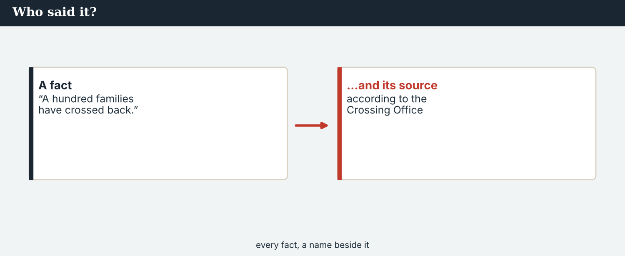
Every fact, a name beside it. A desk abroad cannot ask the stall-holder itself.
3C Write the sentence in reported speech or with according to.
1. “The water is a little better.” (she / say) → ________________________
2. 112 families have returned. (the Crossing Office) → ________________________
3. “The lorries are coming back.” (he / tell / Dren) → ________________________
Who said it, what they said, when, where — and in which language.
3D Complete the note. Use: said · according · told · asked.
She ______ the water was a little better. ______ to the Crossing Office, 112 families have returned. One man ______ Dren the lorries were coming back; we ______ him to go on the record, and he would not.
PRACTISE One more
3E Put the filing note in order. Number the lines 1–4.
1. What is not in the copy, and why. ______
2. The exact quote, and how it was interpreted. ______
3. The figure, and whose it is. ______
4. What the desk still needs from us. ______
PRODUCE Your turn
3F Choose a story. Write a short filing note (4–5 sentences): one exact quote, one fact with according to, one thing a person told you off the record, and one query for the desk.
________________________
________________________
________________________
________________________
PRODUCE Discuss
3G Talk with a partner. Why must copy say which language a quote was spoken in?
3H Why is ‘according to the Crossing Office’ not the same as ‘the Crossing Office says’? Is either wrong?
3I Discuss. A desk abroad cannot call your source. What does that mean for your notes?

PART 4 Listening: the desk has queries
Two audios. Listen for what was said, and for what was changed.
Audio 4.1 — a foreign desk goes through the copy line by line.
Listening A · the desk calls back
MODEL Audio 4.1 — Omar and Mira
Omar: Mira, three queries. First, the long quote. May we shorten it to ‘the river has recovered’?
Mira: No. She said the water was a little better this year. That is not the same.
Omar: Understood. Second: the figure of 112.
Mira: According to the Crossing Office. Not our count. We asked twice for the method.
Omar: Then we will write ‘according to’. Third — the man and the lorries.
Mira: He told Dren they were coming back, but off the record. It stays out.
Omar: Agreed. One more thing: the quote was not in English?
Mira: No. Dren interpreted, and I read the English back to her before we left.
PRACTISE Listen for detail
4A Before you listen: what do you think the desk will query first? Write one idea.
1. ______
4B Answer the questions.
1. What did the woman actually say? ___________
2. Where does the figure of 112 come from? ___________
3. Why does the man’s claim stay out of the copy? ___________
4. How was the quote checked? ___________
4C Quote, according to, or off the record? Write Q, A, or O.
1. “The water is a little better this year.” ______
2. “112 families have returned.” ______
3. “The lorries are coming back.” ______
4D Complete the notes.
The exact words: ___________
The attributed figure: ___________
What stays out, and why: ___________
Audio 4.2 — two reporters check a sentence against the notebook.
Listening B · checking the notebook
MODEL Audio 4.2 — Mira and Dren
Mira: Dren, I need your notebook on one sentence. Did she say ‘better’ or ‘recovered’?
Dren: Better. ‘A little better this year.’ I wrote it down in her words first, then in English.
Mira: Good. And the man at the lorry park?
Dren: He told me the lorries were coming back. Then he said, ‘Not with my name.’
Mira: So we cannot use it.
Dren: No. But I will ask him again next week. He may change his mind.
Mira: Thank you. And Dren — the Post wants to credit the quote to Atlas Wire.
Dren: It is my interview.
Mira: It is. I will tell Omar it carries your name and your paper’s.
PRACTISE Listen for detail
4E Before you listen: what do you think Mira wants to check? Guess.
1. ______
4F Complete the answers.
1. Dren ___________ (say) the woman had said ‘better’.
2. He ___________ (tell) Mira the lorries were coming back.
3. The man ___________ (say) ‘not with my name’.
4. Mira ___________ tell Omar whose interview it was.
4G Which forms do you hear? Write one ‘said’, one ‘told’, and one reported question.
1. ________________________
4H Answer. Why does Dren say ‘It is my interview’?
1. ________________________
PRACTISE Both audios
4I Complete the summary. Use: said · told · according to · off the record.
She ______ the water was a little better. One man ______ Dren the lorries were coming back, but ______ , so it stays out. The figure of 112 is ______ the Crossing Office.
4J The desk wanted to tidy a quote. Why is tidying dangerous in reported speech?
1. ________________________
PRODUCE What do you think?
4K Complete the note comparing the two audios.
The desk’s call is about: ___________
The reporters’ call is about: ___________
4L Discuss. Who should settle a query about a quote — the desk, or the reporter who heard it?

PART 5 Reading: how a quote travels
Two readings. Read for the journey of a sentence, and for the rules that protect it.
One sentence, four newsrooms, millions of readers. It has to arrive intact.
Reading A · a sentence crosses four borders
The long way round: how one sentence reached print
The sentence began at a stall on the Kalina bridge, early on a Tuesday. A woman selling apples was asked how the river was this year, and she answered, in her own language, that the water was a little better than last year.
Dren Markaj of Kalina Daily wrote the words down twice: once as she said them, once in English. “The first version is the evidence,” he says. “The second is only my best attempt.”
Mira Sandoval of Atlas Wire read the English back to the woman before they left the bridge. The woman agreed with it. That took ninety seconds, and it is the reason the sentence survived everything that came next.
The copy went to the Meridian Post’s foreign desk, where a subeditor met it for the first time. She had never been to Kalina and could not call the woman. What she had was the copy, and the copy said who had spoken, in which language, and who had interpreted.
Her first instinct was to shorten. ‘The water is a little better this year’ is nine words; ‘the river has recovered’ is four, and it reads better. She queried it. Mira said no, and explained why: the woman had made a small, careful claim about one year, and the shorter version made a large claim about a river.
“A desk abroad has to be able to trust the copy, because it cannot check the stall,” says Omar Faris, who edits the project at the Post. “So we do not improve quotes. We query them.”
The sentence ran as she said it, with her name, her town, and a line saying the interview was conducted in her own language. Four newsrooms, four editors, two languages — and nine words that still meant what she meant.
PRACTISE Comprehension
5A Before you read: look at the title. Why might a sentence take ‘the long way round’? Write one sentence.
1. ______
5B True or false? Write T or F.
1. Dren wrote the woman’s words down twice. ______
2. Mira read the English back to the woman. ______
3. The subeditor had been to Kalina. ______
4. The sentence was shortened for print. ______
5C Answer the questions.
1. Why does Dren call the first version ‘the evidence’? ___________
2. What could the subeditor not do? ___________
3. Why did Mira refuse the shorter version? ___________
5D Find a word or phrase in the text.
1. the editors who handle one kind of story → ___________
2. the editor who checks and cuts copy → ___________
3. to put words into another language → ___________
Partners do not improve each other’s quotes. They query them.
Reading B · reporting what was said
Four rules for reported speech
1. Shift the tense, not the meaning. ‘The water is better’ becomes she said the water was better. The tense moves back one step; the claim stays the same size.
2. Say who, and how you know. Said and told for speech, according to for a fact you did not confirm. Name the person or body every time.
3. Never improve a quote. A tidier sentence is a different sentence. If a quote is long, cut it with care, or paraphrase it and say that you have.
4. Carry the language with the words. Say which language it was spoken in, say who interpreted, and read the English back to the speaker.
PRACTISE Comprehension
5E Before you read: which do you use for an official figure — said or according to? Guess.
1. ______
5F Match the rule to the example.
1. shift the tense  2. say who, and how  3. never improve  4. carry the language | a) ‘according to the Crossing Office’  b) ‘Dren interpreted; the English was read back’  c) ‘she said the water was better’  d) do not turn ‘a little better’ into ‘recovered’
5G Which rule is about honesty, not grammar? Write the number.
1. ______
PRACTISE Words from the readings
5H Find a word in Reading A or Reading B.
1. a person’s exact words → ___________
2. to report what was said in your own words → ___________
3. exactly right → ___________
PRACTISE Both readings
5I Complete the sentence in reported speech or with according to.
1. “The water is a little better.” → She said ___________
2. 112 families have returned. (the Crossing Office) → ___________
3. “I can read the English back to her.” → She said ___________
PRODUCE Discuss
5J Talk about it. Reading A says ninety seconds saved the sentence. Which ninety seconds, and why?
5K Which of the four rules is hardest on a deadline? Say why.
5L Discuss. ‘We do not improve quotes. We query them.’ What does a desk gain by querying?

PART 6 Writing: copy for a desk abroad
Two short pieces: a filing note, and a reported-speech paragraph.
A filing note tells the desk what it cannot see for itself.
Writing 1 · a filing note
MODEL A model
QUOTE (exact): ‘The water is a little better this year.’ — Hana Petri, apple seller, Kalina bridge
LANGUAGE: spoken in her own language; interpreted by Dren Markaj (Kalina Daily); English read back and agreed
FIGURE: 112 families returned — according to the Crossing Office; method requested twice, not supplied
NOT IN COPY: one man told Dren the lorries were coming back — off the record
NOTICE Notice the model
6A Answer about the model.
1. Which line is the exact quote? ___________
2. Which line uses according to? ___________
PRODUCE Write your note
6B Choose a story. Write a filing note: the exact quote, the language, one attributed figure, and what you are leaving out.
Quote: ___________
Language: ___________
Figure: ___________
Not in copy: ___________
A reported-speech paragraph turns the note into copy a desk can run.
Writing 2 · a reported-speech paragraph
MODEL A model
Hana Petri, who sells apples on the Kalina bridge, said the water was a little better this year. She told our reporter that the lorries had not yet returned to the far bank. According to the Crossing Office, 112 families have come back since the reopening; the office has not supplied its method. One resident said the lorries were coming back, but would not be named.
NOTICE Notice the model
6C Answer. Find one ‘said’, one ‘told’, and one ‘according to’ in the paragraph.
1. ___________
PRACTISE Complete the paragraph
6D Complete the copy. Use: said · told · according · would.
She ______ the water was a little better. She ______ our reporter the lorries had not returned. ______ to the Crossing Office, 112 families have come back. One resident ______ not be named.
PRODUCE Write your paragraph
6E Turn your note into a reported-speech paragraph (4–5 sentences). Use said, told and according to.
________________________
________________________
________________________
PRACTISE Fix it
6F This copy uses ‘say’ wrongly and upgrades a quote. Correct both.
“She said me the river had recovered. According to me, 112 families are back.”
________________________
PRACTISE Plan it
6G Plan a longer piece of copy. Write three lines: one exact quote, one paraphrase, one according-to fact.
Quote: ___________
Paraphrase: ___________
According to: ___________
6H Peer-check. Swap with a partner. Does every fact carry a name, and does every paraphrase keep the same weight? Write one note.
________________________

PART 7 Speaking: answering the desk
Answer a desk’s queries about what was said. Use said, told and according to.
Answering a query out loud: what she said, who heard it, how it was checked.
A model dialogue · a query on a quote
MODEL Listen and read
Sofia: The desk wants the quote shortened. Can we?
Mira: No. She said the water was a little better this year.
Sofia: And ‘the river has recovered’?
Mira: That is a different claim. She did not say it.
Sofia: What about the figure?
Mira: According to the Crossing Office. We asked twice for the method.
Sofia: And the lorries?
Mira: A man told Dren they were coming back. Off the record, so it stays out.
NOTICE Notice the forms
7A Find one ‘said’, one ‘told’, and one ‘according to’ sentence. Write them.
1. ________________________
PRACTISE Controlled practice
7B Answer with said, told or according to.
1. What / she / say / about the water? → ___________
2. Who / tell / Dren / about the lorries? → ___________
3. Where / the figure / come from? → ___________
Open with what is certain, then say what is attributed, then what is out.
7C Make a reported question, then answer it.
1. the desk / ask / whether we can shorten the quote → ________________________
2. Omar / ask / where the figure came from → ________________________
PRODUCE Your role
Reporter | Say what the source actually said, how it was checked, and what is attributed.
Subeditor | Ask: ‘May we shorten this?’ and ‘Where does the figure come from?’
Observer | Listen. Did the reporter keep the claim the same size?
7D Choose a role from the table. Answer your partner’s queries on a quote.
PRODUCE Role-play
7E Role-play a desk query: a reporter, a subeditor, and an observer. Then swap roles.
A second dialogue · whose interview is it?
MODEL Listen and read
Omar: We would like to credit the quote to Atlas Wire. It is cleaner for the reader.
Mira: It is Dren’s interview. He found her, and he interpreted.
Omar: He is not our correspondent.
Mira: He is our partner. According to our own agreement, the local reporter is named.
Omar: Then we name him, and his paper.
Mira: Thank you. And it costs you four words.
PRACTISE Controlled practice
7F Write the sentence Mira uses with ‘according to’ to settle the credit.
1. ________________________
PRODUCE Self-check
Did I… | Yes | Almost | Not yet
shift the tense without changing the claim? | ☐ | ☐ | ☐
use say and tell correctly? | ☐ | ☐ | ☐
attribute every unconfirmed fact with according to? | ☐ | ☐ | ☐
keep off-the-record material out? | ☐ | ☐ | ☐
7G Role-play a conversation about crediting a local partner’s interview. Then swap roles.
PRACTISE Plan it
7H Plan your answers. Note one exact quote, one attributed fact, one thing that stays out.
7I Discuss. How would you answer a desk that keeps asking for shorter quotes?

PART 8 Ethics: the size of a claim
A reported sentence can be made bigger or smaller without a single word being invented. That is the danger.
Accuracy is not only about facts. It is about the size of what someone said.
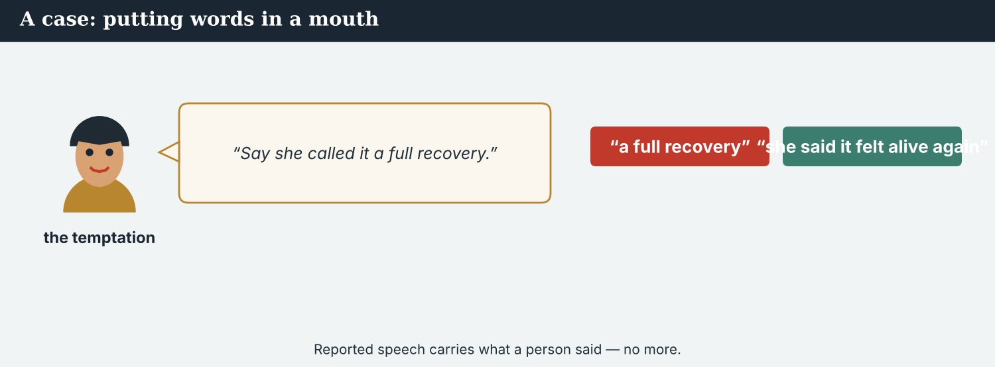
‘A little better’ and ‘recovered’ are both true-sounding. Only one is true.
A first case · the tidier sentence
A case. The Post’s subeditor is not trying to mislead anybody. She has nine words that read awkwardly and four that read well, and ‘the river has recovered’ is the kind of line a reader remembers. She does not invent anything: she is reporting what residents say. But the woman made a small claim about one year, and the short version makes a large claim about a river. If the water falls again next summer, the woman will be the one who said it had recovered. The Code says: a paraphrase must carry the same weight as the words. What does Mira tell the desk?
NOTICE What do you do?
8A Choose (a) or (b), and write one reason.
1. (a) ‘residents say the river has recovered’ (b) ‘the water is a little better this year’. Choice: ______ Because ________________________
2. Making a quote shorter and larger is (a) good editing (b) a change of claim. Choice: ______
8B Same size, or bigger? Write S or B.
1. ‘She said the water was a little better.’ ______
2. ‘Residents say the river has recovered.’ ______
3. ‘According to the Crossing Office, 112 families have returned.’ ______
4. ‘Hundreds are pouring back, officials say.’ ______
PRACTISE Apply the Code
8C Complete the rule. Use: size · name · improve · back.
Keep the ______ of the claim. Put a ______ beside every fact. Do not ______ a quote. Read a translation ______ to the speaker.
PRODUCE Discuss
8D Discuss. Who carries the cost if a quote is made larger — the desk, or the person quoted?
A second case · the interview that was not ours
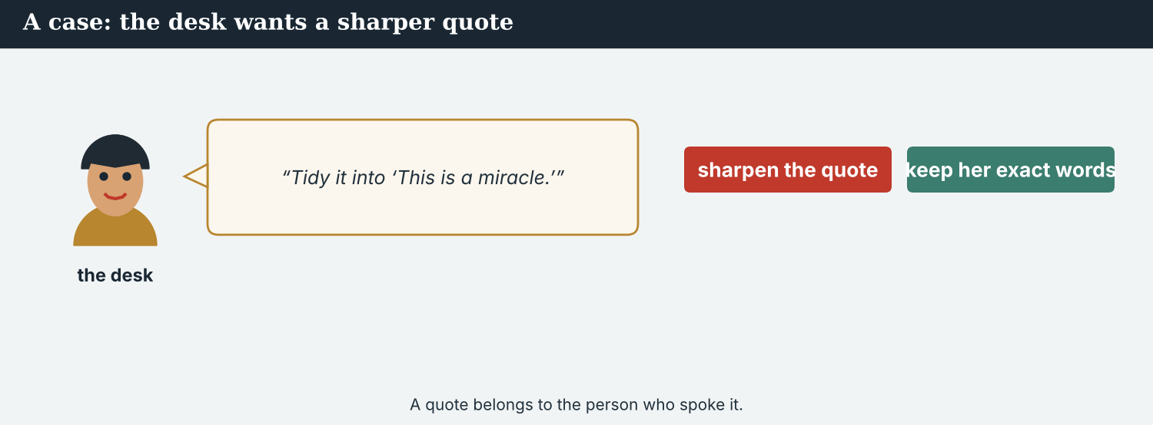
A partner’s interview is theirs. Carrying it is not the same as owning it.
A case. Dren told Mira on a call what the man at the lorry park had said. He said it as a colleague, thinking aloud, not as copy — and the man had refused to be named. Later, the Post’s desk asks Mira for ‘anything on the lorries’. She could write ‘Kalina Daily reported that the lorries were returning’. Nobody would be lying: Dren is a reporter, and he did say it. But he said it to her, not in print, and the man behind it never agreed to anything. The Code says: what a colleague tells you is not published by being repeated. What does Mira send the desk?
NOTICE What do you do?
8E Choose (a) or (b), and write one reason.
1. (a) ‘Kalina Daily reported the lorries were returning’ (b) nothing, until Dren publishes it or the man agrees. Choice: ______ Because ________________________
2. Repeating a colleague’s private words as a report is (a) attribution (b) a claim nobody made in public. Choice: ______
8F Complete with: colleague · named · published · agreement.
1. Dren spoke to Mira as a ___________ .
2. The man refused to be ___________ .
3. Nothing becomes ___________ by being repeated.
4. The partners’ ___________ names the local reporter.
PRODUCE Discuss
8G Discuss. Why is crediting a local partner’s interview a matter of ethics, not only of manners?
PRODUCE Write it
8H Write two sentences to the desk, explaining what you can and cannot send. Use told and according to.
PRACTISE One more
8I Fair attribution, or not? Write F or N.
1. ‘According to the Crossing Office, 112 families have returned.’ ______
2. ‘Sources say the river has recovered.’ ______
3. ‘Hana Petri told Kalina Daily the water was a little better.’ ______
4. ‘A colleague mentioned it on a call, so we reported it.’ ______
8J Discuss. The desk never meets your sources. What does that give you, and what does it cost them?

PART 9 Digital: quoting in a short post
A post has room for one sentence. The attribution still has to fit.
Even in twelve words, the name goes beside the claim.
MODEL A model post
‘The water is a little better this year,’ Hana Petri told @KalinaDaily on the Kalina bridge. 112 families have returned since the reopening, according to the Crossing Office. Interview conducted in Vareni; full story with @MeridianPost. — @AtlasWire
NOTICE The parts of the post
9A Match the part to its job.
1. ‘The water is a little better this year’  2. Hana Petri told @KalinaDaily  3. according to the Crossing Office  4. Interview conducted in Vareni | a) the attribution of a figure  b) the exact quote  c) the language it was spoken in  d) who said it, and to whom
PRACTISE Find and build
9B Find the quote, the attribution and the language note in the post. Write them.
1. ________________________
9C This post drops the name and upgrades the quote. Correct both.
“Sources say the river has recovered. Hundreds are back.”
________________________
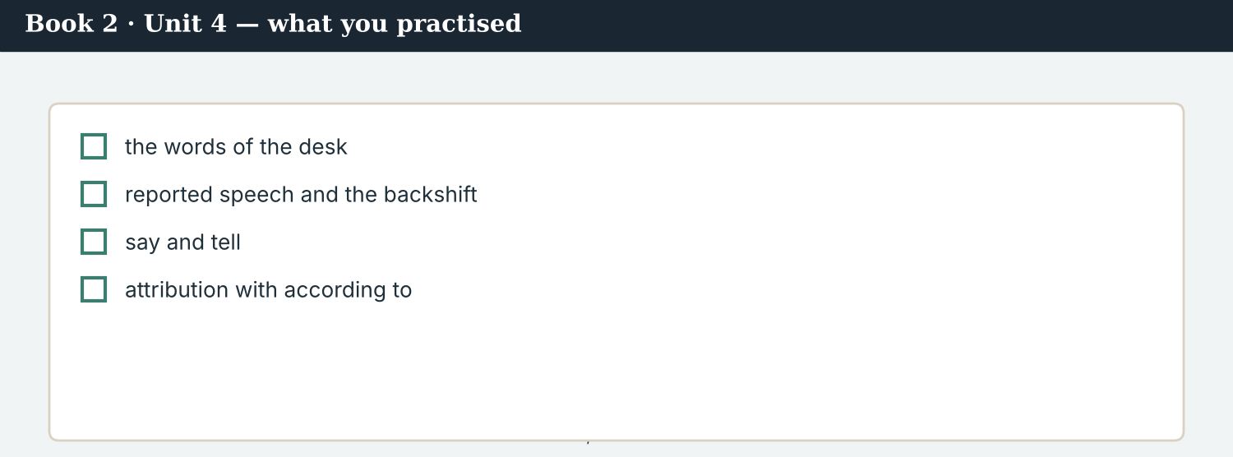
A good post answers: who said it, in what words, and who says the numbers.
9D Write a post. Use one exact quote, one told, and one according to.
’___________ ,’ ___________ told ___________ . ___________ , according to ___________ . — @AtlasWire
PRODUCE Write your post
9E Write a one-line post quoting someone you have spoken to. Name them.
________________________
9F Creative. Write a short headline (4–6 words) using reported speech.
9G A reader asks: ‘Did she really say that?’ Write a short reply. Use said and according to.
________________________
9H A short post has no room for context. Write one line that is short and still the right size.
________________________
PRODUCE Discuss
9I Creative. Write a two-line thread: line 1 the quote with its name, line 2 the figure with its source.
________________________
________________________
9J Discuss. Online, an unattributed quote travels faster. Why is that an argument for attribution, not against it?

PART 10 Review & Can-Do
Check your new English before Unit 5.
The published story: every quote named, every figure attributed.
10A Vocabulary. Complete with: quote · paraphrase · attribution · desk · copy · subeditor · interpreter · on the record.
1. A ___________ gives the exact words.
2. A ___________ gives the sense in your own words.
3. Every fact needs an ___________ .
4. The foreign ___________ had three queries.
5. Mira filed her ___________ at six.
6. A ___________ cut two lines.
7. Dren worked as an ___________ .
8. The man would not go ___________ .
10B Grammar. Put into reported speech.
1. “The water is a little better.” → She said ___________
2. “We will reopen the crossing.” → He said ___________
3. “I can reach the far bank.” → She said ___________
4. “The lorries came back.” → He said ___________
10C Grammar. say or tell?
1. She ___________ me the water was better.
2. He ___________ that the office had no figures.
3. Dren ___________ Mira what she had said.
Can-Do — tick what you can do now.
10D Grammar. Complete with according to.
1. ___________ the Crossing Office, 112 families have returned.
2. ___________ Kalina Daily, the school reopened in March.
3. ___________ Dren, the far bank is still closed.
10E Read and answer.
Hana Petri said the water was a little better this year. She told our reporter the lorries had not returned. According to the Crossing Office, 112 families have come back. One resident said the lorries were coming, but would not be named.
1. What did Hana Petri say about the water? ___________
2. What did she tell our reporter? ___________
3. Where does the figure of 112 come from? ___________
Can-Do — tick what you can do now
☐ I can report what someone said (reported speech).
☐ I can use say and tell correctly.
☐ I can attribute a fact with according to.
☐ I can file copy to a desk in another country.
10F Reflect. Which part of Unit 4 was the most useful for you? Why?
10G Grammar review. Write the sentence correctly.
1. She said me the water was better. → ________________________
2. He told that the crossing was open. → ________________________
3. According to me, 112 families are back. → ________________________
4. She said the river has recovered, but she said ‘a little better’. → ________________________
10H Mixed review. Complete with said, told or according to.
1. She ___________ the water was a little better.
2. She ___________ our reporter the lorries had not returned.
3. ___________ the Crossing Office, 112 families have come back.
10I Reflect. Write one sentence reporting something you were told this week. Use told.

PART 11 Assignment: filing to a foreign desk
Put the unit together: file a short report that a desk abroad can trust.
The assignment template — your filing note and copy.
Your task. A desk in another country is going to publish your report. Write the copy (6–7 sentences) and a short filing note. Use one exact quote in reported speech, one fact with according to, and one thing you are leaving out and why. Say which language the interview was in and who interpreted. Name the local reporter if the interview was theirs.
A model — use Reading A and the Writing 1 model to check the shape of your copy.
Remember: shift the tense, not the claim; say for words, tell for a person, according to for an unconfirmed fact; never improve a quote; carry the language with the words; credit whoever found the source.
Success criteria | Yes | Almost | Not yet
I report speech with the tense one step back. | ☐ | ☐ | ☐
I use say and tell correctly. | ☐ | ☐ | ☐
I attribute every unconfirmed fact with according to. | ☐ | ☐ | ☐
My paraphrase is the same size as the words. | ☐ | ☐ | ☐
I name the language, the interpreter and the local reporter. | ☐ | ☐ | ☐
Keep this. In Unit 5, you set the conditions for publication — the zero and first conditionals, and time clauses — because a story runs if it is confirmed, and when the partners are ready.

ANSWER KEY Book 2 · Unit 4
Check your answers. Open tasks (discussion, role-play and your own writing) are marked at the end.
W1 1 that it was a little better this year · 2 ‘residents say the river has recovered’ · 3 send the query back (keep the original words)
W2 1 F (she said ‘a little better’) · 2 F · 3 T
W3 said: ‘She said, the water is a little better’ · told: ‘She told me it was a little better’ · according to: ‘According to the desk…’
1A 1-b, 2-a, 3-c, 4-d, 5-e, 6-f, 7-g, 8-h, 9-i, 10-j
1B 1 filed · 2 desk · 3 quote · 4 paraphrase · 5 attribution · 6 subeditor
1C 1 file copy · 2 check a quote · 3 attribute a fact · 4 book an interpreter · 5 deny a claim
1D 1 deadline · 2 delete · 3 rough · 4 schedule
1E 1 quote · 2 paraphrase · 3 attribution · 4 according to · 5 accurate
1F 1 on the record · 2 file · 3 deny · 4 insist
1G filed · desk · subeditor · quote · off the record
1J interpreter · translate · accurate · claim · add
2A 1 the water was a little better · 2 they would reopen the second crossing · 3 she could reach the far bank · 4 the lorries had come back the previous spring
2B 1 told · 2 said · 3 told · 4 said
2C 1 According to · 2 According to · 3 According to
2D 1 insisted (that the road was safe) · 2 denied it
2G 1 She told me the water was better. · 2 He said the crossing was open.
3A 1 ‘The water is a little better this year.’ · 2 the Crossing Office · 3 the man would not go on the record
3B according to: ‘According to the Crossing Office’ · told: ‘One man told Dren’ · reported speech: ‘the lorries were coming back’
3C 1 She said the water was a little better. · 2 According to the Crossing Office, 112 families have returned. · 3 He told Dren the lorries were coming back.
3D said · According · told · asked
3E 1 The exact quote, and how it was interpreted. · 2 The figure, and whose it is. · 3 What is not in the copy, and why. · 4 What the desk still needs from us.
3H neither is wrong: ‘according to’ marks the fact as theirs, ‘the Office says’ reports it as speech — the first is clearer with a figure
4B 1 that the water was a little better this year · 2 the Crossing Office · 3 it was off the record · 4 the English was read back to her before they left
4C 1 Q · 2 A · 3 O
4D The exact words = ‘the water is a little better this year’ · The attributed figure = 112 families, Crossing Office · Out = the lorry claim, off the record
4F 1 said · 2 told · 3 said · 4 would
4G said: ‘she said, not with my name’ · told: ‘he told me the lorries were coming back’ · reported question: ‘Mira asked whether she had said better or recovered’
4H because he found the source and interpreted the interview; the work and the relationship are his
4I said · told · off the record · according to
4J a tidier sentence is a different sentence; it can enlarge a claim without inventing a word
4K Desk = queries on the copy · Reporters = the notebook, and the credit
5B 1 T · 2 T · 3 F · 4 F
5C 1 it is her own words, before any translation · 2 call the woman · 3 the short version made a large claim about a river, not a small one about one year
5D 1 desk · 2 subeditor · 3 translate
5F shift the tense → ‘she said the water was better’ · say who → ‘according to the Crossing Office’ · never improve → do not turn ‘a little better’ into ‘recovered’ · carry the language → ‘Dren interpreted; the English was read back’
5G Rule 3
5H 1 quote · 2 paraphrase · 3 accurate
5I 1 the water was a little better · 2 According to the Crossing Office, 112 families have returned. · 3 she could read the English back to her
6A 1 the QUOTE line · 2 the FIGURE line
6C said: ‘said the water was a little better’ · told: ‘told our reporter’ · according to: ‘According to the Crossing Office’
6D said · told · According · would
6F ‘She told me the water was a little better. According to the Crossing Office, 112 families are back.’
7A said: ‘She said the water was a little better’ · told: ‘A man told Dren’ · according to: ‘According to the Crossing Office’
7B 1 She said the water was a little better this year. · 2 A man (at the lorry park) told Dren. · 3 According to the Crossing Office.
7C 1 The desk asked whether we could shorten the quote. · 2 Omar asked where the figure had come from.
7F ‘According to our own agreement, the local reporter is named.’
8A 1 (b) ‘the water is a little better this year’ · 2 (b) a change of claim
8B 1 S · 2 B · 3 S · 4 B
8C size · name · improve · back
8E 1 (b) nothing, until Dren publishes it or the man agrees · 2 (b) a claim nobody made in public
8F 1 colleague · 2 named · 3 published · 4 agreement
8I 1 F · 2 N · 3 F · 4 N
9A ‘The water is a little better this year’ → the exact quote · ‘Hana Petri told @KalinaDaily’ → who said it, and to whom · ‘according to the Crossing Office’ → the attribution of a figure · ‘Interview conducted in Vareni’ → the language it was spoken in
9B quote: ‘The water is a little better this year’ · attribution: ‘according to the Crossing Office’ · language: ‘Interview conducted in Vareni’
9C ’’The water is a little better this year,’ Hana Petri told Kalina Daily. 112 families have returned, according to the Crossing Office.’
10A 1 quote · 2 paraphrase · 3 attribution · 4 desk · 5 copy · 6 subeditor · 7 interpreter · 8 on the record
10B 1 the water was a little better · 2 they would reopen the crossing · 3 she could reach the far bank · 4 the lorries had come back
10C 1 told · 2 said · 3 told
10D 1 According to · 2 According to · 3 According to
10E 1 that it was a little better this year · 2 that the lorries had not returned · 3 the Crossing Office
10G 1 She told me the water was better. · 2 He said that the crossing was open. · 3 According to the Crossing Office, 112 families are back. · 4 She said the water was a little better.
10H 1 said · 2 told · 3 According to
Open tasks W4, W5, 1H, 1I, 1K, 2E, 2F, 2H, 3F, 3G, 3I, 4A, 4E, 4H, 4L, 5A, 5E, 5J, 5K, 5L, 6B, 6E, 6G, 6H, 7D, 7E, 7G, 7H, 7I, 8D, 8G, 8H, 8J, 9D, 9E, 9F, 9G, 9H, 9I, 9J, 10F, 10I — your own answers (discussion, role-play, writing).
A note on real and invented content. The facts about journalism around the world in 2026 are true. Atlas Wire, Kalina Daily, the Meridian Post, their staff, Hana Petri, Dren, Kalina, the Vareni language and the story are invented, for practice. Real people and outlets are only ever in true, sourced facts — never in an invented quote.
English for Journalists — International Edition · Book 2 · Unit 4 (30-page standard). CEFR lower B1 → medium B1 · Beat: Across Borders (wholly) · two readings · two listenings · two writing pieces · two ethics cases · two speaking dialogues · balanced sections · ~28 figures · featured cast + a foreign desk · fictional agency, factual backdrop.

BOOK 2 · UNIT 5 If We Confirm It: The Conditions for Publishing
Beat · Verification & Across Borders CEFR lower B1 → medium B1
In this unit you learn to…
1. state a rule with the zero conditional
2. set a real condition with the first conditional
3. use unless, as long as and provided that
4. say when something will happen with time clauses
The Atlas Wire team — agreeing the conditions that must be met before anything runs.
Nothing runs until it is confirmed. The Seven Crossings is written. Now come the conditions. Four newsrooms have agreed a single hour of publication, and a short list of things that must be true before that hour: two sources for every figure, a document for every claim, a right of reply for everyone named, and a lawyer’s reading in each country. This week, Priya sets the conditions, Omar pushes to run early, and Mira learns to say if and until in a way nobody can misread. (Atlas Wire, Kalina Daily, the River Basin Network and the Meridian Post are invented, for practice.)

WARM-UP The conditions
A short scene to start the unit. Read it, then answer.
The morning conference — the list of conditions goes on the wall.
“If a figure has one source, we do not publish it,” Priya says. “That is the rule, and it does not change.”
Ana writes it on the board. “And if the Crossing Office gives us the method?”
“Then we will run the figure on Sunday, with the method beside it.”
“And if it does not?”
“We publish the story without the number. We do not publish a number we cannot stand behind.”
Omar’s message arrives as she finishes. If we wait, somebody else runs it first. Ana reads it twice. “We will wait,” she says, “until it is confirmed.”
W1 Answer the questions.
1. What is Priya’s rule about a figure with one source? ___________
2. What will they do if the office gives them the method? ___________
3. What does Ana decide? ___________
W2 True or false? Write T or F.
1. They will publish a figure with one source. ______
2. They will run the figure if the office gives the method. ______
3. Ana decides to publish before it is confirmed. ______
W3 Find one zero conditional, one first conditional, and one time clause in the text.
1. ________________________
PRODUCE Talk about it
W4 Discuss with a partner.
1. What is one rule in your work that never changes? Say it with ‘if’.
2. What will you do if your next deadline moves?
PRODUCE One more
W5 Discuss. ‘Somebody else will run it first.’ Is that ever a reason to publish early?

PART 1 The words of verification
The words for conditions, proof and holding a story.
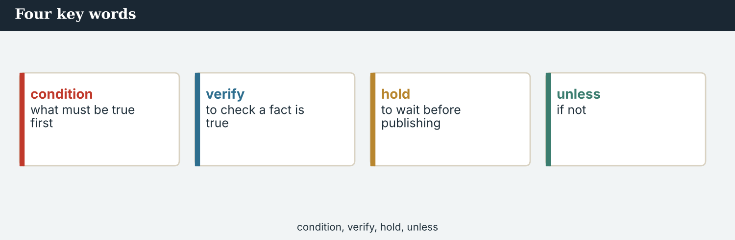
Four key words — condition, verify, embargo, second source.
The words
Word | Meaning
condition | something that must be true first
verify | to prove that something is true
second source | another independent person who confirms it
corroborate | to support a claim with other evidence
evidence | the facts that prove something
document | a paper that proves something
embargo | an agreed time before which nothing is published
hold (v) | to wait before publishing
withhold | to keep something back
legal check | a lawyer’s reading before publication
sign off | to approve for publication
right of reply | the chance to answer a claim about you
threshold | the level you must reach before you publish
provisional | not final; it may still change
independent | not controlled by anyone
risk (n) | the chance that something goes wrong
unless | if not
as soon as | immediately when
PRACTISE Controlled practice
1A Match the word (1–10) to the meaning (a–j).
1. condition  2. verify  3. second source  4. embargo  5. hold  6. right of reply  7. threshold  8. provisional  9. independent  10. withhold | a) to prove that something is true  b) something that must be true first  c) an agreed time before which nothing is published  d) another person who confirms it  e) to wait before publishing  f) the chance to answer a claim about you  g) the level you must reach before you publish  h) not final; it may still change  i) not controlled by anyone  j) to keep something back
1B Complete the sentences with a word from the box.
WORD BOX
condition · verify · embargo · hold · evidence · legal check
1. Two sources is the first ___________ .
2. Priya cannot ___________ the figure yet.
3. All four partners agreed one ___________ hour.
4. We will ___________ the story until Sunday.
5. A document is the strongest ___________ .
6. Every country needs its own ___________ .
1C Match the two halves.
1. meet a  2. break an  3. verify a  4. sign  5. offer a | a) figure  b) condition  c) embargo  d) right of reply  e) off
1D Circle the word that is different.
1. verify · confirm · corroborate · guess
2. evidence · document · proof · rumour
3. hold · wait · delay · rush
4. provisional · final · temporary · uncertain
One source is a claim. Two independent sources are a fact.
1E Complete the paragraph. Use: condition · verify · second source · provisional · embargo.
The first ___________ is simple: ___________ every figure. One voice is a claim; a ___________ makes it a fact. Until then the number is ___________ , and the ___________ holds.
1F Read the definition. Write the word.
1. the chance to answer a claim about you → ___________
2. to approve for publication → ___________
3. the level you must reach before you publish → ___________
4. if not → ___________
1G Complete the collocation paragraph. Use: embargo · legal check · sign off · right of reply · threshold.
The partners agreed one ___________ . Each country ran its own ___________ . Nobody would ___________ until the ___________ had been offered to everyone named, and the two-source ___________ had been met.
PRODUCE Over to you
1H Answer about you. Write full sentences.
1. What is one condition you always meet before you send work out?
2. When did you last have to wait for proof? What happened?
PRODUCE Talk about it
1I Discuss. Which two words in this unit are new for you? Make a sentence with one.
1J Complete with: risk · withhold · independent · as soon as · corroborate.
We will ___________ the name ___________ there is any ___________ to her. Two ___________ witnesses ___________ the rest of the account.
1K Creative. Write two sentences about a condition you would set before publishing something.

PART 2 Grammar: rules and real conditions
The zero conditional for rules; the first conditional for real futures; unless, as long as, provided that.
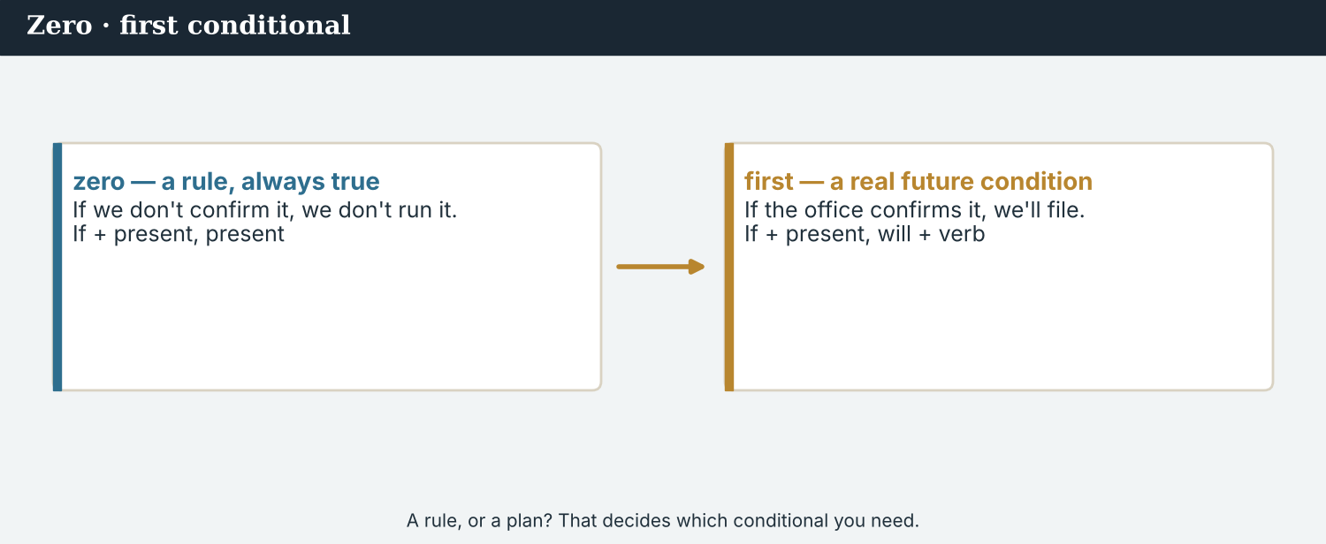
Zero conditional = a rule that is always true. First conditional = one real future.
1 · zero conditional — a rule
Form: If + present simple, present simple. “If a figure has one source, we do not publish it.”
For something always true: a rule, a law, a standing practice.
You can swap the halves: “We do not publish a figure if it has one source.”
2 · first conditional — one real future
Form: If + present simple, will + verb. “If the office confirms it, we will run it on Sunday.”
For one real possibility in the future, and its result.
Never ‘if…will’ in the if-half: say if it confirms, NOT if it will confirm.
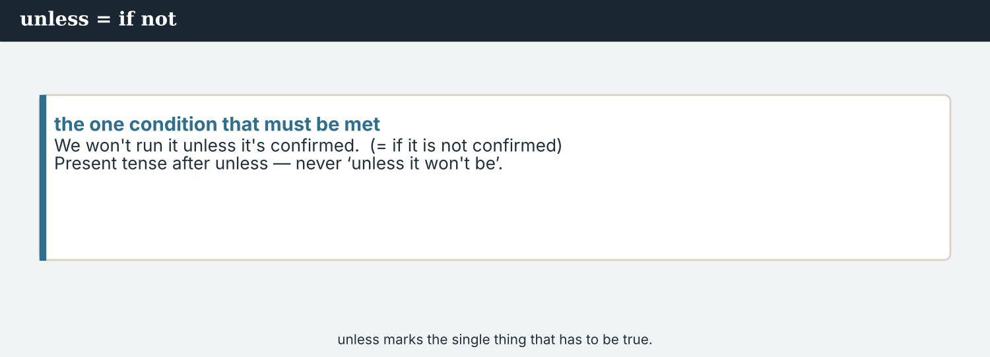
unless = if not · as long as / provided that = only on this condition.
3 · unless · as long as · provided that
Unless = if not: “We will not publish unless we have two sources.”
As long as / provided that = only on this condition: “We will run it as long as the method comes.”
Not with a second not: say unless we have, NOT unless we don’t have.
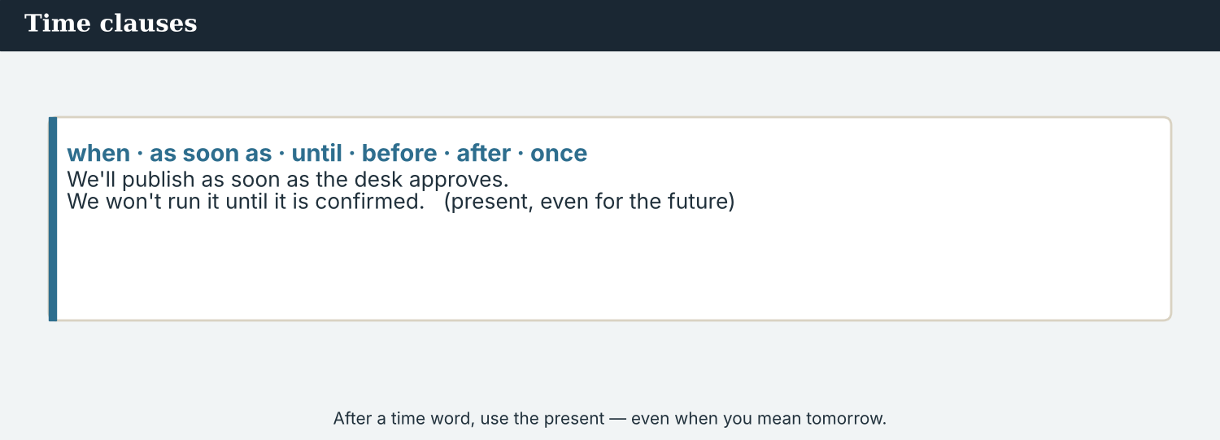
Rule, real future, or condition — each has its own form.
PRACTISE Structured practice
2A Complete with the zero conditional.
1. If a figure ___________ (have) one source, we ___________ (not publish) it.
2. If a claim ___________ (be) about a named person, they ___________ (get) a right of reply.
3. If a document ___________ (be) unsigned, the desk ___________ (ask) for the original.
2B Complete with the first conditional.
1. If the office ___________ (confirm) the figure, we ___________ (run) it on Sunday.
2. If Priya ___________ (not verify) it, we ___________ (publish) the story without the number.
3. If one partner ___________ (break) the embargo, the others ___________ (lose) the day.
2C Rewrite with unless.
1. We will not publish if we do not have two sources. → ________________________
2. He will not be named if he does not agree. → ________________________
2D Complete with as long as or provided that.
1. We will run the figure ___________ the method comes with it.
2. The Post may use the quote ___________ Dren is credited.
Your own words
2E Write two rules of your own work. Use the zero conditional.
1. ________________________
2. ________________________
2F Write two real conditions for your next piece of work. Use the first conditional.
1. ________________________
2. ________________________
2G Rewrite the sentence correctly (zero / first conditional / unless).
1. If the office will confirm it, we will run it. → ________________________
2. Unless we don’t have two sources, we will not publish. → ________________________
2H Your own words. Write one rule and one real condition about your own work.
1. ________________________

PART 3 Setting the conditions
A conditions note says what must be true before publication, and when each thing happens.
One hour, four countries. Every condition has to be met before it, not after.
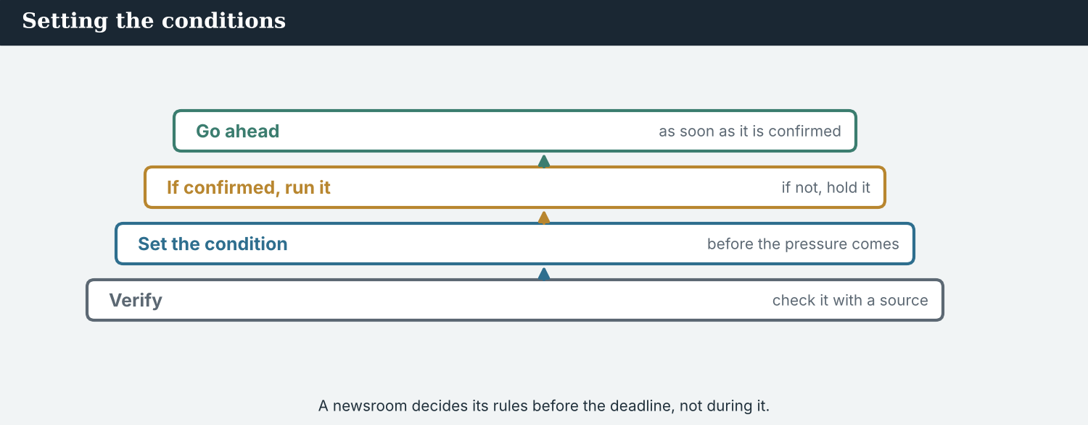
A conditions note: what must be true, who checks it, and by when.
4 · time clauses — saying when
After when, until, as soon as, before, after, by the time, use the present for the future.
“We will run it when the method arrives.” “We will hold until it is confirmed.”
Not ‘will’ twice: say as soon as it arrives, NOT as soon as it will arrive.
MODEL A model conditions note
“Here are the conditions. If a figure has one source, it does not run — that is standing practice, not a judgement call. We will publish the Crossing Office number as soon as the method arrives; if it does not arrive by Friday, the story runs without it.
Everyone named gets a right of reply, and we hold until the replies are in or the deadline passes. Each partner runs its own legal check. Nobody signs off before the two-source threshold is met.
The embargo holds until 07:00 GMT on Sunday, unless all four of us agree to move it together.”
NOTICE Notice the conditions
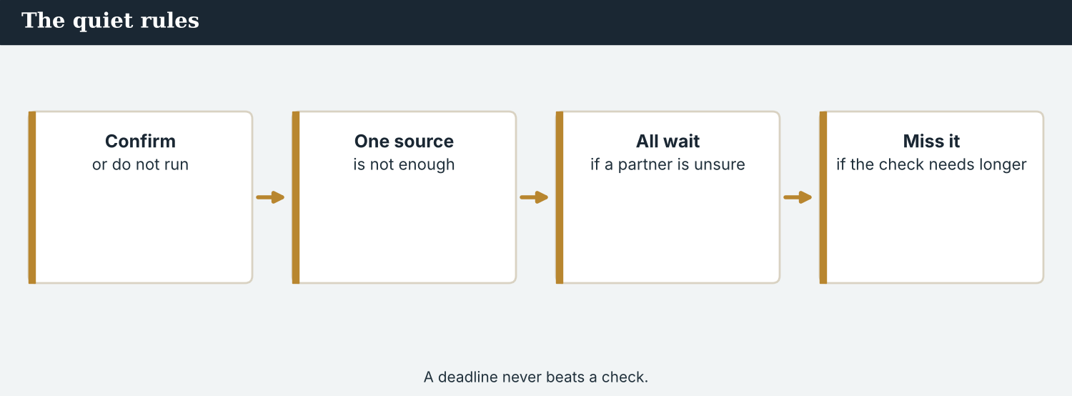
Conditions are not delays. They are the reason a story survives contact with the world.
3A Answer about the model.
1. What happens if a figure has one source? ___________
2. When will they publish the Crossing Office number? ___________
3. Until when does the embargo hold? ___________
3B Find one zero conditional, one first conditional, and one time clause in the model. Write them.
1. ________________________
PRACTISE Build the conditions
A condition answers: what must be true, who checks it, and by when.
3C Write the sentence as a zero conditional, a first conditional, or a time clause.
1. one source / we / not publish (a rule) → ________________________
2. the method / arrive / we / run the figure (a real future) → ________________________
3. the replies / be in / we / publish (a time clause with ‘when’) → ________________________
3D Complete the note. Use: if · unless · until · as soon as.
______ a figure has one source, it does not run. We will publish ______ the method arrives. We hold ______ the replies are in. Nobody signs off ______ the threshold is met.
PRACTISE One more
3E Put the conditions in order. Number them 1–4.
1. The legal check in each country. ______
2. Two sources for every figure. ______
3. Sign-off and publication at the agreed hour. ______
4. A right of reply for everyone named. ______
PRODUCE Your turn
3F Choose a story. Write a conditions note (4–5 sentences): one rule (zero conditional), one real condition (first conditional), one time clause, and one thing you will not do.
________________________
________________________
________________________
________________________
PRODUCE Discuss
3G Talk with a partner. Why is ‘we do not publish one-source figures’ better as a rule than as a decision?
3H Why is ‘we will hold until it is confirmed’ clearer than ‘we will probably wait’? Explain.
3I Discuss. Who should be allowed to move an embargo — any partner, or only all of them together?

PART 4 Listening: before it runs
Two audios. Listen for the conditions, and for the pressure to break them.
Audio 5.1 — verification sets the conditions before anyone talks about hours.
Listening A · verification sets the bar
MODEL Audio 5.1 — Priya and Mira
Priya: Two sources for every figure. If we have one, it does not run.
Mira: And the Crossing Office number?
Priya: One source, and no method. If they send the method, we will run it on Sunday.
Mira: And if they do not?
Priya: The story runs without the number. It is a good story without it.
Mira: The far-bank families?
Priya: Two witnesses, and a document. That one is solid, as long as we do not name the woman who kept the records.
Mira: Understood. When will the legal checks be finished?
Priya: Geneva by Wednesday. The others as soon as their lawyers have read it.
PRACTISE Listen for detail
4A Before you listen: what condition do you think Priya will set first? Write one idea.
1. ______
4B Answer the questions.
1. What is Priya’s rule about figures? ___________
2. What will happen if the office sends the method? ___________
3. What will happen if it does not? ___________
4. On what condition is the far-bank account solid? ___________
4C Rule, real future, or time clause? Write R, F, or T.
1. “If we have one source, it does not run.” ______
2. “If they send the method, we will run it.” ______
3. “As soon as their lawyers have read it.” ______
4D Complete the notes.
The standing rule: ___________
The real condition on the figure: ___________
What happens if the method does not come: ___________
Audio 5.2 — a partner asks to run early, and hears why nobody can.
Listening B · the pressure to run early
MODEL Audio 5.2 — Omar and Ana
Omar: Ana, I think somebody else has the story. If we wait, we lose it.
Ana: If one of us runs early, the other three lose the day. That is the agreement.
Omar: And if a rival publishes on Saturday?
Ana: Then we publish on Saturday — all four of us, together, within the hour.
Omar: That is fair. But I am under pressure here.
Ana: So is Dren, and he has the most to lose. He will still be in Kalina next year.
Omar: Understood. I will hold until Sunday.
Ana: Thank you. As soon as anything changes, you will hear it from me first.
PRACTISE Listen for detail
4E Before you listen: what do you think Omar will ask for? Guess.
1. ______
4F Complete the answers.
1. If one partner runs early, the other three ___________ the day.
2. If a rival publishes on Saturday, all four ___________ publish on Saturday.
3. Omar ___________ hold until Sunday.
4. Ana will call him as soon as anything ___________ .
4G Which forms do you hear? Write one first conditional, one zero conditional, and one time clause.
1. ________________________
4H Answer. Why does Ana say Dren has the most to lose?
1. ________________________
PRACTISE Both audios
4I Complete the summary. Use: if · unless · until · as soon as.
______ a figure has one source, it does not run. Nothing publishes ______ all four partners agree. The embargo holds ______ Sunday, and Ana will call ______ anything changes.
4J Omar is under real pressure. Why is ‘we will all move together’ a better answer than ‘no’?
1. ________________________
PRODUCE What do you think?
4K Complete the note comparing the two audios.
Priya’s conditions are about: ___________
Ana’s conditions are about: ___________
4L Discuss. Which condition is harder to keep — a verification rule, or an embargo?

PART 5 Reading: the rules they agreed first
Two readings. Read for the conditions, and for why they come before the calendar.
A story that runs in four countries can only be as strong as its weakest condition.
Reading A · what must be true before Sunday
Nothing runs until it is confirmed
Before the four newsrooms agreed an hour, they agreed a list. It is one page long, it was written in a morning, and it is the reason the project will survive its own publication.
The first condition is arithmetic. If a figure has one source, it does not run. “That is not a judgement we make story by story,” says Priya Nair, who leads verification at Atlas Wire. “It is a rule. Rules are what you have when you are tired.”
The second is paper. Every claim about the crossings has to rest on something a reader could in principle see: a register, a council minute, a photograph with a date. Where a document exists but naming its keeper would put her at risk, the partners publish the document’s substance and withhold her name.
The third is the right of reply. Everyone named gets the chance to answer before publication, in their own language, with a real deadline. “If somebody answers us at the last hour, we will still carry it,” says Omar Faris of the Meridian Post. “If they do not answer, we say that too.”
The fourth is law. Each partner runs its own legal check, in its own jurisdiction, because what is safe to print in one country is not always safe in another. Nobody signs off until all four have read the piece in their own jurisdiction.
And then, last of all, comes the hour. The embargo holds until 07:00 GMT on the last Sunday of the month, and no partner may move it alone. “If a rival publishes first, we all move together, within the hour,” says Ana Ferreira of Atlas Wire. “The one thing we never do is leave the smallest partner standing in the open on their own.”
PRACTISE Comprehension
5A Before you read: look at the title. What do you think ‘confirmed’ will mean here? Write one sentence.
1. ______
5B True or false? Write T or F.
1. A figure with one source can run if the story is strong. ______
2. The partners withhold a name if publishing it would put someone at risk. ______
3. Everyone named gets a right of reply before publication. ______
4. Any partner may move the embargo alone. ______
5C Answer the questions.
1. Why does Priya call the two-source test a rule, not a judgement? ___________
2. What happens if someone does not answer a right of reply? ___________
3. Why does each partner run its own legal check? ___________
5D Find a word or phrase in the text.
1. an agreed time before which nothing is published → ___________
2. to keep something back → ___________
3. a lawyer’s reading before publication → ___________
The weakest partner sets the real deadline. That is not a weakness; it is the agreement.
Reading B · the conditions, in short
Four conditions before you publish
1. Two independent sources, or it does not run. A rule, not a decision: if a figure has one source, we do not publish it. Rules survive tiredness.
2. Something a reader could see. A register, a minute, a dated photograph. If naming its keeper would put them at risk, publish the substance and withhold the name.
3. A real right of reply. Everyone named is asked before publication, with a deadline they can meet. If they answer late, carry it; if not, say so.
4. One hour, agreed by all. Hold until the agreed time. If it breaks elsewhere, move together — never leave the smallest partner exposed.
PRACTISE Comprehension
5E Before you read: which condition do you think is broken most often? Guess.
1. ______
5F Match the condition to the example.
1. two sources  2. something a reader could see  3. a real right of reply  4. one hour, agreed by all | a) ‘we publish the substance and withhold her name’  b) ‘if they answer late, we carry it’  c) ‘if a figure has one source, it does not run’  d) ‘if it breaks elsewhere, all four move together’
5G Which condition protects a person rather than a fact? Write the number.
1. ______
PRACTISE Words from the readings
5H Find a word in Reading A or Reading B.
1. to prove that something is true → ___________
2. not controlled by anyone → ___________
3. the chance to answer a claim about you → ___________
PRACTISE Both readings
5I Complete with the zero conditional, the first conditional, or a time clause.
1. If a figure ___________ (have) one source, it ___________ (not run).
2. If a rival ___________ (publish) first, all four ___________ (move) together.
3. Nobody signs off until all four partners ___________ (read) the piece.
PRODUCE Discuss
5J Talk about it. ‘Rules are what you have when you are tired.’ What does Priya mean?
5K Which of the four conditions would be hardest in your own work? Say why.
5L Discuss. Why is ‘we all move together’ a condition about fairness, not about speed?

PART 6 Writing: the conditions on paper
Two short pieces: a conditions note, and a note holding a story.
Conditions on one page: the rule, the real condition, the hour.
Writing 1 · a conditions note
MODEL A model
RULE: If a figure has one source, it does not run.
CONDITION: If the Crossing Office sends the method, we will publish the figure on Sunday. If not, the story runs without it.
REPLY: Everyone named is asked by Wednesday. We hold until the replies are in or the deadline passes.
HOUR: The embargo holds until 07:00 GMT on Sunday, unless all four partners agree to move it together.
NOTICE Notice the model
6A Answer about the model.
1. Which line is a zero conditional? ___________
2. Which line uses unless? ___________
PRODUCE Write your note
6B Choose a story. Write a conditions note: one rule, one real condition, one time clause, one hour.
Rule: ___________
Condition: ___________
Reply: ___________
Hour: ___________
A holding note tells a partner why you are waiting, and exactly what will release it.
Writing 2 · a note holding a story
MODEL A model
Dear Omar,
We are holding the figure. If the Crossing Office sends its method, we will publish the number on Sunday with the method beside it. If it does not arrive by Friday, the story runs without the number.
We will not move the embargo unless all four of us agree together. As soon as anything changes, you will hear it from me first.
Best wishes, Mira
NOTICE Notice the model
6C Answer. Find the first conditional, the ‘unless’ clause and the time clause in the note.
1. ___________
PRACTISE Complete the paragraph
6D Complete the note. Use: if · unless · as soon as · will.
______ the method arrives, we ______ publish on Sunday. We will not move the embargo ______ all four of us agree. ______ anything changes, you will hear it from me.
PRODUCE Write your note
6E Turn your conditions into a short holding note to a partner (4–5 sentences). Use if, unless and one time clause.
________________________
________________________
________________________
PRACTISE Fix it
6F This note uses ‘if…will’ and a double negative with ‘unless’. Correct both.
“If the office will send the method, we will publish. Unless we don’t agree together, the embargo stays.”
________________________
PRACTISE Plan it
6G Plan a longer conditions note. Write three lines: one rule, one real condition, one time clause.
Rule: ___________
Condition: ___________
When: ___________
6H Peer-check. Swap with a partner. Is every condition testable, and does every ‘when’ have a date? Write one note.
________________________

PART 7 Speaking: agreeing the conditions
Say what must be true before you publish. Use if, unless and time clauses.
Saying a condition out loud: what must be true, and what happens if it is not.
A model dialogue · setting the bar
MODEL Listen and read
Sofia: Can we run the figure on Sunday?
Mira: If the office sends the method, yes. If not, the story runs without it.
Sofia: And the far-bank account?
Mira: Two witnesses and a document. It runs, as long as we do not name the record-keeper.
Sofia: When do the legal checks finish?
Mira: Geneva on Wednesday, the others as soon as their lawyers have read it.
Sofia: And the hour?
Mira: 07:00 GMT. We do not move it unless all four of us agree together.
NOTICE Notice the forms
7A Find one zero conditional, one first conditional and one ‘unless’ sentence. Write them.
1. ________________________
PRACTISE Controlled practice
7B Answer with a conditional or a time clause.
1. What / happen / if the method / not arrive? → ___________
2. On what condition / the far-bank account / run? → ___________
3. When / the legal checks / finish? → ___________
Open with the rule, then the condition, then the hour.
7C Make a question with ‘if’, then answer it.
1. the office / confirm / the figure → ________________________
2. a rival / publish / first → ________________________
PRODUCE Your role
Verification editor | State the rule, the condition, and what happens if it is not met.
Partner | Ask: ‘And if it does not arrive?’ and ‘Can we run early?’
Observer | Listen. Was every condition testable, with a date?
7D Choose a role from the table. Agree the conditions with your partner.
PRODUCE Role-play
7E Role-play a conditions call: a verification editor, a partner, and an observer. Then swap roles.
A second dialogue · saying no to running early
MODEL Listen and read
Omar: If we hold until Sunday, we may lose it.
Mira: If one of us runs early, the others lose the day. Especially Dren.
Omar: And if somebody else breaks it first?
Mira: Then we all move together, within the hour. Nobody stands out there alone.
Omar: All right. I will hold.
Mira: As soon as anything changes, you will hear it from me — before you hear it anywhere else.
PRACTISE Controlled practice
7F Write the first conditional Mira uses about moving together.
1. ________________________
PRODUCE Self-check
Did I… | Yes | Almost | Not yet
use the zero conditional for a rule? | ☐ | ☐ | ☐
use the first conditional for a real future (no ‘if…will’)? | ☐ | ☐ | ☐
use unless, as long as or provided that correctly? | ☐ | ☐ | ☐
use the present after when, until and as soon as? | ☐ | ☐ | ☐
7G Role-play saying no to a partner who wants to publish early. Then swap roles.
PRACTISE Plan it
7H Plan your call. Note one rule, one condition, and one thing that would release the story.
7I Discuss. How would you say no to a bigger partner, and keep the partnership?

PART 8 Ethics: holding and releasing
An embargo is a promise to three other newsrooms. A condition is a promise to the reader.
Independence is a condition too: nobody outside the newsroom sets the hour.
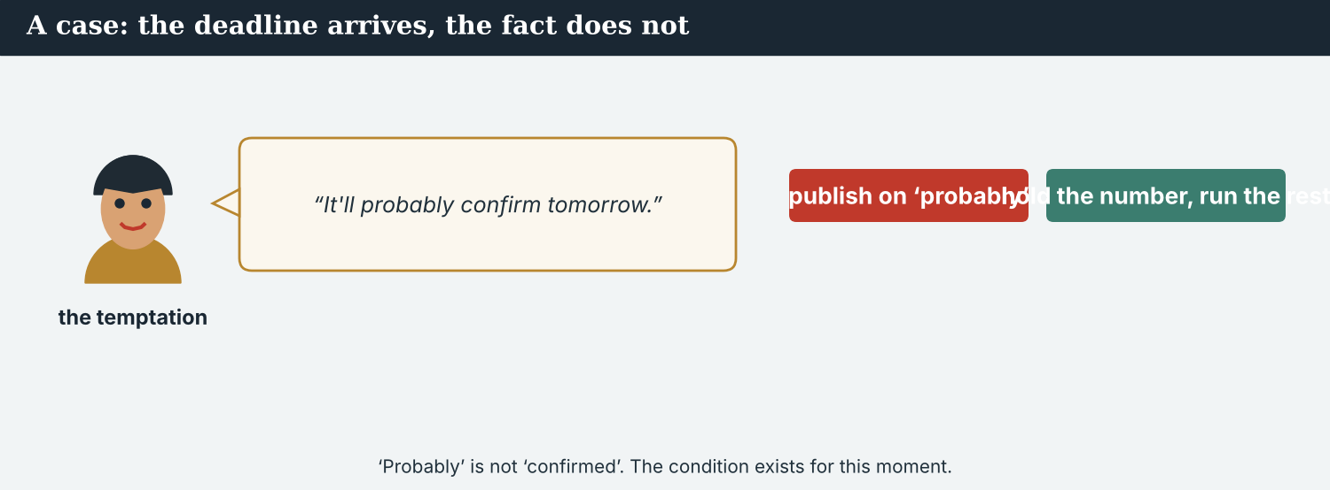
Running early wins one morning and costs three partners a day.
A first case · the temptation to run early
A case. Omar hears that a rival may have the story. If the Post runs on Saturday morning, it gets the credit and the traffic; if it waits, a competitor may take both. Nobody would be publishing anything false — only early. But three newsrooms built their Sunday around the agreed hour, and the smallest of them, Kalina Daily, has one front page a week and no second chance. An embargo is not a courtesy; it is the only thing that makes a partnership of unequal outlets possible. The Code says: a promise to a partner is a promise. What should Omar do if the rival publishes first?
NOTICE What do you do?
8A Choose (a) or (b), and write one reason.
1. (a) run on Saturday and tell the others after (b) call all four partners and move together. Choice: ______ Because ________________________
2. Breaking an embargo alone is (a) competitive (b) a broken promise to three newsrooms. Choice: ______
8B Keeps the agreement, or breaks it? Write K or B.
1. ‘We will all move together, within the hour.’ ______
2. ‘We ran early; we will tell them afterwards.’ ______
3. ‘If a rival publishes, I call the others first.’ ______
4. ‘Our audience is bigger, so our hour wins.’ ______
PRACTISE Apply the Code
8C Complete the rule. Use: together · alone · agreed · first.
Hold until the ______ hour. If the story breaks elsewhere, move ______ . Call your partners ______ . Never leave the smallest one ______ .
PRODUCE Discuss
8D Discuss. Why does an embargo matter more to the smallest partner than to the biggest?
A second case · the condition that protects a person
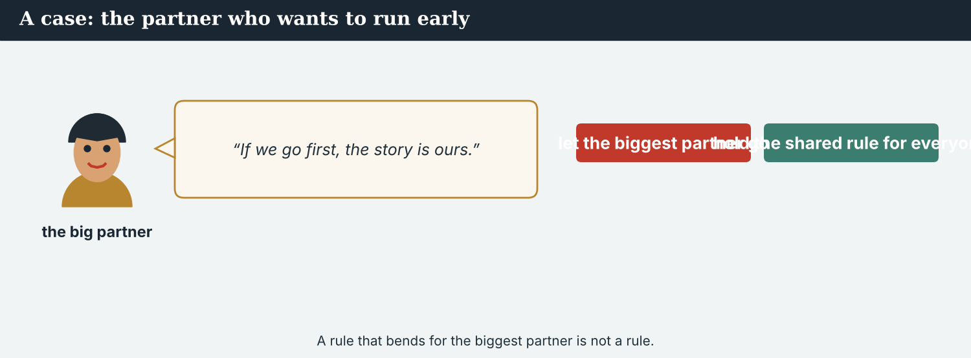
A document proves the claim. Naming its keeper can cost her everything.
A case. The far-bank account rests on a register kept for seven years by a woman on the closed side. The document is decisive, and Dren wants it published in full: it is his town, his scoop, and the proof of what people there lost. But her handwriting is on every page, and three people in the valley know whose it is. Atlas Wire can publish the substance and withhold her name, which is weaker journalism and a safer life. The pressure here comes from below, not above — and it is sincere. The Code says: no story is worth a source. What do the partners publish?
NOTICE What do you do?
8E Choose (a) or (b), and write one reason.
1. (a) publish the register in full (b) publish its substance and withhold her name. Choice: ______ Because ________________________
2. A condition that weakens a story but protects a source is (a) a loss (b) the price of the story. Choice: ______
8F Complete with: register · name · risk · substance.
1. The ___________ proves what people lost.
2. Her ___________ is on every page.
3. Publishing it would put her at ___________ .
4. The partners publish the ___________ only.
PRODUCE Discuss
8G Discuss. Dren’s pressure is sincere and local. Why is it still pressure?
PRODUCE Write it
8H Write two sentences to the partners, setting the condition that protects the record-keeper. Use if and unless.
PRACTISE One more
8I Protects the source, or exposes her? Write P or E.
1. ‘We publish the substance and withhold the name.’ ______
2. ‘We publish the pages as they are.’ ______
3. ‘We describe the document without its handwriting.’ ______
4. ‘We thank the keeper by name at the end.’ ______
8J Discuss. ‘No story is worth a source.’ Is that a rule or a judgement? Say why.

PART 9 Digital: holding the line online
Online, you can say what you know, what you do not, and what you are waiting for.
A holding post is journalism too: this is what we have, and this is what we are waiting for.
MODEL A model post
WHAT WE KNOW · Two witnesses and a seven-year register describe what happened on the far bank. WHAT WE ARE WAITING FOR · The Crossing Office’s method for its figure of 112. If it arrives, we will publish the number; if not, we will publish without it. Full story Sunday, 07:00 GMT, with @KalinaDaily and @MeridianPost. — @AtlasWire
NOTICE The parts of the post
9A Match the part to its job.
1. Two witnesses and a register  2. the Crossing Office’s method  3. if it arrives, we will publish  4. Sunday, 07:00 GMT | a) the real condition  b) what is already confirmed  c) the agreed hour  d) what is still missing
PRACTISE Find and build
9B Find the zero or first conditional in the post, and the time reference. Write them.
1. ________________________
9C This post uses ‘if…will’ and promises a number that is not confirmed. Correct both.
“If the office will confirm it, we publish. 112 families are back — more soon!”
________________________
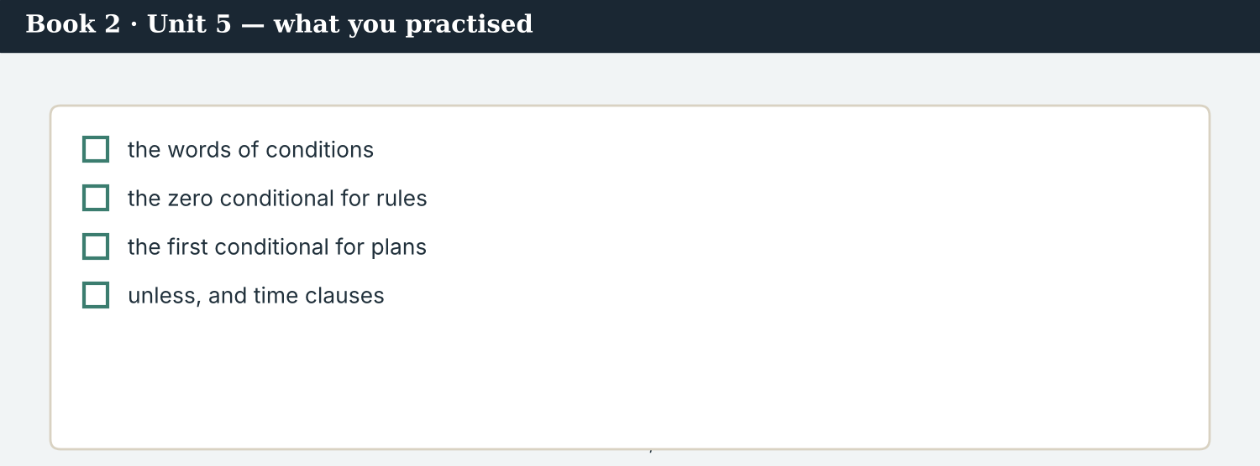
A good holding post answers: what we know, what is missing, and when it runs.
9D Write a holding post. Use one first conditional and one time clause.
WHAT WE KNOW · ___________ . WHAT WE ARE WAITING FOR · ___________ . If ___________ , we will ___________ . — @AtlasWire
PRODUCE Write your post
9E Write a one-line post saying you are holding a story, and what would release it.
________________________
9F Creative. Write a short headline (4–6 words) for a story that is still being confirmed.
9G A reader asks: ‘Why have you not published it yet?’ Write a short reply. Use unless and until.
________________________
9H A holding post can sound like a tease. Write one line that informs without teasing.
________________________
PRODUCE Discuss
9I Creative. Write a two-line thread: line 1 what is confirmed, line 2 the condition on the rest.
________________________
________________________
9J Discuss. Saying ‘we are waiting’ tells a rival what you have. Is it still worth saying?

PART 10 Review & Can-Do
Check your new English before Unit 6.
The published story: every condition met, and the hour kept.
10A Vocabulary. Complete with: condition · verify · embargo · hold · evidence · right of reply · threshold · provisional.
1. Two sources is the first ___________ .
2. Priya could not ___________ the figure.
3. All four partners agreed one ___________ .
4. We will ___________ the story until Sunday.
5. A document is the strongest ___________ .
6. Everyone named is offered a ___________ .
7. The two-source ___________ had been met.
8. Until then the number is ___________ .
10B Grammar. Complete with the zero conditional.
1. If a figure ___________ (have) one source, we ___________ (not publish) it.
2. If a claim ___________ (name) a person, they ___________ (get) a right of reply.
3. If a document ___________ (be) unsigned, the desk ___________ (ask) for the original.
10C Grammar. Complete with the first conditional.
1. If the office ___________ (send) the method, we ___________ (run) the figure.
2. If a rival ___________ (publish) first, all four ___________ (move) together.
3. If Dren ___________ (not agree) , we ___________ (not publish) the name.
Can-Do — tick what you can do now.
10D Grammar. Complete with unless, as long as, until or as soon as.
1. We will not publish ___________ we have two sources.
2. The Post may use the quote ___________ Dren is credited.
3. We will hold ___________ the replies are in.
4. I will call you ___________ anything changes.
10E Read and answer.
If a figure has one source, it does not run. If the Crossing Office sends its method, the partners will publish the number on Sunday; if it does not arrive, the story runs without it. Everyone named is offered a right of reply, and nobody signs off until all four legal checks are done. The embargo holds until 07:00 GMT unless all four partners agree to move it together.
1. What happens if a figure has one source? ___________
2. When will the partners publish the number? ___________
3. What is the one way the embargo can move? ___________
Can-Do — tick what you can do now
☐ I can state a rule with the zero conditional.
☐ I can set a real condition with the first conditional.
☐ I can use unless, as long as and provided that.
☐ I can say when something will happen with time clauses.
10F Reflect. Which part of Unit 5 was the most useful for you? Why?
10G Grammar review. Write the sentence correctly.
1. If the office will send the method, we will publish. → ________________________
2. Unless we don’t agree, the embargo stays. → ________________________
3. We will publish as soon as the method will arrive. → ________________________
4. If a figure has one source, we will not publishing it. → ________________________
10H Mixed review. Complete with a conditional or a time clause.
1. Nobody signs off until all four partners ___________ (read) it.
2. If a rival ___________ (publish) first, we ___________ (move) together.
3. We will not name her ___________ she agrees.
10I Reflect. Write one condition you will set before your next piece of work goes out.

PART 11 Assignment: a conditions note
Put the unit together: write the conditions for publishing a story with partners.
The assignment template — your conditions note.
Your task. You are publishing a story with two partner newsrooms abroad. Write a conditions note (6–7 sentences). Give one standing rule (zero conditional), two real conditions and their results (first conditional), one condition with unless or as long as, and two time clauses saying when each step happens. End with what you will do if the story breaks elsewhere first.
A model — use Reading A and the Writing 1 model to check the shape of your note.
Remember: the zero conditional for rules; the first conditional for real futures (never ‘if…will’); unless = if not; the present tense after when, until and as soon as; and nothing published that the conditions do not cover.
Success criteria | Yes | Almost | Not yet
I state at least one rule in the zero conditional. | ☐ | ☐ | ☐
I set real conditions in the first conditional, with no ‘if…will’. | ☐ | ☐ | ☐
I use unless or as long as correctly. | ☐ | ☐ | ☐
I use the present after when, until and as soon as. | ☐ | ☐ | ☐
Every condition is testable, and has a date. | ☐ | ☐ | ☐
Keep this. In Unit 6, a claim spreads across the basin and nobody can prove it yet — so you learn might, may and could for what is possible, and should and ought to for what a newsroom owes its readers.

ANSWER KEY Book 2 · Unit 5
Check your answers. Open tasks (discussion, role-play and your own writing) are marked at the end.
W1 1 it does not run (they do not publish it) · 2 run the figure on Sunday, with the method beside it · 3 to wait until it is confirmed
W2 1 F · 2 T · 3 F
W3 zero: ‘If a figure has one source, we do not publish it’ · first: ‘If the office gives us the method, we will run it’ · time clause: ‘until it is confirmed’
1A 1-b, 2-a, 3-d, 4-c, 5-e, 6-f, 7-g, 8-h, 9-i, 10-j
1B 1 condition · 2 verify · 3 embargo · 4 hold · 5 evidence · 6 legal check
1C 1 meet a condition · 2 break an embargo · 3 verify a figure · 4 sign off · 5 offer a right of reply
1D 1 guess · 2 rumour · 3 rush · 4 final
1E 1 condition · 2 verify · 3 second source · 4 provisional · 5 embargo
1F 1 right of reply · 2 sign off · 3 threshold · 4 unless
1G embargo · legal check · sign off · right of reply · threshold
1J withhold · as soon as · risk · independent · corroborate
2A 1 has / do not publish · 2 is / get · 3 is / asks
2B 1 confirms / will run · 2 does not verify / will publish · 3 breaks / will lose
2C 1 We will not publish unless we have two sources. · 2 He will not be named unless he agrees.
2D 1 as long as · 2 provided that
2G 1 If the office confirms it, we will run it. · 2 Unless we have two sources, we will not publish.
3A 1 it does not run · 2 as soon as the method arrives (if it comes by Friday) · 3 until 07:00 GMT on Sunday
3B zero: ‘If a figure has one source, it does not run’ · first: ‘if it does not arrive by Friday, the story runs without it’ · time clause: ‘until the replies are in’
3C 1 If a figure has one source, we do not publish it. · 2 If the method arrives, we will run the figure. · 3 We will publish when the replies are in.
3D If · as soon as · until · unless
3E 1 Two sources for every figure. · 2 A right of reply for everyone named. · 3 The legal check in each country. · 4 Sign-off and publication at the agreed hour.
3H ‘hold until it is confirmed’ names what will release the story; ‘probably wait’ names nothing
4B 1 two sources, or it does not run · 2 they will run it on Sunday · 3 the story runs without the number · 4 if the record-keeper is not named
4C 1 R · 2 F · 3 T
4D Rule = two sources · Condition = the method arrives · If not = the story runs without the number
4F 1 will lose · 2 will · 3 will · 4 changes
4G first: ‘if they send the method, we will run it’ · zero: ‘if we have one source, it does not run’ · time clause: ‘as soon as their lawyers have read it’
4H because Kalina Daily is the smallest partner and he will still be in Kalina long after the others have left
4I If · unless · until · as soon as
4J it keeps the agreement and still answers his risk: nobody is left behind
4K Priya = verification: sources, documents, proof · Ana = the agreement: the hour, and moving together
5B 1 F · 2 T · 3 T · 4 F
5C 1 a rule still holds when you are tired; a judgement does not · 2 they say so in print · 3 what is safe to print in one country may not be in another
5D 1 embargo · 2 withhold · 3 legal check
5F two sources → ‘if a figure has one source, it does not run’ · something a reader could see → ‘we publish the substance and withhold her name’ · a real right of reply → ‘if they answer late, we carry it’ · one hour → ‘if it breaks elsewhere, all four move together’
5G Condition 2
5H 1 verify · 2 independent · 3 right of reply
5I 1 has / does not run · 2 publishes / will move · 3 have read
6A 1 the RULE line · 2 the HOUR line
6C first conditional: ‘If the Crossing Office sends its method, we will publish’ · unless: ‘unless all four of us agree together’ · time clause: ‘as soon as anything changes’
6D If · will · unless · As soon as
6F ‘If the office sends the method, we will publish. Unless we agree together, the embargo stays.’
7A zero: ‘If a figure has one source, it does not run’ · first: ‘If the office sends the method, yes’ · unless: ‘we do not move it unless all four of us agree’
7B 1 The story will run without the figure. · 2 As long as we do not name the record-keeper. · 3 Geneva on Wednesday; the others as soon as their lawyers have read it.
7C 1 What will we do if the office confirms the figure? — We will run it on Sunday. · 2 What will we do if a rival publishes first? — We will all move together.
7F ‘If somebody else breaks it first, then we all move together, within the hour.’
8A 1 (b) call all four partners and move together · 2 (b) a broken promise to three newsrooms
8B 1 K · 2 B · 3 K · 4 B
8C agreed · together · first · alone
8E 1 (b) publish its substance and withhold her name · 2 (b) the price of the story
8F 1 register · 2 name · 3 risk · 4 substance
8I 1 P · 2 E · 3 P · 4 E
9A ‘Two witnesses and a register’ → what is already confirmed · ‘the Crossing Office’s method’ → what is still missing · ‘if it arrives, we will publish’ → the real condition · ‘Sunday, 07:00 GMT’ → the agreed hour
9B conditional: ‘if it arrives, we will publish the number’ · time: ‘Sunday, 07:00 GMT’
9C ‘If the office confirms it, we will publish. The figure of 112 is not yet confirmed.’
10A 1 condition · 2 verify · 3 embargo · 4 hold · 5 evidence · 6 right of reply · 7 threshold · 8 provisional
10B 1 has / do not publish · 2 names / get · 3 is / asks
10C 1 sends / will run · 2 publishes / will move · 3 does not agree / will not publish
10D 1 unless · 2 as long as · 3 until · 4 as soon as
10E 1 it does not run · 2 on Sunday, if the Crossing Office sends its method · 3 if all four partners agree to move it together
10G 1 If the office sends the method, we will publish. · 2 Unless we agree, the embargo stays. · 3 We will publish as soon as the method arrives. · 4 If a figure has one source, we will not publish it.
10H 1 have read · 2 publishes / will move · 3 unless
Open tasks W4, W5, 1H, 1I, 1K, 2E, 2F, 2H, 3F, 3G, 3I, 4A, 4E, 4L, 5A, 5E, 5J, 5K, 5L, 6B, 6E, 6G, 6H, 7D, 7E, 7G, 7H, 7I, 8D, 8G, 8H, 8J, 9D, 9E, 9F, 9G, 9H, 9I, 9J, 10F, 10I — your own answers (discussion, role-play, writing).
A note on real and invented content. The facts about journalism around the world in 2026 are true. Atlas Wire, Kalina Daily, the River Basin Network, the Meridian Post, their staff, the register, the record-keeper and the story are invented, for practice. Real people and outlets are only ever in true, sourced facts — never in an invented quote.
English for Journalists — International Edition · Book 2 · Unit 5 (30-page standard). CEFR lower B1 → medium B1 · Beat: Verification & Across Borders · two readings · two listenings · two writing pieces · two ethics cases · two speaking dialogues · balanced sections · ~28 figures · featured cast + three partner newsrooms · fictional agency, factual backdrop.

BOOK 2 · UNIT 6 How Sure Are You? Writing About a Claim
Beat · Verification & Across Borders CEFR lower B1 → medium B1
In this unit you learn to…
1. say what is possible with might, may and could
2. say how likely something is
3. give advice with should and ought to
4. write about a claim you cannot prove yet
The Atlas Wire team — weighing a claim that nobody can prove, and that everybody is sharing.
A claim spreads across the basin. A screenshot appears on Thursday evening. It says the gates of the upstream dam are going to be opened, and that the valley will flood within the week. By Friday morning it is in three countries, with no source, no date and no name. It might be true. It might be nothing. Thousands of people are frightened either way. This week, Priya traces it, Mira writes about it without repeating it, and four newsrooms learn how to say we do not know in a way that still helps. (Atlas Wire, Kalina Daily, the Meridian Post, the dam and the claim are invented, for practice.)

WARM-UP The screenshot
A short scene to start the unit. Read it, then answer.
The morning conference — one screenshot, three countries, and no source at all.
“It may be genuine,” Priya says, “but there is no name on it and no date.”
Leila scrolls. “It has nine thousand shares since last night. People upstream are moving their animals.”
“Then it is already a story,” Ana says, “whether or not it is true.”
Mira looks up. “Could the gates be opened without notice?”
“They might be, in an emergency. The office says there is no plan. That is not the same as a denial.”
Ana closes her notebook. “We should write what we know, and say plainly what we do not. And we ought to say it before lunch.”
W1 Answer the questions.
1. What is missing from the screenshot? ___________
2. What are people upstream doing? ___________
3. What does Ana say they should write? ___________
W2 True or false? Write T or F.
1. Priya is certain the screenshot is genuine. ______
2. The office has denied that there is any plan. ______
3. Ana thinks they should publish before lunch. ______
W3 Find one ‘may’, one ‘might’, and one ‘should’ in the text.
1. ________________________
PRODUCE Talk about it
W4 Discuss with a partner.
1. Have you ever shared something that turned out to be untrue? What happened?
2. What should a newsroom do when a claim is frightening but unproved?
PRODUCE One more
W5 Discuss. ‘It is already a story, whether or not it is true.’ Do you agree?

PART 1 The words of doubt
The words for rumour, likelihood and careful reporting.
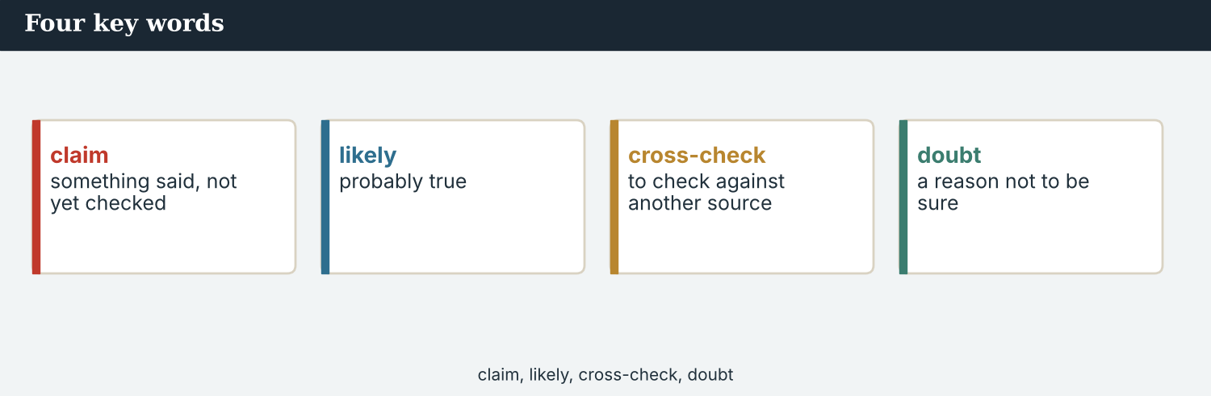
Four key words — rumour, unverified, plausible, speculation.
The words
Word | Meaning
rumour | a story that spreads without proof
unverified | not yet proved
plausible | it sounds possible
likely | probable
unlikely | not probable
speculation | guessing without evidence
hedge (v) | to use careful words when you are not sure
caution | care, because something may be wrong
doubt (n) | the feeling that it may not be true
circulate | to pass from person to person
screenshot | a picture of a screen, often shared
origin | where something started
trace (v) | to follow something back to its origin
debunk | to show that a claim is false
flag (v) | to mark something as doubtful
correction | a published fix for an error
restraint | not publishing what you cannot prove
consequence | what happens because of something
PRACTISE Controlled practice
1A Match the word (1–10) to the meaning (a–j).
1. rumour  2. unverified  3. plausible  4. speculation  5. hedge  6. circulate  7. origin  8. debunk  9. restraint  10. correction | a) not yet proved  b) a story that spreads without proof  c) it sounds possible  d) guessing without evidence  e) to use careful words when you are not sure  f) to pass from person to person  g) where something started  h) to show that a claim is false  i) not publishing what you cannot prove  j) a published fix for an error
1B Complete the sentences with a word from the box.
WORD BOX
rumour · unverified · origin · circulate · debunk · caution
1. The screenshot is still ___________ .
2. Priya is trying to find its ___________ .
3. A ___________ can frighten a whole valley.
4. Screenshots ___________ faster than corrections.
5. If it is false, we will ___________ it.
6. Until then, we write with ___________ .
1C Match the two halves.
1. trace the  2. publish a  3. flag a  4. show  5. debunk a | a) origin  b) correction  c) claim  d) restraint  e) rumour
1D Circle the word that is different.
1. rumour · speculation · guess · proof
2. likely · probable · possible · certain
3. caution · care · restraint · haste
4. debunk · disprove · correct · spread
A screenshot with no name and no date can cross three countries by morning.
1E Complete the paragraph. Use: unverified · circulated · origin · plausible · caution.
The claim ___________ for a night before anyone asked where it came from. It was ___________ , which is why it spread — and ___________ , which is why we held it. Priya is looking for its ___________ ; until she finds it, we write with ___________ .
1F Read the definition. Write the word.
1. to use careful words when you are not sure → ___________
2. to follow something back to where it started → ___________
3. what happens because of something → ___________
4. not publishing what you cannot prove → ___________
1G Complete the collocation paragraph. Use: rumour · screenshot · flagged · correction · consequences.
The ___________ began with one ___________ . Two platforms ___________ it by Friday. If we get it wrong, a ___________ will reach a tenth of the readers — and the ___________ will stay in the valley.
PRODUCE Over to you
1H Answer about you. Write full sentences.
1. How do you check something you are sent online?
2. What is one rumour you have heard that had real consequences?
PRODUCE Talk about it
1I Discuss. Which two words in this unit are new for you? Make a sentence with one.
1J Complete with: doubt · likely · unlikely · hedge · speculation.
There is real ___________ about the date. A controlled release is ___________ ; a sudden flood is ___________ . We will ___________ carefully and keep ___________ out of the copy.
1K Creative. Write two sentences about a claim you cannot prove. Use might and may.

PART 2 Grammar: possibility and advice
might, may and could for what is possible; should and ought to for what should be done.
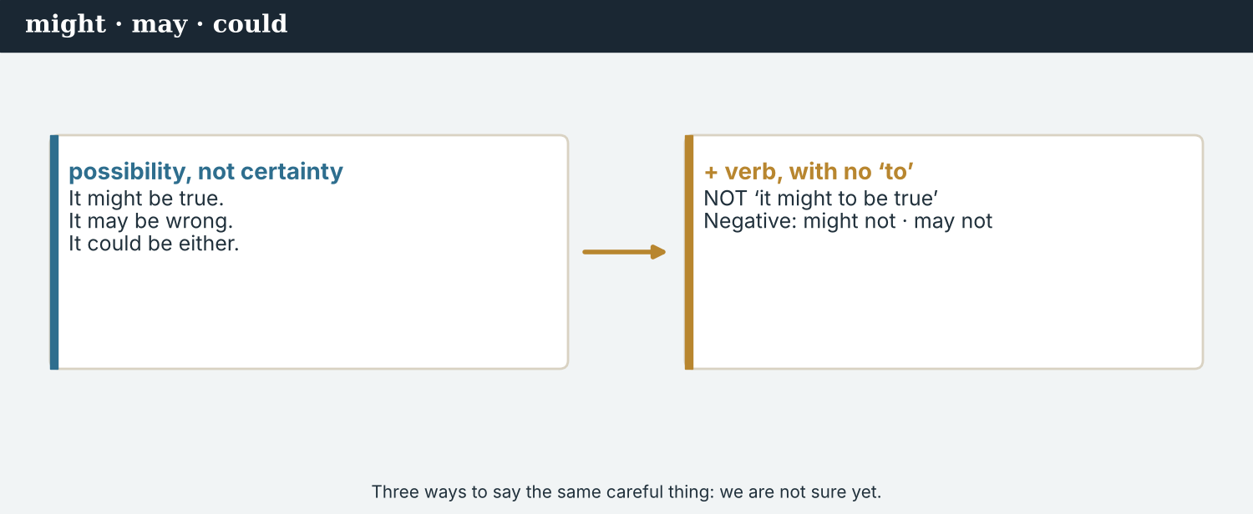
might · may · could — three ways to say ‘possible, not certain’.
1 · might · may · could — it is possible
Form: might / may / could + verb (no to, no -s). “The gates might be opened.” “It may be genuine.”
All three say possible. May is a little more formal; could is often weaker.
Not ‘may to be’: say it may be true, NOT it may to be true.
2 · saying it is not likely
Negative: “The valley may not flood.” “It might not be genuine.”
Careful: could not usually means was unable, not is not likely — so for possibility use may not or might not.
Questions: “Could the gates be opened without notice?”
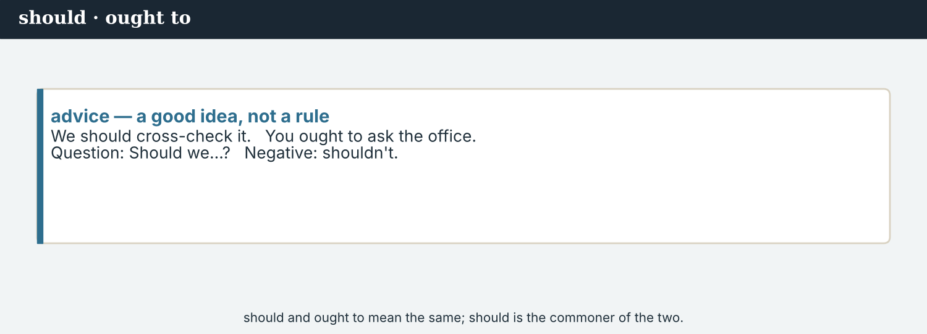
should / ought to — what a newsroom owes its readers.
3 · should · ought to — advice and duty
Form: should / ought to + verb. “We should say what we do not know.” “A newsroom ought to publish a correction.”
For advice, and for a duty that is not a law.
Negative: “We should not repeat the claim in the headline.”
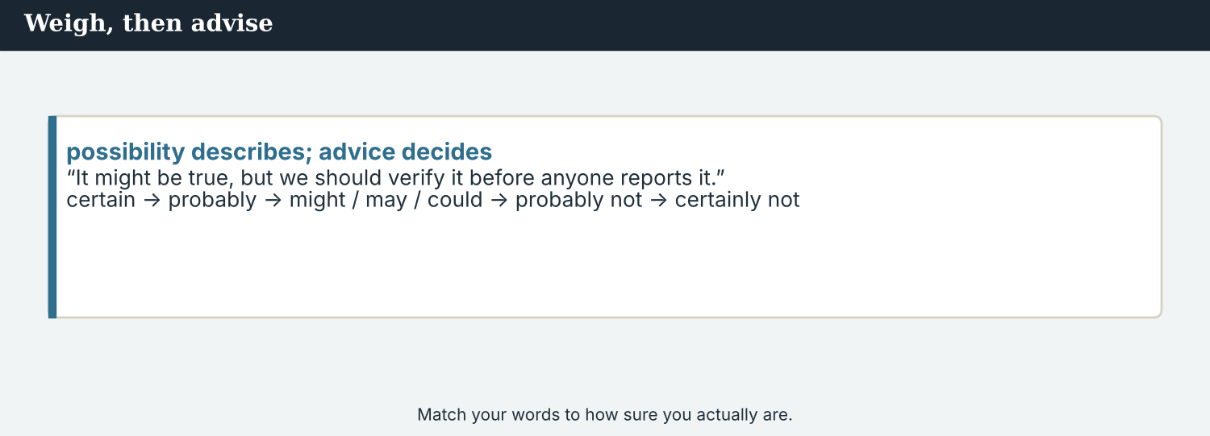
Possible, unlikely, or what we ought to do — each has its own form.
PRACTISE Structured practice
2A Complete with might, may or could.
1. The gates ___________ be opened in an emergency.
2. The screenshot ___________ be genuine; we do not know yet.
3. ___________ the claim have started as a joke?
4. The valley ___________ flood, but it is not likely.
2B Make it less likely. Use may not or might not.
1. The screenshot is genuine. → It ___________
2. The gates will be opened this week. → They ___________
2C Complete with should or ought to.
1. We ___________ say plainly what we do not know.
2. A newsroom ___________ publish a correction quickly.
3. We ___________ not repeat the claim in the headline.
2D Write the sentence with might, may, could, should or ought to.
1. possible / the gates / be opened / in an emergency → ________________________
2. duty / we / say / what we do not know → ________________________
Your own words
2E Write two things that might be true about a story you are following.
1. ________________________
2. ________________________
2F Write two things a newsroom should do when a rumour spreads.
1. ________________________
2. ________________________
2G Rewrite the sentence correctly (might / may / should).
1. It may to be genuine. → ________________________
2. We should to say what we do not know. → ________________________
2H Your own words. Write one possibility and one duty about a claim you have seen online.
1. ________________________

PART 3 Writing about what you cannot prove
You can report a claim without repeating it as a fact — if you are exact about what is known.
A claim with no origin is not a source. It is a thing that happened to the internet.
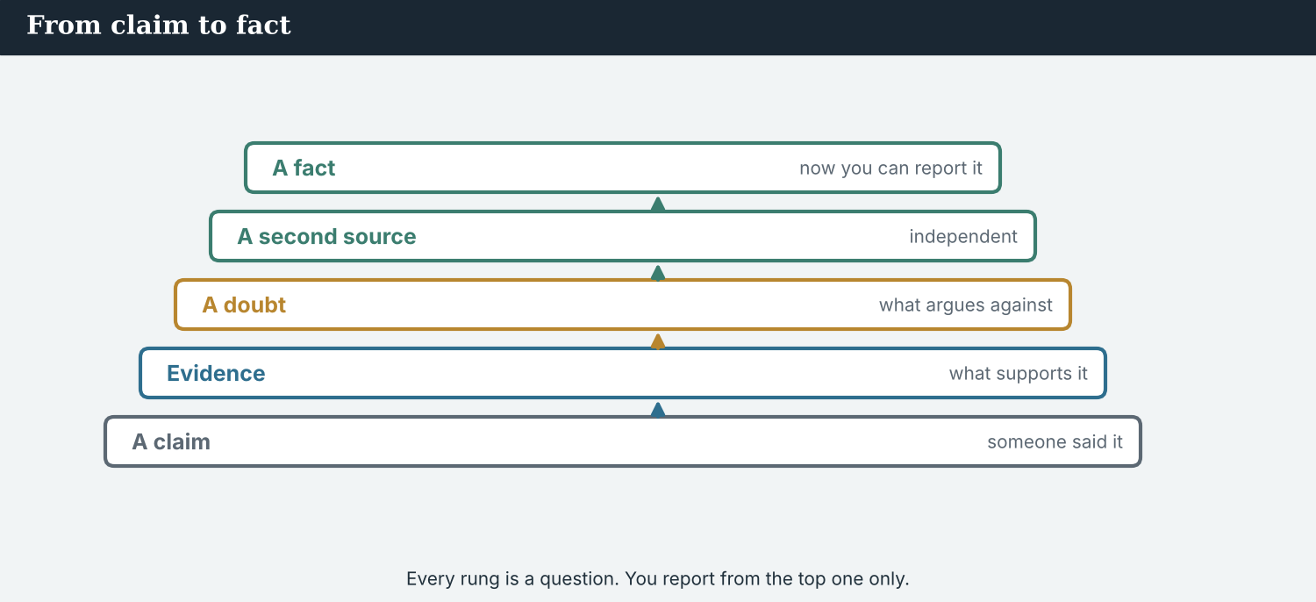
Say what is claimed, who says it, what is confirmed, and what is not.
MODEL A model paragraph
“A screenshot circulating since Thursday evening claims that the gates of the upstream dam will be opened this week and that the valley will flood. Atlas Wire has not been able to trace its origin, and no official body has issued such a notice.
The Crossing Office says there is no plan to open the gates. That is not a denial that they could be opened in an emergency, and we have asked for one.
Residents upstream have moved animals to higher ground. Whatever the claim turns out to be, that has already happened, and it is why we are reporting it.”
NOTICE Notice the paragraph
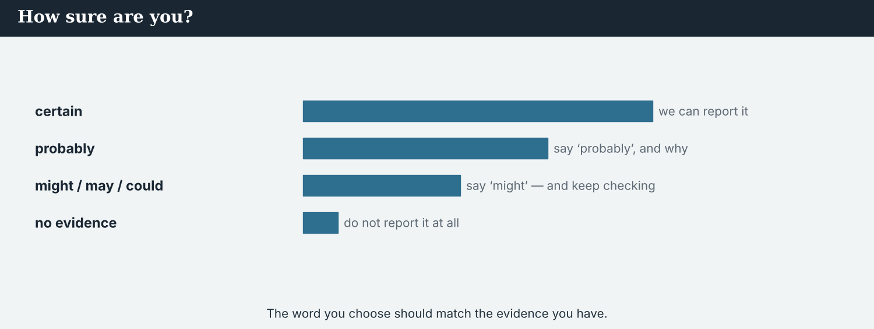
Reporting a rumour is reporting its consequences — not repeating its words.
3A Answer about the model.
1. What does the screenshot claim? ___________
2. What has Atlas Wire not been able to do? ___________
3. Why are they reporting it at all? ___________
3B Find one ‘could’, one ‘may’ or ‘might’, and one ‘should’ or duty in the model. Write them.
1. ________________________
PRACTISE Build the paragraph
A careful paragraph answers: what is claimed, who claims it, what is confirmed, what is not.
3C Write the sentence with might, may, could or should.
1. the gates / be opened / in an emergency (possible) → ________________________
2. the screenshot / not be genuine (not likely) → ________________________
3. we / say / what is not confirmed (duty) → ________________________
3D Complete the paragraph. Use: claims · could · may · should.
A screenshot ______ that the gates will be opened. It ______ be genuine; nobody has traced it. The gates ______ be opened in an emergency, and we ______ say so.
PRACTISE One more
3E Put the paragraph in order. Number the lines 1–4.
1. What the office says, and what it does not say. ______
2. What is claimed, and since when. ______
3. Why we are reporting it: the consequences. ______
4. What we have not been able to confirm. ______
PRODUCE Your turn
3F Choose a claim you have seen online. Write a careful paragraph (4–5 sentences): what is claimed, what is confirmed, what might be true, and what a newsroom should do.
________________________
________________________
________________________
________________________
PRODUCE Discuss
3G Talk with a partner. Why should a headline never repeat an unproved claim as a fact?
3H Why is ‘there is no plan’ not a denial? Explain the difference.
3I Discuss. When does reporting a rumour help people, and when does it only spread it?

PART 4 Listening: tracing the claim
Two audios. Listen for what is possible, and for what a newsroom should do.
Audio 6.1 — verification looks for an origin, and does not find one.
Listening A · looking for the origin
MODEL Audio 6.1 — Priya and Mira
Priya: The earliest copy I can find is Thursday, 21:40, in a group of two hundred people.
Mira: Could that be the origin?
Priya: It might be. Or somebody may have copied it from somewhere we cannot see.
Mira: Is it plausible?
Priya: Partly. The dam does have gates, and they could be opened in an emergency. But the date in the message is wrong, and the logo is from an old document.
Mira: So it may be a real document, used wrongly?
Priya: That is the most likely explanation. We should say exactly that, and not more.
Mira: And the office?
Priya: They say there is no plan. They ought to say whether the gates could be opened at all.
PRACTISE Listen for detail
4A Before you listen: what do you think Priya will find? Write one idea.
1. ______
4B Answer the questions.
1. When is the earliest copy Priya can find? ___________
2. What two things are wrong with the message? ___________
3. What is the most likely explanation? ___________
4. What ought the office to say? ___________
4C Possible, unlikely, or a duty? Write P, U, or D.
1. “It might be the origin.” ______
2. “The date in the message is wrong.” ______
3. “They ought to say whether the gates could be opened.” ______
4D Complete the notes.
Earliest copy: ___________
What is wrong with it: ___________
Most likely explanation: ___________
Audio 6.2 — a partner wants a ‘fears of flooding’ story, today.
Listening B · should we publish the fear?
MODEL Audio 6.2 — Omar and Mira
Omar: We could run ‘Fears of flooding in the Vara valley’. It is accurate: people are afraid.
Mira: It is accurate and it is misleading. A reader will think there may be a flood.
Omar: There might be.
Mira: There might be anything. We should report what we traced: an old logo, a wrong date, and two hundred people in a group.
Omar: And the fear itself?
Mira: That is the story — people moving animals because of an unverified screenshot. Say that in the headline.
Omar: ‘Unverified claim moves families upstream.’
Mira: Better. And we ought to say what we asked the office, and what it would not say.
PRACTISE Listen for detail
4E Before you listen: what headline do you think Omar will suggest? Guess.
1. ______
4F Complete the answers.
1. Omar says they ___________ run ‘Fears of flooding’.
2. Mira says a reader ___________ think there may be a flood.
3. They ___________ report what has been traced.
4. They ___________ to say what the office would not say.
4G Which forms do you hear? Write one ‘could’, one ‘might’, and one ‘ought to’.
1. ________________________
4H Answer. Why does Mira call the first headline ‘accurate and misleading’?
1. ________________________
PRACTISE Both audios
4I Complete the summary. Use: might · may · should · ought to.
The screenshot ______ be a real document used wrongly. The gates ______ be opened in an emergency. The newsroom ______ report what it traced, and ______ say what the office would not say.
4J A headline can be true and still mislead. Why is that a problem of possibility, not of fact?
1. ________________________
PRODUCE What do you think?
4K Complete the note comparing the two audios.
The verification call is about: ___________
The desk call is about: ___________
4L Discuss. Which headline would you run, and what would you put in the second line?

PART 5 Reading: the claim that went upriver
Two readings. Read for what was possible, and for the rules of a careful report.
A claim with no author reached three countries in twelve hours. The correction will not.
Reading A · twelve hours, three countries
The screenshot that moved a valley
At 21:40 on Thursday, a message appeared in a group of about two hundred people upstream. It said the gates of the Vara dam would be opened within the week and that the lower valley would flood. It carried an official-looking logo and no name.
By Friday morning it had reached three countries. “It was plausible, and that is the whole problem,” says Priya Nair of Atlas Wire, who spent the day tracing it. “The dam does have gates. They could be opened in an emergency. Everything around the false part was true.”
Two things did not hold. The date in the message had already passed, and the logo came from a document issued four years ago. “Our best explanation is a real document used wrongly,” Priya says. “It may have started as a warning between neighbours. We cannot prove that, so we have not written it.”
The Crossing Office said there was no plan to open the gates. Asked whether the gates could be opened without notice in an emergency, it did not answer. “That is not a denial,” says Ana Ferreira of Atlas Wire. “A reader ought to be told the difference.”
Meanwhile, families upstream moved animals to higher ground, and a school kept its children indoors. Those consequences were real while the claim was not, which is why four newsrooms decided the story had to be reported — carefully, and without the claim in the headline.
The piece they published said what was claimed, since when, by nobody traceable; what might be true; what the office would not say; and what families had already done. “We should be able to say we do not know in a way that still helps people,” says Omar Faris of the Meridian Post. “That sentence is the hardest one in journalism.”
PRACTISE Comprehension
5A Before you read: look at the title. What do you think moved the valley? Write one sentence.
1. ______
5B True or false? Write T or F.
1. The message carried a name. ______
2. The dam does have gates. ______
3. The logo came from a recent document. ______
4. The office denied that the gates could be opened in an emergency. ______
5C Answer the questions.
1. Why does Priya say the claim was plausible? ___________
2. What two things did not hold? ___________
3. Why did the partners decide the story had to be reported? ___________
5D Find a word or phrase in the text.
1. it sounds possible → ___________
2. to follow something back to its origin → ___________
3. what happens because of something → ___________
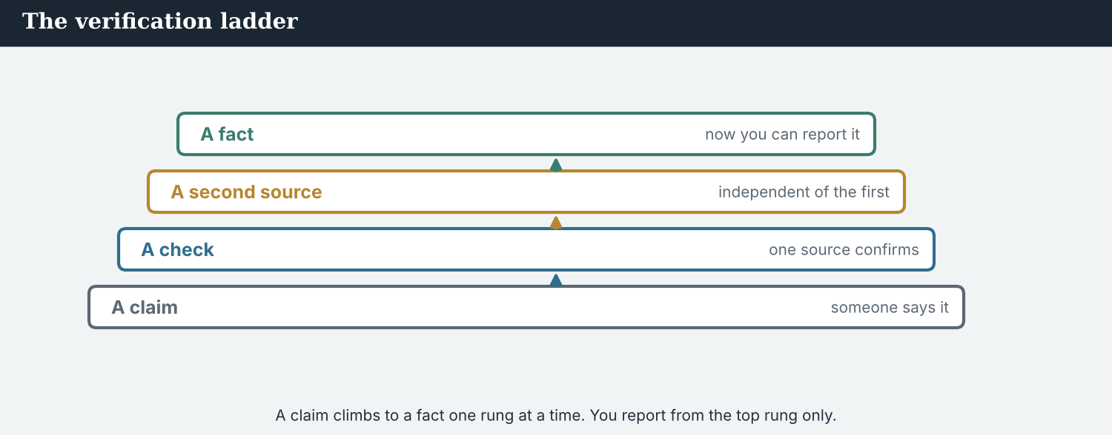
Four rungs from rumour to fact. You may report from the third; you can show from the fourth.
Reading B · from rumour to fact
From rumour to fact: four rungs
1. A rumour. Somebody says it, and nobody can say who said it first. It might be true, and it is not yet reportable as a fact.
2. One source. A person tells you directly, on the record. That is a claim with a name on it — still not a fact.
3. Two sources agree. Two independent people who did not hear it from each other. Now you may report it, and say who.
4. A document. A register, a notice, a dated photograph. Now you can show the reader what you saw.
PRACTISE Comprehension
5E Before you read: which rung may you report from as a fact? Guess.
1. ______
5F Match the rung to the example.
1. a rumour  2. one source  3. two sources agree  4. a document | a) a resident tells you directly, on the record  b) a screenshot with no name on it  c) a dated notice from the office  d) two neighbours who did not speak to each other
5G Which is the first rung you may report from, with a name? Write the number.
1. ______
PRACTISE Words from the readings
5H Find a word in Reading A or Reading B.
1. not yet proved → ___________
2. a story that spreads without proof → ___________
3. where something started → ___________
PRACTISE Both readings
5I Complete with might, may, could, should or ought to.
1. The gates ___________ be opened in an emergency.
2. The screenshot ___________ be a real document used wrongly.
3. A reader ___________ be told the difference.
PRODUCE Discuss
5J Talk about it. Why is ‘we do not know’ the hardest sentence in journalism?
5K Which rung is hardest to reach when a story is moving fast? Say why.
5L Discuss. ‘Everything around the false part was true.’ Why does that make a claim dangerous?

PART 6 Writing: careful copy
Two short pieces: a careful paragraph, and a correction.
Careful copy marks every claim: traced, untraced, confirmed, refused.
Writing 1 · a careful paragraph
MODEL A model
CLAIMED: the gates of the Vara dam will be opened this week; the valley will flood
SOURCE: a screenshot, first seen Thursday 21:40, origin not traced
MAY BE TRUE: the dam has gates, and they could be opened in an emergency
NOT CONFIRMED: any notice, any date, any official plan — the office would not say whether the gates could be opened at all
ALREADY HAPPENED: animals moved upstream; one school kept children indoors
NOTICE Notice the model
6A Answer about the model.
1. Which line uses ‘could’ for a possibility? ___________
2. Which line is the real news? ___________
PRODUCE Write your note
6B Choose a claim. Write the five lines: claimed, source, may be true, not confirmed, already happened.
Claimed: ___________
Source: ___________
May be true: ___________
Not confirmed: ___________
Already happened: ___________
A correction is a piece of journalism, not an apology note.
Writing 2 · a correction
MODEL A model
CORRECTION · On Friday we reported that the upstream gates might be opened this week. The claim came from a screenshot whose origin we could not trace, and whose logo was taken from a document issued four years ago. There is no notice and no plan. We should have said in our first paragraph that the date in the message had already passed. We are sorry. Anyone who moved animals on the strength of it may contact us, and we will say so again as prominently as we said it first.
NOTICE Notice the model
6C Answer. Find one ‘might’, one ‘could’ and one ‘should have’ in the correction.
1. ___________
PRACTISE Complete the paragraph
6D Complete the correction. Use: might · could · should · ought.
We reported that the gates ______ be opened. We ______ not trace the origin. We ______ have said so in the first paragraph. A correction ______ to be as prominent as the story.
PRODUCE Write your correction
6E Turn your note into a short correction (4–5 sentences). Use might, could and should have.
________________________
________________________
________________________
PRACTISE Fix it
6F This copy states a claim as fact and uses ‘may to’. Correct both.
“The gates will be opened this week. The screenshot may to be genuine.”
________________________
PRACTISE Plan it
6G Plan a careful piece. Write three lines: one possibility (might), one thing you could not do, one duty (ought to).
Possible: ___________
Not traced: ___________
Duty: ___________
6H Peer-check. Swap with a partner. Is every unproved claim marked, and is the headline about consequences? Write one note.
________________________

PART 7 Speaking: how sure are you?
Say how likely something is, and what should be done. Use might, may, could, should, ought to.
Saying it out loud: what is possible, what is not likely, and what we owe the reader.
A model dialogue · weighing the claim
MODEL Listen and read
Sofia: Is the screenshot genuine?
Mira: It may be a real document, used wrongly. We could not trace its origin.
Sofia: Could the gates actually be opened?
Mira: They could, in an emergency. The office will not say.
Sofia: So what do we write?
Mira: What people did: families moved animals upstream. The claim goes lower down, marked unverified.
Sofia: And if we are wrong?
Mira: Then we correct it as prominently as we ran it. That is what we ought to do.
NOTICE Notice the forms
7A Find one ‘may’, one ‘could’ and one ‘ought to’ sentence. Write them.
1. ________________________
PRACTISE Controlled practice
7B Answer with might, may, could or ought to.
1. Is the screenshot genuine? → ___________
2. Could the gates be opened? → ___________
3. What should we do if we are wrong? → ___________
Open with what you know, then what might be true, then what you will do.
7C Make a question with could, then answer it carefully.
1. the gates / be opened / without notice → ________________________
2. the claim / start / as a warning between neighbours → ________________________
PRODUCE Your role
Reporter | Say what is confirmed, what might be true, and what you could not trace.
Editor | Ask: ‘How sure are you?’ and ‘What should the headline say?’
Observer | Listen. Did the reporter keep possibility and fact apart?
7D Choose a role from the table. Weigh the claim with your partner.
PRODUCE Role-play
7E Role-play a claim meeting: a reporter, an editor, and an observer. Then swap roles.
A second dialogue · the headline argument
MODEL Listen and read
Omar: ‘Fears of flooding’ is true. People are afraid.
Mira: And a reader may finish the headline believing there will be a flood.
Omar: We cannot write a headline about nothing happening.
Mira: We can write one about what did happen: families moved animals because of an unverified claim.
Omar: ‘Unverified claim moves families upstream.’ It is duller.
Mira: It is duller and it is right. And we ought to say what the office would not answer.
PRACTISE Controlled practice
7F Write the sentence Mira uses with ‘may’ about the reader.
1. ________________________
PRODUCE Self-check
Did I… | Yes | Almost | Not yet
use might, may or could for possibility, with no ‘to’? | ☐ | ☐ | ☐
use may not or might not for ‘not likely’? | ☐ | ☐ | ☐
use should or ought to for a duty? | ☐ | ☐ | ☐
keep the unproved claim out of the headline? | ☐ | ☐ | ☐
7G Role-play arguing for a headline about consequences, not the claim. Then swap roles.
PRACTISE Plan it
7H Plan your answers. Note one possibility, one thing you could not confirm, one duty.
7I Discuss. How would you tell an editor that a true headline is still misleading?

PART 8 Ethics: giving a rumour oxygen
Repeating a claim to deny it still carries it further. So does debunking a person instead of a claim.
Accuracy includes accuracy about your own doubt.
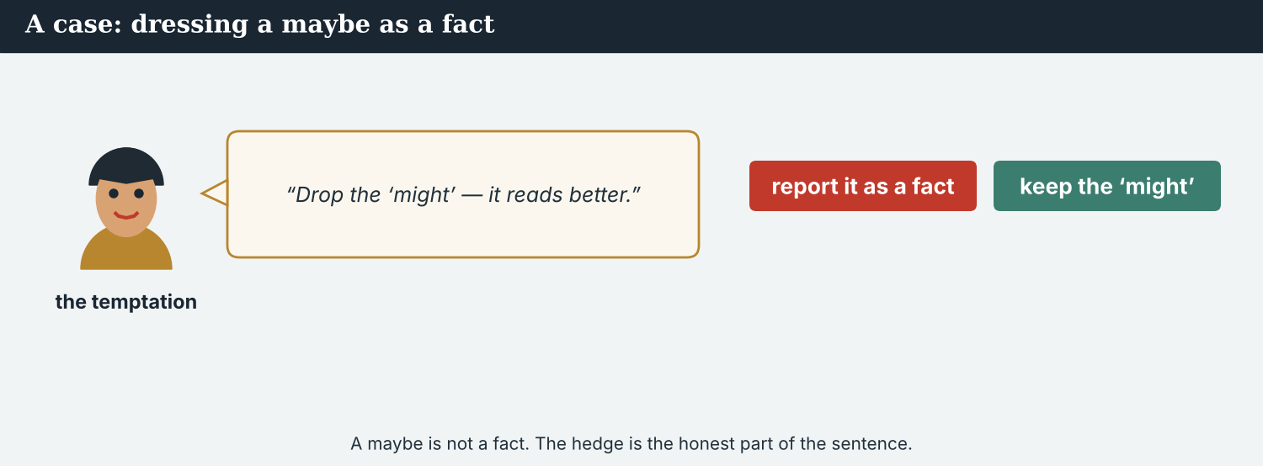
A headline that repeats a claim spreads it, even with ‘claim’ in front.
A first case · the headline that carries it
A case. The Post’s traffic desk points out, correctly, that ‘Fears of flooding in the Vara valley’ will be read ten times more widely than ‘Unverified claim moves families upstream’. More readers would then see the careful paragraphs underneath. But most people read only a headline, and the first version plants exactly the belief the piece exists to correct. The claim gets the audience; the correction gets the few who scroll on. The first version would also be quoted back at the newsroom for a year. The Code says: a true sentence that leaves a false impression is not accurate. What headline should the partners run?
NOTICE What do you do?
8A Choose (a) or (b), and write one reason.
1. (a) ‘Fears of flooding in the Vara valley’ (b) ‘Unverified claim moves families upstream’. Choice: ______ Because ________________________
2. A headline that is true and leaves a false impression is (a) acceptable if the article is careful (b) not accurate. Choice: ______
8B Carries the rumour, or contains it? Write C or N.
1. ‘Unverified claim moves families upstream.’ ______
2. ‘Will the valley flood this week?’ ______
3. ‘No notice, no plan: what we traced and what we did not.’ ______
4. ‘Officials silent as flood fears grow.’ ______
PRACTISE Apply the Code
8C Complete the rule. Use: consequences · headline · impression · unverified.
Put the ______ in the headline, not the claim. Mark the claim ______ . Ask what ______ the ______ leaves.
PRODUCE Discuss
8D Discuss. Most readers see only a headline. What does that mean for careful reporting?
A second case · debunking a person
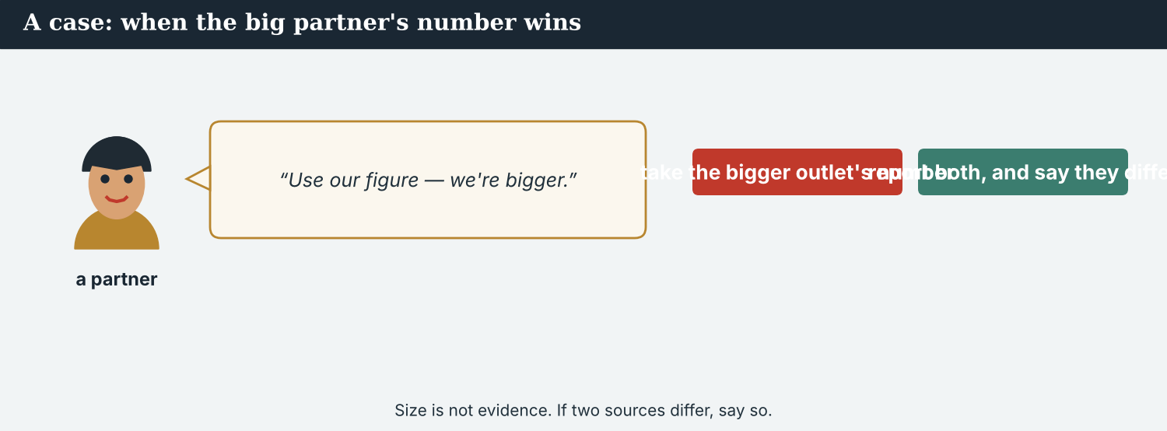
Debunk the claim. Naming the neighbour who forwarded it is not journalism.
A case. By Saturday, Dren has found the man who first posted the screenshot: a retired teacher upstream who believed it and sent it to a village group. Kalina Daily could name him, and the story would be strong — the origin, found, in a small town. But he invented nothing: he forwarded a real old document in fear, and he has neighbours who have already lost a great deal. Naming him would move the valley’s anger from a claim to a person. Atlas Wire wants the origin in the copy; Dren wants his neighbour’s name out of it. The Code says: debunk the claim, not the person. What do the partners publish?
NOTICE What do you do?
8E Choose (a) or (b), and write one reason.
1. (a) name the retired teacher (b) describe the origin without the name. Choice: ______ Because ________________________
2. Naming someone who spread a rumour in good faith is (a) transparency (b) a punishment the story did not need. Choice: ______
8F Complete with: origin · invented · fear · name.
1. Dren has found the ___________ of the screenshot.
2. The teacher ___________ nothing.
3. He forwarded it in ___________ .
4. The partners keep his ___________ out.
PRODUCE Discuss
8G Discuss. Why might naming the first sharer stop the next person from coming forward?
PRODUCE Write it
8H Write two sentences describing the origin of a claim without naming anybody. Use may and could.
PRACTISE One more
8I Debunks the claim, or punishes a person? Write C or P.
1. ‘The logo came from a document issued four years ago.’ ______
2. ‘A retired teacher in the village started it.’ ______
3. ‘The date in the message had already passed.’ ______
4. ‘We publish his name so readers can judge.’ ______
8J Discuss. Is there ever a case for naming the person who started a false claim?

PART 9 Digital: the careful post
Online, you can say what you know, what you do not, and what people should do now.
A careful post is the fastest thing a newsroom can publish — if it is exact.
MODEL A model post
UNVERIFIED · A screenshot claiming the Vara gates will be opened this week has circulated since Thursday. We cannot trace its origin; the logo is from a 2022 document and the date has passed. The Crossing Office says there is no plan, and would not say whether the gates could be opened in an emergency. We will update as soon as it does. — @AtlasWire with @KalinaDaily
NOTICE The parts of the post
9A Match the part to its job.
1. UNVERIFIED  2. we cannot trace its origin  3. the office says there is no plan  4. would not say whether the gates could be opened | a) what the body did say  b) the flag at the front  c) what it refused to say  d) what we could not do
PRACTISE Find and build
9B Find one ‘could’ and one thing the newsroom could not do. Write them.
1. ________________________
9C This post states a claim as fact and has no flag. Correct both.
“The gates are being opened this week. Move your animals now.”
________________________
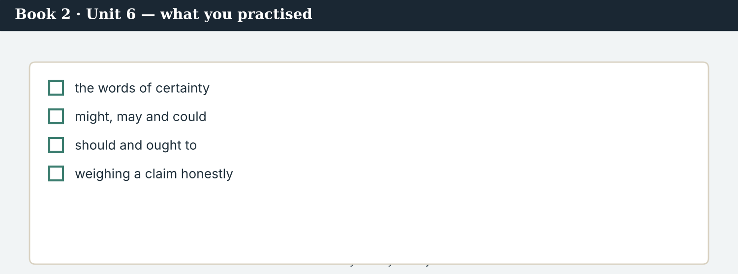
A good careful post answers: what is claimed, what is checked, what is refused, what next.
9D Write a careful post. Use one might or may, and one thing you could not confirm.
UNVERIFIED · ___________ . We could not ___________ . It ___________ be ___________ . We will update ___________ . — @AtlasWire
PRODUCE Write your post
9E Write a one-line post flagging a claim you have seen. Use unverified.
________________________
9F Creative. Write a short headline (4–6 words) about consequences, not the claim.
9G A reader asks: ‘So will it flood or not?’ Write a short, honest reply. Use might and should.
________________________
9H A careful post can sound evasive. Write one line that is careful and still clear.
________________________
PRODUCE Discuss
9I Creative. Write a two-line thread: line 1 what is checked, line 2 what people should do now.
________________________
________________________
9J Discuss. A correction reaches fewer people than the error. What follows from that for how you publish?

PART 10 Review & Can-Do
Check your new English before Unit 7.
The published piece: the claim marked, the consequences first, the correction promised.
10A Vocabulary. Complete with: rumour · unverified · plausible · speculation · origin · debunk · restraint · correction.
1. The screenshot is still ___________ .
2. A ___________ can frighten a valley.
3. It was ___________ , which is why it spread.
4. We keep ___________ out of the copy.
5. Priya traced its ___________ .
6. If it is false, we will ___________ it.
7. Not publishing what you cannot prove is ___________ .
8. A ___________ should be as prominent as the story.
10B Grammar. Complete with might, may or could.
1. The gates ___________ be opened in an emergency.
2. The screenshot ___________ be genuine; we do not know.
3. ___________ the claim have started as a warning?
10C Grammar. Make it less likely with may not or might not.
1. The screenshot is genuine. → It ___________
2. The valley will flood. → It ___________
3. The office will answer. → It ___________
Can-Do — tick what you can do now.
10D Grammar. Complete with should or ought to.
1. We ___________ say plainly what we do not know.
2. A newsroom ___________ publish a correction quickly.
3. We ___________ not repeat the claim in the headline.
10E Read and answer.
A screenshot claiming the gates will be opened has circulated since Thursday. Atlas Wire could not trace its origin; the logo is from an old document and the date has passed. The office says there is no plan, but would not say whether the gates could be opened in an emergency. Families upstream have moved animals, and that is what the headline reports.
1. What could Atlas Wire not do? ___________
2. What would the office not say? ___________
3. What does the headline report? ___________
Can-Do — tick what you can do now
☐ I can say what is possible with might, may and could.
☐ I can say how likely something is.
☐ I can give advice with should and ought to.
☐ I can write about a claim I cannot prove yet.
10F Reflect. Which part of Unit 6 was the most useful for you? Why?
10G Grammar review. Write the sentence correctly.
1. It may to be genuine. → ________________________
2. We should to publish a correction. → ________________________
3. The gates could not be opened — it is not likely. → ________________________
4. The valley will flood, maybe. → ________________________
10H Mixed review. Complete with might, could, should or ought to.
1. The screenshot ___________ be a real document used wrongly.
2. A reader ___________ be told the difference.
3. The office ___________ to answer the question we asked.
10I Reflect. Write one sentence about something you are not sure of. Use might.

PART 11 Assignment: a careful report
Put the unit together: report a claim you cannot prove.
The assignment template — your careful report.
Your task. A claim is spreading and you cannot prove it. Write a careful report (6–7 sentences). Say what is claimed and since when, what you could not trace, what might or may be true, what an official body said and would not say, and what people have already done. Put the consequences in your headline, not the claim. End with one sentence about what your newsroom should do if it turns out to be wrong.
A model — use Reading A and the Writing 1 model to check the shape of your report.
Remember: might, may and could for possibility (no ‘to’); may not or might not for ‘not likely’; should and ought to for duty; the consequences in the headline; and the claim marked unverified.
Success criteria | Yes | Almost | Not yet
I use might, may or could correctly for possibility. | ☐ | ☐ | ☐
I use may not or might not for what is not likely. | ☐ | ☐ | ☐
I use should or ought to for what the newsroom owes its readers. | ☐ | ☐ | ☐
My headline is about consequences, not the claim. | ☐ | ☐ | ☐
I say exactly what I could not confirm. | ☐ | ☐ | ☐
Keep this. In Unit 7, you write for the wire — the passive across tenses — because a wire sentence often has to say what was done before it can say who did it.

ANSWER KEY Book 2 · Unit 6
Check your answers. Open tasks (discussion, role-play and your own writing) are marked at the end.
W1 1 a name and a date · 2 moving their animals (to higher ground) · 3 what they know, and plainly what they do not
W2 1 F (she says it may be genuine) · 2 F (it says there is no plan — not a denial) · 3 T
W3 may: ‘It may be genuine’ · might: ‘They might be, in an emergency’ · should: ‘We should write what we know’
1A 1-b, 2-a, 3-c, 4-d, 5-e, 6-f, 7-g, 8-h, 9-i, 10-j
1B 1 unverified · 2 origin · 3 rumour · 4 circulate · 5 debunk · 6 caution
1C 1 trace the origin · 2 publish a correction · 3 flag a claim · 4 show restraint · 5 debunk a rumour
1D 1 proof · 2 certain · 3 haste · 4 spread
1E 1 circulated · 2 plausible · 3 unverified · 4 origin · 5 caution
1F 1 hedge · 2 trace · 3 consequence · 4 restraint
1G rumour · screenshot · flagged · correction · consequences
1J doubt · likely · unlikely · hedge · speculation
2A 1 could / might · 2 may / might · 3 Could · 4 might
2B 1 It may not be genuine. · 2 They might not be opened this week.
2C 1 should · 2 ought to · 3 should
2D 1 The gates could be opened in an emergency. · 2 We ought to say what we do not know.
2G 1 It may be genuine. · 2 We should say what we do not know.
3A 1 that the gates will be opened this week and the valley will flood · 2 trace the screenshot’s origin · 3 because people are already acting on it (animals moved upstream)
3B could: ‘they could be opened in an emergency’ · may/might: ‘whatever the claim turns out to be’ / ‘it may be genuine’ · duty: ‘we have asked for one’
3C 1 The gates could be opened in an emergency. · 2 The screenshot may not be genuine. · 3 We should say what is not confirmed.
3D claims · may · could · should
3E 1 What is claimed, and since when. · 2 What we have not been able to confirm. · 3 What the office says, and what it does not say. · 4 Why we are reporting it: the consequences.
3H ‘no plan’ describes today’s intention; it does not say whether the thing is possible at all — a denial would answer the possibility
4B 1 Thursday, 21:40 · 2 the date had already passed, and the logo came from an old document · 3 a real document used wrongly · 4 whether the gates could be opened at all
4C 1 P · 2 U · 3 D
4D Earliest copy = Thursday 21:40, a group of 200 · Wrong = the date has passed, the logo is four years old · Most likely = a real document used wrongly
4F 1 could · 2 may / might · 3 should · 4 ought
4G could: ‘they could be opened’ · might: ‘there might be’ · ought to: ‘we ought to say what the office would not say’
4H people are afraid, but the headline leaves a reader expecting a flood
4I might · may / could · should · ought to
4J the fact is true; the possibility it implies is not supported
4K The verification call = the origin, the logo, the date, the most likely explanation · The desk call = the headline, and what the piece implies
5B 1 F · 2 T · 3 F · 4 F
5C 1 the dam does have gates, and they could be opened in an emergency · 2 the date had passed; the logo was four years old · 3 the consequences were real: animals moved, children kept indoors
5D 1 plausible · 2 trace · 3 consequences
5F a rumour → ‘a screenshot with no name on it’ · one source → ‘a resident tells you directly, on the record’ · two sources agree → ‘two neighbours who did not speak to each other’ · a document → ‘a dated notice from the office’
5G Rung 3
5H 1 unverified · 2 rumour · 3 origin
5I 1 could · 2 may / might · 3 ought to
6A 1 the MAY BE TRUE line · 2 the ALREADY HAPPENED line
6C might: ‘the gates might be opened’ · could: ‘whose origin we could not trace’ · should have: ‘we should have said in our first paragraph’
6D might · could · should · ought
6F ‘The gates may be opened this week, according to an unverified screenshot. The screenshot may be genuine.’
7A may: ‘It may be a real document, used wrongly’ · could: ‘They could, in an emergency’ · ought to: ‘That is what we ought to do’
7B 1 It may be a real document, used wrongly. · 2 They could be, in an emergency. · 3 We ought to correct it as prominently as we ran it.
7C 1 Could the gates be opened without notice? — They could, in an emergency. · 2 Could it have started as a warning? — It may have; we cannot prove it.
7F ‘A reader may finish the headline believing there will be a flood.’
8A 1 (b) ‘Unverified claim moves families upstream’ · 2 (b) not accurate
8B 1 N · 2 C · 3 N · 4 C
8C consequences · unverified · impression · headline
8E 1 (b) describe the origin without the name · 2 (b) a punishment the story did not need
8F 1 origin · 2 invented · 3 fear · 4 name
8I 1 C · 2 P · 3 C · 4 P
9A ‘UNVERIFIED’ → the flag at the front · ‘we cannot trace its origin’ → what we could not do · ‘the office says there is no plan’ → what the body did say · ‘would not say whether the gates could be opened’ → what it refused to say
9B could: ‘whether the gates could be opened in an emergency’ · could not: ‘we cannot trace its origin’
9C ‘UNVERIFIED · A screenshot claims the gates will be opened this week. We cannot trace its origin and there is no official notice.’
10A 1 unverified · 2 rumour · 3 plausible · 4 speculation · 5 origin · 6 debunk · 7 restraint · 8 correction
10B 1 could / might · 2 may / might · 3 Could
10C 1 It may not be genuine. · 2 It might not flood. · 3 It may not answer.
10D 1 should · 2 ought to · 3 should
10E 1 trace the screenshot’s origin · 2 whether the gates could be opened in an emergency · 3 that families upstream have moved animals
10G 1 It may be genuine. · 2 We should publish a correction. · 3 The gates may not be opened — it is not likely. · 4 The valley might flood.
10H 1 may / might · 2 ought to · 3 ought
Open tasks W4, W5, 1H, 1I, 1K, 2E, 2F, 2H, 3F, 3G, 3I, 4A, 4E, 4L, 5A, 5E, 5J, 5K, 5L, 6B, 6E, 6G, 6H, 7D, 7E, 7G, 7H, 7I, 8D, 8G, 8H, 8J, 9D, 9E, 9F, 9G, 9H, 9I, 9J, 10F, 10I — your own answers (discussion, role-play, writing).
A note on real and invented content. The facts about journalism around the world in 2026 are true. Atlas Wire, Kalina Daily, the Meridian Post, their staff, the Vara dam, the screenshot and everyone in the stories are invented, for practice. Real people and outlets are only ever in true, sourced facts — never in an invented quote.
English for Journalists — International Edition · Book 2 · Unit 6 (30-page standard). CEFR lower B1 → medium B1 · Beat: Verification & Across Borders · two readings · two listenings · two writing pieces · two ethics cases · two speaking dialogues · balanced sections · ~28 figures · featured cast + partners in three countries · fictional agency, factual backdrop.

BOOK 2 · UNIT 7 For the Wire: Writing to Be Carried Everywhere
Beat · Across Borders (wholly) CEFR lower B1 → medium B1
In this unit you learn to…
1. form the passive in every tense
2. choose the passive when the action matters most
3. say by whom — and know when you must
4. write wire copy that any newsroom can carry
The Atlas Wire team — writing one sentence that two hundred newsrooms can publish unchanged.
One sentence, two hundred newsrooms. This unit is wholly cross-border. A wire report is not written for one audience; it is written to be carried, translated and cut by newsrooms that have never seen the place. That is why so much of it is in the passive: three crossings have been reopened, the figure is being checked. The passive is a tool, and it is also a hiding place. This week, Mira learns to use it for clarity and to refuse it when somebody wants to use it to hide a name. (Atlas Wire, Kalina Daily, the Meridian Post and their staff are invented, for practice.)

WARM-UP On the wire
A short scene to start the unit. Read it, then answer.
A wire sentence travels further than its author ever will.
“The snap has gone,” Daniel says, pushing the screen round. “‘Three crossings on the river Vara have been reopened.’ Eleven words, and it is already in Jakarta.”
Mira reads it. “Reopened by whom?”
“By the Crossing Office. It is in the second take.”
“Then it should be in the snap.”
Daniel smiles. “It should. The lawyers in two countries asked for ‘the crossings were reopened’, with no name at all.”
“That is not shorter,” Mira says. “That is quieter.”
“Yes. The piece is being rewritten now. The name goes back in.”
W1 Answer the questions.
1. What did the snap say? ___________
2. Who reopened the crossings? ___________
3. What did the lawyers ask for? ___________
W2 True or false? Write T or F.
1. The snap named the Crossing Office. ______
2. Mira thinks the name should be in the snap. ______
3. The piece is being rewritten. ______
W3 Find one present-perfect passive, one past passive and one present-continuous passive in the text.
1. ________________________
PRODUCE Talk about it
W4 Discuss with a partner.
1. Why might a lawyer prefer ‘the crossings were reopened’ with no name?
2. When is leaving out the doer honest, and when is it not?
PRODUCE One more
W5 Discuss. ‘That is not shorter. That is quieter.’ What does Mira mean?

PART 1 The words of the wire
The words for agency copy, credits and the newsrooms that carry it.
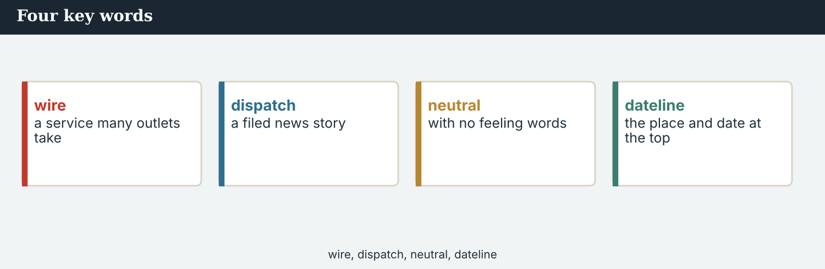
Four key words — wire, dateline, lead, snap.
The words
Word | Meaning
wire | an agency service that many outlets publish
dateline | the place and date at the top of a report
slug | the short name a story is filed under
lead (n) | the first sentence of a report
snap | a one-line urgent message on the wire
take (n) | one part of a story sent in pieces
byline | the reporter’s name on a story
credit (n) | the name of the outlet material came from
subscriber | an outlet that pays to use the wire
carry (v) | to publish material from the wire
pick up | to take a story from the wire
rewrite (v) | to write again for another audience
style guide | rules on writing names, numbers and dates
house style | one outlet’s own rules
neutral | not taking a side
concise | short and clear
update (n) | a new version with new facts
kill (v) | to withdraw a story from the wire
PRACTISE Controlled practice
1A Match the word (1–10) to the meaning (a–j).
1. wire  2. dateline  3. slug  4. snap  5. take  6. byline  7. credit  8. subscriber  9. carry  10. kill | a) the place and date at the top of a report  b) an agency service that many outlets publish  c) the short name a story is filed under  d) a one-line urgent message  e) one part of a story sent in pieces  f) the reporter’s name on a story  g) the name of the outlet material came from  h) an outlet that pays to use the wire  i) to publish material from the wire  j) to withdraw a story from the wire
1B Complete the sentences with a word from the box.
WORD BOX
wire · dateline · lead · snap · credit · carried
1. The story went out on the ___________ .
2. The ___________ reads KALINA, 14 October.
3. A good ___________ says what happened in one sentence.
4. The ___________ was eleven words long.
5. Kalina Daily’s ___________ must stay on it.
6. Two hundred newsrooms ___________ the piece.
1C Match the two halves.
1. file a  2. pick up a  3. keep the  4. follow the  5. send an | a) take  b) story  c) credit  d) style guide  e) update
1D Circle the word that is different.
1. snap · lead · take · deadline
2. neutral · balanced · fair · partial
3. concise · short · brief · wordy
4. carry · publish · run · kill
One wire story, two hundred front pages. Each one cuts it differently.
1E Complete the paragraph. Use: wire · neutral · concise · rewritten · carried.
Copy for the ___________ must be ___________ and ___________ , because it will be ___________ by newsrooms you will never meet, and ___________ for readers you cannot picture.
1F Read the definition. Write the word.
1. an outlet that pays to use the wire → ___________
2. rules on writing names, numbers and dates → ___________
3. a new version with new facts → ___________
4. to write again for another audience → ___________
From snap to take to update: how a wire story is built while it is still happening.
1G Complete the collocation paragraph. Use: slug · takes · update · house style · byline.
The story was filed under the ___________ VARA-CROSSINGS, in three ___________ . An ___________ followed at six. Each subscriber applied its own ___________ , and most of them kept the ___________ .
PRODUCE Over to you
1H Answer about you. Write full sentences.
1. Which outlets in your country carry agency copy? How can you tell?
2. What would you want kept if your work were rewritten elsewhere?
PRODUCE Talk about it
1I Discuss. Which two words in this unit are new for you? Make a sentence with one.
1J Complete with: killed · picked up · subscriber · concise · take.
The first ___________ was ___________ by forty newsrooms. One ___________ asked for a shorter version. The second was more ___________ . The third was ___________ after an error was found.
1K Creative. Write a one-sentence wire lead about something that happened near you. Use the passive.

PART 2 Grammar: the passive
be + past participle, in every tense; and when to name the doer.
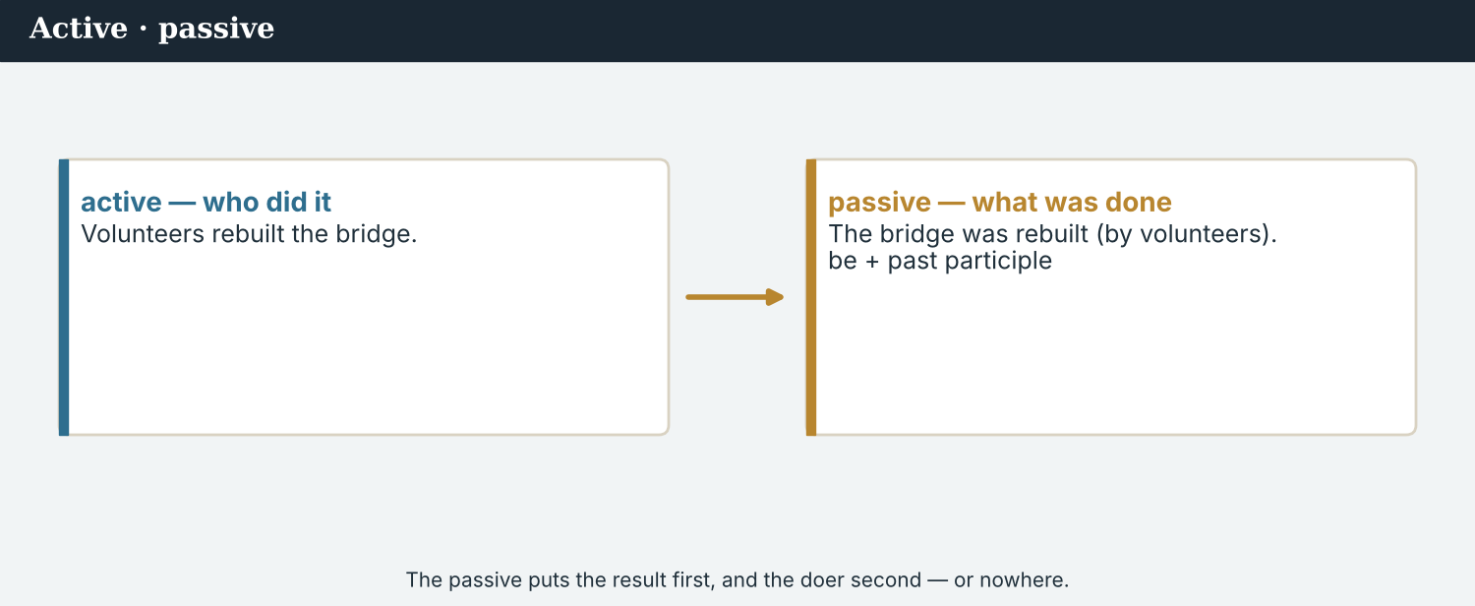
The passive puts the action first: ‘three crossings have been reopened’.
1 · the passive — the action first
Form: be + past participle. “The gates were opened.” “The figure is checked twice.”
Use it when the action matters most, when the doer is unknown, or when the doer is obvious.
Active: The office reopened the crossing. → Passive: The crossing was reopened (by the office).
2 · the passive across tenses
present: is / are checked · past: was / were opened · present perfect: has / have been reopened
continuous: is / are being checked · future: will be carried · modal: can / must be used
Watch the participle: say has been reopened, NOT has been reopen.
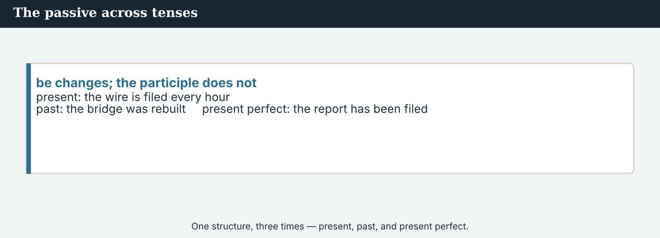
by + the doer: say it whenever you know it.
3 · by whom — and when you must say it
Add by + the doer when the reader needs it: “The gates were opened by the Crossing Office.”
Leave it out only when it is unknown or obvious: “He was arrested yesterday.”
Never use the passive to hide a name you have: mistakes were made says nothing.
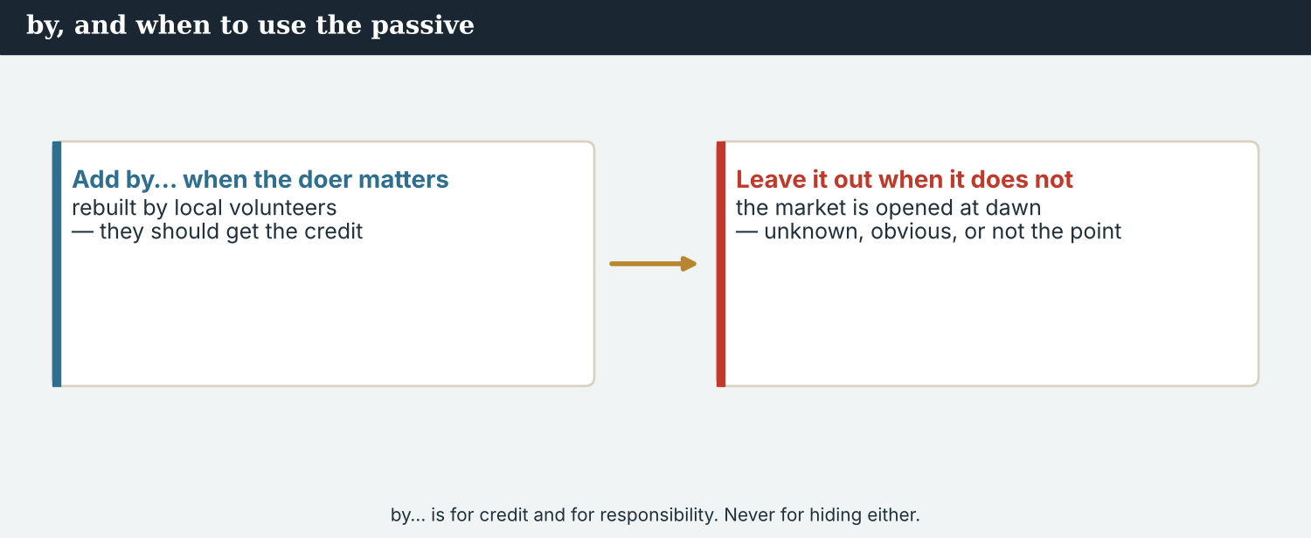
Action first, doer unknown, or a name being hidden — know which you are doing.
PRACTISE Structured practice
2A Make these passive. Keep the tense.
1. The office reopened three crossings. → ___________
2. Priya checks every figure twice. → ___________
3. The desk has rewritten the lead. → ___________
4. Two hundred newsrooms will carry the piece. → ___________
2B Complete with the passive in the tense given.
1. The figure ___________ (check) at the moment. (present continuous)
2. The snap ___________ (send) at 06:40. (past)
3. Three crossings ___________ (reopen) since April. (present perfect)
4. The update ___________ (publish) tomorrow. (future)
2C Add the doer with by, where the reader needs it.
1. The crossings were reopened. (the Crossing Office) → ___________
2. The register was kept for seven years. (a resident) → ___________
3. The lead was rewritten. (the foreign desk) → ___________
2D Which sentence hides a name? Write A or B, and say why.
1. A: Mistakes were made. · B: The desk cut the credit line. ______
2. A: The barrier was closed in 2019. · B: The council closed the barrier in 2019. ______
Your own words
2E Write two passive sentences about work that is being done near you now.
1. ________________________
2. ________________________
2F Write two passive sentences with by + the doer.
1. ________________________
2. ________________________
2G Rewrite the sentence correctly (passive form).
1. Three crossings have been reopen since April. → ________________________
2. The figure is checking at the moment. → ________________________
2H Your own words. Write one sentence where the passive is right, and one where it hides too much.
1. ________________________

PART 3 Writing for the wire
Wire copy is written to be carried: a dateline, a lead, short takes, and a name wherever you have one.
A subscriber’s desk cuts your story to four paragraphs. Which four did you write first?
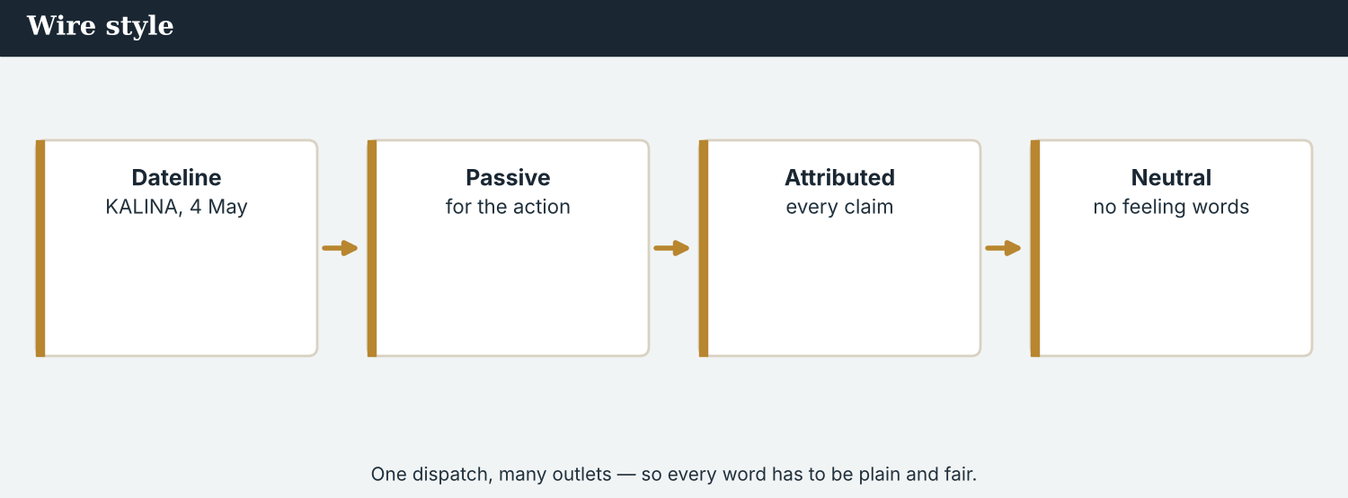
A wire lead: what happened, where, when, and on whose authority.
MODEL A model wire report
KALINA, 14 October (Atlas Wire) — Three crossings on the river Vara have been reopened by the Crossing Office, the first since the Kalina bridge was reopened last spring.
The decision was announced on Tuesday and confirmed to Atlas Wire by the office on Wednesday. A figure of 112 returning families, published earlier by the office, is still being checked.
Reporting from the upstream crossings was carried out with Kalina Daily, whose reporter Dren Markaj interviewed residents on the closed side. The piece may be used by subscribers with the credit line kept.
NOTICE Notice the report
3A Answer about the report.
1. What has been reopened, and by whom? ___________
2. What is still being checked? ___________
3. What must subscribers keep? ___________
3B Find a present-perfect passive, a past passive and a present-continuous passive in the report. Write them.
1. ________________________
PRACTISE Build the copy
A wire lead answers the five questions, and names the authority for each.
3C Write the sentence in the passive, with by where it is needed.
1. the office / reopen / three crossings (present perfect) → ________________________
2. the figure / check / now (present continuous) → ________________________
3. subscribers / may use / the piece (modal passive) → ________________________
3D Complete the lead. Use: been · was · being · be.
Three crossings have ______ reopened by the Crossing Office. The decision ______ announced on Tuesday. The figure of 112 is still ______ checked. The piece may ______ used with the credit kept.
PRACTISE One more
3E Put the wire report in order. Number the lines 1–4.
1. What is still unconfirmed. ______
2. The lead: what has been reopened, and by whom. ______
3. How the reporting was done, and with whom. ______
4. When it was announced and confirmed. ______
PRODUCE Your turn
3F Choose a story. Write a short wire report (4–5 sentences): a dateline, a passive lead with by, one thing still being checked, and a credit line.
________________________
________________________
________________________
________________________
PRODUCE Discuss
3G Talk with a partner. Why is so much wire copy written in the passive?
3H Why is ‘reopened by the Crossing Office’ better in a snap than ‘reopened’? Explain.
3I Discuss. Your copy will be cut to four paragraphs. How does that change what you write first?

PART 4 Listening: on the wire
Two audios. Listen for the passive, and for the name that was nearly left out.
Audio 7.1 — the world desk goes through a wire lead word by word.
Listening A · writing the lead
MODEL Audio 7.1 — Daniel and Mira
Daniel: Your lead: ‘Three crossings on the Vara have been reopened.’ Good. Reopened by whom?
Mira: By the Crossing Office. It is in the second take.
Daniel: Put it in the lead. A subscriber may only carry the first paragraph.
Mira: And the figure of 112?
Daniel: ‘Is still being checked.’ Present continuous passive — it tells the reader the work is not finished.
Mira: The lawyers wanted ‘the crossings were reopened’, with no name.
Daniel: The name is not a risk; it is the authority. Without it the sentence can be read as an accident.
Mira: And the credit?
Daniel: Kalina Daily and Dren’s byline stay in every take, including the snap.
PRACTISE Listen for detail
4A Before you listen: what do you think Daniel will ask for first? Write one idea.
1. ______
4B Answer the questions.
1. What does Daniel want added to the lead? ___________
2. Why does it matter if a subscriber carries only one paragraph? ___________
3. How should the figure of 112 be described? ___________
4. What stays in every take? ___________
4C Present perfect, past, or continuous passive? Write PP, P, or C.
1. “Three crossings have been reopened.” ______
2. “The decision was announced on Tuesday.” ______
3. “The figure is still being checked.” ______
4D Complete the notes.
The lead must say: ___________
The figure is: ___________
What stays in every take: ___________
Audio 7.2 — a subscriber has dropped a credit line, and is asked for it back.
Listening B · the credit that was cut
MODEL Audio 7.2 — Mira and Omar
Mira: Omar, the piece was carried last night without Kalina Daily’s credit.
Omar: It was cut on the page, not by me. The space was short.
Mira: The credit is three words. Dren’s interviews were done on the closed side, alone.
Omar: I know. It will be corrected online within the hour, and in print tomorrow.
Mira: Thank you. And the byline?
Omar: It was dropped by the system, which uses agency bylines. That is being changed this week.
Mira: Good. The reporting was not done by a system.
Omar: No. It was done by him.
PRACTISE Listen for detail
4E Before you listen: what do you think has gone wrong? Guess.
1. ______
4F Complete the answers.
1. The piece ___________ (carry) without Kalina Daily’s credit.
2. The credit ___________ (cut) on the page.
3. It ___________ (correct) online within the hour.
4. The byline ___________ (drop) by the system.
4G Which passive forms do you hear? Write one past, one future and one present-continuous passive.
1. ________________________
4H Answer. What does Mira mean by ‘the reporting was not done by a system’?
1. ________________________
PRACTISE Both audios
4I Complete the summary. Use: been · was · being · be.
Three crossings have ______ reopened by the office. The figure is still ______ checked. The credit ______ cut by a page editor, and it will ______ corrected online within the hour.
4J The byline was dropped by a system, not a person. Why is that still somebody’s responsibility?
1. ________________________
PRODUCE What do you think?
4K Complete the note comparing the two audios.
The desk call is about: ___________
The credit call is about: ___________
4L Discuss. Who should fix a credit that a subscriber’s page template removed?

PART 5 Reading: built to be carried
Two readings. Read for how a wire sentence is made, and for the rules of the passive.
Written once, published two hundred times. Every weakness is published too.
Reading A · how a wire sentence is built
Eleven words, two hundred newsrooms
A wire sentence is written to be used by people who will never meet its author. It will be translated into languages nobody in the newsroom reads, shortened to four paragraphs, and read by someone who has never heard of the river. That is why it is built the way it is.
“Most of our leads are passive, and that is not laziness,” says Daniel Okoye, world editor at Atlas Wire. “What has happened is usually what the reader needs first. Three crossings have been reopened — then the name of the body that reopened them.”
The name of the body is not optional, and never has been. A snap that says the crossings were reopened can be read as an accident of nature, and a sentence that can be read two ways will be, somewhere. So the authority goes into the first paragraph, because the first paragraph is sometimes all that is carried.
Unfinished work is marked in the same grammar. The figure of 112 returning families is still being checked tells a subscriber in another country exactly how much weight to give the number, in six words. “The continuous passive is the most honest tense we have,” Daniel says. “It says the work is still going on.”
Two things are never cut, in any version and at any length. The credit line names the outlet whose reporting it is, and the byline names the reporter who did it. Both were nearly lost when one subscriber’s page template used agency bylines automatically.
“A credit is not a courtesy,” says Omar Faris of the Meridian Post, who had it corrected within the hour. “It is the only payment some reporters get, and in some places it is also their protection. A name on a story says somebody stands behind it.”
PRACTISE Comprehension
5A Before you read: why might eleven words reach two hundred newsrooms? Write one sentence.
1. ______
5B True or false? Write T or F.
1. Most wire leads are passive. ______
2. The name of the authority is optional in a snap. ______
3. ‘Is still being checked’ tells a subscriber how much weight to give a number. ______
4. A credit line is only a courtesy. ______
5C Answer the questions.
1. Why does the authority go into the first paragraph? ___________
2. Why does Daniel call the continuous passive honest? ___________
3. What two things are never cut? ___________
5D Find a word or phrase in the text.
1. an outlet that pays to use the wire → ___________
2. the reporter’s name on a story → ___________
3. short and clear → ___________
The credit line is the smallest partner’s name in the biggest newspaper.
Reading B · the passive on the wire
Four rules for the passive
1. Use it when the action comes first. Three crossings have been reopened puts the news where a reader starts. The body follows at once.
2. Name the doer whenever you have one. Leave out by only when the doer is unknown or obvious. A passive with no name can be read as nobody’s fault.
3. Mark unfinished work with the continuous. The figure is still being checked stops a subscriber abroad printing a number as settled.
4. Never use it to hide. Mistakes were made is grammar standing in for reporting. If you know who did it, the sentence says so.
PRACTISE Comprehension
5E Before you read: which tense shows work that is not finished? Guess.
1. ______
5F Match the rule to the example.
1. action first  2. name the doer  3. mark unfinished work  4. never hide | a) ‘the figure is still being checked’  b) ‘mistakes were made’  c) ‘three crossings have been reopened’  d) ‘reopened by the Crossing Office’
5G Which rule is about honesty rather than clarity? Write the number.
1. ______
PRACTISE Words from the readings
5H Find a word in Reading A or Reading B.
1. a one-line urgent message → ___________
2. the name of the outlet material came from → ___________
3. to publish material from the wire → ___________
PRACTISE Both readings
5I Complete with the passive.
1. Three crossings ___________ (reopen) by the office. (present perfect)
2. The figure ___________ (check) at the moment. (present continuous)
3. The credit ___________ (correct) within the hour. (future)
PRODUCE Discuss
5J Talk about it. ‘A sentence that can be read two ways will be, somewhere.’ What does that mean for wire copy?
5K Which of the four rules is hardest to keep under pressure? Say why.
5L Discuss. ‘A credit is the only payment some reporters get.’ What follows from that?

PART 6 Writing: wire copy
Two short pieces: a snap, and a full wire take.
A snap is one sentence. Everything in it has to be load-bearing.
Writing 1 · a snap
MODEL A model
SNAP · VARA-CROSSINGS
Three crossings on the river Vara have been reopened by the Crossing Office — Atlas Wire, with Kalina Daily
NOTICE Notice the model
6A Answer about the model.
1. Which words are the passive verb? ___________
2. Who is named as the doer? ___________
PRODUCE Write your snap
6B Choose a story. Write a snap: a slug, one passive sentence with by, and a credit.
Slug: ___________
Snap: ___________
Credit: ___________
A full take adds the authority, the date, the unfinished work and the credit.
Writing 2 · a full wire take
MODEL A model
KALINA, 14 October (Atlas Wire) — Three crossings on the river Vara have been reopened by the Crossing Office, the first since the Kalina bridge was reopened last spring. The decision was announced on Tuesday and confirmed on Wednesday. A figure of 112 returning families is still being checked. The upstream reporting was carried out with Kalina Daily; interviews on the closed side were done by its reporter, Dren Markaj. The piece may be used by subscribers with the credit line kept.
NOTICE Notice the model
6C Answer. Find a present-perfect passive, a past passive and a continuous passive in the take.
1. ___________
PRACTISE Complete the paragraph
6D Complete the take. Use: been · was · being · be.
Three crossings have ______ reopened. The decision ______ announced on Tuesday. The figure is still ______ checked. The piece may ______ used with the credit kept.
PRODUCE Write your take
6E Turn your snap into a full wire take (4–5 sentences). Use three different passive tenses.
________________________
________________________
________________________
PRACTISE Fix it
6F This copy uses a broken participle and hides a name. Correct both.
“Three crossings have been reopen. Mistakes were made with the figure.”
________________________
PRACTISE Plan it
6G Plan a take. Write three lines: the passive lead with by, one thing still being checked, the credit.
Lead: ___________
Being checked: ___________
Credit: ___________
6H Peer-check. Swap with a partner. Does every passive either name the doer or have a reason not to? Write one note.
________________________

PART 7 Speaking: defending the copy
Explain your wire copy to a desk. Use the passive, and say by whom.
Defending a sentence: why the passive, and why the name stays.
A model dialogue · why the name stays
MODEL Listen and read
Sofia: The lawyers want the name out of the lead.
Mira: Then the sentence says the crossings reopened themselves.
Sofia: Is the passive not enough?
Mira: The passive puts the action first. It does not remove the doer — it moves it.
Sofia: And if only one paragraph is carried?
Mira: Then that paragraph has to hold the authority. It is the only one some readers will see.
Sofia: And the figure?
Mira: ‘Is still being checked.’ Six words, and no subscriber prints it as settled.
NOTICE Notice the forms
7A Find one passive with by, one continuous passive and one modal passive. Write them.
1. ________________________
PRACTISE Controlled practice
7B Answer with the passive.
1. What / happen / to the three crossings? → ___________
2. Who / reopen / them? → ___________
3. What / be done / with the figure? → ___________
Open with the action, then the authority, then what is unfinished.
7C Make a passive question, then answer it.
1. the piece / carry / by many subscribers → ________________________
2. the credit / keep / in every take → ________________________
PRODUCE Your role
Wire reporter | Say what has been done, by whom, and what is still being checked.
Desk editor | Ask: ‘Reopened by whom?’ and ‘Can this be cut to one paragraph?’
Observer | Listen. Did every passive either name the doer or have a reason not to?
7D Choose a role from the table. Defend your lead to your partner.
PRODUCE Role-play
7E Role-play a wire desk check: a reporter, a desk editor, and an observer. Then swap roles.
A second dialogue · asking for a credit back
MODEL Listen and read
Mira: The piece was carried without Kalina Daily’s credit.
Omar: It was cut by the page, not by the desk. I will have it corrected.
Mira: Online and in print, please. Those interviews were done on the closed side.
Omar: They were. The byline was dropped by our template; it is being changed.
Mira: Three words, Omar. In your paper, they are worth a great deal in his town.
Omar: They will be there tomorrow.
PRACTISE Controlled practice
7F Write the two passive sentences Omar uses about the credit and the byline.
1. ________________________
PRODUCE Self-check
Did I… | Yes | Almost | Not yet
form the passive correctly in each tense? | ☐ | ☐ | ☐
name the doer with by wherever I have one? | ☐ | ☐ | ☐
use the continuous passive for unfinished work? | ☐ | ☐ | ☐
keep the credit and the byline in every version? | ☐ | ☐ | ☐
7G Role-play asking a subscriber to restore a partner’s credit. Then swap roles.
PRACTISE Plan it
7H Plan your answers. Note one passive lead, one unfinished item, one credit you will defend.
7I Discuss. How would you explain to a lawyer that a name makes a sentence safer, not riskier?

PART 8 Ethics: the hiding place
The passive can put the action first, or it can make a person disappear. The grammar is the same; the journalism is not.
Independence means the grammar is chosen by the newsroom, not by whoever is named in it.
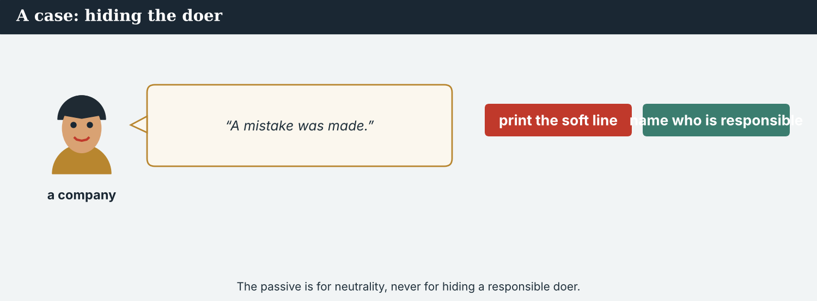
‘Mistakes were made’ is a sentence with nobody in it.
A first case · the name the lawyers wanted out
A case. Lawyers in two countries ask for the lead to read ‘the crossings were reopened’, with no body named. Their reasoning is reasonable: naming an authority invites a complaint, and the complaint lands on the smallest partner first. Nobody is asking Atlas Wire to write anything false. But a passive with no doer can be read as an accident, and the office’s decision — taken by named people, announced on a Tuesday — becomes weather. If the sentence is wrong, nobody can even be asked about it. The Code says: the passive may order a sentence, never empty it. What goes in the lead?
NOTICE What do you do?
8A Choose (a) or (b), and write one reason.
1. (a) ‘The crossings were reopened.’ (b) ‘The crossings were reopened by the Crossing Office.’ Choice: ______ Because ________________________
2. A passive that removes a name you have is (a) careful (b) a gap the reader cannot see. Choice: ______
8B Orders the sentence, or empties it? Write O or E.
1. ‘Three crossings have been reopened by the Crossing Office.’ ______
2. ‘Mistakes were made in the figure.’ ______
3. ‘The figure is still being checked by our verification desk.’ ______
4. ‘The credit was removed.’ ______
PRACTISE Apply the Code
8C Complete the rule. Use: action · name · hide · unfinished.
Use the passive to put the ______ first. Add the ______ whenever you have it. Mark ______ work with the continuous. Never use it to ______ .
PRODUCE Discuss
8D Discuss. Why does a complaint about a named authority usually land on the smallest partner first?
A second case · the credit that disappeared
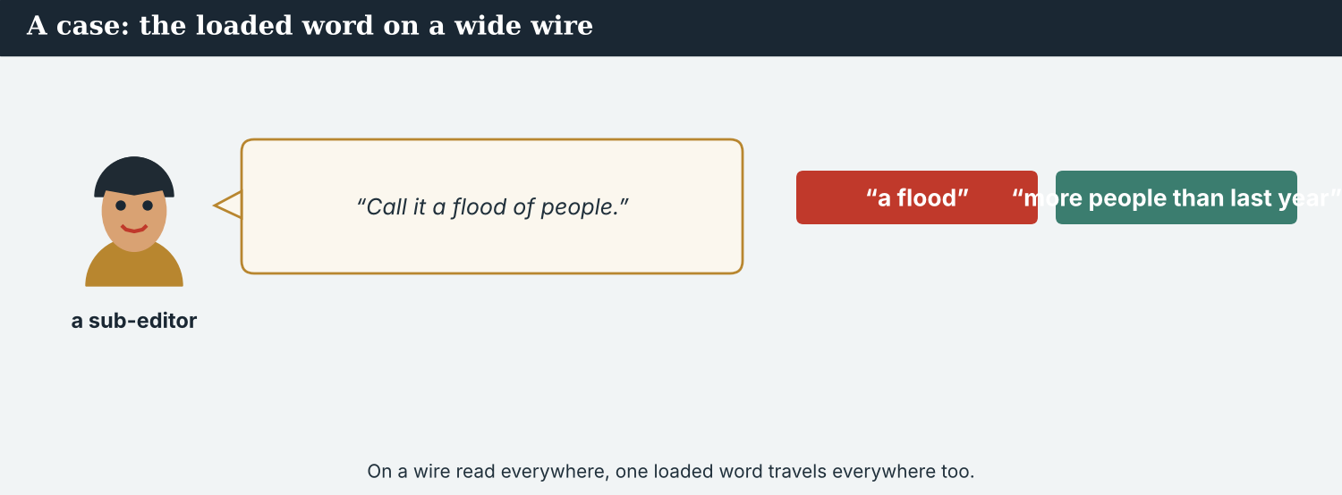
A template dropped three words. In Kalina, those three words are the story’s spine.
A case. The Post’s page template replaces partner credits with an agency line, automatically. Nobody decided to remove Kalina Daily’s name; a system did, as it does every night. But Dren interviewed people on the closed side alone, and in his town the credit is both his pay and his standing — the proof that the work was his and that a large paper stands behind it. ‘It was dropped by the system’ is a true passive sentence with nobody in it. The Code says: a process is not an excuse; somebody owns it. What should the Post do, and what should Atlas Wire insist on?
NOTICE What do you do?
8E Choose (a) or (b), and write one reason.
1. (a) accept that templates do this (b) correct it online and in print, and change the template. Choice: ______ Because ________________________
2. ‘It was dropped by the system’ is (a) an explanation (b) an explanation and not an excuse. Choice: ______
8F Complete with: template · credit · owns · alone.
1. The ___________ replaced the partner’s name.
2. Dren did the interviews ___________ .
3. The ___________ is his pay and his standing.
4. Somebody ___________ the process.
PRODUCE Discuss
8G Discuss. Why is a credit line worth more to a small local paper than to a large one?
PRODUCE Write it
8H Write two sentences to a subscriber asking for a credit to be restored. Use the passive and name who must act.
PRACTISE One more
8I Takes responsibility, or avoids it? Write R or A.
1. ‘The credit was dropped by our template; I am having it changed.’ ______
2. ‘The credit was dropped.’ ______
3. ‘I cut the credit for space, and I was wrong.’ ______
4. ‘Credits are sometimes lost.’ ______
8J Discuss. A passive sentence can be perfectly true and still leave a hole. How do you spot one?

PART 9 Digital: the alert and the update
Online, the wire becomes an alert. The passive gets even shorter — and the name still has to fit.
An alert is a snap with a vibration. There is room for the name.
MODEL A model alert
ALERT · Three crossings on the river Vara have been reopened by the Crossing Office — the first since the Kalina bridge reopened last spring. A figure of 112 returning families is still being checked. — @AtlasWire with @KalinaDaily
NOTICE The parts of the alert
9A Match the part to its job.
1. have been reopened  2. by the Crossing Office  3. is still being checked  4. with @KalinaDaily | a) the doer  b) the action, first  c) the credit  d) the unfinished work
PRACTISE Find and build
9B Find the present-perfect passive and the continuous passive in the alert. Write them.
1. ________________________
9C This alert has a broken participle and no doer. Correct both.
“Three crossings have been reopen. The figure was confirm.”
________________________
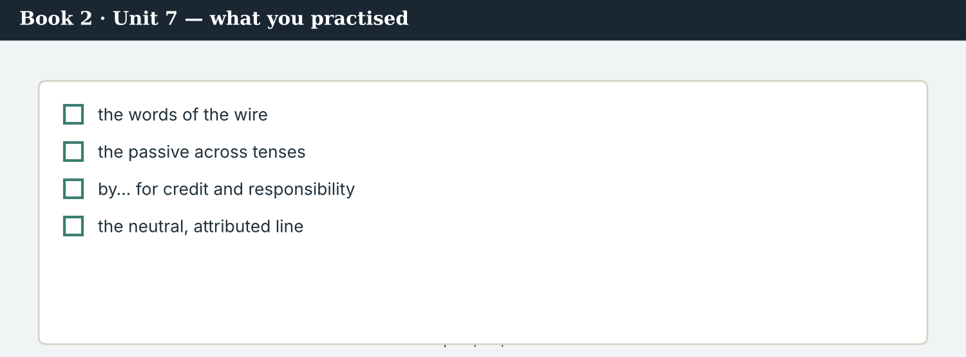
A good alert answers: what has been done, by whom, and what is still being checked.
9D Write an alert. Use one present-perfect passive with by, and one continuous passive.
ALERT · ___________ have been ___________ by ___________ . ___________ is still being ___________ . — @AtlasWire
PRODUCE Write your alert
9E Write a one-line alert about something near you. Use the passive and name the doer.
________________________
9F Creative. Write a short headline (4–6 words) in the passive.
9G A reader replies: ‘Who reopened them?’ Write a short answer. Use the passive with by.
________________________
9H An alert has no room for context. Write one line that is short and still names the authority.
________________________
PRODUCE Discuss
9I Creative. Write a two-line thread: line 1 what has been done and by whom, line 2 what is still being checked.
________________________
________________________
9J Discuss. An alert is read in two seconds. What must never be the thing you cut?

PART 10 Review & Can-Do
Check your new English before Unit 8.
The story as subscribers ran it: the action first, the authority named, the credit kept.
10A Vocabulary. Complete with: wire · dateline · lead · snap · byline · credit · subscriber · kill.
1. The story went out on the ___________ .
2. The ___________ reads KALINA, 14 October.
3. A good ___________ says what happened in one sentence.
4. The ___________ was eleven words long.
5. Dren’s ___________ stays on every take.
6. Kalina Daily’s ___________ must not be cut.
7. One ___________ asked for a shorter version.
8. An error was found, so the take was ___________ .
10B Grammar. Make these passive. Keep the tense.
1. The office reopened three crossings. → ___________
2. Priya checks every figure twice. → ___________
3. The desk has rewritten the lead. → ___________
4. Two hundred newsrooms will carry it. → ___________
10C Grammar. Complete with the passive in the tense given.
1. The figure ___________ (check) at the moment. (present continuous)
2. The snap ___________ (send) at 06:40. (past)
3. Three crossings ___________ (reopen) since April. (present perfect)
Can-Do — tick what you can do now.
10D Grammar. Add the doer with by.
1. The crossings were reopened. (the Crossing Office) → ___________
2. The register was kept for seven years. (a resident) → ___________
3. The lead was rewritten. (the foreign desk) → ___________
10E Read and answer.
KALINA, 14 October (Atlas Wire) — Three crossings on the river Vara have been reopened by the Crossing Office. The decision was announced on Tuesday. A figure of 112 returning families is still being checked. The upstream reporting was carried out with Kalina Daily, and the piece may be used by subscribers with the credit kept.
1. What has been reopened, and by whom? ___________
2. What is still being checked? ___________
3. On what condition may subscribers use the piece? ___________
Can-Do — tick what you can do now
☐ I can form the passive in every tense.
☐ I can choose the passive when the action matters most.
☐ I can say by whom — and know when I must.
☐ I can write wire copy that any newsroom can carry.
10F Reflect. Which part of Unit 7 was the most useful for you? Why?
10G Grammar review. Write the sentence correctly.
1. Three crossings have been reopen since April. → ________________________
2. The figure is checking at the moment. → ________________________
3. Mistakes were made with the credit. (name the doer) → ________________________
4. The piece will carried by subscribers. → ________________________
10H Mixed review. Complete with the passive.
1. The credit ___________ (correct) within the hour. (future)
2. The byline ___________ (drop) by the template. (past)
3. The template ___________ (change) this week. (present continuous)
10I Reflect. Write one passive sentence about your own work, and name the doer.

PART 11 Assignment: a wire report
Put the unit together: write copy that two hundred newsrooms could carry.
The assignment template — your wire report.
Your task. Write a wire report (6–7 sentences) with a dateline and a slug. Your lead must be a passive sentence naming the body that acted. Use at least three passive tenses, mark one thing that is still being checked with the continuous passive, say how the reporting was done and with whom, and end with the credit line a subscriber must keep. Then write the same story as a one-sentence snap.
A model — use Reading A and the Writing 2 model to check the shape of your report.
Remember: be + past participle; the action first, then the doer; by whenever you have a name; the continuous passive for unfinished work; the credit and the byline in every version; and never a passive used to hide.
Success criteria | Yes | Almost | Not yet
My passive forms are correct in every tense I use. | ☐ | ☐ | ☐
My lead names the body that acted. | ☐ | ☐ | ☐
I mark unfinished work with the continuous passive. | ☐ | ☐ | ☐
No passive in my copy hides a name I have. | ☐ | ☐ | ☐
The credit line and the byline survive into the snap. | ☐ | ☐ | ☐
Keep this. In Unit 8, you explain the basin to a reader who has never seen it — comparatives, superlatives, as…as and too/enough — because scale is how a distant reader understands a place.

ANSWER KEY Book 2 · Unit 7
Check your answers. Open tasks (discussion, role-play and your own writing) are marked at the end.
W1 1 ‘Three crossings on the Vara have been reopened.’ · 2 the Crossing Office · 3 ‘the crossings were reopened’, with no name
W2 1 F (the name was in the second take) · 2 T · 3 T
W3 present perfect: ‘have been reopened’ · past: ‘the crossings were reopened’ · present continuous: ‘the piece is being rewritten’
1A 1-b, 2-a, 3-c, 4-d, 5-e, 6-f, 7-g, 8-h, 9-i, 10-j
1B 1 wire · 2 dateline · 3 lead · 4 snap · 5 credit · 6 carried
1C 1 file a take · 2 pick up a story · 3 keep the credit · 4 follow the style guide · 5 send an update
1D 1 deadline · 2 partial · 3 wordy · 4 kill
1E 1 wire · 2 neutral · 3 concise · 4 carried · 5 rewritten
1F 1 subscriber · 2 style guide · 3 update · 4 rewrite
1G slug · takes · update · house style · byline
1J take · picked up · subscriber · concise · killed
2A 1 Three crossings were reopened by the office. · 2 Every figure is checked twice by Priya. · 3 The lead has been rewritten by the desk. · 4 The piece will be carried by two hundred newsrooms.
2B 1 is being checked · 2 was sent · 3 have been reopened · 4 will be published
2C 1 The crossings were reopened by the Crossing Office. · 2 The register was kept for seven years by a resident. · 3 The lead was rewritten by the foreign desk.
2D 1 A — ‘mistakes were made’ names nobody · 2 A — the council is known, so the active names it
2G 1 Three crossings have been reopened since April. · 2 The figure is being checked at the moment.
3A 1 three crossings on the Vara, by the Crossing Office · 2 a figure of 112 returning families · 3 the credit line
3B present perfect: ‘have been reopened’ · past: ‘was announced’ / ‘was reopened’ · continuous: ‘is still being checked’
3C 1 Three crossings have been reopened by the office. · 2 The figure is being checked. · 3 The piece may be used by subscribers.
3D been · was · being · be
3E 1 The lead: what has been reopened, and by whom. · 2 When it was announced and confirmed. · 3 What is still unconfirmed. · 4 How the reporting was done, and with whom.
3H a subscriber may carry only the first paragraph; without a name it reads as an accident
4B 1 the doer — by the Crossing Office · 2 the authority must be in the paragraph that is carried · 3 ‘is still being checked’ · 4 the credit and the byline
4C 1 PP · 2 P · 3 C
4D The lead must say = what has been reopened and by whom · The figure = still being checked · Every take = the credit and the byline
4F 1 was carried · 2 was cut · 3 will be corrected · 4 was dropped
4G past: ‘it was cut on the page’ · future: ‘it will be corrected within the hour’ · continuous: ‘that is being changed this week’
4H a person did the interviews alone, so a person’s name belongs on them
4I been · being · was · be
4J somebody chose the template and somebody can change it
4K Desk = the lead, the authority, unfinished work · Credit = whose name, and who restores it
5B 1 T · 2 F · 3 T · 4 F
5C 1 because the first paragraph is sometimes all that is carried · 2 because it says the work is still going on · 3 the credit line and the byline
5D 1 subscriber · 2 byline · 3 concise
5F action first → ‘three crossings have been reopened’ · name the doer → ‘reopened by the Crossing Office’ · mark unfinished work → ‘the figure is still being checked’ · never hide → ‘mistakes were made’
5G Rule 4
5H 1 snap · 2 credit · 3 carry
5I 1 have been reopened · 2 is being checked · 3 will be corrected
6A 1 ‘have been reopened’ · 2 the Crossing Office
6C present perfect: ‘have been reopened’ · past: ‘was announced’ / ‘were done’ · continuous: ‘is still being checked’
6D been · was · being · be
6F ‘Three crossings have been reopened by the Crossing Office. The figure was published by the office and is still being checked.’
7A with by: ‘the piece was carried without the credit’ / ‘reopened by the Crossing Office’ · continuous: ‘is still being checked’ · modal: ‘the piece may be used’
7B 1 They have been reopened. · 2 They were reopened by the Crossing Office. · 3 It is still being checked.
7C 1 Will the piece be carried by many subscribers? — Yes, by about two hundred. · 2 Is the credit kept in every take? — Yes, in every take, including the snap.
7F ‘It was cut by the page, not by the desk.’ · ‘The byline was dropped by our template; it is being changed.’
8A 1 (b) ‘The crossings were reopened by the Crossing Office.’ · 2 (b) a gap the reader cannot see
8B 1 O · 2 E · 3 O · 4 E
8C action · name · unfinished · hide
8E 1 (b) correct it online and in print, and change the template · 2 (b) an explanation and not an excuse
8F 1 template · 2 alone · 3 credit · 4 owns
8I 1 R · 2 A · 3 R · 4 A
9A ‘have been reopened’ → the action, first · ‘by the Crossing Office’ → the doer · ‘is still being checked’ → the unfinished work · ‘with @KalinaDaily’ → the credit
9B present perfect: ‘have been reopened’ · continuous: ‘is still being checked’
9C ‘Three crossings have been reopened by the Crossing Office. The figure is still being checked.’
10A 1 wire · 2 dateline · 3 lead · 4 snap · 5 byline · 6 credit · 7 subscriber · 8 killed
10B 1 Three crossings were reopened by the office. · 2 Every figure is checked twice by Priya. · 3 The lead has been rewritten by the desk. · 4 It will be carried by two hundred newsrooms.
10C 1 is being checked · 2 was sent · 3 have been reopened
10D 1 The crossings were reopened by the Crossing Office. · 2 The register was kept for seven years by a resident. · 3 The lead was rewritten by the foreign desk.
10E 1 three crossings on the river Vara, by the Crossing Office · 2 a figure of 112 returning families · 3 that the credit line is kept
10G 1 Three crossings have been reopened since April. · 2 The figure is being checked at the moment. · 3 The page editor cut the credit. · 4 The piece will be carried by subscribers.
10H 1 will be corrected · 2 was dropped · 3 is being changed
Open tasks W4, W5, 1H, 1I, 1K, 2E, 2F, 2H, 3F, 3G, 3I, 4A, 4E, 4L, 5A, 5E, 5J, 5K, 5L, 6B, 6E, 6G, 6H, 7D, 7E, 7G, 7H, 7I, 8D, 8G, 8H, 8J, 9D, 9E, 9F, 9G, 9H, 9I, 9J, 10F, 10I — your own answers (discussion, role-play, writing).
A note on real and invented content. The facts about journalism around the world in 2026 are true. Atlas Wire, Kalina Daily, the Meridian Post, their staff, the Crossing Office, Dren Markaj and the story are invented, for practice. Real people and outlets are only ever in true, sourced facts — never in an invented quote.
English for Journalists — International Edition · Book 2 · Unit 7 (30-page standard). CEFR lower B1 → medium B1 · Beat: Across Borders (wholly) · two readings · two listenings · two writing pieces · two ethics cases · two speaking dialogues · balanced sections · ~28 figures · featured cast + the wire desk and a subscriber · fictional agency, factual backdrop.

BOOK 2 · UNIT 8 The Bigger Picture: Explaining Scale to a Distant Reader
Beat · Explainer & Across Borders CEFR lower B1 → medium B1
In this unit you learn to…
1. compare two things with comparatives
2. say which is the most with superlatives
3. use as…as, not as…as, too and enough
4. write an explainer for a reader who has never been there
The Atlas Wire team — turning seven crossings into one picture a distant reader can hold.
Explaining a place nobody has seen. The Seven Crossings is reported. Now it has to be understood by someone two thousand miles away who has never heard of the river Vara. That is an explainer: scale, comparison, proportion. Which crossing is the busiest? Is the valley poorer than it was? Is a hundred and twelve families a lot? This week, Mira learns that a comparison is the most powerful sentence in an explainer — and the easiest one to get wrong. (Atlas Wire, Kalina Daily, the Meridian Post, the Vara basin and the figures in this unit are invented, for practice.)

WARM-UP Is that a lot?
A short scene to start the unit. Read it, then answer.
The morning conference — seven crossings on the wall, and one question: is that a lot?
“A hundred and twelve families,” Daniel says. “Is that a lot?”
“It is more than last year,” Mira says, “and far fewer than left.”
“Then say both. A reader in another country has no idea whether a hundred is big.”
Leila looks up from the chart. “Kalina is the busiest of the seven now. The smallest is Veren — eleven households, and it is the only one that never reopened.”
“Too small for the piece?” Daniel asks.
“Not small enough to leave out,” Ana says. “It is the clearest case in the basin.”
W1 Answer the questions.
1. Is 112 more or fewer than last year? ___________
2. Which crossing is the busiest of the seven? ___________
3. Which is the smallest, and what is special about it? ___________
W2 True or false? Write T or F.
1. A hundred and twelve is fewer than the number who left. ______
2. Kalina is the smallest of the seven crossings. ______
3. Ana wants Veren left out. ______
W3 Find one comparative, one superlative and one ‘too’ or ‘enough’ in the text.
1. ________________________
PRODUCE Talk about it
W4 Discuss with a partner.
1. How would you explain the size of your town to someone far away?
2. When is a number too small to report? Give an example.
PRODUCE One more
W5 Discuss. ‘Not small enough to leave out.’ What does Ana mean?

PART 1 The words of scale
The words for size, proportion and comparison.
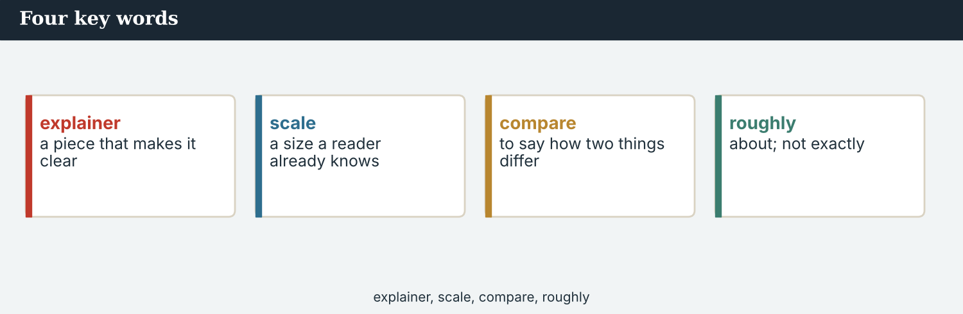
Four key words — explainer, scale, proportion, benchmark.
The words
Word | Meaning
explainer | a piece that explains the background of a story
scale (n) | how big something is
compare | to say how two things are different or alike
population | the number of people who live in a place
statistic | a number that describes a group
average | the usual or middle amount
per cent | out of a hundred
rate | how often or how fast something happens
proportion | one part compared with the whole
roughly | about; not exactly
significant | big enough to matter
benchmark | a figure you compare others against
equivalent | equal in value or size
misleading | giving a wrong impression
exaggerate | to make something sound bigger than it is
understate | to make something sound smaller than it is
far (adv) | by a large amount
slightly | by a small amount
PRACTISE Controlled practice
1A Match the word (1–10) to the meaning (a–j).
1. explainer  2. scale  3. proportion  4. benchmark  5. average  6. rate  7. significant  8. misleading  9. exaggerate  10. understate | a) how big something is  b) a piece that explains the background  c) one part compared with the whole  d) a figure you compare others against  e) the usual or middle amount  f) how often or how fast something happens  g) big enough to matter  h) giving a wrong impression  i) to make something sound bigger  j) to make something sound smaller
1B Complete the sentences with a word from the box.
WORD BOX
explainer · scale · compare · proportion · benchmark · misleading
1. A good ___________ answers ‘is that a lot?’
2. A distant reader cannot judge ___________ .
3. We ___________ this year with the year before.
4. Eleven households is a small ___________ of the valley.
5. Last year’s figure is the obvious ___________ .
6. A true number can still be ___________ .
1C Match the two halves.
1. set a  2. give a  3. exaggerate the  4. write an  5. state a | a) benchmark  b) comparison  c) scale  d) explainer  e) proportion
1D Circle the word that is different.
1. roughly · about · approximately · exactly
2. exaggerate · overstate · inflate · understate
3. significant · important · large · tiny
4. average · typical · usual · unique
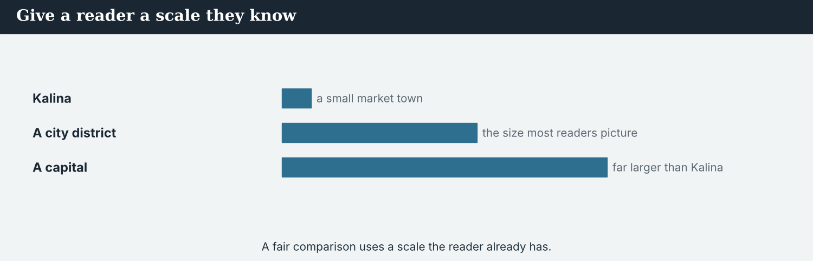
Seven crossings, side by side. A comparison is the fastest explainer there is.
1E Complete the paragraph. Use: scale · compare · benchmark · proportion · misleading.
A reader far away cannot judge ___________ , so you ___________ . Use last year as a ___________ , give the ___________ as well as the number, and check that the comparison is not ___________ .
1F Read the definition. Write the word.
1. equal in value or size → ___________
2. by a small amount → ___________
3. a number that describes a group → ___________
4. out of a hundred → ___________
1G Complete the collocation paragraph. Use: statistics · average · rate · far · slightly.
The ___________ in the piece are simple. The ___________ household has four people. The return ___________ is ___________ higher than last year, though ___________ lower than the office claimed.
PRODUCE Over to you
1H Answer about you. Write full sentences.
1. What benchmark would help a stranger understand your city’s size?
2. Which is more useful to a reader: a number, or a comparison? Why?
PRODUCE Talk about it
1I Discuss. Which two words in this unit are new for you? Make a sentence with one.
1J Complete with: significant · equivalent · roughly · understate · population.
The valley’s ___________ is ___________ nine thousand. Eleven households sounds small, but it is ___________ for Veren. Do not ___________ it, and do not call it the ___________ of a city district.
1K Creative. Write two sentences comparing two places you know. Use a comparative and a superlative.

PART 2 Grammar: comparing
Comparatives and superlatives; as…as and not as…as; too and enough.
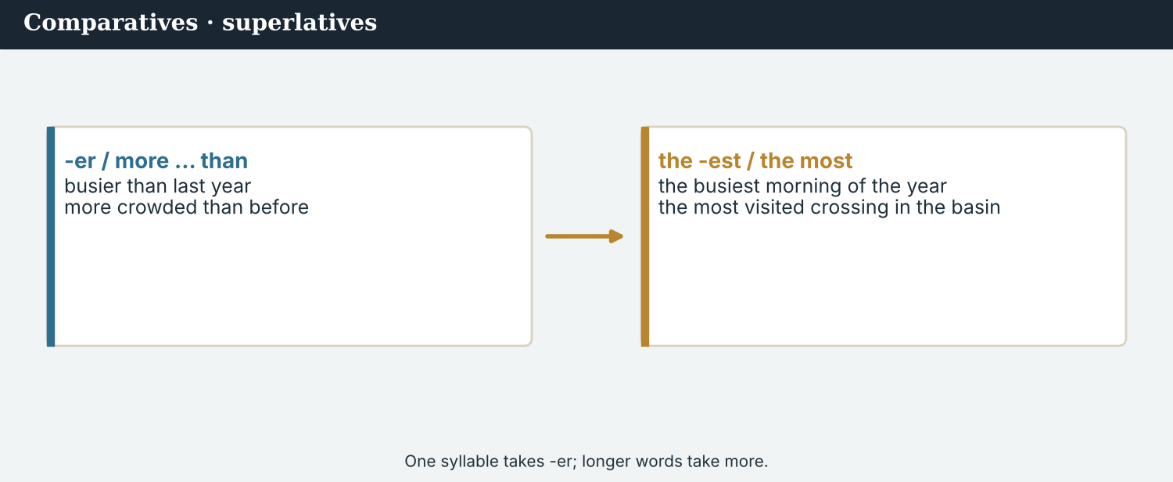
-er and more · the -est and the most.
1 · comparatives — more than one other thing
Short words: busy → busier, small → smaller (than). Longer words: more important than.
Irregular: good → better, bad → worse, far → further.
Make it bigger or smaller: far busier, much smaller, slightly higher, a little worse.
2 · superlatives — the one above all
Short words: the busiest, the smallest. Longer: the most important.
Irregular: the best, the worst, the furthest.
Careful: “one of the busiest” is a claim you can prove; “the busiest” is a claim you must prove.
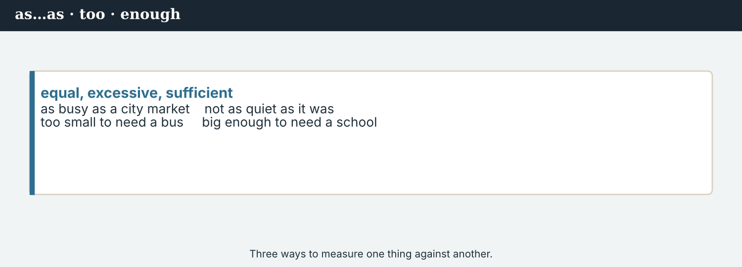
as…as · not as…as · too small · small enough.
3 · as…as · too · enough
Equal: “Veren is as old as Kalina.” Not equal: “It is not as busy as Kalina.”
too + adjective = more than is wanted: “The figure is too small to publish alone.”
adjective + enough = as much as is needed: “The case is clear enough to lead the piece.”
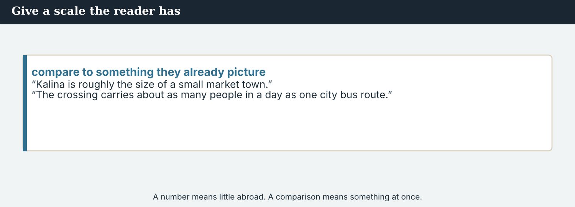
Compare two, pick one from many, or measure against a need.
PRACTISE Structured practice
2A Complete with the comparative.
1. Kalina is ___________ (busy) than Veren.
2. The return rate is ___________ (high) than last year.
3. This winter was ___________ (bad) than the last.
4. The far bank is ___________ (far) from the school.
2B Complete with the superlative.
1. Kalina is ___________ (busy) of the seven crossings.
2. Veren is ___________ (small) in the basin.
3. It is ___________ (clear) case we have.
4. That was ___________ (bad) year of the seven.
2C Complete with as…as or not as…as.
1. Veren is ___________ old ___________ Kalina. (equal)
2. It is ___________ busy ___________ Kalina. (not equal)
3. The river is ___________ high ___________ it was in April. (not equal)
2D Complete with too or enough.
1. Eleven households is ___________ small to make a chart.
2. The case is clear ___________ to lead the piece.
3. The figure is ___________ uncertain to publish alone.
Your own words
2E Write two comparisons about two places you know. Use comparatives.
1. ________________________
2. ________________________
2F Write two superlatives about your town or country, and say how you could prove them.
1. ________________________
2. ________________________
2G Rewrite the sentence correctly (comparative / superlative / too–enough).
1. Kalina is more busier than Veren. → ________________________
2. Veren is the most small of the seven. → ________________________
2H Your own words. Write one comparison that helps a distant reader, and say why it helps.
1. ________________________

PART 3 Writing an explainer
An explainer answers the question a distant reader cannot ask: is that a lot?
Seven crossings, ranked. A ranking is a claim, so every step has to be defensible.
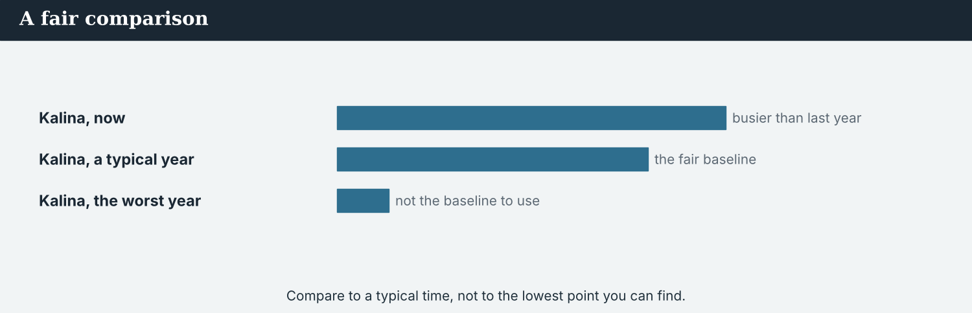
An explainer gives the number, the benchmark, and the proportion.
MODEL A model explainer paragraph
“There are seven crossings on the Vara. Kalina is the busiest: roughly two thousand people a week, more than the next two together. Veren is the smallest — eleven households — and the only one that has not reopened.
A hundred and twelve families have returned to Kalina. That is far more than last year, when eleven came back, and far fewer than the nine hundred who left over the quiet years. In other words: the return is real, and it is about an eighth of what was lost.
Eleven households sounds too small to matter. For Veren it is everything: it is the whole village.”
NOTICE Notice the explainer
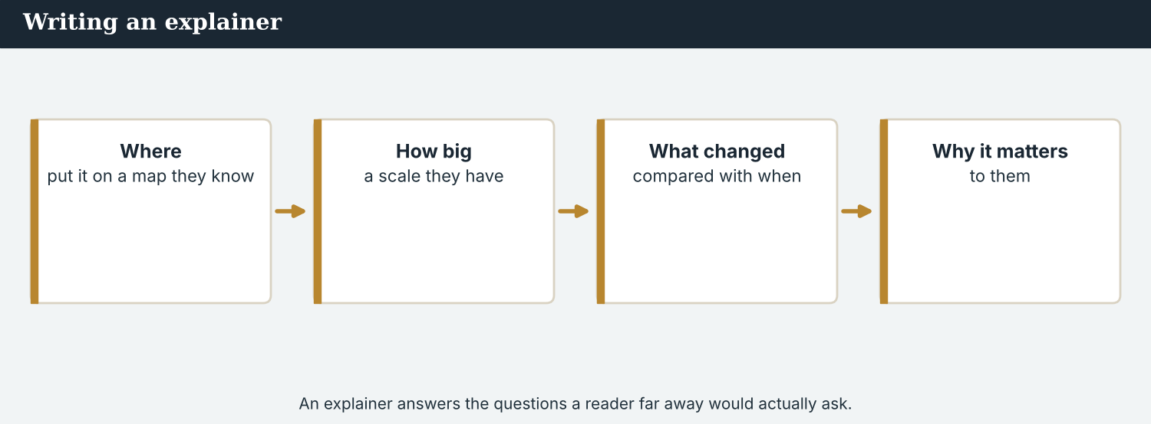
A number alone means nothing. A number with a benchmark means something.
3A Answer about the model.
1. Which crossing is the busiest, and by how much? ___________
2. How does 112 compare with last year, and with the number who left? ___________
3. Why is eleven households not too small to matter? ___________
3B Find one comparative, one superlative and one ‘too’ or ‘enough’ in the model. Write them.
1. ________________________
PRACTISE Build the explainer
An explainer answers one more question: compared with what?
3C Write the sentence with a comparative, a superlative, or too/enough.
1. Kalina / busy / the seven crossings (superlative) → ________________________
2. 112 / many / last year’s eleven (comparative) → ________________________
3. eleven households / small / make a chart (too) → ________________________
3D Complete the paragraph. Use: busiest · more · fewer · enough.
Kalina is the ______ of the seven. A hundred and twelve families is ______ than last year and ______ than the nine hundred who left. The Veren case is clear ______ to lead on.
PRACTISE One more
3E Put the explainer in order. Number the lines 1–4.
1. What the number means as a proportion. ______
2. How many crossings there are, and which is the biggest. ______
3. Why the smallest one still matters. ______
4. The new figure, against last year and against what was lost. ______
PRODUCE Your turn
3F Choose a place you know. Write an explainer paragraph (4–5 sentences): one superlative, two comparatives, one proportion, and one ‘too’ or ‘enough’.
________________________
________________________
________________________
________________________
PRODUCE Discuss
3G Talk with a partner. Why is ‘far fewer than the nine hundred who left’ more useful than ‘112 families’?
3H Why is ‘one of the busiest’ safer than ‘the busiest’? When may you use each?
3I Discuss. Which comparison would help a reader in your country understand the Vara basin?

PART 4 Listening: is that a lot?
Two audios. Listen for the comparisons, and for the argument about the smallest crossing.
Audio 8.1 — the world desk tests every comparison in the explainer.
Listening A · testing the comparisons
MODEL Audio 8.1 — Daniel and Mira
Daniel: ‘A hundred and twelve families have returned.’ Is that a lot?
Mira: It is ten times more than last year, and about an eighth of the nine hundred who left.
Daniel: Good — both directions. And the busiest crossing?
Mira: Kalina, roughly two thousand a week. More than the next two together.
Daniel: Can we prove ‘the busiest’?
Mira: From the office’s weekly counts, yes. If we could not, I would write ‘one of the busiest’.
Daniel: And is the valley poorer than before?
Mira: We do not have figures good enough to say that. I have left it out.
PRACTISE Listen for detail
4A Before you listen: what comparison do you think Daniel will ask for? Write one idea.
1. ______
4B Answer the questions.
1. How does 112 compare with last year? ___________
2. How does it compare with the number who left? ___________
3. How busy is Kalina compared with the next two crossings? ___________
4. Why has Mira left out ‘poorer than before’? ___________
4C Comparative, superlative, or too/enough? Write C, S, or T.
1. “Ten times more than last year.” ______
2. “Kalina is the busiest.” ______
3. “We do not have figures good enough to say that.” ______
4D Complete the notes.
112 compared with last year: ___________
112 compared with those who left: ___________
Left out, and why: ___________
Audio 8.2 — the smallest crossing, and whether it belongs in the piece.
Listening B · the smallest crossing
MODEL Audio 8.2 — Mira and Dren
Dren: I hear Veren may be cut. Eleven households is too small for a chart.
Mira: It is too small for a chart. It is not too small for the story.
Dren: It is the only crossing that never reopened. That makes it the clearest case in the basin.
Mira: I agree. I am arguing for it as the lead.
Dren: Thank you. A chart is not the same as a reason.
Mira: No. And the smallest number here is the most important one.
Dren: Say that in the piece, in those words.
Mira: I will.
PRACTISE Listen for detail
4E Before you listen: what do you think Dren will argue? Guess.
1. ______
4F Complete the answers.
1. Eleven households is too small for a ___________ .
2. It is not too small for the ___________ .
3. Veren is the ___________ case in the basin.
4. The smallest number is the ___________ important one.
4G Which forms do you hear? Write one comparative, one superlative and one ‘too’ phrase.
1. ________________________
4H Answer. What does Dren mean by ‘a chart is not the same as a reason’?
1. ________________________
PRACTISE Both audios
4I Complete the summary. Use: more · fewer · busiest · too.
A hundred and twelve is ten times ______ than last year and far ______ than the number who left. Kalina is the ______ of the seven. Veren is ______ small for a chart, but not for the story.
4J Both calls are about size. Why do they reach different answers about what matters?
1. ________________________
PRODUCE What do you think?
4K Complete the note comparing the two audios.
The desk call is about: ___________
Dren’s call is about: ___________
4L Discuss. Should the smallest crossing lead the piece? Say why.

PART 5 Reading: seven crossings, compared
Two readings. Read for the comparisons, and for the rules that keep them honest.
An explainer is read by people who will never see the place. Scale is all they have.
Reading A · the basin, in proportion
Is a hundred and twelve a lot? The Vara basin in proportion
There are seven crossings on the river Vara, and almost nobody outside the valley could have named a single one of them a year ago. That is exactly the problem an explainer exists to solve.
Kalina is the busiest. Roughly two thousand people cross it in a week — more than the next two crossings together, and about twenty times more than the quietest. “Busiest is a claim, so we checked it against the office’s weekly counts,” says Mira Sandoval of Atlas Wire. “If we could not prove it, we would have written one of the busiest.”
A hundred and twelve families have returned to Kalina since it reopened. On its own the figure means nothing. Last year, eleven families came back; over the quiet years, about nine hundred left. So the return is roughly ten times larger than last year’s and roughly an eighth of what was lost. “Give both comparisons or neither,” says Daniel Okoye, the world editor. “One of them alone is an argument, not a fact.”
Some comparisons were left out. The partners could not show that the valley is poorer than it was before the closure, because the figures are not good enough. “We can say the market is not as busy as it was,” Mira says. “We cannot put a number on poverty here, so we do not.”
The smallest crossing is Veren: eleven households, and the only one of the seven that has not reopened. Eleven is too small for a chart, and the partners nearly cut it. In the end it led the piece. “The smallest number in the basin is the most important one,” the explainer says, in the voice of Dren Markaj of Kalina Daily. “It is a whole village, and nothing has changed for it.”
PRACTISE Comprehension
5A Before you read: look at the title. What makes a number ‘a lot’? Write one sentence.
1. ______
5B True or false? Write T or F.
1. Kalina is busier than the next two crossings together. ______
2. The 112 figure is about an eighth of those who left. ______
3. The partners could show the valley is poorer than before. ______
4. Veren has reopened. ______
5C Answer the questions.
1. Why did Mira check ‘busiest’ against the weekly counts? ___________
2. Why does Daniel say ‘give both comparisons or neither’? ___________
3. Why did Veren lead the piece in the end? ___________
5D Find a word or phrase in the text.
1. one part compared with the whole → ___________
2. about; not exactly → ___________
3. a piece that explains the background → ___________
Four newsrooms argued about one village of eleven households. It led the piece.
Reading B · comparing honestly
Four rules for comparison
1. Give both directions. Ten times more than last year, an eighth of those who left. Either one alone is an argument.
2. Prove every superlative. The busiest needs a source you can name. If you cannot prove it, write one of the busiest — almost as useful, and true.
3. Compare like with like. Not a village against a city, or this April against a dry March. If they are less similar than they look, say so.
4. Never let size decide significance. A number can be too small for a chart and large enough to lead. Eleven households is a whole village.
PRACTISE Comprehension
5E Before you read: which is safer — ‘the busiest’ or ‘one of the busiest’? Guess.
1. ______
5F Match the rule to the example.
1. give both directions  2. prove every superlative  3. compare like with like  4. size is not significance | a) ‘one of the busiest, if you cannot prove the busiest’  b) ‘eleven households led the piece’  c) ‘ten times more than last year, an eighth of those who left’  d) do not measure a village against a city
5G Which rule is about what you choose to report, not how you word it? Write the number.
1. ______
PRACTISE Words from the readings
5H Find a word in Reading A or Reading B.
1. giving a wrong impression → ___________
2. how big something is → ___________
3. big enough to matter → ___________
PRACTISE Both readings
5I Complete with a comparative, a superlative, or too/enough.
1. Kalina is ___________ (busy) than the next two together.
2. Veren is ___________ (small) of the seven.
3. The figures are not good ___________ to say the valley is poorer.
PRODUCE Discuss
5J Talk about it. ‘One of them alone is an argument, not a fact.’ What does Daniel mean?
5K Which of the four rules is hardest in a short piece? Say why.
5L Discuss. ‘Never let size decide significance.’ Give an example from your own country.

PART 6 Writing: the explainer
Two short pieces: a comparison box, and an explainer paragraph.
A comparison box: the number, the benchmark, the proportion, the limit.
Writing 1 · a comparison box
MODEL A model
THE NUMBER: 112 families have returned to Kalina
AGAINST LAST YEAR: eleven returned — roughly ten times fewer
AGAINST WHAT WAS LOST: about nine hundred left — the return is roughly an eighth
BIGGEST / SMALLEST: Kalina is the busiest of the seven; Veren, with eleven households, is the smallest and the only one not reopened
WHAT WE CANNOT SAY: that the valley is poorer than before — the figures are not good enough
NOTICE Notice the model
6A Answer about the model.
1. Which line gives a proportion? ___________
2. Which line is a limit on what you may write? ___________
PRODUCE Write your box
6B Choose a figure from your own country. Write the five lines: the number, against last year, against the whole, biggest/smallest, what you cannot say.
The number: ___________
Against last year: ___________
Against the whole: ___________
Biggest / smallest: ___________
Cannot say: ___________
An explainer paragraph turns the box into prose a stranger can follow.
Writing 2 · an explainer paragraph
MODEL A model
Kalina is the busiest of the seven crossings on the Vara: roughly two thousand people a week, more than the next two together. A hundred and twelve families have returned since it reopened — ten times more than last year, and about an eighth of the nine hundred who left. The market is not as busy as it was, though we cannot put a number on that. The smallest crossing, Veren, has eleven households and has not reopened at all. That is too small for a chart and large enough to lead.
NOTICE Notice the model
6C Answer. Find one comparative, one superlative and one ‘not as…as’ in the paragraph.
1. ___________
PRACTISE Complete the paragraph
6D Complete the explainer. Use: busiest · more · as · enough.
Kalina is the ______ of the seven. A hundred and twelve is ten times ______ than last year. The market is not ______ busy as it was. Veren is small, and clear ______ to lead.
PRODUCE Write your paragraph
6E Turn your box into an explainer paragraph (4–5 sentences). Use a superlative, two comparatives and one too/enough.
________________________
________________________
________________________
PRACTISE Fix it
6F This copy uses a double comparative and an unprovable superlative. Correct both.
“Kalina is more busier than Veren, and it is the most important crossing in the world.”
________________________
PRACTISE Plan it
6G Plan a longer explainer. Write three lines: one superlative you can prove, one comparison in both directions, one thing you cannot say.
Superlative: ___________
Both directions: ___________
Cannot say: ___________
6H Peer-check. Swap with a partner. Is every superlative provable, and does every figure have a benchmark? Write one note.
________________________

PART 7 Speaking: explaining scale
Explain how big something is. Use comparatives, superlatives, as…as, too and enough.
Explaining scale out loud: the number, the comparison, and the limit.
A model dialogue · explaining the basin
MODEL Listen and read
Sofia: A hundred and twelve families. Is that a lot?
Mira: Ten times more than last year. About an eighth of those who left.
Sofia: And which crossing is the biggest?
Mira: Kalina, by a long way — busier than the next two together.
Sofia: Can we say the valley is poorer than before?
Mira: No. The figures are not good enough. We can say the market is not as busy as it was.
Sofia: And the smallest crossing?
Mira: Veren. Eleven households, never reopened. Too small for a chart, clear enough to lead.
NOTICE Notice the forms
7A Find one comparative, one superlative and one ‘not as…as’ sentence. Write them.
1. ________________________
PRACTISE Controlled practice
7B Answer with a comparison.
1. How / 112 / compare / last year? → ___________
2. Which crossing / busy? → ___________
3. Can we say / the valley / poor / before? → ___________
Open with the number, then the benchmark, then the limit of what you know.
7C Make a comparison question, then answer it.
1. Veren / small / Kalina → ________________________
2. this winter / bad / last → ________________________
PRODUCE Your role
Reporter | Give the number, two comparisons, and one thing you cannot say.
Editor | Ask: ‘Is that a lot?’ and ‘Can you prove the superlative?’
Observer | Listen. Was every superlative provable, and every figure given a benchmark?
7D Choose a role from the table. Explain a figure to your partner.
PRODUCE Role-play
7E Role-play an explainer meeting: a reporter, an editor, and an observer. Then swap roles.
A second dialogue · arguing for the smallest case
MODEL Listen and read
Omar: Eleven households will not hold a reader’s attention. Kalina is the bigger story.
Mira: Kalina is the bigger number. Veren is the clearer case.
Omar: Clearer how?
Mira: It is the only crossing of the seven that never reopened. Nothing has changed there at all.
Omar: So the smallest is the most telling.
Mira: Yes. It is too small for a chart and important enough to lead.
Omar: Then lead with it, and put the chart underneath.
PRACTISE Controlled practice
7F Write the two sentences Mira uses to contrast the bigger number with the clearer case.
1. ________________________
PRODUCE Self-check
Did I… | Yes | Almost | Not yet
form comparatives and superlatives correctly? | ☐ | ☐ | ☐
prove every superlative, or write ‘one of the’? | ☐ | ☐ | ☐
use as…as and not as…as correctly? | ☐ | ☐ | ☐
use too and enough in the right order? | ☐ | ☐ | ☐
7G Role-play arguing that a small case should lead a piece. Then swap roles.
PRACTISE Plan it
7H Plan your answers. Note one provable superlative, one two-way comparison, one limit.
7I Discuss. How would you explain your country’s size to someone who has never been there?

PART 8 Ethics: comparisons that mislead
Every comparison is an argument. A true number inside a false comparison is still a false sentence.
Accuracy includes the size of what you claim, not only the figures in it.
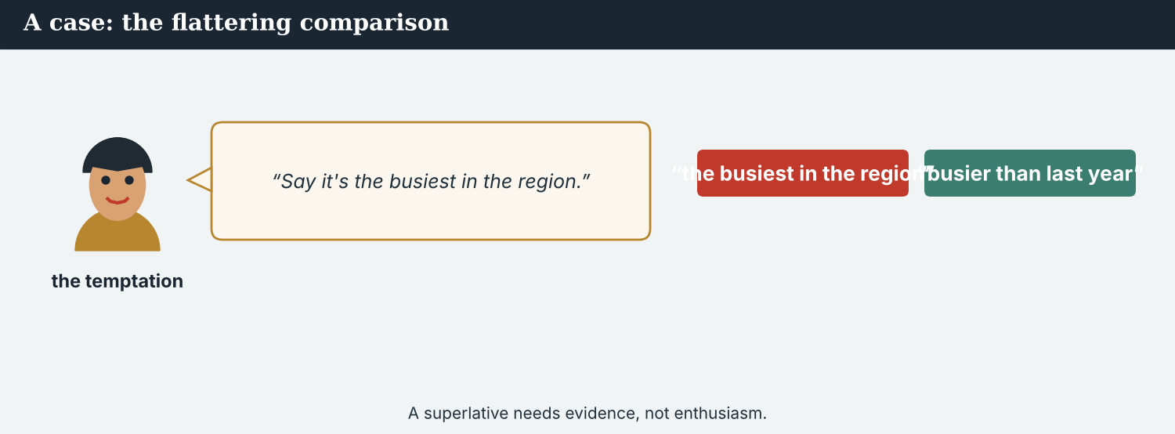
‘The worst-hit valley in the region’ is a superlative nobody has counted.
A first case · the superlative nobody can prove
A case. The Post’s editors want a stronger line: ‘the worst-hit valley in the region’. It would travel well, it would be quoted, and nobody could easily disprove it. The reporting supports something smaller, and firmer: Kalina is one of the worst-hit crossings on this river, by the office’s own weekly counts. Nobody has counted the other valleys, so the bigger claim is not false exactly — it is unmeasured, which is worse, because a reader cannot tell the difference. The Code says: a superlative is a claim, and a claim needs a source. What line should run?
NOTICE What do you do?
8A Choose (a) or (b), and write one reason.
1. (a) ‘the worst-hit valley in the region’ (b) ‘one of the worst-hit crossings on the river’. Choice: ______ Because ________________________
2. An unmeasured superlative is (a) a strong line (b) a claim with no source. Choice: ______
8B Provable, or unmeasured? Write P or U.
1. ‘Kalina is the busiest of the seven crossings, by the office’s weekly counts.’ ______
2. ‘The worst-hit valley in the region.’ ______
3. ‘One of the worst-hit crossings on the river.’ ______
4. ‘The most isolated place anywhere.’ ______
PRACTISE Apply the Code
8C Complete the rule. Use: prove · one · both · like.
Give ______ directions. ______ every superlative, or write ’______ of the’. Compare ______ with like.
PRODUCE Discuss
8D Discuss. Why is an unmeasured claim harder for a reader to spot than a wrong number?
A second case · the village that was too small
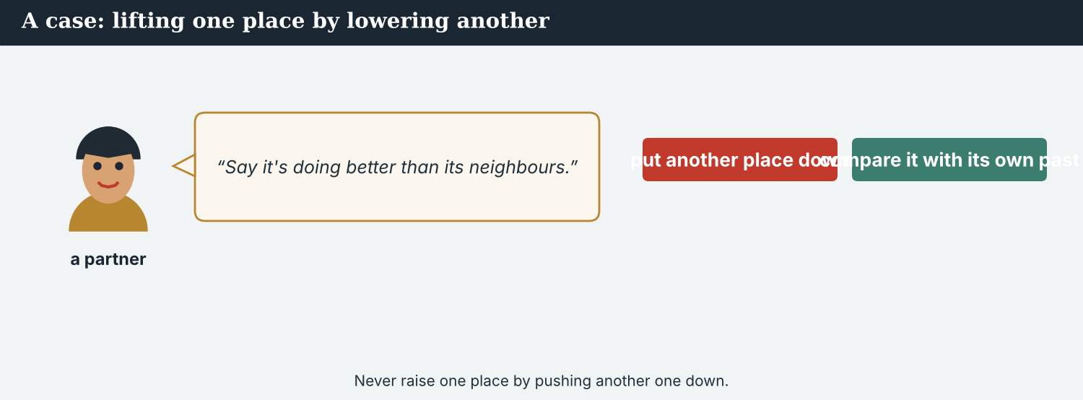
A chart cannot hold eleven households. A newspaper can.
A case. Veren has eleven households, and the data team says it cannot be charted: the bar would be invisible beside Kalina’s. The simplest decision is to cut it, and the argument is about scale, not politics — the piece is long, and eleven is a rounding error beside two thousand. But Veren is the only crossing of the seven that never reopened, which makes it the clearest case in the basin. Cutting it would leave a reader thinking the river had reopened everywhere. The Code says: do not let the size of a number decide whether people exist. What leads the piece?
NOTICE What do you do?
8E Choose (a) or (b), and write one reason.
1. (a) cut Veren — it cannot be charted (b) lead with Veren and put the chart underneath. Choice: ______ Because ________________________
2. Letting the chart decide the story is (a) good data practice (b) letting a tool choose the news. Choice: ______
8F Complete with: invisible · smallest · reopened · clearest.
1. Veren’s bar would be ___________ beside Kalina’s.
2. It is the ___________ of the seven crossings.
3. It is the only one that never ___________ .
4. That makes it the ___________ case.
PRODUCE Discuss
8G Discuss. Who is served when the smallest case is cut, and who is not?
PRODUCE Write it
8H Write two sentences arguing for the smallest case. Use a superlative and ‘too…to’ or ‘enough’.
PRACTISE One more
8I Honest comparison, or misleading? Write H or M.
1. ‘Ten times more than last year, an eighth of those who left.’ ______
2. ‘A record return to the valley.’ ______
3. ‘One of the busiest crossings on the river.’ ______
4. ‘Numbers up sharply — the valley has recovered.’ ______
8J Discuss. ‘Give both directions or neither.’ Is that a rule you could always keep?

PART 9 Digital: the chart post
Online, a comparison becomes a picture. The caption has to do what the chart cannot.
A chart post is a comparison with a caption. The caption carries the honesty.
MODEL A model post
THE SEVEN CROSSINGS · Kalina is the busiest: roughly 2,000 people a week, more than the next two together. 112 families have returned — ten times more than last year, about an eighth of those who left. Not in the chart: Veren, eleven households, the only crossing that never reopened. — @AtlasWire with @KalinaDaily
NOTICE The parts of the post
9A Match the part to its job.
1. Kalina is the busiest  2. more than the next two together  3. about an eighth of those who left  4. Not in the chart: Veren | a) the comparison that gives scale  b) the superlative, provable  c) what the chart leaves out  d) the proportion
PRACTISE Find and build
9B Find the superlative, one comparative and the proportion in the post. Write them.
1. ________________________
9C This post uses one direction only and an unprovable superlative. Correct both.
“Returns up ten times! The most dramatic recovery anywhere on the river.”
________________________
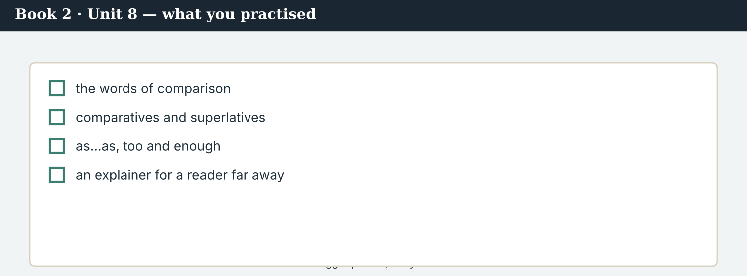
A good chart post answers: compared with what, and what is missing?
9D Write a chart post. Use one provable superlative, one comparison in both directions, and one thing the chart leaves out.
___________ is the ___________ . ___________ is ___________ than ___________ and ___________ than ___________ . Not in the chart: ___________ . — @AtlasWire
PRODUCE Write your post
9E Write a one-line post comparing two figures from your own country. Give both directions.
________________________
9F Creative. Write a short headline (4–6 words) using a comparative, not a superlative.
9G A reader asks: ‘So has the valley recovered?’ Write a short reply. Use not as…as and enough.
________________________
9H A chart can hide the smallest case. Write one line that puts it back.
________________________
PRODUCE Discuss
9I Creative. Write a two-line thread: line 1 the biggest, line 2 the smallest and why it matters.
________________________
________________________
9J Discuss. A chart is shared without its caption. What should you put in the picture itself?

PART 10 Review & Can-Do
Check your new English before Unit 9.
The explainer as published: the scale, the proportions, and the village that led it.
10A Vocabulary. Complete with: explainer · scale · proportion · benchmark · average · rate · misleading · exaggerate.
1. A good ___________ answers ‘is that a lot?’
2. A distant reader cannot judge ___________ .
3. Eleven households is a small ___________ of the valley.
4. Last year’s figure is the obvious ___________ .
5. The ___________ household has four people.
6. The return ___________ is higher than last year.
7. A true number can still be ___________ .
8. Do not ___________ the size of the return.
10B Grammar. Complete with the comparative.
1. Kalina is ___________ (busy) than Veren.
2. The rate is ___________ (high) than last year.
3. This winter was ___________ (bad) than the last.
4. The far bank is ___________ (far) from the school.
10C Grammar. Complete with the superlative.
1. Kalina is ___________ (busy) of the seven.
2. Veren is ___________ (small) in the basin.
3. It is ___________ (clear) case we have.
Can-Do — tick what you can do now.
10D Grammar. Complete with as…as, not as…as, too or enough.
1. Veren is ___________ old ___________ Kalina. (equal)
2. The market is ___________ busy ___________ it was. (not equal)
3. Eleven households is ___________ small for a chart.
4. The case is clear ___________ to lead.
10E Read and answer.
Kalina is the busiest of the seven crossings: roughly two thousand a week, more than the next two together. A hundred and twelve families have returned — ten times more than last year, about an eighth of the nine hundred who left. The market is not as busy as it was. Veren, with eleven households, is the smallest and the only one that never reopened.
1. Which crossing is the busiest, and by how much? ___________
2. How does 112 compare, in both directions? ___________
3. What is special about Veren? ___________
Can-Do — tick what you can do now
☐ I can compare two things with comparatives.
☐ I can say which is the most with superlatives.
☐ I can use as…as, not as…as, too and enough.
☐ I can write an explainer for a reader who has never been there.
10F Reflect. Which part of Unit 8 was the most useful for you? Why?
10G Grammar review. Write the sentence correctly.
1. Kalina is more busier than Veren. → ________________________
2. Veren is the most small of the seven. → ________________________
3. The case is enough clear to lead. → ________________________
4. This winter was worst than the last. → ________________________
10H Mixed review. Complete with a comparative, a superlative, or too/enough.
1. Kalina is ___________ (busy) than the next two together.
2. Veren is ___________ (small) of the seven.
3. The figures are not good ___________ to say the valley is poorer.
10I Reflect. Write one sentence comparing this year with last year in your own work.

PART 11 Assignment: an explainer
Put the unit together: explain a place and its numbers to a distant reader.
The assignment template — your explainer.
Your task. Write an explainer (6–7 sentences) about a place or a figure in your own country, for a reader who has never been there. Use one superlative you can prove and name its source, two comparatives, one comparison in both directions, one ‘not as…as’, and one ‘too…to’ or ’…enough’. End with one thing you cannot say, and why. If there is a small case the numbers would hide, put it first.
A model — use Reading A and the Writing 2 model to check the shape of your explainer.
Remember: -er / more…than; the -est / the most; ‘one of the’ when you cannot prove ‘the’; both directions on every figure; too + adjective, adjective + enough; and never let size decide significance.
Success criteria | Yes | Almost | Not yet
My comparatives and superlatives are correctly formed. | ☐ | ☐ | ☐
Every superlative has a source, or becomes ‘one of the’. | ☐ | ☐ | ☐
I give both directions on at least one figure. | ☐ | ☐ | ☐
I use as…as or not as…as, and too or enough, correctly. | ☐ | ☐ | ☐
A small but telling case is not hidden by the numbers. | ☐ | ☐ | ☐
Keep this. In Unit 9, you co-write with two partners — quantifiers, articles and connectors — because a sentence written by three newsrooms has to join up and still sound like one voice.

ANSWER KEY Book 2 · Unit 8
Check your answers. Open tasks (discussion, role-play and your own writing) are marked at the end.
W1 1 more than last year (and far fewer than the number who left) · 2 Kalina · 3 Veren — eleven households, and the only one that never reopened
W2 1 T · 2 F · 3 F
W3 comparative: ‘more than last year’ / ‘far fewer’ · superlative: ‘the busiest of the seven’ · too/enough: ‘Not small enough to leave out’
1A 1-b, 2-a, 3-c, 4-d, 5-e, 6-f, 7-g, 8-h, 9-i, 10-j
1B 1 explainer · 2 scale · 3 compare · 4 proportion · 5 benchmark · 6 misleading
1C 1 set a benchmark · 2 give a comparison · 3 exaggerate the scale · 4 write an explainer · 5 state a proportion
1D 1 exactly · 2 understate · 3 tiny · 4 unique
1E 1 scale · 2 compare · 3 benchmark · 4 proportion · 5 misleading
1F 1 equivalent · 2 slightly · 3 statistic · 4 per cent
1G statistics · average · rate · far · slightly
1J population · roughly · significant · understate · equivalent
2A 1 busier · 2 higher · 3 worse · 4 further
2B 1 the busiest · 2 the smallest · 3 the clearest · 4 the worst
2C 1 as / as · 2 not as / as · 3 not as / as
2D 1 too · 2 enough · 3 too
2G 1 Kalina is busier than Veren. · 2 Veren is the smallest of the seven.
3A 1 Kalina — more than the next two crossings together · 2 far more than last year’s eleven; far fewer than the nine hundred who left · 3 because for Veren eleven households is the whole village
3B comparative: ‘more than the next two together’ · superlative: ‘Kalina is the busiest’ · too/enough: ‘too small to matter’
3C 1 Kalina is the busiest of the seven crossings. · 2 A hundred and twelve is more than last year’s eleven. · 3 Eleven households is too small to make a chart.
3D busiest · more · fewer · enough
3E 1 How many crossings there are, and which is the biggest. · 2 The new figure, against last year and against what was lost. · 3 What the number means as a proportion. · 4 Why the smallest one still matters.
3H ‘one of the busiest’ can be supported by any strong count, so it is almost always true; ‘the busiest’ is a ranking claim and needs a source that ranks them all
4B 1 ten times more · 2 about an eighth of the nine hundred who left · 3 busier than the next two together · 4 because the figures are not good enough to support it
4C 1 C · 2 S · 3 T
4D Against last year = ten times more · Against those who left = about an eighth · Left out = ‘poorer than before’, the figures are not good enough
4F 1 chart · 2 story · 3 clearest · 4 most
4G comparative: ‘the bigger number’ · superlative: ‘the clearest case’ / ‘the most important’ · too: ‘too small for a chart’
4H the size of a bar does not decide whether something matters
4I more · fewer · busiest · too
4J one measures size, the other weighs significance; they do not always agree
4K Desk = can each comparison be proved · Dren = does the smallest case belong
5B 1 T · 2 T · 3 F · 4 F
5C 1 ‘busiest’ is a ranking claim and needs a source · 2 one comparison alone argues a case · 3 it is the only crossing that never reopened
5D 1 proportion · 2 roughly · 3 explainer
5F give both directions → ‘ten times more than last year, an eighth of those who left’ · prove every superlative → ‘one of the busiest, if you cannot prove the busiest’ · compare like with like → do not measure a village against a city · size is not significance → ‘eleven households led the piece’
5G Rule 4
5H 1 misleading · 2 scale · 3 significant
5I 1 busier · 2 the smallest · 3 enough
6A 1 the AGAINST WHAT WAS LOST line · 2 the WHAT WE CANNOT SAY line
6C comparative: ‘more than the next two together’ · superlative: ‘the busiest of the seven’ · not as…as: ‘not as busy as it was’
6D busiest · more · as · enough
6F ‘Kalina is busier than Veren, and it is one of the busiest crossings on the river.’
7A comparative: ‘ten times more than last year’ · superlative: ‘Kalina, by a long way’ (the biggest) · not as…as: ‘the market is not as busy as it was’
7B 1 It is ten times more than last year, and about an eighth of those who left. · 2 Kalina — busier than the next two together. · 3 No — the figures are not good enough.
7C 1 Is Veren smaller than Kalina? — Yes, far smaller: eleven households. · 2 Was this winter worse than last? — It was slightly worse.
7F ‘Kalina is the bigger number. Veren is the clearer case.’
8A 1 (b) ‘one of the worst-hit crossings on the river’ · 2 (b) a claim with no source
8B 1 P · 2 U · 3 P · 4 U
8C both · Prove · one · like
8E 1 (b) lead with Veren and put the chart underneath · 2 (b) letting a tool choose the news
8F 1 invisible · 2 smallest · 3 reopened · 4 clearest
8I 1 H · 2 M · 3 H · 4 M
9A ‘Kalina is the busiest’ → the superlative, provable · ‘more than the next two together’ → the comparison that gives scale · ‘about an eighth of those who left’ → the proportion · ‘Not in the chart: Veren’ → what the chart leaves out
9B superlative: ‘Kalina is the busiest’ · comparative: ‘more than the next two together’ / ‘ten times more than last year’ · proportion: ‘about an eighth of those who left’
9C ‘Returns are ten times higher than last year, and about an eighth of those who left. Kalina is one of the busiest crossings on the river.’
10A 1 explainer · 2 scale · 3 proportion · 4 benchmark · 5 average · 6 rate · 7 misleading · 8 exaggerate
10B 1 busier · 2 higher · 3 worse · 4 further
10C 1 the busiest · 2 the smallest · 3 the clearest
10D 1 as / as · 2 not as / as · 3 too · 4 enough
10E 1 Kalina — more than the next two crossings together · 2 ten times more than last year, about an eighth of those who left · 3 it is the smallest and the only one that never reopened
10G 1 Kalina is busier than Veren. · 2 Veren is the smallest of the seven. · 3 The case is clear enough to lead. · 4 This winter was worse than the last.
10H 1 busier · 2 the smallest · 3 enough
Open tasks W4, W5, 1H, 1I, 1K, 2E, 2F, 2H, 3F, 3G, 3I, 4A, 4E, 4L, 5A, 5E, 5J, 5K, 5L, 6B, 6E, 6G, 6H, 7D, 7E, 7G, 7H, 7I, 8D, 8G, 8H, 8J, 9D, 9E, 9F, 9G, 9H, 9I, 9J, 10F, 10I — your own answers (discussion, role-play, writing).
A note on real and invented content. The facts about journalism around the world in 2026 are true. Atlas Wire, Kalina Daily, the Meridian Post, their staff, the Vara basin, Veren, the seven crossings and every figure in this unit are invented, for practice. Real people, places and outlets are only ever in true, sourced facts — never in an invented quote or an invented number.
English for Journalists — International Edition · Book 2 · Unit 8 (30-page standard). CEFR lower B1 → medium B1 · Beat: Explainer & Across Borders · two readings · two listenings · two writing pieces · two ethics cases · two speaking dialogues · balanced sections · ~28 figures · featured cast + the data desk and a partner abroad · fictional agency, factual backdrop.

BOOK 2 · UNIT 9 Joining It Up: Co-Writing with Partners
Beat · Co-Writing & Across Borders CEFR lower B1 → medium B1
In this unit you learn to…
1. use quantifiers accurately (some, most, a few, several)
2. use a, an, the and no article correctly
3. join ideas with connectors
4. co-write one piece with two other newsrooms
The Atlas Wire team — merging three drafts into one piece that still tells the truth.
Three drafts, one piece. Three newsrooms have written three parts of The Seven Crossings, and now the parts have to become a piece. Atlas Wire has the mouth of the river, the River Basin Network has the middle, and Kalina Daily has upstream. The facts agree. The voices do not, the quantifiers do not match, and in two places the accounts contradict each other. This week, Mira learns that joining writing up is mostly a matter of small words — some, most, the, however — and that the smallest words carry the most. (Atlas Wire, Kalina Daily, the River Basin Network and the Meridian Post are invented, for practice.)

WARM-UP The seam
A short scene to start the unit. Read it, then answer.
The morning conference — three drafts on the table, and two of them disagree.
“Dren writes that most families upstream have returned,” Mira says. “Ines writes that a few have. They are describing the same river.”
“Different crossings,” Ana says. “Both can be true.”
“Then the piece has to say which, and where. However I join them, the reader must not think they contradict.”
Daniel reads over her shoulder. “And here the Post’s draft says ‘families have returned’. No quantifier at all.”
“That is the worst of the three,” Mira says. “Some is a fact. None is a hole.”
W1 Answer the questions.
1. What does Dren write about families upstream? ___________
2. What does Ines write? ___________
3. Why can both be true? ___________
W2 True or false? Write T or F.
1. Dren and Ines are writing about the same crossings. ______
2. The Post’s draft has no quantifier. ______
3. Mira thinks a missing quantifier is the worst problem. ______
W3 Find two quantifiers and one connector in the text.
1. ________________________
PRODUCE Talk about it
W4 Discuss with a partner.
1. Have you ever written something with another person? What was hardest?
2. What is the difference between ‘some families’ and ‘families’?
PRODUCE One more
W5 Discuss. ‘Some is a fact. None is a hole.’ What does Mira mean?

PART 1 The words of co-writing
The words for merging drafts, voices and bylines.
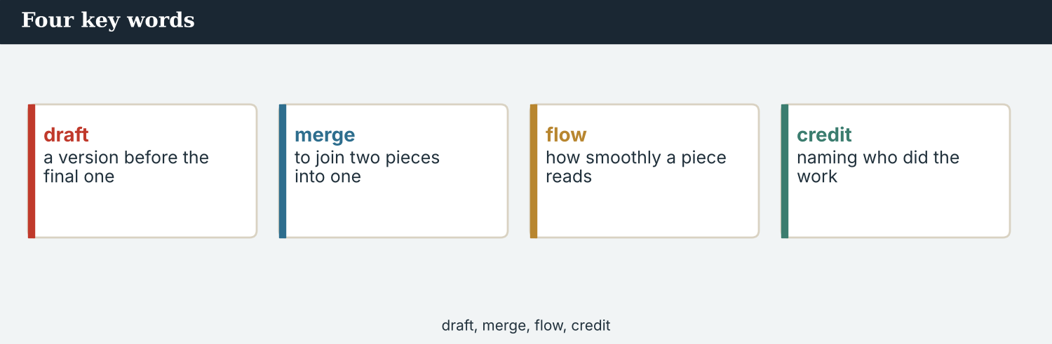
Four key words — merge, version, seam, shared byline.
The words
Word | Meaning
co-write | to write together
merge (v) | to join two texts into one
version | one of several forms of a text
track changes | a record of each person’s edits
house voice | the way one outlet sounds
connector | a word that links sentences or clauses
transition | a phrase that carries a reader from one idea to the next
paragraph | a block of sentences on one point
structure (n) | the order of the parts
repetition | saying the same thing twice
overlap (n) | the part two texts both cover
seam | the place where two pieces join
consistent | the same all the way through
contradiction | two statements that cannot both be true
reconcile | to make two accounts agree
shared byline | a byline with more than one name
sign-off | the final approval
comment (n) | a note left on a draft
PRACTISE Controlled practice
1A Match the word (1–10) to the meaning (a–j).
1. co-write  2. merge  3. version  4. house voice  5. connector  6. overlap  7. seam  8. contradiction  9. reconcile  10. shared byline | a) to join two texts into one  b) to write together  c) one of several forms of a text  d) the way one outlet sounds  e) a word that links sentences  f) the part two texts both cover  g) the place where two pieces join  h) two statements that cannot both be true  i) to make two accounts agree  j) a byline with more than one name
1B Complete the sentences with a word from the box.
WORD BOX
merge · version · seam · overlap · contradiction · shared byline
1. Three drafts have to ___________ into one piece.
2. Each partner sent its own ___________ .
3. A reader should not be able to feel the ___________ .
4. The middle section had a large ___________ with the first.
5. In two places there was a real ___________ .
6. The piece went out with a ___________ .
1C Match the two halves.
1. merge three  2. keep one  3. reconcile two  4. leave a  5. share a | a) drafts  b) house voice  c) accounts  d) comment  e) byline
1D Circle the word that is different.
1. merge · join · combine · separate
2. consistent · even · uniform · uneven
3. connector · transition · link · gap
4. version · draft · copy · chart
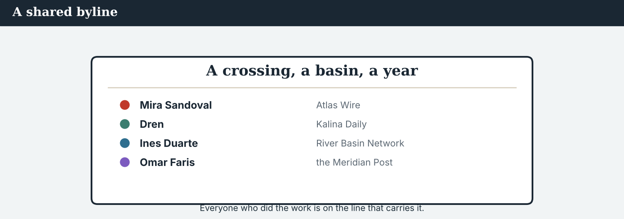
Three names on one byline. Each one did a part no one else could do.
1E Complete the paragraph. Use: merge · seam · house voice · consistent · connectors.
When you ___________ three drafts, the danger is the ___________ . Choose one ___________ , keep the quantifiers ___________ , and join the parts with ___________ a reader does not notice.
1F Read the definition. Write the word.
1. a record of each person’s edits → ___________
2. saying the same thing twice → ___________
3. the order of the parts → ___________
4. the final approval → ___________
1G Complete the collocation paragraph. Use: comments · track changes · sign-off · paragraph · structure.
Ines left eleven ___________ in ___________ . One asked for the ___________ of the middle section to change; another moved a whole ___________ . The ___________ came at six.
PRODUCE Over to you
1H Answer about you. Write full sentences.
1. When you write with someone, who decides the structure?
2. What makes two people’s writing sound like one voice?
PRODUCE Talk about it
1I Discuss. Which two words in this unit are new for you? Make a sentence with one.
1J Complete with: repetition · reconcile · overlap · versions · co-wrote.
The three ___________ had some ___________ , so there was ___________ in the middle. Mira had to ___________ two accounts, and in the end the partners ___________ the lead together.
1K Creative. Write two sentences joining two facts with a connector of your choice.

PART 2 Grammar: the small words
Quantifiers; a, an, the and no article; connectors.
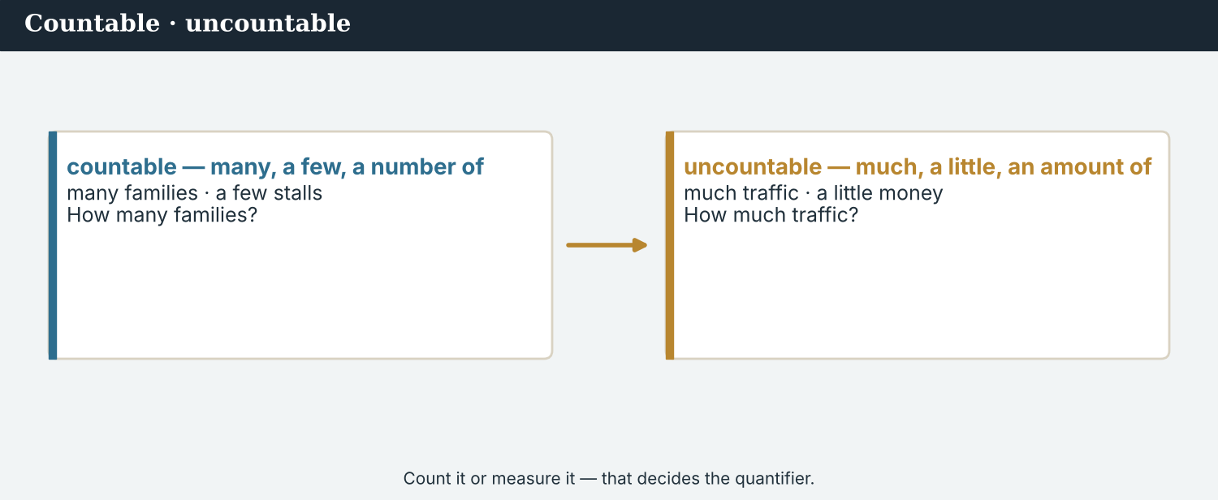
some · most · a few · several — each one is a different fact.
1 · quantifiers — how many, how much
Countable: a few, several, many, most, all, none of the families.
Uncountable: a little, much, most of the water, plenty of time.
A quantifier is part of the fact: some families returned and most families returned are different claims.
2 · a, an, the — and no article
First mention: a crossing, an office. Second mention, or one we both know: the crossing.
the with rivers and named things: the river Vara, the Crossing Office. No article with most place names: Kalina, Veren.
Not ‘the’ for a general plural: say families returned, NOT the families returned, unless you mean particular ones.
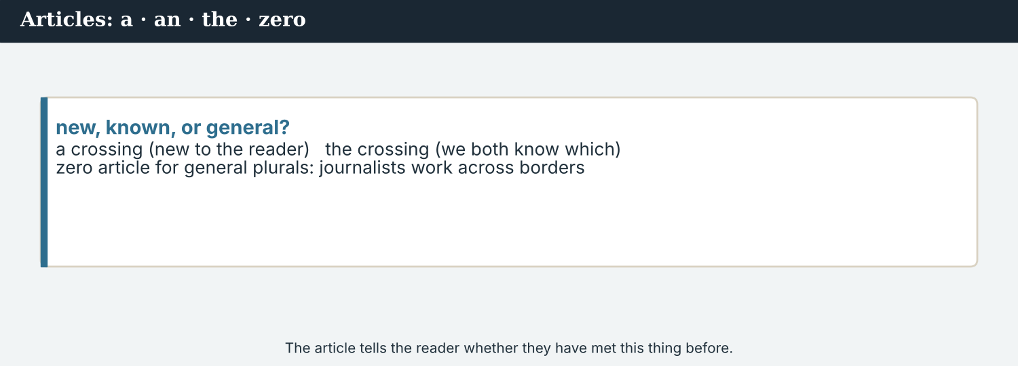
however · although · because · so — the joints of a paragraph.
3 · connectors — joining ideas
Contrast: however (new sentence), although / whereas (one sentence), but.
Cause and result: because, since, so, therefore.
Adding and sequencing: in addition, also, meanwhile, then.
Punctuation: However, the figure is unconfirmed. — comma after however, not before a clause.
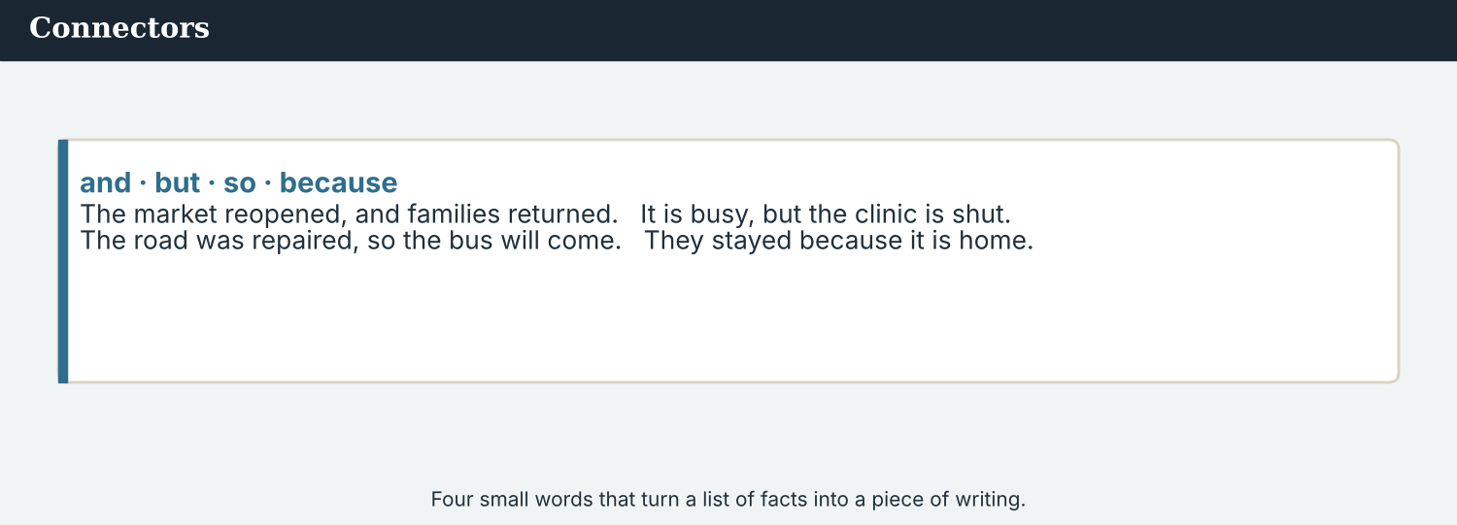
Quantifier, article, connector — the three joints of co-written copy.
PRACTISE Structured practice
2A Complete with a quantifier: a few · several · most · none.
1. ___________ of the seven crossings have reopened — five of them.
2. ___________ of the eleven households in Veren has returned.
3. ___________ families came back last year: eleven in all.
4. ___________ crossings were counted twice in the first draft.
2B Complete with a, an, the, or – (no article).
1. ___________ crossing reopened last spring. ___________ crossing is now the busiest of seven.
2. ___________ river Vara runs through ___________ Kalina.
3. ___________ families have returned, according to ___________ Crossing Office.
2C Join the ideas with the connector given.
1. Most families upstream have returned. A few have returned in the middle. (whereas) → ________________________
2. The figure is unconfirmed. We are publishing the story. (however) → ________________________
3. Veren has eleven households. It led the piece. (although) → ________________________
2D Choose the right connector: because · so · in addition · meanwhile.
1. The office would not give its method, ___________ the figure stayed out.
2. Dren reported upstream. ___________ , Ines was in the middle of the valley.
3. We held the story ___________ two sources were missing.
4. The piece ran in four countries. ___________ , it was translated twice.
Your own words
2E Write two sentences about your own town using different quantifiers.
1. ________________________
2. ________________________
2F Write two sentences joined by a connector of contrast and one of result.
1. ________________________
2. ________________________
2G Rewrite the sentence correctly (quantifier / article / connector).
1. Most of families have returned. → ________________________
2. Although the figure is unconfirmed, but we are publishing. → ________________________
2H Your own words. Write one sentence where changing the quantifier changes the fact.
1. ________________________

PART 3 Merging three drafts
Co-writing is mostly joining: one voice, consistent quantifiers, and seams a reader cannot feel.
Three drafts in, one piece out. The joins are where the errors live.
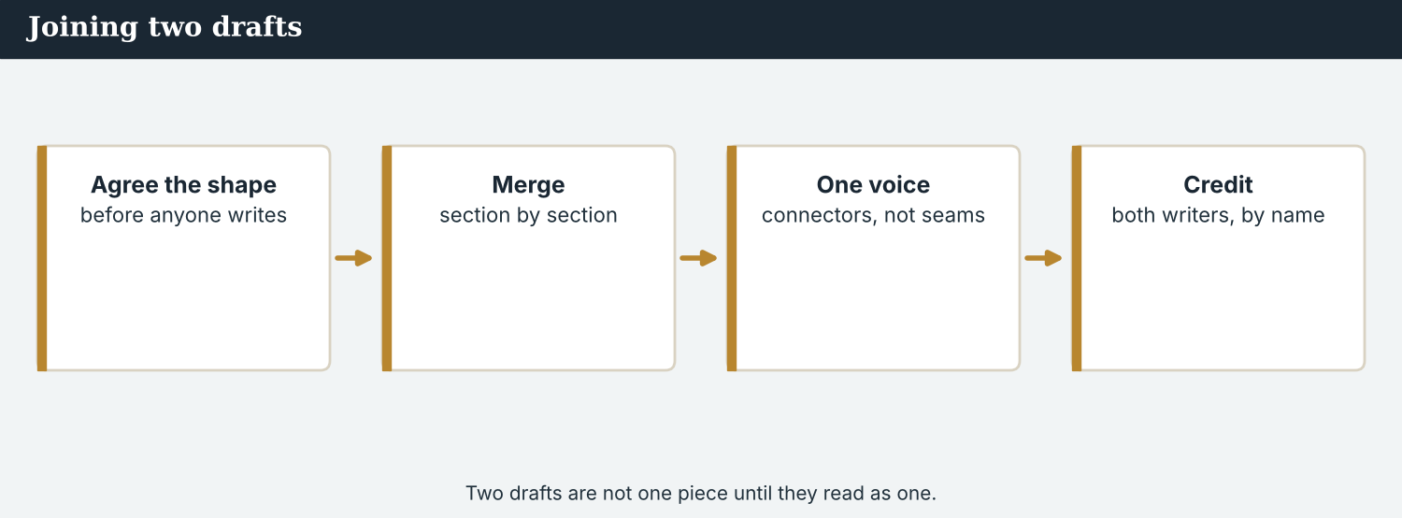
Merge in four passes: structure, quantifiers, articles, connectors.
MODEL A model merge note
“Four passes. First, structure: Veren leads, then Kalina, then the middle crossings; each section keeps its reporter’s byline.
Second, quantifiers. Dren has ‘most families’ upstream; Ines has ‘a few’ in the middle. Both are right, so the piece says which crossings, and where. The Post’s ‘families have returned’ goes — a missing quantifier is not neutral.
Third, articles. It is ‘the river Vara’, ‘the Crossing Office’, but ‘Kalina’ and ‘Veren’ with no article.
Fourth, connectors. However for contrast between sections, whereas inside a sentence, and nothing clever at the seams.”
NOTICE Notice the merge note
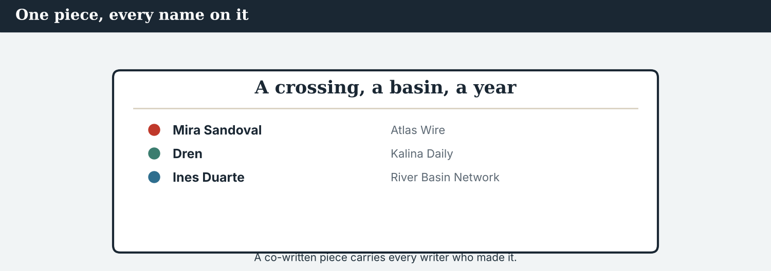
A good seam is invisible. A bad one makes two true sentences look like a contradiction.
3A Answer about the merge note.
1. What is the order of the sections? ___________
2. Why are ‘most’ and ‘a few’ both right? ___________
3. What happens to ‘families have returned’? ___________
3B Find two quantifiers, one article rule and one connector in the note. Write them.
1. ________________________
PRACTISE Build the merge
At every seam: who is speaking, about which crossing, and how many.
3C Write the sentence with the right quantifier, article, or connector.
1. most / families / upstream / return (quantifier) → ________________________
2. a few / families / the middle crossings / return (quantifier) → ________________________
3. join the two with a contrast (whereas) → ________________________
3D Complete the merge. Use: most · a few · the · however.
Upstream, ______ families have returned. In ______ middle crossings, only ______ have. ______ , no family has returned to Veren at all.
PRACTISE One more
3E Put the four merge passes in order. Number them 1–4.
1. Connectors at the seams. ______
2. The structure of the sections. ______
3. Articles and names. ______
4. Quantifiers made consistent. ______
PRODUCE Your turn
3F Take two short accounts of the same event (yours and a partner’s). Write a merged paragraph (4–5 sentences): one structure, consistent quantifiers, correct articles, and two connectors.
________________________
________________________
________________________
________________________
PRODUCE Discuss
3G Talk with a partner. Why is a missing quantifier worse than a cautious one?
3H Why does ‘the families have returned’ mean something different from ‘families have returned’? Explain.
3I Discuss. Who should decide the structure when three newsrooms co-write?

PART 4 Listening: the merge call
Two audios. Listen for the quantifiers, and for the argument about the byline.
Audio 9.1 — two editors join two drafts, line by line.
Listening A · joining the drafts
MODEL Audio 9.1 — Mira and Ines
Ines: Your section says most families have returned. Mine says a few.
Mira: Both are true — yours is the middle crossings, mine is upstream.
Ines: Then we must name the crossings, or the reader sees a contradiction.
Mira: Agreed. ‘Upstream, most families have returned; in the middle crossings, only a few.’
Ines: Good. And the Post’s draft has no quantifier at all.
Mira: That goes. A missing quantifier reads as ‘all’.
Ines: One more thing: I have eleven comments in track changes. Several are about structure.
Mira: Send them. However we order it, Veren leads.
PRACTISE Listen for detail
4A Before you listen: what do you think the two editors will disagree about? Write one idea.
1. ______
4B Answer the questions.
1. Why are ‘most’ and ‘a few’ both true? ___________
2. What must the piece name, and why? ___________
3. What happens to the draft with no quantifier? ___________
4. How many comments has Ines left? ___________
4C Quantifier, article, or connector? Write Q, A, or C.
1. “Most families have returned.” ______
2. “In the middle crossings.” ______
3. “However we order it, Veren leads.” ______
4D Complete the notes.
Upstream: ___________
Middle crossings: ___________
The Post’s draft: ___________
Audio 9.2 — whose name goes first, and what a quantifier is worth.
Listening B · the byline and the hedge
MODEL Audio 9.2 — Mira and Dren
Dren: The Post’s subeditor has changed my ‘most families’ to ‘families’.
Mira: I saw. It is going back. A quantifier is part of the fact.
Dren: Thank you. And the byline order?
Mira: Alphabetical by outlet, as we agreed: Atlas Wire, Kalina Daily, the River Basin Network.
Dren: My name on a piece that leads with my village. That matters here.
Mira: It should. You reported the only crossing that never reopened, alone.
Dren: There is one more thing. My account and Ines’s disagree about the second ferry.
Mira: Then we print both, and say they disagree. We do not smooth that seam.
PRACTISE Listen for detail
4E Before you listen: what do you think Dren will raise? Guess.
1. ______
4F Complete the answers.
1. The subeditor changed ‘most families’ to ’___________ ’.
2. A quantifier is part of the ___________ .
3. The byline order is ___________ by outlet.
4. Where the two accounts disagree, the partners will print ___________ .
4G Which forms do you hear? Write one quantifier, one article and one connector.
1. ________________________
4H Answer. Why will the partners not ‘smooth that seam’?
1. ________________________
PRACTISE Both audios
4I Complete the summary. Use: most · a few · however · the.
Upstream, ______ families have returned; in ______ middle crossings, only ______ have. ______ , no family has returned to Veren.
4J A subeditor removed one word. Why was that a change of fact, not of style?
1. ________________________
PRODUCE What do you think?
4K Complete the note comparing the two audios.
The merge call is about: ___________
Dren’s call is about: ___________
4L Discuss. When two partners’ accounts disagree, should the piece say so? Why?

PART 5 Reading: written by three, read as one
Two readings. Read for the joins, and for the rules of co-writing.
One piece, three newsrooms, four countries — and it has to read as though one person wrote it.
Reading A · how three drafts became one piece
The seams: co-writing The Seven Crossings
Three newsrooms wrote The Seven Crossings, and a reader should not be able to tell where one stopped and the next began. Getting there took four passes over three days, and almost none of the work was about facts. The facts had agreed with each other from the start.
The first pass was structure. Veren, with eleven households, leads; Kalina follows; the middle crossings come third. “We argued for a day about the order and ten minutes about the facts,” says Ines Duarte of the River Basin Network. “That is normal in co-writing.”
The second pass was quantifiers, and it was the dangerous one. Dren Markaj of Kalina Daily had written that most families upstream had returned. Ines had written that a few had. Both were correct, about different crossings, and side by side they looked like a contradiction. The piece now names the crossings in both sentences.
Worse was a draft that had no quantifier at all: families have returned. “A missing quantifier reads as all,” says Mira Sandoval of Atlas Wire. “Some is a fact. None is a hole, and the reader fills it.”
The third pass looked small: articles and names. The river Vara and the Crossing Office take the; Kalina and Veren take none. Three partners, two of them writing in a second language, had made eleven different choices between them, and a reader notices the eleventh even when they cannot say why.
The fourth pass was the joins themselves, and it was the slowest. Contrast between sections is carried by however; contrast inside a sentence by whereas. Where Dren’s account and Ines’s disagree about a second ferry, nothing was smoothed: the piece says both, and says they disagree. “A seam you can feel is better than a seam that hides something,” Ines says.
PRACTISE Comprehension
5A Before you read: what do you think ‘the seams’ means here? Write one sentence.
1. ______
5B True or false? Write T or F.
1. The partners spent longer on the order than on the facts. ______
2. ‘Most’ and ‘a few’ were both correct. ______
3. A missing quantifier reads as ‘none’. ______
4. The disagreement about the ferry was smoothed away. ______
5C Answer the questions.
1. Why did ‘most’ and ‘a few’ look like a contradiction? ___________
2. Why is a missing quantifier worse than a cautious one? ___________
3. What did the partners do about the ferry disagreement? ___________
5D Find a word or phrase in the text.
1. the place where two pieces join → ___________
2. two statements that cannot both be true → ___________
3. to join two texts into one → ___________
Co-writing is an agreement about small words, made by people in different time zones.
Reading B · co-writing with partners
Four rules for co-writing
1. Agree the structure before the sentences. Decide what leads, and in what order. Most arguments about style are arguments about structure.
2. Treat a quantifier as a fact. Most, some, a few are not softeners; each is a different claim. Never delete one to tighten a sentence, or change one without asking its reporter.
3. Choose one house voice, and keep every byline. One outlet’s sound; every reporter’s name, including the local one nobody could replace.
4. Do not smooth a real disagreement. If two accounts differ, print both and say so. A visible seam is honest; a hidden one decides for the reader.
PRACTISE Comprehension
5E Before you read: which is a fact — ‘most families’ or ‘families’? Guess.
1. ______
5F Match the rule to the example.
1. agree the structure  2. a quantifier is a fact  3. one voice, every byline  4. do not smooth | a) ‘the piece says both, and says they disagree’  b) ‘most, some, a few — each is a different claim’  c) ‘Veren leads, then Kalina, then the middle’  d) ‘three names on the byline, one way of writing’
5G Which rule protects a reporter’s words from an editor’s tidying? Write the number.
1. ______
PRACTISE Words from the readings
5H Find a word in Reading A or Reading B.
1. the way one outlet sounds → ___________
2. the same all the way through → ___________
3. a byline with more than one name → ___________
PRACTISE Both readings
5I Complete with a quantifier, an article, or a connector.
1. Upstream, ___________ families have returned.
2. It is ___________ river Vara, but ___________ Kalina.
3. The figure is unconfirmed; ___________ , the story runs.
PRODUCE Discuss
5J Talk about it. ‘A seam you can feel is better than a seam that hides something.’ Do you agree?
5K Which of the four rules would be hardest with a partner in another language? Say why.
5L Discuss. ‘Arguments about structure wearing the costume of style.’ What does Ines mean?

PART 6 Writing: the merged piece
Two short pieces: a merge note, and a joined paragraph.
A merge note: the order, the quantifiers, the articles, the seams.
Writing 1 · a merge note
MODEL A model
STRUCTURE: Veren leads · Kalina second · the middle crossings third
QUANTIFIERS: upstream = most families · middle = a few · Veren = none. Name the crossings in every sentence.
CUT: ‘families have returned’ with no quantifier
ARTICLES: the river Vara, the Crossing Office · Kalina, Veren (no article)
SEAMS: however between sections · whereas inside a sentence · the ferry disagreement stays visible
NOTICE Notice the model
6A Answer about the model.
1. Which line is about quantifiers? ___________
2. Which line tells you not to hide something? ___________
PRODUCE Write your note
6B Choose two accounts of one event. Write a merge note: structure, quantifiers, cuts, articles, seams.
Structure: ___________
Quantifiers: ___________
Cut: ___________
Articles: ___________
Seams: ___________
A joined paragraph: three reporters, one voice, every quantifier kept.
Writing 2 · a joined paragraph
MODEL A model
No family has returned to Veren, the smallest of the seven crossings on the river Vara, although it has been closed the longest. Upstream, most families have come back; in the middle crossings, only a few have. However, the Crossing Office has not published the method behind its figure of 112, so the number stays out of this paragraph. Dren Markaj of Kalina Daily and Ines Duarte of the River Basin Network disagree about whether a second ferry ran last winter; both accounts are below.
NOTICE Notice the model
6C Answer. Find two quantifiers, one ‘the’ with a named thing, and two connectors.
1. ___________
PRACTISE Complete the paragraph
6D Complete the paragraph. Use: most · a few · however · although.
Upstream, ______ families have come back. In the middle crossings, only ______ have. ______ , no family has returned to Veren, ______ it has been closed the longest.
PRODUCE Write your paragraph
6E Turn your merge note into a joined paragraph (4–5 sentences). Use three quantifiers and two connectors.
________________________
________________________
________________________
PRACTISE Fix it
6F This copy drops a quantifier and doubles a connector. Correct both.
“Families have returned upstream. Although the figure is unconfirmed, but the story runs.”
________________________
PRACTISE Plan it
6G Plan a merge. Write three lines: the order of the sections, the quantifier for each, the one seam you will leave visible.
Order: ___________
Quantifiers: ___________
Visible seam: ___________
6H Peer-check. Swap with a partner. Does every claim have a quantifier, and is every byline kept? Write one note.
________________________

PART 7 Speaking: agreeing the join
Agree how to join two accounts. Use quantifiers, articles and connectors.
Agreeing a join out loud: which crossing, how many, and in what order.
A model dialogue · joining two accounts
MODEL Listen and read
Sofia: Your section says most families. Ines’s says a few.
Mira: Different crossings. We name them in both sentences.
Sofia: And the draft with no quantifier?
Mira: It goes. Without a quantifier a reader reads ‘all’.
Sofia: What leads?
Mira: Veren. The smallest crossing, and the only one that never reopened.
Sofia: And the ferry disagreement?
Mira: Both accounts, and a line saying they disagree. However we write it, we do not hide it.
NOTICE Notice the forms
7A Find two quantifiers and one connector in the dialogue. Write them.
1. ________________________
PRACTISE Controlled practice
7B Answer with a quantifier or a connector.
1. How many families upstream? → ___________
2. How many in the middle crossings? → ___________
3. What about the draft with no quantifier? → ___________
Open the merge call with the structure, not the sentences.
7C Make a question with a quantifier, then answer it.
1. how many / the seven crossings / reopen → ________________________
2. how many / households / Veren → ________________________
PRODUCE Your role
Co-writer | Say your structure, your quantifiers, and which seam you will leave visible.
Partner | Ask: ‘Which crossings?’ and ‘Why does that section lead?’
Observer | Listen. Did every claim keep a quantifier, and every reporter a byline?
7D Choose a role from the table. Agree a join with your partner.
PRODUCE Role-play
7E Role-play a merge call: a co-writer, a partner, and an observer. Then swap roles.
A second dialogue · the word that was deleted
MODEL Listen and read
Dren: Someone deleted ‘most’ from my sentence.
Mira: I know. It is going back in before sign-off.
Dren: It is four letters.
Mira: It is four letters and a different claim. ‘Families have returned’ means all of them.
Dren: And the byline?
Mira: All three outlets, alphabetically, as we agreed. Your name is on the section that leads.
Dren: Then I am content. However this reads abroad, it is right here.
PRACTISE Controlled practice
7F Write the sentence Mira uses to explain why four letters matter.
1. ________________________
PRODUCE Self-check
Did I… | Yes | Almost | Not yet
use quantifiers that match the facts? | ☐ | ☐ | ☐
use a, an, the and no article correctly? | ☐ | ☐ | ☐
join ideas with one connector, not two? | ☐ | ☐ | ☐
keep every reporter’s byline and every quantifier? | ☐ | ☐ | ☐
7G Role-play asking for a deleted quantifier to be restored. Then swap roles.
PRACTISE Plan it
7H Plan your call. Note your structure, your three quantifiers, and your visible seam.
7I Discuss. How would you explain to a subeditor that one small word is a fact?

PART 8 Ethics: the small words
Tidying is editing. Tidying away a quantifier, a byline or a disagreement is something else.
Fairness lives in small words: which quantifier, whose name, whose account.
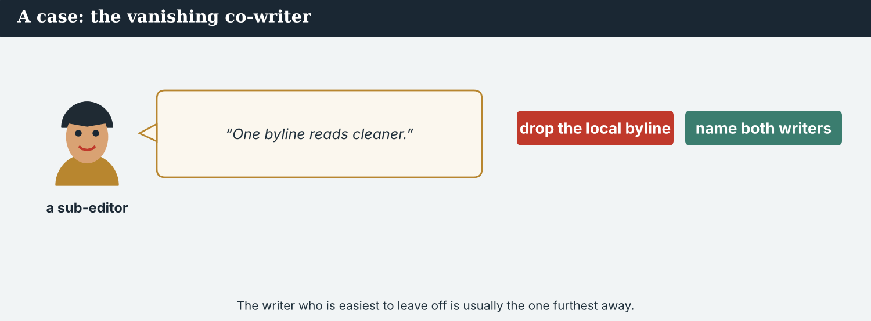
Deleting ‘most’ does not shorten a sentence. It enlarges a claim.
A first case · the quantifier that was tidied
A case. The Post’s subeditor cuts ‘most’ from Dren’s sentence, leaving ‘families upstream have returned’. The motive is length: the line was one word over, and ‘most’ looked like a hedge. Nothing was invented, and no figure changed. But a sentence with no quantifier is read as all, and upstream some families have not come back and will not. Those families are now, in print, home. The person whose sentence it was was not asked, and he is the only one of the three who will meet them. The Code says: a quantifier is part of the fact. What happens before sign-off?
NOTICE What do you do?
8A Choose (a) or (b), and write one reason.
1. (a) leave it — it is one word (b) restore ‘most’ and cut a word elsewhere. Choice: ______ Because ________________________
2. Deleting a quantifier to save space is (a) tightening (b) enlarging a claim. Choice: ______
8B Keeps the fact, or enlarges it? Write K or E.
1. ‘Most families upstream have returned.’ ______
2. ‘Families upstream have returned.’ ______
3. ‘A few families in the middle crossings have returned.’ ______
4. ‘The valley’s families are home.’ ______
PRACTISE Apply the Code
8C Complete the rule. Use: fact · reporter · structure · seam.
A quantifier is part of the ______ . Ask the ______ before you change one. Agree the ______ first. Leave a real ______ visible.
PRODUCE Discuss
8D Discuss. Why does the reporter who lives in the place have the strongest claim on the wording?
A second case · the disagreement nobody wanted
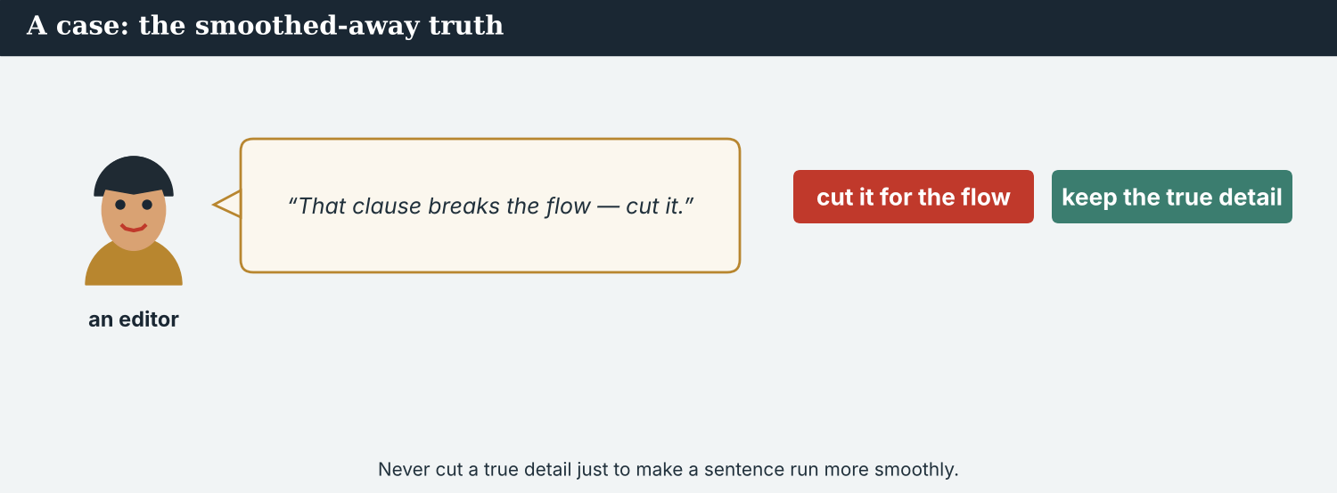
Two partners, two accounts. Printing both is harder and better.
A case. Dren says a second ferry ran last winter; Ines’s sources say it did not. Both have notes, neither can prove it, and the point matters: if it ran, people had a way out that the official account denies. The easiest edit is to cut the sentence, and both partners would accept that — Dren because he is tired, Ines because it is not her section. A cut would leave the piece smooth, and would quietly settle a question in favour of the official version. The Code says: publish the disagreement you cannot resolve. What does the piece do?
NOTICE What do you do?
8E Choose (a) or (b), and write one reason.
1. (a) cut the ferry sentence (b) print both accounts and say they disagree. Choice: ______ Because ________________________
2. Cutting an unresolved disagreement is (a) clean editing (b) choosing a side silently. Choice: ______
8F Complete with: ferry · notes · official · both.
1. Dren says a second ___________ ran.
2. Ines’s sources say it did not; ___________ have notes.
3. A cut would favour the ___________ version.
4. The piece prints ___________ accounts.
PRODUCE Discuss
8G Discuss. Why is a smooth piece sometimes a less honest one?
PRODUCE Write it
8H Write two sentences presenting two accounts that disagree. Use ‘whereas’ and a quantifier in each.
PRACTISE One more
8I Honest join, or hidden choice? Write H or C.
1. ‘Dren’s sources say a ferry ran; Ines’s say it did not.’ ______
2. ‘No ferry ran last winter.’ ______
3. ‘Accounts differ on whether a second ferry ran.’ ______
4. ‘The sentence was cut for length.’ ______
8J Discuss. Three newsrooms, one piece. Who should have the last word on a sentence about somebody’s village?

PART 9 Digital: the joint thread
Online, a co-written piece becomes a thread with several handles. The joins are still the hard part.
Three handles, one thread. Each post has to stand alone and still join up.
MODEL A model thread post
1/ No family has returned to Veren, the smallest of the seven crossings on the Vara — although it has been closed the longest. 2/ Upstream, most families have come back; in the middle crossings, only a few. 3/ The Crossing Office has not published the method behind its figure of 112, so we have left the number out. — @AtlasWire with @KalinaDaily and @RiverBasinNet
NOTICE The parts of the thread
9A Match the part to its job.
1. although it has been closed the longest  2. most families · only a few  3. so we have left the number out  4. with @KalinaDaily and @RiverBasinNet | a) the quantifiers, kept apart by place  b) a connector of contrast  c) the shared credit  d) a connector of result
PRACTISE Find and build
9B Find two quantifiers and two connectors in the thread. Write them.
1. ________________________
9C This post drops its quantifiers and doubles a connector. Correct both.
“Families have returned to the valley. Although the figure is unconfirmed, but we are publishing it.”
________________________
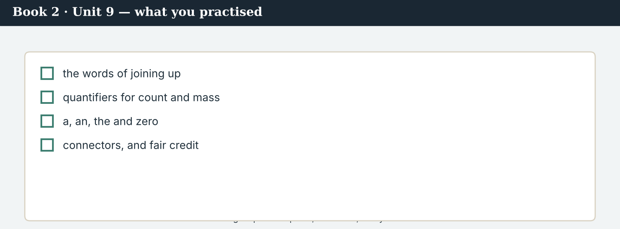
A good joint thread answers: how many, where, and whose reporting?
9D Write a thread post. Use two quantifiers, one connector and a shared credit.
1/ ___________ , although ___________ . 2/ ___________ ; ___________ . — @AtlasWire with ___________
PRODUCE Write your post
9E Write a one-line post about two groups of different sizes. Use two quantifiers.
________________________
9F Creative. Write a short headline (4–6 words) that keeps a quantifier.
9G A reader asks: ‘So is everyone back?’ Write a short reply. Use most, a few and none.
________________________
9H A thread can lose a partner’s credit at the second post. Write one line that keeps it.
________________________
PRODUCE Discuss
9I Creative. Write a two-line thread: line 1 with a quantifier, line 2 with a connector of contrast.
________________________
________________________
9J Discuss. Each post is shared on its own. What must every one of them carry?

PART 10 Review & Can-Do
Check your new English before Unit 10.
The published piece: three newsrooms, one voice, every quantifier in place.
10A Vocabulary. Complete with: merge · version · house voice · connector · overlap · seam · contradiction · shared byline.
1. Three drafts had to ___________ into one.
2. Each partner sent its own ___________ .
3. The piece needed one ___________ .
4. ‘However’ is a ___________ of contrast.
5. The middle section had a large ___________ .
6. A reader should not feel the ___________ .
7. In two places there was a real ___________ .
8. The piece went out with a ___________ .
10B Grammar. Complete with a quantifier: a few · several · most · none.
1. ___________ of the seven crossings have reopened — five of them.
2. ___________ of the eleven households in Veren has returned.
3. ___________ families came back last year: eleven in all.
4. ___________ crossings were counted twice in the first draft.
10C Grammar. Complete with a, an, the, or – (no article).
1. ___________ river Vara runs through ___________ Kalina.
2. ___________ families have returned, according to ___________ Crossing Office.
3. ___________ crossing reopened last spring; ___________ crossing is now the busiest.
Can-Do — tick what you can do now.
10D Grammar. Choose the connector: because · so · however · although.
1. The figure is unconfirmed. ___________ , the story runs.
2. ___________ Veren is the smallest, it leads the piece.
3. The office gave no method, ___________ the number stayed out.
4. We held the story ___________ two sources were missing.
10E Read and answer.
No family has returned to Veren, although it has been closed the longest. Upstream, most families have come back; in the middle crossings, only a few have. However, the Crossing Office has not published its method, so the figure of 112 stays out. Where two partners’ accounts disagree, the piece prints both.
1. How many families have returned to Veren? ___________
2. How do upstream and the middle crossings differ? ___________
3. Why does the figure of 112 stay out? ___________
Can-Do — tick what you can do now
☐ I can use quantifiers accurately.
☐ I can use a, an, the and no article correctly.
☐ I can join ideas with connectors.
☐ I can co-write one piece with other newsrooms.
10F Reflect. Which part of Unit 9 was the most useful for you? Why?
10G Grammar review. Write the sentence correctly.
1. Most of families have returned. → ________________________
2. Although the figure is unconfirmed, but we publish. → ________________________
3. The families have returned upstream. (general) → ________________________
4. It is river Vara. → ________________________
10H Mixed review. Complete with a quantifier, an article or a connector.
1. Upstream, ___________ families have returned.
2. It is ___________ Crossing Office, but ___________ Veren.
3. The accounts disagree; ___________ , we print both.
10I Reflect. Write one sentence with a quantifier you would defend word for word.

PART 11 Assignment: a co-written piece
Put the unit together: join two accounts into one piece.
The assignment template — your merge note and joined paragraph.
Your task. With a partner, report the same event separately, then join the two accounts. Write a merge note and a joined paragraph (6–7 sentences). Agree the structure first. Use at least three different quantifiers, name the place each one applies to, use the and no article correctly with named things, and join your ideas with two connectors. Keep both bylines, and leave any real disagreement visible.
A model — use Reading A and the Writing 2 model to check the shape of your piece.
Remember: a quantifier is part of the fact; first mention a, second mention the; the river Vara but Kalina; one connector, not two; every byline kept; and a seam you can feel is better than one that hides something.
Success criteria | Yes | Almost | Not yet
My quantifiers match the facts, and each names its place. | ☐ | ☐ | ☐
My articles are correct with named and general things. | ☐ | ☐ | ☐
I join ideas with single, correct connectors. | ☐ | ☐ | ☐
Both reporters are credited. | ☐ | ☐ | ☐
A real disagreement is printed, not smoothed. | ☐ | ☐ | ☐
Keep this. In Unit 10, the whole project goes out — gerunds and infinitives, and the capstone — because the last thing a cross-border piece needs is a plan for publishing it, and the will to publish it together.

ANSWER KEY Book 2 · Unit 9
Check your answers. Open tasks (discussion, role-play and your own writing) are marked at the end.
W1 1 that most families upstream have returned · 2 that a few have returned · 3 because they are describing different crossings
W2 1 F (different crossings) · 2 T · 3 T
W3 quantifiers: ‘most families’, ‘a few’ (also ‘no quantifier at all’) · connector: ‘However I join them’ (also ‘Then’)
1A 1-b, 2-a, 3-c, 4-d, 5-e, 6-f, 7-g, 8-h, 9-i, 10-j
1B 1 merge · 2 version · 3 seam · 4 overlap · 5 contradiction · 6 shared byline
1C 1 merge three drafts · 2 keep one house voice · 3 reconcile two accounts · 4 leave a comment · 5 share a byline
1D 1 separate · 2 uneven · 3 gap · 4 chart
1E 1 merge · 2 seam · 3 house voice · 4 consistent · 5 connectors
1F 1 track changes · 2 repetition · 3 structure · 4 sign-off
1G comments · track changes · structure · paragraph · sign-off
1J versions · overlap · repetition · reconcile · co-wrote
2A 1 Most · 2 None · 3 A few · 4 Several
2B 1 A / The · 2 The / – · 3 – / the
2C 1 Most families upstream have returned, whereas a few have returned in the middle. · 2 The figure is unconfirmed. However, we are publishing the story. · 3 Although Veren has eleven households, it led the piece.
2D 1 so · 2 Meanwhile · 3 because · 4 In addition
2G 1 Most families have returned. · 2 Although the figure is unconfirmed, we are publishing.
3A 1 Veren, then Kalina, then the middle crossings · 2 because they describe different crossings · 3 it goes — a missing quantifier is not neutral
3B quantifiers: ‘most families’, ‘a few’ · article rule: ‘the river Vara, the Crossing Office, but Kalina and Veren with no article’ · connector: ‘however’ (or ‘whereas’)
3C 1 Most families upstream have returned. · 2 A few families in the middle crossings have returned. · 3 Most families upstream have returned, whereas only a few have in the middle crossings.
3D most · the · a few · However
3E 1 The structure of the sections. · 2 Quantifiers made consistent. · 3 Articles and names. · 4 Connectors at the seams.
3H ‘the families’ means particular families already known to the reader; ‘families’ is a general plural — and with no quantifier it reads as all of them
4B 1 because they describe different crossings — upstream and the middle · 2 the crossings, so the reader does not see a contradiction · 3 it goes; a missing quantifier reads as ‘all’ · 4 eleven
4C 1 Q · 2 A · 3 C
4D Upstream = most families have returned · Middle crossings = only a few · The Post’s draft = no quantifier, so it is cut
4F 1 families · 2 fact · 3 alphabetical · 4 both (accounts)
4G quantifier: ‘most families’ · article: ‘the River Basin Network’ · connector: ‘and’ / ‘then’
4H because the disagreement is real and unresolved; hiding it would settle the question for the reader in favour of one account
4I most · the · a few · However
4J because without ‘most’ the sentence says all families have returned, which is a different and untrue claim
4K The merge call = quantifiers, structure and the seams · Dren’s call = the deleted quantifier, the byline order, and the disagreement
5B 1 T · 2 T · 3 F · 4 F
5C 1 because they sat side by side describing different crossings · 2 because the reader fills the gap with ‘all’ · 3 printed both accounts and said they disagree
5D 1 seam · 2 contradiction · 3 merge
5F agree the structure → ‘Veren leads, then Kalina, then the middle’ · a quantifier is a fact → ‘most, some, a few — each is a different claim’ · one voice, every byline → ‘three names on the byline, one way of writing’ · do not smooth → ‘the piece says both, and says they disagree’
5G Rule 2
5H 1 house voice · 2 consistent · 3 shared byline
5I 1 most · 2 the / – · 3 however
6A 1 the QUANTIFIERS line · 2 the SEAMS line
6C quantifiers: ‘most families’, ‘only a few’ (also ‘No family’) · the: ‘the river Vara’ / ‘the Crossing Office’ · connectors: ‘although’, ‘However’, ‘so’
6D most · a few · However · although
6F ‘Most families have returned upstream. Although the figure is unconfirmed, the story runs.’
7A quantifiers: ‘most families’, ‘a few’ · connector: ‘However we write it’
7B 1 Most of them. · 2 Only a few. · 3 It goes — without a quantifier a reader reads ‘all’.
7C 1 How many of the seven crossings have reopened? — Five of them. · 2 How many households are there in Veren? — Eleven.
7F ‘It is four letters and a different claim.’
8A 1 (b) restore ‘most’ and cut a word elsewhere · 2 (b) enlarging a claim
8B 1 K · 2 E · 3 K · 4 E
8C fact · reporter · structure · seam
8E 1 (b) print both accounts and say they disagree · 2 (b) choosing a side silently
8F 1 ferry · 2 both · 3 official · 4 both
8I 1 H · 2 C · 3 H · 4 C
9A ‘although it has been closed the longest’ → a connector of contrast · ‘most families · only a few’ → the quantifiers, kept apart by place · ‘so we have left the number out’ → a connector of result · ‘with @KalinaDaily and @RiverBasinNet’ → the shared credit
9B quantifiers: ‘most families’, ‘only a few’ · connectors: ‘although’, ‘so’ (also ‘However’)
9C ‘Most families have returned upstream, and only a few in the middle crossings. Although the figure is unconfirmed, we are publishing the story.’
10A 1 merge · 2 version · 3 house voice · 4 connector · 5 overlap · 6 seam · 7 contradiction · 8 shared byline
10B 1 Most · 2 None · 3 A few · 4 Several
10C 1 The / – · 2 – / the · 3 A / the
10D 1 However · 2 Although · 3 so · 4 because
10E 1 none · 2 upstream most have returned, in the middle crossings only a few · 3 because the Crossing Office has not published its method
10G 1 Most families have returned. · 2 Although the figure is unconfirmed, we publish. · 3 Families have returned upstream. · 4 It is the river Vara.
10H 1 most · 2 the / – · 3 however
Open tasks W4, W5, 1H, 1I, 1K, 2E, 2F, 2H, 3F, 3G, 3I, 4A, 4E, 4L, 5A, 5E, 5J, 5K, 5L, 6B, 6E, 6G, 6H, 7D, 7E, 7G, 7H, 7I, 8D, 8G, 8H, 8J, 9D, 9E, 9F, 9G, 9H, 9I, 9J, 10F, 10I — your own answers (discussion, role-play, writing).
A note on real and invented content. The facts about journalism around the world in 2026 are true. Atlas Wire, Kalina Daily, the River Basin Network, the Meridian Post, their staff, the Vara crossings and the story are invented, for practice. Real people and outlets are only ever in true, sourced facts — never in an invented quote.
English for Journalists — International Edition · Book 2 · Unit 9 (30-page standard). CEFR lower B1 → medium B1 · Beat: Co-Writing & Across Borders · two readings · two listenings · two writing pieces · two ethics cases · two speaking dialogues · balanced sections · ~28 figures · featured cast + two co-writing partners · fictional agency, factual backdrop.

BOOK 2 · UNIT 10 Across Borders: The Co-Production
Beat · Capstone & Across Borders (wholly) CEFR lower B1 → medium B1
In this unit you learn to…
1. use verb + -ing (gerunds) correctly
2. use verb + to + infinitive correctly
3. choose between -ing and to, and know when it changes the meaning
4. plan and publish a cross-border co-production
The Atlas Wire team on launch morning — one package, four countries, seven o’clock.
The co-production goes out. This unit is wholly cross-border, and it is the capstone. At 07:00 GMT on the last Sunday of the month, four newsrooms publish The Seven Crossings: a long read, an audio piece, a subtitled film, a data page and seven photographs. Everything in this book is in it. What is left is the hardest part: deciding what to do after publishing, and agreeing to keep doing it. (Atlas Wire, Kalina Daily, the River Basin Network, the Meridian Post and everyone in the stories are invented, for practice.)

WARM-UP Launch morning
A short scene to start the unit. Read it, then answer.
The morning conference at six — an hour before the world sees it.
“We agreed to publish at seven, and we are publishing at seven,” Ana says. “Nobody waits for anybody.”
Leila finishes checking the subtitles. “The film is ready. I have stopped worrying about the data page; Priya has rechecked it twice.”
“And afterwards?” Mira asks. “People in Kalina will be reading about themselves by breakfast.”
“That is why we agreed to plan the aftercare before launching,” Ana says. “Dren is going to the village at nine. We have promised to moderate the comments for a week, and we intend to keep that promise.”
“Then I will stop talking,” Mira says, “and start publishing.”
W1 Answer the questions.
1. What time did the partners agree to publish? ___________
2. What has Leila stopped worrying about, and why? ___________
3. What have they promised to do for a week? ___________
W2 True or false? Write T or F.
1. One partner is waiting for the others. ______
2. Priya has rechecked the data page twice. ______
3. The aftercare was planned before the launch. ______
W3 Find two gerunds (-ing) and two infinitives (to + verb) in the text.
1. ________________________
PRODUCE Talk about it
W4 Discuss with a partner.
1. What do you enjoy most about finishing a piece of work?
2. What have you promised to do that you intend to keep doing?
PRODUCE One more
W5 Discuss. ‘People will be reading about themselves by breakfast.’ What duty does that create?

PART 1 The words of publishing together
The words for a co-production, a launch and what comes after.
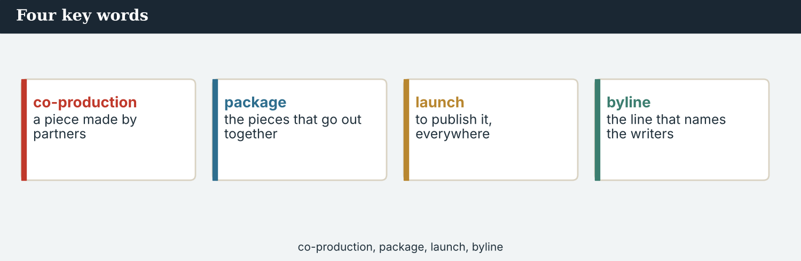
Four key words — co-production, package, launch, aftercare.
The words
Word | Meaning
co-production | a piece made by several newsrooms
package | one story in several forms
launch (n) | the moment of publication
simultaneous | happening at the same time
localise | to adapt a piece for one audience
syndicate | to supply a piece to other outlets
licence (n) | permission to republish
credit line | the words naming every outlet
metrics | the numbers showing how a piece did
reach (n) | how many people saw it
impact | the change a story makes
follow-up | the next story after one
debrief (n) | a meeting to review what happened
aftercare | looking after sources after publication
moderation | managing readers’ comments
transcript | the written version of audio
subtitle (v) | to add written words to a film
accountability | answering for what you publish
PRACTISE Controlled practice
1A Match the word (1–10) to the meaning (a–j).
1. co-production  2. package  3. launch  4. syndicate  5. licence  6. metrics  7. impact  8. debrief  9. aftercare  10. accountability | a) one story in several forms together  b) a piece made by several newsrooms together  c) the moment of publication  d) to supply a piece to other outlets  e) permission to republish  f) the numbers that show how a piece performed  g) the change a story makes  h) a meeting to review what happened  i) looking after sources after publication  j) answering for what you publish
1B Complete the sentences with a word from the box.
WORD BOX
co-production · package · launch · simultaneous · aftercare · moderation
1. The piece is a ___________ by four newsrooms.
2. The ___________ has five parts, including a film.
3. The ___________ is at 07:00 GMT.
4. Publication is ___________ in four countries.
5. The partners planned the ___________ before publishing.
6. They agreed to pay for a week of ___________ .
1C Match the two halves.
1. plan the  2. agree a  3. hold a  4. measure the  5. keep the | a) launch  b) licence  c) debrief  d) reach  e) credit line
1D Circle the word that is different.
1. launch · publication · release · retraction
2. reach · impact · metrics · guess
3. localise · adapt · translate · invent
4. debrief · review · assess · ignore
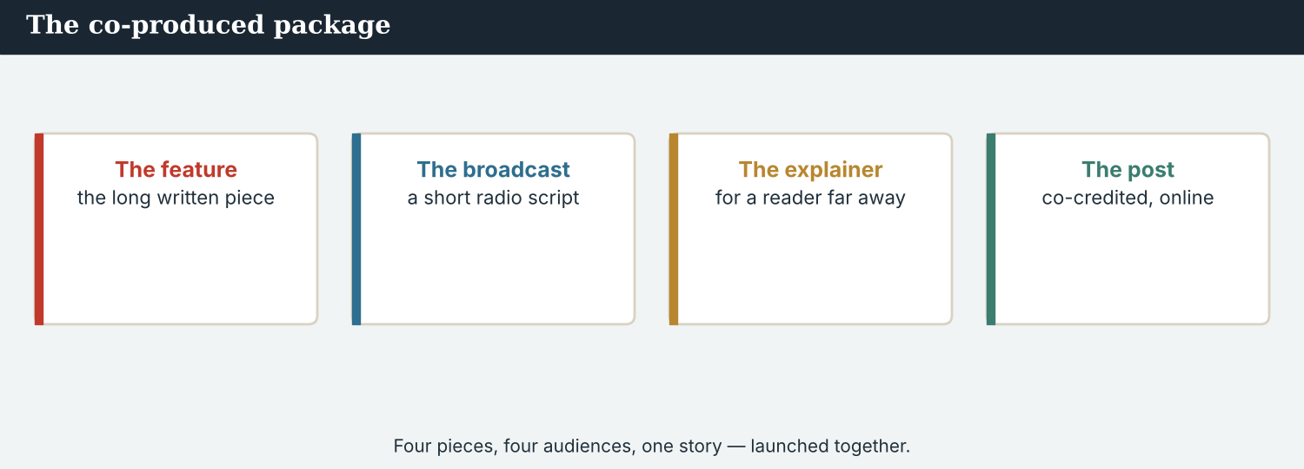
One package: a long read, audio, film, data and photographs — published in one hour.
1E Complete the paragraph. Use: package · simultaneous · localised · credit line · metrics.
The ___________ went out at seven, ___________ in four countries. Each partner ___________ its own version, but nobody changed the ___________ . The ___________ came in by Monday.
1F Read the definition. Write the word.
1. the written version of audio → ___________
2. permission to republish → ___________
3. the next story after one is published → ___________
4. to add written words to a film → ___________
1G Complete the collocation paragraph. Use: syndicated · licence · follow-up · transcript · subtitled.
The film was ___________ in three languages and a full ___________ was published with the audio. The piece was ___________ to forty outlets under a ___________ that keeps every credit. A ___________ is planned for the spring.
PRODUCE Over to you
1H Answer about you. Write full sentences.
1. What would you want in a package about your own town?
2. What does your work owe people after it is published?
PRODUCE Talk about it
1I Discuss. Which two words in this unit are new for you? Make a sentence with one.
1J Complete with: debrief · impact · reach · accountability · moderation.
The ___________ was eleven million. The real ___________ was one reopened school. A week of ___________ cost money, the ___________ took two hours, and the ___________ is still ours.
1K Creative. Write two sentences about a project you would like to publish. Use one gerund and one infinitive.

PART 2 Grammar: -ing and to
Verbs followed by -ing; verbs followed by to; and the ones that take both.
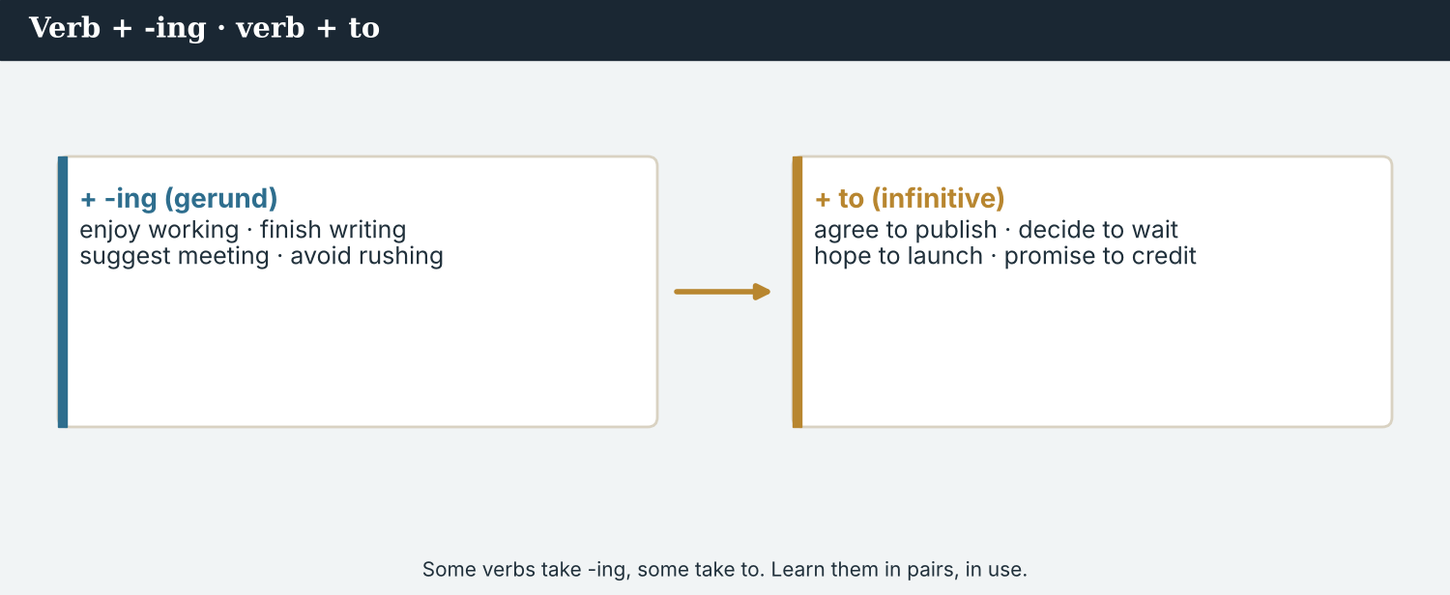
Some verbs take -ing. Some take to. A few take both.
1 · verb + -ing (the gerund)
After enjoy, avoid, finish, keep, suggest, consider, risk, mind, practise: “We finished checking the data.”
After every preposition: “before publishing“, “instead of waiting“, “good at explaining“.
As a subject: “Publishing together is harder than publishing alone.”
2 · verb + to + infinitive
After decide, agree, promise, refuse, manage, offer, hope, plan, learn, intend, want: “We agreed to publish at seven.”
After adjectives: “It is hard to explain.” With too / enough: “too late to change“, “ready enough to launch“.
Not ‘agree publishing’: say agreed to publish, NOT agreed publishing.
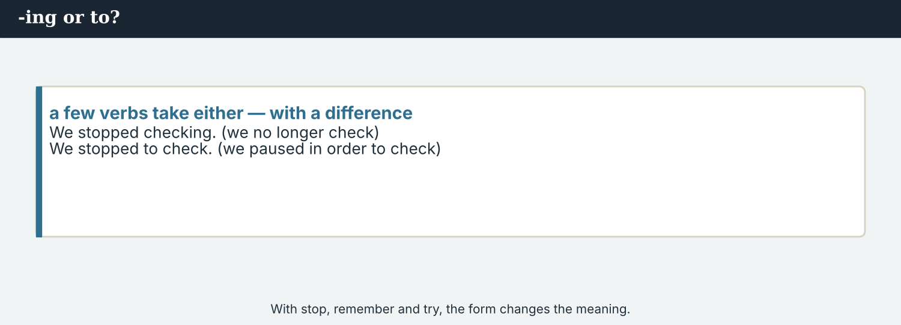
stop doing · stop to do — the same verb, two different facts.
3 · verbs that take both
No real change: start, begin, continue — “It started raining“ = “It started to rain.”
A real change: stop -ing = end it; stop to = pause in order to.
remember to = not forget; remember -ing = have a memory. try to = attempt; try -ing = experiment.
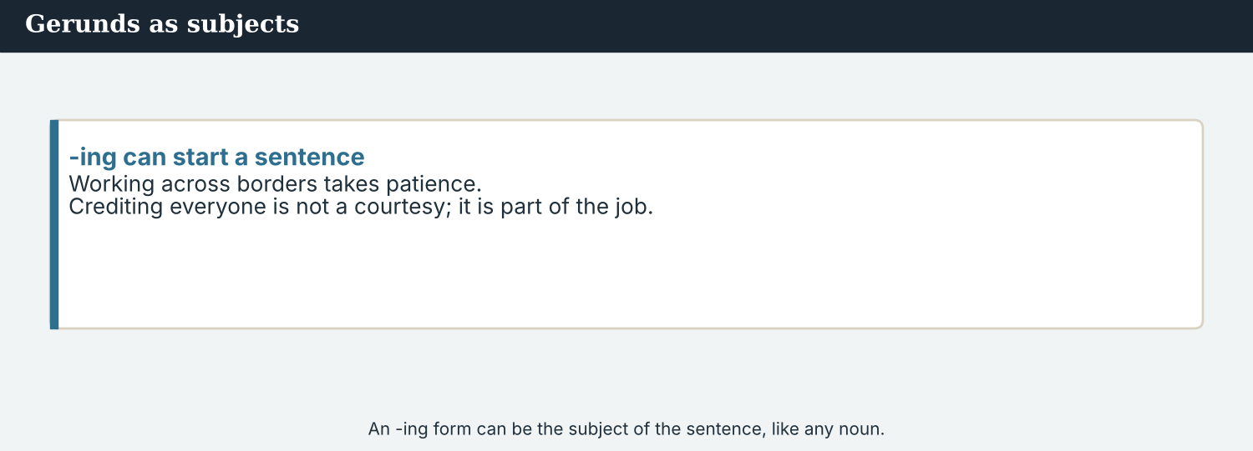
-ing, to, or both — know which verb you have.
PRACTISE Structured practice
2A Complete with the -ing form.
1. We finished ___________ (check) the data at five.
2. Nobody suggested ___________ (wait) for the Post.
3. They avoided ___________ (name) the record-keeper.
4. Dren kept ___________ (ask) about the second ferry.
2B Complete with to + infinitive.
1. The partners agreed ___________ (publish) at seven.
2. Omar promised ___________ (restore) the credit.
3. Priya refused ___________ (sign) off on one source.
4. We intend ___________ (moderate) the comments for a week.
2C -ing or to? Choose and write the verb.
1. We decided ___________ (hold) the figure.
2. It is worth ___________ (read) the transcript.
3. She managed ___________ (reach) the far bank.
4. Before ___________ (launch) , check the subtitles.
2D Explain the difference.
1. We stopped moderating the comments. / We stopped to moderate the comments. → ________________________
2. I remember filing it. / I remembered to file it. → ________________________
Your own words
2E Write two things you enjoy or avoid doing at work. Use -ing.
1. ________________________
2. ________________________
2F Write two things you have agreed or promised to do. Use to + infinitive.
1. ________________________
2. ________________________
2G Rewrite the sentence correctly (-ing / to).
1. They agreed publishing at seven. → ________________________
2. We finished to check the data. → ________________________
2H Your own words. Write one sentence with ‘stop -ing’ and one with ‘stop to’, about your own work.
1. ________________________

PART 3 Planning a co-production
A co-production plan says what is being made, by whom, when it goes out — and what happens afterwards.
Four newsrooms, one package. The plan has to hold after publication too.
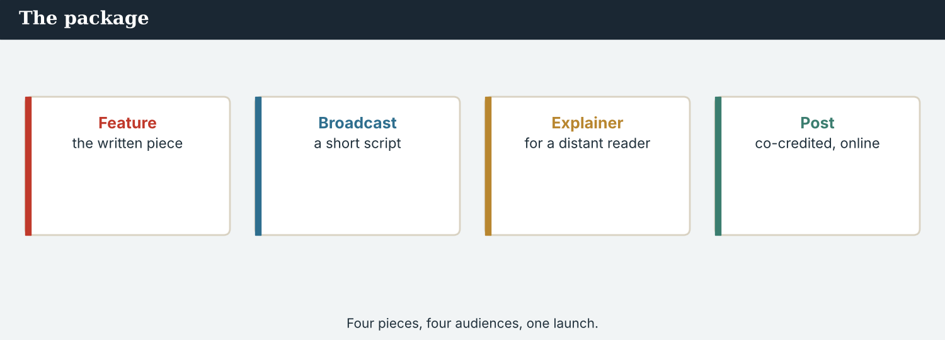
A co-production plan: the parts, the partners, the hour, and the aftercare.
MODEL A model co-production plan
“The package has five parts. Kalina Daily is writing the Veren section; the River Basin Network is making the audio; we are building the data page; the Meridian Post is editing the English and printing it. Everybody agreed to deliver by the 22nd.
We intend to publish simultaneously at 07:00 GMT. Each partner may localise its own version, but nobody may change the credit line, and the licence keeps every name on every republication.
After launching, we have promised to moderate the comments for a week and to hold a debrief on the Tuesday. Dren is going to the village at nine on Sunday morning. Nobody stops working when the piece goes out.”
NOTICE Notice the plan
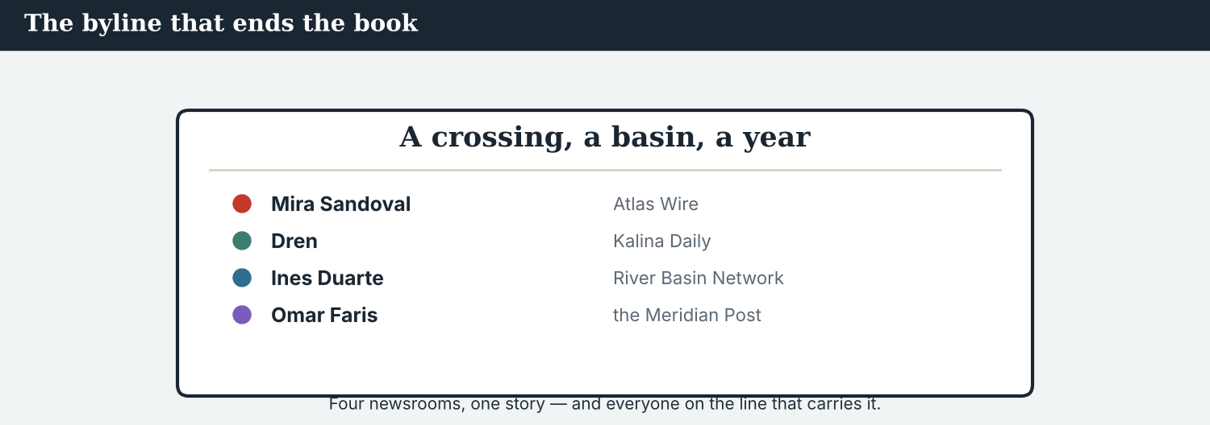
Publishing is the middle of the work, not the end of it.
3A Answer about the plan.
1. Who is making the audio? ___________
2. What may each partner change, and what may it not? ___________
3. What have the partners promised to do after launching? ___________
3B Find two gerunds and two infinitives in the plan. Write them.
1. ________________________
PRACTISE Build the plan
A co-production plan answers one more question: and afterwards?
3C Write the sentence with a gerund or an infinitive.
1. the partners / agree / deliver / by the 22nd → ________________________
2. after / launch / we / moderate the comments → ________________________
3. nobody / may change / the credit line (use ‘without asking’) → ________________________
3D Complete the plan. Use: to publish · launching · to moderate · building.
We are ______ the data page. We intend ______ at 07:00 GMT. After ______ , we have promised ______ the comments for a week.
PRACTISE One more
3E Put the co-production plan in order. Number the steps 1–4.
1. Publishing simultaneously at the agreed hour. ______
2. Agreeing who makes which part. ______
3. The aftercare and the debrief. ______
4. Delivering every part by the deadline. ______
PRODUCE Your turn
3F Choose a story. Write a co-production plan (4–5 sentences): what is being made and by whom, what everyone has agreed to deliver, the hour, and what you have promised to do afterwards.
________________________
________________________
________________________
________________________
PRODUCE Discuss
3G Talk with a partner. Why should the aftercare be agreed before the launch, not after?
3H Why is ‘we agreed to publish’ right, and ‘we agreed publishing’ wrong? Explain.
3I Discuss. Which part of a package is hardest to make across borders? Say why.

PART 4 Listening: launch day
Two audios. Listen for the plans, the promises, and what comes next.
Audio 10.1 — six o’clock, an hour before four countries publish.
Listening A · the hour before
MODEL Audio 10.1 — Ana and Mira
Ana: Everything in? The Post finished editing at four.
Mira: Everything. Leila has stopped worrying about the subtitles, and Priya has rechecked the data page twice.
Ana: Good. We agreed to publish at seven, and nobody waits.
Mira: What if a partner is late?
Ana: Then we publish and they join. We promised not to hold the others, and we intend to keep that.
Mira: And the aftercare?
Ana: Dren is going to the village at nine. We have agreed to moderate the comments for a week, and to hold a debrief on Tuesday.
Mira: Then I will stop talking and start publishing.
PRACTISE Listen for detail
4A Before you listen: what do you think the last check before launch will be? Write one idea.
1. ______
4B Answer the questions.
1. When did the Post finish editing? ___________
2. What happens if a partner is late? ___________
3. What is Dren doing at nine? ___________
4. What two things have the partners agreed to do afterwards? ___________
4C Gerund, infinitive, or both possible? Write G, I, or B.
1. “The Post finished editing at four.” ______
2. “We agreed to publish at seven.” ______
3. “It started raining / to rain.” ______
4D Complete the notes.
The hour: ___________
If a partner is late: ___________
The aftercare: ___________
Audio 10.2 — the Monday afterwards, and the questions nobody plans for.
Listening B · the day after
MODEL Audio 10.2 — Mira and Dren
Dren: Eleven million people read about Veren yesterday. Today I am the only journalist here.
Mira: What do the eleven households need?
Dren: Someone to keep answering the phone. Two of them have stopped sleeping; one has been asked to appear on television.
Mira: We agreed to moderate for a week. I will ask for three.
Dren: Thank you. And there is an award entry. The Post has entered it under its own name.
Mira: That is being corrected today. The entry goes in under all four, or it does not go in.
Dren: I would rather win nothing than see one name on it.
Mira: So would I. Winning is not the point; keeping the partnership is.
PRACTISE Listen for detail
4E Before you listen: what problem do you think the day after will bring? Guess.
1. ______
4F Complete the answers.
1. Dren says someone must keep ___________ (answer) the phone.
2. Two households have stopped ___________ (sleep) properly.
3. Mira has agreed ___________ (ask) for three weeks.
4. The award entry goes in under ___________ four names.
4G Which forms do you hear? Write two gerunds and two infinitives.
1. ________________________
4H Answer. What does Mira mean by ‘winning is not the point’?
1. ________________________
PRACTISE Both audios
4I Complete the summary. Use: to publish · moderating · to ask · launching.
The partners agreed ______ at seven. After ______ , they kept ______ the comments. Mira has agreed ______ for three weeks instead of one.
4J The reach was eleven million; the aftercare was one reporter. What does that tell you about partnerships?
1. ________________________
PRODUCE What do you think?
4K Complete the note comparing the two audios.
Launch morning is about: ___________
The day after is about: ___________
4L Discuss. Which of the two calls is the more important one? Say why.

PART 5 Reading: seven o’clock, four countries
Two readings. Read for the launch, and for what a newsroom owes after publishing.
Eleven million readers. Eleven households. Both numbers are the story.
Reading A · the launch, and the morning after
Seven o’clock: publishing The Seven Crossings
At 07:00 GMT on the last Sunday of October, four newsrooms published the same investigation. The package had five parts: a long read, an audio piece, a subtitled film, a data page and seven photographs. By noon it had been republished by forty outlets, under a licence that keeps every partner’s name on every copy.
“Publishing together is much harder than publishing alone, and it is the only way this story could exist,” says Ana Ferreira of Atlas Wire. “No single newsroom could have reported seven crossings in four countries. We needed to be four.”
The reach was eleven million. The partners had agreed to measure something else as well. “Metrics tell you who saw it,” says Omar Faris of the Meridian Post. “They do not tell you what changed. We decided to publish a follow-up in the spring, before we knew whether we would want to.”
The hardest part began the next morning. Veren, the village of eleven households, had led the piece, and by Monday its residents were being telephoned by broadcasters in three countries. Only one journalist was there: Dren Markaj of Kalina Daily, who had agreed to go at nine on Sunday and was still going at six on Wednesday.
“That is what aftercare means, and it is why we plan it before launching,” he says. “Eleven million people finished reading and went to lunch. I live twenty minutes away.”
The debrief was held on the Tuesday. The partners agreed to extend moderation to three weeks, to pay for it jointly, and to correct an award entry submitted in one outlet’s name. “The work is four newsrooms’ work,” Ines Duarte of the River Basin Network says. “So is the credit, and so is everything that comes afterwards.”
PRACTISE Comprehension
5A Before you read: what do you think ‘seven o’clock’ refers to? Write one sentence.
1. ______
5B True or false? Write T or F.
1. The package had five parts. ______
2. The licence lets outlets drop a partner’s name. ______
3. The reach was eleven million. ______
4. Moderation was extended from one week to three. ______
5C Answer the questions.
1. Why does Ana say they ‘needed to be four’? ___________
2. What do metrics not tell you? ___________
3. Why was Dren still working on the Wednesday? ___________
5D Find a word or phrase in the text.
1. looking after sources after publication → ___________
2. the numbers that show how a piece performed → ___________
3. a meeting to review what happened → ___________
One licence, four names. The credit travels with every copy.
Reading B · after you publish
Four rules for after publication
1. Plan the aftercare before launching. Who answers the phone, for how long, and who pays. The people in the story cannot move on.
2. Keep the credit on every copy. Write the licence so republishing means keeping every name. A credit that survives syndication is worth most.
3. Measure what changed, not only who looked. Metrics count readers; a follow-up asks what is different. Agree it before you know the answer.
4. Share everything that comes afterwards. Awards, money, follow-ups and complaints belong to all the partners. If an entry carries one name, it is the wrong entry.
PRACTISE Comprehension
5E Before you read: who do you think should pay for moderation? Guess.
1. ______
5F Match the rule to the example.
1. plan the aftercare  2. keep the credit  3. measure what changed  4. share what comes afterwards | a) ‘a follow-up agreed before you know the answer’  b) ‘the entry goes in under all four names’  c) ‘who answers the phone, for how long, and who pays’  d) ‘republishing means keeping all four names’
5G Which rule is about money as well as credit? Write the number.
1. ______
PRACTISE Words from the readings
5H Find a word in Reading A or Reading B.
1. one story in several forms together → ___________
2. permission to republish → ___________
3. to supply a piece to other outlets → ___________
PRACTISE Both readings
5I Complete with a gerund or an infinitive.
1. Publishing together is harder than ___________ (publish) alone.
2. They decided ___________ (publish) a follow-up in the spring.
3. We plan the aftercare before ___________ (launch) .
PRODUCE Discuss
5J Talk about it. ‘Eleven million people finished reading and went to lunch.’ What is Dren’s point?
5K Which of the four rules would be hardest to agree with a much bigger partner? Say why.
5L Discuss. ‘So is the credit, and so is everything that comes afterwards.’ Do you agree?

PART 6 Writing: the plan and the note
Two short pieces: a co-production plan, and a note to partners after publication.
The plan on one page: the parts, the hour, the licence, the aftercare.
Writing 1 · a co-production plan
MODEL A model
PACKAGE: long read · audio · subtitled film · data page · seven photographs
WHO MAKES WHAT: Kalina Daily — the Veren section · RBN — audio · Atlas Wire — data · the Meridian Post — English edit and print
DELIVERY: everybody has agreed to deliver by the 22nd
LAUNCH: simultaneous, 07:00 GMT; localising allowed, changing the credit line not allowed
AFTERWARDS: moderation for one week (extendable), a debrief on Tuesday, a follow-up in the spring
NOTICE Notice the model
6A Answer about the model.
1. Which line uses a gerund after ‘allowed’? ___________
2. Which line is about what happens after publication? ___________
PRODUCE Write your plan
6B Choose a story and two partners. Write the five lines: package, who makes what, delivery, launch, afterwards.
Package: ___________
Who makes what: ___________
Delivery: ___________
Launch: ___________
Afterwards: ___________
A note to partners after publication: what happened, and what we now owe.
Writing 2 · a note after publication
MODEL A model
Dear all,
Thank you for publishing on time. The reach was eleven million, and forty outlets have republished the package with all four names intact.
Dren has been in Veren since Sunday morning and intends to keep going this week. I would like to extend moderation from one week to three and to pay for it from the joint budget. I have also asked the Post to correct the award entry: it goes in under all four names, or not at all.
We agreed to publish a follow-up in the spring. I suggest holding the debrief on Tuesday, before anyone starts forgetting.
Mira
NOTICE Notice the model
6C Answer. Find two gerunds and two infinitives in the note.
1. ___________
PRACTISE Complete the paragraph
6D Complete the note. Use: to extend · holding · publishing · to keep.
Thank you for ______ on time. Dren intends ______ going this week. I would like ______ moderation to three weeks. I suggest ______ the debrief on Tuesday.
PRODUCE Write your note
6E Turn your plan into a note to partners after publication (4–5 sentences). Use two gerunds and two infinitives.
________________________
________________________
________________________
PRACTISE Fix it
6F This note uses the wrong forms after ‘agreed’ and ‘finished’. Correct both.
“We agreed publishing at seven, and we finished to check the data at five.”
________________________
PRACTISE Plan it
6G Plan the aftercare. Write three lines: one thing you have promised to do, one thing you will keep doing, one thing you suggest holding.
Promised to: ___________
Keep: ___________
Suggest: ___________
6H Peer-check. Swap with a partner. Does the plan say who pays for the aftercare, and does the licence keep every name? Write one note.
________________________

PART 7 Speaking: agreeing the whole project
Agree a co-production and what follows it. Use gerunds and infinitives.
Agreeing the project out loud: the parts, the hour, and the week after.
A model dialogue · agreeing the co-production
MODEL Listen and read
Sofia: What have the four of you agreed to make?
Mira: Five parts: a long read, audio, a subtitled film, a data page and photographs.
Sofia: And publishing?
Mira: Simultaneously, at 07:00 GMT. Localising is allowed; changing the credit line is not.
Sofia: What happens if someone is late?
Mira: We publish. We promised not to hold the others.
Sofia: And afterwards?
Mira: We plan the aftercare before launching. Moderation for a week, a debrief on Tuesday, and a follow-up agreed in advance.
NOTICE Notice the forms
7A Find two gerunds and two infinitives in the dialogue. Write them.
1. ________________________
PRACTISE Controlled practice
7B Answer with a gerund or an infinitive.
1. What / the partners / agree / make? → ___________
2. What / be allowed / and / not allowed? → ___________
3. When / you / plan / the aftercare? → ___________
Open a project call with what everyone has agreed to do.
7C Make a question with a gerund or an infinitive, then answer it.
1. you / finish / check / the data → ________________________
2. the partners / promise / moderate / the comments → ________________________
PRODUCE Your role
Coordinator | Say what has been agreed: the parts, the hour, the licence, the aftercare.
Partner | Ask: ‘What are we allowed to change?’ and ‘Who pays for the moderation?’
Observer | Listen. Did every verb take the right form — -ing or to?
7D Choose a role from the table. Agree the whole project with your partner.
PRODUCE Role-play
7E Role-play a co-production call: a coordinator, a partner, and an observer. Then swap roles.
A second dialogue · the award entry
MODEL Listen and read
Omar: The entry has gone in under the Post’s name. The system would not accept four.
Mira: Then we will stop entering until it does. Winning under one name is worse than not winning.
Omar: I agree, in fact. I have asked them to change the form.
Mira: Thank you. And if they refuse?
Omar: Then we withdraw. I would rather explain withdrawing than explain the byline.
Mira: Dren said something similar. He would rather win nothing than see one name on it.
PRACTISE Controlled practice
7F Write the sentence Mira uses with ‘stop -ing’ about the award.
1. ________________________
PRODUCE Self-check
Did I… | Yes | Almost | Not yet
use -ing after enjoy, finish, avoid, suggest and prepositions? | ☐ | ☐ | ☐
use to + infinitive after agree, promise, decide and intend? | ☐ | ☐ | ☐
use ‘stop -ing’ and ‘stop to’ with the right meanings? | ☐ | ☐ | ☐
say what happens after publication, not only before? | ☐ | ☐ | ☐
7G Role-play insisting that a credit or an entry carries every partner’s name. Then swap roles.
PRACTISE Plan it
7H Plan your call. Note one thing you have agreed to do, one thing you will keep doing, one thing you refuse to do.
7I Discuss. How would you explain to a big partner that a shared credit is worth more than a prize?

PART 8 Ethics: after the launch
Publishing is the middle of the work. What a partnership does afterwards is what it was really worth.
The Code does not end at publication. Neither does the partnership.
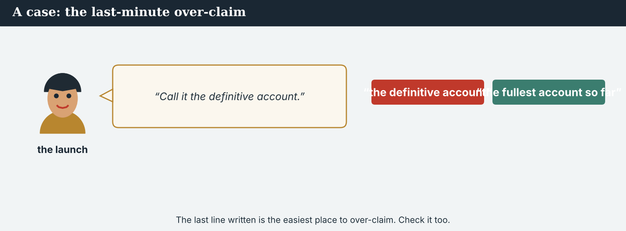
Eleven million readers moved on. Eleven households could not.
A first case · the morning after
A case. By Monday, broadcasters in three countries are telephoning Veren, and one family has been invited onto television. Nobody did anything wrong: the piece was accurate, fair and strong, and the attention is the consequence of its being read. But eleven households did not ask to become the most-read village in the basin, and the only journalist on the ground is Dren, who has a weekly paper to produce. Atlas Wire planned a week of moderation; three weeks is what the week after actually needs. The Code says: the duty starts at publication, it does not end there. What do the partners agree to do?
NOTICE What do you do?
8A Choose (a) or (b), and write one reason.
1. (a) keep to the week that was planned (b) extend moderation to three weeks and pay for it jointly. Choice: ______ Because ________________________
2. Leaving the aftercare to the local partner is (a) practical (b) passing the cost to the smallest newsroom. Choice: ______
8B Takes the duty, or passes it on? Write T or P.
1. ‘We will extend moderation and pay from the joint budget.’ ______
2. ‘Our part is finished; the piece is published.’ ______
3. ‘Dren is there, so he can handle it.’ ______
4. ‘Two of us will share the calls this week.’ ______
PRACTISE Apply the Code
8C Complete the rule. Use: before · afterwards · pays · starts.
Plan the aftercare ______ launching. Say who ______ for it. Share everything that comes ______ . The duty ______ at publication.
PRODUCE Discuss
8D Discuss. Why does attention cost the smallest partner most?
A second case · the entry with one name
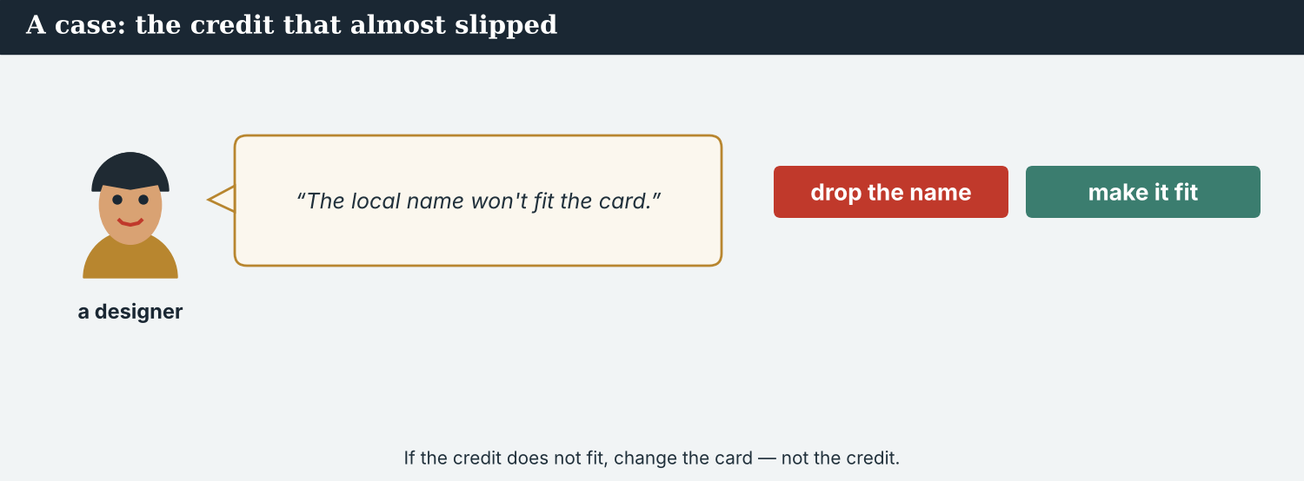
An award with one name on it is a smaller thing than the work it is for.
A case. The Post’s entry for a major award has gone in under its own name, because the form accepts only one outlet. The reasoning is administrative, not greedy, and the Post did most of the editing and all of the printing. But the Veren section was reported alone by a man who still lives there, the audio was made in another country, and the data page took three weeks. An award is a record of who did the work, and this one would be wrong for ever. The Code says: the credit is the partnership’s, or it is nobody’s. What should the partners do if the form cannot take four names?
NOTICE What do you do?
8E Choose (a) or (b), and write one reason.
1. (a) let it stand — the form only takes one (b) ask for the form to change, and withdraw if it cannot. Choice: ______ Because ________________________
2. An entry under one name is (a) an administrative detail (b) a permanent record that is wrong. Choice: ______
8F Complete with: form · withdraw · record · alone.
1. The ___________ accepts only one outlet.
2. Dren reported the Veren section ___________ .
3. An award is a ___________ of who did the work.
4. If the form cannot change, the partners will ___________ .
PRODUCE Discuss
8G Discuss. Why would Dren rather win nothing than see one name on the entry?
PRODUCE Write it
8H Write two sentences to an awards body asking it to accept four names. Use an infinitive and a gerund.
PRACTISE One more
8I Shares the work’s credit, or takes it? Write S or T.
1. ‘The entry goes in under all four names.’ ______
2. ‘We entered it ourselves; we did the editing.’ ______
3. ‘The licence keeps every name on every copy.’ ______
4. ‘Our masthead is the one readers know.’ ______
8J Discuss. A partnership of unequal newsrooms published one piece. What makes it equal, in the end?

PART 9 Digital: launching online
Online, a co-production launches in one hour in four places. Every post has to carry all four names.
One hour, four handles, one package. The credit is part of the alert.
MODEL A model launch post
OUT NOW · THE SEVEN CROSSINGS · A year after one crossing reopened, four newsrooms went to all seven. A long read, an audio piece, a subtitled film and a data page. Reported together by @AtlasWire, @KalinaDaily, @RiverBasinNet and @MeridianPost. Republishing is welcome — keeping all four names is the licence.
NOTICE The parts of the post
9A Match the part to its job.
1. OUT NOW  2. a long read, audio, film, data  3. Reported together by…  4. keeping all four names is the licence | a) the four credits  b) the launch flag  c) the condition on republishing  d) the parts of the package
PRACTISE Find and build
9B Find one gerund and one infinitive (or a gerund as subject) in the post. Write them.
1. ________________________
9C This post uses the wrong forms and drops two partners. Correct both.
“We are proud to publishing our investigation. Reported by @AtlasWire and @MeridianPost.”
________________________
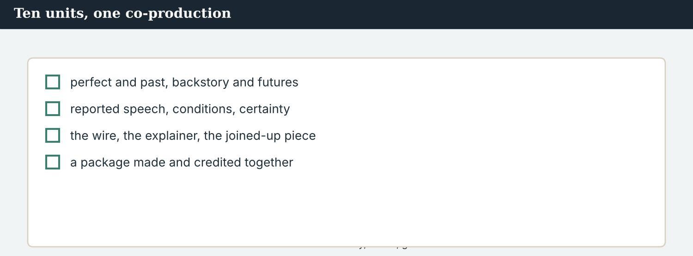
A good launch post answers: what it is, what is in it, who made it, and what republishing requires.
9D Write a launch post. Use one gerund, one infinitive and all your partners’ names.
OUT NOW · ___________ . We set out ___________ . ___________ is welcome — ___________ is the licence. — ___________
PRODUCE Write your post
9E Write a one-line launch post for a project of your own. Name every partner.
________________________
9F Creative. Write a short headline (4–6 words) for a cross-border co-production.
9G A reader asks: ‘Why did four newsrooms do this together?’ Write a short reply. Use a gerund as the subject.
________________________
9H A launch post can lose a partner’s name when it is shared. Write one line that keeps all four.
________________________
PRODUCE Discuss
9I Creative. Write a two-line thread: line 1 the launch, line 2 what happens after publication.
________________________
________________________
9J Discuss. The post travels further than the piece. What must it never leave out?

PART 10 Review & Can-Do
Check everything you have learned in Book 2.
The published co-production: four mastheads, five parts, one hour.
10A Vocabulary. Complete with: co-production · package · launch · simultaneous · licence · metrics · aftercare · debrief.
1. The piece is a ___________ by four newsrooms.
2. The ___________ has five parts.
3. The ___________ was at 07:00 GMT.
4. Publication was ___________ in four countries.
5. The ___________ keeps every name on every copy.
6. The ___________ came in by Monday.
7. The partners planned the ___________ before publishing.
8. The ___________ was held on the Tuesday.
10B Grammar. Complete with the -ing form.
1. We finished ___________ (check) the data at five.
2. Nobody suggested ___________ (wait) for the Post.
3. They avoided ___________ (name) the record-keeper.
4. Before ___________ (launch) , check the subtitles.
10C Grammar. Complete with to + infinitive.
1. The partners agreed ___________ (publish) at seven.
2. Omar promised ___________ (restore) the credit.
3. We intend ___________ (moderate) the comments for a week.
Can-Do — tick what you can do now.
10D Grammar from the whole book. Match the unit’s grammar to its sentence.
1. present perfect vs past simple  2. used to / past continuous  3. future forms  4. reported speech  5. conditionals  6. might / should  7. the passive  8. comparatives | a) ‘We are publishing at 07:00 GMT.’  b) ‘She said the water was a little better.’  c) ‘Three crossings have been reopened.’  d) ‘The crossing used to be busy.’  e) ‘Kalina is the busiest of the seven.’  f) ‘The crossings reopened last spring; the school has not.’  g) ‘If a figure has one source, it does not run.’  h) ‘It might be a real document used wrongly.’
10E Read and answer.
Four newsrooms agreed to publish simultaneously at 07:00 GMT. Each partner was allowed to localise its version, but changing the credit line was not permitted. After launching, the partners kept moderating the comments for three weeks and held a debrief on the Tuesday. They had decided to publish a follow-up in the spring before they knew what it would say.
1. What did the four newsrooms agree to do? ___________
2. What was not permitted? ___________
3. What did they do after launching? ___________
Can-Do — tick what you can do now
☐ I can use verb + -ing and verb + to correctly.
☐ I can tell ‘stop doing’ from ‘stop to do’.
☐ I can plan a cross-border co-production.
☐ I can say what a newsroom owes after publishing.
10F Reflect. Which unit of Book 2 changed the way you work? Why?
10G Grammar review. Write the sentence correctly.
1. They agreed publishing at seven. → ________________________
2. We finished to check the data. → ________________________
3. I am looking forward to meet you. → ________________________
4. She suggested to hold the debrief on Tuesday. → ________________________
10H Mixed review from the whole book. Complete each sentence.
1. The crossing ___________ (reopen) last spring, and the school ___________ (not open) yet.
2. If a figure ___________ (have) one source, it ___________ (not run).
3. Three crossings ___________ (reopen) by the office. (present perfect passive)
10I Reflect. Write one sentence about a partnership you would like to build. Use a gerund and an infinitive.

PART 11 Final project: your co-production
Bring the whole of Book 2 together. Plan and publish a cross-border co-production.
The template — build your co-production part by part.
Your task. Plan a co-production with two partner newsrooms abroad, on a story of your choice. Work alone or in a small team — a coordinator, a reporter and an editor. Write the plan, one section of the package, and the launch post.
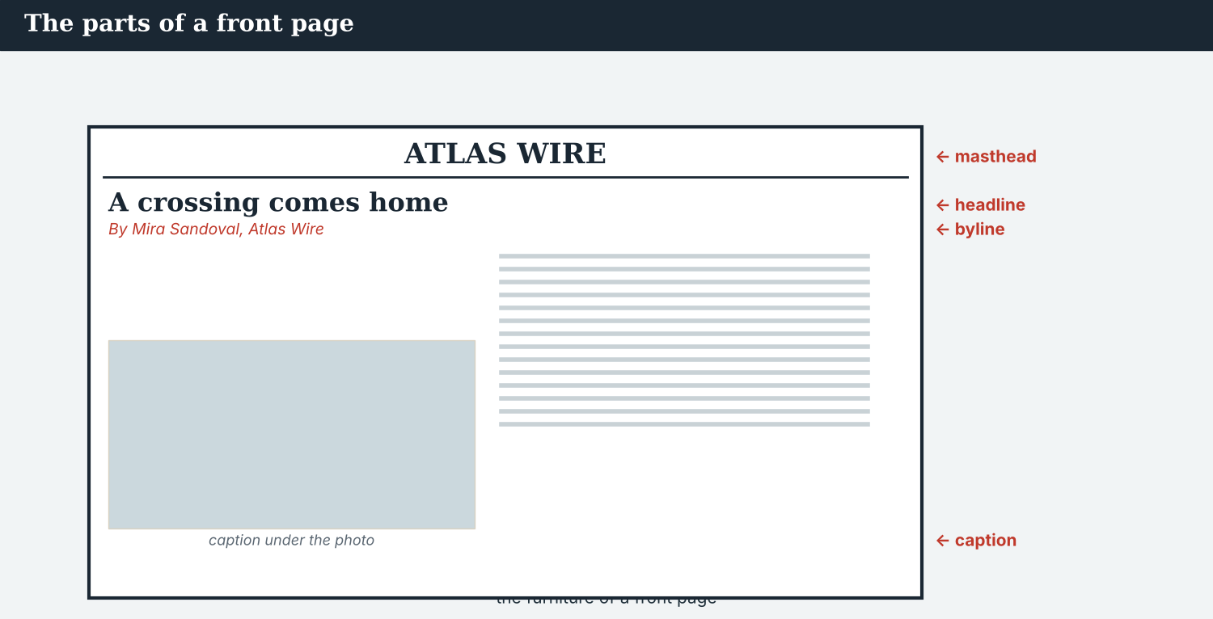
Every part of the package, and what each one is for.
Your co-production must have:
1. a recap, in the present perfect and the past simple — Unit 1;
2. a backstory with used to, would and the past continuous — Unit 2;
3. a plan with going to and every hour in every time zone — Unit 3;
4. one exact quote in reported speech, with say, tell or according to — Unit 4;
5. the conditions for publication, in the zero and first conditionals — Unit 5;
6. one careful paragraph about something unproved — Unit 6;
7. a wire lead in the passive, naming the body that acted — Unit 7;
8. an explainer sentence with a provable superlative — Unit 8;
9. quantifiers, articles and connectors, joining three accounts — Unit 9;
10. a launch post and an aftercare plan — Unit 10.
A model — use Reading A and the Writing 1 model to check the shape of your project.
Before you publish, agree the conditions. Check every figure twice, keep every quantifier, name every partner, and plan the morning after. Hold the hour you promised. Then publish — together, within the hour. That is the whole of Book 2, on one page.
Success criteria — the whole book | Yes | Almost | Not yet
My plan names every partner, every part and every hour with its time zone. | ☐ | ☐ | ☐
My conditions are testable, and the aftercare is agreed before the launch. | ☐ | ☐ | ☐
Every quote is reported accurately, and every figure is attributed. | ☐ | ☐ | ☐
Every unproved claim is marked, and every superlative can be proved. | ☐ | ☐ | ☐
The credit line carries every partner’s name, on every copy. | ☐ | ☐ | ☐
The smallest partner can meet the plan, and is not left alone afterwards. | ☐ | ☐ | ☐
Congratulations. You have finished English for Journalists, Book 2. You began by recapping one story for a colleague abroad; you can now plan, report, write, verify and publish journalism made by newsrooms in four countries — in English, as an equal partner, and with a journalist’s care for the people in the story. A free press, without borders.

ANSWER KEY Book 2 · Unit 10
Check your answers. Open tasks (discussion, role-play, your own writing and the final project) are marked at the end.
W1 1 at seven (07:00 GMT) · 2 the subtitles — the film is ready (Priya has rechecked the data page) · 3 moderate the comments
W2 1 F · 2 T · 3 T
W3 gerunds: ‘worrying’, ‘launching’ (also ‘talking’, ‘publishing’) · infinitives: ‘to publish’, ‘to plan’ (also ‘to moderate’, ‘to keep’)
1A 1-b, 2-a, 3-c, 4-d, 5-e, 6-f, 7-g, 8-h, 9-i, 10-j
1B 1 co-production · 2 package · 3 launch · 4 simultaneous · 5 aftercare · 6 moderation
1C 1 plan the launch · 2 agree a licence · 3 hold a debrief · 4 measure the reach · 5 keep the credit line
1D 1 retraction · 2 guess · 3 invent · 4 ignore
1E 1 package · 2 simultaneous · 3 localised · 4 credit line · 5 metrics
1F 1 transcript · 2 licence · 3 follow-up · 4 subtitle
1G subtitled · transcript · syndicated · licence · follow-up
1J reach · impact · moderation · debrief · accountability
2A 1 checking · 2 waiting · 3 naming · 4 asking
2B 1 to publish · 2 to restore · 3 to sign · 4 to moderate
2C 1 to hold · 2 reading · 3 to reach · 4 launching
2D 1 ‘stopped moderating’ = ended it; ‘stopped to moderate’ = paused in order to · 2 ‘remember filing’ = the memory; ‘remembered to file’ = did not forget
2G 1 They agreed to publish at seven. · 2 We finished checking the data.
3A 1 the River Basin Network · 2 it may localise its own version; it may not change the credit line · 3 moderate the comments for a week and hold a debrief on the Tuesday
3B gerunds: ‘writing’, ‘making’ (also ‘launching’, ‘working’) · infinitives: ‘to deliver’, ‘to publish’ (also ‘to moderate’, ‘to hold’)
3C 1 The partners agreed to deliver by the 22nd. · 2 After launching, we will moderate the comments. · 3 Nobody may change the credit line without asking.
3D building · to publish · launching · to moderate
3E 1 Agreeing who makes which part. · 2 Delivering every part by the deadline. · 3 Publishing simultaneously at the agreed hour. · 4 The aftercare and the debrief.
3H because ‘agree’ is followed by to + infinitive, not by the -ing form
4B 1 at four · 2 the others publish and the late partner joins · 3 going to the village (Veren) · 4 moderate the comments for a week and hold a debrief on Tuesday
4C 1 G · 2 I · 3 B
4D Hour = 07:00 GMT, nobody waits · If late = we publish, they join · Aftercare = Dren in the village, moderation, a debrief
4F 1 answering · 2 sleeping · 3 to ask · 4 all
4G gerunds: ‘answering’, ‘sleeping’ · infinitives: ‘to appear’, ‘to ask’ (also ‘to moderate’)
4H the point is the journalism and the partnership; a prize under one name costs more than it is worth
4I to publish · launching · moderating · to ask
4J reach is shared; aftercare is not, unless the partners agree to share it
4K Launch morning = the hour and the last checks · The day after = the people, the moderation, the credit
5B 1 T · 2 F · 3 T · 4 T
5C 1 no single newsroom could report seven crossings in four countries · 2 what changed · 3 the aftercare was his, and the attention did not stop
5D 1 aftercare · 2 metrics · 3 debrief
5F plan the aftercare → ‘who answers the phone, for how long, and who pays’ · keep the credit → ‘republishing means keeping all four names’ · measure what changed → ‘a follow-up agreed before you know the answer’ · share what comes afterwards → ‘the entry goes in under all four names’
5G Rule 4
5H 1 package · 2 licence · 3 syndicate
5I 1 publishing · 2 to publish · 3 launching
6A 1 the LAUNCH line (‘localising allowed, changing the credit line not allowed’) · 2 the AFTERWARDS line
6C gerunds: ‘publishing’, ‘going’ (also ‘forgetting’, ‘holding’) · infinitives: ‘to keep’, ‘to extend’ (also ‘to pay’, ‘to correct’, ‘to publish’)
6D publishing · to keep · to extend · holding
6F ‘We agreed to publish at seven, and we finished checking the data at five.’
7A gerunds: ‘publishing’, ‘localising’ (also ‘changing’, ‘launching’) · infinitives: ‘to make’, ‘to hold’ (also ‘not to hold the others’)
7B 1 Five parts: a long read, audio, a film, a data page, photographs. · 2 Localising is allowed; changing the credit line is not. · 3 Before launching.
7C 1 Have you finished checking the data? — Yes, at five. · 2 Did the partners promise to moderate the comments? — Yes, for a week, and now for three.
7F ‘Then we will stop entering until it does.’
8A 1 (b) extend moderation to three weeks and pay for it jointly · 2 (b) passing the cost to the smallest newsroom
8B 1 T · 2 P · 3 P · 4 T
8C before · pays · afterwards · starts
8E 1 (b) ask for the form to change, and withdraw if it cannot · 2 (b) a permanent record that is wrong
8F 1 form · 2 alone · 3 record · 4 withdraw
8I 1 S · 2 T · 3 S · 4 T
9A ‘OUT NOW’ → the launch flag · ‘a long read, audio, film, data’ → the parts of the package · ‘Reported together by…’ → the four credits · ‘keeping all four names is the licence’ → the condition on republishing
9B gerunds: ‘Republishing is welcome’ / ‘keeping all four names’ · infinitive: ‘went to all seven’ (accept ‘to all seven crossings’ as the purpose)
9C ‘We are proud to publish our investigation. Reported by @AtlasWire, @KalinaDaily, @RiverBasinNet and @MeridianPost.’
10A 1 co-production · 2 package · 3 launch · 4 simultaneous · 5 licence · 6 metrics · 7 aftercare · 8 debrief
10B 1 checking · 2 waiting · 3 naming · 4 launching
10C 1 to publish · 2 to restore · 3 to moderate
10D present perfect vs past simple → ‘The crossings reopened last spring; the school has not.’ · used to / past continuous → ‘The crossing used to be busy.’ · future forms → ‘We are publishing at 07:00 GMT.’ · reported speech → ‘She said the water was a little better.’ · conditionals → ‘If a figure has one source, it does not run.’ · might / should → ‘It might be a real document used wrongly.’ · the passive → ‘Three crossings have been reopened.’ · comparatives → ‘Kalina is the busiest of the seven.’
10E 1 publish simultaneously at 07:00 GMT · 2 changing the credit line · 3 kept moderating the comments for three weeks and held a debrief on the Tuesday
10G 1 They agreed to publish at seven. · 2 We finished checking the data. · 3 I am looking forward to meeting you. · 4 She suggested holding the debrief on Tuesday.
10H 1 reopened / has not opened · 2 has / does not run · 3 have been reopened
Open tasks W4, W5, 1H, 1I, 1K, 2E, 2F, 2H, 3F, 3G, 3I, 4A, 4E, 4H, 4L, 5A, 5E, 5J, 5K, 5L, 6B, 6E, 6G, 6H, 7D, 7E, 7G, 7H, 7I, 8D, 8G, 8H, 8J, 9D, 9E, 9F, 9G, 9H, 9I, 9J, 10F, 10I, and the Final Project — your own answers (discussion, role-play, writing, and your co-production).
A note on real and invented content. The facts about journalism around the world in 2026 are true. Atlas Wire, Kalina Daily, the River Basin Network, the Meridian Post, their staff, Dren Markaj, Veren, the Vara basin, The Seven Crossings and every figure in it are invented, for practice. Real people and outlets are only ever in true, sourced facts — never in an invented quote.
English for Journalists — International Edition · Book 2 · Unit 10 (30-page standard) · the capstone. CEFR lower B1 → medium B1 · Beat: Capstone & Across Borders · two readings · two listenings · two writing pieces · two ethics cases · two speaking dialogues · balanced sections · ~29 figures · featured cast + three partner newsrooms · fictional agency, factual backdrop. A free press, without borders.

