1.1 The second reading
Chapter 1 · section 1.1

Fill every gap. Each word list holds one word more than there are gaps.
Chapter 1, section by section
Each stage leads to the next.
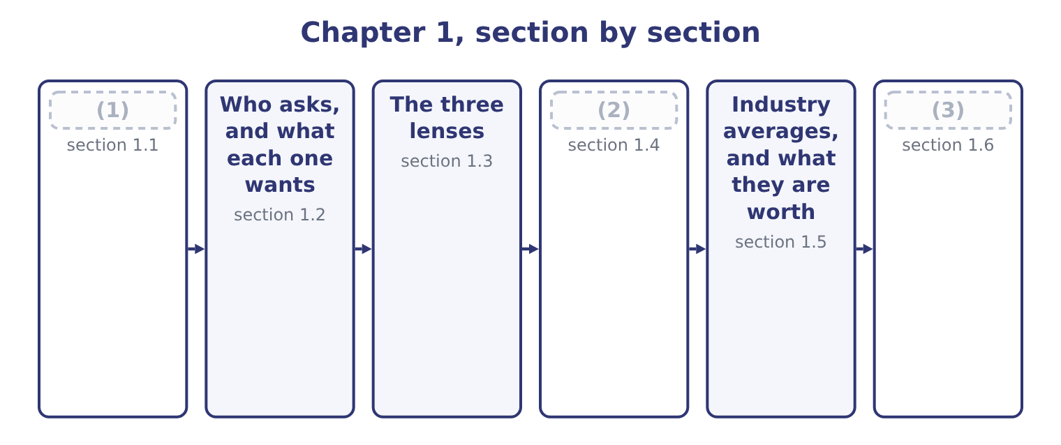
word list
The second reading · The company every ratio is calculated from · Industry averages, and what they are worth · Where the numbers come from

Summary 1 gaps 4–15
A set of financial (4) is a record of what (5) . Reading it a second time turns that record into a (6) about what is (7) to happen next. The two (8) use the same paper and ask opposite (9) . Nothing in the second reading is (10) . A ratio is not a measurement the way a (11) is a measurement. It is a comparison, and a comparison only means something (12) something else: the same company last year, a competitor, the industry, or a (13) the company set itself. A (14) ratio of 3.3 is neither good nor bad until you know what it was a year ago and what a food (15) normally carries. That is the first rule of financial statement analysis, and it is the one candidates forget under exam pressure. A number alone answers nothing.
word list
certain · likely · judgment · happened · manufacturer · target · weight · questions · readings · against · liquidity · statements · current

A ratio needs a comparison

Summary 2 gaps 16–20
A (16) that gives you one ratio and asks whether the company is (17) is testing whether you know that you cannot say. When the exam asks for an (18) , it will give you a comparison: a prior year, a competitor, or an industry figure. Watch the (19) of the comparison. A higher inventory turnover is usually better; a higher (20) is usually worse.
word list
healthy · interpretation · days-sales-outstanding · direction · question · notes

Answer key · 1.1 The second reading

1 The second reading | 11 weight
2 Where the numbers come from | 12 against
3 The company every ratio is calculated from | 13 target
4 statements | 14 current
5 happened | 15 manufacturer
6 judgment | 16 question
7 likely | 17 healthy
8 readings | 18 interpretation
9 questions | 19 direction
10 certain | 20 days-sales-outstanding

the summaries in full
Summary 1 A set of financial statements is a record of what happened. Reading it a second time turns that record into a judgment about what is likely to happen next. The two readings use the same paper and ask opposite questions. Nothing in the second reading is certain. A ratio is not a measurement the way a weight is a measurement. It is a comparison, and a comparison only means something against something else: the same company last year, a competitor, the industry, or a target the company set itself. A current ratio of 3.3 is neither good nor bad until you know what it was a year ago and what a food manufacturer normally carries. That is the first rule of financial statement analysis, and it is the one candidates forget under exam pressure. A number alone answers nothing.
Summary 2 A question that gives you one ratio and asks whether the company is healthy is testing whether you know that you cannot say. When the exam asks for an interpretation, it will give you a comparison: a prior year, a competitor, or an industry figure. Watch the direction of the comparison. A higher inventory turnover is usually better; a higher days-sales-outstanding is usually worse.

1.2 Who asks, and what each one wants
Chapter 1 · section 1.2

Fill every gap. Each word list holds one word more than there are gaps.
Summary 1 gaps 1–2
The same (1) are read by people who want different things from them. The analysis follows the question, so the first thing to settle is whose question you are (2) .
word list
statements · answering · borrowing

Who reads the statements a second time, and what each looks for
Reader | The question | Looks first at
A bank lending for 90 days | Will the cash be there when the note falls due? | Liquidity ratios and the cash cycle
A bank lending for ten years | Will the company still exist, and can it carry the interest? | (3)
A shareholder | Is the return on my money worth the risk? | (4)
An acquirer | What is this business worth to me? | (5)
A supplier granting credit | Will I be paid, and how slowly? | (6)
Management | Which part of the business is dragging? | (7)

word list
Segment margins and asset turnover · Leverage and coverage ratios · Days purchases in accounts payable · Cash flows, margins, asset turnover · management's discussion and analysis · ROE, margins, earnings per share

Summary 2 gaps 8–13
A lender and a shareholder can read the same (8) sheet and reach opposite (9) about the same fact. Heavy borrowing (10) the lender, because it ranks ahead of him only in part and raises the chance of (11) . The same borrowing can please the shareholder, because interest is (12) than equity and the (13) belongs to him. You will meet that disagreement again in, where capital structure is measured.
word list
surplus · follows · balance · worries · cheaper · default · conclusions

The word "analysis"

Summary 3 gaps 14–16
English divides the work into named (14) , and the exam uses the names: (15) analysis, vertical analysis, ratio analysis, variation analysis. Learn the names as labels for (16) , not as synonyms for thinking about the numbers.
word list
horizontal · techniques · because · procedures

The English this section uses, and its Arabic
Each term sits against what it means.
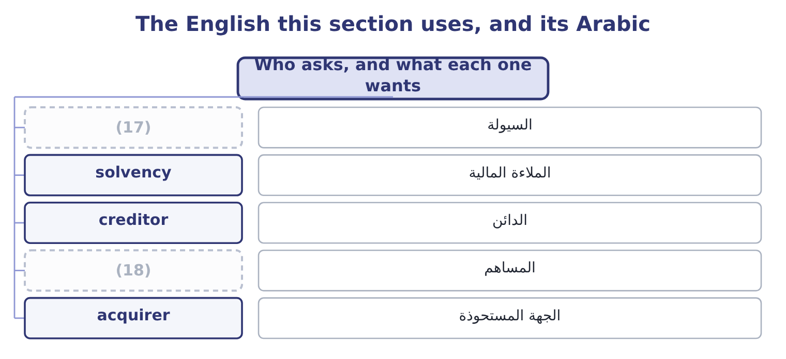
word list
shareholder · median · liquidity

The English this sheet uses, and its Arabic
English (exam term) | Arabic
liquidity | السيولة
solvency | الملاءة المالية
creditor | الدائن
shareholder | المساهم
acquirer | الجهة المستحوذة

Answer key · 1.2 Who asks, and what each one wants

1 statements | 10 worries
2 answering | 11 default
3 Leverage and coverage ratios | 12 cheaper
4 ROE, margins, earnings per share | 13 surplus
5 Cash flows, margins, asset turnover | 14 techniques
6 Days purchases in accounts payable | 15 horizontal
7 Segment margins and asset turnover | 16 procedures
8 balance | 17 liquidity
9 conclusions | 18 shareholder

the summaries in full
Summary 1 The same statements are read by people who want different things from them. The analysis follows the question, so the first thing to settle is whose question you are answering.
Summary 2 A lender and a shareholder can read the same balance sheet and reach opposite conclusions about the same fact. Heavy borrowing worries the lender, because it ranks ahead of him only in part and raises the chance of default. The same borrowing can please the shareholder, because interest is cheaper than equity and the surplus belongs to him. You will meet that disagreement again in, where capital structure is measured.
Summary 3 English divides the work into named techniques, and the exam uses the names: horizontal analysis, vertical analysis, ratio analysis, variation analysis. Learn the names as labels for procedures, not as synonyms for thinking about the numbers.

1.3 The three lenses
Chapter 1 · section 1.3

Fill every gap. Each word list holds one word more than there are gaps.
Summary 1 gaps 1–10
There are only three (1) you can do to a (2) statement to make it speak, and the first five (3) take them in turn. The first is to turn every line into a percentage of one total. On the balance sheet every line becomes a percentage of total assets; on the (4) statement every line becomes a percentage of net sales. This is a common-size statement, and because the (5) run down the (6) it is also called vertical analysis. It lets you compare a company with one ten times its size, because both (7) 100 per cent. The (8) is to compare each line with (9) in an earlier year. Every item is (10) against the same item in a base year, so you can see what has moved and by how much.
word list
column · expressed · percentages · become · itself · second · things · financial · income · chapters · creditor

Summary 2 gaps 11–15
Because the (11) runs across the page it is called horizontal analysis. The third is to (12) one line by another. That is a ratio, and the rest of the book is ratios: (13) of them in Section A alone, (14) by what they are for. (15) ratios in, leverage in, activity in, profitability in, market ratios.
word list
twenty-five · divide · comparison · analysis · Liquidity · grouped

The three lenses, and what each one is for
Lens | What it does | Also called | Answers
Common-size | (16) | Vertical analysis | What is this company made of?
Trend | Divides every line by the same line in a base year | Horizontal analysis | (17)
Ratio | Divides one line by another | Ratio analysis | (18)

word list
Divides every line by one total · How do the parts relate? · What is this company made of? · What has changed?

Summary 3 gaps 19–24
The three are not (19) . An (20) uses all of them on the same (21) , and each one raises the (22) the next one answers. Common-size analysis shows that cost of goods sold is 65 per cent of sales; trend analysis shows that it was 62 per cent two years ago; ratio analysis shows that inventory (23) fell at the same time, which (24) where the extra cost went.
word list
suggests · question · statements · turnover · alternatives · compare · analyst

Worked example: three lenses on one line

Summary 4 gaps 25–28
Orontes's inventory at (25) 31, 2025 is $2,450,000, and total assets are $31,672,600. The common-size figure is 2,450,000 ÷ 31,672,600 = 7.74 per cent. Inventory is a small part of what Orontes owns. A year earlier, inventory was $2,300,000. The trend figure is 2,450,000 ÷ 2,300,000 = 1.065, so inventory rose by 6.5 per cent. Cost of goods sold for 2025 is $27,300,000. The ratio is 27,300,000 ÷ 2,450,000 = 11.14 times, so Orontes turns its inventory about (26) times a year. Each step used the same line and a (27) partner: a total, an earlier year, and another statement. The three answers are about size, about (28) , and about speed, and none of them could be read off the balance sheet alone.
word list
movement · statement · eleven · different · December

The English this section uses, and its Arabic
Each term sits against what it means.
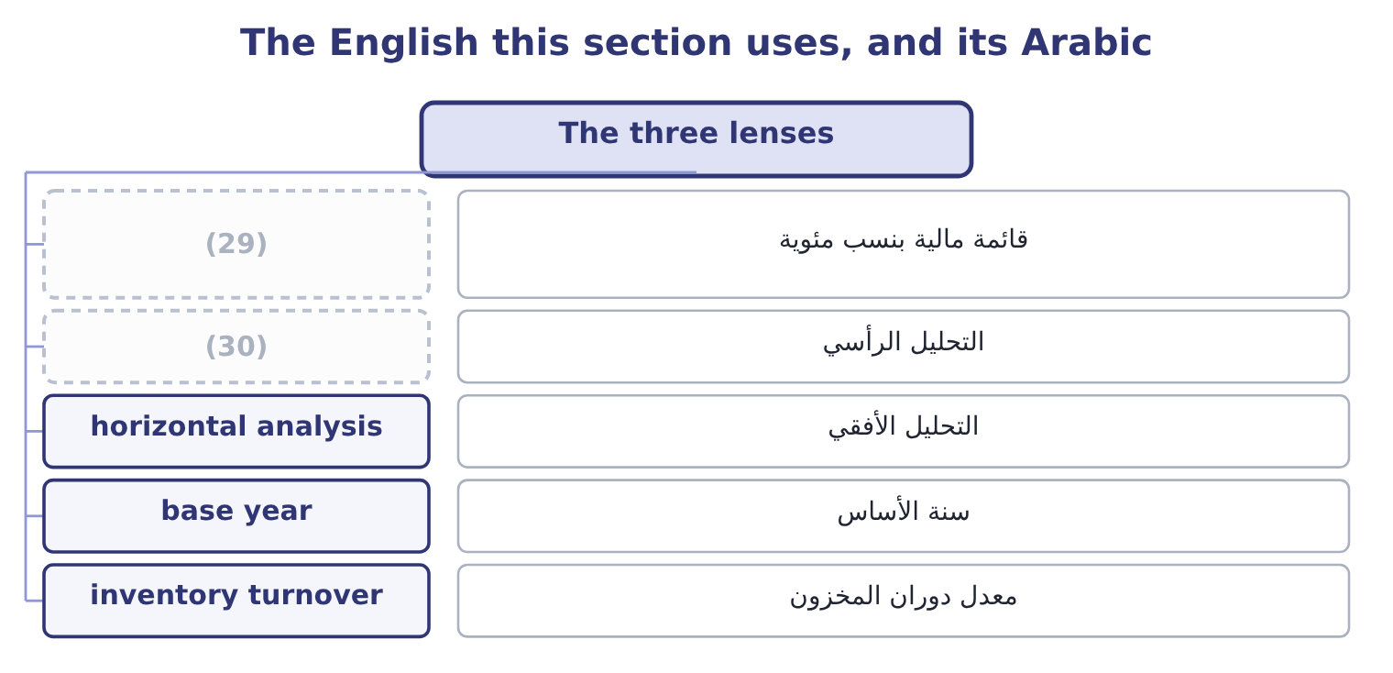
word list
vertical analysis · base year · common-size statement

The English this sheet uses, and its Arabic
English (exam term) | Arabic
common-size statement | قائمة مالية بنسب مئوية
vertical analysis | التحليل الرأسي
horizontal analysis | التحليل الأفقي
base year | سنة الأساس
inventory turnover | معدل دوران المخزون

Answer key · 1.3 The three lenses

1 things | 16 Divides every line by one total
2 financial | 17 What has changed?
3 chapters | 18 How do the parts relate?
4 income | 19 alternatives
5 percentages | 20 analyst
6 column | 21 statements
7 become | 22 question
8 second | 23 turnover
9 itself | 24 suggests
10 expressed | 25 December
11 comparison | 26 eleven
12 divide | 27 different
13 twenty-five | 28 movement
14 grouped | 29 common-size statement
15 Liquidity | 30 vertical analysis

the summaries in full
Summary 1 There are only three things you can do to a financial statement to make it speak, and the first five chapters take them in turn. The first is to turn every line into a percentage of one total. On the balance sheet every line becomes a percentage of total assets; on the income statement every line becomes a percentage of net sales. This is a common-size statement, and because the percentages run down the column it is also called vertical analysis. It lets you compare a company with one ten times its size, because both become 100 per cent. The second is to compare each line with itself in an earlier year. Every item is expressed against the same item in a base year, so you can see what has moved and by how much.
Summary 2 Because the comparison runs across the page it is called horizontal analysis. The third is to divide one line by another. That is a ratio, and the rest of the book is ratios: twenty-five of them in Section A alone, grouped by what they are for. Liquidity ratios in, leverage in, activity in, profitability in, market ratios.
Summary 3 The three are not alternatives. An analyst uses all of them on the same statements, and each one raises the question the next one answers. Common-size analysis shows that cost of goods sold is 65 per cent of sales; trend analysis shows that it was 62 per cent two years ago; ratio analysis shows that inventory turnover fell at the same time, which suggests where the extra cost went.
Summary 4 Orontes's inventory at December 31, 2025 is $2,450,000, and total assets are $31,672,600. The common-size figure is 2,450,000 ÷ 31,672,600 = 7.74 per cent. Inventory is a small part of what Orontes owns. A year earlier, inventory was $2,300,000. The trend figure is 2,450,000 ÷ 2,300,000 = 1.065, so inventory rose by 6.5 per cent. Cost of goods sold for 2025 is $27,300,000. The ratio is 27,300,000 ÷ 2,450,000 = 11.14 times, so Orontes turns its inventory about eleven times a year. Each step used the same line and a different partner: a total, an earlier year, and another statement. The three answers are about size, about movement, and about speed, and none of them could be read off the balance sheet alone.

1.4 Where the numbers come from
Chapter 1 · section 1.4

Fill every gap. Each word list holds one word more than there are gaps.
Summary 1 gaps 1–4
For a (1) company you (2) what you are given. For a company whose shares are (3) traded in the United States, a great deal is (4) , and the exam expects you to know what each document is called and what is in it.
word list
evidence · published · analyze · private · publicly

Summary 2 gaps 5–14
All of the (5) above are public and free. In the United States they are held in EDGAR, the (6) and Exchange (7) electronic filing database, and anyone can read them. That matters for the exam because a (8) about where an analyst would find segment (9) , or officer compensation, has a definite answer. Two parts of the 10-K (10) naming. (11) discussion and analysis, usually called MD&A, is where management explains the results in words: why revenue moved, what the (12) position is, what capital commitments exist. The notes to the statements carry the (13) policies, the detail behind the summarized lines, and the (14) . Part 1 taught you to prepare the notes; here they are evidence.
word list
contingencies · liquidity · information · Management's · Securities · accounting · Commission's · deserve · question · filings · benchmark

Which document?

Summary 3 gaps 15–18
Officer and director compensation is in the proxy (15) , not the 10-K. A (16) figure comes from the 10-Q, and it is unaudited. A single major event between reports is (17) on a Form 8-K. (18) measures such as adjusted EBITDA usually come from a press release, not from the audited statements.
word list
Exchange · announced · quarterly · Non-GAAP · statement

The words this section uses
Each term sits against what it means, and an instance of it.
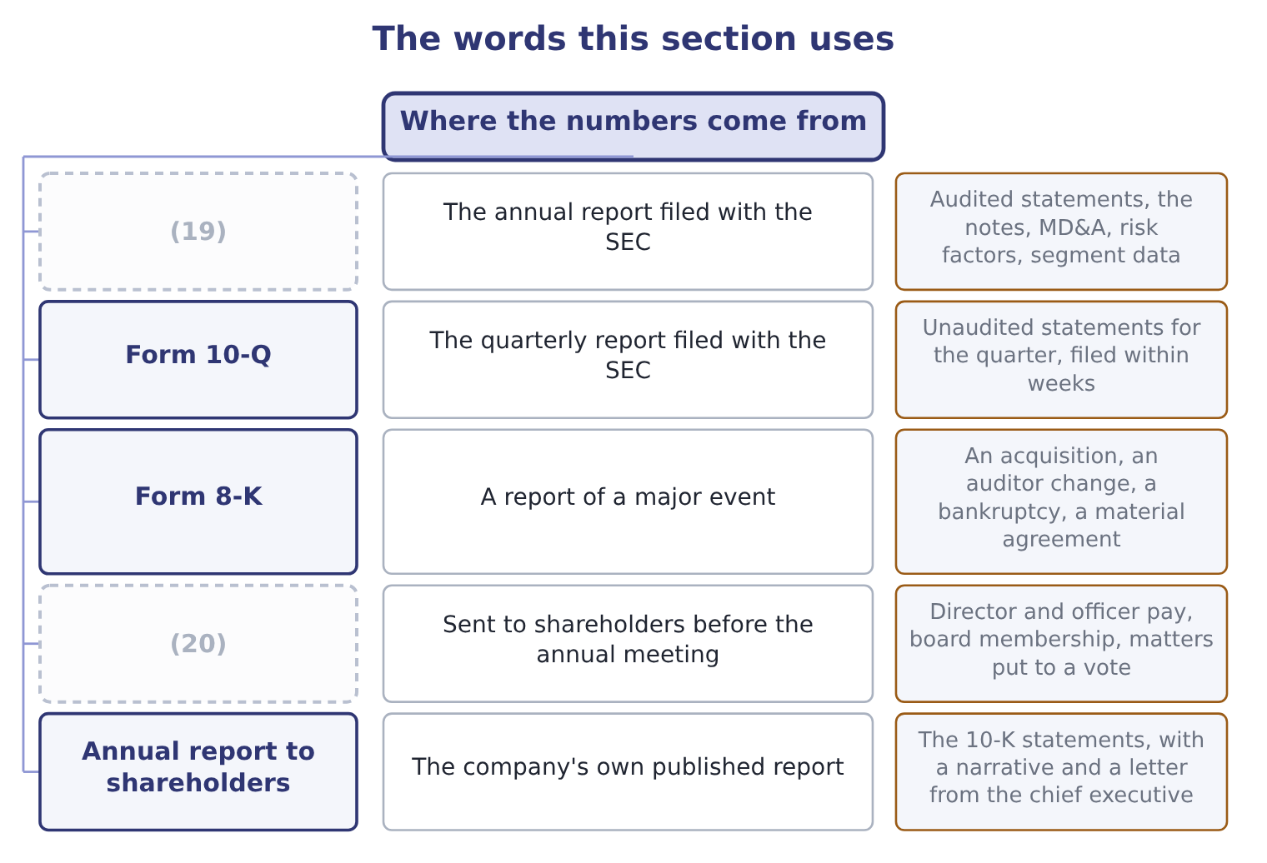
word list
industry average · Form 10-K · Proxy statement

The English this sheet uses, and its Arabic
English (exam term) | Arabic
Form 10-K | التقرير السنوي للهيئة
Form 10-Q | التقرير الربعي
Form 8-K | تقرير الأحداث الجوهرية
proxy statement | بيان التفويض
notes | الإيضاحات المتممة
segment information | معلومات القطاعات

Answer key · 1.4 Where the numbers come from

1 private | 11 Management's
2 analyze | 12 liquidity
3 publicly | 13 accounting
4 published | 14 contingencies
5 filings | 15 statement
6 Securities | 16 quarterly
7 Commission's | 17 announced
8 question | 18 Non-GAAP
9 information | 19 Form 10-K
10 deserve | 20 Proxy statement

the summaries in full
Summary 1 For a private company you analyze what you are given. For a company whose shares are publicly traded in the United States, a great deal is published, and the exam expects you to know what each document is called and what is in it.
Summary 2 All of the filings above are public and free. In the United States they are held in EDGAR, the Securities and Exchange Commission's electronic filing database, and anyone can read them. That matters for the exam because a question about where an analyst would find segment information, or officer compensation, has a definite answer. Two parts of the 10-K deserve naming. Management's discussion and analysis, usually called MD&A, is where management explains the results in words: why revenue moved, what the liquidity position is, what capital commitments exist. The notes to the statements carry the accounting policies, the detail behind the summarized lines, and the contingencies. Part 1 taught you to prepare the notes; here they are evidence.
Summary 3 Officer and director compensation is in the proxy statement, not the 10-K. A quarterly figure comes from the 10-Q, and it is unaudited. A single major event between reports is announced on a Form 8-K. Non-GAAP measures such as adjusted EBITDA usually come from a press release, not from the audited statements.

1.5 Industry averages, and what they are worth
Chapter 1 · section 1.5

Fill every gap. Each word list holds one word more than there are gaps.
Summary 1 gaps 1–3
A (1) own history is the easiest comparison, because you have it. The (2) and more useful comparison is with other companies doing the same thing. For that you need industry (3) , and those are published too.
word list
company's · Studies · harder · figures

Summary 2 gaps 4–15
An industry average is a comparison, not a (4) . Three things limit it, and the exam tests all three. The first is that the industry (5) may not fit. (6) presses olive oil, mills tahini and (7) juice. A food (8) average covers companies that do none of those things, and a company that does all three sits in no single (9) . The (10) is that the companies in the average may use different (11) . One uses LIFO and another FIFO; one (12) its plant and another owns it. Part 1 (13) you how far two sets of (14) can differ while both follow the rules. The third is that an average hides its own (15) . Half the industry is on one side of it. A company at the average is not thereby safe, and a company away from the average is not thereby wrong: it may be better, or it may be doing something the average does not describe.
word list
easiest · second · target · Orontes · classification · taught · category · accounting · manufacturing · leases · spread · statements · bottles

Average, mean, median, norm

Summary 3 gaps 16–18
English "industry average" is loose: a published figure may be a mean, a median, or an upper and lower quartile. Read the (16) own definition. (17) Studies, for example, reports (18) as well as a median, and the quartile is often the more useful comparison.
word list
something · publication's · Statement · quartiles

The words this section uses
Each term sits against what it means.
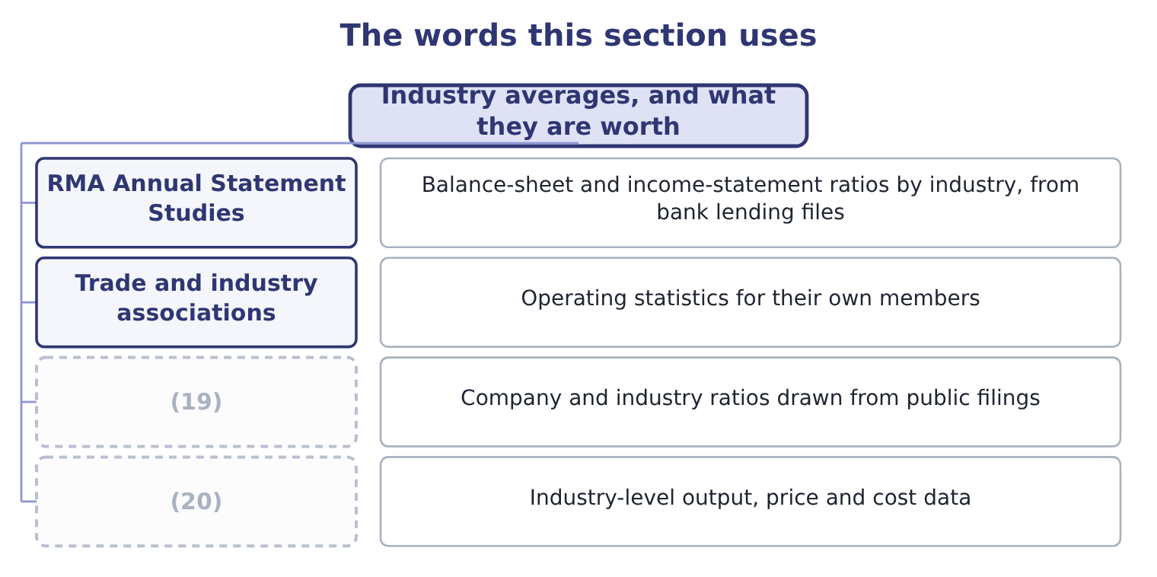
word list
Commercial data services · Government statistical agencies · financial statement analysis

The English this sheet uses, and its Arabic
English (exam term) | Arabic
industry average | متوسط القطاع
benchmark | معيار المقارنة
peer group | مجموعة النظراء
median | الوسيط
quartile | الربيع الإحصائي

Answer key · 1.5 Industry averages, and what they are worth

1 company's | 11 accounting
2 harder | 12 leases
3 figures | 13 taught
4 target | 14 statements
5 classification | 15 spread
6 Orontes | 16 publication's
7 bottles | 17 Statement
8 manufacturing | 18 quartiles
9 category | 19 Commercial data services
10 second | 20 Government statistical agencies

the summaries in full
Summary 1 A company's own history is the easiest comparison, because you have it. The harder and more useful comparison is with other companies doing the same thing. For that you need industry figures, and those are published too.
Summary 2 An industry average is a comparison, not a target. Three things limit it, and the exam tests all three. The first is that the industry classification may not fit. Orontes presses olive oil, mills tahini and bottles juice. A food manufacturing average covers companies that do none of those things, and a company that does all three sits in no single category. The second is that the companies in the average may use different accounting. One uses LIFO and another FIFO; one leases its plant and another owns it. Part 1 taught you how far two sets of statements can differ while both follow the rules. The third is that an average hides its own spread. Half the industry is on one side of it. A company at the average is not thereby safe, and a company away from the average is not thereby wrong: it may be better, or it may be doing something the average does not describe.
Summary 3 English "industry average" is loose: a published figure may be a mean, a median, or an upper and lower quartile. Read the publication's own definition. Statement Studies, for example, reports quartiles as well as a median, and the quartile is often the more useful comparison.

1.6 The company every ratio is calculated from
Chapter 1 · section 1.6

Fill every gap. Each word list holds one word more than there are gaps.
Summary 1 gaps 1–6
Orontes Foods, Inc. presses olive oil and mills tahini in Amman, makes frozen (1) in Dubai, and sells through (2) across the Levant and the Gulf. Its three (3) are Oils, Tahini & Spreads, and (4) . You (5) its statements in Part 1. The full statements are (6) in, and every ratio ahead is calculated from them, so any figure you do not recognize can be traced back to a line you wrote yourself.
word list
investment · reproduced · Beverages · divisions · pastries · distributors · prepared

Orontes Foods, Inc. — the three statements in summary (whole USD)
Item | 2025 | 2024
Total current assets | 14,188,100 | 8,380,000
TOTAL ASSETS | 31,672,600 | 26,445,000
(7) | 4,280,000 | 3,570,000
(8) | 11,279,625 | 10,070,000
(9) | 20,392,975 | 16,375,000
(10) | 42,000,000
Cost of goods sold | (27,300,000)
Operating income | 4,176,000
Net income | 2,969,100
(11) | 7,531,100

word list
Total stockholders' equity · Total current liabilities · Total liabilities · Net cash provided by operating activities · Net sales · Net income

Summary 2 gaps 12–21
Two (12) of the 2025 (13) will occupy several chapters. Cash rose from $2,100,000 to $7,302,100, which is a very large movement for a company of this size and has to be (14) before any (15) ratio is believed. And operating income carries (16) losses of $2,724,000, which is a real (17) but not one that recurs every year. The other companies of Part 1 come with it. Barada Wholesale, Inc. is the (18) whose own statements you worked on, and it supplies the (19) practice at the end of most chapters. Jordan Glass Co. is the bottle (20) Orontes holds an (21) investment. Levant Commerce Bank lends to Orontes, and Gulf Factor Co. buys its receivables.
word list
impairment · explained · supplier · equity-method · features · distributor · liquidity · charge · figures · solvency · case-style

Analyze the company you are given

Summary 3 gaps 22–24
Exam (22) give you the statements or the ratios they want used. Do not (23) what you think you know about the industry. If a question gives both a prior year and an industry figure, the answer (24) turns on one of them.
word list
benchmark · usually · import · questions

Answer key · 1.6 The company every ratio is calculated from

1 pastries | 13 figures
2 distributors | 14 explained
3 divisions | 15 liquidity
4 Beverages | 16 impairment
5 prepared | 17 charge
6 reproduced | 18 distributor
7 Total current liabilities | 19 case-style
8 Total liabilities | 20 supplier
9 Total stockholders' equity | 21 equity-method
10 Net sales | 22 questions
11 Net cash provided by operating activities | 23 import
12 features | 24 usually

the summaries in full
Summary 1 Orontes Foods, Inc. presses olive oil and mills tahini in Amman, makes frozen pastries in Dubai, and sells through distributors across the Levant and the Gulf. Its three divisions are Oils, Tahini & Spreads, and Beverages. You prepared its statements in Part 1. The full statements are reproduced in, and every ratio ahead is calculated from them, so any figure you do not recognize can be traced back to a line you wrote yourself.
Summary 2 Two features of the 2025 figures will occupy several chapters. Cash rose from $2,100,000 to $7,302,100, which is a very large movement for a company of this size and has to be explained before any liquidity ratio is believed. And operating income carries impairment losses of $2,724,000, which is a real charge but not one that recurs every year. The other companies of Part 1 come with it. Barada Wholesale, Inc. is the distributor whose own statements you worked on, and it supplies the case-style practice at the end of most chapters. Jordan Glass Co. is the bottle supplier Orontes holds an equity-method investment. Levant Commerce Bank lends to Orontes, and Gulf Factor Co. buys its receivables.
Summary 3 Exam questions give you the statements or the ratios they want used. Do not import what you think you know about the industry. If a question gives both a prior year and an industry figure, the answer usually turns on one of them.

