2.1 One total as a hundred
Chapter 2 · section 2.1

Fill every gap. Each word list holds one word more than there are gaps.
Chapter 2, section by section
Each stage leads to the next.
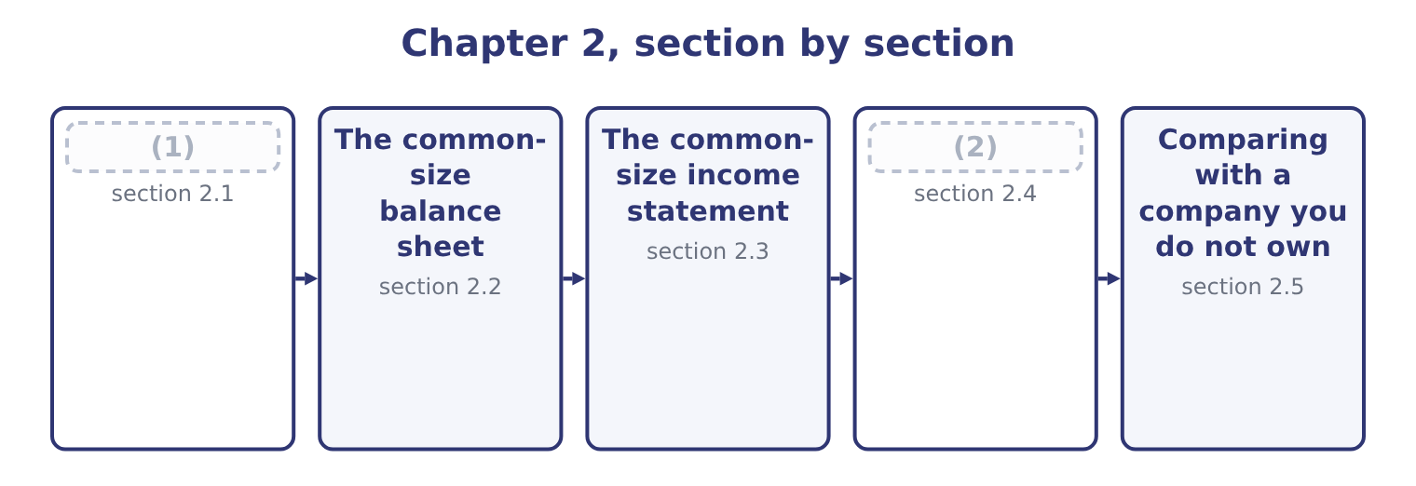
word list
One total as a hundred · The common-size income statement · Reading the two statements together

Summary 1 gaps 3–14
A common-size statement sets one line of the statement to 100 per cent and (3) every other line as a percentage of it. The (4) of base is fixed by (5) , and the exam (6) it. For the balance sheet the base is total assets. Every asset, every liability and every equity line is divided by total assets. (7) assets equal (8) plus equity, the liability and equity side also adds to 100 per cent, so the two sides (9) equal in percentage terms as they were in (10) . For the income statement the base is net sales. Every cost, every (11) and net income (12) is divided by net sales. The result is read as what (13) to each sales dollar: so many cents go to the cost of the goods, so many to selling and (14) , so many survive as profit.
word list
remain · convention · expresses · liabilities · expects · choice · depreciation · subtotal · administration · itself · Because · dollars · happens

The base is not negotiable

Summary 2 gaps 15–22
Balance sheet: total assets. Not total equity, not (15) assets, not the (16) line. Income statement: net sales. Not gross profit, not total revenue (17) other income, not net income. When a (18) gives you other income or interest income, those are (19) against net sales too, even though they are not sales. A common-size statement for one year, (20) alone, tells you the shape of the company. Two years side by side tell you whether the shape is (21) , and that is usually the more useful reading. Both appear in the (22) below.
word list
changing · expressed · question · convention · largest · figures · standing · including · current

The English this section uses, and its Arabic
Each term sits against what it means.
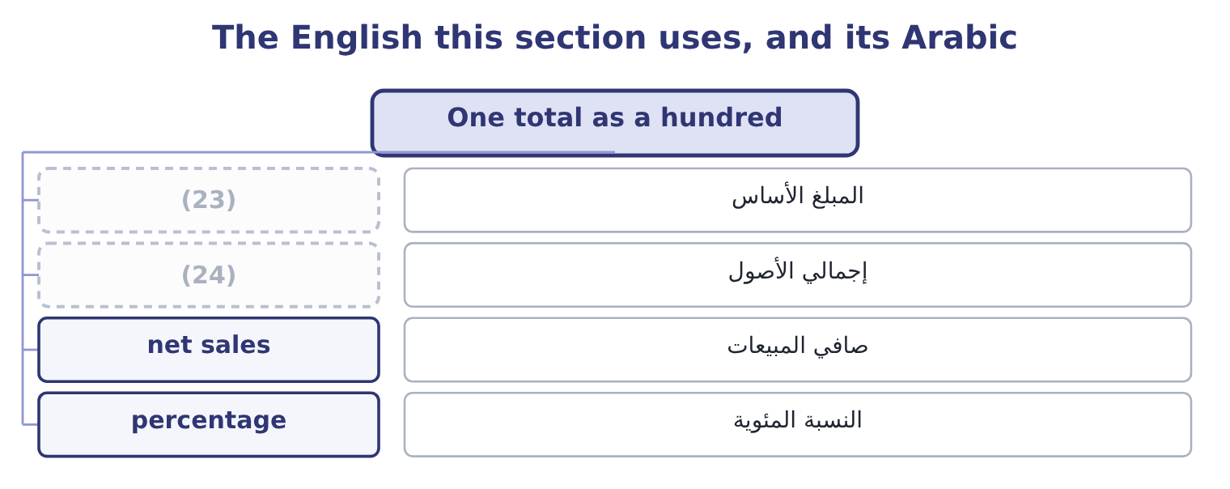
word list
المبلغ الأساس · total assets · base amount

The English this sheet uses, and its Arabic
English (exam term) | Arabic
base amount | المبلغ الأساس
total assets | إجمالي الأصول
net sales | صافي المبيعات
percentage | النسبة المئوية

Answer key · 2.1 One total as a hundred

1 One total as a hundred | 13 happens
2 Reading the two statements together | 14 administration
3 expresses | 15 current
4 choice | 16 largest
5 convention | 17 including
6 expects | 18 question
7 Because | 19 expressed
8 liabilities | 20 standing
9 remain | 21 changing
10 dollars | 22 figures
11 subtotal | 23 base amount
12 itself | 24 total assets

the summaries in full
Summary 1 A common-size statement sets one line of the statement to 100 per cent and expresses every other line as a percentage of it. The choice of base is fixed by convention, and the exam expects it. For the balance sheet the base is total assets. Every asset, every liability and every equity line is divided by total assets. Because assets equal liabilities plus equity, the liability and equity side also adds to 100 per cent, so the two sides remain equal in percentage terms as they were in dollars. For the income statement the base is net sales. Every cost, every subtotal and net income itself is divided by net sales. The result is read as what happens to each sales dollar: so many cents go to the cost of the goods, so many to selling and administration, so many survive as profit.
Summary 2 Balance sheet: total assets. Not total equity, not current assets, not the largest line. Income statement: net sales. Not gross profit, not total revenue including other income, not net income. When a question gives you other income or interest income, those are expressed against net sales too, even though they are not sales. A common-size statement for one year, standing alone, tells you the shape of the company. Two years side by side tell you whether the shape is changing, and that is usually the more useful reading. Both appear in the figures below.

2.2 The common-size balance sheet
Chapter 2 · section 2.2

Fill every gap. Each word list holds one word more than there are gaps.
Every percentage is the dollar amount divided by total assets for that year.
Orontes Foods, Inc. — common-size balance sheets at December 31 (percentage of total assets)
Orontes Foods Inc. (whole USD) | 2025 | % | 2024 | %
Cash | 7,302,100 | 23.1 | 2,100,000 | 7.9
(1) | 42,000 | 0.1 | 40,000 | 0.2
Accounts receivable, net | 4,144,000 | 13.1 | 3,760,000 | 14.2
Inventory | 2,450,000 | 7.7 | 2,300,000 | 8.7
Prepaid expenses | 204,000 | 0.6 | 180,000 | 0.7
Assets held for sale | 46,000 | 0.1 | — | —
Total current assets | 14,188,100 | 44.8 | 8,380,000 | 31.7
Debt securities | 88,500 | 0.3 | 90,000 | 0.3
(2) | 27,000 | 0.1 | 25,000 | 0.1
Equity-method investments | 1,807,000 | 5.7 | 500,000 | 1.9
(3) | 14,802,000 | 46.7 | 16,000,000 | 60.5
Brand (indefinite-lived) | 260,000 | 0.8 | 300,000 | 1.1
Goodwill | 300,000 | 0.9 | 950,000 | 3.6
Other noncurrent assets | 200,000 | 0.6 | 200,000 | 0.8
TOTAL ASSETS | 31,672,600 | 100.0 | 26,445,000 | 100.0
Accounts payable | 2,050,000 | 6.5 | 1,900,000 | 7.2
Accrued liabilities | 900,000 | 2.8 | 850,000 | 3.2
(4) | 350,000 | 1.1 | 300,000 | 1.1
(5) | 180,000 | 0.6 | 120,000 | 0.5
Dividends payable | 400,000 | 1.3 | — | —
(6) | 400,000 | 1.3 | 400,000 | 1.5
Total current liabilities | 4,280,000 | 13.5 | 3,570,000 | 13.5
Long-term debt, less current portion | 6,000,000 | 18.9 | 5,600,000 | 21.2
(7) | 999,625 | 3.2 | 900,000 | 3.4
Total liabilities | 11,279,625 | 35.6 | 10,070,000 | 38.1
(8) | 8,100,000 | 25.6 | 8,000,000 | 30.3
(9) | 5,400,000 | 17.0 | 4,000,000 | 15.1
Retained earnings | 6,894,100 | 21.8 | 4,375,000 | 16.5
(10) | 20,392,975 | 64.4 | 16,375,000 | 61.9
TOTAL LIABILITIES AND EQUITY | 31,672,600 | 100.0 | 26,445,000 | 100.0

word list
Accounts payable · Current portion of long-term debt · Property, plant and equipment, net · Additional paid-in capital · Trading securities · Contract liabilities · Equity securities · Deferred tax liability · Income taxes payable · Common stock, $1 par · Total stockholders' equity

Summary 1 gaps 11–20
Four (11) in that column are worth (12) , and each one (13) a chapter later. The asset mix moved. Current assets were 31.7 per cent of the company and are now 44.8 per cent. Property, plant and equipment fell from 60.5 per cent to 46.7 per cent. Orontes did not sell a (14) : the dollar amount of PP&E fell by only $1,198,000, while total assets grew. Most of the shift is cash. Cash (15) as a proportion. It was 7.9 per cent of total assets and is now 23.1 per cent. Nearly a (16) of this company is now cash. That is (17) a company storing up for (18) , or a company that cannot find (19) to do with its money. The capital (20) barely moved. Total liabilities fell from 38.1 per cent to 35.6 per cent and equity rose from 61.9 to 64.4.
word list
factory · either · things · readings · structure · tripled · anything · something · becomes · quarter · naming

Summary 2 gaps 21–25
Orontes is financed about (21) by its owners, and that did not (22) much in a year when the (23) sheet grew by a fifth. It was 3.6 per cent of assets and is now 0.9 per cent, because of the (24) you recorded in Part 1. A (25) who did not know that would see only the percentage and would have to go to the notes.
word list
change · structure · balance · two-thirds · impairment · reader

Worked example: three lines of the common-size column

Summary 3 gaps 26–31
Round to one decimal, as the whole column does. Note that the base (26) : each year is divided by its own total, never by the (27) total. Total current liabilities, both years. The dollar amount rose by $710,000 and the percentage did not move at all. Step 3 is the point of the (28) . In (29) , current liabilities grew. As a share of the company they stood still, because the company grew by the same proportion. The two (30) are both true and they answer (31) questions.
word list
different · readings · earlier · technique · questions · changed · dollars

Complete the common-size column

Total assets for 2025 are $31,672,600. Fill in the rest, to one decimal place.

Your turn: the 2025 common-size column (complete the blanks)
Line | Amount | Per cent of total assets
Accounts receivable, net | 4,144,000 | 13.1
Inventory | 2,450,000 | (32) : 2,450,000 ÷ 31,672,600.
Equity-method investments | 1,807,000 | 5.7 per cent: 1,807,000 ÷ 31,672,600.
Long-term debt, less current portion | 6,000,000 | (33) : 6,000,000 ÷ 31,672,600.
Retained earnings | 6,894,100 | 21.8 per cent: 6,894,100 ÷ 31,672,600.

word list
7.7 per cent · 21.8 per cent · 18.9 per cent

The English this section uses, and its Arabic
Each term sits against what it means.
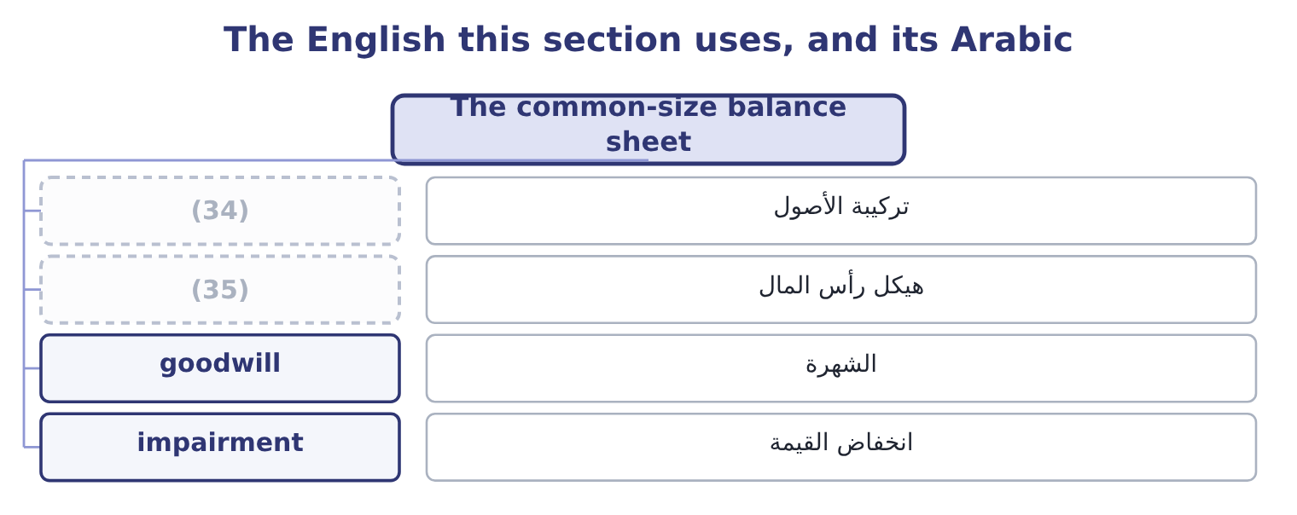
word list
base amount · capital structure · asset mix

The English this sheet uses, and its Arabic
English (exam term) | Arabic
asset mix | تركيبة الأصول
capital structure | هيكل رأس المال
goodwill | الشهرة
impairment | انخفاض القيمة

Answer key · 2.2 The common-size balance sheet

1 Trading securities | 19 anything
2 Equity securities | 20 structure
3 Property, plant and equipment, net | 21 two-thirds
4 Income taxes payable | 22 change
5 Contract liabilities | 23 balance
6 Current portion of long-term debt | 24 impairment
7 Deferred tax liability | 25 reader
8 Common stock, $1 par | 26 changed
9 Additional paid-in capital | 27 earlier
10 Total stockholders' equity | 28 technique
11 things | 29 dollars
12 naming | 30 readings
13 becomes | 31 different
14 factory | 32 7.7 per cent
15 tripled | 33 18.9 per cent
16 quarter | 34 asset mix
17 either | 35 capital structure
18 something

the summaries in full
Summary 1 Four things in that column are worth naming, and each one becomes a chapter later. The asset mix moved. Current assets were 31.7 per cent of the company and are now 44.8 per cent. Property, plant and equipment fell from 60.5 per cent to 46.7 per cent. Orontes did not sell a factory: the dollar amount of PP&E fell by only $1,198,000, while total assets grew. Most of the shift is cash. Cash tripled as a proportion. It was 7.9 per cent of total assets and is now 23.1 per cent. Nearly a quarter of this company is now cash. That is either a company storing up for something, or a company that cannot find anything to do with its money. The capital structure barely moved. Total liabilities fell from 38.1 per cent to 35.6 per cent and equity rose from 61.9 to 64.4.
Summary 2 Orontes is financed about two-thirds by its owners, and that did not change much in a year when the balance sheet grew by a fifth. It was 3.6 per cent of assets and is now 0.9 per cent, because of the impairment you recorded in Part 1. A reader who did not know that would see only the percentage and would have to go to the notes.
Summary 3 Round to one decimal, as the whole column does. Note that the base changed: each year is divided by its own total, never by the earlier total. Total current liabilities, both years. The dollar amount rose by $710,000 and the percentage did not move at all. Step 3 is the point of the technique. In dollars, current liabilities grew. As a share of the company they stood still, because the company grew by the same proportion. The two readings are both true and they answer different questions.

2.3 The common-size income statement
Chapter 2 · section 2.3

Fill every gap. Each word list holds one word more than there are gaps.
Summary 1 gaps 1–2
On the income (1) the base is net sales, and the (2) reads as the fate of each sales dollar.
word list
statement · column · dollars

Orontes Foods, Inc. — common-size income statement, year ended December 31, 2025 (percentage of net sales)
Orontes Foods Inc. (whole USD) | 2025 | %
Net sales | 42,000,000 | 100.0
Cost of goods sold | (27,300,000) | (65.0)
Gross profit | 14,700,000 | 35.0
Selling, general and administrative | (7,237,000) | (17.2)
(3) | (63,000) | (0.1)
Research and development | (500,000) | (1.2)
(4) | (2,724,000) | (6.5)
(5) | (10,524,000) | (25.1)
Operating income | 4,176,000 | 9.9
Interest expense | (390,000) | (0.9)
Equity-method income | 177,000 | 0.4
(6) | (217,200) | (0.5)
(7) | 3,958,800 | 9.4
Income tax expense | (989,700) | (2.4)
Net income | 2,969,100 | 7.1

word list
Total other income and (expense) · Net sales · Income before income taxes · Credit loss expense · Total operating expenses · Impairment losses

Summary 2 gaps 8–19
Read it as a (8) . Of every dollar Orontes sold, 65 cents went to the cost of the goods (9) and 35 cents (10) as gross profit. Of that 35 cents, 17 went to selling and (11) and 6.5 cents went to the impairment. Nine point nine cents (12) as operating income, and after interest and tax, seven cents (13) net income. The impairment line is why this statement has to be read (14) . A reader (15) Orontes with another food (16) would see operating income of 9.9 per cent and might conclude that Orontes is the weaker business. But 6.5 of the 25.1 (17) of operating expense is a write-down of (18) and a brand, which will not happen again next year. Without it, operating income would have been 6,900,000 ÷ 42,000,000 = 16.4 per cent. Which of the two (19) to use is a real question, not a trick.
word list
remained · themselves · points · possible · figures · administration · goodwill · comparing · sentence · manufacturer · became · carefully · survived

Percentages of a negative number

Summary 3 gaps 20–23
Costs are shown in parentheses on the statement and their (20) are shown in parentheses too. Do not change the sign (21) down a column. Gross profit percentage is gross profit over net sales, not cost of goods sold over net sales. Those two add to 100. If a question gives you a common-size income statement and asks for a dollar (22) , you need net sales. Without the base you (23) go back.
word list
cannot · manufacturer · halfway · percentages · amount

Worked example: going back from percentages to dollars

Summary 4 gaps 24–30
A (24) common-size income statement shows gross profit of 28.0 per cent and net sales of $55,000,000. Gross profit in dollars is 55,000,000 × 0.28 = 15,400,000. Its cost of goods sold is (25) 100.0 − 28.0 = 72.0 per cent of sales, or 55,000,000 × 0.72 = 39,600,000. (26) with Orontes, whose gross profit is 35.0 per cent. On $42,000,000 of sales that is 42,000,000 × 0.35 = 14,700,000. The competitor sells more and earns less gross profit in dollars: $15,400,000 (27) $14,700,000 on sales a third (28) . The common-size column made the (29) possible; the dollars make it (30) .
word list
against · larger · manufacturer · concrete · competitor's · Compare · comparison · therefore

The English this section uses, and its Arabic
Each term sits against what it means.
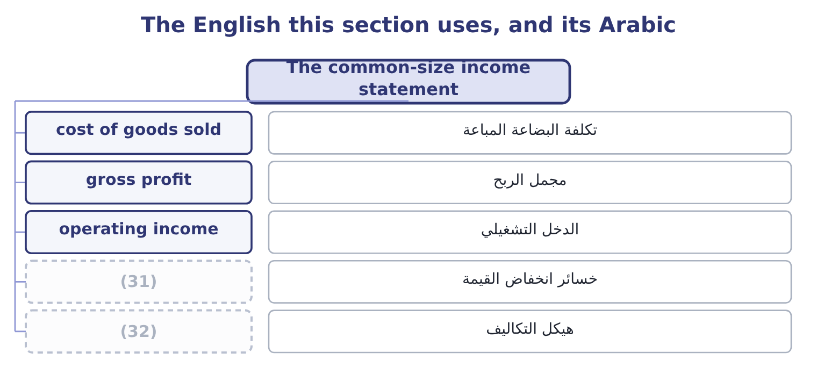
word list
fixed cost · impairment losses · cost structure

The English this sheet uses, and its Arabic
English (exam term) | Arabic
cost of goods sold | تكلفة البضاعة المباعة
gross profit | مجمل الربح
operating income | الدخل التشغيلي
impairment losses | خسائر انخفاض القيمة
cost structure | هيكل التكاليف

Answer key · 2.3 The common-size income statement

1 statement | 17 points
2 column | 18 goodwill
3 Credit loss expense | 19 figures
4 Impairment losses | 20 percentages
5 Total operating expenses | 21 halfway
6 Total other income and (expense) | 22 amount
7 Income before income taxes | 23 cannot
8 sentence | 24 competitor's
9 themselves | 25 therefore
10 remained | 26 Compare
11 administration | 27 against
12 survived | 28 larger
13 became | 29 comparison
14 carefully | 30 concrete
15 comparing | 31 impairment losses
16 manufacturer | 32 cost structure

the summaries in full
Summary 1 On the income statement the base is net sales, and the column reads as the fate of each sales dollar.
Summary 2 Read it as a sentence. Of every dollar Orontes sold, 65 cents went to the cost of the goods themselves and 35 cents remained as gross profit. Of that 35 cents, 17 went to selling and administration and 6.5 cents went to the impairment. Nine point nine cents survived as operating income, and after interest and tax, seven cents became net income. The impairment line is why this statement has to be read carefully. A reader comparing Orontes with another food manufacturer would see operating income of 9.9 per cent and might conclude that Orontes is the weaker business. But 6.5 of the 25.1 points of operating expense is a write-down of goodwill and a brand, which will not happen again next year. Without it, operating income would have been 6,900,000 ÷ 42,000,000 = 16.4 per cent. Which of the two figures to use is a real question, not a trick.
Summary 3 Costs are shown in parentheses on the statement and their percentages are shown in parentheses too. Do not change the sign halfway down a column. Gross profit percentage is gross profit over net sales, not cost of goods sold over net sales. Those two add to 100. If a question gives you a common-size income statement and asks for a dollar amount, you need net sales. Without the base you cannot go back.
Summary 4 A competitor's common-size income statement shows gross profit of 28.0 per cent and net sales of $55,000,000. Gross profit in dollars is 55,000,000 × 0.28 = 15,400,000. Its cost of goods sold is therefore 100.0 − 28.0 = 72.0 per cent of sales, or 55,000,000 × 0.72 = 39,600,000. Compare with Orontes, whose gross profit is 35.0 per cent. On $42,000,000 of sales that is 42,000,000 × 0.35 = 14,700,000. The competitor sells more and earns less gross profit in dollars: $15,400,000 against $14,700,000 on sales a third larger. The common-size column made the comparison possible; the dollars make it concrete.

2.4 Reading the two statements together
Chapter 2 · section 2.4

Fill every gap. Each word list holds one word more than there are gaps.
Summary 1 gaps 1–12
Each statement (1) a different (2) , and the two (3) answer a third. The balance sheet column says what the company is made. The income statement column says what (4) to a sale. Put them side by side and you can see (5) the shape of the assets (6) the shape of the costs. Orontes keeps 46.7 per cent of its assets in plant. A company with that much plant has (7) fixed costs, and you would expect the cost of goods sold to (8) depreciation and factory (9) that do not fall when sales fall. Part 1 (10) depreciation of $2,100,000 for the year, which is 5.0 per cent of net sales. That is the link: half a (11) of every ten in sales is a charge the company owes to assets it bought years ago, (12) this year's sales turn out to be.
word list
recorded · matches · question · whether · financial · overhead · whatever · answers · substantial · together · contain · happens · dollar

What a pair of common-size columns suggests
On the balance sheet | On the income statement | What the pair suggests
A large share in plant | A large share in cost of goods sold that does not move with sales | (13)
A large share in receivables | (14) | Selling to customers who pay slowly or not at all
A large share in inventory | (15) | Goods that are not selling, discounted to move
A large share in cash | Interest and dividend income that is small | (16)
A large share in equity | (17) | Financed by owners, so little fixed charge

word list
Interest and dividend income that is small · Fixed costs: profit swings hard with volume · A credit loss expense that is rising · A falling gross profit margin · A small interest expense · Cash earning almost nothing

Summary 2 gaps 18–20
The fifth row (18) Orontes. Equity is 64.4 per cent of the balance sheet and interest expense is 0.9 per cent of sales: $390,000 against (19) income of $4,176,000. The company is carrying very little fixed (20) cost.
word list
describes · operating · comparability · financial

"Margin" in English

Summary 3 gaps 21–23
English uses margin for (21) different things: gross profit margin, (22) margin, margin of safety, and the margin a broker lends against. In Section A, margin always means a (23) of sales unless the words say otherwise.
word list
depreciation · percentage · contribution · several

The English this section uses, and its Arabic
Each term sits against what it means.
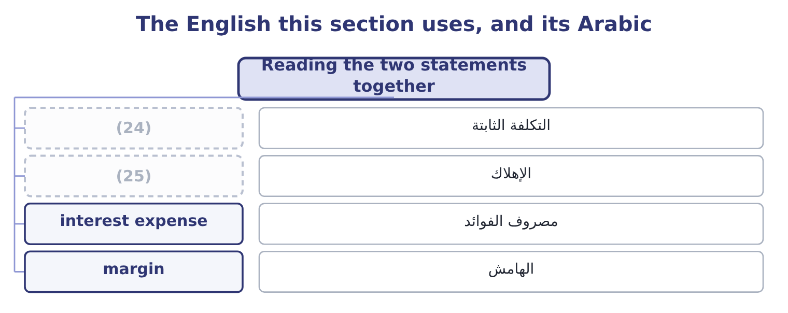
word list
total assets · depreciation · fixed cost

The English this sheet uses, and its Arabic
English (exam term) | Arabic
fixed cost | التكلفة الثابتة
depreciation | الإهلاك
interest expense | مصروف الفوائد
margin | الهامش

Answer key · 2.4 Reading the two statements together

1 answers | 14 A credit loss expense that is rising
2 question | 15 A falling gross profit margin
3 together | 16 Cash earning almost nothing
4 happens | 17 A small interest expense
5 whether | 18 describes
6 matches | 19 operating
7 substantial | 20 financial
8 contain | 21 several
9 overhead | 22 contribution
10 recorded | 23 percentage
11 dollar | 24 fixed cost
12 whatever | 25 depreciation
13 Fixed costs: profit swings hard with volume

the summaries in full
Summary 1 Each statement answers a different question, and the two together answer a third. The balance sheet column says what the company is made. The income statement column says what happens to a sale. Put them side by side and you can see whether the shape of the assets matches the shape of the costs. Orontes keeps 46.7 per cent of its assets in plant. A company with that much plant has substantial fixed costs, and you would expect the cost of goods sold to contain depreciation and factory overhead that do not fall when sales fall. Part 1 recorded depreciation of $2,100,000 for the year, which is 5.0 per cent of net sales. That is the link: half a dollar of every ten in sales is a charge the company owes to assets it bought years ago, whatever this year's sales turn out to be.
Summary 2 The fifth row describes Orontes. Equity is 64.4 per cent of the balance sheet and interest expense is 0.9 per cent of sales: $390,000 against operating income of $4,176,000. The company is carrying very little fixed financial cost.
Summary 3 English uses margin for several different things: gross profit margin, contribution margin, margin of safety, and the margin a broker lends against. In Section A, margin always means a percentage of sales unless the words say otherwise.

2.5 Comparing with a company you do not own
Chapter 2 · section 2.5

Fill every gap. Each word list holds one word more than there are gaps.
Summary 1 gaps 1–4
The (1) to make a common-size statement is to compare. Orontes against itself last year is the easy (2) . Orontes against Barada Wholesale is the (3) one, because Barada is a distributor and Orontes is a manufacturer, and the (4) of the two businesses are different in ways the percentages expose at once.
word list
instructive · shapes · Barada's · comparison · reason

Orontes and Barada, selected common-size lines, 2025
Line | Orontes (manufacturer) | Barada (distributor)
Inventory, per cent of total assets | 7.7 | 34.0
Property, plant and equipment, per cent of total assets | 46.7 | 9.0
(5) | 13.1 | 28.0
(6) | 65.0 | 84.0
(7) | 35.0 | 16.0

word list
Accounts receivable, per cent of total assets · Property, plant and equipment, per cent of total assets · Gross profit, per cent of net sales · Cost of goods sold, per cent of net sales

Summary 2 gaps 8–18
Nothing in that table says one company is (8) run than the other. It says they are different businesses. A distributor buys (9) goods and resells them, so its cost of goods sold is most of its sales and its gross margin is thin; it carries little plant and a great deal of stock and (10) . A manufacturer (11) raw material, so it earns a wider margin and ties its money up in (12) . This is the (13) the common-size statement (14) . The percentages are a (15) , and the judgment comes (16) , from knowing what the business does. (17) Barada's 16 per cent gross margin with Orontes's 35 per cent and (18) that Barada is failing would be a serious error, and it is one the exam tests.
word list
discipline · better · description · finished · afterwards · machinery · receivables · converts · Comparing · teaches · concluding · knowing

Comparable means comparable

Summary 3 gaps 19–22
Compare a company with companies in the same business, or with itself. Where the businesses (19) , say what the difference is before drawing a (20) from the percentages. A difference in (21) policy — LIFO against FIFO, leased plant against owned plant — changes the percentages without (22) the business.
word list
differ · accounting · distributor · conclusion · changing

The English this section uses, and its Arabic
Each term sits against what it means.
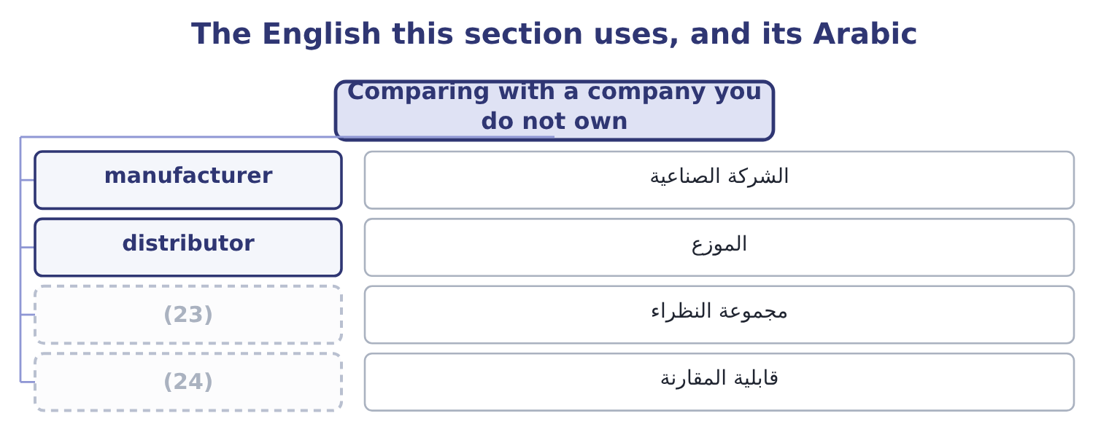
word list
peer group · cost structure · comparability

The English this sheet uses, and its Arabic
English (exam term) | Arabic
manufacturer | الشركة الصناعية
distributor | الموزع
peer group | مجموعة النظراء
comparability | قابلية المقارنة

Answer key · 2.5 Comparing with a company you do not own

1 reason | 13 discipline
2 comparison | 14 teaches
3 instructive | 15 description
4 shapes | 16 afterwards
5 Accounts receivable, per cent of total assets | 17 Comparing
6 Cost of goods sold, per cent of net sales | 18 concluding
7 Gross profit, per cent of net sales | 19 differ
8 better | 20 conclusion
9 finished | 21 accounting
10 receivables | 22 changing
11 converts | 23 peer group
12 machinery | 24 comparability

the summaries in full
Summary 1 The reason to make a common-size statement is to compare. Orontes against itself last year is the easy comparison. Orontes against Barada Wholesale is the instructive one, because Barada is a distributor and Orontes is a manufacturer, and the shapes of the two businesses are different in ways the percentages expose at once.
Summary 2 Nothing in that table says one company is better run than the other. It says they are different businesses. A distributor buys finished goods and resells them, so its cost of goods sold is most of its sales and its gross margin is thin; it carries little plant and a great deal of stock and receivables. A manufacturer converts raw material, so it earns a wider margin and ties its money up in machinery. This is the discipline the common-size statement teaches. The percentages are a description, and the judgment comes afterwards, from knowing what the business does. Comparing Barada's 16 per cent gross margin with Orontes's 35 per cent and concluding that Barada is failing would be a serious error, and it is one the exam tests.
Summary 3 Compare a company with companies in the same business, or with itself. Where the businesses differ, say what the difference is before drawing a conclusion from the percentages. A difference in accounting policy — LIFO against FIFO, leased plant against owned plant — changes the percentages without changing the business.

