3.1 Three ways to state a difference
Chapter 3 · section 3.1

Fill every gap. Each word list holds one word more than there are gaps.
Chapter 3, section by section
Each stage leads to the next.
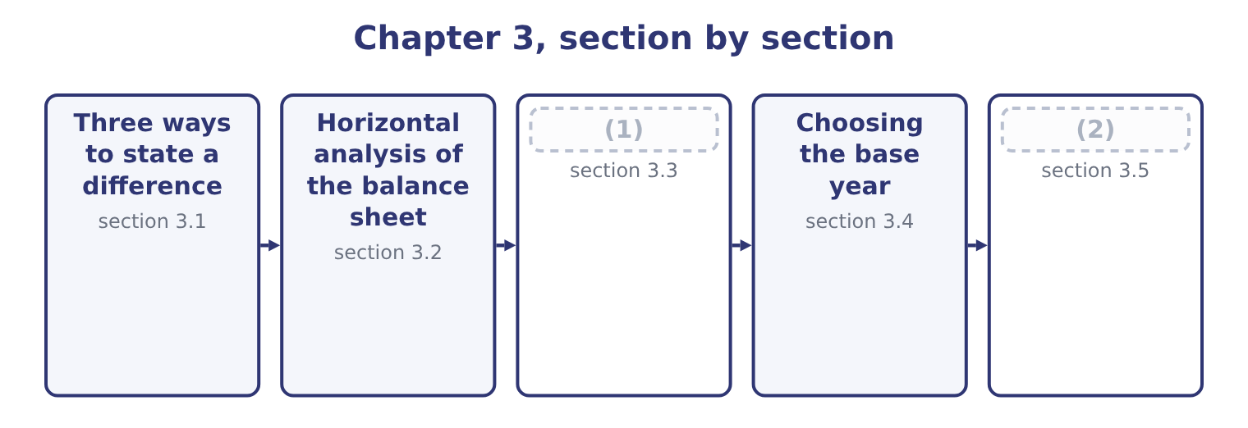
word list
Three ways to state a difference · Horizontal analysis of the income statement · What horizontal analysis cannot do

Summary 1 gaps 3–11
Take one line and two years. There are three (3) ways to say how it moved, and the exam uses all three. The absolute change is the later amount minus the earlier one, in (4) . Orontes's cash rose by 7,302,100 − 2,100,000 = 5,202,100 (5) . This is the figure that (6) when you are asking (7) the movement is large enough to care about. The percentage change is the absolute change (8) by the earlier amount. For cash that is 5,202,100 ÷ 2,100,000 = 247.7 per cent. This is the figure that lets you compare (9) in lines of very different size. The trend index sets the base year to 100 and (10) every later year (11) it. Cash at the end of 2025 is 7,302,100 ÷ 2,100,000 = 347.7 on a 2024 base of 100. The index and the percentage change say the same thing: an index of 347.7 is a rise of 247.7 per cent.
word list
expresses · dollars · honest · matters · whether · anything · currency · movements · against · divided

The denominator is the earlier year

Summary 2 gaps 12–16
Percentage change (12) by the earlier amount, not the later one and not the (13) . An index of 347.7 means a rise of 247.7 per cent. (14) 100 to get the change. A percentage change cannot be calculated when the earlier amount is zero, and it is (15) when the earlier amount is negative. Say "not (16) " rather than inventing a figure.
word list
average · meaningful · dollars · meaningless · Subtract · divides

Three statements of one movement
Measure | How it is calculated | Orontes cash | What it is good for
Absolute change | Later − earlier | 5,202,100 | (17)
Percentage change | (Later − earlier) ÷ earlier | 247.7 per cent | (18)
Trend index | (19) | 347.7 | Following one line over several years

word list
Following one line over several years · Is the movement big enough to matter? · Comparing lines of different size · Later ÷ base, × 100

Summary 3 gaps 20–26
A large percentage on a small line is the commonest way for (20) analysis to (21) . Orontes's assets held for sale went from nothing to $46,000, which is an (22) percentage rise on a line that is (23) of one per cent of the company. Trading (24) rose 5.0 per cent, on $40,000. Neither tells you (25) . The (26) is to read the absolute change and the percentage change together, and the exam sets questions that punish reading only one.
word list
securities · anything · matters · infinite · one-tenth · discipline · horizontal · mislead

The English this section uses, and its Arabic
Each term sits against what it means.
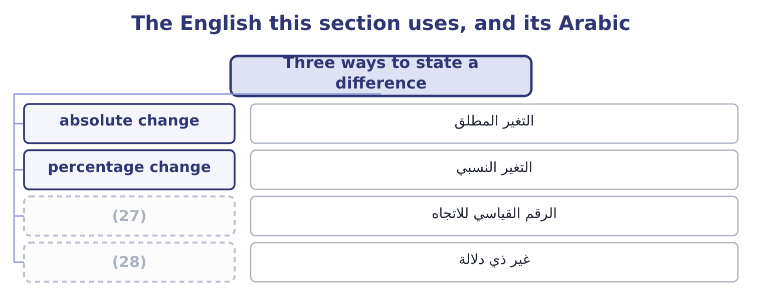
word list
absolute change · not meaningful · trend index

The English this sheet uses, and its Arabic
English (exam term) | Arabic
absolute change | التغير المطلق
percentage change | التغير النسبي
trend index | الرقم القياسي للاتجاه
not meaningful | غير ذي دلالة

Answer key · 3.1 Three ways to state a difference

1 Horizontal analysis of the income statement | 15 meaningless
2 What horizontal analysis cannot do | 16 meaningful
3 honest | 17 Is the movement big enough to matter?
4 currency | 18 Comparing lines of different size
5 dollars | 19 Later ÷ base, × 100
6 matters | 20 horizontal
7 whether | 21 mislead
8 divided | 22 infinite
9 movements | 23 one-tenth
10 expresses | 24 securities
11 against | 25 anything
12 divides | 26 discipline
13 average | 27 trend index
14 Subtract | 28 not meaningful

the summaries in full
Summary 1 Take one line and two years. There are three honest ways to say how it moved, and the exam uses all three. The absolute change is the later amount minus the earlier one, in currency. Orontes's cash rose by 7,302,100 − 2,100,000 = 5,202,100 dollars. This is the figure that matters when you are asking whether the movement is large enough to care about. The percentage change is the absolute change divided by the earlier amount. For cash that is 5,202,100 ÷ 2,100,000 = 247.7 per cent. This is the figure that lets you compare movements in lines of very different size. The trend index sets the base year to 100 and expresses every later year against it. Cash at the end of 2025 is 7,302,100 ÷ 2,100,000 = 347.7 on a 2024 base of 100. The index and the percentage change say the same thing: an index of 347.7 is a rise of 247.7 per cent.
Summary 2 Percentage change divides by the earlier amount, not the later one and not the average. An index of 347.7 means a rise of 247.7 per cent. Subtract 100 to get the change. A percentage change cannot be calculated when the earlier amount is zero, and it is meaningless when the earlier amount is negative. Say "not meaningful" rather than inventing a figure.
Summary 3 A large percentage on a small line is the commonest way for horizontal analysis to mislead. Orontes's assets held for sale went from nothing to $46,000, which is an infinite percentage rise on a line that is one-tenth of one per cent of the company. Trading securities rose 5.0 per cent, on $40,000. Neither tells you anything. The discipline is to read the absolute change and the percentage change together, and the exam sets questions that punish reading only one.

3.2 Horizontal analysis of the balance sheet
Chapter 3 · section 3.2

Fill every gap. Each word list holds one word more than there are gaps.
Read it with the common-size column: the two answer different questions about the same statement.
Orontes Foods, Inc. — horizontal analysis of the balance sheet, 2025 against 2024
Line | 2025 | 2024 | Change | Per cent
Cash | 7,302,100 | 2,100,000 | 5,202,100 | 247.7
(1) | 42,000 | 40,000 | 2,000 | 5.0
Accounts receivable, net | 4,144,000 | 3,760,000 | 384,000 | 10.2
Inventory | 2,450,000 | 2,300,000 | 150,000 | 6.5
Prepaid expenses | 204,000 | 180,000 | 24,000 | 13.3
Total current assets | 14,188,100 | 8,380,000 | 5,808,100 | 69.3
(2) | 1,807,000 | 500,000 | 1,307,000 | 261.4
(3) | 14,802,000 | 16,000,000 | (1,198,000) | (7.5)
Goodwill | 300,000 | 950,000 | (650,000) | (68.4)
TOTAL ASSETS | 31,672,600 | 26,445,000 | 5,227,600 | 19.8
(4) | 2,050,000 | 1,900,000 | 150,000 | 7.9
(5) | 900,000 | 850,000 | 50,000 | 5.9
(6) | 4,280,000 | 3,570,000 | 710,000 | 19.9
Long-term debt, less current portion | 6,000,000 | 5,600,000 | 400,000 | 7.1
Total liabilities | 11,279,625 | 10,070,000 | 1,209,625 | 12.0
Common stock, $1 par | 8,100,000 | 8,000,000 | 100,000 | 1.3
Additional paid-in capital | 5,400,000 | 4,000,000 | 1,400,000 | 35.0
Retained earnings | 6,894,100 | 4,375,000 | 2,519,100 | 57.6
Total stockholders' equity | 20,392,975 | 16,375,000 | 4,017,975 | 24.5

word list
Total current liabilities · Accounts payable · Property, plant and equipment, net · Total current assets · Equity-method investments · Trading securities · Accrued liabilities

Summary 1 gaps 7–18
The company grew by 19.8 per cent in a year, and the (7) column says where the (8) came from and where it went. It came from three places. (9) generated cash: retained earnings rose by $2,519,100, which is net (10) of $2,969,100 less the (11) declared. (12) put money: common stock and additional paid-in capital together rose by $1,500,000. And the bank lent a (13) more: long-term debt rose by $400,000. It went into two places. Cash, by far: $5,202,100 of the $5,227,600 (14) in total assets is cash. And an (15) : the equity-method holding rose by $1,307,000, which was the (16) of the stake in Jordan Glass Co. Plant fell by $1,198,000, which is the year's (17) of $2,100,000 less the $3,000,000 of new equipment, less the (18) amount of what was sold.
word list
purchase · Operations · horizontal · investment · little · income · carrying · depreciation · Owners · growth · increase · additional · dividends

Summary 2 gaps 19–24
Goodwill fell by $650,000 because of the (19) . (20) in the percentage column is as (21) as the two (22) entries read together. Total assets rose 19.8 per cent; total liabilities rose 12.0 per cent; equity rose 24.5 per cent. The company grew and (23) less reliant on (24) at the same time, which is what the common-size column showed from the other side when liabilities fell from 38.1 to 35.6 per cent of assets.
word list
impairment · largest · Nothing · borrowing · depreciation · became · instructive

Worked example: one line, three statements

Summary 3 gaps 25–31
Accounts receivable, net: 4,144,000 − 3,760,000 = 384,000. The company is owed $384,000 more than a year ago. Receivables grew by about a tenth. Total assets grew 19.8 per cent, so receivables grew more (25) than the company. That is why the common-size column showed receivables (26) from 14.2 per cent of assets to 13.1 per cent. Three (27) , one fact: receivables rose in (28) , rose by a tenth, and fell as a share of the company. All three are true, and a (29) who has only one of them can be (30) by any of the (31) .
word list
reader · numbers · slowly · rounding · dollars · others · misled · falling

Complete the horizontal columns

Fill in the absolute change and the percentage change, rounding the percentage to one decimal.
Your turn: the horizontal columns (complete the blanks)
Every item belongs to exactly one group.
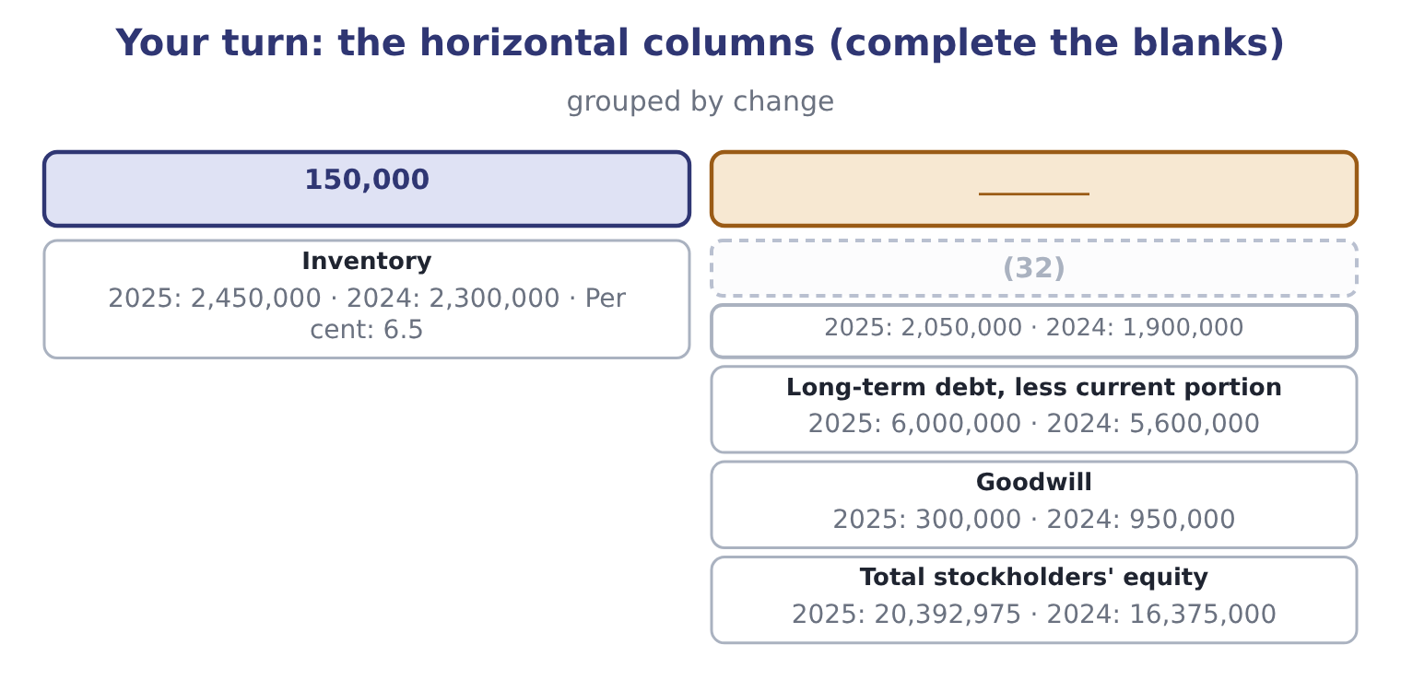
word list
Accounts payable · accounting change

The English this section uses, and its Arabic
Each term sits against what it means.
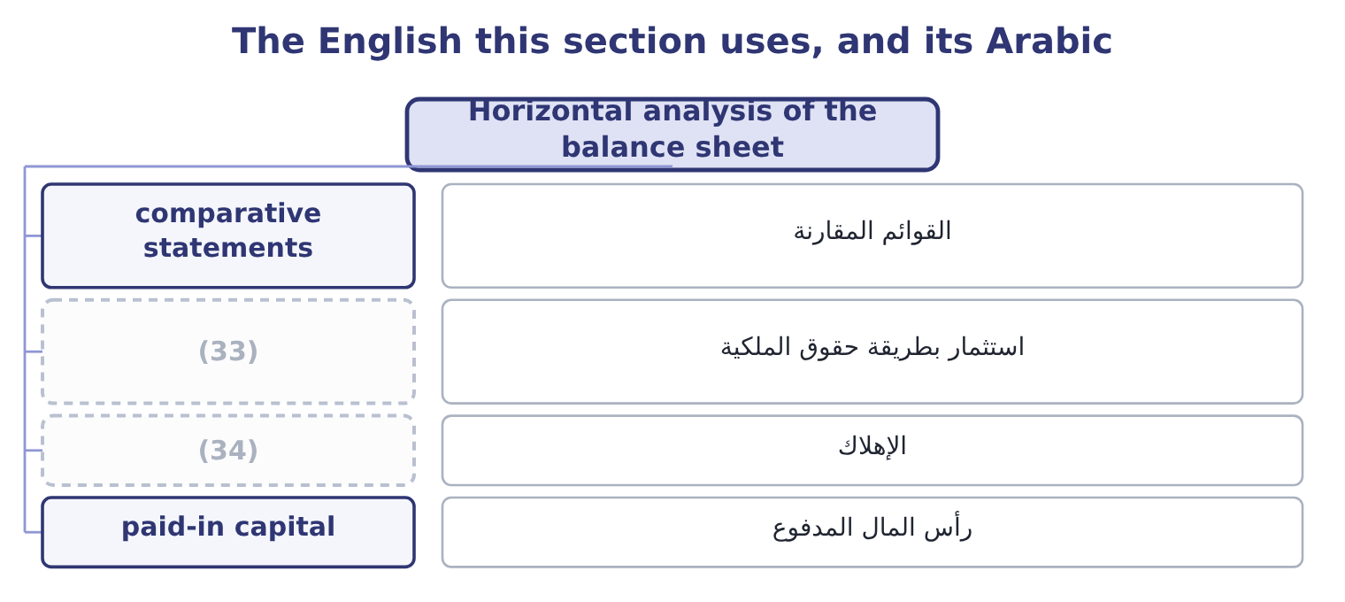
word list
non-recurring item · equity-method investment · depreciation

The English this sheet uses, and its Arabic
English (exam term) | Arabic
comparative statements | القوائم المقارنة
equity-method investment | استثمار بطريقة حقوق الملكية
depreciation | الإهلاك
paid-in capital | رأس المال المدفوع

Answer key · 3.2 Horizontal analysis of the balance sheet

1 Trading securities | 18 carrying
2 Equity-method investments | 19 impairment
3 Property, plant and equipment, net | 20 Nothing
4 Accounts payable | 21 instructive
5 Accrued liabilities | 22 largest
6 Total current liabilities | 23 became
7 horizontal | 24 borrowing
8 growth | 25 slowly
9 Operations | 26 falling
10 income | 27 numbers
11 dividends | 28 dollars
12 Owners | 29 reader
13 little | 30 misled
14 increase | 31 others
15 investment | 32 Accounts payable
16 purchase | 33 equity-method investment
17 depreciation | 34 depreciation

the summaries in full
Summary 1 The company grew by 19.8 per cent in a year, and the horizontal column says where the growth came from and where it went. It came from three places. Operations generated cash: retained earnings rose by $2,519,100, which is net income of $2,969,100 less the dividends declared. Owners put money: common stock and additional paid-in capital together rose by $1,500,000. And the bank lent a little more: long-term debt rose by $400,000. It went into two places. Cash, by far: $5,202,100 of the $5,227,600 increase in total assets is cash. And an investment: the equity-method holding rose by $1,307,000, which was the purchase of the stake in Jordan Glass Co. Plant fell by $1,198,000, which is the year's depreciation of $2,100,000 less the $3,000,000 of new equipment, less the carrying amount of what was sold.
Summary 2 Goodwill fell by $650,000 because of the impairment. Nothing in the percentage column is as instructive as the two largest entries read together. Total assets rose 19.8 per cent; total liabilities rose 12.0 per cent; equity rose 24.5 per cent. The company grew and became less reliant on borrowing at the same time, which is what the common-size column showed from the other side when liabilities fell from 38.1 to 35.6 per cent of assets.
Summary 3 Accounts receivable, net: 4,144,000 − 3,760,000 = 384,000. The company is owed $384,000 more than a year ago. Receivables grew by about a tenth. Total assets grew 19.8 per cent, so receivables grew more slowly than the company. That is why the common-size column showed receivables falling from 14.2 per cent of assets to 13.1 per cent. Three numbers, one fact: receivables rose in dollars, rose by a tenth, and fell as a share of the company. All three are true, and a reader who has only one of them can be misled by any of the others.

3.3 Horizontal analysis of the income statement
Chapter 3 · section 3.3

Fill every gap. Each word list holds one word more than there are gaps.
Summary 1 gaps 1–2
A balance sheet comes with one (1) . An income statement is (2) shown for three years, and three years is the minimum from which an analyst will read a direction.
word list
comparative · comparability · usually

Orontes Foods, Inc. — income statement, three years (whole USD)
Line | 2025 | 2024 | 2023
Net sales | 42,000,000 | 36,400,000 | 32,000,000
(3) | (27,300,000) | (23,296,000) | (20,160,000)
Gross profit | 14,700,000 | 13,104,000 | 11,840,000
(4) | (10,524,000) | (9,100,000) | (8,320,000)
(5) | 4,176,000 | 4,004,000 | 3,520,000
Net income | 2,969,100 | 2,598,000 | 2,320,000

word list
Operating income · Net income · Total operating expenses · Cost of goods sold

Orontes Foods, Inc. — income statement trends
Line | 2024 change | 2025 change | Index 2023 = 100, at 2025
Net sales | 13.8 | 15.4 | 131.2
Cost of goods sold | 15.6 | 17.2 | 135.4
(6) | 10.7 | 12.2 | 124.2
Total operating expenses | 9.4 | 15.6 | 126.5
(7) | 13.8 | 4.3 | 118.6
(8) | 12.0 | 14.3 | 128.0

word list
Operating income · Gross profit · Net income · absolute change

Summary 2 gaps 9–13
Now the statement (9) . Sales grew 13.8 per cent and then 15.4 per cent: a company (10) . But cost of goods sold grew faster in both years, 15.6 and then 17.2 per cent, so gross profit grew more slowly than sales. That is the whole story of the common-size margin falling from 37.0 per cent in 2023 to 36.0 and then 35.0 per cent. Operating income grew 13.8 per cent in 2024 and only 4.3 per cent in 2025, far (11) than sales. The (12) is in the operating expenses, which rose 15.6 per cent in 2025 — and most of that rise is the impairment. Take the impairment out and the picture changes (13) , which is why.
word list
reason · picture · slower · accelerating · completely · speaks

Read the lines against each other

Summary 3 gaps 14–17
A cost growing faster than sales means a falling margin, every time. You do not need the common-size statement to see it. A (14) growing more slowly than the line above it means (15) between them grew faster. When one year (16) a trend, find the line that broke it before (17) the trend.
word list
something · breaks · explaining · subtotal · analyst

"Trend" and "tendency"

Summary 4 gaps 18–21
English trend means the direction of a (18) over time, and it carries no (19) : a trend can be bad. What English does not allow is using trend of a single (20) between two (21) . Two numbers give a change; three or more give a trend.
word list
series · movement · points · something · judgment

The English this section uses, and its Arabic
Each term sits against what it means.
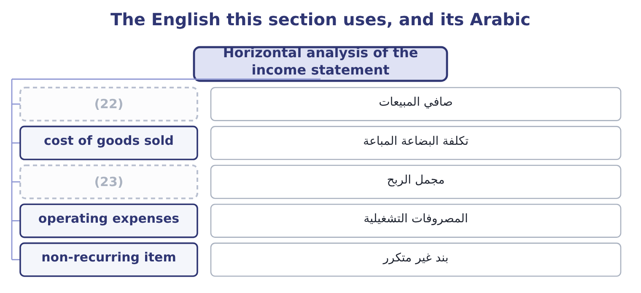
word list
net sales · non-recurring item · gross profit

The English this sheet uses, and its Arabic
English (exam term) | Arabic
net sales | صافي المبيعات
cost of goods sold | تكلفة البضاعة المباعة
gross profit | مجمل الربح
operating expenses | المصروفات التشغيلية
non-recurring item | بند غير متكرر

Answer key · 3.3 Horizontal analysis of the income statement

1 comparative | 13 completely
2 usually | 14 subtotal
3 Cost of goods sold | 15 something
4 Total operating expenses | 16 breaks
5 Operating income | 17 explaining
6 Gross profit | 18 series
7 Operating income | 19 judgment
8 Net income | 20 movement
9 speaks | 21 points
10 accelerating | 22 net sales
11 slower | 23 gross profit
12 reason

the summaries in full
Summary 1 A balance sheet comes with one comparative. An income statement is usually shown for three years, and three years is the minimum from which an analyst will read a direction.
Summary 2 Now the statement speaks. Sales grew 13.8 per cent and then 15.4 per cent: a company accelerating. But cost of goods sold grew faster in both years, 15.6 and then 17.2 per cent, so gross profit grew more slowly than sales. That is the whole story of the common-size margin falling from 37.0 per cent in 2023 to 36.0 and then 35.0 per cent. Operating income grew 13.8 per cent in 2024 and only 4.3 per cent in 2025, far slower than sales. The reason is in the operating expenses, which rose 15.6 per cent in 2025 — and most of that rise is the impairment. Take the impairment out and the picture changes completely, which is why.
Summary 3 A cost growing faster than sales means a falling margin, every time. You do not need the common-size statement to see it. A subtotal growing more slowly than the line above it means something between them grew faster. When one year breaks a trend, find the line that broke it before explaining the trend.
Summary 4 English trend means the direction of a series over time, and it carries no judgment: a trend can be bad. What English does not allow is using trend of a single movement between two points. Two numbers give a change; three or more give a trend.

3.4 Choosing the base year
Chapter 3 · section 3.4

Fill every gap. Each word list holds one word more than there are gaps.
Summary 1 gaps 1–12
The index depends (1) on which year is set to 100, and the choice is not (2) . A base year should be (3) . If the base year was a year of strike, flood, (4) or impairment, every later index is measured against a (5) figure and every later year looks better or worse than it is. Had Orontes used 2025 as its base, the impairment would sit in the (6) and the next three years of operating income would all show handsome growth for no reason (7) to trading. A base year should be far enough back to show a cycle and close enough to be (8) . Three to five years is the usual range. Ten years back the business may be a (9) business; one year back there is no trend to. A base year must be restated when the company (10) . If a prior year is restated for a change in (11) principle or for an error, the index must use the restated figure, or the series mixes two (12) bases.
word list
question · connected · entirely · measurement · denominator · different · restates · acquisition · comparable · distorted · neutral · accounting · normal

Orontes operating income on two different bases
Name each line from how it moves.
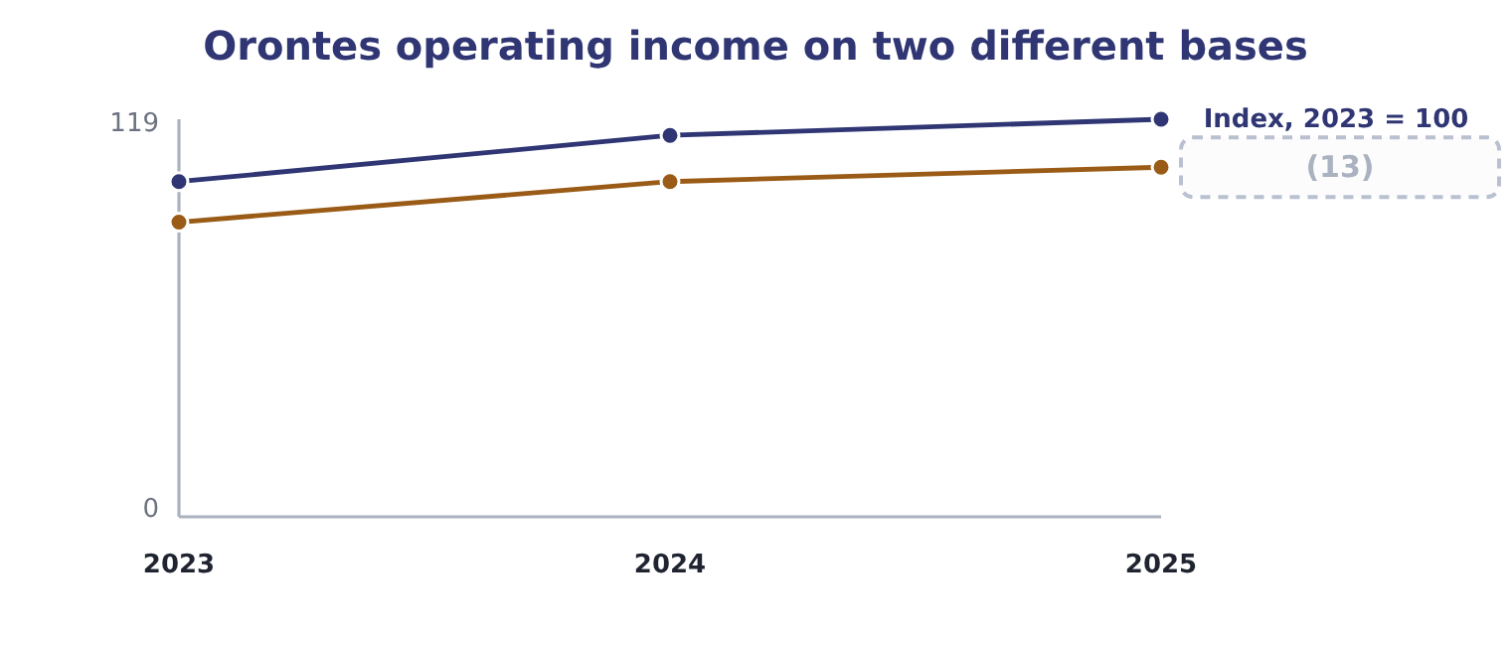
word list
cost of goods sold · Index, 2024 = 100

Summary 2 gaps 14–17
Both (14) are correct and (15) is a trick. The first says operating income is up 18.6 per cent over two years; the (16) says it is up 4.3 per cent over one. An (17) states the base with the index, every time, because an index without its base is not a number.
word list
correct · analyst · second · columns · neither

State the base

Summary 3 gaps 18–21
An index means (18) without its base year, and an exam answer that gives one without the other is (19) . If a (20) changes the base, every index in the series changes. A base year with an unusual event in it (21) the whole series; say so rather than reading the trend.
word list
distorts · nothing · operating · incomplete · question

The English this section uses, and its Arabic
Each term sits against what it means.
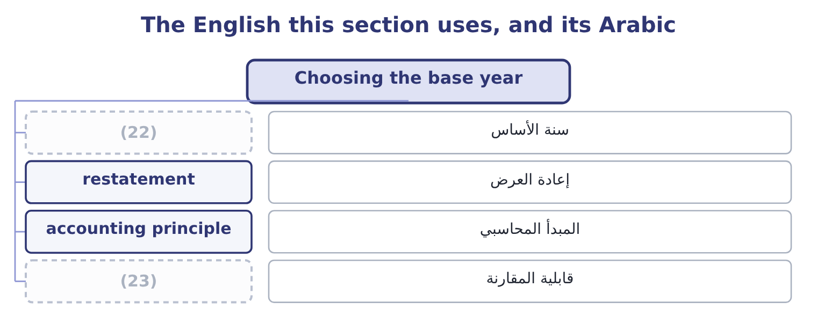
word list
net sales · base year · comparability

The English this sheet uses, and its Arabic
English (exam term) | Arabic
base year | سنة الأساس
restatement | إعادة العرض
accounting principle | المبدأ المحاسبي
comparability | قابلية المقارنة

Answer key · 3.4 Choosing the base year

1 entirely | 13 Index, 2024 = 100
2 neutral | 14 columns
3 normal | 15 neither
4 acquisition | 16 second
5 distorted | 17 analyst
6 denominator | 18 nothing
7 connected | 19 incomplete
8 comparable | 20 question
9 different | 21 distorts
10 restates | 22 base year
11 accounting | 23 comparability
12 measurement

the summaries in full
Summary 1 The index depends entirely on which year is set to 100, and the choice is not neutral. A base year should be normal. If the base year was a year of strike, flood, acquisition or impairment, every later index is measured against a distorted figure and every later year looks better or worse than it is. Had Orontes used 2025 as its base, the impairment would sit in the denominator and the next three years of operating income would all show handsome growth for no reason connected to trading. A base year should be far enough back to show a cycle and close enough to be comparable. Three to five years is the usual range. Ten years back the business may be a different business; one year back there is no trend to. A base year must be restated when the company restates. If a prior year is restated for a change in accounting principle or for an error, the index must use the restated figure, or the series mixes two measurement bases.
Summary 2 Both columns are correct and neither is a trick. The first says operating income is up 18.6 per cent over two years; the second says it is up 4.3 per cent over one. An analyst states the base with the index, every time, because an index without its base is not a number.
Summary 3 An index means nothing without its base year, and an exam answer that gives one without the other is incomplete. If a question changes the base, every index in the series changes. A base year with an unusual event in it distorts the whole series; say so rather than reading the trend.

3.5 What horizontal analysis cannot do
Chapter 3 · section 3.5

Fill every gap. Each word list holds one word more than there are gaps.
Summary 1 gaps 1–12
Horizontal (1) compares a company with itself, and that is both its (2) and its limit. It cannot tell you whether the level is right. (3) sales grew 15.4 per cent. Whether that is good (4) on whether the market grew 5 per cent or 30 per cent, and the (5) do not say. It cannot (6) price from volume. A 15.4 per cent rise in sales may be 15.4 per cent more jars, or the same jars at a 15.4 per cent (7) price, or any (8) . It cannot (9) a change of accounting. If the company moved from FIFO to LIFO during the series, the cost of goods sold line is (10) two ways and the percentage change across the break is not a change in the (11) . And it cannot cope with a negative or zero base. A company whose operating income moved from a loss of $500,000 to a profit of $500,000 has no meaningful percentage change: the (12) gives −200 per cent, which says nothing. Write "not meaningful" and give the absolute change.
word list
statements · higher · percentage · strength · survive · arithmetic · separate · analysis · combination · depends · business · Orontes's · measured

Four things a horizontal column will not tell you
Limit | The question it raises | Where it is answered
The level may still be wrong | (13) | Industry data, Chapter 1
Price and volume are mixed | Did we sell more, or charge more? | (14)
An accounting change breaks the series | (15) | Chapter 18
A zero or negative base | (16) | Report the absolute change instead

word list
Long-term debt, less current portion · How did the market move? · Chapter 4, and Chapter 18 on inflation · Is this the same measurement? · What does a percentage mean here?

Item — Answer
Item | Answer
Accounts payable | (17) : 150,000 ÷ 1,900,000.
Long-term debt, less current portion | 400,000 and 7.1 per cent: 400,000 ÷ 5,600,000.
Goodwill | (650,000) and (68.4) per cent: 650,000 ÷ 950,000, shown as a fall.
Total stockholders' equity | (18) : 4,017,975 ÷ 16,375,000.

word list
150,000 and 7.9 per cent · 4,017,975 and 24.5 per cent · A zero or negative base

The English this section uses, and its Arabic
Each term sits against what it means.
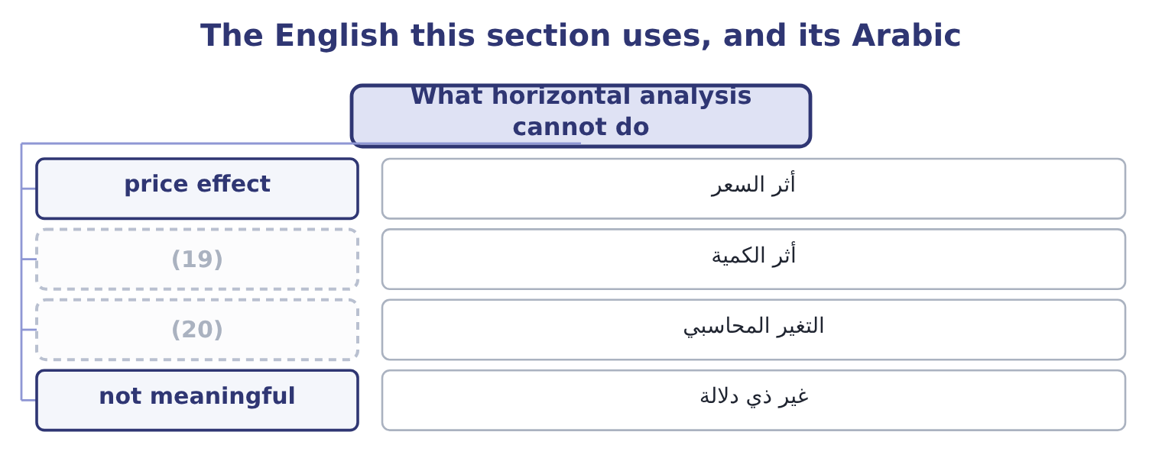
word list
volume effect · accounting change · year-over-year change

The English this sheet uses, and its Arabic
English (exam term) | Arabic
price effect | أثر السعر
volume effect | أثر الكمية
accounting change | التغير المحاسبي
not meaningful | غير ذي دلالة

Answer key · 3.5 What horizontal analysis cannot do

1 analysis | 11 business
2 strength | 12 arithmetic
3 Orontes's | 13 How did the market move?
4 depends | 14 Chapter 4, and Chapter 18 on inflation
5 statements | 15 Is this the same measurement?
6 separate | 16 What does a percentage mean here?
7 higher | 17 150,000 and 7.9 per cent
8 combination | 18 4,017,975 and 24.5 per cent
9 survive | 19 volume effect
10 measured | 20 accounting change

the summaries in full
Summary 1 Horizontal analysis compares a company with itself, and that is both its strength and its limit. It cannot tell you whether the level is right. Orontes's sales grew 15.4 per cent. Whether that is good depends on whether the market grew 5 per cent or 30 per cent, and the statements do not say. It cannot separate price from volume. A 15.4 per cent rise in sales may be 15.4 per cent more jars, or the same jars at a 15.4 per cent higher price, or any combination. It cannot survive a change of accounting. If the company moved from FIFO to LIFO during the series, the cost of goods sold line is measured two ways and the percentage change across the break is not a change in the business. And it cannot cope with a negative or zero base. A company whose operating income moved from a loss of $500,000 to a profit of $500,000 has no meaningful percentage change: the arithmetic gives −200 per cent, which says nothing. Write "not meaningful" and give the absolute change.

