4.1 The growth rate of a line
Chapter 4 · section 4.1

Fill every gap. Each word list holds one word more than there are gaps.
Chapter 4, section by section
Each stage leads to the next.
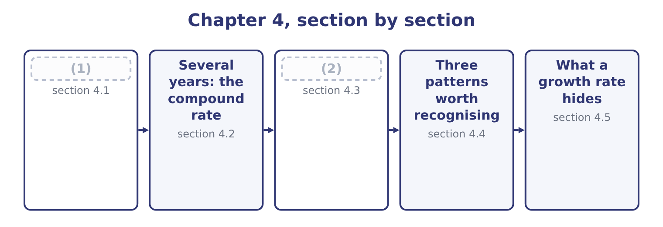
word list
margin squeeze · Variation analysis · The growth rate of a line

Summary 1 gaps 3–7
The growth rate of a line item for one (3) is the change (4) by the opening amount. Orontes's net sales went from $36,400,000 to $42,000,000. The growth rate is 5,600,000 ÷ 36,400,000 = 15.4 per cent. The year (5) , sales went from $32,000,000 to $36,400,000, a growth rate of 4,400,000 ÷ 32,000,000 = 13.8 per cent. Every line has a growth rate, and the exam asks for them on the balance sheet as (6) as on the income (7) .
word list
before · readily · divided · period · statement · translation

Orontes Foods, Inc. — growth rates of selected lines
Every item belongs to exactly one group.
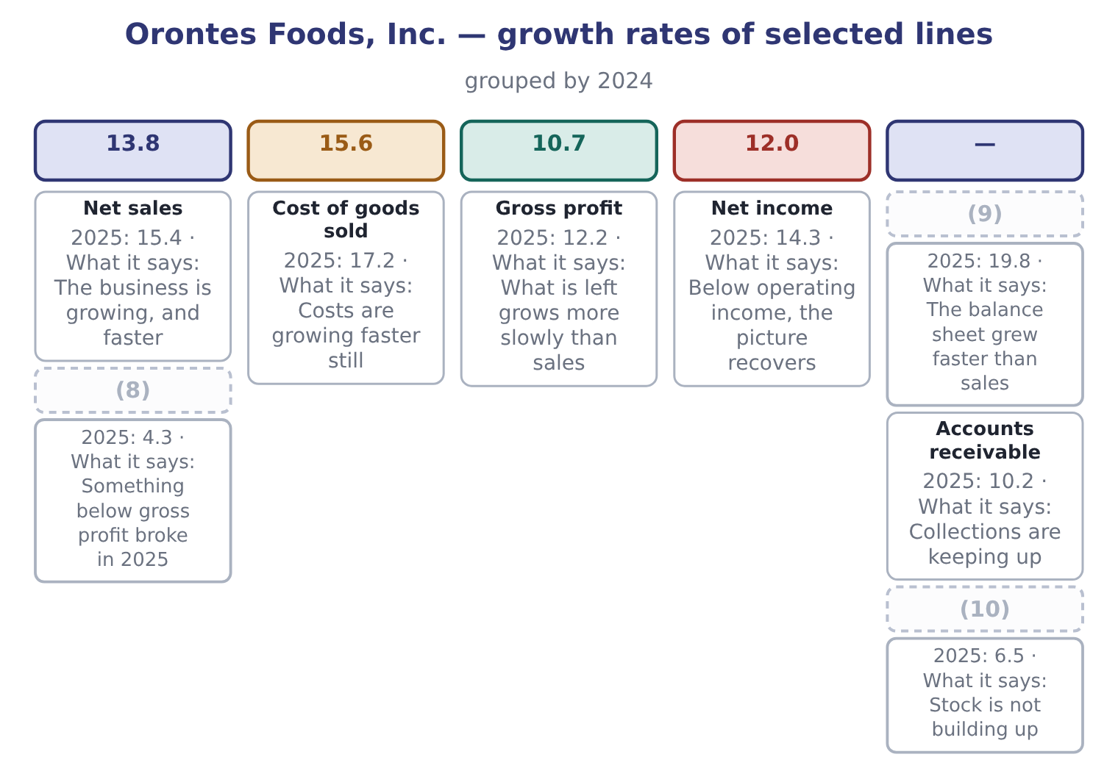
word list
Inventory · Net sales · Total assets · Operating income

Summary 2 gaps 11–18
Two (11) come straight off that figure, and (12) needs another (13) . Total assets grew 19.8 per cent while sales grew 15.4 per cent. A company whose balance sheet grows faster than its sales is using more assets to (14) each dollar of (15) . Here the cause is known: it is the cash. Net income grew faster than operating income. That is (16) , and it happens (17) the lines below operating income — interest, the (18) share of Jordan Glass, and the tax charge — moved in Orontes's favour.
word list
calculation · revenue · equity-method · because · readings · operating · neither · unusual · produce

Growth of a line against growth of its base

Summary 3 gaps 19–22
A line growing faster than sales is a line becoming a larger share of sales. A (19) line growing faster than total assets is a line becoming a larger share of the company. A growth rate on a small line can be huge and still not (20) . (21) ask what the (22) amount is.
word list
absolute · balance-sheet · matter · Always · readily

The English this section uses, and its Arabic
Each term sits against what it means.
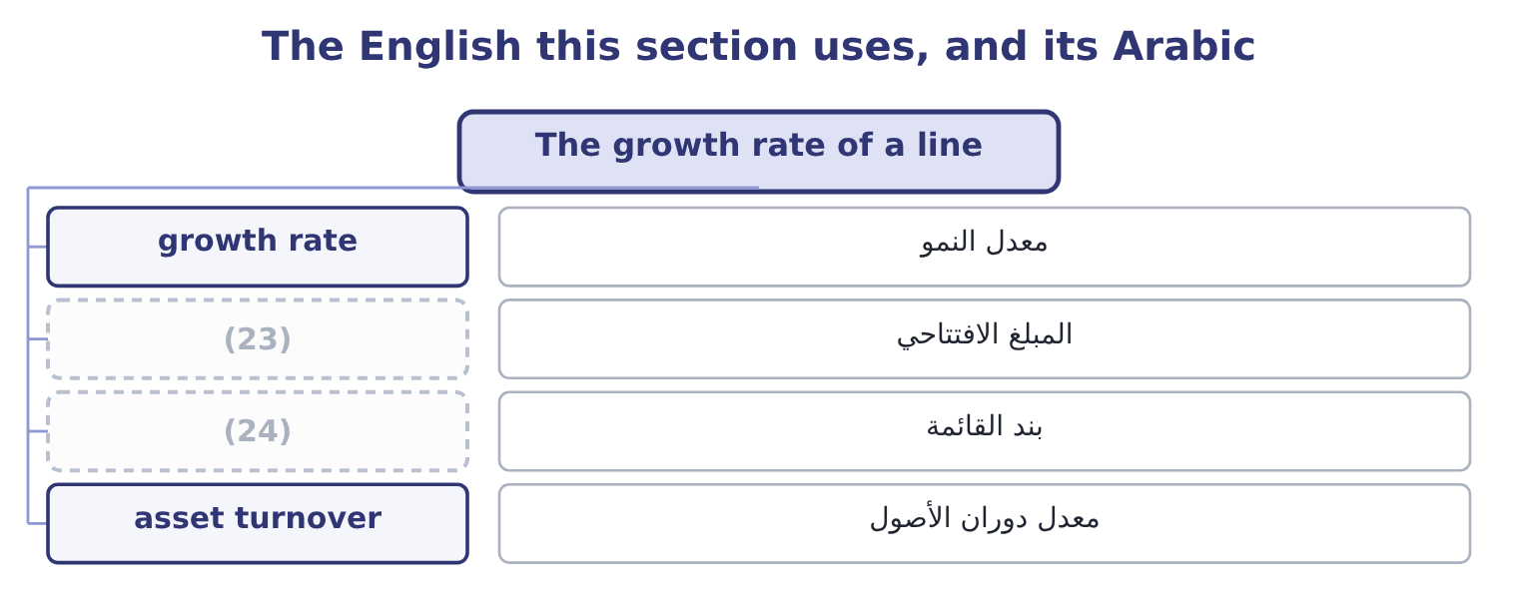
word list
opening amount · line item · arithmetic mean

The English this sheet uses, and its Arabic
English (exam term) | Arabic
growth rate | معدل النمو
opening amount | المبلغ الافتتاحي
line item | بند القائمة
asset turnover | معدل دوران الأصول

Answer key · 4.1 The growth rate of a line

1 The growth rate of a line | 13 calculation
2 Variation analysis | 14 produce
3 period | 15 revenue
4 divided | 16 unusual
5 before | 17 because
6 readily | 18 equity-method
7 statement | 19 balance-sheet
8 Operating income | 20 matter
9 Total assets | 21 Always
10 Inventory | 22 absolute
11 readings | 23 opening amount
12 neither | 24 line item

the summaries in full
Summary 1 The growth rate of a line item for one period is the change divided by the opening amount. Orontes's net sales went from $36,400,000 to $42,000,000. The growth rate is 5,600,000 ÷ 36,400,000 = 15.4 per cent. The year before, sales went from $32,000,000 to $36,400,000, a growth rate of 4,400,000 ÷ 32,000,000 = 13.8 per cent. Every line has a growth rate, and the exam asks for them on the balance sheet as readily as on the income statement.
Summary 2 Two readings come straight off that figure, and neither needs another calculation. Total assets grew 19.8 per cent while sales grew 15.4 per cent. A company whose balance sheet grows faster than its sales is using more assets to produce each dollar of revenue. Here the cause is known: it is the cash. Net income grew faster than operating income. That is unusual, and it happens because the lines below operating income — interest, the equity-method share of Jordan Glass, and the tax charge — moved in Orontes's favour.
Summary 3 A line growing faster than sales is a line becoming a larger share of sales. A balance-sheet line growing faster than total assets is a line becoming a larger share of the company. A growth rate on a small line can be huge and still not matter. Always ask what the absolute amount is.

4.2 Several years: the compound rate
Chapter 4 · section 4.2

Fill every gap. Each word list holds one word more than there are gaps.
Summary 1 gaps 1–10
Two annual rates of 13.8 and 15.4 per cent do not average to one rate by adding them and (1) . That is the commonest (2) error in this part of the (3) , and the exam tests it (4) . The reason is that growth compounds. A line that grows 13.8 per cent and then 15.4 per cent has not grown 29.2 per cent, and it has not grown at 14.6 per cent a year in the sense that the simple average (5) . It has grown by a factor of 1.138 × 1.154, and the rate that (6) the same result in two equal steps is the square root of that factor. The (7) is the compound annual growth rate, (8) written CAGR. CAGR = ( (9) value ÷ beginning value) (10) to the power of 1 ÷ n, minus 1.
word list
suggests · Orontes · usually · arithmetical · directly · syllabus · ending · halving · raised · measure · produces

Worked example: the CAGR of Orontes sales

Summary 2 gaps 11–15
The beginning and the end. Sales in 2023 were $32,000,000 and in 2025 were $42,000,000. There are two periods (11) them, not three: 2023 to 2024, and 2024 to 2025. Sales are 1.3125 times what they were. The rate per (12) . The square root of 1.3125 is 1.1456, so the CAGR is 14.56 per cent. Grow 32,000,000 by 14.56 per cent twice: 32,000,000 × 1.1456 = 36,659,200, and 36,659,200 × 1.1456 = 41,996,780, which is 42,000,000 to the nearest (13) . The simple average of 13.8 and 15.4 is 14.6 per cent, close here (14) the two rates are close; the two (15) sharply when the rates are far apart or when one is negative.
word list
period · because · rounding · diverge · between · directly

Two companies, the same simple average, different results
The bars are drawn to scale.
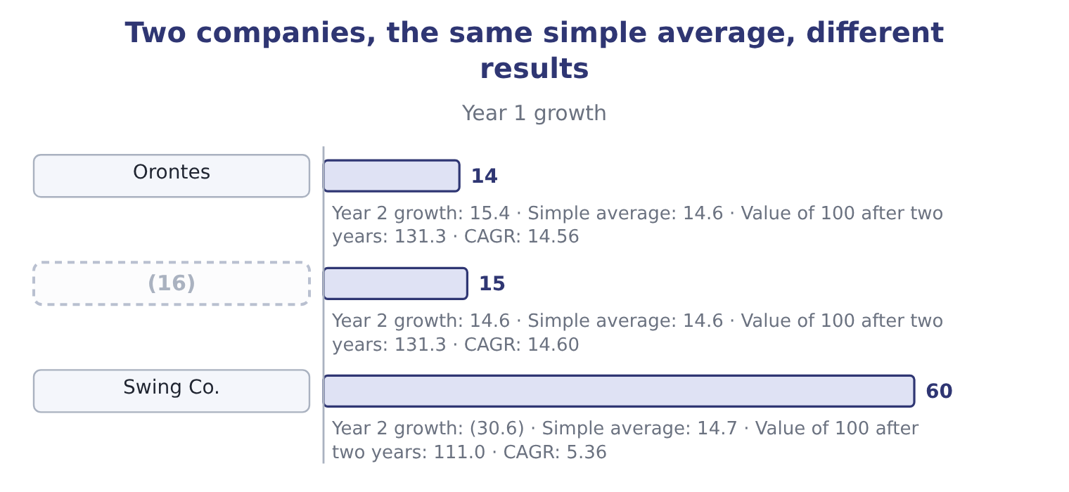
word list
Steady Co. · Swing Co.

Summary 3 gaps 17–19
Swing Co. shows the point. Its simple average is (17) higher than (18) , and $100 invested in it is worth $111.00 after two years (19) $131.30 in Orontes. The simple average of a series of growth rates is not the growth of the series.
word list
Orontes's · figures · slightly · against

Counting the periods

Summary 4 gaps 20–24
The (20) is 1 divided by the number of PERIODS, not the number of data points. Three annual (21) give two periods. A CAGR (22) a smooth path that the company did not actually follow. It is a (23) , not a history. A CAGR cannot be (24) when the beginning value is zero or negative, for the same reason a percentage change cannot.
word list
figures · exponent · summary · describes · calculated · history

"Compound" in English

Summary 5 gaps 25–28
English compound as a verb means to build on itself: (25) compounds, growth compounds. Do not (26) it with English compound as a noun, (27) a mixture, or with a compound journal entry, which is one entry with several lines. The exam uses all three (28) in Part 1 and Part 2.
word list
meaning · interest · written · confuse · senses

The English this section uses, and its Arabic
Each term sits against what it means.
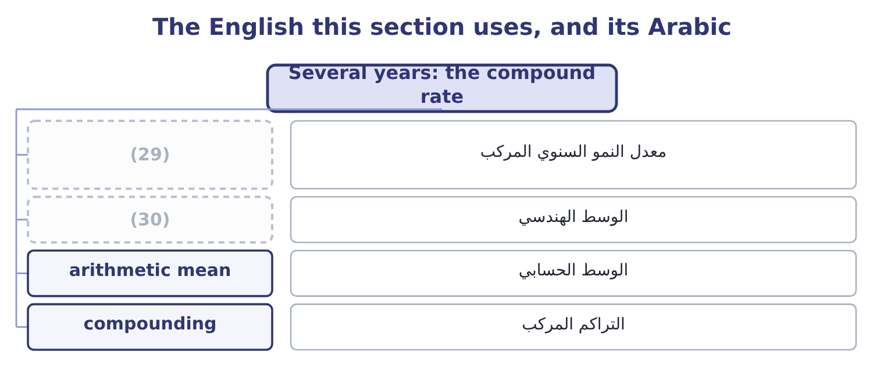
word list
margin squeeze · geometric mean · compound annual growth rate

The English this sheet uses, and its Arabic
English (exam term) | Arabic
compound annual growth rate | معدل النمو السنوي المركب
geometric mean | الوسط الهندسي
arithmetic mean | الوسط الحسابي
compounding | التراكم المركب

Answer key · 4.2 Several years: the compound rate

1 halving | 16 Steady Co.
2 arithmetical | 17 slightly
3 syllabus | 18 Orontes's
4 directly | 19 against
5 suggests | 20 exponent
6 produces | 21 figures
7 measure | 22 describes
8 usually | 23 summary
9 ending | 24 calculated
10 raised | 25 interest
11 between | 26 confuse
12 period | 27 meaning
13 rounding | 28 senses
14 because | 29 compound annual growth rate
15 diverge | 30 geometric mean

the summaries in full
Summary 1 Two annual rates of 13.8 and 15.4 per cent do not average to one rate by adding them and halving. That is the commonest arithmetical error in this part of the syllabus, and the exam tests it directly. The reason is that growth compounds. A line that grows 13.8 per cent and then 15.4 per cent has not grown 29.2 per cent, and it has not grown at 14.6 per cent a year in the sense that the simple average suggests. It has grown by a factor of 1.138 × 1.154, and the rate that produces the same result in two equal steps is the square root of that factor. The measure is the compound annual growth rate, usually written CAGR. CAGR = (ending value ÷ beginning value) raised to the power of 1 ÷ n, minus 1.
Summary 2 The beginning and the end. Sales in 2023 were $32,000,000 and in 2025 were $42,000,000. There are two periods between them, not three: 2023 to 2024, and 2024 to 2025. Sales are 1.3125 times what they were. The rate per period. The square root of 1.3125 is 1.1456, so the CAGR is 14.56 per cent. Grow 32,000,000 by 14.56 per cent twice: 32,000,000 × 1.1456 = 36,659,200, and 36,659,200 × 1.1456 = 41,996,780, which is 42,000,000 to the nearest rounding. The simple average of 13.8 and 15.4 is 14.6 per cent, close here because the two rates are close; the two diverge sharply when the rates are far apart or when one is negative.
Summary 3 Swing Co. shows the point. Its simple average is slightly higher than Orontes's, and $100 invested in it is worth $111.00 after two years against $131.30 in Orontes. The simple average of a series of growth rates is not the growth of the series.
Summary 4 The exponent is 1 divided by the number of PERIODS, not the number of data points. Three annual figures give two periods. A CAGR describes a smooth path that the company did not actually follow. It is a summary, not a history. A CAGR cannot be calculated when the beginning value is zero or negative, for the same reason a percentage change cannot.
Summary 5 English compound as a verb means to build on itself: interest compounds, growth compounds. Do not confuse it with English compound as a noun, meaning a mixture, or with a compound journal entry, which is one entry with several lines. The exam uses all three senses in Part 1 and Part 2.

4.3 Variation analysis
Chapter 4 · section 4.3

Fill every gap. Each word list holds one word more than there are gaps.
Summary 1 gaps 1–12
Variation analysis is the name the (1) Outcome Statements give to the calculation and (2) of percentage change over time. It is the technique of, used (3) on a chosen set of lines rather than on the whole statement. The (4) has three steps, and the third is the one (5) skip. First, (6) the lines. Not every line: the ones that drive the (7) . For a (8) they are usually sales, cost of goods sold, the main operating expenses, inventory, (9) and payables. Second, (10) the variation. The percentage change, year by year, and the (11) rate over the (12) . Third, explain each variation that is out of line with the others. A variation that matches the rest of the statement needs no explanation; a variation that does not is the finding.
word list
Learning · matches · manufacturer · method · receivables · compute · candidates · compound · deliberately · series · choose · business · interpretation

Orontes Foods, Inc. — variation analysis, 2023 to 2025
Line | 2023 | 2025 | Variation over two years | CAGR
Net sales | 32,000,000 | 42,000,000 | 31.2 per cent | 14.56
Cost of goods sold | 20,160,000 | 27,300,000 | 35.4 per cent | 16.38
Gross profit | 11,840,000 | 14,700,000 | (13) | 11.43
Total operating expenses | 8,320,000 | 10,524,000 | 26.5 per cent | 12.48
Operating income | 3,520,000 | 4,176,000 | (14) | 8.91
Net income | 2,320,000 | 2,969,100 | 28.0 per cent | 13.14

word list
24.2 per cent · 26.5 per cent · 18.6 per cent

Summary 2 gaps 15–24
Three (15) fall out of the third step. Cost of goods sold is out of line, and it is the (16) finding of the book so far. It grew at 16.38 per cent against sales at 14.56 per cent. (17) else on the income statement is (18) . Operating income is out of line in the other (19) , growing at 8.91 per cent, (20) than gross profit. The operating expenses grew (21) than gross profit, and the (22) is most of why. Net income is out of line with operating income, growing at 13.14 per cent against 8.91. Below the operating line, (23) is helping. An analyst would now go and find it rather than (24) anything.
word list
findings · impairment · direction · expenses · conclude · consequence · slower · faster · something · central · Everything

Worked example: explaining one variation

Summary 3 gaps 25–36
Find the line that is out of step. Over 2023 to 2025 sales grew 31.2 per cent and cost of goods sold grew 35.4 per cent. Every other line on the income statement is (25) of those two. Had cost of goods sold grown at the same 31.2 per cent as sales, it would be 20,160,000 × 1.312 = 26,449,920 (26) of 27,300,000. The (27) is 27,300,000 − 26,449,920 = 850,080 of cost that (28) alone does not (29) for. Say what it is worth. That $850,080 is gross profit (30) did not earn, on an (31) gross profit of $14,700,000. It is about 5.8 per cent of the gross profit the company made, and it is the whole of the margin (32) from 37.0 per cent to 35.0 per cent. The two statements agree. The (33) column said the margin fell two points; the variation analysis says the same fall is worth $850,080 at this (34) volume. A (35) asked to act needs the second figure, (36) two percentage points is not a sum of money and $850,080 is.
word list
common-size · growth · Orontes · manager · because · decline · growing · downstream · difference · account · year's · instead · actual

The English this section uses, and its Arabic
Each term sits against what it means.
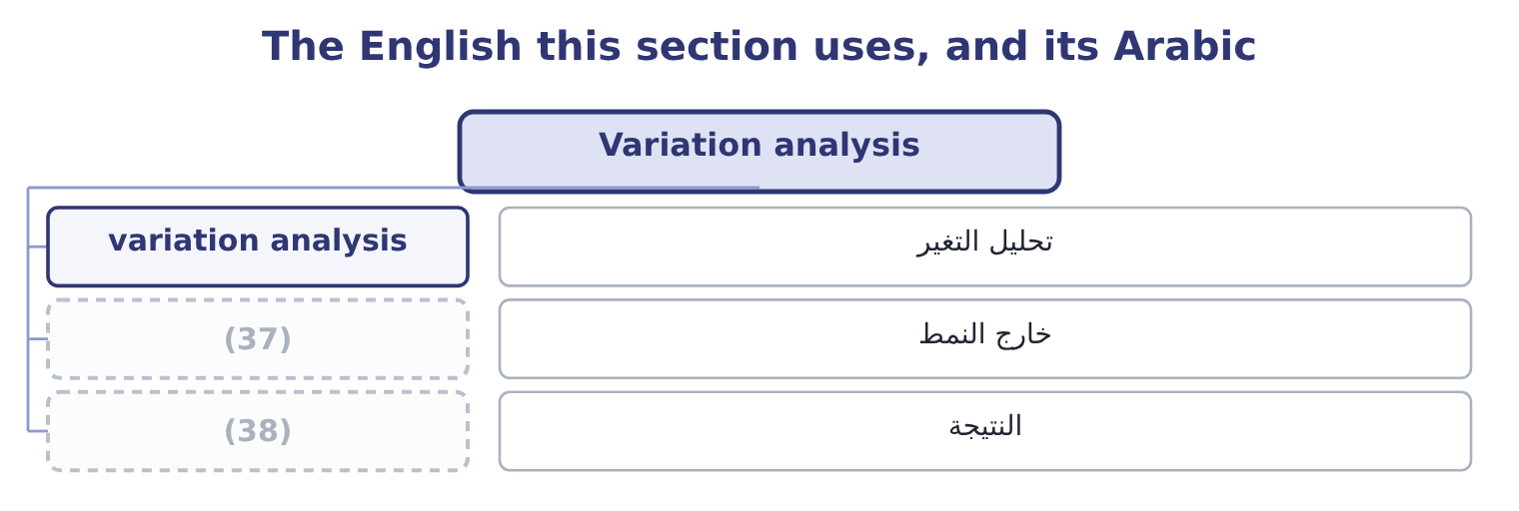
word list
driver · finding · out of line

Answer key · 4.3 Variation analysis

1 Learning | 20 slower
2 interpretation | 21 faster
3 deliberately | 22 impairment
4 method | 23 something
5 candidates | 24 conclude
6 choose | 25 downstream
7 business | 26 instead
8 manufacturer | 27 difference
9 receivables | 28 growth
10 compute | 29 account
11 compound | 30 Orontes
12 series | 31 actual
13 24.2 per cent | 32 decline
14 18.6 per cent | 33 common-size
15 findings | 34 year's
16 central | 35 manager
17 Everything | 36 because
18 consequence | 37 out of line
19 direction | 38 finding

the summaries in full
Summary 1 Variation analysis is the name the Learning Outcome Statements give to the calculation and interpretation of percentage change over time. It is the technique of, used deliberately on a chosen set of lines rather than on the whole statement. The method has three steps, and the third is the one candidates skip. First, choose the lines. Not every line: the ones that drive the business. For a manufacturer they are usually sales, cost of goods sold, the main operating expenses, inventory, receivables and payables. Second, compute the variation. The percentage change, year by year, and the compound rate over the series. Third, explain each variation that is out of line with the others. A variation that matches the rest of the statement needs no explanation; a variation that does not is the finding.
Summary 2 Three findings fall out of the third step. Cost of goods sold is out of line, and it is the central finding of the book so far. It grew at 16.38 per cent against sales at 14.56 per cent. Everything else on the income statement is consequence. Operating income is out of line in the other direction, growing at 8.91 per cent, slower than gross profit. The operating expenses grew faster than gross profit, and the impairment is most of why. Net income is out of line with operating income, growing at 13.14 per cent against 8.91. Below the operating line, something is helping. An analyst would now go and find it rather than conclude anything.
Summary 3 Find the line that is out of step. Over 2023 to 2025 sales grew 31.2 per cent and cost of goods sold grew 35.4 per cent. Every other line on the income statement is downstream of those two. Had cost of goods sold grown at the same 31.2 per cent as sales, it would be 20,160,000 × 1.312 = 26,449,920 instead of 27,300,000. The difference is 27,300,000 − 26,449,920 = 850,080 of cost that growth alone does not account for. Say what it is worth. That $850,080 is gross profit Orontes did not earn, on an actual gross profit of $14,700,000. It is about 5.8 per cent of the gross profit the company made, and it is the whole of the margin decline from 37.0 per cent to 35.0 per cent. The two statements agree. The common-size column said the margin fell two points; the variation analysis says the same fall is worth $850,080 at this year's volume. A manager asked to act needs the second figure, because two percentage points is not a sum of money and $850,080 is.

4.4 Three patterns worth recognising
Chapter 4 · section 4.4

Fill every gap. Each word list holds one word more than there are gaps.
Summary 1 gaps 1–12
Most variation (1) end in one of three (2) , and naming them saves time. The margin squeeze is Orontes's pattern: sales growing, a cost line growing faster, and every (3) below it growing more (4) than sales. The cause is upstream — purchase prices, product mix, (5) — and the remedy is a pricing or sourcing decision, not a (6) one. The working-capital leak is (7) pattern: sales growing (8) while receivables and inventory grow sharply. The income (9) looks adequate and the cash does not (10) . The cause is (11) of the sale, in collection and in stock. The one-off distortion is the pattern of Orontes's operating income in 2025: a single line (12) so far that it breaks the series on its own. The test is whether removing it restores the pattern. Take out the impairment of $2,724,000 and operating income grows 15.4 per cent in 2025 rather than 4.3, which is sales growth exactly; the series was never broken, one line was.
word list
analyses · moving · discounting · patterns · cost-cutting · statement · arrive · modestly · slowly · purchase · subtotal · downstream · Barada's

Three patterns a variation analysis ends in
Pattern | What the figures look like | Where the cause is | What settles it
Margin squeeze | Sales grow; a cost line grows faster | Pricing, mix or sourcing | (13)
Working-capital leak | Sales grow a little; receivables and inventory grow a lot | Collection and stockholding | (14)
One-off distortion | One line breaks the series alone | (15) | Does removing it restore the pattern?

word list
A single event · Total stockholders' equity · Days outstanding and days in inventory · The gross margin, year by year

Your turn: variation analysis of the balance sheet (complete the blanks)
Line | 2024 | 2025 | Variation
Total current assets | 8,380,000 | 14,188,100 | 69.3 per cent
Total current liabilities | 3,570,000 | 4,280,000 | (16) : 710,000 ÷ 3,570,000.
Total liabilities | 10,070,000 | 11,279,625 | (17) : 1,209,625 ÷ 10,070,000.
Total stockholders' equity | 16,375,000 | 20,392,975 | 24.5 per cent: 4,017,975 ÷ 16,375,000.
TOTAL ASSETS | 26,445,000 | 31,672,600 | (18) : 5,227,600 ÷ 26,445,000.

word list
19.8 per cent · 12.0 per cent · A single event · 19.9 per cent

The English this section uses, and its Arabic
Each term sits against what it means.
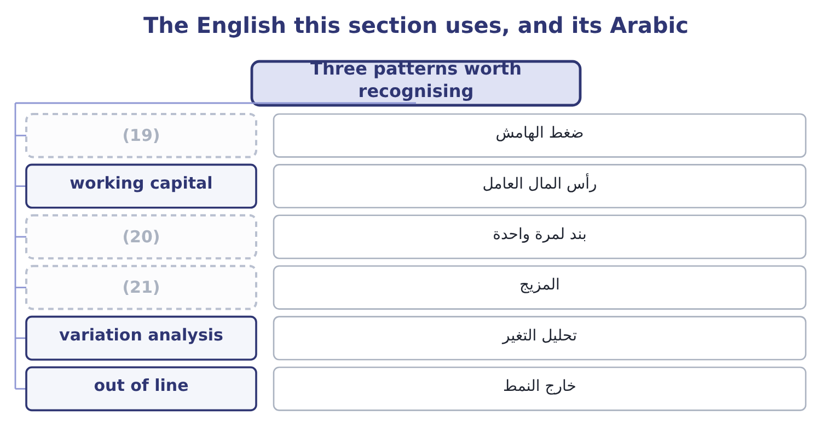
word list
nominal · one-off item · mix · margin squeeze

The English this sheet uses, and its Arabic
English (exam term) | Arabic
margin squeeze | ضغط الهامش
working capital | رأس المال العامل
one-off item | بند لمرة واحدة
mix | المزيج
variation analysis | تحليل التغير
out of line | خارج النمط
driver | المحرك
finding | النتيجة

Answer key · 4.4 Three patterns worth recognising

1 analyses | 12 moving
2 patterns | 13 The gross margin, year by year
3 subtotal | 14 Days outstanding and days in inventory
4 slowly | 15 A single event
5 discounting | 16 19.9 per cent
6 cost-cutting | 17 12.0 per cent
7 Barada's | 18 19.8 per cent
8 modestly | 19 margin squeeze
9 statement | 20 one-off item
10 arrive | 21 mix
11 downstream

the summaries in full
Summary 1 Most variation analyses end in one of three patterns, and naming them saves time. The margin squeeze is Orontes's pattern: sales growing, a cost line growing faster, and every subtotal below it growing more slowly than sales. The cause is upstream — purchase prices, product mix, discounting — and the remedy is a pricing or sourcing decision, not a cost-cutting one. The working-capital leak is Barada's pattern: sales growing modestly while receivables and inventory grow sharply. The income statement looks adequate and the cash does not arrive. The cause is downstream of the sale, in collection and in stock. The one-off distortion is the pattern of Orontes's operating income in 2025: a single line moving so far that it breaks the series on its own. The test is whether removing it restores the pattern. Take out the impairment of $2,724,000 and operating income grows 15.4 per cent in 2025 rather than 4.3, which is sales growth exactly; the series was never broken, one line was.

4.5 What a growth rate hides
Chapter 4 · section 4.5

Fill every gap. Each word list holds one word more than there are gaps.
Summary 1 gaps 1–12
A growth rate is one number (1) for a year of (2) , and four things (3) inside it. Sales grew 15.4 per cent. That is more jars, or (4) jars, or both. Nothing in the (5) statements (6) them, and the two have opposite (7) : more jars at the same price means the business is winning customers; the same jars at a higher price may mean only that costs were passed on. An (8) looks for unit data in the MD&A or the segment note. Acquisition and organic growth. A company that buys (9) company grows. Orontes's (10) investment in Jordan Glass rose by $1,307,000, and if that had been a controlling stake the (11) sales would have jumped without a single extra jar being sold. Growth that comes from buying is called (12) , and growth from the existing business is organic.
word list
financial · analyst · inorganic · separates · standing · trading · consolidated · dearer · implications · disappear · another · equity-method · improved

Summary 2 gaps 13–18
The exam expects the (13) . A company (14) into the Gulf and the Levant (15) in dollars. If a (16) currency weakens, the same local sales (17) into fewer dollars and the growth rate falls with no change in the business. A (18) rise in prices lifts every money figure. In a year of 10 per cent inflation, growth of 15.4 per cent is about 5 per cent in real terms.
word list
usually · translate · distinction · general · customer's · reports · selling

Four things a growth rate does not separate
What is hidden | The question to ask | Where to look
Price against volume | Did we sell more, or charge more? | (19)
Organic against acquired | (20) | Acquisitions note, cash flow statement
Currency | Would the rate be the same in local currency? | (21)
Inflation | What is the real rate? | (22)

word list
A price index, Chapter 18 · What is the real rate? · Segment note, Chapter 18 · Did the existing business grow? · MD&A, segment note, unit data

Real against nominal

Summary 3 gaps 23–25
A growth rate from the statements is (23) : it includes inflation. A real growth rate (24) inflation. If a question gives you an inflation rate, it (25) wants the real figure. Growth from an acquisition is not evidence that the business improved.
word list
usually · expects · subtracts · nominal

The English this section uses, and its Arabic
Each term sits against what it means.
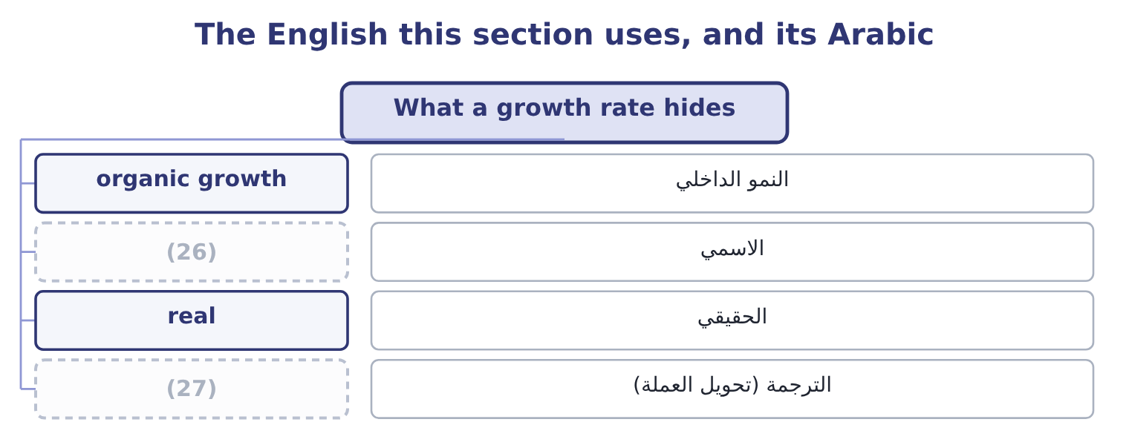
word list
translation · finding · nominal

The English this sheet uses, and its Arabic
English (exam term) | Arabic
organic growth | النمو الداخلي
nominal | الاسمي
real | الحقيقي
translation | الترجمة (تحويل العملة)

Answer key · 4.5 What a growth rate hides

1 standing | 15 reports
2 trading | 16 customer's
3 disappear | 17 translate
4 dearer | 18 general
5 financial | 19 MD&A, segment note, unit data
6 separates | 20 Did the existing business grow?
7 implications | 21 Segment note, Chapter 18
8 analyst | 22 A price index, Chapter 18
9 another | 23 nominal
10 equity-method | 24 subtracts
11 consolidated | 25 usually
12 inorganic | 26 nominal
13 distinction | 27 translation
14 selling

the summaries in full
Summary 1 A growth rate is one number standing for a year of trading, and four things disappear inside it. Sales grew 15.4 per cent. That is more jars, or dearer jars, or both. Nothing in the financial statements separates them, and the two have opposite implications: more jars at the same price means the business is winning customers; the same jars at a higher price may mean only that costs were passed on. An analyst looks for unit data in the MD&A or the segment note. Acquisition and organic growth. A company that buys another company grows. Orontes's equity-method investment in Jordan Glass rose by $1,307,000, and if that had been a controlling stake the consolidated sales would have jumped without a single extra jar being sold. Growth that comes from buying is called inorganic, and growth from the existing business is organic.
Summary 2 The exam expects the distinction. A company selling into the Gulf and the Levant reports in dollars. If a customer's currency weakens, the same local sales translate into fewer dollars and the growth rate falls with no change in the business. A general rise in prices lifts every money figure. In a year of 10 per cent inflation, growth of 15.4 per cent is about 5 per cent in real terms.
Summary 3 A growth rate from the statements is nominal: it includes inflation. A real growth rate subtracts inflation. If a question gives you an inflation rate, it usually wants the real figure. Growth from an acquisition is not evidence that the business improved.

