5.1 From a number to a finding
Chapter 5 · section 5.1

Fill every gap. Each word list holds one word more than there are gaps.
Chapter 5, section by section
Each stage leads to the next.
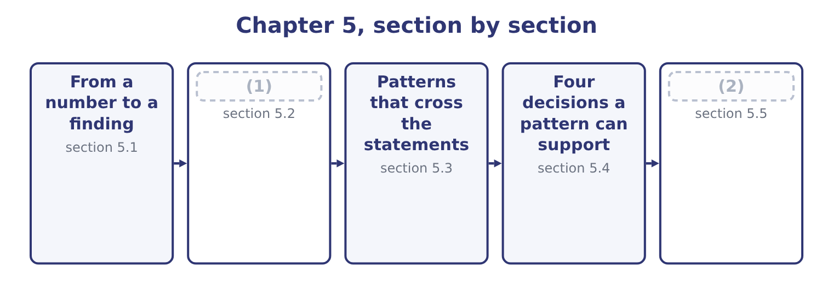
word list
free cash flow · The pattern in the cash · Writing it down

Summary 1 gaps 3–14
A finding has four parts, and an (3) that leaves one out is (4) . It names the movement. Not "costs rose" but "cost of goods sold rose from 63.0 to 65.0 per cent of sales over two years". It sizes the movement in money. Two percentage (5) of a $42,000,000 sales base is $840,000 a year. A (6) cannot act on a percentage; he can act on a sum. It is (7) by a second figure. One (8) can be an error, a (9) or an accident of (10) . A finding stands when two (11) figures point the same way. It names where the cause must be. Not the cause itself — the statements rarely give that — but the part of the (12) in which the cause must lie. A falling gross margin is upstream of the factory gate: purchase prices, product mix, or (13) . It is not in selling and (14) , because those sit below gross profit.
word list
corroborated · reclassification · incomplete · evidence · administration · answer · timing · points · independent · business · number · discounting · manager

One finding, in four parts
Part | For Orontes
The movement | Cost of goods sold rose from 63.0 to 65.0 per cent of net sales, 2023 to 2025
Its size | About $840,000 a year at 2025 sales; $850,080 (15) against sales growth
The corroboration | Gross profit grew at 11.43 per cent against sales at 14.56 per cent over the same period
Where the cause must be | Above gross profit: purchase prices, product mix, or selling price

word list
measured · corroboration

A finding, not a calculation

Summary 2 gaps 16–20
An exam (16) that asks you to " (17) " wants the movement, its size, and what it (18) — not the percentage alone. Corroboration means a second figure that is not (19) derived from the first. Gross margin and cost of goods sold percentage are the same fact twice. Never name a cause the statements do not (20) . Name the place the cause must be.
word list
implies · support · manager · analyse · question · arithmetically

The English this section uses, and its Arabic
Each term sits against what it means.
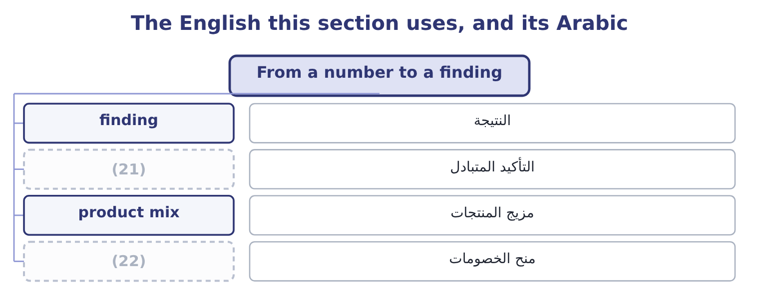
word list
discounting · finding · corroboration

The English this sheet uses, and its Arabic
English (exam term) | Arabic
finding | النتيجة
corroboration | التأكيد المتبادل
product mix | مزيج المنتجات
discounting | منح الخصومات

Answer key · 5.1 From a number to a finding

1 The pattern in the cash | 12 business
2 Writing it down | 13 discounting
3 answer | 14 administration
4 incomplete | 15 measured
5 points | 16 question
6 manager | 17 analyse
7 corroborated | 18 implies
8 number | 19 arithmetically
9 reclassification | 20 support
10 timing | 21 corroboration
11 independent | 22 discounting

the summaries in full
Summary 1 A finding has four parts, and an answer that leaves one out is incomplete. It names the movement. Not "costs rose" but "cost of goods sold rose from 63.0 to 65.0 per cent of sales over two years". It sizes the movement in money. Two percentage points of a $42,000,000 sales base is $840,000 a year. A manager cannot act on a percentage; he can act on a sum. It is corroborated by a second figure. One number can be an error, a reclassification or an accident of timing. A finding stands when two independent figures point the same way. It names where the cause must be. Not the cause itself — the statements rarely give that — but the part of the business in which the cause must lie. A falling gross margin is upstream of the factory gate: purchase prices, product mix, or discounting. It is not in selling and administration, because those sit below gross profit.
Summary 2 An exam question that asks you to "analyse" wants the movement, its size, and what it implies — not the percentage alone. Corroboration means a second figure that is not arithmetically derived from the first. Gross margin and cost of goods sold percentage are the same fact twice. Never name a cause the statements do not support. Name the place the cause must be.

5.2 The pattern in the cash
Chapter 5 · section 5.2

Fill every gap. Each word list holds one word more than there are gaps.
Summary 1 gaps 1–2
The largest single movement in (1) 2025 statements is cash, which rose by $5,202,100 to become 23.1 per cent of the company. The statement of cash flows (2) it.
word list
finding · Orontes's · explains

Orontes Foods, Inc. — where the cash came from and went, 2025
Source or use | Amount | Comment
Net cash provided by operating activities | 7,531,100 | Well above net income of 2,969,100
Purchases of property, plant and equipment | (3,000,000) | Replacing and extending the plant
Investment in Jordan Glass Co. | (1,200,000) | (3)
Net cash used in investing activities | (4,179,000)
Issuance of common stock | 1,500,000 | (4)
Proceeds from bank note | 800,000
Repayment of long-term debt | (400,000)
Dividends paid | (50,000) | (5)
Net cash provided by financing activities | 1,850,000
Net increase in cash | 5,202,100

word list
Well above net income of 2,969,100 · A stake in the bottle supplier · Against 450,000 declared · New shares to existing owners

Summary 2 gaps 6–17
Now the (6) can be stated. Operating cash flow of $7,531,100 against net income of $2,969,100 is two and a half times earnings, and the gap is the non-cash charges: (7) of $2,100,000 and the (8) of $2,724,000. Those two alone are 2,100,000 + 2,724,000 = 4,824,000, which is most of the (9) . The company earned far more cash than its income statement (10) , because a large part of its reported cost this year was a (11) of assets bought years ago. Operating cash flow of $7,531,100 against capital expenditure of $3,000,000 (12) 7,531,100 − 3,000,000 = 4,531,100 of free cash flow. Orontes spent $1,200,000 of it on the Jordan Glass stake and $450,000 on dividends declared, and put most of the rest in the bank. That is the (13) . Orontes is not short of money and it is not (14) for want of an (15) : it invested in plant and in a supplier during the year, and it still finished with a quarter of its balance sheet in cash. The (16) for a manager is why it also raised $1,500,000 of new equity and $800,000 of new debt in a year when it (17) $7,531,100 from trading. A company does not normally raise money it does not need, and the reason will be in the board minutes rather than in the statements.
word list
pattern · stakeholder · leaves · difference · question · finding · depreciation · generated · write-down · hoarding · suggests · impairment · alternative

Worked example: free cash flow and what it says

Summary 3 gaps 18–24
Operating cash flow less capital expenditure: 7,531,100 − 3,000,000 = 4,531,100. Dividends declared were $450,000, so dividend cover on a cash basis is 4,531,100 ÷ 450,000 = 10.07 times. The dividend is not under (18) on any view. Total debt is the long-term portion plus the (19) portion: 6,000,000 + 400,000 = 6,400,000. One year of free cash flow would repay 4,531,100 ÷ 6,400,000 = 70.8 per cent of it. Three uses of one number, each (20) a different (21) . The (22) asks whether the dividend is safe; the (23) asks how long repayment would take; the board asks what is left to (24) .
word list
lender · statements · invest · stakeholder · shareholder · threat · answering · current

The English this section uses, and its Arabic
Each term sits against what it means.
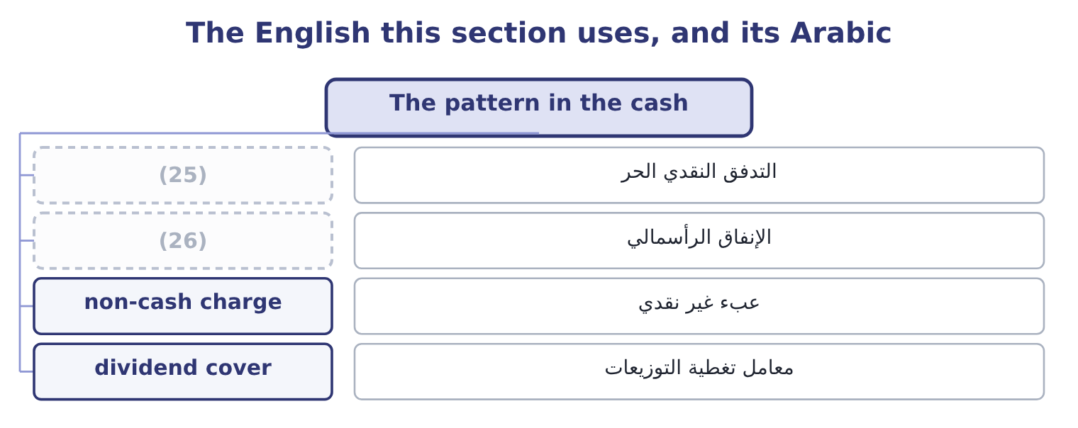
word list
written answer · capital expenditure · free cash flow

The English this sheet uses, and its Arabic
English (exam term) | Arabic
free cash flow | التدفق النقدي الحر
capital expenditure | الإنفاق الرأسمالي
non-cash charge | عبء غير نقدي
dividend cover | معامل تغطية التوزيعات

Answer key · 5.2 The pattern in the cash

1 Orontes's | 14 hoarding
2 explains | 15 alternative
3 A stake in the bottle supplier | 16 question
4 New shares to existing owners | 17 generated
5 Against 450,000 declared | 18 threat
6 pattern | 19 current
7 depreciation | 20 answering
8 impairment | 21 stakeholder
9 difference | 22 shareholder
10 suggests | 23 lender
11 write-down | 24 invest
12 leaves | 25 free cash flow
13 finding | 26 capital expenditure

the summaries in full
Summary 1 The largest single movement in Orontes's 2025 statements is cash, which rose by $5,202,100 to become 23.1 per cent of the company. The statement of cash flows explains it.
Summary 2 Now the pattern can be stated. Operating cash flow of $7,531,100 against net income of $2,969,100 is two and a half times earnings, and the gap is the non-cash charges: depreciation of $2,100,000 and the impairment of $2,724,000. Those two alone are 2,100,000 + 2,724,000 = 4,824,000, which is most of the difference. The company earned far more cash than its income statement suggests, because a large part of its reported cost this year was a write-down of assets bought years ago. Operating cash flow of $7,531,100 against capital expenditure of $3,000,000 leaves 7,531,100 − 3,000,000 = 4,531,100 of free cash flow. Orontes spent $1,200,000 of it on the Jordan Glass stake and $450,000 on dividends declared, and put most of the rest in the bank. That is the finding. Orontes is not short of money and it is not hoarding for want of an alternative: it invested in plant and in a supplier during the year, and it still finished with a quarter of its balance sheet in cash. The question for a manager is why it also raised $1,500,000 of new equity and $800,000 of new debt in a year when it generated $7,531,100 from trading. A company does not normally raise money it does not need, and the reason will be in the board minutes rather than in the statements.
Summary 3 Operating cash flow less capital expenditure: 7,531,100 − 3,000,000 = 4,531,100. Dividends declared were $450,000, so dividend cover on a cash basis is 4,531,100 ÷ 450,000 = 10.07 times. The dividend is not under threat on any view. Total debt is the long-term portion plus the current portion: 6,000,000 + 400,000 = 6,400,000. One year of free cash flow would repay 4,531,100 ÷ 6,400,000 = 70.8 per cent of it. Three uses of one number, each answering a different stakeholder. The shareholder asks whether the dividend is safe; the lender asks how long repayment would take; the board asks what is left to invest.

5.3 Patterns that cross the statements
Chapter 5 · section 5.3

Fill every gap. Each word list holds one word more than there are gaps.
Summary 1 gaps 1–2
The most (1) findings come from a movement in one statement that (2) a movement in another.
word list
trained · reliable · explains

Patterns that cross from one statement to another
On the income statement | On the balance sheet | On the cash flow statement | What it means
Sales rising | Receivables rising faster | (3) | Sales are being made on terms that are not being collected
Sales flat | Inventory rising | Operating cash flow falling | (4)
Profit rising | Payables rising sharply | (5) | Profit is being funded by suppliers, which cannot continue
Profit falling | (6) | Depreciation unchanged | Fixed costs are holding while revenue weakens
A large one-off charge | (7) | Operating cash flow unaffected | The charge is non-cash: earnings fell and cash did not

word list
Plant unchanged · Operating cash flow rising · Goods are not selling and cash is going into stock · The written-down asset smaller · Operating cash flow flat or falling · non-cash charge

Summary 2 gaps 8–15
The last row is (8) exactly. The (9) of $2,724,000 cut operating income to $4,176,000 and left operating cash flow (10) at $7,531,100, because no money moved. An analyst who read only the income statement would record a bad year; an analyst who read only the cash flow statement would record an (11) one. Both are (12) the same company. The first row is (13) , from the case. Sales up 11 per cent, receivables up 38 per cent and an (14) where there was none: a (15) pattern, and the one a credit officer is trained to.
word list
reading · untouched · excellent · impairment · classic · movement · Barada · Orontes · overdraft

Two statements beat one

Summary 3 gaps 16–20
A (16) that gives you both an income statement and a cash flow statement is usually testing whether you noticed they (17) . Profit without cash is the pattern to be (18) . Cash without profit, as here, is usually a non-cash charge and is less (19) . The balance sheet is where the difference between the two (20) .
word list
suspicious · disagree · question · alarming · accumulates · non-cash

"Quality" of earnings

Summary 4 gaps 21–22
English says earnings quality, and quality here does not mean good: it means how closely (21) profit tracks cash and how likely it is to repeat. (22) earnings may be small.
word list
High-quality · corroboration · reported

The English this section uses, and its Arabic
Each term sits against what it means.
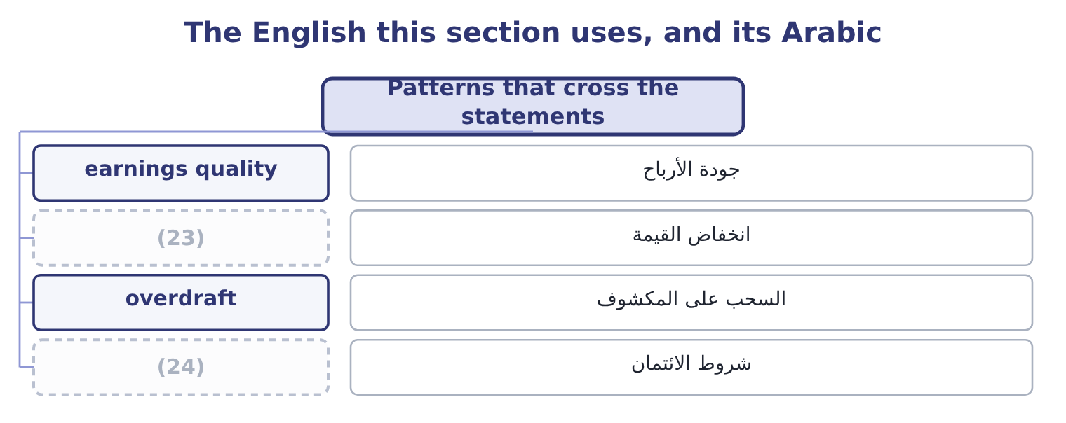
word list
non-cash charge · credit terms · impairment

The English this sheet uses, and its Arabic
English (exam term) | Arabic
earnings quality | جودة الأرباح
impairment | انخفاض القيمة
overdraft | السحب على المكشوف
credit terms | شروط الائتمان

Answer key · 5.3 Patterns that cross the statements

1 reliable | 13 Barada
2 explains | 14 overdraft
3 Operating cash flow flat or falling | 15 classic
4 Goods are not selling and cash is going into stock | 16 question
5 Operating cash flow rising | 17 disagree
6 Plant unchanged | 18 suspicious
7 The written-down asset smaller | 19 alarming
8 Orontes | 20 accumulates
9 impairment | 21 reported
10 untouched | 22 High-quality
11 excellent | 23 impairment
12 reading | 24 credit terms

the summaries in full
Summary 1 The most reliable findings come from a movement in one statement that explains a movement in another.
Summary 2 The last row is Orontes exactly. The impairment of $2,724,000 cut operating income to $4,176,000 and left operating cash flow untouched at $7,531,100, because no money moved. An analyst who read only the income statement would record a bad year; an analyst who read only the cash flow statement would record an excellent one. Both are reading the same company. The first row is Barada, from the case. Sales up 11 per cent, receivables up 38 per cent and an overdraft where there was none: a classic pattern, and the one a credit officer is trained to.
Summary 3 A question that gives you both an income statement and a cash flow statement is usually testing whether you noticed they disagree. Profit without cash is the pattern to be suspicious. Cash without profit, as here, is usually a non-cash charge and is less alarming. The balance sheet is where the difference between the two accumulates.
Summary 4 English says earnings quality, and quality here does not mean good: it means how closely reported profit tracks cash and how likely it is to repeat. High-quality earnings may be small.

5.4 Four decisions a pattern can support
Chapter 5 · section 5.4

Fill every gap. Each word list holds one word more than there are gaps.
A finding is useful when someone can act on it.
From pattern to decision
Pattern | The decision it supports | The figure it turns on
Cost of goods sold growing faster than sales | (1) | $850,080 of gross profit forgone
Cash at 23.1 per cent of assets | (2) | Free cash flow of $4,531,100
Equity at 64.4 per cent of assets | Borrow to fund the next expansion | (3)
Impairment of goodwill and a brand | Review what else was bought at a premium | (4)

word list
Reprice, change mix, or renegotiate supply · Goodwill down from 950,000 to 300,000 · Interest cover of 11.15 times · Invest it, repay debt, or return it to owners · Review what else was bought at a premium

Summary 1 gaps 5–14
Each row is a decision a board can take at its next (5) . That is the standard an exam answer is held to at Level C: not a (6) of the statements, but a (7) with a number behind it. Two (8) belong here, and the exam tests both. A pattern is (9) , not proof. The margin decline may be (10) : a company buying market share prices below its old margin on (11) . The statements cannot (12) a squeeze from a (13) , and an analyst says so. A decision has a cost the statements do not show. Returning cash to owners forgoes the next (14) . The figures bound the decision; they do not make it.
word list
strategy · recommendation · description · acquisition · meeting · evidence · purpose · distinguish · deliberate · Orontes's · cautions

Worked example: sizing a repricing decision

Summary 2 gaps 15–23
Orontes's gross margin fell from 37.0 per cent in 2023 to 35.0 per cent in 2025, a loss of two (15) points. What (16) it is worth. Two points of the 2025 sales base: 42,000,000 × 0.02 = 840,000 of (17) gross profit a year. To recover two points by price alone, Orontes must raise prices about 3.1 per cent, (18) a price rise adds to both sales and gross profit while cost of goods sold stays where it is. Whether the market (19) that is not in the statements. The (20) gives the board the size of the prize, $840,000, and the size of the price move (21) , about 3 per cent. The decision about whether (22) will pay it (23) to the people who sell to them.
word list
because · accepts · recovering · customers · analysis · needed · percentage · belongs · additional · recommendation

The English this section uses, and its Arabic
Each term sits against what it means.
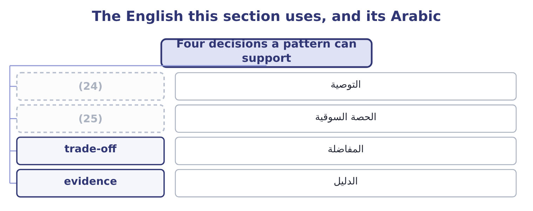
word list
root cause · recommendation · market share

The English this sheet uses, and its Arabic
English (exam term) | Arabic
recommendation | التوصية
market share | الحصة السوقية
trade-off | المفاضلة
evidence | الدليل

Answer key · 5.4 Four decisions a pattern can support

1 Reprice, change mix, or renegotiate supply | 14 acquisition
2 Invest it, repay debt, or return it to owners | 15 percentage
3 Interest cover of 11.15 times | 16 recovering
4 Goodwill down from 950,000 to 300,000 | 17 additional
5 meeting | 18 because
6 description | 19 accepts
7 recommendation | 20 analysis
8 cautions | 21 needed
9 evidence | 22 customers
10 deliberate | 23 belongs
11 purpose | 24 recommendation
12 distinguish | 25 market share
13 strategy

the summaries in full
Summary 1 Each row is a decision a board can take at its next meeting. That is the standard an exam answer is held to at Level C: not a description of the statements, but a recommendation with a number behind it. Two cautions belong here, and the exam tests both. A pattern is evidence, not proof. The margin decline may be deliberate: a company buying market share prices below its old margin on purpose. The statements cannot distinguish a squeeze from a strategy, and an analyst says so. A decision has a cost the statements do not show. Returning cash to owners forgoes the next acquisition. The figures bound the decision; they do not make it.
Summary 2 Orontes's gross margin fell from 37.0 per cent in 2023 to 35.0 per cent in 2025, a loss of two percentage points. What recovering it is worth. Two points of the 2025 sales base: 42,000,000 × 0.02 = 840,000 of additional gross profit a year. To recover two points by price alone, Orontes must raise prices about 3.1 per cent, because a price rise adds to both sales and gross profit while cost of goods sold stays where it is. Whether the market accepts that is not in the statements. The analysis gives the board the size of the prize, $840,000, and the size of the price move needed, about 3 per cent. The decision about whether customers will pay it belongs to the people who sell to them.

5.5 Writing it down
Chapter 5 · section 5.5

Fill every gap. Each word list holds one word more than there are gaps.
An analyst's output is a short piece of writing.
Build the finding

Complete the other two, for the pattern in Orontes's cash.
Your turn: complete the finding (complete the blanks)
Part | Entry
The movement | Cash rose from 7.9 to 23.1 per cent of total assets during 2025
Its size | Cash rose by $5,202,100, from $2,100,000 to $7,302,100, in a company whose total assets are $31,672,600.
The corroboration | Free cash flow of $4,531,100: operating cash flow of $7,531,100 less capital expenditure of $3,000,000. The rise is funded by trading, not b
Where the cause must be | (1) cash flow, which at 7,531,100 exceeded net income by two and a half times

word list
Operating · overdraft

Summary 1 gaps 2–6
A good (2) names the movement in its first sentence, sizes it in the second, (3) it in the third and places the cause in the fourth. That is four sentences, and four sentences is (4) enough. Candidates lose marks by describing the calculation instead of its (5) , and by naming a cause the statements do not (6) .
word list
actionable · paragraph · consequence · corroborates · support · usually

What a written answer must contain

Summary 2 gaps 7–8
The movement, with the (7) . A second figure that (8) it. Where the cause must lie, and what would settle it.
word list
supports · figures · consequence

The English this section uses, and its Arabic
Each term sits against what it means.
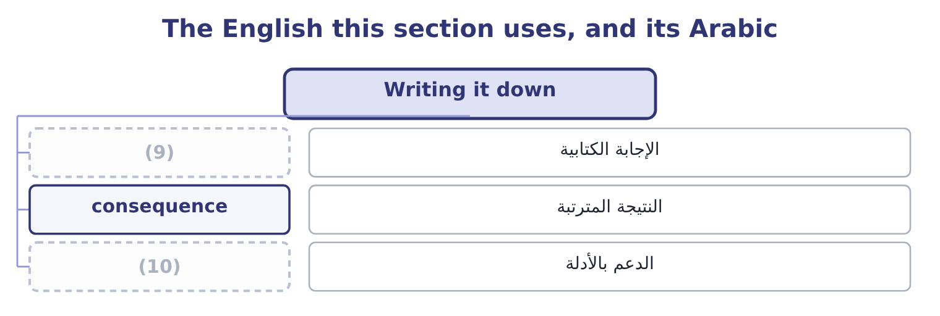
word list
capital expenditure · written answer · support

The English this sheet uses, and its Arabic
English (exam term) | Arabic
written answer | الإجابة الكتابية
consequence | النتيجة المترتبة
support | الدعم بالأدلة

Answer key · 5.5 Writing it down

1 Operating | 6 support
2 paragraph | 7 figures
3 corroborates | 8 supports
4 usually | 9 written answer
5 consequence | 10 support

the summaries in full
Summary 1 A good paragraph names the movement in its first sentence, sizes it in the second, corroborates it in the third and places the cause in the fourth. That is four sentences, and four sentences is usually enough. Candidates lose marks by describing the calculation instead of its consequence, and by naming a cause the statements do not support.
Summary 2 The movement, with the figures. A second figure that supports it. Where the cause must lie, and what would settle it.

