6.1 The five ratios
Chapter 6 · section 6.1

Fill every gap. Each word list holds one word more than there are gaps.
Chapter 6, section by section
Each stage leads to the next.
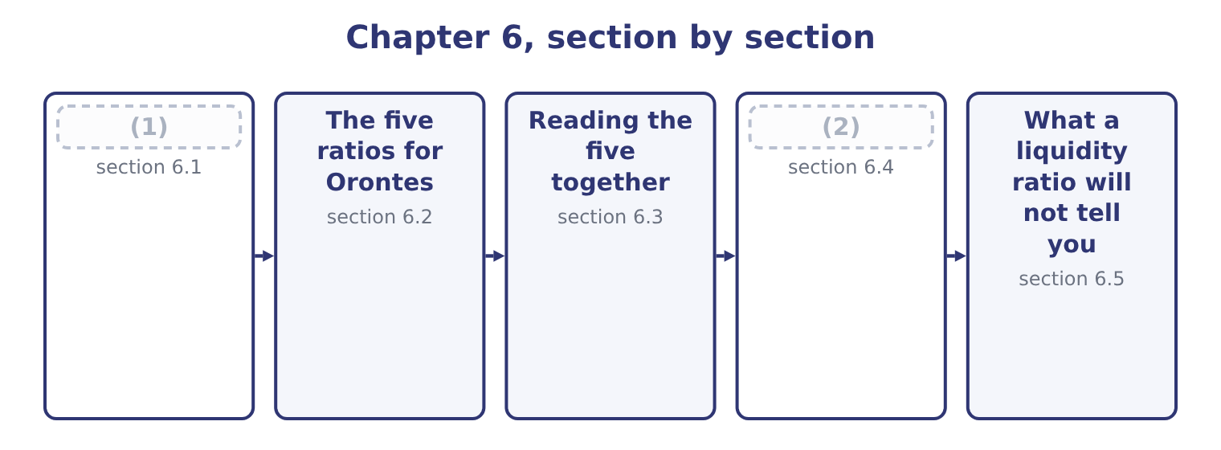
word list
Reading the five together · The five ratios · The liquidity of current liabilities

Summary 1 gaps 3–14
All five (3) something the company can pay with by something it has to pay. They differ in the (4) , and the differences are a ladder of (5) severity. The current ratio divides total current assets by total current liabilities. It (6) everything the (7) allows, including inventory that has not been sold and (8) that will never be cash at all. The quick ratio, also called the (9) ratio, removes inventory and prepaid expenses. What is left is cash, marketable securities and receivables: the assets that become cash (10) first having to be sold to a (11) . The cash ratio removes receivables too. Only cash and marketable securities count. This is the ratio for a company whose customers may not pay on time. The cash flow ratio divides (12) cash flow for the year by current liabilities at the end of it. It asks a (13) question from the other four: not what the company holds, but what it (14) .
word list
operating · prepayments · seasonal · numerator · generates · different · without · increasing · customer · divide · counts · acid-test · classification

Summary 2 gaps 15–17
The net working capital ratio divides net working capital — current assets less current liabilities — by total assets. It expresses the (15) as a share of the whole company (16) than as a multiple of the (17) .
word list
obligations · cushion · including · rather

The five liquidity ratios
Every item belongs to exactly one group.
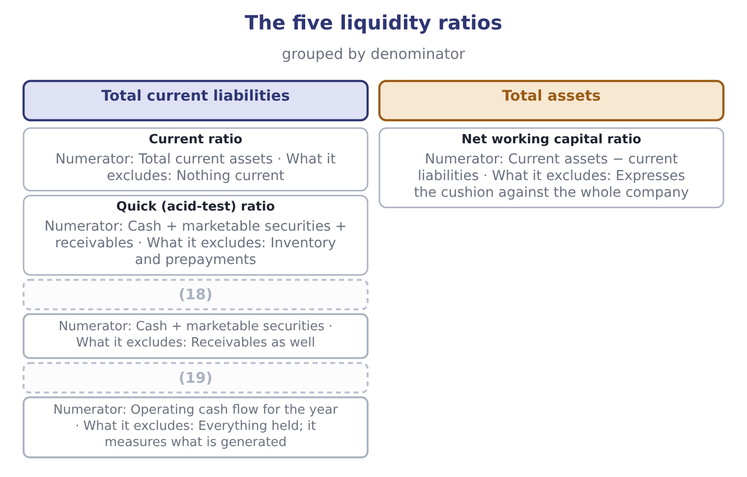
word list
Cash ratio · Cash flow ratio · interim statements

Which assets are quick?

Summary 3 gaps 20–24
Quick assets are cash, marketable securities and net receivables. Inventory is never quick, (20) fast it sells. Prepaid expenses are never quick, (21) they turn into (22) and not into cash. The cash flow ratio uses the cash flow for the YEAR (23) liabilities at a POINT. That mismatch is (24) and is how the ratio is defined.
word list
expense · divides · because · deliberate · against · however

The English this section uses, and its Arabic
Each term sits against what it means.
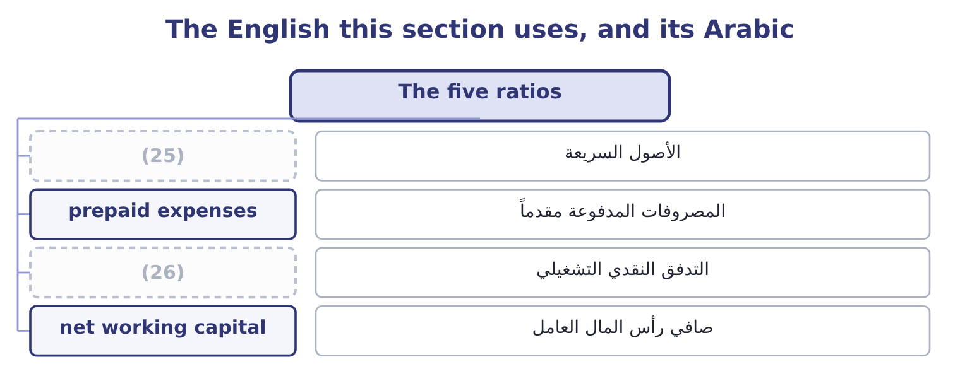
word list
operating cash flow · prepaid expenses · quick assets

The English this sheet uses, and its Arabic
English (exam term) | Arabic
quick assets | الأصول السريعة
prepaid expenses | المصروفات المدفوعة مقدماً
operating cash flow | التدفق النقدي التشغيلي
net working capital | صافي رأس المال العامل

Answer key · 6.1 The five ratios

1 The five ratios | 14 generates
2 The liquidity of current liabilities | 15 cushion
3 divide | 16 rather
4 numerator | 17 obligations
5 increasing | 18 Cash ratio
6 counts | 19 Cash flow ratio
7 classification | 20 however
8 prepayments | 21 because
9 acid-test | 22 expense
10 without | 23 against
11 customer | 24 deliberate
12 operating | 25 quick assets
13 different | 26 operating cash flow

the summaries in full
Summary 1 All five divide something the company can pay with by something it has to pay. They differ in the numerator, and the differences are a ladder of increasing severity. The current ratio divides total current assets by total current liabilities. It counts everything the classification allows, including inventory that has not been sold and prepayments that will never be cash at all. The quick ratio, also called the acid-test ratio, removes inventory and prepaid expenses. What is left is cash, marketable securities and receivables: the assets that become cash without first having to be sold to a customer. The cash ratio removes receivables too. Only cash and marketable securities count. This is the ratio for a company whose customers may not pay on time. The cash flow ratio divides operating cash flow for the year by current liabilities at the end of it. It asks a different question from the other four: not what the company holds, but what it generates.
Summary 2 The net working capital ratio divides net working capital — current assets less current liabilities — by total assets. It expresses the cushion as a share of the whole company rather than as a multiple of the obligations.
Summary 3 Quick assets are cash, marketable securities and net receivables. Inventory is never quick, however fast it sells. Prepaid expenses are never quick, because they turn into expense and not into cash. The cash flow ratio uses the cash flow for the YEAR against liabilities at a POINT. That mismatch is deliberate and is how the ratio is defined.

6.2 The five ratios for Orontes
Chapter 6 · section 6.2

Fill every gap. Each word list holds one word more than there are gaps.
Summary 1 gaps 1–2
The 2024 cash flow ratio cannot be (1) , because Part 1 (2) one statement of cash flows.
word list
numerator · calculated · published

Orontes Foods, Inc. — the five liquidity ratios
The bars are drawn to scale.
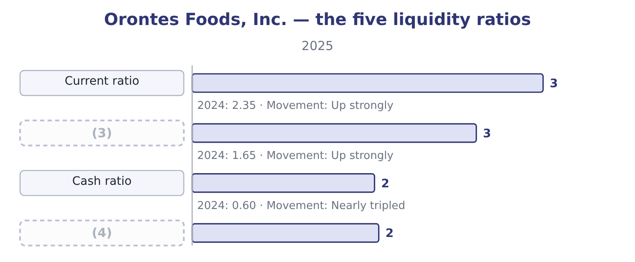
word list
Cash flow ratio · Quick (acid-test) ratio · operating cash flow

Summary 2 gaps 5–9
The (5) behind each is worth (6) once. The current ratio is 14,188,100 ÷ 4,280,000 = 3.31 for 2025, and 8,380,000 ÷ 3,570,000 = 2.35 for 2024. Quick assets for 2025 are cash of $7,302,100, trading securities of $42,000 and net receivables of $4,144,000: 7,302,100 + 42,000 = 7,344,100, and 7,344,100 + 4,144,000 = 11,488,100. The quick ratio is 11,488,100 ÷ 4,280,000 = 2.68. The cash ratio uses only the first two: 7,344,100 ÷ 4,280,000 = 1.72. The cash flow ratio is operating cash flow over current liabilities: 7,531,100 ÷ 4,280,000 = 1.76. Net working capital is 14,188,100 − 4,280,000 = 9,908,100, and the net working capital ratio is 9,908,100 ÷ 31,672,600 = 0.313. Every one of the five rose (7) , and every one of them rose for the same (8) : the $5,202,100 of cash that,531,100. This is what (9) looks.
word list
corroboration · sharply · seeing · reason · seasonal · arithmetic

Summary 3 gaps 10–15
Five ratios computed from four different (10) all move together, because one (11) fact moved. The cash ratio is the (12) one. At 1.72, (13) holds more cash and marketable securities than its (14) current liabilities. It could settle (15) it owes within a year, today, out of the bank account, and have $3,064,100 left over: 7,344,100 − 4,280,000 = 3,064,100. Very few manufacturers are in that position.
word list
Orontes · striking · numerators · entire · together · underlying · everything

Worked example: the five ratios from one balance sheet

Summary 4 gaps 16–21
Quick assets: cash $7,302,100 plus trading securities $42,000 plus receivables $4,144,000, (16) $11,488,100. Cash and securities alone: $7,344,100. Operating cash flow: $7,531,100. One (17) for four of them. Total current liabilities $4,280,000. And the fifth uses total assets: 9,908,100 ÷ 31,672,600 = 0.313. The ratios must fall in order: current ≥ quick ≥ cash, because each (18) is a subset of the one (19) . If your quick ratio ever (20) your current ratio, you have included (21) you should not have.
word list
numerator · something · denominator · giving · securities · before · exceeds

The five ratios for Barada

Compute the first three ratios.
Your turn: Barada's liquidity ratios (complete the blanks)
Item | Amount
Cash | 180,000
Marketable securities | 20,000
Accounts receivable, net | 1,960,000
Inventory | 2,380,000
Prepaid expenses | 60,000
Total current assets | 4,600,000
Total current liabilities | 2,300,000
Current ratio | 2.00: 4,600,000 ÷ 2,300,000.
Quick ratio | (22) : cash 180,000 plus securities 20,000 plus receivables 1,960,000 is 2,160,000, divided by 2,300,000.
Cash ratio | (23) : 200,000 ÷ 2,300,000.

word list
seasonal · 0.94 · 0.09

The English this section uses, and its Arabic
Each term sits against what it means.
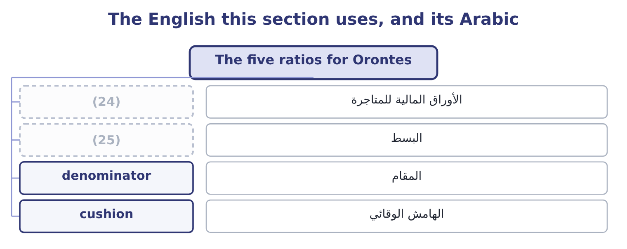
word list
trading securities · numerator · quick assets

The English this sheet uses, and its Arabic
English (exam term) | Arabic
trading securities | الأوراق المالية للمتاجرة
numerator | البسط
denominator | المقام
cushion | الهامش الوقائي

Answer key · 6.2 The five ratios for Orontes

1 calculated | 14 entire
2 published | 15 everything
3 Quick (acid-test) ratio | 16 giving
4 Cash flow ratio | 17 denominator
5 arithmetic | 18 numerator
6 seeing | 19 before
7 sharply | 20 exceeds
8 reason | 21 something
9 corroboration | 22 0.94
10 numerators | 23 0.09
11 underlying | 24 trading securities
12 striking | 25 numerator
13 Orontes

the summaries in full
Summary 1 The 2024 cash flow ratio cannot be calculated, because Part 1 published one statement of cash flows.
Summary 2 The arithmetic behind each is worth seeing once. The current ratio is 14,188,100 ÷ 4,280,000 = 3.31 for 2025, and 8,380,000 ÷ 3,570,000 = 2.35 for 2024. Quick assets for 2025 are cash of $7,302,100, trading securities of $42,000 and net receivables of $4,144,000: 7,302,100 + 42,000 = 7,344,100, and 7,344,100 + 4,144,000 = 11,488,100. The quick ratio is 11,488,100 ÷ 4,280,000 = 2.68. The cash ratio uses only the first two: 7,344,100 ÷ 4,280,000 = 1.72. The cash flow ratio is operating cash flow over current liabilities: 7,531,100 ÷ 4,280,000 = 1.76. Net working capital is 14,188,100 − 4,280,000 = 9,908,100, and the net working capital ratio is 9,908,100 ÷ 31,672,600 = 0.313. Every one of the five rose sharply, and every one of them rose for the same reason: the $5,202,100 of cash that,531,100. This is what corroboration looks.
Summary 3 Five ratios computed from four different numerators all move together, because one underlying fact moved. The cash ratio is the striking one. At 1.72, Orontes holds more cash and marketable securities than its entire current liabilities. It could settle everything it owes within a year, today, out of the bank account, and have $3,064,100 left over: 7,344,100 − 4,280,000 = 3,064,100. Very few manufacturers are in that position.
Summary 4 Quick assets: cash $7,302,100 plus trading securities $42,000 plus receivables $4,144,000, giving $11,488,100. Cash and securities alone: $7,344,100. Operating cash flow: $7,531,100. One denominator for four of them. Total current liabilities $4,280,000. And the fifth uses total assets: 9,908,100 ÷ 31,672,600 = 0.313. The ratios must fall in order: current ≥ quick ≥ cash, because each numerator is a subset of the one before. If your quick ratio ever exceeds your current ratio, you have included something you should not have.

6.3 Reading the five together
Chapter 6 · section 6.3

Fill every gap. Each word list holds one word more than there are gaps.
Summary 1 gaps 1–12
No single liquidity ratio is (1) , and the exam sets questions in which two of the five point in different (2) . When that happens, the (3) between them is itself the (4) . A high current ratio with a low quick ratio means the current assets are mostly inventory. That is the (5) position: Barada's inventory is 34 per cent of its total assets, so its current ratio (6) and its quick ratio tells the truth. A (7) financing a (8) stock build will look at the quick ratio and at how fast the stock moves, which is. A high quick ratio with a low cash ratio means the quick assets are mostly receivables. That is a company whose liquidity depends on its (9) paying, and the ageing (10) matters more than the ratio. A (11) current ratio with a weak cash flow ratio means the company holds enough but is not (12) .
word list
lender · seasonal · difference · generating · healthy · schedule · sufficient · distributor's · happens · flatters · directions · finding · customers

Summary 2 gaps 13–16
The fourth row is (13) . All five ratios rose (14) , the cash flow ratio at 1.76 confirms that the stock is being (15) by trading rather than by borrowing, and the (16) question is no longer whether the company can pay but what it should do with the surplus.
word list
whether · analytical · replenished · Orontes · together

Higher is not always better

Summary 3 gaps 17–21
A current ratio that keeps rising can mean (17) receivables or unsold stock. Look at what the (18) is made. A very high cash ratio is idle money. The exam treats cash (19) nothing as a cost. A ratio below 1.0 is not (20) a failure. A company with fast inventory (21) and slow payables can operate below 1.0 for years.
word list
numerator · earning · healthy · turnover · automatically · uncollected

The words this section uses
Each term sits against what it means, and an instance of it.
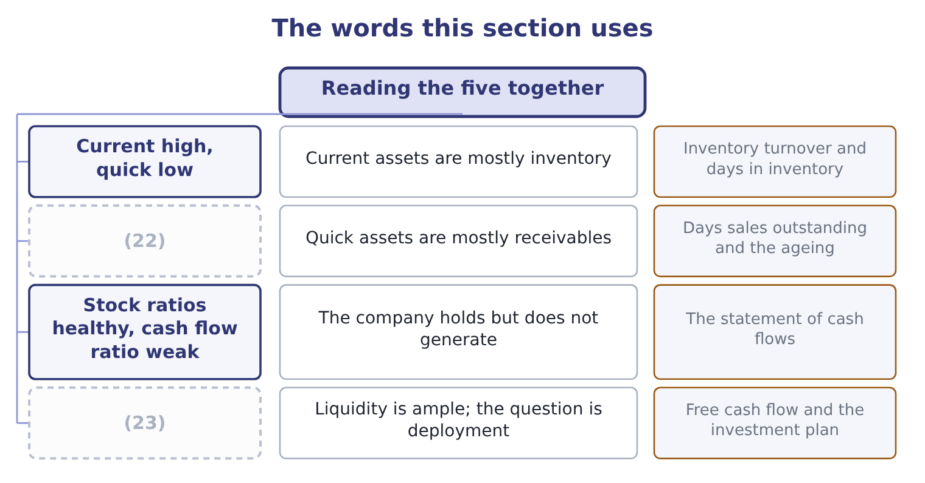
word list
Quick high, cash low · All five high and rising · Current assets are mostly inventory

The English this sheet uses, and its Arabic
English (exam term) | Arabic
ageing schedule | جدول أعمار الذمم
idle cash | النقد العاطل
seasonal | موسمي
deployment | توظيف الأموال

Answer key · 6.3 Reading the five together

1 sufficient | 13 Orontes
2 directions | 14 together
3 difference | 15 replenished
4 finding | 16 analytical
5 distributor's | 17 uncollected
6 flatters | 18 numerator
7 lender | 19 earning
8 seasonal | 20 automatically
9 customers | 21 turnover
10 schedule | 22 Quick high, cash low
11 healthy | 23 All five high and rising
12 generating

the summaries in full
Summary 1 No single liquidity ratio is sufficient, and the exam sets questions in which two of the five point in different directions. When that happens, the difference between them is itself the finding. A high current ratio with a low quick ratio means the current assets are mostly inventory. That is the distributor's position: Barada's inventory is 34 per cent of its total assets, so its current ratio flatters and its quick ratio tells the truth. A lender financing a seasonal stock build will look at the quick ratio and at how fast the stock moves, which is. A high quick ratio with a low cash ratio means the quick assets are mostly receivables. That is a company whose liquidity depends on its customers paying, and the ageing schedule matters more than the ratio. A healthy current ratio with a weak cash flow ratio means the company holds enough but is not generating.
Summary 2 The fourth row is Orontes. All five ratios rose together, the cash flow ratio at 1.76 confirms that the stock is being replenished by trading rather than by borrowing, and the analytical question is no longer whether the company can pay but what it should do with the surplus.
Summary 3 A current ratio that keeps rising can mean uncollected receivables or unsold stock. Look at what the numerator is made. A very high cash ratio is idle money. The exam treats cash earning nothing as a cost. A ratio below 1.0 is not automatically a failure. A company with fast inventory turnover and slow payables can operate below 1.0 for years.

6.4 The liquidity of current liabilities
Chapter 6 · section 6.4

Fill every gap. Each word list holds one word more than there are gaps.
Summary 1 gaps 1–5
The syllabus asks (1) for an understanding of the (2) of current liabilities, and the phrase repays attention. Current liabilities are not a single block (3) due at the same (4) . They differ in when they must be paid, in whether they must be paid in cash at all, and in whether the (5) can demand payment early.
word list
liquidity · moment · specifically · falling · decision · creditor

Orontes Foods, Inc. — current liabilities by how they will be settled
The bars are drawn to scale.
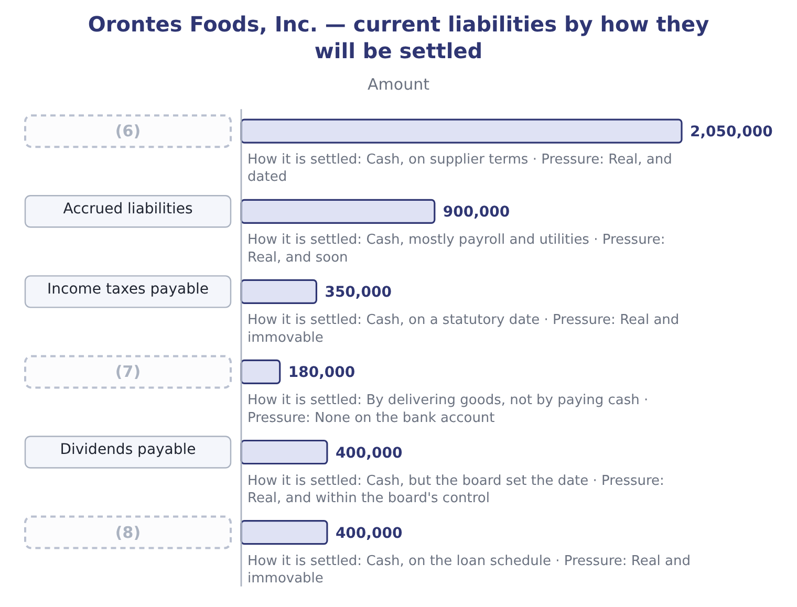
word list
Contract liabilities · Accounts payable · Current portion of long-term debt · marketable securities

Summary 2 gaps 9–20
Two of those lines behave quite (9) from the rest. Contract liabilities of $180,000 are what Part 1 (10) unearned revenue. They are (11) by shipping (12) , not by paying money. A ratio that counts them as a claim on cash (13) the pressure on the bank (14) . (15) payable of $400,000 are a real obligation, but the board declared them and chose the payment date. A company under pressure can, and does, defer the next (16) . Note what Orontes did: it declared $450,000 and paid only $50,000, (17) $400,000 on the (18) sheet at year end. That single (19) raised current liabilities by $400,000 and pushed the current ratio down from what it would (20) have been. Take both out and the picture changes: 4,280,000 − 180,000 = 4,100,000 of liabilities requiring cash, and 4,100,000 − 400,000 = 3,700,000 of liabilities requiring cash on a date Orontes does not control.
word list
overstates · discharged · leaving · Dividends · Deferred · otherwise · balance · tahini · account · declaration · called · decision · differently

Summary 3 gaps 21–24
Against cash and (21) of $7,344,100 that is a cash ratio on the (22) base of 7,344,100 ÷ 3,700,000 = 1.98. Nobody (23) that ratio and the exam will not ask for it by name. The point is the reasoning: the (24) is a classification, and a classification can be interrogated.
word list
denominator · stricter · declaration · securities · publishes

Not every current liability wants cash

Summary 4 gaps 25–29
Contract liabilities and unearned revenue are settled by (25) . Deferred tax is not a current liability at all; all deferred taxes are (26) . Debt (27) on demand is current (28) the lender's (29) , which is a rule you met in Part 1 and which cuts the other way: it adds pressure the ratio should show.
word list
noncurrent · decision · callable · performance · intentions · whatever

"Current" is a classification, not a fact

Summary 5 gaps 30–33
English current liability is a (30) classification: a label the (31) attach. The label does not say the money leaves (32) ; it says the obligation is expected to be settled within a year or the (33) cycle. Candidates lose marks by reading the label as a statement about timing within the year.
word list
cushion · operating · tomorrow · standards · defined

The English this section uses, and its Arabic
Each term sits against what it means.
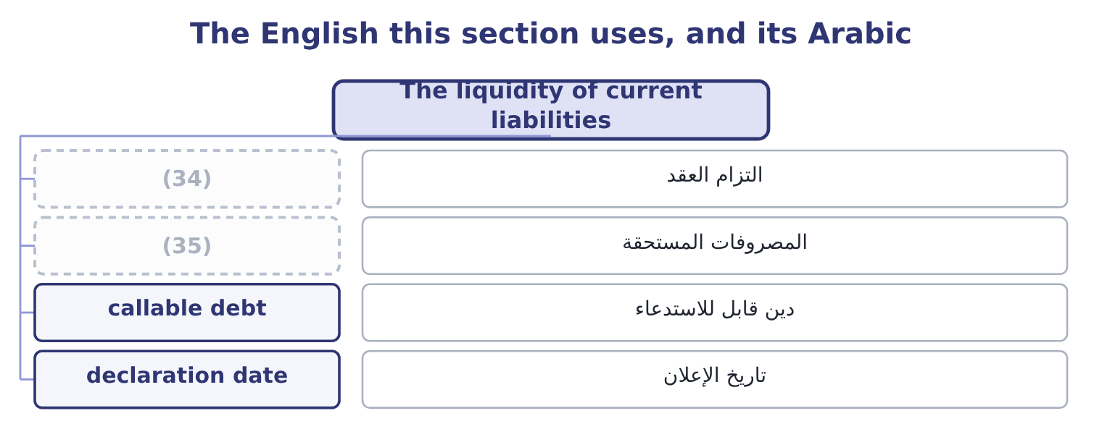
word list
quick assets · contract liability · accrued liabilities

The English this sheet uses, and its Arabic
English (exam term) | Arabic
contract liability | التزام العقد
accrued liabilities | المصروفات المستحقة
callable debt | دين قابل للاستدعاء
declaration date | تاريخ الإعلان

Answer key · 6.4 The liquidity of current liabilities

1 specifically | 19 decision
2 liquidity | 20 otherwise
3 falling | 21 securities
4 moment | 22 stricter
5 creditor | 23 publishes
6 Accounts payable | 24 denominator
7 Contract liabilities | 25 performance
8 Current portion of long-term debt | 26 noncurrent
9 differently | 27 callable
10 called | 28 whatever
11 discharged | 29 intentions
12 tahini | 30 defined
13 overstates | 31 standards
14 account | 32 tomorrow
15 Dividends | 33 operating
16 declaration | 34 contract liability
17 leaving | 35 accrued liabilities
18 balance

the summaries in full
Summary 1 The syllabus asks specifically for an understanding of the liquidity of current liabilities, and the phrase repays attention. Current liabilities are not a single block falling due at the same moment. They differ in when they must be paid, in whether they must be paid in cash at all, and in whether the creditor can demand payment early.
Summary 2 Two of those lines behave quite differently from the rest. Contract liabilities of $180,000 are what Part 1 called unearned revenue. They are discharged by shipping tahini, not by paying money. A ratio that counts them as a claim on cash overstates the pressure on the bank account. Dividends payable of $400,000 are a real obligation, but the board declared them and chose the payment date. A company under pressure can, and does, defer the next declaration. Note what Orontes did: it declared $450,000 and paid only $50,000, leaving $400,000 on the balance sheet at year end. That single decision raised current liabilities by $400,000 and pushed the current ratio down from what it would otherwise have been. Take both out and the picture changes: 4,280,000 − 180,000 = 4,100,000 of liabilities requiring cash, and 4,100,000 − 400,000 = 3,700,000 of liabilities requiring cash on a date Orontes does not control.
Summary 3 Against cash and securities of $7,344,100 that is a cash ratio on the stricter base of 7,344,100 ÷ 3,700,000 = 1.98. Nobody publishes that ratio and the exam will not ask for it by name. The point is the reasoning: the denominator is a classification, and a classification can be interrogated.
Summary 4 Contract liabilities and unearned revenue are settled by performance. Deferred tax is not a current liability at all; all deferred taxes are noncurrent. Debt callable on demand is current whatever the lender's intentions, which is a rule you met in Part 1 and which cuts the other way: it adds pressure the ratio should show.
Summary 5 English current liability is a defined classification: a label the standards attach. The label does not say the money leaves tomorrow; it says the obligation is expected to be settled within a year or the operating cycle. Candidates lose marks by reading the label as a statement about timing within the year.

6.5 What a liquidity ratio will not tell you
Chapter 6 · section 6.5

Fill every gap. Each word list holds one word more than there are gaps.
Summary 1 gaps 1–12
Four limits, all (1) . A ratio is a photograph of one day. A company can (2) its affairs so that the photograph (3) : paying down a payable just before the year end with cash it (4) re-borrows, or (5) a purchase. This is window dressing, and the clue is a ratio that moves (6) at the year end and reverts. A ratio says nothing about the quality of the assets (7) . (8) that will not be (9) and inventory that will not sell are both inside the current ratio at full value until someone writes them down. Part 1 taught you the (10) rules. A ratio says nothing about undrawn credit. A company with a current ratio of 1.0 and a (11) and unused facility of $5,000,000 is in a (12) position than one with a ratio of 2.0 and no facility.
word list
Receivables · examinable · counted · stronger · immediately · flatters · sharply · delaying · arrange · committed · write-down · current · collected

Summary 2 gaps 13–16
The facility is (13) in the notes, not in the ratio. A ratio says nothing about the operating cycle (14) it. A (15) collects in cash and pays its suppliers in sixty days; it runs a current ratio below 1.0 (16) and is never short.
word list
permanently · supermarket · disclosed · dressing · behind

Four limits of a liquidity ratio
Limit | The clue | Where it is resolved
One day only; window dressing is possible | (17) | Interim statements; the cash flow statement
Asset quality is assumed | A rising ratio with a rising ageing | (18)
Undrawn credit is invisible | The notes on borrowings | (19)
The operating cycle is ignored | (20) | Chapter 12, the cash cycle

word list
Chapter 17, earnings quality · A sharp year-end movement that reverts · Chapter 12, the cash cycle · An industry that always runs below 1.0 · The commitments note

The English this section uses, and its Arabic
Each term sits against what it means.
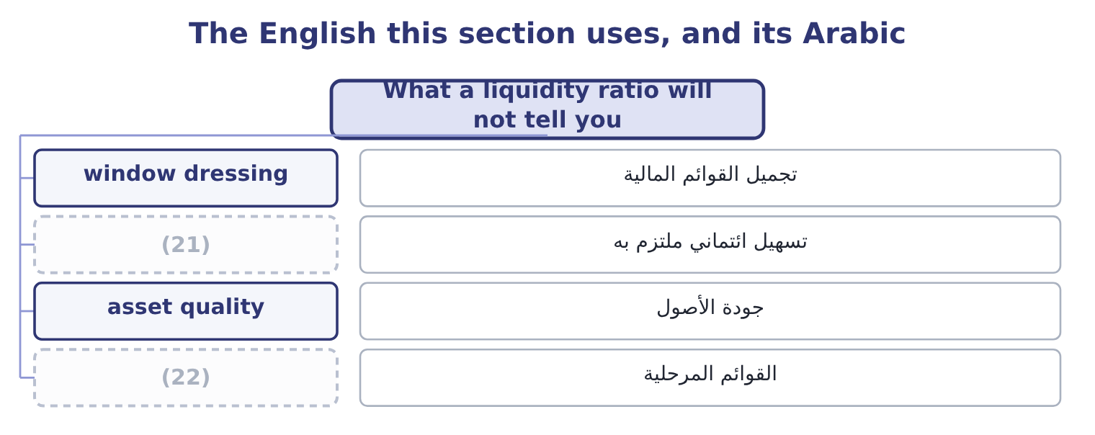
word list
interim statements · committed facility · asset quality

The English this sheet uses, and its Arabic
English (exam term) | Arabic
window dressing | تجميل القوائم المالية
committed facility | تسهيل ائتماني ملتزم به
asset quality | جودة الأصول
interim statements | القوائم المرحلية

Answer key · 6.5 What a liquidity ratio will not tell you

1 examinable | 12 stronger
2 arrange | 13 disclosed
3 flatters | 14 behind
4 immediately | 15 supermarket
5 delaying | 16 permanently
6 sharply | 17 A sharp year-end movement that reverts
7 counted | 18 Chapter 17, earnings quality
8 Receivables | 19 The commitments note
9 collected | 20 An industry that always runs below 1.0
10 write-down | 21 committed facility
11 committed | 22 interim statements

the summaries in full
Summary 1 Four limits, all examinable. A ratio is a photograph of one day. A company can arrange its affairs so that the photograph flatters: paying down a payable just before the year end with cash it immediately re-borrows, or delaying a purchase. This is window dressing, and the clue is a ratio that moves sharply at the year end and reverts. A ratio says nothing about the quality of the assets counted. Receivables that will not be collected and inventory that will not sell are both inside the current ratio at full value until someone writes them down. Part 1 taught you the write-down rules. A ratio says nothing about undrawn credit. A company with a current ratio of 1.0 and a committed and unused facility of $5,000,000 is in a stronger position than one with a ratio of 2.0 and no facility.
Summary 2 The facility is disclosed in the notes, not in the ratio. A ratio says nothing about the operating cycle behind it. A supermarket collects in cash and pays its suppliers in sixty days; it runs a current ratio below 1.0 permanently and is never short.

