7.1 The rule for an equal change
Chapter 7 · section 7.1

Fill every gap. Each word list holds one word more than there are gaps.
Chapter 7, section by section
Each stage leads to the next.
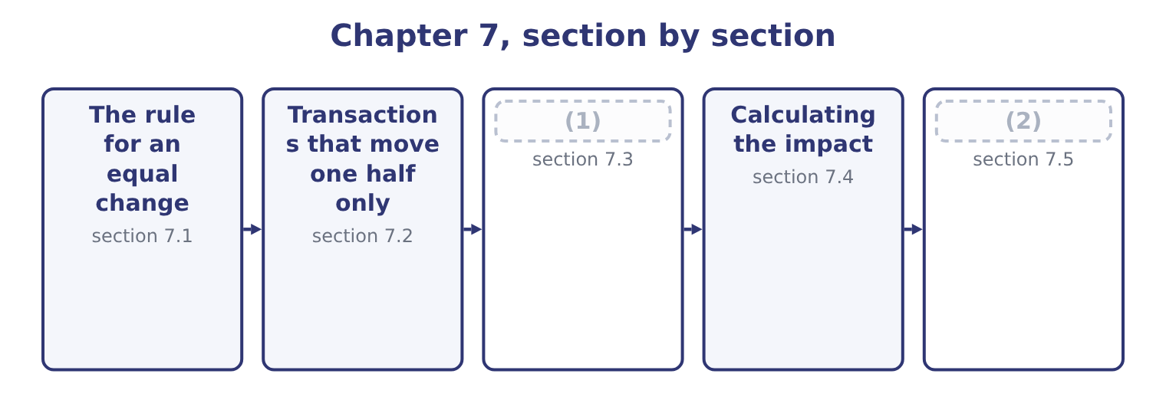
word list
The effect of unit sales · Using the method honestly · allowance for credit losses

Summary 1 gaps 3–8
Take a ratio of a over b, and add the same amount d to both. If a is (3) than b, the ratio is above 1, and adding d to both moves it towards 1, which means it falls. If a is less than b, the ratio is below 1, and adding d to both moves it towards 1, which means it rises. (4) d from both does the (5) : it moves the ratio away from 1. That single rule (6) most of the exam's (7) about the current ratio, because the commonest (8) change current assets and current liabilities by the same amount.
word list
opposite · greater · answers · transactions · Subtracting · liabilities · questions

An equal change in both halves
Starting ratio | Add the same amount to both | Subtract the same amount from both
Above 1.0 | Falls, towards 1.0 | (9)
Exactly 1.0 | No change | No change
Below 1.0 | (10) | Falls, away from 1.0

word list
allowance for credit losses · Rises, towards 1.0 · Rises, away from 1.0

Summary 2 gaps 11–14
Orontes's current ratio is 3.31, which is above 1. So buying (11) on credit, which adds the same amount to current assets and current liabilities, (12) Orontes's current ratio. Paying a supplier, which (13) the same amount from both, raises it. A company with a current ratio of 0.80 would see exactly the (14) .
word list
towards · lowers · subtracts · inventory · reverse

Direction depends on where you start

Summary 3 gaps 15–20
Never (15) "the current ratio rises when you pay a payable" (16) knowing whether the ratio is above or below 1. A transaction that leaves both halves unchanged leaves the ratio unchanged, (17) large the amounts: (18) a receivable in cash moves money inside current assets. Working capital — the (19) , not the ratio — is unchanged by an equal change in both, and (20) by a transaction that touches only one.
word list
collecting · difference · accounts · without · changed · however · answer

Worked example: paying a supplier

Summary 4 gaps 21–24
Current assets $14,188,100 and current liabilities $4,280,000, so the current ratio is 14,188,100 ÷ 4,280,000 = 3.31. Pay $500,000 of (21) payable in cash. Both halves fall by $500,000: 14,188,100 − 500,000 = 13,688,100 and 4,280,000 − 500,000 = 3,780,000. Working capital is unchanged: it was 14,188,100 − 4,280,000 = 9,908,100 and it is now 13,688,100 − 3,780,000 = 9,908,100. The company is no (22) off; the ratio (23) moved away from 1 because both halves (24) .
word list
accounts · transactions · simply · shrank · better

The English this section uses, and its Arabic
Each term sits against what it means.
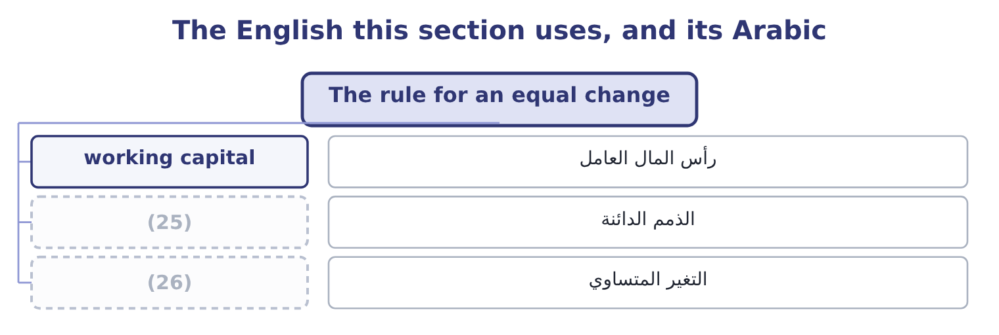
word list
الذمم الدائنة · equal change · accounts payable

The English this sheet uses, and its Arabic
English (exam term) | Arabic
working capital | رأس المال العامل
accounts payable | الذمم الدائنة
equal change | التغير المتساوي

Answer key · 7.1 The rule for an equal change

1 The effect of unit sales | 14 reverse
2 Using the method honestly | 15 answer
3 greater | 16 without
4 Subtracting | 17 however
5 opposite | 18 collecting
6 answers | 19 difference
7 questions | 20 changed
8 transactions | 21 accounts
9 Rises, away from 1.0 | 22 better
10 Rises, towards 1.0 | 23 simply
11 inventory | 24 shrank
12 lowers | 25 accounts payable
13 subtracts | 26 equal change

the summaries in full
Summary 1 Take a ratio of a over b, and add the same amount d to both. If a is greater than b, the ratio is above 1, and adding d to both moves it towards 1, which means it falls. If a is less than b, the ratio is below 1, and adding d to both moves it towards 1, which means it rises. Subtracting d from both does the opposite: it moves the ratio away from 1. That single rule answers most of the exam's questions about the current ratio, because the commonest transactions change current assets and current liabilities by the same amount.
Summary 2 Orontes's current ratio is 3.31, which is above 1. So buying inventory on credit, which adds the same amount to current assets and current liabilities, lowers Orontes's current ratio. Paying a supplier, which subtracts the same amount from both, raises it. A company with a current ratio of 0.80 would see exactly the reverse.
Summary 3 Never answer "the current ratio rises when you pay a payable" without knowing whether the ratio is above or below 1. A transaction that leaves both halves unchanged leaves the ratio unchanged, however large the amounts: collecting a receivable in cash moves money inside current assets. Working capital — the difference, not the ratio — is unchanged by an equal change in both, and changed by a transaction that touches only one.
Summary 4 Current assets $14,188,100 and current liabilities $4,280,000, so the current ratio is 14,188,100 ÷ 4,280,000 = 3.31. Pay $500,000 of accounts payable in cash. Both halves fall by $500,000: 14,188,100 − 500,000 = 13,688,100 and 4,280,000 − 500,000 = 3,780,000. Working capital is unchanged: it was 14,188,100 − 4,280,000 = 9,908,100 and it is now 13,688,100 − 3,780,000 = 9,908,100. The company is no better off; the ratio simply moved away from 1 because both halves shrank.

7.2 Transactions that move one half only
Chapter 7 · section 7.2

Fill every gap. Each word list holds one word more than there are gaps.
Summary 1 gaps 1–12
The other family of (1) touches one half of the fraction and not the other, and those always move the ratio in the obvious (2) . (3) shares for cash adds to current assets and nothing to current liabilities: every liquidity ratio rises and working capital rises by the full amount. Buying (4) for cash subtracts from current assets and (5) current liabilities alone: every ratio falls. The company is not weaker in any deep sense — it (6) cash for a (7) — but it is less liquid, and that is what the ratios are for. Borrowing (8) adds cash and adds a (9) liability: the liquidity ratios rise. Borrowing (10) adds cash and adds a current liability, which is the (11) case. Writing off a bad debt reduces (12) and reduces the allowance, so the net receivable does not move at all. This one catches candidates every time: the write-off was already provided for, so nothing in any ratio changes.
word list
leaves · machine · equipment · long-term · direction · short-term · Borrowing · receivables · swapped · Issuing · equal-change · noncurrent · transactions

Effect of common transactions, current ratio above 1.0
Every item belongs to exactly one group.
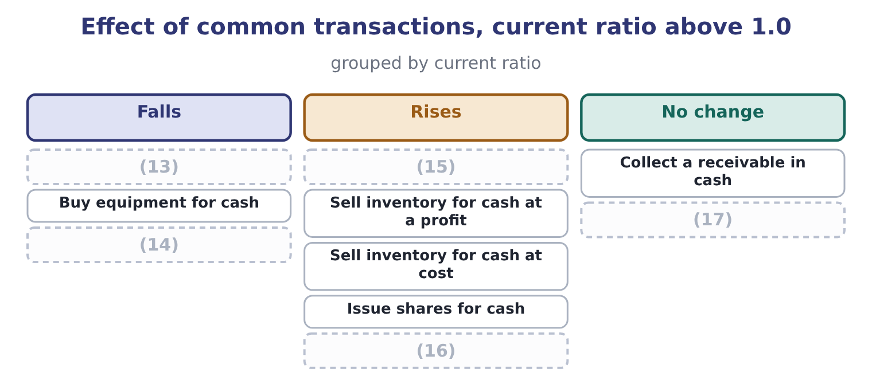
word list
Collect a receivable in cash · Write off a bad debt, fully provided · Buy inventory on credit · Borrow long-term for cash · Declare a dividend, unpaid · Pay a supplier in cash

Summary 2 gaps 18–29
Three rows in that figure (18) a second look. Paying a (19) raises the current ratio and lowers the cash ratio. The cash (20) numerator is cash and (21) only, so it loses the whole payment while the (22) loses the same amount; starting from 1.72, which is above 1, the (23) from both should raise it — but the numerator falls by the full $500,000 while it is smaller than the (24) numerator, so the effect is (25) . Work it: 7,344,100 − 500,000 = 6,844,100 over 3,780,000 is 1.81. The figure says "falls" for a company whose cash ratio is below 1, which is the (26) case, and that is why the row is worth (27) against your own starting point rather than (28) . Selling (29) at a profit raises working capital; selling it at cost does not.
word list
checking · supplier · inventory · ordinary · Selling · securities · reward · ratio's · denominator · subtraction · memorised · different · current-asset

Summary 3 gaps 30–33
Current assets rise by the profit in the first case and (30) change form in the second. Declaring a dividend lowers every ratio even though no money has moved, (31) a current liability (32) . (33) did exactly this with $400,000 at the end of 2025.
word list
checking · because · Orontes · appears · merely

The three that catch people

Summary 4 gaps 34–36
Writing off a fully provided bad debt changes nothing: the allowance already (34) the net receivable. Declaring a dividend changes the ratios (35) any cash moves. (36) a receivable changes the cash ratio and not the current or quick ratio.
word list
ratio's · Collecting · reduced · before

The English this section uses, and its Arabic
Each term sits against what it means.
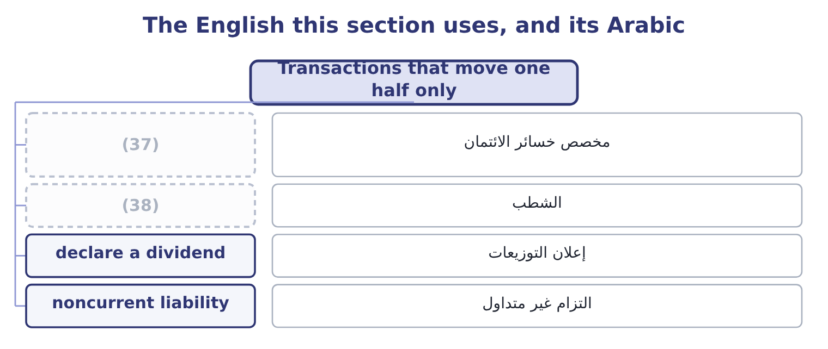
word list
numerator effect · allowance for credit losses · write-off

The English this sheet uses, and its Arabic
English (exam term) | Arabic
allowance for credit losses | مخصص خسائر الائتمان
write-off | الشطب
declare a dividend | إعلان التوزيعات
noncurrent liability | التزام غير متداول

Answer key · 7.2 Transactions that move one half only

1 transactions | 20 ratio's
2 direction | 21 securities
3 Issuing | 22 denominator
4 equipment | 23 subtraction
5 leaves | 24 current-asset
6 swapped | 25 different
7 machine | 26 ordinary
8 long-term | 27 checking
9 noncurrent | 28 memorised
10 short-term | 29 inventory
11 equal-change | 30 merely
12 receivables | 31 because
13 Buy inventory on credit | 32 appears
14 Declare a dividend, unpaid | 33 Orontes
15 Pay a supplier in cash | 34 reduced
16 Borrow long-term for cash | 35 before
17 Write off a bad debt, fully provided | 36 Collecting
18 reward | 37 allowance for credit losses
19 supplier | 38 write-off

the summaries in full
Summary 1 The other family of transactions touches one half of the fraction and not the other, and those always move the ratio in the obvious direction. Issuing shares for cash adds to current assets and nothing to current liabilities: every liquidity ratio rises and working capital rises by the full amount. Buying equipment for cash subtracts from current assets and leaves current liabilities alone: every ratio falls. The company is not weaker in any deep sense — it swapped cash for a machine — but it is less liquid, and that is what the ratios are for. Borrowing long-term adds cash and adds a noncurrent liability: the liquidity ratios rise. Borrowing short-term adds cash and adds a current liability, which is the equal-change case. Writing off a bad debt reduces receivables and reduces the allowance, so the net receivable does not move at all. This one catches candidates every time: the write-off was already provided for, so nothing in any ratio changes.
Summary 2 Three rows in that figure reward a second look. Paying a supplier raises the current ratio and lowers the cash ratio. The cash ratio's numerator is cash and securities only, so it loses the whole payment while the denominator loses the same amount; starting from 1.72, which is above 1, the subtraction from both should raise it — but the numerator falls by the full $500,000 while it is smaller than the current-asset numerator, so the effect is different. Work it: 7,344,100 − 500,000 = 6,844,100 over 3,780,000 is 1.81. The figure says "falls" for a company whose cash ratio is below 1, which is the ordinary case, and that is why the row is worth checking against your own starting point rather than memorised. Selling inventory at a profit raises working capital; selling it at cost does not.
Summary 3 Current assets rise by the profit in the first case and merely change form in the second. Declaring a dividend lowers every ratio even though no money has moved, because a current liability appears. Orontes did exactly this with $400,000 at the end of 2025.
Summary 4 Writing off a fully provided bad debt changes nothing: the allowance already reduced the net receivable. Declaring a dividend changes the ratios before any cash moves. Collecting a receivable changes the cash ratio and not the current or quick ratio.

7.3 The effect of unit sales
Chapter 7 · section 7.3

Fill every gap. Each word list holds one word more than there are gaps.
Summary 1 gaps 1–12
The (1) names unit sales alongside the (2) elements, and that is a (3) kind of movement. A change in (4) works through the (5) rather than (6) on one line. More units sold, on credit, at a profit. Inventory falls by the cost; receivables rise by the selling price. Current assets rise by the profit. The current ratio rises, the quick ratio rises more because the (7) gains the whole receivable and loses nothing, and the cash ratio does not move until the customer pays. More units sold, for cash, at a profit. The same, but the cash ratio rises too. Current assets are (8) in total if (9) continues — the money moves from cash into stock — so the current ratio holds while the quick ratio falls. That (10) is the early signal of the (11) leak of, and it appears in the quick ratio before it appears (12) else.
word list
numerator · unchanged · divergence · syllabus · anywhere · working-capital · different · statements · continues · balance-sheet · production · landing · volume

Summary 2 gaps 13–18
More units sold without any (13) in price, when the company must buy stock to supply them. Receivables and inventory both rise, payables rise to fund the stock, and cash falls because the (14) to the supplier comes before the (15) from the customer. A growing company can become less liquid (16) because it is growing, and a lender who (17) credit at that moment can end a sound (18) .
word list
refuses · increase · business · receivables · payment · receipt · precisely

One additional sale on credit, cost 60 and price 100
Every item belongs to exactly one group.
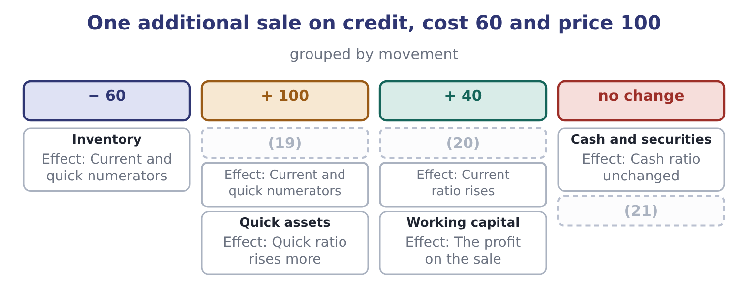
word list
Accounts receivable · Current assets · Current liabilities · accounts payable

Worked example: growth that consumes liquidity

Summary 3 gaps 22–25
Orontes wins a Gulf order and must hold an extra $800,000 of stock to supply it, bought on 30-day supplier terms, selling at $1,200,000 on 60-day customer terms. At the end of month one, the stock is bought and nothing is sold: inventory up $800,000 and payables up $800,000. Current assets 14,188,100 + 800,000 = 14,988,100 and current liabilities 4,280,000 + 800,000 = 5,080,000. The current ratio is 14,988,100 ÷ 5,080,000 = 2.95, down from 3.31. At the end of month two, the supplier is paid and the goods are sold on credit: cash down $800,000, inventory down $800,000, receivables up $1,200,000, payables down $800,000. Current assets are 14,988,100 − 1,600,000 = 13,388,100, plus the receivable of 1,200,000, (22) $14,588,100; current liabilities are back to $4,280,000. The ratio is 14,588,100 ÷ 4,280,000 = 3.41. The ratio fell to 2.95 and then (23) above where it began, because the sale was (24) . The dip is real and it is when the company needs its credit line. A lender reading only the (25) ratio sees none of this.
word list
giving · write-off · year-end · profitable · recovered

The English this section uses, and its Arabic
Each term sits against what it means.
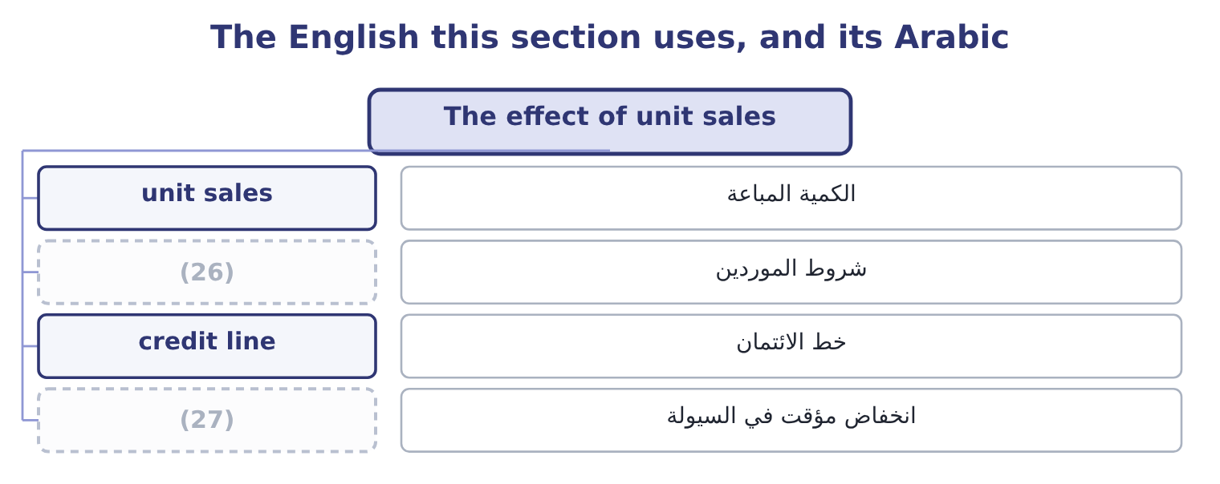
word list
working capital · liquidity dip · supplier terms

The English this sheet uses, and its Arabic
English (exam term) | Arabic
unit sales | الكمية المباعة
supplier terms | شروط الموردين
credit line | خط الائتمان
liquidity dip | انخفاض مؤقت في السيولة

Answer key · 7.3 The effect of unit sales

1 syllabus | 15 receipt
2 balance-sheet | 16 precisely
3 different | 17 refuses
4 volume | 18 business
5 statements | 19 Accounts receivable
6 landing | 20 Current assets
7 numerator | 21 Current liabilities
8 unchanged | 22 giving
9 production | 23 recovered
10 divergence | 24 profitable
11 working-capital | 25 year-end
12 anywhere | 26 supplier terms
13 increase | 27 liquidity dip
14 payment

the summaries in full
Summary 1 The syllabus names unit sales alongside the balance-sheet elements, and that is a different kind of movement. A change in volume works through the statements rather than landing on one line. More units sold, on credit, at a profit. Inventory falls by the cost; receivables rise by the selling price. Current assets rise by the profit. The current ratio rises, the quick ratio rises more because the numerator gains the whole receivable and loses nothing, and the cash ratio does not move until the customer pays. More units sold, for cash, at a profit. The same, but the cash ratio rises too. Current assets are unchanged in total if production continues — the money moves from cash into stock — so the current ratio holds while the quick ratio falls. That divergence is the early signal of the working-capital leak of, and it appears in the quick ratio before it appears anywhere else.
Summary 2 More units sold without any increase in price, when the company must buy stock to supply them. Receivables and inventory both rise, payables rise to fund the stock, and cash falls because the payment to the supplier comes before the receipt from the customer. A growing company can become less liquid precisely because it is growing, and a lender who refuses credit at that moment can end a sound business.
Summary 3 Orontes wins a Gulf order and must hold an extra $800,000 of stock to supply it, bought on 30-day supplier terms, selling at $1,200,000 on 60-day customer terms. At the end of month one, the stock is bought and nothing is sold: inventory up $800,000 and payables up $800,000. Current assets 14,188,100 + 800,000 = 14,988,100 and current liabilities 4,280,000 + 800,000 = 5,080,000. The current ratio is 14,988,100 ÷ 5,080,000 = 2.95, down from 3.31. At the end of month two, the supplier is paid and the goods are sold on credit: cash down $800,000, inventory down $800,000, receivables up $1,200,000, payables down $800,000. Current assets are 14,988,100 − 1,600,000 = 13,388,100, plus the receivable of 1,200,000, giving $14,588,100; current liabilities are back to $4,280,000. The ratio is 14,588,100 ÷ 4,280,000 = 3.41. The ratio fell to 2.95 and then recovered above where it began, because the sale was profitable. The dip is real and it is when the company needs its credit line. A lender reading only the year-end ratio sees none of this.

7.4 Calculating the impact
Chapter 7 · section 7.4

Fill every gap. Each word list holds one word more than there are gaps.
Summary 1 gaps 1–2
The exam asks for the (1) and not just the (2) , and the method is always the same three steps: restate the numerator, restate the denominator, divide.
word list
direction · without · impact

Four transactions

Summary 2 gaps 3–4
Orontes starts with current assets of $14,188,100, current (3) of $4,280,000 and a current ratio of 3.31. Compute the ratio after each one, taken (4) .
word list
current · separately · liabilities

Your turn: the current ratio after each transaction (complete the blanks)
Every item belongs to exactly one group.
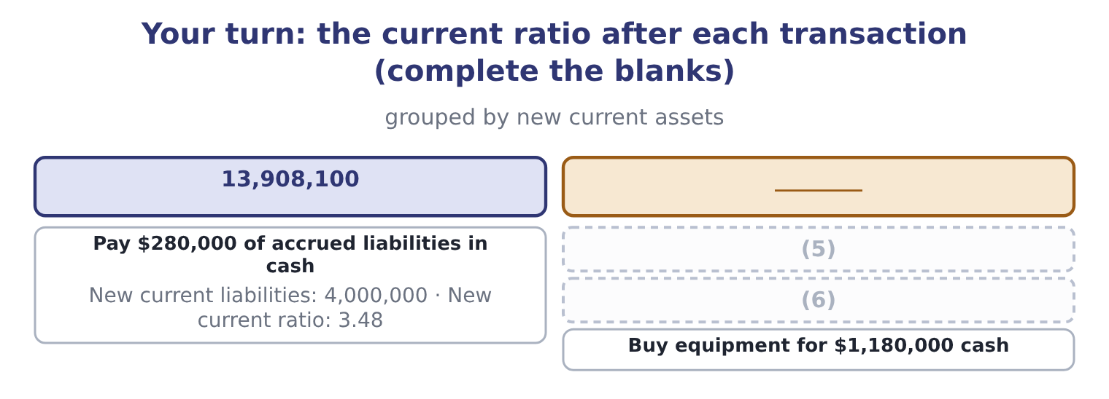
word list
Buy $720,000 of inventory on credit · Buy equipment for $1,180,000 cash · Issue shares for $1,000,000 cash

Summary 3 gaps 7–17
Two (7) are worth knowing. Where a (8) affects the quick ratio (9) from the current ratio, the exam usually wants both. Buying (10) on credit lowers the current ratio by adding to both halves, and lowers the quick ratio much more sharply, because the numerator does not gain (11) at all while the denominator grows. Where a (12) gives a target, work (13) . If Orontes wanted a current ratio of (14) 4.00 by paying down payables, the amount x (15) (14,188,100 − x) ÷ (4,280,000 − x) = 4.00. (16) out: 14,188,100 − x = 17,120,000 − 4x, so 3x = 2,931,900 and x = 977,300. Orontes would pay $977,300. The (17) is worth practising because the exam sets it regularly.
word list
inventory · satisfies · anything · backwards · exactly · regularly · refinements · transaction · arithmetic · Multiplying · differently · question

Working backwards to a target ratio

Summary 4 gaps 18–20
Set up the (18) with the unknown in both halves and solve; do not guess and check. Check the answer is (19) : you cannot pay down more payables than you have cash or than you owe. A target achieved by paying down payables is a target achieved without (20) the business.
word list
improving · write-off · possible · equation

The English this section uses, and its Arabic
Each term sits against what it means.
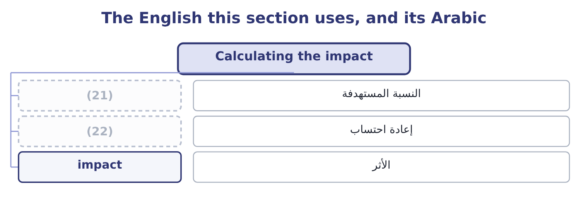
word list
liquidity dip · restate · target ratio

The English this sheet uses, and its Arabic
English (exam term) | Arabic
target ratio | النسبة المستهدفة
restate | إعادة احتساب
impact | الأثر

Answer key · 7.4 Calculating the impact

1 impact | 12 question
2 direction | 13 backwards
3 liabilities | 14 exactly
4 separately | 15 satisfies
5 Buy $720,000 of inventory on credit | 16 Multiplying
6 Issue shares for $1,000,000 cash | 17 arithmetic
7 refinements | 18 equation
8 transaction | 19 possible
9 differently | 20 improving
10 inventory | 21 target ratio
11 anything | 22 restate

the summaries in full
Summary 1 The exam asks for the impact and not just the direction, and the method is always the same three steps: restate the numerator, restate the denominator, divide.
Summary 2 Orontes starts with current assets of $14,188,100, current liabilities of $4,280,000 and a current ratio of 3.31. Compute the ratio after each one, taken separately.
Summary 3 Two refinements are worth knowing. Where a transaction affects the quick ratio differently from the current ratio, the exam usually wants both. Buying inventory on credit lowers the current ratio by adding to both halves, and lowers the quick ratio much more sharply, because the numerator does not gain anything at all while the denominator grows. Where a question gives a target, work backwards. If Orontes wanted a current ratio of exactly 4.00 by paying down payables, the amount x satisfies (14,188,100 − x) ÷ (4,280,000 − x) = 4.00. Multiplying out: 14,188,100 − x = 17,120,000 − 4x, so 3x = 2,931,900 and x = 977,300. Orontes would pay $977,300. The arithmetic is worth practising because the exam sets it regularly.
Summary 4 Set up the equation with the unknown in both halves and solve; do not guess and check. Check the answer is possible: you cannot pay down more payables than you have cash or than you owe. A target achieved by paying down payables is a target achieved without improving the business.

7.5 Using the method honestly
Chapter 7 · section 7.5

Fill every gap. Each word list holds one word more than there are gaps.
Summary 1 gaps 1–11
Paying down (1) just before the reporting date raises the current ratio of any company whose ratio is above 1, and leaves working capital (2) . (3) a purchase does the same. (4) a borrowing as noncurrent when a waiver was obtained after the reporting date is the Part 1 version of the same (5) . The (6) are three. Look at (7) dates, because a ratio that moves and (8) is suspect. Look at the cash flow ratio, which is a flow over the whole year and cannot be (9) on one day. And look at working capital in dollars beside the ratio, because the manoeuvres that move the ratio usually leave working capital exactly where it was — which is the (10) possible signal that nothing (11) .
word list
clearest · untouched · working-capital · manoeuvre · Classifying · Delaying · several · happened · arranged · reverts · defences · payables

Improving a ratio without improving the business
Every item belongs to exactly one group.
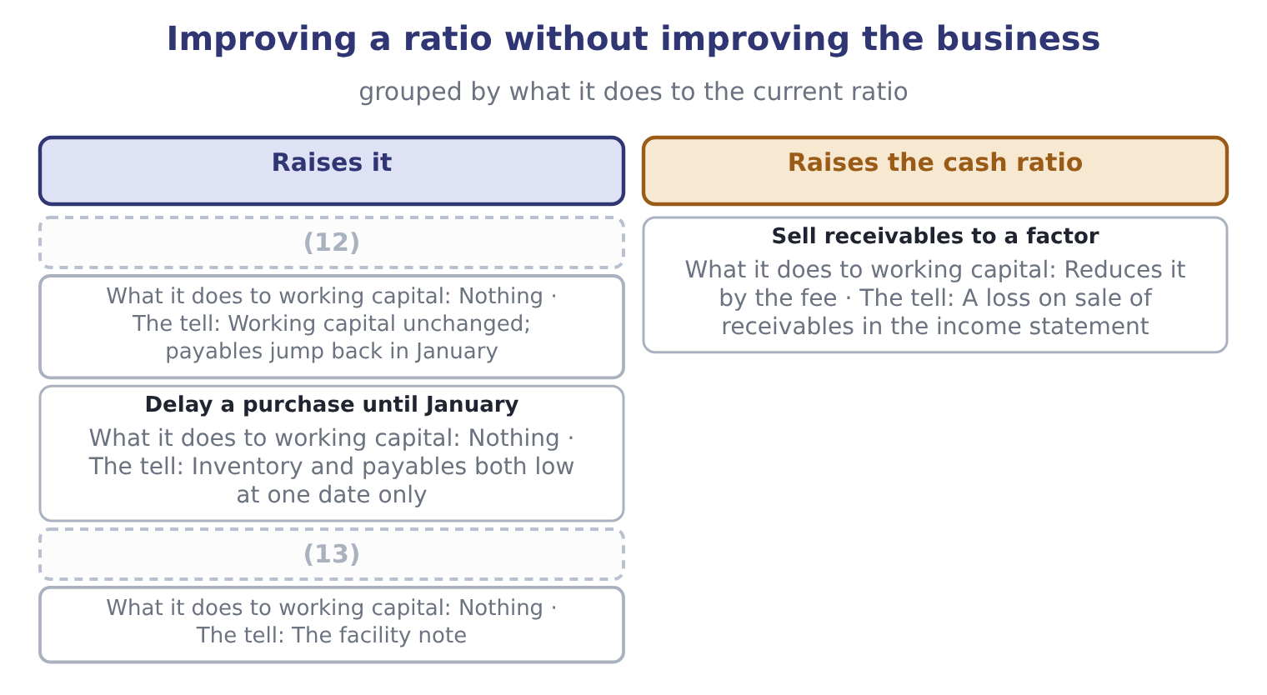
word list
Pay down payables at the year end · Delay a purchase until January · Draw less of a credit line at the year end

Summary 2 gaps 14–18
The last row is one Orontes (14) did: its income (15) carries a loss on sale of receivables of $15,000, which is the fee paid to Gulf Factor Co. The (16) turned receivables into cash, improved the cash ratio, and cost $15,000. (17) that was worth doing is a (18) question, and Book 2 answers it.
word list
Whether · actually · statement · impact · working-capital · transaction

Item — Answer
Item | Answer
Buy $720,000 of inventory on credit | (19)
Issue shares for $1,000,000 cash | 15,188,100 and 4,280,000, giving 3.55.
Buy equipment for $1,180,000 cash | (20)

word list
15,188,100 and 4,280,000, giving 3.55. · 14,908,100 and 5,000,000, giving 2.98. · 13,008,100 and 4,280,000, giving 3.04.

The English this section uses, and its Arabic
Each term sits against what it means.
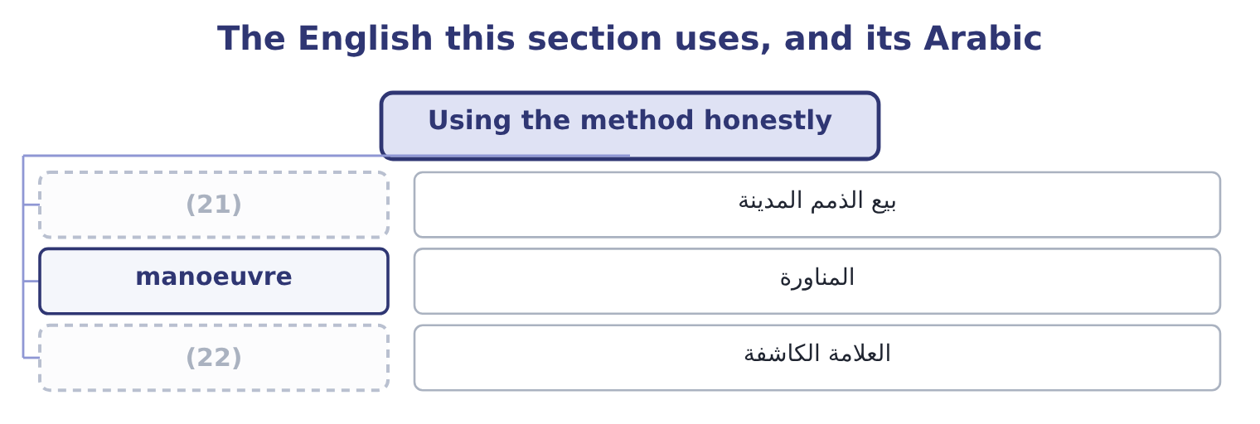
word list
write-off · tell · factoring

The English this sheet uses, and its Arabic
English (exam term) | Arabic
factoring | بيع الذمم المدينة
manoeuvre | المناورة
tell | العلامة الكاشفة

Answer key · 7.5 Using the method honestly

1 payables | 12 Pay down payables at the year end
2 untouched | 13 Draw less of a credit line at the year end
3 Delaying | 14 actually
4 Classifying | 15 statement
5 manoeuvre | 16 transaction
6 defences | 17 Whether
7 several | 18 working-capital
8 reverts | 19 14,908,100 and 5,000,000, giving 2.98.
9 arranged | 20 13,008,100 and 4,280,000, giving 3.04.
10 clearest | 21 factoring
11 happened | 22 tell

the summaries in full
Summary 1 Paying down payables just before the reporting date raises the current ratio of any company whose ratio is above 1, and leaves working capital untouched. Delaying a purchase does the same. Classifying a borrowing as noncurrent when a waiver was obtained after the reporting date is the Part 1 version of the same manoeuvre. The defences are three. Look at several dates, because a ratio that moves and reverts is suspect. Look at the cash flow ratio, which is a flow over the whole year and cannot be arranged on one day. And look at working capital in dollars beside the ratio, because the manoeuvres that move the ratio usually leave working capital exactly where it was — which is the clearest possible signal that nothing happened.
Summary 2 The last row is one Orontes actually did: its income statement carries a loss on sale of receivables of $15,000, which is the fee paid to Gulf Factor Co. The transaction turned receivables into cash, improved the cash ratio, and cost $15,000. Whether that was worth doing is a working-capital question, and Book 2 answers it.

