8.1 Solvency against liquidity
Chapter 8 · section 8.1

Fill every gap. Each word list holds one word more than there are gaps.
Chapter 8, section by section
Each stage leads to the next.
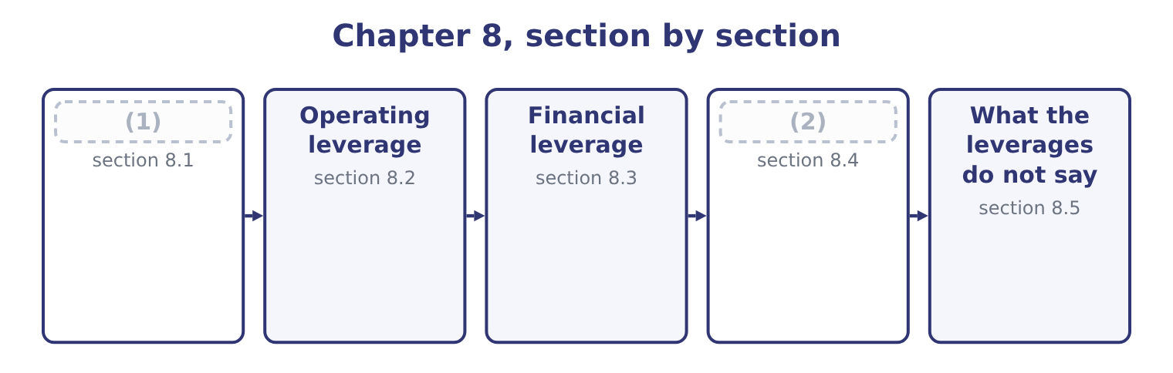
word list
The two together · Solvency against liquidity · debt service

Summary 1 gaps 3–14
Liquidity is about the next (3) months and about current assets (4) current liabilities. Solvency is about the whole (5) sheet and the whole life of the obligations. The two are (6) with different ratios and answer to different people. A (7) granting 30-day terms cares about liquidity. A (8) lending for ten years cares about solvency. Two (9) are worth naming because the exam sets them. A company sells assets, holds the (10) in cash, and still owes more than the business can ever earn. Its current ratio is (11) on the day the receiver is appointed. A company with no debt, (12) plant and a cash squeeze caused by one slow customer. It is in difficulty and it is not insolvent, and the remedy is a credit line rather than a (13) . Orontes is (14) both. Its liquidity ratios are.
word list
excellent · measured · comfortably · restructuring · proceeds · twelve · bondholder · asymmetry · combinations · balance · against · substantial · supplier

The two words are not interchangeable

Summary 2 gaps 15–19
A question about (15) debts "as they fall due" over the (16) year is liquidity. A question about the (17) to meet obligations over the long term, or about the debt-to-equity ratio, is solvency. (18) has a second, legal meaning — liabilities (19) assets — and the exam sometimes uses it. Read which is meant.
word list
meaning · ability · Insolvency · exceeding · coming · paying

Liquidity and solvency
 | Liquidity | Solvency
The question | Can the company pay what falls due soon? | (20)
The horizon | Up to one year, or the operating cycle | (21)
The ratios | (22) | Debt-to-equity, debt-to-assets, interest cover, fixed charge cover
Who asks | (23) | Bondholders, long-term lenders, shareholders
A failure looks like | (24) | Cannot service the debt; the business is worth less than it owes

word list
Cannot meet a payroll · Current, quick, cash, cash flow, net working capital · Can it meet all obligations over their lives? · Suppliers, short-term lenders · Up to one year, or the operating cycle · The life of the debt

The English this section uses, and its Arabic
Each term sits against what it means.
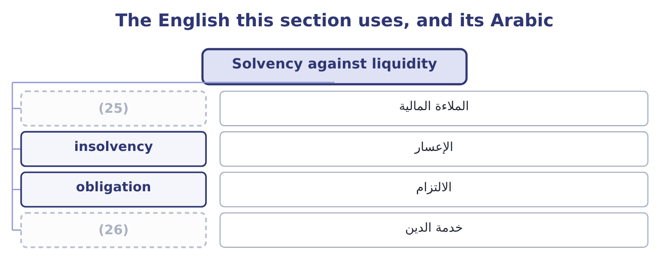
word list
debt service · combined leverage · solvency

The English this sheet uses, and its Arabic
English (exam term) | Arabic
solvency | الملاءة المالية
insolvency | الإعسار
obligation | الالتزام
debt service | خدمة الدين

Answer key · 8.1 Solvency against liquidity

1 Solvency against liquidity | 14 comfortably
2 The two together | 15 paying
3 twelve | 16 coming
4 against | 17 ability
5 balance | 18 Insolvency
6 measured | 19 exceeding
7 supplier | 20 Can it meet all obligations over their lives?
8 bondholder | 21 The life of the debt
9 combinations | 22 Current, quick, cash, cash flow, net working capital
10 proceeds | 23 Suppliers, short-term lenders
11 excellent | 24 Cannot meet a payroll
12 substantial | 25 solvency
13 restructuring | 26 debt service

the summaries in full
Summary 1 Liquidity is about the next twelve months and about current assets against current liabilities. Solvency is about the whole balance sheet and the whole life of the obligations. The two are measured with different ratios and answer to different people. A supplier granting 30-day terms cares about liquidity. A bondholder lending for ten years cares about solvency. Two combinations are worth naming because the exam sets them. A company sells assets, holds the proceeds in cash, and still owes more than the business can ever earn. Its current ratio is excellent on the day the receiver is appointed. A company with no debt, substantial plant and a cash squeeze caused by one slow customer. It is in difficulty and it is not insolvent, and the remedy is a credit line rather than a restructuring. Orontes is comfortably both. Its liquidity ratios are.
Summary 2 A question about paying debts "as they fall due" over the coming year is liquidity. A question about the ability to meet obligations over the long term, or about the debt-to-equity ratio, is solvency. Insolvency has a second, legal meaning — liabilities exceeding assets — and the exam sometimes uses it. Read which is meant.

8.2 Operating leverage
Chapter 8 · section 8.2

Fill every gap. Each word list holds one word more than there are gaps.
Summary 1 gaps 1–10
Operating leverage is the (1) of fixed operating costs on operating income. A company whose costs are mostly fixed sees its operating income swing far more than its sales; a company whose costs are mostly variable sees the two move (2) . The (3) is the degree of operating leverage, (4) DOL. It is the percentage change in operating income divided by the percentage change in sales, and at a given level of sales it can be computed (5) as the contribution margin divided by operating income. (6) total operating cost in 2025 was cost of goods sold of $27,300,000 plus operating (7) of $10,524,000, which is 27,300,000 + 10,524,000 = 37,824,000. Its cost (8) split that into variable costs of $25,200,000 and fixed costs of $12,624,000. Contribution margin is (9) 42,000,000 − 25,200,000 = 16,800,000, and operating income is 16,800,000 − 12,624,000 = 4,176,000, which is the figure on the income (10) . The degree of operating leverage is 16,800,000 ÷ 4,176,000 = 4.02.
word list
Orontes's · asymmetry · accountants · statement · directly · written · expenses · effect · therefore · measure · together

Worked example: what a DOL of 4.02 means

Summary 2 gaps 11–18
Read it as a multiplier. A 1 per cent change in sales produces a 4.02 per cent change in operating income, in the same (11) . Sales rise 10 per cent to $46,200,000. Variable costs rise 10 per cent to $27,720,000. Contribution is 46,200,000 − 27,720,000 = 18,480,000; fixed costs are (12) , so operating income is 18,480,000 − 12,624,000 = 5,856,000. The change is 5,856,000 − 4,176,000 = 1,680,000, which on 4,176,000 is 40.2 per cent — ten times 4.02, as (13) . Sales fall 10 per cent and operating income falls 40.2 per cent, to $2,496,000. The multiplier works both ways, and that is the risk. A company at this level of operating leverage loses a (14) of its operating income on a 6 per cent fall in sales. For Orontes the cause is (15) on the balance sheet: 46.7 per cent of its (16) are plant, and plant produces (17) whether or not (18) is sold.
word list
quarter · unchanged · structure · anything · direction · predicted · visible · assets · depreciation

Orontes operating income at three sales levels, DOL 4.02
The bars are drawn to scale.
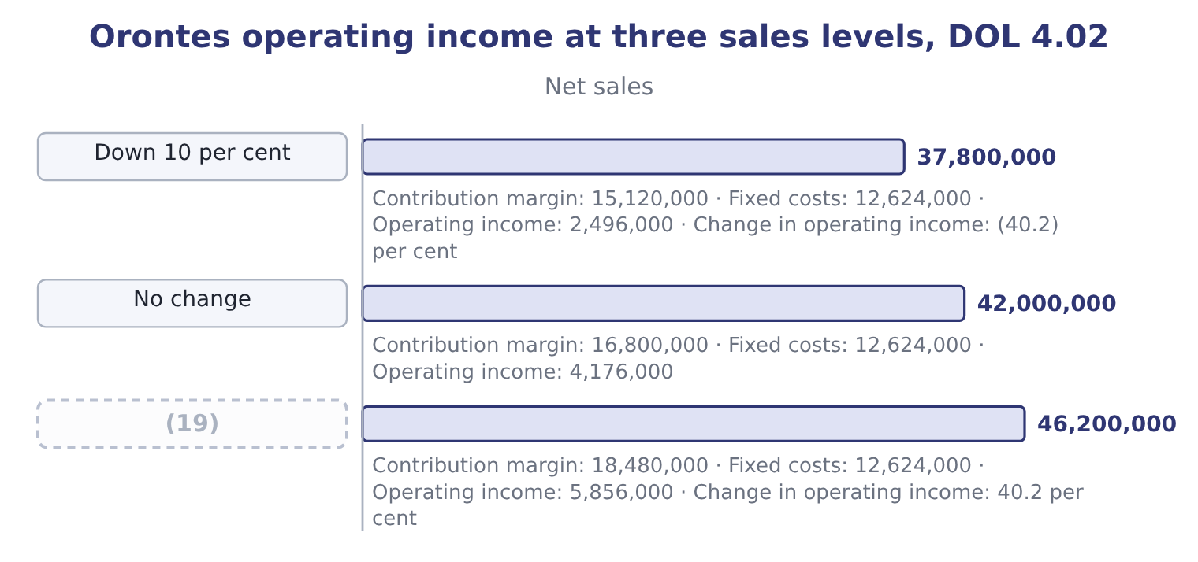
word list
Up 10 per cent · Down 10 per cent

DOL moves as sales move

Summary 3 gaps 20–25
The degree of operating leverage is computed at one level of sales and (20) as sales change. It is highest near (21) and falls as sales rise above it. DOL uses the contribution margin, not gross profit. Gross profit (22) all cost of goods sold, (23) the fixed part. A high DOL is not bad. It is a (24) of a cost structure, and it rewards growth exactly as much as it (25) decline.
word list
breakeven · description · including · deducts · produces · punishes · changes

The English this section uses, and its Arabic
Each term sits against what it means.
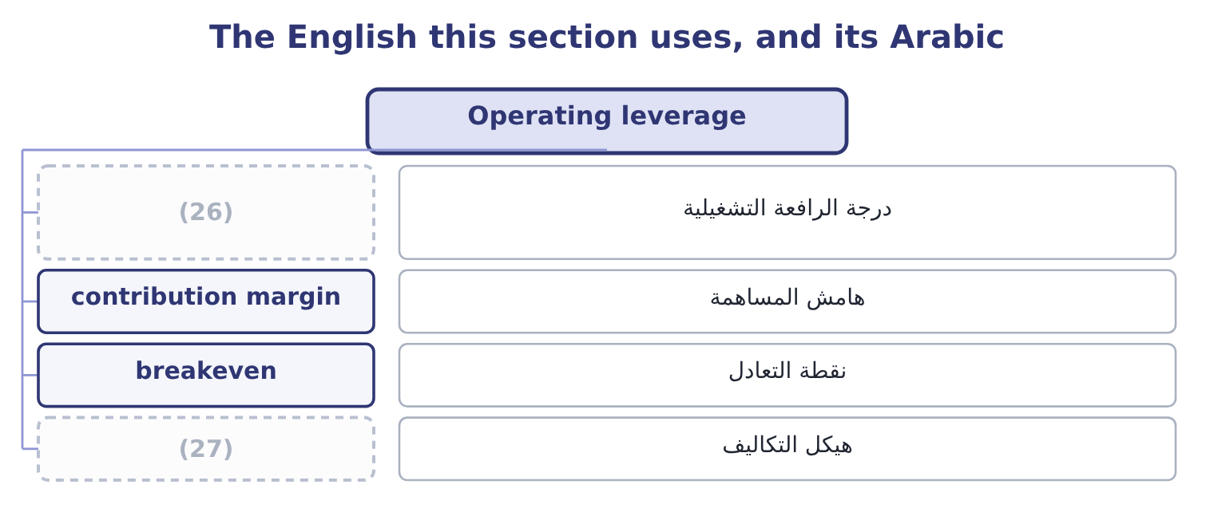
word list
step cost · degree of operating leverage · cost structure

The English this sheet uses, and its Arabic
English (exam term) | Arabic
degree of operating leverage | درجة الرافعة التشغيلية
contribution margin | هامش المساهمة
breakeven | نقطة التعادل
cost structure | هيكل التكاليف

Answer key · 8.2 Operating leverage

1 effect | 15 visible
2 together | 16 assets
3 measure | 17 depreciation
4 written | 18 anything
5 directly | 19 Up 10 per cent
6 Orontes's | 20 changes
7 expenses | 21 breakeven
8 accountants | 22 deducts
9 therefore | 23 including
10 statement | 24 description
11 direction | 25 punishes
12 unchanged | 26 degree of operating leverage
13 predicted | 27 cost structure
14 quarter

the summaries in full
Summary 1 Operating leverage is the effect of fixed operating costs on operating income. A company whose costs are mostly fixed sees its operating income swing far more than its sales; a company whose costs are mostly variable sees the two move together. The measure is the degree of operating leverage, written DOL. It is the percentage change in operating income divided by the percentage change in sales, and at a given level of sales it can be computed directly as the contribution margin divided by operating income. Orontes's total operating cost in 2025 was cost of goods sold of $27,300,000 plus operating expenses of $10,524,000, which is 27,300,000 + 10,524,000 = 37,824,000. Its cost accountants split that into variable costs of $25,200,000 and fixed costs of $12,624,000. Contribution margin is therefore 42,000,000 − 25,200,000 = 16,800,000, and operating income is 16,800,000 − 12,624,000 = 4,176,000, which is the figure on the income statement. The degree of operating leverage is 16,800,000 ÷ 4,176,000 = 4.02.
Summary 2 Read it as a multiplier. A 1 per cent change in sales produces a 4.02 per cent change in operating income, in the same direction. Sales rise 10 per cent to $46,200,000. Variable costs rise 10 per cent to $27,720,000. Contribution is 46,200,000 − 27,720,000 = 18,480,000; fixed costs are unchanged, so operating income is 18,480,000 − 12,624,000 = 5,856,000. The change is 5,856,000 − 4,176,000 = 1,680,000, which on 4,176,000 is 40.2 per cent — ten times 4.02, as predicted. Sales fall 10 per cent and operating income falls 40.2 per cent, to $2,496,000. The multiplier works both ways, and that is the risk. A company at this level of operating leverage loses a quarter of its operating income on a 6 per cent fall in sales. For Orontes the cause is visible on the balance sheet: 46.7 per cent of its assets are plant, and plant produces depreciation whether or not anything is sold.
Summary 3 The degree of operating leverage is computed at one level of sales and changes as sales change. It is highest near breakeven and falls as sales rise above it. DOL uses the contribution margin, not gross profit. Gross profit deducts all cost of goods sold, including the fixed part. A high DOL is not bad. It is a description of a cost structure, and it rewards growth exactly as much as it punishes decline.

8.3 Financial leverage
Chapter 8 · section 8.3

Fill every gap. Each word list holds one word more than there are gaps.
Summary 1 gaps 1–11
Financial leverage is the same idea (1) to the financing. Interest is a fixed charge: it is owed (2) or not the company (3) anything. So a change in operating income (4) a larger change in what is left for the (5) . The (6) is the degree of financial leverage, (7) DFL. It is the percentage change in net income, or in earnings per share, divided by the percentage change in operating income. At a given level it is (8) as earnings before interest and taxes divided by earnings before interest and taxes less interest. (9) earnings before interest and taxes is income before income taxes of $3,958,800 plus interest expense of $390,000, which is 3,958,800 + 390,000 = 4,348,800. The degree of financial leverage is 4,348,800 ÷ 3,958,800 = 1.10. A DFL of 1.10 is very low, and it says what: Orontes (10) very little, so the fixed charge is small and the (11) effect is small with it.
word list
magnification · applied · computed · produces · shareholders · earned · Orontes's · measure · written · whether · magnifying · borrows

Summary 2 gaps 12–15
A company (12) half by debt might carry a DFL of 1.8 or 2.0. Note what does not appear in the (13) . Tax does not, because tax is proportional and a proportional charge does not (14) anything. (15) of principal do not, because they are not an expense. Only the interest matters.
word list
magnify · Repayments · formula · shareholders · financed

Worked example: DFL at two capital structures

Summary 3 gaps 16–19
EBIT $4,348,800, interest $390,000. A 10 per cent change in EBIT (16) pre-tax income by 11.0 per cent. If Orontes (17) $12,000,000 more at 6 per cent, interest would rise by 12,000,000 × 0.06 = 720,000 to 390,000 + 720,000 = 1,110,000. Then DFL = 4,348,800 ÷ 3,238,800 = 1.34. The same 10 per cent change in EBIT would now move pre-tax income by 13.4 per cent. The (18) did not change; only the financing did. More debt, more (19) , in both directions.
word list
borrowed · magnification · business · Financial · changes

The English this section uses, and its Arabic
Each term sits against what it means.
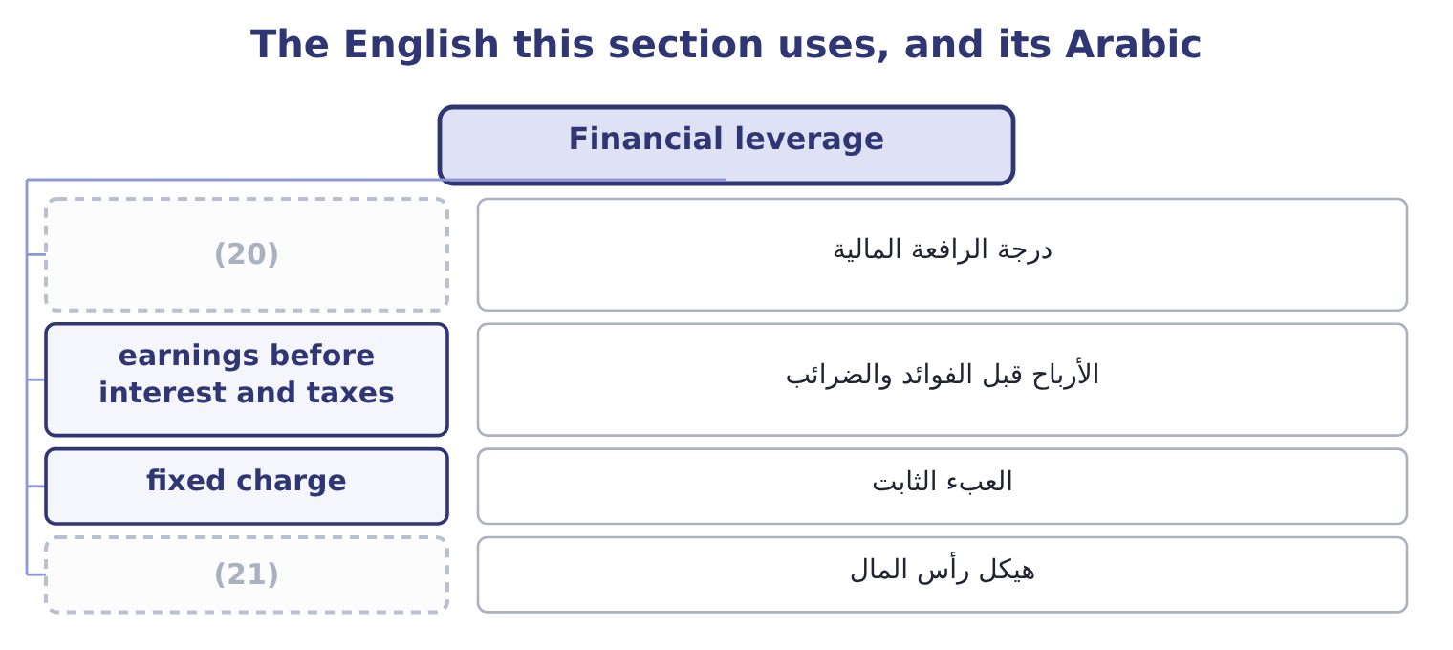
word list
degree of financial leverage · contribution margin · capital structure

The English this sheet uses, and its Arabic
English (exam term) | Arabic
degree of financial leverage | درجة الرافعة المالية
earnings before interest and taxes | الأرباح قبل الفوائد والضرائب
fixed charge | العبء الثابت
capital structure | هيكل رأس المال

Answer key · 8.3 Financial leverage

1 applied | 12 financed
2 whether | 13 formula
3 earned | 14 magnify
4 produces | 15 Repayments
5 shareholders | 16 changes
6 measure | 17 borrowed
7 written | 18 business
8 computed | 19 magnification
9 Orontes's | 20 degree of financial leverage
10 borrows | 21 capital structure
11 magnifying

the summaries in full
Summary 1 Financial leverage is the same idea applied to the financing. Interest is a fixed charge: it is owed whether or not the company earned anything. So a change in operating income produces a larger change in what is left for the shareholders. The measure is the degree of financial leverage, written DFL. It is the percentage change in net income, or in earnings per share, divided by the percentage change in operating income. At a given level it is computed as earnings before interest and taxes divided by earnings before interest and taxes less interest. Orontes's earnings before interest and taxes is income before income taxes of $3,958,800 plus interest expense of $390,000, which is 3,958,800 + 390,000 = 4,348,800. The degree of financial leverage is 4,348,800 ÷ 3,958,800 = 1.10. A DFL of 1.10 is very low, and it says what: Orontes borrows very little, so the fixed charge is small and the magnifying effect is small with it.
Summary 2 A company financed half by debt might carry a DFL of 1.8 or 2.0. Note what does not appear in the formula. Tax does not, because tax is proportional and a proportional charge does not magnify anything. Repayments of principal do not, because they are not an expense. Only the interest matters.
Summary 3 EBIT $4,348,800, interest $390,000. A 10 per cent change in EBIT changes pre-tax income by 11.0 per cent. If Orontes borrowed $12,000,000 more at 6 per cent, interest would rise by 12,000,000 × 0.06 = 720,000 to 390,000 + 720,000 = 1,110,000. Then DFL = 4,348,800 ÷ 3,238,800 = 1.34. The same 10 per cent change in EBIT would now move pre-tax income by 13.4 per cent. The business did not change; only the financing did. More debt, more magnification, in both directions.

8.4 The two together
Chapter 8 · section 8.4

Fill every gap. Each word list holds one word more than there are gaps.
Summary 1 gaps 1–5
The two (1) multiply. A change in sales is (2) first by the fixed operating costs and then by the fixed (3) charge, and the (4) is the degree of total, or combined, leverage. For Orontes: 4.02 × 1.10 = 4.42. A 1 per cent change in sales (5) about a 4.42 per cent change in income before tax.
word list
leverages · meaning · produces · magnified · product · financing

Orontes: a 10 per cent fall in sales, traced down the statement
Every item belongs to exactly one group.
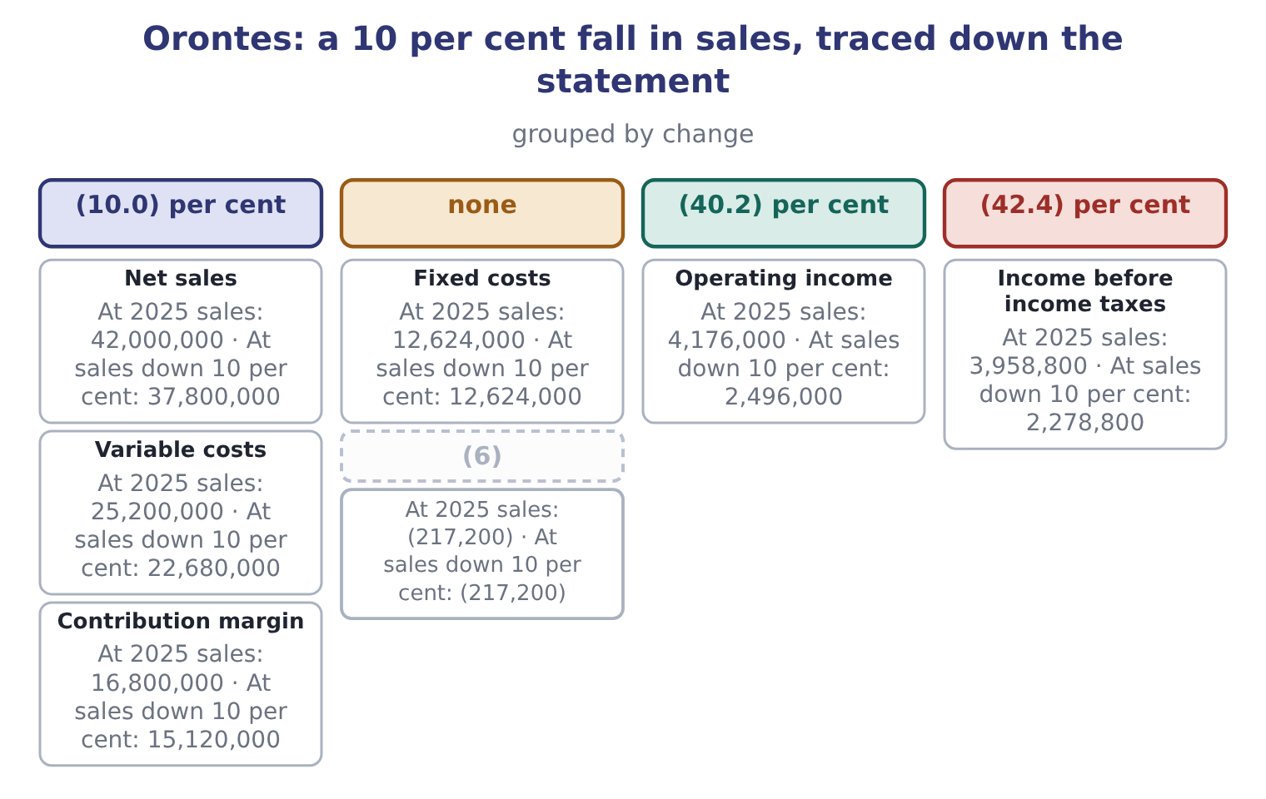
word list
Income before income taxes · Interest and other, net

Summary 2 gaps 7–18
Ten per cent off the top becomes (7) per cent off the (8) . That is the (9) the board has to (10) before it decides anything about either cost structure or borrowing, and it is why. The exam's point is usually the (11) of the two (12) . Operating leverage is largely given: a (13) has plant and a distributor does not, and changing it means changing what the business is. Financial leverage is (14) : the board can borrow or not, this quarter, by (15) . So two companies with the same operating leverage can carry very (16) total leverage, and the (17) is a decision somebody made. Orontes sits in the lower left. Its operating income swings hard with volume, and (18) it has almost no debt the swing stops there. A company in the lower right with the same plant and $20,000,000 of borrowing would face the same 40.2 per cent fall in operating income with interest of over a million to find out of it.
word list
because · resolution · manufacturer · difference · forty-two · asymmetry · solvency · understand · choices · arithmetic · bottom · different · chosen

Compute the three leverages

Your turn: Jordan Glass Co., 2025 (complete the blanks)
Item | Amount
Net sales | 9,000,000
Variable costs | 3,600,000
Contribution margin | 5,400,000
Fixed costs | 3,600,000
Operating income | 1,800,000
Interest expense | 600,000
Degree of operating leverage | 3.00: 5,400,000 ÷ 1,800,000.
Degree of financial leverage | (19) : EBIT of 1,800,000 ÷ (1,800,000 − 600,000).
Combined leverage | (20) : 3.00 × 1.50.

word list
1.50 · magnification · 4.50

"Leverage" and "gearing"

Summary 3 gaps 21–23
American English says leverage; British English often says gearing, and the exam uses leverage (21) . Note that English also uses leverage as a verb in business writing, meaning to make use of (22) . That sense never (23) in the exam.
word list
resolution · throughout · appears · something

Four positions
 | Low financial leverage | High financial leverage
Low operating leverage | Stable: a distributor financed by equity | (24) : fixed charges on a flexible business
High operating leverage | (25) | Dangerous: both magnifiers at once

word list
Orontes: swings with volume, no fixed charge · Moderate · degree of financial leverage

The English this section uses, and its Arabic
Each term sits against what it means.
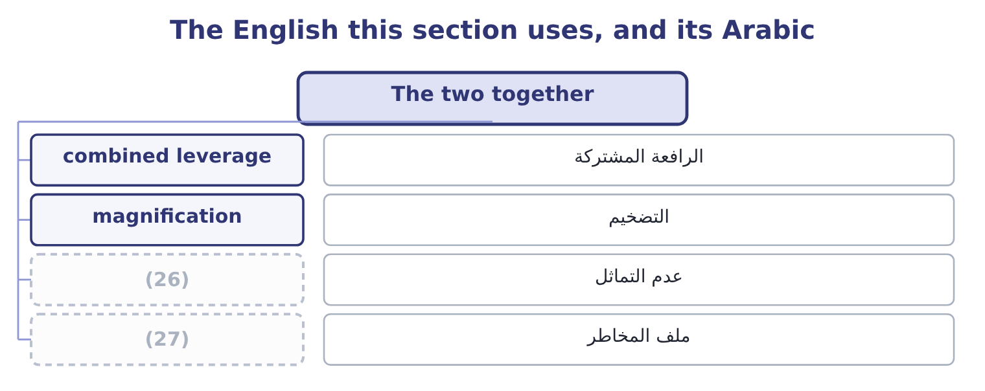
word list
risk profile · asymmetry · financial leverage

The English this sheet uses, and its Arabic
English (exam term) | Arabic
combined leverage | الرافعة المشتركة
magnification | التضخيم
asymmetry | عدم التماثل
risk profile | ملف المخاطر

Answer key · 8.4 The two together

1 leverages | 15 resolution
2 magnified | 16 different
3 financing | 17 difference
4 product | 18 because
5 produces | 19 1.50
6 Interest and other, net | 20 4.50
7 forty-two | 21 throughout
8 bottom | 22 something
9 arithmetic | 23 appears
10 understand | 24 Moderate
11 asymmetry | 25 Orontes: swings with volume, no fixed charge
12 choices | 26 asymmetry
13 manufacturer | 27 risk profile
14 chosen

the summaries in full
Summary 1 The two leverages multiply. A change in sales is magnified first by the fixed operating costs and then by the fixed financing charge, and the product is the degree of total, or combined, leverage. For Orontes: 4.02 × 1.10 = 4.42. A 1 per cent change in sales produces about a 4.42 per cent change in income before tax.
Summary 2 Ten per cent off the top becomes forty-two per cent off the bottom. That is the arithmetic the board has to understand before it decides anything about either cost structure or borrowing, and it is why. The exam's point is usually the asymmetry of the two choices. Operating leverage is largely given: a manufacturer has plant and a distributor does not, and changing it means changing what the business is. Financial leverage is chosen: the board can borrow or not, this quarter, by resolution. So two companies with the same operating leverage can carry very different total leverage, and the difference is a decision somebody made. Orontes sits in the lower left. Its operating income swings hard with volume, and because it has almost no debt the swing stops there. A company in the lower right with the same plant and $20,000,000 of borrowing would face the same 40.2 per cent fall in operating income with interest of over a million to find out of it.
Summary 3 American English says leverage; British English often says gearing, and the exam uses leverage throughout. Note that English also uses leverage as a verb in business writing, meaning to make use of something. That sense never appears in the exam.

8.5 What the leverages do not say
Chapter 8 · section 8.5

Fill every gap. Each word list holds one word more than there are gaps.
Summary 1 gaps 1–12
Three (1) , and the exam uses all three. A degree of leverage is a point (2) . Both are (3) at one level of sales and both change as sales change. A DOL of 4.02 is true at $42,000,000 of sales and not at $30,000,000, where it would be far (4) . The exam (5) gives two sales levels precisely to test this. A leverage figure says nothing about (6) . A DOL of 4.02 tells you what (7) if sales fall 10 per cent; it does not tell you whether they will. The risk is the product of the (8) and the likelihood, and the statements give only the first. A leverage figure (9) the cost split holds. Fixed costs are fixed only within a range of (10) . A fall in volume large enough to close a line turns a fixed cost into an (11) one, and a rise large enough to need a second shift adds a step. Part 1 called this the (12) range.
word list
magnification · happens · relevant · asymmetry · higher · computed · assumes · sometimes · activity · estimate · avoidable · limits · probability

The words this section uses
Each term sits against what it means, and an instance of it.
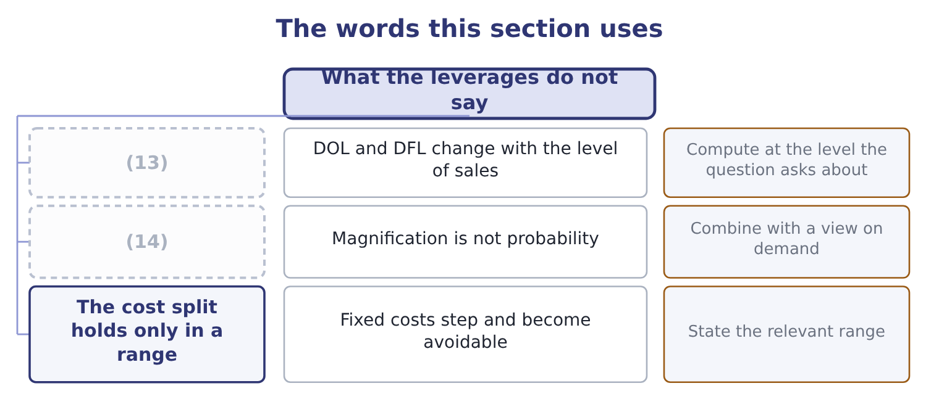
word list
Magnification is not probability · Says nothing about likelihood · A point estimate

The English this sheet uses, and its Arabic
English (exam term) | Arabic
relevant range | المدى الملائم
point estimate | التقدير عند نقطة
step cost | التكلفة المتدرجة
likelihood | الاحتمالية

Answer key · 8.5 What the leverages do not say

1 limits | 8 magnification
2 estimate | 9 assumes
3 computed | 10 activity
4 higher | 11 avoidable
5 sometimes | 12 relevant
6 probability | 13 A point estimate
7 happens | 14 Says nothing about likelihood

the summaries in full
Summary 1 Three limits, and the exam uses all three. A degree of leverage is a point estimate. Both are computed at one level of sales and both change as sales change. A DOL of 4.02 is true at $42,000,000 of sales and not at $30,000,000, where it would be far higher. The exam sometimes gives two sales levels precisely to test this. A leverage figure says nothing about probability. A DOL of 4.02 tells you what happens if sales fall 10 per cent; it does not tell you whether they will. The risk is the product of the magnification and the likelihood, and the statements give only the first. A leverage figure assumes the cost split holds. Fixed costs are fixed only within a range of activity. A fall in volume large enough to close a line turns a fixed cost into an avoidable one, and a rise large enough to need a second shift adds a step. Part 1 called this the relevant range.

