9.1 The four ratios
Chapter 9 · section 9.1

Fill every gap. Each word list holds one word more than there are gaps.
Chapter 9, section by section
Each stage leads to the next.
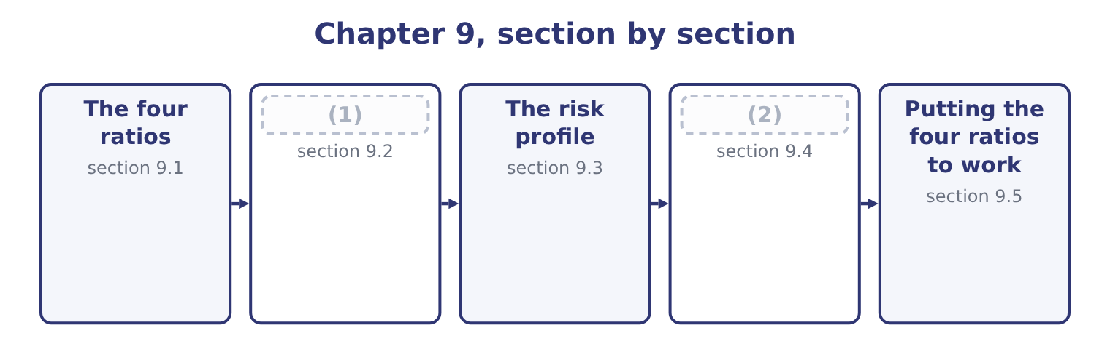
word list
Covenants and the composition of the debt · Putting the four ratios to work · What a change in the composition does

Summary 1 gaps 3–14
Each of the four (3) a measure of debt by a measure of what supports it. The debt-to-equity ratio is total liabilities divided by total stockholders' equity. It asks how many dollars of other (4) money the company (5) for each dollar of the (6) '. The long-term debt-to-equity ratio uses only long-term debt in the (7) . It removes the trade payables and accruals that arise from trading rather than from a (8) decision, so it (9) the borrowing the board chose. The (10) ratio is total liabilities divided by total assets. It asks what share of (11) the company owns is financed by (12) . The equity multiplier, which the Learning Outcome (13) also call the (14) leverage ratio, is total assets divided by total stockholders' equity. It asks how many dollars of assets each dollar of equity supports.
word list
debt-to-total-assets · everything · people's · divides · creditors · magnitude · numerator · financial · isolates · owners · Statements · financing · carries

Orontes Foods, Inc. — the capital structure ratios
The bars are drawn to scale.
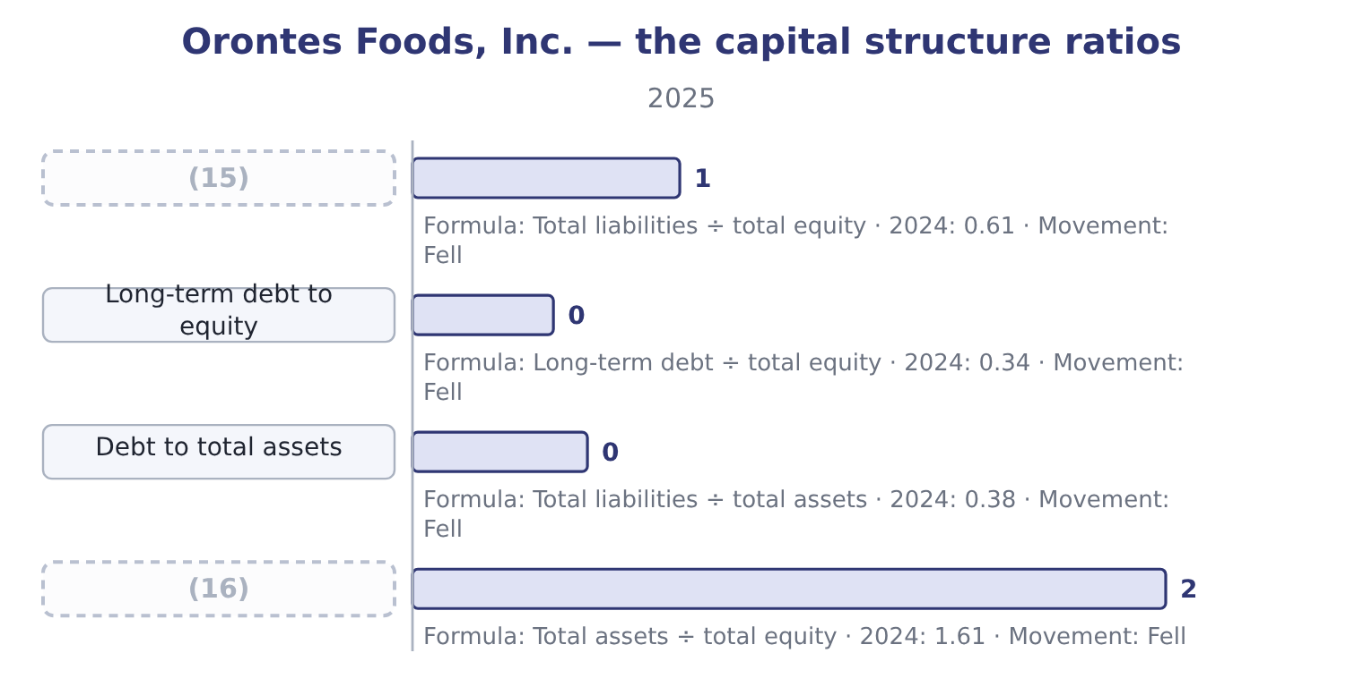
word list
retained earnings · Equity multiplier · Debt to equity

Summary 2 gaps 17–23
The (17) for 2025. Debt to equity is 11,279,625 ÷ 20,392,975 = 0.55. Long-term debt to equity is 6,000,000 ÷ 20,392,975 = 0.29. Debt to total assets is 11,279,625 ÷ 31,672,600 = 0.36. The equity multiplier is 31,672,600 ÷ 20,392,975 = 1.55. All four fell, and they fell for one (18) : equity grew 24.5 per cent while liabilities grew 12.0 per cent. (19) financed its (20) mainly out of (21) profit and a share issue. The (22) structure is (23) and became more so.
word list
retained · capital · restate · reason · conservative · arithmetic · Orontes · growth

Which debt is in the numerator?

Summary 3 gaps 24–27
Debt to equity (24) uses TOTAL liabilities, (25) payables and accruals. Long-term debt to equity uses only the long-term borrowing. (26) the current portion is included varies; the exam states which it wants. Debt to total assets and the equity multiplier both use total liabilities, one (27) assets and one through equity.
word list
including · against · normally · Whether · Learning

Worked example: the four ratios are one fact

Summary 4 gaps 28–30
Start from debt to total assets, 0.36. That means equity to total assets is 1.00 − 0.36 = 0.64. Debt to equity follows. The equity multiplier follows too. Three ratios, one (28) split of 36 per cent debt and 64 per cent equity. If an exam question gives you any one of the three, you can (29) the other two without further (30) , and that is a question the exam sets.
word list
trading · produce · underlying · information

The English this section uses, and its Arabic
Each term sits against what it means.
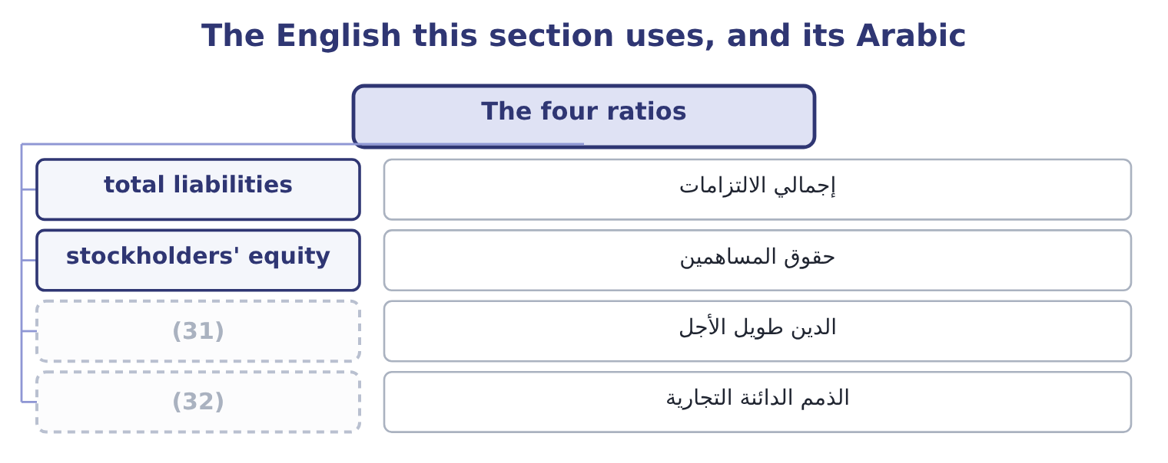
word list
trade payables · debt-to-total-assets ratio · long-term debt

The English this sheet uses, and its Arabic
English (exam term) | Arabic
total liabilities | إجمالي الالتزامات
stockholders' equity | حقوق المساهمين
long-term debt | الدين طويل الأجل
trade payables | الذمم الدائنة التجارية

Answer key · 9.1 The four ratios

1 What a change in the composition does | 17 arithmetic
2 Covenants and the composition of the debt | 18 reason
3 divides | 19 Orontes
4 people's | 20 growth
5 carries | 21 retained
6 owners | 22 capital
7 numerator | 23 conservative
8 financing | 24 normally
9 isolates | 25 including
10 debt-to-total-assets | 26 Whether
11 everything | 27 against
12 creditors | 28 underlying
13 Statements | 29 produce
14 financial | 30 information
15 Debt to equity | 31 long-term debt
16 Equity multiplier | 32 trade payables

the summaries in full
Summary 1 Each of the four divides a measure of debt by a measure of what supports it. The debt-to-equity ratio is total liabilities divided by total stockholders' equity. It asks how many dollars of other people's money the company carries for each dollar of the owners'. The long-term debt-to-equity ratio uses only long-term debt in the numerator. It removes the trade payables and accruals that arise from trading rather than from a financing decision, so it isolates the borrowing the board chose. The debt-to-total-assets ratio is total liabilities divided by total assets. It asks what share of everything the company owns is financed by creditors. The equity multiplier, which the Learning Outcome Statements also call the financial leverage ratio, is total assets divided by total stockholders' equity. It asks how many dollars of assets each dollar of equity supports.
Summary 2 The arithmetic for 2025. Debt to equity is 11,279,625 ÷ 20,392,975 = 0.55. Long-term debt to equity is 6,000,000 ÷ 20,392,975 = 0.29. Debt to total assets is 11,279,625 ÷ 31,672,600 = 0.36. The equity multiplier is 31,672,600 ÷ 20,392,975 = 1.55. All four fell, and they fell for one reason: equity grew 24.5 per cent while liabilities grew 12.0 per cent. Orontes financed its growth mainly out of retained profit and a share issue. The capital structure is conservative and became more so.
Summary 3 Debt to equity normally uses TOTAL liabilities, including payables and accruals. Long-term debt to equity uses only the long-term borrowing. Whether the current portion is included varies; the exam states which it wants. Debt to total assets and the equity multiplier both use total liabilities, one against assets and one through equity.
Summary 4 Start from debt to total assets, 0.36. That means equity to total assets is 1.00 − 0.36 = 0.64. Debt to equity follows. The equity multiplier follows too. Three ratios, one underlying split of 36 per cent debt and 64 per cent equity. If an exam question gives you any one of the three, you can produce the other two without further information, and that is a question the exam sets.

9.2 What a change in the composition does
Chapter 9 · section 9.2

Fill every gap. Each word list holds one word more than there are gaps.
Summary 1 gaps 1–10
The syllabus asks for the effect on capital structure and solvency of a change in the (1) of debt against equity, and the method is to (2) the balance sheet and (3) . Three (4) cover most of what the exam asks. Borrowing to buy an asset raises liabilities and assets by the same (5) and leaves equity alone. Every one of the four ratios rises. Borrowing to buy back shares raises liabilities, reduces equity, and leaves total assets (6) unchanged. The ratios rise much more (7) , because the numerator grows while the denominator (8) . (9) shares to repay debt does the (10) of the second: liabilities fall, equity rises, assets are unchanged. All four ratios fall.
word list
roughly · recompute · transactions · shrinks · sharply · composition · reverse · amount · restate · Issuing · statements

Three financing decisions, from Orontes's 2025 position
Every item belongs to exactly one group.
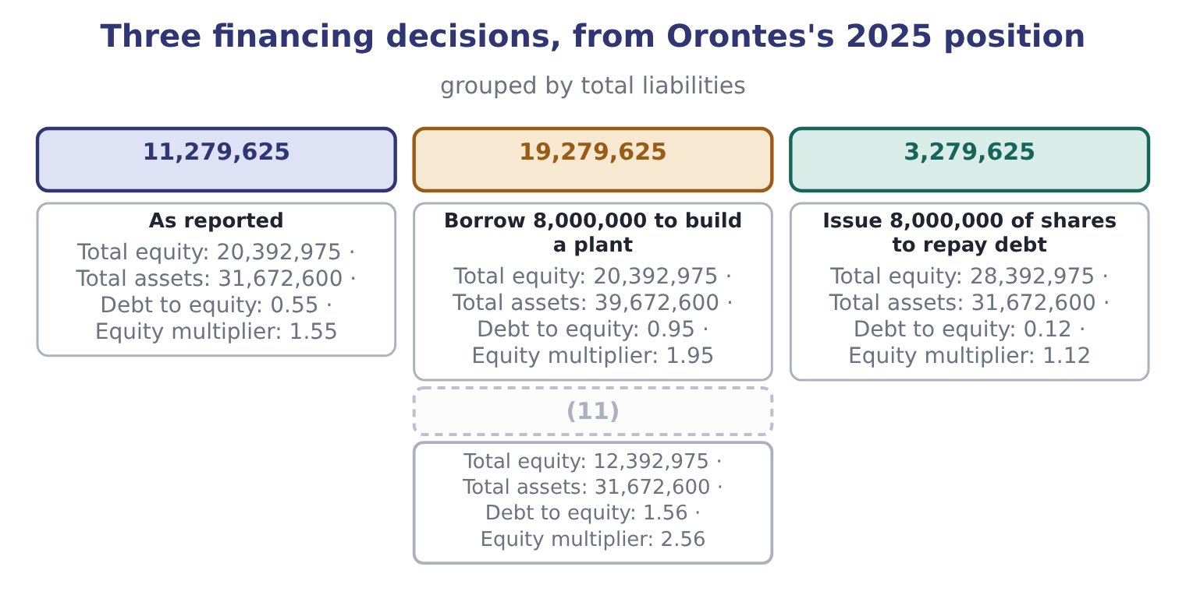
word list
Borrow 8,000,000 to build a plant · Borrow 8,000,000 to buy back shares

Summary 2 gaps 12–22
The second row is the one to (12) . The same $8,000,000 of borrowing takes debt to equity from 0.55 to 0.95 when it buys an asset, and to 1.56 when it buys back shares — (13) twice as far — because a (14) removes equity from the denominator at the same time as it adds debt to the numerator. Boards do this (15) , and a lender reading the (16) afterwards sees a (17) company. Note what does not change in the second row. The (18) is the same: the same plant, the same (19) , the same operating (20) . What (21) is who has a claim on it and in what order. That is the whole of a capital structure decision, and Book 2 takes it up as a decision rather than a (22) .
word list
measurement · buy-back · business · statements · changed · nearly · understand · deliberately · income · customers · numerator · different

Buying an asset is not the same as buying back shares

Summary 3 gaps 23–26
Borrowing to (23) raises both (24) of the balance sheet. Borrowing to (25) raises liabilities and reduces equity, so the ratios move about twice as far. Retained earnings raise equity without any (26) at all, which is why a profitable company deleverages by standing still.
word list
halves · distribute · shrinks · transaction · invest

The English this section uses, and its Arabic
Each term sits against what it means.
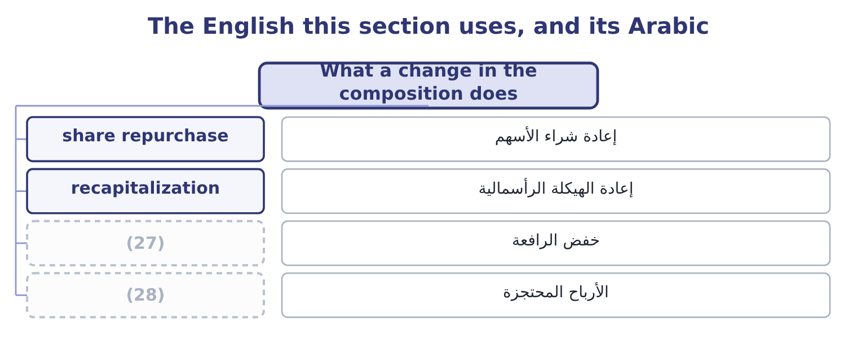
word list
deleverage · retained earnings · magnitude

The English this sheet uses, and its Arabic
English (exam term) | Arabic
share repurchase | إعادة شراء الأسهم
recapitalization | إعادة الهيكلة الرأسمالية
deleverage | خفض الرافعة
retained earnings | الأرباح المحتجزة

Answer key · 9.2 What a change in the composition does

1 composition | 15 deliberately
2 restate | 16 statements
3 recompute | 17 different
4 transactions | 18 business
5 amount | 19 customers
6 roughly | 20 income
7 sharply | 21 changed
8 shrinks | 22 measurement
9 Issuing | 23 invest
10 reverse | 24 halves
11 Borrow 8,000,000 to buy back shares | 25 distribute
12 understand | 26 transaction
13 nearly | 27 deleverage
14 buy-back | 28 retained earnings

the summaries in full
Summary 1 The syllabus asks for the effect on capital structure and solvency of a change in the composition of debt against equity, and the method is to restate the balance sheet and recompute. Three transactions cover most of what the exam asks. Borrowing to buy an asset raises liabilities and assets by the same amount and leaves equity alone. Every one of the four ratios rises. Borrowing to buy back shares raises liabilities, reduces equity, and leaves total assets roughly unchanged. The ratios rise much more sharply, because the numerator grows while the denominator shrinks. Issuing shares to repay debt does the reverse of the second: liabilities fall, equity rises, assets are unchanged. All four ratios fall.
Summary 2 The second row is the one to understand. The same $8,000,000 of borrowing takes debt to equity from 0.55 to 0.95 when it buys an asset, and to 1.56 when it buys back shares — nearly twice as far — because a buy-back removes equity from the denominator at the same time as it adds debt to the numerator. Boards do this deliberately, and a lender reading the statements afterwards sees a different company. Note what does not change in the second row. The business is the same: the same plant, the same customers, the same operating income. What changed is who has a claim on it and in what order. That is the whole of a capital structure decision, and Book 2 takes it up as a decision rather than a measurement.
Summary 3 Borrowing to invest raises both halves of the balance sheet. Borrowing to distribute raises liabilities and reduces equity, so the ratios move about twice as far. Retained earnings raise equity without any transaction at all, which is why a profitable company deleverages by standing still.

9.3 The risk profile
Chapter 9 · section 9.3

Fill every gap. Each word list holds one word more than there are gaps.
Summary 1 gaps 1–9
A capital structure decision changes three things about a company, and the exam asks about all three. It changes who bears the loss first. Equity (1) losses before debt does. A company financed 90 per cent by equity can lose a great deal before a (2) is at risk; a company financed 90 per cent by debt (3) . It changes the fixed charge. Interest must be paid in a bad year. Dividends need not: the board can simply not (4) one, as Orontes could have (5) in 2025. That (6) is the heart of (7) risk. It changes the return to the owners when things go well. Borrowing at 6 per cent to earn 12 per cent leaves the (8) for the shareholders, so (9) raises return on equity as long as the company earns more than its interest.
word list
breach · absorbs · lender · declare · difference · chosen · leverage · asymmetry · financial · cannot

Summary 2 gaps 10–19
The tax row is the one that makes the decision (10) difficult. Interest (11) taxable income and dividends do not, so debt is cheaper after tax than its interest rate (12) . Orontes pays interest of $390,000; at its (13) tax rate of about 25 per cent, the (14) cost is roughly 390,000 × 0.75 = 292,500. Book 2 (15) this as the cost of capital. Debt is 36 per cent of assets, the equity (16) is 1.55, and.15 times. The board has room to (17) and has not used it. Whether that is (18) or timidity is the question, because an (19) balance sheet also holds the return on equity down.
word list
reduces · breach · develops · genuinely · suggests · multiplier · effective · prudence · unlevered · after-tax · borrow

Worked example: what the unused capacity is worth

Summary 3 gaps 20–31
Suppose Orontes (20) enough to take debt to total assets to 0.50, the level many food (21) carry. Total assets would have to be financed half by debt. On the present balance sheet that means (22) of 31,672,600 × 0.50 = 15,836,300, against the present 11,279,625. The (23) borrowing is 15,836,300 − 11,279,625 = 4,556,675. At 6 per cent the extra interest is about 4,556,675 × 0.06 = 273,401, against (24) before interest and taxes of $4,348,800. Interest cover would fall from 11.15 times to about 4,348,800 ÷ 663,401 = 6.56 times, which is still (25) . Orontes could raise over four and a half (26) dollars without (27) its interest cover below six and a half times. That is what a (28) capital structure buys: not (29) for its own sake, but the (30) to act when (31) is worth acting on.
word list
earnings · million · conservative · taking · manufacturers · safety · strong · borrowed · liabilities · something · additional · develops · ability

What more debt does
 | More debt | More equity
Fixed charge | Rises; must be paid in a bad year | (32)
Return to owners in a good year | Higher | (33)
Loss borne by owners in a bad year | (34) | Smaller
Control | (35) | Diluted among more shareholders
Tax | Interest is deductible | (36)
Who is at risk first | Equity, then debt | (37)

word list
Larger, proportionately · None; dividends are discretionary · Diluted among more shareholders · Dividends are not · Lower · Equity, and there is more of it · Unchanged

The English this section uses, and its Arabic
Each term sits against what it means.
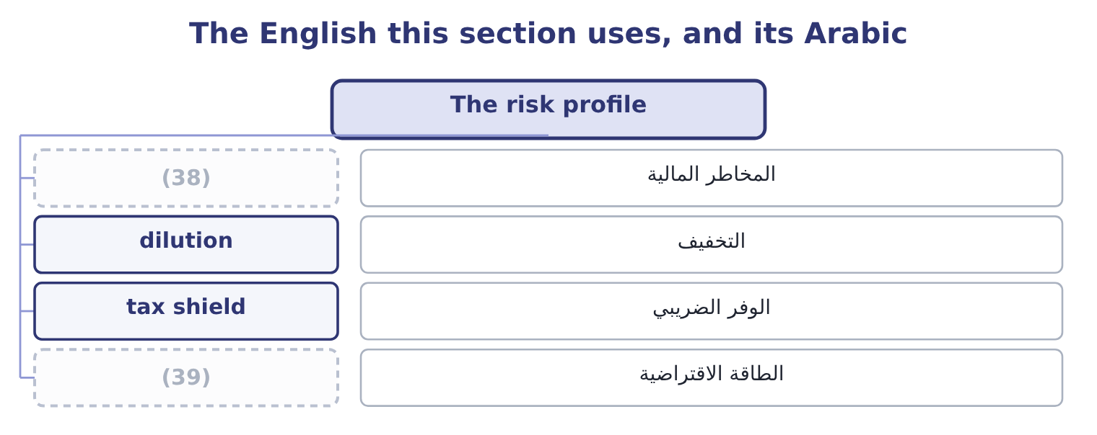
word list
financial risk · debt-to-equity ratio · borrowing capacity

The English this sheet uses, and its Arabic
English (exam term) | Arabic
financial risk | المخاطر المالية
dilution | التخفيف
tax shield | الوفر الضريبي
borrowing capacity | الطاقة الاقتراضية

Answer key · 9.3 The risk profile

1 absorbs | 21 manufacturers
2 lender | 22 liabilities
3 cannot | 23 additional
4 declare | 24 earnings
5 chosen | 25 strong
6 asymmetry | 26 million
7 financial | 27 taking
8 difference | 28 conservative
9 leverage | 29 safety
10 genuinely | 30 ability
11 reduces | 31 something
12 suggests | 32 None; dividends are discretionary
13 effective | 33 Lower
14 after-tax | 34 Larger, proportionately
15 develops | 35 Unchanged
16 multiplier | 36 Dividends are not
17 borrow | 37 Equity, and there is more of it
18 prudence | 38 financial risk
19 unlevered | 39 borrowing capacity
20 borrowed

the summaries in full
Summary 1 A capital structure decision changes three things about a company, and the exam asks about all three. It changes who bears the loss first. Equity absorbs losses before debt does. A company financed 90 per cent by equity can lose a great deal before a lender is at risk; a company financed 90 per cent by debt cannot. It changes the fixed charge. Interest must be paid in a bad year. Dividends need not: the board can simply not declare one, as Orontes could have chosen in 2025. That asymmetry is the heart of financial risk. It changes the return to the owners when things go well. Borrowing at 6 per cent to earn 12 per cent leaves the difference for the shareholders, so leverage raises return on equity as long as the company earns more than its interest.
Summary 2 The tax row is the one that makes the decision genuinely difficult. Interest reduces taxable income and dividends do not, so debt is cheaper after tax than its interest rate suggests. Orontes pays interest of $390,000; at its effective tax rate of about 25 per cent, the after-tax cost is roughly 390,000 × 0.75 = 292,500. Book 2 develops this as the cost of capital. Debt is 36 per cent of assets, the equity multiplier is 1.55, and.15 times. The board has room to borrow and has not used it. Whether that is prudence or timidity is the question, because an unlevered balance sheet also holds the return on equity down.
Summary 3 Suppose Orontes borrowed enough to take debt to total assets to 0.50, the level many food manufacturers carry. Total assets would have to be financed half by debt. On the present balance sheet that means liabilities of 31,672,600 × 0.50 = 15,836,300, against the present 11,279,625. The additional borrowing is 15,836,300 − 11,279,625 = 4,556,675. At 6 per cent the extra interest is about 4,556,675 × 0.06 = 273,401, against earnings before interest and taxes of $4,348,800. Interest cover would fall from 11.15 times to about 4,348,800 ÷ 663,401 = 6.56 times, which is still strong. Orontes could raise over four and a half million dollars without taking its interest cover below six and a half times. That is what a conservative capital structure buys: not safety for its own sake, but the ability to act when something is worth acting on.

9.4 Covenants and the composition of the debt
Chapter 9 · section 9.4

Fill every gap. Each word list holds one word more than there are gaps.
Summary 1 gaps 1–12
A leverage ratio is not only an (1) measure. It is often a term of the loan, and that gives it (2) . A covenant is a promise in a loan agreement, and the (3) are expressed as leverage and (4) ratios: debt to equity not above a stated figure, interest cover not below one. Part 1 recorded exactly this for Barada: at (5) 31 it had broken a (6) covenant on its note, and the bank waived the breach on January 20 before the statements were issued. You (7) there what the waiver did to the classification; here the point is what the covenant does to the company. A breach (8) makes the loan (9) on demand. That turns long-term debt into a current (10) and can wreck a (11) position overnight, which is why a company close to a covenant limit manages towards it. The (12) of, and so is the timing of a share issue.
word list
usually · debt-to-equity · liquidity · commonest · repayable · December · learned · consequences · measures · English · coverage · analyst's · liability

Reading the debt, not just the ratio
Every item belongs to exactly one group.
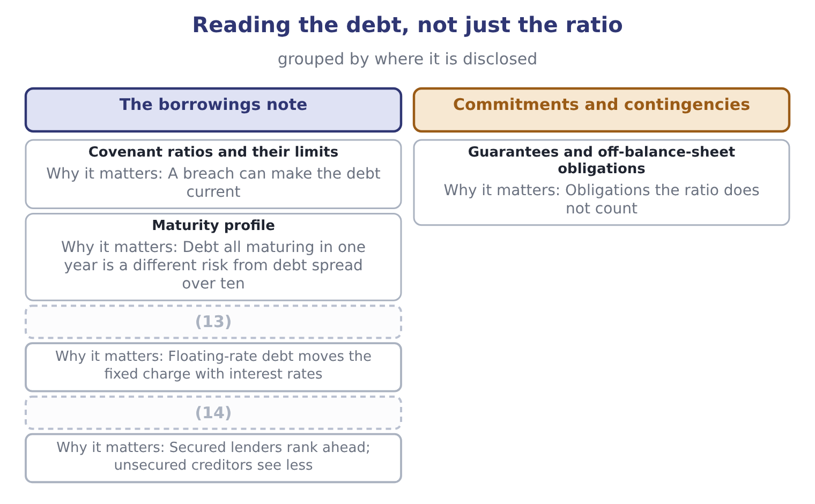
word list
debt-to-equity ratio · Security given · Fixed or floating rate

Summary 2 gaps 15–18
Orontes's own note, as Part 1 recorded, (15) $6,000,000 of long-term debt and $400,000 of it due (16) the year. The (17) profile is (18) and the cover is wide. Barada's is neither, which is the difference between the two companies that the ratios alone understate.
word list
gentle · within · manages · carries · maturity

The ratio and the agreement

Summary 3 gaps 19–22
A covenant may (19) debt or equity (20) from the published ratio. Read the (21) in the agreement. A waiver obtained after the (22) date does not change the classification under IFRS, and does under U.S. GAAP where the agreement is in place before the statements are issued.
word list
reporting · differently · breach · definition · define

"Covenant"

Summary 4 gaps 23–26
In (23) English a covenant is a (24) promise. In a loan agreement it is a specific (25) , and the exam uses it only in that sense. Note the pair of adjectives the exam uses: an (26) covenant requires the borrower to do something, and a negative covenant forbids something.
word list
manages · ordinary · undertaking · affirmative · solemn

The English this section uses, and its Arabic
Each term sits against what it means.
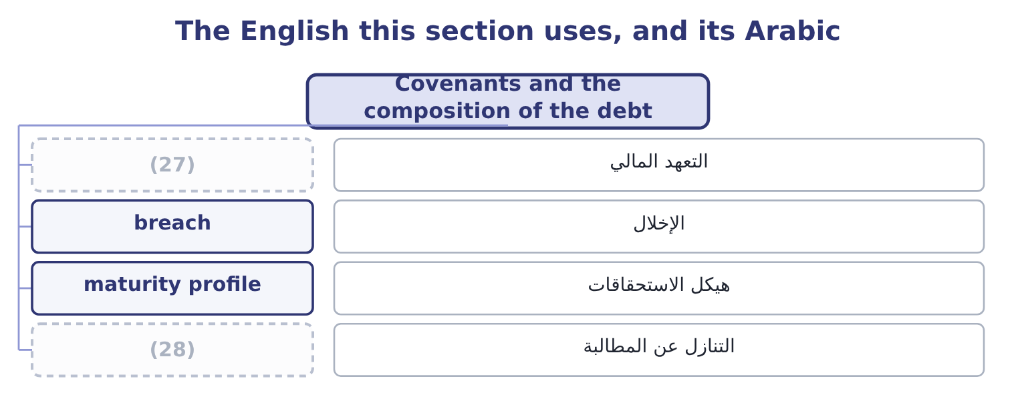
word list
covenant · waiver · magnitude

The English this sheet uses, and its Arabic
English (exam term) | Arabic
covenant | التعهد المالي
breach | الإخلال
maturity profile | هيكل الاستحقاقات
waiver | التنازل عن المطالبة

Answer key · 9.4 Covenants and the composition of the debt

1 analyst's | 15 carries
2 consequences | 16 within
3 commonest | 17 maturity
4 coverage | 18 gentle
5 December | 19 define
6 debt-to-equity | 20 differently
7 learned | 21 definition
8 usually | 22 reporting
9 repayable | 23 ordinary
10 liability | 24 solemn
11 liquidity | 25 undertaking
12 measures | 26 affirmative
13 Fixed or floating rate | 27 covenant
14 Security given | 28 waiver

the summaries in full
Summary 1 A leverage ratio is not only an analyst's measure. It is often a term of the loan, and that gives it consequences. A covenant is a promise in a loan agreement, and the commonest are expressed as leverage and coverage ratios: debt to equity not above a stated figure, interest cover not below one. Part 1 recorded exactly this for Barada: at December 31 it had broken a debt-to-equity covenant on its note, and the bank waived the breach on January 20 before the statements were issued. You learned there what the waiver did to the classification; here the point is what the covenant does to the company. A breach usually makes the loan repayable on demand. That turns long-term debt into a current liability and can wreck a liquidity position overnight, which is why a company close to a covenant limit manages towards it. The measures of, and so is the timing of a share issue.
Summary 2 Orontes's own note, as Part 1 recorded, carries $6,000,000 of long-term debt and $400,000 of it due within the year. The maturity profile is gentle and the cover is wide. Barada's is neither, which is the difference between the two companies that the ratios alone understate.
Summary 3 A covenant may define debt or equity differently from the published ratio. Read the definition in the agreement. A waiver obtained after the reporting date does not change the classification under IFRS, and does under U.S. GAAP where the agreement is in place before the statements are issued.
Summary 4 In ordinary English a covenant is a solemn promise. In a loan agreement it is a specific undertaking, and the exam uses it only in that sense. Note the pair of adjectives the exam uses: an affirmative covenant requires the borrower to do something, and a negative covenant forbids something.

9.5 Putting the four ratios to work
Chapter 9 · section 9.5

Fill every gap. Each word list holds one word more than there are gaps.
Recompute the ratios after a decision

Compute the four ratios.
Your turn: after a debt-funded buy-back (complete the blanks)
Item | Amount
Total liabilities | 17,279,625
Total stockholders' equity | 14,392,975
Total assets | 31,672,600
Long-term debt | 12,000,000
Debt to equity | 1.20: 17,279,625 ÷ 14,392,975.
Long-term debt to equity | (1) : 12,000,000 ÷ 14,392,975.
Debt to total assets | (2) : 17,279,625 ÷ 31,672,600.
Equity multiplier | 2.20: 31,672,600 ÷ 14,392,975.

word list
0.83 · 0.55 · waiver

Summary 1 gaps 3–7
Two habits (3) a Level C answer from a Level B one. State the (4) and the size. Say who the (5) is for. The same movement reassures a (6) expecting a higher return on equity and worries a bondholder whose cushion has halved. An answer that does not name the reader has not (7) .
word list
separate · covenant · finished · shareholder · direction · change

The English this section uses, and its Arabic
Each term sits against what it means.
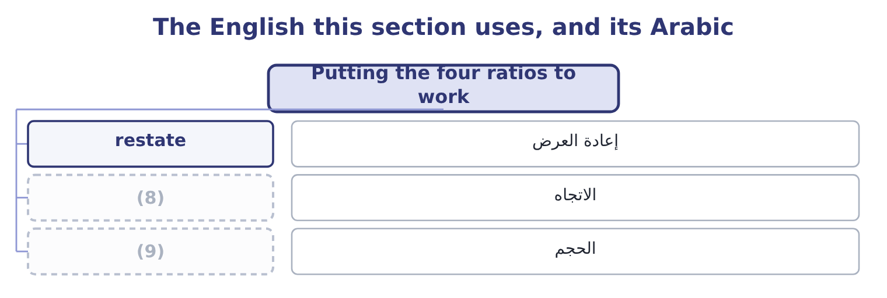
word list
direction · magnitude · الحجم

The English this sheet uses, and its Arabic
English (exam term) | Arabic
restate | إعادة العرض
direction | الاتجاه
magnitude | الحجم

Answer key · 9.5 Putting the four ratios to work

1 0.83 | 6 shareholder
2 0.55 | 7 finished
3 separate | 8 direction
4 direction | 9 magnitude
5 change

the summaries in full
Summary 1 Two habits separate a Level C answer from a Level B one. State the direction and the size. Say who the change is for. The same movement reassures a shareholder expecting a higher return on equity and worries a bondholder whose cushion has halved. An answer that does not name the reader has not finished.

