10.1 Times interest earned
Chapter 10 · section 10.1

Fill every gap. Each word list holds one word more than there are gaps.
Chapter 10, section by section
Each stage leads to the next.
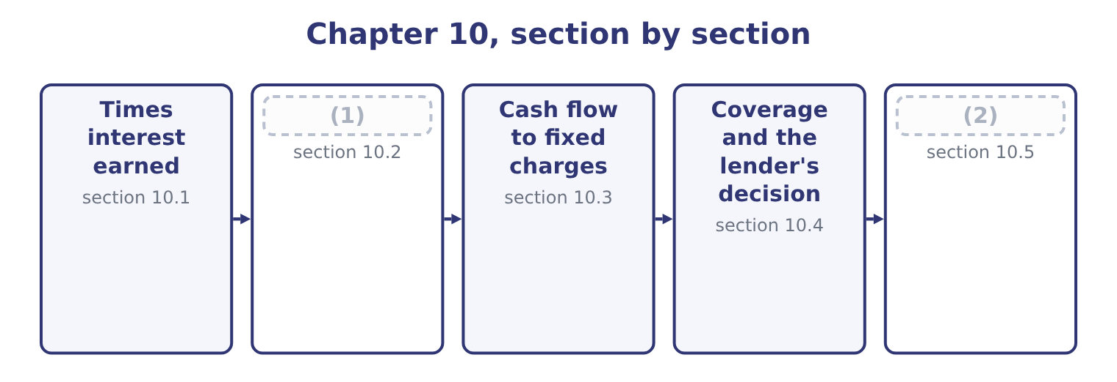
word list
What coverage ratios miss · operating lease rentals · Fixed charge coverage

Summary 1 gaps 3–14
Interest coverage, also (3) times interest earned, (4) earnings before interest and taxes by interest expense. It asks how many times over the year's earnings would pay the year's interest. Interest is added back to the (5) because the question is how much is (6) to pay it. Tax is added back because interest is (7) before tax is (8) : a company does not have to earn the tax on money it pays as interest. For Orontes, earnings before interest and taxes is income before income taxes of $3,958,800 plus interest expense of $390,000, which is 3,958,800 + 390,000 = 4,348,800. Interest coverage is (9) 4,348,800 ÷ 390,000 = 11.15 times. (10) times is a (11) figure. Lenders (12) look for three or four times as a minimum and write (13) at two or two and a half. Orontes's earnings could fall by more than (14) before the interest became difficult to find.
word list
divides · computed · nine-tenths · therefore · covenants · deducted · numerator · commonly · Capitalized · Eleven · strong · available · called

What goes in the numerator

Summary 2 gaps 15–19
Earnings before interest and taxes, not net income and not operating income. Operating income (15) other income and expense, and the exam is (16) . Interest expense in the (17) is the gross (18) , not interest net of interest income. (19) interest is included in some definitions. If a question gives it to you, it wants it included.
word list
specific · Capitalized · excludes · against · denominator · charge

Worked example: coverage after borrowing

Summary 3 gaps 20–28
EBIT $4,348,800 (20) interest of $390,000 is 11.15 times. Orontes (21) $12,000,000 at 6 per cent. Extra interest is 12,000,000 × 0.06 = 720,000, so total interest (22) 390,000 + 720,000 = 1,110,000. If the (23) adds nothing to EBIT in the first year, coverage is 4,348,800 ÷ 1,110,000 = 3.92 times. The same company, the same earnings, and coverage down from 11.15 to 3.92 — from the top to the (24) of the usual (25) range. That is the real (26) of a borrowing (27) , and it is why a lender reads this ratio before the (28) ratios.
word list
borrows · middle · becomes · decision · covenant · excludes · project · content · leverage · against

The words this section uses
Each term sits against what it means, and an instance of it.
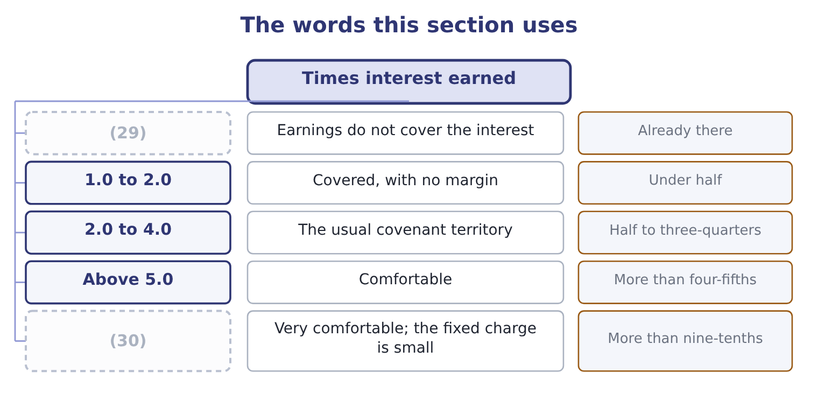
word list
covenant limit · Orontes, 11.15 · Below 1.0

The English this sheet uses, and its Arabic
English (exam term) | Arabic
interest expense | مصروف الفوائد
capitalized interest | الفوائد المرسملة
margin of safety | هامش الأمان
covenant limit | حد التعهد المالي

Answer key · 10.1 Times interest earned

1 Fixed charge coverage | 16 specific
2 What coverage ratios miss | 17 denominator
3 called | 18 charge
4 divides | 19 Capitalized
5 numerator | 20 against
6 available | 21 borrows
7 deducted | 22 becomes
8 computed | 23 project
9 therefore | 24 middle
10 Eleven | 25 covenant
11 strong | 26 content
12 commonly | 27 decision
13 covenants | 28 leverage
14 nine-tenths | 29 Below 1.0
15 excludes | 30 Orontes, 11.15

the summaries in full
Summary 1 Interest coverage, also called times interest earned, divides earnings before interest and taxes by interest expense. It asks how many times over the year's earnings would pay the year's interest. Interest is added back to the numerator because the question is how much is available to pay it. Tax is added back because interest is deducted before tax is computed: a company does not have to earn the tax on money it pays as interest. For Orontes, earnings before interest and taxes is income before income taxes of $3,958,800 plus interest expense of $390,000, which is 3,958,800 + 390,000 = 4,348,800. Interest coverage is therefore 4,348,800 ÷ 390,000 = 11.15 times. Eleven times is a strong figure. Lenders commonly look for three or four times as a minimum and write covenants at two or two and a half. Orontes's earnings could fall by more than nine-tenths before the interest became difficult to find.
Summary 2 Earnings before interest and taxes, not net income and not operating income. Operating income excludes other income and expense, and the exam is specific. Interest expense in the denominator is the gross charge, not interest net of interest income. Capitalized interest is included in some definitions. If a question gives it to you, it wants it included.
Summary 3 EBIT $4,348,800 against interest of $390,000 is 11.15 times. Orontes borrows $12,000,000 at 6 per cent. Extra interest is 12,000,000 × 0.06 = 720,000, so total interest becomes 390,000 + 720,000 = 1,110,000. If the project adds nothing to EBIT in the first year, coverage is 4,348,800 ÷ 1,110,000 = 3.92 times. The same company, the same earnings, and coverage down from 11.15 to 3.92 — from the top to the middle of the usual covenant range. That is the real content of a borrowing decision, and it is why a lender reads this ratio before the leverage ratios.

10.2 Fixed charge coverage
Chapter 10 · section 10.2

Fill every gap. Each word list holds one word more than there are gaps.
Summary 1 gaps 1–12
Interest is not the only charge a company must meet (1) happens. Rent under an operating lease must be paid. So must the lease payments on (2) , preferred (3) in some definitions, and in many (4) the principal (5) too. Fixed charge coverage, which the Learning Outcome (6) also call earnings to fixed charges, widens the ratio to take those. The (7) form adds the interest element of lease rentals to both the numerator and the denominator, because that element was (8) in arriving at earnings and has to be added back before it is counted as a charge. Orontes pays operating lease rentals of $240,000 a year on its Gulf (9) . The (10) treatment takes one-third of a (11) as its interest element, which here is 240,000 ÷ 3 = 80,000. Fixed charges are (12) interest of $390,000 plus the lease element of $80,000: 390,000 + 80,000 = 470,000.
word list
therefore · warehouses · dividends · conventional · equipment · rental · instalments · deducted · standard · Statements · agreements · charges · whatever

Summary 2 gaps 13–21
The numerator is EBIT plus the same lease element: 4,348,800 + 80,000 = 4,428,800. Fixed charge coverage is 4,428,800 ÷ 470,000 = 9.42 times. Fixed charge coverage is (13) the lower of the two, because the denominator widens by more, (14) , than the numerator. The gap (15) them is the (16) of how much of a (17) fixed burden is (18) other than interest. For Orontes the gap is small, because it owns most of its plant. For a (19) that leases every store, the gap is (20) , and a lender who looked only at interest coverage would badly (21) it.
word list
proportionately · misjudge · always · retailer · between · something · company's · measure · enormous · preferred

Fixed charge coverage traps

Summary 3 gaps 22–26
Add the lease element to BOTH (22) . (23) it only to the denominator (24) the ratio. A preferred dividend, where a (25) includes it, must be grossed up for tax: it is paid out of (26) income, so the pre-tax earnings needed are the dividend divided by one minus the tax rate. Principal repayments are included in some definitions and not in others.
word list
halves · understates · includes · question · Adding · after-tax

"Charge" in English

Summary 4 gaps 27–28
English charge has several (27) senses: an expense in the income statement, an (28) to pay, and a security given over an asset.
word list
accounting · conventional · obligation

Orontes: interest coverage and fixed charge coverage
 | Numerator | Denominator | Ratio
Interest coverage | (29) | Interest 390,000 | 11.15
Fixed charge coverage | EBIT plus lease element 4,428,800 | (30) | 9.42

word list
earnings before interest and taxes · EBIT 4,348,800 · Interest plus lease element 470,000

The English this section uses, and its Arabic
Each term sits against what it means.
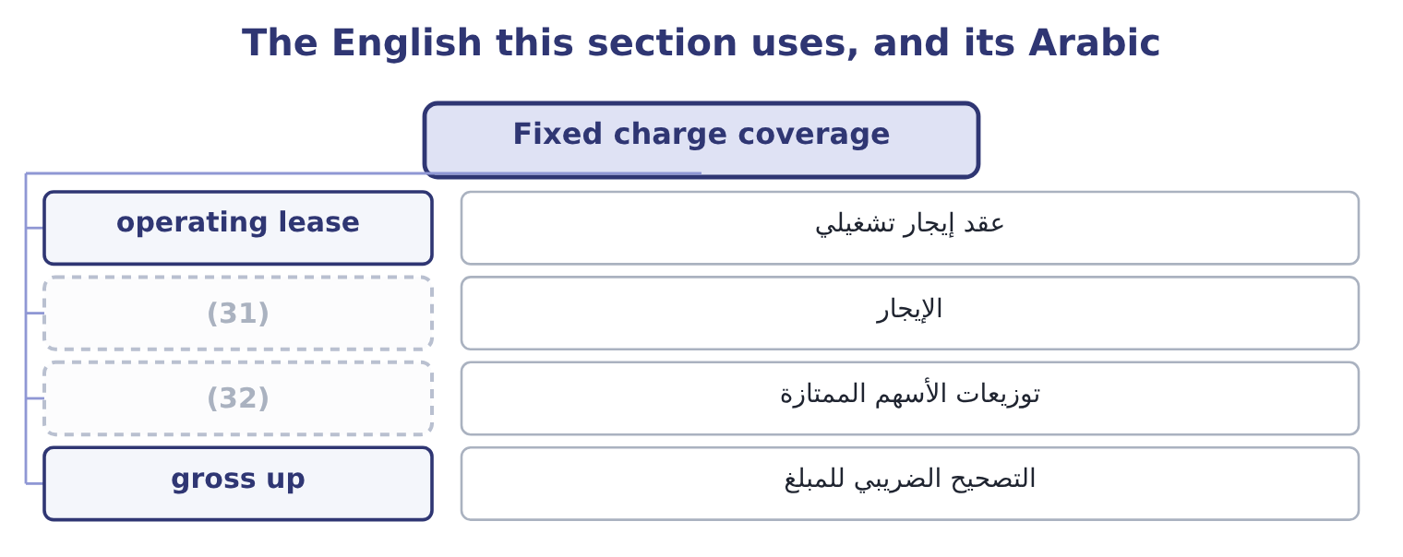
word list
preferred dividend · rental · covenant limit

The English this sheet uses, and its Arabic
English (exam term) | Arabic
operating lease | عقد إيجار تشغيلي
rental | الإيجار
preferred dividend | توزيعات الأسهم الممتازة
gross up | التصحيح الضريبي للمبلغ

Answer key · 10.2 Fixed charge coverage

1 whatever | 17 company's
2 equipment | 18 something
3 dividends | 19 retailer
4 agreements | 20 enormous
5 instalments | 21 misjudge
6 Statements | 22 halves
7 standard | 23 Adding
8 deducted | 24 understates
9 warehouses | 25 question
10 conventional | 26 after-tax
11 rental | 27 accounting
12 therefore | 28 obligation
13 always | 29 EBIT 4,348,800
14 proportionately | 30 Interest plus lease element 470,000
15 between | 31 rental
16 measure | 32 preferred dividend

the summaries in full
Summary 1 Interest is not the only charge a company must meet whatever happens. Rent under an operating lease must be paid. So must the lease payments on equipment, preferred dividends in some definitions, and in many agreements the principal instalments too. Fixed charge coverage, which the Learning Outcome Statements also call earnings to fixed charges, widens the ratio to take those. The standard form adds the interest element of lease rentals to both the numerator and the denominator, because that element was deducted in arriving at earnings and has to be added back before it is counted as a charge. Orontes pays operating lease rentals of $240,000 a year on its Gulf warehouses. The conventional treatment takes one-third of a rental as its interest element, which here is 240,000 ÷ 3 = 80,000. Fixed charges are therefore interest of $390,000 plus the lease element of $80,000: 390,000 + 80,000 = 470,000.
Summary 2 The numerator is EBIT plus the same lease element: 4,348,800 + 80,000 = 4,428,800. Fixed charge coverage is 4,428,800 ÷ 470,000 = 9.42 times. Fixed charge coverage is always the lower of the two, because the denominator widens by more, proportionately, than the numerator. The gap between them is the measure of how much of a company's fixed burden is something other than interest. For Orontes the gap is small, because it owns most of its plant. For a retailer that leases every store, the gap is enormous, and a lender who looked only at interest coverage would badly misjudge it.
Summary 3 Add the lease element to BOTH halves. Adding it only to the denominator understates the ratio. A preferred dividend, where a question includes it, must be grossed up for tax: it is paid out of after-tax income, so the pre-tax earnings needed are the dividend divided by one minus the tax rate. Principal repayments are included in some definitions and not in others.
Summary 4 English charge has several accounting senses: an expense in the income statement, an obligation to pay, and a security given over an asset.

10.3 Cash flow to fixed charges
Chapter 10 · section 10.3

Fill every gap. Each word list holds one word more than there are gaps.
Summary 1 gaps 1–9
Earnings are an (1) measure and the fixed charges are paid in money. A company can (2) earnings that cover its interest (3) and still not have the cash, because the earnings are in receivables and inventory. The third ratio (4) that risk by (5) earnings with cash. Cash flow to fixed charges (6) operating cash flow, before the fixed charges and before tax, by the fixed charges. In practice the (7) is operating cash flow as reported, plus the fixed charges that were deducted in arriving at it, plus income taxes paid. Orontes's operating cash flow for 2025 is $7,531,100. It paid interest of $390,000 and income taxes of $839,700, both of which are deducted in arriving at that figure under U.S. GAAP, and the lease (8) of $80,000 is inside the (9) expense.
word list
comfortably · expense · accounting · element · removes · report · rental · numerator · divides · replacing

Summary 2 gaps 10–14
Cash flow to fixed charges is 8,840,800 ÷ 470,000 = 18.81 times. That is very nearly twice the (10) figure, and the reason is the one: Orontes's earnings this year carry a large (11) charge. The (12) of $2,724,000 (13) EBIT and took no cash. On a cash basis the company covers its fixed charges (14) times over.
word list
reduced · impairment · nineteen · earnings-based · non-cash · reported

Orontes: the three coverage ratios
The bars are drawn to scale.
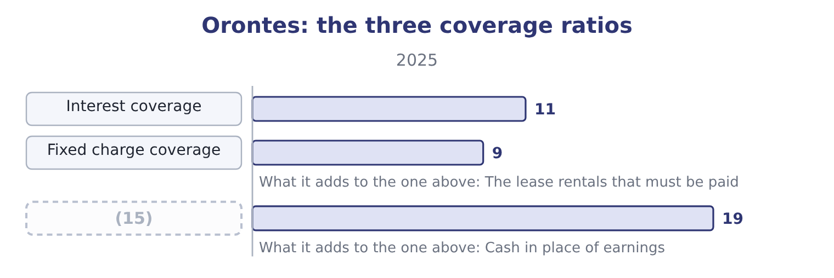
word list
margin of safety · Cash flow to fixed charges

Summary 3 gaps 16–19
A lender reads them in that order and pays most (16) to the third, because the third is what (17) arrives in the bank. When the third is far below the first, earnings are not (18) to cash and the lender is being told (19) the leverage ratios cannot say.
word list
attention · converting · something · numerator · actually

Worked example: when cash coverage is the lower figure

Summary 4 gaps 20–27
Suppose a company (20) EBIT of $5,000,000 and interest of $1,000,000, so interest coverage is 5.00 times. But receivables rose $3,000,000 and inventory rose $1,500,000 (21) the year, so operating cash flow is only $1,200,000. Cash coverage, (22) back interest of $1,000,000 and taxes paid of $400,000, is 2,600,000 ÷ 1,000,000 = 2.60 times. Coverage of 5.00 on earnings and 2.60 on cash (23) a company whose profit is (24) in working capital. Orontes is the (25) case: 11.15 on earnings and 18.81 on cash. The (26) of the gap is the (27) , not its size.
word list
reports · adding · sitting · finding · describes · during · something · opposite · direction

The English this section uses, and its Arabic
Each term sits against what it means.
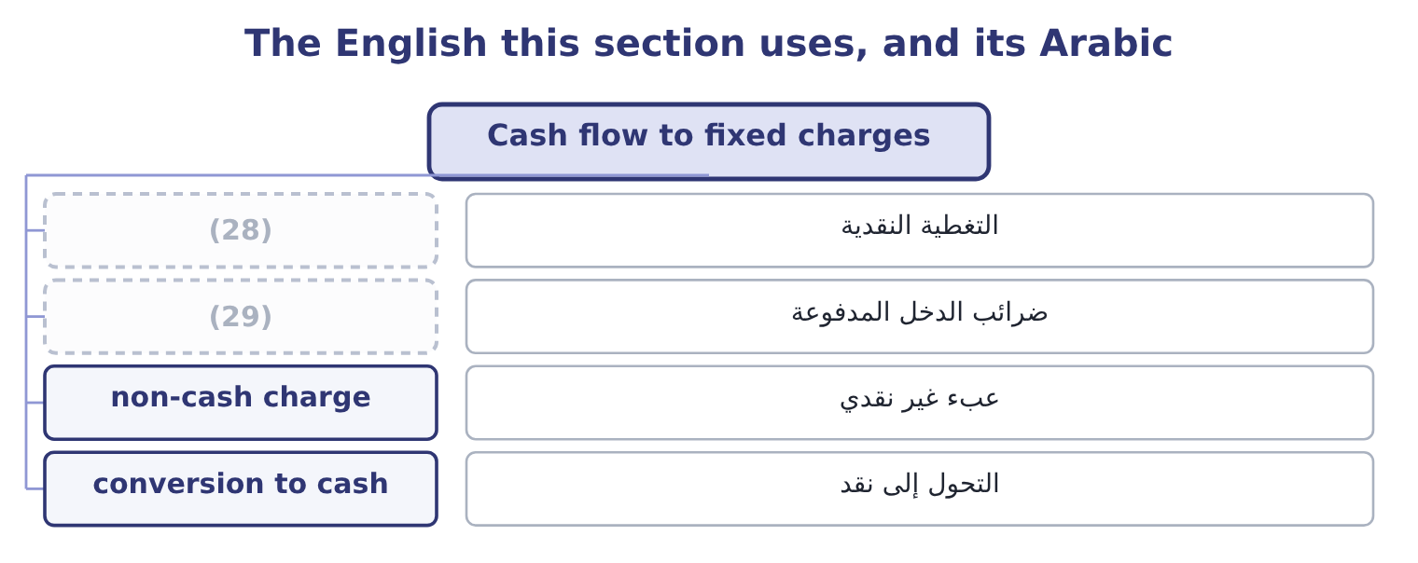
word list
operating lease rentals · cash coverage · income taxes paid

The English this sheet uses, and its Arabic
English (exam term) | Arabic
cash coverage | التغطية النقدية
income taxes paid | ضرائب الدخل المدفوعة
non-cash charge | عبء غير نقدي
conversion to cash | التحول إلى نقد

Answer key · 10.3 Cash flow to fixed charges

1 accounting | 16 attention
2 report | 17 actually
3 comfortably | 18 converting
4 removes | 19 something
5 replacing | 20 reports
6 divides | 21 during
7 numerator | 22 adding
8 element | 23 describes
9 rental | 24 sitting
10 earnings-based | 25 opposite
11 non-cash | 26 direction
12 impairment | 27 finding
13 reduced | 28 cash coverage
14 nineteen | 29 income taxes paid
15 Cash flow to fixed charges

the summaries in full
Summary 1 Earnings are an accounting measure and the fixed charges are paid in money. A company can report earnings that cover its interest comfortably and still not have the cash, because the earnings are in receivables and inventory. The third ratio removes that risk by replacing earnings with cash. Cash flow to fixed charges divides operating cash flow, before the fixed charges and before tax, by the fixed charges. In practice the numerator is operating cash flow as reported, plus the fixed charges that were deducted in arriving at it, plus income taxes paid. Orontes's operating cash flow for 2025 is $7,531,100. It paid interest of $390,000 and income taxes of $839,700, both of which are deducted in arriving at that figure under U.S. GAAP, and the lease element of $80,000 is inside the rental expense.
Summary 2 Cash flow to fixed charges is 8,840,800 ÷ 470,000 = 18.81 times. That is very nearly twice the earnings-based figure, and the reason is the one: Orontes's earnings this year carry a large non-cash charge. The impairment of $2,724,000 reduced EBIT and took no cash. On a cash basis the company covers its fixed charges nineteen times over.
Summary 3 A lender reads them in that order and pays most attention to the third, because the third is what actually arrives in the bank. When the third is far below the first, earnings are not converting to cash and the lender is being told something the leverage ratios cannot say.
Summary 4 Suppose a company reports EBIT of $5,000,000 and interest of $1,000,000, so interest coverage is 5.00 times. But receivables rose $3,000,000 and inventory rose $1,500,000 during the year, so operating cash flow is only $1,200,000. Cash coverage, adding back interest of $1,000,000 and taxes paid of $400,000, is 2,600,000 ÷ 1,000,000 = 2.60 times. Coverage of 5.00 on earnings and 2.60 on cash describes a company whose profit is sitting in working capital. Orontes is the opposite case: 11.15 on earnings and 18.81 on cash. The direction of the gap is the finding, not its size.

10.4 Coverage and the lender's decision
Chapter 10 · section 10.4

Fill every gap. Each word list holds one word more than there are gaps.
Summary 1 gaps 1–12
A lender uses the three ratios (1) , and it uses them forwards rather than (2) . The historical figure (3) the starting point. Orontes (4) interest 11.15 times today. The pro forma figure is what (5) . The lender (6) coverage on the (7) it is being asked to grant, at the interest rate it would charge, assuming the project contributes nothing in the first year. That was the (8) example of section 10.1: 3.92 times. The stressed figure (9) it. The lender then (10) the operating leverage. (11) DOL is 4.02, so a 10 per cent fall in sales cuts operating (12) 40.2 per cent. Take EBIT down by the same proportion, to about 2,600,000, and coverage on the enlarged interest becomes roughly 2,600,000 ÷ 1,110,000 = 2.34 times. That is the number the credit committee argues about.
word list
income · covers · Orontes's · establishes · matters · worked · recomputes · backwards · decides · together · facility · becomes · applies

Build the lender's three figures

Your turn: coverage as a lender computes it (complete the blanks)
Basis | EBIT | Interest | Coverage
As reported, 2025 | 4,348,800 | 390,000 | 11.15
After borrowing 12,000,000 at 6 per cent | 4,348,800 | ________ | ________
Stressed: sales down 10 per cent, DOL 4.02 | 2,600,000 | 1,110,000 | (13)

word list
Coverage 2.34: 2,600,000 ÷ 1,110,000. · earnings before interest and taxes

Summary 2 gaps 14–17
Note the (14) the exercise exposes. The leverage ratios.55 to about 2.14 — a change a (15) might welcome. The coverage ratio moves from 11.15 to 2.34 under stress, which is the same (16) seen from the lender's side. Neither party is wrong; they are measuring different risks with different (17) .
word list
interest · asymmetry · decision · instruments · shareholder

Coverage is forward-looking

Summary 3 gaps 18–21
A question that gives you a (18) borrowing wants the coverage AFTER it, not (19) . If the question gives you a (20) of operating leverage and a fall in sales, it wants the stressed figure. Assume a project contributes nothing in its first year unless the question says (21) .
word list
otherwise · before · backwards · proposed · degree

The English this section uses, and its Arabic
Each term sits against what it means.
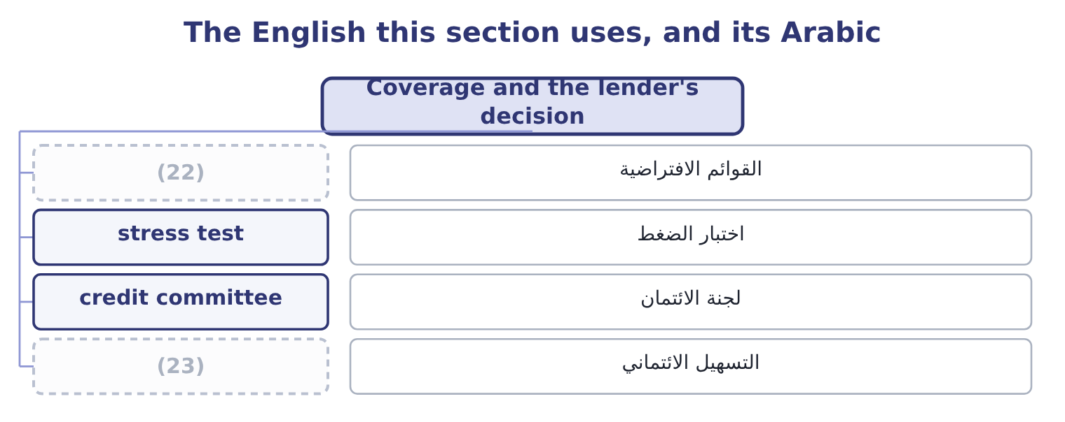
word list
pro forma · facility · credit committee

The English this sheet uses, and its Arabic
English (exam term) | Arabic
pro forma | القوائم الافتراضية
stress test | اختبار الضغط
credit committee | لجنة الائتمان
facility | التسهيل الائتماني

Answer key · 10.4 Coverage and the lender's decision

1 together | 13 Coverage 2.34: 2,600,000 ÷ 1,110,000.
2 backwards | 14 asymmetry
3 establishes | 15 shareholder
4 covers | 16 decision
5 matters | 17 instruments
6 recomputes | 18 proposed
7 facility | 19 before
8 worked | 20 degree
9 decides | 21 otherwise
10 applies | 22 pro forma
11 Orontes's | 23 facility
12 income

the summaries in full
Summary 1 A lender uses the three ratios together, and it uses them forwards rather than backwards. The historical figure establishes the starting point. Orontes covers interest 11.15 times today. The pro forma figure is what matters. The lender recomputes coverage on the facility it is being asked to grant, at the interest rate it would charge, assuming the project contributes nothing in the first year. That was the worked example of section 10.1: 3.92 times. The stressed figure decides it. The lender then applies the operating leverage. Orontes's DOL is 4.02, so a 10 per cent fall in sales cuts operating income 40.2 per cent. Take EBIT down by the same proportion, to about 2,600,000, and coverage on the enlarged interest becomes roughly 2,600,000 ÷ 1,110,000 = 2.34 times. That is the number the credit committee argues about.
Summary 2 Note the asymmetry the exercise exposes. The leverage ratios.55 to about 2.14 — a change a shareholder might welcome. The coverage ratio moves from 11.15 to 2.34 under stress, which is the same decision seen from the lender's side. Neither party is wrong; they are measuring different risks with different instruments.
Summary 3 A question that gives you a proposed borrowing wants the coverage AFTER it, not before. If the question gives you a degree of operating leverage and a fall in sales, it wants the stressed figure. Assume a project contributes nothing in its first year unless the question says otherwise.

10.5 What coverage ratios miss
Chapter 10 · section 10.5

Fill every gap. Each word list holds one word more than there are gaps.
Summary 1 gaps 1–10
Three things, all (1) . They (2) one year. A ratio of 11.15 computed on a year (3) a large one-off gain says less than the same ratio computed on three years. Where the exam gives a series, use it. They (4) the charge is the charge. Floating-rate debt changes the denominator without any (5) by the company, and a covenant tested (6) can be breached by an (7) movement alone. They (8) when the principal falls due. A company covering interest fifteen times with the whole principal (9) in eighteen months is in more danger than one covering it four times over a (10) schedule. The ratio sees the interest and not the maturity, which is why.
word list
measure · assume · repayable · ignore · examinable · twenty-year · computed · interest-rate · decision · quarterly · containing

Three things a coverage ratio does not see
Limit | Why it matters | Where it is answered
One year of earnings | A one-off gain or charge distorts it | (11)
The rate may move | Floating-rate debt changes the denominator | (12)
The maturity is invisible | (13) | The maturity profile, Chapter 9

word list
The borrowings note · Use a series; Chapter 17 on earnings quality · Floating-rate debt changes the denominator · Interest is covered; the principal still falls due

The English this section uses, and its Arabic
Each term sits against what it means.
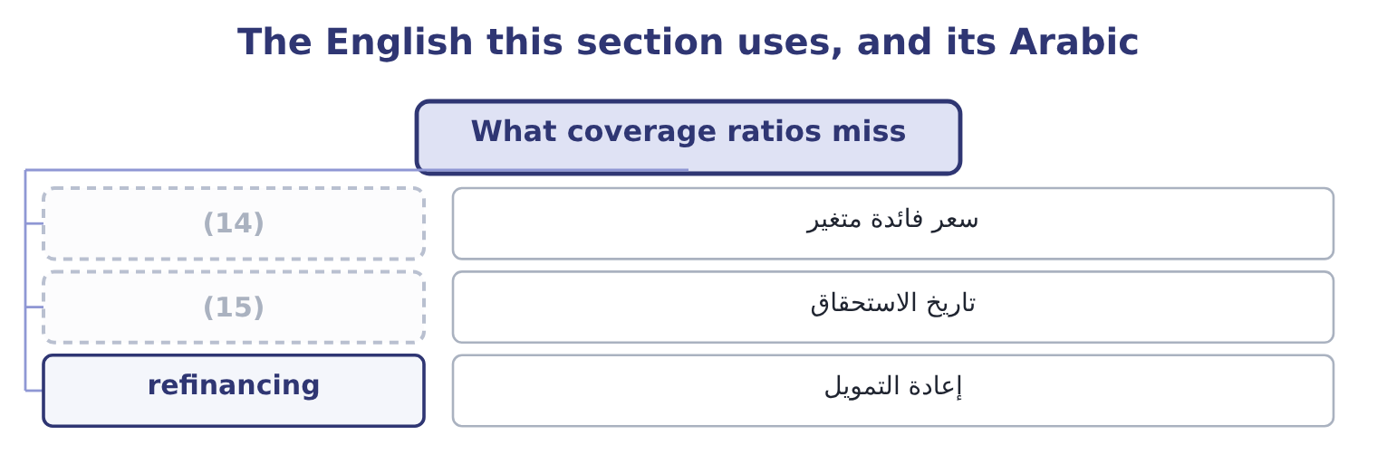
word list
maturity · floating rate · preferred dividend

The English this sheet uses, and its Arabic
English (exam term) | Arabic
floating rate | سعر فائدة متغير
maturity | تاريخ الاستحقاق
refinancing | إعادة التمويل

Answer key · 10.5 What coverage ratios miss

1 examinable | 9 repayable
2 measure | 10 twenty-year
3 containing | 11 Use a series; Chapter 17 on earnings quality
4 assume | 12 The borrowings note
5 decision | 13 Interest is covered; the principal still falls due
6 quarterly | 14 floating rate
7 interest-rate | 15 maturity
8 ignore

the summaries in full
Summary 1 Three things, all examinable. They measure one year. A ratio of 11.15 computed on a year containing a large one-off gain says less than the same ratio computed on three years. Where the exam gives a series, use it. They assume the charge is the charge. Floating-rate debt changes the denominator without any decision by the company, and a covenant tested quarterly can be breached by an interest-rate movement alone. They ignore when the principal falls due. A company covering interest fifteen times with the whole principal repayable in eighteen months is in more danger than one covering it four times over a twenty-year schedule. The ratio sees the interest and not the maturity, which is why.

