11.1 Why the balance is averaged
Chapter 11 · section 11.1

Fill every gap. Each word list holds one word more than there are gaps.
Chapter 11, section by section
Each stage leads to the next.
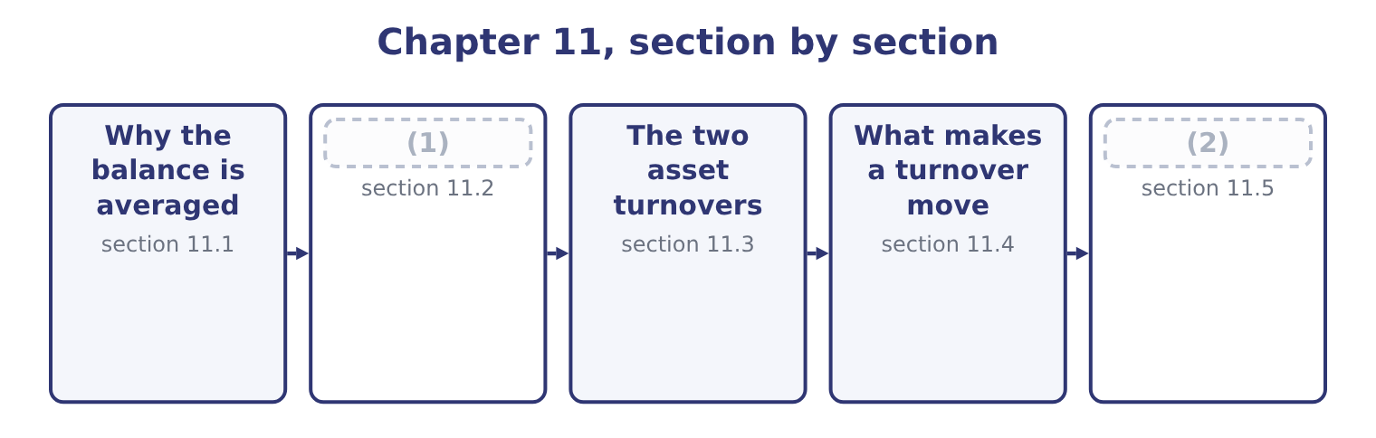
word list
The two asset turnovers · The three working-capital turnovers · Reading the five together

Summary 1 gaps 3–14
Every turnover ratio puts a flow over a balance, and the two are measured (3) . Net sales (4) across twelve months; accounts receivable is a (5) of 31 December. (6) one by the other (7) a year with a day. The (8) is to average the (9) and closing balances. For (10) receivables that is 4,144,000 + 3,760,000 = 7,904,000, (11) : 7,904,000 ÷ 2 = 3,952,000. The average is a crude (12) and the exam knows it. For a (13) business the two year-end balances may both be (14) — a toy manufacturer's receivables in January say nothing about its receivables in November — and a monthly average would be better if the data existed. Where an exam question gives only a closing balance, use it and say what you have done.
word list
opening · halved · business · Dividing · photograph · correction · unrepresentative · convention · differently · seasonal · compares · happened · Orontes's

The five turnover ratios
Ratio | Numerator | Denominator | Measures
Accounts receivable turnover | Net credit sales | Average accounts receivable | (15)
Inventory turnover | Cost of goods sold | (16) | How often the stock is sold
Accounts payable turnover | Purchases | (17) | How often the suppliers are paid
Total asset turnover | Net sales | Average total assets | (18)
Fixed asset turnover | Net sales | (19) | Sales produced per dollar of plant

word list
Average net fixed assets · Average accounts payable · How often the receivables are collected · Average inventory · Sales produced per dollar of assets · Average total assets

Summary 2 gaps 20–28
Three of the (20) repay attention. Receivable turnover (21) use credit sales, not total sales, (22) cash sales never (23) receivables. Few companies (24) the split, so net sales is used in (25) and the exam accepts it — but if a question gives you the credit (26) , use it. Inventory turnover uses cost of goods sold, not sales. Inventory is (27) at cost, so the numerator must be at cost too. Payable turnover uses purchases, not cost of goods sold. Purchases are cost of goods sold (28) for the movement in inventory: what was sold, plus what was added to the shelf, less what was taken from it.
word list
become · adjusted · disclose · practice · numerators · Payables · should · carried · because · proportion

Match the numerator to the balance

Summary 3 gaps 29–31
Inventory is at cost, so the numerator is cost of goods sold. (29) arise from purchases, so the numerator is purchases, not cost of goods sold. (30) arise from credit sales, so the numerator is credit sales where the (31) gives them.
word list
Receivables · Payables · question · numerators

The English this section uses, and its Arabic
Each term sits against what it means.
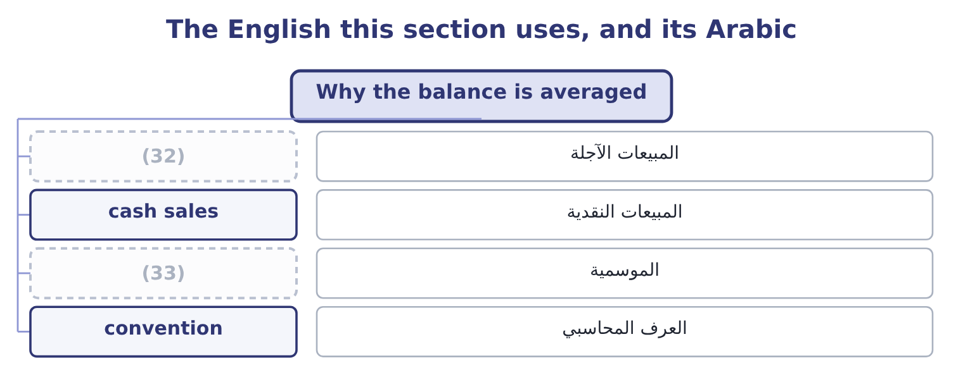
word list
credit sales · seasonality · collection

The English this sheet uses, and its Arabic
English (exam term) | Arabic
credit sales | المبيعات الآجلة
cash sales | المبيعات النقدية
seasonality | الموسمية
convention | العرف المحاسبي

Answer key · 11.1 Why the balance is averaged

1 The three working-capital turnovers | 18 Sales produced per dollar of assets
2 Reading the five together | 19 Average net fixed assets
3 differently | 20 numerators
4 happened | 21 should
5 photograph | 22 because
6 Dividing | 23 become
7 compares | 24 disclose
8 convention | 25 practice
9 opening | 26 proportion
10 Orontes's | 27 carried
11 halved | 28 adjusted
12 correction | 29 Payables
13 seasonal | 30 Receivables
14 unrepresentative | 31 question
15 How often the receivables are collected | 32 credit sales
16 Average inventory | 33 seasonality
17 Average accounts payable

the summaries in full
Summary 1 Every turnover ratio puts a flow over a balance, and the two are measured differently. Net sales happened across twelve months; accounts receivable is a photograph of 31 December. Dividing one by the other compares a year with a day. The convention is to average the opening and closing balances. For Orontes's receivables that is 4,144,000 + 3,760,000 = 7,904,000, halved: 7,904,000 ÷ 2 = 3,952,000. The average is a crude correction and the exam knows it. For a seasonal business the two year-end balances may both be unrepresentative — a toy manufacturer's receivables in January say nothing about its receivables in November — and a monthly average would be better if the data existed. Where an exam question gives only a closing balance, use it and say what you have done.
Summary 2 Three of the numerators repay attention. Receivable turnover should use credit sales, not total sales, because cash sales never become receivables. Few companies disclose the split, so net sales is used in practice and the exam accepts it — but if a question gives you the credit proportion, use it. Inventory turnover uses cost of goods sold, not sales. Inventory is carried at cost, so the numerator must be at cost too. Payable turnover uses purchases, not cost of goods sold. Purchases are cost of goods sold adjusted for the movement in inventory: what was sold, plus what was added to the shelf, less what was taken from it.
Summary 3 Inventory is at cost, so the numerator is cost of goods sold. Payables arise from purchases, so the numerator is purchases, not cost of goods sold. Receivables arise from credit sales, so the numerator is credit sales where the question gives them.

11.2 The three working-capital turnovers
Chapter 11 · section 11.2

Fill every gap. Each word list holds one word more than there are gaps.
Orontes Foods, Inc. — working-capital turnovers, 2025
The bars are drawn to scale.
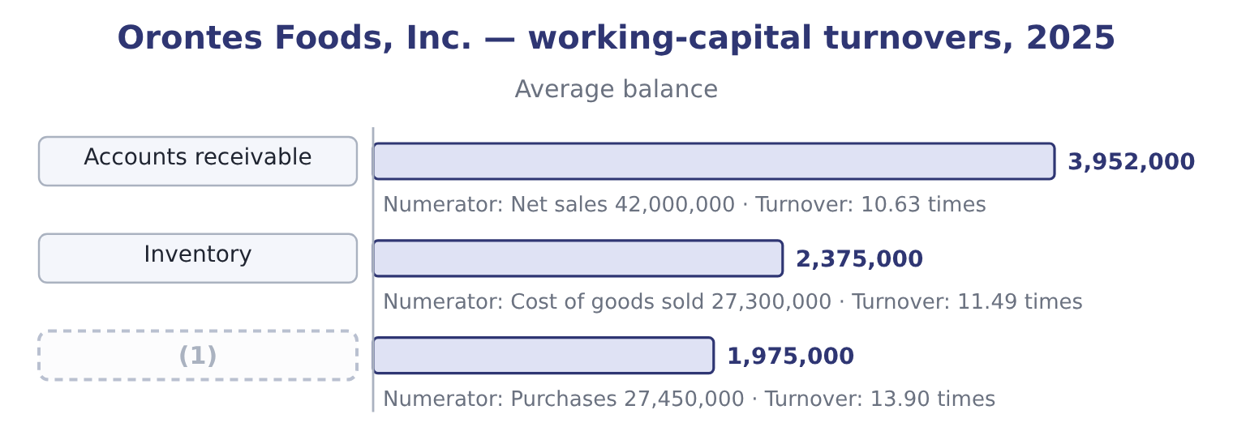
word list
Accounts payable · stretch suppliers

Summary 1 gaps 2–5
Average (2) are (4,144,000 + 3,760,000) ÷ 2 = 3,952,000, and 42,000,000 ÷ 3,952,000 = 10.63. Average inventory is (2,450,000 + 2,300,000) ÷ 2 = 2,375,000, and 27,300,000 ÷ 2,375,000 = 11.49. (3) are cost of goods sold plus the (4) in inventory: 27,300,000 + 150,000 = 27,450,000, where the 150,000 is 2,450,000 − 2,300,000. Average (5) are (2,050,000 + 1,900,000) ÷ 2 = 1,975,000, and 27,450,000 ÷ 1,975,000 = 13.90.
word list
receivables · payables · increase · together · Purchases

Worked example: purchases from cost of goods sold

Summary 2 gaps 6–17
Opening inventory plus purchases less closing inventory (6) cost of goods sold. (7) : purchases equal cost of goods sold plus closing inventory less opening inventory. Inventory rose, so Orontes (8) more than it sold: purchases exceed cost of goods sold by (9) the increase, $150,000. Had inventory (10) , purchases would have been less than cost of goods sold. A (11) who writes purchases equal to cost of goods sold has assumed inventory did not move, and the exam sets the question (12) because inventory did. The three (13) read together say (14) the liquidity ratios did not. Orontes pays its (15) faster than it collects from its (16) : payables turn 13.90 times against receivables at 10.63. Every day of that (17) is a day Orontes finances out of its own money. Inventory turning 11.49 times is brisk for a food manufacturer, and it corroborates the common-size finding.7 per cent of assets. Nothing is sitting on the shelf.
word list
precisely · bought · figures · something · candidate · fallen · difference · customers · suppliers · Rearranged · exactly · equals · Purchases

The English this section uses, and its Arabic
Each term sits against what it means.
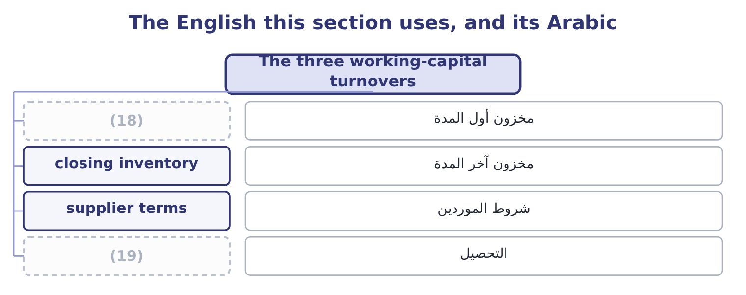
word list
utility · opening inventory · collection

The English this sheet uses, and its Arabic
English (exam term) | Arabic
opening inventory | مخزون أول المدة
closing inventory | مخزون آخر المدة
supplier terms | شروط الموردين
collection | التحصيل

Answer key · 11.2 The three working-capital turnovers

1 Accounts payable | 11 candidate
2 receivables | 12 precisely
3 Purchases | 13 figures
4 increase | 14 something
5 payables | 15 suppliers
6 equals | 16 customers
7 Rearranged | 17 difference
8 bought | 18 opening inventory
9 exactly | 19 collection
10 fallen

the summaries in full
Summary 1 Average receivables are (4,144,000 + 3,760,000) ÷ 2 = 3,952,000, and 42,000,000 ÷ 3,952,000 = 10.63. Average inventory is (2,450,000 + 2,300,000) ÷ 2 = 2,375,000, and 27,300,000 ÷ 2,375,000 = 11.49. Purchases are cost of goods sold plus the increase in inventory: 27,300,000 + 150,000 = 27,450,000, where the 150,000 is 2,450,000 − 2,300,000. Average payables are (2,050,000 + 1,900,000) ÷ 2 = 1,975,000, and 27,450,000 ÷ 1,975,000 = 13.90.
Summary 2 Opening inventory plus purchases less closing inventory equals cost of goods sold. Rearranged: purchases equal cost of goods sold plus closing inventory less opening inventory. Inventory rose, so Orontes bought more than it sold: purchases exceed cost of goods sold by exactly the increase, $150,000. Had inventory fallen, purchases would have been less than cost of goods sold. A candidate who writes purchases equal to cost of goods sold has assumed inventory did not move, and the exam sets the question precisely because inventory did. The three figures read together say something the liquidity ratios did not. Orontes pays its suppliers faster than it collects from its customers: payables turn 13.90 times against receivables at 10.63. Every day of that difference is a day Orontes finances out of its own money. Inventory turning 11.49 times is brisk for a food manufacturer, and it corroborates the common-size finding.7 per cent of assets. Nothing is sitting on the shelf.

11.3 The two asset turnovers
Chapter 11 · section 11.3

Fill every gap. Each word list holds one word more than there are gaps.
Summary 1 gaps 1–4
The same idea (1) to the whole balance sheet asks how much revenue the company (2) from what it owns. Total asset turnover is net sales divided by average total assets. For Orontes: average total assets are (31,672,600 + 26,445,000) ÷ 2 = 29,058,800, and 42,000,000 ÷ 29,058,800 = 1.45 times. Fixed asset turnover is net sales divided by average net (3) , plant and (4) . Average net PP&E is (14,802,000 + 16,000,000) ÷ 2 = 15,401,000, and 42,000,000 ÷ 15,401,000 = 2.73 times.
word list
property · shareholders' · applied · extracts · equipment

Asset turnover across three businesses
Business | Total asset turnover | Why
A manufacturer such as Orontes | About 1.5 | Heavy plant; each dollar of assets (5) about a dollar and a half of sales
A distributor such as Barada | (6) | Little plant; assets are stock and receivables, which move
A utility | (7) | Enormous fixed assets with a regulated revenue

word list
Below 0.5 · supports · receivables · About 3.0

Summary 2 gaps 8–16
Two (8) follow for Orontes. Total asset turnover of 1.45 is low for a food manufacturer, and the (9) is: 23.1 per cent of the assets are cash, which produces no sales at all. Strip the cash out and the ratio on operating assets would be far (10) . An (11) would say so, because the ratio as published (12) how hard the operating assets work. Fixed asset turnover of 2.73 is the figure that (13) the factory, and it rose (14) the year: plant fell $1,198,000 while sales rose 15.4 per cent. The plant is being worked harder, which is (15) with a company whose operating (16) is 4.02.
word list
applied · analyst · reason · describes · understates · consistent · leverage · readings · higher · during

Cash and asset turnover

Summary 3 gaps 17–23
Idle cash lowers total asset turnover (17) any change in (18) . Say so when the balance sheet shows a large cash (19) . Fixed asset turnover rises when assets are old and heavily (20) , because the denominator is net of accumulated (21) . A high ratio can mean an (22) factory or an (23) one. Leased assets that are on the balance sheet are in the denominator; a company that leases and expenses rentals has a smaller denominator and a flattering ratio.
word list
efficient · exhausted · holding · without · equipment · depreciated · depreciation · operations

Worked example: turnover without the cash

Summary 4 gaps 24–27
Cash was $7,302,100 at the end of 2025 and $2,100,000 at the end of 2024, so the average is (7,302,100 + 2,100,000) ÷ 2 = 4,701,050. Turnover on operating assets. Nearly (24) of a turn is (25) by the cash balance. (26) figure is wrong: 1.45 is what the (27) ' money produces and 1.72 is what the business produces. An answer that gives both, and says which is which, is a Level C answer.
word list
shareholders · Neither · three-tenths · exhausted · hidden

The English this section uses, and its Arabic
Each term sits against what it means.
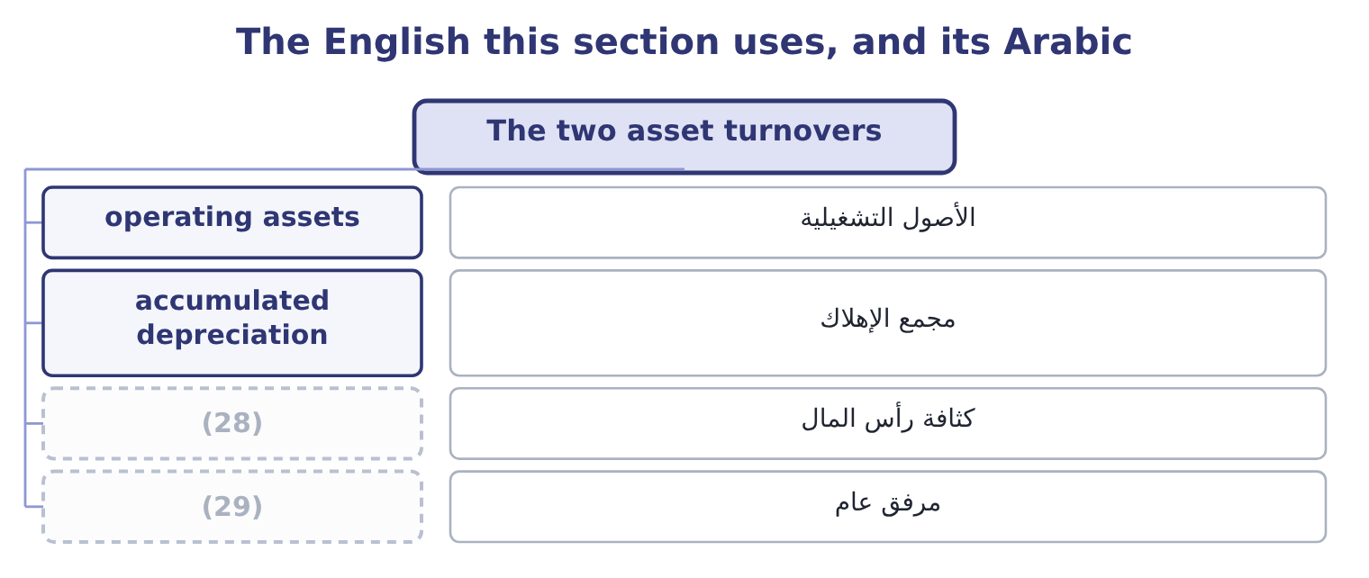
word list
capital intensity · utility · write-off

The English this sheet uses, and its Arabic
English (exam term) | Arabic
operating assets | الأصول التشغيلية
accumulated depreciation | مجمع الإهلاك
capital intensity | كثافة رأس المال
utility | مرفق عام

Answer key · 11.3 The two asset turnovers

1 applied | 16 leverage
2 extracts | 17 without
3 property | 18 operations
4 equipment | 19 holding
5 supports | 20 depreciated
6 About 3.0 | 21 depreciation
7 Below 0.5 | 22 efficient
8 readings | 23 exhausted
9 reason | 24 three-tenths
10 higher | 25 hidden
11 analyst | 26 Neither
12 understates | 27 shareholders
13 describes | 28 capital intensity
14 during | 29 utility
15 consistent

the summaries in full
Summary 1 The same idea applied to the whole balance sheet asks how much revenue the company extracts from what it owns. Total asset turnover is net sales divided by average total assets. For Orontes: average total assets are (31,672,600 + 26,445,000) ÷ 2 = 29,058,800, and 42,000,000 ÷ 29,058,800 = 1.45 times. Fixed asset turnover is net sales divided by average net property, plant and equipment. Average net PP&E is (14,802,000 + 16,000,000) ÷ 2 = 15,401,000, and 42,000,000 ÷ 15,401,000 = 2.73 times.
Summary 2 Two readings follow for Orontes. Total asset turnover of 1.45 is low for a food manufacturer, and the reason is: 23.1 per cent of the assets are cash, which produces no sales at all. Strip the cash out and the ratio on operating assets would be far higher. An analyst would say so, because the ratio as published understates how hard the operating assets work. Fixed asset turnover of 2.73 is the figure that describes the factory, and it rose during the year: plant fell $1,198,000 while sales rose 15.4 per cent. The plant is being worked harder, which is consistent with a company whose operating leverage is 4.02.
Summary 3 Idle cash lowers total asset turnover without any change in operations. Say so when the balance sheet shows a large cash holding. Fixed asset turnover rises when assets are old and heavily depreciated, because the denominator is net of accumulated depreciation. A high ratio can mean an efficient factory or an exhausted one. Leased assets that are on the balance sheet are in the denominator; a company that leases and expenses rentals has a smaller denominator and a flattering ratio.
Summary 4 Cash was $7,302,100 at the end of 2025 and $2,100,000 at the end of 2024, so the average is (7,302,100 + 2,100,000) ÷ 2 = 4,701,050. Turnover on operating assets. Nearly three-tenths of a turn is hidden by the cash balance. Neither figure is wrong: 1.45 is what the shareholders' money produces and 1.72 is what the business produces. An answer that gives both, and says which is which, is a Level C answer.

11.4 What makes a turnover move
Chapter 11 · section 11.4

Fill every gap. Each word list holds one word more than there are gaps.
Summary 1 gaps 1–2
A turnover is a (1) , so it moves when the flow moves, when the balance moves, or when both move at (2) rates.
word list
different · fraction · English

Why a turnover moves
Ratio | Rises when | Falls when
Receivables | Collection tightens; (3) grow; a large customer settles early | Terms are extended to win sales; a customer stops paying; sales are made late in the year
Inventory | Stock is cut; demand rises; obsolete stock is written off | Stock is built for a season; goods stop selling; a (4) is deferred
Payables | (5) | The company stretches suppliers; a dispute delays payment
Total assets | (6) | Cash accumulates; a large asset is bought before it produces
Fixed assets | Sales rise; plant depreciates | (7)

word list
write-down · closing inventory · Sales rise; assets are sold or written down · The company pays faster; a discount is taken · New plant is commissioned before it produces · cash sales

Summary 2 gaps 8–15
Two of those entries are the same event seen from (8) sides, and (9) are regularly caught by them. (10) off obsolete stock raises inventory turnover. The (11) falls and the numerator is (12) , so a company that finally clears its dead stock reports an improvement in efficiency. The improvement is in the (13) and not in the (14) . Buying a new plant lowers fixed asset turnover in the year it is commissioned and raises it (15) . A falling ratio in a year of heavy capital expenditure is expected and is not a finding.
word list
seasonality · Writing · denominator · afterwards · unaffected · measure · opposite · candidates · business

Compute Barada's turnovers

Compute the three working-capital turnovers.

Your turn: Barada's turnovers (complete the blanks)
Item | Amount
Net sales | 21,978,000
Cost of goods sold | 18,900,000
Average accounts receivable | 1,830,000
Average inventory | 2,100,000
Average accounts payable | 1,400,000
Purchases (inventory rose 280,000) | 19,180,000
Accounts receivable turnover | (16) : 21,978,000 ÷ 1,830,000.
Inventory turnover | (17) : 18,900,000 ÷ 2,100,000.
Accounts payable turnover | 13.70 times: 19,180,000 ÷ 1,400,000.

word list
12.01 times · 9.00 times · operating assets

"Turnover" has two meanings

Summary 3 gaps 18–20
In (18) English and on the CMA exam, turnover means the number of times a balance is replaced in a year. In British English, turnover also means revenue: a (19) annual turnover is its sales. The exam (20) means the first.
word list
always · expenditure · American · company's

The English this section uses, and its Arabic
Each term sits against what it means.
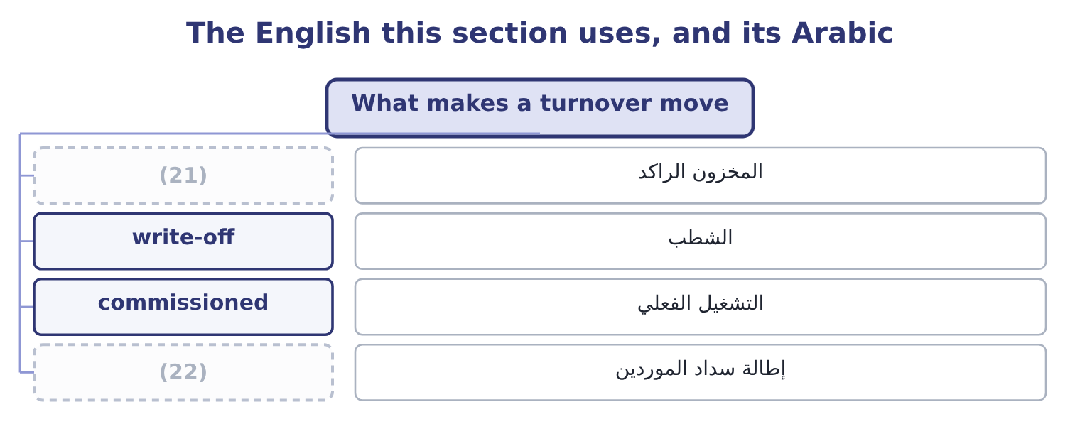
word list
credit sales · stretch suppliers · obsolete stock

The English this sheet uses, and its Arabic
English (exam term) | Arabic
obsolete stock | المخزون الراكد
write-off | الشطب
commissioned | التشغيل الفعلي
stretch suppliers | إطالة سداد الموردين

Answer key · 11.4 What makes a turnover move

1 fraction | 12 unaffected
2 different | 13 measure
3 cash sales | 14 business
4 write-down | 15 afterwards
5 The company pays faster; a discount is taken | 16 12.01 times
6 Sales rise; assets are sold or written down | 17 9.00 times
7 New plant is commissioned before it produces | 18 American
8 opposite | 19 company's
9 candidates | 20 always
10 Writing | 21 obsolete stock
11 denominator | 22 stretch suppliers

the summaries in full
Summary 1 A turnover is a fraction, so it moves when the flow moves, when the balance moves, or when both move at different rates.
Summary 2 Two of those entries are the same event seen from opposite sides, and candidates are regularly caught by them. Writing off obsolete stock raises inventory turnover. The denominator falls and the numerator is unaffected, so a company that finally clears its dead stock reports an improvement in efficiency. The improvement is in the measure and not in the business. Buying a new plant lowers fixed asset turnover in the year it is commissioned and raises it afterwards. A falling ratio in a year of heavy capital expenditure is expected and is not a finding.
Summary 3 In American English and on the CMA exam, turnover means the number of times a balance is replaced in a year. In British English, turnover also means revenue: a company's annual turnover is its sales. The exam always means the first.

11.5 Reading the five together
Chapter 11 · section 11.5

Fill every gap. Each word list holds one word more than there are gaps.
Summary 1 gaps 1–10
The (1) corroborate one (2) and they corroborate the liquidity ratios, and a Level C answer uses the (3) . Receivables turnover of 10.63 against a current ratio of 3.31. The current ratio is high and the receivables are (4) , so the high ratio is not uncollected debts. Had receivables turnover been 4 or 5, the same current ratio would have meant something very (5) . Inventory turnover of 11.49 against inventory at 7.7 per cent of assets. Both say the same thing: (6) money is tied up in stock and what is there moves. Total asset turnover of 1.45 against cash at 23.1 per cent of assets. These point in opposite (7) and the cash (8) the turnover, which is the (9) . Payables turnover of 13.90 against receivables at 10.63. (10) funds the gap.
word list
little · cross-checks · Orontes · another · uncollected · finding · different · moving · explains · turnovers · directions

Cross-checks between the turnovers and the earlier ratios
Turnover | Check it against | What agreement means | What disagreement means
Receivables | (11) | Liquidity is real | A high current ratio is uncollected debts
Inventory | (12) | Stock is under control | Stock is accumulating
Payables | The cash ratio | The company pays from strength | (13)
Total assets | (14) | Assets are working | Something large is idle
Fixed assets | (15) | Capacity matches sales | New capacity is not yet producing

word list
The common-size balance sheet · The current and quick ratios · The company is stretching suppliers · Capital expenditure in the cash flow statement · The company pays from strength · Inventory as a share of assets

The English this section uses, and its Arabic
Each term sits against what it means.
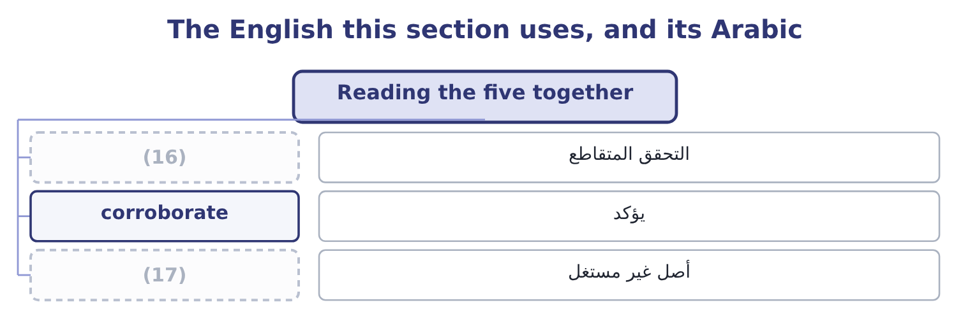
word list
average balance · idle asset · cross-check

The English this sheet uses, and its Arabic
English (exam term) | Arabic
cross-check | التحقق المتقاطع
corroborate | يؤكد
idle asset | أصل غير مستغل

Answer key · 11.5 Reading the five together

1 turnovers | 10 Orontes
2 another | 11 The current and quick ratios
3 cross-checks | 12 Inventory as a share of assets
4 moving | 13 The company is stretching suppliers
5 different | 14 The common-size balance sheet
6 little | 15 Capital expenditure in the cash flow statement
7 directions | 16 cross-check
8 explains | 17 idle asset
9 finding

the summaries in full
Summary 1 The turnovers corroborate one another and they corroborate the liquidity ratios, and a Level C answer uses the cross-checks. Receivables turnover of 10.63 against a current ratio of 3.31. The current ratio is high and the receivables are moving, so the high ratio is not uncollected debts. Had receivables turnover been 4 or 5, the same current ratio would have meant something very different. Inventory turnover of 11.49 against inventory at 7.7 per cent of assets. Both say the same thing: little money is tied up in stock and what is there moves. Total asset turnover of 1.45 against cash at 23.1 per cent of assets. These point in opposite directions and the cash explains the turnover, which is the finding. Payables turnover of 13.90 against receivables at 10.63. Orontes funds the gap.

