12.1 From times to days
Chapter 12 · section 12.1

Fill every gap. Each word list holds one word more than there are gaps.
Chapter 12, section by section
Each stage leads to the next.
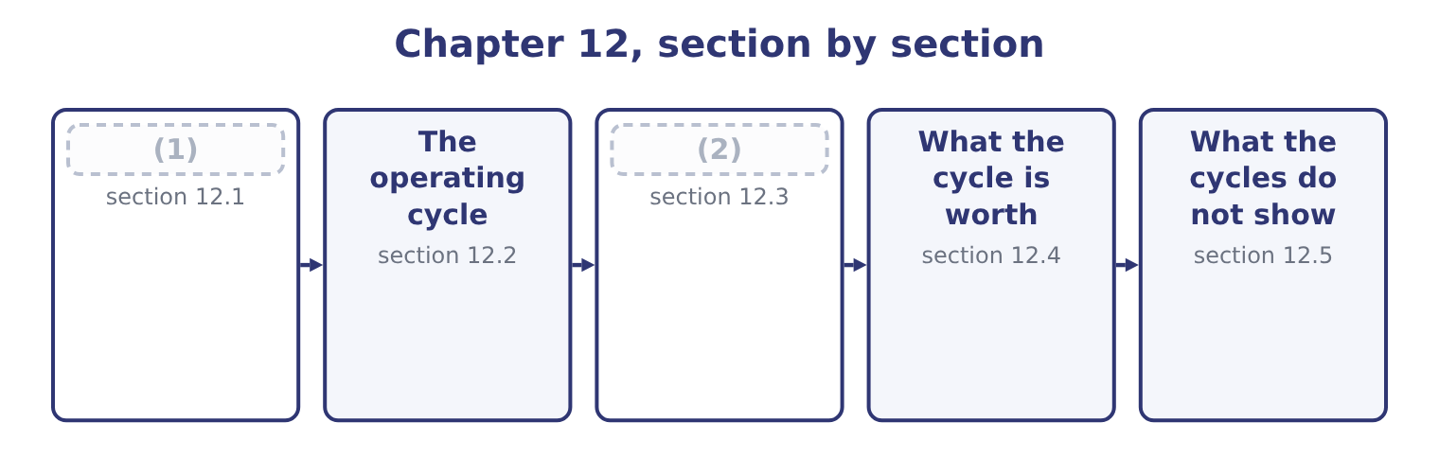
word list
The cash cycle · days sales outstanding · From times to days

Summary 1 gaps 3–14
A turnover says how many times a year a balance is (3) . Dividing 365 by it gives the average (4) of days the balance sits there. Days sales (5) , usually written DSO, is 365 divided by receivables turnover. For (6) : 365 ÷ 10.63 = 34.3 days. Days sales in inventory, written DSI, is 365 divided by inventory turnover: 365 ÷ 11.49 = 31.8 days. Days purchases in (7) payable, written DPO, is 365 divided by (8) turnover: 365 ÷ 13.90 = 26.3 days. Two (9) matter before the arithmetic is (10) . Some (11) supply a year-end balance and some an average of (12) and closing; a day-count built on a year-end balance measures that one day, while a day-count built on an average measures the year, and in a growing company the two differ by the better part of a week. And where a question gives a 360-day year rather than 365, every day-count (13) : 360 ÷ 10.63 = 33.9 days rather than 34.3. (14) convention is wrong, and an answer that states which one it used cannot be marked down for it.
word list
opening · Neither · conventions · payables · number · trusted · spread · shortens · outstanding · Orontes · replaced · accounts · questions

Summary 2 gaps 15–18
The same (15) can be reached without (16) the turnover at all, by dividing the average balance by the daily flow. Daily sales are 42,000,000 ÷ 365 = 115,068, and average receivables of 3,952,000 divided by that is 34.3 days. The two (17) are the same arithmetic written in a (18) order, and the exam uses both.
word list
computing · routes · figures · different · trusted

Orontes Foods, Inc. — the three day-counts, 2025
The bars are drawn to scale.
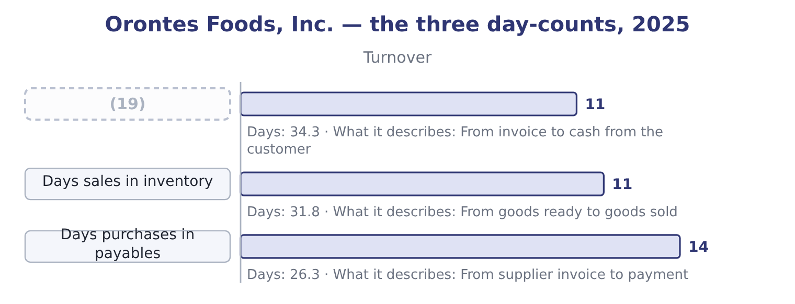
word list
Days sales outstanding · work in progress

Which denominator for which day-count

Summary 3 gaps 20–22
DSO divides by daily (20) sales. DSI divides by daily cost of goods sold. DPO divides by daily purchases. Some texts use 360 days rather than 365. The exam states which; if it does not, use 365 and say so. A day-count is an average. (21) days does not mean every (22) pays on day 34.
word list
Thirty-four · customer · credit · Orontes

The English this section uses, and its Arabic
Each term sits against what it means.
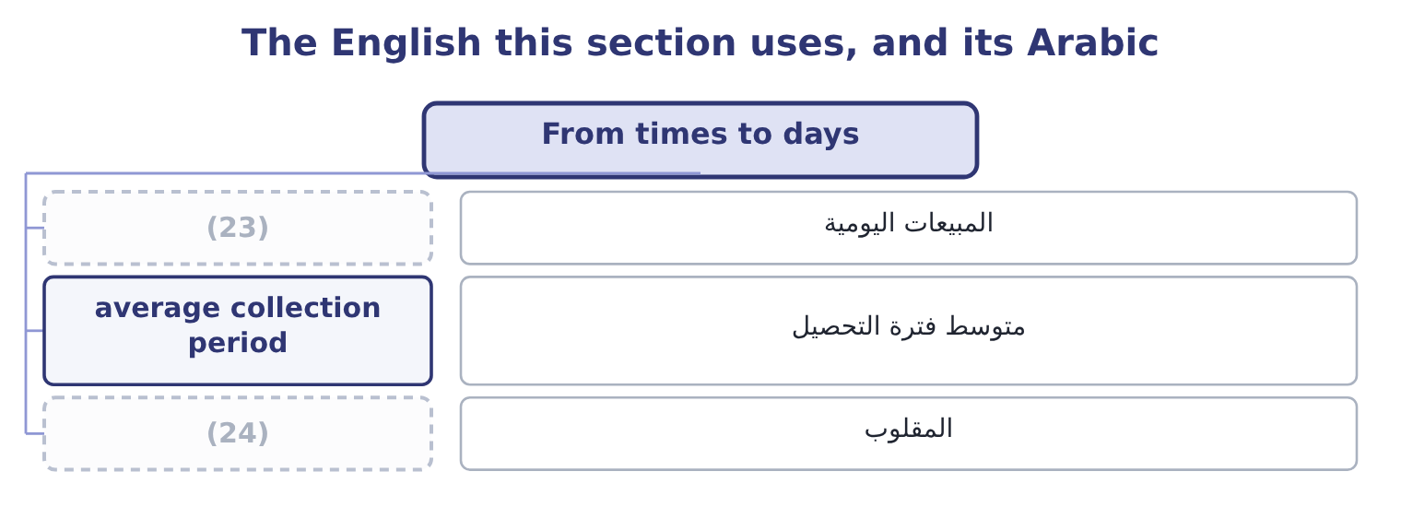
word list
reciprocal · daily sales · المبيعات اليومية

The English this sheet uses, and its Arabic
English (exam term) | Arabic
daily sales | المبيعات اليومية
average collection period | متوسط فترة التحصيل
reciprocal | المقلوب

Answer key · 12.1 From times to days

1 From times to days | 13 shortens
2 The cash cycle | 14 Neither
3 replaced | 15 figures
4 number | 16 computing
5 outstanding | 17 routes
6 Orontes | 18 different
7 accounts | 19 Days sales outstanding
8 payables | 20 credit
9 conventions | 21 Thirty-four
10 trusted | 22 customer
11 questions | 23 daily sales
12 opening | 24 reciprocal

the summaries in full
Summary 1 A turnover says how many times a year a balance is replaced. Dividing 365 by it gives the average number of days the balance sits there. Days sales outstanding, usually written DSO, is 365 divided by receivables turnover. For Orontes: 365 ÷ 10.63 = 34.3 days. Days sales in inventory, written DSI, is 365 divided by inventory turnover: 365 ÷ 11.49 = 31.8 days. Days purchases in accounts payable, written DPO, is 365 divided by payables turnover: 365 ÷ 13.90 = 26.3 days. Two conventions matter before the arithmetic is trusted. Some questions supply a year-end balance and some an average of opening and closing; a day-count built on a year-end balance measures that one day, while a day-count built on an average measures the year, and in a growing company the two differ by the better part of a week. And where a question gives a 360-day year rather than 365, every day-count shortens: 360 ÷ 10.63 = 33.9 days rather than 34.3. Neither convention is wrong, and an answer that states which one it used cannot be marked down for it.
Summary 2 The same figures can be reached without computing the turnover at all, by dividing the average balance by the daily flow. Daily sales are 42,000,000 ÷ 365 = 115,068, and average receivables of 3,952,000 divided by that is 34.3 days. The two routes are the same arithmetic written in a different order, and the exam uses both.
Summary 3 DSO divides by daily credit sales. DSI divides by daily cost of goods sold. DPO divides by daily purchases. Some texts use 360 days rather than 365. The exam states which; if it does not, use 365 and say so. A day-count is an average. Thirty-four days does not mean every customer pays on day 34.

12.2 The operating cycle
Chapter 12 · section 12.2

Fill every gap. Each word list holds one word more than there are gaps.
Summary 1 gaps 1–12
The operating cycle is the time from (1) for goods to (2) the cash from selling them. It is days sales in inventory plus days sales (3) . For Orontes: 31.8 + 34.3 = 66.1 days. That is the figure Part 1 (4) . Money spent on sesame today comes back as cash from a customer about sixty-six days later, on average, and during those sixty-six days it is (5) money and not (6) for anything else. The operating cycle also decides a (7) rule you learned in Part 1. An asset is current if it will be (8) within one year or within the operating cycle, (9) is longer. (10) cycle is 66 days, far (11) than a year, so Orontes uses the year. A (12) with a three-year cycle uses the three years, and its work in progress is a current asset even though it will sit there for thirty months.
word list
collecting · available · inventory · shipbuilder · somebody's · outstanding · classification · paying · shorter · Orontes's · realised · whichever · quoted

Orontes's operating cycle, 2025
Stage | Days | Running total
Goods held in inventory | 31.8 | 31.8
Customer takes to pay | 34.3 | 66.1
Operating cycle |  | (13)

word list
66.1 days · funding cost

Worked example: what the operating cycle costs

Summary 2 gaps 14–25
Cost of goods sold is $27,300,000 a year, which is 27,300,000 ÷ 365 = 74,795 a day. The money in the cycle. Sixty-six days of it: 74,795 × 66.1 = 4,943,949. (14) five million dollars is (15) the cycle at any (16) . Check it (17) the balance sheet. Inventory of $2,450,000 plus (18) of $4,144,000 is 2,450,000 + 4,144,000 = 6,594,000. The two figures differ because the receivable carries the selling price and the (19) was costed at cost; both are correct (20) of the same (21) on different bases, and the exam accepts either where it says which it wants. Either way the order of (22) is the same, and the point is that the cycle is not an (23) . (24) it by one day frees about (25) thousand dollars at cost.
word list
lock-up · measures · receivables · Roughly · against · Orontes's · seventy-five · Shortening · moment · day-count · inside · magnitude · abstraction

The English this section uses, and its Arabic
Each term sits against what it means.
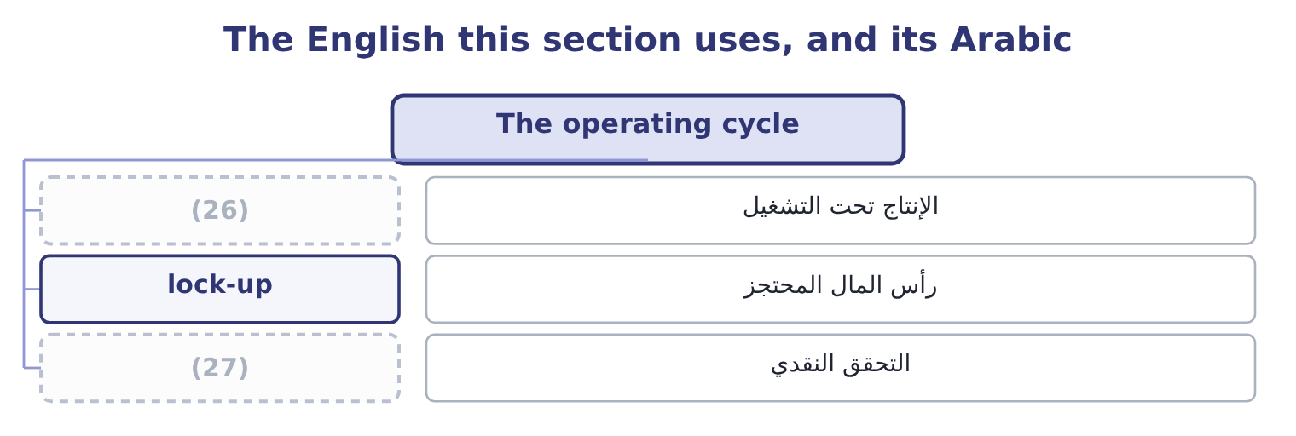
word list
realisation · reciprocal · work in progress

The English this sheet uses, and its Arabic
English (exam term) | Arabic
work in progress | الإنتاج تحت التشغيل
lock-up | رأس المال المحتجز
realisation | التحقق النقدي

Answer key · 12.2 The operating cycle

1 paying | 15 inside
2 collecting | 16 moment
3 outstanding | 17 against
4 quoted | 18 receivables
5 somebody's | 19 day-count
6 available | 20 measures
7 classification | 21 lock-up
8 realised | 22 magnitude
9 whichever | 23 abstraction
10 Orontes's | 24 Shortening
11 shorter | 25 seventy-five
12 shipbuilder | 26 work in progress
13 66.1 days | 27 realisation
14 Roughly

the summaries in full
Summary 1 The operating cycle is the time from paying for goods to collecting the cash from selling them. It is days sales in inventory plus days sales outstanding. For Orontes: 31.8 + 34.3 = 66.1 days. That is the figure Part 1 quoted. Money spent on sesame today comes back as cash from a customer about sixty-six days later, on average, and during those sixty-six days it is somebody's money and not available for anything else. The operating cycle also decides a classification rule you learned in Part 1. An asset is current if it will be realised within one year or within the operating cycle, whichever is longer. Orontes's cycle is 66 days, far shorter than a year, so Orontes uses the year. A shipbuilder with a three-year cycle uses the three years, and its work in progress is a current asset even though it will sit there for thirty months.
Summary 2 Cost of goods sold is $27,300,000 a year, which is 27,300,000 ÷ 365 = 74,795 a day. The money in the cycle. Sixty-six days of it: 74,795 × 66.1 = 4,943,949. Roughly five million dollars is inside the cycle at any moment. Check it against the balance sheet. Inventory of $2,450,000 plus receivables of $4,144,000 is 2,450,000 + 4,144,000 = 6,594,000. The two figures differ because the receivable carries the selling price and the day-count was costed at cost; both are correct measures of the same lock-up on different bases, and the exam accepts either where it says which it wants. Either way the order of magnitude is the same, and the point is that the cycle is not an abstraction. Shortening it by one day frees about seventy-five thousand dollars at cost.

12.3 The cash cycle
Chapter 12 · section 12.3

Fill every gap. Each word list holds one word more than there are gaps.
Summary 1 gaps 1–5
The operating cycle (1) the company pays for its goods on the day it (2) them. It does not: suppliers give credit, and the days of that credit are days the company does not have to fund. The cash cycle, also called the cash (3) cycle, is the operating cycle less days purchases in payables. For Orontes: 66.1 − 26.3 = 39.8 days. So Orontes funds about forty days. Its suppliers fund (4) of the sixty-six, and the company (5) funds the rest.
word list
twenty-six · settlement · itself · receives · assumes · conversion

Orontes: from operating cycle to cash cycle
Component | Days | Effect
Days sales in inventory | 31.8 | Adds to the lock-up
Days sales outstanding | 34.3 | (6)
Operating cycle | 66.1 | (7)
Days purchases in payables | (26.3) | Funded by suppliers
Cash cycle | 39.8 | (8)

word list
Adds to the lock-up · Total lock-up · Funded by the company · trade working capital

Summary 2 gaps 9–15
A negative cash cycle is (9) and is the strongest (10) position there is. A supermarket sells for cash, so its DSO is near zero; it turns its stock in about twenty days; and it pays its suppliers in sixty. Twenty plus (11) less sixty is minus forty days: the supermarket is (12) by its suppliers and holds the (13) ' money for forty days before passing it on. That is why such (14) can run a current ratio below 1.0 (15) .
word list
businesses · permanently · nothing · possible · working-capital · customers · financed · manager

The cash cycle across three businesses
The bars are drawn to scale.
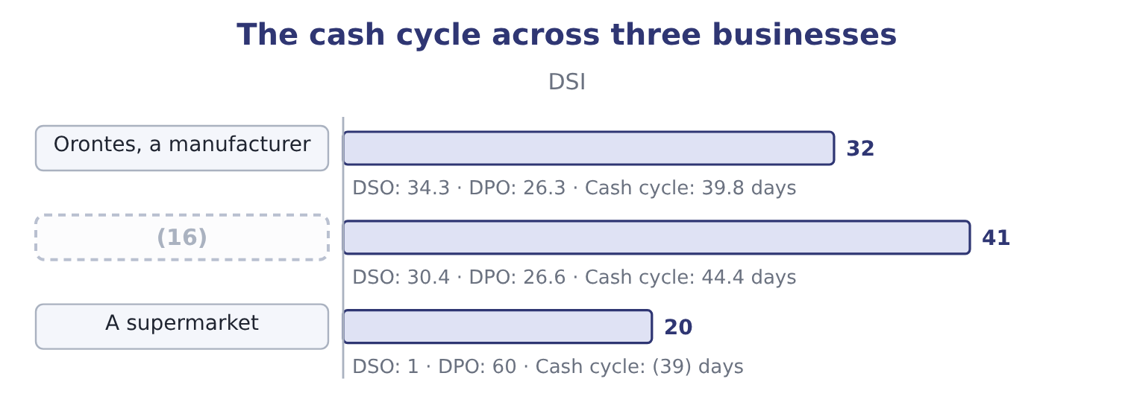
word list
Barada, a distributor · trade working capital

The sign and the direction

Summary 3 gaps 17–21
A (17) cash cycle is better. A negative cash cycle is better still. (18) DPO shortens the cash cycle and may cost supplier goodwill or a settlement discount. The exam treats this as a (19) , not a free gain. A cash cycle computed from year-end balances is a (20) . For a (21) business compute it at more than one date if the data allows.
word list
payables · shorter · seasonal · snapshot · trade-off · Lengthening

Worked example: shortening the cycle three ways

Summary 4 gaps 22–30
Collect five days (22) . DSO falls from 34.3 to 29.3 and the cash cycle from 39.8 to 34.8 days. At daily sales of $115,068 that releases 115,068 × 5 = 575,340 of (23) . Hold five days less stock. DSI falls from 31.8 to 26.8 and the cycle to 34.8 days again. At daily cost of goods sold of $74,795 that releases 74,795 × 5 = 373,975. Take five more days to pay. DPO rises from 26.3 to 31.3 and the cycle falls to 34.8 days once more. At daily purchases of about $75,205 that releases (24) 376,000. Three different (25) , the same five days off the cycle, and three different amounts of cash (26) , because each day is (27) at a different daily flow. A manager (28) between them needs the money figures, not the (29) , and that is the point of the (30) .
word list
valued · position · day-counts · choosing · released · actions · roughly · exercise · faster · receivables

The English this section uses, and its Arabic
Each term sits against what it means.
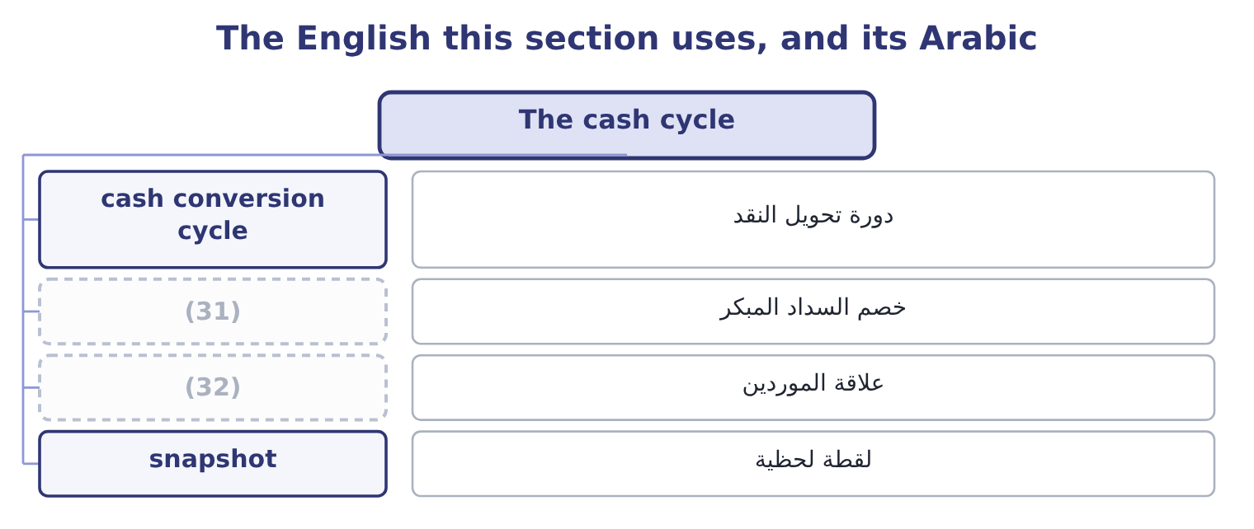
word list
supplier goodwill · daily sales · settlement discount

The English this sheet uses, and its Arabic
English (exam term) | Arabic
cash conversion cycle | دورة تحويل النقد
settlement discount | خصم السداد المبكر
supplier goodwill | علاقة الموردين
snapshot | لقطة لحظية

Answer key · 12.3 The cash cycle

1 assumes | 17 shorter
2 receives | 18 Lengthening
3 conversion | 19 trade-off
4 twenty-six | 20 snapshot
5 itself | 21 seasonal
6 Adds to the lock-up | 22 faster
7 Total lock-up | 23 receivables
8 Funded by the company | 24 roughly
9 possible | 25 actions
10 working-capital | 26 released
11 nothing | 27 valued
12 financed | 28 choosing
13 customers | 29 day-counts
14 businesses | 30 exercise
15 permanently | 31 settlement discount
16 Barada, a distributor | 32 supplier goodwill

the summaries in full
Summary 1 The operating cycle assumes the company pays for its goods on the day it receives them. It does not: suppliers give credit, and the days of that credit are days the company does not have to fund. The cash cycle, also called the cash conversion cycle, is the operating cycle less days purchases in payables. For Orontes: 66.1 − 26.3 = 39.8 days. So Orontes funds about forty days. Its suppliers fund twenty-six of the sixty-six, and the company itself funds the rest.
Summary 2 A negative cash cycle is possible and is the strongest working-capital position there is. A supermarket sells for cash, so its DSO is near zero; it turns its stock in about twenty days; and it pays its suppliers in sixty. Twenty plus nothing less sixty is minus forty days: the supermarket is financed by its suppliers and holds the customers' money for forty days before passing it on. That is why such businesses can run a current ratio below 1.0 permanently.
Summary 3 A shorter cash cycle is better. A negative cash cycle is better still. Lengthening DPO shortens the cash cycle and may cost supplier goodwill or a settlement discount. The exam treats this as a trade-off, not a free gain. A cash cycle computed from year-end balances is a snapshot. For a seasonal business compute it at more than one date if the data allows.
Summary 4 Collect five days faster. DSO falls from 34.3 to 29.3 and the cash cycle from 39.8 to 34.8 days. At daily sales of $115,068 that releases 115,068 × 5 = 575,340 of receivables. Hold five days less stock. DSI falls from 31.8 to 26.8 and the cycle to 34.8 days again. At daily cost of goods sold of $74,795 that releases 74,795 × 5 = 373,975. Take five more days to pay. DPO rises from 26.3 to 31.3 and the cycle falls to 34.8 days once more. At daily purchases of about $75,205 that releases roughly 376,000. Three different actions, the same five days off the cycle, and three different amounts of cash released, because each day is valued at a different daily flow. A manager choosing between them needs the money figures, not the day-counts, and that is the point of the exercise.

12.4 What the cycle is worth
Chapter 12 · section 12.4

Fill every gap. Each word list holds one word more than there are gaps.
Summary 1 gaps 1–12
A day of the cash cycle is a sum of money, and the exam expects the (1) . The (2) version values a day at the daily cost of sales, because that is what is (3) . For Orontes a day is $74,795, so the whole (4) cycle is about 74,795 × 39.8 = 2,976,841 of funding. A (5) version builds it from the (6) sheet. Trade working capital is (7) plus inventory less (8) : 4,144,000 + 2,450,000 = 6,594,000, and 6,594,000 − 2,050,000 = 4,544,000. That is what Orontes (9) has tied up in trade at the year end. The two differ because the first costs (10) at cost and the second (11) the receivable at its selling price. (12) is acceptable; what is not acceptable is to mix them. What the number is for is the next question.
word list
receivables · conversion · carries · simplest · funded · balance · forty-day · Either · fuller · Orontes · everything · actually · payables

Summary 2 gaps 13–18
Orontes funds $4,544,000 of trade working capital. At the 6 per cent it pays Levant (13) Bank, that funding costs about 4,544,000 × 0.06 = 272,640 a year. (14) the cash cycle by ten days would (15) roughly a quarter of it and save about $68,000 a year — which is a real sum and a (16) one than the $840,000 the margin decline. (17) the two side by side is what (18) findings means.
word list
findings · release · Shortening · smaller · ranking · Putting · Commerce

Build Barada's cycle

Compute the three day-counts and the two cycles.
Your turn: Barada's cycles (complete the blanks)
The bars are drawn to scale.
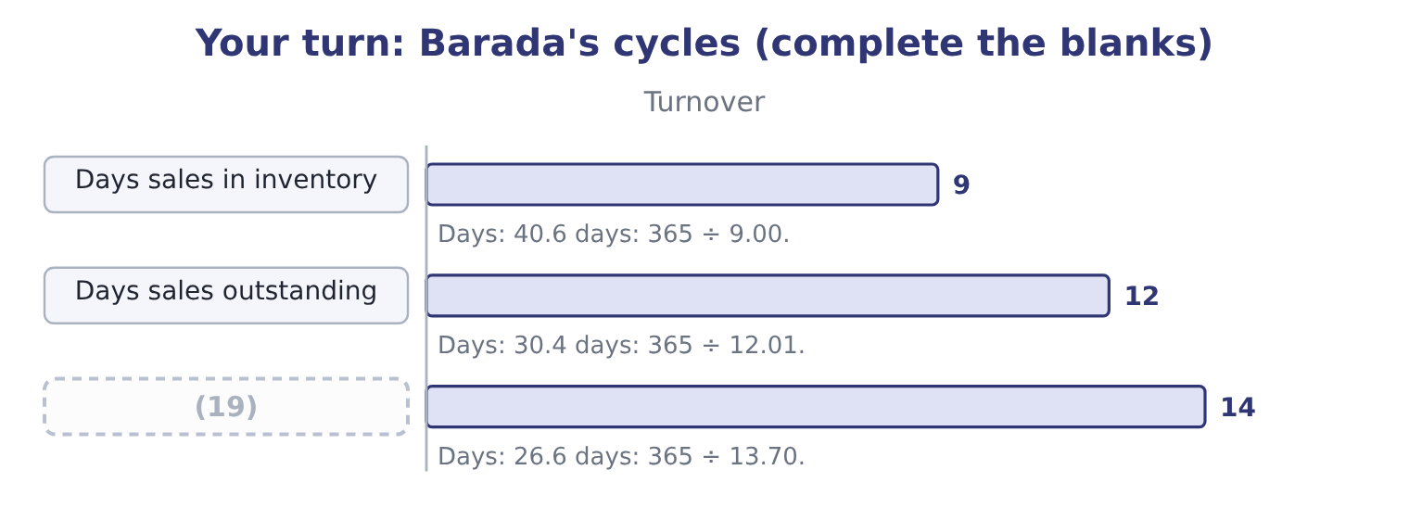
word list
Days purchases in payables · days sales in inventory

"Outstanding"

Summary 3 gaps 20–22
English outstanding has two (20) senses: excellent, and not yet (21) . In days sales outstanding it is the second — the sales still owed to the company. A (22) who reads the phrase as praise will misread the ratio entirely.
word list
candidate · opposite-feeling · working · settled

The English this section uses, and its Arabic
Each term sits against what it means.
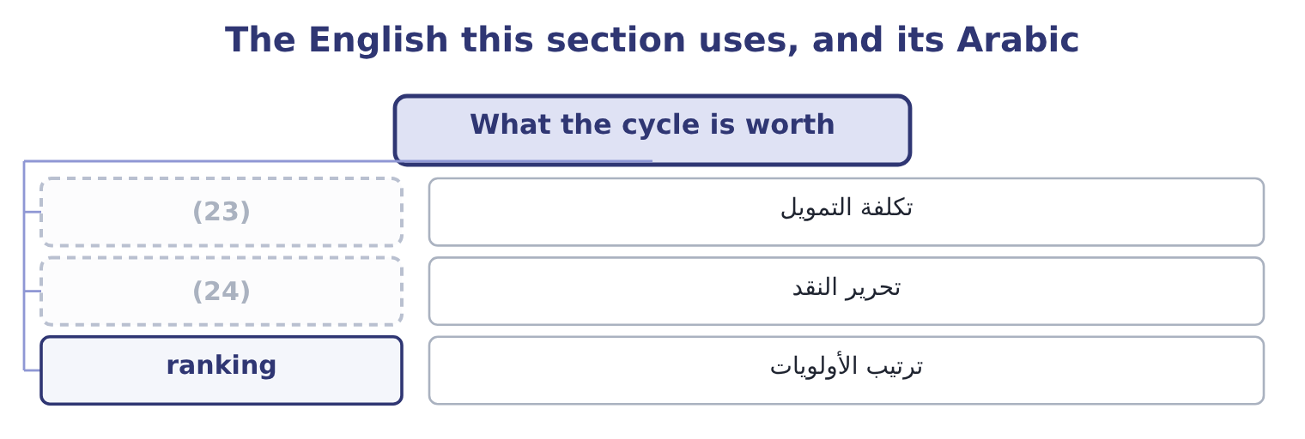
word list
days sales outstanding · funding cost · release of cash

The English this sheet uses, and its Arabic
English (exam term) | Arabic
funding cost | تكلفة التمويل
release of cash | تحرير النقد
ranking | ترتيب الأولويات

Answer key · 12.4 What the cycle is worth

1 conversion | 13 Commerce
2 simplest | 14 Shortening
3 funded | 15 release
4 forty-day | 16 smaller
5 fuller | 17 Putting
6 balance | 18 ranking
7 receivables | 19 Days purchases in payables
8 payables | 20 opposite-feeling
9 actually | 21 settled
10 everything | 22 candidate
11 carries | 23 funding cost
12 Either | 24 release of cash

the summaries in full
Summary 1 A day of the cash cycle is a sum of money, and the exam expects the conversion. The simplest version values a day at the daily cost of sales, because that is what is funded. For Orontes a day is $74,795, so the whole forty-day cycle is about 74,795 × 39.8 = 2,976,841 of funding. A fuller version builds it from the balance sheet. Trade working capital is receivables plus inventory less payables: 4,144,000 + 2,450,000 = 6,594,000, and 6,594,000 − 2,050,000 = 4,544,000. That is what Orontes actually has tied up in trade at the year end. The two differ because the first costs everything at cost and the second carries the receivable at its selling price. Either is acceptable; what is not acceptable is to mix them. What the number is for is the next question.
Summary 2 Orontes funds $4,544,000 of trade working capital. At the 6 per cent it pays Levant Commerce Bank, that funding costs about 4,544,000 × 0.06 = 272,640 a year. Shortening the cash cycle by ten days would release roughly a quarter of it and save about $68,000 a year — which is a real sum and a smaller one than the $840,000 the margin decline. Putting the two side by side is what ranking findings means.
Summary 3 English outstanding has two opposite-feeling senses: excellent, and not yet settled. In days sales outstanding it is the second — the sales still owed to the company. A candidate who reads the phrase as praise will misread the ratio entirely.

12.5 What the cycles do not show
Chapter 12 · section 12.5

Fill every gap. Each word list holds one word more than there are gaps.
Summary 1 gaps 1–8
Three limits, each (1) , and a fourth worth (2) . An average hides its spread. A DSO of 34.3 days is (3) with every customer paying on day 34 and with most paying on day 20 and one large one paying on day 120. The ageing schedule (4) the two and the ratio cannot. A cycle computed at a year end is a (5) of the quietest day. Many companies (6) a year end at the bottom of their season (7) because stock and receivables are low then. A seasonal business (8) be measured at several dates.
word list
knowing · consistent · should · several · precisely · snapshot · examinable · choose · separates

Worked example: the same company measured twice

Summary 2 gaps 9–20
Ghab Mills, a flour (9) , closes its year in (10) , when the harvest has been sold and the silos are empty. Inventory is $1,200,000 and daily cost of goods sold is $20,000, so days sales in inventory is 1,200,000 ÷ 20,000 = 60.0 days. In (11) , just after the harvest, inventory is $3,000,000. The same daily flow gives 3,000,000 ÷ 20,000 = 150.0 days. The year as a whole. The average of the twelve (12) balances is $2,100,000, which gives 2,100,000 ÷ 20,000 = 105.0 days. Three (13) figures for one year, (14) from 60 to 150 days. The (15) accounts will show the 60, and an (16) who stops there will (17) Ghab Mills holds a little over half the stock it really (18) through the year. Where monthly data (19) , use it; where it does not, say which date the figure comes from and whether that date (20) the company.
word list
believe · published · analyst · February · month-end · carries · September · exists · flatters · seasonal · defensible · running · miller

Summary 3 gaps 21–32
A short cycle can be bought. Factoring receivables shortens DSO (21) and costs a fee, which is the loss on sale of receivables of $15,000 in (22) own income statement. Stretching (23) shortens the cycle and may cost a (24) discount worth far more than the funding saved. The cycle (25) the position and not how it was (26) . A fourth limit is (27) than the other three. The cycle is built from three ratios, and each of them has a (28) the company (29) . Purchases are rarely disclosed and must be (30) from cost of goods sold and the (31) in stock, so days purchases in payables inherits whatever error is in that estimate. Credit sales are rarely disclosed separately either, so days sales (32) is usually computed on total sales and understates the true collection period for any company with a cash counter. None of this is a reason to abandon the cycle. It is a reason to compare a company with itself over several years, where one convention runs through every figure, before comparing it with a competitor whose conventions cannot be seen.
word list
movement · month-end · suppliers · Orontes's · immediately · quieter · outstanding · chooses · denominator · reached · estimated · measures · settlement

Three things the cycles do not show
Limit | Why it matters | What answers it
An average hides its spread | (33) | The ageing schedule
A year end is one day | A seasonal business is measured at its quietest | (34)
A short cycle can be bought | (35) | The fee, and the discount forgone

word list
Several dates, or a monthly average · Factoring and stretching both shorten it at a price · A seasonal business is measured at its quietest · One slow customer can hide inside a good average

The English this section uses, and its Arabic
Each term sits against what it means.
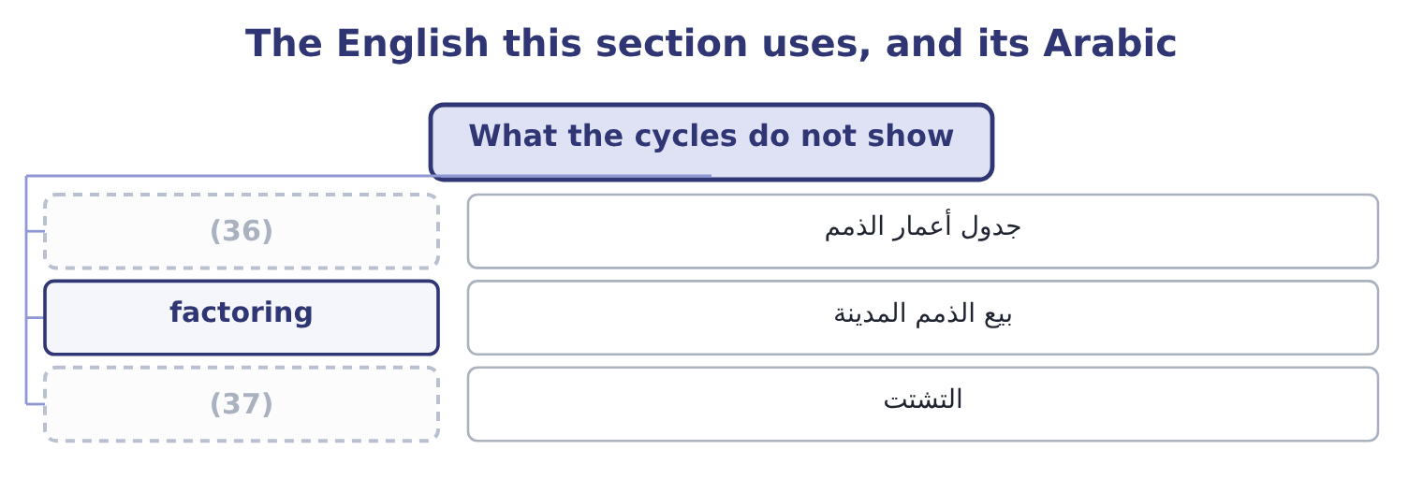
word list
spread · ageing schedule · lock-up

The English this sheet uses, and its Arabic
English (exam term) | Arabic
ageing schedule | جدول أعمار الذمم
factoring | بيع الذمم المدينة
spread | التشتت

Answer key · 12.5 What the cycles do not show

1 examinable | 20 flatters
2 knowing | 21 immediately
3 consistent | 22 Orontes's
4 separates | 23 suppliers
5 snapshot | 24 settlement
6 choose | 25 measures
7 precisely | 26 reached
8 should | 27 quieter
9 miller | 28 denominator
10 February | 29 chooses
11 September | 30 estimated
12 month-end | 31 movement
13 defensible | 32 outstanding
14 running | 33 One slow customer can hide inside a good average
15 published | 34 Several dates, or a monthly average
16 analyst | 35 Factoring and stretching both shorten it at a price
17 believe | 36 ageing schedule
18 carries | 37 spread
19 exists

the summaries in full
Summary 1 Three limits, each examinable, and a fourth worth knowing. An average hides its spread. A DSO of 34.3 days is consistent with every customer paying on day 34 and with most paying on day 20 and one large one paying on day 120. The ageing schedule separates the two and the ratio cannot. A cycle computed at a year end is a snapshot of the quietest day. Many companies choose a year end at the bottom of their season precisely because stock and receivables are low then. A seasonal business should be measured at several dates.
Summary 2 Ghab Mills, a flour miller, closes its year in February, when the harvest has been sold and the silos are empty. Inventory is $1,200,000 and daily cost of goods sold is $20,000, so days sales in inventory is 1,200,000 ÷ 20,000 = 60.0 days. In September, just after the harvest, inventory is $3,000,000. The same daily flow gives 3,000,000 ÷ 20,000 = 150.0 days. The year as a whole. The average of the twelve month-end balances is $2,100,000, which gives 2,100,000 ÷ 20,000 = 105.0 days. Three defensible figures for one year, running from 60 to 150 days. The published accounts will show the 60, and an analyst who stops there will believe Ghab Mills holds a little over half the stock it really carries through the year. Where monthly data exists, use it; where it does not, say which date the figure comes from and whether that date flatters the company.
Summary 3 A short cycle can be bought. Factoring receivables shortens DSO immediately and costs a fee, which is the loss on sale of receivables of $15,000 in Orontes's own income statement. Stretching suppliers shortens the cycle and may cost a settlement discount worth far more than the funding saved. The cycle measures the position and not how it was reached. A fourth limit is quieter than the other three. The cycle is built from three ratios, and each of them has a denominator the company chooses. Purchases are rarely disclosed and must be estimated from cost of goods sold and the movement in stock, so days purchases in payables inherits whatever error is in that estimate. Credit sales are rarely disclosed separately either, so days sales outstanding is usually computed on total sales and understates the true collection period for any company with a cash counter. None of this is a reason to abandon the cycle. It is a reason to compare a company with itself over several years, where one convention runs through every figure, before comparing it with a competitor whose conventions cannot be seen.

