13.1 The four margins and where they come from
Chapter 13 · section 13.1

Fill every gap. Each word list holds one word more than there are gaps.
Chapter 13, section by section
Each stage leads to the next.
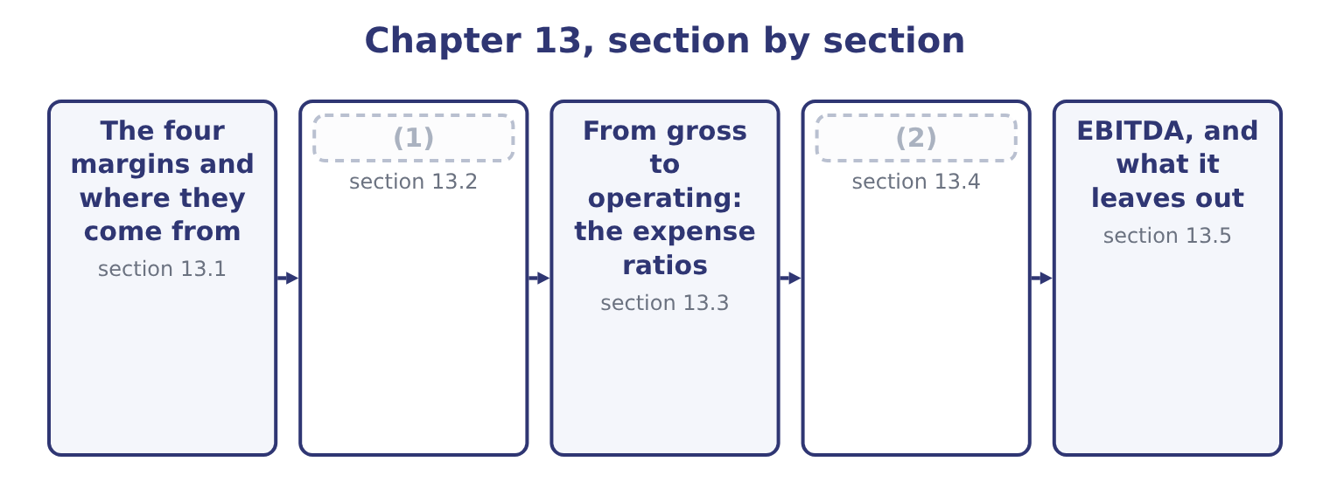
word list
Gross margin and the cost of sales · The four margins and where they come from · From operating to net: what sits below the lin

Summary 1 gaps 3–11
A margin is a profit figure over net sales. The numerator changes; the (3) never does. Gross profit margin is gross profit over net sales. Gross profit is what is left of the selling price after the cost of the goods (4) , so the gross margin is the margin of the trade. For Orontes, gross profit is 42,000,000 − 27,300,000 = 14,700,000, and the margin is 14,700,000 ÷ 42,000,000 = 35.0 per cent. Operating profit margin is operating income over net sales. Operating income is gross profit less the operating (5) — selling, (6) , research, (7) losses and any (8) — so this margin is the margin of the business as a business, before (9) to do with how it is (10) or taxed. For Orontes: 4,176,000 ÷ 42,000,000 = 9.94 per cent, which (11) to 9.9.
word list
financed · rounds · expenses · anything · impairment · denominator · interchangeable · themselves · administration · credit

Summary 2 gaps 12–20
Net profit margin is net income over net sales. It is the last line over the first, so (12) that happened in the year is (13) it: interest, (14) income, one-off gains and losses, and tax. For Orontes: 2,969,100 ÷ 42,000,000 = 7.07 per cent, or 7.1 to one (15) . (16) margin is earnings before interest, taxes, (17) and amortisation over net sales. It adds back to operating profit the (18) that do not move cash in the year, and section 13.5 builds it (19) , because it is the only one of the four whose numerator is not printed on the face of the (20) .
word list
everything · expenses · decimal · EBITDA · statement · depreciation · inside · investment · charges · properly

Orontes Foods, Inc. — the four margins, 2025
The bars are drawn to scale.
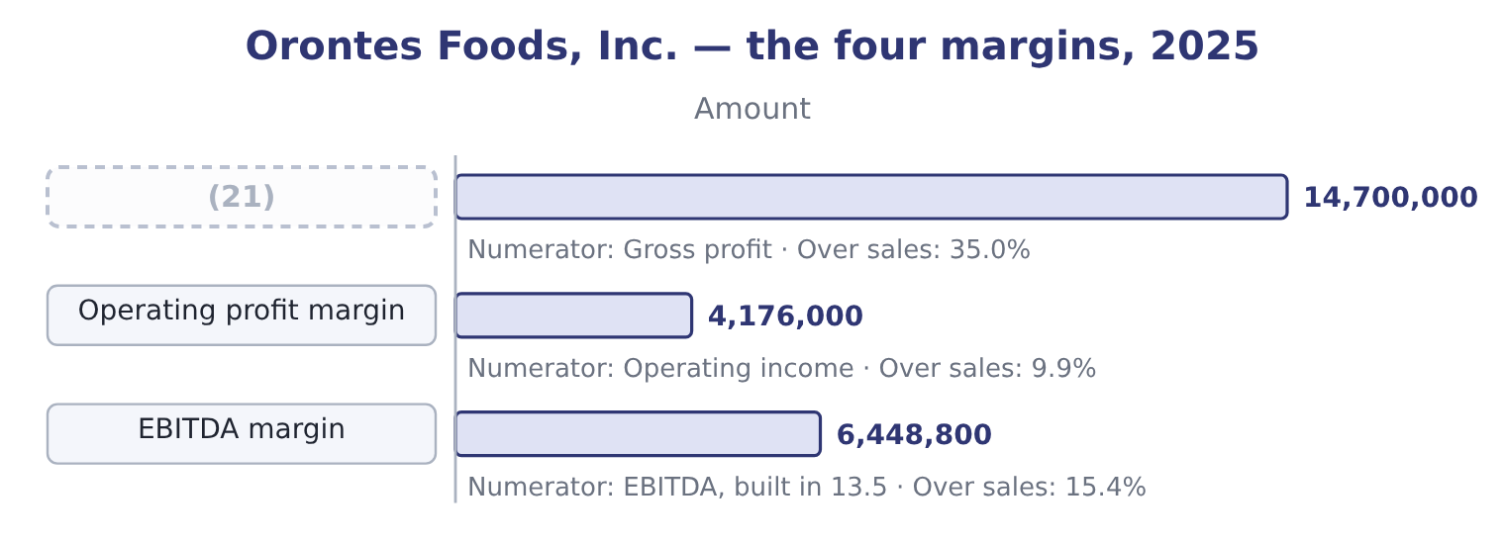
word list
net profit margin · Gross profit margin

Summary 3 gaps 22–26
Read down that column and the (22) is obvious. (23) cents of every sales dollar (24) the cost of goods; ten cents survive the running of the company; seven cents reach the owners. The two gaps — (25) points between gross and operating, three points between operating and net — are where the (26) are.
word list
Thirty-five · questions · decimal · staircase · survives · twenty-five

One denominator, four numerators

Summary 4 gaps 27–33
Every margin (27) by net sales, not by gross sales, not by total revenue (28) other income, and not by assets. A profit over assets is a (29) , which is, not a margin. Operating income (30) interest and tax by (31) . A (32) who deducts interest before computing the operating margin has computed something else. A margin is a percentage. A markup is a percentage of cost. A 35 per cent gross margin is a markup of about 54 per cent, and the two are not (33) .
word list
candidate · including · construction · everything · return · divides · excludes · interchangeable

The English this section uses, and its Arabic
Each term sits against what it means.
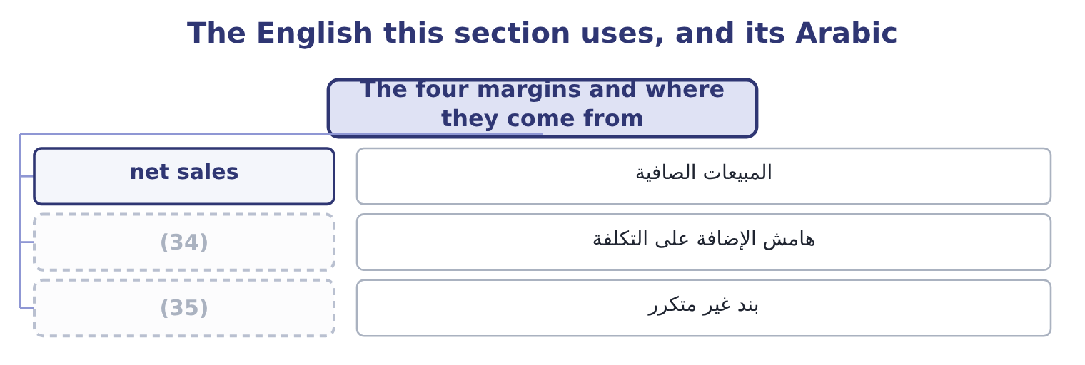
word list
statutory rate · one-off item · markup

The English this sheet uses, and its Arabic
English (exam term) | Arabic
net sales | المبيعات الصافية
markup | هامش الإضافة على التكلفة
one-off item | بند غير متكرر

Answer key · 13.1 The four margins and where they come from

1 Gross margin and the cost of sales | 19 properly
2 From operating to net: what sits below the lin | 20 statement
3 denominator | 21 Gross profit margin
4 themselves | 22 staircase
5 expenses | 23 Thirty-five
6 administration | 24 survives
7 credit | 25 twenty-five
8 impairment | 26 questions
9 anything | 27 divides
10 financed | 28 including
11 rounds | 29 return
12 everything | 30 excludes
13 inside | 31 construction
14 investment | 32 candidate
15 decimal | 33 interchangeable
16 EBITDA | 34 markup
17 depreciation | 35 one-off item
18 charges

the summaries in full
Summary 1 A margin is a profit figure over net sales. The numerator changes; the denominator never does. Gross profit margin is gross profit over net sales. Gross profit is what is left of the selling price after the cost of the goods themselves, so the gross margin is the margin of the trade. For Orontes, gross profit is 42,000,000 − 27,300,000 = 14,700,000, and the margin is 14,700,000 ÷ 42,000,000 = 35.0 per cent. Operating profit margin is operating income over net sales. Operating income is gross profit less the operating expenses — selling, administration, research, credit losses and any impairment — so this margin is the margin of the business as a business, before anything to do with how it is financed or taxed. For Orontes: 4,176,000 ÷ 42,000,000 = 9.94 per cent, which rounds to 9.9.
Summary 2 Net profit margin is net income over net sales. It is the last line over the first, so everything that happened in the year is inside it: interest, investment income, one-off gains and losses, and tax. For Orontes: 2,969,100 ÷ 42,000,000 = 7.07 per cent, or 7.1 to one decimal. EBITDA margin is earnings before interest, taxes, depreciation and amortisation over net sales. It adds back to operating profit the charges that do not move cash in the year, and section 13.5 builds it properly, because it is the only one of the four whose numerator is not printed on the face of the statement.
Summary 3 Read down that column and the staircase is obvious. Thirty-five cents of every sales dollar survives the cost of goods; ten cents survive the running of the company; seven cents reach the owners. The two gaps — twenty-five points between gross and operating, three points between operating and net — are where the questions are.
Summary 4 Every margin divides by net sales, not by gross sales, not by total revenue including other income, and not by assets. A profit over assets is a return, which is, not a margin. Operating income excludes interest and tax by construction. A candidate who deducts interest before computing the operating margin has computed something else. A margin is a percentage. A markup is a percentage of cost. A 35 per cent gross margin is a markup of about 54 per cent, and the two are not interchangeable.

13.2 Gross margin and the cost of sales
Chapter 13 · section 13.2

Fill every gap. Each word list holds one word more than there are gaps.
Summary 1 gaps 1–12
The gross margin and the (1) ratio are the same fact (2) twice. Orontes's cost of goods sold is 27,300,000 ÷ 42,000,000 = 65.0 per cent of sales, and what is left is the 35.0 per cent gross margin. Whenever the exam asks what happened to a gross margin, the answer is always (3) that happened to one of those two (4) , and there are only four candidates. A price rise lifts the margin; a (5) campaign lowers it. The volume sold may be (6) . A rise in the cost of (7) , freight or (8) lowers the margin unless the price rises with it. Selling more of a (9) line and less of a fat one lowers the average margin although no single (10) margin has moved. This is the cause candidates (11) . (12) and inventory method. Under last-in, first-out, rising prices push the newest and highest costs into cost of sales and depress the margin, while first-in, first-out leaves them in inventory. A write-down of stock passes through cost of sales as well.
word list
forget · thin-margin · sesame · percentages · written · happened · Costing · something · unchanged · product's · discount · packaging · cost-of-sales

Orontes: the three margins, 2023 to 2025
Name each line from how it moves.
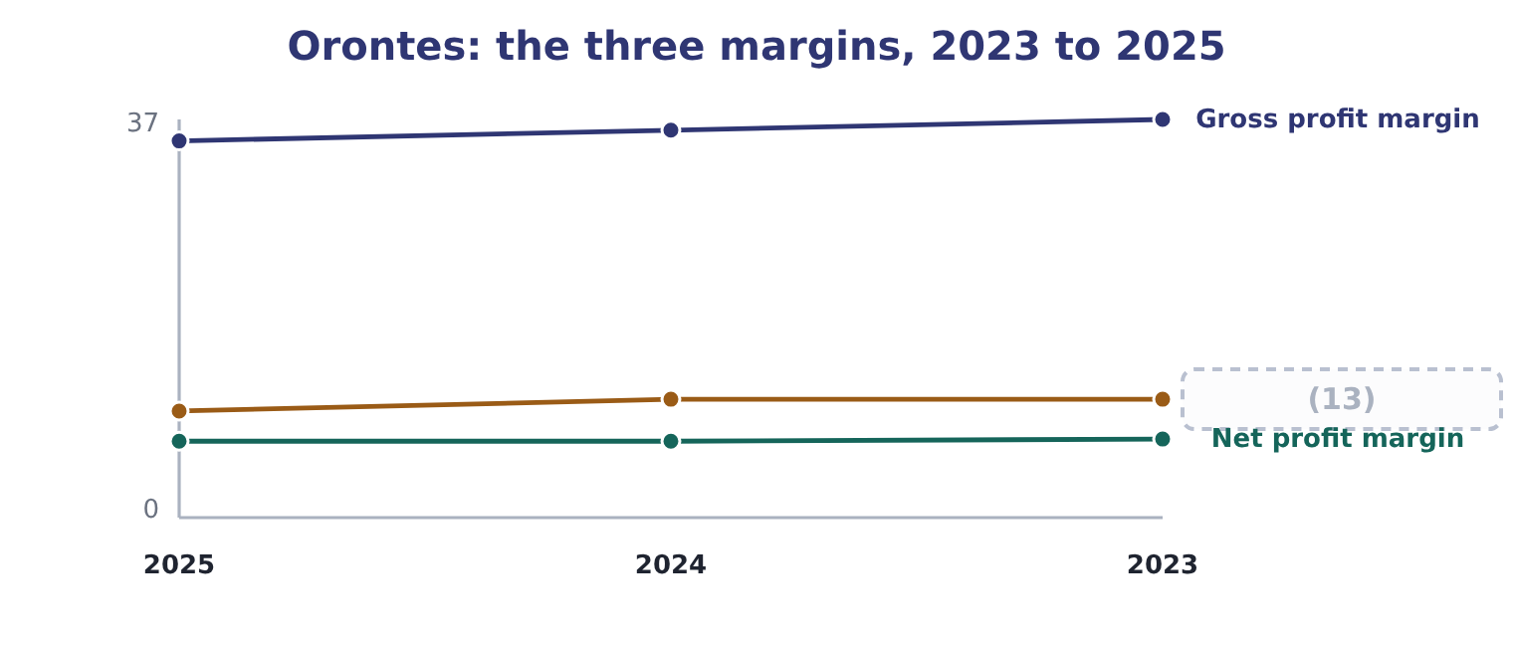
word list
cost of sales · Operating profit margin

Summary 2 gaps 14–16
The gross margins come (14) from the three income (15) : 11,840,000 ÷ 32,000,000 = 37.0 per cent in 2023, 13,104,000 ÷ 36,400,000 = 36.0 per cent in 2024 and 35.0 per cent in 2025. Sales rose every year and the margin fell every year, which is the (16) of growth bought with price.
word list
changed · straight · statements · signature

Worked example: what two points of gross margin are worth

Summary 3 gaps 17–28
The size of the slip. The gross margin was 37.0 per cent in 2023 and is 35.0 per cent in 2025: 37.0 − 35.0 = 2.0 points. Two points of the 2025 sales figure is 42,000,000 × 0.02 = 840,000. Had Orontes held its 2023 margin, gross profit would have been $840,000 higher, and (17) no operating (18) would have (19) , so would operating income. (20) what Orontes earns. Net income for the year is $2,969,100, so the lost margin is 840,000 ÷ 2,969,100 = 28.29 per cent of the profit the company (21) made. The slip is one point a year and (22) small. (23) in money it is the (24) single finding in the whole of Book 1 — larger than the $272,640 a year the trade (25) capital costs to fund, and larger than anything the (26) chapters turned up. A (27) move in the biggest (28) on the statement beats a large move in a small one, every time.
word list
Expressed · changed · liquidity · sounds · actually · largest · working · expense · operating · Against · percentage · because · two-point

A margin can fall while profit rises

Summary 4 gaps 29–34
Orontes's gross profit rose from $11,840,000 to $14,700,000 over the three years while the gross margin fell. Volume did the work; the rate got worse. An answer that says profit fell is (29) wrong. It is the (30) of it. The (31) is a price, a cost, a mix or a method. Where the (32) gives no mix (33) , say that mix is a possible cause rather than (34) a price war.
word list
explanation · asserting · depreciation · arithmetic · information · simply · question

The English this section uses, and its Arabic
Each term sits against what it means.
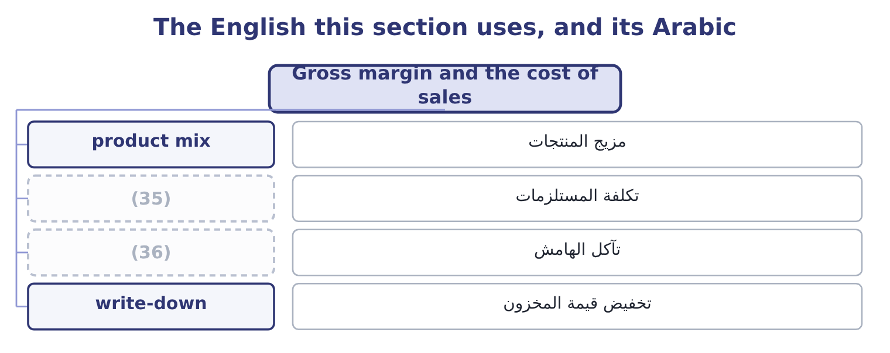
word list
product mix · margin erosion · input cost

The English this sheet uses, and its Arabic
English (exam term) | Arabic
product mix | مزيج المنتجات
input cost | تكلفة المستلزمات
margin erosion | تآكل الهامش
write-down | تخفيض قيمة المخزون

Answer key · 13.2 Gross margin and the cost of sales

1 cost-of-sales | 19 changed
2 written | 20 Against
3 something | 21 actually
4 percentages | 22 sounds
5 discount | 23 Expressed
6 unchanged | 24 largest
7 sesame | 25 working
8 packaging | 26 liquidity
9 thin-margin | 27 two-point
10 product's | 28 percentage
11 forget | 29 simply
12 Costing | 30 arithmetic
13 Operating profit margin | 31 explanation
14 straight | 32 question
15 statements | 33 information
16 signature | 34 asserting
17 because | 35 input cost
18 expense | 36 margin erosion

the summaries in full
Summary 1 The gross margin and the cost-of-sales ratio are the same fact written twice. Orontes's cost of goods sold is 27,300,000 ÷ 42,000,000 = 65.0 per cent of sales, and what is left is the 35.0 per cent gross margin. Whenever the exam asks what happened to a gross margin, the answer is always something that happened to one of those two percentages, and there are only four candidates. A price rise lifts the margin; a discount campaign lowers it. The volume sold may be unchanged. A rise in the cost of sesame, freight or packaging lowers the margin unless the price rises with it. Selling more of a thin-margin line and less of a fat one lowers the average margin although no single product's margin has moved. This is the cause candidates forget. Costing and inventory method. Under last-in, first-out, rising prices push the newest and highest costs into cost of sales and depress the margin, while first-in, first-out leaves them in inventory. A write-down of stock passes through cost of sales as well.
Summary 2 The gross margins come straight from the three income statements: 11,840,000 ÷ 32,000,000 = 37.0 per cent in 2023, 13,104,000 ÷ 36,400,000 = 36.0 per cent in 2024 and 35.0 per cent in 2025. Sales rose every year and the margin fell every year, which is the signature of growth bought with price.
Summary 3 The size of the slip. The gross margin was 37.0 per cent in 2023 and is 35.0 per cent in 2025: 37.0 − 35.0 = 2.0 points. Two points of the 2025 sales figure is 42,000,000 × 0.02 = 840,000. Had Orontes held its 2023 margin, gross profit would have been $840,000 higher, and because no operating expense would have changed, so would operating income. Against what Orontes earns. Net income for the year is $2,969,100, so the lost margin is 840,000 ÷ 2,969,100 = 28.29 per cent of the profit the company actually made. The slip is one point a year and sounds small. Expressed in money it is the largest single finding in the whole of Book 1 — larger than the $272,640 a year the trade working capital costs to fund, and larger than anything the liquidity chapters turned up. A two-point move in the biggest percentage on the statement beats a large move in a small one, every time.
Summary 4 Orontes's gross profit rose from $11,840,000 to $14,700,000 over the three years while the gross margin fell. Volume did the work; the rate got worse. An answer that says profit fell is simply wrong. It is the arithmetic of it. The explanation is a price, a cost, a mix or a method. Where the question gives no mix information, say that mix is a possible cause rather than asserting a price war.

13.3 From gross to operating: the expense ratios
Chapter 13 · section 13.3

Fill every gap. Each word list holds one word more than there are gaps.
Summary 1 gaps 1–8
Twenty-five points of Orontes's sales dollar disappear (1) gross profit and operating income. They disappear into one line, total operating expenses, and the ratio of that line to sales is the (2) number to track. Orontes's operating expenses are 10,524,000 ÷ 42,000,000 = 25.06 per cent of sales in 2025. In 2024 they were 9,100,000 ÷ 36,400,000 = 25.0 per cent and in 2023 8,320,000 ÷ 32,000,000 = 26.0 per cent. On the face of it the company has held its (3) steady while (4) , which is the opposite of the (5) story and would be good news. It is not what happened. The 2025 figure (6) an impairment loss of $2,724,000, which is 2,724,000 ÷ 42,000,000 = 6.49 per cent of sales on its own and did not occur in either (7) year. Strip it out and the (8) reverses.
word list
contains · earlier · gross-margin · second · growing · comparison · between · expenses · overheads

Orontes: operating expenses with and without the impairment
Measure | 2025 as reported | 2025 excluding impairment | 2024
Operating expenses | 10,524,000 | 7,800,000 | 9,100,000
(9) | 25.06% | 18.57% | 25.0%
Operating income | 4,176,000 | 6,900,000 | 4,004,000
Operating margin | 9.9% | 16.4% | 11.0%

word list
As a percentage of sales · Input cost rises, price unchanged

Worked example: the operating margin without the one-off

Summary 2 gaps 10–21
Remove the charge from the expenses. Add it back to profit. Read the two (10) . Orontes lost two points of gross margin and (11) six and a half points of operating margin by spending (12) less on running the (13) . Both are real; the reported operating margin of 9.9 per cent shows (14) , because a (15) charge of $2,724,000 sits on top of them. The adjusted figure is the better (16) of the year's trading and the reported figure is the one that happened. The exam wants both, in that order, with the (17) named. (18) only the adjusted margin is what the term non-GAAP measure was invented to describe. The (19) that links the two margins is worth stating once, because it is the shape of every question on this outcome. The operating margin is the gross margin less the operating expense ratio: 35.0 − 25.06 = 9.94 per cent. So there are exactly two ways for an operating margin to move, and a (20) answer says which of the two did it, and by how much. In 2025 both moved and in opposite (21) : the gross margin took one point off and the expense ratio, loaded with the impairment, took a further point.
word list
business · Orontes's · arithmetic · adjustment · single · complete · proportionately · Presenting · gained · neither · description · directions · together

What moves the operating margin
Every item belongs to exactly one group.
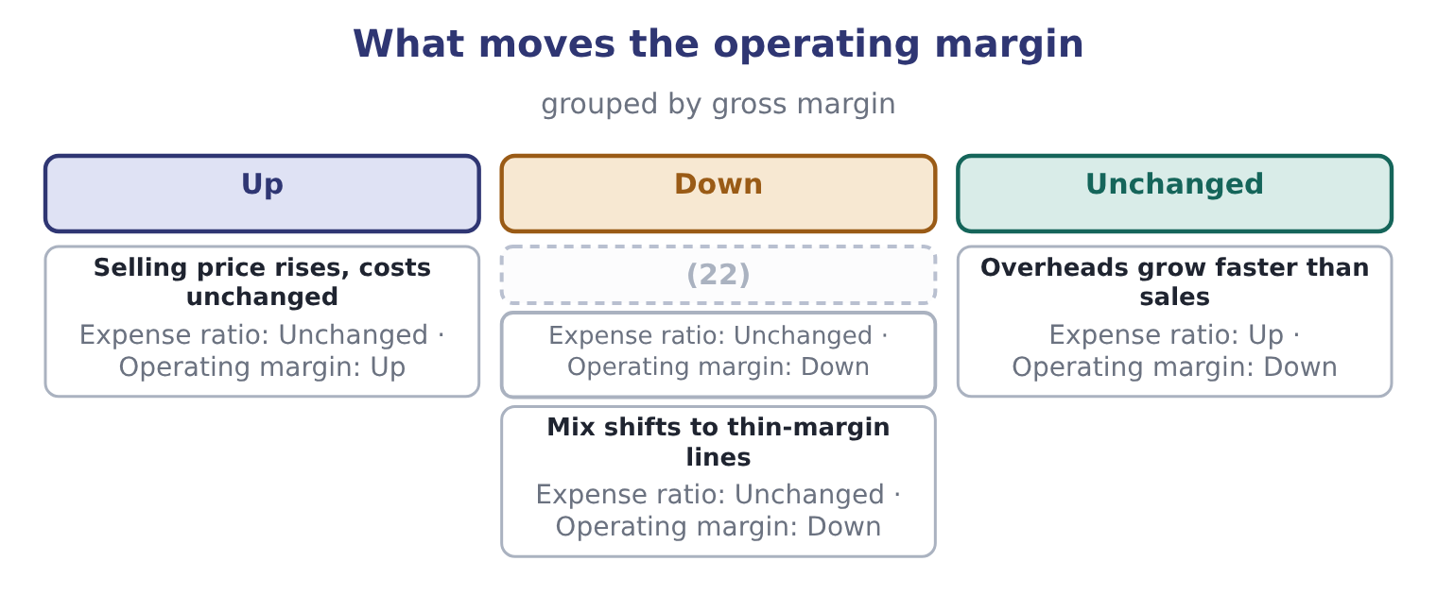
word list
Input cost rises, price unchanged · Mix shifts to thin-margin lines

Which expenses are operating expenses

Summary 3 gaps 23–29
Interest is not an operating expense; it is a (23) cost, and it (24) below operating income. Tax is not an operating expense either. An impairment loss is an operating expense under both GAAP and IFRS, (25) unusual it is. It cannot be (26) from the reported operating margin, only disclosed (27) . A (28) expense is an operating expense of the period it is (29) in, not an asset, and cutting it raises this year's operating margin at the cost of later years.
word list
operating · however · belongs · excluded · research · separately · incurred · financing

The English this section uses, and its Arabic
Each term sits against what it means.
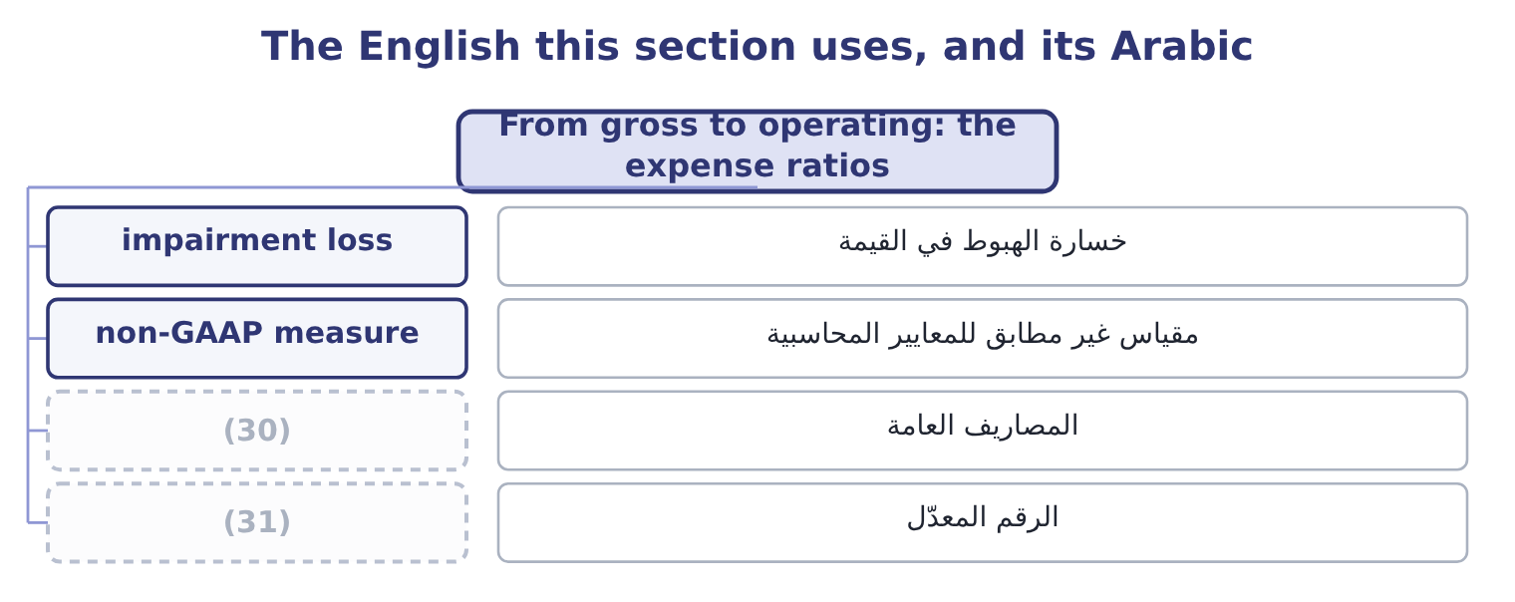
word list
adjusted figure · write-down · overhead

The English this sheet uses, and its Arabic
English (exam term) | Arabic
impairment loss | خسارة الهبوط في القيمة
non-GAAP measure | مقياس غير مطابق للمعايير المحاسبية
overhead | المصاريف العامة
adjusted figure | الرقم المعدّل

Answer key · 13.3 From gross to operating: the expense ratios

1 between | 17 adjustment
2 second | 18 Presenting
3 overheads | 19 arithmetic
4 growing | 20 complete
5 gross-margin | 21 directions
6 contains | 22 Input cost rises, price unchanged
7 earlier | 23 financing
8 comparison | 24 belongs
9 As a percentage of sales | 25 however
10 together | 26 excluded
11 gained | 27 separately
12 proportionately | 28 research
13 business | 29 incurred
14 neither | 30 overhead
15 single | 31 adjusted figure
16 description

the summaries in full
Summary 1 Twenty-five points of Orontes's sales dollar disappear between gross profit and operating income. They disappear into one line, total operating expenses, and the ratio of that line to sales is the second number to track. Orontes's operating expenses are 10,524,000 ÷ 42,000,000 = 25.06 per cent of sales in 2025. In 2024 they were 9,100,000 ÷ 36,400,000 = 25.0 per cent and in 2023 8,320,000 ÷ 32,000,000 = 26.0 per cent. On the face of it the company has held its overheads steady while growing, which is the opposite of the gross-margin story and would be good news. It is not what happened. The 2025 figure contains an impairment loss of $2,724,000, which is 2,724,000 ÷ 42,000,000 = 6.49 per cent of sales on its own and did not occur in either earlier year. Strip it out and the comparison reverses.
Summary 2 Remove the charge from the expenses. Add it back to profit. Read the two together. Orontes lost two points of gross margin and gained six and a half points of operating margin by spending proportionately less on running the business. Both are real; the reported operating margin of 9.9 per cent shows neither, because a single charge of $2,724,000 sits on top of them. The adjusted figure is the better description of the year's trading and the reported figure is the one that happened. The exam wants both, in that order, with the adjustment named. Presenting only the adjusted margin is what the term non-GAAP measure was invented to describe. The arithmetic that links the two margins is worth stating once, because it is the shape of every question on this outcome. The operating margin is the gross margin less the operating expense ratio: 35.0 − 25.06 = 9.94 per cent. So there are exactly two ways for an operating margin to move, and a complete answer says which of the two did it, and by how much. In 2025 both moved and in opposite directions: the gross margin took one point off and the expense ratio, loaded with the impairment, took a further point.
Summary 3 Interest is not an operating expense; it is a financing cost, and it belongs below operating income. Tax is not an operating expense either. An impairment loss is an operating expense under both GAAP and IFRS, however unusual it is. It cannot be excluded from the reported operating margin, only disclosed separately. A research expense is an operating expense of the period it is incurred in, not an asset, and cutting it raises this year's operating margin at the cost of later years.

13.4 From operating to net: what sits below the line
Chapter 13 · section 13.4

Fill every gap. Each word list holds one word more than there are gaps.
Summary 1 gaps 1–6
Three points of sales (1) Orontes's operating margin from its net margin, and three things cause them: the financing cost, the (2) items, and tax. Start with the total of the other income and expense section, which is a net cost of $217,200: 4,176,000 − 217,200 = 3,958,800 of income before income taxes. Inside that net figure, interest expense of $390,000 is the only large item, and it is (3) by $177,000 of equity-method income from (4) Glass Co. and a (5) of small gains and (6) . Orontes's income tax expense is $989,700, so its effective tax rate is 989,700 ÷ 3,958,800 = 25.0 per cent. What is left is net income of $2,969,100.
word list
separate · pre-tax · offset · losses · Jordan · non-operating · handful

Orontes: from operating margin to net margin, 2025
Step | Amount | Over sales
(7) | 4,176,000 | 9.9%
(8) | (217,200) | (0.5)%
Income before income taxes | 3,958,800 | 9.4%
Income tax expense | (989,700) | (2.4)%
(9) | 2,969,100 | 7.1%

word list
net profit margin · Net income · Other income and expense, net · Operating income

Summary 2 gaps 10–13
This is why the net margin is the least useful of the three for judging trading, and the most useful for judging the year. Orontes's net margin held at about 7.1 per cent across 2024 and 2025 — 2,598,000 ÷ 36,400,000 = 7.14 per cent then and 7.07 per cent now — while the operating margin fell more than a point. Two things held it up: the equity-method income, which has (10) to do with (11) food, and a lower effective tax rate. (12) will do so (13) again.
word list
Neither · selling · Orontes's · reliably · nothing

The net margin moves for reasons that are not trading

Summary 3 gaps 14–19
A company can report a better net margin on worse trading, (14) a tax refund, a gain on a (15) , or a fall in interest rates. The effective tax rate is tax expense over (16) income, not the (17) rate. A (18) between them has a cause, and the tax note gives it. Where a question gives you a one-off gain inside net income, say so before (19) net margins across years.
word list
pre-tax · depreciation · comparing · through · difference · disposal · statutory

The English this section uses, and its Arabic
Each term sits against what it means.
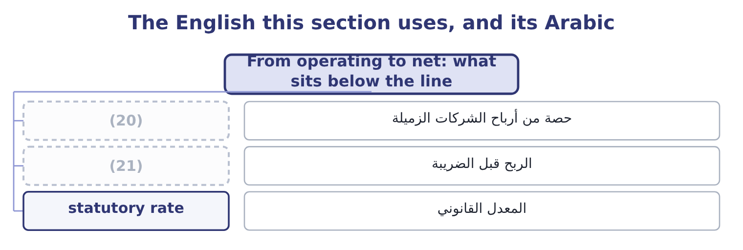
word list
adjusted EBITDA · pre-tax income · equity-method income

The English this sheet uses, and its Arabic
English (exam term) | Arabic
equity-method income | حصة من أرباح الشركات الزميلة
pre-tax income | الربح قبل الضريبة
statutory rate | المعدل القانوني

Answer key · 13.4 From operating to net: what sits below the line

1 separate | 12 Neither
2 non-operating | 13 reliably
3 offset | 14 through
4 Jordan | 15 disposal
5 handful | 16 pre-tax
6 losses | 17 statutory
7 Operating income | 18 difference
8 Other income and expense, net | 19 comparing
9 Net income | 20 equity-method income
10 nothing | 21 pre-tax income
11 selling

the summaries in full
Summary 1 Three points of sales separate Orontes's operating margin from its net margin, and three things cause them: the financing cost, the non-operating items, and tax. Start with the total of the other income and expense section, which is a net cost of $217,200: 4,176,000 − 217,200 = 3,958,800 of income before income taxes. Inside that net figure, interest expense of $390,000 is the only large item, and it is offset by $177,000 of equity-method income from Jordan Glass Co. and a handful of small gains and losses. Orontes's income tax expense is $989,700, so its effective tax rate is 989,700 ÷ 3,958,800 = 25.0 per cent. What is left is net income of $2,969,100.
Summary 2 This is why the net margin is the least useful of the three for judging trading, and the most useful for judging the year. Orontes's net margin held at about 7.1 per cent across 2024 and 2025 — 2,598,000 ÷ 36,400,000 = 7.14 per cent then and 7.07 per cent now — while the operating margin fell more than a point. Two things held it up: the equity-method income, which has nothing to do with selling food, and a lower effective tax rate. Neither will do so reliably again.
Summary 3 A company can report a better net margin on worse trading, through a tax refund, a gain on a disposal, or a fall in interest rates. The effective tax rate is tax expense over pre-tax income, not the statutory rate. A difference between them has a cause, and the tax note gives it. Where a question gives you a one-off gain inside net income, say so before comparing net margins across years.

13.5 EBITDA, and what it leaves out
Chapter 13 · section 13.5

Fill every gap. Each word list holds one word more than there are gaps.
Summary 1 gaps 1–12
EBITDA is earnings before interest, taxes, depreciation and amortisation. It is not a line of any income statement, which is why it has to be built, and the exam (1) the build. Start from earnings before interest and taxes: 3,958,800 + 390,000 = 4,348,800. Then add back the depreciation (2) for the year, which the cash flow statement gives as $2,100,000: 4,348,800 + 2,100,000 = 6,448,800. Orontes has no amortisation of (3) to add. The EBITDA margin is (4) 6,448,800 ÷ 42,000,000 = 15.35 per cent, or 15.4. What EBITDA is for is (5) between companies whose (6) and asset bases differ. Two food (7) of the same size, one owning its plant and one (8) it, one financed with debt and one with equity, will report very different net margins and (9) EBITDA margins, (10) EBITDA removes exactly the (11) that are not about making and (12) food. What EBITDA is not is cash flow, and it is not profit.
word list
selling · manufacturers · similar · because · differences · leasing · charged · markup · intangibles · therefore · expects · financing · comparison

Orontes: building EBITDA, and the claims it steps over
Step | Amount | Note
Income before income taxes | 3,958,800 | (13)
Add interest expense | 390,000 | (14)
Add depreciation | 2,100,000 | From the cash flow statement
EBITDA | 6,448,800 | 15.4% of sales
Less capital expenditure | (3,000,000) | The plant has to be replaced
Less interest paid | (390,000) | The lenders have to be paid
Less income taxes paid | (839,700) | (15)
What is left | 2,219,100 | (16)

word list
5.3% of sales · input cost · The tax authority has to be paid · As reported · Gives EBIT of 4,348,800

Summary 2 gaps 17–28
The last line is the point of the figure: 6,448,800 − 3,000,000 − 390,000 − 839,700 = 2,219,100. Adding back depreciation does not make the plant last longer, and Orontes spent $3,000,000 on (17) , plant and (18) in the year against a depreciation charge of $2,100,000. A company that quotes its EBITDA margin and not its capital expenditure is (19) the half of the (20) that suits it. There is one more trap, and it is the common one in (21) . Many companies report (22) EBITDA, adding back anything they (23) unusual. On Orontes's (24) that would mean adding the (25) : 6,448,800 + 2,724,000 = 9,172,800, which is 9,172,800 ÷ 42,000,000 = 21.84 per cent of sales. The same year, the same (26) , and a margin of 21.8 per cent (27) of 7.1. Both numbers are (28) correct. Only one of them is net income.
word list
arithmetically · adjusted · depreciation · practice · sentence · consider · statements · property · equipment · impairment · instead · figures · quoting

Build Barada's four margins

Compute the four margins.
Your turn: Barada's margins (complete the blanks)
Every item belongs to exactly one group.
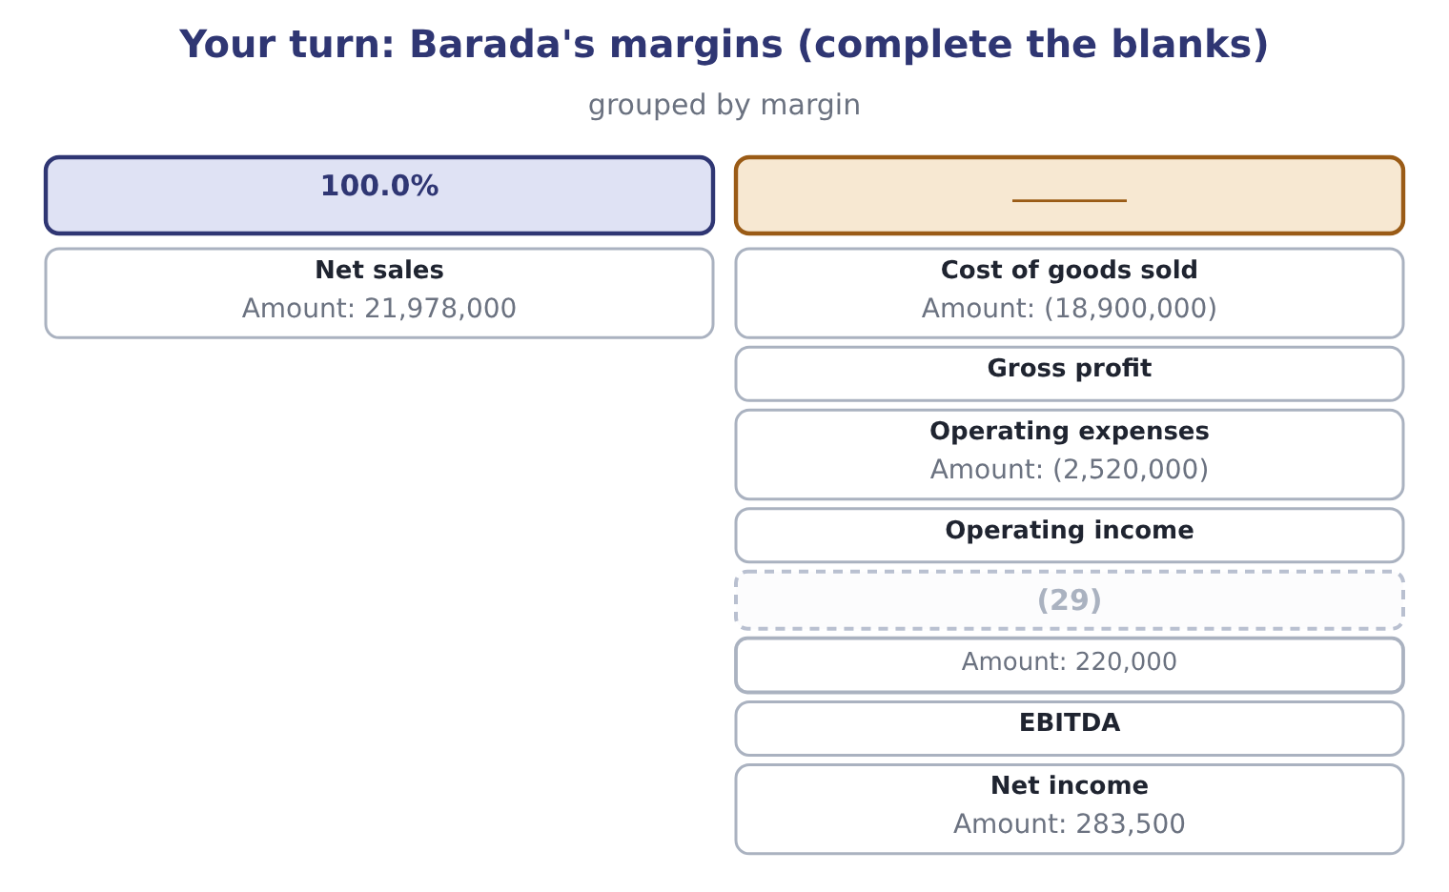
word list
Depreciation for the year · Cost of goods sold

"Margin"

Summary 3 gaps 30–34
English margin is used for three different things in (30) : a percentage of sales, as here; the cash a broker (31) against a position; and the edge of anything. In the phrase gross profit margin it is always the percentage, and a (32) who reads a margin call into a margin (33) question has lost the thread (34) .
word list
property · candidate · analysis · entirely · finance · requires

"Margin"
Item | Answer
Cost of goods sold | (35) : 18,900,000 ÷ 21,978,000.
Gross profit | 3,078,000, from 21,978,000 − 18,900,000 = 3,078,000; the margin is 3,078,000 ÷ 21,978,000 = 14.0 per cent.
Operating expenses | 11.5 per cent of sales: 2,520,000 ÷ 21,978,000.
Operating income | 558,000, from 3,078,000 − 2,520,000 = 558,000; the margin is 558,000 ÷ 21,978,000 = 2.54 per cent.
Depreciation | (36) : 220,000 ÷ 21,978,000.
EBITDA | 778,000, from 558,000 + 220,000 = 778,000; the margin is 778,000 ÷ 21,978,000 = 3.54 per cent.
Net income | (37)
What it tells you | A distributor's margins are a different order of magnitude from a manufacturer's: 14.0 per cent gross against Orontes's 35.0, and 1.29 per c

word list
1.0 per cent of sales · The net margin is 283,500 ÷ 21,978,000 = 1.29 per cent. · From the cash flow statement · 86.0 per cent of sales

The English this section uses, and its Arabic
Each term sits against what it means.
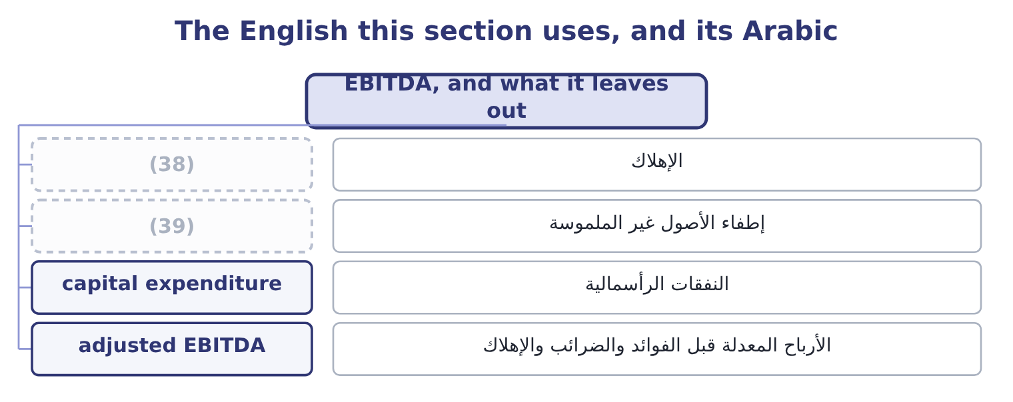
word list
overhead · amortisation · depreciation

The English this sheet uses, and its Arabic
English (exam term) | Arabic
depreciation | الإهلاك
amortisation | إطفاء الأصول غير الملموسة
capital expenditure | النفقات الرأسمالية
adjusted EBITDA | الأرباح المعدلة قبل الفوائد والضرائب والإهلاك

Answer key · 13.5 EBITDA, and what it leaves out

1 expects | 21 practice
2 charged | 22 adjusted
3 intangibles | 23 consider
4 therefore | 24 figures
5 comparison | 25 impairment
6 financing | 26 statements
7 manufacturers | 27 instead
8 leasing | 28 arithmetically
9 similar | 29 Depreciation for the year
10 because | 30 finance
11 differences | 31 requires
12 selling | 32 candidate
13 As reported | 33 analysis
14 Gives EBIT of 4,348,800 | 34 entirely
15 The tax authority has to be paid | 35 86.0 per cent of sales
16 5.3% of sales | 36 1.0 per cent of sales
17 property | 37 The net margin is 283,500 ÷ 21,978,000 = 1.29 per cent.
18 equipment | 38 depreciation
19 quoting | 39 amortisation
20 sentence

the summaries in full
Summary 1 EBITDA is earnings before interest, taxes, depreciation and amortisation. It is not a line of any income statement, which is why it has to be built, and the exam expects the build. Start from earnings before interest and taxes: 3,958,800 + 390,000 = 4,348,800. Then add back the depreciation charged for the year, which the cash flow statement gives as $2,100,000: 4,348,800 + 2,100,000 = 6,448,800. Orontes has no amortisation of intangibles to add. The EBITDA margin is therefore 6,448,800 ÷ 42,000,000 = 15.35 per cent, or 15.4. What EBITDA is for is comparison between companies whose financing and asset bases differ. Two food manufacturers of the same size, one owning its plant and one leasing it, one financed with debt and one with equity, will report very different net margins and similar EBITDA margins, because EBITDA removes exactly the differences that are not about making and selling food. What EBITDA is not is cash flow, and it is not profit.
Summary 2 The last line is the point of the figure: 6,448,800 − 3,000,000 − 390,000 − 839,700 = 2,219,100. Adding back depreciation does not make the plant last longer, and Orontes spent $3,000,000 on property, plant and equipment in the year against a depreciation charge of $2,100,000. A company that quotes its EBITDA margin and not its capital expenditure is quoting the half of the sentence that suits it. There is one more trap, and it is the common one in practice. Many companies report adjusted EBITDA, adding back anything they consider unusual. On Orontes's figures that would mean adding the impairment: 6,448,800 + 2,724,000 = 9,172,800, which is 9,172,800 ÷ 42,000,000 = 21.84 per cent of sales. The same year, the same statements, and a margin of 21.8 per cent instead of 7.1. Both numbers are arithmetically correct. Only one of them is net income.
Summary 3 English margin is used for three different things in finance: a percentage of sales, as here; the cash a broker requires against a position; and the edge of anything. In the phrase gross profit margin it is always the percentage, and a candidate who reads a margin call into a margin analysis question has lost the thread entirely.

