14.1 Return on assets
Chapter 14 · section 14.1

Fill every gap. Each word list holds one word more than there are gaps.
Chapter 14, section by section
Each stage leads to the next.
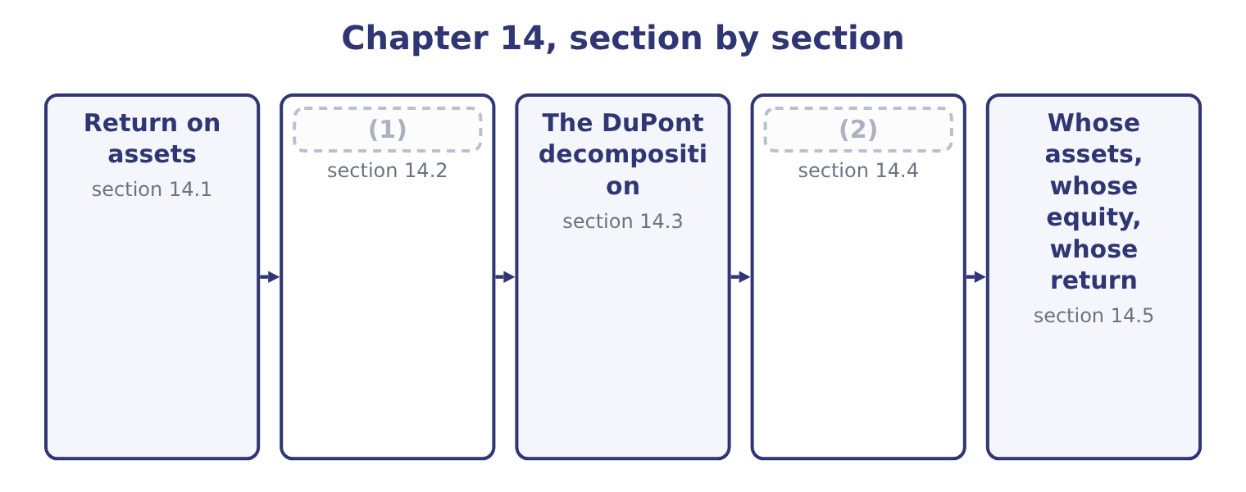
word list
Return on equity · Return on assets · The five-factor decomposition

Summary 1 gaps 3–14
Return on assets is profit over the assets (3) to earn it. (4) net income for 2025 is $2,969,100. Its assets, (5) , were not one figure (6) the year: they began at $26,445,000 and ended at $31,672,600, because the company raised equity and bought plant as the year went on. (7) a flow by a closing balance (8) a whole year's earnings with the assets of the last day. The (9) that answers this is the average: 31,672,600 + 26,445,000 = 58,117,600, and half of that is $29,058,800. Return on assets is (10) 2,969,100 ÷ 29,058,800 = 10.22 per cent, or 10.2 to one (11) . Ten cents of profit a year for every (12) of assets. That is the whole of what the ratio says, and it is enough to compare Orontes with another food (13) , with its own last year, and with the cost of the money that funds those assets — which at the 6 per cent Orontes pays Levant Commerce Bank means the assets earn (14) more than they cost to finance, and that is the test that matters.
word list
Orontes's · Dividing · manufacturer · though · compares · magnitudes · during · employed · decimal · therefore · dollar · comfortably · convention

Orontes Foods, Inc. — return on assets, 2025
Element | Amount | Source
Net income | 2,969,100 | (15)
Total assets, end of 2025 | 31,672,600 | (16)
Total assets, end of 2024 | 26,445,000 | Balance sheet
Average total assets | 29,058,800 | (17)
Return on assets | 10.22% | Net income over average assets

word list
Half the sum of the two · Net income over average assets · Balance sheet · Income statement

Summary 2 gaps 18–29
Now the (18) half of this outcome: what happens to the return when one element of the (19) changes. Work it by (20) which of the two parts of the fraction the change touches, and in which (21) . A change that reduces profit alone lowers the return. A rise in the cost of (22) , a larger credit loss (23) , a higher effective tax rate. A change that (24) assets alone lowers the return. Buying plant, (25) inventory, letting (26) run. A change that touches both may do either, and the (27) decides. (28) an asset off reduces assets, which helps the ratio, and reduces profit, which hurts it; which effect wins (29) on the size of the write-off against the size of each total. A change that touches neither leaves the return alone. Paying a dividend that was already declared, refinancing debt at the same amount, issuing shares and holding the cash — the last of these raises assets, so it does lower the return, and candidates who answer otherwise have forgotten that cash is an asset.
word list
direction · expense · statements · receivables · arithmetic · forgotten · examinable · Writing · asking · sesame · increases · building · depends

Summary 3 gaps 30–41
Suppose Orontes (30) a further $1,000,000 of (31) at the very end of 2025, (32) at its 25 per cent effective rate: 1,000,000 × 0.25 = 250,000 of tax (33) , so net income falls by 750,000 to 2,969,100 − 750,000 = 2,219,100. (34) assets fall to 31,672,600 − 1,000,000 = 30,672,600, so the average becomes half of 26,445,000 + 30,672,600 = 57,117,600, which is 28,558,800. Return on assets becomes 2,219,100 ÷ 28,558,800 = 7.77 per cent, against 10.22 per cent (35) . Both parts of the fraction fell and the return still fell (36) , because profit fell by a (37) while average assets fell by less than two per cent. That is the general rule for a write-off: the (38) is always the smaller number, so a charge of a given size moves it (39) more. An exam answer that says "assets fall, so the return rises" has the (40) right and the (41) wrong.
word list
sharply · impairs · deductible · magnitudes · numerator · before · proportionately · building · relief · mechanism · Ending · goodwill · quarter

Average or closing

Summary 4 gaps 42–46
Where the question gives two balance (42) , use the average, and say that you have. Where it gives one, use the closing figure and say that too. The average of two year ends is itself a rough (43) . A company that bought its plant in (44) has carried those assets for a month, and the average (45) them as carried for six. Return on assets uses total assets, not net assets and not (46) assets, unless the question says otherwise. Section 14.5 is about what happens when it does.
word list
operating · treats · December · sheets · measure · happens

The English this section uses, and its Arabic
Each term sits against what it means.
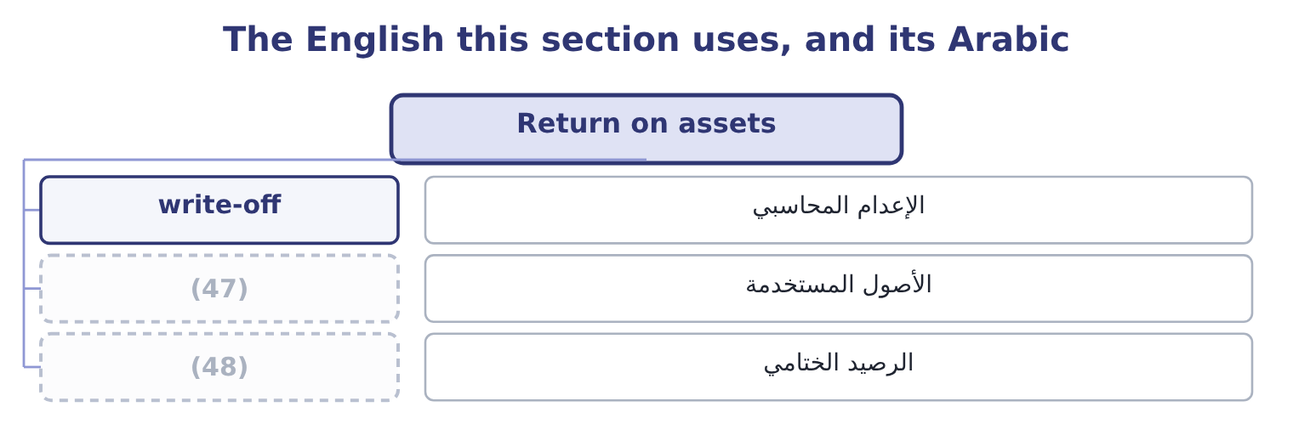
word list
assets employed · equity multiplier · closing balance

The English this sheet uses, and its Arabic
English (exam term) | Arabic
write-off | الإعدام المحاسبي
assets employed | الأصول المستخدمة
closing balance | الرصيد الختامي

Answer key · 14.1 Return on assets

1 Return on equity | 25 building
2 The five-factor decomposition | 26 receivables
3 employed | 27 arithmetic
4 Orontes's | 28 Writing
5 though | 29 depends
6 during | 30 impairs
7 Dividing | 31 goodwill
8 compares | 32 deductible
9 convention | 33 relief
10 therefore | 34 Ending
11 decimal | 35 before
12 dollar | 36 sharply
13 manufacturer | 37 quarter
14 comfortably | 38 numerator
15 Income statement | 39 proportionately
16 Balance sheet | 40 mechanism
17 Half the sum of the two | 41 magnitudes
18 examinable | 42 sheets
19 statements | 43 measure
20 asking | 44 December
21 direction | 45 treats
22 sesame | 46 operating
23 expense | 47 assets employed
24 increases | 48 closing balance

the summaries in full
Summary 1 Return on assets is profit over the assets employed to earn it. Orontes's net income for 2025 is $2,969,100. Its assets, though, were not one figure during the year: they began at $26,445,000 and ended at $31,672,600, because the company raised equity and bought plant as the year went on. Dividing a flow by a closing balance compares a whole year's earnings with the assets of the last day. The convention that answers this is the average: 31,672,600 + 26,445,000 = 58,117,600, and half of that is $29,058,800. Return on assets is therefore 2,969,100 ÷ 29,058,800 = 10.22 per cent, or 10.2 to one decimal. Ten cents of profit a year for every dollar of assets. That is the whole of what the ratio says, and it is enough to compare Orontes with another food manufacturer, with its own last year, and with the cost of the money that funds those assets — which at the 6 per cent Orontes pays Levant Commerce Bank means the assets earn comfortably more than they cost to finance, and that is the test that matters.
Summary 2 Now the examinable half of this outcome: what happens to the return when one element of the statements changes. Work it by asking which of the two parts of the fraction the change touches, and in which direction. A change that reduces profit alone lowers the return. A rise in the cost of sesame, a larger credit loss expense, a higher effective tax rate. A change that increases assets alone lowers the return. Buying plant, building inventory, letting receivables run. A change that touches both may do either, and the arithmetic decides. Writing an asset off reduces assets, which helps the ratio, and reduces profit, which hurts it; which effect wins depends on the size of the write-off against the size of each total. A change that touches neither leaves the return alone. Paying a dividend that was already declared, refinancing debt at the same amount, issuing shares and holding the cash — the last of these raises assets, so it does lower the return, and candidates who answer otherwise have forgotten that cash is an asset.
Summary 3 Suppose Orontes impairs a further $1,000,000 of goodwill at the very end of 2025, deductible at its 25 per cent effective rate: 1,000,000 × 0.25 = 250,000 of tax relief, so net income falls by 750,000 to 2,969,100 − 750,000 = 2,219,100. Ending assets fall to 31,672,600 − 1,000,000 = 30,672,600, so the average becomes half of 26,445,000 + 30,672,600 = 57,117,600, which is 28,558,800. Return on assets becomes 2,219,100 ÷ 28,558,800 = 7.77 per cent, against 10.22 per cent before. Both parts of the fraction fell and the return still fell sharply, because profit fell by a quarter while average assets fell by less than two per cent. That is the general rule for a write-off: the numerator is always the smaller number, so a charge of a given size moves it proportionately more. An exam answer that says "assets fall, so the return rises" has the mechanism right and the magnitudes wrong.
Summary 4 Where the question gives two balance sheets, use the average, and say that you have. Where it gives one, use the closing figure and say that too. The average of two year ends is itself a rough measure. A company that bought its plant in December has carried those assets for a month, and the average treats them as carried for six. Return on assets uses total assets, not net assets and not operating assets, unless the question says otherwise. Section 14.5 is about what happens when it does.

14.2 Return on equity
Chapter 14 · section 14.2

Fill every gap. Each word list holds one word more than there are gaps.
Summary 1 gaps 1–12
Return on equity is profit over the owners' money. Orontes's equity began the year at $16,375,000 and ended at $20,392,975, so the average is half of 20,392,975 + 16,375,000 = 36,767,975, which is $18,383,988. Return on equity is 2,969,100 ÷ 18,383,988 = 16.15 per cent. On the closing (1) instead it is 2,969,100 ÷ 20,392,975 = 14.56 per cent. The two (2) by more than a point and a half, and the (3) is the $1,500,000 share issue and the $1,400,000 of (4) paid-in capital that came with it: equity grew by a (5) during the year, so the (6) of which equity to divide by is not a (7) . Why is the return on equity higher than the return on assets? (8) some of the assets are funded by (9) else. Orontes's $31,672,600 of assets are funded by $11,279,625 of liabilities and $20,392,975 of equity, so the owners put up about (10) of the money and keep all of the profit that the whole of it earns, after paying the lenders their fixed (11) . That is the (12) of leverage.
word list
replacing · additional · differ · somebody · arithmetic · question · interest · two-thirds · balance · quarter · reason · quibble · Because

Orontes: the two returns, and the gap between them
Measure | 2025 | Basis | What it measures
Return on assets | 10.22% | (13) | The business
Return on equity | 16.15% | (14) | The owners' share
Return on equity, closing basis | 14.56% | Net income over closing equity | (15)
Gap, assets to equity | (16) | The effect of the liabilities | Leverage

word list
Net income over average equity · The same, measured at one date · 5.93 points · preferred dividends · Net income over average assets

Return on equity rewards debt until it does not

Summary 2 gaps 17–23
A company can raise its return on equity by (17) equity with debt, and nothing about the business (18) when it does. Return on equity for a (19) company with negative equity is a positive number and is (20) . (21) look at the two parts before (22) the ratio. Preferred (23) are deducted from net income before computing the return to common equity, and preferred stock is excluded from the equity. Orontes has no preferred stock; many exam questions do.
word list
meaningless · quibble · quoting · improves · replacing · Always · loss-making · dividends

The English this section uses, and its Arabic
Each term sits against what it means.
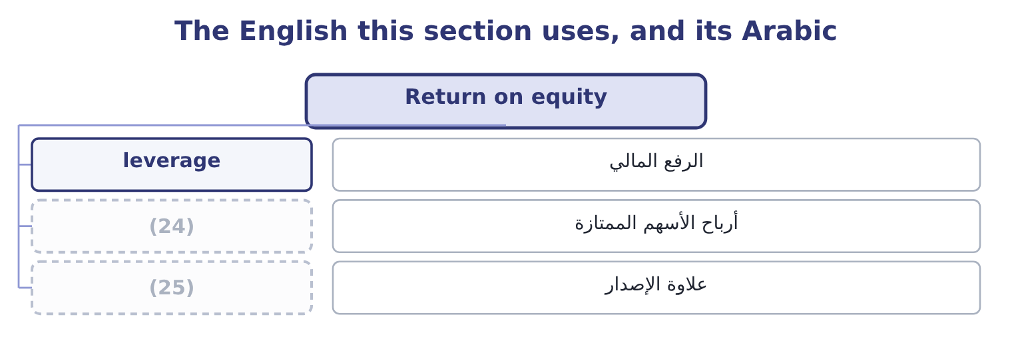
word list
burden ratio · paid-in capital · preferred dividends

The English this sheet uses, and its Arabic
English (exam term) | Arabic
leverage | الرفع المالي
preferred dividends | أرباح الأسهم الممتازة
paid-in capital | علاوة الإصدار

Answer key · 14.2 Return on equity

1 balance | 14 Net income over average equity
2 differ | 15 The same, measured at one date
3 reason | 16 5.93 points
4 additional | 17 replacing
5 quarter | 18 improves
6 question | 19 loss-making
7 quibble | 20 meaningless
8 Because | 21 Always
9 somebody | 22 quoting
10 two-thirds | 23 dividends
11 interest | 24 preferred dividends
12 arithmetic | 25 paid-in capital
13 Net income over average assets

the summaries in full
Summary 1 Return on equity is profit over the owners' money. Orontes's equity began the year at $16,375,000 and ended at $20,392,975, so the average is half of 20,392,975 + 16,375,000 = 36,767,975, which is $18,383,988. Return on equity is 2,969,100 ÷ 18,383,988 = 16.15 per cent. On the closing balance instead it is 2,969,100 ÷ 20,392,975 = 14.56 per cent. The two differ by more than a point and a half, and the reason is the $1,500,000 share issue and the $1,400,000 of additional paid-in capital that came with it: equity grew by a quarter during the year, so the question of which equity to divide by is not a quibble. Why is the return on equity higher than the return on assets? Because some of the assets are funded by somebody else. Orontes's $31,672,600 of assets are funded by $11,279,625 of liabilities and $20,392,975 of equity, so the owners put up about two-thirds of the money and keep all of the profit that the whole of it earns, after paying the lenders their fixed interest. That is the arithmetic of leverage.
Summary 2 A company can raise its return on equity by replacing equity with debt, and nothing about the business improves when it does. Return on equity for a loss-making company with negative equity is a positive number and is meaningless. Always look at the two parts before quoting the ratio. Preferred dividends are deducted from net income before computing the return to common equity, and preferred stock is excluded from the equity. Orontes has no preferred stock; many exam questions do.

14.3 The DuPont decomposition
Chapter 14 · section 14.3

Fill every gap. Each word list holds one word more than there are gaps.
Summary 1 gaps 1–6
The (1) decomposition is a piece of cancelling. Write the return on equity as three fractions multiplied together and every (2) term cancels, (3) net income over equity, which is where you (4) . What the three fractions buy is a (5) . Net income over sales is the net profit margin: how profitable each sale is. Sales over average assets is the total asset turnover: how hard the assets work. Average assets over average equity is the equity multiplier: how much of the assets the owners had to fund. For Orontes, the net margin is 7.07 per cent, the asset turnover is 42,000,000 ÷ 29,058,800 = 1.4453 times, and the equity multiplier on average balances is 29,058,800 ÷ 18,383,988 = 1.5807. Multiply them: 7.07 × 1.4453 × 1.5807 = 16.15 per cent, which is the return on equity computed (6) in section 14.2.
word list
intermediate · leaving · leverage · directly · diagnosis · DuPont · started

Summary 2 gaps 7–8
The first two factors multiply to the return on assets: 7.07 × 1.4453 = 10.22 per cent. So the (7) version is return on assets times the equity multiplier: 10.22 × 1.5807 = 16.15 per cent. The exam asks for (8) .
word list
directly · either · two-factor

Orontes: the three-factor DuPont decomposition, 2025
Factor | Computation | Value | Question it answers
Net profit margin | (9) | 7.07% | How profitable is a sale?
Total asset turnover | (10) | 1.4453 | How hard do the assets work?
Equity multiplier | (11) | 1.5807 | How much is funded by others?
Return on equity | The three multiplied | 16.15% | (12)

word list
Orontes, a manufacturer · 42,000,000 over 29,058,800 · 2,969,100 over 42,000,000 · What do the owners earn? · 29,058,800 over 18,383,988

Summary 3 gaps 13–14
The point of the (13) is that two companies with the same return on equity can be (14) different businesses, and the three factors say.
word list
completely · leaving · decomposition

The same return reached three ways
The bars are drawn to scale.
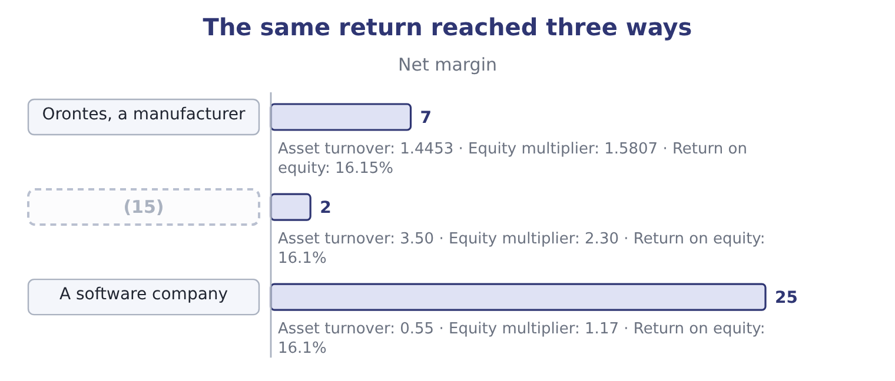
word list
non-controlling interest · A supermarket

Summary 4 gaps 16–23
Three (16) returns and no two of these companies would be run the same way. The (17) lives on turnover and would be (18) by a week of empty shelves. The (19) company lives on margin and could lose a third of it and still show a (20) return. Orontes sits (21) them. A (22) told to raise the return on equity needs to know which of the three factors is the one with room in it, and that is a question about the (23) , not about the ratio.
word list
between · decent · leverage · manager · destroyed · business · identical · supermarket · software

The multiplier is not a target

Summary 5 gaps 24–32
Raising the equity multiplier (24) raises the return on equity in the (25) . It does so by (26) debt, which adds the fixed (27) . The exam (28) a return raised this way as a different kind of return. The three factors must use (29) bases. If the multiplier uses average assets, the turnover must use average assets too, or the cancelling fails and the (30) will not equal the return. An equity multiplier computed on (31) balances is 31,672,600 over 20,392,975, which is 1.55 — the figure. It is not wrong; it is a different basis, and it (32) with a closing-basis return.
word list
belongs · closing · arithmetic · consistent · computed · treats · always · product · interest · adding

The English this section uses, and its Arabic
Each term sits against what it means.
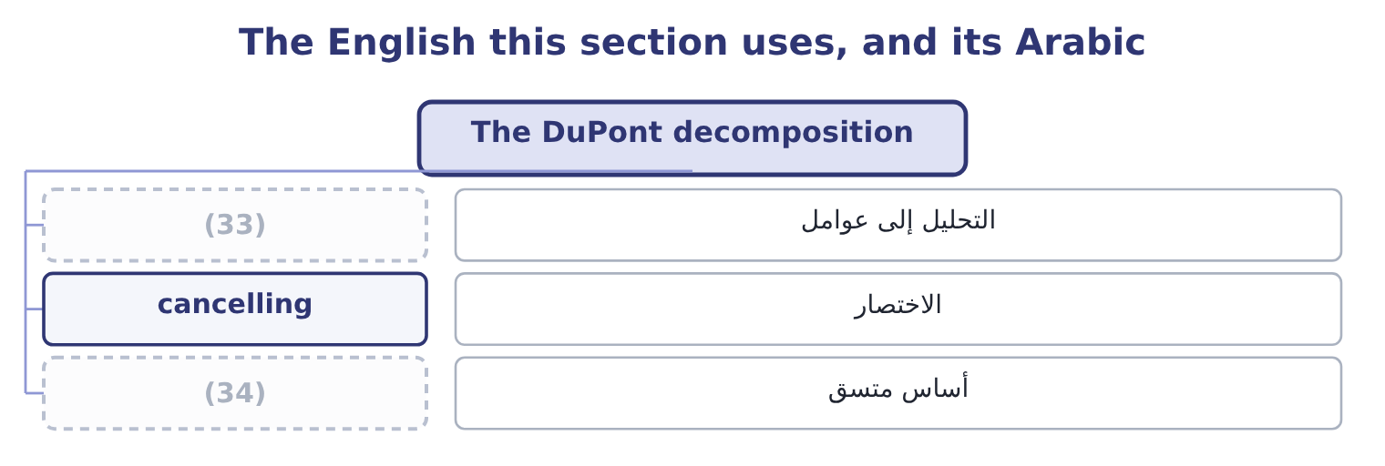
word list
cancelling · consistent basis · decomposition

The English this sheet uses, and its Arabic
English (exam term) | Arabic
decomposition | التحليل إلى عوامل
cancelling | الاختصار
consistent basis | أساس متسق

Answer key · 14.3 The DuPont decomposition

1 DuPont | 18 destroyed
2 intermediate | 19 software
3 leaving | 20 decent
4 started | 21 between
5 diagnosis | 22 manager
6 directly | 23 business
7 two-factor | 24 always
8 either | 25 arithmetic
9 2,969,100 over 42,000,000 | 26 adding
10 42,000,000 over 29,058,800 | 27 interest
11 29,058,800 over 18,383,988 | 28 treats
12 What do the owners earn? | 29 consistent
13 decomposition | 30 product
14 completely | 31 closing
15 A supermarket | 32 belongs
16 identical | 33 decomposition
17 supermarket | 34 consistent basis

the summaries in full
Summary 1 The DuPont decomposition is a piece of cancelling. Write the return on equity as three fractions multiplied together and every intermediate term cancels, leaving net income over equity, which is where you started. What the three fractions buy is a diagnosis. Net income over sales is the net profit margin: how profitable each sale is. Sales over average assets is the total asset turnover: how hard the assets work. Average assets over average equity is the equity multiplier: how much of the assets the owners had to fund. For Orontes, the net margin is 7.07 per cent, the asset turnover is 42,000,000 ÷ 29,058,800 = 1.4453 times, and the equity multiplier on average balances is 29,058,800 ÷ 18,383,988 = 1.5807. Multiply them: 7.07 × 1.4453 × 1.5807 = 16.15 per cent, which is the return on equity computed directly in section 14.2.
Summary 2 The first two factors multiply to the return on assets: 7.07 × 1.4453 = 10.22 per cent. So the two-factor version is return on assets times the equity multiplier: 10.22 × 1.5807 = 16.15 per cent. The exam asks for either.
Summary 3 The point of the decomposition is that two companies with the same return on equity can be completely different businesses, and the three factors say.
Summary 4 Three identical returns and no two of these companies would be run the same way. The supermarket lives on turnover and would be destroyed by a week of empty shelves. The software company lives on margin and could lose a third of it and still show a decent return. Orontes sits between them. A manager told to raise the return on equity needs to know which of the three factors is the one with room in it, and that is a question about the business, not about the ratio.
Summary 5 Raising the equity multiplier always raises the return on equity in the arithmetic. It does so by adding debt, which adds the fixed interest. The exam treats a return raised this way as a different kind of return. The three factors must use consistent bases. If the multiplier uses average assets, the turnover must use average assets too, or the cancelling fails and the product will not equal the return. An equity multiplier computed on closing balances is 31,672,600 over 20,392,975, which is 1.55 — the figure. It is not wrong; it is a different basis, and it belongs with a closing-basis return.

14.4 The five-factor decomposition
Chapter 14 · section 14.4

Fill every gap. Each word list holds one word more than there are gaps.
Summary 1 gaps 1–12
The three-factor version hides two (1) inside the net margin: the interest the company pays and the tax it pays. (2) them out gives the five-factor (3) , which the exam also names, and which is the version a finance director actually uses. Start at the top of the income (4) and work down. The operating margin on an (5) basis is 4,348,800 ÷ 42,000,000 = 10.35 per cent. The interest burden ratio is pre-tax income over EBIT, which measures how much of the operating (6) survives the (7) : 3,958,800 ÷ 4,348,800 = 91.03 per cent. The tax burden ratio is net income over pre-tax income, which measures how much survives the tax (8) : 2,969,100 ÷ 3,958,800 = 75.0 per cent. The (9) two factors are the turnover and the multiplier, (10) . (11) the operating side first: 10.35 × 1.4453 × 1.5807 = 23.65 per cent. That is what the (12) would earn if there were no interest and no tax. Then apply the two burdens: 23.65 × 0.9103 × 0.7500 = 16.14 per cent, the return on equity again, give or take the rounding.
word list
unchanged · Splitting · authority · decomposition · remaining · earnings-before-interest-and-taxes · owners · lenders · profit · cancelling · things · Multiply · statement

Orontes: the five-factor decomposition, 2025
Factor | Computation | Value | What a change in it means
Tax burden | Net income over pre-tax income | 75.0% | (13)
Interest burden | Pre-tax income over EBIT | 91.03% | (14)
Operating margin | (15) | 10.35% | Trading
Asset turnover | (16) | 1.4453 | Asset efficiency
Equity multiplier | Average assets over average equity | 1.5807 | Funding mix

word list
The cost of the debt · Sales over average assets · EBIT over sales · average total assets · A tax change, not a trading change

Summary 2 gaps 17–25
Read the five together and the (17) question becomes (18) in a way the three-factor version cannot show. Debt (19) twice and in opposite (20) : it raises the equity multiplier, which helps, and it lowers the interest burden ratio, which hurts. Orontes keeps 91 cents of each operating dollar after interest and (21) its asset base by 1.58, so on these figures the trade is clearly (22) . Push the debt far (23) and the interest burden falls (24) than the multiplier rises, and the return on equity turns down. That is the same (25) , reached from the other end.
word list
enters · multiplies · worthwhile · directions · leverage · break-even · enough · visible · faster · together

The English this section uses, and its Arabic
Each term sits against what it means.
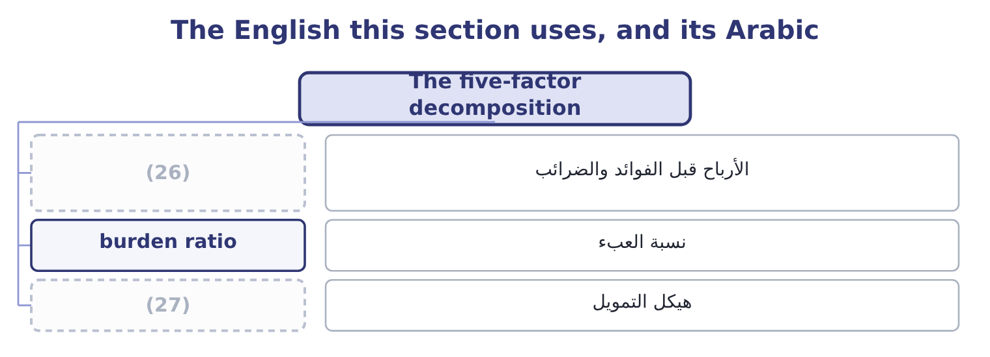
word list
assets employed · funding mix · earnings before interest and taxes

The English this sheet uses, and its Arabic
English (exam term) | Arabic
earnings before interest and taxes | الأرباح قبل الفوائد والضرائب
burden ratio | نسبة العبء
funding mix | هيكل التمويل

Answer key · 14.4 The five-factor decomposition

1 things | 15 EBIT over sales
2 Splitting | 16 Sales over average assets
3 decomposition | 17 leverage
4 statement | 18 visible
5 earnings-before-interest-and-taxes | 19 enters
6 profit | 20 directions
7 lenders | 21 multiplies
8 authority | 22 worthwhile
9 remaining | 23 enough
10 unchanged | 24 faster
11 Multiply | 25 break-even
12 owners | 26 earnings before interest and taxes
13 A tax change, not a trading change | 27 funding mix
14 The cost of the debt

the summaries in full
Summary 1 The three-factor version hides two things inside the net margin: the interest the company pays and the tax it pays. Splitting them out gives the five-factor decomposition, which the exam also names, and which is the version a finance director actually uses. Start at the top of the income statement and work down. The operating margin on an earnings-before-interest-and-taxes basis is 4,348,800 ÷ 42,000,000 = 10.35 per cent. The interest burden ratio is pre-tax income over EBIT, which measures how much of the operating profit survives the lenders: 3,958,800 ÷ 4,348,800 = 91.03 per cent. The tax burden ratio is net income over pre-tax income, which measures how much survives the tax authority: 2,969,100 ÷ 3,958,800 = 75.0 per cent. The remaining two factors are the turnover and the multiplier, unchanged. Multiply the operating side first: 10.35 × 1.4453 × 1.5807 = 23.65 per cent. That is what the owners would earn if there were no interest and no tax. Then apply the two burdens: 23.65 × 0.9103 × 0.7500 = 16.14 per cent, the return on equity again, give or take the rounding.
Summary 2 Read the five together and the leverage question becomes visible in a way the three-factor version cannot show. Debt enters twice and in opposite directions: it raises the equity multiplier, which helps, and it lowers the interest burden ratio, which hurts. Orontes keeps 91 cents of each operating dollar after interest and multiplies its asset base by 1.58, so on these figures the trade is clearly worthwhile. Push the debt far enough and the interest burden falls faster than the multiplier rises, and the return on equity turns down. That is the same break-even, reached from the other end.

14.5 Whose assets, whose equity, whose return
Chapter 14 · section 14.5

Fill every gap. Each word list holds one word more than there are gaps.
Summary 1 gaps 1–11
A (1) who computes a return on assets of 10.22 per cent and an analyst who computes 14.97 per cent for the same company in the same year may both be right. The ratio has three parts and each of them is defined by (2) rather than by a (3) . Net income is the usual numerator and it is not the only one. Net income is (4) after interest, which is a (5) to one of the two (6) that funded the assets, so (7) it by all of the assets mixes two bases. Adding back the (8) interest repairs that: 390,000 × 0.75 = 292,500, so the numerator (9) 2,969,100 + 292,500 = 3,261,600 and the return is 3,261,600 ÷ 29,058,800 = 11.22 per cent. An analyst who wants a (10) measure uses EBIT (11) : 4,348,800 ÷ 29,058,800 = 14.97 per cent.
word list
struck · groups · becomes · convention · instead · after-tax · pre-financing · dividing · standard · payment · candidate · compulsory

Summary 2 gaps 12–23
All three are (12) return on assets in print. (13) or closing is the first choice, and it moved Orontes's return on equity by a point and a half in section 14.2. Then: total assets, or only the assets used in the (14) ? Orontes holds $1,807,000 of (15) investments, $115,500 of (16) and $46,000 of assets held for sale, none of which (17) any of its operating profit. (18) them out gives a return on operating assets, which is (19) and is a better measure of the trade. Gross or net of accumulated (20) is a third choice, and it (21) : Orontes's plant cost $26,790,000 and stands at $14,802,000, so a return computed on gross plant is barely half the one computed on net. Total equity includes accumulated other (22) income, which for Orontes is a negative $1,125 and so changes nothing, but for a company with large currency or pension reserves can swing the (23) by a tenth.
word list
denominator · higher · securities · comprehensive · Average · produces · business · equity-method · matters · depreciation · reduces · Taking · called

Summary 3 gaps 24–28
Preferred stock is (24) excluded, with its (25) taken out of the numerator. Where a group has (26) it does not wholly own, the (27) interest is part of consolidated equity and no part of the parent shareholders' equity, and the two returns differ. Treasury stock reduces equity and (28) raises the return, which is a point.
word list
normally · non-controlling · subsidiaries · dividends · therefore · compulsory

One company, one year, five returns on assets
Every item belongs to exactly one group.
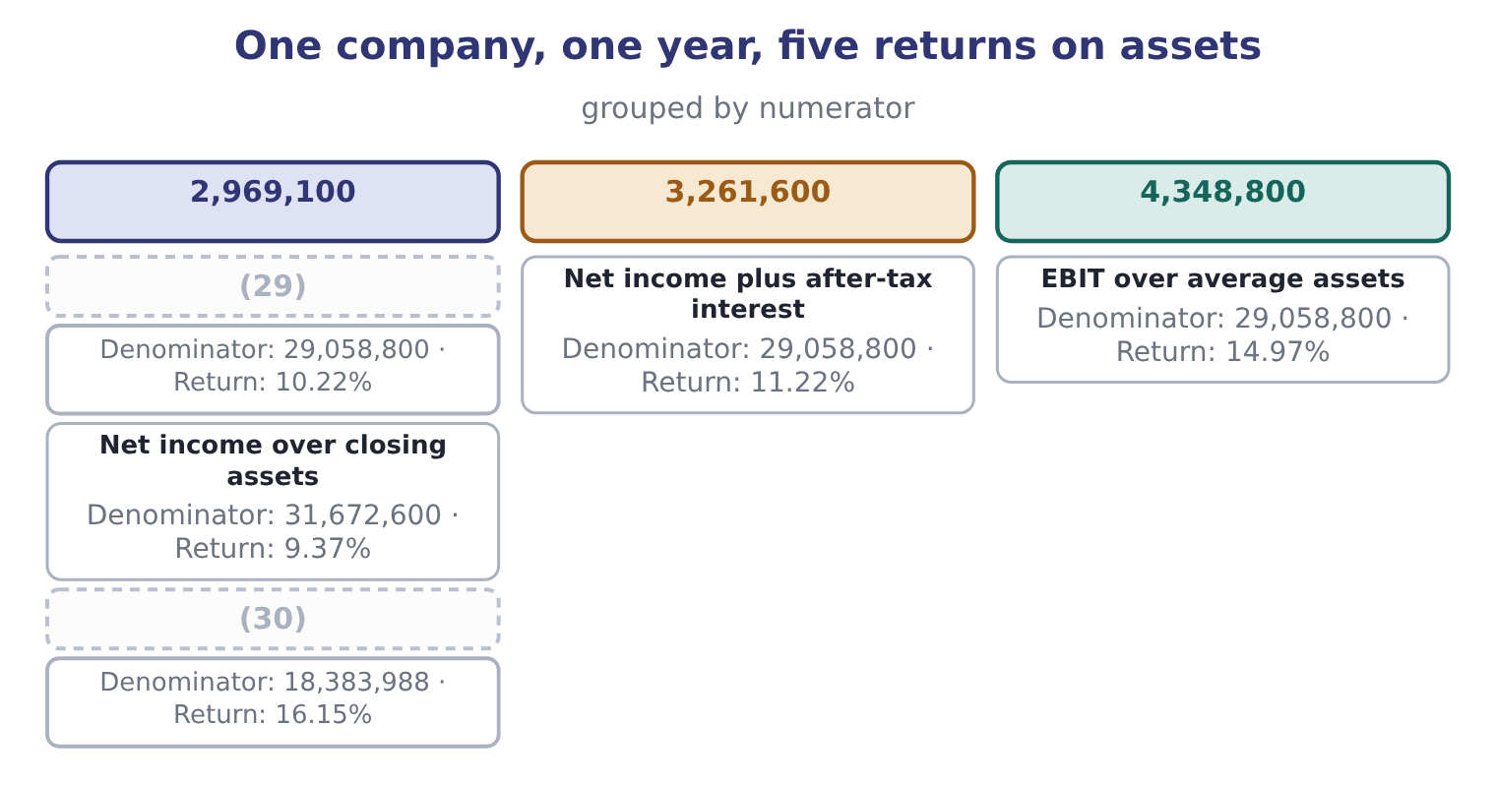
word list
Net income over average equity, for contrast · Net income plus after-tax interest · Net income over average assets

Summary 4 gaps 31–33
None of this makes the ratio (31) . It makes three rules (32) . State the definition you used. Use the same definition on both sides of every (33) . And when a published figure disagrees with yours, find the definition before you find a fault.
word list
compulsory · accumulated · comparison · useless

Decompose Barada's return

Only one balance sheet is available, so use closing balances throughout.

Your turn: Barada's returns (complete the blanks)
Item | Amount or ratio
Net sales | 21,978,000
Net income | 283,500
Total assets | 7,000,000
Total equity | 3,100,000
Net profit margin | (34) : 283,500 ÷ 21,978,000.
Total asset turnover | 3.14 times: 21,978,000 ÷ 7,000,000.
Equity multiplier | 2.2581: 7,000,000 ÷ 3,100,000.
Return on assets | (35) : 283,500 ÷ 7,000,000.
Return on equity | (36) : 283,500 ÷ 3,100,000, and the same figure from the decomposition, 1.29 × 3.14 × 2.2581 = 9.15.

word list
1.29 per cent · 4.05 per cent · tax burden ratio · 9.15 per cent

"Return"

Summary 5 gaps 37–39
English return does duty for three ideas that the exam keeps apart: a rate of profit, as in return on assets; the act of giving (37) back, as in a return of (38) ; and a filed (39) , as in a tax return.
word list
something · document · capital · nothing

The English this section uses, and its Arabic
Each term sits against what it means.
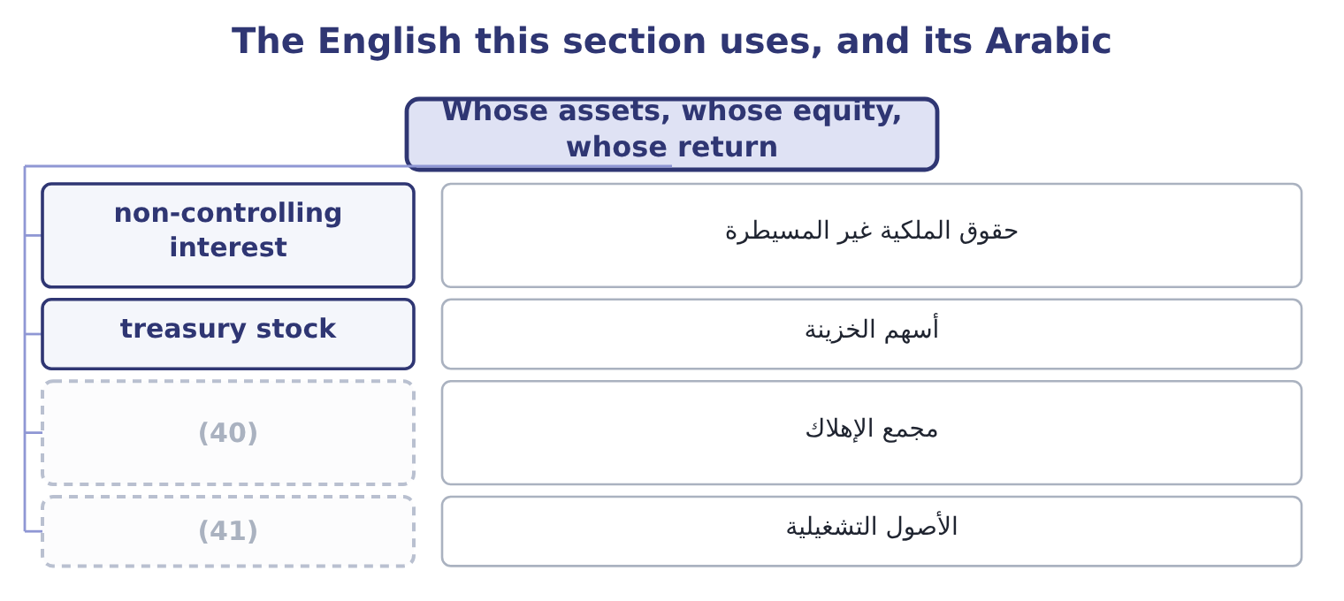
word list
assets employed · accumulated depreciation · operating assets

The English this sheet uses, and its Arabic
English (exam term) | Arabic
non-controlling interest | حقوق الملكية غير المسيطرة
treasury stock | أسهم الخزينة
accumulated depreciation | مجمع الإهلاك
operating assets | الأصول التشغيلية

Answer key · 14.5 Whose assets, whose equity, whose return

1 candidate | 22 comprehensive
2 convention | 23 denominator
3 standard | 24 normally
4 struck | 25 dividends
5 payment | 26 subsidiaries
6 groups | 27 non-controlling
7 dividing | 28 therefore
8 after-tax | 29 Net income over average assets
9 becomes | 30 Net income over average equity, for contrast
10 pre-financing | 31 useless
11 instead | 32 compulsory
12 called | 33 comparison
13 Average | 34 1.29 per cent
14 business | 35 4.05 per cent
15 equity-method | 36 9.15 per cent
16 securities | 37 something
17 produces | 38 capital
18 Taking | 39 document
19 higher | 40 accumulated depreciation
20 depreciation | 41 operating assets
21 matters

the summaries in full
Summary 1 A candidate who computes a return on assets of 10.22 per cent and an analyst who computes 14.97 per cent for the same company in the same year may both be right. The ratio has three parts and each of them is defined by convention rather than by a standard. Net income is the usual numerator and it is not the only one. Net income is struck after interest, which is a payment to one of the two groups that funded the assets, so dividing it by all of the assets mixes two bases. Adding back the after-tax interest repairs that: 390,000 × 0.75 = 292,500, so the numerator becomes 2,969,100 + 292,500 = 3,261,600 and the return is 3,261,600 ÷ 29,058,800 = 11.22 per cent. An analyst who wants a pre-financing measure uses EBIT instead: 4,348,800 ÷ 29,058,800 = 14.97 per cent.
Summary 2 All three are called return on assets in print. Average or closing is the first choice, and it moved Orontes's return on equity by a point and a half in section 14.2. Then: total assets, or only the assets used in the business? Orontes holds $1,807,000 of equity-method investments, $115,500 of securities and $46,000 of assets held for sale, none of which produces any of its operating profit. Taking them out gives a return on operating assets, which is higher and is a better measure of the trade. Gross or net of accumulated depreciation is a third choice, and it matters: Orontes's plant cost $26,790,000 and stands at $14,802,000, so a return computed on gross plant is barely half the one computed on net. Total equity includes accumulated other comprehensive income, which for Orontes is a negative $1,125 and so changes nothing, but for a company with large currency or pension reserves can swing the denominator by a tenth.
Summary 3 Preferred stock is normally excluded, with its dividends taken out of the numerator. Where a group has subsidiaries it does not wholly own, the non-controlling interest is part of consolidated equity and no part of the parent shareholders' equity, and the two returns differ. Treasury stock reduces equity and therefore raises the return, which is a point.
Summary 4 None of this makes the ratio useless. It makes three rules compulsory. State the definition you used. Use the same definition on both sides of every comparison. And when a published figure disagrees with yours, find the definition before you find a fault.
Summary 5 English return does duty for three ideas that the exam keeps apart: a rate of profit, as in return on assets; the act of giving something back, as in a return of capital; and a filed document, as in a tax return.

