15.1 Sustainable growth: what the business can fund itself
Chapter 15 · section 15.1

Fill every gap. Each word list holds one word more than there are gaps.
Chapter 15, section by section
Each stage leads to the next.
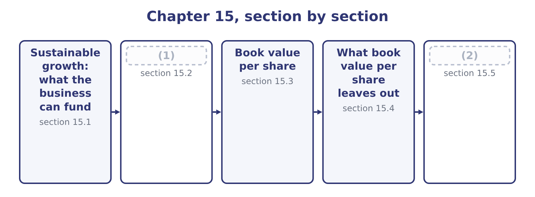
word list
What book value per share leaves out · Market value, and the profit the accountants d · Growing faster than that, and growing slower

Summary 1 gaps 3–14
A company (3) a fifth more next year needs a fifth more (4) and a fifth more (5) , and sooner or later a fifth more plant. There are only four (6) the money can come: profit the company keeps, new debt, new equity, or a (7) in the way the business works. The sustainable growth rate asks how fast the company can grow on the first of those alone, holding its (8) policies constant — the same (9) ratio, the same payout, the same margins, the same asset turnover. The (10) is short. Sustainable growth (11) the return on equity (12) by the proportion of profit retained. The retention ratio is one minus the payout. Orontes declared dividends of 50,000 + 400,000 = 450,000 in 2025 — the $50,000 paid in cash (13) the year and the $400,000 still payable at (14) 31 — so the payout ratio is 450,000 ÷ 2,969,100 = 15.16 per cent and the retention ratio is 100.0 − 15.16 = 84.84 per cent.
word list
during · financial · December · debt-to-equity · answer · change · selling · receivables · cleanest · multiplied · places · equals · inventory

Summary 2 gaps 15–21
At the (15) return on equity of 16.15 per cent, sustainable growth is 16.15 × 0.8484 = 13.70 per cent. You can see the same thing (16) in the statement of retained earnings, which is where the retained profit (17) lands: 4,375,000 + 2,969,100 − 450,000 = 6,894,100, the retained earnings figure on the 2025 (18) sheet. Equity grew by that retention, and if (19) about the business or its (20) mix changed, the business could support about 13.7 per cent more of (21) .
word list
funding · beginning-equity · nothing · average-equity · balance · happening · everything · physically

Orontes Foods, Inc. — sustainable growth, 2025
Element | Figure | Source
Net income | 2,969,100 | (22)
Dividends declared | 450,000 | (23)
Payout ratio | 15.16% | Dividends over net income
Retention ratio | 84.84% | One less the payout
Return on equity | 16.15% | (24)
Sustainable growth rate | 13.70% | Return on equity times retention

word list
Income statement · par value · Chapter 14, average basis · Paid 50,000, payable 400,000

Which return on equity goes into the growth rate

Summary 3 gaps 25–32
The formula is (25) to the equity basis, and the exam is (26) when it matters. On closing equity (27) return is 14.56 per cent, giving 14.56 × 0.8484 = 12.35 per cent. On (28) equity it is 2,969,100 ÷ 16,375,000 = 18.13 per cent, giving 18.13 × 0.8484 = 15.38 per cent. The beginning-equity version has the (29) logic — this year's profit on the equity the company (30) with — and the widest spread of (31) . Dividends declared, not dividends paid, (32) in the payout ratio. Orontes paid only $50,000 in cash and declared nine times.
word list
explicit · cleanest · started · sensitive · Orontes's · declared · answers · belong · beginning

The English this section uses, and its Arabic
Each term sits against what it means.
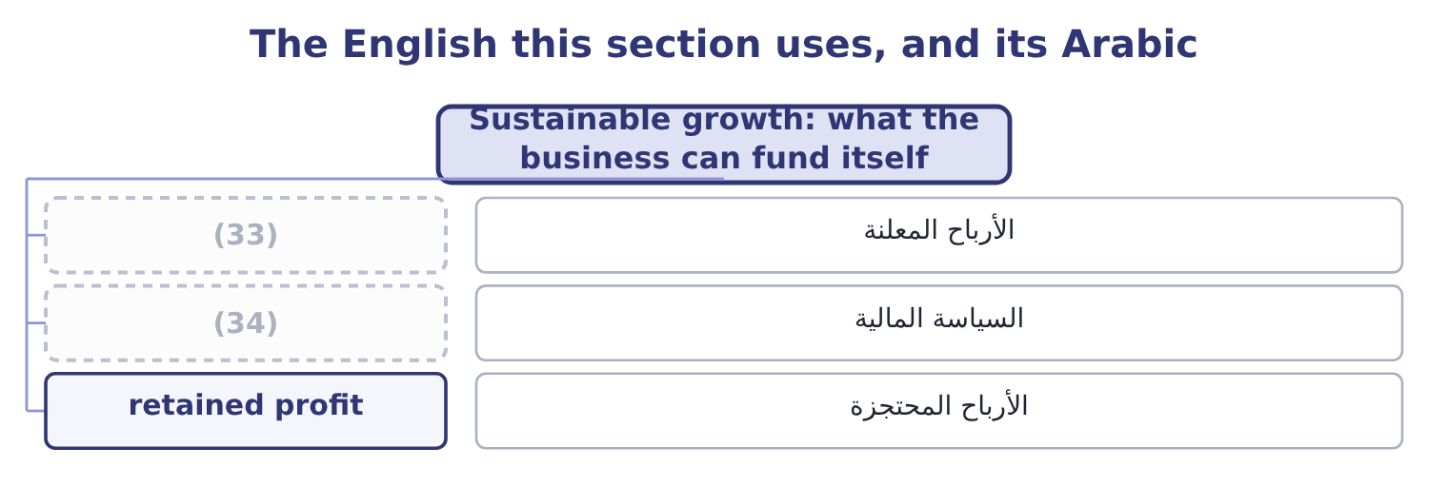
word list
financial policy · dividends declared · value creation

The English this sheet uses, and its Arabic
English (exam term) | Arabic
dividends declared | الأرباح المعلنة
financial policy | السياسة المالية
retained profit | الأرباح المحتجزة

Answer key · 15.1 Sustainable growth: what the business can fund itself

1 Growing faster than that, and growing slower | 18 balance
2 Market value, and the profit the accountants d | 19 nothing
3 selling | 20 funding
4 inventory | 21 everything
5 receivables | 22 Income statement
6 places | 23 Paid 50,000, payable 400,000
7 change | 24 Chapter 14, average basis
8 financial | 25 sensitive
9 debt-to-equity | 26 explicit
10 answer | 27 Orontes's
11 equals | 28 beginning
12 multiplied | 29 cleanest
13 during | 30 started
14 December | 31 answers
15 average-equity | 32 belong
16 happening | 33 dividends declared
17 physically | 34 financial policy

the summaries in full
Summary 1 A company selling a fifth more next year needs a fifth more inventory and a fifth more receivables, and sooner or later a fifth more plant. There are only four places the money can come: profit the company keeps, new debt, new equity, or a change in the way the business works. The sustainable growth rate asks how fast the company can grow on the first of those alone, holding its financial policies constant — the same debt-to-equity ratio, the same payout, the same margins, the same asset turnover. The answer is short. Sustainable growth equals the return on equity multiplied by the proportion of profit retained. The retention ratio is one minus the payout. Orontes declared dividends of 50,000 + 400,000 = 450,000 in 2025 — the $50,000 paid in cash during the year and the $400,000 still payable at December 31 — so the payout ratio is 450,000 ÷ 2,969,100 = 15.16 per cent and the retention ratio is 100.0 − 15.16 = 84.84 per cent.
Summary 2 At the average-equity return on equity of 16.15 per cent, sustainable growth is 16.15 × 0.8484 = 13.70 per cent. You can see the same thing happening in the statement of retained earnings, which is where the retained profit physically lands: 4,375,000 + 2,969,100 − 450,000 = 6,894,100, the retained earnings figure on the 2025 balance sheet. Equity grew by that retention, and if nothing about the business or its funding mix changed, the business could support about 13.7 per cent more of everything.
Summary 3 The formula is sensitive to the equity basis, and the exam is explicit when it matters. On closing equity Orontes's return is 14.56 per cent, giving 14.56 × 0.8484 = 12.35 per cent. On beginning equity it is 2,969,100 ÷ 16,375,000 = 18.13 per cent, giving 18.13 × 0.8484 = 15.38 per cent. The beginning-equity version has the cleanest logic — this year's profit on the equity the company started with — and the widest spread of answers. Dividends declared, not dividends paid, belong in the payout ratio. Orontes paid only $50,000 in cash and declared nine times.

15.2 Growing faster than that, and growing slower
Chapter 15 · section 15.2

Fill every gap. Each word list holds one word more than there are gaps.
Summary 1 gaps 1–12
Orontes's sales grew 42,000,000 − 36,400,000 = 5,600,000 in 2025, which is 5,600,000 ÷ 36,400,000 = 15.38 per cent, against a sustainable rate of 13.70 per cent. The company grew faster than its own profit could fund, and the (1) show exactly where the (2) came: a $1,500,000 share issue, $1,400,000 of (3) paid-in capital, and an $800,000 bank note. But the growth was (4) from outside, and that cannot be repeated (5) without either more (6) or more debt. A company growing faster than its sustainable rate has four (7) , and the exam (8) you to name them rather than simply observe the gap. Raise the sustainable rate through the (9) . A better margin or a faster asset (10) raises the return on equity and (11) the growth the company can fund. This is the only route that costs (12) .
word list
expects · business · repeated · additional · statements · indefinitely · turnover · part-funded · difference · nothing · issues · therefore · choices

Summary 2 gaps 13–24
Raise it through (13) . Cut the (14) , which raises retention (15) . Orontes (16) 84.84 per cent already, so there is (17) room; a company paying out half its profit has a great deal. Issue equity, as Orontes did, or (18) , which raises the equity (19) and with it the return on equity — and the risk. (20) , and it is what (21) anyway to a company that will not do the other three: the overdraft arrives first and the decision is taken for it. That last case is Barada's, and you have seen it twice already. Barada's sales grew 11 per cent while it retained (22) it earned on a return on equity of 9.15 per cent. Eleven against nine, year after year, is the whole (23) of the inventory up 41 per cent, the (24) up 38 per cent, and the overdraft of $240,000 where there was none.
word list
happens · directly · receivables · little · explanation · multiplier · Unfashionable · everything · borrow · retains · payout · policy · business

Growth against sustainable growth
The bars are drawn to scale.
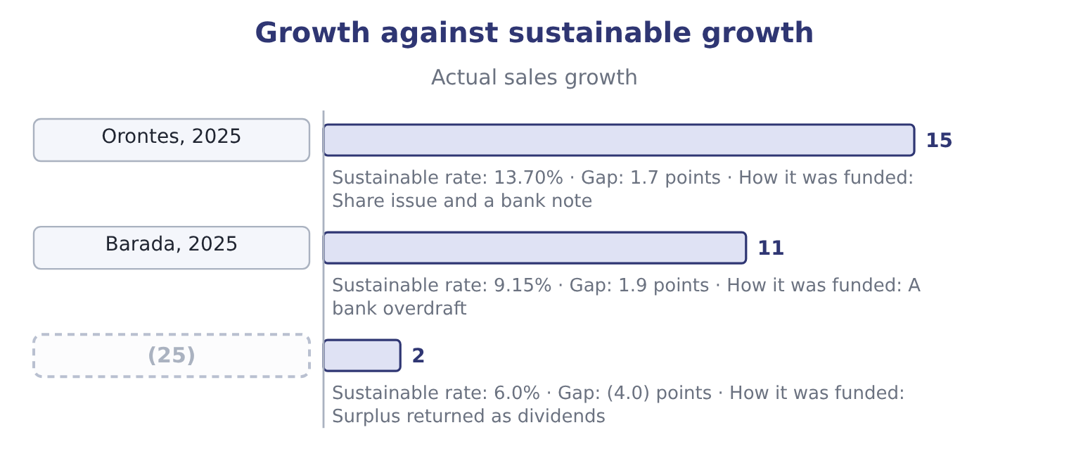
word list
sustainable growth rate · A mature utility

Summary 3 gaps 26–37
The third row is the (26) problem and it is (27) too. A company growing more slowly than it can fund (28) cash it has no use for, which lowers its return on assets — the point section 14.1 made about issuing shares and holding the (29) . The remedy is a larger dividend, a (30) , or an acquisition, and Book 3 takes that decision (31) . Return on equity on the beginning equity of $16,375,000 is 2,969,100 ÷ 16,375,000 = 18.13 per cent, and the retention ratio is 84.84 per cent. On the (32) basis Orontes grew at its sustainable rate, and on the (33) basis it grew faster than it. The two bases disagree (34) because the share issue (35) in the middle of the year — the average basis counts half of the new money as if it had been there all along, and the beginning basis counts none of it. This is not a trick of (36) ; it is the (37) the exam names the basis.
word list
accumulates · business · beginning-equity · proceeds · average-equity · precisely · opposite · landed · examinable · reason · properly · buyback · arithmetic

Summary 4 gaps 38–42
For a company that has not issued or (38) shares, the three answers are close (39) and the choice does not (40) . For Orontes in 2025 the spread is 12.35 to 15.38 per cent, and an answer that quotes one figure without naming its basis cannot be (41) by the marker or by (42) else.
word list
repurchased · together · anybody · matter · problem · checked

The English this section uses, and its Arabic
Each term sits against what it means.
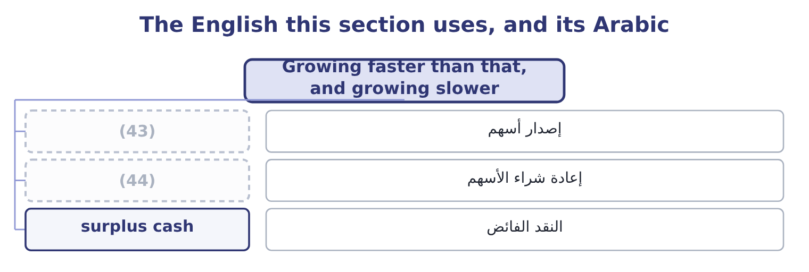
word list
buyback · share issue · required return

The English this sheet uses, and its Arabic
English (exam term) | Arabic
share issue | إصدار أسهم
buyback | إعادة شراء الأسهم
surplus cash | النقد الفائض

Answer key · 15.2 Growing faster than that, and growing slower

1 statements | 23 explanation
2 difference | 24 receivables
3 additional | 25 A mature utility
4 part-funded | 26 opposite
5 indefinitely | 27 examinable
6 issues | 28 accumulates
7 choices | 29 proceeds
8 expects | 30 buyback
9 business | 31 properly
10 turnover | 32 beginning-equity
11 therefore | 33 average-equity
12 nothing | 34 precisely
13 policy | 35 landed
14 payout | 36 arithmetic
15 directly | 37 reason
16 retains | 38 repurchased
17 little | 39 together
18 borrow | 40 matter
19 multiplier | 41 checked
20 Unfashionable | 42 anybody
21 happens | 43 share issue
22 everything | 44 buyback

the summaries in full
Summary 1 Orontes's sales grew 42,000,000 − 36,400,000 = 5,600,000 in 2025, which is 5,600,000 ÷ 36,400,000 = 15.38 per cent, against a sustainable rate of 13.70 per cent. The company grew faster than its own profit could fund, and the statements show exactly where the difference came: a $1,500,000 share issue, $1,400,000 of additional paid-in capital, and an $800,000 bank note. But the growth was part-funded from outside, and that cannot be repeated indefinitely without either more issues or more debt. A company growing faster than its sustainable rate has four choices, and the exam expects you to name them rather than simply observe the gap. Raise the sustainable rate through the business. A better margin or a faster asset turnover raises the return on equity and therefore the growth the company can fund. This is the only route that costs nothing.
Summary 2 Raise it through policy. Cut the payout, which raises retention directly. Orontes retains 84.84 per cent already, so there is little room; a company paying out half its profit has a great deal. Issue equity, as Orontes did, or borrow, which raises the equity multiplier and with it the return on equity — and the risk. Unfashionable, and it is what happens anyway to a company that will not do the other three: the overdraft arrives first and the decision is taken for it. That last case is Barada's, and you have seen it twice already. Barada's sales grew 11 per cent while it retained everything it earned on a return on equity of 9.15 per cent. Eleven against nine, year after year, is the whole explanation of the inventory up 41 per cent, the receivables up 38 per cent, and the overdraft of $240,000 where there was none.
Summary 3 The third row is the opposite problem and it is examinable too. A company growing more slowly than it can fund accumulates cash it has no use for, which lowers its return on assets — the point section 14.1 made about issuing shares and holding the proceeds. The remedy is a larger dividend, a buyback, or an acquisition, and Book 3 takes that decision properly. Return on equity on the beginning equity of $16,375,000 is 2,969,100 ÷ 16,375,000 = 18.13 per cent, and the retention ratio is 84.84 per cent. On the beginning-equity basis Orontes grew at its sustainable rate, and on the average-equity basis it grew faster than it. The two bases disagree precisely because the share issue landed in the middle of the year — the average basis counts half of the new money as if it had been there all along, and the beginning basis counts none of it. This is not a trick of arithmetic; it is the reason the exam names the basis.
Summary 4 For a company that has not issued or repurchased shares, the three answers are close together and the choice does not matter. For Orontes in 2025 the spread is 12.35 to 15.38 per cent, and an answer that quotes one figure without naming its basis cannot be checked by the marker or by anybody else.

15.3 Book value per share
Chapter 15 · section 15.3

Fill every gap. Each word list holds one word more than there are gaps.
Summary 1 gaps 1–12
Book value per share is total stockholders' equity (1) by the shares outstanding at the same date. It is what the accountants say the (2) own, per share, after every (3) . (4) equity at December 31, 2025 is $20,392,975 and 8,100,000 shares are issued and outstanding, so book value per share is 20,392,975 ÷ 8,100,000 = 2.5177. A year (5) it was 16,375,000 ÷ 8,000,000 = 2.0469. Three points of (6) before the (7) . Use shares outstanding at the balance sheet date, not the weighted average. The weighted average (8) to earnings per share, which is a flow over a period; book value is a balance at a date, and so is the share count that goes with it. Treasury shares are not outstanding. They reduce equity and they reduce the share count, and because they are normally (9) above book value they usually raise book value per share — a point that trips (10) who expect a (11) to lower it. Where preferred stock (12) , deduct it. Book value per common share is equity less the preferred claim, over the common shares.
word list
exists · candidates · shareholders · buyback · belongs · interpretation · Averaging · Orontes's · divided · earlier · repurchased · mechanics · liability

Orontes: book value per share
Element | 2025 | 2024
Total stockholders' equity | 20,392,975 | 16,375,000
(13) | 8,100,000 | 8,000,000
Book value per share | 2.5177 | 2.0469

word list
cost of equity capital · Shares issued and outstanding

Summary 2 gaps 14–19
Book value per share rose by about 23 per cent in a year, from (14) profit and from the share issue, which was (15) well above book. For a bank or an (16) , which hold mostly (17) assets carried at or near fair value, that figure would be close to a real (18) of worth. For a food (19) it is not, and the next section says why.
word list
priced · measure · closing · financial · insurer · retained · manufacturer

Which share count, which equity

Summary 3 gaps 20–25
Shares issued is not (20) shares outstanding: the (21) is treasury stock. Orontes has none, so for Orontes the two are the same and the exam may still ask. Book value per share uses the (22) equity. (23) it is an error — there is no period for a balance to be averaged over. Earnings per share and book value per share use (24) share counts on (25) .
word list
always · purpose · difference · closing · manufacturer · different · Averaging

The English this section uses, and its Arabic
Each term sits against what it means.
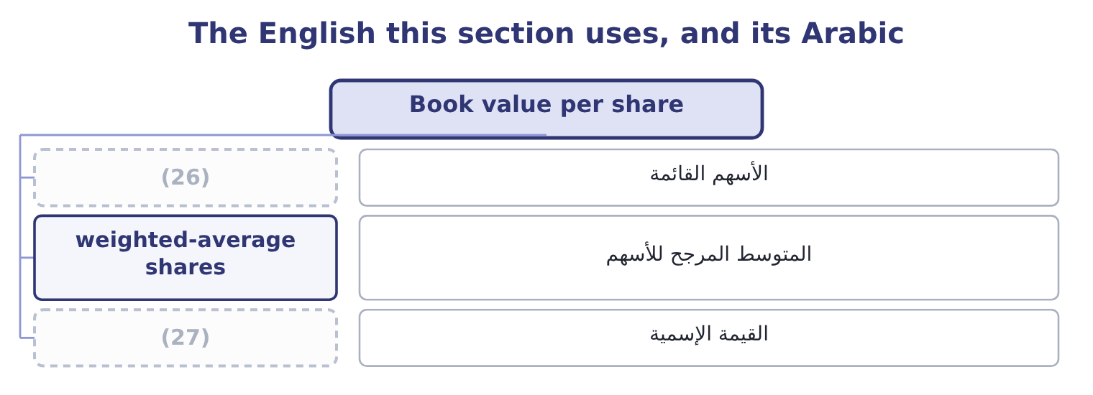
word list
par value · القيمة الإسمية · shares outstanding

The English this sheet uses, and its Arabic
English (exam term) | Arabic
shares outstanding | الأسهم القائمة
weighted-average shares | المتوسط المرجح للأسهم
par value | القيمة الإسمية

Answer key · 15.3 Book value per share

1 divided | 15 priced
2 shareholders | 16 insurer
3 liability | 17 financial
4 Orontes's | 18 measure
5 earlier | 19 manufacturer
6 mechanics | 20 always
7 interpretation | 21 difference
8 belongs | 22 closing
9 repurchased | 23 Averaging
10 candidates | 24 different
11 buyback | 25 purpose
12 exists | 26 shares outstanding
13 Shares issued and outstanding | 27 par value
14 retained

the summaries in full
Summary 1 Book value per share is total stockholders' equity divided by the shares outstanding at the same date. It is what the accountants say the shareholders own, per share, after every liability. Orontes's equity at December 31, 2025 is $20,392,975 and 8,100,000 shares are issued and outstanding, so book value per share is 20,392,975 ÷ 8,100,000 = 2.5177. A year earlier it was 16,375,000 ÷ 8,000,000 = 2.0469. Three points of mechanics before the interpretation. Use shares outstanding at the balance sheet date, not the weighted average. The weighted average belongs to earnings per share, which is a flow over a period; book value is a balance at a date, and so is the share count that goes with it. Treasury shares are not outstanding. They reduce equity and they reduce the share count, and because they are normally repurchased above book value they usually raise book value per share — a point that trips candidates who expect a buyback to lower it. Where preferred stock exists, deduct it. Book value per common share is equity less the preferred claim, over the common shares.
Summary 2 Book value per share rose by about 23 per cent in a year, from retained profit and from the share issue, which was priced well above book. For a bank or an insurer, which hold mostly financial assets carried at or near fair value, that figure would be close to a real measure of worth. For a food manufacturer it is not, and the next section says why.
Summary 3 Shares issued is not always shares outstanding: the difference is treasury stock. Orontes has none, so for Orontes the two are the same and the exam may still ask. Book value per share uses the closing equity. Averaging it is an error — there is no period for a balance to be averaged over. Earnings per share and book value per share use different share counts on purpose.

15.4 What book value per share leaves out
Chapter 15 · section 15.4

Fill every gap. Each word list holds one word more than there are gaps.
Summary 1 gaps 1–12
Orontes's (1) change hands at $9.25. Its book value per share is $2.5177. The market says a share is worth (2) four times what the balance sheet says, and the (3) is not that one of them is wrong. It is that they measure (4) things, and the gap is the sum of (5) the balance sheet is not designed to carry. (6) is carried at what it cost less (7) depreciation. Orontes's plant cost $26,790,000 and stands at $14,802,000; land (8) thirty years ago stands at its 1990s price. Under IFRS a company may (9) ; under US GAAP it may not. Intangibles the company built. Orontes's brand is on the balance sheet at $260,000 (10) it was acquired. The recipes, the customer (11) , the trained (12) and the reputation that make the brand worth anything were built internally, and internally generated intangibles are not recognised at all.
word list
revalue · everything · bought · Property · workforce · different · reason · acquired · because · nearly · shares · relationships · accumulated

Summary 2 gaps 13–22
A (13) company's whole value sits in this gap, which is why its market-to-book ratio runs in double (14) . Goodwill, which is only ever (15) . Acquired goodwill is recognised and then tested for (16) . It can fall and can never rise. Orontes's goodwill went from $950,000 to $300,000 in 2025 (17) exactly that (18) . What the future holds. The market price (19) expected future cash flows. The balance sheet records past (20) . A company whose (21) are expected to double trades far above book; a company expected to shrink trades below it, and a market-to-book ratio under 1.0 is the market saying the assets are worth less in this company's hands than their (22) amount.
word list
mechanism · depreciation · figures · profits · discounts · software · impairment · downhill · through · carrying · transactions

Why book value per share understates a going concern
What is missing | Why | Orontes's evidence
Current values | (23) | Plant at 14,802,000 against a cost of 26,790,000
Internally built intangibles | Not recognised under GAAP | (24)
Rising goodwill | Only tested downwards | (25)
Expected future profit | (26) | A share price of 9.25 against a book value of 2.5177

word list
Goodwill fell from 950,000 to 300,000 · The balance sheet is a record, not a forecast · Brand at 260,000; recipes and reputation at nil · Plant at 14,802,000 against a cost of 26,790,000 · Assets at cost less depreciation

The English this section uses, and its Arabic
Each term sits against what it means.
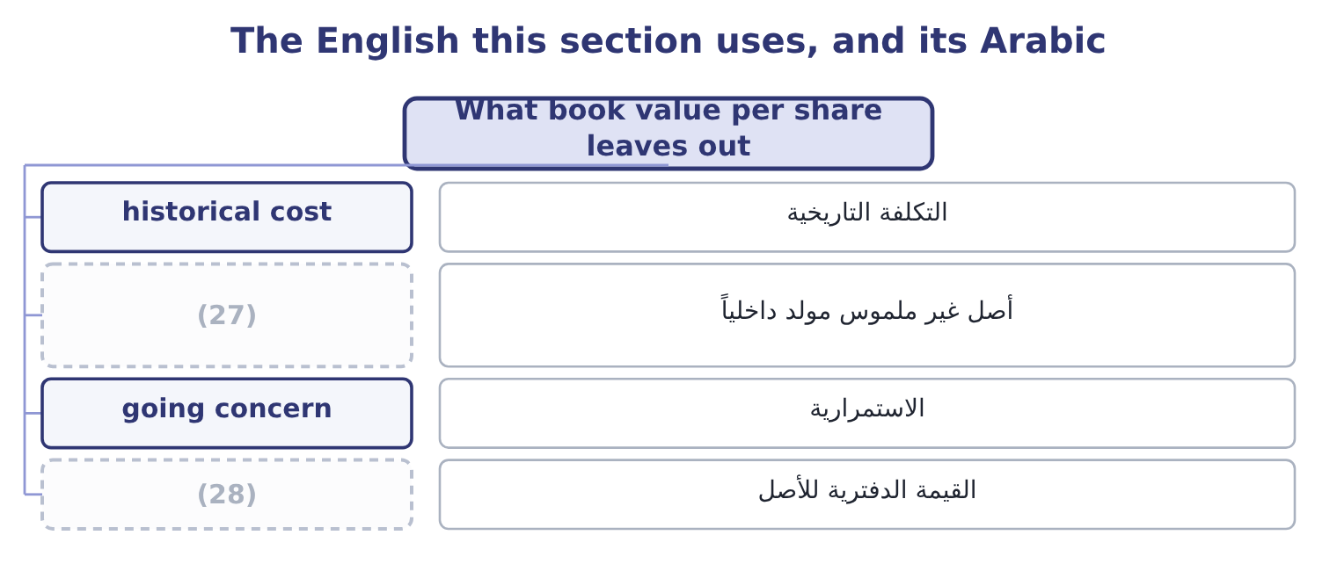
word list
market value · carrying amount · internally generated intangible

The English this sheet uses, and its Arabic
English (exam term) | Arabic
historical cost | التكلفة التاريخية
internally generated intangible | أصل غير ملموس مولد داخلياً
going concern | الاستمرارية
carrying amount | القيمة الدفترية للأصل

Answer key · 15.4 What book value per share leaves out

1 shares | 15 downhill
2 nearly | 16 impairment
3 reason | 17 through
4 different | 18 mechanism
5 everything | 19 discounts
6 Property | 20 transactions
7 accumulated | 21 profits
8 bought | 22 carrying
9 revalue | 23 Assets at cost less depreciation
10 because | 24 Brand at 260,000; recipes and reputation at nil
11 relationships | 25 Goodwill fell from 950,000 to 300,000
12 workforce | 26 The balance sheet is a record, not a forecast
13 software | 27 internally generated intangible
14 figures | 28 carrying amount

the summaries in full
Summary 1 Orontes's shares change hands at $9.25. Its book value per share is $2.5177. The market says a share is worth nearly four times what the balance sheet says, and the reason is not that one of them is wrong. It is that they measure different things, and the gap is the sum of everything the balance sheet is not designed to carry. Property is carried at what it cost less accumulated depreciation. Orontes's plant cost $26,790,000 and stands at $14,802,000; land bought thirty years ago stands at its 1990s price. Under IFRS a company may revalue; under US GAAP it may not. Intangibles the company built. Orontes's brand is on the balance sheet at $260,000 because it was acquired. The recipes, the customer relationships, the trained workforce and the reputation that make the brand worth anything were built internally, and internally generated intangibles are not recognised at all.
Summary 2 A software company's whole value sits in this gap, which is why its market-to-book ratio runs in double figures. Goodwill, which is only ever downhill. Acquired goodwill is recognised and then tested for impairment. It can fall and can never rise. Orontes's goodwill went from $950,000 to $300,000 in 2025 through exactly that mechanism. What the future holds. The market price discounts expected future cash flows. The balance sheet records past transactions. A company whose profits are expected to double trades far above book; a company expected to shrink trades below it, and a market-to-book ratio under 1.0 is the market saying the assets are worth less in this company's hands than their carrying amount.

15.5 Market value, and the profit the accountants do not charge for
Chapter 15 · section 15.5

Fill every gap. Each word list holds one word more than there are gaps.
Summary 1 gaps 1–12
Market value per share is the price. Market (1) is the price times the shares: 8,100,000 × 9.25 = 74,925,000. Against a book equity of $20,392,975, the market adds 74,925,000 − 20,392,975 = 54,532,025 of value that no statement (2) . The ratio of the two is the market-to-book ratio: 9.25 ÷ 2.5177 = 3.67 for 2025, and 7.80 ÷ 2.0469 = 3.81 for 2024. The (3) fell slightly while the price rose, because book value rose faster. Now the second (4) this outcome requires, and the one (5) find least (6) . Accounting profit is revenue less the costs the standards require to be (7) . Economic profit is revenue less all costs, (8) the cost of the equity capital (9) — which the standards never charge, because equity has no (10) cost and so no (11) is recorded. That (12) is large.
word list
capitalisation · employed · familiar · including · distinction · expense · contractual · recognised · candidates · omission · records · multiple · revenue

Summary 2 gaps 13–15
Orontes's (13) are charged for in the income statement, at $390,000 of interest. Its (14) , who put up $18,383,988 on average, are charged nothing at all, although they could have invested the money (15) .
word list
lenders · shareholders · elsewhere · manufacturer

Worked example: Orontes's economic profit

Summary 3 gaps 16–27
Net income for 2025 is $2,969,100, (16) after interest and after tax, and it is the profit every ratio in Book 1 has used. The charge the (17) omit. (18) a shareholder in a food (19) of this risk requires 10 per cent. On average equity the charge is 18,383,988 × 0.10 = 1,838,399. Orontes earned about 1.1 (20) dollars more than the (21) its owners require. The sign is what (22) . A positive economic profit means the company is creating value and the market-to-book ratio above 1.0 is (23) ; a negative one means the company earns an accounting profit while (24) value, which is (25) the case a market-to-book ratio below 1.0 describes. Note also the (26) test: a return on equity of 16.15 per cent against a required 10 per cent is the same statement as a positive economic profit, (27) as a rate instead of an amount.
word list
Economic · justified · consistency · destroying · million · Suppose · precisely · expressed · struck · minimum · manufacturer · matters · statements

Barada's growth and its book value

Compute the missing items.

Your turn: Barada's growth and book value (complete the blanks)
Item | Amount or ratio
Net income | 283,500
Total equity | 3,100,000
(28) | 1,000,000
(29) | nil
Sales, 2025 | 21,978,000
Sales, 2024 | 19,800,000
Return on equity, closing basis | ________
Retention ratio | ________
Sustainable growth rate | ________
Actual sales growth | ________
Book value per share | ________
(30) | ________

word list
Shares outstanding · Actual sales growth · Dividends declared · Market-to-book, at the investor's implied price of 6.00

"Value"

Summary 4 gaps 31–34
English value carries no built-in basis: book value, market value, fair value, net (31) value and present value are five (32) numbers for one asset, and the word alone tells the reader nothing. The (33) habit is to name the basis every time. A marker cannot (34) an answer written that way.
word list
misread · different · realisable · professional · Orontes

"Value"
Item | Answer
Return on equity, closing basis | (35) : 283,500 ÷ 3,100,000.
Retention ratio | (36)
Sustainable growth rate | 9.15 per cent: 9.15 × 1.00 = 9.15.
Actual sales growth | 11.0 per cent: 21,978,000 − 19,800,000 = 2,178,000, and 2,178,000 ÷ 19,800,000 = 11.0 per cent.
Book value per share | 3.10: 3,100,000 ÷ 1,000,000.
Market-to-book | (37) : 6.00 ÷ 3.10, where the price comes from 6,000,000 ÷ 1,000,000 = 6.00.
What it tells you | Barada grows about two points a year faster than it can fund, retains everything, and pays no dividend, so the gap can only go on the overdr

word list
3.10 · 9.15 per cent · 1.9355 · 100 per cent, because no dividend was declared.

The English this section uses, and its Arabic
Each term sits against what it means.
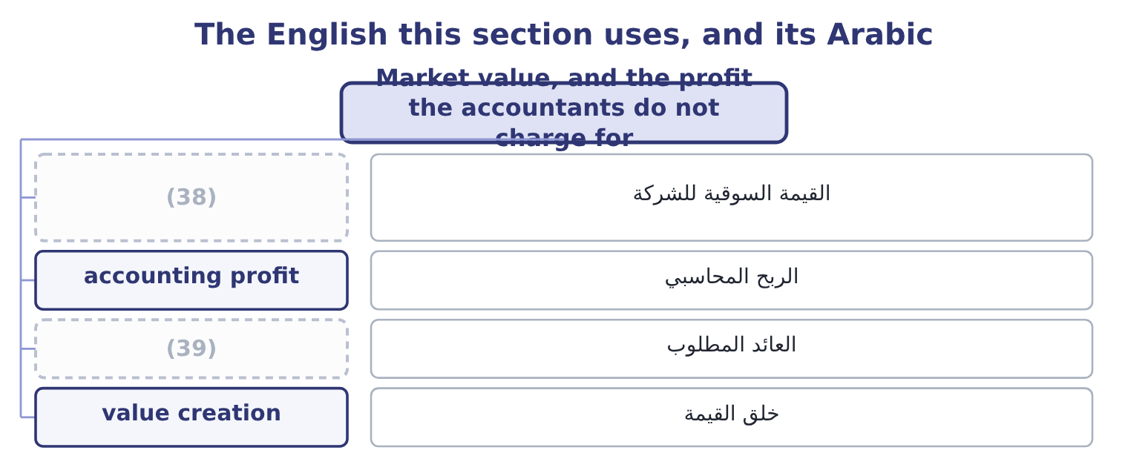
word list
carrying amount · required return · market capitalisation

The English this sheet uses, and its Arabic
English (exam term) | Arabic
market capitalisation | القيمة السوقية للشركة
accounting profit | الربح المحاسبي
required return | العائد المطلوب
value creation | خلق القيمة

Answer key · 15.5 Market value, and the profit the accountants do not charge for

1 capitalisation | 21 minimum
2 records | 22 matters
3 multiple | 23 justified
4 distinction | 24 destroying
5 candidates | 25 precisely
6 familiar | 26 consistency
7 recognised | 27 expressed
8 including | 28 Shares outstanding
9 employed | 29 Dividends declared
10 contractual | 30 Market-to-book, at the investor's implied price of 6.00
11 expense | 31 realisable
12 omission | 32 different
13 lenders | 33 professional
14 shareholders | 34 misread
15 elsewhere | 35 9.15 per cent
16 struck | 36 100 per cent, because no dividend was declared.
17 statements | 37 1.9355
18 Suppose | 38 market capitalisation
19 manufacturer | 39 required return
20 million

the summaries in full
Summary 1 Market value per share is the price. Market capitalisation is the price times the shares: 8,100,000 × 9.25 = 74,925,000. Against a book equity of $20,392,975, the market adds 74,925,000 − 20,392,975 = 54,532,025 of value that no statement records. The ratio of the two is the market-to-book ratio: 9.25 ÷ 2.5177 = 3.67 for 2025, and 7.80 ÷ 2.0469 = 3.81 for 2024. The multiple fell slightly while the price rose, because book value rose faster. Now the second distinction this outcome requires, and the one candidates find least familiar. Accounting profit is revenue less the costs the standards require to be recognised. Economic profit is revenue less all costs, including the cost of the equity capital employed — which the standards never charge, because equity has no contractual cost and so no expense is recorded. That omission is large.
Summary 2 Orontes's lenders are charged for in the income statement, at $390,000 of interest. Its shareholders, who put up $18,383,988 on average, are charged nothing at all, although they could have invested the money elsewhere.
Summary 3 Net income for 2025 is $2,969,100, struck after interest and after tax, and it is the profit every ratio in Book 1 has used. The charge the statements omit. Suppose a shareholder in a food manufacturer of this risk requires 10 per cent. On average equity the charge is 18,383,988 × 0.10 = 1,838,399. Orontes earned about 1.1 million dollars more than the minimum its owners require. The sign is what matters. A positive economic profit means the company is creating value and the market-to-book ratio above 1.0 is justified; a negative one means the company earns an accounting profit while destroying value, which is precisely the case a market-to-book ratio below 1.0 describes. Note also the consistency test: a return on equity of 16.15 per cent against a required 10 per cent is the same statement as a positive economic profit, expressed as a rate instead of an amount.
Summary 4 English value carries no built-in basis: book value, market value, fair value, net realisable value and present value are five different numbers for one asset, and the word alone tells the reader nothing. The professional habit is to name the basis every time. A marker cannot misread an answer written that way.

