16.1 Earnings per share
Chapter 16 · section 16.1

Fill every gap. Each word list holds one word more than there are gaps.
Chapter 16, section by section
Each stage leads to the next.
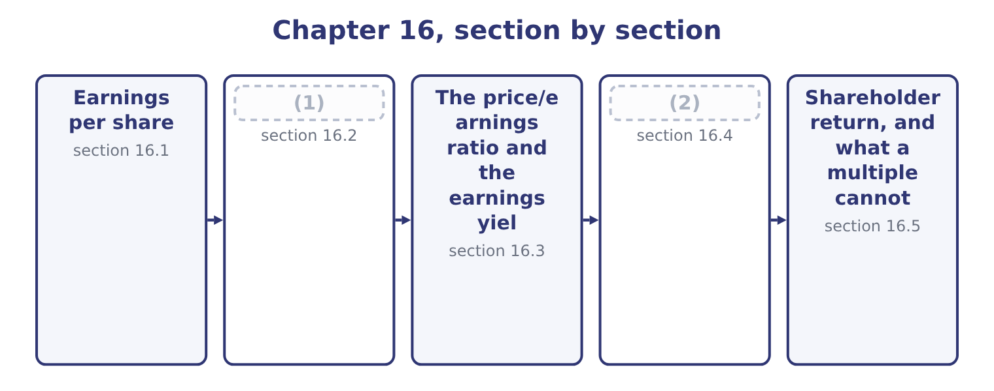
word list
Diluted earnings per share · Dividend yield and payout · basic earnings per share

Summary 1 gaps 3–13
Basic earnings per share is the profit attributable to common shareholders (3) by the weighted-average (4) of common shares outstanding (5) the period. Two words in that (6) do the work. Attributable means after any preferred (7) , because a preferred dividend is not the common shareholders' profit; Orontes has no preferred stock, so its whole net income of $2,969,100 is attributable. Weighted-average means each share counts for the (8) of the year it was outstanding, because a share issued in (9) did not help earn the (10) profit. Orontes began 2025 with 8,000,000 shares and ended with 8,100,000, the 100,000 new shares (11) been issued on January 2. Each was outstanding for 364 of the 365 days: 100,000 × 364 ÷ 365 = 99,726, and the weighted (12) is 8,000,000 + 99,726 = 8,099,726 — the figure on the face of the income statement. So basic earnings per share is 2,969,100 ÷ 8,099,726 = 0.3666, which the (13) present as $0.37.
word list
divided · presented · fraction · December · statements · dividends · average · sentence · during · number · year's · having

Orontes Foods, Inc. — basic earnings per share, 2025
Element | Figure | Note
Net income | 2,969,100 | (14)
Shares at January 1 | 8,000,000 | Outstanding all year
Shares issued January 2 | 100,000 | (15)
Weighted-average shares | 8,099,726 | (16)
Basic earnings per share | 0.3666 | Presented as 0.37

word list
8,000,000 plus 99,726 · potential common share · Outstanding 364 days · No preferred stock, so all of it is attributable

The share count is where the marks are

Summary 2 gaps 17–23
A share split or a stock dividend is applied (17) to every period presented, because no cash came in and nothing was earned (18) . A share issue for cash is weighted from its date. (19) shares are excluded from the moment they are (20) , weighted in the same way. Earnings per share is the one ratio the (21) define and (22) on the face of the income statement. Every other ratio in Book 1 is an analyst's (23) .
word list
average · require · differently · repurchased · retrospectively · standards · construction · Treasury

The English this section uses, and its Arabic
Each term sits against what it means.
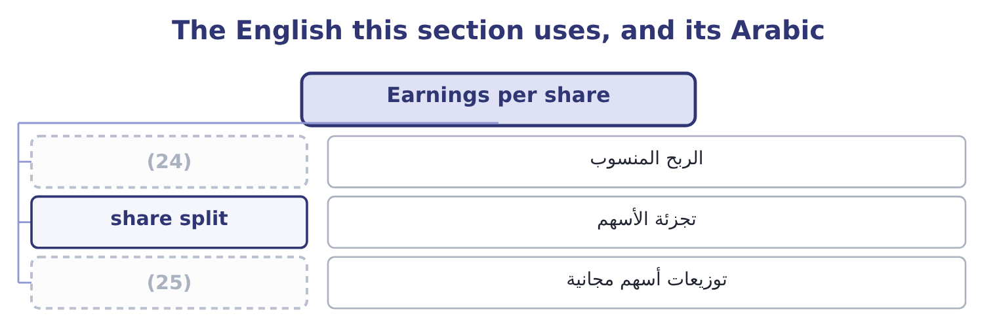
word list
mature company · attributable profit · stock dividend

The English this sheet uses, and its Arabic
English (exam term) | Arabic
attributable profit | الربح المنسوب
share split | تجزئة الأسهم
stock dividend | توزيعات أسهم مجانية

Answer key · 16.1 Earnings per share

1 Diluted earnings per share | 14 No preferred stock, so all of it is attributable
2 Dividend yield and payout | 15 Outstanding 364 days
3 divided | 16 8,000,000 plus 99,726
4 number | 17 retrospectively
5 during | 18 differently
6 sentence | 19 Treasury
7 dividends | 20 repurchased
8 fraction | 21 standards
9 December | 22 require
10 year's | 23 construction
11 having | 24 attributable profit
12 average | 25 stock dividend
13 statements

the summaries in full
Summary 1 Basic earnings per share is the profit attributable to common shareholders divided by the weighted-average number of common shares outstanding during the period. Two words in that sentence do the work. Attributable means after any preferred dividends, because a preferred dividend is not the common shareholders' profit; Orontes has no preferred stock, so its whole net income of $2,969,100 is attributable. Weighted-average means each share counts for the fraction of the year it was outstanding, because a share issued in December did not help earn the year's profit. Orontes began 2025 with 8,000,000 shares and ended with 8,100,000, the 100,000 new shares having been issued on January 2. Each was outstanding for 364 of the 365 days: 100,000 × 364 ÷ 365 = 99,726, and the weighted average is 8,000,000 + 99,726 = 8,099,726 — the figure on the face of the income statement. So basic earnings per share is 2,969,100 ÷ 8,099,726 = 0.3666, which the statements present as $0.37.
Summary 2 A share split or a stock dividend is applied retrospectively to every period presented, because no cash came in and nothing was earned differently. A share issue for cash is weighted from its date. Treasury shares are excluded from the moment they are repurchased, weighted in the same way. Earnings per share is the one ratio the standards define and require on the face of the income statement. Every other ratio in Book 1 is an analyst's construction.

16.2 Diluted earnings per share
Chapter 16 · section 16.2

Fill every gap. Each word list holds one word more than there are gaps.
Summary 1 gaps 1–11
Diluted earnings per share asks what the figure would have been if everything that could become a common share had become one. Convertible bonds, convertible preferred stock, options and warrants are all potential common shares, and a company that has issued them has (1) away part of each (2) dollar of profit. Orontes reports the same figure for basic and diluted, which tells you it has no potential common shares outstanding. Most (3) companies do, so the exam tests the (4) on figures the question (5) . Two (6) cover almost everything. The treasury stock method, for options and warrants. Assume they are (7) at their exercise price and that the company uses the proceeds to buy its own shares back at the average market price. The net new shares are the (8) . The if-converted method, for convertible debt and convertible preferred. Assume (9) at the start of the period. Add the shares that would be issued, and add back to the numerator the interest after tax, or the preferred (10) , that would no (11) be paid.
word list
exercised · listed · conversion · methods · difference · future · mechanics · longer · antidilutive · dividend · supplies · promised

Worked example: two kinds of dilution

Summary 2 gaps 12–16
Options, by the treasury stock method. Suppose Orontes had 500,000 options outstanding at an exercise price of $5.00, with an average market price of $9.25. The proceeds would be 500,000 × 5.00 = 2,500,000, which buys back 2,500,000 ÷ 9.25 = 270,270 shares, so the net new shares are 500,000 − 270,270 = 229,730. Diluted shares are 8,099,726 + 229,730 = 8,329,456, and diluted earnings per share is 2,969,100 ÷ 8,329,456 = 0.3565. A convertible bond, by the if-converted method. Suppose (12) Orontes had $2,000,000 of 5 per cent convertible bonds (13) for 400,000 shares. The interest saved is 2,000,000 × 0.05 = 100,000, and after tax at the (14) 25 per cent (15) rate that is 100,000 × 0.75 = 75,000. The numerator (16) 2,969,100 + 75,000 = 3,044,100 and the share count 8,099,726 + 400,000 = 8,499,726, so diluted earnings per share is 3,044,100 ÷ 8,499,726 = 0.3581.
word list
instead · effective · security · exchangeable · becomes · company's

Summary 3 gaps 17–27
Test each for (17) . A security is only included if it (18) earnings per share. The bond adds 75,000 of (19) for 400,000 shares, which is 75,000 ÷ 400,000 = 0.1875 a share, below the basic figure of 0.3666, so it (20) and must be included. Had the bond (21) a high enough (22) that its per-share effect exceeded 0.3666, (23) it would raise earnings per share, and an antidilutive security is (24) . Both figures are below the basic 0.3666, which is the whole point: diluted earnings per share can never be (25) than basic. Where a question gives several (26) , rank them by their per-share effect, include them (27) first, and stop at the one that stops reducing the figure.
word list
higher · including · reduces · cheapest · income · coupon · carried · company's · instruments · excluded · dilutes · dilution

The two dilution methods
Every item belongs to exactly one group.
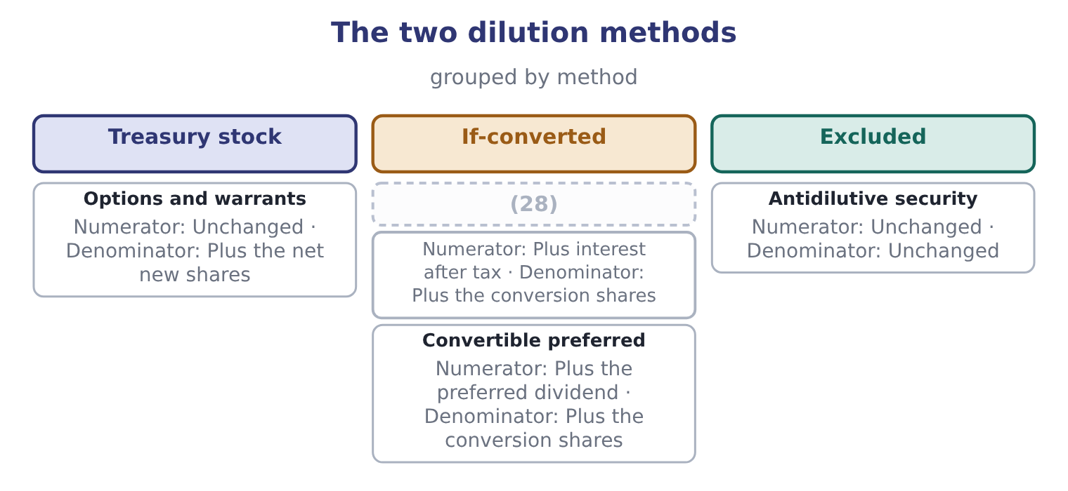
word list
capital gain · Convertible debt

Dilution has a direction

Summary 4 gaps 29–34
Diluted earnings per share is (29) less than or equal to basic. A (30) diluted figure above the basic one means an antidilutive security has been included by (31) . A loss changes the (32) of the test: when the company reports a loss, potential shares reduce the loss per share and are (33) antidilutive, so diluted equals basic. The treasury stock method uses the average market price for the period, not the (34) price.
word list
closing · always · Suppose · computed · therefore · mistake · direction

The English this section uses, and its Arabic
Each term sits against what it means.
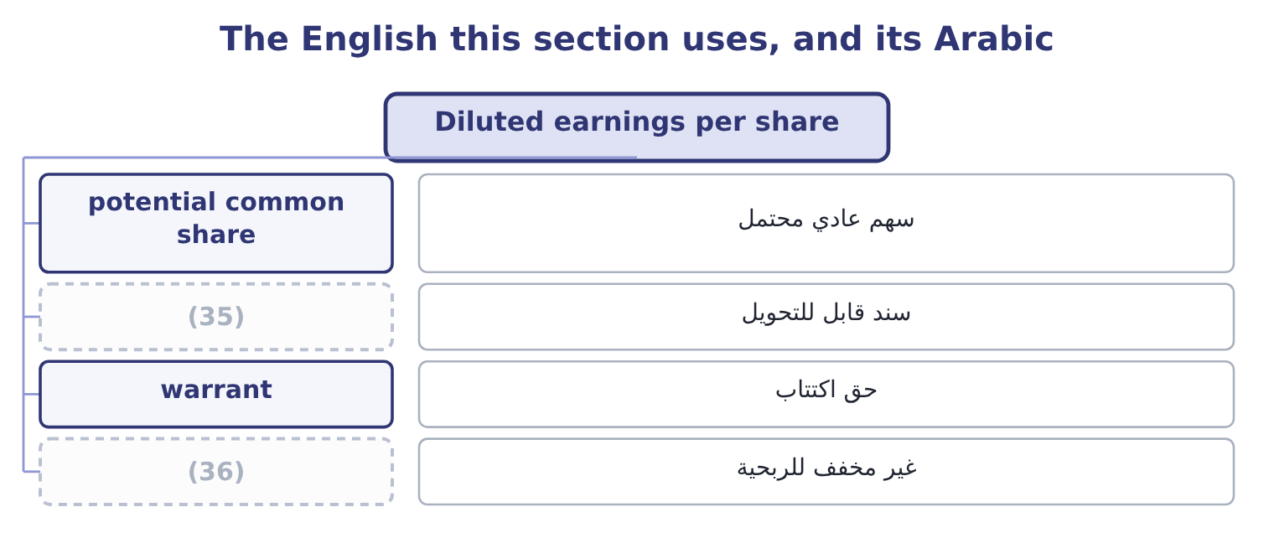
word list
mature company · convertible bond · antidilutive

The English this sheet uses, and its Arabic
English (exam term) | Arabic
potential common share | سهم عادي محتمل
convertible bond | سند قابل للتحويل
warrant | حق اكتتاب
antidilutive | غير مخفف للربحية

Answer key · 16.2 Diluted earnings per share

1 promised | 19 income
2 future | 20 dilutes
3 listed | 21 carried
4 mechanics | 22 coupon
5 supplies | 23 including
6 methods | 24 excluded
7 exercised | 25 higher
8 difference | 26 instruments
9 conversion | 27 cheapest
10 dividend | 28 Convertible debt
11 longer | 29 always
12 instead | 30 computed
13 exchangeable | 31 mistake
14 company's | 32 direction
15 effective | 33 therefore
16 becomes | 34 closing
17 dilution | 35 convertible bond
18 reduces | 36 antidilutive

the summaries in full
Summary 1 Diluted earnings per share asks what the figure would have been if everything that could become a common share had become one. Convertible bonds, convertible preferred stock, options and warrants are all potential common shares, and a company that has issued them has promised away part of each future dollar of profit. Orontes reports the same figure for basic and diluted, which tells you it has no potential common shares outstanding. Most listed companies do, so the exam tests the mechanics on figures the question supplies. Two methods cover almost everything. The treasury stock method, for options and warrants. Assume they are exercised at their exercise price and that the company uses the proceeds to buy its own shares back at the average market price. The net new shares are the difference. The if-converted method, for convertible debt and convertible preferred. Assume conversion at the start of the period. Add the shares that would be issued, and add back to the numerator the interest after tax, or the preferred dividend, that would no longer be paid.
Summary 2 Options, by the treasury stock method. Suppose Orontes had 500,000 options outstanding at an exercise price of $5.00, with an average market price of $9.25. The proceeds would be 500,000 × 5.00 = 2,500,000, which buys back 2,500,000 ÷ 9.25 = 270,270 shares, so the net new shares are 500,000 − 270,270 = 229,730. Diluted shares are 8,099,726 + 229,730 = 8,329,456, and diluted earnings per share is 2,969,100 ÷ 8,329,456 = 0.3565. A convertible bond, by the if-converted method. Suppose instead Orontes had $2,000,000 of 5 per cent convertible bonds exchangeable for 400,000 shares. The interest saved is 2,000,000 × 0.05 = 100,000, and after tax at the company's 25 per cent effective rate that is 100,000 × 0.75 = 75,000. The numerator becomes 2,969,100 + 75,000 = 3,044,100 and the share count 8,099,726 + 400,000 = 8,499,726, so diluted earnings per share is 3,044,100 ÷ 8,499,726 = 0.3581.
Summary 3 Test each for dilution. A security is only included if it reduces earnings per share. The bond adds 75,000 of income for 400,000 shares, which is 75,000 ÷ 400,000 = 0.1875 a share, below the basic figure of 0.3666, so it dilutes and must be included. Had the bond carried a high enough coupon that its per-share effect exceeded 0.3666, including it would raise earnings per share, and an antidilutive security is excluded. Both figures are below the basic 0.3666, which is the whole point: diluted earnings per share can never be higher than basic. Where a question gives several instruments, rank them by their per-share effect, include them cheapest first, and stop at the one that stops reducing the figure.
Summary 4 Diluted earnings per share is always less than or equal to basic. A computed diluted figure above the basic one means an antidilutive security has been included by mistake. A loss changes the direction of the test: when the company reports a loss, potential shares reduce the loss per share and are therefore antidilutive, so diluted equals basic. The treasury stock method uses the average market price for the period, not the closing price.

16.3 The price/earnings ratio and the earnings yield
Chapter 16 · section 16.3

Fill every gap. Each word list holds one word more than there are gaps.
Summary 1 gaps 1–12
The price/earnings ratio is the market price of a share (1) by its earnings per share. For Orontes: 9.25 ÷ 0.3666 = 25.23. Read it two ways, and the exam uses both. (2) , the market is paying 25.23 (3) for each dollar of last (4) earnings, or about twenty-five years of earnings at this level. (5) , a high multiple is the market (6) it expects earnings to grow, or that it regards them as (7) , or both; a low multiple is the market (8) decline, or (9) a discount for risk. The earnings yield is the same (10) inverted: earnings per share over price, 0.3666 ÷ 9.25 = 3.96 per cent. It is the more useful form when (11) a share with a bond, because a bond is quoted as a yield and a 3.96 per cent earnings yield can be set (12) against the 6 per cent Orontes pays its own bank.
word list
twenty-five · directly · Arithmetically · low-risk · relationship · expecting · comparing · dollars · saying · demanding · Economically · divided · year's

Orontes: the market ratios, 2025 and 2024
The bars are drawn to scale.
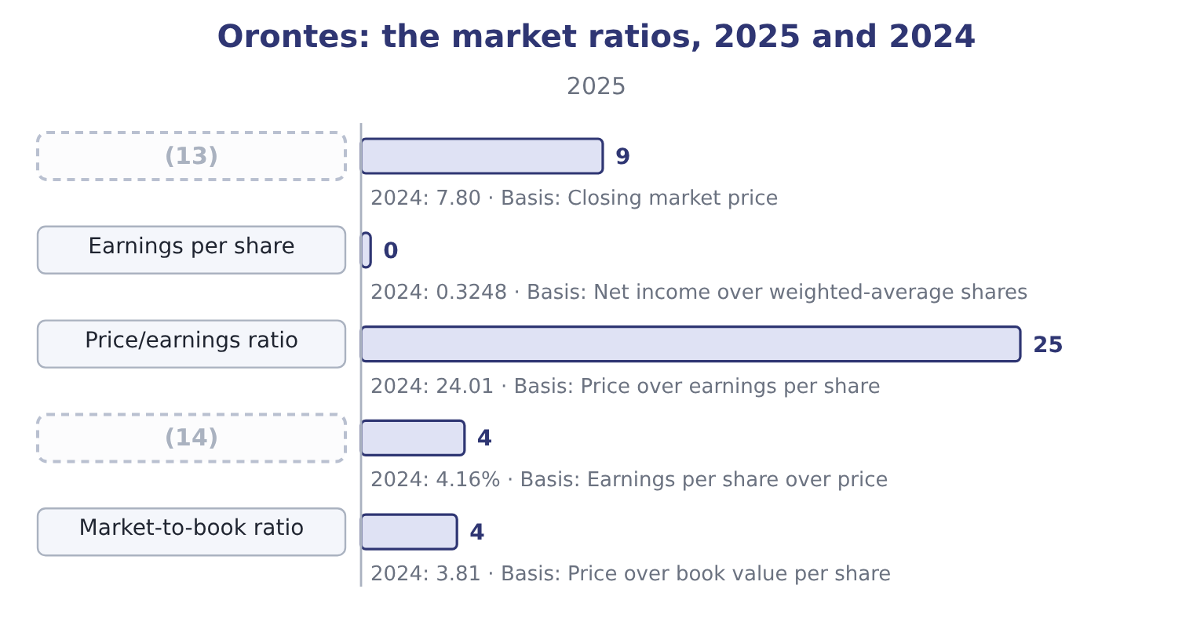
word list
Share price · shareholder return · Earnings yield

Summary 2 gaps 15–21
A multiple of twenty-five on a food (15) growing sales at 15 per cent a year is a price that (16) the growth (17) . (18) : the growth has been (19) with two points of gross margin, and the market multiple has risen while the margin fell. That is not a (20) ; it is the single most useful sentence an analyst can write about Orontes, and it comes from putting a market ratio next to an (21) one.
word list
manufacturer · negative · accounting · bought · assumes · Nothing · continues · prediction

Which earnings in the price/earnings ratio

Summary 3 gaps 22–27
A (22) multiple uses the last reported year. A forward multiple uses a forecast. They are not (23) , and a question that gives you a forecast expects the forward figure. Diluted earnings per share is the (24) denominator for a company with (25) common shares, because it is the more prudent figure. A (26) company has no meaningful price/earnings ratio. The ratio is left blank rather than reported as a (27) number.
word list
trailing · conventional · potential · growing · loss-making · comparable · negative

The English this section uses, and its Arabic
Each term sits against what it means.
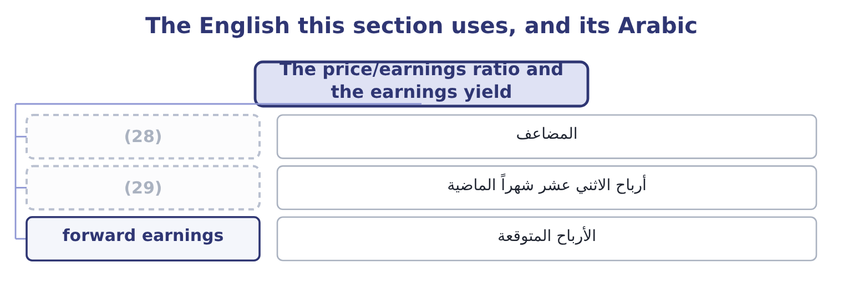
word list
multiple · earnings yield · trailing earnings

The English this sheet uses, and its Arabic
English (exam term) | Arabic
multiple | المضاعف
trailing earnings | أرباح الاثني عشر شهراً الماضية
forward earnings | الأرباح المتوقعة

Answer key · 16.3 The price/earnings ratio and the earnings yield

1 divided | 16 assumes
2 Arithmetically | 17 continues
3 dollars | 18 Nothing
4 year's | 19 bought
5 Economically | 20 prediction
6 saying | 21 accounting
7 low-risk | 22 trailing
8 expecting | 23 comparable
9 demanding | 24 conventional
10 relationship | 25 potential
11 comparing | 26 loss-making
12 directly | 27 negative
13 Share price | 28 multiple
14 Earnings yield | 29 trailing earnings
15 manufacturer

the summaries in full
Summary 1 The price/earnings ratio is the market price of a share divided by its earnings per share. For Orontes: 9.25 ÷ 0.3666 = 25.23. Read it two ways, and the exam uses both. Arithmetically, the market is paying 25.23 dollars for each dollar of last year's earnings, or about twenty-five years of earnings at this level. Economically, a high multiple is the market saying it expects earnings to grow, or that it regards them as low-risk, or both; a low multiple is the market expecting decline, or demanding a discount for risk. The earnings yield is the same relationship inverted: earnings per share over price, 0.3666 ÷ 9.25 = 3.96 per cent. It is the more useful form when comparing a share with a bond, because a bond is quoted as a yield and a 3.96 per cent earnings yield can be set directly against the 6 per cent Orontes pays its own bank.
Summary 2 A multiple of twenty-five on a food manufacturer growing sales at 15 per cent a year is a price that assumes the growth continues. Nothing: the growth has been bought with two points of gross margin, and the market multiple has risen while the margin fell. That is not a prediction; it is the single most useful sentence an analyst can write about Orontes, and it comes from putting a market ratio next to an accounting one.
Summary 3 A trailing multiple uses the last reported year. A forward multiple uses a forecast. They are not comparable, and a question that gives you a forecast expects the forward figure. Diluted earnings per share is the conventional denominator for a company with potential common shares, because it is the more prudent figure. A loss-making company has no meaningful price/earnings ratio. The ratio is left blank rather than reported as a negative number.

16.4 Dividend yield and payout
Chapter 16 · section 16.4

Fill every gap. Each word list holds one word more than there are gaps.
Summary 1 gaps 1–8
The dividend per share is dividends declared over the shares that will (1) them: 450,000 ÷ 8,100,000 = 0.0556. The dividend yield is that over the price: 0.0556 ÷ 9.25 = 0.60 per cent. An Orontes (2) receives six-tenths of one per cent a year in cash, which is next to (3) , and expects the rest of the return in the share price. The dividend payout ratio is dividends over earnings.16 per cent from the (4) and which comes to the same thing per share: 0.0556 ÷ 0.3666 = 15.17 per cent, the small (5) being the share count — the dividend is declared on the 8,100,000 shares in issue and the earnings are (6) by the 8,099,726 (7) average. The three are one (8) looked at from three sides.
word list
nothing · totals · shareholder · difference · weighted · receive · statement · sentiment · divided

Orontes: how the dividend ratios fit together
Measure | Computation | 2025 | What it tells the owner
Dividend per share | 450,000 over 8,100,000 | 0.0556 | (9)
Dividend yield | (10) | 0.60% | The cash return on the price
Dividend payout ratio | 0.0556 over 0.3666 | 15.17% | (11)
Retention ratio | (12) | 84.84% | What the company keeps to grow

word list
What arrives in cash · The share of profit handed over · 0.0556 over 9.25 · One less the payout · The cash return on the price

Summary 2 gaps 13–19
A low yield with a high retention is a growth (13) profile, and it is (14) with everything else in Book 1: Orontes retains 84.84 per cent because it needs the money to fund 13.70 per cent growth. A (15) utility shows the (16) — a 5 per cent yield, a 70 per cent payout, and growth of 2 per cent. (17) pattern is (18) . What matters is whether the pattern matches the (19) , and whether the company can keep it.
word list
mature · Neither · expects · business · consistent · company's · better · opposite

Yield is on price, payout is on earnings

Summary 3 gaps 20–26
The dividend yield divides by the share price; the payout ratio divides by earnings. (20) the dividend by book value or by the par value is a (21) slip and gives a (22) figure. A company can pay a dividend it has not (23) : a payout ratio above 100 per cent means the dividend came out of reserves or out of (24) , which is a (25) worth stating. The declared dividend, not the paid dividend, (26) both ratios. Orontes paid $50,000 of cash and declared $450,000.
word list
meaningless · common · borrowings · earned · drives · finding · utility · Dividing

The English this section uses, and its Arabic
Each term sits against what it means.
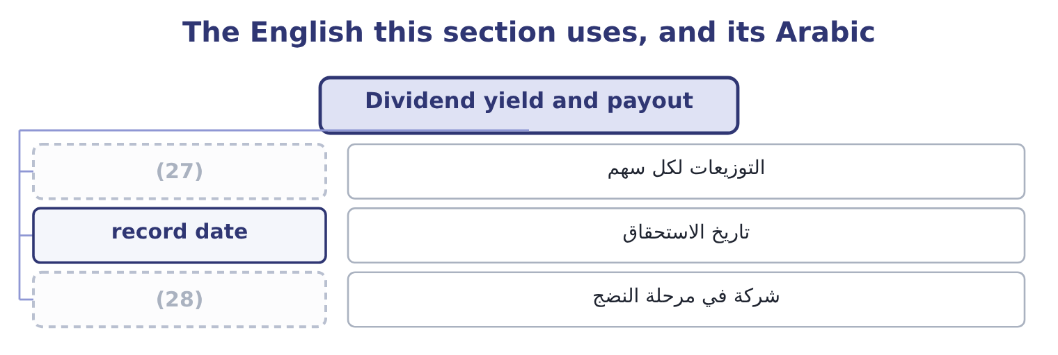
word list
mature company · attributable profit · dividend per share

The English this sheet uses, and its Arabic
English (exam term) | Arabic
dividend per share | التوزيعات لكل سهم
record date | تاريخ الاستحقاق
mature company | شركة في مرحلة النضج

Answer key · 16.4 Dividend yield and payout

1 receive | 15 mature
2 shareholder | 16 opposite
3 nothing | 17 Neither
4 totals | 18 better
5 difference | 19 business
6 divided | 20 Dividing
7 weighted | 21 common
8 statement | 22 meaningless
9 What arrives in cash | 23 earned
10 0.0556 over 9.25 | 24 borrowings
11 The share of profit handed over | 25 finding
12 One less the payout | 26 drives
13 company's | 27 dividend per share
14 consistent | 28 mature company

the summaries in full
Summary 1 The dividend per share is dividends declared over the shares that will receive them: 450,000 ÷ 8,100,000 = 0.0556. The dividend yield is that over the price: 0.0556 ÷ 9.25 = 0.60 per cent. An Orontes shareholder receives six-tenths of one per cent a year in cash, which is next to nothing, and expects the rest of the return in the share price. The dividend payout ratio is dividends over earnings.16 per cent from the totals and which comes to the same thing per share: 0.0556 ÷ 0.3666 = 15.17 per cent, the small difference being the share count — the dividend is declared on the 8,100,000 shares in issue and the earnings are divided by the 8,099,726 weighted average. The three are one statement looked at from three sides.
Summary 2 A low yield with a high retention is a growth company's profile, and it is consistent with everything else in Book 1: Orontes retains 84.84 per cent because it needs the money to fund 13.70 per cent growth. A mature utility shows the opposite — a 5 per cent yield, a 70 per cent payout, and growth of 2 per cent. Neither pattern is better. What matters is whether the pattern matches the business, and whether the company can keep it.
Summary 3 The dividend yield divides by the share price; the payout ratio divides by earnings. Dividing the dividend by book value or by the par value is a common slip and gives a meaningless figure. A company can pay a dividend it has not earned: a payout ratio above 100 per cent means the dividend came out of reserves or out of borrowings, which is a finding worth stating. The declared dividend, not the paid dividend, drives both ratios. Orontes paid $50,000 of cash and declared $450,000.

16.5 Shareholder return, and what a multiple cannot say
Chapter 16 · section 16.5

Fill every gap. Each word list holds one word more than there are gaps.
Summary 1 gaps 1–12
A (1) return for a year is the dividend (2) plus the change in the price, over the price at the start. For an Orontes shareholder in 2025 the price gain is 9.25 − 7.80 = 1.45 and the dividend is 0.0556, so the total is 1.45 + 0.0556 = 1.5056, and the return is 1.5056 ÷ 7.80 = 19.30 per cent. That is the figure an owner (3) earned, and it is worth (4) against the three (5) Book 1 has computed from the (6) : a return on (7) of 10.22 per cent, a return on (8) of 16.15 per cent, and now a shareholder return of 19.30 per cent. They answer (9) questions. The first two ask what the company earned on the money (10) in it; the third asks what the market paid the shareholder, which depends on the (11) results and on a change in (12) the company does not control.
word list
returns · invested · accounts · sentiment · assets · shareholder's · company's · setting · actually · received · equity · different · dividend

Orontes: four returns for one year
The bars are drawn to scale.
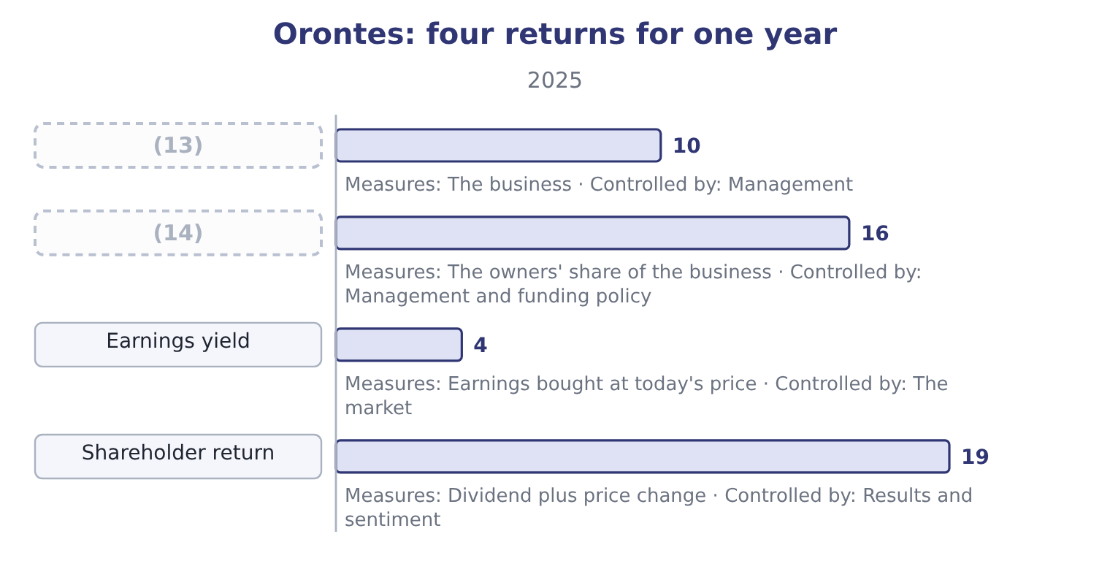
word list
Return on equity · Return on assets · potential common share

Summary 2 gaps 15–24
Three (15) of the market ratios close the chapter, and all three are (16) . The (17) is an accounting (18) . A price/earnings ratio of 25.23 computed on earnings that (19) a one-off gain is not a multiple of anything (20) . The (21) is a price on one day. (22) multiple of 25.23 uses the (23) 31 close. A week (24) or later it would differ, and nothing about the company would have changed. A multiple is a comparison and not a value. Twenty-five times earnings is high against a food manufacturer and low against a software company. The ratio is the beginning of a valuation question, which Book 2 answers properly with the dividend discount model and the relative-valuation multiples.
word list
repeatable · nothing · limits · numerator · denominator · include · earlier · Orontes's · examinable · December · number

Barada's market ratios

Compute the market ratios.
Your turn: Barada's market ratios (complete the blanks)
Item | Amount or ratio
Net income | 283,500
Shares outstanding | 1,000,000
Implied price per share | 6.00
Book value per share | 3.10
Dividends declared | nil
Earnings per share | (25) : 283,500 ÷ 1,000,000.
Price/earnings ratio | 21.16: 6.00 ÷ 0.2835.
Earnings yield | 4.73 per cent: 0.2835 ÷ 6.00.
Dividend yield | Nil, because no dividend was declared.
Market-to-book ratio | (26) : 6.00 ÷ 3.10.

word list
0.2835 · 21.16 · 1.9355

"Yield"

Summary 3 gaps 27–31
English yield in finance always means an income expressed as a (27) of a price or a (28) — a dividend yield, an earnings yield, a bond's yield to maturity. It never means the amount (29) . Note the trap in both English and (30) : a yield rises when the price falls, so a share whose yield has (31) may simply have had a bad year.
word list
expressed · principal · French · percentage · itself · improved

The English this section uses, and its Arabic
Each term sits against what it means.
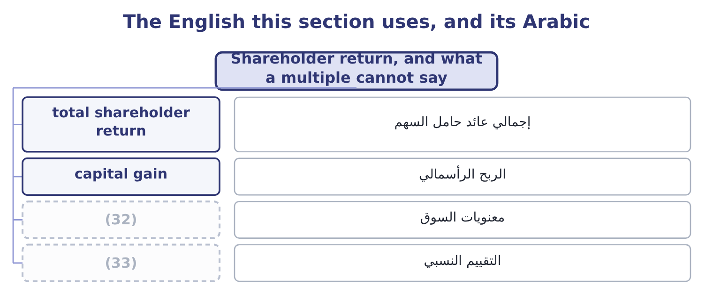
word list
sentiment · earnings yield · relative valuation

The English this sheet uses, and its Arabic
English (exam term) | Arabic
total shareholder return | إجمالي عائد حامل السهم
capital gain | الربح الرأسمالي
sentiment | معنويات السوق
relative valuation | التقييم النسبي

Answer key · 16.5 Shareholder return, and what a multiple cannot say

1 shareholder's | 18 number
2 received | 19 include
3 actually | 20 repeatable
4 setting | 21 numerator
5 returns | 22 Orontes's
6 accounts | 23 December
7 assets | 24 earlier
8 equity | 25 0.2835
9 different | 26 1.9355
10 invested | 27 percentage
11 company's | 28 principal
12 sentiment | 29 itself
13 Return on assets | 30 French
14 Return on equity | 31 improved
15 limits | 32 sentiment
16 examinable | 33 relative valuation
17 denominator

the summaries in full
Summary 1 A shareholder's return for a year is the dividend received plus the change in the price, over the price at the start. For an Orontes shareholder in 2025 the price gain is 9.25 − 7.80 = 1.45 and the dividend is 0.0556, so the total is 1.45 + 0.0556 = 1.5056, and the return is 1.5056 ÷ 7.80 = 19.30 per cent. That is the figure an owner actually earned, and it is worth setting against the three returns Book 1 has computed from the accounts: a return on assets of 10.22 per cent, a return on equity of 16.15 per cent, and now a shareholder return of 19.30 per cent. They answer different questions. The first two ask what the company earned on the money invested in it; the third asks what the market paid the shareholder, which depends on the company's results and on a change in sentiment the company does not control.
Summary 2 Three limits of the market ratios close the chapter, and all three are examinable. The denominator is an accounting number. A price/earnings ratio of 25.23 computed on earnings that include a one-off gain is not a multiple of anything repeatable. The numerator is a price on one day. Orontes's multiple of 25.23 uses the December 31 close. A week earlier or later it would differ, and nothing about the company would have changed. A multiple is a comparison and not a value. Twenty-five times earnings is high against a food manufacturer and low against a software company. The ratio is the beginning of a valuation question, which Book 2 answers properly with the dividend discount model and the relative-valuation multiples.
Summary 3 English yield in finance always means an income expressed as a percentage of a price or a principal — a dividend yield, an earnings yield, a bond's yield to maturity. It never means the amount itself. Note the trap in both English and French: a yield rises when the price falls, so a share whose yield has improved may simply have had a bad year.

