17.1 Measuring income: four things that shape the number
Chapter 17 · section 17.1

Fill every gap. Each word list holds one word more than there are gaps.
Chapter 17, section by section
Each stage leads to the next.
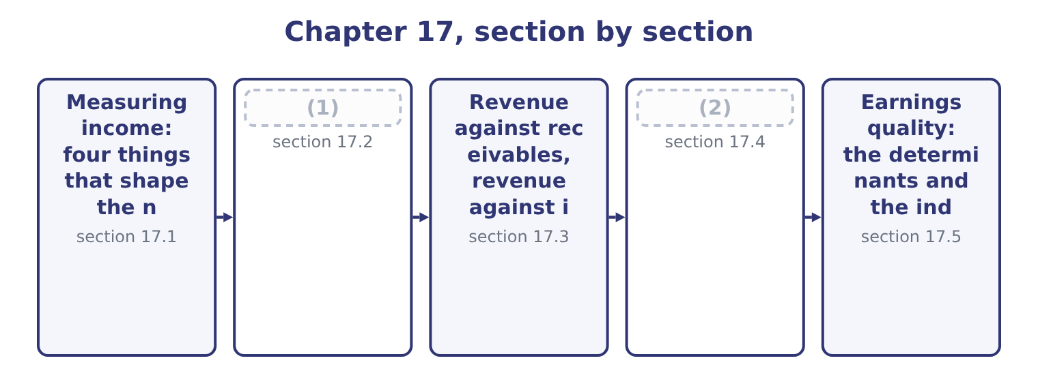
word list
Measuring income: four things that shape the n · The source, the stability and the trend of rev · When the recognition or the measurement change

Summary 1 gaps 3–14
Four (3) sit between the (4) of a year and the (5) reported for it, and the exam names all four. Orontes's (6) contain an (7) for credit losses of $156,000, a depreciation charge of $2,100,000 that depends on assumed useful lives, a deferred tax (8) of $999,625 built on expected future rates, and an impairment of $2,724,000 that rests on a forecast of what a brand and a plant will earn. None of these is a fact and all of them are in net income. Within the standards there are choices: first-in, (9) or weighted average for inventory; straight line or an (10) basis for depreciation; whether a cost is (11) or expensed. Two identical companies choosing (12) report different profits, and the exam tests the direction of the (13) rather than the (14) .
word list
identical · bookkeeping · economics · difference · profit · differently · capitalised · forces · first-out · statements · allowance · liability · accelerated

Summary 2 gaps 15–25
Incentives to (15) , or not to. (16) is rewarded on reported results, borrows against covenants written on reported ratios, and is judged by (17) ' forecasts of reported earnings. Where an estimate has a range, the incentives are not (18) . A company that must keep a (19) covenant at 1.50 — Barada's (20) . The needs of different users. A (21) wants to know whether the (22) will be paid and prefers conservatism. A (23) wants to know what the (24) will earn and prefers neutrality. A tax (25) wants a figure computed under its own rules. The same transaction serves all three badly if it is measured for only one, which is why the standards aim at neutrality rather than at any user's preference.
word list
situation · lender · interest · analysts · debt-to-equity · shareholder · neutral · authority · disclose · Management · reported · business

Four forces on a reported profit
Force | How it enters | Orontes's evidence
Estimates | (26) | Impairment of 2,724,000 on a forecast
Method choices | (27) | Straight-line depreciation of 2,100,000
Disclosure incentives | Covenants, bonuses, forecasts | (28)
Different users | (29) | One statement serving all three

word list
Covenants, bonuses, forecasts · Inventory, depreciation, capitalisation · A bank note with covenants, per Chapter 9 · Allowances, lives, impairment, tax · Lenders, owners, tax authorities

An estimate is not an error

Summary 3 gaps 30–35
A change in estimate is accounted for (30) and never restated. A change in accounting principle is applied (31) . An error is (32) by restating the prior periods. Conservatism is not neutrality. A persistently conservative estimate understates income now and overstates it later, and the exam treats a reversal of an (33) as a quality problem too. A disclosed estimate is better than an (34) one whatever its value. The note (35) more than the number.
word list
over-provision · undisclosed · prospectively · matters · corrected · inventory · retrospectively

The English this section uses, and its Arabic
Each term sits against what it means.
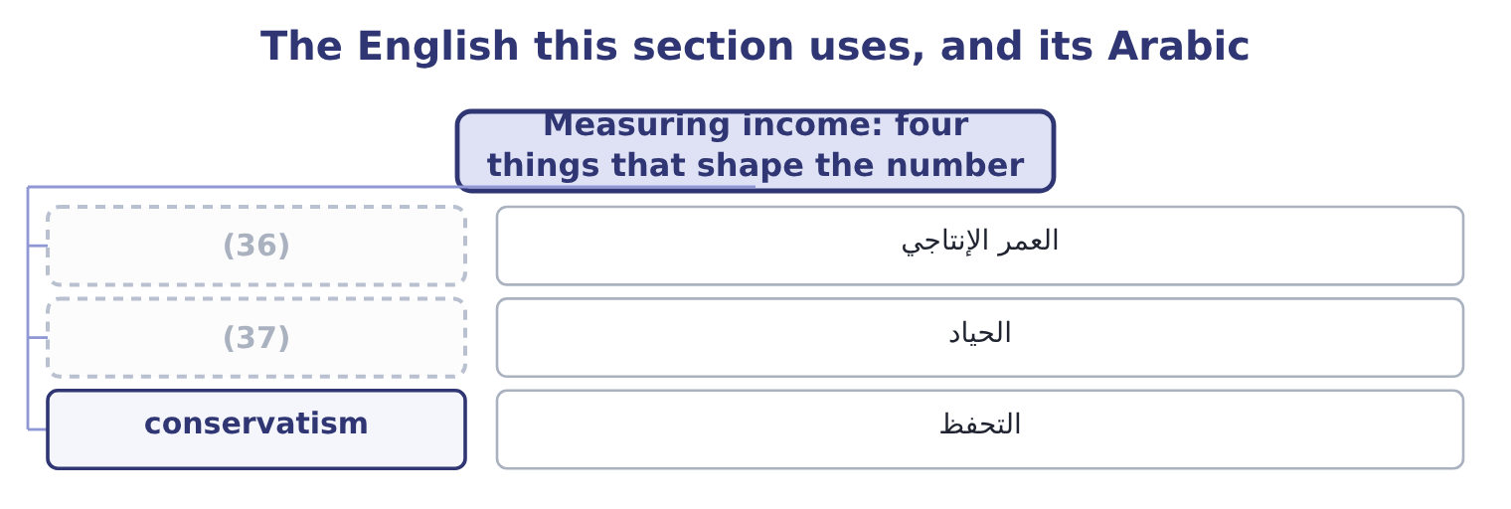
word list
useful life · accrual accounting · neutrality

The English this sheet uses, and its Arabic
English (exam term) | Arabic
useful life | العمر الإنتاجي
neutrality | الحياد
conservatism | التحفظ

Answer key · 17.1 Measuring income: four things that shape the number

1 The source, the stability and the trend of rev | 20 situation
2 When the recognition or the measurement change | 21 lender
3 forces | 22 interest
4 economics | 23 shareholder
5 profit | 24 business
6 statements | 25 authority
7 allowance | 26 Allowances, lives, impairment, tax
8 liability | 27 Inventory, depreciation, capitalisation
9 first-out | 28 A bank note with covenants, per Chapter 9
10 accelerated | 29 Lenders, owners, tax authorities
11 capitalised | 30 prospectively
12 differently | 31 retrospectively
13 difference | 32 corrected
14 bookkeeping | 33 over-provision
15 disclose | 34 undisclosed
16 Management | 35 matters
17 analysts | 36 useful life
18 neutral | 37 neutrality
19 debt-to-equity

the summaries in full
Summary 1 Four forces sit between the economics of a year and the profit reported for it, and the exam names all four. Orontes's statements contain an allowance for credit losses of $156,000, a depreciation charge of $2,100,000 that depends on assumed useful lives, a deferred tax liability of $999,625 built on expected future rates, and an impairment of $2,724,000 that rests on a forecast of what a brand and a plant will earn. None of these is a fact and all of them are in net income. Within the standards there are choices: first-in, first-out or weighted average for inventory; straight line or an accelerated basis for depreciation; whether a cost is capitalised or expensed. Two identical companies choosing differently report different profits, and the exam tests the direction of the difference rather than the bookkeeping.
Summary 2 Incentives to disclose, or not to. Management is rewarded on reported results, borrows against covenants written on reported ratios, and is judged by analysts' forecasts of reported earnings. Where an estimate has a range, the incentives are not neutral. A company that must keep a debt-to-equity covenant at 1.50 — Barada's situation. The needs of different users. A lender wants to know whether the interest will be paid and prefers conservatism. A shareholder wants to know what the business will earn and prefers neutrality. A tax authority wants a figure computed under its own rules. The same transaction serves all three badly if it is measured for only one, which is why the standards aim at neutrality rather than at any user's preference.
Summary 3 A change in estimate is accounted for prospectively and never restated. A change in accounting principle is applied retrospectively. An error is corrected by restating the prior periods. Conservatism is not neutrality. A persistently conservative estimate understates income now and overstates it later, and the exam treats a reversal of an over-provision as a quality problem too. A disclosed estimate is better than an undisclosed one whatever its value. The note matters more than the number.

17.2 The source, the stability and the trend of revenue
Chapter 17 · section 17.2

Fill every gap. Each word list holds one word more than there are gaps.
Summary 1 gaps 1–12
Revenue is the top line and the most (1) number in the (2) , because every other line (3) on it and because it is the (4) to flatter. Three (5) settle its quality. Where does it come from? Revenue from many customers in several markets is worth more than the same amount from one customer, because the loss of one customer is (6) . Revenue from a (7) contract is worth more than revenue from a spot sale. Revenue earned as principal is a (8) thing from a commission earned as agent, even where the amount is identical. How stable is it? Recurring revenue — (9) , maintenance, (10) — repeats without being won again. One-off revenue does not. A company (11) a record year on a single large order has a (12) next year that its income statement does not show.
word list
depends · different · repeats · questions · reporting · problem · subscriptions · consumables · easiest · examined · long-term · survivable · statements

Summary 2 gaps 13–21
Which way is it (13) , and how? A (14) trend built on volume is worth more than the same trend built on price, and both are worth more than one built on terms — longer credit, (15) return rights, (16) to pull next (17) orders into this one. For (18) the trend is clear and the quality of it is not (19) . Sales rose from $32,000,000 to $36,400,000 to $42,000,000, and the gross margin fell from 37.0 to 36.0 to 35.0 per cent. Growth bought with price is real growth and it is the least (20) kind, because the price (21) stays when the volume goes.
word list
moving · flattering · Orontes · rising · generous · quarter's · receivables · concession · durable · discounts

Three questions about a revenue figure
Question | High quality | Low quality | Where to look
Source | (22) | One customer, one market | The segment and concentration notes
Stability | Recurring, contracted | One-off orders, spot sales | (23)
Trend | Volume growth at a held margin | (24) | The gross margin against the growth rate

word list
Many customers, several markets · The segment and concentration notes · Growth bought with price or terms · The revenue note and the contract liabilities

Gross or net, principal or agent

Summary 3 gaps 25–33
A company (25) as agent reports only its commission. (26) a business that bills customers $10,000,000 and keeps $1,000,000, passing the rest to a (27) . As principal it reports revenue of $10,000,000 at a 10 per cent margin; as agent it reports revenue of $1,000,000 at a 100 per cent margin. Net income is identical and every (28) ratio differs by a (29) of ten. Revenue growth from an (30) is not organic growth. The exam expects the (31) to be stated. A record revenue figure says (32) about quality on its own. The segment note, the margin and the (33) say the rest.
word list
revenue-based · nothing · acquisition · Consider · supplier · receivables · depends · acting · distinction · factor

The English this section uses, and its Arabic
Each term sits against what it means.
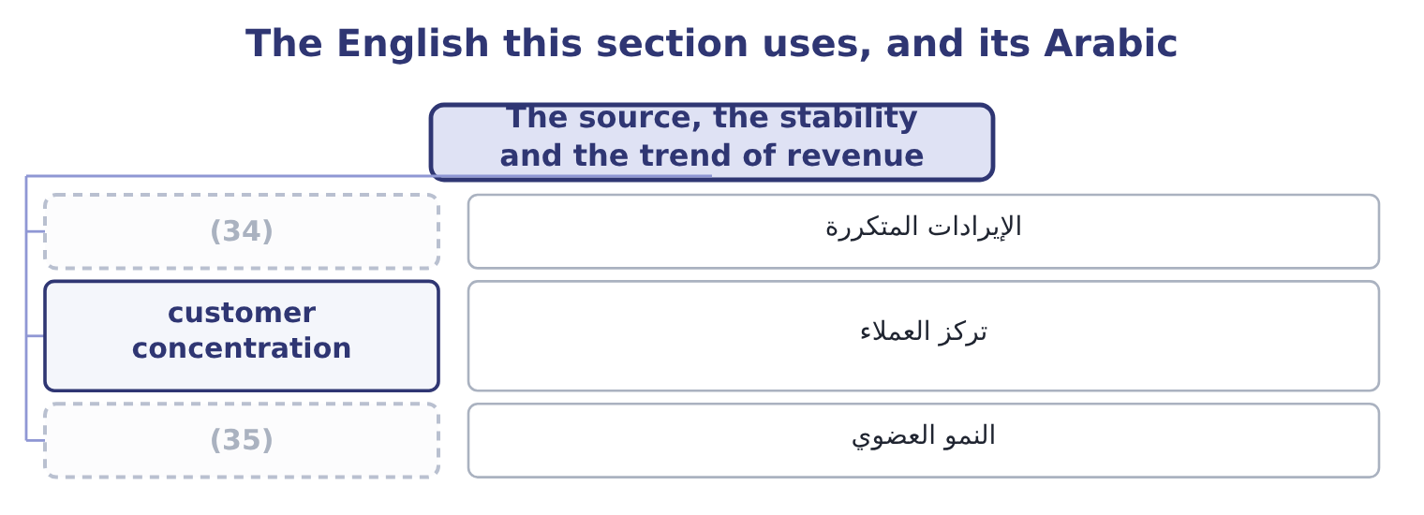
word list
تركز العملاء · recurring revenue · organic growth

The English this sheet uses, and its Arabic
English (exam term) | Arabic
recurring revenue | الإيرادات المتكررة
customer concentration | تركز العملاء
organic growth | النمو العضوي

Answer key · 17.2 The source, the stability and the trend of revenue

1 examined | 19 flattering
2 statements | 20 durable
3 depends | 21 concession
4 easiest | 22 Many customers, several markets
5 questions | 23 The revenue note and the contract liabilities
6 survivable | 24 Growth bought with price or terms
7 long-term | 25 acting
8 different | 26 Consider
9 subscriptions | 27 supplier
10 consumables | 28 revenue-based
11 reporting | 29 factor
12 problem | 30 acquisition
13 moving | 31 distinction
14 rising | 32 nothing
15 generous | 33 receivables
16 discounts | 34 recurring revenue
17 quarter's | 35 organic growth
18 Orontes

the summaries in full
Summary 1 Revenue is the top line and the most examined number in the statements, because every other line depends on it and because it is the easiest to flatter. Three questions settle its quality. Where does it come from? Revenue from many customers in several markets is worth more than the same amount from one customer, because the loss of one customer is survivable. Revenue from a long-term contract is worth more than revenue from a spot sale. Revenue earned as principal is a different thing from a commission earned as agent, even where the amount is identical. How stable is it? Recurring revenue — subscriptions, maintenance, consumables — repeats without being won again. One-off revenue does not. A company reporting a record year on a single large order has a problem next year that its income statement does not show.
Summary 2 Which way is it moving, and how? A rising trend built on volume is worth more than the same trend built on price, and both are worth more than one built on terms — longer credit, generous return rights, discounts to pull next quarter's orders into this one. For Orontes the trend is clear and the quality of it is not flattering. Sales rose from $32,000,000 to $36,400,000 to $42,000,000, and the gross margin fell from 37.0 to 36.0 to 35.0 per cent. Growth bought with price is real growth and it is the least durable kind, because the price concession stays when the volume goes.
Summary 3 A company acting as agent reports only its commission. Consider a business that bills customers $10,000,000 and keeps $1,000,000, passing the rest to a supplier. As principal it reports revenue of $10,000,000 at a 10 per cent margin; as agent it reports revenue of $1,000,000 at a 100 per cent margin. Net income is identical and every revenue-based ratio differs by a factor of ten. Revenue growth from an acquisition is not organic growth. The exam expects the distinction to be stated. A record revenue figure says nothing about quality on its own. The segment note, the margin and the receivables say the rest.

17.3 Revenue against receivables, revenue against inventory
Chapter 17 · section 17.3

Fill every gap. Each word list holds one word more than there are gaps.
Summary 1 gaps 1–12
This is the most (1) idea in the chapter and the one most often tested with (2) . Revenue, receivables and inventory are (3) linked: a genuine sale (4) a receivable that turns into cash, and it removes inventory. So the three should grow at (5) the same rate, and when they do not, the (6) is the finding. Receivables growing faster than revenue means one of three things: the company has (7) its credit terms, its (8) have slowed down, or some of the revenue was never going to be collected. All three reduce the (9) of the reported revenue, and all three show up in days sales (10) . Inventory growing faster than revenue means the company has built stock that it has not yet sold — because it (11) demand that has not (12) , or because demand has already fallen. Either way, next year carries a risk of a write-down, which passes through cost of sales and hits the gross margin.
word list
because · creates · expects · numbers · arrived · outstanding · mechanically · customers · practical · broadly · quality · extended · divergence

Summary 2 gaps 13–15
Orontes passes this test. Sales rose 15.38 per cent; (13) receivable rose $384,000 on an opening $3,760,000, which is 384,000 ÷ 3,760,000 = 10.21 per cent; and inventory rose $150,000 on an opening $2,300,000, or 150,000 ÷ 2,300,000 = 6.52 per cent. Both balances grew more (14) than sales, which is the healthy (15) and means the company collected and sold faster in 2025 than in 2024.
word list
slowly · accounts · direction · broadly

Revenue against the balances it should move with
Company | Sales growth | Receivables growth | Inventory growth | Reading
Orontes, 2025 | 15.38% | 10.21% | 6.52% | (16)
Barada, 2025 | 11.0% | 38% | 41% | Balances grew three to four times faster

word list
Balances grew slower than sales · allowance for credit losses

Summary 3 gaps 17–28
Barada fails it, and this is the same finding that.94. One company, one (17) , five ways of (18) it. That is what a ratio (19) is for. Orontes's receivables are (20) net of an allowance of $156,000 in 2025 and $140,000 in 2024, so the gross (21) are 4,144,000 + 156,000 = 4,300,000 and 3,760,000 + 140,000 = 3,900,000. The allowance as a proportion. The allowance has been held at about the same proportion of the book while the book grew, which is consistent and is what a (22) hopes to. The (23) would have been the finding. An allowance (24) as a proportion of a (25) growing receivable book is one of the classic ways to lift reported profit: the credit loss expense is lower, net income is higher, and nothing has to be (26) . Orontes's credit loss expense of $63,000 (27) a growing book is (28) but the allowance ratio held, so the two facts are consistent and there is no finding here.
word list
invented · extended · falling · against · system · figures · modest · stated · reader · rapidly · seeing · problem · alternative

The English this section uses, and its Arabic
Each term sits against what it means.
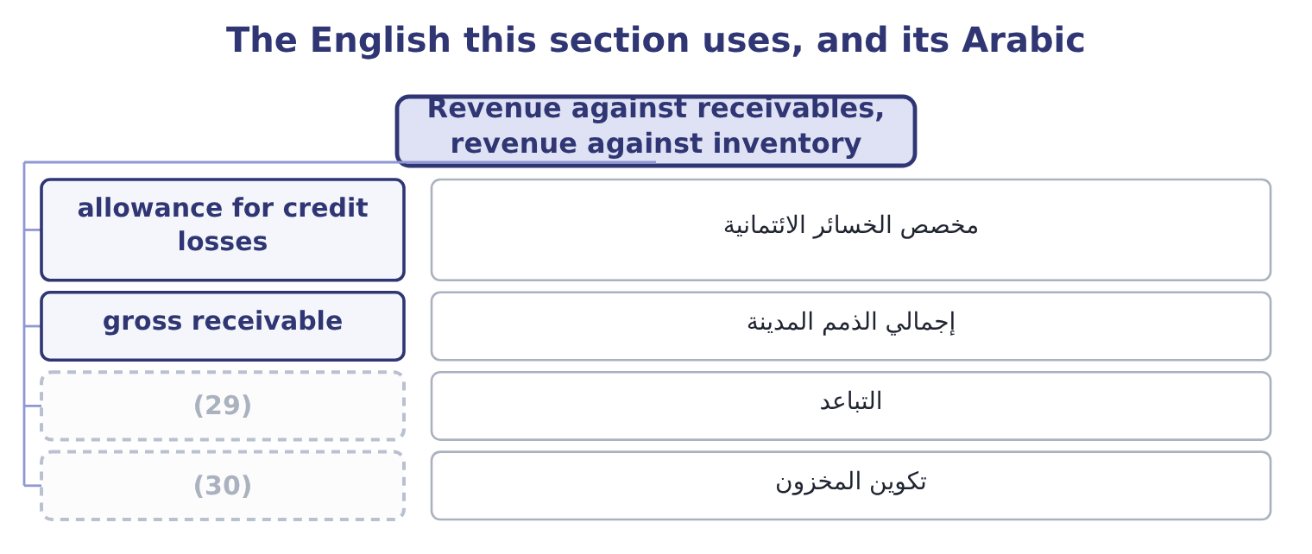
word list
bill-and-hold · stock build · divergence

The English this sheet uses, and its Arabic
English (exam term) | Arabic
allowance for credit losses | مخصص الخسائر الائتمانية
gross receivable | إجمالي الذمم المدينة
divergence | التباعد
stock build | تكوين المخزون

Answer key · 17.3 Revenue against receivables, revenue against inventory

1 practical | 16 Balances grew slower than sales
2 numbers | 17 problem
3 mechanically | 18 seeing
4 creates | 19 system
5 broadly | 20 stated
6 divergence | 21 figures
7 extended | 22 reader
8 customers | 23 alternative
9 quality | 24 falling
10 outstanding | 25 rapidly
11 expects | 26 invented
12 arrived | 27 against
13 accounts | 28 modest
14 slowly | 29 divergence
15 direction | 30 stock build

the summaries in full
Summary 1 This is the most practical idea in the chapter and the one most often tested with numbers. Revenue, receivables and inventory are mechanically linked: a genuine sale creates a receivable that turns into cash, and it removes inventory. So the three should grow at broadly the same rate, and when they do not, the divergence is the finding. Receivables growing faster than revenue means one of three things: the company has extended its credit terms, its customers have slowed down, or some of the revenue was never going to be collected. All three reduce the quality of the reported revenue, and all three show up in days sales outstanding. Inventory growing faster than revenue means the company has built stock that it has not yet sold — because it expects demand that has not arrived, or because demand has already fallen. Either way, next year carries a risk of a write-down, which passes through cost of sales and hits the gross margin.
Summary 2 Orontes passes this test. Sales rose 15.38 per cent; accounts receivable rose $384,000 on an opening $3,760,000, which is 384,000 ÷ 3,760,000 = 10.21 per cent; and inventory rose $150,000 on an opening $2,300,000, or 150,000 ÷ 2,300,000 = 6.52 per cent. Both balances grew more slowly than sales, which is the healthy direction and means the company collected and sold faster in 2025 than in 2024.
Summary 3 Barada fails it, and this is the same finding that.94. One company, one problem, five ways of seeing it. That is what a ratio system is for. Orontes's receivables are stated net of an allowance of $156,000 in 2025 and $140,000 in 2024, so the gross figures are 4,144,000 + 156,000 = 4,300,000 and 3,760,000 + 140,000 = 3,900,000. The allowance as a proportion. The allowance has been held at about the same proportion of the book while the book grew, which is consistent and is what a reader hopes to. The alternative would have been the finding. An allowance falling as a proportion of a rapidly growing receivable book is one of the classic ways to lift reported profit: the credit loss expense is lower, net income is higher, and nothing has to be invented. Orontes's credit loss expense of $63,000 against a growing book is modest but the allowance ratio held, so the two facts are consistent and there is no finding here.

17.4 When the recognition or the measurement changes
Chapter 17 · section 17.4

Fill every gap. Each word list holds one word more than there are gaps.
Summary 1 gaps 1–12
A change in how revenue is recognised or (1) changes the top line without anything (2) in the business, and the exam asks for the effect on revenue, on profit and on the (3) . Three kinds of change come up. (4) at delivery rather than at (5) , or over the life of a contract rather than at its start, moves revenue between periods. The year of the change gains or loses; the total over the life of the contract is the same. A change in the (6) of variable consideration. Revenue is recognised net of expected returns, rebates, (7) and penalties. (8) the estimate of returns (9) revenue now. A change in the (10) conclusion. This changes the gross (11) with no effect on profit at all, as section 17.2 showed, and it is the change with the (12) effect on every ratio.
word list
measurement · Raising · Recognising · largest · measured · happening · reduces · principal-or-agent · ratios · discounts · turnover · shipment · amount

Worked example: a bigger returns provision

Summary 2 gaps 13–24
Suppose Orontes (13) that expected returns on its 2025 sales are $200,000 (14) than it first (15) . Revenue is recognised net of expected returns, so revenue falls to 42,000,000 − 200,000 = 41,800,000. The gross profit falls by the same $200,000 less the cost of the goods coming back, and at the (16) 25 per cent (17) tax rate the (18) effect is, (19) , 200,000 × 0.75 = 150,000, so net income falls to 2,969,100 − 150,000 = 2,819,100. The net margin becomes 2,819,100 ÷ 41,800,000 = 6.74 per cent against 7.07 per cent; the asset (20) falls because sales fell; the return on assets falls because profit fell more in (21) . Earnings per share falls to about 0.3480 and the price/earnings ratio rises at an unchanged price. One estimate, (22) by less than half of one per cent of sales, moves the net margin by a third of a point and every return with it. That is the (23) the phrase earnings quality is about, and it is why a reader goes to the note on estimates before (24) a single ratio.
word list
sensitivity · approximately · estimated · effective · higher · company's · computing · proportion · turnover · revised · Raising · concludes · after-tax

Three changes to revenue, and what each moves
Change | Revenue | Net income | Margin | Where it shows
Timing of recognition | (25) | (26) | Both move | Contract liabilities
Variable consideration estimate | Falls or rises now | Falls or rises now | Both move | (27)
Principal to agent | Falls sharply | Unchanged | (28) | The revenue policy note

word list
expected returns · Moves with it · Moves between periods · The estimates note · Rises sharply

The direction of a contract liability

Summary 3 gaps 29–36
Cash received before (29) is a contract (30) , not revenue. (31) contract liabilities rose from $120,000 to $180,000, which means it holds more customer money against goods not yet (32) — revenue deferred into 2026, and a small sign of quality rather than a problem. A change in revenue recognition policy is a change in (33) principle and is applied (34) . A change in an estimate of returns is (35) . Where the (36) gives a tax rate, state the profit effect after tax. Where it does not, state it before tax and say so.
word list
performance · retrospectively · liability · delivered · Orontes's · question · accounting · prospective · estimate

The English this section uses, and its Arabic
Each term sits against what it means.
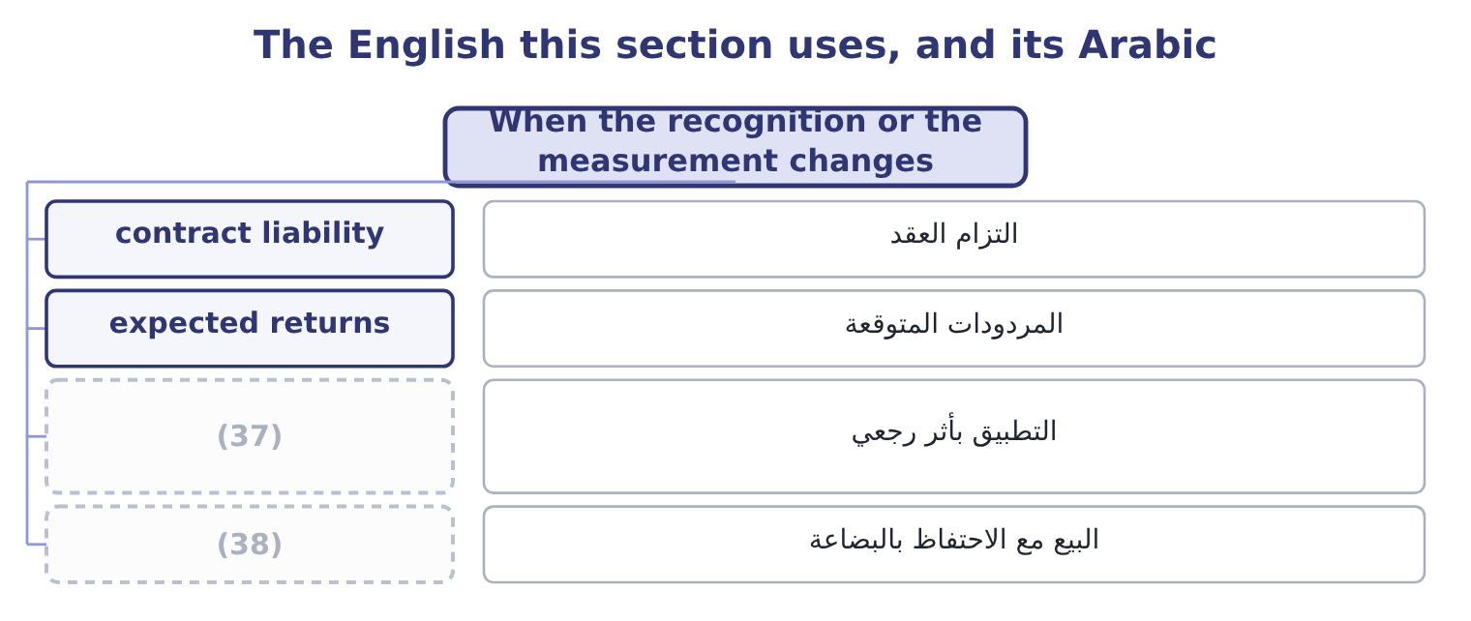
word list
bill-and-hold · retrospective application · divergence

The English this sheet uses, and its Arabic
English (exam term) | Arabic
contract liability | التزام العقد
expected returns | المردودات المتوقعة
retrospective application | التطبيق بأثر رجعي
bill-and-hold | البيع مع الاحتفاظ بالبضاعة

Answer key · 17.4 When the recognition or the measurement changes

1 measured | 20 turnover
2 happening | 21 proportion
3 ratios | 22 revised
4 Recognising | 23 sensitivity
5 shipment | 24 computing
6 measurement | 25 Moves between periods
7 discounts | 26 Moves with it
8 Raising | 27 The estimates note
9 reduces | 28 Rises sharply
10 principal-or-agent | 29 performance
11 amount | 30 liability
12 largest | 31 Orontes's
13 concludes | 32 delivered
14 higher | 33 accounting
15 estimated | 34 retrospectively
16 company's | 35 prospective
17 effective | 36 question
18 after-tax | 37 retrospective application
19 approximately | 38 bill-and-hold

the summaries in full
Summary 1 A change in how revenue is recognised or measured changes the top line without anything happening in the business, and the exam asks for the effect on revenue, on profit and on the ratios. Three kinds of change come up. Recognising at delivery rather than at shipment, or over the life of a contract rather than at its start, moves revenue between periods. The year of the change gains or loses; the total over the life of the contract is the same. A change in the measurement of variable consideration. Revenue is recognised net of expected returns, rebates, discounts and penalties. Raising the estimate of returns reduces revenue now. A change in the principal-or-agent conclusion. This changes the gross amount with no effect on profit at all, as section 17.2 showed, and it is the change with the largest effect on every ratio.
Summary 2 Suppose Orontes concludes that expected returns on its 2025 sales are $200,000 higher than it first estimated. Revenue is recognised net of expected returns, so revenue falls to 42,000,000 − 200,000 = 41,800,000. The gross profit falls by the same $200,000 less the cost of the goods coming back, and at the company's 25 per cent effective tax rate the after-tax effect is, approximately, 200,000 × 0.75 = 150,000, so net income falls to 2,969,100 − 150,000 = 2,819,100. The net margin becomes 2,819,100 ÷ 41,800,000 = 6.74 per cent against 7.07 per cent; the asset turnover falls because sales fell; the return on assets falls because profit fell more in proportion. Earnings per share falls to about 0.3480 and the price/earnings ratio rises at an unchanged price. One estimate, revised by less than half of one per cent of sales, moves the net margin by a third of a point and every return with it. That is the sensitivity the phrase earnings quality is about, and it is why a reader goes to the note on estimates before computing a single ratio.
Summary 3 Cash received before performance is a contract liability, not revenue. Orontes's contract liabilities rose from $120,000 to $180,000, which means it holds more customer money against goods not yet delivered — revenue deferred into 2026, and a small sign of quality rather than a problem. A change in revenue recognition policy is a change in accounting principle and is applied retrospectively. A change in an estimate of returns is prospective. Where the question gives a tax rate, state the profit effect after tax. Where it does not, state it before tax and say so.

17.5 Earnings quality: the determinants and the indicators
Chapter 17 · section 17.5

Fill every gap. Each word list holds one word more than there are gaps.
Summary 1 gaps 1–12
Earnings quality is how well this year's reported profit (1) next year's cash. (2) earnings are (3) , backed by cash, and produced by the business the company says it is. (4) earnings are none of those things, and the (5) are not wrong in either case. The (6) — what makes earnings high or low quality — are three. Does the item repeat? A sale (7) ; a gain on the sale of (8) does not. Orontes's net income (9) $3,000 of gain on disposal and $177,000 of (10) income, neither of which comes from selling food. Does the profit turn into cash? Orontes's cash from operations is $7,531,100 against net income of $2,969,100, which is 7,531,100 ÷ 2,969,100 = 2.54 times. A ratio above one is the healthy direction, and 2.54 is strong — (11) ,824,000 of the gap is simply (12) and the impairment, so the figure flatters the company a little. How much of the profit rests on estimates that management chose? The impairment of $2,724,000 is the largest discretionary item in Orontes's 2025 statements, and it works in the unusual direction: it reduced this year's profit, which lowers the base for every future comparison. The indicators — what a reader looks at — are the practical half of the outcome.
word list
Low-quality · High-quality · accounts · contains · repeats · equipment · equity-method · Orontes · persistent · depreciation · determinants · predicts · although

Indicators of earnings quality
Indicator | Healthy | A warning | Orontes, 2025
Cash from operations against net income | Above 1.0 | (13) | 2.54 times
Receivables growth against revenue growth | (14) | Faster | 10.21% against 15.38%
Inventory growth against revenue growth | Slower | Faster | (15)
Share of profit from one-off items | Small | Large | (16)
Gross margin trend | Held or rising | Falling while sales rise | (17)
Allowance ratios | Steady | Falling as the book grows | (18)

word list
Slower · Falling three years running · 3.63% against 3.59% · Below 1.0, or falling · 6.52% against 15.38% · conservatism · 180,000 of 2,969,100

Summary 2 gaps 19–23
Five of the six are healthy and one is not, and the one that is not is the (19) . That is a fair (20) on Orontes: a company whose earnings are (21) and whose working (22) is well run, growing by giving away margin, and (23) a large discretionary charge in the year under review.
word list
verdict · carrying · bill-and-hold · capital · cash-backed · finding

Judge Barada's earnings quality

Summary 3 gaps 24–25
Mark each (24) healthy or a warning, and say what the (25) as a whole means.
word list
pattern · comparison · indicator

Your turn: Barada's earnings quality (complete the blanks)
Indicator | Barada | Healthy or warning
Sales growth | 11.0% | ________
Receivables growth | 38% | ________
Inventory growth | 41% | ________
Payables growth | 9% | ________
Bank overdraft | (26) | ________
Net margin | 1.29% | ________
Overall reading |  | ________

word list
240,000, from nil · persistence of earnings

"Quality"

Summary 4 gaps 27–31
English quality in earnings quality does not mean how large the earnings are or how good the company is. It means how far the reported figure can be (27) on to repeat and to turn into cash. A company with low earnings of high quality is a better (28) than one with high earnings of low quality, and (29) who read the word as a (30) for size answer the question (31) .
word list
backwards · investment · synonym · pattern · relied · candidates

"Quality"
Indicator | Answer
Sales growth | (32) : modest growth, and healthy in itself.
Receivables growth | 38 per cent: a warning, more than three times the sales growth.
Inventory growth | 41 per cent: a warning, and the source of a possible write-down.
Payables growth | (33) : a warning in context — Barada is paying suppliers as before while funding a much larger stock and receivable book.
Bank overdraft | A warning: the funding gap has arrived on the balance sheet.
Net margin | (34) : thin, and leaves no room to absorb a write-down.
Overall reading | Low quality. Reported profit is not matched by cash: the growth in receivables and inventory, funded by an overdraft rather than by supplier

word list
9 per cent · 3.63% against 3.59% · 1.29 per cent · 11.0 per cent

The English this section uses, and its Arabic
Each term sits against what it means.
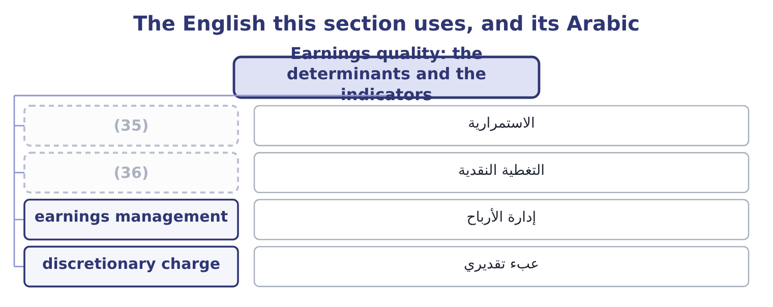
word list
useful life · cash backing · persistence

The English this sheet uses, and its Arabic
English (exam term) | Arabic
persistence | الاستمرارية
cash backing | التغطية النقدية
earnings management | إدارة الأرباح
discretionary charge | عبء تقديري

Answer key · 17.5 Earnings quality: the determinants and the indicators

1 predicts | 19 finding
2 High-quality | 20 verdict
3 persistent | 21 cash-backed
4 Low-quality | 22 capital
5 accounts | 23 carrying
6 determinants | 24 indicator
7 repeats | 25 pattern
8 equipment | 26 240,000, from nil
9 contains | 27 relied
10 equity-method | 28 investment
11 although | 29 candidates
12 depreciation | 30 synonym
13 Below 1.0, or falling | 31 backwards
14 Slower | 32 11.0 per cent
15 6.52% against 15.38% | 33 9 per cent
16 180,000 of 2,969,100 | 34 1.29 per cent
17 Falling three years running | 35 persistence
18 3.63% against 3.59% | 36 cash backing

the summaries in full
Summary 1 Earnings quality is how well this year's reported profit predicts next year's cash. High-quality earnings are persistent, backed by cash, and produced by the business the company says it is. Low-quality earnings are none of those things, and the accounts are not wrong in either case. The determinants — what makes earnings high or low quality — are three. Does the item repeat? A sale repeats; a gain on the sale of equipment does not. Orontes's net income contains $3,000 of gain on disposal and $177,000 of equity-method income, neither of which comes from selling food. Does the profit turn into cash? Orontes's cash from operations is $7,531,100 against net income of $2,969,100, which is 7,531,100 ÷ 2,969,100 = 2.54 times. A ratio above one is the healthy direction, and 2.54 is strong — although,824,000 of the gap is simply depreciation and the impairment, so the figure flatters the company a little. How much of the profit rests on estimates that management chose? The impairment of $2,724,000 is the largest discretionary item in Orontes's 2025 statements, and it works in the unusual direction: it reduced this year's profit, which lowers the base for every future comparison. The indicators — what a reader looks at — are the practical half of the outcome.
Summary 2 Five of the six are healthy and one is not, and the one that is not is the finding. That is a fair verdict on Orontes: a company whose earnings are cash-backed and whose working capital is well run, growing by giving away margin, and carrying a large discretionary charge in the year under review.
Summary 3 Mark each indicator healthy or a warning, and say what the pattern as a whole means.
Summary 4 English quality in earnings quality does not mean how large the earnings are or how good the company is. It means how far the reported figure can be relied on to repeat and to turn into cash. A company with low earnings of high quality is a better investment than one with high earnings of low quality, and candidates who read the word as a synonym for size answer the question backwards.

