18.1 Foreign operations and the exchange rate
Chapter 18 · section 18.1

Fill every gap. Each word list holds one word more than there are gaps.
Chapter 18, section by section
Each stage leads to the next.
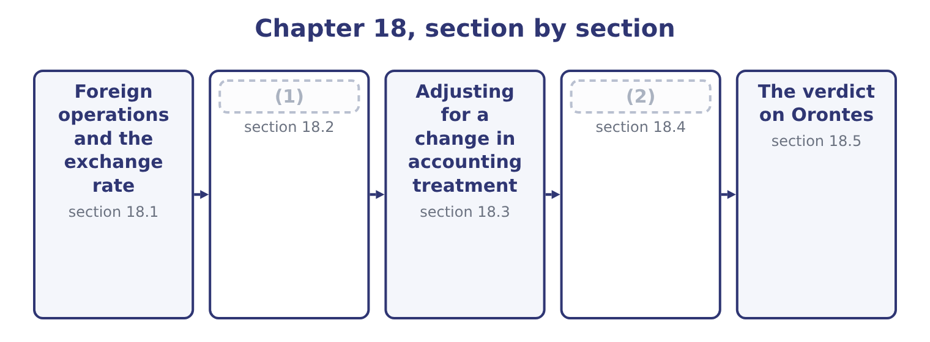
word list
verdict · The limitations of ratio analysis · Inflation

Summary 1 gaps 3–14
A company with a subsidiary abroad must (3) that subsidiary's (4) in the currency the group reports. (5) about the subsidiary (6) in the process, and almost every ratio can. Start with the term the exam (7) . The functional currency is the currency of the primary economic (8) in which an entity (9) — the one in which it prices its goods, pays its staff and holds its cash. It is a (10) of fact, not of (11) . The (12) currency is the one the group reports in, which for (13) is the US dollar. Where the subsidiary's functional currency is its own local currency, the (14) rate method applies. Assets and liabilities are translated at the closing rate, income and expenses at the average rate for the period, and equity at historical rates. The imbalance this creates does not go through profit: it accumulates in other comprehensive income as a cumulative translation adjustment, and it is the reason the equity section of a group balance sheet carries a reserve that nobody earned.
word list
choice · operates · question · current · changes · environment · verdict · presentation · results · defines · Nothing · express · Orontes

Summary 2 gaps 15–19
Where the functional currency is the (15) — a subsidiary that is merely a shell (16) in dollars — the temporal method applies instead. Monetary items are (17) at the closing rate, (18) items stay at historical rates, and the gain or loss goes through net income. That is the distinction that matters for earnings volatility: translation is quiet and (19) is noisy.
word list
business · remeasured · non-monetary · operating · parent's · remeasurement

Worked example: the same subsidiary, two exchange rates

Summary 3 gaps 20–30
A subsidiary reports sales of 10,000,000 dinars, net income of 1,000,000 dinars and total assets of 5,000,000 dinars. In a year when the dinar is (20) at $0.70, sales translate at 10,000,000 × 0.70 = 7,000,000 and assets at 5,000,000 × 0.70 = 3,500,000, so asset turnover is 7,000,000 ÷ 3,500,000 = 2.00 times. In the next year the dinar (21) $0.65 and closes at $0.60, the subsidiary's local figures (22) . Sales translate at 10,000,000 × 0.65 = 6,500,000 and assets at 5,000,000 × 0.60 = 3,000,000. Asset turnover (23) 6,500,000 ÷ 3,000,000 = 2.17 times, (24) 2.00 the year (25) . The subsidiary sold the same goods to the same (26) with the same assets, and its reported asset turnover rose 8 per cent. The cause is (27) that the income statement is translated at an average rate and the balance sheet at a closing rate, so a currency that moved (28) the year puts the two (29) of every mixed ratio on (30) bases.
word list
customers · during · halves · process · before · averages · stable · becomes · purely · unchanged · against · different

Summary 4 gaps 31–34
Ratios built entirely within the income statement — every margin in, (31) the numerator and the (32) move together. Ratios built entirely within the balance sheet are (33) for the same reason. It is the mixed ratios, which is to say every turnover and every (34) , that move.
word list
verdict · because · unaffected · return · denominator

Which ratios a rate change moves
Every item belongs to exactly one group.
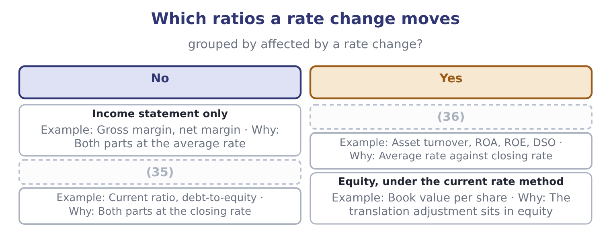
word list
Mixed · Balance sheet only · non-financial factor

Summary 5 gaps 37–44
The last (37) point of this outcome is (38) . Reported earnings that swing with a currency are earnings that (39) did not cause and cannot control, and the response is (40) : companies hedge, and they hedge the reported number as well as the economic (41) . (42) in turn discount (43) earnings, so a group whose profit moves with the dinar trades at a lower multiple than one whose profit does not — which is a cost of the volatility, not of the business. Book 2 prices the (44) used to manage it.
word list
predictable · instruments · volatile · management · examinable · Investors · behavioural · carries · exposure

The English this section uses, and its Arabic
Each term sits against what it means.
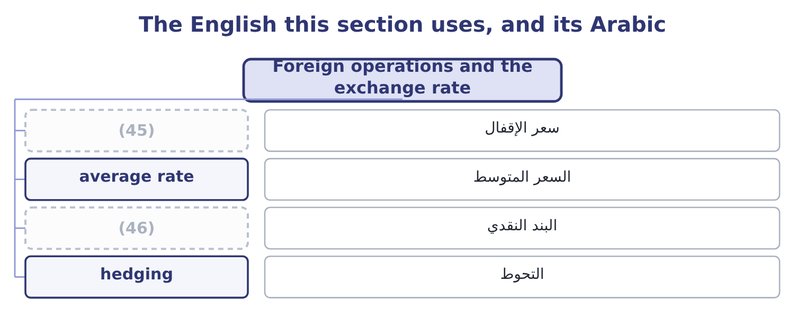
word list
monetary item · closing rate · سعر الإقفال

The English this sheet uses, and its Arabic
English (exam term) | Arabic
closing rate | سعر الإقفال
average rate | السعر المتوسط
monetary item | البند النقدي
hedging | التحوط

Answer key · 18.1 Foreign operations and the exchange rate

1 Inflation | 24 against
2 The limitations of ratio analysis | 25 before
3 express | 26 customers
4 results | 27 purely
5 Nothing | 28 during
6 changes | 29 halves
7 defines | 30 different
8 environment | 31 because
9 operates | 32 denominator
10 question | 33 unaffected
11 choice | 34 return
12 presentation | 35 Balance sheet only
13 Orontes | 36 Mixed
14 current | 37 examinable
15 parent's | 38 behavioural
16 operating | 39 management
17 remeasured | 40 predictable
18 non-monetary | 41 exposure
19 remeasurement | 42 Investors
20 stable | 43 volatile
21 averages | 44 instruments
22 unchanged | 45 closing rate
23 becomes | 46 monetary item

the summaries in full
Summary 1 A company with a subsidiary abroad must express that subsidiary's results in the currency the group reports. Nothing about the subsidiary changes in the process, and almost every ratio can. Start with the term the exam defines. The functional currency is the currency of the primary economic environment in which an entity operates — the one in which it prices its goods, pays its staff and holds its cash. It is a question of fact, not of choice. The presentation currency is the one the group reports in, which for Orontes is the US dollar. Where the subsidiary's functional currency is its own local currency, the current rate method applies. Assets and liabilities are translated at the closing rate, income and expenses at the average rate for the period, and equity at historical rates. The imbalance this creates does not go through profit: it accumulates in other comprehensive income as a cumulative translation adjustment, and it is the reason the equity section of a group balance sheet carries a reserve that nobody earned.
Summary 2 Where the functional currency is the parent's — a subsidiary that is merely a shell operating in dollars — the temporal method applies instead. Monetary items are remeasured at the closing rate, non-monetary items stay at historical rates, and the gain or loss goes through net income. That is the distinction that matters for earnings volatility: translation is quiet and remeasurement is noisy.
Summary 3 A subsidiary reports sales of 10,000,000 dinars, net income of 1,000,000 dinars and total assets of 5,000,000 dinars. In a year when the dinar is stable at $0.70, sales translate at 10,000,000 × 0.70 = 7,000,000 and assets at 5,000,000 × 0.70 = 3,500,000, so asset turnover is 7,000,000 ÷ 3,500,000 = 2.00 times. In the next year the dinar averages $0.65 and closes at $0.60, the subsidiary's local figures unchanged. Sales translate at 10,000,000 × 0.65 = 6,500,000 and assets at 5,000,000 × 0.60 = 3,000,000. Asset turnover becomes 6,500,000 ÷ 3,000,000 = 2.17 times, against 2.00 the year before. The subsidiary sold the same goods to the same customers with the same assets, and its reported asset turnover rose 8 per cent. The cause is purely that the income statement is translated at an average rate and the balance sheet at a closing rate, so a currency that moved during the year puts the two halves of every mixed ratio on different bases.
Summary 4 Ratios built entirely within the income statement — every margin in, because the numerator and the denominator move together. Ratios built entirely within the balance sheet are unaffected for the same reason. It is the mixed ratios, which is to say every turnover and every return, that move.
Summary 5 The last examinable point of this outcome is behavioural. Reported earnings that swing with a currency are earnings that management did not cause and cannot control, and the response is predictable: companies hedge, and they hedge the reported number as well as the economic exposure. Investors in turn discount volatile earnings, so a group whose profit moves with the dinar trades at a lower multiple than one whose profit does not — which is a cost of the volatility, not of the business. Book 2 prices the instruments used to manage it.

18.2 Inflation
Chapter 18 · section 18.2

Fill every gap. Each word list holds one word more than there are gaps.
Summary 1 gaps 1–12
Inflation does to time what a (1) does to distance: it makes two numbers that look comparable (2) . A (3) sheet carried at historical cost mixes dollars of many (4) , and the older the asset the more the mixing matters. Four (5) follow, and the exam asks for their (6) . Assets are understated, so every ratio with assets in the (7) is overstated. Return on assets looks (8) than it is; asset (9) looks faster than it is. (10) own plant stands at $14,802,000 against a cost of $26,790,000, and the cost (11) is in the dollars of the years in which it was spent. Depreciation is understated, so profit is overstated. A charge computed on what an asset cost does not (12) for what the replacement will cost. The company reports a profit and distributes some of it, and then finds the replacement unaffordable.
word list
balance · turnover · Orontes's · currency · vintages · better · Last-in · incomparable · denominator · direction · provide · distortions · itself

Summary 2 gaps 13–22
Inventory profits are not profits. Under (13) , first-out, the cost of sales (14) the oldest costs and the gross margin (15) the holding gain on stock that (16) sat there. (17) , first-out (18) current costs against current prices and reports a lower and more honest margin — which is why the choice of inventory method matters most in exactly the periods when inflation is high. Debt is repaid in (19) money, so the (20) gains and the lender loses. Debt ratios computed on historical amounts (21) how light an old fixed-rate borrowing has become, and a company with long-dated fixed-rate debt and (22) assets is the one inflation treats most kindly.
word list
borrower · Last-in · understate · cheaper · matches · carries · includes · merely · first-in · short-lived · amounts

Worked example: one company, two price levels

Summary 3 gaps 23–34
A company (23) its plant for 10,000,000 ten years ago, (24) it over ten years at 1,000,000 a year, and reports a profit of 2,000,000 on net assets now (25) at 5,000,000. Return on assets is 2,000,000 ÷ 5,000,000 = 40.0 per cent. (26) the plant today would cost 18,000,000, so the (27) honest depreciation charge is 1,800,000 and the asset base (28) to current prices is 9,000,000. Profit (29) 2,000,000 − 800,000 = 1,200,000. A return of 40 per cent and a return of 13 per cent for the same company in the same year, and the (30) is entirely the price level. Nothing in US GAAP (31) the second figure, and the first one is what every (32) will carry. This is why a long series of returns on assets for a (33) company is one of the least reliable (34) in analysis, and why an analyst comparing a company that renewed its plant last year with one that renewed it in 2005 is not comparing like with.
word list
database · capital-intensive · bought · restated · becomes · requires · Replacing · standing · difference · comparisons · economically · current · depreciates

What inflation does to the ratios
Every item belongs to exactly one group.
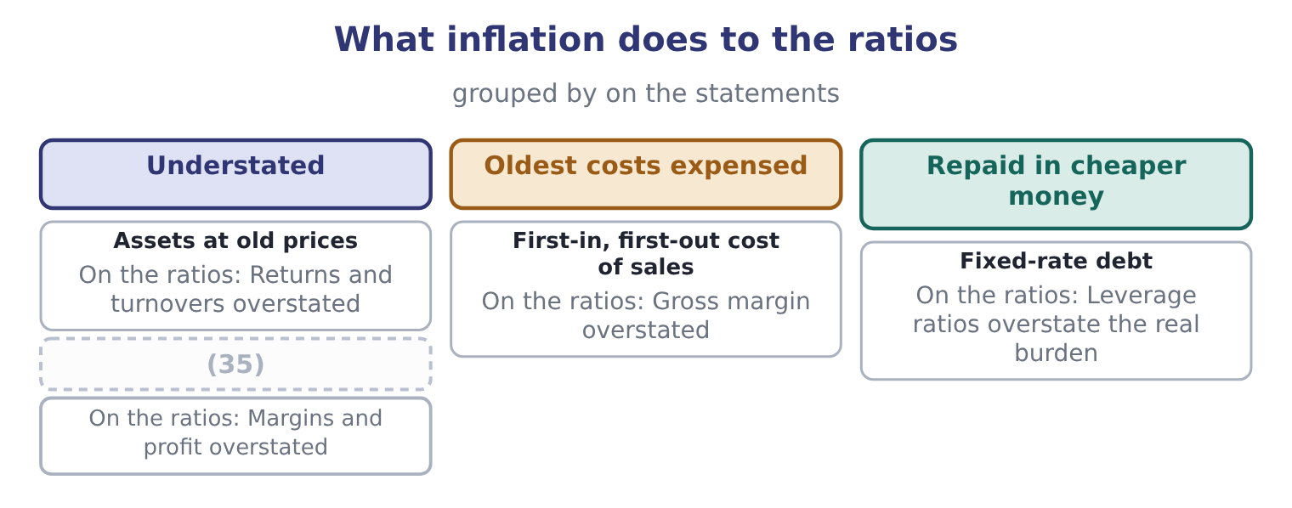
word list
Depreciation on old cost · change in accounting principle

The English this section uses, and its Arabic
Each term sits against what it means.
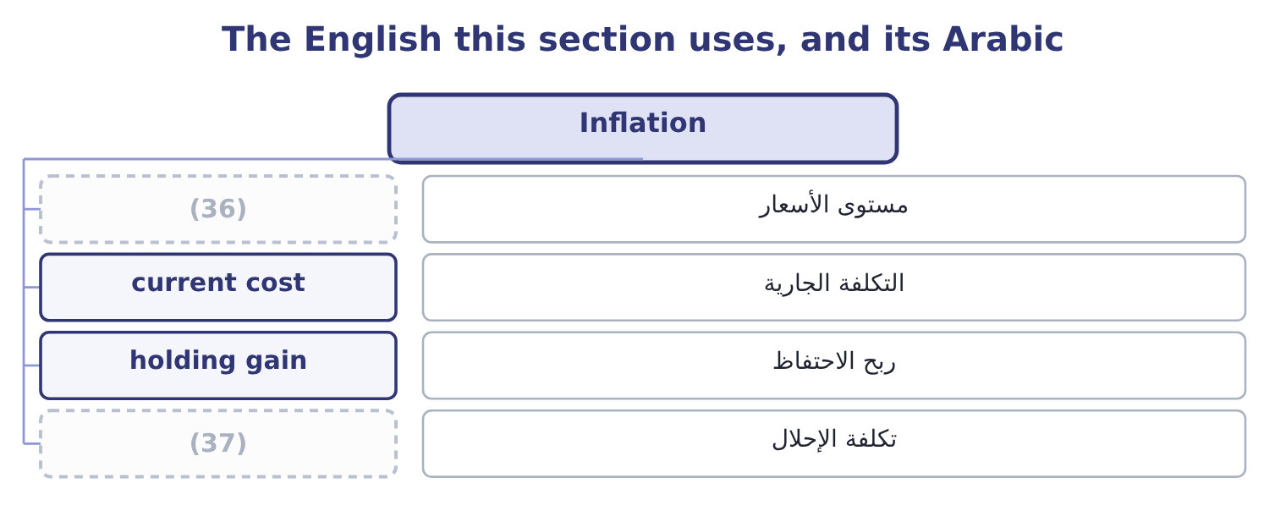
word list
replacement cost · price level · presentation currency

The English this sheet uses, and its Arabic
English (exam term) | Arabic
price level | مستوى الأسعار
current cost | التكلفة الجارية
holding gain | ربح الاحتفاظ
replacement cost | تكلفة الإحلال

Answer key · 18.2 Inflation

1 currency | 20 borrower
2 incomparable | 21 understate
3 balance | 22 short-lived
4 vintages | 23 bought
5 distortions | 24 depreciates
6 direction | 25 standing
7 denominator | 26 Replacing
8 better | 27 economically
9 turnover | 28 restated
10 Orontes's | 29 becomes
11 itself | 30 difference
12 provide | 31 requires
13 first-in | 32 database
14 carries | 33 capital-intensive
15 includes | 34 comparisons
16 merely | 35 Depreciation on old cost
17 Last-in | 36 price level
18 matches | 37 replacement cost
19 cheaper

the summaries in full
Summary 1 Inflation does to time what a currency does to distance: it makes two numbers that look comparable incomparable. A balance sheet carried at historical cost mixes dollars of many vintages, and the older the asset the more the mixing matters. Four distortions follow, and the exam asks for their direction. Assets are understated, so every ratio with assets in the denominator is overstated. Return on assets looks better than it is; asset turnover looks faster than it is. Orontes's own plant stands at $14,802,000 against a cost of $26,790,000, and the cost itself is in the dollars of the years in which it was spent. Depreciation is understated, so profit is overstated. A charge computed on what an asset cost does not provide for what the replacement will cost. The company reports a profit and distributes some of it, and then finds the replacement unaffordable.
Summary 2 Inventory profits are not profits. Under first-in, first-out, the cost of sales carries the oldest costs and the gross margin includes the holding gain on stock that merely sat there. Last-in, first-out matches current costs against current prices and reports a lower and more honest margin — which is why the choice of inventory method matters most in exactly the periods when inflation is high. Debt is repaid in cheaper money, so the borrower gains and the lender loses. Debt ratios computed on historical amounts understate how light an old fixed-rate borrowing has become, and a company with long-dated fixed-rate debt and short-lived assets is the one inflation treats most kindly.
Summary 3 A company bought its plant for 10,000,000 ten years ago, depreciates it over ten years at 1,000,000 a year, and reports a profit of 2,000,000 on net assets now standing at 5,000,000. Return on assets is 2,000,000 ÷ 5,000,000 = 40.0 per cent. Replacing the plant today would cost 18,000,000, so the economically honest depreciation charge is 1,800,000 and the asset base restated to current prices is 9,000,000. Profit becomes 2,000,000 − 800,000 = 1,200,000. A return of 40 per cent and a return of 13 per cent for the same company in the same year, and the difference is entirely the price level. Nothing in US GAAP requires the second figure, and the first one is what every database will carry. This is why a long series of returns on assets for a capital-intensive company is one of the least reliable comparisons in analysis, and why an analyst comparing a company that renewed its plant last year with one that renewed it in 2005 is not comparing like with.

18.3 Adjusting for a change in accounting treatment
Chapter 18 · section 18.3

Fill every gap. Each word list holds one word more than there are gaps.
Summary 1 gaps 1–12
The third way a ratio moves without the (1) moving is that the company (2) how it measures (3) . A change in accounting principle — first-in, first-out to weighted average, one (4) policy to another — is applied (5) . Every prior (6) presented is restated as though the new principle had always been used, and the (7) effect on periods before those presented goes to opening (8) earnings. For the analyst the work is already done: the comparatives in the current statements are on the new basis, and the trap is (9) them with figures taken from an older annual report, which are on the old one. A change in accounting estimate — a useful life, an allowance, a warranty (10) — is applied (11) . So the comparatives are on the old estimate and the current year is on the new one, and the analyst must adjust if the change is large (12) to matter.
word list
prospectively · cumulative · business · Orontes · retained · provision · revenue · changes · comparing · period · enough · something · retrospectively

Summary 2 gaps 13–24
The note (13) the effect; the statements do not (14) it. The (15) of an error is applied by (16) the prior periods affected and disclosing the fact. A restatement is a signal in its own right, (17) of its size: it says the control (18) failed once. (19) Orontes changed from first-in, first-out to weighted average for 2025, and the effect is to raise cost of goods sold by $300,000 and to lower (20) inventory by the same amount. Gross (21) becomes 14,700,000 − 300,000 = 14,400,000, so the gross margin is 14,400,000 ÷ 42,000,000 = 34.29 per cent against the 35.0 (22) . Inventory becomes 2,450,000 − 300,000 = 2,150,000. The ratios that move, and their (23) . The gross margin falls. Inventory (24) rises on both counts, because cost of sales is larger and the average inventory smaller.
word list
closing · discloses · independent · compare · correction · turnover · profit · direction · separate · environment · reported · Suppose · restating

Summary 3 gaps 25–34
Days sales in inventory (25) falls. The current ratio falls, because current (26) are $300,000 lower against unchanged current (27) . Net (28) falls by 300,000 × 0.75 = 225,000 after tax, so every margin and every (29) falls with it. Six ratios moved and the company (30) , made and sold (31) the same goods. Because this is a change in principle, the comparatives would also be restated, so a reader working only from the 2025 statements sees a (32) series — and a reader who takes 2024 from last year's annual report and 2025 from this one sees a margin (33) that never happened. That is the practical reason the outcome is (34) .
word list
happened · bought · liabilities · exactly · therefore · income · assets · collapse · consistent · return · examinable

Three kinds of change, three treatments
Kind of change | Treatment | What the analyst must do | Example
Accounting principle | Retrospective restatement | (35) | Inventory method
Accounting estimate | Prospective | (36) | Useful life, allowance
Error | (37) | Treat the restatement itself as a finding | A misstatement corrected

word list
Restate and disclose · Use the restated comparatives, not the old report · Adjust for the change where it is material · Useful life, allowance

The direction of an adjustment

Summary 4 gaps 38–42
Write down the two (38) of the ratio before and after the change and compare them (39) . A ratio with both parts (40) can move either way, and only the (41) decide. Where a change is retrospective, the comparatives in the current statements are already on the new basis. Where it is prospective, they are not. A restatement for an error is never a (42) event, however small the amount.
word list
separately · verdict · halves · falling · neutral · proportions

The English this section uses, and its Arabic
Each term sits against what it means.
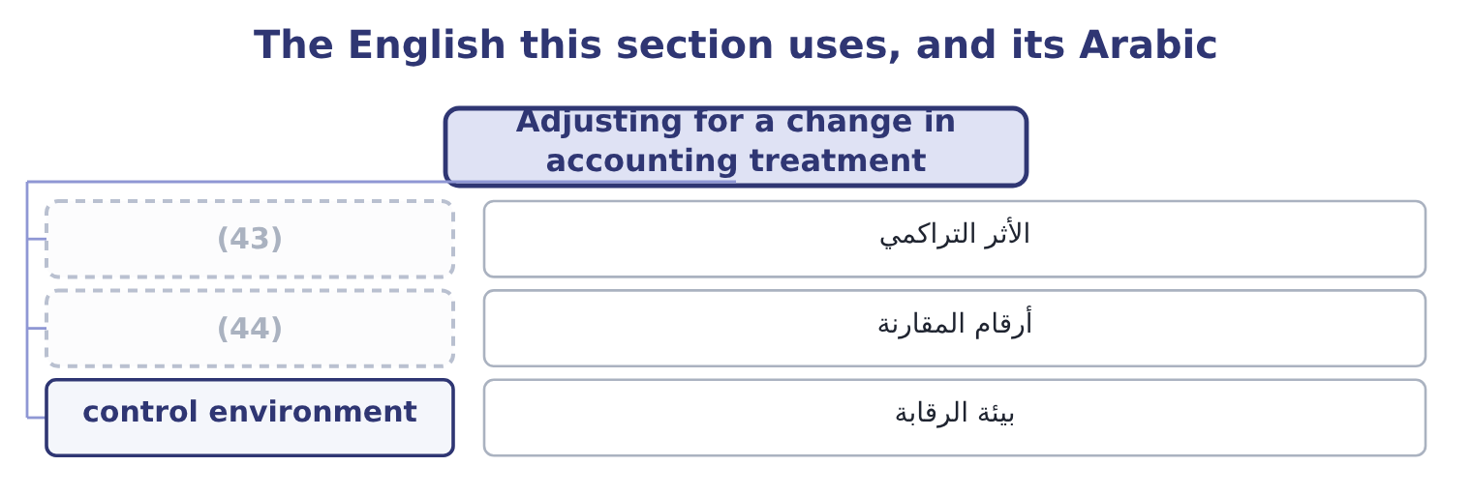
word list
cumulative effect · average rate · comparative figures

The English this sheet uses, and its Arabic
English (exam term) | Arabic
cumulative effect | الأثر التراكمي
comparative figures | أرقام المقارنة
control environment | بيئة الرقابة

Answer key · 18.3 Adjusting for a change in accounting treatment

1 business | 23 direction
2 changes | 24 turnover
3 something | 25 therefore
4 revenue | 26 assets
5 retrospectively | 27 liabilities
6 period | 28 income
7 cumulative | 29 return
8 retained | 30 bought
9 comparing | 31 exactly
10 provision | 32 consistent
11 prospectively | 33 collapse
12 enough | 34 examinable
13 discloses | 35 Use the restated comparatives, not the old report
14 separate | 36 Adjust for the change where it is material
15 correction | 37 Restate and disclose
16 restating | 38 halves
17 independent | 39 separately
18 environment | 40 falling
19 Suppose | 41 proportions
20 closing | 42 neutral
21 profit | 43 cumulative effect
22 reported | 44 comparative figures

the summaries in full
Summary 1 The third way a ratio moves without the business moving is that the company changes how it measures something. A change in accounting principle — first-in, first-out to weighted average, one revenue policy to another — is applied retrospectively. Every prior period presented is restated as though the new principle had always been used, and the cumulative effect on periods before those presented goes to opening retained earnings. For the analyst the work is already done: the comparatives in the current statements are on the new basis, and the trap is comparing them with figures taken from an older annual report, which are on the old one. A change in accounting estimate — a useful life, an allowance, a warranty provision — is applied prospectively. So the comparatives are on the old estimate and the current year is on the new one, and the analyst must adjust if the change is large enough to matter.
Summary 2 The note discloses the effect; the statements do not separate it. The correction of an error is applied by restating the prior periods affected and disclosing the fact. A restatement is a signal in its own right, independent of its size: it says the control environment failed once. Suppose Orontes changed from first-in, first-out to weighted average for 2025, and the effect is to raise cost of goods sold by $300,000 and to lower closing inventory by the same amount. Gross profit becomes 14,700,000 − 300,000 = 14,400,000, so the gross margin is 14,400,000 ÷ 42,000,000 = 34.29 per cent against the 35.0 reported. Inventory becomes 2,450,000 − 300,000 = 2,150,000. The ratios that move, and their direction. The gross margin falls. Inventory turnover rises on both counts, because cost of sales is larger and the average inventory smaller.
Summary 3 Days sales in inventory therefore falls. The current ratio falls, because current assets are $300,000 lower against unchanged current liabilities. Net income falls by 300,000 × 0.75 = 225,000 after tax, so every margin and every return falls with it. Six ratios moved and the company bought, made and sold exactly the same goods. Because this is a change in principle, the comparatives would also be restated, so a reader working only from the 2025 statements sees a consistent series — and a reader who takes 2024 from last year's annual report and 2025 from this one sees a margin collapse that never happened. That is the practical reason the outcome is examinable.
Summary 4 Write down the two halves of the ratio before and after the change and compare them separately. A ratio with both parts falling can move either way, and only the proportions decide. Where a change is retrospective, the comparatives in the current statements are already on the new basis. Where it is prospective, they are not. A restatement for an error is never a neutral event, however small the amount.

18.4 The limitations of ratio analysis
Chapter 18 · section 18.4

Fill every gap. Each word list holds one word more than there are gaps.
Summary 1 gaps 1–12
The limitations are (1) as a list, and the list is short (2) to learn. Each entry below has appeared in Book 1 as a worked (3) rather than as an (4) . No single ratio means (5) . A current ratio of 3.31 is a fact and not a verdict. A ratio needs a benchmark. Against last year, against a (6) , against a (7) , against the (8) . Barada's 16 per cent gross margin against Orontes's 35 is a difference of business, not of (9) . (10) policies differ between companies. Inventory method, depreciation basis, capitalisation policy, and the whole of the (11) difference. Section 18.3 moved six of Orontes's own ratios with one policy change. A balance sheet is one day. Seasonal (12) are measured at their quietest point, and, 105 and 150 days of inventory depending on the date chosen.
word list
businesses · customer's · anything · GAAP-against-IFRS · competitor · competence · problem · covenant · enough · assertion · examinable · Accounting · industry

Summary 2 gaps 13–20
Every figure in Book 1 (13) a year that has ended. Definitions are not (14) . Averages hide their spread. Window dressing is (15) . A company can repay a loan on the last day of the year and (16) it on the first day of the next, which lifts the current ratio and (17) nothing. Non-financial factors are absent. The quality of (18) , the strength of the brand, the state of the plant, a key (19) intentions, a lawsuit. None of them is in a ratio, and any of them can (20) more than all the ratios.
word list
describes · management · matter · competitor · customer's · possible · standardised · changes · redraw

Nine limitations, and where Book 1 met each
Limitation | Where it appeared
No single ratio is a verdict | (21)
A ratio needs a benchmark | Chapter 2, Barada against Orontes
Policies differ | (22)
A balance sheet is one day | (23)
Ratios are historical | Chapter 16, the only forward number is the price
Definitions are not standard | (24)
Averages hide spread | (25)
Window dressing | Chapter 6, the year-end repayment
Non-financial factors are absent | Chapter 18, this list

word list
Chapter 12, the seasonal miller · Chapter 14, four returns on assets · Section 18.3, the inventory method · Chapter 2, Barada against Orontes · Chapter 12, the ageing schedule · Chapter 6, the current ratio

Say the limitation that bites

Summary 3 gaps 26–31
A question asking for the limitations of ratio (26) wants the ones (27) to the data given, not a (28) . Where the question hands you one balance sheet date for a seasonal business, the limitation that bites is the date. Where it hands you two companies with (29) inventory methods, it is the policy difference. A limitation is not a reason to (30) to answer. State the (31) , then state what would change it.
word list
analysis · finding · different · examinable · recital · relevant · decline

The English this section uses, and its Arabic
Each term sits against what it means.
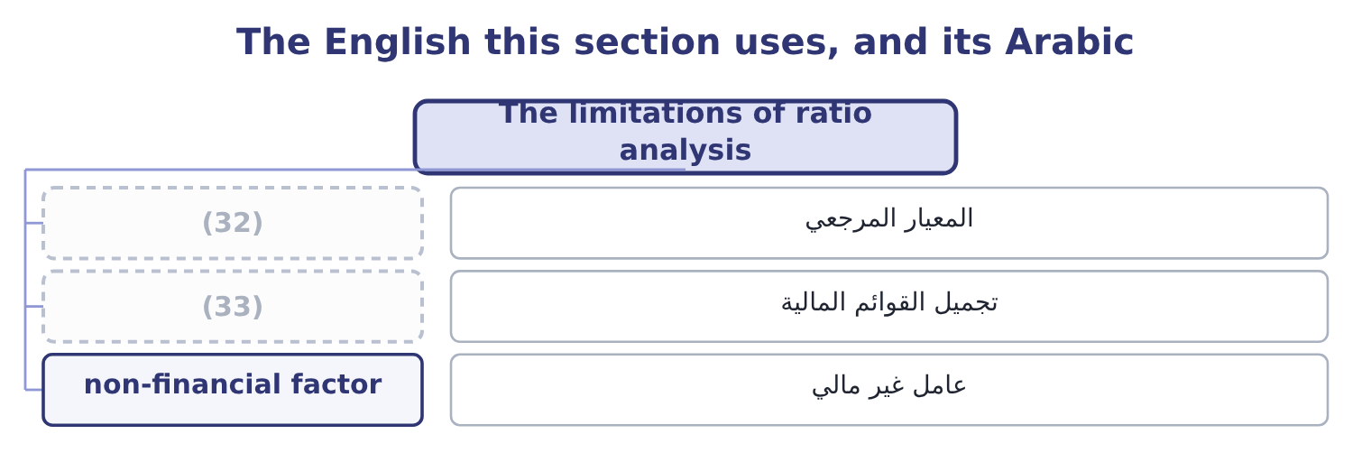
word list
historical cost · window dressing · benchmark

The English this sheet uses, and its Arabic
English (exam term) | Arabic
benchmark | المعيار المرجعي
window dressing | تجميل القوائم المالية
non-financial factor | عامل غير مالي

Answer key · 18.4 The limitations of ratio analysis

1 examinable | 18 management
2 enough | 19 customer's
3 problem | 20 matter
4 assertion | 21 Chapter 6, the current ratio
5 anything | 22 Section 18.3, the inventory method
6 competitor | 23 Chapter 12, the seasonal miller
7 covenant | 24 Chapter 14, four returns on assets
8 industry | 25 Chapter 12, the ageing schedule
9 competence | 26 analysis
10 Accounting | 27 relevant
11 GAAP-against-IFRS | 28 recital
12 businesses | 29 different
13 describes | 30 decline
14 standardised | 31 finding
15 possible | 32 benchmark
16 redraw | 33 window dressing
17 changes

the summaries in full
Summary 1 The limitations are examinable as a list, and the list is short enough to learn. Each entry below has appeared in Book 1 as a worked problem rather than as an assertion. No single ratio means anything. A current ratio of 3.31 is a fact and not a verdict. A ratio needs a benchmark. Against last year, against a competitor, against a covenant, against the industry. Barada's 16 per cent gross margin against Orontes's 35 is a difference of business, not of competence. Accounting policies differ between companies. Inventory method, depreciation basis, capitalisation policy, and the whole of the GAAP-against-IFRS difference. Section 18.3 moved six of Orontes's own ratios with one policy change. A balance sheet is one day. Seasonal businesses are measured at their quietest point, and, 105 and 150 days of inventory depending on the date chosen.
Summary 2 Every figure in Book 1 describes a year that has ended. Definitions are not standardised. Averages hide their spread. Window dressing is possible. A company can repay a loan on the last day of the year and redraw it on the first day of the next, which lifts the current ratio and changes nothing. Non-financial factors are absent. The quality of management, the strength of the brand, the state of the plant, a key customer's intentions, a lawsuit. None of them is in a ratio, and any of them can matter more than all the ratios.
Summary 3 A question asking for the limitations of ratio analysis wants the ones relevant to the data given, not a recital. Where the question hands you one balance sheet date for a seasonal business, the limitation that bites is the date. Where it hands you two companies with different inventory methods, it is the policy difference. A limitation is not a reason to decline to answer. State the finding, then state what would change it.

18.5 The verdict on Orontes
Chapter 18 · section 18.5

Fill every gap. Each word list holds one word more than there are gaps.
Summary 1 gaps 1–12
This is the outcome the whole book has been for: a judgment on a company's (1) strength and performance, built from many ratios and (2) in a form somebody can act on. Three rules make the (3) between an answer and a list. Rank the findings by what they are worth. A (4) gross margin move on $42,000,000 of sales is $840,000 a year; the trade working capital (5) ,640 a year. The first (6) in the first (7) and the second does not. (8) the position from the performance. The balance sheet says how strong the company is now. The income (9) says how well it is trading. They can (10) , and Orontes is a company where they do. Say what would change the verdict. A verdict with no (11) test is an (12) .
word list
support · stated · opinion · financial · difference · funding · disagree · two-point · belongs · sentence · Separate · expressed · statement

Orontes Foods, Inc. — the evidence, 2025
Area | Key ratios | Reading
Liquidity | Current 3.31, quick 2.68, cash 1.72 | (13)
Cash generation | (14) | Strong
Solvency | (15) | Conservative
Coverage | Interest cover 11.15, fixed charge 9.42 | Wide
Working capital | Cash cycle 39.8 days, DSO 34.3 | (16)
Margins | (17) | Gross margin falling three years running
Returns | ROA 10.22%, ROE 16.15% | (18)
Growth | (19) | Part-funded from outside
Market | (20) | Priced for growth that costs margin

word list
Debt-to-equity 0.55, debt-to-assets 0.36 · Gross 35.0%, operating 9.9%, net 7.1% · Good, and flattered by the growth · P/E 25.23, market-to-book 3.67 · Cash flow ratio 1.76, cash backing 2.54 times · Well run, improving · Strong, and stronger than 2024 · Receivables up 38%, inventory up 41%, overdraft 240,000 · Sales 15.38% against a sustainable 13.70%

Summary 2 gaps 21–32
Orontes is (21) strong and its trading is (22) in one specific, (23) way. The strength is not in doubt. It holds $7,302,100 of cash, (24) its current liabilities 3.31 times and its interest 11.15 times, (25) total liabilities of only $11,279,625 against equity of $20,392,975, and (26) its profit into cash 2.54 times over. Its working capital is better run than a year ago on every (27) . On the (28) of the balance sheet alone, this company could borrow (29) million dollars (30) . The deterioration is in the gross margin, and it is the only finding in the book worth $840,000 a year. Sales have risen 31 per cent in two years and the gross margin has (31) from 37.0 per cent to 35.0, which means the growth was (32) with price. Price concessions are permanent in a way volume gains are not.
word list
measure · tomorrow · bought · fallen · covers · measurable · converts · deteriorating · carries · evidence · financially · several · performance

Summary 3 gaps 33–44
Meanwhile the market has raised its multiple from 24.01 to 25.23, so the share price now embodies an (33) of continued growth that the margin trend does not (34) . Two (35) findings belong in the same answer. The company grew (36) than it can fund and (37) the gap with a $1,500,000 share issue and an $800,000 note, which is sound once and not a (38) . And 2025 contains a (39) impairment of $2,724,000, which depresses the reported operating margin to 9.9 per cent against an underlying 16.4 — so the reported deterioration overstates the trading decline, while the margin finding (40) nothing. What would change the verdict. A gross margin of 36 per cent or better in 2026 on continued volume growth would settle the matter in the company's favour: it would show the concessions were an entry price into new (41) rather than a permanent (42) . A margin of 34 per cent would confirm the opposite and would, at an (43) multiple of 25, make the share price (44) .
word list
expectation · understates · support · discretionary · indefensible · repricing · closed · policy · continued · secondary · faster · unchanged · customers

Reach a verdict on Barada

Write the verdict in three sentences: the position, the performance, and the test.

Your turn: Barada's evidence (complete the verdict)
Area | Barada | Your reading
Liquidity | Current 2.00, quick 0.94 | ________
Working capital | (45) | ________
Solvency | Debt-to-equity 1.26, covenant limit 1.50 | ________
Margins | (46) | ________
Growth | Sales 11.0% against a sustainable 9.15% | ________
Earnings quality | (47) | ________
Verdict |  | ________

word list
Cash cycle 44.4 days, DSI 40.6 · Gross 14.0%, net 1.29% · Receivables up 38%, inventory up 41%, overdraft 240,000 · Priced for growth that costs margin

"Material"

Summary 4 gaps 48–53
English (48) in accounting does not mean physical or important in a general sense: it means large enough that its omission or (49) could change a user's decision. It is a threshold, and it is (50) relative to the (51) . The exam uses the word in its accounting sense every time, and a (52) who reads it as important loses the threshold idea that makes it (53) .
word list
misstatement · deliberately · trading · material · candidate · useful · entity

"Material"
Area | Answer
Liquidity | Adequate on the current ratio of 2.00 and weak behind it: a quick ratio of 0.94 means Barada cannot meet its current liabilities without sel
Working capital | Poorly run and getting worse. A 44.4-day cash cycle on a 40.6-day inventory period is the profile of a (54) whose stockroom is growin
Solvency | Tight. At 1.26 against a covenant limit of 1.50 there is room, but the $1,500,000 the company wants would take it to 1.74 and breach the cov
Margins | Thin by nature and (55) : 14.0 per cent gross against 16.0 two years ago, and 1.29 per cent net leaves no margin for error.
Growth | Above the sustainable rate by about two points a year, with no dividend to cut and no equity raised, so the gap goes on the overdraft.
Earnings quality | Low. Receivables up 38 per cent and inventory up 41 per cent on sales up 11 means the reported profit is sitting in working capital rather t
Verdict | The position is weak behind an adequate-looking current ratio, the performance is a thin and thinning margin on growth the company cannot fu

word list
Reading · thinning · distributor

The English this section uses, and its Arabic
Each term sits against what it means.
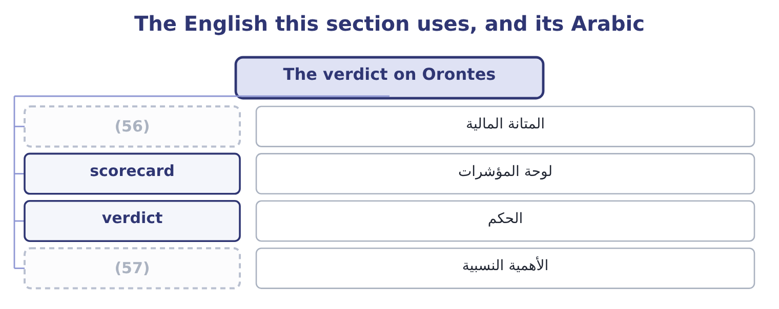
word list
الأهمية النسبية · materiality · financial strength

The English this sheet uses, and its Arabic
English (exam term) | Arabic
financial strength | المتانة المالية
scorecard | لوحة المؤشرات
verdict | الحكم
materiality | الأهمية النسبية

Answer key · 18.5 The verdict on Orontes

1 financial | 30 tomorrow
2 expressed | 31 fallen
3 difference | 32 bought
4 two-point | 33 expectation
5 funding | 34 support
6 belongs | 35 secondary
7 sentence | 36 faster
8 Separate | 37 closed
9 statement | 38 policy
10 disagree | 39 discretionary
11 stated | 40 understates
12 opinion | 41 customers
13 Strong, and stronger than 2024 | 42 repricing
14 Cash flow ratio 1.76, cash backing 2.54 times | 43 unchanged
15 Debt-to-equity 0.55, debt-to-assets 0.36 | 44 indefensible
16 Well run, improving | 45 Cash cycle 44.4 days, DSI 40.6
17 Gross 35.0%, operating 9.9%, net 7.1% | 46 Gross 14.0%, net 1.29%
18 Good, and flattered by the growth | 47 Receivables up 38%, inventory up 41%, overdraft 240,000
19 Sales 15.38% against a sustainable 13.70% | 48 material
20 P/E 25.23, market-to-book 3.67 | 49 misstatement
21 financially | 50 deliberately
22 deteriorating | 51 entity
23 measurable | 52 candidate
24 covers | 53 useful
25 carries | 54 distributor
26 converts | 55 thinning
27 measure | 56 financial strength
28 evidence | 57 materiality
29 several

the summaries in full
Summary 1 This is the outcome the whole book has been for: a judgment on a company's financial strength and performance, built from many ratios and expressed in a form somebody can act on. Three rules make the difference between an answer and a list. Rank the findings by what they are worth. A two-point gross margin move on $42,000,000 of sales is $840,000 a year; the trade working capital funding,640 a year. The first belongs in the first sentence and the second does not. Separate the position from the performance. The balance sheet says how strong the company is now. The income statement says how well it is trading. They can disagree, and Orontes is a company where they do. Say what would change the verdict. A verdict with no stated test is an opinion.
Summary 2 Orontes is financially strong and its trading is deteriorating in one specific, measurable way. The strength is not in doubt. It holds $7,302,100 of cash, covers its current liabilities 3.31 times and its interest 11.15 times, carries total liabilities of only $11,279,625 against equity of $20,392,975, and converts its profit into cash 2.54 times over. Its working capital is better run than a year ago on every measure. On the evidence of the balance sheet alone, this company could borrow several million dollars tomorrow. The deterioration is in the gross margin, and it is the only finding in the book worth $840,000 a year. Sales have risen 31 per cent in two years and the gross margin has fallen from 37.0 per cent to 35.0, which means the growth was bought with price. Price concessions are permanent in a way volume gains are not.
Summary 3 Meanwhile the market has raised its multiple from 24.01 to 25.23, so the share price now embodies an expectation of continued growth that the margin trend does not support. Two secondary findings belong in the same answer. The company grew faster than it can fund and closed the gap with a $1,500,000 share issue and an $800,000 note, which is sound once and not a policy. And 2025 contains a discretionary impairment of $2,724,000, which depresses the reported operating margin to 9.9 per cent against an underlying 16.4 — so the reported deterioration overstates the trading decline, while the margin finding understates nothing. What would change the verdict. A gross margin of 36 per cent or better in 2026 on continued volume growth would settle the matter in the company's favour: it would show the concessions were an entry price into new customers rather than a permanent repricing. A margin of 34 per cent would confirm the opposite and would, at an unchanged multiple of 25, make the share price indefensible.
Summary 4 English material in accounting does not mean physical or important in a general sense: it means large enough that its omission or misstatement could change a user's decision. It is a threshold, and it is deliberately relative to the entity. The exam uses the word in its accounting sense every time, and a candidate who reads it as important loses the threshold idea that makes it useful.

