1.1 Rates of return
Chapter 1 · section 1.1

Fill every gap. Each word list holds one word more than there are gaps.
Chapter 1, section by section
Each stage leads to the next.
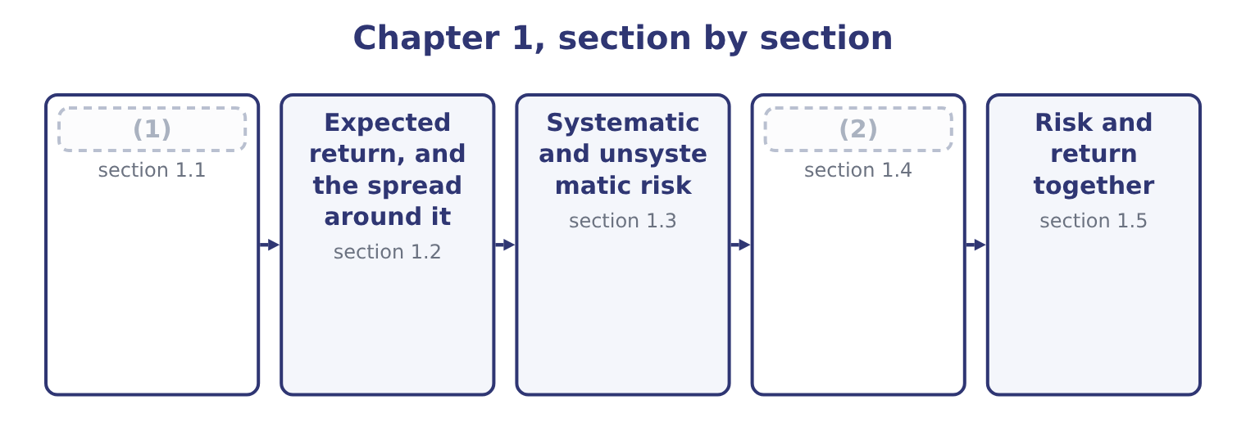
word list
Risk and return together · The four risks a treasurer names · Rates of return

Summary 1 gaps 3–11
A rate of return is what was earned, over what was put in, over a (3) period. The three parts of that (4) are where the marks are. The holding period return is the (5) and the one the exam uses most. It is the income (6) plus the change in value, over the value at the start. For an Orontes (7) in 2025: the price rose 9.25 − 7.80 = 1.45 and the (8) was 0.0556, so the return is 1.45 + 0.0556 = 1.5056 on an opening 7.80, which is 1.5056 ÷ 7.80 = 19.30 per cent. Where the period is not a year, the return has to be annualised before it can be (9) with anything. A return of 19.30 per cent over two years is not 19.30 per cent a year; (10) makes it 1.1930 (11) to the power of one half, which is 9.22 per cent a year.
word list
sentence · received · compared · through · compounding · dividend · simplest · shareholder · raised · stated

Summary 2 gaps 12–21
Where the period is (12) than a year the same (13) runs the other way: 2 per cent over a quarter (14) to 8.24 per cent a year, not 8. (15) a series of returns has the same trap in a (16) form. The arithmetic mean of +40 per cent and −30 per cent is 5 per cent, and an investor who lived through those two years has lost money: 1.40 × 0.70 = 0.98, so one (17) became 98 cents and the true compound return is about minus 1 per cent a year. The geometric mean is the (18) figure for a series of returns actually earned; the arithmetic mean is the right figure for a single period drawn at (19) from the same distribution, which is why both (20) in the exam and why the question (21) says.
word list
Averaging · always · honest · dollar · appear · sharper · shorter · compounds · random · relationship · holding

Four rates of return, and when each is right
Measure | Computation | Use it for
Holding period return | Income plus price change, over opening value | (22)
Annualised return | The holding period return compounded to a year | (23)
Arithmetic mean | The simple average of the periods | (24)
Geometric mean | (25) | What an investor actually earned

word list
Comparing periods of different lengths · One period, any length · Income plus price change, over opening value · One period drawn from the same distribution · The compound rate that links start to finish

Summary 3 gaps 26–32
Finally, a return (26) in money of the day is a nominal return, and what it buys (27) on inflation. The real return (28) one by the other: at 19.30 per cent nominal and 4 per cent inflation, 1.1930 ÷ 1.04 = 1.1471, so the real return is 14.71 per cent. The approximation that every (29) reaches for, 19.30 − 4.00 = 15.30 per cent, is close (30) at these rates and wrong by a (31) point when rates are high — which is (32) when the question asks.
word list
depends · shareholder · quoted · exactly · percentage · enough · candidate · divides

Say which period and which basis

Summary 4 gaps 33–36
A return with no period attached is (33) . Geometric for a series lived through, arithmetic for a single (34) period. The question will tell you; the (35) will not. Nominal less inflation is an approximation. Where the question gives both rates to one decimal, use the (36) .
word list
meaningless · expected · figures · nominal · division

The English this section uses, and its Arabic
Each term sits against what it means.
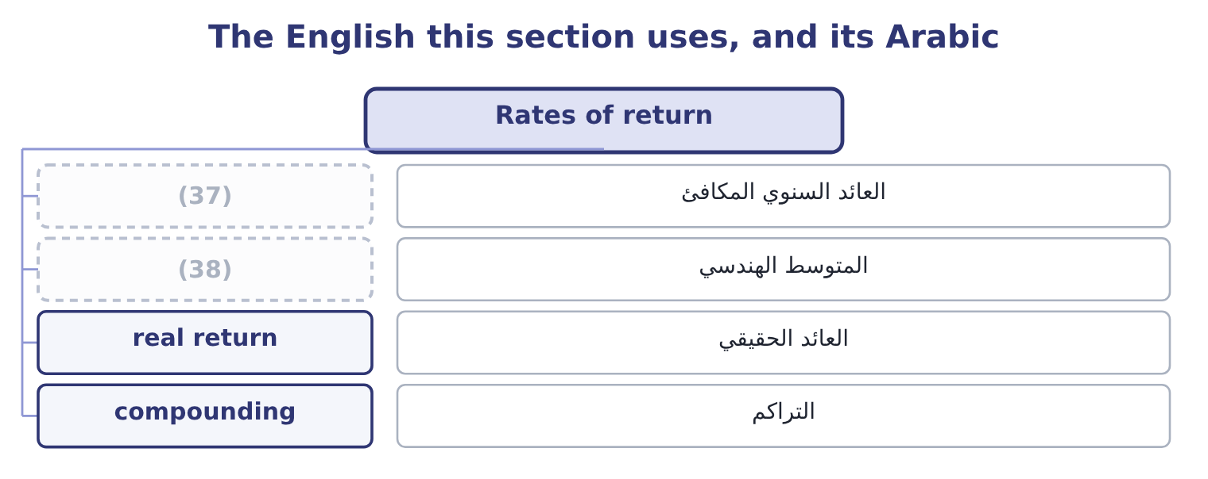
word list
geometric mean · annualised return · standard deviation

The English this sheet uses, and its Arabic
English (exam term) | Arabic
annualised return | العائد السنوي المكافئ
geometric mean | المتوسط الهندسي
real return | العائد الحقيقي
compounding | التراكم

Answer key · 1.1 Rates of return

1 Rates of return | 20 appear
2 The four risks a treasurer names | 21 always
3 stated | 22 One period, any length
4 sentence | 23 Comparing periods of different lengths
5 simplest | 24 One period drawn from the same distribution
6 received | 25 The compound rate that links start to finish
7 shareholder | 26 quoted
8 dividend | 27 depends
9 compared | 28 divides
10 compounding | 29 candidate
11 raised | 30 enough
12 shorter | 31 percentage
13 relationship | 32 exactly
14 compounds | 33 meaningless
15 Averaging | 34 expected
16 sharper | 35 figures
17 dollar | 36 division
18 honest | 37 annualised return
19 random | 38 geometric mean

the summaries in full
Summary 1 A rate of return is what was earned, over what was put in, over a stated period. The three parts of that sentence are where the marks are. The holding period return is the simplest and the one the exam uses most. It is the income received plus the change in value, over the value at the start. For an Orontes shareholder in 2025: the price rose 9.25 − 7.80 = 1.45 and the dividend was 0.0556, so the return is 1.45 + 0.0556 = 1.5056 on an opening 7.80, which is 1.5056 ÷ 7.80 = 19.30 per cent. Where the period is not a year, the return has to be annualised before it can be compared with anything. A return of 19.30 per cent over two years is not 19.30 per cent a year; compounding makes it 1.1930 raised to the power of one half, which is 9.22 per cent a year.
Summary 2 Where the period is shorter than a year the same relationship runs the other way: 2 per cent over a quarter compounds to 8.24 per cent a year, not 8. Averaging a series of returns has the same trap in a sharper form. The arithmetic mean of +40 per cent and −30 per cent is 5 per cent, and an investor who lived through those two years has lost money: 1.40 × 0.70 = 0.98, so one dollar became 98 cents and the true compound return is about minus 1 per cent a year. The geometric mean is the honest figure for a series of returns actually earned; the arithmetic mean is the right figure for a single period drawn at random from the same distribution, which is why both appear in the exam and why the question always says.
Summary 3 Finally, a return quoted in money of the day is a nominal return, and what it buys depends on inflation. The real return divides one by the other: at 19.30 per cent nominal and 4 per cent inflation, 1.1930 ÷ 1.04 = 1.1471, so the real return is 14.71 per cent. The approximation that every candidate reaches for, 19.30 − 4.00 = 15.30 per cent, is close enough at these rates and wrong by a percentage point when rates are high — which is exactly when the question asks.
Summary 4 A return with no period attached is meaningless. Geometric for a series lived through, arithmetic for a single expected period. The question will tell you; the figures will not. Nominal less inflation is an approximation. Where the question gives both rates to one decimal, use the division.

1.2 Expected return, and the spread around it
Chapter 1 · section 1.2

Fill every gap. Each word list holds one word more than there are gaps.
Summary 1 gaps 1–10
A return that has happened is a fact. A return that has not happened yet is a distribution, and the exam (1) it with a short list of outcomes and their probabilities. The expected return is the (2) average of the outcomes. (3) a project whose return is 25 per cent if the (4) is good, 10 per cent if it is (5) and minus 5 per cent if it fails, with probabilities of 0.2, 0.5 and 0.3. Then 0.2 × 25 = 5.0, 0.5 × 10 = 5.0 and 0.3 × 5 = 1.5 in the other (6) , so the expected return is 5.0 + 5.0 − 1.5 = 8.5 per cent. (7) earns 8.5 per cent. The expected return is the centre of the distribution and not a (8) of any single year, which is why it must (9) be quoted with a (10) of how wide the distribution is.
word list
harvest · ordinary · Consider · measure · Nobody · describes · whenever · probability-weighted · direction · forecast · always

Worked example: the spread, and what it is worth knowing

Summary 2 gaps 11–19
Each (11) distance from the 8.5 per cent (12) : 25.0 − 8.5 = 16.5, then 10.0 − 8.5 = 1.5, then an outcome of minus 5 which is 13.5 below the mean. Square each deviation and weight it by its (13) : 0.2 × 272.25 = 54.45, 0.5 × 2.25 = 1.125 and 0.3 × 182.25 = 54.675. The three add to 110.25. The standard deviation and the coefficient of variation. The square root of 110.25 is 10.5 (14) points. (15) against the expected return, the coefficient of variation is 10.5 ÷ 8.5 = 1.24. Two projects with the same expected return are not the same project. The standard deviation says how far a single year is (16) to fall from the centre; the coefficient of variation (17) that spread by the size of the return, which is what lets a small project be (18) with a large one. The exam asks for the coefficient whenever the two projects (19) in size, and for the standard deviation whenever they do not.
word list
outcome's · scales · distance · probability · percentage · likely · differ · compared · Expressed · expectation

The expected return and its spread
The bars are drawn to scale.
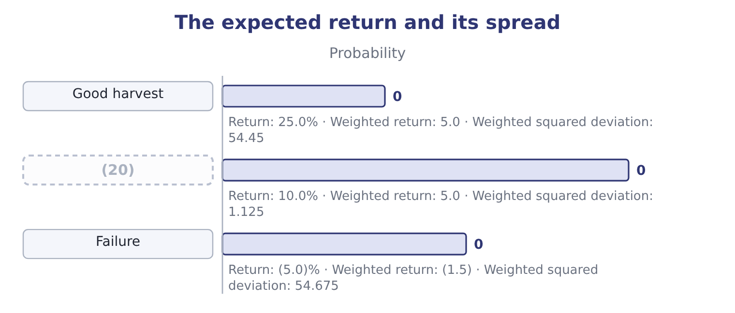
word list
Ordinary · hedge

The English this section uses, and its Arabic
Each term sits against what it means.
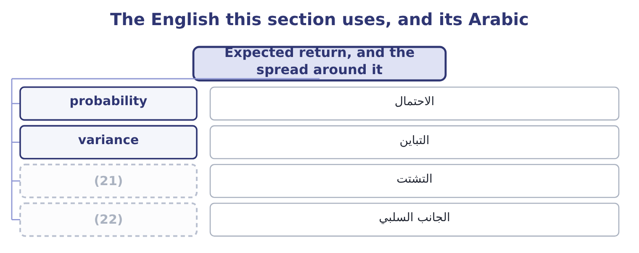
word list
downside · probability · dispersion

The English this sheet uses, and its Arabic
English (exam term) | Arabic
probability | الاحتمال
variance | التباين
dispersion | التشتت
downside | الجانب السلبي

Answer key · 1.2 Expected return, and the spread around it

1 describes | 12 expectation
2 probability-weighted | 13 probability
3 Consider | 14 percentage
4 harvest | 15 Expressed
5 ordinary | 16 likely
6 direction | 17 scales
7 Nobody | 18 compared
8 forecast | 19 differ
9 always | 20 Ordinary
10 measure | 21 dispersion
11 outcome's | 22 downside

the summaries in full
Summary 1 A return that has happened is a fact. A return that has not happened yet is a distribution, and the exam describes it with a short list of outcomes and their probabilities. The expected return is the probability-weighted average of the outcomes. Consider a project whose return is 25 per cent if the harvest is good, 10 per cent if it is ordinary and minus 5 per cent if it fails, with probabilities of 0.2, 0.5 and 0.3. Then 0.2 × 25 = 5.0, 0.5 × 10 = 5.0 and 0.3 × 5 = 1.5 in the other direction, so the expected return is 5.0 + 5.0 − 1.5 = 8.5 per cent. Nobody earns 8.5 per cent. The expected return is the centre of the distribution and not a forecast of any single year, which is why it must always be quoted with a measure of how wide the distribution is.
Summary 2 Each outcome's distance from the 8.5 per cent expectation: 25.0 − 8.5 = 16.5, then 10.0 − 8.5 = 1.5, then an outcome of minus 5 which is 13.5 below the mean. Square each deviation and weight it by its probability: 0.2 × 272.25 = 54.45, 0.5 × 2.25 = 1.125 and 0.3 × 182.25 = 54.675. The three add to 110.25. The standard deviation and the coefficient of variation. The square root of 110.25 is 10.5 percentage points. Expressed against the expected return, the coefficient of variation is 10.5 ÷ 8.5 = 1.24. Two projects with the same expected return are not the same project. The standard deviation says how far a single year is likely to fall from the centre; the coefficient of variation scales that spread by the size of the return, which is what lets a small project be compared with a large one. The exam asks for the coefficient whenever the two projects differ in size, and for the standard deviation whenever they do not.

1.3 Systematic and unsystematic risk
Chapter 1 · section 1.3

Fill every gap. Each word list holds one word more than there are gaps.
Summary 1 gaps 1–12
Not all risk is the same kind, and the difference (1) whether an investor is paid for carrying it. Unsystematic risk, also called company-specific or diversifiable risk, belongs to one company or one (2) . A fire in (3) plant, a recall of one product, the loss of its largest customer, a strike, a lawsuit, the (4) of a chief executive. These (5) are independent across companies: a fire at Orontes tells you (6) about a fire at a glass works in Amman. Systematic risk, also called market risk or non-diversifiable risk, belongs to the (7) . A rise in (8) rates, a recession, a tax change, a war, a (9) crisis. Every company is affected, in (10) degrees but in the same (11) . The (12) is the most important sentence in Section B. Because unsystematic risk is independent across companies, holding many companies at once makes most of it disappear: the fire at one is offset by the good year at another.
word list
nothing · consequence · events · economy · interest · different · currency · decides · industry · departure · Orontes's · company's · direction

Summary 2 gaps 13–21
Systematic risk cannot be (13) by holding more companies, because it moves them all (14) . So an investor who can diversify will not pay to avoid unsystematic risk — and will not be paid for (15) it. Only systematic risk (16) a reward. A (17) management sees it (18) , and the exam tests the difference. A diversified (19) does not care about the fire; the chief executive, the (20) and the lender very much do, because they cannot diversify their exposure to this one company. That is why companies buy insurance and (21) currencies when, on a strict reading of portfolio theory, their shareholders need neither.
word list
carries · differently · removed · company's · hedge · shareholder · bearing · together · non-diversifiable · workforce

Diversifiable means unpaid

Summary 3 gaps 22–26
A risk that can be diversified away earns no premium, however (22) it is to the company carrying it. Diversification (23) unsystematic risk; it does not (24) risk. A portfolio of a (25) shares still falls in a recession. The (26) is about the source of the risk, not its size. A large company-specific risk is still unsystematic.
word list
reduces · frightening · hundred · distinction · bearing · eliminate

The two kinds of risk
 | Unsystematic risk | Systematic risk
Also called | (27) | Market risk, non-diversifiable
Examples | Fire, recall, strike, lawsuit, a lost customer | (28)
Removable by diversification? | Yes, almost entirely | No
Rewarded by the market? | No | Yes
Who still cares | (29) | Everybody

word list
Company-specific, diversifiable · Managers, employees, lenders · Recession, rates, inflation, tax, war · credit risk

The English this section uses, and its Arabic
Each term sits against what it means.
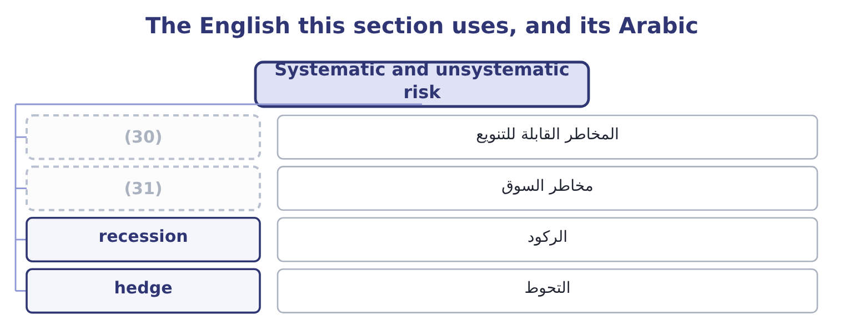
word list
market risk · standard deviation · diversifiable risk

The English this sheet uses, and its Arabic
English (exam term) | Arabic
diversifiable risk | المخاطر القابلة للتنويع
market risk | مخاطر السوق
recession | الركود
hedge | التحوط

Answer key · 1.3 Systematic and unsystematic risk

1 decides | 17 company's
2 industry | 18 differently
3 Orontes's | 19 shareholder
4 departure | 20 workforce
5 events | 21 hedge
6 nothing | 22 frightening
7 economy | 23 reduces
8 interest | 24 eliminate
9 currency | 25 hundred
10 different | 26 distinction
11 direction | 27 Company-specific, diversifiable
12 consequence | 28 Recession, rates, inflation, tax, war
13 removed | 29 Managers, employees, lenders
14 together | 30 diversifiable risk
15 bearing | 31 market risk
16 carries

the summaries in full
Summary 1 Not all risk is the same kind, and the difference decides whether an investor is paid for carrying it. Unsystematic risk, also called company-specific or diversifiable risk, belongs to one company or one industry. A fire in Orontes's plant, a recall of one product, the loss of its largest customer, a strike, a lawsuit, the departure of a chief executive. These events are independent across companies: a fire at Orontes tells you nothing about a fire at a glass works in Amman. Systematic risk, also called market risk or non-diversifiable risk, belongs to the economy. A rise in interest rates, a recession, a tax change, a war, a currency crisis. Every company is affected, in different degrees but in the same direction. The consequence is the most important sentence in Section B. Because unsystematic risk is independent across companies, holding many companies at once makes most of it disappear: the fire at one is offset by the good year at another.
Summary 2 Systematic risk cannot be removed by holding more companies, because it moves them all together. So an investor who can diversify will not pay to avoid unsystematic risk — and will not be paid for bearing it. Only systematic risk carries a reward. A company's management sees it differently, and the exam tests the difference. A diversified shareholder does not care about the fire; the chief executive, the workforce and the lender very much do, because they cannot diversify their exposure to this one company. That is why companies buy insurance and hedge currencies when, on a strict reading of portfolio theory, their shareholders need neither.
Summary 3 A risk that can be diversified away earns no premium, however frightening it is to the company carrying it. Diversification reduces unsystematic risk; it does not eliminate risk. A portfolio of a hundred shares still falls in a recession. The distinction is about the source of the risk, not its size. A large company-specific risk is still unsystematic.

1.4 The four risks a treasurer names
Chapter 1 · section 1.4

Fill every gap. Each word list holds one word more than there are gaps.
Summary 1 gaps 1–12
The (1) names four risks (2) , and each of them can be (3) at in Orontes's own statements. Credit risk is the risk that (4) who owes money does not pay. Orontes carries $4,144,000 of receivables net of an allowance of $156,000, which is the (5) own estimate of the credit risk it is running on its (6) . A (7) carries the same risk the other way round, which is why. Foreign exchange risk is the risk that a rate moves against a position. Orontes (8) sesame, so a fall in the (9) raises its input cost and (10) the gross margin that Book 1 spent a chapter on. There are three kinds, and the exam separates them: (11) exposure on a contract already struck, translation exposure on the statements of a foreign subsidiary, and economic exposure on the long-run (12) of the business.
word list
company's · pointed · dollar · somebody · squeezes · transaction · lender · exchange · outcome · imports · specifically · competitiveness · customers

Summary 2 gaps 13–21
Interest rate risk is the risk that a change in rates (13) the value of an instrument or the cost of a (14) . Orontes has $6,000,000 of long-term debt and $400,000 of it due (15) the year, so a rate rise reaches it at (16) rather than (17) . A (18) meets the same risk as a fall in price. Market risk, in the (19) sense used here, is the risk that the price of a traded instrument moves. Orontes holds $42,000 of trading securities and $88,500 of debt securities, and the $4,000 of (20) gains in its income (21) is market risk showing up in reported profit.
word list
business · unrealised · immediately · narrow · borrowing · statement · within · bondholder · refinancing · changes

Four risks, and where each one touches Orontes
Risk | What it is | Orontes's exposure | Managed by
Credit risk | (22) | Receivables of 4,144,000 | Credit policy, allowance, factoring
Foreign exchange risk | A rate moves against a position | Imported sesame; any foreign sale | (23)
Interest rate risk | (24) | 6,000,000 of long-term debt | Fixed rates, swaps, maturity choice
Market risk | A traded price moves | 42,000 of trading securities | (25)

word list
A counterparty does not pay · Rates change value or cost · Receivables of 4,144,000 · Position size, maturity, quality · Forwards, matching, pricing

The English this section uses, and its Arabic
Each term sits against what it means.
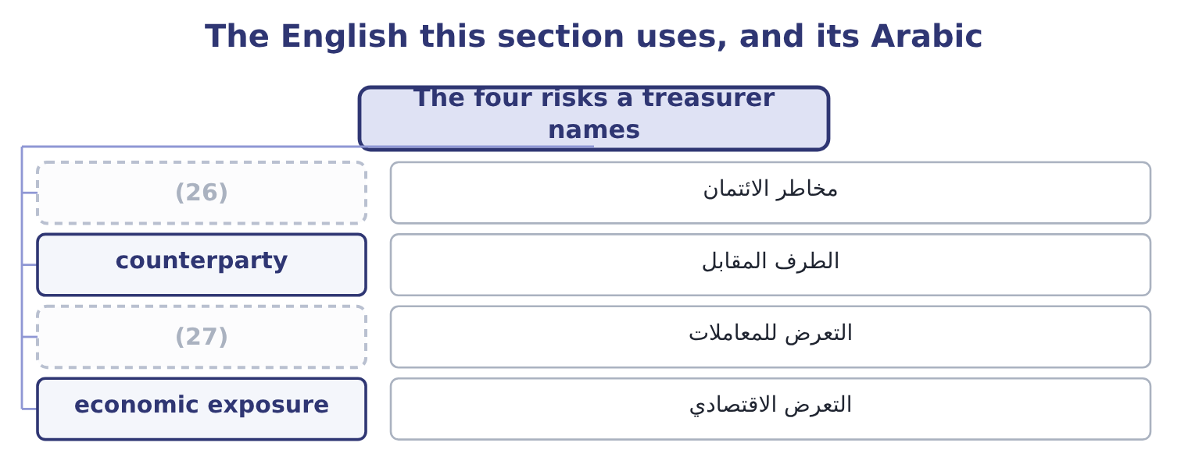
word list
diversifiable risk · credit risk · transaction exposure

The English this sheet uses, and its Arabic
English (exam term) | Arabic
credit risk | مخاطر الائتمان
counterparty | الطرف المقابل
transaction exposure | التعرض للمعاملات
economic exposure | التعرض الاقتصادي

Answer key · 1.4 The four risks a treasurer names

1 outcome | 15 within
2 specifically | 16 refinancing
3 pointed | 17 immediately
4 somebody | 18 bondholder
5 company's | 19 narrow
6 customers | 20 unrealised
7 lender | 21 statement
8 imports | 22 A counterparty does not pay
9 dollar | 23 Forwards, matching, pricing
10 squeezes | 24 Rates change value or cost
11 transaction | 25 Position size, maturity, quality
12 competitiveness | 26 credit risk
13 changes | 27 transaction exposure
14 borrowing

the summaries in full
Summary 1 The outcome names four risks specifically, and each of them can be pointed at in Orontes's own statements. Credit risk is the risk that somebody who owes money does not pay. Orontes carries $4,144,000 of receivables net of an allowance of $156,000, which is the company's own estimate of the credit risk it is running on its customers. A lender carries the same risk the other way round, which is why. Foreign exchange risk is the risk that a rate moves against a position. Orontes imports sesame, so a fall in the dollar raises its input cost and squeezes the gross margin that Book 1 spent a chapter on. There are three kinds, and the exam separates them: transaction exposure on a contract already struck, translation exposure on the statements of a foreign subsidiary, and economic exposure on the long-run competitiveness of the business.
Summary 2 Interest rate risk is the risk that a change in rates changes the value of an instrument or the cost of a borrowing. Orontes has $6,000,000 of long-term debt and $400,000 of it due within the year, so a rate rise reaches it at refinancing rather than immediately. A bondholder meets the same risk as a fall in price. Market risk, in the narrow sense used here, is the risk that the price of a traded instrument moves. Orontes holds $42,000 of trading securities and $88,500 of debt securities, and the $4,000 of unrealised gains in its income statement is market risk showing up in reported profit.

1.5 Risk and return together
Chapter 1 · section 1.5

Fill every gap. Each word list holds one word more than there are gaps.
Summary 1 gaps 1–12
The (1) between risk and return is not a (2) observed in the data. It is a (3) for a market to clear. If two assets (4) the same return and one was riskier, nobody would hold the riskier one, and its price would fall until its return rose enough to (5) a buyer. Risk and return move (6) because prices make them. A required return is a risk-free rate plus a premium for the risk (7) . The risk-free rate is what a lender earns with no credit risk and no (8) uncertainty over the period — in (9) a government security of matching maturity. It (10) for two things only: waiting, and expected inflation. The risk premium is (11) else, and it is (12) to the asset. A corporate bond pays more than a treasury because the company may default.
word list
relationship · compensates · reinvestment · specific · attract · everything · tendency · practice · condition · offered · shareholders · carried · together

Summary 2 gaps 13–21
A share pays more than the company's own bond because the (13) is paid last. A small company pays more than a large one, and an (14) asset more than a liquid one. Orontes's own (15) show the ladder. The company (16) from Levant (17) Bank at 6 per cent. Book 1 charged its shareholders 10 per cent as a required return when it (18) economic profit, and the shareholders (19) earned 19.30 per cent in 2025. The gap between 6 and 10 is the price of (20) behind the lender; the gap between 10 and 19.30 is the year (21) out well.
word list
statements · shareholder · computed · illiquid · standing · risk-averse · actually · Commerce · turning · borrows

The required-return ladder
Claim | Required return | Why it sits there
Government security | 3% to 4% | (22)
Senior secured bank debt | 6% | (23)
Unsecured corporate bond | 7% to 8% | (24)
Preferred stock | 9% | Paid after debt; dividend not contractual
Common equity | 10% and above | (25)

word list
Waiting and expected inflation only · Default risk, with security and covenants · Default risk, no security · Geometric mean of +50% then −40% · Paid last, and only what is left

Summary 3 gaps 26–35
Two (26) close the chapter, and both are (27) . The first is that a company's cost of capital is its (28) ' required return seen from the other side. Every rate in that ladder is a cost to Orontes and a return to (29) . The second is that risk (30) is a matter of degree, not of (31) . A risk-averse investor is not one who (32) risk; it is one who (33) compensation for it. An investor who required no compensation would be (34) , and an investor who paid for risk would be (35) — which is a fair description of a lottery ticket and of nothing a company should be doing with its shareholders' money.
word list
refuses · somebody · risk-neutral · examined · principle · expected · investors · aversion · consequences · risk-seeking · requires

Compute the returns and the spread

Your turn: returns and risk (complete the blanks)
Item | Data | Answer
Holding period return | (36) | 19.00 per cent: 23.00 − 20.00 = 3.00 of price gain, plus 0.80 of dividend, and 3.80 ÷ 20.00 = 19.00 per cent.
Real return | Nominal 12.0 per cent, inflation 5.0 per cent | (37) : 1.1200 ÷ 1.05 = 1.0667.
Geometric mean of +50% then −40% | (38) | A loss: 1.50 × 0.60 = 0.90, so one dollar became 90 cents, about minus 5.1 per cent a year.
Expected return | 30% at 0.3, 10% at 0.4, (10)% at 0.3 | (39) : 0.3 × 30 = 9.0, 0.4 × 10 = 4.0, and 0.3 × 10 = 3.0 in the other direction, so 9.0 + 4.0 − 3.0 = 10.0.
Standard deviation | The same three outcomes | 15.49 points: the weighted squared deviations are 0.3 × 400 = 120, nil for the middle outcome, and 0.3 × 400 = 120, giving a variance of 240
Coefficient of variation | The same three outcomes | (40) : 15.49 ÷ 10.0.

word list
Two years · 10.0 per cent · 6.67 per cent · 1.549 · Bought 20.00, dividend 0.80, sold 23.00 · Paid after debt; dividend not contractual

"Risk"

Summary 4 gaps 41–46
English risk in finance is neutral: it means the (41) of possible outcomes, good and bad alike, and an asset whose return might be far above (42) is risky in exactly the sense meant here. (43) English uses the word only for the bad half, and that is the reading (44) import by mistake. Note the phrase risk-averse: it does not mean (45) risk, it means (46) payment for it.
word list
requiring · candidates · expectations · refusing · Everyday · statements · dispersion

The English this section uses, and its Arabic
Each term sits against what it means.
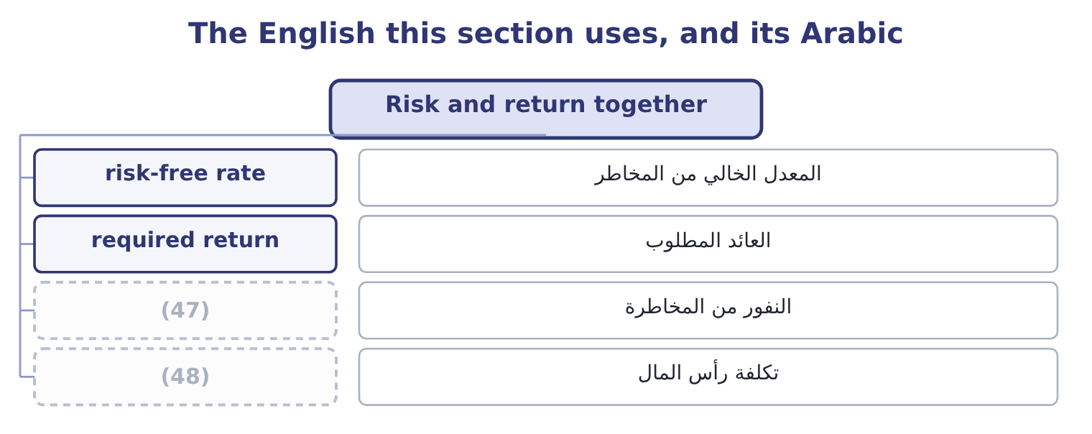
word list
risk aversion · cost of capital · العائد المطلوب

The English this sheet uses, and its Arabic
English (exam term) | Arabic
risk-free rate | المعدل الخالي من المخاطر
required return | العائد المطلوب
risk aversion | النفور من المخاطرة
cost of capital | تكلفة رأس المال

Answer key · 1.5 Risk and return together

1 relationship | 25 Paid last, and only what is left
2 tendency | 26 consequences
3 condition | 27 examined
4 offered | 28 investors
5 attract | 29 somebody
6 together | 30 aversion
7 carried | 31 principle
8 reinvestment | 32 refuses
9 practice | 33 requires
10 compensates | 34 risk-neutral
11 everything | 35 risk-seeking
12 specific | 36 Bought 20.00, dividend 0.80, sold 23.00
13 shareholder | 37 6.67 per cent
14 illiquid | 38 Two years
15 statements | 39 10.0 per cent
16 borrows | 40 1.549
17 Commerce | 41 dispersion
18 computed | 42 expectations
19 actually | 43 Everyday
20 standing | 44 candidates
21 turning | 45 refusing
22 Waiting and expected inflation only | 46 requiring
23 Default risk, with security and covenants | 47 risk aversion
24 Default risk, no security | 48 cost of capital

the summaries in full
Summary 1 The relationship between risk and return is not a tendency observed in the data. It is a condition for a market to clear. If two assets offered the same return and one was riskier, nobody would hold the riskier one, and its price would fall until its return rose enough to attract a buyer. Risk and return move together because prices make them. A required return is a risk-free rate plus a premium for the risk carried. The risk-free rate is what a lender earns with no credit risk and no reinvestment uncertainty over the period — in practice a government security of matching maturity. It compensates for two things only: waiting, and expected inflation. The risk premium is everything else, and it is specific to the asset. A corporate bond pays more than a treasury because the company may default.
Summary 2 A share pays more than the company's own bond because the shareholder is paid last. A small company pays more than a large one, and an illiquid asset more than a liquid one. Orontes's own statements show the ladder. The company borrows from Levant Commerce Bank at 6 per cent. Book 1 charged its shareholders 10 per cent as a required return when it computed economic profit, and the shareholders actually earned 19.30 per cent in 2025. The gap between 6 and 10 is the price of standing behind the lender; the gap between 10 and 19.30 is the year turning out well.
Summary 3 Two consequences close the chapter, and both are examined. The first is that a company's cost of capital is its investors' required return seen from the other side. Every rate in that ladder is a cost to Orontes and a return to somebody. The second is that risk aversion is a matter of degree, not of principle. A risk-averse investor is not one who refuses risk; it is one who requires compensation for it. An investor who required no compensation would be risk-neutral, and an investor who paid for risk would be risk-seeking — which is a fair description of a lottery ticket and of nothing a company should be doing with its shareholders' money.
Summary 4 English risk in finance is neutral: it means the dispersion of possible outcomes, good and bad alike, and an asset whose return might be far above expectations is risky in exactly the sense meant here. Everyday English uses the word only for the bad half, and that is the reading candidates import by mistake. Note the phrase risk-averse: it does not mean refusing risk, it means requiring payment for it.

