2.1 From one security to a portfolio
Chapter 2 · section 2.1

Fill every gap. Each word list holds one word more than there are gaps.
Chapter 2, section by section
Each stage leads to the next.
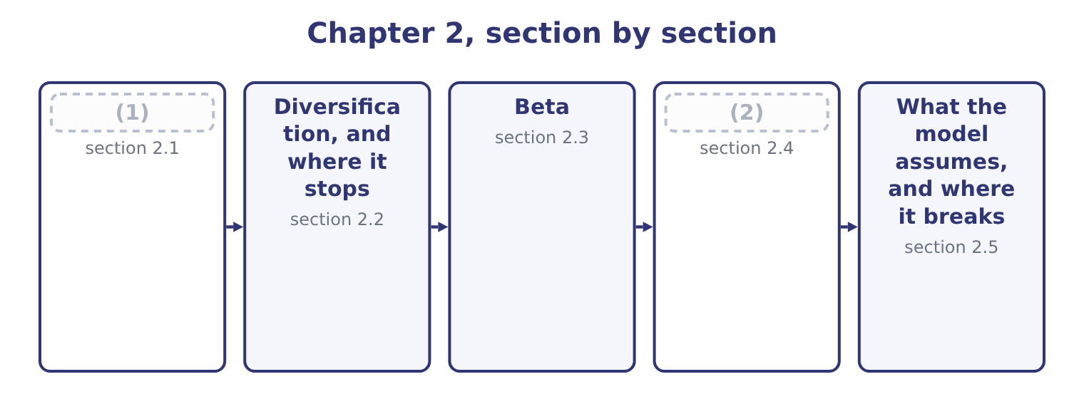
word list
From one security to a portfolio · Diversification, and where it stops · The Capital Asset Pricing Model

Summary 1 gaps 3–11
The expected return of a portfolio is the weighted average of the expected (3) of what is in it. Put 60 per cent of the money into a share expected to return 12 per cent and 40 per cent into one expected to return 8 per cent: 0.6 × 12 = 7.2 and 0.4 × 8 = 3.2, so the portfolio (4) 7.2 + 3.2 = 10.4 per cent. The risk of a portfolio is not the weighted average of the risks, and that (5) fact is the (6) of modern finance. It is less, (7) the two assets move in (8) step. The (9) is that when one is having a bad year the other may be having a good one, and the two (10) cancel. How much they cancel is (11) by the correlation coefficient, which runs from minus one to plus one.
word list
single · returns · reason · expects · measured · foundation · perfect · floor · unless · partly

Summary 2 gaps 12–13
At plus one the two move in exact (12) and nothing cancels. At zero they are (13) . At minus one they are mirror images and, in the right proportions, cancel exactly.
word list
unrelated · proportion · expects

Worked example: the same two shares, three correlations

Summary 3 gaps 14–19
Sixty per cent in a share with a standard deviation of 20 points and forty per cent in one with 10 points. The contributions are 0.6 × 20 = 12 and 0.4 × 10 = 4. Nothing (14) , so the portfolio's standard deviation is the weighted average: 12 + 4 = 16 points. The squared contributions add (15) : 12 squared is 144 and 4 squared is 16, so the variance is 144 + 16 = 160 and the standard deviation is 12.65 points. The contributions offset (16) : 12 − 4 = 8 points. The expected return is 10.4 per cent in all three cases, (17) correlation does not touch the return. Only the risk moved, from 16 points to 8, and the (18) paid nothing for the improvement. That free improvement is what the word (19) means, and it is the only free thing in finance.
word list
weight · directly · investor · because · offsets · instead · diversification

One portfolio, three correlations
The bars are drawn to scale.
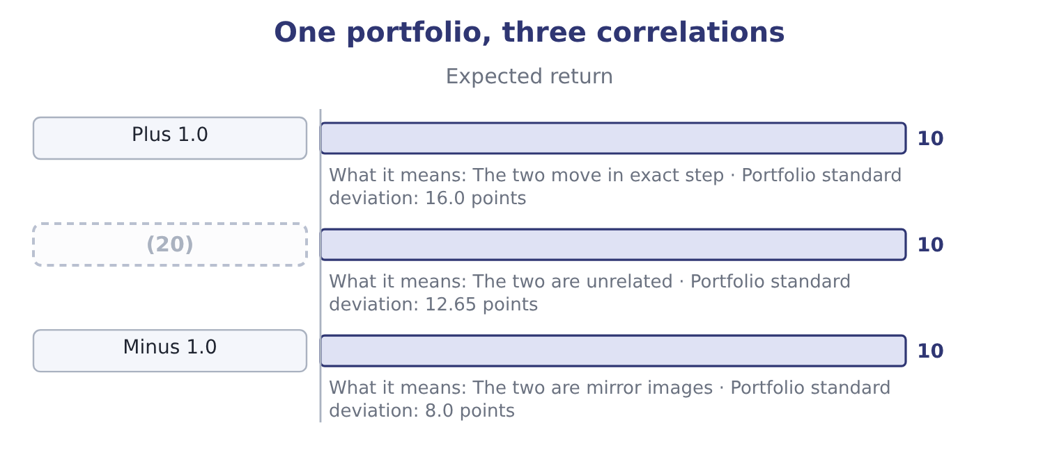
word list
Zero · equilibrium

Returns average, risks do not

Summary 4 gaps 21–25
A portfolio's expected return is (21) the weighted average. Its standard deviation is the weighted average only at a correlation of exactly plus one, and is lower (22) . Correlation of zero does not mean no risk. The variance still adds. Covariance and correlation measure the same (23) . The correlation coefficient is the covariance scaled to run (24) minus one and plus one, which is why the exam (25) it.
word list
between · otherwise · quotes · relationship · regression · always

The English this section uses, and its Arabic
Each term sits against what it means.
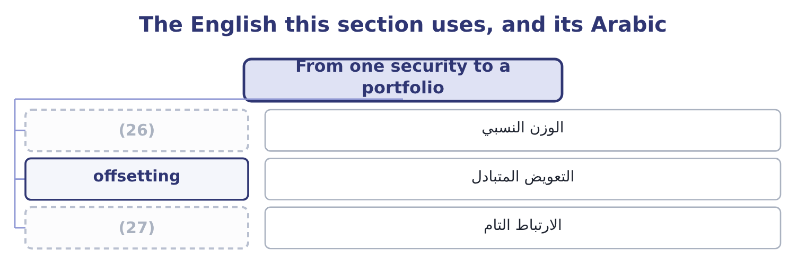
word list
الوزن النسبي · perfect correlation · weight

The English this sheet uses, and its Arabic
English (exam term) | Arabic
weight | الوزن النسبي
offsetting | التعويض المتبادل
perfect correlation | الارتباط التام

Answer key · 2.1 From one security to a portfolio

1 From one security to a portfolio | 15 instead
2 The Capital Asset Pricing Model | 16 directly
3 returns | 17 because
4 expects | 18 investor
5 single | 19 diversification
6 foundation | 20 Zero
7 unless | 21 always
8 perfect | 22 otherwise
9 reason | 23 relationship
10 partly | 24 between
11 measured | 25 quotes
12 proportion | 26 weight
13 unrelated | 27 perfect correlation
14 offsets

the summaries in full
Summary 1 The expected return of a portfolio is the weighted average of the expected returns of what is in it. Put 60 per cent of the money into a share expected to return 12 per cent and 40 per cent into one expected to return 8 per cent: 0.6 × 12 = 7.2 and 0.4 × 8 = 3.2, so the portfolio expects 7.2 + 3.2 = 10.4 per cent. The risk of a portfolio is not the weighted average of the risks, and that single fact is the foundation of modern finance. It is less, unless the two assets move in perfect step. The reason is that when one is having a bad year the other may be having a good one, and the two partly cancel. How much they cancel is measured by the correlation coefficient, which runs from minus one to plus one.
Summary 2 At plus one the two move in exact proportion and nothing cancels. At zero they are unrelated. At minus one they are mirror images and, in the right proportions, cancel exactly.
Summary 3 Sixty per cent in a share with a standard deviation of 20 points and forty per cent in one with 10 points. The contributions are 0.6 × 20 = 12 and 0.4 × 10 = 4. Nothing offsets, so the portfolio's standard deviation is the weighted average: 12 + 4 = 16 points. The squared contributions add instead: 12 squared is 144 and 4 squared is 16, so the variance is 144 + 16 = 160 and the standard deviation is 12.65 points. The contributions offset directly: 12 − 4 = 8 points. The expected return is 10.4 per cent in all three cases, because correlation does not touch the return. Only the risk moved, from 16 points to 8, and the investor paid nothing for the improvement. That free improvement is what the word diversification means, and it is the only free thing in finance.
Summary 4 A portfolio's expected return is always the weighted average. Its standard deviation is the weighted average only at a correlation of exactly plus one, and is lower otherwise. Correlation of zero does not mean no risk. The variance still adds. Covariance and correlation measure the same relationship. The correlation coefficient is the covariance scaled to run between minus one and plus one, which is why the exam quotes it.

2.2 Diversification, and where it stops
Chapter 2 · section 2.2

Fill every gap. Each word list holds one word more than there are gaps.
Summary 1 gaps 1–12
Add a third share to the two, then a tenth, then a (1) . Each new (2) brings its own company-specific risk and partly cancels the others', and the (3) standard deviation falls — quickly at first and then more slowly. It does not fall to zero. What is left when the company-specific risk has gone is the part every share has in (4) , which is the market (5) . A portfolio of fifty shares still falls in a recession, (6) a recession is not a company-specific event. The (7) numbers are worth (8) . Most of the (9) arrives within the first (10) or twenty holdings; beyond thirty, adding names changes very little. The risk that remains is the (11) risk of, and it is the floor. Three things limit diversification in (12) , and the exam names them.
word list
holding · fifteen · systematic · remembering · common · portfolio's · itself · conditions · fiftieth · benefit · practice · because · practical

Summary 2 gaps 13–22
Correlation is (13) low within one market. Shares in the same country and the same industry move together, so a portfolio of twenty food (14) is far less (15) than a portfolio of twenty companies in twenty industries. Diversification across (16) works until it is (17) . (18) holdings reduce risk in normal conditions, and (19) rise sharply in a crisis, which is when the protection was wanted. A company (20) on its own account is not doing its (21) a favour. A shareholder can buy shares in a glass works (22) and more cheaply than Orontes can buy the glass works. That is the standard objection to conglomerate acquisitions, and Book 3 returns to it.
word list
needed · manufacturers · diversified · correlations · rarely · shareholders · borders · diversifying · diversification · International · directly

What happens as holdings are added
Number of holdings | Total risk | What has gone | What remains
1 | (23) | Nothing | All company risk and all market risk
10 | Much lower | (24) | Market risk and some company risk
30 | Near the floor | (25) | Market risk
100 | (26) | All company-specific risk | Market risk only

word list
Most company-specific risk · sensitivity · Almost all company-specific risk · Highest · At the floor

The English this section uses, and its Arabic
Each term sits against what it means.
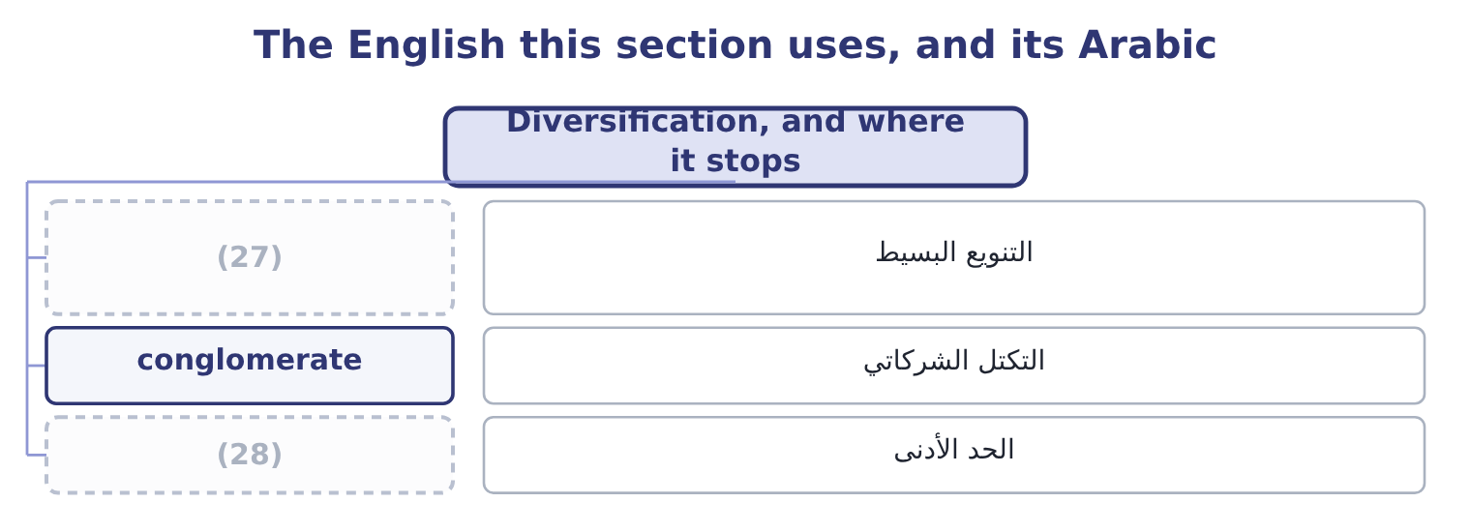
word list
covariance · floor · naive diversification

The English this sheet uses, and its Arabic
English (exam term) | Arabic
naive diversification | التنويع البسيط
conglomerate | التكتل الشركاتي
floor | الحد الأدنى

Answer key · 2.2 Diversification, and where it stops

1 fiftieth | 15 diversified
2 holding | 16 borders
3 portfolio's | 17 needed
4 common | 18 International
5 itself | 19 correlations
6 because | 20 diversifying
7 practical | 21 shareholders
8 remembering | 22 directly
9 benefit | 23 Highest
10 fifteen | 24 Most company-specific risk
11 systematic | 25 Almost all company-specific risk
12 practice | 26 At the floor
13 rarely | 27 naive diversification
14 manufacturers | 28 floor

the summaries in full
Summary 1 Add a third share to the two, then a tenth, then a fiftieth. Each new holding brings its own company-specific risk and partly cancels the others', and the portfolio's standard deviation falls — quickly at first and then more slowly. It does not fall to zero. What is left when the company-specific risk has gone is the part every share has in common, which is the market itself. A portfolio of fifty shares still falls in a recession, because a recession is not a company-specific event. The practical numbers are worth remembering. Most of the benefit arrives within the first fifteen or twenty holdings; beyond thirty, adding names changes very little. The risk that remains is the systematic risk of, and it is the floor. Three things limit diversification in practice, and the exam names them.
Summary 2 Correlation is rarely low within one market. Shares in the same country and the same industry move together, so a portfolio of twenty food manufacturers is far less diversified than a portfolio of twenty companies in twenty industries. Diversification across borders works until it is needed. International holdings reduce risk in normal conditions, and correlations rise sharply in a crisis, which is when the protection was wanted. A company diversifying on its own account is not doing its shareholders a favour. A shareholder can buy shares in a glass works directly and more cheaply than Orontes can buy the glass works. That is the standard objection to conglomerate acquisitions, and Book 3 returns to it.

2.3 Beta
Chapter 2 · section 2.3

Fill every gap. Each word list holds one word more than there are gaps.
Summary 1 gaps 1–8
If the only risk that is (1) is the part that moves with the market, then what has to be (2) is how much a given share moves with the market. That measure is beta. Beta is the sensitivity of a security's return to the return on the market as a whole. The market portfolio has a beta of 1.0 by (3) . A share with a beta of 1.5 tends to rise 15 per cent when the market rises 10 and to fall 15 when it falls 10. A share with a beta of 0.5 moves half as far in each (4) . A beta below zero is rare and means the share tends to move against the market. Three (5) matter and all three are (6) . Beta measures (7) risk only. A company can have enormous (8) risk and a low beta, because its risks have nothing to do with the economy.
word list
measured · direction · risk-free · definition · rewarded · systematic · examined · properties · company-specific

Summary 2 gaps 9–20
A gold miner is the (9) example and a (10) company in a trial is (11) . Betas are (12) additive. The beta of a portfolio is the weighted average of the betas in it: half in a share of beta 0.9 and half in one of 1.5 gives 0.5 × 0.9 = 0.45 and 0.5 × 1.5 = 0.75, so the portfolio beta is 0.45 + 0.75 = 1.20. Beta is (13) by the business and by the (14) . A company whose sales swing with the economy has a higher beta than one whose sales do not — which is why a food (15) like Orontes, (16) a staple, has a beta below 1.0 while a car maker has one above. Debt (17) it further, because the fixed interest (18) whatever the business does. That is the degree of (19) leverage of Book 1, seen in the (20) measure.
word list
driven · pharmaceutical · weighted-average · another · magnifies · standard · financial · raises · financing · conglomerate · selling · market's · manufacturer

Worked example: what a change in beta does to a price

Summary 3 gaps 21–31
A share pays a dividend of 0.60 next year, (21) at 4 per cent a year for ever. Its beta is 0.90, the (22) rate is 4 per cent and the market is (23) to return 10 per cent. The market premium is 10.0 − 4.0 = 6.0 points, and at a beta of 0.90 the premium (24) is 0.90 × 6.0 = 5.4 points, so the required return is 9.4 per cent. (25) the company (26) heavily and its beta rises to 1.20. The premium becomes 1.20 × 6.0 = 7.2 points and the required return 11.2 per cent, so the price becomes 0.60 ÷ 0.072 = 8.33. Nothing about the dividend (27) . The share fell 25 per cent because the market now (28) more to hold it, and the only thing that moved was the sensitivity of its (29) to the economy. That is the whole of what the (30) means by the (31) of a change in beta on a security's price.
word list
expected · requires · risk-free · average · impact · outcome · earned · growing · returns · borrows · changed · Suppose

What a beta says
Beta | Behaviour against the market | Typical business | Required return at rf 4%, premium 6%
1.60 | (32) | Construction, luxury goods | 13.6%
1.00 | Moves with the market | The market portfolio | 10.0%
0.90 | (33) | Food manufacturing | 9.4%
0.40 | Moves far less | (34) | 6.4%

word list
Regulated utility · risk-adjusted return · Moves 60 per cent further · Moves slightly less

The English this section uses, and its Arabic
Each term sits against what it means.
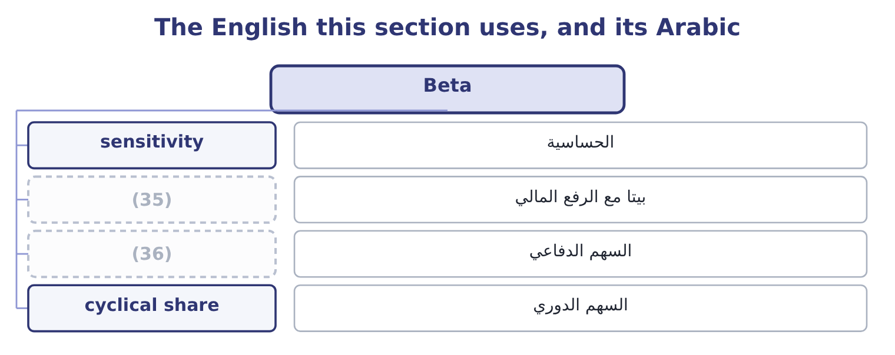
word list
السهم الدوري · levered beta · defensive share

The English this sheet uses, and its Arabic
English (exam term) | Arabic
sensitivity | الحساسية
levered beta | بيتا مع الرفع المالي
defensive share | السهم الدفاعي
cyclical share | السهم الدوري

Answer key · 2.3 Beta

1 rewarded | 19 financial
2 measured | 20 market's
3 definition | 21 growing
4 direction | 22 risk-free
5 properties | 23 expected
6 examined | 24 earned
7 systematic | 25 Suppose
8 company-specific | 26 borrows
9 standard | 27 changed
10 pharmaceutical | 28 requires
11 another | 29 returns
12 weighted-average | 30 outcome
13 driven | 31 impact
14 financing | 32 Moves 60 per cent further
15 manufacturer | 33 Moves slightly less
16 selling | 34 Regulated utility
17 raises | 35 levered beta
18 magnifies | 36 defensive share

the summaries in full
Summary 1 If the only risk that is rewarded is the part that moves with the market, then what has to be measured is how much a given share moves with the market. That measure is beta. Beta is the sensitivity of a security's return to the return on the market as a whole. The market portfolio has a beta of 1.0 by definition. A share with a beta of 1.5 tends to rise 15 per cent when the market rises 10 and to fall 15 when it falls 10. A share with a beta of 0.5 moves half as far in each direction. A beta below zero is rare and means the share tends to move against the market. Three properties matter and all three are examined. Beta measures systematic risk only. A company can have enormous company-specific risk and a low beta, because its risks have nothing to do with the economy.
Summary 2 A gold miner is the standard example and a pharmaceutical company in a trial is another. Betas are weighted-average additive. The beta of a portfolio is the weighted average of the betas in it: half in a share of beta 0.9 and half in one of 1.5 gives 0.5 × 0.9 = 0.45 and 0.5 × 1.5 = 0.75, so the portfolio beta is 0.45 + 0.75 = 1.20. Beta is driven by the business and by the financing. A company whose sales swing with the economy has a higher beta than one whose sales do not — which is why a food manufacturer like Orontes, selling a staple, has a beta below 1.0 while a car maker has one above. Debt raises it further, because the fixed interest magnifies whatever the business does. That is the degree of financial leverage of Book 1, seen in the market's measure.
Summary 3 A share pays a dividend of 0.60 next year, growing at 4 per cent a year for ever. Its beta is 0.90, the risk-free rate is 4 per cent and the market is expected to return 10 per cent. The market premium is 10.0 − 4.0 = 6.0 points, and at a beta of 0.90 the premium earned is 0.90 × 6.0 = 5.4 points, so the required return is 9.4 per cent. Suppose the company borrows heavily and its beta rises to 1.20. The premium becomes 1.20 × 6.0 = 7.2 points and the required return 11.2 per cent, so the price becomes 0.60 ÷ 0.072 = 8.33. Nothing about the dividend changed. The share fell 25 per cent because the market now requires more to hold it, and the only thing that moved was the sensitivity of its returns to the economy. That is the whole of what the outcome means by the impact of a change in beta on a security's price.

2.4 The Capital Asset Pricing Model
Chapter 2 · section 2.4

Fill every gap. Each word list holds one word more than there are gaps.
Summary 1 gaps 1–11
The model (1) the required return on any security as the risk-free rate plus beta times the market risk premium. Each of the three (2) is a question in (3) . The risk-free rate is a (4) security of (5) maturity. The market risk premium is the extra return the market as a whole is expected to earn over that rate, which is estimated from long runs of history and (6) quoted between four and six points. Beta is estimated by (7) the security's returns on the (8) , usually over five years of (9) data. Apply it to Orontes. At a risk-free rate of 4 per cent, a market premium of 6 points and a beta of 0.90, the premium (10) is 0.90 × 6.0 = 5.4 points and the required return on (11) equity is 9.4 per cent.
word list
monthly · inputs · matching · earned · typically · shareholders · states · regressing · itself · market's · government · Orontes's

Summary 2 gaps 12–23
Book 1 charged its (12) 10 per cent when it (13) economic profit, and said at the time that the figure would be (14) later. This is the (15) , and the two are close enough that the (16) there — a positive economic profit of about 1.1 million dollars — (17) either number. Drawn as a line, with beta on one axis and required return on the other, the model is the security market line. Its (18) is the risk-free rate and its slope is the market risk premium. Every (19) priced security sits on the line. A security above it (20) more return than its risk (21) and is a buy; one below it is a sell — and the act of buying and (22) moves prices until it sits on the line again, which is what the model means by (23) .
word list
requires · shareholders · correctly · equilibrium · intercept · justified · selling · outcome · conclusion · survives · computed · offers · justification

The security market line at a 4 per cent risk-free rate and a 6-point premium
The bars are drawn to scale.
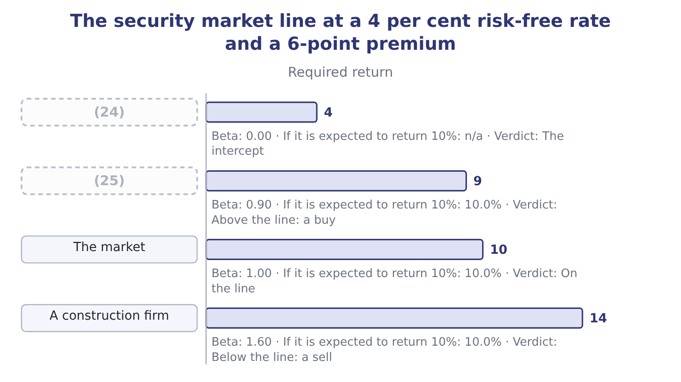
word list
Treasury bill · Orontes · defensive share

Expected against required

Summary 3 gaps 26–33
The CAPM gives the required return — what the risk (26) . The expected return is what the (27) thinks the security will (28) . The comparison of the two is the (29) decision, and a question that gives you both is asking for (30) that comparison. The market risk premium is the market return less the risk-free rate, not the market return. (31) beta by the whole market return is the commonest (32) error on this (33) . A beta of zero gives the risk-free rate, not a zero return.
word list
deliver · Multiplying · expected · arithmetic · exactly · deserves · investment · outcome · analyst

The English this section uses, and its Arabic
Each term sits against what it means.
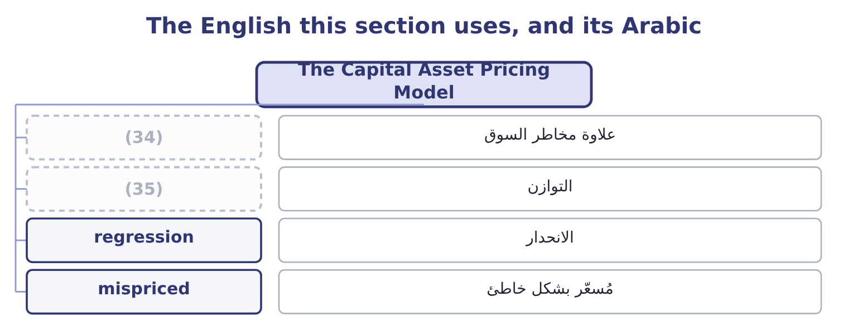
word list
portfolio · equilibrium · market risk premium

The English this sheet uses, and its Arabic
English (exam term) | Arabic
market risk premium | علاوة مخاطر السوق
equilibrium | التوازن
regression | الانحدار
mispriced | مُسعّر بشكل خاطئ

Answer key · 2.4 The Capital Asset Pricing Model

1 states | 19 correctly
2 inputs | 20 offers
3 itself | 21 requires
4 government | 22 selling
5 matching | 23 equilibrium
6 typically | 24 Treasury bill
7 regressing | 25 Orontes
8 market's | 26 deserves
9 monthly | 27 analyst
10 earned | 28 deliver
11 Orontes's | 29 investment
12 shareholders | 30 exactly
13 computed | 31 Multiplying
14 justified | 32 arithmetic
15 justification | 33 outcome
16 conclusion | 34 market risk premium
17 survives | 35 equilibrium
18 intercept

the summaries in full
Summary 1 The model states the required return on any security as the risk-free rate plus beta times the market risk premium. Each of the three inputs is a question in itself. The risk-free rate is a government security of matching maturity. The market risk premium is the extra return the market as a whole is expected to earn over that rate, which is estimated from long runs of history and typically quoted between four and six points. Beta is estimated by regressing the security's returns on the market's, usually over five years of monthly data. Apply it to Orontes. At a risk-free rate of 4 per cent, a market premium of 6 points and a beta of 0.90, the premium earned is 0.90 × 6.0 = 5.4 points and the required return on Orontes's equity is 9.4 per cent.
Summary 2 Book 1 charged its shareholders 10 per cent when it computed economic profit, and said at the time that the figure would be justified later. This is the justification, and the two are close enough that the conclusion there — a positive economic profit of about 1.1 million dollars — survives either number. Drawn as a line, with beta on one axis and required return on the other, the model is the security market line. Its intercept is the risk-free rate and its slope is the market risk premium. Every correctly priced security sits on the line. A security above it offers more return than its risk requires and is a buy; one below it is a sell — and the act of buying and selling moves prices until it sits on the line again, which is what the model means by equilibrium.
Summary 3 The CAPM gives the required return — what the risk deserves. The expected return is what the analyst thinks the security will deliver. The comparison of the two is the investment decision, and a question that gives you both is asking for exactly that comparison. The market risk premium is the market return less the risk-free rate, not the market return. Multiplying beta by the whole market return is the commonest arithmetic error on this outcome. A beta of zero gives the risk-free rate, not a zero return.

2.5 What the model assumes, and where it breaks
Chapter 2 · section 2.5

Fill every gap. Each word list holds one word more than there are gaps.
Summary 1 gaps 1–12
The CAPM is used (1) and believed nowhere (2) , and the exam expects both halves. The assumptions are (3) . Investors are rational and (4) , hold diversified portfolios, agree about the expected returns and risks of everything, can borrow and lend freely at the risk-free rate, pay no taxes or (5) costs, and act over one period. None of these is true. The measurement (6) are worse than the assumptions. The market (7) should contain every risky asset in the world, including property, private (8) and human capital; in practice an index of large listed shares stands in for it. Beta is estimated from the past and is (9) : a beta measured over the last five years may (10) a company that no longer exists in that form. And the market risk premium cannot be observed at all, only estimated, with (11) estimates ranging from about three points to about seven — a spread that moves a required return by four points and a (12) by far more.
word list
valuation · completely · portfolio · reputable · strong · describe · transaction · unstable · problems · businesses · pricing · risk-averse · everywhere

Summary 2 gaps 13–22
What (13) all that is the structure, which is why the model is still (14) . Return should rise with risk; only (15) risk should be rewarded; and the compensation for risk should be proportional to the (16) . (17) exist — multi-factor models adding size, value and momentum factors, and the arbitrage pricing theory, which allows several sources of (18) risk — and all of them keep that structure and refine the measurement. For a (19) , three practical rules (20) . Use the model when the (21) gives you its three inputs. State the inputs you used. And treat the output as a required return for a decision, not as a (22) of next year.
word list
follow · prediction · Alternatives · proxy · systematic · candidate · survives · question · sensitivity · non-diversifiable · taught

Apply the model

Summary 3 gaps 23–24
Complete the (23) , taking the (24) rate as 3 per cent and the expected market return as 9 per cent.
word list
blanks · risk-free · portfolio

Your turn: required returns (complete the blanks)
The bars are drawn to scale.
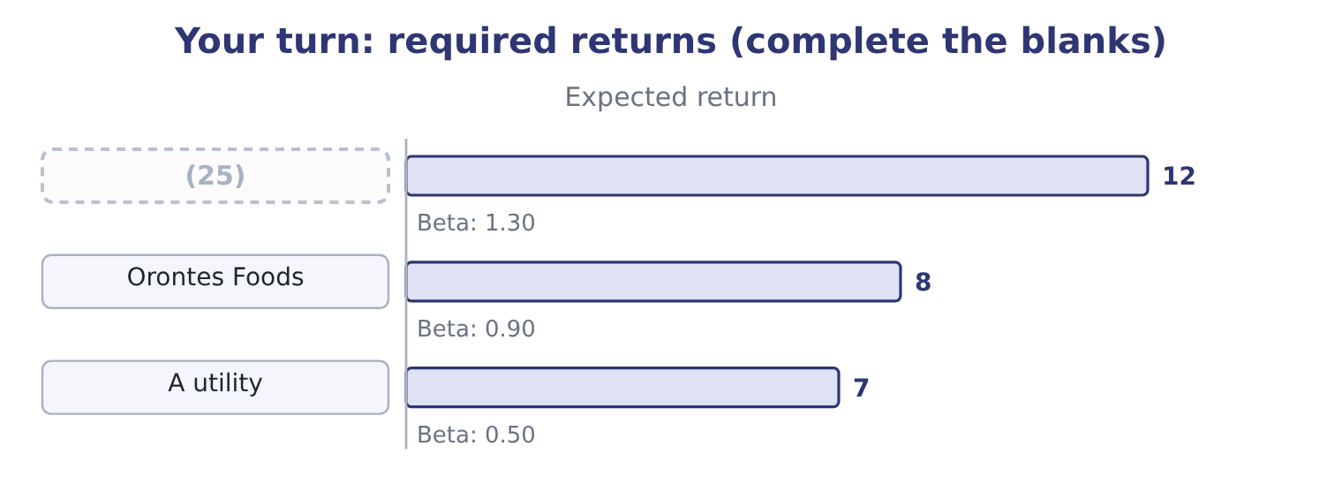
word list
Barada Wholesale · correlation coefficient

"Expected"

Summary 4 gaps 26–32
English expected in finance means the (26) average of the (27) , not what anybody (28) in the ordinary sense and not what is (29) . An expected return of 8.5 per cent can be an outcome that cannot occur at all, as it was. Note the pairing the exam relies on: expected return against required return, where the first is a (30) and the second is a (31) , and reading either as the other reverses the (32) conclusion.
word list
anticipates · probability-weighted · likely · outcomes · ranging · forecast · standard · buy-or-sell

The English this section uses, and its Arabic
Each term sits against what it means.
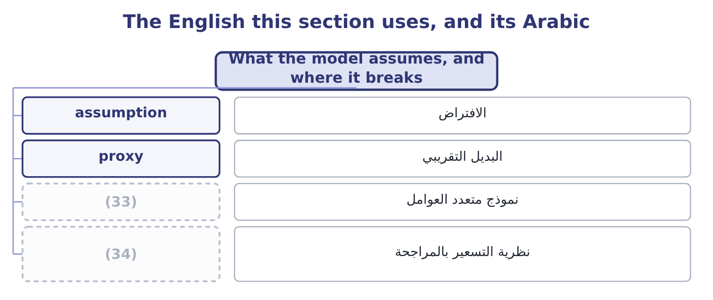
word list
multi-factor model · market portfolio · arbitrage pricing theory

The English this sheet uses, and its Arabic
English (exam term) | Arabic
assumption | الافتراض
proxy | البديل التقريبي
multi-factor model | نموذج متعدد العوامل
arbitrage pricing theory | نظرية التسعير بالمراجحة

Answer key · 2.5 What the model assumes, and where it breaks

1 everywhere | 18 systematic
2 completely | 19 candidate
3 strong | 20 follow
4 risk-averse | 21 question
5 transaction | 22 prediction
6 problems | 23 blanks
7 portfolio | 24 risk-free
8 businesses | 25 Barada Wholesale
9 unstable | 26 probability-weighted
10 describe | 27 outcomes
11 reputable | 28 anticipates
12 valuation | 29 likely
13 survives | 30 forecast
14 taught | 31 standard
15 non-diversifiable | 32 buy-or-sell
16 sensitivity | 33 multi-factor model
17 Alternatives | 34 arbitrage pricing theory

the summaries in full
Summary 1 The CAPM is used everywhere and believed nowhere completely, and the exam expects both halves. The assumptions are strong. Investors are rational and risk-averse, hold diversified portfolios, agree about the expected returns and risks of everything, can borrow and lend freely at the risk-free rate, pay no taxes or transaction costs, and act over one period. None of these is true. The measurement problems are worse than the assumptions. The market portfolio should contain every risky asset in the world, including property, private businesses and human capital; in practice an index of large listed shares stands in for it. Beta is estimated from the past and is unstable: a beta measured over the last five years may describe a company that no longer exists in that form. And the market risk premium cannot be observed at all, only estimated, with reputable estimates ranging from about three points to about seven — a spread that moves a required return by four points and a valuation by far more.
Summary 2 What survives all that is the structure, which is why the model is still taught. Return should rise with risk; only non-diversifiable risk should be rewarded; and the compensation for risk should be proportional to the sensitivity. Alternatives exist — multi-factor models adding size, value and momentum factors, and the arbitrage pricing theory, which allows several sources of systematic risk — and all of them keep that structure and refine the measurement. For a candidate, three practical rules follow. Use the model when the question gives you its three inputs. State the inputs you used. And treat the output as a required return for a decision, not as a prediction of next year.
Summary 3 Complete the blanks, taking the risk-free rate as 3 per cent and the expected market return as 9 per cent.
Summary 4 English expected in finance means the probability-weighted average of the outcomes, not what anybody anticipates in the ordinary sense and not what is likely. An expected return of 8.5 per cent can be an outcome that cannot occur at all, as it was. Note the pairing the exam relies on: expected return against required return, where the first is a forecast and the second is a standard, and reading either as the other reverses the buy-or-sell conclusion.

