3.1 The term structure of interest rates
Chapter 3 · section 3.1

Fill every gap. Each word list holds one word more than there are gaps.
Chapter 3, section by section
Each stage leads to the next.
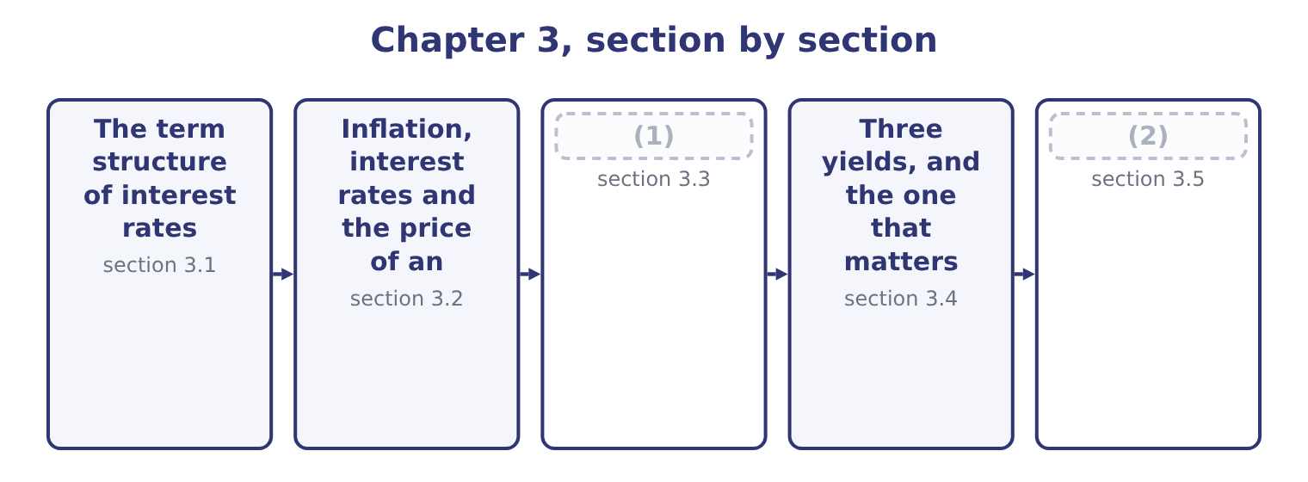
word list
The term structure of interest rates · What a bond is · Reading the structure as a borrower

Summary 1 gaps 3–13
Plot the yield on government securities (3) their maturity and the (4) is the yield curve. It is normally upward-sloping: a (5) security yields more than a one-year one. It can be flat, and (6) it inverts, with short rates above long ones. Three (7) explain the shape, and the exam names all three. The expectations theory says long rates are (8) of expected (9) short rates. If one-year money costs 4 per cent now and is expected to cost 6 per cent next year, then (10) money must cost about the same as (11) over: 1.04 × 1.06 = 1.1024, which is about 4.99 per cent a year. On this theory an upward-sloping curve means the market expects rates to rise, and an inverted curve means it expects them to fall — which is why an (12) is watched as a recession signal, since rates fall when the (13) weakens.
word list
economy · theories · occasionally · against · quality · two-year · result · inversion · ten-year · future · rolling · averages

Summary 2 gaps 14–23
The liquidity (14) theory adds that lenders (15) tying money up and (16) a premium for length, so the curve slopes upward even when no change in rates is expected. This (17) why upward slopes are the normal case rather than the (18) one. The market (19) theory says that borrowers and lenders have preferred (20) — a pension fund wants (21) assets, a company financing stock wants ninety-day money — and that rates in each segment are set by supply and demand there. On this theory the curve can take any shape at all, and a large government issue at one maturity can move that part of the curve (22) telling you (23) about expectations.
word list
require · thirty-year · anything · explains · without · segmentation · maturity · preference · maturities · occasional · dislike

Three yield curves and what each is taken to mean
Shape | Short rates | Long rates | Usual reading
Upward-sloping | Lower | (24) | Normal: a term premium, or rates expected to rise
Flat | Equal | Equal | (25)
Inverted | Higher | Lower | (26)

word list
premium · Higher · Rates expected to hold; a turning point · Rates expected to fall; often a recession signal

Summary 3 gaps 27–31
The curve moves for the (27) the outcome asks about. A central bank raising its policy rate lifts the short end (28) . A rise in expected (29) lifts the whole curve, and the long end most. A (30) to safety in a crisis pushes money into government securities and pushes long yields down. And a government (31) heavily at one maturity lifts that segment.
word list
flight · inflation · directly · borrowing · government · reasons

Yield curve questions are about direction

Summary 4 gaps 32–37
The exam (32) asks you to draw a curve. It asks what a stated change does to it, or what a stated shape (33) . A curve is drawn for one credit (34) , normally government. A (35) curve sits above it by the credit spread, and the spread itself widens in a downturn. An inverted curve is a signal, not a (36) . It (37) nothing on its own.
word list
securities · corporate · implies · mechanism · rarely · quality · predicts

The English this section uses, and its Arabic
Each term sits against what it means.
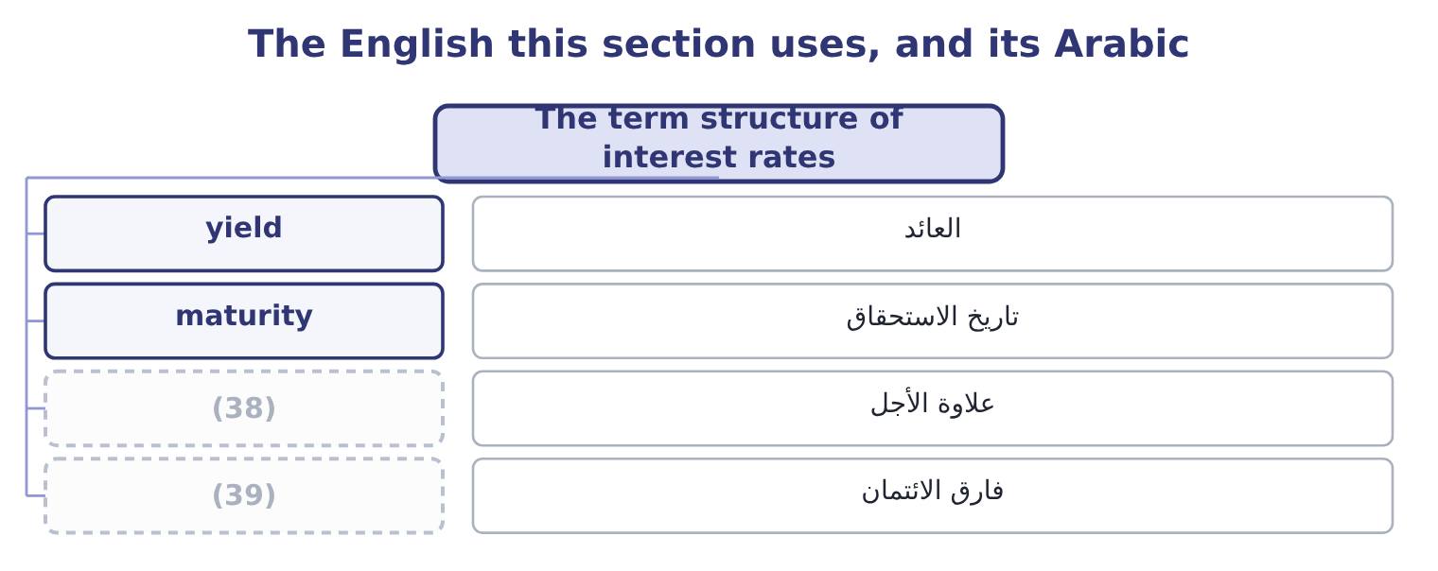
word list
تاريخ الاستحقاق · credit spread · term premium

The English this sheet uses, and its Arabic
English (exam term) | Arabic
yield | العائد
maturity | تاريخ الاستحقاق
term premium | علاوة الأجل
credit spread | فارق الائتمان

Answer key · 3.1 The term structure of interest rates

1 What a bond is | 21 thirty-year
2 Reading the structure as a borrower | 22 without
3 against | 23 anything
4 result | 24 Higher
5 ten-year | 25 Rates expected to hold; a turning point
6 occasionally | 26 Rates expected to fall; often a recession signal
7 theories | 27 reasons
8 averages | 28 directly
9 future | 29 inflation
10 two-year | 30 flight
11 rolling | 31 borrowing
12 inversion | 32 rarely
13 economy | 33 implies
14 preference | 34 quality
15 dislike | 35 corporate
16 require | 36 mechanism
17 explains | 37 predicts
18 occasional | 38 term premium
19 segmentation | 39 credit spread
20 maturities

the summaries in full
Summary 1 Plot the yield on government securities against their maturity and the result is the yield curve. It is normally upward-sloping: a ten-year security yields more than a one-year one. It can be flat, and occasionally it inverts, with short rates above long ones. Three theories explain the shape, and the exam names all three. The expectations theory says long rates are averages of expected future short rates. If one-year money costs 4 per cent now and is expected to cost 6 per cent next year, then two-year money must cost about the same as rolling over: 1.04 × 1.06 = 1.1024, which is about 4.99 per cent a year. On this theory an upward-sloping curve means the market expects rates to rise, and an inverted curve means it expects them to fall — which is why an inversion is watched as a recession signal, since rates fall when the economy weakens.
Summary 2 The liquidity preference theory adds that lenders dislike tying money up and require a premium for length, so the curve slopes upward even when no change in rates is expected. This explains why upward slopes are the normal case rather than the occasional one. The market segmentation theory says that borrowers and lenders have preferred maturities — a pension fund wants thirty-year assets, a company financing stock wants ninety-day money — and that rates in each segment are set by supply and demand there. On this theory the curve can take any shape at all, and a large government issue at one maturity can move that part of the curve without telling you anything about expectations.
Summary 3 The curve moves for the reasons the outcome asks about. A central bank raising its policy rate lifts the short end directly. A rise in expected inflation lifts the whole curve, and the long end most. A flight to safety in a crisis pushes money into government securities and pushes long yields down. And a government borrowing heavily at one maturity lifts that segment.
Summary 4 The exam rarely asks you to draw a curve. It asks what a stated change does to it, or what a stated shape implies. A curve is drawn for one credit quality, normally government. A corporate curve sits above it by the credit spread, and the spread itself widens in a downturn. An inverted curve is a signal, not a mechanism. It predicts nothing on its own.

3.2 Inflation, interest rates and the price of an instrument
Chapter 3 · section 3.2

Fill every gap. Each word list holds one word more than there are gaps.
Summary 1 gaps 1–12
A lender gives up money now and gets money back later. If prices rise in between, the money that comes back buys less, so the lender requires compensation for the loss (1) any compensation for risk. That is why every nominal (2) rate contains an inflation expectation. The relationship is the Fisher effect, and it is (3) rather than (4) . A lender (5) a real return of 2 per cent who (6) inflation of 3 per cent requires 1.02 × 1.03 = 1.0506, that is 5.06 per cent. The (7) everybody uses, 2.0 + 3.0 = 5.0 per cent, is close at low rates and wrong by a full point at the rates of a (8) economy. Two (9) matter for the exam. Only expected inflation is in the rate. Inflation that was not expected (10) wealth: between a borrower and a lender at a fixed rate, (11) inflation makes the borrower better off and the lender worse off, because the fixed payments are made in cheaper money. That is the point Book 1, (12) from the other side.
word list
transfers · consequences · high-inflation · reached · approximation · unexpected · interest · multiplicative · before · wanting · additive · promised · expects

Summary 2 gaps 13–23
A (13) in the expectation moves prices now. A fixed-rate instrument promises fixed (14) . If the (15) required return rises, the only thing that can (16) is the price, and it falls. If the required return falls, the price rises. This (17) relationship between rates and the price of a (18) instrument is the most important (19) fact in Section B. A (20) bond with a par value of $1,000 and a 6 per cent (21) coupon pays $60 a year and $1,000 at the end. Rates equal the coupon. If the market requires 6 per cent, the promised payments are worth (22) what the bond promises to repay and the bond trades at par, $1,000. If the market now requires 7 per cent, (23) will pay $1,000 for a 6 per cent coupon when a new bond pays 7.
word list
five-year · inverse · exactly · amounts · because · mechanical · fixed-income · nobody · market's · change · adjust · annual

Summary 3 gaps 24–29
The price falls until the total return (24) : a little under $960 on these terms, and the bond trades at a discount. If the market requires 5 per cent, the 6 per cent coupon is worth (25) and the price rises above par, to a little over $1,040. The bond trades at a premium. (26) about the issuer (27) in any of the three cases. The coupon is fixed, the maturity is fixed, and the price did all the (28) . The yield to maturity — the rate that makes the promised payments worth the market price — is 6, 7 and 5 per cent in the three cases, and it is the number a buyer (29) earns.
word list
moving · actually · having · matches · changed · discount · Nothing

Price, coupon and the market rate
Market required return | Price against par | Called | Coupon rate against yield
Below the coupon rate | Above par | (30) | Coupon higher than yield
Equal to the coupon rate | At par | (31) | Coupon equals yield
Above the coupon rate | (32) | A discount bond | Coupon lower than yield

word list
A premium bond · Above par · Below par · A par bond

Summary 4 gaps 33–39
Inflation (33) shares as well, and less (34) . A company whose prices rise with inflation (35) the cost on and its nominal earnings grow; one locked into fixed (36) prices does not. Higher nominal rates also raise the discount rate (37) to those earnings, which (38) the value of a given stream. Which effect (39) is an empirical question and the exam treats shares as a partial inflation hedge: better than a fixed-rate bond, worse than an asset whose price moves with the price level directly.
word list
applied · passes · reaches · promised · selling · dominates · lowers · predictably

The English this section uses, and its Arabic
Each term sits against what it means.
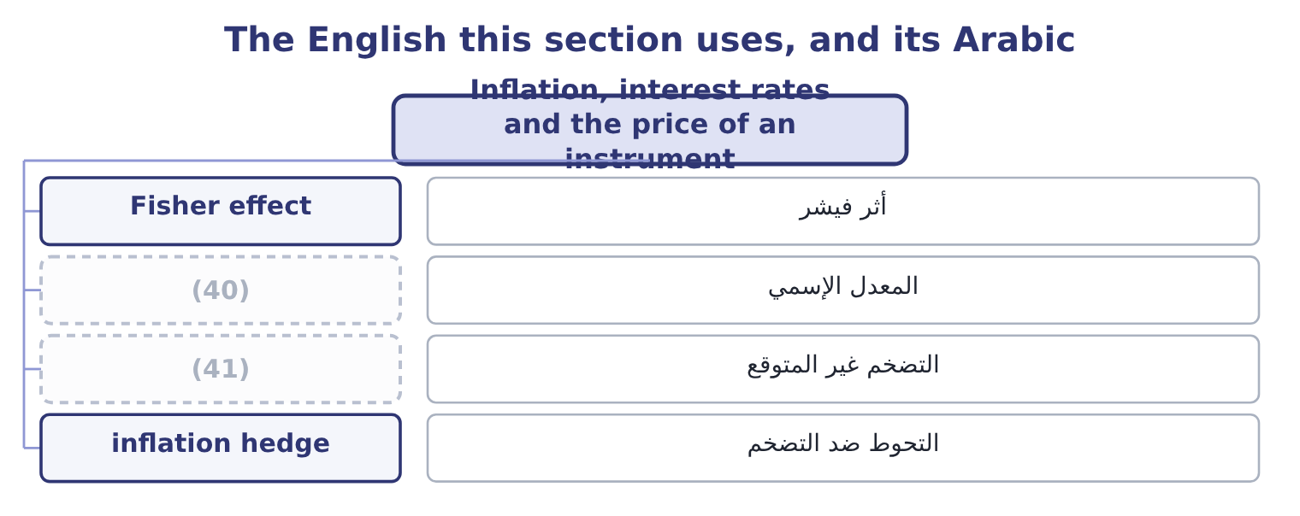
word list
term premium · nominal rate · unexpected inflation

The English this sheet uses, and its Arabic
English (exam term) | Arabic
Fisher effect | أثر فيشر
nominal rate | المعدل الإسمي
unexpected inflation | التضخم غير المتوقع
inflation hedge | التحوط ضد التضخم

Answer key · 3.2 Inflation, interest rates and the price of an instrument

1 before | 22 exactly
2 interest | 23 nobody
3 multiplicative | 24 matches
4 additive | 25 having
5 wanting | 26 Nothing
6 expects | 27 changed
7 approximation | 28 moving
8 high-inflation | 29 actually
9 consequences | 30 A premium bond
10 transfers | 31 A par bond
11 unexpected | 32 Below par
12 reached | 33 reaches
13 change | 34 predictably
14 amounts | 35 passes
15 market's | 36 selling
16 adjust | 37 applied
17 inverse | 38 lowers
18 fixed-income | 39 dominates
19 mechanical | 40 nominal rate
20 five-year | 41 unexpected inflation
21 annual

the summaries in full
Summary 1 A lender gives up money now and gets money back later. If prices rise in between, the money that comes back buys less, so the lender requires compensation for the loss before any compensation for risk. That is why every nominal interest rate contains an inflation expectation. The relationship is the Fisher effect, and it is multiplicative rather than additive. A lender wanting a real return of 2 per cent who expects inflation of 3 per cent requires 1.02 × 1.03 = 1.0506, that is 5.06 per cent. The approximation everybody uses, 2.0 + 3.0 = 5.0 per cent, is close at low rates and wrong by a full point at the rates of a high-inflation economy. Two consequences matter for the exam. Only expected inflation is in the rate. Inflation that was not expected transfers wealth: between a borrower and a lender at a fixed rate, unexpected inflation makes the borrower better off and the lender worse off, because the fixed payments are made in cheaper money. That is the point Book 1, reached from the other side.
Summary 2 A change in the expectation moves prices now. A fixed-rate instrument promises fixed amounts. If the market's required return rises, the only thing that can adjust is the price, and it falls. If the required return falls, the price rises. This inverse relationship between rates and the price of a fixed-income instrument is the most important mechanical fact in Section B. A five-year bond with a par value of $1,000 and a 6 per cent annual coupon pays $60 a year and $1,000 at the end. Rates equal the coupon. If the market requires 6 per cent, the promised payments are worth exactly what the bond promises to repay and the bond trades at par, $1,000. If the market now requires 7 per cent, nobody will pay $1,000 for a 6 per cent coupon when a new bond pays 7.
Summary 3 The price falls until the total return matches: a little under $960 on these terms, and the bond trades at a discount. If the market requires 5 per cent, the 6 per cent coupon is worth having and the price rises above par, to a little over $1,040. The bond trades at a premium. Nothing about the issuer changed in any of the three cases. The coupon is fixed, the maturity is fixed, and the price did all the moving. The yield to maturity — the rate that makes the promised payments worth the market price — is 6, 7 and 5 per cent in the three cases, and it is the number a buyer actually earns.
Summary 4 Inflation reaches shares as well, and less predictably. A company whose prices rise with inflation passes the cost on and its nominal earnings grow; one locked into fixed selling prices does not. Higher nominal rates also raise the discount rate applied to those earnings, which lowers the value of a given stream. Which effect dominates is an empirical question and the exam treats shares as a partial inflation hedge: better than a fixed-rate bond, worse than an asset whose price moves with the price level directly.

3.3 What a bond is
Chapter 3 · section 3.3

Fill every gap. Each word list holds one word more than there are gaps.
Summary 1 gaps 1–12
A bond is a contract to pay stated (1) on stated dates. (2) else about it is a feature, and the exam asks for the (3) by name. Par value, also (4) face value or principal, is the amount repaid at maturity and the base on which the coupon is (5) . The (6) is $1,000 in the (7) States. Maturity is the date the principal is repaid. (8) paper runs to a year, notes to about ten, bonds beyond that; the terms overlap and the exam uses (9) the question says. The coupon rate is the (10) interest as a (11) of par. A 6 per cent coupon on a $1,000 bond pays $60 a year, usually in two instalments of $30. A (12) bond pays nothing until maturity and is sold at a deep discount, so the whole return is the rise to par.
word list
features · zero-coupon · percentage · Everything · insurance · called · computed · amounts · convention · annual · whatever · United · Short-term

Summary 2 gaps 13–24
A (13) note resets its coupon (14) against a reference rate, which removes most of the price risk and gives the holder rate risk instead. (15) provisions say how and when the principal comes back. A call provision lets the issuer repay early, (16) at a stated premium above par, and it is (17) to the issuer and costly to the holder: the issuer will call when rates have fallen, which is exactly when the holder would rather keep the bond. A put provision is the mirror image, (18) the holder (19) early repayment. A sinking fund (20) the issuer to retire part of the issue each year, which reduces the risk of a single large repayment and is usually (21) by holders. (22) bonds mature in instalments by (23) . Conversion provisions let the holder (24) the bond for a fixed number of shares.
word list
demand · letting · floating-rate · exchange · normally · requires · Serial · welcomed · principal · periodically · valuable · Redemption · design

Summary 3 gaps 25–36
The option is worth something, so a (25) carries a lower coupon than the same (26) ordinary debt. Covenants are promises in the (27) , which is the contract (28) the issuer and the trustee acting for the holders. (29) covenants require the issuer to do something: maintain insurance, supply audited (30) , keep a current ratio above a stated figure. Negative covenants forbid something: further (31) beyond a stated debt-to-equity ratio, the sale of major assets, (32) beyond a limit. Book 1 met one of these when Barada (33) a debt-to-equity (34) at 1.50 and the bank waived it. (35) ranks the claim. A mortgage bond is secured on named property; a (36) is unsecured and relies on the general credit of the issuer; subordinated debt stands behind other debt in a liquidation. The weaker the claim, the higher the coupon.
word list
debenture · Affirmative · covenant · between · indenture · convertible · company's · premium · dividends · breached · borrowing · statements · Security

The anatomy of a bond
Every item belongs to exactly one group.
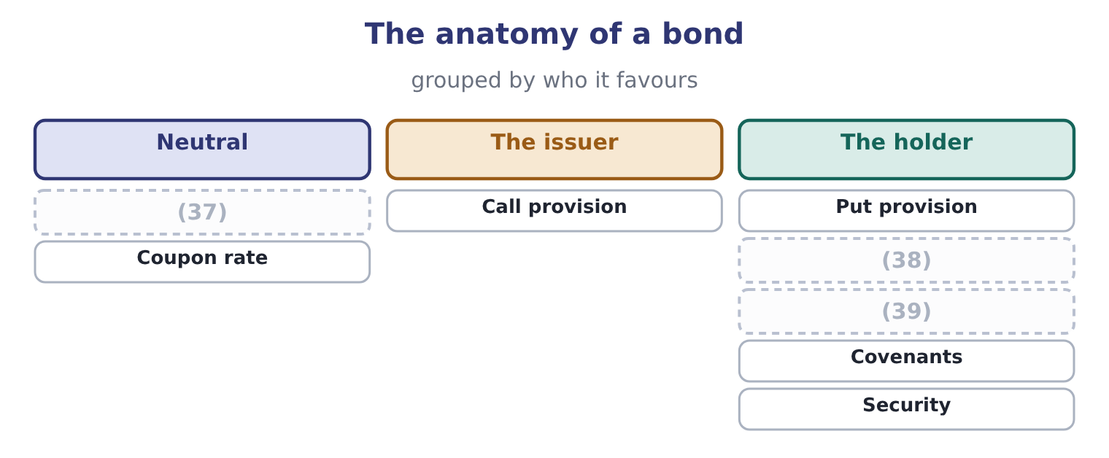
word list
Sinking fund · Conversion · Par value and maturity · indenture

Coupon rate is not yield

Summary 4 gaps 40–45
The coupon rate is fixed at issue and never (40) . The current yield is the coupon over the current price. The yield to maturity is the return (41) by a buyer (42) to maturity, and it is the one that (43) "what does this bond pay now". A call provision (44) the coupon the issuer must offer, because it takes something from the holder. A sinking fund and a conversion right lower it, because they give something. A bond (45) at a discount has a yield above its coupon rate; at a premium, below.
word list
answers · holding · earned · discount · trading · changes · raises

The English this section uses, and its Arabic
Each term sits against what it means.
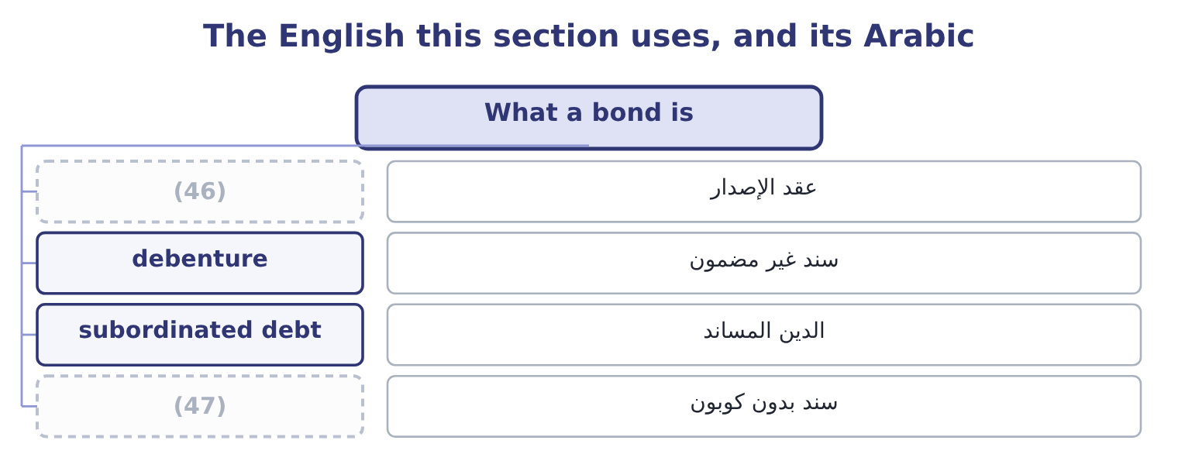
word list
indenture · subordinated debt · zero-coupon bond

The English this sheet uses, and its Arabic
English (exam term) | Arabic
indenture | عقد الإصدار
debenture | سند غير مضمون
subordinated debt | الدين المساند
zero-coupon bond | سند بدون كوبون

Answer key · 3.3 What a bond is

1 amounts | 25 convertible
2 Everything | 26 company's
3 features | 27 indenture
4 called | 28 between
5 computed | 29 Affirmative
6 convention | 30 statements
7 United | 31 borrowing
8 Short-term | 32 dividends
9 whatever | 33 breached
10 annual | 34 covenant
11 percentage | 35 Security
12 zero-coupon | 36 debenture
13 floating-rate | 37 Par value and maturity
14 periodically | 38 Sinking fund
15 Redemption | 39 Conversion
16 normally | 40 changes
17 valuable | 41 earned
18 letting | 42 holding
19 demand | 43 answers
20 requires | 44 raises
21 welcomed | 45 trading
22 Serial | 46 indenture
23 design | 47 zero-coupon bond
24 exchange

the summaries in full
Summary 1 A bond is a contract to pay stated amounts on stated dates. Everything else about it is a feature, and the exam asks for the features by name. Par value, also called face value or principal, is the amount repaid at maturity and the base on which the coupon is computed. The convention is $1,000 in the United States. Maturity is the date the principal is repaid. Short-term paper runs to a year, notes to about ten, bonds beyond that; the terms overlap and the exam uses whatever the question says. The coupon rate is the annual interest as a percentage of par. A 6 per cent coupon on a $1,000 bond pays $60 a year, usually in two instalments of $30. A zero-coupon bond pays nothing until maturity and is sold at a deep discount, so the whole return is the rise to par.
Summary 2 A floating-rate note resets its coupon periodically against a reference rate, which removes most of the price risk and gives the holder rate risk instead. Redemption provisions say how and when the principal comes back. A call provision lets the issuer repay early, normally at a stated premium above par, and it is valuable to the issuer and costly to the holder: the issuer will call when rates have fallen, which is exactly when the holder would rather keep the bond. A put provision is the mirror image, letting the holder demand early repayment. A sinking fund requires the issuer to retire part of the issue each year, which reduces the risk of a single large repayment and is usually welcomed by holders. Serial bonds mature in instalments by design. Conversion provisions let the holder exchange the bond for a fixed number of shares.
Summary 3 The option is worth something, so a convertible carries a lower coupon than the same company's ordinary debt. Covenants are promises in the indenture, which is the contract between the issuer and the trustee acting for the holders. Affirmative covenants require the issuer to do something: maintain insurance, supply audited statements, keep a current ratio above a stated figure. Negative covenants forbid something: further borrowing beyond a stated debt-to-equity ratio, the sale of major assets, dividends beyond a limit. Book 1 met one of these when Barada breached a debt-to-equity covenant at 1.50 and the bank waived it. Security ranks the claim. A mortgage bond is secured on named property; a debenture is unsecured and relies on the general credit of the issuer; subordinated debt stands behind other debt in a liquidation. The weaker the claim, the higher the coupon.
Summary 4 The coupon rate is fixed at issue and never changes. The current yield is the coupon over the current price. The yield to maturity is the return earned by a buyer holding to maturity, and it is the one that answers "what does this bond pay now". A call provision raises the coupon the issuer must offer, because it takes something from the holder. A sinking fund and a conversion right lower it, because they give something. A bond trading at a discount has a yield above its coupon rate; at a premium, below.

3.4 Three yields, and the one that matters
Chapter 3 · section 3.4

Fill every gap. Each word list holds one word more than there are gaps.
Summary 1 gaps 1–12
A bond (1) at $950 with a 6 per cent coupon and five years to run has three rates (2) to it, and the exam will use all three in one question. The coupon rate is 6 per cent, fixed at issue on the par value. It tells you the cash (3) , $60 a year, and (4) about what a buyer earns. The current yield is the coupon over the market price: 60 ÷ 950 = 6.32 per cent. It is a quick measure of the cash return and it ignores the $50 the (5) will gain when $1,000 is (6) . The yield to maturity is the rate that makes all the (7) payments worth (8) $950 today. It is found properly by trial or by a calculator, and the exam accepts a standard (9) : the annual coupon plus the annual (10) of the discount, over the average of par and price. Here the discount is 1,000 − 950 = 50 (11) over five years, which is 10 a year, so the (12) is 60 + 10 = 70; the average of par and price is 975; and the yield is 70 ÷ 975 = 7.18 per cent. So the same bond pays 6, 6.32 or 7.18 per cent depending on which question is being asked, and only the last is the return a buyer earns by holding to maturity.
word list
promised · payment · approximation · numerator · spread · nothing · holder · repaid · amortisation · attached · quoted · collateral · exactly

Summary 2 gaps 13–17
Two more yields appear in (13) on callable bonds. The yield to call (14) the same thing to the call date at the call price, and the (15) figure to quote on a callable bond trading above par is the lower of yield to maturity and yield to call. The (16) yield assumes a sale before maturity at an (17) price.
word list
computes · prudent · questions · assumed · realised · indenture

Four yields on one bond
Measure | What it divides | On this bond | What it ignores
Coupon rate | Coupon over par | 6.00% | (18)
Current yield | Coupon over price | 6.32% | (19)
Yield to maturity | All payments over price | 7.18% | (20)
Yield to call | (21) | Depends on the call terms | What happens if it is not called

word list
Payments to the call date · The gain to par at maturity · Reinvestment risk · call provision · The market price entirely

The English this section uses, and its Arabic
Each term sits against what it means.
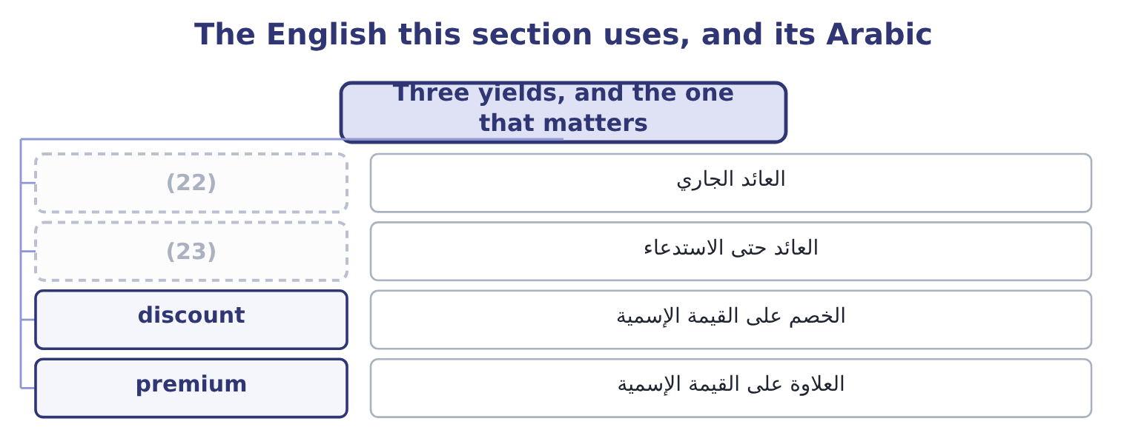
word list
maturity matching · current yield · yield to call

The English this sheet uses, and its Arabic
English (exam term) | Arabic
current yield | العائد الجاري
yield to call | العائد حتى الاستدعاء
discount | الخصم على القيمة الإسمية
premium | العلاوة على القيمة الإسمية

Answer key · 3.4 Three yields, and the one that matters

1 quoted | 13 questions
2 attached | 14 computes
3 payment | 15 prudent
4 nothing | 16 realised
5 holder | 17 assumed
6 repaid | 18 The market price entirely
7 promised | 19 The gain to par at maturity
8 exactly | 20 Reinvestment risk
9 approximation | 21 Payments to the call date
10 amortisation | 22 current yield
11 spread | 23 yield to call
12 numerator

the summaries in full
Summary 1 A bond quoted at $950 with a 6 per cent coupon and five years to run has three rates attached to it, and the exam will use all three in one question. The coupon rate is 6 per cent, fixed at issue on the par value. It tells you the cash payment, $60 a year, and nothing about what a buyer earns. The current yield is the coupon over the market price: 60 ÷ 950 = 6.32 per cent. It is a quick measure of the cash return and it ignores the $50 the holder will gain when $1,000 is repaid. The yield to maturity is the rate that makes all the promised payments worth exactly $950 today. It is found properly by trial or by a calculator, and the exam accepts a standard approximation: the annual coupon plus the annual amortisation of the discount, over the average of par and price. Here the discount is 1,000 − 950 = 50 spread over five years, which is 10 a year, so the numerator is 60 + 10 = 70; the average of par and price is 975; and the yield is 70 ÷ 975 = 7.18 per cent. So the same bond pays 6, 6.32 or 7.18 per cent depending on which question is being asked, and only the last is the return a buyer earns by holding to maturity.
Summary 2 Two more yields appear in questions on callable bonds. The yield to call computes the same thing to the call date at the call price, and the prudent figure to quote on a callable bond trading above par is the lower of yield to maturity and yield to call. The realised yield assumes a sale before maturity at an assumed price.

3.5 Reading the structure as a borrower
Chapter 3 · section 3.5

Fill every gap. Each word list holds one word more than there are gaps.
Summary 1 gaps 1–12
Everything above is written from the (1) side. Turn it round, because a (2) works for the issuer. The maturity (3) is the first decision, and it is a (4) the exam states as a rule. Borrowing short is usually (5) , because the curve usually slopes upward, and it exposes the company to refinancing at (6) rate prevails when the loan falls due. Borrowing long costs more and fixes the cost. The (7) principle —, so that a refinancing never (8) before the asset has paid for itself. Orontes's own (9) reads cleanly against that rule. It carries $6,000,000 of (10) debt against $14,802,000 of net property, plant and (11) , with only $400,000 falling due within the year, and it has $7,302,100 of cash. Its plant is funded long, its working capital is funded by (12) and by its own cash, and its refinancing risk in any one year is small.
word list
cheaper · maturity-matching · inflation · candidate · position · suppliers · whatever · lender's · arrives · trade-off · equipment · choice · long-term

Summary 2 gaps 13–24
Book 1 (13) the maturity (14) gentle; this is what gentle means. The (15) decision is fixed against (16) . (17) debt makes the cost certain and the value of the (18) move with rates. Floating-rate debt keeps the value near par and makes the cost (19) . A company whose revenue rises with inflation can carry floating-rate debt more (20) than one whose revenue is (21) fixed, because its receipts and its payments move together. The third decision is what to give away. Every feature in section 3.3 that favours the (22) lowers the coupon, and every feature that favours the issuer (23) it. A company that wants the right to (24) cheaply pays for it in the coupon from the first day; a company that accepts tight covenants is paid for them in the same way, and then has to live inside them. Barada, whose covenant at 1.50 was already breached when it wanted to borrow, is the illustration of what living inside them means.
word list
liability · second · profile · holder · contractually · raises · comfortably · called · floating · Fixed-rate · uncertain · refinance · already

Read the curve and the bond

Your turn: rates and a bond (complete the blanks)
Item | Data | Answer
One-year government yield | 3.0% | (25)
Ten-year government yield | 5.0% | n/a
Shape of the curve |  | ________
Orontes's ten-year borrowing cost, at a 2-point credit spread |  | ________
Nominal rate wanted | (26) | ________
A bond's current yield | 7% coupon, $1,000 par, priced at $875 | ________
Its approximate yield to maturity | (27) | ________

word list
n/a · Real 2.5%, expected inflation 4.0% · Four years to run · zero-coupon bond

"Security"

Summary 3 gaps 28–33
English security in finance means two (28) things. A security is a tradable financial (29) — a share, a bond, a bill. Security, uncountable, is the (30) a lender takes. A secured bond is (31) a security with security, and the sentence is not a joke but a standard (32) . The exam uses both English senses freely, and the one meant is always clear from (33) the word takes an article.
word list
instrument · therefore · unrelated · collateral · whether · covenant · description

"Security"
Item | Answer
Shape of the curve | Upward-sloping: the ten-year yield of 5.0 per cent is two points above the one-year 3.0 per cent.
Orontes's ten-year borrowing cost | About 7.0 per cent: 5.0 + 2.0 = 7.0.
Nominal rate wanted | (34) : 1.025 × 1.04 = 1.066.
Current yield | (35)
Approximate yield to maturity | About 10.8 per cent: the discount is 1,000 − 875 = 125 over four years, which is 31.25 a year, so the numerator is 70 + 31.25 = 101.25 and t
What it tells you | The bond's 7 per cent coupon says almost (36) about what a buyer earns. At $875 the buyer earns about 10.8 per cent, which is three point

word list
6.6 per cent · n/a · 8.00 per cent: 70 ÷ 875 = 8.00 per cent. · nothing

The English this section uses, and its Arabic
Each term sits against what it means.
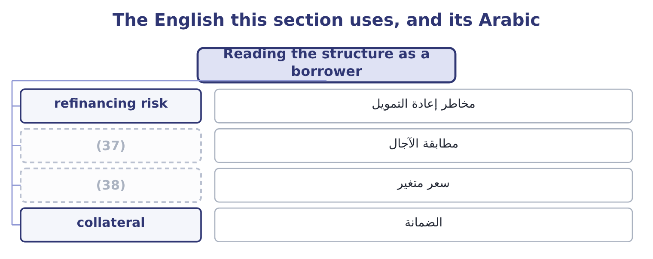
word list
maturity matching · floating rate · سعر متغير

The English this sheet uses, and its Arabic
English (exam term) | Arabic
refinancing risk | مخاطر إعادة التمويل
maturity matching | مطابقة الآجال
floating rate | سعر متغير
collateral | الضمانة

Answer key · 3.5 Reading the structure as a borrower

1 lender's | 20 comfortably
2 candidate | 21 contractually
3 choice | 22 holder
4 trade-off | 23 raises
5 cheaper | 24 refinance
6 whatever | 25 n/a
7 maturity-matching | 26 Real 2.5%, expected inflation 4.0%
8 arrives | 27 Four years to run
9 position | 28 unrelated
10 long-term | 29 instrument
11 equipment | 30 collateral
12 suppliers | 31 therefore
13 called | 32 description
14 profile | 33 whether
15 second | 34 6.6 per cent
16 floating | 35 8.00 per cent: 70 ÷ 875 = 8.00 per cent.
17 Fixed-rate | 36 nothing
18 liability | 37 maturity matching
19 uncertain | 38 floating rate

the summaries in full
Summary 1 Everything above is written from the lender's side. Turn it round, because a candidate works for the issuer. The maturity choice is the first decision, and it is a trade-off the exam states as a rule. Borrowing short is usually cheaper, because the curve usually slopes upward, and it exposes the company to refinancing at whatever rate prevails when the loan falls due. Borrowing long costs more and fixes the cost. The maturity-matching principle —, so that a refinancing never arrives before the asset has paid for itself. Orontes's own position reads cleanly against that rule. It carries $6,000,000 of long-term debt against $14,802,000 of net property, plant and equipment, with only $400,000 falling due within the year, and it has $7,302,100 of cash. Its plant is funded long, its working capital is funded by suppliers and by its own cash, and its refinancing risk in any one year is small.
Summary 2 Book 1 called the maturity profile gentle; this is what gentle means. The second decision is fixed against floating. Fixed-rate debt makes the cost certain and the value of the liability move with rates. Floating-rate debt keeps the value near par and makes the cost uncertain. A company whose revenue rises with inflation can carry floating-rate debt more comfortably than one whose revenue is contractually fixed, because its receipts and its payments move together. The third decision is what to give away. Every feature in section 3.3 that favours the holder lowers the coupon, and every feature that favours the issuer raises it. A company that wants the right to refinance cheaply pays for it in the coupon from the first day; a company that accepts tight covenants is paid for them in the same way, and then has to live inside them. Barada, whose covenant at 1.50 was already breached when it wanted to borrow, is the illustration of what living inside them means.
Summary 3 English security in finance means two unrelated things. A security is a tradable financial instrument — a share, a bond, a bill. Security, uncountable, is the collateral a lender takes. A secured bond is therefore a security with security, and the sentence is not a joke but a standard description. The exam uses both English senses freely, and the one meant is always clear from whether the word takes an article.

