4.1 Valuing a bond by discounting
Chapter 4 · section 4.1

Fill every gap. Each word list holds one word more than there are gaps.
Chapter 4, section by section
Each stage leads to the next.
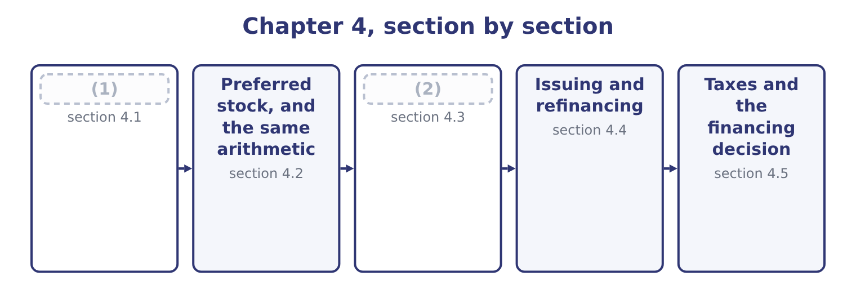
word list
section 4.1 · Duration · Valuing a bond by discounting

Summary 1 gaps 3–9
A (3) bond with a par value of $1,000 and a 6 per cent (4) coupon promises $60 at the end of each of five years and $1,000 at the end of the fifth. Its value is what those promises are worth today at the rate the market requires. Two present-value tools do all the work. The annuity factor converts a stream of equal (5) into a single present value; at 7 per cent for five years it is 4.1002. The present-value factor converts a single (6) amount; at 7 per cent for five years it is 0.7130. So at a required return of 7 per cent: the coupons are worth 60 × 4.1002 = 246.01, the principal is worth 1,000 × 0.7130 = 713.00, and the bond is worth 246.01 + 713.00 = 959.01. That is the "a (7) under $960" of, and the $41 (8) against par is the market's (9) for a coupon one point below what it now requires.
word list
annual · because · future · amounts · little · shortfall · charge · five-year

Summary 2 gaps 10–13
At a required return of 5 per cent the same two steps give a (10) answer: the annuity factor is 4.3295 and the present-value factor 0.7835, so the coupons are worth 60 × 4.3295 = 259.77, the principal 1,000 × 0.7835 = 783.50, and the bond 259.77 + 783.50 = 1,043.27. The bond trades at a (11) because its coupon is (12) than the market now (13) .
word list
immunisation · offers · different · premium · better

One bond, two required returns
Component | At 7 per cent | At 5 per cent
Annuity factor, five years | 4.1002 | 4.3295
(14) | 246.01 | 259.77
(15) | 0.7130 | 0.7835
Present value of the principal | 713.00 | 783.50
(16) | 959.01 | 1,043.27

word list
Present value of the coupons · Annuity factor, five years · Value of the bond · Present-value factor, five years

Summary 3 gaps 17–28
Three (17) points are (18) often. (19) coupons halve the (20) and the rate and double the periods. A 6 per cent bond paying twice a year, valued at a required 7 per cent, is thirty (21) for ten periods (22) at 3.5 per cent. The discount rate is the market's required return on this risk, not the coupon rate and not the (23) own view of (24) . For a (25) bond it is the (26) yield for that maturity plus a credit spread. Price and yield move (27) , always, and the (28) is curved rather than straight. A fall in yields raises the price slightly more than an equal rise in yields lowers it, which is the property called convexity and is why duration, which assumes a straight line, is an approximation.
word list
mechanical · corporate · itself · company's · participating · examined · inversely · payment · Semi-annual · discounted · dollars · government · relationship

The English this section uses, and its Arabic
Each term sits against what it means.
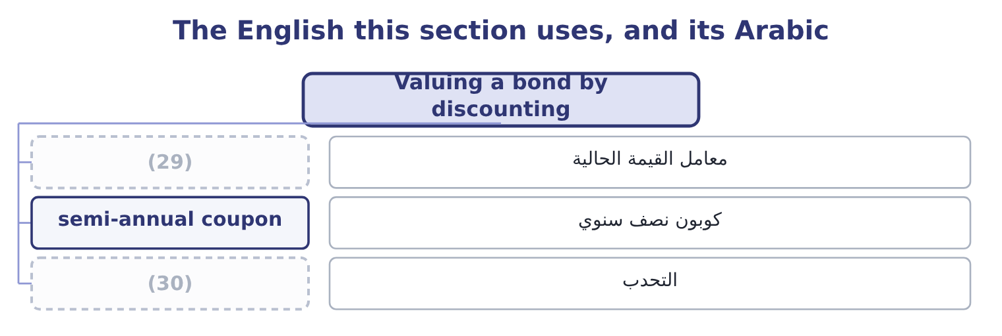
word list
present-value factor · convexity · payback

The English this sheet uses, and its Arabic
English (exam term) | Arabic
present-value factor | معامل القيمة الحالية
semi-annual coupon | كوبون نصف سنوي
convexity | التحدب

Answer key · 4.1 Valuing a bond by discounting

1 Valuing a bond by discounting | 16 Value of the bond
2 Duration | 17 mechanical
3 five-year | 18 examined
4 annual | 19 Semi-annual
5 amounts | 20 payment
6 future | 21 dollars
7 little | 22 discounted
8 shortfall | 23 company's
9 charge | 24 itself
10 different | 25 corporate
11 premium | 26 government
12 better | 27 inversely
13 offers | 28 relationship
14 Present value of the coupons | 29 present-value factor
15 Present-value factor, five years | 30 convexity

the summaries in full
Summary 1 A five-year bond with a par value of $1,000 and a 6 per cent annual coupon promises $60 at the end of each of five years and $1,000 at the end of the fifth. Its value is what those promises are worth today at the rate the market requires. Two present-value tools do all the work. The annuity factor converts a stream of equal amounts into a single present value; at 7 per cent for five years it is 4.1002. The present-value factor converts a single future amount; at 7 per cent for five years it is 0.7130. So at a required return of 7 per cent: the coupons are worth 60 × 4.1002 = 246.01, the principal is worth 1,000 × 0.7130 = 713.00, and the bond is worth 246.01 + 713.00 = 959.01. That is the "a little under $960" of, and the $41 shortfall against par is the market's charge for a coupon one point below what it now requires.
Summary 2 At a required return of 5 per cent the same two steps give a different answer: the annuity factor is 4.3295 and the present-value factor 0.7835, so the coupons are worth 60 × 4.3295 = 259.77, the principal 1,000 × 0.7835 = 783.50, and the bond 259.77 + 783.50 = 1,043.27. The bond trades at a premium because its coupon is better than the market now offers.
Summary 3 Three mechanical points are examined often. Semi-annual coupons halve the payment and the rate and double the periods. A 6 per cent bond paying twice a year, valued at a required 7 per cent, is thirty dollars for ten periods discounted at 3.5 per cent. The discount rate is the market's required return on this risk, not the coupon rate and not the company's own view of itself. For a corporate bond it is the government yield for that maturity plus a credit spread. Price and yield move inversely, always, and the relationship is curved rather than straight. A fall in yields raises the price slightly more than an equal rise in yields lowers it, which is the property called convexity and is why duration, which assumes a straight line, is an approximation.

4.2 Preferred stock, and the same arithmetic
Chapter 4 · section 4.2

Fill every gap. Each word list holds one word more than there are gaps.
Summary 1 gaps 1–12
Preferred stock pays a fixed dividend and (1) has no maturity, so it is a perpetuity: a stream of equal (2) that never stops. The (3) value of a perpetuity is the payment (4) by the required return. A preferred share (5) $5.00 a year, where the market (6) 8 per cent for that risk, is worth 5.00 ÷ 0.08 = 62.50. If the required return rises to 10 per cent the same share is worth 5.00 ÷ 0.10 = 50.00. There is no principal to come back, so the price carries the entire (7) — which makes preferred stock more (8) to rates than most bonds, a point section 4.3 will make precisely. The features of preferred stock follow from its (9) between debt and (10) . A cumulative preferred share carries (11) any dividend not paid, and nothing may go to the common (12) until the arrears are cleared.
word list
position · balance · divided · present · equity · forward · payments · sensitive · paying · normally · shareholders · adjustment · requires

Summary 2 gaps 13–19
A (13) preferred share shares in (14) beyond its fixed rate. Both features raise what a buyer will pay and lower the rate the (15) has to offer. Note what the perpetuity (16) assumes and what the exam does with it. It assumes the payment is fixed and (17) for ever, so it suits preferred stock exactly, a long-dated bond (18) , and a common share not at all until a growth rate is built. That is the (19) of the next chapter.
word list
subject · issuer · formula · arrears · continues · participating · approximately · profits

Three instruments, one method
Instrument | Payment pattern | Valuation | Sensitivity to rates
Bond | Coupons, then principal | (20) | Moderate: the principal anchors it
Preferred stock | A fixed dividend for ever | Payment over required return | (21) : nothing anchors it
Common stock | (22) | Payment over the return less growth | Highest

word list
Annuity plus a lump sum · High · A growing dividend for ever · price sensitivity

Perpetuities and the rate

Summary 3 gaps 23–28
In a perpetuity the rate must be (23) as a decimal and must match the payment (24) . An (25) dividend over a (26) rate is a figure twelve times too large. Preferred stock has no maturity and (27) no yield to maturity. Its yield is (28) dividend over price. A cumulative preferred dividend in arrears is not a liability on the balance sheet; it is disclosed, and it blocks the common dividend.
word list
period · required · monthly · simply · therefore · expressed · annual

The English this section uses, and its Arabic
Each term sits against what it means.
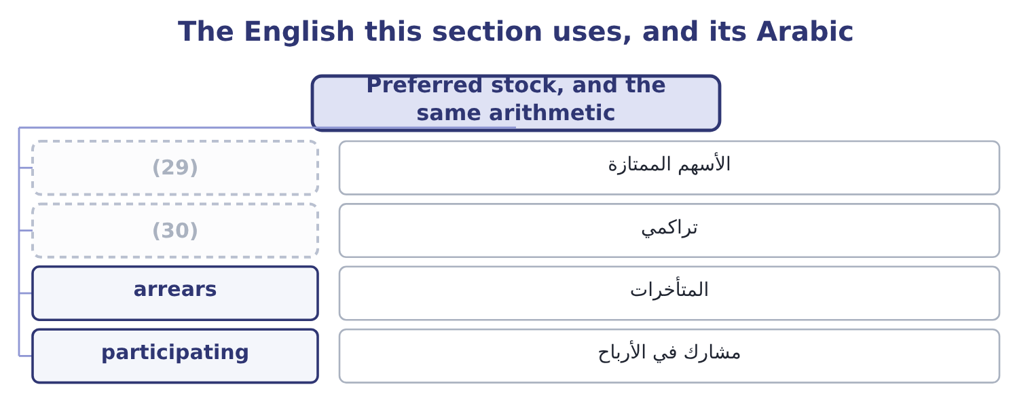
word list
after-tax cost · cumulative · preferred stock

The English this sheet uses, and its Arabic
English (exam term) | Arabic
preferred stock | الأسهم الممتازة
cumulative | تراكمي
arrears | المتأخرات
participating | مشارك في الأرباح

Answer key · 4.2 Preferred stock, and the same arithmetic

1 normally | 16 formula
2 payments | 17 continues
3 present | 18 approximately
4 divided | 19 subject
5 paying | 20 Annuity plus a lump sum
6 requires | 21 High
7 adjustment | 22 A growing dividend for ever
8 sensitive | 23 expressed
9 position | 24 period
10 equity | 25 annual
11 forward | 26 monthly
12 shareholders | 27 therefore
13 participating | 28 simply
14 profits | 29 preferred stock
15 issuer | 30 cumulative

the summaries in full
Summary 1 Preferred stock pays a fixed dividend and normally has no maturity, so it is a perpetuity: a stream of equal payments that never stops. The present value of a perpetuity is the payment divided by the required return. A preferred share paying $5.00 a year, where the market requires 8 per cent for that risk, is worth 5.00 ÷ 0.08 = 62.50. If the required return rises to 10 per cent the same share is worth 5.00 ÷ 0.10 = 50.00. There is no principal to come back, so the price carries the entire adjustment — which makes preferred stock more sensitive to rates than most bonds, a point section 4.3 will make precisely. The features of preferred stock follow from its position between debt and equity. A cumulative preferred share carries forward any dividend not paid, and nothing may go to the common shareholders until the arrears are cleared.
Summary 2 A participating preferred share shares in profits beyond its fixed rate. Both features raise what a buyer will pay and lower the rate the issuer has to offer. Note what the perpetuity formula assumes and what the exam does with it. It assumes the payment is fixed and continues for ever, so it suits preferred stock exactly, a long-dated bond approximately, and a common share not at all until a growth rate is built. That is the subject of the next chapter.
Summary 3 In a perpetuity the rate must be expressed as a decimal and must match the payment period. An annual dividend over a monthly rate is a figure twelve times too large. Preferred stock has no maturity and therefore no yield to maturity. Its yield is simply dividend over price. A cumulative preferred dividend in arrears is not a liability on the balance sheet; it is disclosed, and it blocks the common dividend.

4.3 Duration
Chapter 4 · section 4.3

Fill every gap. Each word list holds one word more than there are gaps.
Summary 1 gaps 1–10
Everybody knows a long bond moves more than a short one when rates change. Duration says how much more, in a (1) number. Macaulay duration is the weighted average time to receive the bond's cash flows, where each time is weighted by the present value of the payment (2) then. A (3) bond pays once, so its duration (4) its maturity. A coupon bond (5) some money (6) , so its duration is always (7) than its maturity. (8) duration converts that into a price sensitivity: it is the Macaulay duration divided by one plus the (9) return per period, and it estimates the (10) change in price for a one-point change in yield.
word list
single · equals · Modified · required · returns · zero-coupon · sensitivity · percentage · earlier · shorter · received

Worked example: the five-year bond, measured

Summary 2 gaps 11–22
Discounting the five (11) at 7 per cent gives present (12) of 56.07, 52.41, 48.98, 45.77 and 755.79, which add to the price of 959.01. Almost (13) of the bond's value sits in the final payment. (14) each year by its share of the price gives a weighted average of about 4.45 years, (15) a maturity of five. The (16) pull it. The (17) is slightly (18) , and knowing why is the mark. Duration assumes the (19) line is straight; it is curved, so the true fall is a little smaller than duration (20) and the true rise on a fall in yields a little larger. The curvature is (21) , and it always works in the (22) favour. For a one-point move the difference is small; for a five-point move on a long bond it is large.
word list
pessimistic · knowing · convexity · values · predicts · price-yield · against · payments · coupons · holder's · four-fifths · estimate · Weighting

What makes a bond more sensitive to rates
Every item belongs to exactly one group.
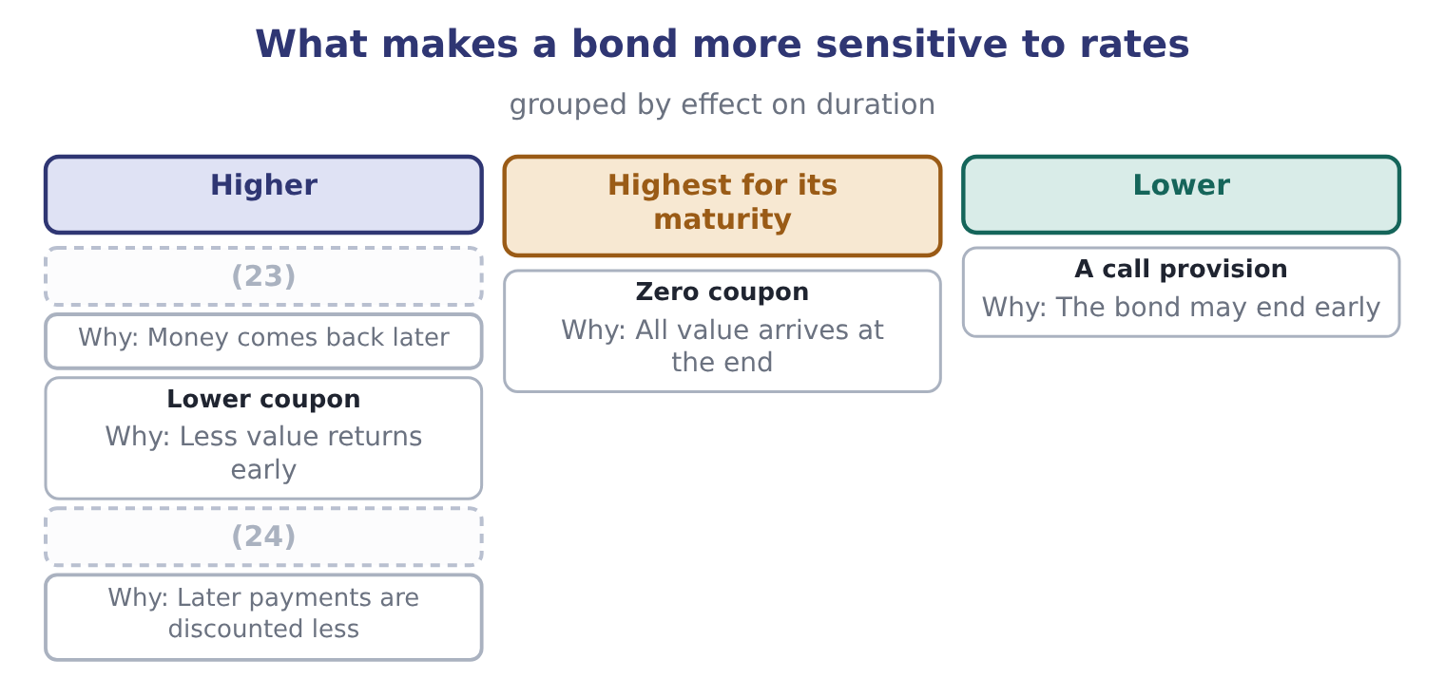
word list
preferred stock · Lower yield · Longer maturity

Summary 3 gaps 25–31
Duration is used for three (25) , and the exam names all three. It (26) the rate sensitivity of two bonds in one number. It estimates the price (27) of a stated rate move. And it allows a (28) to be matched to a (29) — an insurer with claims expected in seven years holds assets of duration seven, so that a rate move changes the value of both sides together. That last use is called (30) and it is the (31) duration exists.
word list
portfolio · immunisation · Everybody · compares · effect · liability · things · reason

The English this section uses, and its Arabic
Each term sits against what it means.
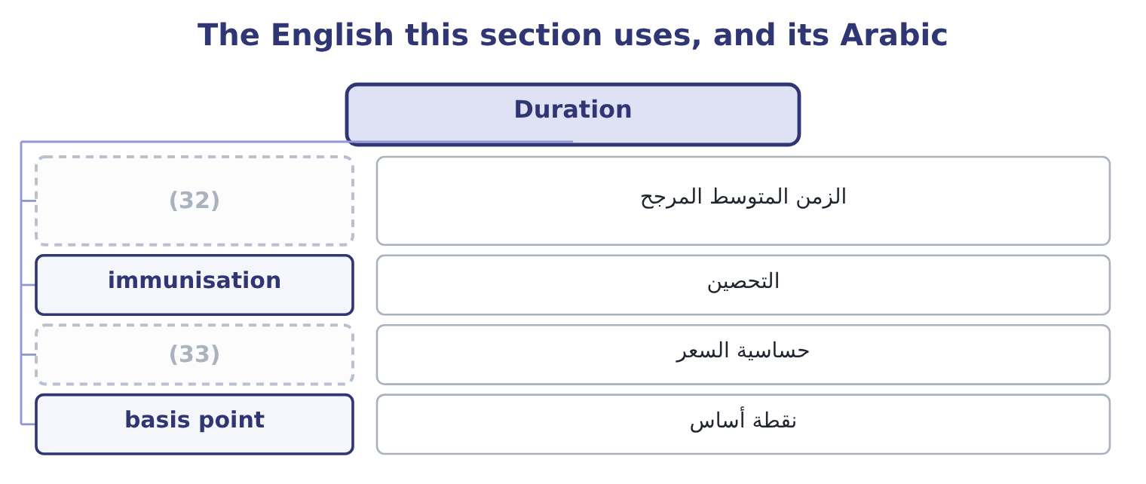
word list
preferred stock · price sensitivity · weighted average time

The English this sheet uses, and its Arabic
English (exam term) | Arabic
weighted average time | الزمن المتوسط المرجح
immunisation | التحصين
price sensitivity | حساسية السعر
basis point | نقطة أساس

Answer key · 4.3 Duration

1 single | 18 pessimistic
2 received | 19 price-yield
3 zero-coupon | 20 predicts
4 equals | 21 convexity
5 returns | 22 holder's
6 earlier | 23 Longer maturity
7 shorter | 24 Lower yield
8 Modified | 25 things
9 required | 26 compares
10 percentage | 27 effect
11 payments | 28 portfolio
12 values | 29 liability
13 four-fifths | 30 immunisation
14 Weighting | 31 reason
15 against | 32 weighted average time
16 coupons | 33 price sensitivity
17 estimate

the summaries in full
Summary 1 Everybody knows a long bond moves more than a short one when rates change. Duration says how much more, in a single number. Macaulay duration is the weighted average time to receive the bond's cash flows, where each time is weighted by the present value of the payment received then. A zero-coupon bond pays once, so its duration equals its maturity. A coupon bond returns some money earlier, so its duration is always shorter than its maturity. Modified duration converts that into a price sensitivity: it is the Macaulay duration divided by one plus the required return per period, and it estimates the percentage change in price for a one-point change in yield.
Summary 2 Discounting the five payments at 7 per cent gives present values of 56.07, 52.41, 48.98, 45.77 and 755.79, which add to the price of 959.01. Almost four-fifths of the bond's value sits in the final payment. Weighting each year by its share of the price gives a weighted average of about 4.45 years, against a maturity of five. The coupons pull it. The estimate is slightly pessimistic, and knowing why is the mark. Duration assumes the price-yield line is straight; it is curved, so the true fall is a little smaller than duration predicts and the true rise on a fall in yields a little larger. The curvature is convexity, and it always works in the holder's favour. For a one-point move the difference is small; for a five-point move on a long bond it is large.
Summary 3 Duration is used for three things, and the exam names all three. It compares the rate sensitivity of two bonds in one number. It estimates the price effect of a stated rate move. And it allows a portfolio to be matched to a liability — an insurer with claims expected in seven years holds assets of duration seven, so that a rate move changes the value of both sides together. That last use is called immunisation and it is the reason duration exists.

4.4 Issuing and refinancing
Chapter 4 · section 4.4

Fill every gap. Each word list holds one word more than there are gaps.
Summary 1 gaps 1–12
Now the (1) side. A company (2) to issue debt faces four (3) , and the exam asks them in (4) : how much, for how long, on what terms, and (5) what route. The route is a choice between a public issue, which is registered, (6) by an investment bank, rated by an agency and sold to many holders, and a private (7) with a small number of institutions, which is quicker and cheaper to arrange and carries tighter covenants and a slightly higher rate. Below a certain size the fixed costs of a public issue cannot be (8) , which is why most (9) companies borrow from banks and institutions rather than from the bond market. The refinancing decision is a (10) the exam sets often, and the (11) never changes. A company with an existing bond at a high (12) can call it, pay the call premium, pay the costs of issuing a new bond, and save the interest difference for the remaining life.
word list
issuer's · coupon · through · deciding · underwritten · mid-sized · calculation · justified · combination · after-tax · questions · structure · placement

Worked example: a refinancing that works

Summary 2 gaps 13–19
A company has $10,000,000 of bonds (13) at 8 per cent with five years to run. It can issue new five-year bonds at 6 per cent. The existing bonds are callable at 103, so the call premium is 3 per cent of par, and issuing the new bonds costs $200,000. Two points on ten (14) : 10,000,000 × 0.02 = 200,000 a year before tax. At a 25 per cent tax rate the interest saved is worth 200,000 × 0.75 = 150,000 a year after tax, (15) the interest was deductible. The call premium is 10,000,000 × 0.03 = 300,000 and the issue costs are 200,000, so 300,000 + 200,000 = 500,000 before tax. Both are deductible, so the after-tax cost is 500,000 × 0.75 = 375,000. (16) properly at the (17) after-tax cost of debt the net present value is (18) , and the refinancing (19) go ahead.
word list
company's · perpetuity · Discounted · outstanding · should · because · positive · million

Summary 3 gaps 20–25
Three (20) would reverse the (21) and all three are (22) . If only two years (23) , the saving would not cover the cost. If the new issue were at a (24) rate, the 6 per cent would be today's rate and not a five-year (25) . And if the existing bond were not callable, there would be no decision to take at all — which is why.
word list
carries · conclusion · commitment · things · examinable · remained · floating

The refinancing template
Line | This case | Note
Annual interest saved, before tax | 200,000 | The rate difference on the principal
Annual interest saved, after tax | 150,000 | (26)
Call premium | 300,000 | (27)
Issue costs of the new bonds | 200,000 | (28)
Total cost after tax | 375,000 | Both costs are deductible
Payback | 2.50 years | (29)

word list
weighted average time · A percentage of par, stated in the indenture · Interest is deductible, so the saving is taxed · Against five years of remaining life · Underwriting, legal, rating

The English this section uses, and its Arabic
Each term sits against what it means.
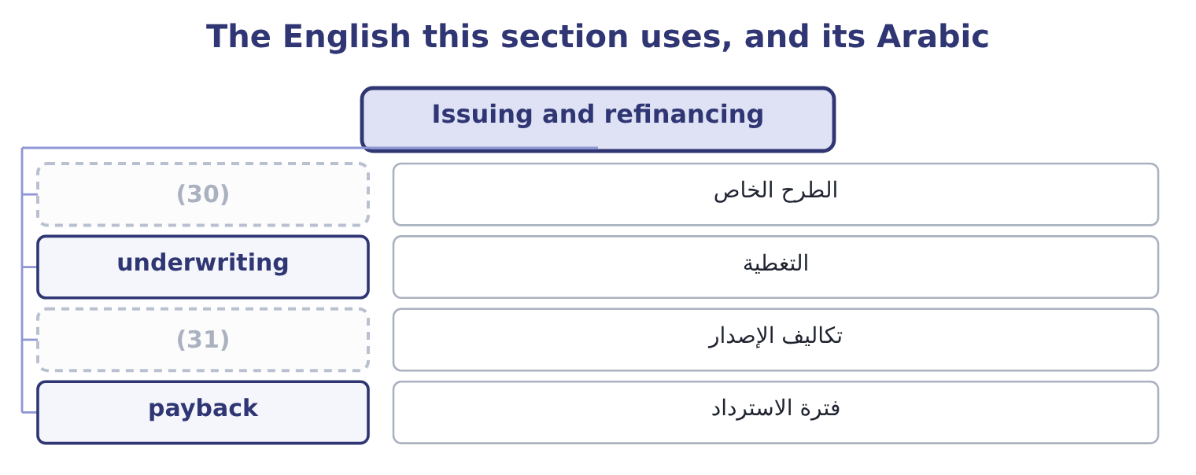
word list
modified duration · issue costs · private placement

The English this sheet uses, and its Arabic
English (exam term) | Arabic
private placement | الطرح الخاص
underwriting | التغطية
issue costs | تكاليف الإصدار
payback | فترة الاسترداد

Answer key · 4.4 Issuing and refinancing

1 issuer's | 17 company's
2 deciding | 18 positive
3 questions | 19 should
4 combination | 20 things
5 through | 21 conclusion
6 underwritten | 22 examinable
7 placement | 23 remained
8 justified | 24 floating
9 mid-sized | 25 commitment
10 calculation | 26 Interest is deductible, so the saving is taxed
11 structure | 27 A percentage of par, stated in the indenture
12 coupon | 28 Underwriting, legal, rating
13 outstanding | 29 Against five years of remaining life
14 million | 30 private placement
15 because | 31 issue costs
16 Discounted

the summaries in full
Summary 1 Now the issuer's side. A company deciding to issue debt faces four questions, and the exam asks them in combination: how much, for how long, on what terms, and through what route. The route is a choice between a public issue, which is registered, underwritten by an investment bank, rated by an agency and sold to many holders, and a private placement with a small number of institutions, which is quicker and cheaper to arrange and carries tighter covenants and a slightly higher rate. Below a certain size the fixed costs of a public issue cannot be justified, which is why most mid-sized companies borrow from banks and institutions rather than from the bond market. The refinancing decision is a calculation the exam sets often, and the structure never changes. A company with an existing bond at a high coupon can call it, pay the call premium, pay the costs of issuing a new bond, and save the interest difference for the remaining life.
Summary 2 A company has $10,000,000 of bonds outstanding at 8 per cent with five years to run. It can issue new five-year bonds at 6 per cent. The existing bonds are callable at 103, so the call premium is 3 per cent of par, and issuing the new bonds costs $200,000. Two points on ten million: 10,000,000 × 0.02 = 200,000 a year before tax. At a 25 per cent tax rate the interest saved is worth 200,000 × 0.75 = 150,000 a year after tax, because the interest was deductible. The call premium is 10,000,000 × 0.03 = 300,000 and the issue costs are 200,000, so 300,000 + 200,000 = 500,000 before tax. Both are deductible, so the after-tax cost is 500,000 × 0.75 = 375,000. Discounted properly at the company's after-tax cost of debt the net present value is positive, and the refinancing should go ahead.
Summary 3 Three things would reverse the conclusion and all three are examinable. If only two years remained, the saving would not cover the cost. If the new issue were at a floating rate, the 6 per cent would be today's rate and not a five-year commitment. And if the existing bond were not callable, there would be no decision to take at all — which is why.

4.5 Taxes and the financing decision
Chapter 4 · section 4.5

Fill every gap. Each word list holds one word more than there are gaps.
Summary 1 gaps 1–12
Interest is deductible and (1) are not. That single (2) shapes capital structure (3) , and the exam tests it in three forms. The after-tax cost of debt. A company borrowing at 6 per cent with a 25 per cent tax rate bears 6.0 × 0.75 = 4.5 per cent, because each dollar of interest (4) taxable income by a dollar. (5) $390,000 of interest is worth 390,000 × 0.25 = 97,500 a year in tax saved, and that (6) is called the interest tax shield. Equity has no (7) shield: a dividend is paid out of profit that has (8) been taxed. So on a pure tax (9) , debt is the (10) funding and a company (11) use as much of it as it can — which is (12) wrong, and the reason it is wrong is the whole of capital structure theory.
word list
Orontes's · already · plainly · saving · dividends · asymmetry · should · reduces · equivalent · everywhere · argument · cheaper · credits

Summary 2 gaps 13–24
Beyond some level of borrowing, the costs of (13) distress grow faster than the shield: lenders demand more, suppliers shorten terms, customers worry about (14) , management spends its time on the bank. The (15) is where the marginal value of the shield equals the marginal cost of distress, and no (16) locates it. The shield is worth (17) to a company with no taxable profit. A company making losses, or sheltered by large (18) or tax credits, cannot use the (19) , so debt costs it the full 6 per cent. This is the standard reason a (20) company leases rather than buys, and: the lessor has the taxable profit and can use the (21) , so it prices the lease to share some of the benefit. Two (22) tax points belong here because (23) pair them with the above. A premium or discount on issue is (24) for tax over the life of the bond rather than deducted at once. And in a refinancing, the unamortised issue costs of the old bond are normally deductible when it is retired, which improves the arithmetic of section 4.4 slightly.
word list
allowances · further · questions · after-tax · amortised · financial · loss-making · warranties · optimum · nothing · deduction · depreciation · formula

What the tax system does to each source of money
The bars are drawn to scale.
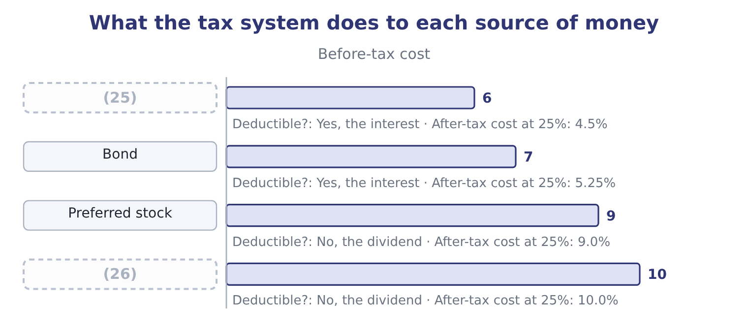
word list
Common equity · Bank debt · semi-annual coupon

Value, measure and refinance

Your turn: valuation, duration and refinancing (complete the blanks)
Item | Data | Answer
Value of a bond | 4 years, 1,000 par, 5% coupon, required 6%; annuity factor 3.4651, PV factor 0.7921 | 965.35: the coupons are 50 × 3.4651 = 173.26 and the principal 1,000 × 0.7921 = 792.10, so 173.26 + 792.10 = 965.36, which rounds to 965.35
Value of a preferred share | Dividend 4.00, required 10% | (27)
Modified duration | Macaulay 3.72 years, required return 6% | (28)
Price fall on a one-point rise | (29) | About 33.88: 965.40 × 0.0351 = 33.89, so the price falls to about 931.50.
After-tax cost of a 7% bond | (30) | 5.25 per cent: 7.0 × 0.75 = 5.25.
Refinancing payback | (31) | 3.00 years: 270,000 ÷ 90,000 = 3.00.

word list
Dividend 4.00, required 10% · Tax rate 25% · 3.51: 3.72 ÷ 1.06 = 3.51. · Saves 90,000 a year after tax, costs 270,000 after tax · On a price of 965.40 · 40.00: 4.00 ÷ 0.10 = 40.00.

"Discount"

Summary 3 gaps 32–36
To discount a cash flow is to (32) its present value. A bond at a discount (33) below par. A (34) discount is a price (35) for early payment. The three are related only by the idea of something being reduced, and a candidate who reads the wrong one has misread the question rather than the (36) .
word list
compute · calculation · settlement · trades · reduction · plainly

The English this section uses, and its Arabic
Each term sits against what it means.
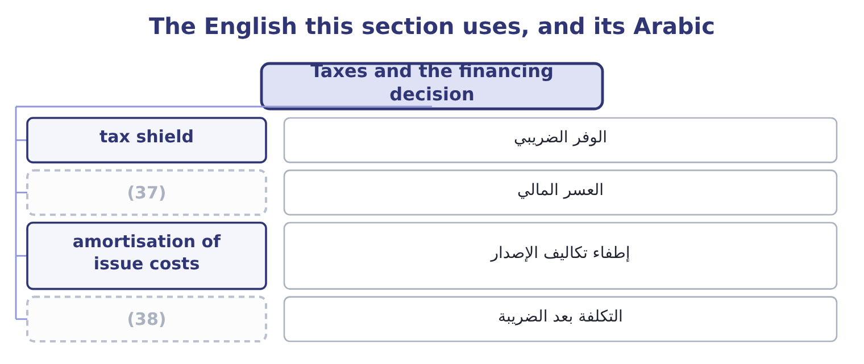
word list
after-tax cost · present value · financial distress

The English this sheet uses, and its Arabic
English (exam term) | Arabic
tax shield | الوفر الضريبي
financial distress | العسر المالي
amortisation of issue costs | إطفاء تكاليف الإصدار
after-tax cost | التكلفة بعد الضريبة

Answer key · 4.5 Taxes and the financing decision

1 dividends | 20 loss-making
2 asymmetry | 21 allowances
3 everywhere | 22 further
4 reduces | 23 questions
5 Orontes's | 24 amortised
6 saving | 25 Bank debt
7 equivalent | 26 Common equity
8 already | 27 40.00: 4.00 ÷ 0.10 = 40.00.
9 argument | 28 3.51: 3.72 ÷ 1.06 = 3.51.
10 cheaper | 29 On a price of 965.40
11 should | 30 Tax rate 25%
12 plainly | 31 Saves 90,000 a year after tax, costs 270,000 after tax
13 financial | 32 compute
14 warranties | 33 trades
15 optimum | 34 settlement
16 formula | 35 reduction
17 nothing | 36 calculation
18 depreciation | 37 financial distress
19 deduction | 38 after-tax cost

the summaries in full
Summary 1 Interest is deductible and dividends are not. That single asymmetry shapes capital structure everywhere, and the exam tests it in three forms. The after-tax cost of debt. A company borrowing at 6 per cent with a 25 per cent tax rate bears 6.0 × 0.75 = 4.5 per cent, because each dollar of interest reduces taxable income by a dollar. Orontes's $390,000 of interest is worth 390,000 × 0.25 = 97,500 a year in tax saved, and that saving is called the interest tax shield. Equity has no equivalent shield: a dividend is paid out of profit that has already been taxed. So on a pure tax argument, debt is the cheaper funding and a company should use as much of it as it can — which is plainly wrong, and the reason it is wrong is the whole of capital structure theory.
Summary 2 Beyond some level of borrowing, the costs of financial distress grow faster than the shield: lenders demand more, suppliers shorten terms, customers worry about warranties, management spends its time on the bank. The optimum is where the marginal value of the shield equals the marginal cost of distress, and no formula locates it. The shield is worth nothing to a company with no taxable profit. A company making losses, or sheltered by large depreciation or tax credits, cannot use the deduction, so debt costs it the full 6 per cent. This is the standard reason a loss-making company leases rather than buys, and: the lessor has the taxable profit and can use the allowances, so it prices the lease to share some of the benefit. Two further tax points belong here because questions pair them with the above. A premium or discount on issue is amortised for tax over the life of the bond rather than deducted at once. And in a refinancing, the unamortised issue costs of the old bond are normally deductible when it is retired, which improves the arithmetic of section 4.4 slightly.
Summary 3 To discount a cash flow is to compute its present value. A bond at a discount trades below par. A settlement discount is a price reduction for early payment. The three are related only by the idea of something being reduced, and a candidate who reads the wrong one has misread the question rather than the calculation.

