5.1 Common stock
Chapter 5 · section 5.1

Fill every gap. Each word list holds one word more than there are gaps.
Chapter 5, section by section
Each stage leads to the next.
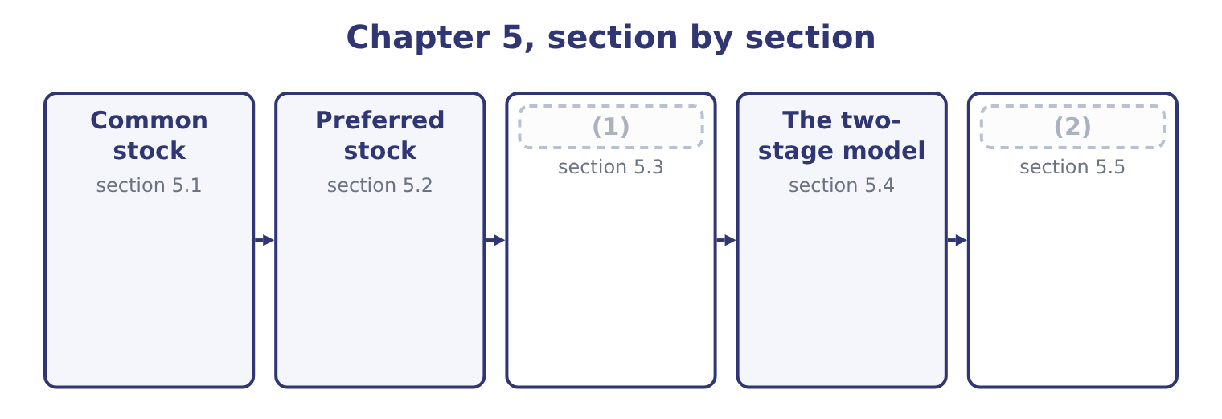
word list
Preferred stock · The constant growth dividend discount model · Relative valuation

Summary 1 gaps 3–14
A common share is an (3) interest, and five (4) define it. It is a residual claim. The common shareholder is paid after (5) , suppliers, lenders and preferred (6) , in good years and in a liquidation alike. That is why equity carries the highest (7) return in the ladder of, and why it has no (8) : the residue can be very large. It carries limited (9) . A shareholder can lose what was paid for the share and no more, which is the (10) that makes public companies (11) . One share, one vote is the normal (12) , used to elect directors and approve major (13) . Dual-class structures give some shares more votes than others, which lets founders keep (14) with a minority of the economics, and which the exam treats as a governance risk rather than a defect. It may carry a pre-emptive right, which entitles existing holders to subscribe for new shares before outsiders, in proportion to what they hold, so that their percentage is not diluted without their consent. It is described by a share count with four different meanings, and questions exploit the difference.
word list
arrangement · employees · liability · different · ceiling · ownership · invention · transactions · possible · shareholders · characteristics · control · required

Summary 2 gaps 15–23
Shares (15) are the maximum the (16) permits. Shares issued are those ever sold. Treasury shares are issued shares the company has (17) back. Shares outstanding are issued less treasury, and they are the ones that vote and receive (18) . Orontes has 8,100,000 issued and outstanding and no treasury stock, which is why Book 1 could use one figure (19) . Par value, (20) , is a legal (21) in modern practice. (22) shares carry a $1 par value, so $8,100,000 sits in common stock and $5,400,000 in (23) paid-in capital, and the split between the two columns tells a reader nothing about the company.
word list
authorised · Orontes's · bought · formality · dividends · described · finally · charter · throughout · additional

Common against preferred
Feature | Common stock | Preferred stock
Claim on income | (24) | Fixed dividend, ahead of common
Claim in liquidation | Last | (25)
Dividend | (26) | Fixed, and often cumulative
Votes | Normally one a share | Normally none
Upside | Unlimited | (27)
Maturity | None | (28)

word list
Ahead of common, behind all debt · Residual, after everybody · Capped at the fixed dividend · Discretionary · None, unless callable or redeemable · sensitivity

The English this section uses, and its Arabic
Each term sits against what it means.
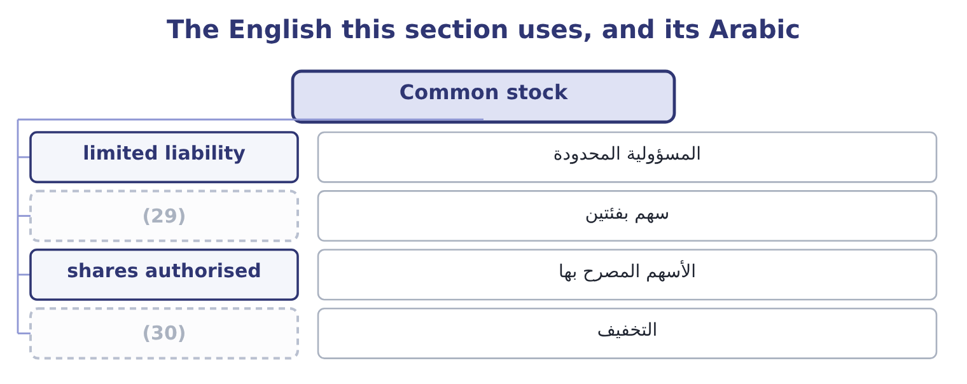
word list
dilution · المسؤولية المحدودة · dual-class share

The English this sheet uses, and its Arabic
English (exam term) | Arabic
limited liability | المسؤولية المحدودة
dual-class share | سهم بفئتين
shares authorised | الأسهم المصرح بها
dilution | التخفيف

Answer key · 5.1 Common stock

1 The constant growth dividend discount model | 16 charter
2 Relative valuation | 17 bought
3 ownership | 18 dividends
4 characteristics | 19 throughout
5 employees | 20 finally
6 shareholders | 21 formality
7 required | 22 Orontes's
8 ceiling | 23 additional
9 liability | 24 Residual, after everybody
10 invention | 25 Ahead of common, behind all debt
11 possible | 26 Discretionary
12 arrangement | 27 Capped at the fixed dividend
13 transactions | 28 None, unless callable or redeemable
14 control | 29 dual-class share
15 authorised | 30 dilution

the summaries in full
Summary 1 A common share is an ownership interest, and five characteristics define it. It is a residual claim. The common shareholder is paid after employees, suppliers, lenders and preferred shareholders, in good years and in a liquidation alike. That is why equity carries the highest required return in the ladder of, and why it has no ceiling: the residue can be very large. It carries limited liability. A shareholder can lose what was paid for the share and no more, which is the invention that makes public companies possible. One share, one vote is the normal arrangement, used to elect directors and approve major transactions. Dual-class structures give some shares more votes than others, which lets founders keep control with a minority of the economics, and which the exam treats as a governance risk rather than a defect. It may carry a pre-emptive right, which entitles existing holders to subscribe for new shares before outsiders, in proportion to what they hold, so that their percentage is not diluted without their consent. It is described by a share count with four different meanings, and questions exploit the difference.
Summary 2 Shares authorised are the maximum the charter permits. Shares issued are those ever sold. Treasury shares are issued shares the company has bought back. Shares outstanding are issued less treasury, and they are the ones that vote and receive dividends. Orontes has 8,100,000 issued and outstanding and no treasury stock, which is why Book 1 could use one figure throughout. Par value, finally, is a legal formality in modern practice. Orontes's shares carry a $1 par value, so $8,100,000 sits in common stock and $5,400,000 in additional paid-in capital, and the split between the two columns tells a reader nothing about the company.

5.2 Preferred stock
Chapter 5 · section 5.2

Fill every gap. Each word list holds one word more than there are gaps.
Summary 1 gaps 1–12
Preferred stock sits (1) debt and equity and takes (2) from both, which is why the exam calls it a hybrid. From debt it takes a fixed payment and (3) . The dividend is stated as a (4) of par or as an (5) , it does not rise when profits rise, and it must be paid in full before any common dividend. In a (6) the preferred holder ranks ahead of the common and behind every (7) . From equity it takes (8) and permanence. The dividend is (9) , not owed: missing it is not a default and cannot force the company into (10) . There is usually no (11) . And the payment is not deductible for tax: a 9 per cent preferred costs 9 per cent after tax, while a 9 per cent bond costs 6.75. The variants are (12) by name.
word list
liquidation · examinable · percentage · bankruptcy · creditor · amount · characteristics · declared · holder's · priority · maturity · between · discretion

Summary 2 gaps 13–24
Cumulative preferred carries unpaid dividends forward as arrears that block the common dividend; (13) does not, and is (14) cheaper for the issuer and worse for the holder. (15) preferred takes its fixed dividend and then shares in (16) profits. (17) preferred can be (18) for common shares. Callable or (19) preferred can be bought back by the issuer at a stated price, which caps the (20) gain. Valuation is the (21) : the dividend over the (22) return. A $100 par 9 per cent preferred pays $9.00 a year, and if the market requires 10 per cent for that risk it is worth 9.00 ÷ 0.10 = 90.00. If the market requires 8 per cent it is worth 9.00 ÷ 0.08 = 112.50. Why issue it at all, given that it costs more after tax than debt? Three (23) the exam accepts. It carries no (24) and no default risk, so it does not restrict the company or threaten it.
word list
missing · correspondingly · holder's · redeemable · perpetuity · covenants · non-cumulative · further · reasons · Participating · required · Convertible · exchanged

Summary 3 gaps 25–26
Rating agencies and lenders treat part of it as equity, so it (25) borrowing capacity. And it (26) money without giving away votes.
word list
raises · preserves · reasons

What each preferred feature does
Every item belongs to exactly one group.
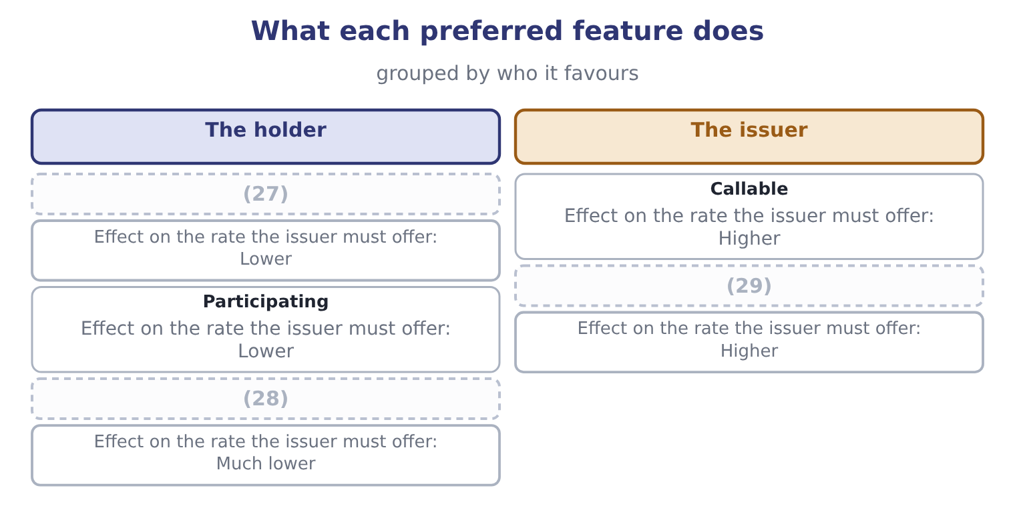
word list
Convertible · Arrears carried forward · relative valuation · Arrears lost if unpaid

Preferred is not debt

Summary 4 gaps 30–36
A (30) preferred dividend is not a default and creates no (31) on the balance sheet. It creates arrears, (32) in the notes, which block the common dividend. Preferred dividends are deducted from net income before (33) per share, and preferred stock is deducted from equity before book value per common share. The preferred dividend is not deductible for tax. (34) a 9 per cent preferred with a 9 per cent bond without (35) for tax is the (36) error.
word list
liability · adjusting · earnings · missed · standard · Comparing · disclosed · preserves

The English this section uses, and its Arabic
Each term sits against what it means.
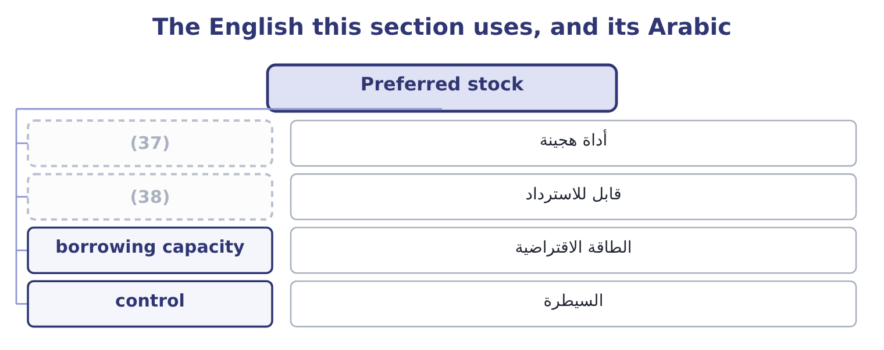
word list
قابل للاسترداد · redeemable · hybrid security

The English this sheet uses, and its Arabic
English (exam term) | Arabic
hybrid security | أداة هجينة
redeemable | قابل للاسترداد
borrowing capacity | الطاقة الاقتراضية
control | السيطرة

Answer key · 5.2 Preferred stock

1 between | 20 holder's
2 characteristics | 21 perpetuity
3 priority | 22 required
4 percentage | 23 reasons
5 amount | 24 covenants
6 liquidation | 25 preserves
7 creditor | 26 raises
8 discretion | 27 Arrears carried forward
9 declared | 28 Convertible
10 bankruptcy | 29 Arrears lost if unpaid
11 maturity | 30 missed
12 examinable | 31 liability
13 non-cumulative | 32 disclosed
14 correspondingly | 33 earnings
15 Participating | 34 Comparing
16 further | 35 adjusting
17 Convertible | 36 standard
18 exchanged | 37 hybrid security
19 redeemable | 38 redeemable

the summaries in full
Summary 1 Preferred stock sits between debt and equity and takes characteristics from both, which is why the exam calls it a hybrid. From debt it takes a fixed payment and priority. The dividend is stated as a percentage of par or as an amount, it does not rise when profits rise, and it must be paid in full before any common dividend. In a liquidation the preferred holder ranks ahead of the common and behind every creditor. From equity it takes discretion and permanence. The dividend is declared, not owed: missing it is not a default and cannot force the company into bankruptcy. There is usually no maturity. And the payment is not deductible for tax: a 9 per cent preferred costs 9 per cent after tax, while a 9 per cent bond costs 6.75. The variants are examinable by name.
Summary 2 Cumulative preferred carries unpaid dividends forward as arrears that block the common dividend; non-cumulative does not, and is correspondingly cheaper for the issuer and worse for the holder. Participating preferred takes its fixed dividend and then shares in further profits. Convertible preferred can be exchanged for common shares. Callable or redeemable preferred can be bought back by the issuer at a stated price, which caps the holder's gain. Valuation is the perpetuity: the dividend over the required return. A $100 par 9 per cent preferred pays $9.00 a year, and if the market requires 10 per cent for that risk it is worth 9.00 ÷ 0.10 = 90.00. If the market requires 8 per cent it is worth 9.00 ÷ 0.08 = 112.50. Why issue it at all, given that it costs more after tax than debt? Three reasons the exam accepts. It carries no covenants and no default risk, so it does not restrict the company or threaten it.
Summary 3 Rating agencies and lenders treat part of it as equity, so it preserves borrowing capacity. And it raises money without giving away votes.
Summary 4 A missed preferred dividend is not a default and creates no liability on the balance sheet. It creates arrears, disclosed in the notes, which block the common dividend. Preferred dividends are deducted from net income before earnings per share, and preferred stock is deducted from equity before book value per common share. The preferred dividend is not deductible for tax. Comparing a 9 per cent preferred with a 9 per cent bond without adjusting for tax is the standard error.

5.3 The constant growth dividend discount model
Chapter 5 · section 5.3

Fill every gap. Each word list holds one word more than there are gaps.
Summary 1 gaps 1–12
A share is worth the (1) value of its dividends. Since the dividends go on for ever and are (2) to grow, the sum has a short (3) form: next year's dividend (4) by the required return less the growth rate. Three inputs, each a (5) . Next year's dividend is this year's grown by one (6) . Orontes paid $0.0556 a share for 2025, so at a 4 per cent growth rate next year's is 0.0556 × 1.04 = 0.0578. The required return comes: 9.4 per cent for Orontes. The growth rate is the hard one. The (7) estimate is the (8) growth rate of Book 1: the return on equity times the (9) ratio. For Orontes that is 13.70 per cent, which is larger than the required return — and the formula (10) , because the denominator goes (11) . That is not an arithmetic (12) .
word list
sustainable · period · retention · question · expected · accident · divided · present · business · negative · standard · collapses · closed

Summary 2 gaps 13–17
No company can grow (13) than the return (14) require of it for ever; if it could, it would (15) be larger than the economy. The constant growth model (16) a long-run growth rate, and a long-run rate cannot exceed the growth of the economy the company sells into, which is why the exam's (17) are usually between 2 and 6 per cent.
word list
standard · faster · investors · figures · eventually · demands

Worked example: what the market is assuming about Orontes

Summary 3 gaps 18–29
Value Orontes on a 4 per cent long-run growth rate. Next year's dividend is $0.0578 and the denominator is 9.4 − 4.0 = 5.4 points, so the value is 0.0578 ÷ 0.054 = 1.07 a share. (18) with the market. The (19) trade at $9.25, nearly nine times the model's answer. Nothing is wrong with the arithmetic; what is wrong is (20) a dividend of 15 per cent of (21) as the whole of what the (22) will receive. Run the model (23) instead. If the price is right and the required return is 9.4 per cent, the growth rate the market must be (24) is the required return less the dividend yield: the yield is 0.0578 ÷ 9.25 = 0.62 per cent, so the (25) growth is 9.4 − 0.62 = 8.78 per cent a year, for ever. That is the (26) form of the model and the one the exam (27) . Asking what growth a price implies turns an (28) valuation into a testable claim: is 8.78 per cent a year for ever plausible for a food (29) whose gross margin has fallen three years running? Book 1's verdict says it is not, and the model has just converted that verdict into a number.
word list
negative · backwards · manufacturer · rewards · useful · shareholder · treating · implied · earnings · shares · Compare · assuming · unanswerable

The same dividend at four growth rates, required return 9.4 per cent
Growth rate | Denominator | Next year's dividend | Value a share
2.0% | 7.4 points | 0.0567 | 0.77
4.0% | 5.4 points | 0.0578 | 1.07
6.0% | (30) | 0.0589 | 1.73
8.0% | (31) | 0.0600 | 4.29

word list
3.4 points · shares authorised · 1.4 points

Summary 4 gaps 32–36
The model's (32) are examinable in their own right. It cannot value a company that pays no dividend. It is (33) sensitive to the growth rate, as the figure shows: two points of growth nearly (34) the answer. It (35) the growth rate to be below the required return. And it assumes growth is constant for ever, which no (36) is.
word list
business · requires · extremely · doubles · dilution · weaknesses

The English this section uses, and its Arabic
Each term sits against what it means.
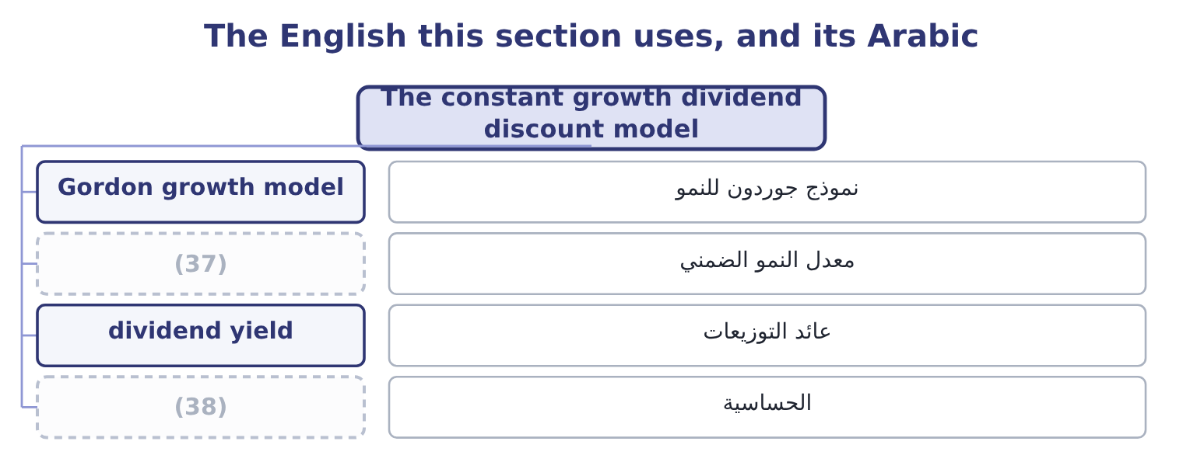
word list
shares authorised · sensitivity · implied growth rate

The English this sheet uses, and its Arabic
English (exam term) | Arabic
Gordon growth model | نموذج جوردون للنمو
implied growth rate | معدل النمو الضمني
dividend yield | عائد التوزيعات
sensitivity | الحساسية

Answer key · 5.3 The constant growth dividend discount model

1 present | 20 treating
2 expected | 21 earnings
3 closed | 22 shareholder
4 divided | 23 backwards
5 question | 24 assuming
6 period | 25 implied
7 standard | 26 useful
8 sustainable | 27 rewards
9 retention | 28 unanswerable
10 collapses | 29 manufacturer
11 negative | 30 3.4 points
12 accident | 31 1.4 points
13 faster | 32 weaknesses
14 investors | 33 extremely
15 eventually | 34 doubles
16 demands | 35 requires
17 figures | 36 business
18 Compare | 37 implied growth rate
19 shares | 38 sensitivity

the summaries in full
Summary 1 A share is worth the present value of its dividends. Since the dividends go on for ever and are expected to grow, the sum has a short closed form: next year's dividend divided by the required return less the growth rate. Three inputs, each a question. Next year's dividend is this year's grown by one period. Orontes paid $0.0556 a share for 2025, so at a 4 per cent growth rate next year's is 0.0556 × 1.04 = 0.0578. The required return comes: 9.4 per cent for Orontes. The growth rate is the hard one. The standard estimate is the sustainable growth rate of Book 1: the return on equity times the retention ratio. For Orontes that is 13.70 per cent, which is larger than the required return — and the formula collapses, because the denominator goes negative. That is not an arithmetic accident.
Summary 2 No company can grow faster than the return investors require of it for ever; if it could, it would eventually be larger than the economy. The constant growth model demands a long-run growth rate, and a long-run rate cannot exceed the growth of the economy the company sells into, which is why the exam's figures are usually between 2 and 6 per cent.
Summary 3 Value Orontes on a 4 per cent long-run growth rate. Next year's dividend is $0.0578 and the denominator is 9.4 − 4.0 = 5.4 points, so the value is 0.0578 ÷ 0.054 = 1.07 a share. Compare with the market. The shares trade at $9.25, nearly nine times the model's answer. Nothing is wrong with the arithmetic; what is wrong is treating a dividend of 15 per cent of earnings as the whole of what the shareholder will receive. Run the model backwards instead. If the price is right and the required return is 9.4 per cent, the growth rate the market must be assuming is the required return less the dividend yield: the yield is 0.0578 ÷ 9.25 = 0.62 per cent, so the implied growth is 9.4 − 0.62 = 8.78 per cent a year, for ever. That is the useful form of the model and the one the exam rewards. Asking what growth a price implies turns an unanswerable valuation into a testable claim: is 8.78 per cent a year for ever plausible for a food manufacturer whose gross margin has fallen three years running? Book 1's verdict says it is not, and the model has just converted that verdict into a number.
Summary 4 The model's weaknesses are examinable in their own right. It cannot value a company that pays no dividend. It is extremely sensitive to the growth rate, as the figure shows: two points of growth nearly doubles the answer. It requires the growth rate to be below the required return. And it assumes growth is constant for ever, which no business is.

5.4 The two-stage model
Chapter 5 · section 5.4

Fill every gap. Each word list holds one word more than there are gaps.
Summary 1 gaps 1–4
Real companies grow fast for a while and then slow down, as (1) arrives and the (2) fills. The two-stage model says so (3) : a period of high growth with each dividend discounted (4) , then a constant-growth phase valued by the formula of section 5.3 and discounted back as a single terminal value.
word list
explicitly · perpetuity · individually · competition · market

Worked example: two stages

Summary 2 gaps 5–16
A company has just paid a dividend of $2.00. It will grow at 15 per cent for two years and at 5 per cent for ever after. The (5) return is 10 per cent. Year one: 2.00 × 1.15 = 2.30. Year two: 2.30 × 1.15 = 2.6450. Year three, the first of the slow phase: 2.6450 × 1.05 = 2.7773. At the end of year two the (6) stream is a constant-growth (7) worth 2.7773 ÷ 0.05 = 55.546. Discount (8) to today. Year one: 2.30 ÷ 1.10 = 2.0909. Year two (9) both the dividend and the terminal value: 2.6450 + 55.546 = 58.191, and 58.191 ÷ 1.21 = 48.09. The share is worth 2.0909 + 48.09 = 50.18. Note where the value sits: more than (10) per cent of it is in the terminal value, which rests (11) on an assumed 5 per cent for ever. That is true of (12) every two-stage (13) and it is the first thing to say when (14) one. The (15) phase that the analysis spent all its effort (16) contributed four per cent of the answer.
word list
valuation · presenting · carries · ninety-five · entirely · forecasting · high-growth · control · remaining · required · perpetuity · everything · almost

The two-stage model, step by step
The bars are drawn to scale.
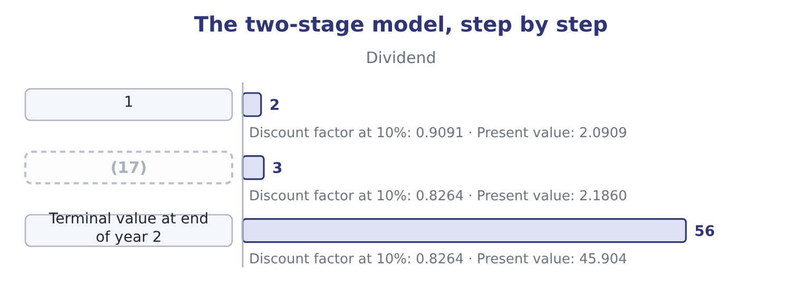
word list
2 · sensitivity

Summary 3 gaps 18–21
The same logic (18) . A (19) model adds a (20) phase in which growth declines gradually, which is more realistic and adds no new idea. Where a company pays no dividend at all, the same machinery is applied to free cash flow instead, which Book 3 develops for capital projects and (21) .
word list
acquisitions · transition · extends · three-stage · valuation

The English this section uses, and its Arabic
Each term sits against what it means.
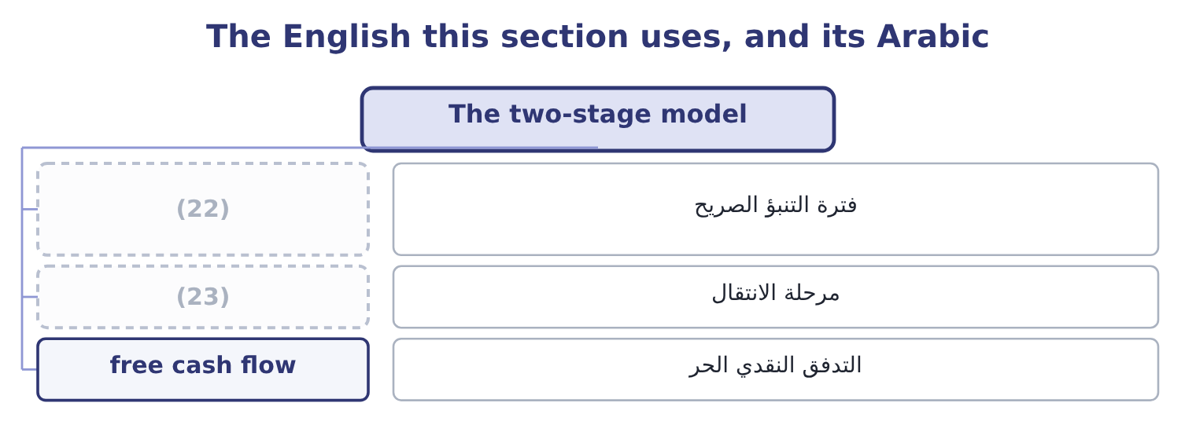
word list
Gordon growth model · explicit forecast period · transition phase

The English this sheet uses, and its Arabic
English (exam term) | Arabic
explicit forecast period | فترة التنبؤ الصريح
transition phase | مرحلة الانتقال
free cash flow | التدفق النقدي الحر

Answer key · 5.4 The two-stage model

1 competition | 13 valuation
2 market | 14 presenting
3 explicitly | 15 high-growth
4 individually | 16 forecasting
5 required | 17 2
6 remaining | 18 extends
7 perpetuity | 19 three-stage
8 everything | 20 transition
9 carries | 21 acquisitions
10 ninety-five | 22 explicit forecast period
11 entirely | 23 transition phase
12 almost

the summaries in full
Summary 1 Real companies grow fast for a while and then slow down, as competition arrives and the market fills. The two-stage model says so explicitly: a period of high growth with each dividend discounted individually, then a constant-growth phase valued by the formula of section 5.3 and discounted back as a single terminal value.
Summary 2 A company has just paid a dividend of $2.00. It will grow at 15 per cent for two years and at 5 per cent for ever after. The required return is 10 per cent. Year one: 2.00 × 1.15 = 2.30. Year two: 2.30 × 1.15 = 2.6450. Year three, the first of the slow phase: 2.6450 × 1.05 = 2.7773. At the end of year two the remaining stream is a constant-growth perpetuity worth 2.7773 ÷ 0.05 = 55.546. Discount everything to today. Year one: 2.30 ÷ 1.10 = 2.0909. Year two carries both the dividend and the terminal value: 2.6450 + 55.546 = 58.191, and 58.191 ÷ 1.21 = 48.09. The share is worth 2.0909 + 48.09 = 50.18. Note where the value sits: more than ninety-five per cent of it is in the terminal value, which rests entirely on an assumed 5 per cent for ever. That is true of almost every two-stage valuation and it is the first thing to say when presenting one. The high-growth phase that the analysis spent all its effort forecasting contributed four per cent of the answer.
Summary 3 The same logic extends. A three-stage model adds a transition phase in which growth declines gradually, which is more realistic and adds no new idea. Where a company pays no dividend at all, the same machinery is applied to free cash flow instead, which Book 3 develops for capital projects and acquisitions.

5.5 Relative valuation
Chapter 5 · section 5.5

Fill every gap. Each word list holds one word more than there are gaps.
Summary 1 gaps 1–12
The (1) to discounting is (2) : value a company at what the market pays for similar companies, using a multiple of (3) the companies share. The price/earnings ratio is the (4) one. Take the multiple at which comparable companies trade, (5) by the subject (6) earnings per share, and that is the implied value. If food (7) of Orontes's size trade at 18 times earnings, Orontes's implied value is 18 × 0.3666 = 6.60 a share, against a market price of $9.25. (8) the market (9) Orontes is better than its peers, or it is dear. The market-to-book ratio (10) price with net assets. It is most useful where assets are carried near their current values, which is why it is the (11) multiple for banks and (12) and a weak one for a company whose value is in brands and recipes.
word list
manufacturers · alternative · standard · multiply · something · Either · comparison · insurers · compares · warning · common · company's · thinks

Summary 2 gaps 13–19
The price/sales ratio (13) market capitalisation by (14) : 74,925,000 ÷ 42,000,000 = 1.78 for Orontes. Its use is the case the other two (15) handle — a company with no earnings, or with earnings (16) by a one-off such as the $2,724,000 (17) Book 1 spent a section on. Sales are harder to (18) than earnings, which is its second attraction, and it ignores (19) entirely, which is its fatal weakness: two companies with the same sales and different margins are not worth the same.
word list
revenue · profitability · divides · distorted · manipulate · company's · impairment · cannot

Three multiples, and when each is the right one
The bars are drawn to scale.
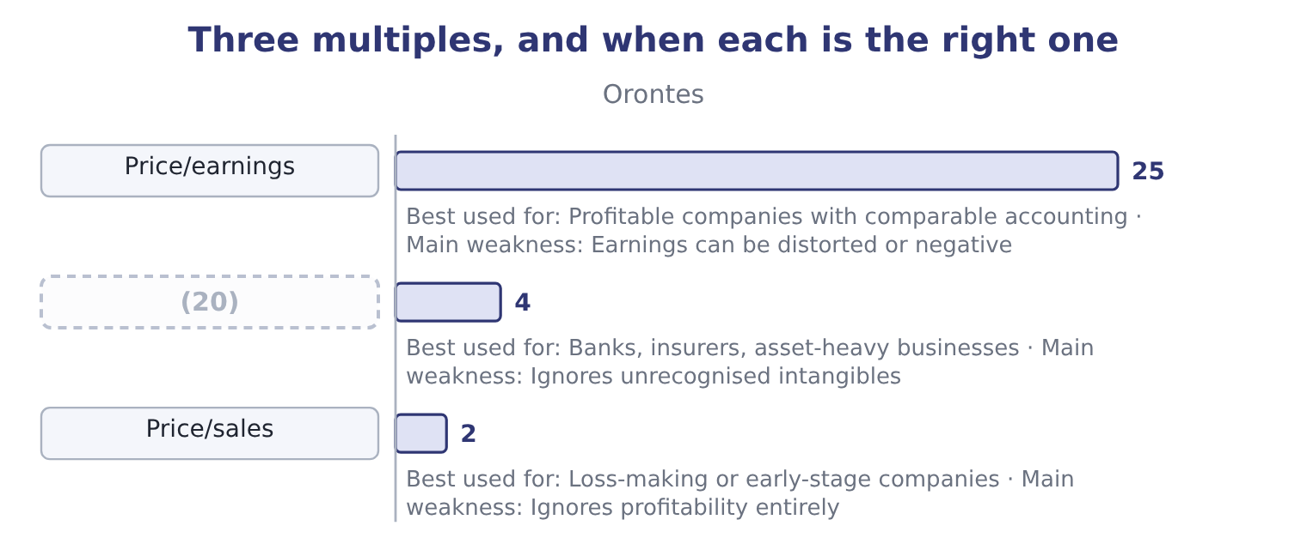
word list
Market/book · dilution

Summary 3 gaps 21–29
Three rules (21) the method and all three are (22) . The (23) must be genuinely comparable in (24) , size, growth and risk — Book 1's warning about (25) 14 per cent gross margin against Orontes's 35 is the same point. The (26) must be on the same basis, or the (27) are not measuring the same thing. And relative (28) tells you what the market pays today, not what a company is worth: a sector (29) at thirty times earnings gives a high answer for every company in it, and the method has no way of saying the sector is wrong.
word list
examined · against · comparables · accounting · govern · valuation · multiples · business · valued · Barada's

Value Barada's shares

Your turn: valuing Barada (complete the blanks)
Item | Data | Answer
Earnings per share | (30) | ________
Book value per share | Equity 3,100,000 | ________
Value on a constant growth model | Dividend just paid 0.10, growth 3%, required return 10.8% | ________
Value at a peer multiple | (31) | ________
Value at a peer market-to-book | Distributors trade at 1.2 times book | ________
Price/sales at the investor's 6.00 a share | (32) | ________

word list
Distributors trade at 14 times earnings · Sales 21,978,000 · 3.72: 1.2 × 3.10 = 3.72. · Net income 283,500 on 1,000,000 shares

"Equity"

Summary 4 gaps 33–40
English equity means three different (33) in these books. It is the (34) ' claim on a company, as in (35) ' equity. It is the shares (36) , as in an equity (37) . And in (38) English it means (39) , which is where the word came from and why courts of equity have nothing to do with shares. The exam uses the first two senses (40) and expects you to tell them apart from the context; the phrase cost of equity, for instance, means the return required on the ownership claim, not the price of a share.
word list
interchangeably · comparable · things · ordinary · investment · owners · stockholders · fairness · themselves

"Equity"
Item | Answer
Earnings per share | 0.2835: 283,500 ÷ 1,000,000.
Book value per share | (41) : 3,100,000 ÷ 1,000,000.
Constant growth value | 1.32: next year's dividend is 0.10 × 1.03 = 0.103, and 0.103 ÷ 0.078 = 1.32.
Value at a peer multiple | (42)
Value at a peer market-to-book | 3.72: 1.2 × 3.10 = 3.72.
Price/sales at 6.00 a share | 0.27: the market capitalisation is 1,000,000 × 6.00 = 6,000,000, and 6,000,000 ÷ 21,978,000 = 0.27.
What it tells you | Three of the four methods put Barada between about 3.70 and 4.00 a share, and the investor is offering 6.00. On these figures the offer is g

word list
3.10 · 3.97: 14 × 0.2835 = 3.97. · Distributors trade at 1.2 times book

The English this section uses, and its Arabic
Each term sits against what it means.
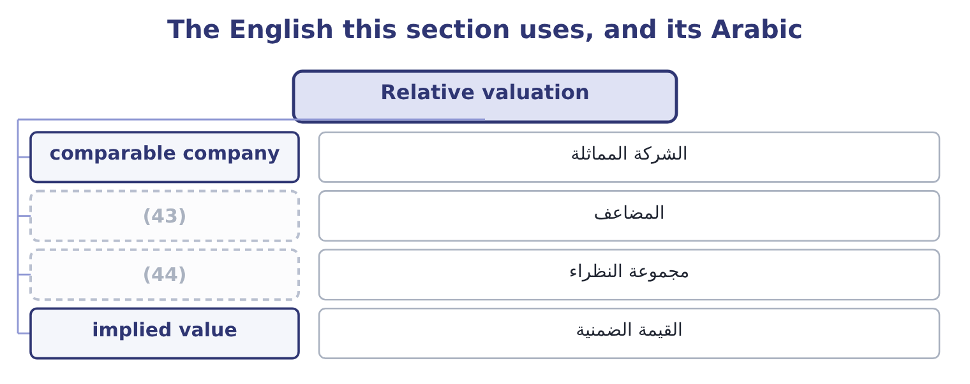
word list
terminal value · multiple · peer group

The English this sheet uses, and its Arabic
English (exam term) | Arabic
comparable company | الشركة المماثلة
multiple | المضاعف
peer group | مجموعة النظراء
implied value | القيمة الضمنية

Answer key · 5.5 Relative valuation

1 alternative | 23 comparables
2 comparison | 24 business
3 something | 25 Barada's
4 common | 26 accounting
5 multiply | 27 multiples
6 company's | 28 valuation
7 manufacturers | 29 valued
8 Either | 30 Net income 283,500 on 1,000,000 shares
9 thinks | 31 Distributors trade at 14 times earnings
10 compares | 32 Sales 21,978,000
11 standard | 33 things
12 insurers | 34 owners
13 divides | 35 stockholders
14 revenue | 36 themselves
15 cannot | 37 investment
16 distorted | 38 ordinary
17 impairment | 39 fairness
18 manipulate | 40 interchangeably
19 profitability | 41 3.10
20 Market/book | 42 3.97: 14 × 0.2835 = 3.97.
21 govern | 43 multiple
22 examined | 44 peer group

the summaries in full
Summary 1 The alternative to discounting is comparison: value a company at what the market pays for similar companies, using a multiple of something the companies share. The price/earnings ratio is the common one. Take the multiple at which comparable companies trade, multiply by the subject company's earnings per share, and that is the implied value. If food manufacturers of Orontes's size trade at 18 times earnings, Orontes's implied value is 18 × 0.3666 = 6.60 a share, against a market price of $9.25. Either the market thinks Orontes is better than its peers, or it is dear. The market-to-book ratio compares price with net assets. It is most useful where assets are carried near their current values, which is why it is the standard multiple for banks and insurers and a weak one for a company whose value is in brands and recipes.
Summary 2 The price/sales ratio divides market capitalisation by revenue: 74,925,000 ÷ 42,000,000 = 1.78 for Orontes. Its use is the case the other two cannot handle — a company with no earnings, or with earnings distorted by a one-off such as the $2,724,000 impairment Book 1 spent a section on. Sales are harder to manipulate than earnings, which is its second attraction, and it ignores profitability entirely, which is its fatal weakness: two companies with the same sales and different margins are not worth the same.
Summary 3 Three rules govern the method and all three are examined. The comparables must be genuinely comparable in business, size, growth and risk — Book 1's warning about Barada's 14 per cent gross margin against Orontes's 35 is the same point. The accounting must be on the same basis, or the multiples are not measuring the same thing. And relative valuation tells you what the market pays today, not what a company is worth: a sector valued at thirty times earnings gives a high answer for every company in it, and the method has no way of saying the sector is wrong.
Summary 4 English equity means three different things in these books. It is the owners' claim on a company, as in stockholders' equity. It is the shares themselves, as in an equity investment. And in ordinary English it means fairness, which is where the word came from and why courts of equity have nothing to do with shares. The exam uses the first two senses interchangeably and expects you to tell them apart from the context; the phrase cost of equity, for instance, means the return required on the ownership claim, not the price of a share.

