6.1 What a derivative is, and what it is for
Chapter 6 · section 6.1

Fill every gap. Each word list holds one word more than there are gaps.
Chapter 6, section by section
Each stage leads to the next.
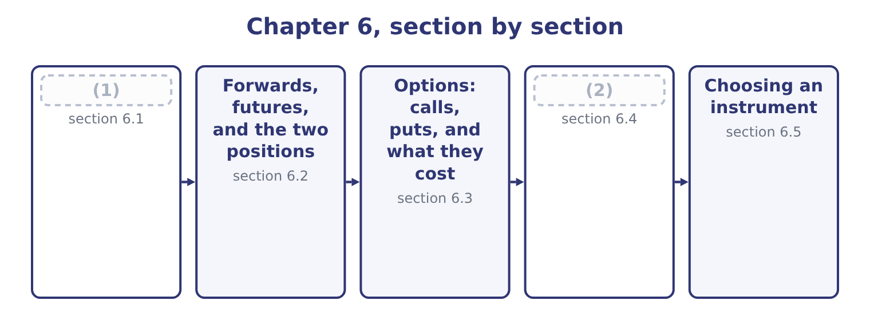
word list
Options: calls, puts, and what they cost · What a derivative is, and what it is for · What an option is worth

Summary 1 gaps 3–14
A derivative's value is (3) from an underlying — the asset, rate or index the contract (4) to. The contract (5) creates no new asset. If one party gains a dollar the other loses a dollar, which is why a derivatives (6) is called a (7) game, and why its total size says (8) about the wealth in it. Three uses, and the exam (9) them sharply. Hedging takes an (10) exposure and offsets it. (11) is already exposed to the sesame price by the simple fact of being a food (12) ; a contract to buy sesame forward at a fixed price cancels part of that exposure. A (13) gain on the contract is (14) by a loss on the underlying business, and the point is not to make money on the contract but to make the outcome certain.
word list
market · refers · separates · existing · itself · zero-sum · Orontes · matched · nothing · hedger's · derived · exposure · manufacturer

Summary 2 gaps 15–25
Speculation takes an exposure that did not exist. A (15) with no sesame business who buys the same contract has (16) a position in the sesame price. The (17) is identical; the purpose, and the risk, are the (18) . Arbitrage takes two prices for the same thing and locks in the difference. In theory it is (19) and in practice it is (20) so, and it is the force that keeps a derivative's price tied to its underlying. A fourth motive (21) naming because (22) use it: a derivative can change the form of a position (23) . Converting (24) debt to fixed by (25) the interest, rather than repaying one bond and issuing another, saves the whole cost of an issue —.
word list
swapping · created · opposite · questions · floating-rate · cheaply · underlying · nearly · deserves · trader · riskless · instrument

Three reasons to hold a derivative
Purpose | The underlying exposure | What the contract does | Risk after the trade
Hedging | (26) | Offsets it | Lower
Speculation | Does not exist | Creates it | (27)
Arbitrage | Two prices for one thing | Locks the difference | (28)

word list
Already exists · Higher · Close to nil · natural hedge

The same contract does opposite work

Summary 3 gaps 29–37
Whether a position is a hedge or a speculation (29) on what else the (30) owns, never on the contract. A (31) that describes a company buying a commodity forward for a commodity it does not use is (32) a speculation. A hedge (33) the upside with the (34) . A company that hedges and then (35) prices fall has paid for (36) , not made a mistake. Derivatives are off balance sheet in the sense that no asset is bought, and they are (37) at fair value under the standards. Part 1 covered the accounting; Section B covers the economics.
word list
watches · downside · removes · describing · exposed · depends · question · recognised · certainty · holder

The English this section uses, and its Arabic
Each term sits against what it means.
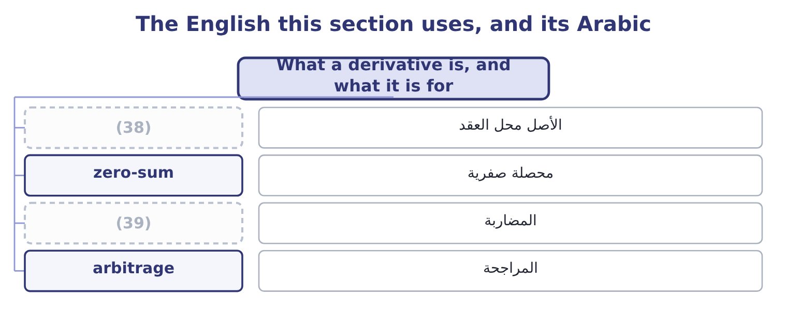
word list
speculation · volatility · underlying

The English this sheet uses, and its Arabic
English (exam term) | Arabic
underlying | الأصل محل العقد
zero-sum | محصلة صفرية
speculation | المضاربة
arbitrage | المراجحة

Answer key · 6.1 What a derivative is, and what it is for

1 What a derivative is, and what it is for | 21 deserves
2 What an option is worth | 22 questions
3 derived | 23 cheaply
4 refers | 24 floating-rate
5 itself | 25 swapping
6 market | 26 Already exists
7 zero-sum | 27 Higher
8 nothing | 28 Close to nil
9 separates | 29 depends
10 existing | 30 holder
11 Orontes | 31 question
12 manufacturer | 32 describing
13 hedger's | 33 removes
14 matched | 34 downside
15 trader | 35 watches
16 created | 36 certainty
17 instrument | 37 recognised
18 opposite | 38 underlying
19 riskless | 39 speculation
20 nearly

the summaries in full
Summary 1 A derivative's value is derived from an underlying — the asset, rate or index the contract refers to. The contract itself creates no new asset. If one party gains a dollar the other loses a dollar, which is why a derivatives market is called a zero-sum game, and why its total size says nothing about the wealth in it. Three uses, and the exam separates them sharply. Hedging takes an existing exposure and offsets it. Orontes is already exposed to the sesame price by the simple fact of being a food manufacturer; a contract to buy sesame forward at a fixed price cancels part of that exposure. A hedger's gain on the contract is matched by a loss on the underlying business, and the point is not to make money on the contract but to make the outcome certain.
Summary 2 Speculation takes an exposure that did not exist. A trader with no sesame business who buys the same contract has created a position in the sesame price. The instrument is identical; the purpose, and the risk, are the opposite. Arbitrage takes two prices for the same thing and locks in the difference. In theory it is riskless and in practice it is nearly so, and it is the force that keeps a derivative's price tied to its underlying. A fourth motive deserves naming because questions use it: a derivative can change the form of a position cheaply. Converting floating-rate debt to fixed by swapping the interest, rather than repaying one bond and issuing another, saves the whole cost of an issue —.
Summary 3 Whether a position is a hedge or a speculation depends on what else the holder owns, never on the contract. A question that describes a company buying a commodity forward for a commodity it does not use is describing a speculation. A hedge removes the upside with the downside. A company that hedges and then watches prices fall has paid for certainty, not made a mistake. Derivatives are off balance sheet in the sense that no asset is bought, and they are recognised at fair value under the standards. Part 1 covered the accounting; Section B covers the economics.

6.2 Forwards, futures, and the two positions
Chapter 6 · section 6.2

Fill every gap. Each word list holds one word more than there are gaps.
Summary 1 gaps 1–12
A forward contract is an agreement between two parties to buy or sell a stated quantity of (1) at a stated price on a stated (2) date. It is negotiated privately, so every term can be tailored, and it is settled once, at delivery. A futures contract is the same (3) , standardised and traded on an exchange. Quantity, (4) , delivery date and delivery point are fixed by the exchange; the only thing negotiated is the price. The (5) clearing house (6) between the two parties, so (7) takes the other's (8) risk, and both post margin: an initial (9) , and then a daily settlement of gains and (10) called marking to market. Those two (11) — customisation against (12) , one settlement against daily settlement — generate every other difference the exam asks for.
word list
exchange's · stands · future · promise · losses · contract · differences · standardisation · something · neither · deposit · quality · credit

Forwards against futures
Feature | Forward | Futures
Where traded | (13) | On an exchange
Terms | Negotiated and tailored | Standardised
Counterparty risk | On the other party | (14)
Margin | (15) | Initial and maintenance, settled daily
Settlement | (16) | Daily, by marking to market
Closing early | (17) | By an offsetting trade, easily
Typical user | (18) | A company or a trader wanting liquidity

word list
Once, at maturity · None usually · Privately, over the counter · On the clearing house · A company hedging a specific exposure · By agreement, or a new offsetting contract · By an offsetting trade, easily

Summary 2 gaps 19–24
The two (19) are simple and are tested (20) . The long position is the (21) : long means committed to buy, and a long gains when the price rises. The short position is the (22) : short means committed to sell, and a short gains when the price falls. A hedger (23) the position that offsets the (24) . Orontes buys sesame, so a price rise hurts it, so it goes long. A farmer sells sesame, so a price rise helps, so the farmer goes short — and the farmer and Orontes are the two sides of the same contract, each made safer by it.
word list
seller's · business · reaches · chooses · positions · buyer's · constantly

Worked example: Orontes fixes its sesame price

Summary 3 gaps 25–31
Orontes (25) to buy 1,000 tonnes of sesame in six months. The (26) price is $1,200 a tonne, so the expected cost is 1,000 × 1,200 = 1,200,000. A rise of a tenth would add $120,000 to cost of sales, which is more than a point of gross margin. The company buys 1,000 tonnes six months forward at $1,200. It is now long sesame futures and long the physical (27) , and the two (28) . Suppose sesame (29) $1,350. The physical purchase costs 1,350 − 1,200 = 150 a tonne more than planned, which is 150 × 1,000 = 150,000. The contract gains the (30) $150,000. Net cost: $1,200 a tonne, as planned. Suppose sesame falls to $1,100. The physical purchase is $100 a tonne (31) , saving $100,000, and the contract loses $100,000. Net cost: $1,200 a tonne, as planned.
word list
requirement · physical · expects · reaches · identical · cheaper · current · offset

Summary 4 gaps 32–40
In both (32) Orontes paid $1,200 a tonne, which is what hedging means. The company gave up a $100,000 (33) to avoid a $150,000 shock, and whether that is a good trade (34) on whether (35) is worth more to it than the (36) outcome — which for a company with a gross margin of 35 per cent and a bank (37) to respect, it (38) is. Had Orontes (39) futures rather than a forward, it would also have had to fund margin: at an initial margin of 5 per cent, 1,200,000 × 0.05 = 60,000 of cash tied up, plus whatever the daily (40) demanded.
word list
covenant · windfall · certainty · hedging · average · depends · generally · directions · bought · settlements

The English this section uses, and its Arabic
Each term sits against what it means.
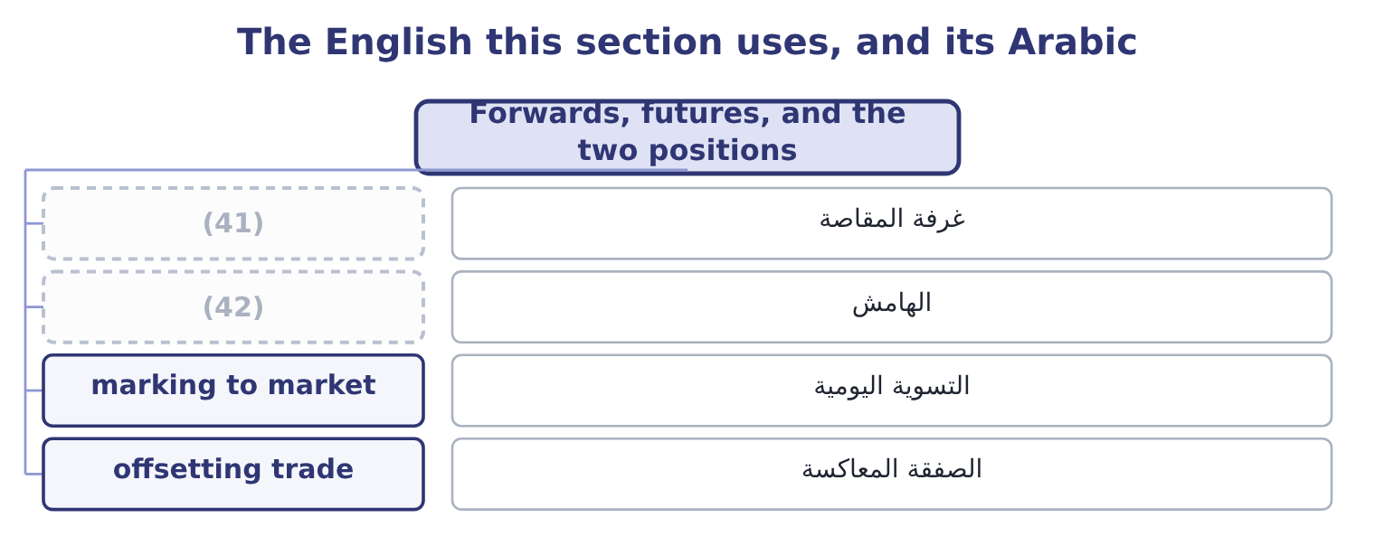
word list
clearing house · margin · intrinsic value

The English this sheet uses, and its Arabic
English (exam term) | Arabic
clearing house | غرفة المقاصة
margin | الهامش
marking to market | التسوية اليومية
offsetting trade | الصفقة المعاكسة

Answer key · 6.2 Forwards, futures, and the two positions

1 something | 22 seller's
2 future | 23 chooses
3 promise | 24 business
4 quality | 25 expects
5 exchange's | 26 current
6 stands | 27 requirement
7 neither | 28 offset
8 credit | 29 reaches
9 deposit | 30 identical
10 losses | 31 cheaper
11 differences | 32 directions
12 standardisation | 33 windfall
13 Privately, over the counter | 34 depends
14 On the clearing house | 35 certainty
15 None usually | 36 average
16 Once, at maturity | 37 covenant
17 By agreement, or a new offsetting contract | 38 generally
18 A company hedging a specific exposure | 39 bought
19 positions | 40 settlements
20 constantly | 41 clearing house
21 buyer's | 42 margin

the summaries in full
Summary 1 A forward contract is an agreement between two parties to buy or sell a stated quantity of something at a stated price on a stated future date. It is negotiated privately, so every term can be tailored, and it is settled once, at delivery. A futures contract is the same promise, standardised and traded on an exchange. Quantity, quality, delivery date and delivery point are fixed by the exchange; the only thing negotiated is the price. The exchange's clearing house stands between the two parties, so neither takes the other's credit risk, and both post margin: an initial deposit, and then a daily settlement of gains and losses called marking to market. Those two differences — customisation against standardisation, one settlement against daily settlement — generate every other difference the exam asks for.
Summary 2 The two positions are simple and are tested constantly. The long position is the buyer's: long means committed to buy, and a long gains when the price rises. The short position is the seller's: short means committed to sell, and a short gains when the price falls. A hedger chooses the position that offsets the business. Orontes buys sesame, so a price rise hurts it, so it goes long. A farmer sells sesame, so a price rise helps, so the farmer goes short — and the farmer and Orontes are the two sides of the same contract, each made safer by it.
Summary 3 Orontes expects to buy 1,000 tonnes of sesame in six months. The current price is $1,200 a tonne, so the expected cost is 1,000 × 1,200 = 1,200,000. A rise of a tenth would add $120,000 to cost of sales, which is more than a point of gross margin. The company buys 1,000 tonnes six months forward at $1,200. It is now long sesame futures and long the physical requirement, and the two offset. Suppose sesame reaches $1,350. The physical purchase costs 1,350 − 1,200 = 150 a tonne more than planned, which is 150 × 1,000 = 150,000. The contract gains the identical $150,000. Net cost: $1,200 a tonne, as planned. Suppose sesame falls to $1,100. The physical purchase is $100 a tonne cheaper, saving $100,000, and the contract loses $100,000. Net cost: $1,200 a tonne, as planned.
Summary 4 In both directions Orontes paid $1,200 a tonne, which is what hedging means. The company gave up a $100,000 windfall to avoid a $150,000 shock, and whether that is a good trade depends on whether certainty is worth more to it than the average outcome — which for a company with a gross margin of 35 per cent and a bank covenant to respect, it generally is. Had Orontes bought futures rather than a forward, it would also have had to fund margin: at an initial margin of 5 per cent, 1,200,000 × 0.05 = 60,000 of cash tied up, plus whatever the daily settlements demanded.

6.3 Options: calls, puts, and what they cost
Chapter 6 · section 6.3

Fill every gap. Each word list holds one word more than there are gaps.
Summary 1 gaps 1–7
That (1) word is the (2) , and it is why an option costs money up front and a forward does not. A call option gives its holder the right, but not the obligation, to buy the underlying at a stated price on or before a stated date. A put option gives the right to sell. The stated price is the strike price or (3) price. The date is the expiration. The money paid for the right is the premium, and it is paid (4) or not the option is ever used. Every option has two sides. The holder, who paid the premium, has a right and no obligation; the writer, who (5) it, has an obligation and no right. The (6) loss is limited to the premium and the gain is open-ended on a call; the (7) gain is limited to the premium and the loss is open-ended.
word list
difference · happens · holder's · received · exercise · single · writer's · whether

Summary 2 gaps 8–14
The exam checks that (8) more often than any other point in the chapter. Two (9) appear: an American option may be exercised at any time up to expiration, a European option only at expiration. The American style is worth at least as much, because it allows (10) the European allows and more. Intrinsic value is what the option would be worth if exercised (11) , and it is never negative. For a call it is the underlying price less the strike, or zero if that is negative. For a put it is the strike less the underlying price, or zero. An option with intrinsic value is in the money; with none and the underlying at the strike, at the money; with none and the underlying the wrong side, out of the money. Time value is the rest of the premium: what a buyer pays for the (12) that the option moves (13) into the money before expiration. Premium equals intrinsic value plus time value, (14) , and at expiration time value is zero so the premium equals the intrinsic value.
word list
out-of-the-money · styles · everything · chance · always · further · direction · immediately

Worked example: a call on sesame

Summary 3 gaps 15–24
Instead of a forward, Orontes buys a (15) call on 1,000 (16) of sesame with a strike of $1,250 a tonne, (17) a premium of $40 a tonne. At $1,350, the call is in the money: its intrinsic value is 1,350 − 1,250 = 100 a tonne, and after the premium the gain is 100 − 40 = 60 a tonne. Orontes (18) and its effective cost is $1,290 a tonne. At $1,100, the call is (19) and Orontes lets it (20) , losing the $40 premium and buying in the (21) at $1,100. Its effective cost is $1,140 a tonne — $60 better than the forward of section 6.2. The call buyer is better off than doing (22) above 1,250 + 40 = 1,290, and worse off below it by the premium. Compare the three (23) at the two (24) .
word list
tonnes · worthless · strategies · market · paying · out-of-the-money · expire · exercises · prices · nothing · six-month

Summary 4 gaps 25–28
Unhedged, Orontes pays $1,350 or $1,100. Forward, it pays $1,200 (25) way. Call, it pays $1,290 or $1,140. The option is the only one that caps the bad (26) and keeps the good one, and the premium of $40 a tonne — $40,000 in total — is exactly what that (27) costs. There is no free (28) .
word list
outcome · either · premium · version · asymmetry

One exposure, three strategies
Each stage leads to the next.
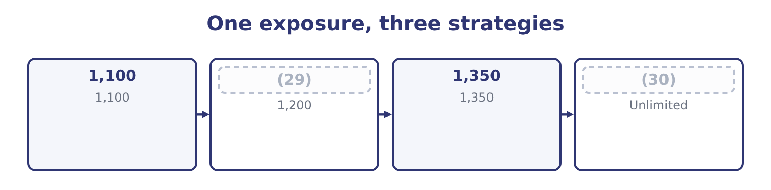
word list
basis risk · Worst case · 1,200

Who has the right, and who has the obligation

Summary 5 gaps 31–34
The holder of a call or a put has the right. The writer has the obligation and keeps the premium (31) happens. Intrinsic value is never negative. An (32) option has an intrinsic value of zero, not a negative one. A call is not the opposite of a put. The opposite of buying a call is (33) a call. Buying a put is a (34) position entirely.
word list
out-of-the-money · whatever · different · derivative · writing

Who holds the right, and who carries the obligation
Every item belongs to exactly one group.
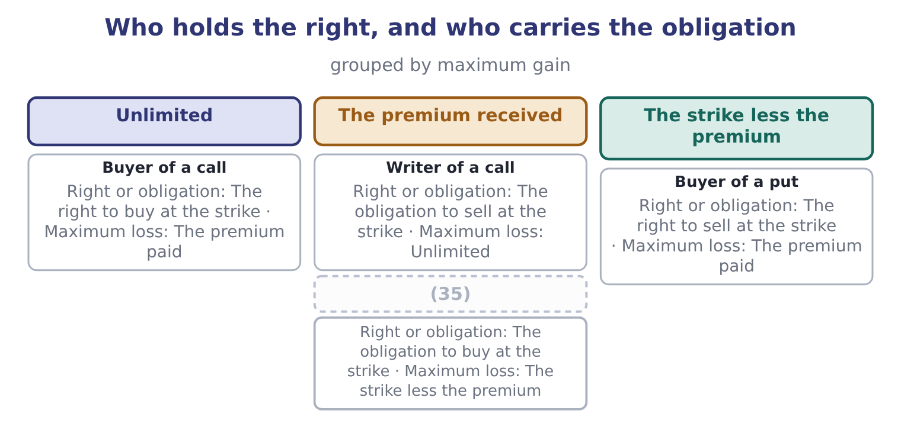
word list
Writer of a put · Buyer of a call

The English this section uses, and its Arabic
Each term sits against what it means.
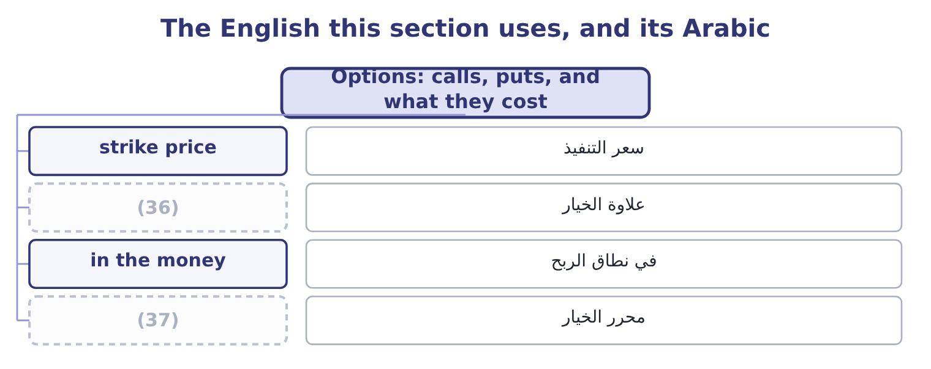
word list
premium · option writer · basis risk

The English this sheet uses, and its Arabic
English (exam term) | Arabic
strike price | سعر التنفيذ
premium | علاوة الخيار
in the money | في نطاق الربح
option writer | محرر الخيار

Answer key · 6.3 Options: calls, puts, and what they cost

1 single | 20 expire
2 difference | 21 market
3 exercise | 22 nothing
4 whether | 23 strategies
5 received | 24 prices
6 holder's | 25 either
7 writer's | 26 outcome
8 direction | 27 asymmetry
9 styles | 28 version
10 everything | 29 1,200
11 immediately | 30 Worst case
12 chance | 31 whatever
13 further | 32 out-of-the-money
14 always | 33 writing
15 six-month | 34 different
16 tonnes | 35 Writer of a put
17 paying | 36 premium
18 exercises | 37 option writer
19 worthless

the summaries in full
Summary 1 That single word is the difference, and it is why an option costs money up front and a forward does not. A call option gives its holder the right, but not the obligation, to buy the underlying at a stated price on or before a stated date. A put option gives the right to sell. The stated price is the strike price or exercise price. The date is the expiration. The money paid for the right is the premium, and it is paid whether or not the option is ever used. Every option has two sides. The holder, who paid the premium, has a right and no obligation; the writer, who received it, has an obligation and no right. The holder's loss is limited to the premium and the gain is open-ended on a call; the writer's gain is limited to the premium and the loss is open-ended.
Summary 2 The exam checks that direction more often than any other point in the chapter. Two styles appear: an American option may be exercised at any time up to expiration, a European option only at expiration. The American style is worth at least as much, because it allows everything the European allows and more. Intrinsic value is what the option would be worth if exercised immediately, and it is never negative. For a call it is the underlying price less the strike, or zero if that is negative. For a put it is the strike less the underlying price, or zero. An option with intrinsic value is in the money; with none and the underlying at the strike, at the money; with none and the underlying the wrong side, out of the money. Time value is the rest of the premium: what a buyer pays for the chance that the option moves further into the money before expiration. Premium equals intrinsic value plus time value, always, and at expiration time value is zero so the premium equals the intrinsic value.
Summary 3 Instead of a forward, Orontes buys a six-month call on 1,000 tonnes of sesame with a strike of $1,250 a tonne, paying a premium of $40 a tonne. At $1,350, the call is in the money: its intrinsic value is 1,350 − 1,250 = 100 a tonne, and after the premium the gain is 100 − 40 = 60 a tonne. Orontes exercises and its effective cost is $1,290 a tonne. At $1,100, the call is worthless and Orontes lets it expire, losing the $40 premium and buying in the market at $1,100. Its effective cost is $1,140 a tonne — $60 better than the forward of section 6.2. The call buyer is better off than doing nothing above 1,250 + 40 = 1,290, and worse off below it by the premium. Compare the three strategies at the two prices.
Summary 4 Unhedged, Orontes pays $1,350 or $1,100. Forward, it pays $1,200 either way. Call, it pays $1,290 or $1,140. The option is the only one that caps the bad outcome and keeps the good one, and the premium of $40 a tonne — $40,000 in total — is exactly what that asymmetry costs. There is no free version.
Summary 5 The holder of a call or a put has the right. The writer has the obligation and keeps the premium whatever happens. Intrinsic value is never negative. An out-of-the-money option has an intrinsic value of zero, not a negative one. A call is not the opposite of a put. The opposite of buying a call is writing a call. Buying a put is a different position entirely.

6.4 What an option is worth
Chapter 6 · section 6.4

Fill every gap. Each word list holds one word more than there are gaps.
Summary 1 gaps 1–12
Six (1) determine an (2) premium, and the (3) asks for the direction of each. (4) a call first. The price of the underlying. Higher is better for a call: more intrinsic value. Lower is better for a call, because the right to buy (5) is worth more. Higher is better for a put. More is better for both. Time is the chance of a (6) move, and since the (7) is capped at the premium, more chances can only help. Volatility of the underlying. More is better for both, and this is the one candidates find (8) . A more volatile underlying produces more extreme outcomes in both (9) , and the option holder keeps the good extremes and is protected from the bad ones. Volatility is therefore the variable option traders (10) trade. A higher rate is slightly better for a call, because the strike will be paid later and money paid later is worth less; slightly worse for a put, by the same (11) . Dividends on the underlying. A dividend lowers the share price on the (12) date, so expected dividends reduce a call's value and raise a put's.
word list
reasoning · directions · favourable · variables · ex-dividend · outcome · downside · counter-intuitive · Taking · option's · cheaply · relationships · actually

What moves an option premium
Every item belongs to exactly one group.
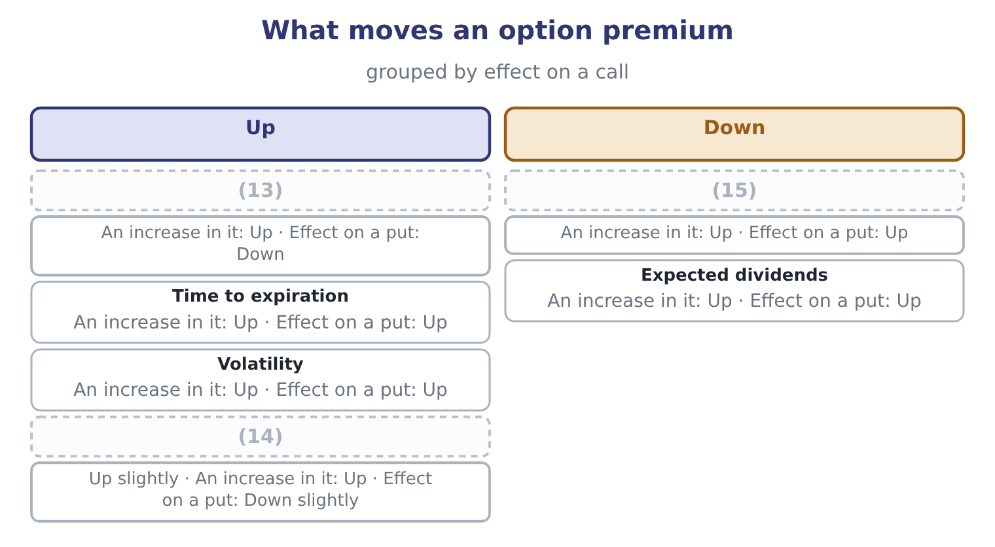
word list
Risk-free rate · Price of the underlying · Strike price · put-call parity

Summary 2 gaps 16–27
Two further (16) appear in questions. The premium can never be less than the intrinsic value, because anybody could (17) buy the option and (18) it at once for a (19) — the arbitrage of section 6.1 at work. And a call and a put with the same strike and (20) are linked to the underlying and a (21) bond by put-call parity, which is the formal (22) that the same payoff can be built two ways and must therefore cost the same. Note (23) what is not on the list. The expected (24) on the underlying is not there, and neither is (25) opinion about where the price is going. That is the (26) result at the heart of option pricing, and it holds because the option can be (27) by holding the underlying and borrowing, so its price is fixed by arbitrage rather than by forecasts.
word list
expiration · exercise · return · statement · derivative · replicated · anybody's · profit · risk-free · finally · otherwise · surprising · relationships

The English this section uses, and its Arabic
Each term sits against what it means.
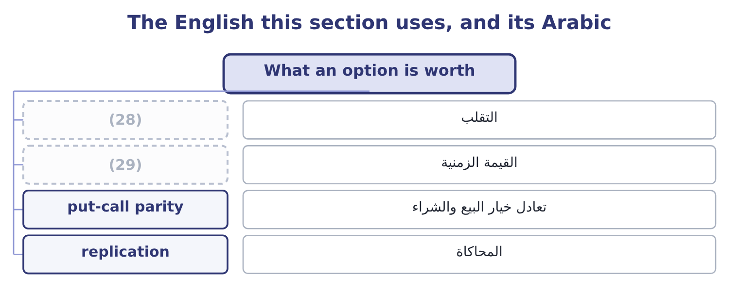
word list
premium · volatility · time value

The English this sheet uses, and its Arabic
English (exam term) | Arabic
volatility | التقلب
time value | القيمة الزمنية
put-call parity | تعادل خيار البيع والشراء
replication | المحاكاة

Answer key · 6.4 What an option is worth

1 variables | 16 relationships
2 option's | 17 otherwise
3 outcome | 18 exercise
4 Taking | 19 profit
5 cheaply | 20 expiration
6 favourable | 21 risk-free
7 downside | 22 statement
8 counter-intuitive | 23 finally
9 directions | 24 return
10 actually | 25 anybody's
11 reasoning | 26 surprising
12 ex-dividend | 27 replicated
13 Price of the underlying | 28 volatility
14 Risk-free rate | 29 time value
15 Strike price

the summaries in full
Summary 1 Six variables determine an option's premium, and the outcome asks for the direction of each. Taking a call first. The price of the underlying. Higher is better for a call: more intrinsic value. Lower is better for a call, because the right to buy cheaply is worth more. Higher is better for a put. More is better for both. Time is the chance of a favourable move, and since the downside is capped at the premium, more chances can only help. Volatility of the underlying. More is better for both, and this is the one candidates find counter-intuitive. A more volatile underlying produces more extreme outcomes in both directions, and the option holder keeps the good extremes and is protected from the bad ones. Volatility is therefore the variable option traders actually trade. A higher rate is slightly better for a call, because the strike will be paid later and money paid later is worth less; slightly worse for a put, by the same reasoning. Dividends on the underlying. A dividend lowers the share price on the ex-dividend date, so expected dividends reduce a call's value and raise a put's.
Summary 2 Two further relationships appear in questions. The premium can never be less than the intrinsic value, because anybody could otherwise buy the option and exercise it at once for a profit — the arbitrage of section 6.1 at work. And a call and a put with the same strike and expiration are linked to the underlying and a risk-free bond by put-call parity, which is the formal statement that the same payoff can be built two ways and must therefore cost the same. Note finally what is not on the list. The expected return on the underlying is not there, and neither is anybody's opinion about where the price is going. That is the surprising result at the heart of option pricing, and it holds because the option can be replicated by holding the underlying and borrowing, so its price is fixed by arbitrage rather than by forecasts.

6.5 Choosing an instrument
Chapter 6 · section 6.5

Fill every gap. Each word list holds one word more than there are gaps.
Summary 1 gaps 1–12
A (1) with an exposure has four honest answers and the exam expects the choice to be argued rather than (2) . Appropriate when the exposure is small against the business, when the company is (3) hedged because its costs and (4) move together, or when the cost of hedging exceeds the risk removed. Doing nothing is a (5) and should be (6) as one. Hedge with a forward or a future. Appropriate when the exposure is known in amount and (7) and the company wants (8) . It costs nothing up front and it removes the upside. (9) a forward when the amount or date is specific, a future when (10) and credit safety matter more than an exact fit. Hedge with an (11) . Appropriate when the exposure is uncertain — a tender that may not be won, a harvest that may not arrive — or when the company wants (12) and is willing to pay for keeping the upside. It costs a premium, and that premium is the whole of what distinguishes it from a forward.
word list
liquidity · treasurer · recorded · certainty · decision · Choose · revenues · inventory · protection · timing · naturally · asserted · option

Summary 2 gaps 13–24
Match the exposure inside the business: borrow in the (13) you earn, buy from a supplier whose price moves with your selling price, hold (14) as a hedge against a rising input cost. This is the cheapest hedge (15) and the exam rewards the (16) who mentions it first. Two (17) close the chapter. A hedge is (18) exact. If the (19) underlying is not precisely what the company buys — a sesame future against a specific grade, or a crude oil future against jet fuel — the two prices move together but not (20) , and the difference between them is basis risk, which no hedge of that kind removes. A hedge that becomes a (21) . A company that (22) more than its exposure, or keeps a contract after the exposure has gone, is speculating with the (23) ' money. Every famous (24) loss in corporate history began as an authorised hedging programme, and the control that prevents it is a policy limiting positions to documented exposures.
word list
rarely · inventory · contract's · identically · derivatives · warnings · available · shareholders · hedges · currency · becomes · speculation · candidate

Price the positions

Your turn: positions and values (complete the blanks)
Position | Data | Answer
Intrinsic value of a call | (25) | ________
Intrinsic value of a put | Strike 50, underlying 58 | ________
Time value of that call | (26) | ________
Breakeven for the call buyer |  | ________
Maximum loss of the call buyer |  | ________
Maximum loss of the call writer |  | ________
Position for a company that will SELL wheat in three months |  | ________

word list
natural hedge · Premium 11 · Strike 50, underlying 58

"Short"

Summary 3 gaps 27–34
English short in finance means (27) to deliver something you do not hold: a short position gains when prices fall. It has nothing to do with time, although (28) debt is a phrase in the same book, and nothing to do with a (29) , although a short seller may (30) one. Note the (31) pair: to cover a short is to close it by buying, and a short (32) is what happens when many shorts are forced to cover at once — both phrases appear in exam (33) on market mechanics without (34) .
word list
committed · short-term · hedging · questions · create · shortage · explanation · companion · squeeze

"Short"
Position | Answer
Intrinsic value of a call | (35)
Intrinsic value of a put | Nil: the strike is below the underlying, so exercising would sell at 50 something worth 58.
Time value of that call | 3: 11 − 8 = 3.
Breakeven for the call buyer | (36)
Maximum loss of the call buyer | 11, the premium paid.
Maximum loss of the call writer | Unlimited, because the underlying can rise without limit.
Position for a seller of wheat | Short: sell wheat futures, so that a fall in the wheat price is offset by a gain on the contract.

word list
61: 50 + 11 = 61. · 8: 58 − 50 = 8. · 3: 11 − 8 = 3.

The English this section uses, and its Arabic
Each term sits against what it means.
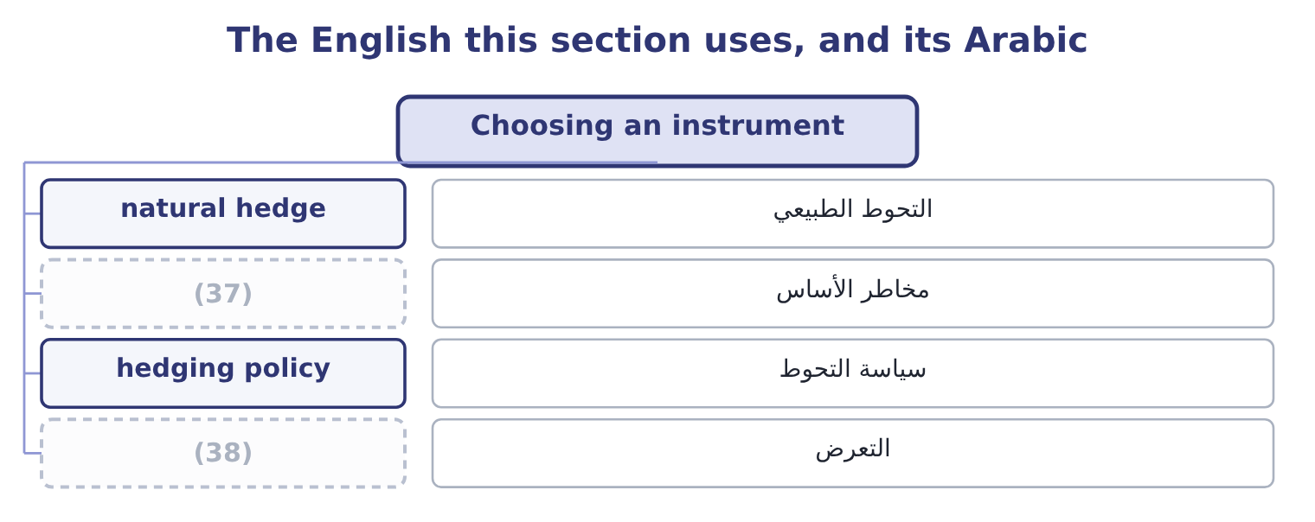
word list
exposure · basis risk · hedging policy

The English this sheet uses, and its Arabic
English (exam term) | Arabic
natural hedge | التحوط الطبيعي
basis risk | مخاطر الأساس
hedging policy | سياسة التحوط
exposure | التعرض

Answer key · 6.5 Choosing an instrument

1 treasurer | 20 identically
2 asserted | 21 speculation
3 naturally | 22 hedges
4 revenues | 23 shareholders
5 decision | 24 derivatives
6 recorded | 25 Strike 50, underlying 58
7 timing | 26 Premium 11
8 certainty | 27 committed
9 Choose | 28 short-term
10 liquidity | 29 shortage
11 option | 30 create
12 protection | 31 companion
13 currency | 32 squeeze
14 inventory | 33 questions
15 available | 34 explanation
16 candidate | 35 8: 58 − 50 = 8.
17 warnings | 36 61: 50 + 11 = 61.
18 rarely | 37 basis risk
19 contract's | 38 exposure

the summaries in full
Summary 1 A treasurer with an exposure has four honest answers and the exam expects the choice to be argued rather than asserted. Appropriate when the exposure is small against the business, when the company is naturally hedged because its costs and revenues move together, or when the cost of hedging exceeds the risk removed. Doing nothing is a decision and should be recorded as one. Hedge with a forward or a future. Appropriate when the exposure is known in amount and timing and the company wants certainty. It costs nothing up front and it removes the upside. Choose a forward when the amount or date is specific, a future when liquidity and credit safety matter more than an exact fit. Hedge with an option. Appropriate when the exposure is uncertain — a tender that may not be won, a harvest that may not arrive — or when the company wants protection and is willing to pay for keeping the upside. It costs a premium, and that premium is the whole of what distinguishes it from a forward.
Summary 2 Match the exposure inside the business: borrow in the currency you earn, buy from a supplier whose price moves with your selling price, hold inventory as a hedge against a rising input cost. This is the cheapest hedge available and the exam rewards the candidate who mentions it first. Two warnings close the chapter. A hedge is rarely exact. If the contract's underlying is not precisely what the company buys — a sesame future against a specific grade, or a crude oil future against jet fuel — the two prices move together but not identically, and the difference between them is basis risk, which no hedge of that kind removes. A hedge that becomes a speculation. A company that hedges more than its exposure, or keeps a contract after the exposure has gone, is speculating with the shareholders' money. Every famous derivatives loss in corporate history began as an authorised hedging programme, and the control that prevents it is a policy limiting positions to documented exposures.
Summary 3 English short in finance means committed to deliver something you do not hold: a short position gains when prices fall. It has nothing to do with time, although short-term debt is a phrase in the same book, and nothing to do with a shortage, although a short seller may create one. Note the companion pair: to cover a short is to close it by buying, and a short squeeze is what happens when many shorts are forced to cover at once — both phrases appear in exam questions on market mechanics without explanation.

