7.1 Interest rate swaps
Chapter 7 · section 7.1

Fill every gap. Each word list holds one word more than there are gaps.
Chapter 7, section by section
Each stage leads to the next.
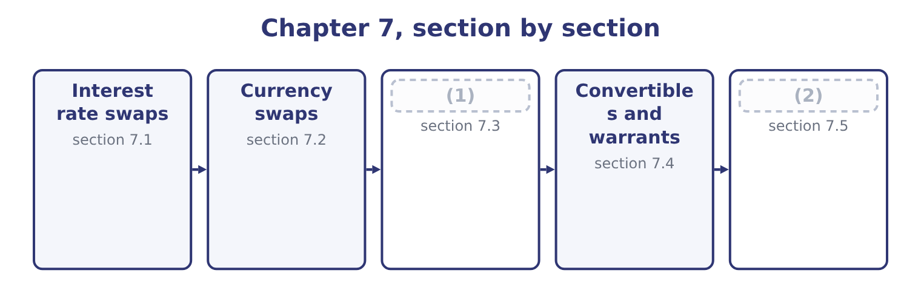
word list
Leases as a source of finance · Taxes, capital structure and investment · plain vanilla swap

Summary 1 gaps 3–14
An interest rate swap is an (3) between two parties to (4) interest payments on a notional principal for a stated period. One pays fixed and receives floating; the other does the (5) . The principal (6) is never exchanged, which is why it is called notional: it exists only to (7) the payments. The (8) are simple. A company with $10,000,000 of (9) debt agrees to pay 6 per cent fixed and (10) the floating rate. If the floating rate for a period is 4.5 per cent, the company pays 10,000,000 × 0.06 = 600,000 and receives 10,000,000 × 0.045 = 450,000, so it (11) 600,000 − 450,000 = 150,000 net. (12) it is paying 4.5 per cent to its own lender, which the swap (13) covers exactly. Its total cost is 6 per cent fixed, (14) the floating rate does.
word list
floating-rate · compute · mechanics · Meanwhile · exchange · opposite · agreement · receive · receipt · whatever · itself · difference · settles

Summary 2 gaps 15–26
Why not (15) borrow at a fixed rate in the first place? Three (16) the exam accepts. The company's (17) changed. The debt was issued years ago on a view of rates that no longer holds, and (18) a bond early costs a call (19) and issue costs. A swap (20) the exposure without (21) the debt. The company can borrow more (22) in one market than the other. This is the (23) advantage argument and it is the classic exam (24) . (25) a strong company can borrow fixed at 5.0 per cent or floating at the reference rate plus 0.3 points, while a weaker one pays fixed 7.0 per cent or floating plus 1.0 point. The strong company is better in both (26) , but it is better by 7.0 − 5.0 = 2.0 points in the fixed market and only by 1.0 − 0.3 = 0.7 points in the floating one.
word list
changes · touching · Suppose · repaying · markets · surplus · circumstances · cheaply · question · comparative · premium · reasons · simply

Summary 3 gaps 27–35
The (27) , 2.0 − 0.7 = 1.3 points, is a gain (28) to be shared: each borrows where its advantage is largest and they swap, and both end up paying less than they could have on their own. A swap can be (29) in days, costs no issue fees and can be reversed with an (30) swap. The risks are real and (31) . A swap (32) counterparty risk, since the other side may fail — which is why most swaps now clear (33) a central counterparty, as futures do. And a swap entered without a (34) exposure is a (35) on rates, exactly as a surplus hedge was.
word list
speculation · through · available · arranged · examinable · reversed · offsetting · carries · difference · matching

A swap that leaves both parties better off
Step | The strong company | The weaker company
Can borrow fixed at | 5.0% | 7.0%
Can borrow floating at | (36) | Reference + 1.0
Where its advantage is larger | Fixed, by 2.0 points | (37)
What it actually borrows | (38) | Floating at reference + 1.0
What it wants | Floating | Fixed
The swap | Receives fixed, pays floating | (39)
Total gain to be shared | 1.3 points | 1.3 points

word list
Floating at reference + 1.0 · Pays fixed, receives floating · Fixed at 5.0% · Floating, by the smaller gap · Reference + 0.3

The English this section uses, and its Arabic
Each term sits against what it means.
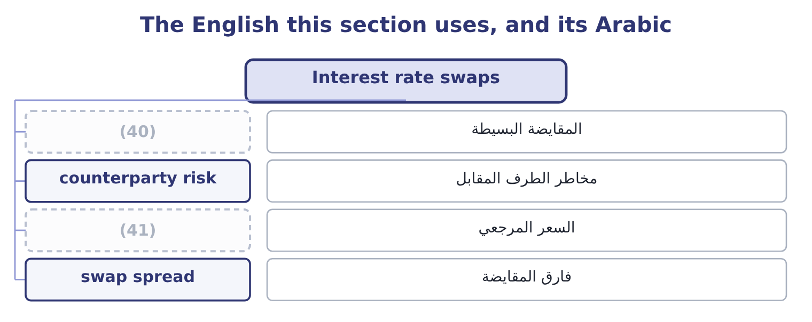
word list
counterparty risk · reference rate · plain vanilla swap

The English this sheet uses, and its Arabic
English (exam term) | Arabic
plain vanilla swap | المقايضة البسيطة
counterparty risk | مخاطر الطرف المقابل
reference rate | السعر المرجعي
swap spread | فارق المقايضة

Answer key · 7.1 Interest rate swaps

1 Leases as a source of finance | 22 cheaply
2 Taxes, capital structure and investment | 23 comparative
3 agreement | 24 question
4 exchange | 25 Suppose
5 opposite | 26 markets
6 itself | 27 difference
7 compute | 28 available
8 mechanics | 29 arranged
9 floating-rate | 30 offsetting
10 receive | 31 examinable
11 settles | 32 carries
12 Meanwhile | 33 through
13 receipt | 34 matching
14 whatever | 35 speculation
15 simply | 36 Reference + 0.3
16 reasons | 37 Floating, by the smaller gap
17 circumstances | 38 Fixed at 5.0%
18 repaying | 39 Pays fixed, receives floating
19 premium | 40 plain vanilla swap
20 changes | 41 reference rate
21 touching

the summaries in full
Summary 1 An interest rate swap is an agreement between two parties to exchange interest payments on a notional principal for a stated period. One pays fixed and receives floating; the other does the opposite. The principal itself is never exchanged, which is why it is called notional: it exists only to compute the payments. The mechanics are simple. A company with $10,000,000 of floating-rate debt agrees to pay 6 per cent fixed and receive the floating rate. If the floating rate for a period is 4.5 per cent, the company pays 10,000,000 × 0.06 = 600,000 and receives 10,000,000 × 0.045 = 450,000, so it settles 600,000 − 450,000 = 150,000 net. Meanwhile it is paying 4.5 per cent to its own lender, which the swap receipt covers exactly. Its total cost is 6 per cent fixed, whatever the floating rate does.
Summary 2 Why not simply borrow at a fixed rate in the first place? Three reasons the exam accepts. The company's circumstances changed. The debt was issued years ago on a view of rates that no longer holds, and repaying a bond early costs a call premium and issue costs. A swap changes the exposure without touching the debt. The company can borrow more cheaply in one market than the other. This is the comparative advantage argument and it is the classic exam question. Suppose a strong company can borrow fixed at 5.0 per cent or floating at the reference rate plus 0.3 points, while a weaker one pays fixed 7.0 per cent or floating plus 1.0 point. The strong company is better in both markets, but it is better by 7.0 − 5.0 = 2.0 points in the fixed market and only by 1.0 − 0.3 = 0.7 points in the floating one.
Summary 3 The difference, 2.0 − 0.7 = 1.3 points, is a gain available to be shared: each borrows where its advantage is largest and they swap, and both end up paying less than they could have on their own. A swap can be arranged in days, costs no issue fees and can be reversed with an offsetting swap. The risks are real and examinable. A swap carries counterparty risk, since the other side may fail — which is why most swaps now clear through a central counterparty, as futures do. And a swap entered without a matching exposure is a speculation on rates, exactly as a surplus hedge was.

7.2 Currency swaps
Chapter 7 · section 7.2

Fill every gap. Each word list holds one word more than there are gaps.
Summary 1 gaps 1–12
A currency swap (1) principal and interest in one currency for principal and interest in another. (2) an interest rate swap, the principal is exchanged — at the start, at the end, or both — because the two amounts are in different currencies and there is no way to net them. The use is (3) . A company that earns in one currency and has (4) in another has a mismatch: its debt service rises when the borrowing currency (5) , and the business does nothing to offset it. A currency swap converts the (6) into the currency the company earns, which is the (7) hedge. Two motives recur in (8) . A company may be able to borrow (9) in its home market and not at all in a market where it has just started (10) . It borrows at home, swaps into the foreign currency, and (11) the foreign debt from the foreign (12) .
word list
strengthens · natural · borrowed · questions · Unlike · operating · because · revenue · obligation · straightforward · services · cheaply · exchanges

Summary 2 gaps 13–22
A company with a long-term foreign (13) uses the swap so that both the asset and the (14) move with the same rate, so that a currency move changes the value of both (15) and the net (16) is stable. That is the (17) exposure of Book 1, (18) . The risks are the interest rate swap's risks plus one. Counterparty risk is larger, because the principal is exchanged and the amounts at stake are (19) than a stream of interest (20) . And the swap fixes the rate for its term, so a company whose foreign (21) shrink is left with a hedge larger than its exposure, which is a (22) it did not intend.
word list
speculation · translation · together · liability · position · investment · differences · cheaply · bigger · managed · operations

Two swaps
Feature | Interest rate swap | Currency swap
What is exchanged | (23) | Interest and principal
Principal | (24) | Exchanged, in two currencies
Main use | Change fixed to floating, or back | (25)
Main risk | Counterparty, and rate moves | (26)

word list
Change fixed to floating, or back · Interest payments only · Match debt to the currency earned · Counterparty, and currency moves · Notional, never exchanged

Notional against exchanged

Summary 3 gaps 27–33
An interest rate swap's principal is never exchanged. A currency swap's principal is. A (27) that says "the principal is exchanged at the start" has told you which swap it is. A swap does not change the (28) borrowing. The (29) loan stays on the (30) sheet and the swap sits (31) it. Both (32) to a swap can be better off, because they start from different costs in two markets. Nobody creates money; a gap in (33) pricing is shared.
word list
principal · beside · balance · question · relative · parties · original · underlying

The English this section uses, and its Arabic
Each term sits against what it means.
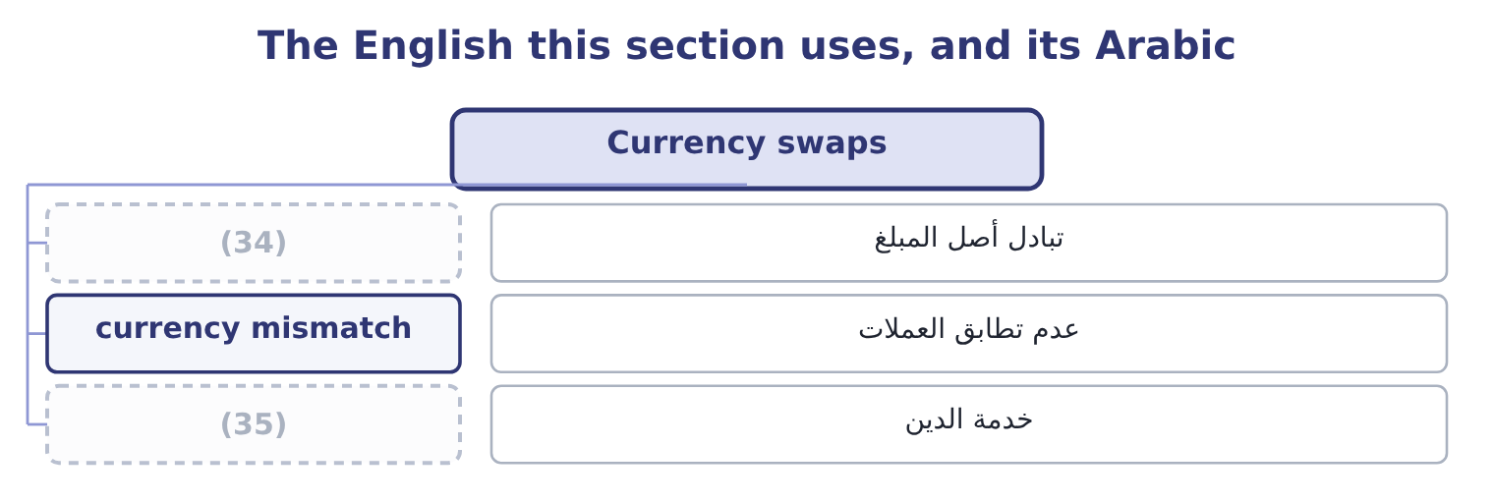
word list
notional principal · principal exchange · debt service

The English this sheet uses, and its Arabic
English (exam term) | Arabic
principal exchange | تبادل أصل المبلغ
currency mismatch | عدم تطابق العملات
debt service | خدمة الدين

Answer key · 7.2 Currency swaps

1 exchanges | 19 bigger
2 Unlike | 20 differences
3 straightforward | 21 operations
4 borrowed | 22 speculation
5 strengthens | 23 Interest payments only
6 obligation | 24 Notional, never exchanged
7 natural | 25 Match debt to the currency earned
8 questions | 26 Counterparty, and currency moves
9 cheaply | 27 question
10 operating | 28 underlying
11 services | 29 original
12 revenue | 30 balance
13 investment | 31 beside
14 liability | 32 parties
15 together | 33 relative
16 position | 34 principal exchange
17 translation | 35 debt service
18 managed

the summaries in full
Summary 1 A currency swap exchanges principal and interest in one currency for principal and interest in another. Unlike an interest rate swap, the principal is exchanged — at the start, at the end, or both — because the two amounts are in different currencies and there is no way to net them. The use is straightforward. A company that earns in one currency and has borrowed in another has a mismatch: its debt service rises when the borrowing currency strengthens, and the business does nothing to offset it. A currency swap converts the obligation into the currency the company earns, which is the natural hedge. Two motives recur in questions. A company may be able to borrow cheaply in its home market and not at all in a market where it has just started operating. It borrows at home, swaps into the foreign currency, and services the foreign debt from the foreign revenue.
Summary 2 A company with a long-term foreign investment uses the swap so that both the asset and the liability move with the same rate, so that a currency move changes the value of both together and the net position is stable. That is the translation exposure of Book 1, managed. The risks are the interest rate swap's risks plus one. Counterparty risk is larger, because the principal is exchanged and the amounts at stake are bigger than a stream of interest differences. And the swap fixes the rate for its term, so a company whose foreign operations shrink is left with a hedge larger than its exposure, which is a speculation it did not intend.
Summary 3 An interest rate swap's principal is never exchanged. A currency swap's principal is. A question that says "the principal is exchanged at the start" has told you which swap it is. A swap does not change the underlying borrowing. The original loan stays on the balance sheet and the swap sits beside it. Both parties to a swap can be better off, because they start from different costs in two markets. Nobody creates money; a gap in relative pricing is shared.

7.3 Leases as a source of finance
Chapter 7 · section 7.3

Fill every gap. Each word list holds one word more than there are gaps.
Summary 1 gaps 1–12
A lease is a (1) giving the use of an asset for a period in (2) for payments. As a (3) device it has one (4) feature: the company (5) the asset without paying for it at once, and the lessor keeps legal title. The accounting (6) Part 1 taught matters (7) as well. A finance lease transfers (8) all the risks and rewards of (9) — a long term relative to the asset's life, a bargain purchase option, present value of payments close to fair value — and it is (10) , so an asset and a liability both appear. An operating lease does not transfer those risks and, under current US GAAP, still produces a (11) asset and a lease liability on the balance sheet, with the expense (12) as a single operating cost rather than as interest and depreciation.
word list
commercially · substantially · capitalised · contract · presented · right-of-use · financing · obtains · available · exchange · ownership · distinction · defining

Summary 2 gaps 13–24
The (13) the exam expects are these. No large payment at the start, so the (14) own capital stays (15) . (16) for a company that cannot (17) . The lessor retains title, so its (18) is better secured than a (19) , and it will often provide for a weaker company at a rate no bank would offer. The tax (20) of the lessor. A lessor with taxable (21) can use the depreciation allowances; a (22) lessee cannot. The lessor prices the lease to keep part of that (23) and pass part to the lessee, so a lease can (24) be cheaper than borrowing for a company with no taxable income. This is the single most examinable reason to lease. Protection against obsolescence, where the lease is short and the asset is technology. Fewer covenants than a comparable loan, and faster arrangement.
word list
available · loss-making · company's · profits · genuinely · position · exposure · advantages · benefit · taxable · Access · borrow · lender's

Summary 3 gaps 25–31
The (25) are the mirror image. The (26) interest rate in a lease is usually higher than a secured loan's; the company has no (27) asset at the end unless it buys one; a long lease is a fixed (28) exactly as debt is, and the rating agencies and Book 1's (29) coverage ratio both treat it as such; and breaking a lease early is normally (30) . The point here is the list of (31) a company would want one.
word list
fixed-charge · reasons · obligation · expensive · payment · implicit · residual · disadvantages

The English this section uses, and its Arabic
Each term sits against what it means.
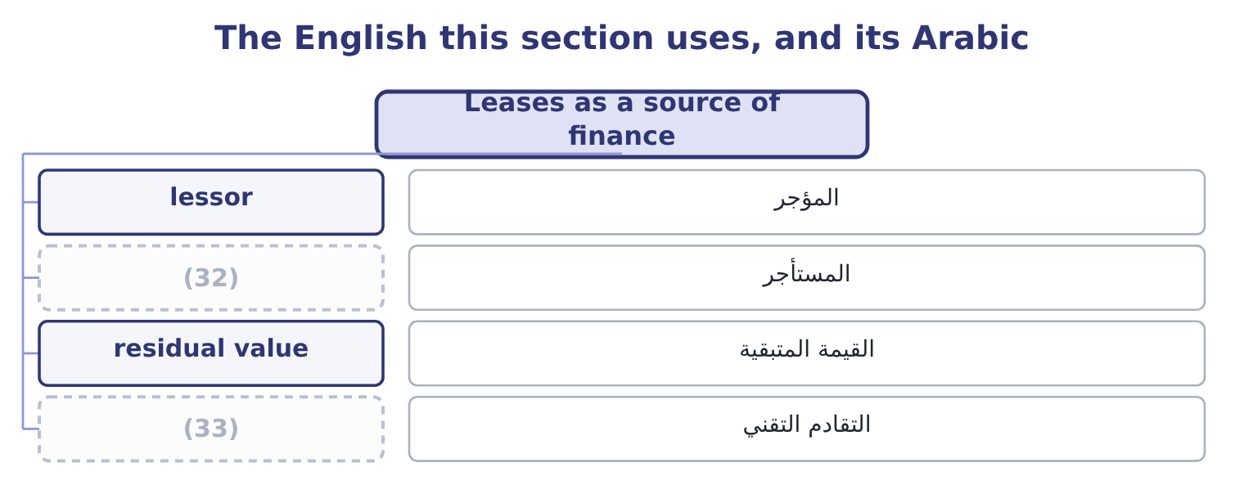
word list
المستأجر · obsolescence · lessee

The English this sheet uses, and its Arabic
English (exam term) | Arabic
lessor | المؤجر
lessee | المستأجر
residual value | القيمة المتبقية
obsolescence | التقادم التقني

Answer key · 7.3 Leases as a source of finance

1 contract | 18 exposure
2 exchange | 19 lender's
3 financing | 20 position
4 defining | 21 profits
5 obtains | 22 loss-making
6 distinction | 23 benefit
7 commercially | 24 genuinely
8 substantially | 25 disadvantages
9 ownership | 26 implicit
10 capitalised | 27 residual
11 right-of-use | 28 obligation
12 presented | 29 fixed-charge
13 advantages | 30 expensive
14 company's | 31 reasons
15 available | 32 lessee
16 Access | 33 obsolescence
17 borrow

the summaries in full
Summary 1 A lease is a contract giving the use of an asset for a period in exchange for payments. As a financing device it has one defining feature: the company obtains the asset without paying for it at once, and the lessor keeps legal title. The accounting distinction Part 1 taught matters commercially as well. A finance lease transfers substantially all the risks and rewards of ownership — a long term relative to the asset's life, a bargain purchase option, present value of payments close to fair value — and it is capitalised, so an asset and a liability both appear. An operating lease does not transfer those risks and, under current US GAAP, still produces a right-of-use asset and a lease liability on the balance sheet, with the expense presented as a single operating cost rather than as interest and depreciation.
Summary 2 The advantages the exam expects are these. No large payment at the start, so the company's own capital stays available. Access for a company that cannot borrow. The lessor retains title, so its exposure is better secured than a lender's, and it will often provide for a weaker company at a rate no bank would offer. The tax position of the lessor. A lessor with taxable profits can use the depreciation allowances; a loss-making lessee cannot. The lessor prices the lease to keep part of that benefit and pass part to the lessee, so a lease can genuinely be cheaper than borrowing for a company with no taxable income. This is the single most examinable reason to lease. Protection against obsolescence, where the lease is short and the asset is technology. Fewer covenants than a comparable loan, and faster arrangement.
Summary 3 The disadvantages are the mirror image. The implicit interest rate in a lease is usually higher than a secured loan's; the company has no residual asset at the end unless it buys one; a long lease is a fixed obligation exactly as debt is, and the rating agencies and Book 1's fixed-charge coverage ratio both treat it as such; and breaking a lease early is normally expensive. The point here is the list of reasons a company would want one.

7.4 Convertibles and warrants
Chapter 7 · section 7.4

Fill every gap. Each word list holds one word more than there are gaps.
Summary 1 gaps 1–10
A convertible bond is a bond that its holder may (1) for a fixed number of (2) shares. A warrant is a right to (3) for new shares at a stated price, usually (4) attached to a bond and then detachable and (5) separately. Both are debt with an equity option attached, and the (6) of both is the same. The conversion ratio is the number of shares a bond converts into. The conversion price is the par value (7) by that ratio: a $1,000 bond converting into 25 shares has a conversion price of 1,000 ÷ 25 = 40.00 a share. The conversion value is the ratio times the current share price: at $36 a share it is 25 × 36 = 900, and at $48 a share it is 25 × 48 = 1,200. A (8) market price is never below the higher of its conversion value and its value as a straight bond, because (9) floor can be (10) .
word list
arithmetic · subscribe · realised · issued · either · convertible's · traded · exchange · divided · expired · common

Worked example: what the convertible costs the issuer

Summary 2 gaps 11–15
A company issues $10,000,000 of convertible bonds at a 5 per cent coupon when its straight debt would cost 7 per cent. The saving is two (11) : 10,000,000 × 0.02 = 200,000 a year of (12) not paid. What was given away. At a conversion price of $40 (13) a current share price of $34, the holders may buy shares at $40 that the company could (14) have sold at the market price of (15) day they convert. The outcome if the shares do well. If the shares reach $60, holders convert: the company issues 250,000 shares for $10,000,000 of debt extinguished, which is $40 a share for stock worth $60. It has sold equity at a third below the market, and the cheap coupon over the life was the price it received for doing so.
word list
interest · whatever · realised · against · otherwise · points

Summary 3 gaps 16–24
The outcome if the shares do badly. If the shares stay at $30, (16) converts, the bonds are (17) at par, and the company has (18) at 5 per cent (19) of 7. The saving was real and the option expired (20) . A convertible is not cheap debt. It is debt sold (21) with a call option on the (22) own shares, and the discount on the coupon is the premium received for the option. Whether it was a good bargain is known only (23) , which is why the exam asks for the (24) rather than for a verdict.
word list
realised · company's · afterwards · mechanism · nobody · instead · borrowed · repaid · together · worthless

A convertible, measured
Measure | Computation | On a 1,000 bond converting into 25 shares
Conversion ratio | (25) | 25 shares
Conversion price | (26) | 40.00
Conversion value at a 36 share price | (27) | 900
Conversion value at a 48 share price | Ratio times price | 1,200
Straight bond value | Discounted at the straight rate | (28)
Market price | Never below the higher of the two floors | The higher of the above

word list
Below par if the coupon is below market · Par over the ratio · optimal capital structure · Ratio times price · Stated in the indenture

Summary 4 gaps 29–38
Warrants differ from (29) in three ways the exam tests. (30) a warrant brings new money into the company, because the holder pays the exercise price in cash; converting a bond brings none, since debt is (31) extinguished. A warrant is detachable and (32) separately, so the bond and the option can end in (33) hands. And warrants are usually (34) than the conversion (35) attached to bonds. A (36) intrinsic value works (37) as a call's: at an exercise price of $30 with the shares at $38, it is 38 − 30 = 8. Book 1, by the (38) method for a convertible and the treasury stock method for a warrant.
word list
exactly · Whether · longer-dated · rights · if-converted · warrant's · simply · Exercising · trades · different · convertibles

The English this section uses, and its Arabic
Each term sits against what it means.
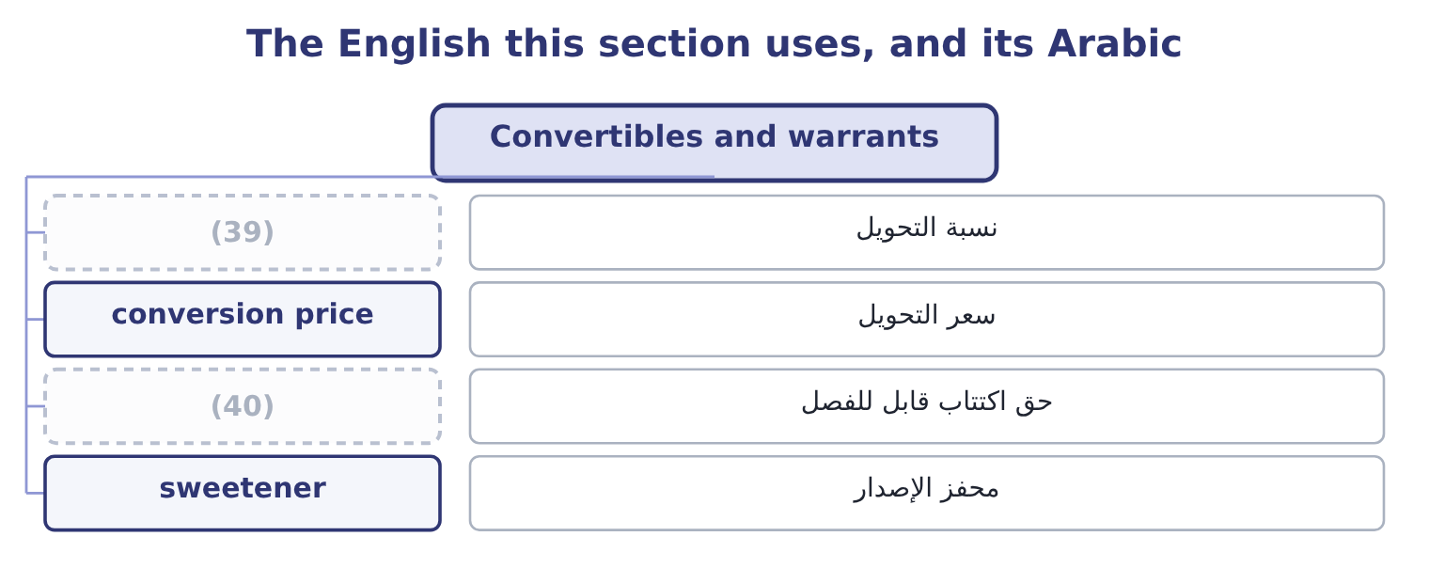
word list
محفز الإصدار · detachable warrant · conversion ratio

The English this sheet uses, and its Arabic
English (exam term) | Arabic
conversion ratio | نسبة التحويل
conversion price | سعر التحويل
detachable warrant | حق اكتتاب قابل للفصل
sweetener | محفز الإصدار

Answer key · 7.4 Convertibles and warrants

1 exchange | 21 together
2 common | 22 company's
3 subscribe | 23 afterwards
4 issued | 24 mechanism
5 traded | 25 Stated in the indenture
6 arithmetic | 26 Par over the ratio
7 divided | 27 Ratio times price
8 convertible's | 28 Below par if the coupon is below market
9 either | 29 convertibles
10 realised | 30 Exercising
11 points | 31 simply
12 interest | 32 trades
13 against | 33 different
14 otherwise | 34 longer-dated
15 whatever | 35 rights
16 nobody | 36 warrant's
17 repaid | 37 exactly
18 borrowed | 38 if-converted
19 instead | 39 conversion ratio
20 worthless | 40 detachable warrant

the summaries in full
Summary 1 A convertible bond is a bond that its holder may exchange for a fixed number of common shares. A warrant is a right to subscribe for new shares at a stated price, usually issued attached to a bond and then detachable and traded separately. Both are debt with an equity option attached, and the arithmetic of both is the same. The conversion ratio is the number of shares a bond converts into. The conversion price is the par value divided by that ratio: a $1,000 bond converting into 25 shares has a conversion price of 1,000 ÷ 25 = 40.00 a share. The conversion value is the ratio times the current share price: at $36 a share it is 25 × 36 = 900, and at $48 a share it is 25 × 48 = 1,200. A convertible's market price is never below the higher of its conversion value and its value as a straight bond, because either floor can be realised.
Summary 2 A company issues $10,000,000 of convertible bonds at a 5 per cent coupon when its straight debt would cost 7 per cent. The saving is two points: 10,000,000 × 0.02 = 200,000 a year of interest not paid. What was given away. At a conversion price of $40 against a current share price of $34, the holders may buy shares at $40 that the company could otherwise have sold at the market price of whatever day they convert. The outcome if the shares do well. If the shares reach $60, holders convert: the company issues 250,000 shares for $10,000,000 of debt extinguished, which is $40 a share for stock worth $60. It has sold equity at a third below the market, and the cheap coupon over the life was the price it received for doing so.
Summary 3 The outcome if the shares do badly. If the shares stay at $30, nobody converts, the bonds are repaid at par, and the company has borrowed at 5 per cent instead of 7. The saving was real and the option expired worthless. A convertible is not cheap debt. It is debt sold together with a call option on the company's own shares, and the discount on the coupon is the premium received for the option. Whether it was a good bargain is known only afterwards, which is why the exam asks for the mechanism rather than for a verdict.
Summary 4 Warrants differ from convertibles in three ways the exam tests. Exercising a warrant brings new money into the company, because the holder pays the exercise price in cash; converting a bond brings none, since debt is simply extinguished. A warrant is detachable and trades separately, so the bond and the option can end in different hands. And warrants are usually longer-dated than the conversion rights attached to bonds. A warrant's intrinsic value works exactly as a call's: at an exercise price of $30 with the shares at $38, it is 38 − 30 = 8. Book 1, by the if-converted method for a convertible and the treasury stock method for a warrant.

7.5 Taxes, capital structure and investment
Chapter 7 · section 7.5

Fill every gap. Each word list holds one word more than there are gaps.
Summary 1 gaps 1–12
The (1) asks how income taxes affect capital (2) and capital investment decisions, and the answer has four parts. The shield favours debt. Interest is deductible and dividends are not, so each (3) of interest saves the company its tax rate in cash. On $10,000,000 of debt at a 25 per cent rate, the whole shield is worth 10,000,000 × 0.25 = 2,500,000 in (4) value terms if the debt is permanent — the (5) textbook result, and the reason a tax (6) that favours one kind of money (7) how companies are (8) . Distress sets the limit. The shield is worth (9) to a company that (10) pay. Past some level of borrowing the expected costs of financial distress — a higher rate demanded by lenders, suppliers (11) terms, customers doubting warranties, (12) time consumed, and in the extreme the direct costs of a bankruptcy — rise faster than the shield grows.
word list
dollar · structure · consumed · cannot · tightening · present · changes · standard · management's · nothing · funded · system · outcome

Summary 2 gaps 13–24
The optimum is where the two margins meet, and it differs by (13) : a company with (14) cash flows and (15) assets can carry far more debt than one whose value is a brand and a (16) of research. Personal taxes work the other way. Interest received is usually taxed at a higher personal rate than dividends and capital gains, so (17) demand more for holding debt than the corporate shield alone would suggest, and part of the (18) advantage is given back. The exam mentions this as a (19) rather than asking for a (20) . Tax (21) investment decisions too, and in three (22) . Depreciation is deductible, so an asset (23) a tax shield of its own: (24) $2,100,000 depreciation charge saves 2,100,000 × 0.25 = 525,000 of tax a year, and that saving is a cash flow of the project that bought the asset.
word list
industry · investors · generates · pipeline · Orontes's · company-level · places · Personal · calculation · tangible · stable · reaches · qualification

Summary 3 gaps 25–32
Only after-tax cash flows are (25) , so a project's (26) and costs are taken net of tax. And the discount rate is the after-tax cost of capital, (27) the shield has (28) been counted there. The tax shield is not a reason to (29) a bad project. A project that earns less than its cost of capital (30) value whether or not it was financed with debt, and the (31) decision is separate from the investment decision. Mixing them is the most common error in Section B and Book 3 is built on (32) them apart.
word list
calculation · already · financing · revenues · discounted · keeping · because · destroys · prefer

Where tax touches the financing and investment decisions
Decision | The tax effect | Direction | Limit
Debt against equity | Interest deductible, dividends not | Favours debt | (33)
How much debt | The shield grows with the debt | (34) | The optimum, where margins meet
Which project | Cash flows are taken after tax | Lowers every return | (35)
Buying an asset | Depreciation is deductible | (36) | The asset's tax life
Leasing | The lessor uses the allowances | (37) | The lessor's pricing

word list
Favours leasing for a loss-maker · A separate shield · principal exchange · Distress costs · Favours more · None; it applies to all

Reshape a financing

Your turn: swaps, convertibles and tax (complete the blanks)
Item | Data | Answer
Net swap settlement | Pays 5.5% fixed, receives 4.0% floating, notional 8,000,000 | ________
Conversion price | 1,000 par bond converting into 20 shares | ________
Conversion value | At a share price of 56 | ________
Warrant intrinsic value | (38) | ________
Annual coupon saving on a convertible | (39) | ________
Permanent tax shield | (40) | ________

word list
Exercise price 30, share price 38 · 20,000,000 of debt at a 25 per cent tax rate · At a share price of 56 · 20,000,000 issued at 4.5% against straight debt at 6.5%

"Notional"

Summary 4 gaps 41–48
English notional in finance means a (41) amount used to (42) payments and never (43) paid — the notional principal of a swap. In (44) English it means imaginary or (45) , which is close enough to mislead: the notional amount is not imaginary, and the payments computed on it are (46) real. The practical (47) is in the exam: a question that gives you a notional principal of $10,000,000 is not telling you that anybody will pay ten million, only that the interest (48) is computed on it.
word list
consequence · compute · itself · difference · theoretical · entirely · ordinary · deductible · reference

"Notional"
Item | Answer
Net swap settlement | 120,000 paid: 8,000,000 × 0.055 = 440,000 paid and 8,000,000 × 0.040 = 320,000 received, so 440,000 − 320,000 = 120,000.
Conversion price | (49)
Conversion value | 1,120: 20 × 56 = 1,120.
Warrant intrinsic value | (50)
Annual coupon saving | (51)
Permanent tax shield | 5,000,000: 20,000,000 × 0.25 = 5,000,000.
What it tells you | Every line is a price for something given up. The swap payer has bought certainty at 1.5 points a year on these rates; the convertible issue

word list
50.00: 1,000 ÷ 20 = 50.00. · 400,000: 20,000,000 × 0.02 = 400,000. · The shield grows with the debt · 8: 38 − 30 = 8.

The English this section uses, and its Arabic
Each term sits against what it means.
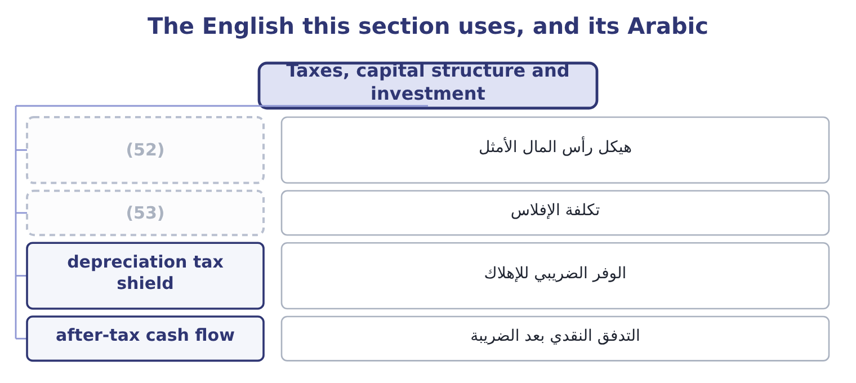
word list
notional principal · bankruptcy cost · optimal capital structure

The English this sheet uses, and its Arabic
English (exam term) | Arabic
optimal capital structure | هيكل رأس المال الأمثل
bankruptcy cost | تكلفة الإفلاس
depreciation tax shield | الوفر الضريبي للإهلاك
after-tax cash flow | التدفق النقدي بعد الضريبة

Answer key · 7.5 Taxes, capital structure and investment

1 outcome | 28 already
2 structure | 29 prefer
3 dollar | 30 destroys
4 present | 31 financing
5 standard | 32 keeping
6 system | 33 Distress costs
7 changes | 34 Favours more
8 funded | 35 None; it applies to all
9 nothing | 36 A separate shield
10 cannot | 37 Favours leasing for a loss-maker
11 tightening | 38 Exercise price 30, share price 38
12 management's | 39 20,000,000 issued at 4.5% against straight debt at 6.5%
13 industry | 40 20,000,000 of debt at a 25 per cent tax rate
14 stable | 41 reference
15 tangible | 42 compute
16 pipeline | 43 itself
17 investors | 44 ordinary
18 company-level | 45 theoretical
19 qualification | 46 entirely
20 calculation | 47 consequence
21 reaches | 48 difference
22 places | 49 50.00: 1,000 ÷ 20 = 50.00.
23 generates | 50 8: 38 − 30 = 8.
24 Orontes's | 51 400,000: 20,000,000 × 0.02 = 400,000.
25 discounted | 52 optimal capital structure
26 revenues | 53 bankruptcy cost
27 because

the summaries in full
Summary 1 The outcome asks how income taxes affect capital structure and capital investment decisions, and the answer has four parts. The shield favours debt. Interest is deductible and dividends are not, so each dollar of interest saves the company its tax rate in cash. On $10,000,000 of debt at a 25 per cent rate, the whole shield is worth 10,000,000 × 0.25 = 2,500,000 in present value terms if the debt is permanent — the standard textbook result, and the reason a tax system that favours one kind of money changes how companies are funded. Distress sets the limit. The shield is worth nothing to a company that cannot pay. Past some level of borrowing the expected costs of financial distress — a higher rate demanded by lenders, suppliers tightening terms, customers doubting warranties, management's time consumed, and in the extreme the direct costs of a bankruptcy — rise faster than the shield grows.
Summary 2 The optimum is where the two margins meet, and it differs by industry: a company with stable cash flows and tangible assets can carry far more debt than one whose value is a brand and a pipeline of research. Personal taxes work the other way. Interest received is usually taxed at a higher personal rate than dividends and capital gains, so investors demand more for holding debt than the corporate shield alone would suggest, and part of the company-level advantage is given back. The exam mentions this as a qualification rather than asking for a calculation. Tax reaches investment decisions too, and in three places. Depreciation is deductible, so an asset generates a tax shield of its own: Orontes's $2,100,000 depreciation charge saves 2,100,000 × 0.25 = 525,000 of tax a year, and that saving is a cash flow of the project that bought the asset.
Summary 3 Only after-tax cash flows are discounted, so a project's revenues and costs are taken net of tax. And the discount rate is the after-tax cost of capital, because the shield has already been counted there. The tax shield is not a reason to prefer a bad project. A project that earns less than its cost of capital destroys value whether or not it was financed with debt, and the financing decision is separate from the investment decision. Mixing them is the most common error in Section B and Book 3 is built on keeping them apart.
Summary 4 English notional in finance means a reference amount used to compute payments and never itself paid — the notional principal of a swap. In ordinary English it means imaginary or theoretical, which is close enough to mislead: the notional amount is not imaginary, and the payments computed on it are entirely real. The practical consequence is in the exam: a question that gives you a notional principal of $10,000,000 is not telling you that anybody will pay ten million, only that the interest difference is computed on it.

