8.1 What the cost of capital is
Chapter 8 · section 8.1

Fill every gap. Each word list holds one word more than there are gaps.
Chapter 8, section by section
Each stage leads to the next.
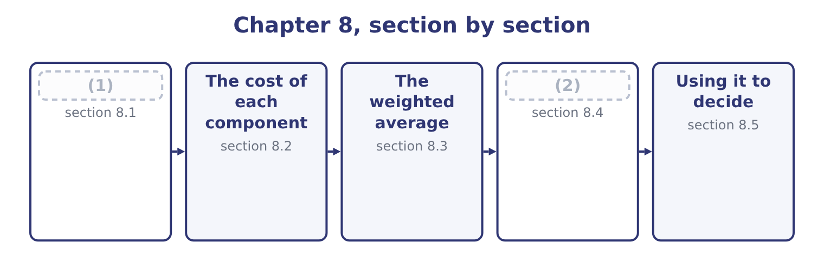
word list
The marginal cost of capital · What the cost of capital is · The cost of each component

Summary 1 gaps 3–14
The cost of capital is the return a company must earn on its (3) to leave its providers of money no worse off. It has three equivalent (4) , and the exam uses all three. Every (5) raised carries a price: (6) to a lender, a fixed dividend to a (7) holder, a required return to a (8) . The blend is what the company pays for the use of money. It is a required return. The same figures, seen from the (9) side, are what each (10) demands for the risk carried. It is an (11) cost. The providers could have put the same money into something else of the same risk. A company that earns less than that something else has (12) value, which is exactly the (13) profit of Book 1. Three uses follow, and the (14) names the first and last of them.
word list
opportunity · interest · outcome · economic · provider · investments · shareholder · irrelevant · investor's · dollar · descriptions · destroyed · preferred

Summary 2 gaps 15–25
As a (15) rate for investment. A project is worth (16) if it earns more than the money it (17) costs. Book 3 (18) the whole of capital (19) on that sentence. The (20) value of a future cash flow is (21) at the cost of capital, which is why every (22) . As the test of a capital structure. Different mixes of debt and equity produce different (23) averages, and the structure that (24) the average is the one that (25) the value of the company — because value is future cash discounted at that rate, and a lower rate gives a higher value. That is the whole of what the exam means by the use of the cost of capital in capital structure decisions.
word list
belongs · present · maximises · hurdle · valuation · weighted · computed · budgeting · builds · minimises · consumes · taking

Whose cost, and for what

Summary 3 gaps 26–32
The cost of capital (26) to the risk of the investment, not to the (27) own average risk. A food manufacturer (28) a software venture should not discount it at a food (29) rate. A project (30) with debt does not have (31) cost of capital. Financing and investment decisions are kept apart, and the project is discounted at the rate its own risk (32) . Historical rates are irrelevant. What matters is what money costs now, which section 8.4 develops.
word list
belongs · evaluating · requires · company's · debt's · descriptions · financed · manufacturer's

The English this section uses, and its Arabic
Each term sits against what it means.
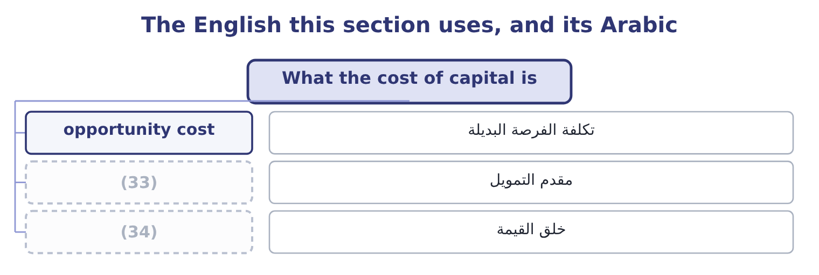
word list
value creation · capital structure · provider of capital

The English this sheet uses, and its Arabic
English (exam term) | Arabic
opportunity cost | تكلفة الفرصة البديلة
provider of capital | مقدم التمويل
value creation | خلق القيمة

Answer key · 8.1 What the cost of capital is

1 What the cost of capital is | 18 builds
2 The marginal cost of capital | 19 budgeting
3 investments | 20 present
4 descriptions | 21 computed
5 dollar | 22 valuation
6 interest | 23 weighted
7 preferred | 24 minimises
8 shareholder | 25 maximises
9 investor's | 26 belongs
10 provider | 27 company's
11 opportunity | 28 evaluating
12 destroyed | 29 manufacturer's
13 economic | 30 financed
14 outcome | 31 debt's
15 hurdle | 32 requires
16 taking | 33 provider of capital
17 consumes | 34 value creation

the summaries in full
Summary 1 The cost of capital is the return a company must earn on its investments to leave its providers of money no worse off. It has three equivalent descriptions, and the exam uses all three. Every dollar raised carries a price: interest to a lender, a fixed dividend to a preferred holder, a required return to a shareholder. The blend is what the company pays for the use of money. It is a required return. The same figures, seen from the investor's side, are what each provider demands for the risk carried. It is an opportunity cost. The providers could have put the same money into something else of the same risk. A company that earns less than that something else has destroyed value, which is exactly the economic profit of Book 1. Three uses follow, and the outcome names the first and last of them.
Summary 2 As a hurdle rate for investment. A project is worth taking if it earns more than the money it consumes costs. Book 3 builds the whole of capital budgeting on that sentence. The present value of a future cash flow is computed at the cost of capital, which is why every valuation. As the test of a capital structure. Different mixes of debt and equity produce different weighted averages, and the structure that minimises the average is the one that maximises the value of the company — because value is future cash discounted at that rate, and a lower rate gives a higher value. That is the whole of what the exam means by the use of the cost of capital in capital structure decisions.
Summary 3 The cost of capital belongs to the risk of the investment, not to the company's own average risk. A food manufacturer evaluating a software venture should not discount it at a food manufacturer's rate. A project financed with debt does not have debt's cost of capital. Financing and investment decisions are kept apart, and the project is discounted at the rate its own risk requires. Historical rates are irrelevant. What matters is what money costs now, which section 8.4 develops.

8.2 The cost of each component
Chapter 8 · section 8.2

Fill every gap. Each word list holds one word more than there are gaps.
Summary 1 gaps 1–12
Four (1) appear in exam (2) , and each has its own (3) . The cost of debt is the yield a (4) requires on the (5) debt today, not the coupon on debt (6) years ago and not the (7) rate in the notes. Because (8) is deductible it is taken after tax: a company (9) at 6.5 per cent with a 25 per cent tax rate bears 6.5 × 0.75 = 4.875 per cent. Where a bond trades at a (10) or a premium, the yield to (11) . The cost of preferred stock is the dividend over the price the company would (12) today, with no tax adjustment because preferred dividends are not deductible. A $100 par 9 per cent preferred that the market would buy at $95 costs 9.00 ÷ 95.00 = 9.47 per cent.
word list
schedule · company's · maturity · lender · receive · interest · discount · issued · average · components · borrowing · calculation · questions

Summary 2 gaps 13–24
The cost of retained earnings is the cost of equity: the shareholders' required return. Retained profit is not free (13) because no cheque is (14) . It (15) to the shareholders, who could have had it as a dividend and (16) it themselves, so its (17) cost is exactly what they (18) — 9.4 per cent for Orontes by the CAPM of, or the dividend yield plus the growth rate by the model. The cost of new common equity is (19) than the cost of retained earnings, by the (20) costs of issuing. If a share can be sold at $40 and the issue costs $2 a share, the company (21) $38 and must earn the shareholders' required return on $40 of (22) while holding $38. Using the dividend growth form: a $2.00 (23) dividend over the net (24) is 2.00 ÷ 38.00 = 5.26 per cent, plus a growth rate of 5 per cent, giving 10.26 per cent against 10.00 per cent for retained earnings on the same figures.
word list
receives · written · proceeds · opportunity · invested · flotation · belongs · merely · expected · expectations · require · higher · premium

The four component costs
Every item belongs to exactly one group.
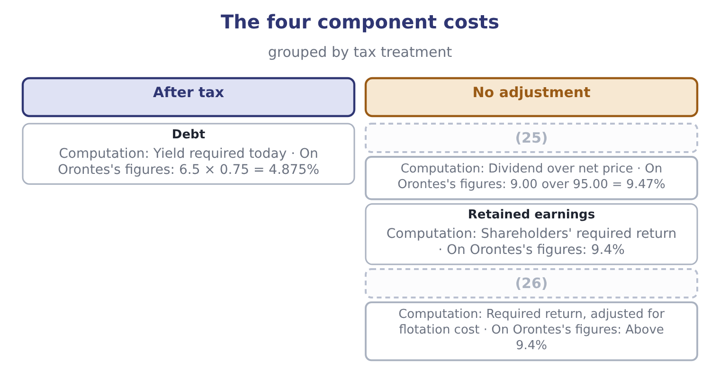
word list
opportunity cost · Preferred stock · New common equity

Three traps in the component costs

Summary 3 gaps 27–32
Only debt gets the tax adjustment. Preferred and common dividends are paid out of taxed profit. Retained earnings are not free. (27) them as costless is the (28) error in this topic and it makes every project look (29) . Use the (30) required return, not the (31) coupon. A company (32) 8 per cent on an old bond whose market yield is now 5 per cent has a cost of debt of 5, because that is what new money costs.
word list
commonest · historical · current · acceptable · flotation · paying · Treating

The English this section uses, and its Arabic
Each term sits against what it means.
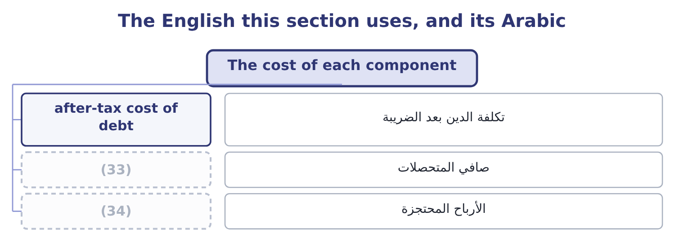
word list
flotation cost · net proceeds · retained earnings

The English this sheet uses, and its Arabic
English (exam term) | Arabic
after-tax cost of debt | تكلفة الدين بعد الضريبة
net proceeds | صافي المتحصلات
retained earnings | الأرباح المحتجزة

Answer key · 8.2 The cost of each component

1 components | 18 require
2 questions | 19 higher
3 calculation | 20 flotation
4 lender | 21 receives
5 company's | 22 expectations
6 issued | 23 expected
7 average | 24 proceeds
8 interest | 25 Preferred stock
9 borrowing | 26 New common equity
10 discount | 27 Treating
11 maturity | 28 commonest
12 receive | 29 acceptable
13 merely | 30 current
14 written | 31 historical
15 belongs | 32 paying
16 invested | 33 net proceeds
17 opportunity | 34 retained earnings

the summaries in full
Summary 1 Four components appear in exam questions, and each has its own calculation. The cost of debt is the yield a lender requires on the company's debt today, not the coupon on debt issued years ago and not the average rate in the notes. Because interest is deductible it is taken after tax: a company borrowing at 6.5 per cent with a 25 per cent tax rate bears 6.5 × 0.75 = 4.875 per cent. Where a bond trades at a discount or a premium, the yield to maturity. The cost of preferred stock is the dividend over the price the company would receive today, with no tax adjustment because preferred dividends are not deductible. A $100 par 9 per cent preferred that the market would buy at $95 costs 9.00 ÷ 95.00 = 9.47 per cent.
Summary 2 The cost of retained earnings is the cost of equity: the shareholders' required return. Retained profit is not free merely because no cheque is written. It belongs to the shareholders, who could have had it as a dividend and invested it themselves, so its opportunity cost is exactly what they require — 9.4 per cent for Orontes by the CAPM of, or the dividend yield plus the growth rate by the model. The cost of new common equity is higher than the cost of retained earnings, by the flotation costs of issuing. If a share can be sold at $40 and the issue costs $2 a share, the company receives $38 and must earn the shareholders' required return on $40 of expectations while holding $38. Using the dividend growth form: a $2.00 expected dividend over the net proceeds is 2.00 ÷ 38.00 = 5.26 per cent, plus a growth rate of 5 per cent, giving 10.26 per cent against 10.00 per cent for retained earnings on the same figures.
Summary 3 Only debt gets the tax adjustment. Preferred and common dividends are paid out of taxed profit. Retained earnings are not free. Treating them as costless is the commonest error in this topic and it makes every project look acceptable. Use the current required return, not the historical coupon. A company paying 8 per cent on an old bond whose market yield is now 5 per cent has a cost of debt of 5, because that is what new money costs.

8.3 The weighted average
Chapter 8 · section 8.3

Fill every gap. Each word list holds one word more than there are gaps.
Summary 1 gaps 1–12
Weight each component cost by the proportion of capital it (1) , and add. Two rules govern the (2) and both are (3) . Use market values, not book values. The cost of capital is about what (4) require on what they hold now, and what they hold is worth its market value. Book values (5) what was paid years ago. Use the (6) structure where the (7) gives one. A company (8) to move to 30 per cent debt should (9) projects at the cost of capital of that structure, because that is how the money will in fact be (10) over time. Equity is 8,100,000 shares at $9.25, which Book 1 computed as $74,925,000. Debt is $6,000,000 of (11) debt plus the $400,000 (12) portion, which is $6,400,000. Total capital is 74,925,000 + 6,400,000 = 81,325,000.
word list
current · represents · intending · investors · record · examined · evaluate · target · question · weights · long-term · raised · flattens

Summary 2 gaps 13–18
Equity is 74,925,000 ÷ 81,325,000 = 92.13 per cent of the total and debt is 6,400,000 ÷ 81,325,000 = 7.87 per cent. Equity at 9.4 per cent; debt at 6.5 per cent before tax, which is 6.5 × 0.75 = 4.875 per cent after. (13) that with Book 1's return on assets of 10.22 per cent: Orontes earns more on its assets than its capital costs, which is the same statement as the (14) economic profit computed there, and the same statement again as a (15) ratio of 3.67. Three (16) measures, one fact. Note also how (17) the cheap debt helps: at 7.87 per cent of the capital it pulls the average down by (18) a third of a point.
word list
positive · different · little · market-to-book · barely · Compare · arithmetic

The same two costs at four capital structures
Debt proportion | Equity proportion | Weighted average, at 4.875% debt and 9.4% equity | Note
0% | 100% | 9.40% | All equity
7.87% | 92.13% | 9.04% | (19)
30% | 70% | 8.04% | (20)
50% | 50% | 7.14% | Arithmetically, and not in practice

word list
Orontes today, on market values · Arithmetically, and not in practice · Before any rise in the cost of either

Summary 3 gaps 21–32
That figure also contains the (21) largest trap. It (22) to show that more debt always lowers the average, which would make a 100 per cent debt structure (23) . It does not, because the component costs are not (24) : as debt rises, lenders demand more and (25) demand much more, since their residual claim has become riskier. The true curve falls, (26) and then rises, and the (27) is at the bottom. The (28) in the figure holds the costs fixed, which is why the figure is wrong beyond a point and why the exam asks for the (29) rather than the number. On book values the (30) would differ. (31) book equity is $20,392,975 (32) the same $6,400,000 of debt, so debt is 6,400,000 ÷ 26,792,975 = 23.89 per cent of book capital and the average would be 0.7611 × 9.4 = 7.15 plus 0.2389 × 4.875 = 1.16, which is 7.15 + 1.16 = 8.31 per cent. Seventy basis points lower than the market-value figure, and wrong, because the shares are not worth book value and nobody requires a return on what was paid in 1998.
word list
Orontes's · answer · optimal · requires · against · constant · arithmetic · shareholders · explanation · flattens · optimum · appears · chapter's

The English this section uses, and its Arabic
Each term sits against what it means.
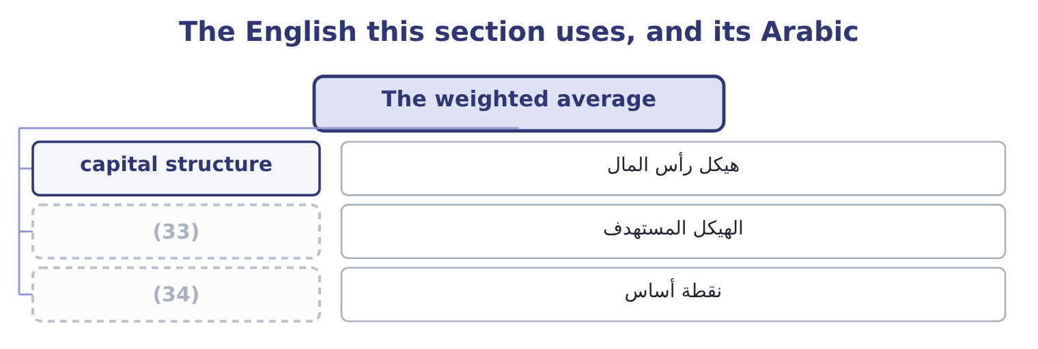
word list
target structure · flotation cost · basis point

The English this sheet uses, and its Arabic
English (exam term) | Arabic
capital structure | هيكل رأس المال
target structure | الهيكل المستهدف
basis point | نقطة أساس

Answer key · 8.3 The weighted average

1 represents | 18 barely
2 weights | 19 Orontes today, on market values
3 examined | 20 Before any rise in the cost of either
4 investors | 21 chapter's
5 record | 22 appears
6 target | 23 optimal
7 question | 24 constant
8 intending | 25 shareholders
9 evaluate | 26 flattens
10 raised | 27 optimum
11 long-term | 28 arithmetic
12 current | 29 explanation
13 Compare | 30 answer
14 positive | 31 Orontes's
15 market-to-book | 32 against
16 different | 33 target structure
17 little | 34 basis point

the summaries in full
Summary 1 Weight each component cost by the proportion of capital it represents, and add. Two rules govern the weights and both are examined. Use market values, not book values. The cost of capital is about what investors require on what they hold now, and what they hold is worth its market value. Book values record what was paid years ago. Use the target structure where the question gives one. A company intending to move to 30 per cent debt should evaluate projects at the cost of capital of that structure, because that is how the money will in fact be raised over time. Equity is 8,100,000 shares at $9.25, which Book 1 computed as $74,925,000. Debt is $6,000,000 of long-term debt plus the $400,000 current portion, which is $6,400,000. Total capital is 74,925,000 + 6,400,000 = 81,325,000.
Summary 2 Equity is 74,925,000 ÷ 81,325,000 = 92.13 per cent of the total and debt is 6,400,000 ÷ 81,325,000 = 7.87 per cent. Equity at 9.4 per cent; debt at 6.5 per cent before tax, which is 6.5 × 0.75 = 4.875 per cent after. Compare that with Book 1's return on assets of 10.22 per cent: Orontes earns more on its assets than its capital costs, which is the same statement as the positive economic profit computed there, and the same statement again as a market-to-book ratio of 3.67. Three different measures, one fact. Note also how little the cheap debt helps: at 7.87 per cent of the capital it pulls the average down by barely a third of a point.
Summary 3 That figure also contains the chapter's largest trap. It appears to show that more debt always lowers the average, which would make a 100 per cent debt structure optimal. It does not, because the component costs are not constant: as debt rises, lenders demand more and shareholders demand much more, since their residual claim has become riskier. The true curve falls, flattens and then rises, and the optimum is at the bottom. The arithmetic in the figure holds the costs fixed, which is why the figure is wrong beyond a point and why the exam asks for the explanation rather than the number. On book values the answer would differ. Orontes's book equity is $20,392,975 against the same $6,400,000 of debt, so debt is 6,400,000 ÷ 26,792,975 = 23.89 per cent of book capital and the average would be 0.7611 × 9.4 = 7.15 plus 0.2389 × 4.875 = 1.16, which is 7.15 + 1.16 = 8.31 per cent. Seventy basis points lower than the market-value figure, and wrong, because the shares are not worth book value and nobody requires a return on what was paid in 1998.

8.4 The marginal cost of capital
Chapter 8 · section 8.4

Fill every gap. Each word list holds one word more than there are gaps.
Summary 1 gaps 1–12
The weighted average computed in section 8.3 (1) the money a company (2) has. The (3) it faces is about money it does not have yet, and the next (4) may cost more than the last. The (5) is retained earnings. A company's (6) source of equity is the profit it has kept, because issuing new shares costs (7) fees. Once the retained earnings are (8) , further equity must be raised (9) and costs more. The same (10) in debt: a company can borrow a certain amount at its current rate and more only at a higher one, as lenders see the (11) rise. The point at which a component's cost steps up is a break point, and it is computed as the amount of the (12) source available, divided by that component's weight in the capital structure.
word list
describes · already · externally · exhausted · approve · dollar · leverage · reason · happens · cheaper · decision · flotation · cheapest

Worked example: a marginal cost schedule

Summary 2 gaps 13–24
The structure and the costs. A company (13) 60 per cent equity and 40 per cent debt. Its (14) cost of debt is 4.875 per cent. Retained earnings cost 9.4 per cent and new shares would cost 11.0 per cent. The cost below the break. The company has $4,800,000 of retained earnings available. Equity is 60 per cent of the structure, so the retained earnings (15) 4,800,000 ÷ 0.60 = 8,000,000 of total new capital (16) new shares are (17) . The cost above the break. The company's cost of capital is 7.59 per cent for the first eight (18) it raises and 8.55 per cent after that — one (19) , two answers, (20) on how much it (21) to invest. A (22) that gives you retained earnings and a target structure is (23) for exactly this (24) , and the second break, where the cost of debt steps up, is computed the same way from the debt side.
word list
number · question · million · earnings · intends · before · depending · schedule · needed · asking · after-tax · support · targets

A marginal cost of capital schedule
New capital raised | Source of the equity | Cost of equity | Weighted average
Up to 8,000,000 | Retained earnings | 9.4% | 7.59%
Above 8,000,000 | (25) | 11.0% | 8.55%

word list
provider of capital · New common shares

Summary 3 gaps 26–35
Why marginal (26) than historical. A company that (27) at 4 per cent five years ago and would pay 7 per cent today has a historical average cost that is lower than (28) available to it. (29) a new project at the historical figure would approve (30) that cannot in fact be funded (31) , because the money for them has to be raised at today's prices. The historical cost is a (32) of past decisions and the marginal cost is the price of the next one — and only decisions about the future can be (33) . The same logic appears (34) management (35) as the rule that sunk costs are irrelevant.
word list
record · projects · accounting · rather · borrowed · throughout · Discounting · issuing · anything · profitably · influenced

The English this section uses, and its Arabic
Each term sits against what it means.
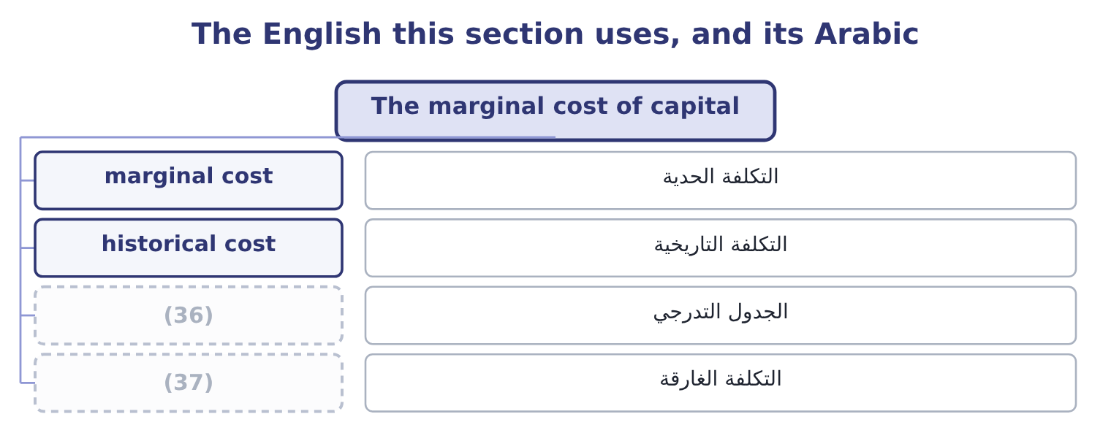
word list
sunk cost · schedule · value creation

The English this sheet uses, and its Arabic
English (exam term) | Arabic
marginal cost | التكلفة الحدية
historical cost | التكلفة التاريخية
schedule | الجدول التدرجي
sunk cost | التكلفة الغارقة

Answer key · 8.4 The marginal cost of capital

1 describes | 20 depending
2 already | 21 intends
3 decision | 22 question
4 dollar | 23 asking
5 reason | 24 schedule
6 cheapest | 25 New common shares
7 flotation | 26 rather
8 exhausted | 27 borrowed
9 externally | 28 anything
10 happens | 29 Discounting
11 leverage | 30 projects
12 cheaper | 31 profitably
13 targets | 32 record
14 after-tax | 33 influenced
15 support | 34 throughout
16 before | 35 accounting
17 needed | 36 schedule
18 million | 37 sunk cost
19 number

the summaries in full
Summary 1 The weighted average computed in section 8.3 describes the money a company already has. The decision it faces is about money it does not have yet, and the next dollar may cost more than the last. The reason is retained earnings. A company's cheapest source of equity is the profit it has kept, because issuing new shares costs flotation fees. Once the retained earnings are exhausted, further equity must be raised externally and costs more. The same happens in debt: a company can borrow a certain amount at its current rate and more only at a higher one, as lenders see the leverage rise. The point at which a component's cost steps up is a break point, and it is computed as the amount of the cheaper source available, divided by that component's weight in the capital structure.
Summary 2 The structure and the costs. A company targets 60 per cent equity and 40 per cent debt. Its after-tax cost of debt is 4.875 per cent. Retained earnings cost 9.4 per cent and new shares would cost 11.0 per cent. The cost below the break. The company has $4,800,000 of retained earnings available. Equity is 60 per cent of the structure, so the retained earnings support 4,800,000 ÷ 0.60 = 8,000,000 of total new capital before new shares are needed. The cost above the break. The company's cost of capital is 7.59 per cent for the first eight million it raises and 8.55 per cent after that — one number, two answers, depending on how much it intends to invest. A question that gives you retained earnings and a target structure is asking for exactly this schedule, and the second break, where the cost of debt steps up, is computed the same way from the debt side.
Summary 3 Why marginal rather than historical. A company that borrowed at 4 per cent five years ago and would pay 7 per cent today has a historical average cost that is lower than anything available to it. Discounting a new project at the historical figure would approve projects that cannot in fact be funded profitably, because the money for them has to be raised at today's prices. The historical cost is a record of past decisions and the marginal cost is the price of the next one — and only decisions about the future can be influenced. The same logic appears throughout management accounting as the rule that sunk costs are irrelevant.

8.5 Using it to decide
Chapter 8 · section 8.5

Fill every gap. Each word list holds one word more than there are gaps.
Summary 1 gaps 1–8
Put the marginal cost schedule beside the company's investment (1) and the capital budget (2) itself. Rank the available projects by their (3) rate of return, (4) first. Draw the marginal cost schedule (5) them. Every project whose return (6) the marginal cost of the money that would fund it is worth taking; the first project whose return falls below that cost is where the budget stops. The (7) is the company's optimal capital budget, and it moves when either curve moves: a better (8) set pushes it out, a rise in the cost of money pulls it.
word list
internal · highest · decides · across · opportunity · intersection · accepts · opportunities · exceeds

Where the capital budget stops
The bars are drawn to scale.
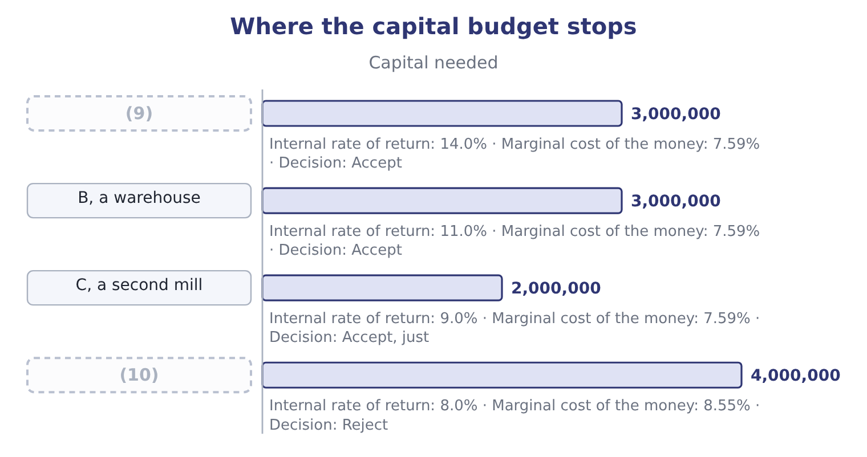
word list
A, a new roasting line · weighted average cost of capital · D, an export depot

Summary 2 gaps 11–22
Three (11) turn that simple (12) into the answer the exam wants. Risk (13) by project. The weighted average (14) the company's (15) risk. A project that is riskier should be (16) at more and a safer one at less, which is done either by (17) a beta for the project's industry and running the CAPM of, or by adding a risk adjustment to the company rate and saying so. A single company-wide rate (18) accepts risky projects and (19) safe ones. The (20) mix does not belong to the project. Project D is not (21) because it could be (22) with debt at 4.875 per cent. The company's structure applies to all of its projects together, and the alternative is a firm that accepts bad projects whenever it happens to have borrowing capacity. Capital may be rationed.
word list
funded · refinements · describes · differs · acceptable · discounted · rejects · picture · rationed · estimating · financing · systematically · existing

Summary 3 gaps 23–31
Where the amount available is fixed by (23) other than cost — a covenant, an (24) to dilute, a (25) limit — projects are ranked by value (26) for each dollar (27) rather than by return alone, and Book 3 (28) that properly. One last point (29) the loop with Book 1. (30) weighted average cost of capital is 9.04 per cent, its return on assets is 10.22 per cent, and its board set a target return on equity of 20 per cent in the case there. That target is not a cost of capital; it is an (31) .
word list
parent's · develops · something · unwillingness · invested · created · budgeting · closes · Orontes's · aspiration

Build a cost of capital

Your turn: a weighted average (complete the blanks)
Component | Data | Answer
Debt | (32) | ________ after tax
Preferred stock | (33) | ________
Common equity | (34) | ________
Weights | Debt 30%, preferred 10%, equity 60% | (35)
Weighted average cost of capital |  | ________
Break point | Retained earnings 6,000,000, equity weight 60% | ________

word list
after-tax cost of debt · 8.0% before tax, tax rate 25% · n/a · 7.00 dividend, price 80.00 · Risk-free 3%, beta 1.2, market premium 6 points

"Capital"

Summary 4 gaps 36–42
English capital means at least four (36) in these two books. It is the money a company (37) , as in cost of capital. It is the (38) ' stake, as in (39) capital. It is (40) assets, as in capital (41) . And capital (42) are where the first of these is raised. The practical warning for an exam: capital structure is about the money, capital budgeting is about the assets, and the two phrases differ by one word and belong to different decisions, as section 8.5 insisted.
word list
owners · long-lived · things · raises · practical · paid-in · markets · expenditure

"Capital"
Component | Answer
Debt | (43) : 8.0 × 0.75 = 6.0.
Preferred stock | (44)
Common equity | 10.2 per cent: the premium earned is 1.2 × 6.0 = 7.2 points on top of 3 per cent.
Weighted average cost of capital | 8.80 per cent: 0.30 × 6.0 = 1.80 from the debt, 0.10 × 8.75 = 0.875 from the preferred and 0.60 × 10.2 = 6.12 from the equity, so 1.80 + 0.8
Break point | (45)
What it tells you | The company can raise ten million at 8.80 per cent and must pay more after that, so a project returning 9 per cent is worth taking out of th

word list
8.0% before tax, tax rate 25% · 8.75 per cent: 7.00 ÷ 80.00 = 8.75 per cent. · 10,000,000: 6,000,000 ÷ 0.60 = 10,000,000. · 6.0 per cent after tax

The English this section uses, and its Arabic
Each term sits against what it means.
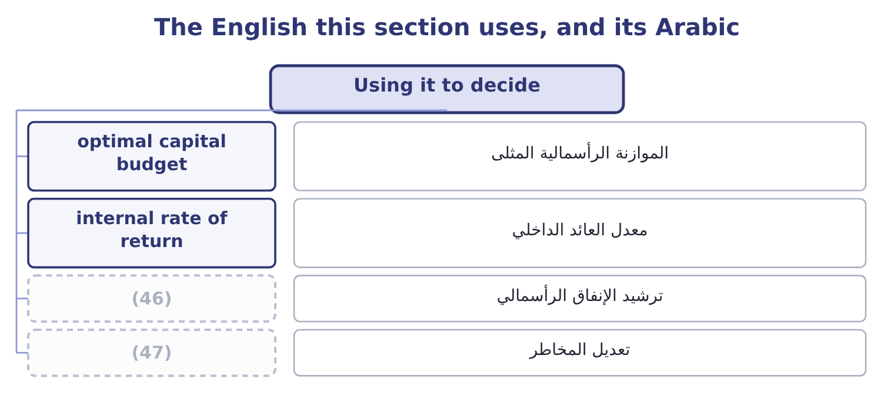
word list
value creation · risk adjustment · capital rationing

The English this sheet uses, and its Arabic
English (exam term) | Arabic
optimal capital budget | الموازنة الرأسمالية المثلى
internal rate of return | معدل العائد الداخلي
capital rationing | ترشيد الإنفاق الرأسمالي
risk adjustment | تعديل المخاطر

Answer key · 8.5 Using it to decide

1 opportunities | 25 parent's
2 decides | 26 created
3 internal | 27 invested
4 highest | 28 develops
5 across | 29 closes
6 exceeds | 30 Orontes's
7 intersection | 31 aspiration
8 opportunity | 32 8.0% before tax, tax rate 25%
9 A, a new roasting line | 33 7.00 dividend, price 80.00
10 D, an export depot | 34 Risk-free 3%, beta 1.2, market premium 6 points
11 refinements | 35 n/a
12 picture | 36 things
13 differs | 37 raises
14 describes | 38 owners
15 existing | 39 paid-in
16 discounted | 40 long-lived
17 estimating | 41 expenditure
18 systematically | 42 markets
19 rejects | 43 6.0 per cent after tax
20 financing | 44 8.75 per cent: 7.00 ÷ 80.00 = 8.75 per cent.
21 acceptable | 45 10,000,000: 6,000,000 ÷ 0.60 = 10,000,000.
22 funded | 46 capital rationing
23 something | 47 risk adjustment
24 unwillingness

the summaries in full
Summary 1 Put the marginal cost schedule beside the company's investment opportunities and the capital budget decides itself. Rank the available projects by their internal rate of return, highest first. Draw the marginal cost schedule across them. Every project whose return exceeds the marginal cost of the money that would fund it is worth taking; the first project whose return falls below that cost is where the budget stops. The intersection is the company's optimal capital budget, and it moves when either curve moves: a better opportunity set pushes it out, a rise in the cost of money pulls it.
Summary 2 Three refinements turn that simple picture into the answer the exam wants. Risk differs by project. The weighted average describes the company's existing risk. A project that is riskier should be discounted at more and a safer one at less, which is done either by estimating a beta for the project's industry and running the CAPM of, or by adding a risk adjustment to the company rate and saying so. A single company-wide rate systematically accepts risky projects and rejects safe ones. The financing mix does not belong to the project. Project D is not acceptable because it could be funded with debt at 4.875 per cent. The company's structure applies to all of its projects together, and the alternative is a firm that accepts bad projects whenever it happens to have borrowing capacity. Capital may be rationed.
Summary 3 Where the amount available is fixed by something other than cost — a covenant, an unwillingness to dilute, a parent's limit — projects are ranked by value created for each dollar invested rather than by return alone, and Book 3 develops that properly. One last point closes the loop with Book 1. Orontes's weighted average cost of capital is 9.04 per cent, its return on assets is 10.22 per cent, and its board set a target return on equity of 20 per cent in the case there. That target is not a cost of capital; it is an aspiration.
Summary 4 English capital means at least four things in these two books. It is the money a company raises, as in cost of capital. It is the owners' stake, as in paid-in capital. It is long-lived assets, as in capital expenditure. And capital markets are where the first of these is raised. The practical warning for an exam: capital structure is about the money, capital budgeting is about the assets, and the two phrases differ by one word and belong to different decisions, as section 8.5 insisted.

