9.1 The markets
Chapter 9 · section 9.1

Fill every gap. Each word list holds one word more than there are gaps.
Chapter 9, section by section
Each stage leads to the next.
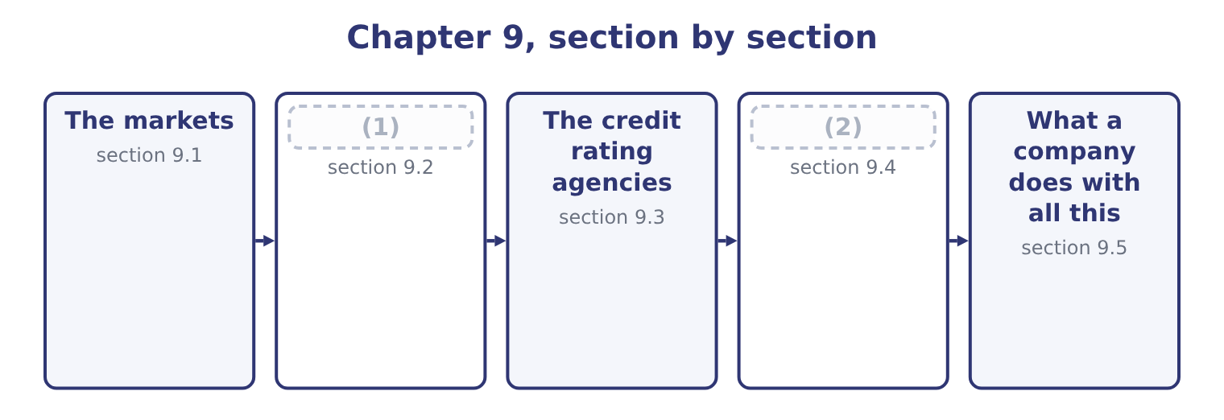
word list
Investment banks · investment grade · Market efficiency

Summary 1 gaps 3–14
Financial markets are (3) four ways, and the exam uses every one of them. The money market trades (4) maturing within a year: treasury bills, commercial paper, (5) of deposit, repurchase agreements. The capital market trades (6) claims: bonds and (7) . By (8) the money reaches the issuer. In the primary market a company sells new securities and receives the (9) : an initial public (10) , a bond issue, a rights issue. In the secondary market existing securities change hands between (11) and the company receives (12) . The secondary market (13) to the issuer all the same, because nobody would buy in the primary market (14) it, and because the secondary price sets the terms of the next primary issue. By how trading is organised. An exchange brings orders together in one place under one rule book, with listing requirements and a published price.
word list
offering · investors · instruments · classified · nothing · explain · shares · without · proceeds · longer · matters · whether · certificates

Summary 2 gaps 15–22
An (15) market is a network of dealers quoting bids and offers, which is where most bonds, most (16) and all swaps trade. An auction market matches buyers and sellers (17) ; a dealer market has an (18) who takes the other side of every trade and earns the spread between bid and offer. By who may (19) . Public markets are open to any investor and carry disclosure (20) . Private markets are restricted to (21) and wealthy (22) , with far less disclosure, which is why a private placement is quicker and cheaper to arrange than a public issue.
word list
participate · intermediary · obligations · individuals · institutions · over-the-counter · directly · currencies · receives

Four ways to classify a market
Classification | One side | The other side | Example of each
Maturity | Money market, under a year | Capital market, over a year | (23)
Issuance | Primary, new securities | Secondary, existing securities | (24)
Organisation | Exchange, centralised | (25) | A listed share; a swap
Access | Public, with disclosure | Private, restricted | (26)

word list
Money market, under a year · Treasury bills; corporate bonds · A listed bond; a private placement · An IPO; a trade on an exchange · Over the counter, dealer network

Summary 3 gaps 27–31
Three (27) explain why any of it (28) , and the exam asks for them. Markets move money from those who have it to those who can use it. They provide (29) , so that a long-term claim can be held by a (30) investor. And they (31) prices, which tell every company in the economy what its capital costs — the signal.
word list
short-term · functions · investors · exists · liquidity · produce

The English this section uses, and its Arabic
Each term sits against what it means.
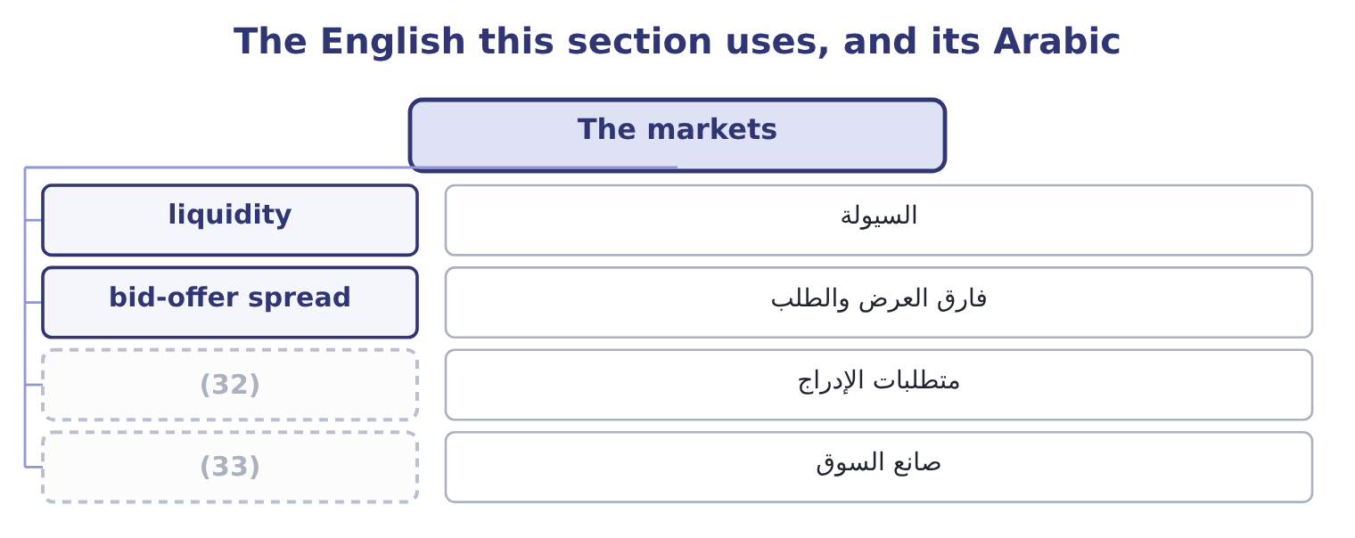
word list
market maker · firm commitment · listing requirement

The English this sheet uses, and its Arabic
English (exam term) | Arabic
liquidity | السيولة
bid-offer spread | فارق العرض والطلب
listing requirement | متطلبات الإدراج
market maker | صانع السوق

Answer key · 9.1 The markets

1 Market efficiency | 18 intermediary
2 Investment banks | 19 participate
3 classified | 20 obligations
4 instruments | 21 institutions
5 certificates | 22 individuals
6 longer | 23 Treasury bills; corporate bonds
7 shares | 24 An IPO; a trade on an exchange
8 whether | 25 Over the counter, dealer network
9 proceeds | 26 A listed bond; a private placement
10 offering | 27 functions
11 investors | 28 exists
12 nothing | 29 liquidity
13 matters | 30 short-term
14 without | 31 produce
15 over-the-counter | 32 listing requirement
16 currencies | 33 market maker
17 directly

the summaries in full
Summary 1 Financial markets are classified four ways, and the exam uses every one of them. The money market trades instruments maturing within a year: treasury bills, commercial paper, certificates of deposit, repurchase agreements. The capital market trades longer claims: bonds and shares. By whether the money reaches the issuer. In the primary market a company sells new securities and receives the proceeds: an initial public offering, a bond issue, a rights issue. In the secondary market existing securities change hands between investors and the company receives nothing. The secondary market matters to the issuer all the same, because nobody would buy in the primary market without it, and because the secondary price sets the terms of the next primary issue. By how trading is organised. An exchange brings orders together in one place under one rule book, with listing requirements and a published price.
Summary 2 An over-the-counter market is a network of dealers quoting bids and offers, which is where most bonds, most currencies and all swaps trade. An auction market matches buyers and sellers directly; a dealer market has an intermediary who takes the other side of every trade and earns the spread between bid and offer. By who may participate. Public markets are open to any investor and carry disclosure obligations. Private markets are restricted to institutions and wealthy individuals, with far less disclosure, which is why a private placement is quicker and cheaper to arrange than a public issue.
Summary 3 Three functions explain why any of it exists, and the exam asks for them. Markets move money from those who have it to those who can use it. They provide liquidity, so that a long-term claim can be held by a short-term investor. And they produce prices, which tell every company in the economy what its capital costs — the signal.

9.2 Market efficiency
Chapter 9 · section 9.2

Fill every gap. Each word list holds one word more than there are gaps.
Summary 1 gaps 1–12
A market is efficient when prices reflect the information available. The useful (1) of the idea names which information, and there are three. The weak form says prices reflect all past prices and trading volumes. If it holds, (2) charts of past prices cannot produce abnormal returns, because (3) a pattern would (4) is already in the price. Technical analysis is worthless under the weak form. The semi-strong form says prices reflect all (5) available information: past prices, published (6) statements, announcements, analysts' reports, news. If it holds, no amount of analysis of public information (7) abnormal returns, because (8) has already read it. Fundamental analysis of published statements is worthless under the semi-strong form — which is an (9) conclusion for a book whose first volume was (10) chapters of exactly. The strong form says prices reflect all information, public and private, (11) what the directors know and have not (12) .
word list
financial · version · eighteen · announced · whatever · produces · everyone · notch · predict · publicly · studying · uncomfortable · including

Summary 2 gaps 13–16
If it holds, even insiders cannot earn abnormal returns. Almost nobody (13) the strong form, and the (14) of insider trading laws is the clearest evidence that (15) do not either —. Each form (16) the weaker ones: semi-strong efficiency implies weak efficiency, and strong implies both.
word list
legislators · estimate · existence · contains · believes

Three forms of efficiency
Form | Prices reflect | What cannot work | Evidence
Weak | Past prices and volumes | Technical analysis, chart patterns | (17)
Semi-strong | All public information | (18) | Mostly supported; some anomalies
Strong | All information, public and private | (19) | Rejected; insiders do earn abnormal returns

word list
Fundamental analysis of published data · Rejected; insiders do earn abnormal returns · Strong: prices are close to a random walk · Even insider dealing

Summary 3 gaps 20–31
The evidence is mixed in a (20) way the exam (21) . Prices adjust to public announcements very fast, (22) within minutes, which (23) the semi-strong form. But documented anomalies persist: small companies have earned more than their risk appeared to justify, shares with low (24) ratios have (25) , prices drift in the direction of an earnings surprise for weeks after it. And (26) finance has catalogued the ways investors depart from the rational benchmark — (27) , anchoring on irrelevant numbers, herding into a rising market, selling winners and holding losers. Four practical (28) , and the exam asks for them. A company cannot (29) its share price by cosmetic (30) . If the market is semi-strong efficient, a change of (31) method that raises reported earnings and changes no cash flow will move nothing, because the note disclosing it is public too. This is the strongest argument for the earnings-quality work of Book 1: the market is looking through to the cash.
word list
strongest · specific · supports · overconfidence · outperformed · expects · consequences · behavioural · price-to-book · depreciation · improve · usually · accounting

Summary 4 gaps 32–42
The (32) of an issue is not a (33) of value. (34) for the share price to be high (35) the manager knows better than the market what the shares are worth. A (36) own share price is the best available (37) of its value, and the right response to a price that seems wrong is to ask what the market knows that you do not. And analysis is still worth doing, because the market is efficient as a (38) of analysts competing to find (39) . If (40) stopped analysing, prices would stop (41) anything. The paradox is genuine and the (42) is that analysis earns roughly what it costs — which is also why a candidate learns to do it.
word list
consequence · reflecting · finance · Waiting · mispricings · assumes · resolution · company's · timing · source · everybody · estimate

The English this section uses, and its Arabic
Each term sits against what it means.
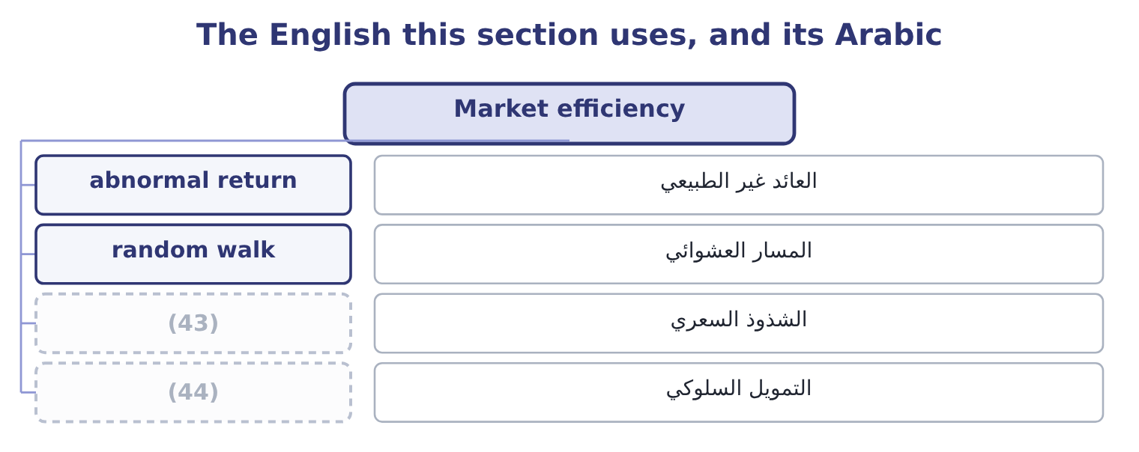
word list
anomaly · behavioural finance · mandate

The English this sheet uses, and its Arabic
English (exam term) | Arabic
abnormal return | العائد غير الطبيعي
random walk | المسار العشوائي
anomaly | الشذوذ السعري
behavioural finance | التمويل السلوكي

Answer key · 9.2 Market efficiency

1 version | 23 supports
2 studying | 24 price-to-book
3 whatever | 25 outperformed
4 predict | 26 behavioural
5 publicly | 27 overconfidence
6 financial | 28 consequences
7 produces | 29 improve
8 everyone | 30 accounting
9 uncomfortable | 31 depreciation
10 eighteen | 32 timing
11 including | 33 source
12 announced | 34 Waiting
13 believes | 35 assumes
14 existence | 36 company's
15 legislators | 37 estimate
16 contains | 38 consequence
17 Strong: prices are close to a random walk | 39 mispricings
18 Fundamental analysis of published data | 40 everybody
19 Even insider dealing | 41 reflecting
20 specific | 42 resolution
21 expects | 43 anomaly
22 usually | 44 behavioural finance

the summaries in full
Summary 1 A market is efficient when prices reflect the information available. The useful version of the idea names which information, and there are three. The weak form says prices reflect all past prices and trading volumes. If it holds, studying charts of past prices cannot produce abnormal returns, because whatever a pattern would predict is already in the price. Technical analysis is worthless under the weak form. The semi-strong form says prices reflect all publicly available information: past prices, published financial statements, announcements, analysts' reports, news. If it holds, no amount of analysis of public information produces abnormal returns, because everyone has already read it. Fundamental analysis of published statements is worthless under the semi-strong form — which is an uncomfortable conclusion for a book whose first volume was eighteen chapters of exactly. The strong form says prices reflect all information, public and private, including what the directors know and have not announced.
Summary 2 If it holds, even insiders cannot earn abnormal returns. Almost nobody believes the strong form, and the existence of insider trading laws is the clearest evidence that legislators do not either —. Each form contains the weaker ones: semi-strong efficiency implies weak efficiency, and strong implies both.
Summary 3 The evidence is mixed in a specific way the exam expects. Prices adjust to public announcements very fast, usually within minutes, which supports the semi-strong form. But documented anomalies persist: small companies have earned more than their risk appeared to justify, shares with low price-to-book ratios have outperformed, prices drift in the direction of an earnings surprise for weeks after it. And behavioural finance has catalogued the ways investors depart from the rational benchmark — overconfidence, anchoring on irrelevant numbers, herding into a rising market, selling winners and holding losers. Four practical consequences, and the exam asks for them. A company cannot improve its share price by cosmetic accounting. If the market is semi-strong efficient, a change of depreciation method that raises reported earnings and changes no cash flow will move nothing, because the note disclosing it is public too. This is the strongest argument for the earnings-quality work of Book 1: the market is looking through to the cash.
Summary 4 The timing of an issue is not a source of value. Waiting for the share price to be high assumes the manager knows better than the market what the shares are worth. A company's own share price is the best available estimate of its value, and the right response to a price that seems wrong is to ask what the market knows that you do not. And analysis is still worth doing, because the market is efficient as a consequence of analysts competing to find mispricings. If everybody stopped analysing, prices would stop reflecting anything. The paradox is genuine and the resolution is that analysis earns roughly what it costs — which is also why a candidate learns to do it.

9.3 The credit rating agencies
Chapter 9 · section 9.3

Fill every gap. Each word list holds one word more than there are gaps.
Summary 1 gaps 1–12
A rating is an opinion on the (1) that a borrower pays. The agencies publish it on a scale, and the scale has one division that matters more than all the (2) within it: investment grade, from the top down to BBB− or Baa3, and below that speculative grade, (3) high yield or junk. The division matters because of what sits on it. Many (4) investors — pension funds, insurers, money market funds — are restricted by their own rules or by regulation to (5) paper. A downgrade across that line does not merely raise a company's interest cost; it (6) a large part of the (7) of buyers for its bonds, all at once. That is why companies manage towards a rating target, and why Book 1's (8) and coverage ratios matter to a (9) . What the agencies look at is, with few additions, what Book 1 measured: leverage, coverage, margin stability, cash generation, the industry's (10) , the quality of the accounts, and the company's (11) as well as its ability to pay. Orontes would read well on most of them — interest coverage of 11.15 times, debt to assets of 0.36, and total debt of $6,400,000 against an EBITDA of $6,448,800, which is 6,400,000 ÷ 6,448,800 = 0.99 times, a ratio most agencies would call (12) for a food manufacturer.
word list
institutional · gradations · conservative · likelihood · cyclicality · investment-grade · mandate · covenants · willingness · removes · treasurer · universe · colloquially

Worked example: what a notch is worth

Summary 2 gaps 13–24
Suppose the market (13) 1.2 points over the (14) curve for an A rating, 2.0 points for BBB and 4.0 points for BB. One notch down, within investment grade. Moving from A to BBB costs 2.0 − 1.2 = 0.8 points. On the $5,000,000 (15) Orontes was (16) in, that is 5,000,000 × 0.008 = 40,000 a year. Moving from BBB to BB costs 4.0 − 2.0 = 2.0 points, which is 5,000,000 × 0.02 = 100,000 a year — and that (17) it, because some (18) will not be there at all. The steps are not equal, and the one that (19) from investment to speculative grade is the one to plan (20) . A company one notch above the line (21) its balance sheet (22) from one three notches above it, and that is a real cost of leverage that no (23) average cost of capital formula shows (24) .
word list
manages · government · considering · lenders · requires · differently · facility · crosses · Orontes · weighted · directly · understates · around

Summary 3 gaps 25–36
The (25) are examinable and (26) be stated fairly. The company being rated pays the agency, which is a (27) of interest, (28) it is managed. The alternative, an (29) model, failed because ratings leak and investors would not pay for what they could (30) free. An agency acts on (31) after the market has moved, so a downgrade often (32) what the bond price said weeks earlier. The (33) on structured (34) . In the financial crisis of 2007 and 2008, highly rated structured (35) defaulted in numbers that the ratings had said were close to impossible, and the models behind those ratings proved to rest on (36) about correlation that did not hold. A rating is not a recommendation. It is an opinion on default risk alone, and says nothing about whether a security is correctly priced for that risk.
word list
investor-pays · information · record · confirms · should · products · obtain · criticisms · conflict · assumptions · however · formula · securities

The rating scale, and what it changes
Every item belongs to exactly one group.
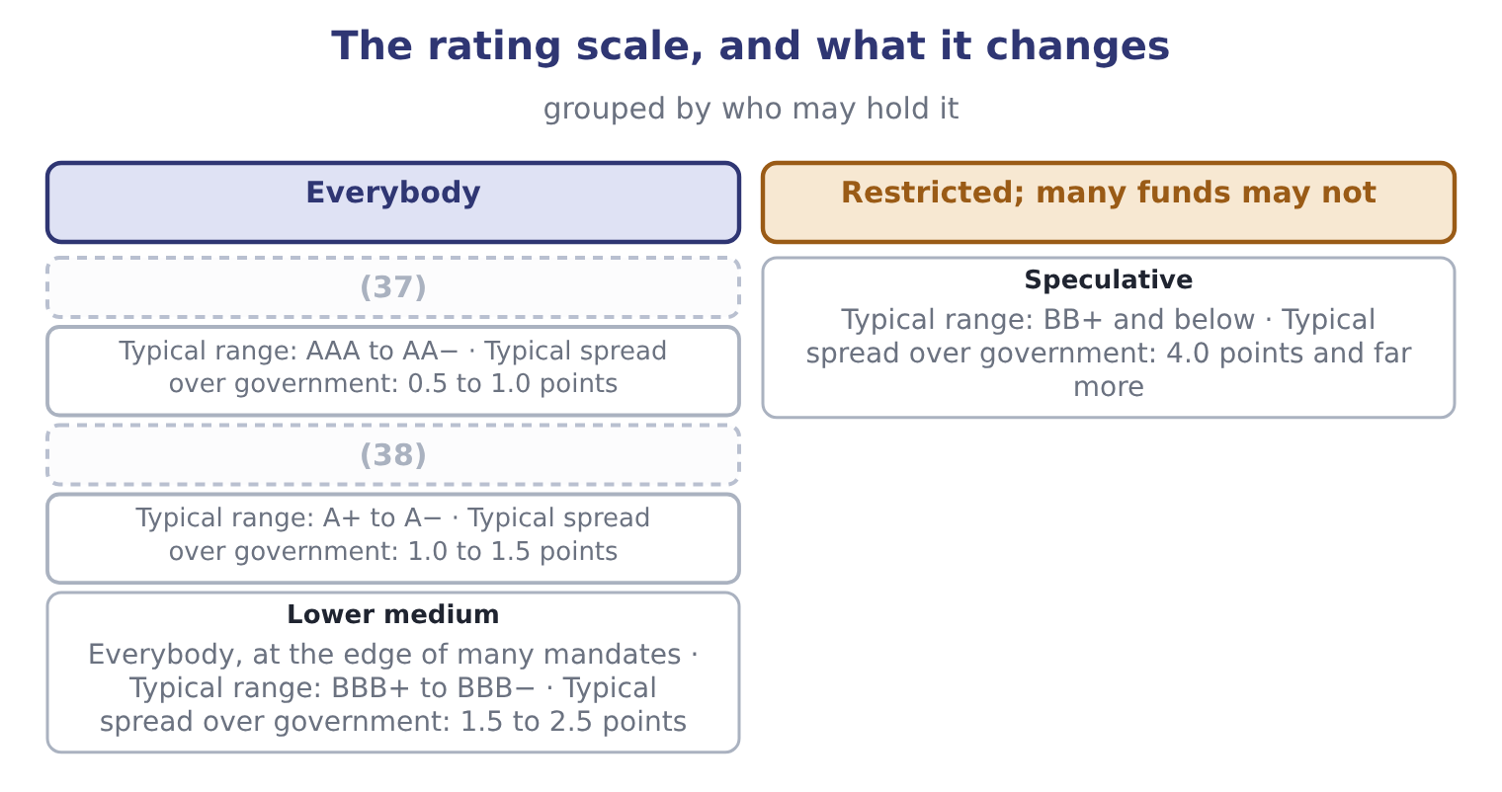
word list
capital market · High grade · Upper medium

The English this section uses, and its Arabic
Each term sits against what it means.
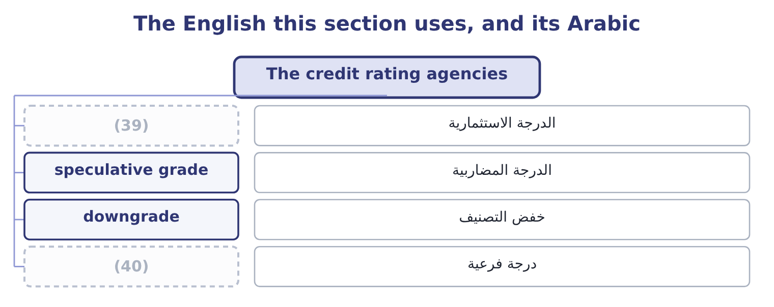
word list
investment grade · downgrade · notch

The English this sheet uses, and its Arabic
English (exam term) | Arabic
investment grade | الدرجة الاستثمارية
speculative grade | الدرجة المضاربية
downgrade | خفض التصنيف
notch | درجة فرعية

Answer key · 9.3 The credit rating agencies

1 likelihood | 21 manages
2 gradations | 22 differently
3 colloquially | 23 weighted
4 institutional | 24 directly
5 investment-grade | 25 criticisms
6 removes | 26 should
7 universe | 27 conflict
8 covenants | 28 however
9 treasurer | 29 investor-pays
10 cyclicality | 30 obtain
11 willingness | 31 information
12 conservative | 32 confirms
13 requires | 33 record
14 government | 34 products
15 facility | 35 securities
16 considering | 36 assumptions
17 understates | 37 High grade
18 lenders | 38 Upper medium
19 crosses | 39 investment grade
20 around | 40 notch

the summaries in full
Summary 1 A rating is an opinion on the likelihood that a borrower pays. The agencies publish it on a scale, and the scale has one division that matters more than all the gradations within it: investment grade, from the top down to BBB− or Baa3, and below that speculative grade, colloquially high yield or junk. The division matters because of what sits on it. Many institutional investors — pension funds, insurers, money market funds — are restricted by their own rules or by regulation to investment-grade paper. A downgrade across that line does not merely raise a company's interest cost; it removes a large part of the universe of buyers for its bonds, all at once. That is why companies manage towards a rating target, and why Book 1's covenants and coverage ratios matter to a treasurer. What the agencies look at is, with few additions, what Book 1 measured: leverage, coverage, margin stability, cash generation, the industry's cyclicality, the quality of the accounts, and the company's willingness as well as its ability to pay. Orontes would read well on most of them — interest coverage of 11.15 times, debt to assets of 0.36, and total debt of $6,400,000 against an EBITDA of $6,448,800, which is 6,400,000 ÷ 6,448,800 = 0.99 times, a ratio most agencies would call conservative for a food manufacturer.
Summary 2 Suppose the market requires 1.2 points over the government curve for an A rating, 2.0 points for BBB and 4.0 points for BB. One notch down, within investment grade. Moving from A to BBB costs 2.0 − 1.2 = 0.8 points. On the $5,000,000 facility Orontes was considering in, that is 5,000,000 × 0.008 = 40,000 a year. Moving from BBB to BB costs 4.0 − 2.0 = 2.0 points, which is 5,000,000 × 0.02 = 100,000 a year — and that understates it, because some lenders will not be there at all. The steps are not equal, and the one that crosses from investment to speculative grade is the one to plan around. A company one notch above the line manages its balance sheet differently from one three notches above it, and that is a real cost of leverage that no weighted average cost of capital formula shows directly.
Summary 3 The criticisms are examinable and should be stated fairly. The company being rated pays the agency, which is a conflict of interest, however it is managed. The alternative, an investor-pays model, failed because ratings leak and investors would not pay for what they could obtain free. An agency acts on information after the market has moved, so a downgrade often confirms what the bond price said weeks earlier. The record on structured products. In the financial crisis of 2007 and 2008, highly rated structured securities defaulted in numbers that the ratings had said were close to impossible, and the models behind those ratings proved to rest on assumptions about correlation that did not hold. A rating is not a recommendation. It is an opinion on default risk alone, and says nothing about whether a security is correctly priced for that risk.

9.4 Investment banks
Chapter 9 · section 9.4

Fill every gap. Each word list holds one word more than there are gaps.
Summary 1 gaps 1–10
An (1) bank stands between companies that want money and investors that have it, and it does so in four (2) that the exam names. Underwriting is the first. In a firm commitment underwriting the bank buys the whole issue from the company at an agreed price and (3) it, taking the risk that it (4) be sold at more. In a best efforts underwriting the bank (5) only to try, and the risk of an (6) issue stays with the company. A large issue is normally (7) , with a lead (8) and a group of banks (9) the risk and the distribution. The (10) is paid by the spread between what investors pay and what the company receives. On a $20,000,000 equity issue at a 6 per cent gross spread, the company receives 20,000,000 × 0.94 = 18,800,000 and the syndicate keeps 20,000,000 × 0.06 = 1,200,000.
word list
sharing · businesses · resells · syndicated · agrees · manager · undersubscribed · acquisitions · cannot · investment · underwriter

Summary 2 gaps 11–22
Spreads are far lower on bonds than on equity, and lower on a large issue than a small one, which is the (11) behind. Advisory is the second: mergers and (12) , defence against a hostile bid, valuations, fairness opinions for boards, (13) . The bank is paid a fee, (14) with a large part (15) on completion — which is itself a conflict, since the adviser is paid more if the deal happens. Trading and market making is the third. The bank quotes prices in (16) , holds inventory, and earns the bid-offer spread, which is what provides the liquidity section 9.1 listed as a (17) of markets. Research is the (18) . (19) publish on companies, which (20) trading and distribution. The conflict here is old and well (21) : an analyst's employer may be seeking underwriting business from the company being written about, and the (22) now required between research and underwriting exist because that conflict was once resolved the wrong way too often.
word list
function · arithmetic · acquisitions · documented · bid-offer · separations · contingent · securities · usually · supports · fourth · Analysts · restructurings

What an investment bank does, and how it is paid
Business | What it provides | How it is paid | The conflict to watch
Underwriting | Capital raised and risk taken | (23) | Pricing the issue to sell easily
Advisory | (24) | Fees, largely on completion | Paid more if the deal happens
Trading and market making | (25) | The bid-offer spread | Trading against clients
Research | Analysis and distribution | (26) | Covering companies that pay fees

word list
Valuation, negotiation, opinions · The gross spread · Indirectly, through the above · Liquidity and quoted prices · conflict of interest

Firm commitment against best efforts

Summary 3 gaps 27–35
In a firm commitment the bank (27) the risk of an (28) issue. In a best efforts arrangement the (29) does. A question (30) an issue that (31) to sell is asking which arrangement was in place. The underwriting spread is a cost of the issue, (32) from the proceeds. It is not an (33) of the period in the (34) sense; it reduces the capital raised. (35) — a first-day rise in the share price — is a cost to the company, not a success, because the difference is money the company could have raised and did not.
word list
carries · describing · written · ordinary · Underpricing · failed · expense · issuer · deducted · unsold

The English this section uses, and its Arabic
Each term sits against what it means.
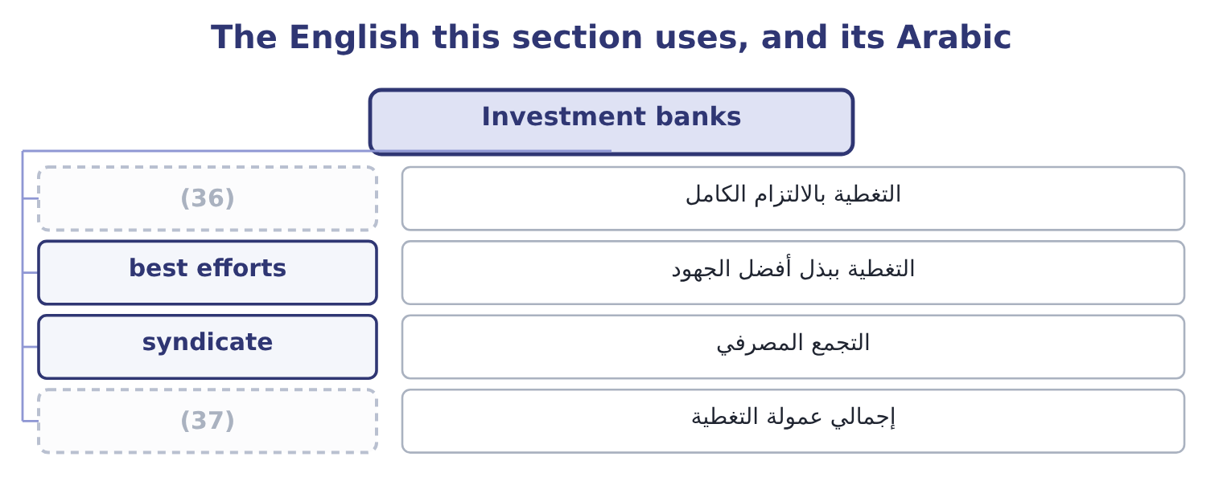
word list
firm commitment · gross spread · investment grade

The English this sheet uses, and its Arabic
English (exam term) | Arabic
firm commitment | التغطية بالالتزام الكامل
best efforts | التغطية ببذل أفضل الجهود
syndicate | التجمع المصرفي
gross spread | إجمالي عمولة التغطية

Answer key · 9.4 Investment banks

1 investment | 20 supports
2 businesses | 21 documented
3 resells | 22 separations
4 cannot | 23 The gross spread
5 agrees | 24 Valuation, negotiation, opinions
6 undersubscribed | 25 Liquidity and quoted prices
7 syndicated | 26 Indirectly, through the above
8 manager | 27 carries
9 sharing | 28 unsold
10 underwriter | 29 issuer
11 arithmetic | 30 describing
12 acquisitions | 31 failed
13 restructurings | 32 deducted
14 usually | 33 expense
15 contingent | 34 ordinary
16 securities | 35 Underpricing
17 function | 36 firm commitment
18 fourth | 37 gross spread
19 Analysts

the summaries in full
Summary 1 An investment bank stands between companies that want money and investors that have it, and it does so in four businesses that the exam names. Underwriting is the first. In a firm commitment underwriting the bank buys the whole issue from the company at an agreed price and resells it, taking the risk that it cannot be sold at more. In a best efforts underwriting the bank agrees only to try, and the risk of an undersubscribed issue stays with the company. A large issue is normally syndicated, with a lead manager and a group of banks sharing the risk and the distribution. The underwriter is paid by the spread between what investors pay and what the company receives. On a $20,000,000 equity issue at a 6 per cent gross spread, the company receives 20,000,000 × 0.94 = 18,800,000 and the syndicate keeps 20,000,000 × 0.06 = 1,200,000.
Summary 2 Spreads are far lower on bonds than on equity, and lower on a large issue than a small one, which is the arithmetic behind. Advisory is the second: mergers and acquisitions, defence against a hostile bid, valuations, fairness opinions for boards, restructurings. The bank is paid a fee, usually with a large part contingent on completion — which is itself a conflict, since the adviser is paid more if the deal happens. Trading and market making is the third. The bank quotes prices in securities, holds inventory, and earns the bid-offer spread, which is what provides the liquidity section 9.1 listed as a function of markets. Research is the fourth. Analysts publish on companies, which supports trading and distribution. The conflict here is old and well documented: an analyst's employer may be seeking underwriting business from the company being written about, and the separations now required between research and underwriting exist because that conflict was once resolved the wrong way too often.
Summary 3 In a firm commitment the bank carries the risk of an unsold issue. In a best efforts arrangement the issuer does. A question describing an issue that failed to sell is asking which arrangement was in place. The underwriting spread is a cost of the issue, deducted from the proceeds. It is not an expense of the period in the ordinary sense; it reduces the capital raised. Underpricing — a first-day rise in the share price — is a cost to the company, not a success, because the difference is money the company could have raised and did not.

9.5 What a company does with all this
Chapter 9 · section 9.5

Fill every gap. Each word list holds one word more than there are gaps.
Summary 1 gaps 1–12
Pull the four (1) together from the issuer's chair, which is where a (2) accountant sits. (3) the market that fits the size and the (4) . (5) needs belong in the money market. (6) needs belong in the capital market, publicly if the company is large and well known, (7) if it is not. Orontes, wanting $5,000,000, is (8) in the private and bank market and should not be paying for a public issue's (9) . (10) the market's (11) on price, and work on the thing behind it. If the shares trade at (12) times earnings while the gross margin falls, the lesson is about the margin, not about the market's judgment. Under semi-strong efficiency a company cannot talk its price up and can only change what the price is about. Manage the rating rather than the ratio.
word list
verdict · sections · meaning · Short-term · purpose · Accept · privately · twenty-five · Long-term · Choose · machinery · management · squarely

Summary 2 gaps 13–21
A (13) who understands that one (14) is worth 0.8 points and that (15) the investment-grade line is worth far more will set internal limits inside the covenant limits, which is why Book 1's chapter on coverage ended where it did. Use the (16) and price the (17) . An (18) is paid to sell the issue, which means it prefers a price that sells easily; an (19) is paid on (20) , which means it prefers a deal. Neither (21) is a reason to do without them, and both are reasons for a board to ask the question that the fee structure will not ask itself.
word list
notch · underwriter · completion · observation · adviser · crossing · conflict · treasurer · intermediary · judgment

Place each item

Classify or compute each.

Your turn: markets, ratings and fees (complete the blanks)
Item | Question | Answer
A 90-day treasury bill | Which market? | ________
A trade in listed shares between two investors | Primary or secondary? | ________
An interest rate swap | (22) | ________
A fund restricted to investment grade | What is the lowest rating it may hold? | ________
A 2-point spread widening on 8,000,000 of debt | (23) | ________
A 30,000,000 issue at a 5 per cent gross spread | (24) | ________
Chart patterns predicting prices | (25) | ________

word list
Which form of efficiency would this contradict? · Exchange or over the counter? · secondary market · Proceeds to the company · Annual cost

"Efficient"

Summary 3 gaps 26–32
English efficient in market efficiency does not mean well run, fast or cheap. It means that prices (26) information, and a market can be efficient in this sense while being slow, (27) and badly organised. The (28) sense is a false friend, and (29) who import it answer that a market with high (30) costs cannot be efficient — which does not follow. Note also the phrase efficient (31) : a third sense again, meaning the best risk-return (32) available.
word list
frontier · combinations · trading · everyday · expensive · reflect · Orontes · candidates

"Efficient"
Item | Answer
A 90-day treasury bill | The money market: it matures within a year.
A trade between two investors | (33)
An interest rate swap | Over the counter, through dealers, though most now clear (34) .
Lowest rating an investment-grade fund may hold | BBB− or Baa3, the bottom of investment grade.
A 2-point widening on 8,000,000 | 160,000 a year: 8,000,000 × 0.02 = 160,000.
A 30,000,000 issue at a 5 per cent spread | (35)
Chart patterns predicting prices | The weak form, which says past prices carry no further information.

word list
centrally · speculative grade · 28,500,000: 30,000,000 × 0.95 = 28,500,000. · Secondary: the company receives nothing.

The English this section uses, and its Arabic
Each term sits against what it means.
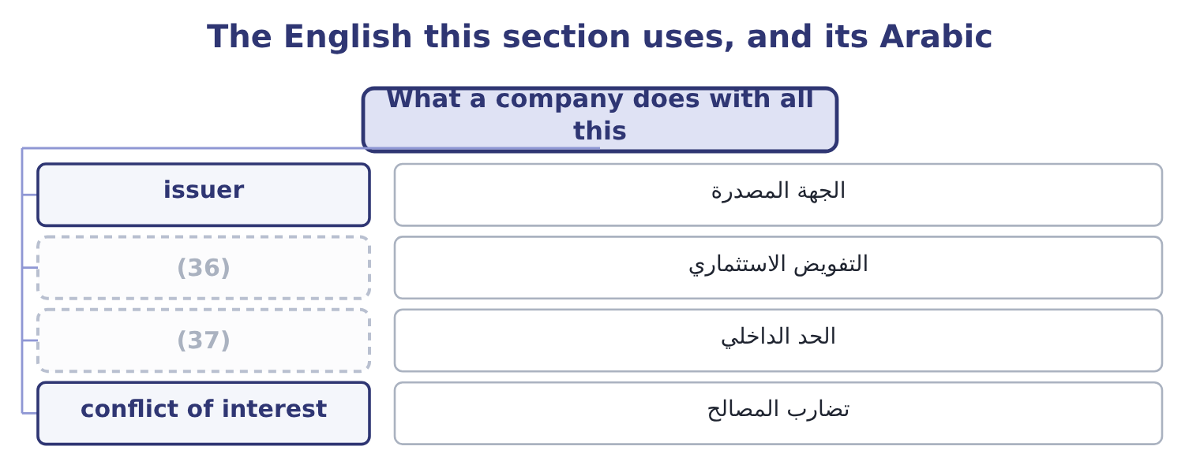
word list
mandate · internal limit · behavioural finance

The English this sheet uses, and its Arabic
English (exam term) | Arabic
issuer | الجهة المصدرة
mandate | التفويض الاستثماري
internal limit | الحد الداخلي
conflict of interest | تضارب المصالح

Answer key · 9.5 What a company does with all this

1 sections | 20 completion
2 management | 21 observation
3 Choose | 22 Exchange or over the counter?
4 purpose | 23 Annual cost
5 Short-term | 24 Proceeds to the company
6 Long-term | 25 Which form of efficiency would this contradict?
7 privately | 26 reflect
8 squarely | 27 expensive
9 machinery | 28 everyday
10 Accept | 29 candidates
11 verdict | 30 trading
12 twenty-five | 31 frontier
13 treasurer | 32 combinations
14 notch | 33 Secondary: the company receives nothing.
15 crossing | 34 centrally
16 intermediary | 35 28,500,000: 30,000,000 × 0.95 = 28,500,000.
17 conflict | 36 mandate
18 underwriter | 37 internal limit
19 adviser

the summaries in full
Summary 1 Pull the four sections together from the issuer's chair, which is where a management accountant sits. Choose the market that fits the size and the purpose. Short-term needs belong in the money market. Long-term needs belong in the capital market, publicly if the company is large and well known, privately if it is not. Orontes, wanting $5,000,000, is squarely in the private and bank market and should not be paying for a public issue's machinery. Accept the market's verdict on price, and work on the thing behind it. If the shares trade at twenty-five times earnings while the gross margin falls, the lesson is about the margin, not about the market's judgment. Under semi-strong efficiency a company cannot talk its price up and can only change what the price is about. Manage the rating rather than the ratio.
Summary 2 A treasurer who understands that one notch is worth 0.8 points and that crossing the investment-grade line is worth far more will set internal limits inside the covenant limits, which is why Book 1's chapter on coverage ended where it did. Use the intermediary and price the conflict. An underwriter is paid to sell the issue, which means it prefers a price that sells easily; an adviser is paid on completion, which means it prefers a deal. Neither observation is a reason to do without them, and both are reasons for a board to ask the question that the fee structure will not ask itself.
Summary 3 English efficient in market efficiency does not mean well run, fast or cheap. It means that prices reflect information, and a market can be efficient in this sense while being slow, expensive and badly organised. The everyday sense is a false friend, and candidates who import it answer that a market with high trading costs cannot be efficient — which does not follow. Note also the phrase efficient frontier: a third sense again, meaning the best risk-return combinations available.

