10.1 The initial public offering
Chapter 10 · section 10.1

Fill every gap. Each word list holds one word more than there are gaps.
Chapter 10, section by section
Each stage leads to the next.
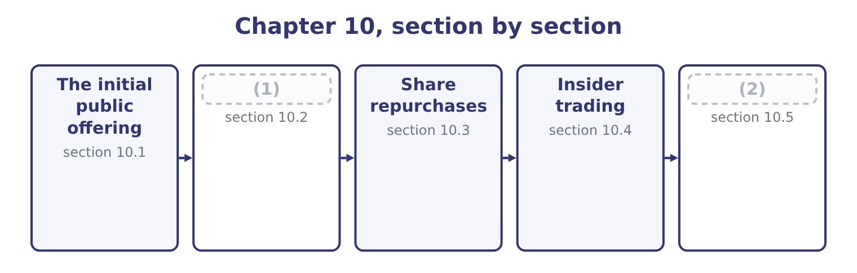
word list
Deciding, as Orontes · The initial public offering · Offerings after the first

Summary 1 gaps 3–14
An (3) public offering is the first sale of a company's shares to the public. Two things can happen at once in it, and the exam (4) them: the company may issue new shares, in which case it receives the money, and existing (5) may sell some of theirs, in which case they do. To raise (6) for growth that (7) profit cannot fund. To give the (8) and early investors a way out, which is often the real reason. To create a traded currency for (9) and for employee (10) . To raise the company's standing with (11) and lenders. And to establish a market price, which every (12) financing then (13) . The costs are large and (14) . A public company carries continuous disclosure obligations, quarterly scrutiny, governance requirements and the attention of people whose horizon is shorter than the business's.
word list
distinguishes · founders · permanent · acquisitions · references · retained · shareholders · subsequent · regulator · incentives · customers · capital · initial

Summary 2 gaps 15–26
Control is diluted and in (15) can be lost. The direct costs of the issue are heavy, and the indirect cost of underpricing is (16) still. The (17) has six stages. (18) the underwriters and agreeing the structure, which fixes the firm (19) or best efforts basis. Due diligence and the (20) statement, filed with the (21) regulator, from which the prospectus is drawn. The prospectus is the (22) on which the investors decide, and the (23) for what it says is the reason due diligence is thorough. The (24) , in which management presents to (25) investors over two or three weeks. (26) , in which the underwriters collect indications of how much each investor would buy at what price, and from which the demand curve is assembled. Pricing, the night before the offer, at a figure that the book says will clear with demand left over. Trading, followed by a lock-up period of typically ninety to a hundred and eighty days during which insiders may not sell, and often a stabilisation period in which the underwriter may support the price.
word list
institutional · roadshow · process · registration · extremis · securities · liability · heavier · Selecting · Book-building · commitment · document · standing

Worked example: what an offering costs

Summary 3 gaps 27–38
A company sells 5,000,000 new shares at $12.00. The gross (27) is 5,000,000 × 12.00 = 60,000,000. At a 7 per cent gross spread, the underwriters take 60,000,000 × 0.07 = 4,200,000, so the company receives 60,000,000 − 4,200,000 = 55,800,000, before legal, accounting and listing fees of (28) a further two (29) . The shares close their first day at $15.00. The company sold for $12.00 (30) the market (31) at $15.00, so the underpricing is 15.00 − 12.00 = 3.00 a share, which is 5,000,000 × 3.00 = 15,000,000 of value (32) from the company's existing (33) to the investors who were (34) stock. The indirect cost is three and a half times the direct one, and it is the part (35) puts in the fee table. Some underpricing is (36) — a discount is needed to persuade investors to take an unknown, and the underwriter needs the issue to sell — but the average first-day rise across decades of (37) is far larger than that (38) supports, and it is why the exam treats a large first-day pop as a question about the pricing rather than as good news.
word list
transferred · million · valued · perhaps · something · allocated · explanation · rational · owners · offerings · nobody · amount · document

What an initial public offering costs
Cost | How it arises | On this offering
Gross spread | The underwriting syndicate's fee | 4,200,000
Legal, accounting, listing | (39) | About 2,000,000
Underpricing | (40) | 15,000,000
Continuing costs | (41) | Every year thereafter

word list
Disclosure, governance, investor relations · The underwriting syndicate's fee · Advisers and the exchange · The first-day rise on shares already sold

The English this section uses, and its Arabic
Each term sits against what it means.
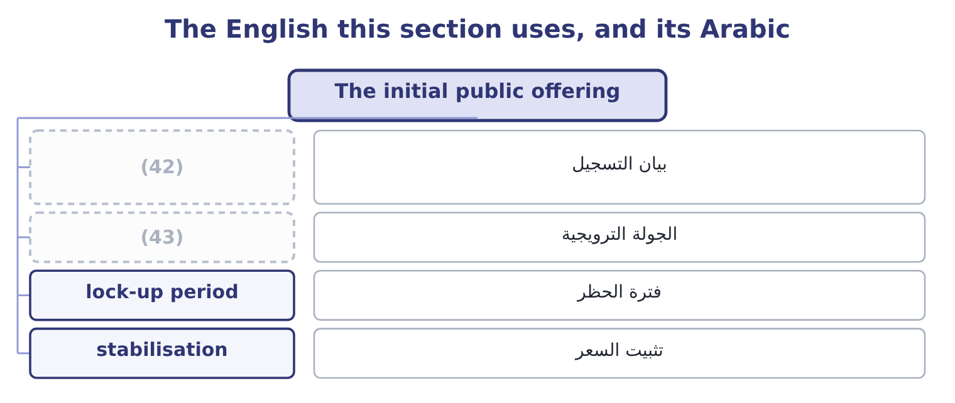
word list
underpricing · roadshow · registration statement

The English this sheet uses, and its Arabic
English (exam term) | Arabic
registration statement | بيان التسجيل
roadshow | الجولة الترويجية
lock-up period | فترة الحظر
stabilisation | تثبيت السعر

Answer key · 10.1 The initial public offering

1 Offerings after the first | 23 liability
2 Deciding, as Orontes | 24 roadshow
3 initial | 25 institutional
4 distinguishes | 26 Book-building
5 shareholders | 27 amount
6 capital | 28 perhaps
7 retained | 29 million
8 founders | 30 something
9 acquisitions | 31 valued
10 incentives | 32 transferred
11 customers | 33 owners
12 subsequent | 34 allocated
13 references | 35 nobody
14 permanent | 36 rational
15 extremis | 37 offerings
16 heavier | 38 explanation
17 process | 39 Advisers and the exchange
18 Selecting | 40 The first-day rise on shares already sold
19 commitment | 41 Disclosure, governance, investor relations
20 registration | 42 registration statement
21 securities | 43 roadshow
22 document

the summaries in full
Summary 1 An initial public offering is the first sale of a company's shares to the public. Two things can happen at once in it, and the exam distinguishes them: the company may issue new shares, in which case it receives the money, and existing shareholders may sell some of theirs, in which case they do. To raise capital for growth that retained profit cannot fund. To give the founders and early investors a way out, which is often the real reason. To create a traded currency for acquisitions and for employee incentives. To raise the company's standing with customers and lenders. And to establish a market price, which every subsequent financing then references. The costs are large and permanent. A public company carries continuous disclosure obligations, quarterly scrutiny, governance requirements and the attention of people whose horizon is shorter than the business's.
Summary 2 Control is diluted and in extremis can be lost. The direct costs of the issue are heavy, and the indirect cost of underpricing is heavier still. The process has six stages. Selecting the underwriters and agreeing the structure, which fixes the firm commitment or best efforts basis. Due diligence and the registration statement, filed with the securities regulator, from which the prospectus is drawn. The prospectus is the document on which the investors decide, and the liability for what it says is the reason due diligence is thorough. The roadshow, in which management presents to institutional investors over two or three weeks. Book-building, in which the underwriters collect indications of how much each investor would buy at what price, and from which the demand curve is assembled. Pricing, the night before the offer, at a figure that the book says will clear with demand left over. Trading, followed by a lock-up period of typically ninety to a hundred and eighty days during which insiders may not sell, and often a stabilisation period in which the underwriter may support the price.
Summary 3 A company sells 5,000,000 new shares at $12.00. The gross amount is 5,000,000 × 12.00 = 60,000,000. At a 7 per cent gross spread, the underwriters take 60,000,000 × 0.07 = 4,200,000, so the company receives 60,000,000 − 4,200,000 = 55,800,000, before legal, accounting and listing fees of perhaps a further two million. The shares close their first day at $15.00. The company sold for $12.00 something the market valued at $15.00, so the underpricing is 15.00 − 12.00 = 3.00 a share, which is 5,000,000 × 3.00 = 15,000,000 of value transferred from the company's existing owners to the investors who were allocated stock. The indirect cost is three and a half times the direct one, and it is the part nobody puts in the fee table. Some underpricing is rational — a discount is needed to persuade investors to take an unknown, and the underwriter needs the issue to sell — but the average first-day rise across decades of offerings is far larger than that explanation supports, and it is why the exam treats a large first-day pop as a question about the pricing rather than as good news.

10.2 Offerings after the first
Chapter 10 · section 10.2

Fill every gap. Each word list holds one word more than there are gaps.
Summary 1 gaps 1–12
A company that is already (1) can sell more shares, and the exam uses three terms for what (2) . A (3) or follow-on offering is any sale of shares by an already-listed company. A seasoned equity offering is the same thing, named for the fact that the shares are seasoned — already (4) , with a known price. A (5) offering, strictly, is a sale of existing shares by large (6) rather than new shares by the company. The (7) matters because no money (8) the company, and because a sale by (9) or a private equity owner (10) a signal that a sale of new shares does not. A rights issue offers new shares to existing shareholders in proportion to their (11) , usually at a discount to the market price, in order to honour the (12) right.
word list
pre-emptive · founders · subsequent · carries · happens · holdings · secondary · reaches · distinction · holders · trading · execution · listed

Summary 2 gaps 13–23
A (13) who takes up the rights keeps their proportion and (14) no dilution; one who sells the rights receives (15) for the dilution; one who does nothing loses. A shelf (16) allows a company to register an amount of (17) once and sell them in pieces over the following years whenever (18) suit, which lowers cost and speeds execution. The (19) of a follow-on is easier than an (20) offering, because the market has already set a price, but the signal is (21) . Under the (22) efficiency of, and the evidence is that share prices fall on the (23) of a new equity issue, typically by two or three per cent. The practical consequence for a treasurer is that equity is expensive in a way that no cost-of-capital calculation captures.
word list
pricing · distinction · harder · conditions · shareholder · suffers · compensation · securities · registration · initial · semi-strong · announcement

Four ways to sell shares after listing
Every item belongs to exactly one group.
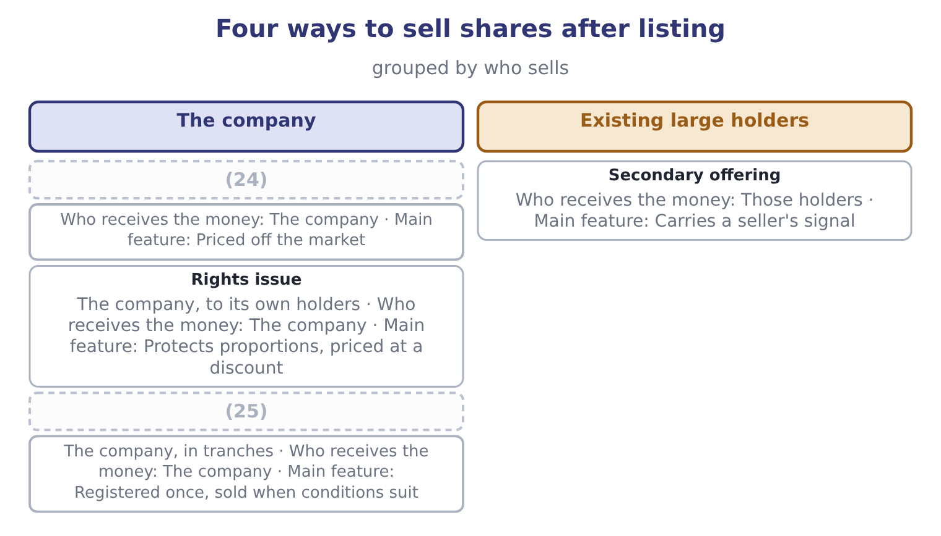
word list
insider trading · Follow-on (seasoned) offering · Shelf registration

The English this section uses, and its Arabic
Each term sits against what it means.
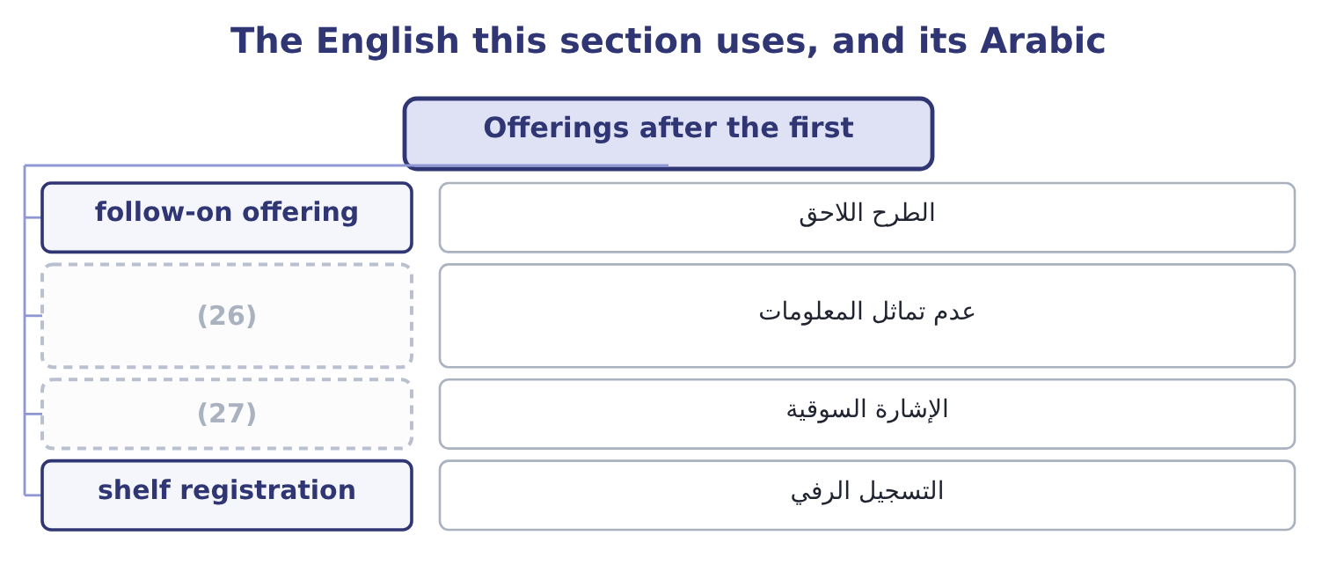
word list
signalling · information asymmetry · insider trading

The English this sheet uses, and its Arabic
English (exam term) | Arabic
follow-on offering | الطرح اللاحق
information asymmetry | عدم تماثل المعلومات
signalling | الإشارة السوقية
shelf registration | التسجيل الرفي

Answer key · 10.2 Offerings after the first

1 listed | 15 compensation
2 happens | 16 registration
3 subsequent | 17 securities
4 trading | 18 conditions
5 secondary | 19 pricing
6 holders | 20 initial
7 distinction | 21 harder
8 reaches | 22 semi-strong
9 founders | 23 announcement
10 carries | 24 Follow-on (seasoned) offering
11 holdings | 25 Shelf registration
12 pre-emptive | 26 information asymmetry
13 shareholder | 27 signalling
14 suffers

the summaries in full
Summary 1 A company that is already listed can sell more shares, and the exam uses three terms for what happens. A subsequent or follow-on offering is any sale of shares by an already-listed company. A seasoned equity offering is the same thing, named for the fact that the shares are seasoned — already trading, with a known price. A secondary offering, strictly, is a sale of existing shares by large holders rather than new shares by the company. The distinction matters because no money reaches the company, and because a sale by founders or a private equity owner carries a signal that a sale of new shares does not. A rights issue offers new shares to existing shareholders in proportion to their holdings, usually at a discount to the market price, in order to honour the pre-emptive right.
Summary 2 A shareholder who takes up the rights keeps their proportion and suffers no dilution; one who sells the rights receives compensation for the dilution; one who does nothing loses. A shelf registration allows a company to register an amount of securities once and sell them in pieces over the following years whenever conditions suit, which lowers cost and speeds execution. The pricing of a follow-on is easier than an initial offering, because the market has already set a price, but the signal is harder. Under the semi-strong efficiency of, and the evidence is that share prices fall on the announcement of a new equity issue, typically by two or three per cent. The practical consequence for a treasurer is that equity is expensive in a way that no cost-of-capital calculation captures.

10.3 Share repurchases
Chapter 10 · section 10.3

Fill every gap. Each word list holds one word more than there are gaps.
Summary 1 gaps 1–12
A repurchase is the company buying its own shares. The shares bought either become treasury stock, (1) to be reissued, or are (2) . Either way the share count falls and so does equity. Six reasons a company (3) , and the exam expects them named and (4) . To return cash it (5) use. A company generating more than its investment (6) need has three choices: hold the cash, which lowers the return on assets as Book 1 showed; raise the dividend, which the market expects to be maintained; or buy back shares, which carries no such (7) . (8) is the central (9) for a buyback over a dividend. To signal that the (10) believe the shares are (11) . Buying is the opposite of issuing, and the signal is read in the opposite direction: prices typically rise on a repurchase (12) .
word list
directors · undervalued · argument · repurchases · employee · available · cancelled · Flexibility · distinguished · expectation · opportunities · announcement · cannot

Summary 2 gaps 13–24
To (13) the capital (14) . A buyback funded with debt raises leverage (15) , moving the company (16) the optimum. To offset the (17) of employee share schemes, which is in practice the largest single use of repurchase (18) . To use the tax (19) . Where capital gains are taxed more lightly than dividends, or are deferred until the (20) chooses to sell, a repurchase delivers value more (21) than a dividend. To defend against a (22) , by reducing the free float and (23) the price. The methods differ and are (24) . An open-market repurchase buys gradually through the exchange over months, cheapest and least committing. A fixed-price tender offer invites all holders to sell a stated number at a stated price, usually at a premium. A Dutch auction tender invites holders to state the lowest price at which they will sell, and the company pays the lowest price that fills the order. And a targeted repurchase buys from one holder privately, which is the transaction that acquired the name greenmail when the holder was a hostile bidder being paid to go away.
word list
dilution · tax-efficiently · raising · takeover · structure · deliberately · treatment · privately · shareholder · programmes · change · towards · examinable

Worked example: Orontes buys back 500,000 shares

Summary 3 gaps 25–28
Orontes buys 500,000 of its 8,100,000 shares at the market price of $9.25, spending 500,000 × 9.25 = 4,625,000 of the $7,302,100 of cash on its (25) sheet. Cash falls to 7,302,100 − 4,625,000 = 2,677,100. Net income is (26) at $2,969,100 and the share count falls to 8,100,000 − 500,000 = 7,600,000, so earnings per share rises to 2,969,100 ÷ 7,600,000 = 0.3907 from 0.3666. Book value per share. Equity falls by the cash spent: 20,392,975 − 4,625,000 = 15,767,975, and book value per share (27) 15,767,975 ÷ 7,600,000 = 2.07, down from 2.5177 — because the shares were bought at (28) four times book. Return on equity rises to 2,969,100 ÷ 15,767,975 = 18.83 per cent from 16.15. Debt to equity rises to 11,279,625 ÷ 15,767,975 = 0.715 from 0.55. The current ratio falls, because $4,625,000 of current assets has gone.
word list
becomes · dividend · unchanged · nearly · balance

Summary 4 gaps 29–36
Earnings per share rose, return on equity rose, and nothing (29) happened to the (30) . That is the warning this example exists to give: a buyback (31) every per-share measure (32) , and an incentive scheme based on earnings per share can (33) be satisfied by spending cash rather than by trading better. The (34) to ask is the one: did the $4,625,000 earn more inside the company or returned to its owners? If Orontes has projects (35) more than 9.04 per cent, the buyback (36) value however good the ratios look.
word list
whatever · question · business · therefore · improves · destroyed · returning · auction · arithmetically

The English this section uses, and its Arabic
Each term sits against what it means.
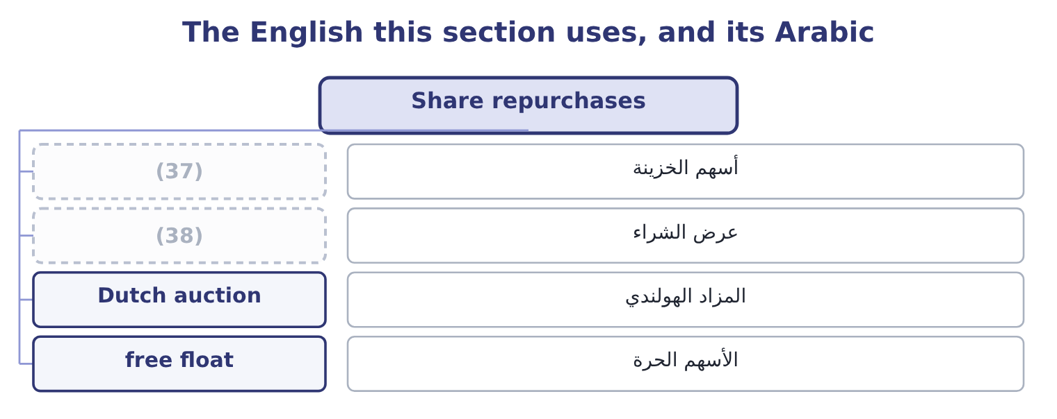
word list
registration statement · treasury stock · tender offer

The English this sheet uses, and its Arabic
English (exam term) | Arabic
treasury stock | أسهم الخزينة
tender offer | عرض الشراء
Dutch auction | المزاد الهولندي
free float | الأسهم الحرة

Answer key · 10.3 Share repurchases

1 available | 20 shareholder
2 cancelled | 21 tax-efficiently
3 repurchases | 22 takeover
4 distinguished | 23 raising
5 cannot | 24 examinable
6 opportunities | 25 balance
7 expectation | 26 unchanged
8 Flexibility | 27 becomes
9 argument | 28 nearly
10 directors | 29 whatever
11 undervalued | 30 business
12 announcement | 31 improves
13 change | 32 arithmetically
14 structure | 33 therefore
15 deliberately | 34 question
16 towards | 35 returning
17 dilution | 36 destroyed
18 programmes | 37 treasury stock
19 treatment | 38 tender offer

the summaries in full
Summary 1 A repurchase is the company buying its own shares. The shares bought either become treasury stock, available to be reissued, or are cancelled. Either way the share count falls and so does equity. Six reasons a company repurchases, and the exam expects them named and distinguished. To return cash it cannot use. A company generating more than its investment opportunities need has three choices: hold the cash, which lowers the return on assets as Book 1 showed; raise the dividend, which the market expects to be maintained; or buy back shares, which carries no such expectation. Flexibility is the central argument for a buyback over a dividend. To signal that the directors believe the shares are undervalued. Buying is the opposite of issuing, and the signal is read in the opposite direction: prices typically rise on a repurchase announcement.
Summary 2 To change the capital structure. A buyback funded with debt raises leverage deliberately, moving the company towards the optimum. To offset the dilution of employee share schemes, which is in practice the largest single use of repurchase programmes. To use the tax treatment. Where capital gains are taxed more lightly than dividends, or are deferred until the shareholder chooses to sell, a repurchase delivers value more tax-efficiently than a dividend. To defend against a takeover, by reducing the free float and raising the price. The methods differ and are examinable. An open-market repurchase buys gradually through the exchange over months, cheapest and least committing. A fixed-price tender offer invites all holders to sell a stated number at a stated price, usually at a premium. A Dutch auction tender invites holders to state the lowest price at which they will sell, and the company pays the lowest price that fills the order. And a targeted repurchase buys from one holder privately, which is the transaction that acquired the name greenmail when the holder was a hostile bidder being paid to go away.
Summary 3 Orontes buys 500,000 of its 8,100,000 shares at the market price of $9.25, spending 500,000 × 9.25 = 4,625,000 of the $7,302,100 of cash on its balance sheet. Cash falls to 7,302,100 − 4,625,000 = 2,677,100. Net income is unchanged at $2,969,100 and the share count falls to 8,100,000 − 500,000 = 7,600,000, so earnings per share rises to 2,969,100 ÷ 7,600,000 = 0.3907 from 0.3666. Book value per share. Equity falls by the cash spent: 20,392,975 − 4,625,000 = 15,767,975, and book value per share becomes 15,767,975 ÷ 7,600,000 = 2.07, down from 2.5177 — because the shares were bought at nearly four times book. Return on equity rises to 2,969,100 ÷ 15,767,975 = 18.83 per cent from 16.15. Debt to equity rises to 11,279,625 ÷ 15,767,975 = 0.715 from 0.55. The current ratio falls, because $4,625,000 of current assets has gone.
Summary 4 Earnings per share rose, return on equity rose, and nothing whatever happened to the business. That is the warning this example exists to give: a buyback improves every per-share measure arithmetically, and an incentive scheme based on earnings per share can therefore be satisfied by spending cash rather than by trading better. The question to ask is the one: did the $4,625,000 earn more inside the company or returned to its owners? If Orontes has projects returning more than 9.04 per cent, the buyback destroyed value however good the ratios look.

10.4 Insider trading
Chapter 10 · section 10.4

Fill every gap. Each word list holds one word more than there are gaps.
Summary 1 gaps 1–12
Insider trading is (1) in a company's (2) on the basis of material non-public information, by somebody who owes a duty with respect to that information. Three (3) define it and each is (4) . Material means the information would matter to a reasonable (5) decision — an earnings figure not yet announced, a merger in (6) , the loss of a major customer, a drug trial's result. (7) information is not caught (8) secret. Non-public means not yet (9) to the market. Once an announcement has been made and the market has had time to (10) it, the information is public and trading on it is lawful. A duty means the trader is an insider or has (11) one. (12) , officers and employees are classic insiders. So are temporary insiders — the lawyers, auditors, bankers and printers who receive the information to do their work. And so is a tippee, somebody given the information by an insider who breached a duty in telling them, where the tippee knew or should have known of the breach.
word list
however · negotiation · investor's · tested · disseminated · dealing · announced · securities · Directors · Immaterial · become · elements · absorb

Summary 2 gaps 13–22
Why it is (13) , which is the part of the outcome (14) answer weakly. Four (15) , and the first is the (16) . It is theft of information that (17) to the company and its (18) , used for private gain. It destroys (19) in the market. (20) who believe the game is rigged demand a higher return for (21) , which raises the cost of capital for every company — a harm to the whole economy, not only to the person on the other side of the trade. It harms the (22) directly. Somebody sold the shares the insider bought, at a price that did not reflect what the insider knew. It creates perverse incentives inside the company.
word list
candidates · shareholders · belongs · strongest · Investors · participating · illegal · assumes · confidence · reasons · counterparty

Summary 3 gaps 23–32
A manager who can trade on bad news has an (23) in bad news, and in (24) its announcement. The (25) and safe harbours are (26) . A (27) trading plan, adopted when the insider had no material non-public information and executed (28) , protects routine sales by executives. Trading after full public disclosure is lawful. And the (29) that require fair disclosure exist (30) to stop selective briefing of analysts, which would otherwise create insiders by the dozen. (31) efficiency says prices (32) reflect private information, in which case insider trading could not be profitable. The law assumes it is profitable. The law is right, which is the plainest available evidence that the strong form does not hold.
word list
interest · already · delaying · regulations · briefing · pre-arranged · automatically · Strong-form · defences · precisely · examinable

What makes trading unlawful
Element | Test | Example that meets it | Example that does not
Material | Would a reasonable investor care? | Unannounced earnings, a merger | (33)
Non-public | Has the market been told? | (34) | After it has been absorbed
Duty | Is the trader an insider or a tippee? | (35) | A stranger who worked it out from public data

word list
Before the announcement · A director, an auditor, a tipped friend · An internal reorganisation of departments · initial public offering

The English this section uses, and its Arabic
Each term sits against what it means.
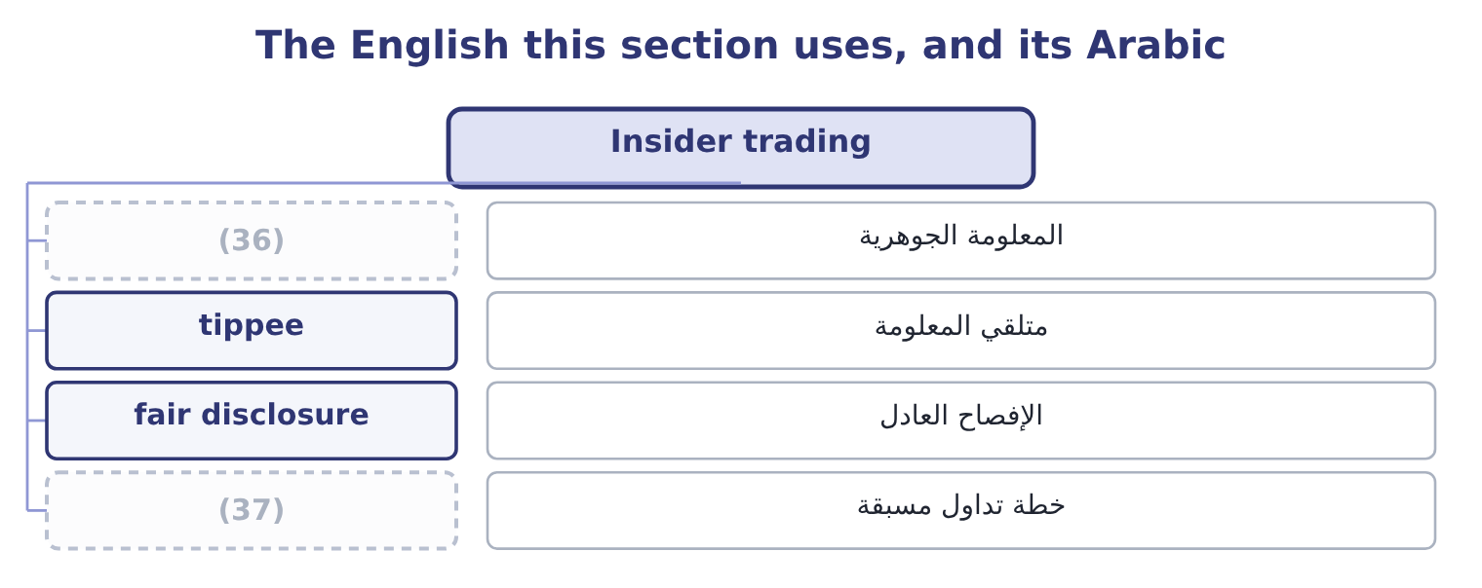
word list
material information · trading plan · insider trading

The English this sheet uses, and its Arabic
English (exam term) | Arabic
material information | المعلومة الجوهرية
tippee | متلقي المعلومة
fair disclosure | الإفصاح العادل
trading plan | خطة تداول مسبقة

Answer key · 10.4 Insider trading

1 dealing | 20 Investors
2 securities | 21 participating
3 elements | 22 counterparty
4 tested | 23 interest
5 investor's | 24 delaying
6 negotiation | 25 defences
7 Immaterial | 26 examinable
8 however | 27 pre-arranged
9 disseminated | 28 automatically
10 absorb | 29 regulations
11 become | 30 precisely
12 Directors | 31 Strong-form
13 illegal | 32 already
14 candidates | 33 An internal reorganisation of departments
15 reasons | 34 Before the announcement
16 strongest | 35 A director, an auditor, a tipped friend
17 belongs | 36 material information
18 shareholders | 37 trading plan
19 confidence

the summaries in full
Summary 1 Insider trading is dealing in a company's securities on the basis of material non-public information, by somebody who owes a duty with respect to that information. Three elements define it and each is tested. Material means the information would matter to a reasonable investor's decision — an earnings figure not yet announced, a merger in negotiation, the loss of a major customer, a drug trial's result. Immaterial information is not caught however secret. Non-public means not yet disseminated to the market. Once an announcement has been made and the market has had time to absorb it, the information is public and trading on it is lawful. A duty means the trader is an insider or has become one. Directors, officers and employees are classic insiders. So are temporary insiders — the lawyers, auditors, bankers and printers who receive the information to do their work. And so is a tippee, somebody given the information by an insider who breached a duty in telling them, where the tippee knew or should have known of the breach.
Summary 2 Why it is illegal, which is the part of the outcome candidates answer weakly. Four reasons, and the first is the strongest. It is theft of information that belongs to the company and its shareholders, used for private gain. It destroys confidence in the market. Investors who believe the game is rigged demand a higher return for participating, which raises the cost of capital for every company — a harm to the whole economy, not only to the person on the other side of the trade. It harms the counterparty directly. Somebody sold the shares the insider bought, at a price that did not reflect what the insider knew. It creates perverse incentives inside the company.
Summary 3 A manager who can trade on bad news has an interest in bad news, and in delaying its announcement. The defences and safe harbours are examinable. A pre-arranged trading plan, adopted when the insider had no material non-public information and executed automatically, protects routine sales by executives. Trading after full public disclosure is lawful. And the regulations that require fair disclosure exist precisely to stop selective briefing of analysts, which would otherwise create insiders by the dozen. Strong-form efficiency says prices already reflect private information, in which case insider trading could not be profitable. The law assumes it is profitable. The law is right, which is the plainest available evidence that the strong form does not hold.

10.5 Deciding, as Orontes
Chapter 10 · section 10.5

Fill every gap. Each word list holds one word more than there are gaps.
Summary 1 gaps 1–12
Put the chapter to work on the company. Orontes holds $7,302,100 of cash against total current (1) of $4,280,000 and a cash ratio of 1.72, which Book 1 called strong and faintly (2) . The (3) is 15.16 per cent and the dividend yield 0.60 per cent, which is a growth (4) profile. (5) it creates an (6) the company will be judged against for years. The (7) example showed what it would do to the ratios and what it would not do to the (8) . Two further (9) decide it. The shares trade at 3.67 times book and 25.23 times earnings, which is the price at which the company would be buying — a high price to pay for its own equity unless the (10) believe the market is (11) it, and Book 1's margin finding suggests the opposite. And the cash is partly a defence: a company whose gross margin is falling a point a year may need the $7,302,100 more than its (12) do.
word list
Raising · payout · excessive · liabilities · undervaluing · company's · directors · considerations · business · shareholders · worked · expectation · creates

Summary 2 gaps 13–17
The (13) that follows from the whole of Books 1 and 2 so far is: fund the (14) , leave the dividend where it is, and do not buy back shares at 3.67 times book while the margin is still falling. That is a (15) , and the marks in an exam are for the (16) , not for the (17) .
word list
reasoning · judgment · projects · undervaluing · recommendation · verdict

Classify and compute

Your turn: offerings, buybacks and insiders (complete the blanks)
Item | Question | Answer
4,000,000 shares at 15.00, 6 per cent spread | Proceeds to the company | ________
Those shares close at 18.00 on day one | Underpricing in total | ________
A founder sells 2,000,000 existing shares | (18) | ________
A company buys back 1,000,000 of 10,000,000 shares; net income 5,000,000 | New earnings per share | ________
An auditor trades before an unannounced merger | Lawful or not, and why? | ________
A trading plan adopted a year earlier executes a sale | (19) | ________

word list
Lawful or not, and why? · Proceeds to the company · Who receives the money?

"Offering"

Summary 3 gaps 20–25
English offering in finance means a sale of (20) , and the related words divide along lines that catch (21) out. An offer is what a bidder makes for a company; an offering is what a company makes to (22) ; and the offer price in a market (23) is the price at which a dealer will sell to you, which is the opposite of the bid. Read the (24) and the context before (25) which is meant.
word list
candidates · deciding · quotation · securities · shareholders · investors · preposition

"Offering"
Item | Answer
Proceeds to the company | 56,400,000: the gross is 4,000,000 × 15.00 = 60,000,000 and the spread 60,000,000 × 0.06 = 3,600,000, leaving 60,000,000 − 3,600,000 = 56,40
Underpricing in total | 12,000,000: the rise is 18.00 − 15.00 = 3.00 a share on 4,000,000 shares.
Who receives the money | (26) : this is a secondary sale of existing shares.
New earnings per share | (27)
The auditor's trade | (28) : the auditor is a temporary insider with material non-public information.
The trading plan | Lawful: it was adopted when the insider held no material non-public information and executes automatically.
What it tells you | The two costs of an offering are the one in the fee table and the one that is not, and on these figures the second is more than three times

word list
0.5556: 5,000,000 ÷ 9,000,000 = 0.5556. · Proceeds to the company · The founder, not the company · Unlawful

The English this section uses, and its Arabic
Each term sits against what it means.
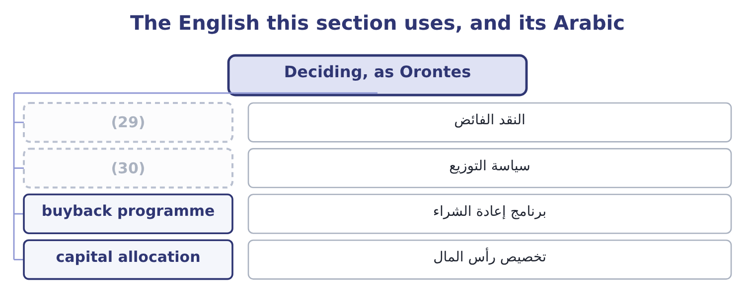
word list
payout policy · excess cash · registration statement

The English this sheet uses, and its Arabic
English (exam term) | Arabic
excess cash | النقد الفائض
payout policy | سياسة التوزيع
buyback programme | برنامج إعادة الشراء
capital allocation | تخصيص رأس المال

Answer key · 10.5 Deciding, as Orontes

1 liabilities | 16 reasoning
2 excessive | 17 verdict
3 payout | 18 Who receives the money?
4 company's | 19 Lawful or not, and why?
5 Raising | 20 securities
6 expectation | 21 candidates
7 worked | 22 investors
8 business | 23 quotation
9 considerations | 24 preposition
10 directors | 25 deciding
11 undervaluing | 26 The founder, not the company
12 shareholders | 27 0.5556: 5,000,000 ÷ 9,000,000 = 0.5556.
13 recommendation | 28 Unlawful
14 projects | 29 excess cash
15 judgment | 30 payout policy

the summaries in full
Summary 1 Put the chapter to work on the company. Orontes holds $7,302,100 of cash against total current liabilities of $4,280,000 and a cash ratio of 1.72, which Book 1 called strong and faintly excessive. The payout is 15.16 per cent and the dividend yield 0.60 per cent, which is a growth company's profile. Raising it creates an expectation the company will be judged against for years. The worked example showed what it would do to the ratios and what it would not do to the business. Two further considerations decide it. The shares trade at 3.67 times book and 25.23 times earnings, which is the price at which the company would be buying — a high price to pay for its own equity unless the directors believe the market is undervaluing it, and Book 1's margin finding suggests the opposite. And the cash is partly a defence: a company whose gross margin is falling a point a year may need the $7,302,100 more than its shareholders do.
Summary 2 The recommendation that follows from the whole of Books 1 and 2 so far is: fund the projects, leave the dividend where it is, and do not buy back shares at 3.67 times book while the margin is still falling. That is a judgment, and the marks in an exam are for the reasoning, not for the verdict.
Summary 3 English offering in finance means a sale of securities, and the related words divide along lines that catch candidates out. An offer is what a bidder makes for a company; an offering is what a company makes to investors; and the offer price in a market quotation is the price at which a dealer will sell to you, which is the opposite of the bid. Read the preposition and the context before deciding which is meant.

