11.1 The kinds of dividend
Chapter 11 · section 11.1

Fill every gap. Each word list holds one word more than there are gaps.
Chapter 11, section by section
Each stage leads to the next.
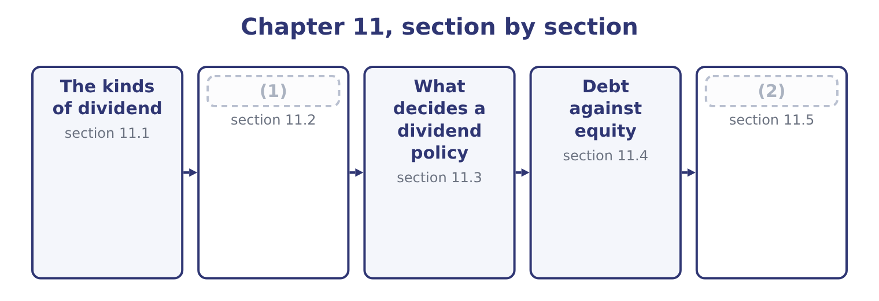
word list
What decides a dividend policy · How a dividend is paid · Leasing, and the net advantage to leasing

Summary 1 gaps 3–14
Four (3) appear in exam (4) and only the first moves cash. A cash dividend is a (5) out of retained earnings. It reduces cash and reduces equity by the same amount, and it does not touch the income (6) — a distribution is not an (7) . Orontes (8) $450,000 for 2025, of which $50,000 was paid in cash during the year and $400,000 stood as a dividend payable at (9) 31. A stock dividend is a distribution of additional shares. Nothing (10) the company. A holder of 100 shares who (11) a 10 per cent stock dividend holds 110 shares of a company worth exactly what it was worth before, so each share is worth (12) less. In the (13) , a small stock dividend transfers an amount from retained earnings to common stock and additional paid-in capital at the market value of the shares issued: on (14) 8,100,000 shares a 10 per cent stock dividend would issue 810,000 shares, and at $9.25 that is 810,000 × 9.25 = 7,492,500 moved within equity.
word list
December · receives · additional · statement · payment · proportionately · Orontes's · declared · distributions · accounts · expense · questions · leaves

Summary 2 gaps 15–26
Earnings per share falls (15) to 2,969,100 ÷ 8,910,000 = 0.3332. A stock split (16) each share into more shares. A (17) split on Orontes gives 16,200,000 shares, each worth about half as much, and earnings per share (18) 2,969,100 ÷ 16,200,000 = 0.1833. (19) a split changes the par value and transfers nothing; (20) it is identical to a stock dividend, and the reason both exist is a convention about size — a distribution of more than about a quarter is treated as a split. A property dividend (21) an asset rather than cash, and a (22) dividend returns capital rather than profit, which reduces paid-in capital and is a signal in its own right. Why issue shares that are worth nothing new? Three (23) the exam accepts. To bring a high share price into a range where small (24) trade more (25) . To signal (26) , since a board that splits usually expects the price to keep rising. And to conserve cash while appearing to distribute something, which is the least respectable of the three and the commonest.
word list
liquidating · mechanically · confidence · reasons · economically · exactly · two-for-one · distributes · easily · Accounting-wise · investors · becomes · divides

What each distribution changes
Every item belongs to exactly one group.
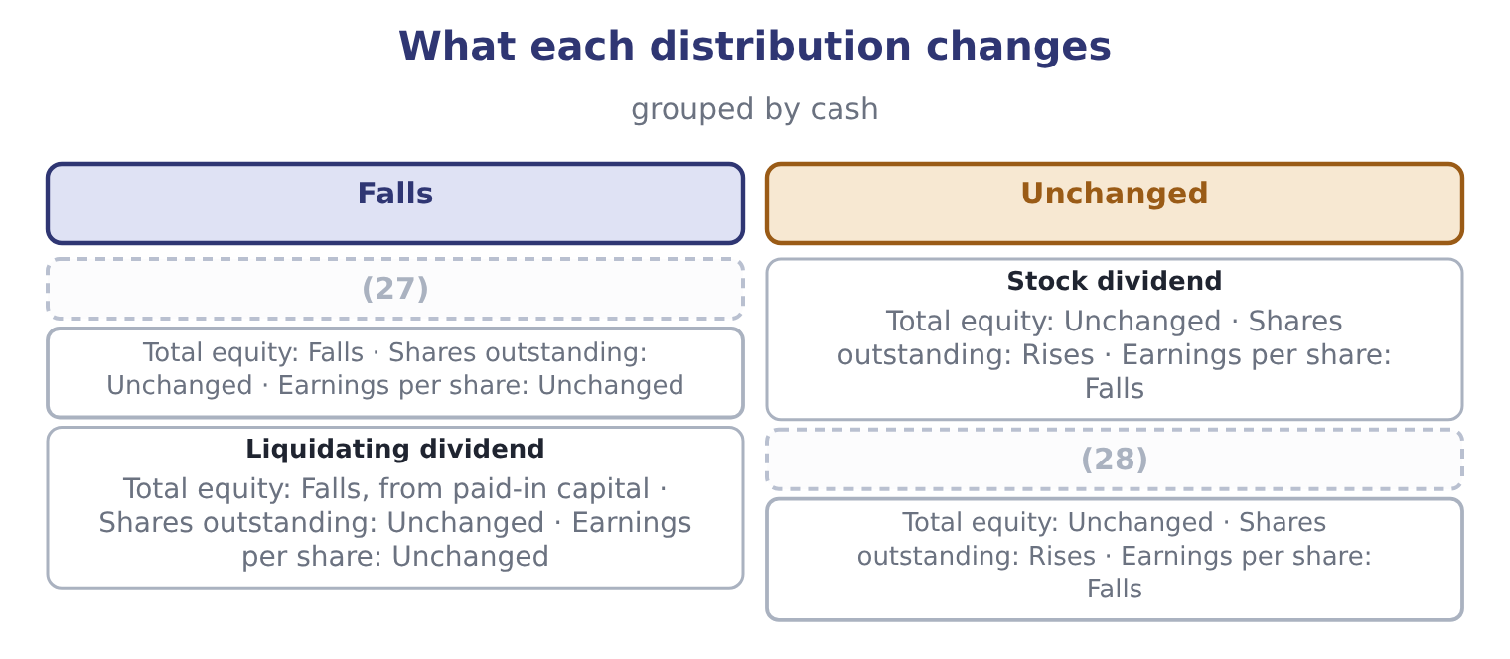
word list
irrelevance theory · Cash dividend · Stock split

The English this section uses, and its Arabic
Each term sits against what it means.
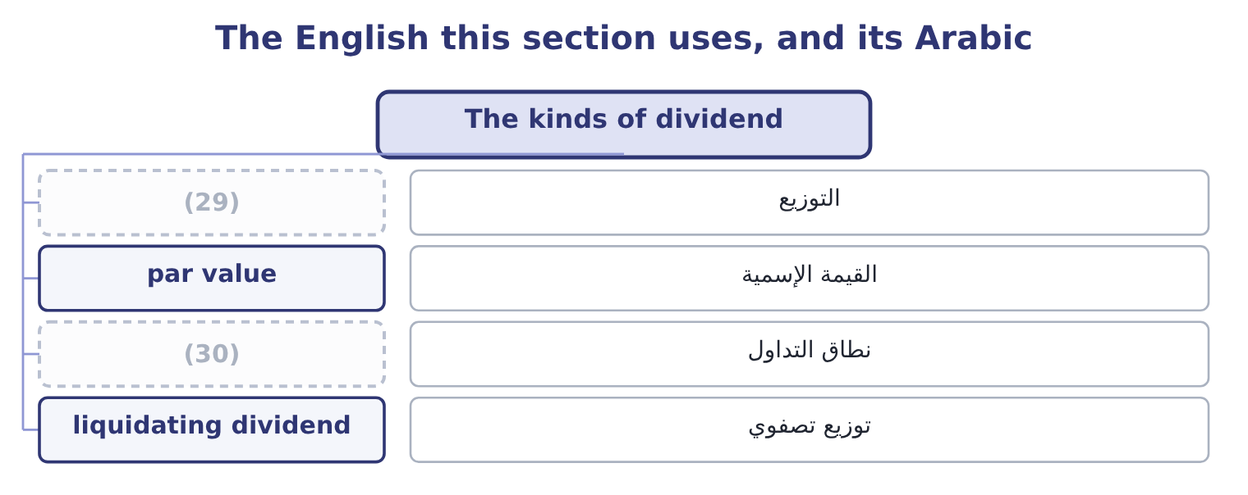
word list
distribution · trading range · dividend policy

The English this sheet uses, and its Arabic
English (exam term) | Arabic
distribution | التوزيع
par value | القيمة الإسمية
trading range | نطاق التداول
liquidating dividend | توزيع تصفوي

Answer key · 11.1 The kinds of dividend

1 How a dividend is paid | 16 divides
2 Leasing, and the net advantage to leasing | 17 two-for-one
3 distributions | 18 becomes
4 questions | 19 Accounting-wise
5 payment | 20 economically
6 statement | 21 distributes
7 expense | 22 liquidating
8 declared | 23 reasons
9 December | 24 investors
10 leaves | 25 easily
11 receives | 26 confidence
12 proportionately | 27 Cash dividend
13 accounts | 28 Stock split
14 Orontes's | 29 distribution
15 mechanically | 30 trading range

the summaries in full
Summary 1 Four distributions appear in exam questions and only the first moves cash. A cash dividend is a payment out of retained earnings. It reduces cash and reduces equity by the same amount, and it does not touch the income statement — a distribution is not an expense. Orontes declared $450,000 for 2025, of which $50,000 was paid in cash during the year and $400,000 stood as a dividend payable at December 31. A stock dividend is a distribution of additional shares. Nothing leaves the company. A holder of 100 shares who receives a 10 per cent stock dividend holds 110 shares of a company worth exactly what it was worth before, so each share is worth proportionately less. In the accounts, a small stock dividend transfers an amount from retained earnings to common stock and additional paid-in capital at the market value of the shares issued: on Orontes's 8,100,000 shares a 10 per cent stock dividend would issue 810,000 shares, and at $9.25 that is 810,000 × 9.25 = 7,492,500 moved within equity.
Summary 2 Earnings per share falls mechanically to 2,969,100 ÷ 8,910,000 = 0.3332. A stock split divides each share into more shares. A two-for-one split on Orontes gives 16,200,000 shares, each worth about half as much, and earnings per share becomes 2,969,100 ÷ 16,200,000 = 0.1833. Accounting-wise a split changes the par value and transfers nothing; economically it is identical to a stock dividend, and the reason both exist is a convention about size — a distribution of more than about a quarter is treated as a split. A property dividend distributes an asset rather than cash, and a liquidating dividend returns capital rather than profit, which reduces paid-in capital and is a signal in its own right. Why issue shares that are worth nothing new? Three reasons the exam accepts. To bring a high share price into a range where small investors trade more easily. To signal confidence, since a board that splits usually expects the price to keep rising. And to conserve cash while appearing to distribute something, which is the least respectable of the three and the commonest.

11.2 How a dividend is paid
Chapter 11 · section 11.2

Fill every gap. Each word list holds one word more than there are gaps.
Summary 1 gaps 1–9
Four dates (1) the process, and the exam asks which one matters. The declaration date is when the board declares the dividend. At that (2) a legal liability arises: Orontes's $400,000 dividend payable exists because the board declared before the year end and had not yet paid. The date of record is the date on which the company looks at its share register. (3) is on it receives the dividend. The ex-dividend date is one (4) day before the record date in most (5) , and it is the one that matters to an (6) . A share (7) on or after it does not carry the dividend. On the ex-dividend date the price falls by (8) the dividend, because the buyer no (9) receives it: Orontes's $9.25 share would open at about 9.25 − 0.0556 = 9.1944, before any other news.
word list
govern · markets · bought · longer · Whoever · business · approximately · moment · investor · payment

Summary 2 gaps 10–17
The payment date is when the cash goes out. For preferred stock the process is the same with one (10) . The preferred dividend must be declared and paid in full before any common dividend, and where the stock is cumulative, any (11) from earlier years must be (12) first. Preferred dividends are (13) at a fixed rate on par and are declared on a (14) cycle, so the (15) a board exercises over the common dividend (16) exists for the preferred — in (17) if not in law.
word list
arrears · addition · barely · practice · dividend · discretion · regular · usually · cleared

The four dates
Date | What happens | Effect
Declaration date | The board declares | (18)
Ex-dividend date | (19) | The price falls by about the dividend
Date of record | (20) | Holders on it will be paid
Payment date | The cash is sent | (21)

word list
Cash and the liability both fall · The shares trade without the dividend · A liability arises; equity falls · The register is read · net advantage to leasing

Which date, and which effect

Summary 3 gaps 22–26
The liability arises on declaration, not on payment. Orontes's (22) sheet carries $400,000 of dividends payable for exactly that reason. The price (23) on the ex-dividend date, not on the payment date. Buying the day before the (24) to capture the dividend gains nothing, because the price falls by it. A dividend is not an (25) and never reduces net income. It reduces (26) earnings.
word list
adjusts · ex-date · retained · expense · balance · payment

The English this section uses, and its Arabic
Each term sits against what it means.
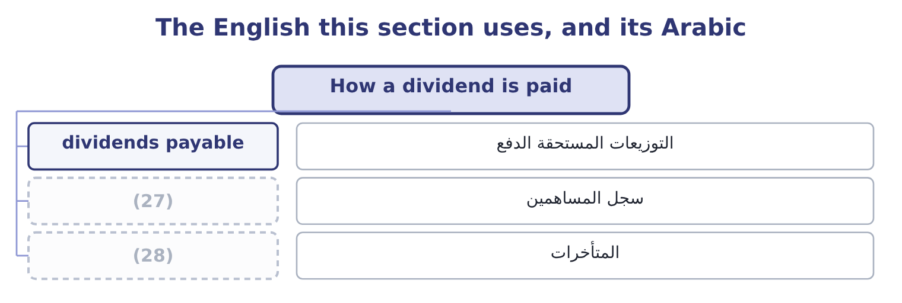
word list
payout policy · share register · arrears

The English this sheet uses, and its Arabic
English (exam term) | Arabic
dividends payable | التوزيعات المستحقة الدفع
share register | سجل المساهمين
arrears | المتأخرات

Answer key · 11.2 How a dividend is paid

1 govern | 15 discretion
2 moment | 16 barely
3 Whoever | 17 practice
4 business | 18 A liability arises; equity falls
5 markets | 19 The shares trade without the dividend
6 investor | 20 The register is read
7 bought | 21 Cash and the liability both fall
8 approximately | 22 balance
9 longer | 23 adjusts
10 addition | 24 ex-date
11 arrears | 25 expense
12 cleared | 26 retained
13 usually | 27 share register
14 regular | 28 arrears

the summaries in full
Summary 1 Four dates govern the process, and the exam asks which one matters. The declaration date is when the board declares the dividend. At that moment a legal liability arises: Orontes's $400,000 dividend payable exists because the board declared before the year end and had not yet paid. The date of record is the date on which the company looks at its share register. Whoever is on it receives the dividend. The ex-dividend date is one business day before the record date in most markets, and it is the one that matters to an investor. A share bought on or after it does not carry the dividend. On the ex-dividend date the price falls by approximately the dividend, because the buyer no longer receives it: Orontes's $9.25 share would open at about 9.25 − 0.0556 = 9.1944, before any other news.
Summary 2 The payment date is when the cash goes out. For preferred stock the process is the same with one addition. The preferred dividend must be declared and paid in full before any common dividend, and where the stock is cumulative, any arrears from earlier years must be cleared first. Preferred dividends are usually at a fixed rate on par and are declared on a regular cycle, so the discretion a board exercises over the common dividend barely exists for the preferred — in practice if not in law.
Summary 3 The liability arises on declaration, not on payment. Orontes's balance sheet carries $400,000 of dividends payable for exactly that reason. The price adjusts on the ex-dividend date, not on the payment date. Buying the day before the ex-date to capture the dividend gains nothing, because the price falls by it. A dividend is not an expense and never reduces net income. It reduces retained earnings.

11.3 What decides a dividend policy
Chapter 11 · section 11.3

Fill every gap. Each word list holds one word more than there are gaps.
Summary 1 gaps 1–12
A dividend policy is the rule a board (1) about how much of its profit to distribute. Eight factors (2) it, and the exam (3) them named. Legal and (4) constraints. (5) are limited by law to profits available for the purpose, and covenants in loan agreements often restrict them further — a lender that has just advanced money does not want it paid out to (6) . A dividend is paid in cash, not in profit. A company can be (7) and unable to pay, which is (8) Barada's position in Book 1: an overdraft where there was none, and the profit sitting in inventory. A company with projects (9) more than its cost of capital should retain; one (10) should distribute. (11) retains 84.84 per cent and has projects at 14 and 11 per cent against a cost of capital of 9.04, which is (12) .
word list
everything · influence · earning · shareholders · follows · consistent · precisely · expects · Distributions · Orontes · contractual · without · profitable

Summary 2 gaps 13–24
A large, listed, (13) company can pay out and raise money again (14) . A small (15) company cannot, so it retains. (16) and the signal. Boards (17) cutting dividends because a cut is read as bad news, so they raise only when the higher level can be (18) . The result is that dividends are (19) and lag earnings, and an (20) cut moves a share price far more than the cash involved would justify. Different investors want different things: a pension fund wants income, a taxpaying (21) in a high bracket may prefer capital gains, a growth investor wants (22) retained. A (23) existing holders have selected it partly for its policy, so changing the policy sells the company to a different clientele and the (24) is costly. Where dividends are taxed more heavily than capital gains, distribution is an expensive way to deliver value, which is the argument for the buyback. A dividend paid out may have to be raised again by issuing shares, which dilutes the existing holders. A family company protecting control retains instead.
word list
starting · unexpected · private · smoothed · sustained · transition · Stability · everything · company's · cheaply · well-rated · dislike · individual

Orontes's policy, tested against the factors
Every item belongs to exactly one group.
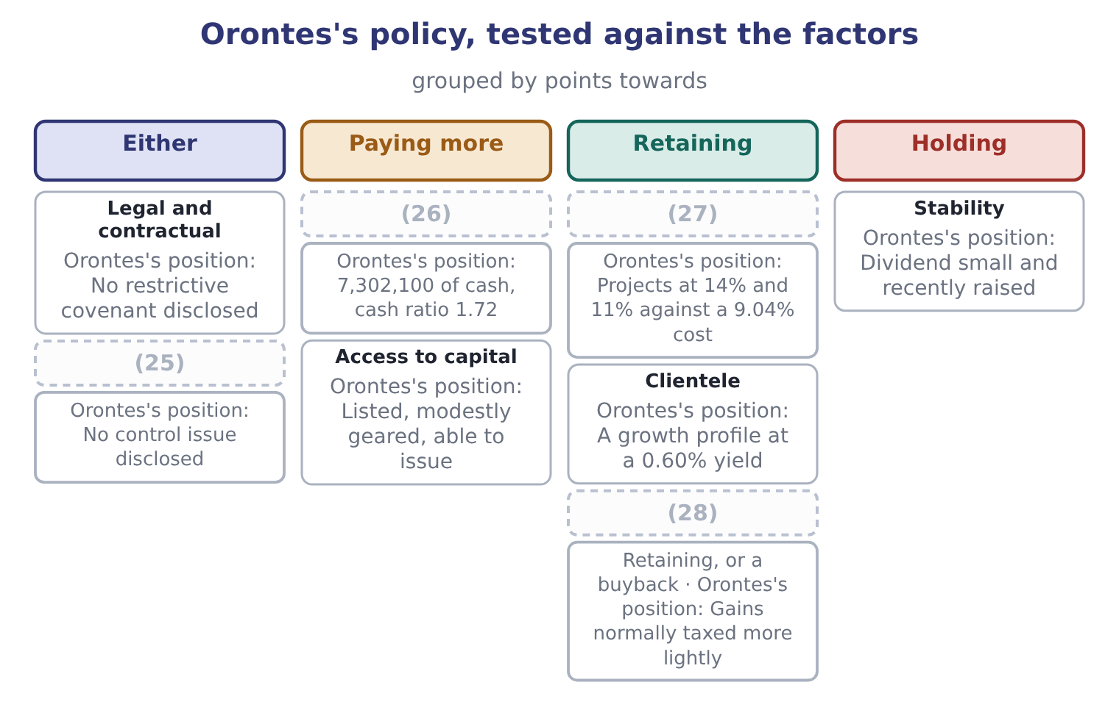
word list
Investment opportunities · stock dividend · Liquidity · Taxes · Control

Summary 3 gaps 29–38
Three (29) close the section and the exam names them. The irrelevance theory says that in a world with no taxes, no (30) costs and no (31) problems, dividend policy cannot affect value: a (32) wanting cash sells a share, and one not wanting it reinvests the dividend. The (33) view says investors prefer a certain dividend to an (34) capital gain and will pay more for a payer. And the (35) view says the policy (36) not for the cash but for what a change in it tells the market. The irrelevance theory is the correct (37) point and the real world's (38) are what give the other two their force.
word list
bird-in-the-hand · information · signalling · uncertain · shareholder · theories · taxpaying · matters · transaction · frictions · starting

The English this section uses, and its Arabic
Each term sits against what it means.
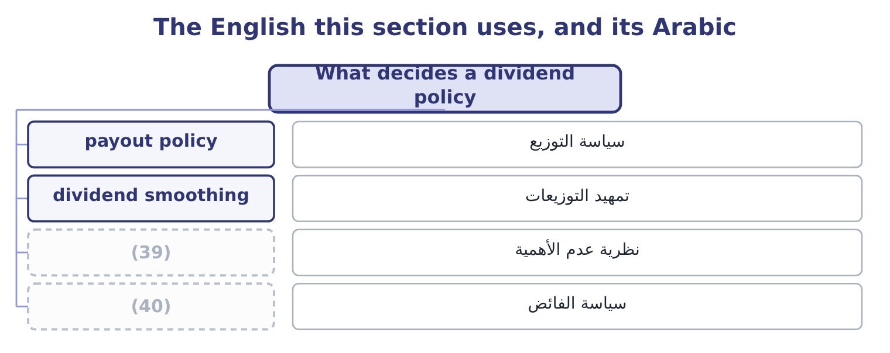
word list
irrelevance theory · residual policy · تمهيد التوزيعات

The English this sheet uses, and its Arabic
English (exam term) | Arabic
payout policy | سياسة التوزيع
dividend smoothing | تمهيد التوزيعات
irrelevance theory | نظرية عدم الأهمية
residual policy | سياسة الفائض

Answer key · 11.3 What decides a dividend policy

1 follows | 21 individual
2 influence | 22 everything
3 expects | 23 company's
4 contractual | 24 transition
5 Distributions | 25 Control
6 shareholders | 26 Liquidity
7 profitable | 27 Investment opportunities
8 precisely | 28 Taxes
9 earning | 29 theories
10 without | 30 transaction
11 Orontes | 31 information
12 consistent | 32 shareholder
13 well-rated | 33 bird-in-the-hand
14 cheaply | 34 uncertain
15 private | 35 signalling
16 Stability | 36 matters
17 dislike | 37 starting
18 sustained | 38 frictions
19 smoothed | 39 irrelevance theory
20 unexpected | 40 residual policy

the summaries in full
Summary 1 A dividend policy is the rule a board follows about how much of its profit to distribute. Eight factors influence it, and the exam expects them named. Legal and contractual constraints. Distributions are limited by law to profits available for the purpose, and covenants in loan agreements often restrict them further — a lender that has just advanced money does not want it paid out to shareholders. A dividend is paid in cash, not in profit. A company can be profitable and unable to pay, which is precisely Barada's position in Book 1: an overdraft where there was none, and the profit sitting in inventory. A company with projects earning more than its cost of capital should retain; one without should distribute. Orontes retains 84.84 per cent and has projects at 14 and 11 per cent against a cost of capital of 9.04, which is consistent.
Summary 2 A large, listed, well-rated company can pay out and raise money again cheaply. A small private company cannot, so it retains. Stability and the signal. Boards dislike cutting dividends because a cut is read as bad news, so they raise only when the higher level can be sustained. The result is that dividends are smoothed and lag earnings, and an unexpected cut moves a share price far more than the cash involved would justify. Different investors want different things: a pension fund wants income, a taxpaying individual in a high bracket may prefer capital gains, a growth investor wants everything retained. A company's existing holders have selected it partly for its policy, so changing the policy sells the company to a different clientele and the transition is costly. Where dividends are taxed more heavily than capital gains, distribution is an expensive way to deliver value, which is the argument for the buyback. A dividend paid out may have to be raised again by issuing shares, which dilutes the existing holders. A family company protecting control retains instead.
Summary 3 Three theories close the section and the exam names them. The irrelevance theory says that in a world with no taxes, no transaction costs and no information problems, dividend policy cannot affect value: a shareholder wanting cash sells a share, and one not wanting it reinvests the dividend. The bird-in-the-hand view says investors prefer a certain dividend to an uncertain capital gain and will pay more for a payer. And the signalling view says the policy matters not for the cash but for what a change in it tells the market. The irrelevance theory is the correct starting point and the real world's frictions are what give the other two their force.

11.4 Debt against equity
Chapter 11 · section 11.4

Fill every gap. Each word list holds one word more than there are gaps.
Summary 1 gaps 1–12
The choice between the two is the oldest question in (1) finance and the exam wants the (2) on both sides, not a verdict. Debt is cheaper, for two (3) . The (4) claim is safer, so the (5) return is lower, and the interest is deductible, so a 6.5 per cent rate costs 6.5 × 0.75 = 4.875 per cent after tax. It does not (6) ownership or votes. Its cost is fixed, so all the (7) of a good year (8) to the shareholders — the leverage of Book 1. And it imposes a (9) : a company that must meet interest payments cannot easily waste cash, which is a genuine argument and not only a (10) one. Debt is also (11) . The payments are compulsory, in bad years as in good. Covenants restrict what the company may do, as Barada (12) . It must be repaid or refinanced, which brings the refinancing risk. And past some level it raises the cost of everything, including equity, because the residual claim has become riskier.
word list
lender's · discipline · dilute · belongs · upside · reasons · dangerous · discovered · arguments · rhetorical · corporate · against · required

Summary 2 gaps 13–19
Equity has the mirror (13) . It never has to be repaid and its (14) is discretionary, so it absorbs a bad year instead of (15) it. It carries no covenants. It improves the credit standing, which makes the next (16) cheaper. But it is (17) , because the shareholders stand last and require the most; it is not deductible; it dilutes both ownership and control; and issuing it carries a (18) cost, because the market reads an issue as (19) view that the shares are fully valued.
word list
management's · borrowing · amplifying · properties · dividend · shareholders · expensive · signalling

Debt against equity
Dimension | Debt | Equity
Cost | (20) | Higher, and not deductible
Obligation | Fixed and compulsory | Discretionary
Maturity | Must be repaid or refinanced | Permanent
Control | (21) | Dilutes ownership and votes
Covenants | Usually restrictive | (22)
In a bad year | Amplifies the loss | (23)
Effect on credit standing | Worsens it | (24)
Signal on issue | (25) | Usually negative

word list
No dilution · Improves it · None · Neutral to positive · Absorbs it · Lower, and deductible · irrelevance theory

Summary 3 gaps 26–33
The (26) framework the exam rewards is a short (27) . How stable are the cash flows: stable flows (28) debt. How tangible are the assets: (29) secure on tangible assets. What is the (30) leverage against the (31) limits and against the rating target. What does the (32) tax position look like, since the shield is worth nothing to a (33) . What matters to the owners, since a family may value control above cost. And what is the maturity of the need: permanent capital should not be funded with money that must be refinanced in a year.
word list
covenant · existing · checklist · lenders · company's · practical · loss-maker · support · reasons

The English this section uses, and its Arabic
Each term sits against what it means.
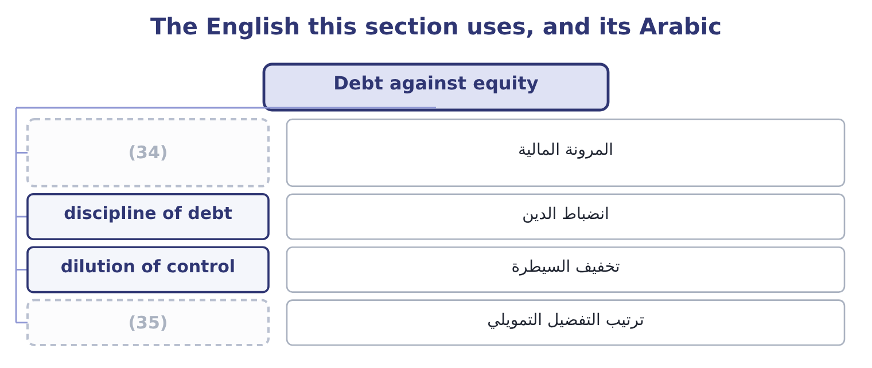
word list
dividend smoothing · pecking order · financial flexibility

The English this sheet uses, and its Arabic
English (exam term) | Arabic
financial flexibility | المرونة المالية
discipline of debt | انضباط الدين
dilution of control | تخفيف السيطرة
pecking order | ترتيب التفضيل التمويلي

Answer key · 11.4 Debt against equity

1 corporate | 19 management's
2 arguments | 20 Lower, and deductible
3 reasons | 21 No dilution
4 lender's | 22 None
5 required | 23 Absorbs it
6 dilute | 24 Improves it
7 upside | 25 Neutral to positive
8 belongs | 26 practical
9 discipline | 27 checklist
10 rhetorical | 28 support
11 dangerous | 29 lenders
12 discovered | 30 existing
13 properties | 31 covenant
14 dividend | 32 company's
15 amplifying | 33 loss-maker
16 borrowing | 34 financial flexibility
17 expensive | 35 pecking order
18 signalling

the summaries in full
Summary 1 The choice between the two is the oldest question in corporate finance and the exam wants the arguments on both sides, not a verdict. Debt is cheaper, for two reasons. The lender's claim is safer, so the required return is lower, and the interest is deductible, so a 6.5 per cent rate costs 6.5 × 0.75 = 4.875 per cent after tax. It does not dilute ownership or votes. Its cost is fixed, so all the upside of a good year belongs to the shareholders — the leverage of Book 1. And it imposes a discipline: a company that must meet interest payments cannot easily waste cash, which is a genuine argument and not only a rhetorical one. Debt is also dangerous. The payments are compulsory, in bad years as in good. Covenants restrict what the company may do, as Barada discovered. It must be repaid or refinanced, which brings the refinancing risk. And past some level it raises the cost of everything, including equity, because the residual claim has become riskier.
Summary 2 Equity has the mirror properties. It never has to be repaid and its dividend is discretionary, so it absorbs a bad year instead of amplifying it. It carries no covenants. It improves the credit standing, which makes the next borrowing cheaper. But it is expensive, because the shareholders stand last and require the most; it is not deductible; it dilutes both ownership and control; and issuing it carries a signalling cost, because the market reads an issue as management's view that the shares are fully valued.
Summary 3 The practical framework the exam rewards is a short checklist. How stable are the cash flows: stable flows support debt. How tangible are the assets: lenders secure on tangible assets. What is the existing leverage against the covenant limits and against the rating target. What does the company's tax position look like, since the shield is worth nothing to a loss-maker. What matters to the owners, since a family may value control above cost. And what is the maturity of the need: permanent capital should not be funded with money that must be refinanced in a year.

11.5 Leasing, and the net advantage to leasing
Chapter 11 · section 11.5

Fill every gap. Each word list holds one word more than there are gaps.
Summary 1 gaps 1–7
The comparison is (1) the same: lease the asset, or (2) the money and buy it. Both are ways of (3) the use of an asset without paying cash today, so the (4) decision — whether the asset is worth having at all — is settled first and separately. What remains is a financing comparison, and because it is a financing comparison it is (5) at the after-tax cost of debt, not at the (6) average cost of capital. That point (7) marks on its own.
word list
payment · discounted · obtaining · borrow · investment · weighted · always · carries

Worked example: the net advantage to leasing

Summary 2 gaps 8–15
A (8) line costs $1,000,000 to buy, lasts five years, and would be depreciated (9) to nil, which is $200,000 a year. (10) it can be leased for $240,000 a year for five years. The (11) tax rate is 25 per cent and it (12) at 8 per cent. The after-tax cost of debt is 8.0 × 0.75 = 6.0 per cent, and the (13) annuity factor at 6 per cent is 4.2124. The cost of leasing. Each lease payment is (14) , so it costs 240,000 × 0.75 = 180,000 after tax, and the present value of five of them is 180,000 × 4.2124 = 758,232. Leasing also (15) the depreciation allowances, which are worth 200,000 × 0.25 = 50,000 a year, with a present value of 50,000 × 4.2124 = 210,620. The total cost of leasing is 758,232 + 210,620 = 968,852.
word list
five-year · borrows · company's · Alternatively · payments · straight-line · roasting · forfeits · deductible

Summary 3 gaps 16–24
Borrowing and buying costs the purchase price of $1,000,000 today; the (16) on the borrowing is not counted separately, because (17) at the after-tax cost of debt has already (18) for the financing. The answer turned on two (19) : the lease payment and the tax (20) . At a tax rate of nil the depreciation shield would be worth (21) , the lease payments would cost their full $240,000, and the present value of leasing would be 240,000 × 4.2124 = 1,010,976 — more than buying. That is the point: leasing is (22) to the company that (23) use the allowances, and it is the (24) ability to use them that funds the rate.
word list
nothing · present · interest · attractive · cannot · accounted · position · numbers · lessor's · discounting

The net advantage to leasing, as a template
Line | This case | Note
After-tax lease payment a year | 180,000 | The payment less the tax saved on it
Present value of the lease payments | 758,232 | At the after-tax cost of debt
Depreciation shield forfeited a year | 50,000 | (25)
Present value of the shield forfeited | 210,620 | (26)
Total cost of leasing | 968,852 | (27)
Cost of buying | 1,000,000 | The purchase price
Net advantage to leasing | 31,148 | Buying less leasing

word list
The two added · Price 24.00, dividend 0.80 · At the same rate · Depreciation times the tax rate

Summary 4 gaps 28–34
Three (28) complete the method and appear in harder (29) . A (30) value the owner would keep is a cost of leasing, added to the lease side at its present value. (31) included in a lease is a saving, (32) . And where the lease is a finance lease recognised on the balance sheet, the comparison does not change — the accounting follows the economics rather than driving it, which is a sentence worth (33) for both parts of the (34) .
word list
financing · questions · Maintenance · residual · refinements · remembering · deducted · examination

Dividends and a lease

Your turn: distributions and leasing (complete the blanks)
Item | Data | Answer
Shares after a 20 per cent stock dividend | 5,000,000 shares now | (35)
Earnings per share after it | (36) | 0.3333: 2,000,000 ÷ 6,000,000 = 0.3333.
Price on the ex-dividend date | Price 24.00, dividend 0.80 | (37)
After-tax lease payment | Payment 300,000, tax rate 25% | (38)
Present value of five such payments | Annuity factor 4.2124 | 947,790: 225,000 × 4.2124 = 947,790.
Depreciation shield forfeited each year | (39) | 60,000: the annual depreciation is 1,200,000 ÷ 5 = 240,000, and 240,000 × 0.25 = 60,000.

word list
Cost of buying · 6,000,000: 5,000,000 × 1.20 = 6,000,000. · Asset 1,200,000 over five years, tax 25% · Net income 2,000,000 · 23.20: 24.00 − 0.80 = 23.20. · 225,000: 300,000 × 0.75 = 225,000.

"Dividend"

Summary 5 gaps 40–46
English dividend comes from the Latin for a thing to be divided, and in finance it means the share of profit (40) . (41) finance it survives in (42) , where the dividend is the number being divided — the same root, a different object. The (43) for an exam is the phrase dividend payout: it is a ratio of a (44) to earnings, not a payment. Note too that dividends (45) and dividends paid are different figures in the same year, as (46) $450,000 and $50,000 show.
word list
remembering · mathematics · distribution · distributed · declared · warning · Orontes's · Outside

The English this section uses, and its Arabic
Each term sits against what it means.
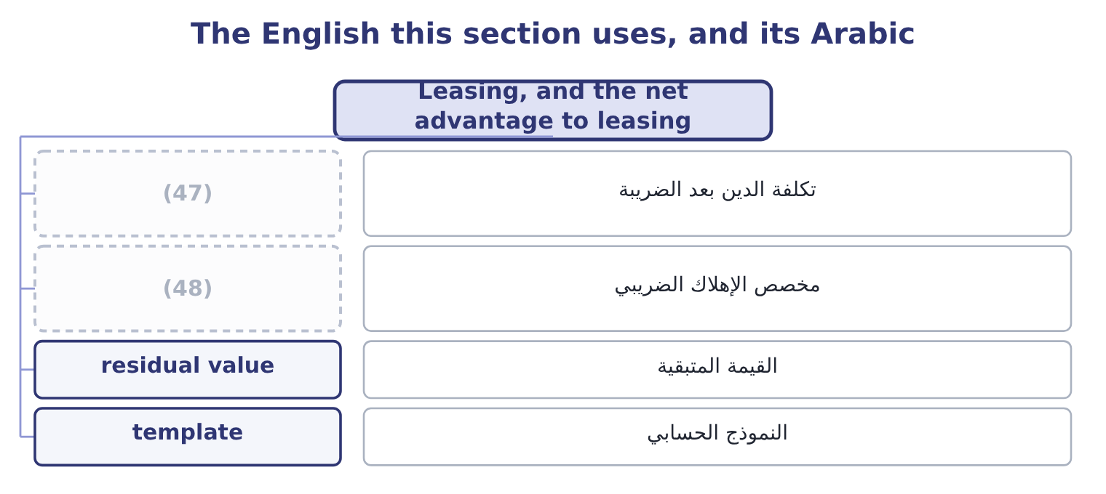
word list
stock dividend · depreciation allowance · after-tax cost of debt

The English this sheet uses, and its Arabic
English (exam term) | Arabic
after-tax cost of debt | تكلفة الدين بعد الضريبة
depreciation allowance | مخصص الإهلاك الضريبي
residual value | القيمة المتبقية
template | النموذج الحسابي

Answer key · 11.5 Leasing, and the net advantage to leasing

1 always | 25 Depreciation times the tax rate
2 borrow | 26 At the same rate
3 obtaining | 27 The two added
4 investment | 28 refinements
5 discounted | 29 questions
6 weighted | 30 residual
7 carries | 31 Maintenance
8 roasting | 32 deducted
9 straight-line | 33 remembering
10 Alternatively | 34 examination
11 company's | 35 6,000,000: 5,000,000 × 1.20 = 6,000,000.
12 borrows | 36 Net income 2,000,000
13 five-year | 37 23.20: 24.00 − 0.80 = 23.20.
14 deductible | 38 225,000: 300,000 × 0.75 = 225,000.
15 forfeits | 39 Asset 1,200,000 over five years, tax 25%
16 interest | 40 distributed
17 discounting | 41 Outside
18 accounted | 42 mathematics
19 numbers | 43 warning
20 position | 44 distribution
21 nothing | 45 declared
22 attractive | 46 Orontes's
23 cannot | 47 after-tax cost of debt
24 lessor's | 48 depreciation allowance

the summaries in full
Summary 1 The comparison is always the same: lease the asset, or borrow the money and buy it. Both are ways of obtaining the use of an asset without paying cash today, so the investment decision — whether the asset is worth having at all — is settled first and separately. What remains is a financing comparison, and because it is a financing comparison it is discounted at the after-tax cost of debt, not at the weighted average cost of capital. That point carries marks on its own.
Summary 2 A roasting line costs $1,000,000 to buy, lasts five years, and would be depreciated straight-line to nil, which is $200,000 a year. Alternatively it can be leased for $240,000 a year for five years. The company's tax rate is 25 per cent and it borrows at 8 per cent. The after-tax cost of debt is 8.0 × 0.75 = 6.0 per cent, and the five-year annuity factor at 6 per cent is 4.2124. The cost of leasing. Each lease payment is deductible, so it costs 240,000 × 0.75 = 180,000 after tax, and the present value of five of them is 180,000 × 4.2124 = 758,232. Leasing also forfeits the depreciation allowances, which are worth 200,000 × 0.25 = 50,000 a year, with a present value of 50,000 × 4.2124 = 210,620. The total cost of leasing is 758,232 + 210,620 = 968,852.
Summary 3 Borrowing and buying costs the purchase price of $1,000,000 today; the interest on the borrowing is not counted separately, because discounting at the after-tax cost of debt has already accounted for the financing. The answer turned on two numbers: the lease payment and the tax position. At a tax rate of nil the depreciation shield would be worth nothing, the lease payments would cost their full $240,000, and the present value of leasing would be 240,000 × 4.2124 = 1,010,976 — more than buying. That is the point: leasing is attractive to the company that cannot use the allowances, and it is the lessor's ability to use them that funds the rate.
Summary 4 Three refinements complete the method and appear in harder questions. A residual value the owner would keep is a cost of leasing, added to the lease side at its present value. Maintenance included in a lease is a saving, deducted. And where the lease is a finance lease recognised on the balance sheet, the comparison does not change — the accounting follows the economics rather than driving it, which is a sentence worth remembering for both parts of the examination.
Summary 5 English dividend comes from the Latin for a thing to be divided, and in finance it means the share of profit distributed. Outside finance it survives in mathematics, where the dividend is the number being divided — the same root, a different object. The warning for an exam is the phrase dividend payout: it is a ratio of a distribution to earnings, not a payment. Note too that dividends declared and dividends paid are different figures in the same year, as Orontes's $450,000 and $50,000 show.

