12.1 What working capital is
Chapter 12 · section 12.1

Fill every gap. Each word list holds one word more than there are gaps.
Chapter 12, section by section
Each stage leads to the next.
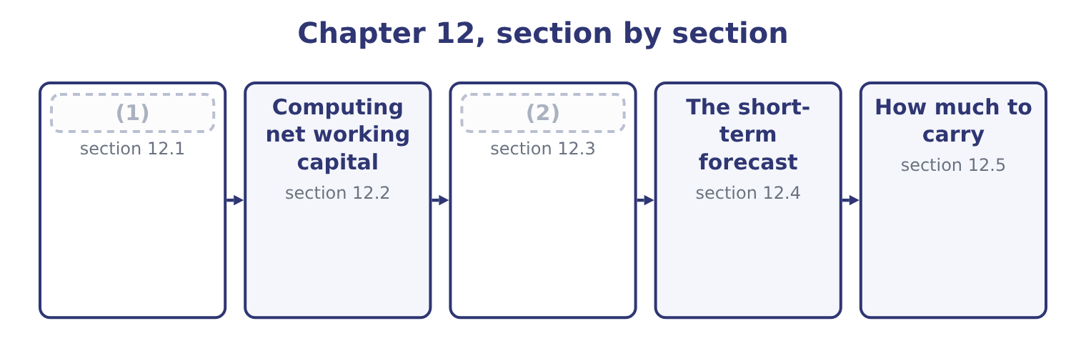
word list
What working capital costs · Computing net working capital · What working capital is

Summary 1 gaps 3–14
Working capital, in the broad sense, is the current assets of a business: the assets that will turn into cash within a year or within the (3) cycle if that is (4) . Net working capital is those assets less the current liabilities. The first measures what is tied up; the (5) measures how much of it the company has to fund (6) after its short-term (7) have done their part. The (8) are the lines of the current section of the (9) sheet. Marketable securities, which are cash held in a form that earns a (10) . Prepaid (11) , which are small and managed by nobody in (12) . Against those stand the current liabilities: accounts payable, which is (13) credit and the cheapest funding in the business; accrued liabilities; taxes payable; the current portion of long-term debt; and short-term (14) .
word list
creditors · operating · itself · longer · balance · sensitivity · particular · expenses · components · borrowings · supplier · return · second

Summary 2 gaps 15–26
Two (15) matter before any (16) . A business that never runs out of stock always has stock, so some part of its working capital is (17) invested even though the (18) items turn over (19) . That permanent core should be funded like any other (20) asset, with long-term money. The seasonal peak above it — the extra stock before a harvest, the extra receivables after it — is (21) and should be funded (22) . Gross against net, and trade against total. A (23) asking for working capital usually means current assets; one asking for net working capital means the (24) . Trade working capital narrows it again to receivables plus inventory less payables, (25) cash and short-term debt, and it is the figure that measures the trading cycle rather than the funding (26) .
word list
position · question · individual · excluding · long-lived · temporary · invested · permanently · constantly · arithmetic · distinctions · temporarily · difference

The components, and where each is managed
Component | Orontes, 2025 | Managed in | Governed by
Cash | 7,302,100 | Chapters 13 and 14 | (27)
Marketable securities | 42,000 | (28) | Safety, liquidity, yield
Accounts receivable | 4,144,000 | Chapter 16 | (29)
Inventory | 2,450,000 | (30) | Lead time and order quantity
Accounts payable | (2,050,000) | Chapter 18 | (31)
Short-term borrowing | (32) | Chapter 18 | The line of credit

word list
The cash budget · Chapter 15 · Terms and discounts · Credit policy · Chapter 18 · Nil at the year end · Chapter 17

The English this section uses, and its Arabic
Each term sits against what it means.
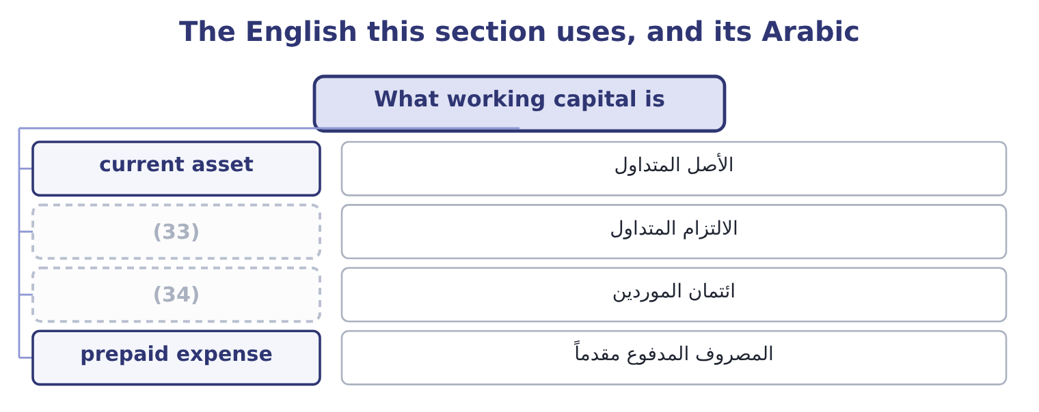
word list
supplier credit · current liability · working capital

The English this sheet uses, and its Arabic
English (exam term) | Arabic
current asset | الأصل المتداول
current liability | الالتزام المتداول
supplier credit | ائتمان الموردين
prepaid expense | المصروف المدفوع مقدماً

Answer key · 12.1 What working capital is

1 What working capital is | 18 individual
2 What working capital costs | 19 constantly
3 operating | 20 long-lived
4 longer | 21 temporary
5 second | 22 temporarily
6 itself | 23 question
7 creditors | 24 difference
8 components | 25 excluding
9 balance | 26 position
10 return | 27 The cash budget
11 expenses | 28 Chapter 15
12 particular | 29 Credit policy
13 supplier | 30 Chapter 17
14 borrowings | 31 Terms and discounts
15 distinctions | 32 Nil at the year end
16 arithmetic | 33 current liability
17 permanently | 34 supplier credit

the summaries in full
Summary 1 Working capital, in the broad sense, is the current assets of a business: the assets that will turn into cash within a year or within the operating cycle if that is longer. Net working capital is those assets less the current liabilities. The first measures what is tied up; the second measures how much of it the company has to fund itself after its short-term creditors have done their part. The components are the lines of the current section of the balance sheet. Marketable securities, which are cash held in a form that earns a return. Prepaid expenses, which are small and managed by nobody in particular. Against those stand the current liabilities: accounts payable, which is supplier credit and the cheapest funding in the business; accrued liabilities; taxes payable; the current portion of long-term debt; and short-term borrowings.
Summary 2 Two distinctions matter before any arithmetic. A business that never runs out of stock always has stock, so some part of its working capital is permanently invested even though the individual items turn over constantly. That permanent core should be funded like any other long-lived asset, with long-term money. The seasonal peak above it — the extra stock before a harvest, the extra receivables after it — is temporary and should be funded temporarily. Gross against net, and trade against total. A question asking for working capital usually means current assets; one asking for net working capital means the difference. Trade working capital narrows it again to receivables plus inventory less payables, excluding cash and short-term debt, and it is the figure that measures the trading cycle rather than the funding position.

12.2 Computing net working capital
Chapter 12 · section 12.2

Fill every gap. Each word list holds one word more than there are gaps.
Summary 1 gaps 1–12
Net working capital is total current assets less total current liabilities. For Orontes at (1) 31, 2025: 14,188,100 − 4,280,000 = 9,908,100. A year (2) it was 8,380,000 − 3,570,000 = 4,810,000. So net working capital more than (3) in a year: 9,908,100 − 4,810,000 = 5,098,100 of additional money locked into the (4) side of the (5) . Where did it come from, and was it well spent? The cash flow (6) answers the first (7) — a $1,500,000 share issue, an $800,000 bank note, and $7,531,100 of cash from (8) — and Book 1 answers the second: most of the (9) is cash, which rose from $2,100,000 to $7,302,100, and cash earning nothing is the least (10) asset a company can hold. Three ratios express the same balance (11) , and all three (12) in Book 1.
word list
earlier · statement · answers · appeared · business · doubled · question · December · differently · productive · operations · increase · short-term

Summary 2 gaps 13–17
The current ratio divides current assets by current liabilities: 14,188,100 ÷ 4,280,000 = 3.31 times. The net working capital ratio divides net working capital by total assets: 9,908,100 ÷ 31,672,600 = 31.3 per cent, which says that (13) a third of (14) Orontes owns is tied up short term. And the trade figure, (15) plus inventory less (16) , is $4,544,000 — less than half the net working capital, the (17) being the cash pile.
word list
everything · inventory · receivables · nearly · payables · difference

Worked example: what growth does to working capital

Summary 3 gaps 18–29
Trade working capital is (18) by sales. Orontes (19) $4,544,000 of it on sales of $42,000,000, which is 4,544,000 ÷ 42,000,000 = 10.82 per cent of sales. The requirement of growth. If sales grow 15 per cent next year and nothing about the cycle (20) , trade working capital grows with them: 4,544,000 × 0.15 = 681,600 of additional funding (21) , before a single dollar of new plant. Orontes (22) 84.84 per cent of a $2,969,100 profit, which is about $2,519,100 — (23) more than the $681,600 the growth demands. The company can fund its own (24) in working capital, which is what a (25) growth rate of 13.70 per cent meant in Book 1. Run the same arithmetic for (26) . Its trade working capital is a far higher (27) of its sales, because it is a (28) whose inventory is a third of its assets; its net margin is 1.29 per cent, so its retained profit is about $283,500; and its sales grew 11 per cent. The requirement exceeds the (29) , every year, and the gap went on the overdraft. The same two lines of arithmetic explain both companies.
word list
sustainable · expansion · retains · driven · required · spectrum · retention · distributor · changes · comfortably · carries · Barada · proportion

The English this section uses, and its Arabic
Each term sits against what it means.
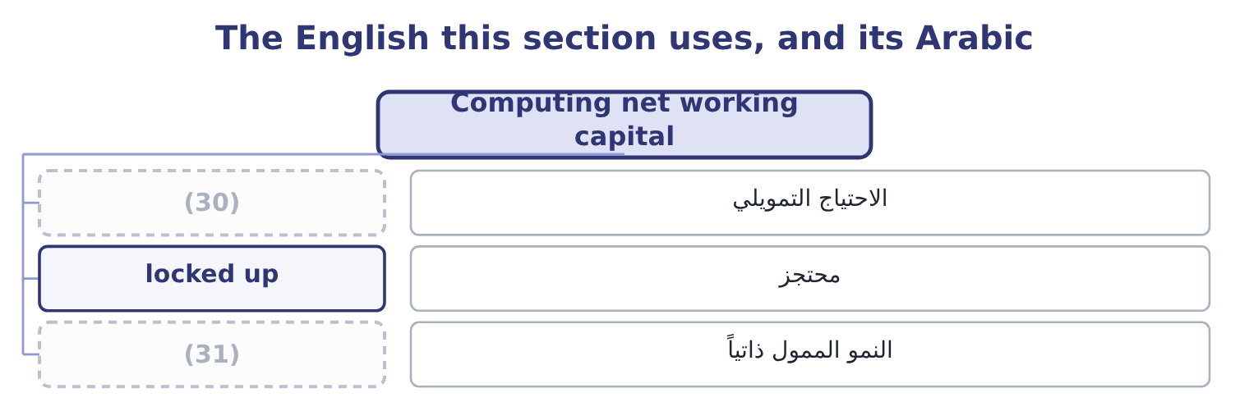
word list
self-funding growth · collection pattern · funding requirement

The English this sheet uses, and its Arabic
English (exam term) | Arabic
funding requirement | الاحتياج التمويلي
locked up | محتجز
self-funding growth | النمو الممول ذاتياً

Answer key · 12.2 Computing net working capital

1 December | 17 difference
2 earlier | 18 driven
3 doubled | 19 carries
4 short-term | 20 changes
5 business | 21 required
6 statement | 22 retains
7 question | 23 comfortably
8 operations | 24 expansion
9 increase | 25 sustainable
10 productive | 26 Barada
11 differently | 27 proportion
12 appeared | 28 distributor
13 nearly | 29 retention
14 everything | 30 funding requirement
15 receivables | 31 self-funding growth
16 payables

the summaries in full
Summary 1 Net working capital is total current assets less total current liabilities. For Orontes at December 31, 2025: 14,188,100 − 4,280,000 = 9,908,100. A year earlier it was 8,380,000 − 3,570,000 = 4,810,000. So net working capital more than doubled in a year: 9,908,100 − 4,810,000 = 5,098,100 of additional money locked into the short-term side of the business. Where did it come from, and was it well spent? The cash flow statement answers the first question — a $1,500,000 share issue, an $800,000 bank note, and $7,531,100 of cash from operations — and Book 1 answers the second: most of the increase is cash, which rose from $2,100,000 to $7,302,100, and cash earning nothing is the least productive asset a company can hold. Three ratios express the same balance differently, and all three appeared in Book 1.
Summary 2 The current ratio divides current assets by current liabilities: 14,188,100 ÷ 4,280,000 = 3.31 times. The net working capital ratio divides net working capital by total assets: 9,908,100 ÷ 31,672,600 = 31.3 per cent, which says that nearly a third of everything Orontes owns is tied up short term. And the trade figure, receivables plus inventory less payables, is $4,544,000 — less than half the net working capital, the difference being the cash pile.
Summary 3 Trade working capital is driven by sales. Orontes carries $4,544,000 of it on sales of $42,000,000, which is 4,544,000 ÷ 42,000,000 = 10.82 per cent of sales. The requirement of growth. If sales grow 15 per cent next year and nothing about the cycle changes, trade working capital grows with them: 4,544,000 × 0.15 = 681,600 of additional funding required, before a single dollar of new plant. Orontes retains 84.84 per cent of a $2,969,100 profit, which is about $2,519,100 — comfortably more than the $681,600 the growth demands. The company can fund its own expansion in working capital, which is what a sustainable growth rate of 13.70 per cent meant in Book 1. Run the same arithmetic for Barada. Its trade working capital is a far higher proportion of its sales, because it is a distributor whose inventory is a third of its assets; its net margin is 1.29 per cent, so its retained profit is about $283,500; and its sales grew 11 per cent. The requirement exceeds the retention, every year, and the gap went on the overdraft. The same two lines of arithmetic explain both companies.

12.3 What working capital costs
Chapter 12 · section 12.3

Fill every gap. Each word list holds one word more than there are gaps.
Summary 1 gaps 1–12
Money tied up in working capital has to be financed, and the (1) has a price. Book 1 (2) it: $4,544,000 of trade working capital (3) at the 6 per cent Orontes pays its bank costs about 4,544,000 × 0.06 = 272,640 a year. That is the (4) cost. Three more are real and less often (5) . The (6) cost of the cash. Orontes holds $7,302,100 in a (7) account. At the 4 per cent a (8) government (9) would pay, holding it idle forgoes 7,302,100 × 0.04 = 292,084 a year — more than the whole cost of funding the trade cycle. The risk cost of the inventory. Stock can be stolen, damaged, or made (10) by a change in demand, and (11) and storage are paid whether or not it sells. A (12) passes through cost of sales and lands on the gross margin.
word list
obsolete · security · Against · counted · current · computed · short-dated · write-down · visible · insurance · funded · financing · opportunity

Summary 2 gaps 13–24
The credit cost of the receivables. Some will not be paid. Orontes's (13) of $156,000 is its own (14) of that, and its credit loss expense of $63,000 is what the year actually cost. Against those costs stand the (15) , and this is the (16) every chapter from here to eighteen turns on. Inventory exists so that a customer who wants (17) can have it; cutting it too far loses sales and, at Orontes's degree of operating (18) of 4.02, a lost sale costs four times its margin in operating income. Receivables exist (19) customers will not buy without credit; (20) terms loses volume. Cash exists so that (21) can be met without borrowing in a hurry. So the question is never "how (22) working capital can we hold" but "where is the level at which the cost of holding more (23) the cost of holding less". Every one of the next six (24) answers that question for one component.
word list
allowance · estimate · because · write-down · tightening · something · obligations · exceeds · leverage · trade-off · little · chapters · benefits

The two sides of every working-capital decision
Component | Cost of holding more | Cost of holding less
Cash | Interest forgone | (25)
Marketable securities | A lower yield than long investments | (26)
Receivables | (27) | Lost sales to customers who need terms
Inventory | Funding, storage, obsolescence | (28)
Payables | (29) | Funding the gap yourself

word list
Less liquidity when it is needed · Lost settlement discounts, supplier goodwill · Funding, and credit losses · Stockouts, lost sales, expedited freight · Borrowing in a hurry, or missing a payment · Funding the gap yourself

The English this section uses, and its Arabic
Each term sits against what it means.
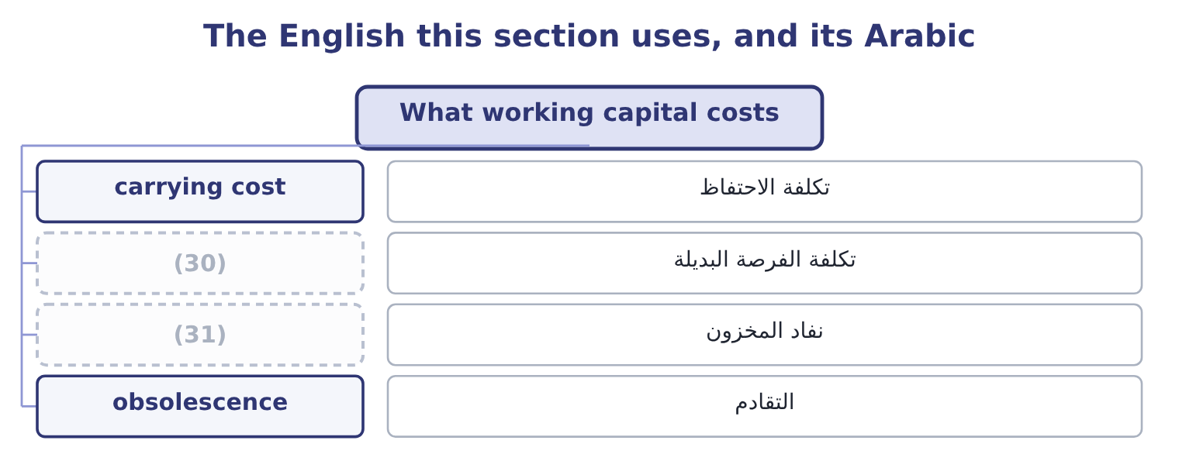
word list
stockout · carrying cost · opportunity cost

The English this sheet uses, and its Arabic
English (exam term) | Arabic
carrying cost | تكلفة الاحتفاظ
opportunity cost | تكلفة الفرصة البديلة
stockout | نفاد المخزون
obsolescence | التقادم

Answer key · 12.3 What working capital costs

1 financing | 17 something
2 computed | 18 leverage
3 funded | 19 because
4 visible | 20 tightening
5 counted | 21 obligations
6 opportunity | 22 little
7 current | 23 exceeds
8 short-dated | 24 chapters
9 security | 25 Borrowing in a hurry, or missing a payment
10 obsolete | 26 Less liquidity when it is needed
11 insurance | 27 Funding, and credit losses
12 write-down | 28 Stockouts, lost sales, expedited freight
13 allowance | 29 Lost settlement discounts, supplier goodwill
14 estimate | 30 opportunity cost
15 benefits | 31 stockout
16 trade-off

the summaries in full
Summary 1 Money tied up in working capital has to be financed, and the financing has a price. Book 1 computed it: $4,544,000 of trade working capital funded at the 6 per cent Orontes pays its bank costs about 4,544,000 × 0.06 = 272,640 a year. That is the visible cost. Three more are real and less often counted. The opportunity cost of the cash. Orontes holds $7,302,100 in a current account. At the 4 per cent a short-dated government security would pay, holding it idle forgoes 7,302,100 × 0.04 = 292,084 a year — more than the whole cost of funding the trade cycle. The risk cost of the inventory. Stock can be stolen, damaged, or made obsolete by a change in demand, and insurance and storage are paid whether or not it sells. A write-down passes through cost of sales and lands on the gross margin.
Summary 2 The credit cost of the receivables. Some will not be paid. Orontes's allowance of $156,000 is its own estimate of that, and its credit loss expense of $63,000 is what the year actually cost. Against those costs stand the benefits, and this is the trade-off every chapter from here to eighteen turns on. Inventory exists so that a customer who wants something can have it; cutting it too far loses sales and, at Orontes's degree of operating leverage of 4.02, a lost sale costs four times its margin in operating income. Receivables exist because customers will not buy without credit; tightening terms loses volume. Cash exists so that obligations can be met without borrowing in a hurry. So the question is never "how little working capital can we hold" but "where is the level at which the cost of holding more exceeds the cost of holding less". Every one of the next six chapters answers that question for one component.

12.4 The short-term forecast
Chapter 12 · section 12.4

Fill every gap. Each word list holds one word more than there are gaps.
Summary 1 gaps 1–12
Working capital is managed by (1) , and the instrument is the cash budget: a statement of (2) receipts and payments, period by period, usually monthly for a year and weekly or daily for the nearest weeks. What it does, and the (3) asks exactly this. It shows when, not (4) . An (5) profit forecast says the year will be (6) . A monthly cash forecast says that in March the company will be $900,000 short, (7) the harvest is paid for in February and the (8) pay in April. Only the (9) can be acted on. It sizes the (10) before they are needed. A line of credit (11) three months ahead of a seasonal peak is cheaper, larger and less (12) than one requested the week the overdraft appears. A bank asked to lend in a hurry charges for the hurry. It prices the alternatives.
word list
facilities · expected · because · customers · whether · conditional · second · profitable · forecasting · annual · outcome · overnight · negotiated

Summary 2 gaps 13–24
Once the (13) and its duration are known, the treasurer can compare borrowing, delaying a payment, (14) a collection, and deferring a capital project — which is the decision. It puts (15) cash to work. (16) that $2,000,000 will not be needed for four months means it can be placed for four months rather than left (17) , which is. It is a (18) as well as a plan. (19) the forecast with what (20) reveals which assumption was wrong — collections slower than assumed, a supplier paid earlier than agreed — and improves the next forecast. Three (21) make a forecast useful rather than (22) . A rolling horizon, re-cut every month so that twelve months are always in view rather than a budget that (23) to nothing by (24) . Sensitivity: a base case, and at least one case in which collections run a week slower, which is the single assumption that most often fails. And a reconciliation to the balance sheet, so that the forecast's closing receivables and inventory are the ones the sales and purchasing plans imply.
word list
spectrum · shortens · December · Knowing · surplus · accelerating · overnight · control · happened · Comparing · practices · ornamental · shortfall

A cash budget is not a forecast income statement

Summary 3 gaps 25–28
Sales are not receipts. A sale on 30-day terms is cash next month, and a (25) that gives a collection pattern is testing exactly. (26) never appears in a cash budget. Nor does any other (27) item. Capital (28) and dividends do appear, although neither is in the income statement.
word list
borrowing · expenditure · question · Depreciation · non-cash

The words this section uses
Each term sits against what it means, and an instance of it.
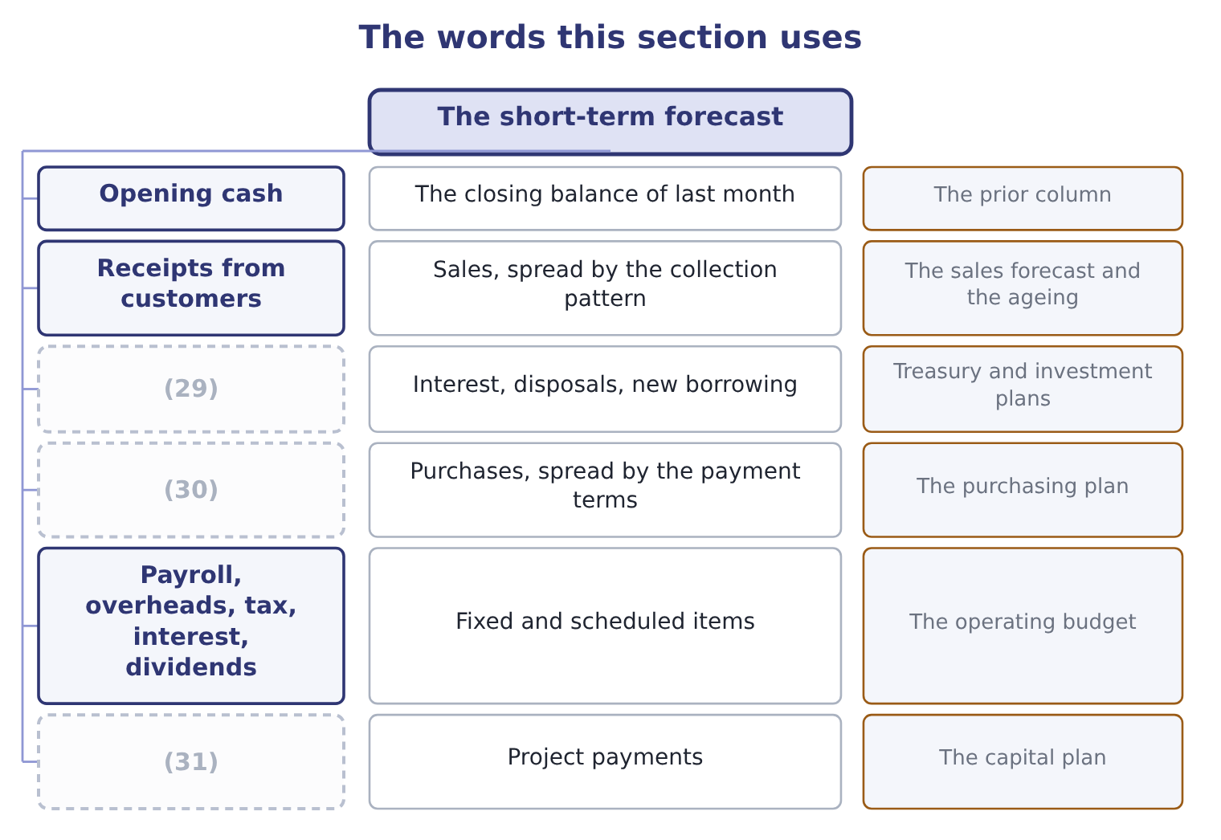
word list
Payments to suppliers · Other receipts · The prior column · Capital expenditure

The English this sheet uses, and its Arabic
English (exam term) | Arabic
collection pattern | نمط التحصيل
minimum cash balance | الحد الأدنى للرصيد النقدي
sensitivity | تحليل الحساسية
variance | الانحراف

Answer key · 12.4 The short-term forecast

1 forecasting | 17 overnight
2 expected | 18 control
3 outcome | 19 Comparing
4 whether | 20 happened
5 annual | 21 practices
6 profitable | 22 ornamental
7 because | 23 shortens
8 customers | 24 December
9 second | 25 question
10 facilities | 26 Depreciation
11 negotiated | 27 non-cash
12 conditional | 28 expenditure
13 shortfall | 29 Other receipts
14 accelerating | 30 Payments to suppliers
15 surplus | 31 Capital expenditure
16 Knowing

the summaries in full
Summary 1 Working capital is managed by forecasting, and the instrument is the cash budget: a statement of expected receipts and payments, period by period, usually monthly for a year and weekly or daily for the nearest weeks. What it does, and the outcome asks exactly this. It shows when, not whether. An annual profit forecast says the year will be profitable. A monthly cash forecast says that in March the company will be $900,000 short, because the harvest is paid for in February and the customers pay in April. Only the second can be acted on. It sizes the facilities before they are needed. A line of credit negotiated three months ahead of a seasonal peak is cheaper, larger and less conditional than one requested the week the overdraft appears. A bank asked to lend in a hurry charges for the hurry. It prices the alternatives.
Summary 2 Once the shortfall and its duration are known, the treasurer can compare borrowing, delaying a payment, accelerating a collection, and deferring a capital project — which is the decision. It puts surplus cash to work. Knowing that $2,000,000 will not be needed for four months means it can be placed for four months rather than left overnight, which is. It is a control as well as a plan. Comparing the forecast with what happened reveals which assumption was wrong — collections slower than assumed, a supplier paid earlier than agreed — and improves the next forecast. Three practices make a forecast useful rather than ornamental. A rolling horizon, re-cut every month so that twelve months are always in view rather than a budget that shortens to nothing by December. Sensitivity: a base case, and at least one case in which collections run a week slower, which is the single assumption that most often fails. And a reconciliation to the balance sheet, so that the forecast's closing receivables and inventory are the ones the sales and purchasing plans imply.
Summary 3 Sales are not receipts. A sale on 30-day terms is cash next month, and a question that gives a collection pattern is testing exactly. Depreciation never appears in a cash budget. Nor does any other non-cash item. Capital expenditure and dividends do appear, although neither is in the income statement.

12.5 How much to carry
Chapter 12 · section 12.5

Fill every gap. Each word list holds one word more than there are gaps.
Summary 1 gaps 1–12
A working capital policy is a choice about the level of current assets to hold for a given level of sales, and it runs along a (1) . A conservative policy holds high (2) of cash, stock and receivables. (3) are never turned away for lack of stock, (4) are paid promptly, the company is never short. It is safe and it is expensive: more funding, more storage, more (5) , and a lower return on assets, because the (6) is large. An (7) policy holds the (8) of each. The return on assets is higher and so is the risk of a (9) , a lost customer, or a (10) that cannot be made on the day it falls due. A (11) policy sits between them, and the exam's usual answer is that the right level depends on three things: the (12) of the business, the cost of running out, and the cost of money.
word list
aggressive · Customers · million · obsolescence · minimum · spectrum · variability · payment · stockout · levels · denominator · suppliers · moderate

Summary 2 gaps 13–22
A company with (13) demand and expensive (14) holds more; one with steady demand and cheap, quickly (15) stock holds less. (16) sits firmly on the conservative side and Book 1 said so: a current ratio of 3.31 against an (17) that would (18) run nearer 2.0, a cash ratio of 1.72, and a cash balance that grew by five million in one year. The company is safe, and section 12.3 (19) the safety at (20) $292,084 a year of forgone (21) on the cash alone. That is a (22) choice for a company whose gross margin is falling and whose board may want options — and it is a choice, which is the point, rather than something that happened.
word list
Orontes · stockouts · roughly · interest · priced · replaced · defensible · storage · industry · normally · volatile

Compute and judge

Your turn: working capital (complete the blanks)
Item | Data | Answer
Net working capital | Current assets 6,400,000, current liabilities 2,500,000 | ________
Current ratio | (23) | ________
Trade working capital | Receivables 2,100,000, inventory 1,800,000, payables 1,200,000 | ________
Cost of funding it at 7 per cent |  | ________
Extra funding needed if sales grow 20 per cent | (24) | ________
Retained profit available | Net income 900,000, payout 25 per cent | ________
Verdict |  | ________

word list
Trade working capital scales with sales · 189,000: 2,700,000 × 0.07 = 189,000. · The same figures

"Capital"

Summary 3 gaps 25–29
English working capital is a phrase in which (25) word means what it (26) means. The capital is not long-term funding, as in cost of capital or capital (27) ; it is the (28) money in the trading cycle. And working does not mean (29) ; it means circulating, in the old sense of a sum that works by turning over.
word list
neither · functioning · usually · short-term · expenditure · working

"Capital"
Item | Answer
Net working capital | 3,900,000: 6,400,000 − 2,500,000 = 3,900,000.
Current ratio | (30)
Trade working capital | 2,700,000: 2,100,000 + 1,800,000 = 3,900,000, less payables of 1,200,000.
Cost of funding it at 7 per cent | (31)
Extra funding if sales grow 20 per cent | (32)
Retained profit available | 675,000: 900,000 × 0.75 = 675,000.
Verdict | The growth is just affordable. Retained profit of 675,000 covers the 540,000 the working capital will absorb, with 135,000 left for everythi

word list
540,000: 2,700,000 × 0.20 = 540,000. · 2.56: 6,400,000 ÷ 2,500,000 = 2.56. · 189,000: 2,700,000 × 0.07 = 189,000. · Receivables 2,100,000, inventory 1,800,000, payables 1,200,000

The English this section uses, and its Arabic
Each term sits against what it means.
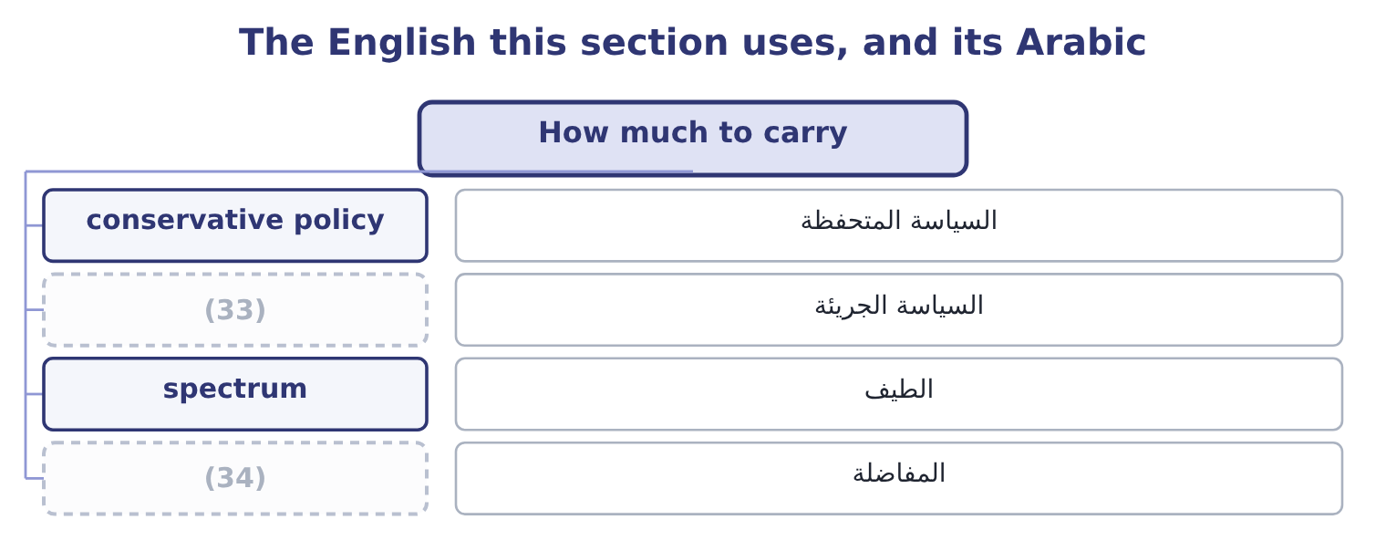
word list
trade-off · aggressive policy · السياسة الجريئة

The English this sheet uses, and its Arabic
English (exam term) | Arabic
conservative policy | السياسة المتحفظة
aggressive policy | السياسة الجريئة
spectrum | الطيف
trade-off | المفاضلة

Answer key · 12.5 How much to carry

1 spectrum | 18 normally
2 levels | 19 priced
3 Customers | 20 roughly
4 suppliers | 21 interest
5 obsolescence | 22 defensible
6 denominator | 23 The same figures
7 aggressive | 24 Trade working capital scales with sales
8 minimum | 25 neither
9 stockout | 26 usually
10 payment | 27 expenditure
11 moderate | 28 short-term
12 variability | 29 functioning
13 volatile | 30 2.56: 6,400,000 ÷ 2,500,000 = 2.56.
14 stockouts | 31 189,000: 2,700,000 × 0.07 = 189,000.
15 replaced | 32 540,000: 2,700,000 × 0.20 = 540,000.
16 Orontes | 33 aggressive policy
17 industry | 34 trade-off

the summaries in full
Summary 1 A working capital policy is a choice about the level of current assets to hold for a given level of sales, and it runs along a spectrum. A conservative policy holds high levels of cash, stock and receivables. Customers are never turned away for lack of stock, suppliers are paid promptly, the company is never short. It is safe and it is expensive: more funding, more storage, more obsolescence, and a lower return on assets, because the denominator is large. An aggressive policy holds the minimum of each. The return on assets is higher and so is the risk of a stockout, a lost customer, or a payment that cannot be made on the day it falls due. A moderate policy sits between them, and the exam's usual answer is that the right level depends on three things: the variability of the business, the cost of running out, and the cost of money.
Summary 2 A company with volatile demand and expensive stockouts holds more; one with steady demand and cheap, quickly replaced stock holds less. Orontes sits firmly on the conservative side and Book 1 said so: a current ratio of 3.31 against an industry that would normally run nearer 2.0, a cash ratio of 1.72, and a cash balance that grew by five million in one year. The company is safe, and section 12.3 priced the safety at roughly $292,084 a year of forgone interest on the cash alone. That is a defensible choice for a company whose gross margin is falling and whose board may want options — and it is a choice, which is the point, rather than something that happened.
Summary 3 English working capital is a phrase in which neither word means what it usually means. The capital is not long-term funding, as in cost of capital or capital expenditure; it is the short-term money in the trading cycle. And working does not mean functioning; it means circulating, in the old sense of a sum that works by turning over.

