13.1 Three motives for holding cash
Chapter 13 · section 13.1

Fill every gap. Each word list holds one word more than there are gaps.
Chapter 13, section by section
Each stage leads to the next.
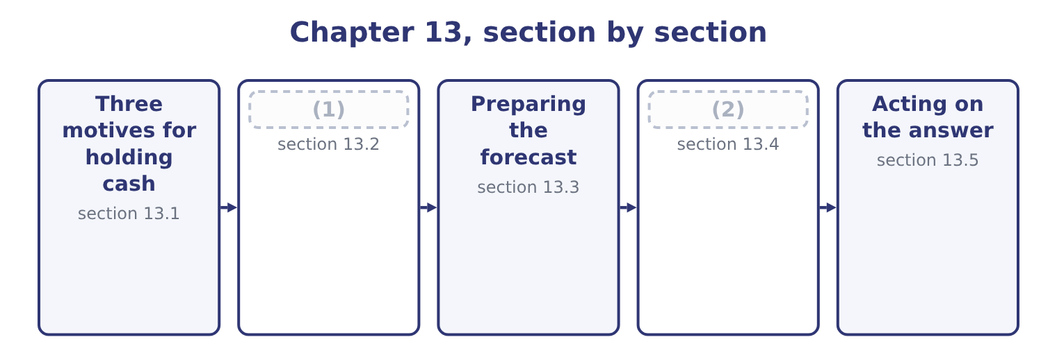
word list
What decides the level · Three motives for holding cash · Longer horizons and other methods

Summary 1 gaps 3–14
The classical (3) gives three (4) , and the exam asks for them by name. (5) and receipts do not (6) . Payroll falls due on a day, (7) on another, (8) pay when they pay, and a balance is needed so that the ordinary business of the month can be conducted without borrowing on a Tuesday to repay on a Thursday. The size of this requirement depends on the volume of (9) and on how well they can be timed. The unexpected happens: a customer fails, a machine breaks, a (10) is delayed, a tax (11) arrives. A buffer (12) the shock without (13) a sale of assets or a hurried loan. The size of this requirement depends on how variable the flows are and on how quickly the company could borrow instead — which is why a company with a committed, undrawn line of credit can hold less cash than one without, and the line is a (14) for the buffer.
word list
arrives · Payments · substitute · shipment · transactions · analysis · customers · absorbs · reasons · forcing · assessment · coincide · suppliers

Summary 2 gaps 15–26
Opportunities arrive at short notice: a (15) assets at a price, a (16) offering a large discount for a bulk purchase, a company for sale. Cash is the (17) to act, and a company with none (18) . In practice this is the motive most often given and least often true, since (19) cash is more usually the absence of a decision than the (20) for one. A fourth reason is (21) rather than classical and appears in questions (22) . A compensating balance is a minimum balance a bank (23) a borrower to keep in its account as a (24) of a loan or a line of credit. It is not (25) for use, so it is cash in form and not in substance, and it raises the effective cost of the borrowing — a (26) .
word list
supplier · surplus · preparation · offering · competitor's · calculation · cannot · requires · condition · available · ability · institutional · constantly

Why a company holds cash
Motive | What it funds | What increases it | What substitutes for it
Transaction | The timing gap in ordinary business | (27) | Better scheduling, faster collection
Precautionary | The unexpected | Variability of flows | (28)
Speculative | Opportunities at short notice | (29) | Rapid access to borrowing
Compensating balance | (30) | The terms of the facility | Negotiating a fee instead

word list
A strategy of acquisition · A committed line of credit · receipts and disbursements · A bank's requirement · Volume, and poor timing of flows

The English this section uses, and its Arabic
Each term sits against what it means.
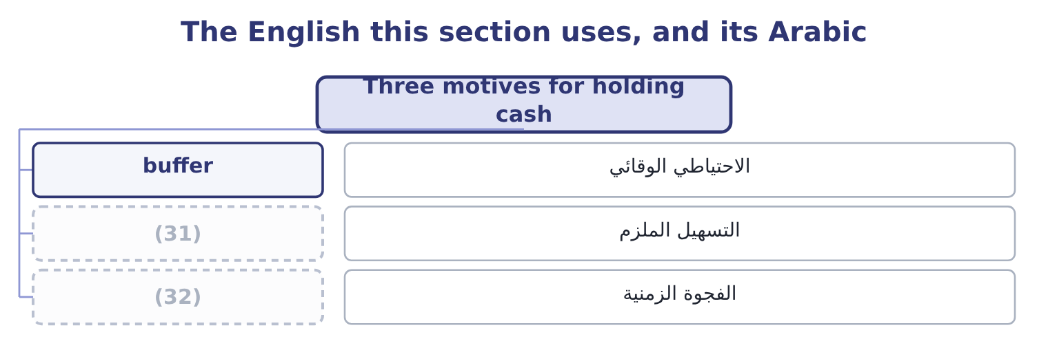
word list
الفجوة الزمنية · timing gap · committed facility

The English this sheet uses, and its Arabic
English (exam term) | Arabic
buffer | الاحتياطي الوقائي
committed facility | التسهيل الملزم
timing gap | الفجوة الزمنية

Answer key · 13.1 Three motives for holding cash

1 What decides the level | 17 ability
2 Longer horizons and other methods | 18 cannot
3 analysis | 19 surplus
4 reasons | 20 preparation
5 Payments | 21 institutional
6 coincide | 22 constantly
7 suppliers | 23 requires
8 customers | 24 condition
9 transactions | 25 available
10 shipment | 26 calculation
11 assessment | 27 Volume, and poor timing of flows
12 absorbs | 28 A committed line of credit
13 forcing | 29 A strategy of acquisition
14 substitute | 30 A bank's requirement
15 competitor's | 31 committed facility
16 supplier | 32 timing gap

the summaries in full
Summary 1 The classical analysis gives three reasons, and the exam asks for them by name. Payments and receipts do not coincide. Payroll falls due on a day, suppliers on another, customers pay when they pay, and a balance is needed so that the ordinary business of the month can be conducted without borrowing on a Tuesday to repay on a Thursday. The size of this requirement depends on the volume of transactions and on how well they can be timed. The unexpected happens: a customer fails, a machine breaks, a shipment is delayed, a tax assessment arrives. A buffer absorbs the shock without forcing a sale of assets or a hurried loan. The size of this requirement depends on how variable the flows are and on how quickly the company could borrow instead — which is why a company with a committed, undrawn line of credit can hold less cash than one without, and the line is a substitute for the buffer.
Summary 2 Opportunities arrive at short notice: a competitor's assets at a price, a supplier offering a large discount for a bulk purchase, a company for sale. Cash is the ability to act, and a company with none cannot. In practice this is the motive most often given and least often true, since surplus cash is more usually the absence of a decision than the preparation for one. A fourth reason is institutional rather than classical and appears in questions constantly. A compensating balance is a minimum balance a bank requires a borrower to keep in its account as a condition of a loan or a line of credit. It is not available for use, so it is cash in form and not in substance, and it raises the effective cost of the borrowing — a calculation.

13.2 What decides the level
Chapter 13 · section 13.2

Fill every gap. Each word list holds one word more than there are gaps.
Summary 1 gaps 1–12
Beyond the motives, seven (1) factors set the balance a company (2) , and the outcome asks for them. The (3) of the cash flows. A utility (4) monthly from a million households can hold very little; a (5) with four payments a year must hold a great deal. A (6) whose receipts arrive in three months of the year holds through the other nine, and the peak (7) , not the average, sizes the balance. A company with a committed facility and a (8) rating can treat the facility as its buffer. One whose borrowing is (9) , or whose rating is at the (10) boundary of, cannot, because the facility may not be there on the day it is wanted. The cost of being short. A missed payroll, a supplier who stops (11) , a covenant tested on a date — the more expensive the (12) , the larger the balance.
word list
delivering · uncommitted · requirement · collecting · carries · expressing · consequence · predictability · business · investment-grade · shipbuilder · strong · practical

Summary 2 gaps 13–21
The higher the return available on (13) securities, the more expensive it is to hold idle cash, and the harder a (14) works to invest it. At Orontes's $7,302,100 and a 4 per cent short rate, the cost of (15) is 7,302,100 × 0.04 = 292,084 a year. The (16) profile of the debt. A company with a large (17) in six months holds against it; one with (18) due for five years does not. Banking (19) and policy. (20) balances, minimum balances set by the board, and the number of accounts a group runs all raise the total held, which is why cash (21) —.
word list
concentration · instalment · Compensating · idleness · arrangements · nothing · short-term · repayment · maturity · treasurer

Worked example: how much cash is Orontes holding?

Summary 3 gaps 22–33
Orontes's cash operating payments in 2025 were (22) its cost of goods sold of $27,300,000 and its cash operating expenses, which are the $10,524,000 of total operating expenses less the $2,724,000 (23) , so 10,524,000 − 2,724,000 = 7,800,000. (24) that is 27,300,000 + 7,800,000 = 35,100,000 a year, or 35,100,000 ÷ 365 = 96,164 a day. The $7,302,100 balance is (25) 7,302,100 ÷ 96,164 = 75.9 days of operating payments. Two and a half months of payments in the bank, against a cash cycle of 39.8 days and a committed (26) with Levant (27) Bank, is a large buffer by any standard. A (28) with predictable flows and bank access would (29) run on a third of it. The (30) is not an error, and section 13.5 (31) to what should be done with it. The point of the (32) is that "is $7,302,100 a lot of cash?" is (33) and "is 75.9 days of payments a lot of cash?" is answerable, which is what expressing a balance in days of its own flow is for — the same move Book 1 made with receivables and inventory.
word list
broadly · manufacturer · calculation · Together · normally · therefore · Commerce · impairment · surplus · returns · delivering · relationship · unanswerable

The English this section uses, and its Arabic
Each term sits against what it means.
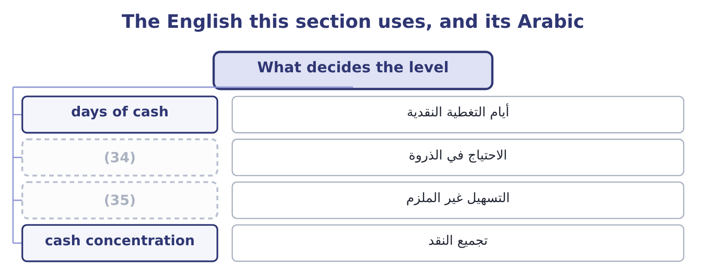
word list
compensating balance · uncommitted facility · peak requirement

The English this sheet uses, and its Arabic
English (exam term) | Arabic
days of cash | أيام التغطية النقدية
peak requirement | الاحتياج في الذروة
uncommitted facility | التسهيل غير الملزم
cash concentration | تجميع النقد

Answer key · 13.2 What decides the level

1 practical | 19 arrangements
2 carries | 20 Compensating
3 predictability | 21 concentration
4 collecting | 22 broadly
5 shipbuilder | 23 impairment
6 business | 24 Together
7 requirement | 25 therefore
8 strong | 26 relationship
9 uncommitted | 27 Commerce
10 investment-grade | 28 manufacturer
11 delivering | 29 normally
12 consequence | 30 surplus
13 short-term | 31 returns
14 treasurer | 32 calculation
15 idleness | 33 unanswerable
16 maturity | 34 peak requirement
17 repayment | 35 uncommitted facility
18 nothing

the summaries in full
Summary 1 Beyond the motives, seven practical factors set the balance a company carries, and the outcome asks for them. The predictability of the cash flows. A utility collecting monthly from a million households can hold very little; a shipbuilder with four payments a year must hold a great deal. A business whose receipts arrive in three months of the year holds through the other nine, and the peak requirement, not the average, sizes the balance. A company with a committed facility and a strong rating can treat the facility as its buffer. One whose borrowing is uncommitted, or whose rating is at the investment-grade boundary of, cannot, because the facility may not be there on the day it is wanted. The cost of being short. A missed payroll, a supplier who stops delivering, a covenant tested on a date — the more expensive the consequence, the larger the balance.
Summary 2 The higher the return available on short-term securities, the more expensive it is to hold idle cash, and the harder a treasurer works to invest it. At Orontes's $7,302,100 and a 4 per cent short rate, the cost of idleness is 7,302,100 × 0.04 = 292,084 a year. The maturity profile of the debt. A company with a large repayment in six months holds against it; one with nothing due for five years does not. Banking arrangements and policy. Compensating balances, minimum balances set by the board, and the number of accounts a group runs all raise the total held, which is why cash concentration —.
Summary 3 Orontes's cash operating payments in 2025 were broadly its cost of goods sold of $27,300,000 and its cash operating expenses, which are the $10,524,000 of total operating expenses less the $2,724,000 impairment, so 10,524,000 − 2,724,000 = 7,800,000. Together that is 27,300,000 + 7,800,000 = 35,100,000 a year, or 35,100,000 ÷ 365 = 96,164 a day. The $7,302,100 balance is therefore 7,302,100 ÷ 96,164 = 75.9 days of operating payments. Two and a half months of payments in the bank, against a cash cycle of 39.8 days and a committed relationship with Levant Commerce Bank, is a large buffer by any standard. A manufacturer with predictable flows and bank access would normally run on a third of it. The surplus is not an error, and section 13.5 returns to what should be done with it. The point of the calculation is that "is $7,302,100 a lot of cash?" is unanswerable and "is 75.9 days of payments a lot of cash?" is answerable, which is what expressing a balance in days of its own flow is for — the same move Book 1 made with receivables and inventory.

13.3 Preparing the forecast
Chapter 13 · section 13.3

Fill every gap. Each word list holds one word more than there are gaps.
Summary 1 gaps 1–9
The receipts and (1) method builds the forecast from the (2) themselves. It is the method the exam sets, and it has four steps. Forecast the sales, month by month. Convert sales into receipts using the collection pattern — the (3) collected in the month of sale, the month after, and so on, with an (4) for what is never collected. Forecast the payments: purchases, (5) by the supplier terms; payroll; overheads; tax; (6) ; dividends; capital (7) . Roll the balance (8) : opening cash plus receipts less payments is closing cash, which (9) next month's opening, and compare the result with the minimum balance the company has decided to hold.
word list
interest · converted · disbursements · expenditure · forward · allowance · becomes · transactions · dividends · proportions

Worked example: a month that needs a facility

Summary 2 gaps 10–13
January $800,000, February $1,000,000, March $1,400,000, April $1,200,000. (10) per cent is collected in the month of sale, 50 per cent in the following month, 28 per cent in the month after that, and 2 per cent is never collected. March receipts are (11) 0.20 × 1,400,000 = 280,000 from (12) own sales, 0.50 × 1,000,000 = 500,000 from February and 0.28 × 800,000 = 224,000 from January, which is 280,000 + 500,000 + 224,000 = 1,004,000. Purchases are 60 per cent of the following month's sales and are paid a month after purchase, so March pays for (13) purchases of 0.60 × 1,400,000 = 840,000. Payroll is $220,000, overheads $90,000, and a tax instalment of $150,000 falls due, so payments are 840,000 + 220,000 + 90,000 + 150,000 = 1,300,000. Opening cash is $300,000, so closing cash is 300,000 + 1,004,000 − 1,300,000 = 4,000.
word list
February's · March's · therefore · Twenty · dividends

Summary 3 gaps 14–22
Against a minimum balance policy of $250,000, the company is short by 250,000 − 4,000 = 246,000. The company is (14) in March — it sells $1,400,000 and its costs are far below that — and it is (15) out of money, (16) the sales growth means it is (17) for a larger February purchase while still (18) on a smaller January sale. That is the pattern of every growing (19) cash crisis, and the forecast found it two months before it (20) , which is long enough to arrange a (21) , collect faster, or delay the tax payment by (22) .
word list
paying · company's · nearly · facility · because · agreement · expenditure · collecting · happened · profitable

One month of a cash budget
Line | Computation | March
Opening cash | (23) | 300,000
Collections from March sales | 20% of 1,400,000 | 280,000
Collections from February sales | 50% of 1,000,000 | 500,000
Collections from January sales | (24) | 224,000
Total receipts |  | 1,004,000
Payment for February purchases | (25) | (840,000)
Payroll and overheads |  | (310,000)
Tax instalment |  | (150,000)
Closing cash | Opening plus receipts less payments | 4,000
Shortfall against a 250,000 minimum |  | (246,000)

word list
28% of 800,000 · Prior closing balance · line of credit · 60% of March sales, paid a month later

Three things that go wrong in a cash budget

Summary 4 gaps 26–31
Sales are not receipts. Apply the collection pattern, and (26) that the percentages must include the (27) part so they sum to 100. Purchases are not payments. Apply the supplier terms, and watch for a (28) in which purchases are a (29) of the following month's sales rather than the (30) month's. The minimum balance is not zero. The shortfall to be (31) is measured against the policy minimum, not against an empty account.
word list
pattern · question · uncollectable · percentage · current · remember · financed

The English this section uses, and its Arabic
Each term sits against what it means.
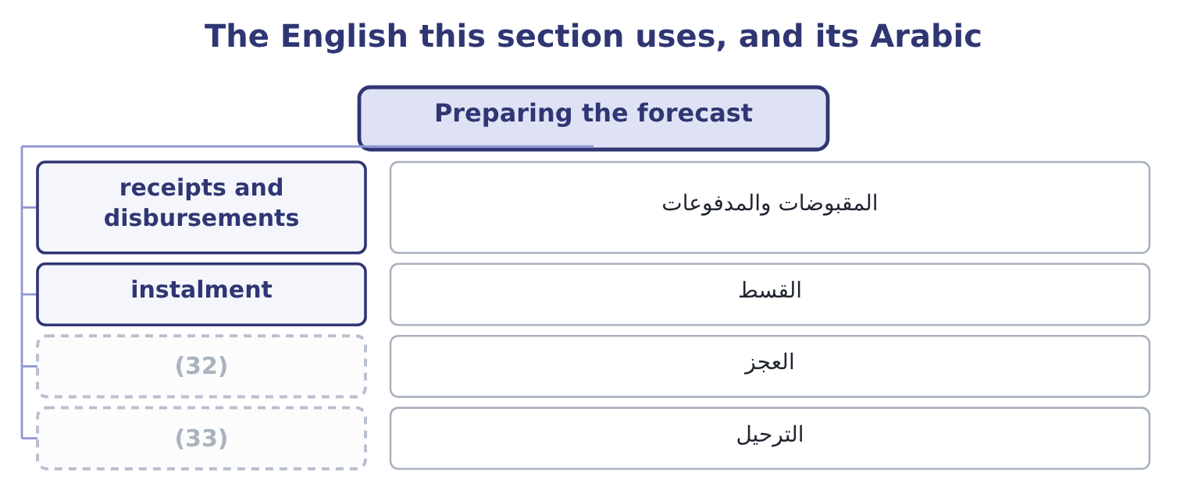
word list
roll forward · idle balance · shortfall

The English this sheet uses, and its Arabic
English (exam term) | Arabic
receipts and disbursements | المقبوضات والمدفوعات
instalment | القسط
shortfall | العجز
roll forward | الترحيل

Answer key · 13.3 Preparing the forecast

1 disbursements | 18 collecting
2 transactions | 19 company's
3 proportions | 20 happened
4 allowance | 21 facility
5 converted | 22 agreement
6 interest | 23 Prior closing balance
7 expenditure | 24 28% of 800,000
8 forward | 25 60% of March sales, paid a month later
9 becomes | 26 remember
10 Twenty | 27 uncollectable
11 therefore | 28 question
12 March's | 29 percentage
13 February's | 30 current
14 profitable | 31 financed
15 nearly | 32 shortfall
16 because | 33 roll forward
17 paying

the summaries in full
Summary 1 The receipts and disbursements method builds the forecast from the transactions themselves. It is the method the exam sets, and it has four steps. Forecast the sales, month by month. Convert sales into receipts using the collection pattern — the proportions collected in the month of sale, the month after, and so on, with an allowance for what is never collected. Forecast the payments: purchases, converted by the supplier terms; payroll; overheads; tax; interest; dividends; capital expenditure. Roll the balance forward: opening cash plus receipts less payments is closing cash, which becomes next month's opening, and compare the result with the minimum balance the company has decided to hold.
Summary 2 January $800,000, February $1,000,000, March $1,400,000, April $1,200,000. Twenty per cent is collected in the month of sale, 50 per cent in the following month, 28 per cent in the month after that, and 2 per cent is never collected. March receipts are therefore 0.20 × 1,400,000 = 280,000 from March's own sales, 0.50 × 1,000,000 = 500,000 from February and 0.28 × 800,000 = 224,000 from January, which is 280,000 + 500,000 + 224,000 = 1,004,000. Purchases are 60 per cent of the following month's sales and are paid a month after purchase, so March pays for February's purchases of 0.60 × 1,400,000 = 840,000. Payroll is $220,000, overheads $90,000, and a tax instalment of $150,000 falls due, so payments are 840,000 + 220,000 + 90,000 + 150,000 = 1,300,000. Opening cash is $300,000, so closing cash is 300,000 + 1,004,000 − 1,300,000 = 4,000.
Summary 3 Against a minimum balance policy of $250,000, the company is short by 250,000 − 4,000 = 246,000. The company is profitable in March — it sells $1,400,000 and its costs are far below that — and it is nearly out of money, because the sales growth means it is paying for a larger February purchase while still collecting on a smaller January sale. That is the pattern of every growing company's cash crisis, and the forecast found it two months before it happened, which is long enough to arrange a facility, collect faster, or delay the tax payment by agreement.
Summary 4 Sales are not receipts. Apply the collection pattern, and remember that the percentages must include the uncollectable part so they sum to 100. Purchases are not payments. Apply the supplier terms, and watch for a question in which purchases are a percentage of the following month's sales rather than the current month's. The minimum balance is not zero. The shortfall to be financed is measured against the policy minimum, not against an empty account.

13.4 Longer horizons and other methods
Chapter 13 · section 13.4

Fill every gap. Each word list holds one word more than there are gaps.
Summary 1 gaps 1–12
The receipts and disbursements method is exact and (1) : it needs a collection pattern, supplier terms and a payment (2) , and beyond a few months the detail is spurious. For a longer horizon the adjusted net income method is used instead, and it is the (3) cash flow statement of Part 1 run (4) . Start with forecast net income. Add back the non-cash charges — (5) , amortisation, (6) . Adjust for the expected movements in (7) capital: an increase in receivables or inventory is a use of cash, an increase in (8) a source. Deduct the planned capital (9) , the debt repayments and the (10) . What is left is the expected (11) in cash. The two methods answer different questions and the exam (12) them. The receipts method tells a treasurer which week needs a facility.
word list
dividends · depreciation · forecast · schedule · impairment · distinguishes · change · demanding · payables · indirect · working · forwards · expenditure

Summary 2 gaps 13–24
The adjusted net income method tells a board (13) next year's plan is fundable at all. A company needs both, at different (14) : daily for a (15) , weekly for a quarter, monthly for a year, annually for the plan. Three (16) improve any of them. (17) every month so that the view ahead never (18) . A base case, a case in which (19) run a week slower, and a case in which a large (20) fails. The second of these is the (21) that most often breaks, and (22) it is cheap. A (23) to the balance sheet. The (24) closing receivables should equal the sales not yet collected under the assumed pattern, and its closing inventory should equal the cover the purchasing plan implies. A forecast that does not reconcile contains an error that the cash line alone will hide.
word list
whether · collections · resolutions · customer · assumption · dividends · testing · Re-cut · reconciliation · fortnight · forecast's · techniques · shortens

Two forecasting methods
Feature | Receipts and disbursements | Adjusted net income
Built from | Individual flows and their timing | (25)
Horizon | (26) | Quarters to years
Answers | When will we be short, and by how much? | (27)
Needs | Collection pattern, supplier terms | (28)
Weakness | Spurious precision at long range | (29)

word list
A forecast income statement and balance sheet · Days to a few months · No detail about timing within a period · Is the plan fundable? · Individual flows and their timing · Forecast profit and balance movements

The English this section uses, and its Arabic
Each term sits against what it means.
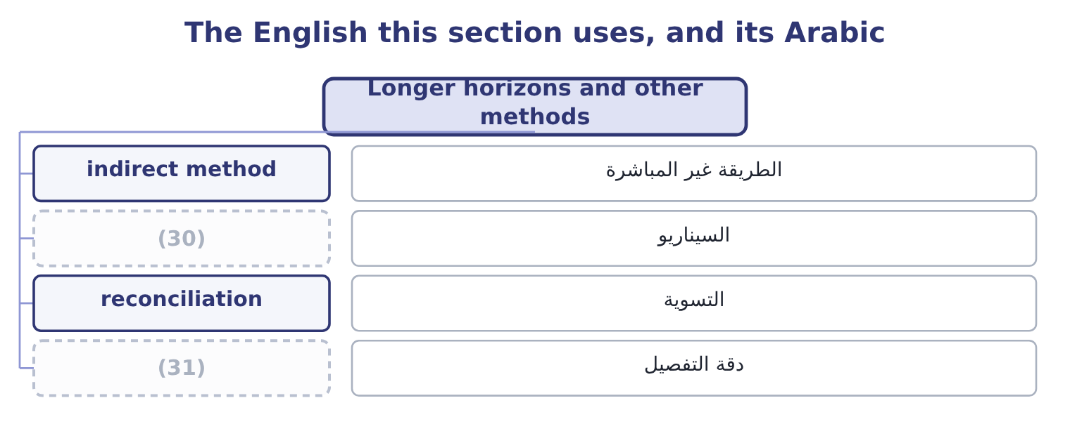
word list
reconciliation · resolution · scenario

The English this sheet uses, and its Arabic
English (exam term) | Arabic
indirect method | الطريقة غير المباشرة
scenario | السيناريو
reconciliation | التسوية
resolution | دقة التفصيل

Answer key · 13.4 Longer horizons and other methods

1 demanding | 17 Re-cut
2 schedule | 18 shortens
3 indirect | 19 collections
4 forwards | 20 customer
5 depreciation | 21 assumption
6 impairment | 22 testing
7 working | 23 reconciliation
8 payables | 24 forecast's
9 expenditure | 25 Forecast profit and balance movements
10 dividends | 26 Days to a few months
11 change | 27 Is the plan fundable?
12 distinguishes | 28 A forecast income statement and balance sheet
13 whether | 29 No detail about timing within a period
14 resolutions | 30 scenario
15 fortnight | 31 resolution
16 techniques

the summaries in full
Summary 1 The receipts and disbursements method is exact and demanding: it needs a collection pattern, supplier terms and a payment schedule, and beyond a few months the detail is spurious. For a longer horizon the adjusted net income method is used instead, and it is the indirect cash flow statement of Part 1 run forwards. Start with forecast net income. Add back the non-cash charges — depreciation, amortisation, impairment. Adjust for the expected movements in working capital: an increase in receivables or inventory is a use of cash, an increase in payables a source. Deduct the planned capital expenditure, the debt repayments and the dividends. What is left is the expected change in cash. The two methods answer different questions and the exam distinguishes them. The receipts method tells a treasurer which week needs a facility.
Summary 2 The adjusted net income method tells a board whether next year's plan is fundable at all. A company needs both, at different resolutions: daily for a fortnight, weekly for a quarter, monthly for a year, annually for the plan. Three techniques improve any of them. Re-cut every month so that the view ahead never shortens. A base case, a case in which collections run a week slower, and a case in which a large customer fails. The second of these is the assumption that most often breaks, and testing it is cheap. A reconciliation to the balance sheet. The forecast's closing receivables should equal the sales not yet collected under the assumed pattern, and its closing inventory should equal the cover the purchasing plan implies. A forecast that does not reconcile contains an error that the cash line alone will hide.

13.5 Acting on the answer
Chapter 13 · section 13.5

Fill every gap. Each word list holds one word more than there are gaps.
Summary 1 gaps 1–12
A forecast (1) one of two findings, and each has a short list of (2) . In order of preference: collect faster; slow payments within the terms agreed; draw on a (3) line of credit, which is why it was arranged; delay (4) spending, such as a capital project or a dividend; sell marketable securities; and only then negotiate new borrowing, which is the most expensive because it is the least prepared. In order of preference: fund the investment (5) ; repay expensive short-term debt; place the money in marketable securities matched to the date it will be needed; and, where the surplus is permanent rather than temporary, return it to (6) by the dividend or buyback. (7) $7,302,100 is a surplus by the measure of section 13.2 — 75.9 days of operating payments against a 39.8-day cash cycle and a bank (8) that works. The order above gives the answer Book 2 has been (9) towards: fund the two (10) at 14 and 11 per cent, which absorb $6,000,000; place the rest for the dates the forecast says it will be needed; and hold the dividend where it is until the gross margin has stopped falling. What should not happen is what (11) in 2025, which is that the balance grew by $5,202,100 and sat in a current account earning nothing while the (12) cost of capital ran at 9.04 per cent.
word list
company's · Orontes's · building · projects · happened · relationship · responses · current · committed · discretionary · produces · shareholders · opportunities

Build a month

Your turn: one month of a cash budget (complete the blanks)
Item | Data | Answer
Collections from June sales | (13) | 225,000: 0.25 × 900,000 = 225,000.
Collections from May sales | (14) | 440,000: 0.55 × 800,000 = 440,000.
Collections from April sales | April sales 700,000, 18 per cent collected two months after | (15)
Total receipts |  | 791,000: 225,000 + 440,000 + 126,000 = 791,000.
Payments | Suppliers 600,000, payroll 180,000, overheads 70,000 | (16)
Closing cash | Opening cash 120,000 | (17)
Shortfall against a 200,000 minimum |  | 139,000: 200,000 − 61,000 = 139,000.

word list
850,000: 600,000 + 180,000 + 70,000 = 850,000. · 440,000: 0.55 × 800,000 = 440,000. · 126,000: 0.18 × 700,000 = 126,000. · June sales 900,000, 25 per cent collected in month · 61,000: 120,000 + 791,000 − 850,000 = 61,000. · May sales 800,000, 55 per cent collected the month after

"Liquid"

Summary 2 gaps 18–25
English liquid in finance means (18) into cash quickly and without loss of value, and (19) is that quality. The metaphor is of (20) that flows, and it is used in three (21) senses that a (22) must keep apart: an asset is liquid if it can be sold quickly; a company is liquid if it can meet its (23) ; and a market is liquid if a large order can be (24) without moving the price. Note that illiquid never means (25) : a company can be solvent and illiquid.
word list
liquidity · stopped · related · executed · convertible · candidate · obligations · insolvent · something

The English this section uses, and its Arabic
Each term sits against what it means.
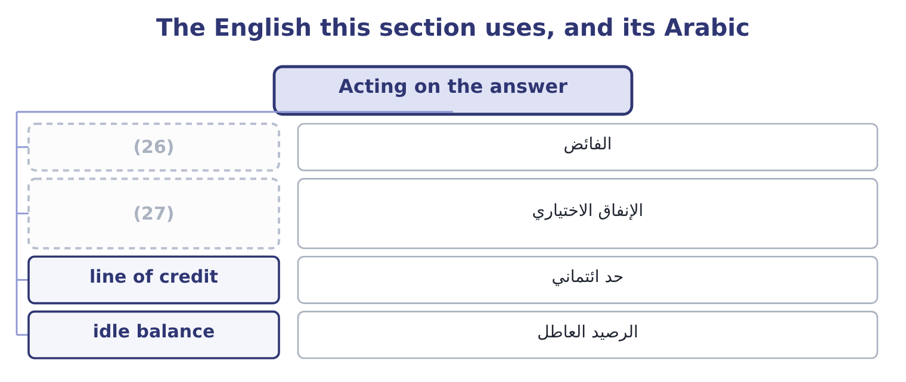
word list
buffer · discretionary spending · surplus

The English this sheet uses, and its Arabic
English (exam term) | Arabic
surplus | الفائض
discretionary spending | الإنفاق الاختياري
line of credit | حد ائتماني
idle balance | الرصيد العاطل

Answer key · 13.5 Acting on the answer

1 produces | 15 126,000: 0.18 × 700,000 = 126,000.
2 responses | 16 850,000: 600,000 + 180,000 + 70,000 = 850,000.
3 committed | 17 61,000: 120,000 + 791,000 − 850,000 = 61,000.
4 discretionary | 18 convertible
5 opportunities | 19 liquidity
6 shareholders | 20 something
7 Orontes's | 21 related
8 relationship | 22 candidate
9 building | 23 obligations
10 projects | 24 executed
11 happened | 25 insolvent
12 company's | 26 surplus
13 June sales 900,000, 25 per cent collected in month | 27 discretionary spending
14 May sales 800,000, 55 per cent collected the month after

the summaries in full
Summary 1 A forecast produces one of two findings, and each has a short list of responses. In order of preference: collect faster; slow payments within the terms agreed; draw on a committed line of credit, which is why it was arranged; delay discretionary spending, such as a capital project or a dividend; sell marketable securities; and only then negotiate new borrowing, which is the most expensive because it is the least prepared. In order of preference: fund the investment opportunities; repay expensive short-term debt; place the money in marketable securities matched to the date it will be needed; and, where the surplus is permanent rather than temporary, return it to shareholders by the dividend or buyback. Orontes's $7,302,100 is a surplus by the measure of section 13.2 — 75.9 days of operating payments against a 39.8-day cash cycle and a bank relationship that works. The order above gives the answer Book 2 has been building towards: fund the two projects at 14 and 11 per cent, which absorb $6,000,000; place the rest for the dates the forecast says it will be needed; and hold the dividend where it is until the gross margin has stopped falling. What should not happen is what happened in 2025, which is that the balance grew by $5,202,100 and sat in a current account earning nothing while the company's cost of capital ran at 9.04 per cent.
Summary 2 English liquid in finance means convertible into cash quickly and without loss of value, and liquidity is that quality. The metaphor is of something that flows, and it is used in three related senses that a candidate must keep apart: an asset is liquid if it can be sold quickly; a company is liquid if it can meet its obligations; and a market is liquid if a large order can be executed without moving the price. Note that illiquid never means insolvent: a company can be solvent and illiquid.

